Preface – DJPR Cover Note
Latrobe Valley Regional Rehabilitation Strategy: Geotechnical-related Metrics and Thresholds for Impact Assessment on Recognised Regional Receptors
February 2021
The Latrobe Valley Regional Rehabilitation Strategy: Geotechnical-related Metrics and Thresholds for Impact Assessment on Recognised Regional Receptors, authored by Jacobs and commissioned by the Department of Jobs, Precincts and Regions (DJPR), was largely developed over the period of August to December 2017. It was undertaken at an early stage in the process of preparing the Latrobe Valley Regional Rehabilitation Strategy (LVRRS), and its primary purpose was to inform the scope of the regional studies that would inform the LVRRS – particularly the regional geotechnical study. Parts of this report have therefore been superseded by the regional study and the LVRRS itself. The LVRRS was released by the Minister for Resources in June 2020 and is currently being implemented.
The regional receptors in this report were identified based on a scenario in which the three coal mine voids of the Latrobe Valley would be filled with water to create waterbodies as final rehabilitated landforms. This particular scenario was used in this study because, in response to the findings of the Hazelwood Fire Mine Inquiry (HMFI), the Victorian Government committed to further investigating the feasibility of water-based rehabilitation options. It is also unlikely that all receptors that may be relevant to the scenario at hand have been identified. The receptor inventory may also need to be re-visited in the future if different options are explored or put forward by mine licensees.
This report provides guidance for assessing potential geotechnical impacts of regional rehabilitation scenarios. The report is focused on physical receptors (e.g. environmental assets, Aboriginal heritage places, infrastructure, land or water resources). Social and economic receptors (e.g. rehabilitated mine land amenity and use, employment and jobs growth, industry, tourism and recreation), valued by stakeholders and communities in the Latrobe Valley that could potentially be affected by mine rehabilitation are being further considered, including as part of the LVRRS implementation.

Latrobe Valley Regional Rehabilitation Strategy
Department of Jobs Precincts and Regions and Department of Environment, Land, Water and Planning
Geotechnical-related Metrics and Thresholds for Impact Assessment on Recognised Regional Receptors

IS209100-204 | Final
4 December 2020

Prepared by Mining One and Jacobs
Department of Jobs Precincts and Regions and Department of Environment, Land, Water and Planning
Geotechnical-related Metrics and Thresholds for Impact Assessment on Recognised Regional Receptors

Latrobe Valley Regional Rehabilitation Strategy
Project No: | IS209100
Document Title: | Geotechnical-related Metrics and Thresholds for Impact Assessment on Recognised Regional Receptors
Document No.: | IS209100-204
Revision: | Final
Date: | 4 December 2020
Client Name: | Department of Jobs Precincts and Regions and Department of Environment, Land, Water and Planning
Client No: | Prepared by Mining One and Jacobs
Project Manager: | Greg Hoxley
Author: | Meredith Goss and Andrew Nelson
File Name: | J:\IE\Projects\03_Southern\IS209100\21 Deliverables\Final Set Dec 2020\IS209100-204 LVRRS geotechnical metrics and thresholds Final w markup.docx
Jacobs Group (Australia) Pty Limited  ABN 37 001 024 095  Floor 11, 452 Flinders Street  Melbourne VIC 3000  PO Box 312, Flinders Lane  Melbourne VIC 8009 Australia  T +61 3 8668 3000  F +61 3 8668 3001  www.jacobs.com |  | Mining One Pty Ltd  Level 9, 50 Market Street  Melbourne VIC 3000  Ph: 03 9600 3588  Fax: 03 9600 3944  
© Copyright 2020 Jacobs Group (Australia) Pty Limited. The concepts and information contained in this document are the property of Jacobs. Use or copying of this document in whole or in part without the written permission of Jacobs constitutes an infringement of copyright.
Limitation: This document has been prepared on behalf of, and for the exclusive use of Jacobs’ client, and is subject to, and issued in accordance with, the provisions of the contract between Jacobs and the client. Jacobs accepts no liability or responsibility whatsoever for, or in respect of, any use of, or reliance upon, this document by any third party.

Document history and status
Revision | Date | Description | By | Review | Approved
A | 30/11/17 | Exposure Draft Report | MG | KD | GH
B | 18/12/17 | Internal Review | MG | KD/AN | GH
C | 21/12/17 | Final Draft with client comments resolved | MG | KD/AN | GH
D | 9/02/18 | Final Draft with client technical comments resolved | MG | AN | GH
E | 9/3/18 | Final draft for review prior to stakeholder issue | MG | KD/AN | GH
F | 8/6/18 | Client comments resolved. Reissued for review | MG | AN | GH
G | 21/6/18 | Client comments resolved. Reissued for review | AN | GH | GH
H | July 2019 | Revised TOC and Executive summary issued | EM | GH | GH
I | Oct 2019 | Further revised ES issued | GH |  | GH
J | Mar 2020 | Fully revised in line with DJPR directions | EM/AR/GH | GH | GH
K | June 2020 | Further revisions after DJPR review | GH |  | GH
L | July 2020 | Final edits in response to comments | GH |  | GH
Final | Dec 2020 | Changes to intro and context provided by DJPR | GH |  | GH

Contents
Acknowledgements i
Definitions and abbreviations i
Executive Summary ii
Important note about this report xiii
1. Introduction 1
1.1 Background 1
1.2 LVRRS Development Context for the Study 2
1.3 Objective 2
1.4 Scope 2
1.5 Approach 3
1.6 Report Structure 3
2. Approach to identifying metrics and thresholds 5
3. Overview of Ground Movement 7
3.1 Ground Movement Types 7
3.2 Ground movement as it relates to receptors 16
4. Introduction to recognised regional receptors 17
5. Quantitative Metrics and Thresholds 18
5.1 Aboriginal and Non-aboriginal cultural heritage 18
5.2 Environment 19
5.3 Infrastructure 20
5.4 Quantitative Metrics and Thresholds – Land 51
5.5 Quantitative Metrics and Thresholds – Water 54
6. Conclusions 56

Appendix A. Literature reviewed and referenced - Technical Papers/Reports/Letters

Acknowledgements
The authors of this report wish to acknowledge the guidance and support provided by the Technical Advisory Group for the LVRRS and the many reviewers who have contributed to this document. We also acknowledge the contribution made by many stakeholders in participating in workshops and meetings and providing generously of their time and experience to the development of this report.

Definitions and abbreviations
Abbreviations | Definition
AEP | Annual Exceedance Probability
ANCOLD | Australia National Committee on Large Dams
ARI | Annual Recurrence Interval
AS | Australian Standard
ASTM | American Society for Testing and Materials
BCA | Building Classification Australia
CR | Compression Ratio
DJPR | Department of Jobs, Precincts and Regions
DELWP | Department of Environment, Land, Water and Planning
DMR | Declared Mine Report
EDC | Earthquake Design Category
EPA | Environmental Protection Authority
FOS | Factor of Safety
GCMP | Ground Control Management Plan
GHERG | Geotechnical and Hydrogeological Engineering Research Group
GL | Gigalitre
GLaWAC | Gunaikurnai Land and Waters Aboriginal Corporation
GMU | Groundwater Management Unit
HMFI | Hazelwood Mine Fire Inquiry
ICCP | International Commission of Coal Petrology
ICOLD | International Commission of Large Dams
km | Kilometre
LiDAR | Light Detection and Ranging
LV | Latrobe Valley
LVMRC | Latrobe Valley Mine Rehabilitation Commissioner
LVRRS | Latrobe Valley Regional Rehabilitation Strategy
m | Metre
mm | Millimetre
MFAS | Morwell Formation Aquifer System
M_{L} | Local Magnitude
MRD | Morwell River Diversion
POF | Probability of Failure
RGS | Regional Geotechnical Study
RIS | Reservoir Induced Seismicity
s | Second
SAS | Shallow Aquifer System
SECV | State Electricity Commission of Victoria
t | Tonne
TAG | LVRRS Regional Geotechnical Study Technical Advisory Group
TARP | Trigger, Action, Response Plan

Executive Summary
Background to the need for geotechnical metrics and thresholds
Following the 2014 fire in the Hazelwood Coal Mine, the Victorian Government opened the ‘Hazelwood Mine Fire Inquiry’ (HMFI). In 2016 the HMFI made several recommendations regarding planning and preparing for closure of the Hazelwood, Yallourn and Loy Yang coal mines. The HMFI concluded that for each of the three coal mines, the most feasible post-mining landform appears to be some variation of a pit lake. However, it was recognised that there were knowledge gaps that needed to be investigated to confirm that a pit lake is a feasible landform.
In June 2016, in response to the findings to the HMFI, the Victorian Government released the ‘Hazelwood Mine Fire Inquiry: Victorian Government Implementation Plan’ which committed to develop a Latrobe Valley Regional Rehabilitation Strategy (LVRRS) by June 2020.
Jacobs Group (Australia) Pty Ltd in partnership with Mining One Consultants was appointed in July 2017 to prepare this report for the (then) Department of Economic Development, Jobs, Transport and Resources (DEDJTR). In December 2018 the department changed to the Department of Jobs, Precincts and Regions (DJPR).
The objective of this report is to define the metrics and threshold guidelines that can be used to determine the geotechnical impacts of regional rehabilitation scenarios on recognised receptors with the potential for material impact within the LVRRS study area.
The study has involved the following steps:
Step 1 - Collate recognised regional receptors identified from the LVRRS ‘Identification of Recognised Regional Receptors’ study (Jacobs, 2020a). An inventory of recognised receptors within the study area was developed.
Step 2 - Consult with geotechnical related receptor custodians and identify proposed recognised and materially impacted receptors, to identify likely geotechnical-related dependent receptors.
Step 3 - Conduct a literature review of geotechnical related receptor metrics including an overview of existing and accepted metrics used for the likely geotechnical-related dependent receptors.
Step 4 - Select metrics and thresholds to identify and describe the potential impact of geotechnical concern and identification of the best metrics to measure current condition and trends for each receptor.
Receptors considered in this assessment
Receptors for assessment as part of the LVRRS were defined in the LVRRS ‘Identification of Recognised Regional Receptors’ report (Jacobs, 2020a) and further categorised by those likely to be affected by the impacts of mine rehabilitation. The approach used to determine whether recognised regional receptors are linked is described in the associated report.
The identification of recognised regional receptors was conducted to:
- Define and describe the receptors within the LVRRS study area (Receptor Inventory);
- Identify recognised receptors in which a material link or pathway for potential impact from a regional rehabilitation scenario is unclear. While receptors may experience some ground movement, the current information suggests that such movement will not be significant enough to warrant specific mitigating action, and therefore their impacts are to be qualitatively assessed (shorter list); and
- Identify recognised receptors likely to be materially linked, that is, a clear impact pathway can be identified to a regional rehabilitation scenario and specific assessment to identify the potential for ground movement impacts quantitatively assessed in the LVRRS (short list).
• For this latter quantitative group of recognised receptors, metrics (and thresholds) have been identified.
The LVRRS Identification of Recognised Receptors report (Jacobs, 2020a) formed the following category groups of receptors to be used for assessment in this study:
- Aboriginal and non-aboriginal Cultural Heritage;
- Environmental receptors;
- Infrastructure;
- Land; and
- Water.
This geotechnical report is only focussed on physical receptors. These include existing Latrobe Valley coal reserves and foreseeable future receptors e.g., new infrastructure such as Traralgon Bypass.
Ground Movement Mechanisms that can affect Recognised Regional Receptors
Through an assessment of the available literature regarding historic ground movements (GHD, 2019) and consultation with stakeholders through the course of this study, the main ground movement mechanisms, or types, that have potential to affect regional receptors have been identified. Exclusion of any ground movement mechanism from this assessment is not an indication that it is not relevant, rather that at this stage of the study the higher impact processes have been the focus.
The primary ground movement mechanisms adopted for this study are:
- Subsidence and Rebound - primarily vertical ground movement recorded across the Latrobe Valley
- Stress Relief and Block Sliding - primarily horizontal ground movement as it may affect regional receptors, recorded in the vicinity of the mines
- Reservoir Induced Seismicity – potential combination of vertical and horizontal ground movement, not yet recorded in the region as a result of mine rehabilitation.
These mechanisms all have aspects that make them relevant to regional receptors and the rehabilitation period that are the focus of this study. Within the mine areas and during operations, other mechanisms may also be relevant. In very simplistic terms, subsidence and rebound extend out to the regional areas with mainly vertical movement. Stress relief and block sliding are at an inter-mine scale and involves mainly horizontal movement as it affects regional receptors. There are vertical components to this mechanism within the mine voids. A regional receptor may extend across inter-mine and regional scales with examples including railway lines, gas pipelines and freeways. Hence these receptors may be affected by more than one ground movement mechanism.
These mechanisms are explained briefly below.
Subsidence and Rebound
Under natural conditions sediments below the watertable contain water in the pore spaces between sediment particles, in part supporting the weight of overlying material. Depressurisation of the geological materials (such as by the action of groundwater pumping) causes groundwater to flow out of the pores. The structure of the drained material is compressed by the increase in effective vertical stress, causing subsidence over a period of time, depending on the extent of depressurisation, mass permeabilities and material thickness characteristics at any location. Subsidence occurs over the inter-mine and regional scales and can affect up to 20 km x 45 km of the Latrobe Valley (PSM, 2013). The most common expression of subsidence is the lowering in elevation of the ground surface over time.
Rebound is the reverse geotechnical process to subsidence. When depressurisation (groundwater extraction) ceases, groundwater pressures will recover (rebound) with a consequent increase in pore pressures to a new, and likely different, equilibrium condition. The reduction of effective stress that results will cause material to rebound recovering some of the volume lost to positive pore pressure changes. Experience elsewhere (as described generally in the literature on rebound) suggests that rebound does not fully recover the amount of subsidence that has occurred, although to what degree this will be the case in the Latrobe Valley is yet to be finally assessed.
Stress Relief and Block Sliding
For this report Stress Relief and Block Sliding are considered together as they both result in primarily horizontal ground movement and the effects on receptors are difficult to clearly separate. For other studies, such as mine operations, separation of these processes may be important.
Stress relief from mining is well understood in the Latrobe Valley, based on a long history of monitoring and understanding of ground movements:
- Prior to mining, the in-situ ground conditions experienced a regional compressive horizontal stress field. There is also a vertical stress component due to the overburden and coal;
- With the commencement of mining and formation of the mine void the in-situ stress condition is changed, (“redistributed”) as the coal formation moves slowly into the mine void. These are mainly horizontal ground movements; and
- The rate of stress relief movement reduces with time after reaching the maximum depth of the mine void and will typically only further develop if mining is continued at greater depth (apart from long term creep movements, which although typically small may be locally significant).
Experience in the Latrobe Valley has shown that the most significant ground movement impacts (and events) are a result of a combination of local stresses, coal jointing and water ingress to the joints. Block sliding can occur when mining induced stress relief causes joints in the coal and/or overburden to open sufficiently for water to drain through these sediments into coal joints, resulting in increased hydrostatic lateral pressure in the joint and horizontal movement within or below the coal seam.
Stress relief and block sliding ground movement can extend for 100s of metres away from a mine, however the effects diminish significantly beyond approximately 1 km (GHD, 2019).
Reservoir Induced Seismicity
As the LVRRS is concerned with the formation of new water bodies within the mine voids, ground movement induced by Reservoir Induced Seismicity (RIS) is also included. The Gippsland area is one of the most seismically active regions in Australia. Many geological faults underlie the Latrobe Valley and have been active over geological time.
Two mechanisms that could induce seismicity within the region because of forming pit lakes include:
- An increased weight of the water from lake filling may change the stress field around the mine and produce seismic activity (on an inter-mine or regional scale).
- Increased groundwater pressure due to the cessation of aquifer depressurisation combined with the presence of new (pit) lakes may alter stress on an existing fault, hence increasing the potential for movement along that fault.
The potential influence of RIS emanating from future pit lakes in the Latrobe Valley requires further study to assess the nature of the risk.

Receptors and proposed thresholds to measure rehabilitation impacts
In the initial phase of this study, recognised regional receptors were defined that would be the subject of future assessment (Jacobs, 2020a). The process of selecting geotechnical-related receptors included identifying potential ground movement effects at a receptor location and preliminary assessment of the materiality of effects should movement occur.
The next stage in this study was the identification and selection of metrics by which to assess impacts and thresholds which set an expected ground movement tolerance limit for each receptor group.
A metric is defined as the numerical value that enables a quantitative assessment or measure for the damage criteria of each receptor against potential ground movement to be made. The threshold is the magnitude of the metric value that, if exceeded, will result in an unacceptable change or damage to the receptor.
Thresholds are often represented by the metric of strain which is a measure of relative ground movement.
Metric and threshold data for respective receptor types have been proposed by this study. Wherever possible, both metrics and thresholds have been sourced from published and accepted literature including: standards; guidelines; and technical publications.
Publications from sources such as Standards Australia and stakeholders such as VicRoads have been used to adopt relevant metrics and derive threshold values. These references are listed in full in Appendix A. These provide a framework for the design, management and monitoring of relevant receptor metrics (with defined thresholds). Furthermore, all reference material used for a receptor has been cited within the text of each geotechnical receptor section and are also publicly accessible.
All receptors except for intangible Aboriginal and non-Aboriginal cultural heritage and some water and land use type related receptors have been allocated a metric. Where a recognised receptor does not have a clear metric, further assessment by the receptor custodians may be required if quantitative effects are to be evaluated. This is beyond the scope of this study.
For listed species and some water related metrics (such as water quality), the threshold associated with the physical stability of a river and wetland is considered to represent these receptors. It is not possible based on the information available to describe a ground movement effect directly on individual species. Neither is there a clear pathway between ground movement and water quality or flow, outside of the physical channel conditions. Where limited threshold limits have been indicated for receptors such as reservoirs, dams and the Morwell Main Drain, the ground strain provided is recommended as a first estimate. Further, it is recommended that site-specific analyses and/or numerical modelling be conducted if future calculations of ground strains exceed the thresholds provided in this report.
Table E1 presents the metrics and thresholds assigned for each receptor group. The commentary provided in the table indicates where specific uncertainties or knowledge gaps relate to that metric and/or threshold.
There is uncertainty associated with many of the proposed thresholds. Also, it may be determined that a more appropriate metric comes to light during future studies. It is expected that receptor custodians will consider the utility and relevance of these thresholds and even of the metrics, in the light of ongoing work in this area as more information on the receptors and potential effects is available. The values in table E1 represent a starting point and may be modified by further work.
Geotechnical impacts on a receptor may not only be direct but may also be indirect. This means that the relationship between other physical effects that are generated by geotechnical processes and the geotechnical related impacts that are generated by other (for example) water processes is not fully resolved in this report. This is an initial study in the evolution of assessment of possible effects and it is expected that further and future analysis will be needed to tie together any co-evolving effects.
There are possibly a number of geotechnical effects overlooked at this stage resulting from restricting commentary to only those elements of geotechnical impact that are ground movement related. It is expected that relevant future studies if required will deal with these complexities and that this report provides a first step only.
Table E1: Ground movement metrics and thresholds determined by this study for agreed receptor groups for the LVRRS
Receptor Category | Receptor Sub-Category | Metric | Threshold (may be indicative or firm, see comments) | Comment | Reference
Aboriginal and Non-aboriginal cultural heritage | Aboriginal cultural heritage  (Includes tangible heritage such as artefacts, sites and landscape features) | Horizontal and vertical strain | Horizontal strain value of  1.0 x 10⁻³ | Sites are undisclosed however understood to likely be near water ways. Metric for embankments, canals and miscellaneous structures used as guideline. | Singh, M (1986) Mining Engineering Handbook. Chapter 3 Mine subsidence, Society for Mining, Metallurgy and Exploration
 | Non-aboriginal cultural heritage  (including historical open cuts and buildings/structures) | Resisting and driving force of open cut slopes and earthquake loading  Horizonal and vertical strain | Open Cuts see Section 5.3, Factor of Safety (FOS) and Probability of Failure (POF).  Dependant on Heritage structure type. See damage criteria for buildings and structure Tables 5.7 and 5.8. Actual threshold varies by the construction of the receptor and is not a single value for the receptor category | Infrastructure thresholds are a guideline due to unknown construction and age of heritage buildings and structures, i.e. these may not conform to current Australian building standards. | Read, J., and Stacey, P. (2009) Guidelines for Open Pit Slope Design. CSIRO 2009  Earth Resources (2015) Guidance Material for the Assessment of Geotechnical Risks in Open Pit Mines and Quarries  Singh, M (1986) Mining Engineering Handbook. Chapter 3 Mine subsidence, Society for Mining, Metallurgy and Exploration
Environment | Rivers, waterways and natural lakes | Horizontal and vertical strain | Horizontal strain value of  1.0 x 10⁻³ | Limited data available for this receptor. Metric for embankments, canals and miscellaneous structures used as guideline.  Unknown geotechnical related magnitudes for different flow components (low flows, freshes, high flows, overbank flows), sediment transport, changes in gradient and the timing, frequency and duration of various components unknown. | Singh, M (1986) Mining Engineering Handbook. Chapter 3 Mine subsidence, Society for Mining, Metallurgy and Exploration
 | Wetlands | Horizontal and vertical strain | Horizontal strain value of  1.0 x 10⁻³ | Limited data available for this receptor. Metric for embankments, canals and miscellaneous structures used as guideline.  Unknown geotechnical related magnitudes for different flow components (low flows, freshes, high flows, overbank flows), sediment transport, changes in gradient and the timing, frequency and duration of various components unknown. | Singh, M (1986) Mining Engineering Handbook. Chapter 3 Mine subsidence, Society for Mining, Metallurgy and Exploration
Infrastructure | Extractive Industry | Resisting and driving force of open cut slopes and earthquake loading including mine batter stability generally | Open Cuts see Section 5.3, Factor of Safety (FOS) and Probability of Failure (POF). | Overseen by mine operators and regulated by Earth Resources Regulations | Read, J., and Stacey, P. (2009) Guidelines for Open Pit Slope Design. CSIRO 2009  Earth Resources (2015) Guidance Material for the Assessment of Geotechnical Risks in Open Pit Mines and Quarries
 | Electricity Transmission Network | Horizontal and vertical strain and earthquake loading | Horizontal strain value of  1.0 x 10⁻³ | Damage criteria for Lattice Towers.  For many individual structures the threshold has been exceeded by historical movement. This indicates the threshold for future movement and needs further assessment by the LVRRS to determine practicality | Sriram Kalaga, Prasad Yenumula (2016) Design of Electrical Transmission Lines: Structures and Foundations.  Singh, M (1986) Mining Engineering Handbook. Chapter 3 Mine subsidence, Society for Mining, Metallurgy and Exploration
 | Gas Fired Power Generation | Horizontal and vertical strain and earthquake loading | See damage criteria for buildings and structure Tables 5.7 and 5.8. Recommend “architectural” as investigation threshold. | Damage criteria for Buildings/Structures | Singh, M (1986) Mining Engineering Handbook. Chapter 3 Mine subsidence, Society for Mining, Metallurgy and Exploration
 | Road - Freeway/State maintained | Horizontal and vertical strain and earthquake loading | Horizontal strain (architectural) = 1.0 x 10⁻³  Tilt (architectural) = 5.0 x 10⁻³  Tilt (functional) = 5.0 x 10⁻³  Tilt (structural) = 10 x 10⁻³ | Damage criteria for Freeway/State Roads classified by VicRoads Road Management Plan (2014) (Table 5.11) | Singh, M (1986) Mining Engineering Handbook. Chapter 3 Mine subsidence, Society for Mining, Metallurgy and Exploration
 | Road – Local Council maintained | Horizontal and vertical strain and earthquake loading | Horizontal strain (architectural) = 1.0 x 10⁻³  Tilt (architectural) = 5.0 x 10⁻³  Tilt (functional) = 5.0 x 10⁻³  Tilt (structural) = 10 x 10⁻³ | Damage criteria for local roads and intervention levels classified by Latrobe City Council (Table 5.15) | Singh, M (1986) Mining Engineering Handbook. Chapter 3 Mine subsidence, Society for Mining, Metallurgy and Exploration
 | Pipelines | Strain along pipe lengths or excessive distortion a the joint or both and earthquake loading | For pipe in ground, cast iron pipe with lead-caulked joints  Angular distortion = 4.0 x 10⁻³  Horizontal strain = 1.0 x 10⁻³ | Damage criteria for Pipelines described for two basic damage levels (1) interruption of use (2) failure or loss of use | Singh, M (1986) Mining Engineering Handbook. Chapter 3 Mine subsidence, Society for Mining, Metallurgy and Exploration
 | Rail | Horizontal and vertical strain and earthquake loading | Horizontal strain = 2.0 x 10⁻³  Undulations/slope strain = 10.0 x 10⁻³ (maximum permissible track gradient specified by design) | Damage criteria for Railroads may be classified in terms of interruption of use or failure | Singh, M (1986) Mining Engineering Handbook. Chapter 3 Mine subsidence, Society for Mining, Metallurgy and Exploration
 | Telecommunications | Horizontal and vertical strain and earthquake loading | Telecommunication Towers -Settlement and rebound of up to 1-2mm/year.  Horizontal strain value of  1.0 x 10⁻³  In ground, cast iron pipe with lead-caulked joints  Angular distortion = 4.0 x 10⁻³  Horizontal strain = 1.0 x 10⁻³ | Damage criteria for Telecommunications described for two basic damage levels (1) interruption of use (2) failure or loss of use.  For many individual structures the threshold has been exceeded by historical movement. This indicates the threshold for future movement and needs further assessment by the LVRRS to determine practicality | Singh, M (1986) Mining Engineering Handbook. Chapter 3 Mine subsidence, Society for Mining, Metallurgy and Exploration
 | Bridges | Horizontal and vertical strain and earthquake loading | Angular distortion (architectural) strain =  1.0 x 10⁻³  Differential settlement (architectural) = 25 mm  Angular distortion (functional) strain = 3.0 x 10⁻³  Differential settlement (functional) = 50 mm  Horizontal movement (Architectural) = 25 mm | Damage criteria for Highway Bridges | Bridge Design Guidelines for earthquake loading  Singh, M (1986) Mining Engineering Handbook. Chapter 3 Mine subsidence, Society for Mining, Metallurgy and Exploration for other ground movements
Land | Townships/Settlements | Horizontal and vertical strain and earthquake loading | Dependant on structure type. See damage criteria for buildings and structure Tables 5.7 and 5.8. Recommended earthquake severity level VI | Infrastructure thresholds are a guideline due to unknown construction and age of heritage buildings and structures, i.e. these may not conform to current Australian building standards. | Earth Resources (2015) Guidance Material for the Assessment of Geotechnical Risks in Open Pit Mines and Quarries  Singh, M (1986) Mining Engineering Handbook. Chapter 3 Mine subsidence, Society for Mining, Metallurgy and Exploration
Water | Dams, artificial lakes, and reservoirs where ground movement may affect the associated impoundment structures or other infrastructure | Horizontal and vertical strain and earthquake loading, strain resulting from subsidence/rebound | Horizontal strain 1.0 x 10⁻³ | Limited data available for these surface structures | Nishida, T and Goto, K (1969) Damage to Irrigation Pond Due to Mining Subsidence. Proceedings International Symposium on Land Subsidence, ATHS Pub 89, Japan pp.496-501  Lackington, D.W and Robinson, B. (1973) Articulated Service Reservoirs in Mining Subsidence Areas. Journal of the Institution of Water Engineers, Vol 27 pp. 197-215
 | Drains | Horizontal and vertical strain and earthquake loading | Horizontal strain 1.0 x 10⁻³ | Limited data available for surface open drain structures | Singh, M (1986) Mining Engineering Handbook. Chapter 3 Mine subsidence, Society for Mining, Metallurgy and Exploration

Important note about this report
The sole purpose of this report and the associated services performed by Jacobs/Mining One is to develop and describe the metrics and thresholds for geotechnical (ground movement) impacts of potential pit lake rehabilitation scenarios, in accordance with the scope of services set out in the contract between Jacobs/Mining One and the Victorian Government Department of Jobs Precincts and Regions (DJPR) (‘the Client’). That scope of services, as described in this report, was developed with the Client.
In preparing this report, Jacobs/Mining One has relied upon, and presumed accurate, any information (or confirmation of the absence thereof) provided by the Client and/or from other sources. Except as otherwise stated in the report, Jacobs/Mining One has not attempted to verify the accuracy or completeness of any such information. If the information is subsequently determined to be false, inaccurate or incomplete then it is possible that our observations and conclusions as expressed in this report may change.
In preparing this report, reliance has been placed upon the published studies and reference documents worldwide which can be developed for this Project. Jacobs/Mining One has not attempted to verify the accuracy or completeness of any such studies.
Jacobs/Mining One derived the data in this report from information sourced from the Client (if any) and/or available in the public domain at the time or times outlined in this report. The passage of time, manifestation of latent conditions or impacts of future events may require further examination of the project and subsequent data analysis, and re-evaluation of the data, findings, observations and conclusions expressed in this report. Jacobs/Mining One has prepared this report in accordance with the usual care and thoroughness of the consulting profession, for the sole purpose described above and by reference to applicable standards, guidelines, procedures and practices at the date of issue of this report. For the reasons outlined above, however, no other warranty or guarantee, whether expressed or implied, is made as to the data, observations and findings expressed in this report, to the extent permitted by law.
This report should be read in full and no excerpts are to be taken as representative of the findings. No responsibility is accepted by Jacobs/Mining One for use of any part of this report in any other context.
This report has been prepared on behalf of, and for the exclusive use of, the Client, and is subject to, and issued in accordance with, the provisions of the contract between Jacobs/Mining One and the Client. Jacobs/Mining One accepts no liability or responsibility whatsoever for, or in respect of, any use of, or reliance upon, this report by any third party.

Introduction
The Latrobe Valley Regional Rehabilitation Strategy (LVRRS) is part of the Victorian Government’s response to the Hazelwood Mine Fire Inquiry (HMFI), which found that there were significant uncertainties and gaps in knowledge surrounding the closure and rehabilitation of the Latrobe Valley’s three brown coal mines. The LVRRS will address some of these knowledge gaps through a series of technical studies leading to a final Strategy to be completed by June 2020.
The Department of Jobs, Precincts and Regions (DJPR) and the Department of Environment, Land, Water and Planning (DELWP) are jointly responsible for preparing and delivering the LVRRS. Development of the strategy will involve technical studies covering hydrology, hydrogeology, geomechanics, water quality, geochemistry, and statutory/regulatory issues, and environmental, socioeconomic and cultural issues.

Background
The Latrobe Valley, 150 km east of Melbourne, Victoria, hosts one of the world’s largest brown coal deposits and is the site of three coal mines – known as Yallourn, Hazelwood and Loy Yang – with associated power stations. The three mine voids are very large, each up to 12 km² in area and up to approximately 200 m deep and are located in close proximity to each other (within a ~20 km zone) and to local towns. The mines have been in operation for 40-90 years, and at closure are expected to have a combined void volume of more than 3,000 GL (Mm³).
The Hazelwood mine and power station ceased operations in March 2017. Yallourn has plans to continue operating until 2032, and Loy Yang until 2048.
A major fire at the Hazelwood Coal Mine in 2014 triggered by local bushfires resulted in significant impacts to the local community. In response, the Victorian Government established an inquiry into the Hazelwood mine fire. Among other issues, the inquiry considered the options for rehabilitation of all three mines in a regional context and identified that there are significant knowledge gaps around the feasibility of the mine operators’ proposed rehabilitation plans and the cumulative effects of those plans. The LVRRS aims to address these knowledge gaps.
To fill the regional knowledge gap the Victorian Government committed to investigating the feasibility of water-based rehabilitation options identified by the HMFI for the Latrobe Valley mines, and to prepare the LVRRS to guide regional and influence site scale rehabilitation planning, taking into account the interactions between the mine voids. Specifically the LVRRS committed to undertake regional studies to investigate geotechnical and water considerations:
- Latrobe Valley Regional Geotechnical Study - to investigate the regional stability and fire risks associated with the coal mine voids, and whether those risks can be mitigated if water was used to fill or partly fill the voids.
- Latrobe Valley Regional Water Study - to investigate whether, and to what extent, the proposed filling or partial filling of the mine voids with water taken from the Latrobe River system and Latrobe Valley aquifers would result in adverse ecological, social, cultural and economic impacts to the region.

LVRRS Development Context for the Study
An important task of the LVRRS is to assess the biophysical feasibility of water-based mine void rehabilitated landforms as regional rehabilitation ‘scenarios’ based on the findings of technical studies and an assessment of cumulative effects.
The LVRRS considers the mines individually and collectively (cumulatively) in the context of potential impacts on the environment, aboriginal and non-aboriginal cultural heritage values, infrastructure and land uses in the Latrobe Valley, with a focus on water and land-stability issues, noting that the primary objective of rehabilitation is to achieve a safe, stable and sustainable landform for the closed mine voids.
The biophysical feasibility assessment incorporates an assessment of cumulative impacts, defined as the collective effects of activities and pressures on regional receptors, being the environment (e.g. rivers, lakes, flora, fauna), major infrastructure (e.g. roads, residential property) and other land uses (e.g. agricultural), both direct and indirect, including present and reasonably foreseeable future pressures.
To support assessing the degree of geotechnical-related effects on recognised regional receptors, this report defines:
- the metrics (that is, the measures) that could be used to assess the degree of effect of rehabilitation on geotechnical-related receptors, with consideration of a range of values for each receptor;
- the available information on the status of the geotechnical-related receptors so that likely effects and the degree to which a receptor status changes can be assessed with respect to the defined metrics; and
- assessment guidance that can be used to assess the degree of effect of rehabilitation on geotechnical-related receptors identified for quantitative effects assessment.
The materiality assessment of the link of regional rehabilitation scenarios to recognised regional receptors was undertaken based on end state regional rehabilitation scenarios, particularly related to water and/or geotechnical related effects. This included the filling process, the landform that is in place once the mine void water body level has reached an equilibrium state, the water quality the water body is approaching, connectivity of a void water body with the other two or adjacent/receiving waterways, as its long-term status.
The results of the biophysical assessments can then be used to inform an assessment of the potential social and economic effects and opportunities of land uses resulting from or supported by the rehabilitation scenarios.

Objective
The objective of this study is to identify metrics and thresholds to use as an initial basis for assessment of the potential impacts of ground movement from pit lake rehabilitation on recognised regional receptors.

Scope
The following receptors are within the scope of this study and have been considered from the perspective of geotechnical-related effects, that is ones caused by ground movement related to rehabilitation:
- Aboriginal and non-aboriginal Cultural Heritage
- Infrastructure
- Land
- Water resources related infrastructure
- Environmental features.
Within this report, existing Latrobe Valley coal reserves have been treated as a receptor in relation to potential restrictions on future coal access because of mine rehabilitation.
Foreseeable future receptors have been identified through a combination of stakeholder workshops conducted for this study and a review of literature. These (foreseeable) future receptors are most commonly potential land use changes which may occur in the short to medium term. These land use changes are foreseeable as they are based on regional growth plans and strategies (e.g. expansion of urban growth in Morwell and Traralgon or proposed sites for major new infrastructure, such as the Traralgon bypass).
This geotechnical report is focused on physical receptors. Social and economic receptors, valued by stakeholders and communities in the Latrobe Valley, potentially affected by mine rehabilitation will require consideration as part of the mine operators’ development and government approval of Declared Mine Rehabilitation Plans.
This task has compiled information on the metrics and thresholds of receptors to support and maintain their primary and inter-dependent values and has not undertaken original research on the tolerance of receptors to possible effects. Future work may be required if significant effects are expected for receptors and the specifics of their situation needs to be considered.
Time dependency of thresholds is not quantified in this study. For example, if a strain value or movement threshold is approached over a long period of time, the capacity of a receptor to respond may differ compared with a rapid approach to a threshold. These differences have not been considered in this work. Again, future study under the auspices of the LVRRS may be required to address critical receptors, if they are identified. Similarly, details of the age and condition of most receptors is generally not known at this stage of the assessment. Future analysis can provide guidelines for time-based changes, especially once the likely rehabilitation approach is better known and the risks of effects are better understood.

Approach
The study has involved the following steps:
Step 1 - Collate recognised regional receptors identified from the LVRRS Identification of Recognised Regional Receptor study (Jacobs, 2019). An inventory of recognised receptors within the study area was developed.
Step 2 - Consult with geotechnical related receptor custodians and identify proposed recognised and materially impacted receptors, to identify likely geotechnical-related dependent receptors.
Step 3 - Conduct a literature review of geotechnical related receptor metrics including an overview of existing and accepted metrics used for the likely geotechnical-related dependent receptors.
Step 4 - Select metrics and thresholds to identify and describe the potential impact of geotechnical concern and identification of the best metrics to measure current condition and trends for each receptor.

Report Structure
The body of this report is structured as follows:
- Section 1 - Introduction: describes the background, objective, scope, and approach for this report.
- Section 2 - Approach to identifying metrics and thresholds: provides an overview of the approach used for this study.
- Section 3 - Overview of ground movement: describes the modes of ground movement in the Latrobe Valley which may give rise to the effect that the metrics and thresholds apply to.
- Section 4 - Introduction to recognised regional receptors: Provides an overview of what the receptors are and why they have been adopted.
- Section 5 - Quantitative Metrics and Thresholds: This sets out the recommended metrics and thresholds, along with the basis of determination.
- Section 6 Conclusion: provides a summary of the metrics and thresholds in one table.
Literature reviewed for this study are listed in Appendix A.

Approach to identifying metrics and thresholds
This project has developed an initial list of suggested metrics and thresholds that could be used to determine the extent or acceptability of effects from ground movement, which may result from rehabilitation of the three Latrobe Valley coal mines. This work was completed at a time when the actual effects of rehabilitation are not known. Accordingly, identification of the measures, that is the metrics, that could be used are to some extent theoretical. Furthermore, the recommendations in this report should be considered as a first assignment of the metrics and thresholds, as with the advantage of a clearer understanding of the likely impacts, more appropriate measures may become apparent.
A metric is defined as the numerical value that enables a quantitative assessment or measure for the damage criteria of each receptor against potential ground movement to be made. The threshold is the magnitude of the metric value that if exceeded would result in an unacceptable change or damage to the receptor. Metrics are often represented as a strain value which is a measure of relative ground movement.
Whilst recognising that this report provides an initial estimate the following approach has been used.
Recognising regional receptors potentially affected
An important early research and investigation study to inform scoping and developing the regional studies for the LVRRS was the identification of recognised regional receptors that may be affected by mine rehabilitation ground movement. It is these receptors that will likely need appropriate ground movement metrics and thresholds. This process of identification was undertaken by the receptor definition stage and the basis of choosing the sub-set of receptors is described in the relevant report (Jacobs, 2020a).
Review literature for standards or guidelines relevant to groups
Having defined the categories of receptors that are to be assessed, a literature review was undertaken covering engineering and geotechnical sectors to identify what published standards or guidelines from which relevant metrics or thresholds could be adopted. In many cases there are no directly relevant published standards or guidelines. This study has identified where a substitute standard or guide could be relevant and has derived a metric and/or threshold from these related guides where deemed valid to do so.
Collate literature references and assign to recognised regional receptors
For some receptor categories there is directly applicable published information on ground movement tolerance. In this case these values have been reported. In some cases, it is not always clear what the most appropriate match is. In such cases, the study team have used professional judgement to define the best match. This is part of the reason why the results of this study should be considered as a guide, as there may not be consensus on the best application of a standard to guide between different stakeholders. Nevertheless, a starting recommendation is made by this study and later stages of the LVRRS may refine or modify these accordingly.
Publications from sources such as Standards Australia and stakeholders such as VicRoads have been used to derive receptor specific threshold values (reports are listed in Appendix A). These provide a framework for the design, management and monitoring of relevant receptor metrics (with defined thresholds).
All receptors except for intangible Aboriginal cultural and heritage and some water related receptors have been allocated a metric and associated threshold.
For listed environmental receptor species and some water receptor related metrics (such as water quality), thresholds associated with a physical river or wetland structure (as a surrogate) were adopted to represent these receptors. It is not possible based on the information available to describe a ground movement effect directly on the identified receptor species. Neither is there a clear pathway of affect between ground movement and water quality or flow, outside of a change to the physical waterway channel conditions.
Defined thresholds and rationale for damage severity levels for physical structures (that is, architectural, structural and functional) is provided. In conducting future impact assessment these values may need to be reviewed and derived from ground movement monitoring and can be used in geotechnical numerical modelling software that simulates the stress and strain distribution when analysing ground movement impact.
Tabulate and present results
The final stage was to tabulate the adopted values to form the basis of the recommendation from this study.
Possible future considerations
Impacts created by the rehabilitation of two or more mine voids need to consider the time-bound nature and any resulting implications for rehabilitation projects. As the mines all have different closure dates and potential future fill timelines, there is the possibility that equalisation timeframes may not, or have limited, over-lap. Future modelling phases should consider this detail.
Geotechnical stability (and erosion potential) around waterways and wetlands can have a major impact on environmental receptors. In the most extreme case this could include a river avulsing (forging a pathway) leading to significant changes in water quality and flow regimes. While change from geotechnical influences will likely be incremental and slow, if such a risk is not actively managed it may be possible that this influence could lead to instabilities or failure. These changes are linked the physical waterway / channel morphology but should not be understated as a risk.
As the local landform and groundwater system responds to changes from rehabilitation, it is possible that interactions between surface water and groundwater will change (losing vs gaining systems). While these changes would not be the result of a direct impact of landform change, they are nevertheless interlinked and could affect flow and water quality in receiving waterways.

Overview of Ground Movement

Ground Movement Types
The mining induced ground movements of significance to rehabilitation are identified (DJPR, 2019) to be:
- Block sliding
- Sinkhole formation
- Floor heave
- Subsidence
Each of these movement types can occur separately or together depending on the conditions prevailing in the mine. While block sliding typically results in rapid movements after onset, sinkhole formation, floor heave and subsidence are all longer time processes that occur over weeks to decades.
In addition to the above list of key effects there is a possible effect from Reservoir Induced Seismicity, which is not considered to be a likely effect. The ground movement mechanisms relevant for rehabilitation have been described in Jacobs (2020b) and DJPR (2019). This report does not consider the movements in any detail, but rather considers the implications of movement for receptors.
Through an assessment of the available literature regarding historic ground movements (GHD, 2019) and consultation with stakeholders through the course of this study, the main ground movement mechanisms, or types, that have potential to affect regional receptors have been identified. The LVRRS Regional Geotechnical Study will further define the mechanisms involved. Exclusion of any ground movement mechanism from this assessment is not an indication that it is not relevant, rather that at this stage of the study the clearly established rehabilitation impact processes have been the focus.
The primary ground movement mechanisms adopted for this study are:
- Subsidence and Rebound - primarily vertical ground movement recorded across the Latrobe Valley
- Stress Relief and Block Sliding - primarily horizontal ground movement as it may affect regional receptors, recorded in the vicinity of the mines
- Reservoir Induced Seismicity – potential combination of vertical and horizontal ground movement, not yet recorded in the region as a result of mine rehabilitation
These mechanisms all have aspects that make them relevant for the regional receptors and the rehabilitation period that are the focus of this study. Within the mine areas and during operations, other mechanisms may also be relevant. In very simplistic terms, subsidence and rebound extend out to the regional areas with mainly vertical movement. Stress relief and block sliding are at an inter-mine scale and involve mainly horizontal movement as it affects regional receptors. There are vertical components to this mechanism within the mine voids. A regional receptor may extend across inter-mine and regional scales with examples including railway lines, gas pipelines and freeways. Hence these receptors may be affected by more than one ground movement mechanism.
These mechanisms are explained briefly below. Further and detailed technical descriptions of these and how they relate to the Latrobe Valley are provided in DJPR (2019) and Jacobs (2020b).

Subsidence and Rebound
Under natural conditions sediments below the watertable contain water in the pore spaces between sediment particles, in part supporting the weight of overlying material. Depressurisation of the geological materials (such as by the action of groundwater pumping) causes groundwater to flow out of the pores. The structure of the drained material is compressed by the increase in effective vertical stress, causing subsidence over a period of time, depending on the extent of depressurisation, mass permeabilities and material thickness characteristics at any location. Subsidence occurs over the inter-mine and regional scales and can affect up to 20 km x 45 km of the Latrobe Valley centred around the mines (PSM, 2013). The most common expression of subsidence is the lowering in elevation of the ground surface over time.
Rebound is the reverse geotechnical process to subsidence. When depressurisation (groundwater extraction) ceases, groundwater pressures will recover (rebound) with a consequent increase in pore pressures to a new, and likely different, equilibrium condition. The reduction of effective stress that results will cause material to rebound recovering some of the volume lost to positive pore pressure changes. Experience elsewhere (as described generally in the literature on rebound e.g. (GHD, 2019)) suggests that rebound does not fully recover the amount of subsidence that has occurred, although to what degree this will be the case in the Latrobe Valley is yet to be finally assessed. Future studies in the LVRRS will explore this matter.
Over forty years of ground movement records and information exists on the Latrobe Valley area. It is well known that groundwater extraction from the Morwell and Traralgon Formation aquifers (termed ‘aquifer depressurisation’) for mine stability have caused compression of coal, inter-seam and clay layers, leading to regional subsidence (i.e. lowering of the ground level). If aquifer pressures are allowed to recover, and therefore the stress is removed from the aquifers, coal and interseam deposits the ground will rebound, allowing some of the volume it had lost in the consolidation process to recover.
Literature reviewed for this study identified case studies of rebound that give some indication of the possible rates and extent of rebound following wide-spread subsidence. These case studies are summarised below. As already stated, each aquifer basin is different, and these rates may not necessarily apply to the Latrobe Valley. Future work will define better the magnitude and rate of rebound that is likely for the region.
Selected large scale case studies of rebound in Asia, following long periods of subsidence are:
- Taiwan- Metropolitan Taipei Basin in Northern Taiwan (Chen et al. 2007) experienced a thirty-year land elevation change following the termination of groundwater pumping, with approximately 10% rebound of the former amount of subsidence. Ground water pumping commenced in 1895, with the installation of 150 wells. The piezometric level decreased more than 40 m and reached its lowest point in 1975. After the placement of government restriction in the 1970s, the fast decline of the groundwater table has stopped; the piezometric head began to rise and recovered 30-40 m in 30 years. During 1975 to 1980 a maximum settlement of 75mm/yr was observed compared to a rebound of 20mm/yr observed over 1996-2000. The Taipei Basin has four stratigraphic units bottom to top consisting of (1) Banchiao formation fluvial sands, mud and conglomerates, (2) Wuku formation of fluvial sand, conglomerates, (3) Jingmei formation comprising lateritic alluvial f-fan conglomerates and (4) Sungshan formation composed of estuary interbedded sand-mud deposits. Land elevation change from survey data during post-pumping in 1975–2003 is documented in detail. The post-pumping behaviour is characterized by an interval of waning subsidence followed by slight uplift
- China- Land subsidence and uplift due to long-term groundwater extraction and artificial recharge in Shanghai (Zhang et al., 2015). Groundwater extraction in Shanghai dates to 1860. The amount of groundwater extraction was quite small before 1949, however increased rapidly after then especially in the late 1950s. The yearly groundwater extraction reached its peak of 2.03 × 10⁸ m³ in 1963. If only the urban area of Shanghai is considered, however, the yearly groundwater extraction reached its peak of 1.39 × 10⁸ m³ in 1958. Intensive groundwater extraction has caused severe land subsidence; during the period of 1957–1961, the average subsidence was 99.4 mm/year and the maximum rate was 170 mm/year. In order to alleviate land subsidence, the amount of groundwater extraction was strictly limited and so declined sharply to 0.59 × 10⁸ m³ in 1968. The area reported is composed of Quaternary deposits of six aquifers consisting mainly of medium to dense sands and gravels. Between the aquifers are aquitards of clay. Artificial recharge and limitation of pumping are used as measures for controlling land subsidence. As a result of these measures, land subsidence in most parts of Shanghai has been arrested and land uplift has even occurred at some localities.

Stress relief effects that result from the excavation of each open pit also involve relaxation and horizontal movement from outside the limit of block sliding movement (see the description of this mechanism elsewhere in this report). These stress relief effects can also add to consolidation / subsidence movements and give rise to slightly enhanced vertical ground movement.
GHD (2016) found that:
- Subsidence is centred around the mines with measured ground movement extending to the margins of the western Gippsland Basin and beyond Rosedale to the east.
- Regional subsidence rates have generally been less than 10 mm/year.
- Rates of settlement in the Hazelwood Mine and Yallourn Mine areas up to 12 mm/year.
- Loy Yang Mine has developed towards the north and east resulting in an increase of subsidence. Subsidence rates for the Loy Yang Mine area are up to 40/mm year with larger subsidence up to
43 mm/year adjacent at the northern batters.
- Subsidence rates have remained the same or reduced in the Yallourn and Hazelwood Mine areas due to groundwater extraction rates reducing or remaining relatively stable.
No significant differential land movement has been apparent in the Latrobe Valley, rather locally uniform reductions in land levels have occurred, centred around the mines. At the inter-mine and regional scale subsidence that has occurred over years of mining expresses itself as modest tilt in the landscape rather than sharply defined local (differential) movements.
Major considerations when designing for subsidence as shown in Figure 3.1 include:

- Design for vertical subsidence
- Design to accommodate strains
- Design to accommodate curvature
- Design to accommodate tilt
Published studies and reference documents (CEN, 2004) have been used as a guide for assessment of building damage under the influence of horizontal strain and deflection ratio (Figure 3.1) for buildings with a ratio Length/Height = 1. These published studies identify that for a generally square building, the defined strain limits can be used as an indication of the point before damage is detected. In a longer or not square building, some damage may be detectable at these strain limits. In balance, the recommended limits are considered to be early in any damage developing and are considered to be appropriate for this application, even if all buildings are not truly square. In this report the strain limit typically is defined as the movement limit value prior to damage being detected.

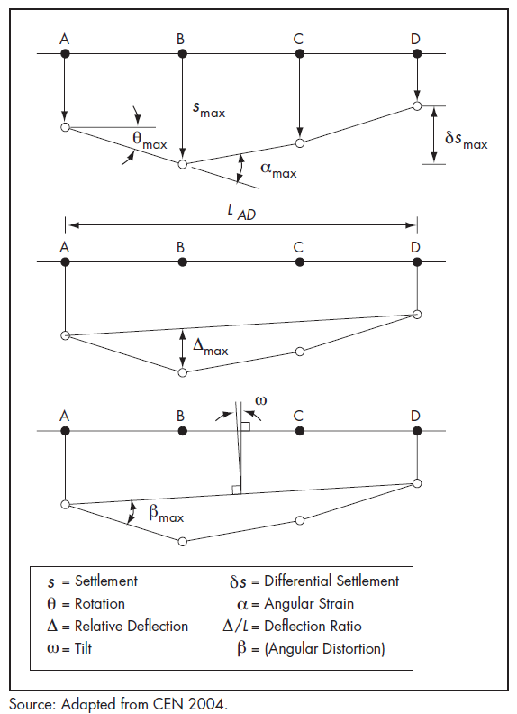
Figure 3.1 : Definitions of structural deformation (adapted from CEN 2004)

Stress Relief and Block Sliding
For this study assessment stress relief and block sliding are considered together as they both result in primarily horizontal ground movement and the effects on receptors are difficult to clearly separate. For other studies, such as mine operations, separation of these processes may be important.
Stress relief from mining is well understood in the Latrobe Valley, based on a long history of monitoring and understanding of ground movements:
- Prior to mining, the in-situ ground conditions experienced a regional compressive horizontal stress field. There is also a vertical stress component due to the overburden and coal;
- With the commencement of mining and formation of the mine void the in-situ stress condition is changed, (“redistributed”) as the coal formation moves slowly into the mine void. These are mainly horizontal ground movements; and
- The rate of stress relief movement reduces with time after reaching the maximum depth of the mine void and will typically only further develop if mining is continued at greater depth (apart from long term creep movements, which although typically small may be locally significant).
Experience in the Latrobe Valley has shown that the most significant ground movement impacts (and events) are a result of a combination of local stresses, coal jointing and water ingress to the joints. Block sliding can occur when mining induced stress relief causes joints in the coal and/or overburden to open sufficiently for water to drain through these sediments into coal joints, resulting in increased hydrostatic lateral pressure in the joint and horizontal movement within or below the coal seam.
Stress relief and block sliding ground movement can extend for 100s of metres away from a mine, however the effects diminish significantly beyond approximately 1 km (GHD, 2019).
Stress relief effects involving relaxation and horizontal movement of ground towards the pit void from mine excavation are well understood in the Latrobe Valley based on a long history of monitoring and understanding of ground movements. This type of movement is mostly linear elastic deformation and it occurs in every excavated slope and is not necessarily symptomatic of instability (Read, 2009).
The magnitude of horizontal movements adjacent to the mines is largely influenced by topographic relief and the direction of the major regional NNW‐SSE compressive tectonic stresses. At Loy Yang Mine these stresses are aligned with the major, near vertical, joint set in the area being the north – south direction (Barton, 1981). High in-situ stress and coal with a tendency to fracture or be brittle (that is, low modulus coal) have combined to produce relatively large movements (up to 1.5 m) immediately behind the mine crest or near the mine crest over approximately 40 years (Mining Warden, 2008). The magnitude of movement reduces away from the mine. The implications of stress relief movements are an increase in ground strain on the batters and batter crests, which can result in localised cracking of the coal. The cracking will occur preferentially along one of the joint sets in the coal. The horizontal movement towards the open pit is diagrammatically represented in Figure 3.2.
An interpretation of the origins of folds and joints, which affect the Tertiary Brown Coal Measures of the Latrobe Valley, indicates that the geological structures have been formed under a regional Late Tertiary NNW‐SSE compressive stress. Considerations of the pattern of measured in situ stresses and of interpreted stresses, derived from earth movements around open cuts and from earthquakes, indicate that a regional NNW‐SSE compressive stress is still in existence in the South East part of Australia at the present time (Barton, 1981).
Joints in coal do not generally impact on mine stability provided the jointing has not been forced open by water pressure or the jointing is on an unfavourable plane. Experience has shown that the most significant problem with coal jointing (that is, the largest scale problems) in terms of its impact on mining lies with the effect of water on stability. This usually occurs when mining induced stress relief causes joints to open sufficiently for surface water and/or groundwater to fill them, resulting in increased hydrostatic pressure and related movement within or below the coal seam. Numerous examples of significant cracks are described in the various reports, both internal and external to the mines, prepared over the last 10 to 11 years (Mining Warden 2008; Technical Review Board Annual Reports: 2009, 2010, 2011, 2012, 2013, 2014, 2015, 2016; Earth Resources Regulation, 2014).
An example of a large block sliding event occurred at the Yallourn mine in 2007 (Figure 3.3). Surface cracking due to stress relief extended from the mine batter back to the Latrobe River and allowed the river water to flow into the coal seam. Leakage of water into the coal created a rise in hydrostatic pressure that increased the width of the cracks, which in turn allowed more ingress of water. This caused large-scale block movement along the coal interseam at the base of the coal seam and consequent failure of the batter system.
Figure 3.4 presents a simplified diagram describing block sliding movement. High water levels can result in high pore pressures on the inter seam clays, and a high horizontal force component acting on the coal joints can result in block sliding. Any water entering open joints can lead to block sliding of the batters. At Yallourn mine a direct hydraulic connection into joints/cracks forming a back release plane of failure caused a major block sliding event and subsequently the river to enter the mine.
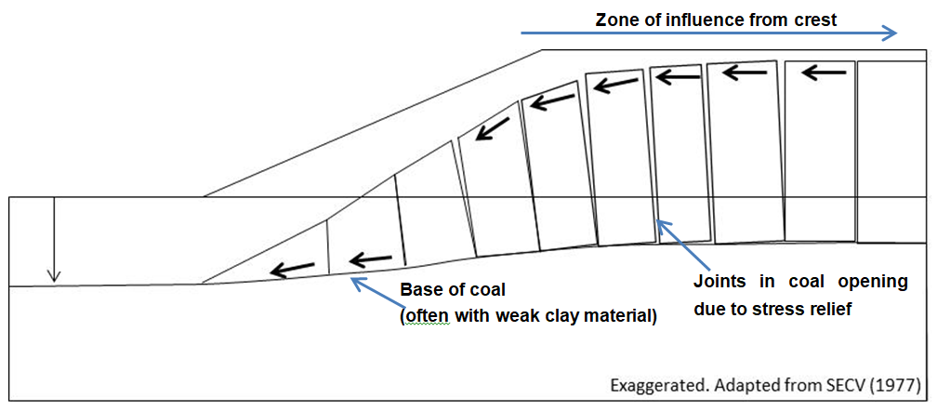
Figure 3.2 : Horizontal movements as a result of stress relief/water ingress

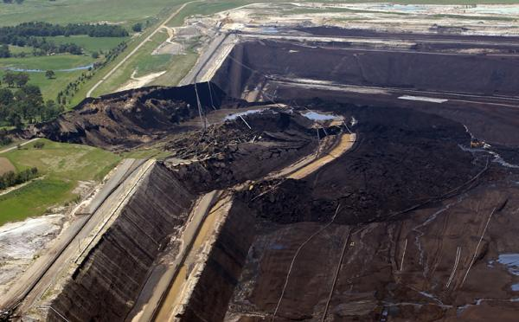
Figure 3.3 : Yallourn Mine batter failure (Photo source: theage.com.au online)

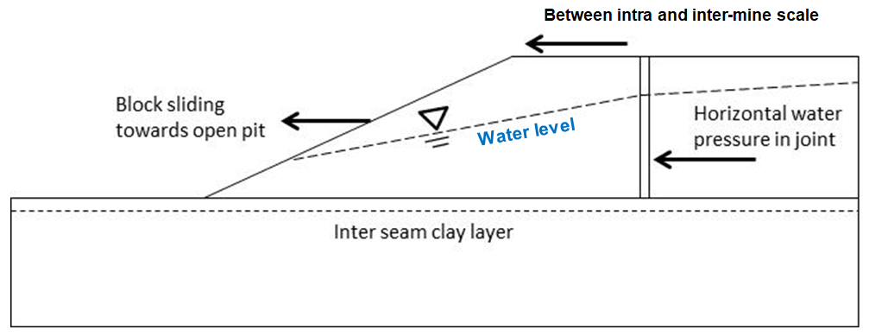
Figure 3.4 : Block sliding diagram

Reservoir Induced Seismicity
As the LVRRS is concerned with the formation of new lakes within the mine voids, ground movement induced by Reservoir Induced Seismicity (RIS) is also included. The Gippsland area is one of the most seismically active regions in Australia. Many geological faults underlie the Latrobe Valley and have been active over geological time.
Two mechanisms that could induce seismicity within the region because of forming pit lakes include;
- An increased weight of the water from lake filling may change the stress field around the mine and produce seismic activity (on an inter-mine or regional scale).
- Increased groundwater pressure due to the cessation of aquifer depressurisation combined with the presence of new (pit) lakes may alter stress on an existing fault, hence increasing the potential for movement along that fault.
The potential influence of RIS emanating from future pit lakes in the Latrobe Valley requires further study to assess the nature of the risk. It has not been identified as one of the principal risks but remains as a potential mechanism.
The Gippsland area is one of the most seismically active regions in Australia. Many of the known faults are located within the Strzelecki Ranges where faulting has continued from the mid Miocene to the present. Many other structures underlie the Latrobe Valley and have been active over geological time (Figure 3.5). The current stress is northwest to southeast compression, producing horst and graben structures by reverse faults striking northeast to southwest Brown et al. (2001). The magnitude 5.4 Moe/Thorpdale earthquake in 2012 was the largest Victorian event in thirty years (Sandiford et al. 2012).
Induced seismicity can be related to such activities as lake, reservoir or valley filling during mining. Any significant change to a pre-existing stress environment may induce a degree of seismicity.

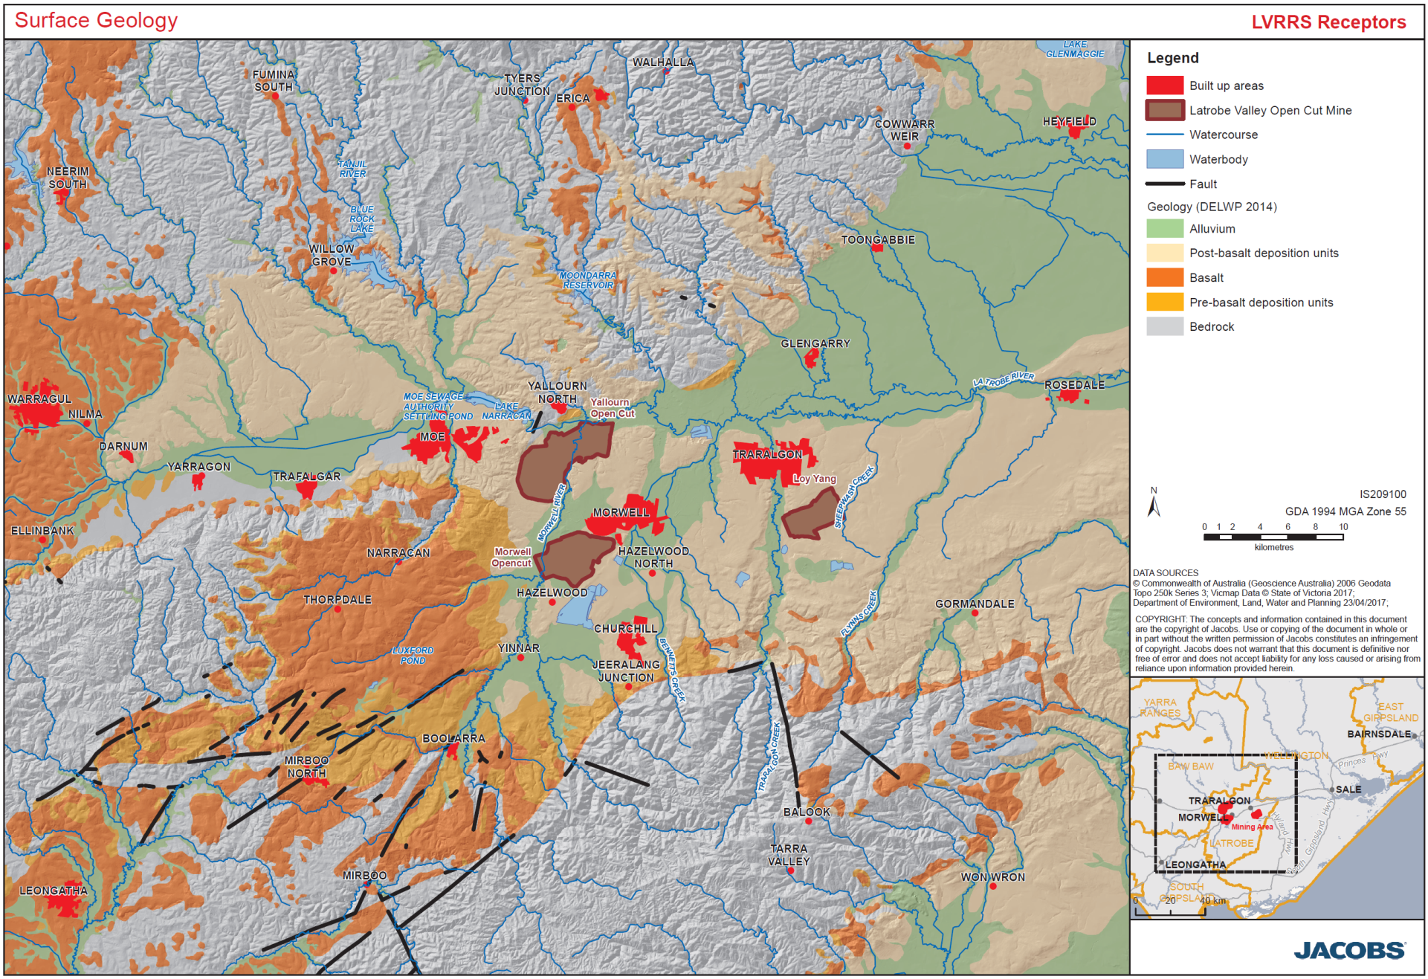
Figure 3.5 : Surface Geology and Regional Faults in the Latrobe Valley

Seismic events of regional scale, i.e. along regional faults, due to lake filling are referred to as Reservoir Induced Seismicity. Evidence of RIS has been observed across the world. As of 2012, 127 RIS events have been reported globally (Qiu, 2012). In Australia three notable events have been identified and are listed in Table 3.1, note that one of these events (Thomson Dam) is in Gippsland.
Table 3.1 : Induced RIS events in Australia (Gibson & Sandiford, 2013)
Year | Location | Magnitude* | Event/Lithology
1959 | Jindabyne | 5.0 | Induced by Eucumbene Reservoir filling.  Predominantly granite
1973 | Warragamba | 5.5 | Induced by Warragamba Reservoir filling.  Predominantly sandstones and shales
1996 | Err Dam | 5.0 | Induced by Thomson Reservoir filling.  Both granite and sedimentary rock
* See Table 5.8: Damage Criteria for Earthquakes – describing the likely impact felt and damage sustained for earthquakes of different magnitude levels.
These cases, and those identified on an international level, host a key set of factors and conditions to induce seismicity. RIS is likely to exist in areas where there is already relatively high stress. The active faults such as the Strzelecki and Hoddle Ranges in the Gippsland region are thought to contribute to the seismic activity in the region.
In general, RIS events usually occur:
- In formations and faults where stress build-up can occur. This would normally require competent rocks that would not appreciably deform under stress and hence allow stress build-up (examples in Table 3.1) to a magnitude that drives failure on the fault plane. The Latrobe Valley coal formations are not considered to be competent rocks and while some stress build-up and transfer would occur it is uncertain to what magnitude.
- When pore pressure increases at shallow depth under or alongside a reservoir; and
- Until the stress field and pore pressure fields stabilise. This may be a number of years after the pit lakes have been established.
Gibson and Sandiford (2013) states that ‘Induced seismicity under large reservoirs can be delayed for up to several years after reservoir filling due to slow increase in pore pressure as groundwater slowly permeates to greater depths. The activity can then continue for many years, typically 10 to 30 years, before a new equilibrium is established, and seismicity returns to normal levels.’
In line with industry standards RIS should be considered in the seismic hazard assessment for new pit lakes, either by risk based or deterministic methods.

Other ground movements
Inundation settlement may occur when the volume of an unsaturated material decreases, as it becomes saturated by rising surface water or groundwater. The process has been widely studied and documented in literature, including by Tadepalli and Fredlund (1991), which reports on earlier studies.
Inundation settlement during or after pit lake filling could lead to ground movement due to the loss of negative pore pressure (suction) at the soil particle contacts. The mechanism of settlement accompanying wetting has been described by Tadepalli and Fredlund (1991). Due to inundation, the negative pore-water pressure at the contact points decrease, giving rise to grain slippage and distortion.
Inundation settlement commonly occurs in mines when overburden has been disposed of in a loose state. Settlement is due to loss of strength at the base when an overburden dump becomes saturated by rising water. This may occur within the rehabilitated mines during the establishment of pit lakes. As the areas that may be affected by this are well within the mine there is unlikely to be any regional receptors that are affected by this type of ground movement.
Tunnel erosion mechanisms potentially form sinkholes when either:
- Water ponds on the surface of slopes, which then enters the soil, seeps laterally, and creates a tunnel. The tunnel may develop to a significant size before the surface collapses revealing a fully-formed gully. This erosion is common on batter slopes where berms can cause water to pond and infiltrate.
- Water flows overland towards a relatively steep slope, infiltrates close to the crest, and then seeps through to exit on the outer face of the slope. Tunnels form in examples such as steep slopes, roadside cuttings, and into constructed drainage structures.
Tunnel erosion has been observed in the Latrobe Valley where the presence of jointed coal at shallow depth allows water ingress to the coal seam which may influence block sliding movement as discussed above. Tunnel erosion can lead to the development of sinkholes.

Ground movement as it relates to receptors
The amount of ground movement that could potentially have an adverse effect on a receptor is influenced by many factors including:
- Type and size of structure and construction standards
- Properties of the material of which it is constructed
- Characteristics of the natural soils
- Rate and nature of ground movement.
Critical movements have not been specifically (or individually) determined or calculated for the ground movement processes and receptor combinations due to the complexity of factors described to do so for infrastructure receptors. Instead this study provides suggested criteria for tolerable ground movement strain. The data contained within this report is sourced from published data. No new testing has been conducted.
Subsidence contours due to aquifer depressurisation indicate the current impact is up to 15 km from the mine crests, which will gradually increase if aquifer depressurisation continues. It should be noted that not all mining and associated works results in subsidence nor does all subsidence (rebound) cause damage to structures.
Stress relief impacts material to regional receptors may extend 1 km from a Latrobe Valley coal mine crest as indicated by GHD (2016). The potential for block sliding is likely to extend hundreds of metres from the pit crest based on the Yallourn batter failure experience. The area in this study with potential for block sliding with respect to pit lake filling is an area extending several hundred metres from each mine crest. The block sliding rate of movement will be governed by water conditions. Other studies associated with the LVRRS will further define this area, but for the purposes of the metrics and thresholds assessment it is relevant to recognise that these movements are likely to occur only over a limited area of the Latrobe Valley.

Introduction to recognised regional receptors
As described in the introduction, the purpose of this report is to define the metrics and thresholds for ground movement that relate to the recognised regional receptors in the Latrobe Valley. A separate study was undertaken, and an associated report prepared that describes the detail of the definition of recognised receptors and what constitutes the members of receptor categories. Readers are referred to the Jacobs (2020a) report for a full description of the definitions and lists of the receptor categories.
Jacobs (2020a) defines the following five categories of recognised regional receptor:
- Aboriginal and non-aboriginal Cultural Heritage
- Environment
- Infrastructure
- Land
- Water Resources related infrastructure
Receptors have been identified for quantitative assessment based on a conceptualisation of casual pathways leading to a potential material impact from mine rehabilitation. A precautionary principal has been applied to this process, whereby if the potential for a material impact on a receptor based on conceptualisation is unclear, then the receptor is identified for quantitative assessment. Quantified receptors require metrics and thresholds for assessment. These, quantified receptors, are the focus of this study.
The following chapter describes the recommended metrics and thresholds for the different receptor categories.

Quantitative Metrics and Thresholds

Aboriginal and Non-aboriginal cultural heritage

Aboriginal cultural heritage
Tangible Aboriginal cultural values may be materially linked to ground movement associated with rehabilitation due to:
  - Close proximity – Aboriginal Places are often recorded near water sources, such as rivers, waterways and lakes
  - Groundwater and surface water interactions which may impact on the health of scarred trees
  - Erosional impacts resulting from the change in flow and runoff volumes
Receptors are most likely to be materially impacted by ground movement process of erosion through:
  - Altered flow rates and runoff volumes
  - Flooding events
The following provides a brief description of common Aboriginal heritage features that would most likely be potentially affected by mine rehabilitation ground movement processes:
  - Artefact scatters generally consist of a small number of artefacts on the surface (or sub-surface) within the vicinity of a watercourse. Depending upon location in the landscape, artefact scatters can have varying degrees of integrity. In areas subject to repeated inundation, artefacts can be dispersed across a large area. Artefact scatters which are found in more intact deposits are likely to have a fair degree of integrity.
  - Earth features can comprise a number of site types, however, within the Latrobe Valley they are recorded as ‘soil deposits’. Generally, these indicate that there are sub-surface artefact scatters suspected within an area which has not been subject to test-excavation.
  - Object collections comprise a collection of artefacts that are reburied or stored at a location.
  - Scarred trees are the result of Aboriginal people harvesting bark for various uses such as canoes, shields, shelters and containers. Aboriginal people also cut toe holds into trees when hunting possums or for access to other resources, such as honey. Within the region, scars will generally be found on gums species such as Red Gum (Eucalyptus camaldulensis) and Stringybark (E. obliqua), although a number of trees were on unidentified eucalypt species.
  - Quarries comprise of native sources of stone that were mined by Aboriginal people in the past. Rock from these sites could be used to make artefacts.
Intangible Aboriginal cultural values may be materially linked due to:
  - Water dependence (in the form of habitat or environment)
  - Alteration of landscape
The intangible Aboriginal cultural values of the Latrobe Valley have yet to be defined. It is also possible that species of non-threatened flora or fauna may be of cultural significance to Gunaikurnai Land and Waters Aboriginal Corporation (GLaWAC). Further assessment will provide more clarity on the potential impact pathways associated with these water-dependent cultural values.
Based on the legislative review, the key metric and threshold for all Aboriginal cultural heritage is avoidance of harm and protection of cultural values. Therefore, the intangible and tangible Aboriginal cultural values within the Latrobe Valley requires that heritage values remain in their current condition into the future and so should not be affected by ground movement related to mine rehabilitation.
The impacts on cultural heritage receptors are likely to be in response to a change in the flow-rate and volume of surface water systems. Therefore, quantitative impact assessment of cultural heritage should be considered during the quantitative assessment of Environment receptors i.e. Rivers and Waterways. The metrics and thresholds for these water-related impacts are defined in the LVRRS Water-Related Metrics (2020c) and Thresholds for Impact Assessment on Recognised Regional Receptors report (Jacobs, 2020a).

Non-aboriginal cultural heritage
Non-aboriginal cultural heritage involves buildings and structures that are similar to buildings and structures that are found more widely in the area. No specific metrics or thresholds that are different to those for general buildings and structures have been defined in this study. Should specific buildings be identified by later studies to be at risk it is likely that structure specific guidance will be needed. Such detailed assessment is beyond the scope of this study.
For metrics and thresholds for heritage areas, please see the relevant infrastructure sections below.

Environment

Ground movement considerations for environment receptors
Through literature review and assessment of the available reports and data we were essentially unable to locate research that describes the ground movement effect on most of the environmental receptors. For example, the range and distribution of many of the individual species identified in the Environment receptor classification (Jacobs 2020a) do not have clear linkages to ground movement. We have been therefore unable to define metrics or thresholds that have a reasonable basis in literature.
In many cases we have identified that the environmental receptors are supported by maintaining integrity of waterway natural conduits / infrastructure, such as rivers or wetlands. Unknown geotechnical related magnitudes for different flow components (low flows, freshes, high flows, overbank flows), sediment transport, changes in gradient and the timing, frequency and duration of various components is unknown.
The recommended metrics for environmental receptors are set for the associated water structures. It must be emphasised that these are preliminary values and that further research through the LVRRS is expected to provide more detail in the future.

Metrics
For environmental receptors, movement may result from any of the define movement types, but the largest area that is likely to be affected is from subsidence and rebound. These ground movements are characterised by gentle and continuous movements, as discussed in Section 3.
Accordingly, we have assessed that horizontal ground strain is likely to be the most likely effect and thus is recommended as the appropriate metric. Sharp or rapid movements associated with seismic events are difficult to characterise and we have not been able to determine any specific structures or features for which we can define a seismic limit. It is recommended that as future work develops a better understanding of the potential risk of seismic activity, that the requirement for additional metrics is revisited.
Subsidence can change the elevation of an area which may lead to increased exposure to flooding. Lowering of the ground level may lead to levees overflowing, especially in low lying regions. Consideration of flooding patterns may need to be defined by future work if significant ground movement is identified at a specific receptor.

Rehabilitation ground movements effects for environmental receptors are likely to constitute reversal of trends or affects that have already been felt through the mine development phase. Accordingly, an extensive suite of metrics is not considered warranted at this time. Future study may point to additional requirements.

Thresholds and Rationale
As described above, limited data and research is available for this receptor category. In absence of a clear limit that is defined by causal mechanisms, we recommend that the horizontal strain threshold for embankments, canals and miscellaneous structures from Singh (1986) by used. This is a strain value of 1 x 10⁻³. This is considered a conservative measure, as for many other structures such a low strain value would be considered a minor impact. See the discussion on buildings and structures later in this report for comparison.

Infrastructure

Introduction
This section summarises the metrics and thresholds for infrastructure receptors in relation to potential ground movement impact detection. The damage severity level to a structure tends to be different depending on the type of ground strain exposure. Tensile stress by horizontal ground strain often produce vertical step like cracks in brickwork. In the upper part of the structure the cracks may be diagonal. Compressive damage is characterised by bulging and bending failures and formation of foundation cracks. Angular distortion related to differential settlement can cause vertical cracks in floor slabs and diagonal cracks in masonry.
In the case of the different ground movement effects, at the scale of most of the defined infrastructure receptors horizontal ground strain provides a good measure of the potential impact on a structure. Literature values and guidance is available for this metric and it has generally been adopted for all movement types.
It should be noted that the potential damage caused to infrastructure foundations or structural members is difficult to characterise in simple terms since the nature of the damage depends on several variables including strength properties of the structural members, type of construction, zones of weakness, building condition and previous deformation history. Determining individual strength properties of structural members was beyond this project and may require further work by later stages of the LVRRS. It should be noted that the published studies and reference documents may not be applicable to heritage buildings and these may require further detailed consideration.
Published studies and reference documents used as guidance for assessment of building damage under the influence of horizontal strain and deflection ratio (Figure 3.1) for buildings with a Length/Height ratio equal to 1. In this report the strain limit is the movement limit value prior to damage being observed.
As noted in earlier discussion, there has already been a history of ground movement strain due to mining activities and the ground movement effects of rehabilitation are unlikely to be significantly different. Thus, all the identified infrastructure receptors have experienced a history of ground strain to some extent.
Throughout this study we have adapted and utilised a severity ranking that has been derived for structures. In some cases, this has also been applied to other types of receptors, in absence of a clear literature-based definition of damage. Tables of threshold values for different receptors are listed throughout the report which define severity levels. The damage severity levels are classified into three categories for all receptors, based on the classification for structures:
- Architectural: Minor cracking, opening and closing of construction joints in abutments, cracking and spalling of concrete decks. This category could be interpreted to damage classification of “Negligible or very slight” damage (refer to damage classification described above)
- Functional: Superstructure distress, horizontal displacement, bearing damage or damage to abutments, warping or tilt of bridge decks, bumps at compressed and open expansion joints. This category could be interpreted to damage classification of “Slight” to “Appreciable” damages
- Structural: Instability of primary structural members, possibility of collapse. This category could be interpreted to damage classification of “Severe” to “Very severe” damages.
The damage severity levels will have different considerations depending on the type of receptor. In the case of residential dwellings, the architectural category would need to be highly considered whereas the functional category for the power station would be deemed as important. For example, minor cracking in an industrial building which is not damaging to the overall function is likely to be more acceptable than minor but aesthetically un-pleasing damage in a person’s home.

Extractive Industry
The operating coal mines, Yallourn and Loy Yang, and Hazelwood have been identified as recognised regional receptors. Other small quarries in the Latrobe Valley are considered for the purpose of this study to be outside the inter-mine scale and thus have little evidence of a pathway for impact.
To assess the impacts of rehabilitation on other mines it is proposed this is undertaken in terms of the potential change in Factor of Safely (FOS) and Probability of Failure (POF) that would result from the rehabilitation action - whether rehabilitation ground movement from one site would result in a change in FOS or POF in another site as the relevant threshold for response. In truth, each mine will be constantly adjusting its response in light of external stressors so this is not a simple situation and no single test is likely to be suitable on its own.
In addition, the setting of thresholds for the FOS and POF is potentially problematic in this setting as the FOS and POF are continually reviewed, revised and the mine design is altered through ongoing operations and into rehabilitation. The guidance in this section may not make any practical difference to the management of the mine voids, nevertheless a guidance value has been identified.
Metrics
Geotechnical risk of ground movement in a mine void is assessed by several guidelines and industry standards. Earth Resources Regulation (ERR) regulates the development, operation and rehabilitation of mines and quarries within Victoria, including the regulation of geotechnical risks. Declared mines and quarries are required to regularly submit reviews of stability assessments to ERR. The ongoing review of the Ground Control Management Plan (GCMP) is critical to the management of geotechnical risks on these large and complex sites. Declared mine stability requirements and processes are provided in Part 2 of Schedule 15 in the Mineral Resources (Sustainable Development) (Mineral Industries) Regulations 2013 (Earth Resources Regulation, 2015).
Mine operators have a duty to provide an auditable, robust and rigorous design process for the mining operation and by its nature this will necessarily consider the effects of external ground movement on the design. Accordingly stating a single metric and threshold for these sites is simplistic and potentially problematic.
Each mine’s GCMP indicates design process and information inputs to mine batter stability assessment. A principle goal of design is to limit the potential occurrence of block sliding movements at batter scale. This analysis assumes that any future mine batter block movement events would be at the same scale as the historically observed events. Stress relief will continue with ongoing mining and into the rehabilitation period until pit lakes are finally established. Depending on the depth of the pit lake, stress relief may continue at a reduced rate for a considerable time after mine closure as in-situ stresses in the region around the mines equilibrate.
It should be noted that reference by the mines to seismic influence assumes seismicity in general to include both earthquake and mining induced seismicity. For the LVRRS this should also include RIS.
Design Acceptance Criteria
Design acceptance criteria are thresholds of Factor of Safety (FOS) and Probability of Failure (POF) that determine whether slope designs are acceptable. Criteria vary, depending on the nature of potential risks and who may be impacted by them; for example, FOS where slopes are impacted only by the mining operation are lower than for public infrastructure, because hazards are managed differently within an operating mine (Figure 5.1).
There is no single industry standard for FOS and POF, generally determined on a case by case basis, guided by various industry guidelines which consider the data that is used to derive them, and the level of perceived acceptable risk, key stakeholder requirements, economics, and societal impacts. For example, the acceptable slope design criteria for maximum design FOS for an operating mine with interim or permanent batter walls can be different to the FOS requirement for a mine closure and rehabilitation site due to public infrastructure and liability.
Various acceptance criteria that are commonly used in the mining industry are published in Read and Stacey (2009) which was the product of a CSIRO led international research and knowledge transfer project. It is widely accepted in Australia and is regarded as an industry standard in geotechnical engineering for open-pit mining. Selected relevant examples are summarised in Table 5.1 and Table 5.2.
There are no legislative specifications for FOS and POF in Australia, and the only state that provides guidance is Western Australia, with their 1999 guidelines. These have been used widely and are frequently regarded as a requirement, but the original publication clearly states that they are a guideline.
Examples of acceptable FOS and POF, values are presented in Table 5.1 and Table 5.2 and are deemed an acceptable industry standard for the design of block sliding with an earthquake loading component. FOS as a design criterion is a deterministic measure of ratio between the resisting forces (capacity, C) and driving forces (demand, D) of a system in its environment.
FOS = C_
D

In concept, limiting equilibrium is achieved when the FOS has a value of 1.0. Due to uncertainty of likely performance, from industry experience the current standard is to prescribe a minimum design acceptance value. Examples of acceptable FOS values for civil and mining applications is shown in Figure 5.1.
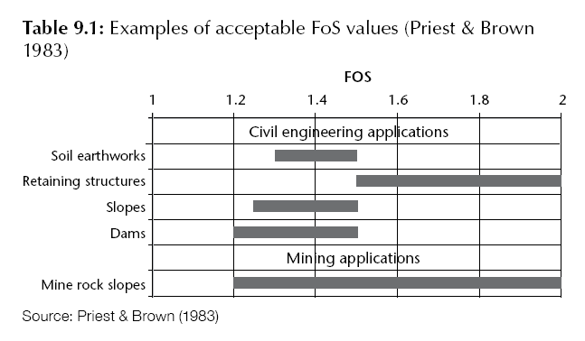
Figure 5.1 : Examples of acceptable FOS values for different industries

Table 5.1 : Acceptable FOS values, civil engineering applications (After Read and Stacey 2009)
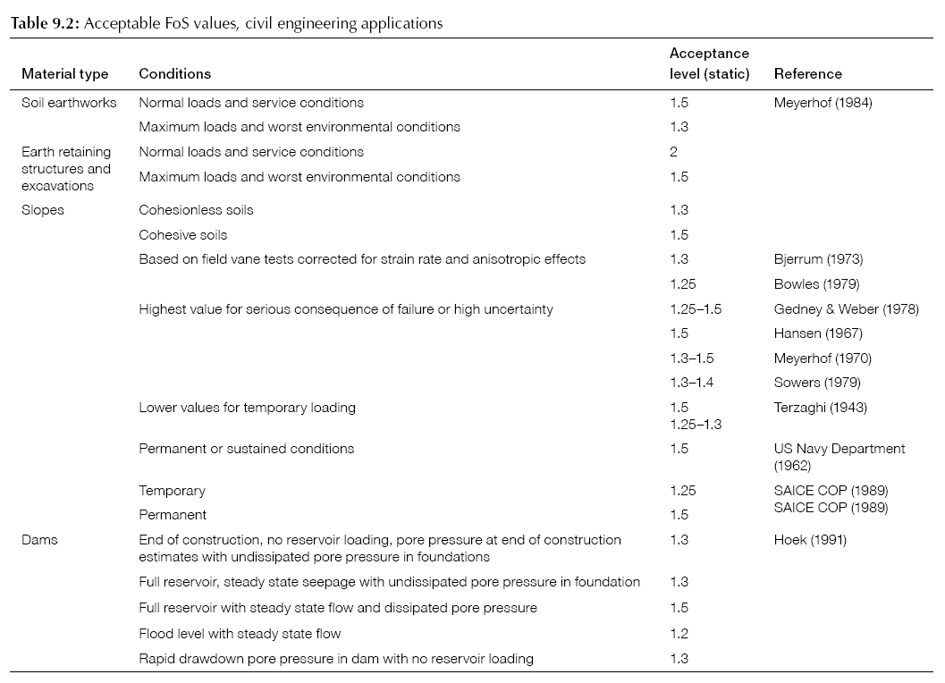
Used along with the FOS, the POF design criterion considers the variability of the capacity (C) and demand (D). The POF enables the variabilities in capacity (C) and demand (D) functions to be taken into account and helps establish the level of confidence in the design. The POF scales linearly, for example a POF of 10% is twice as great as a POF of 5% and the POF can be used in risk calculations.
POF = P(FOS ≤ 1)
POF design acceptance guidelines are listed in Table 5.2.

Table 5.2 : POF design acceptance guidelines
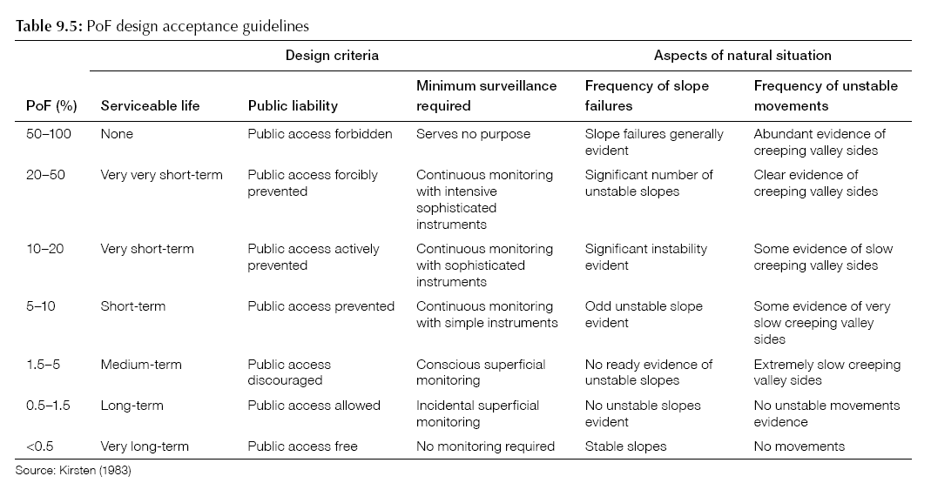
Interpretations of POF for Slope Designs
FOS thresholds are a well-established criterion in geotechnical engineering that are widely used and their implied risk in a qualitative sense is typically well understood. POF requires practitioners to consider assumptions about uncertainties in the geotechnical model. POF values provided in mining guidelines need to also consider a risk-based approach.
Probability and Risk
Geotechnical design processes that incorporate prescribed levels of reliability, and consideration of acceptable risk, rather than a constant FOS prescribed in codes or guidelines, are becoming increasingly recognised and accepted in recent literature (for example, Lacasse, 2016).
It is implied in this process that risks cannot be reduced to zero, and that as they are reduced to very low levels, an extremely high cost is required, which may then in turn induce further risks; for example, considerable earthworks, or importing of materials, in the case of a geotechnical design, which has flow-on effects for industrial risks and transportation on public roads. The concept of ALARP (as low as reasonably practicable) risk level was developed, which is the point at which the cost involved in reducing the risk further would be greatly disproportionate to the benefit gained.

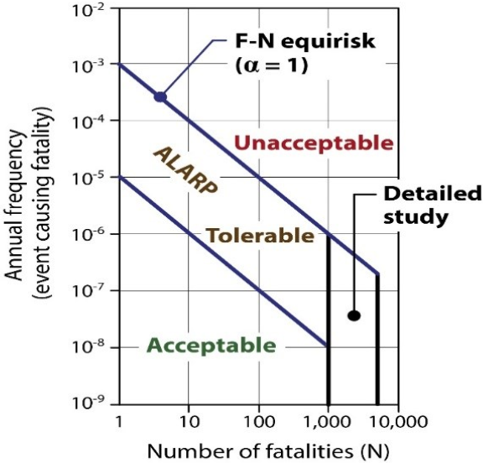
Figure 5.2 : ALARP Range, Acceptable and Unacceptable Risk Concept (adapted after Australian Geomechanics Society, 2000)
Figure 5.3 compares some risk guidelines from various countries and suggests that where one or no lives are at risk, an annual probability of 10⁻² to 10⁻³ may be acceptable. The ANCOLD/AGS line on this figure is placed at 10⁻⁵, and the AGS reference on risk management of landslides in natural slopes indicates that the average risk per person may be 10⁻⁵ with the tolerable risk for the person most at risk rising to 10⁻⁴.
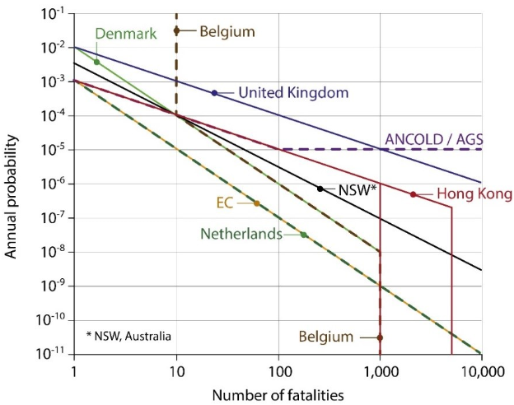
Figure 5.3 : Comparison of Risk Guidelines in Various Countries (adapted after Australian Geomechanics Society, 2000)

Taking as a benchmark the maximum individual risk due to common activities, excepting those that are inherently safe or highly unlikely, and the range of ALARP from the various examples where low numbers of fatalities may occur, it is considered that a probability of 10⁻⁴ events per year is an upper limit, and 10⁻⁵ events per year is an acceptable target, for this purpose, a POF design target of 10⁻⁵ could be adopted.

Thresholds and Rationale
The setting of thresholds for the factor of safety (FOS) and probability of failure (POF) is potentially problematic in this setting as the FOS and POF are continually reviewed, revised and the mine design is altered through ongoing operations and into rehabilitation. The guidance in this section may not make any practical difference to the management of the mine voids, nevertheless a guidance value has been identified.
We propose that impacts of rehabilitation on other mines should be viewed in terms of the potential change in FOS and POF that would result from the rehabilitation action. In truth, each mine will be constantly adjusting its response in light of external stressors so this is not a simple situation and no single test is likely to be suitable on its own.
Our recommended approach is to consider the change whether rehabilitation ground movement from one site would result in a change in FOS or POF in another site as the relevant threshold for response. As noted in the discussion above, mine operators are duty bound to respond to such external changes in any case, so this threshold may never be able to be applied in practice.
The defined threshold for extractive industry is to consider any rehabilitation ground movement effect that lowers the FOS below the threshold or increases the POF above the threshold as subject to review. The recommended threshold values are given in Table 5.3. Because of the circular nature of these factors their application may be problematic.
Table 5.3 : Recommended thresholds for Batter Stability (see text for important context to these recommended numbers)
Design Case | Static |  | Dynamic
 | Minimum FOS | Maximum POF | Minimum FOS
All slopes, following completion  of final landforms | 1.5 | 10⁻⁵ | 1.05  With Liquefaction Analysis

Earthquake/RIS Loading
Analysis of slope stability undergoing shaking due to earthquakes/RIS is carried out using a standard screening method which determines whether slopes may require further assessment. This is a limit equilibrium analysis with the earthquake motion applied as a constant, uniform horizontal acceleration (seismic loading). The method is recognised to be very conservative in the way it applies the seismic load, and therefore the minimum FOS typically used are low to compensate for this conservatism. For example, a standard used by one large international mining company is a range of 1.0 to 1.05, which reflects the common practice in the industry, and is also used for dam designs.
There are no clear guidelines on acceptable FOS for seismic loading for short-term mine design, vs. long-term and post-closure conditions for mining. The long-term life spans and safety requirements of dams would suggest that the ANCOLD guidelines on tailings dams (ANCOLD, 2012) are a useful indication for stability of soil slopes and compacted fill embankments. Tailings comprise a mixture of fine sand, silt, gravel and ash, placed in a loose state, may be taken to represent a worse-case end of the spectrum of the slopes at a mine site.
The ANCOLD Guidelines have moved away from pseudo-static analysis, and toward a process that assesses the consequence category of the dam, liquefaction potential, and post-liquefaction strengths of the materials.
The following assessment approach could be adopted:
- Pseudo-static analysis with seismic coefficient, as this is a standard industry approach for assessing slopes. Considering that the full value of the peak ground acceleration has been used, the upper end of the range of FOS may be considered reasonable. A minimum seismic FOS of 1.05 adopted; and
- Liquefaction assessment, to determine whether any loss of shear strength may occur during an earthquake.

Electricity Transmission Network
The electricity transmission network is a recognised regional receptor. The recognised component of the network is the 500kV and greater capacity transmission lines. Smaller distribution systems such as the individual poles and wires in residential areas are not recognised and so are not intended to be covered by the metric and thresholds in this discussion.
Relevant standards, guidelines and reference documents which maintain value for this receptor have been identified and are listed in Table 5.4.
Table 5.4 : Electricity Transmission Network – standards and guidelines
Value Category | Standard, Guideline or Reference Documents
Social/Cultural | - Electricity Industry Act (2000)  - Electricity Safety Act (1998)  - Energy Safe Victoria  - DELWP (2017) Latrobe Planning Scheme  - Planning & Environment Act (1987)  - Live Work Latrobe (Housing Strategy, Industrial Land Use and Employment Strategy and Rural Land Use Strategy) (2016)  - Mine Subsidence Board (2009) Graduated Guidelines for Residential Construction (NSW) Historical and Technical Background  - Harrison, J (2011) Mining Engineering Handbook, Mine Subsidence, Society for Mining, Metallurgy and Exploration  - Singh, M (1986) Mine subsidence, Society for Mining, Metallurgy and Exploration  - Standards Australia associated publications.  - AS/NZS7000 Overhead Line Design Standard  - AS 3600 Concrete Structures  - AS 4100 1990 - Steel Structures
Economic | - Live Work Latrobe (Housing Strategy, Industrial Land Use and Employment Strategy and Rural Land Use Strategy) (2016)
Safety, Electrical Maintenance, Operability and Reliability | - ENA NENS 04 – 2006 National Guidelines for Safe Approach Distances and to Electrical and Mechanical Apparatus  - AS/NZS7000 Overhead Line Design Standard  - AS 1170.2 : 2016 Wind Code

Metrics
For transmission line foundation design, the shear strength and compressibility properties of the soil are normally required (Kalaga and Yenumula, 2016). Damage to the lattice structures, is mainly caused by foundation settlement which may be caused by high flooding events, foundation tilt, angular distortion, bending, and horizontal strain (Figure 5.4). In the extreme differential settlement scenario, if there is considerable settlement in all four legs of the structure it may cause imbalance loads which lead to overstress in the connections leading to structural failure (Figure 5.4).

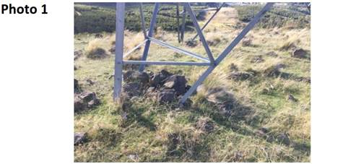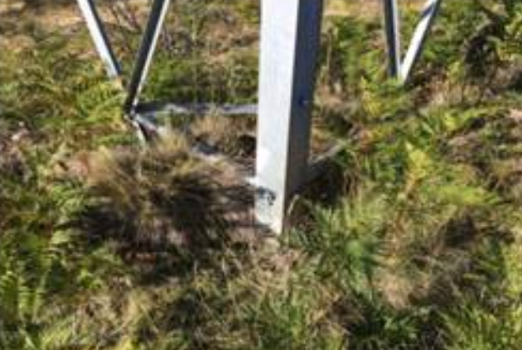
Figure 5.4 : Extensive footing backfill carried out in areas of displacing soils (Kalaga and Yenumula, 2016)
These effects can be indicated by horizontal strain. Accordingly, this is recommended as the metric for assessing rehabilitation ground movement.

Thresholds and Rationale
In terms of damage criteria (movement limit values) across a wide range of structures, there is consensus in literature for a conservative strain value of 1.0 x 10⁻³ for tolerable horizontal strain (see, for example Nishida and Goto 1970; Lackington and Robinson 1973). This value will provide protection for more sensitive structures and can be used as early warning for less sensitive structures. Final acceptance will need to be determined for each individual structure because of the differences in age, materials and design.
This strain value can also be used for differential settlement due to subsidence and rebound for any individual tower or lattice structure. As has been described earlier, during mining it is likely that some individual towers have experienced strain in excess of this threshold so the individual circumstances of design and location for any structure will need to be considered when assessing a receptor.

Gas Fired Power Generation
Jeeralang Power Station is a gas turbine power station with a capacity of 460 megawatts (620,000 hp) about 6 km south of Morwell. The plant is used during periods of peak demand, and as a black start facility to restore power to the grid in the event of major system failure. The power station was built by the State Electricity Commission of Victoria. Jeeralang consists of seven gas turbines configured to operate in single cycle mode. The plant is divided into two stations:
- Jeeralang A was built between 1977 and 1979; and
- Jeeralang B was built between 1978 and 1980.
The metrics and thresholds for the potential damage induced by ground movement to the Jeeralang gas fired power station (Figure 5.5) has been adopted from those used for buildings and structures.
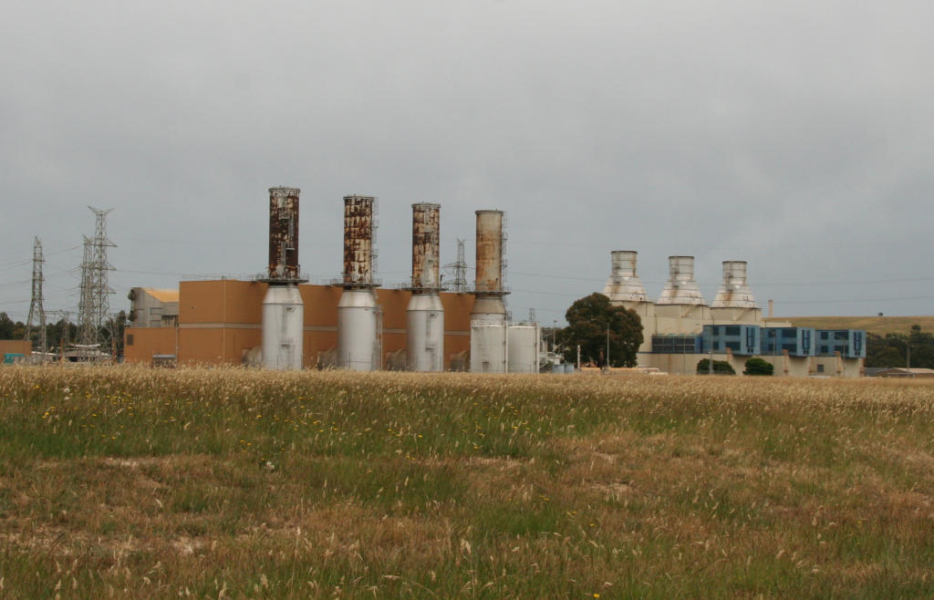
Figure 5.5 : Jeeralang gas fired power station (Source: By Marcus Wong - Own work, CC BY-SA 3.0, https://commons.wikimedia.org/w/index.php?curid=5567823)
Relevant standards and guidelines that apply to this receptor have been identified and are listed in table 5.6.
Table 5.5 : Gas Fired Power Generation – identified standards and guidelines
Value Category | Standard, Guideline or Reference Documents
Social/Cultural | - Australian Pipelines and Gas Association Ltd (APGA)  - Gas Industry Act 2001  - Gas Safety Act 1997  - Gas Safety (Gas Installation) Regulations 2008  - Gas Safety (Safety Case) Regulations 2008  - Gas Safety (Gas Quality) Regulations 2017  - Renewable Energy (Electricity) Act 2000  - Pipelines Act 2005  - Pipelines Regulations 2017  - DELWP (2017) Latrobe Planning Scheme  - Planning and Environment Act (1987)  - Live Work Latrobe (Housing Strategy, Industrial Land Use and Employment Strategy and Rural Land Use Strategy) (2016)  - Harrison, J (2011) Mining Engineering Handbook, Mine Subsidence, Society for Mining, Metallurgy and Exploration  - Singh, M (1986) Mine subsidence, Society for Mining, Metallurgy and Exploration  - Standards Australia AS 2885 pipeline Industry  - AS 3600 Concrete Structures  - AS 1170.4:2007 Structural design actions – Part 4: Earthquake actions in Australia  - IECA (2008). Best Practice Erosion and Sediment Control – Appendix P Land-Based Pipeline Construction  - APGA CP-04-004 Design in Mine Subsidence Areas, release H1 2018
Economic | - Live Work Latrobe (Housing Strategy, Industrial Land Use and Employment Strategy and Rural Land Use Strategy) (2016)

Metrics
Rebound/subsidence metrics for buildings and structures have been considered and are recommended to apply to the Jeeralang power station. Section 5.4 (Towns) gives details of the types of metrics and impacts that have been classified.

Thresholds and Rationale
The damage severity levels due to ground movement are classified into three categories for buildings/structures as described in section 5.3. In terms of damage criteria (movement limit values) for each damage severity level, currently, a sufficient database does not exist to extend this nationwide for Australia. However, the results of a survey of a wide range of sources presented in Table 5.6,Table 5.7 and Table 5.8 are deemed an acceptable industry standard and are recommended for use in this case. These standards represent the best complication of effects and cover a wide range of structures that include the range of buildings and features at the power station. Note that the movements listed are all strain percentages and do not have units.
Jeeralang power station is approximately 6 km from Hazelwood mine (the closest rehabilitation site) and is thus unlikely to be affected by batter failure or long-term stress relief associated with the void walls (DJPR, 2019).

Table 5.6 : Damage Criteria for Buildings/Structures (Source: Singh, 1986)
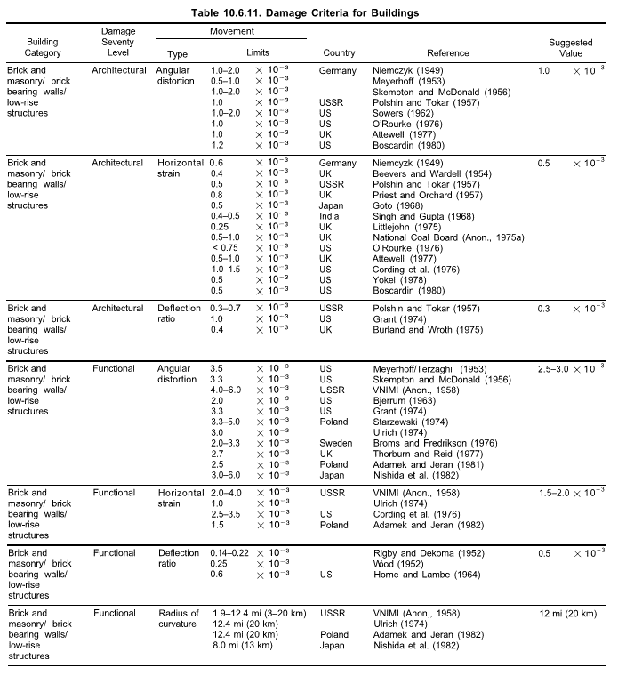

Table 5.7 : Damage Criteria for Buildings/Structures (continued)
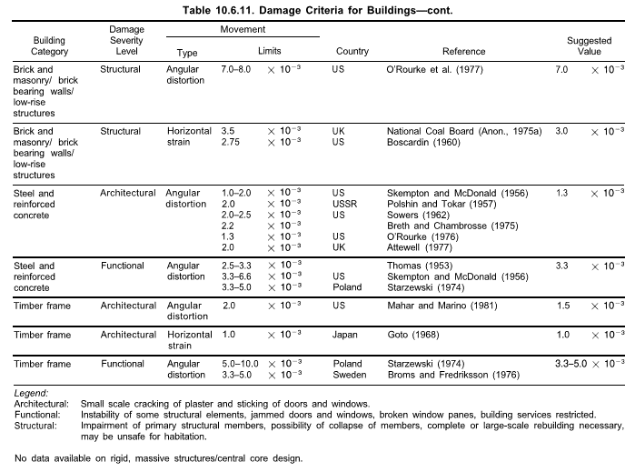

Table 5.8 : Damage Criteria for Earthquakes (Source: European Seismological Commission, 2000)
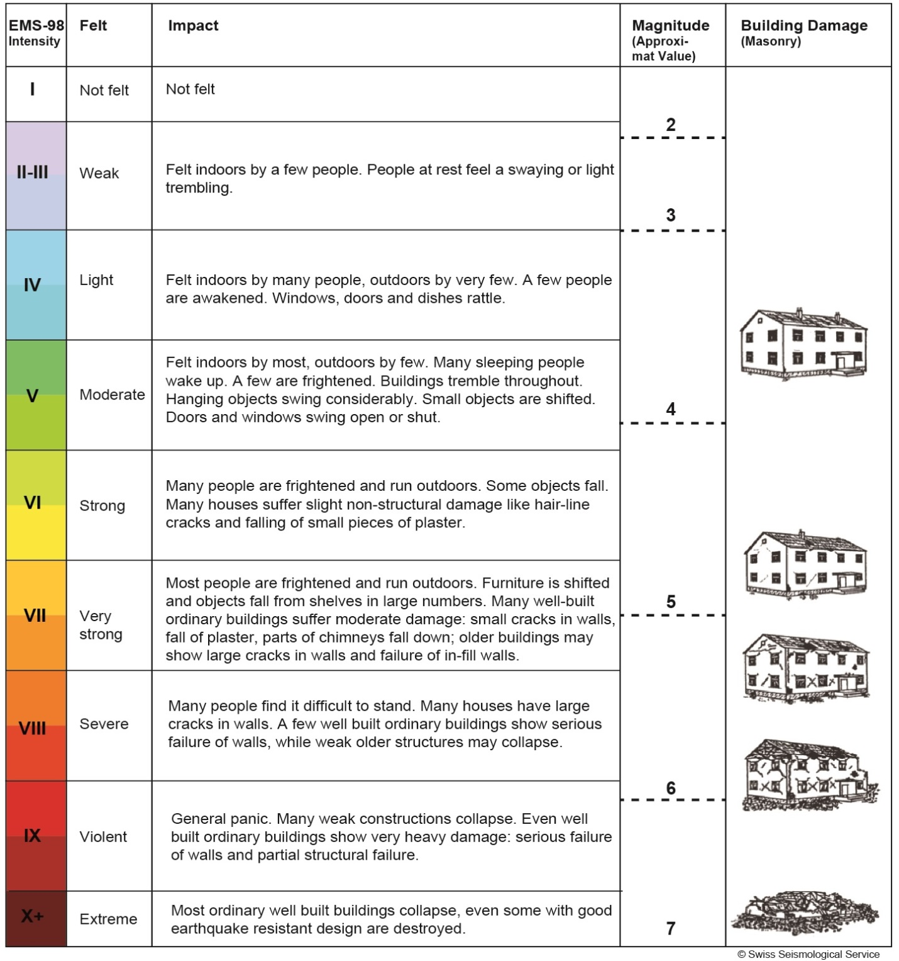

Road – Freeway/State Maintained
Metrics and thresholds for ground movement induced damage to freeways, associated infrastructure, and arterial roads are effectively set by VicRoads and this study has adopted the guidance already developed (Latrobe City Council, 2017). Relevant standards, guidelines and reference documents which maintain this receptor value are listed in Table 5.9. The Austroads Guide titled ‘The Austroads Guide to Road Design 1 to 8’ are over-arching documents that provide the national framework for design and management of freeways, including in the Latrobe Valley.
Table 5.9 : Road/Freeway – relevant standards and guidelines
Value Category | Standard, Guideline or Reference Documents
Social/Cultural | - Road Management Act 2004  - Codes of Practice under the Road Management Act  - Road Safety Act 1986  - Austroads (2013) Guide to Road Design Parts 1-8  - DELWP (2017) Latrobe Planning Scheme  - Planning and Environment Act (1987)  - Live Work Latrobe (Housing Strategy, Industrial Land Use and Employment Strategy and Rural Land Use Strategy) (2016)  - Mine Subsidence Board (2009) Graduated Guidelines for Residential Construction (NSW) Historical and Technical Background  - Harrison, J (2011) Mining Engineering Handbook, Mine Subsidence, Society for Mining, Metallurgy and Exploration  - Singh, M (1986) Mine subsidence, Society for Mining, Metallurgy and Exploration  - Building Code of Australia (BCA), in the National Construction Code series, contains technical provisions for the design and construction of buildings and other structures.  - Standards Australia associated publications  - AS 2159 Design and Installation of Piles  - AS 5100 Bridge Design (2004)  - AS 3600 Concrete Structures  - VicRoads Supplement to the Austroads Guide to Road Design Part 5 – Drainage: General & Hydrology Considerations Part 5A – Drainage: Road Surface, Networks, Basins & Subsurface Part 5B – Drainage: Open Channels, Culverts & Floodways
Economic | - DELWP (2017) Latrobe Planning Scheme  - Live Work Latrobe (Housing Strategy, Industrial Land Use and Employment Strategy and Rural Land Use Strategy) (2016)

Metrics
The main mechanisms for ground movement damage affecting freeways and highways due to subsidence/rebound movements include (Singh 1986):
- Cracks on the road surface.
- Deterioration of base course and/or subgrade.
- Distortion of horizontal and vertical alignment.
- Bumps or undulations on the road surface.
- Damage to ancillary works such as sidewalks, drains, fences, curbs, etc.
- Altered drainage leading to flooding.
The most common damage caused is the formation of tensile cracks on the road surface. Compression ridges may also occur and local changes of gradient that may become a hazard for high-speed traffic, especially if it causes surface water to pool in affected areas.
Classification used by VicRoads for hazard inspection and response are listed in Table 5.10.
Table 5.10 : Classification for hazard inspection and response (VicRoads, 2014)
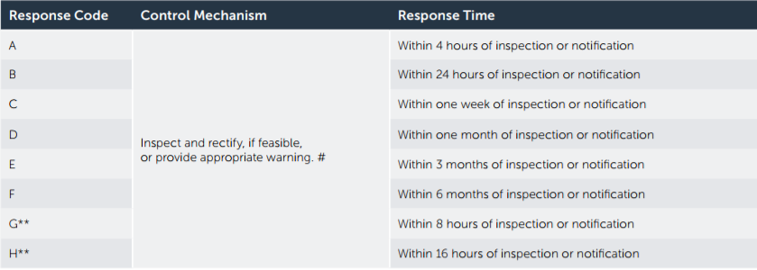
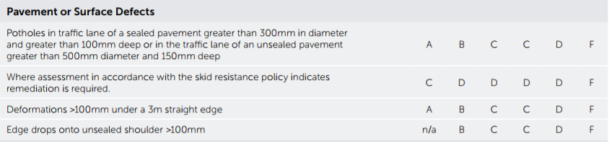
RMC = Road Maintenance Category
It is understood that road maintenance in the Latrobe Valley is undertaken as is required under the Road Management Plan (VicRoads, 2014). This includes responding within the time frames to different threshold events as shown in Table 5.10. Essentially this means that there will be a response within the defined timeframe for pavement defects. As a result, it is not expected that any significant defect will persist beyond the requirement time frame outlined. Whilst there may be a cost associated with this, any defect resulting from rehabilitation can be expected to be rectified under normal maintenance procedure.
The Princes Freeway has subsided with regional land levels across the Latrobe Valley, due to large-scale aquifer depressurisation, at rates of up to 50 mm/year in the Hazelwood Mine and Yallourn Mine areas and up to 18 mm/year in the Loy Yang Mine area (GHD, 2019). However, no anecdotal evidence or data has been found to suggest that any significant impacts to the Princes Freeway have occurred due to regional subsidence in the Latrobe Valley. There are documented effects on the freeway, but these have been related to block sliding movements (Jacobs 2020, in prep). In 2011, following heavy rainfall, the Princes Freeway where it bypasses Morwell was closed for approximately six months due to small but significant movement in the northern batter of the Hazelwood Mine. The movement resulted in cracks on the surface of the freeway and the adjoining area, prompting the road’s temporary closure. Remedial works were required prior to re-opening the freeway and a targeted ground movement monitoring program is currently in place in the area of the 2011 damage.

Thresholds and Rationale
The Princes Freeway and other state-maintained roads in the LVRRS inter-mine area can potentially be impacted by regional subsidence/rebound, long term stress relief, RIS and/or block sliding due to mine rehabilitation. The damage severity levels are classified into three categories for freeways/roads and are as described in section 5.3.
From this study and a survey of a wide range of sources, acceptable industry standards are listed in Table 5.11 and are considered appropriate to use in the context of the LVRRS (as they relate to mine movements and are consistent with the VicRoads damage criteria). According to the damage severity level, a strain value of 10 x 10⁻³ could be expected to cause structural damage.
Table 5.11 : Damage Criteria for Freeway/Roads (Singh, 1986)
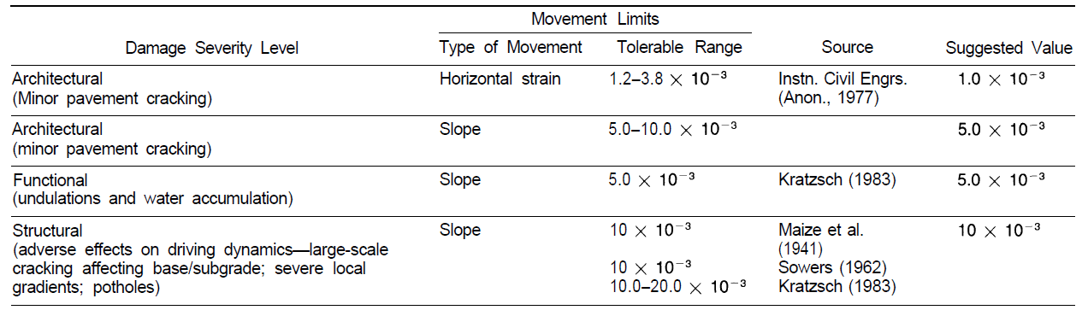

Road – local Government maintained
The metrics and thresholds for the potential ground movement effects on local-government maintained roads is provided in this section. There is significant overlap with the discussion on freeways provided in the section above and the separation of these road classes has been because of the receptor definition process rather than resulting from ground movement and strain response assessment. From the view of geotechnical assessment, the two receptor sub-categories could be considered together.
Relevant standards, guidelines and reference documents for these roads are listed in Table 5.12. The Austroads Guide titled ‘The Austroads Guide to Road Design 1 to 8’ is the over-arching reference source that provides the framework for design and management of roads across Australia.
Table 5.12 : Roads local relevant standards and guidelines
Value Category | Standard, Guideline or Reference Documents
Social/Cultural | - Road Management Act 2004  - Latrobe City Road Management Plan V4 (2017)  - Codes of Practice under the Road Management Act  - Road Safety Act 1986  - Austroads (2013) Guide to Road Design Parts 1-8  - DELWP (2017) Latrobe Planning Scheme  - Planning and Environment Act (1987)  - Live Work Latrobe (Housing Strategy, Industrial Land Use and Employment Strategy and Rural Land Use Strategy) (2016)  - Mine Subsidence Board (2009) Graduated Guidelines for Residential Construction (NSW) Historical and Technical Background  - Harrison, J (2011) Mining Engineering Handbook, Mine Subsidence, Society for Mining, Metallurgy and Exploration  - Singh, M (1986) Mine subsidence, Society for Mining, Metallurgy and Exploration  - Building Code of Australia (BCA), in the National Construction Code series, contains technical provisions for the design and construction of buildings and other structures.  - Standards Australia associated publications  - AS 2159 Design and Installation of Piles  - AS 5100 Bridge Design (2004)  - AS 3600 Concrete Structures  - VicRoads Supplement to the Austroads Guide to Road Design Part 5 – Drainage: General & Hydrology Considerations Part 5A – Drainage: Road Surface, Networks, Basins & Subsurface Part 5B – Drainage: Open Channels, Culverts & Floodways
Economic | - DELWP (2017) Latrobe Planning Scheme  - Live Work Latrobe (Housing Strategy, Industrial Land Use and Employment Strategy and Rural Land Use Strategy) (2016)

Local councils maintain the area outside the road for declared main road infrastructure belonging to VicRoads and this includes the road pavement and kerbs as shown in Figure 5.6.
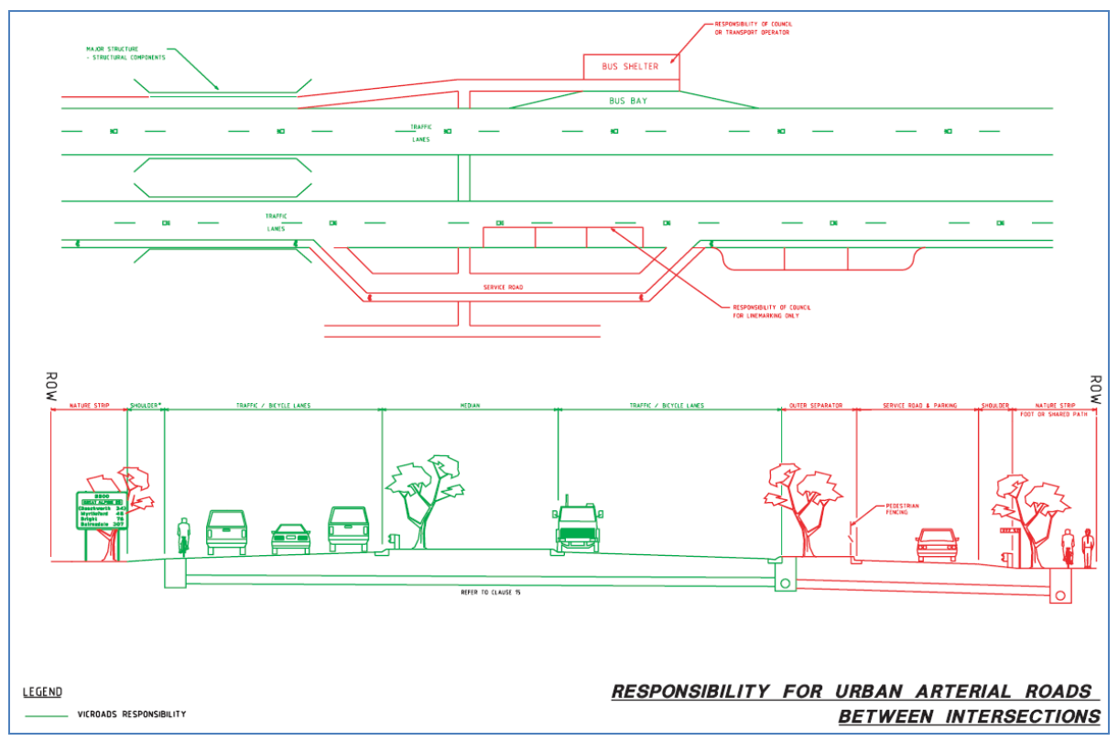
Figure 5.6 : Typical cross section showing Council’s area of responsibility outside the kerbs of the VicRoads declared main road
The Latrobe City Road Management Plan (Latrobe City Council, 2017) classified the roadways and pathways by a hierarchal system based on the function and importance of particular road or pathway which determines the metrics for the level of service required. Council road assets include:
- Link Road
- Collector Road
- Sealed Access Road with a speed limit greater than 60 km/hr and all Unsealed Access Roads
- Sealed Access Road with a speed limit less than or equal to 60 km/hr
- Minor Access Road
- Limited Access Road.

Metrics
Damage to roads by ground movement or other factors are inspected and maintained based on the defined metrics listed in Table 5.14.
Council roads may also include unsealed, gravel roads which are not considered in this report as the nature of the road material and the wide variety of materials means that a define metric will have little practical value.
The main mechanisms for ground movement damage affecting freeways and highways due to subsidence/rebound movements include (Singh, 1986):
- Cracks on the road surface.
- Deterioration of base course and/or subgrade.
- Distortion of horizontal and vertical alignment.
- Bumps or undulations on the road surface.
- Damage to ancillary works such as sidewalks, drains, fences, curbs, etc.
- Altered drainage leading to flooding.
The most common damage caused is the formation of tensile cracks on the road surface. Compression ridges may also occur and local changes of gradient that may become a hazard for high-speed traffic, especially if it causes surface water to pool in affected areas.
Council roads may also include unsealed, gravel roads which are not considered in this report as the nature of the road material and the wide variety of materials means that a define metric will have little practical value.
The main mechanisms for ground movement damage affecting freeways and highways due to subsidence/rebound movements include (Singh, 1986):
• Cracks on the road surface.
• Deterioration of base course and/or subgrade.
• Distortion of horizontal and vertical alignment.
• Bumps or undulations on the road surface.
• Damage to ancillary works such as sidewalks, drains, fences, curbs, etc.
• Altered drainage leading to flooding.
The most common damage caused is the formation of tensile cracks on the road surface. Compression ridges may also occur and local changes of gradient that may become a hazard for high-speed traffic, especially if it causes surface water to pool in affected areas.
Classification used by Latrobe City Council for hazard inspection and response are listed in Table 5.10. and 5.15 (Latrobe City Council, 2017). Whilst some roads are outside of the Latrobe council jurisdiction, these metrics are considered still relevant and appropriate as there is no rationale for different damage criteria for this study.
Table 5.13 : Reactive Inspection Response Timeframes for Road and Footpath Maintenance (Latrobe City, 2017)
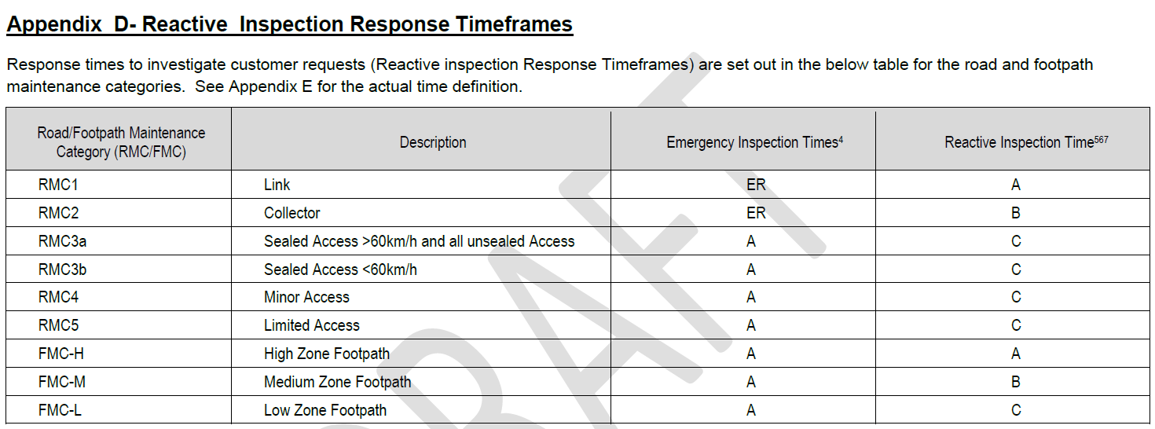

Table 5.14 : Description of Defect and Intervention Level (Latrobe City, 2017)
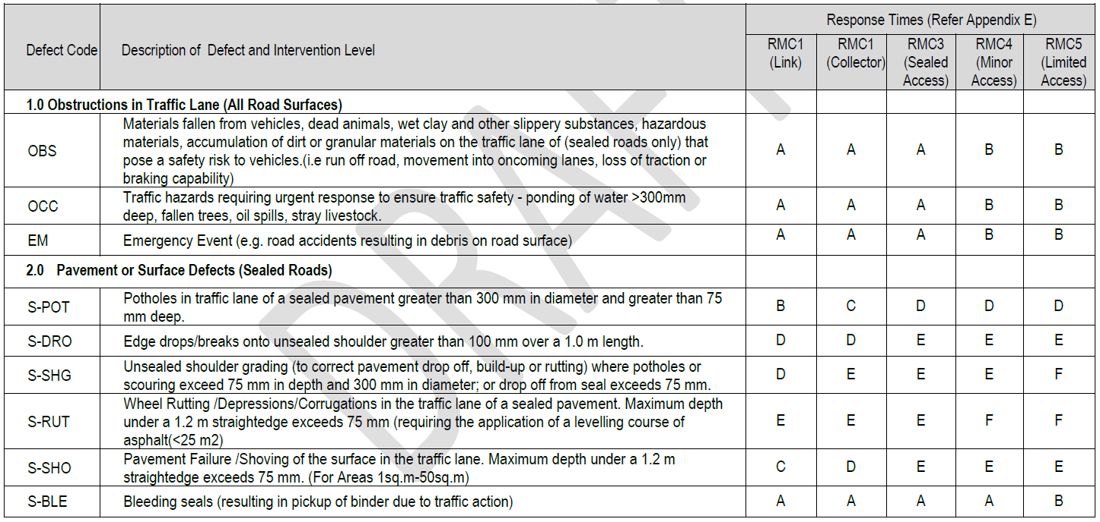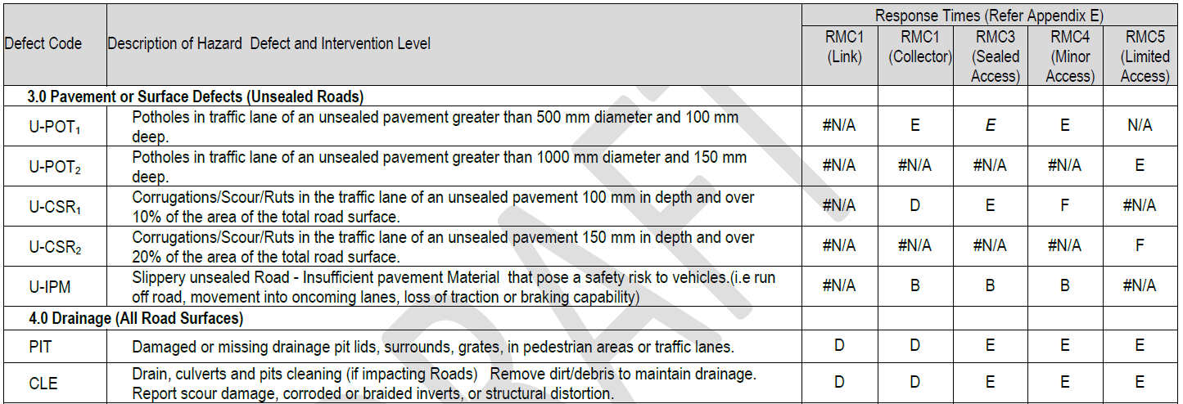

Thresholds and Rationale
The damage severity levels are classified into three categories for roads are as described in section 5.3.
In terms of damage criteria (movement limit strain values) for each damage severity level for each potential movement type, currently a sufficient database does not exist to extend this nationwide for Australia. However, the results of a survey of a wide range of sources, deemed an acceptable industry standard, is listed in Table 5.15 and are considered appropriate to use in the context of the LVRRS. According to the damage severity level, a strain value of 10 x 10⁻³ could be expected to cause structural damage. These criteria are the same as applied to freeways, to provide a consistent approach to considering risk to the regional road network.
Table 5.15 :Damage Criteria for Council Roads (Singh, 1986)

Gas Pipelines
The metrics and thresholds for the potential damage induced by ground movement is detailed in this section. Figure 5.7 shows the pipeline network in the Latrobe Valley region. The thresholds for this receptor class is highly complex and not easily reduced to a single value. In particular, the age and condition of individual pipelines and pipe segments may be important to defining the tolerance to movement. In most cases, however, the pipelines are well outside the indicated limited for batter scale movements and are most likely to subjected to subsidence/rebound effects. In this case there has already been subsidence effects felt for this receptor sub-category.
Through this study Jacobs/Mining One held a workshop with pipeline owners and key stakeholders to help determine concerns and to identify any specific requirements for pipelines in the region. This included consideration of possible future pipeline routes, including the CarbonNET project being undertaken by DJPR. The outcome of this workshop was that there was little additional information that could be provided by the receptor owners and custodians that would set specific values for thresholds. Clearly strain is a concern, but most of the pipeline network is in areas where the strain effects to date have been very small. Figure 5.7 shows the location of key pipelines in the area. The GIS database associated with this project has a full listing of the relevant features.

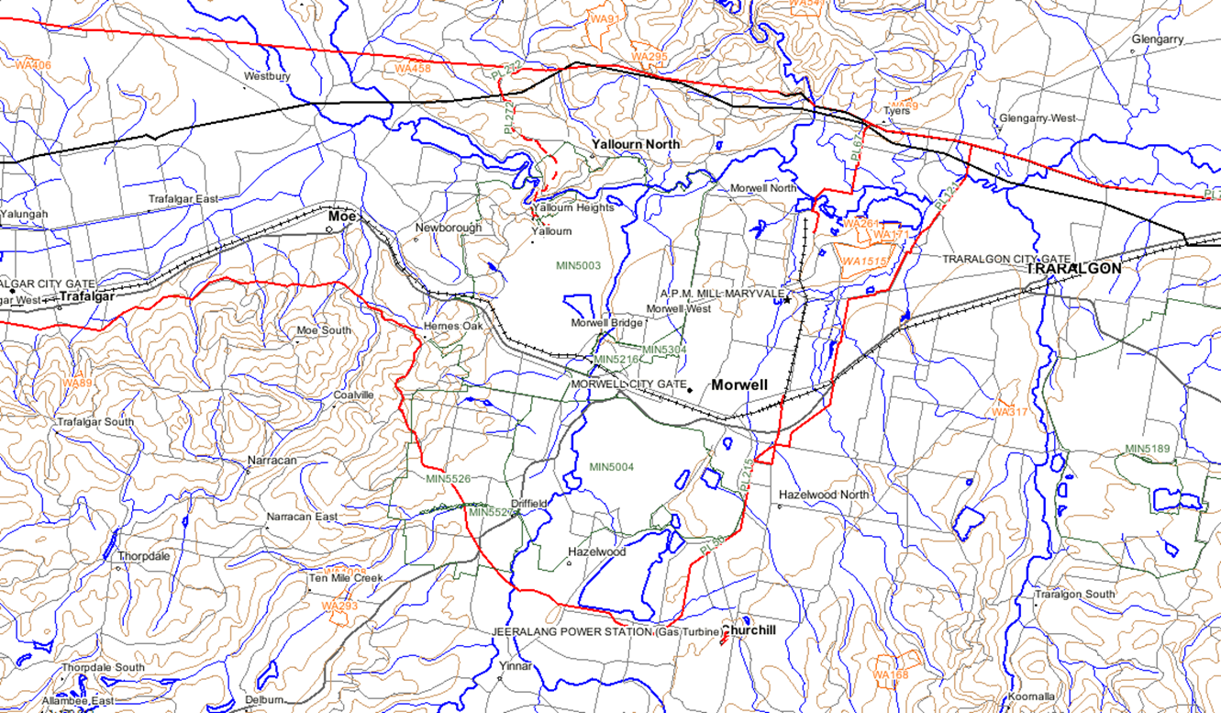
_____ Red lines indicate pipelines
Source: Department of Economic Development, Jobs, Transport and Resources
Figure 5.7 : Pipelines
APA VTS Australia (Operations) Pty Ltd (Pipeline licences 50, 67, 75) – pipeline used to transport natural gas
Australian Gas Networks (Vic) Pty Ltd (Pipeline licence 215) – pipeline used to transport natural gas
Energy Australia (Yallourn) have an application for a gas transmission line pending with the DEDJTR (Pipeline licence 272)
Esso Australia Resources Pty Ltd (Pipeline licence 35, three pipelines within the one easement, Liquid and High Vapour Pressure Liquid)

Relevant standards, guidelines and reference documents for pipelines are listed in Table 5.16.
Table 5.16 : Pipelines – relevant standards and guidelines
Value Category | Standard, Guideline or Reference Documents
Social/Cultural | - Australian Pipelines and Gas Association Ltd (APGA)  - Pipelines Act 2005  - Gas Industry Act 2001  - Pipelines Regulations 2017  - Gas Safety Act 1997  - Gas Safety (Gas Installation) Regulations 2008  - Gas Safety (Safety Case) Regulations 2008  - Gas Safety (Gas Quality) Regulations 2017  - DELWP (2017) Latrobe Planning Scheme  - Planning and Environment Act (1987)  - Live Work Latrobe (Housing Strategy, Industrial Land Use and Employment Strategy and Rural Land Use Strategy) (2016)  - Harrison, J (2011) Mining Engineering Handbook, Mine Subsidence, Society for Mining, Metallurgy and Exploration  - Singh, M (1986) Mine subsidence, Society for Mining, Metallurgy and Exploration  - Standards Australia AS 2885 pipeline Industry  - CMIT- 2005-259 Analysis of Hydrostatic Test (To be read in conjunction with the APGA Code of Environmental Practice)  - APGA Code of Practice in the Coal Seam Gas Industry  - APGA Guideline for investigations of land use around pipelines to guide initial location classification under AS2885  - APGA Guidelines for Management of Electrical Hazards in Pipeline Constructing  - APGA Hydrotesting Guidelines  - APGA/VFF Easement Guidelines  - IECA (2008). Best Practice Erosion and Sediment Control – Appendix P Land-Based Pipeline Construction  - APGA CP-04-004 Design in Mine Subsidence Areas, release H1 2018
Economic | - Live Work Latrobe (Housing Strategy, Industrial Land Use and Employment Strategy and Rural Land Use Strategy) (2016)

Because of the degree of ground movement, including subsidence around the Hazelwood mine, several gas pipeline inspections and investigations were undertaken by SECV or related parties (Inc. Gas and Fuel Corporation) over the period between 1971 and 1983. This work was to understand the impact of the Hazelwood mine operation on pipes and ascertain the impact of pipe failure or leaks (if any) on the Morwell township. The drivers for the work appear to stem from SECV surveillance programs and discussion from community or local government liaison. This includes planning and design of latter community infrastructure. For the most part, the assessments aimed to understand the stress and strain along the pipe, consideration to tolerable limits and the source of the ground displacement. It was generally concluded there was no damage that could be directly attributed to ground movement (SEC, 1976). No pipe in the Morwell area was considered to be overstressed as a result of earth movement, however, displacements may have occurred at certain pipe intersections. As this area is one with a high concentration of large movements this indicates that the pipe network may have good tolerance also for rehabilitation derived movement.
Pipelines in the LVRRS inter-mine area range in age from approximately 50 years to less than 10 years, with additional pipelines planned for construction within the next 10 years. Stakeholder engagement meetings with the pipeline owners indicated that pipelines approaching 50 years of age will be replaced sometime within the next twenty years and that these older pipelines would not have been built to the current Australian Standards. This is further indication of the capacity of the pipelines to deal with rehabilitation ground movement.

Metrics
Pipelines laid below the ground are typically more susceptible to deformation than those laid above, in response to ground movements due to friction and soil pressure. Pipelines will fail if the magnitude of ground movement causing strain or rotation is greater than the pipeline or its joints or couplings can accommodate. For example, if a thin-wall steel pipe was to buckle then this could lead to interruption or loss of service.
The extent to which a pipeline is affected by ground movement is dependent on (Trautmann, 1985):
- Mechanical properties of the pipeline
- Rotation and pull-out capacity of the couplings
- Connection to other structural elements
- Corrosion resistance of pipe and joints
- State of repair
- Installation technique
Damage may be caused either by excessive strain along pipe lengths or excessive distortion at the joints or both. Three basic modes of failure may be identified:
- Strain in pipe material leading to rupture or intolerable deformation
- Rotation of the joints leading to leakage or loss of connectivity
- Axial slip at the joints leading to leakage or disengagement of adjacent pipe lengths
The first two failure modes may be caused by differential settlement and the first and third by lateral displacement. The largest percentage of pipe failures are caused by compressional forces causing excessive telescoping at joints. Tensile failures are the next major mode, whereas failures due to ending or shearing rarely occur (Trautmann, 1985).
In light of the proceeding discussion angular distortion and horizontal strain are considered as the relevant metrics for gas pipelines.

Thresholds and Rationale
The location of the joints with respect to the subsidence profile and the degree of rigidity of the pipeline will significantly affect the nature and extent of damage. The weakest link in a pipeline system is generally the joints and these are usually affected by ground movements first. Flexible couplings are generally equipped with a gasket that is compressed to prevent leakage.
Pipeline joints are capable of sustaining rotations that vary from 1 to 7º. Mechanical joints can tolerate about 50 mm of horizontal slippage before leakage. When both horizontal strains and differential settlements must be sustained, pipeline joints can be designed to rotate and telescope. Welded pipelines are most susceptible to damage by compression because ground movements cause local wrinkling or buckling of the pipe wall. Once local wrinkling has initiated, all subsequent deformations will tend to concentrate at the location of the wrinkle. Local wrinkling may occur at compressive strains on the order of 0.4 to 0.6% (Bouwkamp and Stephen, 1973). Butt-welded steel pipelines are most capable of sustaining the differential soil movements caused by mining subsidence, but these must be high quality welds, free of significant corrosion and weld defects.
In terms of damage criteria (movement limit values) for each type of movement (angular and horizontal movement), the results of available failure data (Singh, 1986) are presented in Table 5.17, and are recommended as an acceptable industry standard and appropriate to use in the context of the LVRRS, in light of the outcomes of the consultation and the available information on the existing and likely future pipe network.
Table 5.17 : Damage Criteria for Pipelines (Singh, 1986)
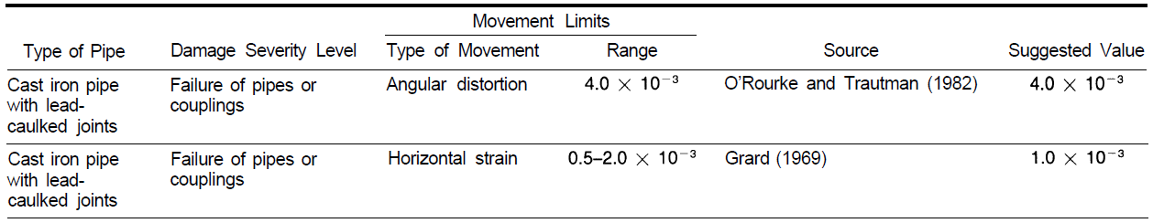

Rail
The metrics and thresholds for the potential damage to rail infrastructure due to ground movement is detailed in this section. Rail management and engineering design are heavily codified and subject to a large number of standards. These generally involve the definition of movement criteria to be taken into account for design, rather than absolute limits. During this study we attempted to contact the rail custodians for the receptors of interest but were advised that they did not have any relevant information to share with the project. Accordingly, the approach presented here is based on the literature and general theory.
Relevant standards, guidelines and reference documents which relate to rail receptors are listed in Table 5.18.
Table 5.18 : Rail – relevant standards and guidelines
Value Category | Standard, Guideline or Reference Documents
Social/Cultural | - National Rail Corporation (Victoria) Act 1991  - Rail Management Act 1996  - Rail Safety (Local Operations) Act 2006  - Rail Safety National Law Application Act 2013  - Rail Safety National Law (Victoria)  - Road Management Act 2004  - ‘Transport bodies’ under the Transport Integration Act Codes of Practice under the Road Management Act  - DELWP (2017) Latrobe Planning Scheme  - Planning and Environment Act (1987)  - Live Work Latrobe (Housing Strategy, Industrial Land Use and Employment Strategy and Rural Land Use Strategy) (2016)  - Mine Subsidence Board (2009) Graduated Guidelines for Residential Construction (NSW) Historical and Technical Background  - Harrison, J (2011) Mining Engineering Handbook, Mine Subsidence, Society for Mining, Metallurgy and Exploration  - Singh, M (1986) Mine subsidence, Society for Mining, Metallurgy and Exploration  - Standards Australia associated publications  - AS 4292.2—2006 Railway safety management  - AS 7508 Track Forces and Stresses  - AS 7454 Management of Network Route Competence
Economic | - DELWP (2017) Latrobe Planning Scheme  - Live Work Latrobe (Housing Strategy, Industrial Land Use and Employment Strategy and Rural Land Use Strategy) (2016)

Metrics
Ground movement by subsidence or rebound on railway tracks first affects the rider discomfort often by bumps which in turn can then require the reduction of maximum permissible speeds. At higher levels of ground strain such as stress relief and subsidence/rebound, rail tracks tend to “snake” or bend, and in more extreme cases, entire rails may be forced out of the track. Changes in ground slope may adversely affect track performance by formation of localised depressions or creating gradients greater than permissible for a given type of train.
The extent to which a railway line is affected by ground movements is related to:
- Types of traffic involved
- Speed limits
- Types and construction of track
- Preventive and remedial works
- Nature and magnitude of ground movements.
In light of these considerations, the relevant metrics are horizontal strain and slope changes in track.

Thresholds and Rationale
The threshold for damage to rail should be set to avoid undue disruption to train operations. In the absence of specific data from the region, general literature values have been adopted as a recommended first stage. Quantitative limits are difficult to assign due to the many variables involved. A railroad track may be deemed to have failed if the deformations are of such magnitude that it is incapable of sustaining traffic due to risk of derailment (Singh, 1986).
The damage criteria (movement limit values) for each damage severity level defined from published reviews of available limits (Singh, 1986) is presented in Table 5.19. We have recommended that the horizontal strain threshold of 2.0x10⁻³ be adopted and also the maximum slope strain of 10 x 10⁻³.
Table 5.19 : Recommended Damage Criteria for Railroads (Singh, 1986), in the suggested value column
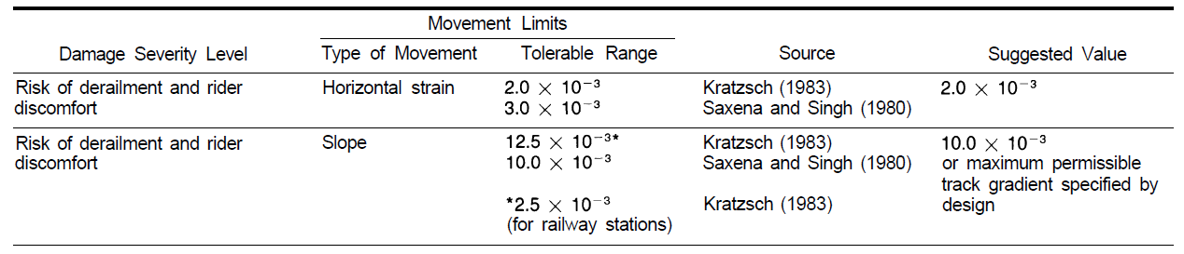

Telecommunications
The metrics and thresholds for the potential damage to telecommunications infrastructure due to ground movement is detailed in this section. For the LVRRS study the recognised receptor are the main telecommunication trunk systems, such as primary towers or main communication cables. Individual telephone lines or broadband connections are not considered. These receptors are detailed in the GIS database of receptors that accompanies the LVRRS. During the study requests were sent to telecommunications providers of trunk infrastructure in the Latrobe Valley to gather pertinent local information. No response was received from theses providers despite several approaches. In light of this, literature-derived values have been adopted and are recommended as starting values.
In the Latrobe Valley, telecommunications services include VicTrack telecommunications associated with the railway corridor. This carries government communications traffic in addition to rail operations.
The Australian Communications and Media Authority (ACMA) under authority of the Commonwealth Act provide technical standards that address issues related to protecting personal health and safety, protecting the integrity of telecommunications networks, ensuring the supply of a standard telephone service and ensuring access to emergency call services.
Relevant standards, guidelines and reference documents for telecommunications are listed in Table 5.20.
Table 5.20 : Telecommunications Network – relevant standards and guidelines
Value Category | Standard, Guideline or Reference Documents
Social/Cultural | - Telecommunications Act 1997  - Telecommunications and Other Legislation Amendment Act 2017  - Australian Communications and Media Authority (ACMA), Commonwealth  - DELWP (2017) Latrobe Planning Scheme  - Planning and Environment Act (1987)  - Live Work Latrobe (Housing Strategy, Industrial Land Use and Employment Strategy and Rural Land Use Strategy) (2016)  - Harrison, J (2011) Mining Engineering Handbook, Mine Subsidence, Society for Mining, Metallurgy and Exploration  - Singh, M (1986) Mine subsidence, Society for Mining, Metallurgy and Exploration  - AS/CA S009:2013 Installation requirements for customer cabling (wiring rules)  - Telecommunications Technical Standard (Requirements for customer cabling products – AS/CA S008) 2015  - Telecommunications Technical Standard (Requirements for Customer Equipment for connection to a metallic local loop interface of a Telecommunications Network – AS/CA S043) 2015  - Telecommunications Technical Standard (Surge Protective Devices for Telecommunication Applications – AS/NZS 4117) 2015  - Telecommunications Technical Standard (Information Technology Equipment – Safety, Part 1: General Requirements – AS/NZS 60950.1:2011) 2011
Economic | - Live Work Latrobe (Housing Strategy, Industrial Land Use and Employment Strategy and Rural Land Use Strategy) (2016)

Metrics
Telecommunications laid below the ground are considered to be more susceptible to deformation than those laid above in response to ground movements due to friction and soil pressure. Telecommunications above ground are subject to movement stresses that are considered like those described for transmission towers in preceding sections.
The relevant metrics for telecommunication has thus been determined to be angular distortion and horizontal strain.

Thresholds and Rationale
The proposed thresholds for telecommunications are recommended to be the same as those recommended for pipelines and electricity transmission towers.

Bridges
The metrics and thresholds for the potential damage to bridges due to ground movement is detailed in this section.
Relevant standards, guidelines and reference documents for bridges are listed in Table 5.21. The Austroads Guide titled ‘The Austroads Guide to Bridge Technology Parts 1 to 8’ are the over-arching documents that provide the framework for design and management of the bridges (and other highway structures) across Australia.
There is little difference in the overall approach to design and operations standards for road bridges and roads themselves. Similarly, the standards of rail bridges are fundamentally defined by the track standards for rail that have been discussed previously. Through this study we have been unable to identify thresholds that are markedly different for bridges than apply to roads and rail. Accordingly, these values are recommended as a starting point. At later stages in the LVRRS if ground movement is seen as a significant issue for a particular structure, then additional data on particular structures should be sought.
Table 5.21 : Bridges – key design standards and guidelines
Value Category | Standard, Guideline or Reference Documents
Social/Cultural | - Road Management Act 2004  - Codes of Practice under the Road Management Act  - Road Safety Act 1986  - Austroads (2013) Guide to Bridge Technology  - Austroads (2012) Bridge Design Guidelines for Earthquakes  - DELWP (2017) Latrobe Planning Scheme  - Planning and Environment Act (1987)  - Live Work Latrobe (Housing Strategy, Industrial Land Use and Employment Strategy and Rural Land Use Strategy) (2016)  - Mine Subsidence Board (2009) Graduated Guidelines for Residential Construction (NSW) Historical and Technical Background  - Harrison, J (2011) Mining Engineering Handbook, Mine Subsidence, Society for Mining, Metallurgy and Exploration  - Singh, M (1986) Mine subsidence, Society for Mining, Metallurgy and Exploration  - Building Code of Australia (BCA), in the National Construction Code series, contains technical provisions for the design and construction of buildings and other structures.  - Standards Australia associated publications  - AS 2159 Design and Installation of Piles  - AS 5100 Bridge Design (2004)  - AS 5100.2 Section 14 Earthquake design for bridges
Economic | - DELWP (2017) Latrobe Planning Scheme  - Live Work Latrobe (Housing Strategy, Industrial Land Use and Employment Strategy and Rural Land Use Strategy) (2016)

Metrics
Ground movement may cause damage to bridges by horizontal ground strain resulting in the movement of the supports of piers either towards or away from one another. Differential vertical settlement or distortions in the horizontal plane may bring about complex and often serious effects on the decking and arches (Anon, 1975a).
Damage by ground movement can often be the result of compressive damage which can lead to crushing and spalling of concrete decks and plaster or a combination of compression and extension due to bending which may cause opening and closing of construction joints in abutments and plaster cracking. At the higher end of the scale, damage is characterised by distress in the superstructure, inward horizontal movement of abutments, jamming of beams and girders against the back wall of the abutments, and serious damage to the bearings (Moulton et al. 1982).
In event of a large earthquake, the performance of bridges during and after earthquakes is essential in ensuring transport networks remain open. The current Australian design guideline and international seismic design practices formulates new force-based and displacement-based code provisions for the design of bridges to earthquake loads suitable for inclusion in current Australian design codes. In Australia, bridges are designed to prevent collapse while allowing some damage to be sustained. The level of damage depends on the function and importance of the structure as determined by a number of Australian Standards (Austroads, 2012), such as AS 5100.2:2004 Bridge design – Part 2. Design loads should ensure compatibility with AS 1170.4:2007 Minimum design loads on structures – Part 4: Earthquake loads.
Based on the AS 5100.2:2004 and AS 1170.4:2007 the general overview for design with respect to earthquakes includes:
- Determine bridge importance level
- Determine probability factor
- Determine site hazard factor
- Determine site subsoil class
- Using the outcomes of steps 1, 2 and 3, determine bridge earthquake design category (BEDC)
- Based on the BEDC, determine the required analysis effort
- Determine equivalent horizontal and/or vertical design earthquake force (either by static or dynamic analysis)
- Detail the structural members, restraining devices, bearings and deck joints. This is the force-based approach
AS 1170.4:2007 allows for an alternative displacement-based approach to be used. Austroads (2012) provides further guidance for Bridge Design Guidelines for Earthquakes and includes an alternative displacement-based design with the design procedure as follows:
- Determine the site seismicity in terms of the elastic design displacement spectrum
- Determine the risk of yield displacements of internal piers
- Check whether yield displacements exceed the elastic corner-period displacement. If so, no further earthquake design is needed.
- If the check in step 3 fails, determine the fundamental period of the bridge in the direction considered.
- Determine the elastic displacement response of the fundamental period.
- Check whether yield displacements exceed elastic displacements for fundamental period. If so, no further earthquake design is needed.
If ductile earthquake design is indicated by the above steps, carry out a displacement-based earthquake design and then determined if ductile earthquake is required for lateral strength of piers and abutments.
The general requirement for analysis, in accordance to AS 5100.2 when determining earthquake forces on bridges, is summarised in Table 5.22 for either static or dynamic analysis.
Table 5.22 : Bridge Design Actions for Earthquakes in AS 5100.2
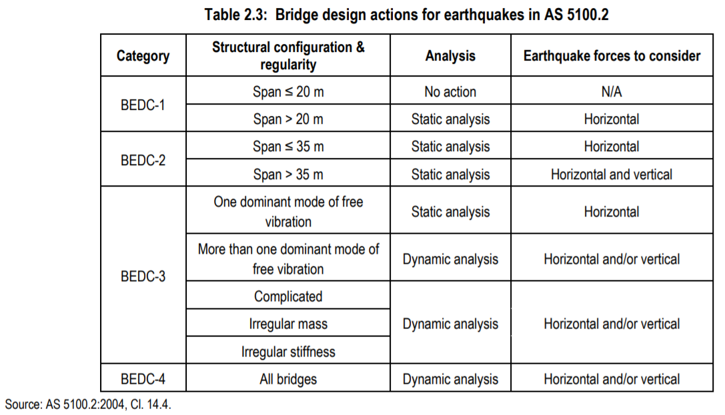
The proposed method to assess the potential for RIS-induced damage to bridges as part of the LVRRS is presented in Table 5.22. It may not be practical for high level design dynamic assessments to be made as part of the LVRRS, so discussion would be needed if these higher risk events are identified, such as more detailed discussion with receptors owners and custodians. In such a heavily codified area of design, it is not considered appropriate for this study to recommend a simplified approach. Should significant earthquake forces be forecast as a result of rehabilitation then further consultation with bridge owners is likely to be needed to define the best course of action.
Table 5.23 : Bridge analysis requirement (Austroads, 2012) See also discussion in text regarding applicability
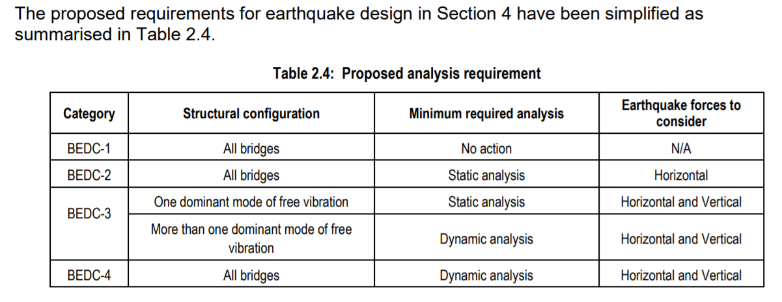

Thresholds and Rationale
The damage severity levels are classified into three categories for bridges and are as described in section 5.3.
As per the discussion on metrics above, a simple single threshold is unlikely to be universally applicable to all structures. However, a value of ground movement effect that could be used as a trigger to undertake further assessment and discussions with bridge owners is needed. For this purpose, we have reviewed the available literature and recommend the thresholds identified by Singh (1986) for highway bridges to apply to all bridges. These are outlined in table 5.24. We suggest that for the purposes of further assessment that the architectural value be adopted as a threshold, in the absence of any clear structure specific value. It may be that, with further assessment, specific thresholds for key structures may be able to be define. If this is important in later studies.
Table 5.24 : Damage Criteria for Highway Bridges (Singh, 1986)
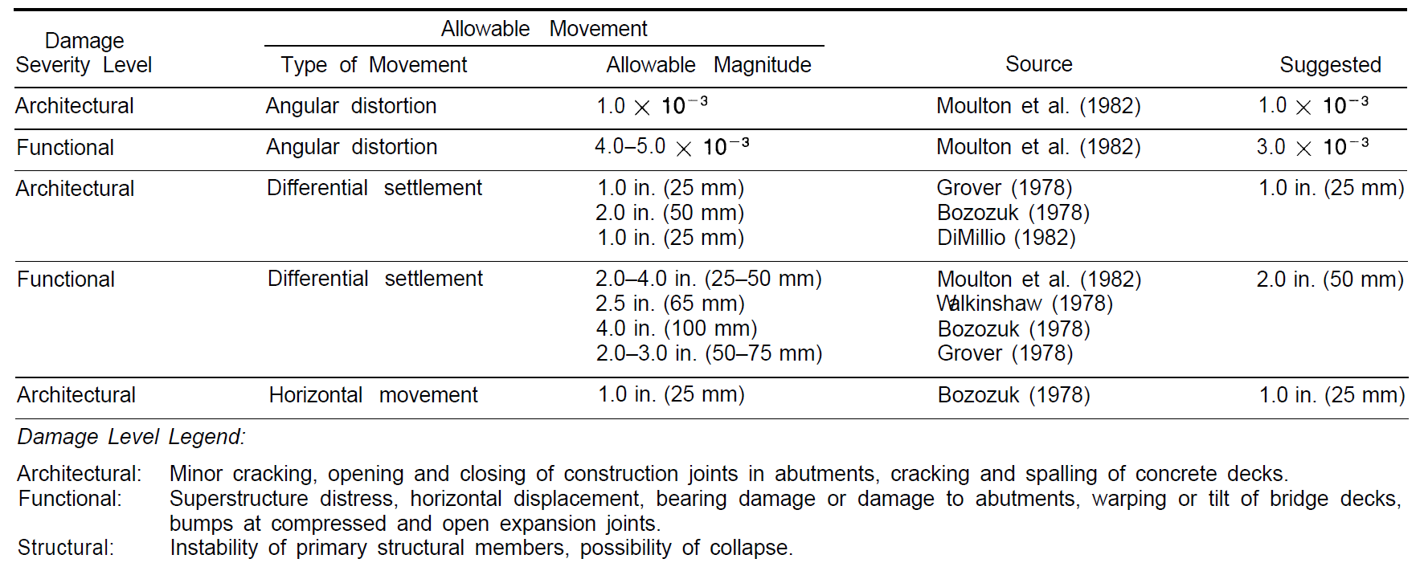

Quantitative Metrics and Thresholds – Land

Towns
The metrics and thresholds for potential impacts induced by subsidence / rebound or sub-base ground movement to towns (commercial and residential land including buildings and structures) is detailed in this section. Relevant standards, guidelines and reference documents for buildings and land are listed in Table 5.25.
Table 5.25 : Towns – relevant guidelines and standards
Value Category | Standard, Guideline or Reference Documents
Social/Cultural | - Water for Victoria (2016) Recognising and Managing Aboriginal Values.  - DELWP (2017) Latrobe Planning Scheme  - Planning and Environment Act (1987)  - Live Work Latrobe (Housing Strategy, Industrial Land Use and Employment Strategy and Rural Land Use Strategy) (2016)  - Mine Subsidence Board (2009) Graduated Guidelines for Residential Construction (NSW) Historical and Technical Background  - Harrison, J (2011) Mining Engineering Handbook, Mine Subsidence, Society for Mining, Metallurgy and Exploration  - Singh, M (1986) Mine subsidence, Society for Mining, Metallurgy and Exploration  - Building Code of Australia (BCA), in the National Construction Code series, contains technical provisions for the design and construction of buildings and other structures.  - Standards Australia associated publications  - AS 3600 Concrete Structures  - AS 2870 Residential Slabs and Footings  - AS 3700 Masonry Structures
Economic | - Live Work Latrobe (Housing Strategy, Industrial Land Use and Employment Strategy and Rural Land Use Strategy) (2016)

Buildings and structures in the inter-mine scale of the LVRRS project area can be observed to range in age from the early 1900s through to recent. Ground movement historical records date back some forty years in the Morwell area. Recently, a Morwell Land Movement Survey was also undertaken to survey cracks in an area to the south of the Morwell township, closest to the Hazelwood Mine. This survey was commissioned as a reference survey that will be used for comparison in future, so that any changes in the cracking can be tracked.

Metrics
Damage to surface structures such as buildings, is mainly caused by tilt, angular distortion, bending, and horizontal strain. Direct settlement that does not cause strain across a building is not regarded as high risk. This is in keeping with the observation in the Latrobe Valley to date, based on mining related settlement that has already occurred (DJPR, 2019). Several distinct types of damage are evident as manifestations of tension, compression, angular distortion, shear, bending, and rigid body rotation and/or translation of the structure. Structure deformations from ground movements usually begin at foundation level and propagate upward through the basement to the superstructure [Anon., 1975a, Bruhn et al., 1982]. The transmission of the deformations from the foundation to the superstructure depends on the nature and condition of the structure its continuity and attachment.
In actual practice, several different forces (i.e., horizontal/vertical movements, angular distortion, differential tilting) may occur together and produce a complex pattern of cracking and distortion in various locations and directions see Figure 5.8.
In addition, the length of the structure has a major influence on the relative severity of the resulting damage (Figure 5.9). Studies have indicated that the longer the structure, the greater the damage severity (Anon.,1975).
A few damage classifications and limits have been developed which correlate building damage to ground movements. The scheme developed by the National Coal Board (Anon, 1975) based on direct observations of structure/building damage in the United Kingdom is probably the best known to determine the intended class of damage. This has been classified to ‘Negligible or Very slight’ damage, ‘Slight” damage’, ‘Appreciable’ damage, ‘Severe’ damage and ‘“Very severe’” damage.
Table 5.26 below (extracted from Singh, M., 1986) describes each damage classification.
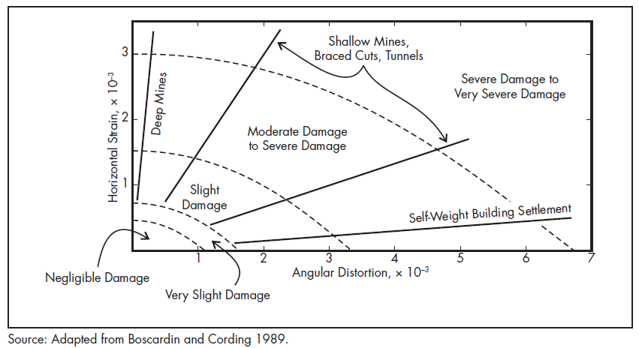
Figure 5.8: Building damage in terms of angular distortion and horizontal strain (after Singh, 1986)
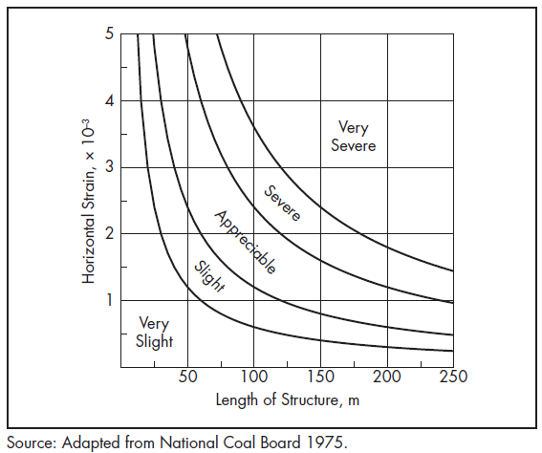
Figure 5.9: Structural damage in terms of length of structure and horizontal strain (after Singh, 1986)
Table 5.26: Classification of Subsidence Damage
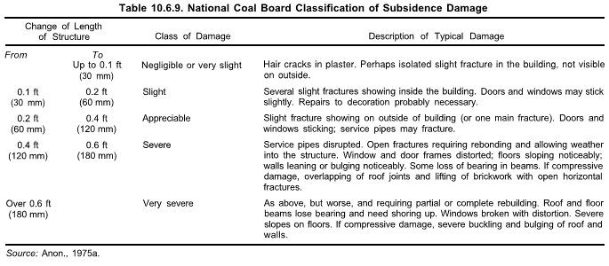

Thresholds and Rationale
The damage severity levels are classified into three categories for buildings and are as described in Section 5.3.
In terms of damage criteria (movement limit values) for each damage severity level the results of a survey of a wide range of sources are presented in Table 5.6, 5.7 and 5.8. These are recommended for use as a starting point in the LVRRS as they are based on a well-accepted literature review study and can be applied in the Latrobe Valley. Note that Table 5.8 presents the earthquake intensity scale. For RIS, the recommended threshold is intensity VI – slight non-structural damage - in keeping with the strain related thresholds given above.

Quantitative Metrics and Thresholds – Water

Dams, artificial lakes and reservoirs
The metrics and thresholds for the potential damage induced by ground movement due to subsidence / rebound or sub-base ground movement and RIS to the water infrastructure (such as dams, artificial lakes and reservoirs) is described in this section.
Relevant standards, guidelines and reference documents which maintain value are listed in Table 5.27 including the Australian National Committee on Large Dams (ANCOLD) Guidelines.
Table 5.27 : Water – key guidelines and standards
Value Category | Standard, Guideline or Reference Documents
Social/Cultural | - Water for Victoria (2016) Recognising and Managing Aboriginal Values.  - DELWP (2017) Latrobe Planning Scheme  - Planning and Environment Act (1987)  - Live Work Latrobe (Housing Strategy, Industrial Land Use and Employment Strategy and Rural Land Use Strategy) (2016)  - Mine Subsidence Board (2009) Graduated Guidelines for Residential Construction (NSW) Historical and Technical Background  - Harrison, J (2011) Mining Engineering Handbook, Mine Subsidence, Society for Mining, Metallurgy and Exploration  - Singh, M (1986) Mine subsidence, Society for Mining, Metallurgy and Exploration  - ANCOLD Guidelines (2012)
Economic | - Live Work Latrobe (Housing Strategy, Industrial Land Use and Employment Strategy and Rural Land Use Strategy) (2016)

Buckley’s Hill Reservoir
The Buckley’s Hill Reservoir provides treated water to the Morwell and Churchill communities as well as raw water to the power industry. The raw water source for the Buckley’s Hill Reservoir is the Moondarra Reservoir on the Tyers River for which Gippsland Water holds a Bulk Entitlement of 62,000 ML/y on average. Water is piped from Moondarra Reservoir to the Buckley’s Hill storage.
The original Buckley’s Hill storage was built in the early 1960s and embankment works and other maintenance were performed most recently in 2015 and 2017 respectively to ensure ongoing compliance with modern design standards and to extend the life of the facility. For example, to ensure the future integrity of the structure, extra material was added to the northern walls of the reservoir which has been subject to some minor movements over many years. The reservoir is likely to be outside of the area of influence most affected by ground movement. Nevertheless, it is recommended that the general metrics and thresholds for dams as described below be applied.

Defined Metrics
Ground movement may cause damage to dams or reservoirs by horizontal ground strain, subsidence or rebound resulting in the movement in the foundation or embankment. For RIS, the performance of dams during and after earthquakes is essential to ensure that water or tailings is contained. ANCOLD provides guidelines with respect to seismicity, assessment of the consequence of dam failure, dam safety management and risk assessment to name a few. These factors are included in dam design and approval prior to construction.
Subsidence can change the elevation of an area which may lead to increased exposure to flooding. Lowering of the ground level may lead to low level dam walls overflowing, especially in low lying regions (IESC, 2014).
For this study the measure of horizontal ground strain is recommended to be the basis of a metric, which could form the basis of a trigger for further investigation. This is recommended at the starting point.

Thresholds and Rationale
In terms of damage criteria (movement limit values) for dams and reservoirs, very limited data is available on these structures. Consensus in the literature appears to converge on a strain value of 1.0 x 10⁻³ for tolerable horizontal strain (see, for example Nishida and Goto 1970; Lee 1986; Lackington and Robinson 1973). This value is recommended as the trigger value for further assessment for LVRRS.

Drains
The metrics and thresholds for the potential damage induced by ground movement due to drains (including the distal parts of the Morwell Main Drain) are in line with the defined metrics and thresholds for reservoirs discussed earlier. It is arguable that the focus of the lower part of the drain is closely aligned with Hazelwood mine activities and so a regional threshold is not appropriate. The MMD is a lined drain for several hundreds of metres in vicinity of Hazelwood Mine and an earthen structure near the Morwell township and the out flow. The section of the MMD likely to be most affected by ground movement is closest to Hazelwood Mine. Thus, this may not be a regional receptor, rather its design performance is subject to controls associated with the mine.

Conclusions
Metrics and threshold recommendations that can be used to assess regional ground movement effects of rehabilitation scenarios on recognised receptors have been defined.
Metrics and thresholds have been recommended for each receptor potentially effected by ground movement (geotechnical processes) and are compiled in Table 6.1. All receptors except for intangible Aboriginal and non-aboriginal cultural heritage and some water and land use type related receptors have been allocated a metric. Where a recognised receptor does not have a clear metric, further assessment by the LVRRS and receptor custodians may be required if quantitative effects are to be evaluated. This is beyond the scope of this study.
The recommended metrics and thresholds identified have been sourced from:
- Standards;
- Guidelines; and,
- Reference Documents.
Recognised industry standards / guidelines / technical publications, including those from Standards Australia and stakeholders such as VicRoads, have been sourced. These provide a framework for the design, management and monitoring of relevant receptor metrics (with defined thresholds). Furthermore, all reference material has been cited within the text of each geotechnical receptor section and is publicly accessible.
Ground movement in the Latrobe Valley is currently monitored using the following instruments:
- Prisms to monitor ground movement
- Extensometers to monitor subsurface ground movement
- Inclinometers to monitor lateral ground movement
- Survey Pins to monitor ground settlement
- Piezometers to measure ground water behaviour and pore water pressures that can influence ground movement
- Tiltmeters to monitor change in tilt of existing structures

Each mine site currently undertakes a monitoring program in line with the respective site Work Plan and Ground Control Management Plan (GCMP). The GCMP for each site outlines the frequency and level of monitoring required for each. The requirements for regional ground movement monitoring as the mines shift from operational to rehabilitation and ultimately post-closure phases will need to be considered. The intention should be to utilise the existing monitoring network as far as possible, and to examine efficient, cost effective solutions to address any additional requirements, particularly at the inter-mine and regional scales.
This monitoring data will be key to determining whether specific thresholds have been exceeded.

Table 6.1: Ground movement metrics and thresholds determined by this study for agreed receptor groups for the LVRRS
Receptor Category | Receptor Sub-Category | Metric | Threshold (may be indicative or firm, see comments) | Comment | Reference
Aboriginal and Non-aboriginal cultural heritage | Aboriginal cultural heritage  (Includes tangible heritage such as artefacts, sites and landscape features) | Horizontal and vertical strain | Horizontal strain value of  1.0 x 10⁻³ | Sites are undisclosed however understood to likely be near water ways. Metric for embankments, canals and miscellaneous structures used as a guideline. | Singh, M (1986) Mining Engineering Handbook. Chapter 3 Mine subsidence, Society for Mining, Metallurgy and Exploration
 | Non-aboriginal cultural heritage  (including historical open cuts and buildings/structures) | Resisting and driving force of open cut slopes and earthquake loading  Horizonal and vertical strain | Open Cuts see Section 5.3, Factor of Safety (FOS) and Probability of Failure (POF).  Dependant on Heritage structure type. See damage criteria for buildings and structure Tables 5.7 and 5.8. Actual threshold varies by the construction of the receptor and is not a single value for the receptor category | Infrastructure thresholds are a guideline due to unknown construction and age of heritage buildings and structures, i.e. these may not conform to current Australian building standards. | Read, J., and Stacey, P. (2009) Guidelines for Open Pit Slope Design. CSIRO 2009  Earth Resources Regulation (2015) Guidance Material for the Assessment of Geotechnical Risks in Open Pit Mines and Quarries  Singh, M (1986) Mining Engineering Handbook. Chapter 3 Mine subsidence, Society for Mining, Metallurgy and Exploration
Environment | Rivers, waterways and natural lakes | Horizontal and vertical strain | Horizontal strain value of  1.0 x 10⁻³ | Limited data available for this receptor. Metric for embankments, canals and miscellaneous structures used as guideline.  Unknown geotechnical related magnitudes for different flow components (low flows, freshes, high flows, overbank flows), sediment transport, changes in gradient and the timing, frequency and duration of various components unknown. | Singh, M (1986) Mining Engineering Handbook. Chapter 3 Mine subsidence, Society for Mining, Metallurgy and Exploration
 | Wetlands | Horizontal and vertical strain | Horizontal strain value of  1.0 x 10⁻³ | Limited data available for this receptor. Metric for embankments, canals and miscellaneous structures used as a guideline.  Unknown geotechnical related magnitudes for different flow components (low flows, freshes, high flows, overbank flows), sediment transport, changes in gradient and the timing, frequency and duration of various components unknown. | Singh, M (1986) Mining Engineering Handbook. Chapter 3 Mine subsidence, Society for Mining, Metallurgy and Exploration
Infrastructure | Extractive Industry | Resisting and driving force of open cut slopes and earthquake loading including mine batter stability generally | Open Cuts see Section 5.3, Factor of Safety (FOS) and Probability of Failure (POF). | Overseen by mine operators and regulated by Earth Resources Regulations | Read, J., and Stacey, P. (2009) Guidelines for Open Pit Slope Design. CSIRO 2009  Earth Resources Regulation (2015) Guidance Material for the Assessment of Geotechnical Risks in Open Pit Mines and Quarries
 | Electricity Transmission Network | Horizontal and vertical strain and earthquake loading | Horizontal strain value of 1.0 x 10⁻³ | Damage criteria for Lattice Towers.  For many individual structures the threshold has been exceeded by historical movement. This indicates the threshold for future movement and needs further assessment by the LVRRS to determine practicality | Sriram Kalaga, Prasad Yenumula (2016) Design of Electrical Transmission Lines: Structures and Foundations.  Singh, M (1986) Mining Engineering Handbook. Chapter 3 Mine subsidence, Society for Mining, Metallurgy and Exploration
 | Gas Fired Power Generation | Horizontal and vertical strain and earthquake loading | See damage criteria for buildings and structure Tables 5.7 and 5.8. Recommend “architectural” as investigation threshold. | Damage criteria for Buildings/Structures | Singh, M (1986) Mining Engineering Handbook. Chapter 3 Mine subsidence, Society for Mining, Metallurgy and Exploration
 | Road - Freeway/State maintained | Horizontal and vertical strain and earthquake loading | Horizontal strain (architectural) = 1.0 x 10⁻³  Tilt (architectural) = 5.0 x 10⁻³  Tilt (functional) = 5.0 x 10⁻³  Tilt (structural) = 10 x 10⁻³ | Damage criteria for Freeway/State Roads classified by VicRoads Road Management Plan (2014) (Table 5.11) | Singh, M (1986) Mining Engineering Handbook. Chapter 3 Mine subsidence, Society for Mining, Metallurgy and Exploration
 | Road – Local Council maintained | Horizontal and vertical strain and earthquake loading | Horizontal strain (architectural) = 1.0 x 10⁻³  Tilt (architectural) = 5.0 x 10⁻³  Tilt (functional) = 5.0 x 10⁻³  Tilt (structural) = 10 x 10⁻³ | Damage criteria for local roads and intervention levels classified by Latrobe City Council (Table 5.15) | Singh, M (1986) Mining Engineering Handbook. Chapter 3 Mine subsidence, Society for Mining, Metallurgy and Exploration
 | Pipelines | Strain along pipe lengths or excessive distortion a the joint or both and earthquake loading | For pipe in ground, cast iron pipe with lead-caulked joints  Angular distortion = 4.0 x 10⁻³  Horizontal strain = 1.0 x 10⁻³ | Damage criteria for Pipelines described for two basic damage levels (1) interruption of use (2) failure or loss of use | Singh, M (1986) Mining Engineering Handbook. Chapter 3 Mine subsidence, Society for Mining, Metallurgy and Exploration
 | Rail | Horizontal and vertical strain and earthquake loading | Horizontal strain = 2.0 x 10⁻³  Undulations/slope strain = 10.0 x 10⁻³ (maximum permissible track gradient specified by design) | Damage criteria for Railroads may be classified in terms of interruption of use or failure | Singh, M (1986) Mining Engineering Handbook. Chapter 3 Mine subsidence, Society for Mining, Metallurgy and Exploration
 | Telecommunications | Horizontal and vertical strain and earthquake loading | Telecommunication Towers -Settlement and rebound of up to 1-2mm/year.  Horizontal strain value of  1.0 x 10⁻³  In ground, cast iron pipe with lead-caulked joints  Angular distortion = 4.0 x 10⁻³  Horizontal strain = 1.0 x 10⁻³ | Damage criteria for Telecommunications described for two basic damage levels (1) interruption of use (2) failure or loss of use.  For many individual structures the threshold has been exceeded by historical movement. This indicates the threshold for future movement and needs further assessment by the LVRRS to determine practicality | Singh, M (1986) Mining Engineering Handbook. Chapter 3 Mine subsidence, Society for Mining, Metallurgy and Exploration
 | Bridges | Horizontal and vertical strain and earthquake loading | Angular distortion (architectural) strain =  1.0 x 10⁻³  Differential settlement (architectural) = 25 mm  Angular distortion (functional) strain = 3.0 x 10⁻³  Differential settlement (functional) = 50 mm  Horizontal movement (Architectural) = 25 mm | Damage criteria for Highway Bridges | Bridge Design Guidelines (Austroads 2012) for earthquake loading  Singh, M (1986) Mining Engineering Handbook. Chapter 3 Mine subsidence, Society for Mining, Metallurgy and Exploration for other ground movements
Land | Townships/Settlements | Horizontal and vertical strain and earthquake loading | Dependant on structure type. See damage criteria for buildings and structure Tables 5.7 and 5.8. Recommended earthquake severity VI. | Infrastructure thresholds are a guideline due to unknown construction and age of heritage buildings and structures, i.e. these may not conform to current Australian building standards. | Earth Resources Regulation (2015) Guidance Material for the Assessment of Geotechnical Risks in Open Pit Mines and Quarries  Singh, M (1986) Mining Engineering Handbook. Chapter 3 Mine subsidence, Society for Mining, Metallurgy and Exploration
Water | Dams, artificial lakes, and reservoirs where ground movement may affect the associated impoundment structures or other infrastructure | Horizontal and vertical strain and earthquake loading, strain resulting from subsidence/rebound | Horizontal strain 1.0 x 10⁻³ | Limited data available for these surface structures | Nishida, T and Goto, K (1969) Damage to Irrigation Pond Due to Mining Subsidence. Proceedings International Symposium on Land Subsidence, ATHS Pub 89, Japan pp.496-501  Lackington, D.W and Robinson, B. (1973) Articulated Service Reservoirs in Mining Subsidence Areas. Journal of the Institution of Water Engineers, Vol 27 pp. 197-215
 | Drains | Horizontal and vertical strain and earthquake loading | Horizontal strain 1.0 x 10⁻³ | Limited data available for surface open drain structures | Singh, M (1986) Mining Engineering Handbook. Chapter 3 Mine subsidence, Society for Mining, Metallurgy and Exploration

Literature reviewed and referenced - Technical Papers/Reports/Letters
The following provides a list of the literature that was reviewed and assessed for the purposes of recommending metrics and thresholds. Not all the literature cited here have been referenced in the text. This list was prepared as the request of reviewers who asked to see the breadth of material that was considered.
Aggarwal, A. K. (2001). Seismic Provisions of Papua New Guinea Code of Practice. Australian Earthquake Engineering Society (pp. 1-538). Canberra: AEES.
Allen, T. (2001). Implementation of Routine Processing Technique for Source Parameter Determination of Australian Earthquakes. Australian Earthquake Engineering Society (pp. 1-538). Canberra: AEES.
Allen, T., Gibson, G., & Hill, C. (200). The Thomson Reservoir-Triggered Earthquakes. 2000 Conference of the Australian Earthquake Engineering Society (pp. 1-7). AEES.
ANCOLD (1998) Guidelines for Design of Dams for Earthquake. Australian National Committee on Large Dams, August 1998
ANCOLD (2012) Guidelines on Tailings Dams. Planning, Design, Construction, Operation and Closure. Australian National Committee on Large Dams Incorporated, May 2012.
ANCOLD. (2017). ANCOLD Guidelines for Design of Dams and Appurtenant Structures for Earthquake. ANCOLD.
Anon. (1975) Subsidence Engineers’ Handbook, National Coal Board, Mining Department, London, 111 pp.
APIA Pipeline Corridor Committee. (2014). Guidelines for investigations of land use around pipelines to guide initial location classification under AS 2885. Australian Pipeline Industry Association.
Asten, M. W. (2001). The Spatial Auto-Correlation Method for Phase Velocity . Australian Earthquake Engineering Society (pp. 1-538). Canberra: AEES.
Australian Geomechanics Society, 2000. Landslide Risk Management Concepts and Guidelines. Australian Geomechanics Society, Sub-Committee on Landslide Risk Management, Australian Geomechanics, 35, 49-92
Australian Standard®. (1998). Steel structures. In AS 4100—1998 (Incorporating Amendment No. 1) Reconfirmed 2016. Sydney: SAI Global Limited .
Australian Standard®. (2006). Railway safety management Part 2: Track, civil and electrical infrastructure. In AS 4292.2—2006. Sydney: Standards Australia.
Australian Standard®. (2006). Railway safety management Part 3: Rolling stock. In AS 4292.3—2006. Sydney: Standards Australia.
Australian Standard®. (2006). Railway safety management Part 4: Signaling and telecommunications systems and equipment. In AS 4292.4—2006. Sydney: Standards Australia.
Australian Standard®. (2006). Railway safety management Part 5: Operational systems. In AS 4292.5—2006. Sydney: Standards Australia.
Australian Standard®. (2012). Pipelines—Gas and liquid petroleum Part 3: Operation and maintenance. In AS 2885.3—2012. Sydney: Australian Standard.
Australian Standard®. (2012). Structural design actions Part 4: Earthquake actions in Australia. In AS 1170.4—2007 (Incorporating Amendment No. 1). Sydney: SAI Global Limited & Standards New Zealand.
Australian Standard®. (2013). Bitumen for pavements. In AS 2008—2013. Sydney: SAI Global Limited.
Australian Standard™. (1996). Residential Slabs and footings - Construction. In AS 2870—1996. Sydney: Standards Australia International Ltd.
Australian Standard™. (2006). Railway safety management Part 1: General requirements. In AS 4292.1—2006. Sydney: Standards Australia.
Australian Standard™. (2006). Railway safety management Part 7: Railway safety investigation. In AS 4292.7—2006. Sydney: Standards Australia.
Australian/New Zealand Standard™. (2012). Pipelines—Gas and liquid petroleum Part 5: Field pressure testing. In AS/NZS 2885.5:2012. Sydney: SAI Global Limited and Standards New Zealand.
Austroads (2012) Bridge Design Guidelines for Earthquakes. Published May 2012
Austroads. (2012). Bridge Design Guidelines for Earthquakes. Sydney: Austroads Ltd.
Baoqi, C., & Renfa, C. (1990). The Srinakarin Reservoir Earthquake, Thailand. Journal of Southeast Asian Earth Sciences, Vol 4, 49-54.
Barton, C. M. (1981). Regional stress and Structure in relation to brown coal open cuts of the Latrobe Valley. Journal of the Geological Society of Australia, 333-339.
Barton, C. M. (1981). Regional stress and structure in relation to brown coal open cuts of the Latrobe Valley, Victoria. Journal Geological Society Australia, 28, pp 333 – 339.
Bell, F. G., Cripps, J. C., Culshaw, M. G., & Lovell, m. A. (1988). A review of ground movements due to civil and mining engineering operations. Geological Society, Engineering Geology Special Publications, 3-31.
Bommer, J. J., Crowley, H., & Pinho, R. (2015). A risk-mitigation approach to the management of induced. Seismology Vol. 19, 623–646.
Bouwkamp, J.C., and Stephen, R.M., (1973) Large Diameter Pipe Under Combined Loading, Transportation Engineering Journal, ASCE, Vol. 99, No. TE3, Aug., pp. 521–536
Breitenbach, A. J., & E, P. (n.d.). Backfilling Depleted Open Pit Mines with Lined Landfills, Tailings Impoundments, and Ore Heap Leach Pads for Reduced Closure Costs. GeoAmericas 2008. Cancun, Mexico: Vector Engineering Inc.
Brown, A., Allen, T., & Gibson, G. (2001). Seismicity and Earthquake Hazard in Gippsland, Victoria. Australian Earthquake Engineering Society (pp. 1-538). Canberra: AEES.
Brown, A., Peck, W., Gibson, G., & Landon-Jones, I. (2000). The 17 March 199 Appin ML 4.5 Earthquake. 2000 Conference of the Australian Earthquake Engineering Society. AEES.
Bubb, C., Horoschun, G., Love, D., & McCue, K. (200). Building to resist Earthquakes - Three Generations of Codes in Australia. 2000 Conference of the Australian Earthquake Engineering Society (pp. 1-5). AEES.
CEN (2004) Eurocode 2: Design of concrete structures, Part 1-1: General rules and rules for buildings. CEN, Brussels, EN 1992-1-1:2004.
Chaytor, J. D., & Huftile, G. J. (200). Faulting in the Newcastle Area and its Relationship to the 1989 M5.6 Newcastle Earthquake. 2000 Conference of the Australian Earthquake Engineering Society (pp. 1-6). AEES.
Chen, C.-T., Hu, J.-C., Lu, C.-Y., Lee, J.-C., & Chan, Y.-C. (2007). Thirty-year land elevation change from subsidence to uplift following the termination of groundwater pumping and its geological implications in the metropolitan Taipei Basin, Northern Taiwan. Engineering Geology, 30-47.
Chen, Chih-Tung & Hu, Jyr-Ching & Lu, Chia-Yu & Lee, Jian-Cheng & Chan, Yu-Chang. (2007). Thirty-year land elevation change from subsidence to uplift following the termination of groundwater pumping and its geological implications in the Metropolitan Taipei Basin, Northern Taiwan. Engineering Geology. 95. 30-47. 10.1016/j.enggeo.2007.09.001.
Chen, L., & Talwani, P. (1998). Reservoir induced Seismicity in China. Pure and Applied Geophysics, 133-149.
Chen, Y. Did the reservoir impoundment trigger the Wenchuan earthquake? Sci. China Ser. D-Earth Sci. 52, 431–433 (2009). https://doi.org/10.1007/s11430-009-0067-2
Cranswick, E. (2011). Coincidence of Mines and Earthquakes in Australia. Australian Earthquake Engineering Society 2011 Conference (pp. 1-19). Barossa Valley: Australian Earthquake Engineering Society.
Department of Minerals and Energy, Western Australia, Mines Occupational Safety and Health Advisory Board (MOSHAB). Geotechnical Considerations in Open Pit Mines, Guideline. August 1999
DJPR (2019) Regional Geotechnical Study Synopsis Report, ISBN 978-1-76090-202-5 (Online)
Dojchinovski, D., Olumceva, T., Dimiskovska, B., Pekevski, L., & Guoxin, W. (2012). Estimating Reservoir Induced Seismicity RIS Potential. 15 WCEE.
Earth Resources Regulation (2014) Morwell Land Movement. Department of Economic Development, Jobs, Transport and Resources
Earth Resources Regulation (2015) Guidance Material for the Assessment of Geotechnical Risks in Open Pit Mines and Quarries, Department Economic Development, Jobs, Transport and Resources.
Earth Resources Technical Review Board (2009-2016) Technical Review Board Annual Reports.
European Seimological Commission 2000, POST EARTHQUAKE DAMAGE AND USABILITY ASSESSMENT OF BUILDINGS: FURTHER DEVELOPMENT AND APPLICATIONS FINAL REPORT.
Ge, S., Liu, M., Lu, N., Godt, J. W., & Luo, G. (2009). Did the Zipingpu Reservoir trigger the 2008 Wenchuan earthquake? GEOPHYSICAL RESEARCH LETTERS.
GHD. (2011). Latrobe Valley Regional Groundwater and Land Level Monitoring Report - 5 Year Review. Regional Groundwater Management Committee. GHD.
GHD. (2013). Latrobe Valley Ground Water and Land Level Monitoring Annual Report, July 2012 to June 2013. In Regional Monitoring Committee. GHD.
GHD. (2016). Latrobe Valley Regional Groundwater and Land Level Monitoring Report - 5 Year Review. Regional Groundwater Management Committee, June 2016
GHD. (2019) Latrobe Valley Regional Rehabilitation Strategy Geotechnical Data and Methods, March 2019
Gibson, G and Sandiford, M, (2013) “Seismicity and Induced earthquakes” Melbourne Energy Institute
Gibson, G., & Sandiford, M. (2013). Seismicity & induced earthquakes. Melbourne: Melbourne Energy Institute, University of Melbourne.
Golder Associates Ltd. (1986). Morwell Open Cut Review of Earth Movement to 1985, Melbourne, Australia (852-1187 April). State Electricity Commission of Victoria.
Golder Associates Ltd. (1989). Morwell Open Cut Review of Earth Movement to 1988, Melbourne, Australia (GVB07392). State Electricity Commission of Victoria.
González, P. J., Tiampo, K. F., Palano, M., Cannavó, F., & Fernández, J. (2013). The 2011 Lorca earthquake slip distribution controlled by groundwater crustal unloading. NATURE GEOSCIENCE, Vol. 5, 821-825.
Gupta, H. K. (2002). A review of recent studies of triggered earthquakes by artificial water reservoirs with special emphasis on earthquakes in Koyna, India. Earth-Science Reviews 58, 279-310.
Gupta, H. K., & Iyer, H. M. (1984). Are Reservoir Induced Earthquakes of Magnitude > 5.0 at Koya, India, Preceded by Pairs of Earthquake of Magnitude >4.0? Bulletin of Seismological Society of America, Vol. 74, 863-873.
Gupta, H. K., Radhakrishna, I., Chadha, R. K., Kumpel, H. J., & Grecksch, G. (2000). Pore Pressure Studies Initiated in Area of Reservoir Induced Earthquakes in India. EOS Transactions, 145-151.
Gupta, H. K., Rastogi, B. K., Chadha, R., Mandal, P., & Sarma, C. S. (1997). Enhanced reservoir induced earthquakes in Koyna Region, India, during 1993-95. Journal of Seismology, 47-53.
Houqun, C. (2009). Lessons learned from Wenchuan earthquake for seismic safety of large dams. EARTHQUAKE ENGINEERING AND ENGINEERING VIBRATION Vol.8, No.2, 241-249.
Hsieh, P. A. (1979). A reservoir analysis of the Denver earthquakes : a case of. Arizona: The University of Arizona.
Hutchings, R., Fajdiga, M., & Raisbeck, D. (1977). The Effects of Large Ground Movements Resulting from Brown Coal Open Cut Excavations in the Latrobe Valley, Victoria (Report No DD125). State Electricity Commission of Victoria.
Hutchings, R., Fajdiga, M., & Raisbeck, D. (n.d.). The Effects of Large Ground Movements Resulting from Brown Coal Open Cut Excavations in the Latrobe Valley, Victoria. State Electricity Commission of Victoria, Australia.
Independent Expert Scientific Committee on Coal Seam Gas and Large Coal Mining Development (2014) Knowledge Report - Monitoring and management of subsidence induced by coal seam gas extraction. Department of Environment
Jacobs (2020a) “Identification of Recognised Regional Receptors” Report prepared for DJPR IS209100-201
Jacobs (2020b) “LVRRS Regional Geotechnical Assessment – Preliminary Assessment Report”, in preparation.
Jacobs (2020c) “LVRRS Regional Geotechnical Assessment – Water-Related Metrics and Thresholds”
Kalaga, S. and Yenumula, P. (2016) Design of Electrical Transmission Lines: Structures and Foundations. CRC Press. https://doi.org/10.1201/9781315755687
Kalpna, R. C. (1997). On categorising induced and natural tectonic earthquakes near new reservoirs. Engineering Geology 46, 81-92.
Keranen, K. M., Savage, H. M., Abers, G. A., & Cochran, E. S. (2013). Potentially induced earthquakes in Oklahoma, USA: Links between. Geology vol. 41 no. 4, 699-702.
Kerr, R. A., & Stone, R. (2009). A Human Trigger for the Great Quake of Sichuan? Science, New Series, Vol. 323, 322.
Klose, C. D. (2007). Mine Water Discharge and Flooding: A Cause of Severe Earthquakes. Mine Water Environment, 172-180.
Lacasse, S. 2016. Hazard, Reliability and Risk Assessment – Research and Practice for Increased Safety. NGM 2016 Rejkjavik, Proceedings of the 17th Nordic Geotechnical Meeting, Challenges in Nordic Geotechnic, 25th – 28th May 2016
Lackington, D.W and Robinson, B. (1973) Articulated Service Reservoirs in Mining Subsidence Areas. Journal of the Institution of Water Engineers, Vol 27 pp. 197-215
Lamontagne , M., Hammamji, Y., Tournier, J.-P., & Woodgold, C. (2005). Reservoir-Induced Earthquakes at Sainte-Marguerite-3, Quebec, Canada. Retrieved from NRC Research Press: http://cjfr.nrc.ca
Latrobe City (2017) Road Management Plan. Latrobe City Council, V4 21 August 2017.
Latrobe City Council. (2017). Road Management Plan (Version No. 4). Latrobe: Latrobe City Council.
Learmonth, A. P. (1985). Geomechanics Working in Power Industry. The National Engineering. Melbourne: State Electricity Commission of Victoria.
Leonard, M., & Boldra, P. (2001). Cadoux Swarm September 2000 - An Indication of Rapid Stress Transfer? Australian Earthquake Engineering Society (pp. 1-538). Canberra: AEES.
Love, D. (2000). Digital Isoseismal Mapping. 2000 Conference of the Australian Earthquake Engineering Society (pp. 1-5). AEES.
Meade, R. B. (1991). Reservoirs and Earthquakes. Engineering Geology 30, 245-262.
Miao-Yueh, W., Mao-Yuan, Y., Yu-Liang, H., Tzu-Chiang, L., Yun-Tai, C., Yen, C., & Jui, F. (1976). Mechanism of the Reservoir Impounding Earthquakes at Hsinfengkiang and a Preliminary Endeavour to Discuss their Cause. Engineering Geology, 331-351.
Mine Subsidence Engineering Consultants. (2007). Mine Subsidence damage to Building structures. Chatswood: Mine Subsidence Engineering Consultants.
Mine Subsidence. (n.d.). In M. M. Singh, Mining Engineering Handbook (pp. 938-971).
Mining Warden (2008) Yallourn Mine Batter Failure Inquiry. Tim Sullivan Mining Warden. Victorian Government, 30 June 2008, No 156 Session 2006–08.
Moore, M. (2009, February 2). Chinese earthquake may have been man-made, say scientists. Telegraph, p. 2009.
Moulton, L.K., Ganga Rao, H.V.S., and Halvorsen, G.T. (1982) Tolerable Movement Criteria for Highway Bridges, Vol. I—Interim Re- port, Federal Highway Administration, No. FHWA/RD-81/162, Sep., 126 pp
Mulargia, F., & Bizzarri, A. (2014). Anthropogenic Triggering of Large. SCIENTIFIC REPORTS Vol. 4 : 6100, 1-7.
NDMP Landslide Taskforce. (2007). A National Landslide Risk Management Framework for Australia. Australian Geomechanics Vol. 42 No.1, NDMP Landslide Taskforce.
NDMP Landslide Taskforce. (2007). Commentary on Guideline for Landslide Susceptibility, Hazard and Risk Zoning for Land Use Planning. Australian Geomechanics.
Newcomb, S. R., Kacavenda, S., Walker, M., & Missen, J. (2000). Pit Slope Stability and Ground Movements Associated with the development of Loy Yang Power Mine. ISRM International Symposium. Melbourne: International Society for Rock Mechanics and Rock Engineering.
Nikolaev, N. (1974). Tectonic Conditions Favourable for Causing Earthquakes Occurring in Connection with Reservoir Filling. Engineering Geology 8, 171-189.
Nishida, T and Goto, K (1969) Damage to Irrigation Pond Due to Mining Subsidence. Proceedings International Symposium on Land Subsidence, ATHS Pub 89, Japan pp.496-501
Phllips, G. N., Hughes, M. J., Arne, D. C., Bierlein, F. P., Carey, S. P., Jackson, P., & Willman, C. E. (2003). Geology of Victoria. Geological Society of Australia, 377–433.
Priest, S.D. and E.T. Brown. (1983). Probabilistic stability analysis of variable rock slopes. Trans. Inst. Min. Metall. (Sect. A) 92: 1-12
PSM (2013) “Hazelwood Northern Batter Movement Report” Report to DPI.
Qiu, X. (2012). Factors Controlling the Occurrence of Reservoir-Induced Seismicity. 1st Civil and Environmental Student Conference (pp. 1-6). London: Imperial College London.
Raisbeck, D. (1980). Settlement of Power Station Structures in the Latrobe Valley, Victoria. Third Australia-New Zealand conference on Geomechanics (pp. 33-38). Wellington: Institution of Professional Engineers New Zealand.
Raisbeck, D. (1988). Surveillance of Structures in the Latrobe Valley. Maitland: Mine Subsidence Technological Society.
Raisbeck, D. (n.d.). Settlement of Power Station Structures in the Latrobe Valley, Victoria. State Electricity Commission of Victoria.
Raisebeck, D., & Pedler, I. V. (1985). Settlement prediction and monitoring in an area of regional subsidence. State Electricity Commission of Victoria.
Rastogi, B. K., Rao, C. R., Chadha, R., & Gupta, H. K. (1986). Microearthquakes near Osmansagar Reservoir, Hyderabad, India. Physics of the Earth and Planetary Interiors, 44, 134-141.
Read, J (2009) Guidelines for Open Pit Slope Design. CSIRO
Read, J., and Stacey, P. (2009) Guidelines for Open Pit Slope Design. CSIRO 2009
RISSB. (2013). Products Available for Use in Absence of RISSB Standards. Rail Industry Safety and Standards Board. V1. March 2013
Sandiford, D., Gibson, G., & Rawling, T. (2012) The 2012 Moe/Thorpdale earthquake: Preliminary investigation. School of Earth Sciences, University of Melbourne, December 11, 2012.
Sandiford, D., Gibson, G., & Rawling, T. (2012). The 2012 Moe/Thorpdale Earthquake: Preliminary Investigation. Melbourne: School of Earth Sciences, University of Melbourne.
Schaeffer, J., Laird, M., Kacavenda, S., Khan, S., & Yuen, S. (2001). The Potential for Artificial Recharge of the Tertiary Aquifers of the Latrobe Valley depression, Victoria, Australia. 2nd ANZ Conference on Environmental Geotechnics (pp. 1-6). Newcastle: GeoEnvironment.
Schneider , J. f., & Silva, W. J. (200). Earthquake Scenario Ground Motion Hazard Maps for the San Francisco Bay Region. 2000 Conference of the Australian Earthquake Engineering Society. AEES.
SEC (1976) Investigation of the Effects of Ground Movements on Gas Pipelines; Morwell Township, Letter to Chief Engineer, Gas and Fuel Corporation, 25 may 1976.
Sharpio, S. A., Dinske, C., Langenbruch, C., & Wenzel, F. (2010). Seismogenic index and magnitude probability of earthquakes. The Leading Edge, 304-309.
Shire of Traralgon. (1987). RE: Traralgon Creek Road. Traralgon: Shire of Traralgon.
Sinadinovski, C., & McCue, K. (2001). Recurrence Relationships For Australian Earthquakes. Engineering Earthquake Engineering Society (pp. 1-538). Canberra: AEES.
Singh, M. (1986) Mine Subsidence, Society for Mining Engineers, Mining and Exploration Division, Coal Division
Sriram Kalaga, Prasad Yenumula (2016) Design of Electrical Tranmission Lines: Structures and Foundations
State Electricity Commission of Victoria, Fuel Department. (1987). Latrobe Valley Subsidence Predictions Traralgon Townships (GVB07024). In DD221. Open Cut Design Division.
State Electricity Commission of Victoria. (1967). Local Earth Movements at Yallourn North Extension Open Cut. In C. M. Barton, Geological Report No. 17. State Electricity Commission of Victoria.
State Electricity Commission of Victoria. (1972-1985). Latrobe Valley Earth Movements. In Correspondence and Technical Documentation (GVC08273). State Electricity Commission of Victoria.
State Electricity Commission of Victoria. (1975-1976). Effects of Ground Movement on Gas Pipelines, Morwell Township. In Correspondence and Technical Documentation, (GVC08271). State Electricity Commission of Victoria.
State Electricity Commission of Victoria. (1984). Report of Surveillance of Structures in the Latrobe Valley (GDV05309). In P. Schneider, G. Reinsch, & D. Raisbeck, GD1. State Electricity Commission of Victoria.
State Electricity Commission of Victoria. (1984). Yallourn Open Cut Stability of Western Batters, Measurement of In Situ Horizontal Stresses (GVB07289). In Report No. GD2. State Electricity Commission of Victoria.
State Electricity Commission of Victoria. (1985). Report of Surveillance of Structures in the Latrobe Valley: 1985 (GVD05316). In H. Mulder, S. Libroaperto, & D. Raisbeck, GD26. State Electricity Commission of Victoria.
State Electricity Commission of Victoria. (1985-1989). Correspondence and Technical Documentation (GVC08184), Alleged Subsidence. State Electricity Commission of Victoria.
State Electricity Commission of Victoria. (1986). Report of Surveillance of Structures in the Latrobe Valley: 1986. In W. Martin, A. Skotnicki, & D. Raisbeck, GDD1. State Electricity Commission of Victoria.
State Electricity Commission of Victoria. (1987). Earth Movement Claim, Shire of Traralgon (Traralgon Creek Road Near Settling Pond)( File No 12380). State Electricity Commission of Victoria.
State Electricity Commission of Victoria. (1987-1990). Earth Movement Claims - 22 Wallace Street, Morwell. In Correspondence and Technical Documents (GCV08274). State Electricity Commission of Victoria.
State Electricity Commission of Victoria. (1989). Ground Movement Survey - Morwell. State Electricity Commission of Victoria.
State Electricity Commission of Victoria. (1989). Morwell Township and Ground Movements. State Electricity Commission of Victoria.
State Electricity Commission of Victoria. (1989). Morwell Township Ground Movements (File no DEE 41AB5901). State Electricity Commission of Victoria.
State Electricity Commission of Victoria. (1989). Morwell Township Movements. State Electricity Commission of Victoria.
State Electricity Commission of Victoria. (1989). Morwell Township Movements. State Electricity Commission of Victoria.
State Electricity Commission of Victoria. (1989). Report GDD 19. State Electricity Commission of Victoria.
State Electricity Commission of Victoria. (1989). Report of Surveillance of Structures in the Latrobe Valley - 1989 (GVF05479). In A. Hateley, & D. Raisbeck, GDD43. State Electricity Commission of Victoria.
State Electricity Commission of Victoria. (1990). Earth Movement Claim, 22 Wallace Street (File No DEE 295/7). State Electricity Commission of Victoria.
State Electricity Commission of Victoria. (1990). Earth Movement Claim, 22 Wallace Street, Morwell (File No GD 1905/4). State Electricity Commission of Victoria.
State Electricity Commission of Victoria. (1990). Morwell Township Ground Movements, Survey Data Revised to June 1990, Report No. GDD67. State Electricity Commission of Victoria.
Tadepalli, R. and Fredlund, D.G. (1991) The collapse behaviour of a compacted soil during inundation. Canadian Geotechnical Journal, 28, 477-488
Tobyas, V. (1996). Induced Seismicity by Open Pit Mining in North West Bohemia. ACTA Montana IRSM AS CR, Series A, 159-168.
Tomic, J., Abercrombie, R. E., & Nascimento, A. F. (2009). Source parameters and rupture velocity of small M ≤ 2.1 reservoir. Geophysics Journal International 179, 1013-1023.
Trautmann, C.H., and O’Rourke, T.D., (1985) Lateral force-displacement response of buried pipe. ASCE J. Geotech eng. 111(9):1077-1092.
Tschebotarioff, G. P. (1973). Foundations, Retaining and Earth Structures. 2nd Edition Pub McGraw-Hill p176.
Turnbull, M. (2000). Seismic Microzonation of Bundaberg, Queensland. 2000 Conference of the Australian Earthquake Engineering Society (pp. 1-7). AEES.
Urban Services. (n.d.). Design Standards for Urban Infrastructure for Urban Infrastructure - 3 Road Design. Canberra: Urban Services .
Vic Roads. (2010). Pit and Pipe Invert Levels. Vic Roads.
Vic Roads. (2012). Vic Roads Road Maintenance Category - Road List Version 1. Prepared by D & Li, Vic Roads.
Vic Roads. (2013). Vic Roads Supplement to the Austroad Guide to Bridge Technology. Vic Roads.
Vic Roads. (2013). Vic Roads Supplement to the Austroads Guide to Road Design; Part 5, Part 5A and Part 5B. Vic Roads.
Vic Roads. (2014). Road Management Plan. Vic Roads.
VicRoads Road Management Plan (2014)
Wang, Z. (2006). Understanding Seismic Hazard and Risk Assessments: an Example in the New Madrid Seismic Zone of the Central United States. Proceedings of the 8th U.S. National Conference on Earthquake Engineering. San Francisco: Earthquake Engineering Research Institute.
Wieland, M. (n.d.). Seismic Design and Performance Criteria for Large Storage Dams . Zurich: Poyry Switzerland Ltd.
Williams, N., & Leonard, M. (2001). Classifying the Seismic Regions of Australia. Australian Earthquake Engineering Society (pp. 1-538). Canberra: AEES.
Zhang, T., Wu, J., Xue, Y., Wang, Z., Yao, Y., Yan, X., & Wang, H. (2015). Land subsidence and uplift due to long term ground water extraction and artificial recharge in Shanghai, China. Hydro Geology, 1851-1866.
Zhang, Yun & Wu, Jichun & Xue, Yuqun & Wang, Zhecheng & Yao, Yiguang & Yan, Xuexin & Wang, Hanmei. (2015). Land subsidence and uplift due to long-term groundwater extraction and artificial recharge in Shanghai, China. Hydrogeology Journal, 23.10.1007/s10040-015-1302-x.
Zhong, Y. Z., Gao, C., & Yun, B. (1997). Induced Seismicity in Liaoning Province, China. Pure Applied Physics, 461-472.

Hazelwood Mine Fire Inquiry (HMFI) Report 2015/2016 – Volume IV – Mine Rehabilitation
Hazelwood Mine Fire Inquiry – Victorian Government Implementation Plan”, Department of Premier and Cabinet, June 2016, http://dpc.vic.gov.au/index.php/news-publications/hazelwood-mine-fire-inquiry-implementation-monitor
Austroads (2012) Bridge Design Guidelines for Earthquakes. Published May 2012
Hazelwood Mine Fire Inquiry (HMFI) Report 2015/2016 – Volume IV – Mine Rehabilitation
As defined during previous bioregional assessments in Victoria as the “likely or potential cumulative impact on receptors based on contextual information and is based on judgement following consideration of proximity, causal pathway and expected level of exposure. Where receptors are not linked to events, are too far away, only briefly exposed or only impacted by one mine the impacts may not be material to this regional cumulative impact assessment”.
Australian Geomechanics Society, 2000. Landslide Risk Management Concepts and Guidelines. Australian Geomechanics Society, Sub-Committee on Landslide Risk Management, Australian Geomechanics, 35, 49-92

