Department of Economic Development, Jobs, Transport and Resources
Demand analysis of extractive resources in Victoria

16 May 2016
        - Restrictions on the use of this Report
        - The production of extractive resources grows as the demand for construction materials increases, driven by the continued increase in population and new levels of economic development. This creates heightened challenges for the Victorian Government as competing land uses, particularly in urban and regional fringe areas, have the potential to sterilise strategic extractive resources and increase the cost and complexity of future construction activity.
        - Our work, presented in this Report consisted of forecasting the demand for extractive resources in Victoria from 2015 to 2050 and was undertaken to help inform the State’s industry and land use policies, collaborating closely with the Department of Economic Development, Jobs, Transport and Resources (“DEDJTR” or “Client”), the Extractive Industries Taskforce and PwC, engaged by the DEDJTR to undertake the supply analysis and the overall appraisal of an integrated demand and supply over the period of analysis.
- Recognising the inherent uncertainties in forecasting cyclical demand and supply factors over the longer term, this Report outlines a range of demand projections, including both high and low demand profiles around a central estimate. Given the potential for significant year-on-year variations in the production and use of extractive resources across the construction industry, it is considered prudent for the DEDJTR to consider the full range of results when informing future policy deliberations by the Extractive Industries Taskforce or more broadly across the Victorian Government. In this regard, the demand analysis of the extractive resources in Victoria is a “first of its kind” exercise, meant to be indicative only for policy making purposes in line with the requirements of the Extractive Industries Taskforce and not for use as a general industry forecast for commercial or other purposes. Our work is governed by limitations inherent to the approach and analysis that are presented in Appendix A of the Report.
- Ernst & Young ("Consultant") was engaged on the instructions of the DEDJTR solely for the purpose of assessing the demand of extractive resources in Victoria ("Project"), in accordance with the engagement agreement dated 13 May 2015 including the General Terms and Conditions (“the Engagement Agreement”).

- The results of the Consultant’s work, including the assumptions and qualifications made in preparing the report, are set out in the Consultant's report dated 16 May 2016 ("Report"). You should read the Report in its entirety including any disclaimers and attachments. A reference to the Report includes any part of the Report. No further work has been undertaken by the Consultant since the date of the Report to update it.

- Unless otherwise agreed in writing with the Consultant, access to the Report is made only on the following basis and in either accessing the Report or obtaining a copy of the Report the recipient agrees to the following terms:

1. Subject to the provisions of this notice, the Report has been prepared for the Client and may not be disclosed to any other party or used by any other party or relied upon by any other party without the prior written consent of the Consultant.

2. The Consultant disclaims all liability in relation to any other party who seeks to rely upon the Report or any of its contents.

3. The Consultant has acted in accordance with the instructions of the Client in conducting its work and preparing the Report, and, in doing so, has prepared the Report for the benefit of the Client, and has considered only the interests of the Client. The Consultant has not been engaged to act, and has not acted, as advisor to any other party. Accordingly, the Consultant makes no representations as to the appropriateness, accuracy or completeness of the Report for any other party's purposes.

4. No reliance may be placed upon the Report or any of its contents by any recipient of the Report for any purpose and any party receiving a copy of the Report must make and rely on their own enquiries in relation to the issues to which the Report relates, the contents of the Report and all matters arising from or relating to or in any way connected with the Report or its contents.

5. Subject to clause 6 below, the Report is confidential and must be maintained in the strictest confidence and must not be disclosed to any party for any purpose without the prior written consent of the Consultant.

6. All tax advice, tax opinions, tax returns or advice relating to the tax treatment or tax structure of any transaction to which the Consultant’s services relate (“Tax Advice”) is provided solely for the information and internal use of Client and may not be relied upon by anyone else (other than tax authorities who may rely on the information provided to them) for any purpose without the Consultant’s prior written consent. If the recipient wishes to disclose Tax Advice (or portion or summary thereof) to any other third party, they shall first obtain the written consent of the Client before making such disclosure. The recipient must also inform the third party that it cannot rely on the Tax Advice (or portion or summary thereof) for any purpose whatsoever without the Consultant’s prior written consent.

7. No duty of care is owed by the Consultant to any recipient of the Report in respect of any use that the recipient may make of the Report.

8. The Consultant disclaims all liability, and takes no responsibility, for any document issued by any other party in connection with the Project.

9. No claim or demand or any actions or proceedings may be brought against the Consultant arising from or connected with the contents of the Report or the provision of the Report to any recipient. The Consultant will be released and forever discharged from any such claims, demands, actions or proceedings.

10. To the fullest extent permitted by law, the recipient of the Report shall be liable for all claims, demands, actions, proceedings, costs, expenses, loss, damage and liability made against or brought against or incurred by the Consultant arising from or connected with the Report, the contents of the Report or the provision of the Report to the recipient.

11. In the event that a recipient wishes to rely upon the Report that party must inform the Consultant and, if the Consultant so agrees, sign and return to the Consultant a standard form of the Consultant’s reliance letter. A copy of the reliance letter can be obtained from the Consultant. The recipient’s reliance upon the Report will be governed by the terms of that reliance letter.

        - The contents of this Report are provided for information purposes only. No claim is made as to the accuracy or currency of the content of this Report and the DEDJTR has not independently verified the contents of the Report. The DEDJTR does not accept any liability or responsibility to any person for relying on the information or advice (or the use of such information or advice) which is provided in the Report or incorporated into it by reference.

Contents
Executive summary 1
1. Introduction 7
1.1 Project background 7
1.2 Purpose of this Report 8
1.3 Methodology 8
1.4 Key assumptions and parameters of scope 11
1.5 Structure of the Report 12
2. Overview of the extractive industry sector in Victoria 14
2.1 Supply and demand value chain 14
2.2 Uses of extractive resources in Victoria 17
3. Historic analysis 24
3.1 Historic relationships between macro-economic demand drivers and construction activities 24
3.2 Historic relationships between construction activities and the total production of extractive
resources 28
4. Future construction activities 32
4.1 Forecast of macro-economic demand drivers 32
4.2 Forecast of construction activities 34
5. Forecast demand for extractive resources 37
5.1 Forecast Demand Process 37
5.2 Results 38
5.3 Validation of results 46
6. Scenarios analysis 49
6.1 High demand 49
6.2 Scenario 2A: low demand 51
6.3 Scenario 3: redistribution of demand 52
6.4 Overview of scenarios results 55
7. Broader insights for Government 57
8. Recommended next steps 60
Appendix A Limitations 62
Appendix B Local Government Areas Directory 63
Appendix C Assumptions Book 65
Appendix D List of organizations consulted 77
Appendix E Stakeholders Consultation – Key findings 78
Appendix F Demand Forecast Data 89
Appendix G Demand Scenarios Forecast - Maps 92
Appendix H Assessment of the economic implications of resource constraints 103

Figures
Figure 1 – Total demand for extractive resources by LGA over the period (2015-2025) 4
Figure 2 – Construction Activities Weightings in Victoria – Average of the last 12 years 15
Figure 3 – Breakdown of construction spend per construction activity – 2002-2014 15
Figure 4 – Value Chain Flow Diagram 16
Figure 5 – Historic relationship between population growth and extractive resources production from 2002 to 2014 24
Figure 6 – Historic Relationship between residential activity and population growth 25
Figure 7 – Historic relationship between non-residential activity and GSP 26
Figure 8 – Historic relationship between transport activity and GSP 26
Figure 9 – Historic relationship between energy and utility activity and GSP 27
Figure 10 – Historic relationship between residential activity and total production of hard rock, clay and clay shale and sand and gravel 29
Figure 11 – Historic relationship between non-residential activity and the total production of hard rock and limestone 29
Figure 12 – High level analysis of historic resource production and construction activities 30
Figure 13 – Population growth - Historic and Forecast Trend (’000 Individuals) 33
Figure 14 – GSP growth - Historic and Forecast Trend ($’000 Million) 34
Figure 15 – Construction Activities - Historic and Forecast trend ($’000 Million) 34
Figure 16 – Extractive Resources Demand – Historic data and Forecast over the period 2002-2050 – million tonnes 39
Figure 17 – Extractive Resources Demand for Hard Rock Types – Forecast over the period 2015-2050 – million tonnes 39
Figure 18 – Extractive Resources Demand for Sand and Gravel over the period 2015-2050 – Indicative breakdown per type of use – million tonnes 40
Figure 19 – Metropolitan Melbourne – Urban Growth Zone 41
Figure 20 – Spatial allocation of Extractive Resources Demand by type of LGA - Forecast over the period 2015-2050 – million tonnes 42
Figure 21 – Total demand for extractive resources by LGA over the period 2015-2025 43
Figure 22 – Total demand for extractive resources by LGA over the period 2026-2050 44
Figure 23 – Total demand forecast models appraisal – Demand Yearly Evolution 47
Figure 24 – Total demand for extractive resources over the period 2015-2050 – Baseline vs. Scenario 1A 50
Figure 25 – Total demand for extractive resources over the period 2015-2050 – Baseline vs. Scenario 2A 51
Figure 26 – Total demand for extractive resources over the period 2015-2050 – Baseline vs. Scenario 3A 53
Figure 27 – Total demand for extractive resources over the period 2015-2050 – Baseline vs. Scenario 3B 54
Figure 28 – Scenarios analysis - Total demand for extractive resources over the period 2015-2050 – Overview of results 55
Figure 29 – Scenario 1A - Total demand for extractive resources by LGA over the period 2015-2025 93
Figure 30 – Scenario 1A - Total demand for extractive resources by LGA over the period 2026-2050 94
Figure 31 – Scenario 1B - Total demand for extractive resources in Wyndham over the period 2015-2025 95
Figure 32 – Scenario 1B - Total demand for extractive resources in Wyndham over the period 2026-2050 96
Figure 33 – Scenario 2A - Total demand for extractive resources by LGA over the period 2015-2025 97
Figure 34 – Scenario 2A - Total demand for extractive resources by LGA over the period 2026-2050 98
Figure 35 – Scenario 3A - Total demand for extractive resources by LGA over the period 2015-2025 99
Figure 36 – Scenario 3A - Total demand for extractive resources by LGA over the period 2026-2050 100
Figure 37 – Scenario 3B - Total demand for extractive resources by LGA over the period 2015-2025 101
Figure 38 – Scenario 3B - Total demand for extractive resources by LGA over the period 2026-2050 102

Tables
Table 1 – Demand Forecast per type of LGAs– Total in 2015, 2026 and 2050 (million tonnes) 3
Table 2 – Scenarios analysis results – Total in 2015, 2026 and 2050 (million tonnes) 5
Table 3 – Materials and commodity products extracted in Victoria 18
Table 4 – Uses of commodity products in Victoria per type of construction activities 19
Table 5 – Uses of extractive materials in the manufacture of commodity products 19
Table 6 – Breakdown of Sand and Gravel uses per type of construction activities in Victoria 20
Table 7 – Spatial allocation of hard rocks in Victoria 21
Table 8 – Production of Extractive Resources 2002 – 2014 (in million tonnes) 28
Table 9 – GSP Projections 33
Table 10 – Construction Activities Forecast – Weightings in 2015, 2026 and 2050 (%) 35
Table 11 – Spatial allocation of extractive resources per construction activity in Victoria 37
Table 12 – Demand Forecast – Total in 2015, 2026 and 2050 (million tonnes) 38
Table 13 – Demand Forecast per type of LGAs– Total in 2015, 2026 and 2050 (million tonnes) 41
Table 14 – Demand Forecast – Top 10 LGAs 2015-2025 (million tonnes) 45
Table 15 – Demand Forecast – Top 10 LGAs 2026-2050 (million tonnes) 45
Table 16 – Demand Forecast – Baseline vs. Scenario 1A – Total in 2015, 2026 and 2050 (million tonnes) 50
Table 17 – Demand Forecast – Baseline vs. Scenario 2A – Total in 2015, 2026 and 2050 (million tonnes) 52
Table 18 – Demand Forecast – Baseline vs. Scenario 3A – Total in 2015, 2026 and 2050 (million tonnes) 53
Table 19 – Demand Forecast – Baseline vs. Scenario 3B – Total in 2015, 2026 and 2050 (million tonnes) 54
Table 20 – LGAs Directory 63
Table 21 – Demand Drivers Historic Data - Sources 65
Table 22 – Construction Activities Historic Data ($) - Sources 65
Table 23 – Production of Extractive Resources 2002 – 2014 (in million tonnes) 66
Table 24 – GSP Projections 66
Table 25 – Transport Major Projects 2015-2022 67
Table 26 – Dwellings Split Forecast 2021-2050 68
Table 27 – Estimated breakdown of extractive resources required for residential construction activity (%) 69
Table 28 – Estimated breakdown of extractive resources required for non-residential construction activity (%) 71
Table 29 – Estimated breakdown of extractive resources required for transport construction activity (%), excluding major projects 73
Table 30 – Transport Major Projects 74
Table 31 – Estimated breakdown of extractive resources required for transport major projects activity (%) 75
Table 32 - Wind Farms - Approved and planned projects - August 2015 75
Table 33 – Windfarms Projects – Construction Profile 76
Table 34 – Estimated breakdown of extractive resources required for wind farm construction activity (%) 76
Table 35 – List of industry stakeholders consulted 77
Table 36 – Stakeholders Consultation – Construction Companies and Quantity Surveyors Key Findings 79
Table 37 – Brookfield Multiplex - Concrete Volume Ratios 83
Table 38 – PROBUILD Concrete and Plasterboard Quantity Ratios 83
Table 39 – Stakeholders Consultation – VicRoads Key Findings 84
Table 40 – Boral use of hard rocks 88
Table 41 – Production of Extractive Resources in Victoria - 2015-2050 (in million tonnes) - Baseline 90
Table 42 – Production of Extractive Resources in Victoria - 2015-2050 (in million tonnes) – Scenario 1A 90
Table 43 – Production of Extractive Resources in Victoria - 2015-2050 (in million tonnes) – Scenario 1B 90
Table 44 – Production of Extractive Resources in Victoria - 2015-2050 (in million tonnes) – Scenario 2A 91
Table 45 – Production of Extractive Resources in Victoria - 2015-2050 (in million tonnes) – Scenario 3A 91
Table 46 – Production of Extractive Resources in Victoria - 2015-2050 (in million tonnes) – Scenario 3B 91
Table 47 – Cost Reckoner – Vehicle Mix 104
Table 48 – Estimated values of externalities for freight heavy vehicles, 2011 Australian dollars 104
Table 49 – Cost Reckoner Escalation Profile - Sources 105


Executive summary

Executive summary
Purpose
The production of extractive resources grows as the demand for construction materials increases, which creates heightened challenges for the Victorian Government as competing land uses, particularly in urban and regional fringe areas, have the potential to sterilise strategic extractive resources and increase the cost and complexity of future construction activity.
The Victorian Government recognises these challenges and to that end established the Extractive Industries Taskforce, following the recommendations from the Victorian Parliament’s Economic Development and Infrastructure Committee’s inquiry into greenfield mineral exploration and project development in Victoria, released in May 2012. The purpose of the Extractive Industries Taskforce is to identify which resources (and their location) are likely to be of strategic value, so as to appropriately inform the Victorian Government’s industry and land use policies and enable planning for the supply of Victoria’s extractive resources to be secured and for the delivery of public infrastructure, housing and private sector development. To support the Taskforce, the Department of Economic Development, Jobs, Transport and Resources (DEDJTR) commissioned an independent demand research project to:
- Develop consolidated and regional views of the projected demand for extractive resources from 2015 to 2050, through the assessment of the needs for extractive resources from the public and private sectors. EY was appointed by the DEDJTR to undertake the demand analysis.
- Solicit the various perspectives held by industry across the supply chain in relation to available capacity and potential capacity constraints.
- Form an assessment on any regional gaps in the available capacity of the supply chain and the needs for extractive resources that may adversely impact the Victorian economy and lead to identify mitigating actions which could involve revisiting the Victorian Government land use policy. PwC was appointed by the DEDJTR to undertake the supply analysis as well as present a combined view of the demand and supply of extractive resources.
This Report has been prepared to inform the Extractive Industries Taskforce’s understanding of the total and regional demand requirements for extractive resources in Victoria from 2015 to 2050. These projections are to be used as an input to the integrated demand and supply analysis of the industry in order to identify strategic resources and inform the Taskforce in recommending future policy directions aimed at ensuring the longer term sustainability of the extractive resources and construction industries.
Overview of our approach
Our approach to developing the long term projections of the demand for extractive resources across Victoria combines macroeconomic and demographic forecasting with a detailed analysis of the use of extractive resources within defined construction industry sectors.
To inform our approach, a supply and demand value chain was developed in consultation with the DEDJTR and its advisors. This enabled us to map the movement of extractive resources from production and conversion into commodity products, and through to different construction types that are provided to meet the various drivers of demand.
The analysis of the connection between different construction types and selected drivers of demand provides a set of defined relationships that underpin the basis for developing longer term demand projections linked to fundamental trends in the economy and Victoria’s demographic profile. This enabled us to link our projections to the Victorian Government’s forecasts for population, economic growth and employment, as well as to provide a baseline set of demand projections for validation and refinement through a detailed industry analysis.
The points below outline the key steps of our approach to developing a baseline set of (macro-driven) demand projections:
- Identification of historic relationships between macro-economic demand drivers and construction activities.
- Identification of historic relationships between construction activities and the total production of extractive resources. During the course of the demand analysis, undertaken from May to December 2015, this work relied on extractive resources production data provided by the DEDJTR. This data covered the period from 1991 to 2014.
- Develop a high level forecast of construction activities based on Victorian Government population and macroeconomic projections and in line with their long term relationships with different construction sectors.
- Forecast of the total demand for extractive resources, focusing on four key categories of extractive resources (hard rock, limestone, sand and gravel and clay and clay shale).
- Develop a spatial allocation per local government area (LGA) of the demand for hard rock, limestone, sand and gravel and clay and clay shale, based on the spatial allocation of construction activities and key technical assumptions received from the DEDJTR’s technical advisors linking each construction activity with the use of extractive resources.
A further detailed industry analysis was undertaken to refine our projections to account for the complex nature of the industry and the interdependent relationships between demand in certain locations and the supply of available extractive resources. This recognizes the tendency for the construction industry to make best use of what is available and can be transported to construction sites at least cost. This helped us refine the spatial allocation of the demand for extractive resources, including the development of projections of hard rock demand with an increased level of granularity around the different types of hard rocks.
The detailed industry analysis for the full range of significant construction activities, including those that may not have a clear relationship to the macroeconomic drivers modelled at a higher level (e.g. wind farms and road network development and maintenance, where government policy directions and unique industry characteristics may influence construction trends), was also developed to validate the macro-driven projections, through the development of detailed sector models that linked assumptions about the construction mix in each sector with macroeconomic forecasts and information from the DEDJTR’s technical advisor, AECOM, engaged on 9 December 2015 by DEDJTR to identify and quantify extractive resources used in a selection of specific construction activities in Victoria. The outcome of this validation process was that the forecast resulting from the detailed industry analysis, relying upon technical data provided, was within a +10% range from our baseline macro-driven model, on an average yearly basis. With respect to the complexity associated with this analysis, this is considered as a reasonable criterion and threshold to validate the adequate representation of the demand resulting from our overall macro-driven forecast framework.
- Recognising the inherent uncertainties in forecasting cyclical demand and supply factors over the longer term, this Report outlines a range of demand projections, including both high and low demand profiles around a central estimate. Given the potential for significant year-on-year variations in the production and use of extractive resources across the construction industry, it is considered prudent for the DEDJTR to consider the full range of results when informing future policy deliberations by the Taskforce or more broadly across the Victorian Government. In this regard, the demand analysis of the extractive resources in Victoria is a “first of its kind” exercise. While the demand projections are strongly indicative for the purposes of policy making, they carry a number of important limitations related to the complexity of the construction and extractive resources industries, as well as future uncertainties around regional extractive resources supply constraints and construction methods, which have not been assessed as part of this study. Further information about the limitations inherent to the approach and analysis is presented in Appendix A of the Report.
        - Results
The baseline demand projections over the short, medium and long term are summarized below in Table 1, in aggregate for LGAs in Urban Infill locations, Urban Growth Areas and regional areas. This shows significant increases in the production and use of extractive resources across all parts of the State, and in particular Urban Infill and regional LGAs where total production is expected to double by 2050. Increases in Urban Growth Areas are also significant, with around 50% more demand expected in 2050 compared to today’s levels.
These dramatic increases are driven by the expectation for continued strong population growth across Victoria, which creates the increased need for housing and supporting infrastructure, as well as the need for large numbers of non-residential buildings to accommodate commercial, industrial, retail and other employment.
Table 1 – Demand Forecast per type of LGAs– Total in 2015, 2026 and 2050 (million tonnes)
 | 2015 | 2026 | 2050
Urban Infill LGAs | 22.3 | 25.6 | 46.0
Urban Growth Areas LGAs | 15.4 | 19.6 | 24.3
Regional LGAs | 8.7 | 10.6 | 17.5
Total Demand | 46.4 | 55.8 | 87.8
Source: EY analysis

In comparing LGAs, there is a noticeable increase in key Urban Growth Areas such as Casey, Whittlesea and Wyndham, and to a lesser but nevertheless significant extent, Melton and Hume. There are also material increases expected in regional population centres such as Ballarat, Greater Bendigo and Greater Geelong. In each of these cases this follows sharp rises in population in those areas over the last decade, and the continuation of these trends is expected to be an ongoing challenge for the extractive resources industry.

Figure 1 – Total demand for extractive resources by LGA over the period (2015-2025)
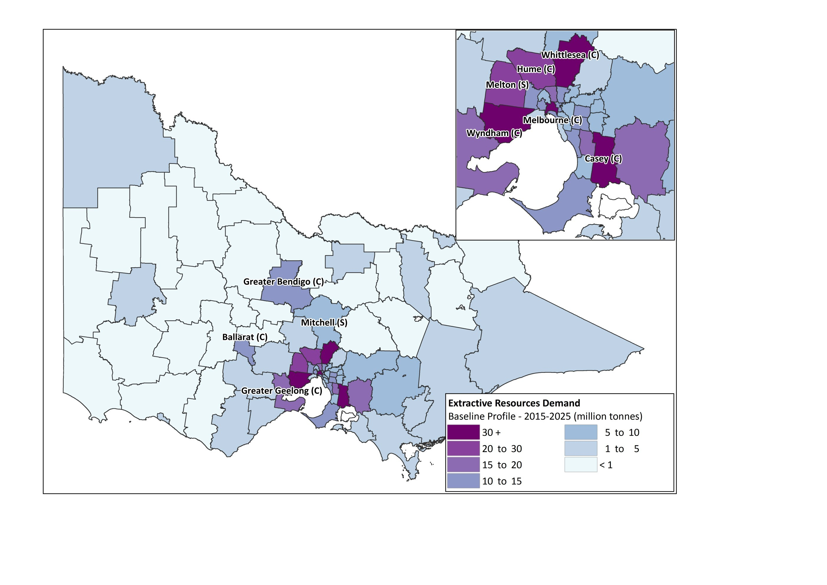
Source: EY analysis

Given the potential for significant year-on-year variations in the production and use of extractive resources across the construction industry, it is considered prudent for DEDJTR to consider the full range of results, summarised below, when informing future policy deliberations by the Taskforce or more broadly across the Victorian Government.
Table 2 – Scenarios analysis results – Total in 2015, 2026 and 2050 (million tonnes)
 | 2015 | 2026 | 2050
Total Demand Baseline | 46.4 | 55.8 | 87.8
Total Demand Scenario 1A – High Demand | 55.7 | 67.0 | 105.3
Total Demand Scenario 2A – Low Demand | 37.1 | 44.7 | 70.2
Source: EY analysis
Recommended next steps
Continued strong population growth and economic development is going to drive significant increases in the demand for extractive resources, especially in growing population centres in key Urban Growth Areas, infill suburbs in Metropolitan Melbourne and major regional centres like Ballarat, Geelong and Bendigo. As the extractive resources and construction industries respond to these persistent trends and industry pressures, there is likely to be a growing role for the further development and updating of these demand projections.
Through the process of completing this study, and to assist the DEDJTR and the Extractive Industries Taskforce, possible next steps that could be taken to enhance any future updates have been identified:
- The forecast model that has been developed to assess the needs for extractive resources from the construction sector in Victoria was calibrated based on historic production data and linked to the Victorian Government’s long term forecasts around population and economic growth. Given the limitations and the inherent challenges around undertaking year-on-year demand projections for the highly cyclical construction industry, future updates could consider approaches to readily accommodate up-to-date production data as they arise, particularly given the inherent volatility of extractive resources production.
- Stakeholder consultation implemented during the development process of the demand for extractive resources was quite limited in terms of number of stakeholders consulted. An extended market testing process may be considered so as to confirm and/or fine-tune the outcomes of the demand analysis.
- A constraint identified during the demand analysis was the lack of available data from a supply perspective, leading therefore to the development of an unconstrained demand forecast based on current patterns. Looking forward a more integrated supply and demand analysis could be contemplated to more explicitly account for possible regional supply constraints.
- Road base Class 1 and 2, concrete and concrete sand have been identified throughout the analysis as potential areas of concern due to their minimal substitutability. Should a similar exercise of forecasting the demand for extractive resources in Victoria be undertaken in the future, it may be recommended to narrow it down on those non-substitutable and highly consumed commodity products.

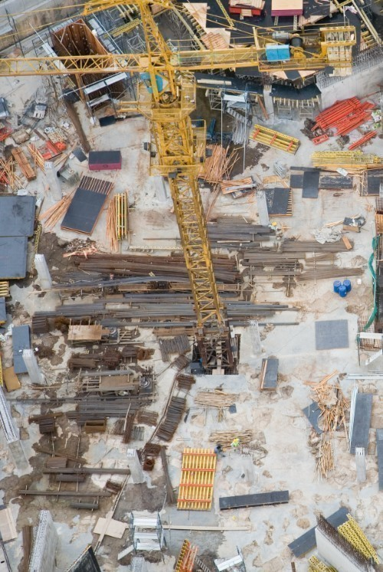
Introduction
- Introduction
This Report has been prepared for the Department of Economic Development, Jobs, Transport and Resources (DEDJTR), whose purpose is to create the conditions to sustainably develop the Victorian economy and grow employment.
This section outlines the reasons and scope of the study, the approach employed and the structure of the Report.
- Project background
The extractive industry sector is engaged in the extraction or removal of raw extractive materials including various forms of hard rock, limestone, clay and sand and gravel, from various quarry sites. It is defined as an industry if the primary purpose of the extraction or removal is the sale or commercial use of the stone or the use of stone in construction, building, road or manufacturing works, which includes the treatment of stone or the manufacture of a variety of different commodity products on or adjacent to the land from which the stone is extracted. Those commodity products include for example bricks, tiles, pottery, cement products, asphalt, aggregates and road paving used in the construction of public infrastructure such as roads and railways and in commercial and residential buildings.
Six main categories of extractive resources are defined in the Schedule 2 of the Mineral Resources (Sustainable Development) Extractive Industries Regulations Act 2010, listed as follows:
- Hard Rock0F
- Limestone (including limesand)
- Sand and Gravel (naturally occurring gravels, not crushed sedimentary rocks)
- Clay and Clay Shale
- Soil
- Peat
Due to the diversity of extractive resources uses, the extractive industries sector is an important contributor to Victoria’s economic development and the sustainability of the construction industry. The production of extractive resources grows as the demand for construction materials increases, which creates heightened challenges for the Victorian Government as competing land uses, particularly in urban and regional fringe areas, have the potential to sterilise strategic extractive resources and increase the cost and complexity of future construction activity. As the urban and regional development activity creeps closer to existing or reserved quarry operations there is an increasing need for land use policy to be informed by an understanding of the total demand and the available supply of extractive resources with respect to Victoria’s growth agenda.
Where the planning framework does not make adequate provision for quarrying as a potential land use, due to competing land uses such as residential development, especially in the fringe Greater Melbourne area, this could impact the economy, requiring increased transportation of quarried materials, which would also increase the costs of supply for end-users.
The Victorian Government recognises these challenges and the Extractive Industries Taskforce was established to identify current extractive resources and the future needs and future available supply of extractive resources, so as to appropriately inform the Victorian Government’s industry and land use policies. To support the Taskforce, the DEDJTR commissioned an independent demand research project to:
- Develop consolidated and regional views of the projected demand for extractive resources from 2015 to 2050, through the assessment of the needs for extractive resources from the public and private sectors. EY was appointed by the DEDJTR to undertake the demand analysis.
- Solicit the various perspectives held by industry across the supply chain in relation to available capacity and potential capacity constraints.
- Form an assessment on any regional gaps in the available capacity of the supply chain and the needs for extractive resources that may adversely impact the Victorian economy and lead to identify mitigating actions which could involve revisiting the Victorian Government land use policy. PwC was appointed by the DEDJTR to undertake the supply analysis as well as present a combined view of the demand and supply of extractive resources.
- Purpose of this Report
This Report has been prepared to inform the Extractive Industries Taskforce’s understanding of the total and regional demand requirements for extractive resources in Victoria’s Local Government Areas (LGAs) and provide a long term perspective on the demand of extractive resources across the private and public sectors, from 2015 to 2050 (financial years). The list of LGAs included in the scope of analysis is provided in Appendix B of this Report. These projections are to be used as an input to the integrated demand and supply analysis of the industry in order to identify strategic resources and inform the Taskforce in recommending future policy directions aimed at ensuring the longer term sustainability of the extractive resources and construction industries.
The set of final estimates, illustrating the future yearly demand for extractive resources per LGA and per type of extractive resources, as defined in the Schedule 2 of the Extractive Industries Regulations Act 2010, has been provided on 15 February 2016 to PwC. The demand data set was aligned with PwC requirements to align the demand analysis with their supply analysis and therefore facilitate their overall assessment. Key aggregated outputs from the final demand data set, including the results from the baseline set of demand projections and scenarios analyses, respectively presented in Sections 5 and 6 of the Report, are available in Appendix F.
In addition to the demand analysis, EY was mandated to support the overall assessment of the economic implications any gaps between the available capacity of the supply chain and the demand for extractive resources may have from a transportation perspective, where for instance needed to source materials from quarries located further away due to a shortage of required extractive materials to meet the needs in near-by quarries. A cost reckoner has been accordingly developed. Methodology and key results outputs from the cost reckoner are outlined in Appendix H of the Report.
- Methodology
Our approach to developing the long term projections of the demand for extractive resources across Victoria combines macroeconomic and demographic forecasting with a detailed analysis of the use of extractive resources within defined construction industry sectors.
To inform our approach, a supply and demand value chain was developed in consultation with the DEDJTR and its advisors. This enabled us to map the movement of extractive resources from production and conversion into commodity products, and through to different construction types that are provided to meet the various drivers of demand.
Macroeconomic forecasting
The analysis of the connection between different construction types and selected drivers of demand provides a set of defined relationships that underpin the basis for developing longer term demand projections linked to fundamental trends in the economy and Victoria’s demographic profile. This enabled us to link our projections to the Victorian Government’s forecasts for population, economic growth and employment, as well as to provide a baseline set of demand projections for validation and refinement through detailed industry analysis.
The initial starting point for the development of our macro-driven model was the analysis of the strong correlation between extractive resource production in one year and population growth in the following year, particularly in relation to hard rock which accounts for around 65% of extractive resource production.
However, in order to enhance the robustness of our analysis and ensure our model could be validated with detailed sector analysis, EY has developed a forecasting methodology that links production with a set of disaggregated demand drivers linked to each of the construction types identified.
The points below outline the key steps of our approach to developing a baseline set of (macro-driven) demand projections:
- Identification of historic relationships between macro-economic demand drivers and construction activities.
- Identification of historic relationships between construction activities and the total production of extractive resources. During the course of the demand analysis, undertaken from May to December 2015, this work relied on extractive resources production data provided by the DEDJTR. This data covered the period from 1991 to 2014.
- Develop a high level forecast of construction activities based on Victorian Government population and macroeconomic projections and in line with their long term relationships with different construction sectors.
- Forecast of the total demand for extractive resources, focusing on four key categories of extractive resources (hard rock, limestone, sand and gravel and clay and clay shale).
- Develop a spatial allocation per LGA of the demand for hard rock, limestone, sand and gravel and clay and clay shale, based on the spatial allocation of construction activities and key technical assumptions received from the DEDJTR’s technical advisors linking each construction activity with the use of extractive resources.
Detailed industry analysis
A further detailed industry analysis was undertaken to validate and refine our projections to account for the complex nature of the industry and the interdependent relationships between demand in certain locations and the supply of available extractive resources. This recognizes the tendency for the construction industry to make best use of what is available and can be transported to construction sites at least cost.
EY also developed detailed sector models in order to ensure that our overall forecasting framework was adequately representing demands for the full range of significant construction activities, including those that may not have a clear relationship to the macroeconomic drivers modelled at a higher level (e.g. wind farms and road network development and maintenance, where government policy directions and unique industry characteristics may influence construction trends). This required the development of models that linked assumptions about the construction mix in each sector with macroeconomic forecasts and information from the DEDJTR’s technical advisor, AECOM, engaged on 9 December 2015 by DEDJTR to identify and quantify extractive resources used in a selection of specific construction activities in Victoria.
The detailed industry analysis specifically consisted of developing a forecast based on the projections of the numbers of buildings and infrastructure projects expected to be built by the public and private sectors across Victoria (subject to available data in the public domain) and the conversion metrics provided by the DEDJTR’s technical advisor (AECOM) for each of those construction types, allowing to first identify the extractive resources used for each construction type, whether directly or through the manufacturing of commodity products, and then to calculate the quantity, in tonnes, of extractive resources required by construction type. The analysis consisted of developing a forecast for the following construction activities:
- Residential, consisting of projections in relation to the numbers of individual houses, townhouses and apartments expected to be built.
- Non-residential, consisting of projections in relation to the numbers of commercial, retail and industrial buildings, as well as the number of schools expected to be built.
- Transport, consisting of projections in relation to new roads expected to be built and works needed in terms of roads maintenance and rehabilitation.
- Major transport infrastructure projects expected to be built.
- Energy and utilities, consisting of the wind farm turbines expected to be built. Limited information available in the public domain, particularly to forecast corresponding construction activity over the period of analysis, prevented to inform a broader assessment of the construction of energy and utilities related infrastructures.
Further details in relation to the detailed industry analysis and assumptions used for its development are provided in Appendix C sub-section 2 of the Report.
Through this analysis EY validated its baseline macro-driven model and refined the spatial allocation per LGA of the demand for extractive resources, including the development of projections of hard rock demand with an increased level of granularity around the different types of hard rock (i.e. consisting of rock types including basalt old, basalt new, trachyte, dolerite, granite (incl. granodiorite, porphyry, microgranites), rhyodacite (incl. dacite, rhyolite), scoria, tuff, gneiss, hornfels, marble, quartzite, schist, slate and sedimentary (usually rippable rocks incl. sandstone, shale, siltstone chert, mudstone, claystone)). Those categories of extractive resources are defined in the Schedule 2 of the Mineral Resources (Sustainable Development) Extractive Industries Regulations Act 2010.
Further details in relation to each step implemented for the compilation of the baseline demand forecast are provided throughout the Report in Sections 3 to 7.
Recognising the inherent uncertainties in forecasting cyclical demand and supply factors over the longer term, this Report outlines a range of demand projections, including both high and low demand profiles around a central estimate. Given the potential for significant year-on-year variations in the production and use of extractive resources across the construction industry, it is considered prudent for the DEDJTR to consider the full range of results when informing future policy deliberations by the Taskforce or more broadly across the Victorian Government. In this regard, the demand analysis of the extractive resources in Victoria is a “first of its kind” exercise. While the demand projections are strongly indicative for the purposes of policy making, they carry a number of important limitations related to the complexity of the construction and extractive resources industries, as well as future uncertainties around regional extractive resources supply constraints and construction methods, which have not been assessed as part of this study. Further information about the limitations inherent to the approach and analysis are presented in Appendix A of the Report.
Sources
To develop the baseline demand profile, a number of sources have been considered, non-exhaustively listed as follows:
- DEDJTR, in relation to the historic production of extractive resources in Victoria, provided from 1991 to 2014, and Victoria Transport Modelling (VITM) data with respect to 2046 population projections by LGA and employment projections by LGA in 2011, 2021, 2031 and 2046.
- Victoria in the Future 2015 (VIF 2015), with respect to 2011, 2021 and 2031 population and household size projections by LGA and Statistical Areas Level 2 (SA2).
- Australian Bureau of Statistics (ABS) data, with respect to the construction value of works done per type of construction activities, population, labour force, dwellings approval and structure.
- State Budget Papers in relation to the Gross State Product (GSP) historic data and projections and government spending on infrastructure.
- Other Government sources (e.g. Australian Grant Commission Annual Reports, growth areas precinct plans).
- Reserve Bank of Australia (RBA) with respect to interest rates historic data.
- BIS Shrapnel – Engineering Construction Activity data to identify transport major projects planned to be developed by the Victorian Government.
- EY knowledge on future infrastructure transport projects.
- Additional reports, such as the Economic Contribution of the Extractive Industries in Victoria prepared for Cement Concrete & Aggregates Australia in May 2006 that helped inform the analysis.
- Interviews with industry stakeholders, through a formal stakeholder consultation launched by the DEDJTR on 22 October 2015. The list of organizations consulted is provided in Appendix D of the Report and the findings from this process in Appendix E of the Report.
- Final inputs from the DEDJTR’s technical advisor, AECOM, provided on 23 December 2015 under the form of excel spreadsheets. AECOM was engaged on 9 December 2015 by the DEDJTR to identify and quantify extractive resources used in Victoria’s construction activities.
Further details in relation to the exhaustive list of data sources used to develop the baseline demand forecast and the detailed industry models are provided in Appendix C of the Report.
- Key assumptions and parameters of scope
Underpinning this study is a number of assumptions and determinations of scope designed to achieve an effective balance between the study’s comprehensiveness and level of focus.
Timeframe
The demand analysis has been considered over two time periods, in accordance with the DEDJTR’s specifications in its original request for tender:
- 2015 – 2025: detailed forecasts
- 2026 – 2050: broader forecasts
A similar level of detail, in terms of demand forecast and breakdown, has been however provided during those two periods to PwC on 15 February 2016, to align with the information required to help form an overall assessment of potential regional gaps between the demand and the supply analysis.
Extractive resources
The list of extractive resources considered for the demand analysis was developed in accordance with the definition of extractive resources provided in the Schedule 2 of the Mineral Resources (Sustainable Development) Extractive Industries Regulations Act 2010.
Geographic scope for the study of demand
As agreed with the DEDJTR during the process, the study has been undertaken on an LGA basis across Victoria.
Historic production for extractive resources
The historic production data were provided by the DEDJTR until 2014. Used as a benchmark reference to develop the demand forecast, the assumption to do so was to consider that the production of extractive resources equalled the consumption during this period.
All assumptions considered for the development of the baseline demand profile (macro-economic driven approach) and the development of the detailed industry analysis, for refinement and validation purposes, are provided in the Assumptions Book prepared in Appendix C of the Report.

- Structure of the Report
The structure of the report is as follows:
- Section 1 is an introduction, covering the areas of concerns to the DEDJTR that led to undertake this analysis, and summarizing the methodology and key sources used to development the demand analysis.
- Section 2 provides an overview of the extractive resources sector in Victoria, summarizing the findings from the process undertaken to define the supply and demand value chain peculiar to the extractive industries sector and outlining the use of extractive resources in Victoria’s construction sector, instrumental in tailoring the demand modelling.
- Section 3 presents the historic analysis undertaken, founding base of the methodology.
- Section 4 summarizes the process undertaken to forecast construction activities in Victoria over the period of analysis, another pillar of the methodology developed to assess the demand profile for extractive resources.
- Section 5 presents the results of the baseline demand modelling and key findings.
- Section 6 outlines the development of scenarios for demand modelling and presents the results.
- Section 7 provides broader insights for the DEDJTR, collated from stakeholders’ interviews.
- Section 8 outlines the recommended next steps.

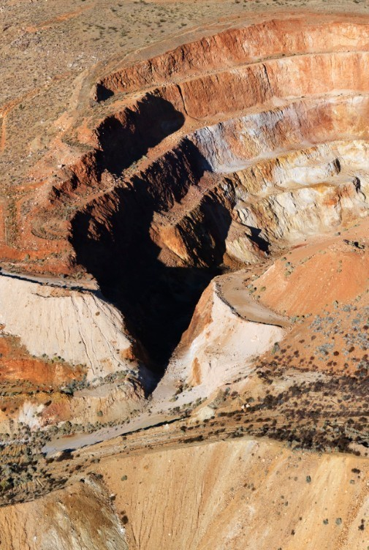
Overview of the extractive industry sector in Victoria
- Overview of the extractive industry sector in Victoria
- Supply and demand value chain
The supply and demand value chain of the extractive industry sector was developed in consultation with the DEDJTR and its advisors to address the following key questions and therefore inform our approach:
- How does the extractive industry work and what are the linkages across the production of extractive resources and commodity products, and the different sectors of the construction industry?
- What are the key demand drivers of the demand for different kinds of construction extractive resources?
- What do the different demand drivers imply for the production and consumption of extractive resources?
This process enabled us to clearly map the movement of extractive resources from production and conversion into commodity products, and through to different construction types that are provided to meet the various drivers of demand.
The key findings from this mapping process are listed as follows and summarized in Figure 4 below:
- The construction activities driving the consumption of extractive resources are:
- Residential building construction, consisting of the construction of dwellings. The residential construction activity represents on average 51% of the overall construction activity, in terms of nominal construction spend in Victoria from 2002 to 2014.
- Non-residential building construction, consisting of the construction of commercial, retail and industrial buildings, as well as social related buildings, such as health, education and community buildings. The non-residential construction activity represents on average 20% of the overall construction activity, in terms of nominal construction spend in Victoria from 2002 to 2014.
- Transport engineering construction, consisting of the construction of new roads and the maintenance and rehabilitation works inherent to the existing road network. This category also includes major transport projects, such as the construction of bridges, railways and airports. The transport construction activity represents on average 12% of the overall construction activity, in terms of construction spend in Victoria from 2002 to 2014.
- Energy and Utilities engineering construction, consisting of the construction of water treatment plants, power transmissions lines and footings, pipes, pits and backfill/thrust blocks, dams, solar farms, power stations and substations and wind farms. The energy and utilities construction activity represents on average 18% of the overall construction activity, in terms of construction spend in Victoria from 2002 to 2014.
The weight of each of those construction activities within the construction sector is summarized in the below figure. The residential building construction activity represents the most important proportion of the construction sector. Overall, activities within the Building Construction sector represent 70% of the construction sector in terms of construction spend in Victoria from 2002 to 2014, while construction activities traditionally directly correlated with population growth represent 82% of the construction sector in Victoria (i.e. Building Construction associated with Transport Engineering Construction).

- Figure 2 – Construction Activities Weightings in Victoria – Average of the last 12 years
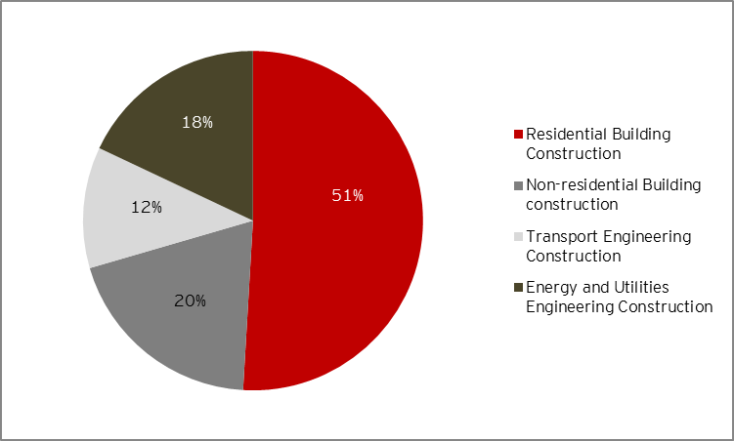
Source: EY analysis
The historic evolution of the nominal construction spend per type of construction activity identified as driving the consumption of extractive resources is provided in Figure 3 below. Data in Figure 3 indicates that although there is evidence of cyclical patterns that affect each type of construction activity during specific years, the overall trends in shares of activity have remained relatively stable over the last 12 years. It is therefore considered that the historic trends in construction activity across these sectors and relationships with broader macroeconomics variables would provide a reasonable basis for considering future construction activity.
- Figure 3 – Breakdown of construction spend per construction activity – 2002-2014
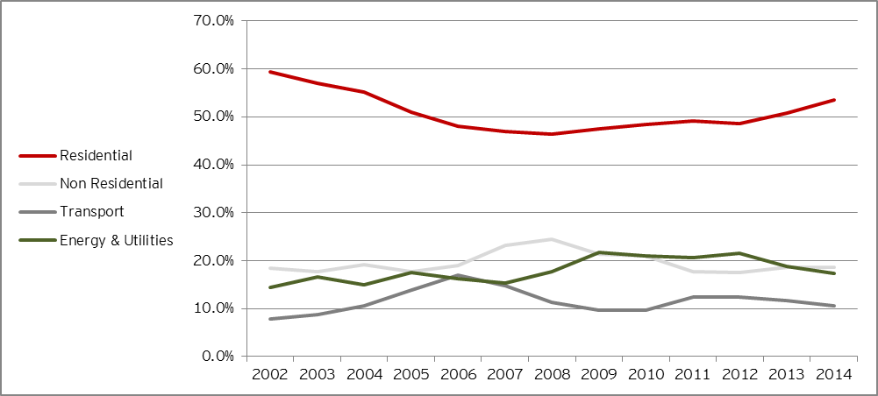
Source: EY analysis
- Macro-economic demand drivers that influence construction trends are:
- Population and household growth with respect to the construction of residential dwellings.
- Employment growth with respect to the non-residential construction (including office, retail and industrial).
- Public and private sectors infrastructure investment with respect to Engineering Construction.

The supply and demand value chain presented in the below figures forms the practical basis of our analysis.
- Figure 4 – Value Chain Flow Diagram
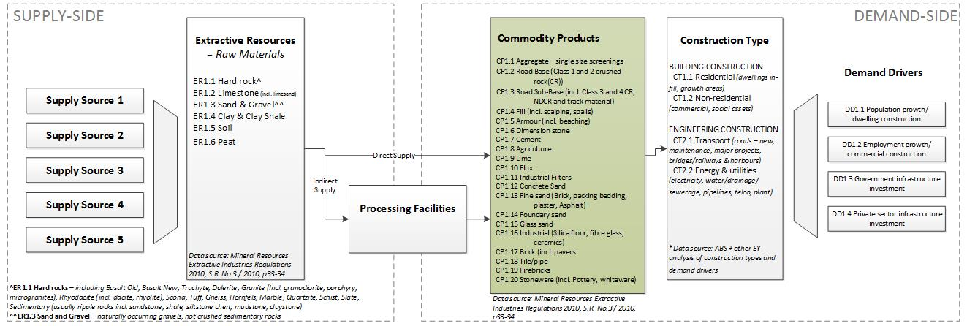
Source: EY analysis

The list of Commodity Products outlined in Figure 4 is extracted from the Mineral Resources Extractive Industries Regulations Act 2010. Note that although ‘CP1.8 Agriculture’ is listed as one of the commodity products, it is not used in building and construction but rather in farming sector.
The main limitation of the supply and demand value chain is that it does not outline one of the key features of the extractive industry sector, which is that there is a high dependency and interaction between the supply and the demand for extractive resources.
The demand for commodity products within a region is primarily driven by the construction types within that region. However, for a wide range of commodity products such as road materials, aggregates and fill, the requirements for the product can be strongly driven by the local availability of raw materials of the required quality. For example, in most regions, the demand for road base materials is met by the locally available raw materials that meet specification requirements, not a particular rock type. Breaking down the demand into the supply sources without reference to the specifications or the quality of the supply sources, as noted in the figure above, may be misleading. A most useful indicator in the assessment of a demand profile may be the commodity product and the extractive resources definitions, the demand for extractive resources being interconnected with the demand for commodity products required by the construction sector. For a concrete mix for example, it may be more meaningful to focus on the identification of the quantity of aggregate (i.e. hard rock) and quality requirements needed (e.g. durability, hardness, friction rating), which can be met by a range of hard rock types, rather than on the actual type of hard rock (e.g. basalt, hornfels). This granular analysis can be subject to the regional specificities of the supply and the technical specifications of the required commodity products.
Despite this limitation of the value chain, it provides an important foundation and starting position for the analysis of the various factors that contribute to the use of extractive resources at the level of different types of construction activities and underlying demand.
Through this framework, EY was able to link the historic production of different resources with recorded levels of construction activity and, through those, with macroeconomic and demographic trends. These relationships are explored in the following sections, with the detailed projections of long term demand for extractive resources presented thereafter.
- Uses of extractive resources in Victoria
Extractive resources are used as direct inputs to building, construction and infrastructure projects and are also transformed into commodity products, i.e. finished outputs such as bricks, tiles, road paving, cement products, asphalt, or aggregates (defined as crushed extractive stones, then screened into a specific narrow size range).
This sub-section presents the key findings from the stakeholders’ consultation process and the DEDJTR technical advisor’s (AECOM) works, in relation to the actual uses of extractive resources in Victoria.
- Role of extractive resources in the Victoria construction sector
Extractive resources are used as direct inputs to building, construction and infrastructure projects and are also transformed into commodity products, i.e. finished outputs such as bricks, tiles, road paving, cement products, asphalt, or aggregates (defined as crushed extractive stones, then screened into a specific narrow size range).
Stone, as referenced above, can mean sandstone, freestone, basalt, granite, limestone, or other similar materials. Materials which are currently extracted in Victoria, as well as the most common manufactured commodity products used by construction end-users such as Brookfield Multiplex or Lend Lease, are identified in the below table, in accordance with the Schedule 2 of the Mineral Resources (Sustainable Development) Extractive Industries Regulations Act 2010 and the extractive industry value chain diagram presented in Figure 4 of the Report.

Table 3 – Materials and commodity products extracted in Victoria
Rock types | Commodity products
- Basalt Old (Hard Rock)  - Basalt New (Hard Rock)  - Trachyte (Hard Rock)  - Dolerite (Hard Rock)  - Granite (including granodiorite, porphyry, microgranites) (Hard Rock)  - Rhyodacite (including dacite, rhyolite) (Hard Rock)  - Scoria (Hard Rock)  - Tuff (Hard Rock)  - Gneiss (Hard Rock)  - Hornfels (Hard Rock)  - Marble (Hard Rock)  - Quartzite (Hard Rock)  - Schist (Hard Rock)  - Slate (Hard Rock)  - Sedimentary (usually rippable rocks including sandstone, shale, siltstone chert, mudstone, claystone) (Hard Rock)  - Limestone (including limes and) (Soft Rock)  - Sand and Gravel (naturally occurring gravels, not crushed sedimentary rocks) (Soft Rock)  - Clay and clay shale (Soft Rock)  - Soil (Soft Rock)  - Peat (Soft Rock) | - Aggregate (i.e. aggregate, rail ballast, filler material) single size screenings such as concrete  - Road Base (Class 1 and 2 crushed rock (CR))  - Road Sub-Base (incl. Class 3 and 4 CR, NDCR and track material)  - Fill (incl. scalpings, spalls)  - Armour (incl. beaching)  - Dimension stone  - Cement  - Agriculture  - Lime  - Flux  - Industrial Filters  - Concrete sand  - Fine sand (Brick, Packing Bedding, Plaster, Asphalt)  - Foundry sand  - Glass sand  - Industrial (silica flour, fibre glass, ceramics, etc.)  - Brick (incl. Pavers)  - Tile/Pipe  - Firebricks  - Stoneware (incl. Pottery, Whiteware)
Source: Schedule 2 of the Mineral Resources (Sustainable Development) Extractive Industries Regulations Act 2010

Commodity products
In light of the key construction activities presented above that are driving the consumption of extractive resources in Victoria, discussions with consulted construction stakeholders (referred to in Appendix D of the Report) and AECOM works indicated that a few of the commodity products presented in the above Table 3 were actually used by those key construction activities, listed as follows:
- Single size aggregate
- Road Base Class 1 and 2
- Road Sub-Base including Class 3 and 4
- Fill
- Armour
- Dimension stone
- Cement
- Lime
- Concrete Sand
- Fine Sand
The uses of commodity products per type of analysed construction activities are presented in below Table 4. The commodity products highlighted in orange are the most intensively used in each of those construction activities and should therefore be considered as critical and focused on in terms of extractive resources consumption, as they are expected to significantly drive the latter.

Table 4 – Uses of commodity products in Victoria per type of construction activities
 | Residential activity | Non-residential activity | Transport activity | Major transport projects | Wind farm projects
Aggregate single size screenings |  |  |  | *
Road Base Class 1 and 2
Road Sub-Base (incl. Class 3 and 4 CR, NDCR and track material)
Fill |  |  |  | **
Armour |  |  |  | **
Dimension stone
Cement
Agriculture
Lime
Flux
Industrial Filters
Concrete sand
Fine sand
Foundry sand
Glass sand
Industrial
Brick
Tile/Pipe
Firebricks
Stoneware
Source: EY analysis relying up stakeholders consultation and AECOM works
* In relation to rail tunnels
** In relation to rail tracks

Glass sand, used for the manufacture of glass related products (such as facades), is not listed as a commonly used commodity product in the above table. This is related to a current trend in the construction market, most glass related products being procured outside of Australia and therefore not extracted in Victoria.
Extractive Resources
For each of the most commonly used commodity products, the following main categories of extractive materials have been identified as playing a key role in their manufacturing process in Victoria:
Table 5 – Uses of extractive materials in the manufacture of commodity products
Commodity products | Rock types
- Aggregate single size screenings | - Hard Rock
- Road Base Class 1 and 2 | - Hard Rock
- Road Sub-Base (incl. Class 3 and 4 CR, NDCR and track material) | - Hard Rock
- Fill | - Hard Rock  - Sand and Gravel (Soft Rock)
- Armour | - Hard Rock
- Dimension Stone | - Hard Rock
- Cement | - Limestone (Soft Rock)  - Sand and Gravel (Soft Rock)  - Clay and Clay Shale (Soft Rock)
- Lime | - Limestone (Soft Rock)
- Concrete Sand | - Sand and Gravel (Soft Rock)
- Fine Sand | - Sand and Gravel (Soft Rock)
Source: AECOM

Construction stakeholders consultation as well as AECOM works led to identify that amongst the extractive materials listed in the above Table 5, soil and peat were not consumed by the construction activities driving the overall consumption of extractive resources in Victoria. Those categories have therefore been excluded from the demand analysis and consequently from the baseline demand data set.
Within the Hard Rock category, the construction stakeholders consultation as well as AECOM works also led to identify that hard rocks’ sub-categories listed in the above Table 5 were not all consumed by the key construction activities driving the overall consumption of extractive resources in Victoria, while a few of them were used more significantly than others. Out of the 15 different categories of hard rocks provided in the Schedule 2 of the Mineral Resources (Sustainable Development) Extractive Industries Regulations Act 2010:
- Dolerite and marble are not used, either directly or for the manufacture of commodity products consumed by the residential, non-residential, transport and energy and utilities construction activities.
- Basalt Old, Basalt New, Hornfels, Granite and Rhyodacite are the most commonly used hard rocks in Victoria, subject to the regional availability of extractive materials.
Within the Sand and Gravel category, the detailed industry analysis enabled to identify the share of soft rocks attributable to concrete sand (combined with subsurface drainage sand) and fine sand, per type of construction activities. The table below presents the consolidated findings of this analysis. Sand and gravel is also extracted as a key resource for the following construction materials and elements:
- Cement, across all construction activities.
- Fill, mainly within the transport construction activity, including major transport projects.
- Brick, mainly within the residential construction activity.
Table 6 – Breakdown of Sand and Gravel uses per type of construction activities in Victoria
 | Concrete sand and subsurface drainage sand  (%) | Fine Sand (Brick, Bedding, Mortar)  (%) | Others (cement, fill)  (%) | Total  (%)
Residential Activity | 60% | 23% | 17% | 100%
Non Residential Activity | 86% | 1% | 13% | 100%
Transport (excluding major projects) Activity | 11% | 2% | 88% | 100%
Transport Major Projects | 26% | 0% | 74% | 100%
Energy and Utilities Activity | 87% | 0% | 13% | 100%
Source: EY analysis based on AECOM inputs

The detailed industry analysis identified that these shares of Sand and Gravel attributable to specific commodity products are stable over time for all construction activities. As such, consumption of concrete and fine sand varies with the evolving mix of construction activity.
Regional allocation of hard rocks in Victoria
Works performed by AECOM also helped inform the potential break down of the uses of hard rocks on a regional basis, relying on the availability of the materials in those specific areas. Concordance between the regions considered in AECOM analysis and the LGAs considered for the demand analysis is provided in Appendix B of the Report. Table 7 below summarizes the key findings, in terms of spatial allocation of the demand for hard rocks, derived from AECOM works.

Table 7 – Spatial allocation of hard rocks in Victoria
 | Barwon | Central Highlands | Gippsland | Goulburn | Great South Coast | Greater Melbourne | Loddon Campaspe | Mallee | Ovens Murray | Wimmera Southern Mallee
Basalt Old | 1.60% | - | 51.33% | 16.04% | 1.21% | 6.62% | 13.00% | - | - | -
Basalt New | 97.99% | 90.17% | 26.70% | 59.14% | 91.47% | 47.92% | 56.42% | - | - | 28.94%
Trachyte | - | - | - | - | 2.10% | - | - | - | - | -
Dolerite | - | - | - | - | - | - | - | - | - | -
Scoria | 0.30% | 0.49% | - | 0.05% | 1.70% | 0.03% | - | - | - | -
Tuff | 0.05% | - | 0.002% | - | 0.95% | - | - | - | - | -
Granite | - | 2.37% | 14.66% | 1.49% | 1.94% | 13.60% | 10.25% | 53.08% | 55.28% | 0.11%
Rhyodacite | - | - | - | 0.79% | - | 6.45% | 19.56% | - | 20.18% | 8.40%
Gneiss | - | - | - | - | - | - | - | - | 1.10% | -
Hornfels | - | 0.15% | 5.80% | 22.30% | - | 25.18% | 0.52% | - | 18.05% | 57.00%
Marble | - | - | - | - | - | - | - | - | - | -
Quartzite | 0.06% | 6.76% | 1.31% | - | - | - | 0.09% | - | - | 1.96%
Schist | - | - | - | - | - | - | - | 42.00% | 4.39% | -
Slate | - | 0.03% | - | - | - | - | 0.07% | - | - | -
Sedimentary | - | 0.03% | 0.20% | 0.20% | 0.63% | 0.21% | 0.09% | 4.92% | 1.00% | 3.60%
Source: EY analysis based on AECOM inputs
- Use of recycled materials in the Victorian construction sector
Recycling is a burgeoning industry in Victoria as an initiative to reduce cost and improve environmental sustainability.
While not providing quantities estimates, AECOM works indicated that substitute materials are currently used during the manufacturing process of commodity products used by construction end-users:
- Recycled concrete materials can be used in the required mix to manufacture Road Base Class 1 and 2 and Single Size Aggregate commodity products.
- Reclaimed asphalt can be used in the required mix to manufacture asphalt out of Road Base Class 1 and 2 commodity product. Reclaimed asphalt is currently representing on average 15% of the quantity of asphalt consumed, proportion that could potential increase to up to 30% over the next 20 to 30 years.
VicRoads furthermore indicated that it adjusted its specifications in the latest years to accommodate the use of materials for Road Base Sub-Base Class 3 and 4 and Type A materials, subject to the suitability of those materials to their intended use, to be identified on a project by project basis. Recycled materials are also commonly used to fill batters and for other landscaping purposes where the properties required (e.g. strength or permeability) are different to road construction and structure.
Manufactured (or reclaimed) sand can also be used as a substitute to natural concrete sand in the concrete mix. This is a growing trend as natural available resources in terms of natural concrete sand used in the concrete mix are declining, for instance in metropolitan Melbourne.

However, it should be noted that the use of recycled materials has its own limitations:
- Within the transport construction activity, the use of recycled materials, which could potentially be optimized through a more consistent use within the State, is not expected to increase substantially unless a higher amount of materials from demolition activities is available in the coming years.
- Higher quality materials required for instance for roads construction works (e.g. Road Base Class 1 and 2) cannot be substituted.
- The use of recycled concrete is generally limited as, being a product from demolition activities, its particular properties tend to limit its use. It requires for instance to remove steel and fire materials, such as plastic and timber, from the demolition products before a potential use as a substitute. As such, it also requires specific approval prior to any use, which creates additional limitations to its use.
- The use of manufactured sand in the concrete mix highly depends on the required technical specifications on a project by project basis, depending for instance on the required strength of concrete for any type of constructions. In addition, from a cost perspective, the use of reclaimed sand may not always add value for money to the projects.
In conclusion, although the use of recycled materials is a growing trend, some commodity products that are the most significantly used by the construction industry, such as Road Base Class 1 and 2, Single Size Aggregate (concrete) and concrete sand, are not easily substitutable and should as a result be considered as areas of concern in terms of cost to the State, should extractive resources paramount to their manufacture (i.e. high quality hard rock for concrete) be constrained or exhausted.

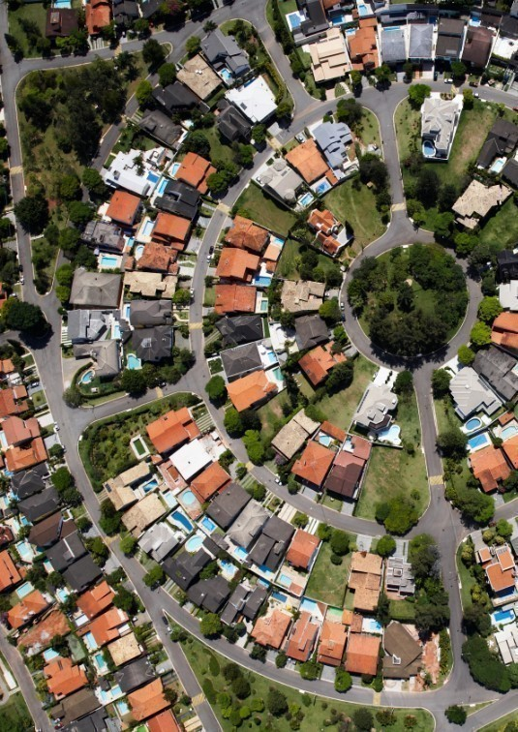
Historic analysis
- Historic analysis
The baseline model to assess the demand for extractive resources, from 2015 to 2050, has been developed based on the analysis of the historic relationships between the production of extractive resources, different construction types and selected drivers of demand, including fundamental trends in the economic and Victoria’s demographic profile.
This section focuses on the historic relationships established between the total production of extractive resources, the construction activities and the macro-economic demand drivers, to identify trends and help develop a robust forecast framework.
- Historic relationships between macro-economic demand drivers and construction activities
- Process
The initial starting point for the development of our macro-driven model was the analysis of the strong correlation between extractive resource production in one year and population growth in the following year, particularly in relation to hard rock which accounts for around 65% of extractive resource production. This strong correlation is illustrated in the below Figure 5.
- Figure 5 – Historic relationship between population growth and extractive resources production from 2002 to 2014
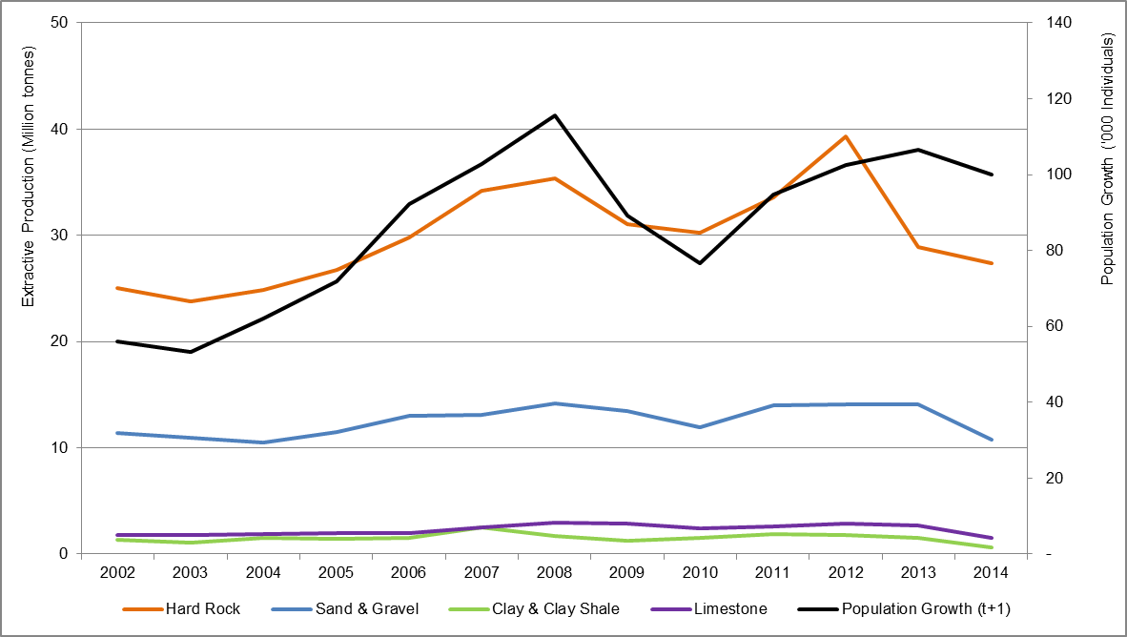
Source: EY analysis
However, in order to enhance the robustness of our analysis and ensure our model could be validated with detailed sector analysis, EY has developed a forecasting methodology that links production with a set of disaggregated demand drivers linked to each of the construction types identified throughout the supply-demand value chain process.
Building a macro-driven forecast therefore first consisted of identifying strong historic relationships between macro-economic demand drivers and construction activities.
The following historic data sets have been sourced to perform the analyses required to identify robust historic relationships. Official sources of those data have been listed in Appendix C of the Report.
- With respect to potential macro-economic demand drivers, the following have been analysed:
- Population growth (in number of people)
- GSP (in real $m)
- Interest Rate (in %)
- Employment growth (in number of people)
- In accordance with the key construction activities identified as relevant for the extractive resources sector, through the supply value chain analysis presented in Section 3 of the Report, the following activities have been analysed, in 2015 prices to remove the yearly impact of inflation over the period of analysis:
- Residential activity
- Non-Residential activity
- Transport activity
- Energy and Utility activity
- Findings
Analysis conducted between macro-economic demand drivers and construction activities identified the following relationships, based on historic data available:
- Residential construction activity is historically correlated with population growth, as illustrated in the below graph.
- Figure 6 – Historic Relationship between residential activity and population growth
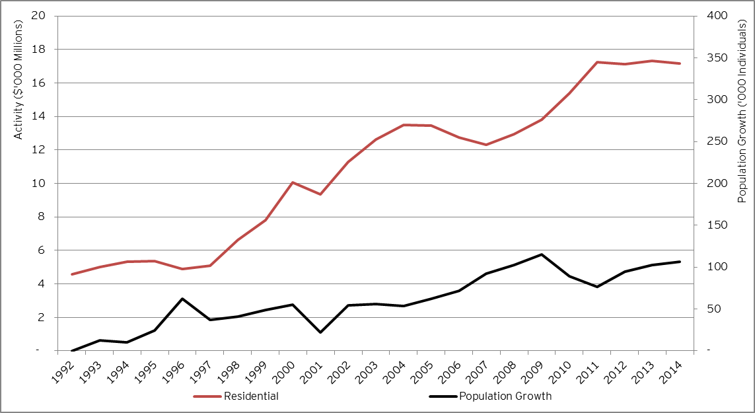
Source: EY analysis
- Non-residential construction activity is historically correlated with the GSP, as illustrated in the below graph.
- Figure 7 – Historic relationship between non-residential activity and GSP
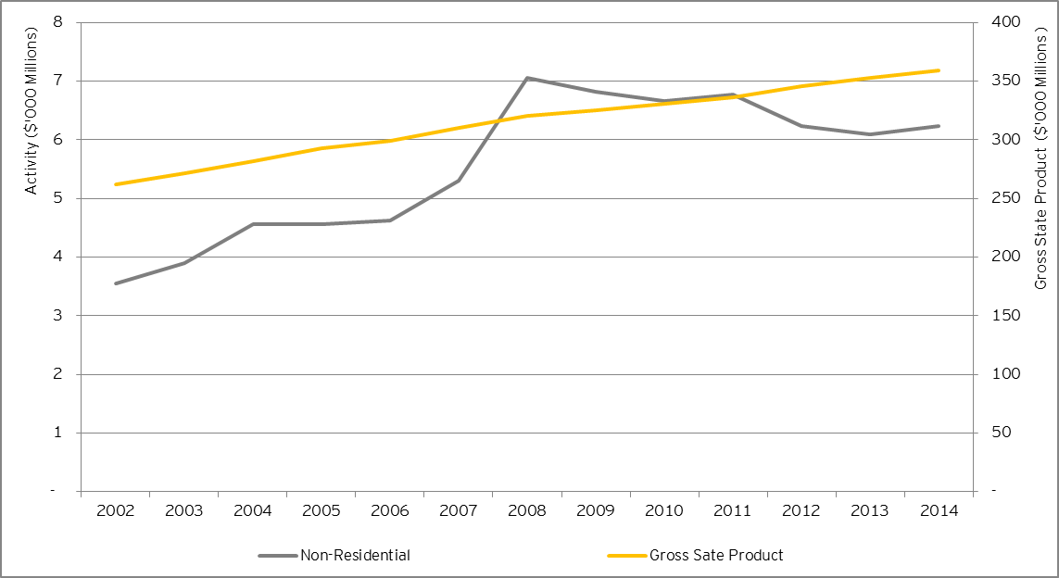
Source: EY analysis

- Transport construction activity is highly cyclical, however is generally correlated with the long term movement in GSP, as illustrated in the below graph.
- Figure 8 – Historic relationship between transport activity and GSP
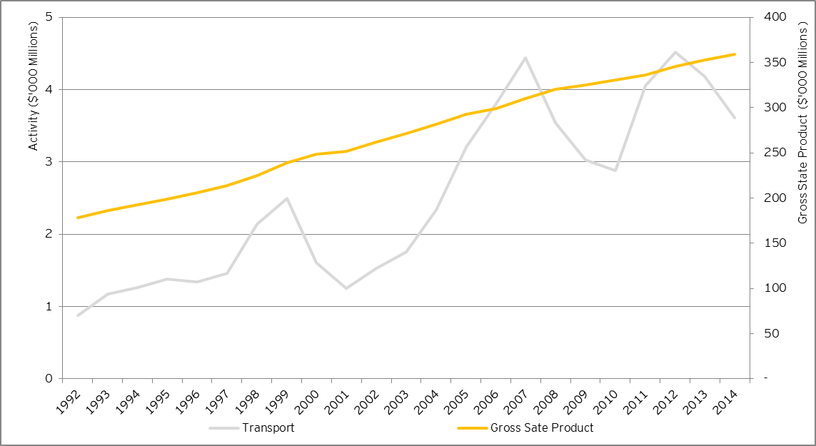
Source: EY analysis

- Energy and utilities related construction activity is also cyclical and broadly correlated with the long term movement in GSP, as illustrated in the below graph:
- Figure 9 – Historic relationship between energy and utility activity and GSP
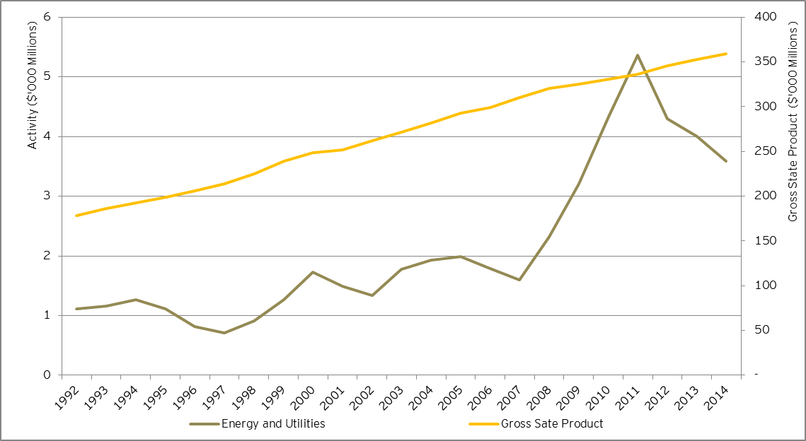
Source: EY analysis

The surge in energy and utilities related construction activity from 2008 to 2011 is related to a strong increase during this period of the construction spend ($) within the water storage and supply, sewerage and drainage and electricity generation, transmission and pipeline sectors, proportionately more important in the water sector which grew by a yearly increase of 63% over the period, compared to 21% in the electricity sector.
These trends reflected the Victorian Government’s significant investments in water infrastructure over the last decade to ensure the State’s water security, including:
- Melbourne Desalination Plant
- Sugarloaf (North-South) Pipeline
- Tarago-Warragul-Moe Pipeline
- Wimmera Mallee Interconnector
- Goldfields Superpipe
- Hamilton Grampians Interconnector
From 2012 onward, the construction spend within the Energy and Utilities related construction activity decreased overall, although this trend was more significant within the water sector.

- Historic relationships between construction activities and the total production of extractive resources
- Process
Building a macro-driven forecast secondly consisted of identifying strong historic relationships between construction activities and the total production of extractive resources.
The following historic data sets have been sourced to identify robust relationships. Official sources of those data have been listed in Appendix C of the Report.
Historic data used in relation to the production of extractive resources in Victoria have been provided by the DEDJTR, on a financial year basis, in May 2015, from 1991 to 2014. The inputs used for the analysis, from 2002 to 2014, are summarized in the Table 8 below.
Table 8 – Production of Extractive Resources 2002 – 2014 (in million tonnes)
Rock type | 2002 | 2003 | 2004 | 2005 | 2006 | 2007 | 2008 | 2009 | 2010 | 2011 | 2012 | 2013 | 2014
Hard Rock | 25.0 | 23.8 | 24.9 | 26.7 | 29.8 | 34.2 | 35.4 | 31.1 | 30.3 | 33.5 | 39.3 | 28.9 | 27.4
Clay and Clay Shale | 1.3 | 1.1 | 1.5 | 1.4 | 1.5 | 2.5 | 1.7 | 1.3 | 1.5 | 1.9 | 1.8 | 1.6 | 0.6
Limestone | 1.8 | 1.8 | 1.9 | 2.0 | 2.0 | 2.5 | 3.0 | 2.8 | 2.4 | 2.6 | 2.9 | 2.7 | 1.5
Sand and Gravel | 11.4 | 10.9 | 10.5 | 11.5 | 13.0 | 13.1 | 14.2 | 13.5 | 11.9 | 14.0 | 14.1 | 14.0 | 10.8
Total | 39.5 | 37.6 | 38.8 | 41.6 | 46.4 | 52.3 | 54.2 | 48.7 | 46.1 | 52.1 | 58.1 | 47.2 | 40.3
Source: DEDJTR
In accordance with the key construction activities identified as relevant for the extractive resources sector, through the supply value chain analysis presented in Section 2 of the Report, the following activities have been analysed, in 2015 prices to remove the yearly impact of inflation over the period of analysis:
- Residential activity
- Non-Residential activity
- Transport activity
- Energy and Utility activity
- Findings
Analyses conducted between construction activities and the total production of extractive resources identified the following relationships, based on historic data available:
- Hard rock production moves in line with residential and non-residential construction activities.
- Clay and clay shale production moves with residential construction activities, albeit on a lower scale.
- Limestone production is historically correlated with non-residential construction activities, also on a lower scale.
- Sand and gravel production is historically correlated with residential construction activities.
Figure 10 illustrates the correlations between the residential construction activities and hard rock, clay and clay shale and sand and gravel productions, while Figure 11 illustrates the correlations between the non-residential construction activities and hard rock and limestone productions.

Figure 10 – Historic relationship between residential activity and total production of hard rock, clay and clay shale and sand and gravel
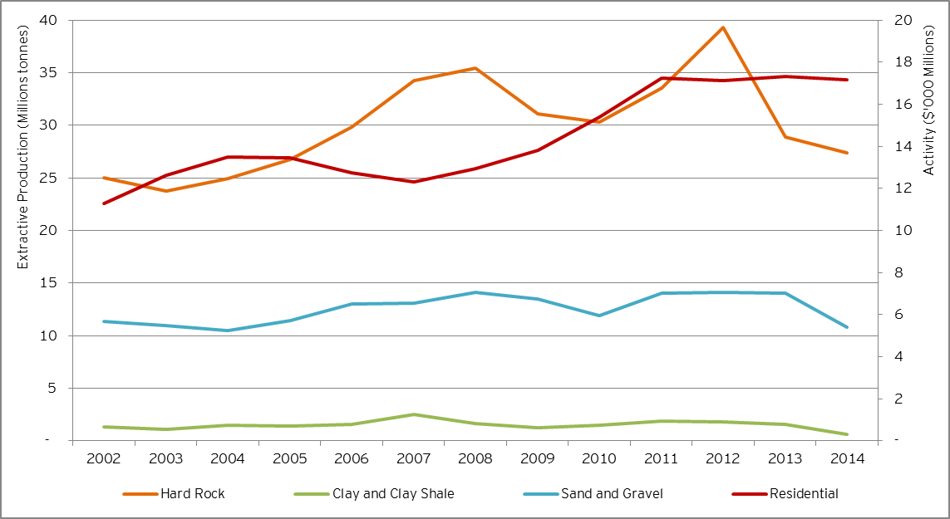
Source: EY analysis

Figure 11 – Historic relationship between non-residential activity and the total production of hard rock and limestone
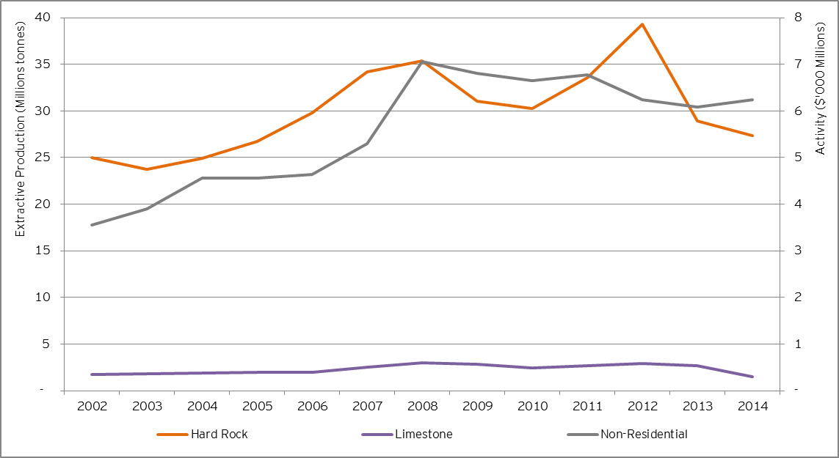
Source: EY analysis
Note that the analyses conducted in relation to historic relationships between construction activities, based on the value of work done, and the total production of extractive resources over the last 12 years, led us identifying a break in the trends observed. We illustrated this break in trend in the recent years in Figure 12 below, through the analysis of aggregate construction from 2002 to 2015 and aggregate production of extractive resources from 2002 to 2014, based on data available.
- Figure 12 – High level analysis of historic resource production and construction activities
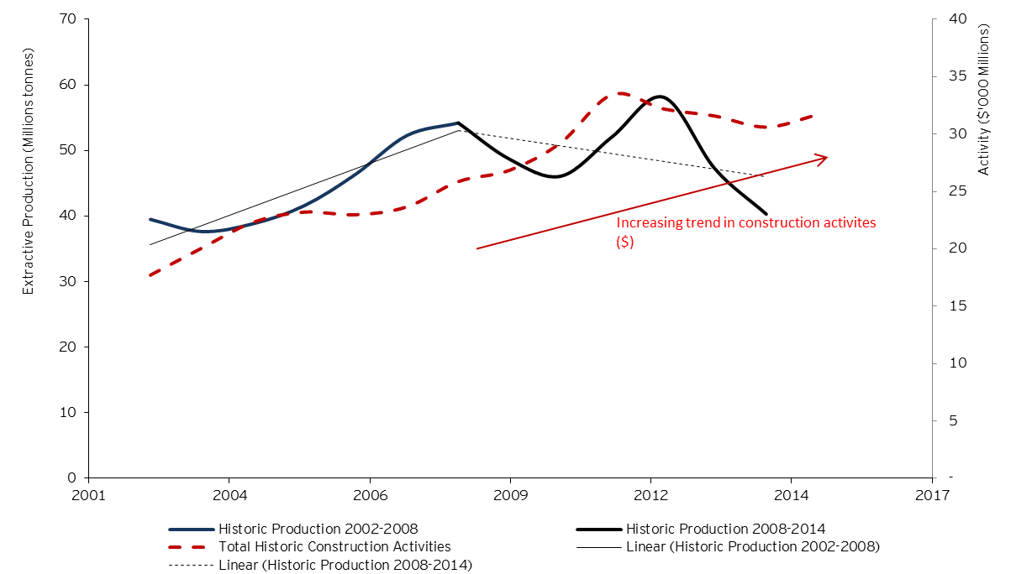
Source: EY analysis
Figure 12 above shows a break in the trend of the historic production of extractive resources since around 2008, compared to aggregate construction activity (refer to red line and approximate trend).
The production of extractive resources appears to have been cyclical over the more recent timeframe, compared to construction activity (albeit the above presentation masks sector by sector variations), evolving in an opposite direction. This observation raised concerns that there could be some supply side changes that would need to be considered in basing our demand forecast if persisting over the medium to long term.
Preliminary indicative 2015 draft data provided by the DEDJTR, in relation to the production of extractive resources, were reported to amount to 47m tonnes over the period. This indicates that the production of extractive resources could be heading back toward the longer term trend, given the increase in construction activities observed over the same period.
While accounting for this potential issue, given latest 2015 preliminary data in relation to the production of extractive resources, we have considered that the production is returning to its long term trend, relying upon an historic relationship with construction activities, population and economic growth forecast.


Future construction activities
- Future construction activities
The analysis of the connection between different construction types and selected drivers of demand provided a set of defined relationships that underpin the basis for developing longer term demand projections linked to fundamental trends in the economy and Victoria’s demographic profile.
This section focuses on the third step required to build the macro-economic driven forecast demand for extractive resources, consisting of developing a high level forecast of the construction activities from 2015 to 2050, based on Victorian Government population and macroeconomic projections and in line with their long term relationships with different construction sectors.
- Forecast of macro-economic demand drivers
The analysis identified the following relationships between macro-economic demand drivers and construction activities, instrumental to forecast the future construction activities over the period:
- Population growth and residential construction activity
- GSP and non-residential construction activity
- GSP and transport construction activity
- GSP and energy and utilities construction activity
These relationships form the basis for the forecast of construction activities. As a result, building-up the forecast of the construction activities required to first develop the forecast of the identified demand drivers.
- Population growth
The forecast of the population growth relied on data publically available, provided by VIF 2015 at the LGAs level in relation to 2011, 2021 and 2031 milestones dates. The period of analysis covering 2015 to 2050, population projections in 2046 have been sourced from the VITM, provided by the DEDJTR in August 2015.
The forecast of the population growth is illustrated at an aggregated level in Victoria in Figure 13 below.

Figure 13 – Population growth - Historic and Forecast Trend (’000 Individuals)
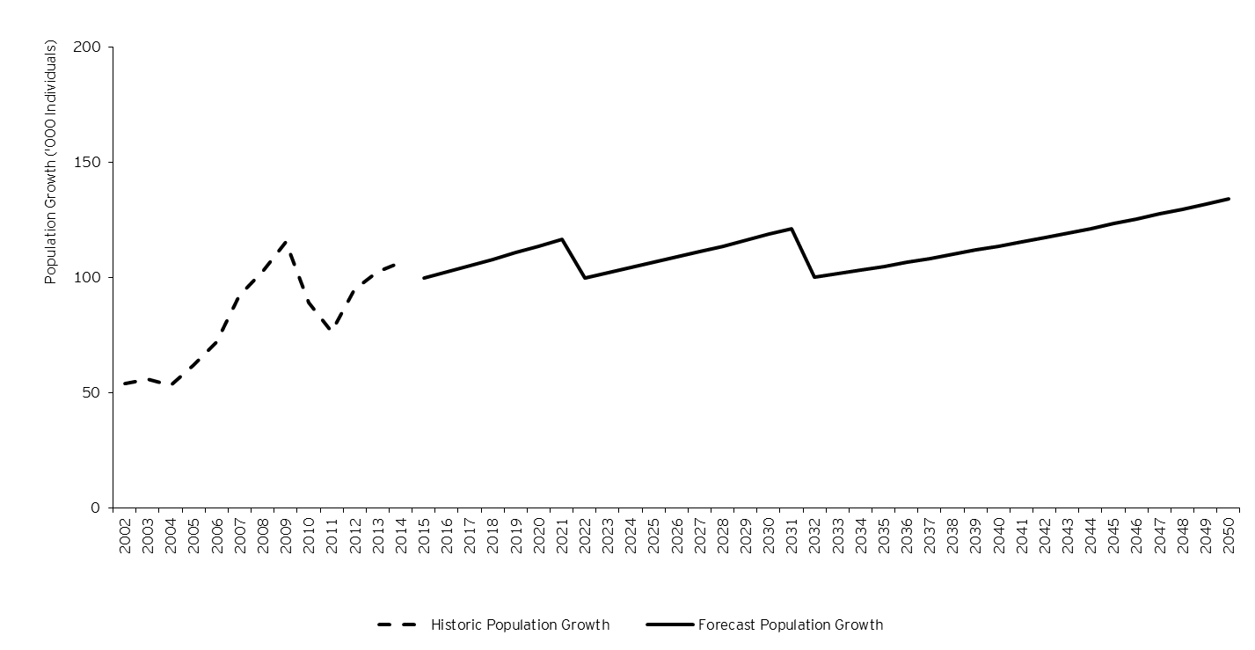
Source: EY analysis
The yearly population growth has been calculated as follows:
- From 2015 to 2020: using the average annual growth rate between actual 2014 population data provided by ABS and VIF 2015 forecast in 2021.
- From 2021 to 2030: using the average annual growth rate between 2021 and 2031 VIF 2015 forecast data.
- From 2031 to 2045: using the average annual growth rate between VIF 2015 forecast in 2031 and VITM forecast in 2046.
- From 2046, using the same average annual growth rate calculated for the period 2031-2045.
The government population forecast did not predict a decline in population but predicted instead a slow-down in the increasing pace of the population in Victoria between each milestone, which is reflected in the figure above through significant falls in the population growth in 2022 and 2032, compared to previous years. Residential construction activity being historically correlated with population growth, the unusual pattern associated with the population growth forecast is expected to be reflected in our demand projections through the forecast of residential construction activity. Such a forecast pattern could be smoothed out, requiring however to change key assumptions provided by the Government’s population forecast.
- Gross State Product
The GSP has been forecast relying upon data publically available, provided by Victorian Department of Treasury and Finance in the 2015-2016 Budget paper. Key inputs are summarized in the below table. From 2020 to 2050, a stable rate of 2.75%, corresponding to 2019 forecast, has been used.
Table 9 – GSP Projections
Rock type | 2015 | 2016 | 2017 | 2018 | 2019
GSP | 2.25% | 2.50% | 2.75% | 2.75% | 2.75%
Source: 2015-2016 Budget Paper

The GSP forecast over the period of analysis is illustrated in Figure 14 below.

Figure 14 – GSP growth - Historic and Forecast Trend ($’000 Million)
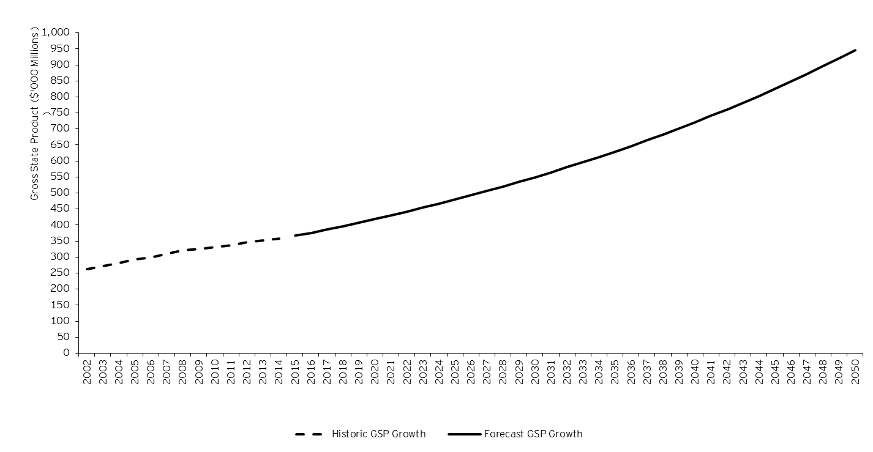
Source: EY analysis
Non-residential, transport and energy and utilities related construction activities being broadly historically correlated with the long term movement in GSP, the GSP long term forecast pattern illustrated in the figure above is expected to be reflected in our demand projections through the forecast of non-residential, transport and energy and utilities related construction activities.
- Forecast of construction activities
Relying upon the demand drivers forecast, the construction activities have therefore been forecast from 2015 to 2050, as illustrated in Figure 15.

Figure 15 – Construction Activities - Historic and Forecast trend ($’000 Million)
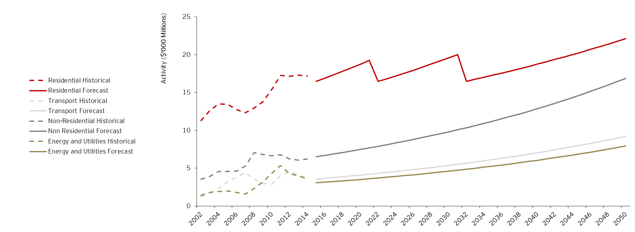
Source: EY analysis and ABS (listed in Table 20 of the Report in relation to historic data)
Construction activities increase over time, in accordance with population growth and GSP forecast trends. Downward trends and spikes in relation to residential construction activity are related to population data and average annual growth rates provided by the Government projections used for this forecast.
With respect to the transport construction activity, it should be noted that historic data in relation to this activity include the value of works done associated with major transport infrastructure projects. Transport major projects data is therefore factored in as a component of the total transport construction activity forecast. However, transport major projects have been clearly separated out in the forecast due to the different spatial allocation requirement (i.e. need to breakdown the demand for extractive resources by LGA) and the potential different demand for extractive resources for this specific component of the transport construction activity.
As a result, the following assumptions have been considered to develop the forecast of the transport major project construction activity from 2015 to 2050, in order to tailor the spatial demand for extractive resources associated to those key infrastructure projects:
- 2015 – 2022: forecast based on BIS Shrapnel data and assumptions around other known major projects that have been procured since the compilation of the BIS Shrapnel data. The list of transport major projects considered in the analysis is outlined in Appendix C of the Report subsection 1.
- 2023 – 2050: forecast based on the average percentage of total transport construction activity. From 2015 to 2022, transport major projects represent a yearly average of $1.8 billion in terms of values of work to be undertaken, which equals 46% of the total transport construction activity over the same period. As a result, from 2023 onwards, transport major projects are forecast to represent 46% of the yearly value of transport construction activity. This forecast trend is consistent with guidelines provided by the State Budget Papers, according to which, out of 30% of the State GSP committed to infrastructure projects, 80% should be dedicated to transport projects.
Finally, with respect to the Energy and Utilities activity, it should be noted that wind farm related construction activities are considered to be factored into the macro-economic forecast.
The construction activities weightings over the short, medium and long term are summarized in the below table.
Table 10 – Construction Activities Forecast – Weightings in 2015, 2026 and 2050 (%)
 | 2015 | 2026 | 2050
Residential | 56% | 50% | 39%
Transport | 12% | 13% | 16%
Non Residential | 22% | 25% | 30%
Energy and Utilities | 10% | 12% | 14%
Total | 100% | 100% | 100%
Source: EY analysis

The share of the residential construction activity is forecast to decrease overtime. This trend is mainly driven by the long term forecast pattern developed in the macro-economic driven forecast model. As documented above, residential construction activity is historically correlated with the long term movement in population growth, whereas non-residential building activity and infrastructure sectors were found to be driven by economic activity more broadly. The government population forecast did not predict a decline in population over time but predicted instead a progressive slow-down in the increasing pace of the population in Victoria between each milestone, which is reflected in the table above through a decreasing weighting of residential construction activity within the construction mix.

In terms of the overall demand projections, with residential construction activity being a major driver of the demand for extractive resources, the demand for extractive resources is expected to increase at a slowing pace over time.


Forecast demand for extractive resources
- Forecast demand for extractive resources
Previously outlined key steps of our approach enabled us to provide a baseline set of demand projections for validation and refinement through detailed industry analysis.
This section therefore outlines the final steps of the methodology implemented to forecast the demand for extractive resources over the required period, provides the demand profile and outlines the process followed to validate those results.
- Forecast Demand Process
The forecast of the construction activities outlined in Section 4 and the historic relationships identified in Section 3 between construction activities and the total demand of hard rock, clay and clay shale, limestone and sand and gravel, allowed to extrapolate the demand for extractive resources from 2015 to 2050.
The initial level of the demand projections in 2015 was determined using the production trend line identified from 2009 to 2014. This anchoring process ensured the appropriate setting of our baseline model, using latest production trends available.
Spatial allocation per LGA of the total demand for extractive resources has then been developed as follows:
- Construction activities ($ value) have been spatially allocated by LGA, based on:
- Population growth for residential construction, transport and energy and utilities construction activities
- Employment growth for non-commercial construction activity
- Known allocation of major infrastructure projects, only related to the transport activity
Population growth and employment growth have therefore been considered as the key drivers for the spatial allocation of the demand for extractive resources by LGA.
- Extractive resources (i.e. hard rock, limestone, clay and clay shale and sand and gravel) have then been spatially allocated, in each LGA, based on the forecast spatial allocation of construction activities ($ value) by LGA and key technical assumptions linking each construction activity with the use of extractive resources. Those assumptions result from technical data provided by the DEDJTR’s technical advisor, AECOM, per type of construction and are outlined in Appendix C of the Report. For clarity purposes, the below table presents the assumptions considered for the spatial allocation of construction activity ($ value) per type of extractive resources.
Table 11 – Spatial allocation of extractive resources per construction activity in Victoria
 | Hard rock (%) | Limestone  (%) | Clay and clay shale (%) | Sand and gravel  (%)
Residential Activity | 72% | 6% | 1% | 21%
Non Residential Activity | 78% | 5% | 1% | 15%
Transport (excluding major projects) Activity | 96% | 1% | 0% | 2%
Transport Major Projects | 77% | 2% | 2% | 18%
Energy and Utilities Activity1F | 100% | 0% | 0% | 0%
Source: Outputs of the analysis performed on AECOM data, provided on 23 December 2015

A further detailed industry analysis was undertaken to refine our projections, to account for the complex nature of the industry and the interdependent relationships between demand in certain locations and the supply of available extractive resources, recognizing the tendency for the construction industry to make best use of what is available and can be transported to construction sites at least cost. It also consisted of the development of detailed industry sector models, linking assumptions about the construction mix in each sector with macroeconomic forecasts and information from the DEDJTR’s technical advisor regarding each type of construction and the quantities of extractive resources used in current construction methodologies). Those models were developed in order to ensure that our overall forecasting framework was adequately representing demands for the full range of significant construction activities, including those that may not have a clear relationship to the macroeconomic drivers modelled at a higher level (e.g. wind farms and road network development and maintenance, where government policy directions and unique industry characteristics may influence construction trends).
Through this analysis and key technical assumptions provided by the DEDJTR’s technical advisor, AECOM, EY refined the spatial allocation per LGA of the demand for extractive resources in relation to the development of projections of hard rock demand with an increased level of granularity around the different types of hard rock (i.e. consisting of rock types including basalt old, basalt new, trachyte, dolerite, granite (incl. granodiorite, porphyry, microgranites), rhyodacite (incl. dacite, rhyolite), scoria, tuff, gneiss, hornfels, marble, quartzite, schist, slate and sedimentary (usually rippable rocks incl. sandstone, shale, siltstone chert, mudstone, claystone)).
Those assumptions considered for the spatial allocation of each hard rock type are outlined in Table 7 of the Report.
- Results
The macro-economic driven demand model, whose key build-up steps have been outlined in this Report, has therefore allowed the development of the baseline demand profile for extractive resources, from 2015 to 2050.
Consolidated trend
The baseline demand projections over the short, medium and long term are summarized, in aggregate, in the below table.
Table 12 – Demand Forecast – Total in 2015, 2026 and 2050 (million tonnes)
 | 2015 | 2026 | 2050
Total Demand | 46.4 | 55.8 | 87.8
Source: EY analysis

The figure below presents the high level consolidated trend of the yearly demand forecast, for total demand and per main category of extractive resources. This figure presents the forecast results from 2015 to 2050, as well as historic trend from 2002.

Figure 16 – Extractive Resources Demand – Historic data and Forecast over the period 2002-2050 – million tonnes
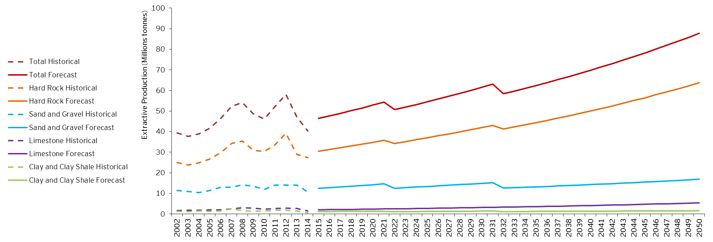
Source: EY analysis

Sudden downward movements at years 2022 and 2032 are related to changes to population growth rates provided by the Victorian Government in its official population forecast (Victoria in Future). As our approach to forecasting the demand for extractive resources is based on absolute changes in population and other macroeconomic variables, this has the impact of creating sudden drops in total demand as the amount of people added in those years identified is less than the amount added in the previous year. It is considered preferable to adhere to the Government’s population profile rather than artificially smoothing the results.
This forecast, illustrating an increase in needs for extractive resources, follows expected trends in relation to the demographic evolution in Victoria and social behaviours, which is therefore driving the needs for public infrastructure (i.e. social assets) and increased mobility.
Demand for hard rocks
Much greater demand for hard rock is forecast compared to other extractive resources. Figure 17 below presents the breakdown of hard rock demand estimate from 2015 to 2050, at a more granular level.

Figure 17 – Extractive Resources Demand for Hard Rock Types – Forecast over the period 2015-2050 – million tonnes
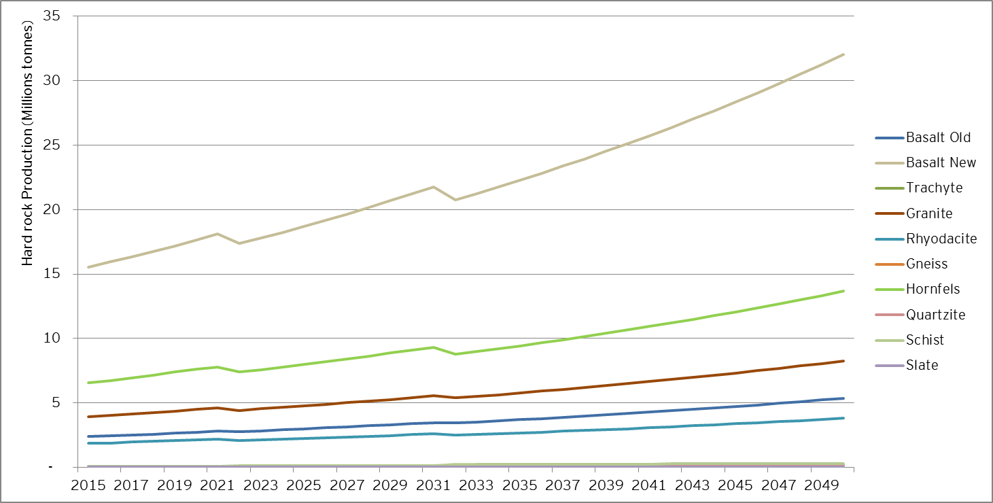
Source: EY analysis

Greater demand for basalt new, hornfels, granite, basalt old and rhyodacite is forecast through Victoria during the period, in accordance with preliminary findings provided in Table 7 of the Report.
Demand for sand and gravel
Within the Sand and Gravel category, the detailed industry analysis identified shares of demand for soft rocks attributable to the manufacture of concrete sand (combined with subsurface drainage sand), fine sand and other construction materials (cement and fill). The figure below illustrates the indicative breakdown of the Sand and Gravel demand forecast according to each of those products.

Figure 18 – Extractive Resources Demand for Sand and Gravel over the period 2015-2050 – Indicative breakdown per type of use – million tonnes
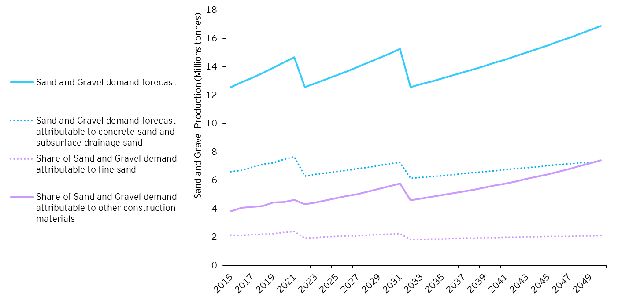
Source: EY analysis
This figure shows a slow-down over time in the growth of the Sand and Gravel share attributable to concrete and fine sand, mainly driven by a changing construction mix that has been forecast over the period of analysis.
Given the mix of construction activities forecast in Victoria, the following ranges were identified through the analysis of Sand and Gravel soft rocks needed from 2015 to 2050:
- Share attributable to concrete sand and subsurface drainage sand: 44% to 53%
- Share attributable to fine sand: 12% to 17%
- Share attributable to other construction materials: 30% to 44%
Regional allocation
The Metropolitan Planning Authority has identified seven Urban Growth Areas within Metropolitan Melbourne, where significant economic development is expected. These are listed as follows and illustrated in Figure 19:
- Cardinia (S)
- Casey (C)
- Hume (C)
- Melton (C)
- Mitchell (C)
- Whittlesea (C)
- Wyndham (C)

Figure 19 – Metropolitan Melbourne – Urban Growth Zone
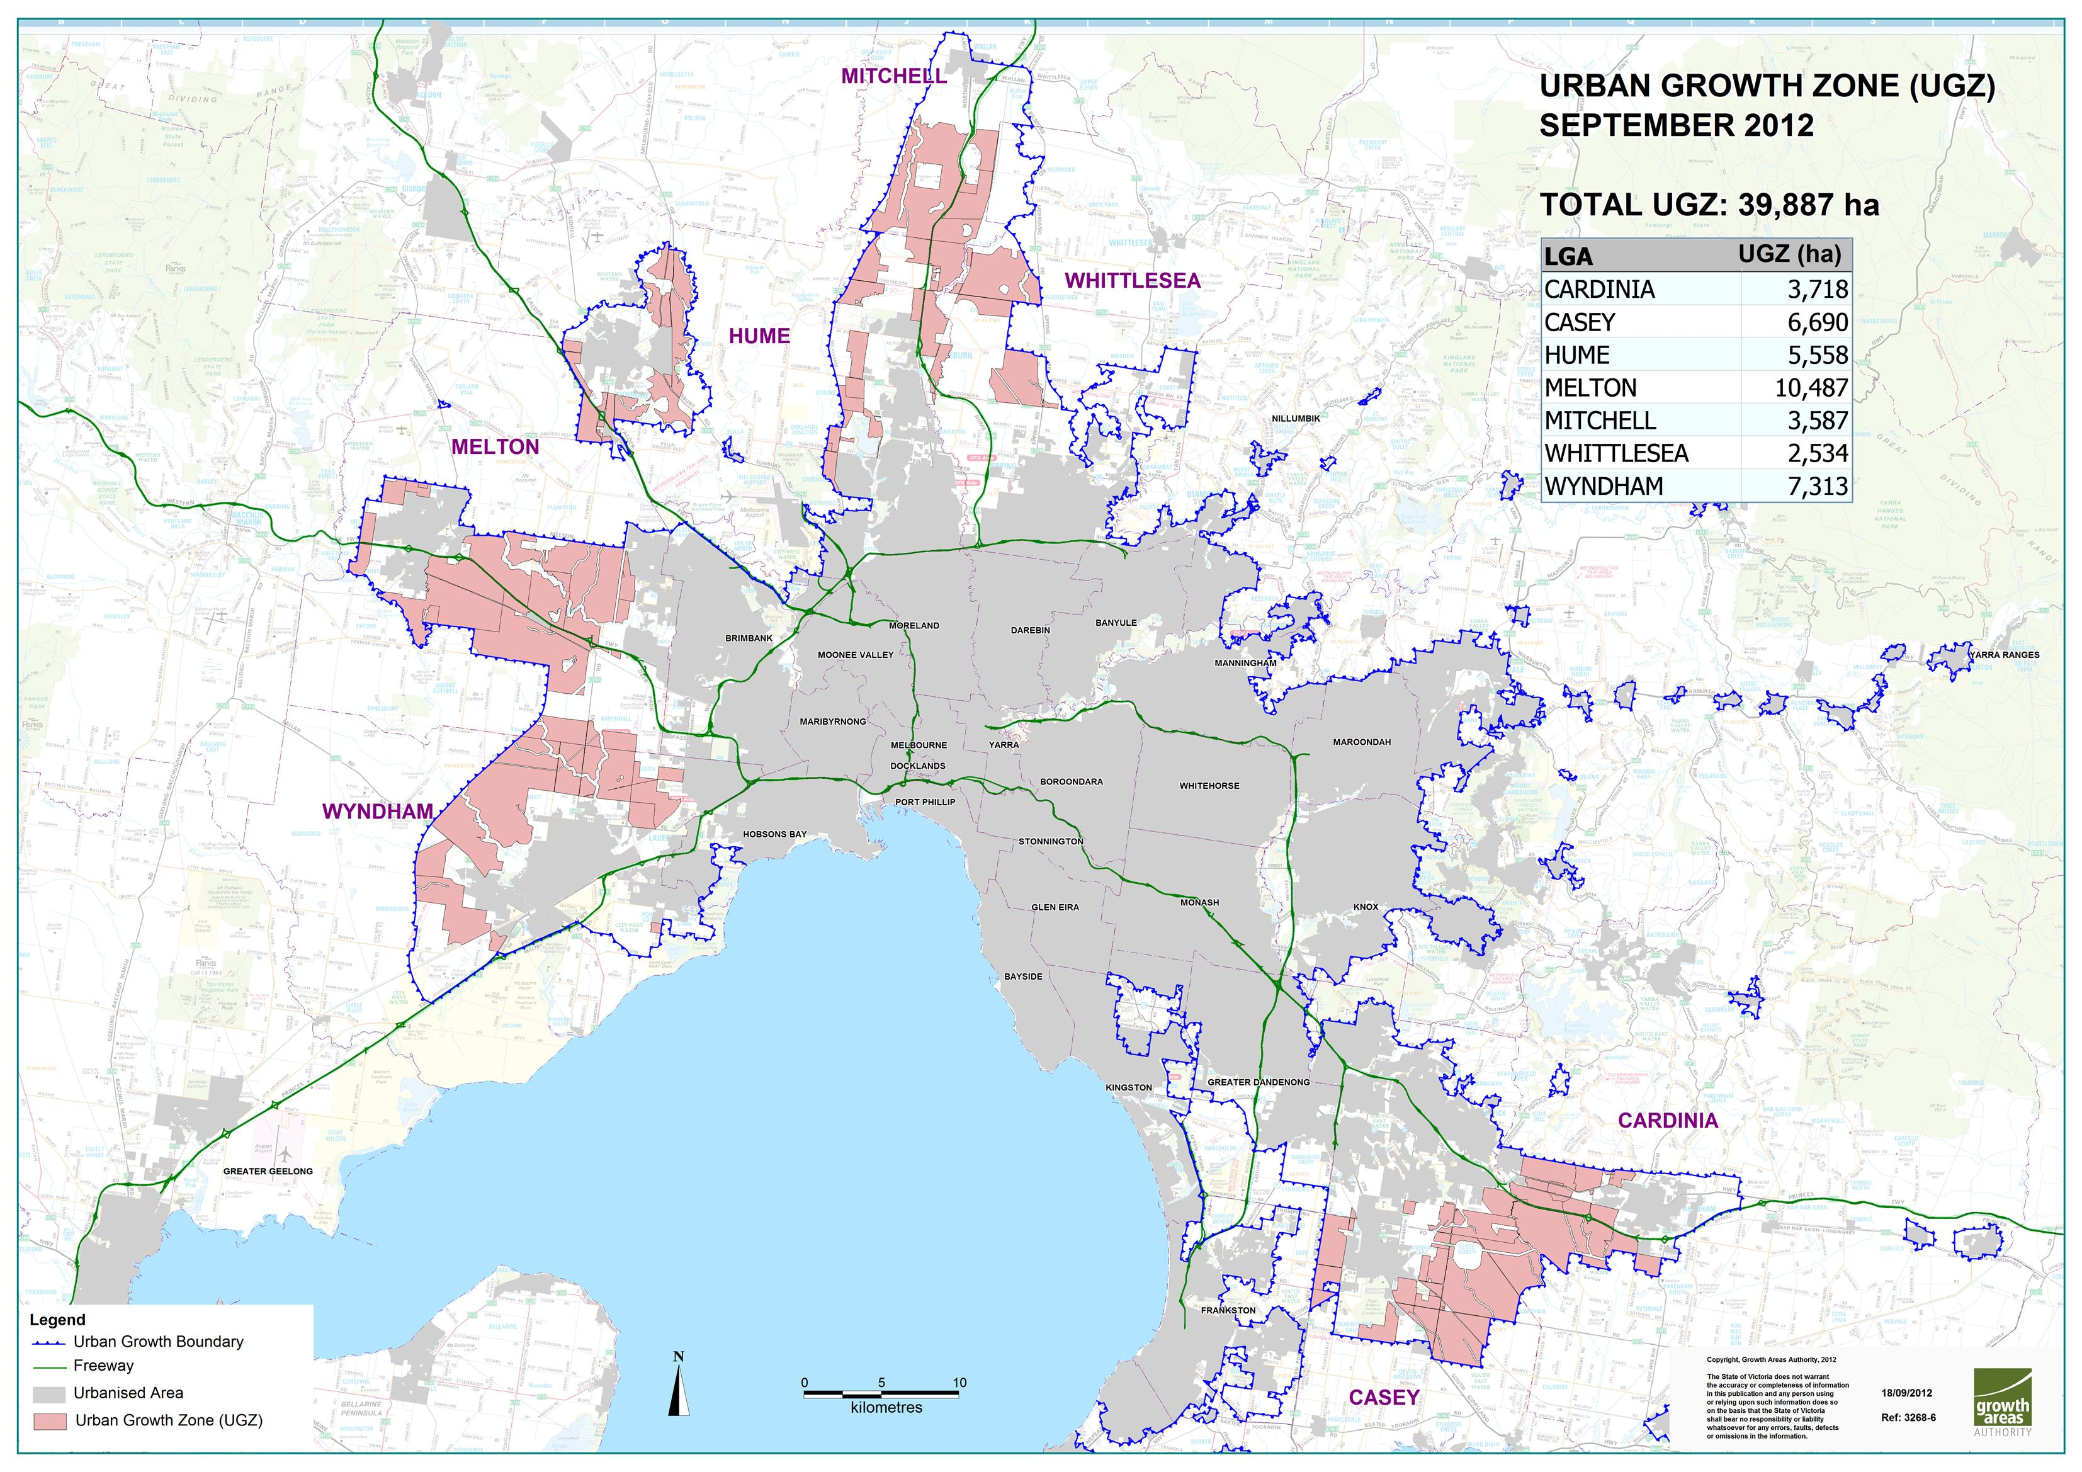
Source: Metropolitan Planning Authority

We have by default defined the rest of the LGAs within Metropolitan Melbourne as Urban Infill LGAs, and the remainder within Victoria as regional LGAs.

The baseline demand projections over the short, medium and long term are summarized in the below table in aggregate for LGAs in Urban Infill locations, Urban Growth Areas and regional areas.
Table 13 – Demand Forecast per type of LGAs– Total in 2015, 2026 and 2050 (million tonnes)
 | 2015 | 2026 | 2050
Urban Infill LGAs | 22.3 | 25.6 | 46.0
Urban Growth Areas LGAs | 15.4 | 19.6 | 24.3
Regional LGAs | 8.7 | 10.6 | 17.5
Total Demand | 46.4 | 55.8 | 87.8
- Source: EY analysis
This shows significant increases in the production and use of extractive resources across all parts of the State, and in particular Urban Infill and regional LGAs where total production is expected to double by 2050. Increases in Urban Growth Areas are also significant, with around 50% more demand expected in 2050 compared to today’s levels.
These dramatic increases, illustrated in Figure 20, are driven by the expectation for continued strong population growth across Victoria, which creates the increased need for housing and supporting infrastructure, as well as the need for large numbers of non-residential buildings to accommodate commercial, industrial, retail and other employment.

Figure 20 – Spatial allocation of Extractive Resources Demand by type of LGA - Forecast over the period 2015-2050 – million tonnes
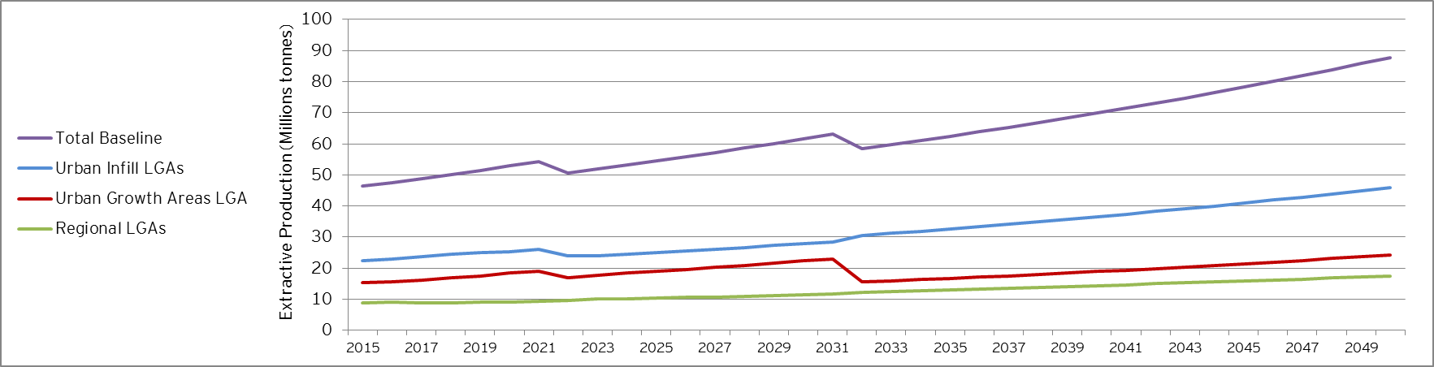
Source: EY analysis

The following maps in Figure 21 and Figure 22 illustrate the intensity of the aggregate demand for extractive resources per LGA, classified in terms of projected tonnes.
In comparing LGAs, there is a noticeable increase in key Urban Growth Areas such as Casey, Whittlesea and Wyndham, and to a lesser but nevertheless significant extent, Melton and Hume. There are also material increases expected in regional population centres such as Ballarat, Greater Bendigo and Greater Geelong. In each of these cases this follows sharp rises in population in those areas over the last decade, and the continuation of these trends is expected to be an ongoing challenge for the extractive resources industry.
Extensive details in relation to the demand for extractive resources per LGA and per category of resources has been provided, on a yearly basis from 2015 to 2050, to PwC on 15 February 2016 and are available in Appendix F of this Report.

Figure 21 – Total demand for extractive resources by LGA over the period 2015-2025
Source: EY analysis

Figure 22 – Total demand for extractive resources by LGA over the period 2026-2050
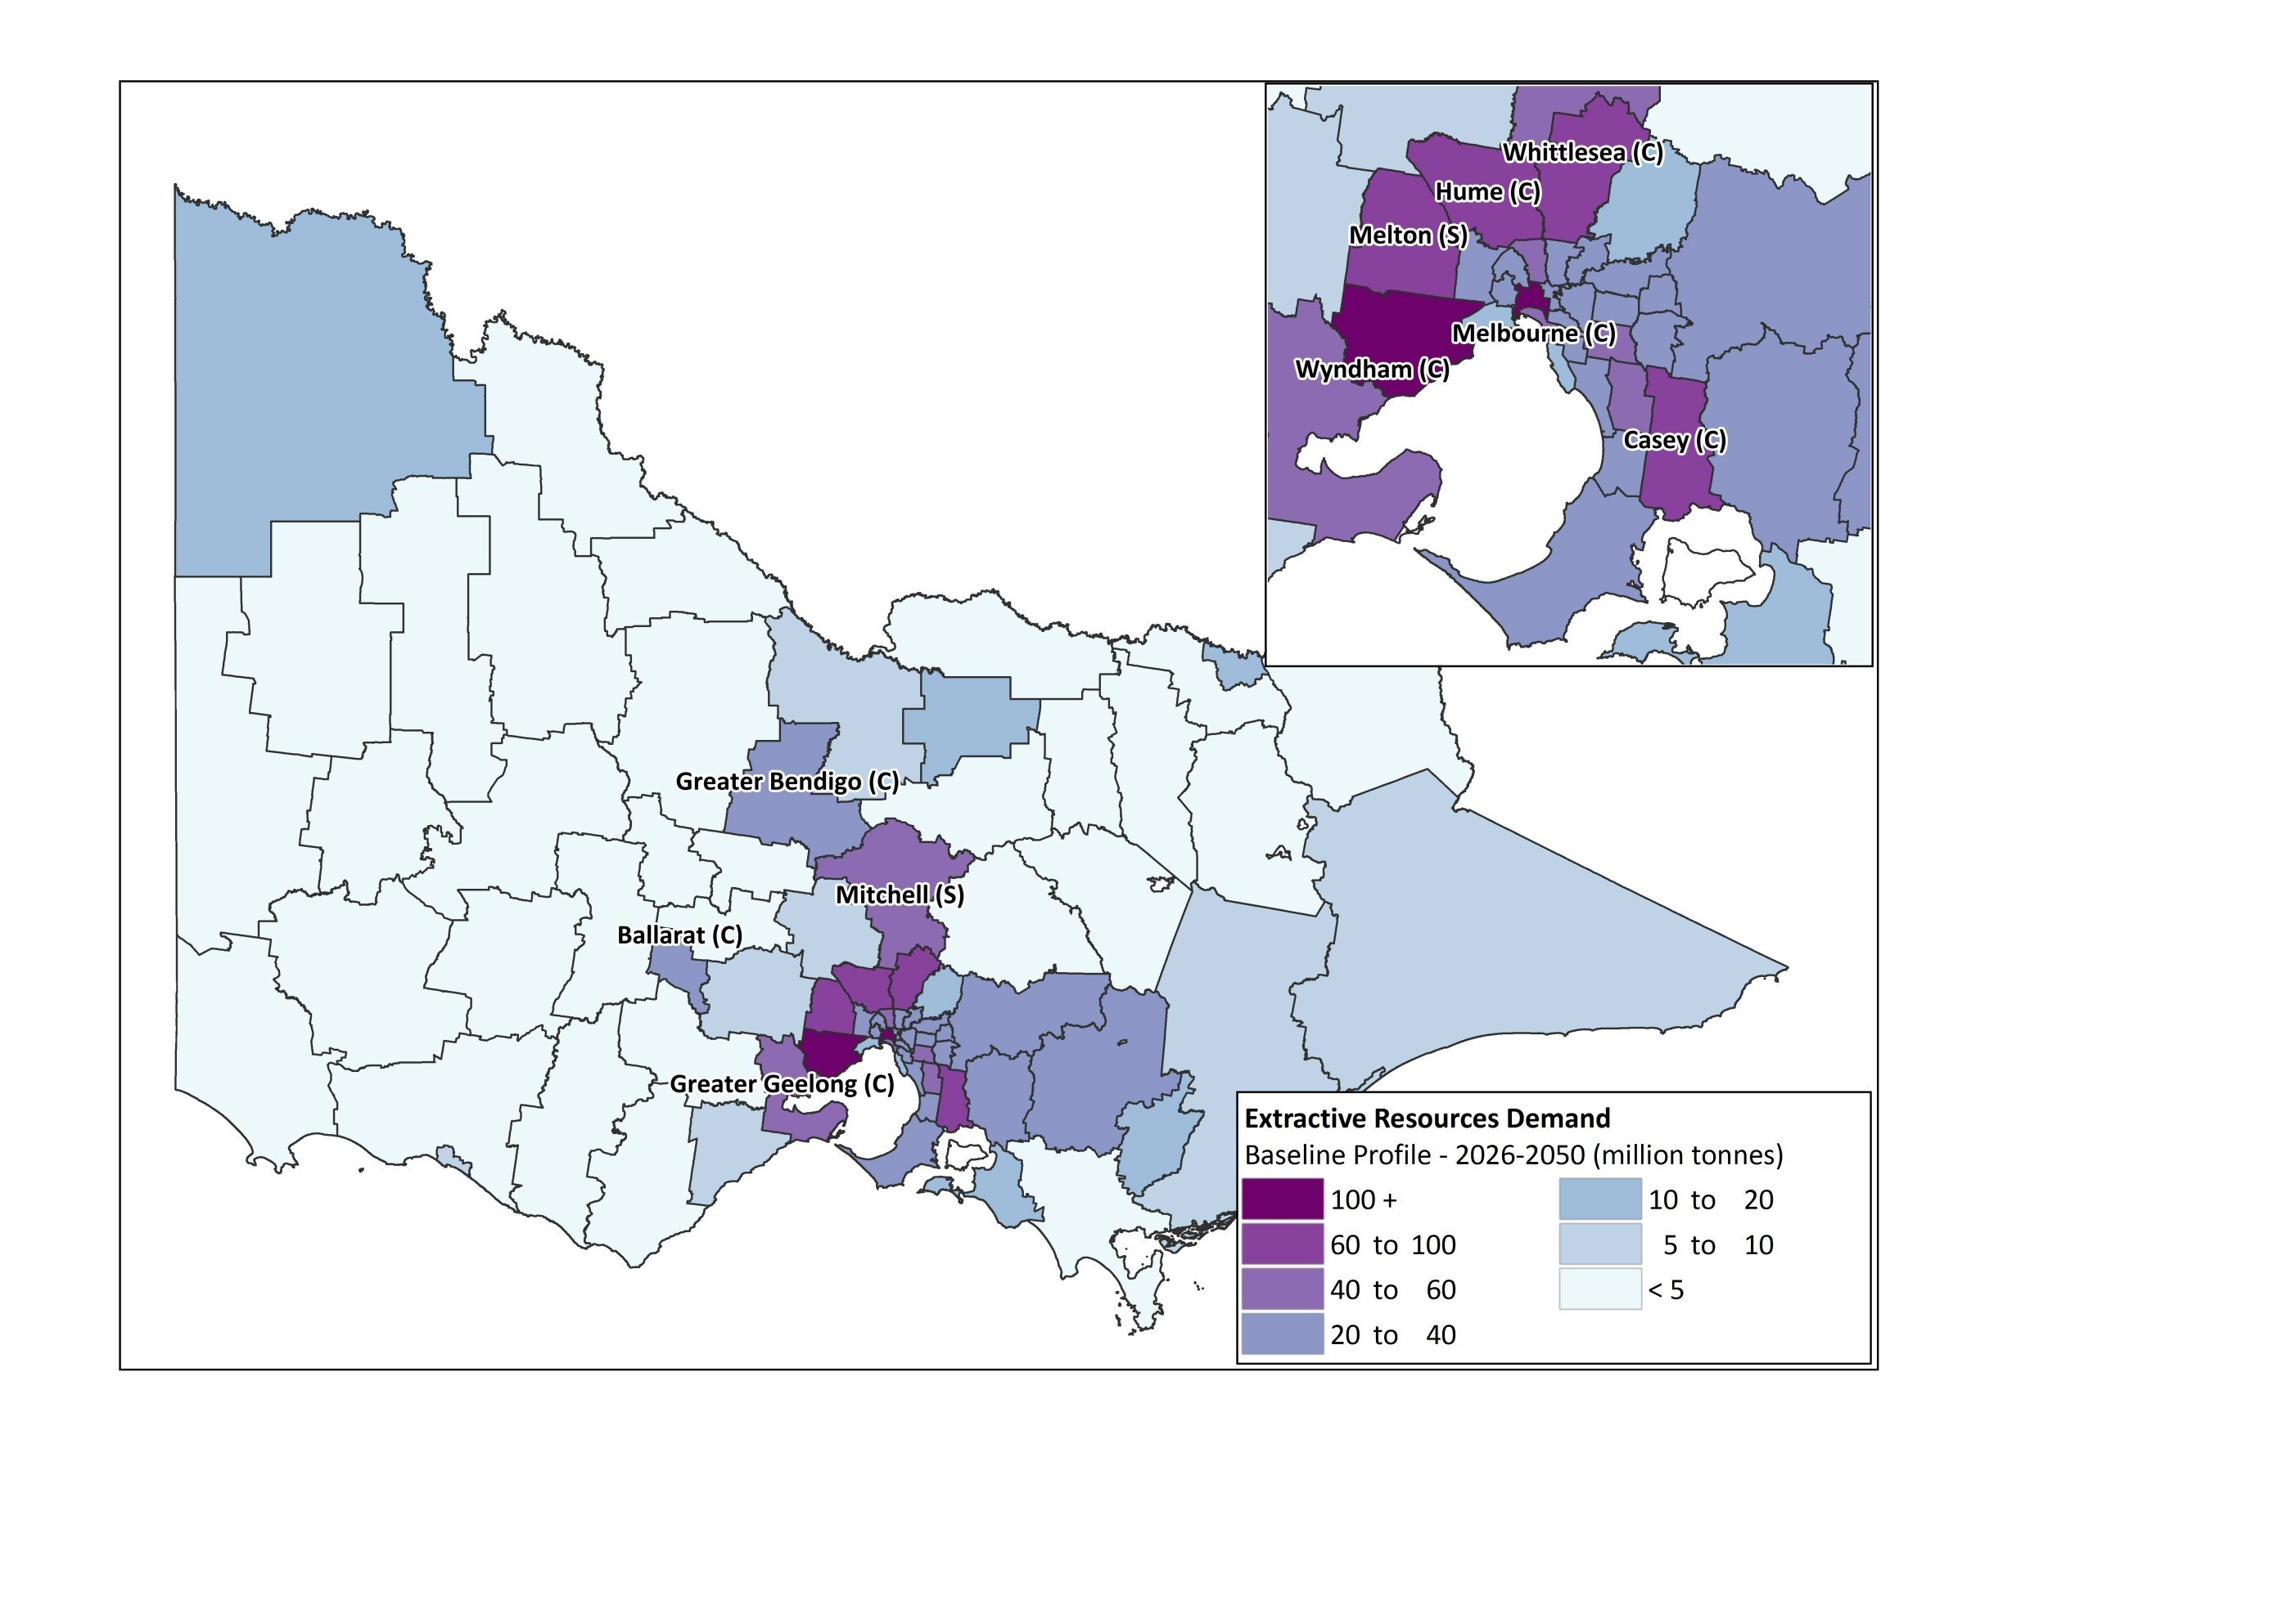
Source: EY analysis

From 2015 to 2025, the demand forecast for extractive resources identified the following hot spots:
Table 14 – Demand Forecast – Top 10 LGAs 2015-2025 (million tonnes)
# | Top 10 LGAs | Total demand | Hard rock total demand | Limestone total demand | Sand and gravel total demand | Clay and clay shale total demand
 | Melbourne (C) | 51.9 | 34.5 | 2.5 | 13.5 | 1.4
 | Wyndham (C) | 39.3 | 26.2 | 1.9 | 10.3 | 0.9
 | Casey (C) | 36.8 | 24.6 | 1.7 | 9.6 | 0.9
 | Whittlesea (C) | 32.8 | 21.9 | 1.5 | 8.6 | 0.8
 | Melton (S) | 27.9 | 18.7 | 1.3 | 7.3 | 0.6
 | Hume (C) | 26.8 | 17.9 | 1.3 | 7.0 | 0.6
 | Greater Geelong (C) | 19.1 | 12.8 | 0.9 | 5.0 | 0.4
 | Cardinia (S) | 18.2 | 12.2 | 0.8 | 4.8 | 0.4
 | Moreland (C) | 15.1 | 10.0 | 0.7 | 4.0 | 0.4
 | Greater Dandenong (C) | 15.0 | 10.0 | 0.7 | 3.9 | 0.4
Source: EY analysis

Strong demand is therefore expected from 2015 to 2025 around Urban Growth Areas such as Wyndham and Hume, and predominantly within Metropolitan LGAs. Population centres in regional Victoria such as Greater Bendigo (ranked 20th), Mitchell (ranked 23rd), Ballarat (ranked 18th) and Greater Geelong (ranked 7th) are also driving demand for extractives.
To a lesser extent, note that as illustrated in Figure 21, remote rural LGAs such as East Gippsland and Mildura are also driving needs for extractive resources, due to their projected increases in population growth over the period.
From 2026 to 2050, the long term demand for extractive resources is forecast to continue to be in locations with strong population growth, predominantly in metropolitan areas, as illustrated in Table 15 which identified the following hot spots:
Table 15 – Demand Forecast – Top 10 LGAs 2026-2050 (million tonnes)
# | Top 10 LGAs | Total demand | Hard rock total demand | Limestone total demand | Sand and gravel total demand | Clay and clay shale total demand
 | Melbourne (C) | 201.3 | 142.1 | 12.9 | 42.4 | 3.9
 | Wyndham (C) | 114.9 | 82.7 | 6.4 | 23.7 | 2.1
 | Melton (S) | 90.4 | 64.9 | 5.0 | 18.8 | 1.7
 | Casey (C) | 76.5 | 54.4 | 4.3 | 16.3 | 1.5
 | Hume (C) | 71.9 | 51.2 | 4.1 | 15.2 | 1.4
 | Whittlesea (C) | 64.3 | 45.7 | 3.6 | 13.8 | 1.2
 | Greater Geelong (C) | 52.6 | 37.6 | 3.1 | 10.9 | 0.9
 | Greater Dandenong (C) | 43.9 | 31.0 | 2.6 | 9.4 | 0.9
 | Moreland (C) | 41.4 | 29.6 | 2.3 | 8.7 | 0.8
 | Cardinia (S) | 36.0 | 25.6 | 1.9 | 7.7 | 0.8
Source: EY analysis

- Validation of results
Tailored using key technical inputs provided by AECOM, the macro-economic driven model:
- ►Provides a robust long term forecast of the total demand for extractive resources required to service the construction sectors as it is based on historic relationships across activity levels and resource use.
- Provides a good spatial coverage using relevant demand drivers (i.e. population, employment, infrastructure profiles).
- Is well informed by industry assumptions that link construction types with resources use at a high level.
- Captures regional variations in relation to the availability of specific types of rocks.
A further detailed industry analysis, through the development of detailed industry models, was also undertaken to validate our projections.
The detailed industry analysis specifically consisted of developing a forecast based on our projections of the numbers of buildings and infrastructure projects expected to be built by the public and private sectors across Victoria (subject to available data in the public domain) and the conversion metrics provided by the DEDJTR technical advisor (AECOM) for each of those construction types, allowing to first identify the extractive resources used for each construction type, whether directly or through the manufacturing of commodity products, and then to calculate the quantity, in tonnes, of extractive resources required by construction type. The analysis consisted of developing a forecast for the following construction activities:
- Residential activity: the number of separate houses, townhouses, apartments in up to three storey buildings and apartments in more than three storeys buildings has been projected over the period of analysis, using population projections and key assumptions in relation to household sizes and accordingly required types of dwellings, per LGA.
- Non-residential activity: the number of new jobs expected to be created over the period of analysis has been projected and a relationship identified between the number of new jobs and the number of new buildings to be constructed, therefore allowing to forecast the number of commercial, industrial and retail buildings required to be built in accordance with the projections of retail, industrial and commercial jobs over the period.
- Transport activity:
- Future transport major projects, with extraction implications, were identified and their requirements in terms of extractive resources assessed.
- VicRoads’ network expansions over the period, as well as VicRoads’ maintenance and rehabilitation requirements, with extractive implications, have been forecast, relying on information provided by VicRoads through the stakeholders’ consultation.
- Local Councils’ arterial network expansions over the period, as well as those roads’ maintenance and rehabilitation requirements, with extractive implications, have been forecast, relying on information available in the public domain.
- Energy and Utilities development: the number of wind farms has been projected, relying upon information publically available in relation to the wind farm projects approved and subject to an ongoing approval. Limited information available in the public domain, particularly to forecast corresponding construction activity over the period of analysis, prevented a broader and more detailed industry assessment of the construction of energy and utilities related infrastructures.
All assumptions considered to develop the detailed industry models are provided in the Appendix C sub-section 2 of the Report. It should also be noted that where asphalt is used as a commodity product for construction purposes, 15% of the quantity of asphalt is considered to be recycled materials and therefore not accounted in the demand for extractive resources subsequent to the construction needs. This is reflecting a growing trend of using recycled materials in construction activities and could potentially reach as high as 30% over the next 20 to 30 years.
The figure below presents the results of this analysis and provides a comparison between the macro-economic driven demand projections and the demand forecast resulting from the detailed industry analysis. Note that DIA in the below figure stands for detailed industry analysis. This figure illustrates how closely aligned the macro-driven forecast and the projections resulting from the detailed industry analysis are.

Figure 23 – Total demand forecast models appraisal – Demand Yearly Evolution
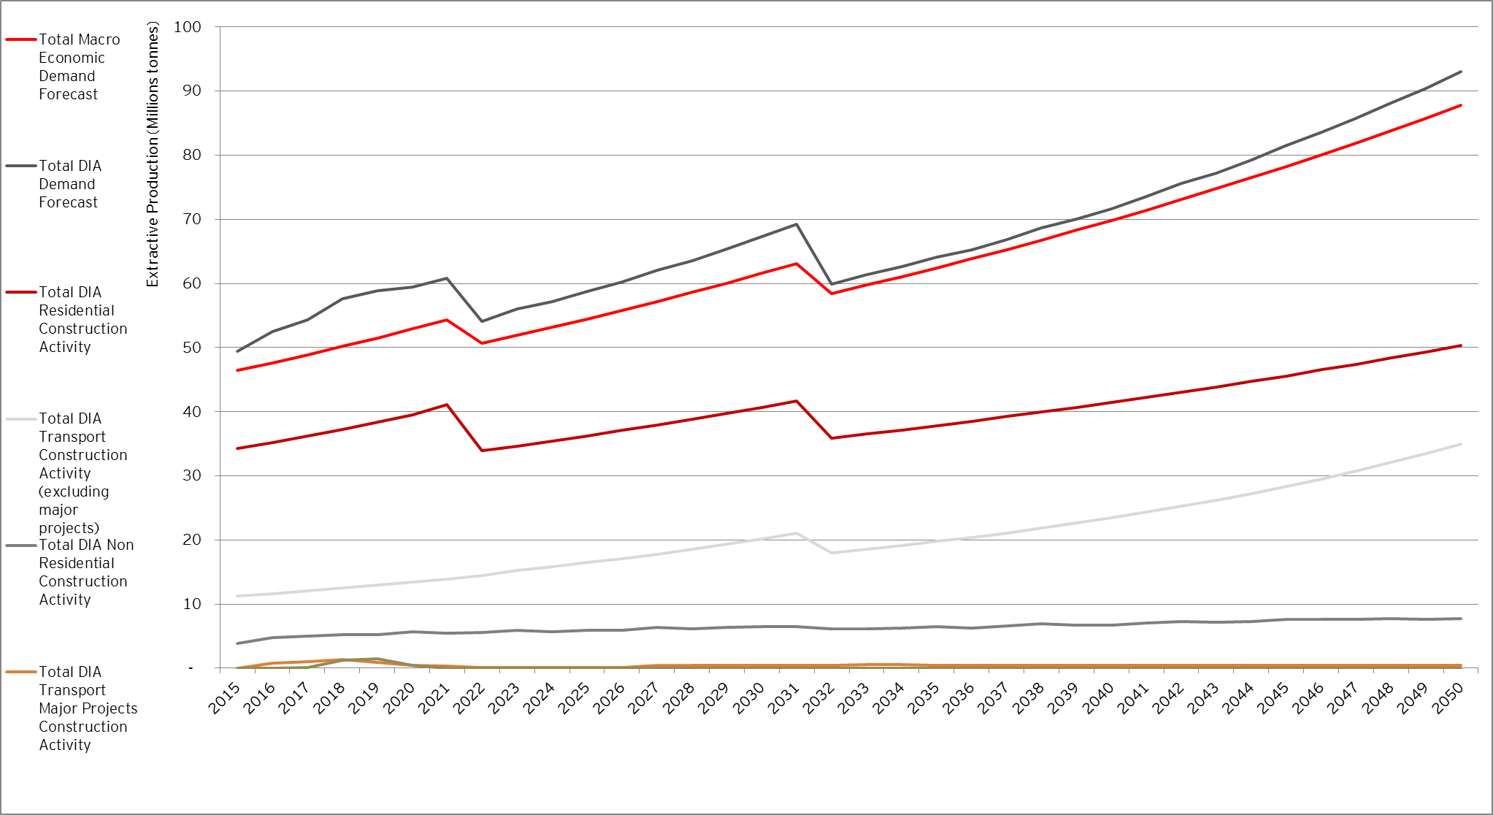
Source: EY Analysis.

The forecast over the period resulting from the detailed industry models is mainly driven by the needs for extractive resources in relation to residential and transport construction activities’ expected development. In relation to transport major projects, note that from 2027, transport major projects have not been forecast using a detailed industry analysis, due to the lack of data availability. As a result, based on the requirements of extractive resources calculated from 2015 to 2026, a trend line has been used to forecast the assumed demand for extractive resources from major transport projects from 2027 onwards. This forecast trend is consistent with guidelines provided by the State Budget Papers, according to which, out of 30% of the State GSP committed to infrastructure projects, 80% should be dedicated to transport projects.
The forecast resulting from the detailed industry analysis is within a +10% range from the total demand generated by our baseline macro-driven model, on an average yearly basis. With respect to the complexity associated with this analysis, this is considered as a reasonable criterion and threshold to validate the adequate representation of the demand resulting from our overall macro-driven forecast framework.
Sudden downward movements at years 2022 and 2032 are related to changes to population growth rates provided by the Victorian Government in its official population forecast (Victoria in Future). As our approach to forecasting the demand for extractive resources is based on absolute changes in population and other macroeconomic variables, this has the impact of creating sudden drops in total demand as the amount of people added in those years identified is less than the amount added in the previous year. It is considered preferable to adhere to the Government’s population profile rather than artificially smoothing the results.

Scenarios analysis
- Scenarios analysis
Five scenarios analyses have been performed on the baseline outputs calculated based on the macro-economic demand driven model. The purpose of those analyses was to help understand and inform the sensitivity of the baseline demand for extractive resources to changes in economic patterns or other key demand drivers for extractive resources, therefore helping assessing the impact of potential industry occurrences on the demand for extractive resources.
The scenarios analysed are listed as follows and the scenarios analysis performed, as well as their key outcomes, are detailed in the sub-sections presented below:
- Scenario 1A: population and employment growth ahead of government projections in Victoria – (20% increase).
- Scenario 1B: population and employment growth ahead of government projections in Wyndham LGA– (20% increase).
- Scenario 2A: population and employment growth behind government projections in Victoria– (20% decrease).
- Scenario 3A: redistribution of the growth in Metropolitan Melbourne toward Urban Infill LGAs.
- Scenario 3B: redistribution of the growth in Metropolitan Melbourne toward Urban Growth Areas LGAs.

Extensive details in relation to the demand for extractive resources per LGA and per category of resources have been provided, on a yearly basis from 2015 to 2050, to PwC on 15 February 2016, and are available in Appendix F of this Report.
The maps illustrating the aggregate demand for extractive resources per LGA for each scenario are available in Appendix G of the Report.
- High demand
- Scenario 1A: increase by 20% of government projections
Scenario 1A consisted of assessing the impact of an increase by 20% of government projections driving the demand for extractive resources.
Based on demand drivers identified, this scenario has been performed by increasing the population and GSP growth by 20%, of the baseline projection but as per current projections for land use patterns. The scenario assumes that the 20% increase in demand drivers would result in a 20% increase in construction activities (residential, non-residential, transport, energy and utilities), therefore flowing through to a 20% increase of extractive resources demand but as per current projections of land use. It should be noted that within this scenario growth by 20% is not applied to transport major projects identified over the next ten years, as the demand for extractive resources should not increase for a specific project from those drivers.
The impact of scenario 1A against the baseline demand forecast, in terms of spatial allocation per LGA classification, is presented below in Figure 24.

Figure 24 – Total demand for extractive resources over the period 2015-2050 – Baseline vs. Scenario 1A
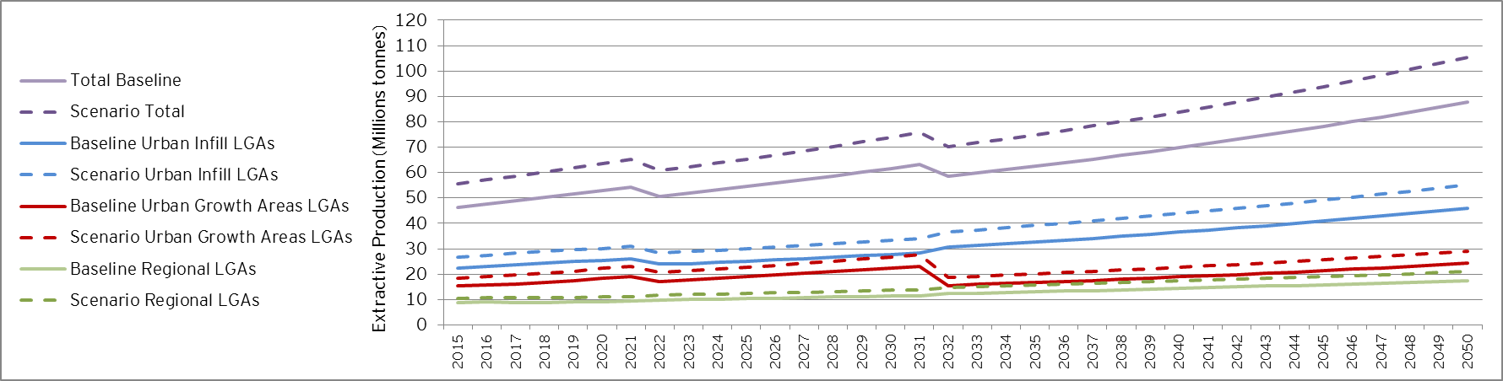
- Source: EY analysis
The following table summarises how the scenario 1A compares to the baseline demand projections over the short, medium and long term, in aggregate for LGAs in Urban Infill locations, Urban Growth Areas and regional areas:
Table 16 – Demand Forecast – Baseline vs. Scenario 1A – Total in 2015, 2026 and 2050 (million tonnes)
 | 2015 | 2026 | 2050
Baseline
Urban Infill LGAs | 22.3 | 25.6 | 46.0
Urban Growth Areas LGAs | 15.4 | 19.6 | 24.3
Regional LGAs | 8.7 | 10.6 | 17.5
Total Demand | 46.4 | 55.8 | 87.8
Scenario 1A
Urban Infill LGAs | 26.7 | 30.7 | 55.2
Urban Growth Areas LGAs | 18.5 | 23.5 | 29.1
Regional LGAs | 10.5 | 12.8 | 21.0
Total Demand | 55.7 | 67.0 | 105.3
- Source: EY analysis
Conclusions in terms of adverse economic impacts of an increase by 20% of the demand drivers’ growth on the supply side are expected to be provided in the overall assessment developed by PwC in relation to the identification of regional gaps in the available capacity of the supply chain and the needs for extractive resources.
- Scenario 1B: increase by 20% of government projections in Wyndham LGA
Scenario 1B consisted of considering greater levels of growth, extending the settlement pattern in proximity to the boundary as well as hypothetical locations up to 100 km outside of the boundary. To help inform the issues such scenario could create for the supply side and help assess the potential economic impact of extending the scope of supply to meet demand requirements, this scenario has been performed on a LGA only defined as an urban growth area, Wyndham (C).
Scenario 1B therefore consisted of determining the impact of an increased growth within the Wyndham LGA, considered as key as it straddles the settlement boundary. To make the scenario more relevant to DEDJTR, the impact of an increase by 20% of government projections within the Wyndham LGA has been modelled at the Statistical Area 2 level, using population growth forecast available at this level, provided by VITM. This scenario furthermore assumes that the increase in growth is immediate from 2015 and consistent until 2050.
Conclusions in terms of adverse economic impacts of an increase by 20% of the demand drivers’ growth on the supply side in Wyndham are expected to be provided in the overall assessment developed by PwC in relation to the identification of regional gaps in the available capacity of the supply chain and the needs for extractive resources.
- Scenario 2A: low demand
Scenario 2A consisted of assessing the impact of a decrease by 20% of government projections driving the demand for extractive resources.
Based on demand drivers identified, this scenario has been performed by decreasing the population and GSP growth by 20% of the baseline projection but as per current projections for land use patterns. The scenario assumes that the 20% decrease in demand drivers would result in a 20% decrease in construction activities (residential, non-residential, transport, energy and utilities), therefore flowing through to a 20% decrease of extractive resources demand but as per current projections of land use. It should be noted that within this scenario decrease of growth by 20% is not applied to transport major projects identified over the next ten years, as the demand for extractive resources should not decrease for a specific project from those drivers.
It is unknown whether any substitute resource will revolutionize the way things are done in the future. Such changes will likely be incremental and lower the demand profile for extractive resources over time, which is therefore to a certain extent reflected in this “low demand” scenario.
The impact of scenario 2A against the Baseline demand forecast, in terms of spatial allocation per LGA classification, is presented in below Figure 25.

Figure 25 – Total demand for extractive resources over the period 2015-2050 – Baseline vs. Scenario 2A
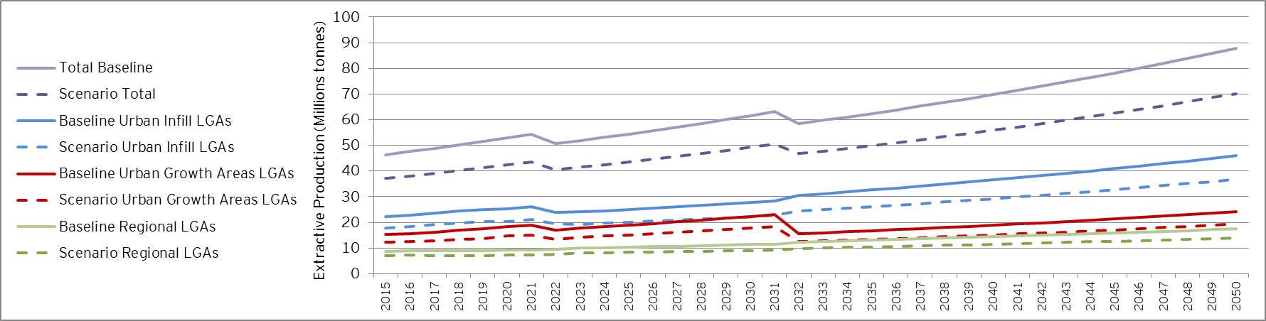
- Source: EY analysis

The following table summarises how the scenario 2A compares to the baseline demand projections over the short, medium and long term, in aggregate for LGAs in Urban Infill locations, Urban Growth Areas and regional areas:
Table 17 – Demand Forecast – Baseline vs. Scenario 2A – Total in 2015, 2026 and 2050 (million tonnes)
 | 2015 | 2026 | 2050
Baseline
Urban Infill LGAs | 22.3 | 25.6 | 46.0
Urban Growth Areas LGAs | 15.4 | 19.6 | 24.3
Regional LGAs | 8.7 | 10.6 | 17.5
Total Demand | 46.4 | 55.8 | 87.8
Scenario 2A
Urban Infill LGAs | 17.9 | 20.5 | 36.8
Urban Growth Areas LGAs | 12.2 | 15.6 | 19.4
Regional LGAs | 7.0 | 8.4 | 14.0
Total Demand | 37.1 | 44.7 | 70.2
- Source: EY analysis
Conclusions in terms of adverse economic impacts of a decrease by 20% of the demand drivers’ growth on the supply side are expected to be provided in the overall assessment developed by PwC in relation to the identification of regional gaps in the available capacity of the supply chain and the needs for extractive resources.
- Scenario 3: redistribution of demand
Scenario 3A
Scenario 3A consisted of assessing the impact of considering more infill development without amending government projections, therefore resulting in a redistribution of the demand for extractive resources towards those Urban Infill LGAs, listed as follows and defined in Appendix B of the Report.
- Banyule (C)
- Bayside (C)
- Boroondara (C)
- Brimbank (C)
- Darebin (C)
- Frankston (C)
- Glen Eira (C)
- Greater Dandenong (C)
- Hobsons Bay (C)
- Kingston (C)
- Knox (C)
- Manningham (C)
- Maribyrnong (C)
- Maroondah (C)
- Melbourne (C)
- Monash (C)
- Moonee Valley (C)
- Moreland (C)
- Mornington Peninsula (S)
- Nillumbik (S)
- Port Phillip (C)
- Stonnington (C)
- Whitehorse (C)
- Yarra (C)

To allow the redistribution to Urban Infill areas, this scenario considered an increased residential development in those LGAs, involving an automatic decrease in residential development within Urban Growth areas. In terms of transport activity, this scenario considered that the increase in population growth within the Urban Infill LGAs should not have any impact on the roads network due to a presumably already sufficient transport network in those areas. However, within this scenario, transport network growth has been assumed to slow down in the Urban Growth areas. The scenario assumes that this change is immediate and consistent until 2050.
The impact of scenario 3A against the Baseline demand forecast, in terms of spatial allocation per LGA classification, is presented in below Figure 26, which illustrates the impact of the redistribution is expected to be quite neutral in terms of total demand forecast and demand from regional LGAs.

Figure 26 – Total demand for extractive resources over the period 2015-2050 – Baseline vs. Scenario 3A
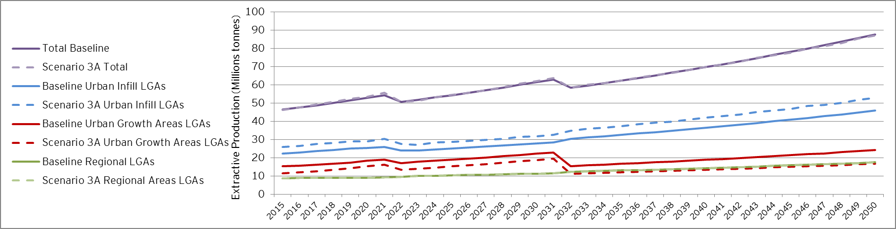
- Source: EY analysis

The following table summarises how the scenario 3A compares to the baseline demand projections over the short, medium and long term, in aggregate for LGAs in Urban Infill locations, Urban Growth Areas and regional areas:
Table 18 – Demand Forecast – Baseline vs. Scenario 3A – Total in 2015, 2026 and 2050 (million tonnes)
 | 2015 | 2026 | 2050
Baseline
Urban Infill LGAs | 22.3 | 25.6 | 46.0
Urban Growth Areas LGAs | 15.4 | 19.6 | 24.3
Regional LGAs | 8.7 | 10.6 | 17.5
Total Demand | 46.4 | 55.8 | 87.8
Scenario 3A
Urban Infill LGAs | 25.9 | 29.2 | 52.9
Urban Growth Areas LGAs | 11.6 | 16.0 | 16.7
Regional LGAs | 8.8 | 10.6 | 17.6
Total Demand | 46.3 | 55.8 | 87.2
- Source: EY analysis

Conclusions in terms of adverse economic impacts of a redistribution of the growth toward Urban Infill areas on the supply side are expected to be provided in the overall assessment developed by PwC in relation to the identification of regional gaps in the available capacity of the supply chain and the needs for extractive resources.
Scenario 3B
Scenario 3B consisted of assessing the impact of considering more development within Urban Growth Areas without amending government projections, therefore resulting in a redistribution of the demand for extractive resources towards those Urban Growth Areas, listed as follows and defined in Appendix B of the Report.
- Cardinia (S)
- Casey (C)
- Hume (C)
- Melton (C)
- Mitchell (C)
- Whittlesea (C)
- Wyndham (C)
To allow the redistribution to Urban Growth Areas, this scenario considered an increased residential development in those LGAs, involving an automatic decrease in residential development within Urban Infill LGAs. In terms of transport activity, this scenario considered that the increase in population growth within the Urban Growth Areas would lead to a faster extension of the transport network within those areas. The scenario assumes that this change is immediate and consistent until 2050.
The impact of scenario 3B against the Baseline demand forecast, in terms of spatial allocation per LGA classification, is presented in below Figure 27, which illustrates the impact of the redistribution towards Urban Growth Areas is expected not to be minor in terms of total demand forecast while neutral on the demand from regional LGAs.

Figure 27 – Total demand for extractive resources over the period 2015-2050 – Baseline vs. Scenario 3B
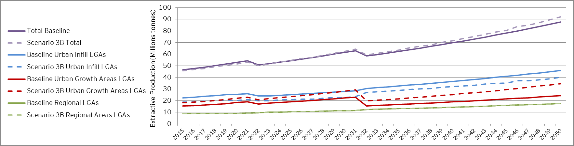
- Source: EY analysis

The following table summarises how the scenario 3B compares to the baseline demand projections over the short, medium and long term, in aggregate for LGAs in Urban Infill locations, Urban Growth Areas and regional areas:
Table 19 – Demand Forecast – Baseline vs. Scenario 3B – Total in 2015, 2026 and 2050 (million tonnes)
 | 2015 | 2026 | 2050
Baseline
Urban Infill LGAs | 22.3 | 25.6 | 46.0
Urban Growth Areas LGAs | 15.4 | 19.6 | 24.3
Regional LGAs | 8.7 | 10.6 | 17.5
Total Demand | 46.4 | 55.8 | 87.8
Scenario 3B
Urban Infill LGAs | 18.7 | 21.4 | 40.1
Urban Growth Areas LGAs | 18.2 | 24.2 | 34.7
Regional LGAs | 8.8 | 10.6 | 17.5
Total Demand | 45.7 | 56.2 | 92.3
- Source: EY analysis
Conclusions in terms of adverse economic impacts of a redistribution of the growth towards Urban Growth areas on the supply side are expected to be provided in the overall assessment developed by PwC in relation to the identification of regional gaps in the available capacity of the supply chain and the needs for extractive resources.

- Overview of scenarios results
The respective aggregated impacts of the scenarios 1A, 2A, 3A and 3B against the Baseline demand forecast, are presented in below Figure 28.

Figure 28 – Scenarios analysis - Total demand for extractive resources over the period 2015-2050 – Overview of results
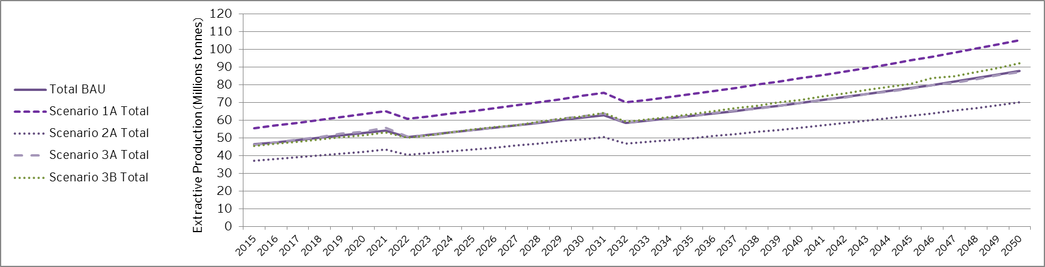
- Source: EY analysis
Note that from an aggregated perspective, the proportion between rock types according to the different scenarios analysed does not materially change.

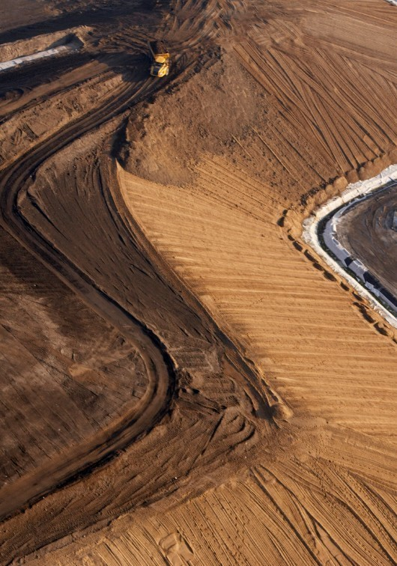
Broader insights for Government
- Broader insights for Government
Discussions with construction stakeholders during the consultation process, outlined in Appendix D and Appendix E of the Report, as well as discussions with AECOM provided key insights in relation to current and projected trends with respect to the uses of recycled materials, outlined in Section 2 of the Report.
Additional insights that could be relevant to the DEDJTR in terms of factors that could affect the demand for extractive resources in Victoria are described as follows:
Trend to importing products
It has been reported that most façade related products (impacting on the quantity of (glass) sand extracted in Victoria) are currently procured outside of Australia. This trend may be more and more applicable to finished products as well, such as precast materials.
Discussion with Boral also indicated that clinker, which is a raw material used to produce cement, is imported by Boral from China while the manufacturing process of cement is undertaken in Australia. As indicated in AECOM’s report, the main assumption in relation to cement was that this commodity product was composed of lime (65%), fine sand (25%) and clay (10%), all being extracted in Victoria. Information from Boral, if applicable to other manufacturers of commodity products, may have an impact of the quantities of extractive resources required in Victoria to produce cement.
Energy and Utilities construction activity
Further discussion with the DEDJTR’s technical advisor indicated that the Energy and Utilities sector may be a construction sector in decline with respect to the new builds as major infrastructure projects have been procured and built over the last decade in relation to power and water related infrastructures. And while wind farm projects seem to be currently driving the sector, this is for an expected short span of a few years only. Current expectations are that, in the next 10 to 20 years, the sector may only focus on improving efficiencies of existing infrastructure rather than building new power stations.
The Victorian Government discussion paper, Water for Victoria, which was released in early 2016, indicates that the Government is exploring opportunities to improve and augment the Victorian water grid (e.g. pipeline projects. In that respect, the following observations should be noted in relation to the baseline demand projections:
- The macro-economic driven forecast demand has been developed using the forecast of construction activities from 2015 to 2050, based on historic trends. It therefore largely reflects the recent peak in the construction of water infrastructure given the effect it had on the long term average spend in the sector (see Figure 9). As a result, while major water infrastructure projects have not been specifically modelled in the baseline demand projections, by reflecting recent trends, a level of ongoing construction in this sector has been factored in the forecast demand for extractive resources. This gives confidence that any significant changes in the Government’s investment program would not require a material upwards revision to the current demand projections.
- Further discussion with the DEDJTR’s technical advisor also indicated that for the Energy and Utilities sector, most of the materials required for new builds would be hard rock and soil, the latter being excluded from the demand analysis.
Based on these considerations, it is not anticipated that the projects outlined in Water for Victoria should have any major impact on the demand projections presented in this Report. However, it is recommended that the Government continues to monitor the construction trends in the water sector in the short to medium term in order to identify any major changes in construction activity and the implications for the demand for extractive resources.
Wind farms and rural areas
Quarries may be created on site in relation to wind farm projects. While identified as a potentially very expensive and lengthy process to get approvals from Works Authority, such trend could have an impact on the demand for extractive resources from an existing supply perspective, all the more if combined to an existing reported trend, according to which less materials seem to be sourced from quarries in rural areas.
Technological changes
AECOM reported an existing trend in buildings construction towards stiffer materials, illustrated for instance through an increasing appeal to the communities of sustainable or green buildings. This would imply a potential impact on the needs for extractive resources.
While concrete is not expected however to be fully substituted in the construction sector in the long term, where a scarcity of this commodity product was to take place, the substitution process would lead to move away completely from concrete and extractive materials altogether (rather than accepting a sharp increase in costs). The practical implementation of such a trend would heavily rely however on technological progress.
Steel and metal products in general may emerge as one of the leading materials for building construction activities in the future, as well as wood products.
In relation to transport construction activity, plastic roads are looked at in Europe, contemplated as an innovative and sustainable (from a value for money prospective) solution to replace concrete. Plastic roads are currently mainly considered for non-vehicle access surfaces such as bike lanes, footpath or shared users path).

Recommended
next steps
- Recommended next steps
Continued strong population growth and economic development is going to drive significant increases in the demand for extractive resources, especially in growing population centres in key Urban Growth Areas, infill suburbs in Metropolitan Melbourne and major regional centres like Ballarat, Geelong and Bendigo. As the extractive resources and construction industries respond to these persistent trends and industry pressures, there is likely to be a growing role for the further development and updating of these demand projections.
Through the process of completing this study, and to assist the DEDJTR and the Extractive Industries Taskforce, possible next steps that could be taken to enhance any future updates have been identified:
Update of the demand analysis based on latest data available
The forecast model that has been developed to assess the needs for extractive resources from the construction sector in Victoria was calibrated based on historic production data and linked to the Victorian Government’s long term forecasts around population and economic growth. Given the limitations and the inherent challenges around undertaking year-on-year demand projections for the highly cyclical construction industry, future updates could consider approaches to readily accommodate up-to-date production data as they arise, particularly given the inherent volatility of extractive resources production.
Extended market sounding
Stakeholders’ consultation implemented during the development process of the demand for extractive resources was quite limited in terms of number of stakeholders consulted. An extended market testing process may be considered so as to confirm and/or fine-tune the outcomes of the demand analysis.
Integration of demand and supply analysis
A constraint identified during the demand analysis was the lack of available data from a supply perspective, leading therefore to the development of an unconstrained demand forecast based on current patterns. Looking forward a more integrated supply and demand analysis could be contemplated to more explicitly account for possible regional supply constraints.
Demand for commodity products
Road base Class 1 and 2, concrete and concrete sand have been identified throughout the analysis as potential areas of concern due to their minimal substitutability. Should a similar exercise of forecasting the demand for extractive resources in Victoria be undertaken in the future, it may be recommended to narrow it down on those non-substitutable commodity products.

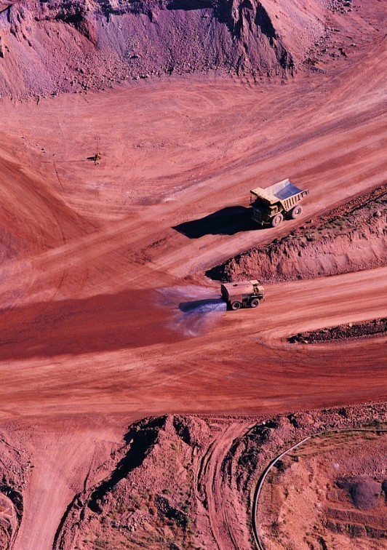
Appendices
- Limitations
The demand analysis of the extractive resources in Victoria is a first of its kind exercise, meant to be indicative only for policy making purposes in line with the requirements of the Taskforce and not for use as a general industry forecast for commercial or other purposes.
The extractive resources industry and the construction activities it supports are part of complex value chains, where both short and long term production and consumption could be subject to significant variations in demand and supply characteristics. For example, changing demographic and employment profiles could have material but as yet unknown implications for the demand for building construction. There could also be significant changes in the provision and use of transport and other forms of infrastructure, which could reflect changing preferences or the implementation of new technologies that create sudden step-changes in demand. There are also likely to be technological and other changes that affect the construction industry, which could include greater use of recycled materials or new commodity products and substitutes that are developed to overcome supply constraints or to meet changing community needs.
An important limitation is around the challenge of developing long term demand projections without detailed information of the supply of extractive resources, particularly over the longer term. This information is either commercially sensitive or not generally available, and the nature of the studies being undertaken for the Taskforce has meant that any detailed analysis of the supply of extractive resources has been completed separately by other advisors to the DEDJTR (PwC). EY has therefore been unable to identify and model the impact of future supply constraints on the demand for extractive resources at the economy-wide or local levels. Instead, our projections rely on the current patterns of supply of extractive resources being available over the longer term.
Given these limitations and the inherent challenges around undertaking year-on-year demand projections, there are likely to be significant variations in annual resource production that cannot be predicted in macro-driven models that are generally linked to long term Government forecasts of population growth and economic activity, which generally assume smooth changes over the short, medium and long term.
Despite these issues EY has used its best endeavours to develop a robust and informative set of demand projections, making use of all available industry information and economic data. EY also relied on input from key government and non-government stakeholders (e.g. VicRoads) and detailed data on the use of resources according to different construction types, which was supplied by the DEDJTR’s technical advisor (AECOM).
EY has not been in a position to verify the accuracy of these statements and other inputs from stakeholders. Neither has EY sought to verify the accuracy and consistency of the data provided by the technical advisor.
Furthermore, a number of the assumptions used to develop and test the demand projections derive from industry generalizations and rules-of-thumb, which were considered to be an acceptable approach at the industry level, but may not reflect the actual use of extractive resources in particular locations. These considerations add further weight to treating these projections with a reasonable degree of caution.

- Local Government Areas Directory
The geographic unit used to undertake the analysis of the demand for extractive resources is the LGA.
The table below outlines the list of LGAs used for the demand assessment, as well as their classifications (e.g. urban vs regional, Urban Infill vs Urban Growth Areas) and their regional affiliations.
Table 20 – LGAs Directory
# | LGAs | Classification | Regional affiliations
 | Alpine (S) | Regional | Ovens Murray
 | Ararat (RC) | Regional | Central Highlands
 | Ballarat (C) | Regional | Central Highlands
 | Banyule (C) | Urban Infill | Greater Melbourne
 | Bass Coast (S) | Regional | Gippsland
 | Baw Baw (S) | Regional | Gippsland
 | Bayside (C) | Urban Infill | Greater Melbourne
 | Benalla (RC) | Regional | Ovens Murray
 | Boroondara (C) | Urban Infill | Greater Melbourne
 | Brimbank (C) | Urban Infill | Greater Melbourne
 | Buloke (S) | Regional | Mallee
 | Campaspe (S) | Regional | Loddon Campaspe
 | Cardinia (S) | Urban Growth Area | Greater Melbourne
 | Casey (C) | Urban Growth Area | Greater Melbourne
 | Central Goldfields (S) | Regional | Loddon Campaspe
 | Colac-Otway (S) | Regional | Barwon
 | Corangamite (S) | Regional | Great South Coast
 | Darebin (C) | Urban Infill | Greater Melbourne
 | East Gippsland (S) | Regional | Gippsland
 | Frankston (C) | Urban Infill | Greater Melbourne
 | Gannawarra (S) | Regional | Mallee
 | Glen Eira (C) | Urban Infill | Greater Melbourne
 | Glenelg (S) | Regional | Great South Coast
 | Golden Plains (S) | Regional | Central Highlands
 | Greater Bendigo (C) | Regional | Loddon Campaspe
 | Greater Dandenong (C) | Urban Infill | Greater Melbourne
 | Greater Geelong (C) | Regional | Barwon
 | Greater Shepparton (C) | Regional | Goulburn
 | Hepburn (S) | Regional | Central Highlands
 | Hindmarsh (S) | Regional | Wimmera Southern Mallee
 | Hobsons Bay (C) | Urban Infill | Greater Melbourne
 | Horsham (RC) | Regional | Wimmera Southern Mallee
 | Hume (C) | Urban Growth Area | Greater Melbourne
 | Indigo (S) | Regional | Ovens Murray
 | Kingston (C) | Urban Infill | Greater Melbourne
 | Knox (C) | Urban Infill | Greater Melbourne
 | Latrobe (C) | Regional | Gippsland
 | Loddon (S) | Regional | Loddon Campaspe
 | Macedon Ranges (S) | Regional | Loddon Campaspe
 | Manningham (C) | Urban Infill | Greater Melbourne
 | Mansfield (S) | Regional | Ovens Murray
 | Maribyrnong (C) | Urban Infill | Greater Melbourne
 | Maroondah (C) | Urban Infill | Greater Melbourne
 | Melbourne (C) | Urban Infill | Greater Melbourne
 | Melton (C) | Urban Growth Area | Greater Melbourne
 | Mildura (RC) | Regional | Mallee
 | Mitchell (S) | Urban Growth Area | Goulburn
 | Moira (S) | Regional | Goulburn
 | Monash (C) | Urban Infill | Greater Melbourne
 | Moonee Valley (C) | Urban Infill | Greater Melbourne
 | Moorabool (S) | Regional | Central Highlands
 | Moreland (C) | Urban Infill | Greater Melbourne
 | Mornington Peninsula (S) | Urban Infill | Greater Melbourne
 | Mount Alexander (S) | Regional | Loddon Campaspe
 | Moyne (S) | Regional | Great South Coast
 | Murrindindi (S) | Regional | Goulburn
 | Nillumbik (S) | Urban Infill | Greater Melbourne
 | Northern Grampians (S) | Regional | Wimmera Southern Mallee
 | Port Phillip (C) | Urban Infill | Greater Melbourne
 | Pyrenees (S) | Regional | Central Highlands
 | Queenscliffe (B) | Regional | Barwon
 | South Gippsland (S) | Regional | Gippsland
 | Southern Grampians (S) | Regional | Great South Coast
 | Stonnington (C) | Urban Infill | Greater Melbourne
 | Strathbogie (S) | Regional | Goulburn
 | Surf Coast (S) | Regional | Barwon
 | Swan Hill (RC) | Regional | Mallee
 | Towong (S) | Regional | Ovens Murray
 | Wangaratta (RC) | Regional | Ovens Murray
 | Warrnambool (C) | Regional | Great South Coast
 | Wellington (S) | Regional | Gippsland
 | West Wimmera (S) | Regional | Wimmera Southern Mallee
 | Whitehorse (C) | Urban Infill | Greater Melbourne
 | Whittlesea (C) | Urban Growth Area | Greater Melbourne
 | Wodonga (RC) | Regional | Ovens Murray
 | Wyndham (C) | Urban Growth Area | Greater Melbourne
 | Yarra (C) | Urban Infill | Greater Melbourne
 | Yarra Ranges (S) | Regional | Greater Melbourne
 | Yarriambiack (S) | Regional | Wimmera Southern Mallee
Sources: Classification as Urban Growth Areas: http://www.mpa.vic.gov.au/
Regional Affiliations: http://www.rdv.vic.gov.au/information-portal/more-information/region-descriptions-and-geography-structure

- Assumptions Book
This Appendix outlines the assumptions and sources of data used for the development of the demand forecast for extractive resources from 2015 to 2050 and summarizes the key inputs, where applicable, used for the development and validation of the demand profile provided to PwC on 15 February 2016.
The Assumptions Book, in relation to the assumptions used to develop and refine the macro-economic driven model, as well as to develop the detailed industry analysis, is reliant on the information provided by AECOM and stakeholders consulted. A number of assumptions derive from industry generalization and rules-of-thumbs, which were considered to be an acceptable approach at the industry level but may not reflect the actual use of extractive resources in particular locations.
- Baseline Forecast – Macro-economic driven model
  - Historic data - Correlation analysis
    - Demand drivers – Historic data
Table 21 below indicates the sources of demand drivers’ historic data used to undertake regression analyses required for the development of the baseline macro-economic driven demand model.
Table 21 – Demand Drivers Historic Data - Sources
Item | Sources
Employment Growth (1993 – 2014) | ABS 6202.0 Labour Force, Australia / Table 5. Labour force status by Sex, Victoria - Trend, Seasonally adjusted and Original / Employed Total Persons (Series ID A84423685F)
Gross State Product (1993 – 2014) | Victorian Department of Treasury and Finance - 2015-2016 Budget (Australian Bureau of Statistics - 5220.0)
Interest Rate (1993 – 2014) | A2 Reserve Bank of Australia – Monetary Policy Changes
Population Growth (1993 – 2014) | ABS Estimated Resident Population (ERP) by LGA 1991-2014.
Population Growth (2014-2015) | VIF 2015 – Use of 2011 and 2021 data, which allowed deriving an average annual growth rate (AAGR) in 2015.
Source: EY data
    - Construction activities – Historic data
Table 22 below indicates the sources of construction activities’ historic data used to undertake regression analyses required for the development of the baseline macro-economic driven demand model.
Nominal values of the works done being provided per type of construction activity by the ABS, all construction activity data have been adjusted for inflation to obtain the real values and eliminate the impact of inflation in the regression analyses, using Melbourne Producer Price Index inputs.
Table 22 – Construction Activities Historic Data ($) - Sources
Item | Sources
Residential Activity (1993 – 2014) | ABS 8752.0 Building Activity, Australia / Table 42. Value of Building Work by Sector, Victoria: Original:  Total Residential (Series ID A83801931L)
Non Residential Activity (2002 – 2014) | ABS 8752.0 Building Activity, Australia / Table 53. Value of Value of Non-residential Building Work Done, by Sector, Victoria: Original:  Total Commercial Buildings (Series ID A1011348R)  Total Education Buildings (Series ID A1094082L)  Total Health Buildings (Series ID A988727F)
Transport Activity (1993 – 2014) | ABS 8762.0 Engineering Construction Activity, Australia / Table 16. Value of Work Done, by Sector, Victoria, Original:  Roads, Highway and Subdivisions (Series ID A1839245X)  Bridges, Railways and Harbours (Series ID A1839293T)
Energy and Utility Activity (1993 – 2014) | ABS 8762.0 Engineering Construction Activity, Australia / Table 16. Value of Work Done, by Sector, Victoria, Original:  Electricity generation, transmission etc. and pipelines (Series ID A1839296X)  Water storage and supply, sewerage and drainage (Series ID A1839299F)
Producer Price Index (1993-2014) | ABS 6427.0 Producer Price Indexes, Australia / Table 18. Input to the House construction industry, six state capital cities, weighted average and city, index numbers and percentage changes:  Melbourne (Series ID A2390462F)
Source: EY data
    - Production of extractive resources – Historic data
Historic data used in relation to the production of extractive resources in Victoria have been provided by DEDJTR, on a financial year basis, in May 2015. The inputs used for the analysis, from 2002 to 2014, are summarized in the Table 23 below.
Table 23 – Production of Extractive Resources 2002 – 2014 (in million tonnes)
Rock type | 2002 | 2003 | 2004 | 2005 | 2006 | 2007 | 2008 | 2009 | 2010 | 2011 | 2012 | 2013 | 2014
Hard Rock | 25.0 | 23.8 | 24.9 | 26.7 | 29.8 | 34.2 | 35.4 | 31.1 | 30.3 | 33.5 | 39.3 | 28.9 | 27.4
Clay and Clay Shale | 1.3 | 1.1 | 1.5 | 1.4 | 1.5 | 2.5 | 1.7 | 1.3 | 1.5 | 1.9 | 1.8 | 1.6 | 0.6
Limestone | 1.8 | 1.8 | 1.9 | 2.0 | 2.0 | 2.5 | 3.0 | 2.8 | 2.4 | 2.6 | 2.9 | 2.7 | 1.5
Sand and Gravel | 11.4 | 10.9 | 10.5 | 11.5 | 13.0 | 13.1 | 14.2 | 13.5 | 11.9 | 14.0 | 14.1 | 14.0 | 10.8
Total | 39.5 | 37.6 | 38.8 | 41.6 | 46.4 | 52.3 | 54.2 | 48.7 | 46.1 | 52.1 | 58.1 | 47.2 | 40.3
Source: DEDJTR May 2015
  - Forecast Analysis
    - Demand Drivers
Population projections inputs relied upon to forecast the population growth from 2015 to 2050 per LGA have been sourced from VIF 2015 in relation to 2011, 2021 and 2031 milestones data and from VITM in relation to 2046 milestone data. Yearly population growth has been calculated using the average annual growth rate between those key milestones data.
GSP projections used for the forecast analysis have been provided by Victorian Department of Treasury and Finance in the 2015-2016 Budget paper. Key inputs are summarized in the below table. From 2020 to 2050, a stable rate of 2.75%, corresponding to 2019 forecast, has been used.
Table 24 – GSP Projections
Rock type | 2015 | 2016 | 2017 | 2018 | 2019
GSP | 2.25% | 2.50% | 2.75% | 2.75% | 2.75%
Source: 2015-2016 Budget Paper

    - Transport major projects
Forecast and spatial allocation of transport major projects from 2015 to 2022 is based on BIS Shrapnel data, updated to remove known completed or abandoned projects, and EY knowledge of Victorian Government’s major transport projects to be undertaken. The list of the transport major projects considering in the macro-economic driven demand model is the following:

Table 25 – Transport Major Projects 2015-2022
# | Item | LGAs location
 | Melbourne Metro Rail | Melbourne (C), Port Philip (C)
 | Level Crossing Removal Program | Banyule (C), Brimbank (C), Casey (C), Darebin (C), Frankston (C), Glen Eira (C), Greater Dandenong (C), Hobsons Bay (C), Kingston (C), Knox (C), Monash (C), Moonee Valley (C), Moreland (C), Stonnington (C), Whitehorse (C), Wyndham (C), Yarra Ranges (S)
 | Western Distributor | Melbourne (C), Maribyrnong (C)
 | CityLink – Tullamarine Freeway Widening | Melbourne (C), Moonee Valley (C), Moreland (C)
 | Mernda Rail Extension | Whittlesea (C)
 | Murray Basin Rail Project | Central Goldfields (S), Northern Grampians (S), Loddon (S), Buloke (S), Swan Hill (RC), Mildura (RC)
 | Princes Highway duplication project | Colac Otway (S), Surf Coast (S), Latrobe (C), Wellington (S), Greater Geelong (C)
 | M80 Upgrade | Brimbank (C), Moreland(C), Hume (C), Whittlesea (C), Banyule (C)
 | Dingley Bypass | Kingston (C)
 | Chandler Highway Bridge Duplication | Boroondara (C)
 | Western Highway Duplication | Ballarat (C), Pyrenees (S), Ararat (RC), Northern Grampians (S)
 | Kilmore Wallan Bypass | Mitchell (S)
 | Goulburn Valley Hwy | Greater Shepparton (C)
 | Melbourne Airport | Hume (C)
Source: EY analysis

  - Spatial Allocation – Employment Growth
Employment projections inputs, relied upon to forecast the employment growth from 2015 to 2050 per LGA and spatially allocate non-residential activity, have been sourced from VITM data, provided by the DEDJTR in August 2015. Yearly employment growth has been calculated using the average annual growth rate between those key milestones data.
- Baseline Forecast – Detailed Industry Analysis
To test the robustness of the macro-economic driven model developed to assess the demand for extractive resources from 2015 to 2050 in Victoria, an alternative demand model has been developed, informed by technical data provided by AECOM and discussions with stakeholders collected during the stakeholder consultation process, as well as a micro-economic forecast of the construction activities’ key drivers.
This sub-section of this Assumptions Book focuses on the listing of all the assumptions used for the development of the detailed industry model forecast per type of construction activities.
  - Residential Construction Activity
In accordance with the Australian Construction Handbook 2015, the residential construction commonly consists of the construction of the following buildings:
- Houses - single unit, referring to:
- Individual houses
- Town houses
- Multi units – low density, referring to:
- Flats – maximum three storeys
- Flats – multi storeys
- Holiday units
- Aged persons homes
- Hostels
For the purpose of this analysis, residential profile of construction in relation to houses and multi-units has only been developed, being considered to represent the greatest proportion of residential buildings to be constructed in the future.
To develop the residential construction profile, i.e. to forecast the number of new dwellings to be built from 2015 to 2050, the following demand drivers have been taken into consideration:
- Population growth projections, in accordance with VIF 2015 and VITM 2046 projections.
- Existing dwellings structure provided by SA2 in the ABS Census 2011 (Table B31 Dwelling Structure). Those data have been compiled in accordance with the following categories:
- Individual houses
- Townhouses
- Apartments up to three storeys
- Apartments exceeding three storeys

- Household sizes projections by Statistical Area, in accordance with VIF 2015 projections available in 2011, 2021 and 2031. Resulting trends were then used in 2046.
From 2015 to 2020, 2011 Census split of existing dwellings by SA2 has been used to forecast the number of new individual houses, townhouses and apartments.
From 2021 to 2050, the following split has been assumed for new residential constructions, driven by household sizes and geographical location. Those assumptions correspond to trends observed from the analysis of the 2011 Census data, where averages of construction splits per household size could be derived, respectively for regional and urban areas.
Table 26 – Dwellings Split Forecast 2021-2050
Household sizes (persons per household) | Individual house | Urban area townhouse | Dwelling splits apartment up to 3 storeys | Apartment 4+ storeys | Individual house | Regional area townhouse | Dwelling splits apartment up to 3 storeys | Apartment 4+ storeys
3.40 | 93% | 6% | 1% | 0% | n/a | n/a | n/a | n/a
3.20 | 93% | 6% | 1% | 0% | n/a | n/a | n/a | n/a
3.00 | 93% | 6% | 1% | 0% | n/a | n/a | n/a | n/a
2.80 | 89% | 5% | 6% | 0% | 99% | 0% | 0% | 0%
2.60 | 86% | 7% | 6% | 0% | 96% | 2% | 3% | 0%
2.40 | 75% | 13% | 11% | 1% | 93% | 3% | 4% | 0%
2.20 | 57% | 14% | 26% | 2% | 92% | 3% | 5% | 0%
2.00 | 32% | 30% | 16% | 22% | 92% | 4% | 4% | 0%
1.80 | 17% | 13% | 40% | 30% | 75% | 13% | 11% | 1%
1.60 | 2% | 11% | 27% | 61% | 57% | 14% | 26% | 2%
Source: EY analysis

Demand of new residential dwellings, driven by population projections and household sizes, has therefore been consequently forecast on a yearly basis (using an average annual growth rate) over the period of analysis. Where the population projections provided were decreasing from one key milestone date to the other, no destruction of houses has been accounted for.
Estimates of the residential construction demand for extractive resources have then been calculated, multiplying the housing commencements derived from population and household size forecast data by the quantity of extractive resources required for a standard individual house, a standard townhouse, a standard apartment in a three storeys building and a standard apartment in a multi-storey building. Those estimated quantities were provided by AECOM on 23 December 2015. Where asphalt is used as a commodity product for construction purposes, 15% of asphalt manufactured was considered to be made from recycled materials and therefore not accounted in the demand for extractive resources subsequent to the construction needs. Figures presented in AECOM data do not reflect this adjustment.
Overall, based on AECOM data provided for key residential construction activities, the use of extractive resources in relation to the residential construction activity can be summarized as follows. This breakdown, an average across the State, has been used in the macro-economic driven model to spatially allocate extractive resources, in each LGA, based on the forecast spatial allocation of residential construction activity ($ value).
Table 27 – Estimated breakdown of extractive resources required for residential construction activity (%)
 | Hard rock (%) | Limestone (%) | Clay and clay shale (%) | Sand and gravel (%)
Residential Activity | 72% | 6% | 1% | 21%
Source: EY analysis based on AECOM inputs

  - Non-residential Construction Activity
In accordance with the Australian Construction Handbook 2015, the non-residential construction commonly consists of the construction of the following types of buildings:
- Commercial buildings (e.g. offices buildings)
- Retail buildings (e.g. suburban neighbourhood shopping centres or regional department stores or shopping centres)
- Industrial Buildings (e.g. warehouses, factories)
- Others (e.g. banks, schools, hospital, hotels, recreational)
For the purpose of this analysis, the non-residential profile of construction in relation to commercial buildings, retail buildings, industrial buildings and schools has only been developed, those being considered as the most appropriate categories of non-residential buildings to forecast accurately in terms of future construction trends.
To develop the non-residential construction profile, i.e. to forecast the number of new commercial, retail and industrial buildings and the number of new schools to be built from 2015 to 2050, demand drivers have been taken into consideration. They will be presented separately for schools in the following sub-section, as different.
    - New schools construction profile
The demand drivers taken into consideration to develop the new schools construction profile are the following:
- Population growth projections, in accordance with VIF 2015 and VITM 2046 projections.
- Household sizes projections by Statistical Area, in accordance with VIF 2015 projections available in 2011, 2021 and 2031. Resulting trends were then used in 2046.
- “Rockbank Precinct Structure Plan – Social Infrastructure Needs Assessment” study, released by the Metropolitan Planning Authority (MPA) in July 2014. This study indicates on p.16 that within the area of analysis:
- A primary school is required to be built per 3,000 dwellings
- A secondary school is required to be built per 9,000 dwellings

As a result, based on household projections and consequent new dwellings to be built, the number of new primary and secondary schools required to be built has been forecast on a yearly basis (using an average annual growth rate) over the period of analysis.
Estimates of the construction demand for extractive resources in relation to new schools have then been calculated, multiplying the number of schools derived from population and household size forecast data by the quantity of extractive resources required for a standard primary and secondary school. Those estimated quantities were provided by AECOM on 23 December 2015. Where asphalt is used as a commodity product for construction purposes, 15% of asphalt manufactured was considered to be made from recycled materials and therefore not accounted in the demand for extractive resources subsequent to the construction needs. Figures presented in AECOM data do not reflect this adjustment.
    - Commercial / Retail / Industrial buildings construction profile
The demand drivers taken into consideration to develop the commercial / retail / industrial buildings’ construction profile are the following:
- Employment growth historic data provided by LGA by ABS
- Employment growth projections by LGA, in accordance with VITM 2021, 2031 and 2046 projections
- Existing employment split by category of jobs by LGA, provided for 2011 by ABS Industry of Employment (ANZSIC06)
- Total building approvals historic data provided for Victoria by ABS (8731.0 Building Approvals, Australia, Table 61. Number of Non-residential Building Jobs Approved, by Value Range, Original – Victoria) from 2001 to 2015
- National Construction Code (NCC) 2015 Building Code of Australia – Volume 1
A statistical regression analysis has been conducted, leading to identify a strong correlation between the total building approvals issued and new jobs created. The result of this analysis indicated that a building approval is issued for around every 100 extra jobs created.
Using 2011 available split of jobs by LGA and compiling those data in accordance with three main categories that are commercial, retail and industrial jobs, the creation of new commercial, retail and industrial jobs has been extrapolated from 2015 to 2050 on the basis of the available employment growth projections by LGA. Then, using the conversion metric identified (i.e. every 100 extra jobs 1 building is constructed), the number of new commercial, retail and commercial buildings to be built has been accordingly forecast on a yearly basis (using an average annual growth rate) over the period of analysis.
Section D1.13 “Number of persons accommodated” of the NCC provides information with respect to the standard area (m2) per person to be considered per type of use. As a result, the following assumptions have been considered to estimate the standard surface areas of new non-residential buildings to be constructed, per type of use. Note that the square meters estimates provided exclude spaces set aside for lifts, stairways, ramps, escalators, corridors, hallways and lobbies. As a result, an increase by 20% of the average surface area to be considered by person with respect to commercial and retail uses has been factored in.
- Commercial buildings: average 10m² per person required (12m² considering a 20% increase). A building being assumed to be constructed every 100 new jobs, the standard surface area of a commercial building has been estimated to amount to 1,200m²
- Retail buildings: average 5m² per person required (6m² considering a 20% increase). A building being assumed to be constructed every 100 new jobs, the standard surface area of a retail building has been estimated to amount to 600m²
- Industrial buildings: average 27.5m² per person required. A building being assumed to be constructed every 100 new jobs, the standard surface area of an industrial building has been estimated to amount to 2,750m²
Estimates of the construction demand for extractive resources in relation to new commercial, retail and industrial buildings have then been calculated, multiplying the number of buildings identified, by each building type standard surface area and ultimately by the quantity of extractive resources required for the construction of 1m2 of standard commercial, retail and industrial building. Those estimated quantities were provided by AECOM on 23 December 2015, whose inputs were categorized as follows:
- High rise commercial office CBD – Tower building: this category has been assumed to correspond to a commercial building in urban areas
- Neighbourhood centre supermarket anchor: this category has been assumed to correspond to a retail building in urban and regional areas
- Warehouse units 5m springing height: this category has been assumed to correspond to a commercial building in regional areas and to an industrial building in urban and regional areas.
Where asphalt is used as a commodity product for construction purposes, 15% of asphalt manufactured was considered to be made from recycled materials and therefore not accounted in the demand for extractive resources subsequent to the construction needs. Figures presented in AECOM data do not reflect this adjustment.
Overall, based on AECOM data provided for the non-residential construction, the use of extractive resources in relation to the non-residential construction activity can be summarized as follows. This breakdown, an average across the State, has been used in the macro-economic driven model to spatially allocate extractive resources, in each LGA, based on the forecast spatial allocation of non-residential construction activity ($ value).
Table 28 – Estimated breakdown of extractive resources required for non-residential construction activity (%)
 | Hard rock (%) | Limestone (%) | Clay and clay shale (%) | Sand and gravel (%)
Non-residential activity | 78% | 5% | 1% | 15%
Source: EY analysis based on AECOM inputs

  - Transport Construction Activity
    - Transport Network in Victoria
Construction activities in relation to the transport network in Victoria are related to the construction of new roads and the maintenance and rehabilitation of the transport network, including existing and new network extended on a yearly basis, although subject to the availability of public funding. In Victoria, the arterial roads network and freeways are planned and managed by VicRoads. This includes maintaining 55,000 lane kilometres of roads, as indicated in VicRoads annual report 2014-2015. The remainder of the network is planned and managed by the local councils of Victoria.
The transport network profile to forecast the needs for extractive resources in relation to the construction of new roads and the roads maintenance and rehabilitation works has been developed considering the following demand drivers:
- Existing VicRoads network (55,000 lane kms) and potential roads development in Metropolitan Melbourne. The potential roads development forecast from 2015 to 2046 has been provided by VicRoads representatives. Where a ‘various item’ was specified in VicRoads dataset, it has been evenly broken down within each metropolitan LGA. From 2046 to 2050, a constant increase has been considered.
- Existing local councils’ roads network and potential roads development in Victoria. The Australian Grant Commission Annual Reports, available in the public domain, helped inform and understand the length of the existing network in urban and regional LGAs and the yearly historic evolution from 2009 to 2014, which provided robust grounds to estimate an appropriate forecast of the yearly network expansion by LGA over the period of analysis. A key assumption has been to only forecast, based on existing data available in 2014, an increase of the network in Urban Growth Areas (defined by LGA in Appendix B of the Report) and a few specific regional LGAs that are Ballarat, Greater Bendigo and Greater Geelong, considered as regional hubs of potential growth. The development of transport network varying depending upon economic growth, business requirements, population growth, housing demand and government planning, it has been considered in those LGAs to factor in an increase of the existing road network by 70% of the projected population growth in those locations, in order to mitigate the multiplicity of parameters the roads development is subject to. Note that the local councils’ roads are made up in each LGA of local urban and local rural roads, which was taken into consideration in the calculation of extractive resources requirements, due to the inherent maintenance and rehabilitation impacts in terms of extractive resources requirements, specific to those categories of roads.
Estimates of the transport development demand for extractive resources have then been calculated, multiplying either the transport network length or the net increase in the transport network by the quantity of extractive resources required for each of the roads works considered. Those estimated quantities were provided by AECOM on 23 December 2015, on a km or lane km basis. Where asphalt is used as a commodity product for construction purposes, 15% of asphalt manufactured was considered to be made from recycled materials and therefore not accounted in the demand for extractive resources subsequent to the construction needs. Figures presented in AECOM data do not reflect this adjustment.
Those calculations have been categorized as follows:
- Requirements for new roads construction:
- VicRoads network: extractive resources requirements have been calculated by multiplying the yearly net increase of the network, in lane kms, by the quantity of extractive resources required for the construction of 1 lane km of urban highway (4 lanes).
- Local councils’ road network – Local urban roads: extractive resources requirements have been calculated by multiplying the yearly net increase of the network, in kms, by the quantity of extractive resources required for the construction of 1 lane km of urban highway (2 lanes) and by 2 to account for the lane numbers.
- Local councils road network – Local rural roads:
- In Ararat, Gannawarra, Moira, Moyne, South Gippsland LGAs (considered as remote rural councils), extractive resources requirements have been calculated by multiplying the yearly net increase of the rural network, in kms, by 80% of the quantity of extractive resources required for the construction of 1 km of sealed road and by 20% of the quantity of extractive resources required for the construction of 1 km of unsealed road.
- In Buloke, East Gippsland, Glenelg, Hindmarsh, Horsham, Mildura, Swan Hill, Towong, Wellington, West Wimmera and Yarrambiak LGAs (considered as very remote rural councils), extractive resources requirements have been calculated by multiplying the yearly net increase of the rural network, in kms, by 60% of the quantity of extractive resources required for the construction of 1 km of sealed road and by 40% of the quantity of extractive resources required for the construction of 1 km of unsealed road.
- In other LGAs, extractive resources requirements have been calculated by multiplying the yearly net increase of the rural network, in kms, by the quantity of extractive resources required for the construction of 1 km of sealed road.
- Requirements for roads maintenance and rehabilitation works:
- VicRoads network: an initial assumption has been considered to split the network in urban and rural areas according to a respective 60% / 40% split, therefore impacting on the type of treatments expected to be implemented.
- In urban areas, in terms of maintenance works, 50% of the periodic maintenance area is asphalt patching, where 5% of this area is covered. 30% of the periodic maintenance is spray seal, where 5.5% of this area is covered. 20% of the periodic maintenance is reseal with asphalt patch, where 5.5% of this area is covered. In terms of rehabilitation works, 80% of the periodic rehabilitation area is asphalt, where 0.06% of this area is covered by asphalt overlay, 0.03% is covered by major deep patch asphalt and 2% is covered by asphalt resurfacing. 20% of the periodic rehabilitation area is road rehabilitation.
- In rural areas, in terms of maintenance works, 90% of the periodic maintenance area is treated by reseal, with 30% of this area having gravel patch where 5.5% of this area is covered. 10% of the period maintenance area is treated by asphalt patch, where 5.5% of this area is covered. In terms of rehabilitation works, 20% of the periodic rehabilitation area is asphalt, where 0.06% of this area is covered by asphalt overlay, 0.03% is covered by major deep patch asphalt and 2% is covered by asphalt resurfacing. 80% of the periodic rehabilitation area is road rehabilitation.
- Local councils’ road network – Local urban roads: similar treatment to VicRoads network in urban areas, using a 1.5% coverage for asphalt resurfacing though instead of 2% for rehabilitation works.
- Local councils’ road network – Local rural roads:
- In Ararat, Gannawarra, Moira, Moyne, South Gippsland LGAs (considered as rural councils), in terms of maintenance works, 2% of the road-km is maintained by a periodic reseal and 2% is maintained by gravel wearing course top up. Within this area covered by wearing course to up, 30% of that area also incorporates gravel patching. In terms of rehabilitation works, 80% of the periodic rehabilitation area is sealed road rehabilitation and 20% is unsealed road rehabilitation, with a 1% coverage for asphalt resurfacing.
- In Buloke, East Gippsland, Glenelg, Hindmarsh, Horsham, Mildura, Swan Hill, Towong, Wellington, West Wimmera and Yarrambiak LGAs (considered as remote rural councils), in terms of maintenance works, 2% of the road-km is maintained by a periodic reseal and 1% is maintained by gravel wearing course top up. Within this area covered by wearing course to up, 30% of that area also incorporates gravel patching. In terms of rehabilitation works, 60% of the periodic rehabilitation area is sealed road rehabilitation and 40% is unsealed road rehabilitation, with a 0.5% coverage for asphalt resurfacing.
- In other LGAs, in terms of maintenance works, 2% of the road-km is maintained by a periodic reseal. In terms of rehabilitation works, 100% of the period rehabilitation area is sealed road rehabilitation.
Overall, based on AECOM data provided for transport network activity, the use of extractive resources in relation to the whole activity can be summarized as follows. This breakdown has been used in the macro-economic driven model to refine the spatial allocation of extractive resources. This breakdown has been used in the macro-economic driven model to spatially allocate extractive resources, in each LGA, based on the forecast spatial allocation of transport construction activity ($ value). This is an average across the State and does not reflect that some areas use more locally sourced material like sand and gravel or limestone for the majority of their transport needs.
Table 29 – Estimated breakdown of extractive resources required for transport construction activity (%), excluding major projects
 | Hard rock (%) | Limestone (%) | Clay and clay shale (%) | Sand and gravel (%)
Transport Activity (excluding major projects) | 96% | 1% | 0% | 2%
Source: EY analysis based on AECOM inputs

    - Transport Major Projects
The transport major projects requirements, in terms of extractive resources, have been assessed in accordance with the list of transport major projects, based on BIS Shrapnel data and EY analysis, that has been used, in terms of $ value, to inform the development of the macro-economic driven model from 2015 to 2026. Technical assumptions have been considered for each of those projects however in order to accurately assess the materials requirements.
From 2027 onwards, based on the requirements of extractive resources calculated from 2015 to 2026, a trend line has been used to forecast the assumed demand for extractive resources from major transport projects from 2027 onwards. This forecast trend is consistent with guidelines provided by the State Budget Papers, according to which, out of 30% of the State GSP committed to infrastructure projects, 80% should be dedicated to transport projects.
The below table summarizes those technical assumptions.
Table 30 – Transport Major Projects
# | Item | LGAs location
 | Melbourne Metro Rail | Melbourne (C), Port Philip (C) | - Twin nine-kilometre underground rail tunnels to be built
 | Level Crossing Removal Program | Banyule (C), Brimbank (C), Casey (C), Darebin (C), Frankston (C), Glen Eira (C), Greater Dandenong (C), Hobsons Bay (C), Kingston (C), Knox (C), Monash (C), Moonee Valley (C), Moreland (C), Stonnington (C), Whitehorse (C), Wyndham (C), Yarra Ranges (S) | - 50 level crossings  - 500m rail track to be built per level crossing  - 1 bridge (2200m length) per level crossing, made up out of in situ and precast concrete
 | Western Distributor | Melbourne (C), Maribyrnong (C) | - 20 lane kms along the West Gate Freeway  - 2 bridges (36000m2 each)  - 3 lane road tunnel (3.5km length)
 | CityLink – Tullamarine Freeway Widening | Melbourne (C), Moonee Valley (C), Moreland (C) | - 23.8 kms
 | Mernda Rail Extension | Whittlesea (C) | - Eight kilometres of dual rail tracks, i.e. 16kms total
 | Murray Basin Rail Project | Central Goldfields (S), Northern Grampians (S), Loddon (S), Buloke (S), Swan Hill (RC), Mildura (RC) | - Gheringhap to Maryborough (dual gauge conversion). New ballast required for 140km @ 50% ratio for ballast.  - Maryborough to Ararat (re-open and upgrade unused rail line). New sleepers and ballast required for 85km @ 100% for each.  - Maryborough to Yelta (broad to standard gauge conversion). New sleepers and ballast required for 420km at 60% for sleepers and 100% for ballast.  - Ouyen to Murrayville (broad to standard gauge conversion). New sleepers and ballast required for 100km at respectively 50%.  - Dunolly to Manangatang (broad to standard gauge conversion). New sleepers and ballast required for 270km at respectively 50%.  - Charlton to Sea Lake (broad to standard gauge conversion). New sleepers and ballast required for 100km at respectively 50%.
 | Princes Highway duplication project | Colac Otway (S), Surf Coast (S), Latrobe (C), Wellington (S), Greater Geelong (C) | - 12.9kms
 | M80 Upgrade | Brimbank (C), Moreland(C), Hume (C), Whittlesea (C), Banyule (C) | - 10 kms
 | Dingley Bypass | Kingston (C) | - 19 kms
 | Chandler Highway Bridge Duplication | Boroondara (C) | - One 4 lanes bridge (2200m2)
 | Western Highway Duplication | Ballarat (C), Pyrenees (S), Ararat (RC), Northern Grampians (S) | - 29 kms
 | Kilmore Wallan Bypass | Mitchell (S) | - 13 kms
 | Goulburn Valley Hwy | Greater Shepparton (C) | - 36 kms
 | Melbourne Airport | Hume (C) | - 3rd runway (3200m length) in 2020-2021  - 4th runway (3200m length) in 2033-2034
Source: EY analysis

Estimates of the transport major projects demand for extractive resources have been calculated, multiplying technical features of each project by available unit quantity of extractive resources required per type of projects. Those estimated quantities were provided by AECOM on 23 December 2015. Note that the calculation of the quantity of extractive resources required for major roads projects relied upon AECOM data provided per lane Km for rural highway 2 lanes. As the km data available were not provided in lane kms, each project road length has been multiplied by 2 as well. This is applicable to all roads projects except Western Distributor where conversion metrics available per lane km for urban highway 4 lanes have been considered.
Where asphalt is used as a commodity product for construction purposes, 15% of asphalt manufactured was considered to be made from recycled materials and therefore not accounted in the demand for extractive resources subsequent to the construction needs. Figures presented in AECOM data do not reflect this adjustment.
Overall, based on AECOM data provided for transport major projects, the use of extractive resources in relation to the transport major projects activity can be summarized as follows. This breakdown, an average across the State, has been used in the macro-economic driven model to refine the spatial allocation of extractive resources. This breakdown, an average across the State, has been used in the macro-economic driven model to spatially allocate extractive resources, in each LGA, based on the forecast spatial allocation of transport major projects construction activity ($ value).
Table 31 – Estimated breakdown of extractive resources required for transport major projects activity (%)
 | Hard rock (%) | Limestone (%) | Clay and clay shale (%) | Sand and gravel (%)
Transport Major Projects Activity | 77% | 2% | 2% | 18%
Source: EY analysis based on AECOM inputs

  - Wind Farm Construction Activity
Energy and utilities construction commonly consists of the construction of water treatment plants, power transmissions lines and footings, pipes, pits and backfill/thrust blocks, dams, solar farms, power stations and substations and wind farms.
For the purpose of this analysis, energy and utilities construction profile in relation to wind farms projects has only been developed, due to the lack of data availability in relation to other types of energy and utilities projects, therefore undermining a forecasting process.
To develop the wind farms projects construction profile, i.e. to forecast the number of new wind farms turbines expected to be built in the coming years, the following assumptions have been taken into consideration:
- List of approved projects and planned projects with a permit process underway or lodged with the Minister of Planning, based on latest information available on DEDJTR website (i.e. as of 21 August 2015 at the date of the development of the demand profile). The table below summarizes the available data:
Table 32 - Wind Farms - Approved and planned projects - August 2015
Projects | Proponent | Number of Generators/Turbines | Maximum Power  (MW) High Range | LGAs
Ararat | RES Australia | 75 | 240 | Ararat (RC)
Berrimal | Acciona Energy | 24 | 72 | Northern Grampians (S)
Berrybank | Union Fenosa | 89 | 178 | Ballarat (C)
Bulgana | Enerfin | 63 | 189 | Ararat (RC)
Cherry Tree | Infigen Energy | 16 | 48 | Greater Shepparton (C)
Coonooer Bridge | Windlab Systems | 6 | 19.4 | Northern Grampians (S)
Crowlands | Pacific Hydro | 41 | 82 | Ararat (RC)
Hawkesdale | Union Fenosa | 31 | 62 | Moyne (S)
Lal  (Elaine and Yendon) | West Wind Energy | 64 | 150 | Ballarat (C)
Moorabool | West Wind Energy | 107 | 321 | Ballarat (C)
Mortlake South | Acciona Energy | 51 | 76 | Moyne (S)
Mount Gellibrand | Acciona Energy | 63 | 189 | Colac-Otway (S)
Ryan Corner | Union Fenosa | 67 | 134 | Moyne (S)
Salt Creek | TrustPower | 15 | 30 | Moyne (S)
Stockyard Hill | Origin Energy | 157 | 471 | Ballarat (C)
Woolsthorpe | Wind Farm Developments | 20 | 46 | Warrnambool (C)
Yaloak South | Pacific Hydro | 14 | 29 | Moorabool (S)
Dundonnell | TrustPower | 104 | 312 | Moyne (S)
Winchelsea | GDF Suez | 14 | 28 | Greater Geelong (C)
TOTAL |  | 1021 | 2676 | n/a
Source: http://www.energyandresources.vic.gov.au/energy/sustainable-energy/wind-energy/wind-projects (August 2015)

Windfarm construction profile (low range scenario) provided in Acil Allen Study in relation to Victorian New Wind Capacity expected to be constructed and provided by the DEDJTR. The below table outlines the construction profile assumed for the purpose of the analysis.
Table 33 – Windfarms Projects – Construction Profile
 | 2016 | 2017 | 2018 | 2019 | 2020 | Total
Construction Profile | 0.0% | 3.2% | 45.9% | 38.6% | 12.2% | 100.0%
Capacity Profile | 0 | 87 | 1228 | 1034 | 328 | 2,676
Source: EY analysis based on Acil Allen Study

As a result, a construction profile of wind farms turbines to be built has been extrapolated, that prioritized the construction of windfarms with the highest proposed capacities.
Estimates of the wind farms construction demand for extractive resources have then been calculated, multiplying the number of wind turbines by the quantity of extractive resources required for a wind turbine. Those estimated quantities were provided by AECOM on 23 December 2015. Where asphalt is used as a commodity product for construction purposes, 15% of asphalt manufactured was considered to be made from recycled materials and therefore not accounted in the demand for extractive resources subsequent to the construction needs. Figures presented in AECOM data do not reflect this adjustment. Overall, based on AECOM data provided for wind turbines, the use of extractive resources in relation to the wind farms construction can be summarized as follows.
Table 34 – Estimated breakdown of extractive resources required for wind farm construction activity (%)
 | Hard rock (%) | Limestone (%) | Clay and clay shale (%) | Sand and gravel (%)
Wind Farm projects | 93% | 2% | 0.3 % | 5%
Source: EY analysis based on AECOM inputs
However, further discussion with AECOM indicated that from an Energy and Utilities sector perspective, most of the materials required for new builds would be hard rock and soil. As a result, the assumption has been made to consider, for the Energy and Utilities construction activity as a whole, that hard rock may represent 100% of the extractive resources required. This breakdown has been used in the macro-economic driven model to spatially allocate extractive resources, in each LGA, based on the forecast spatial allocation of Energy and Utilities construction activity ($ value).

- List of organizations consulted
The following organizations were consulted in the course of the demand profile development.
Table 35 – List of industry stakeholders consulted
# | Industry stakeholders | Representatives | Consultation dates
 | Brookfield Multiplex | Frank McMahon, Business Development Director  Andrew James, Regional Director | Face to face meeting on 4 November 2015
 | PROBUILD | Seamus Eagan, Construction Director | Communication via email November 2015
 | Aquenta | Nick Monaghan , Associate Director  James Lambert, Consultant | Face to face meeting on 11 November 2015
 | VicRoads | John Murphy, Strategic Planning Coordinator – Regional Strategy and Planning  Graeme Newman, Quarry Materials Specialist | Face to face meeting on 23 November 2015
 | Boral | Mario Tabone, Technical Specialist Concrete | Phone call 23 November 2015
 | Boral | Cameron McInnes, Technical Manager - Quarries (Southern Region) | Phone call 30 November 2015
Source: EY data

- Stakeholders Consultation – Key findings
A stakeholder consultation process was officially launched by the DEDJTR on 22 October 2015. Last feedback from stakeholders was provided on 23 December 2015.
The purpose of the stakeholder consultation was to gather information allowing filling previous data gaps, which prevented the demand analysis to be appropriately completed, and which were mainly related to the absence of conversion metrics allowing calculating the quantity of extractive resources required per type of construction.
The selection of industry stakeholders had therefore been accordingly guided. While Lend Lease declined any involvement in the process, the other industry stakeholders listed in Appendix D confirmed their involvement.
Overall, the process has been successful in relation to the quality of the insights. However, the process did not enable to collect accurate data in relation to the conversion metrics allowing calculating the quantity of extractive resources required per type of construction. This led the DEDJTR to engage AECOM on 9 December 2015 to identify and quantify extractive resources used in Victoria’s key construction activities.
  - Construction companies and Quantity Surveyors
    - Key findings – Qualitative Data

The overview of Brookfield Multiplex, ProBuild, Aquenta responses to the questionnaire developed for construction companies and quantity surveyors is provided in the below table:

Table 36 – Stakeholders Consultation – Construction Companies and Quantity Surveyors Key Findings
# | Construction/Quantity surveyors questionnaire | Brookfield Multiplex | PROBUILD | Aquenta
 | Sector of Expertise | End-user of commodity products used in the construction of non-residential buildings and apartments in high-rise buildings. | End-user of commodity products used in the construction of non-residential buildings (offices, shopping centres) and apartments in high-rise buildings. | Construction quantity surveyor specialized in Non-Residential Building Construction and Engineering Construction.
 | Please identify the extractive resources/products that are used as key construction inputs and are important to your projects. | Resources requirements are identical for each of those construction types, used in the substructure and superstructure elements of the buildings.  Main commodity product used out of extractive resources manufactured in Victoria is concrete, composed of:  - 50% aggregate, comprised primarily of bluestone crushed rock.  - 33% concrete sand, comprised primarily of sand and gravel.  - 17% cement, indicated to be a raw product.  Other resources, such as fine sand for example, are used in very small amounts in construction projects and therefore considered as negligible in terms of project cost and resource volume. | - Hard Rock used for Aggregate, Road Base (Class 1 and 2 crushed rock) and Road Sub-Base (incl. Class 3 and 4 CR, NDCR and track material).  - Limestone used for Road Base (Class 1 and 2 crushed rock), Road Class Sub-Base (Class 3 and 4 CR, NDCR and track material) and cement.  - Sand and Gravel used for Aggregate, Road Base (Class 1 and 2 crushed rock), Concrete Sand, Fine Sand, Glass Sand and Industrial (silica flour, fibre glass, ceramics, etc.).  - Clay and Clay Shale used for Brick and Tile/Pipe.  All projects use hard rocks, limestone, sand and gravel and clay and clay shale through trade elements, i.e.; concrete structure (aggregates, sands, cement, lime, fills, etc.), external landscape (pavers), roadways (road base aggregates, sub-base, etc.), brick/block. Hard rocks is also used within benchtops (granite and marble), floor tiles (marble) as a re-constituted product, paving (bluestone). | - Commodity products used for Non-Residential buildings are concrete (made out of concrete sand, crushed rock_ basalt and cement), glass, tile and plasterboard (compressed cement used in finishes).  - Concrete will represent the most significant portion of commodity products used (generally 50% of construction components necessary to build 1 m2) although no precise range has been provided by Aquenta.  - Commodity products used for Engineering Construction in respect of road and rail construction are Road Base Aggregate (80%-90%) and concrete, asphalt, earthworks and imported fill (10-20%).  No further information has been provided in relation to the raw materials components of those commodity products.
 | Are there general rules of thumb (conversion factors) used in the industry for extractive resources? If yes, can you please describe the type of projects and provide indicative estimates of quantity required per unit. (e.g. an average 10 storey residential building requires x glass panels translating into x tonnes of sand) | Concrete volume ratios used on a sample of Brookfield Multiplex projects have been provided, presented in Table 34.  Based on the projects analysed, there does not seem to be any applicable rules of thumb. | Uncertainties as to what those are. Concrete and plasterboard example of quantities have been provided in Table 34.
 | What proportion of the total cost of the following construction types is comprised of extractive resource costs/products: (excluding labour costs).  a. Building construction - Non-residential  i. Hospital  ii. School  iii. Commercial office space  b. Building construction - Residential  c. Engineering Construction - Energy and utilities infrastructure  d. Engineering Construction - Transport infrastructure | Extractive resources used equal 32.5% of a construction project total costs (i.e. 40% of the total project cost out of which 75% correspond to labour):  - 22.5% of the construction project costs relate to the cost of concrete, including transport costs and excluding labour costs.  - 10% is related to the cost of façade (glass), including transport costs. | Not provided / available. | Commodity products used in Aquenta’s sectors of expertise equal 30% to 40% of a construction project total costs, including transport costs and excluding labour. They are more commonly used within the substructure and finishes elements of the total project costs.
 | Which rock types contribute the greatest proportion of your project costs? Is this on a volume or price basis? Given this, which rock types do you think have the potential to greatly influence your construction costs looking forward to 2050? | Inputs to concrete would drive production costs in the future if these were to grow. | Either hard rocks (being granite/marble for tiles/benchtops, and concrete) or sands (within concrete, reconstituted products, mortar, glass). This would be both on cost and volume fronts. Nearly all will affect future costs as they are used in combinations for quite a few building products (i.e. concrete, glass).
 | Given your responses to Question 4, would a general increase (say 10%) in the price of the resources identified as important to your projects generate a proportionate increase in construction costs? Or:  a. Would there be other indirect cost increases that would occur? (for instance, the costs of other non-extractive inputs could also increase)  b. Would there be a substitution away from these resources to other options? | In theory there would be a potential price increase as suggested. However aside from materials and labour, other key factors such as market forces, subcontractor circumstances and states of design would be key influences.  Potentially a substitution would occur. However this decision will most likely be influenced by a range of market factors instead of a singular material price increase. | No, an increase of 10% on the elements of concrete (aggregates, sands, etc), which is approximately 3% of total costs would not have a proportionate affect. In theory no other indirect cost increase would occur. However, suppliers would look to increase transport costs as a side effect.  There are substitutions already being made to use substitute products that have an environmental impact (i.e. fly-ash and recycled concrete for aggregates). | If the price of concrete was to increase, the only additional indirect cost increase that would occur would be related to potential delays in the project caused by this increase (i.e. time cost).
 | Of the resources/products identified as important to your projects, is there a specific grade/quality that you require for your projects or is there a degree of substitution that is possible? Which resources/products lack substitute and which products are easily substitutable. (e.g. granite and limestone are both used as inputs into the product ‘dimension stone’) | Not provided / available. | The grade for items such as concrete and glazing would not be looked at by the builder. However there would be substitutions that the suppliers/manufacturers would use. Aggregates are easier to substitute, whereas a marble/granite within tiles/benchtops would not be.
 | Is proximity of quarry or product manufacturers to your project sites a key factor to determine the type of product you will use in your projects? | Not provided / available. | This has not been a contributing factor to date, though this will become more prevalent in the future (i.e. in relation to associated transport costs).
 | What proportion of the cost of your project is attributed to the cost of transporting construction materials from the quarry/product manufacturer to the project site? | Transport cost is ‘negligible’ in terms of extractive resource cost for resources procured locally to Australia. | Not definitive without more research – under 0.01%. | Transport cost was indicated to represent 50% of the cost of extractive resources, exponentially increasing depending on the distance to be covered. Standard quarry rates would usually be based on 24-50k radius. A threshold of 50km from the quarry was provided as a trigger for the increase in transport costs.
 | Of the products you identified as key inputs, do you source the products locally (within Victoria), interstate or other locations? If you do not source the products locally, please provide indicative estimates of how much (% of total) and the reasons for sourcing from other locations. | Most façade related products (e.g. glass) are procured outside of Australia, so glass sand consumed in Brookfield’s construction may not entirely come from Victoria.  No change would lead the company to use Australian glass, unless determined by specific technical requirements or a client request. Exchange rate volatility would be a consideration also. | As building products go, glazing is predominately sources overseas rather than locally. | Most façade related products (precast glass etc) are procured overseas, subject to client preference. For small projects though, those products may be procured locally.
 | Are there existing locations where construction is already threatened due to supply sterilization/shortages? If so, which locations does this relate to? | Not provided / available. | Not provided / available. | Not provided / available.
 | What action will you take if the construction products that are important to your projects become constrained or unavailable in the future? Would you source it from other locations or consider other products as substitution (e.g. recycled concrete as road base, or imported pre-cast units etc)?  Are there other alternatives to extractive resources that could be used in your projects? What are these and have you considered using these alternatives? | Not provided / available. | New locations and substitutions would be looked at and there would be measured on costs, effect on programme, quality of product and benefit to the end user/client. | Not provided / available.
 | Is there any evidence of changes in product types or alternative products being used in the construction sector, as a result of new technology, market preferences, or new building standards? If so, what are these changes? | If substitution were to occur, this would be away from concrete and extractive materials altogether, driven by the scarcity of concrete as a commodity product. Extractive resources would be abandoned in favour of metal and wood products, relying on technological progress. Structural steel framed building could be considered. However, factors including subcontractor pricing, design, programme, logistics etc. may come into play in determining the final structural design. | Not provided / available. | - The concrete mix does not really allow any substitution of its major component that is basalt. There could be a problem with concrete supply and cost in the state if basalt is exhausted.  - Aggregate would stay the same (any changes would be more related to design specifications than underlying resource composition), cement might change, drying time might change.  - Use of recycled concrete is quite limited (as approval is generally required to us it).  - If a broader substitution was to occur, this could be away from concrete towards steel for instance. However, from Aquenta’s perspective, concrete cannot be fully substituted in the construction. Glass reinforced polymer pipes have replaced concrete in some instances, although it depends on the use.  Aquenta has indicated that they forecast, subject to political decisions , in the coming years:  - Slow-down in the building of high rise structures (CBD), dependent on land availability.  - Focus on education and health facilities.  - Steady residential development.  - Steady transport construction.
Source: EY data

    - Key findings - Quantitative Data
Brookfield Multiplex
Concrete volume ratios used on a sample of Brookfield Multiplex projects have been provided, presented in below Table 37. Those concrete ratios exclude volume of reinforcement, stairs and other ancillary concrete works associated with services and landscaping and assume a density of concrete as 2,400kg/m³.
Table 37 – Brookfield Multiplex - Concrete Volume Ratios
 | Levels | GFAm² | Volume m³ | Weight(t) | t/Lvl | t/GFA
Structure and precast office
700 Bourke NAB | 16 | 92,658 | 35,672 | 85,612 | 5,351 | 0.92
720 Bourke Medibank | 20 | 76,358 | 34,957 | 83,898 | 4,195 | 1.10
Collins Square 4D (Precast not included) | 38 | 106,217 | 39,247 | 94,192 | 2,479 | 0.89
Apartments
Bella Apartments | 32 | 17,944 | 7,315 | 17,556 | 549 | 0.98
Southbank Grand | 43 | 62,313 | 21,328 | 51,187 | 1,190 | 0.82
Australis | 48 | 56,354 | 21,705 | 52,092 | 1,085 | 0.92
EQ Tower | 66 | 57,044 | 23,425 | 56,221 | 852 | 0.99
Lighthouse | 69 | 49,770 | 18,559 | 44,541 | 646 | 0.89
Australia 108 | 102 | 140,411 | 55,210 | 132,505 | 1,299 | 0.94
Source: Brookfield Multiplex
PROBUILD
Average quantities of commodity products used on a sample of PROBUILD’s projects have been provided, presented in below Table 38.
Table 38 – PROBUILD Concrete and Plasterboard Quantity Ratios
 | Total quantity | Concrete | Plasterboard
Commercial (per apartment)
Empire - 398 Elizabeth Street, Melbourne 61 storey, 474 Apartments | Total Quantity | 17,776 m³ | 130,503 m²
 | Quantity per Apartment | 37.50 m³ | 275.32 m²
Aurora - 250 Latrobe St, Melbourne 92 storey, 1150 Apartments | Total Quantity | 47,528 m³ | 375,742 m²
 | Quantity per Apartment | 41.33 m³ | 326.73 m²
Caulfield Precinct 1 15,000 m² - 443 Apartments | Total Quantity | 14,377 m³ | 87,592 m²
 | Quantity per Apartment | 32.45 m³ | 197.72 m²
Average |  | 38.55 m³ | 287.29 m²
Retail (per m2)
Werribee Plaza - Stage 7  GFA 148,190 m² | Total Quantity | 44,218 m³ | 48,888 m²
 | Quantity per m2 | 0.298 m³ | 0.33 m²
Chadstone  GFA 81,424 m² | Total Quantity | 20,150 m³ | 36,133 m²
 | Quantity per m2 | 0.25 m³ | 0.44 m²
Average |  | 0.28 m³ | 0.37 m²
Source: PROBUILD
  - VicRoads – Key findings

The overview of VicRoads responses to the questionnaire is provided in the below table.
Table 39 – Stakeholders Consultation – VicRoads Key Findings
# | VicRoads questionnaire | Responses
 | Please provide indicative estimates of new roads construction (in kilometres of road by road type) forecast for the period 2015 – 2025. If possible, is this able to be forecast through to 2050? | - The development of Metropolitan Melbourne and the transport network will vary depending upon rates of economic growth business requirements, population growth, government planning and housing demand.  - Over the previous ten years, approximately 180 lane kilometres have been added per year to the transport network.  - Economic and population growth over the last 10 years are in line with current expectations of growth for the next 20 years. As a result, an increase of the network by 180 lane kilometres on a yearly basis seems like a suitable baseline, subject to government funding and private developers’ plans.  - Historically, the spatial breakdown of urban growth contemplated within Metropolitan Melbourne has been 60% in growth areas and 40% in the rest of Melbourne.  - Potential road development within Metropolitan Melbourne has been provided by VicRoads though, from 2015 to 2046. Naturally these lengths are indicative only and subject to growth as previously discussed.  - The Plan Melbourne Refresh Discussion Paper indicates that Melbourne’s population is expected to increase from 4.4 million to 7.7 million by 2051, requiring an additional 1.5 million homes to accommodate this growth. The Plan Melbourne refresh discussion paper also discusses establishing a 70/30 target where established areas will provide 70% of Melbourne new housing supply and Greenfield growth areas provide 30%. This is slightly different to what has been identified by Victoria’s long term population projection in Victoria in Future which has previously envisaged established areas contributing 61% of new dwellings to 2051.  - The Melbourne Growth Corridor Plans are high level integrated land use and transport plans that provide a strategy for the development of Melbourne’s growth corridors over the coming decades. These plans will guide the delivery of key housing, employment and transport infrastructure in Melbourne’s new suburbs and provide a clear strategy for the development of the growth corridors over the next 30 to 40 years.  - Precinct Structure Plans details the development of the transport network in outer Melbourne, including the location, length and width road and footpaths can been found in each of the precinct structure plans that have been formally adopted and incorporated in the relevant planning schemes.
 | Please provide indicative estimates (in kilometres or road or % of total) of annual road maintenance activity covering periodic maintenance (covering resurfacing and resealing) and rehabilitation works (resheeting, reconstruction). | - Over the last 4-5 years, the indicative estimate % coverage in future works in relation to periodic maintenance was 4% while the typical benchmark required ranges around 7%. It is noted that if this gap persists over a long period, the need to rebuild parts of the network will become increasingly likely  - Typical benchmark in terms of rehabilitation works is a 2% coverage.  - It is estimated that over 2m tons of asphalt are used within the State on a yearly basis for maintenance and rehabilitation works. However it is unclear what % of this amount is used by VicRoads, local council or private development roads.
 | Please identify the products that are used as key construction inputs and are important to VicRoads projects | - Commodity Products used for a typical country two-lane highway (7m width – factoring shoulders as well), typically further than 50km from the CBD:  - Pavement Layer:  Surfacing: Spray Seal  Base: Class 1 Crushed Rock (200mm thick layer)  Upper Subbase: Class 3 Crushed Rock (200mm thick layer)  Lower Subbase: Class 4 Crushed Rock (100mm thick layer)  - Earthworks Layer:  Fill: Type A Material (450mm thick layer)  - Commodity Products used for a typical urban two-lane road (10m width- factoring shoulders as well):  - Pavement Layer:  - Wearing Course: Asphalt (Type H Size 14 - 40mm thick layer)  - Intermediate Course: Asphalt (Type SI Size 20 – 80mm thick layer)  - Base Course: Asphalt (Type SF Size 20 – 75mm thick layer)  - Upper Subbase: Cement Treated Crushed Rock/Concrete (500 Mpa – 180mm thick layer)  - Lower Subbase: Class 4 Crushed Rock (230mm thick layer)  - Earthworks Layer:  - Fill: Type A Material (250mm thick layer)  - Concrete is infrequently used in road pavement construction due to its higher cost, and is used in far lesser quantities. It is however used extensively in road structures, such as: roadside barriers, retaining walls, parapets, kerb and channel, pedestrian footpath and road structures (e.g. bridge superstructure e.g. beams, piles, decks etc). VicRoads confirms it is no longer viable to use concrete pavement across the metropolitan or rural road network. In terms of concrete mix, basalt represents the highest portion of aggregates used. Other products will be used depending on costs (i.e. products will be used depending on supply available and shortest distance to site), as long as the suitable mix is provided. Various companies have registered suitable mixes with VicRoads. 20 to 40 different concrete mixes are used for road works in a variety of special applications. It is difficult to know which types of mixes have actually been more or less used in the past, and these registered mixes are only valid for a maximum of 1-2 years. 32 MPa is generally targeted for road construction. 50 MPa+ for bridge related works.  - Types of hard rocks used on VicRoads projects:  - Basalt: highest use in terms of hard rocks. Old basalt is used for a wider range of products. New basalt is mainly used for crushed rocks, concrete and asphalt. Generally only suitable for spray seal on lower classification roads.  - Trachyte: probably 20,000 tonnes used a year. Not common in Victoria as there is only one supplying quarry.  - Dolerite: few quarries providing this resource but not used on VicRoads projects.  - Granite: reasonably frequently used as a crushed rock making up asphalt and concrete to some extent, but in small quantities. However, generally not used for high end products and used as spray seal in small quantities.  - Rhyodacite: only a couple of quarries in Victoria, used extensively on road network.  - Scoria: no longer used on VicRoads network  - Tuff: available in South West of Victoria. However, due to its poor performance, it is only used as a subbase on road network.  - Gneiss: not used on road network.  - Hornfels: used quite extensively as four significant quarries are currently supplying this material. Generally used for premium products (i.e. in line with the use of old basalt).  - Marble: not significantly used on road network.  - Quartzite: not significantly used on road network.  - Schist: not significantly used on road network.  - Sedimentary: not significantly used on road network (<5% of total hard rock used).  - Limestone: main uses for cement (mainly 100% limestone) in relation to the stabilisation of earthworks. Cement as a manufactured product is mainly procured overseas (e.g. coming through Port of Geelong) due to the cheaper cost.  - Sand and Gravel: extensive use in more rural areas. Generally not used as pavement materials as their properties fluctuates too much.  - Clay and clay shale: only related to firebricks – which are used significantly as a recycled component. Not largely used.  - Soil: not used  - Peat: not used  Overall, in relation to type A material, local sand is also used as substitute to reduce the amount of higher quality materials to be used.  Asphalt is a far superior pavement surfacing product in urban areas to spray seal across many different aspects (e.g. lower traffic noise, longer life, and superior ride quality) but spray seal is much more economical and used extensively in rural areas. On spray seal, mainly used in rural areas as asphalt better performs and is therefore used in more metropolitan / growth areas. In Geelong however, although located in a growth area, spray seal is used and will remain in the future.  Regarding wind farm projects, thicker pavement needed (up to 1m thick) which therefore implies the use of more material. Besides, wind farm projects being most of the time located up hills, a great deal of internal roads networks need to be built depending on the number of turbines. However, wind farm are usually not using materials from nearby quarries.
 | Are there general rules of thumb (conversion factors) used in VicRoads for extractive resources? If yes, can you please describe the type of projects and provide indicative estimates of quantity required per unit. (e.g. an average four-lane highway requires x tonnes of Class 2 crushed rock) | - For the construction of 1km of road (typical two lane), a total of 11,000 tonnes of commodity products is required (4,400 tonnes of Class 1 and 3, 2,200 tonnes of Class 4, remainder being Type A material, whose nature depends strength and properties of existing subgrade).  - These figures would have to be doubled if a four lane road is considered and are based on a nominal density of 2.2t/m³.
 | What proportion of the cost of the following construction types is comprised of extractive resources costs:  a. Four-lane highway  b. Urban two-lane road  c. Country sealed road  d. Country unsealed road | - In terms of % of project costs:  - Hard Rock would represent 30-35% in rural areas. Less in urban areas.  - Clay would represent 5-10% (often imported).  - Limestone would represent 5-10%.  - Sand and Gravel would represent 5-10% in rural areas.  - Prices for each rock type are governed by processing costs to some extent but primarily based on local competitor’s cost and cartage costs.
 | Which rock type contributes the most to the cost of road building? Is this on a volume or price basis? Given this, which rock types do you think have the potential to greatly influence road construction costs looking forward to 2050? | - Cost is on a mass basis in most instances, rock type is generally not considered, provided it is a conforming source. However, those with higher compacted densities (i.e. closer to 2.4t/m³) require more material and are potentially more costly to use.  - Increase costs will likely be generated by supply/demand and additional cartage, and therefore not by rock types. As quarry reserves become largely depleted (which is likely given current trends), the cost of quarry products will likely increase substantially.
 | Given your responses to Question 6, would a general increase (say 10%) in the price of the resources identified as important to your projects generate a proportionate increase in construction costs? Or:  a. Would there be other indirect cost increases that would occur? (for instance, the costs of other non-extractive inputs could also increase)  b. Would there be a substitution away from these resources to other options? | - An increase by 10% would lead to an actual 3.5% increase in road construction costs, excluding the cost of cartage that may increase as well should there be a shortage in supply (most likely scenario in the East of Victoria, therefore leading to an increase in transport costs from West to East to meet the demand).  - Indicative cartage cost (raw cost in getting quarry products from one location to the other) provided: 20c/t/km. Same price is to be considered to the transport of all kinds of materials, considering an average payload of 40t/load. This cost includes driver and vehicle cost but exclude any externalities.
 | Are there substitution factors between extractive resources? (e.g. limestone and sand/gravel can both be used for roads categorised under Road Base Class 1 and 2 crushed rock) | - Cement is not interchangeable.  - Sand and gravel within a reasonable distance from Melbourne are more and more difficult to secure (with quarries either exhausted or closing). Therefore, the use of sand and gravel greatly depends on location of quarries where those resources are available.  - Recycling is a burgeoning industry, representing 10-15% of the total quantity of materials used on the road construction (crushed concrete class 3). The availability of recycling materials is highly dependent on demolition activities. Currently use of 3.5 t to 4m tonnes per year of recycled materials. These materials can be 15% cheaper than other materials but their use is not expected to increase substantially unless a higher amount of materials from demolition is available in the next years.
 | Of the resources/products identified as important to your projects, is there a specific grade/quality that you require for your projects or is there a degree of substitution that is possible? Which resources lack substitute and which products are easily substitutable? | - Depends on the kind of projects as the scope and specification would vary between different types of project. Pavement design is predominately governed by: road classification, expected traffic volume, commercial vehicle % or other service requirements (e.g. bus lane).
 | Are there existing locations where construction is already threatened due to supply sterilization/shortages? If so, which locations does this relate to? | - Most quarries in Growth Areas (namely in the North and East of Melbourne) do not have long life expectancies. Situation in the South West Victoria (West of Geelong) is a concern for VicRoads, especially if wind farms projects re-energize again. This will further shorten the life expectancies of many quarries in this area. Hence the recent proposals to create quarries on site in relation to wind farm projects. This could be however a very expensive and a lengthy process (time to get approvals from Works Authority). East in the Metropolitan area is also a concern where the quarries will close in 5 to 10 years (e.g. Montrose quarry which is currently supplying 1.2m tons of materials). Basalt supply will especially be a concern in the east side of Melbourne.  - Northern and Western Regions in rural Victoria would seem to be adequate at this stages fine in terms of supply resources.
 | Do you source any extractive resources from interstate? If yes, please provide indicative estimates of how much (% of total) and the reasons for sourcing from other locations.  Are there specialty materials that you can’t get in Victoria? | - Would be below 2% of the total. These are sourced from time to time but it really depends on cost and availability or whether there is a need for a very specific type of source. VicRoads would typically refrain from specifying a concrete mix or pavement design that specifically requires resources interstate. However from time to time contractors may seek permission from VicRoads to use non-standard designs due to availability and cost of sourcing a particular resource. Generally interstate imports are in very small quantities.
 | Are there other alternatives to extractive resources that could be used in infrastructure projects? What products have been substituted for others in recent times (e.g. recycled concrete as road base, recycled asphalt product etc). Is VicRoads considering updating specifications to include further alternative products? | - The specifications in the latest years have been modified to accommodate the use of recycled materials (i.e. use of fit for purpose instead of premium for class 3 and 4). However, base course for pavements on rural/urban freeways/highways and major arterial roads require Class 1 materials and can’t be substituted. The use of recycled materials from construction or demolition waste has steadily increased as an initiative to reduce cost and improve environmental sustainability. Recycle material can generally be used in the lower class sub grade (e.g. class 3, class 4 and Type A) depending on the suitability of the material. Recycled materials are also commonly used to fill batters and other landscaping purposes where the properties required (e.g. strength, permeability) are different to road construction and structure.  - Plastic roads are also looked at in Europe. It has been used as a replacement to concrete as an innovative solution due to its feasibility in both material and construction cost. Plastic roads are mainly considered for non- vehicle access surface (e.g. bike lanes, footpath or shared user path).
Source: EY data

  - Boral – Key findings
Representatives from Boral were consulted on 23 and 30 November 2015 so as to help inform each extractive resource’s role in a standard construction process and help identify the main components of the concrete mix, outlined by the construction companies consulted as the main commodity product used for their constructions.
The overview of Boral insights is provided in the below table.
Concrete Mix
The common mix used to manufacture 1 m³ of concrete (standard 32 mpa strength) is presented as follows:
- Water: 180 litres/m³
- Water Reducer: 1.2l/ m³
- Cement: 300kg/ m³
- Coarse aggregate (14mm and 20mm): 1065 kg/ m³, commonly using, depending on the availability of rocks, basalt, hornfels, quartzite, and rhyolite.
- Sand: 860 kg/ m³ of concrete sand. If manufactured sand is consumed however (as an alternative to natural sand), 100kg/m³ of manufactured sand would be typically required and 760 kg/ m³ of concrete sand. The use of manufactured sand in the concrete mix will depend on required technical specifications (for example, a highest strength of concrete of 40mpa would limit the use of manufactured sand to a maximum of 20%). Note that the use of reclaimed sand is not always beneficial from a cost point of view. Natural available resources are declining in metropolitan Melbourne.

As a result, based on those metrics, the key components of concrete (1 m³) made out of extractive resources could be weighted as follows:
- Cement: 13%. Clinker, which is the raw material to produce cement for Boral, is imported by from China, while cement is produced in Australian.
- Sand: 39%
- Aggregate: 48%

The concrete mix obviously varies depending on the building specifications and customers’ requirements.
General insights – Hard Rock Uses
The use of certain types of hard rocks is subject to the geological variety in Victoria and therefore the availability of rocks in specific areas. For instance, basalt being widely available in the western areas of Melbourne), this type of hard rock will be generally used in the corresponding LGAs.
The use of certain types of hard rocks and their substitutions’ ability is highly dependent as well on the engineering properties required by technical specifications defined on a project by project basis, therefore driving the ability of hard rocks to suit applications.
The below table summarizes the general uses of hard rocks by Boral, subject to regional variations in terms of availability:
Table 40 – Boral use of hard rocks
 | Basalt Old | Basalt New | Trachyte | Dolerite | Scoria | Tuff | Granite | Rhyodacite | Gneiss | Hornfels | Marble | Quartzite | Schist | Slate | Sedimentary
Predominantly used
Not much used (e.g. limited applications)
Source: EY data

During the last 10-15 years, recycled aggregates have been predominantly used for road base commodity products, whose specifications are made available by VicRoads. The use of recycled concrete aggregate is generally limited though as its particular properties tend to limit its use (for instance in relation to the need to remove steel and fire materials such as plastic and timber from the demolition products

- Demand Forecast Data
The tables below reflect key aggregated outputs from the final demand data set provided to PwC and the DEDJTR on 15 February 2016.
The tables present key aggregated outputs from 2015 to 2030 and in 2035, 2040, 2045 and 2050, in relation to:
- Baseline demand data set.
- Scenario 1A: population and employment growth ahead of government projections in Victoria – (20% increase).
- Scenario 1B: population and employment growth ahead of government projections – (20% increase) in Wyndham LGA only.
- Scenario 2A: population and employment growth behind government projections in Victoria– (20% decrease).
- Scenario 3A: Redistribution toward Urban Infill LGAs.
- Scenario 3B: Redistribution towards Urban Growth Areas LGAs.

Table 41 – Production of Extractive Resources in Victoria - 2015-2050 (in million tonnes) - Baseline
Rock type | 2015 | 2016 | 2017 | 2018 | 2019 | 2020 | 2021 | 2022 | 2023 | 2024 | 2025 | 2026 | 2027 | 2028 | 2029 | 2030 | 2035 | 2040 | 2045 | 2050
Baseline
Hard rock | 30.5 | 31.3 | 32.2 | 33.0 | 33.9 | 34.8 | 35.8 | 34.3 | 35.2 | 36.1 | 37.0 | 38.0 | 38.9 | 39.9 | 41.0 | 42.0 | 44.4 | 50.0 | 56.5 | 63.8
Clay and Clay Shale | 1.2 | 1.2 | 1.3 | 1.3 | 1.3 | 1.4 | 1.4 | 1.2 | 1.2 | 1.3 | 1.3 | 1.3 | 1.3 | 1.4 | 1.4 | 1.4 | 1.3 | 1.4 | 1.5 | 1.6
Limestone | 2.1 | 2.2 | 2.2 | 2.3 | 2.3 | 2.4 | 2.5 | 2.5 | 2.6 | 2.7 | 2.8 | 2.8 | 2.9 | 3.0 | 3.1 | 3.2 | 3.6 | 4.1 | 4.8 | 5.4
Sand and Gravel | 12.6 | 12.9 | 13.2 | 13.6 | 13.9 | 14.3 | 14.7 | 12.6 | 12.8 | 13.1 | 13.4 | 13.7 | 14.0 | 14.3 | 14.6 | 14.9 | 12.6 | 14.3 | 15.5 | 16.9
Total | 46.4 | 47.6 | 48.9 | 50.2 | 51.5 | 52.9 | 54.3 | 50.7 | 51.9 | 53.2 | 54.5 | 55.8 | 57.2 | 58.6 | 60.1 | 61.6 | 46.4 | 69.9 | 78.3 | 87.8

Table 42 – Production of Extractive Resources in Victoria - 2015-2050 (in million tonnes) – Scenario 1A
Rock type | 2015 | 2016 | 2017 | 2018 | 2019 | 2020 | 2021 | 2022 | 2023 | 2024 | 2025 | 2026 | 2027 | 2028 | 2029 | 2030 | 2035 | 2040 | 2045 | 2050
Scenario 1A
Hard rock | 36.6 | 37.6 | 38.6 | 39.6 | 40.7 | 41.8 | 42.9 | 41.2 | 42.3 | 43.3 | 44.4 | 45.6 | 46.7 | 47.9 | 49.2 | 50.4 | 53.2 | 60.1 | 67.8 | 76.6
Clay and Clay Shale | 1.4 | 1.5 | 1.5 | 1.6 | 1.6 | 1.6 | 1.7 | 1.4 | 1.5 | 1.5 | 1.5 | 1.6 | 1.6 | 1.6 | 1.7 | 1.7 | 1.5 | 1.6 | 1.8 | 1.9
Limestone | 2.5 | 2.6 | 2.7 | 2.7 | 2.8 | 2.9 | 3.0 | 3.1 | 3.1 | 3.2 | 3.3 | 3.4 | 3.5 | 3.6 | 3.7 | 3.8 | 4.3 | 5.0 | 5.7 | 6.5
Sand and Gravel | 15.1 | 15.5 | 15.9 | 16.3 | 16.7 | 17.2 | 17.6 | 15.1 | 15.4 | 15.7 | 16.1 | 16.4 | 16.8 | 17.2 | 17.5 | 17.9 | 15.8 | 17.2 | 18.6 | 20.2
Total | 55.7 | 57.1 | 58.6 | 60.2 | 61.8 | 63.5 | 65.2 | 60.8 | 62.3 | 63.8 | 65.4 | 67.0 | 68.6 | 70.3 | 72.1 | 73.9 | 74.9 | 83.8 | 93.9 | 105.3

Table 43 – Production of Extractive Resources in Victoria - 2015-2050 (in million tonnes) – Scenario 1B
Rock type | 2015 | 2016 | 2017 | 2018 | 2019 | 2020 | 2021 | 2022 | 2023 | 2024 | 2025 | 2026 | 2027 | 2028 | 2029 | 2030 | 2035 | 2040 | 2045 | 2050
Scenario 1B
Hard rock | 2.5 | 2.5 | 2.6 | 2.7 | 2.8 | 2.9 | 3.1 | 2.5 | 2.6 | 2.7 | 2.7 | 2.8 | 2.9 | 3.0 | 3.1 | 3.2 | 3.2 | 3.7 | 4.3 | 5.0
Clay and Clay Shale | 0.1 | 0.1 | 0.1 | 0.1 | 0.1 | 0.1 | 0.1 | 0.1 | 0.1 | 0.1 | 0.1 | 0.1 | 0.1 | 0.1 | 0.1 | 0.1 | 0.1 | 0.1 | 0.1 | 0.1
Limestone | 0.2 | 0.2 | 0.2 | 0.2 | 0.2 | 0.2 | 0.2 | 0.2 | 0.2 | 0.2 | 0.2 | 0.2 | 0.2 | 0.2 | 0.2 | 0.3 | 0.3 | 0.3 | 0.4 | 0.4
Sand and Gravel | 1.1 | 1.1 | 1.2 | 1.2 | 1.2 | 1.3 | 1.4 | 1.0 | 1.0 | 1.0 | 1.1 | 1.1 | 1.1 | 1.1 | 1.2 | 1.2 | 1.0 | 1.1 | 1.2 | 1.3
Total | 3.8 | 3.9 | 4.1 | 4.2 | 4.3 | 4.5 | 4.8 | 3.8 | 3.9 | 4.0 | 4.1 | 4.2 | 4.4 | 4.5 | 4.7 | 4.8 | 4.6 | 5.3 | 6.0 | 6.9

Table 44 – Production of Extractive Resources in Victoria - 2015-2050 (in million tonnes) – Scenario 2A
Rock type | 2015 | 2016 | 2017 | 2018 | 2019 | 2020 | 2021 | 2022 | 2023 | 2024 | 2025 | 2026 | 2027 | 2028 | 2029 | 2030 | 2035 | 2040 | 2045 | 2050
Scenario 2A
Hard rock | 24.4 | 25.0 | 25.7 | 26.4 | 27.1 | 27.9 | 28.6 | 27.5 | 28.2 | 28.9 | 29.6 | 30.4 | 31.2 | 32.0 | 32.8 | 33.6 | 35.5 | 40.0 | 45.2 | 51.1
Clay and Clay Shale | 1.0 | 1.0 | 1.0 | 1.0 | 1.1 | 1.1 | 1.1 | 1.0 | 1.0 | 1.0 | 1.0 | 1.1 | 1.1 | 1.1 | 1.1 | 1.1 | 1.0 | 1.1 | 1.2 | 1.3
Limestone | 1.7 | 1.7 | 1.8 | 1.8 | 1.9 | 1.9 | 2.0 | 2.0 | 2.1 | 2.1 | 2.2 | 2.3 | 2.3 | 2.4 | 2.5 | 2.5 | 2.9 | 3.3 | 3.8 | 4.4
Sand and Gravel | 10.1 | 10.3 | 10.6 | 10.9 | 11.1 | 11.4 | 11.7 | 10.1 | 10.3 | 10.5 | 10.7 | 11.0 | 11.2 | 11.4 | 11.7 | 12.0 | 10.6 | 11.4 | 12.4 | 13.5
Total | 37.1 | 38.1 | 39.1 | 40.1 | 41.2 | 42.3 | 43.5 | 40.5 | 41.5 | 42.5 | 43.6 | 44.7 | 45.8 | 46.9 | 48.1 | 49.2 | 50.0 | 55.9 | 62.6 | 70.2

Table 45 – Production of Extractive Resources in Victoria - 2015-2050 (in million tonnes) – Scenario 3A
Rock type | 2015 | 2016 | 2017 | 2018 | 2019 | 2020 | 2021 | 2022 | 2023 | 2024 | 2025 | 2026 | 2027 | 2028 | 2029 | 2030 | 2035 | 2040 | 2045 | 2050
Scenario 3A
Hard rock | 30.4 | 31.3 | 32.3 | 33.3 | 34.5 | 35.2 | 36.7 | 34.4 | 34.8 | 36.2 | 37.1 | 37.9 | 38.9 | 40.0 | 41.4 | 42.3 | 44.2 | 50.0 | 56.0 | 63.2
Clay and Clay Shale | 1.2 | 1.3 | 1.3 | 1.3 | 1.4 | 1.4 | 1.5 | 1.2 | 1.2 | 1.3 | 1.3 | 1.3 | 1.4 | 1.4 | 1.4 | 1.5 | 1.3 | 1.4 | 1.5 | 1.6
Limestone | 2.1 | 2.2 | 2.2 | 2.3 | 2.4 | 2.4 | 2.5 | 2.6 | 2.6 | 2.7 | 2.8 | 2.9 | 2.9 | 3.0 | 3.1 | 3.2 | 3.7 | 4.2 | 4.8 | 5.5
Sand and Gravel | 12.6 | 12.9 | 13.3 | 13.7 | 14.1 | 14.5 | 15.1 | 12.6 | 12.8 | 13.2 | 13.4 | 13.7 | 14.0 | 14.4 | 14.8 | 15.1 | 13.2 | 14.4 | 15.5 | 16.9
Total | 46.3 | 47.7 | 49.2 | 50.7 | 52.4 | 53.5 | 55.8 | 50.8 | 51.4 | 53.3 | 54.6 | 55.8 | 57.2 | 58.8 | 60.8 | 62.1 | 62.4 | 70.0 | 77.8 | 87.2

Table 46 – Production of Extractive Resources in Victoria - 2015-2050 (in million tonnes) – Scenario 3B
Rock type | 2015 | 2016 | 2017 | 2018 | 2019 | 2020 | 2021 | 2022 | 2023 | 2024 | 2025 | 2026 | 2027 | 2028 | 2029 | 2030 | 2035 | 2040 | 2045 | 2050
Scenario 3B
Hard rock | 30.0 | 30.7 | 31.4 | 32.4 | 33.2 | 33.8 | 35.0 | 34.1 | 35.0 | 36.3 | 37.2 | 38.3 | 39.0 | 40.4 | 41.5 | 42.6 | 45.2 | 51.3 | 58.3 | 67.4
Clay and Clay Shale | 1.2 | 1.2 | 1.2 | 1.3 | 1.3 | 1.3 | 1.4 | 1.2 | 1.2 | 1.3 | 1.3 | 1.3 | 1.4 | 1.4 | 1.4 | 1.5 | 1.3 | 1.4 | 1.6 | 1.7
Limestone | 2.1 | 2.1 | 2.2 | 2.2 | 2.3 | 2.3 | 2.4 | 2.5 | 2.6 | 2.7 | 2.7 | 2.8 | 2.9 | 3.0 | 3.0 | 3.1 | 3.6 | 4.1 | 4.7 | 5.4
Sand and Gravel | 12.4 | 12.7 | 12.9 | 13.3 | 13.7 | 14.0 | 14.4 | 12.4 | 12.8 | 13.2 | 13.5 | 13.8 | 14.0 | 14.5 | 14.8 | 15.2 | 13.5 | 14.7 | 16.1 | 17.8
Total | 45.7 | 46.7 | 47.7 | 49.3 | 50.5 | 51.4 | 53.2 | 50.2 | 51.6 | 53.4 | 54.8 | 56.2 | 57.2 | 59.2 | 60.8 | 62.3 | 63.5 | 71.5 | 80.6 | 92.3
Sources for Table 41-46: EY analysis
- Demand Scenarios Forecast - Maps
The following maps illustrate for the following scenarios the intensity of the aggregate demand for extractive resources per LGA, classified in terms of projected tonnes:
- Scenario 1A: population and employment growth ahead of government projections in Victoria – (20% increase).
- Scenario 2A: population and employment growth behind government projections in Victoria– (20% decrease).
- Scenario 3A: Redistribution toward Urban Infill LGAs.
- Scenario 3B: Redistribution towards Urban Growth Areas LGAs.
In relation to scenario 1B, consisting of forecasting a 20% increase in the population and employment growth ahead of government projections in Wyndham LGA only, the demand for extractive resources is illustrated through the changes in the demand compared to Wyndham baseline forecast.
For each scenario, two periods of analysis are illustrated:
- 2015-2025.
- 2026-2050.

        - Scenario 1A

Figure 29 – Scenario 1A - Total demand for extractive resources by LGA over the period 2015-2025
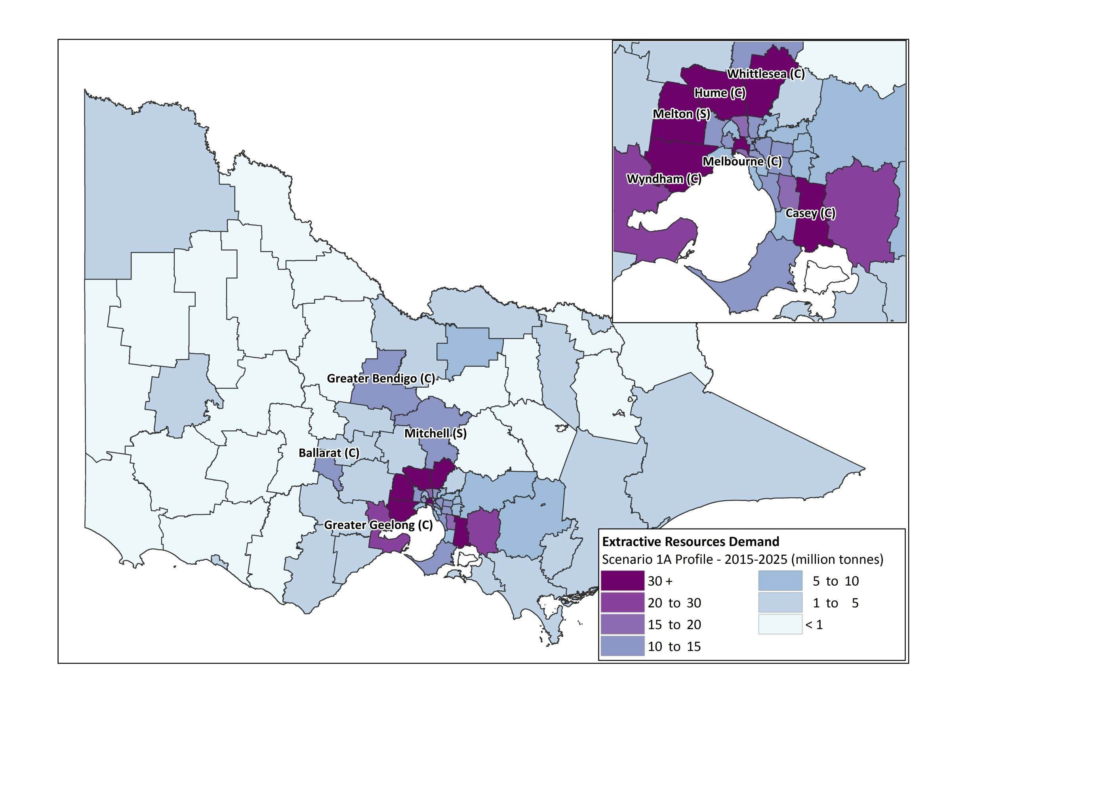
Source: EY analysis

Figure 30 – Scenario 1A - Total demand for extractive resources by LGA over the period 2026-2050
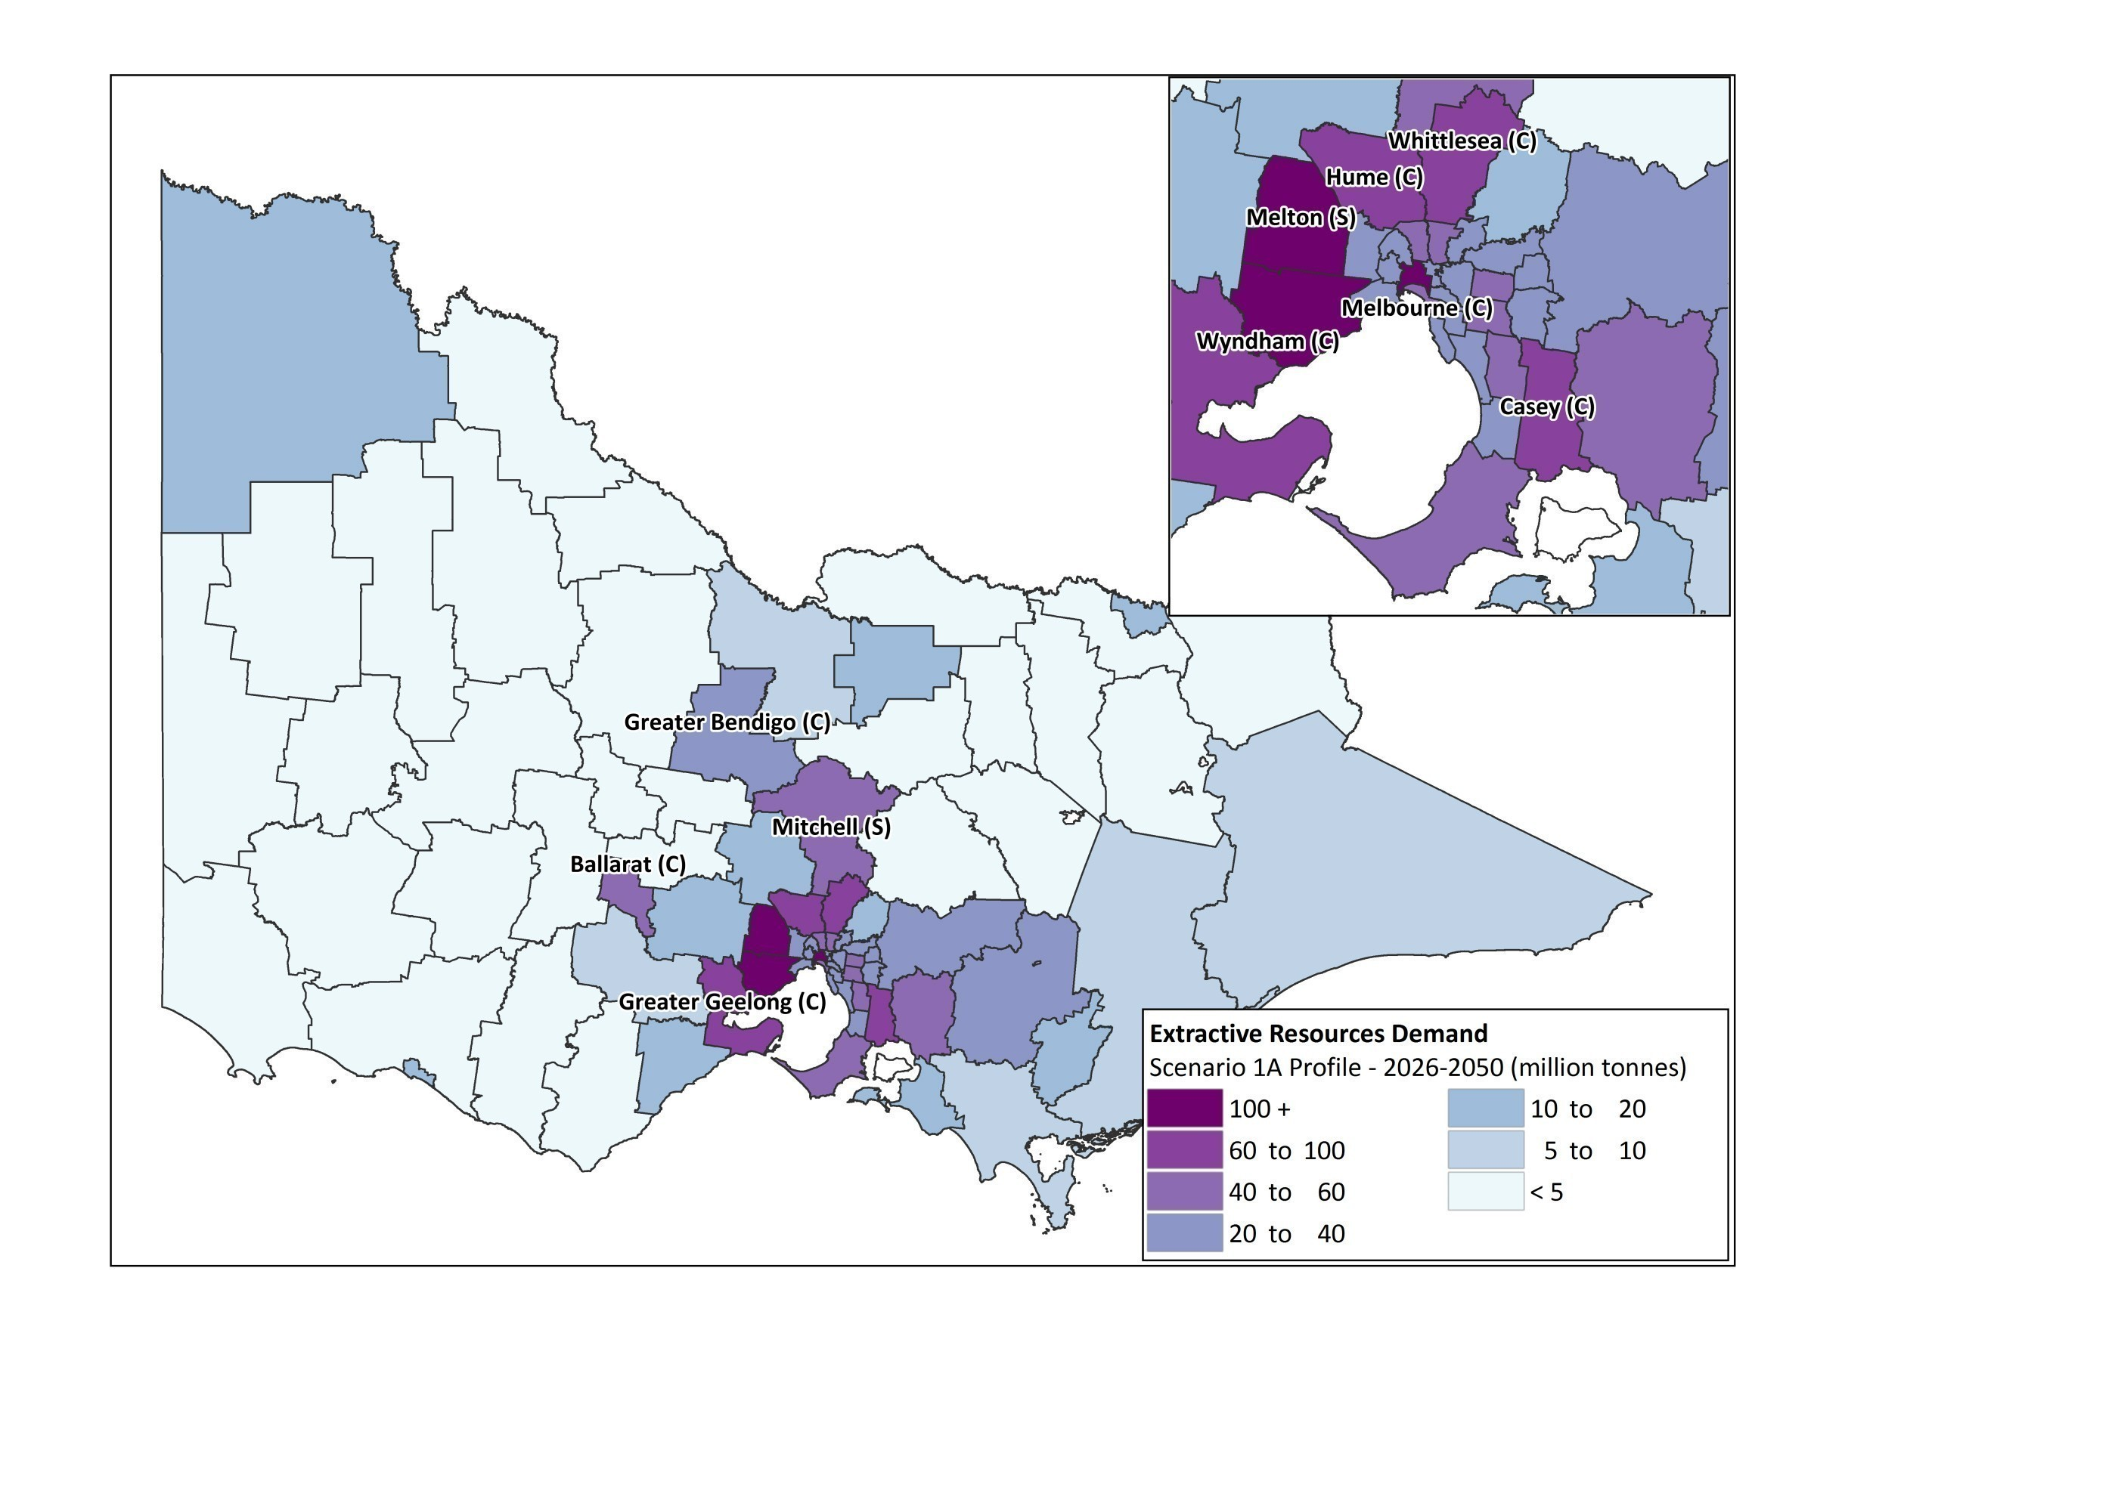
Source: EY analysis
        - Scenario 1B

Figure 31 – Scenario 1B - Total demand for extractive resources in Wyndham over the period 2015-2025
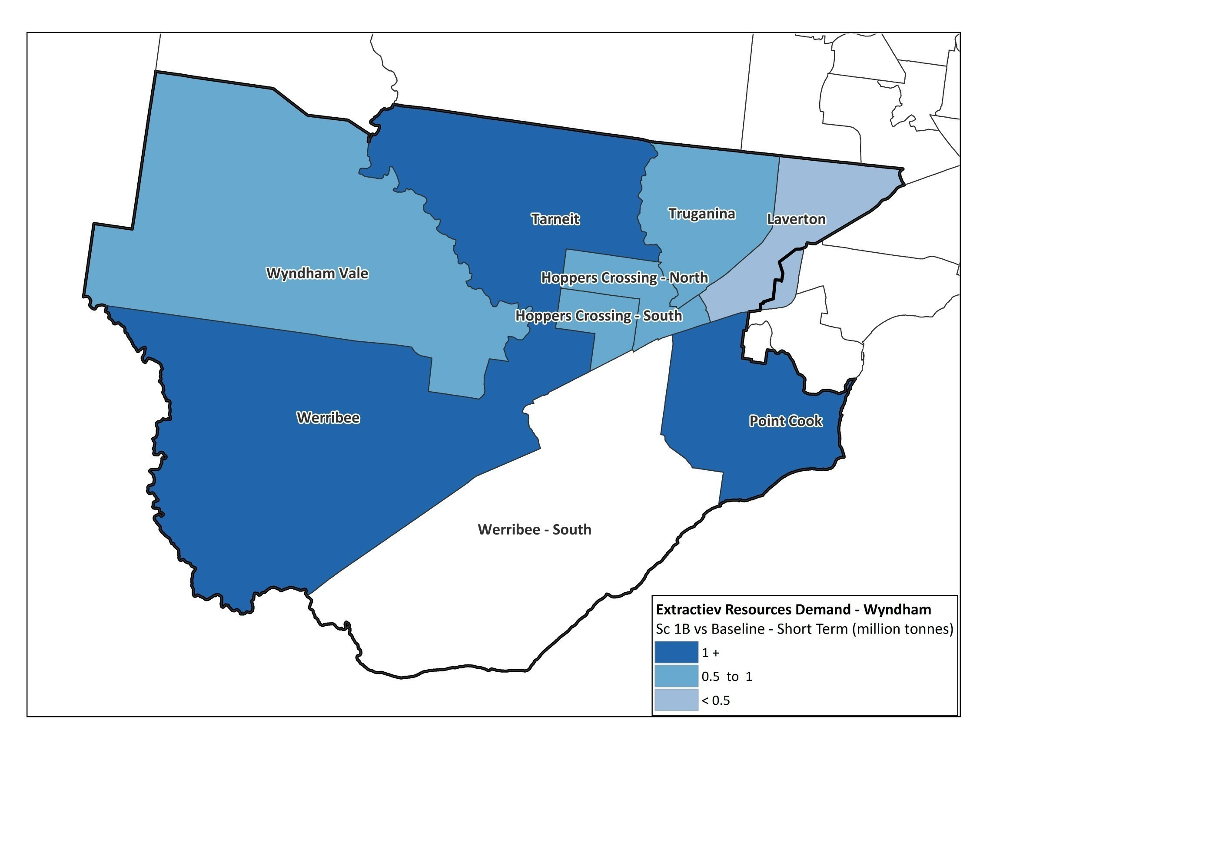
Source: EY analysis

Figure 32 – Scenario 1B - Total demand for extractive resources in Wyndham over the period 2026-2050
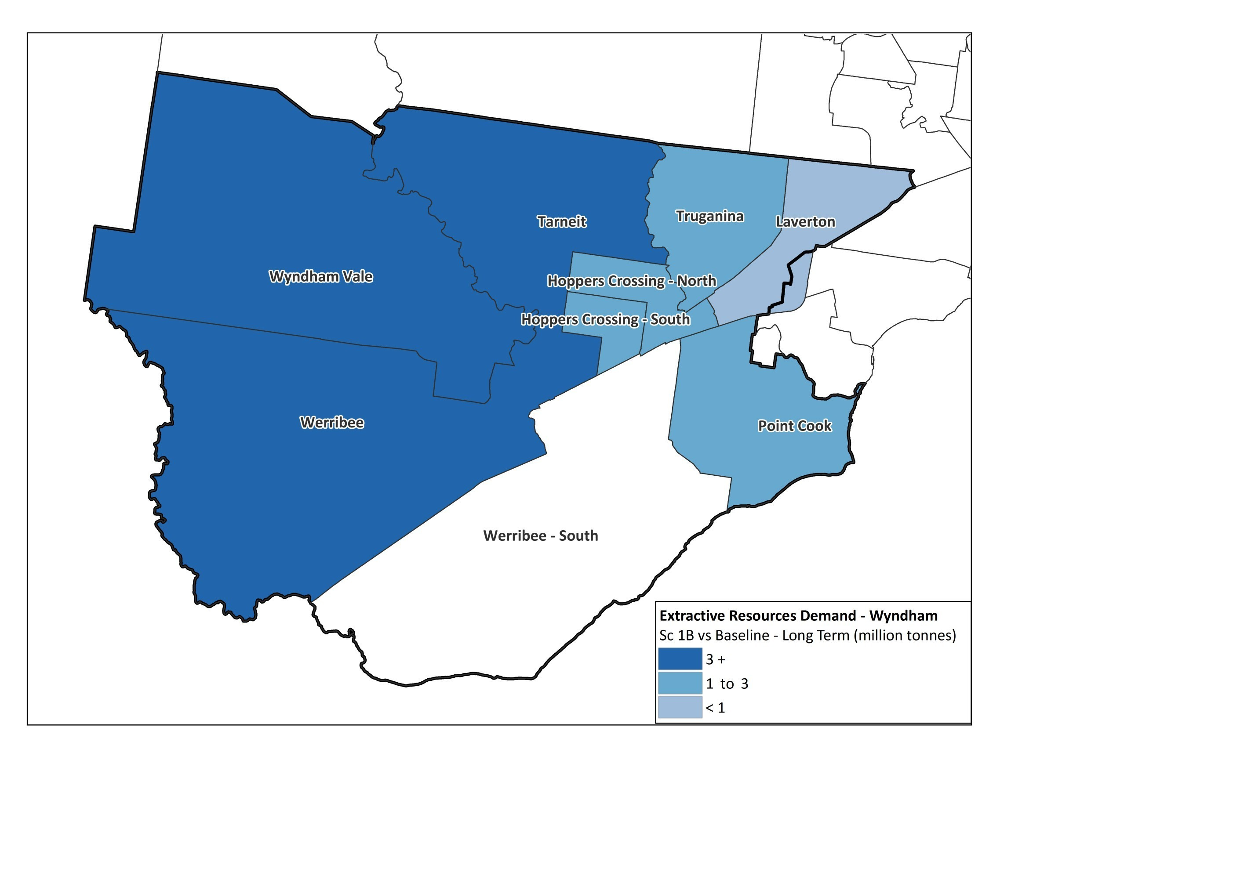
Source: EY analysis
        - Scenario 2A

Figure 33 – Scenario 2A - Total demand for extractive resources by LGA over the period 2015-2025
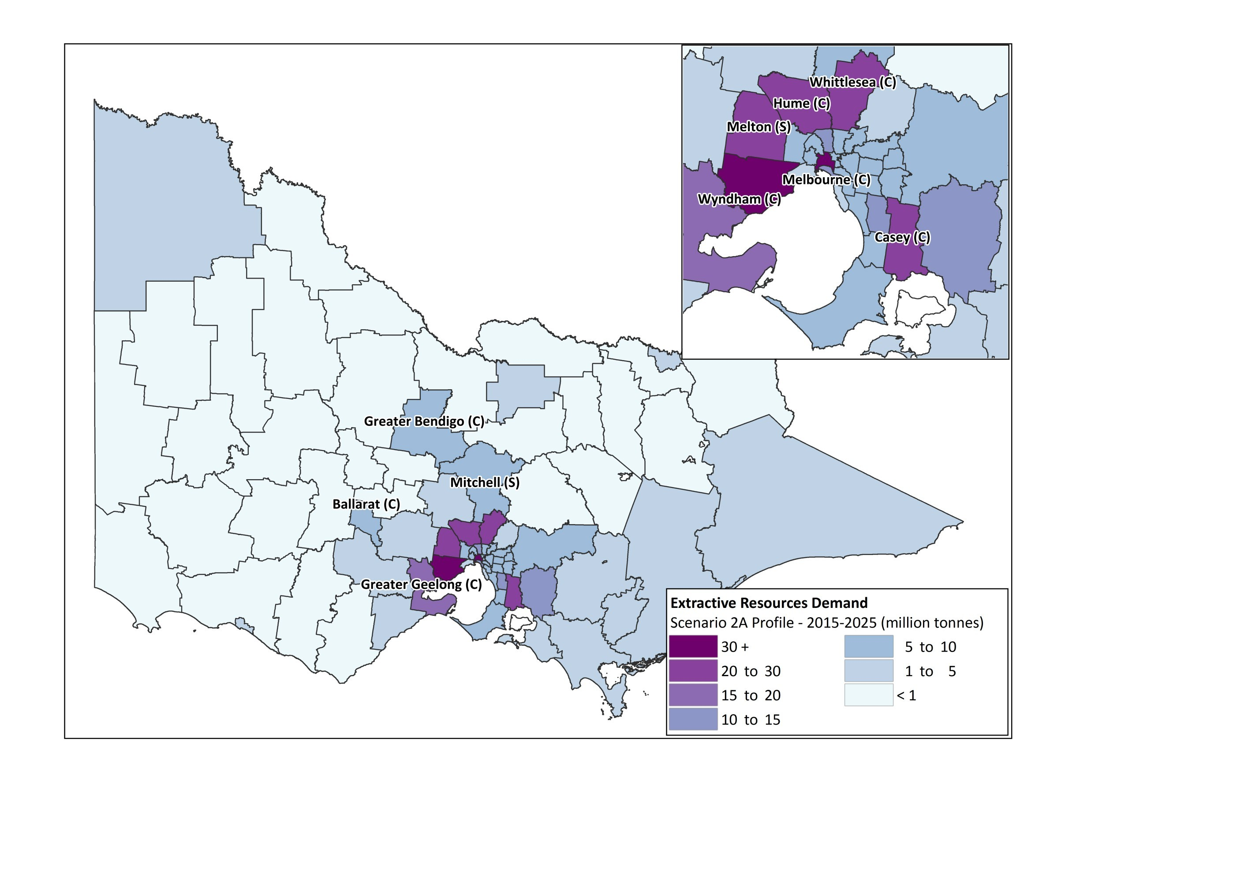
Source: EY analysis

Figure 34 – Scenario 2A - Total demand for extractive resources by LGA over the period 2026-2050
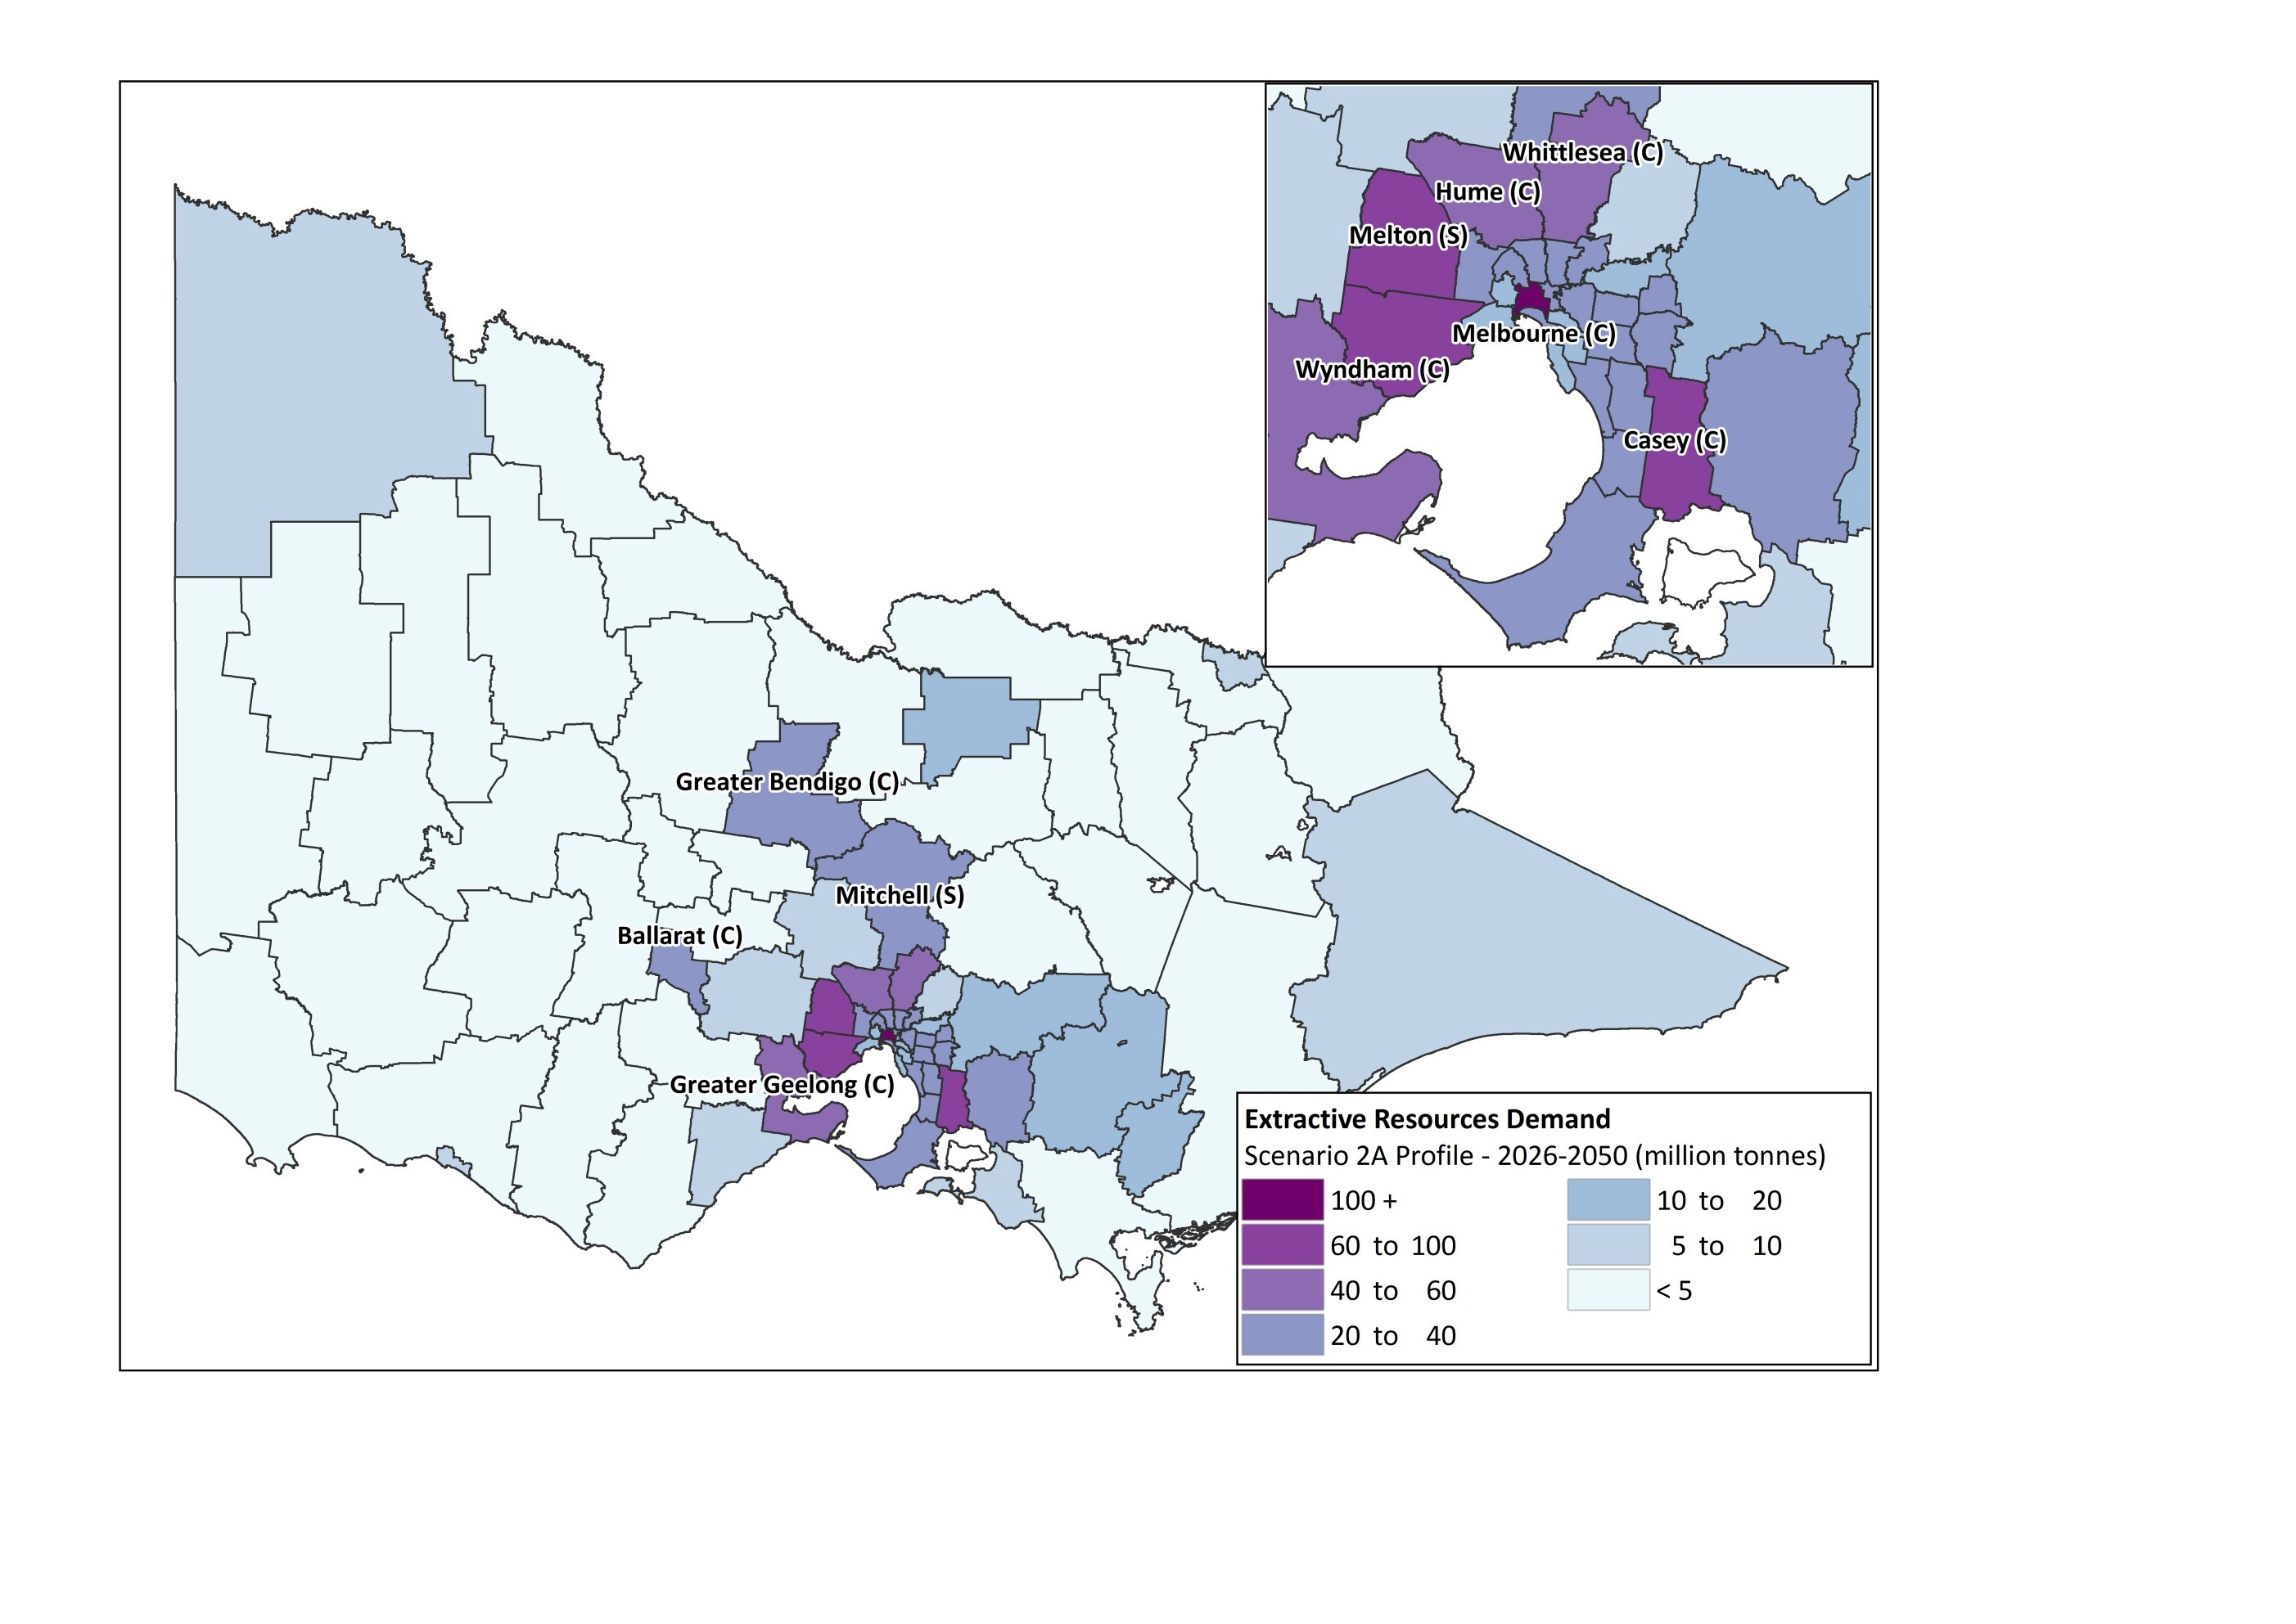
Source: EY analysis
        - Scenario 3A

Figure 35 – Scenario 3A - Total demand for extractive resources by LGA over the period 2015-2025
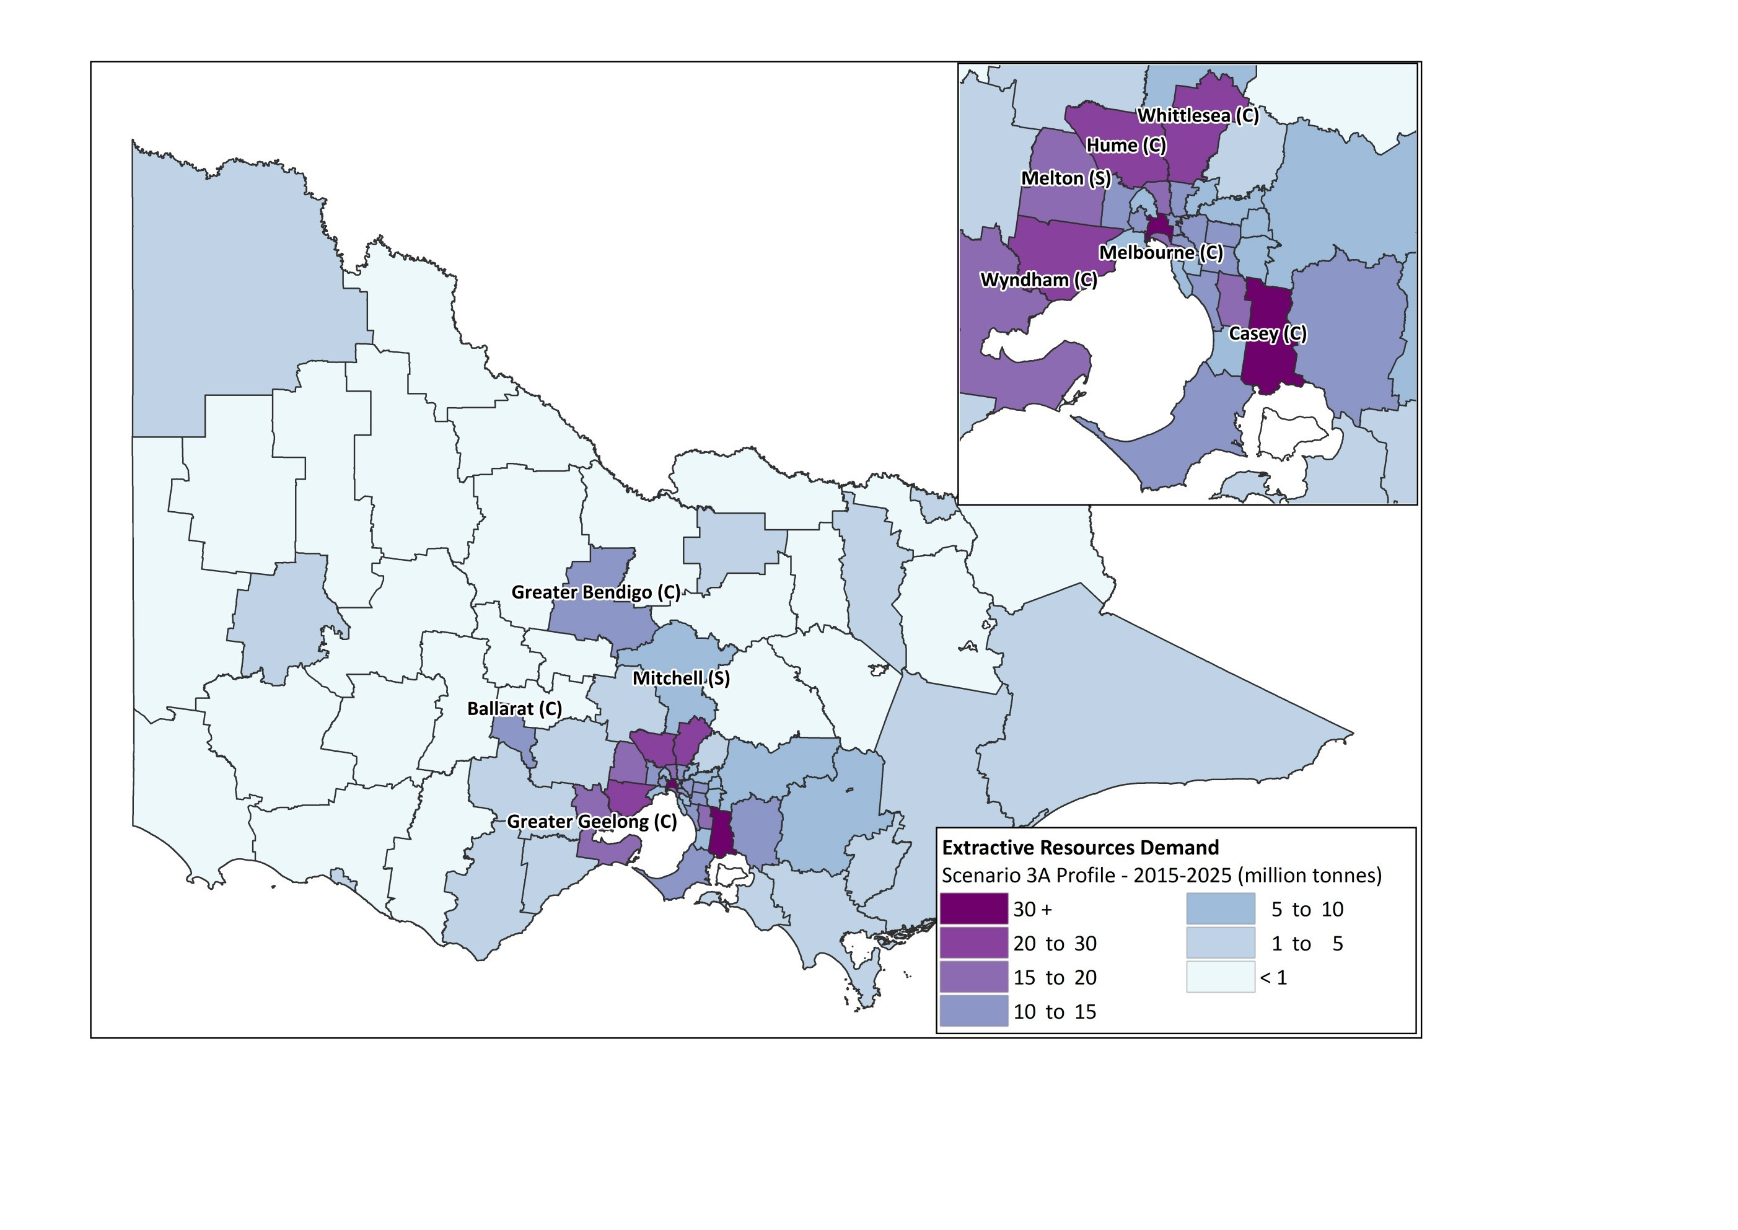
Source: EY analysis

Figure 36 – Scenario 3A - Total demand for extractive resources by LGA over the period 2026-2050
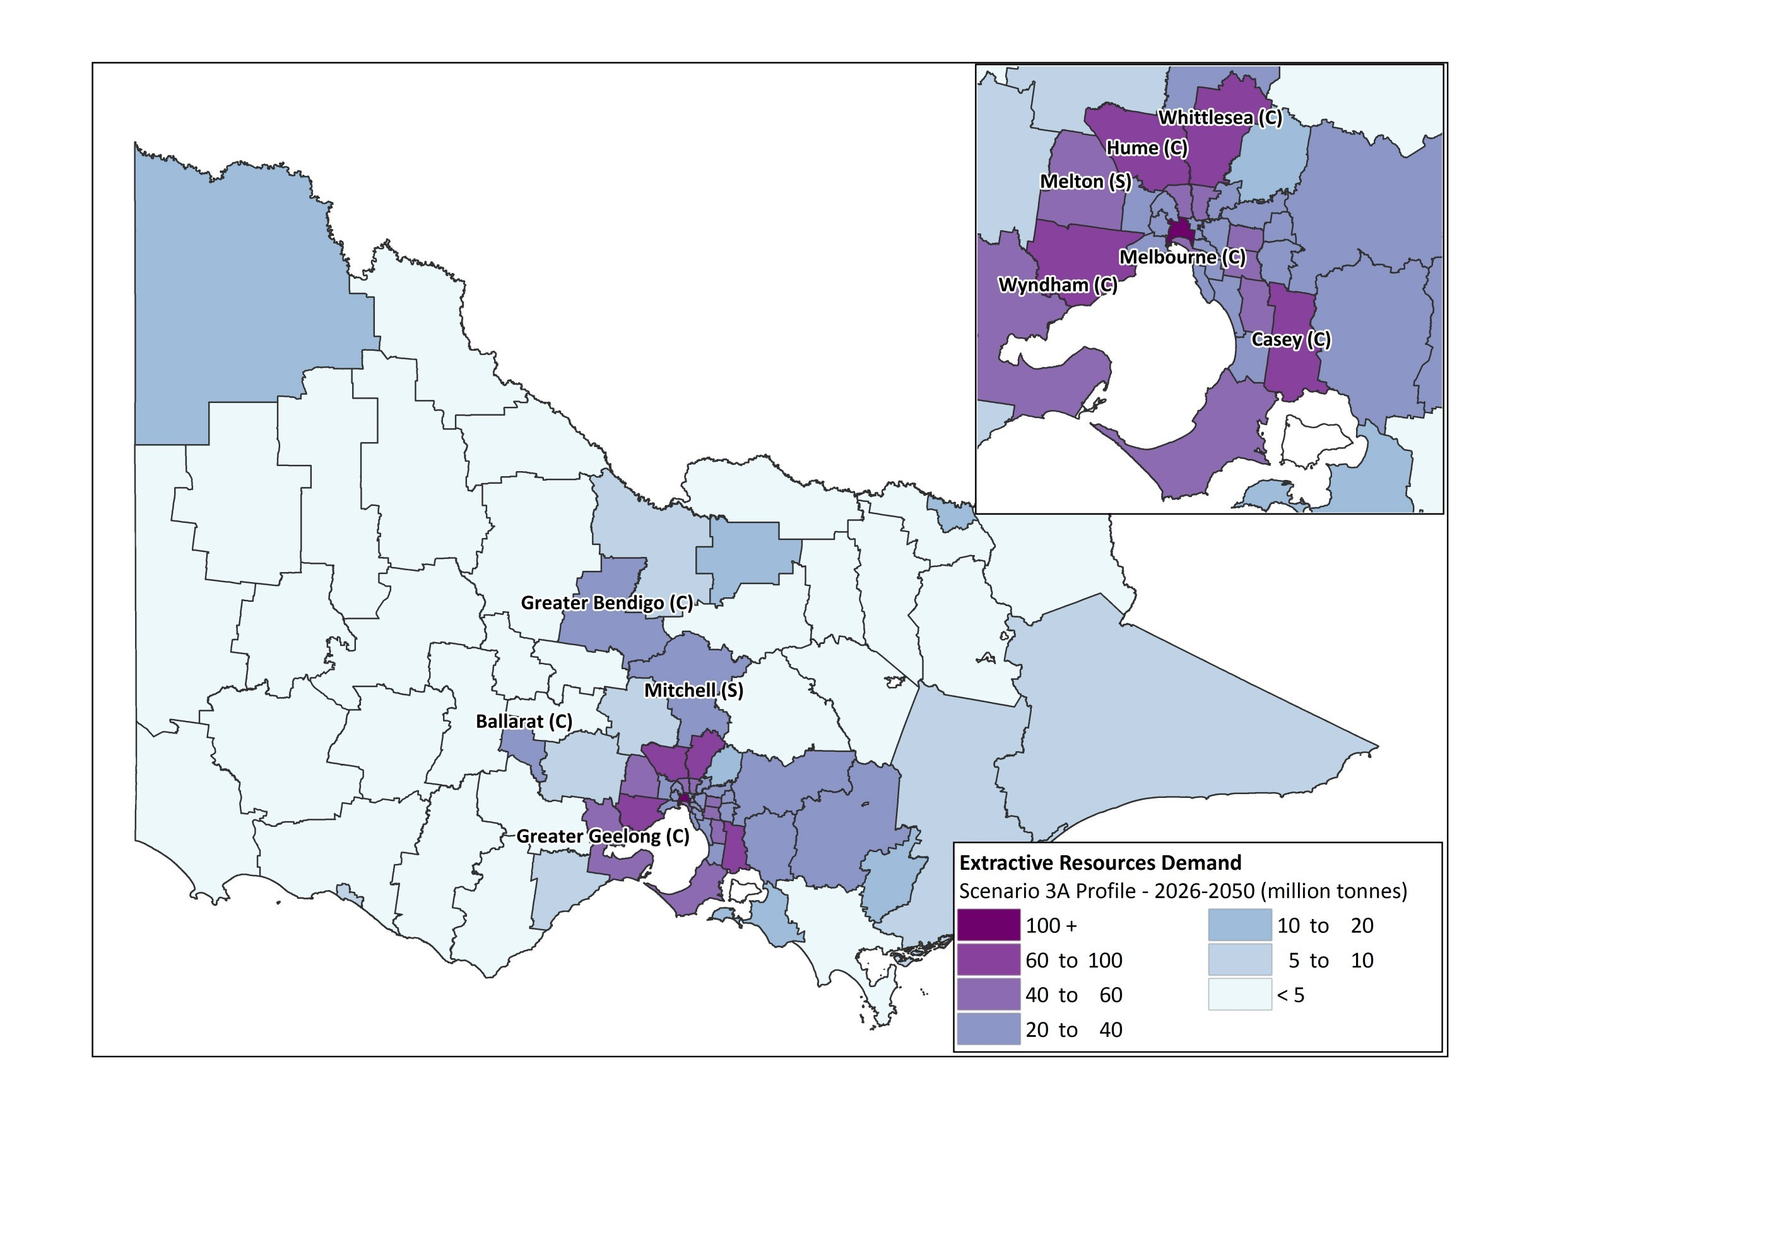
Source: EY analysis
        - Scenario 3B

Figure 37 – Scenario 3B - Total demand for extractive resources by LGA over the period 2015-2025
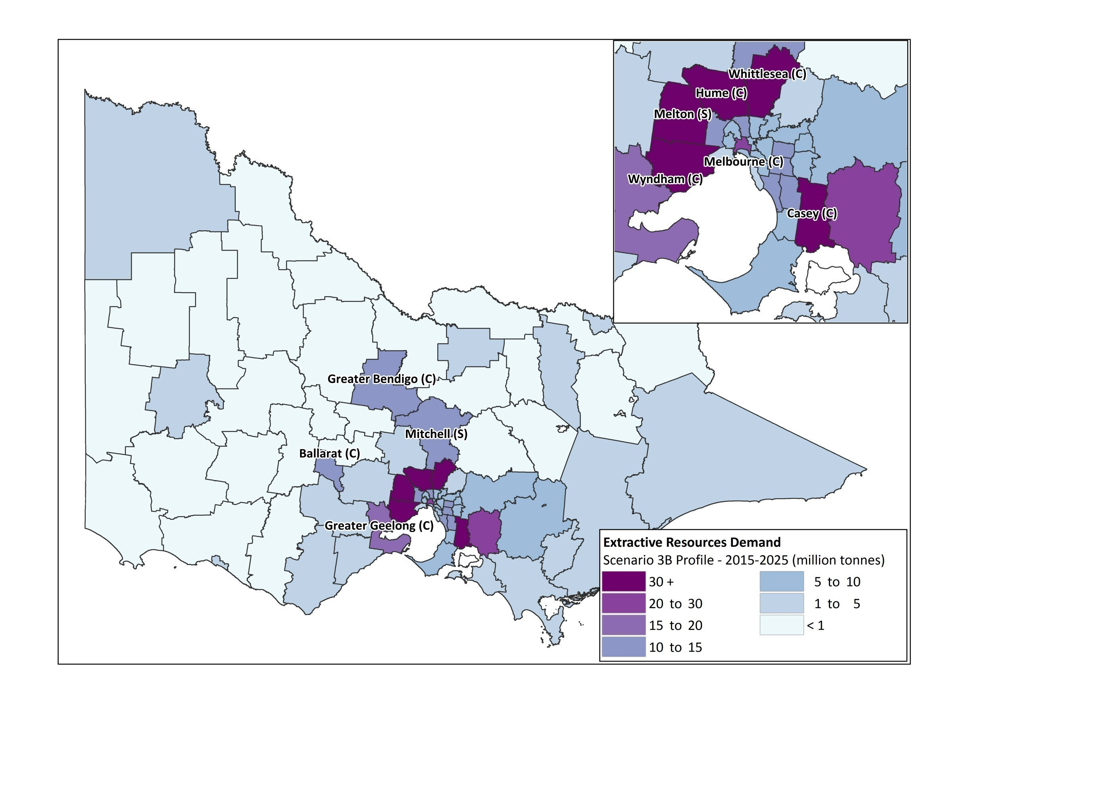
Source: EY analysis

Figure 38 – Scenario 3B - Total demand for extractive resources by LGA over the period 2026-2050
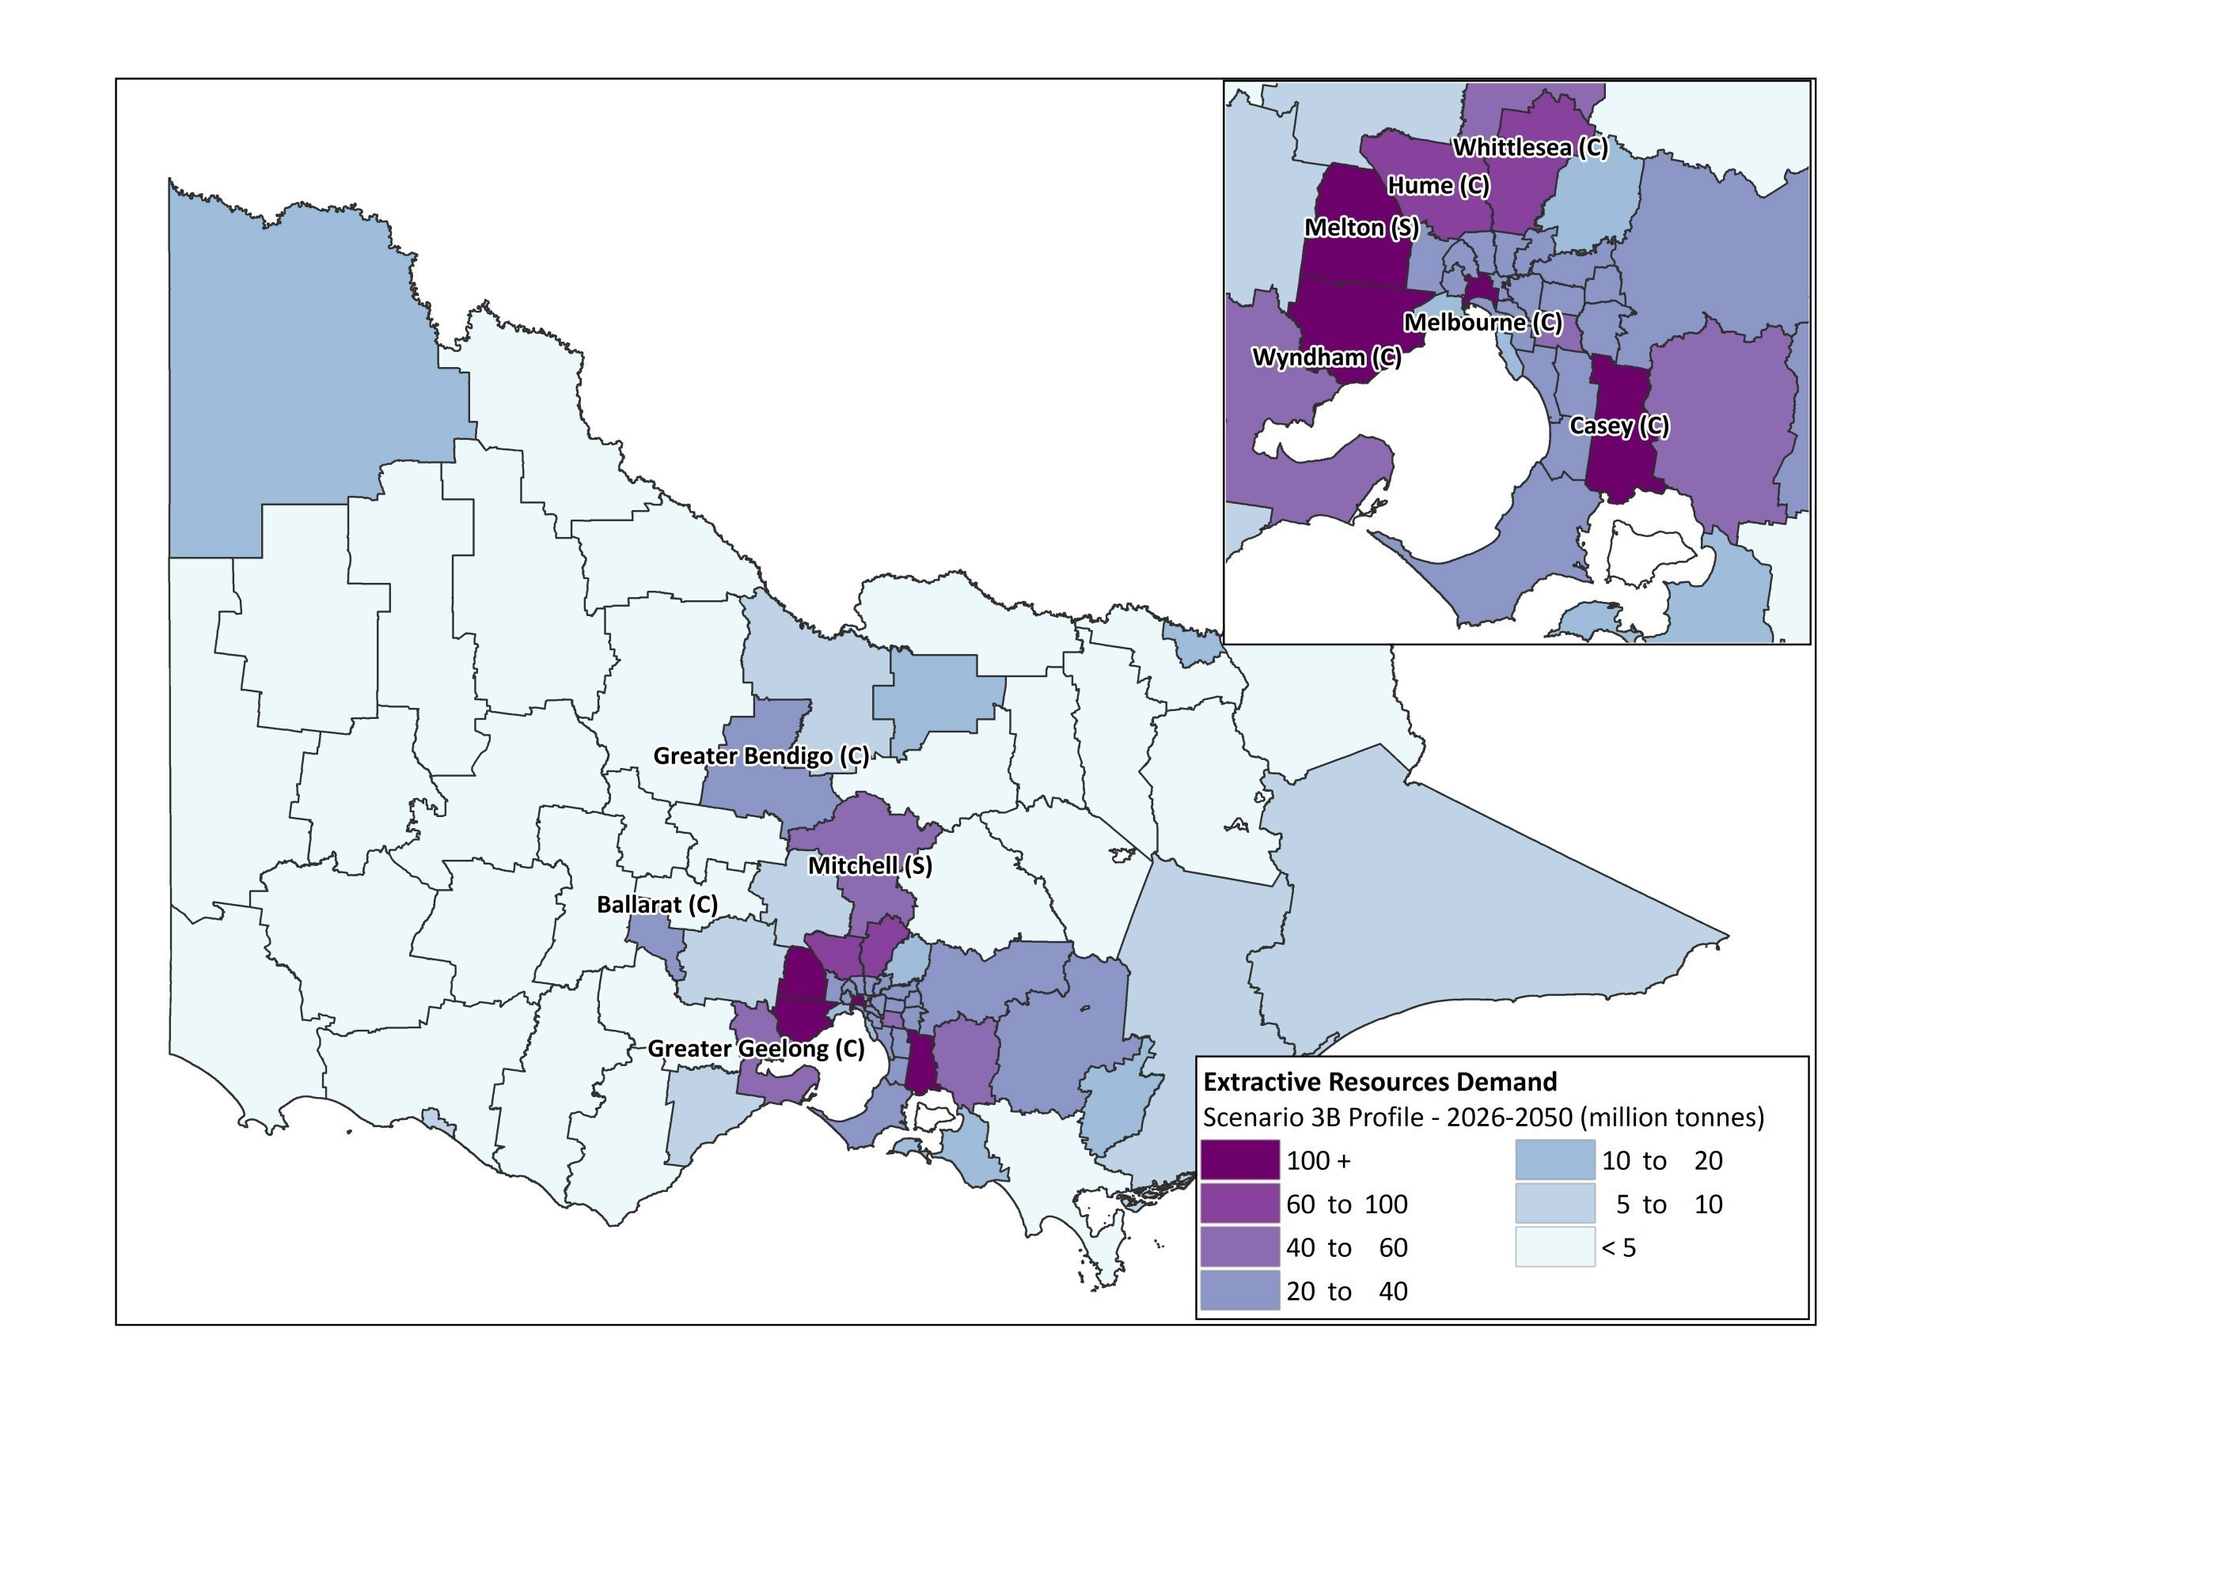
Source: EY analysis

- Assessment of the economic implications of resource constraints
A cost reckoner was developed to support the analysis of the economic implications of resource constraints.
This Appendix describes the methodology implemented to develop the cost reckoner and presents key outputs.
- Cost Reckoner - Methodology

  - Unit cost of transporting extractive resources
The cost reckoner was developed to calculate the total cost of transporting extractive resources. This cost was defined as including:
- The vehicle cost of transporting extractive resources.
- The social and environmental cost (referred to as externalities cost) associated with the transportation of extractive resources. The externalities cost reflects the cost to the wider community rather than a cost to the industry.
This is an economic cost that excludes taxes and subsidies.
Vehicle Cost
The vehicle cost was calculated based on standard Austroads methodologies and values provided in 2015 National Guidelines for Transport System Management in Australia, Transport and Infrastructure Council, to calculate the resource dollar cost per net tonne kilometre of transportation of extractive resources and key assumptions related to the heavy vehicle fleet, road types and locations and fuel prices. The vehicle cost considered for this study was assumed to include:
- The vehicle operating cost (VOC) per kilometre, allowing for fuel, oil, tyres, repairs & maintenance and depreciation (through new vehicle prices). The VOC was calculated on a resource cost basis using standard Austroads rates. Separate calculations were applied for considering different transport models:
- Urban travel (interrupted): this interrupted model allows for stop-start model (<60km/h) and free-flow model (>60km/h) conditions. The choice of model should be based on judgment of the user.
- Rural travel (uninterrupted).
Both the uninterrupted and interrupted VOC models include a number of assumptions, as follows:
- The urban travel (interrupted) VOC model includes an average travel speed assumption.
- The rural (uninterrupted) VOC model includes a number of assumptions including an average travel speed, an international roughness index and a gross vehicle mass
- The travel time cost per kilometre, provided for vehicle occupants (passenger and freight), and the value of travel time for freight. The travel time was calculated for each transport model based on Austroads values and included travel speed assumptions.

The weighted average vehicle cost per net tonne kilometre was calculated based on an assumption of the vehicle mix used to transport extractive resources in Victoria, illustrated in the below table:
Table 47 – Cost Reckoner – Vehicle Mix
# | Vehicle Type | Percentage
 | Heavy Rigid | 3%
 | Artic 4 Axle | 27%
 | Artic 5 Axle | 20%
 | Artic 6 Axle | 20%
 | Rigid + 5 Axle Dog | 20%
 | B-Double | 10%
TOTAL |  | 100%
Source: Economic contribution of the extractive industries in Victoria, Access Economics, May 2006

      - To calculate the weighted average cost per net tonne kilometre of extractive resources, the vehicle cost per kilometre was divided by the average truck payload, resulting from the vehicle mix presented in the above table.
      - The vehicle cost then calculated was presented in nominal 2013 Australian prices.
- Externalities Cost
The externalities cost was calculated per tonne kilometre based on estimated urban and rural values of externalities for freight heavy vehicles (middle range) provided in Transport for New South Wales, Principles and guidelines for economic appraisal of transport initiatives March 2013.
The externalities cost are composed of the following externalities types:
- Air pollution
- Greenhouse Gas Emissions
- Noise pollution
- Water Pollution
- Nature and Landscape
- Urban Separation
- Upstream and downstream costs
      - The externalities costs then calculated were presented in nominal 2011 Australian prices, as follows.
Table 48 – Estimated values of externalities for freight heavy vehicles, 2011 Australian dollars
Externalities type | Urban Value ($/per 1000 tonne -kilometre travelled) | Rural Value ($/per 1000 tonne-kilometre travelled)
Air pollution | 24.18 | 0.24
Greenhouse Gas Emissions | 5.38 | 5.38
Noise | 4.03 | 0.41
Water Pollution | 3.62 | 1.45
Nature and Landscape | 0.4 | 4.04
Urban Separation | 2.69 | -
Upstream and downstream costs | 21.53 | 21.53
Total | 61.83 | 33.05
- Source: Transport for New South Wales, Principles and guidelines for economic appraisal of transport initiatives March 2013

  - Note that these calculations exclude accident costs as the focus of the study was more on environmental externalities. The weighted average crash cost by road type provided in the Transport for New South Wales study is $58.5 per thousand vehicle kilometres travelled on a mix of local roads, arterial roads and freeways.

- Escalation
The vehicle cost and the externalities cost were ultimately provided in 2015 Australian prices from 2015 to 2050. An escalation profile was then built to convert those costs to 2015 values, including forward escalation rates for forecasting purposes.
Table 49 below indicates the sources of escalation used to escalate the vehicle and externalities costs.
Table 49 – Cost Reckoner Escalation Profile - Sources
Item | Sources | Cost Type applied to
Fuel Price Forecast, assuming a nil impact from vehicle fuel efficiency | Frontier analysis, DTPLI | VOC
Consumer Price Index | Victorian Department of Treasury and Finance – Melbourne Price Index, 2015-2016 Budget Update (Australian Bureau of Statistics) | VOC
Producer Price Index | ABS 6427.0 Producer Price Index Australia Table 21. Output of the Transport, postal and warehousing industries, group and class index numbers, Index Numbers 461 Road freight transport, 10 year average | Travel Time (Freight)
Wage Price Index | Victorian Department of Treasury and Finance – Melbourne Price Index, 2015-2016 Budget Update (Australian Bureau of Statistics) | Travel Time (Passenger / Driver)
Per Capita Real Gross Domestic Product | Victorian Department of Treasury and Finance – Melbourne Price Index, 2015-2016 Budget Update (Australian Bureau of Statistics) | Externalities Cost
Source: EY data

  - Calculation of transport costs from origin to destination
A cost reckoner, i.e. an origin-destination cost matrix (from the origin LGA to the destination LGA), was then developed, using either rural or urban transport unit costs multiplied by the distance between the origin LGA and the destination LGA.

The VOC costs were calculated taking into account the different transport models identified to calculate the unit VOC, based on the following assumptions:
- Urban LGA to Urban LGA (<20km): 100% urban stop start model.
- Urban LGA to Urban LGA (>20km): 50% urban stop start model + 50% urban free flow model.
- Urban LGA to Regional LGA (<100km): 25% urban stop start model + 25% urban free flow model + 50% rural model.
- Urban LGA to Regional LGA (>100km): 25km urban stop start model + 25km urban free flow model + (total distance – 50km) rural model.
- Regional LGA to Urban LGA (<100km): 25% urban stop start model + 25% urban free flow model + 50% rural model.
- Regional LGA to Urban LGA (>100km): 25km urban stop start model + 25km urban free flow model + (total distance – 50km) rural model.
- Regional LGA to Regional LGA: rural model
Within the same LGA, transport costs calculation was based on the following travel distance assumptions, determined relying upon the average size of each LGA and the potential distance travelled:
- Urban LGA: 10km
- Regional LGA: 25 km

- Cost Reckoner – Key Outputs
Key outputs were provided to PwC on 8 January 2016, including:
- Weighted average unit transport cost per net tonne km, including and excluding externalities cost, in 2015 Australian prices.
- Cost reckoner matrix.
Forward escalation profile to convert 2016 to 2050 costs to 2015 prices.

EY | Assurance | Tax | Transactions | Advisory

About EY
EY is a global leader in assurance, tax, transaction and advisory
services. The insights and quality services we deliver help build trust and
confidence in the capital markets and in economies the world over. We
develop outstanding leaders who team to deliver on our promises to all
of our stakeholders. In so doing, we play a critical role in building a better
working world for our people, for our clients and for our communities.

EY refers to the global organisation and may refer to one or more of the member
firms of Ernst & Young Global Limited, each of which is a separate legal
entity. Ernst & Young Global Limited, a UK company limited by guarantee,
does not provide services to clients. For more information about our
organisation, please visit ey.com.
© 2016 Ernst & Young, Australia.
All Rights Reserved.

This communication provides general information which is current at the time of production. The information contained in this communication does not constitute advice and should not be relied on as such. Professional advice should be sought prior to any action being taken in reliance on any of the information. Ernst & Young disclaims all responsibility and liability (including, without limitation, for any direct or indirect or consequential costs, loss or damage or loss of profits) arising from anything done or omitted to be done by any party in reliance, whether wholly or partially, on any of the information. Any party that relies on the information does so at its own risk. Liability limited by a scheme approved under Professional Standards Legislation.

ey.com/au

Under the Mineral Resources Extractive Industries Regulations Act 2010 (Schedule 2), the hard rock category of extractive resources consists of the following rock types: basalt old, basalt new, trachyte, dolerite, granite (incl. granodiorite, porphyry, microgranites), rhyodacite (incl. dacite, rhyolite), scoria, tuff, gneiss, hornfels, marble, quartzite, schist, slate and sedimentary (usually rippable rocks incl. sandstone, shale, siltstone chert, mudstone, claystone).
The detailed industry analysis identified that the use of Sand and Gravel soft rocks as subsurface drainage sand seems mainly related to the transport construction activity.
Based on information available, the detailed industry analysis only enables to identify the share of sand and gravel attributable to concrete sand for the construction of wind farms, in lieu of the Energy and Utilities construction activity.
Water for Victoria Discussion Paper, 2016
The assumption taken by this study was to account for longer term use of extractive resources across the Energy and Utilities sector. Relying upon our detailed industry analysis, as indicated in Appendix C sub-section Section 2.4 of the Report, it is acknowledged that the construction of wind turbines may require the use (estimate) of 93% hard rock, 2% limestone, 0.3% clay and clay shale and 5% sand and gravel. However, further discussion with AECOM indicated that from an Energy and Utilities sector perspective, most of the materials required for new builds would be hard rock and soil. As a result, the assumption taken by the study was to reflect broader patterns of demand for extractive resources across the Energy and Utilities sector, leading to consider that hard rock represent 100% of the extractive resources required by the sector.

