Otway Region
Groundwater sampling and characterisation for hydrocarbons

June 2015

Acknowledgements
This report has been prepared by Jacobs (Australia) Pty Ltd for the Department of Environment, Land,
Water and Planning in collaboration with the Department of Economic Development, Jobs, Transport
and Resources.

Contents
Figures 3
Tables 4
Executive summary 5
1 Introduction 7
2 Literature review of hydrocarbon occurrence in groundwater 9
2.1 Otway Basin – aquifer overview 9
2.2 Otway reguion - hydrocarbon occurrence 14
2.3 Onshore natural gas prospectivity 19
2.4 Groundwater chemistry sampling suite 21
2.5 Summary of literature review 24
3 Bore selection 26
3.1 Selection criteria 26
3.2 Groundwater dependent ecosystems and surface water assets 27
3.3 Aquifers 31
3.4 Naturally occurring hydrocarbon sites and potential vertical migration 37
3.5 Nested sites 38
3.6 Summary of selected monitoring network 40
4 Sampling method 45
4.1 Reporting of gas concentrations 48
5 Quality control and quality assurance 49
5.1 Quality control and quality assurance types 49
5.2 Acceptance criteria for quality control samples 50
5.3 Quality control and quality assurance assessment 50
6 Groundwater sampling – summary of results 52
6.1 Semi volatile organic compounds 52
6.2 Total petroleum hydrocarbons 55
6.3 Inorganic analytes and indicators 56
7 Groundwater sampling – aquifer characterisation 61
7.1 Quaternary Aquifer (100) 61
7.2 Upper Tertiary / Quaternary Basalt Aquifer (101) 62
7.3 Upper Tertiary Aquifer (marine) (104) 63
7.4 Upper Mid-Tertiary Aquifer (107) 64
7.5 Lower Mid Tertiary Aquifer (109) 66
7.6 Lower Tertiary Aquifer (111) 66
7.7 Mesozoic and Palaeozoic Bedrock (114) 68
8 Conclusions 69
References 70
Appendices 72
Appendix A. Standard operating procedure for groundwater sampling in the Otway region 72
Appendix B. Standard operating procedure for collection of dissolved gas and groundwater
samples from coal seams 85
Appendix C. Standard operating procedure for the deployment and operation of double valve pumps 95
Appendix D. Laboratory Results 105

Figures
Figure 1 Typical geological formations bearing prospective onshore natural gas in the Otway region 7
Figure 2 Stratigraphy of the Otway basin (from the Petroleum Atlas of Victoria . 11
Figure 3: Otway Basin Formations categorised by Victorian Aquifer Framework names, codes
and numbers. 12
Figure 4 Location of gas exploration and discovery bores in the Otway Basin (from the Petroleum
Atlas of Victoria 16
Figure 5 Review of the thickness of the Narrawaturk Marl Aquitard 17
Figure 6 Review of the thickness of the Gellibrand Marl Aquitard 18
Figure 7 Otway Basin coal seam gas development scenarios 19
Figure 8 Otway Basin tight gas development scenarios 20
Figure 9 Otway Basin shale gas development scenarios 20
Figure 10 Otway Basin conventional gas development scenarios 21
Figure 11 Hopkins-Corangamite Groundwater Catchment Unit showing prospective natural gas
areas and proposed monitoring bores 28
Figure 12 Portland Groundwater Catchment Unit showing prospective natural gas areas and
proposed monitoring bores 29
Figure 13 Glenelg Groundwater Catchment Unit showing prospective natural gas areas and
proposed monitoring bores 31
Figure 14 GMAs and WSPAs and targeted monitoring bores 34
Figure 15 GMAs and WSPAs and targeted monitoring bores 35
Figure 16 GMAs and WSPAs and targeted monitoring bores 36
Figure 17 Areas identified in literature review 38
Figure 18 Nested SOB sites across the Otway region selected for inclusion in the monitoring program 40
Figure 19 Selected monitoring network for the Otway region 41
Figure 20 Flow diagram showing water sample collection, field parameter measurement and
gas sample collection 46
Figure 21 Example of gas collection and sampling procedure in the field 46
Figure 22 Example of gas collection and sampling procedure in the field 47
Figure 23 Spatial distribution of dissolved methane in groundwater 54
Figure 24 Piper diagram showing major ion concentrations 56
Figure 25a Schoeller plots showing major ion chemistry by aquifer 57
Figure 26b Schoeller plots showing major ion chemistry by aquifer 58

Tables
Table 1 Proposed monitoring bores in areas of prospectivity and potential groundwater dependent environmental assets 28
Table 2 Proposed monitoring bores in areas of prospectivity and high value Groundwater Dependent Environmental Assets 29
Table 3 Proposed monitoring bores in areas of prospectivity and high value Groundwater Dependent Environmental Assets 30
Table 4 Summary of GMAs and WSPAs in the Otway region 31
Table 5 Selected monitoring bores in areas of high value groundwater asset (as indicated by GMAs
and WSPAs) 33
Table 6 Selected monitoringbores in areas of high value groundwater asset (as indicated by GMAs
and WSPAs) 35
Table 7 Selected monitoring bores in areas of high value groundwater asset (as indicated by GMAs
and WSPAs) 36
Table 8 Summary of intersection between areas identified as potential hydrocarbon occurrence and
selected monitoring bores 37
Table 9 Summary of nested sites targeting well recognised assets in the Otway region 39
Table 10 Summary of selected bores for the Otway monitoring network 42
Table 11 Acceptance criteria for QA/QC samples 50
Table 12 QA/QC samples 50
Table 13: Anomalies determined through QA/QC assessment 51
Table 14 Methane concentration by aquifer (water samples) 53
Table 15 Concentrations of Total Recoverable Hydrocarbons for bores where detection occurred (µg/L) 55
Table 16 Groundwater salinity 59
Table 17 Total Nitrogen Concentrations 59
Table 18 Summary of indicator parameters measured in the field 60
Table 19 Quaternary Aquifer monitoring Bores 62
Table 20 Upper Tertiary / Quaternary Basalt Aquifer 63
Table 21 Upper Tertiary Aquifer (marine) 64
Table 22 Upper Mid-Tertiary Aquifer 65
Table 23 Lower Mid-Tertiary Aquifer 66
Table 24 Lower Tertiary Aquifer 67
Table 25 Mesozoic and Palaeozoic Bedrock 68

Executive summary
This study is part of the onshore natural gas water science studies being undertaken jointly by the Department of Environment, Land, Water and Planning (DELWP) and the Department of Economic Development, Jobs, Transport and Resources (DEDJTR).
The purpose of groundwater sampling project was to characterise the groundwater chemistry, particularly with presence or not or not of hydrocarbons, and to provide an indication of baseline, that is the concentration of hydrocarbons in groundwater.
This report focusses on the Otway region. A parallel study of the Gippsland region is covered in a companion report (DELWP (2015)). It includes a review of the literature on previous groundwater chemistry studies in the Otway Basin and conclusions on likely hydrocarbon movements through the profile. The literature review provides input to the selection of sampling bores and analytes and also provides the context for interpretation of results. Key observations from the literature review include:
- A potentially prospective formation for coal seam gas in the Otway Basin is the Killara Coal Measures in the Cretaceous geology located north of Warnambool and west of Hamilton.
- A potentially prospective formation for tight gas in the Otway Basin is the Cretaceous aged Eumeralla Formation underlying the Waaree Formation south-east of Warnambool and the Cretaceous aged Pretty Hill Formation, north-west of Portland.
- A potentially prospective formation for shale gas in the Otway region is the Casterton Formation to the far west of the state.
- Naturally occurring hydrocarbons have been found in the following units:
  - the Cretaceous aged sediments of the Sherbrook Group in the Port Campbell Embayment
  - the Lower Tertiary aged Wangerrip Group in the Port Campbell Embayment with particular localities in the Port Campbell area and the Barwon Downs region west of Geelong
  - Cretaceous aged sediments of the Sherbrook Group and the Lower Tertiary aged sediments of the Wangerrip Group in the Portland Trough.
- The presence or absence of major aquitards is likely to have a significant impact on the vertical movement of hydrocarbons through the vertical profile and the potential impact on overlying groundwater and surface water assets. The two major aquitards across the region include:
  - the Narrawaturk Marl and Upper Mepunga Formation of the Nirranda Group
  - the Gellibrand Marl of the Heytesbury Group.
A representative number of bores for sampling were selected from aquifers known to have, or suspected of having, hydrocarbon concentrations (from the literature review) and/or within or near groundwater or surface water assets. Priority was given to nested sites which provide vertical information on variations in groundwater chemistry and sites with known construction details.

This report presents the results from 30 bores sampled in the Otway region between 19th January 2015 and 29th January 2015 using low flow sampling techniques.
The results indicate that dissolved methane in groundwater occurs naturally at low concentrations across the Otway region. The median concentration from the 30 samples collected was 0.01 mg/L. A single outlier was observed for bore 111786, which indicated dissolved methane in the Lower Tertiary Aquifer of 5.8 mg/L.
Total Recoverable Hydrocarbons were also detected in 5 of the 30 samples, although most detections were low (equal to the detection limit) and the detections were not in the fraction range for Benzene, Toluene, Ethylbenzene and Xylene (BTEX). The lack of BTEX detection suggests that BTEX compounds are not a natural occurrence in any of the sampled aquifers and any future detection is likely to reflect an anthropogenic origin.
The role of aquitards in limiting the vertical movement of hydrocarbons through the vertical profile is currently difficult to ascertain in the Otway region, given the inherent low concentrations of methane in groundwater across all aquifers. The only elevated methane concentration was recorded for the Lower Tertiary Aquifer (5.8 mg/L) and this bore is located north-east of Colac and is nested with bore 111787 which screens the Newer Volcanic Basalt and did not record any methane in its groundwater. In this area the combined thickness of the Upper and Lower Mid Tertiary Aquitard is approximately 450 m. In this area it can be tentatively concluded that vertical hydrocarbon migration is reduced where a significant aquitard thickness exists. This is consistent with the conceptual hydrogeological model for the Otway region.
It should be noted that whilst the primary prospective formations for potential oil and gas deposits reside in the deep Eumeralla Formation, Waarre Formation and Casterton Formation, only one groundwater bore was available for sampling these units and it was located away from likely prospective areas and was quite shallow. Although the groundwater chemistry information associated with the units that contain the natural gas prospectivity is limited, the negligible methane concentration observed in the overlying units implies that the vertical hydraulic conductivity of the Cretaceous fractured rock is low and there is little opportunity for gas migration to shallower overlying units.

- Introduction
This study is part of the onshore natural gas water science studies being undertaken jointly by the Department of Environment, Land, Water and Planning (DELWP) and the Department of Economic Development, Jobs, Transport and Resources (DEDJTR).
The purpose of groundwater sampling project was to characterise the groundwater chemistry, particularly with presence or not or not of hydrocarbons, and to provide an indication of baseline, that is the concentration of hydrocarbons in groundwater.
This report focuses on the Otway region with the results in the Gippsland region covered in DELWP (2015).
Natural gas includes conventional gas, coal seam gas, tight gas and shale gas. Figure 1 shows a representation of the typical geological formations potentially bearing natural gas resources in the Otway region and the relative depth of the different potential gas sources.
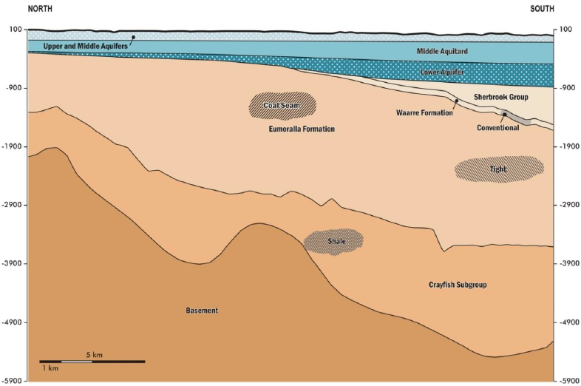
Figure 1 Typical geological formations potentially bearing onshore natural gas in the Otway region (depth shown in metres)
This report presents the sampling results from the groundwater monitoring program in the Otway region.

The work undertaken for this study has been documented as follows:
Chapter 2 Literature review
Chapter 3 Bore selection
Chapter 4 Sampling method
Chapter 5 Quality assurance procedures and results
Chapter 6 Groundwater sampling – summary of results by analyte
Chapter 7 Groundwater sampling – aquifer characterisation
Chapter 8 Conclusions and implications for conceptual model.

- Literature review of hydrocarbon occurrence in groundwater
A literature review has been undertaken to determine whether any previous studies have detected occurrences of methane, BTEX or other hydrocarbons in the groundwater resources of the Otway Basin and how these results have been interpreted in the context of the conceptual model of the basin. The literature review provided input to the selection of sampling bores and analytes and also provides the context for interpretation of results.
This chapter begins with a summary of the hydrogeology of the Otway region, including the main aquifers and structural features (Section 2.1). Section 2.2 reviews the literature on hydrocarbon occurrence and movement in the Otway region. Potential areas for onshore natural gas prospectivity are discussed in Section 2.3 and the implications of the literature review for the selection of groundwater chemistry parameters for this study is discussed in Section 2.4.
The approach to the literature review included the following components:
- Review literature that identifies the occurrence of methane, BTEX or other hydrocarbons in the groundwater resources of the Otway Basin, where coal and oil and gas are potentially present including: DSE (2010), Geological Society of Victoria (1995), GHD (2009), Hawkins and Dellenbach (1971), Hyder Consulting (2009), Laing et. al. (1989), Leeder Consulting (2009), Woollands and Wong (2001).
- The querying of readily available databases for additional groundwater data that might help to identify the location of hydrocarbon occurrence in the region:
  - Geoscience Australia Petroleum Wells Database (http://dbforms.ga.gov.au/www/npm.well.search) viewed October 2014.
  - Victorian Water Management Information System (queried the laboratory chemistry information, however no relevant groundwater hydrocarbon information was stored in this database).
- Review national and international literature regarding coal seam gas monitoring programs to understand industry standards including CSIRO (2011), Claytor and Shaw (2008), Alberta Environment (2006) and QGC (2012).
  - Otway Basin – aquifer overview
The Otway Basin is a NE-SW striking passive margin rift basin approximately 500 km long located in eastern South Australia (25% of the basin), southern Victoria (50% of the basin) and northern Tasmania (25% of the basin). The basin covers an area of roughly 155,000 km², 80% of which is located offshore. Petroleum exploration in the basin began in 1892 but the basin failed to yield any hydrocarbons until 1959 when an onshore sub-commercial quantity of gas was discovered at Port Campbell. No commercial quantities were discovered until 1978 with larger commercial quantities discovered in 1993 and 2001 both on and offshore (Woollands & Wong, 2001).

The Otway Basin consists of a 10 km thick sequence of Mesozoic and Cenozoic sedimentary and volcanic rocks including a number of significant aquifers. The primary units in the Otway Basin that have been associated with hydrocarbon exploration include:
- the Otway Group (Mesozoic and Palaeozoic Bedrock Aquifer 114 ) – oil and gas was encountered at multiple levels within the sequence
- the Sherbrook Group (Cretaceous and Permian Sediments 113) – gas and weak oil was encountered in the lower half of sequence
- the Wangerrip Group (Lower Tertiary Aquifer 111) – oil and gas at different levels within the sequence
- the Eastern View Group (Lower Tertiary Aquifer 111) – weak gas encountered in some wells but nothing commercial discovered.
No hydrocarbon accumulations have been reported in the overlying units. A generalised stratigraphic section is shown in Figure 2. The Victorian Aquifer Framework (VAF) (SKM, 2011) simplified the aquifer and aquitard units of Victoria for the purposes of water resource management. The VAF aquifer nomenclature is used throughout this report to describe the aquifers across the Otway Basin. The relationship between the Otway Formation names shown in Figure 2 and the VAF nomenclature is shown in Figure 3. A brief description of each of the units listed above is provided below.

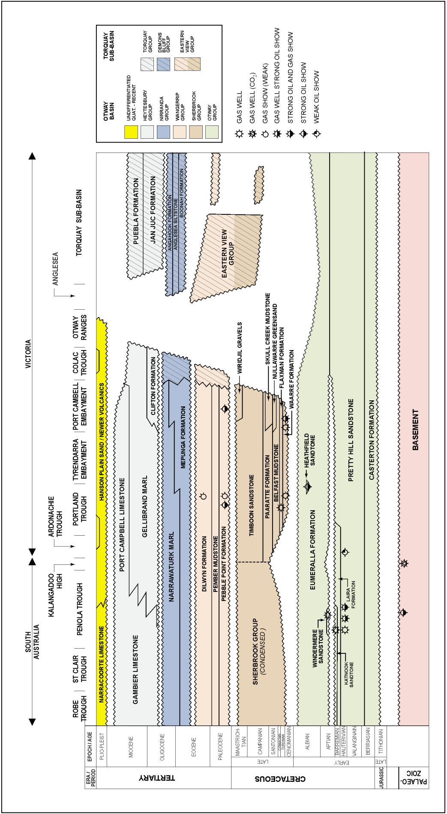
Figure 2 Stratigraphy of the Otway basin (from the Petroleum Atlas of Victoria (source: Woollands & Wong, 2001)).
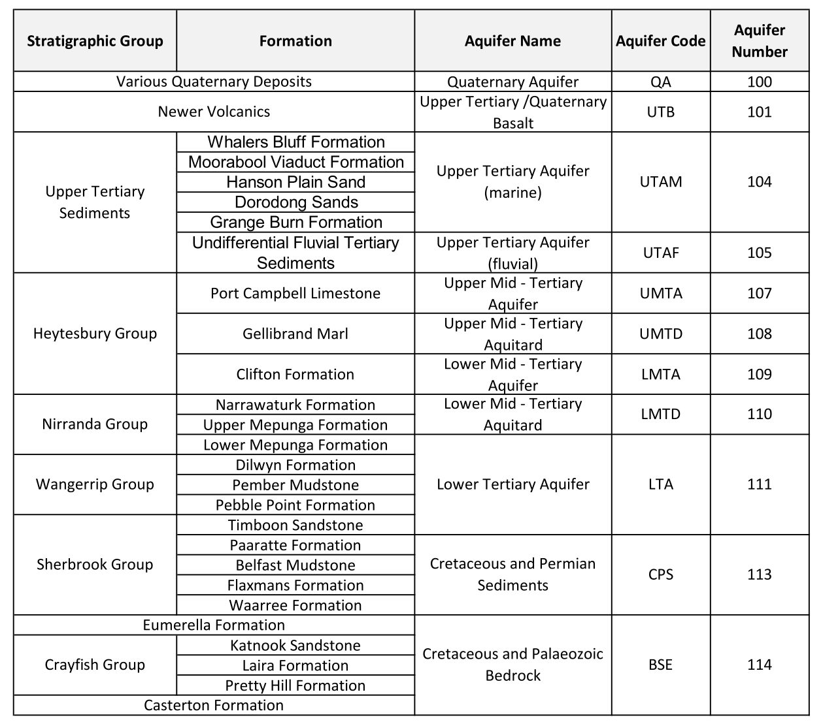
Figure 3: Otway Basin Formations categorised by Victorian Aquifer Framework names, codes and numbers (source: modified from GHD, 2012).
    - The Otway Group (Mesozoic and Palaeozoic Bedrock Aquifer 114)
The Otway Group consists of a thick sequence (up to 8 km thick) of sandstone and shale with minor interbedded coal and volcanics. The youngest formation in the Otway Group is the Eumeralla Formation which consists of fluvial sandstone interbedded with mudstone, fine sandstone and shale. The Eumeralla Formation is not considered to be a viable fractured rock aquifer and is generally considered to form the impermeable basement of the younger Otway Basin sediments (SKM & GHD, 2009). The Eumeralla Formation is unconformably underlain by the Pretty Hill Formation from which commercial quantities of gas are extracted in South Australia (Woollands & Wong, 2001).
    - The Sherbrook Group (Cretaceous and Permian Sediments 113)
The Sherbrook Group unconformably overlies the Eumeralla Formation of the Otway Group and consists of sandstone, shale, mudstone and minor coal up to 5 km thick. This sequence is restricted to the western portion of the Otway Basin and is not present in the Torquay sub-basin. The upper Cretaceous sediments present in the Torquay sub-basin are assigned to the Eastern View Group. The result of a long period of variable depositional environments, the hydrostratigraphy of the Sherbrook Group is complex. The stratigraphic formations from oldest to youngest are: the Waarre Formation, the Flaxman Formation, the Belfast Mudstone, the Paaratte Formation and the Timboon Sandstone.
The Waarre and Flaxman Formations consist of sandstone, mudstone and minor coal and have relatively good porosity. However, their potential as aquifers is low due to the high salinity formation waters associated with the hydrocarbon reserves. Most of the known hydrocarbon occurrences in the Sherbrook Group are located within these two formations, with the commercial onshore gas extraction at Port Campbell extracting from the Waarre Formation. Weak oil accumulations have also been reported in this formation (Woollands & Wong, 2001).
The Belfast Mudstone is a low hydraulic conductivity aquitard and the overlying Paaratte Formation and Timboon Sandstone are confined aquifers consisting of weakly-cemented sandstone with some pebble and gravel beds and minor siltstone that host good quality water (SKM & GHD, 2009). No hydrocarbons occurrences have been reported in these units.
In the Port Campbell Embayment there are two additional formations: the Nullawarre Greensand and the Skull Creek Mudstone. The Nullawarre Greensand is up to 388 m thick and consists of fine to coarse grained glauconitic sandstone (Hawkins and Dellenbach, 1971 and Geological Society of Victoria, 1995). This formation passes into equivalents of the Paaratte Formation and the Belfast Mudstone. The Skull Creek Mudstone (Laing et al., 1989) is up to 208 m thick and consists of pale grey to black silty mudstone that unconformably overlies the Nullawarre Greensand.
    - The Wangerrip Group (Lower Tertiary Aquifer 111)
The Wangerrip Group consists of a sequence of gravel, sand, silt and mudstone up to 350 m thick (Woollands & Wong, 2001). This sequence is restricted to the western portion of the Otway Basin and is not present in the Torquay Sub-basin. The Lower Tertiary sediments present in the Torquay Sub-basin are assigned to the Eastern View Group. The Wangerrip Group consists of three formations from oldest to youngest: the Pebble Point Formation, the Pember Mudstone and the Dilwyn Formation. The Pebble Point and Dilwyn Formations are aquifers that have both unconfined and confined portions and the Pember Mudstone is an aquitard consisting of siltstone, mudstone and shale.
The Pebble Point Formation consists of ferruginous sandstone and gravel with some conglomerate and is where the majority of gas and oil has been reported in the Wangerrip Group. Weak gas accumulations have also been reported in the Dilwyn Formation which is characterised by marine sandstone and minor shale and siltstone.
    - The Eastern View Group (Lower Tertiary Aquifer 111)
The Eastern View Formation consists of mostly unconsolidated sand with minor carbonaceous silt and brown coal up to 450 m thick. The Eastern View Group overlaps in time of deposition with the upper Sherbrook Group and Wangerrip Group and is restricted to the Colac and Torquay Sub Basins in the eastern end of the Otway Basin (Woollands & Wong, 2001). Small amounts of gas have been reported in this group but no commercial quantities of gas have been discovered.

  - Otway region - hydrocarbon occurrence
Figure 4 (Woollands & Wong, 2001) shows where gas and oil have been reported in each formation and Figure 2 shows the location of oil and gas occurrences. The commercial hydrocarbon discoveries in the Otway Basin to date have largely been found in just two units: The Pretty Hill Formation and the Waarre Formation. The commercial onshore gas fields in Victoria are restricted to the Port Campbell area where Waarre Formation is the reservoir rock. The Port Campbell gas fields are located on the Port Campbell Embayment, a stratigraphic structural feature approximately 50 km wide and 15 – 20 km deep. This
structure is defined by the northern extent of the Waarre Formation onshore at Port Campbell (Woollands
& Wong, 2001).
To the west of the Port Campbell Embayment there are weak and strong oil and gas reserves in the Portland Trough in both the Wangerrip Group (gas in the Dilwyn Formation and oil and gas in the Pebble Point Formation) and the Sherbrook Group (gas in the Waarre and Flaxman Formations) as well and oil in the Sherbrook Sandstone, a member of the Eumeralla Formation. There are no commercial gas fields between the South Australian border and the Port Campbell gas fields.
Routine monitoring of observation bores near the Barwon Water bore field, located approximately 10 km southeast of Colac, identified a strong smell of hydrocarbons. The groundwater was sampled and analysed from five groundwater observation bores in 2009 by Hyder Consulting (2009) who concluded that the source was likely to be anthropogenic (i.e. an act of waste disposal or vandalism). The groundwater was found to contain TPH, BTEX and some PAHs in four of the five bores. TPH was detected at 13,390 µg/L in bore 64233 (standing water column) with the representative aquifer sample recording TPH at 2,940 µg/L at this bore. One bore had no discernible hydrocarbons and TPH concentrations were between 200 and 500 µg/L in the remaining three bores.
Subsequent assessment by GHD (2009), Leeder Consulting (2009) and Department of Sustainability (2010) gave varying opinions on the source of the hydrocarbons present in the groundwater. The overall conclusions appears to be that although the TPH concentrations in bore 64233 are likely to be due to an act of waste disposal, the hydrocarbon concentrations in the other three bores may be natural. There is insufficient information to fully determine the source of these hydrocarbons, but based on the carbonaceous materials in the bores, the absence of free product and the low concentrations, natural sources could be the source of these TPHs.
The bores that recorded low level (potentially naturally occurring) hydrocarbons during the low flow groundwater sampling included:
- Bore 109113: screened in the Pebble Point Formation and recorded a TPH below detection and a toluene concentration of 25 µg/L
- Bore 82840:; screened in the Pebble Point Formation and recorded a TPH concentration of 200 µg/L and a toluene concentration of 18 µg/L
- Bore 48249; screened in the Dilwyn Formation and recorded a TPH concentration of 500 µg/L.
There have been no identified hydrocarbons through exploration drilling in this area (Figure 4). The Petroleum Atlas of Victoria states that the top of the Wangerrip Group (i.e. the Group containing the aquifers sampled in the Barwon Water bore field) has so far only been mapped seismically offshore in the Otway Basin as it is not considered by exploration companies to be an exploration target onshore.

    - Potential for vertical migration of hydrocarbons
The literature review identified a number of areas of naturally occurring hydrocarbons with particular focus areas being:
- the Cretaceous aged sediments of the Sherbrook Group in the Port Campbell Embayment
- the Lower Tertiary aged Wangerrip Group in the Port Campbell Embayment with particular hot spots in the Port Campbell area and the Barwon Downs region west of Geelong
- Cretaceous aged sediments of the Sherbrook Group and the Lower Tertiary aged sediments of the Wangerrip Group in the Portland Trough.
In addition to those units and areas which are known to host hydrocarbon deposits, there is the potential for vertical migration of hydrocarbons into overlying or underlying aquifers. The presence or absence of major aquitards is likely to have a significant impact on the vertical movement of hydrocarbons through the vertical profile and the potential impact on overlying groundwater and surface water assets. The two major aquitards across the region include:
- the Narrawaturk Marl and Upper Mepunga Formation of the Nirranda Group
- the Gellibrand Marl of the Heytesbury Group.
Vertical hydrocarbon migration is most likely where these aquitards are thinnest or absent, or where structural features such as faulting or cinder cones can cause vertical conduits. The thickness of these units has been mapped by SKM and GHD (2009). The risk of impact to important overlying aquifers is a combination of this likelihood of vertical migration, combined with the consequence of impact (as defined by the usability of the groundwater resource or the value of the groundwater dependent ecosystems).
Figure 5 shows the mapped thickness of the Narrawaturk Marl aquitard unit (SKM and GHD, 2009). This confining unit directly overlies the shallowest unit of known hydrocarbon occurrence, the Wangerrip Group (111 aquifer). Figure 5 indicates that the aquitard is relatively thin across the Otway Basin, only reaching a thickness of greater than 200 m in isolated areas around the Portland and Colac Troughs.
Figure 6 shows the mapped thickness of the Gellibrand Marl aquitard unit (SKM and GHD, 2009). This is
a shallower confining unit comprised of marine shelf deposits and is more significant in terms of thickness, relative to the deeper Narrawaturk Marl. A thickness of between 200 to 500 m is more widespread across
the basin.

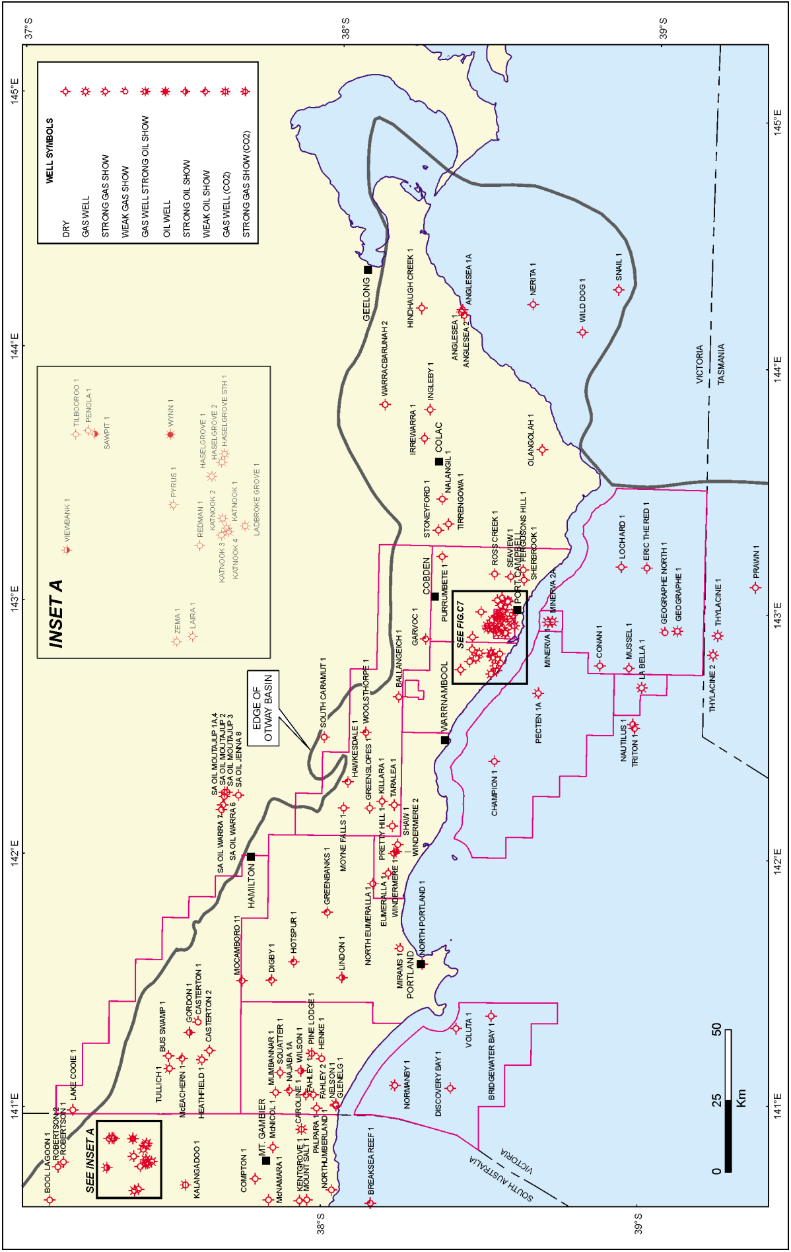
Figure 4 Location of gas exploration and discovery bores in the Otway Basin (from the Petroleum Atlas of Victoria (source: Woollands & Wong, 2001)
Figure 5 Review of the thickness of the Narrawaturk Marl Aquitard
Figure 6 Review of the thickness of the Gellibrand Marl Aquitard

  - Onshore natural gas prospectivity
    - Coal seam gas prospectivity
Coal seam gas extraction is governed by the Langmuir isotherm, relating gas content to reservoir pressure. Once the reservoir hydrostatic pressure is reduced to a critical point, the gas is liberated from the coal seams. Unlike conventional oil and gas reserves, it is not necessary to have a ‘seal’ above the coal seams but rather the gas is held in the coal beds by adsorption on to the coal surfaces and by hydrostatic pressure. However, the presence of low permeability material above the coal seam can be beneficial in reducing the groundwater pumping required to liberate the coal seam gas.
A prospective formation for coal seam gas in the Otway region is the Killara Coal Measures in the Cretaceous hydrogeological basement, located north of Warrnambool and west of Hamilton (Figure 7).
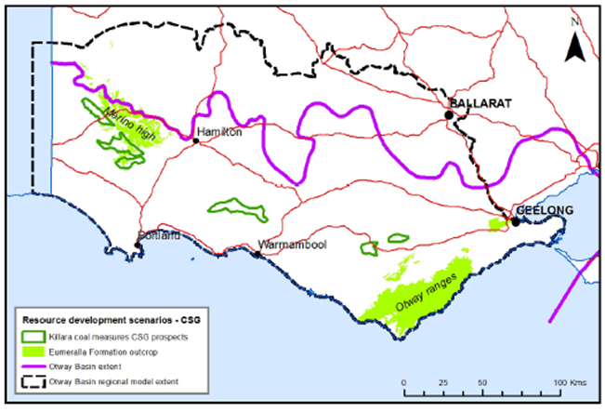
Figure 7 Otway Basin coal seam gas development scenarios (source: Goldie Divko, 2014)
    - Tight gas prospectivity
Tight gas is held in low permeability and low porosity rocks. The lack of permeability does not allow the gas to migrate out of the rock. Unlike coal seam gas where depressurisation of the coal seams is essential for gas migration, much smaller volumes of groundwater are required to be extracted in the development of tight gas deposits.
A prospective formation for tight gas in Otway region is the Cretaceous aged Eumeralla Formation underlying the Waaree Formation and the Cretaceous aged Pretty Hill Formation. Tight gas development scenarios from Goldie Divko (2014) are shown in Figure 8.
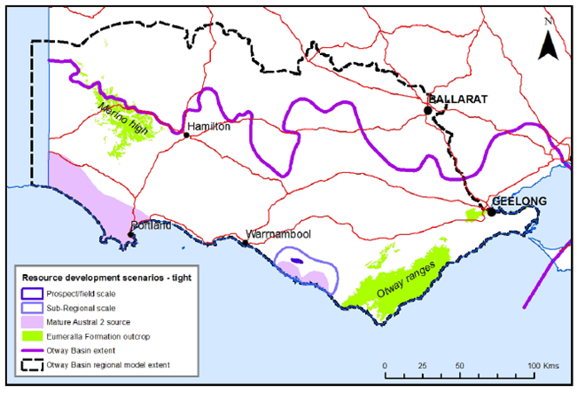
Figure 8 Otway Basin tight gas development scenarios (source: Goldie Divko, 2014)
    - Shale gas prospectivity
Shale gas is natural gas found trapped in shale formations. A prospective formation for shale gas in the Otway region is the Casterton Formation in the far west of the state. Tight gas development scenarios from Goldie Divko (2014) are shown in Figure 9.
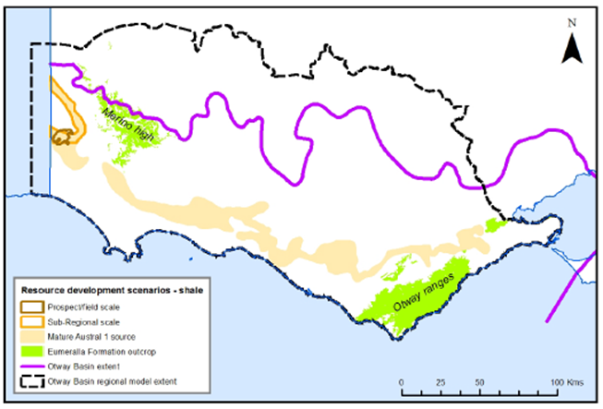
Figure 9 Otway Basin shale gas development scenarios (source: Goldie Divko, 2014)

    - Conventional gas prospectivity
Conventional gas fields have been developed and depleted in a number of locations in the Port Campbell Embayment. Conventional gas development scenarios from Goldie Divko (2014) are shown in Figure 10.
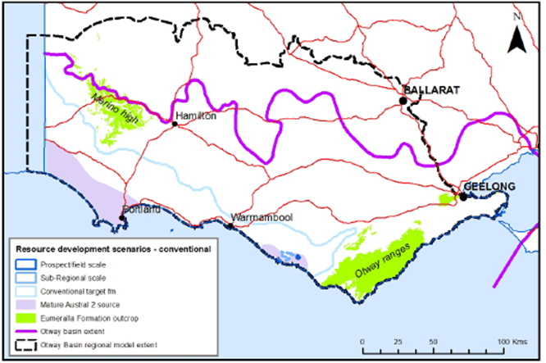
Figure 10 Otway Basin conventional gas development scenarios (source: Goldie Divko, 2014)
  - Groundwater chemistry sampling suite
In developing sampling approach a range of literature has been used to understand the most efficient and informative monitoring suite.
A number of natural gas exploration companies are currently operating in Queensland, Australia. The groundwater quality monitoring program undertaken by QGC for Queensland Curtis LNG (QCLNG) has been considered in development of this monitoring suite. International baseline groundwater monitoring protocols associated with natural gas have also been reviewed and used to inform the proposed monitoring suite. Protocols for Alberta and British Columbia, Canada have particularly provided useful basis from which to assess the groundwater parameters (Alberta Environment (2006), Chaytor, S. and Shaw, R., (2008)).
    - Groundwater characterisation
Monitoring of physical and inorganic properties of groundwater will be used to characterise the existing variability in aquifer chemistry. This will be done by assessing the unique chemical characteristics of the different aquifers, which can then be used as tracers to provide qualitative estimates of the degree of mixing between multiple aquifers.
Inorganic minerals are those derived from geological systems as opposed to organic minerals that are derived from biological systems. Groundwater contact with rocks and soils will lead to dissolution of inorganic minerals, namely major cations and major anions. The proposed suite of inorganic parameters to use in this project is:
- Calcium
- Sodium
- Magnesium
- Potassium
- Chloride
- Sulphate
- Fluoride
- Total alkalinity, carbonate / bicarbonate
- Total Nitrogen, Nitrate / Nitrite.
The above proposed suite of inorganics is largely consistent with the ALS Environmental basic coal seam gas suite. The extended coal seam gas suite (which is adopted by QGC in their baseline groundwater sampling programs) incorporates dissolved and total metals. This assessment has not recommended the inclusion of metals, as the objectives of this program can be achieved without their inclusion.
The following inorganic indicators are also proposed to be calculated to assist in aquifer characterisation;
- hardness: expressed as mg/L of CaCO3 and used to classify waters as soft -> hard
- Total Dissolved Solids (TDS): a measure of the salt dissolved in a water sample after the removal of suspended solids. TDS is the residue remaining after evaporation of the water and it is related to the specific conductance.
- Specific Conductance (or electrical conductivity uS/cm). Specific conductance measures the capacity of water to transmit electrical current and is proportional to salt content.
- Sodium Adsorption Ratio: used to evaluate the hazard in irrigation waters caused by sodium. It relates the concentration of sodium ions to magnesium and calcium ions. An increasing SAR relates to less favourable irrigated soil conditions.
- pH
- Physical water quality characteristics include those that relate to temperature, colour, taste and odour. The physical characteristics can be collected in the field and will be based on observations of such things as:
  - odour
  - water colour
  - effervescence.

    - Isotopes
Incorporation of isotope chemistry into the suite would be useful, however not vital to aquifer characterisation. Stable isotopes of oxygen and hydrogen and strontium in groundwater are routinely used to characterise groundwater and to investigate mixing between aquifers.
DSDBI (2013) recommended the inclusion of groundwater isotope analysis to investigate groundwater age and therefore flow paths. This would suggest inclusion of either Chlorine or Carbon isotopes.
    - Naturally occurring hydrocarbons
Organic chemistry in this study focuses on the organic geochemical properties of coal with particular focus on hydrocarbon associated chemicals such as:
- hydrocarbon gases (natural gas)
- hydrocarbon liquids (petroleum hydrocarbons).
Hydrocarbon gases include Methane (C1), Ethane (C2), Propane (C3) and Butane (C4). Measurement of the four gases means that gas component ratios can be used to help establish the role that hydrocarbon-oxidizing bacteria play in altering the original source gas composition. This ratio (referred to as the Bernard Parameter) can be used to indicate a likely thermogenic hydrocarbon source for any gas fields.
Methane occurs naturally in the atmosphere and is commonly found at trace levels as a dissolved component of groundwater. It can also be released by anthropogenic activities including agriculture, landfills. There is no authoritative guidance for methane concentrations in groundwater, given it is practically non-toxic. A 2012 National Methane Baseline Study was undertaken by the British Geological Survey (BGS) and was defined as the ‘current background range of methane concentrations in UK groundwater before any significant exploitation of unconventional hydrocarbons, such as shale gas, takes place’. This study found maximum Methane concentrations of 14.2 mg/L and 132 mg/L in the two study regions. Analysis of methane concentration from nearly 4,000 samples indicated a median Methane concentration of <0.5 mg/L. The study analysed only potable water and observation bores within Cretaceous, Jurassic and Triassic carbonates and sandstones.
The protocols for baseline groundwater sampling reported for both British Columbia and the state of Colorado indicate that if dissolved methane levels exceed 2 mg/L, gas composition analysis and stable isotope analysis of the methane (i.e. carbon and deuterium) should be performed to assess the potential origins of the gas. Stable carbon and deuterium isotopes of methane provide an independent means to determine the origin of gases and are conventionally used to differentiate between biogenic and thermogenic methane sources. Both chromatographic composition and isotope ratios are used to differentiate naturally occurring gas sources.
It is noted that DSDBI (2013) found methane in a number of sampled groundwater bores, yet the origin of this gas was unknown and was noted to require further investigation. For this reason it is proposed that measurement of all four gases (C1-C4) is undertaken and consideration for stable isotopes be given to later rounds of sampling where elevated methane concentrations are observed.
Sampling for petroleum hydrocarbons typically includes samples for:
- aromatic hydrocarbons benzene, ethylbenzene, toluene and xylene (BTEX)
- total petroleum hydrocarbons (TPH)
- polynuclear aromatic hydrocarbons (PAH).
A National Methane Baseline Study was undertaken by the British Geological Survey (BGS, 2012) and was defined as the ‘current background range of methane concentrations in UK groundwater before any significant exploitation of unconventional hydrocarbons, such as shale gas, takes place’. This study found maximum methane concentrations of 14.2 mg/L and 132 mg/L in the two study regions. Analysis of methane concentration from nearly 4,000 samples indicated a median methane concentration of <0.5 mg/L. The study analysed only potable water and observation bores within Cretaceous, Jurassic and Triassic carbonates and sandstones.
BTEX compounds are naturally found in crude oil, coal and gas deposits. Leusch and Bartkow (2011) concluded that BTEX compounds may therefore be naturally present at low concentrations in groundwater associated with these deposits.
Total petroleum hydrocarbons (TPH) are defined as carbon chains in the range of C6 through to C35. Products containing TPH include a wide variety of mixtures that may contain hundreds to thousands of hydrocarbon compounds including aliphatic (straight carbon chain) and aromatic (carbon ring) compounds. Evaluating hundreds to thousands of compounds is not usually practical. Evaluations for overall TPH are common and is generally accepted practice.
Sampling for BTEX and TPH is recommended as part of this suite given that national and international protocols for baseline groundwater sampling all include TPH and BTEX and BTEX compounds are used in hydraulic fracturing activities.
PAHs are produced in coal and the presence of PAHs in groundwater is due to the leaching of coals. Orem et al. (2007) tested produced waters from coal seam gas wells in the Powder River Basin, Wyoming, and concluded that the probable source of the PAHs was leaching from sub-bituminous coals, based on the similarities between the spectrum of PAHs present in the produced water and those found in the coal.
The international baseline sampling protocols reviewed did not include PAHs (i.e. the Colorado oil and gas conservation commission statewide groundwater baseline sampling and monitoring rules (2014), the Alberta Environment standard for baseline water well testing (2006) or the protocols developed for British Columbia (Chaytor & Shaw, 2008)). The groundwater monitoring program adopted in Queensland by QGC however did include PAHs.
The sampling of PAHs has not been included in the recommended sampling suite.
  - Summary of literature review
    - Groundwater sample locations informed by hydrocarbon occurrence
The monitoring program should target observation bores in the following locations where hydrocarbons have been observed:
- Cretaceous aged sediments of the Sherbrook Group in the Port Campbell Embayment
- Lower Tertiary aged Wangerrip Group in the Port Campbell Embayment with particular hot spots in the Port Campbell area and the Barwon Downs region west of Geelong
- Cretaceous aged sediments of the Sherbrook Group and the Lower Tertiary aged sediments of the Wangerrip Group in the Portland Trough.
In addition to these units and areas which are known to host hydrocarbon deposits, monitoring bores should target areas where the Narrawatruk and Gellibrand Marl is known to be thin as there could be an increased risk of vertical migration of hydrocarbons into overlying aquifers.
These conclusions were taken into account in the selection of bores for sampling (chapter 3).
    - Summary of groundwater sampling parameters
Based on the above literature review, in order to characterise the groundwater chemistry of chosen aquifers and to determine the natural occurrence of hydrocarbons in groundwater, groundwater samples should be analysed for the following parameters:
- major ions: Calcium, Sodium, Magnesium, Potassium, Chloride, Sulphate, Fluoride, Total alkalinity, carbonate, bicarbonate, Total Nitrogen, Nitrate, Nitrite
- inorganic indicators: Hardness, Total Dissolved Solids (TDS) , Specific Conductance (or electrical conductivity uS/cm), Sodium Adsorption Ratio, pH
- physical water quality characteristics (identified in the field): odour, water colour, effervescence
- hydrocarbons: Methane (C1), Ethane (C2), Propane (C3), Butane (C4), Benzene, Toluene, Ethylbenzene, Xylene, Total Petroleum Hydrocarbons.

- Bore selection
The sampling program has the following objectives:
- to characterise the groundwater chemistry, particularly with presence or not or not of hydrocarbons, in prospective onshore natural gas areas, and
- to provide an indication of baseline groundwater quality, in particular the concentration of hydrocarbons in groundwater.
This project utilised low flow techniques to sample a representative number of bores screened within aquifers known to have, or suspected of having, hydrocarbon concentrations and/or within or near key groundwater or surface water assets. Low flow sampling is a recognised technique for sampling small volumes of groundwater from the bore (Geoscience Australia, 2009). The technique relies on knowledge
of the bore construction especially the screen interval and also the diameter and condition of the bore. Reliability of results also requires knowledge of which aquifer and interval the sample represents. For this reason, this project chose state observation bores (SOBs) for sampling due to the reliable data on bore construction and condition. The alternative of using private bores was discounted due to the variable
nature of bore construction and casing condition data. and the problems with already installed pumps and obtaining access.
  - Selection criteria
The following criteria were used to select bores for the monitoring program:
- bores in the prospective units for unconventional gas development especially in areas of identified high prospectivity
- watertable bores chosen in or around groundwater dependent ecosystem assets particularly above zones of high unconventional gas prospectivity
- bores in areas of either high potential or actual use
- nested bores which highlight the vertical differences in groundwater chemistry at the same location
- bores with known hydrocarbon concentrations determined from the above literature review
- bores in aquifers above known seals and also where the seal is absent to allow analysis of the effectiveness of the seal for capping vertical hydrocarbon migration
- bores should not be chosen if they have one or more of the following characteristics:
  - failed bores or bores of poor condition
  - bores with lack of construction data.
The Otway prospectivity areas (Section 2.3) and the locations of the state observation bores have been used to inform the monitoring program by comparing with:
- key groundwater dependent ecosystems and surface water assets
- aquifers
- naturally occurring hydrocarbon locations identified by the literature review.
A recent review of the State Observation Bore Network (SOBN) undertaken by GHD (2014) included an assessment and scoring of bore condition. Bores were scored from 1 (good) through to 5 (poor) and it was noted that bores with a final score of 4 or 5 were least preferred for inclusion as an SOBN asset. Bores with a poor condition ranking (4 or 5) were excluded from the initial round of bore selection and only considered for inclusion in the monitoring network if an obvious gap in the remaining SOBs was observed.
  - Groundwater dependent ecosystems and surface
water assets
The Victorian Water Asset Database (VWAD) was used to identify potential Groundwater Dependent Ecosystems (GDEs), waterways and wetlands in the Otway Basin.
The VWAD ranks assets from the perspective of habitat, economic, recreation and cultural value, whereby the following scores were applied:
- Neutral = 1, Low = 10, Moderate = 20 , High = 40 , Extreme = 100
Based on these criteria the following rules were applied to VWAD to generate datasets of potential groundwater dependent ecosystems s for potential bore monitoring target sites in the monitoring program:
- GDE score = 100. A score of 100 implies a potential groundwater dependent ecosystems has been identified.
- Water source = 100. A score of 100 implies the water source is groundwater.
- Habitat score = 100. This implies extremely valuable rivers and wetlands were selected from the VWAD. Examples include Iconic Rivers, Living Murray Icon Sites, Nationally Important Wetlands, Victorian Biodiversity Atlas, Highly Localised Asset sites of significance etc.
- Economic score = 100. This implies extremely valuable rivers and wetlands were selected from the VWAD. Examples include Town Supply Reservoirs, features used for urban water supply, features located in Designated Water Supply Catchment etc.
- Recreation score = 100. This includes rivers and wetlands where recreational activities have been observed.
- Cultural score = 40 (there were no score = 100 in the Otway Basin). As a result, highly valuable rivers and wetlands were selected from the VWAD. Examples include features listed in the Victorian Heritage Register or AVIRA for National Heritage Sites etc.
There were no springs identified in the Basin or Basin Margin catchment system of the Otway Basin. Springs were only present in the upland valley and upland layered valley region in the north east corner of the Corangamite CMA area.
Identified potential groundwater dependent ecosystems s were compared to the locations of the field scale and sub-regional scale prospectivity for conventional gas, coals seam gas and tight/shale gas localities, as defined by Goldie Divko (2014) and described in Section 2.3.
The analysis was undertaken at a Groundwater Catchment Unit (GCU) scale, which includes the Hopkins-Corangamite, Portland and Glenelg GCUs. The absence of prospectivity in the Otway-Torquay GCU meant it was excluded from further assessment.

    - Hopkins Corangamite Groundwater Catchment Unit
Within the Hopkins Corangamite Groundwater Catchment Unit (GCU), there are a number of field scale and sub-regional scale conventional gas, tight gas and coal seam gas prospective areas. These areas were intersected with key waterways and wetlands as identified from VWAD to identify bores for inclusion in the monitoring program.Figure 11 shows the proposed sampling bores which are summarised in Table 1.

Table 1 Proposed monitoring bores in areas of prospectivity and potential groundwater dependent environmental assets
Bore | Details | Justification
115872 | Lower Tertiary Aquifer (111) | - Located in the area of prospectivity and key rivers and wetlands
113467 | Lower Tertiary Aquifer (111) | - Located in the area of prospectivity and key rivers and wetlands
54925 | Upper Tertiary/Quaternary Basalt Aquifer (101) | - Located in the area of prospectivity and key rivers and wetlands  - Monitors the watertable aquifer
142660 | Upper Tertiary/Quaternary Basalt Aquifer (101) | - Located in the area of prospectivity and key rivers and wetlands (including RAMSAR wetland site Lake Corangamite)
141241 | Upper Mid-Tertiary Aquifer (107) | - Located in the area of prospectivity and key rivers and wetlands
141242 | Upper Mid-Tertiary Aquifer (107) | - Located in the area of prospectivity and key rivers and wetlands

Figure 11 Hopkins-Corangamite Groundwater Catchment Unit showing prospective natural gas areas and proposed monitoring bores (black circles)
    - Portland Groundwater Catchment Unit
Within the Portland GCU, the Killara coal seam gas prospect near Hawkesdale and Digby present the primary prospect areas for natural gas. These areas were intersected with key waterways and wetlands as identified from VWAD to identify bores for inclusion in the monitoring program. Figure 12 shows the proposed sampling bores which are summarised in Table 2.

Table 2 Proposed monitoring bores in areas of prospectivity and high value Groundwater Dependent Environmental Assets
Bore | Details | Justification
111524 | Upper Mid-Tertiary Aquifer (107) | - Located in the area of prospectivity and key rivers and wetlands
111525 | Upper Tertiary/Quaternary Basalt Aquifer (101)) | - Located in the area of prospectivity and key rivers and wetlands  - Monitors the watertable aquifer in the vicinity of environmental assets
122677 | Lower Mid-Tertiary Aquifer (109) | - Located adjacent to the area of prospectivity and key rivers and wetlands

Figure 12 Portland Groundwater Catchment Unit showing prospective natural gas areas and proposed monitoring bores (black circle)

    - Glenelg Groundwater Catchment Unit
Within the Glenelg GCU, there are a number of coal seam gas and shale gas field prospects and the sub-regional shale gas prospect area. These areas were intersected with high value waterways and wetlands as identified from VWAD to identify bores for inclusion in the monitoring program.

Table 3 Proposed monitoring bores in areas of prospectivity and high value Groundwater Dependent Environmental Assets
Bore | Details | Justification
83446 | Lower Tertiary Aquifer (111) | - Located in the area of prospectivity and high value rivers and wetlands (including wetlands protected by the Directory of Important Wetlands)
83447 | Upper Mid-Tertiary Aquifer (107) | - Located in the area of prospectivity and high value rivers and wetlands
S61557-2 | Quaternary Aquifer (100)) | - Located in the area of prospectivity and high value rivers and wetlands. Including the Directory of Important Wetland ‘McCallums Swamp’  - Monitors the watertable aquifer
102621 | Upper Mid-Tertiary Aquifer (107) | - Located in the area of prospectivity and high value rivers and wetlands
83729 | Upper Mid-Tertiary Aquifer (107) | - Located in the area of prospectivity and high value rivers and wetlands
S61557-3 | Quaternary Aquifer (100) | - Located in the area of prospectivity and high value rivers and wetlands. Including Directory of Important Wetlands (Mundi-Selkirk Wetlands) and the Glenelg River  - Monitors the watertable aquifer
S61557-1 | Quaternary Aquifer (100) | - Located in the area of prospectivity and high value rivers and wetlands. Including Directory of Important Wetlands (Mundi-Selkirk Wetlands, Pig Swamp and Lake Mundi)  - Monitors the watertable aquifer
Figure 13 Glenelg Groundwater Catchment Unit showing prospective natural gas areas and proposed monitoring bores (black circle)
  - Aquifers
Across Victoria, areas where groundwater is either a high potential or actual use are defined by Groundwater Management Areas (GMAs) and Water Supply Protection Areas (WSPAs). In the Otway Basin there are multiple GMAs and WSPAs and these are summarised below in Table 4. The target aquifers for these high value groundwater areas have been used to develop the monitoring network.

Table 4 Summary of GMAs and WSPAs in the Otway region
GCU | GMA/WSPA | Depth Criteria | Target Aquifer | Code
Glenelg | Glenelg | All | Port Campbell Limestone and Dilwyn Formation | Upper Mid-Tertiary Aquifer (107) and Lower Tertiary Aquifer (111)
Portland | Portland | >200 | Dilwyn Formation | Lower Tertiary Aquifer (111)1
Portland | Condah | 70-200 | Clifton Formation | Lower Mid-Tertiary Aquifer (109)
Portland | Yangery | <100 | Port Campbell Limestone | Upper Mid-Tertiary Aquifer (107)
Portland | Hawkesdale | Zone 1 <200 and zone 2 all | Port Campbell Limestone | Upper Mid-Tertiary Aquifer (107)
Portland | Heywood | <70 | Quaternary volcanics, Bridgewater and Whalers Bluff Formations and the Port Campbell Limestone Aquifer. | Upper Tertiary/Quaternary Basalt Aquifer (101) and Upper Tertiary Aquifer (marine) (104)and Upper Mid-Tertiary Aquifer (107)
Hopkins - Corangamite | Newlingrook | All | Dilwyn Formation | Lower Tertiary Aquifer (111)
Hopkins - Corangamite | Nullawarre | <250 | Port Campbell Limestone | Upper Mid-Tertiary Aquifer (107)
Hopkins - Corangamite | Paaratte | >120 | Dilwyn Formation | Lower Tertiary Aquifer (111)
Hopkins - Corangamite | Warrion | All | Newer Volcanics | Upper Tertiary/Quaternary Basalt Aquifer (101)
Hopkins - Corangamite | Colongulac | <60 | Newer Volcanics | Upper Tertiary/Quaternary Basalt Aquifer (101)
Hopkins - Corangamite | Gellibrand | All | Dilwyn Formation | Lower Tertiary Aquifer (111)
Hopkins - Corangamite | Gerangamete | >60 | Dilwyn Formation and Pebble Point | Lower Tertiary Aquifer (111)
Hopkins - Corangamite | Glenormiston | <60 | Hanson Plain Sands and Newer Volcanics | Upper Tertiary/Quaternary Basalt Aquifer (101)

    - Hopkins Corangamite Groundwater Catchment Unit
The Hopkins Corangamite GCU includes the following GMAs and WSPAs:
- Newlingook
- Nullawarre
- Paaratte
- Warrion
- Colonguluc
- Gellibrand
- Gerangamete
- Glenormiston.
SRW (2014) provides an overview of the target aquifers for groundwater use within each of the above management areas in the Hopkins Corangamite GCU and this information was used to target bores for inclusion in the monitoring network. Bores identified for inclusion in the network are summarised in Table 5 and shown in Figure 14.

Table 5 Selected monitoring bores in areas of high value groundwater asset (as indicated by GMAs and WSPAs)
GCU | GMA/WSPA | Target Aquifer | Bore | Justification
Hopkins - Corangamite | Newlingrook | Lower Tertiary Aquifer (111) | 75070 | Closest bore monitoring the Dilwyn Formation to the prospectivity area. No nested sites to present alternative option.
Hopkins - Corangamite | Nullawarre | Upper Mid-Tertiary Aquifer (107) | 141241*  141242* | Monitors the target aquifer (PCL) in the Nullawarre WSPA
Hopkins - Corangamite | Paaratte | Lower Tertiary Aquifer (111) | 115872*  113467* | Both bores monitor the target aquifer (Dilwyn Formation) in the Paaratte GMA
Hopkins - Corangamite | Warrion | Newer Volcanics (101) | 142660* | Monitors the target aquifer (Newer Volcanics) in the Warrion WSPA
Hopkins - Corangamite | Colongulac | Newer Volcanics (101) | 89040 | Only available SOB in the GMA. No nested sites to present alternative option.
Hopkins - Corangamite | Gellibrand | Lower Tertiary Aquifer (111) | 114169 | No nested sites to present alternative option.
Hopkins - Corangamite | Gerangamete | Lower Tertiary Aquifer (111) | 114167 | Monitors the target aquifer (Dilwyn Fmn) in the Gerangamete GMA
Hopkins - Corangamite | Glenormiston | Upper Tertiary/Quaternary Basalt Aquifer (101) and Upper Tertiary Aquifer (marine) (104) | NA | No SOBs (including poor condition bore check)
*bores have already been included in the monitoring network based on other selection criteria
Figure 14 GMAs and WSPAs and targeted monitoring bores (new selected bores based on this criteria indicated in blue)
    - Portland Groundwater Catchment Unit
The Portland GCU includes the following GMAs and WSPAs:
- Portland
- Condah
- Yangery
- Hawkesdale
- Heywood.
SRW (2014b) provides an overview of the target aquifers for groundwater use within each of the above management areas in the Portland GCU and this information was used to target bores for inclusion in the monitoring network. Bores identified for inclusion in the network are summarised in Table 6 and shown in Figure 15.

Table 6 Selected monitoring bores in areas of high value groundwater asset (as indicated by GMAs and WSPAs)
GCU | GMA/WSPA | Target Aquifer | Bore | Justification
Portland | Portland | Lower Tertiary Aquifer (111) | NA | There are no SOBs monitoring the Dilwyn Formation aquifer in this GMA with suitable condition criteria.
Portland | Condah | Lower Mid-Tertiary Aquifer (109) | 122677* | Monitors the target aquifer (Clifton Fmn) in the Condah WSPA
Portland | Yangery | Upper Mid-Tertiary Aquifer (107) | 141308 | Monitors the target aquifer in the Yangery WSPA.
Portland | Hawkesdale | Upper Mid-Tertiary Aquifer (107) | 111524* | Monitors the target aquifer (PCL) in the Hawkesdale GMA
Portland | Heywood | Newer Volcanics, Bridgewater and Whalers Bluff Formations and the Port Campbell Limestone Aquifer. (101, 104 and 107) | S9037242-1 | Bore included to provide information for the PCL aquifer in this GMA.
*bores have already been included in the monitoring network based on other selection criteria
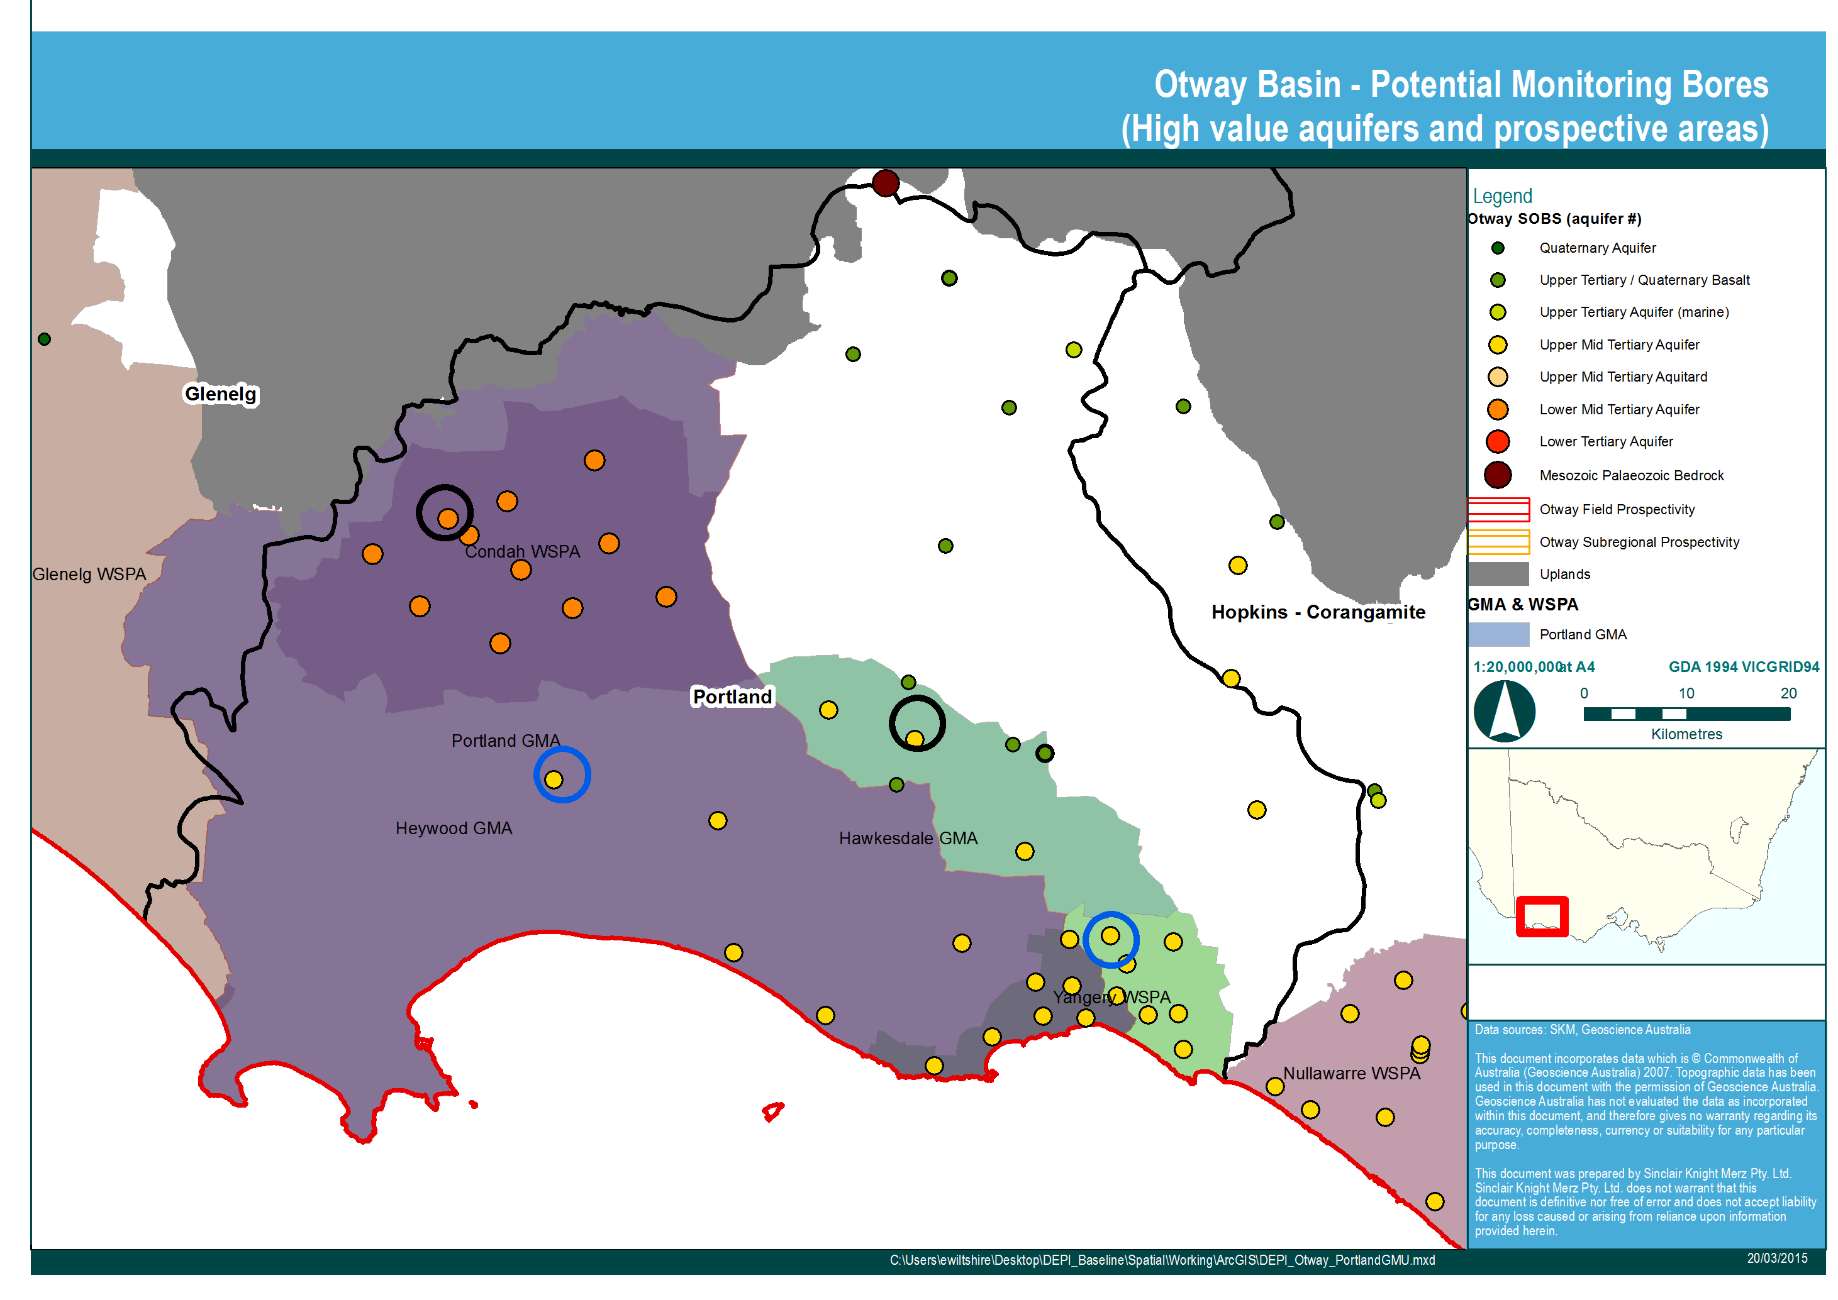
Figure 15 GMAs and WSPAs and targeted monitoring bores (new selected bores based on this criteria indicated in blue)

    - Glenelg Groundwater Catchment Unit
Within the Glenelg GCU there is a single WSPA – the Glenelg, which represents groundwater sourced from aquifers at all depths. The target aquifers in this area however are the Port Campbell Limestone and the Dilwyn Formation (SRW, 2013). Bores identified for inclusion in the network are summarised in Table 7 and shown in Figure 16.

Table 7 Selected monitoring bores in areas of high value groundwater asset (as indicated by GMAs and WSPAs)
GCU | GMA/WSPA | Target Aquifer | Bore | Justification
Glenelg | Glenelg | Upper Mid-Tertiary Aquifer (107) and Lower Tertiary Aquifer (111) | 83446*  83447*  102621*  83729* | - Monitors the target aquifer (Dilwyn) in the Glenelg WSPA  - Monitors the target aquifer (PCL) in the Glenelg WSPA  - Monitors the target aquifer (PCL) in the Glenelg WSPA  - Monitors the target aquifer (PCL) in the Glenelg WSPA
Glenelg | Glenelg | Quaternary Aquifer (100) and Lower Tertiary Aquifer (111) | 82347 (111)  S61557-4 (100) | Bores will monitor the Dilwyn Formation Aquifer and the watertable aquifer and will inform groundwater chemistry of multiple aquifers at one site and allow for interpretation of potential mixing.
*bores have already been included in the monitoring network based on other selection criteria
Figure 16 GMAs and WSPAs and targeted monitoring bores (new selected bores based on this criteria indicated in blue)
  - Naturally occurring hydrocarbon sites and potential vertical migration
The monitoring program aimed to target observation bores in the locations identified in the literature review as areas of naturally occurring hydrocarbon presence and also areas where the overlying aquitards are thin and there is an increased risk of vertical migration of hydrocarbons. Bores identified for inclusion in the network are summarised in Table 8 and shown in Figure 17.

Table 8 Summary of intersection between areas identified as potential hydrocarbon occurrence and selected monitoring bores
Area | Bore | Justification
The Cretaceous aged sediments of the Sherbrook Group (113) in the Port Campbell Embayment | 115872*  113467* | There are no SOBs monitoring the 113 aquifer. Two bores overlying this formation (i.e. the 111 aquifer) have already been included in the program.
The Wangerrip Group (111) in the Port Campbell Embayment with particular hot spots in the Port Campbell area | 115872*  113467* | These Wangerrip Group (111) bores are the closest suitable SOBs to the Port Campbell locality.
Sherbrook Group (113) and Wangerrip Group (111) in the Portland Trough. | NA | There are no SOBs monitoring these units in the Portland Trough. Only SOBs with poor condition codes exist in this area.
Glenelg – area of thin / absent aquitard | 83446 (111)*  83447 (107)* | This nested site represents a Wangerrip Group (111) bore and an overlying Limestone bore (107). These units straddle the marl aquitards and hence this nested site will provide information regarding aquifer chemistry where the marl is absent/thin.
Hopkins-Corangamite – area of thin / absent aquitard | NA | Although there is a significant density of SOBs in this area, all bores monitor the Wangerrip (111) aquifer and there are no sites with a shallow nested bore. Hence a recommendation has not been made in this area, as a shallow aquifer bore was the target.
*bores have already been included in the monitoring network based on other selection criteria

Figure 17 Areas identified in literature review
  - Nested sites
Targeting nested bore sites for inclusion in the monitoring network assists in the aquifer characterisation process and also informs the potential for mixing of groundwater from multiple aquifers. Any future natural gas investigations will target deep aquifers that underlie the aquifers that are currently used extensively for private groundwater extraction purposes (e.g. irrigation, stock and domestic) and by the environment (e.g. GDEs). Hence, understanding the amount of connection between the deep and shallow aquifers is important and this can potentially be informed by interpreting groundwater chemistry information for multiple aquifers at a single site (i.e. at a nested site).
A review has been undertaken to identify the nested sites in the Otway region. A total of 47 sites remained after the poor condition bores were removed from the dataset and the nested sites that appeared to monitor the same aquifer were also removed. Three of these sites were already included in the program from previous selection criteria. Figure 18 shows the distribution of the nested sites (coloured by nested aquifers) and also shows the location of the Ramsar listed western district wetlands. Three additional nested sites of bores have been included in the monitoring program. One site has been included so that the potential for mixing of groundwater between aquifers that straddle the Gellibrand Marl aquitard can be compared in an area where the marl is significantly thick (this site) and absent (the Glenelg nested site). The other two sites focus around two important Ramsar listed wetlands. The nested sites are summarised in Table 9.

Table 9 Summary of nested sites targeting well recognised assets in the Otway region
Bore | Target Aquifer | Justification
111524*  111525* | Upper Mid-Tertiary Aquifer (107) and Upper Tertiary/Quaternary Basalt Aquifer (101) | - Nested site will inform groundwater chemistry of multiple aquifers at one site and allow for interpretation of potential mixing.
111787  111786 | Watertable aquifer (101 Newer Volcanics) and Dilwyn Formation (111) | - Nested site located in the vicinity of the Lake Murdeduke Ramsar listed site.  - Nested site will inform groundwater chemistry of multiple aquifers at one site and allow for interpretation of potential mixing.
83446*  83447* | Lower Tertiary Aquifer (111)  Upper Mid-Tertiary Aquifer (107) | - Nested site will inform groundwater chemistry of multiple aquifers at one site and allow for interpretation of potential mixing. Also located in an area where the aquitard is thin/absent
110985  110984 | Watertable aquifer (101 Newer Volcanics) and Whalers Bluff/Hanson Plain Sand (104) | - Nested site located in the vicinity of the Lake Corangamite Ramsar listed site.  - Nested site will inform groundwater chemistry of multiple aquifers at one site and allow for interpretation of potential mixing.
141307  141308* | Upper Tertiary/Quaternary Basalt Aquifer (101)  Upper Mid-Tertiary Aquifer (107) | - Bores will monitor the high value PCL aquifer and the watertable aquifer (101 Newer Volcanics) and will inform groundwater chemistry of multiple aquifers at one site and allow for interpretation of potential mixing.
82347*  S61557-4* | Lower Tertiary Aquifer (111)  Quaternary Aquifer (100) | - Bores will monitor the Dilwyn Formation Aquifer and the watertable aquifer and will inform groundwater chemistry of multiple aquifers at one site and allow for interpretation of potential mixing.

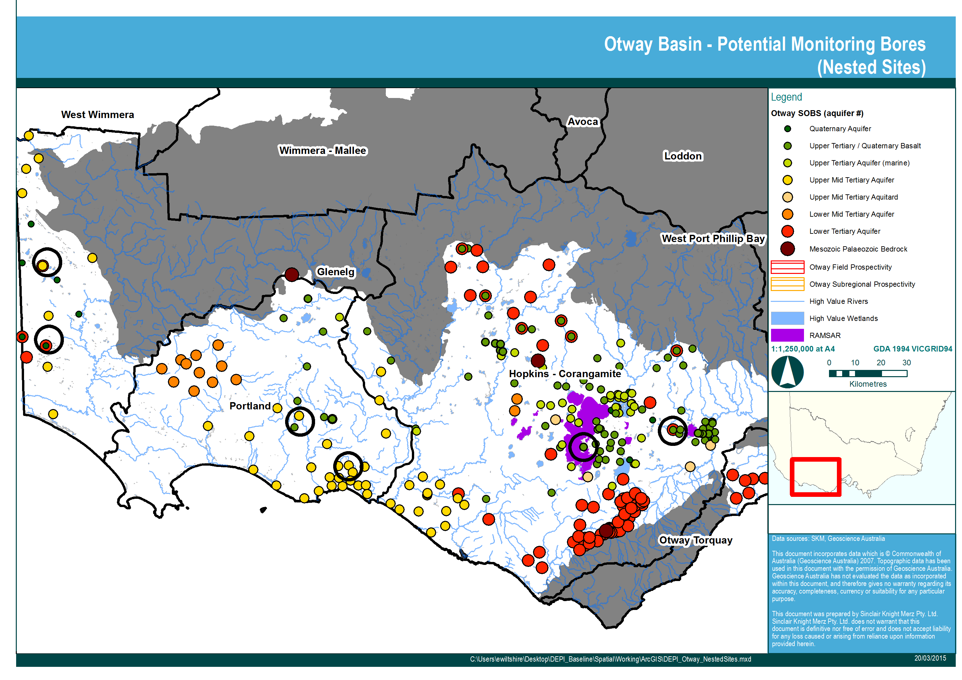
Figure 18 Nested SOB sites across the Otway region selected for inclusion in the monitoring program
  - Summary of selected monitoring network
Table 10 provides a summary of the selected bores for the Otway monitoring network. A total of 30 bores were selected for inclusion in the monitoring program. These bores were selected because they meet one or more of the following selection criteria:
- located in a prospectivity area and near a high value groundwater dependent ecosystems
- monitors the target aquifer in a proclaimed groundwater area
- monitors the watertable aquifer near a high value groundwater dependent ecosystems
- targets areas identified in literature review
- includes a nested site
- located near a Ramsar listed site.
Upon review of the final set of monitoring bores, a single additional bore (69455) was incorporated. This is the only State Observation Bore in the Otway Basin constructed into the Mesozoic and Palaeozoic Bedrock aquifer. Although this bore did not meet any of the selection criteria listed above, it was included to provide groundwater chemistry information for the primary target aquifers in the region. The network is shown in Figure 19 and summary comments provided in Table 10.

Figure 19 Selected monitoring network for the Otway region

Table 10 Summary of selected bores for the Otway monitoring network
Bore | Aquifer Monitored | Justification for inclusion in the monitoring network
111524 | Upper Mid-Tertiary Aquifer (107) | - Located in the area of prospectivity and high value rivers and wetlands  - Monitors the target aquifer (PCL) in the Hawkesdale GMA  - Nested with 111525 and will inform groundwater chemistry of multiple aquifers at one site and allow for interpretation of potential mixing.
111525 | Upper Tertiary/Quaternary Basalt Aquifer (101) | - Located in the area of prospectivity and high value rivers and wetlands  - Monitors the watertable aquifer in the vicinity of environmental assets  - Nested with 111524 and will inform groundwater chemistry of multiple aquifers at one site and allow for interpretation of potential mixing.
83446 | Lower Tertiary Aquifer (111) | - Located in the area of prospectivity and high value rivers and wetlands (including wetlands protected by the Directory of Important Wetlands)  - Monitors the target aquifer (Dilwyn) in the Glenelg WSPA  - Nested with 83447 and will inform groundwater chemistry of multiple aquifers at one site and allow for interpretation of potential mixing.  - Also located in an area where the aquitard is thin/absent
83447 | Upper Mid-Tertiary Aquifer (107) | - Located in the area of prospectivity and high value rivers and wetlands  - Monitors the target aquifer (PCL) in the Glenelg WSPA  - Nested with 83446 and will inform groundwater chemistry of multiple aquifers at one site and allow for interpretation of potential mixing.  - Also located in an area where the aquitard is thin/absent
111787 | Upper Tertiary/Quaternary Basalt Aquifer (101) | - Nested site located in the vicinity of the Lake Murdeduke Ramsar listed site. Nested with 111786 and will inform groundwater chemistry of multiple aquifers at one site and allow for interpretation of potential mixing
111786 | Lower Tertiary Aquifer (111) | - Nested site located in the vicinity of the Lake Murdeduke Ramsar listed site. Nested with 111787 and will inform groundwater chemistry of multiple aquifers at one site and allow for interpretation of potential mixing.
110985 | Upper Tertiary/Quaternary Basalt Aquifer (101) | - Nested site located in the vicinity of the Lake Corangamite Ramsar listed site.  - Nested with 110984 and will inform groundwater chemistry of multiple aquifers at one site and allow for interpretation of potential mixing.
110984 | Upper Tertiary Aquifer (marine) (104) | - Nested site located in the vicinity of the Lake Corangamite Ramsar listed site.  - Nested with 110985 and will inform groundwater chemistry of multiple aquifers at one site and allow for interpretation of potential mixing.
122677 | Lower Mid-Tertiary Aquifer (109) | - Located adjacent to the area of prospectivity and high value rivers and wetlands  - Monitors the target aquifer (Clifton Fmn) in the Condah WSPA
115872 | Lower Tertiary Aquifer (111) | - Located in the area of prospectivity and high value rivers and wetlands  - Monitors the target aquifer (Dilwyn Formation) in the Paaratte GMA
113467 | Lower Tertiary Aquifer (111) | - Located in the area of prospectivity and high value rivers and wetlands  - Monitors the target aquifer (Dilwyn Formation) in the Paaratte GMA
54925 | Upper Tertiary/Quaternary Basalt Aquifer (101) | - Located in the area of prospectivity and high value rivers and wetlands  - Monitors the watertable aquifer
142660 | Upper Tertiary/Quaternary Basalt Aquifer (101) | - Located in the area of prospectivity and high value rivers and wetlands (including RAMSAR wetland site Lake Corangamite)  - Monitors the target aquifer (Newer Volcanics) in the Warrion WSPA
141241 | Upper Mid-Tertiary Aquifer (107) | - Located in the area of prospectivity and high value rivers and wetlands  - Monitors the target aquifer (PCL) in the Nullawarre WSPA
S61557-2 | Quaternary Aquifer (100) | - Located in the area of prospectivity and high value rivers and wetlands.  - Including the Directory of Important Wetland ‘McCallums Swamp’ Monitors the watertable aquifer
102621 | Upper Mid-Tertiary Aquifer (107) | - Located in the area of prospectivity and high value rivers and wetlands  - Monitors the target aquifer (PCL) in the Glenelg WSPA
83729 | Upper Mid-Tertiary Aquifer (107) | - Located in the area of prospectivity and high value rivers and wetlands  - Monitors the target aquifer (PCL) in the Glenelg WSPA
S61557-3 | Quaternary Aquifer (100) | - Located in the area of prospectivity and high value rivers and wetlands.  - Including Directory of Important Wetlands (Mundi-Selkirk Wetlands) and the Glenelg River  - Monitors the watertable aquifer
S61557-1 | Quaternary Aquifer (100) | - Located in the area of prospectivity and high value rivers and wetlands.  - Including Directory of Important Wetlands (Mundi-Selkirk Wetlands, Pig Swamp and Lake Mundi)  - Monitors the watertable aquifer
141307 | Upper Tertiary/Quaternary Basalt Aquifer (101) | - Located in the Yangery WSPA.  - Nested with 141308.  - Bores will monitor the high value PCL aquifer and the watertable aquifer (101 Newer Volcanics) and will inform groundwater chemistry of multiple aquifers at one site and allow for interpretation of potential mixing.
141308 | Upper Mid-Tertiary Aquifer (107) | - Located in the Yangery WSPA. Nested with 141307.  - Bores will monitor the high value PCL aquifer and the watertable aquifer (101 Newer Volcanics) and will inform groundwater chemistry of multiple aquifers at one site and allow for interpretation of potential mixing.
82347 | Lower Tertiary Aquifer (111) | - Located in the Glenelg WSPA. Nested with S61557-4.  - Bores will monitor the Dilwyn Formation Aquifer and the watertable aquifer and will inform groundwater chemistry of multiple aquifers at one site and allow for interpretation of potential mixing.
S61557-4 | Quaternary Aquifer (100) | - Located in the Glenelg WSPA. Nested with 82347.  - Bores will monitor the Dilwyn Formation Aquifer and the watertable aquifer and will inform groundwater chemistry of multiple aquifers at one site and allow for interpretation of potential mixing.
S9037242-1 | Upper Mid-Tertiary Aquifer (107) | - Heywood GMA.  - Bore included to provide monitoring information for the PCL aquifer in the Heywood GMA.
75070 | Lower Tertiary Aquifer (111) | - Newlingrook GMA. Closest bore monitoring the Dilwyn Formation to the prospectivity area.  - No nested sites to present alternative option.
89040 | Upper Tertiary/Quaternary Basalt Aquifer (101) | - Only available SOB in the Colongulac GMA.  - No nested sites to present alternative option.
114169 | Lower Tertiary Aquifer (111) | - Gellibrand GMU.  - No nested sites to present alternative option.
141242 | Upper Mid-Tertiary Aquifer (107) | - Located in the area of prospectivity and high value rivers and wetlands.  - Monitors the target aquifer (PCL) in the Nullawarre WSPA.
114167 | Lower Tertiary Aquifer (111) | - Monitors the target aquifer (Dilwyn Formation) in the Gerangamete GMA.
69455 | Mesozoic and Palaeozoic Bedrock (114) | - Only SOB available that monitors the Mesozoic Palaeozoic bedrock.

- Sampling method
Sampling of groundwater and gas from DELWP monitoring bores was conducted by HydroTerra personnel, subcontracted by Jacobs.
All groundwater purging, sampling and manual water level monitoring activities undertaken by HydroTerra were completed under their Standard Operating Procedure (SOP) for Groundwater Sampling, a copy of which is included in Appendix A. The SOP includes a detailed methodology for the following activities:
- Field instrument calibration: instruments were routinely checked for calibration at the start and end of the day in accordance with equipment procedures.
- Water level monitoring.
- Water quality monitoring: field parameters were routinely monitored during purging.
- Water sample collection: water samples were collected once field parameter stabilisation was achieved (three consecutive readings within 10%). Groundwater samples were collected into approved ALS Environmental supplied glass containers.
- Handling, storage and Chain of Custody procedures for collected samples: groundwater samples, including QA/QC samples, were stored on ice between the bore and delivery to the laboratory.
- Gas sampling was conducted in accordance with HydroTerra’s technical work instruction for Collection of Dissolved Gas and Groundwater Samples from Coal Seam, included in Appendix B. The instruction includes a detailed methodology for the following activities:
  - Gas monitoring: gas was monitored onsite using a gas analyser.
  - Gas sample collection: when all the groundwater sample containers required for analysis were filled, a gas sample was collected. Gas samples were collected into ALS Environmental supplied summa canisters.
  - Handling, storage and Chain of Custody procedures for collected samples.
Samples were collected using a low flow pump installed at depth, which pumped water to the surface. Water was diverted into two lines – one for measurement of field parameters, one for water sample and gas sample collection. A flow diagram of the sampling lines is shown in Figure 20. Pump installation, operation and maintenance were conducted in accordance with HydroTerra’s technical work instruction for Solinst 408 Double Valve Pump Deployment and Operation, included in Appendix C.
Between bore sites, all equipment was decontaminated to prevent cross-contamination between bores and samples. Equipment was decontaminated by rinsing with tap water, chemical detergent, tap water and then de-ionised water. The methodology used by HydroTerra personnel is described in full in Appendix A.

Figure 20 Flow diagram showing water sample collection, field parameter measurement and gas sample collection
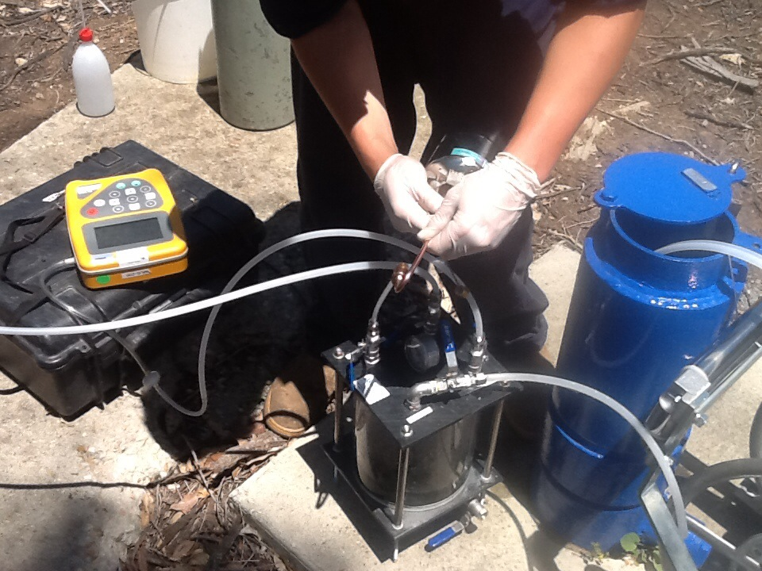
Figure 21 Example of gas collection and sampling procedure in the field
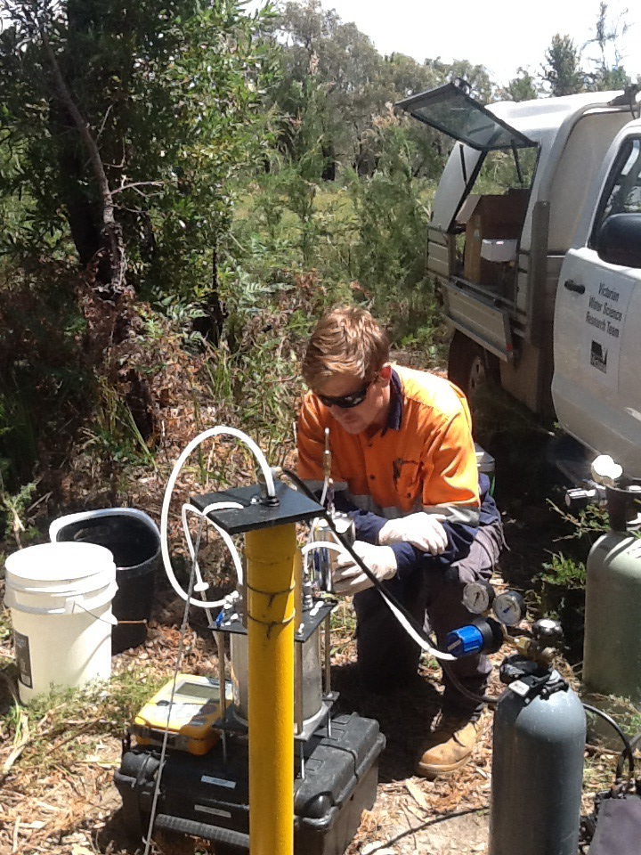
Figure 22 Example of gas collection and sampling procedure in the field

  - Reporting of gas concentrations
Unlike water samples, the mass of a particular analyte in a gas sample is dependent on the pressure and temperature of the sample. For this reason, the laboratory reports the following parameters in the methane analysis of gas samples collected in summa canisters:
- concentration of methane (in mg/m³)
- molar percentage of methane (as Mol %)
- pressure as received (in kPa)
- pressure – Laboratory Atmosphere (in kPa)
- temperature as received (as ºC).
The concentration of methane in the gas samples cannot be easily combined with the concentration of methane in water samples collected from the same bore. Therefore, the two results are reported separately in this study.

- Quality control and quality assurance
  - Quality control and quality assurance types
Water quality sampling from all bores included in this monitoring program was undertaken in accordance with Hydroterra standard operating procedures (as described in Section 4), EPA guidelines ‘A Guide to Groundwater Sampling’ (2000) and Australian Standard AS/NZS 5667.11 (1998). The following QA/QC samples were collected as part of the monitoring program:

Duplicate sample (also known as an intra-lab sample)
One duplicate sample was collected for every thirty samples collected. To collect a duplicate sample, water collected from the selected bore was separated into three bottle sets – one as the ‘primary’ sample, one as the ‘duplicate’ and one as the ‘triplicate’. The purpose of a ‘duplicate’ sample is to validate the consistency of the sampling technique and laboratory analysis procedures. To assess results, the relative percentage difference (RPD) between the duplicate and primary is calculated for each analyte where observed concentration is greater than five times the Limit of Reporting (LOR) and compared to acceptance criteria.

Triplicate sample (also known as an inter-lab sample)
One triplicate sample was collected for every thirty samples collected. The triplicate was collected at the same site as the duplicate sample. To collect a triplicate sample, water collected from the selected bore was separated into three bottle sets – one as the ‘primary’ sample, one as the ‘duplicate’ and one as the ‘triplicate’. The purpose of a ‘triplicate’ sample is to validate the results and analysis procedure of the primary lab. To assess results, the RPD between the duplicate and triplicate is calculated for each analyte where observed concentration is greater than five times the LOR and compared to acceptance criteria.

Field blank
One field blank was collected for every thirty samples collected. The purpose of the field blank is to validate the onsite sampling method. Sample bottles were filled with deionised water using the same method as filling bottles with groundwater. This includes field filtration, where required. If all tested analytes for the field blank are returned with results below detection levels, then the onsite sampling technique is verified.

Transport blank (also known as trip blank)
The purpose of a transport blank is to detect any sample contamination that may occur during transportation, namely in the form of volatile organics. A transport blank consists of a vial filled with deionised water that is stored in the esky by the laboratory. The vial remains in the esky during the field program and is not removed until the esky and samples are returned to the laboratory. If no contamination has occurred during transport, then the transport blank will return results below detection limits for all analytes tested.

  - Acceptance criteria for quality control samples
The calculation for RPD for quality control samples follows the methodology outlined in AS 4482.1-2005 (sampling at contaminated sites). Acceptance criteria used in this assessment are outlined in Table 11.

Table 11 Acceptance criteria for QA/QC samples
QA/QC sample | Typical RPD for QA/QC sample where observed concentration is greater than five time LOR  (see Notes 1 and 2)
Duplicate | 30% - 40% of mean concentration of analyte.  See Note 3.
Triplicate | 30% - 50% of mean concentration of analyte determined by both laboratories.  See Note 3.

Notes:
- $Relative Percentage Difference RPD=\frac{Result No. 1-Result No. 2}{Mean result}×100$
- The significance of RPD of results should be evaluated on the basis of sampling technique, sample variability, absolute concentration relative to criteria and laboratory performance.
- This variation can be expected to be higher for organic analysis then for inorganics, and for low concentration of analytes.
- Cation and Anion balance.
  - Quality control and quality assurance assessment
    - Primary, duplicate and triplicate samples
The RPD has been calculated for the QA/QC samples shown in Table 12.

Table 12 QA/QC samples
Primary | Duplicate | Triplicate
110984 | QA02 | QA03
114169 | QA01 | -
The laboratory results and calculation of RPD are shown in
Table 13 described the anomalies (duplicate RPD>40% and triplicate RPD>50%) identified through QA/QC assessment.

Table 13: Anomalies determined through QA/QC assessment
Sample | %RPD and analyte | Comment
QA03  Triplicate of 110984 | 199.7 for Total Nitrogen | All other duplicate and triplicate RPD results are within acceptable limits. Hence, this result is expected to be laboratory error.
QA01  Duplicate of 114169 | 168.85 for ionic balance | Difference in ionic balance not considered significant as major cation and anion results were within RPD limits.
QA01  Duplicate of 114169 | 124.64 for sulphate | Both the primary and duplicate were re-analysed by the laboratory following re-preparation.  Actual difference between results not considered significant.
QA01  Duplicate of 114169 | 77.68 for TDS | Both the primary and duplicate were re-analysed by the laboratory following re-preparation.  Actual difference between results not significant.
    - Rinsates
Two rinsate samples were collected following bore sampling and decontamination of equipment. All results indicate that decontamination methods were satisfactory.
    - Trip blanks
Trip blanks were included in all eskies. All results are below detection limits and as such, contamination during transport is considered unlikely.

- Groundwater sampling – summary
of results
A total of 30 bores were sampled in the Otway region. The bores were sampled between 19th January
2015 and 29th January 2015. The chemistry results as obtained from ALS Environmental are included in Appendix D. This chapter presents a summary of the results.
  - Semi volatile organic compounds
Semi volatile Organic Compounds (SVOCs) include organic compounds that vaporise under normal
pressure and temperature conditions. Seven SVOCs were analysed in water samples, including: butane, butene, propane, propene, ethane, ethene and methane. Only dissolved methane was detected in the sampled bores.
In addition, methane concentrations were analysed in collected gas samples as per the procedure detailed in the Standing Operating Procedure (Appendix B).
Figure 23 shows the spatial distribution of the dissolved methane concentrations detected across the Otway region. The methane concentrations observed across the 30 sites in the Otway region ranged from 0 mg/L to 5.8 mg/L (Table 14). The median concentration was 0.01 mg/L. Methane was detected in one of the gas samples collected (Bore 111786 in the Lower Tertiary Aquifer)
The range of methane concentrations in water samples in this study is consistent with methane concentrations determined from baseline studies in other parts of the world (BGS, 2012).
The detection limit for dissolved methane in groundwater is 0.01 mg/L. No methane was detected in the Upper Tertiary Aquifer (marine) or the Lower Mid Tertiary Aquifer. Low methane concentrations were detected in the remaining aquifers, all with a maximum of <1 mg/L dissolved methane. The exception to
this is a single reading obtained from the Lower Tertiary Aquifer, which records a methane concentration
of 5.8 mg/L.

Table 14 Methane concentration by aquifer (water samples)
Aquifer | Number of Bores Sampled | Minimum Methane (mg/L) | Maximum Methane (mg/L) | Average Methane (mg/L)
Quaternary Aquifer (100) | 4 | 0.00 | 0.01 | 0.00
Upper Tertiary / Quaternary Basalt Aquifer (101) | 7 | 0.00 | 0.64 | 0.11
Upper Tertiary Aquifer (marine) (104) | 1 | 0.00 | 0.00 | 0.00
Upper Mid Tertiary Aquifer (107) | 8 | 0.00 | 0.04 | 0.01
Lower Mid Tertiary Aquifer (109) | 1 | 0.00 | 0.00 | 0.00
Lower Tertiary Aquifer (111) | 8 | 0.00 | 5.75 | 0.76
Mesozoic and Palaeozoic Bedrock (114) | 1 | 0.38 | 0.38 | 0.38

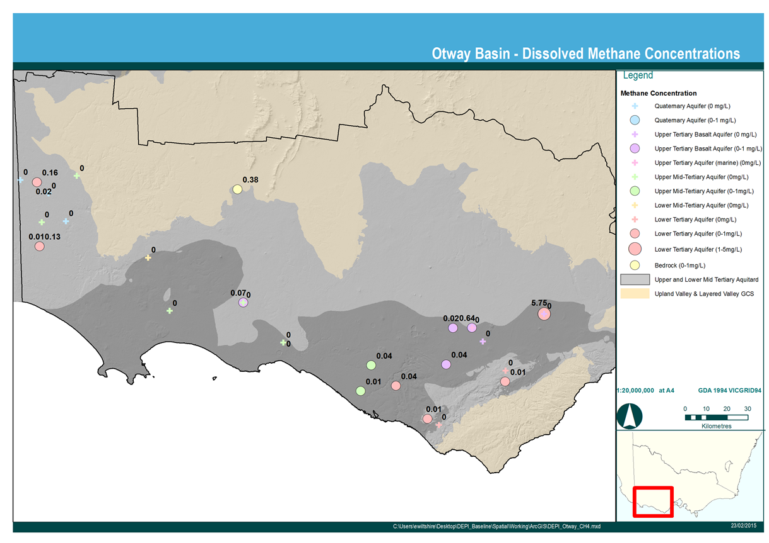
Figure 23 Spatial distribution of dissolved methane in groundwater

  - Total petroleum hydrocarbons
Total Petroleum Hydrocarbons (TPH) include any mixture of hydrocarbons that can be found in crude oil. TPH in groundwater can be either naturally occurring or can have anthropogenic origins. TPH analysis is often reported as Total Recoverable Hydrocarbons (TRH) which represents a mixture of compounds without the specific identification of individual compounds. Any detected organic compounds are reported against one of a limited number of ranges (or fractions). The lower fraction is often referred to as the petrol range of organics, whilst the higher fractions are called the diesel range organics.
Of the 30 groundwater samples collected for the Otway region, five bores recorded detectable concentrations of dissolved hydrocarbons. The laboratory has reported total recoverable hydrocarbons (TRH) according to the industry standard assessment criteria defined by the National Environment Protection Measures (Australian Government, 2013).
The bores where detection was identified are shown in Table 15. Generally these detections are minor, with 110985 and S61557/2 recording hydrocarbons at the detection limit of the analytical technique for TRH. The majority of the detected hydrocarbons are in the medium to heavy fraction range, with S61557/2 detecting a light (volatile) range of hydrocarbons. This volatile detection is not a BTEX compound (no BTEX detected in the sample). These techniques generally act as a screening method and further analysis (e.g. gas chromatography-mass spectrometry) of the sample can identify the organic compound. The low levels detected across the Otway region do not warrant further investigation.
The three bores that record TRH greater than detection limits are all screened in the Lower Tertiary Aquifer (111). There is no evidence of a spatial correlation with these bores (i.e. they do not occur in a particular part of the region). The fact that the TRH detection occurs primarily in a deep coal bearing aquifer with little interaction with the surface and the detections are quite low, indicates the hydrocarbons may be of natural origin.

Table 15 Concentrations of Total Recoverable Hydrocarbons for bores where detection
occurred (µg/L)
Fraction | Detection Limit | S61557/2 (Quaternary Aquifer) | 110985 (Upper Tertiary / Quaternary Basalt) | 111786 (Lower Tertiary Aquifer) | 115872 (Lower Tertiary Aquifer) | 82347 (Lower Tertiary Aquifer)
C6-C10 | 20 | 20 | <20 | <20 | <20 | <20
>C10-C16 | 100 | <100 | <100 | <100 | 260 | <100
>C16-C34 | 100 | <100 | 100 | 380 | 110 | 400
>C34-C40 | 100 | <100 | <100 | <100 | <100 | <100
>C10-C40 (sum) | 100 | <100 | 100 | 380 | 370 | 400

    - BTEX
All samples were analysed for the presence of Benzene, Toluene, Ethylbenzene, and Xylene (collectively known as BTEX). BTEX compounds are volatile organic compounds that can be naturally found in crude oil, coal and gas deposits. BTEX falls within the C6-C10 fraction of TRHs. There was no BTEX detected in groundwater in the Otway region.

  - Inorganic analytes and indicators
    - Major ion chemistry
The ratio of various cations and anions in any one aquifer is often reasonably constant and provides a chemical signature of that aquifer. Changes in these ratios over time can signal chemical mixing of aquifers or addition of a new source of water. One graphical method for characterising the geochemistry of aquifers is the use of Piper diagrams (Piper, 1953), which plot anions and cations separately and combine using trilinear and quadrilinear plots. A Piper diagram plot showing the ratios of the analysed cations and anions by aquifer is shown in Figure 24.
The Piper diagram shows that the sampled groundwater ranges from sodium-chloride type to mixed bicarbonate-chloride type, but with low sulphate levels. There are no obvious vertical (aquifer) trends in the data, though data from the Quaternary Aquifer show clustering. The similarity of groundwater above and below major aquitards suggests lateral flow originates from similar sources and undergoes similar processes.
An indication of chemical processes is provided using Schoeller diagrams, as shown in Figure 26 a and b. Thus, the Quaternary groundwater show an evaporated rainfall signature, while deeper formation show the effect of cation exchange with reduced calcium and increased sodium, typical of exchange on swelling clays in the aquifer matrix. Sulphate remains low throughout, suggesting a lack of sulphur-bearing minerals in the aquifer sediments.
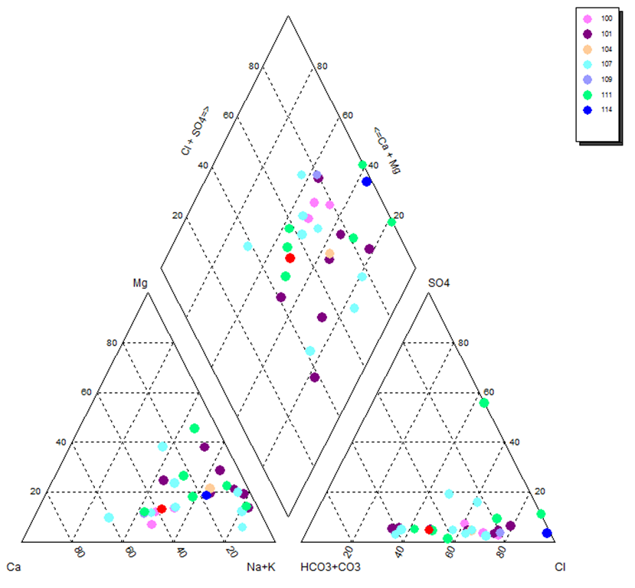
Figure 24 Piper diagram showing major ion concentrations
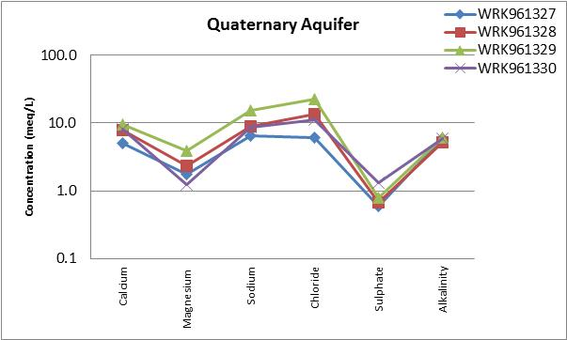
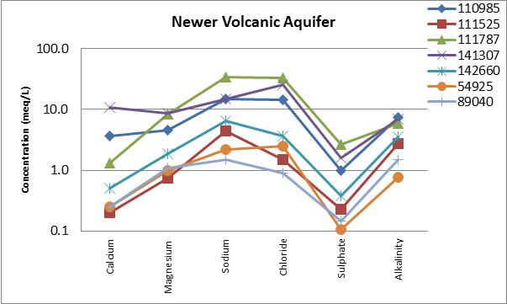
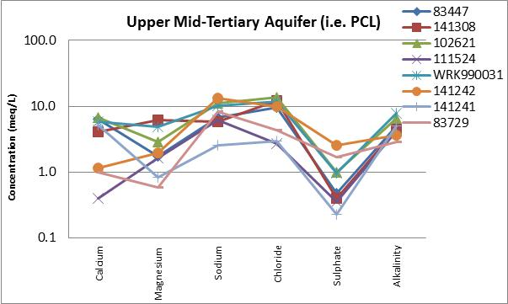
Figure 25a Schoeller plots showing major ion chemistry by aquifer

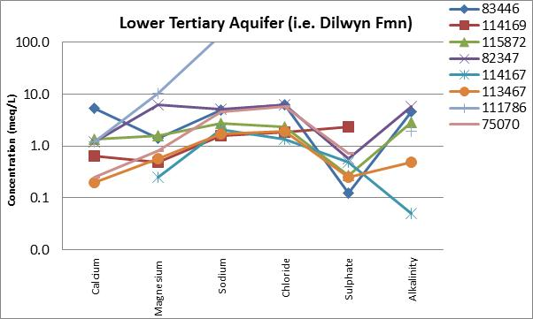
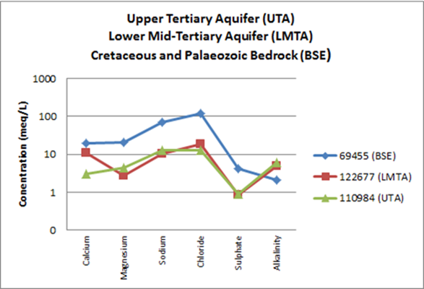
Figure 26b Schoeller plots showing major ion chemistry by aquifer

    - Groundwater salinity
Groundwater salinity is described using concentration of Total Dissolved Solids (TDS). The average groundwater salinity for all aquifers is classified as marginal to brackish (1,003 – 2,130 mg/L TDS) with the exception of the Mesozoic and Palaeozoic Bedrock which is classified as saline (>5,000 mg/L TDS). Salinity is dominated by sodium chloride, with minor calcium and magnesium salt. Groundwater salinity ranges per aquifer are summarised in Table 16.

Table 16 Groundwater salinity
Aquifer | Number of Samples Collected | Minimum Groundwater TDS (mg/L) | Maximum Groundwater TDS (mg/L) | Mean Groundwater TDS (mg/L)
Quaternary Aquifer (100) | 4 | 860 | 2,210 | 1,425
Upper Tertiary / Quaternary Basalt Aquifer (101) | 7 | 221 | 2,790 | 1,178
Upper Tertiary Aquifer (marine) (104) | 1 | 1,160 | 1,160 | 1,160
Upper Mid Tertiary Aquifer (107) | 8 | 568 | 1,390 | 1,003
Lower Mid Tertiary Aquifer (109) | 1 | 2,130 | 2,130 | 2,130
Lower Tertiary Aquifer (111) | 8 | 241 | 9410 | 1,637
Mesozoic and Palaeozoic Bedrock (114) | 1 | 8,640 | 8,640 | 8,640

    - Nitrogen
Groundwater samples were analysed for Kjeldahl Nitrogen, oxidised Nitrogen and total Nitrogen (the sum of the two). The results for total Nitrogen, by aquifer, are summarised in Table 17.

Table 17 Total Nitrogen Concentrations
Aquifer | Number of Samples Collected | Minimum Nitrogen (mg/L) | Maximum Nitrogen (mg/L) | Mean Nitrogen (mg/L)
Quaternary Aquifer (100) | 4 | 0.0 | 1.4 | 0.5
Upper Tertiary / Quaternary Basalt Aquifer (101) | 7 | 0.0 | 10.9 | 2.9
Upper Tertiary Aquifer (marine) (104) | 1 | 0.4 | 0.4 | 0.4
Upper Mid Tertiary Aquifer (107) | 8 | 0.0 | 13 | 2.3
Lower Mid Tertiary Aquifer (109) | 1 | 0.7 | 0.7 | 0.7
Lower Tertiary Aquifer (111) | 8 | 0.0 | 4.6 | 1.5
Mesozoic and Palaeozoic Bedrock (114) | 1 | 1.2 | 1.2 | 1.2

    - Field indicators
The following field parameters were measured at the time of groundwater sample collection: pH, redox, dissolved oxygen, temperature and odour. The field parameter values for each aquifer are summarised in Table 18.
The median Dissolved Oxygen (DO) concentration for each aquifer ranges from 0.3 to 3.7 mg/L (Table 6), which is low relative to atmospheric oxygen (~10 mg/L). This means the atmospheric oxygen that was originally present in the infiltrating rainwater has been consumed in the soil and unsaturated zone by microbial activity and decomposition of organic matter (Rose and Long, 1998). The median DO of 3.7 mg/L in the Lower Mid Tertiary Aquifer indicates that either the microbial reduction of oxygen is limited in some aquifers, or oxygen can move to saturated aquifers from overlying unconfined aquifers.
Mean temperature for each aquifer is fairly consistent, ranging from 15.8 to 17.8 degrees Celsius (Table 18). No observation of increasing temperature with depth was observed.
Hydrogen sulphide odour was noted on six occasions (Table 18) including for the shallow Upper Tertiary / Quaternary Basalt Aquifer, the Upper Mid Tertiary Aquifer, the Lower Tertiary Aquifer and the Bedrock Aquifer. Hydrogen sulphide is generally associated as a by-product of sulphate-reducing bacteria activity and generally requires an adequate organic carbon source to facilitate fermentation. While some groundwater held measurable TRH and sulphate, many did not. The source of the hydrogen sulphide for some of the samples is indeterminant at this time.
Groundwater pH is essentially neutral across all aquifers, ranging from 6.15 - 7.2 (Table 18).
Redox conditions are measured as the standard redox potential and this indicates the tendency of the groundwater to either gain or lose electrons. Negative potentials are indicative of reducing conditions and are usually found when air supply is limited. Positive potentials are typical of aerated surface waters and indicate oxidising conditions. Both negative and positive redox potentials are found throughout the Otway region (Table 18), though values are generally low suggesting that both oxidising and reducing conditions exist. The values indicate that the Lower Tertiary Aquifer and the Bedrock Aquifer exhibits stronger reducing conditions than other shallower aquifers as indicated by the lower median redox potential values, the lower dissolved oxygen values and the smell of hydrogen sulphide gas at the surface.

Table 18 Summary of indicator parameters measured in the field
Aquifer | Mean pH | Median Redox (mV) | Median  DO (mg/L) | Mean Temp (o C) | Odour
Quaternary Aquifer (100) | 6.7 | 2.2 | 2.2 | 16.1 | None
Upper Tertiary / Quaternary Basalt Aquifer (101) | 6.7 | 1.0 | 1.0 | 16.5 | H₂S smell (x2)
Upper Tertiary Aquifer (marine) (104) | 7.2 | -34.0 | -0.3 | 16.4 | None
Upper Mid Tertiary Aquifer (107) | 6.7 | 1.1 | 1.1 | 16.0 | H₂S smell (x2)
Lower Mid Tertiary Aquifer (109) | 6.6 | 87.6 | 3.7 | 15.8 | None
Lower Tertiary Aquifer (111) | 6.1 | 0.5 | 0.5 | 16.8 | H₂S smell (x1)
Mesozoic and Palaeozoic Bedrock (114) | 7.2 | -122.1 | 0.5 | 17.8 | H₂S smell (x1)

- Groundwater sampling –
aquifer characterisation
This chapter provides comments on the sampling results, by aquifer, relating back to the justification for bore selection.
  - Quaternary Aquifer (100)
Four observation bores were sampled from the Quaternary Aquifer (Table 19). The Quaternary Aquifer is comprised of various aeolian, fluvial, lacustrine, alluvial and colluvial sediments. These observation bores are located in areas of shale gas prospectivity and important wetlands and rivers such as McCallums Swamp, Mundi-Selkirk Wetlands, Lake Mundi and the Glenelg River.
Groundwater salinity for this aquifer ranges from 860 mg/L TDS to 2,210 mg/L TDS. The average groundwater salinity is marginal (1,425 mg/L TDS). Total Nitrogen concentration for this aquifer ranges from 0 mg/L to 1.4 mg/L. The average nitrogen concentration is 0.5 mg/L. The groundwater is near-neutral with an average pH of 6.7.
Dissolved methane and TRH (which includes BTEX) detection is negligible for this aquifer. A single observation of TRH and methane was observed and both results were low concentration (equivalent to the level of reporting).

Table 19 Quaternary Aquifer monitoring Bores
Bore | Aquifer Monitored | Justification for inclusion in the monitoring network | Comment
S61557-2 | Quaternary Aquifer (100) | - Located in the area of prospectivity  - Located in area of key rivers and wetlands, including the Directory of Important Wetland ‘McCallums Swamp’  - Monitors the watertable aquifer | - Watertable aquifer in area of prospectivity and key assets is characterised by; no methane and trace amounts of TRH (i.e. equal to detection limit) and no BTEX
S61557-3 | Quaternary Aquifer (100) | - Located in the area of prospectivity  - Located in the area of key rivers and wetlands. Including Directory of Important Wetlands (Mundi-Selkirk Wetlands) and the Glenelg River  - Monitors the watertable aquifer | - Watertable aquifer in area of prospectivity and key assets is characterised by; no methane, no TRH and no BTEX
S61557-1 | Quaternary Aquifer (100) | - Located in the area of prospectivity  - Located in the area of key rivers and wetlands, including Directory of Important Wetlands (Mundi-Selkirk Wetlands, Pig Swamp and Lake Mundi)  - Monitors the watertable aquifer | - Watertable aquifer in area of prospectivity and high value assets is characterised by; no methane, no TRH and no BTEX
S61557-4 | Quaternary Aquifer (100) | - Located in the Glenelg WSPA. Nested with 82347.  - Bores will monitor the Dilwyn Formation Aquifer and the watertable aquifer and will inform groundwater chemistry of multiple aquifers at one site and allow for interpretation of potential mixing | - In the Glenelg WSPA a downward vertical hydraulic gradient occurs from the Quaternary Aquifer to the Lower Tertiary Aquifer.  - Low level methane detected (equal to the detection limit). Methane was also detected in the Lower Tertiary Aquifer at this location. Methane concentration decreases from the deep to the shallow aquifer.  - No TRH or BTEX detected

  - Upper Tertiary / Quaternary Basalt Aquifer (101)
Seven observation bores were sampled from the Upper Tertiary / Quaternary Basalt Aquifer, which comprises the Newer Volcanics basalt in this area (Table 20). These sampled bores are outside of the sub-regional areas of the natural gas prospectivity, but do occur in areas of high value rivers and wetlands, including Ramsar listed Lake Corangamite. Parts of this aquifer are covered by the Warrion WSPA.
Groundwater salinity for this aquifer ranges from 221 mg/L TDS to 2,790 mg/L TDS. The average groundwater salinity is marginal; 1,178 mg/L TDS. Total Nitrogen concentration for this aquifer ranges from 0 mg/L to 10.9 mg/L. The average nitrogen concentration is 2.9 mg/L.
The highest nitrogen concentration is associated with a bore located within the Warrion WSPA. Oxidised nitrogen (the sum of nitrate and nitrite) makes up most of the total nitrogen for this sample. Fertilizers mainly contain nitrite and hence it is likely that the source of the elevated concentration in groundwater is leaching of nutrients through the unsaturated zone to the watertable. The Upper Tertiary / Quaternary Basalt Aquifer is the watertable aquifer in this area.
The groundwater is near neutral with an average pH of 6.7. An odour indicative of hydrogen sulphide gas was noted on two occasions for this aquifer.
Dissolved methane and TRH (which includes BTEX) detection is negligible for this aquifer. Average methane concentration was 0.11 mg/L and a single occurrence of TRH was observed, equal to the detection limit for the carbon fraction.

Table 20 Upper Tertiary / Quaternary Basalt Aquifer
Bore | Aquifer Monitored | Justification for inclusion in the monitoring network | Comment
S61557-2 | Quaternary Aquifer (100) | - Located in the area of prospectivity  - Located in area of key rivers and wetlands, including the Directory of Important Wetland ‘McCallums Swamp’  - Monitors the watertable aquifer | - Watertable aquifer in area of prospectivity and key assets is characterised by; no methane and trace amounts of TRH (i.e. equal to detection limit) and no BTEX
S61557-3 | Quaternary Aquifer (100) | - Located in the area of prospectivity  - Located in the area of key rivers and wetlands. Including Directory of Important Wetlands (Mundi-Selkirk Wetlands) and the Glenelg River  - Monitors the watertable aquifer | - Watertable aquifer in area of prospectivity and key assets is characterised by; no methane, no TRH and no BTEX
S61557-1 | Quaternary Aquifer (100) | - Located in the area of prospectivity  - Located in the area of key rivers and wetlands, including Directory of Important Wetlands (Mundi-Selkirk Wetlands, Pig Swamp and Lake Mundi)  - Monitors the watertable aquifer | - Watertable aquifer in area of prospectivity and key assets is characterised by; no methane, no TRH and no BTEX
S61557-4 | Quaternary Aquifer (100) | - Located in the Glenelg WSPA. Nested with 82347.  - Bores will monitor the Dilwyn Formation Aquifer and the watertable aquifer and will inform groundwater chemistry of multiple aquifers at one site and allow for interpretation of potential mixing | - In the Glenelg WSPA a downward vertical hydraulic gradient occurs from the Quaternary Aquifer to the Lower Tertiary Aquifer.  - Low level methane detected (equal to the detection limit). Methane was also detected in the Lower Tertiary Aquifer at this location. Methane concentration decreases from the deep to the shallow aquifer.  - No TRH or BTEX detected

  - Upper Tertiary Aquifer (marine) (104)
A single bore was sampled for the Upper Tertiary Aquifer (marine) (Table 21). This aquifer comprises a number of formations including: Whalers Bluff Formation, Moorabool Viaduct Formation, Hanson Plain Sand, Dorodong Sand and Grange Burn Formation. Groundwater salinity is brackish for this aquifer and nitrogen concentration is low (0.4 mg/L). Groundwater pH is near neutral (7.2) and redox potential indicates reducing conditions.
There was no methane detected in groundwater for the Upper Tertiary Aquifer (marine) and no TPH (including BTEX).

Table 21 Upper Tertiary Aquifer (marine)
Bore | Aquifer Monitored | Justification for inclusion in the monitoring network | Comment
110984 | Upper Tertiary Aquifer (marine) (104) | - Nested site located in the vicinity of the Lake Corangamite Ramsar listed site.  - Nested with 110985 and will inform groundwater chemistry of multiple aquifers at one site and allow for interpretation of potential mixing. | - The Upper Tertiary Aquifer (marine) near Lake Corangamite did not contain dissolved methane, TRH or BTEX  - The underlying Newer Volcanic basalt aquifer contains low methane concentrations (0.64mg/L).

  - Upper Mid-Tertiary Aquifer (107)
Eight bores were sampled from the Upper Mid-Tertiary Aquifer, which includes a number of limestone units, including the Port Campbell Limestone and the Gambier Limestone (Table 22). Some of these observation bores are located in sub regional potential onshore natural gas development areas. Most bores also intersect an area of groundwater, covered by the Glenelg, Hawkesdale, Heywood, Nullawarre and Yangery GMUs.
Groundwater salinity for this aquifer ranges from 568 mg/L TDS to 1,390 mg/L TDS. The average groundwater salinity is marginal (1,003 mg/L TDS). Total Nitrogen concentration for this aquifer ranges from 0 mg/L to 13 mg/L. The average nitrogen concentration is 2.3 mg/L. An elevated nitrogen concentration is associated with a bore located within the Glenelg WSPA. Oxidised nitrogen (the sum of nitrate and nitrite) makes up most of the total nitrogen for this sample. Fertilizers mainly contain nitrite and hence it is likely that the source of the elevated concentration in groundwater is leaching of nutrients through the unsaturated zone to the watertable. The Upper Mid-Tertiary Aquifer is essentially at the surface in this area and forms the watertable aquifer.
The groundwater is near neutral with an average pH of 6.7. An odour indicative of hydrogen sulphide gas was noted on two occasions for this aquifer. A positive redox potential was noted for this aquifer, indicating oxidising groundwater conditions.
Five bores did not detect any methane in groundwater and three bores recorded low concentrations of methane, all less than 0.05 mg/L (detection is 0.01 mg/L). No TPHs (including BTEX) were detected in groundwater from this aquifer.

Table 22 Upper Mid-Tertiary Aquifer
Bore | Aquifer Monitored | Justification for inclusion in the monitoring network | Comment
83447 | Upper Mid-Tertiary Aquifer (107) | - Located in the area of prospectivity and key rivers and wetlands  - Monitors the target aquifer (PCL) in the Glenelg WSPA  - Nested with 83446 and will inform groundwater chemistry of multiple aquifers at one site and allow for interpretation of potential mixing.  - Also located in an area where the aquitard is thin/absent | - In the Glenelg WSPA, the Port Campbell Limestone (PCL) aquifer is characterised by groundwater with low methane concentration (0.02 mg/L), no TPH or BTEX.  - Underlying the PCL is the Lower Tertiary Aquifer with a measured methane concentration of 0.16 mg/L. A reduction in methane is observed in an upward vertical direction.  - There is no aquitard present in this area (equivalent to the Gelibrand Marl or Narrawaturk Marl).
111524 | Upper Mid-Tertiary Aquifer (107) | - Located in the area of prospectivity and key rivers and wetlands  - Monitors the target aquifer (PCL) in the Hawkesdale GMA  - Nested with 111525 and will inform groundwater chemistry of multiple aquifers at one site and allow for interpretation of potential mixing. | - The Port Campbell Limestone in the Hawkesdale GMA does not contain methane, TRHs or BTEX
141241 | Upper Mid-Tertiary Aquifer (107) | - Located in the area of prospectivity and key rivers and wetlands  - Monitors the target aquifer (PCL) in the Nullawarre WSPA | - The Port Campbell Limestone in the Nullawarre WSPA does not contain methane, TRHs or BTEX
102621 | Upper Mid-Tertiary Aquifer (107) | - Located in the area of prospectivity and key rivers and wetlands  - Monitors the target aquifer (PCL) in the Glenelg WSPA | - In the Glenelg WSPA, the Port Campbell Limestone aquifer does not contain methane, TPHs or BTEX.
83729 | Upper Mid-Tertiary Aquifer (107) | - Located in the area of prospectivity and key rivers and wetlands  - Monitors the target aquifer (PCL) in the Glenelg WSPA | - In the Glenelg WSPA, the Port Campbell Limestone aquifer does not contain methane, TPHs or BTEX.
141308 | Upper Mid-Tertiary Aquifer (107) | - Located in the Yangery WSPA. Nested with 141307.  - Bores will monitor the key PCL aquifer and the watertable aquifer (101 Newer Volcanics) and will inform groundwater chemistry of multiple aquifers at one site and allow for interpretation of potential mixing. | - In the Yangery WSPA, the Port Campbell Limestone aquifer does not contain methane, TPHs or BTEX.  - There is no methane in groundwater or TRH or BTEX in the Newer Volcanic Basalt aquifer or the underlying Port Campbell Limestone aquifer at this location.
S9037242-1 | Upper Mid-Tertiary Aquifer (107) | - Heywood GMA.  - Bore included to provide monitoring information for the PCL aquifer in the Heywood GMA. | - In the Heywood GMA, the Port Campbell Limestone does not contain methane, TRH or BTEX

  - Lower Mid Tertiary Aquifer (109)
A single bore was sampled for the Lower Mid Tertiary Aquifer which comprises the Clifton Formation in the Otway region (Table 23). This bore is located away from sub-regional prospectivity areas but does reside in the Condah WSPA. Groundwater salinity for the Clifton Formation aquifer is brackish (2,130 mg/L TDS) and total nitrogen concentration is low (0.7 mg/L). The groundwater is near neutral with a pH of 6.6. A positive redox potential was noted for this aquifer, suggesting oxidising groundwater conditions.
There was no methane detected in groundwater for this aquifer and no TPH (including BTEX).

Table 23 Lower Mid-Tertiary Aquifer
Bore | Aquifer Monitored | Justification for inclusion in the monitoring network | Comment
122677 | Lower Mid-Tertiary Aquifer (109) | - Located adjacent to the area of prospectivity and key rivers and wetlands  - Monitors the target aquifer (Clifton Fmn) in the Condah WSPA | - The Clifton Formation aquifer in the Condah WSPA does not contain methane, TPH or BTEX

  - Lower Tertiary Aquifer (111)
Eight bores were sampled from the Lower Tertiary Aquifer, which includes the Dilwyn Formation, Pebble Point Formation, Wangerrip Group and the Knight Group (Table 24).
Some of these observation bores intersect sub-regional areas of natural gas prospectivity. Most bores also intersect an area of groundwater, covered by the Glenelg, Paaratte, Newlingrook and Gellibrand GMUs.
Groundwater salinity for this aquifer ranges from 241 mg/L TDS to 9,410 mg/L TDS. The average groundwater salinity is brackish (1,637 mg/L TDS). A single high groundwater salinity reading from bore 111786 does not appear characteristic of this aquifer.
Total Nitrogen concentration for this aquifer ranges from 0 mg/L to 4.6 mg/L. The average nitrogen concentration is 1.5 mg/L.
The groundwater is slightly acidic with an average pH of 6.1. An odour indicative of hydrogen sulphide gas was noted on one occasion for this aquifer. A positive redox potential was noted for this aquifer, indicating oxidising groundwater conditions.
Six of the eight bores detected methane in groundwater, albeit the average concentration (0.76 mg/L) is low. TRH was detected for three bores, though no BTEX was detected in any samples.

Table 24 Lower Tertiary Aquifer
Bore | Aquifer Monitored | Justification for inclusion in the monitoring network Comment | Comment
83446 | Lower Tertiary Aquifer (111) | - Located in the area of prospectivity and key rivers and wetlands (including wetlands protected by the Directory of Important Wetlands)  - Monitors the target aquifer (Dilwyn) in the Glenelg WSPA  - Nested with 83447 and will inform groundwater chemistry of multiple aquifers at one site and allow for interpretation of potential mixing.  - Also located in an area where the aquitard (UMTD and LMTD) is thin/absent | - The Dilwyn Formation in the Glenelg WSPA has low methane concentration (less than 0.5 mg/L).  - Low methane was also detected in overlying Upper Mid-Tertiary Aquifer at this location.  - A reduction in methane is observed in an upward vertical direction. Aquitard is absent in this area.
111786 | Lower Tertiary Aquifer (111) | - Nested site located in the vicinity of the Lake Murdeduke Ramsar listed site. Nested with 111787 and will inform groundwater chemistry of multiple aquifers at one site and allow for interpretation of potential mixing. | - Highest methane concentration detected in this area (northeast of Colac).  - Methane is detected in the Lower Tertiary Aquifer (5.8 mg/L) and is not detected in the overlying basalt aquifer.  - Only bore sampled where methane gas was detected in analysed gas sample.  - Approximately 450 m of aquitard associated with the Upper and Lower Mid Tertiary Aquitard units resides between the Lower Tertiary Aquifer and the Quaternary Tertiary Basalt Aquifer and hence may be providing an effective seal to the vertical migration of methane in this area.  - This bore records low TRH concentration, though no BTEX.
115872 | Lower Tertiary Aquifer (111) | - Located in the area of prospectivity and key rivers and wetlands  - Monitors the target aquifer (Dilwyn Formation) in the Paaratte GMA | - The Dilwyn Formation in the Paaratte GMA has low methane concentration (0.04 mg/L) and low TRH detected, though not in the range for BTEX
113467 | Lower Tertiary Aquifer (111) | - Located in the area of prospectivity and key rivers and wetlands  - Monitors the target aquifer (Dilwyn Formation) in the Paaratte GMA | - The Dilwyn Formation in the Paaratte GMA has low methane concentration (equal to detection limit)
82347 | Lower Tertiary Aquifer (111) | - Located in the Glenelg WSPA. Nested with S61557-4.  - Bores will monitor the Dilwyn Formation Aquifer and the watertable aquifer and will inform groundwater chemistry of multiple aquifers at one site and allow for interpretation of potential mixing. | - The Dilwyn Formation in the Glenelg WSPA has low methane concentration (0.13 mg/L) and low TRH (though not in the BTEX fraction)  - A downward vertical hydraulic gradient occurs from the Quaternary Aquifer to the Lower Tertiary Aquifer at this location  - Methane detected in both the Lower Tertiary Aquifer and the Quaternary Aquifer.  - Methane concentration decreases from the deep to the shallow aquifer
75070 | Lower Tertiary Aquifer (111) | - Newlingrook GMA. Closest bore monitoring the Dilwyn Formation to the prospectivity area.  - No nested sites to present alternative option. | - The Dilwyn Formation in the Newlingrook GMA does not contain methane, TRH or BTEX.
114169 | Lower Tertiary Aquifer (111) | - Gellibrand GMU.  - No nested sites to present alternative option. | - The Dilwyn Formation in the Gellibrand GMU has low methane (equal to detection limit), no TRH or BTEX
114167 | Lower Tertiary Aquifer (111) | - Monitors the target aquifer (Dilwyn Fmn) in the Gerangamete GMA | - The Dilwyn Formation in the Gerangamete GMA does not contain methane, TRH or BTEX

  - Mesozoic and Palaeozoic Bedrock (114)
A single bore was sampled for the Mesozoic and Palaeozoic Bedrock aquifer which forms the basement
unit in the Otway region (Table 25). This bore resides away from any sub-regional natural gas prospectivity areas and is also shallow compared to the depths associated with likely natural gas occurrence (bore
middle screen depth is 74 m below natural surface). There were no more suitable monitoring bores available for sampling.
The highest groundwater salinity in the region was recorded for this aquifer and groundwater is classified as saline. Total Nitrogen concentration for this aquifer is 1.2 mg/L and groundwater is approximately neutral in terms of pH (7.2). An odour indicative of hydrogen sulfide gas was noted at this bore. A negative redox potential was noted for this aquifer, indicating reducing groundwater conditions.
A low concentration of dissolved methane was detected (0.4 mg/L) but no TPH (including BTEX).

Table 25 Mesozoic and Palaeozoic Bedrock
Bore | Aquifer Monitored | Justification for inclusion in the monitoring network | Comment
69455 | Mesozoic and Palaeozoic Bedrock (114) | - Only SOB available that monitors the Mesozoic Palaeozoic bedrock | - Low methane detected and no TPH (including BTEX)  - Saline groundwater

- Conclusions
Dissolved methane in groundwater occurs naturally at low concentrations across the Otway region. The median concentration from the 30 samples collected was 0.01 mg/L. A single outlier was observed for bore 111786, which indicated dissolved methane in the Lower Tertiary Aquifer of 5.8 mg/L and is the only bore sampled in the Otway region with methane concentrations of collected gas samples above detection.
Total Recoverable Hydrocarbons were also detected in 5 of the 30 samples, although most detections were low (equal to the detection limit) and the detections were not in the fraction range for BTEX. The lack of BTEX detection suggests that BTEX compounds are not a natural occurrence in any of the sampled aquifers and any future detection is likely to reflect an anthropogenic origin.
The role of aquitards in limiting the vertical movement of hydrocarbons through the vertical profile is currently difficult to ascertain in the Otway region, given the inherent low concentrations of methane in groundwater across all aquifers. The only elevated methane concentration was recorded for the Lower Tertiary Aquifer (5.8 mg/L) and this bore is located north-east of Colac and is nested with bore 111787 which screens the Newer Volcanic Basalt and did not record any methane in its groundwater. In this area the combined thickness of the Upper and Lower Mid Tertiary Aquitard is approximately 450 m. In this area it can be tentatively concluded that vertical hydrocarbon migration is reduced where a significant aquitard thickness exists. This is consistent with the conceptual hydrogeological model for the Otway region.
It should be noted that whilst the primary prospective formations for potential oil and gas deposits reside in the deep Eumeralla Formation, Waarre Formation and Casterton Formation, only one groundwater bore was available for sampling these units and it was located away from likely prospective areas and the bore was quite shallow. Although the groundwater chemistry information associated with the units that contain the Natural Gas prospectivity is limited, the negligible methane concentration observed in the overlying units is an important piece of information for the conceptual hydrogeological model for the Otway region. This information implies that the vertical hydraulic conductivity of the Mesozoic and Palaeozoic fractured rock is low and that there is little opportunity for gas migration to shallower overlying units.

References
Alberta Environment (2006) Standard for Baseline Water-Well Testing for Coalbed Methane/Natural Gas in Coal Operations April 2006 < http://environment.alberta.ca/documents/Standard_for_Baseline_Water-Well_Testing_for_CBM_Apr2006.pdf >
Australian Government (2013). National Environment Protection (Assessment of Site Contamination) Measure 1999. Measures as amended, taking into account amendments up to National Environment Protection (Assessment of Site Contamination) Amendment Measure 2013 (No. 1). Australian Government, 22 May 2013
Chaytor, S. and Shaw, R., (2008), Synopsis of the report “Recommended Sampling, Analysis, and Reporting Protocols for Baseline Groundwater Sampling in Advance of Coalbed Gas Development in the Telkwa Coalfield, British Columbia;” in: Geoscience Reports 2008, BC Ministry of Energy, Mines and Petroleum Resources, pages 9-11.
Colorado Oil and Gas Conservation Commission (2014) Statewide groundwater baseline sampling and monitoring rules - the Alberta Environment standard for baseline water well testing (2006) or the protocols developed for British Columbia
Colorado Oil and Gas Conservation Commission, Rule set 609. Statewide groundwater baseline and monitoring as of September 30 2014 : < http://cogcc.state.co.us/ >
CSIRO (2011) A desktop study of the occurrence of Total Petroleum Hydrocarbon (TPH) and partially water-soluble organic compounds in Permian coals and associated coal seam groundwater.
CSIRO (2011b) Resource Management for Carbon Storage. A literature review.
DELWP (2015) Onshore gas water science studies – Gippsland region groundwater sampling and characterisation for hydrocarbons. Department of Environment, Land, Water and Planning. May 2015
DSE (2010). Risk Assessment of Hydrocarbon Contamination of Bores in Barwon Downs. (Assumed to be dated January 2010, based on the file name)
Geological Society of Victoria (1995) The stratigraphy, structure, geophysics and hydrocarbon potential of the Eastern Otway region, Victoria. Geological Survey of Victoria Report 103. Department of Agriculture, Energy and Minerals.
GHD (2009) Barwon Downs Groundwater Analysis – Potential Origin of Hydrocarbons. Unpublished letter report from GHD to the Department of Environment, Land, Water and Planning. 19 June 2009
GHD (2012) Report on the development of Statewide 3D aquifer surfaces. May 2012. Report to the Department of Sustainability and Environment.
GHD (2014) State Groundwater Observation bore Network – review, redefinition and works prioritisation. Prepared for the Department of Environment and Primary Industries, July 2014.
Goldie Divko, L. (2014), Otway Basin gas development scenarios to inform regional groundwater modelling. Geological Survey of Victoria report, Department of State Development Business and Innovation, 2014 (draft in preparation).
Hawkins, .P.J. & Dellenbach, J., (1971) A review of the Otway region. Bureau of Mineral Resources Geology and Geophysics Report 134, pp. 7-29.
Hyder Consulting Pty. Ltd. (2009) Barwon Downs Groundwater Sampling, Groundwater Contamination Investigation, 19th June 2009.
Laing, S., Dee, C.N. & Best, P.W., (1989) The Otway region. Australian Petroleum Exploration Association Journal 29 (1), pp. 417-429.
Leeder Consulting (2009) Review of Hyder Consulting Report on Barwon Downs Groundwater Contamination Investigation, Unpublished letter report from Leeder Consulting to the Department of Environment, Land, Water and Planning, 30th July 2009.
Leusch, F., Bartkow, M., (2011) A short primer on benzene, toluene, ethylbenzene and xylenes (BTEX) in the environment and in hydraulic fracturing fluids. Cited from: http://www.derm.qld.gov.au/environmental_management/coal-seam-gas/pdf/btex-report.pdf, accessed on the 18th of July 2011.
Orem, W.H., Tatu, C.A., Lerch, H.E., Rice, C.A., Bartos, T.T., Bates, A.L., Tewalt, S., Corum, M.D., (2007) “Organic compounds in produced waters from coalbed natural gas wells in the Powder River region, Wyoming, USA”. Applied Geochemistry, 22(10), 2240-2256.
QGC (2012) QCLNG Groundwater quality and hydrochemistry program. QGC Pty Ltd (2012)
Rose and Long (1998) Monitoring Dissolved Oxygen in Ground Water: Some Basic Considerations. Ground Water Monitoring Review, Winter, 1998.
SKM and GHD (2009) Hydrogeological Mapping of Southern Victoria. Report prepared by SKM and GHD, July 2009 for Southern Rural Water.
SRW (2013) Glenelg Groundwater Catchment Statement. Southern Rural Water 19 July 2013
SRW (2014) Hopkins Corangamite Groundwater Catchment Statement. Southern Rural Water 19 July 2013
SRW (2014b) Portland Groundwater Catchment Statement. Southern Rural Water 19 July 2013
Woollands, M.A. & Wong, D., (Eds), 2001. Petroleum Atlas of Victoria. Department of Natural Resources and Environment
(BGS 2014) British Geological Survey, National Methane Baseline Survey, http://www.bgs.ac.uk/research/groundwater/shaleGas/methaneBaseline/home.html

Appendices

Appendix A. Standard operating procedure for groundwater sampling in the Otway region

Appendix B. Standard operating procedure for collection of dissolved gas and groundwater samples from coal seams

Appendix C. Standard operating procedure for the deployment and operation of double valve pumps

Appendix D. Laboratory Results


© The State of Victoria Department of Environment, Land, Water & Planning 2015

This work is licensed under a Creative Commons Attribution 4.0 International licence. You are free to re-use the work under that licence, on the condition that you credit the State of Victoria as author. The licence does not apply to any images, photographs or branding, including the Victorian Coat of Arms, the Victorian Government logo and the Department of Environment, Land, Water and Planning (DELWP) logo. To view a copy of this licence, visit http://creativecommons.org/licenses/by/4.0/

ISBN 978-1-74146-623-2 (pdf)

Accessibility
If you would like to receive this publication in an alternative format, please telephone the DELWP Customer Service Centre on 136186, email customer.service@delwp.vic.gov.au or via the National Relay Service on 133 677 www.relayservice.com.au. This document is also available on the internet at www.onshoregas.vic.gov.au

Disclaimer
This publication may be of assistance to you but the State of Victoria and its employees do not guarantee that the publication is without flaw of any kind or is wholly appropriate for your particular purposes and therefore disclaims all liability for any error, loss or other consequence which may arise from you relying on any information in this publication.

