A review of gas prospectivity:
Otway region

June 2015

Acknowledgements
The author wishes to thank Michelle Guzel for her contribution to the text (Sections 2.1 and 2.2) and Tim Moore for Appendix 1, including his permission to use figures 8.2, A1.1, A1.2 and A1.3 from Moore (2012).
Gordon Wakelin-King is thanked for his contribution to the text (Section 1.2), assistance with Sections 6, 7 and 10, and for his review of the text. Dr Peter Cook is also thanked for his review of the text and useful comments.
David Higgins, Graham Callaway, Cassady O’Neill and Michelle Guzel are thanked for their help with mapping and drafting figures.

Goldie Divko, L. M., 2015. A review of gas prospectivity: Otway region. Department of Economic Development, Jobs, Transport and Resources, Melbourne, Victoria.

Contents
List of figures 3
List of tables 4
Executive summary 5
Conventional gas 5
Tight gas 5
Shale gas 6
Coal seam gas 6
Hypothetical development scenarios 6
1 Introduction 8
1.1 Gas types 8
1.2 Gas resource estimation and reporting 10
1.3 Gas exploration in the Otway region 12
1.4 Study area 13
2 Regional geology 14
2.1 Tectonic setting 14
2.2 Stratigraphy 16
3 Previous exploration and production 22
3.1 Oil and gas 22
3.2 Coal 24
3.3 Coal seam gas 24
4 Current tenements 27
4.1 Petroleum Exploration Permits 27
4.2 Exploration Licences 29
5 Conventional gas 30
5.1 Waarre Formation 31
5.2 Pretty Hill Formation 32
6 Tight gas 35
6.1 Eumeralla Formation 36

7 Shale gas 40
7.1 Shale gas reservoir properties 41
7.2 Casterton Formation 42
7.3 Eumeralla Formation 46
8 Coal seam gas 47
8.1 Formation of coal seam gas 47
8.2 Coal properties 48
8.3 Coal seam gas from black coal 50
8.4 Coal seam gas from brown coal 52
9 Geological uncertainty 55
9.1 Broad geological uncertainty 55
9.2 Delineation of formations of interest 55
9.3 Specific rock characteristics 56
10 Gas prospectivity 58
10.1 Conventional gas 58
10.2 Tight gas 58
10.3 Shale gas 59
10.4 Coal seam gas 60
11 Hypothetical gas development scenarios 61
11.1 Conventional gas 61
11.2 Tight gas 62
11.3 Shale gas 63
11.4 Coal seam gas 65
12 Conclusions 66
References 67
Glossary 72
Abbreviations and units 73
Appendix 1 74
Formation of gas in coal 74
How is gas generated? 74
How is gas stored? 77
How does gas move through the coal reservoir? 77
References 80
Appendix 2 82

List of figures
Figure 1.1 Gas types. 9
Figure 1.2 Petroleum Resource Management System Resources Classification Framework. 11
Figure 1.3 Location map onshore Otway Basin. 13
Figure 2.1 Otway Basin depocentres 15
Figure 2.2 Otway Basin stratigraphy. 17
Figure 3.1 Historic Exploration Licences with coal bed methane (CSG) as a target resource. 25
Figure 4.1 Petroleum Exploration Permits in the Otway Basin. 28
Figure 4.2 Exploration Licences in the Otway Basin with coal seam gas. 29
Figure 5.1 Conventional gas schematic. 30
Figure 6.1 Tight gas schematic 35
Figure 6.2 Natural fracture orientations. 39
Figure 7.1 Shale gas schematic. 40
Figure 7.2 (a) Casterton Formation and (b) Eumeralla Formation intersections. 44
Figure 8.1 Coal seam gas schematic. 47
Figure 8.2 Correlation of different rank parameters, all approximate. 49
Figure 11.1 Otway Basin conventional gas resource development scenarios. 62
Figure 11.2 Otway Basin tight gas resources development scenarios. 63
Figure 11.3 Otway Basin shale gas development scenarios. 64
Figure 11.4 Otway Basin coal seam gas development scenarios. 65
Figure A1.1 Simplified pathway of secondary biogenic methane production in coal. 75
Figure A1.2 Schematic showing biogenic and thermogenic gas generation. 76
Figure A1.3 Coal bed permeability versus depth in a coal seam from the Bowen basin. 79

List of tables
Table 3.1 Port Campbell Embayment gas production history. 23
Table 3.2 Cancelled, surrendered and expired Exploration Licences. 26
Table 4.1 Petroleum Exploration Permit holders in the Otway Basin. 27
Table 5.1 Porosity and permeability values for the Pretty Hill Formation. 33
Table 6.1 Otway Basin tight gas plays and regions. 36
Table 6.2 Eumeralla Formation TOC (Total Organic Content) values by area. 38
Table 6.3 Eumeralla Formation vitrinite reflectance values by area. 38
Table 7.1 Otway Basin shale gas plays and regions. 41
Table 7.2 A guide to organic richness in shales as given by TOC. 41
Table 7.3 Kerogen types. 42
Table 7.4 Casterton Formation Total Organic Carbon values by area. 45
Table 7.5 Casterton Formation vitrinite reflectance values. 46
Table 8.1 Best coal seam intersections in PGE-4 (Gordon) and PHE-1 (Hawkesdale). 50
Table 8.2 Proximate analysis for Early Cretaceous black coals. 51
Table 8.3 Gas content and composition data from the Gordon project area. 52
Table 8.4 Gas content and composition data from the Hawkesdale project area. 52
Table 8.5 Proximate analysis from South west Victorian brown coals. 53
Table 8.6 Gas content data from Eastern Star coal seam gas drilling. 54

Executive summary
Water science studies have been undertaken by government to assess the potential impacts of possible onshore gas developments on Victoria’s water resources. The Geological Survey of Victoria (GSV) has reviewed the prospectivity of all gas types in the Otway Basin to inform the preparation of an impact assessment on water resources. This review of the gas prospectivity of the Otway region covers the onshore Otway Basin from the Bellarine Peninsula to the South Australian border. The review draws on the current knowledge of the geology and resource distribution discovered to date through exploration activity.
Numerous sedimentary sequences in the onshore Otway Basin are prospective for gas. The Waarre Formation is a known target for conventional gas and the Pretty Hill Formation has been explored for conventional gas in the past. The primary target for tight gas is the Eumeralla Formation with some potential in the deeper Pretty Hill Formation. The primary target for shale gas is the Casterton Formation with some potential in the Eumeralla Formation. The Killara coal measures have potential for coal seam gas but the younger Tertiary-aged Eastern View Group and Werribee Formation coals are less likely to be prospective based on previous exploration.

Conventional gas
Conventional gas production began in the Port Campbell Embayment in 1986 and continues today with small quantities of carbon dioxide gas produced from the well Boggy Creek-1. Most methane was produced between 1986 and 2006. Some methane remains in place but a relatively high proportion of carbon dioxide in the gas means that production from these fields would be less straight-forward. Petroleum Production Licences are active over these areas, although activity is restricted to storage.
It is likely that further conventional gas accumulations may be discovered in the Port Campbell Embayment within the Waarre Formation, which hosts all current discoveries in the area. The same formation is present along the coast from Port Campbell to the South Australian border. Potentially, oil and gas may be present in the Waarre Formation across this area.
The Pretty Hill Formation is a proven conventional gas reservoir in the South Australian Otway Basin. In Victoria, the Pretty Hill Formation has similar good reservoir quality and may have conventional gas potential.

Tight gas
The Eumeralla Formation lies below the Waarre Formation and is considered the primary target for tight gas in the onshore Otway Basin. The formation is present across the entire basin and is considered to have tight gas potential, in particular, in the Port Campbell Embayment. Many petroleum wells drilled for conventional gas in the Port Campbell area have also encountered significant gas in the Eumeralla Formation. The Eastern Otway Basin and the Windermere Trough/Tyrendarra Embayment, to the northwest of Warnambool, may also provide tight gas targets in the Eumeralla Formation.
The Pretty Hill Formation may also be prospective for tight gas; regions include the Windermere Trough/Tyrendarra Embayment and the Penola Trough.

Shale gas
Shale gas prospects include the Casterton Formation and the Eumeralla Formation. The area considered most prospective for shale gas is the Penola Trough. High gas readings recorded from previous exploration where the top of the Casterton Formation was reached, suggested that the gas was migrating from deeper in the sequence. The Casterton Formation and overlying Crayfish Subgroup have been targeted in drilling activities over the border in South Australia.
Other regions where the Casterton Formation may be considered a target for shale gas include the Ardonachie/Tahara troughs and the Windermere Trough/Tyrendarra Embayment. Wells drilled in these regions have previously encountered trace amounts of oil and gas.
Although primarily a tight gas target, the Eumeralla Formation also has shale units that may have shale gas potential, mainly in the Port Campbell Embayment and Windermere Trough/Tyrendarra Embayment.

Coal seam gas
The Early Cretaceous black coals of the Eumeralla Formation and the Tertiary brown coal seams of the Eastern View Group and Werribee Formation have been the focus of past coal seam gas exploration in the Otway region.
The black coal seams at the base of the Eumeralla Formation, informally known as the Killara Coal measures, were evaluated by Purus Energy for coal seam gas potential in the mid-2000s. Purus held tenements across the northern margin of the Otway Basin, where the coal measures are intersected at depths that are considered suitable for coal seam gas extraction (i.e. above 1500 m depth). Results from coal samples acquired through a drilling program were disappointing. Rather than methane, nitrogen was encountered at one project area and a mixture of methane and carbon dioxide at another. The gas contents and coal permeability measurements were low. In the areas where nitrogen was encountered, there could be implications for tight gas prospectivity.
Low gas contents were a feature of the drilling and testing undertaken by Eastern Star in the Bells Beach Syncline and the Parwan Trough. Both the Anglesea and Maddingley coal seams in these areas produced low gas contents; most could not be measured as the volumes were too low.

Hypothetical development scenarios
As part of this review, hypothetical scenarios for the potential development of gas in the onshore Otway Basin were devised. For there to be a chance of development, the rock unit that might host the gas resource must be present, and so presence/absence of the geological formation of interest was the first consideration in the development of scenarios. Secondary considerations included information from specialist studies indicating areas of favourable rock characteristics within a prospective formation, and past and current areas of gas production and recent exploration.
Hypothetical development scenarios for conventional and tight gas focussed on the Port Campbell Embayment, because of the history of conventional gas discoveries and the intersection of gas in the deeper and tight Eumeralla Formation in the area.
For shale gas, the Penola Trough was the focus of development scenarios, as current exploration to test for the resource in the same geology in South Australia reportedly yielded gas and oil readings.

For coal seam gas development scenarios, Purus Energy’s delineation of areas with potential for coal seam gas provided some guidance.
The uncertainty associated with these development scenarios is primarily related to the geology. For instance, if there is a chance of development, then the target rock formation must be present. The current understanding and delineation of target geological formations is imperfect. Especially where deeper tight and shale gas target units are concerned, there has been lesser attention paid to these in the past, with a focus instead on the overlying conventional gas bearing units of the Waarre Formation. There are also a number of specific characteristics that a geological unit must exhibit to be considered prospective for oil or gas. In the case of tight and shale gas in particular, these characteristics are not yet well known or poorly understood.

Introduction
Water science studies to assess the potential impacts of possible onshore gas developments on Victoria’s water resources are being undertaken by government. The Department of Environment, Land, Water and Planning is leading the water studies with technical assistance from the Geological Survey of Victoria (GSV). GSV is investigating all types of onshore gas - tight, shale, coal seam and conventional gas through a review of the prospectivity of each of these gas types. The review of the Otway Basin is based on all available current data and knowledge. This prospectivity review will be used to inform the preparation of an impact assessment on water resources.
This report describes past and current exploration efforts in the onshore Otway Basin. The geology of the region is summarised to provide geological context for the subsequent discussion. The prospectivity of each gas type - tight, shale, coal seam and conventional gas is reviewed on the basis of current available published and unpublished data. In particular, the review focuses on where future development of each gas type would be more likely based on current knowledge of the geology and resource distribution discovered to date through exploration activity.
This review is not a resource assessment. In Victoria, little data pertaining to unconventional gas potential is available. The data that has been gathered to assess onshore conventional gas has been used to inform this review. The evaluation of an unconventional resource requires knowledge of a greater number of geological and petroleum related parameters across larger areas than for conventional gas resources. As such, the current data is limited in its application.

Gas types
Gas is found in conventional or unconventional reservoirs; the latter of which can be described as tight, shale or coal seam gas (Figure 1.1).
The majority of oil and gas produced across the globe comes from conventional reservoirs. This is also the case in Victoria, where all natural gas production to date is from conventional reservoirs. The majority of natural gas discovered and produced to date in Victoria has been from the offshore portion of the Gippsland Basin, with smaller but significant volumes from the offshore Otway Basin. Relatively smaller gas fields were discovered and produced between 1986 and 2006 in the onshore Otway Basin.
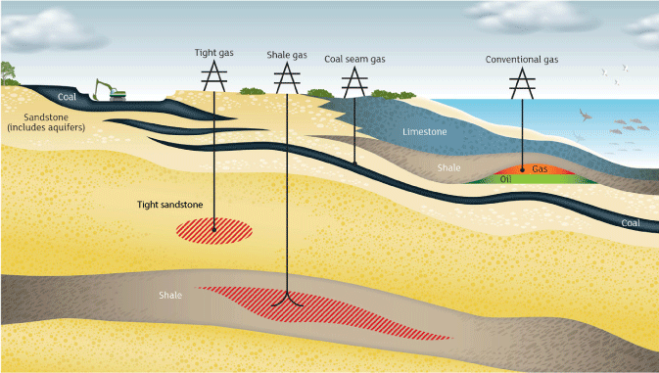
Figure 1.1 Gas types.
Conventional gas reservoirs are commonly porous and permeable rocks such as sandstones or limestones. Impermeable rocks such as claystones lie directly above the reservoirs and are known as a seal or cap-rocks. The gas is trapped in the reservoir and under the seal in geological structures. Geological structures are like an inverted dish, with the gas held underneath. A gas well drilled into the geological structure will intersect the porous gas reservoir and, when present, gas will flow into the well.
Tight, shale and coal seam gas are termed unconventional gas types. These differ from conventional gas in that the gas is trapped at or near the source, which may also act as the gas reservoir. In the case of tight gas, the gas is produced from relatively low permeability and low porosity sedimentary reservoirs. The lack of permeability in the rock prevents gas from migrating, and so it is trapped in the tight rock formation. A similar principle applies to shale gas where the gas is sourced from and trapped in fine-grained sedimentary rocks that have low porosity and permeability, and are organic-rich. The gas is held on organic matter in the rock, in tiny pores between grains, and in any fractures present in the rock. In the case of coal seam gas (also known as coal bed methane), naturally occurring methane in the coal seams is held on the coal surfaces by water pressure and may also exist in the gaps and cracks in the coal seams.
Shale gas in the US has been produced since 1820 (e.g. Martin et al., 2010) and coal seam gas production in Queensland has grown from the first small scale commercial production 18 years ago at Moura (Slater & Baker, 2012). In the case of US shale gas, it is only in the last few years that decades of experience and knowledge gained from the development of individual shale gas plays, and advancements in well completion technologies, have led to the growth of the industry. The rising price of the commodity has also contributed to the commercial viability of gas development projects that would not have been possible in the past.
The difference between conventional gas production and the unconventional gas types (tight, shale and coal seam gas) is that for most conventional wells, gas will flow from the reservoir into the well and to the surface infrastructure without assistance, whereas for the other gas types, additional technologies are required to release the gas. For instance, gas may not flow unless the rocks are fractured to create artificial permeability in the formation to release the trapped gas. For coal seam gas, water must be drawn away from the coal seam by depressurising the coal to release the gas into the well.
Not all unconventional gas types require fracturing or are suitable for fracturing, and some conventional gas reservoirs are artificially fractured to maintain or enhance production. For instance, more than 700 conventional wells have been fracture stimulated to enhance hydrocarbon recovery in South Australia since 1969 (Goldstein et al., 2012).

Gas resource estimation and reporting
Australian companies, particularly those with reporting obligations under ASX listing rules, report their estimates of petroleum (oil or gas) assets according to a system developed by the Society of Petroleum Engineers (SPE), known as the Petroleum Resource Management System 2007 or PRMS. The following is summarised from the PRMS (SPE, 2007).
There are three categories of resource (Figure 1.2), determined by the progress from untested concept toward commercial production and each category may be further defined by the degree of certainty by which it is known.
The lowest category is Prospective Resource: an estimate from geological data of economically recoverable volumes, as yet undiscovered. Because many variables are poorly understood the range between a high and low estimate of a prospective resource will be large, and crucially, the actual presence of recoverable petroleum at all is yet to be tested by drilling.
Once a discovery of recoverable petroleum is made, the resource, or part of it may be described as a Contingent Resource: the volume that may be commercially recoverable once certain contingencies are satisfied. The contingencies may include commercial, legal, logistical or technical.
The term Reserve is applied only where commerciality can be shown, and is defined more rigorously than resources. Reserves are volumes anticipated to be commercially recoverable by a development project from a given date forward under defined conditions. There must be a high confidence in the commercial producibility of the reservoir, as supported by actual production or formation tests. Reserves must be discovered, recoverable, commercial, and remaining based on the development project(s) applied. The specification of the development project is important: different methods of development (e.g. well spacings) may allow more or less of the petroleum in place to be commercially produced, thus each development plan has a different reserve even though the geology is the same.
The critical factors for elevation of a resource from ‘prospective’ to ‘contingent’ and from ‘contingent’ to ‘reserve’ are thus discovery and commerciality. A discovery is where one or several exploratory wells have established, through testing, sampling, and/or logging, the existence of a significant quantity of potentially moveable hydrocarbons. Shows and indications are not discoveries, whereas a flow or recovery in volume may be.
Commerciality requires demonstrated evidence that commercial flow rates are attainable, that production and transport facilities to a known market are available, that legal, contractual and commercial arrangements and internal approvals are in place, that project economics meet investment criteria and that the controlling entity is proceeding into commercial production or has a clear intention to do so. In summary, an undrilled prospect may be quantified with a prospective resource, if successful and whilst under evaluation it may contain a contingent resource, and once all hurdles toward commercial production are cleared it may be considered a reserve.
As the exact volume of oil or gas that will ultimately be economically recoverable over the life of a project is unknowable a range of values can be reported. When a single value is reported it should be accompanied by an indication of where the value sits in the range. This range is expressed either in terms such as ‘low’, ‘high’ or ‘most-likely estimate’, or as ‘proven’, ‘probable’ or ‘possible’, or in statistical terms ‘P10’, ‘P50’ and ‘P90’.
The statistical terms indicate that (for example) there is a 90% chance that the volume will exceed the P90 figure, whereas there is only a 10% chance that the volume will exceed the P10 figure. In reporting reserves as a single number for simplicity, most entities report a 2P or PP value (proven plus the probable), which is the most likely or median value.
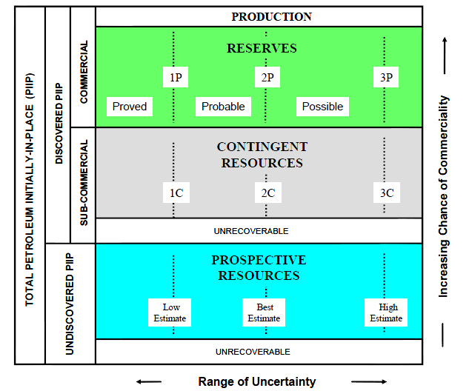
Figure 1.2 Petroleum Resource Management System Resources Classification Framework
(after SPE, 2007).
In all cases, the unrecoverable portion is not part of the resource or the reserve. Terms such as Petroleum Initially In Place (PIIP) are used to describe the volume in the ground.
Public reports of volumes discovered or anticipated may not state whether these are recoverable or in place, and categories or certainty values may have been used without due regard to the formal definitions. Care and understanding of the basis of the resource estimation method is essential.
Using the categories defined here, Victoria has no reserves of unconventional hydrocarbons.

Gas exploration in the Otway region
The eastern extent of the Otway Basin is about 100 km to the southwest of Melbourne, whilst the Port Campbell Embayment (an area of past gas production) is a farther 100 km away. The basin has both onshore and offshore elements from which gas has been produced since 1986 and 2005 respectively.
In the offshore Otway Basin to date, 23 PJ of liquid hydrocarbons (crude oil, condensate and naturally occurring LPG resources) have been produced and 65 PJ remain (Geoscience Australia & BREE, 2014). With respect to gas, 850 PJ have been produced and an estimated 1292 PJ remains (Geoscience Australia & BREE, 2014).
Recent drilling results from Speculant-1, a well drilled 3 km south of the Victorian coast-line appear set to increase reserves with the discovery of a 145-metre gas column in the primary target, the Waarre Formation, with evaluation of secondary targets continuing (Origin Energy, 2014).
In the onshore Otway Basin there is a long history of petroleum (oil and gas) exploration with 155 wells drilled since the early 1920s. Gas was first discovered in the onshore Victorian Otway Basin in 1959 in the Port Campbell Embayment but it was not until 1978 that a commercial gas discovery in the same area revived interest in the commodity. From the early 1990s into the 2000s, gas discoveries both onshore and offshore around the Port Campbell area established the region as an active gas producing province.
In 2002, the initial recoverable reserves from the small Port Campbell Embayment gas fields were 59 Bcf with 47.3 Bcf remaining in mid-2001 (Mehin & Kemal, 2002). The only remaining production since the closure of the Heytesbury gas processing plant in 2006 is a small volume of carbon dioxide gas that is produced from Boggy Creek. Nearly 12 Bcf of carbon dioxide remained in 2001 (Mehin & Kamel, 2002). The nearby Iona gas field is used as a storage facility for gas piped from offshore. Both activities are carried out under current production licences, a cluster of which are still ‘active’ in the Port Campbell area.
There are currently nine Petroleum Exploration Permits across the Otway Basin. Although exploration for coal seam gas has occurred across the northern margin of the basin and in the east, there are only two small licence areas remaining.

Study area
The study area defined for this review (Figure 1.3) is based on the occurrence of the Jurassic to Pliocene Otway Basin sedimentary sequence. The onshore Otway Basin extends into South Australia and is bounded by a Palaeozoic basement high along its north-eastern extent. To the east of the Otway Ranges, the basin extends to Port Philip Bay. The area between the Otway Ranges and Geelong is known as the Torquay
Sub-basin.
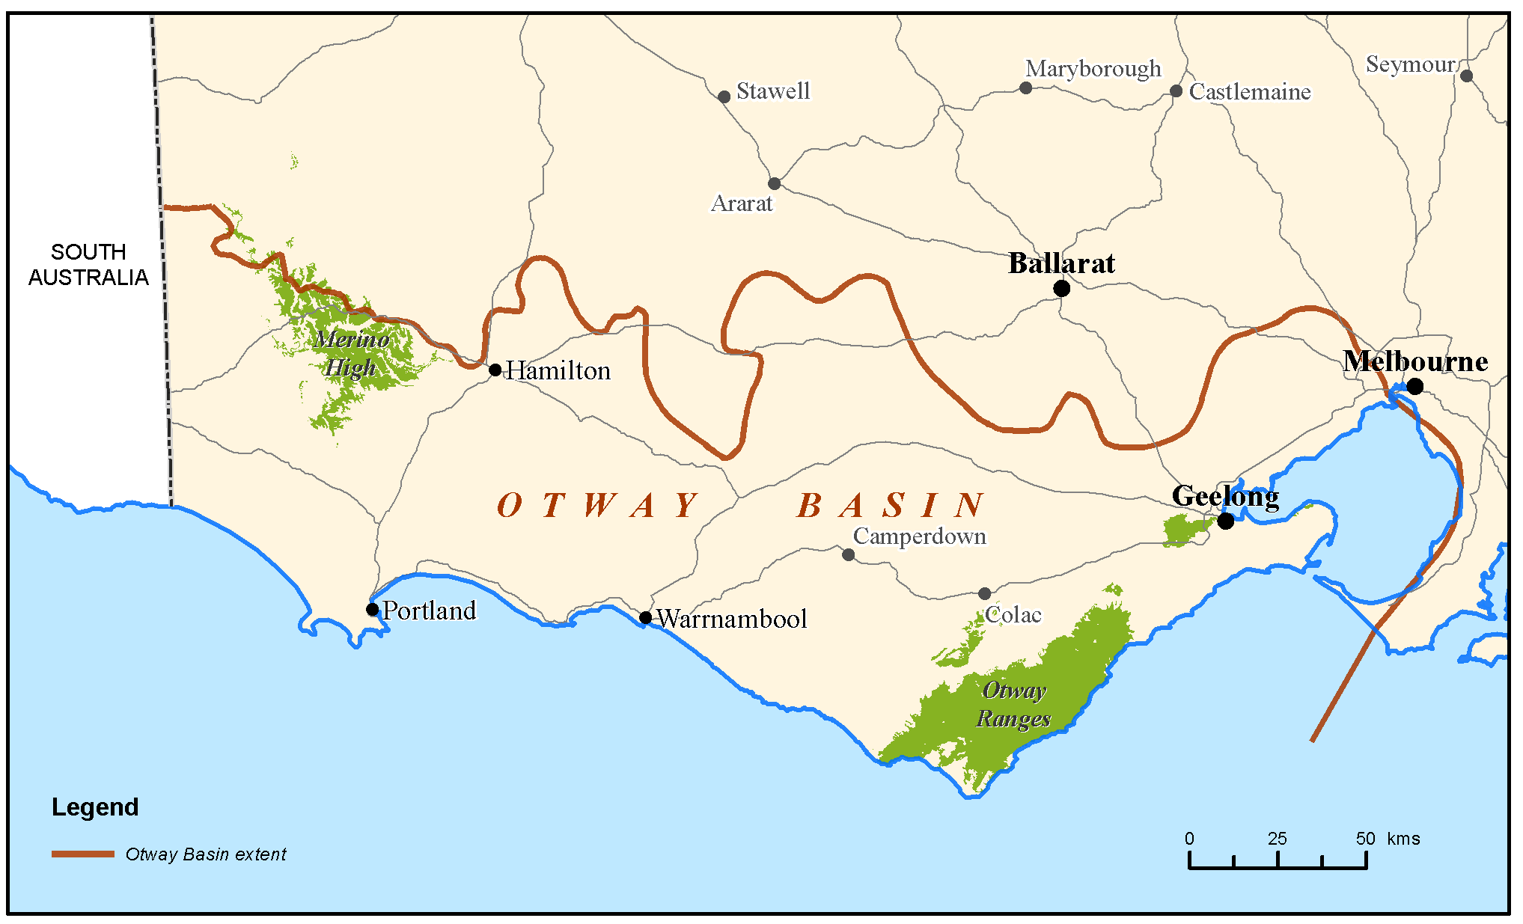
Figure 1.3 Location map of the onshore Otway Basin.

Regional geology

Tectonic setting
The Otway Basin is a northwest‐southeast trending basin that extends for 500 km along the onshore and offshore parts of south-eastern Australia (Figure 2.1). It is a non‐volcanic, passive margin, rift basin (Brown et al., 2003) that formed during the break‐up of southern and eastern Gondwana.
Rifting in the Late Jurassic‐Early Cretaceous resulted in the development of graben and half graben of limited lateral extent (Krassay et al., 2004) and varying orientations (NW‐SE in the onshore Otway Basin, E‐W in the western and central Otway Basin, SW‐NE in the eastern Otway Basin and Torquay Sub‐basin, and N‐S in the Shipwreck Trough) (Stacey et al., 2013). Up to 8 km of Otway Group continental and fluvio‐lacustrine sediments were deposited in the Early Cretaceous depocentres.
Compressional inversion and uplift in the early Late Cretaceous separated the Torquay Sub‐basin from the eastern Otway Basin and shifted the locus of extension offshore (Krassay et al., 2004). A thick sequence of Sherbrook Group fluvial, deltaic and shallow marine sediments was deposited in the Late Cretaceous depocentres, including the trans-tensional Shipwreck Trough.
Rifting in the Otway Basin “culminated at the end of the Cretaceous and is marked by a regional intra‐Maastrichtian unconformity” (Holford et al, 2014). Krassay et al (2004) have interpreted this to represent the time when the continental plates of Australia and Antarctica separated, although the first evidence of oceanic crust in the Otway Basin does not appear until the middle Eocene (Norvick & Smith, 2001).
The intra‐Maastrichtian unconformity was followed by basin margin subsidence and the deposition of the transgressive siliciclastic Wangerrip Group, which reaches a maximum thickness of more than 1200 m in the Portland Trough (Holdgate & Gallagher, 2003).
Local inversion in the middle Eocene resulted in the intra‐Lutetian unconformity, which separates the Wangerrip Group from the overlying prograding marine clastics and carbonates of the Nirranda Group (Holdgate & Gallagher, 2003; Krassay et al., 2004). The Nirranda Group has a maximum thickness of about 200 m in the Portland Trough and the Port Campbell Embayment (Holdgate & Gallagher, 2003). The marine marls and limestones of the Heytesbury Group are separated by two regional unconformities from the underlying Nirranda Group and the overlying thin Pliocene to Pleistocene shallow marine sediments and basalts of the Bridgewater Bay Group.
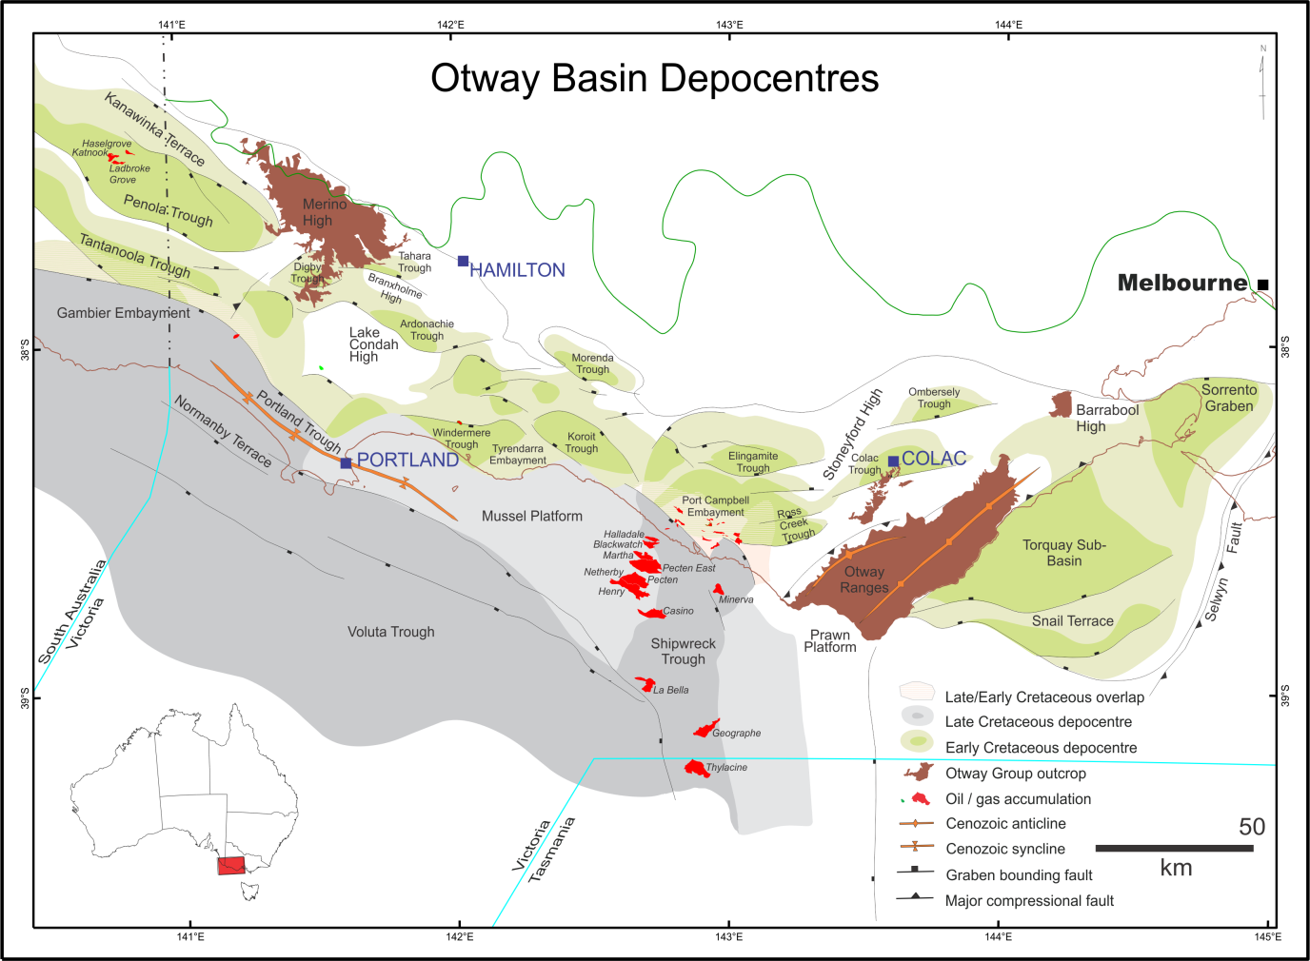
Figure 2.1 Otway Basin depocentres with gas accumulations denoted in red

Stratigraphy
The mostly sedimentary rock units found both at the surface and in the subsurface across the Otway region have been described to various extents, dated (using fossil evidence) and for the most part, given geological names. The description of geological units in this context is known as stratigraphy.
Based on lithological variations in the Otway Basin, six main sequences are described: the Otway Group, Sherbrook Group, Wangerrip Group, Nirranda Group, Heytesbury Group and Bridgewater Bay Group (Figure 2.2). In the eastern Otway Basin, known as the Torquay Sub-basin, and in the adjacent Parwan Trough, different geological unit names are applied in some instances.

Casterton Formation
The Casterton Formation was deposited during the latest Jurassic to Early Cretaceous in half-graben structures related to rifting between Australia and Antarctica (Mitchell et al., 1997). The Casterton Formation type section is found between 2220 mKB and 2450 mKB in Casterton-1 (Morton et al., 1994). It “consists of interbedded carbonaceous shale, with minor feldspathic sandstone and siltstone and basaltic volcanics” (Morton et al., 1994).

Otway Group
There are some notable discrepancies between the accepted stratigraphic nomenclature for the Otway Group as adopted for the South Australian portion of Otway Basin versus that for Victoria. For instance, the status of the Group is raised to Supergroup in South Australia. Units such as the Katnook Sandstone and the Laira Formation are identified within the Crayfish Group in South Australia, whereas these have not been identified in Victoria (Parker, 1995).

Pretty Hill Formation
The Pretty Hill Formation is the only lithostratigraphic unit from the Crayfish Subgroup that is identified in Victoria. The Pretty Hill Formation consists of sandstone, with varying proportions of interbedded siltstone, claystone and shale, which were deposited in fluvio-lacustrine and alluvial environments, although at the top of Moyne Falls-1 rare saline algae indicate brackish conditions (Morgan, 1997).
In the Penola Trough, the Pretty Hill Formation is subdivided into four informal members: the Pretty Hill sandstone, Sawpit sandstone, Sawpit shale and McEachern sandstone (Lovibond et al., 1995) but the application of this division is questioned (Guzel, 2015).

Eumeralla Formation
The Eumeralla Formation is composed of medium- to coarse-grained fluvial channel sandstones interbedded with mudstone, fine sandstone and shale, including palaeosoils and coal seams that were deposited in levees and floodplains (Duddy, 2003). The sandstones and mudstones are quartz-poor volcanogenic sediments derived largely from the products of contemporaneous explosive dacitic volcanism (Duddy, 2003). Outcrops of the Eumeralla Formation occur in the Otway Ranges, Barrabool High and Merino High.
In the Victorian Otway Basin, the Windermere and Heathfield sandstones and the Killara Coal Measures are recognised as distinct units within the Eumeralla Formation.

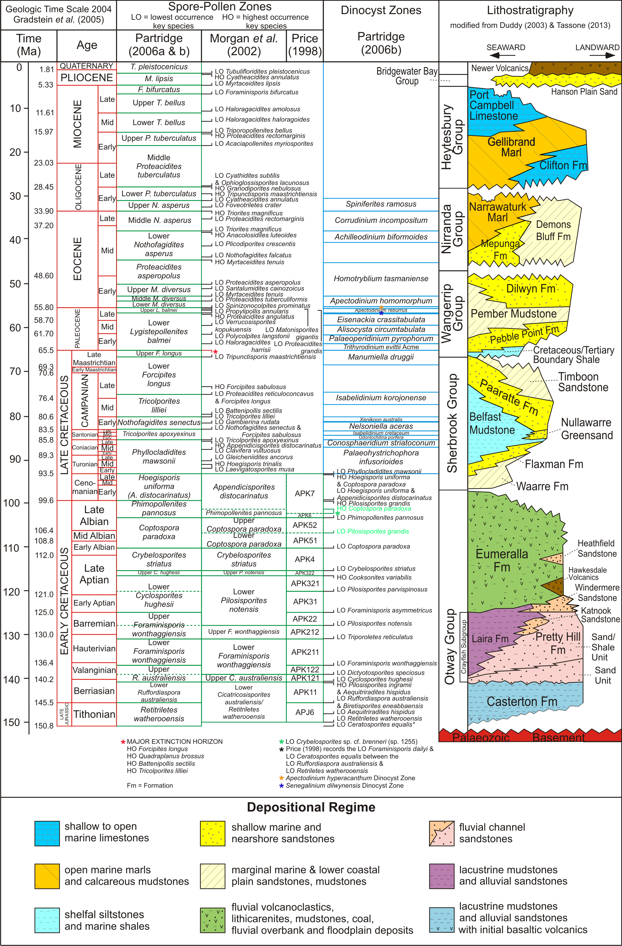
Figure 2.2 Otway Basin stratigraphy (Guzel, 2015).

Windermere Sandstone
The Windermere Sandstone is composed of interbedded sandstones and shales and is 105 metres thick at its type section in Windermere-2. The Windermere Sandstone is considered to occur at the base of the Eumeralla Formation and was deposited in the base of troughs; usually upon an unconformable base, due to a “significant change in depositional and structural style” (Morton et al., 1994).
The gas discovered in Katnook-1 in South Australia was reservoired in the Windermere Sandstone; although, the reservoir was reported to be of poor quality (Kopsen & Scholefield, 1990). In Victoria, oil in the Windermere Sandstone is considered to be sourced from a coaly lithology in the Crayfish Subgroup – an Austral-1 source (Boreham et al., 2004).

Heathfield Sandstone
The Heathfield Sandstone is a distinct quartzose sandstone and is recognised in a number of wells in the Penola Trough (Duddy, 2003). It is represented by poorly consolidated quartz sand between 1254.3 and 1263.1 m in the well Heathfield-1 (Brown, 1965). Whilst the Heathfield Sandstone probably reflects limited accumulations derived from local basement sources its widespread distribution in the Albian suggests a common origin, perhaps related to a period of uplift and erosion of the northern margin to the Penola Trough that rejuvenated the supply of quartzose detritus and possibly during “a lull in local contemporaneous volcanism” (Duddy, 2003).
Distinct sandstones of the same age have also been identified on the Merino High, on the central northern margin of the Otway Basin, in the Ross Creek Trough, in the Windermere Trough, and in Fergusons Hill-1, between the Ross Creek Trough and the Otway Ranges, and in North Eumeralla-1, Eumeralla-1 and Killara-1, north of the Windermere Trough (Guzel, 2015).

Killara Coal Measures
The black coals of the Early Cretaceous Eumeralla Formation have been intersected by petroleum exploration companies for many decades. Following the drilling of Killara-1, Buckingham (1992) first applied the informal name - the ‘Killara Coals’ to describe the coal seams found at the base of the Eumeralla Formation. The Killara Coal Measures are therefore not a formal lithostratigraphic unit, and whilst coal beds may occur in the “Basal Eumeralla Formation” they also occur elsewhere in the Eumeralla Formation (Guzel, 2015). Coals of the same age (as found in Killara-1) from the base of the Eumeralla Formation are found in Lindon-1 on the Lake Condah High, Stoneyford-1 on the Stoneyford High, and possibly in Hawkesdale-1 on the central northern margin of the Otway Basin (Wakelin-King & Menpes, 2007). The coals of the Eumeralla Formation are not laterally extensive and as a consequence, are difficult to correlate.

Sherbrook Group
The siliciclastic Sherbrook Group was derived largely from eroded Palaeozoic basement and the Eumeralla Formation (Duddy, 2003). The nature of the contact between the Sherbrook and Otway groups is variable – from conformable or mildly disconformable in the Late Cretaceous depocentres to massively unconformable where the Sherbrook Group wedges out onto the mid-Cretaceous inversion structures (Duddy, 2003). As a consequence, the Sherbrook Group is absent from the northern margin of the Otway Basin, except for in Heathfield-1 in the Penola Trough, where it is only 140.6 m thick (Guzel, 2015).

Waarre Formation
The Waarre Formation (previously the Waarre Sandstone of Bock & Glenie, 1965) is the basal unit of the Sherbrook Group. The unit is characterised by clean quartzose sandstones, conglomerates and minor siltstones and shales of non-marine origin. The type section is identified in the petroleum well Port Campbell-2 (Morton et al., 1994). Commonly, in the Port Campbell Embayment wells, the Waarre Formation is divided into units A, B and C on the basis of lithological variations (Buffin, 1989).

Flaxman Formation
The Flaxman Formation is typically an interbedded sand/shale unit. It is composed of dark grey silty mudstone and fine-grained grey brown sandstones, with distinctive ‘floating quartz’ from coarse sand to pebbles, common microplankton, and irregular glauconite, which becomes more common along with rare arenaceous and calcareous foraminifera towards the top (Duddy, 2003). It is considered that the Flaxman Formation was deposited in a lower delta plain environment (Boyd & Gallagher, 2001).

Belfast Mudstone
The Belfast Mudstone, in the middle of the Sherbrook Group, is a “remarkably uniform pyritic marine shale” (Duddy, 2003). In Victoria, the Belfast Mudstone represents a middle to outer shelf, open marine prodelta environment (Boyd & Gallagher, 2001) and forms a major regional seal for prospective hydrocarbon accumulations in sandstone reservoirs in the Waarre and Flaxman Formations (Duddy, 2003). It is conformable with, and partly a facies variant of, the underlying Flaxman Formation and the overlying Paaratte Formation, and includes a “significant contribution of detritus from reworking of the volcanogenic sediments of the Eumeralla Formation” (Duddy, 2003).

Paaratte Formation
The Paaratte Formation consists of quartzose, fine to coarse-grained, laminated, sometimes bioturbated, cross-bedded, greenish sandstones interbedded with mudstone and occasional coals (Duddy, 2003) that were mainly deposited in a marine lower-upper deltaic environment (Boyd & Gallagher, 2001).

Timboon Sandstone
The Timboon Sandstone, at the top of the Sherbrook Group, is characterised by fine to very coarse sandstones with siltstone/mudstone interbeds with occasional leaf fossils and represents the onset of fluvial terrestrial interdistributary deposition in the Otway Basin (Boyd & Gallagher, 2001). The culmination of rifting in the Otway Basin is marked by a regional intra-Maastrichtian unconformity (Holford et al., 2014) at the top of the Sherbrook Group.

Wangerrip Group
The transgressive siliciclastic Wangerrip Group consists of the Cretaceous/Tertiary Boundary Shale (the Massacre Shale), the Pebble Point Formation, Pember Mudstone and the Dilwyn Formation. Local inversion in the middle Eocene resulted in an intra-Lutetian unconformity that separates the Wangerrip Group from the overlying Nirranda Group (Holdgate & Gallagher, 2003; Krassay et al., 2004); whilst an intra-Maastrichtian unconformity, associated with the culmination of rifting in the Otway Basin (Holford et al., 2014), separates it from the underlying Sherbrook Group.
In the Torquay Sub-basin (north-east of the Otway Ranges), deposition at the same time (i.e. during the Paleocene to early Eocene) is represented by the Eastern View Group. This is of relevance as the Anglesea brown coals are found in the Eastern View Group. The coals of the Eastern View Group in the Torquay Sub-basin and the upper Dilwyn Formation in the Otway Basin proper are both Eocene in age. These coals are equivalent in age to the Traralgon coal seams in Gippsland.

Pebble Point Formation
The Pebble Point Formation consists of ferruginous (mainly quartz) sandstone, grit and conglomerate with less common fossiliferous beds (Holdgate & Gallagher, 2003). In the Gambier Embayment oolitic and pelletal sandstone and claystones display a complex mineralogy; ranging from chlorite to glauconite with secondary replacement by siderite and phosphate (Holdgate & Gallagher, 2003). Macro and microfossil content indicate a dominantly transgressive shallow marine environment and an early to middle Paleocene age (Holdgate & Gallagher, 2003).

Pember Mudstone
The Pember Mudstone consists of tan to grey siltstones, mudstones and shales, usually pyritic, carbonaceous and micaceous, and locally glauconitic. Carbonate-cemented sandstones are more common in the upper part of the formation, as are rare arenaceous foraminifera (Holdgate & Gallagher, 2003). The Pember Mudstone represents a delta-front and prodelta environment. Although it usually conformably overlies the Pebble Point Formation (Holdgate & Gallagher, 2003), in places there is evidence of a disconformable relationship (Tabassi & Davey, 1986; Keating, 1993) and in Greenslopes-1, north of the Windermere Trough, it is absent

Dilwyn Formation
The Dilwyn Formation is transitional with the underlying Pember Mudstone and is characterised by sandstones predominating over shales and by transgressive-regressive repetitions of sandstone-siltstone-claystone (Holdgate & Gallagher, 2003). The sandstones were deposited as distributary channels, and barriers and offshore bars associated with a delta-front environment, whilst the shales may include marine arenaceous and calcareous foraminifera (Holdgate & Gallagher, 2003). Brown coals are found in the Dilwyn Formation; such as those at Benwerrin that are considered Palaeocene in age (Gloe & Holdgate, 1991).

Nirranda Group
The marine Nirranda Group consists of the carbonate-dominated Narrawaturk Marl, the mixed carbonate and clastic Mepunga Formation (Holdgate & Gallagher, 2003) and, northeast of the Port Campbell Embayment, the clastic Demons Bluff Formation (Tickell et al., 1992). An intra-Lutetian unconformity, due to local inversion in the middle Eocene, separates the Nirranda Group from the underlying Wangerrip Group (Holdgate & Gallagher, 2003; Krassay et al., 2004), and an early-late Oligocene regional unconformity occurs between the Nirranda Group and the overlying Heytesbury Group.

Mepunga Formation
The Mepunga Formation consists of coarse often pebbly, ferruginous, occasionally glauconitic sandstones, with sandstones and sandy limestones that are often dolomitic, glauconitic and ferruginous offshore and in the Portland Trough (Holdgate & Gallagher, 2003). The foraminiferal faunas indicate deposition in paralic high-energy shoreline environments in the north, to outer shelf marine environments in the south; whilst the preservation of restricted calcareous faunas and miliolinids indicates inner to mid-shelf marine environments in the eastern part of the basin (Holdgate & Gallagher, 2003).

Narrawaturk Marl
The Narrawaturk Marl consists of marly, sandy, ferruginous, glauconitic, occasionally dolomitic mudstone, occasionally cherty and dolomitic marl; some coarse ferruginous sandstone; sandy limestone and sandy marl; and, in the west, a dolomitic marly limestone (Holdgate & Gallagher, 2003). Based on planktonic foraminifera most of the Narrawaturk Marl is early Oligocene in age (Holdgate & Gallagher, 2003).

Clifton Formation
The Clifton Formation consists of sandy limestone, which may be dolomitic or contain thin horizons of phosphate and limonite nodules, limestone and, northeast of the Port Campbell Embayment, ferruginous sandy marl (Holdgate & Gallagher, 2003). The clastics in the sandy facies, deposited around the margin of the basin, were supplied by rivers to the north and east. The depositional environment transitions from paralic coastal environments in the north and east, to high-energy outer shelf environments, where clastic-poor limestones are deposited, in the south and west (Holdgate & Gallagher, 2003).

Heytesbury Group
The marine Heytesbury Group consists of the carbonate-dominated Port Campbell Limestone and Gellibrand Marl, and the basal part-clastic, part-carbonate Clifton Formation (Holdgate & Gallagher, 2003). At the base of the Heytesbury Group there is a disconformity (Holdgate & Gallagher, 2003), whilst at the top of the Heytesbury Group there is an unconformity, which formed due to tectonic uplift and regression at the end of the Miocene (Holdgate & Gallagher, 2003).

Gellibrand Marl
The Gellibrand Marl has abundant planktonic foraminifera that indicate a middle Miocene to late Oligocene age (Holdgate & Gallagher, 2003). The marl was deposited in a low-energy inner shelf environment north of Port Campbell where there was clastic input; whilst an outer shelf environment was predominant around the Portland area (Holdgate & Gallagher, 2003). In the Gambier Embayment, more limestone-rich facies were deposited in shallower seas.
At this time, in the Parwan Trough to the east, the Maddingley brown coals of the Werribee Formation were deposited. These are Early Miocene-aged coals (and are equivalent to the Morwell Formation coals in Gippsland).

Port Campbell Limestone
The Port Campbell Limestone was deposited at outer shelf water depths during peak transgressions and at mid to inner shelf depths during regressions. The upper part of the Port Campbell Limestone records continuous sea-level fall towards the end of the Miocene. Based on planktonic foraminifera it is late to early middle Miocene in age (Holdgate & Gallagher, 2003).

Bridgewater Bay Group
Following widespread tectonic uplift in the Pliocene (e.g. Dickinson et al., 2001), a sequence of relatively thin localised units was deposited during the Pliocene to Pleistocene. Some discrepancies exist in the nomenclature but named units include: the Whalers Bluff Formation, Werrikoo Limestone, Nelson Bay Formation, Dorodong Sands, Grange Burn Formation, Hanson Plain Sand, Moorabool Viaduct Formation and the Newer Volcanics (Holdgate & Gallagher, 2003; Cupper et al., 2003).

Previous exploration and production

Oil and gas
Exploration for oil began prior to 1900 in the South Australian portion of the onshore Otway Basin but it was not until the 1920s that wells were sunk for that purpose in Victoria. Some of those initial wells were drilled around Torquay and Anglesea with no success. A small number of companies searched again a decade later. One of these wells was the Geelong Oil Bore-1. It was drilled in 1934 to a depth of around 100 m near the beachfront at Geelong. There was no oil and the only gain from the well was stratigraphic information and some fossil samples, which were collected and sent to the museum in Melbourne. Little exploration had occurred until gas was discovered in 1959 in the Waarre Formation in the Port Campbell-1 well near the Port Campbell township (Woollands & Wong, 2001).
With more holes drilled and subsequent resolution of the deeper geology, further drilling in the 1960s targeted the Waarre reservoir sands in seismically defined structures, and tested the underlying Otway Group (e.g. Bain, 1961). Wells were drilled from one end of the basin to the other – from Casterton-1 in the Penola Trough to Hindhaugh Creek-1 on the Bellarine Peninsula. In the late 1960s, the first wells were drilled offshore by Esso and Shell – including Nautilus, Nerita, Mussel, Pecten and Voluta; none of which intersected hydrocarbon accumulations.
In 1978, Beach Petroleum discovered a commercial quantity of gas in the North Paaratte Field. Between 1979 and 2003 a further 20 small conventional gas fields were discovered (Table 3.1). From the early 1990s into the 2000s, gas discoveries both onshore and offshore around the Port Campbell Embayment established the region as an active gas producing province. For 20 years between 1986 and 2006, two facilities, (North Paaratte and Heytesbury) processed gas from the onshore fields.
To date, across the Otway Basin, 155 wells have been drilled for oil and gas exploration and nine wells have been drilled specifically to produce gas from the Port Campbell fields. The majority of wells in the onshore Otway Basin have been drilled to test conventional plays with only a small number targeting tight gas plays.
Gas remains in place in the Grumby and Langley fields due to the high CO₂ content – 53% and 66% respectively (Woollands & Wong, 2001); whilst methane remains in place in the Lavers Field. Current onshore activities comprise gas storage and minor CO₂ production. The depleted Iona, North Paaratte and Wallaby Creek gas fields, to the north and northeast of Port Campbell, operate as a gas storage facility, taking gas piped from offshore production and storing it prior to release to consumers. Victoria’s only onshore gas well is located at Boggy Creek and produces a small amount of carbon dioxide gas.

Table 3.1 Port Campbell Embayment gas production history.
Licence | Gas Field/well | Date of discovery | Status
PPL1 | North Paaratte Field  Wallaby Creek | October 1979  March 1981 | Both fields produced; now used for underground gas storage
PPL2 | Iona Field | March 1989 | Produced; now used for underground gas storage
PPL3 | Boggy Creek (CO₂) | January 1992 | Remains in production
PPL4 | Mylor-1  Fenton Creek-1 | June 1994  April 1997 | Produced  Produced
PPL5 | Penryn Gas Field | January 2000 | Produced
PPL6 | McIntee-1 | 2001 | Produced
PPL7 | Tregony Gas Field | 2001 | Produced
PPL8 | Grumby Field  Dunbar-1  Langley Field  Skull Creek-1  Wild Dog Road-1 | March 1981  March 1994  1994  June 1996  December 1999 | Not produced; high CO₂  Produced  Not produced, high CO₂  Produced  Produced
PPL9 | Lavers-1 | May 2001 | Not produced
PPL10 | Croft-1 | April 2001 | Produced
PPL11 | Buttress-1 (CO₂) | 2001 | Production well for CO2CRC pilot
PPL12 | Seamer Gas Field | December 2002 | Produced
PPL13 | Naylor | 2001 | Produced; now used as CO2CRC CO₂ storage
Source: DEDJTR records; GSV GEDIS database.

Coal
Coal exploration has a long history in the Otway Basin with the first discovery in Victoria at the basin’s northernmost extent. This discovery of brown coal in 1857 was a result of gold mining at Lal Lal to the south of Ballarat. Brown coals were also encountered in the deep leads at Creswick, Ballarat and Daylesford (Gloe, 1984).
Through the mid to late 1800s further brown coal discoveries were made with many located at or near the ground surface. In 1890, coal was discovered at Altona and mined up until 1919 (Holdgate, 2003). In 1894, construction works carried out by the Railway Department near Bacchus March intersected brown coals. Mining of these seams took place much later, in the mid to late 1940s (Gloe, 1984). From 1899, three million tonnes of brown coal was extracted from coal deposits identified at Deans Marsh, Wensleydale and Benwerrin (Holdgate, 2003). Later in 1958, extensive drilling for brown coal at Anglesea revealed a significant deposit that has since been mined to fuel a thermal power station to generate power for the Point Henry aluminium smelter at Geelong. The smelter closed in 2014.
The Mines Department noted black coal occurrences in Mesozoic outcrop (the Eumeralla Formation) near Lorne in the early 1870s (Hodgkinson et al., 1873). The government party sent to investigate coalfields in the Loutit Bay District noted that coal seams had been mined by the areas inhabitants, thus providing evidence of earlier discovery. Although there are coaly units and fragments throughout the black coal-bearing Eumeralla Formation, the thickest black coals are found at the base of this unit and so do not outcrop. These black coals are generally intersected below 700 m depth and so could only be encountered in deep boreholes and wells such as those drilled for groundwater and petroleum exploration, and therefore were not discovered through early mining activities.

Coal seam gas
The first Exploration Licence for coal seam gas to the west of Melbourne was granted to Western Victoria Energy Pty Ltd in 2000. Altogether, the licences covered a large portion of the onshore Otway Basin
(Figure 3.1). Between 2000 and 2013 twenty-two Exploration Licences were granted, and some renewed (Table 3.2). Most had expired, been surrendered or cancelled by 2004, although a few remained active
until 2014.
Two separate exploration licence holders carried out work programs that were designed to test the coal seam gas potential of Otway Basin brown and black coals. Eastern Star and Purus Energy drilled and tested the brown coals of the Werribee Formation and Eastern View Group, and the black coals of the Eumeralla Formation, respectively.
Purus Energy targeted the Early Cretaceous black coals at the base of the Eumeralla Formation in the Otway Basin. Rationalisation of the tenement areas held by Purus occurred in 2003, after which the company focussed on the northern margin of the basin. Six project areas had been defined based on previous well and seismic data. The coals in Digby-1, Hawkesdale-1 and Gordon-1 were considered of better quality, and subsequent interpretive work led to the drilling of seven wells (PGE-1 to -4 and PHE-1 to -3) to evaluate the Gordon and Hawkesdale project areas (Evans et al., 2007).
Eastern Star Gas Limited drilled four wells – one in the Bells Beach Syncline, targeting the Anglesea brown coal seams and the other three targeting the coal seams of the Werribee Formation in the Parwan Trough. That exploration has concluded and the exploration licences are no longer current.
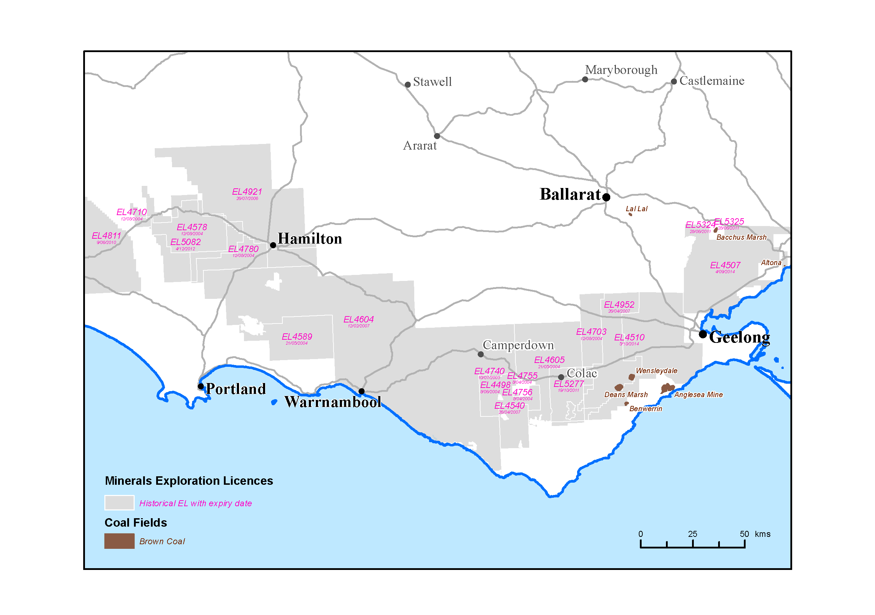
Figure 3.1 Historic Exploration Licences with coal bed methane (CSG) as a target resource
(with expiration dates).
Table 3.2 Cancelled, surrendered and expired Exploration Licences.
Exploration Licence no. | Primary Owner | Activities
4507, 4510 | Eastern Star Gas | Drilled four wells (one in the Bells Beach Syncline and three in the Parwan Trough); production testing at the ‘Oak Park pilot’ including high pressure water injection testing (fracturing).
5277 | ECI International | Desktop reviews only
4811 | Greenpower Natural Gas | Desktop reviews only
4540, 4498, 4755, 4756 | Ironbark Mineralsands | A wholly owned subsidiary of Purus – formed in 2001 to explore for coal seam gas and mineral sands
5082 | Leichhardt Resources | Desktop reviews only
5324, 5325 | Mantle Mining Corporation | Desktop reviews; drilling to intersect the Maddingley coal seams in adjoining tenements
4578, 4604, 4710, 4740, 4589, 4703, 4605, 4780, 4921, 4952 | Purus Energy | Targeted Early Cretaceous coals at the base of the Eumeralla Formation. Drilled seven wells over two project areas – Gordon and Hawkesdale – to test coal seam gas potential
4507 | Western Victoria Energy | Took over lease from Eastern Star – not focused on CSG; potential for underground coal gasification and coal liquification investigated; water formation laboratory tests conducted.
Source: DEDJTR records; GSV GEDIS database.

Current tenements
Two types of tenements may be granted in Victoria to allow for gas exploration: Petroleum Exploration Permits and Exploration Licences. Petroleum Exploration Permits (PEPs) are granted to companies to explore for Petroleum (including gas but excluding coal seam gas) under the Petroleum Act (1998).
Prospective acreage blocks are offered to companies via an acreage release process, which is run in tandem with the Commonwealth Acreage Release and other participating states and territories. Petroleum exploration may also be carried out under a retention lease, which enables the holder of an exploration permit to retain certain rights to a petroleum discovery that is not considered commercially viable at the time. Exploration Licences (ELs) for minerals including coal and hydrocarbons contained in coal are granted to companies via a direct application process by the State Regulator under the Mineral Resources (Sustainable Development) Act (1990) Vic.

Petroleum Exploration Permits
Most of the onshore Otway Basin is covered by nine PEPs held by four companies (Table 4.1 and Figure 4.1). PEP150 does not have an assigned operator but the permit is co-ordinated by Mawson Petroleum Pty Ltd. In addition, there is one Petroleum Retention Lease (PRL) held by Origin Energy Resources Ltd and 13 Petroleum Production Licences (PPLs) held by Energy Australia Gas Storage, Boggy Creek Pty Ltd, Origin Energy Resources Ltd and CO2CRC Ltd.
Table 4.1 Petroleum Exploration Permit holders in the Otway Basin.
Tenement | Operator
PEP150 | Not assigned
PEP151 | Bridgeport Energy
PEP163 | Mirboo Ridge
PEP167 | Mirboo Ridge
PEP168 | Beach Energy
PEP169 | Mirboo Ridge
PEP171 | Beach Energy
PEP174 | Mecrus Resources
PEP175 | Mirboo Ridge

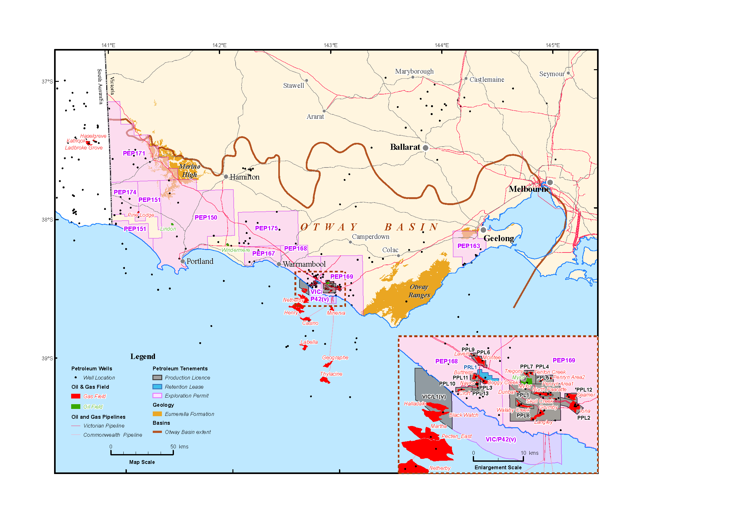
Figure 4.1 Petroleum Exploration Permits in the Otway Basin.

Exploration Licences
Any company that holds an exploration licence under the Mineral Resources (Sustainable Development) Act (1990) has the right to explore for minerals as defined under the Act. In the Moorabool Shire of the Southwest District, only one company, Mantle Mining Corporation holds current exploration licences (EL5294 and EL5323) that include coal seam gas. The title holders’ efforts are focussed on the development of the brown coal resource.
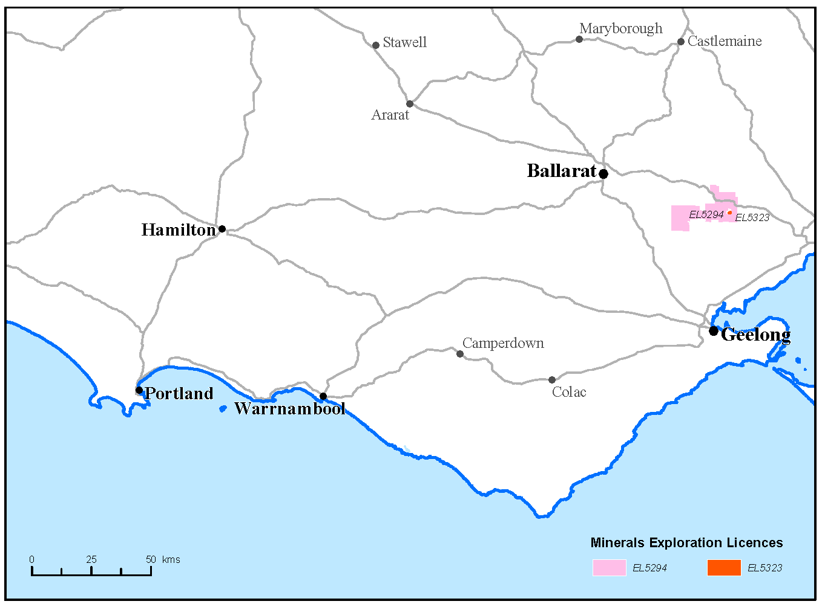
Figure 4.2 Exploration Licences in the Otway Basin with coal seam gas (coal bed methane) nominated as a commodity of interest.

Conventional gas
The following four sections of this review provide information about the four prospective gas types; the geological formations in which the gas might be found and, if available, information about the characteristics of the formations that might provide evidence for prospectivity. A discussion about the prospectivity of each gas type is provided in Section 10 of this review. Each of sections 5 to 8 begins with an explanation about the gas type.
Conventional gas is stored in porous and permeable sedimentary rocks such as sandstones or limestones in geological structures known as traps. Traps are discrete structures that can be mapped with the aid of seismic surveys from the ground surface (or sea surface if offshore). The gas migrated into the trap through porous rock units from the source from which it was generated. Impermeable rocks known as a seal or cap-rock directly above the structure trap the gas (Figure 5.1).
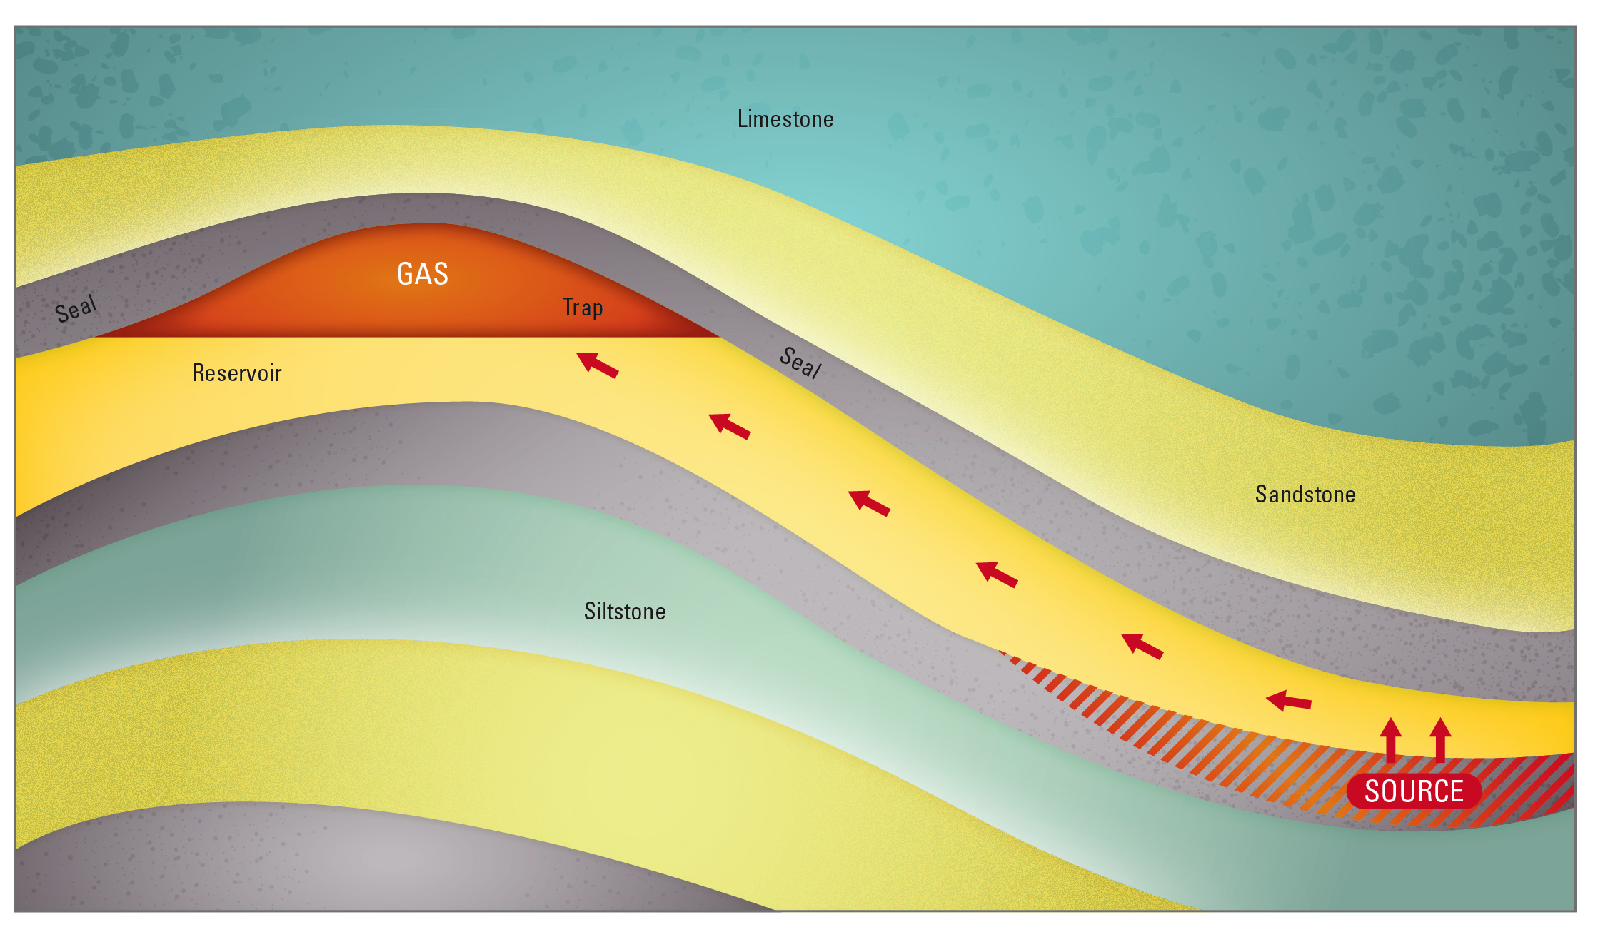
Figure 5.1 Conventional gas schematic.
Conventional gas was discovered in the Port Campbell Embayment in 1959. Nearly two decades later in 1979, a commercial gas discovery in the area revived interest in the commodity. In June 1986, the first gas in the area was produced from the 10.9 Bcf North Paaratte Field. From the 1980s gas discoveries both onshore and offshore in the Port Campbell Embayment and the adjacent Shipwreck Trough established the region as an active gas producing province.
In Victoria, all conventional gas production has come from the Waarre Formation, the basal unit of the Late Cretaceous Sherbrook Group. The Waarre Formation is recognised as the principle reservoir in the Port Campbell Embayment (Buffin, 1989). In South Australia, conventional gas in the Katnook, Haselgrove and Redman fields is reservoired in the Pretty Hill Formation.

Waarre Formation
Most Otway Basin hydrocarbon discoveries belong to the Austral-1 and Austral-2 petroleum systems (Edwards et al., 1999). The Waarre Formation reservoirs, together with the source rocks of the Eumeralla Formation, comprise the Austral-2 petroleum system. The hydrocarbons of the Otway Basin belong to the Austral petroleum supersystem. The Austral petroleum supersystem, defined by Bradshaw (1993) and Summons et al. (1998), on the basis of the age of the source rocks and their common tectonic history, includes all southern Australian sedimentary basins. As such, the hydrocarbons of the Otway Basin are assigned to the Austral supersystem.
The Austral petroleum supersystem is further divided into three sub-systems (Edwards et al., 1999); Austral-1, -2 and -3. The three-fold subdivision recognizes the difference in geochemical characteristics of liquid hydrocarbons encountered in petroleum exploration wells. The main difference between the liquid hydrocarbons is related to the different type of depositional environment of the source rocks that form part of each subsystem.

Distribution and thickness
The Waarre Formation is encountered onshore in the Port Campbell Embayment, the Tyrendarra Embayment and the Portland Trough. As is the case for all the Sherbrook Group units, the Waarre Formation is absent from the northern margin of the Otway Basin, with the exception of part of the Penola Trough. The thickness of the Waarre Formation in the Port Campbell Embayment varies from 148.5 m in Croft-1 to 53 m in Howmains-1. In Pine Lodge-1 and Najaba-1A, in the Gambier Embayment, its thickness is 81 m and 48 m, respectively. In Koroit West-1 and Pretty Hill-1, in the Tyrendarra Embayment, its thickness is 19.5 m and 14.6 m, respectively, and there are indications that it probably also occurs in Windermere-1. It is 12.6 m thick in Heathfield-1 in the Penola Trough, and only 3 m thick in Lindon-1 on the Lake Condah High (Guzel, 2015).

Reservoir properties
Three reservoir units are recognised in the Waarre Formation: Units A, B and C. Buffin (1989) originally divided the formation into four units but the fourth (Unit D) was subsequently assigned to the overlying Flaxman Formation on the basis of a late Turonian age (Partridge, 2001). Unit C is considered to be the best reservoir unit with an average porosity of 16.9% (with a range of 1.1% to 29%) and an average permeability of 2719 mD (with a range of 0.01 to 24,794 mD); units A and B are considered tight (Mehin & Constantine, 1999).

Seals
The Belfast Mudstone is described as a uniform marine shale (e.g. Duddy, 2003). The unit is a proven seal in the eastern part of the basin (i.e. the Port Campbell Embayment) (e.g. Mehin & Constantine, 1999), and along with the Paaratte Formation, has the widest distribution of all the Sherbrook Group units. From formation limits delineated in Woollands & Wong (2001), the Belfast Mudstone is always present over the Waarre Formation reservoirs. The Belfast Mudstone is up to 570 m thick (e.g. Gibson-Poole et al., 2006).
The Flaxman Formation is also considered a sealing facies in part but is restricted in its distribution to the Port Campbell Embayment and the far western portion of the Portland Trough/Gambier Embayment onshore (Woollands & Wong, 2001). The Flaxman Formation is thickest onshore in the Gambier Embayment (417 m in Najaba-1A and 269.5 m in Pine Lodge-1); whilst in the Port Campbell Embayment it varies from 63 m in Callista-1 to 5.8 m in Dunbar-1 (Guzel, 2015). In other parts of the basin such as the Tyrendarra Embayment, the Penola Trough and the Lake Condah High, the Flaxman Formation may be present but is thin (i.e. 5-13 m) (Guzel, 2015).

Source rocks
The Waarre Formation hydrocarbons are sourced from the underlying Eumeralla Formation (e.g. Mehin & Constantine, 1999; Boreham et al., 2004). Geary & Reid (1998) and Bernecker et al. (2003) considered that the gas in the Waarre was derived from two Eumeralla Formation coal-bearing sequences, each about 200 metres thick with individual coal units of 2-3 metre thickness. O’Brien et al. (2009) thought that in addition to these coals, organic-rich mudstones and shales in the Eumeralla Formation also contributed to the ‘hydrocarbon inventory’. Geary & Reid (1998) suggested that these mudstones were lean, referring to the organic content.
Some authors have considered that hydrocarbon shows in units above the Waarre Formation (particularly in the Wangerrip Group) provide evidence of a working Austral-3 petroleum system (e.g. Lavin, 1998). The wells Wilson-1, Lindon-1 and Lindon-2 have been cited as examples.
Wilson-1 was drilled in 1987 in the Tyrendarra Embayment. The well was drilled to test the hydrocarbon prospectivity at the top of the Late Cretaceous Paaratte Formation. Secondary targets included the younger Pebble Point Formation and intra-Pember Mudstone sands (Rayner, 1988). A weak oil show from a sidewall core taken from the Pebble Point Formation was considered to have a marine source rock affinity (Rayner, 1988). Boreham et al. (2004) has since shown that the oil was a drilling contaminant.

Pretty Hill Formation
In the South Australian portion of the Penola Trough, the Pretty Hill Formation is a conventional reservoir. It is considered that the majority of hydrocarbons in the onshore Otway Basin in South Australia are sourced from the Austral-1 Petroleum System (O’Brien et al., 2009). In Victoria, the Pretty Hill Formation has been explored for conventional gas and oil; particularly in the earlier stages of Otway Basin exploration.

Distribution and thickness
The Pretty Hill Formation is found across most of the extent of the onshore Otway Basin. It is found in the Early Cretaceous depocentres (or troughs) and across some basement highs such as the Lake Condah High (e.g. in well Lindon-1). There is strong structural control on the thickness of the Pretty Hill Formation and the thicknesses are variable as a result. Many wells that penetrate the top of the formation do not penetrate the full thickness. The greatest thickness intersected by drilling was 1500 m in Pretty Hill-1. Seismic data, however, suggests that the formation may exceed 5000 m thickness in the axis of the major half-graben depocentres (e.g. Lavin, 1997).
The depth at which the Pretty Hill Formation is found increases toward the offshore portion of the basin. The Pretty Hill Formation is intersected at a minimum of 1500 m downhole depth in the Penola Trough. In the Ardonachie/Tahara troughs, the formation is intersected between 1000 and 1500 m depth, whereas in the Windermere Trough/Tyrendarra Embayment, the depth to the Pretty Hill Formation increases and it is reached between 1500 m (e.g. Woolsthorpe-1) and 2300 m (e.g. Greenslopes-1). The formation is encountered at depths of 1100 m (e.g. Ross Creek-1) and greater in the Eastern Otway Basin.
From east to west, in the Penola Trough, the Pretty Hill Formation exceeds 900 metres thickness (e.g. McEachern-1). In the Ardonachie/Tahara troughs around 450 m thickness is encountered (e.g. Digby-1
and Mocamboro-11). In the Eastern Otway Basin, at the northern margin, the Pretty Hill Formation overlies Palaeozoic basement and is less than 150 m thick in Stoneyford-1. Further towards the south, away from
the northern margin, the formation increases in thickness (i.e. up to 600 m) but total drilling depths are
often reached in the formation and so few wells penetrate the full thickness (i.e. greater thicknesses
may be present).

Hydrocarbon indications
Weak oil and gas shows have been noted in the Pretty Hill Formation (e.g. Green Banks-1 in the Ardonachie/Tahara troughs). Tests to obtain information on the formation and fluids (drill stem tests) have recovered water rather than hydrocarbons from the Pretty Hill Formation (e.g. Digby-1), although oil-cut mud was also recovered (Lanigan, 1995).

Reservoir properties
The sandstone in the Pretty Hill Formation is quartzose and substantially more permeable than the overlying Eumeralla Formation. Porosity and permeability measurements from Victorian and South Australian Pretty Hill Formation samples are listed in Table 5.1.
Table 5.1 Porosity and permeability values for the Pretty Hill Formation.
Area | Well | Average porosity (%) | Porosity range (%) | Average permeability (mD) | Permeability range (mD)
Merino High | Mocamboro-11 | 19.9 | 13.3 – 27.4 | 110.8 | 0.01 - 980
Elingamite Trough | Garvoc-1 | 18.4 | 13.2 – 22.7 | 231.1 | 2.9 - 661
Central north | Hawkesdale-1 | 30 | 26 - 32 | 2397.6 | 64 - 5093
Windermere Trough | Pretty Hill-1 | 22.8 | 20 - 25 | 757.8 | 2 - 2029
South Australia | Katnook Field | >20 |  | 500
Source: Victorian wells (Mehin & Constantine, 1999); South Australia values (Morton et al., 2002).
Further analysis of the data would be required to confirm reservoir quality but these limited porosity and permeability measurements from Victorian wells and the South Australian Katnook Field are similar. This suggests, as other have previously, that the reservoir quality of the Pretty Hill Formation in Victoria is very good (i.e. Mehin & Constantine, 1999).
Morton et al. (2002) describe the complex mineralogy and diagenetic histories that explain the variation in Pretty Hill Formation reservoir quality.

Seals
In the South Australian portion of the Penola Trough, the Laira Formation provides the seal for the Pretty Hill Formation (Morton et al., 2002). Facies changes in the Laira Formation outside the central Penola Trough in South Australia are considered responsible for loss of seal.
In Victoria, there is some uncertainty associated with the identification of the Laira Formation (Guzel, 2015). Guzel has identified an upper sand/shale component to the Pretty Hill Formation (overlying a sand unit). Potentially, the shales within the upper Pretty Hill Formation could provide a good seal for hydrocarbons, as was suggested by Morton et al. (2002) in relation to the sequence in South Australia.

Source rocks
The source for oil and gas in the Pretty Hill Formation is most likely the Casterton Formation and the Pretty Hill Formation itself.
In Victoria, the Casterton Formation has a Total Organic Carbon (TOC) content of 2.6% (ranging from 0.4 to 8.9%) and consists largely of Type II to III kerogens, suggesting potential for oil and gas generation (Mehin & Constantine, 1999).
The Pretty Hill Formation is considered to have fair source rock potential. The formation has an average TOC content of 1.7% with a range from 0.4 to 13.8%. The kerogen type is Type III with some Type II and IV (Mehin & Constantine, 1999). These kerogen types suggest that the unit could generate oil and gas.
The basis for the assessment of source richness of organic material is discussed further in the shale gas and coal seam gas sections of this review (Sections 7 and 8).

Tight gas
Tight gas is sourced from relatively low permeability and low porosity sedimentary reservoirs. The lack of permeability does not allow the gas to migrate out of the rock (Figure 6.1). In this case the method to extract gas may involve fracturing the rocks to create artificial porosity and permeability.
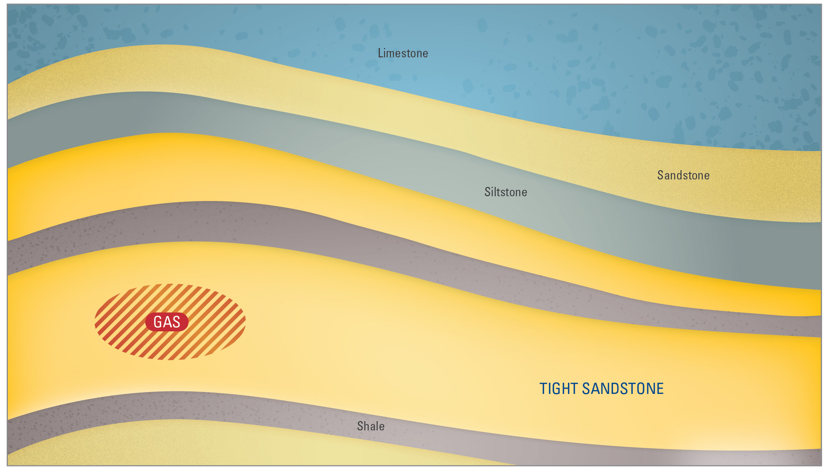
Figure 6.1 Tight gas schematic.
Low permeability tight gas reservoirs may be sandstones, carbonates, shales or coal seams. A tight gas reservoir is characterised by a matrix porosity of ≤ 10% and a permeability of ≤ 0.1 millidarcy (mD) exclusive of fracture permeability (e.g. Haines, 2006). The American Association of Petroleum Geologists (AAPG) uses the term ‘tight gas sand’ to refer to low permeability sandstone reservoirs that produce primarily dry natural gas. Holditch (2006) asserted that a tight gas reservoir is “a reservoir that cannot be produced at economic flow rates nor recover economic volumes of natural gas unless the well is stimulated by a large hydraulic fracture treatment, by a horizontal wellbore, or by use of multilateral wellbores”.
There are two forms of tight gas. One is known as basin-centred or pervasive gas and the other is discrete and defined by the limit of a trap – such is the case for conventional reservoirs. Basin-centred gas is continuous and widespread in its distribution. Within certain limits defined by the depth of burial required for gas generation, wherever the tight formation is intersected there will be gas, although explorers look for permeability “sweet spots”. The issues associated with gas recovery are technical and relate to the tight nature of the reservoir. This is also true for discrete tight gas where accumulations occur in low-permeability, poor-quality reservoir rocks in localised geological features such as structural traps. Regardless of the definition or type, Australia currently has no tight gas reserves (Geoscience Australia and BREE, 2014).
Tassone (2013) evaluated the unconventional gas and oil potential of the Otway Basin by reviewing much of the existing petroleum well data. Two tight gas plays were identified – the intra-Eumeralla Formation and the Pretty Hill Formation. The regions considered by Tassone (2013) as most prospective are listed in Table 6.1.
As discussed in Section 5, the Pretty Hill Formation is host to conventional gas resources in the South Australian portion of the Penola Trough. It is considered that the formation exhibits similar reservoir properties in Victoria. At greater depths however, tighter reservoir units may be encountered in the
Pretty Hill Formation. The characteristics of the Pretty Hill Formation discussed in Section 5 are also relevant for tight gas.
Table 6.1 Otway Basin tight gas plays and regions (Tassone, 2013).
Tight gas play | Region
Intra-Eumeralla Formation | Eastern Onshore Victorian Otway Basin  Port Campbell Embayment  Windermere Trough/Tyrendarra Embayment
Pretty Hill Formation | Ardonachie/Tahara troughs  Eastern Otway Basin  Penola Trough  Windermere Trough/Tyrendarra Embayment

Eumeralla Formation
The Early Cretaceous Eumeralla Formation (Austral 2) is a rift facies with sandstones mudstones and coaly sequences deposited in a wide range of environments (i.e. from lacustrine to high-energy fluvial). The sediment that comprises most of the formation was derived from volcanic material, which breaks down to clays reducing the permeability to low values. The volcanoclastic nature of the sediments complicates petrophysical evaluation of the sequence when applying standard methods. Also, within the Eumeralla Formation is an organic carbon component; present either as dispersed organic matter or as coal. The carbon content is variable but significant. The Eumeralla Formation is considered the source rock for all commercial gas found to date in the Victorian part of the Otway Basin (e.g. O’Brien et al., 2009). The formation is prospective for tight gas by virtue of containing both mature gas-prone organic material and potential reservoir rocks.

Distribution and thickness
The Eumeralla Formation was deposited across the entire Otway Basin. It is equivalent in age and similar in character to the Strzelecki Group in the Gippsland Basin. While the unit thickens considerable across the Early Cretaceous depocentres (see Figure 2.1), deposition was widespread and records the onset of thermal subsidence in the region.
Wells in the western Victorian portion of the Penola Trough and the Ardonachie/Tahara troughs record Eumeralla Formation thicknesses of 750 m to 1500 m. Intersections further east in the Tyrendarra Embayment range from 250 m at the northern basin margin to 2300 m, with most exceeding 750 m. In depocentres further east, most intersections exceed 2000 m thickness (e.g. 2750 m in Ferguson’s Hill-1). Basin margin intersections are generally in the range of 400 to 750 m.

Hydrocarbon indications
The Eumeralla Formation has been intersected by many petroleum wells, with the majority reaching the top of the formation only. In the Port Campbell Embayment for example, at least 44 wells drilled since 1960 have either intersected the top of the section, or drilled through to the underlying Crayfish Subgroup. Hydrocarbon shows throughout the Eumeralla Formation are common. Tassone (2013) notes that more than 70% of the wells in the Port Campbell area report elevated gas readings in the Eumeralla Formation. In addition, explorers have noted the tight and impermeable nature of the formation (for example, the first well to intersect the Eumeralla Formation in the Port Campbell Embayment - Port Campbell-2 drilled in 1960; Wood & Bain, 1964).
Bellarine-1 was drilled to test Early Cretaceous Eumeralla Formation tight gas reservoirs in the Eastern Otway Basin. Several gas shows were observed in intra-Eumeralla Formation sands, coaly intervals and isolated fractures (O’Brien & Edwards, 2005). Hindhaugh Creek-1 and Ferguson Hill-1 recovered and flowed ignitable gas to surface from intervals within the Eumeralla Formation but at rates too small to measure (Pyecroft & Millheim, 1970; Bain, 1964). At the time, explorers concluded from these tests that these rocks had low to nil permeability, with probably no porosity (i.e. tight) and that gas emanated from fracture porosity despite core samples generally showing calcite-filled micro-fractures.

Reservoir characteristics
Measurements of porosity and permeability of Eumeralla Formation samples have been undertaken throughout the Victorian Otway Basin. Results vary considerably: geographically, vertically and within sub-units of the formation. Cleaner sandstone sub-units at the base of the formation (i.e. the Heathfield and Windermere sandstones are more likely to have been sampled in historical wells, biasing results somewhat).
In the Eumeralla Formation, porosity and permeability decrease with depth. Porosity and permeability values from the eastern portion of the basin are variable (Tassone, 2013). In Anglesea-1, porosities are less than 10% at depths below 500 metres and permeabilities are effectively zero. The same ‘tight’ conditions prevail in Ferguson Hill-1 and in deeper samples from Sherbrook-1; whereas porosities and permeabilities in Hindhaugh Creek-1 range between 1 to 28% and 0.1 to 1000 mD.
Values from the west of Victoria can be somewhat higher than values from the east. For example, on the Merino High, in Mocamboro-11, porosities and permeabilities are predominantly greater than 20% and 0.1 mD at depths shallower than 1000 metres. In the Penola Trough, samples from Casterton-1 displayed porosities greater than 20% (decreasing with increasing depth) but had no permeability (Tassone, 2013).
In the Port Campbell Embayment, data from well samples, porosities of 8 to 25% and permeabilities of 0.1 to 100 mD are typical (Tassone, 2013).
A compilation and review of sand/shale ratios by Tassone (2013) indicates a range from 35% to 75% sandstone, although the volcanogenic (quartz-poor) nature of the sediment complicates net sand interpretation.

Source rock characteristics
The Eumeralla Formation is considered the source rock for all commercial conventional gas in the Victorian Otway Basin (e.g. O’Brien et al., 2009). This assessment can also be applied to evaluate the potential for tight gas (both source and reservoir) within the Eumeralla Formation itself. The basis for the assessment of source richness of organic material is discussed further in the shale gas and coal seam gas sections of this review (Sections 7 and 8).
The Eumeralla Formation contains coal. High total organic carbon measurements derived from thin coal seams can distort attempts to understand average organic carbon values. The organic matter found in the Eumeralla Formation is predominantly Type III (gas prone); however some more oil prone kerogens were detected in Ross Creek-1 in the eastern Otway Basin (Preston, 1992).
In the Ardonachie/Tahara and Penola Troughs, most Eumeralla Formation samples have 0.5 to 1.5% TOC with peaks above 10%. This is also the case in the Eastern Otway Basin. The shallow (i.e. less than one kilometre below ground level) Eumeralla Formation samples in Hindhaugh Creek-1, Stoneyford-1, Tirrengowa-1 and Warracbarunah-2, have high TOC estimates (i.e. typically >4%). The well Ferguson Hill-1 has been sampled extensively over a wide depth range, and although TOC content is generally less than 1.5%, a number of samples exceed 10% highlighting the vertical variability of carbon content in the sequence. Ross Creek-1 exhibits similar high magnitudes of TOC content between 2.2 and 2.5 km below ground level and 3.3 to 3.4 km below ground level with values greater than 2%. The median total organic content for the Eumeralla Formation across the basin ranged from 0.47% to 1.26% (Table 6.2).
Table 6.2 Eumeralla Formation TOC (Total Organic Content) values by area (Tassone, 2013).
Region | Number of samples | Average TOC  (%) | Median TOC  (%) | Standard deviation TOC  (%) | TOC range  (%)
Ardonachie/Tahara troughs | 28 | 3.79 | 0.66 | 8.42 | 0.18 - 35.00
Eastern Otway Basin | 293 | 8.45 | 1.26 | 15.98 | 0.09 - 67.65
Penola Trough | 21 | 1.48 | 0.85 | 3.20 | 0.12 - 15.10
Port Campbell Embayment | 134 | 0.81 | 0.47 | 1.00 | 0.09 - 8.34
Windermere Trough/Tyrendarra Embayment | 41 | 7.03 | 0.96 | 14.45 | 0.10 - 66.10

The thickness of the Eumeralla Formation (generally greater than 1000 metres), and the Otway Basin’s geological history of variable burial and uplift have resulted in a range of thermal maturities (Table 6.3). Levels of maturity sufficient for gas generation in the Eumeralla Formation have been reached in the Eastern Otway Basin, with the exception of the far eastern basin (e.g. Bellarine-1) where samples are considered overmature (Tassone, 2013).
Table 6.3 Eumeralla Formation vitrinite reflectance values by area (Tassone, 2013).
Region | Depth range  (metres below ground level | Number of samples | Average vitrinite reflectance  (%) | Vitrinite reflectance range  (%)
Ardonachie/Tahara troughs | 64.2 - 1201.0 | 41 | 0.427 | 0.220 - 0.720
Eastern Otway Basin | 73.5 - 3568.5 | 124 | 1.213 | 0.210 - 7.400
Penola Trough | 397.8 - 1370.7 | 20 | 0.448 | 0.260 - 0.630
Port Campbell Embayment | 1040.0 - 3508.7 | 49 | 0.675 | 0.300 - 1.250
Windermere Trough/  Tyrendarra Embayment | 391.7 - 3239.5 | 59 | 0.527 | 0.260 - 1.040

Rock mechanical and geomechanical considerations
Tassone (2013) reviewed all Otway Basin petroleum wells for valid rock mechanical data, which could be useful for consideration of response to hydraulic fracturing or other production considerations. The paucity of work in relevant lithotypes does not allow reliable generalisations.
A single sample plug form the Eumeralla Formation in Skull Creek-1 in the Port Campbell Embayment yielded static elastic values of 0.27 and 6.0 GPa for Poisson's Ratio and Young's Modulus, respectively. Poisson’s ratio measures the expansion of a material perpendicular to the direction in which it is compressed and Young’s Modulus is a measure of the stiffness or elasticity of a material.
There is a wider availability of dynamic elastic rock properties derived from advanced sonic logging tools; however, correlation with lab-derived static properties is required to make full use of this data. This correlation is not possible as the required sonic data was not acquired in the sampled well. The limited data does suggest that the Eumeralla Formation does not exhibit the brittleness noted in unconventional reservoirs in the United States. Considerable additional analytical and petrophysical work is required.

Natural fracturing
Natural fracturing has been observed in both image log and outcrop. There is considerable variation in orientation. Fracture frequencies of 3 to 10 fractures per metre were observed in outcrop at Castle Crag, although calcite and siderite filling was present. Figure 6.2 shows observed orientations, which vary across the basin.
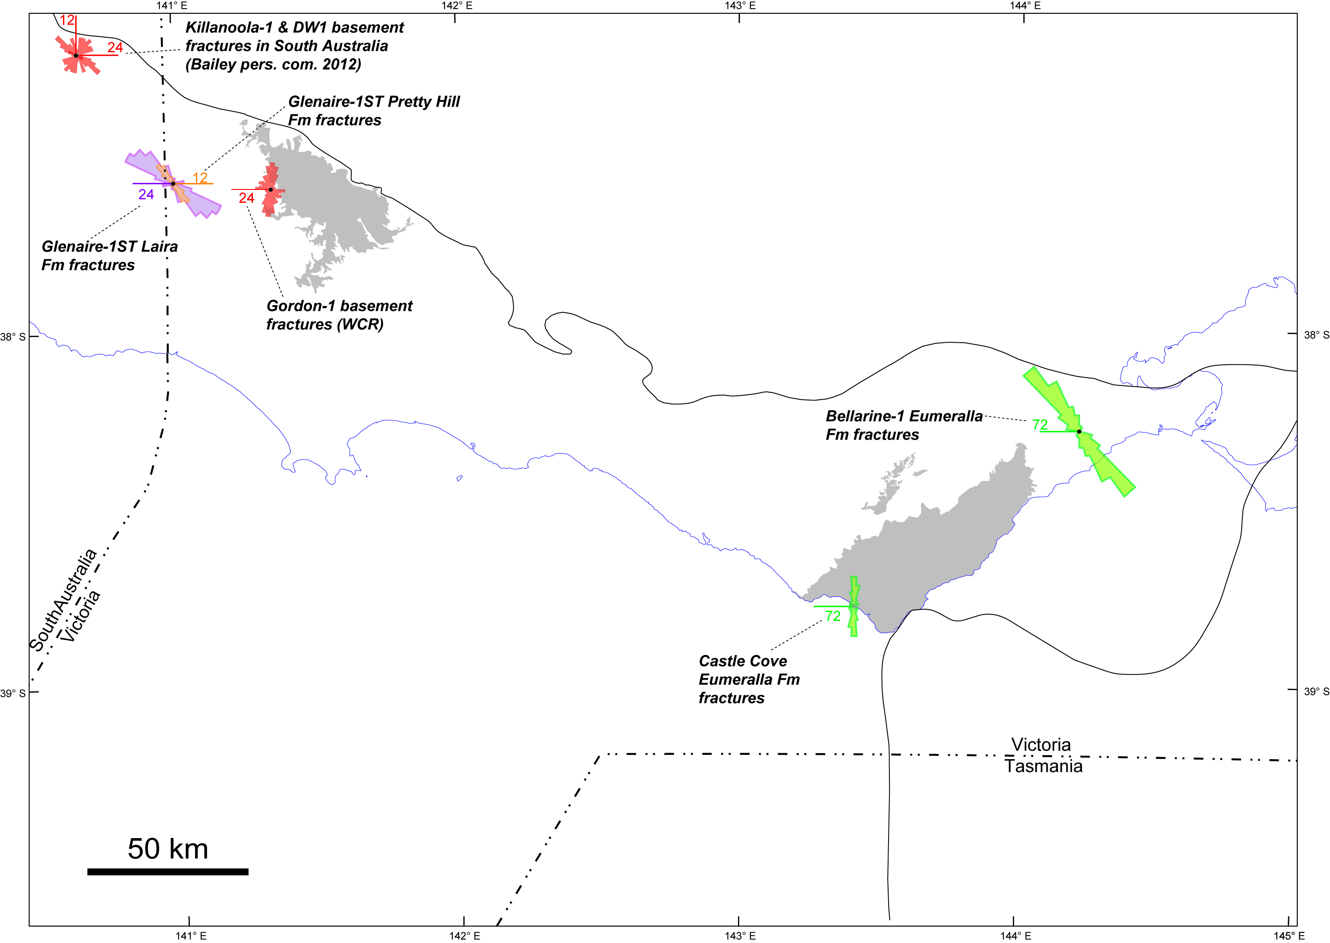
Figure 6.2 Natural fracture orientations (Tassone 2013).

Shale gas
Shale gas is sourced from very fine-grained sedimentary rocks that have low porosity and permeability and are organic-rich (Figure 7.1). The gas is held on organic matter in the rock, in pores between grains and any fractures present in the rock. As with tight gas, hydraulic fracturing of the formation to create artificial porosity and permeability will enhance production flow rates.
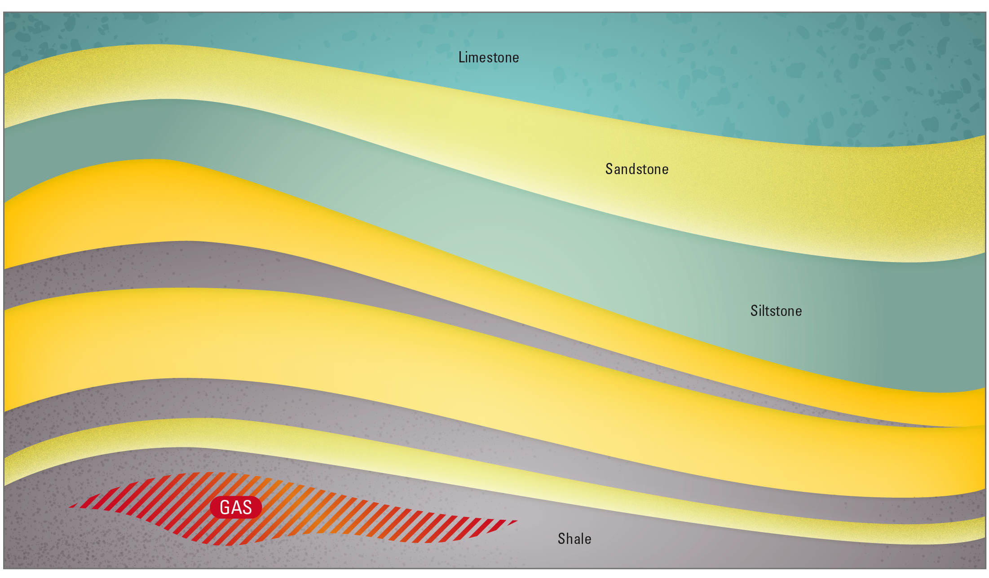
Figure 7.1 Shale gas schematic.
There are no reserves for shale gas in the Victorian onshore Otway Basin. Rawsthorn (2013), however, has determined a best estimate recoverable resource of 9 Tcf of dry gas in the Eumeralla Formation over an area of 4109 km² (roughly between Portland and Port Campbell).
The first test of a deeper source in the Western Otway Basin was carried out in March 2014 by Cooper Energy, who drilled well Jolly-1 to a total depth of just over 4000m in the South Australian portion of the Penola Trough. The well reached the Casterton Formation and an overlying sandstone unit (the Sawpit Sandstone), which was 340m thick and reported to have liquids and gas potential. That explorers are beginning to target deeper units such as the Casterton Formation suggests that the potential for shale gas cannot be ruled out.
Tassone (2013) evaluated the unconventional gas and oil potential of the Otway Basin by reviewing much of the existing petroleum well data. Three shale gas plays were identified – the Casterton Formation, the Laira Formation and the intra-Eumeralla Formation. The regions considered by Tassone (2013) as most prospective are listed in Table 7.1.

Table 7.1 Otway Basin shale gas plays and regions (Tassone, 2013).
Shale gas play | Region
Casterton Formation | Ardonachie/Tahara troughs  Penola Trough  Windermere Trough/Tyrendarra Embayment
Intra-Eumeralla Formation | Eastern Otway Basin  Port Campbell Embayment  Windermere Trough/Tyrendarra Embayment
Note: Laira Formation not included here as there is doubt about positive identification of the unit in Victoria

Shale gas reservoir properties
Shale gas is found in organic-rich fine-grained sedimentary rocks. Many shale gas and shale oil producing formations are not strictly shales; with quartz and calcite often dominating the mineralogy of the reservoir units (e.g. Ottoman & Bohacs, 2014). A shale gas target formation is essentially the source rock component of a petroleum system. After first identifying that a target formation (shale/source rock) is present then it is important to establish the thickness of the formation and lateral extent, the depth to the formation, organic content (measured as TOC), kerogen type, thermal maturity, overpressure and the brittleness of the formation as dictated by its mineralogy.

Organic richness
Hydrocarbons are mostly carbon (by molecular weight) and so the amount of carbon in a rock, to some extent, determines the ability of the rock to generate hydrocarbons. A measure of the organic richness of a rock is known as TOC (Total Organic Carbon). A guide to the richness of a source rock according to TOC is given in Table 7.2.
Table 7.2 A guide to organic richness in shales as given by TOC (after Law, 1999).
Generation potential | Wt% TOC, Shales
Poor | 0.0 – 0.5
Fair | 0.5 – 1.0
Good | 1.0 – 2.0
Very good | 2.0 – 5.0
Excellent | >5.0

Kerogen type
Organic matter is transformed into kerogen over time, at greater burial depths and with increasing temperatures. The type of kerogen that forms is dependent on the original depositional environment of the organic matter. Sediments may be deposited in either the terrestrial or marine realm. Organic matter derived from terrestrial versus marine environments determines whether a source rock is more prone to generating oil or gas.

Kerogens are classified into four types (Table 7.2). The more hydrogen in the kerogen, the more likely it is to generate oil, and the higher the quality of the kerogen (Law, 1999). Type I kerogen is mainly oil prone but is uncommon; although the largest oil shale deposit in the world - the Green River Formation in the US has Type I kerogen. Type II kerogens can produce oil or gas depending on temperature. Type III kerogens are mostly derived from plant debris deposited in terrestrial settings and are gas prone. Most coals contain Type III kerogen. Type IV kerogen has little potential for generating oil or gas. A source rock may contain one or a mixture of kerogen types. Source rock characterisation studies rate the hydrogen content (and hence kerogen type) by a hydrogen index (HI) and oxygen index (OI) derived from careful measurement of material given off as a lab sample is heated through the generation phase (pyrolysis).
Table 7.3 Kerogen types (after McCarthy et al., 2011; Law, 1999).
Kerogen type | Predominant hydrocarbon potential | Amount of hydrogen | Source material | General environment of deposition
I | Oil prone | Abundant | Mainly algae | Lacustrine (lake) setting
II | Oil and gas prone | Moderate | Mainly plankton, some contribution from algae | Marine setting
III | Gas prone | Small | Mainly higher plants | Terrestrial setting
IV | Neither | None | Reworked, oxidised material | Varied settings

Thermal Maturity
As rock exposure to heat over time changes the chemistry of organic matter, that change or thermal maturity can be measured by vitrinite reflectance (expressed as Vr). Vitrinite is a one of several components of coal (known as macerals) found in buried organic matter. As the organic matter becomes thermally mature with burial and increasing temperature it devolves volatile components (i.e. oil; and at higher temperatures gas) and the molecular structure of the remaining organic matter including the vitrinite becomes increasingly well-ordered and hence more reflective to light. Reflectance is measured in oil of a polished surface of vitrinite in a sedimentary rock (ASTM, 2011). Other measures of maturity exist, and with care can be related back to vitrinite reflectance.
Source rocks within certain ranges of thermal maturity (expressed as vitrinite reflectance) are said to be immature, in the oil or gas windows, or over-mature. The gas window is taken as a Vr of between 1.2% and 3%. The state of thermal maturation is as important as organic richness in determining the effectiveness of a particular shale as a source rock and as a shale gas target. The depth range of the gas window and its lateral extent within a potential shale gas target are important constraints on prospectivity.

Casterton Formation
In the Otway Basin, the most likely shale gas target is the Casterton Formation. The Casterton Formation is latest Jurassic to Early Cretaceous in age and is the basal unit of a fluvial rift sequence. The Casterton Formation and overlying Crayfish Subgroup are the source rock for the Austral 1 petroleum system located on Australia’s southern margin (Edwards et al., 1999).

Distribution and thickness
The Casterton Formation has been intersected in 12 wells across the central and northwest of the basin (Figure 7.2a); specifically in the Penola Trough, the Ardonachie/Tahara troughs and the Windermere Trough/Tyrendarra Embayment.
The top of the Casterton Formation is intersected at various depths through the central area of the basin: from 748m in Moyne Falls-1 to 2503m in Greenslopes-1. The top of the Casterton Formation is intersected in the Penola Trough between 1475m in Tullich-1 and 2065m in Casterton-1.
The Casterton Formation reaches a maximum recorded thickness of 535 metres in Hawkesdale-1 between 1205 and 1740 metres, where it is represented almost entirely by volcanics. The thickness of the unit in the Penola Trough varies from 27m to 243m. In between these two areas in Digby-1 the Casterton Formation was intersected between 1899m and 2088m (total well depth); a total of 189m thickness. Net shale thickness calculated on the basis of gamma ray response and then separately on cuttings is greatest in Gordon-1 at 204m and 240m respectively.

Hydrocarbon indications
Oil shows appear to be more commonly encountered in the Casterton Formation than gas shows. For example, results obtained from drill stem tests (DSTs) performed at Digby-1, recovered slightly oil-cut mud from within the Casterton Formation (Lanigan, 1995). Three other wells in the Ardonachie Trough also had weak oil and gas shows but no formation testing was carried out (Tassone, 2013). Oil shows were also reported in Penola Trough wells Sawpit-1 and Gordon-1; and in the Tyrendarra Embayment in Woolsthorpe-1 near the top of the Casterton Formation (Tassone, 2013).

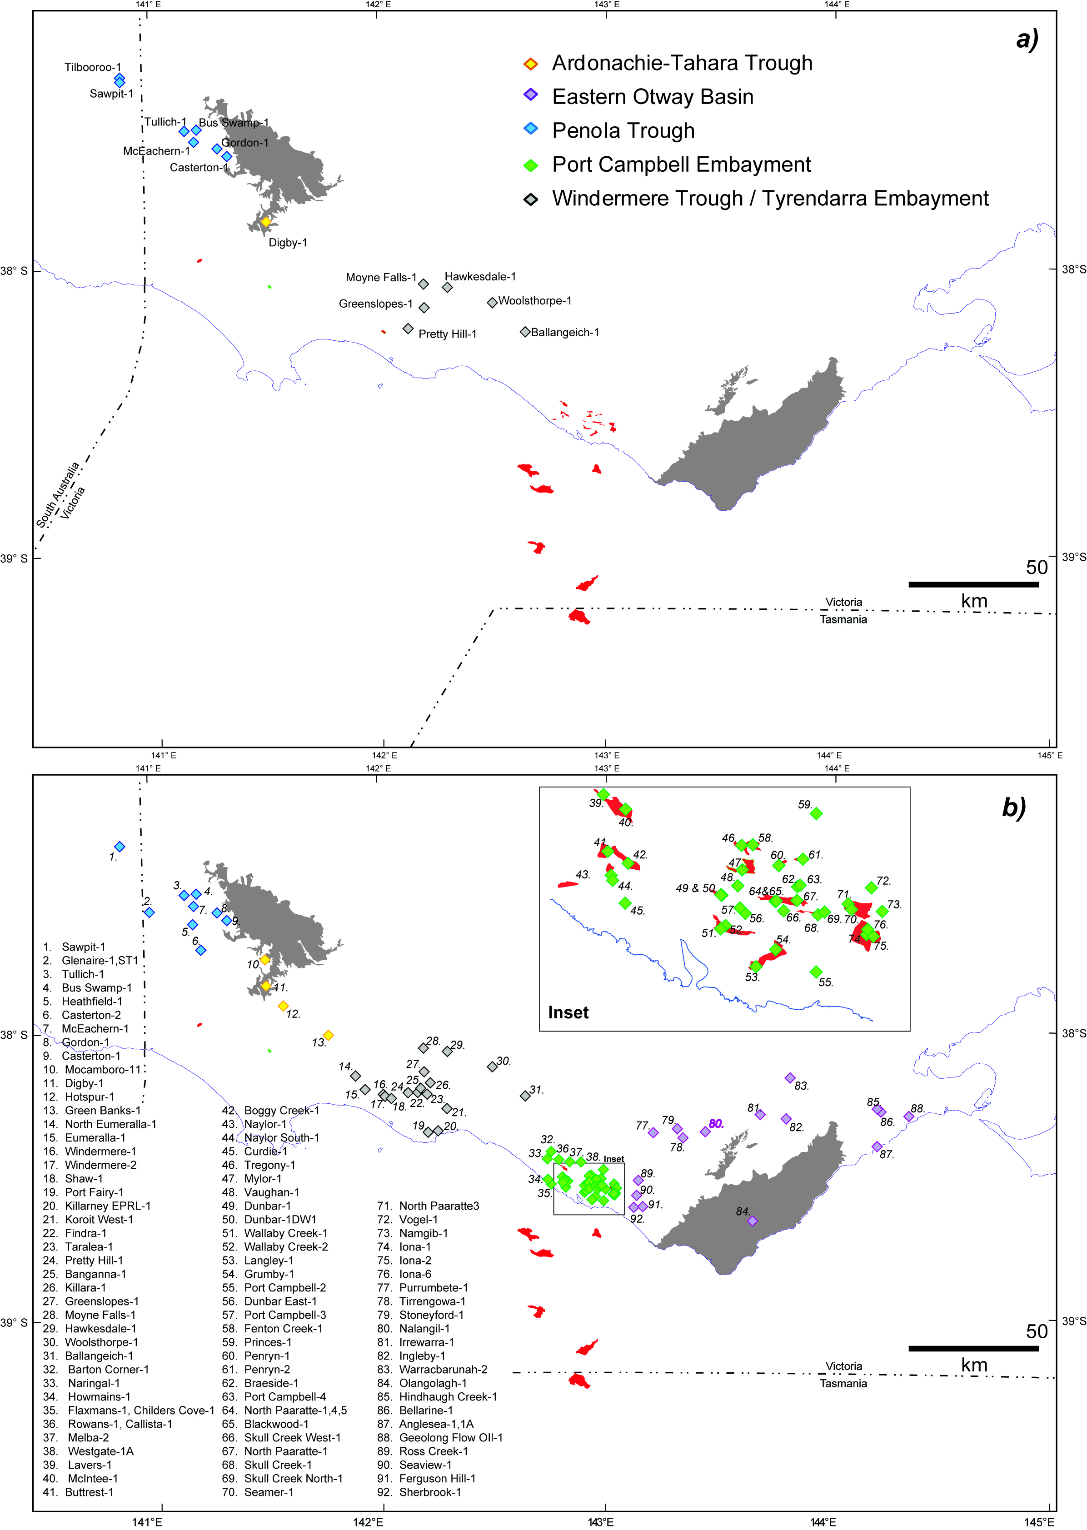
Figure 7.2 (a) Casterton Formation and (b) Eumeralla Formation intersections (Tassone, 2013).

Organic richness
In Victoria, the Casterton Formation has a Total Organic Carbon (TOC) content of 2.6 wt% (ranging from 0.4 to 8.9 wt%) (Mehin & Constantine, 1999).
Lacustrine shales from the Casterton Formation have the highest average total organic carbon values in the Otway Basin (Tassone, 2013). The Casterton Formation has been sampled in the western portion of the Victorian Otway Basin and demonstrates good source rock richness in the Windermere Trough/Tyrendarra Embayment and very good source rock richness in the Ardonachie/Tahara and Penola troughs with an average of 5.5 wt% and 3.5 wt% TOC, respectively. Some samples in the Ardonachie/Tahara and Penola troughs had values in excess of 30 wt% TOC, with median values also indicating good to very good source rock richness.
Table 7.4 Casterton Formation Total Organic Carbon values by area (Tassone 2013).
Region | Number of samples | Average TOC  (wt%) | Median TOC  (wt%) | Standard Deviation TOC  (wt%) | TOC range  (wt%)
Ardonachie/Tahara troughs | 13 | 5.53 | 2.50 | 9.39 | 0.42-35.90
Penola Trough | 46 | 3.15 | 1.67 | 6.70 | 0.17-45.90
Windermere Trough/Tyrendarra Embayment | 12 | 1.38 | 1.10 | 1.02 | 0.42-3.82

Kerogen type
The kerogen type associated with the Casterton Formation is Type II-III (Mehin & Constantine, 1999), and is therefore oil and gas prone (see Table 7.3). The Casterton Formation is substantially more oil-prone than the Eumeralla Formation. At Gordon-1, the Casterton Formation has HI values approaching 350 mgHC/g TOC and low OI values indicating oil-prone Type I to oil and gas prone Type II kerogen. Similarly, the Casterton Formation at Sawpit-1 and Casterton-1 indicates oil and gas prone Type II kerogen, which is consistent with recovered hydrocarbons at these locations (Tassone, 2013).

Thermal maturity
The Casterton Formation is considered the source rock in the Austral 1 Petroleum System (O’Brien et al., 2009). Sampling of this formation has taken place in wells at significantly shallower depths than the interpreted source units (e.g. in the Penola Trough). Samples are immature for gas (Table 7.5); drilling in deeper areas might have provided a different result. This is also the case for the Eastern Otway where depocentres such as the Gellibrand and Colac Troughs (see Figure 2.1) may contain mature Casterton Formation however, no intersections have been recorded. Based on the maturity profile in the shallower Eumeralla Formation (Tassone, 2013), any Casterton Formation occurring in the deeper parts of the Eastern Otway Basin would be mature to overmature for gas.

Table 7.5 Casterton Formation vitrinite reflectance values (Tassone, 2013).
Region | Depth range (metres below ground level) | Number of samples | Average vitrinite reflectance  (%) | Vitrinite reflectance range  (%)
Ardonachie/Tahara troughs | 1920.6-2042.4 | 4 | 0.880 | 0.650-1.110
Penola Trough | 1801.5-2492.5 | 11 | 0.663 | 0.500-0.920
Windermere Trough/  Tyrendarra Embayment | 1249.3-2519.0 | 7 | 0.616 | 0.480-0.970

Eumeralla Formation
The distribution of the Eumeralla Formation (see Figure 7.2b for well intersections), hydrocarbon occurrences within the formation and source rock characteristics have been discussed in Section 6 - Tight Gas. Shale units have been identified in the Eumeralla Formation (Tassone, 2013).
The thermal maturity of the Eumeralla Formation appears low for self-sourced shale gas in most areas. The exceptions are the Gellibrand Trough, north of the Otway Ranges uplift, in the Eastern Otway Basin, and in the deepest parts of the Port Campbell Embayment, adjacent to the Shipwreck Trough (Tassone, 2013).

Coal seam gas
Previous exploration for coal seam gas in the Otway Basin has been unsuccessful. Between 2000 and 2013 twenty-two Exploration Licences were granted, and some renewed. Only two of these licences situated near Bacchus Marsh remain active.
Past coal seam gas exploration in the Otway region has targeted either the older black coals of the Eumeralla Formation or the brown coal seams of the younger Eastern View Group and Werribee Formation.

Formation of coal seam gas
Coal seam gas (CSG), also called coal bed methane (CBM), refers to naturally occurring methane in coal seams. The coal mainly decomposed and essentially fossilized plant material, acts as the reservoir for the gas and the gas is itself generated within the coals. Thus the coal is both the source of the gas and the reservoir or storage unit for the gas (Figure 8.1).
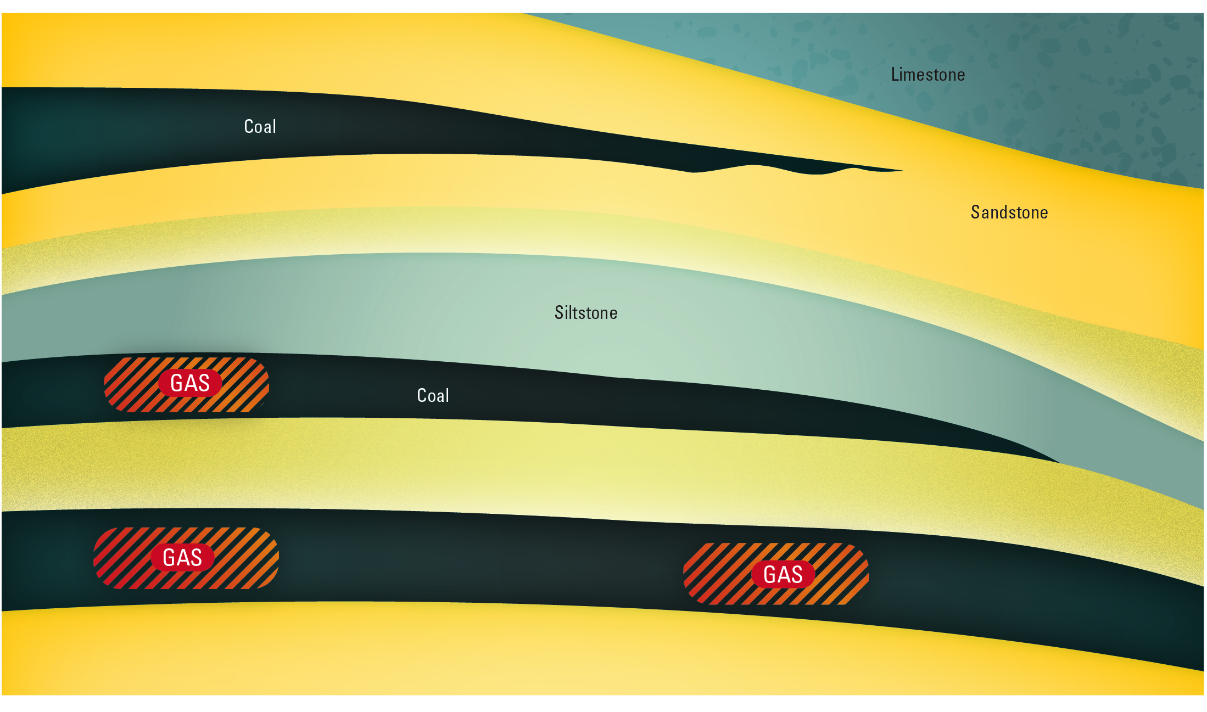
Figure 8.1 Coal seam gas schematic.
Gas can be generated by one of two ways – either by biogenic processes, where microbes convert the coal into methane or by thermogenic processes where heat drives chemical changes in the coal to produce methane. Biogenic and thermogenic processes are explained in more detail in Appendix 1.
Most gas in coals is stored by holding on to (or by being adsorbed on to) the coal surfaces and trapped by water pressure. When water pressure is reduced, gas will flow from the higher pressure area to the lower pressure area. This technique is used to allow the gas to flow towards a well where it is produced.

The permeability of the coal (how well the tiny pores and gaps within the coal are connected) is of great importance because no amount of gas trapped in coal will be released unless there is a path for it to flow from between the organic particles of the coal. Permeability tends to decrease with depth in the subsurface because rocks deeper down are compressed under the weight of rocks above, however shrinkage of the coal with maturation can lead to small fractures (known as cleats) that can provide permeability. Further discussion on how gas is stored and moves in coal is presented in Appendix 1.

Coal properties
Coal is largely composed largely of organic matter with some sedimentary particles like silt or clay (referred to as the ash content) and moisture (water trapped in the coal).These components and their constituents (e.g. carbon, hydrogen, oxygen and volatile matter) can all be measured via laboratory analysis. Coal composition can be quite variable, affecting the quality of the coal and as a consequence, its potential use.
Coals form from the deposition and burial of plant remains. The geological time period and prevailing environmental conditions influence the type of plant materials that grow and are deposited; and in turn determine the internal composition of the coal. Coals are comprised largely of a variety of microscopic constituents known as macerals; essentially like minerals in rocks. Different macerals give rise to different internal compositions within the coal, changing the ability to form gas and the potential to produce gas.
The depositional environment also influences the distribution of coals in a rock sequence whether the coal is widely distributed or limited in its extent; whether the seams are thick or thin; whether there are many closely stacked seams vertically or few separated by a lot of inter-seam (inorganic) material; and whether or not the seams are connected.
To what extent coal formation has occurred is also important. This is reported as coal rank (Figure 8.2). Rank is a product of the chemical and physical changes that take place within the organic matter in the coal over time and with increasing temperature. As the coals are more deeply buried and exposed to higher temperatures, the rank increases. When the coal rank has increased to anthracite all gas has been generated and is no longer in the coal; the coal is then said to be “overcooked”. Lower ranked coals have high moisture content whereas the highest ranked coals have lost their moisture. The capacity of a coal to hold gas generally increases with rank but the relationship is actually more complex and dependent on a number of variables (Moore, 2012). Lower rank coals such as lignite are more likely to present as a biogenic coal seam gas play, whereas higher ranked coals will tend towards thermogenic gas.
Coal rank can be defined in a number of ways. One of these is thermal maturity; a measure of which is vitrinite reflectance (expressed as Vr). Vitrinite is a type of maceral found in organic matter in coals. Reflectance is measured from a polished surface of vitrinite in a sedimentary rock immersed in oil (ASTM, 2011). Values which correspond to a coal rank suitable for coal seam gas range from about 0.2 to 2.0% (Figure 8.2).
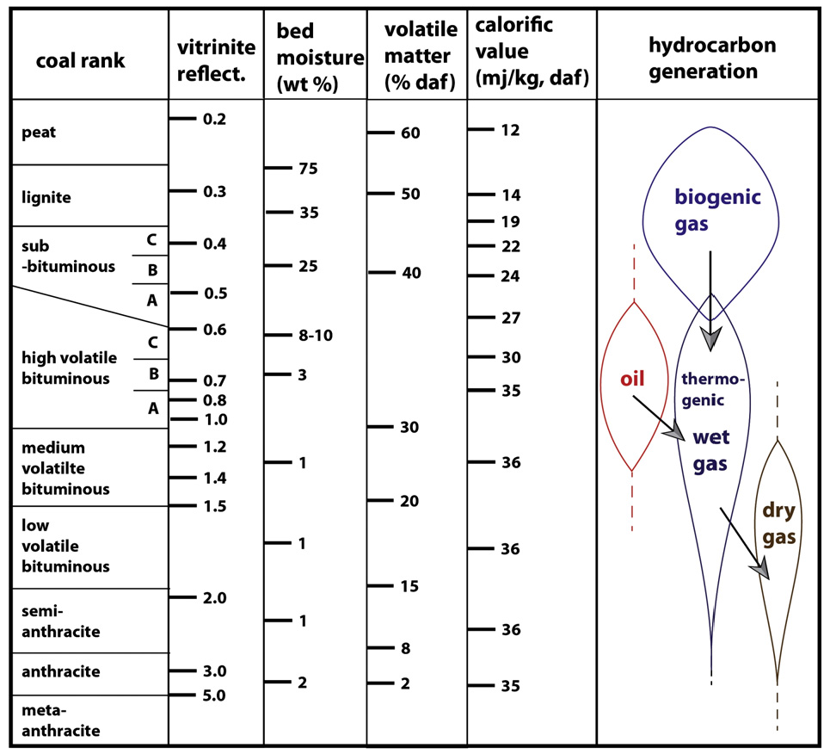
Figure 8.2 Correlation of different rank parameters, all approximate (after Moore, 2012).
The permeability and to a lesser degree, the porosity of a coal and the adjacent rocks is a key variable in the recovery of coal seam gas. The porosity of a rock refers to the gaps or pore spaces between the grains where fluids or gas can reside. If those gaps or pore spaces are well connected, the rock is considered permeable. Permeability may also be created by fractures in a rock – that is microscale displacement within the rock sequence. In coals in particular, fractures known as cleats form in two sets perpendicular to each other and are known as face and butt cleats. Cleats are important as they create both porosity and permeability in coal seam gas reservoirs.
Numerous different measurements of gas that can be taken from a coal sample to assess suitability for coal seam gas production. The first of these is the gas type or quality (e.g. hydrocarbons such as methane versus inert gases such as CO₂ – the latter of no value for combustion purposes). Next is the measurement of coalbed gas content by collection of freshly drilled coal samples and the measurement of gas emitted over weeks or months (gas desorption) as outline in Seidle (2011). The gas content in cubic metres per tonne is compared with the coal sample’s ultimate gas holding capacity to determine the saturation. A saturated coal will begin to release gas immediately as the hydrostatic pressure of water is relieved, whereas an undersaturated coal will require greater removal of water pressure before gas production begins. The pressures at which gas production begins and ceases are important factors in the design of production equipment and in measuring the economic recovery factor.
In the absence of reliable desorption gas content measurements the holding capacity, and other geological information may be used to estimate a possible gas content indirectly.

Coal seam gas from black coal
The black coals of the Early Cretaceous Eumeralla Formation have been intersected by petroleum exploration companies for many decades. Following the drilling of Killara-1, Buckingham (1992) first applied the informal name - the ‘Killara Coals’ to describe the coal seams found at the base of the Eumeralla Formation; although it was thought the coals were present in the upper part of the Pretty Hill Formation. Buckingham (1992) considered that the coals were a readily mappable seismic unit, represented by a series of high amplitude continuous reflectors.
Wakelin-King & Menpes (2007) compiled an inventory of coals in the Eumeralla Formation and the Crayfish Subgroup. Coal determinations were based on density and gamma ray log readings from petroleum wells. The work was carried out on behalf of Purus Energy which had begun exploration for coal seam gas within this sequence across the northern margin of the Otway Basin.

Black coal seam distribution and thickness
The extent of the black coals in the Eumeralla Formation had not been mapped prior to Purus taking up Exploration Licences across the Otway Basin. Blackburn (2003) used seismic data to map the coals across the northern extent of the basin in Casterton/Gordon, Branxholme/Digby, Hawkesdale/Woolsthorpe, Stoneyford/Tirrengowa, Nalangil/Warracbarunah, Tullich/Kanawinka and Terang (Evans et al., 2007). The extent of the coals outside these areas remains unknown but an area defining the ‘likely coal prospective area’ (Blackburn, 2003) includes the northern half of the basin.
Wakelin-King & Menpes (2007) identified coals across the Otway Basin in the “upper” Eumeralla, the basal section / Killara coals, and the Crayfish Subgroup. Seam thickness using this method would have been limited by the resolution of the logs but it is clear from the tabulated results that the seams were thin and cumulative thicknesses were low (many less than 10 m thickness). Purus then targeted the thickest potential coal seam intersections from the well review and seismic data at Gordon and Hawkesdale (Blackburn, 2003). This drilling confirmed the thin and sparse nature of the seams (Table 8.1).
Table 8.1 Best coal seam intersections in PGE-4 (Gordon) and PHE-1 (Hawkesdale).
Project area | Main coal sequence  interval depth  (m) | Thickest seam  (m) | Cumulative thickness  (m)
Gordon | 836.5 - 848 | 0.96 | 4.28
Hawkesdale | 602.6 - 662 | 1.9 | 5

Physical coal characteristics
Little is known about the coal quality of the Otway Group black coals. Unlike similar aged coals found near Wonthaggi in South Gippsland, the coals in the Otway Basin are rarely seen in outcrop or the near surface.
According to Cuffley (2002) proximate analysis for the Early Cretaceous Eumeralla coals are rare. Data ranges published by Douglas et al. (1988) from Merino Block bores (drilled to the far west of the state) are tabulated along with average values and ranges from the two Purus project areas (Gordon and Hawkesdale). The value ranges for moisture, volatile matter and fixed carbon tend to coincide for all sample areas in Table 8.2, whereas ash values from the Gordon area are on average much higher. Values for all parameters vary much more than those representing the Strzelecki Group. Strzelecki Group moisture content (5-10%) and ash (6-12%; Holdgate, 2003) is generally much lower than values recorded from the Eumeralla coals.
Table 8.2 Proximate analysis for Early Cretaceous black coals.
Project area | Depth  (m) | Average/Range | Air dried moisture  (%) | Ash  (%) | Volatile matter  (%) | Fixed Carbon  (%)
Gordon | 764 - 900 | Average | 13.7 | 36 | 22.1 | 23.9
 |  | Range | 10.2-17.8 | 7.9 – 61.5 | 13.9 – 34.4 | 14.4 – 41.8
Hawkesdale | 662 - 938 | Average | 18.2 | 12.16 | 31.1 | 38.5
 |  | Range | 16.5-21.3 | 6.3 – 25.9 | 29.0 – 34.4 | 32.5 - 40.4
Merino area | 11 - 194 | Range | 16.6 – 21.1 | 15.3 – 28.6 | 25.4 – 32.6 | 29.3 – 35.7

Black coal rank
From the synthesis of petroleum well completion report data, Evans et al. (2007) reported that the Killara coals (coals at the base of the Eumeralla Formation) had vitrinite reflectance values that varied from 0.4-0.6%, corresponding with sub-bituminous to high volatile C bituminous rank. These values apply to coals intersected above 1500m. Evans et al. (2007) noted that values from both the Otway Ranges and from deeper in the sequence (i.e. depths below 1500 m) were higher. These values are comparable with values for Strzelecki Group black coals in South Gippsland.

Coal seam gas measurements
Purus acquired ten gas content measurements from wells PGE-1, PGE-3 and PGE-4 in the Gordon project area (Table 8.3). The bulk of the measurements were acquired from PGE-4 between depths of 764.72 and 847.50 m. A weighted average of 3.11 m³/t was calculated (Evans et al., 2007). Thinner seams had higher gas content measurements and gas content values deceased with depth. A theoretical Langmuir isotherm value of 11.79 m³/t indicated that the coals were undersaturated.
Anomalously high nitrogen values (41.99 – 97.56%mol) were encountered (Table 8.3). CSIRO carried out isotope testing on the nitrogen gas on behalf of Purus, and established that the ratios were inconsistent with air contamination; however, the source of the nitrogen was not established.

Table 8.3 Gas content and composition data from the Gordon project area (Evans et al., 2007).
Well | Gas content (m³/t) - DAF | Nitrogen (%mol) | Methane (%mol)
PGE-1 | 5.07 | 94.75 | 4.72
PGE-2 | na | 97.56 | 2.02
PGE-3 | 5.61 | 84.67 | 15.11
PGE-4 | 1.58 – 10.47 | 48.75  41.99  53.12 | 50  55.04  44.29

Five gas content measurements were acquired from two wells in the Hawkesdale project area (Table 8.4). These ranged from 0.80 to 3.83 m³/t, comparatively lower than for the Gordon project area. Again, the coals were considered undersaturated with a Langmuir isotherm of 3.72 m³/t. In contrast with the Gordon project area, the gas composition was very high in carbon dioxide, which is not uncommon in the Otway Basin.
Table 8.4 Gas content and composition data from the Hawkesdale project area (Evans et al., 2007).
Well | Gas content (m³/t) - DAF | Nitrogen (%mol) | Methane (%mol) | Carbon Dioxide (%mol)
PHE-1 | 1.63 | 88.82 | 8.29 | 2.86
PHE-2 | 0.80-3.83 | 10.42  39.38  11.33 | <0.01  56.18  <0.01 | 89.58  3.99  88.66
PHE-3 | na | na | na | na

Black coal permeability
Purus determined the permeability of the Killara coals at the Gordon and Hawkesdale project areas (Evans et al., 2007). The permeabilities in the Gordon area ranged from 0.003 to 0.13 mD. In the Hawkesdale project area permeabilities ranged from 0.002 to 0.056 mD. These are very low values in comparison with the Walloon Coal Measures in Queensland (0.4 – 52 mD) and Gunnedah Basin coals (5.4 – 41 mD) (Evans et al., 2007).

Coal seam gas from brown coal
Brown coals are found on the eastern fringe of the Otway Basin. Coal seams at Anglesea, Bacchus Marsh, Benwerrin, Deans Marsh and Wensleydale have all been mined to some extent over the last 100 years or more. Miners were able to exploit these seams as the seams were all found close to or at the ground surface. Coal seam gas production from some of these seams would seem unlikely as most occur within 100 to 200 metres of the ground surface, even though their host formations might extend to depths of 700 metres (such is the case for the Eastern View Group at Anglesea).

Brown coal seam distribution
The brown coal deposits found to the west of Melbourne tend to be discrete and limited in their geographic extent in comparison to the vast deposits found underlying the Gippsland region.
In the Bacchus March area the Maddingley coal seams of the Werribee Formation are found within the Parwan Trough. The subsurface lateral extent of the seams covers an area of around 35 km long by 10 to 15 km wide (Holdgate, 2003). This area is bound by the NNW-SSE trending Parwan Trough, which extends from Bacchus Marsh to Altona. The greatest seam thickness of around 40 m is attained to the southeast of the Bacchus Marsh town-ship. The average seam depth is 69.5 m and the maximum seam depth is 235 m (Osborne, 2013).
The Anglesea coal seams of the Eastern View Group extend across an area 10 km long by 6 km wide (Holdgate, 2003). The deepest of the seams are found 70 m below the surface at the top of the Eastern View Group in the area. The Eastern View Group itself is about 700 m thick in the central Anglesea Syncline (Holdgate, 2003). Coal seam gas targets may be found in the deeper Eastern View Group seams in the Anglesea and Bells Beach synclines (as shown in Holdgate et al., 2005). In well Anglesea-1, drilled at the Eastern extent of the Anglesea coal mine, sands and brown coal seams are dominant in the upper section of the Eastern View Group intersected between 118 and 396 m (Oil Development N.L., 1962).
Three coal deposits are located at the extreme north-eastern extent of the Port Campbell Embayment in the Otway Basin at Wensleydale, Deans Marsh and Benwerrin. The seam thicknesses reach 40 m, 9 m and 2.5 m respectively (Gloe & Holdgate, 1991). The Benwerrin coals were considered very limited in extent, occupying less than 10 acres (Thomas & Baragwanath, 1950). The workings at Wensleydale were less than one kilometre in length (853 m) and 243 m in width (Thomas & Baragwanath, 1950).

Physical coal characteristics
Gloe & Holdgate (1991) summarise coal quality of the Otway coals (Table 8.5), although Deans Marsh values are taken from Thomas and Baragwanath (1950). Moisture contents for the Anglesea and Benwerrin coals are low relative to the others tabulated and the Gippsland brown coals. In comparison to the black coals discussed in the previous section these coals have very low ash.
Table 8.5 Proximate analysis from South west Victorian brown coals (Gloe & Holdgate, 1991; Deans Marsh values from Thomas & Baragwanath, 1950).
Coal deposit | Air dried moisture  (ar)% | Ash (db)% | Volatile matter  (db)% | Fixed Carbon  (db)%
Anglesea | 44.0 | 4.0 | 47.9 | 66.6
Bacchus March/Maddingley | 59.5 | 5.2 | 47.5 | 64.4
Benwerrin | 33.4 | 2.4 | 40.2 | 70.3
Deans Marsh | 54.5 | 4.3 | 20.3 | 20.8
Wensleydale | 50.8 | 3.3 | 45.7 | 66.3
ar = as received; db = dry basis

Brown coal rank
The Eastern View A Group coal seam is considered the highest rank of any brown coal extracted in Victoria based on its high net wet specific energy - 13.2 MJ/kg (Gloe & Holdgate, 1984; Holdgate et al., 2005). Coal from the B Group coal seam in the Bells Beach Syncline was tested by Eastern Star Gas Ltd in 2001 (Vlahovic & Jacobs, 2001d). Samples from 105.8 – 113.57 m had Vr values of 0.30-0.31% (Rv_{max}), which is within the normal range for lignite (Figure 8.2). Samples from the same drilling program also tested the Maddingley seams, which had similar values; 0.26-0.30% - also Rv_{max} (Vlahovic & Jacobs, 2001a,b,c).

Coal seam gas measurements
Gas content measurements have been obtained from the Maddingley and Eastern View Group B coal seams via a drilling program that was undertaken by Eastern Star Gas in 2001 over three exploration licences covering the Parwan Trough and the Bells Beach Syncline (Table 8.6). The measured gas contents were low (<0.01 - <0.56 m³/t). Only 14 gas content measurements could be determined from 49 samples (i.e. for 35 samples there was no gas content).
Table 8.6 Gas content data from Eastern Star coal seam gas drilling (Vlahovic & Jacobs,
2001a, b, c, d).
Well name | Trough/Basin | Coal seam name | Depth range  (m) | Results / No. of samples analysed | Gas content  m³/t
Ballan-1 | Parwan Trough | Maddingley | 144.2 – 180.6 | 5 /15 | <0.01 - <0.11
Cobbledick-1 | Parwan Trough | Maddingley | 174.68 – 200.50 | 4 /15 | <0.03 - <0.34
 | Parwan Trough | Maddingley Lower | 213.35 – 216.65 | 1 / 2 | <0.08
Point Cook-1 | Parwan Trough | Maddingley | 152.69 – 168.10 | 2 / 11 | 0.34 – 0.56
Portheath-1 | Torquay Sub-basin | Eastern View Seam B | 104.5 – 116.07 | 2 / 6 | <0.05 - <0.13

In Cobbledick-1 and Portheath-1 there was no methane or carbon dioxide present and in Ballan-1 there was no gas available for compositional analysis. A minor amount of methane (<1%) and carbon dioxide (~5%) was measured in Point Cook-1.

Brown coal permeability
No permeability values for the brown coals of the Otway Basin could be sourced for this review. Given the shallow burial depths of most coals in the Eastern View Group and Werribee Formation, it would be reasonable to assume some permeability in the formations. In Ballan-1, the coals were considered ‘highly permeable’ based on air-lift fluid production tests and high volume water injection tests (Vlahovic & Jacobs, 2001b).

Geological uncertainty
There are significant uncertainties that apply to the potential for natural gas resources across the onshore Otway Basin, most of which are associated with a lack of data to aid better understanding of unconventional plays and their gas potential.
The geological constraints on prospectivity for conventional targets are reasonably well understood. A long history of petroleum exploration has resulted in the acquisition of a significant amount of data particularly focused on Late Cretaceous conventional plays. At a regional scale, the subsurface geology down to the top of the Eumeralla Formation (i.e. just below the conventional Waarre Formation plays) is fairly well constrained owing to the density of seismic and well data. The exceptions are the northern margin of the basin and the Eastern Otway Basin where there has been less activity in the past. As a result of exploration for conventional targets, data acquisition or investigation of the Late Jurassic to Early Cretaceous stratigraphy where potential unconventional exploration targets reside is sparse.

Broad geological uncertainty
Of most importance to unconventional gas exploration, is the extent and depth of the Late Jurassic to Early Cretaceous troughs containing the Casterton Formation and the Crayfish Sub-group. These are broadly known (i.e. Jorand et al., 2010); however there has been limited detailed work. The study by Jorand et al. (2010) probably represents the best compilation of seismic and well data for the purpose of interpretation of the lower sedimentary sequence in the basin (i.e. the syn-rift section). This data was compiled and interpreted as part of joint Geoscience Australia, South Australian and Victorian government study of the hot sedimentary aquifers in the Otway Basin, with a focus onshore. Work to build on this 3D geological framework is currently underway (FROGTECH, 2015).

Delineation of formations of interest
Past geophysical surveys and drilling may help to aid in the identification of a geological unit, its presence or absence but the detailed stratigraphic knowledge of the sedimentary succession may be lacking. There may be some reasons for this: the data is available and of sufficient quality but it has not been studied or else the data is available but the quality is insufficient to support detailed analysis. Some examples pertinent to the current review of the onshore Otway Basin are provided.
A current 3D geological framework model exists for the onshore area of the basin north-west of the Otway Ranges (Jorand et al. 2010). Work on a more detailed interpretation and model to better resolve the distribution (presence/absence) and thickness of deeper unconventional target units based on the current dataset is underway (FROGTECH, 2015). Through this study, basin structural elements such as faults will be mapped, however, it is noted that smaller-scale pervasive faulting and fracturing important for unconventional play evaluation cannot be resolved on seismic images. Although regional models provide a framework and a good basis for further work, the issues associated with inconsistent seismic datums, velocity modelling and depth conversions result in an imperfect data set.
Exploration drilling through full sections of the units of greatest interest for unconventional gas (e.g. the Eumeralla Formation, Crayfish Sub-group and Casterton Formation), has been very limited in the Victorian part of the Otway Basin. The distribution of the Casterton Formation is largely unknown east of the Penola Trough, and the internal stratigraphy of the Crayfish Sub-group is poorly understood; as most wells that intersect it have only penetrated the top. Suggestions of prospectivity have been based on few wells and inferences are therefore elemental at best.
The delineation of the thickness and quality of black coals in the Eumeralla Formation has been poor. The density of drilling is insufficient to rule out the possibility that better coal may exist in restricted areas. Lateral variation in facies within the Eumeralla Formation is not recorded in detail and predictive models for facies variations leading to better coal, or better reservoir characteristics do not exist at this time.
For example, the Austral 2 source rocks of the Eumeralla Formation, at least within the vicinity of the Otway Ranges, were deposited in a large, high-energy, complex braided/anastomosing fluvial system. For this reason, the quality and richness of source rocks (as well as mechanical, petrophysical and elastic properties) will vary greatly both laterally and vertically, with the best source rocks probably located within the floodplain, swampy and over-bank deposits. In contrast to understanding the distribution of good conventional reservoirs, basic mapping of unconventional 'reservoirs' within the Eumeralla Formation is required. Seismic facies mapping of vintage data, integrated with re-evaluated and detailed well stratigraphy (using available core, palynology and wire-line petrophysical logs) may help with this gap in understanding (Tassone, 2013).

Specific rock characteristics
Once regional structure and target formation distribution are known, specific data about source rock, reservoir and sealing unit characteristics is required.
Using existing data it is possible to better understand the characteristics of target formations through log analysis and laboratory analysis of core and cuttings samples. Although there are numerous laboratory techniques that can be applied to existing core and cuttings, analysis on dried out ageing rock samples can be restricted due to sample deterioration whilst in storage. For this reason Tassone (2013) suggested that acquisition of new core samples and wet cuttings of Late Jurassic to Early Cretaceous sedimentary packages in key locations would be of benefit. Tassone (2013) considered that the reactivity of some of the mineral constituents within the Eumeralla Formation (with air) could drastically alter the rock's properties, leading to erroneous results with respect to the in situ conditions.
Tassone (2013) outlined some specific recommendations to further characterise tight and shale gas reservoirs in the Otway Basin.
- Historic sampling and analysis for porosity and permeability are useful for tight gas reservoir evaluation but many visibly low-permeability rocks have not been sampled. Sampling and analysis from these intervals to increase the vertical and geographic spread of porosity and permeability data available for evaluation would be beneficial.
- The mineralogy the volcanoclastic Eumeralla Formation does not lend itself well to the use of uncalibrated generic petrophysical relationships (as is usually applied to other rock types). Tassone (2013) considered that following a workflow outlined by Josh et al. (2012) to characterise shale gas target rocks would provide datasets suitable for such an evaluation. The method included laboratory testing of samples in order to establish relationships between key rock properties such as silt content, organic matter abundance and type, static and dynamic mechanical properties, micro/macro-fabrics, porosity, permeability, petrophysical properties and anisotropy.
- Understanding the variation in mechanical, petrophysical, petrological and elastic properties of unconventional target formations (testing different sedimentary facies) would help to constrain a good mechanical earth model that could form the basis/benchmark of future geomechnical modelling throughout the basin.
- Undertaking further investigation of source rock quality and richness of unconventional target formations.
- Lithology has a strong control on the leak-off pressures that is assumed to be a proxy for fracture propagation pressures and minimum horizontal stress magnitudes, which varies laterally and vertically. A systematic petrological investigation coupled with borehole imaging logging within Late Jurassic to Early Cretaceous stratigraphy would aid fracture propagation modelling.
- A detailed study on the in-fill composition of fractures, as well as the age and mechanism of fracture development and age of in-fill material has yet to be undertaken in the Otway Basin. Such a study, including fluid inclusion studies, would constrain the genesis of fracture formation relative to hydrocarbon generation and palaeo-pore pressures.
- Understanding stress-induced anisotropy in addition to weak vertical (layer) anisotropy would aid seismic processing as well as fracture propagation modelling. Full wave-form sonic data is available in the Otway Basin but rarely provides Upper Jurassic to Lower Cretaceous stratigraphic information. By re-logging existing wells (if possible) using newer advanced wire-line tools, anisotropy information could be acquired.
- Collecting further image log data would help to gain a better understanding of structural permeability in subsurface structural discontinuities (i.e. fractures and faults) that may be in-filled with calcite or quartoze material.

Gas prospectivity
The onshore Otway Basin remains prospective for conventional gas; in particular in the Port Campbell Embayment where over 20 conventional gas fields have been discovered and many produced. With proven petroleum systems (Austral 1 and Austral 2) in both Victoria and South Australia, the Otway Basin is also a target for tight and shale gas. Drilling has shown that there is gas present within the Eumeralla Formation but commercial quantities of tight or shale gas are yet to be produced from the region. No previous exploration in the Victorian portion of the Otway Basin has targeted shale gas. AWT, however, calculated a best estimate recoverable resource of 9 Tcf from of dry gas from shales in the Eumeralla Formation (Rawsthorn, 2013).
Exploration for coal seam gas from the older black coals of the Eumeralla Formation and younger brown coals of the Eastern View Group and Werribee Formation has been unsuccessful. In both cases the gas content measurements were low (although the readings from the brown coals were lower) and the gas quality was poor; in some cases nitrogen or carbon dioxide were the dominant fraction (i.e. over 90%).
Significant geological uncertainty remains at this time and recoverability of gas resources would be highly dependent upon the ability to apply suitable technologies to these resources, if required, and non-geological factors such as commodity prices.

Conventional gas
The Waarre Formation as a conventional gas play is considered ‘mature’. The Austral-2 petroleum system is proven in the Port Campbell Embayment. Successful exploration and production methods have been established. There is potential for remaining yet-to-be discovered fields in the region but like the Bcf-size fields discovered and produced to date, these are likely to be small relative to those situated offshore in the Shipwreck Trough.
In addition to the Port Campbell area, the Portland Trough/Gambier Embayment is interpreted as prospective, with peak hydrocarbon generation fairways for both the Austral 2 and Austral 3 petroleum systems identified (O’Brien et al., 2009). With contributions from the Turonian Waarre-Flaxman source system, O’Brien et al. (2009) considered that there is greater potential for geochemically wetter hydrocarbons.
The Pretty Hill Formation has good reservoir properties and potential sealing units within and above the formation. An understanding of the distribution of the formation is lacking in the east of the Otway Basin with better knowledge in the central and western areas. Shows have been encountered in the formation but no accumulations have been discovered. More prospective areas for conventional gas in the Pretty Hill Formation may align with areas of peak maturity for the Austral 1 petroleum system (as presented in O’Brien et al., 2009).

Tight gas
The Eumeralla Formation is prospective for tight gas. Gas indications in the uppermost part of the formation, directly beneath the Waarre Formation conventional gas, are concentrated in the Port Campbell Embayment. Gas has flowed at low rates from a number of wells penetrating the top of the Eumeralla Formation in this region (e.g. Tassone, 2013). As these wells were drilled to intersect conventional gas in structures, gas flows from the top (or near the top) of the Eumeralla Formation, indicate that the Austral 2 petroleum system (i.e. a functional source and tight reservoir) is present. These gas shows, however, do not necessary establish the prospectivity for tight gas through the body of the Eumeralla Formation. It is worth considering whether or not tight gas encountered in the Otway Basin fit the classification as described by Shanley et al. (2004) where tight reservoirs are confined to structures rather than continuous tight basin-centred gas across wider areas.
At the base of the Eumeralla Formation, in some areas, there are indications of locally improved reservoir conditions. Examples include the Windermere Trough (e.g. the Windermere Sandstone) and the Heathfield Sandstone in Heathfield-1 (in the Penola Trough). These quartz dominated sandstones have greater porosity and therefore better reservoir potential. To date, hydrocarbon shows encountered in these units have been oil rather than gas.
Gas composition tests from coal seam gas exploration have identified high nitrogen (i.e. greater than 90%) and carbon dioxide contents (i.e. around 50%) in the Eumeralla Formation at the northern margin of the basin (i.e. the Gordon and Hawkesdale project areas of Purus Energy). Such gases are likely to have a deep crustal origin (Boreham et al., 2004). The presence of gases other than methane in these areas is likely to have implications for tight gas exploration; not only in these areas but perhaps in other similar settings within the basin.

Shale gas
In the United States, the most successful shale oil plays (that also have associated shale gas plays) have a number of similarities. These plays have concentrated Type II kerogen in marine strata, present-day total organic carbon (TOC) >2%, a net thickness of TOC-rich rocks > 20 m, thermal maturity in the oil window (for oil, with shale gas reservoirs being overmature oil source rocks), a brittle lithology that can sustain fractures, abnormally high fluid pressures, and a tectonic history conductive to oil retention.
Large shale gas plays in the United States such as Eagle Ford and the Barnett Shale have marine derived Type II kerogen. In the Casterton and Eumeralla Formations, there is evidence of these kerogen types. TOC-rich rocks are present in both the Casterton and Eumeralla formations but their associated lithologies require further investigation.
The distribution of the Casterton Formation is not well known but is expected to occur at depth in the Early Cretaceous troughs that form the first-deposited section of the Otway Basin. The Casterton Formation has not yet been intersected in all such troughs and its presence, thickness and character across the Otway Basin is poorly known. More detailed information to characterise the formation is desirable. The Casterton Formation is known to occur in the Penola Trough and is considered most prospective in that area, but this may be driven by the increased availability of data in that area, relative to other areas.
Shale units have been identified in the Crayfish subgroup (Guzel, 2015) and the Eumeralla Formation (Tassone, 2013). Issues surrounding the identification of the Laira Formation versus the shaley upper section of the Pretty Hill Formation need to be addressed, with attribution of data to the correct unit.
Rawsthorn (2013) determined a best estimate recoverable resource of 9 Tcf of dry gas in the Eumeralla Formation over an area of 4109 km² (roughly between Portland and Port Campbell). Although the author lists O’Brien et al. (2009) as a reference, the area outlined in Rawsthorn (2013) for assessment does not correspond to the peak Austral 2 prospective zone of the former.

Coal seam gas
Past explorers have targeted coal seam gas from brown coals located at the eastern extreme of the basin and older black coals along the northern margin of the basin. Shallow brown coals in the Bells Beach Syncline (Torquay Sub-basin) and the Parwan Trough had very low gas contents (<0.01 - <0.56 m³/t). Little methane was detected from gas composition testing. A pilot project to test flow rates for water and gas from the Maddingley coal seams in the Parwan Trough was unsuccessful with very low flow rates.
The brown coals targeted for exploration were immature with low (0.3%) vitrinite reflectance values. In many instances, gas content was unable to be determined because the volume of gas was too low.
Purus Energy, the licence holder operating at the northern margin of the basin, determined that both project areas (Gordon and Hawkesdale) did not constitute viable coal seam gas projects due to variable and low gas contents, poor gas quality (i.e. mostly nitrogen in Gordon and carbon dioxide in Hawkesdale) and low permeability values (Evans et al., 2007). Purus Energy undertook an exploration program in which available data was reviewed and locations for drilling were high-graded. The approach taken to determine permeablility, gas quality and gas content was consistent with industry practice and would be expected to yield good results in a prospective area.
All attempts to discover coal seam gas accumulations in the Otway Basin have proven unsuccessful. However, brown coal seams deeper in the sequence (within the Torquay Sub-basin), located closer to the coast may be more prospective. Further attempts to search for coal seam gas in the Eumeralla Formation might rely more heavily on the identification and delineation of target seismic facies.

Hypothetical gas development scenarios
Hypothetical development scenarios for the Otway Basin are considered at a prospect/field scale and at a sub-regional scale. Prospectivity is indicated on a regional scale for conventional, tight and shale gas based on previous mapping of target formations or maturity of source rocks or both within the Austral petroleum systems (O’Brien et al., 2009). The main focus for resource development scenarios in the onshore Otway Basin is on the two depocentres where gas resources have been discovered and produced in the past – the Port Campbell Embayment in Victoria and the Penola Trough in South Australia (see Figure 2.1). Information included in the following sub-sections is tabulated in Appendix 2.

Conventional gas
In the Port Campbell Embayment, a number conventional gas fields have been discovered, developed and depleted. The two scenarios outlined here are therefore located within that region (Figure 11.1). At a regional scale, the extent of the Sherbrook Group, with the Waarre Formation (the conventional hydrocarbon target formation) at its base, and the location of mature Austral 2 source rocks (O’Brien et al., 2009) provide some indication of the distribution of potentially prospective areas, with the Port Campbell Embayment considered most prospective.

Scenario 1 – Prospect/field scale
A number of relatively small conventional gas fields were developed in the Port Campbell Embayment between 1986 and 2006. A field scale assessment based on the production of gas from the Iona field was chosen for the field scale scenario.

Scenario 2 – Sub-regional scale
A cluster of fields within the Port Campbell Embayment were discovered, and some but not all, were developed and depleted. A cluster of fields located within the Port Campbell Embayment (Langley/Grumby, North Paaratte, Skull Creek, Dunbar and Wallaby Creek) was chosen to represent this scale of development.

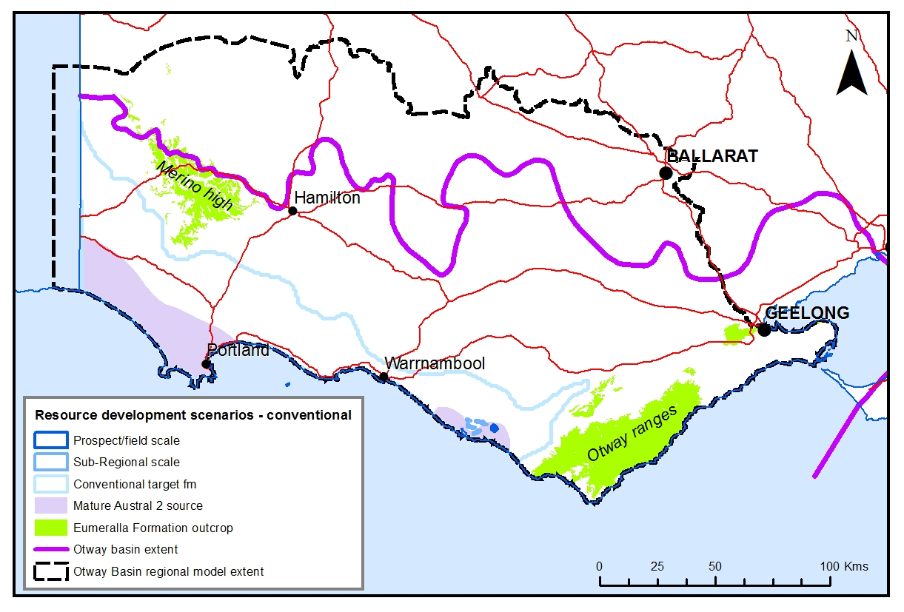
Figure 11.1 Otway Basin conventional gas resource development scenarios.

Tight gas
Tight gas has long been identified in the Eumeralla Formation, underlying the Waarre Formation conventional resources in the Port Campbell Embayment and elsewhere in the basin (e.g. Bain, 1961; O’Brien & Edwards, 2005 respectively). Any area within the mature Austral 2 source polygon (Figure 11.2) could be prospective for tight gas. The Austral 1 sourced Pretty Hill Formation in the west of the basin may also be a prospective tight gas target.

Scenario 1 – Prospect/field scale
The Moreys-1 petroleum well drilled by Lakes Oil (JV with Armour Energy) in 2012 intersected the Waarre ‘C’ Formation conventional play and the primary target for the well, the Eumeralla Formation, between 1985 and 1995 m down-hole depth. The prospect, delineated by Armour Energy and Lakes Oil in various online announcements (e.g. Armour Energy Limited, 2012), covers an area of almost 6 km².

Scenario 2 – Sub-regional scale
The sub-regional scale scenario polygon (Figure 11.2) is based on the geographic distribution of petroleum wells with shows that are Austral 2 sourced (although some of these occur outside the mature zone identified by O’Brien et al., 2009). The area covers around 141 km² and the top of the formation is intersected between 1300 and 2200 m; with the base of the formation deeper than 3500 m at the coast (i.e. in Flaxmans-1).
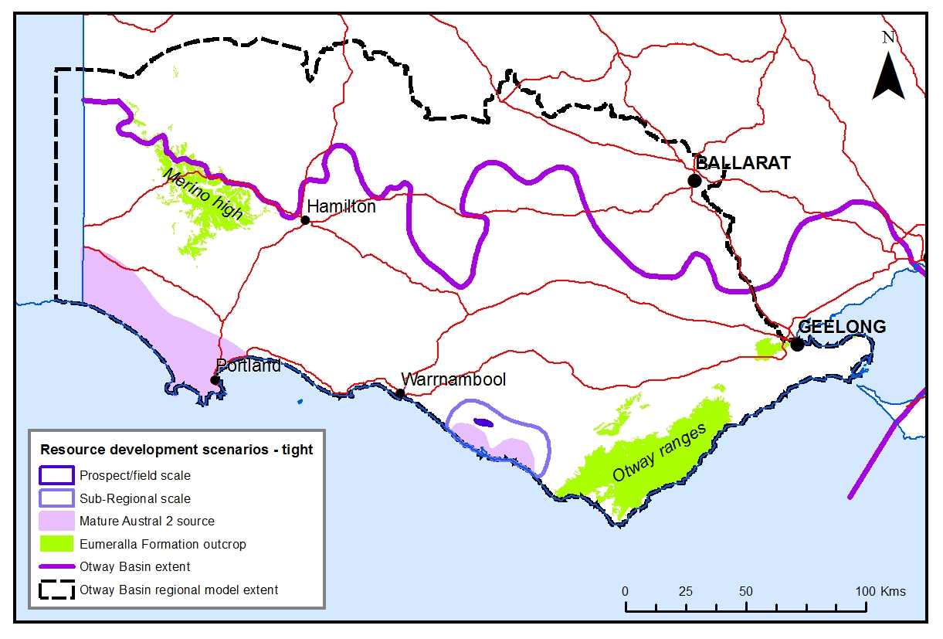Figure 11.2 Otway Basin tight gas resources development scenarios.

Shale gas
The Casterton Formation is considered a target for shale gas in the Otway Basin’s Penola Trough – in the far west of the state. Two scenarios are identified – one at the prospect scale and the other at a sub-regional scale (Figure 11.3). Where the Austral 1 source is mature (Figure 11.3; from O’Brien et al., 2009), prospectivity for shale gas is increased. There is little data for the east of the basin (i.e. north and north-east of the Otway Ranges) so prospectivity is less certain in that area.
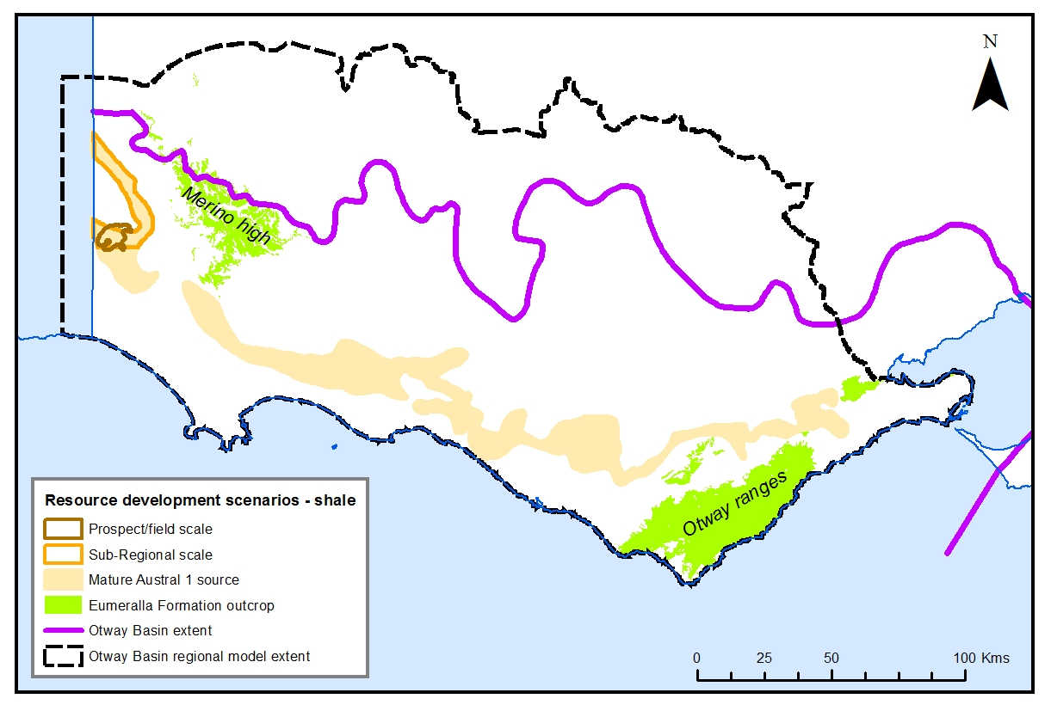
Figure 11.3 Otway Basin shale gas development scenarios.

Scenario 1 – Prospect/field scale
The size of the prospect/field scale polygon for shale gas is based on a shale gas prospect in the Cooper Basin; its extent is 46km². It is difficult to establish the size of such a development in Australia, as exploration and development of such a resource is at an early stage. In this case the prospect size is considered an upper limit as the extent of the Casterton Formation covers a substantially smaller area than the prospective units in the Cooper Basin.

Scenario 2 – Sub-regional scale
The sub-regional scale scenario polygon (Figure 11.3) covers an area of around 326 km² over the Penola Trough within an active Petroleum Exploration Permit. The area is delineated by the extent of the mature Austral 1 petroleum source in the Penola Trough (O’Brien et al., 2009).

Coal seam gas
Aptian aged black coals (the Killara coal measures) and younger Tertiary brown coal deposits sub-crop in the Otway Basin. The focus of past coal seam gas exploration in the Otway Basin proper has been the Killara coal measures. The younger brown coals (i.e. in the Torquay Sub-basin and Parwan Trough) have also been targeted for exploration but their low gas contents decrease prospectivity.
One or a combination of prospects in the Killara coal measures may be considered for modelling at either a prospect or a sub-regional scale (Figure 11.4). The polygons are based on the project areas identified by Purus Energy, which held exploration licences (now surrendered) across the northern margins of the Otway Basin, where the base of the Eumeralla Formation and hence the Killara coal measures occur at shallower depths.
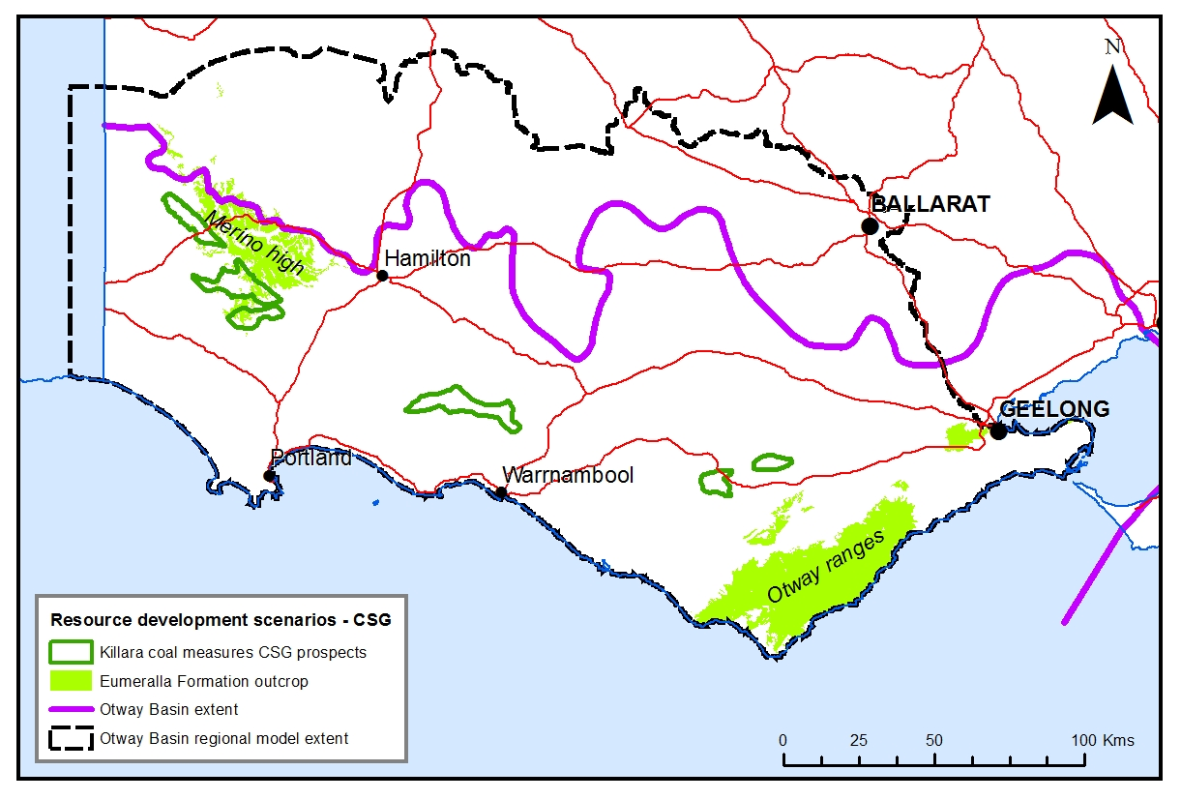
Figure 11.4 Otway Basin coal seam gas development scenarios.

Conclusions
Numerous sedimentary sequences in the onshore Otway Basin are prospective for gas.
The Waarre Formation is a proven target for conventional gas, especially in the Port Campbell Embayment. The Port Campbell Embayment has a working petroleum system that has been proven through the discovery and recovery of around 89 Bcf of gas (Department of Primary Industries, 2007). Further discoveries, although small relative to those encountered offshore, are possible in the area. The Pretty Hill Formation is a proven conventional gas reservoir in the South Australian Otway Basin. Reservoir quality in the Victorian Pretty Hill Formation would seem conducive to conventional hydrocarbon plays but the formation may also have tight gas potential.
The primary target for tight gas is the Eumeralla Formation. Tight gas within the Eumeralla Formation and the Pretty Hill Formation has been subjected to less direct investigation than conventional targets. Shows and indications from conventional wells suggest there is some prospectivity, and the companies presently holding exploration permits list these play types as being potential targets. Tight gas, specifically in the Eumeralla Formation, is prospective by virtue of shows and gas flows from the top of that formation in several previous wells, particularly in the Port Campbell Embayment. The extent of prospectivity beyond the confines of conventional traps in which these indications have been noted is yet to be established.
There is considered to be potential for shale gas in the Casterton Formation with some potential in the Eumeralla Formation. The existence of the Casterton Formation within other depocentres beside the known occurrences in the west of Victoria is not well established and would be of significance in determining the prospectivity of this unit for shale gas.
The ‘Killara coal measures’ so far tested at the northern margin of the Otway Basin have little coal seam gas potential but other unidentified black coals in the Eumeralla Formation may host ‘yet-to-find’ coal seam gas.
Poor results from drilling of the younger Eastern View Group and Werribee Formation brown coals suggests’ that coal seam gas potential in these coals is less likely. While only a small number of holes were drilled to assess coal seam gas potential, the nature of the work carried out under the exploration was technically adequate to evaluate the wells. The spread of holes in the basin is insufficient to make definitive statements but it is clear that the prospectivity for coal seam gas in the Otway Basin has been reduced rather than enhanced by previous exploration.
There is sufficient information derived from prior conventional petroleum and coal seam gas exploration to identify areas that are more prospective. There is less uncertainty associated with the geology in the onshore Otway Basin than for the Gippsland Region but some knowledge is better constrained in some areas and for certain geological units. For example, the distribution of some formations, such as the deeper Casterton and Pretty Hill formations is not well understood. As in the Gippsland Basin, where data does exist, it is often insufficient for the proper characterisation of unconventional gas potential. Unlike the Gippsland region where there has been only one proper test for coal seam gas content, in the Otway Basin, two separate exploration programs have tested gas contents and compositions.
In the offshore Otway Basin 850 PJ of gas have been produced, and an estimated 1292 PJ of conventional gas remains in place. This remaining conventional gas sits at the top of the resource pyramid (e.g. McCabe, 1998) where small volumes of high quality gas resources are relatively easy to develop and less costly to extract. For the most part, onshore gas resources, particularly the unconventional resources, sit at the base of the pyramid. These might be larger in volume but lower in quality and are more difficult to develop and at a greater cost.

References
ARMOUR ENERGY LIMITED, 2012. Armour Energy Limited 10 May 2012 Moreys 1 Encounters Tight Gas and Condensate Armour Energy and Lakes Oil to Spud New Well in PEP166. http://www.armourenergy.com.au/assets/downloads/announcements/2012/may/asx_20120510-Moreys-1-Encounters-Tight-Gas-and-Condensate.pdf. Accessed 27th October 2014.
AMERICAN SOCIETY FOR TESTING AND MATERIALS (ASTM), 2011, Standard test method for microscopical determination of the reflectance of vitrinite dispersed in sedimentary rocks: West Conshohocken, PA, ASTM International, Annual book of ASTM standards: Petroleum products, lubricants, and fossil fuels; Gaseous fuels; coal and coke, Sec. 5, V. 5.06, D7708-11, pp. 823-830, doi: 10.1520/D7708-11, http://www.astm.org/Standards/D7708.htm Accessed 9th May 2012.
APPEA, 2015. Australian oil and gas glossary. http://www.appea.com.au/industry-in-depth/australia-oil-and-gas-glossary/ Accessed 21st May 2015.
BAIN, J. S., 1961. Well completion report Flaxmans No.1 Southwest Victoria. Frome-Broken Hill Company Pty Ltd. Report No. 7200-G-85. Unpublished Report. 86p.
BAIN, J. S., 1964. Well Completion Report – Ferguson’s Hill No. 1, Southwest Victoria. Frome-Broken Hill Company Pty Ltd. Unpublished Report.
BERNECKER, T., SMITH, M. A., HILL, K. A. & CONSTANTINE, A. E., 2003. Oil and gas – fuelling Victoria’s economy. In W.D Birch (ed.) Geology of Victoria, Geological Society of Australia Special Publication 23, pp. 469-487.
BLACKBURN, G., 2003. Coal Bed Methane Study, Onshore Otway Basin, Victoria. Terratek Pty Ltd. Unpublished Report.
BOCK, P. E. & GLENIE, R. C., 1965. Late Cretaceous and Tertiary depositional cycles in southwestern Victoria. Proceedings of the Royal Society of Victoria, 79, pp. 153-163.
BOREHAM, C. J., HOPE, J. M., JACKSON, P., DAVENPORT, R., EARL, K. L., EDWARDS, D. S., LOGAN, G. A. & KRASSAY, A. A., 2004. Gas–oil–source correlations in the Otway Basin, southern Australia In P. J. Boult, D. R. Johns & S. C. Lang (eds) Eastern Australasian Basins Symposium II: Petroleum Exploration Society of Australia Special Publication, pp. 603–627.
BOYD, G.A. & GALLAGHER, S.J., 2001. The sedimentology and palaeoenvironments of the Late Cretaceous Sherbrook Group in the Otway Basin. In K.C. Hill & T. Bernecker (eds) Eastern Australasian Basins Symposium – A Refocussed Energy Perspective for the Future, Petroleum Exploration Society of Australia, Special Publication, pp. 475-483.
BRADSHAW, M.T., 1993, Australian Petroleum Systems. Petroleum Exploration Society of Australia Journal, 21,
pp. 43-53.
BROWN, G.A., 1965. New Geological Concepts in the Casterton Area, Otway Basin, Victoria. APEA Journal 5,
pp. 27-35.
BROWN, B.J., MÜLLER, R.D., GAINA, C., STRUCKMEYER, H.I.M., STAGG, H.M.J. & SYMONDS, P.A., 2003. Formation and evolution of Australian passive margins: implications for locating the boundary between continental and oceanic crust. Geological Society of Australia Special Publication 22 and Geological Society of America Special Paper 372, pp. 223‐243.
BUCKINGHAM, I. D., 1992. Well Completion Report Killara-1 PEP 101 Otway Basin Victoria, Volume 1: text. Anglo Australian Oil Company N.L.. Unpublished Report, 62p.
BUFFIN, A., J. 1989. Waarre Sandstone Development within the Port Campbell Embayment. The APEA Journal,
pp. 299-311.
CUFFLEY, B. W., 2002. Coal Bed Methane Project, Otway Basin. Coal references in well completion reports, petroleum and stratigraphic wells. Northern Margin – Prospective zone onshore Otway Basin, South West Victoria, Australia. Unpublished report, 247p.
CUPPER, M. L., WHITE, S. & NEILSON, J. L., 2003. Quaternary: ice ages – environments of change. In W.D. Birch (ed) Geology of Victoria, Geological Society of Australia, Special Publication 23, pp. 337-359.
DICKINSON, J.A., WALLACE, M.W., HOLDGATE, G.R., DANIELS, J., GALLAGHER, S.J. & THOMAS, L., 2001. Neogene tectonics in SE Australia: implications for petroleum systems, The APEA Journal, 41, pp. 37-52.
DOUGLAS, J. G., ABELE, C., BENEDEK, S., DETTMAN, M. E., KENLEY, P. R., LAWRENCE, C. R., RICH, T. H. V. & RICH P. V., 1988. Mesozoic. In J. G. Douglas & J. A. Ferguson (eds.) Geology of Victoria, Victorian Division Geological Society of Australia, pp. 213‐250.
DEPARTMENT OF PRIMARY INDUSTRIES, 2007. Victoria’s Minerals, Petroleum and Extractives Industries 2005/06 Statistical Review. Department of Primary Industries.
DUDDY, I.R., 2003. Mesozoic, a time of change in tectonic regime. In W.D. Birch (ed) Geology of Victoria, Geological Society of Australia, Special Publication 23, pp. 239‐286.
EDWARDS, D.S., STRUCKMEYER, H.I.M., BRADSHAW, M.T. & SKINNER, J.E., 1999. Geochemical Characteristics of Australia’s Southern Margin Petroleum Systems. Australian Petroleum Production and Exploration Association Journal, 39(1), pp. 297-321.
EVANS, T.J., CUFFLEY, B. W. & BLAKE, R., 2007. Exploration licences EL4604, EL4952 Coal Seam Gas project onshore Otway Basin South West Victoria – Final annual technical and relinquishment report. Purus Energy Ltd, Unpublished report, 127p.
FROGTECH, 2015. 3D geological framework of the onshore Otway Basin. FROGTECH Pty Ltd, Canberra, Australia. Unpublished report.
GEARY, G. C. & REID, I. S. A., 1998. Geology and prospectivity of the offshore eastern Otway Basin, Victoria – for the 1998 acreage release. Victorian Initiative for Minerals and Petroleum Report 55. Department of Natural Resources and Environment.
GEOSCIENCE AUSTRALIA, 2015. Oil and gas resources of Australia – 2009. http:www.ga.gov.au/data-and-publications-search/publications/oil-gas-resources-australia/2009 Accessed 21st May 2015.
GEOSCIENCE AUSTRALIA & BREE, 2014. Australian Energy Resource Assessment. 2nd Ed. Geoscience Australia, Canberra.
GIBSON-POOLE, C. M., EDWARDS, S., LANGFORD, R. P. & VAKARELOV, B., 2006. Review of Geological Storage Opportunities for Carbon Capture and Storage (CCS) in Victoria. The Cooperative Research Centre for Greenhouse Gas Technologies (CO2CRC), Australian School of Petroleum, The University of Adelaide, Adelaide, Report No ICTPL-RPT06-0506.
GLOE, C. S.,1984. Chapter 4 - The geology, discovery, and assessment of the brown coal deposits of Victoria. In J. T. Woodcock (ed.) Victoria’s brown coal – a huge fortune in chancery. The Australasian Institute of Mining and Metallurgy, pp. 79-109.
GLOE & HOLDGATE, G., 1991. Chapter 1 - Geology and Resources. In R.A. Durie (ed.) The Science of Victorian Brown Coal: Structure, Properties and Consequences for Utilisation, Butterworth-Heinemann, Oxford, UK.
GOLDSTEIN, B., MENPES, S., HILL, A., WICKHAM, A., ALEXANDER, E., JAROSZ, M., PEPICELLI, D., MALAVAZOS, M., STARITSKI, K., TALIANGIS, P., CODA, J., HILL, D. & WEBB, M., 2012. Roadmap for unconventional gas projects in South Australia. Energy Resources Division, Department of Manufacturing, Innovation, Trade, Resources and Energy, Government of South Australia. 267p.
GUZEL, M., 2015. Review of Formation Tops of the onshore Otway Basin, Victoria, Australia. Unpublished report.
HAINES, L., 2006. Tight Gas, Oil and Gas Investor, Houston, Texas, Hart Energy Publishing, LP.
HODGKINSON, C., BROUGH SMYTH, R. & COUCHMAN, T., 1873. Coalfields: Loutit Bay District. Geological Survey Progress Report No. 1, Mines Department, pp. 91-98.
HOLFORD, S. P., TUITT, A. K., HILLIS, R. R., GREEN, P. F., STOKER, M. S., DUDDY, I. R., SANDIFORD, M. & TASSONE, D.R., 2014. Cenozoic deformation in the Otway Basin, southern Australian margin: implications for the origin and nature of post‐breakup compression at rifted margins. Basin Research 26, pp. 10‐37.
Holdgate, G. R., 2003. Coal – world class energy reserves without limits. In W.D Birch (ed.) Geology of Victoria, Geological Society of Australia Special Publication 23, pp. 489-517.
HOLDGATE, G. R. & GALLAGHER, S. J., 2003. Tertiary, a period of transition to marine basin environments. In W.D. Birch (ed.) Geology of Victoria, Geological Society of Australia, Special Publication 23, pp. 289‐335.
HOLDGATE, G. R., SMITH, T. A. G., GALLAGHER, S. J. & WALLACE, M. W., 2005. Geology of the coal-bearing Palaeogene sediments, onshore Torquay Basin, Victoria. Australian Journal of Earth Sciences, 48, pp. 657-679.
HOLDITCH, S.A., 2006: Tight gas sands. Journal of Petroleum Technology, 58(6), pp. 86-93.
JORAND, C., KRASSAY, A. & HALL, L., 2010. Otway Basin Hot Sedimentary Aquifers & SEEBASETM Study. Geoscience Victoria 3D Victoria Report 7. Department of Primary Industries.
JOSH, M., ESTEBAN, L., DELLE PIANE, C., SAROUT, J., DEWHURST, D.N. & CLENNELL, M.B., 2012. Laboratory characterisation of shale properties. Journal of Petroleum Science and Engineering, 88-89, 107-124.
KEATING, K., 1993. The lithostratigraphy, palynology and sequence stratigraphy of the Pebble Point Formation. Unpublished BSc (Hons) thesis. La Trobe University, Bundoora, Victoria.
KOPSEN, E. & SCHOLEFIELD, T., 1990. Prospectivity of the Otway Supergroup in the central and western Otway Basin. The APEA Journal, 30, pp. 263-278.
KRASSAY, A.A., CATHRO, D.L. & RYAN, D.J., 2004. A regional tectonostratigraphic framework for the Otway Basin. In P.J. Boult, D.R. Johns & S.C. Lang (eds) Eastern Australasian Basins Symposium II, Petroleum Exploration Society of Australia, Special Publication, pp. 97‐116.
LANIGAN, K., 1995. Well completion report Digby-1, Digby joint venture Otway Basin, Victoria. GFE Resources Ltd. Unpublished Report.
LAVIN, C.J., 1997. A review of the prospectivity of the Crayfish Group in the Victorian Otway Basin. Journal of the Australian Petroleum Production and Exploration Association, 37, pp. 232-244.
LAVIN, C. J., 1998. Geology and prospectivity of the western Victorian Voluta Trough, Otway Basin, for the 1998 Acreage release. Victorian Initiative for Minerals and Petroleum Report 41, Department of Natural Resources and Environment.
LAW, C., A., 1999. Evaluating source rocks. In E. A. Beaumont & N. H. Foster (eds) Exploring for oil and gas traps. America Association of Petroleum Geologists, Oklahoma, US.
LOVIBOND, R., SUTTILL, R.J., SKINNER, J.E. & ABURAS, A.N., 1995. The Hydrocarbon Potential of the Penola Trough, Otway Basin. APEA Journal 35, pp. 358-371.
MARTIN, J. P., HILL, D. G., LOMBARDI, T. E. & NYAHAY, R., 2010. A primer on New York’s gas shales. http://offices.colgate.edu/bselleck/AppBasin/GasshaleMartin.pdf. Accessed 11th March 2015.
MCCABE, P. J., 1998. Energy Resources – Cornucopia or Empty Barrel? AAPG Bulletin, 82(11), pp. 2110-2134.
MCCARTHY, K., NIEMANN, M., PALMOWSKI, D., PETERS, K. & STANKIEWICZ, A., 2011. Basic Petroleum Geochemistry for Source Rock Evaluation. Oilfield Review, 23(2), pp. 32-43.
MEHIN, K. & CONSTANTINE, A, E., 1999. Hydrocarbon potential of the Western Onshore Otway Basin in Victoria: 1999 Acreage Release. Victorian Initiative for Minerals and Petroleum Report 62. Department of Natural Resources and Environment. 71p.
MEHIN, K. & KAMEL, M., 2002 Gas resources of the Otway Basin in Victoria. Department of Natural Resources and the Environment. 54p.
MITCHELL, M.M., DUDDY, I.R. & O’SULLIVAN, P.B., 1997. Reappraisal of the age and origin of the Casterton Formation, western Otway Basin, Victoria. Australian Journal of Earth Sciences 44, pp. 819-830.
MOORE, T.A., 2012. Coalbed methane: A review. International Journal of Coal Geology, 101, pp. 36 – 81.
MORGAN, R., 1997. Early Cretaceous/Latest Jurassic palynology review of the Victorian Otway Basin. Morgan Palaeo Associates Report 1997/14.
MORGAN, R., ALLEY, N.F., ROWETT, A.I. & WHITE, M.R., 2002. Chapter 7 - Biostratigraphy. In P.J. Boult & J.E. Hibburt (eds) The Petroleum Geology of South Australia. Volume 1: Otway Basin. Second edition, South Australia, Department of Primary Industries and Resources, Petroleum Geology of South Australia Series.
MORTON, J. G. G., SANSOME, A. & BOULT, P. J., 2002. Chapter 10 – Reservoirs and seals. In P. J. Boult & J. E. Hibburt (eds) The Petroleum Geology of South Australia, Volume 1, Otway Basin. Second edition. South Australian Department of Primary Industries and Resources. Petroleum Geology of South Australia Series.
MORTON, J.G.G., HILL, A.J., PARKER, G. & TABASSI, A. 1994. Towards a unified stratigraphy of the Otway Basin. In: National Geoscience Mapping Accord Symposium April 1994, Melbourne, Australian Geological Survey Organisation Record 1994/14, pp. 7-12.
NORVICK, M.S. & SMITH, M.A., 2001. Mapping the plate tectonic reconstruction of southern and southeastern Australia and implications for petroleum systems. The APPEA Journal 41, pp. 15‐35.
O’BRIEN, G.W., BOREHAM, C.J., THOMAS, H. & TINGATE, P. R., 2009. Understanding the critical success factors determining prospectivity – Otway Basin, Victoria. APPEA Journal, p. 129-170.
O’BRIEN, T. & EDWARDS, B., 2005. Bellarine-1 Exploration Well in PEP 163 Victoria: Well completion report. Lakes Oil N. L. Unpublished Report. 34p.
OIL DEVELOPMENT N. L., 1962. Completion report for Anglesea Well No. 1 P.P.L. 256, Victoria. Unpublished report.
ORIGIN ENERGY, 2014. Origin confirms new gas discovery offshore Victoria. http://www.originenergy.com.au/news/article/asxmedia-releases/1625. Accessed 18th March 2015.
OSBORNE, C. R., 2013. Parwan Trough inventory coal estimate. Department of Economic Development, Jobs, Transport and Resources. Unpublished Report.
OTTMANN, J. & BOHACS, K., 2014. Conventional Reservoirs Hold Keys to the ‘Un’s’. American Association of Petroleum Geologists, Explorer, February 2014.
PARKER, G. J., 1995. Early Cretaceous stratigraphy along the northern margin of the Otway Basin, Victoria. Victorian Initiative for Minerals and Petroleum Report 23. Department of Agriculture, Energy and Minerals.
PARTRIDGE, A. D., 2001. Revised Stratigraphy for the Sherbrook Group. In K.C. Hill & T. Bernecker (eds) Eastern Australasian Basins Symposium – A Refocussed Energy Perspective for the Future, Petroleum Exploration Society of Australia, Special Publication, pp. 455-464.
PARTRIDGE, A.D., 2006a. Jurassic – Early Cretaceous spore‐pollen and dinocyst zonations for Australia. In: E. Monteil (coord) Australian Mesozoic and Cenozoic Palynology Zonations – updated to the 2004 Geologic Time Scale, Geoscience Australia Record 2006/23.
PARTRIDGE, A.D., 2006b. Late Cretaceous ‐ Cenozoic palynology zonations Gippsland Basin. In: E. Monteil (coord) Australian Mesozoic and Cenozoic Palynology Zonations – updated to the 2004 Geologic Time Scale, Geoscience Australia Record 2006/23.
PRESTON, J., 1992. Geochemical evaluation of cuttings samples from Ross Creek-1, Otway Basin, Victoria, Southern Australia. BHP Petroleum Pty Ltd. Unpublished Report. 117p.
PRICE, P.L., 1998. Palynostratigraphic Review of PEP 119, Otway Basin, Victoria for SANTOS Ltd. APG Consultants Report 640/06, SANTOS File 1997/46.
PYECROFT, M. & MILLHEIM, K., 1970. Hindhaugh Creek No. 1 Otway Basin, Victoria, Well completion report. Pursuit Oil N. L. Unpublished Report.
RAWSTHORN, K., 2013. Shale gas prospectivity potential. Prepared by AWT international for Australian Council of Learned Academies (ACOLA).
RAYNER, B. L., 1988. PEP 105 Otway Basin, Wilson No. 1, well completion report text & appendices.
Unpublished Report.
SCHLUMBERGER, 2015. Oilfield Glossary. http:www.glossary.oilfield.slb.com/ Accessed 21st May 2015.
SEIDLE, J., 2011. Fundamentals of coalbed methane reservoir engineering. Pen Well Corporation, Oklahoma. 401p.
SHANLEY, K. W., CLUFF, R. M & ROBINSON, J. W., 2004. Factors controlling prolific gas production from low-permeability sandstone reservoirs: Implications for resource assessment, prospect development, and risk analysis. American Association of Petroleum Geologists Bulletin, 88, pp. 1083-1121.
SLATER, S. & BAKER, G., 2012. CSG – 15 years of unprecedented development. In T. Mares (ed) Eastern Australasian Basins Symposium IV. Petroleum Exploration Society of Australia, Special Publication, CD-ROM.
SOCIETY OF PETROLEUM ENGINEERS, 2007. Petroleum Resource Management System. http://www.spe.org/industry/docs/Petroleum_Resources_Management_System_2007.pdf. Accessed 21st April, 2015.
STACEY, A., MITCHELL, C., STRUCKMEYER, H. & TOTTERDELL, J., 2013. Geology and hydrocarbon prospectivity of the deepwater Otway and Sorell basins, offshore southeastern Australia. Geoscience Australia Record 2013/02, 55 p.
SUMMONS, R. E., BRADSHAW, M., CROWLEY, J., EDWARDS, D. E., GEORGE, S. C. & ZUMBERGE, J. E., 1998. Vagrant oils: geochemical signposts to unrecognised petroleum systems. In P. G. Purcell & R. R. Purcell (eds) The Sedimentary Basins of Western Australia 2, Petroleum Exploration Society of Australia Symposium, Perth, pp. 447-472.
TABASSI, A. & DAVEY, L. K., 1986. Recovery of oil from the basal Pebble Point Formation at Lindon No. 1 – summary, results and implication. In R.C. Glenie (ed) Second Southeastern Australia Oil Exploration Symposium, Technical Papers Presented at PESA Symposium, 14-15 November 1985, Melbourne, Petroleum Exploration Society of Australia, Victorian and Tasmanian Branch, pp. 241-253.
TASSONE, D., 2013. Otway Basin Unconventional Assessment. Australian School of Petroleum, University of Adelaide. Unpublished report.
THOMAS, D.E. & BARAGWANATH, W., 1950. Geology of the Brown Coals of Victoria, Part 3. Mining and Geological Journal, Department of Mines, Victoria 4(2), pp. 41-63.
TICKELL, S.J., EDWARDS, J. & ABELE, C., 1992. Port Campbell Embayment 1:100 000 Map Geological Report. Geological Survey of Victoria Report 95, 97 p.
VLAHOVIC, W. & JACOBS, S., 2001a. Well Completion Report ESG Cobbledick 1 (ECD 1). Eastern Star Gas Limited EL4507 – Port Phillip Basin. Unpublished Report. 28p + appendices.
VLAHOVIC, W. & JACOBS, S., 2001b. Well Completion Report ESG Ballan 1 (EBN 1). Eastern Star Gas Limited EL4507 – Port Phillip Basin. Unpublished Report. 30p + appendices.
VLAHOVIC, W. & JACOBS, S., 2001c. Well Completion Report ESG Point Cook 1 (EPC 1). Eastern Star Gas Limited EL4392 – Port Phillip Basin. Unpublished Report. 32p + appendices.
VLAHOVIC, W. & JACOBS, S., 2001d. Well Completion Report ESG Portheath 1 (EPH 1). Eastern Star Gas Limited EL4510 – Port Phillip Basin. Unpublished Report. 32p + appendices.
WAKELIN‐KING, G. & MENPES, S., 2007. Appendix 2. Summary of Coal Data from Petroleum Wells. In T.J. Evans, B.W. Cuffley & R. Blake. Exploration Licences EL 4604, EL 4952, Coal Seam Gas Project, onshore Otway Basin, south west Victoria, Final Annual Technical and Relinquishment Report. Purus Energy Ltd. Unpublished report.
WOOD, R.L. & BAIN, J.S., 1964. Frome-Broken Hill Company Proprietary Limited. Port Campbell No. 1 and No. 2 Wells Victoria, Commonwealth of Australia, Department of National Development, Bureau of Mineral Resources, Geology and Geophysics Petroleum Search Subsidy Acts Publication No. 18.
WOOLLANDS, M. A. & WONG, D., 2001. Petroleum Atlas of Victoria, Australia. Department of Natural Resources and Environment. 208p.

Glossary
Term | Explanation
Basin | A geological depression filled with sediments.
Exploration | The phase of operations in which a company searches for oil or gas by carrying out detailed geological and geophysical surveys followed up where appropriate by exploratory drilling in the most prospective locations
Fault | A break or planar surface in a brittle rock across which there is an observable displacement.
Gas show | An observation of hydrocarbons. An increase in gas readings from gas-detection equipment in a petroleum well.
Permeability | The degree to which gas or fluids can move through a rock.
Play | An area in which hydrocarbon accumulations or prospects of a given type occur (e.g. shale gas play).
Porosity | The amount of pore space in between the grains in a rock that are available for air, water, other fluids or gas to be stored.
Production | The phase of bringing well fluids to the surface and separating then and storing, gauging and otherwise preparing the product for transportation.
Prospective resources | Petroleum that is potentially recoverable from undiscovered accumulations.
Prospectivity | An assessment, whether qualitative or quantitative, of the potential for prospective resources.
Reservoir | A rock or geological formation that may hold petroleum within the pore spaces in the rock.
Seal | An impermeable rock that forms a barrier or cap above reservoir rocks such that fluids cannot migrate beyond the reservoir.
Source rock | A rock rich in organic matter, which, if heated sufficiently, will generate oil or gas.
Trap | Any barrier to the upward movement of oil or gas, allowing either or both to accumulate.
Source: APPEA (2015); Geoscience Australia (2009); Schlumberger (2015).

Abbreviations and units
ASX Australian Securities Exchange
AMA Automated Mineral Analysis
Bcf Billion Cubic Feet
CBM Coal Bed Methane
CSG Coal Seam Gas
DST Drill Stem Test
EL Exploration Licence
FIS Fluid Inclusion Stratigraphy
GSV Geological Survey of Victoria
LPG Liquefied Petroleum Gas
mD Millidarcies
Mt Million tonnes
PEP Petroleum Exploration Permit
PJ Petajoules
PRL Petroleum Retention Lease
PRMS Petroleum Resource Management System
SECV State Electricity Commission of Victoria
SCF/ton Standard Cubic Feet per Tonne
Tcf Trillion Cubic Feet
TOC Total Organic Content
Vr Vitrinite reflectance
wt weight

Appendix 1

Formation of gas in coal
When natural gas (methane) is found within coal it is usually classified as an unconventional resource. The term unconventional refers to the fact that the gas is stored and extracted in a fundamentally different way than in the porous sandstone, limestone or highly fractured reservoirs that most oil and gas has been produced from to date. Other unconventional reservoirs include shale gas, shale oil, and tight sandstones, for example. A coal reservoir is unique in that it is composed almost entirely of organic material, whereas the other reservoirs are not. That the reservoir is composed of mostly organic material significantly affects how this reservoir type behaves in all of its properties. A major shift in thinking and engineering, from a conventional reservoir sense, is therefore needed, before any gas can be optimally extracted.
The starting point for understanding coal seam gas (CSG) reservoirs is to ask three basic questions: How is gas generated? How is gas stored? How does gas move through the coal reservoir?
The purpose of this appendix is to give concise answers to the above questions. The cited references will help readers investigate further if needed.

How is gas generated?
Coal seam gas may be produced through two very different pathways. One pathway is a biological process (and thus gas generated in this way is termed ‘biogenic’ in origin), where microbes living within the coal actually convert coal molecules into methane. The second pathway is purely a chemical transformation driven by heat (and thus the gas is appropriately termed ‘thermogenic’) related to deeper burial that ‘devolatilizes’ the coal, with one of the volatiles released being methane. Just about all conventional gas plays are derived through thermogenic processes. Although coal seam gas production worldwide is predominately thermogenic gas, up to 10% is biogenic in origin (Strąpoć et al., 2011). For an idea of scale, total world production was at least 2 trillion cubic feet (Tcf) in 2009.

Biogenic coal seam gas
It has long been recognized that methane can be generated from microbes living within the coal (Rogoff et al., 1962) but it has only recently been discovered how that process works. To generate methane from coal requires the cooperation of two out of the three domains of life on earth: Bacteria and Archaea. There are literally hundreds of microbial taxa that are found in coal (Flores, 2013; Moore, 2012a; Strąpoć et al., 2011).
It is a consortium of bacteria that first takes the coal molecules – the actual, complexly-structured organic materials – and breaks them down (Figure A1.1). In relatively simplistic terms, there are two pathways that the bacteria use to consume the coal molecules; an anaerobic oxidation process and fermentation. These processes result in either production of acetate or carbon dioxide. Then the Archaea take over. It is thought that Archaea make the final conversion into methane through acetoclastic and CO₂-reduction methanogenesis (Strąpoć et al., 2008).
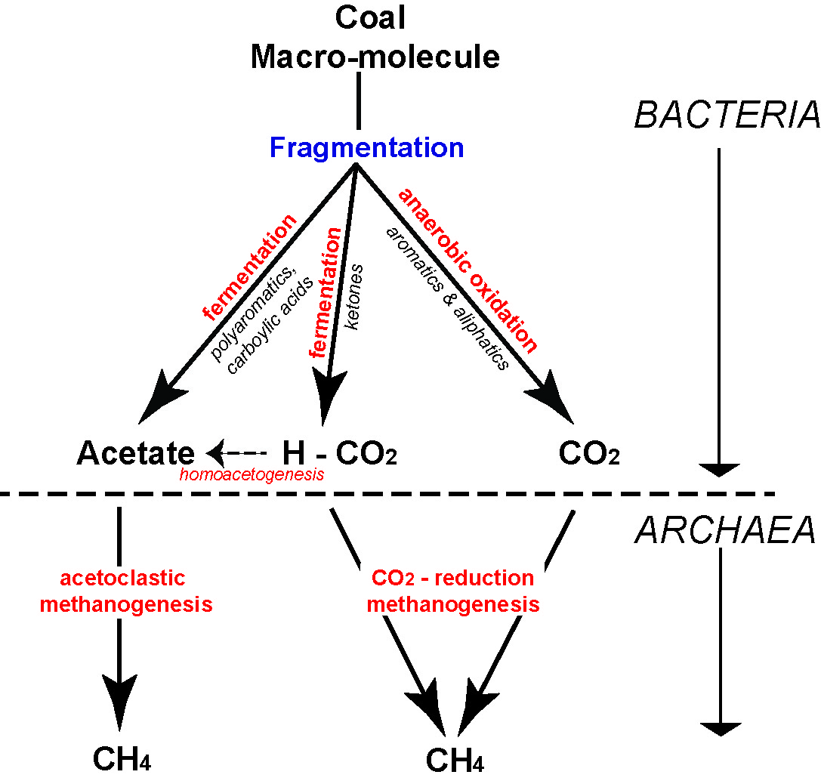
Figure A1.1 Simplified pathway of secondary biogenic methane production in coal (from Moore, 2012a).
A character of biogenic coal seam gas plays is that they may vary significantly in their gas content, both vertically within a single seam as well as laterally (see Mares &Moore, 2008; Moore, 2012a; Warwick et al., 2008). Microbes are quite sensitive to their environment, thus even slight changes in temperature, pH, salinity and amount of available surface area within the reservoir will affect methane generation (Green et al., 2008). In addition there seems to be some evidence that the type of coal substrate is important; higher concentrations of waxy and resinous material may be more attractive to the microbes for conversion into methane (Mares, 2009; Moore, 2012a; Scott et al., 2007).
The methanogenic microbes find it difficult to survive in temperatures above 55ºC (Scott & Fleet, 1994). Thus, biogenic gas generation tails off quickly above this temperature. However, it should be noted that if a coal is uplifted above this temperature threshold and re-inoculated with Bacteria and Archaea – most probably from groundwater recharge into the reservoir – then there may be renewed biogenic gas generation (Ayers Jr., 2002; Faiz et al., 2003; Flores et al., 2008; Smith & Pallasser, 1996).

Thermogenic coal seam gas
As coal is buried and heated its molecular structure rearranges itself. The most fundamental trend is that of increasing carbon content the deeper (and hotter) the coal bed is buried. In order for carbon to increase, the proportion of other elements, primarily oxygen, hydrogen, nitrogen and sulphur must decrease. These elements are thus more ‘volatile’ and this process is called de-volatilization. One of the most abundant molecules expelled is CH₄ – methane (Kopp et al., 2000).
The onset of thermogenic gas generation is approximately at the transition of subbituminous to bituminous coal (Figure A1.2) (Clayton, 1998). The exact timing of onset of thermogenic gas generation can vary. Some coals may start generation at slightly lower or slightly higher thermal maturities (i.e. rank) depending largely on the organic composition of the coal seam (Moore et al., 2014; Petersen, 2004, 2006; Whiticar, 1994). As long as there is a seal over the coal seam, gas will stay within the coal reservoir. Kinematic studies indicate that a sizeable volume of gas per unit of coal will be evolved, enough to completely ‘fill up’ any available space within the coal (Hunt, 1979; Zhang et al., 2008).
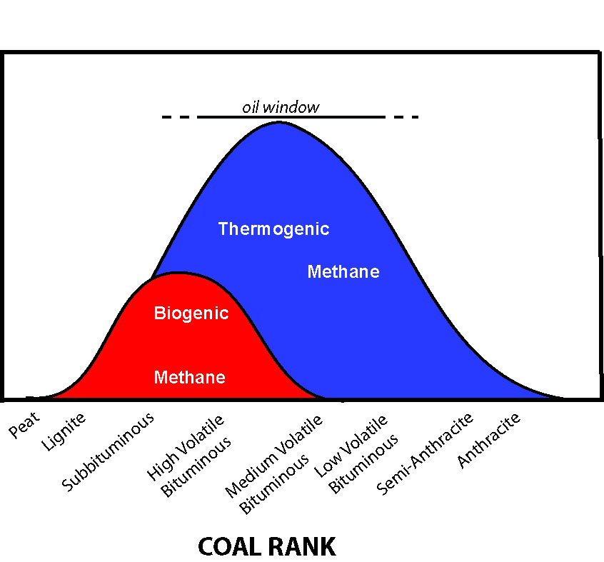
Figure A1.2 Schematic showing biogenic and thermogenic gas generation in relation to coal rank and the oil window. (Modified from Moore, 2012a).
Cessation of thermogenic gas generation is thought to occur at temperatures greater than 555°C (Lewan & Kotarba, 2014). As with the onset of gas generation, there is no single temperature that de-volatilization will be complete, and will be dependent on reservoir composition and overall thermal history effects.

How is gas stored?
In conventional reservoirs (typically sandstone and limestone), gas is stored within the pore space between the grains; that is, gas is ‘free’ and distinct from the surrounding rock material. Indeed, gas compressibility is an important consideration in conventional gas plays because with depth more gas can be compressed within the pore void. Coal holds its gas in a fundamentally different way.
Methane has a tendency to be sorbed (attached) onto the surface of organic materials. It is generally thought that methane can be absorbed or adsorbed. Absorption is where the methane is ‘dissolved’ within the molecular structure of the coal, whereas adsorption is when methane molecules have a physical attachment (through weak van der Waal forces) with the organic material (Ceglarsk-Stefańska & Brzóska, 1998; 2002; Rice, 1993). It is generally thought that most methane is attached through adsorption.
Thus it is the surface area of pores, not the pore volume, as in conventional reservoirs, which is ultimately the most important character in determining gas storage potential in coal. A practical consideration of this is that pore volume can remain the same but pore surface area can change drastically, with no pore volume increase, just by changing the size and abundance of the pores (Moore, 2012b). Pore surface area is also incredibly abundant in coals. In just one cubic centimetre, pores can have an internal surface area between 3 to 115 m² (Radlinski et al., 2004; Mares et al., 2009; Şenel et al., 2001).
Pores range in size from very small (angstroms) to relatively large (millimeters). In general, coal is thought to have a dual porosity system: large fractures and smaller pores (Clarkson & Bustin, 1999; Cui et al., 2004). Volumetrically, the fractures, though hugely influential in the reservoir’s permeability, are not where the methane is predominantly stored. Storage is mostly in pores less than 50 nm. Actually, the pore system is classified as those pores that are >50 nm (macropores), 2 – 50 nm (mesopores) and <2 nm (micropores) (Gan et al., 1972; Şenel et al., 2001). It is the micropores that are thought to hold most of the methane (Moore, 2012a).
Finally, although rank plays a large and important part in determining pore size (Gan et al., 1972), it is the organic composition of the coal that has the most direct influence. Studies by Bustin & Clarkson (1998) and Mares et al. (2009) indicate that different organic compositions will have different size distributions of pores; this ultimately also affects the storage capacity for methane as well.

How does gas move through the coal reservoir?
One of the many differences between conventional gas and coal seam reservoirs is that methane tends to stay put; firmly attached to the organics in a coal bed. Until, that is, there is a pressure drop, caused by de-watering, which allows the methane molecules to break the weak van der Waals forces and travel from higher to low-pressure areas. The de-watering process reduces hydrostatic pressure, at first near the drill hole but over time further and further out, progressively allowing the methane to flow.
Methane flow in coal seams is governed by two principles: Darcy’s Law and Fick’s Law. The latter deals with how the majority of methane in a coal bed starts its journey – diffusing out from the pores towards the fracture system where it more or less free flows towards the lower pressure area created by the well bore. From the moment the gas starts to flow freely, it is thought to behave in a way described by Darcy’s Law.
Fick’s Law describes how one set of molecules moves past another set of molecules (Philibert, 2005; Zarrouk, 2008), much like how air inside a balloon moves through the ‘solid’ rubber encasement of the balloon wall. The air inside the balloon is under relatively higher pressure compared to the air outside the balloon and so the high pressure air diffuses (albeit slowly) through the balloon wall to the lower pressure air outside. The rapidity of how fast those air molecules move is a function of the pressure gradient, the pore surface area and the distance the molecules need to travel.
Once, however, the methane molecules reach a coal cleat, or fracture system, the character of the flow becomes quite different to diffusion, and Darcy’s Law is best used to describe that movement (Seidle, 2011). Similar to diffusion, the pressure gradient is important. Viscosity of the fluid (or gas) must also be taken into account. The resulting flow rate as derived through Darcy’s Law essentially describes permeability in a rock medium.
It is permeability that usually determines if a coal seam gas play is commercial or not. Permeability in thermogenic coal seam gas is primarily determined by the number of cleats or fractures that a coal reservoir has and how open they are. Even very fine fractures are many times more permeable than the un-fractured coal: so they are effectively the ‘super highway’ of methane flow. In general, the higher the rank of the coal, the more frequent are the cleats/fractures, and thus the higher the permeability. But even within a single rank of coal there is a high degree of variability in cleat frequency depending on the coal type (Dawson & Esterle, 2010). Coals with higher concentrations of the organic particle type termed ‘vitrinite’, tend to have more cleats/fractures and thus higher permeability (Ayers Jr., 2002; Smyth & Buckley, 1993).
Biogenic coal seam gas is developed in coal that is too low in rank to develop cleat. In this case permeability is provided by original organic structure (i.e. leaf and woody tissue) that remains uncompressed enough in this low maturity material to provide original porosity and permeability for the passage of the gas.
It is not enough to just have cleats and fractures in the coal reservoir to allow gas to flow. They have to be open and remain open. Because coal is quiet compressible, it is highly effected by stress, both vertical as well as horizontal applied stresses (Bell, 2006; Sparks et al., 1995). No matter how permeable a coal reservoir might be at, say, 300 m; with depth, permeability tends to fall off dramatically (Esterle et al., 2006; McCants et al., 2001) (Figure A1.3). There are few commercial coal seam gas plays that are deeper than 1000 m – the permeability is practically non-existent. Permeability is also not static, it can and does change as the reservoir is de-watered and de-gassed; the effects of which can be detrimental to, or sometimes a boost for, gas flow. Finally, cleats and fractures may be closed as a result of horizontal stresses or mineralisation, most likely caused by tectonic compression, regardless of depth.
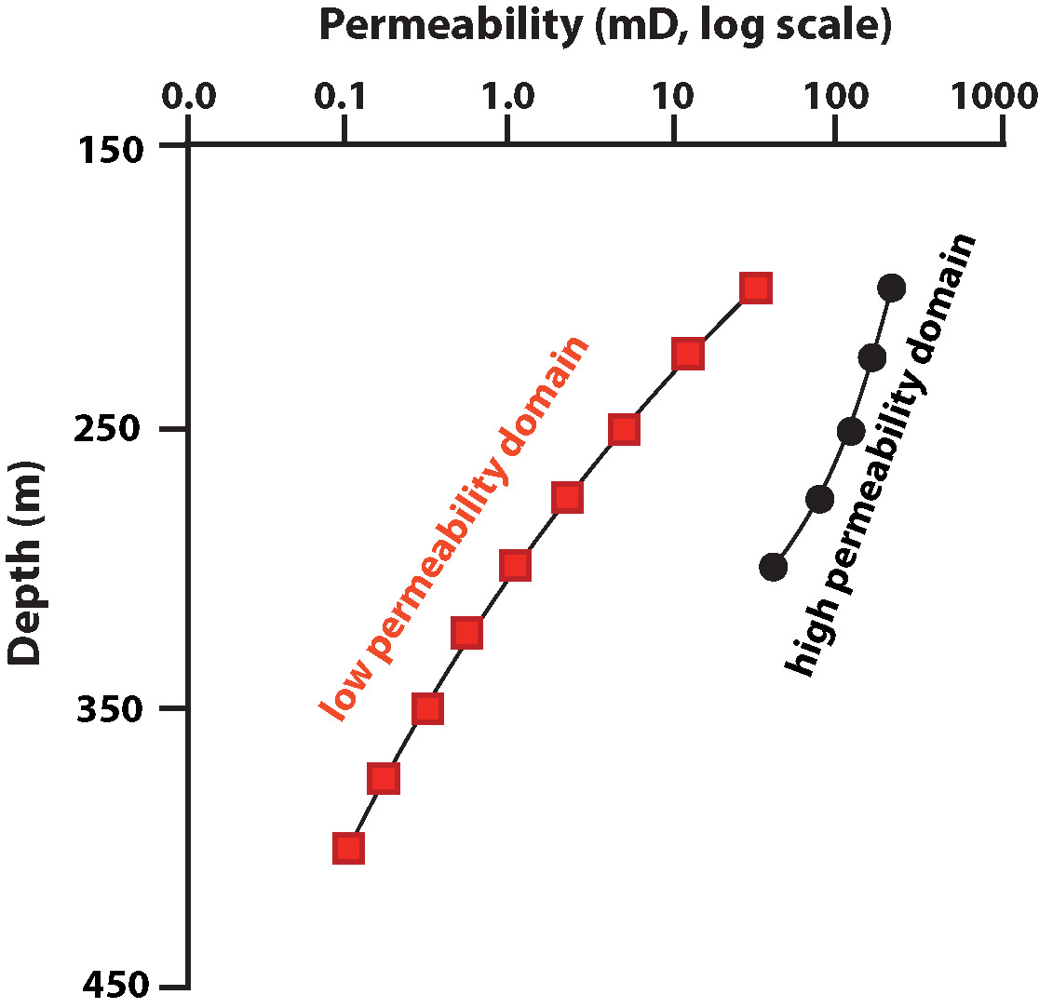
Figure A1.3 Coal bed permeability versus depth in a coal seam from the Permian age Bowen basin (Australia). Permeability has been spatially segregated into geological domains (i.e. geographic areas of similar geology and gas relationships) where ‘high’ and ‘low’ permeability have been identified. Note that the X axis is a log normal scale. See Esterle et al. (2006) for further explanation.

References
Ayers Jr., W.B., 2002. Coalbed gas systems, resources, and production and a review of contrasting cases from the San Juan and Powder River basins. AAPG Bulletin 86, 1853-1890.
Bell, J.S., 2006. In-situ stress and coal bed methane potential in Western Canada. Bulletin of Canadian Petroleum Geology 54, 197-220.
Bustin, R.M. & Clarkson, C.R., 1998. Geological controls on coalbed methane reservoir capacity and gas content. International Journal of Coal Geology 38, 3-26.
Ceglarsk-Stefańska, G. & Brzóska, K., 1998. The effect of coal metamorphism on methane desorption. Fuel 77, 645-648.
Ceglarsk-Stefańska, G. & Zarębska, K., 2002. The competitive sorption of CO2 and CH4 with regard to the release of methane from coal. Fuel Processing Technology 77-78, 423-429.
Clarkson, C.R. & Bustin, R.M., 1999. The effect of pore structure and gas presure upon the transport properties of coal: a laboratory modeling study. 2. Adsorption rate modeling. Fuel 78, 1345-1362.
Clayton, J.L., 1998. Geochemistry of coalbed gas - a review. International Journal of Coal Geology 35, 159-173.
Cui, X., Bustin, M. & Dipple, G., 2004. Differential transport of CO2 and CH4 in coalbed aquifers: Implications for coalbed gas distribution and composition. International Journal of Coal Geology 88, 1149-1161.
Dawson, G.K.W. & Esterle, J.S., 2010. Controls on coal cleat spacing. International Journal of Coal Geology 82,
213-218.
Esterle, J.S., Williams, R.J., Sliwa, R. & Malone, M., 2006. Variability in gas reservoir parameters that impact on emissions estimations for Australian black coals. Final Report ACARP Project C13071, Brisbane, 36 pp.
Faiz, M., Stalker, L., Sherwood, N., Saghafi, A., Wold, M., Barclay, S., Choudhury, J., Barker, W. & Wang, I., 2003. Bio-enhancement of coal bed methane resources in the southern Sydney Basin. APPEA 43, 595-610.
Flores, R.M., 2013. Coal and Coalbed Gas: Fueling the Future. Elsevier, Amsterdam.
Flores, R.M., Rice, C.A., Stricker, G.D., Warden, A. & Ellis, M.S., 2008. Methanogenic pathways of coal-bed gas in the Powder River Basin, United States: The geologic factor. International Journal of Coal Geology 76, 52-75.
Gan, H., Nandi, S.P. & Walker Jr., P.L., 1972. Nature of the porosity in American coals. Fuel 51, 272-277.
Green, M.S., Flanegan, K.C. & Gilcrease, P.C., 2008. Characterisation of a methanogenic consortium enriched from a coalbed methane well in the Powder River Basin, U.S.A. International Journal of Coal Geology 76, 34-45.
Hunt, J.M., 1979. Petroleum geochemistry and geology. Freeman & Co., San Francisco.
Kopp, O.C., Bennett III, M.E. & Clark, C.E., 2000. Volatiles lost during coalification. International Journal of Coal Geology 44, 69-84.
Lewan, M.D &, Kotarba, M.J., 2014. Thermal-maturity limit for primary thermogenic-gas generation from humic coals as determined by hydrous pyrolysis. AAPG Bulletin 98, 2581-2610.
Mares, T.E., 2009. An investigation of the relationship between coal and gas properties in the Huntly coalfield, New Zealand, Department of Geological Sciences. University of Canterbury, Christchurch, 394 pp.
Mares, T.E. & Moore, T.A., 2008. The influence of macroscopic texture on biogenically-derived coalbed methane, Huntly coalfield, New Zealand. International Journal of Coal Geology 76, 175-185.
Mares, T.E., Radlinski, A.P., Moore, T.A., Cookson, D., Thiyagarajan, P., Ilavsky, J. & Klepp, J., 2009. Assessing the potential for CO2 adsorption in a subbituminous coal, Huntly Coalfield, New Zealand, using small angle scattering techniques. International Journal of Coal Geology 77, 54-68.
McCants, C.Y., Spafford, S. & Stevens, S.H., 2001. Five-spot production pilot on tight spacing: rapid evaluation of a coalbed methane block in the Upper Silesian Coal Basin, Poland, The 2001 International Coalbed Methane Symposium. University of Alabama, Tuscaloosa, pp. 193-204.
Moore, T.A., 2012a. Coalbed methane: A review. International Journal of Coal Geology 101, 36-81.
Moore, T.A., 2012b. How many holes does it take to fill the Albert Hall? The importance of porosity in a coalbed methane reservoir, 36th Annual Convention & Exhibition, Indonesian Petroleum Association. Indonesian Petroleum Association, Paper IPA12-G-092, Jakarta, Indonesia, Not paginated.
Moore, T.A., Bowe, M. & Nas, C., 2014. High heat flow effects on a coalbed methane reservoir, East Kalimantan (Borneo), Indonesia. International Journal of Coal Geology 131, 7-31.
Petersen, H.I., 2004. Oil generation from coal source rocks: the influence of depositional conditions and stratigraphic age, Geological Survey of Denmark and Greenland Bulletin Nr 7, review of activities 2004, pp. 9-12, http://www.geus.dk/publications/bull/nr17/nr17_p09-12-uk.htm, accessed 14.05.16.
Petersen, H.I., 2006. The petroleum generation potential and effective oil window of humic coals related to coal composition and age. International Journal of Coal Geology 67, 221-248.
Philibert, J., 2005. One and a half century of diffusion: Fick, Einstein, before and beyond. Diffusion Fundamentals 2,
1-10.
Radlinski, A.P, Mastalerz, M., Hinde, A.L., Hainbuchner, M., Rauch, H., Baron, M., Lin, J.S., Fan, L., & Thiyagarajan, P., 2004. Application of SAX and SANS in evaluation of porosity, pore size and surface area of coal. International Journal of Coal Geology 59, 245-271.
Rice, D.D., 1993. Composition and origins of coalbed gas, in: Law, B.E., Rice, D.D. (Eds.), Hydrocarbons from coal. American Association of Petroleum Geologists, Studies in Geology 38, Tulsa, Oklahoma, pp. 159-184.
Rogoff, M.H., Wender, I., Anderson, R.B., 1962. Microbiology of coal. U.S. Bureau of Mines, p. 85.
Scott, A.C. & Fleet, A.J., 1994. Coal and coal-bearing strata as oil-prone source rocks: current problems and future directions, in: Scott, A.C., Fleet, A.J. (eds), Coal and coal-bearing strata as oil-prone source rocks? Geological Society Special Publication, London, U.K., pp. 201-205.
Scott, S., Anderson, B., Crosdale, P.J., Dingwall, J. & Leblang, G., 2007. Coal petrology and coal seam gas contents of the Walloon Subgroup - Surat Basin, Queensland, Australia. International Journal of Coal Geology 70, 209-222.
Seidle, J., 2011. Fundamentals of coalbed methane reservoir engineering. PennWell, Tulsa, Oklahoma.
Şenel, I.G., Gürüz, A.G. & Yücel, H., 2001. Characterization of pore structure of Turkish coals. Energy & Fuels 15,
331-338.
Smith, J.W. & Pallasser, R.J., 1996. Microbial origin of Australian coalbed methane. AAPG Bulletin 80, 891-897.
Smyth, M. & Buckley, M.J., 1993. Statistical analysis of the microlithotype sequences in the Bulli Seam, Australia, and relevance to permeability for coal gas. International Journal of Coal Geology 22, 167-187.
Sparks, D.P., McLendon, T.H., Saulsberry, J.L. & Lambert, S.W., 1995. The effects of stress on coalbed reservoir performance, Black Warrior Basin, U.S.A., Proceedings fo the Society of Petroleum Engineers Annual Technical Conference and Exhibition. SPE Paper 30743, Dallas, Texas, pp. 339-351.
Strąpoć, D., Mastalerz, M., Dawson, K., Macalady, J., Callaghan, A.V., Wawrik, B., Turich, C. & Ashby, M., 2011. Biogeochemistry of Microbial coal-bed methane. Annual Review of Earth and Planetary Sciences 39, 617-656.
Strąpoć, D., Picardal, F.W., Turich, C., Schaperdoth, I., Macalady, J.L., Lipp, J.S., Lin, Y.-S., Ertefai, T.F., Schubotz, F., Hinrichs, K.-U., Mastalerz, M. & Schimmelmann, A., 2008. Methane-producing microbial community in a coal bed of the Illinois Basin. Applied and Environmental Microbiology 74, 2424-2432.
Warwick, P.D., Breland Jr., F.C. & Hackley, P.C., 2008. Biogenic origin of coalbed gas in the northern Gulf of Mexico Coastal Plain, U.S.A. International Journal of Coal Geology 76, 119-137.
Whiticar, M.J., 1994. Correlation of natural gases with their sources, in: Magoon, L.B., Dow, W.G. (Eds.), The petroleum system - from source to trap. APG Memoir 22 pp.
Zarrouk, S.J., 2008. Reacting flows in porous media. VDM Verlag Dr Muller Aktiengesellshaft & Co. KG, Berlin.
Zhang, E., Hill, R.J., Katz, B.J. & Tang, Y., 2008. Modeling of gas generation from the Cameo coal zone in the Piceance Basin, Colorado. AAPG Bulletin 92, 1077-1106.

Appendix 2
Hypothetical gas development scenario data
Gas type | Development Type | Location/ Site | Target formation | Target formation Depth (m) | Project area (km²)
Conventional | (1) Prospect/field scale | Iona | Waarre Formation | 1,193 | 2.96
 | (2) Sub-regional | Langley | Waarre Formation | 1715 | 1.59
 |  | Grumby | Waarre Formation | 1595
 |  | North Paaratte | Waarre Formation | 1365 | 1.55
 |  | Skull Creek | Waarre Formation | 1125 | 0.247
 |  | Dunbar | Waarre Formation | 1,476 | 0.193
 |  | Wallaby Creek | Waarre Formation | 1,490 | 1.35
Tight | (1) Prospect/field scale | Moreys | Eumeralla Formation | 1985 | 5.89
 | (2) Sub-regional | Port Campbell Embayment | Eumeralla Formation | 1300->3500 | 141.4
Shale | (1) Prospect/field scale | Penola Trough | Casterton Formation | >3500 | 46
 | (2) Sub-regional | Penola Trough (Extent of A1 maturity) | Casterton Formation | >3500 | 326.6
Coal Seam (Black coal) | Prospect/field scale | Gordon | Killara coal measures | 836 | 100
 |  | Mocamboro | Killara coal measures | 710 | 159
 |  | Digby | Killara coal measures | 980 | 70
 |  | Hawkesdale | Killara coal measures | 602 | 189
 |  | Stoneyford | Killara coal measures | 803 | 60
 |  | Nalangil | Killara coal measures | 803 | 46
Killara coal measures -= base Eumeralla Formation

Authorised by the Victorian State Government,
Department of Economic Development, Jobs, Transport & Resources
1 Spring Street Melbourne Victoria 3000
Telephone (03) 9208 3333
June 2015
© Copyright State of Victoria
Except for any logos, emblems, trademarks, artwork and photography this document is made available under the terms of the
Creative Commons Attribution 3.0 Australia licence.

ISBN 978-1-74146-664-5 (pdf)

Accessibility
If you would like to receive this publication in an alternative format, please telephone DEDJTR Customer Service Centre 136 186, email customer.service@ecodev.vic.gov.au, via the National Relay Service on 133 677, www.relayservice.com.au
This document is also available on the internet at www.onshoregas.vic.gov.au
Disclaimer
This publication may be of assistance to you but the State of Victoria and its employees do not guarantee that the publication is without flaw of any kind or is wholly appropriate for your particular purposes and therefore disclaims all liability for any error, loss or other consequence which may arise from you relying on any information in this publication.

The contained energy within gas and oil is measured in joules or kilojoules. Large volumes in gas reservoirs are described in petajoules (PJ). Relating the contained energy to the physical volume in trillion cubic feet or billion cubic meters requires knowledge of the chemical makeup of the gases present, as different hydrocarbon species (e.g. methane, ethane, propane), contain different energies per unit volume, and some non-flammable gas such as nitrogen or carbon dioxide may be present in small amounts. ..

