Otway region
Assessment of Potential Impacts
on Water Resources

June 2015

Acknowledgements
This report has been prepared by Jacobs (Australia) Pty Ltd for the Department of Environment, Land, Water and Planning in collaboration with the Geological Survey of Victoria (part the Department of Economic Development, Jobs, Transport and Resources).
Independent review of this report was provided by:
Professor Rae Mackay, Director, Geotechnical and Hydrogeological Engineering Group, Federation University Australia
Professor Dayanthi Nugegoda, Ecotoxicology, School of Applied Science, RMIT University
Professor Craig Simmons, Director, National Centre for Groundwater Research and Training, Flinders University.

Contents
Figures 4
Tables 5
Glossary and abbreviations 6
1 Overview of impact assessment 8
1.1 Context 8
1.2 Study area 9
1.3 Onshore natural gas resources 10
1.4 Groundwater resources 10
1.5 Assessment approach 12
1.6 Results 14
2 Hydrogeological conceptual model 16
2.1 Introduction 16
2.2 Geology 16
2.3 Hydrogeology 27
2.4 Water use 37
2.5 Natural gas interactions with groundwater, surface water and ecosystems 39
3 Aquifer depressurisation impact assessment 48
3.1 Introduction 48
3.2 Impact assessment approach 48
3.3 Impact assessment results 53
3.4 Potential impact to groundwater quality 61
4 Chemical contamination of groundwater from hydraulic fracturing fluids: risk assessment 62
4.1 Overview of hydraulic fracturing 62
4.2 Key risks to water resources associated with hydraulic fracturing 64
4.3 Contaminant sources 65
4.4 Contaminant pathways 66
4.5 Contamination mechanisms 68
4.6 Summary of potential risks of hydraulic fracturing 73
4.7 Qualitative risk assessment 73
5 Induced seismicity risk assessment 76
5.1 Seismicity 76
5.2 Induced seismicity 78
5.3 Hydraulic fracturing 80
5.4 Gas development 81
5.5 Qualitative risk assessment 82
6 Land subsidence risk assessment 84
6.1 Overview 84
6.2 Summary of subsidence processes 84
6.3 Summary of subsidence processes 84
6.4 Qualitative risk assessment 86
6.5 Summary 87
7 Conclusions 88
7.1 Aquifer depressurisation 88
7.2 Chemical contamination of groundwater from hydraulic fracturing fluids 88
7.3 Induced seismicity 89
7.4 Land subsidence 89
7.5 Summary of potential impacts 90
7.6 Gaps and uncertainty 91
References 93
Appendix A: Literature review on risk assessment frameworks for onshore gas 98
Appendix B: Otway region assessment method 164
Appendix C: Maps of aquifer depressurisation assessment results 192

Figures
Figure 1: Otway study area, showing surface water catchments. 9
Figure 2: Location of protential onshore natural gas scenario areas used for the impact assessment 11
Figure 3: Typical geological formations bearing prospective onshore natural gas in the Otway region. 12
Figure 4: Major structures and sub-basins in the Otway Basin 17
Figure 5: Stratigraphy of the Otway Basin 18
Figure 6: Distribution of Crayfish Group, Eumeralla Formation and Tertiary sediment outcrop 19
Figure 7: Isopach of the Wangerrip Group 21
Figure 8: Isopach of the Nirranda Group 22
Figure 9: Isopach of the Heytesbury Group 23
Figure 10: Isopach of the Newer Volcanics at 20 m contour intervals 24
Figure 11: Otway region tight gas resource development scenario area 25
Figure 12: Otway region shale gas resource development scenario area. 26
Figure 13: Otway region coal seam gas resource development scenario area 26
Figure 14: Otway region conventional gas resource development scenario area 27
Figure 15: Groundwater salinity and water level contour map of the upper aquifers 29
Figure 16: Groundwater salinity and yield map of the Upper Mid-Tertiary Aquifer 31
Figure 17: Potentiometric surface and groundwater flow directions in the UMTA 32
Figure 18: Groundwater salinity and yield map of the LTA 33
Figure 19: Potentiometric surface and groundwater flow directions in the Lower Tertiary aquifer of the southwest Otway Basin 34
Figure 20: Isopach of the Cretaceous Aquifer 35
Figure 21: Groundwater salinity map of the upper Cretaceous aquifer 36
Figure 22: Potentiometric surface and groundwater flow directions in the Cretaceous aquifer 37
Figure 23: Surface water consumptive use for 2003 to 2013 38
Figure 24: Penola Trough cross section 40
Figure 25: Hydrostratigraphic cross-section of the Port Campbell Sub-basin 42
Figure 26: Hydrostratigraphic cross section of the Tyrendarra Sub-basin 43
Figure 27: Location of surface water features and depth to groundwater in the Otway region with sub-regional development scenario areas. 46
Figure 28: Baseflow estimates to Victorian rivers 47
Figure 29: Overview of impact assessment. 49
Figure 30: Potential impact on receptors due to aquifer depressurisation. 52
Figure 31: Potential impact to aquifers from possible conventional gas development. 53
Figure 32: Potential impact to surface water users from possible conventional gas development. 54
Figure 33: Potential impact to surface water ecosystems from possible conventional gas development. 54
Figure 34: Potential impact to aquifers from possible tight gas development 55
Figure 35: Potential impact to surface water users from possible tight gas development. 56
Figure 36: Potential impact to surface water ecosystems from possible tight gas development. 56
Figure 37: Potential impact to aquifers from possible shale gas development. 57
Figure 38: Potential impact to surface water users from possible shale gas development. 58
Figure 39: Potential impact to surface water ecosystems from possible shale gas development. 58
Figure 40: Potential impact to aquifers from possible coal seam gas (black coal) development. 59
Figure 41: Potential impact to surface water users from possible coal seam gas (black coal) development. 60
Figure 42: Potential impact to surface water ecosystems from possible coal seam gas (black coal) development. 60
Figure 43: Schematic of a deep unconventional (shale) gas well in the Cooper Basin, Australia 63
Figure 44: Location of formations where fracture height and HF fluid volume were collected and co-variance between fracture height and HF fluid volume 68
Figure 45: Conceptual shape of zone of hydraulic fracture extent for a vertical well 69
Figure 46: Number and magnitude of earthquakes recorded from 2000 to 2012 worldwide and in the USA 76
Figure 47: Earthquake magnitude and typical effect. 77
Figure 48: Frequency and magnitude of earthquakes in Victoria from 1990 to 2014 77
Figure 49: Distribution and magnitude of earthquakes in Victoria from 1990 to 2014 current 78
Figure 50: Location and magnitude of seismic events caused by or likely to be related to energy development from various energy technologies worldwide. 79

Tables
Table 1: Relationship between stratigraphic units and hydrogeological units. 28
Table 2: Surface water entitlements and volumes taken (i.e. usage) figures for 2012–2013. 38
Table 3: Summary of total groundwater use in groundwater management units for the
2012–2013 period. 39
Table 4: Rules to define water receptors’ potential connection to groundwater. 50
Table 5: Rules defining the potential effect on water receptors of groundwater drawdown. 51
Table 6: Hydraulic fracturing fluid constituents. 65
Table 7: Proposed connection assessment criteria for hydraulic fracturing impacts. 73
Table 8: Proposed consequence scale for hydraulic fracturing impacts. 73
Table 9: Proposed likelihood assessment criteria for induced seismicity. 82
Table 10: Proposed consequence scale for induced seismicity. 83
Table 11: Proposed likelihood scale for subsidence caused by drawdown in aquifers. 87
Table 12: Proposed likelihood assessment criteria for subsidence as a result of onshore
gas development. 87
Table 13: Potential for impact due to aquifer depressurisation from onshore natural gas development
in the Otway region. 90
Table 14: Potential risks due chemical contamination of groundwater from hydraulic fracturing fluids, induced seismicity and land subsidence from onshore natural gas development in the Otway region. 90

Glossary and abbreviations
Term | Meaning
AHD | Australian Height Datum
aquifer | rock or soil that readily transmits water
aquitard | rock or soil that transmits water very slowly
baseflow | contribution of surface water flow due attributed to groundwater
BoM | Bureau of Meteorology
CMA | Catchment Management Authority
confined aquifer | an aquifer in which an impermeable rock or soil layer or layers prevents water from seeping into the aquifer vertically
constant head boundary | time constant specified head which represents flows into or out of the model domain where groundwater connects or interacts with features (and the ocean) outside the model domain
co-produced water | the water extracted from coal seams to depressurise the coal seam thereby releasing gas
coal seam gas | coal seam gas
CSIRO | Commonwealth Scientific and Industrial Research Organisation
DEDJTR | Department of Economic Development, Jobs, Transport and Resources
DELWP | Department of Environment, Land, Water and Planning
DEM | digital elevation model defining surface elevations
DEPI | former Department of Environment and Primary Industries
drawdown | reduction in groundwater head elevation relative to a nominated baseline condition.
DSE | former Department of Sustainability and Environment
ET | water lost due to a combination of soil evaporation and vegetation transpiration
GA | Geoscience Australia
GDE | groundwater-dependent ecosystem
GL | gigalitres
GMA | Groundwater Management Area
IESC | Independent Expert Scientific Committee
hydraulic head | energy contained in a water mass, produced by elevation, pressure or velocity
hydraulic conductivity (K) | the rate of flow of water through a cross section area under a unit gradient head
mAHD | elevation in metres with reference to the Australian Height Datum
m/day | metres per day
m²/day | cubic metres per day
MDBA | Murray Darling Basin Authority
MDBC | Murray–Darling Basin Commission
mg/L | milligrams per litre
M_{L} | local magnitude, from the Richter magnitude scale that assigns a magnitude number to quantify the energy released by an earthquake
ML | megalitres
MPa | megapascal
permeability | the property or capacity of a porous rock, sediment or soil for transmitting a fluid; it is the a measure of the relative ease of fluid to flow under unequal pressure
porosity | the percentage of the bulk volume of a rock or soil that is occupied by interstices, whether isolated or connected
potentiometric surface | an imaginary surface representing the total head of groundwater in a confined aquifer that is defined by the level to which the water rise in a bore
Term | Meaning
prospectivity | an assessment, whether qualitative or quantitative, of the potential for prospective resources
prospective resources | petroleum (including natural gas) which is potentially recoverable from undiscovered accumulations
recharge rate | water that flows below the root zone and enters the groundwater
SAFE | Victorian Secure Allocation Future Entitlement
specific yield (Sy) | the ratio of the volume of water that a given body of rock or soil will hold against the pull of gravity to the volume of the body itself. It is usually expressed as a percentage
specific storage (Ss) | the amount of water that a portion of an aquifer releases from storage, per unit mass or volume of aquifer, per unit change in hydraulic head, while remaining fully saturated
TCF | trillion cubic feet
TDS | total dissolved solids
transient | time-varying
transmissivity | the rates at which water is transmitted through a unit width of an aquifer under a unit hydraulic gradient
unconfined aquifer | an aquifer where the watertable is exposed to the atmosphere through openings in the overlying materials
VAF | Victorian Aquifer Framework
vertical hydraulic conductivity (Kz) | the rate of vertical flow of water through a cross section area under a unit gradient head
watertable | the surface where the groundwater level is balanced against atmospheric pressure. Often, this is the shallowest water below the ground
WSPA | Water Supply Protection Area
yield | the volume of water discharged from a bore

1 Overview of impact assessment

1.1 Context
The purpose of the water science studies on onshore natural gas is to provide an initial screening analysis of the potential impacts of possible onshore gas exploration and development on water users and ecosystems.
There are four different types of possible onshore natural gas development in Victoria: conventional, shale, tight and coal seam gas. These types of natural gas developments may have different impacts on water resources.
At present there is no active onshore natural gas development in Victoria. The Geological Survey of Victoria has conducted research into potential areas where onshore natural gas resources may exist. However, the commercial feasibility of onshore gas development has not been determined. As a consequence, the studies documented here test the potential effects of hypothetical natural gas developments.
The studies assess the potential impacts due to; aquifer depressurisation (i.e. groundwater level decline), chemical contamination of groundwater from hydraulic fracturing fluids, induced seismicity and land subsidence.
Gas extraction depressurises the gas bearing formation and this may cause groundwater level decline, impacting water users and ecosystems. Groundwater level decline may also cause land subsidence.
Hydraulic fracturing can increase gas yield but may have the unintended consequence of contaminating water supply. Contamination could occur if as a result of fracturing there was a change in the connection between a gas source and the relevant groundwater resource. There is also a potential to induce seismicity (earth tremor).
The studies apply a causal pathway approach, describing where natural gas might be, where water resources are, and the physical connections between the gas and water resources. For aquifer depressurisation, modelling and analysis is utilised to assess the potential impacts on groundwater levels and by inference the potential impacts on water users and ecosystems, as relevant region-specific data was not available for a quantitative risk assessment approach but suitable for impact assessment. For chemical contamination of groundwater from hydraulic fracturing fluids, induced seismicity and land subsidence, a qualitative risk assessment approach is utilised to assess the potential risks to water users and ecosystems, as the necessary region-specific data for a quantitative risk assessment or impact assessment approach is not currently available.
The studies were conducted by the Department of Environment, Land, Water and Planning and the Geological Survey of Victoria (part of the Department of Economic Development, Jobs, Transport and Resources). An integral part of the water science studies has been the engagement of a scientific review panel, which has provided an independent peer review of this report, ensuring the rigour of the significant body of technical work that has been undertaken.
The studies have used the best available information, noting that there are known gaps in the geological and hydrogeological data sets. In light of this, the impact assessment has been completed conservatively; the results are likely to estimate higher impacts than may eventuate if development did occur.
There are issues that are beyond the scope of these water science studies. These include treatment and disposal of coproduced water, water use for fracturing and gas production, non-water resource issues such as amenity, air quality, fugitive gas emissions, on-site chemical management and bore integrity. Therefore the findings should be considered only with respect to the topics addressed.
The outputs of the studies take the form of two plain-language synthesis reports, one each for the Gippsland Region and Otway Region, and a series of stand-alone technical reports. This technical report presents the Gippsland region impact assessment work.

1.2 Study area
The report focuses on the potential impacts and risk to water resources that might arise from onshore gas development in the Otway region (Figure 1). The areal extent of the Otway region is defined by the surface water catchment areas shown in Figure 1. The study area incorporates the water resources and water users that may be impacted by gas exploration or development.
The vertical extent of the study area includes the entire aquifer sequence that forms the onshore Otway Basin. This includes all the sedimentary sequence overlying the Palaeozoic basement. The basement formation also contains the geological formations with potential gas resources. The potential gas formations occur deep in the geological sequence and are below all the aquifers. A detailed description of the geology and hydrogeology of the study area is included in Chapter 2, which describes the conceptual model used as the basis of this study.

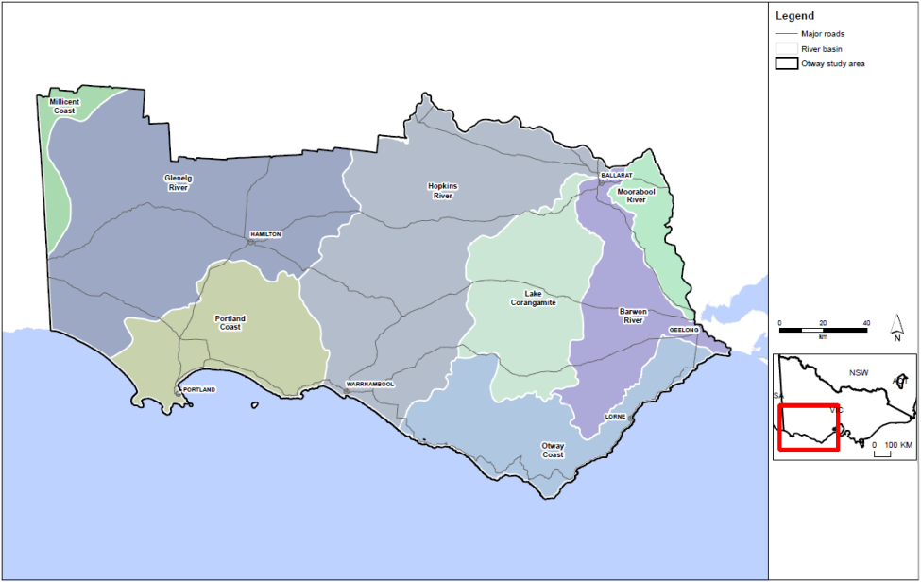
Figure 1: Otway study area, showing surface water catchments.

1.3 Onshore natural gas resources
The analysis has considered the range of natural gas resources that might be developed in the onshore Otway region. Figure 2 shows the areas in the region where gas might be found, based on the presence of a prospective gas geological unit and previous petroleum exploration in the region.
Potential gas resources in the Otway region are located at great depth below the surface, underneath many geology types, including aquifers. A diagrammatic view of the relationship between surface water features, aquifers and gas resources areas is shown in Figure 3.

1.3.1 Tight gas
The most prospective geological unit for tight gas in the Otway region is the Eumarella Formation. In an area near Port Campbell, previous drilling for conventional gas found gas in the tight rocks of this formation. In this area potential tight gas resources may be present from approximately 1300 m to greater than 3500 m below the ground surface. This covers a prospective area of approximately 140 km² near Port Campbell.

1.3.2 Shale gas
Potential shale gas resources may be present in the Casterton Formation at depths greater than 3.5 km in the far west of the state. Drilling of the same rock unit over the border in South Australia shows that there is interest in exploring for this resource in the area. For this assessment an area (of approximately 326 km²) was delineated where the Casterton Formation is found at sufficient depth where it may hold gas.

1.3.3 Coal seam gas (black coal)
Six separate areas in the Otway region potentially hold coal seam gas in black coal deposits known as the Killara coal measures. These areas are based on previous exploration across the northern part of the Otway region. Although the discovery of low gas readings and thin coal seams resulted in the previous tenement holder relinquishing licences across the region, these areas would still is the most prospective for coal seam gas in the Otway region. The six areas range from approximately 46 to 159 km² and are at approximate depths below the surface of at least 600 m.

1.3.4 Conventional gas
Conventional gas has been discovered and produced from the onshore Otway Basin near Port Campbell. Future discoveries of conventional gas are most likely to occur in the same region. Conventional onshore gas is located in a rock unit known as the Waarre Formation from 1100 m to more than 1500 m below the surface. As conventional gas resources are found in more concentrated discrete areas in comparison to the other gas types, the area covered is much smaller. An area of 5 km² identified for this assessment is based on the size of conventional gas developments that have previously been developed.

1.4 Groundwater resources
Groundwater resources are contained in layers of high water yield (aquifers) and low water yield (aquitards) and may be relatively fresh or saline. The Otway Basin is a highly variable sequence of aquifers and aquitards that generally thicken and deepen as they approach the coast. Onshore there is significant groundwater extraction for agriculture and town supply (approximately 177 000 ML/annum of aggregated entitlement and registered bores for domestic and stock use) in areas where surface water is limited. Surface water users and groundwater-dependent ecosystems also rely on baseflow and depth to the water table.
Groundwater resources in the Otway region are can be generally classified divided into three broad groups (Figure 5): the upper (generally less than 100 m), the middle (which may be very shallow to the north of the basin and deepen towards the coast) and the lower (generally underneath the middle layer). These aquifer groups are generally separated by aquitards, which are low water yielding formations.
Aquitards are always present between the gas source units (reservoirs) and the aquifers in the Otway region.

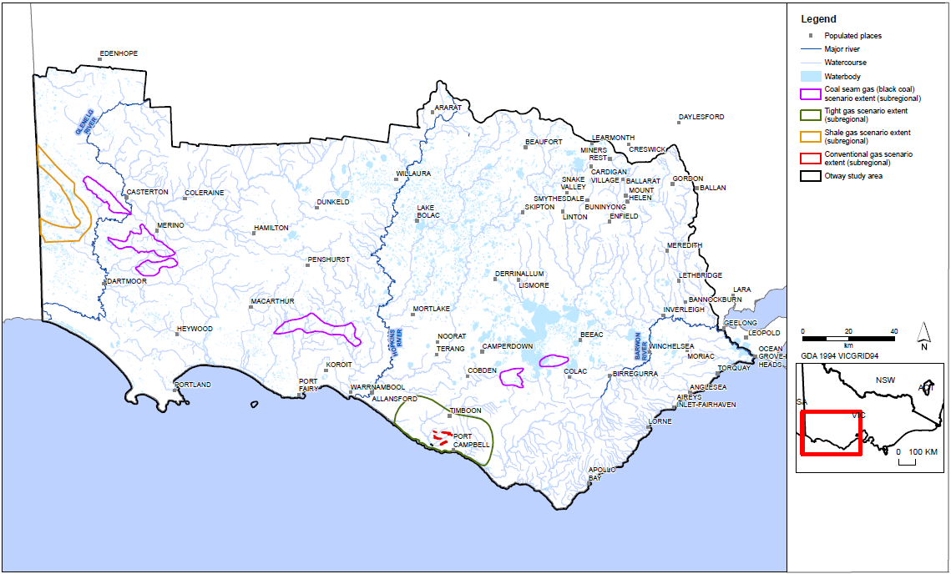

Figure 2: Location of protential onshore natural gas scenario areas used for the impact assessment. (Source: Goldie Divko, 2015.)
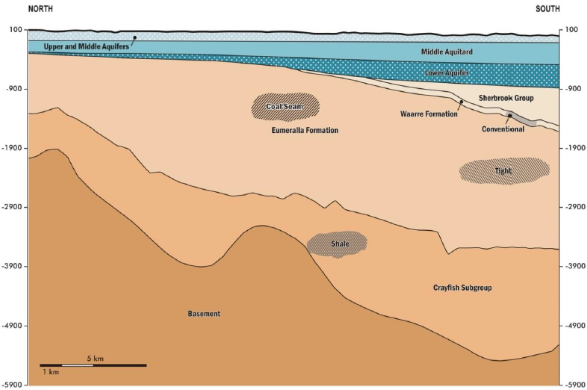
Figure 3: Typical geological formations bearing prospective onshore natural gas in the Otway region (depth shown in metres).

1.5 Assessment approach
Prior to developing this impact assessment, a review of relevant Australian and international literature which looked at risk from gas development was completed. This is presented in Appendix A. This assessment considers impacts and risks associated with the potential future development of the following onshore natural gas resources in the Otway region:
• tight gas
• shale gas
• coal seam gas (from black coal)
• conventional gas.
The extent of the possible onshore natural gas resources used in the assessment was taken from Goldie Divko (2015) and is shown in Figure 2. Further detail on the nature of the gas resources included in this impact assessment is provided in Section 2.2.3.
The assessment framework is based on the hazard/pathway/receptor/ model to assess impacts on the receptors (water resources) from possible future onshore natural gas development. For an impact to occur, all three components need to be present: a hazard; a receptor that could potentially be adversely impacted; and a pathway to link the two.

The four hazards considered are:
1 aquifer depressurisation
2 chemical contamination of groundwater from hydraulic fracturing fluids
3 induced seismicity
4 land subsidence.
The assessment approach considers three types of high-value water resource receptors:
• aquifers (which support groundwater users)
• rivers (which support surface water users and ecosystems)
• water bodies (wetlands and lakes which support surface water users and ecosystems).
The studies apply a causal pathway approach, describing where natural gas might be, where water resources are, and the physical connections between the gas and water resources. For aquifer depressurisation, modelling and analysis is used to assess the potential impacts on groundwater levels and by inference the potential impacts on water users and ecosystems, as relevant region-specific data was not available for a quantitative risk assessment approach but suitable for impact assessment. For chemical contamination of groundwater from hydraulic fracturing fluids, induced seismicity and land subsidence, a qualitative risk assessment approach is used to assess the potential risks to water users and ecosystems, as the necessary region-specific data for a quantitative risk assessment or impact assessment approach is not currently available.
The metrics used to determine the potential connection to groundwater and the potential drawdown expected from a gas development are outlined in subsequent chapters and detailed in Appendix B.
The potential for impacts was assessed according to the following criteria (for compete definitions refer to Chapters 3 to 6):
• low potential: impact is within normal variability or not anticipated (e.g. for groundwater users, a predicted decline in the water table of less than 2 m and a predicted decline in deep groundwater levels of less than 10 m or no change is anticipated)
• moderate potential while the impact is outside normal variability, the impact does not significantly change the function of water users or ecosystems (e.g. for groundwater users, a predicted decline in the water table of 2 m to 15 m or a predicted decline in deep groundwater levels of 10 m to 75 m)
• high potential: impact significantly changes the function of water users or ecosystems (e.g. for groundwater users, a predicted decline in the water table of greater than 15 m or a predicted decline in deep groundwater levels of greater than 75 m). Moderate potential: impact is measurable (e.g. for groundwater users this is a predicted drop in the water table of 2 m to 15 m)

1.5.1 Aquifer depressurisation
The pathway for aquifer depressurisation is the transmission of pressure reductions in the prospective gas formation through the adjacent seal or aquitard units, which may cause drawdown in the aquifers. For drawdown to have an impact it must occur in an aquifer that supports a receptor. This means that, for a surface water receptor to be adversely impacted, there must be a pathway between the gas source and the watertable that enables drawdown to occur in the watertable aquifer. To understand the hydrogeological pathways that have the potential to connect possible gas developments with overlying water resources a hydrogeological conceptual model was produced. This is presented in Chapter 2.
The impact assessment for aquifer depressurisation is based on hypothesised gas development scenarios.
Impact assessment of aquifer depressurisation considers the potential for impacts on groundwater users and the water table with an inferred impact on surface water users and ecosystems. This is based on an estimate of potential groundwater level changes from each hypothetical onshore natural gas development scenario.
The impact on water resources has been assessed for an operation of a hypothetical development running for 30 years. Impacts are assessed at the end of the operating period. This operating period corresponds to a typical life span of coal seam gas resources and infrastructure used in other jurisdictions. While 30 years is long enough for a scenario impact to be identified, maximum impacts may occur after 30 years.

1.5.2 Chemical contamination of groundwater from hydraulic fracturing fluids
In hydraulic fracturing the rock of the gas reservoir is put under pressure to generate small cracks in the rock, allowing the gas to be extracted. The findings in the main report use the available literature to assess the in-situ hydrogeological factors that may contribute to fracture propagation beyond the intended zone of fracturing, an assessment of their distribution potential for groundwater contamination.

1.5.3 Induced seismicity
Induced seismicity associated with unconventional gas extraction can be related to hydraulic fracturing, gas production and/or coproduced re-injection. The potential impact for induced seismicity has been assessed from a review of international literature and reporting of the risk factors for induced seismicity and how they can be managed.

1.5.4 Land subsidence
The potential impacts of land subsidence as a result of gas extraction were assessed through a literature review. The literature review was based on a number of recent literature reviews undertaken for the Independent Expert Scientific Committee on Coal Seam Gas and Large Coal Mining Development that reports to the Commonwealth Government.

1.6 Results
The potential impacts associated with onshore natural gas development in the Otway region for tight, shale, coal seam (black coal) and conventional gas types are described below.

1.6.1 Aquifer depressurisation
The key finding of the assessment is that the potential impact on all aquifers (confined and unconfined) in the Otway region is low for all gas types. Potential impacts on surface water resources (including users) and ecosystems are also inferred to be low.
There are about 1100 surface water licences in the Otway region, and no surface water licences are classified as having elevated impacts (that is, moderate to high potential) from conventional, tight, shale and coal seam gas development.
There are about 2000 groundwater entitlement holders in the area, but none were found to be at risk of elevated impacts from gas development through depressurisation.

1.6.2 Chemical contamination of groundwater from hydraulic fracturing fluids
Based on existing tight and shale gas development around Australia and internationally, the development of tight, shale, and possibly coal seam gas in the Otway region may require hydraulic fracturing in order to increase permeability and hence gas production. Available literature indicates that typical fracture propagation distances are around tens of metres, although this is highly dependent on rock type and geology.
The development scenario proposed for shale gas indicates the depths are in the Casterton Formation at around 3500 m. There are around 900 and 2000 m of low-permeability formations between the Casterton Formation and the nearest aquifer. This formation provides a significant physical separation from any groundwater resources. Given the typical fracture propagation distances of up to tens of metres, contamination or increased connectivity via the generation of fully penetrating fractures, or the intersection between stimulated and pre-existing fractures, is unlikely. The overlying aquifers would therefore almost certainly remain unaffected. With respect to tight gas development, a vertical fracture of tens of metres would still be about 500 m from the deepest groundwater resource in the Port Campbell Embayment of the Otway region. Based on these and other factors the overall potential for groundwater contamination from hydraulic fracturing of tight gas and shale gas, is low.
Prospective coal seam gas is limited to where the base of the Eumeralla Formation is at depths of approximately 600 m or more below the surface. Coal seam gas sources will be separated from the lowermost aquifers by approximately 300 m or more of low-permeability Eumeralla Formation, so the potential for chemical contamination of groundwater from hydraulic fracturing fluids is assessed as low risk.
The development of conventional gas in the Otway region is unlikely to require hydraulic fracturing.
Based on these and other factors presented in the report, the overall potential for groundwater contamination from hydraulic fracturing is assessed as low.

1.6.3 Induced seismicity
The potential for seismic events being triggered by hydraulic fracturing in the Otway region is associated specifically with shale gas, tight gas and coal seam gas development. In contrast, aquifer depressurisation resulting from fluid and gas extraction in the Otway region is related primarily to coal seam gas (although it is a possibility for all gas types) where water extraction may be required to release gas from coal.
In the Otway region a number of fault systems are present. These provide the potential for fault activation via depressurisation and hydraulic fracturing. The natural level of seismicity in the Otway region is relatively low.
During hydraulic fracturing it is almost certain that very low magnitude (below 1.5 M_{L}) seismicity would be induced. Most earthquakes are so low that they would not be detected by highly sensitive instruments placed at the surface whilst exploration activities are taking place. Such events would not be felt by individuals and are of no consequence to people and structures. As such, the overall risk posed by such events is low. Therefore, the risk of hydraulic fracture induced seismic events large enough to be felt by an individual is low. In a global context, of the tens of thousands of hydraulic fracture stimulations that have occurred, two reports of induced seismicity felt by an individual have been confirmed. Furthermore, the maximum magnitude of these events was 2.3 M_{L} and 3.8 M_{L}. As such, the overall risk of inducing moderate to high seismic events by hydraulic fracturing in the Otway region is low.

1.6.4 Land subsidence
The time and extent of groundwater drawdown and recovery can be estimated. Estimates for onshore gas development are over 30 years, and water level recovery in the aquifer sequence (as compared with the gas source rocks) is likely to be in the order of a decade or so after development ceases, which means land subsidence may continue while the aquifers are recovering.
Detailed predictions of subsidence in the Otway region are not possible, because the pre-consolidation history is key to predicting the likely subsidence but there is limited data for the region. Assumptions about the stress history of the sediments can be inferred from local observations where possible subsidence has been monitored.
Based on the estimated low to moderate drawdown for gas development, and extrapolating from the parameter data available, the risk of land subsidence from gas development is low.

2 Hydrogeological conceptual model

2.1 Introduction
This chapter provides an overview of the geology and the hydrogeology of the Otway region to present the hydrogeological conceptual model that informs the impact assessments.
The hydrogeological model draws on literature of groundwater resource management, carbon sequestration and natural gas exploration. The conceptual model:
• outlines the stratigraphy, onshore gas resources (source), key aquifers in the basin and groundwater dependent assets (receptors)
• describes in general terms any potential hydrogeological pathways between the source and receptors
• defines potential low-permeability layers
• describes key hydrogeological parameters
• forms the basis of impact assessment from aquifer depressurisation
• informs risk assessments for hydraulic fracturing, induced seismicity and land subsidence.

2.2 Geology

2.2.1 Geological and structural setting

Basin formation and boundaries
The onshore Otway Basin is a north west – south east orientated basin extending approximately 500 km in length from Cape Jaffa, South Australia, across south west Victoria to Port Phillip Bay (Boult and Hibburt, 2002). The formation of the basin began in the Late Jurassic and Early Cretaceous periods during the initial stages of rifting between Australia and Antarctica throughout the Gondwanan breakup. Deposition throughout the Jurassic, Cretaceous and Tertiary periods has resulted in the accumulation of up to 12 km of sediments.
The eastern margin of the basin is marked by the north–south trending Sorell Fault zone which extends down to the west of Tasmania, while the western margin of the basin is defined by the northeast trending Trumpet Fault in South Australia (Birch, 2003).
The north west margin of the basin is defined by the fault bounded Padthaway Ridge which consists of Palaeozoic volcanics and metasediments, while the remaining northern boundaries of the basin are characterised by a series of east – west trending depositional faults that run sub parallel to the axis of the basin itself. The southern (offshore) margin of the basin is less well defined, extending at least to the break in continental slope.

Major sub-basins and structures
The Otway Basin is divided into four major embayments including the Gambier Embayment, Tyrendarra Embayment, Port Campbell Embayment and the Barwon Downs Embayment (Bush, 2009). These embayments are separated largely by northeast trending highs in the underlying Palaeozoic basement including the Merino High, Lake Condah High, Warrnambool High, Stoneyford High and Barrabool High. These highs have been related to rifting during the Cretaceous period and have been variably eroded at various stages in the basin’s history, effectively acting as terrestrial sediment sources for the neighbouring sub-basins (Figure 4).
Amongst these four major embayments lie a number of sub-basins (troughs) which have acted as major depocentres throughout the development of the Otway Basin. These include the Penola Trough, Portland Trough, Colac sub-basin and Torquay sub-basin, amongst others.
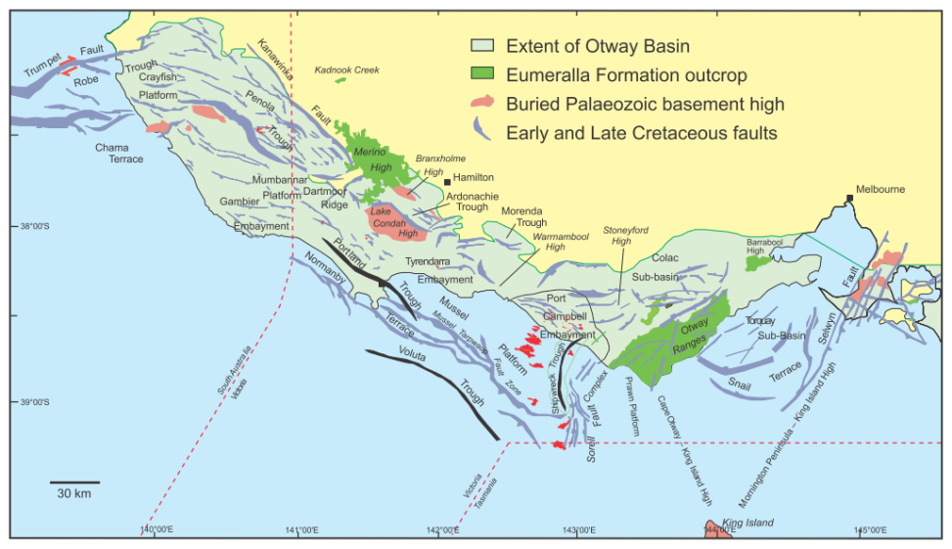
Figure 4: Major structures and sub-basins in the Otway Basin. (Source: O’Brien et al., 2009.)
Most features considered part of the Otway Ranges occur in the Gellibrand Trough (O’Brien et al, 2009) and have formed during uplift in the mid-Cretaceous. Further uplift has occurred in the Late Miocene at the Moonlight Head and Barongarook High areas, as well as in the mid-Tertiary throughout the Otway Ranges.

2.2.2 Stratigraphy
The stratigraphy of the Otway Basin can be divided into a series of major successions that overlie the Palaeozoic basement. From oldest to youngest these include:
• Casterton Formation
• Crayfish Subgroup
• Eumeralla Formation
• Sherbrook Group
• Wangerrip Group
• Nirranda Group
• Heytesbury Group
• Late Tertiary Sediments
• Newer Volcanics
• Quaternary sediments.
The stratigraphic relationships between these units and their constituents are illustrated in Figure 5. The major successions listed above are overlain by Quaternary aeolian, lacustrine, fluvial and alluvial sediments. The deposition of these sediments is driven by local processes which are highly variable and as such, their distribution and lithofacies are highly variable throughout the basin.

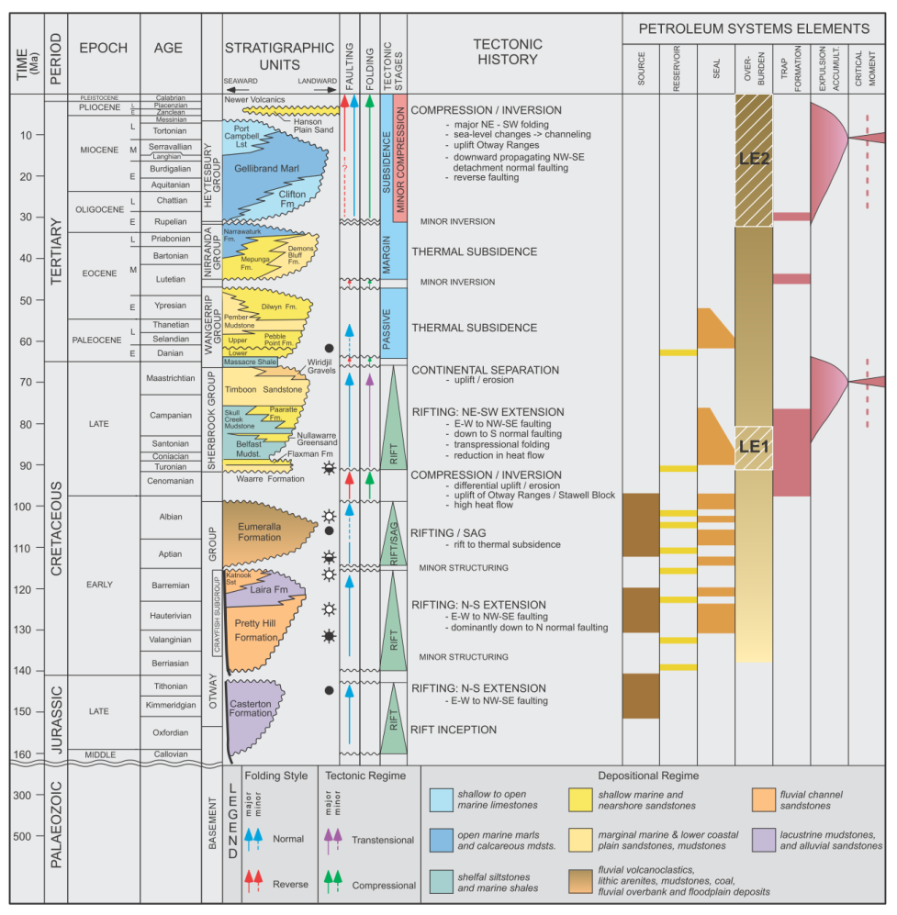
Figure 5: Stratigraphy of the Otway Basin. (Source: O’ Brien et al, 2009.)

Casterton Formation
The Casterton Formation is characterised by lacustrine carbonaceous shales in the western part of the Otway Basin while in Victoria, it also includes basaltic volcanics and non-marine sandstones and shales. The extent of the formation is largely restricted to the Penola Trough in South Australia and the Tyrendarra Embayment in Victoria. The formation has a maximum known thickness of 230 m, occurring from 2220 to 2450 m depth (Birch, 2003). Outcropping sections of this formation are limited to the northern margin of the Otway Basin near Coleraine in western Victoria.

Crayfish Subgroup
The Crayfish Subgroup consists of sedimentary successions up to 5000 m thick. These include alluvial and fluvial quartz rich sandstones and mudstones that were deposited in half grabens and were derived largely form the underlying basement margins. The distribution of the Crayfish Subgroup in these major depocentres is illustrated in Figure 6. The group consists of three formations, including:
• Pretty Hill Formation
• Laira Formation
• Katnook Sandstone.
The Laira Formation and Katnook Sandstone overlie the Pretty Hill Formation. They are treated as separate units in South Australia but are not differentiated in Victoria. The Laira Formation is restricted largely to the Penola Trough and consists of grey and green siltstones and claystones interbedded with minor finer-grained sandstones. The Katnook Sandstone is largely restricted to the area around Katnook in the west of the basin and is characterised by grey, medium-grained quartzose sandstones.

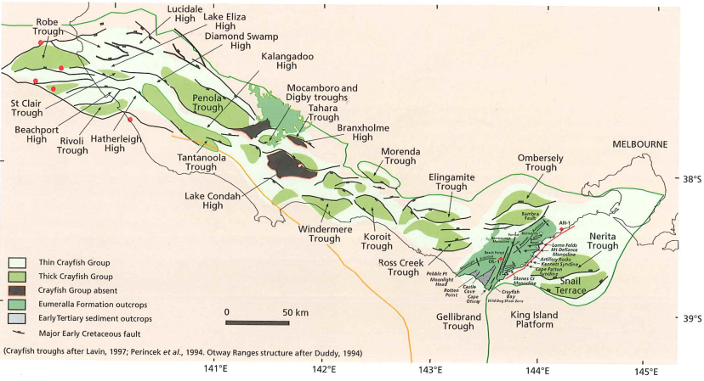
Figure 6: Distribution of Crayfish Group, Eumeralla Formation and Tertiary sediment outcrop.
(Source: Birch, 2003.)

Eumeralla Formation
The Eumeralla Formation overlies the Crayfish Subgroup. It is the thickest and most homogeneous unit in the Otway Basin above the Palaeozoic basement. The formation is dominated by channel deposits consisting of equal volumes of coarse sandstones, fine sandstones, mudstones and shales, with thin coal seam deposits found in paleo-levee and floodplain settings. The sediments are generally quartz-poor and are associated with basaltic volcanism that was active during deposition. The Windermere Sandstone occurs at the base of the Eumeralla Formation and is distinctive as a quartzose sandstone (Birch, 2003). The Killara coal measures also occur at the base of the Eumeralla Formation in discrete areas. The coals are thin and not widespread.

The Eumeralla Formation occurs throughout the subsurface of the entire onshore part of the basin and outcrops at the Merino High, Otway Ranges and Barrabool High (Figure 4). Throughout the majority of the basin, drill logs suggest a relatively uniform thickness ranging between 1500 and 3000 m. Thicker sections have been interpreted from reconstructions based on eroded outcrops in the Otway Ranges.

Sherbrook Group
The Sherbrook Group is present within approximately 50 km of the current coastline, increasing in thickness towards the offshore parts of the basin. The group is absent from the onshore part of the basin to the east of the Otway Ranges and thins towards the Merino High before thickening in the Penola Trough. The geological units of the Sherbrook Group include the following:
• Waarre Formation
• Flaxmans Formation
• Belfast Mudstone
• Paaratte Formation
• Timboon Sandstone.
Deposition of the Sherbrook Group began with quartz rich non-marine sandstones, mudstones and coals of the Waarre Formation, which were succeeded by deltaic–clastic sediments. These exhibit varying marine influence over at least three transgressive cycles.
The Waarre Formation is the basal unit of the Sherbrook group. It comprises quartzose sandstones, conglomerates and minor siltstones and shales, and is around 200 m thick onshore, increasing to over 600 m thick offshore. Cores taken from Port Campbell-2 typify the formation at a depth of 2494 to 2675 m (Boult and Hibburt, 2002).
The Flaxmans Formation represents the first period of marine transgression in the Sherbrook Group and consists of interbedded dark grey silty mudstones/shales and fine-grained brown sandstones. Drill cores from Port Campbell-2 are typical of the formation and identify its occurrence between 2483 and 2495 m in depth.
The Belfast Mudstone is pyritic marine shale. Its type section from Port Campbell-1 occurs from 1501 to 1685 m, although other wells have identified successions ranging from a few metres to over 1700 m in offshore parts of the basin. The unit occurs in the central and eastern parts of the basin and is the major confining layer (seal) for prospective hydrocarbon reservoirs in the Waarre and Flaxmans Formations.
The Paaratte Formation is dominated by fine to coarse-grained, cross-bedded quartzose sandstones, interbedded with mudstones and occasional coals. It represents a period of deltaic deposition during marine regression in the Sherbrook Group and is thought to exist between 1344 and 1514 m in the Port Campbell-1 type core.
The Timboon Sandstone represents a period of marine transgression and is characterised by fine to coarse quartzose sandstones with minor interbedded fluvial mudstones occurring throughout the lower parts of the formation. The type core for this formation in Port Campbell-1 is dominated by sandstones from 886 to 1295 m in depth.

Wangerrip Group
The Wangarrip Group consists of coastal plain, deltaic and shallow marine deposits ranging from mudstones to sandstones. The group becomes prevalent some 10 to 30 km from the northern margin of the Otway Basin and increases in thickness towards the coastline where it reaches thicknesses of in excess of 450 and 1200 m in the Port Campbell Embayment and Rivoli Troughs, respectively (Figure 7). Formations in the group are the Pebble Point Formation, Pember Mudstone and Dilwyn Formation.
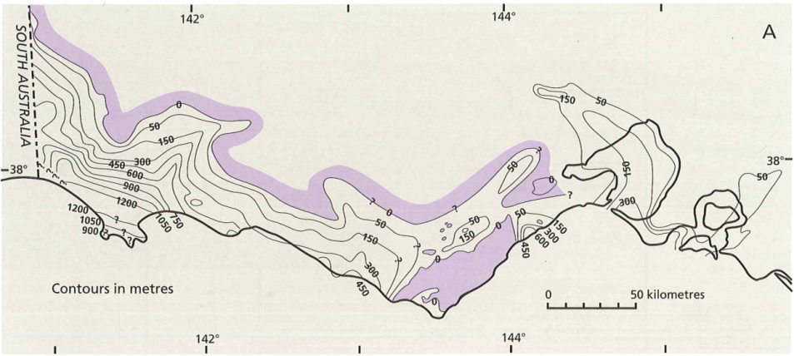
Figure 7: Isopach of the Wangerrip Group. (Source: Abele et al., 1988 as modified by Birch, 2003.)
The Pebble Point Formation is a mostly quartzose ferruginous sandstone with conglomerates and less common fossiliferous beds which represent a marginal marine environment. It ranges in thickness from 10 to 90 m and has been characterised by a South Australian type core (Caroline-1) at a depth of 925 to 951 m.
The Pember Mudstone occurs at the base of the overlying Dilwyn Formation and consists of siltstones, mudstones and shales that are pyritic, carbonaceous and micaceous. It also contains cemented carbonaceous sands in the upper stratigraphy of the unit. Thicknesses ranging from 32 m to 200 m have been recorded in Sawpit-1 and Mt Salt-1 respectively (Boult and Hibburt, 2002).
The Dilwyn Formation has a drilled thickness ranging from 6 to 1247 m. Typical thicknesses are around 100 m throughout the majority of the basin, but become thicker in the Portland Trough and Port Campbell Embayment. For example, seismic profiling in the Portland Trough indicates thicknesses reaching up to 2000 m (Birch, 2003). It is characterised by sandstones and shales with sandstone, siltstone and claystone sequences that represent transgressive/regressive cycles.
In the northeastern part of the Port Campbell Embayment, the formation becomes richer in sand and coal, and is equivalent to the Eastern View Formation in the Torquay Sub-basin. The Eastern View Formation is an individual formation in Victoria and is the equivalent of the Wangerrip and lower Nirranda Groups. Thick brown coal seams have been mined from this facies at Wensleydale, Deans Marsh and Benwerrin.

Nirranda Group
The Nirranda Group overlies the Wangerrip Group. It represents a period of marine transgression and is characterised by the prevalence of cool marine carbonate deposits. It follows a similar distribution to the underlying Wangarrip Group, thickening from the northern parts of the basin towards the coast where successions reach up to 200 m near Port Campbell and 300 m near Portland (see Figure 8). The majority of the Nirranda Group is a subsurface unit throughout the Otway Basin, but outcrops occur in the far east of the basin near the Johanna River – Glen Aire district. The group consists of the Mepunga Formation and the Narrawaturk Marl.
The Mepunga Formation represents a period of marine transgression and is characterised by a mixture of carbonate and clastic lithologies including carbonaceous marine sandstones, silty sandstones and shale.
The Narrawaturk Marl is characterised by bioclastic marls, carbonaceous sandy clays, glauconite, quartz and ferruginised grits and limestones.
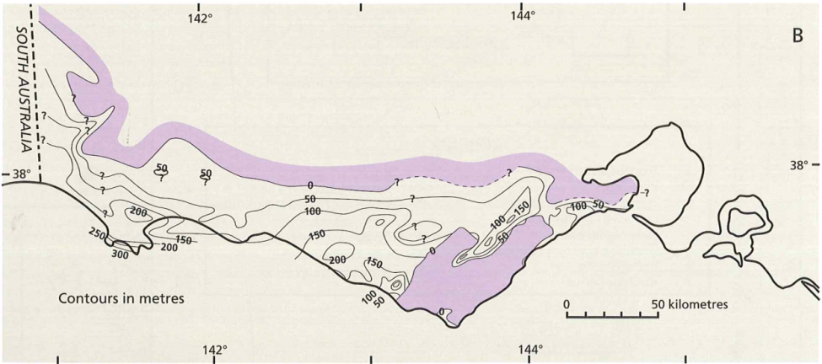
Figure 8: Isopach of the Nirranda Group. (Source: Abele et al., 1988 as modified by Birch, 2003.)

Heytesbury Group
The Heytesbury Group is up to 700 m thick and is dominated by various calcareous deposits including calcareous quartz sands, sandy limestone, limestone, marl, and calcareous clay. The group shows a similar distribution to the Wangerrip and Nirranda Groups, thickening from the northern areas of the Otway Basin to over 600 m in the Port Campbell Embayment and Portland Trough (Figure 9). However unlike the other groups, successions of the Heytesbury group also reach over 600 m in thickness in the Torquay Sub Basin. The Heytesbury Group consists of the Clifton Formation, Gellibrand Marl and Port Campbell Limestone.
The Clifton Formation forms the basal unit of the Heytesbury Group and consists of sandy limestones and sandy marls which represent a high energy inner shelf environment. The formation is up to 90 m thick and outcrops are generally confined to the eastern end of the Otway Basin.
The Gellibrand Marl is dominated by marls with interspersed calcarenite and chalk that represent an inner shelf shallow marine environment. While it is up to 1300 m thick in the offshore part of the basin, it is generally around 200 to 400 m thick throughout the onshore part of the basin, excluding the Mount Gambier Embayment where it thins to <50 m thick.
The Port Campbell Limestone is a deep marine limestone that is fine grained and weakly cemented. It contains minor clays and silts and is up to approximately 500 m thick. The limestone overlays and has a higher carbonate content than the Gellibrand Marl. Both the Gellibrand Marl and Port Campbell Limestone are exposed along approximately 80 km of the Port Campbell coastline. The Gambier Limestone is equivalent to the Port Campbell Limestone in the Gambier Embayment and is likewise formed in a shallow marine setting and is rich in bioclastic deposits. It is karstic and at times dolomitised with a maximum thickness of approximately 400 m (GHD, 2012).
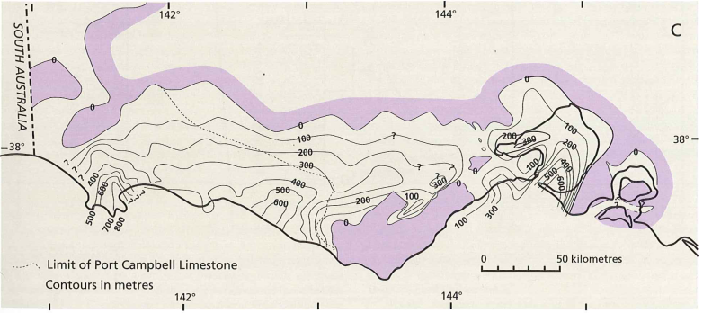
Figure 9: Isopach of the Heytesbury Group. (Source: Abele et al., 1988 as modified by Birch, 2003.)

Late Tertiary sediments
The Late Tertiary Period in the Otway Basin is characterised by a series of relatively thin and mixed silicate-carbonate sediments that are distributed locally throughout the basin (Birch, 2003). These include:
• Whalers Bluff Formation
• Werikoo Limestone
• Bridgewater Formation
• Nelson Bar Formation
• Dorodong Sands
• Grange Burn Formation
• Hanson Plain Sand
• Moorabool Viaduct Formation.
The Whalers Bluff Formation consists of fossiliferous clays, oyster beds and sandy limestones that are equivalent to the sandy limestone of the Werrikoo Limestone. The limestones grade into the Bridgewater Formation, which consists of cross-bedded, mainly carbonate-cemented aeolian sandstones.
The Bridgewater Formation occurs as sub-parallel dune deposits throughout the Gambier Embayment and at nearshore localities throughout the Otway Basin, including Portland, Warnambool and the Nepean Peninsula. The Bridgewater Formation also comprises aeolian deposits that are Quaternary in age and are not part of the Tertiary stratigraphy.
The Nelson Bar Formation consists of calcarenite deposits that are up to 30 m thick. These outcrop near Nelson Bay and are similar in age to the Werikoo Limestone.
The Dorodong Sands are slightly fossiliferous and micaceous sands to gravels that are up to 30 m thick and unconformably overlie the Heytesbury Group. The Grange Burn Formation consists of shelly marls and limestone that outcrop near Muddy Creek and Grange Burn near Hamilton.
The Hanson Plain Sand consists of shelly sands and silts and disconformably overlies the Port Campbell Limestone and are equivalent in age to the Whalers Bluff Formation. The sands have been previously named the Moorabool Viaduct Formation.

Newer Volcanics
The Newer Volcanics largely comprise basaltic lavas, tuffs and pyroclastic flows that are widespread throughout the Otway Basin. They generally unconformably overlie the Heytesbury Group, and tuffs interbed with the Heytesbury Group near Heywood. The distribution and thickness of the Newer Volcanics is illustrated in Figure 10.
The Newer Volcanics represent various stages of eruption, resulting in the formation of numerous basalt sheets reaching more than 30 m thick throughout depressions and fluvial channels (Bush, 2009). Between various eruption phases, erosion of the volcanics and deposition of Quaternary sediments dominated the depositional regime, resulting in the interbedding of Newer Volcanics and overlying Quaternary sediments in many areas.
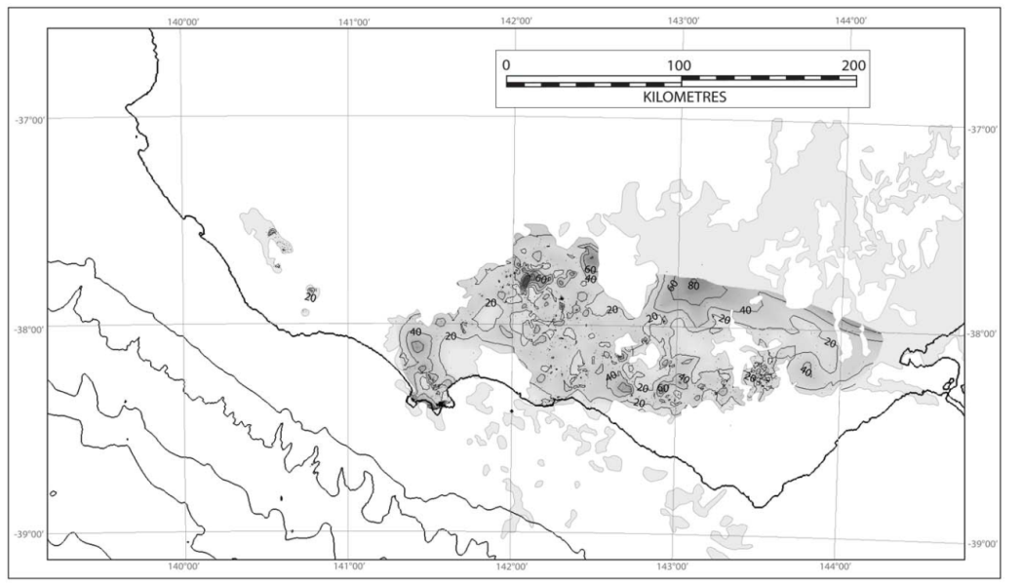
Figure 10: Isopach of the Newer Volcanics at 20 m contour intervals. (Source: Bush, 2009.)

2.2.3 Potential onshore natural gas
A number of potential gas resources have been defined in the Otway region at different spatial scales. The following section outlines prospective areas for onshore gas, based on Goldie Divko (2015).

Tight gas
The prospective tight gas formation is the Eumeralla Formation, which underlies the Waarre Formation at a depth ranging from 1300 to around 2200 m. The assessment of potential impacts from tight gas development has adopted the sub-regional scale scenario area (140 km²) shown in Figure 10.
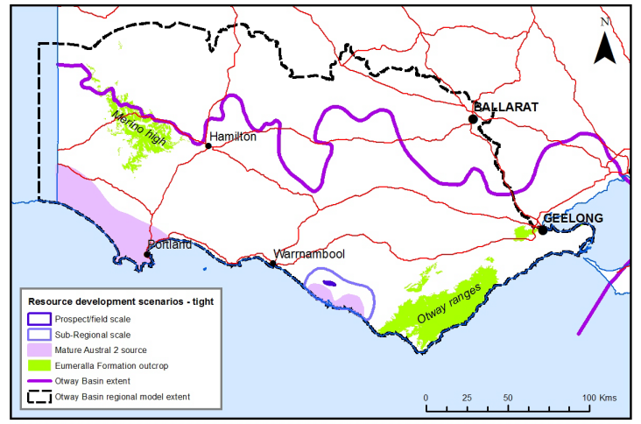
Figure 11: Otway region tight gas resource development scenario area. (Source: Goldie Divko, 2015.)

Shale gas
The Casterton Formation is generally the primary potential for shale gas in the Penola Trough at depths greater than 3,500 m.
The different areas of prospective shale gas are shown in Figure 12. The assessment of potential impacts from shale gas development has adopted the subregional scale scenario area (an area of 300 km²) shown in Figure 12. This area has been inferred based on the depth to the formation where gas may have been generated and trapped (O’Brien et al., 2009).

Coal seam gas
In the past the Killara coal measures have been the focus of exploration for coal seam gas and younger Tertiary brown coals (generally restricted to the Torquay Sub-Basin). Figure 13 shows the different areas of prospective coal seam gas. This shows the areas where the base of the Eumeralla Formation (and thus the Killara coal measures) occurs at relatively shallow depths. The areas range from approximately 50 to 160 km² at depths of 600 m or more.

Conventional gas
A number of conventional gas fields have been developed in the Port Campbell Embayment, which remains a prospective site for potential future conventional gas discoveries. The conventional gas reservoir unit is the Waarre Formation and is found at depths ranging between 1100 and 1700 m. Conventional gas prospectivity is defined at project, subregional and regional scales (Figure 14). The assessment of potential impacts from conventional gas is based on the subregional scale scenario area shown in Figure 14. This area includes a cluster of gas fields (some of which are developed), including the Langley/Grumby, North Paaratte, Skull Creek, Dunbar and Wallaby Creek fields. The sub-regional scale is defined as the part of the Waarre Formation that is mature for gas generation (after O’Brien et al., 2009).
Figure 12: Otway region shale gas resource development scenario area. (Source: Goldie Divko, 2015.)
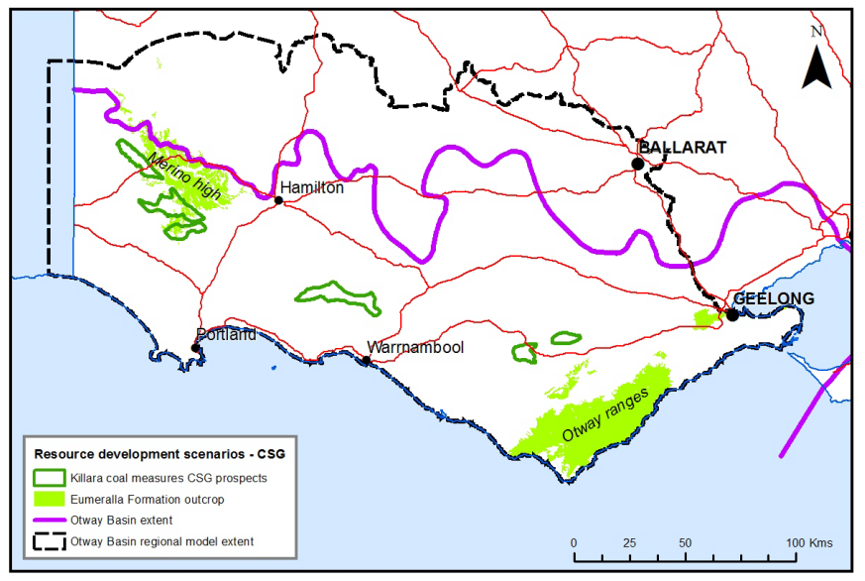
Figure 13: Otway region coal seam gas resource development scenario area. (Source: Goldie Divko, 2015.)
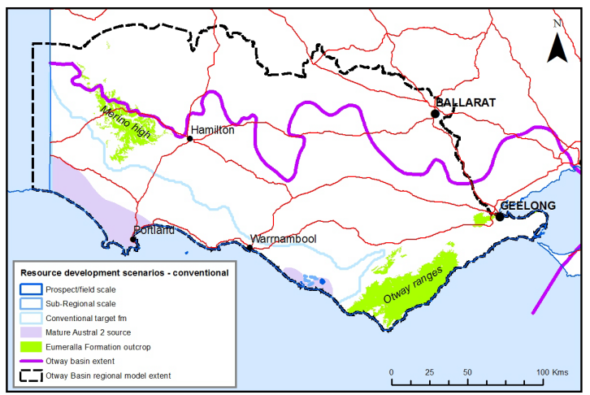
Figure 14: Otway region conventional gas resource development scenario area.
(Source: Goldie-Divko, 2015.)

2.3 Hydrogeology

2.3.3 Key aquifers and aquitards
Cretaceous rocks in the Otway Basin are not regionally significant aquifers and are generally thought of as the hydrogeological basement; that is, they are effectively impermeable for the purposes of groundwater resources. The useable aquifers are dominated by Cainozoic sediments. While there are many different named aquifers and aquitards throughout the Otway Basin, many are restricted in their distribution and do not constitute significant components of the basin’s water resources as a whole. Many of these smaller or restricted units can be incorporated into the larger or major units. The major hydrogeological units are as follows.
• The upper aquifer sequence, which includes all of the aquifers found at the surface and those immediately underlying them. These include the Quaternary Aquifer (QA); the Upper Tertiary Basalt (UTB); the Upper Tertiary Marine (UTAM); and Upper Tertiary Fluvial (UTAF) aquifer.
• The middle aquifer sequence, which includes the extensive Upper Mid-Tertiary Aquifer (UMTA), the Lower-Mid Tertiary Aquifer, and an important regional aquitard — the Gellibrand Marl, also known as the Upper Mid-Tertiary Aquitard (UMTD). At the base is the Lower Mid-Tertiary Aquifer (LMTA).
• The lower aquifer sequence, which includes the Lower Mid -Tertiary Aquitard (LMTD) that can be an important separator between aquifers. Beneath this lies the Lower Tertiary Aquifer (LTA) which constitutes the second of the two most extensive aquifers in the basin. The LTA is a very high-yielding and extensive aquifer unit found at depth across the Otway region. It is underlain by Lower Tertiary Basalts (LTB), Cretaceous and Permian Sediments (CPS) and the Cretaceous and Palaeozoic
Bedrock (BSE).
The relationship between the major aquifers in the Otway Basin and their constituent stratigraphic units as described above have been summarised in Table 1. The stratigraphic and geological units described above have been categorised according to the Victorian Aquifer Framework as outlined in GHD (2012).

Table 1: Relationship between stratigraphic units and hydrogeological units.
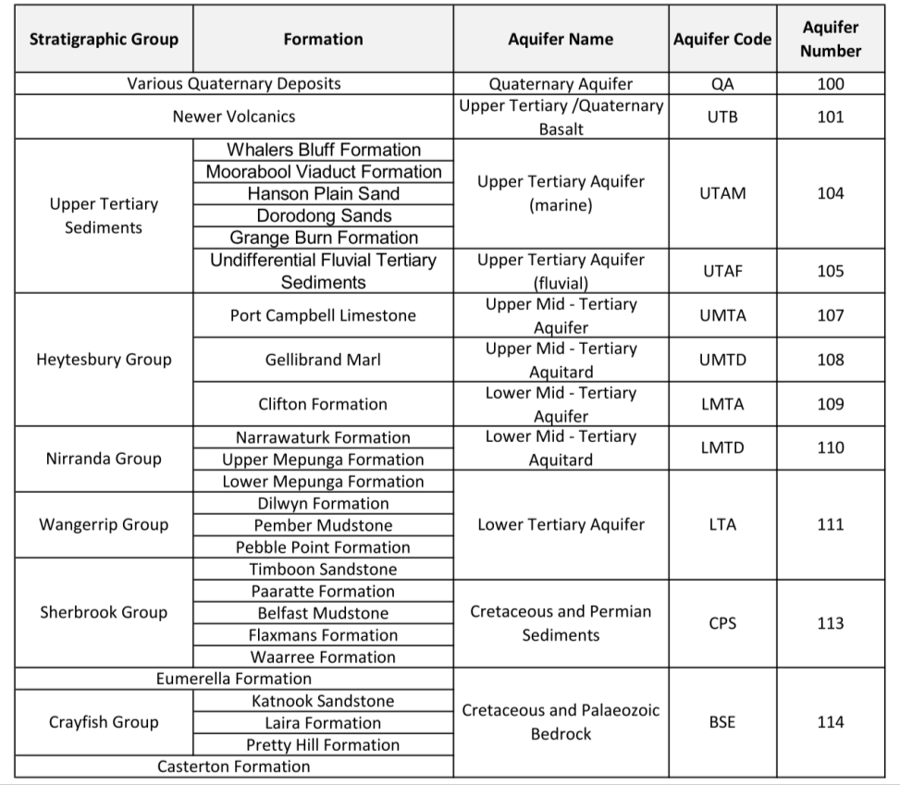
The Victorian Aquifer Framework classifies the geology described in Section 2.2 into units of similar hydrogeological behaviour. The framework classifies the full geological sequence and is inclusive of both aquifers and aquitards. The classification of aquifers and aquitards is regional and signifies that these units act mostly as aquifers or aquitards respectively but can act differently locally. For example, in most of the Otway Basin the Cretaceous and Palaeozoic Bedrock stores and transmits limited groundwater and is an aquitard (SRW, 2013), but near the basin margins where it is exposed and fractured it can act locally as an aquifer, although a generally poor one.
Table 1 does not include all of the stratigraphic units in the Otway Basin, nor all of the aquifers or aquitards. It highlights the major aquifers and aquitards in the basin and the major stratigraphic units that comprise them, to enable the stratigraphy and the aquifers to be compared.

2.3.4 Upper aquifers

Extent of aquifer
The upper aquifers have been defined by SRW (2011) as those that occur within 100 m of the surface. While this water is easy to access, yields are generally low and water quality is variable. The upper aquifers occur within the Newer Volcanics, Bridgewater Formation and various other sand units. The Newer Volcanics and Bridgewater Formations are thickest near Ballarat, Colac, Portland and south of Hamilton. They are variably distributed throughout the majority of the Otway Basin, excluding the areas to the south of Colac and to the east of Hamilton where the Eumeralla Formation outcrops. Older sand units are more prevalent throughout the northern portion of the basin and near Warnambool.

Salinity
Groundwater salinity in the upper aquifers is variable, however salinity is generally lower in the southern portion of the basin in comparison to the northern areas of the basin (Figure 15). For the purposes of this study, the areas highlighted in blue and green in Figure 15 represent groundwater assets with TDS (total dissolved solids) concentrations less than 3500 mg/L. Because salinity and yield in the upper aquifers is variable, it is possible that isolated areas with good potential remain undeveloped locally.

Groundwater levels and flow patterns
Groundwater levels in the upper aquifers of the Otway region show a strong correlation with topography. This is illustrated in Figure 15 which shows higher groundwater elevations and steeper hydraulic gradients (areas where groundwater contours are tightly spaced) closer to topographically elevated areas such as the Otway Ranges and the northern basin margins.

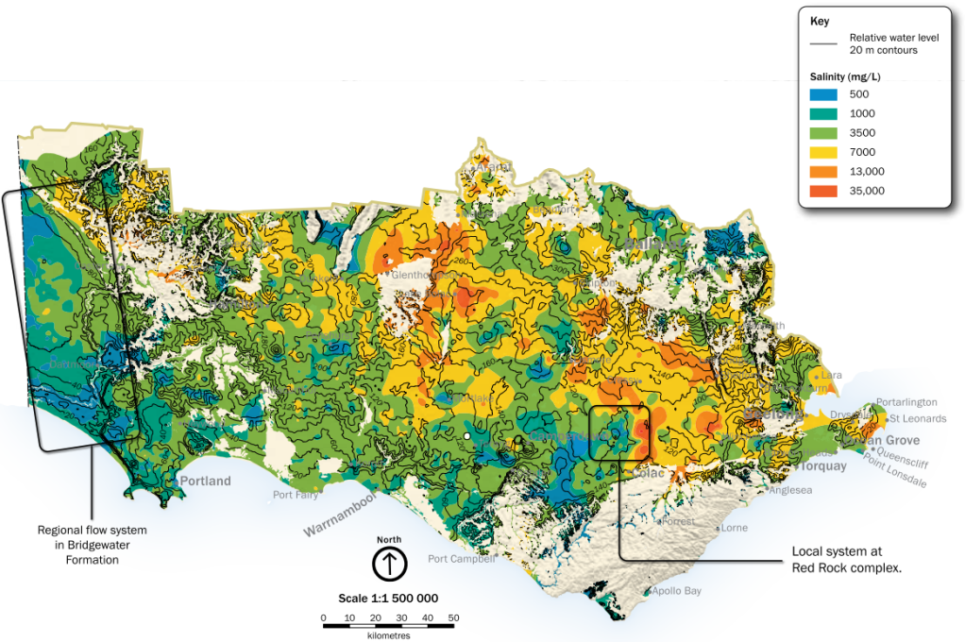
Figure 15: Groundwater salinity and water level contour map of the upper aquifers. (source: SRW, 2013.)
These areas are dominated by local groundwater flow systems where large topographic variations drive steep hydraulic gradients and frequent intersection between the water table and topographic depressions. This results in groundwater discharge to springs and streambeds. For example, Figure 15 highlights Warrion Hill Red Rock complex. In this setting, groundwater recharge occurs on elevated scoria mounds before flowing away radially and discharging into the nearby lakes systems. In these setting, upward hydraulic gradients are common and groundwater flow from underlying aquifers into the upper aquifers occurs where they are hydraulically connected.
Conversely, topographically flatter areas such as those along the western margin of the basin result in shallow hydraulic gradients (Figure 15). In these settings, groundwater flow paths are longer and flow rates slower, resulting in long groundwater residence times. Groundwater flow directions in these areas are roughly north–south and groundwater discharge generally occurs offshore.

Hydraulic connection to other aquifers
The upper aquifers are generally well connected to the underlying Upper Mid-Tertiary Aquifers, including the Port Campbell Limestone and Gambier Limestone. In the majority of the basin, aquitards are generally absent between the upper and middle aquifers, and groundwater recharge to the Upper Mid-Tertiary Aquifers occurs through the upper aquifers. Likewise, upward groundwater movement from the Upper
Mid-Tertiary Aquifers to the upper aquifers commonly occurs at depressions where groundwater
discharge occurs.
In some areas, such as the northern margin of the Port Campbell Embayment (Figure 4) where upper aquifers directly overlie the Upper Mid-Tertiary Aquitard, vertical groundwater exchange is limited and groundwater is either discharged to surface water bodies or laterally into the UMTA where it becomes prevalent (Bush, 2009).

2.3.5 Middle aquifers

Extent of aquifer
The Upper Mid-Tertiary Aquifer (UMTA) system includes the Gambier Limestone in the Gambier Embayment in South Australia. It is separated by the Merino High and extends laterally across the majority of the Victorian part of the Otway Basin as the Port Campbell Limestone. The underlying Gellibrand Marl forms
the Upper Mid-Tertiary Aquitard (UMTD) to the east of the Gambier Embayment and separates the Port Campbell Limestone from the underlying Clifton Formation which comprises the Lower Mid-Tertiary
Aquifer (LMTA).

Salinity
Groundwater in both the Gambier and Port Campbell Limestones has generally less than 1500 mg/L TDS, however values as high as 7000 mg/L TDS exist toward the outer extents of the aquifer away from the coast (Leonard, 2003). Less information is available for the Clifton Formation aquifer, but high-yielding groundwater with a TDS below 1000 mg/L is known to occur around the Lake Condah High. For the purposes of this study, the areas highlighted in blue and green in Figure 16 represent groundwater assets.
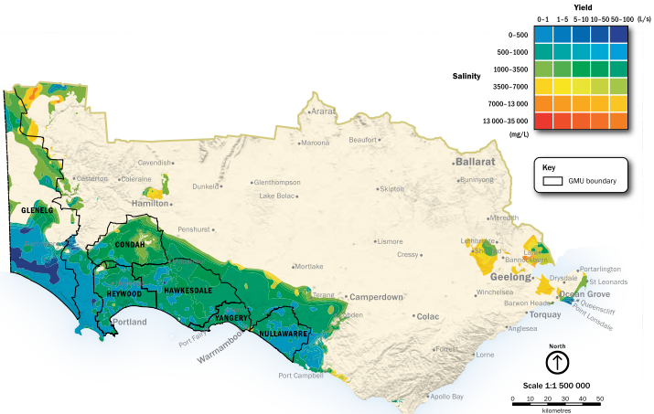
Figure 16: Groundwater salinity and yield map of the Upper Mid-Tertiary Aquifer. (Source: SRW, 2013.)

Groundwater levels and flow patterns
While the UMTA is overlain by the upper aquifers, the absence of significant overlying aquitards and hydraulic connection with the upper aquifers mean that it behaves in an unconfined manner. As a result the potentiometric surface of groundwater in the UMTA is strongly influenced by topography (Figure 17). Where the UMTA is exposed, shallow portions of the aquifer are subject to the heterogeneous flow patterns of local flow systems. In these areas groundwater follows relatively short flow paths between recharge at topographically elevated areas and discharge at topographically depressed lakes, streambeds and springs.
Groundwater flow in most of the aquifer occurs on an intermediate to regional scale, as indicated in Figure 17, which shows recharge along the topographically elevated northern basin margin and groundwater flow in a south to south westerly direction towards the coast. While it is likely that this mechanism dominates the flow regime in the UMTA, it is also likely that local flow systems and vertical infiltration into the UMTA occur throughout the basin where vertical head gradients permit.

Hydraulic connection to other aquifers
The UMTA is generally well connected to the upper aquifers and groundwater flow between the two readily occurs. Recharge to the UMTA commonly occurs via infiltration though the upper aquifers at topographic highs, while upward groundwater flow from the UMTA into the above lying aquifers is common where the surface discharge of groundwater occurs. The UMTA is confined by overlying basalts of the Newer Volcanics at a local scale where low permeability basalts occur. In these areas the UMTA acts as a semi-confined aquifer.
The Gellibrand Marl aquitard (UMTD) hydraulically separates the UMTA from the underlying LMTA; however where the aquitard is thinner, more flow between the two does occur. For example, upward groundwater flow from the LMTA to the UMTA is thought to occur near the coastline of the Gambier Embayment where the LMTD thins. Equally, the Gellibrand Marl thins near Mt Eccles in the Tyrendarra Embayment, allowing recharge to the Clifton Formation via the upper aquifers and the UMTA (Bush, 2009). While flow between the UMTA and LMTA will be restricted and diffuse throughout the majority of the basin, local faulting and volcanic pipes are thought to facilitate localised groundwater connectivity.
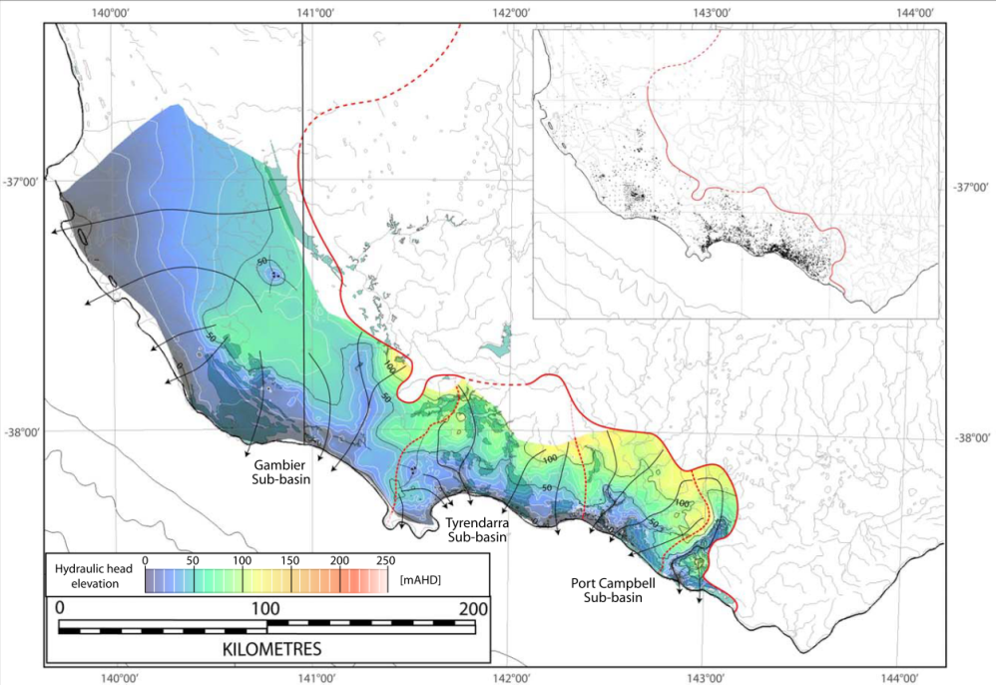
Figure 17: Potentiometric surface and groundwater flow directions in the UMTA. (Source: Bush, 2009.)

2.3.6 Lower aquifers

Extent of aquifer
The Lower Tertiary Aquifer (LTA) is commonly known as the confined sandy aquifer and is dominated by the Dilwyn Formation (Leonard 2003) and Eastern View Formation. Additionally, while the Mepunga Formation is generally an aquitard, in some areas the lower Mepunga Formation exhibits aquifer properties and is connected to the LTA (Bush, 2009). In these circumstances the Mepunga Formation is to be part of the LTA. The LTA is prevalent throughout the majority of the Otway Basin excluding the Otway Ranges where the Eumeralla Formation outcrops. Successions increase in thickness from the northern basin margin towards the coast and generally range between 50 to 250 m. However, successions increase to over 500 m and 800 m in the Gambier Embayment and Portland Troughs, respectively.
The LTA is confined by the overlying sedimentary and volcanic rocks including the Narrawaturk Marl and the upper Mepunga Formation which form the Lower Mid-Tertiary Aquitard (LMTD). The LMTD shows a similar distribution to the underlying LTA however its inland extent is not as great as the LTA and thicknesses are around half that of the LTA.

Salinity
Total dissolved solids in the LTA are generally around 500 mg/L near recharge areas, but increase to 1000 mg/L towards the coast. Figure 18 shows higher TDS concentrations around inland drainage lines. It is likely that these areas represent terminal groundwater discharge points where evapotranspiration drives the accumulation of salts. Throughout the rest of the basin, groundwater TDS generally exceeds 3500 mg/L north of Warnambool (over the Warnambool High) where concentrations of up to 5600 mg/L occur (Leonard, 2003). For the purposes of this investigation, the green and blue highlighted areas in Figure 18 are groundwater assets (TDS less than 3500 mg/L).
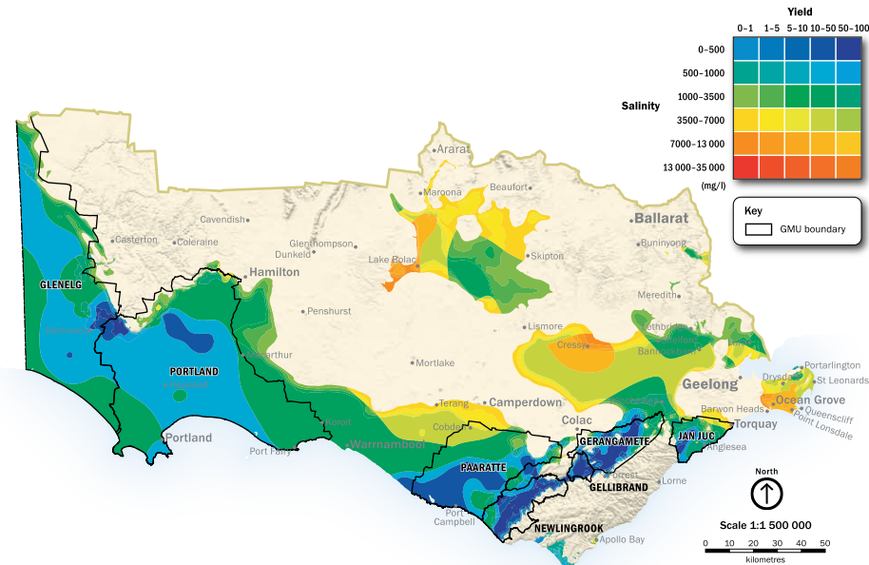
Figure 18: Groundwater salinity and yield map of the LTA. (Source: SRW, 2013.)

Groundwater levels and flow patterns
The potentiometric surface of the LTA is shown in Figure 19. This indicates that groundwater recharge in the aquifer is occurring towards the northern margin of the Otway Basin and near the Otway Ranges. The link between topography and groundwater elevation is emphasised at the northern margin of the Tyrendarra Embayment, where groundwater elevations approaching the Grampian Ranges exceed 100 m, while those near the Otway Ranges exceed 200 m. Groundwater flow generally occurs in a southward direction towards the coast, where groundwater elevations approach sea level.
Groundwater flow in the LTA is also governed by basement ridges which restrict east–west orientated groundwater flow (SRW, 2013). In the southern portion of the basin to the west of Colac, groundwater flow paths are generally orientated in a south to southwest direction, terminating to the south of the coastline as submarine groundwater discharge. Groundwater flow patterns in the northern parts of the aquifer follow a similar pattern, with flow occurring in a southwest direction from areas around Beaufort towards Lake Bolac. In the east of the basin, groundwater flow occurs in a roughly eastern direction from areas around Cressy and Colac, towards the township of Geelong. Groundwater flow from areas south of Geelong are roughly southeast towards the coastline.
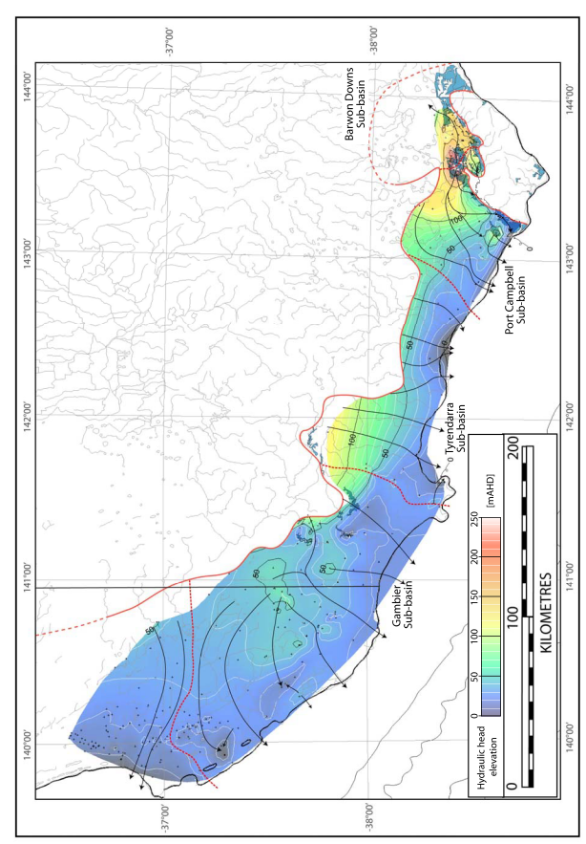
Figure 19: Potentiometric surface and groundwater flow directions in the Lower Tertiary aquifer of the southwest Otway Basin. (Source: Bush, 2009.)
Shallow groundwater flow paths are prevalent where the aquifer is close to the surface or outcropping (near Dartmore in the west and Colac and Torquay in the east). The remaining parts of the aquifer are dominated by flow paths that are more than 30 km long, yielding groundwater residence times of thousands of years.

Hydraulic connection to other aquifers
The LTA is confined by the LMTD over most of the Otway Basin, but as the inland extent of the LMTD is not as great as the aquifer the hydraulic connection between it and overlying middle aquifers is likely to be greater near the margins of the Otway Basin.
Additionally, in the Condah and Lake Mundi areas the LMTD is thin or absent, allowing hydraulic connection between the Dilwyn Formation of the LTA, the Clifton Formation of the LMTA and limestone aquifers of the UMTA. This is also true in offshore sections of the Gambier Basin where upward leakage from the LTA to the middle aquifers occurs through the thinned LMTD.
It has also been shown that eruption centres are usually associated with fully penetrating faults or volcanic vents, both of which may acts as zones of high permeability for groundwater flow (Bush, 2009). This (along with topographically driven increased groundwater elevations) provides potential for groundwater recharge to the lower aquifers and increased connectivity to the above aquifer. This is thought to occur in areas of the Port Campbell Embayment where many maars are present (Bush, 2009), but the scarcity of bore data currently prevents the identification of groundwater mounding in these areas.
Where the lower Mepunga Formation directly overlies the LTA and exhibits aquifer characteristics, the LTA is in hydraulic connection with the Mepunga Formation, which is thus part of the LTA in these areas.

2.3.7 Cretaceous and bedrock aquifers

Extent of aquifer
The basement aquifer comprises the Eumarella Formation, Casterton Formation, Crayfish Group and all underlying Palaeozoic rocks. While the basement is pervasive and underlies the entirety of the Otway Basin, appreciable outcropping sections are exposed at the Otway Ranges, Merino High and along the northern margin of the basin at the Grampians.
The Cretaceous aquifer is essentially comprised of the Sherbrook Group (section 0) and as such contains the Waarre Formation, Flaxmans Formation, Belfast Mudstone, Paaratte Formation and Timboon Sandstone. The Belfast Mudstone acts as an aquitard within the Cretaceous aquifer, confining the units below it. The extent of the aquifer follows a trend roughly sub-parallel to the current coastline and is shown in Figure 20. The aquifer thickens in a south west direction, reaching thicknesses of over 2000 m around the Gambier Embayment and Penola Trough and 700 m thick in the Port Campbell Embayment.

Salinity
Salinity data for the Cretaceous and bedrock aquifers is very limited and mainly relies on petroleum exploration wells. In the Eumeralla Formation, salinities ranging from 10 000 to 26 800 mg/L have been recorded (Reynold, 1971). Groundwater from the Casterton Formation has yielded water with a salinity of approximately 35 000 mg/L.
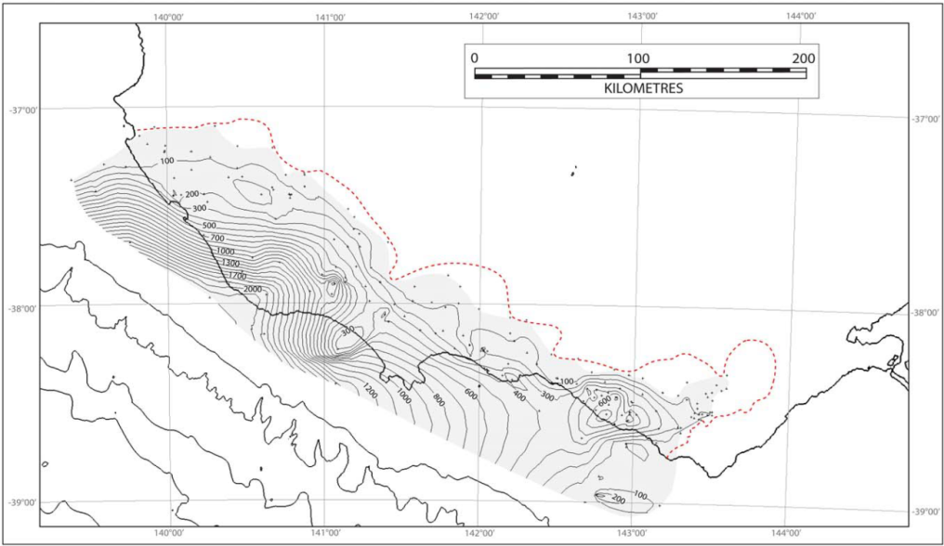
Figure 20: Isopach of the Cretaceous Aquifer. (Source: Bush, 2009.)

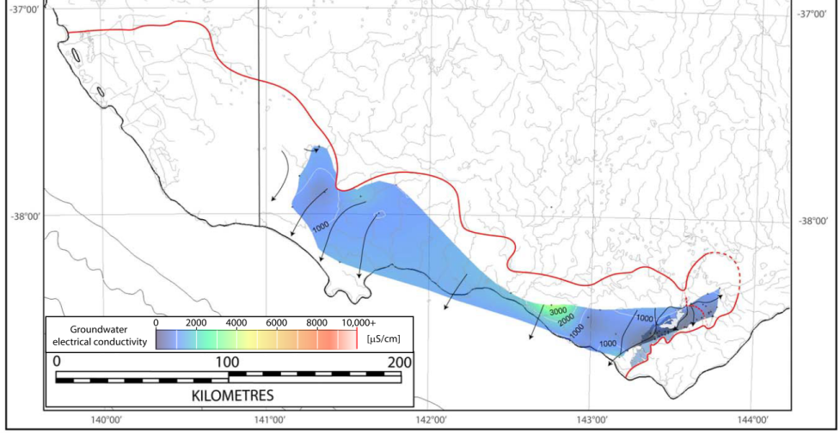
Figure 21: Groundwater salinity map of the upper Cretaceous aquifer. (Source: Bush, 2009.)
Figure 21 from Bush (2009) depicts the electrical conductivity of groundwater from the Upper Cretaceous Aquifer, which includes the Pebble Point Formation, Moomowroong Sand Member, Timboon Sand and Paaratte Formation as data from the underlying units is particularly sparse.
In the Port Campbell Embayment, Reynold (1971) indicated the presence of both ‘salty’ and ‘fresh’ water in the Waarre Formation. (A conservative taste threshold for salt in water is 500 mg/L; EPA 2003.) In Victoria, groundwater salinities in the Waarre Formation vary from fresh to hypersaline, ranging from 400 to 200 000 mg/L TDS (Mehin and Link 1995).
The majority of these data were obtained towards the coast where groundwater has longer flow paths, residence times, and potential to increase in salinity. However, the limited data indicates that lower salinities occur towards recharge zones near basin margins.

Groundwater levels and flow patterns
Groundwater recharge to the Cretaceous aquifer in the western part of the Otway region presumably occurs through the overlying units, as it does not outcrop in this section of the basin. I is assumed that recharge and discharge mechanisms in these areas are similar to those in the overlying LTA, with groundwater flow in a roughly coastward direction (Figure 22). Direct recharge to the aquifer occurs where it becomes exposed in the Port Campbell and Barwon Downs sub-basins due to inversion against the basement. The main recharge zone is the Barongarook High, from which the groundwater flows roughly radially before diverting towards the coast in a south west direction and also inland in a northeast direction; most of the discharge is thought to occur offshore.
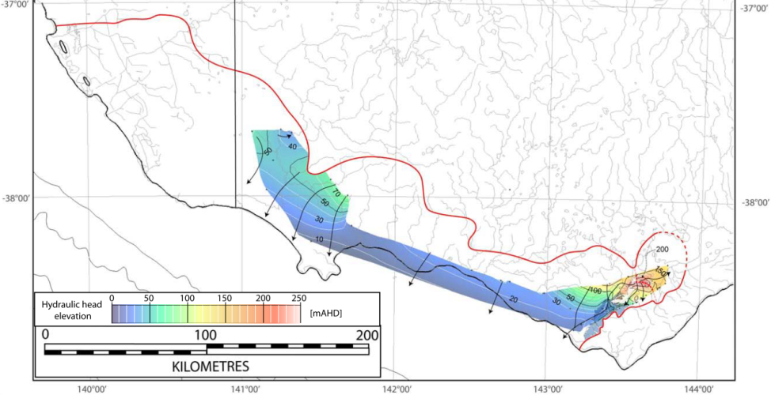
Figure 22: Potentiometric surface and groundwater flow directions in the Cretaceous aquifer.
(Source: Bush, 2009.)

Hydraulic connection to other aquifers
The basement is mainly very low-permeability siltstone and regionally acts as an aquitard, although fracturing at the near surface along the basin margin and near the Grampians, Central Highlands and Otway Ranges allows for some limited groundwater transmission. Even so it is porous enough to hold water and fossil fuels and has a high potential for gas production and geothermal energy. It is therefore likely that minor diffusive groundwater recharge to the basement occurs regionally through the overlying Cretaceous aquifer where vertical hydraulic gradients are downward, such as those closer to the northern basin margin in topographically elevated areas.
Where the Belfast Mudstone is present within the Cretaceous aquifer it acts as an aquitard between the lower Flaxman and Warree Formations and the overlying Paaratte Formation and Timboon Sandstone. In areas where the Belfast Mudstone is absent, however, the Cretaceous aquifer is in direct contact with the overlying LTA.

2.4 Water use

2.4.1 Surface water users
Surface water use in Victoria during the 2003 to 2013 period is summarised in Figure 23. During this period, reduced water use during the 2006–2007 to 2009–2010 period is a reflection of lower water availability in response to drought conditions (DEPI, 2014). Restrictions on water use by urban customers, and low seasonal allocations in irrigation districts at this time, were widespread. During 2010–2011 and 2011–2012, lower water use was a reflection of reduced water demand resulting from wet conditions.
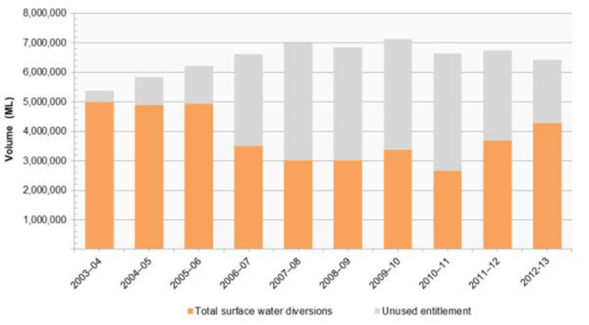
Figure 23: Surface water consumptive use for 2003 to 2013. (Source: DEPI, 2014.)
Consumptive entitlements can broadly be classified into four categories: irrigation, domestic and stock, urban and commercial, and power generation. During 2012–2013 consumptive use attributed to irrigation was 3467 ML, which was 80% of all consumptive use for the period. Urban and commercial use accounted for 14% of consumptive use for the period, and domestic and stock and power generation accounted for 4% and 2% respectively.
The surface water basins in the Otway region include the Millicent Coast, Glenelg, Portland Coast, Hopkins River, Lake Corangamite, Otway Coast, Barwon and Moorabool Basins. The entitlements for 2012–2013 in each of these basins has been summarised in Table 2. These figures indicate that the majority of surface water entitlements and usage occur in the Otway Coast, Barwon and Moorabool Basins. These three basins account for 85% of the combined bulk and licensed entitlements and 91% of the combined and bulk and licensed volumes taken (i.e. actual usage) in the Otway region for the 2013–2013 period.

Table 2: Surface water entitlements and volumes taken (i.e. usage) figures for 2012–2013. (Source: DEPI, 2014.)
Basin  (from west to east) | Bulk entitlements |  |  | Licences
Basin  (from west to east) | Entitlement volume (ML) | Volume taken (ML) | Proportion of entitlement taken (%) | Entitlement volume (ML) | Volume taken (ML) | Proportion of entitlement taken (%)
Millicent Coast | 0 | 0 | n/a | 4 | 4 | 100
Glenelg | 4554 | 1361 | 30 | 1068 | 348 | 33
Portland Coast | 0 | 0 | n/a | 1081 | 73 | 7
Hopkins | 629 | 179 | 28 | 11423 | 3484 | 30
Corangamite | 0 | 0 | N/A | 1237 | 142 | 11
Otway Coast | 19667 | 13395 | 68 | 6740 | 845 | 13
Barwon | 55734 | 33260 | 60 | 5639 | 1370 | 24
Moorabool | 40600 | 13849 | 34 | 3600 | 1276 | 35
n/a = not applicable

2.4.2 Groundwater users
Like surface water use, groundwater use can be broadly classified into four main categories: irrigation and salinity control, domestic and stock, urban, and power generation. Over the 2012–2013 period, the majority of groundwater use (275 964 ML) was attributed to irrigation and salinity control and represented 75% of total consumption. Domestic and stock use accounted for 15% of total consumption over this period while power generation and urban use accounted for 8% and 2% of total use (respectively) during the period.
Groundwater use is measured within different groundwater management areas. Table 3 summarises the total groundwater use (both licensed and domestic and stock for each of the groundwater management units in the Otway region. This illustrates that the most significant areas of groundwater use during the 2012–2013 period occurred in the Nullawarre and Glenelg areas.

Table 3: Summary of total groundwater use in groundwater management units for the 2012-2013 period. (Source: DEPI, 2014.)
Groundwater Management Unit | Aquifer group | Licensed entitlement (ML/Yr) | Total use in 2012–13 (excluding stock and domestic) (ML)
Gellibrand | All | n/a | 3
Nullawarre | Upper | 22635 | 11583
Warrion | All | 14081 | 4530
Yangery | Upper | 14343 | 3059
Condah | Middle | 7475 | 3380
Glenelg | All | N/A | 10636
Colongulac | All | 4068 | 1215
Gerangamete | Lower | 20000 | 0
Glenormiston | Upper | 2691 | 1167
Hawkesdale | Upper | 12454 | 5939
Heywood | Upper | 7006 | 1726
Jan Juc | Upper | N/A | 3511
Newlingrook | All | 5293 | 2729
Paaratte | Upper | 3212 | 345
Portland | Lower | 7794 | 2692
n/a = not available

2.5 Natural gas interactions with groundwater, surface water and ecosystems
The onshore Otway region contains potentially prospective sites for all gas types including conventional, tight, shale and coal seam gas. The main focus for resource development scenarios presented in this study of the onshore Otway region is the Port Campbell Embayment and the Penola Trough. The Port Campbell Embayment is the place in Victoria where onshore natural gas has been discovered and produced in the past. In the South Australian portion of the Penola Trough, numerous gas fields have also been discovered and produced.

2.5.1 Groundwater
The following section considers the hydraulic connectivity between the geological formations in which gas prospects have been identified (in Section 2.2.3), and any aquifers or groundwater assets that occur in the overlying stratigraphy. In this context, the connectivity between gas prospect formations and directly overlying aquifers has been evaluated, as well as the connectivity between any aquifers that may be subsequently impacted by those directly affected aquifers.

Shale gas
The Casterton Formation within the Penola Trough is potentially prospective for shale gas (Figure 24). In the Penola Trough the LTA is the closest aquifer to the Casterton Formation and is separated from it by approximately 1 to 3 km of alternating aquifer and aquitard sequences. As such, it is unlikely that the LTA is appreciably hydraulically connected to the Casterton Formation.
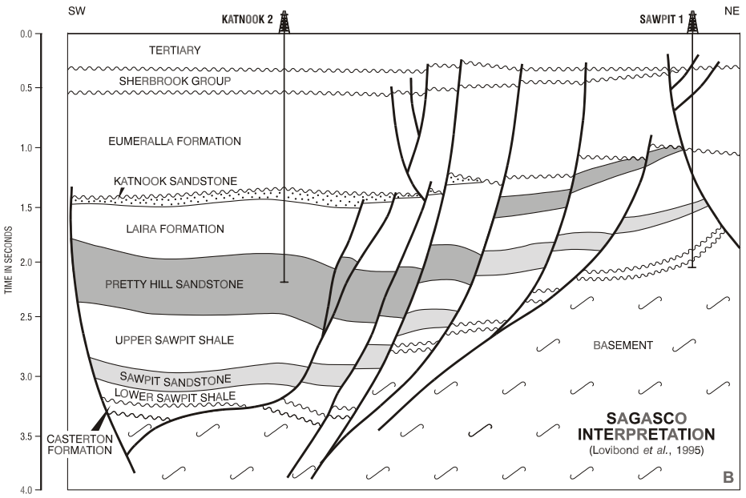
Figure 24: Penola Trough cross section. (Source: Boult and Hibburt, 2002.)
In a study undertaken by SKM (2011) the hydraulic connection between the LTA and UMTA around the South Australia – Victoria border (commonly referred to as the border zone) was undertaken. As part of this study, pump tests were conducted at 8 sites located within 40 km of the township of Penola. Groundwater was extracted from the LTA and responses were measured in the LTA and overlying aquifers and aquitards. A numerical model was subsequently developed to help assess the potential for leakage between the LTA and UMTA.
The investigations determined that there is moderate to very good hydraulic connection between the LTA and the UMTA in the border zone. While the presence of an aquitard was identified across most of the study area, its thickness and effective vertical permeability were not homogeneous and its effectiveness as a barrier is therefore expected to vary. At two sites the aquitard was absent or so thin that the aquifer was effectively unconfined; at one of these sites, pumping in the LTA induced drawdown in the UMTA within one day of test activation. Results from numerical modelling indicate that leakage between the aquifers can be expected to occur within days of pumping commencement, and that significant flow between the aquifers is possible even when the aquitard is present. These results indicate that, in the event of drawdown in the LTA, it is likely that responses in the overlying UMTA will also be observed.
While these results indicate a strong hydraulic connection between the LTA and UMTA in the Penola Trough, less information is available regarding the connectivity between these units and the underlying Mesozoic and Palaeozoic bedrock formations, such as the Casterton Formation in which shale gas is a prospect.
In many hydrogeological studies in the Otway Basin it is assumed that the top of the basement is the base of the LTA and that the hydraulic properties of all underlying units (including the Sherbrook Group, Eumeralla Formation, Crayfish Group and Casterton Formation) are uniform (SKM and GHD, 2009). A comparison of the groundwater salinity in the LTA and all underlying units by SKM (2010) indicates that the LTA and the basement are not hydrogeologically well connected.
A similar approach which characterise the units underlying the LTA as an impermeable basement, has been adopted in other studies. For example, numerical modelling of the Barwon Downs and Newlingrook areas (e.g. SKM, 2001) considered the basement as everything underlying the Pebble Point Formation. In these models the basement is a no-flow boundary (a boundary over which no groundwater flows occurs). While such assumptions may be reasonable for such modelling purposes, recent investigations (Jacobs, 2014a) have indicated that the hydraulic conductivity of the upper basement is in the order of 6 × 10^{–3} m/day. While this suggests that the upper basement may not always be impermeable and may in fact act as a leaky boundary, this value is reflective of the upper few tens of metres of the basement that are weathered and fractured and hence does not reflect the conductivity of the basement as a whole.
It should be noted that these results were recorded in the upper basement in the Barwon Downs area and so may not reflect conditions lower in the basement (i.e. in the Casterton Formation) in the Penola Trough. The results do, however, highlight potential flaws in assuming a set of homogeneous aquifer properties for all units underlying the LTA. In any case the scarcity of data for the units underlying the LTA in the Penola Trough means that further assessment is required to determine the connectivity between the prospective shale gas formations and the overlying aquifers.

Conventional and tight gas
Prospective conventional gas and tight gas formations are identified in the Port Campbell Embayment, within the Eumeralla and Waarre Formations. The following section assesses the connectivity of these formations with groundwater assets in the Port Campbell Embayment.
The cross-section in Figure 25 shows the hydrogeological relationships and groundwater flow directions in the Port Campbell Sub-basin. In this figure the Pliocene Quaternary Volcanic Aquifer, Lower Tertiary Sandy aquifer and Upper Tertiary Carbonate Aquifer are equivalent to the Upper Tertiary Basalt (UTB), Lower Tertiary Aquifer (LTA) and Upper mid-Tertiary Aquifer (UMTA) respectively.
The basal unit of the LTA (the Timboon Sand) is separated from the Waarre Formation by over 1100 m of alternating aquifer and aquitard sequences in the Port Campbell Embayment. This includes the Paaratte Formation, Belfast Mudstone and Flaxman Formation. As outlined in Section 2.3.4, the LTA is in greater hydraulic connection with other aquifers closer to the margins of the Otway Basin to the north, where the thickness of separating units is diminished. This suggests that the LTA will be relatively hydraulically disconnected from the Waarre Formation in the Port Campbell Embayment near the location of natural gas prospects where the intervening units are thick. However, it is possible that where faults, volcanic eruption columns or reduced aquitard thickness exist, hydraulic connectivity will increase (Bush, 2009).
The connectivity between the Waarre Formation and overlying UMTA and LTA aquifers in the Port Campbell Embayment, was assessed as part of the CSIRO’s Geological Storage of Carbon (GSC) project (Cook, 2014). As part of this project, 66 000 tonnes of CO₂ were injected into the Waarre Formation between February 2008 and October 2009. Groundwater monitoring in both the LTA and UMTA was conducted from 2007 and 2011 during the injection, in order to assess the potential leakage of CO₂ from the Waarre Formation into the above lying aquifers.

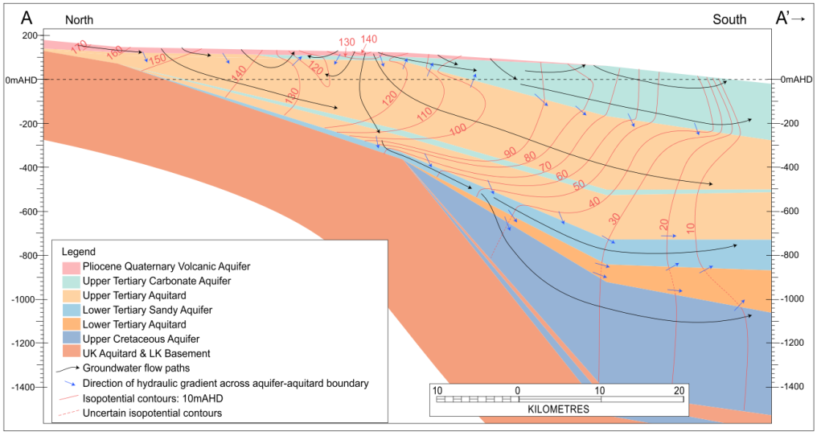
Figure 25: Hydrostratigraphic cross-section of the Port Campbell Sub-basin. (Source: Bush, 2009.)
Note: Units in this figure are equivalent to those discussed above and relate to Table 3 as follows: Pliocene Quaternary Volcanic Aquifer = UTB, Upper Tertiary Carbonate Aquifer = UMTA (and LMTA where overlain by UMTD), Upper Tertiary Aquitard = UMTD, Lower Tertiary Aquifer = LTA, Lower Tertiary Aquitard = Pember Mudstone (within the LTA), Upper Cretaceous Aquifer = CPS, UK Aquitard and LK Basement = BSE.
Groundwater levels were monitored in 17 bores in the UMTA and 3 bores in the LTA as part of the study. During the study, groundwater levels recorded in the LTA showed very minor (< 0.25 m) fluctuations in response to rainfall (Cook, 2014), suggesting hydraulic separation between the LTA and the upper aquifers that readily receive direct local recharge. Groundwater elevations in the monitoring bores were consistent with the regional trends discussed in Section 2.3.4, which indicate a decline in groundwater elevation in a roughly south west direction towards the coast. As in the UMTA, chemical analysis of groundwater collected before, during, and after gas injection showed no statistically significant change over the duration of the study. These results indicate that the Waarre Formation is hydraulically separated from the LTA by the above lying Cretaceous Aquifer and Belfast Mudstone, such that pressure stress in the Waarre Formation was not observed in the LTA.
Fluctuations in the UMTA indicated some response to rainfall. This varied throughout the basin, indicating varying degrees of connectivity between the UMTA and overlying aquifers and recharge zones. The variations were insignificant in comparison to regional hydraulic gradient which declines from 100 m in the north east of the project area to 20 m in the south west. Groundwater levels did not show a response to CO₂ injections. Additionally, chemical analysis of groundwater in the UMTA before, during and after gas injection, indicated no statistically significant change in groundwater chemistry. These results indicate that the Waarre Formation is hydrogeologically well separated from the above the UMTA by the above lying aquifer and aquitard sequences in the Port Campbell Embayment. This indicates that significant stresses in the Waarre Formation are unlikely to be transmitted into the UMTA in the study area.
While groundwater was not monitored in the QA and UTB aquifers as part of the GSC project (Cook, 2014), it is reasonable to assume a greater hydraulic disconnect with the Waarre Formation compared to the LTA and UMTA, due to the presence of additional overlying separating aquifers and aquitards.
Groundwater levels were not measured in the Cretaceous and Permian Sediments (CPS) during the study. While this aquifer is not currently readily used as a groundwater resource in the Port Campbell Embayment, it may store significant volumes of water for future use. Its connectivity to the Waarre Formation remains hard to evaluate because hydrograph data for the CPS is sparse. There is little hydraulic information for the CPS, but data from petroleum wells in the area and regional trends (Bush, 2009) suggest that groundwater quality in the CPS will be poor in this area and therefore have a low prospectivity as a groundwater asset.

Coal seam gas
Coal seam gas prospectivity is limited to where the base of the Eumeralla Formation is relatively shallow, which coincides spatially with areas to the southeast of the Merino High, through the centre of the Tyrendarra Embayment and the Colac Sub-basin.
The cross-section in Figure 26 shows the hydrogeological units and groundwater flow directions in the Tyrendarra Embayment. As indicated in section 0 (conventional and tight gas), Bush (2009) uses a different terminology to the Victorian Aquifer Framework. In the Figure 26 the Pliocene Quaternary Volcanic Aquifer, Upper Tertiary Carbonate Aquifer and Lower Tertiary Sandy Aquifer are equivalent to the Upper Tertiary Basalt, Upper Mid Tertiary Aquifer/Lower Mid Tertiary Aquifer, and Lower Tertiary Aquifer. These are the major aquifers in the Tyrendarra Embayment.

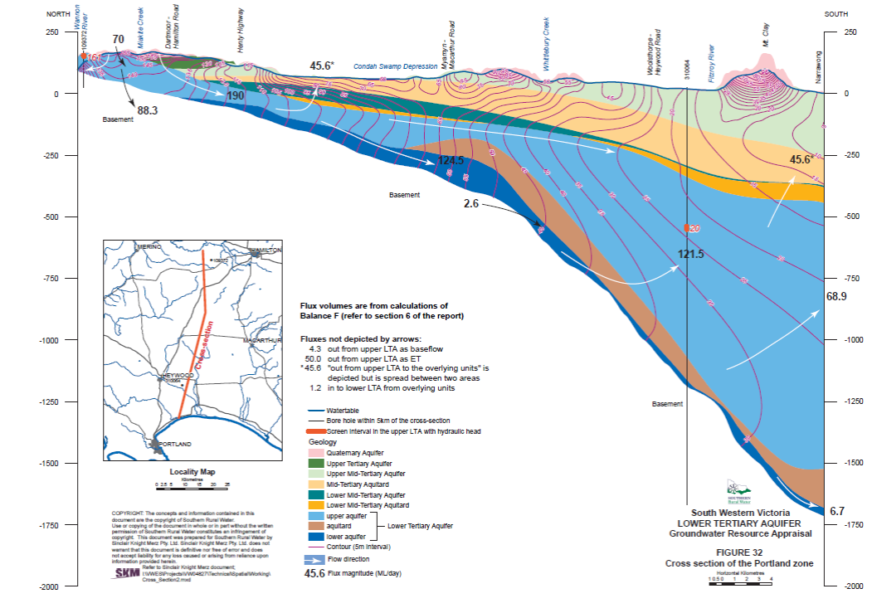
Figure 26: Hydrostratigraphic cross section of the Tyrendarra Sub-basin. (Source: SKM, 2010.)
Note: nits in this figure are equivalent to those discussed above and relate to Table 3 as follows: Pliocene Quaternary Volcanic Aquifer = UTB, Upper Tertiary Carbonate Aquifer = UMTA (and LMTA where overlain by UMTD), Upper Tertiary Aquitard = UMTD, Lower Tertiary Aquifer = LTA, Lower Tertiary Aquitard = Pember Mudstone (within the LTA), Upper Cretaceous Aquifer = CPS, UK Aquitard and LK Basement = BSE.

From Figure 26 it can be seen that the Clifton Formation (LMTA) receives recharge through the overlying marl (UMTD) in the northern sections of the embayment where groundwater mounds (usually formed by the topographic highs of volcanic eruption centres) facilitate vertical infiltration (Bush, 2009). This is consistent with Bennetts (2005) who asserted significant inter-aquifer leakage between the QA, UTB, UMTA and which allows for the recharge of the LMTA. Additionally, the disruption of aquitard sequences provided by volcanic eruption centres (such as Mt Napier and Mt Eccles) are likely to facilitate greater hydraulic connection between the deeper and shallower aquifers. As such, these areas are likely to be more sensitive to aquifer stresses than others.
The UMTA is absent through the Colac Sub-basin, and although the LMTA is present the LTA acts as the major aquifer in this area. As noted earlier in relation to shale gas, the upper basement in this area is likely to have some hydraulic connection to the LTA (Jacobs, 2014) and thus depressurisation of the Eumeralla Formation may produce drawdown in the LTA. However, this remains speculative because it is based on results that are characteristic of the upper 50 m of the basement. Further characterisation of the deeper basement is required to better assess the connectivity between the Eumeralla Formation and LTA in the Colac Sub-basin.

2.5.2 Surface water features and ecosystems
The following section discusses surface water features and ecosystems and their potential connection with groundwater and onshore natural gas. The major surface water features in the Otway region fall within eight river basins: Millicent Coast, Glenelg River, Portland Coast, Hopkins River, Lake Corangamite, Otway Coast, Barwon River and Moorabool River Basins (Figure 27).
The highest areas of runoff throughout the Otway region are in the Otway Ranges and result in larger stream flows there; for example, the Gellibrand and Aire Rivers. In other areas where runoff is more variable, streams are often ephemeral and carry flows only after significant rainfall (SRW, 2013). Streams between Portland and Warnambool have shown declining baseflows over the last 40 years. This has been attributed mainly to reduced rainfall in the area. Removal of the rainfall effect from stream flows yields consistent baseflow contributions until the 1990s but has declined since. This trend has been attributed to land use changes in the area (SRW, 2013).
The baseflow contribution and the variably gaining and losing nature of a number of rivers and streams in the Otway region were calculated by GHD (2014a) and are summarised in Figure 28. This shows that the Barwon River transitions from generally losing in the upland reaches to gaining through the mid-reaches and variably gaining and losing throughout its lower reaches, in response to topographically driven hydraulic gradients. The lower Glenelg and Gellibrand Rivers are generally gaining rivers and receive greater groundwater inputs during winter and spring when streamflow and groundwater levels are higher. The lower Hopkins River is variably gaining and losing, with groundwater flows occurring during winter months when groundwater levels are higher and lower groundwater inflows during drier months when groundwater levels are lower. The proportion of baseflow throughout western Victoria in the Barwon, Gellibrand, Glenelg and Hopkins river catchments ranges from 26 to 34%.
Some potentially significant surface water systems also rely on groundwater associated with local groundwater recharge and flow systems (groundwater flow paths <5 km). This includes a number of groundwater discharge zones along the upper Eumeralla River and the lower Fitzroy River near Portland. A number of springs near volcanic cones such as Mt Warrenheip near Ballarat and the crater lakes surrounding the Red Rock complex near Colac also appear to be fed by local groundwater discharge. Saline groundwater discharge tends to dominate the intermediate and regional flow systems, where the movement of groundwater is very slow; Lake Burrumbeet and Lake Bolac are two examples. Figure 27 shows the groundwater-dependent ecosystems in the Otway region.
The Water Asset Identification Project (GHD, 2014b) identified surface water bodies, groundwater assets and ecosystems within the Otway region, including aquifers, springs, rivers and creeks, lakes and wetlands. The project also assessed the vulnerability of these assets to the development of coal seam gas and coal mining. It found that in the Corangamite and Glenelg Hopkins regions over 90% of the rivers and creeks have a mid to high vulnerability. The springs in the Corangamite region have a mostly mid to high vulnerability, while those in the Glenelg Hopkins region are less vulnerable. The remaining springs throughout the Otway region have various vulnerabilities.
For the purpose of this report, surface water features are linked to groundwater where groundwater levels are within 2.0 m of the ground surface. The areas shaded in orange in Figure 27 define the occurrence of groundwater within 2.0 m of the ground surface; where the orange areas intersect surface water bodies, groundwater and surface water are linked.

Conventional and tight gas
The tight gas potential development scenario includes an area that extends along the coastline from the eastern lower Hopkins River Basin into the central regions of the lower Otway Coast Basin (Figure 27). Within the Hopkins River Basin the natural gas scenario does not directly intersect the Hopkins River itself, but the upper reaches of Deep Creek and Brucknell Creek, which feed into the lower Glenelg River, are linked to the groundwater system near the gas source. In the lower Otway Coast Basin, Curdies Inlet and Curdies River appear to be linked to the groundwater system, as do Scotts Creek (which drains into Curdies River), and a number of upland tributaries draining into Scotts Creek. (e.g. Little Cooriemungle Creek and Cooriemungle Creek) are surrounded by the wider areas of shallow (< 2.0 m below ground level) groundwater. Lower sections of the Gellibrand River and a number of neighbouring wetlands and lakes are also located near shallow groundwater systems and are linked to them.

Shale gas
Shale gas sources are focused along the western margin of the Glenelg River Basin and the eastern margin of the Millicent Coast Basin (Figure 27). Within the defined shale gas source area, the Glenelg River does not appear to be linked to groundwater, nor do its tributaries. The surface water bodies that appear to be linked to groundwater associated with this scenario are some inland lakes and wetlands such as Kaladbro Swamp, Mackinnon Swamp and Mosquito Swamp.

Coal seam gas
Coal seam gas sources are scattered across multiple surface water basins including the central Glenelg River Basin, across the border of the central Portland Coast and lower Hopkins River Basins and the lower Lake Corangamite Basin. The development areas in the Glenelg Basin intersect a number of minor tributaries draining into the Glenelg River. Most of these tributaries appear to have minor linkages to groundwater. However, there do appear to be a number of wetlands associated with Dwyer Creek that are connected to groundwater. Throughout the Portland Coast Basin and Hopkins River Basin, upper sections of the Loachlabar Gully and Spring Creek (in the Hopkins River Basin) appear to be the major surface water features linked to groundwater, before they drain into the Merri River. Coal seam sources in the Lake Corangamite Basin underlie Lake Corangamite and Lake Colac, both of which are connected to groundwater, as is Pirron Yallock Creek which drains into Lake Corangamite (Figure 27).

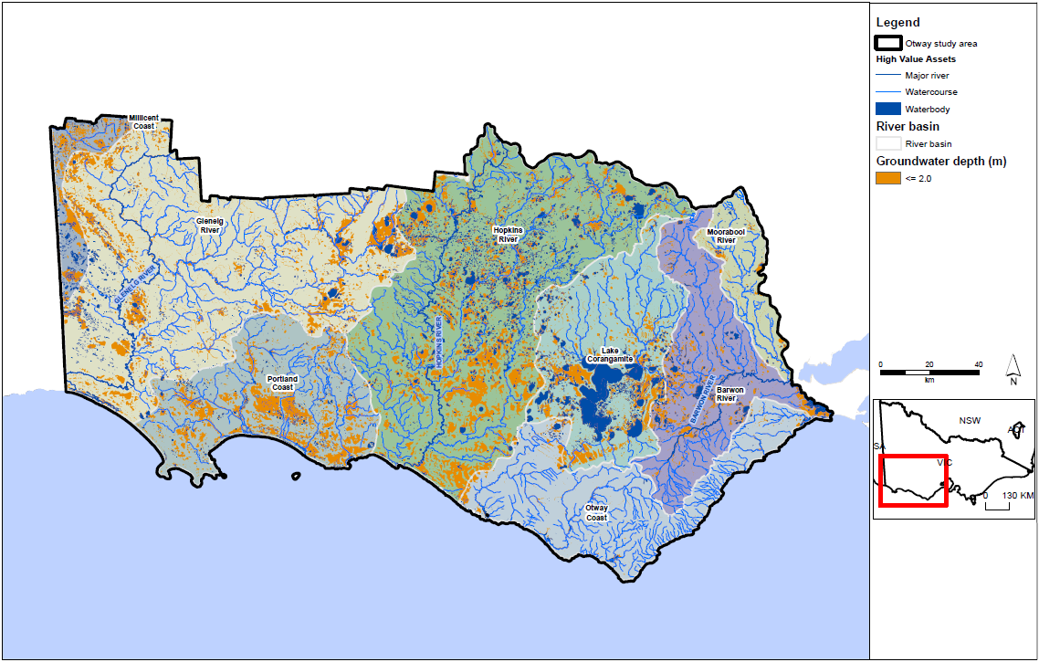
Figure 27: Location of surface water features and depth to groundwater in the Otway region with sub-regional development scenario areas.
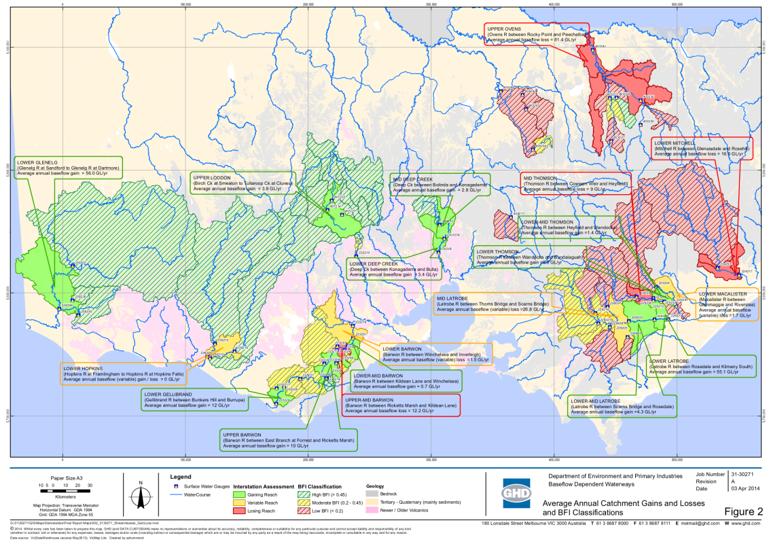
Figure 28: Baseflow estimates to Victorian rivers. (Source: GHD, 2014a.)

3 Aquifer depressurisation impact assessment

3.1 Introduction
The depressurisation of a gas source formation can affect water resources by changing the groundwater level in adjacent or overlying aquifers. This occurs as a result of movement of water from aquifers into the gas source formations. This movement results from the pressure reduction generated by water abstraction, which is supplemented by gas extraction, in the gas reservoir.
This chapter describes the approach used to assessing potential impacts of aquifer depressurisation from hypothetical gas developments where there is a connection between gas resources and water resources.

3.2 Impact assessment approach

3.2.1 Literature review
In order to inform the impact assessment approach, a review of over 100 relevant Australian and international sources which looked at risk from gas development was completed (Appendix A). The focus of the literature review was guided by the requirements of this assessment which include:
• assess the risks arising from the potential impact of possible onshore gas development on water resources across a broad region
• be compatible with limited data on the gas development and limited data on impacts.
The literature review indicated that there is no single or standard risk assessment method which is tested and proven as fit-for-purpose for hypothetical onshore gas development. A range of approaches have been adopted in different studies, depending on the purpose and the information available. No one approach stands out as highly suited to analysing risks at a strategic level from hypothetical developments.
The literature review also indicated that risk assessment methods generally require detailed site-specific geo-science data and extensive quantitative/numerical modelling to assess likelihood (e.g. probability of hazards occurring, historical instances of failure) and consequence (direct and indirect impacts). However, detailed region-specific data is not available in Victoria, largely due to the fact that there has not been a significant onshore gas industry in the state to generate such data.
It was concluded from the literature review that an impact assessment approach, rather than a risk assessment approach, that draws on specific Victorian groundwater impact policy, is appropriate and in keeping with the literature.
For assessing the impact of gas development through aquifer depressurisation the most relevant Victorian approach is the draft ministerial guidelines for groundwater licensing and the protection of high-value groundwater dependent ecosystems, as these guidelines:
• are designed to inform government decisions on proposed groundwater use (aquifer depressurisation), based on an assessment of the potential impacts on groundwater-dependent ecosystems
• can accommodate a range of inputs to the assessment process, from purely qualitative and conceptual information, to quantitative data and numerical modelling inputs as available
• are pragmatic to apply
• have been developed through a consultative process
• are currently in the process of being endorsed for use by the Victorian government.
For this impact assessment an approach has been developed that is specific to the Victorian situation and draws on existing work for the assessment of groundwater-related impacts. It is not intended to be used for assessing a specific gas development project.

3.2.2 Approach overview
The impact assessment approach for this study has been developed by adapting the Victorian draft guidelines for groundwater licensing and the protection of high-value groundwater dependent ecosystems. The following is an overview only; more detail is provided in Appendix B.
The approach is designed to assess the potential impacts of hypothetical onshore natural gas developments on groundwater levels (depressurisation), and then by inference on groundwater users, groundwater quality, surface water quantity and quality, and groundwater-dependent ecosystems. Three types of water resource receptors are considered:
• aquifers (which support groundwater users)
• rivers (which support surface water users and ecosystems)
• water bodies (wetlands and lakes which support surface water users and ecosystems).
All three of the receptor classes above are of high and equal value. The assessment does not attempt to classify relative value of individual receptors (e.g. whether one aquifer or river / reach more important than another).
The impact assessment is characterised by assessing:
• the potential connection between receptors and groundwater, using depth to watertable as an indicator
• the potential effect of aquifer depressurisation on receptors, using predicted drawdown as an indicator.

Figure 29: Overview of impact assessment.

3.2.3 Potential connection between receptors and groundwater
In this impact assessment, the potential degree of hydraulic connection between receptors and groundwater is based on depth to groundwater (in metres).
In the case of surface water receptors (rivers, lakes and wetlands), the potential for connection to groundwater varies depending on the depth of the watertable, and is classified as:
• low potential for deep watertables
• moderate potential for moderate depth watertable
• high potential for shallow watertables.
In the case of aquifers, connection to groundwater is inherent, and therefore the potential connection is always high. The rules for defining these three connection categories are outlined in Table 4.
Areas that have been mapped as having shallow watertables (< 2 m) have a high potential for surface features to be connected to groundwater. Where watertables are deeper (> 6 m), surface water has a lower potential of being connected to the groundwater.
The depth to watertable data used for this project is the mapping developed as part of DELWP’s SAFE database (GHD, 2012) and is mapped on a grid across the areas of interest. This database provides a consistent approach to estimating connection using depth to watertable for this study. The depth to watertable map is derived from existing monitoring data and is more accurate in areas of greater density of monitoring bores. In areas with limited monitoring bores, the elevation of the surface water body is used when close to the surface water features.

Table 4: Rules to define water receptors’ potential connection to groundwater.
Water Receptor | Low connection | Moderate connection | High connection
Rivers | Initial depth to watertable (before gas development) is greater than 6 m | Initial depth to watertable (before gas development) is between 2 and 6 m | Initial depth to watertable (before gas development) is less than 2 m
Water bodies (lakes, wetlands)
Aquifers | n/a | n/a | Inherent connection to groundwater

3.2.4 Potential effect of aquifer depressurisation
Table 5 presents the criteria which have been adopted to classify the effect of aquifer depressurisation on receptors, using predicted drawdown as an indicator. For surface water receptors, the delineation of a low potential effect of gas development (i.e. 0.1 m predicted drawdown) has been based on the minimum change in water level that could reasonably be discerned (DELWP, 2015). The upper limit of 2.0 m is based on a range of studies. It was identified during the development of the draft ministerial guidelines that watertable changes greater than 2.0 m can be expected to have a significant impact on ecosystems.
In the case of aquifers, the categories were defined based on extrapolation of the approach embedded in the draft Victorian water sharing guidance notes, in which a high potential for effect of gas development is determined when an aquifer ceases to be able to supply. Most aquifers in the study areas would need to have high drawdown before ceasing to supply, (DELWP 2015).

Table 5: Rules defining the potential effect on water receptors of groundwater drawdown.
Water receptor | Low drawdown | Moderate drawdown | High drawdown
Rivers | Effect is small on stream flow of connected waterway to natural or current conditions.  Minimum change in water level that could reasonably be expected to be measured in the field.  Drawdown in watertable aquifer < 0.1 m after 30 years. | Extraction impacts measurably on stream flow of connected waterway to natural or current conditions.  Maximum annual variation in water level that could reasonably be expected.  Drawdown in watertable aquifer between 0.1 m and 2 m after 30 years. | Extraction impacts on stream flow of connected waterway to natural or current conditions.  Drawdown in watertable aquifer > 2 m after 30 years.
Water bodies (lakes, wetlands)
Unconfined aquifer | Drawdown is small with respect to aquifer ability to supply.  Drawdown < 2 m after 30 years. | Extraction impacts measurably with respect to aquifer ability to supply, but can potentially be mitigated by deepening of boreholes/pumps.  Drawdown between 2 m and 15 m after 30 years. | Extraction is large with respect to aquifer ability to supply.  Drawdown > 15 m after 30 years.
Confined  Aquifers | Drawdown is small with respect to aquifer ability to supply.  Drawdown < 10 m after 30 years. | Extraction impacts measurably with respect to aquifer ability to supply, but can potentially be mitigated by deepening of boreholes/pumps.  Drawdown between 10 m and 75 m after 30 years. | Extraction is large with respect to aquifer ability to supply.  Drawdown > 75 m after 30 years.

3.2.5 Estimation of drawdown
Aquifer depressurisation can affect water resources by changing the groundwater level in aquifers adjacent to the water resources. In turn this change in level may affect the flow rate of water, or the contribution of groundwater to surface water, or the overall availability of groundwater. This section discusses the approach that has been taken to estimating and evaluating changes in groundwater level. In the case of groundwater resources, an impact can occur as a result of changing the pressure surface (or groundwater level) within the aquifer itself.
A water level change outside a gas source formation can occur if water moves from the aquifers into the gas source formation. This movement would in turn be driven by pressure reduction in the source formation by gas (and any coproduced water) extraction. A change in water level in aquifers is normally expressed as drawdown, or a change in the pressure level in an aquifer. In confined aquifers the pressure change is usually converted to a water elevation, and the change in water elevation is then expressed as drawdown. For example, in the watertable aquifer the drawdown would be expressed as the drop in the level of the watertable in metres. To assess the impact of gas development on water resources it is necessary to assess both the initial watertable elevation and depth to watertable, then combine these with the potential drawdown that may result from gas development.

For the impact assessment approach, the depth to watertable that was adopted is the published map for the whole of Victoria, developed by DEWLP and gridded across the state at 100 m grid cells. This data set was adopted because:
• it is uniformly available across the Otway study area
• it has been developed and approved for use in water resource assessment by DELWP
• it is consistent with other policy assessments undertaken by DELWP
• uncertainty in the data set is acceptable for this policy-level impact assessment.
For an estimate of drawdown, no existing drawdown data set (i.e. from a numerical model) was identified as suitable and considered the development of onshore gas, so a specific assessment was required for this study. Unfortunately the information currently available for the Otway Basin is insufficient for developing a regional numerical model. As a result a more pragmatic ‘block model’ approach has been used. A full description of this approach is provided in Appendix B.

3.2.6 Assessment of overall potential impact
The potential impact to a receptor from aquifer depressurisation is based on the potential for the receptor class to be connected to groundwater (represented by depth to watertable in metres) and the potential effect of aquifer depressurisation (represented by predicted drawdown in metres).
The impact matrix showing the combinations of potential connection and effect of aquifer depressurisation to evaluate overall potential impact is presented in Figure 30. If a receptor class has a low potential connection to groundwater (deep watertable) and drawdown is predicted to be low, the potential impact to the receptor class is low. Conversely, the potential impact to a receptor class with high connection (shallow watertable) and a high potential drawdown, will be high.
The potential impacts to receptor classes have been assessed for hypothetical gas field development scenarios over a timeframe of 30 years, as this is an indicative project life cycle for possible future natural gas developments. Different potential effects may result if a longer time frame was to be used.
The results are presented in summary figures in this report. The full set of maps of potential connection, effect and overall impact, is provided in Appendix C.

Connection between receptor class and groundwater | High | HC / LD | HC / MD | HC / HD
Connection between receptor class and groundwater | Moderate | MC / LD | MC / MD | MC / HD
Connection between receptor class and groundwater | Low | LD / LD | LD / MD | LD / HD
 |  | Low | Moderate | High
 | Groundwater Drawdown
Key: HC = high connection; MC = moderate connection; LD = low connection; HD = high drawdown;
MD = moderate drawdown; LD = low drawdown.
Figure 30: Potential impact on receptors due to aquifer depressurisation.

3.3 Impact assessment results

3.3.1 Conventional gas scenario

Potential impact to groundwater users
The potential impact to groundwater users is presented as impact classes for each aquifer. Thumbnails are presented in Figure 31 and detailed result maps are given in Appendix E.
Overall the potential impact to all aquifers (confined and unconfined) from the development of conventional gas in the Otway region is low, with a typical category HC-LD (high connection, low drawdown). In the case of aquifers, the connection is always high (i.e. aquifers are inherently connected to groundwater). This means that the drawdown result determines the overall impact. The category HC-LD is therefore the lowest impact possible for aquifers.
It is predicted that none of the more than 1700 groundwater entitlements in the Otway region would be impacted by conventional gas development.

Potential Impact to surface water users
Figure 32 indicates that potential conventional gas development in the Otway region poses a low potential impact to surface water users. None of the more than 1100 surface water entitlements in the Otway region are predicted to experience moderate to high impact as a result of conventional gas development.

Potential impact to surface water ecosystems
The impact assessment indicates that potential conventional gas development in the Otway region poses a low potential impact to surface water ecosystems.

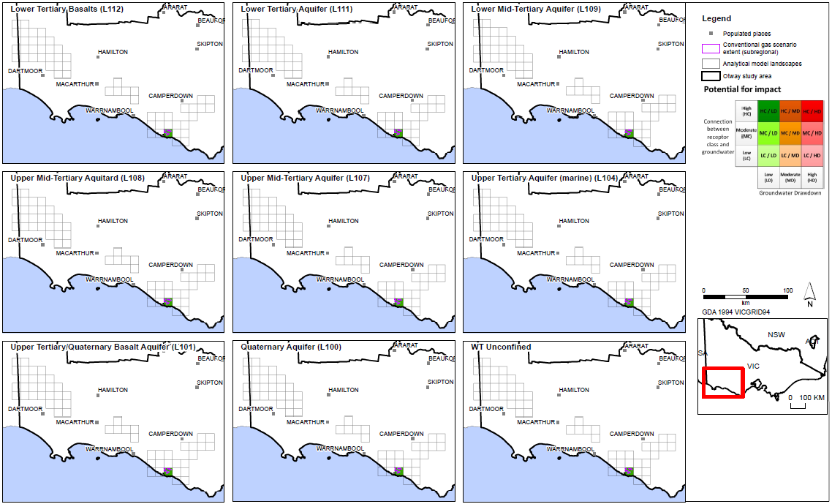
Figure 31: Potential impact to aquifers from possible conventional gas development.

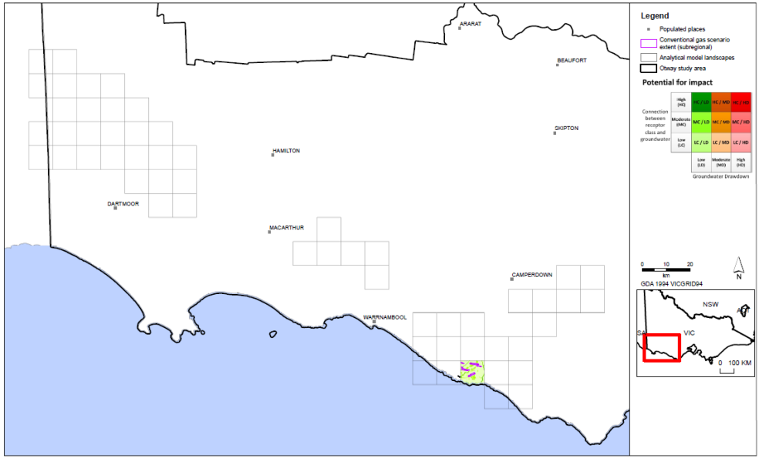
Figure 32: Potential impact to surface water users from possible conventional gas development.

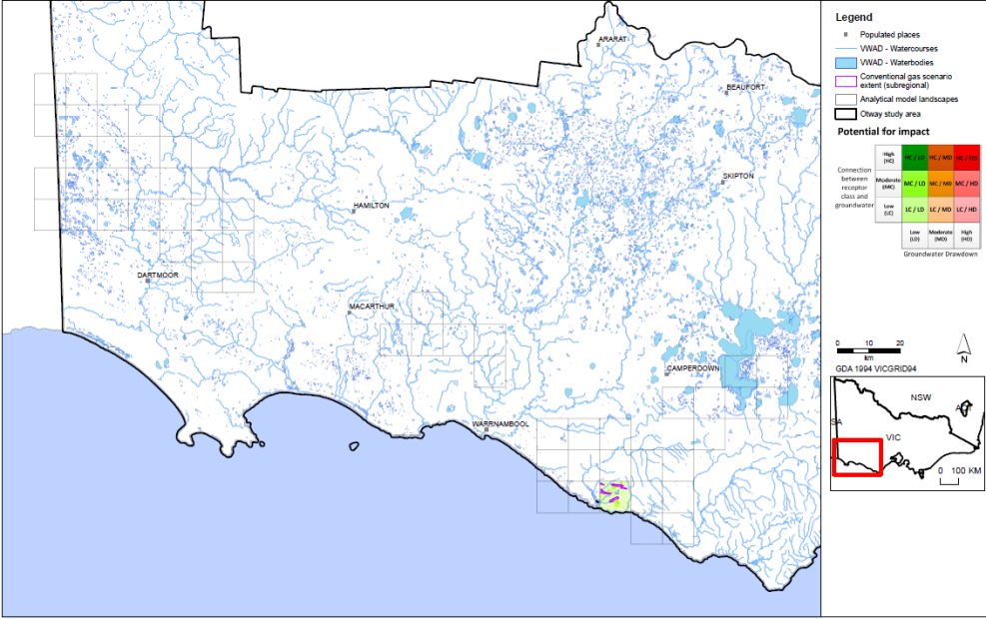
Figure 33: Potential impact to surface water ecosystems from possible conventional gas development.

3.3.2 Tight gas scenario

Potential impact to groundwater users
The potential impact to groundwater users is presented as classes for each aquifer. Thumbnails are presented in Figure 34 and detailed result maps are given in Appendix D.
Overall the potential impact to all aquifers (confined and unconfined) from the development of tight gas in the Otway region is low, with a typical potential impact class of Category HC-LD (high connection, low drawdown). In the case of aquifers, the connection is always high (i.e. aquifers are inherently connected to groundwater). This means that the drawdown metric for drawdown determines the overall impact rating. The category HC-LD is therefore the lowest potential impact possible for aquifers.
It is predicted that none of the more than 1700 groundwater entitlements in the Otway region would be impacted by tight gas development.

Potential impact to surface water users
The impact assessment indicates that potential tight gas development in the Otway region poses a low potential impact to surface water users. None of the more than 1100 surface water entitlements in the Otway region are predicted to experience moderate to high potential impact as a result of tight gas development.

Potential impact to surface water ecosystems
The impact assessment indicates that the potential tight gas development in the Otway region poses a low potential impact to surface water ecosystems.

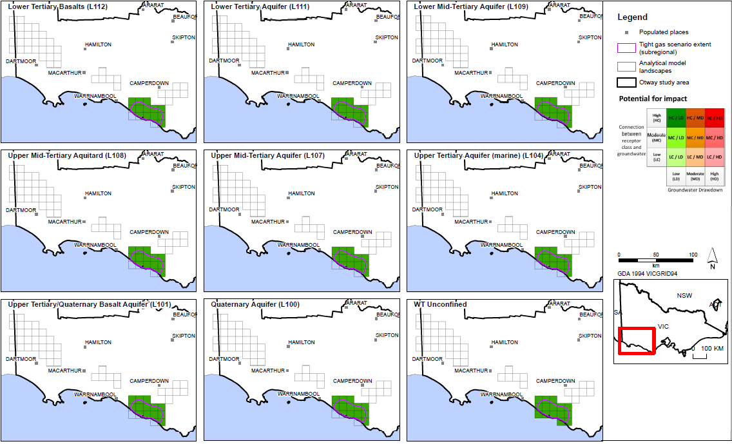
Figure 34: Potential impact to aquifers from possible tight gas development

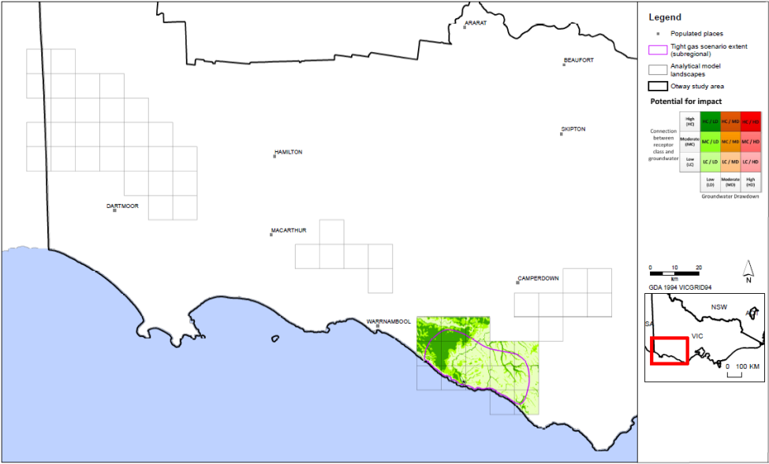
Figure 35: Potential impact to surface water users from possible tight gas development.

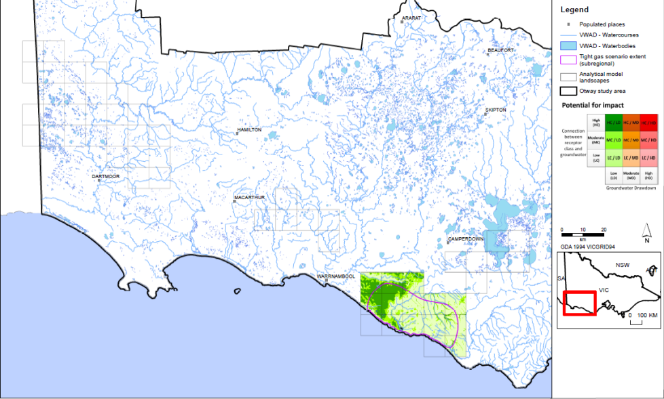
Figure 36: Potential impact to surface water ecosystems from possible tight gas development.

3.3.3 Shale gas scenario

Potential impact to groundwater users
The potential impact to groundwater users is presented as classes for each aquifer. Thumbnails are presented in Figure 37 and detailed result maps are given in Appendix E.
Overall the potential impact to all aquifers (confined and unconfined) from the development of shale gas in the Otway region, is low with a typical potential impact class of Category HC-LD (high connection, low drawdown). In the case of aquifers, the connection is always high (i.e. aquifers are inherently connected to groundwater). This means that the drawdown metric for drawdown determines the overall potential impact rating. The category HC-LD is therefore the lowest potential impact possible for aquifers.
It is predicted that none of the more than 1700 groundwater entitlements in the Otway region would be impacted by shale gas development.

Potential impact to surface water users
Figure 38 indicates that potential shale gas development in the Otway region poses a low potential impact to surface water users. None of the more than 1100 surface water entitlements in the Otway region are predicted to experience moderate to high potential impact as a result of shale gas development.

Potential impact to surface water ecosystems
Figure 39 indicates that the potential shale gas development in the Otway region poses a low potential impact to surface water ecosystems.

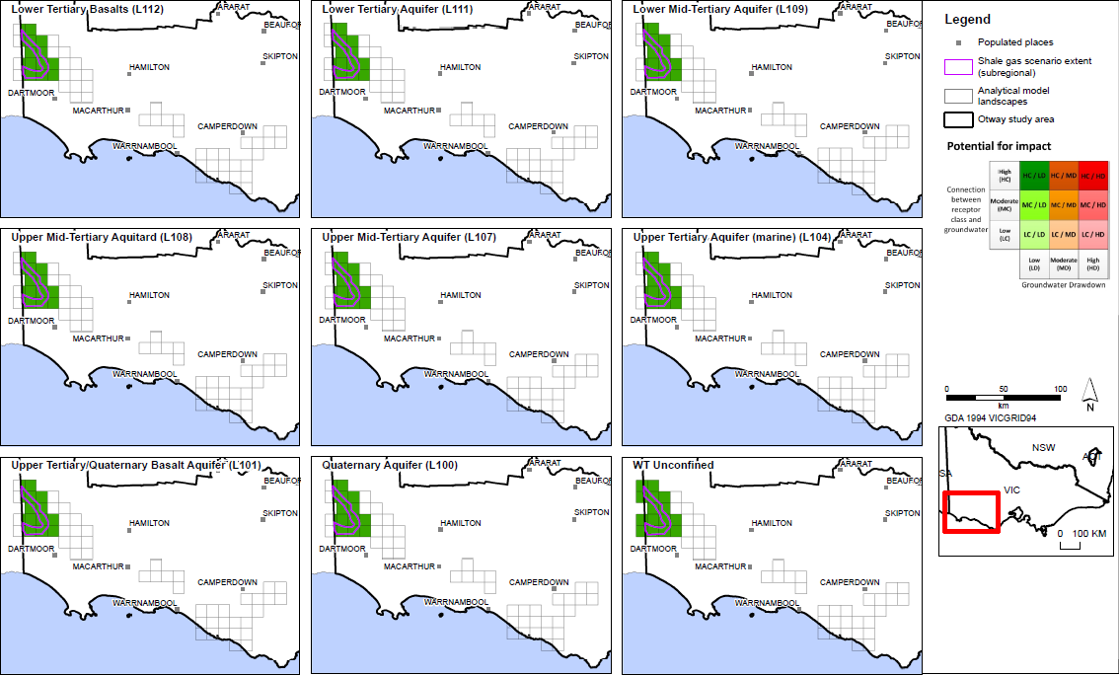
Figure 37: Potential impact to aquifers from possible shale gas development.

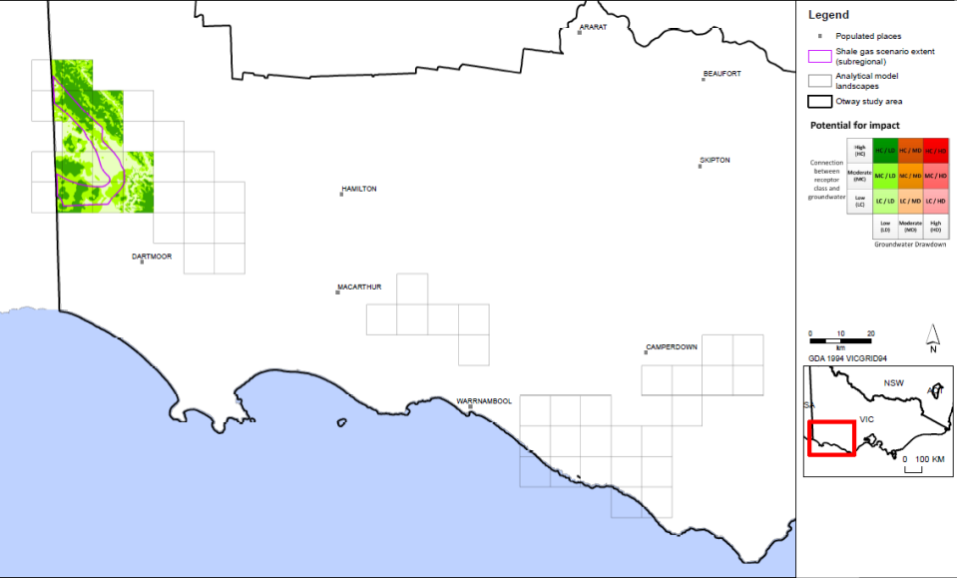
Figure 38: Potential impact to surface water users from possible shale gas development.

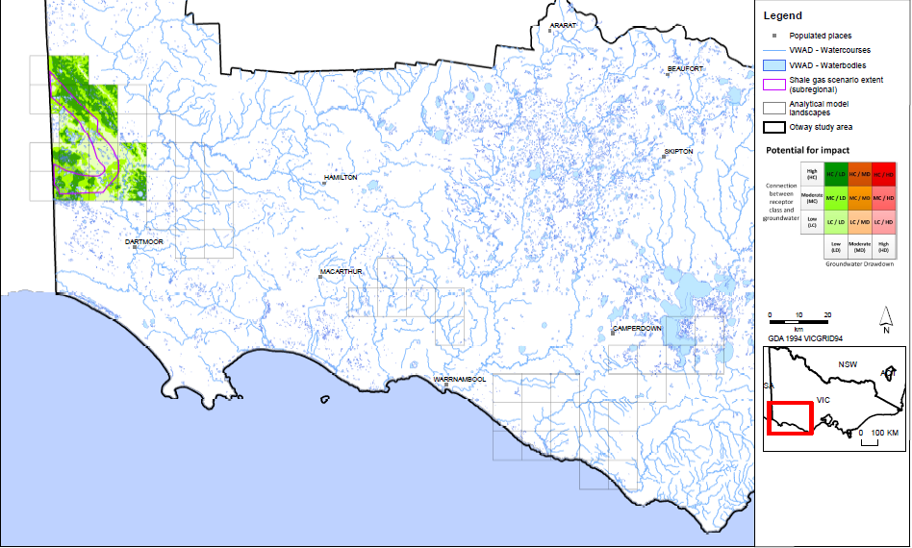
Figure 39: Potential impact to surface water ecosystems from possible shale gas development.

3.3.4 Coal seam gas scenario

Potential impact to groundwater users
The potential impact to groundwater users is presented as classes for each aquifer. Thumbnails are presented in Figure 40 and detailed result maps are given in Appendix E.
The potential impact to all aquifers (confined and unconfined) from the development of coal seam gas in the Otway region is low, with a typical class of Category HC-LD (high connection, low drawdown). In the case of aquifers the connection is always high (i.e. aquifers are inherently connected to groundwater). This means that the metric for drawdown determines the overall rating. The category HC-LD is therefore the lowest potential impact possible for aquifers.
It is predicted that none of the more than 1700 groundwater entitlements in the Otway region would be impacted by coal seam gas development.

Potential impact to surface water users
The assessment indicates that potential coal seam gas development in the Otway region poses a low potential impact to surface water users. There are over 1,100 surface water entitlements in the Otway region and none are classified as having a moderate to high potential impact as a result of coal seam gas development.

Potential impact to surface water ecosystems
The assessment indicates that the potential coal seam gas development in the Otway region poses a low potential impact to surface water ecosystems (see Figure 42).

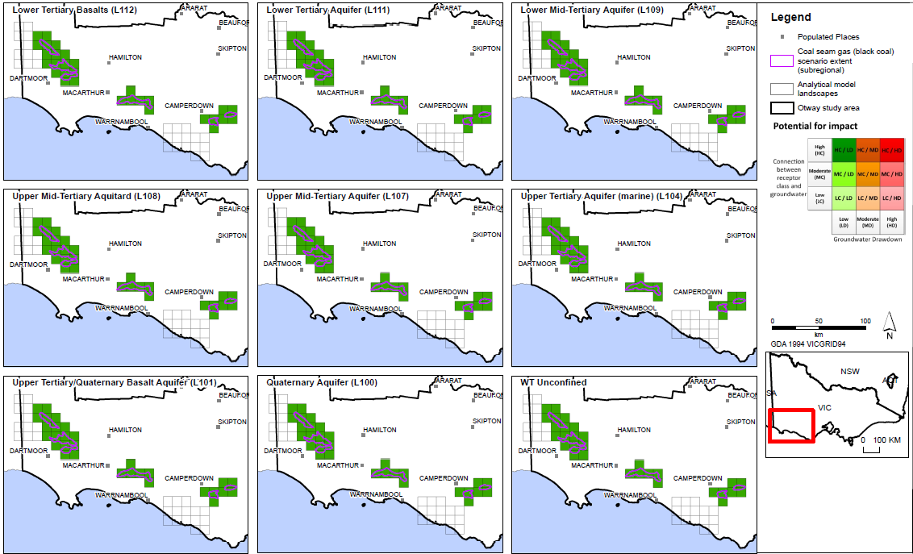
Figure 40: Potential impact to aquifers from possible coal seam gas (black coal) development.

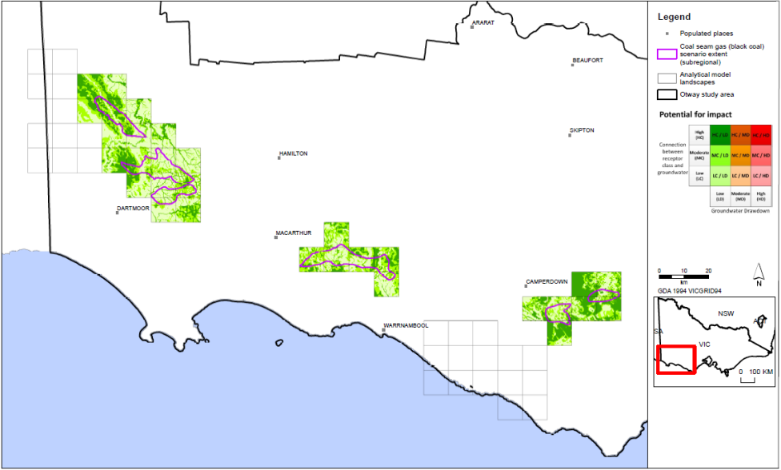
Figure 41: Potential impact to surface water users from possible coal seam gas (black coal) development.

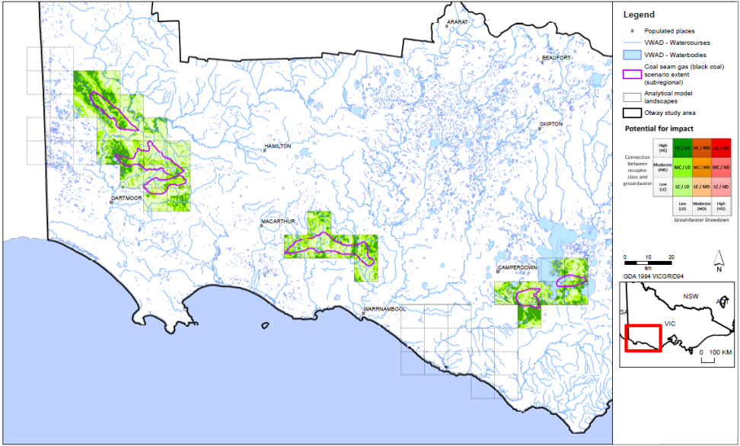
Figure 42: Potential impact to surface water ecosystems from possible coal seam gas (black coal) development.

3.3.5 Summary of results
• The potential impacts from all gas development scenarios are assessed as low for the Otway region.
• The potential impacts to aquifers are assessed low for all cases, as the drawdown resulting from gas development is not sufficient to pose an impact to groundwater users.
• The potential impacts to surface water users from all gas developments are assessed as low. The potential impact to surface water ecosystems mirrors the potential impact to surface water users, because the same drawdown scale has been adopted. In all cases the potential impact to surface water ecosystems from all gas development scenarios are assessed as low.
• As exploration would have less impact than full development, the potential impact of exploration is also assessed as low.

3.4 Potential impact to groundwater quality
Groundwater quality could be affected where gas development, combined with regional groundwater use, causes drawdown to change groundwater gradients. If this was to occur where low quality groundwater
and high quality groundwater exist adjacent to each other, there is potential for high quality groundwater
to become contaminated via mixing with poor quality groundwater. This could occur between two
adjacent aquifers that contain groundwater of variable quality, or within an aquifer that contains variable groundwater quality.
This assessment has determined that the impact of gas development on groundwater gradients in the aquifer sequence is small and well within the range of gradients that have already been experienced by aquifers. As such, the hydraulic gradient within, and between aquifers, is not likely to vary considerably in response to the scenarios, and contamination of high quality groundwater with adjacent low quality groundwater is not likely to occur either within or between aquifers. This is to be contrasted with other areas in Australia where gas development occurs within the aquifer sequence and there is not always a seal or aquitard to effectively isolate the drawdown from gas development.
In the Otway region the potential impact of groundwater quality changes is assessed as low.

4 Chemical contamination of groundwater from hydraulic
fracturing fluids: risk assessment
Hydraulic fracturing is variously known as well stimulation, hydraulic fracturing, fraccing or fracking. The technical term ‘hydraulic fracturing’ is used in this report.
This report is a qualitative assessment of impacts from chemical contamination of groundwater from hydraulic fracturing, as the technical detail required to undertake more detailed analysis in Victoria is
not available.
If onshore gas reserves were to be discovered in the Otway region, hydraulic fracturing may be employed to develop tight/shale gas and possibly deep coal seam gas. As the geological understanding of these potential reservoirs in the Otway region is immature, it is not known whether the rocks are suitable for fracturing. While there is a significant volume of information available on the risks associated with hydraulic fracturing, the risks are difficult to quantify at any scale in the Otway region due to the high level of uncertainty associated with the geology.
Information required to fully assess the risks of hydraulic fracturing include detailed data associated with rock and reservoir properties, details about the proposed drilling and development techniques, and specific analysis of the combination of these factors at individual well sites. Given that none of this detailed information is available for this study, a review of the key factors that influence the risks and how they might relate to Victorian onshore gas has been undertaken. To this end, this document presents a discussion on the potential risks associated with hydraulic fracturing and builds upon scientific research and case studies in order to evaluate the associated risks to water resources. A key reference for this risk assessment discussion is Cook et al. (2013), who completed a study on shale gas in Australia. Cook et al. (2013) built on other key references such as King (2012) and RS/RAE (2012).

4.1 Overview of hydraulic fracturing
Hydraulic fracturing is a technique that has been employed in the petroleum industry globally for over 60 years and in Australia for over 40 years. The process involves ‘stimulating’ the hydrocarbon-bearing formations by the injection of fluid (and other materials) under high pressure to enhance the flow of hydrocarbons to the well head during later development. This stimulation creates or enhances permeability and existing fluid and gas pathways. Typically the process creates additional fractures in the reservoir rock and holds open for a period of time.
Hydraulic fracturing is required for most, though not all, types of onshore gas development. Hydraulic fracturing is not normally required for conventional gas because of the high porosities and permeabilities in which conventional gas is commonly found, together with the high formation pressures. Large amounts of conventional gas can often be extracted using a small number of wells. Shale gas and tight gas cannot usually be extracted using a single production well of the type used for conventional gas, because of the low permeabilities in the reservoir rocks. In the case of coal seam gas, some but not all gas fields have a high natural permeability due to the fractures in cleats, which means that hydraulic fracturing is required occasionally. In Australia since 2000, 8% of coal seam gas wells have been hydraulically fractured, and the industry estimates that between 10 and 40% of wells yet to be drilled for current coal seam gas developments across Australia (mainly Queensland) may need some method of flow enhancement, including hydraulic fracturing (SKM, 2012).
There have been significant technological advancements over the last decade resulting in the growth of the shale gas industry in the United States. Cook et al. (2013) highlighted that the implementation processes such as deep horizontal drilling, multiple-stage hydraulic fracturing, improved real-time sensing monitoring to guide both the horizontal drilling and hydraulic fracturing processes have improved the viability of natural gas developments in United States. These technological improvements in horizontal drilling techniques within the petroleum industry is leading to coal seam gas developers utilising ‘surface to in-seam drilling’, or horizontal drilling, which can reduce the requirement for conventional hydraulic fracturing of coal seam gas wells
(SKM, 2012).
Figure 43 illustrates the effects of hydraulic fracturing in a vertical well and a horizontal well. Hydraulic fracturing is often performed sequentially at multiple depths and horizontally along beds. Additionally, fracturing may be conducted multiple times in the same well over its life in order to widen or lengthen the initial fractures to increase gas productivity.
Fluid volumes pumped down wells during the hydraulic fracturing of tight and shale gas formations are usually in the order of 10 to 20 million litres and reach maximum pressures of up to about 70 000 kPa over a period of a few hours (Myers et al., 2012, Kissinger et al., 2013, Lange et al., 2013). In coal seam gas developments, fracture fluid volumes are typically much smaller, usually ranging between 0.5 and 3 million litres (CSIRO, 2014).

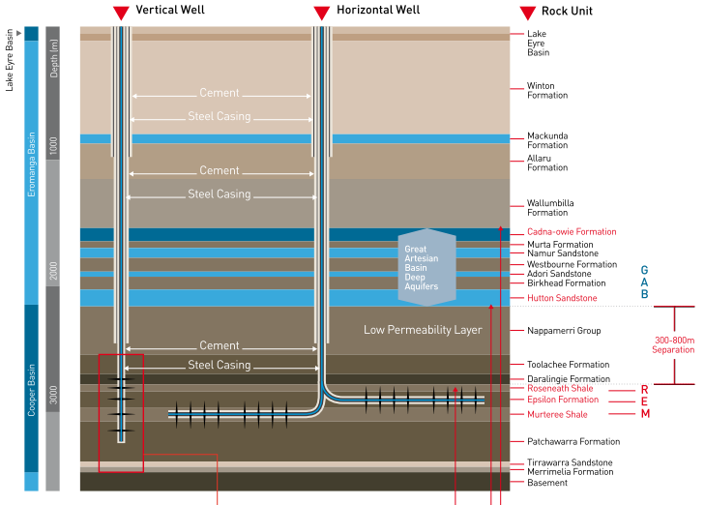
Figure 43: Schematic of a deep unconventional (shale) gas well in the Cooper Basin, Australia.
(Source: Cook et al., 2013.)

After the prospective formation has been sufficiently fractured, pressures are reduced and the fluids are back-produced (removed) from the formation. The recently formed fractures are prevented from closing by the proppant (sand-sized particles included in the fluid mixture that is injected) allowing the gas to migrate through the more permeable formation and be extracted via the production well.
Cook et al. (2013) suggested that in a typical hydraulic fracture treatment, between 3 and 12 additive chemicals may be used depending on the characteristics of the water and the formation being fractured. The chemicals used in hydraulic fracturing are discussed in detail in section 0.

4.2 Key risks to water resources associated with
hydraulic fracturing
The United States Environmental Protection Authority identified four mechanisms by which hydraulic fracturing can cause or increase the potential for groundwater contamination (USEPA 2011), including:
• failure of wells during the hydraulic fracturing process, which may create pathways by which contaminants can affect groundwater assets
• leakage of hydraulic fracturing fluids beyond the fracture zones from the prospective zone to adjacent formations
• mobilisation and migration of naturally occurring contaminants from the prospective zone to adjacent formations via fractures
• leakage of gas from prospective formations.
These broadly correlate with the Standing Council for Energy Resources, which indicated that the major risk during hydraulic fracturing was excessive fracture propagation, resulting in potential groundwater contamination via fracture fluid leakage and increased connectivity between naturally occurring contaminants and groundwater resources (SCER 2013).
Hydraulic fracturing operations also have the potential to cause groundwater and surface water contamination via a range of other mechanisms including co-produced water storage, contaminant spills, leakages and pipeline failures. King (2012) identified 20 key risks associated with hydraulic fracturing, which were summarised by Cook et al. (2013). The key risks relate to on-site spill and well integrity issues induced by hydraulic fracturing.
Well failure can occur due to incorrect construction, poor seal construction in the annulus, or deterioration due to pressure, stress or corrosion. If the cement or casing surrounding the well fails then contaminants may migrate through the resulting gaps, potentially contaminating above lying aquifers (USEPA, 2012). The proper construction of the well and correct use of materials is therefore crucial to protect groundwater resources. In Queensland and NSW, coal seam gas wells are required to be constructed in accordance with the relevant code of practice for constructing and abandoning coal seam gas wells (DEEDI, 2011; DTIRIS, 2012). Other onshore gas wells are required to be constructed in accordance with the relevant state petroleum legislation.
For the purpose of this review it is assumed that appropriate standards and guidelines have been developed in order to mediate any risks associated with well installation. Therefore, this review does not assess the risks to groundwater resources resulting from well integrity. While concerns continue to be raised regarding the integrity of wells and their potential to lead to groundwater contamination, such discussion is outside the scope of this generalised assessment of the risks to water resources.

4.3 Contaminant sources

4.2.1 Hydraulic fracturing fluid
Between 97% and 99% of hydraulic fracturing fluid consists of water and proppant (IESC, 2014a). Typically the proppant is sand. The remaining additives vary according to site specific requirements; however, a list and brief description of such additives is given in Table 6. There is a ban on the use of mono-aromatic hydrocarbons such as benzene, toluene, ethylbenzene and xylene (BTEX), so these chemicals cannot be used in hydraulic fracturing.
In some cases hydraulic fracturing can be conducted using air instead of water, where carbon dioxide or nitrogen is used as a carrier fluid. Fracturing with carbon dioxide as the carrier fluid was first introduced in 1981 and has been used commercially in unconventional gas applications in Canada and the US (Gandossi, 2013). The technology can be preferable to water as carbon dioxide requires less chemical additives than water with enhanced gas recovery. The use of nitrogen as a hydraulic fracturing fluid is still a relatively new technology. The technique is commercially available and it has been applied for fracturing shale formations, it’s costly usage appears to be limited.

Table 6: Hydraulic fracturing fluid constituents. (Source: Cook et al., 2013.)
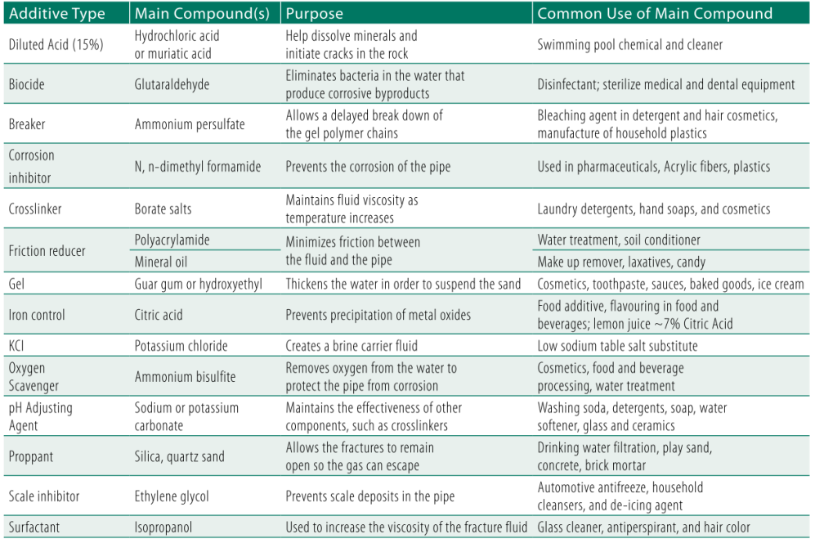

4.2.2 Naturally occurring contaminants
Groundwater contains small quantities of naturally occurring substances such as heavy metals, radioactive elements and organic compounds (USEPA 2011). Onshore natural gas also commonly contains various gases, including methane, ethane, carbon dioxide, hydrogen sulfide, nitrogen and helium.
Hydraulic fracturing fluids can contain acids and carbonates which theoretically could have the potential to alter the acid–base (i.e. pH) conditions within the gas-bearing formation. Additionally, the injected water could have the potential to alter the redox and temperature conditions within the prospective formation, further mobilising potentially hazardous substances. If naturally occurring contaminants are mobilised within the prospective formation, they can be recovered in the flow back water and be treated accordingly.
Limited research has been conducted on the mobility of naturally occurring substances associated with coals or other gas-bearing formations in Australia. CSIRO (2011) found that water-soluble constituents of Permian coal may be produced by the breakdown of the chemical structures within the coal matrix. Such water soluble compounds include phenols, aldehydes, ketones, and various compounds that contain carboxy, hydroxyl and methoxy groups. Other water soluble compounds include nitrogen-bearing compounds (such as pyridines and amines), polycyclic aromatic hydrocarbons (PAHs), low molecular weight aliphatic hydrocarbons, and mono aromatic hydrocarbons such as benzene, toluene, ethylbenze and xylenes (BTEX).
In addition to the mobilisation of potentially hazardous metal, organic and gaseous compounds, the water quality within shale and tight gas formations is commonly low. Shale and tight gas host formations have a low permeability and are located at greater depths than surface aquifers. These factors drive long groundwater residence times, greater water rock interaction and mineral dissolution, result in groundwater with a high salinity.

4.4 Contaminant pathways
As outlined in the previous section, the primary contaminants associated with hydraulic fracturing include hydraulic fracturing fluids and gases. Assuming that well integrity is maintained and that contaminants in formations above the natural gas source do not migrate via the well, for the purposes of assessing the risk of release, all of these contaminants will be sourced from the hydraulic fracturing fluids.
By their nature, tight and shale gas sources have a low permeability (otherwise they would not need to be fractured prior to gas extraction). The migration of contaminants from a prospective tight and shale gas resource into adjacent aquifers therefore requires a pathway. Such pathways include the intersection of induced fractures with overlying or adjacent permeable formations, or intersection with a nearby natural fracture/fault systems, which may further increase permeability (e.g. Kissinger et al., 2013; USEPA, 2004). In contrast to shale and tight gas, some coal seam gas formations may have a high permeability and hydraulic fracturing may not be required.
There are two primary potential pathways for contaminants to migrate: newly created or widened fractures, or via natural zones of high permeability driven by structural features such as faults. This section discusses these potential pathways in the context of the hydraulic fracturing process.

4.4.1 Fracture propagation
Over time hydraulic fracturing processes and technologies have become more sophisticated, but it is still energy intensive and expensive (Fisher and Warpinski, 2011). The industry has been motivated to better understand and control fracture growth, which has been documented in technical and research articles.
For fractures to propagate they must be opened by internal pressure (Fisher and Warpinski, 2011). In order for this to occur, the internal pressure must be sufficient to counteract the least compressive stress, displace the walls of the fracture, propagate the fracture and counteract any pressure loss due to fluid leakage through the prospective formation (Flewelling et al., 2013). Fisher and Warpinski (2011) noted that in the Marcellus Shale, fractures generally propagate vertically in tight and shale gas formations at depths greater than ~600 m. This is because fracture growth occurs perpendicular to the direction of least stress (in the direction of maximum stress) and in this system the vertical stress of the overburden typically becomes the largest single stress at depths greater than about 600 m.
During propagation, fracture width increases proportional to height. Thus, in order to maintain the fluid pressure required to propagate fractures, large volumes of fluid are required. Additionally, leakage of hydraulic fracturing fluids throughout the prospective formation can reduce fluid pressure and the extent of the fractures. Hydraulic fractures are therefore limited in their extent; although heights have been recorded in excess of this in homogeneous shale formations, fractures of less than 100 m are most common (Fisher and Warpinski, 2011).
Predictive computer modelling and microseismic monitoring of fracture growth in the United States shales suggests a typical maximum vertical extent of 90 m (Cook et al., 2013). However Fisher and Warpinski (2011) conducted a review of thousands of shale hydraulic fracturing treatments across North America and found that in rare occurrences when transmissive faults were intersected, additional height growth (about 100 m) can occur. This study showed that in such circumstances, vertical fracture growth has been recorded up to 500 metres, however these large distances are likely to be the result of re-opening an old fault rather than a newly created fault propagating such distances. Such incidents were recorded in the Marcellus Shale which extends across New York, Pennsylvania, Ohio, Maryland, West Virginia and Virginia. Fracture growth in the Marcellus Shale generally showed a greater upward limit when compared to other shale units in the United States such as the Barnett Shale (Texas), the Woodford Shale (Oklahoma) and the Eagleford Shale (south Texas).
It should be noted that the dominant stress regime throughout North America is associated with extensional tectonics (processes associated with crustal stretching), while the dominant stress regime in Victoria is associated with compressional tectonics (processes driven by crustal compression). In this setting, it is expected that hydraulic fractures will propagate in a dominantly horizontal direction opposed to the vertical fracture direction that dominates at depths of greater than about 600 m in North America. It is therefore expected that the vertical extent of fractures resulting from stimulations in the Gippsland and Otway regions is likely to be less than the 90 m extent cited in North American examples. Compression-driven horizontal stresses are expected to be greater than those that exist in an extensional setting. This is supported by work in the Gippsland Basin (e.g. Nelson et al., 2006) which indicates that vertical stress will increase from about 20 to 66 MPa between 1 and 3 km depth below sea level, while the maximum horizontal stress will increase from about 40 to MPa over the same depths (a rate of about 40 MPa/km, which is roughly twice the rate of the vertical stress increase).
While hydraulic fracturing in prospective coal seam gas units (when required) can create new fractures, it most commonly opens and enlarges existing fractures within the coal seam (US EPA, 2004). In doing so, the connections of the natural fracture networks in and around the coal seams are increased and the overall permeability increased. It should also be noted that gases within coal beds are not structurally trapped by geologic strata in the same way that conventional and tight gas is, and most of the coal seam gas is contained within the coal itself, adsorbed to the coal particles.
Fracture growth in coal seam gas formations is typically slow, with an average velocity of less than 10 m per minute initially, slowing to less than 1 m per minute towards the end of the treatment (CSIRO, 2014). For a large coal seam gas development, proppant extent (and fracture widening) might extend horizontally to a distance of 200 to 300 m from a vertical well (CSIRO, 2014).
As for shale gas, the depth and rock types surrounding coal seam gas have a fundamental influence on fracture dimensions and orientations. For coal seam gas in the United States, it is reported that at depths less than about 300 m, the direction of least principal stress tends to be vertical and thus, fractures tend to propagate horizontally (USEPA, 2004). USEPA (2004) reported that vertical fractures at this depth were usually related to pre-existing natural fractures in the coal seam. At depths greater than about300 m, the direction of least principal stress generally becomes horizontal and thus vertical fractures tend to dominate. This means that for potential coal seam gas development in Victoria the least principal stress at the prospective depth should be determined to confirm the likely direction of propagation of fractures and optimise any fracture stimulation program.
Recent investigations indicate a clear and simple relationship between the volume of hydraulic fracturing fluids used during fracturing of shales and the height of the fractures developed (Flewelling et al., 2013). The study compared the estimated upper limit of fracture height as a function of fluid volume in over 12 000 fracture networks across Canada and America (approximately 57% of these data were collected in the Barnett, Eagle Ford, and Marcellus shale plays) that were mapped with microseismic sensors (Figure 44). The results indicate that the majority of fractures were less than 100 m, and the maximum vertical extent of possible fracture growth was about 600 m, with a handful of fractures between 400 and 600 m.
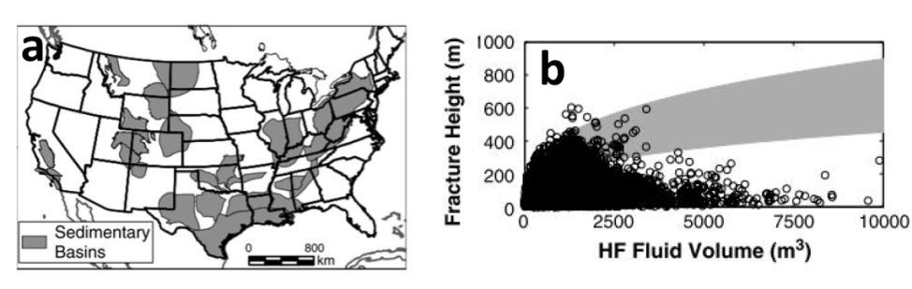
Figure 44: (a) Location of formations where fracture height and HF fluid volume were collected. (b) Covariance between fracture height and HF fluid volume. (Source: Flewelling et al., 2013.)
While it is useful to have an idea of typical fracture extents, it is widely documented that hydraulic fracture growth is not always predictable and that all extractive industry activities, including onshore gas, carry some level of risk (IESC, 2014a). Accordingly, pre-fracture assessments are commonly conducted as part of the hydraulic fracturing program design. Such assessments typically include a characterisation of the geology, permeability, stresses and fault distribution in the prospective and surrounding formations, and estimates of fluid losses during fracturing.

4.4.2 Natural faults and fractures
Faults have been suggested as mechanisms for enhancing fracture growth during hydraulic fracturing of prospective shale gas resources. This however ignores the principles underlying the formation of hydrocarbon reservoirs (Fisher and Warpinski, 2011). That is, if there has been an open pathway between the prospective formation and the near surface through an existing fault, then over geological time periods it is possible that hydrocarbons in the immediate vicinity could escape. If, on the other hand, the fault zone is not highly permeable and is closed, the conditions required to extend the fault may be almost identical to those required to induce fractures in competent rock.
These observations about the practicalities of oil and gas reservoirs strongly suggest that natural faults and fractures do not necessarily result in enhanced fracture growth during stimulation. In this context, it remains possible that the hydraulic fracturing may result in connection between induced fractures and fracture/fault zones with an elevated permeability (e.g. Kissinger et al., 2013; Lange et al., 2013). It is important to establish a sound geological and hydrogeological understanding of the prospective natural gas source and surrounding formations prior to hydraulic fracturing in order to avoid the potential for unwanted connection between high permeability areas.

4.5 Contamination mechanisms
There are three main mechanisms by which hydraulic fracturing can lead to contamination are fluid migration during hydraulic fracturing, passive fluid migration, and gas migration.

4.5.1 Fluid migration during hydraulic fracturing
As discussed in Section 4.1, the maximum pressures reached during fracturing last for a few hours while total fracturing operations last around 12 hours (Lange et al., 2013). After fracture stimulation has ceased, the pressure built up in the formation drives the return of some fluids back to the surface via the well. Additionally, some further hydraulic fracturing fluids are returned to the surface during a flushing phase (back production), where guidelines recommend flushing out about 1.5 times the volume of the hydraulic fracturing fluid (IESC, 2014a). Further recovery of hydraulic fracturing fluids will occur during the production of gas from the gas source.
The movement of fracturing fluids into a formation during the fracturing phase is known as fluid “leak-off”. This occurs during the fracturing phase as the pressure within the fractures is greater than the fluid pressure in the prospective gas formation.
Fluid leak-off rates have been estimated over the last 30 years and have become more efficient over time. Reports from the US EPA (2011) estimate variations in fracturing fluid recovery in prospective shale gas formations ranging from 25 to 75%. In contrast, estimates for the Marcellus Shale suggest a fracture fluid recovery rate of 10 to 30 % (Arthur et al., 2008). For coal seam gas, Penny et al. (1985) suggested a flow-back rate of about 30%, while Palmer et al. (1991) estimated a 61 % fracturing fluid recovery rate over a 19 day period in the Black Warrior Basin. Golder Associates (2010) estimated a 40% fluid recovery rate for wells in the Surat Basin. These results are consistent with reports from the CSIRO (2014) who suggest typical recovery rates in the order of 30 to 60%. It is noted however that leak-off fluids may not be completely lost to the formation as these are partially recovered during gas production when fluid pressure regimes are reversed (IESC, 2014a).
The risk of hydraulic fracture fluid entering groundwater resources has been previously assessed (IESC, 2014a; USEPA, 2011), and three major factors that control contamination risks were outlined. These were:
• distance between the natural gas source and overlying aquifers
• geochemical and physical transport mechanisms operating between the natural gas source and overlying aquifers
• hydraulic connectivity between the natural gas source and overlying aquifers.
Modelling of fracture fluid migration is simulated using organic compounds under the assumption that inorganic compounds are readily soluble and dissociate in groundwater (IESC, 2014a). Models are initiated with a given volume and concentration of a chemical of potential concern to simulate those left after hydraulic fracturing. The models generally use dispersion and sorption processes to model transport but assume no degradation of chemicals over time.
Fate and transport modelling by Golder Associates (2010) was used to assess the migration of oxyalklated alcohol and drilling mud from vertical coal seam gas wells. The modelling suggested that both compounds would migrate less than 5 m beyond the hydraulic fracturing radius of influence over a period of 1000 years. The hydraulic fracturing radius of influence is assumed to occur within 20 m of the perforated section of the well and is illustrated in Figure 45. This is an upper estimate as it assumes that natural groundwater conditions were resumed immediately after fracturing, whereas in reality hydraulic pressure gradients would be directed towards the well in the periods immediately after fracture stimulation.
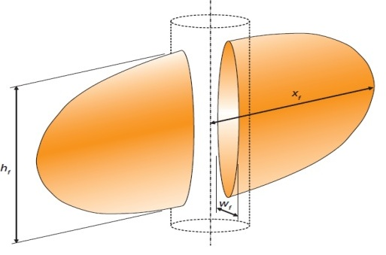
Figure 45: Conceptual shape of zone of hydraulic fracture extent for a vertical well. (Source: Golder Associates, 2010.)
To a similar end, Kissinger et al. (2013) modelled fluid migration from fractured shale gas reservoirs during over-pressure conditions in order to simulate conditions in onshore gas formations during hydraulic fracturing. Models were set up and run for a series of settings throughout the Musteland Basin and Lower Saxony Basin in Germany and included coal seam gas, tight gas and shale gas. Over pressures used in the simulations ranged from 5000 to 70 000 kPa and are within the range for hydraulic fracturing operations. Each model was run for 12 hours, representing 2 hours of high-pressure fracturing and a 10 hour relaxation period. The results indicate that when the hydraulic fracture zones are directly overlain by very low permeability overburden fluid migration from the fracture zone is negligible.
Kissinger et al. (2013) also assessed scenarios in which the very low permeability overburden contained a hypothetical naturally occurring fracture zone, and a maximum fluid migration distance of 48 metres was assumed. It was also noted that the assumption of such pressures over the duration of 2 hrs is unlikely and thus, migration distances were the upper limit. Furthermore, large fluid losses during this period could be detected by the operator and the connection to a fracture zone of high permeability is likely to reduce overall hydraulic fracturing due to pressure loss.
While the migration of fluids during hydraulic fracturing is thought of as a mechanism by which hydraulic fracturing fluids can migrate into natural formations and groundwater systems, naturally occurring contaminants may also be mobilised by this mechanism. For example, increased permeability within the prospective gas formations and high pressures generated during hydraulic fracturing may drive the movement of high salinity groundwater from prospective gas formations into nearby aquifers. For the most part this would occur if the fractures propagate out of the prospective gas formation.
Where hydraulic fracturing in coal seam gas is required, fractures are rarely induced during the injection of hydraulic fracturing fluids into coals seam gas formations. Instead, the fluids are injected in order to widen and “prop” the existing fractures open. Therefore the extent of fluid migration during hydraulic fracturing in coal seams is reliant on the existing fracture network within and surrounding the coal seam, as well as the permeability of the units surrounding the coal seam.
The US EPA (2004) cited a study by Diamond and Oyler (1987) in which coal beds and surrounding formations were investigated after hydraulic fracturing had taken place. The study suggested that fluid movement during stimulations could exceed proppant distances and induced fracture distances, although significant uncertainties still exist. By adding fluorescent tracers to hydraulic fracture fluids during stimulations, the movement of fluids along and beyond fractures was traced. While tracers were used in 8 stimulations and 5 of these were used together with proppants, in all but one of these scenarios the tracer migrated beyond the distance of the proppant. The most significant example of this was at Oak Grave Mine in Alabama where the proppant was found ~30 m from the well while the tracer was found ~200 m from the well. In this circumstance it was found that the fracture width was essentially the width of the naturally occurring cleat and without the tracer, the cleat would not have been identified as a pathway for hydraulic fracture fluids.

4.5.2 Passive fluid migration
If induced hydraulic fractures become connected with existing zones of high permeability that are connected with aquifers (such as faults or fracture systems), contaminant laden fluids have the potential to passively migrate into those aquifers. Unlike fluid migration during hydraulic fracturing, passive fluid migration after fracturing will rely on the natural hydraulic gradients within the formation and not the hydraulic gradients formed during fluid injections. In this context, fluid migration after fracturing is likely to occur over longer time scales than during fracturing, as natural hydraulic gradients are lower than those established during fracturing. Additionally, for a contaminant to migrate from the natural gas source into the overlying aquifers, the prevailing vertical hydraulic gradient must be upwards from the prospective formation towards those aquifers.

This is consistent with modelling results of Kissinger et al. (2013), who found negligible vertical movement of a conservative tracer along a simulated high-permeability fracture/fault zone linking a contaminant zone to an aquifer above with an identical hydraulic head. In contrast, when the same model was run with a hydraulic head in the contaminant zone 60 m greater than the aquifer above, the tracer migrated upwards from the contaminant zone into the aquifer above over a period of 30 years. While the model indicates that groundwater contamination can occur when the simulated hydrogeological setting is optimised for contaminant migration, it should also be noted that tracer concentrations in the model decreased by a factor of 4000 over a fracture/fault zone of about 1000 m, indicating that significant dilution of contaminants is likely to occur in such settings.
In these simulations, contaminant transport via the low permeability formation (1 × 10^{–18} m²) surrounding the higher permeability fracture/fault zone was not apparent, indicating that the passive movement of fluids through low permeability seals is negligible.
The mobility of contaminants will not rely on the physical hydrogeology of the area, the chemical nature of the hydraulic fracturing fluids used and the natural hydrogeochemistry of the groundwater system. Hydraulic fracturing fluids have the potential to mobilise naturally occurring substances such as heavy metals from the prospective formation (IESC, 2014a). There are a range of chemical and biological processes which can reduce the mobility of naturally occurring substances. For example a change in the redox potential of groundwater can decrease the mobility of naturally occurring substances, while microbes can reduce contaminant mobility by binding metals or organic substances (IESC, 2014a).
The key issue with passive fluid migration is that the depressurisation associated with the gas extraction will create a gradient towards the well for the life of the gas field typically 30 years. The key question then becomes the recovery time until the natural gradient takes over. For deep confined reservoirs such as tight gas, this may take hundreds of years. Hence for a very long time passive fluid migration into connected aquifers is not likely to occur.

4.5.3 Gas migration
In general terms there are no distinct natural barriers in shale gas and tight gas reservoirs which trap the gas in the natural gas-bearing formation and also act as barriers to the vertical migration of gas from that formation; instead it is the overall depth and low vertical hydraulic conductivity. Additionally, during gas production, high pressure gradients towards the production well are established and thus, the migration of gases away from the well would be unlikely given that the well is in operation and maintains integrity (USEPA, 2011).
Modelling by Kissinger et al. (2013) focused on the migration of gas (methane) from a hydraulically fractured resource through low-permeability overburden in order to simulate conditions in areas of the Lower Saxony Basin in Germany. The model simulations were based on one setting with an overburden of about 1200 m and another with an overburden of about 3500 m and variable vertical permeabilities ranging from 1 × 10^{–14} to 1 × 10^{–18} m² throughout the stratigraphy. The force driving the upward migration of gasses in this setting is the buoyancy of the gas due to the density difference between gas and water phases, and capillary forces which differ from layer to layer and may cause the lateral spreading of gases (Kissinger et al., 2013). The simulations consider the migration of residual methane from a resource formation over a 100 year post-operation period.
The findings of the study indicated that the leakage of methane from a resource formation to surface aquifers is possible if a range of criteria are fulfilled. There must be a fully penetrating permeable fault/fracture zone between the prospective gas formation and aquifer. Additionally, large volumes of methane need to be mobilised from the gas reservoir and the gas reservoir needs to be relatively close to surface aquifers (i.e. methane did not migrate to the surface aquifer when separated from the prospective gas formation by about 3500 m, but did when separated by about 1200 m and a fully penetrating permeable fault/fracture zone exists between the prospective gas formation and aquifer). Kissinger et al. (2013) suggested that fracturing

operations should not be carried out in a reservoir with a fault zone that penetrates the full thickness of the overburden and that, given this, it is highly unlikely that leakage of methane from a resource formation to surface would occur.
In undisturbed coal seams, gases migrate to areas of lower pressure or diffuse to areas of lower concentration via networks of natural minor fractures called cleats (IESC, 2014a). Once within the cleat system, the gas is adsorbed to the formation and held there under static fluid conditions. However once the pressure in the coal is lowered during depressurisation and development, the gas desorbs from the cleats and migrates to the area of lowest pressure. Horizontal or inclined wells and hydraulic fracturing (when required) can provide a high permeability pathway via which gasses can migrate. In contrast to shale gas, coal seam gas resources are often comparatively shallow and located in closer proximity to groundwater resources. Under these circumstances, the hydraulic fracturing and depressurisation of coal seam gas may result in the mobilisation and migration of gasses into adjacent groundwater resources when sufficient low permeability units are not present (Eco Logical Australia, 2011; USEPA, 2011).
The USEPA (2004) reported a number of incidents in which methane gas migration has led to subsurface contamination. This includes incidents in the San Juan Basin (Colorado and New Mexico), Powder River Basin (Wyoming and Montana), Black Warrior Basin (Alabama) and Central Appalachian Basin (Virginia and West Virginia). In The San Juan Basin the major mechanism driving the migration of methane to groundwater resources appeared to be improperly constructed and abandoned gas wells. However, documented gas seeps and the occurrence of methane in water wells prior to any coal seam gas developments, also indicates that natural fractures probably serve as conduits in parts of the basin where coal formations are near or at the surface and in the interior of the basin, where the coal formations are deeper.
There have been many reports of methane being detected in water bores in Queensland, some of them natural and others resulting from coal seam gas developments. The Walloon Coal Measures in the Surat Basin act as an aquifer in areas where coal seam gas is also being developed. While gas in water bores was reported before the coal seam gas industry was established, the coal seam gas industry has drawn media attention as a result of the large scale depressurisation, which appears to have caused fugitive gas emissions in water bores and inappropriately decommissioned/abandoned water bores and mining exploration bores (Day et al., 2014; Walker and Mallants, 2014). In the case of the Walloon Coal Measures, the water bores are intersecting the same unit as the coal seams, and the gas has not migrated into an overlying aquifer, rather it has been desorbed in response to the depressurisation. Risks associated with the construction and decommissioning or abandonment of wells are dealt with during project-specific risk assessments and are not assessed in this risk assessment. However, operational water bores with gas leakages are assessed.
As the chemical nature of the hydraulic fracturing fluid, groundwater system and geological formation at each natural gas site will vary, it has been recommended that baseline characterisation of methane and other contaminants be conducted and overseen by relevant government agencies prior to hydraulic fracturing (RS/RAE, 2012). According to this recommendation, the baseline data should be collected from the same well that will be hydraulically fractured, however water quality data from nearby wells screened in the same formation may also be suitable for baseline monitoring, provided they are up gradient of the fracturing site.
Cook et al. (2013) highlighted the importance of conducting baseline and key development studies, especially in relation to groundwater monitoring. They indicated that operators should carry out site-specific monitoring of methane and other groundwater contaminants before, during and after gas development operations. They pointed out that regulator driven national baseline surveys of methane and other contaminants in groundwater are desirable to improve the understanding of background levels of methane in groundwater unrelated to gas development and to remove ambiguity surrounding groundwater contamination.

4.6 Summary of potential risks of hydraulic fracturing
Hydraulic fracturing is commonly required during the development of tight gas and shale gas resource formations in order to increase permeability in the formation and the resulting well productivity. However, coal seam gas resource often exhibit naturally high permeabilities and may not require hydraulic fracturing prior to production. Horizontal drilling is also commonly used in the development of shale and tight gas. Horizontal drilling is also being adopted by the coal seam gas industry in Australia and this is often sufficient for gas development and hydraulic fracturing is not required. In such circumstances, the risks presented by hydraulic fracturing are absent.
The contamination risks presented by hydraulic fracturing originate from contaminants associated with hydraulic fracturing fluids used during stimulation (see Section 4.3.1) and contaminants that occur naturally in prospective gas formations and proximal formations (e.g. poor-quality groundwater and methane). As hydraulic fracturing is conducted in settings where the prospective formation has a low permeability, the migration of contaminants from the target into an adjacent aquifer must be via a pathway of increased permeability that links the prospective gas formation to an aquifer. A review of relevant literature indicates that for this to be achieved, an induced fracture must either extend beyond the limit of the low permeability prospective formation and into an adjacent low permeability formation, or intersect a structural feature (such as a fault/fracture zone) that provides a pathway of increased permeability. Additionally, a hydraulic gradient would need to be prevalent such that groundwater would flow from the natural gas source towards the aquifer for the migration of liquid contamination.

4.7 Qualitative risk assessment
Risks associated with contamination of groundwater from hydraulic fracturing fluids are assessed and managed through project/site specific studies. As the current study does not relate to a specific project the potential risks associated with groundwater contamination from hydraulic fracturing are assessed based on a proposed connection and consequence criteria as shown in Table 7 and Table 8 respectively.

Table 7: Proposed connection assessment criteria for hydraulic fracturing impacts.
Likelihood of fracture propagation | Pressure/time/volume of hydraulic fracturing.
High | High pressure, long time, high volume
Moderate | Moderate pressure, medium time, medium volume
Low | Low pressure, short time, low volume

Table 8: Proposed consequence scale for hydraulic fracturing impacts.
Hydraulic fracturing Impact | Low consequence | Moderate consequence | High consequence
Increased connectivity with adjacent good quality aquifers | Fracture propagation is confined to a small fraction of formation thickness within the prospective gas formation. | Fracture propagation is confined to within the prospective gas formation. | Fracture propagation extends to adjacent formations.
Unacceptable contamination of adjacent good quality aquifers | Substantial recovery of fracture stimulation fluids (FSF), and or use of inert FSF. | Partial recovery of FSF, combined with fracture propagation within the prospective gas formation. | No or poor recovery of FSF, combined with fracture propagation into adjacent formations.

4.7.1 Tight gas and shale gas
Tight gas has been identified at the top of the Eumeralla Formation in the Port Campbell Embayment by previous petroleum exploration. The formation is present in the areas between depths of around 1300 to 3500 m (Goldie Divko, L. M., 2015). The Lower Tertiary Aquifer is the closest groundwater resource to the Eumeralla Formation. The Eumeralla Formation is separated from the Lower Tertiary Aquifer in the Port Campbell Embayment by the Sherbrook Group (excluding the Timboon Sandstone which comprises the lower most unit of the Lower Tertiary Aquifer) including the Waarre Formation, Flaxmans Formation, Belfast Mudstone and Paaratte Formation. In the Port Campbell Embayment, these units constitute approximately 600 m of low permeability sandstones, mudstones and shales.
Shale gas prospects have been identified in the Casterton Formation within the Penola Trough at depths of over 3500 m. Again, the Lower Tertiary Aquifer is the most proximal groundwater asset to the Casterton Formation in the Penola Tough. Here, the Casterton Formation is separated from the Lower Tertiary Aquifer by the Crayfish Subgroup, the Eumeralla Formation and in some areas the Sherbrook Group (again excluding the Timboon Sandstone). This constitutes a variety of sandstones, mudstones and shales of predominantly low permeability which have been estimated at thicknesses of up to 3000 m in the southwest of the Penola Trough and approximately 1500 m in the northeast of the Trough (Boult and Hibburt, 2002).
As indicated above, maximum vertical fracture propagation distances are less than 100 m in North America (Cook et al., 2013), and expected to be less than this in the Otway region. With respect to tight gas development, a vertical fracture in the order of tens of metres would not reach within 500 m of the nearest groundwater resource in the Port Campbell Embayment. In the case of shale gas, a vertical hydraulic fracture in the order of tens of metres would not reach within 1400 to2900 m of the nearest groundwater resource.
Under particular conditions vertical fractures larger than 100 m have been recorded (e.g. Fisher and Warpinski, 2011). Although fractures of such distances cannot be discounted, it is possible to reduce their likelihood by mini-fracture testing, fracture design, and the implementation of appropriate operational procedures (Fisher and Warpinski, 2011). In the event of a fracture intersecting a zone of high permeability, the operator would be able to identify fluid leakage and cease operations. Furthermore, the likelihood of intersecting such zones can be reduced by fault/fracture mapping. Consequently, contamination via the generation of fully penetrating fractures or the intersection between stimulated and pre-existing fractures
is unlikely.
Based on the above, the overall risk of groundwater contamination or drawdown resulting from hydraulic fracturing of shale and tight gas prospective formations in the Otway region is low.

4.7.2 Coal seam gas
Coal seam gas prospectivity is limited to where the base of the Eumeralla Formation is relatively shallow (at depths of approximately 600 m or more). Although the Lower Tertiary Aquifer (LTA) is the closest groundwater resource to the Eumeralla Formation, it is absent or yields low-quality groundwater near prospective coal seam gas formations surrounding Lake Corangamite, Lake Colac and to the northeast of Port Fairy. Additionally, the overlying Upper Mid-Tertiary Aquifer (UMTA) is also generally absent in these areas, so that surface aquifers are generally the closest groundwater resource.
As the upper aquifers are within the upper 100 m of the stratigraphic column (SRW, 2011), potential natural gas-bearing formations at greater than 600 m depth will be separated by approximately 500 m of variably distributed sandstones, mudstones, marls and limestones which constitute alternating layers of higher and lower permeability. In this setting, maximum vertical fracture propagation distances of tens of metres would not be closer than 500 m from the nearest groundwater resource. Accordingly, it remains unlikely that highly permeable pathways of over 500 m would exist between the prospective gas formations and upper aquifers in this setting and thus the overall risk from hydraulic fracturing is low.
For the remaining prospective coal seam gas areas there is a minimum of approximately 300 m of low-permeability Eurmeralla Formation between the top of the prospective coal seam gas resource (the Killara coal measures) and the lowermost aquifer. It is unlikely that highly permeable pathways of over 300 m would exist between the prospective gas formations and lowermost aquifer in this setting and as such, the overall risk from hydraulic fracturing is low.
Key factors to be determined for a site-specific risk assessment would be the thickness of the units separating the prospective formations and groundwater assets, their specific permeabilities, stress regimes in the basin, and the proximity of prospective gas formations to existing faults that might provide high-permeability pathways.

5 Induced seismicity risk assessment
This chapter outlines the risk assessment on induced seismicity informed by a literature review.

5.1 Seismicity
Seismic events or seismicity, refer to natural events which release energy in the Earth's crust due to tectonic processes such as faulting. This produces seismic wave energy which travels through the crust producing earthquakes (Geosciences Australia, 2014). The motions of the earth’s crust during such an event are recorded by seismometers and used to determine the size and location of seismic events. The amount of energy released during an episode is related to the crustal material, movement in the crust and the area over which the movement has occurred.
These features are commonly reported by using either the moment of magnitude (MW) scale (Hanks and Kanamori, 1979) or Richter (M_{L}) scale (Richter, 1935). The Richter scale was designed for measuring earthquakes ranging in magnitude from 3 to 7. As such, Richter's original methodology is not always used as it does not give reliable results when applied to M_{L} > 7 earthquakes, and it was not designed to use data from earthquakes recorded at epicentral distances greater than ~ 600 km. The two scales are approximately equal for medium scale earthquakes (i.e. MW is approximately equal to M_{L} when MW is approximately 5) and in fact, most methods for measuring earthquakes are based on Richter’s method.
The United States Geological Survey estimates that several million earthquakes occur in the world each year (USGS, 2014). However, it is likely that most of these go undetected because they are located in remote areas away from seismometers or are very small in magnitude. The National Earthquake Information Centre record approximately 50 earthquakes each day, or about 20,000 a year (Figure 46). Earthquakes of a magnitude of 3.4 M_{L} or lower are not felt and are measurable by seismographs, although exceptions to this may occur if a person is close to the epicentre (Middelmann, 2007). A summary of the likely consequences resulting from earthquake magnitude has been summarised in Figure 47.

Figure 46: Number and magnitude of earthquakes recorded from 2000 to 2012 worldwide and in the USA. (Source: USGS, 2014.)
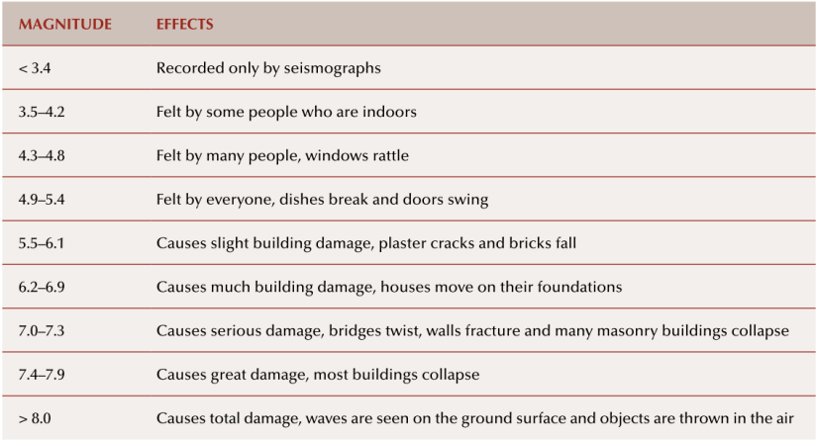
Figure 47: Earthquake magnitude and typical effect. (Source: Middelmann, 2007.)
Seismic events commonly occur in tectonically active areas such as plate margins where zones of crustal deformation are dominant. In these areas, strain energy accumulates over time until the contact strength between two surfaces is exceeded, resulting in a rupture (a fault) and a seismic event (Ellsworth, 2013). While far more common along plate margins, seismic events also occur within continental plates, as shear stress levels within plate interiors is commonly close to the strength limit of the crust and thus small perturbations that affect fault stability can trigger seismic events.
As Australia is located in an intra-plate setting (within a continental plate and away from plate margins), earthquakes occur less frequently than in plate marginal settings. In Australia a person is likely to experience an earthquake large enough to be felt once in every five to ten years (SRC, 2014). Despite this, regions within Australia remain seismically active, albeit at lower scales of magnitude. In Victoria 608 earthquakes have been recorded since 1990 (Geosciences Australia, 2014). Most seismic events in Victoria range in magnitude from 2.0-2.9 (Figure 48) and 6 earthquakes have recorded a magnitude of 4.0 or greater.
Within Victoria, earthquakes occur throughout the southern portion of the Gippsland Basin (Figure 49) around the Strzelecki Ranges and the township of Moe. This is understood to be related to the reactivation of Palaeozoic faults due to northeast–southwest compressional stress (McCue et al., 2013).

Figure 48: Frequency and magnitude of earthquakes in Victoria from 1990 to 2014.
(Source: Geoscience Australia, 2014.)
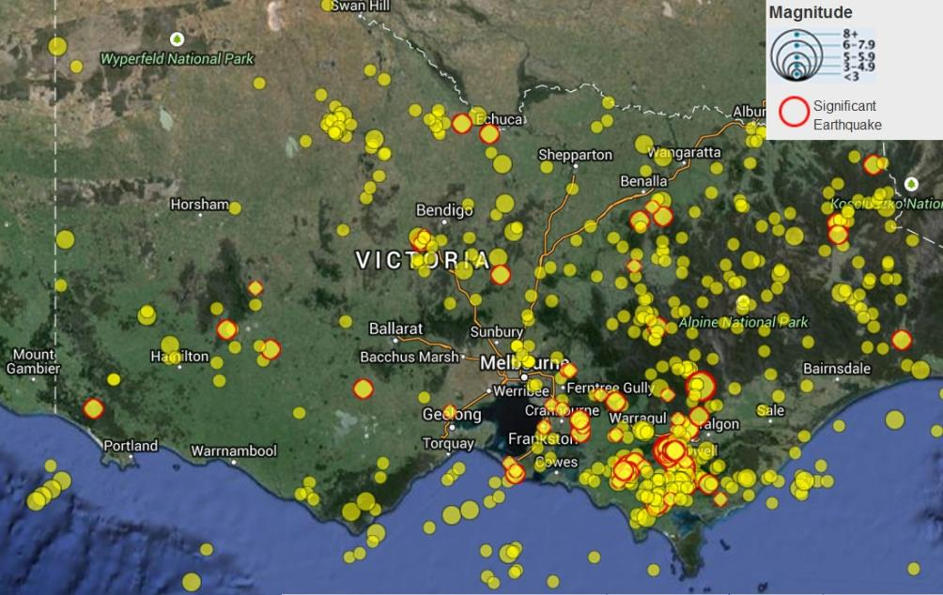
Figure 49: Distribution and magnitude of earthquakes in Victoria from 1990 to 2014 current. (Source: Geoscience Australia, 2014.)

5.2 Induced seismicity
Induced seismicity refers to seismic events that are triggered by human activity, including filling of large water reservoirs, mining and activities involving pumping fluids or gases into the earth (which includes injection of water and gases). These activities produce changes in stress regimes and fluid/rock characteristics. The most common way to trigger an earthquake is to increase the groundwater pore pressure. Small local earthquakes can be triggered by pumping water into the earth, oil and gas extraction activities and geothermal energy (NAS, 2013).
It is important to highlight that while induced seismic events are triggered by human activity, they most commonly release pre-existing stresses that have built up between two surfaces (Ellsworth, 2013). Factors that control the probability of inducing a seismic event include the magnitude of the induced stress change, the spatial scale of the change, the natural stress regime of the material affected and the presence of pre-existing structural weaknesses in the subject material.
Induced seismicity associated with unconventional gas extraction is potentially related to three key activities:
• hydraulic fracturing
• gas production
• co-produced re-injection.

Figure 50 summarises seismic events related to various forms of energy development, including:
• extraction of oil and gas
• secondary recovery of hydrocarbons from fluid injection
• disposal of co-produced via injection
• construction of water reservoirs
• geothermal energy production
• hydraulic fracturing.
There has been a growing realisation that most of the injection-induced earthquakes associated with hydrocarbon development are associated with the re-injection of coproduced into deep formations (Ellsworth, 2013). Nine earthquakes attributed to coproduced re-injection have been reported in the USA (NAS, 2013). Seven of these had a magnitude of 4 or greater and the maximum magnitude was 4.8. The major mechanism driving these seismic events was an increase in pore pressure.
Management of coproduced water, including re-injection, is addressed by existing regulations and requirements for project-specific risk assessments (including the potential for induced seismicity). Therefore, the re-injection of waste water as a cause of induced seismicity is not discussed further in this section. Instead, the section focusses on other potential causes, notably hydraulic fracturing and gas production.
This distinction between hydraulic fracturing and reinjection of co-produced is arbitrary, as hydraulic fracturing involves the injection of fracturing fluids to increase the pressure to create fractures. The key difference between the two activities relates to the period of time over which the higher pressures are maintained. For hydraulic fracturing the higher pressures are temporary (hours), compared to reinjection of co-produced for disposal where the higher pressures are maintained over long time scales.

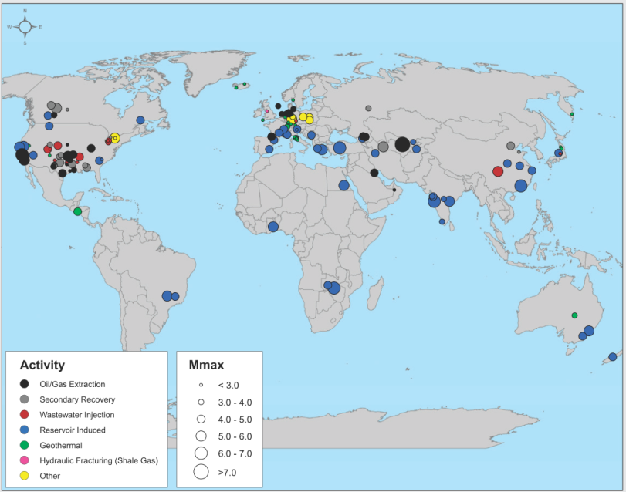
Figure 50: Location and magnitude of seismic events caused by or likely to be related to
energy development from various energy technologies worldwide. (Source: NAS, 2013.)

5.3 Hydraulic fracturing
In prospective onshore gas formations with low permeabilities (i.e. shale gas, tight gas and some coal seam gas settings), fluids may be injected into a prospective gas formation under pressure in order to create fractures and increase permeabilities via a process known as hydraulic fracturing (chapter 0). During hydraulic fracturing, fracture growth is often mapped using micro-seismic monitoring. This process involves monitoring small movements resulting from fracture growth using arrays of sensitive receivers (geophones or accelerometers) deployed at various depths in nearby wells (Fisher and Warpinsk, 2013). As such, during fracture stimulations, hydraulic fracturing intentionally and continuously induces micro-seismic events. Most seismic events associated with hydraulic fracturing have a magnitude of less than 1 M_{L} (Ellsworth, 2013).
Continuous monitoring of seismicity and the implementation of a ‘traffic light’ system was recommended by the Royal Society and the Royal Academy of Engineering (RS/RAE 2012). They indicated that for induced seismic events with an M_{L} between 0 and 1.7, operations may continue but monitoring after injections should be continued for at least two days, until the seismicity rates fall below one event per day. For events larger than M_{L} = 1.7, it was recommended that injections should be temporarily stopped and flowback induced while monitoring continues. Green et al. (2012) proposed more stringent guidelines (as noted by Frogtech, 2013) as part of a study for the Department of Energy and Climate Change, recommending that operations be halted and remedial actions instituted if seismic events > 0.5 M_{L} are detected.
The Marcellus Shale in the United States is the largest source of natural gas in the United States and extends throughout Pennsylvania, West Virginia, Ohio and New York and is characterised by low levels of seismic activity. The regional seismograph network in this area systematically logs all earthquakes with a magnitude of greater than 2 and despite thousands of fracture stimulations in Pennsylvania since the major development in the field since 2005, six earthquakes with a magnitude greater than 2 have been recorded, with a maximum magnitude of 2.3 (Ellsworth, 2013).
Of around 35 000 hydraulically fractured shale gas wells which exist in the United States, one case of felt seismicity has been recorded in which hydraulic fracturing for shale gas development is suspected as the cause (NAS, 2013). This event was reported as a sequence of earthquakes in Oklahoma during nearby hydraulic fracturing operations, with a maximum magnitude of 2.9 M_{L}. Holland (2011) reported that despite a clear temporal correlation with hydraulic fracturing, the natural seismicity of the area and limitations in the data made it uncertain whether the source of the seismicity was related to hydraulic fracturing or natural processes. Subsequent work by Kim (2013) indicates that this seismicity was related to the injection of coproduced and not hydraulic fracturing.
In British Columbia, Canada, a series of seismic events were recorded in the Horn River Basin associated with the development of prospective shale gas formations in 2009 (BC Oil and Gas Commission, 2012). This example is not displayed in Figure 50 above as investigations into these seismic events were conducted contemporaneously with the NAS (2013) report. A total of 21 seismic events were recorded with a magnitude of 3.0 or larger, however the largest (3.8) was reported as felt by workers. It was determined that the cause of the events was the injection of fluids during hydraulic fracture stimulation in close proximity to pre-existing faults (Ellsworth, 2013). It was also determined that the earthquakes were driven by the movement of previously unknown critically stressed faults that were oriented for failure. These were activated in response to increased fluid pressure communicated through conductive pathways that caused slip via a reduction in the effective normal stress.
In England, one case of induced seismicity felt by workers has been confirmed to have been caused by hydraulic fracturing for shale gas development (Green et al., 2012). In April 2011, the Blackpool area experienced a seismic event of magnitude 2.3 M_{L} shortly after hydraulic fracturing in Cuadrilla’s Preese Hall well in the Bowland Shale (RS/RAE, 2012). An additional seismic event 1.5 M_{L} in magnitude occurred in May 2011 following further hydraulic fracturing of the same well. The reports by Green et al. (2012) and the Royal Society and the Royal Academy of Engineering (RS/RAE 2012) both indicate that hydraulic fracturing was responsible for the induced seismic events as a result of reactivation of a pre-stressed fault.
The NAS (2013) suggests that very low number of fault events relative to the large number of hydraulically fractured wells for shale gas is likely due to the short duration of injection of fluids and the limited fluid volumes used over a small spatial area.
In New Zealand, hydraulic fracturing is a comparatively new technique, the first recorded hydraulic fracturing was undertaken in 1989. Almost all the fracturing undertaken to date has occurred near Taranaki. The NZ Parliamentary Commissioner for the Environment commissioned a study to evaluate the environmental impacts of hydraulic fracturing in New Zealand in 2012 NZPCE, 2012). This study suggested that hydraulic fracturing in New Zealand creates earthquakes, with magnitudes less than 2 that cannot be felt at the surface. These earthquakes are within the natural variability experienced in the region. However, where injected hydraulic fracturing fluids migrate to an active fault, the fluid can cause movement within the stressed fault which allows the fault to slip. The study infers that it is not possible to trigger significant earthquakes if there is no local active fault and that the chance of inducing an earthquake is influenced by a range of variables, which include the volume of fluid injected, the size of the existing fault and how much stress it is under. The key conclusion of this study, based on records from the earthquake monitoring systems, was that there is no evidence to suggest that fracturing around Taranaki has cause induced seismicity that could be felt at the surface.
In summary, despite tens of thousands of hydraulic fracture stimulations globally, two events large enough
to be felt by workers have been confirmed as related to hydraulic fracturing. As outlined above, this includes an event in British Columbia, Canada (maximum M_{L} = 3.8) and an event in Blackpool, England (maximum
M_{L} = 2.3). Cook et al. (2013) summarised the findings of a number of reports with respect to the risk of induced seismicity presented by hydraulic fracturing and reported that:
• Seismicity induced by hydraulic fracturing would be no greater than 3 M_{L} and would be felt by people, resulting in negligible, if any, surface impacts.
• Hydraulic fracturing itself rarely triggers earthquakes large enough to be a safety concern.
• Hydraulic fracturing a well as presently implemented for shale gas recovery does not pose a high risk for inducing felt seismic events.
Cook et al. (2013) concludes that despite the relatively low risk presented by hydraulic fracturing itself, real-time seismic monitoring can allow operators to respond to seismic indicators and mitigate the risk.

5.4 Gas development
Oil, gas and fluid extraction from a reservoir can cause declines in the pore pressure that can cause induced seismic events (NAS, 2013). Declining pore pressure associated with extraction causes contraction of the reservoir and induces stresses in the surrounding rock. This can increase horizontal stresses above and below the reservoir and increases the potential for reverse faulting. It has been estimated that the withdrawal of fluids from reservoirs can cause earthquakes up to magnitude 5.0 M_{L} (Grasso, 1992).
In a study into induced seismicity related to natural gas extraction, Van Eijs et al. (2006) found three major contributing factors in producing seismicity:
• pore pressure drop from pumping
• existing fault density overlying the gas field
• contrast in crustal stiffness between the reservoir rock and the surrounding rock.
The extraction of fluids and hydrocarbons may cause vertical stress reduction and isostatic uplift (the ascent of underlying rock as a result of the removal of overburden weight) of the lithosphere surrounding gas development (McGarr, 1991). This may induce slip on pre-existing faults at depth.
The National Academy of Sciences (NAS, 2013) reported that, on approximately 6000 producing oil and gas extraction fields across California, Illinois, Nebraska, Oklahoma and Texas, workers have felt seismic events at 20 locations. Of these, five events have had a magnitude of 4 or greater, and the most significant event had a magnitude of 6.5 M_{L}. The global distribution of seismic events related to oil and gas extraction are illustrated in Figure 50 (see Section 5.2).
It has been well documented that the Lacq gas field in France provides a good example of induced seismicity resulting from fluid extraction (NAS, 2013). The gas reservoir is a limestone sequence approximately 500 m thick and the first earthquake felt at the site occurred after a decrease in pressure of approximately 300 bar (3060 mH₂O) from 1957 to 1969. Development over the ensuing ~15 years resulted in a further 200 bar pressure drop accompanied by 800 seismic events with magnitude of up to M_{L} 4.2. While this provides an example of seismicity related to reductions in pore pressure associated with fluid extraction, it should also be noted that the Lacq gas field is an example of conventional gas production. As such, the intrinsic differences between prospective conventional and unconventional gas should be accounted for before directly relating such results to prospective unconventional gas.
Understanding seismicity induced by fluid and hydrocarbon withdrawal requires characterisation of stress changes associated with the large-scale reservoir expansion due to pore pressure reduction and uplift driven by mass removal. Because stress change can take place over large areas (approximate to the size of the oil/gas reservoir) there is potential for event magnitudes to be high. Additionally, unconventional gas is usually over large areas and may induce seismicity over greater spatial scales. However in order to trigger an event, the stress field between two surfaces must be close to critical as stress changes in response to pore pressure reductions are small. For example, at the Lacq gas field a pressure drop of 300 bar was required to increase the maximum shear stress by 1 bar (NAS, 2013).
Cook et al. (2013) also highlights potential risks associated with pressure changes in gas reservoirs. A review of gas withdrawal and injection history at the Iona facility in southwest Victoria including modelling of pressure changes, revealed maximum subsidence predictions of 2.5 and 9.0 mm at various stages of gas production from the reservoir. Subsidence was expected to be greatest directly above the reservoir but some displacement was expected up to 2.5 km from the centre of the reservoir. Fault stability during pressure changes was predicted by modelling plastic strain, and a value of 1% strain increase was used to indicate the point at which rock failure becomes elevated.

5.5 Qualitative risk assessment
The development of a qualitative risk assessment for induced seismicity involves the understanding of uncertainties associated with subsurface complexities. At the start of any subsurface project, the uncertainty is broad and is not expected to be fully resolved. The risks associated with induced seismicity include those associated with increased pressure driven by processes such as hydraulic fracturing and decreases in pressure resulting from gas or fluid extraction. These processes could possibly lead to fault re-activation and seismic events.
The likelihood of inducing a seismic event during gas development relies on a number of factors including the natural level of seismicity in the area, current stress regimes in the prospective gas formations and surrounding formations, the prevalence and proximity of faults and weaknesses to the prospective gas formation, and the nature and operation of the development undertaken (i.e. pressure changes and intensity of development wells). Using these criteria, the likelihood of inducing a seismic event can be characterised as low, moderate or high (Table 9).

Table 9: Proposed likelihood assessment criteria for induced seismicity.
Induced seismicity likelihood | Pressure change | Intensity of development of wells
High | High change | High intensity
Moderate | Moderate change | Moderate intensity
Low | Small change | Low intensity

The consequence of induced seismicity is related to the magnitude or size of the seismic event that has been induced. Events less than 3.4 in magnitude are not felt by individuals and usually measurable with seismometers. Events between and including 3.5 and 4.2 in magnitude can be felt by individuals but cause little to no structural damage, while events 4.3 or greater in magnitude are felt by individuals and have the potential to cause structural damage. These events have been categorised as of low, moderate and high consequence, respectively (Table 10).

Table 10: Proposed consequence scale for induced seismicity.
Induced seismicity impact | Low consequence | Moderate consequence | High consequence
Earthquake magnitude | M_{L} ≤ 3.4 | M_{L} between 3.5 and 4.2 | M_{L} ≥ 4.3

The potential for hydraulic fracturing to trigger seismic events in the Otway region can be related to the potential development of shale gas, tight gas and to a lesser extent coal seam gas. In contrast, depressurisation resulting from fluid and gas extraction in the Otway region is primarily related to coal seam gas where water extraction may be required to induce desorption of gas from the coals.
Within the Otway region a number of fault systems are present which provide the potential for fault activation via depressurisation and hydraulic fracturing. However, the natural level of seismicity in the Otway region is relatively low, as indicated by Figure 49. Of the 604 seismic events recorded in Victoria since 1990, 38 occurred in the Otway region. This suggests that the fault systems in the basin are not critically stressed or commonly subject to stress accumulation and rupture. Additionally, about 70% of these events were less than magnitude 3 M_{L} and not likely to be felt by an individual.
There is evidence to suggest that seismic events of moderate magnitude (up to 4.2 M_{L}) can occur in response to the depressurisation of a gas reservoir, however such evidence is related to prospective conventional gas formation in which significant pressure changes occur over small areas. Local studies in the Otway region (Cook et al., 2014) found that there was no fault activity associated with the injection of 66,000 tonnes of CO₂ into the Waarre Formation (the formation overlying the coal seam gas formation). This suggests that the likelihood of inducing a seismic event via fluid and gas removal is low. Therefore the overall risk posed by depressurisation is low to moderate.
During the process of hydraulic fracturing it is almost certain that low-magnitude seismicity (under 1.5 M_{L}) will be induced. However such events are unlikely to be felt by individuals and are of low consequence. Therefore, the overall risk posed by such events is low. The likelihood of hydraulic fracture induced seismic events large enough to be felt by an individual is highly remote. In a global context, of the tens of thousands of hydraulic fracture stimulations that have occurred, two reports of induced seismicity felt by an individual have been confirmed. Furthermore, the maximum magnitude of these events was 2.3 and 3.8 M_{L}.
Events of this magnitude are not likely to cause damage, nor commonly are they felt by individuals. Additionally, it is possible to mitigate the development of such events during hydraulic fracturing by pre-operation assessments and the implementation of operational procedures such as those outlined by the Royal Society and the Royal Academy of Engineering (RS/RAE 2012). The overall risk of inducing moderate to high seismic events by hydraulic fracturing in the Otway region is therefore low.

6 Land subsidence risk assessment

6.1 Overview
Subsidence refers to the phenomenon of ground level lowering resulting from water (or fluid) removal from the subsurface. It is sometimes referred to as land subsidence. Subsidence is a geomechanical process that can occur when water is withdrawn from an aquifer. One of the impacts that the exploration or development of onshore gas could have is to cause drawdown in aquifers in the Otway region. This chapter provides a brief review and overview of the process by which drawdown may lead to subsidence and a qualitative assessment of the potential risks that may arise from onshore gas development.

6.2 Summary of subsidence processes
The pressure within an aquifer is caused by a combination of the weight of the sediments and the weight of water (fluid) and the atmosphere. This weight is borne in part by the aquifer sediments, and in part by the water (fluid) in the aquifer. For the purposes of this discussion we will refer to the fluid in an aquifer as water. The weight of both the overlying sediment grains and the overlying water contribute to the aquifer pressure in proportion to the mix of water and sediment in the hydrogeological sequence.
Subsidence is potentially of concern in sedimentary aquifers (Poland, 1984). A sedimentary aquifer can be considered to be a collection of grains of gravel, sands, silt and clay of different sizes that are combined together. Pressure from overlying sediments or rocks and the weight of water are carried by the grains in contact with each other. Increasing pressure will compress the sediments. The rate of compression with increasing pressure is very small. It can be measured by taking samples of the sediment and testing in a laboratory.
As sediments are deposited they become progressively buried. The burial process compacts and consolidates the sediment. Over geological time the sediments may be moved or lifted by geological forces. Typically sediments as we find them today have been buried deeper in the earth at some stage in the past.
While the general pattern of consolidation and the forces that control it are well understood, there is relatively little known about the precise characteristics of the consolidation process of sediments in the Otway region. Very few field studies have been undertaken. One study has been undertaken where laboratory testing of aquifers for compression parameters has been reported (the Barwon Downs case study; see below).
Subsidence is dominated by the clay and fine grained sediments within a sedimentary sequence. Typically this means that for the aquifers and sediments in the Otway region, the aquitards will provide the majority of any potential settlement and thus are likely to be the source of the majority of any subsidence. Fractured rock aquifers are not expected to provide significant settlement.

6.3 Summary of subsidence processes
The key factors that influence the risk of subsidence are:
• water level drawdown in aquifers
• compressibility of the aquifer sediments, especially the aquitards (or clay bearing layers) and coal layers
• ratio of fine grained (clay) sediments to medium to coarse grained sediments (sands)
• length of time that the water level drawdown persists
• prior compaction (consolidation) history of the sediments.

For the Otway area, some of the risk factors are reasonably known and others can be estimated or inferred. Each of the risk factors is discussed below.

Drawdown
The block model approach described earlier in this report has been used to estimate the potential drawdown in aquifers in the Otway region as a result of onshore gas exploration or development. These drawdown estimates provide an indication of the likely influence of gas developments on regional groundwater systems. The typical regional drawdown (in any aquifer) estimated by this study is in the order of 10 to 100 cm after 30 years. This drawdown is small (less than 100 mm) and well within the range of drawdown that may be expected from other regional groundwater extraction.

Aquifer and aquitard compressibility
Little is known of the actual sediment compressibility characteristics in the broader Otway region. The Barwon Downs case study indicated that the Gellibrand Marl (which is the major regional aquitard) is over-consolidated and recompression ratio values are available from laboratory testing. The extent to which these would be more applicable to the rest of the study area is not defined but it can reasonably be assumed that these values can be taken to represent the Gellibrand Marl more widely. Whether these values apply specifically to other units is not clear. It can be confidently assumed that the bulk of the aquifer sequence below the Gellibrand Marl is over-consolidated.
Uncertainty in the compressibility of sediments is a significant barrier to any quantitative assessment of subsidence. In the absence of any other more relevant values, the values adopted for Barwon Downs appear to be the best available.

Ratio of clay to sand
In the Otway region the stratigraphy is well defined for the Tertiary and earlier sediments. Stratigraphic profiles in the upper part of the sequence are reasonably well known. Deeper profiles are known from a more limited number of bores, but they are generally well described and the ratios of clay to sand are moderately well known. The data on sediment size is adequate given the uncertainties in other parameters

Timing of drawdown
The time that elapses between drawdown and recovery is moderately well known. Estimates for onshore gas development are over 30 years, and water level recovery in the aquifer sequence (as compared with the gas source rocks) is likely to be in the order of a decade.

Consolidation history
Prior consolidation and compaction history of sediments is important when predicting subsidence, because how sediments behave to the stress of water withdrawal depends on whether the stresses are greater than or less than the maximum pressure that has been previously applied to the sediments. Sediments with stresses that are less than the historical maximum are called over-consolidated. Sediments where stresses are greater than previously applied are called normally-consolidated sediments. The compressibility of over-consolidated sediments is about one tenth of the compressibility of normally consolidated (Helm 1984; Underschultz, 2006).
The pre-consolidation history is key to predicting the likely subsidence but there is no known data from the broader sedimentary sequence in the Otway area. As a result, detailed predictions of subsidence in the Otway region are not possible. (Assumptions about the stress history of the sediments can be made, but these have little data to support them.) The single relevant observation is that the Barwon Downs area is responding in a way that is consistent with the sediments being over-consolidated with respect to current extraction stresses. Within an aquifer at any point below the ground surface, the pressure is caused by a combination of the combined weight of the sediments above that point, the weight of water (fluid), and the atmospheric pressure above that point. This weight is borne in part by the aquifer sediments and in part by the water (fluid) in the aquifer. For the purposes of this discussion we will refer to the fluid in an aquifer as water. It can be any fluid, but as the focus of this report is the risk to water resources, water is the main consideration. Subsidence is potentially of concern in sedimentary aquifers (UNESCO 1984). Fractured rock aquifers are generally of less concern. In the Otway region the majority of water resources occur in sedimentary aquifers, although significant fractured rock aquifers are present (Refer conceptual model, in Chapter 1).
Subsidence is dominated by the clay and fine grained sediments within a sedimentary sequence. Typically this means that for the aquifers and sediments in the Otway region, the aquitards will provide the majority of any potential settlement and thus are likely to be the source of the majority of any subsidence. Fractured rock aquifers are not expected to provide significant settlement.

Barwon Downs
In the Otway region the Barwon Downs area has been identified as being potentially at risk of subsidence as a result of groundwater extraction. Barwon Downs contains a major public groundwater supply located in the Gerangamete area. At this site, where deep pumping bores extract groundwater from the Dilwyn Formation and adjacent aquifers, land subsidence is identified as a risk of pumping.
An investigation was undertaken early in the development of the wellfield, (Rural Water Commission, 1986), in which estimates of subsidence were prepared. These estimates were based on compaction parameters that were adopted from Gippsland (Helm, 1984), as local test results were not available. Subsequently laboratory testing of samples from the Barwon Downs region were collected (Rural Water Commission, 1987). These results indicated laboratory estimates of the compression ratio (CR₂) in the range of 0.06 to 0.09. This indicates that the clays from the Gellibrand Marl (the unit tested) are over-consolidated. Estimates of land subsidence were then made. These indicated that (depending on the groundwater extraction rate and pattern) land subsidence of up to 0.4 m could be possible.
The license for groundwater take and use for the Barwon Downs wellfield includes a requirement to monitor for subsidence and allows for up to 200mm of subsidence within the licence conditions, (Barwon Water 2013). In 2013 the maximum measured subsidence was 54mm. The Barwon Downs well field has generated drawdown of up to 40 metres. The bore field is used intermittently as a reserve supply for Geelong.

6.4 Qualitative risk assessment
Detailed predictions of subsidence in the Otway region are not possible as the pre-consolidation history is key to predicting the likely subsidence and yet there is no known data from the broader sedimentary sequence in the Otway area. Assumptions as to the stress history of the sediments can be made, but these are assumptions with little data to support them. The single relevant observation is that the Barwon Downs area is responding in a way that is consistent with the sediments being over-consolidated with respect to the current day extraction stresses.
The likelihood of subsidence is determined by the nature of the aquifers and how they may respond to drawdown. In effect this means that a likelihood scale is linked to the magnitude of subsidence that may occur. This is a combination of the consolidation parameters of the aquifers/aquitards and the expected drawdown. An approximate likelihood framework (Table 11) is proposed, based on the discussion above.
The consequence of subsidence is variable depending on the receptor. Built structures have deformation limits. Natural systems tend to be more resilient but will still have a limit. For this study the water resources that are being considered are aquifers, streams and ecosystems that are dependent on groundwater. Determining a consequence scale will need to be based on the nature of the water resource under consideration. In this study consequence is not able to be determined directly from data, as the key parameters to determine potential subsidence and the flow on consequences are not sufficiently known. For the purposes of this assessment the DELWP Resource Share Guidance approach is recommended as the basis of assessing likelihood, as shown in Table 11.

Table 11: Proposed likelihood scale for subsidence caused by drawdown in aquifers.
Consolidation response / Drawdown Range | LOW  Less than 1 m drawdown over 30 years | MODERATE  Between 1 m and 10 m drawdown over 30 years | HIGH  Greater than 10 m drawdown over 30 years
HIGH  Normally consolidated sediments | Moderate | High | High
MODERATE  Over-consolidated sediments with >20% clay | Low | Moderate | Moderate
LOW  Over-consolidated sediments with little clay | Low | Low | Low

Table 12: Proposed likelihood assessment criteria for subsidence as a result of onshore gas development.
Water Resource (Asset) Group | Low Consequence | Moderate Consequence | High Consequence
Groundwater users (aquifers) | Impact of subsidence is within annual variability in function and operating costs of current and future users. | Without modification current pumping regime cannot meet water demand due to subsidence | Aquifer, without modification of current pumping infrastructure such as deepening bores, cannot meet demand requirements as a result of subsidence.
Surface water users (rivers) | Subsidence results in either no change or a material change in river flow, with no measurable impairment of users’ ability to access entitlement. | Subsidence results in a material change in river flow, with measurable impairment of users’ ability to access entitlement. | Subsidence results in a material change in river flow, with significant impairment of users’ ability to access entitlement.
Surface water ecosystems | Subsidence results in a material change in ecosystem condition, with no measurable impairment of ecosystem function. | Subsidence results in material change in ecosystem condition, with measurable impairment of ecosystem function. | Subsidence results in material change in ecosystem condition, with significant impairment of ecosystem function.

Considering the range of values for clay content and the potential range of drawdown that may result from gas exploration or development, the expected range of subsidence as a result is likely to be in keeping with that experienced from current licensed groundwater extraction. That is, land subsidence would be expected to be in the range of millimetres to tens of millimetres.
Give the indicative consequence table and the sediment types in the Otway region, there is a low risk of subsidence. Primarily this assessment results from the estimation of low drawdown as a result of gas exploration or development.

6.5 Summary
In the Otway region the risk of subsidence from onshore gas development is low.

7 Conclusions

7.1 Aquifer depressurisation
The potential impacts associated with aquifer depressurisation were assessed using a block model approach to estimate drawdown.
Overall the potential impact on aquifers (confined and unconfined), surface water resources (including) users, and ecosystems from the development of all gas scenarios in the Otway region is low.
The potential impact on groundwater users, surface water users and ecosystems from possible combined gas development in the Otway region is low.
The potential impact on surface water users in all gas development scenarios is low. In the conventional gas development scenario the potential impact is low.
The potential impact of groundwater quality changes resulting from gas development is low because the groundwater pressure changes that are estimated to arise from the combined development are modest. There is no indication that elevated potential impact of water quality changes will arise resulting from gas development above that which currently exists from groundwater use.
The potential impact on water resources from aquifer depressurisation resulting from the development of any of the four identified gas scenarios in the Otway region is low.

7.2 Chemical contamination of groundwater from hydraulic fracturing fluids
The risks associated with groundwater contamination from hydraulic fracturing were assessed using information in the available literature. Any development of shale and tight gas in the Otway region is expected to require hydraulic fracturing in order to increase formation permeability and hence gas production. The development of conventional gas in the Otway region is unlikely to require hydraulic fracturing.
Maximum vertical fracture propagation distances are reported to be less than 100 m based on North American data (Cook et al., 2013). Evidence for the stress regime in southern Australia would indicate that the fracture propagation would be much less than the American case and is likely to be up to tens of metres. With respect to tight gas development, a vertical fracture of tens of metres would still be about 500 m from the nearest groundwater resource in the Port Campbell Embayment. With respect to the development of shale gas, a vertical hydraulic fracture tens of metres in length would still be 1400 to 22900 m from the nearest aquifer.
Within the defined coal seam gas prospective areas around Lake Corangamite, Lake Colac and to the north east of Port Fairy (Figure 13), the upper aquifers occur within the upper 100 m of the stratigraphic column (SRW, 2011). Hence, source formations at greater than 600 m depth will be separated by approximately 500 m of variably distributed sandstones, mudstones, marls and limestones which constitute alternating layers of higher and lower permeability. Accordingly, it is unlikely that highly permeable pathways exist between coal seam gas formations and upper aquifers in these areas, and therefore the overall risk from hydraulic fracturing is low. The separation between the source rocks and the lower aquifers is also several hundred metres and so the risk to lower aquifers from fracturing is also low.

For the remaining prospective coal seam gas areas there is a minimum of approximately 300 m of low permeability Eumeralla Formation between the top of the prospective coal seam gas resource (the Killara coal measures) and the lowermost aquifer. It is unlikely that highly permeable pathways of over 300 m would exist between the prospective gas formations and lowermost aquifer in this setting and as such, the overall risk from hydraulic fracturing is low.

7.3 Induced seismicity
The potential for hydraulic fracturing to trigger seismic events in the Otway region is related to most development scenarios, including shale gas, tight gas and coal seam gas. In contrast, depressurisation resulting from fluid and gas extraction in the Otway region is primarily related to coal seam gas where water extraction may be required to induce desorption of gas from the coals.
Within the Otway region a number of fault systems are present which provide the potential for fault activation via depressurisation and hydraulic fracturing. However, the natural level of seismicity in the Otway region is relatively low.
Local studies in the Otway region (Cook et al., 2014) found that there was no fault activity associated with the injection of 66 000 tonnes of CO₂ into the conventional gas-bearing formation (the Waarre Formation). This suggests that the likelihood of inducing a seismic event via fluid and gas removal is low. As such, the overall risk posed by depressurisation is low to moderate.
During the process of hydraulic fracturing, it is almost certain that low magnitude (<1.5 M_{L}) seismicity will be induced. However such events will not be felt by individuals and are of low consequence to people and structures. As such, the overall risk posed by such events is low. In contrast, the likelihood of hydraulic fracture induced seismic events large enough to be felt by an individual is highly remote. In a global context, of the tens of thousands of hydraulic fracture stimulations that have occurred, two reports of induced seismicity felt by an individual have been confirmed. Furthermore, the maximum magnitude of these events was 2.3 and 3.8 M_{L}. The overall risk of inducing moderate to high seismic events by hydraulic fracturing in the Otway region is therefore assessed as low.

7.4 Land subsidence
Land subsidence is a geomechanical response to reduced stress in aquifers, which is bought about by groundwater pressure decline. The key factors that influence and control land subsidence are understood, but how these factors are present across the region varies. The key factors that affect the potential for land subsidence are as follows.

Aquifer and aquitard compressibility
Little is known of the actual sediment compressibility characteristics in the broader Otway region. From the Barwon Downs case study the Gellibrand Marl (which is the major regional aquitard) is over-consolidated and recompression ratio values are available from Laboratory testing. It can reasonably be assumed that these values can be taken to represent the Gellibrand Marl more widely. It can be reasonably assumed that the bulk of the aquifer sequence below the Gellibrand Marl is over-consolidated. Uncertainty in the compressibility of sediments is a significant barrier to any quantitative assessment of subsidence. In the absence of any other more relevant values, the values adopted for Barwon Downs appear to be the best available.

Ratio of clay to sand
In the Otway region the stratigraphy is well defined for the Tertiary and earlier sediments. Stratigraphic profiles in the upper part of the sequence are reasonably well known.

Timing of drawdown
The time of drawdown and recovery is moderately well known from predictive tools. Estimates for onshore gas development are over 30 years and water level recovery in the aquifer sequence (as compared with the gas source rocks) is likely to be in the order of a decade or so. This parameter is reasonably well known, when compared with other parameters.
Consolidation History: Prior consolidation and compaction history of sediments is important when predicting subsidence as sediments behave differently to the stress of water withdrawal depending on whether the stresses are greater than or less than the maximum pressure that has been previously applied to the sediments. Detailed predictions of subsidence in the Otway region are not possible as the pre-consolidation history is key to predicting the likely subsidence and yet there no known data from the broader sedimentary sequence in the Otway area. Assumptions as to the stress history of the sediments can be made, but these are assumptions with little data to support them. The single relevant observation is that the Barwon Downs area is responding in a way that is consistent with the sediments being over-consolidated with respect to the current day extraction stresses.
Based on the estimated low to moderate drawdown for combined gas development and groundwater pumping and extrapolating from the parameter data available for Barwon Downs the risk of land subsidence from combined gas development and groundwater pumping is generally low, with small areas of moderate risk located in areas of (existing) heavy groundwater pumping.

7.5 Summary of potential impacts
A summary of the potential impacts for aquifer depressurisation from onshore natural gas development in the Otway region is provided in Table 13.

Table 13: Potential for impact due to aquifer depressurisation from onshore natural gas development in the Otway region.
Natural gas type | Aquifer depressurisation
Natural gas type | Groundwater | Surface water | Ecosystems
Shale | Low | Low | Low
Tight | Low | Low | Low
Coal seam gas | Low | Low | Low
Conventional | Low | Low | Low

A summary of the potential risks from chemical contamination of groundwater due to hydraulic fracturing fluids, induced seismicity and land subsidence from onshore natural gas development in the Otway region is provided in Table 14.

Table 14: Potential risks due chemical contamination of groundwater from hydraulic fracturing fluids, induced seismicity and land subsidence from onshore natural gas development in the
Otway region.
Natural gas type | Chemical contamination of groundwater from hydraulic fracturing fluids |  |  | Induced seismicity | Land subsidence
Natural gas type | Groundwater | Surface water | Ecosystems | All users | All Users
Shale | Low | Low | Low | Low | Low
Tight | Low | Low | Low | Low | Low
Coal seam gas | Low | Low | Low | Low | Low
Conventional | n/a | n/a | n/a | Low | Low

7.6 Gaps and uncertainty
This assessment has identified a number of areas of data uncertainty and data gaps. Additional information in the following areas would enable the assessment to be improved. The framework that has been developed is valid despite the uncertainties in the data, as with the provision of better data and evaluation the framework can be re-applied.
Throughout this report areas of uncertainty have been identified and discussed. The following areas are the key gaps prioritised for further data gathering.
Permeability of seal rocks: In the Otway region the seal rocks for the gas reservoirs are also the key aquitards that separate the reservoirs from the main aquifers. Relatively little is known of the hydraulic properties of the seal rocks as they relate to water movement. Collection of data on the hydraulic performance of the seal rocks would improve the assessment of potential impacts and risks. In this study a relatively high degree of connection has been adopted and it is possible that less connection exists over much of the area, resulting in lower potential impacts and risks.
Drawdown estimates: The impact of gas development and groundwater use is fundamentally indicated by the drawdown response. For this assessment a block model approach has been adopted that gives a regional and simplified assessment of the likely drawdown. Whilst this assessment has indicated that the drawdown impacts are relatively minor, the assessment could be improved if a better estimate of drawdown as a result of combined gas development and groundwater use was available. The assessment framework could readily be re-applied when a more detailed assessment of the aquifer response is available. In particular the current method does not allow for widespread lateral migration of drawdown away from the gas source. This is an area that could be improved.
Definition of potential gas sources: Although exploration for conventional gas resources in the Otway region has occurred over many decades, the search for unconventional resources is a relatively recent phenomenon. As such the geological understanding associated with unconventional gas resources in the Otway region is immature. Although it is possible to make educated estimates about potential host gas-bearing formations and their extent, whether or not gas is present, and then present in economically recoverable volumes is unknown. Given the small scale of the production of conventional gas fields that occurred in the Port Campbell Embayment in the 1980s to 2000s, the gas development scenarios envisaged in this assessment are representative of development at an expanded scale that may overestimate areal extent. Better definition of the potential extent of development would improve the assessment of potential impacts and risks to water resources by more clearly identifying areas that have no potential for development.
Compaction and consolidation parameters: The risk of land subsidence is evaluated based on parameters for compaction. These parameters are known at one location (Barwon Downs). Improved assessment of the risk of subsidence could be made if more data on the compaction of aquitards was available. In particular additional data on these factors for the Gellibrand Marl, across the region, would be a useful addition.
Relationship between drawdown and river flows: For this assessment the impact on surface water users has been assessed by inferring impact from the existing depth to watertable and predicted drawdown. To improve this, improved descriptions of the relationship between drawdown and river flow could be developed. For example, if major river reaches were to have a drawdown sensitivity assigned to flow, then the drawdown estimates could be more readily assessed in terms of the impact on surface water availability. The current study infers that in all areas drawdown will lower surface water availability where the watertable is shallow. This may not be the case in all areas because of the nature of the surface water systems. Better description of the link between drawdown and surface water flow could improve the assessment of potential impacts, allowing it to be more targeted.

Connection of ecosystems to groundwater: The potential impact to surface water ecosystems has been inferred from the groundwater depth. This may or may not reflect the sensitivity and likelihood of impact in response to drawdown. The assessment could be improved if a better definition of the response to drawdown for different surface water ecosystems was available for the Otway. This could enable a more targeted assessment to be made.
These data gaps and uncertainties do not alter the assessment method, which remains appropriate. It is expected that the assessment would not change as a result of updating the data as suggested above.

References
AMERICAN PETROLEUM INSTITUTE – API, 2009. Hydraulic fracturing operations – well construction and integrity guidelines. API guidance document HF1, API Publishing Services, Washington USA.
ARTHUR, J. D., BOHM, B., & LAYNE, M., 2008. Hydraulic fracturing considerations for natural gas wells of the Marcellus Shale. Presented at The Ground Water Protection Council 2008 Annual Forum, Cincinnati, OH., September 21-24.
BARWON WATER (2013) Gerangamete groundwater management area Groundwater licence no: BEE032496 2012 - 2013 report.
BC OIL AND GAS COMMISSION, 2012. Investigation of Observed Seismicity in the Horn River Basin. August 2012.
BENNETTS, D., 2005. Hydrology, hydrogeology and hydrogeochemistry of groundwater flow systems within the Hamilton basalt plains, western Victoria, and their role in dryland salinisation. Unpublished PhD Thesis. La Trobe University.
BIRCH W. D., 2003. Geology of Victoria. Geological Society of Australia special publication 23.
BOULT, P. & HIBBURT, J., 2002. The petroleum geology of South Australia. Vol. 1: Otway Basin. 2nd edn. South Australia. Department of Primary Industries and Resources. Petroleum Geology of South Australia Series, Vol. 1.
BOUWER, H., 1978. Groundwater Hydrology. ISBN 0-07-006715-5
BUSH, A.L., 2009. Physical and chemical hydrogeology of the Otway Basin, southeast Australia. PhD Thesis, School of Earth Sciences, Faculty of Science, University of Melbourne.
CAPP, 2012. The facts on natural gas fact sheet published as part of the upstream dialogue series http://www.capp.ca/UpstreamDialogue/NaturalGas/Pages/default.aspx
CAMPIN, D., 2013. Environmental Regulation of Hydraulic Fracturing in Queensland, Society of Petroleum Engineers, Annual Technical Conference and Exhibition. https://www.spe-qld.org/useruploads/files/spe_166146_for_6_march_2014.pdf
CSIRO, 2011. A desktop study of the occurrence of Total Petroleum Hydrocarbon TPH and partially water-soluble organic compounds in Permian coals and associated coal seam groundwater. A report for AGL Energy, Petroleum and Geothermal Research Portfolio. Open File Report EP-13-09-11-11, Commonwealth Scientific and Industrial Research Organisation.
COMMONWEALTH SCIENTIFIC RESEARCH INDUSTRIAL RESEARCH ORGANISATION – CSIRO, 2014. Hydraulic fracturing in coal seams. 4-00589. August 2014.
COOK, P.J. (ed.), 2014. Geologically Storing Carbon – Learning from the Otway Experience. CSIRO Publishing, Collingwood, Australia.
COOK, P., BECK, V., BRERETON, D., CLARK, R., FISHER, B., KENTISH, S., TOOMEY, J. & WILLIAMS, J., 2013. Engineering energy: unconventional gas production. Report for the Australian Council of Learned Academies, www.acola.org.au.
DAY, S., DELL’AMICO, F. & JAVANMARD TOUSI, H., 2014. Field Measurements of Fugitive Emissions from Equipment and Well Casings in Australian Coal Seam Gas Production Facilities. CSIRO, Australia.
DEEDI, 2011. Code of practice for constructing and abandoning coal seam gas wells in Queensland. Version 1. Department of Employment, Economic Development and Innovation, Queensland. November 2011.
DELWP 2015. Ministerial guidelines for groundwater licensing and the protection of groundwater dependent ecosystems. (unpublished technical note)
DEPARTMENT OF SUSTAINABILITY AND ENVIRONMENT (2011) POLICY PAPER - Improving management of Victoria’s groundwater resources ISBN 978-1-74287-358-9 (online) http://www.depi.vic.gov.au/__data/assets/pdf_file/0005/188942/Improving-management-of-Victorias-groundwater-resoruces.pdf

DEPI, 2014. Victorian Water Accounts 2012–2013 - A statement of Victorian water resources. Department of Environment and Primary Industries, Victoria. October 2014.
DTIRIS, 2012. Code of Practice for Coal Seam Gas - Well Integrity. September 2012. ISBN: 978 1 74256 328 2. Department of Trade and Investment, Regional Infrastructure and Services, Resources and Energy (http://www.resources.nsw.gov.au)
DIAMOND, W. & OYLER, C., 1987. Effects of Stimulation Treatments on Coal beds and Surrounding Strata Evidence from Underground Observations. Bureau of Mines Report of Investigations, l987, RO 9083.
DRESEL, P.E., ZYDOR, H., HEKMEIJER, P. & ADELANA, M., 2012. Catchment Scale Impacts of Land Use in South-Western Victoria. Department of Primary Industries, Victoria.
ECO LOGICAL AUSTRALIA, 2011. Proposed Framework for Assessing the Cumulative Risk of Mining on Natural Resource Assets in the Namoi Catchment. Project 11COFNRM-0006 prepared for Namoi CMA. September 2011.
ELLSWORTH, W., 2013. Injection induced earthquakes. Science 341(6142). DOI: 10.1126/science.1225942
EPA, 2003. Drinking Water Advisory: Consumer Acceptability Advice and Health Effects Analysis on Sodium. Prepared for: U.S. Environmental Protection Agency Office of Water 4304T Health and Ecological Criteria Division Washington, DC 20460. Available at: www.epa.gov/safewater/ccl/pdf/sodium.pdf EPA 822-R-03-006 February 2003.
FISHER, K. & WARPINSKI, N., 2011. Hydraulic fracture-height growth: real data. Society of Petroleum Engineers –
SPE 145949.
FLEWELLING, S.A, TYMCHAK, M.P. & WARPINSKI, N., 2013. Hydraulic fracture height limits and fault interactions in tight oil and gas formations. Geophysical Research Letters 40 pp. 3602–3606.
FROGTECH, 2013. Geological Risks of Shale Gas in Australia. Project code: AAS801, January 2013.
GANDOSSI, L (2013) An overview of hydraulic fracturing and other formation stimulation technologies for shale gas production Report EUR 26347 EN European Commission Joint Research Centre Institute for Energy and Transport ISBN 978-92-79-34729-0 (pdf)
GEOSCIENCE AUSTRALIA, 2014. Geoscience Australia Earthquakes. Available at: http://www.ga.gov.au/earthquakes/. Last access December 2014.
GHD, 2012. Report on the Development of State-wide 3D Aquifer Surfaces. Prepared for the DSE, May 2012.
GHD, 2014a. Groundwater assessment – baseflow dependant rivers. Prepared for the Department of Environment and Primary Industries, May 2014.
GHD, 2014b. Water Asset Identification Project, State Report. Prepared for the West Gippsland Catchment Management Authority, May 2014.
GOLDER ASSOCIATES, 2010. Coal Seam Hydraulic Fracturing Fluid Environmental Risk Assessment. Response to the Coordinator – General Requirements for Coal Seam Gas Operations in the Surat and Bowen Basins, Queensland http://www.santos.com/library/Roma_Shallow_Gas_East_EMP_AppD.pdf
GOLDIE DIVKO, L. M., 2015. A review of natural gas prospectivity: Otway Region. Department of Economic Development, Jobs, Resources and Transport, Victoria.
GOLDIE DIVKO, L.M., O'BRIEN, G.W., HARRISON, M.L. & HAMILTON, P.J., 2010. Evaluation of the regional top seal in the Gippsland Basin: Implications for geological carbon capture and storage and hydrocarbon prospectivity. APPEA Journal 2010 (50th anniversary issue), pp. 463-486.
GRASSO, J., 1992. Mechanics of seismic instabilities induced by the recovery of hydrocarbons. Pure and Applied Geophysics, 139, pp. 507-534.
GREEN, C., STYLES, P. & BAPTIE, B., 2012. Preese hall shale gas fracturing review & recommendations for induced seismic mitigation. British Geological Survey.
HANKS, T. & KANAMORI, H., 1979. A moment of magnitude scale. Journal of Geophysical Research: Solid Earth 87, pp. 2348-2350. DOI: 10.1029/JB084iB05p02348
HELM D.C., 1984. Latrobe Valley Subsidence Predictions, the Modelling of Time-Dependent Ground Movement due to Groundwater Withdrawal Unpublished Report to Fuel Department and Design and Engineering Department of the State Electricity Commission, March 1984.

HOLLAND, A., 2011. Examination of Possibly Induced Seismicity from Hydraulic Fracturing in the Eola Field, Garvin Country, Oklahoma. Oklahoma geological Survey, open file report OF1-2011.
IESC, 2014a. Hydraulic fracturing ‘fraccing’ techniques, including reporting requirements and governance arrangements. Independent Expert Scientific Committee on Coal Seam Gas and Large Coal Mining Development.
IESC, 2014b. Aquifer connectivity within the Great Artesian Basin, and the Surat, Bowen and Galilee Basins background report. Independent Expert Scientific Committee on Coal Seam Gas and Large Coal Mining Development.
JACOBS, 2014a. Barwon Downs Monitoring Program-Field Investigations Report: Draft A. October, 2014 VW07575.
JACOBS, 2014b. Risk assessment framework – water resources, method report, report for Department of State Development Business and Innovation, December 2014
KIM, W., 2013. Induced seismicity associated with fluid injection into a deep well in Youngstown, Ohio. Journal of geophysical research: solid earth 118, pp. 1-13, DOI:10.1002/jgrb.50247, 2013.
KING, G., 2012. Hydraulic Fracturing 101: What Every Representative, Environmentalist, Regulator, Reporter, Investor, University Researcher, Neighbour and Engineer Should Know About Estimating Frac Risk and Improving Frac Performance in Unconventional Gas and Oil Wells. Society of Petroleum Engineers.
KISSINGER, A., HELMIG, R., EBIGBO, A., CLASS, H., LANGE, T., SAUTER, M., HEITFELD, M., KLÜNKER, J. & WIEBKE, J., 2013. Hydraulic fracturing in unconventional gas reservoirs: risks in the geological system, Part 2. Environmental Earth Sciences 70, pp. 3855-3873.
LANGE, T., SAUTER, M., HEITFELD, M., SCHETELIG, K., JAHNKE, W., KISSINGER, A., HELMIG, R., EBIGBO, A. & CLASS, H., 2013. Hydraulic fracturing in unconventional gas reservoirs: risks in the geological system, part 1. Environmental Earth Sciences, 70, pp. 3839-3853.
LEONARD, J.G., 2003. Groundwater, In: Birch, W.D., (Editor), Geology of Victoria, Geological Society of Australia.
pp. 521-531.
MCCUE, K., MUSSON, R., & GIBSON, G., 2013. A comparison of the seismicity of the UK and south eastern Australia. Australian earthquake engineering society, available at: http://www.aees.org.au/wp-content/uploads/2013/11/37-
McCue-Kevin.pdf
MCGARR, A., 1991. On a possible connection between three major earthquakes in California and oil production. Bulletin of the Seismological Society of America 813, pp. 948-970.
MEHIN, L. & LINK, A., 1995. Source rock distribution, richness, and maturity of the onshore Otway Basin, Victoria. PESA News October-November, p.B17.
MIDDELMANN, M. (Editor), 2007. Natural Hazards in Australia. Identifying Risk Analysis Requirements. Geoscience Australia, Canberra.
MYERS, T., 2012. Potential contaminant pathways from hydraulically fractured shale to aquifers. Groundwater 50(6),
pp. 872-882.
NAS (NATIONAL ACADEMY OF SCIENCES), 2013. Induced Seismicity Potential in Energy Technologies. National Academies Press, Washington DC, USA.
NELSON, E., HILLIS, R., MILDREN, S., 2006. Stress partitioning and wellbore failure in the West Tuna Area, Gippsland Basin. Exploration Geophysics 37, pp. 215–221.
NWC, 2012. Atlas of groundwater dependent ecosystems, Task 5 report: identifying and mapping GDEs, report from Sinclair Knight Merz to the National Water Commission, July 2012.
NWC, 2011. Australian Groundwater Dependent Ecosystems toolbox, Waterlines reports no. 69 and 70,
December 2011.
NZPCE, 2012. Evaluating the environmental impacts of fracking in New Zealand: An interim report, November 2012. New Zealand Parliamentary Commissioner for the Environment, Wellington.
O’BRIEN, G., BOREHAM, C., THOMAS, H. & TINGATE, P., 2009. Understanding the critical success factors determining prospectivity - Otway Basin, Victoria. Australian Petroleum Production & Exploration Association,
pp. 129-170.

OSBORN, S.G., VENGOSH, A., WARNER, N.R. & JACKSON, R.B., 2011. Methane contamination of drinking water accompanying gas-well drilling and hydraulic fracturing. Proceedings of the National Academy of Sciences 108(20),
pp. 8172-8176.
PENNY, G.S., CONWAY, M.W. & WELLINGTON, L., 1985. Control and modelling of fluid leak-off during hydraulic fracturing. Journal of Petroleum Technology, 37(6), pp. 1071-1081.
Poland, F. (ed.), 1984. Guidebook to studies of land subsidence due to ground-water withdrawal. Prepared for the International Hydrological Programme, Working Group 8.4 USGS, 2014. Earthquake Facts and Statistics, National Earthquake Information Centre. Available at http://earthquake.usgs.gov/earthquakes/eqarchives/year/eqstats.php. United States Geological Survey. Last accessed 12/12/2014.
QGC (2009) QCLNG Environmental Impact Statement (EIS), published online http://www.qgc.com.au/environment/environmental-impact-management/qclng-environmental-impact-statement-(eis).aspx
QGC, 2012. Approval conditions 49 to 52: Stage 2 Coal Seam Gas Water Monitoring and Management Plan, 2nd revision to 23 April 2012 Submission, 7 December, 2012. Queensland Gas Commission, Brisbane.
QGC, 2013. Approval Conditions 49 to 64: Stage 3 Coal Seam Gas Water Monitoring and Management Plan. Queensland Gas Commission, Brisbane.
REYNOLD, M. A., 1971. A review of the Otway Basin: BMR, Report 134.
RICHTER, C., 1935. An instrumental earthquake magnitude scale. Bulletin of the Seismological Society of America 25(1), pp. 1-32.
RURAL WATER COMMISSION, 1986. Subsidence estimates for Groundwater Development at Barwon Downs, Kawarren and Gellibrand, unpublished report.
RURAL WATER COMMISSION, 1987. Supplementary Note on Subsidence Estimates to Barwon Downs, Kawarren and Gellibrand Unpublished file note.
SKM, 2001. Barwon Downs Groundwater Flow and Subsidence Modelling Project, Report on the Groundwater Flow Model, Draft D, report for Barwon Water, May 2001 WC01476
SKM, 2010. Lower Tertiary Aquifer Groundwater Resource Appraisal. September, 2010 VW04827.
SKM, 2011. SA-Vic Border Zone groundwater investigation – Interaction between TLA and TSCA – Analysis of Pumping Tests in Victoria. Aug, 2011 VW05800.
SKM, 2012. A Leading Practice Framework for Coal Seam Gas Development in Australia. Advisory report for the Department of Resources, Energy and Tourism.
SKM & GHD, 2009. Hydrogeological mapping of southern Victoria. July, 2009 VW04237.
SRW, 2013. South West Victoria Groundwater Atlas. (Southern Rural Water). http://www.srw.com.au/page/page.asp?page_Id=687 (accessed April 2013).
SRC, 2014. Earthquakes in Australia. Seismology Research Centre (http://www.src.com.au/).
SCER, 2013. The National Harmonised Regulatory Framework for Natural Gas from Coal Seams. Standing Council for Energy Resources. http://scer.govspace.gov.au/files/2013/06/National-Harmonised-Regulatory-Framework-for-Natural-Gas-from-Coal-Seams.pdf (accessed 20 May 2015).
SOUTHERN RURAL WATER (2011) South West Victoria Groundwater Atlas,
ISBN 978-0-9758420-5-8
SYDNEY CATCHMENT AUTHORITY (UNDATED) Principles for Managing Mining and Coal Seam Gas Impacts http://www.sca.nsw.gov.au/__data/assets/pdf_file/0017/40850/SCA-Mining-Principles.PDF (online file created 2013)
ROYAL SOCIETY & ROYAL ACADEMY OF ENGINEERING (UK), 2012. Shale gas extraction in the UK: a review of hydraulic fracturing. London: The Royal Society and the Royal Academy of Engineering.
UNDERSCHULTZ, J., BAILEY, W., FREIJ-AYOUB, R. & OTTO, C., 2006. Falling Water Levels in the Latrobe Aquifer, Gippsland Basin. Offshore Aquifer Update, Onshore Fault Seal Analysis and Preliminary Numerical Simulation of Coastal Subsidence Risk. CSIRO Wealth from Oceans, CSIRO Petroleum Open Report June 2006

USEPA, 2004. Evaluation of Impacts to Underground Sources of Drinking Water by Hydraulic Fracturing of Coalbed Methane Reservoirs. Report number EPA 816-R-04-003. United States Geological Survey. June 2004.
USEPA, 2011. Plan to study the potential impacts of hydraulic fracturing on drinking water resources. Report number EPA/600/R-11/1. 22 November 2011. United States Geological Survey. (www.epa.gov/research).
USEPA, 2012. Plan to study the potential impacts of hydraulic fracturing on drinking water resources: status update. Report number EPA 601/R-12/011, December 2012. United States Geological Survey (available at www.epa.gov/hfstudy).
VAN EIJS, R.M.H.E., MULDERS, F.M.M., NEPVEU, M., KENTER, C.J. & SCHEFFERS, B.C., 2006. Correlation between hydrocarbon reservoir properties and induced seismicity in the Netherlands. Engineering Geology 84, pp. 99-111.
WALKER, G. & MALLANTS, D., 2014. Methodologies for Investigating Gas in Water Bores and Links to Coal Seam Gas Development. CSIRO, Australia.

Appendix A:
Literature review on risk assessment frameworks for onshore gas
Appendix A1 Introduction 99
A1.1 Background 99
A1.2 Purpose of the literature review 99
A1.3 Literature review research objectives 100
A1.4 Scope of risk assessment framework 101
A1.5 Approach to the literature review 101
A1.6 Structure 102
A1.7 Summary of references 102
Appendix A2 Key findings 103
A2.1 Risk and uncertainty 103
A2.4 Pathways 108
A2.5 Thresholds 111
A2.6 Standard controls 112
A2.7 Consequence 115
A2.8 Likelihood 118
A2.9 Risk rating 120
A2.10 Presentation of risk assessment findings 122
Appendix A3 Implications for the design of a QQRA 126
A3.1 Common elements 126
A3.2 Key differences 127
A3.3 Key conclusions 127
Appendix AA: Matters out of scope for the literature review 129
Appendix AB: Sources consulted 130
Appendix AC: Features of unconventional onshore gas resources 137
Appendix AD: Modelling pathways 139
Appendix AE: Methodologies used to assess groundwater vulnerability 146
Appendix AF: Controls 149
Appendix AG: Consequence 152

Appendix A1 Introduction

A1.1 Background
Onshore natural gas resources can be broadly classified as conventional and unconventional. Conventional gas refers to gas trapped in multiple, relatively small, porous zone in various rock formations, like sandstone (CAPP, 2012). Conventional gas exists as free gas which has migrated away from its source rock and is trapped in a reserve by an impermeable layer. Conventional gas is significantly easier and more cost effective to extract and has been used in Australia since the mid-1960s (APH, 2008).
In comparison, unconventional gas remains in-situ in the formation in which it was produced and is held there by hydrostatic pressure. To release the gas, water is pumped from the aquifer to lower the pressure and release the gas (desorb). As water pressure is reduced, gas flow increases and water flow rates decrease over a period of a few months depending on the hydrogeological conditions. In some cases the permeability of the formation is too low to allow the gas to flow, and hydraulic fracturing may be used to increase the permeability. Unconventional gas is typically more difficult and costly to extract and larger volumes of groundwater is also produced (co-produced water) and needs to be managed. Technological advances in horizontal drilling and hydraulic fracturing have made unconventional gas supplies more commercially viable.
There are three main types of unconventional gas:
• Coal seam gas (coal seam gas), also known as coalbed methane (CBM), is natural gas found in coal seams. Coal seam gas is typically the shallowest unconventional gas found between 300 m to 1,000 m depth.
• Tight gas is found in sandstone, sands and carbonate that have a very low permeability and are generally deeper than coal seam gas reserves at depths ranging between 1200 m and 3000 m. The gas is extracted from the formation which has a low permeability and is required to be hydraulically fractured to increase the permeability to release the gas.
• Shale gas is found deeper again (2500 to 4000 m) in the fine grained sedimentary rock called shale (APPEA, 2013). Hydraulic fracturing is also required to increase the permeability to release the gas.
Figure A1 shows a conceptual diagram which illustrates the differences between gas sources. Conventional gas sources are shown in red, and unconventional gas sources exist in the shale and coal seams.
Unconventional gas resources in Australia are at an early stage of maturity (Geoscience Australia and BREE, 2012). Coal seam gas has been commercially produced in Australia since 1996 (Ross, 2013).
Some tight gas has been commercially produced but the first shale gas is now starting to be produced in South Australia.

A1.2 Purpose of the literature review
The literature review is to provide a theoretical and practical basis for the design, development and application of the Qualitative and Quantitative Risk Assessment (QQRA) Framework. The focus of the literature review has been guided by the scope of the QQRA which is designed to assess the risk of onshore gas development, including conventional, coal seam gas, tight and shale, to water resources in the Gippsland and Otway Basins. Potential risks excluded from the scope of the QQRA is outlined in
Appendix AA.
Conventional gas is held in place by an overlying very low permeability layer which significantly reduces the potential interaction with groundwater resources. In contrast, unconventional gas and coal seam gas. Coal seam gas in particular, may pose a greater risk to water resources as in some cases, significant volumes of groundwater (or coproduced water) are also extracted. Coal seam gas is the shallowest unconventional gas type and therefore may be the closest to the groundwater resources. Consequently in terms of risk assessment frameworks, much of the literature is focussed on unconventional gas development, and coal seam gas in particular. In addition to this, Australia has been focussed on managing impacts associated with coal seam gas development in the last 5 to 10 years, with limited information available in Australia on tight and shale gas development. More information on tight and shale gas is found internationally in particular northern America. As a result, this literature primarily draws on the experience of risk assessment frameworks relating to coal seam gas, however the results are applicable to all onshore gas sources.
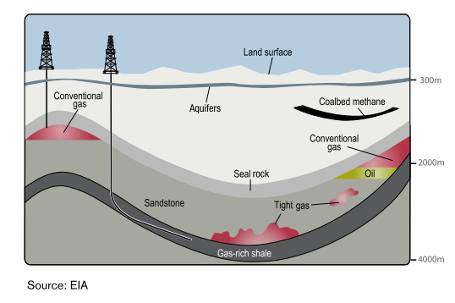
Figure A1: Conceptual diagram illustrating the differences between gas sources. (Source: CAPP, 2012.)

A1.3 Literature review research objectives
The literature review set out to answer the following questions:
- Is there an off-shelf, proven and widely accepted complete risk assessment methodology that can be adopted largely as is or with minor customisations to meet the purpose of QQRA?
- What are the key features and components of a risk assessment methodology used to identify and assess the potential risks to water resources within an ‘area/zone’ based on hypothetical onshore natural development scenarios?
- Are the features and components of a risk assessment methodology used to assess an application from a Proponent for approval to undertake development applicable/transferable to assessing potential risks of hypothetical development at a broader scale?
- What specific considerations and criteria have been used to identify, assess and rate potential risks for a hypothetical versus proposed development play?
- Are there any specific consequence and likelihood considerations or criteria unique to a specific type of gas (shale, tight, coal seam or conventional)?
The literature review has not examined nor reported on the potential or actual impacts of onshore natural gas development on water resources. The QQRA will not assess cumulative impacts; it will assess the impact of an individual development in different locations within an area of interest. The QQRA could eventually be amended to include cumulative impacts.

A1.4 Scope of risk assessment framework
The literature review separates findings regarding what risk assessment techniques and approaches have been used to inform Government policy decisions as distinct from an assessment of an onshore natural gas licence (work program) or work plan application. Overall the literature review found regulators in many jurisdictions are seeking to enhance their understanding of risks and define conditions or areas where onshore gas developments may or may not be assessed d.
The literature review considered frameworks and guidance available for each stage of a risk assessment process including:
• Sensitive receptors – the review considers how vulnerable regional water-related assets in the area of the development might be identified and what tools may be used.
• Hazards – the review focuses on how risk frameworks have framed and approached the issue of assessing potential impacts from unconventional gas development on sensitive receptors.
• Pathways – the review considers how complex cause-effect relationships has been conceptualised and what if any differences are evident in approaches to assessments for different onshore gas types (tight, shale, coal seam gas).
• Thresholds – the review is concerned to evaluate what criteria have been developed to provide guidance on assessing/rating the buffering capacity and resilience of groundwater resources and water-dependent assets.
• Standard Controls – the review focuses on what measures are commonly used to avoid or minimise risk.
• Consequence – the review summarises how risk assessments have approached estimating the level of impact on a water resource.
• Likelihood – the review examines how probability of impact has been assessed.
• Risk Rating – what approaches are used to assess ‘retained risk’ after standard controls have been applied and what criteria exist to determine the implication the retained risk.

A1.5 Approach to the literature review
The methodology used to complete the Literature Review involved identifying literature on the basis of:
• Resource focus: to the extent possible, preference was given to risk assessment techniques specifically addressing onshore natural gas developments (coal seam gas, tight, shale and conventional). Offshore oil and gas and offshore extractive and mining activities which impact on groundwater were also assessed for completeness.
• Jurisdictions: the literature review assessed risk assessment techniques developed in a number of jurisdictions, including England, Germany, United States, Canada and Australia.
• Provenance/authorship: the literature review assessed (in order of standing):
– peer-reviewed literature published in academic journals
– government policies or guidelines for conducting risk assessments (either mandated by law or recommended)
– literature including reports and papers produced by scientific agencies, Government agencies or peak industry bodies and
– publicly available risk assessment techniques used by private-sector proponents.

A1.6 Structure
The structure of the literature review is as follows:
Chapter 1 – Introduction – background, purpose, key research questions, methodology and references
Chapter 2 – Key Findings – organised by risk assessment phases of identify hazards, identify sensitive receptors, identify and assess pathway between hazard and sensitive receptors, set a threshold for acceptable impact on sensitive receptor(s), apply standard controls to ensure impact is within acceptable limits, assess the potential consequence and likelihood of risk occurring with standard controls in place and rate the retained risk. For each phase of the risk assessment, literature relevant to “policy specific” and “project specific” risk assessments has been analysed.
Section 3 – Key Implications for QQRA design, development and application – answers each of the key research questions by drawing on the key findings and outlines the key QQRA design and development implications
Appendices:
AA – Matters out of scope from the risk assessment & literature review
AB – List of references & sources consulted for the literature review
AC – Features of onshore gas resources
AD – Modelling pathways
AE – Methodologies used to assess groundwater vulnerability
AF – Controls
AG – Consequence.

A1.7 Summary of references
The full list of 115 sources consulted is provided in Appendix A. Of these sources, 19 were deemed to provide direct and relevant material to the key literature review research questions.

Appendix A2 Key findings
Key findings have been discussed in terms of risks assessments to inform either government policy or a project scale risk assessment. The key findings for each of the following phases of risk assessment are discussed in the following sections:
• risk and uncertainty
• hazards
• sensitive receptors
• pathways
• thresholds
• standard controls
• consequence
• likelihood
• risk rating.

A2.1 Risk and uncertainty
A consistent finding arising from the literature review is that understanding of hydrogeological pathways is still evolving and groundwater models need to be refined as more monitoring data becomes available. Most of the literature reviewed, such as Moran and Vink (2010), emphasises that ongoing monitoring of water levels and other characteristics should be compared with modelled predictions to progressively refine models and present the best available representation of risk. The Independent Expert Scientific Committee (2014) proposes several quantitative approaches to assess uncertainty in risk determination for coal seam gas development, including:
• Bayesian methods for calculating model structural uncertainties.
• Stochastic modelling; which may be used to addresses likely inaccuracies in relation to uncertainties around estimated water flow rates and solute transport. It generates multiple hydrogeological scenarios which are run concurrently in a Monte Carlo framework. Statistical analysis is conducted on each result (Cook, 2003).
• Random domain decomposition. For example, Guadagnini et al (2003) focused on analysing two dimensional flow in a system where hydraulic properties and spatial distribution are known statistically but are otherwise uncertain.
• The transition probability approach which considers relative frequency of transitions from one state to another in a system consisting of multiple states (Elfeki et al, 1997:67).
• Decision theory to assist with risk management.
The simplifying assumptions underlying groundwater models are highlighted by the IESC (2014) and should be considered in both project and strategic level risk assessments. It provides a valuable summary of use of MODFLOW and FEFLOW groundwater models for project risk assessments in the United States and Australia. It shows there are limitations in how sources and pathways are conceptualised, even if most projects do seek to consider how uncertainty is assessed in each risk assessment. The report provides an evaluation of strengths and drawbacks of different types of modelling techniques (analytical, regional groundwater impact assessment, axisymmetric and reservoir assessments) in capturing potential impacts and groundwater processes. Full details are provided in Appendix D.
The temporal component to risk analysis is a key uncertainty factor. Potential changes to groundwater quality/quantity may take years to decades to develop depending on a variety of factors, including the proximity of an aquifer to a coal seam reservoir. Impacts may also persist for prolonged periods after potentially hazardous operations have ceased.
It is commonly agreed that the limitations and assumptions underpinning risk assessments should be subject to sensitivity analysis. For example, the Queensland Department Natural Resources & Mines Healthy Headwaters coal seam gas study (Worley Parsons, 2013) recommended that a sensitivity analysis be undertaken on the ranking and weighting criteria adopted by the panel of experts. In relation to coal seam gas water production, uncertainty could also be presented visually by means of an attribute layer to show the limits of current understanding around pathways, for instance in terms of interactions between Condamine Alluvium and the Walloon Coal Measures in the Surat and southern Bowen Basins, Queensland.

A2.2 Hazards
A hazard is a source of potential harm or a situation with a potential to cause loss (negative consequence). Hazard identification is first stage of any risk assessment process and should be used to inform preliminary investigations of potential impacts from onshore natural gas.

Risk assessment to inform government policy
The literature review did not identify any particular techniques for hazard identification at a policy level different to those techniques used to identify hazards for project risk assessments, which are outlined in section 0 below.

Risk assessment to inform project scale developments
In their paper prepared as part of the independent review of coal seam gas activities in NSW, Anderson et al (2013) group hazards on the basis of their contamination potential or contribution to depleting water resource aquifers and surface waters. Contamination issues are further disaggregated into operational hazards (e.g. extraction) and those associated with changes in hydrogeological environments. Potential consequences of depletion are impacts on Groundwater Dependent Ecosystems (GDEs) from movement of groundwater towards the depressurised coal seam gas formation. Seepage may also occur from surface water assets to depleted watertable aquifers.
Specific coal seam gas activities that may present hazards are provided in the methodology for conducting Bioregional Assessments by Barrett et al (2013) including depressurisation and dewatering of coal seams; potential regulated and unregulated discharge of stored worked water on mine sites; and fate of coal seam gas permeate and brine derived from treatments of associated water. The size and extent of a zone of depressurisation is influenced by a variety of factors including the size of the seam, its storage capacity, the pumping rate, initial pressure, recharge rates, geology and the flow of water through the seam.
Most sources consulted list potential hazards based on the activity source (specific actions taken in the course of onshore gas development). Wilson et al (2014) identify discharges to surface water, evaporation ponds, groundwater dewatering and extraction, hydraulic fracturing, in-situ gasification, managed aquifer recharge, overburden management, surface water diversion and capture and well drilling as potential hazards.
Identifying the potential direct and indirect effects on characteristics of groundwater resources is alternative approach used by IESC (2013) which provides a greater level of detail on the range of possible hazard scenarios; for example:
• Direct impacts are changes to physical/chemical characteristics of groundwater/surface water as a result of dewatering processes, and include loss of pressure in an aquifer, changes in groundwater chemistry from change in hydraulic relationship and changes in aquifer hydraulic properties such as porosity due to pressure reduction
• Indirect impacts to receptors occur through a pathway of cause and effect, such as the direct impact loss of pressure head in an aquifer has on dewatering on a gaining or losing stream; drying of agricultural wells or natural springs and the salinisation of freshwater aquifers from depressurisation of coal seams.
Arrow Energy (Coffey Environments, 2012) used the same framework of direct/indirect impacts as IESC to assess the potential impacts of the depressurisation of Walloon Coal Measures. However they conceptualise it somewhat differently. Impacts of depressurisation of aquifers to Walloon Coal Measures through the removal of gas and water is classified as a direct impacts whereas indirect impacts are potential consequences on aquifers above and below the measures. Groundwater drawdown resulting in a reduction in the supply to existing or future users and groundwater dependent ecosystems reliant on the Walloon Coal Measures is thus a direct impact. In contrast, groundwater flux and drawdown in adjacent aquifers causing water quality and supply impacts to existing and future users and groundwater dependent ecosystems, changes in inter-aquifer flows or subsidence are indirect impacts.
Hazards from other unconventional gas resources may vary as certain key characteristics (depth, permeability, groundwater take and need for hydraulic fracturing) are different for shale, tight and coal seam gas. A summary of these is provided in Appendix C. For instance, local hydrogeological characteristics between and within shale reserves will influence the volumes of water withdrawals required.
A conceptual approach to hazard identification is provided by NOPSEMA (2012) which gives an overview of the benefits and drawbacks of different hazard identification techniques; including HAZOP, historical records, Failure Modes, Effects and Criticality Analysis (FMECA) and Failure Modes and Effects Analysis (FMEA) as well as Fault Tree and Event Tree Analysis in the context of assessing risks from offshore oil and gas exploration and development.
These hazard identification techniques are applied to determine what could result in equipment or procedure failure (e.g. well drilling, well casing etc.) and therefore resulting in uncontrolled releases of dangerous additives.

A2.3 Sensitive receptors
Sensitive receptors are entities (members of the public, environmental values, water resources, third party infrastructure etc.) that could potentially be exposed to adverse impacts resulting from a hazard. This Literature Review is solely focused on water resources (aquifers, rivers, springs, wetlands and lakes).

Risk assessments to inform government policy
The Literature Review found no clear differences between the types of water resource assets included in a risk assessment used to inform policy decisions and a risk assessment used to assess and determine a licence/work plan application. Techniques to identify sensitive receptors are relevant to both types of assessment.

Risk assessment to inform project-scale developments
The literature review found two ways by which water resources are commonly identified: the sensitivity of the resource to potential impacts and the value of the water asset.
Most jurisdictions approach classification of water assets by considering both sensitivity and value. For instance NSW’s Aquifer Interference Policy has numeric quality and quantity criteria which must be achieved to be a highly-productive resources. This binary categorisation is further disaggregated according to source characteristics (alluvial, fractured rock etc.) which provides a measure of sensitivity. Victoria’s State Environmental Protection Policy (SEPP) for both Groundwater and Surface Waters similarly establishes minimum water quality thresholds for different Beneficial Uses, thereby incorporating a measure of value
and sensitivity. The New York Department of Environment SGEIS evidences that it considers aquifer vulnerability on a combination of value and sensitivity-based criteria, although less detail is provided around specific values.

However, risk assessments for specific projects will usually go a step further and consider secondary impacts arising as a consequence of changes in quantity/quality of water (first-order impacts) e.g. to ecosystems, local communities and cultural values, existing or potential land uses and their economic implications including agriculture, tourism and recreation. The extent of investigation is likely to be at least partly determined by any relevant impact assessment pathway or applicable environmental regulations.
At a policy and project level, identification of sensitive receptors in relation to potential risks associated with onshore gas developments should consider the physical characteristics that determine sensitivity and value of the resource in terms of both the cultural and the ecological services they provide.
Queensland Department of Resources and Mines Healthy Headwaters study (2012) states that aquifers can be both receptors and pathways for potential impacts. The Guidelines for Groundwater Protection in Australia (1995) list potential attributes and techniques to underpin a classification of aquifer vulnerability as a receptor. Aquifer value is measured qualitatively based on its:
• designated beneficial use
• water quality (usually in terms of Total Dissolved Solids)
• social value
• economic value
• ecosystem values
• vulnerability to contamination
• current and planned land tenure and use
• availability of alternative sources
• current extent of contamination
• potential for successful clean-up
• hydraulic relationship with other resources (surface and groundwater).
NYSDEC consider the inherent susceptibility of the aquifers on the basis of:
• groundwater productivity
• aquifer vulnerability
• natural water quality
• whether the aquifer is confined or unconfined
• whether the aquifer is contained in bedrock or unconsolidated material.
This draws on pre-existing NYSDEC (1990) criteria that distinguished ‘principal aquifers’ from primary water supply aquifers’ based on aquifer area, thickness of saturated deposits and maximum obtainable well yields (actual or estimated).
The New South Wales Aquifer Interference Policy (2012) appears to place greater emphasis on value to distinguish between “highly productive” and “less productive” groundwater resources. This is on the basis of specific water quality and quantity standards — highly productive resources have less than 1500 mg/L total dissolved solids (TDS) content and yield water at a rate in excess of 5 L/s. Water quality, pressure and watertable criteria for highly productive groundwater resources are then tailored to different aquifer types (e.g. alluvial, porous, and fractured).
Guidance issued by NSW Office of Water (2014) for prospective mining and petroleum extraction activities, may also be relevant to identifying receptors to groundwater impacts from onshore natural gas developments. They outline that ‘proponents must identify sensitive receptors, which can include groundwater users, groundwater dependent ecosystems (GDEs), culturally significant sites (CSS), connected groundwater and surface water sources’. These can be defined as the ecological, economic or cultural characteristics of the bioregion. They can be assigned a defined value, and used (either directly or indirectly) to assess impact on water quantity or quality.
The Bureau of Meteorology’s Atlas of Groundwater Dependent Ecosystems identifies potential subsurface and surface expression of groundwater, and can help inform identification of sensitive receptors. The available information can be used as a starting point to study cause and affect pathways.
The New South Wales Office of Water (2012a) also classifies groundwater dependent ecosystems according to whether they are considered:
• sub-surface dependent (karst and caves, subsurface phreatic aquifer ecosystems, baseflow streams) or
• surface-dependent (groundwater dependent wetlands; baseflow streams; estuarine and near shore marine ecosystems and phreatophytes or groundwater dependent terrestrial ecosystems).
The NSW Office of Water collaborated with the NSW Division of Resources and Energy to develop the NSW Gas Plan. The Gas Plan was released in November 2014 and is framework to identify, study and protect groundwater in NSW, which will initially focus on basins that present the greatest potential for development to large-scale coal mining and onshore gas industry (NSW Government, 2014).
Spatial and temporal information is required about a receptor to determine potential impacts from natural onshore gas developments (DOE, 2013). Santos commissioned several studies in the Surat and Bowen basins in Queensland illustrating how impacts can vary both spatially and temporally (Golder Associates, 2009; Arrow Energy, 2012). Their findings predicted impacts on groundwater drawdown could extend for decades, even hundreds of years after operations cease. Arrow Energy (2012) considers the magnitude of potential impacts in terms of severity, duration and geographical extent, highlighting that impacts vary on the basis of distance from zone of depressurisation and the individual groundwater system.
In assessing groundwater dependent ecosystems, the Queensland Department of Resources and Mines Healthy Headwaters study (2012) determined flow-path lengths was a key factor in explaining why recharge springs have greater resilience to potential coal seam gas water extraction impacts than discharge springs.
The IRGC (2013) advises that baseline assessments or preliminary studies are required to identify receptors, and determine what an acceptable level of impact is. It considers that preliminary studies should focus on:
• groundwater quality and quantity
• existing pollution levels and sources
• flow and contaminant transport and biogeochemical interactions.
Combined these will determine the vulnerability of groundwater to contamination from onshore gas development activities.
The US state of Connecticut has a four-tier groundwater classification system. The system uses water usage arrangements rather than discharge criteria to determine the value and sensitivity of an aquifer resource. The system details the designated usage, relevant discharges that may be permitted and water quality criteria that must be achieved. These are set out in Table AE3.

A2.4 Pathways
A risk assessment should identify causal pathways through which a harmful event could lead to an adverse outcome (impact) for a receptor.
The IESC (2013) bioregional assessment methodology highlights the role of pathways in linking cause and effect, by distinguishing between activities that give rise to direct effects as opposed to indirect and cumulative impacts.

Risk assessment to inform government policy
No significant differences were identified between types of data required for pathway characterisation at a project and policy level. Data requirements for informing identification of pathways for policy and project risk assessments may be partially met by the Bioregional Assessments which are currently underway in Queensland, New South Wales and Victoria.
Internationally, the province of Alberta (Canada) targets its regulatory framework to assess the specific risks of a proposed development. The Energy Resources Conservation Board conducts an initial strategic risk assessment of a proposed development on the basis of the known or estimated oil or gas accumulation and geographic, geologic and temporal properties that exist at the development site (e.g. source rock, migration pathways, timing, trapping mechanism and hydrocarbon type). The strategic risk assessment is used to profile the proposed development as being potentially low, medium or high risk and therefore what assessment standard should be met by the proponent in preparing their licence application (ERCB, nd).
In Germany, on the basis of modelling of fluid flow dynamics and pathways in key basins, Ewen et al (2012) recommend that a statutory land-use framework be established, informing areas where fracking will and will not be permitted. A panel of experts used a strategic environmental risk assessment to recommend the following areas where fracking or deep-injection disposal would not be permitted. For example:
• Zone I and II drinking water protection areas
• thermal spring conservation areas
• areas exhibiting pressurised artesian/confined deep groundwater as well as continuous transparent pathways (marked by porous faults or having a history of disturbance)
• areas characterised by critical underground tectonic stress/upheavals.
The methodology used to undertake the strategic environmental risk assessment has not been made publicly available.
The New York State Department of Environmental Conservation (NYSDEC, 2011) use the source-pathway-receptor model in their assessment of potential impacts to drinking water from higher risk/high-volume hydraulic fracturing in the large and sensitive Marcellus Shale. The NYSDEC Draft Supplemental Generic Environmental Impact Statement or SGEIS (2009) reports that hydraulic fracturing does not present a ‘reasonably foreseeable’ risk of significant adverse impacts to potential freshwater aquifers from migration of fracturing fluids out of the target fracture formation, where the following conditions exist:
• maximum depth to the bottom of a potential aquifer ≤ 305 m
• minimum depth of the target fracture zone ≥ 610 m
• average hydraulic conductivity of intervening strata ≤ 1 x 10^{–5} cm/sec
• average porosity of intervening strata ≥ 10%.
The United States Environment Protection Authority identifies that man-made sub-surface disturbances (drinking water wells, exploratory wells, production wells, abandoned wells (plugged and unplugged), injection wells, and underground mines) may also act as conduits for contaminants. For shale gas the distance to drinking water reserves and the geochemical and transport processes occurring in intermediary strata are key determinants of level of risk of fluid leak off to those assets.
The Namoi Catchment study (Eco Logical Australia, 2012) considers that all types of resource extraction (coal seam gas, open cut and long-wall mining) are likely to have some level of impact on groundwater drawdown. The study established qualitative criteria for each asset such as depth to groundwater, connectivity, status, major recharge area, groundwater dependent ecosystem potential. The criteria were used to assign a score on a scale of 0–3. These were then combined and averaged to give final sensitivity values, from very high (> 1.5), high, moderate, low and very low (< 0.50).
The study found sensitive areas tend to be characterised by shallow watertable, areas that were isolated from surface flow (thereby increasing the importance of groundwater) and groundwater recharge areas.
The Queensland Department of Environment & Heritage Protection (nd) suggest the likelihood of impacts (i.e. pathways) arising on groundwater assets will be influenced by:
• the level of development
• the drawdown in the source aquifer of individual springs
• the degree of aquifer connectivity
• the potentiometric surface at individual springs.
Queensland Department of Natural Resources and Mines (2013) state aquifers are pathways for impacts. The study in the Surat and Bowen Basins in Queensland examined how hydrogeological properties (e.g. storativity, and transmissivity) influences the aquifer’s intrinsic vulnerability. Worley Parsons (2013) identify that flow of water in a groundwater system (aquifers and aquitards) is determined by two processes: hydraulic conductivity and hydraulic diffusivity. Hydraulic diffusivity determines the rate the pressure effects travels through the overlying aquifers, and laterally along the aquifer/coal seam.
Frogtech (2009) identify two groups of specific pathway assessment factors:
• Inter-aquifer connectivity — faults, fractures, and over- and under-lying gas shales (sources). Moran and Vink (2010) emphasise these must be accounted for in the models, or at least signalled as areas of concern.
• Risk assessments should consider the hydrogeological conditions of permeability, porosity and groundwater quality and flow direction. DOE (2013) also identify that aquifer pressure and pressure relationships between aquifers; watertable and potentiometric surface levels; groundwater-surface interactions may warrant consideration.

Risk assessment to inform project scale developments
The Australian Office of Water (2014) outlines two types of monitoring to be undertaken by proponents in relation to understanding potential pathways and water-related risks from other onshore extractive industries (petroleum and mining). They are:
Aquifer testing to understand hydraulic features and interaction with other aquifers and surface assets. This can minimise the need to ‘calibrate’ models and improves reliability of results and may include: pumping drawdown and recovery tests, slug tests, packer tests and laboratory core testing. Testing over longer periods through pump tests can help to elicit pathways to overlying surface water and alluvial systems, in parallel with a study of surface water chemistry.
Hydrogeochemical analysis (e.g. environmental isotopes) can be sampled to improve understanding of aquifer recharge and discharge processes, aquifer interconnectivity, groundwater-surface water interaction and groundwater dependent ecosystems, as well as specific consideration given to groundwater dependent ecosystem monitoring

Proponents are directed to estimate the likely water take from an aquifer or connected water surface over the duration of the project. The following guidance is also taken from the Office of Water and provides an indication of what conceptual models should consider:
• the location, timing, volume and method of take and use of water (and the prospective future take and use of water) by the proponent and other users of water sharing the resource
• the potential to base the conceptualisation on existing geological models presumably developed for the resource investigation phase
• detailed cross sections or three-dimensional block diagrams showing stratigraphy, major aquifers, aquitards, flow paths and groundwater levels
• groundwater level contour maps
• time-series groundwater level and stream gauge data
• groundwater and surface water quality data
• aquifer characteristics including porosity, hydraulic conductivity, storativity and transmissivity
• groundwater age, residence time, recharge and discharge processes
• topographic and geomorphic information including stream locations and bed elevations.
Approaches to assess source -pathways - receptor vary considerably according to Daly and Warren (1998). Daly and Warren note there is considerable variability in models in terms of the number of vulnerability categories that are identified and the scale of spatial representation that is used (from less than 1:10 000 to in excess of 1:500 000).
Studies may seek to model pathways for a range of hazards or concentrate on individual potential impacts, such as contamination. Myers (2012) conceptualise potential natural pathways and necessary conditions for water contamination from shale gas developments and proposes several potential transport scenarios based on hydrogeological conditions in the Marcellus shale. He tests potential impacts (transport times under different conditions and the time taken for the system to revert to steady-state) by varying scenarios according to whether there are individual or multiple gas developments, and whether or not there is in-situ fractures and potential connectivity. He notes limited data availability constrains the application of certain modelling tools, concluding that mapping of subsurface faults and establishing deep and shallow monitoring wells are two key requirements prior to significant resource development occurring (further details about the study are provided in Appendix AD).
The benefits and limitations of a number of commonly used groundwater solute transport models to understand potential pathways is provided Worley Parsons for the Queensland Department of Natural Resources & Mines (2013) in the context of coal seam gas in the Surat and Southern Bowen Basins. A fuller assessment of the components they consider and approaches used to classify risk to water resources are outlined in 0. Two drawbacks that are identified about groundwater solute transport models are:
• They all focus on risk of contamination to water sources where an impact is occurring at the surface and may travel horizontally or vertically through the system, whereas in coal seam gas production hazards can arise at considerable depths below the surface, and spread outwards from the source with the potential to eventually manifest themselves as impacts to groundwater resources.
Most are static (or point-in time) and typically do not fully factor in groundwater process or geological/hydrological pathways.
The alternative hybrid technique put forward in the study (the ‘Groundwater model and multi criteria analysis methodology) was established by consensus between a technical reference group of experts. It combines overlay methods used in multi-criteria analysis (similar to the methodologies above) with process-based (quantitative) information drawn directly from groundwater modelling conducted by Queensland Water Commission. Source, pathway and receptor attributes are selected for the specific basin study area in terms of risks to groundwater systems, and then overlaid by different vulnerability and consequence measures. These are ranked according to asset properties and weighed to inform the relative importance to overall calculation.

A2.5 Thresholds
To understand the significance of a predicted or observed impact, thresholds are required to be defined. For this section specific quantifiable criteria and the rationale for their use were sought wherever possible. The measures used to set level of unacceptable impact tend to be changes in water quantity/quality or deviation from an accepted norm (taking into account natural factors such as seasonal variability). There does not appear to be a difference in the thresholds used for project and policy risk assessments.
A common recommendation across government reports and within the academic literature is that more rigorous catchment-level risk assessment frameworks are required to inform future onshore gas development, and that key to this is the sharing of information between proponents and regulators.
In Queensland’s Department of Environment and Heritage Protection, the Department administers quantitative thresholds for protection of water assets under the Water Act 2000. Specific quantitative thresholds are set for coal seam gas project-related water declines in bores and reduced aquifer levels feeding natural springs. They are:
• If the projected decline from a bore exceeds the minimum threshold of a 5m reduction in water level for consolidated aquifers (e.g. sandstone) or a 2m reduction in water level for unconsolidated aquifers (i.e. shallow alluvial aquifers), then further investigation is required. If coal seam gas activities are determined to be responsible, then the Proponent is responsible for ‘making good’ the impact.
For springs, a spring impact management strategy is required to determine potentially affected springs, investigate risks and develop a management strategy to address these if the water level in the aquifer is expected to decline by more than the spring trigger threshold of 0.2 metres in the source aquifer (unless otherwise defined) at the location of the spring (EHP, n.d.).
The New South Wales Aquifer Interference Policy (2012) establishes quantitative thresholds for watertable and groundwater pressure, drawdown and groundwater and surface water quality changes in relation to highly productive and less productive groundwater sources. The thresholds have due regard to the geology of the water source (e.g. alluvial, coastal sands, porous rock, fractured rock). Refer to Appendix AF for tables listing these.
The Australian Council of Learned Academies Shale Gas report (2012) suggests thresholds for cumulative impacts at a catchment scale could be the use of groundwater extraction for shale gas as a proportion of total groundwater extraction and the proportion of shale gas water that contributes to surface water flow to nationally important wetlands.
The National Water Quality Management Strategy has published Guidelines for Drinking Water and Fresh and Marine Water Quality in Australia. These guidelines may be used for both project and policy risk assessments. The guidelines define several beneficial use or environmental values categories: aquatic ecosystems, drinking water; cultural and spiritual values; primary industries (including agriculture and general water uses, stock drinking water, aquaculture); recreation and aesthetics and industrial water. All of these, except industry and cultural/spiritual values have water quality guidelines based on numerical concentration limit or a narrative statement recommended to ensure the designated use is protected.
In Victoria groundwater protection legislation defines groundwater categories according to beneficial use and water quality criteria (SEPP, 1997). The concentration of Total Dissolved Solids (an indicator of salinity measured in mg/L) is used. Further information on beneficial uses and values is provided in Appendix F.
Exceedance of environmental values set out in the Water Quality Guidelines (2000) indicate potential for impact can be categorised as ‘slightly to moderately disturbed’; ‘highly disturbed ecosystems’ and ‘high conservation/ecological value ecosystems’. Water Quality Guidelines (2000) also recommend biological indicators should be used to complement the use of chemical indicators.
Guidance is available to help determine:
• acceptable level of change against relative condition categories of the ecosystem
applicability of different biotic taxa as indicators of aquatic ecosystem health (e.g. physical and chemical stress such as nutrients, dissolved oxygen, salinity, temperature, pH, optical properties and environmental flows).
Default trigger values are provided if locally-derived thresholds cannot be determined. The Commonwealth Department of Environment (2013) states that where no local/regional quality objectives exist, thresholds should be set in accordance with guidelines under National Water Quality Management Strategy and in consultation with the local water authority.
The Guidelines provide information on good-practice for conducting toxicology studies. Guidance is provided about factors affecting individual element toxicity and the level of confidence that can be derived depending on data used.
Setting triggers for further assessment is one of the recommendations in relation to risk from chemical constituents of fracking fluids by Ewen et al (2012). Under the proposed system, a substance can be identified as hazardous by one of three forms of assessment:
Classification by the European Union’s Regulation on Classification, Labelling and Packaging of Substances and Mixtures
Failure to meet Germany’s drinking water regulation requirements (limit of 0.1 µg/l of organic biocides)
Determine the hazard quotient which represents the ratio of potential exposure to the substance and the level at which no negative consequences are anticipated. If the hazard quotient value is greater than 1, adverse health effects are possible.

A2.6 Standard controls
Risk controls are the part of risk management that involves the provision of policies, standards and procedures that describe measures, techniques and practices to eliminate, avoid or minimise adverse risks. A standard control is a standard accepted onshore natural gas industry practice for addressing a potential impact on a sensitive receptor. Industry recognised and endorsed procedures, guidelines and methodologies may exist for a standard control.
The literature review found no distinct difference between the types of standard controls applied in a risk assessment to inform government policy and a risk assessment used to assess licence/work plan application.
There are many different types of standard controls that are adopted. The literature reviewed shows many jurisdictions are seeking to regulate aspects of onshore natural gas development activities through existing permitting regimes, and setting triggers under which proponents must conduct further monitoring and management (CRS, 2014).
For the purpose of this discussion standard controls have been broadly categorised as operational controls, land use planning controls, and monitoring controls and are discussed below.

Operational controls
Several sources consulted provide an overview of the legislative measures to minimise risk associated with onshore natural gas developments in the United States, Europe and Australia. For example Anderson et al (2013) classify the options available to minimise or offset impacts from onshore natural gas into strategic land use planning, codes of practice, managed aquifer recharge, ‘make-good’ arrangements, security bonds, improved technologies and research methods, groundwater remediation.
Well integrity, wastewater management and regulating chemical compounds used in hydraulic fracturing are the onshore natural gas hazards commonly targeted by mandatory regulation or best practice guidance for proposed projects that could impact on water resources across the UK, US and Australia.
In the United Kingdom, the Environment Agency (2011) requires any activity that proposes discharges to groundwater to produce management options such as enhancing the engineering measures or tightening operational and aftercare controls. The UK Onshore Operators Group (UKOOG) has produced Shale Gas Well Guidelines which sets out what proponents must comply with under various regulations and permitting systems. This includes legislation relating to well construction and design (to be informed by assessment of geological conditions), well control equipment, availability of competent personnel and the proponent making provision for independent well examinations.
In the United States, Worldwatch (2010) finds many state regulators often require compliance against standards set by the American Petroleum Institute (API, 2009) or other organizations which develop and update standards on recommended practice for oil and gas exploration and production activities. These include the API’s Hydraulic Fracturing Operations — Well Construction and Integrity Guidelines (HF1), Water Management Associated with Hydraulic Fracturing (HF2), and Practices for Mitigating Surface Impacts Associated with Hydraulic Fracturing (HF3).
The Commonwealth Government’s National Harmonised Framework for Coal Seam Gas (2012) has produced a list of 18 leading practices which can help to reduce risks associated with well integrity, hydraulic fracturing, chemical use and water management in coal seam gas operations. Further detail on these is provided in Appendix F.
The Queensland Department of Environment & Heritage Protection requires applicants to develop management criteria to ensure quantity and quality of co-produced water at critical control points: injection to aquifers, storage of produced water, transmission through pipelines, treatment of coal seam gas water and water quality acceptance criteria, beneficial use and management of produced waste. Queensland also has a Code of Practice for Constructing and Abandoning Coal Seam Gas Wells (DEEDI, 2011).
New South Wales Trade & Investment (2012) references good industry practice and relevant standards and specifications to be complied with, in respect of human and technological-based controls. Well integrity is the focus of one of two New South Wales Division of Resources and Energy Codes of Practice for coal seam gas, along with guidance to proponents on hydraulic fracturing. Coal seam gas titleholders are required to comply with both NSW Codes to assure coal seam gas activities are compliant with the Petroleum (Onshore) Act 1991.
AEA provide suggested or existing technology-based controls in United States jurisdictions relating to permanent well abandonment (minimum depth of cement for plugging), storage of waste-water and extent of production casing. The rationale used to determine these specific values is not provided.

DNV (2013) provides guidance to proponents around preventative risk management practices for shale gas development and operations. For instance, in order to avoid possible groundwater contamination from induced fractures, the operator should estimate:
• the minimum required vertical separation between the deepest groundwater formation boundary and the shallowest edge of induced fracture
• the minimum required distance between the wellbore above the prospective shale gas formation and the nearest edge of an induced fracture
• the minimum required distance between the outermost edge of an induced fracture and any nearby wellbore
• the minimum required distance between any identified pre-existing faults or fractures to the nearest edge of an induced fracture.
Risk management is often conceived as a hierarchy, with emphasis on minimising opportunity for hazards to arise (e.g. through timing or spacing of certain activities), providing mitigation appropriate to the hazard profile, and offsetting any remaining impacts. A common tool to minimise manageable risks is through operation-based regulations or referring proponents to best-practice codes or guidelines. These are to be regularly reviewed on the basis of the “As Low as Reasonably Practical” principle. Offshore oil and gas regulations are consistent with this regulatory approach.

Land use planning controls
The National Conference of State Legislatures (2012) provides a broad overview of state-based legislative measures to minimise risk of impact to water quality across the United State. These include setbacks or location restrictions to create buffers between drilling and public drinking water resources. Specific distances and criteria are not specified.
The New York Department of Environment and Conservation has banned unconventional gas development in the New York City and Syracuse watersheds (with suitable buffer areas), public water supplies, primary aquifers and certain state lands. Further controls (e.g. restrictions and setbacks) are recommended to restrict development in areas close to public water supplies, principal aquifers and other sensitive assets. Details are provided in Table AE1.
New South Wales similarly defined coal seam gas exclusion zones as part of their Strategic Regional Land Use Policy late last year focused on existing residential areas, which were updated earlier this year in relation to future growth areas and key industry clusters. In New South Wales coal seam gas development proposals on strategic agricultural land need to be assessed by a gateway panel before they are lodged. Gateway assessments are conducted by an independent panel of scientific experts and provide an additional level of scrutiny of a proposal’s land and water impacts, including consideration of potential effects of the proposal on aquifers against the Aquifer Interference Policy.
Examples of specific buffer zone distances from private wells, surface watercourse, and drinking water supplies that are proposed or recommended by authorities and natural resource management agencies in the United States are summarised by a report prepared for the for the European Commission by AEA (2012). Also collated by the AEA is the minimum depth or minimum separation between strata required for hydraulic fracturing to take place. These measures are recommended or mandated across different States, however the rationale used to determine these specific values was not provided.

Monitoring controls
The Queensland Water and Other Legislation Amendment Bill 2011 makes a range of changes to the Water Act 2000. In addition to an obligation on coal seam gas companies to enter into formal arrangement with landholders to ‘make good’ any impairment on landholder’s bores prior to these impacts actually occurring, it also mandates the “production of underground water impact” reports at no more than three yearly intervals. This is firmly based on adaptive management, as proponents are required to review monitoring results, produce predicted water level impacts using progressively updated groundwater flow models, write up a spring impact management strategy, and provide an updated water monitoring strategy.
Well integrity inspections are another feature of the United Kingdom regulatory framework designed to minimise risks and ensure construction is in accordance with standards (HSE, nd).

A2.7 Consequence
The potential consequence (adverse impact) of the risk identified occurring with standard controls in place should be assessed. Consequence (adverse) can typically range from critical through to negligible. The criteria used to determine potential impact can often be subjective and contentious.

Risk assessment to inform government policy
The Commonwealth of Australian Government’s National Partnership Agreement defines qualitatively what significant direct and indirect impacts on water assets and water-dependent would be. Some of these – ecological impacts, coastal and inland processes, heavy metal accumulation and water availability – are outside the scope of the risk assessment framework. The pertinent impacts are provided below and the full list is available in 0:
• result in substantial change in the quantity, quality or flow regimes of surface water or groundwater
• substantially alter groundwater pressure and/or watertable levels
The literature review did not identify any unique consequence -rating criteria applied to determine consequences used to specifically inform a government policy decision. The IESC (2014) provides consequence tables which vary in complexity depending on whether consequence (and likelihoods) can be defined in quantitative or qualitative terms.

Risk assessment to inform project scale development
The significance of the impact on a receptor depends on the sensitivity to the impact as well as the value of the receptor.
The Department of Environment (2013) provides general guidance to proponents on what level of impact may be deemed significant in terms of the hydrological characteristics of water resources. These are:
• changes in water quantity.
• modified integrity of hydrological or hydrogeological connections (including substantial structural damage e.g. large scale subsidence)
• altered area or extent of a water resource at a sufficient scale/intensity to significantly reduce current or future use for third party users.
In New South Wales, most waterways are protected on the basis of being ‘slightly to moderately disturbed ecosystems’ and thus a significant impact is likely if the expected change in water quality exceeds this level, as contained in relevant local or regional water quality objectives. These objectives are typically the 80% to 95% ecosystem protection values listed in the Australian Water Quality Guidelines (ARMCANZ and ANZECC 2000). Waterways which flow through relatively undisturbed national parks, World Heritage Areas or Ramsar-listed Wetlands(Matters of National Environmental Significance) benefit from more stringent thresholds and are deemed of ‘high conservation value’.
The Aquifer Interference Policy sets out the minimum levels (level 1) of groundwater protection a proposed development must achieve for specific groundwater sources. The level of protection will differ depending on whether the asset is a ‘highly productive’ or ‘less productive’ groundwater sources. Indicative minimum impact considerations for alluvial water sources are provided below (see Appendix AG for full details):
• variation from watertable levels within 40m of high priority groundwater dependent ecosystems or high priority culturally significant sites
• pressure head declines of not more than 40% of post-water sharing plan levels
• changes in groundwater quality should not reduce beneficial use beyond 40m of the activity
• not contribute to more than 1% increase in salinity in highly-connected surface water at closest point to the activity.
DMITRE (2013) provide guidance on criteria used to assess level of environmental impact from under Petroleum and Geothermal Energy Act 2000. The framework is based around the concepts of manageability and predictability of a given impact:
• The predictability criterion is a function of size, scope, duration, likelihood/frequency and stakeholder concerns associated with potential impacts.
• The manageability criterion is based on the assumption of the event occurring, and is a consideration of the extent to which consequences can be avoided or minimised in terms of size, scope and duration. It too considers likelihood/frequency of the event occurring and stakeholder concerns, but additionally requires consideration and estimation of the potential for cumulative impacts.
The level of confidence in each of these criteria, as rated on a scale of 1 to 5, are the two decisive determinants in the environmental significance matrix (see Figure A2 below).
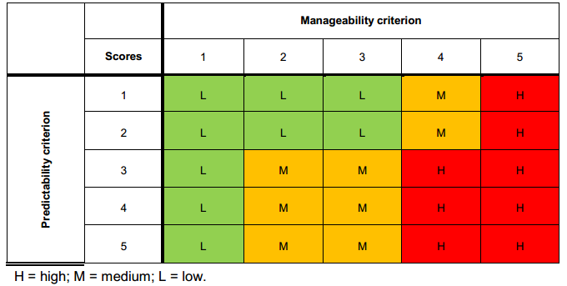
Figure A2: Matrix to determine level of environmental significance (DMITRE, 2013).
The circumstances outlined below determine the significance scores that should be applied:
• 1 – where potential adverse consequences can be completely avoided, there are no adverse consequences or low likelihood of an event (which would lead to adverse effects) occurring.
• 2 – where potentially adverse consequences cannot be entirely avoided, or likelihood of being realised is not low but these can be managed to occur only in the near term.
• 3, 4 – if impacts are expected to occur over a longer period, but they can be confined to a relatively small area in relation to surrounding environment, then a significance score of 3 can be given. If this is not the case a level of 4 should be applied. A score of 4 should also be given if impacts considered to be level 1 or 2 can have cumulative impacts with other existing activities.
• 5 – where consequences are potentially catastrophic with respect to scale or irreversibility or major concerns are raised by other stakeholders.
The Queensland Water Commission (2012) underground water impact report for the Surat and Bowen basins, assessed and ranked risks to springs on a level of 1 to 5. The level is determined on the basis of likelihood of reduced water flows, and on the resulting impact to spring values should this eventuate. For each spring vent, a risk level between 1 (lower) and 5 (higher) were assigned on the basis of the likelihood of there being reductions in the flow of water and likely consequences on spring values if a reduction in flow was to arise.
The Queensland Water Commission study (2012) used two criteria to assess consequence of impacts to springs. The two criteria were:
• conservation value – the updated conservation ranking for each spring informed by the spring survey
• proximity of the spring to the recharge area of the spring’s source aquifer, as an indicator of the ecosystem’s resilience to changes in terms of availability of water to the spring.
Cultural heritage values were not assessed in the study. The study did also not explicitly consider all factors that could influence groundwater drawdown propagation such as faults and wellbore pathways, and focussed entirely on springs and did not consider the potential sensitivity of the aquifers and groundwater users.

Techniques to determine consequence
NSW DPI Office of Water (2012b) Risk assessment guidelines for groundwater dependent ecosystems provides a process to identify, evaluate and assess the consequence of impacts to groundwater dependent ecosystems which explicitly recognises the inherent interconnectedness of groundwater and surface water assets – the process is summarised in Appendix G.
Multiple attributes are used to inform the consequence of impacts to four key aquifer assets. These are water quantity, water quality, aquifer integrity and biological integrity assets. High, medium and low impacts to water quantity and quality are determined in accordance with:
- Water quantity
– Reduction or fluctuation in groundwater levels or piezometric pressure beyond seasonal variation, leading to loss of or alteration to habitat type. If permanent, high impact; if temporary, medium impact. No change to aquifer water levels or pressure is a low impact.
– Reversal of base flow conditions – if permanent, high impact; if temporary reversal exceeding seasonal variation, medium impact. No change in direction of flow is a low impact.
- Water quality
– Change in chemical conditions (e.g. in pH, DO, nutrients, temperature and/ or turbidity), if permanent, high impact. If temporary, medium impact. If negligible (<5%) it is a low impact
– Permanent change in location or gradient of salt/freshwater interface
– Reduction in water quality for identified trigger parameters– if beyond designated Beneficial Use category it is high impact; if within designated BU category medium impact. Negligible change for identified triggers is low impact (<5%)
- Aquifer integrity – If permanent destruction of aquifer matrix through major fracturing of bedrock, stream bed leading to dewatering of groundwater dependent ecosystems, then a high impact is determined. Moderate impacts are temporary adjustment to aquifer matrix, with minor fracturing leading to partial dewatering of groundwater dependent ecosystems. Low impacts must register no change in geologic structure from the activity.
- Biological integrity
– > 10% reduction in number of native species within groundwater dependent communities is a high impact. 5–10% is a moderate impact and no reduction is a low impact
– >10% change to species composition is high impact, 5–10% is moderate impact, and no change is a low impact.
– Risk of increasing the presence of exotic species is high if large populations of one or more species are recorded, moderate if species in small numbers are noted and low risk if no exotic species exist
– Risk of removing or altering groundwater dependent ecosystem subtype habitat is high if there is >20% loss or change to habitat area, moderate if there is 10–20% change and low if there is no removal or alteration of habitat.
If proponents provide ‘unknown’ against more than half of these considerations, then the risk is high until evidence can be shown to prove otherwise.
Current measures to manage impacts to Groundwater Dependent Ecosystems largely fall under Water Management Act 2000, which provides for monitoring of impacts against change in groundwater extraction relative to extraction limit, change in climate-adjusted water levels, change in ecological condition of the aquifers and dependent ecosystems and change in water quality.
The Water Quality Guidelines (ARMCANZ and ANZECC 2000) provide guidance on performance indicators and trigger values for impacts to aquatic ecosystems in terms of physical/chemical stress. For some water quality indicators, the Water Quality Guidelines (ARMCANZ and ANZECC 2000) indicate there is a need to establish reference condition against which to measure impacts, which may be derived from on-site historic data or spatial data from reference/proximate sites.
The Royal Society & Royal Academy of Engineering (UK) (2012) recommends that all shale gas operations be subject to an Environmental Risk Assessment, which provides better opportunity to prioritise and manage risks more proportionately than Environmental Impact Assessments, which do not consider event likelihood. ERAs should assess risks across the entire lifecycle of shale gas extraction to include waste disposal and well abandonment. However, no further specific information however was given about the form of risk assessment that should be undertaken.

A2.8 Likelihood
The next step in a standard risk assessment process is to evaluate qualitatively or quantitatively the probability of a hazardous event occurring. The likelihood of the consequence is typically based on the frequency of the sensitive receptor being exposed to the risk.

Risk assessment to inform government policy
The literature review did not identify any different techniques or criteria used to assess likelihood in the context of a risk assessment to inform government policy than those that are commonly used for project risk assessments.

Risk assessment to inform project-scale developments
Gormley et al (2011) suggest conceptualising likelihood in terms of three factors which should be addressed in risk assessments at a project level: the probability of an initiating event occurring, the probability of exposure to the hazard and probability of receptors being affected by the hazard (resilience/vulnerability). These may be assessed together or separately.
The Queensland Water Commission (2012) use three equally weighed criteria to assess likelihood. They involve use of predicted water pressure impacts in aquifers made using the regional groundwater flow model, the proximity of a spring to development areas, and the stratigraphic separation of a spring’s source aquifer from the prospective resource formations.
One technique for conceptualising likelihood and significance of impact is in relation to the worst case scenario. In terms of probability bounds analysis, a qualitative description of a worst case scenario for coal seam gas groundwater pumping is provided by Anderson et al (2013), and would involve:
• loss of the same volume of beneficial groundwater from an overlying aquifer as a result of enhanced flow along any geological pathways and/or leakage through pores and transmissive fractures or faults
• leakage along/through coal seam gas well casing if perfect seal was not achieved, the well casing materials shrink or well construction materials break/become permeable with time
• changes in groundwater chemistry and beneficial use due to mixing from different aquifers and aquitards
• deterioration of groundwater quality in beneficial aquifer to the point at which quality no longer meets requirements of groundwater users/beneficial use category as set out by authorities
• depletion of groundwater in the beneficial aquifer to a level/pressure preventing other users/uses from accessing groundwater entitlement for its intended purposes.
Historical trends and data may be used to assess event likelihood. For instance, Gross et al. (2013) reviewed data on groundwater spills from storage and production facilities at active wells, finding relatively low likelihood of spills occurring. Whilst the crude oil compounds (benzene, toluene, ethylbenzene and xylene) exceeded national drinking water standards in 18-90% of recorded instances, subsequent measures were successful in remediating impacts in 87% of cases.
Riha and Rahm (2010) distinguish between gas drilling impacts that are deterministic, events that are certain to occur and a direct function of extent and pace of development and probabilistic, which may occur but whose occurrence and consequence is spatially and temporally unclear. Deterministic events can be foreseen, planned for and regulated, whereas probabilistic events must be inferred from historical data.
There are several approaches to estimating likelihood that generate semi-quantitative estimates of frequency of potential impacts being realised. In relation to project-level risk assessments for the offshore oil and gas industry, ABS (2000) propose the use of event tree analysis (modelling possible outcomes of an event against the end state), which may be particularly useful where multiple controls are in place to minimise risk. Fault-tree analysis is also suggested as a means of modelling complex interactions to determine how relationships between technological failure, external events and human error can interact. Finally, human reliability analysis can be used to identify areas of potential human error, and re-evaluate high risks according to impact that an individual could have in completing the scenario.
In the absence of historical records and given complexity of interactions between human, hydrological and geological components, the approach used by Rozell and Reaven (2012) may be the most useful. They apply probability bounds analysis (best and worst case scenarios) to investigate likelihood of possible water pollution in the Marcellus Shale by assessing contamination risk and epistemic uncertainty associated with five pathways: transportation spills, well casing leaks, leaks through fractured rock, drilling site surface discharge, and wastewater disposal.

A2.9 Risk rating
Risk estimation is the final step in a risk assessment, and is determined from the likelihood and consequences of an adverse outcome (with due regard to uncertainty) should the impact be realised. Retained risk assesses the residual impact after standard controls have been implemented.

Risk assessment to inform government policy

Risk rating: considerations
For the purpose of producing bioregional assessments, IESC (2014) states risk matrices and consequence tables, which may be quantitative, semi-quantitative or qualitative depending on the degree of confidence regarding likelihood and potential impacts, should consider residual impacts on the basis of likelihood of event occurrence, impact uncertainties and information from risk registers.
Risk registers are one component of the proposed centralised Risk Management and Prediction Tool for extractive industries recommended by the NSW Chief Scientist and Engineer (2014). It would also feature a database of event histories, and previous trigger action response plans, which in addition to improving review of proposed developments for government, would help to improve the ability to predict risk likelihoods and consequences of potential impacts in risk assessments.

Criteria and techniques
The literature review identified a couple of techniques to assist with a strategic planning risk assessment risk rating approach. The Namoi Cumulative Risk Assessment Tool (NCRAT, Ecological Australia 2012) is a spatial tool which was developed for Namoi CMA to assess cumulative risk from mining and coal seam gas on ten natural resource assets at the strategic landscape scale. It focuses on relative risk from different development scenarios (e.g. risk level between site A and B) as opposed to absolute risk at the project level, which would need to be informed by more specific site-relevant data.
Sensitivity classes (very low, low, moderate, high and very high) were developed using thresholds identified by Namoi Catchment Action Plan. These set out immediate impacts and input layers required and developed rules for assigning scores. For instance, three forms of spatial data underlie representation of groundwater quality: coal resource potential (which indicates development feasibility), distribution of alluvial aquifers (risk will be greater where alluvial aquifers are above coal beds) and density of agricultural bores (to proxy for water demand by agriculture).
Sensitivity to groundwater drawdown was determined on the basis of 4 components: coal and gas potential, distribution of major groundwater aquifers in the catchment (and associated data regarding status – recovering, stable or declining - and groundwater connectivity -connected, transition, disconnected); groundwater depth data and groundwater dependent ecosystem potential.
Risk rating matrices were then developed for each type of impact – an example of which is provided in Section 2.10. The cumulative risk framework produced provides an indication of the relative risk of a scenario to the underlying asset, although it is noted that risk tables are not final and may be modified as improved data comes to hand.
Another approach to assessing vulnerability of water assets to hydrological change is provided by Wilson et al (2014) who apply the pressure-stressor-response model in the South Australian context. Rather than seek to identify impacts to individual assets, they develop classes based on their hydrology and potential for hydrological change. The component attributes used by Wilson et al are water source (which can be combination of surface and groundwater) and water regime (prevailing mode of flow in terms of magnitude, duration, frequency, seasonality).
Table A1: Qualitative impact categories for impacts to water resource asset classes. (Source: Wilson et al, 2014.) shows they developed qualitative impact categories on a scale of ‘negligible’, ‘low’, ‘moderate’ and ‘high’ for hydrological integrity, asset resilience and time to recovery of system criteria. These were rated for each combination of asset class, activity and effect. Unknown and not applicable impact ratings were also identified.

Table A1: Qualitative impact categories for impacts to water resource asset classes. (Source: Wilson et al, 2014.)
Qualitative impact categories | Changes to hydrological integrity | Resilience | Time to recovery
High | Change in ‘state’ (i.e. different asset class) | No return or transition back to previous hydrology or asset class | Permanent or non-permanent change
Moderate | Change to hydrology | No return or transition back to previous hydrology | Permanent change
Low | Change to hydrology | Return to expected/previous hydrology | Rapid
Negligible | No change to hydrology | Return to expected/previous hydrology | Not relevant
N/A | Not relevant | Not relevant | Not relevant
Unknown | Unknown | Unknown | Unknown

These impact ratings describe the potential change in hydrological characteristics of an asset caused by an activity and were assigned through a collaborative expert elicitation process combining knowledge from surface water hydrology, ecology of water dependent ecosystems and hydrogeology.
Considered alone, it does not represent a true risk assessment framework as it does not assess likelihood of coal seam gas and coal mining activities, values attached to water assets, acceptability or tolerability of vulnerabilities. However, it provides a starting point for considering potential scenarios of hydrological impacts based on a general asset type and coal seam gas or large coal mine activity, without factoring in local circumstances affecting vulnerability, such as asset-specific features or risk control measures that may already be in existence.

Risk assessment to inform project-scale developments

Risk rating criteria
The number of criteria comprising a risk assessment rating varies from study to study but impacts are usually represented using a 3 by 3 or 5 by 5 risk rating matrix.
Moran and Vink (2010) assign processes of water recharge, discharge and redistribution from coal seam gas activities a rating of ‘no significant changes', 'minor changes' 'intermediate' and 'significant changes/local risk' based on impacts to surface and groundwater assets. Flows between components of the system were categorised into ‘significant’, ‘intermediate’ and ‘minor’ changes.
The Alberta Ministry of Environment and Sustainable Resource Development, in Canada has developed a 3 stage, three tier risk rating tool which helps Proponents determine the level of analysis/investigation required for a licence application for oilfield injection activities (ERSD, 2006) . The three tiers, with increasingly stringent requirements for investigation are qualitatively described as:
Step 1 involves determining whether the project will likely have a minor, moderate or major consequence based on numeric and qualitative criteria for safe, secure drinking water supply (water supply effects up to x km, negligible, local or community supply constraints); healthy aquatic ecosystems (measurability of effect, in -stream flow needs, existence of cumulative effects) and reliable water supplies for a sustainable economy (degree of development pressure, competition for supply).
Step 2 involves rating of likelihood against probability criteria which are: ‘remote’ (practically impossible, occurrence of 1 in 100 years or less) ‘unlikely’ (conceivable but very unusual, occurrence is 1-10 in 100 years) or ‘likely’ (would happen often, more than 10 occurrences in 100 years).
Step 3 provides the risk matrix for self-assessment of retained risk and guidance on information that must be provided and measured Proponents complete a water allocation licence application for one of three tiers, based on project scale. Each tier specifies management aims and what data must be collected and the measures taken to conserve and prevent excessive water use.
Water-short areas are determined on the basis of low natural runoff potential (‘exceptionally dry’ being less than 5mm of runoff, and ‘potentially water short’ 5-10mm of runoff), and existing human use and administrative restrictions (3 categories are identified: water-short, which are closed to most new applications).
The report for ACOLA (2013) creates risk tables for each potential impact to ecological systems from shale gas development, assuming best practice measures are used to minimise spills, leaks and incidents and mitigate indirect impacts. In relation to surface water abstraction or drawdown of sub-surface water, it concludes there is a moderate risk of impacts to aquatic ecology based on the combined likelihood of impact occurring and consequences should this impact arise. Uncertainties are qualitatively captured on a scale of ‘high’, ‘medium’, ‘low’ based on ‘reliability’ of event likelihood and impact consequence. A description to support the rating is provided where needed. Refer to 0 for the risk tables.

A2.10 Presentation of risk assessment findings

Risk assessment to inform government policy
Multiple sensitivity layers were developed for the Namoi Catchment Management Authority by Eco Logical Australia (2012) to inform a cumulative risk assessment of different mining scenarios on ten types of natural resource assets found in the catchment. Table A2 shows the relative risks posed by coal seam gas, open-cut mining and long wall mining to groundwater drawdown and quality at different locations in the Namoi catchment.
Owing to the study’s scope which assessed risks to both terrestrial and aquatic ecosystems, the risk assessment is focused on the potential footprint of mining (area requiring clearing) relative to catchment area.

Table A2: Risk matrix showing sensitivity of water assets at different scales of coal seam gas, Long-Wall Mining and Open-Cut Mining Development. (Source: Eco Logical Australia, 2012.)

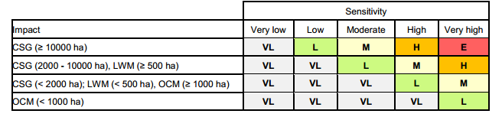
As shown in Figure A3 the relative risk water assets from different development scenarios is assessed to be greatest from large-scale coal seam gas development owing to the proximity to groundwater resources and the volume of co-produced water generated. Similar conclusions were drawn for sensitivity of groundwater quality to coal seam gas development, as shown in the top right diagram of Figure A3, due to the fact that coal seam gas has a relatively greater concentration of wells and holding ponds than open-cut or long-wall mining. This finding is relevant to considering relative risks from onshore unconventional gas to conventional gas development, which typically will involve gas extraction from a single rather than multiple wells.
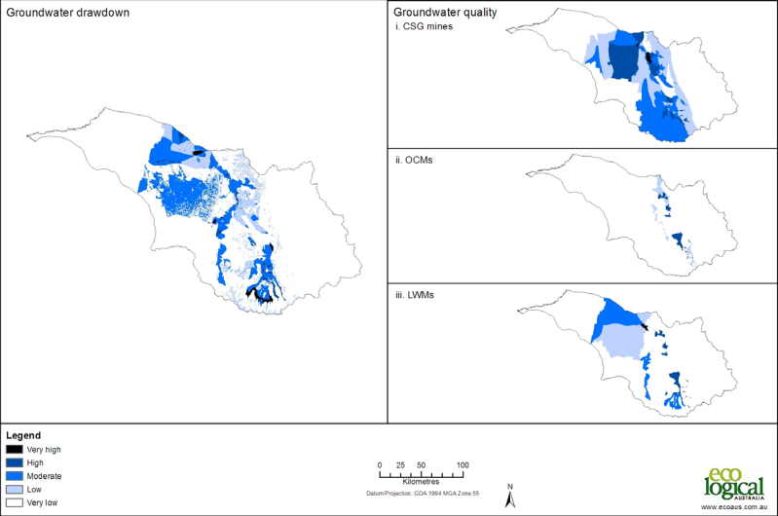
Figure A3: Sensitivity to Groundwater Drawdown under Coal Seam Gas, Open Cut Mining and Long Wall Mining Development. (Source: Eco Logical Australia, 2012.)
In Western Maryland, the Marcellus Shale Safe Drilling Initiative was designed to inform policymakers and regulators to determine whether and under what circumstances gas production can proceed without presenting unacceptable health and safety and environmental risks.
A qualitative risk assessment for unconventional gas well development was conducted by technical teams who reviewed available literature and identified potential risks across well lifecycle from site identification to abandonment/reclamation. Risks were assigned to categories, two relevant to this literature review being “potential impacts to surface and ground waters” and “water withdrawal”.
The risk assessment was based on two development scenarios: 25% extraction and 75% extraction levels of available natural gas resource. Table A3 below shows the assumptions underlying these scenarios.

Table A3: Development scenario assumptions. (Source: Maryland Department of Environment, 2014.)
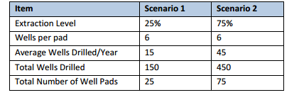
Risk impacts included direct and indirect impacts to human, community, ecological and recreation receivers. The likelihood (low, medium or high) and consequence (minor, moderate or serious) evaluated and combined to inform an assessment of a low, moderate or high risk rating for each risk (see Table A4).

Table A4: Risk ranking matrix. (Source: Maryland Department of Environment, 2014.)
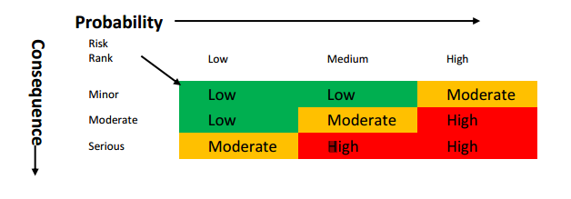
The risk assessment assigns a rating to each risk category by phase of well development (e.g. water withdrawal for drilling, water withdrawal for hydraulic fracturing), based on assumptions around the scale of development and ability of current regulatory framework to manage development.
However, it is not geographically-focused i.e. does not seek to evaluate risks under different hydrogeological conditions or to specific groundwater assets.
In Alberta, the Ministry of Environment and Sustainable Resource Development (ERSD) uses a qualitative
3 by 3 risk matrix (Table A5) as the basis for its guidelines around information which must be provided to support a Licence Application for oilfield injection. It instructs proponents to plot qualitative impacts (on a scale of minor, moderate and major) and probability ratings (remote, unlikely, likely) to determine the Tier level and corresponding technical, economic and net environmental effects which proponents must be characterised for the project.

Table A5: Risk-based tier selection: determining the appropriate Tier Level. (Source: ERSD, 2006.)
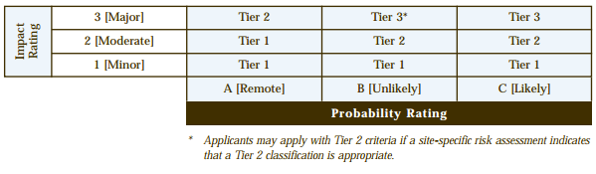
Table A6 and Table A6 provide high-level guidance to determine probability and impact and inform the selection of the appropriate tier level.

Table A6: Risk-based tier selection: scale of impact against ‘Water for Life’ goals.
(Source ERSD, 2006.)
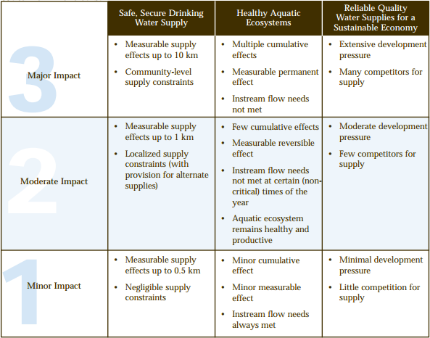

Table A7: Risk-based tier selection: determining probability of impacts. (Source: ERSD, 2006.)
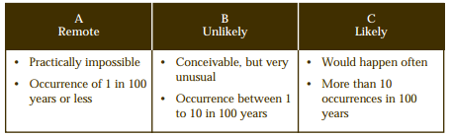

Appendix A3 Implications for the design of a QQRA
There is no fit-for-purpose risk assessment methodology that is suited to analysing risks at a policy-making/strategic land use level to water resources from unconventional onshore gas developments.
Many jurisdictions use their existing regulation frameworks to manage risks from onshore gas development including water supply requirements, discharges to environment and well integrity.
Land use planning around onshore gas appears to be based on a precautionary approach to risk, given there is still considerable uncertainty around precise pathways for cause and effect. As pathways are highly site specific it is difficult to generalise likelihood of impacts across larger areas. Consequently, several regulators at both state and national level have delineated exclusion zones around pre-existing determinations of sensitive assets. For instance, New South Wales share the New York State Department of Environmental Conservation’s concern regarding protecting drinking water from principal and primary aquifers. However there are a number of studies and research programs to improve understanding and frameworks to manage impacts associated with onshore gas development e.g. Bioregional Assessments, Cumulative Management Areas (Queensland).
Components of project risk assessments are often transferable to assessing risk at a strategic level. This is particularly the case when considering the scale of unconventional gas developments in comparison to traditional conventional gas. Conventional gas typically involves relatively few wells, whereas unconventional gas, in particular coal seam gas involves many wells, sometimes 1,000s of wells over large areas. This blurs the distinction between project and regional scale assessments. In light of this, through the National Harmonised Framework the Federal Government requires that proponents assess cumulative impacts from other gas developments and/or different existing/potential land uses.
Common elements and differences between the two scales of risk assessments are discussed below.

A3.1 Common elements
Common to all risk assessment methodologies at either a project or hypothetical level is the characterisation of the existing hydrogeological conceptual model and establishing a baseline from which to assess potential impacts and identifying sensitive receptors (water resources and water-dependent assets). There is scope to integrate data from asset registers/natural resource management authorities (IESC, 2013).
Whilst numerical modelling is typically carried out for project level risk assessments, lack of sufficient data at a regional level to support strategic planning risk assessments means conceptual models and qualitative or semi-quantitative criteria are often adopted until better information becomes available. The exception to this is Queensland, where the Office of Groundwater Impact Assessment has commissioned numerical modelling of the cumulative management areas to understand predicted impacts across the region to inform government policy.
Another common element is the principle of hazard identification (i.e. the source-pathway-receptor). However hazard identification at a strategic planning scale will invariably have to make assumptions around onshore gas development in order to infer potential impacts (e.g. location, extent). This introduces an added dimension of uncertainty which needs to be factored into risk ratings or made clear in the limitations and assumptions section of a report.
In terms of understanding potential hydrogeological pathways, at both the project scale and the regional scale they are often described conceptually as there is rarely sufficient information to identify to describe them more in more detail and specifically.

Thresholds for significant impact are similar between project-based and strategic land-use planning risk assessments, and will depend on whether individual or cumulative impacts are being factored into consequence ratings.
The criteria used to identify water resources and water-dependent assets – typically value and sensitivity - are relevant to risk assessments for both actual and hypothetical developments. Arguably there has been greater focus on assessing sensitivity than value. At a strategic planning level, the scale and number of receptors involved means it may be necessary to group receptors into ‘asset classes’ according to common characteristics and pathways through which they could experience adverse impacts.

A3.2 Key differences
There are a couple of differences between project scale and strategic planning scale such as the project scale risk assessment will be required to consider potential impacts on a broader range of assets (terrestrial ecosystems, local communities etc.) as required under existing regulatory frameworks.
Also assessment of likelihood differs between hypothetical onshore gas development and actual proposed activity-based risk assessments. Likelihood at strategic planning level relates to the understanding of direct and indirect impacts between source and receptor. Likelihood for particular development would consider this, but also take into account project-specific considerations (control standards used, confidence around numerical modelling, expected development lifespan, current state of development)
In terms of risk identification considerations, hazards will vary according to the type of gas; the key risk for coal seam gas development relates more to depressurisation although hydraulic fracturing can be an issue in some cases. For developments targeting tight and shale gas the risks will primarily relate to potential impacts from hydraulic fracturing.
Strategic level risk assessments will have to give due regard to key differences in typical characteristics of different gas types (notably depth and permeability of overlying layers) and this will determine pathways by which potential impacts on water assets are realised. However, this is just one side of the equation and the characteristics of sensitive assets (confined/unconfined aquifers, perennial/ephemeral streams) will also have to be taken into consideration to determine likelihood of potential impacts being realised.
Thresholds could be alike between tight, shale and coal seam gas if they are outcome-focused, i.e. linked to changes in the quantity/quality of the water asset assessed, rather than the level or type of activity.
Risk rating is based on likelihood and consequence. As described above, pathways will determine likelihood of impacts at a strategic land use planning level so criteria used may differ between gas resources. However consequence is linked to potential for significant adverse effect on the receptor and criteria used is based on the threshold level of impact, which is common to the different types of gas that are targeted.

A3.3 Key conclusions
Individual jurisdictions are managing risks associated with onshore gas development differently as indicated by the following examples.
ERCB in Alberta (Canada) has developed generic risk profiles (geographic, geologic, temporal properties such as source rock, migration pathways, timing, trapping mechanisms and hydrocarbon type) and standard resource plays to inform if proposed development is likely to be a low, medium or high risk.
Queensland have used a regional numerical model to predict impacts within the defined Cumulative Impact Area. Even though threshold criteria have been defined, these are being challenged as further technical work is undertaken.
NSW has recently released the NSW Gas Plan which outlines the key actions already implemented such as the Strategic Regional Land Use Policy, the Aquifer Interference Policy and codes of practice for well integrity and hydraulic fracturing. The majority of other actions outlined in the plan are directed and reducing the number of exploration licences and ensuring the community benefits from gas development.
South Australia released a Roadmap for Unconventional Gas Projects in South Australia in late 2012. Five working groups were established in 2013, one is focused on pooling together water use forecasts for basin wide modelling in Cooper-Eromanga basin as an initial step towards life-cycle catchment planning (DMITRE, 2014). Groundwater assessment projects have also been conducted in Arckaringa and Pedirka basins (Wohling et al, 2013), owing to significant potential for large-scale mining or coal-seam gas development, the findings will be to inform further resource characterisation and testing.
Western Australia, the EPA is assessing hydraulic fracturing for shale and tight gas projects on a case-by-case basis as for petroleum and mining to date. Government agencies will in parallel periodically review and refine the regulatory framework, for instance the Department of Mines and Petroleum is revising regulations for well design and operation and the Department of Water is reviewing current water legislation
(DMP, 2014).
In terms of approaches to risk assessments, the key conclusions from the literature review are
outlined below:
• The literature review found many jurisdictions are seeking to enhance understanding of risks and define under what conditions or in what areas onshore gas developments may be considered.
• 5 × 5 consequence and likelihood criteria and risk rating scales require detailed data and/or extensive quantitative/numerical modelling and project specific risk assessments which treat consequence (direct, indirect, financial and non-financial etc) and likelihood (probability, historical instances of failure) differently (DMITRE, 2013)
• Two most common ways by which water resources are commonly identified are the vulnerability/sensitivity of the resource (physical characteristics) to potential impacts and the value of the water asset.
Risk assessments used to answer/inform strategic planning and policy questions typically involve cumulative impacts and the most similar approach to this project is the Namoi CMA (Eco Logical Australia 2012). Key components of the approach in the Namoi catchment are:
• spatial tool to assess cumulative risk from mining and coal seam gas on ten natural resource assets at strategic landscape scale.
• focuses on relative risk between site A and B, not absolute risk
• five classes of sensitivity (VL, L, M, H, VH)
• sensitivity was determined by:
– coal and gas potential
– distributions of major groundwater aquifers in catchment and connectivity
– groundwater level data
– groundwater dependent ecosystems potential
– qualitative risk matrices developed for each aquifer.
The proposed approach for the QQRA has not been implemented at a regional scale anywhere in the world where all the components of the risk assessment framework (consequence, likelihood and hence risk) can be assessed qualitatively and semi-quantitatively using existing information and eventually quantitatively as more accurate information becomes available.

Appendix AA Matters out of scope for the literature review
The literature review has been guided by the scope of the QQRA, as such the following hazards, receptors and impacts identified in Figure AA1 below have not been the primary focus for analysis.

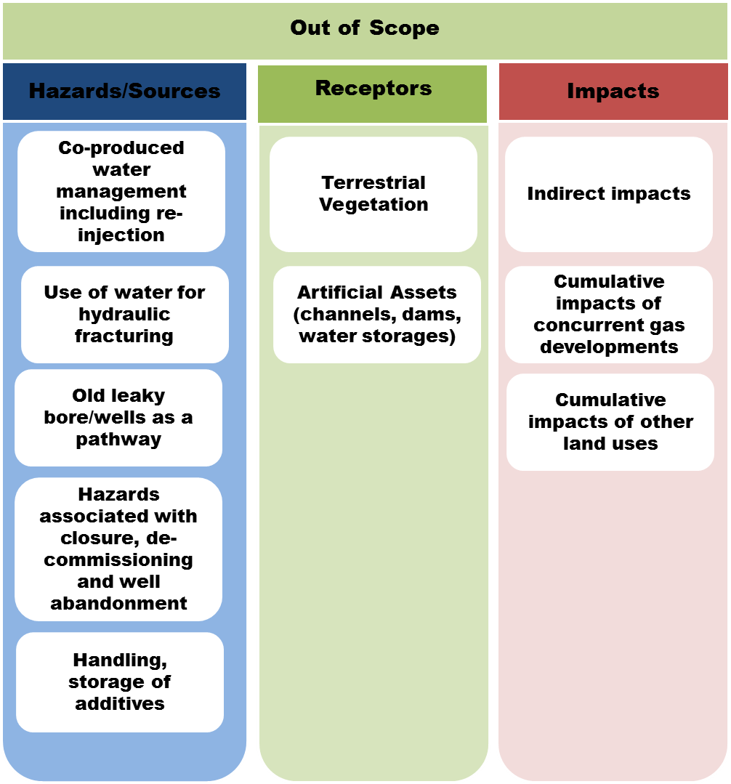
Figure AA1: Hazards, receptors and impacts outside the scope of the proposed Qualitative and
Quantitative Risk Assessment (QQRA) Framework.

Appendix AB: Sources consulted
A. GUADAGNINI, L. GUADAGNINI, D. M. TARTAKOVSKY AND C. L. WINTER, 2003. "Random domain decomposition for flow in heterogeneous stratified aquifers", Stoch. Environ. Res. Risk Assess., vol. 17, no. 6, pp. 394-407, 2003
A.M.M. ELFEKI, G.J.M. UFFINK, F.B.J. BARENDS (1997) Groundwater Contaminant Transport: Impact of heterogenous characterization: a new view on dispersion
ACCENTURE (2013) Water and Shale Gas Development: Leveraging the US experience in new shale developments, http://www.accenture.com/SiteCollectionDocuments/PDF/Accenture-Water-And-Shale-Gas-Development.pdf
ADBDULLAHI, U.S. (2009) Evaluation of Models for Assessing Groundwater Vulnerability to Pollution in Nigeria, Bayero Journal of Pure and Applied Sciences, 2(2): 138 - 142
AEA (2014 ) Shale gas risk assessment for Maryland, http://chesapeakeclimate.org/wp/wp-content/uploads/2014/02/Shale-gas-risk-assessment-for-Maryland_Feb2014.pdf Report for Chesapeake Climate Action Network and Citizen Shale
AEA TECHNOLOGY (2012) Support to the identification of potential risks for the environment and human health arising from hydrocarbons operations involving hydraulic fracturing in Europe. Report prepared for the for the European Commission http://ec.europa.eu/environment/integration/energy/pdf/fracking%20study.pdf
ALBERTA MINISTRY OF ENVIRONMENT AND SUSTAINABLE RESOURCE DEVELOPMENT - ERSD (2006) Water Conservation and Allocation Guideline for Oilfield Injection
http://esrd.alberta.ca/water/education-guidelines/documents/Oilfield_Injection_Guideline_2006.pdf
AMERICAN BUREAU OF SHIPPING (2000) Guidance Notes on Risk Assessment Applications for the Marine and Offshore Oil and Gas Industries https://www.eagle.org/eagleExternalPortalWEB/ShowProperty/BEA%20Repository/Rules&Guides/Current/97_RiskAssessApplMarine&OffshoreO&G/Pub97_RiskAssesment
ANDERSON ET AL (2013): Background Paper on Groundwater Resources in Relation to Coal Seam Gas Production, WRL Technical Report 2013/09 http://www.chiefscientist.nsw.gov.au/__data/assets/pdf_file/0007/38158/WRL-2013-09-Final-November-2013.pdf
ANDRZEJ J. WITKOWSKI, ANDRZEJ KOWALCZYK, JAROSLAV VRBA (2007) Groundwater Vulnerability Assessment and Mapping CRC Press http://books.google.com.au/books?id=LTqEEL6ROcgC&dq=risk+assessment+aquifer&source=gbs_navlinks_s
APH (2008) Australia’s natural gas issues and trends. M. Roarty. Parliamentary Library Research Paper no.25. ISSN 1834 9854. http://www.aph.gov.au/binaries/library/pubs/rp/2007-08/08rp25.pdf
ARROW ENERGY (2012) EIS groundwater Impact Assessment: Surat Gas project http://www.arrowenergy.com.au/__data/assets/pdf_file/0005/2966/126908_SGP_EIS_Groundwater_Factshet.pdf
ARROW ENERGY (2012) Supplementary Report to the Surat Gas Project EIS http://www.arrowenergy.com.au/__data/assets/pdf_file/0016/8611/7040_12_Ch08_Rev1.pdf
AUSTRALIAN PETROLEUM PRODUCTION & EXPLORATION ASSOCIATION (peak industry body) Western Australian Onshore Gas: Code of Practice for Hydraulic Fracturing http://www.newstandard.com.au/wp-content/uploads/2011/11/APPEA_Code_of_Practice.pdf
BARRETT, D.J., COUCH, C.A., METCALFE, D.J., LYTTON, L., ADHIKARY D.P., AND SCHMIDT R.K., 2013 (2013) Methodology for bioregional assessments of the impacts of coal seam gas and coal mining development on water resources. A report prepared for the Independent Expert Scientific Committee on Coal Seam Gas and Large Coal Mining Development through the Department of the Environment. NSW
BASELINE FOR COMPARISON OF ALL FUTURE POTENTIAL RISKS (http://www.resourcesandenergy.nsw.gov.au/landholders-and-community/coal-seam-gas/water-data-project
BRITISH COLUMBIA OIL & GAS COMMISSION (2014) Well Permit Application Manual http://www.bcogc.ca/node/5854/download?documentID=874&type=.pdf
BUREAU OF METEOROLOGY, Groundwater Dependent Ecosystem Atlas http://www.bom.gov.au/water/groundwater/gde/
CAMPIN, D. (2013) Environmental Regulation of Hydraulic Fracturing in Queensland, Society of Petroleum Engineers Annual Technical Conference and Exhibition https://www.spe-qld.org/useruploads/files/spe_166146_for_6_march_2014.pdf
CAPP (2012) Upstream Dialogue – The Facts on Natural Gas. Canadian Association of Petroleum Producers (CAPP). Available at: http://www.capp.ca/UpstreamDialogue/NaturalGas/Pages/default.aspx (Accessed October 2013)
COMMONWEALTH OF AUSTRALIA (2013) Significant Impact Guidelines: Coal Seam Gas and Large Coal Mining Developments – Impacts on Water Resources http://www.environment.gov.au/system/files/resources/d078caf3-3923-4416-a743-0988ac3f1ee1/files/sig-water-resources.pdf
COMMONWEALTH OF AUSTRALIA (2014) Coal seam gas extraction: modelling groundwater impacts, prepared by Coffey Geotechnics for the Department of the Environment, Commonwealth of Australia’ http://www.environment.gov.au/system/files/resources/ee38b672-6faa-452e-979f-d97b7d425333/files/coal seam gas-modelling-groundwater-impacts.pdf
CONNECTICUT ENVIRONMENTAL CONDITIONS ONLINE (2010) CT ECO Complete User Guide: Water Quality Classifications. http://cteco.uconn.edu/guides/resource/CT_ECO_Resource_Guide_Water_Quality_Classifications.pdf
COOK, P.G. (2003) A guide to regional groundwater flow in Fractured Aquifers, CSIRO http://lwa.gov.au/files/products/river-landscapes/px020312/px020312.pdf
COOK, P.J. et al. (2013) “Engineering energy: unconventional gas production.” Report for the Australian Council of Learned Academies (ACOLA)
COOK, P.J. (2013) Life Cycle of Coal Seam Gas Projects: Technologies and Potential Impacts Report for the New South Wales Office of the Chief Scientist and Engineer http://www.chiefscientist.nsw.gov.au/__data/assets/pdf_file/0010/31321/Life-Cycle-of-Coal-Seam-Gas-Report_FINAL_PJC.pdf
COUNCIL OF AUSTRALIAN GOVERNMENTS (n.d.) National Partnership Agreement on Coal Seam Gas and Large Coal Mining Development https://www.ehp.qld.gov.au/management/impact-assessment/pdf/partnership-agreement.pdf
DALY, D. AND WARREN, W.P. (1998) Mapping groundwater vulnerability: the Irish perspective. Geological Society, London, Special Publications, 130:179-190
DALY, D. AND WARREN, W.P. (1998) Mapping groundwater vulnerability: the Irish perspective Geological Society, London, Special Publications, 130:179-190,
DECC (2014) “Fracking UK Shale: water” https://www.gov.uk/government/uploads/system/uploads/attachment_data/file/277211/Water.pdf
DEPARTMENT OF ENVIRONMENT & HERITAGE PROTECTION (n.d.) Guideline Water Act Underground Water Impact Report https://www.ehp.qld.gov.au/management/non-mining/groundwater.html
DEPARTMENT OF ENVIRONMENT (2013) Significant impact guidelines 1.3: Coal Seam Gas and Large Coal Mining Developments – impacts on water resources. Commonwealth of Australia
http://www.environment.gov.au/system/files/resources/d078caf3-3923-4416-a743-0988ac3f1ee1/files/sig-water-resources.pdf
DEPARTMENT OF MINES AND PETROLEUM (2014) ‘Natural Gas from Shale and Tight Rocks: An overview of Western Australia’s regulatory framework’. Government of Australia
http://www.dmp.wa.gov.au/15139.aspx
DEPARTMENT OF PRIMARY INDUSTRIES AND ENERGY (1995) National Water Quality Management Strategy: guidelines for Groundwater Protection in Australia http://www.environment.gov.au/system/files/resources/4d08becb-c90a-4637-bcbc-5772451f7c5e/files/nwmqs-groundwater-guidelines.pdf
DEPARTMENT OF SUSTAINABILITY AND ENVIRONMENT () Policy Paper: Improving Management of Victoria’s Groundwater Resources http://www.depi.vic.gov.au/__data/assets/pdf_file/0005/188942/Improving-management-of-Victorias-groundwater-resources.pdf
DEPI article: Groundwater monitoring of the State Observation Bore Network http://www.depi.vic.gov.au/water/governing-water-resources/environmental-contributions/groundwater-monitoring-of-the-state-observation-bore-network
DET NORSKE VERITAS (2013) Recommended Practice: Risk Management of Shale Gas Developments and Operations file:///C:/Users/AHerford/Downloads/rp-u301_2013-01.pdf
DIVISION OF WATER TECHNICAL & OPERATIONAL GUIDANCE (1990) Primary & Principal Aquifer Determinations http://www.dec.ny.gov/docs/water_pdf/togs213.pdf
DMITRE (2013) Criteria for classifying the level of environmental impact of regulated activities: requirement under Part 12 of the Petroleum and Geothermal Energy Act 2000 https://sarigbasis.pir.sa.gov.au/WebtopEw/ws/samref/sarig1/image/DDD/PGRG004.pdf
DMITRE (2014) South Australian Developments: Excellence in Oil and Gas 2014. http://www.pir.sa.gov.au/__data/assets/pdf_file/0019/218350/Excellence_in_O_and_G_Alexander_Mar2014.pdf
DNRM (2014) Report on the coal seam gas engagement and compliance plan 2013 http://www.dnrm.qld.gov.au/__data/assets/pdf_file/0007/171646/report-coal seam gas-engagement-compliance-plan.pdf
ECO LOGICAL AUSTRALIA 2012. Assessing the cumulative risk of mining scenarios on bioregional assets in the Namoi Catchment: Development and trial of an interactive GIS tool. Prepared for Namoi Catchment Management Authority http://specialplaces.namoi.xceed.com.au/client/multimedia/stage_3_report_final_v2_1__dec12.pdf
EHP (n.d.) coal seam gas water management: Measurable criteria https://www.ehp.qld.gov.au/management/non-mining/documents/coal seam gas-water-measurable-criteria.pdf
EHP (n.d.) Guideline Water Act 2000: Underground Water Impact Reports and Final Reports
https://www.ehp.qld.gov.au/management/non-mining/documents/uwir-guideline.pdf
ENERGY RESOURCES CONSERVATION BOARD (2011) “Unconventional Gas Regulatory Framework – Jurisdictional Review” http://www.aer.ca/documents/reports/r2011-A.pdf
ENERGY RESOURCES CONSERVATION BOARD (n.d.) “Regulating Unconventional Oil & Gas in Alberta: A Discussion paper”, http://www.aer.ca/documents/projects/URF/URF_DiscussionPaper_20121217.pdf
ENERGY RESOURCES DIVISION DEPARTMENT FOR MANUFACTURING, INNOVATION, TRADE, RESOURCES AND ENERGY (2012) First draft: Roadmap for Unconventional Gas Projects in South Australia http://www.petroleum.pir.sa.gov.au/__data/assets/pdf_file/0006/170889/Combined_doc_19_April.pdf
ENVIRONMENT AGENCY (2011) H1 Environmental Risk Assessment framework: Annex J – Groundwater https://www.gov.uk/government/uploads/system/uploads/attachment_data/file/298242/geho0410bsip-e-e.pdf
ENVIRONMENT AGENCY (2013) “An Environmental Risk Assessment for shale gas exploratory operations in England” https://www.gov.uk/government/uploads/system/uploads/attachment_data/file/296949/LIT_8474_fbb1d4.pdf
EPA OFFICE OF RESEARCH & DEVELOPMENT (2012) Study of the Potential Impacts of Hydraulic Fracturing on Drinking Water Resources: Progress Report http://www2.epa.gov/sites/production/files/documents/hf-report20121214.pdf
EVANS & PECK (2009) Bickham Coal WRA & draft WMP Appendix 3: Surface Water and Groundwater Risk Assessment
EWEN, C., BORCHARDT, D., RICHTER, S., & HAMMERBACHER, R., (2012) Hydrofracking Risk Assessment Executive Summary: Study concerning the safety and environmental compatibility of hydrofracking for natural gas production from unconventional reservoirs http://dialog-erdgasundfrac.de/sites/dialog-erdgasundfrac.de/files/Ex_HydrofrackingRiskAssessment_120611.pdf
FISHER, J.B. (n.d.) Environmental Issues and Challenges In Coal Bed Methane Production
GEOSCIENCE AUSTRALIA AND BREE, 2012, Australian Gas Resource Assessment 2012, Canberra http://www.ga.gov.au/webtemp/image_cache/GA21116.pdf
GOLDER ASSOCIATES (2009) Santos GLNG Project – Arcadia, Fairview, Roma coal seam gas Fields: Groundwater and Associated Water Management Impact Assessment http://www.santosglng.com/media/pdf1597/AttachmentD2_Groundwater.pdf
GOLDER ASSOCIATES (2010) Coal Seam Hydraulic Fracturing Fluid Environmental Risk Assessment. Response to the Coordinator – General Requirements for Coal Seam Gas Operations in the Surat and Bowen Basins, Queensland http://www.santos.com/library/Roma_Shallow_Gas_East_EMP_AppD.pdf
GOLDER ASSOCIATES (2014) (Presentation on) Impacts of Mining on GDEs and Groundwater Quality, Groundwater in Mining, Adelaide 2 May 2014
HEALTH & SAFETY EXECUTIVE (HSE Information sheet: Guidance on Risk Assessment for Offshore Installations
http://www.hse.gov.uk/offshore/sheet32006.pdf
HEALTH & SAFETY EXECUTIVE (n.d.) HSE Shale Gas Regulation, available online: http://www.hse.gov.uk/shale-gas/assets/docs/shale-gas.pdf
http://www.nopsema.gov.au/assets/Guidance-notes/N-04300-GN0165-Risk-Assessment.pdf
HUNTER, T. AND TAYLOR, M. (n.d.) Regulatory Best Practice for coal seam gas in Qld: A Briefing Paper http://www.law.uq.edu.au/documents/cimel/Regulatory-Best-Practice-for-Coal-Seam-Gas-in-Queensland-Briefing-Paper.pdf
IESC (2013) Information Guidelines for Independent Expert Scientific Committee advice on coal seam gas and large coal mining development proposals http://www.iesc.environment.gov.au/publications/information-guidelines-independent-expert-scientific-committee-advice-coal-seam-gas
IESC (2014b) Coal seam gas extraction: modelling groundwater impacts
Impact of Shale Gas Development on Regional Water Quality, Science, 17 May 2013
INTERNATIONAL ENERGY AGENCY (2012) Golden Rules for Golden Age of Gas: World Energy Outlook Special Report on Unconventional Gas http://www.worldenergyoutlook.org/media/weowebsite/2012/goldenrules/weo2012_goldenrulesreport.pdf
JACKSON et al. (2013) Issue Paper: Groundwater Protection and Unconventional Gas Extraction: The Critical Need for Field-Based Hydrogeological Research, Groundwater, 51 (4): 488-510 http://onlinelibrary.wiley.com/doi/10.1111/gwat.12074/abstract?deniedAccessCustomisedMessage=&userIsAuthenticated=false
LANDIS, W.G. (2004) Regional Scale Ecological Risk Assessment: Using the Relative Risk Model, CRC Press http://books.google.com.au/books?id=-gdO-NF1bb0C&pg=PA13&lpg=PA13&dq=risk+assessment+receptors&source=bl&ots=aUpZ8IWfVs&sig=UmB8O19JbhOWKiYJMQqYIVyIpzs&hl=en&sa=X&ei=u3JIVMSbNsS5mwXAgoLwAw&ved=0CE0Q6AEwCA#v=onepage&q=risk%20assessment%20receptors&f=false
MAATHUIS, H. AND SIMPSON, M. (2006) Groundwater Resources in the Yorkton Aquifer Management Plan Area: Final Report, Saskatchewan Research Council, SRC Publication No. 10419-1E06, June 2006.
MARYLAND DEPARTMENT OF ENVIRONMENT (2014) Assessment of risks from unconventional gas well development in the Marcellus Shale of Western Maryland. Appendix G Water Withdrawal and H: Wells & Formations http://www.mde.state.md.us/programs/Land/mining/marcellus/Pages/Risk_Assessment.aspx
MONTANA BUREAU OF MINES & GEOLOGY (2002) Potential Ground-Water Drawdown and Recovery from Coalbed Methane Development in the Powder River Basin, Montana. Project Completion Report to the U. S. Bureau of Land Management
http://www.blm.gov/pgdata/etc/medialib/blm/mt/field_offices/miles_city/og_eis/techdocs.Par.2601
MORAN, C. AND VINK, S. (2010) Assessment of impacts of the proposed coal seam gas operations on surface and groundwater systems in the Murray-Darling Basin, commissioned by Department of Sustainability, Environment, Water, Population and Communities http://www.environment.gov.au/epbc/notices/assessments/pubs/coal-seam-gas-operations-impacts.pdf
MYERS, T (2012) Potential Contaminant pathways from Hydraulically Fractured Shale to Aquifers, Groundwater, 50 (6): 872-882 http://onlinelibrary.wiley.com/doi/10.1111/j.1745-6584.2012.00933.x/full
NATIONAL CONFERENCE OF STATE LEGISLATURES (2012) Natural Gas Development and Hydraulic Fracturing: A policymaker’s guide http://www.ncsl.org/documents/energy/frackingguide_060512.pdf
NATURAL ENGLAND (2011) “Green Leaves III” Guidelines for Environmental Risk Assessment & Management, https://www.gov.uk/government/uploads/system/uploads/attachment_data/file/69450/pb13670-green-leaves-iii-1111071.pdf
NATURAL RESOURCES CANADA (2013) “Responsible Shale Development – Enhancing the Knowledge Base on Shale oil and Gas in Canada”. Annex B: Shale Resources Compendium https://www.nrcan.gc.ca/sites/www.nrcan.gc.ca/files/www/pdf/publications/emmc/Shale_Resources_e.pdf
NEW YORK STATE DEPARTMENT OF ENVIRONMENTAL CONSERVATION (2009). Draft Supplemental Generic Environmental Impact Statement (SGEIS) on the Oil, Gas, and Solution Mining Regulatory Program. Albany, New York, USA: Chapter 6 Potential Environmental Impacts. NYSDEC. http://www.dec.ny.gov/energy/58440.html
NEW YORK STATE DEPARTMENT OF ENVIRONMENTAL CONSERVATION (2011). Revised Draft Supplemental Generic Environmental Impact Statement (RDSGEIS) on the Oil, Gas and Solution Mining Regulatory Program. Albany, New York, USA: Well Permit Issuance for Horizontal Drilling and High-Volume Hydraulic Fracturing to Develop the Marcellus Shale and Other Low-Permeability Gas Reservoirs. http://www.dec.ny.gov/data/dmn/rdsgeisfull0911.pdf
NOBLE AND HARRIMAN (2008) Regional Strategic Environmental Assessment (R-SEA): Methodological Guidance and Good Practice. Environmental Assessment Task Group, Alberta Environment, Canadian Council of Ministers of Environment http://environment.gov.ab.ca/info/library/8181.pdf
NOPSEMA (2012) Hazard Identification Guidance Note, Revision 5 http://www.nopsema.gov.au/assets/Guidance-notes/N-04300-GN0107-Hazard-Identification.pdf
NOPSEMA (2012) Risk Assessment Guidance Note, Revision 4
NSW CHIEF SCIENTIST & ENGINEER (2014) Placement of monitoring equipment for water resources in NSW http://www.chiefscientist.nsw.gov.au/__data/assets/pdf_file/0007/47086/140630-FINAL-Monitoring-Report.pdf
NSW CHIEF SCIENTIST & ENGINEER (2014) On measuring the cumulative impacts of activities which impact ground and surface water in the Sydney Water Catchment
NSW DEPARTMENT OF TRADE AND INVESTMENT, REGIONAL INFRASTRUCTURE AND SERVICES, RESOURCES & ENERGY (2012) Code of Practice for coal seam gas: Well Integrity https://www.nsw.gov.au/sites/default/files/coal seam gas-wellintegrity_sd_v01.pdf
NSW DPI OFFICE OF WATER (2013) Water and Coal Seam Gas: Fact Sheet 3 Regulation & Monitoring file:///C:/Users/AHerford/Downloads/groundwater_coal_seam_gas_regulation_monitor.pdf
NSW EPA (2012) “Guidelines for the Assessment and Management of Sites Impacted by Hazardous Ground Gases” http://www.epa.nsw.gov.au/resources/clm/120932GroundGas.pdf
NSW EPA Risk assessment tool for licensing (http://www.epa.nsw.gov.au/poeoraapp/default.aspx).
NSW GOVERNMENT (2014) NSW Gas Plan – Protecting what’s valuable, securing our future. http://www.resourcesandenergy.nsw.gov.au/__data/assets/pdf_file/0005/534830/NSW-Gas-Plan.pdf
NSW GOVERNMENT CHIEF SCIENTIST & ENGINEER (2014) Final Report of the Independent Review of Coal Seam Gas Activities in NSW http://www.chiefscientist.nsw.gov.au/__data/assets/pdf_file/0005/56912/140930-coal seam gas-Final-Report.pdf
NSW GOVERNMENT CHIEF SCIENTIST & ENGINEER (2014) Independent Review of Coal Seam Gas Activities in NSW: Study of regulatory compliance systems and processes for coal seam gas http://www.chiefscientist.nsw.gov.au/__data/assets/pdf_file/0006/56913/140930-Final-Compliance-Report.pdf
NSW OFFICE OF WATER (2012) NSW Aquifer Interference Policy http://www.resourcesandenergy.nsw.gov.au/__data/assets/pdf_file/0017/516113/nsw_aquifer_interference_policy.pdf
NSW OFFICE OF WATER (2012b) Risk assessment guidelines for groundwater dependent ecosystems: Volume 1 – The conceptual framework file:///C:/Users/AHerford/Downloads/gde_risk_assessment_guidelines_volume_1_final_accessible%20(4).pdf
NSW OFFICE OF WATER (2014) Groundwater Monitoring and Modelling Plans – Information for prospective mining and petroleum exploration activities
NSW RESOURCES & ENERGY: Water Monitoring Framework http://www.resourcesandenergy.nsw.gov.au/landholders-and-community/coal-seam-gas/water-data-project and http://www.resourcesandenergy.nsw.gov.au/__data/assets/pdf_file/0007/526633/Water-Monitoring-Framework-factsheet.pdf
NYSDEC (1990) Memorandum to Regional Water Engineers, Bureau Directors, Section Chiefs to clarify the meaning of the terms ‘Primary Water Supply Aquifer’ and ‘Principal Aquifer’ as they are set forth in the Upstate New York Groundwater Management Program, and to establish guidance for determining whether an aquifer is assessed as a Primary Water Supply Aquifer or Principal Aquifer http://www.dec.ny.gov/docs/water_pdf/togs213.pdf
PAGE, D. et al., 2009. Operational residual risk assessment for the Salisbury stormwater ASTR project. CSIRO: Water for a Healthy Country National Research Flagship
Petroleum and Geothermal Energy Resources (Resource Management and Administration) Regulations 2014 a s summarised inhttp://www.jws.com.au/images/news/migrated/TMB%20-20WA%20onshore%20regulations.pdf http://www.dmp.wa.gov.au/documents/Draft_Resource_Regulations.pdf
PRECHT, P. AND DEMPSTER, D. (2012) “Final Report: Jurisdictional Review of Hydraulic Fracturing Regulation” Report for Nova Scotia Hydraulic Fracturing Review Committee Nova Scotia Department of Energy and Nova Scotia Environment http://www.novascotia.ca/nse/pollutionprevention/docs/Consultation.Hydraulic.Fracturing-Jurisdictional.Review.pdf
QLD DEEDI, 2011. Code of Practice for Constructing and Abandoning Coal Seam Gas Wells in Queensland. QLD Department of Employment, Economic Development and Innovation.
QUEENSLAND WATER COMMISSION (2012) Draft Underground Water Impact Report, Surat Cumulative Management Area, Consultation Draft, May 2012
RAHM, B.G. & RIHA, S.J. (2010) Framework for Assessing Water Resource Impacts from Shale Gas Drilling http://nywea.org/clearwaters/10-4-winter/8.pdf
RAHM, B.G. & RIHA, S.J. (2012) Toward strategic management of shale gas development: Regional, collective impacts on water resources, Environmental Science and Policy, 17 12-23 http://ac.els-cdn.com/S1462901111001948/1-s2.0-S1462901111001948-main.pdf?_tid=d9d3021e-526d-11e4-ace9-00000aab0f6b&acdnat=1413159428_bef54731abc60324c87ba0cbfbe55d3a
Risks and Risk Governance in Unconventional Shale Gas Development http://pubs.acs.org/doi/pdf/10.1021/es502111u
ROSS, C. (2013) Research paper - Unconventional Gas: coal seam gas, shale gas and tight gas: An introduction and overview to the development of unconventional gas in Victoria. http://www.academia.edu/6887415/Unconventional_Gas_coal_seam_gas_shale_gas_and_tight_gas
ROZELL, D.J. AND REAVEN, S.J. (2012) Water Pollution Risk Associated with Natural Gas Extraction from the Marcellus Shale Article first published online: 28 DEC 2011 DOI: 10.1111/j.1539-6924.2011.01757.x © 2012 Society for Risk Analysis, Risk Analysis Volume 32, Issue 8, pages 1382–1393, August 2012
SABA T, ORZECHOWSKI M (2011) Lack of data to support a relationship between methane contamination of drinking water wells and hydraulic fracturing. Proc Natl Acad Sci USA
SAIERS AND BARTH (2012) Potential Contaminant Pathways from Hydraulically Fractured Shale Aquifers, Groundwater, 50 (6) http://onlinelibrary.wiley.com/doi/10.1111/j.1745-6584.2012.00990.x/abstract?deniedAccessCustomisedMessage=&userIsAuthenticated=false
SKM (2012) Impacts of groundwater extraction on streamflow in selected catchments throughout Australia http://archive.nwc.gov.au/__data/assets/pdf_file/0020/22907/Impacts-of-groundwater-extraction-on-streamflow-in-selected-catchments-throughout-Australia.pdf
STAMMERS, J. (2012) Coal Seam Gas: Issues for Consideration in the Illawara Region, NSW, Australia http://ro.uow.edu.au/cgi/viewcontent.cgi?article=1038&context=thsci
Attempt at risk analysis matrix (pg. 122)
STANDING COUNCIL ON ENERGY AND RESOURCES (2013) “The National Harmonised Regulatory Framework for Natural Gas from Coal Seams” The Committee for Economic Development of Australia - CEDA (2012) “Australia’s Unconventional Energy Options” https://ceda.com.au/media/263565/cedaunconventionalenergyfinal.pdf
STEMPVOORT, D.V, EWERT, L, WASSENAAR, L. (1993) Aquifer Vulnerability Index: A GIS-Compatible Method for Groundwater Vulnerability Mapping, Canadian Water Resources Journal, 18 (1) http://www.tandfonline.com/doi/pdf/10.4296/cwrj1801025
STUART, M.E. (2012) “Potential groundwater impact from exploitation of shale gas in the UK”. British Geological Survey
SWAYNE, N. (2012) Regulating coal seam gas in Queensland: lessons in an adaptive environmental management approach? Environmental and Planning Law Journal, 29(2), pp. 163-185. http://eprints.qut.edu.au/49293/2/49293.pdf
SYDNEY CATCHMENT AUTHORITY (UNDATED) Principles for Managing Mining and Coal Seam Gas Impacts http://www.sca.nsw.gov.au/__data/assets/pdf_file/0017/40850/SCA-Mining-Principles.PDF (online file created 2013)

THE CHARTERED INSTITUTION OF WATER AND ENVIRONMENTAL MANAGEMENT (2014) “An independent review of shale gas exploration and exploitation in the UK with a particular focus on the implications for the water environment http://www.ciwem.org/media/1023226/Shale%20Gas%20and%20Water%20WEB.pdf
THE ROYAL SOCIETY & THE ROYAL ACADEMY OF ENGINEERING (2012) “Shale Gas Extraction in the UK: a Review of Hydraulic Fracturing”
UNITED KINGDOM ONSHORE OPERATORS GROUP (2013) UK Onshore Shale Gas Well Guidelines: Exploration and appraisal phase, Issue 1 February 2013
https://www.gov.uk/government/uploads/system/uploads/attachment_data/file/185935/UKOOGShaleGasWell
Guidelines.pdf
UNIVERSITY OF WOLLONGONG (2012) Bioregional Assessment Project: Sydney Metropolitan, Southern Rivers and Hawkesbury-Nepean Catchments: Data Collation Phase to study the Impact of Mining Activity and Coal Seam Gas on Environmental Assets http://ro.uow.edu.au/cgi/viewcontent.cgi?article=1376&context=smhpapers
URS (2013) for BHP Billiton. Red Hill Mining Lease EIS: Appendix J Groundwater Impact Assessment http://www.planning.nsw.gov.au/planningsystem/pdf/southerncoalfieldinquiry_sca_monitoring.pdf
USEPA (2011). Draft Plan to Study the Potential Impacts of Hydraulic Fracturing on Drinking Water Resources. Washington DC: Office of Research and Development, United States Environmental Protection Agency http://yosemite.epa.gov/sab/sabproduct.nsf/0/D3483AB445AE61418525775900603E79/$File/Draft+Plan+to+Study+the+Potential+Impacts+of+Hydraulic+Fracturing+on+Drinking+Water+Resources-February+2011.pdf
VARMA, S, 2009, Southern Perth basin groundwater-resource assessment: Application of the SWAMS and ESCP models, Department of Water, Government of Western Australia, Hydrogeological record series, Report no. HG26. http://www.water.wa.gov.au/PublicationStore/first/83807.pdf
VICTORIAN GOVERNMENT GAZETTE (1997) State Environment Protection Policy: Groundwaters of Victoria http://www.epa.vic.gov.au/~/media/Publications/S160.pdf
WARNER et al. (2012) Geochemical evidence for possible natural migration of Marcellus Formation brine to shallow aquifers in Pennsylvania, PNAS, 109 (30) http://www.pnas.org/conteandersonnt/109/30/11961.full.pdf+html
WILSON H E C, IMGRABEN S, AURICHT C M (2014) Assessment of Vulnerability of Water Assets to Hydrological Change caused by Coal Seam Gas and Large Coal Mining Development in South Australia. DEWNR Technical Report 2014/02 https://www.waterconnect.sa.gov.au/Content/Publications/DEWNR/DEWNR-TR-2014-02.pdf
WOHLING, D., KEPPEL, M., FULTON, S., COSTAR, A., SAMPSON, L. AND BERENS, V. (2013), Australian Government Initiative on Coal Seam Gas and Large Coal Mining – Arckaringa Basin and Pedirka Basin Groundwater Assessment Projects, DEWNR Technical Report 2013/11https://www.waterconnect.sa.gov.au/Content/Publications/DEWNR/Arckaringa_Pedirka_Stage1_Report.pdf
WORLEY PARSONS (2013) Groundwater risks associated with coal seam gas development in the Surat and southern Bowen basins: Final report, prepared for Department of Natural Resources & Mines http://www.dnrm.qld.gov.au/__data/assets/pdf_file/0020/106148/act-5-groundwater-risks-report.pdf
WORLEY PARSONS (n.d.) Healthy HeadWaters Coal Seam Gas Water Feasibility Study: Spatial analysis of coal seam gas water chemistry http://www.dnrm.qld.gov.au/__data/assets/pdf_file/0011/106022/activity-1-2-poster.pdf

Appendix AC: Features of unconventional onshore gas resources
The distinction drawn between conventional and unconventional gas is linked to the cost, difficulty and techniques required to extract the resource. Table AC1.
Table AC1: Characteristics of Unconventional Gas Resources.
 | Coal seam gas | Shale gas | Tight gas
Source and reservoir rocks | Low rank Coal both the source and the reservoir | Low permeability fine grained sedimentary rocks constitute both the source and the reservoir | Various source rocks have generated gas that has migrated into low permeability sandstone and limestone reservoirs
Depth | Shallower  300-1000 m | Deeper  1000–2000+ m  2000–4000 m | In excess of 1000 m
Permeability | Lower flow rate (permeability) than conventional gas, higher density of wells required to develop a resource | Harder than coal, very low permeability | Very low permeability
Hydraulic fracturing | Whether or not fracking is required is dependent on the nature and depth of the coals. Not needed for shallow brown coal | Most often required to increase the permeability. High pressure required ( due to depth of rock, strength of shale)
Extraction technology | Vertical or directional wells; if required, generally low numbers of fracks per well  Dewatering of coals an essential feature of most coal seam gas developments.  Gas is adsorbed onto the coal | High volume/pressure hydraulic fracturing required and directional or horizontal wells are usually necessary  Wells may need to be fracked multiple times.  Shales have diverse reservoir properties, and a wide array of drilling, completion, and development practices may be applied to exploit them  In the US almost all shale gas is extracted from horizontal wells and vertical induced fractures. In Australia the stress field is often compressive, and fracking in vertical wells may be necessary. | Large scale hydraulic fracturing treatments. required and horizontal wells may be necessary.  Hydraulic fracture stimulation (single or multi-stage) is necessary to produce from tight gas reservoirs via vertical, slanted and horizontal wells.
Water usage | If hydraulic fracturing is necessary, some water would be required for the fracturing process. | Large volumes of water are required for hydraulic fracturing  Estimates of water requirements vary depending on rock formation, the number of stages that are fractured, whether vertical or horizontal wells are drilled and also between operators. Additionally, much of the water is or can be recycled water.  Indicative figures from Nicot and Scanlon (2012) of water use for shale-gas production in 3 major plays in Texas, the major shale gas producer in the US:  – Eagle Ford Shale: 4.3 m gallons (1040 wells)  – Barnett Shale: 2.8 m gallons (15 000 wells in mid 2011)  – Haynesville Shale: 5.7 m gallons (390 wells)  Note: Figures are based on well completion data.
Co-produced Water | Water must be pumped from seams to reduce reservoir pressure and allow gas to flow.  Dewatering may produce significant volumes, although highly variable according to stage of gas extraction. | Low volumes of produced water, insignificant in many cases, than coal seam gas
Adapted from Cook (2003), Barrett et al. (2013)

Appendix AD: Modelling pathways

Methods of assessing groundwater attributes

Table AD1: Groundwater assessment methods. (Source: Anderson et al 2011.)
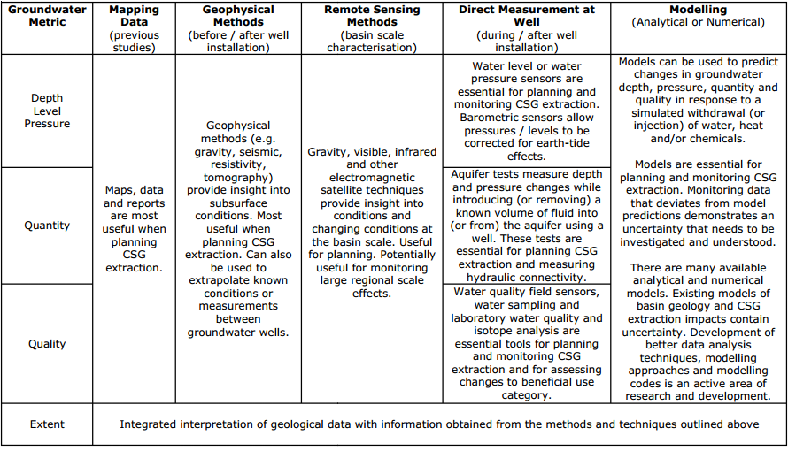

Groundwater vulnerability assessment models
The following methodologies have been developed in the European and US contexts of minimising contamination risks to sensitive groundwater systems and in some cases as a basis for defining spatial controls (zoning) for land use development.
GOD (measuring Groundwater occurrence (including recharge), Overlying lithology rating, and Depth to water rating (Foster, 1987) was one of the earliest indexing methods developed in the UK context. Key components are: ground A result of less than 0.3 is low, 0.3-0.5 moderate, 0.5 high and >0.7 extreme.
DRASTIC is a methodology developed by the US EPA and has been more widely used. It comprises 7 parameters: Depth to groundwater, net recharge, aquifer media, soil media, topography, influence of the vadose zone media, and hydraulic conductivity of the aquifer (Aller et al., 1987). Van Stempvoort et al note there is some overlap between certain criteria. Weights are assigned to each parameter on a scale of 1 to 5 – with depth to water the greatest significance (5) and topography the least (1).
The AVI (Aquifer Vulnerability Index) implicitly considers parameters used by DRASTIC (with the exception of topography and aquifer media). It seeks to estimate hydraulic resistance of aquitards to vertical flow using water well records, according to two parameters: thickness of sedimentary layers (gravel, sand, fractured till clay or shale at 0-5m; 5-10m and >10m from surface, massive till, mixed sand-silt-clay, massive clay or shale) above the shallowest aquifer and b) judge the hydraulic conductivity of each layer.
Regions are then contoured according to relative level of hydraulic resistance (isovulnerability) on a scale of 1 to 5 (extremely low, low, moderate, high and extremely high) which can be understood in terms of what the minimum thickness a particular layer must be to have a” less than extremely high vulnerability to impacts”.
Van Stempvoort et al suggest these can be used to help and thus delineate groundwater protection zones or be used for screening potential land uses. However they also recognise certain limitations: exclusion of aquifer media from assessment criteria is significant, as it influences the rate at which groundwater contamination can spread. Detailed information would be required on boundaries, flow paths and would need to be gathered from studies in-situ or data on major aquifer systems, Other parameters that are omitted are porosity and water content of the porous media, and reactivity of the layers. Each aquifer is assigned the same value, and the model does not seek to measure determinants of aquifer quality.
EPIK – Epikarst, Protective cover, Infiltration conditions and Karstic network development (Doerfliger and Zwahlen, 1998; Doerflinger et al., 1999) have been used to assess groundwater vulnerability in karst areas. For example it has been applied by the Swiss Agency for the Environment, Forests and Landscape as a standard tool for groundwater Protection zone delineation in these areas. It considers development of epikarst, effectiveness of the protective cover, conditions of infiltration and development of the karst network. Again, relative weights are assigned to each component and an equation is used to give an overall value of protection (Abdullahi, 2009).

Pathways and conditions for contamination from high volume hydraulic fracturing (shale gas) – Myers (2012)
In relation to high volume hydraulic fracturing of shale gas in the Marcellus Shale, Myers (2012) seeks to identify potential natural pathways and necessary conditions for contaminants to adversely impact water resources. Travel times of contaminants through bedrock are also estimated based on hydraulic parameters.
Several potential transport scenarios are developed based on pre-development baseline conditions and which are refined once fracturing has commenced:
1 natural upward advective flow from head drop of 30 m from shale to ground surface
2 same conditions as (1) with vertical fracture connecting the surface, simulating flow into alluvial aquifers near stream channels
3 study effect of more extensive fracturing on a regional shale – considering effects on changes in flows and time to reach steady-state equilibrium
4 same conditions as (3) but with vertical fault as in (2)
5 simulate actual injection of 13–15 million litres of fluid over a five–day period, into fractured shale from a horizontal well with and without a fault and potentiometric surface and flux changes.
Potential pathways include advective transport through sedimentary rock, fractures and faults, and abandoned wells or open boreholes. The latter pathway is not considered in his study. Myers (2012) considers actual changes in gradient and potential for buoyancy (created by difference in mass/density of water due to high TDS content) forcing water upwards as factors affecting fluid flow and concludes the potential for contaminants to enter into contact with overlying formations can occur as a result of:
• fracking out of formation,
• the creation of links between fractures in the shale to overlying bedrock, or
• displacing ﬂuids from the shale into the overburden.
In reality the risk of the latter is assessed to be very low, as there is virtually no naturally permeability to allow fluids to move into the overburden except as a result of a poorly completed well, a risk which is outside the scope of the Risk Assessment (see Appendix AA – Matters out of Scope for the Literature Review).

The applicability of different methodologies to conceptualise pathways such as MODFLOW-2000 and dual porosity modelling are reviewed by Myers in light of data availability and knowledge of hydrogeological conditions. Assumptions underpinning modelling in relation to geological characteristics and resource depth are set out.
Myers concludes fracking can alter the shale and overburden hydrogeology, releasing fluids and contaminants from the shale which can also result from injected ﬂuid forcing other ﬂuids out of the shale. High pressure is generated from injection of fluid, which dissipates over distance and time, key estimates of these are provided below:
• •Pressure drops back to pre-injection level within 300 days, suggesting that impacts of fracking extend beyond time at which fracking ceases.
• Potential surface contamination from advective transport could take up to tens of thousands of years however fracking could reduce this to tens or hundreds of years, and shorter lags could be experienced from preferential flow through conductive faults or fracture zones.
• Vertical ﬂow be affected over large areas depending on the density of wells that are developed in region.
A caveat with the analysis is that there is no data to verify either the pre- or post-fracking properties of the shale and hence a number of recommendations are made to improve detection of contaminant transport including mapping of subsurface faults, establishing setbacks between fracking operations and faults, establishing deep and shallow monitoring wells prior to significant resource development occurring.

Modelling regional impacts

Table AD2: Modelling Approaches, Simplifications and Uncertainty Analysis at a Project Level. (Source: Commonwealth of Australia, 2014.)
Coal seam gas Project  /Author | Modelling tool used | Modelling approach  Processes involved | Simplifications/  Assumptions | Uncertainty Analysis
Arrow Energy Surat Gas Project, Australia (Arrow Energy Pty Ltd, 2012) | MODFLOW | Regional groundwater model (120,000 km2 model domain)  Well field represented by individual abstraction wells  Cumulative impacts assessed (including other coal seam gas developments) | Dual-phase and unsaturated flow, geomechanical effects, and dual porosity nature of coal all assumed insignificant  Assessed to be limited groundwater–surface water interaction – simple (non-coupled) approach to groundwater–surface water interaction adopted  Coal horizontal anisotropy not modelled  Coal seams not modelled independently of coal measures  Hydraulic connectivity of geologic structural features ignored  (Hydraulic fracturing not proposed to be undertaken by Arrow, thus its potential impact was not required to be assessed) | Deterministic uncertainty analysis only: Sensitivity analysis for specific aquifer parameters and multiple aquifers. Effect of sensitivity-adopted parameter values on calibration performance discussed  Indicated significance of hydraulic parameters and range of drawdown magnitudes
Australia Pacific LNG  Project, Australia (Australia Pacific LNG, 2010; Geoscience Australia and Habermehl, 2010) | FEFLOW | Regional groundwater  Model (172,740 km2 model domain)  Finite element method  (FEFLOW) allows improved definition of complex geology  Dual-phase flow implicitly accounted for by reducing coal seam permeability  Cumulative impacts assessed (including other coal seam gas developments) | Geomechanical effects, and dual porosity nature of coal all assumed insignificant  Simple (non-coupled) approach to groundwater–surface water interaction adopted  Coal horizontal anisotropy not modelled  Coal seams not modelled independently of coal improved definition of complex geology  Dual-phase flow implicitly accounted for by reducing coal seam permeability  Cumulative impacts assessed (including other coal seam gas developments) | Deterministic uncertainty analysis only: Sensitivity analysis (two extreme cases only) for aquifer, recharge and stream conductance parameters.  Effect of sensitivity-adopted parameter values on calibration performance discussed  Indicated significance of hydraulic parameters and range of drawdown magnitudes
Santos Gladstone LNG Project, Australia (Santos, 2009) | Analytical model (Roma field),  MODFLOW  (Comet Ridge field) | Regional groundwater model  Model domain limited to project area  Time-varying constant head boundary condition used to represent well field (rather than pumping/flow rates) for MODFLOW model;  constant pumping rate used to represent well field in analytical model | Model not calibrated  Dual-phase flow, coal dual porosity and anisotropy, and Geomechanical effects not included  Coal seams not modelled independently of coal measures  Vertical movement of groundwater not well constrained  Aquifer confinement and interconnection simplified  Effects of geological faults assumed insignificant  Analytical modelling did not account for size of well field  Apparently no accounting of groundwater–surface water interaction | Limited deterministic uncertainty analysis:  Sensitivity analysis (four cases) for specific aquifer parameters and recharge for the MODFLOW model, and for storativity for the analytical model  Coal seam gas well fields were modelled separately and cumulative impacts associated with other developments assessed on a qualitative basis
Surat Basin (QGC, 2009) | MODFLOW | Regional groundwater model – coal seam gas region divided into three subdomains (hydraulic compartmentalisation assumed)  Time-varying constant head boundary condition used to represent well field (rather than pumping/flow rates) | Dual-phase flow, coal dual porosity and anisotropy, and geomechanical effects not included  Coal seams not modelled independently of coal measures  No consideration of rainfall recharge  Simplified geology, homogeneous isotropic conditions  Cumulative impacts not assessed  Apparently no accounting of groundwater–surface water interaction | None
Queensland Water Resources (CWC, 2012) | MODFLOW | Regional groundwater model (300,000 km2 model domain) | Modelling of historical coal seam gas operation, included simulation of multiple coal seam gas operations, was used to develop and assess cumulative impacts and aggregate groundwater extraction associated with coal seam gas extraction | Uncertainty analysis was carried out using multiple simulations incorporating changes to the model. The results of this analysis were used to assess uncertainty in the predicted impacts
Namoi Catchment (Schlumberger Water Services, 2012) |  | Regional groundwater model (30,000 km2 model domain)  coal seam gas well fields modelled  using a specified extraction rate over each well field modelled  Cumulative impacts assessed (existing and proposed developments) | Separate model of surface water system  Multi-layered model to address future coal seam gas and coal mine development. Modelling of existing, planned and possible development  Cumulative effects assessed through multiple model analyses by comparing the results for a range of alternate development scenarios with a base case of limited development  Groundwater impacts on surface water obtained using nominated head boundaries to represent permanent  Water courses | Sensitivity analyses carried out to assess uncertainty associated with rock permeability and recharge values adopted
Powder River Basin, Montana, US (Myers, 2009) | MODFLOW | Regional groundwater model  (1240 km2 model domain)  Subregional constant head boundary condition used to represent coal seam gas well field | Dual-phase flow, coal dual porosity and anisotropy not included.  Geomechanical effects assumed to have no impact  Coal seams not modelled independently of coal measures  Cumulative impacts not assessed Implicit (uncoupled) groundwater–surface water interaction | None

Table AD3: Evaluation of modelling approaches. (Source: IESC, 2014b.)
Modelling approach/ purpose | Advantages | Disadvantages | Appropriate application
Analytical | Efficient and simplified analysis of all potential impacts to groundwater resources  Useful when data is limited and/or geological and hydraulic conditions are relatively simple | Unable to capture complex geologic geometries (e.g. non-uniformly layered geology) or hydraulic conditions (e.g. coal anisotropy)  May oversimplify hydraulic processes | Screening or preliminary assessment (particularly where data is severely limited)  Can be a valuable tool for modelling flow in the vicinity of individual wells
Axisymmetric | Useful for modelling relatively symmetric conditions (e.g. in vicinity of coal seam gas wells where geological conditions are axisymmetric) | Not suitable for regional scale assessment  Available tools do not consider gas desorption and migration, dual phase flow or coal dual porosity, which may pose inaccuracies in predicting impacts  Not capable of assessing cumulative impacts | Assessment of impacts in the near-well (or near-field) under axisymmetric conditions  Can be a valuable tool for modelling flow in the vicinity of individual wells
Reservoir assessment | Designed (and therefore best suited) to predict produced water volumes and depressurisation and in the near-field.  Can model near-field produced water re-injection.  Tools do not consider groundwater–surface water interaction  Most tools account for geomechanical processes, gas desorption and migration, dual phase flow and coal dual porosity, as well as complex geological conditions | Reservoir assessment | Assessment of impacts to groundwater (not surface water) in the near-field (but not water quality)  Used for design of coal seam gas well networks
Regional Groundwater Impact Assessment | Tools practicable for regional scale impact assessment  Capable of representing complex geology, assessing cumulative impacts and changes to groundwater quality | Generally ignores geomechanical processes, gas desorption and migration, dual phase flow and coal dual porosity; this may create inaccuracies | Regional-scale assessment of impacts, water quality, re-injection and cumulative impacts

Appendix AE: Methodologies used to assess groundwater vulnerability

Victoria – State Environment Protection Policy
The State Environment Protection Policy (Groundwaters of Victoria) 1997 establishes water quality objectives and indicators based on Total Dissolved Content concentrations for various Beneficial Uses of groundwater as outlined in tables AE1 and AE2 below.

Table AE1: SEPP Beneficial Uses to be Protected and Groundwater Quality Indicators (mg/L of Total Dissolved Solids), (Source: Victorian Government Gazette, 1997).
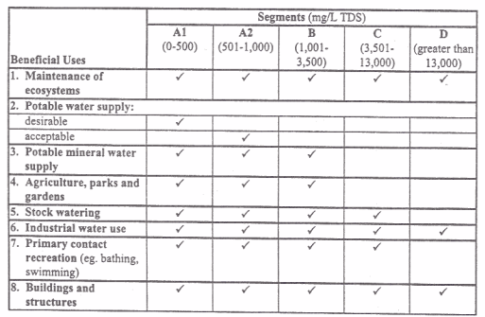

Table AE2: Groundwater quality indicators and objectives by beneficial use. (Source: Victorian Government Gazette, 1997.)
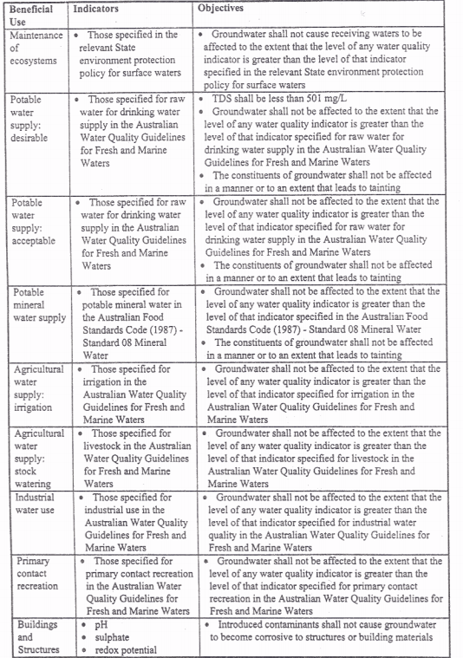

Connecticut’s groundwater classification system
Connecticut’s Water Quality Standards comprise three components:
- Standards, which assign water quality goals, allowable discharges
- Classification and Criteria, which set out water quality classes, designated uses and criteria that must be achieved (chemical or physical levels, or bacterial concentrations)
- Classification maps, illustrating what classification is assigned to specific surface or groundwater assets based on their designated use.
The water quality classification system is comprised of several classes for different types of water resources, including 5 classes for inland surface waters, and 4 classes for ground water (GAA, GA, GB, and GC) – see Table AEAE3.

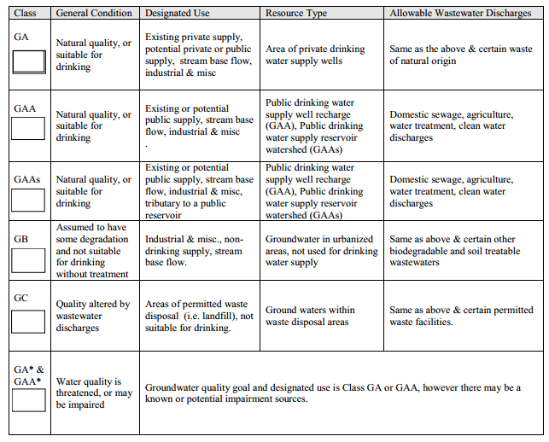
Table AE3: Connecticut’s Groundwater Quality Classes. (Source: Connecticut Environmental Conditions Online, 2010.)

Appendix AF: Controls

Setback distances from sensitive receptors in the US

Table AF1: Setback distances from water resources and private dwellings in various US states. (Source: NYSDEC, 2009.)
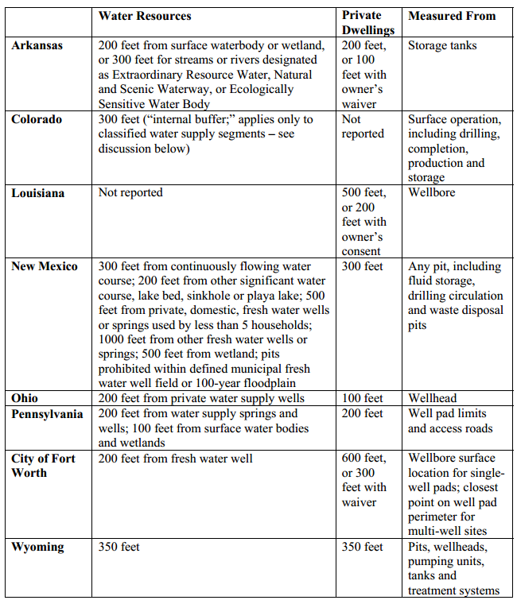

Technical assistance provided to the New York State Department of Environmental Conservation (NYSDEC, 2009) by ICF included a review of setback distances from water resources and private dwellings across several US states – see Table AF1.
The following section transcribes the NYSDEC (2009) proposed setback distances in relation to well drilling and high-volume hydraulic fracturing.
“An application for a permit to drill less than 305 metres from a municipal water supply well be considered "always significant" and requires a site-specific supplemental EIS to assess groundwater hydrology, potential impacts and propose mitigation measures.
Site disturbance for multi-well pads and high-volume hydraulic fracturing be prohibited within 610m of any public (municipal or otherwise) water supply well, reservoirs, natural lake or man-made storage system.
For at least two years the surface disturbance associated with high-volume hydraulic fracturing, including well pad and associated road construction and operation, be prohibited within the boundaries of primary aquifers and outside but within 120 metres of their boundaries.
A site-specific SEQRA review (Environmental Impact Assessment) be required for high-volume hydraulic fracturing projects at any proposed well pad within 120 metres of the boundary of a Principal Aquifer.
It will not issue well permits for high-volume hydraulic fracturing within 120 metres of a private water well or domestic-supply spring, unless waived by the landowner.
The preliminary revised draft SGEIS document (2011) confirmed that irrespective of the intended formation and number/direction of wells to be drilled, site-specific environmental assessments and SEQRA determinations of significance would be required for the following types of HVHF applications:
1 Any proposed high-volume hydraulic fracturing where the top of the target fracture zone is shallower than 610 metres along a part of the proposed length of the wellbore
2 Any proposed high-volume hydraulic fracturing where the top of the target fracture zone at any point along the entire proposed length of the wellbore is less than 305 metres below the base of a known fresh water supply
3 Any proposed well pad within the boundaries of a principal aquifer, or outside but within 150 metres of the boundaries of a principal aquifer
4 Any proposed well pad within 45 metres of a perennial or intermittent stream that is not a tributary to a public drinking water supply, storm drain, lake or pond
5 A proposed surface water withdrawal that is found not to be consistent with the Department’s preferred passby flow methodology
6 Any proposed well location within 305 metres of New York City Department of Environmental Protection’s subsurface water supply infrastructure.”

Principles for mitigating coal seam gas impacts
The National Harmonised Regulatory Framework sets out 18 principles for managing potential coal seam gas impacts across the lifecycle of a typical development. Most of these practices would address risks to more than one of the four areas of concern: well integrity, water management, hydraulic fracturing and chemical use. See Table AF2 below for further details.

Table AF2: Leading practices to mitigate potential impacts from coal seam gas.
(Source: SCER, 2013.)
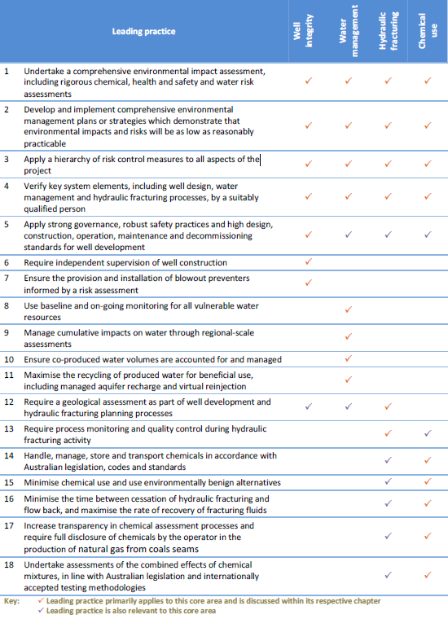

Appendix AG: Consequence

Principles to define significant impact – National Partnership Agreement
According to the National Partnership Agreement, a significant impact on water resources is caused by an action (or the effect of several actions) – that would directly or indirectly:
• result in substantial change in the quantity, quality or flow regimes of surface water or groundwater
• substantially alter groundwater pressure and/or watertable levels
• alter the ecological character of a wetland that is state or nationally significant or Ramsar-listed
• divert or impound rivers or creeks or substantially alter drainage patterns
• reduce biological diversity or change species composition or ecosystem processes
• alter coastal processes and inland processes, including sediment movement or accretion, or water circulation patterns
• result in persistent organic chemicals, heavy metals or other potentially harmful chemicals accumulating in the environment such that biodiversity, ecological integrity, human health or other community and economic use may be adversely affected, or
• substantially increase demand for – or reduce the availability of water for – human consumption or ecosystem services.

Figure AG1: Ecological Valuation and Risk Assessment process. (Source: NSW Office of Water, 2012.)

NSW aquifer interference policy: Minimal impact considerations for aquifer interference activities
The following tables sourced from the NSW Aquifer Interference Policy provide quantitative thresholds against key water characteristics (level, pressure, quality) for highly productive and less productive groundwater resources (refer to ‘Receptors’ section in body of the Literature Review for a definition of these) in different groundwater systems.
Note that individual criteria have been established for the Great Artesian Basin groundwater sources on the basis of its particular hydrogeology and management profile.

Table AG1: Minimal impact considerations for watertable, pressure and quality thresholds by category of highly productive groundwater sources (alluvial, coastal sands, porous rock, fractured rock and Great Artesian Basin). (Source: NSW Office of Water, 2012.)
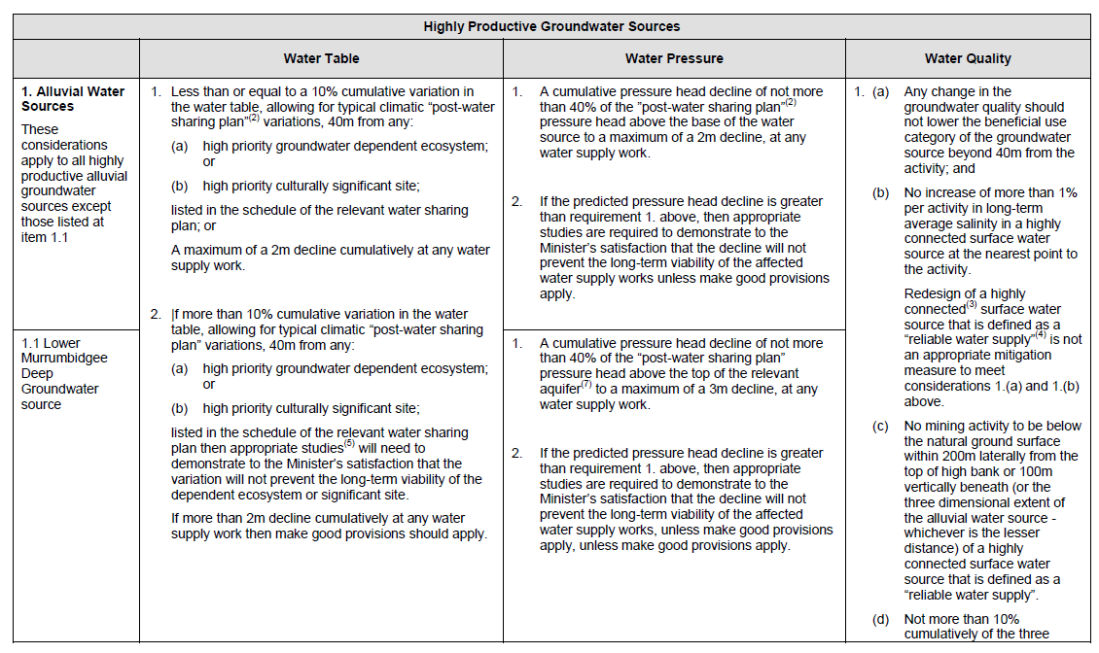
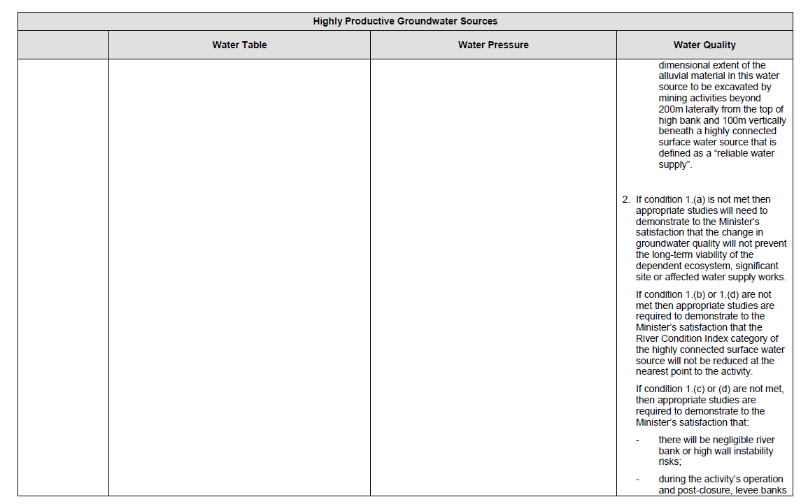
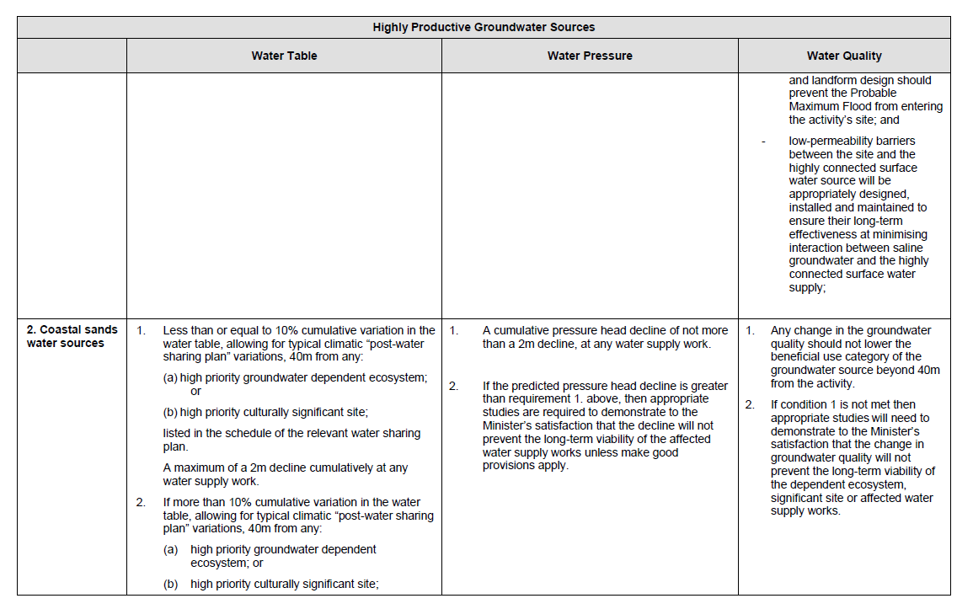
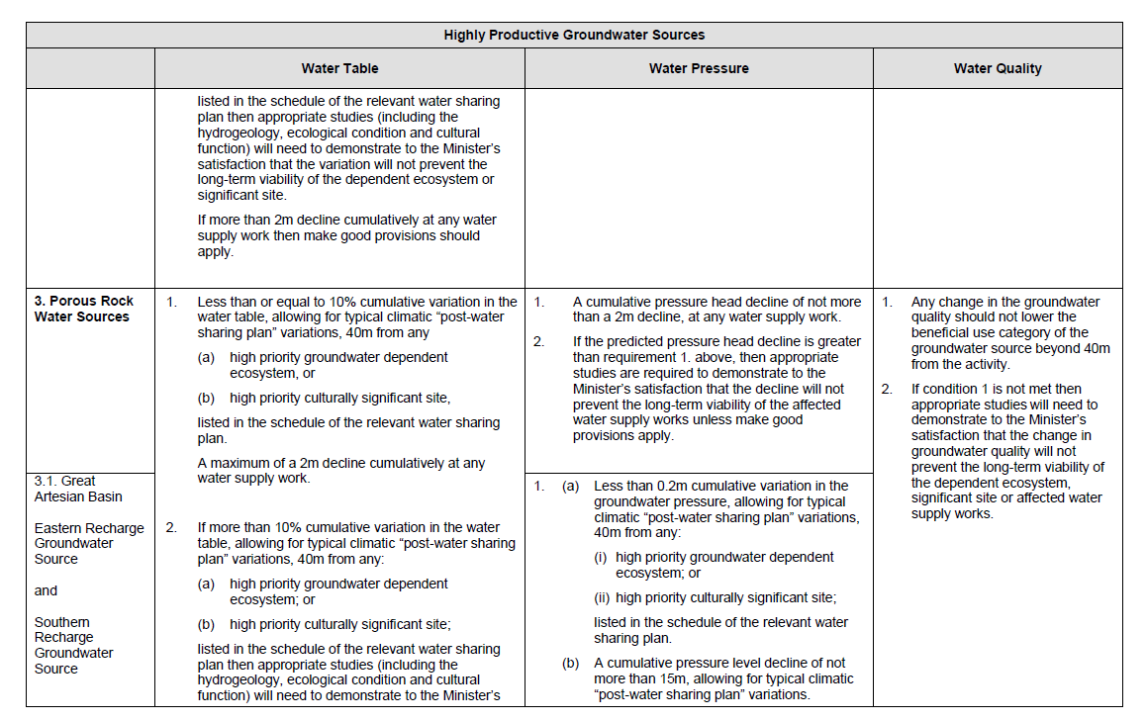
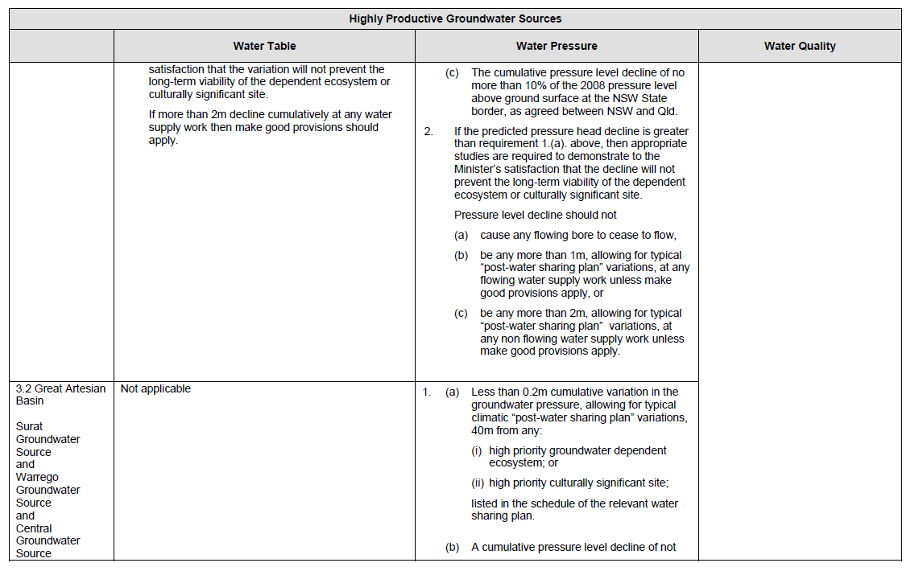
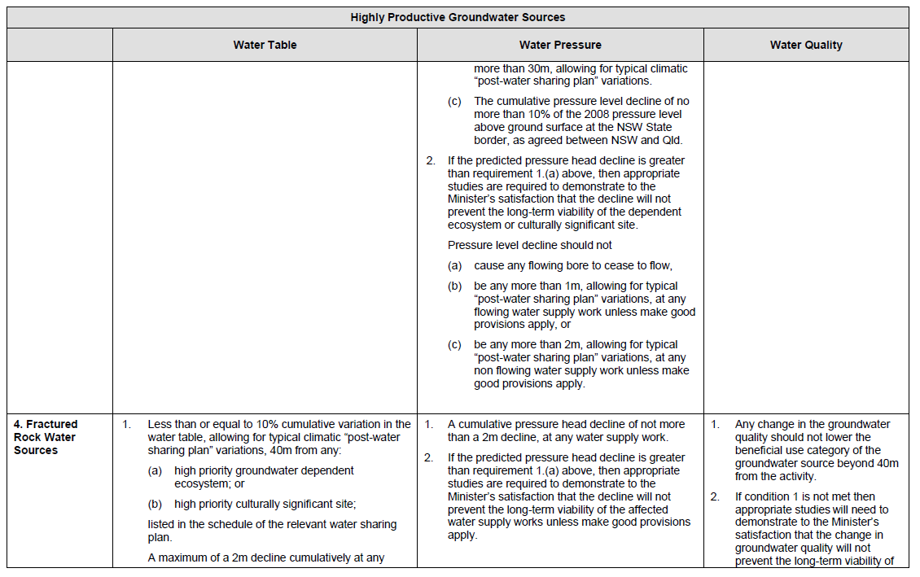
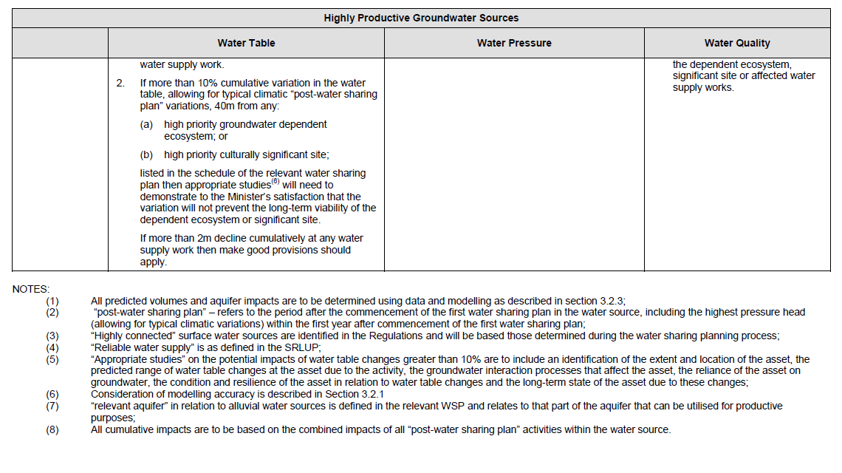

Table AG2: Minimal impact considerations for watertable, pressure and quality thresholds by category of less productive groundwater sources (alluvial, porous rock, fractured rock). (Source: NSW Office of Water, 2012.)
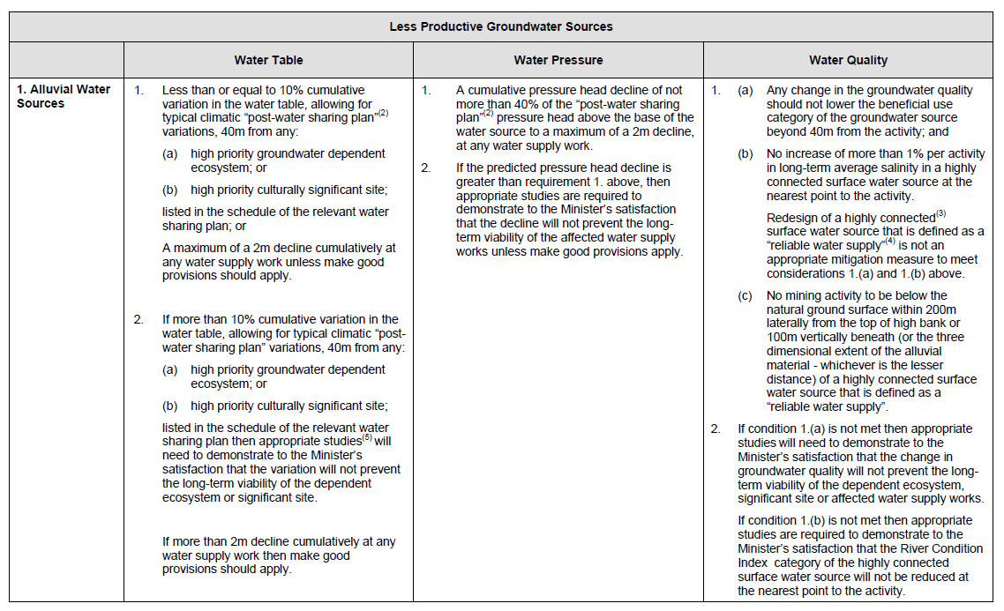
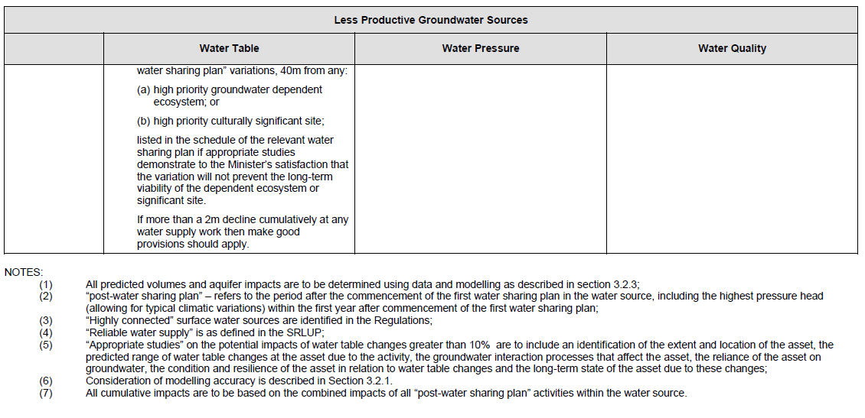

DMITRE (2013) Manageability and predictability criteria as determinants of environmental significance.
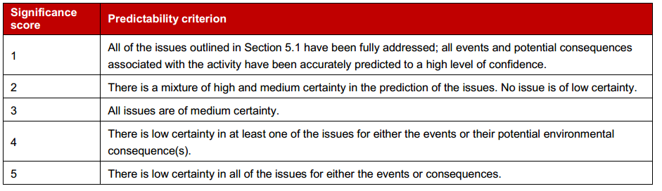
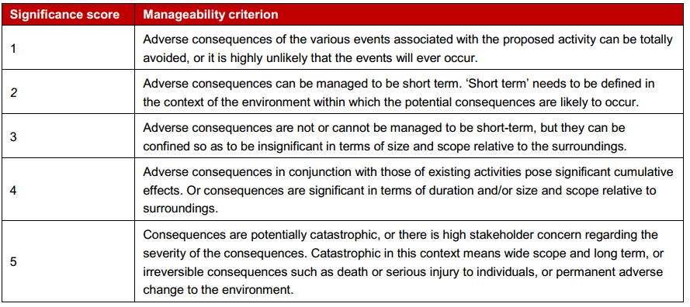
Figure AG3: Guidance to determine manageability score (source: DMITRE, 2013)

Tools to inform impact analysis IESC (2014)
IESC (2014) outlines that impact analysis should draw on conceptual models, analysis of thresholds, carrying capacity and ecotoxicology, numerical modelling of direct impacts, and numerical and conceptual modelling of pathways to assess indirect and cumulative effects.
• Direct impacts should be assessed using satellites and ground movements from Geodetic GPS systems, such as InSAR.
• Indirect impacts should be considered through impact pathways, via model functions which quantitatively link influence of direct impact on indirect impacts of each receptor. Confidence in determined impact level can be assessed through an impact analysis model.

Table AG4: Qualitative risk matrix example (Source: ACOLA, 2013).
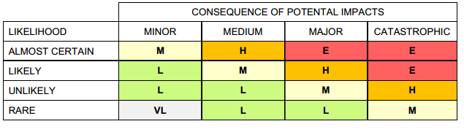

Appendix B:
Otway region assessment method
B1 Introduction 165
B2 Hazard/pathway/receptor model 167
B2.1 Hazard 167
B2.2 Pathway 168
B2.3 Receptors 168
B3 Aquifer depressurisation 170
B3.1 Introduction 170
B2.2 Block model approach for predicting drawdown 171
B2.3 Block model layout, aquifers and hydraulic properties 171
B2.4 Hydraulic properties 175
B2.5 Gas development representation 178
B2.6 Initial conditions 178
B2.7 Boundary conditions 178
B2.8 Other inputs 179
B3 Chemical contamination of groundwater from hydraulic fracturing fluids 184
B4 Induced seismicity 185
B5 Land subsidence 185
B6 References 186
Appendix BA: Hydraulic parameters 187
Appendix BB: Parameters for block model structure 188

B1 Introduction
This report describes the method used for the impact assessments of possible future onshore gas developments in the Otway region. The impact assessment framework was informed by a literature review on approaches to risk and impact assessments for onshore gas development, which is presented in Appendix A of the main report.
The approach taken considers current data, limitations on the data, the limited knowledge about the extent of natural gas resources in these regions, and that the purpose of the studies is to inform consideration of government policy not for individual development proposals.
A key basis for the impact assessment is that existing regulations and guidelines (based on leading practices) are applied, which ensure that operational risks are manageable. The assessment therefore conveys impact of a gas development activity that is established and operated in accordance with current regulations. The impact on water resources will be assessed based on normal operations. This project is not considering potential impacts associated with failures of process or controls, such as poor well integrity.
The impact assessment has considered potential future development of the following onshore natural gas in the Otway region:
• tight gas
• shale gas
• coal seam gas (from black coal deposits)
• conventional gas.
Impact was assessed individually for each of these gas types. Figures showing the extent of the gas development scenarios are given in Figure B1 to B4. Further detail on the gas development scenarios is included in the conceptual model description in Chapter 2 of the main report.
Each gas scenario in the Otway region was described by Goldie Divko (2015). These gas source locations were generated specifically for this risk assessment and were based on the professional judgment of the geologist of the Geological Survey of Victoria.
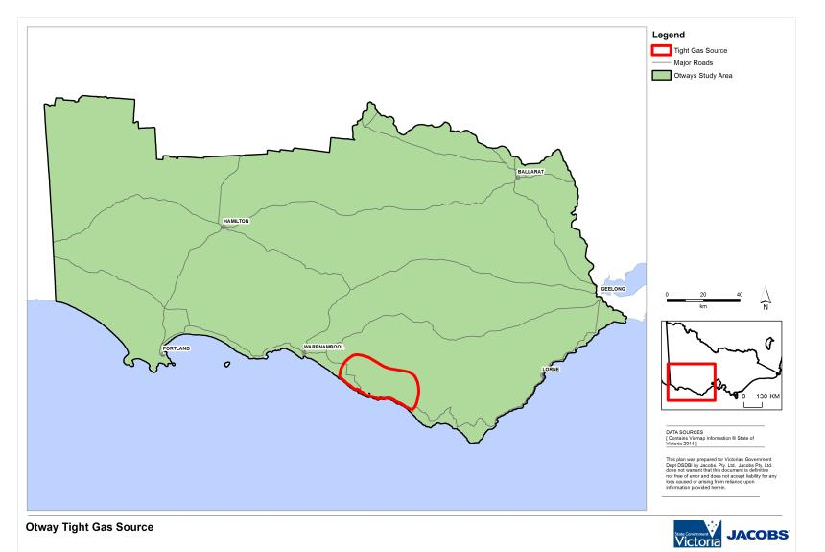
Figure B1: Extent of potential tight gas in the Otway region. (Source: Goldie Divko, 2015.)

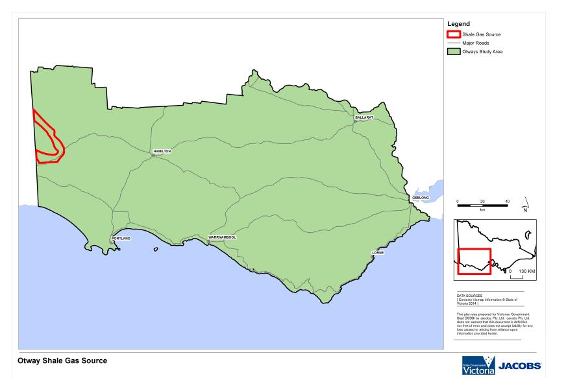
Figure B2: Extent of potential shale gas in the Otway region. (Source: Goldie Divko, 2015.)
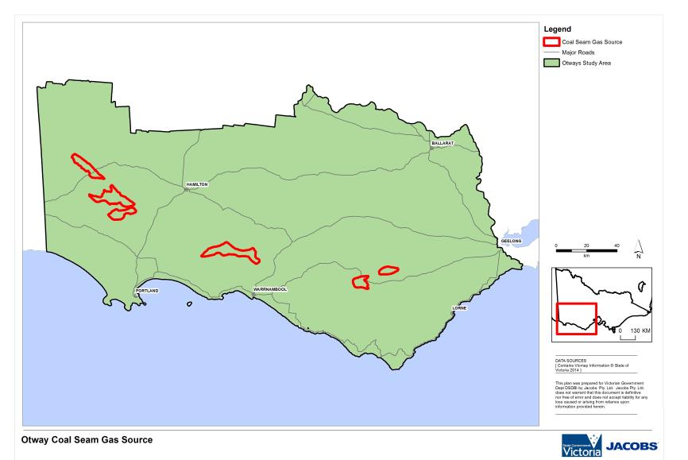
Figure B3: Extent of potential coal seam gas (black coal) in the Otway region. (Source: Goldie Divko, 2015.)

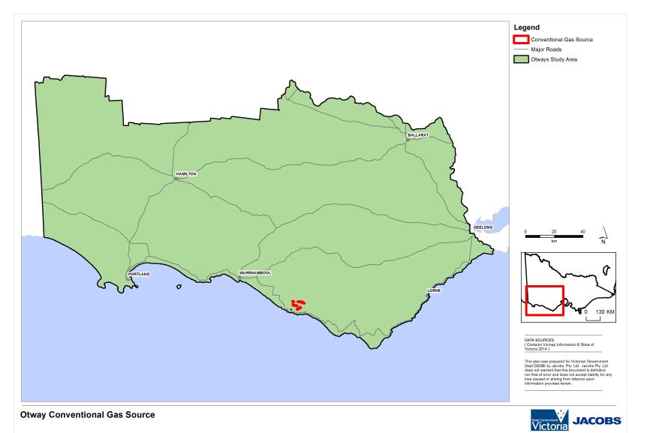
Figure B4: Extent of potential conventional gas in the Otway region. (Source: Goldie Divko, 2015.)

B2 Hazard/pathway/receptor model
The impact assessment framework is based on the hazard/pathway/receptor model to assess the impact on receptors (water resources) resulting from possible future onshore gas development. For impact to exist all three components need to be present: a hazard; a receptor that could potentially be adversely impacted; and a pathway to link the two.

B2.1 Hazard
Four key hazards for water resources have been assessed in the Gippsland region:
1 aquifer depressurisation
2 chemical contamination of groundwater from hydraulic fracturing fluids
3 induced seismicity
4 land subsidence.
Depressurisation of aquifers associated with onshore gas development is the key hazard assessed in this impact assessment. For the development scenarios, numerical modelling was undertaken to assess aquifer depressurisation and resulting drawdown, which then feeds into the impact assessment. The modelling method is described in Chapter B3.
While changes in aquifer pressure are also associated with hydraulic fracturing, induced seismicity and land subsidence, these hazards have multiple causes (i.e. well failure and re-injection of coproduced water) that are more appropriately assessed within the project-specific approvals process. Due to the broad context of this study, the assessment of causes of potential impacts associated with these hazards have been based on a review of international literature review rather than a modelling approach.

B2.2 Pathway
The hazards associated with gas extraction arise largely because of the possibility that altered fluid pore pressure in a gas source formation which may be transmitted to overlying (or underlying) aquifers or aquitards. The impact pathway is determined by the potential for pressure reductions in the gas source formation to propagate through the adjacent hydrogeological units and cause drawdown in overlying or underlying aquifer(s). For drawdown to adversely impact receptors, it must occur in the aquifer that supports the receptor. This means that a surface water receptor can be impacted only if there is a pathway that allows drawdown to propagate from the gas source to the watertable aquifer.
A hydrogeological conceptual model was produced in order to understand the hydrogeological pathways that have the potential to connect possible gas developments with overlying water resources. The hydrogeological conceptual model outlines:
• stratigraphy and gas source formations for onshore gas extraction, key usable aquifers in the basin and significant groundwater dependent assets (receptors)
• potential hydrogeological pathways between the source and the receptors
• potential low permeability layers between the source and the receptors
• aquifer parameters (e.g. K_{h}, S and K_{v}).
The hydrogeological conceptual model informs the impact assessment approaches and is presented in Chapter 2 of the main report.

B2.3 Receptors
This assessment considers the potential impacts of onshore gas development in three types of water resources, or receptors:
• aquifers (which support groundwater users)
• rivers (which support surface water users and ecosystems)
• water bodies (wetlands and lakes which support surface water users and ecosystems).
The water resources included in the impact assessment are identified by the following attributes:
• surface water assets (rivers and water bodies) as listed in the Victorian Water Assets Database (VWAD)
• aquifers as defined in the Victorian Aquifer Framework (VAF) and incorporated into the DEPI SAFE scheme with a mapped salinity less than 3500 mg/L.
The surface water resources assessed in this assessment are shown in Figure B5. These assets have been generated using the Victorian Water Assets Database, which is a geospatial database of water asset features that has attributes disaggregated from the Water Asset Identification Project database (GHD, 2014). The surface water resources shown in Figure B3 includes all rivers and creeks but exclude those classified as irrigation channels, drains, structures or farm dams.
For the purposes of this study, the impacts to springs are not specifically assessed. Rather, it is assumed that wherever the potential impact for surface water assets and the watertable is high, the potential impact to springs is also high.
Terrestrial vegetation has also been excluded as dependence on groundwater is highly variable and site specific. Assessment of potential impacts on terrestrial vegetation would need to be completed as part of an individual development proposal.
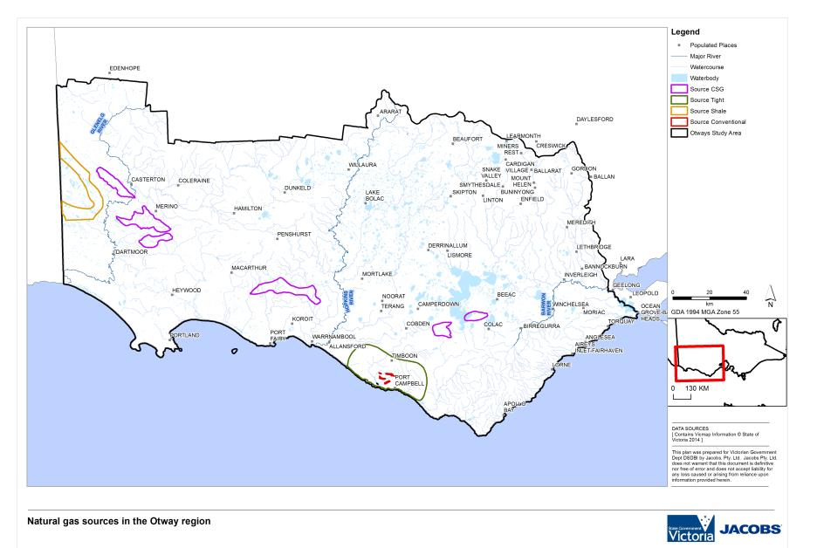
Figure B5: Otway region potential onshore gas development locations and surface water resources.

B3 Aquifer depressurisation

B3.1 Introduction
Aquifer depressurisation can affect water resources by changing the groundwater level in aquifers adjacent to the water resources. In turn this change in level may affect the flow rate of water or the contribution of groundwater to surface water or the overall availability of groundwater. This section discusses the approach that has been taken to estimating and evaluating changes in groundwater level. In the case of groundwater resources, an impact can occur as a result of changing the pressure surface (or groundwater level) within the aquifer itself.
A water level change outside of a gas source formation can only occur if water moves from the aquifers into the gas source formation. This movement would in turn be driven by pressure reduction in the source formation by gas (and any co-produced water) extraction. A change in water level in aquifers is normally expressed as drawdown, or a change in the pressure level in an aquifer. In confined aquifers, the pressure change is usually converted to a water elevation and the change in water elevation then is expressed as drawdown. For example, in the watertable aquifer, the drawdown would be expressed as the drop in the level of the watertable, in metres. To assess the impact of gas development on water resources it is necessary to assess both the initial watertable elevation and depth to watertable, then combine these with the potential drawdown that may result from gas development.
For the impact assessment approach the depth to watertable that was adopted is the published map for the whole of Victoria, developed by DEWLP and gridded across the state at 100m grid cells. This data set was adopted because:
• it is uniformly available across the Otway region
• it has been developed and approved for use in water resource assessment by the DELWP
• it is consistent with other policy assessments undertaken by DELWP
• uncertainty in the data set is considered to be acceptable for this policy level impact assessment.
For an estimate of drawdown, no existing drawdown data set (i.e. from a numerical model) was identified that was suitable and considered the development of onshore gas. A specific assessment was required for this study. When the impact assessment report was initially commissioned it was possible that a numerical groundwater model may have been developed for the Otway region, similar to that developed for the Gippsland region.
The development of a regional numerical model requires significant effort to obtain relevant information and in model development. The information currently available of the properties of potential natural gas resources is poor particularly in the onshore Otway basin. While a numerical model was developed for the Gippsland region, a more pragmatic approach was taken for the Otway region.
The drawdown assessment that was developed needed to meet the following criteria:
• each onshore gas source should have an estimate of drawdown
• only existing data could be used
• the level of assessment was to support a policy level analysis
• it needed to be completed in the available time
• it needed to provide drawdown for all aquifers present at given locations
• no information on drawdown or water extraction rate was available for the Otway region at the commencement of the assessment, so the approach had to use broad scale understanding of gas source effects.

The drawdown approach that was developed for the Otway region was called the ‘block model’ approach. Once drawdown data were developed, they were classified into the effect categories (minor, moderate and significant). These categories were delineated differently for each receptor, since tolerance to changes in watertable depth varies for different receptors. This is described in the main body of the report.

B2.2 Block model approach for predicting drawdown
This section describes the block model approach used to estimate drawdown in the Otway region. As mentioned above in the introduction, this approach was developed to meet the need for a pragmatic assessment at a policy level of analysis in a very short timeframe (under a month). As a result the approach is necessarily simplified and there are a number of assumptions built into the assessment. During the course of the assessments the sensitivity of the block model approach was tested to a limited extent and this is described in later sections.
The fundamental principal of the block model approach is one of assessing the impact of gas development on groundwater in isolation of other potential effects. In hydrogeology this is the basis of the principal of superposition. The founding basis of the block model assessment is that it attempts to describe the impact on groundwater of gas development alone. This impact would need to be then added to other aquifer trends or effects to describe the cumulative or total effect. For example, the block model approach provides an estimate of drawdown due to gas development. In the real aquifer, regional groundwater pumping may result in drawdown. To find the cumulative effect on the aquifer, the regional drawdown needs to be added to the block model approach estimate. This would need information to model effects such as the possible alteration to recharge from surface water and rainfall effects, requiring a significantly detailed modelling approach. As noted previously this was a pragmatic simplification given the available data in particular the hypothetical nature of any development scenarios. Future modelling of Otway region could address cumulative impacts when better information on aquifer and aquitard properties relevant to the location and depth of a potential exploration or development is known. This approach is different to that taken with the Gippsland regional model, which does consider the cumulative impacts in the model, but then isolates the gas derived impacts for the assessment. The block model approach estimates the drawdown from gas development alone.
The results have been compared with drawdown results for other studies and with the drawdown results predicted by the Gippsland numerical model. These comparisons are described later and they give some assurance that the model is reasonable, noting that the block model is not calibrated.
The approach to defining the parameters for the model is described in detail in the following sections. Where published data were available, these data have been used. In most cases the data adopted were in the mid-point of the range of values. In some cases (for example, vertical hydraulic conductivity), the values chosen were towards the upper end of the range of likely values. In this way the results of the block model approach are considered to be towards the upper end of likely values. The results are not the extreme worst case. It is possible to identify unlikely and extreme sets of values that would result in greater drawdown effect than has been produced by this approach. The intent of this model was to develop estimates that are towards the upper end of the likely range of drawdown to test this in the impact assessment to see if the results were acceptable. The impact assessment approach and results are presented in the main body of the report.

B2.3 Block model layout, aquifers and hydraulic properties
Across each gas source a series of regular 10 × 10 km areas were defined that encapsulated each gas source extent. These blocks were selected to facilitate an approach to estimating drawdown. These 10 × 10 km areas are referred to as “calculation blocks” and were based on a regular grid that covers the Otway region. In the block model the calculation blocks are taken to be the extent of the model domain. The scale of 10 × 10 km was chosen because this is a convenient multiple of the scale of the depth to watertable data that were used in the impact assessment and it gave a suitable number of blocks for which the calculations could be done across the region.
For each calculation block, spatial data on the elevation of the top and bottom of each aquifer and aquitard were obtained from the Victorian Aquifer Framework (VAF). The framework layers and how they were developed are described in GHD (2012).
Each calculation block has the same essential layer structure. Each block model has six active layer groups that represent the main aquifers and aquitards. Where an aquifer or aquitard is not present within a calculation block area it is assigned a nominal minimum thickness in the block model (1 m). In this way the block models all have the same structure. Where an aquifer or aquitard is not present in a block model area, although there is a nominal thickness in the model, no drawdown results are presented for that aquifer.
Within each calculation block the top and bottom of each aquifer is flat (horizontal), and is set at the average elevation of each Victorian Aquifer Framework layer across the calculation block. For the watertable layer a composite layer was developed that represented the dominant watertable layer in the calculation block. Dominance for this purpose was defined as the watertable layer that covered the greatest proportion of the calculation block. This means that, in effect, the watertable aquifer in the block model is a merged upper layer that represents the watertable, but may actually be a number of different hydrogeological units. As this approach is intended to be simple and preliminary, this was considered an adequate representation for estimating watertable drawdown. The average thickness of the dominant unit was used to define the watertable layer thickness.
The calculation block was then incorporated into a simple layered numerical groundwater model, using MODFLOW as the modelling code. Each aquifer is represented by a single model layer and each aquitard was represented by three model layers in the calculation block. Within the model the aquitards are represented as layers between the aquifers (Figure B6). In some cases multiple aquitards have been conceptually grouped together to form a single separating aquitard. In particular the sediments and rocks below the lower aquifer and down to the top of the gas source are considered as a single aquitard for the purposes of estimating drawdown. The tops and bottoms of each of the layers in each calculation block are given in Appendix C in the main report. The locations and identifying code of the calculation cells are given in Figure B7 to Figure B10.
For each block model drawdown results for use in the impact assessment were taken from the central grid cell in the layer for the relevant aquifer unit. This drawdown was then taken to represent the regional drawdown across the whole 10 × 10 km calculation block.

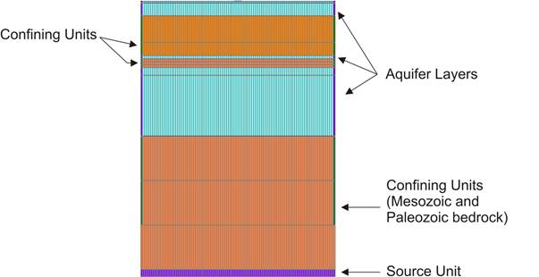
Figure B6: Example of the layered block model for the block model approach.

Figure B7: Location and number of calculation blocks for the Otway region tight gas scenario.

Figure B8: Location and number of calculation blocks for the Otway region shale gas scenario.

Figure B9: Location and number of calculation blocks for the Otway region coal seam gas (black coal) scenario.

Figure B10: Location and number of calculation blocks for the region Otway conventional gas scenario.

B2.4 Hydraulic properties
Hydraulic properties of the aquifers and aquitards have been taken directly from literature sources for the Otway region. Attachment 1 gives a summary of hydraulic properties for the Otway region from a study by Bush (2009). Aquifer values in the mid-point of the reported range were chosen for hydraulic conductivity. This means that the hydraulic conductivity of the aquifer should be considered as a representative value. It is neither the maximum or minimum value. Because the thickness of the aquifers within the different calculation blocks varies across most of the gas sources, the effective transmissivity that is used in the block models does vary across most gas sources and thus a range of transmissivity values are used for assessment. There is only one transmissivity for each aquifer within a calculation block. Blocks with thinner aquifers have lower end transmissivity and thicker blocks have higher transmissivity. In this way the overall drawdown results show (in some way) the sensitivity to changes in transmissivity across the area.
As described in the introduction the block model is not calibrated. Middle of the range literature figures have been used directly for the prediction of drawdown. The justification for this approach is that the block models were developed in a very short time frame and are intended to provide a screening level, or policy level assessment, based on reasonable data for the area. So the use of relevant literature data for the hydraulic properties for the region is entirely consistent and in keeping with a screening and policy level approach to the impact assessment.
Hydraulic conductivity and storage values for the major aquifers and aquitards have been adopted from Bush (2009). One of the key hydraulic values that influence the end drawdown calculated is the vertical permeability of the aquitard (or seal rocks) that underlies the lowermost aquifer, between that aquifer and the gas source.
Relatively little information is available on the water permeability of the gas seal rocks in the Otway region, although Cook (2014) provides gas entry permeability values for the source rocks. Typically the seal rocks (which are for this study the relevant aquitard) is a shale or fine grained rock. There are usually a number of different geological formations that are encapsulated in the single conceptual aquitard and these can vary in hydraulic properties and in the degree of consolidation. In all the published studies identified as part of the water science studies, the permeability of this layer has not been the subject of detailed examination.
Groundwater studies, such as Bush (2009), have conceptualised the Belfast Mudstone and similar units in the lower Sherbrook Group as effectively impermeable basement from a water resources perspective. There are no groundwater management studies of the aquifers in the Otway region that consider the permeability of this lower unit as being of any significance. This is consistent with a strictly water resources view of the aquifer. Similarly, the oil and gas studies of the area have considered the Sherbrook group to be an effective seal for the movement of hydrocarbons and, by implication, water. Formation fluids have not been seen to mingle. So for the block model by allowing for permeability and leakage through these layers we have taken an approach that adopts a much greater likelihood of drawdown impact than essentially all of the gas or water studies in the area to date. It is routine for groundwater studies in this area to allow for no deeper leakage. This is despite the development of conventional on shore gas fields in the Otway region in the past.
Petroleum specialists tend to focus on the permeability of reservoirs and gas entry pressure for seal rocks (for example, Cook 2014 and Goldie-Divko 2010). A recent and comprehensive study of aquifer and aquitard connectivity has been published by the IESC (IESC, 2014b). This study provides a range of estimates for aquitard vertical permeability. The range of K_{v} is from 10⁻³ m/day to 10⁻⁷ m/day. Comparing the geology of the Otway region with the published values a vertical permeability of 1x10⁻⁵ m/day for the aquitard above the gas source has been adopted for this impact assessment. The choice of this parameter is further supported by the observations and modelled vertical permeability values used for the Walloon Coal measures in Queensland (QGC, 2013). The aquitards in Queensland are shallower and less well compacted compared with the seal units in the Otway and vertical permeability in the Surat Basin (Queensland) is commonly around 10⁻⁶ m/day or smaller. Figure B11 demonstrates the range of K_{v} results that have been determined for rocks in Queensland. By inference by comparison of rock types it would be expected that the vertical permeability in the Otway region would be less than that found in Queensland. By adopting a vertical permeability that is near the upper end of the range as described it is considered that the drawdown impact provided by the block model will be similarly toward the upper end of the range of likely values. Without field evidence for the Otway region this remains to be proven. Collection of this information from the field would be very valuable to help assess drawdown impact.
Table B1 provides the hydraulic parameters that have been used for the block model for the Otway region. Vertical hydraulic conductivity has an impact on the nature of the drawdown predicted. In the conceptualization of the block model, the gas source is at the base of the model and lowered pressure in the gas source then induces leakage which works its way up through the aquifer sequence. One parameter that determines the rate of migration of drawdown is vertical conductivity of the aquitards between the aquifers. Higher vertical hydraulic conductivity allows water to more readily leak between the aquifer layers and will tend to lead to a drawdown effect at the watertable sooner, all else being equal. Lower vertical hydraulic conductivity will have the effect of accentuating the drawdown in the lower aquifers (close to the gas source) as water can drain at a lesser rate.
In groundwater studies across Victoria conventional practice is to adopt vertical hydraulic conductivity of one tenth (0.1) of the horizontal hydraulic conductivity. This was the starting point for vertical hydraulic conductivity in the Gippsland region model.
For the block model approach the watertable aquifer has the most sensitive impact criteria. Deeper aquifers have larger thresholds for high impact. So a small drawdown in the watertable would provide a higher impact result. In order to ensure that the effect on the watertable was not understated the ratio of vertical to horizontal conductivity was chosen to allow a higher end range of vertical leakage. It was considered to be unrealistic to adopt a regional K_{v} to K_{h} ratio of 1. Whilst 0.1 would have been in keeping with the commonly adopted values, for this study a ratio of 0.6 was adopted, based in part on laboratory permeability testing reported in Cook (2014) that relates to the gas source rocks. The purpose of this higher ratio was (as stated before) to ensure that the watertable effect was at the higher end. This does have the consequence that the drawdown in deeper layers may be slightly understated, but these layers are much less sensitive to drawdown (as defined in this study) than the watertable.
In the block model approach, aquifer storage was also included in the model. For confined aquifers the aquifer storage is calculated by the modelling software from a specific storage of 5 x 10⁻⁶. In the watertable the aquifer storage is set at 0.1. As with the other aquifer parameters, changes in storage will change the calculated drawdown. Higher storage values will lower the drawdown estimate and smaller storage values will lead to higher drawdown.
The value of specific storage that has been chosen that is close to the compressibility of water with only a very small allowance for compressibility of the aquifer material. It is expected that most of the aquitards in the sequence would have higher compressibility than this value. For example, the major regional aquifer, the Gellibrand Marl, is a plastic clay which is expected to have higher storage values. This storage value will have the effect of magnifying the drawdown compared with a higher specific storage value that might be justified on the basis of the material properties only.
During the development of the block model approach, the sensitivity of the drawdown results to changes in hydraulic parameters was tested and evaluated. This provided insight into the change in the results that might come from changes to the inputs. This analysis did not identify any particular model sensitivity to the chosen parameter ranges. Whilst the calculated drawdown did vary with changes in input parameters no significant discontinuities or high change results were identified when testing the parameters over several orders of magnitude.

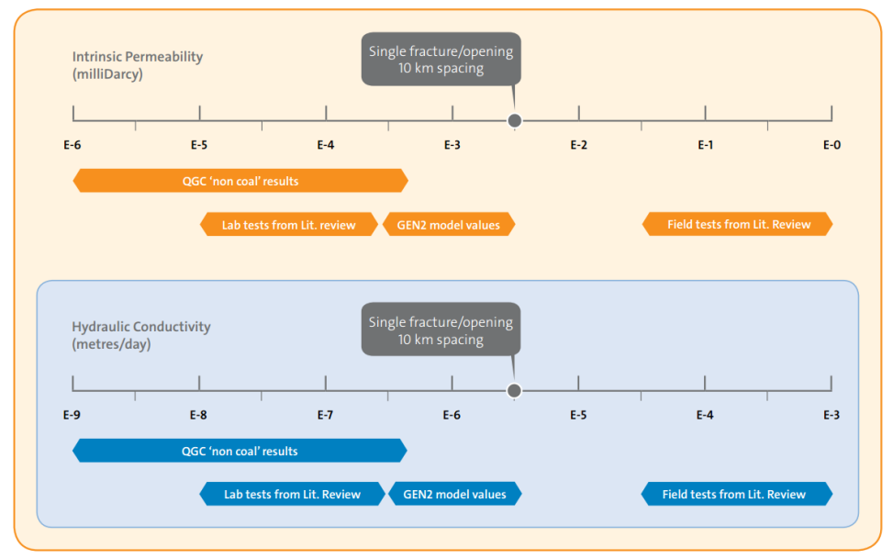
Figure B11: Range of K_{v} values for Surat Basin (Queensland) Coal Seal gas aquitards. (Source: QGC, 2013.)
Note: For this study the relevant range of results of relevance are those marked ‘QGC non-coal results’ and ‘GEN2 model values’ as these represent units in stratigraphically similar settings.

Table B1: Hydraulic parameters for the used for the Otway regional impact assessment block model approach to estimate drawdown.
Victorian Aquifer Framework Layer | K_{h} m/day | K_{v} m/day
100, 101, 104 | 9.9 | 5.9
107 | 3.8 | 2.3
108 | 0.008 | 0.005
109 | 10.5 | 6.3
110/111 | 11.3 | 6.8
113-114  (gas source layer) | 1.6x10⁻⁵ | 1x10⁻⁵

The vertical hydraulic conductivity of the gas source aquitard was identified as important during sensitivity assessment. Permeability in the range of 10^{–4} or greater resulted in significant increases in calculated drawdown at the watertable. This effect is driven by the extreme drawdown level adopted in the gas source. Given that the vertical permeability is at the upper end of the expected range and that the gas source drawdown is similarly at the upper end, the drawdown impact calculated is considered to be towards the upper end of what would be anticipated and is not unduly sensitive to parameter choice.
In addition the storage value adopted for the aquifer and aquitard sequence influences the calculated drawdown. Storage values have been adopted that are in line with commonly used in groundwater models. This is the specific storage at a level close to the compressibility of water. If the effective porosity of an aquitard is very low then the resultant storage may be lower than has been adopted. This would have the effect of increasing the drawdown calculated at 30 years. In order for the storage to be lower than has been adopted, the aquitard would need to be a very tight and solid block with very low porosity, which in turn would have very low connection. If this were the case then the conductivity would be expected to also be low. The chosen storage is considered appropriate. Changes to storage values would affect the final calculated drawdown. The effect on the calculation has been shown to be modest in the sensitivity assessment.

B2.5 Gas development representation
The block model approach was developed to make use of available data and information. Almost no information is available on the likely hydraulic pressure effect of future onshore gas development. From published data for conventional gas developments in the Otway Region (Cook 2014) a pressure decline is expected within the gas source. For coal seam gas developments the target pressure level for groundwater is typically the top of the coal seam. For tight and shale gas it appears to be highly variable. The Geological Survey of Victoria has considered the likely water effects and has advised that the rate of water removal is likely to be very low (Goldie Divko, pers. comm, 2014).
For this study a representation of the gas development effects on hydraulic pressure was needed that would not understate the effect and thus should provide an upper end of the likely impact. For the block model approach it has been assumed that gas development would result in an instant lowering of groundwater pressure within the gas source across the entire calculation block. The level of lowering would be to the elevation of the top of the gas source. This level would then remain for 30 years. This is an extreme simulation of the pressure response. In reality, a development would expand over time and would not be instant. Also, for most gas types there is unlikely to be a target drawdown, so the holding of pressure at the top of the gas source bed will be an overstatement of the effect.
The hydraulic impact of the gas source is represented as a fixed elevation of the groundwater head in the gas source layer (fixed head boundary condition). The head applies across all cells in the gas source layer. In this way it is not required to specify a volume of withdrawal from the gas source, the block model calculates the leakage in response and this is assumed to be withdrawn as co-produced water. There is no restriction on the amount of co-produced water that can be withdrawn in the model. This is also an unlikely as it is likely to be uneconomic to develop gas sources with high rates of co-produced water. This high water impact in the gas source is considered to be appropriate for this study as it will have the effect of not underestimating the effect of gas development and will tend to produce drawdown effects that are toward the upper end of the likely amount.

B2.6 Initial conditions
In each model block the initial conditions were set with heads in all layers at the same level, being the top of the uppermost layer (water table). This is considered an adequate representation for this study as across the block areas modelled, the vertical head difference is small (several metres to up to around 10 metres) compared with the drawdown in the gas source. This approximation was considered to in keeping with the regional and policy intent of the model, as well as the time constraints of the study.

B2.7 Boundary conditions
Conceptualisation of the aquifer system was described in the introduction as modelling the impact of gas source development as it might be in addition to other groundwater influences. This required consideration of the appropriate inputs or boundary conditions. In the real aquifers, groundwater will be replenished by rainfall recharge to the watertable. Interaction with surface water features may also provide water to the aquifers. The model accounts for leakage between the aquifers. As the block model approach is a superposition style of assessment, it was assumed that rainfall recharge and surface water interaction would be held constant. In this case, they can be removed from the model as if there is no change in these components of the water balance they can be omitted from a difference model such as the block model approach.
Connection with the “outside” aquifer is a different matter to recharge or river interaction. In the same way that an analytical equation for drawdown will allow for an infinite extent aquifer (for example, the Theim equation or Theis equation) it was considered appropriate to allow the block models to “connect” with the aquifer beyond the block model. This was done by holding the head at the boundaries at the starting level for the model. In all layers the external boundary cells were set as constant head at the initial head elevation. No drawdown is estimated for areas outside the calculation blocks.
There is a risk that the use of constant head boundaries may dampen the amount of drawdown that is calculated by the block model approach. To assess how the boundary may have affected the drawdown the block models were run with no flow boundaries as well. This is described in later sections. For the purposes of the primary impact assessment models with a fixed head boundary condition have been adopted.

B2.8 Other inputs
The block model grid was 100 m square cells within the calculation blocks (Figure B12). The block models were run with a single stress period and 30 annual time steps (over 30 years). Maximum drawdown results summarized by aquifer and scenario are given in Table B2. These results are a summary of the full results. Full results are given in the Table B3.


Figure B12: Model grid (10 × 10 km grid paved with 100 m × 100 m cells). The blue borders represent constant head boundary conditions.

Table B2: Summary of the maximum calculated drawdown in any 10km by 10km calculation block. Results are from the block model approach as described in the text, for the impact of gas development only, after 30 years.
Gas Scenario | Maximum Drawdown  (all confined aquifers) m | Maximum Drawdown (watertable) m
Tight | 0.04 | 0.01
Shale | 0.02 | 0.01
Coal seam gas | 0.09 | 0.02
Conventional | 0 | 0

Table B3: Calculated drawdown in all 10km by 10km calculation block. Results are from the block model approach as described in the text, for the impact of gas development, after 30 years of gas development.
Bloc_ID | Dilwyn (Aq111) | Mepunga Form. / Older Volc (Aq111/Aq112) | Clifton From. (Aq 109) | Port Campbell (Aq107) | Aq100 | Aq101 | Aq104 | Resource
156 | 0 | 0 | 0 | 0 | 0 | 0 | 0 | Conventional
123 | 0.0002 | 0.0002 | 0 | 0 | 0 | 0 | 0 | tight
124 | 0.001 | 0.001 | 0.0008 | 0.0005 | 0.0005 | 0.0005 | 0.0005 | tight
154 | 0.008 | 0.008 | 0.005 | 0.0005 | 0.0005 | 0.0005 | 0.0005 | tight
155 | 0.004 | 0.004 | 0.002 | 0.0002 | 0.0002 | 0.0002 | 0.0002 | tight
156 | 0 | 0 | 0 | 0 | 0 | 0 | 0 | tight
157 | 0.002 | 0.002 | 0.001 | 0.0004 | 0.0004 | 0.0004 | 0.0004 | tight
158 | 0.03 | 0.03 | 0.02 | 0.01 | 0.01 | 0.01 | 0.01 | tight
188 | 0.007 | 0.006 | 0.003 | 0.0002 | 0.0002 | 0.0002 | 0.0002 | tight
189 | 0.03 | 0.03 | 0.02 | 0.002 | 0.002 | 0.002 | 0.002 | tight
190 | 0.01 | 0.01 | 0.004 | 0.0009 | 0.0009 | 0.0009 | 0.0009 | tight
191 | 0.02 | 0.02 | 0.01 | 0.006 | 0.006 | 0.006 | 0.006 | tight
192 | 0.04 | 0.04 | 0.03 | 0.01 | 0.01 | 0.01 | 0.01 | tight
222 | 0.03 | 0.03 | 0.01 | 0.0007 | 0.0007 | 0.0007 | 0.0007 | tight
223 | 0.03 | 0.03 | 0.01 | 0.0007 | 0.0007 | 0.0007 | 0.0007 | tight
224 | 0.02 | 0.02 | 0.007 | 0.0007 | 0.0007 | 0.0007 | 0.0007 | tight
514 | 0.0003 | 0.0003 | 0.0003 | 0.0003 | 0.0003 | 0.0003 | 0.0003 | shale
546 | 0.0002 | 0.0002 | 0.0002 | 0.0002 | 0.0002 | 0.0002 | 0.0002 | shale
547 | 0.0003 | 0.0003 | 0.0003 | 0.0003 | 0.0003 | 0.0003 | 0.0003 | shale
548 | 0.001 | 0.001 | 0.001 | 0.001 | 0.001 | 0.001 | 0.001 | shale
580 | 0.0008 | 0.0008 | 0.0004 | 0.0003 | 0.0003 | 0.0003 | 0.0003 | shale
581 | 0.001 | 0.001 | 0.001 | 0.001 | 0.001 | 0.001 | 0.001 | shale
445 | 0 | 0 | 0 | 0 | 0 | 0 | 0 | shale
446 | 0.02 | 0.02 | 0.01 | 0.01 | 0.01 | 0.01 | 0.01 | shale
447 | 0.0001 | 0.0001 | 0 | 0 | 0 | 0 | 0 | shale
480 | 0.0002 | 0.0002 | 0.0002 | 0.0001 | 0.0001 | 0.0001 | 0.0001 | shale
481 | 0.0002 | 0.0002 | 0.0002 | 0.0002 | 0.0002 | 0.0002 | 0.0002 | shale
513 | 0.0002 | 0.0002 | 0.0002 | 0.0002 | 0.0002 | 0.0002 | 0.0002 | shale
516 | 0.003 | 0.003 | 0.003 | 0.003 | 0.003 | 0.003 | 0.003 | csg
548 | 0.001 | 0.001 | 0.001 | 0.001 | 0.001 | 0.001 | 0.001 | csg
227 | 0.0007 | 0.0007 | 0.0002 | 0.0001 | 0.0001 | 0.0001 | 0.0001 | csg
260 | 0.002 | 0.002 | 0.0004 | 0 | 0 | 0 | 0 | csg
261 | 0.01 | 0.01 | 0.003 | 0.0004 | 0.0004 | 0.0004 | 0.0004 | csg
262 | 0.01 | 0.01 | 0.008 | 0.002 | 0.002 | 0.002 | 0.002 | csg
263 | 0.01 | 0.01 | 0.008 | 0.002 | 0.002 | 0.002 | 0.002 | csg
288 | 0.002 | 0.002 | 0.001 | 0 | 0 | 0 | 0 | csg
296 | 0.09 | 0.09 | 0.08 | 0.02 | 0.02 | 0.02 | 0.02 | csg
Bloc_ID | Dilwyn (Aq111) | Mepunga Form. / Older Volc (Aq111/Aq112) | Clifton From. (Aq 109) | Port Campbell (Aq107) | Aq100 | Aq101 | Aq104 | Resource
297 | 0.02 | 0.02 | 0.01 | 0.001 | 0.001 | 0.001 | 0.001 | csg
319 | 0.0008 | 0.0008 | 0.0008 | 0 | 0 | 0 | 0 | csg
320 | 0.003 | 0.003 | 0.003 | 0.0003 | 0.0003 | 0.0003 | 0.0003 | csg
321 | 0.003 | 0.003 | 0.003 | 0.0002 | 0.0002 | 0.0002 | 0.0002 | csg
322 | 0.004 | 0.004 | 0.004 | 0.0004 | 0.0004 | 0.0004 | 0.0004 | csg
354 | 0.007 | 0.007 | 0.007 | 0.0007 | 0.0007 | 0.0007 | 0.0007 | csg
381 | 0 | 0 | 0 | 0 | 0 | 0 | 0 | csg
382 | 0 | 0 | 0 | 0 | 0 | 0 | 0 | csg
414 | 0 | 0 | 0 | 0 | 0 | 0 | 0 | csg
415 | 0.0002 | 0.0002 | 0.0001 | 0.0001 | 0.0001 | 0.0001 | 0.0001 | csg
416 | 0.0002 | 0.0002 | 0.0002 | 0.0002 | 0.0002 | 0.0002 | 0.0002 | csg
447 | 0.0002 | 0.0002 | 0 | 0 | 0 | 0 | 0 | csg
448 | 0.001 | 0.001 | 0.0007 | 0.0007 | 0.0007 | 0.0007 | 0.0007 | csg
449 | 0.002 | 0.002 | 0.002 | 0.002 | 0.002 | 0.002 | 0.002 | csg
450 | 0.002 | 0.002 | 0.002 | 0.002 | 0.002 | 0.002 | 0.002 | csg
481 | 0.0002 | 0.0002 | 0.0002 | 0.0002 | 0.0002 | 0.0002 | 0.0002 | csg
482 | 0.001 | 0.001 | 0.001 | 0.001 | 0.001 | 0.001 | 0.001 | csg
483 | 0.005 | 0.005 | 0.005 | 0.005 | 0.005 | 0.005 | 0.005 | csg
514 | 0.0003 | 0.0003 | 0.0003 | 0.0003 | 0.0003 | 0.0003 | 0.0003 | csg
515 | 0.0008 | 0.0008 | 0.0008 | 0.0008 | 0.0008 | 0.0008 | 0.0008 | csg

Sensitivity of the results to boundary condition
As described above, in developing the block model approach a decision about the degree of connection with the “outside” aquifer was taken. A constant head boundary was chosen to represent the ability for the regional aquifer to contribute flow. The choice of a constant head boundary condition has the effect of reducing the drawdown compared with a no flow boundary or some other form of restriction to flow.
To help assess the sensitivity of the effect of the boundary condition on the calculation of drawdown for a given set of aquifer properties the model was run with no flow boundaries and maintaining no recharge or infiltration processes. For no-flow boundaries around the edge of the models and no compensatory recharge from rainfall or surface water each block acts as a “bucket” of water that is never topped up by the usual groundwater processes. This provides an absolute upper end estimate of the water table drawdown. This is considered to be quite extreme as lateral flow to all aquifer layers is likely because of the way in which the gas source pressure head has been defined and because the aquifer areas have lateral connection.
The drawdown for the no flow condition is presented in the following tables for each gas source.
These results indicate that even with the most conservative of assumptions none of the drawdowns predicted would be above moderate effect. All are less than 2 metres at the watertable aquifer.

Table B4: Drawdown in metres after 30 years with no-flow boundary condition on aquifers, coal seam gas case.
Bloc_ID | Dilwyn (Aq111) | Mepunga Form. / Older Volc (Aq111/Aq112) | Clifton From. (Aq 109) | Port Campbell (Aq107) | Aq100 | Aq101 | Aq104
516 | 0.01 | 0.01 | 0.01 | 0.01 | 0.01 | 0.01 | 0.01
548 | 0.01 | 0.01 | 0.01 | 0.01 | 0.01 | 0.01 | 0.01
227 | 0.006 | 0.006 | 0.004 | 0.002 | 0.002 | 0.002 | 0.002
260 | 0.003 | 0.003 | 0.002 | 0.0005 | 0.0005 | 0.0005 | 0.0005
261 | 0.08 | 0.08 | 0.06 | 0.02 | 0.02 | 0.02 | 0.02
262 | 0.03 | 0.03 | 0.02 | 0.01 | 0.01 | 0.01 | 0.01
263 | 0.03 | 0.03 | 0.02 | 0.009 | 0.009 | 0.009 | 0.009
288 | 0.03 | 0.03 | 0.02 | 0.01 | 0.01 | 0.01 | 0.01
296 | 0.15 | 0.15 | 0.14 | 0.05 | 0.05 | 0.05 | 0.05
297 | 0.14 | 0.14 | 0.12 | 0.05 | 0.05 | 0.05 | 0.05
319 | 0.01 | 0.01 | 0.01 | 0.007 | 0.007 | 0.007 | 0.007
320 | 0.03 | 0.03 | 0.03 | 0.01 | 0.01 | 0.01 | 0.01
321 | 0.02 | 0.02 | 0.02 | 0.01 | 0.01 | 0.01 | 0.01
322 | 0.03 | 0.03 | 0.03 | 0.02 | 0.02 | 0.02 | 0.02
354 | 0.05 | 0.05 | 0.05 | 0.03 | 0.03 | 0.03 | 0.03
381 | 0.0008 | 0.0008 | 0.0007 | 0.0006 | 0.0006 | 0.0006 | 0.0006
382 | 0.002 | 0.002 | 0.001 | 0.001 | 0.001 | 0.001 | 0.001
414 | 0.001 | 0.001 | 0.0009 | 0.0009 | 0.0009 | 0.0009 | 0.0009
415 | 0.0007 | 0.0007 | 0.0007 | 0.0007 | 0.0007 | 0.0007 | 0.0007
416 | 0.002 | 0.002 | 0.001 | 0.001 | 0.001 | 0.001 | 0.001
447 | 0.002 | 0.002 | 0.001 | 0.001 | 0.001 | 0.001 | 0.001
448 | 0.005 | 0.005 | 0.004 | 0.004 | 0.004 | 0.004 | 0.004
449 | 0.005 | 0.005 | 0.005 | 0.005 | 0.005 | 0.005 | 0.005
450 | 0.006 | 0.006 | 0.005 | 0.005 | 0.005 | 0.005 | 0.005
481 | 0.001 | 0.001 | 0.001 | 0.001 | 0.001 | 0.001 | 0.001
482 | 0.005 | 0.005 | 0.005 | 0.005 | 0.005 | 0.005 | 0.005
483 | 0.01 | 0.01 | 0.01 | 0.01 | 0.01 | 0.01 | 0.01
514 | 0.005 | 0.005 | 0.005 | 0.005 | 0.005 | 0.005 | 0.005
515 | 0.006 | 0.006 | 0.006 | 0.006 | 0.006 | 0.006 | 0.006

Table B5: Drawdown in metres after 30 years with no-flow boundary condition on aquifers,
shale case.
Bloc_ID | Dilwyn (Aq111) | Mepunga Form. / Older Volc (Aq111/Aq112) | Clifton From. (Aq 109) | Port Campbell (Aq107) | Aq100 | Aq101 | Aq104
514 | 0.005 | 0.005 | 0.005 | 0.005 | 0.005 | 0.005 | 0.005
546 | 0.006 | 0.006 | 0.006 | 0.006 | 0.006 | 0.006 | 0.006
547 | 0.006 | 0.006 | 0.006 | 0.006 | 0.006 | 0.006 | 0.006
548 | 0.01 | 0.01 | 0.01 | 0.01 | 0.01 | 0.01 | 0.01
580 | 0.01 | 0.01 | 0.01 | 0.01 | 0.01 | 0.01 | 0.01
581 | 0.007 | 0.007 | 0.007 | 0.007 | 0.007 | 0.007 | 0.007
445 | 0.0003 | 0.0003 | 0.0002 | 0.0002 | 0.0002 | 0.0002 | 0.0002
446 | 0.0005 | 0.0005 | 0.0004 | 0.0004 | 0.0004 | 0.0004 | 0.0004
447 | 0.002 | 0.002 | 0.001 | 0.001 | 0.001 | 0.001 | 0.001
480 | 0.006 | 0.006 | 0.006 | 0.006 | 0.006 | 0.006 | 0.006
481 | 0.001 | 0.001 | 0.001 | 0.001 | 0.001 | 0.001 | 0.001
513 | 0.006 | 0.006 | 0.006 | 0.006 | 0.006 | 0.006 | 0.006

Table B6: Drawdown in metres after 30 years with no-flow boundary condition on aquifers,
tight gas case.
Bloc_ID | Dilwyn (Aq111) | Mepunga Form. / Older Volc (Aq111/Aq112) | Clifton From. (Aq 109) | Port Campbell (Aq107) | Aq100 | Aq101 | Aq104
123 | 0.009 | 0.009 | 0.006 | 0.004 | 0.004 | 0.004 | 0.004
124 | 0.04 | 0.04 | 0.03 | 0.02 | 0.02 | 0.02 | 0.02
154 | 1.2 | 1.2 | 1 | 0.39 | 0.39 | 0.39 | 0.39
155 | 0.52 | 0.52 | 0.4 | 0.15 | 0.15 | 0.15 | 0.15
156 | 0.005 | 0.005 | 0.004 | 0.002 | 0.002 | 0.002 | 0.002
157 | 0.13 | 0.13 | 0.09 | 0.06 | 0.06 | 0.06 | 0.06
158 | 1.1 | 1.1 | 0.88 | 0.79 | 0.79 | 0.79 | 0.79
188 | 0.76 | 0.76 | 0.63 | 0.23 | 0.23 | 0.23 | 0.23
189 | 3.8 | 3.8 | 3.2 | 1.5 | 1.5 | 1.5 | 1.5
190 | 0.82 | 0.82 | 0.66 | 0.32 | 0.32 | 0.32 | 0.32
191 | 1.2 | 1.2 | 0.99 | 0.66 | 0.66 | 0.66 | 0.66
192 | 1.9 | 1.9 | 1.7 | 1.2 | 1.2 | 1.2 | 1.2
222 | 1.7 | 1.7 | 1.4 | 0.57 | 0.57 | 0.57 | 0.57
223 | 1.5 | 1.5 | 1.1 | 0.46 | 0.46 | 0.46 | 0.46
224 | 0.97 | 0.97 | 0.78 | 0.34 | 0.34 | 0.34 | 0.34

Table B7: Drawdown in metres after 30 years with no-flow boundary condition on aquifers, conventional gas case.
Bloc_ID | Dilwyn (Aq111) | Mepunga Form. / Older Volc (Aq111/Aq112) | Clifton From. (Aq 109) | Port Campbell (Aq107) | Aq100 | Aq101 | Aq104
156 | 0.005 | 0.005 | 0.004 | 0.002 | 0.002 | 0.002 | 0.002

Sensitivity of the results to coal seam gas formation depth
In addition to the general sensitivity tests described above an additional assessment of the sensitivity of the drawdown results for the coal seam gas scenario was undertaken. The results reported in the main body of the report use the best available surfaces for the geology layers. As there has been limited exploration for coal seam gas in the Otway region to date there is some uncertainty in the depth of the coal seam gas source and the associated geological surfaces used for this assessment. To test the effect of shallower source on the drawdown predicted by the block model all coal seam gas block models were adjusted so that top of the prospective coal seam gas zone (source) was 300 metres shallower than in the base case. The purpose of this was to see if the drawdown results were heavily affected by a shallower coal seam gas source. This change of 300m was considered to represent a reasonable upper limit on the prospective depth for coal seam gas in the Otway region, based on current information. Not all areas would be as shallow as this, but this change was applied to all areas to see how it affected drawdown.
For the sensitivity test for coal seam gas, the adjusted depth to the top of the prospective gas source across the block models was between 569 metres and 1661 metres. This compares with the original range of 869 metres to 1961 metres depth. The overlying Tertiary age aquifer sequence thickness was not changed, and as result the thickness of low permeability ‘hydrogeological basement’ between the prospective gas source and Tertiary aquifers was reduced by 300 m. As with the original models the target drawdown was set to the top of the coal seam gas source zone. All other aspects of the block models were left as they were for the main drawdown estimates.
The drawdown that results from this change is greater than originally predicted, as was expected, as follows:
- The watertable drawdown is between zero and 0.1 metres for all blocks, with the exception of one (block 296) where the drawdown is up to 0.18 metres. The single block with a calculated drawdown that is over 0.1m has a range of watertable depth across the block. As a result there is likely to be some areas of moderate potential impact within this block for surface water users and ecosystems. All other blocks are calculated to remain at low impact for surface water users and ecosystems.
- The drawdown in the deepest aquifer (the Dilwyn and equivalent units) ranges from 0.0001 metre to 0.73 metres. All of which represents a low potential for impact on groundwater users.
It is concluded that the block modelling results are not materially affected with a 300 m shallower prospective coal seam gas source. The depth to gas source is a key variable in determining the potential impact and, as discussed elsewhere in this report, remains an area for future data gathering to improve the impact assessment.

B3 Chemical contamination of groundwater from hydraulic fracturing fluids
The approach to assessing risks associated with groundwater contamination resulting from hydraulic fracturing assumes that hydraulic fracturing is conducted according to the appropriate regulatory guidelines and that relevant controls are likely to be in place during a fracture episode.
The impact of hydraulic fracturing on reservoirs and aquifers is an area of intense study and the subject of many published reports. Importantly, the actual impact of fracturing depends on a number of elements that are very specific to a well, in particular the specific site and most especially the well construction methods and hydraulic fracturing operations. Given the site specific nature of the risks associated with hydraulic fracturing, the risk assessment is based on international literature.
The risk assessment describes the features and elements of hydraulic fracturing that lead to the creation of a pathway or the enhancement of a pathway between the gas source and the water resources. In cases where hydraulic fracturing has caused adverse impacts, the primary cause has been attributed to surface infrastructure failure, poor well integrity or insufficient monitoring during the hydraulic fracturing operations to alert operators to an issue. The purpose of the literature review is to determine if there are any cases where fractures have propagated beyond the target formation, and whether any conclusions have been drawn on maximum fracture propagation distances, minimum thicknesses of overlying aquitard or distance to nearest high value groundwater resource. The key risk considered is the risk that hydraulic connection between the gas source and the adjacent aquifer is significantly increased as a result of hydraulic fracturing.
The finding in the main report uses literature to assess the in-situ hydrogeological risk factors that may contribute to fracture propagation beyond the target zone and a risk assessment in the Otway region.

B4 Induced seismicity
Induced seismicity has been detected at a number of locations around the world and is typically associated with re-injection of co-produced water. Given the range of causes of induced seismicity, the risk of induced seismicity has been assessed through a review of international literature. Recent publications have documented the international literature and reviewed key risk factors for induced seismicity and how they can be managed. These risks are described in the specific context of the Otway study area so that the elements that influence induced seismicity can be put into context.
The findings in the main report use the literature to assess the likely risk of induced seismicity and an assessment of potential high risk locations in the Otway region.

B5 Land subsidence
The risks of land subsidence as a result of gas extraction are assessed for the Otway study area through a literature review. The literature review uses a number of recent literature reviews undertaken for the Independent Expert Scientific Committee on Coal Seam Gas and Large Coal Mining Development that reports to the Federal Government in addition to studies undertaken in the Otway region.
The findings in the main report assesses the likely risk of land subsidence as a result of regional (cumulative) and project scale gas development and an assessment of potential high risk locations in the Otway region.

B6 References
BUREAU OF METEOROLOGY, 2012, Atlas of Groundwater Dependent Ecosystems. http://www.bom.gov.au/water/groundwater/gde/ Accessed 12th Dec 2014
BUSH A.L., 2009 “Physical and chemical hydrogeology of the Otway Basin, southeast Australia” Ph.D. Thesis, University of Melbourne
COOK, P., BECK, V., BRERETON, D., CLARK, R., FISHER, B., KENTISH, S., TOOMEY, J. AND WILLIAMS, J. (2013) Engineering energy: unconventional gas production. Report for the Australian Council of Learned Academies, www.acola.org.auDresel P. E., Zydor H., Hekmeijer P., Adelana M., Catchment Scale Impacts of Land Use in South-Western Victoria, Victoria Department of Primary Industries, Melbourne VIC., 2012.
COOK, P.J. (ed.), 2014. Geologically Storing Carbon – Learning from the Otway Experience. CSIRO Publishing, Collingwood, Australia.
GHD, 2014. Water Asset Identification Project, State Report. Prepared for the West Gippsland Catchment Management Authority, May 2014.
GHD 2012. “Report on the Development of State-wide 3D Aquifer Surfaces” Unpublished report for the Department of Sustainability and Environment, May 2013
GOLDIE DIVKO, L.M. 2015. A review of natural gas prospectivity: Otway Region, Department of Economic Development Jobs Resources and Transport (in preparation).
GOLDIE DIVKO, L.M., O'BRIEN, G.W., HARRISON, M.L AND HAMILTON, P.J. 2010. 'Evaluation of the regional top seal in the Gippsland Basin: Implications for Geological Carbon Capture and Storage and Hydrocarbon Prospectivity.' APPEA Journal 2010. 50th Anniversary Issue. pp463-486.
IESC (2014) Hydraulic fracturing ‘fraccing’ techniques, including reporting requirements and governance arrangements. Independent Expert Scientific Committee on Coal Seam Gas and Large Coal Mining Development. June, 2014.
NWC 2011, Australian Groundwater Dependent Ecosystems toolbox, Waterlines reports no. 69 and 70, December 2011.
QGC (2012) Approval conditions 49 to 52: Stage 2 CSG Water Monitoring and Management Plan, 2nd revision to 23 April 2012 Submission, 7 December, 2012. Queensland Gas Commission, Brisbane.
SKM & GHD 2010, Hydrogeological mapping of Southern Victoria, Final 2, 20th April 2010. Unpublished report to Southern Rural Water. SKM proj no. VW04237.

Appendix BA: Hydraulic parameters

Table BA1: Hydraulic parameters (source: Bush, 2009)

Appendix BB: Parameters for block model structure

Table BB1: Parameters for block model structure for shale gas.
 | Elevation of Top of Layer (m AHD)
Aquifer | 514 | 546 | 547 | 548 | 580 | 581 | 444 | 445
Aq100,101,104 | 76.8 | 70.3 | 74.4 | 103.2 | 79.9 | 123.4 | 68.8 | 67.8
Volcanics Basal
Aq107 | 75.8 |  | 87.2 | 103.3 | 55.5 | 101.7 | 33.6 | 49.2
Aqd108
AQ109
AQD110/AQD111 |  |  |  |  | 14.8 |  | 31.6 | 48.1
Aq111 | 34.3 | 47.0 | 36.1 | 47.8 | 22.3 | 49.1 | -68.6 | -55.7
Aq112
Aq111
Sherbrook 113 | -346.1 | -496.1 | -431.7 |  |  |  | -819.4 | -718.0
Source Unit | -1190.6 | -1431.7 | -1217.3 | -898.5 | -1069.3 | -952.2 | -2945.0 | -2792.0

 | Elevation of Top of Layer (m AHD)
Aquifer | 445 | 446 | 447 | 478 | 479 | 480 | 481 | 513
Aq100,101,104 | 67.8 | 63.0 | 54.5 | 68.0 | 66.5 | 67.3 | 70.5 | 66.6
Volcanics Basal
Aq107 | 49.2 | 46.2 | 38.6 | 43.6 | 45.6 | 43.4 | 87.1
Aqd108
AQ109
AQD110/AQD111 | 48.1 | 19.0 | 22.9 | 44.5 | 45.2 | 23.3 | 31.6
Aq111 | -55.7 | -14.6 | 3.6 | 5.0 | 19.4 | 23.0 | 55.5 | 37.8
Aq112
Aq111
Sherbrook 113 | -718.0 | -410.9 | -110.5 | -772.7 | -686.4 | -375.2 | -94.3 | -527.3
Source Unit | -2792.0 | -2551.0 | -1389.0 | -2916.0 | -2941.0 | -1413.3 | -1282.6 | -1547.8

Table BB2 – Parameters for block model structure for coal seam gas
 | Elevation of Top of Layer (m AHD)
Aquifer | 516 | 548 | 549 | 227 | 260 | 261 | 262 | 263 | 288 | 296
Aq100,101,104 | 148.0 | 103.2 | 130.2 | 150.0 | 139.8 | 155.7 | 122.0 | 127.4 | 83.3 | 113.8
Volcanics Basalts
Aq107 | 137.3 | 103.3 | 124.5 |  | 81.3 |  |  |  | 62.1
Aqd108 |  |  |  | 142.9 | 95.2 | 108.3 | 108.7 | 103.4 | -73.1 | 101.5
AQ109 |  |  |  | -81.0 | -144.0 | -141.8 | -129.1 |  | -262.8
AQD110/AQD111 |  |  |  | -32.4 | -179.7 | -189.6 | -112.6 | -89.8 | -292.9 | -194.7
Aq111 | 93.9 | 47.8 | 46.5 | -131.4 | -331.7 | -256.2 |  | 77.1 | -312.1 | -221.2
Aq112
Aq111
Sherbrook |  |  |  | -188.5 |  |  |  | 114.9
Source Unit | -761.6 | -898.5 |  | -1390.1 | -1417.3 | -1073.7 | -1106.7 | -1116.8 | -1281.3 | -875.2

 |  | Elevation of Top of Layer (m AHD)
Aquifer | 297 |  | 319 | 320 | 321 | 322 | 354 | 381 | 382 | 414 | 415
Aq100,101,104 | 137.0 |  | 113.6 | 126.3 | 132.7 | 114.9 | 163.5 | 149.2 | 135.0 | 105.5 | 160.4
Volcanics Basalts
Aq107 |  |  | 72.9 | 75.7 | 115.9 | 80.6 | 89.9 | 95.8 | 91.0 | 90.1 | 75.0
Aqd108 | 76.9 |  | -10.0 | 10.1 | 2.7 | -29.6 | 60.4 | -5.8 | 36.2
AQ109 |  |  | -206.8 | -215.7 | -179.2 | -148.6 | -83.7 | -56.4 | 6.0
AQD110/AQD111 | -230.9 |  |  |  |  | -264.1 |  | -75.8 | -30.3 | 40.8
Aq111 | -270.1 |  | -260.1 | -328.9 | -297.2 | -278.2 |  | 102.4 | -53.0 | 48.6 | 136.5
Aq112
Aq111
Sherbrook |  |  | -349.2 | -310.7 | -345.4 |  |  | -170.1 | -170.6 | -148.7
Source Unit | -968.5 |  | -1335.6 | -1125.8 | -1140.0 | -1042.4 | -887.3 | -1625.3 | -1603.9 | -1420.2 | -1428.7

 |  | Elevation of Top of Layer (m AHD)
Aquifer | 416 |  | 447 | 448 | 449 | 450 | 481 | 482 | 483 | 514 | 515
Aq100,101,104 | 153.5 |  | 54.5 | 109.5 | 160.0 | 170.3 | 72.2 | 119.7 | 147.9 | 76.8 | 127.3
Volcanics Basalts
Aq107 | 113.7 |  | 38.6 | 110.7 | 135.6 |  | 87.1 | 108.4 | 109.4 | 75.8 | 113.0
Aqd108 | 47.8
AQ109 | 46.3
AQD110/AQD111 | 13.7 |  | 22.9 | 45.7 |  |  | 31.6 | 40.3
Aq111 | 128.1 |  | 3.6 | 39.6 |  | 179.6 | 55.5 | 95.7 |  | 34.3 | 53.2
Aq112
Aq111
Sherbrook | 55.3 |  | -110.5 | -76.7 |  |  | -94.3 |  |  | -346.1
Source Unit | -1163.7 |  | -1389.0 | -883.5 | -863.3 | -852.3 | -1282.6 | -937.2 | -738.0 | -1190.6 | -953.9

Table BB3 – Parameters for block model structure for tight gas
 |  | Elevation of Top of Layer (m AHD)
Aquifer | 123 |  | 124 | 154 | 155 | 156 | 157 | 158 | 188 | 189 | 190
Aq100,101,104 | 73.6 |  | 101.4 | 37.4 | 25.7 | 72.3 | 79.7 | 108.6 | 53.8 | 62.5 | 97.1
Volcanics Basal
Aq107 | 56.4 |  | 39.8 | 50.7 | 19.8 | 64.8 | 78.1 |  | 39.9 | 51.9 | 87.1
Aqd108 | 20.5 |  | 44.5 | -83.6 | -107.1 | -11.8 | 80.3 | 97.7 | -198.5 | -84.8 | 26.3
AQ109 | -137.0 |  | -58.3 | -434.6 | -455.6 | -295.0 | -53.8 | 25.7 | -570.0 | -400.4 | -211.7
AQD110/AQD111 | -97.1 |  | 6.3 | -441.5 | -472.9 | -314.0 | -56.8 | 79.3 | -587.0 | -414.4 | -235.3
Aq111 | -201.2 |  | 19.7 | -508.3 | -571.7 | -395.2 | -140.8 | 59.3 | -655.0 | -474.4 | -304.2
Aq112
Aq111
Sherbrook | -516.6 |  | -241.6 | -1330.4 | -1223.4 | -859.7 | -551.5 | -291.2 | -1236.8 | -1071.3 | -752.8
Source Unit | -1659.0 |  | -1016.6 | -1815.7 | -1816.3 | -2190.3 | -1230.9 | -628.4 | -1780.7 | -1397.6 | -1231.8

 |  | Elevation of Top of Layer (m AHD)
Aquifer | 191 |  | 192 | 222 | 223 | 224
Aq100,101,104 | 72.8 |  | 148.7 | 67.9 | 108.2 | 127.4
Volcanics Basal
Aq107 | 110.2 |  |  | 42.8 | 81.4 | 98.9
Aqd108 | 77.8 |  | 124.8 | -227.4 | -146.4 | -31.7
AQ109 | -46.9 |  | -11.4 | -560.9 | -477.9 | -320.3
AQD110/AQD111 | -60.7 |  | -34.9 | -581.5 | -498.6 | -349.3
Aq111 | -102.0 |  | -45.0 | -651.8 | -594.6 | -423.3
Aq112
Aq111
Sherbrook | -575.4 |  | -331.6 | -914.7 | -796.9 | -697.6
Source Unit | -957.0 |  | -622.4 | -1337.5 | -1236.3 | -1083.7

Appendix C:
Maps of aquifer depressurisation assessment results

Contents
Figure C1: Otway study area 193
Figure C2: Depth to watertable in the Otway study area 194
Figure C3: Otway tight gas scenario extent 195
Figure C4: Otway shale gas scenario extent 196
Figure C5: Otway coal seam gas (black coal) scenario extent 197
Figure C6: Otway conventional gas scenario extent 198
Figure C7: Location of internationally significant wetlands in the Otway region 199
Figure C8: Otway surface water assets 200

Tight gas
Figure C9: Tight gas drawdown for aquifers in the Otway region 201
Figure C10: Tight gas impact assessment for aquifers in the Otway region 202
Figure C11: Tight gas watertable drawdown in the Otway region 203
Figure C12: Tight gas impact assessment for surface water users in the Otway region 204
Figure C13: Tight gas impact assessment for surface water ecosystems in the Otway region 205

Shale gas
Figure C14: Shale gas drawdown for aquifers in the Otway region 206
Figure C15: Shale gas impact assessment for aquifers in the Otway region 207
Figure C16: Shale gas drawdown results in the Otway Basin 208
Figure C17: Shale gas impact assessment for surface water users in the Otway region 209
Figure C18: Shale gas impact assessment for surface water ecosystems in the Otway region 210

Coal seam gas
Figure C19: Coal seam gas (black coal) drawdown for aquifers in the Otway region 211
Figure C20: Coal seam gas (black coal) impact assessment for aquifers in the Otway region 212
Figure C21: Coal seam gas (black coal) watertable drawdown in the Otway region 213
Figure C22: Coal seam gas (black coal) impact assessment for surface water users in the Otway region 214
Figure C23: Coal seam gas (black coal) impact assessment for surface water ecosystems in the Otway region 215

Conventional gas
Figure C24: Conventional gas drawdown for aquifers in the Otway region 216
Figure C25: Conventional gas impact assessment for aquifers in the Otway region 217
Figure C26: Conventional gas watertable drawdown in the Otway region 218
Figure C27: Conventional gas impact assessment for surface water users in the Otway region 219
Figure C28: Conventional gas project scale impact assessment for surface water ecosystems in the Otway region 220

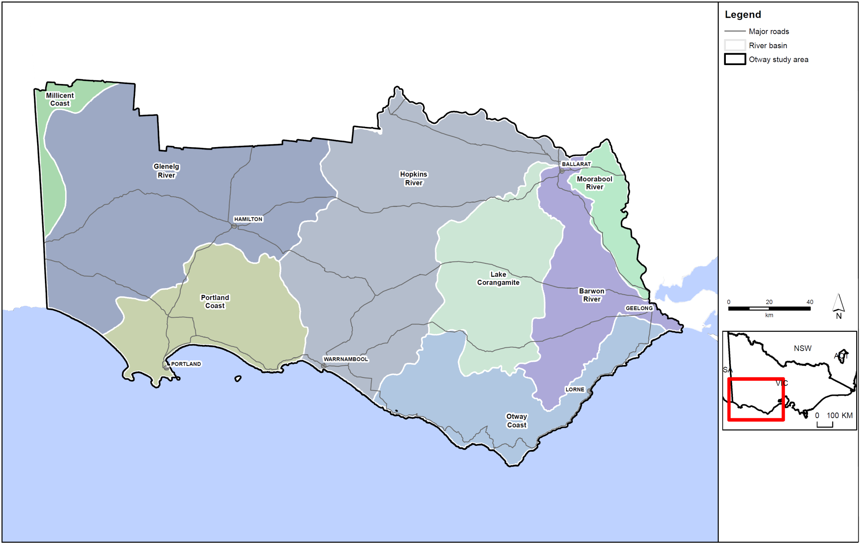
Figure C1: Otway study area.
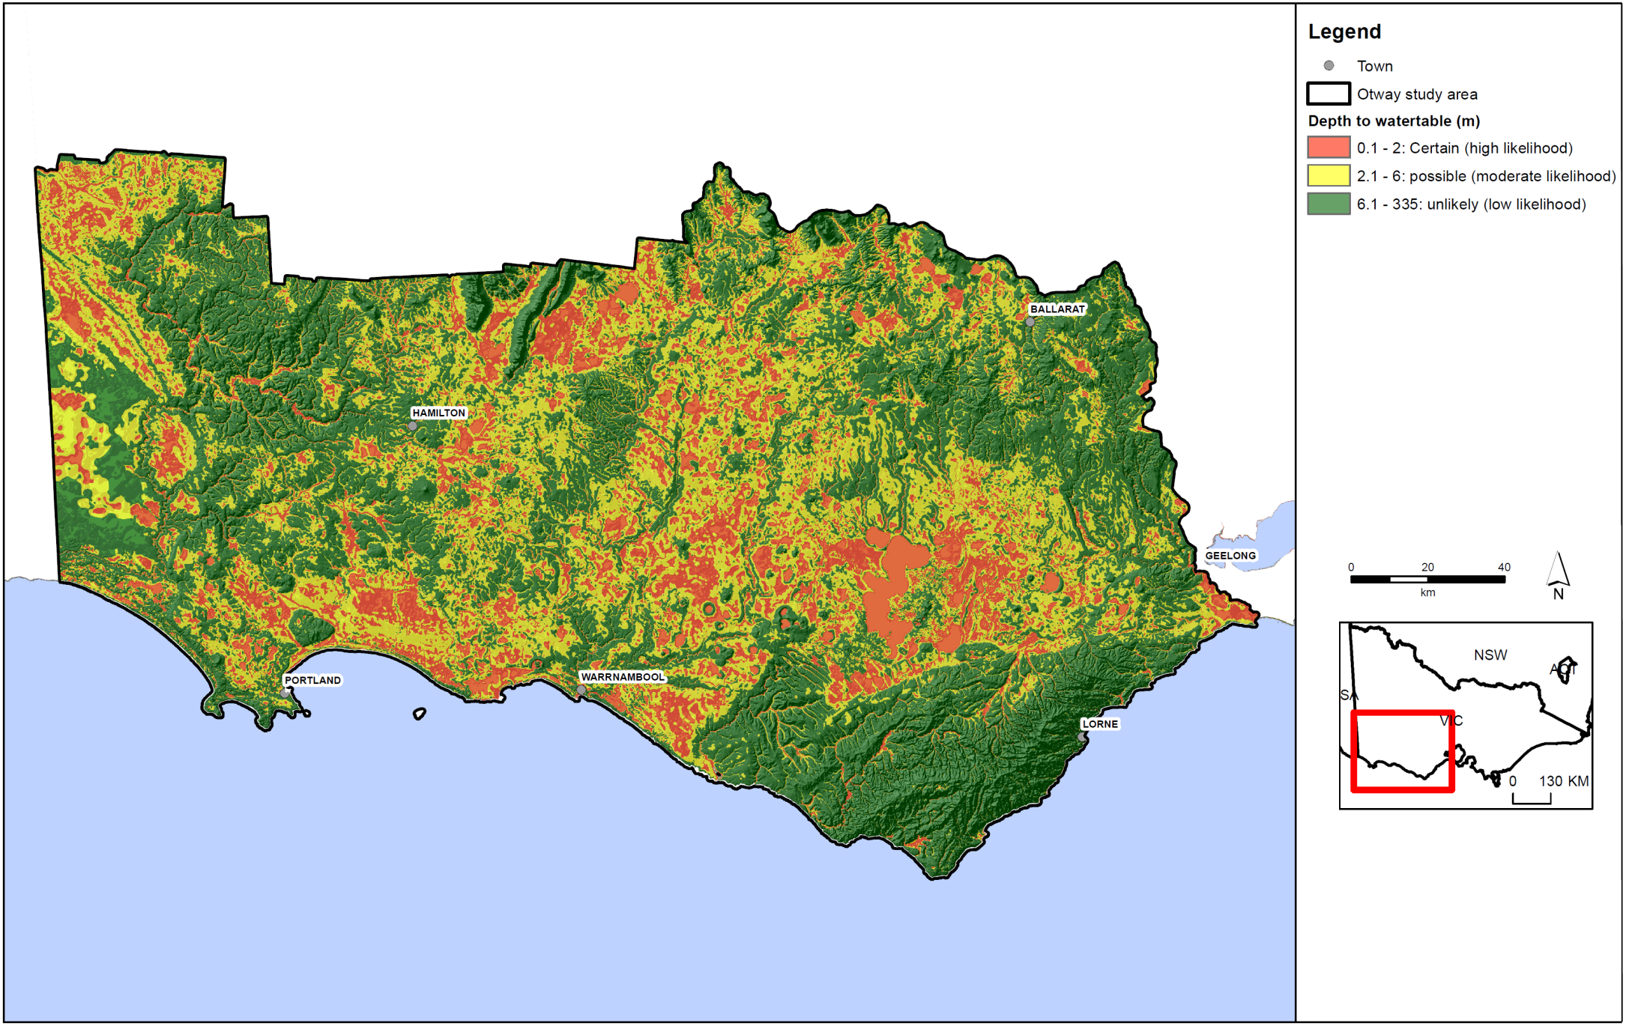
Figure C2: Depth to watertable in the Otway region.
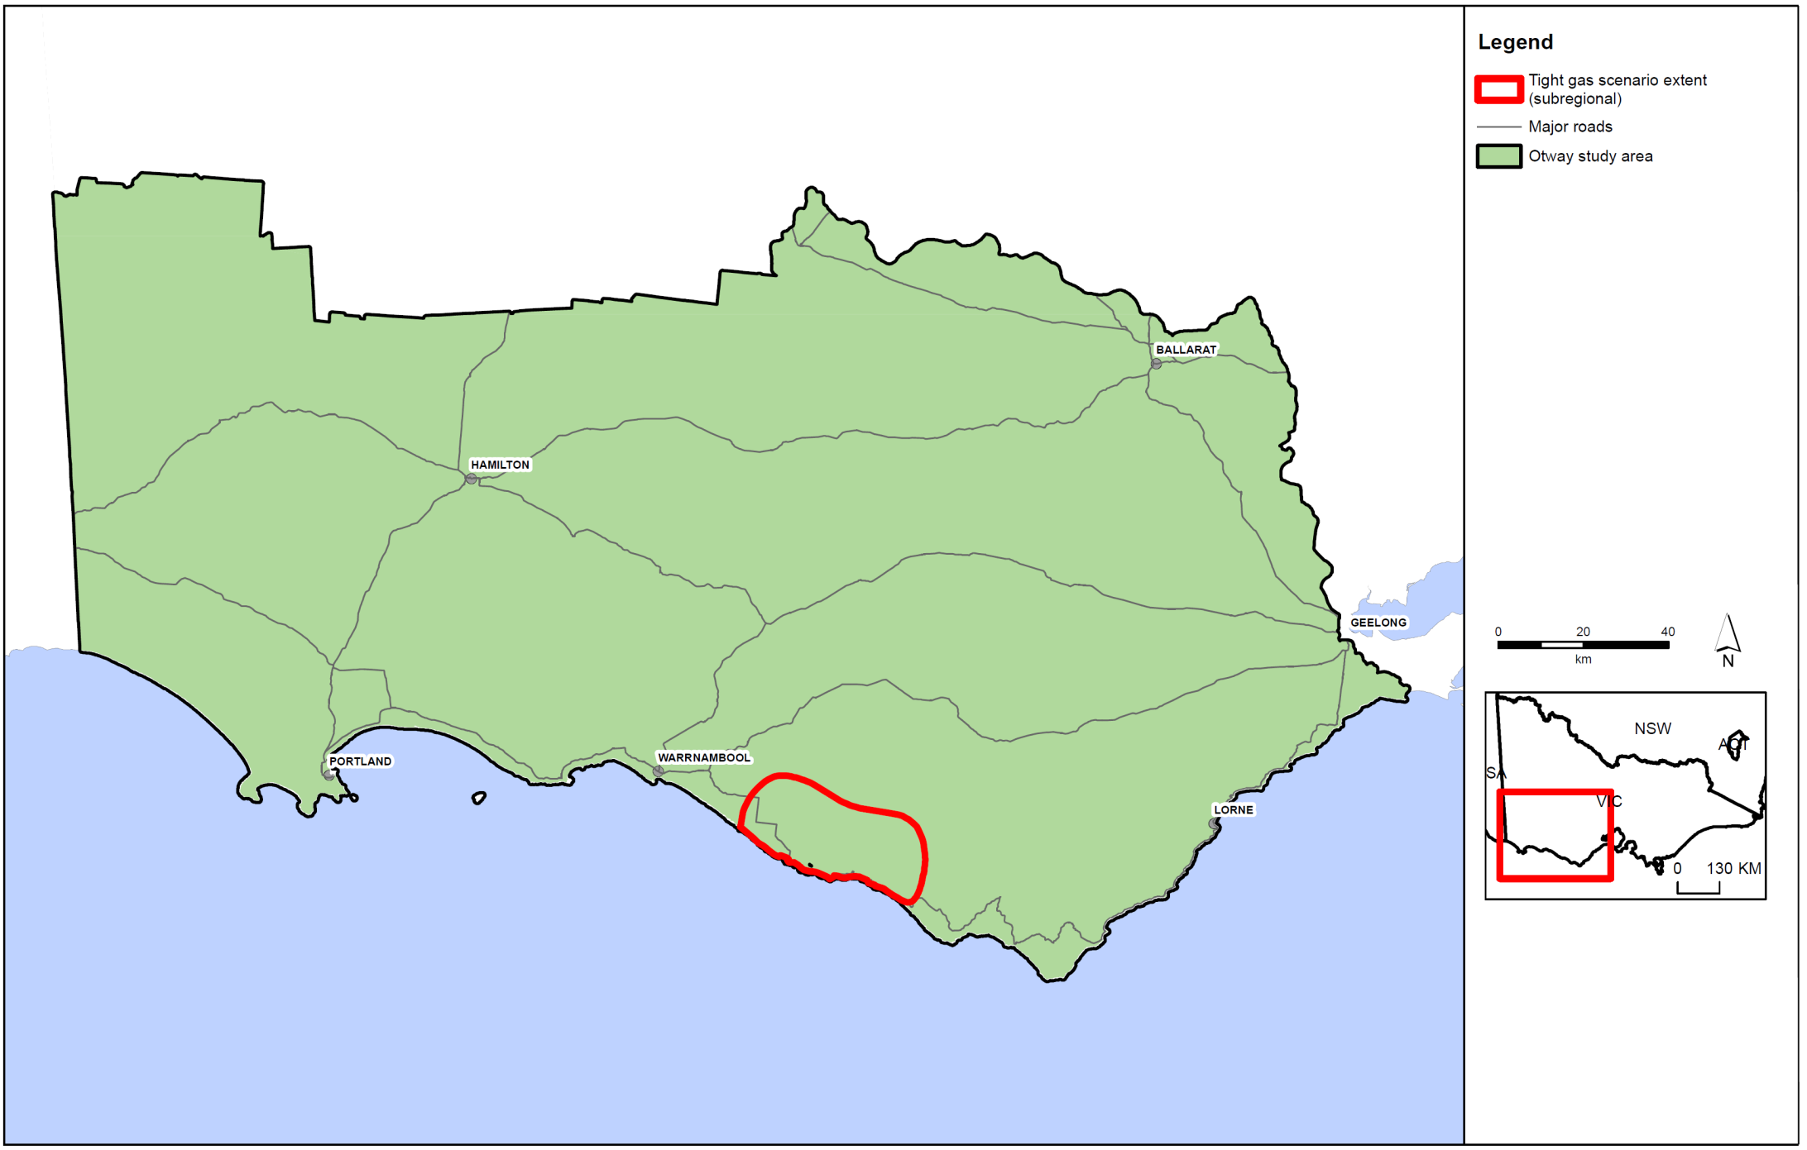
Figure C3: Otway tight gas scenario extent.
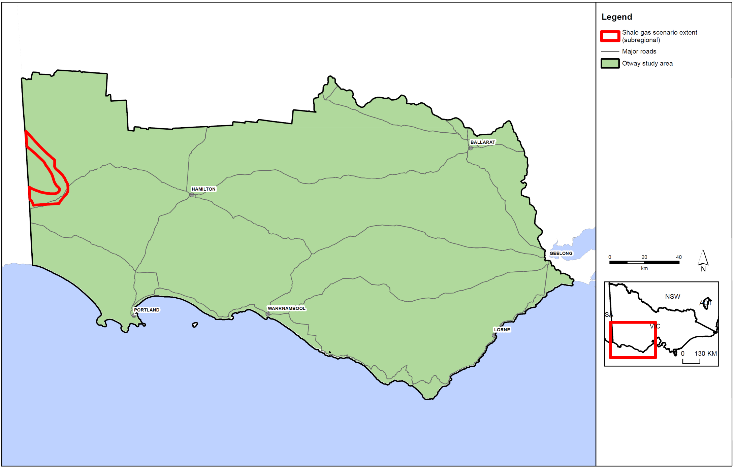
Figure C4: Otway shale gas scenario extent.
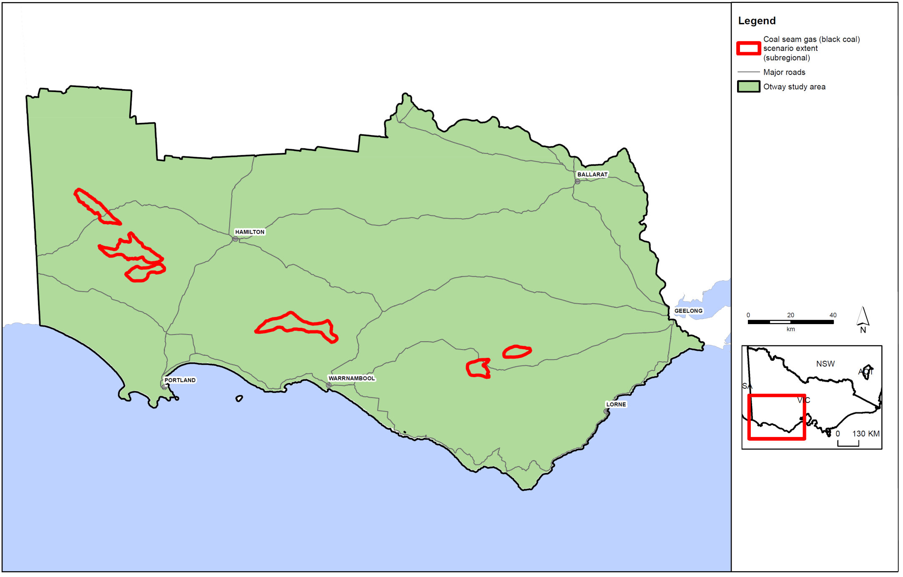
Figure C5: Otway coal seam gas scenario extent.
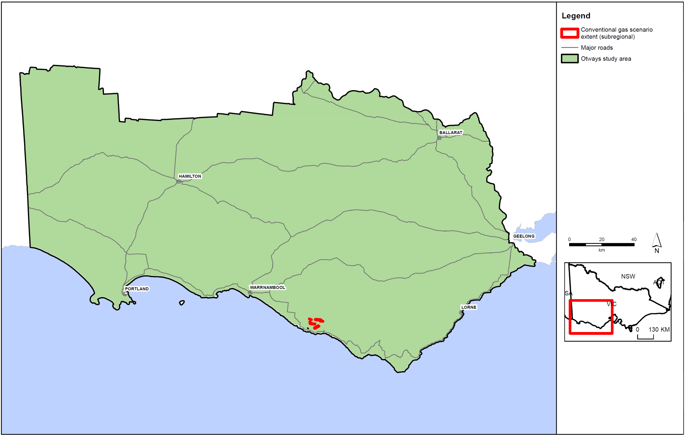
Figure C6: Otway conventional gas scenario extent.
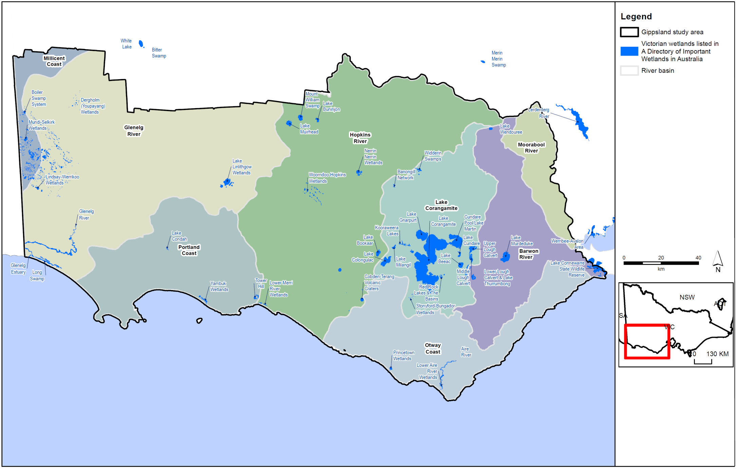
Figure C7: Location of internationally significant wetlands in the Otway region.
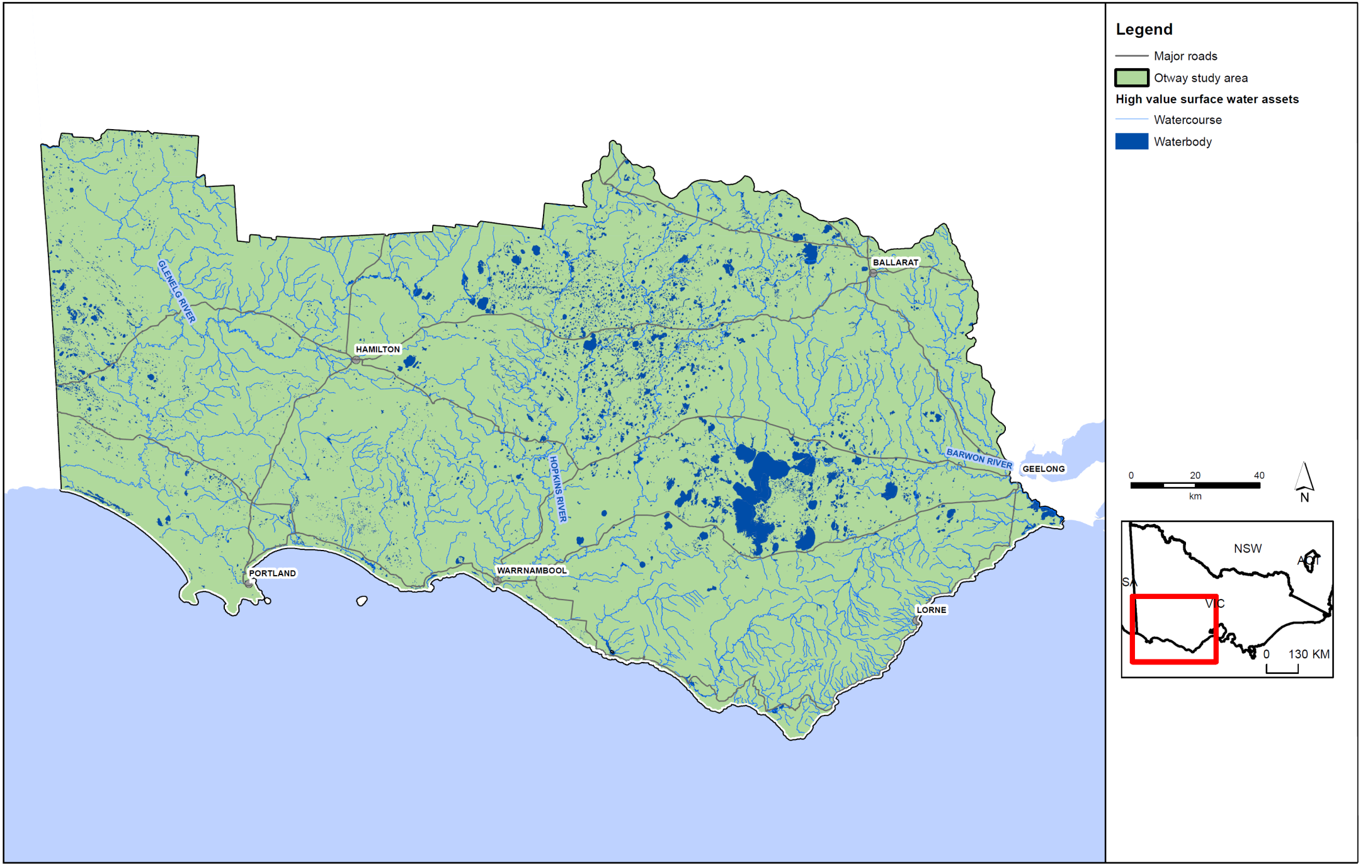
Figure C8: Otway surface water assets.
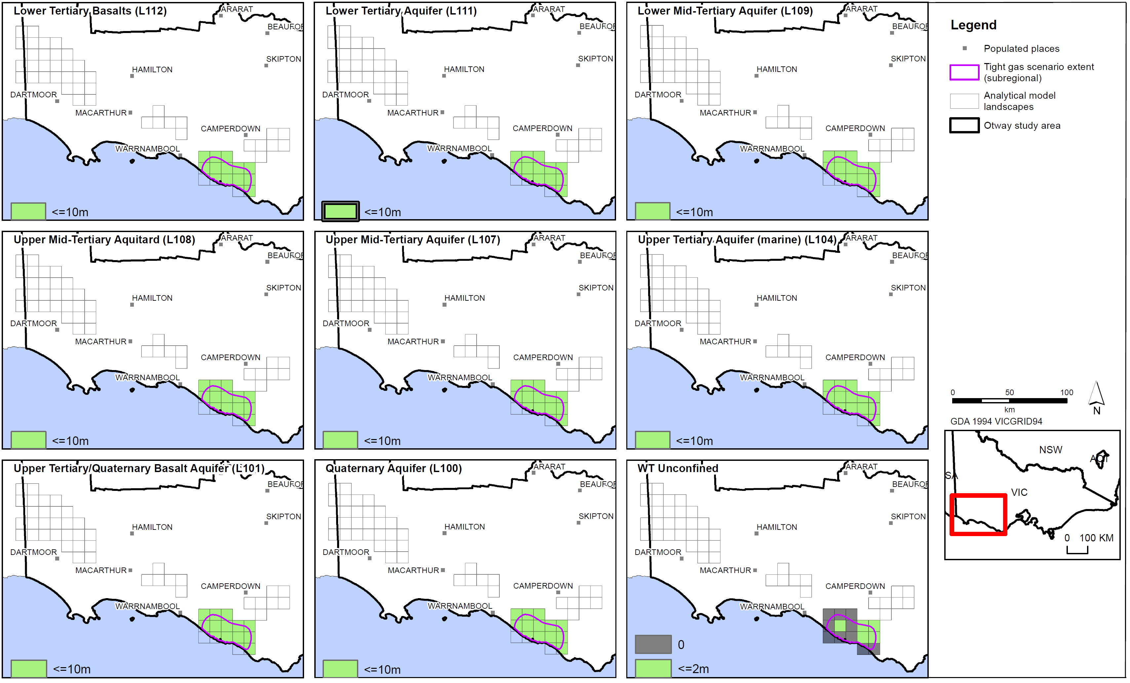
Figure C9: Tight gas scale drawdown for aquifers in the Otway region.

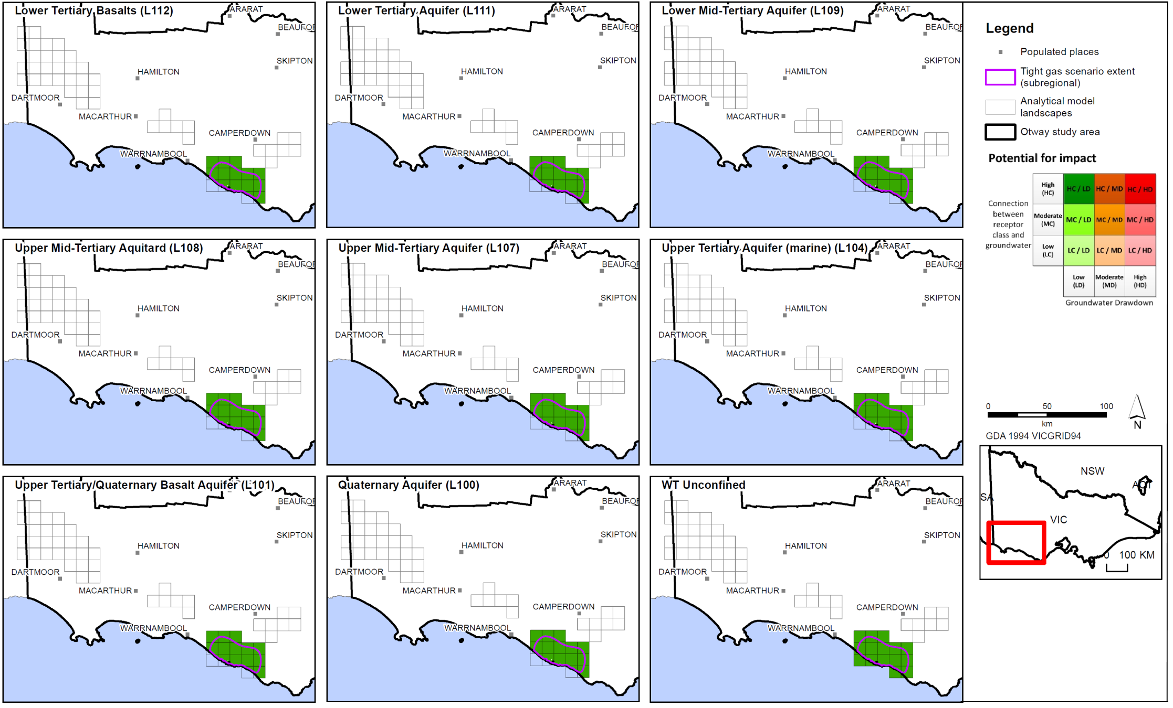
Figure C10: Tight gas scale impact assessment for aquifers in the Otway region.
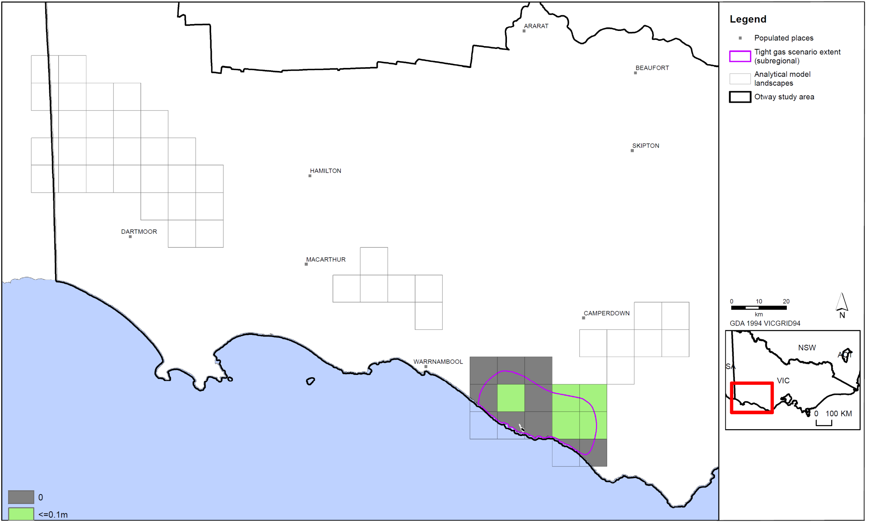
Figure C11: Tight gas scale watertable drawdown in the Otway region.
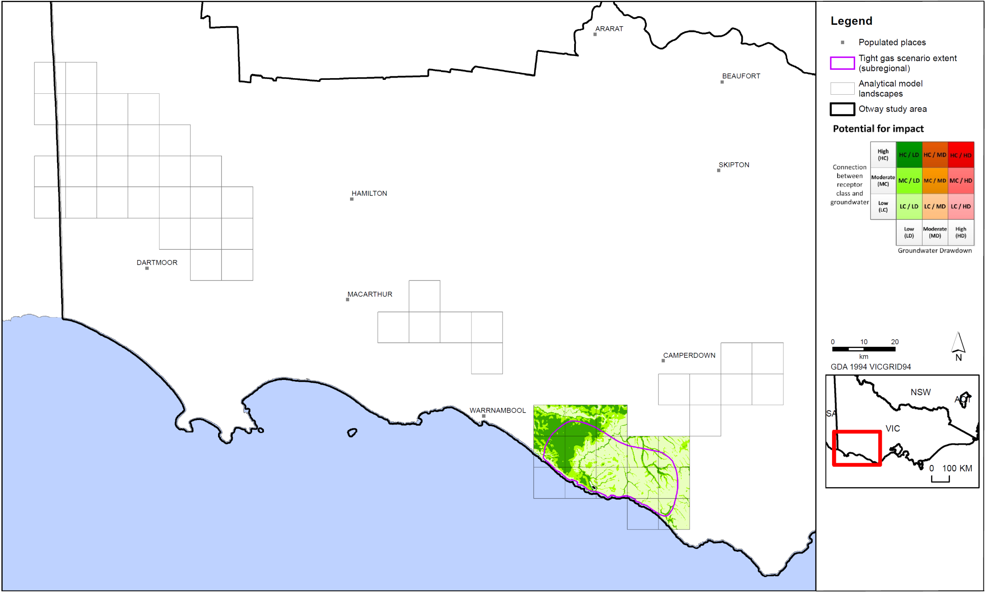
Figure C12: Tight gas scale impact assessment for surface water users in the Otway region.
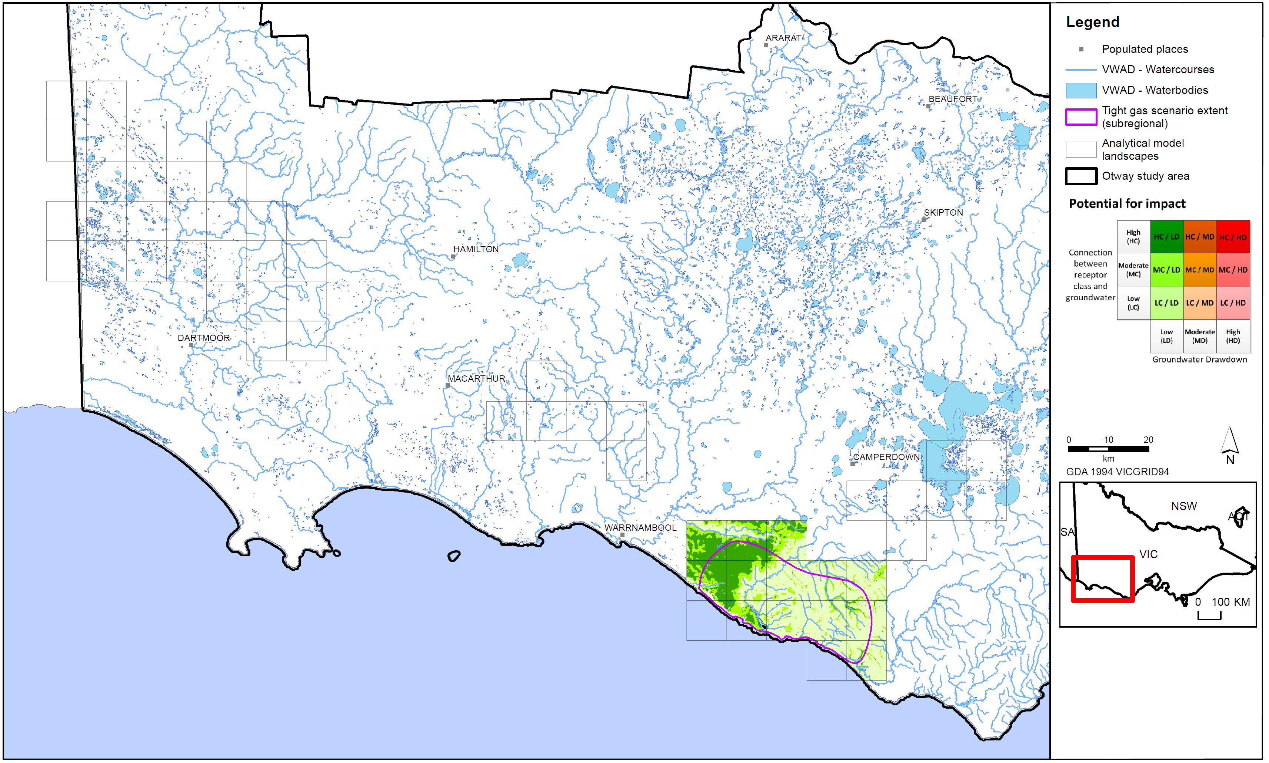
Figure C13: Tight gas scale impact assessment for surface water ecosystems in the Otway region.
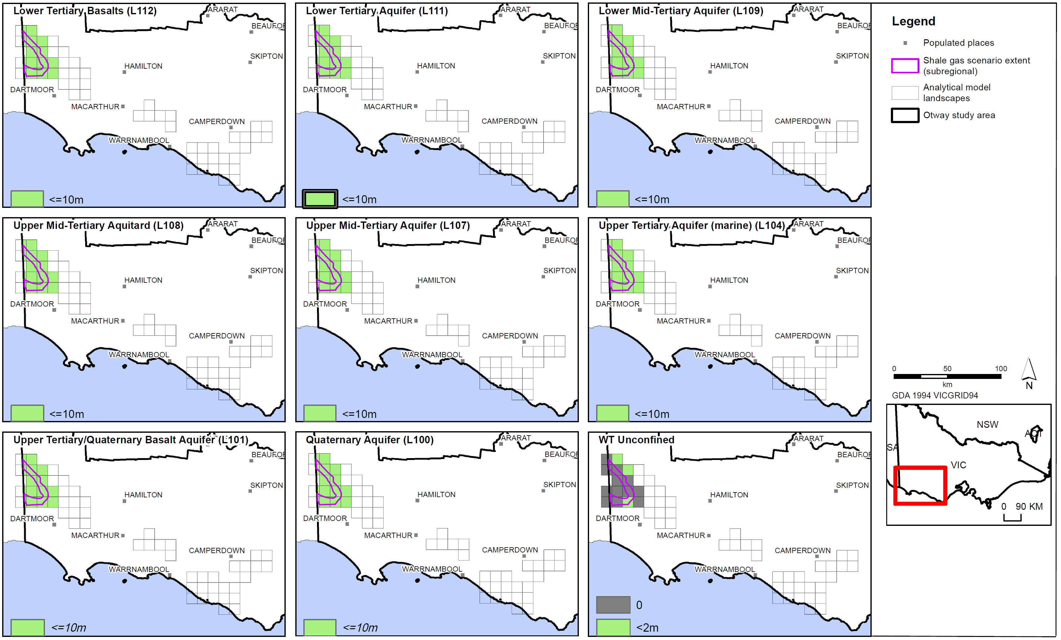
Figure C14: Shale gas scale drawdown for aquifers in the Otway region.
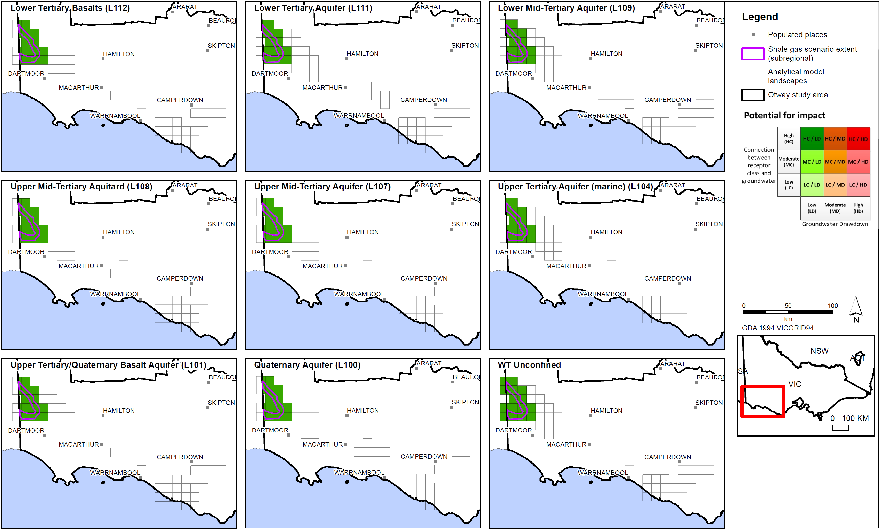
Figure C15: Shale gas scale impact assessment for aquifers in the Otway region.
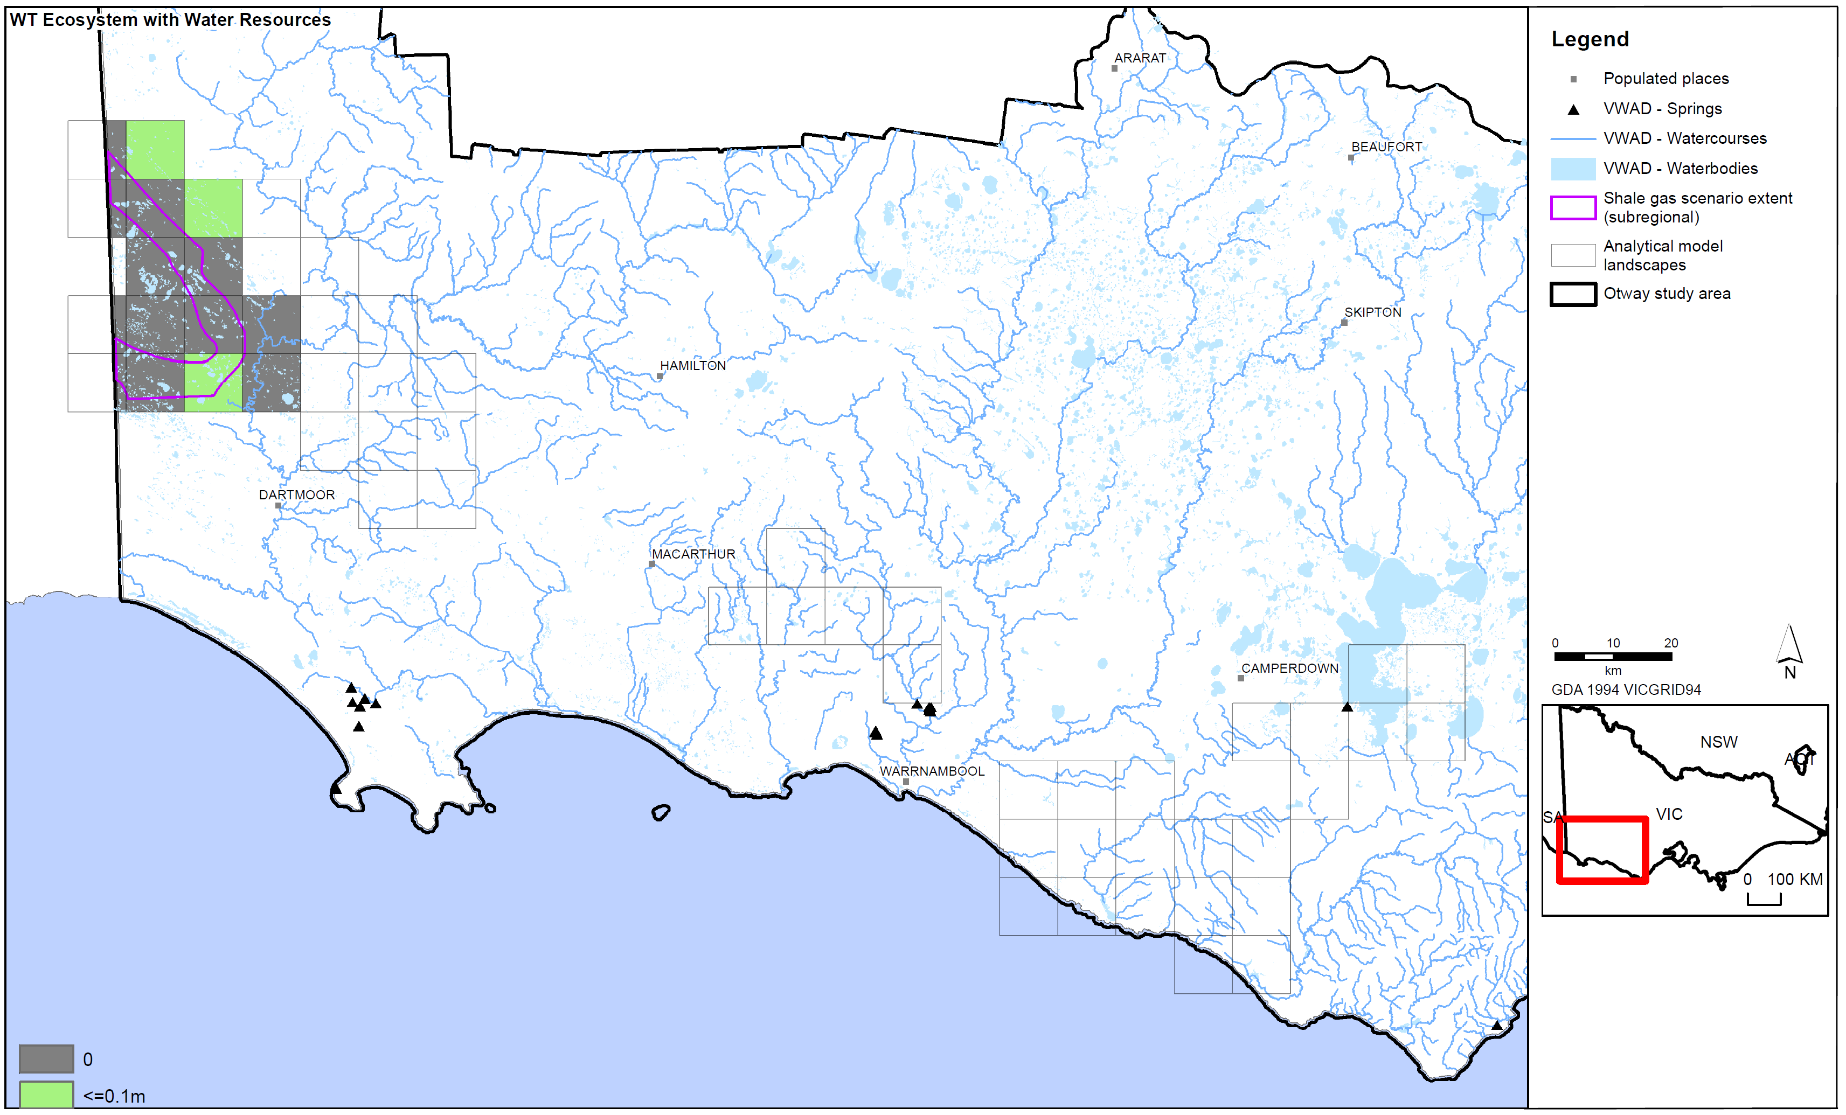
Figure C16: Shale gas scale drawdown results in the Otway region.
Figure C17: Shale gas scale impact assessment for surface water users in the Otway region.

Figure C18: Shale gas scale impact assessment for surface water ecosystems in the Otway region.

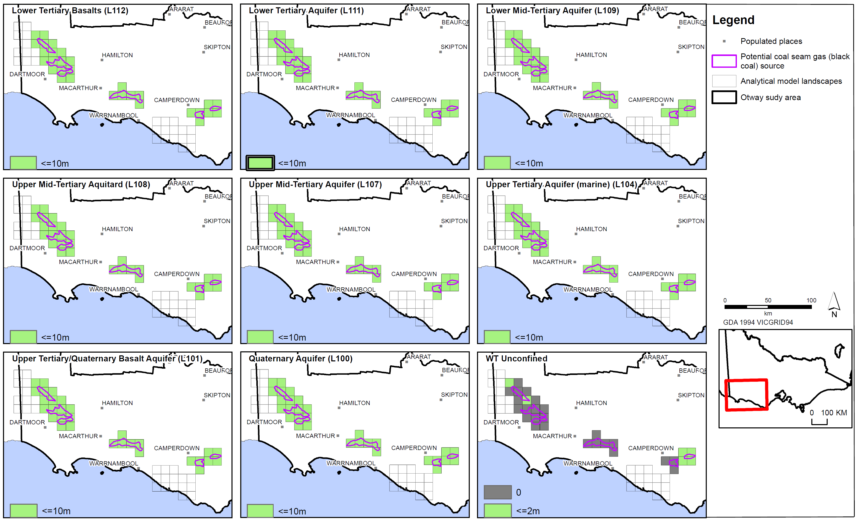
Figure C19: Coal seam gas (black coal) scale drawdown for aquifers in the Otway region.

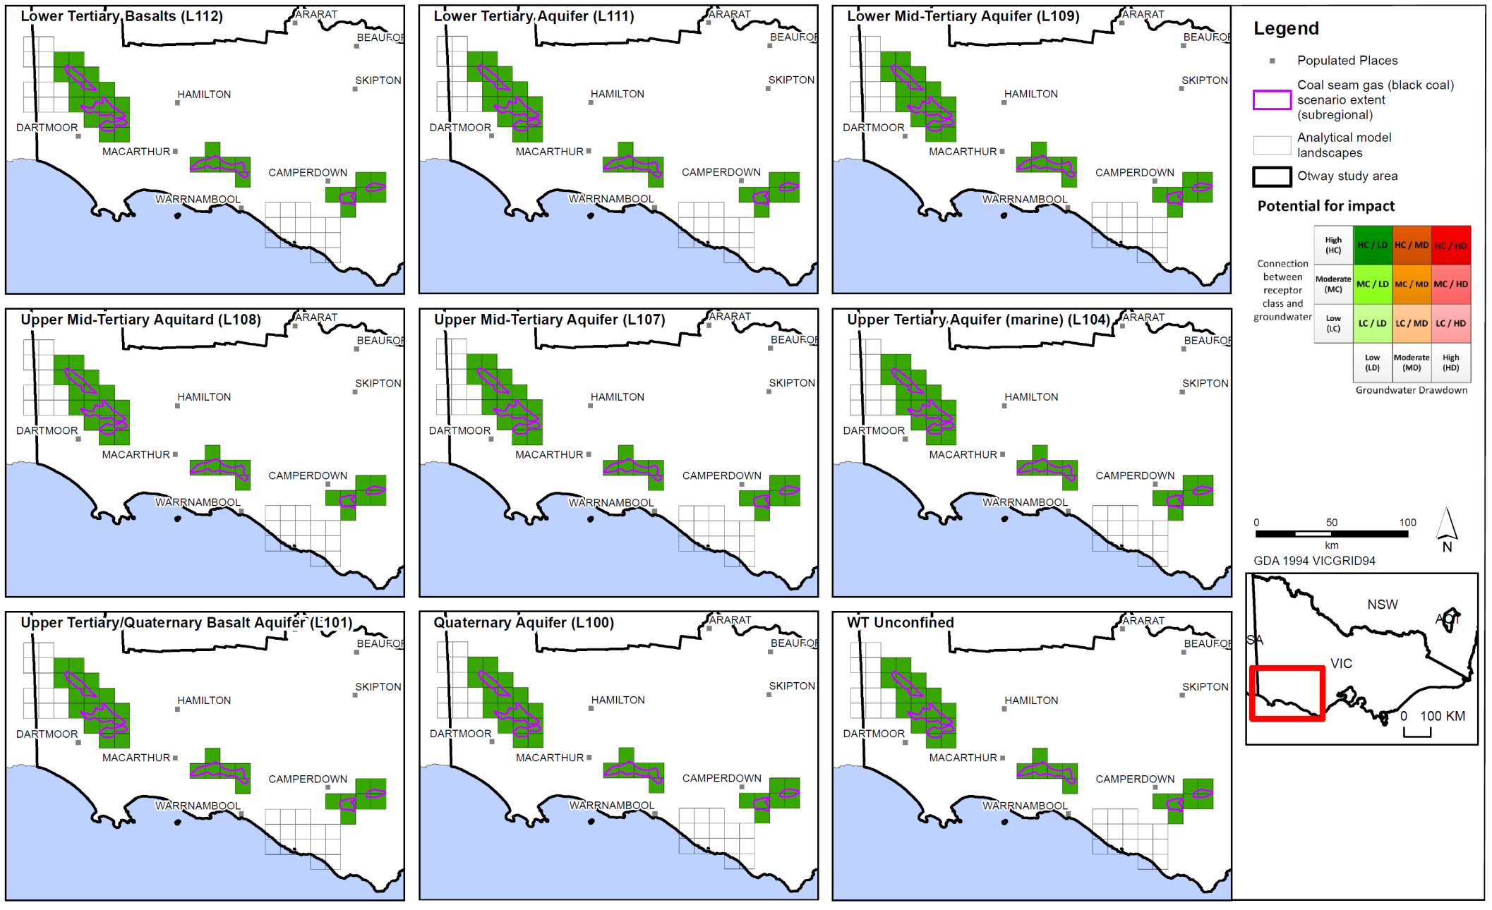
Figure C20: Coal seam gas (black coal) scale impact assessment for aquifers in the Otway region.
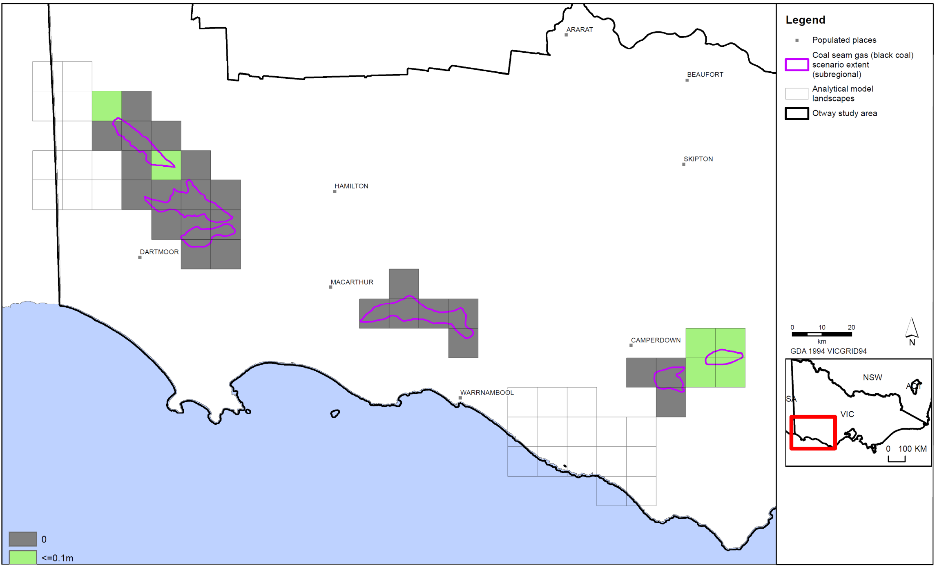
Figure C21: Coal seam gas (black coal) scale watertable drawdown in the Otway region.
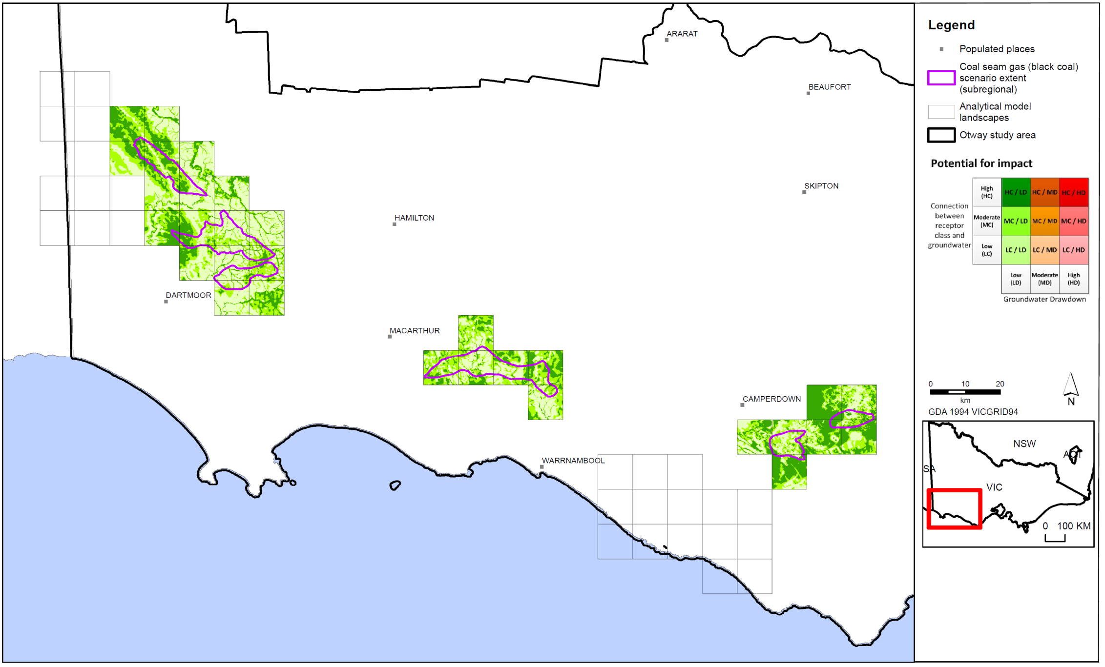
Figure C22: Coal seam gas (black coal) scale impact assessment for surface water users in the Otway region.
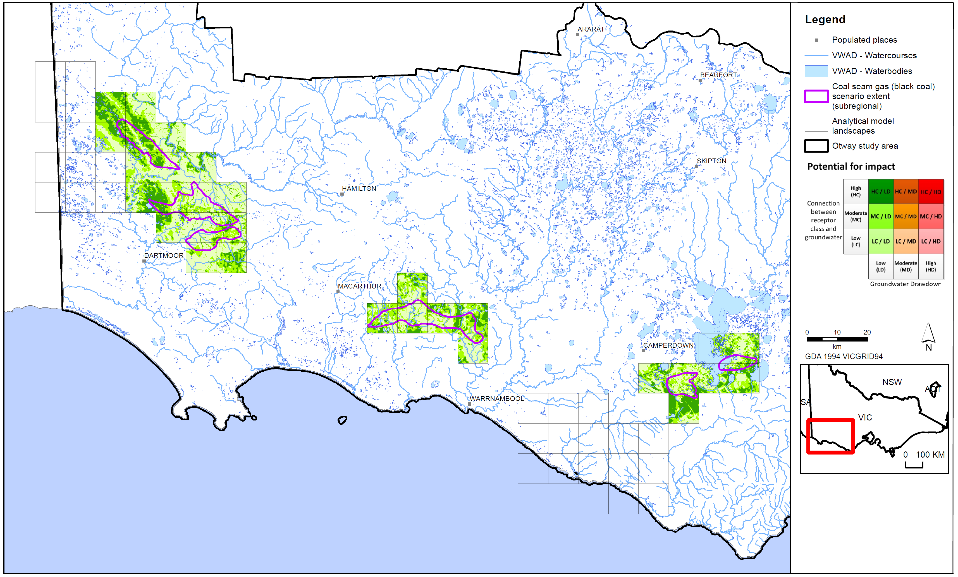
Figure C23: Coal seam gas (black coal) scale impact assessment for surface water ecosystems in the Otway region.
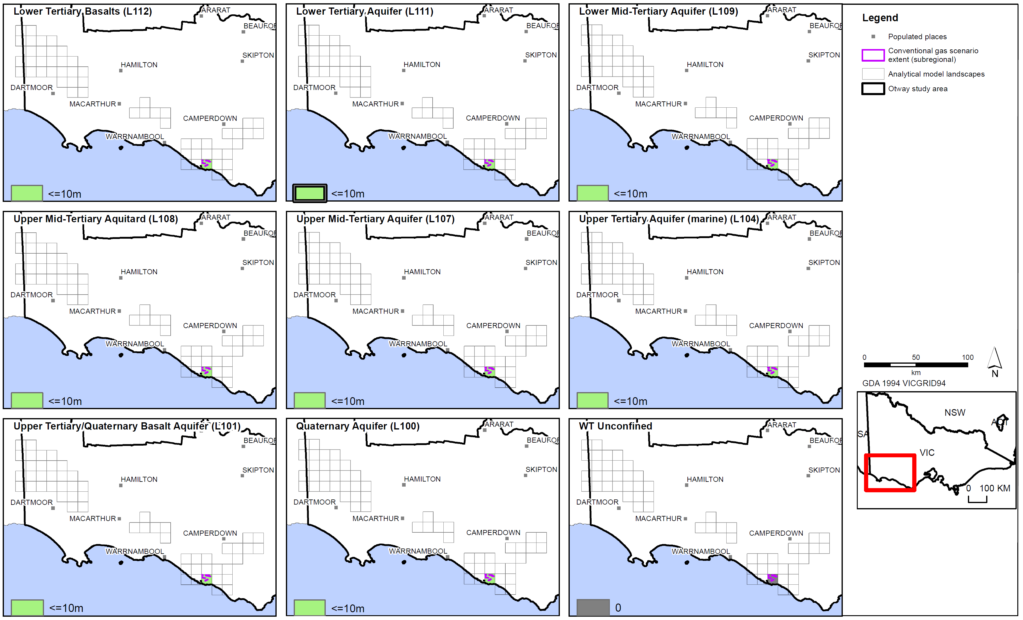
Figure C24: Conventional gas scale drawdown for aquifers in the Otway region.
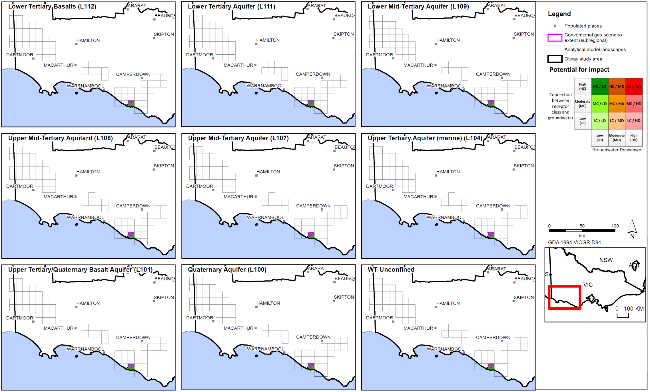
Figure C25: Conventional gas scale impact assessment for aquifers in the Otway region.
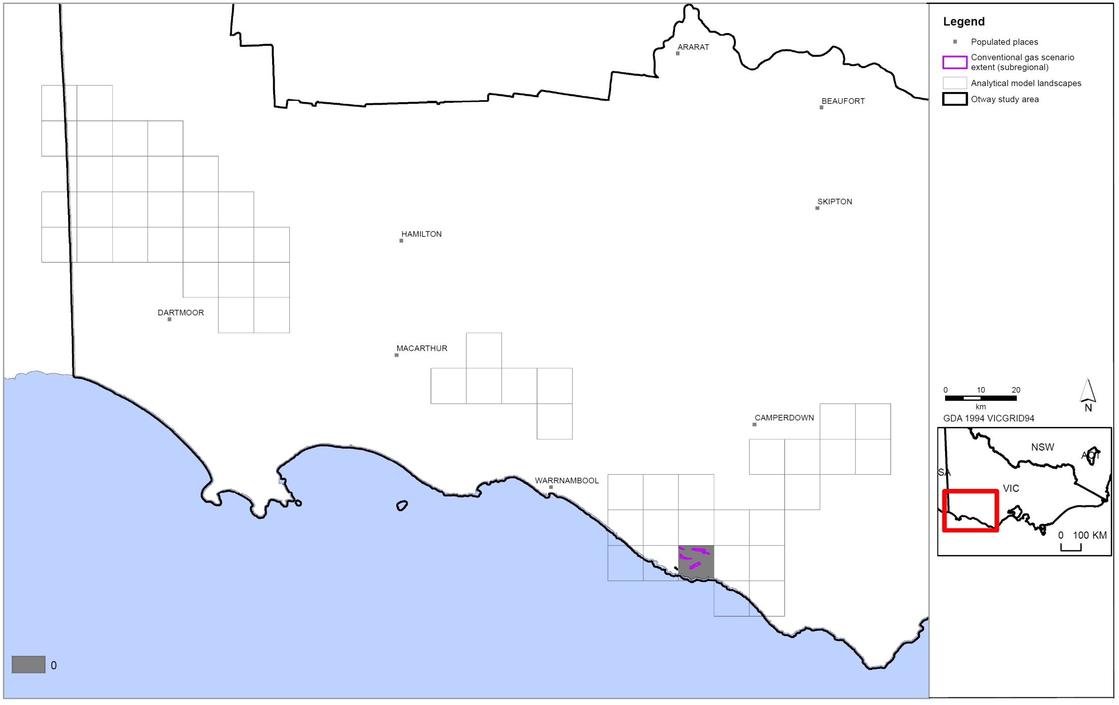
Figure C26: Conventional gas scale watertable drawdown in the Otway region.
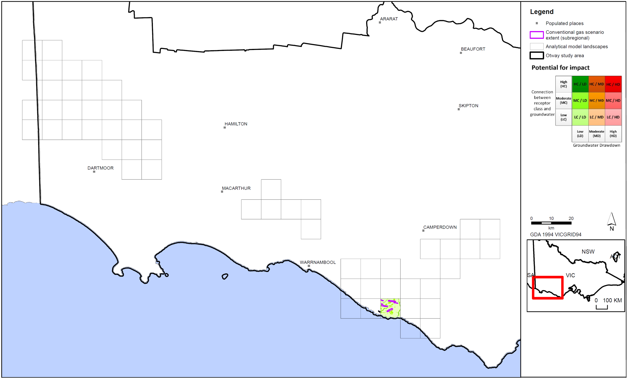
Figure C27: Conventional gas scale impact assessment for surface water users in the Otway region.
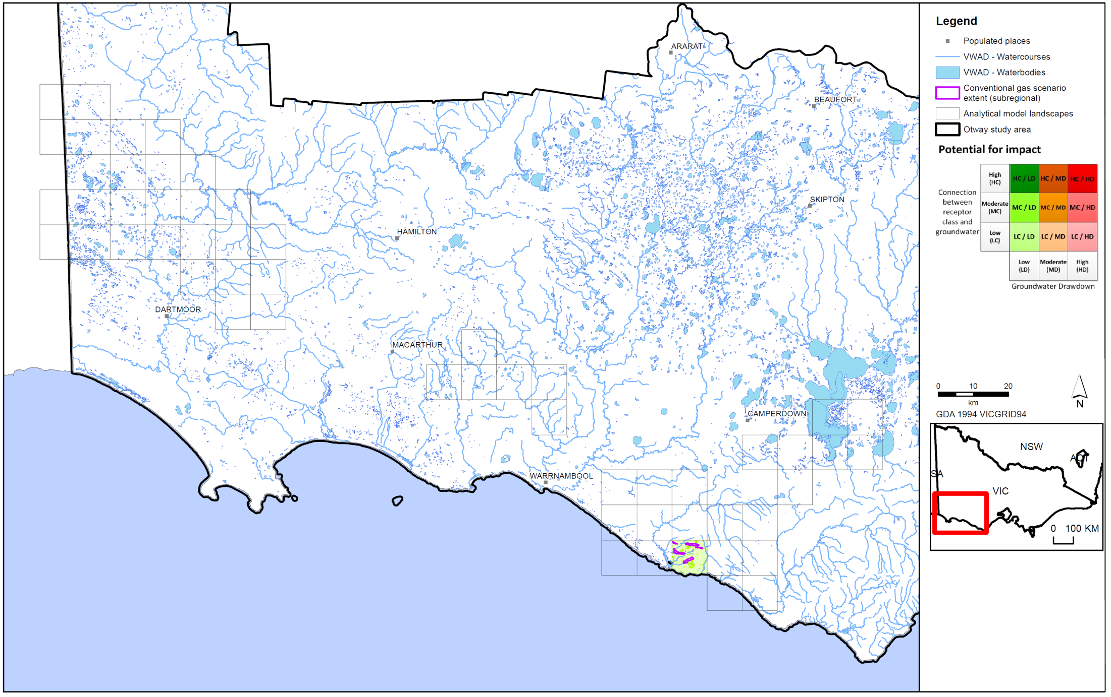
Figure C28: Conventional gas scale impact assessment for surface water ecosystems in the Otway region..


© The State of Victoria Department of Environment, Land, Water & Planning 2015

This work is licensed under a Creative Commons Attribution 4.0 International licence. You are free to re-use the work under that licence, on the condition that you credit the State of Victoria as author. The licence does not apply to any images, photographs or branding, including the Victorian Coat of Arms, the Victorian Government logo and the Department of Environment, Land, Water and Planning (DELWP) logo. To view a copy of this licence, visit http://creativecommons.org/licenses/by/4.0/

ISBN 978-1-74146-621-8 (pdf)

Accessibility
If you would like to receive this publication in an alternative format, please telephone the DELWP Customer Service Centre on 136186, email customer.service@delwp.vic.gov.au or via the National Relay Service on 133 677 www.relayservice.com.au. This document is also available on the internet at www.onshoregas.vic.gov.au

Disclaimer
This publication may be of assistance to you but the State of Victoria and its employees do not guarantee that the publication is without flaw of any kind or is wholly appropriate for your particular purposes and therefore disclaims all liability for any error, loss or other consequence which may arise from you relying on any information in this publication.

Methodology for Bioregional Assessments produced for the Independent Scientific Committee on coal seam gas and Large Coal Mining Development
High productivity aquifers must be at least 5 to 10 square miles of contiguous area, with a thickness of saturated deposits should average at least 20 feet through most of the area, and at some locations be at least 50 feet thick and sustained yields to individual wells should be 50 gallons per minute or more from sizeable areas
http://www.indiana.edu/~spea/faculty/pdf/IRGC-Report-2013.pdf
http://www.dec.ny.gov/data/dmn/ogprdsgeisfull.pdf
Ecological Australia (2012) Shale Gas Development in Australia: Potential Impacts and Risks to Ecological Systems. Final report prepared for the Australian Council of Learned Academies (ACOLA). January 2013.
Study conducted in the context of Germany, with EU and national legislation governing chemical use.
http://fas.org/sgp/crs/misc/R43148.pdf
https://www.ehp.qld.gov.au/management/non-mining/documents/coal seam gas-water-measurable-criteria.pdf
https://www.nsw.gov.au/sites/default/files/coal seam gas-wellintegrity_sd_v01.pdf
http://www.ncsl.org/documents/energy/frackingguide_060512.pdf
Significant Impact Guidelines
Healthy HeadWaters coal seam gas Water Feasibility Study, Activity 5 Groundwater Risks Associated With Coal Seam Gas Development in the Surat and Southern Bowen Basinshttp://www.dnrm.qld.gov.au/__data/assets/pdf_file/0020/106148/act-5-groundwater-risks-report.pdf
Guidelines for Environmental Risk Assessment and Management, Green Leaves III
Pressure being the coal seam gas activity, stressor the potential hydrological change caused by the pressure and response the change in environmental, social or economic values.
ERSD anticipate that around 80% of ER projects are small-scale and may be categorised as Tier 1, except in water-short and potentially-water-short areas of Alberta. These projects account for approximately 20 per cent of water use. Large-scale projects (Tier 2 or Tier 3) are expected to use around 80 per cent of non-saline water use for oilfield injection.
new draft regulations governing exploration and production of petroleum and geothermal energy resources in onshore WA. Onshore regulation is also evolving in the Eastern States with Queensland and South Australia taking proactive steps towards unconventional gas development. However, regimes in New South Wales and Victoria are seen to have a more restrictive effect on the development of these projects due to delays in approving activities and a shifting moratorium on the coal seam gas industry in those states
Barrett et al (2013)
ACOLA (2013)
http://www.parliament.vic.gov.au/publications/research-papers/8927-unconventional-gas-coal-seam-gas-shale-gas-and-tight-gas
Energy Resources Division Department for Manufacturing, Innovation, Trade, Resources and Energy (2012) First draft: Roadmap for Unconventional Gas Projects in South Australia http://www.petroleum.pir.sa.gov.au/__data/assets/pdf_file/0006/170889/Combined_doc_19_April.pdf
Cook, P.J. (2003) Life Cycle of Coal Seam Gas Projects: Technologies and Potential Impacts Report for the New South Wales Office of the Chief Scientist and Engineer http://www.chiefscientist.nsw.gov.au/__data/assets/pdf_file/0010/31321/Life-Cycle-of-Coal-Seam-Gas-Report_FINAL_PJC.pdf
http://www.petroleum.pir.sa.gov.au/__data/assets/pdf_file/0006/170889/Combined_doc_19_April.pdf
Energy Resources Division Department for Manufacturing, Innovation, Trade, Resources and Energy (2012) First draft: Roadmap for Unconventional Gas Projects in South Australia
Stempvoort et al (1993) Aquifer Vulnerability Index: A GIS-Compatible Method for Groundwater Vulnerability Mapping, Canadian Water Resources Journal, 18 (1)
Original distances specified in NYSDEC (2009) are in feet, not metres.
excluding engineered impoundments constructed for fresh water storage associated with fracturing operations
http://www.dec.ny.gov/data/dmn/ogprdsgeisfull.pdf

