Otway region synthesis report

Overview of the assessment of potential
impacts on water resources

June 2015

Acknowledgements
This report has been prepared by Jacobs (Australia) Pty Ltd for the Department of Environment, Land, Water and Planning in collaboration with the Geological Survey of Victoria (part of the Department of Economic Development, Jobs, Transport and Resources).
Independent review was provided by:
Professor Rae Mackay, Director, Geotechnical and Hydrogeological Engineering Group, Federation University Australia
Professor Dayanthi Nugegoda, Ecotoxicology, School of Applied Science, RMIT University
Professor Craig Simmons, Director, National Centre for Groundwater Research and Training, Flinders University.

Contents
Summary 3
1 Introduction 6
1.1 What are the water science studies? 6
1.2 How did we go about it? 7
1.3 About this report 8
2 Onshore natural gas 9
2.1 Onshore natural gas types in the Otway region 9
2.2 History of gas exploration and development 11
2.3 Industry practices for production of natural gas 11
3 Water resources of the Otway region 13
3.1 Groundwater 13
3.2 Surface water 13
3.3 Ecosystems 16
3.4 Groundwater and surface water connection 16
3.5 Groundwater sampling and characterisation for hydrocarbons 17
4 Where are gas and water likely to be connected? 19
5 What are the potential impacts from possible natural gas development? 20
5.1 Assessment approach 20
5.2 Potential impacts from aquifer depressurisation 21
5.3 Potential for chemical contamination of groundwater from hydraulic fracturing fluids 22
5.4 Potential for increased earthquakes 23
5.5 Potential for land subsidence 23
5.6 Summary of potential for impacts 24
Water science studies outputs for Otway region 25
Glossary of terms and abbreviations 26

Summary
This report is a synthesis of the Otway region component of the onshore natural gas water science studies. These studies provide the Victorian Government and community with technical information about potential water-related issues and impacts that may arise as a consequence of the development of an onshore natural gas industry in Victoria.
The Gippsland and Otway regions were the focus of these studies. This is because these two regions are thought to be the most prospective areas in Victoria for onshore natural gas development. At present there is no active onshore natural gas development in Victoria.
The purpose of the water science studies on onshore natural gas is to provide an initial screening analysis of the potential impacts of possible onshore gas exploration and development on water users and ecosystems. The studies assess the potential impacts of aquifer depressurisation (i.e. groundwater level decline), chemical contamination of groundwater from hydraulic fracturing fluids, induced seismicity, and land subsidence.
Gas extraction depressurises the gas-bearing formation and may cause a decline in groundwater level, which could impact water users and ecosystems. Groundwater level decline may also cause land subsidence.
Hydraulic fracturing can increase gas yield, but may unintentionally contaminate water supplies with hydraulic fracturing fluids and induce seismicity (earthquakes).
The studies apply a causal pathway approach, describing where natural gas might be, where water resources are, the physical connection between the gas and water resources, and utilising modelling and analysis to infer impacts on water users and ecosystems.
The studies were conducted by the Department of Environment, Land, Water and Planning and the Geological Survey of Victoria (part of the Department of Economic Development, Jobs, Transport and Resources). An essential part of the water science studies was the engagement of a scientific review panel, which provided an independent peer review of the studies, ensuring the rigour of the significant body of technical work that was undertaken.
The studies have used the best available information, although noting that there are known gaps in the geological and hydrogeological data sets. Because of these gaps the impact assessment is conservative; that is, the results are likely to estimate higher impacts than may eventuate if development did occur. It is important to note that there are issues that are beyond the scope of these water science studies. These include treatment and disposal of co-produced water, water use for fracturing and gas production, and non-water resource issues such as amenity, air quality, fugitive gas emissions, on-site chemical management and bore integrity. Therefore, the findings that follow should be considered only with respect to the topics addressed.

Findings for the Otway region
Overall, the potential for impacts on water users and ecosystems from possible onshore natural gas developments in the Otway region was found to be low. Specific findings are summarised below and in Tables 1 and 2.
- The potential for impacts on groundwater users from aquifer depressurisation for gas development is low, as inferred from a predicted decline in the water table of less than 2 m and a predicted decline in deep groundwater levels of less than 10 m.
- The potential for impacts on groundwater quality from aquifer depressurisation for gas development is inferred as low, based on the predicted changes to groundwater pressure gradients being within historical ranges.
- The potential for impacts on surface water users and ecosystems as a result of reduced stream flow or changes in surface water quality caused by aquifer depressurisation is inferred as low, because the predicted changes to groundwater levels are within historical ranges.
- The potential for chemical contamination of groundwater from hydraulic fracturing fluids is low, based on a review of national and international literature with consideration of the particular geological conditions of the Otway region and the fact that the addition of BTEX chemicals to hydraulic fracturing fluids is banned under Victorian law.
- The potential for induced seismicity is low, based on a review of national and international literature with consideration of the particular geological conditions of the Otway region.
- The potential for land subsidence is low, based on the predicted changes to groundwater levels.

Table 1: The potential impacts associated with aquifer depressurisation for each gas scenario.
Natural gas type | Impacts on users
Natural gas type | Groundwater users | Surface water users | Ecosystems
Conventional gas | Low | Low | Low
Tight gas | Low | Low | Low
Shale gas | Low | Low | Low
Coal seam gas | Low | Low | Low

Table 2: The potential impacts associated with hydraulic fracturing, induced seismicity and land subsidence for each gas scenario.
Natural gas type | Chemical contamination of groundwater from  hydraulic fracturing fluids |  |  | Induced seismicity | Land subsidence
Natural gas type | Groundwater users | Surface water users | Ecosystems
Conventional gas | Low | Low | Low | Low | Low
Tight gas | Low | Low | Low | Low | Low
Shale gas | Low | Low | Low | Low | Low
Coal seam gas | Low | Low | Low | Low | Low

- Introduction
  - What are the water science studies?
The water science studies provide an initial screening analysis of a set of potential water-related issues and impacts that may arise as a consequence of the development of an onshore natural gas industry.
The studies describe where natural gas might be, where water resources are, and assess what physical connections there may be between these gas and water resources. Where these resources are thought to be physically connected, the potential quantity and quality impacts on groundwater were investigated,
and by inference the potential impacts on groundwater users, surface water users and ecosystems. The potential effectiveness of possible mitigation strategies were also assessed if the risks were assessed as moderate or high.
There are four different types of possible onshore natural gas development in Victoria: conventional, shale, tight and coal seam gas. These types of gas developments may have different impacts on water resources and so each is assessed in these studies.
The two study regions are the Gippsland region and the Otway region (Figure 1) as these are thought to be the most prospective areas in Victoria for onshore natural gas development. While the Geological Survey of Victoria has conducted some research into potential areas where onshore natural gas resources may exist, the commercial feasibility of onshore gas development has not been determined.
Figure 1: Otway (left) and Gippsland (right) study regions
The four topics investigated with regard to the potential impacts of developing an onshore natural gas industry are:
- aquifer depressurisation
- chemical contamination of groundwater from hydraulic fracturing fluids
- induced seismicity
- land subsidence.
The studies have been undertaken by the Department of Environment, Land, Water and Planning with the assistance of the Geological Survey of Victoria (part of the Department of Economic Development, Jobs, Transport and Resources), as a joint program, between June 2014 and June 2015.
The outputs of the studies take the form of two synthesis reports (one each for the Gippsland region and Otway regions) and a series of supporting technical reports. This report is the synthesis report for the
Otway region.
  - How did we go about it?
These studies have used the best available data, noting that this is limited by gaps in the geological and hydrogeological data. New information has been generated to augment the existing body of knowledge on onshore natural gas and how it relates to water resources in the Gippsland and Otway regions. As a result, the following were developed as part of the water science studies:
- hypothetical gas development scenarios
- a database identifying water resources and their attributes for the state of Victoria
- groundwater modelling
- a baseline groundwater monitoring program
- a regional assessment of potential impacts on water resources for the Gippsland and Otway regions.
The outputs of the studies provide government and communities with a substantial body of new, region-specific technical information for considering the potential development of an onshore gas industry in these two regions.
A scientific review panel has provided an independent peer review of this report and the Otway region assessment of potential impacts, ensuring the rigour of the work. A list of the detailed technical reports which have been prepared as part of the Otway region water science studies is provided on page 25.
The detailed technical reports present the specific methods used to conduct the detailed assessments, including the use of an 'impact assessment' approach for the analysis of aquifer depressurisation and a
'risk assessment' approach for the analysis of hydraulic fracturing, induced seismicity and land subsidence. The term 'impact assessment' has been used in this synthesis report to describe the approach for a
wider audience.
As there is no onshore natural gas development in Victoria at present, these studies have assessed the potential impacts of hypothetical natural gas development projects on water users and ecosystems in the Gippsland and Otway regions.
Within the bounds of the issues assessed, a conservative approach has been taken towards assessing
the potential impacts associated with onshore natural gas development. This conservative approach is appropriate given the limited data available and the need to test hypothetical scenarios for analysis. Therefore, the findings in this report are likely to estimate higher impacts than may eventuate if
development did occur.
  - About this report
Chapter 2 of this report explains the different types of potentially prospective onshore natural gas in the Otway region, provides a synopsis of gas exploration and development in the region, and outlines industry production practices for the different types of natural gas.
Chapter 3 provides an overview of the groundwater and surface water resources of the Otway region and the significant water dependent ecosystems. It also explains how groundwater and surface water resources can be connected. Finally, this chapter presents the results of the monitoring of groundwater quality that was undertaken to inform these studies.
Chapter 4 discusses where gas resources and groundwater resources are likely to be connected in the Otway region. This information is used to inform the assessment of the potential impacts from possible onshore natural gas development.
Chapter 5 summarises the potential impacts on water users and ecosystems from possible tight, shale and coal seam gas development. The potential impacts associated with aquifer depressurisation, chemical contamination of groundwater from hydraulic fracturing fluids, induced seismicity and land subsidence are discussed in turn.
A full list of the technical reports prepared for the Otway region as part of the water science studies are listed on page 25.

- Onshore natural gas
Natural gas is a naturally occurring hydrocarbon consisting primarily of methane, but which can also contain small amounts of ethane, propane, butane and pentanes. Sulfur compounds, nitrogen, carbon dioxide, water and other substances may also be present. Natural gas forms over millions of years, as heat and pressure transform decaying plant and animal matter buried in rock layers.
  - Onshore natural gas types in the Otway region
Conventional gas, tight gas, shale gas and coal seam gas are the main types of prospective onshore
natural gas in the Otway region. Conventional gas has been discovered and produced from the onshore Otway Basin near Port Campbell. Future discoveries of conventional gas are most likely to occur in the
same region.
The impact assessment for the Otway region analysed the following potentially prospective onshore natural gas types for the Otway region. These are the range of natural gas resources that could potentially be developed in the onshore Otway region.
Conventional gas is natural gas that is concentrated in a defined area and is trapped by a low permeability seal layer. In the Otway Basin, conventional gas has been found in the Waarre Formation around Port Campbell. | 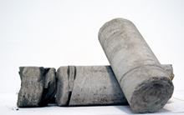 | 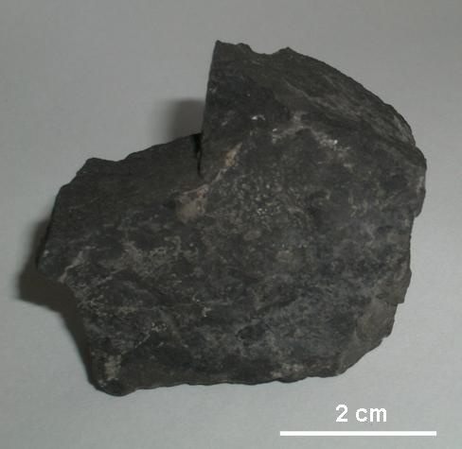
Tight gas refers to gas trapped in low permeability rock formations such as sandstone and carbonate. Tight gas might be located at depths of 1000 to 3000 m below the ground surface in some areas of the Otway region. | 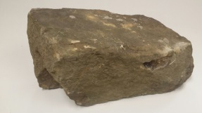 | 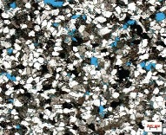
Shale gas might be located at depths between 2500 and 4000 m in some areas of the Otway region, within a fine-grained sedimentary rock called shale. | 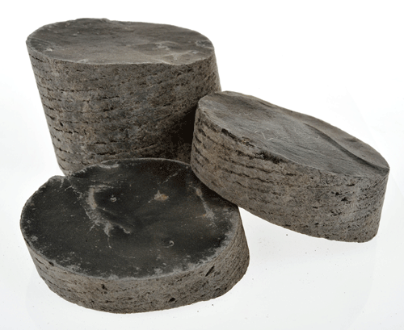 | 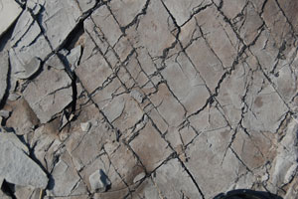
Coal seam gas, also known as coalbed methane, is natural gas found in coal seams. Coal seam gas is generally a shallower gas resource than tight and shale gas. In the Otway region black coals of the Killara coal measures in the Eumeralla Formation may host coal seam gas at depths greater than 600 m. Coal seam gas is held in coal seams by water pressure. | 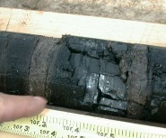 | 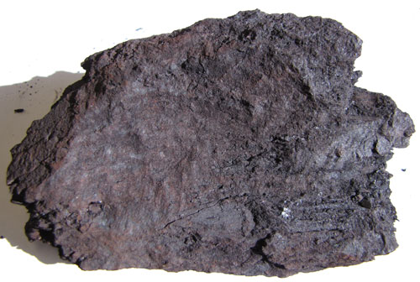
The approximate location of potentially prospective onshore natural gas is shown in Figure 2. The cross-section in Figure 3 shows a representation of the typical rock formations bearing potential gas resources and the relative depth of the different potential gas sources.
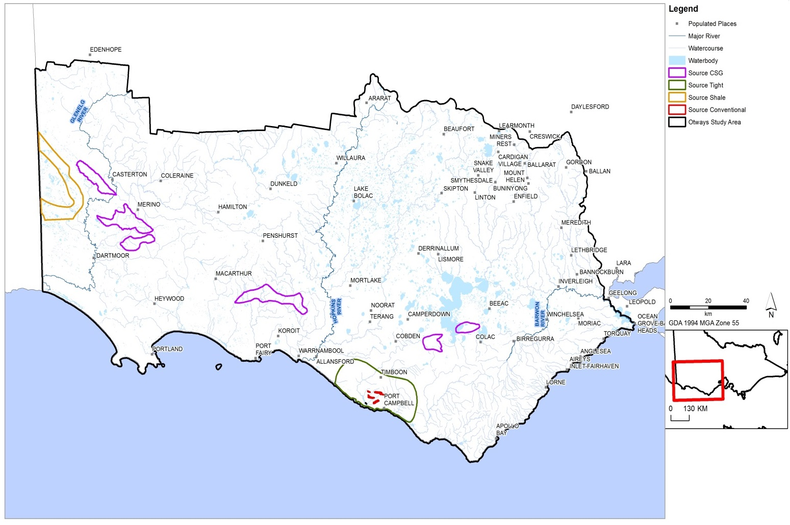
Figure 2: Extent of hypothetical onshore natural gas development scenarios for the assessment of potential impacts on water resources in the Otway region.
Figure 3: Typical rock formations bearing potentially prospective onshore natural gas in the Otway region (depth shown in metres).
  - History of gas exploration and development
Exploration for oil and gas has a long history in the Otway region with the drilling of the first wells in the 1920s. Conventional gas was first discovered in the onshore Otway Basin in 1959 around Port Campbell but it was not until 1978 that a commercial conventional gas discovery in the area revived interest in the commodity. From the early 1990s into the 2000s, conventional gas discoveries both onshore and offshore around the Port Campbell area established the region as an attractive gas producing province.
In the onshore Otway region, 155 wells have been drilled over the years for exploration purposes and nine wells have been drilled for conventional gas production in the Iona gas field, near Port Campbell. The Iona gas field is now depleted and is used as a gas storage facility taking gas from offshore production and storing it temporarily prior to release to consumers. Natural gas (methane) is no longer produced in the onshore Otway region.
  - Industry practices for production of natural gas
Unlike conventional gas, tight, shale, and coal seam gas may be continuous over wide geographic areas rather than concentrated in discrete areas. This observation is based on experience elsewhere. This means that increased drilling activity may be necessary for both exploration and development phases for these natural gas types. The development of tight and shale gas (and sometimes coal seam gas) uses technologies such as horizontal drilling and hydraulic fracturing techniques to extract the gas. Tight and shale gas project developers may drill multiple wells from a single well pad, which enables a greater spacing between the well pads at the surface: often around 1 km. Well spacing for coal seam gas production is generally around 400 m, which means more wells are required over the same area.
The development of tight and shale gas production has advanced in the United States of America due to the application of hydraulic fracturing and horizontal drilling technologies (Figure 4). Hydraulic fracturing, also called fracture stimulation or fracking, is a process that generates small fractures to increase the permeability of the rock formation and allows greater gas extraction. Tight gas rocks within the Gippsland region may require hydraulic fracturing in order to increase their permeability, enabling the gas to be released. The applicability of hydraulic fracturing to extract tight and shale gas in Victoria is not proven. Horizontal drilling (also known as directional or in-seam drilling) is used to access all types of natural gas. There is a lot that must be understood about the geology from on-ground surveys and vertical drilling before determining whether horizontal drilling would be effective to extract gas. This technique has been successfully used in the United States of America. The applicability of horizontal drilling methods to potential natural gas formations in Victoria is not proven.
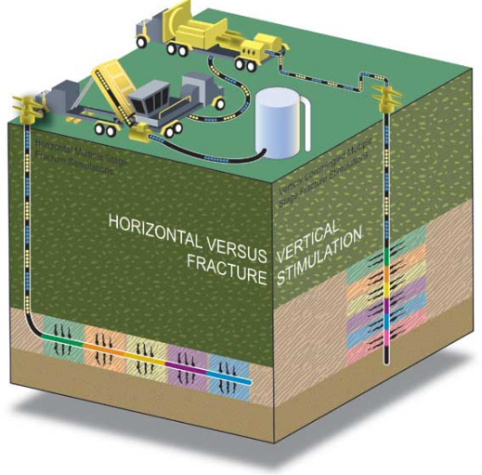
Figure 4: Hydraulic fracturing or stimulation process in vertical and horizontal wells. (Source: Standing Council for Energy Resources, 2013, The National Harmonised Regulatory Framework for Natural Gas
from Coal Seams.)

- Water resources of the Otway region
  - Groundwater
Groundwater is water that is stored under the ground within aquifers and aquitards. An aquifer is a layer of rock that is porous enough to hold groundwater and permeable enough to allow the groundwater to flow. An aquitard is a layer of rock that may hold groundwater, but is less permeable than an aquifer and therefore restricts groundwater flow. Groundwater can vary in quality from fresh to saline.
The Otway region contains a variable sequence of aquifers and aquitards. The sequence of aquifers and aquitards generally thickens toward the coast. Groundwater and surface water are utilised in the Otway region for agriculture and town water supplies.
The major groundwater resources in the Otway region are found in three main aquifer groups:
- Upper aquifers are generally less than 100 m depth and comprise the Newer Volcanics, Bridgewater Formation and various other sand units.
- Middle aquifers that may be relatively shallow to the north of the basin and deepen towards the coast. Middle aquifers include the Port Campbell Limestone and the Clifton Formation aquifers. These aquifers are separated from the Lower aquifer by the Gellibrand Marl aquitard.
- Lower aquifers include the Dilwyn Formation and Eastern View Formation aquifers. These aquifers are confined by the overlying Narrawaturk Marl and the upper Mepunga Formation.
Gas resources in the Otway region are usually located at great depth below the surface, underneath the aquifer layers. In some areas coal seam gas could be found in black coal, which can be closer to the deeper sections of lower aquifers. Aquitards and gas seal rocks lying between the gas sources and the aquifer sequence and restrict the degree of connection between the two. Crucially, there is always an aquitard present between the potential natural gas resource and the aquifers in the Otway region. The thickness of these aquitards varies; their combined thickness can be up to 2000 m.
Figure 5 shows the spatial density of entitlement to pump groundwater from all aquifers, and the locations of the town water supply bores across the Otway region. The distribution of bores highlights that groundwater use is scattered throughout the region. High water-use areas are located in the south near the coast, the central part of the region, the west near the state border, and in the northeast near Ballarat. Stock and domestic bores (Figure 6) have a similar distribution to groundwater entitlements. Groundwater entitlement refers to licensed groundwater use; the total annual entitlements from the upper, middle and lower aquifers are shown in Figure 7.
  - Surface water
The major surface water features in the Otway region fall within eight river basins, including the Millicent Coast, Glenelg River, Portland Coast, Hopkins River, Lake Corangamite, Otway Coast, Barwon River and Moorabool River Basins (Figure 8).
The highest areas of runoff throughout the Otway Basin are in the Otway Ranges, resulting in higher
stream flows in these areas (for example the Gellibrand and Aire Rivers in the Otway Coast basin in
Figure 8). In other areas where runoff is more variable, many of the streams are ephemeral, flowing only after significant rainfall.
The surface water entitlements for 2012–2013 are summarised in Figure 8. This shows that the majority of surface water entitlements are in the Otway Coast, Barwon and Moorabool basins. Major towns that use surface water are Geelong, Colac, Hamilton, Warrnambool and other coastal towns.

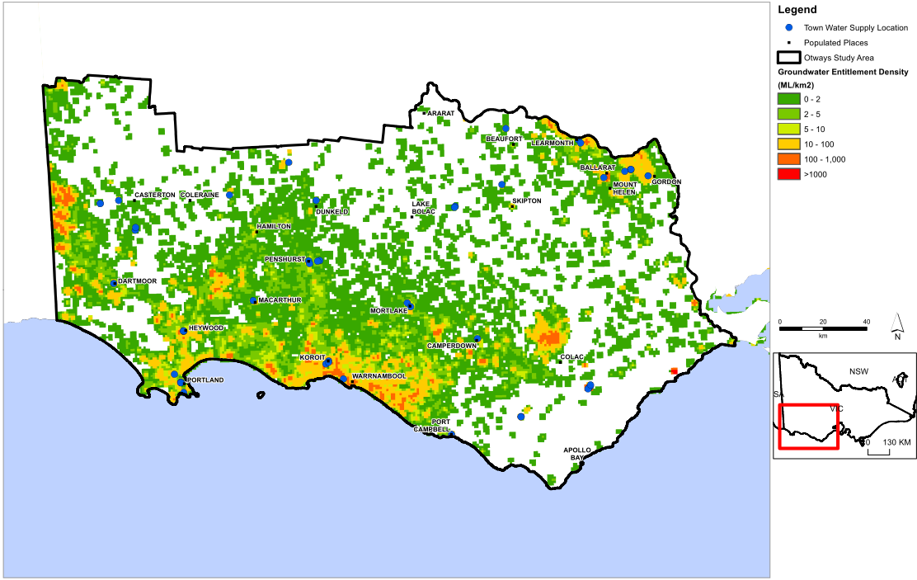
Figure 5: Density of groundwater entitlements (ML/km²) and town water supply bores in the
Otway region.

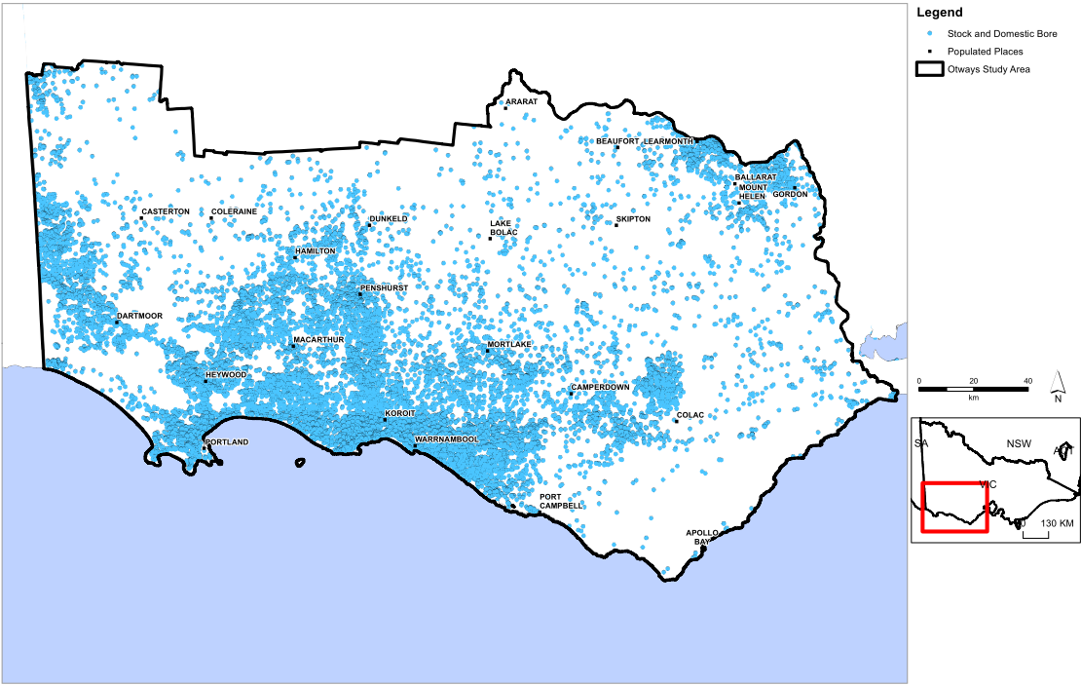
Figure 6: Location of stock and domestic bores in the Otway region.

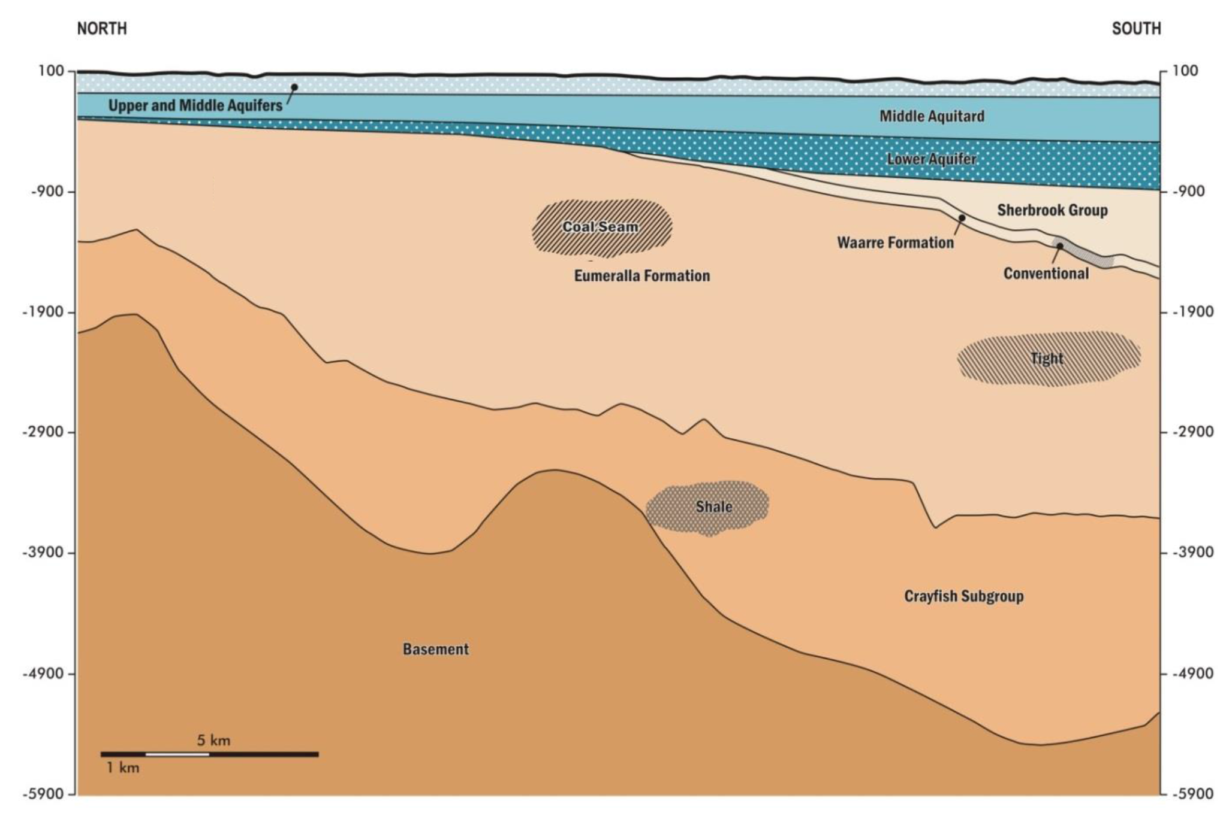
UPPER & MIDDLE AQUIFERS
Approximately 154,000 ML/year in groundwater entitlements in upper and middle aquifers

No entitlements
LOWER AQUIFER
Approximately 35,000 ML/year in groundwater entitlements in lower aquifers

Figure 7: Groundwater use entitlements in the Otway region.

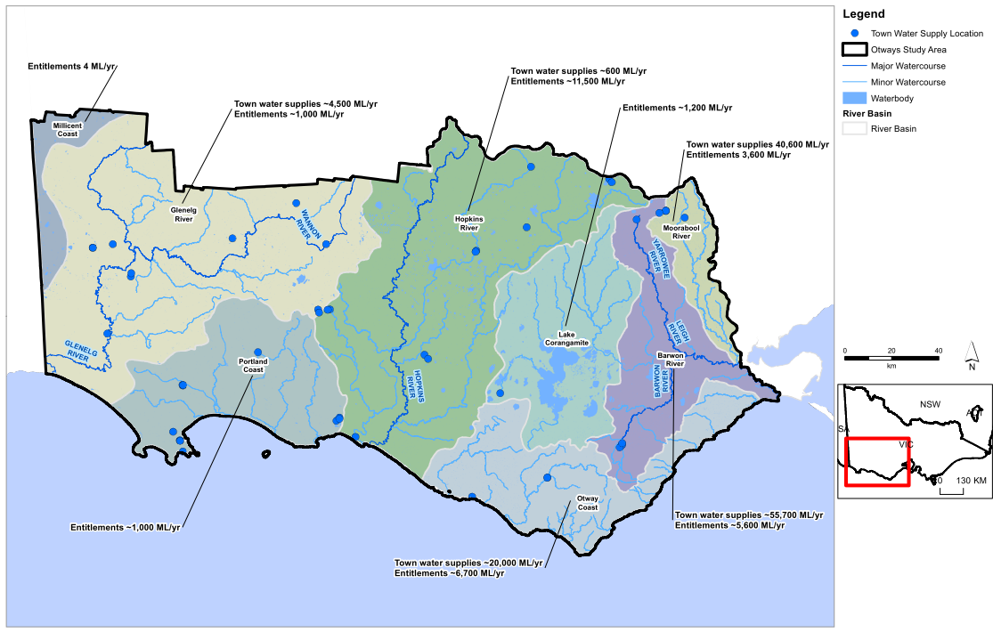
Figure 8: Major surface water features and entitlements in the Otway region.

  - Ecosystems
Numerous water-dependent ecosystems including lakes and wetlands are located in the Otway region. The Western District Lakes are the largest in the region and include Lake Corangamite, the largest permanent saltwater lake in Australia and Lake Bookaar Wildlife Reserve. These lakes are Ramsar-listed and recognised as internationally important. There are 22 nationally important wetlands in the Otway region as recognised in the Directory of important wetlands in Australia (2001), and these are shown in Figure 9.
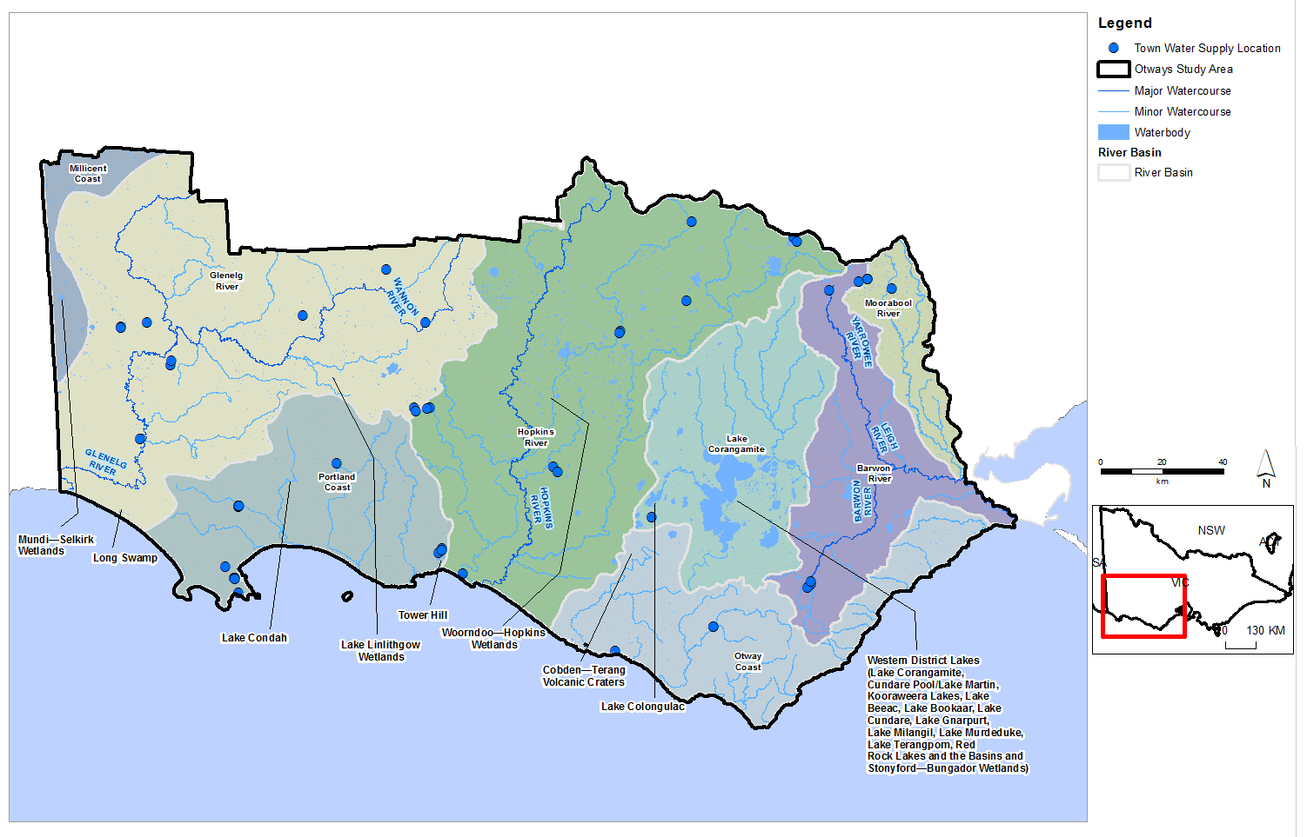
Figure 9: Wetlands listed in the Directory of Important Wetlands in Australia.
  - Groundwater and surface water connection
Groundwater and surface water are connected resources in places. Groundwater contributes to river flow when the watertable is higher than the river level. The volume of groundwater that contributes to the river flow is called baseflow. When the groundwater level is below the river level, a river may lose water to the groundwater; this is also known as indirect groundwater recharge. If there is a low permeability layer between the base of the river and the underlying groundwater, the river and groundwater resources are likely to be poorly connected or disconnected.
Water bodies, such as lakes and wetlands, have a similar connection to groundwater, dependent on the depth to watertable adjacent to and beneath the water body and the permeability of the ground beneath the water body.

Depth to watertable provides an indication of where groundwater and surface water systems may be connected. The depth to watertable across the Otway region is shown in Figure 10. Areas with a depth to watertable of less than 2.0 m were assessed as having a high potential for connection between surface water bodies and groundwater. Areas with a depth to watertable of between 2.0 and 6.0 m were assessed as having a moderate potential for connection, while areas with a depth to water table of greater than 6.0 m were assessed as having a low potential for connection based on existing knowledge of systems in
western Victoria.
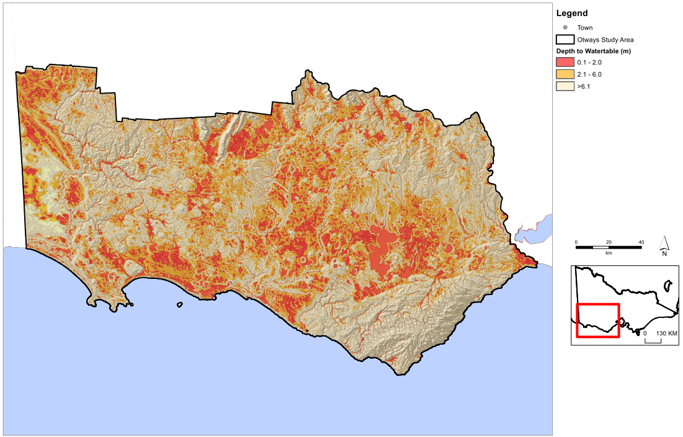
Figure 10: Depth to watertable across the Otway region.
  - Groundwater sampling and characterisation for hydrocarbons
The water science studies included groundwater sampling and characterisation for hydrocarbons (Victorian Government 2015a; see the list of studies on page 27). In 2014 thirty bores were sampled across the Otway region in the upper, middle and lower aquifers. The groundwater was sampled for a range of parameters, primarily hydrocarbons. The results of the sampling indicate the following:
- Methane concentrations are low in all aquifers, observed in concentrations up to 5.8 parts per million. No methane was detected in the upper aquifer. Methane occurs naturally in the atmosphere and is commonly found at trace levels as a dissolved component of groundwater. It can also be released by anthropogenic activities including agriculture, landfills and hydrocarbon development. There is no authoritative guidance for methane concentrations in groundwater.

- Ethane, ethene, butane, butene, propane, and propene were not detected in the 30 bores sampled, suggesting that they do not occur naturally in the sampled aquifers.
- Benzene, toluene, ethylene and xylene, collectively known as BTEX, are other naturally occurring hydrocarbons. No BTEX was found in groundwater samples in the Otway region.
- Total petroleum hydrocarbons (TPH) were detected in 5 of the 30 samples at low concentrations, at up to 0.4 parts per million in the lower aquifer and at up to 0.1 parts per million in the upper aquifer. The TPH detected may occur naturally, but could also have been unintentionally introduced to the bores during their construction. TPH in the lower aquifer could exceed relevant guideline thresholds, depending on the intended use of the water, but in the upper aquifer the levels detected did not exceed relevant guideline thresholds.
- Naphthalene was not detected, which indicates that it does not occur naturally in any of the sampled groundwater.

- Where are gas and water likely
to be connected?
Groundwater resources in the Otway region occur in the upper, middle and lower aquifers at depths of less than 1000 m below ground surface.
Potential natural gas resources in the Otway region are located beneath the aquifer layers, at depths between 750 m and 4000 m. There is limited potential for connection between the two resources across the region, with the exception of coal seam gas, which is the most shallow potential gas resource.
In the case of conventional gas resources a low-permeability layer over the gas reserve is required to trap and hold the natural gas in place. This low-permeability layer is also known as a seal, or seal rock. While many of the known conventional gas reserves have been depleted in the Port Campbell region, further potential conventional gas could occur in the Waarre Formation around Warrnambool. The Waarre Formation has at least 400 m of the low-permeability Sherbrook Group between the potential conventional gas resource and the lower aquifer. Therefore the potential for hydraulic connection between these two resources is limited.
Potential tight gas resources are located around Port Campbell and Warrnambool in a similar geographic area to the potential conventional gas resources. However, the prospective tight gas resources are at around 2000 to 2500 m depth in the Eumeralla Formation, beneath the potential conventional gas resources. Between 250 m to over 1000 m of the low-permeability Eumeralla Formation and Sherbrook Group overlie the potential tight gas resources, which significantly reduces the potential for hydraulic connection between these two resources.
Shale gas is the deepest potential source of onshore natural gas in the Otway region and is expected to exist in the Casterton Formation at depths greater than 2500 m. Prospective shale gas resources could be located near the South Australian border. The prospective shale gas resource is separated from the lower aquifer by 900–3000 m of alternating aquitards and aquifers. There is little potential for connection between the resources because of the significant thickness of aquitards between the two resources and their low hydraulic conductivity.
Coal seam gas in the black coals of the Killara coal measures within the Eumeralla Formation is the shallowest prospective gas source in the Otway region. Prospective coal seam gas resources could be located at depths in excess of 600 m.
There are many fracture zones throughout the Otway region, but the existing fractures and faults are
not considered to be a source of connectivity between different aquifers. This is supported by historic onshore and offshore gas extraction in the Otway region, which has not had any measurable impact on overlying aquifers.
- What are the potential impacts from possible natural gas development?
  - Assessment approach
A screening-level approach was utilised to assess the potential impacts of natural gas development on water users and ecosystems. The key elements of the approach are summarised in Table 3 and Table 4. For further details about the impact assessment criteria, refer to Otway region assessment of potential impacts on water resources (full reference given on page 25).

Table 3: Approach to assessing potential impacts.
Potential impacts | Groundwater users | Surface water users | Ecosystems
Aquifer depressurisation | Groundwater modelling to estimate potential declines in groundwater levels | Inferred from modelled declines in groundwater levels
Chemical contamination from hydraulic fracturing fluids | Review of national and international literature with consideration  of the particular geological conditions of the Otway region
Induced seismicity
Land subsidence

Table 4: Impact criteria.
Level of impact | Criteria | Example
Low | Impact is within normal variability | For groundwater users, a predicted decline in the water table of less than 2 m and a predicted decline in deep groundwater levels of less than 10 m or no change is anticipated
Moderate | While the impact is outside normal variability, the impact does not significantly change the function of water users or ecosystems | For groundwater users, a predicted decline in the water table of 2 m to 15 m or a predicted decline in deep groundwater levels of 10 m to 75 m
High | Impact significantly changes the function of water users or ecosystems | For groundwater users, a predicted decline in the water table of greater than 15 m or a predicted decline in deep groundwater levels of greater than 75 m

  - Potential impacts from aquifer depressurisation
    - The basis for potential impacts
The following is an overview of the potential impacts that may arise from aquifer depressurisation based on international experience.
The possible impact on water users and ecosystems from aquifer depressurisation depends on the gas development type (conventional, tight, shale, and coal seam gas) and the nature of connections between groundwater, surface water, ecosystems and the gas.
Conventional gas is generally extracted from a single well in a gas field and generally without the need for hydraulic fracturing. Gas is pumped from the rock formation or allowed to flow freely to surface, often together with oil and water.
Tight gas and shale gas are stored in low-permeability rock formations that also have low water yields. Technologies such as hydraulic fracturing and horizontal drilling are sometimes required to increase permeability and to release the gas from a sufficiently large volume of the rock. Gas is removed from the formation by lowering the groundwater pressures, which is achieved by pumping the groundwater from the drilled wells. The gas is recovered with the pumped groundwater.
Coal seam gas is held in the coal seam by water pressure. As for tight gas, the water pressure must be reduced to release and extract the gas, which can be achieved by pumping groundwater from the coal seam. In coal seam gas development, hydraulic fracturing is often not required to release the gas.
Removing groundwater and gas means that groundwater may flow from adjacent aquifers towards the area of gas extraction, leading to lowering of pressures (depressurisation) of these aquifers. After long periods of pumping the depressurisation may extend to shallow aquifers and to a wider region than just the area of gas development. Eventually, depressurisation may affect surface water bodies.
All forms of gas development have the potential to impact groundwater users, surface water users and ecosystems as a result of aquifer depressurisation leading to loss of access to groundwater, reductions in surface water flows or changes in groundwater quality. Generally, changes in groundwater quality may arise when groundwater levels and flow regimes change to the extent that poorer quality is drawn into good quality aquifers. Reduced groundwater levels and changes in groundwater quality could affect surface water users or ecosystems if the resources are connected.
    - Otway region study results
Based on the water science studies, the potential impacts from aquifer depressurisation for possible conventional, tight, shale and/or coal seam gas developments in the Otway study region are as follows:
- The potential for impacts on groundwater users and groundwater quality from aquifer depressurisation is low across the Otway region. This is inferred from the predicted changes to groundwater levels, which are within historical ranges for the region.
- The potential for impacts on surface water users and ecosystems as a result of reduced stream flow
or changes in surface water quality due to aquifer depressurisation is low across the Otway region.
This is inferred from the predicted changes to groundwater levels, which are within historical ranges
for the region.

  - Potential for chemical contamination of groundwater from hydraulic fracturing fluids
    - The basis for potential impacts
Chemicals are used in many aspects of the petroleum and gas industry, including drilling operations, hydraulic fracturing, water management and treatment and general operations such as fuel for transport. Drilling fluids are typically water-based and include clays and other additives to control density and viscosity, which reduces fluid loss and prevents potential gas release. Hydraulic fracturing fluids are composed primarily of water (typically 90%), sand or a manufactured equivalent (typically 9%) and chemical additives (typically 1%). The chemical additives used in hydraulic fracturing fluid vary, depending on the application, the nature of the rock formation, the developer and, in some cases, legislation and regulations applicable
to the state or territory. Many of the chemicals may be used in hydraulic fracturing fluid, many of which are commonly used in other industries, including chemicals used in swimming pools additives, disinfectants
and detergents. There is a ban in Victoria on the use of BTEX, so these chemicals cannot be used in hydraulic fracturing.
Based on experience from existing tight and shale gas development around the world, the development of tight and shale gas in the Otway region may require hydraulic fracturing in order to increase rock permeability and hence gas production. The literature suggests that typical fracture propagation distances are in the order of tens of metres, although this depends on the rock type and the geology.
Potential impacts to groundwater users, surface water users and ecosystems as a result of hydraulic fracturing operations relate primarily to chemical contamination of groundwater from hydraulic fracturing fluids. This can occur if the fracture propagation extends further than intended and creates a direct connection to an aquifer.
The potential impacts to water users and ecosystems from possible hydraulic fracturing were assessed by reviewing international literature on typical fracture propagation distances within the context of their geological setting and applying that to the Otway geological setting. This review assessed the potential for connections to be created between hydraulic fracturing fluids and water resources.
    - Otway region study results
The development scenario used for shale gas indicates that the prospective resources are in the Casterton Formation at about 3500 m depth. There are around 1500 to 3000 m (vertical distance) of low-permeability formations between the Casterton Formation and the nearest aquifer. These formations provide a significant physical separation between the aquifers and any fractures generated in the Casterton Formation. Given the typical fracture propagation distances of up to tens of metres, the potential for chemical contamination of groundwater from hydraulic fracturing fluids as a result of the generation of fully penetrating fractures, or the intersection between stimulated and pre-existing fractures is low.
With respect to tight gas development, a vertical fracture of tens of metres would still be about 500 m from the deepest groundwater resource in the Port Campbell Embayment of the Otway region. Based on this and other factors, the overall potential for chemical contamination of groundwater from hydraulic fracturing fluids due to tight or shale gas developments is low.
Prospective coal seam gas may exist where the base of the Eumeralla Formation is at depths in excess of 600 metres below the surface. Possible coal seam gas sources would be separated from overlying aquifers by at least 300 m of low-permeability Eumeralla Formation, so the potential for impacting groundwater users, surface water users or ecosystems as a result of chemical contamination of groundwater from hydraulic fracturing fluids is inferred to be low.
Overall, the potential for chemical contamination of groundwater from hydraulic fracturing fluids as a result of possible tight, shale or coal seam gas development in the Otway region is low, based on the above and the fact that the addition of BTEX chemicals to hydraulic fracturing fluids is banned under Victorian law.
Hydraulic fracturing is not expected to be required for conventional gas development in the Otway region, and therefore the potential for associated chemical contamination of groundwater would not occur.
  - Potential for increased earthquakes
    - The basis for potential impacts
Small earthquakes can be triggered by human activity; this is known as induced seismicity. Induced seismicity associated with gas development may be related to three key activities:
- hydraulic fracturing
- large-scale depressurisation as a result of gas development
- re-injection of produced water.
    - Otway region study results
Natural seismicity is driven largely by compressional stresses in the ground. The Otway region has a low level of seismic activity. The potential for hydraulic fracturing and depressurisation during conventional, tight, shale and coal seam gas developments in the Otway region induce seismicity (i.e. an earthquake) in the Otway region with a magnitude greater than 3.5 (M_{L}), which can be felt by an individual, was assessed to
be low.
Experience from overseas indicates that most induced earthquakes associated with gas development are associated with re-injection of produced water into deep rock formations. The potential for re-injection of water to induce seismicity in the Otway region is site specific and would need to be assessed on a case-by-case basis.
  - Potential for land subsidence
    - The basis for potential impacts
Land subsidence can be brought about by declining groundwater levels. When dewatering reduces the pressure in fine-grained sediments (e.g. clays) they can compress, and this results in lowering of the land surface. Prior consolidation and compaction history of sediments is important when predicting subsidence.
    - Otway region study results
For the Otway region the water science studies indicate that there is a low potential for subsidence from onshore conventional, tight, shale and coal seam gas developments, based on the low water-level drawdown in aquifers predicted.

  - Summary of potential for impacts
A summary of the potential for impacts is presented in Table 5 and Table 6.

Table 5: The potential for impacts associated with aquifer depressurisation for each gas scenario.
Natural gas type | Impacts on users
Natural gas type | Groundwater users | Surface water users | Ecosystems
Conventional gas | Low | Low | Low
Tight gas | Low | Low | Low
Shale gas | Low | Low | Low
Coal seam gas | Low | Low | Low

Table 6: The potential for impacts associated with hydraulic fracturing, induced seismicity and land subsidence for each gas scenario.
Natural Gas Type | Chemical contamination of groundwater from  hydraulic fracturing fluids |  |  | Induced seismicity | Land subsidence
Natural Gas Type | Groundwater users | Surface water users | Ecosystems
Conventional gas | Low | Low | Low | Low | Low
Tight gas | Low | Low | Low | Low | Low
Shale gas | Low | Low | Low | Low | Low
Coal seam gas | Low | Low | Low | Low | Low

Water science studies outputs for
Otway region

Otway region synthesis report (this report) Department of Environment, Land, Water and Planning and the Geological Survey of Victoria, 2015. Onshore natural gas water science studies — Otway region synthesis report. Department of Environment, Land, Water and Planning and the Department of Economic Development, Jobs, Transport and Resources, Melbourne. June 2015.

Onshore natural gas prospectivity: Otway region
GOLDIE DIVKO, L. M., 2015. A review of natural gas prospectivity: Otway region. Department of Economic Development, Jobs, Transport and Resources, Melbourne, Victoria. June 2015.

Victorian Water Asset Database
Department of Environment, Land, Water and Planning, 2014. Victorian Water Asset Database, (electronic resource: not online)

Groundwater sampling and characterisation for hydrocarbons for the Otway region Department of Environment, Land, Water and Planning, 2015. Onshore natural gas water science studies — Otway region groundwater sampling and characterisation for hydrocarbons. Department of Environment, Land, Water and Planning, Melbourne. June 2015.

Otway region assessment of potential impacts Department of Environment, Land, Water and Planning and the Geological Survey of Victoria, 2015. Onshore natural gas water science studies – Otway region assessment of potential impacts on water resources. Department of Environment, Land, Water and Planning and the Department of Economic Development, Jobs, Transport and Resources, Melbourne. June 2015.

Glossary of terms and abbreviations
Term | Meaning
aquifer | rock or soil that readily transmits water
aquitard | rock or soil that transmits water very slowly
baseflow | contribution of surface water flow attributed to groundwater
BTEX | Benzene, toluene, ethylbenzene and xylene
confined aquifer | an aquifer in which an impermeable rock or soil layer or layers prevents water from seeping into the aquifer vertically
drawdown | reduction in groundwater head elevation relative to a nominated baseline condition.
entitlements | the volume of water authorised to be taken and used by an irrigator or water authority, including bulk entitlements, environmental entitlements, water rights, sales water, and surface water and groundwater licences
ML | megalitre, one million litres
M_{L} | Local magnitude, from the Richter magnitude scale that assigns a magnitude number to quantify the energy released by an earthquake
Ramsar (Convention) | An international treaty that aims to conserve wetlands which have been listed for their international significance and ensure that they are managed wisely, signed in Ramsar, Iran, in 1971
regulated river | a river containing structures such as dams or major diversion weirs which control the flow of water in the river for licensed diverters or users in an irrigation district
unconfined aquifer | an aquifer where the watertable is exposed to the atmosphere through openings in the overlying materials
watertable | the surface where the groundwater level is balanced against atmospheric pressure; often this is the shallowest water below the ground


© The State of Victoria Department of Environment, Land, Water & Planning 2015

This work is licensed under a Creative Commons Attribution 4.0 International licence. You are free to re-use the work under that licence, on the condition that you credit the State of Victoria as author. The licence does not apply to any images, photographs or branding, including the Victorian Coat of Arms, the Victorian Government logo and the Department of Environment, Land, Water and Planning (DELWP) logo. To view a copy of this licence, visit http://creativecommons.org/licenses/by/4.0/

ISBN 978-1-74146-618-8 (pdf)

Accessibility
If you would like to receive this publication in an alternative format, please telephone the DELWP Customer Service Centre on 136186, email customer.service@delwp.vic.gov.au or via the National Relay Service on 133 677 www.relayservice.com.au. This document is also available on the internet at www.onshoregas.vic.gov.au

Disclaimer
This publication may be of assistance to you but the State of Victoria and its employees do not guarantee that the publication is without flaw of any kind or is wholly appropriate for your particular purposes and therefore disclaims all liability for any error, loss or other consequence which may arise from you relying on any information in this publication.

