
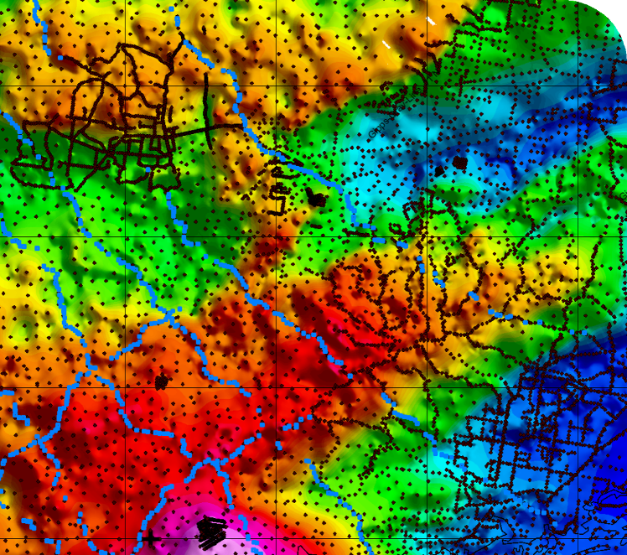

Gippsland Basin Gravity Survey
Mathews, L.R., and McLean, M.A.

Geological Survey of Victoria Technical Record 2015/1



Earth resources development

Bibliographic reference:
Mathews, L.R., and McLean, M.A. 2015. Gippsland Basin gravity survey. Geological Survey of Victoria Technical Record 2015/1
Authorised by the Victorian State Government, Department of Economic Development, Jobs, Transport & Resources
1 Spring Street Melbourne Victoria 3000
Telephone (03) 9208 3333
June 2015
© Copyright State of Victoria
Except for any logos, emblems, trademarks, artwork and photography this document is made available under the terms of the Creative Commons Attribution 3.0 Australia licence.

ISSN 1324 0307
ISBN 978-1-921572-28-9 (pdf)
Report Cat. No. 88311
Accessibility
If you would like to receive this publication in an alternative format, please telephone DEDJTR Customer Service Centre 136 186, email customer.service@ecodev.vic.gov.au, via the National Relay Service on 133 677,
www.relayservice.com.au
This document is also available on the internet at www.onshoregas.vic.gov.au
Keywords:
Gravity, gravity survey, acquisition, Gippsland, Gippsland Basin, Strzelecki Group
This report is available:
As a digital download from the Earth Resources Online Store
http://earthresources.efirst.com.au/
For further information or enquiries, please call 136 186
or email erd_info@ecodev.vic.gov.au
Acknowledgements:
This report has been prepared by Atlas Geophysics and the Geological Survey of Victoria with support provided by Murray Richardson at Geoscience Australia.
Disclaimer:
This publication may be of assistance to you but the authors and the State of Victoria and its employees do not guarantee that the publication is without flaw of any kind or is wholly appropriate for your particular purposes and therefore disclaim all liability for any error, loss or other consequence which may arise from you relying on any information in this publication.
Front cover illustration:
Bouguer anomaly grid over the Strzelecki Ranges of newly acquired gravity data integrated with
pre-existing gravity data.

Contents
Executive Summary 5
1 Introduction 6
1.1 Location and Access 6
1.2 Survey Configuration 6
2 Equipment and instrumentation 9
2.1 GPS Glonass receiver equipment 9
2.2 Gravity instrumentation 9
2.3 Other equipment 9
3 Survey methodology 11
3.1 Gravity and GPS control establishment 11
3.2 GPS data acquisition, processing and quality analysis 11
3.3 Gravity data acquisition, processing and quality analysis 14
4 Results 21
4.1 Survey timing and production rates 21
4.2 Data formats 21
4.3 Data and cross survey repeatability 22
4.4 Grids, images and plots 24
Appendix A - Primary control stations 26
Appendix B - Gravity control ties 28
Appendix C - Gravity meter calibration data 29
Appendix D - Repeat gravity data 31
Appendix E - Longman’s earth tide correction formula 34
Appendix F - Data formats and metadata 35
Executive Summary

The geometry of the Cretaceous Strzelecki Group in the Gippsland region and the underlying Palaeozoic basement of the Melbourne Zone are unresolved. The current coverage of land based gravity data in the onshore Gippsland Basin is approximately 1500 m. This resolution is not detailed enough to sufficiently characterise the geometry of the Strzelecki Group.
This project involved the acquisition of more closely spaced gravity data (500 m), placed along a series of profile lines. Specifically, the Geological Survey of Victoria (GSV) has acquired 12 regional gravity transects – 3 in a northeast orientation, and 9 in a northwest orientation – strategically located to maximise our understanding of this region’s geological structures. The transects (Figures 1a & 1b) cover areas located on the Healesville, Western Port, Warragul, Moe, Traralgon, Woolamai, Wonthaggi, Foster and Yarram 1:100 000 map sheets; an area of 8,358 km².
When combined with petrophysical data such density measurements made both from surface outcrops and also from drill core, the newly acquired gravity will be used to construct both two, and three dimensional models. Calibration with a planned 2D seismic survey across the region will further increase confidence in gravity modelling outputs. These models provide a framework which can be used to make depth to basement estimates, but most importantly, to perform hydrodynamic flow scenarios to assess the behaviour of the groundwater system in response to possible onshore natural gas development within the Gippsland Basin.

1 Introduction
Atlas Geophysics were contracted to acquire and process 1,213 new regional gravity stations by Geoscience Australia (GA) on behalf of the Geological Survey of Victoria (GSV). Acquisition was carried out by a 2-person crew in a vehicle along existing roads and tracks within the Gippsland Basin in south-eastern Victoria. The survey commenced on 1st July 2014 and was completed on 21st July 2014.
The objective of the project was to collect more gravity data to maximise our understanding of the geometry and internal structure of the Cretaceous sequence and the underlying crustal architecture of the region. When combined with density data the newly acquired gravity will be used to construct 2D models and depth estimates. Calibration with a planned 2D seismic survey across the region will increase confidence in gravity modelling outputs.
1.1 Location and Access
The gravity survey covered an area of approximately 8,358 km² within the Gippsland Basin in south-east Victoria (Figure 1). The crew utilised a single logistical base at Korumburra, in the northern part of the survey area. Most surveying was in open, farmland areas, but some surveying was conducted in heavily forested areas requiring longer GPS occupation times. On busy roads, traffic noise necessitated longer gravity observation times to stack out noise.
1.2 Survey Configuration
Gravity acquisition was conducted on existing roads and tracks on a nominal 500 m spacing according to a pre-defined survey plan outlined by the GSV. A small percentage of stations were offset or omitted from the survey where vehicular access was poor, or where tracks were fenced off due to private property. All gravity data were collected along a total of 12 profile lines – 3 in a northeast orientation, and 9 in a northwest orientation (Figures 1a & 1b). No new data were collected where previously acquired data is sufficiently detailed. Therefore, some of the northeast trending lines appear minimal, however they will be bolstered with pre-existing data during the modelling phase of the project.
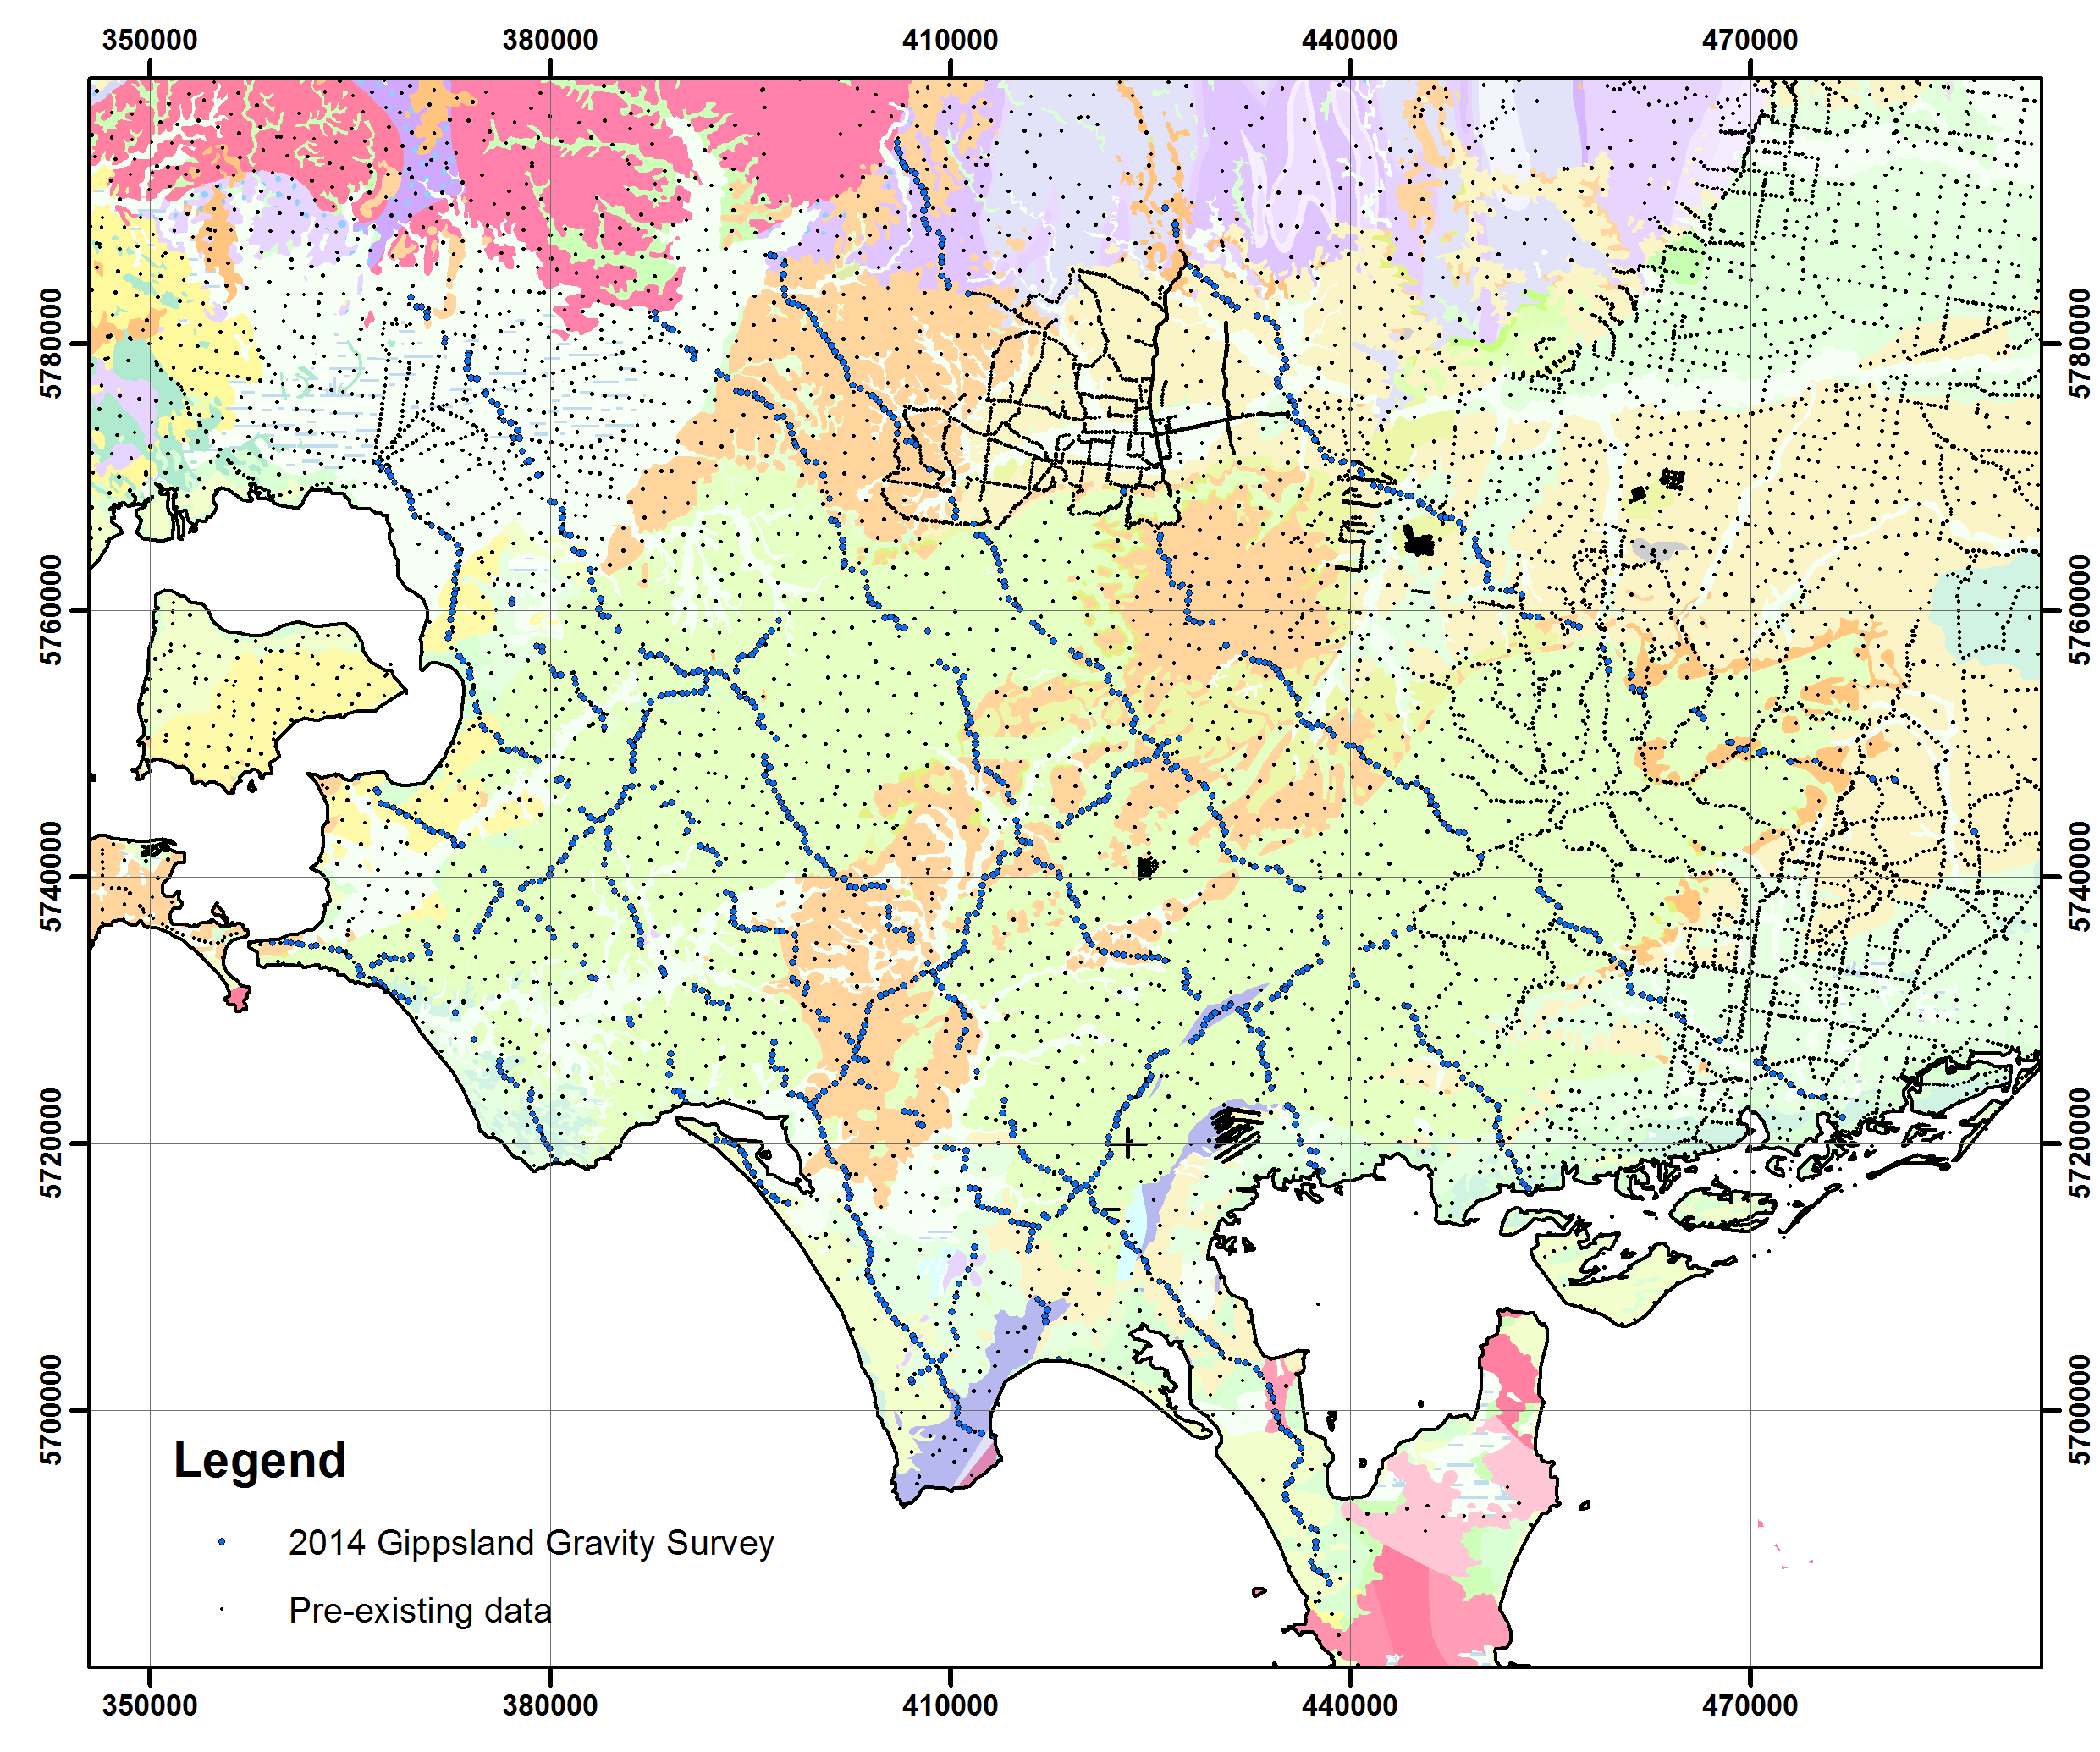
Figure 1a Newly acquired land based gravity data (blue) and pre-existing data (black) in the onshore Gippsland Basin overlaid on the Surface Geology of Victoria 1:250000 map (2011).
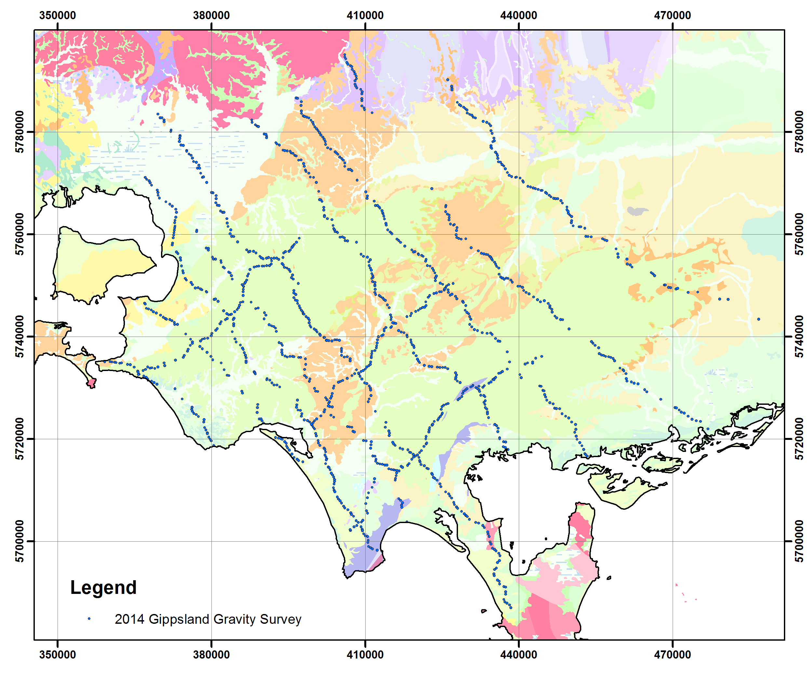
Figure 1b Newly acquired land based gravity data in the onshore Gippsland Basin overlaid on the Surface Geology of Victoria 1:250000 map (2011).

2 Equipment and instrumentation

2.1 GPS Glonass receiver equipment
Leading edge dual-frequency GPS technologies from Leica Geosystems such as the Leica GS14 have been utilised on the project to allow for real-time kinematic (RTK) centimetre level accuracy 3D positions. The GS14 system is equipped with future proof GNSS technology which is capable of tracking all available GNSS signals including the currently available GLONASS. These new generation receivers, in conjunction with full GNSS tracking and processing, offer a new level of unmatched solution accuracy and reliability, especially when compared to existing conventional L1, L2 GPS technologies.
The use of Glonass technology in addition to GPS provides very significant advantages:
• markedly increased spatial distribution of visible satellites
• reduced horizontal and vertical Dilution of Precision (DOP) factors
• improved post-processed-kinematic (PPK) performance
• decreased occupation times means faster acquisition.
A single Leica GS14 receiver was used to conduct the survey with the receiver connecting to the Leica SmartNet Virtual Reference Station (VRS) network via Telstra Next G.
2.2 Gravity instrumentation
Complementing the GNSS/GPS technologies is a Scintrex CG-5 gravity meter (Figure 2). The CG-5 digital automated gravity meter offers all of the features of the low noise industry standard CG-3M micro-gravity unit, but is smaller and lighter. It also offers improved noise rejection. By constantly monitoring tilt sensors electronically, the CG-5 automatically compensates for errors in gravity meter tilt. Due to a low mass and the excellent elastic properties of fused quartz, tares are virtually eliminated.
The CG-5 can be transported over very rough terrain, on quad bikes, foot, vehicle or helicopter without taring or drifting. In terms of repeatability, the CG-5 outperforms all existing gravity meter technologies, with a factory quoted repeatability of better than 0.005 mGal. A single gravity meter was used on the project (Table 1).
Table 1: Gravity meters used on the project
Gravity meter type | Gravity meter code | Gravity Meter Serial Number
Scintrex CG5 | A3 | 40269

2.3 Other equipment
Atlas Geophysics utilised the following additional equipment to fully support the operations:
• two HP laptop computers for data download and processing
• personal Protective Equipment for all personnel
• batteries, battery chargers, solar cells, UPS System
• survey consumables
• tools, engineering and maintenance equipment for vehicle servicing
• first aid and survival kits
• tyres and recovery equipment
• two satellite tracking and communication devices.
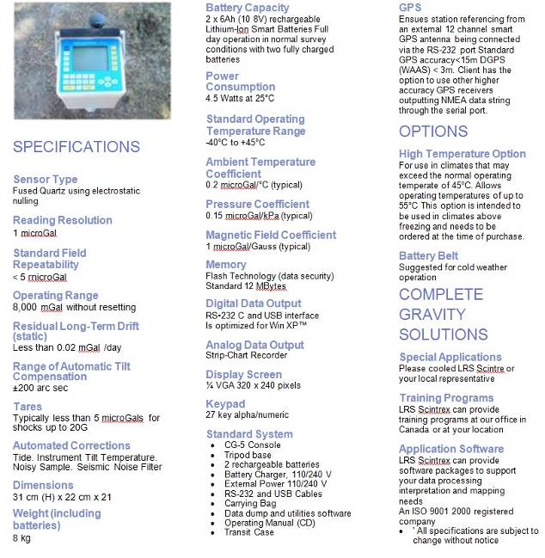
Figure 2 Scintrex CG5 specifications

3 Survey methodology

All gravity data were acquired using Atlas Geophysics Pty Ltd vehicle-borne techniques. These techniques, which involve concurrent GPS and gravity acquisition, allow for rapid acquisition of very high quality data.
3.1 Gravity and GPS control establishment
A single gravity control station was established near to the logistical base (Table 2). As all positional observations were made using a VRS network, it was not necessary to establish any GPS control (see Section 3.1.1)
The station was placed at the Korumburra Coal Creek toilet block (Appendix A). The station was not witnessed with an Atlas Geophysics plaque for fear of vandalism.
Table 2: Gravity control stations used to control the survey
Control station ID | Lat / Long / Ht (GDA94) | Observed Gravity (AAGD07 µm/s²)
201406500001 (GA 20140100001) Korumburra Coal Creek Toilets | -38 26 30.0700  145 49 48.7210 211.718m | 9799977.70

The details of all primary control stations have been recorded on Atlas Geophysics Pty Ltd control station summary sheets. The sheets include the geodetic coordinates, observed gravity value, station description, locality sketch, locality map and a digital photo of the station. The sheets are contained in Appendix A.
3.1.1 Gravity control
Primary gravity control was established at the same location as the primary GPS control stations. Once tied to the Australian Fundamental Gravity Network (AFGN), the gravity control stations allowed all field gravity observations to be tied to the Australian Absolute Gravity Datum 2007 (AAGD07).
An accurate observed or absolute gravity value for the control station was established via “ABABA” ties with the project gravity meter to a nearby AFGN station. Table 3 summarises the control ties conducted and Appendix B contains the control tie data. Expected accuracy of the tie surveys would be better than 0.1 µm/s² (or 0.01 mGal).
Table 3: Primary gravity control stations used to control the survey
Control station ID | AFGN station tied to | Date of ties
201406500001 (GA 20140100001) Korumburra Coal Ck Toilets | 1995901324 War Memorial Park Toilets, Drouin  1995909324 Anglican Church Hall, Drouin | 14/07/2014

3.2 GPS data acquisition, processing and
quality analysis
GPS-Glonass data were collected in real-time kinematic mode using a Leica GS14 receiver connected to the Leica SmartNet Reference Station network. This allowed for excellent GPS-Glonass ambiguity resolution and 3-D solution coordinate qualities better than 3 cm for each of the gravity station locations.
3.2.1 GPS-Glonass acquisition using the Virtual Reference Station Network
Each gravity station location (GSL) was positioned using navigation grade receivers running a mobile map display. At each station, the driver ensured the vehicle was always positioned safely off the road and never on a blind corner or hill crest. The vehicle was, where possible, positioned so that maximum sky coverage was achieved to minimise GPS cycle slips and record the cleanest data possible. At times, gravity station spacing was adjusted to obtain a better view of the sky and increase GPS performance.
A single GPS-Glonass receiver was used in each vehicle with the sensor mounted on the roof of the vehicle using a magnetic mount.
To acquire centimetre-level positions in real time, the crew simply connected to the VRS network via a Telstra internet connection, acquired 20 individual RTK shots, then disconnected (see 3.2.2).
3.2.2 Virtual Reference (VRS) Station Network
In lieu of traditional GPS-Glonass acquisition techniques which require a base station and radio links, the crew utilised the Leica SmartNet AUS Network to obtain centimetre level real-time positions. The network, covering the entire survey area, is run by Leica Geosystems Australia and consists of a network of continuously operating reference stations (CORS), and position-correcting software to provide highly accurate real-time corrections via an internet link (Figure 3).
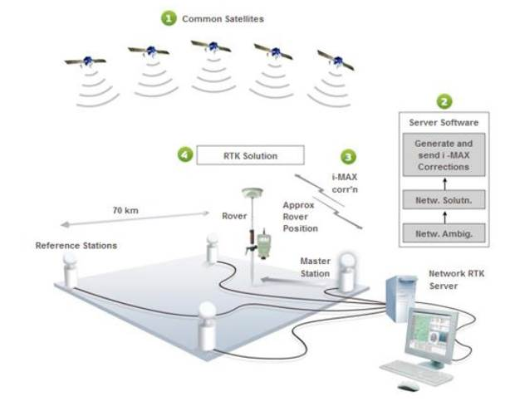
Figure 3 Leica I-Max solution
3.2.3 GPS-Glonass Processing
As all positional data were recorded in real time, no post processing was required other than simple projection and geoid modelling. The Leica Geo Office software suite was used to import the real time data, apply a geoid correction and projection, and then output the data into Atlas Geophysics RTK standard format. The formatted data were then imported into Atlas Geophysics data processing software “AGRIS” (Atlas Geophysics Reduction and Interpretation Software) and combined with gravity data to produce a gravity database for the project. This process was carried out on a daily basis.
Projections between GPS/Glonass derived WGS84 coordinates to Map Grid of Australia (MGA) coordinates were conducted using Leica Geo Office. For most practical applications where a horizontal accuracy of only a metre or greater is required, GDA94 coordinates can be considered the same as WGS84. MGA coordinates were obtained by projecting the GPS-derived coordinates using a Universal Transverse Mercator (UTM) projection with zone 55S. For more information about WGS84, GDA94, GRS80 and MGA coordinates, the reader is asked to visit the Geoscience Australia website: http://www.ga.gov.au/earth-monitoring/geodesy/geodetic-datums/GDA.html
Elevations above the Australian Height Datum (AHD) were modelled using Leica Geo Office software and the latest geoid model for Australia, AUSGEOID09. Information about the geoid and the modelling process used to extract separations (N values) can be found at http://www.ga.gov.au/geodesy/ausgeoid/. To obtain AHD elevation, the modelled N value is subtracted from the GPS derived WGS84/GRS80 ellipsoidal height (Figure 4).
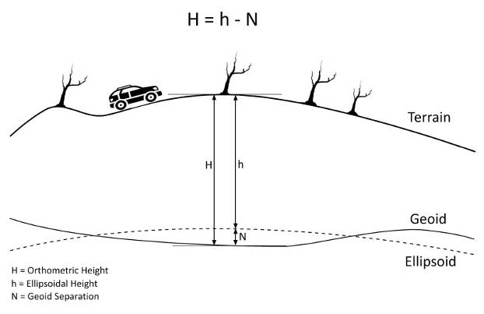
Figure 4 Geoid-ellipsoid separation
3.2.4 GPS-Glonass quality analysis
Rigorous quality analysis procedures were applied to the acquired GPS data on a daily basis using the company’s in-house AGRIS (Atlas Geophysics Reduction and Information Software) software. The GPSQA module within AGRIS is used to analyse such factors as the recorded positional data, baseline distance, number of satellites, coordinate quality (CQ), standard deviation and dilution of precision (DOP) to ensure the final positional data used for gravity processing meets stringent quality specifications. Comprehensive statistics, repeatability analysis and histogram plotting are also performed.
QA procedures were applied to the GPS-Glonass data on a daily basis and any gravity stations not conforming to contract specifications were repeated.

3.3 Gravity data acquisition, processing and
quality analysis
3.3.1 Calibration of the gravity meter
The gravity meters used for survey on this project were calibrated pre and post survey on the Guildford Cemetery – Helena Valley Primary School calibration range (2010990117- 2010990217) in Western Australia. The calibration process has validated the gravity meter’s scale factor to ensure reduction of the survey data produces correct observed gravity from measured dial reading values. Table 4 summarises the results of the calibration ties and lists the resultant scale factor for the survey gravity meter. Appendix C contains the reduced data used to create the summary.
Table 4: Gravity meter scale factors
Pre survey calibration run 27/06/2014
Meter Code | Meter SN | Calc 2010990217 AAGD07 (µm/s²) | Diff (µm/s²) | Scale
A3 | 40269 | 9794484.19 | 0.20 | 1.000000

Pre survey calibration run 12/09/2014
Meter Code | Meter SN | Calc 2010990117 AAGD07 (µm/s²) | Diff (µm/s²) | Scale
A3 | 40269 | 9794484.06 | 0.30 | 1.000000

Weekly tilt-tests and cycles were conducted to ensure the meter’s drift and tilt correction factors were valid. Gravity meter drift rates were monitored on a day to day basis using AGRIS software.
3.3.2 Acquisition of the gravity data
Gravity data were acquired concurrently with GPS-Glonass data using a Scintrex CG5 gravity meter. Data were acquired using a single loop of 10 hours duration controlled by observations at the gravity control stations. Each loop contained a minimum of two repeated readings so that an interlocking network of closed loops was formed. A total of 9.89% repeats were acquired for quality control purposes. Repeat readings were evenly distributed on a time-basis throughout each of the gravity loops.
When acquiring gravity data using a vehicle, the driver, after safely navigating to the station, parked the vehicle alongside the road in a safe position, with headlights on, rotating beacon flashing, park brake applied and vehicle engine off. Once safe to do so, the observer disembarked the vehicle on the verge or shoulder side and took the gravity reading alongside the vehicle, underneath the GPS observation point (Figure 5). At all times, the vehicle was parked on flat, level ground. Under no circumstances, did the observer acquire a reading in front of, or behind the vehicle.
At each station, the gravity operator took a minimum of two gravity readings of 60 seconds duration so that any seismic or wind noise could be detected. Control station readings were also set to 60 second duration. Before taking the reading, the operator ensured that the instrument tilt-reading was restricted to less than 5 arc-seconds and after the reading, not higher than 20 arc-seconds. Tilt-testing prior to project commencement showed that the gravity meters performed well even at extreme tilts (better than 0.01 mGal at +150/-150 arc-seconds).
If two separate readings did not agree to better than 0.02 mGal (0.01 mGal for control station readings), then the operator continued taking readings until the tolerance between consecutive readings was achieved. At the conclusion of the gravity reading, the final data display on the gravity meter was analysed to ensure the instrument was performing to specification and that the station observation provided data conforming to the project specifications. The operator also checked that the temperature, standard deviation and rejection values were within required tolerance before recording the reading. At each station, the operator recorded the gravity data digitally in the gravity meter as well as a field book so that instrument drift and reading repeatability could be analysed easily whilst in the field. Data recorded at each gravity station location was assigned a unique station code and station number.
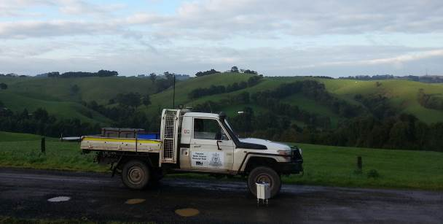
Figure 5 Gravity acquisition by vehicle
Repeat stations were marked with a biodegradable flagging tape and water based marker paint for subsequent reoccupation. When reoccupying a station, the crews positioned the vehicle/walking staff as close to the original position as possible (usually better than 0.5 m). All repeat gravity observations were taken in exactly the same location.
3.3.3 Gravity processing
The acquired gravity data were processed using the company’s in-house gravity pre-processing and reduction software, AGRIS. This software allows for full data pre-processing, reduction to Complete Bouguer Anomaly, repeatability and statistical analysis, as well as full quality analysis of the output dataset.
The software is capable of downloading Scintrex CG3/CG5 and Lacoste Romberg gravity data. Once downloaded, the gravity data is analysed for consistency and preliminary QA is performed on the data to check that observations meet specification for standard deviation, reading rejection, temperature and tilt values. Once the data is verified, the software averages the multiple readings and performs a merge with the GPS data (which it has also previously verified) and performs a linear drift correction and earth tide correction. Calculation of Free Air and Bouguer Anomalies is then performed using the contract specified formulae.
The following corrections were applied to the dataset to produce Bouguer Anomaly values for each of the gravity stations. All formulae produce values in µm/s².
Instrument scale factor
This correction is used to correct a gravity reading (in dial units) to a relative gravity unit value based on the meter calibration.
𝑟_{𝑐} = 10 · (𝑟 · S(𝑟))
where,
𝑟_{𝑐} corrected reading in µm/s²
𝑟 gravity meter reading in dial units
S(𝑟) scale factor (dial units/mGal)

Earth Tide Correction (ETC)
The earth is subject to variations in gravity due to the gravitational attraction of the Sun and the Moon. These background variations can be corrected for using a predictive formula which utilises the gravity observation position and time of observation. The Scintrex CG5 gravity meter automatically calculates ETC but uses only an approximate position for the gravity observation so is not entirely accurate. For this reason, the Scintrex ETC is subtracted from the reading and a new correction calculated within AGRIS software. The full formula is listed in Appendix E.
𝑟_{t} = 𝑟_{c} + g_{tide}
where,
𝑟_{t} tide corrected reading in µm/s²
𝑟_{c} scale factor corrected reading in µm/s²
g_{tide} Earth Tide Correction (ETC) in µm/s²
Instrument Drift Correction
Since all gravity meters are mechanical they are all prone to instrument drift. Drift can be caused by mechanical stresses and strains in the spring mechanism as the meter is moved, knocked, reset, subjected to temperature extremes, subjected to vibration, unclamped etc. The most common cause of instrument drift is due to extension of the sensor spring with changes in temperature (obeying Hooke’s law). To calculate and correct for daily instrument drift, the difference between the gravity control station readings (closure error) is used to assume the drift and a linear correction is applied.
𝐼𝐷₌𝑟_{𝑐𝑠2 −} 𝑟_{𝑐𝑠1 /} 𝑡_{𝑐𝑠2 −} 𝑡_{𝑐𝑠1}
where,
𝐼𝐷 Instrument Drift in µm/s² /hour
𝑟_{𝑐𝑠2} control station 2nd reading in µm/s²
𝑟_{𝑐𝑠1} control station 1st reading in µm/s²
𝑡_{𝑐𝑠2} control station 2 time
𝑡_{𝑐𝑠1} control station 1 time
Observed Gravity
The preceding corrections are applied to the raw gravity reading to calculate the earth’s absolute gravitational attraction at each gravity station. The corrections produced observed gravity on the AAGD07 datum.
𝐺_{𝑜}=𝑔_{𝑐𝑠1} + (𝑟_{𝑡} − 𝑟_{𝑐𝑠1}) − (𝑡 − 𝑡_{𝑐𝑠1}) ∙ 𝐼𝐷
where,
𝐺_{𝑜} Observed gravity in µm/s²
𝑔_{𝑐𝑠1} control station 1 known observed gravity in µm/s²
𝑟_{𝑡} tide corrected reading in µm/s²
𝑟_{𝑐𝑠1} control station 1 reading in µm/s²
𝑡 reading time
𝑡_{𝑐𝑠1} control station 1 time
𝐼𝐷 instrument drift in µm/s²/hour
Normal Gravity
The normal (or theoretical) gravity value at each gravity station is calculated based on the assumption that the Earth is a homogeneous ellipsoid. The closed form of the 1980 International Gravity Formula is used to approximate the theoretical gravity at each station location and essentially produce a latitude correction. Gravity values vary with latitude as the earth is not a perfect sphere and the polar radius is much smaller than the equatorial radius. The effect of centrifugal acceleration is also different at the poles versus the equator.
𝐺_{𝑛}=9780326.7715((1+0.001931851353(𝑠𝑖𝑛²𝑙)/(𝑆𝑄𝑅𝑇(1−0.0066943800229(𝑠𝑖𝑛²𝑙)))
where,
𝐺𝑛 Theoretical Gravity in gravity units
𝑙 GDA94 latitude at the gravity station in decimal degrees
Atmospheric Correction
The gravity effect of the atmosphere above the ellipsoid can be calculated with an atmospheric model and is subtracted from the normal gravity.
𝐴𝐶=8.74 – 0.00099 ∙ ℎ + 0.0000000356∙ℎ²
where,
𝐴𝐶 Atmospheric correction in gravity units
ℎ elevation above the GRS80 ellipsoid in metres
Free Air Correction
Since the gravity field varies inversely with the square of distance, it is necessary to correct for elevation changes from the reference ellipsoid (GRS80). Gravitational attraction decreases as the elevation above the reference ellipsoid increases.
𝐹𝐴𝐶=−(3.087691 – 0.004398 𝑠𝑖𝑛²𝑙) ∙ ℎ + 7.2125 ∙ 10⁻⁷∙ℎ²
where,
𝐹𝐴𝐶 Free air correction in gravity units
𝑙 GDA94 latitude at the gravity station in decimal degrees
h elevation above the GRS80 ellipsoid in metres
Bouguer Correction
If a gravity observation is made above the reference ellipsoid, the effect of rock material between the observation and the ellipsoid must be taken into account. The mass of rock makes a positive contribution to the gravity value.
The correction is calculated using the closed form equation for the gravity effect of a spherical cap of radius
166.7 km, based on a spherical Earth with a mean radius of 6,371.0087714 km, height relative the ellipsoid and
a rock density of 2.67 t/m³.
𝐵𝐶= 2πGρ((1+μ)∙ℎ – λR)
where,
𝐵𝐶 Bouguer correction in gravity units
𝐺 gravitational constant = 6.67428 x 10⁻¹¹ m³kg⁻¹s⁻²
ρ rock density (2.67 t/m³)
ℎ elevation above the GRS80 ellipsoid in metres
R (𝑅𝑜+ℎ) the radius of the earth at the station
𝑅𝑜 mean radius of the earth = 6,371.0087714 km (on the GRS80 ellipsoid)
𝜇 & 𝜆 are dimensionless coefficients defined by:
𝜇=((1/3)∙η²−η)∙
where,
η ℎ/𝑅
𝜆 = (1/3){(𝑑 + 𝑓𝛿 + 𝛿²)[(𝑓 – 𝛿)² + 𝑘]^{1/2} + 𝑝 + 𝑚 ∙ 𝑙𝑛(𝑛/(𝑓 – 𝛿+ [(𝑓 – 𝛿)² + 𝑘]^{1/2})}
where,
𝑑 3∙𝑐𝑜𝑠2𝛼−2
𝑓 𝑐𝑜𝑠𝛼
𝑘 𝑠𝑖𝑛2𝛼
𝑝 −6 ∙ 𝑐𝑜𝑠2𝛼 ∙ sin(𝛼/2) + 4 ∙ 𝑠𝑖𝑛3(𝛼/2)
δ (𝑅𝑜/𝑅)
𝑚 −3 ∙ 𝑘 ∙ 𝑓
𝑛 2 ∙ [𝑠𝑖𝑛 (𝛼/2)−𝑠𝑖𝑛2(𝛼/2)]
𝛼 𝑆/𝑅𝑜 with S = Bullard B Surface radius = 166.735 km
Terrain Correction
The terrain correction accounts for variations in gravity values caused by variations in topography near the observation point. The correction accounts for the attraction of material above the assumed spherical cap and for the over-correction made by the Bouguer correction when in valleys. The terrain correction is positive regardless of whether the local topography consists of a mountain or a valley. Section 3.3.4 contains a more in-depth discussion of the terrain correction process.
Free Air Anomaly
The free air anomaly is the difference between the observed gravity and normal gravity that has been computed for latitude and corrected for the elevation of the gravity station above or below the reference ellipsoid:
𝐹𝐴𝐴 =𝐺𝑜 –(𝐺𝑛−𝐴𝐶)−𝐹𝐴𝐶
where,
𝐹𝐴𝐴 Free Air Anomaly in gravity units
𝐺𝑜 Observed Gravity in gravity units
𝐺𝑛 Normal Gravity in gravity units
𝐴𝐶 Atmospheric Correction in gravity units
𝐹𝐴𝐶 Free Air Correction in gravity units
Bouguer Anomaly
The Bouguer anomaly is computed from the free air anomaly above by removing the attraction of the spherical cap calculated by the Bouguer correction.
𝐵𝐴 =𝐹𝐴𝐴 − 𝐵𝐶
where,
𝐵𝐴 Bouguer Anomaly in gravity units
𝐹𝐴𝐴 Free Air Anomaly in gravity units
𝐵𝐶 Bouguer Correction in gravity units
Complete Bouguer Anomaly
This is obtained by adding the terrain correction to the Bouguer anomaly. The Complete Bouguer anomaly is the most interpretable value derived from a gravity survey as changes in the anomaly can be directly attributed to lateral density contrasts within the geology below the observation point.
𝐶𝐵𝐴 =𝐵𝐴 + 𝑇𝐶
where,
𝐶𝐵𝐴 Complete Bouguer Anomaly in gravity units
𝐵𝐴 Bouguer Anomaly in gravity units
TC Terrain Correction in gravity units

3.3.4 Terrain Corrections
Terrain corrections, which account for the variation in gravity due to topography proximal to the gravity station, were computed using a digital elevation model (DEM) and RASTERTC software from Geopotential. RASTERTC software permits the user to input a DEM in the form of a binary grid file, and gravity data in an ASCII file. From this information, the software is capable of calculating extremely accurate terrain corrections. For more detailed information regarding the software and algorithm, the reader is asked to visit the Geopotential website http://geopotential.com/docs/RasterTC/RasterTC.html
Elevation data were sourced from the 1 second SRTM Level 2 Derived Smoothed Digital Elevation Model (DEM-S) Version 1.0 which has an equivalent cell size of 30 m. Data were extracted to provide a 30 km buffer from the extents of the gravity survey. To account for bathymetry, the SRTM DEM data were merged with data from the AUSBATH_09_v4 coverage.
A comparison against GPS heights recorded during the gravity survey revealed that the DEM data were sufficiently accurate to be used in regional terrain corrections. The average difference between GPS height and DEM heights was -2.99 m and the standard deviation of the differences was 3.39 m. Some of the larger differences would be attributable to vegetation cover.
When executing the terrain correction, the following inputs were used with RASTERTC:
RMIN = 30 m
RMED = 250 m
RMAX = 30000 m
Angle = 6 degrees
RMIN was selected to enable correction for topography near to the gravity station and coincided with the grid cell size of the SRTM DEM. RMAX was selected to allow for outer zone correction of severe topography at large distances from the gravity station. RMED was chosen so that the DEM would be sampled at an interval close to the grid cell size of the DEM when using the 6 degree integration angle.
The terrain correction software provides indicators for terrain correction quality and accuracy as part of its output. The output variables QFINNER and QFOUTER specify the quality factor for each correction made. If these factors have a value of 0, then the user can assume that the terrain correction proceeded successfully. If non-zero values are reported, then the value of the QF factor will provide an indication as to possible problems or inadequacies in the correction.
For the inner zone correction, an indicator of how well the terrain in the immediate vicinity of a gravity station is represented by the available elevation samples is obtained by examining the spatial distribution of the elevation samples. In the radial interval Rmin to Rmed, RASTERTC counts the number of samples falling within the 8 octants surrounding the station. If any of these octants are missing elevation samples, that fact is noted, and the tabulated quality factor simply notes how many of the octants are missing samples (see Table 5).
For the outer zone correction, a result of 0 means that the correction proceeded successfully. If a portion of the outer-zone terrain is missing from the DEM supplied, the value of QF-Outer will reflect the per cent of terrain that was available (rounded to the nearest per cent). For example, if QF-Outer is 91, the implication is that 9% of the terrain in the outer zones was missing for some reason, and that the terrain correction calculated for that particular station is too small by some amount.
Table 5: Terrain correction error codes
QF-Inner | Explanation of error code
0 | Inner-zone terrain calculation OK
1 | No elevation samples occur in 1 octant surrounding the gravity station
2 | No elevation samples occur in 2 octant surrounding the gravity station
3 | No elevation samples occur in 3 octant surrounding the gravity station
4 | No elevation samples occur in 4 octant surrounding the gravity station
5 | No elevation samples occur in 5 octant surrounding the gravity station
6 | No elevation samples occur in 6 octant surrounding the gravity station
7 | No elevation samples occur in 7 octant surrounding the gravity station
22 | Duplicate elevation nodes encountered while calculating terrain gradients
23 | All elevation nodes collinear or triangulation structure corrupted

3.3.5 Quality analysis of the processed gravity data
Following reduction of the data to Bouguer Anomaly, repeatability and QA procedures were applied to both the positional and gravity observations using AGRIS software. AGRIS checks the following as part of its QA processing:
• Easting Observation Repeatability and Histogram
• Northing Observation Repeatability and Histogram
• Elevation Observation Repeatability and Histogram
• Gravity Observation Repeatability and Histogram
• Gravity SD, Tilt XY, Temperature, Rejection, Reading Variance
• Gravity meter drift / closure
• Gravity meter loop time, drift per hour
• GPS Dilution of Precision, Coordinate Quality Factor, Standard Error
• Variation of surveyed station location from programmed location.
QA procedures were applied to the gravity data on a daily basis and any gravity stations not conforming to contract specifications were repeated.
3.3.6 Additional processing, gridding and plotting
Complementing the QA procedures is additional daily gridding, imaging and plotting of the elevation and gravity data. Once processed to Bouguer Anomaly and assessed for QA, data are imported into Geosoft Oasis Montaj or ChrisDBF software for gridding at 1/5th the station spacing to produce ERMapper compatible grid files. Resultant grids are contoured, filtered and interpreted using ERMapper and ArcMap software to check that data is smoothly varying and that no spurious anomalies are present. A first vertical, tilt angle and horizontal derivative filter are routinely applied to the data as these filters allow for excellent noise recognition. Once identified, any spurious stations can be field checked the following day and repeated if required. During the course of the survey, two anomalous stations were field checked and found to be valid.
Plotting of the acquired stations on a daily basis allowed for identification of any missed stations which were then gained the following day.

4 Results

The Gippsland gravity survey was completed with relative ease despite a few issues with access where tracks did not exist, or were fenced off.
Some inclement weather and boggy conditions (in State Forest) did slow acquisition at times, as did surveying under canopy. Observations along the roadside and in sandy, soft conditions often required longer occupation times for readings to be within tolerance.
A total of 1,213 new gravity stations were gained during the survey.
Final data have been delivered to a technically excellent standard and are presented both digitally and hardcopy as Appendices to this report.
4.1 Survey timing and production rates
The survey crew began gravity data acquisition on Tuesday 1st July 2014 with survey cessation on Monday 21st July 2014. The only downtime experienced was due to inclement weather and a requirement to revisit roads which received a lot of traffic during peak times.
Production for the duration of the survey was good whilst surveying using vehicles with an average production of about 60 stations per day.
4.2 Data formats
Final point located data for the project have been delivered in ASEG-GDF2 compliant format. Appendix F contains a listing of the definition and description files accompanying the final data. Table 6 summarises the deliverables.
Table 6: Final deliverables
Final delivered data | Format | Data USB | Hardcopy
Gravity Database | Point located data ASEG-GDF2 | •
Raw Positional Data | AGRIS format, comma delimited | •
Raw Gravity Data | Scintrex CG5 format | •
Raw GPS-GNSS Data | Waypoint GPB Binary | •
Gravity Control Data | Microsoft Excel Format | • | •
Calibration Data | Microsoft Excel Format | • | •
Repeat Data | Microsoft Excel Format | • | •
Terrain Corrections | RASTERTC output file | •
Final Grids | ERMapper Grids .ers | •
Final Images | GIS compatible TIFF | • | •
Acquisition Report | PDF .pdf | • | •
4.3 Data and cross survey repeatability
The repeatability of both the gravity and GPS data was excellent. In total, 120 gravity and GPS repeat stations were collected and analysed. As a percentage, this equates to 9.89% of the total number of new gravity stations acquired. Repeat stations were acquired so that an even distribution between gravity loops was established and that all loops were interlocked.
Descriptive statistics pertaining to the repeatability are contained in Table 7 and Appendix D contains a tabulation of the actual repeat data for the entire survey.
The standard deviation of the gravity repeat deviations was 0.25 µm/s² and the standard deviation of the GPS derived elevation repeat deviations was 0.038 m. These statistics confirm that the data have exceeded contract specifications.
Table 7: Repeat statistics
 | Elevation Repeat (mGRS80) | Gravity Repeat (μm/s²)
Mean | -0.003 | 0.01
Standard Error | 0.004 | 0.02
Median | 0.000 | 0.00
Mode | -0.013 | 0.00
Standard Deviation | 0.038 | 0.25
Sample Variance | 0.001 | 0.06
Kurtosis | 1.166 | -0.16
Skewness | -0.212 | 0.14
Range | 0.240 | 1.34
Minimum | -0.117 | -0.68
Maximum | 0.123 | 0.66
Sum | -0.383 | 0.63
Count | 120 | 120

4.3.1 Repeatability histograms
Histograms showing the distribution of repeat differences for both the GPS and gravity observations are shown in Figures 6 and 7.
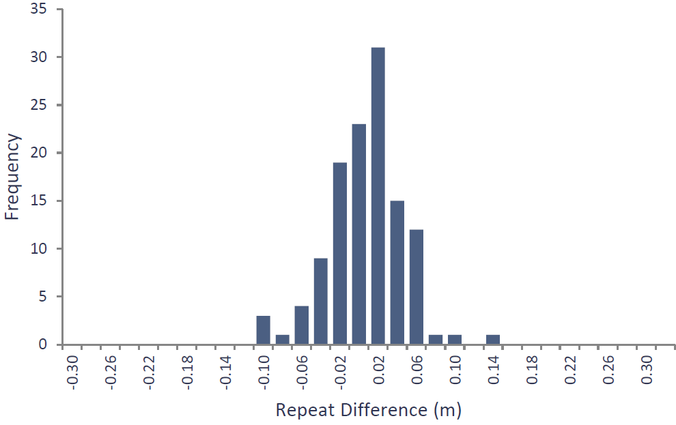
Figure 6: Histogram of elevation repeat differences
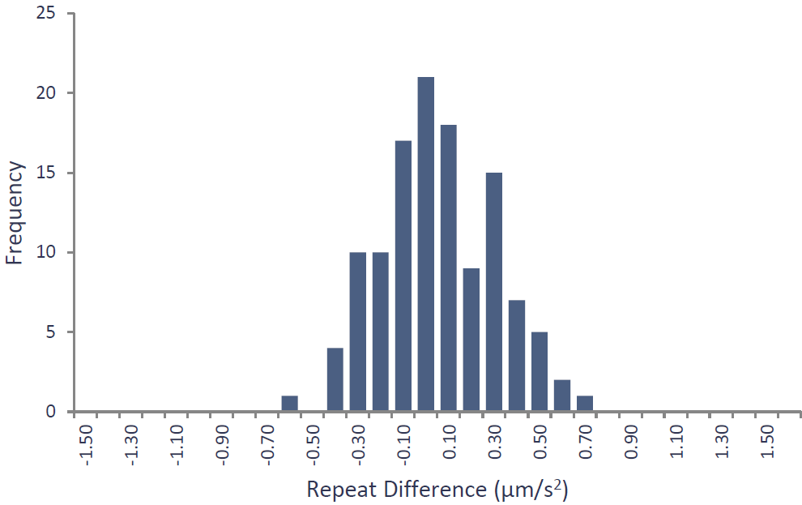
Figure 7: Histogram of gravity repeat differences
4.4 Grids, images and plots
Final reduced Complete Spherical Cap Bouguer Anomaly (CSCBA267) data have been integrated with the pre-existing gravity data and gridded using Geosoft Oasis Montaj software. Data have been gridded with a minimum curvature algorithm, a grid cell size of 100 m and displayed in µm/s².
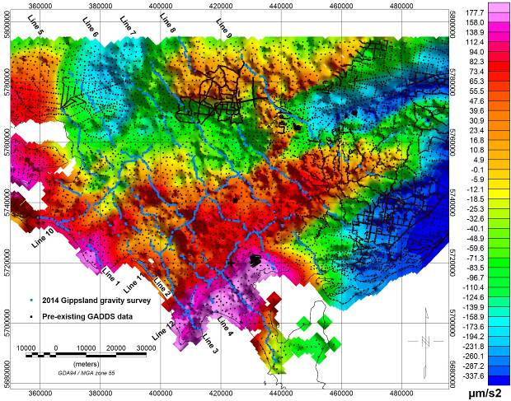
Figure 8 Complete Spherical Cap Bouguer Anomaly (CSCBA267) of newly acquired gravity data (blue points) integrated with pre-existing gravity data (black points).
An example profile through line 7 is shown in figure 9. This figure shows that although the broad wavelength is captured by the pre-existing data, the newly acquired data has identified short wavelength variations in the gravity field which can be attributed to the geological signal.
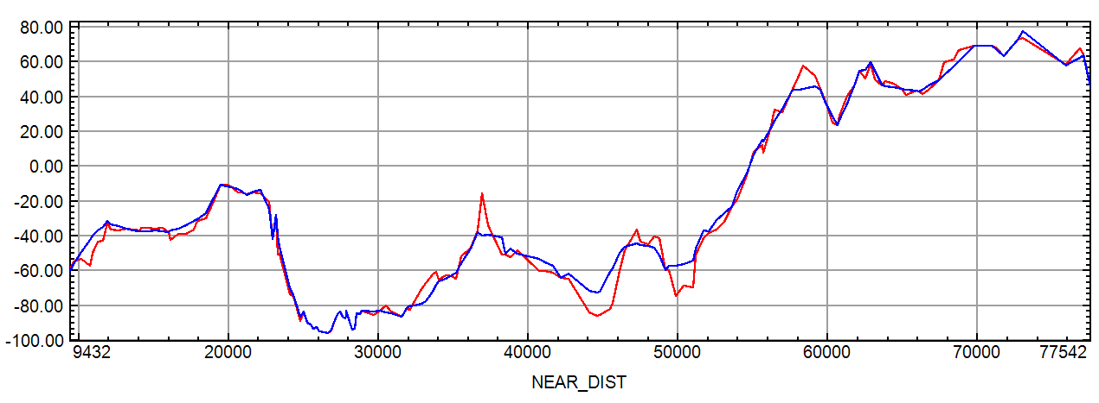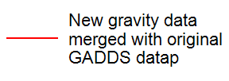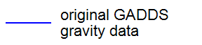
Figure 9 Profile through line 7 showing the processed Complete Spherical Cap Bouguer Anomaly (CSCBA267) values of both the pre-existing gravity data (blue), and the newly acquired gravity data integrated with pre-existing gravity data (red).
Appendix A - Primary control stations

201406500001 (GA 20143000001) – Korumburra Coal Creek Toilets
GDA94/GRS80 |  |  | MGA Z55 |  | AMG Z55
Latitude | -38 26 30.0700 |  | Easting | 397,912.138 | Easting | 397,798
Longitude | 145 49 48.7210 |  | Northing | 5,744,529.163 | Northing | 5,744,344
Ellipsoidal Height | 211.718 |  | Orthometric Height | 207.474 | Orthometric Height | 207.474
Observed Gravity
AAGD07 μm/s² |  | 9799977.90
Occupation Method/Location Details
The gravity control point is located on a concrete slab floor abutting the northern wall of the Coal Creek toilets, Korumburra. The gravity location is centred in the middle of the wall directly under the green and white emergency assembly area sign, 0.5 m from the wall.
Gravity Control was established by Atlas Geophysics via three separate ABA loops with the project gravity meter to AFGN stations 1995901324 and 1995909324, Drouin, Victoria. Expected accuracy would be better than 0.1 μm/s².
GPS Control was not established at this station, but the coordinates of the gravity base have been established with a VRS Network averaged solution accurate to better than 2cm.
The toilet block is located 32 m south west of Silkstone Rd, Korumburra. A large gravel car park is located to the north of the toilet block and provides ample parking space.

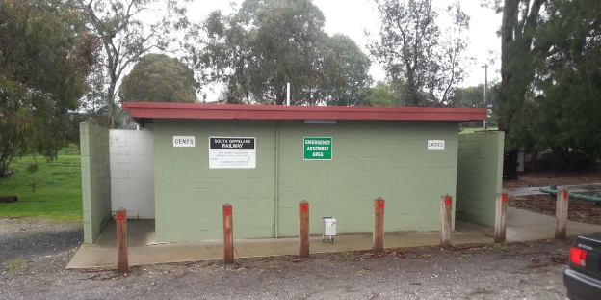
Photograph of Control Station 201406500001
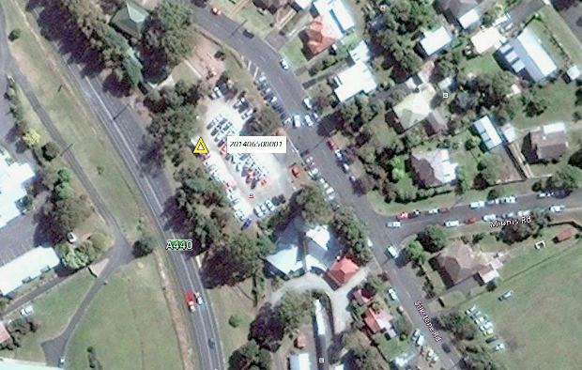
Location of control station 201406500001
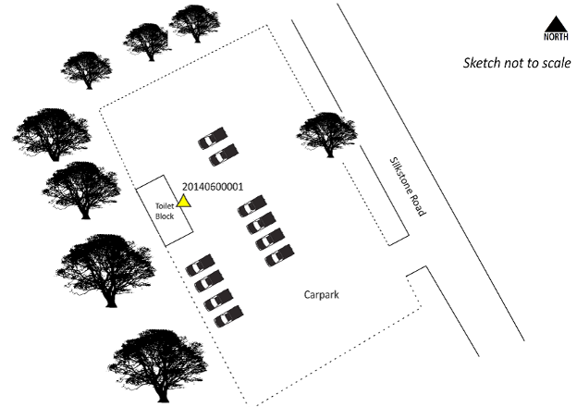
Locality Sketch of Control Station 201406500001
Appendix B - Gravity control ties

201406500001 Gravity Control Ties
1 = 201406500001 Korumburra Coal Creek Toilets
1324 = 1995901324 War Memorial Park Toilets, Drouin
9324 = 1995909324 Anglican Church Hall, Drouin
Ties carried out by vehicle
METER A3
station | gda94_longitude_dd | gda94_latitude_dd | date_  ddmmyyyy | time_  hhmmss | dialrdng_  mgal | etc_  mgal | aagd07_  mgal | metersn
1 | 145.830200 | -38.441686 | 14/07/2014 | 8:38:46 | 3071.628 | -0.102 | 980000.000 | 40269
1 | 145.830200 | -38.441686 | 14/07/2014 | 8:39:52 | 3071.626 | -0.102 | 980000.000 | 40269
1324 | 145.856250 | -38.135136 | 14/07/2014 | 10:36:27 | 3045.767 | -0.053 | 979974.205 | 40269
1324 | 145.856250 | -38.135136 | 14/07/2014 | 10:37:33 | 3045.771 | -0.053 | 979974.210 | 40269
9324 | 145.854770 | -38.133125 | 14/07/2014 | 10:56:34 | 3044.967 | -0.042 | 979973.419 | 40269
9324 | 145.854770 | -38.133125 | 14/07/2014 | 10:57:40 | 3044.966 | -0.042 | 979973.419 | 40269
1 | 145.830200 | -38.441686 | 14/07/2014 | 12:23:41 | 3071.493 | -0.004 | 980000.000 | 40269
1 | 145.830200 | -38.441686 | 14/07/2014 | 12:24:47 | 3071.496 | -0.004 | 980000.000 | 40269
1 | 145.830200 | -38.441686 | 14/07/2014 | 12:24:47 | 3071.496 | -0.004 | 980000.000 | 40269
1 | 145.830200 | -38.441686 | 14/07/2014 | 12:24:47 | 3071.496 | -0.004 | 980000.000 | 40269
1324 | 145.856250 | -38.135136 | 14/07/2014 | 13:15:34 | 3045.720 | 0.009 | 979974.237 | 40269
1324 | 145.856250 | -38.135136 | 14/07/2014 | 13:16:40 | 3045.720 | 0.009 | 979974.237 | 40269
9324 | 145.854770 | -38.133125 | 14/07/2014 | 13:25:21 | 3044.903 | 0.010 | 979973.420 | 40269
9324 | 145.854770 | -38.133125 | 14/07/2014 | 13:26:27 | 3044.905 | 0.010 | 979973.422 | 40269
1 | 145.830200 | -38.441686 | 14/07/2014 | 14:18:33 | 3071.488 | 0.004 | 980000.000 | 40269
1 | 145.830200 | -38.441686 | 14/07/2014 | 14:19:39 | 3071.488 | 0.004 | 980000.000 | 40269
1 | 145.830200 | -38.441686 | 14/07/2014 | 14:19:39 | 3071.488 | 0.004 | 980000.000 | 40269
1 | 145.830200 | -38.441686 | 14/07/2014 | 14:19:39 | 3071.488 | 0.004 | 980000.000 | 40269
1324 | 145.856250 | -38.135136 | 14/07/2014 | 15:23:08 | 3045.744 | -0.015 | 979974.238 | 40269
1324 | 145.856250 | -38.135136 | 14/07/2014 | 15:24:14 | 3045.757 | -0.015 | 979974.251 | 40269
9324 | 145.854770 | -38.133125 | 14/07/2014 | 15:36:12 | 3044.931 | -0.021 | 979973.419 | 40269
9324 | 145.854770 | -38.133125 | 14/07/2014 | 15:37:18 | 3044.933 | -0.021 | 979973.421 | 40269
1 | 145.830200 | -38.441686 | 14/07/2014 | 16:46:56 | 3071.543 | -0.056 | 980000.000 | 40269
1 | 145.830200 | -38.441686 | 14/07/2014 | 16:46:56 | 3071.543 | -0.056 | 980000.000 | 40269

AVG 1324 | 979974.241
AVG 9324 | 979973.420
DIFF 1324_1 | -25.759
DIFF 9324_1 | -26.580
KNOWN 1324 | 979972.038
KNOWN 9324 | 979971.202
CALC 1 1324 | 979997.797
CALC 1 9324 | 979997.782
CALC 1 | 979997.790 mGal AAGD07
 | 9799977.90 μm/s² AAGD07

Appendix C - Gravity meter calibration data

P2014065_GA_Gippsland
Pre Survey Calibration Data
1 = 2010990117 CS1 Guildford Cemetery 9793899.63 μm/s² AAGD07
2 = 2010990217 CS2 Helena Valley Primary School 9794483.85 μm/s² AAGD07
Station | MGAE | MGAN | Date | Time | OBSGAAD07_  μm/s² | Drift_  μm/s² | Serial
A3 METER
1 | 403387.00 | 6468170.00 | 27/06/2014 | 10:17:14 | 9793899.63 | 0.11 | 40269
1 | 403387.00 | 6468170.00 | 27/06/2014 | 10:18:20 | 9793899.73 | 0.11 | 40269
2 | 410153.00 | 6467499.00 | 27/06/2014 | 10:45:59 | 9794484.12 | 0.11 | 40269
2 | 410153.00 | 6467499.00 | 27/06/2014 | 10:47:05 | 9794484.19 | 0.11 | 40269
1 | 403387.00 | 6468170.00 | 27/06/2014 | 11:11:09 | 9793899.66 | 0.11 | 40269
1 | 403387.00 | 6468170.00 | 27/06/2014 | 11:12:15 | 9793899.63 | 0.11 | 40269
1 | 403387.00 | 6468170.00 | 27/06/2014 | 11:12:15 | 9793899.63 | 0.25 | 40269
2 | 410153.00 | 6467499.00 | 27/06/2014 | 11:39:40 | 9794483.98 | 0.25 | 40269
2 | 410153.00 | 6467499.00 | 27/06/2014 | 11:40:46 | 9794483.95 | 0.25 | 40269
1 | 403387.00 | 6468170.00 | 27/06/2014 | 12:05:34 | 9793899.63 | 0.25 | 40269
1 | 403387.00 | 6468170.00 | 27/06/2014 | 12:06:40 | 9793899.63 | 0.25 | 40269
1 | 403387.00 | 6468170.00 | 27/06/2014 | 12:06:40 | 9793899.63 | 0.28 | 40269
2 | 410153.00 | 6467499.00 | 27/06/2014 | 12:33:10 | 9794484.02 | 0.28 | 40269
2 | 410153.00 | 6467499.00 | 27/06/2014 | 12:34:16 | 9794484.09 | 0.28 | 40269
1 | 403387.00 | 6468170.00 | 27/06/2014 | 13:00:16 | 9793899.61 | 0.28 | 40269
1 | 403387.00 | 6468170.00 | 27/06/2014 | 13:01:22 | 9793899.63 | 0.28 | 40269
 |  |  | AVG2 |  | 9794484.06

P2014065_GA_Gippsland
Post Survey Calibration Data
1 = 2010990117 CS1 Guildford Cemetery 9793899.63 μm/s² AAGD07
2 = 2010990217 CS2 Helena Valley Primary School 9794483.85 μm/s² AAGD07
Station | MGAE | MGAN | Date | Time | OBSGAAD07_  μm/s² | Drift_  μm/s² | Serial
A3 METER
1 | 403387.00 | 6468170.00 | 12/09/2014 | 9:33:31 | 9793899.63 | 0.07 | 40269
1 | 403387.00 | 6468170.00 | 12/09/2014 | 9:34:37 | 9793899.62 | 0.07 | 40269
2 | 410153.00 | 6467499.00 | 12/09/2014 | 10:13:35 | 9794484.18 | 0.07 | 40269
2 | 410153.00 | 6467499.00 | 12/09/2014 | 10:14:41 | 9794484.18 | 0.07 | 40269
1 | 403387.00 | 6468170.00 | 12/09/2014 | 10:48:58 | 9793899.63 | 0.07 | 40269
1 | 403387.00 | 6468170.00 | 12/09/2014 | 10:50:04 | 9793899.63 | 0.07 | 40269
1 | 403387.00 | 6468170.00 | 12/09/2014 | 10:50:04 | 9793899.63 | 0.07 | 40269
2 | 410153.00 | 6467499.00 | 12/09/2014 | 11:22:54 | 9794484.21 | 0.07 | 40269
2 | 410153.00 | 6467499.00 | 12/09/2014 | 11:24:00 | 9794484.20 | 0.07 | 40269
1 | 403387.00 | 6468170.00 | 12/09/2014 | 11:58:11 | 9793899.64 | 0.07 | 40269
1 | 403387.00 | 6468170.00 | 12/09/2014 | 11:59:17 | 9793899.63 | 0.07 | 40269
 |  |  | AVG2 |  | 9794484.19

Appendix D - Repeat gravity data

Repeat Listing: All Observations
Station | MGAEast | MGANorth | Repeat_error elevation_m | Repeat_error gravity_μm/s² | Date_  ddmmyy | Time_  hhmmss | Metersn
20140101371 | 397277.6 | 5745579.7 | 0.045 | 0.24 | 02072014 | 080251 | 40269
20140102157 | 392639.1 | 5741005.2 | -0.111 | -0.03 | 02072014 | 130952 | 40269
20140101395 | 405368.9 | 5737736.7 | 0.019 | 0.43 | 02072014 | 165336 | 40269
20140101386 | 401990.1 | 5739859.4 | -0.012 | 0.04 | 02072014 | 170609 | 40269
20140101370 | 397134.2 | 5746060.4 | -0.028 | -0.07 | 02072014 | 172024 | 40269
20140101371 | 397278.0 | 5745580.5 | 0.082 | -0.32 | 03072014 | 073132 | 40269
20140101386 | 401987.5 | 5739858.4 | -0.003 | 0.00 | 03072014 | 075543 | 40269
20140101395 | 405369.0 | 5737737.0 | 0.043 | -0.23 | 03072014 | 080552 | 40269
20140102178 | 399117.7 | 5731288.5 | 0.070 | -0.29 | 03072014 | 081511 | 40269
20140101370 | 397134.4 | 5746060.1 | 0.017 | -0.35 | 03072014 | 173300 | 40269
20140101386 | 401989.9 | 5739860.1 | -0.015 | 0.03 | 04072014 | 074833 | 40269
20140101395 | 405368.6 | 5737737.9 | 0.004 | 0.08 | 04072014 | 081355 | 40269
20140102178 | 399116.6 | 5731286.1 | 0.018 | 0.00 | 04072014 | 082243 | 40269
20140101212 | 396747.4 | 5727635.7 | -0.078 | 0.21 | 04072014 | 083029 | 40269
20140101219 | 398081.3 | 5723737.8 | -0.054 | 0.07 | 04072014 | 083938 | 40269
20140102235 | 399508.1 | 5722908.6 | -0.060 | 0.33 | 04072014 | 084527 | 40269
20140102253 | 407942.9 | 5732764.1 | -0.089 | 0.37 | 04072014 | 143931 | 40269
20140102248 | 404747.6 | 5731107.0 | 0.027 | 0.21 | 04072014 | 144655 | 40269
20140102235 | 399508.3 | 5722909.1 | 0.059 | 0.46 | 04072014 | 151351 | 40269
20140101370 | 397134.3 | 5746060.2 | -0.013 | -0.27 | 05072014 | 072508 | 40269
20140101013 | 366795.3 | 5732340.6 | -0.041 | -0.45 | 05072014 | 141847 | 40269
20140101372 | 397482.0 | 5745179.8 | -0.002 | 0.66 | 06072014 | 072758 | 40269
20140101386 | 401988.2 | 5739858.8 | -0.016 | 0.21 | 06072014 | 074043 | 40269
20140101395 | 405368.9 | 5737736.6 | -0.030 | 0.09 | 06072014 | 074953 | 40269
20140102253 | 407942.9 | 5732764.0 | 0.050 | -0.21 | 06072014 | 080139 | 40269
20140102414 | 434518.1 | 5699534.1 | -0.049 | -0.09 | 06072014 | 141457 | 40269
20140102403 | 429664.6 | 5705074.1 | 0.053 | -0.48 | 06072014 | 142347 | 40269
20140101459 | 424758.7 | 5710684.0 | 0.027 | 0.01 | 06072014 | 143322 | 40269
20140101445 | 419820.0 | 5716720.7 | 0.014 | 0.27 | 06072014 | 154815 | 40269
20140101372 | 397482.0 | 5745179.8 | 0.003 | 0.10 | 07072014 | 072136 | 40269
20140101386 | 401988.2 | 5739858.6 | 0.029 | -0.04 | 07072014 | 073455 | 40269
20140101395 | 405369.1 | 5737737.4 | -0.030 | -0.42 | 07072014 | 074539 | 40269
20140102253 | 407942.7 | 5732763.8 | 0.029 | 0.27 | 07072014 | 082232 | 40269
20140102208 | 412113.1 | 5716065.8 | 0.045 | -0.20 | 07072014 | 103022 | 40269
20140101445 | 419820.4 | 5716720.8 | -0.001 | -0.14 | 07072014 | 105755 | 40269
20140101372 | 397482.0 | 5745179.8 | 0.045 | 0.23 | 08072014 | 073316 | 40269
20140101371 | 397277.4 | 5745579.3 | -0.002 | 0.04 | 08072014 | 073733 | 40269
20140101370 | 397134.4 | 5746060.4 | 0.010 | 0.30 | 08072014 | 074525 | 40269
20140102157 | 392643.1 | 5741008.9 | 0.055 | 0.05 | 08072014 | 075822 | 40269
20140101189 | 386738.1 | 5735897.6 | -0.032 | -0.11 | 08072014 | 080957 | 40269
20140101087 | 383417.6 | 5732418.8 | -0.041 | -0.02 | 08072014 | 081949 | 40269
20140101077 | 378227.2 | 5737690.3 | 0.020 | -0.09 | 08072014 | 091547 | 40269
20140102076 | 386056.9 | 5746819.3 | 0.057 | 0.26 | 08072014 | 162304 | 40269
20140101370 | 397134.8 | 5746060.4 | -0.033 | 0.08 | 08072014 | 164204 | 40269
20140101372 | 397482.0 | 5745179.8 | 0.002 | -0.09 | 09072014 | 080622 | 40269
20140101371 | 397277.3 | 5745579.3 | 0.008 | 0.60 | 09072014 | 081010 | 40269
20140101370 | 397134.7 | 5746060.4 | -0.008 | 0.33 | 09072014 | 081358 | 40269
20140102157 | 392642.8 | 5741008.5 | 0.028 | 0.41 | 09072014 | 082521 | 40269
20140101189 | 386738.3 | 5735897.6 | -0.021 | 0.25 | 09072014 | 083641 | 40269
20140102070 | 383839.6 | 5744395.8 | 0.011 | 0.00 | 09072014 | 093412 | 40269
20140102068 | 382728.5 | 5743309.6 | -0.028 | 0.14 | 09072014 | 093929 | 40269
20140101160 | 376849.6 | 5749552.1 | 0.000 | 0.34 | 09072014 | 104603 | 40269
20140101161 | 377376.6 | 5749569.5 | -0.104 | 0.03 | 09072014 | 105322 | 40269
20140102127 | 381904.3 | 5754492.9 | 0.026 | 0.13 | 09072014 | 131821 | 40269
20140102095 | 391644.1 | 5754241.7 | -0.024 | 0.21 | 09072014 | 141141 | 40269
20140101372 | 397482.1 | 5745179.8 | 0.052 | -0.18 | 10072014 | 072109 | 40269
20140101371 | 397277.5 | 5745579.4 | -0.009 | -0.17 | 10072014 | 072513 | 40269
20140101370 | 397134.6 | 5746060.3 | 0.003 | 0.14 | 10072014 | 072926 | 40269
20140101352 | 393788.6 | 5754302.3 | -0.035 | -0.28 | 10072014 | 074943 | 40269
20140101349 | 392165.2 | 5755387.0 | 0.021 | -0.35 | 10072014 | 075438 | 40269
20140101349 | 392165.7 | 5755387.1 | -0.019 | -0.36 | 10072014 | 151140 | 40269
20140101370 | 397134.6 | 5746060.4 | 0.014 | 0.30 | 10072014 | 170604 | 40269
20140101372 | 397482.1 | 5745179.7 | -0.033 | 0.19 | 11072014 | 072701 | 40269
20140102253 | 407942.9 | 5732764.0 | -0.022 | -0.11 | 11072014 | 075014 | 40269
20140102351 | 424818.4 | 5725781.2 | -0.013 | 0.54 | 11072014 | 083135 | 40269
20140101371 | 397277.2 | 5745579.1 | -0.030 | -0.14 | 12072014 | 075006 | 40269
20140102351 | 424818.3 | 5725781.7 | 0.014 | -0.68 | 12072014 | 083348 | 40269
20140101592 | 432151.2 | 5729677.2 | -0.034 | -0.33 | 12072014 | 090408 | 40269
20140101395 | 405368.8 | 5737737.0 | 0.011 | 0.31 | 12072014 | 170048 | 40269
20140101386 | 401990.5 | 5739859.4 | 0.023 | 0.00 | 12072014 | 171028 | 40269
20140101372 | 397482.2 | 5745179.8 | 0.016 | -0.17 | 13072014 | 072602 | 40269
20140101371 | 397277.1 | 5745579.0 | -0.056 | -0.17 | 13072014 | 073000 | 40269
20140101370 | 397134.6 | 5746060.4 | 0.003 | -0.36 | 13072014 | 073413 | 40269
20140101789 | 408393.8 | 5788642.2 | 0.123 | 0.45 | 13072014 | 154624 | 40269
20140101372 | 397482.1 | 5745179.7 | 0.016 | -0.15 | 15072014 | 073510 | 40269
20140101386 | 401988.2 | 5739859.1 | 0.011 | 0.03 | 15072014 | 074652 | 40269
20140102270 | 412374.5 | 5739364.0 | 0.039 | -0.09 | 15072014 | 080100 | 40269
20140101624 | 397554.6 | 5783607.9 | -0.066 | -0.07 | 15072014 | 131049 | 40269
20140101650 | 406031.2 | 5773254.3 | -0.018 | 0.34 | 15072014 | 151347 | 40269
20140101370 | 397134.7 | 5746060.3 | 0.003 | -0.14 | 15072014 | 165748 | 40269
20140101371 | 397277.2 | 5745579.1 | -0.020 | -0.10 | 15072014 | 170231 | 40269
20140101372 | 397482.0 | 5745179.7 | 0.016 | -0.06 | 16072014 | 071846 | 40269
20140101371 | 397277.0 | 5745579.0 | -0.033 | -0.05 | 16072014 | 072305 | 40269
20140101386 | 401988.5 | 5739859.1 | 0.000 | 0.00 | 16072014 | 073616 | 40269
20140101550 | 414920.5 | 5744285.0 | -0.028 | 0.11 | 16072014 | 075417 | 40269
20140101701 | 425722.9 | 5749586.4 | 0.022 | -0.17 | 16072014 | 080836 | 40269
20140101665 | 413375.1 | 5764204.8 | 0.002 | -0.02 | 16072014 | 135913 | 40269
20140101701 | 425723.2 | 5749586.3 | 0.014 | -0.31 | 16072014 | 165339 | 40269
20140101550 | 414920.0 | 5744284.9 | 0.037 | -0.22 | 16072014 | 171547 | 40269
20140101372 | 397482.1 | 5745179.5 | -0.027 | 0.08 | 17072014 | 072755 | 40269
20140101371 | 397277.0 | 5745578.9 | -0.013 | 0.19 | 17072014 | 074344 | 40269
20140101550 | 414920.4 | 5744284.7 | -0.026 | 0.25 | 17072014 | 080504 | 40269
20140101701 | 425722.7 | 5749586.5 | -0.013 | 0.33 | 17072014 | 081846 | 40269
20140101822 | 432065.1 | 5756741.9 | -0.028 | 0.12 | 17072014 | 083110 | 40269
20140101934 | 434526.5 | 5780234.5 | 0.056 | -0.01 | 17072014 | 115800 | 40269
20140101942 | 435424.9 | 5776080.3 | 0.006 | 0.25 | 17072014 | 120509 | 40269
20140101372 | 397482.1 | 5745179.5 | 0.016 | -0.15 | 18072014 | 071749 | 40269
20140101550 | 414920.3 | 5744284.8 | -0.002 | -0.07 | 18072014 | 073918 | 40269
20140101701 | 425722.8 | 5749586.3 | -0.049 | -0.33 | 18072014 | 075413 | 40269
20140101763 | 451140.8 | 5720600.1 | -0.076 | 0.15 | 18072014 | 171113 | 40269
20140101372 | 397481.9 | 5745179.6 | 0.021 | -0.19 | 19072014 | 072442 | 40269
20140102253 | 407943.2 | 5732763.9 | 0.023 | -0.30 | 19072014 | 075432 | 40269
20140102351 | 424818.5 | 5725781.2 | 0.000 | -0.41 | 19072014 | 081338 | 40269
20140101763 | 451140.9 | 5720600.3 | 0.008 | 0.00 | 19072014 | 090906 | 40269
20140101837 | 436416.2 | 5751707.8 | -0.013 | 0.25 | 19072014 | 170106 | 40269
20140101701 | 425723.0 | 5749586.6 | -0.013 | 0.43 | 19072014 | 172608 | 40269
20140101371 | 397276.9 | 5745579.4 | 0.040 | 0.01 | 20072014 | 072536 | 40269
20140102270 | 412374.1 | 5739363.9 | -0.055 | 0.02 | 20072014 | 074500 | 40269
20140101701 | 425722.8 | 5749586.4 | 0.000 | -0.01 | 20072014 | 082830 | 40269
20140101837 | 436416.1 | 5751707.0 | 0.017 | 0.01 | 20072014 | 095446 | 40269
20140102351 | 424818.5 | 5725781.6 | 0.024 | -0.17 | 20072014 | 144304 | 40269
20140101372 | 397481.9 | 5745179.4 | -0.015 | -0.30 | 21072014 | 074212 | 40269
20140101371 | 397277.2 | 5745579.3 | -0.003 | 0.07 | 21072014 | 074612 | 40269
20140101650 | 406031.4 | 5773254.3 | -0.041 | -0.28 | 21072014 | 091814 | 40269
20140101763 | 451140.8 | 5720600.2 | -0.045 | -0.25 | 21072014 | 135844 | 40269
20140102253 | 407942.4 | 5732763.7 | -0.029 | -0.16 | 21072014 | 152408 | 40269
20140102248 | 404748.8 | 5731105.9 | -0.117 | -0.20 | 21072014 | 153026 | 40269
20140101395 | 405368.9 | 5737737.4 | -0.018 | 0.09 | 21072014 | 154624 | 40269
20140101386 | 401990.6 | 5739859.2 | -0.010 | 0.06 | 21072014 | 155618 | 40269
20140101370 | 397134.7 | 5746060.1 | 0.004 | -0.16 | 21072014 | 160936 | 40269

Appendix E - Longman’s earth tide correction formula

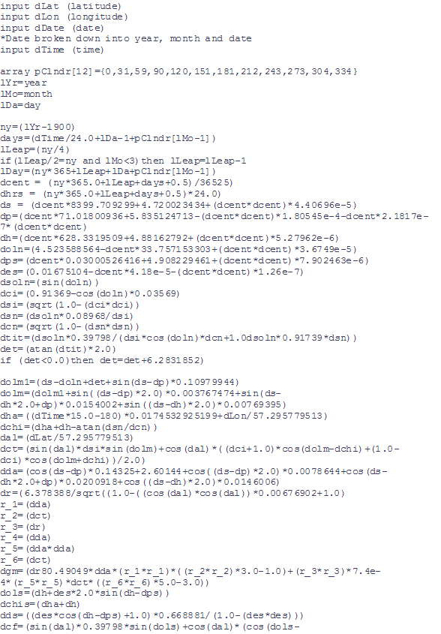
Appendix F - Data formats and metadata
DEFN ST=RECD,RT=COMM;RT:A4;COMMENTS:A76
DEFN 1 ST=RECD,RT=;PROJECT:F7.0:NULL=-9999.,UNIT=None,NAME=PROJECT
DEFN 2 ST=RECD,RT=;STATION:F12.0:NULL=-999999999.,UNIT=None,NAME=STATION
DEFN 3 ST=RECD,RT=;LATITUDE:F11.6:NULL=-99.999999,UNIT=Decimal Degrees,NAME=LATITUDE
DEFN 4 ST=RECD,RT=;LONGITUDE:F12.6:NULL=-999.999999,UNIT=Decimal Degrees,NAME=LONGITUDE
DEFN 5 ST=RECD,RT=;EASTING:F9.1:NULL=-99999.9,UNIT=metres,NAME=EASTING
DEFN 6 ST=RECD,RT=;NORTHING:F10.1:NULL=-999999.9,UNIT=metres,NAME=NORTHING
DEFN 7 ST=RECD,RT=;ELLIPSHTGRS80:F9.3:NULL=-999.999,UNIT=metres,NAME=ELLIPSHTGRS80
DEFN 8 ST=RECD,RT=;NAG09:F9.3:NULL=-999.999,UNIT=metres,NAME=NAG09
DEFN 9 ST=RECD,RT=;GRNDELEVATION:F9.3:NULL=-999.999,UNIT=metres,NAME=GRNDELEVATION
DEFN 10 ST=RECD,RT=;OBSGAAGD07:F12.2:NULL=-9999999.99,UNIT=μm/s^2,NAME=OBSGAAGD07
DEFN 11 ST=RECD,RT=;HTGM:F9.3:NULL=-999.999,UNIT=metres,NAME=HTGM
DEFN 12 ST=RECD,RT=;TCINNER:F7.2:NULL=-99.99,UNIT=μm/s^2,NAME=TCINNER
DEFN 13 ST=RECD,RT=;TCQFINNER:I4:NULL=-99,UNIT=None,NAME=TCQFINNER
DEFN 14 ST=RECD,RT=;TCOUTER:F7.2:NULL=-99.99,UNIT=μm/s^2,NAME=TCOUTER
DEFN 15 ST=RECD,RT=;TCQFOUTER:I4:NULL=-99,UNIT=None,NAME=TCQFOUTER
DEFN 16 ST=RECD,RT=;TCTOTAL:F7.2:NULL=-99.99,UNIT=μm/s^2,NAME=TCTOTAL
DEFN 17 ST=RECD,RT=;EFAA:F10.2:NULL=-99999.99,UNIT=μm/s^2,NAME=EFAA
DEFN 18 ST=RECD,RT=;SCBA267:F10.2:NULL=-99999.99,UNIT=μm/s^2,NAME=SCBA267
DEFN 29 ST=RECD,RT=;CSCBA267:F10.2:NULL=-99999.99,UNIT=μm/s^2,NAME=CSCBA267
DEFN 20 ST=RECD,RT=;HORIZDIST:F9.2:NULL=-9999.99,UNIT=metres,NAME=HORIZDIST
DEFN 21 ST=RECD,RT=;GRVBASE:F13.0:NULL=-9999999999.,UNIT=None,NAME=GRVBASE
DEFN 22 ST=RECD,RT=;GPSBASE:F13.0:NULL=-9999999999.,UNIT=None,NAME=GPSBASE
DEFN 23 ST=RECD,RT=;TIME:A9:,UNIT=None,NAME=TIME
DEFN 24 ST=RECD,RT=;DATE:A9:,UNIT=None,NAME=DATE
DEFN 25 ST=RECD,RT=;MGAZONE:F4.0:NULL=-9.,UNIT=None,NAME=MGAZONE
DEFN 26 ST=RECD,RT=;GMTYPESN:A30:,UNIT=None,NAME=GMTYPESN
DEFN 27 ST=RECD,RT=;STATIONDESC:F20.0:NULL=-99.,UNIT=None,NAME=STATIONDESC;END DEFN
DEFN 29 ST=RECD,RT=;COMMENTS:F20.0:NULL=-99.,NAME=COMMENTS;END DEFN
DEFN 1 ST=RECD,RT=PROJ; RT:A4
DEFN 2 ST=RECD,RT=PROJ; PROJNAME:A30: COMMENT=GDA94 / MGA zone 55
DEFN 3 ST=RECD,RT=PROJ; ELLPSNAM:A30: COMMENT=GRS 1980
DEFN 4 ST=RECD,RT=PROJ; MAJ_AXIS: D12.1: UNIT=m, COMMENT=6378137.000000
DEFN 5 ST=RECD,RT=PROJ; ECCENT: D12.9: COMMENT=298.257222
DEFN 6 ST=RECD,RT=PROJ; PRIMEMER: F10.1: UNIT=deg, COMMENT=0.000000
DEFN 7 ST=RECD,RT=PROJ; PROJMETH: A30: COMMENT=Transverse Mercator
DEFN 8 ST=RECD,RT=PROJ; PARAM1: D14.0: COMMENT= 0.000000
DEFN 9 ST=RECD,RT=PROJ; PARAM2: D14.0: COMMENT= 147.000000
DEFN 10 ST=RECD,RT=PROJ; PARAM3: D14.0: COMMENT= 0.999600
DEFN 11 ST=RECD,RT=PROJ; PARAM4: D14.0: COMMENT= 500000.000000
DEFN 12 ST=RECD,RT=PROJ; PARAM5: D14.0: COMMENT=10000000.00000
DEFN 13 ST=RECD,RT=PROJ; PARAM6: D14.0:
DEFN 14 ST=RECD,RT=PROJ; PARAM7: D14.0:
DEFN 15 ST=RECD,RT=PROJ; END DEFN

COMM ATLAS GEOPHYSICS PTY LTD ASEG-GDF2 FORMAT FILE
COMM WWW.ATLASGEO.COM.AU
COMM INFO@ATLASGEO.COM.AU
COMM
COMM ATLAS PROJECT NUMBER P2014065
COMM GA PROJECT NUMBER 201430
COMM CLIENT GA
COMM PROJECT AREA GIPPSLAND GRAVITY SURVEY
COMM START DATE 01072014
COMM END DATE 21072014
COMM PROCESSED BY LR MATHEWS
COMM
COMM VESSEL VEHICLE
COMM OPERATORS GEOSCIENCE AUSTRALIA / GA
COMM OBSERVERS ZS,WB
COMM
COMM MIN SPACING 500m
COMM MAX SPACING 500m
COMM LAYOUT TRAVERSE
COMM
COMM GRAVITY STATIONS 1213
COMM
COMM GEODETIC DATUM GDA94
COMM PROJECTION MGA55
COMM HORIZ ACCURACY 0.05 m
COMM
COMM VERTICAL DATUM GRS80
COMM VERTICAL ACCURACY 0.08 m
COMM
COMM GRAVITY DATUM AAGD07
COMM GRAVITY ACCURACY 0.25 μm/s^2
COMM
COMM GRAVITY INSTRUMENT SCINTREX CG5
COMM GRAVITY SN 40269
COMM GPS INSTRUMENT LEICA GS14
COMM GPS METHOD RTK
COMM
COMM GPS BASE 20143000001 (VRS BASES)
COMM GRV BASE 20143000001
COMM CTRL TIE STATION 1995901324,1995909324
COMM
COMM PROCESSING
COMM DRIFT CORRECTION
COMM ETC CORRECTION LONGMAN
COMM NORMAL GRAVITY 9780326.7715*((1+0.001931851353*(SIN(B3*(PI()/180)))^2)/(SQRT(1-0.0066943800229*(SIN(B3*(PI()/180)))^2)))
COMM ATMOSPHERIC CORRECTION 8.74-0.00099*F3+0.0000000356*F3^2
COMM FREE AIR CORRECTION -(3.087691-0.004398*SIN(LAT)^2)*ELLIPSHT+0.00000072125*ELLIPSHT^2

COMM SCAP BOUGUER CORRECTION 2*PI*Gp((1+μ)*ELLIPSHT-LAMBDA*R) for p=2.67 t/m^3
COMM TERRAIN CORRECTION METHOD RASTERTC
COMM
COMM SOFTWARE AGRIS(IN HOUSE), WAYPOINT850, CHRISDBF, ERMAPPER, RASTERTC
COMM
COMM
COMM DETAILED COLUMN DESCRIPTIONS
COMM COLUMN NAME COLUMN DESCRIPTION UNITS
COMM
COMM PROJECT GA PROJECT NUMBER NONE
COMM STATION GA STATION NUMBER NONE
COMM LATITUDE COORDINATE LATITUDE GDA94 DECIMAL DEGREES
COMM LONGITUDE COORDINATE LONGITUDE GDA94 DECIMAL DEGREES
COMM EASTING COORDINATE EASTING MGA/GDA94 M
COMM NORTHING COORDINATE NORTHING MGA/GDA94 M
COMM ELLIPSHTGRS80 COORDINATE ELEVATION ELLIPSOIDAL GRS80 M
COMM NAG09 GEOID ELLIPSOID SEPARATION AUSGEOID09 M
COMM GRNDELEVATION GROUND LEVEL ELEVATION M
COMM OBSGAAGD07GU OBSERVED GRAVITY AAGD07 μm/s^2
COMM HTGM STATION HEIGHT OF GRAVITY METER M
COMM TCINNER267 INNER ZONE TERRAIN CORRECTION 2.67 t/m^3 μm/s^2
COMM TCQFINNER QUALITY FACTOR OF INNER ZONE TERRAIN
CORRECTION NONE
COMM TCOUTER267 OUTER ZONE TERRAIN CORRECTION 2.67 t/m^3 μm/s^2
COMM TCQFOUTER QUALITY FACTOR OF OUTER ZONE TERRAIN
CORRECTION NONE
COMM TCTOTAL267 TOTAL TERRAIN CORRECTION 2.67 t/m^3 μm/s^2
COMM EFAA ELLIPSOIDAL FREE AIR ANOMALY μm/s^2
COMM SCBA267 SPHERICAL CAP BOUGUER ANOMALY 2.67 t/m^3 μm/s^2
COMM CSCBA267 COMPLETE SPHERICAL CAP BOUGUER ANOMALY
2.67 t/m^3 μm/s^2
COMM HORIZDIST HORIZONTAL DISTANCE FROM PROGRAMMED
STATION M
COMM GRVBASE GRAVITY BASE STATION REFERENCED TO NONE
COMM GPSBASE GPS BASE STATION REFERENCED TO NONE
COMM TIME TIME OF GRAVITY OBSERVATION NONE
COMM DATE DATE OF GRAVITY OBSERVATION NONE
COMM MGAZONE MGA ZONE NUMBER NONE
COMM GMTYPESN GRAVITY METER TYPE SERIAL NONE
COMM STATIONDESC STATION DESC NONE
COMM COMMENTS COMMENTS NONE

