Gippsland Region
Groundwater sampling and characterisation for hydrocarbons

June 2015

Acknowledgements
This report has been prepared by Jacobs (Australia) Pty Ltd for the Department of Environment, Land,
Water and Planning in collaboration with the Department of Economic Development, Jobs, Transport
and Resources.

Contents
Figures 3
Tables 4
Executive summary 5
1 Introduction 8
2 Literature review of hydrocarbon occurrence in groundwater 10
2.1 Gippsland region – aquifer overview 11
2.2 Gippsland region - hydrocarbon occurrence 15
2.3 Onshore natural gas prospectivity 19
2.4 Groundwater chemistry sampling suite 21
2.5 Summary of literature review 25
3 Bore selection 26
3.1 Selection criteria 26
3.2 Water asset identification 27
3.3 Aquifers 30
3.4 Naturally occurring hydrocarbon sites 33
3.5 Nested sites 35
3.6 Summary of selected monitoring network 36
4 Sampling method 40
4.1 Reporting of gas concentrations 43
5 Quality control and quality assurance 44
5.1 Quality control/quality assurance types 44
5.2 Acceptance criteria for quality control samples 45
5.3 QA/QC assessment 45
6 Groundwater sampling – summary of results 46
6.1 Semi-volatile organic compounds 46
6.2 Total petroleum hydrocarbons 50
6.3 Inorganic analytes and indicators 50
7 Groundwater sampling – aquifer characterisation 56
7.1 Quaternary Aquifer (100) and Upper Tertiary/Quaternary Aquifer (102) 56
7.2 Upper Tertiary Aquifer (fluvial) (105) 57
7.3 Upper Tertiary Aquitard (106) and Upper Mid-Tertiary Aquitard (108) 59
7.4 Upper Mid-Tertiary Aquifer (107) 60
7.5 Lower Tertiary Aquifer (111) 60
8 Conclusions 63
References 65
Appendices 67
Appendix A. Standard operating procedure for groundwater sampling 67
Appendix B. Standard operating procedure for collection of dissolved gas and groundwater samples from coal seams 80
Appendix C. Standard operating procedure for the deployment and operation of double valve pumps 90
Appendix D. Laboratory results 100

Figures
Figure 1 Victorian Aquifer Framework relationship between aquifers and hydrogeological units in the Gippsland Basin . 12
Figure 2 Generalised stratigraphy for the Gippsland Basin 13
Figure 3 Lakes Entrance Formation thickness (points) and depth to top of Latrobe Group structure map 14
Figure 4 Fault bounded structures in the Gippsland region 16
Figure 5 Uranium counts and gas bores in the Gippsland region 17
Figure 6 Sealing potential of the Lakes Entrance Formation and oil and gas fields 18
Figure 7 Gas composition for petroleum wells in the Seaspray Depression 19
Figure 8 Gippsland region coal seam gas development scenarios 20
Figure 9 Gippsland region tight/shale gas development scenarios 21
Figure 10 Prospective natural gas areas, key assets and selected monitoring bores to target
surface water assets 29
Figure 11 Prospective natural gas areas, groundwater management units and selected monitoring
bores to target high value aquifers 32
Figure 12 Areas identified in literature review and selected monitoring bores to target these areas
of interest 34
Figure 13 Locations of Gippsland region Monitoring Bores 39
Figure 14 Flow diagram showing water sample collection, field parameter measurement and gas
sample collection 41
Figure 15 Example of gas collection and sampling procedure in the field 41
Figure 16 Example of gas collection and sampling procedure in the field 42
Figure 17 Distribution of dissolved methane concentration by aquifer 48
Figure 18 Distribution of BTEX results by aquifer 49
Figure 19 Piper diagram of major ion analyses by aquifer 51
Figure 20A Schoeller diagrams showing major ion chemistry for each aquifer 52
Figure 21B Schoeller diagrams showing major ion chemistry for each aquifer 53

Tables
Table 1 Proposed monitoring bores in areas of prospectivity and potential groundwater dependent
assets and surface water assets 28
Table 2 GMAs and WSPAs in the Gippsland region 30
Table 3 Summary of selected state observation bore in aquifers of high potential or actual use 31
Table 4 Summary of intersection between areas identified as potential hydrocarbon occurrence
and selected monitoring bores 33
Table 5 Hydrocarbon occurrences measured in groundwater bores and samples in the
Gippsland region 35
Table 6 Summary of nested sites selected for the monitoring program 36
Table 7 Summary of selected bores for the Gippsland monitoring network 37
Table 8 Acceptance criteria for QA/QC samples 45
Table 9 Summary of salinity results by aquifer (Total Dissolved Solids – TDS) 53
Table 10 Summary of Nitrogen results by aquifer (total Nitrogen) 54
Table 11 Summary of indicator parameters collected in the field 55
Table 12 Summary of Round 1 results for sampled watertable bores 57
Table 13 Summary of Round 1 results for sampled Upper Tertiary Aquifer bores
(Boisdale Formation) 58
Table 14 Summary of Round 1 results for sampled Upper Tertiary Aquitard bore 59
Table 15 Summary of Round 1 results for sampled Upper Mid-Tertiary Aquifer bores 60
Table 16 Commentary on Round 1 results for sampled Lower Tertiary Aquifer bores 61

Executive summary
This study is part of the onshore natural gas water science studies being undertaken jointly by the Department of Environment, Land, Water and Planning (DELWP) and the Department of Economic Development, Jobs, Transport and Resources (DEDJTR).
The purpose of groundwater sampling project was to characterise the groundwater chemistry, particularly with presence or not or not of hydrocarbons, and to provide an indication of baseline, that is the concentration of hydrocarbons in groundwater.
This report focusses on the Gippsland region. A parallel study of the Otway region is covered in a companion report (DELWP (2015)). This report includes a review of the literature on previous groundwater chemistry studies in the Gippsland region and possible conclusions on likely hydrocarbon movements through the profile. The literature review provides input to the selection of sampling bores and analytes and also provides the context for interpretation of results.
Key observations from the literature review include:
- The Traralgon Formation coal seams (part of the Latrobe Group) is the most prospective unit for coal seam gas in the Gippsland region (particularly the Longford/ Woodside/ Seaspray region).
- The Cretaceous aged Strzelecki Group is the most prospective unit for tight gas in the Gippsland region (particularly the Longford/Holey Plains/Seaspray region). The Strzelecki Group forms a hydrogeological basement, along with the Palaeozoic rocks in the Gippsland region.
- The Upper Mid-Tertiary Aquitard comprising the Lakes Entrance Formation, the Tambo River Formation and the Gippsland Limestone is a key regional aquitard likely to restrict the upward movement of hydrocarbons from the underlying Lower Tertiary Aquifer (Latrobe Group or Traralgon Formation).
Structural features such as the Lake Wellington depression, and Darriman Fault systems and the Rosedale monocline are likely to breach seals above the Lower Tertiary Aquifer resulting in conduits for hydrocarbons to the surface (Goldie Divko et al., 2010). This conclusion is largely based on soil geochemistry studies which show anomalous results over these structural features.
A representative number of bores for sampling were selected from aquifers known or suspected of having hydrocarbon concentrations (from the literature review) and/or within or near high value groundwater or surface water assets. Priority was given to nested sites which provide vertical information on variations in groundwater chemistry and sites with known construction details.
This report presents the results from 29 bores sampled in Gippsland between 9th December 2014 and 17th January 2015 using low flow sampling techniques. The interpretation of results focuses on spatial variations of analytes (both between aquifers and within aquifers).
The main conclusions from the analysis of the groundwater sampling results include:

Major ions
- The sampled groundwater is sodium chloride dominated. There are no vertical trends in major ion chemistry. The similar ratios of major ions in the various sampled aquifers suggest lateral flow originates from a similar source and undergoes a similar process.

Methane
- Methane concentrations tend to be highest in the coal bearing units of the Lower Tertiary Aquifer (Latrobe Group) and the Upper Mid-Tertiary Aquifer (Latrobe Valley Coal Measures and Balook Formation). The methane concentrations in these units are likely to be sourced from the organic content of the coals.
- There is a decreasing methane concentration upwards above the coal bearing units (for example all watertable bores had undetected or negligible methane concentrations). All nested sites exhibit this trend. The methane concentrations in upper aquifers in areas where the Upper Mid-Tertiary Aquitard is absent is slightly higher than in areas where it is present suggesting the Upper Mid-Tertiary Aquitard partially restricts upwards flow of methane.
- There is no apparent increasing trend in methane concentrations near faults.
- Methane was only detected in analysed gas samples from bores screened in the Lower Tertiary Aquifer and only in bores with significant methane concentrations in water samples. The higher confined pressures in the Lower Tertiary Aquifer are likely to result in the gas coming out of solution during the sampling process.

Ethane, Ethene, Butane, Butene, Propane and Propene
- There were no observations of Ethene, Butane, Butene, Propane and Propene in the 29 sampled bores suggesting that these compounds are not a natural occurrence in any of the sampled aquifers and any future detection is likely to reflect an anthropogenic origin.

Benzene, Tolulene, Ethylbenzene and Xylene (BTEX)
- BTEX was detected in the Lower Tertiary Aquifer and the Upper Tertiary Aquifer. No BTEX was detected in the quaternary aquifers, suggesting that BTEX compounds are unlikely to be a natural occurrence in these quaternary aquifers and any future detection is likely to reflect an anthropogenic origin.

Total Petroleum Hydrocarbons (TPH)
- TPH was detected in 8 of the 29 bores sampled and 7 of these bores are screened in the coal bearing units of the Lower Tertiary Aquifer (Latrobe Group) and the Upper Mid-Tertiary Aquifer (Latrobe Valley Coal Measures and Balook Formation). Although no definitive conclusion can be drawn on the source of the hydrocarbons, the depth of the bores, the presence of coals and the likely lack of interaction with the surface suggest a natural origin.

Naphthalene
- The lack of detection of naphthalene in any of the 30 sampled bores suggests that these compounds are not a natural occurrence in any of the sampled aquifers and any future detection is likely to reflect an anthropogenic origin.

Nitrogen
- The Quaternary Aquifer contains the highest nitrogen concentrations, likely to be the result of leaching from fertiliser rich surface soils to the watertable.
- Slightly higher values were found in the Lower Tertiary Aquifer compared to other confined aquifers which is likely to be an inherent characteristic of the aquifer, rather than leaching from the surface. Potentially the nitrogen is associated with the presence of natural gas in this coal bearing aquifer.

Implications for conceptual model
The groundwater chemistry results presented in this report are generally consistent with the prevailing conceptual model of groundwater flow in the Gippsland region. The upwards decrease in methane concentrations is consistent with the general upwards groundwater flow across the region. Although not definitive, the upwards reduction in methane levels suggests that the detected methane in the upper units (especially the Upper Tertiary Aquifer (Boisdale Formation)) is likely to be sourced from the underlying coal bearing units of the Lower Tertiary Aquifer and the Upper Mid-Tertiary Aquifer.
The results are consistent with the Upper Mid-Tertiary Aquitard (Lakes Entrance Formation) being a seal on top of the Lower Tertiary Aquifer although the methane results show that upwards seepage through the aquitard to overlying aquifers is possible and that the seal is imperfect. Similarly, the results suggest that areas of aquitard absence are likely to exhibit greater inter-aquifer connection as evidenced by the greater methane concentrations in surface aquifers.
There is no apparent increase in hydrocarbon concentrations near faults although there is not enough data to indicate whether faults provide conduits for fluid flow as suggested by the conceptual model.

- Introduction
This study is part of the onshore natural gas water science studies being undertaken jointly by the Department of Environment, Land, Water and Planning (DELWP) and the Department of Economic Development, Jobs, Transport and Resources (DEDJTR).
The purpose of groundwater sampling project was to characterise the groundwater chemistry, particularly with presence or not or not of hydrocarbons, and to provide an indication of baseline, that is the concentration of hydrocarbons in groundwater.
This report focusses on the Gippsland region with the results in the Otway region covered in DELWP (2015).
Natural gas includes conventional gas, coal seam gas, tight gas and shale gas. Figure 1 shows a representation of the typical geological formations potentially bearing natural gas resources and the relative depth of the different potential gas sources.
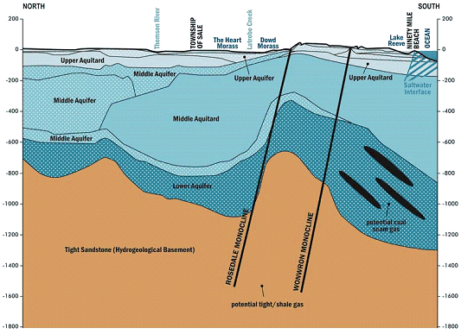
Figure 1 Typical geological formations bearing prospective onshore natural gas in the Gippsland region
(depth shown in metres)
In the Gippsland onshore region, there is no significant potential for conventional gas based on current information. Tight and shale gas are assessed as a single resource in the Gippsland region as they are expected to be in the same geological formation (tight sandstones and shales of the Strzelecki Group).

This report presents the sampling results from the groundwater monitoring program in the Gippsland region. The work undertaken for this study has been documented as follows:
- Chapter 2 Literature review
- Chapter 3 Bore selection
- Chapter 4 Sampling method
- Chapter 5 Quality Assurance procedures and results
- Chapter 6 Groundwater sampling – summary of results by analyte
- Chapter 7 Groundwater sampling – aquifer characterisation
- Chapter 8 Conclusions and implications for conceptual model.

- Literature review of hydrocarbon occurrence in groundwater
A literature review has been undertaken to determine whether any previous studies have detected occurrences of methane, BTEX or other hydrocarbons in the groundwater resources of the Gippsland region, and how these results have been interpreted in the context of the conceptual model of the basin. The literature review provides input as recommendations regarding the selection of sampling bores and analytes and also provides the context for interpretation of results.
There is limited published or publically available information on the organic hydrochemistry of groundwater associated with coal seams (CSIRO, 2011). Some of the first instances of organic information collection in the Gippsland region only recently occurred, in 2013, as part of a science program to investigate the potential impacts on groundwater of possible future coal mining and on-shore natural gas development. The lessons learned regarding sampling procedures for organic chemistry in particular, and the identified knowledge gaps, have been incorporated into this sampling program.
A number of the reviewed reports are focused on the potential for CO₂ storage in the Gippsland region and the common stratigraphic interval of interest (the Latrobe and Strzelecki groups) for both hydrocarbon production and CO₂ storage plans. While the challenge of understanding and managing these operations is not the focus of this report, these studies discuss and identify critical information relevant to this review, including:
- potential hydrocarbon locations
- mechanisms of hydrocarbon migration
location of fracture or high permeability zones that can potentially act as fluid conduits.
The approach to the literature review included the following components:
- Review literature that identifies the occurrence of methane, BTEX or other hydrocarbons in the groundwater resources of the Gippsland region, where coal and oil and gas are potentially present including Divko et al., (2010), Nahm (2002), O’Brien et al., (2008), Varma and Michael (2011), Woollands and Wong (2001) and DSDBI (2013).
- Interrogate readily available databases for additional groundwater data that might help to identify the location of hydrocarbon occurrence in the region.
- Geoscience Australia Petroleum Wells Database (http://dbforms.ga.gov.au/www/npm.well.search ) viewed October 2014.
- Victorian Water Management Information System (queried the laboratory chemistry information, however no relevant groundwater hydrocarbon information was stored in this database).
- Review national and international literature regarding coal seam gas monitoring programs to understand industry standards including CSIRO (2011), Claytor and Shaw (2008), Alberta Environment (2006) and QGC (2012).

This chapter includes the following discussion:
- Section 2.1 Aquifer overview - a summary of the hydrogeology of the Gippsland region including the main aquifers and structural features
- Section 2.2: Literature review of hydrocarbon occurrence and movement in the Gippsland region
- Section 2.3: Onshore natural gas prospectivity
- Section 2.4: Discussion about the appropriate analytes for this project
- Section 2.5: Discussion about potential areas for on-shore natural gas prospectivity
Section 2.6: Summary of the implications of the literature review for the selection of groundwater chemistry parameters for this study.
  - Gippsland region – aquifer overview
The Gippsland region containing the Gippsland Basin an approximate East-West trending sedimentary region bounded by major fault systems from southern and northern margins. Approximately two thirds of the basin is located offshore. Although oil was found in the 1920s in onshore wells, all producing fields were discovered after 1965 and are located offshore in water depths ranging from 45 m to 450 m (Woolands & Wong, 2001).
The hydrogeology of the Gippsland Basin is complex with a number of differing hydro stratigraphic units inter-fingering other units. The Victorian Aquifer Framework (VAF) (SKM, 2011) simplified the aquifer and aquitard units of Victoria for the purposes of water resource management. The VAF aquifer nomenclature is used throughout this report to describe the aquifers across the Gippsland region (Figure 1).
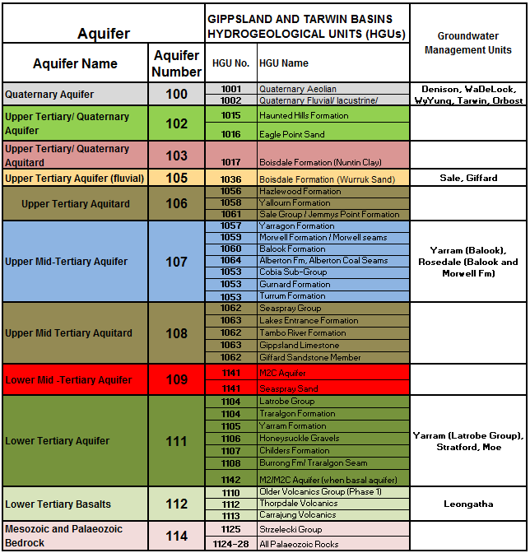
Figure 1 Victorian Aquifer Framework relationship between aquifers and hydrogeological units
in the Gippsland Basin (source: modified from GHD, 2012).
The primary units noted to be associated with natural gas resources include:
- The Lower Tertiary Aquifer (Aquifer 111) – hosts all currently known major hydrocarbon accumulations including offshore conventional oil and gas deposits and potential on-shore coal seam gas deposits.
The Strzelecki Group (Aquifer 114) – hosts on-shore tight gas occurrences
Of particular importance to the vertical migration of groundwater and hydrocarbons through the Basin is the presence or absence of the Seaspray Group (Aquifer 108) – Lakes Entrance Formation which forms a regional seal across the region.
A generalised stratigraphic column is shown in Figure 2 and a description of each of the key units is provided below. For additional information on the Gippsland Basin stratigraphy, the reader is directed to the following literature; James and Evans (1971), Rahmanian et al., (1990) and Bohacs and Suter (1997), Smith et al. (2000), Bernecker et al.(2001) and Bernecker and Partridge (2001), cited in Woodlands & Wong (2001).
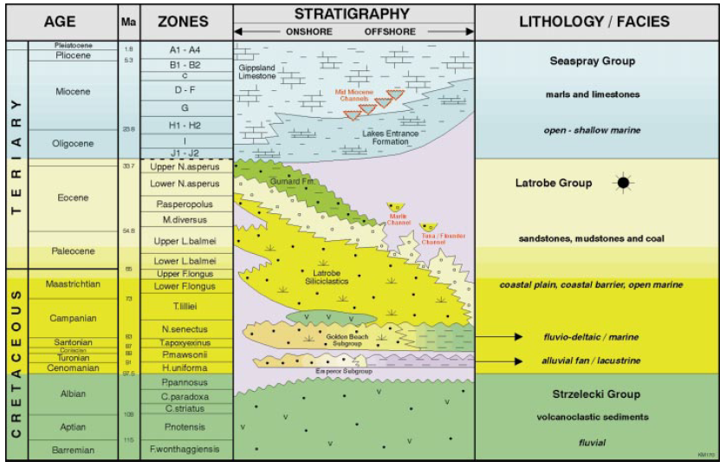
Figure 2 Generalised stratigraphy for the Gippsland Basin (source: Malek and Mehin, 1998)
    - The Strzelecki Group
The Strzelecki Group forms part of the Palaeozoic basement rocks of the Gippsland Basin. The Strzelecki Group consists of interbedded lithic, volcanoclastic sandstones and mudstones, including several coal-rich horizons. Comparisons have been made between the Strzelecki Group and the Eumeralla Formation in the Otway region (which is a significant gas source) in that it may contain good quality gas-prone source rocks (O’Brien, 2008). The Strzelecki Group has previously been identified as a target for exploration for tight gas by Lakes Oil.
    - The Latrobe Group
The Latrobe Group forms the lowermost sedimentary aquifer in the Gippsland Basin and is underlain by the consolidated sandstones and shales of the Strzelecki Group. The Latrobe Group aquifer itself is formed by alluvio-fluvial sediments at the bottom, to marginal-marine, deltaic and increasingly marine sediments toward the top. The Latrobe Group forms a confined aquifer that dips from the area of onshore outcrop, to several kilometres depth in the offshore area of the Basin. The depth to the top of the Latrobe Group aquifer is shown in Figure 3. The Latrobe Group may have coal seam gas potential and is also being considered for its CO₂ storage potential. The Latrobe Group is the most important reservoir for oil and gas in both the onshore and offshore parts of the Basin (Varma & Michael, 2012).
The formations overlying the Latrobe Group (e.g. the Latrobe Valley coal measures- T0, T1 and T2)
contain substantial coal resources that are being mined in the onshore part of the Basin and as part of these mining process substantial volumes of groundwater are extracted from the Latrobe Group to facilitate the mining operations.
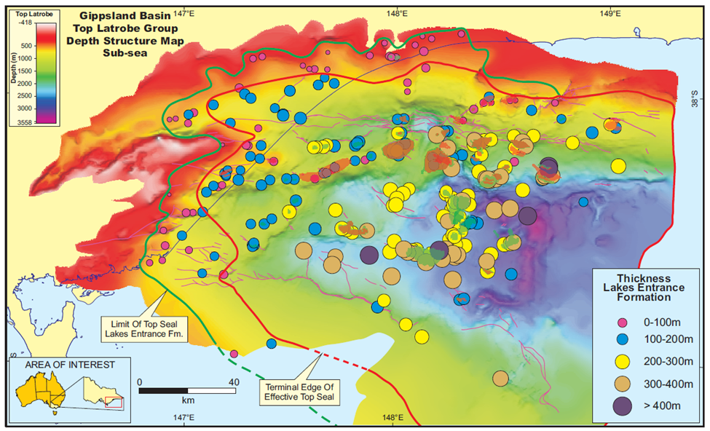
Figure 3 Lakes Entrance Formation thickness (points) and depth to top of Latrobe Group structure map
(source: O’Brien et al. 2008)
    - The Seaspray Group

Lakes Entrance Formation
The Seaspray Group is a carbonate dominated mega-sequence and the basal Lakes Entrance Formation forms a regional seal across the eastern part of the Basin. The Seaspray Group is the lateral marine equivalent to the barrier dune deposits of the Balook Formation and the terrestrial deposits of the Latrobe Valley Coal measures.
Hocking (1976) identified the onshore units that comprise the Lakes Entrance Formation to be: the Cunningham Greenstone Member, Giffard Sandstone Member, Colquhoun Sandstone Member, Seacombe Marl and the Metung Marl.
Figure 3 shows the thickness of the Lakes Entrance Formation, increasing from the on-shore to the offshore parts of the region. O’Brien et al. (2008) undertook a regional quantitative assessment of the sealing capacity of the Lakes Entrance Formation. The study found that onshore; the top-seal is relatively thick, in particular around the Lake Wellington and Seaspray depressions (locations of depressions can be seen in Figure 4). Outside of these areas in the onshore part of the region, the Lakes Entrance Formation seal is thin or absent and there is an absence of conventional gas accumulations at the top of the Latrobe Group aquifer. Where the aquitard is absent, there is potential connection between the Latrobe Group aquifer and overlying aquifers (especially the sand dominated Balook Formation). The sealing capability of intra-Latrobe facies (i.e. low permeability units found within the Latrobe Group itself) was found to be poor on a regional scale and largely ineffective in preventing the migration of hydrocarbons to the base of the regional seal.

The Gippsland Limestone
The Gippsland Limestone is a thick sequence of limestone and marl that overlies the Lakes Entrance Formation in the Gippsland region. Goldie Divko et al. (2009) recommended further investigation into the role of the Gippsland Limestone in providing an adequate top seal to the Latrobe Group aquifer, especially at the region margins where the Lakes Entrance Formation is absent.
  - Gippsland region - hydrocarbon occurrence
The Gippsland Basin is one of Australia’s most productive oil and gas provinces. Ongoing hydrocarbon production has until now focused on oil and conventional gas (mainly offshore); however interest in unconventional hydrocarbon resources is growing.
Conventional gas relates to gas that is sourced from an organic rock that has been compacted by layers of overlying rocks over a long period of time, such that the high pressure and temperature at depth has produced hydrocarbons to form and to migrate towards an area of lesser pressure until it reaches a trap (or an impermeable layer of rock). The reservoir is the rock of high porosity and permeability that holds the hydrocarbon beneath the trap.
Unconventional gas doesn’t require the geological precursors described for conventional gas above. It is gas that is trapped in impermeable rock and cannot migrate to a trap as would occur in a conventional gas deposit. It may be trapped in the source rock from which it was generated. Unconventional gas includes: coals seam gas, shale gas and tight gas.
The occurrence of hydrocarbons in the Gippsland Basin is typically described in terms of the main fault-bounded structures (Figure 4). Offshore these include (from north to south): Northern Platform, Northern Terrace, Central Deep, Southern Terrace and the Southern Platform. Onshore they are described as (north to south): the Lakes Entrance Platform, the Lakes Wellington Depression, the Seaspray Depression and the Alberton Depression.
Figure 4 Fault bounded structures in the Gippsland region
    - Lakes Entrance Platform
Varma & Michael (2011) hypothesise potential connection between the shallower aquifers and the Latrobe Group Aquifer from an interpreted absence or thinning of the Lakes Entrance aquitard, in the area around the northern part of the Gippsland Lakes. This could allow groundwater to migrate upward, possibly unimpeded by the Rosedale and the Lake Wellington faults due to aquifer-aquifer juxtapositions along the fault planes. Geochemical seepage indicators reported by Goldie Divko et al. (2010) suggest potential for vertical upward flow along the fault systems.
Secondary migration of hydrocarbons in the Basin is believed to be largely through large scale vertical migration along faults, although significant lateral migration can also be demonstrated by the occurrence of the small accumulation at the onshore Lakes Entrance Field (Woollands & Wong, 2001). The Lake Bunga 1 exploration hole location is shown in Figure 5 and represents the first discovery of oil in this area in 1924. The oil was found at the base of the Lakes Entrance Formation. Gas reports for the Lake Bunga 1 well indicate methane composition of between 44 and 94 mol %. No other discoveries have indicated the presence of hydrocarbons in this area (Goldie Divko et al. 2009).
Recommendation for the selection of sampling bores and analytes: Monitoring program should target bores in the area around the northern part of the Gippsland Lakes to better understand the implications of thin or absent Lakes Entrance aquitard and the potential for mixing between Latrobe Group and shallower aquifers.
Monitoring program should also target bores located near the Rosedale & Lake Wellington faults to better understand the potential for vertical upward flow along the fault systems. Monitoring program should also target bores near the Lake Bunga 1 bore that has records of methane.
Figure 5 Uranium counts and gas bores in the Gippsland region
    - Lake Wellington Depression
O’Brien (2008) indicated a likely good sealing capacity of the Lakes Entrance Formation in the Lake Wellington Depression and an adequate seal in the Seaspray Depression (Figure 6). Across the rest of the onshore Gippsland region the Lakes Entrance Formation is thinner (<100 m thick).
Murray (1997) detected petroleum in sediments in the floor of Lake Wellington and the oil was thought to be similar geochemically to that found in one of the offshore fields. Although there is no unequivocal proof, it is possible that the seepage represents migration from the northern spill-fill chain across the Rosedale Fault and into the Lake Wellington Depression.
DSDBI (2013) sampled 53 bores across Gippsland for methane concentration and of the 53 bores tested, two bores recorded high levels at 10.4 mg/L and 26.4 mg/L in bores 109044 and 110724 respectively. Bore 109044 is screened in the Boisdale Formation and is located to the North of the Lake Wellington Depression, near the Lake Wellington Fault. The fault may provide a gas pathway for methane movement from the offshore gas system. However, it was noted that the ionic chemistry was at the Calcium Sulphate end of the spectrum for Boisdale and was not considered an outlier. Bore 110724 is screened in the Latrobe Group aquifer located near Port Welshpool in the Yarram WSPA.
Recommendation for the selection of sampling bores and analytes: Monitoring program should target bores in the Lake Wellington Depression and / sample for petroleum hydrocarbons.
Monitoring program should target bores in the Lake Wellington Depression near the Lake Wellington Fault and near Port Welshpool and sample for methane gas.
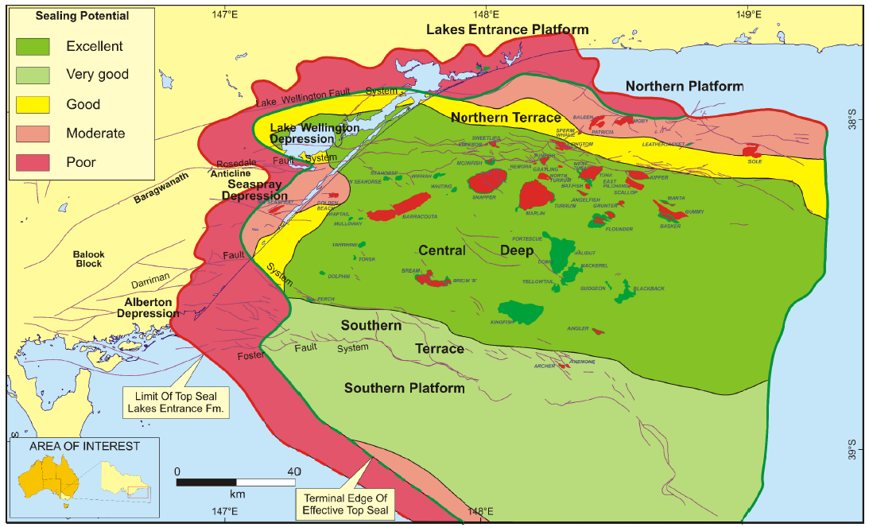
Figure 6 Sealing potential of the Lakes Entrance Formation and oil and gas fields (shown in green and red respectively). (source: Goldie Divko et al., 200))
    - Baragwanath Anticline
The Lakes Entrance Formation is absent over the Baragwanath Anticline. An active hydrocarbon seep, located approximately 10 km southeast of Sale, has been confirmed by Lakes Oil (Mulready, 2002). The location of this seep is indicated in Figure 5, whereby peaks in the statewide uranium survey dataset were used to identify the hydrocarbon seeps along the fill-spill chain at the top of the Latrobe Group. The trend of enriched uranium was interpreted by O’Brien (2008) to potentially indicate hydrocarbons in a broad east-south-east direction away from the confirmed seep. The seep may have originated from seepage up the Rosedale Fault.
Recommendation for the selection of sampling bores and analytes: Monitoring program should target bores in the vicinity of the interpreted hydrocarbon seep and the Rosedale Fault.
    - Seaspray Depression
There are no known hydrocarbon accumulations at the base of the regional Lakes Entrance Formation seal in the Seaspray Depression (Goldie Divko et al. 2009). Onshore, gas accumulations of the North Seaspray and Gangell fields are held in the Strzelecki Group sands (Goldie Divko et al. 2009) rather than the Latrobe Group aquifer. It is likely that the lack of gas in the Latrobe Group in this area is due to the lack of regional seal in this area. The location of the petroleum bore Gangell 1 indicates the location of these gas accumulations (see Figure 4).
Gangell 1 and Trifon 1 were drilled in 2000 under the onshore permit PEP157 to test the Strzelecki oil play. Information for these bores was sourced from the Geoscience Australia petroleum well database. Gangell 1 has a recorded depth of 2350 m and Trifon 1 to 2570 m and both of these wells include gas composition analysis that indicates more than 95% methane (Figure 7).
Hydrocarbon gases are formed from either microbial decay or thermogenic alteration of organic matter. Microbial gases are essentially enriched in methane (C1) with respect to other higher molecular weight hydrocarbon gases (e.g. ethane (C2) and propane (C3)). The Bernard Parameter (C1/(C2+C3)) range from 1,000-100,000 would indicate microbial gases, while values less than 50 are typical for thermogenic hydrocarbon gases (Grassa et al. 2004).
For the gas samples from Gangell 1 and Trifon 1 the ratios have been calculated at 45 and 40, respectively. This indicates that the gas is not biodegraded and that it is of thermogenic origin. O’Brien et al. (2008) concluded that the gases were reservoired in the tight sandstones of the Strzelecki Group and that they are produced from fractures as opposed to within a matrix. A similar conclusion was drawn by Woollands & Wong (2001) whereby, in the Seaspray Depression, burial history and geochemical modelling was thought to suggest that the Early Cretaceous Strzelecki Group, rather than the Latrobe Group, was the source for the onshore hydrocarbon.
There are numerous gas chimneys and anomalous readings of seismic reflection data in the near shore Seaspray Depression which may imply active hydrocarbon migration, leakage, seepage. The onshore gas chimneys have been correlated with anomalous mapped soil geochemistry (Goldie Divko et al., 2009).
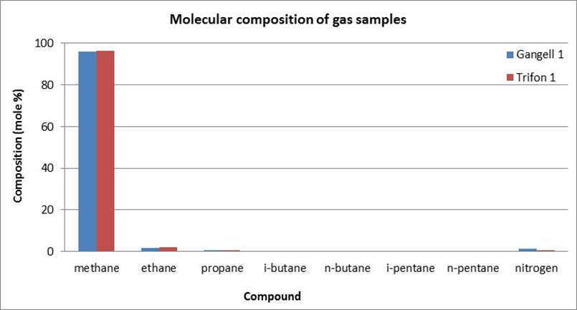
Figure 7 Gas composition for petroleum wells in the Seaspray Depression (source: Geoscience Australia Petroleum Wells Database)
Recommendation for the selection of sampling bores and analytes: Monitoring program should target Strzelecki Group aquifer in the Seaspray Depression. If State Observation Bore Network bores are not available for this stratigraphic layer, an overlying aquifer in the area should be targeted to monitor for potential occurrence of methane gas.
  - Onshore natural gas prospectivity
    - Coal seam gas prospectivity
Coal seam gas extraction is governed by the Langmuir isotherm, relating gas content to reservoir pressure. Once the reservoir hydrostatic pressure is reduced to a critical point, the gas is liberated from the coal seams. Unlike conventional oil and gas reserves, it is not necessary to have a ‘seal’ above the coal seams but rather the gas is held in the coal beds by adsorption on to the coal surfaces and by hydrostatic pressure. However, the presence of low permeability material above the coal seam can be beneficial in reducing the groundwater pumping required to liberate the coal seam gas.
A potentially prospective formation for coal seam gas in Gippsland is the brown coal seams of the Traralgon Formation within the Latrobe Group. Goldie-Divko (2015) provides an analysis of coal seam gas prospectivity at the following three different scales:
- Field scale: the extent of the top of the Traralgon seams within the Burong structure
- Sub-regional scale: where the roof of the Upper Traralgon coal seam (T1) sub-crops between 400 and 800 metres depth inside the Seaspray Depression
- Regional scale: where the Traralgon coal seams sub-crop below 200 metres down-hole depth within the Seaspray Depression and the Latrobe Valley.
Areas of the above scales of coal seam gas prospectivity are shown in Figure 8.
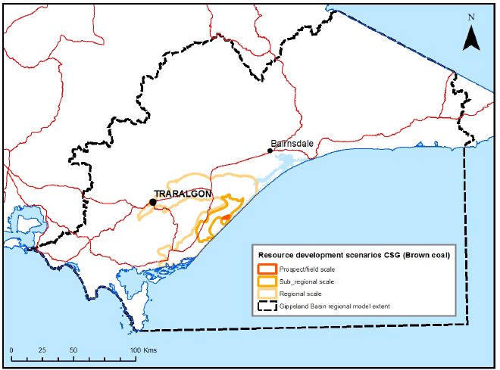
Figure 8 Gippsland region coal seam gas development scenarios (source: Goldie Divko, 2015)
    - Tight gas prospectivity
Tight gas is held in relatively low permeability and low porosity rocks. The lack of permeability does not allow the gas to migrate out of the rock. Unlike coal seam gas where depressurisation of the coal seams is essential for gas migration, much smaller volumes of groundwater are required to be extracted in the development of tight gas deposits.
Goldie-Divko (2015) notes that since the late 1990s the Strzelecki Group has been the target of some tight gas exploration, and provides an analysis of tight gas prospectivity at the following three different scales:
- Field scale: area denoted by structural traps at the top of the Strzelecki Group (and potentially the Golden Beach Sub-group) in the Wombat, Trifon and Gangell fields, as well as a number of smaller scale prospects (Echidna, Steele and Carrs Creek).
- Sub-regional scale: areas of potential tight gas prospectivity covering the field scale areas noted above and all areas in between.
- Regional scale: all tight/shale sub-crop areas in the onshore Gippsland Basin and Latrobe Valley (including the entire area of buried Strzelecki Group underlying the Gippsland region).
Areas of the above scales of tight gas prospectivity are shown in Figure 9.
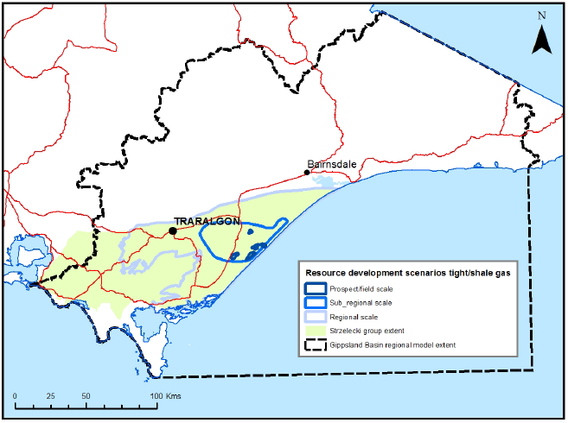
Figure 9 Gippsland region tight/shale gas development scenarios (source: Goldie Divko, 2015)
  - Groundwater chemistry sampling suite
In developing sampling approach a range of literature has been used to understand the most efficient and informative monitoring suite.
A number of natural gas exploration companies are currently operating in Queensland, Australia. The groundwater quality monitoring program undertaken by QGC for Queensland Curtis LNG (QCLNG) has been considered in development of this monitoring suite. International baseline groundwater monitoring protocols associated with natural gas have also been reviewed and used to inform the proposed monitoring suite. Protocols for Alberta and British Columbia, Canada have particularly provided useful basis from which to assess the groundwater parameters (Alberta Environment (2006), Chaytor, S. and Shaw, R., (2008)).

2.4.1 Groundwater characterisation
Monitoring of physical and inorganic properties of groundwater will be used to characterise the existing variability in aquifer chemistry. This will be done by assessing the unique chemical characteristics of the different aquifers, which can then be used as tracers to provide qualitative estimates of the degree of mixing between multiple aquifers.

Inorganic minerals are those derived from geological systems as opposed to organic minerals that are derived from biological systems. Groundwater contact with rocks and soils will lead to dissolution of inorganic minerals, namely major cations and major anions. The typical major ions are included in the proposed sampling program.
Nahm (2002) undertook an analysis of the inorganic chemistry in the Gippsland region, using 937 laboratory results of the available 2289 in the Gippsland region (a 5% ionic balance error margin criterion was used to filter the results used in the analysis). The average concentration of major ions: calcium, magnesium, sodium, potassium, carbonate, bicarbonate, sulphate and chloride, were plotted on a piper diagram. The piper plot analysis indicated there were three groundwater types present in the region: calcium-sodium-chloride, sodium-chloride and sodium-bicarbonate-chloride types.
A Schoeller diagram was used to plot the major ions and some additional ions/compounds, including: iron, silicate and nitrate. The Schoeller diagram was used to identify differences in groundwater chemistry for each of the hydrostratigraphic units defined by Nahm (2002). The Schoeller plot indicated that analysis of iron and dissolved silica did not prove useful in distinguishing between aquifers, however, analysis of nitrate proved useful as significant variation was observed between the aquifers.
Based on the results of the literature review, the following analytes were chosen for the sampling of the Gippsland region:
- Calcium
- Sodium
- Magnesium
- Potassium
- Chloride
- Sulphate
- Fluoride
- Total alkalinity, carbonate / bicarbonate
Total Nitrogen, Nitrate / Nitrite.
The above proposed suite of inorganics is consistent with the ALS Environmental basic coal seam gas
suite, with the exception of exclusion of dissolved silicate and the addition of nitrate and nitrite. The extended coal seam gas suite (which is adopted by QGC) incorporates dissolved and total metals. This assessment has not recommended the inclusion of metals, as the objectives of this program can be achieved without their inclusion.
The following inorganic indicators are also proposed to be calculated to assist in aquifer characterisation:
- Hardness, expressed as mg/L of CaCO3 and used to classify waters as soft -> hard
- Total Dissolved Solids (TDS): a measure of the salt dissolved in a water sample after the removal of suspended solids. TDS is the residue remaining after evaporation of the water and it is related to the specific conductance.
- Specific Conductance (or electrical conductivity). Specific conductance measures the capacity of water to transmit electrical current and is proportional to salt content.
- Sodium Adsorption Ratio- - used to evaluate the hazard in irrigation waters caused by sodium. It relates the concentration of sodium ions to magnesium and calcium ions. An increasing SAR relates to less favourable irrigated soil conditions.
pH.
Physical water quality characteristics include those that relate to temperature, colour, taste and odour. The physical characteristics can be collected in the field and will be based on observations of such qualities as:
- odour
- water colour
- bubbles
effervescence.
    - Isotopes
Incorporation of isotope chemistry into the suite would be useful, however not vital to aquifer characterisation. Stable isotopes of Oxygen, Hydrogen and Strontium in groundwater are routinely used to characterise groundwater and to investigate mixing between aquifers.
DSDBI (2013) recommended the inclusion of groundwater isotope analysis to investigate groundwater age and therefore flow paths. This would suggest inclusion of either Chlorine or Carbon isotopes.
RMIT will be undertaking sampling of a number of the same bores (approximately 10 and including one nested site) identified in this monitoring program, including isotope analysis. Although not undertaken in this study due to time constraints, it is recommended that both datasets be analysed together.
    - Naturally occurring hydrocarbons
Organic chemistry in this study focuses on the organic geochemical properties of coal with particular focus on hydrocarbon associated chemicals such as:
- Hydrocarbon gases (natural gas
Hydrocarbon liquids (petroleum hydrocarbons).
      - Hydrocarbon gases
Hydrocarbon gases include Methane (C1), Ethane (C2), Propane (C3) and Butane (C4). Measurement of the four gases means that gas component ratios can be used to help establish the role that hydrocarbon-oxidizing bacteria play in altering the original source gas composition. This ratio (referred to as the Bernard Parameter) was mentioned in section 2.2.4 to indicate a likely thermogenic hydrocarbons source for the North Seaspray and Gangell fields.
Methane occurs naturally in the atmosphere and is commonly found at trace levels as a dissolved component of groundwater. It can also be released by anthropogenic activities including agriculture, landfills. There is no authoritative guidance for methane concentrations in groundwater, given it is practically non-toxic. A 2012 National Methane Baseline Study was undertaken by the British Geological Survey (BGS) and was defined as the ‘current background range of methane concentrations in UK groundwater before any significant exploitation of unconventional hydrocarbons, such as shale gas, takes place’. This study found maximum Methane concentrations of 14.2 mg/L and 132 mg/L in the two study regions. Analysis of methane
concentration from nearly 4,000 samples indicated a median Methane concentration of <0.5 mg/L. The study analysed only potable water and observation bores within Cretaceous, Jurassic and Triassic carbonates and sandstones.
The protocols for baseline groundwater sampling reported for both British Columbia and the State of Colorado indicate that if dissolved methane levels exceed 2 mg/L, gas composition analysis and stable isotope analysis of the methane (i.e. carbon and deuterium) should be performed assess the potential origins of the gas. Stable carbon and deuterium isotopes of methane provide an independent means to determine the origin of gases and are conventionally used to differentiate between biogenic and thermogenic methane sources. Both chromatographic composition and isotope ratios are used to differentiate naturally occurring gas sources.
It is noted that DSDBI (2013) found methane in a number of sampled groundwater bores, yet the origin of this gas was unknown and was noted to require further investigation. For this reason it is proposed that measurement of all four gases C1-C4 is undertaken and consideration for stable isotopes be given to later rounds of sampling where elevated methane concentrations are observed.
      - Petroleum Hydrocarbons
Sampling for petroleum hydrocarbons typically includes samples for:
- aromatic hydrocarbons benzene, ethylbenzene, tolulene and xylene (BTEX)
- total petroleum hydrocarbons (TPH)
- polynuclear aromatic hydrocarbons (PAH).
BTEX compounds are naturally found in crude oil, coal and gas deposits. Leusch and Bartkow (2011) concluded that BTEX compounds may therefore be naturally present at low concentrations in groundwater associated with these deposits.
Total petroleum hydrocarbons (TPH) are defined as carbon chains in the range of C6 through C35. Products containing TPH include a wide variety of mixtures that may contain hundreds to thousands of hydrocarbon compounds including aliphatic (straight carbon chain) and aromatic (carbon ring) compounds. Evaluating hundreds to thousands of compounds is not usually practical. Evaluations for overall TPH are common and is generally accepted practice.
Sampling for BTEX and TPH is recommended as part of this suite for the following reasons:
- DSDBI (2013) found raised BTEX and TPH concentrations in a number of bores sampled in the Gippsland region. It was concluded that the elevated concentrations occurred as single peaks within their chromatograms and this suggested that refined hydrocarbon products are likely to be attributed to contamination of the bores or near surface (e.g. fuel tanks) seepage.
- The national and international protocols for baseline groundwater sampling all include TPH and BTEX.
- The Gippsland region literature review indicated potential hydrocarbon seeps near Sale.
The use of BTEX compounds in hydraulic fracturing activities.
PAHs are produced in coal and the presence of PAHs in groundwater is due to the leaching of coals. Orem et al. (2007) tested produced waters from coal seam gas wells in the Powder River region, Wyoming and concluded that the probable source of the PAHs was leaching from sub-bituminous coals, based on the similarities between the spectrum of PAHs present in the produced water and those found in the coal.
The international baseline sampling protocols reviewed did not include PAHs (i.e. the Colorado oil and gas conservation commission state wide groundwater baseline sampling and monitoring rules (2014), the Alberta Environment standard for baseline water well testing (2006) or the protocols developed for British Columbia (Chaytor & Shaw, 2008)). The groundwater monitoring program adopted in Queensland by QGC however did include PAHs.
A recent groundwater sampling program in Victoria (DSDBI, 2013) sampled 53 groundwater bores across Gippsland for PAHs and none of the bores recorded concentrations above detection limits. For this reason, sampling of PAHs has not been included in the recommended sampling suite.
  - Summary of literature review
    - Groundwater sample locations informed by hydrocarbon occurrence
The monitoring program should target observation bores in the following locations where hydrocarbon occurrences have been identified:
- in the area around the northern part of the Gippsland Lakes to better understand the implications of thin or absent Lakes Entrance aquitard and the potential for mixing between Latrobe Group and shallower aquifers
- located near the Rosedale & Lake Wellington faults to better understand the potential for vertical upward flow along the fault systems
- near the Lake Bunga 1 bore that has records of methane
- in the Lake Wellington Depression and sample for petroleum hydrocarbons
- in the Lake Wellington Depression near the Lake Wellington Fault and sample for methane gas
- in the vicinity of the interpreted hydrocarbon seep (10 km southeast of Sale) and the Rosedale Fault
in the Strzelecki Group aquifer in the Seaspray Depression. If State Observation Bore Network bores are not available for this stratigraphic layer, an overlying aquifer in the area should be targeted to monitor for potential occurrence of methane gas.
These conclusions will be taken into consideration in Chapter 3, which details the bore selection method.
    - Summary of groundwater sampling parameters
Based on the above literature review, to characterise the groundwater chemistry of chosen aquifers and to determine the natural occurrence of hydrocarbons in groundwater, groundwater samples should be analysed for the following parameters:
- Major ions: Calcium, Sodium, Magnesium, Potassium, Chloride, Sulphate, Fluoride, Total alkalinity, carbonate, bicarbonate, Total Nitrogen, Nitrate, Nitrite
- Inorganic Indicators: Hardness, Total Dissolved Solids (TDS) , Specific Conductance (or electrical conductivity), Sodium Adsorption Ratio, pH
- Physical water quality characteristics (identified in the field): odour, water colour, effervescence
- Hydrocarbons: Methane (C1), Ethane (C2), Propane (C3), Butane (C4), Benzene, Tolulene, Ethylbenzene, Xylene, Total Petroleum Hydrocarbons.

- Bore selection
The sampling program has the following objectives:
- to characterise the groundwater chemistry, particularly with presence or not or not of hydrocarbons, in prospective onshore natural gas areas, and
- to provide an indication of baseline groundwater quality, in particular the concentration of hydrocarbons in groundwater.
This project will utilise low flow techniques to sample a representative number of bores screened within aquifers known, or suspected of having hydrocarbon concentrations, and/or within or near high value groundwater or surface water assets. Low flow sampling is a recognised technique for sampling small volumes of groundwater from the bore (Geoscience Australia, 2009). The technique relies on knowledge of the bore construction especially the screen interval and also the diameter and condition of the bore. Reliability of results also requires knowledge of which aquifer and interval the sample represents. For this reason, this project will only choose state observation bores for sampling due to the reliable data on bore construction and condition. The alternative of using private bores was discounted due to the variable
nature of bore construction and casing condition data, and the problems with already installed pumps and obtaining access.
  - Selection criteria
The following criteria were used to select bores for the monitoring program:
- bores in the prospective units for unconventional gas development especially in areas of identified high prospectivity
- watertable bores chosen in or around groundwater dependent ecosystems particularly above zones of high unconventional gas prospectivity
- bores in aquifers of high potential or actual use
- nested bores which highlight the vertical differences in groundwater chemistry at the same location
- bores with known hydrocarbon concentrations determined from the above literature review
bores in aquifers above known seals and also where the seal is absent to allow analysis of the effectiveness of the seal for capping vertical hydrocarbon migration.
Bores should not be chosen if they have one or more of the following characteristics:
- failed bores or bores of poor condition
bores with lack of construction data (relevant to the WG CMA bores).
The Gippsland prospectivity areas (Section 2.3) and the locations of the state observation bores have been used to inform the monitoring program by comparing with:
- key groundwater dependent surface water assets
- areas of high groundwater use or potential use
- naturally occurring hydrocarbon locations (from the literature review).
A recent review of the state observation bore network was undertaken by GHD (2014) which included an assessment and scoring of bore condition. Bores were scored from 1 (good) through to 5 (poor) and it was noted that bores with a final score of 4 or 5 were least preferred for inclusion as a state observation bore network asset. Bores with poor condition ranking (of 4 or 5) were excluded from the initial round of bore selection and only considered for inclusion in the monitoring network if an obvious gap in the remaining state observation bores was observed.
  - Water asset identification
The Victorian Water Asset Database (VWAD) was used to identify potential Groundwater Dependent Ecosystems (GDEs), waterways and wetlands in the Gippsland Basin.
The VWAD ranks assets from the perspective of habitat, economic, recreation and cultural value, whereby the following scores were applied:
Neutral = 1, Low = 10, Moderate = 20 , High = 40 , Extreme = 100
Based on these criteria the following rules were applied to VWAD to generate datasets of GDEs for potential bore monitoring target sites in the monitoring program:
- GDE score = 100. A score of 100 implies a potential GDE has been identified. Applying this rule means that only the potential GDE rivers (91% of total) and wetlands (31% of total) in the Gippsland region were selected from the VWAD.
- Water source = 100. A score of 100 implies the water source is groundwater.
- Habitat score = 100. This implies extremely valuable rivers and wetlands were selected from the VWAD. Examples include Iconic Rivers, Living Murray Icon Sites, Nationally Important Wetlands, Victorian Biodiversity Atlas, Highly Localised Asset sites of significance etc.
- Economic score = 100. This implies extremely valuable rivers and wetlands were selected from the VWAD. Examples include Town Supply Reservoirs, features used for urban water supply, features located in a Designated Water Supply Catchment etc.
- Recreation score = 100. This includes rivers and wetlands where recreational activities have been observed.
Cultural score = 40 (there were no score = 100 in Gippsland). This means highly valuable rivers and wetlands were selected from the VWAD. Examples include features listed in the Victorian Heritage Register or AVIRA for National Heritage Sites etc.
Note: there were no springs identified in the region or region margin catchment system of the Gippsland region. Springs were only present in the upland valley (i.e. the outcropping fractured rock) area of the Gippsland region.
These GDEs were then compared to the locations of the field scale and sub-regional scale prospectivity for coal seam gas and tight/shale gas localities as defined by Goldie-Divko (2015) and described in Section 2.3.
Within the Gippsland region the prospectivity areas intersect a number of key assets including potential groundwater dependent ecosystems, waterways and wetlands as identified from VWAD. State observation bore locations have been compared to these features and prospectivity areas and specific bores have been selected for inclusion in the monitoring network. Figure 10 shows the selected sampling bores which are summarised in Table 1.

Table 1 Proposed monitoring bores in areas of prospectivity and potential groundwater dependent assets and surface water assets
Bore | Details | Justification
145092 | Upper Tertiary Aquifer (fluvial) (105) | - Located in the area of prospectivity and key rivers and wetlands  - Monitors the target aquifer (Boisdale Formation) in the Giffard GMU
105483 | Lower Tertiary Aquifer (111) | - Monitors the target aquifer (Latrobe Group) in the Yarram GMU  - Located in the area of prospectivity and key rivers and wetlands  - Located in the Seaspray depression area of interest.  - Nested with 105483
105484 | Upper Tertiary Aquifer (fluvial) (105) | - Located in the area of prospectivity and key rivers and wetlands  - Monitors the target aquifer (Boisdale Formation) in the Giffard GMU.  - Located in the Seaspray depression area of interest.  - Nested with 105483
WRK059120 | Upper Tertiary Aquitard (106) | - Located in the area of prospectivity and key rivers and wetlands  - Nested with WRK059119 and will inform groundwater chemistry of multiple aquifers at one location and will inform potential for mixing.  - Located in Seaspray Depression area of interest
WRK059119 | Upper Mid-Tertiary Aquitard (108) | - Located in the area of prospectivity and key rivers and wetlands  - Nested with WRK059119 and will inform groundwater chemistry of multiple aquifers at one location and will inform potential for mixing.  - Located in Seaspray Depression area of interest
64835 | Upper Mid-Tertiary Aquifer (107) | - Located in the area of prospectivity and key rivers and wetlands  - Located in Seaspray Depression area of interest
67442 | Upper Tertiary Aquifer (fluvial) (105) | - Located in the area of prospectivity and key rivers and wetlands  - Monitors the target aquifer (Boisdale Formation) in the Sale GMU  - Located along Rosedale Fault
67441 | Lower Tertiary Aquifer (111) | - Located in the area of prospectivity and key rivers and wetlands  - Monitors the target aquifer (Latrobe Group) in the Stratford GMU  - Located along Rosedale Fault
90148 | Upper Tertiary Aquifer (fluvial) (105) | - Located in the area of prospectivity and key rivers and wetlands  - Monitors the target aquifer (Boisdale Formation) in the Sale GMU  - Located in the lake wellington depression area of interest and hydrocarbon seep
145093 | Upper Tertiary Aquifer (fluvial) (105) | - Located in the area of prospectivity and key rivers and wetlands, including Ramsar listed Lake Reeve  - Monitors the target aquifer (Boisdale Formation) in the Giffard GMU
90323 | Upper Mid-Tertiary Aquifer (107) | - Located in the area of prospectivity and key rivers and wetlands  - Located along Rosedale Fault area of interest
WRK059121 | Quaternary Aquifer (100) | - Located outside of sub regional prospectivity  - Located along Darriman Fault  - Located outside of regional seal

Figure 10 Prospective natural gas areas, key assets and selected monitoring bores to target surface water assets (black circles)
  - Aquifers
Across Victoria, aquifers with either a high potential or actual use, are covered by Groundwater Management Areas (GMAs) and Water Supply Protection Areas (WSPAs). In the Gippsland region there are a number of proclaimed groundwater areas (Table 2). The targeted state observation bores are shown in Figure 11 with the objective to provide coverage of the target aquifer in each of the proclaimed areas. A summary of the state observation bores that target each of these high value areas and aquifers is listed in Table 3.
In order to obtain adequate coverage of the watertable aquifer in the Macalister irrigation district the West Gippsland CMA was approached for access to their network of shallow groundwater monitoring bores. Access was granted and these bores have been included in the bore selection process.

Table 2 GMAs and WSPAs in the Gippsland region
GCU | GMA/WSPA | Target Aquifer | Code
Central Gippsland | Wa De Lock | Quaternary Alluvium | 100
Central Gippsland | Denison | Quaternary Alluvium | 100
Central Gippsland | Wy Yung | Quaternary Alluvium | 100
Central Gippsland | Sale | Boisdale Formation | 105
Central Gippsland/Seaspray | Giffard | Boisdale Formation | 105
Central Gippsland | Rosedale | Balook Formation | 107
Central Gippsland/Seaspray | Stratford | Latrobe Group | 111
Central Gippsland/Seaspray | Yarram | Latrobe Group | 111

Table 3 Summary of selected state observation bore in aquifers of high potential or actual use
GMA/WSPA | Target Aquifer | Code | Bore
Wa De Lock | Quaternary Alluvium | 100 | - 95489
Denison | Quaternary Alluvium | 100 | - No 100 bores (45762 is a 102 bore)
Wy Yung | Quaternary Alluvium | 100 | - 105479 (100 AQ)
Sale | Boisdale Formation | 105 | - 67442*  - 90148*  - 90615  - 140691  - 140692
Giffard | Boisdale Formation | 105 | - 105484  - 145092  - 145093*
Rosedale | Balook Formation | 107 | - No Balook state observation bore is available
Stratford | Latrobe Group | 111 | - 47063  - 58937  - 67441*
Yarram | Latrobe Group | 111 | - 110724  - 147173  - WRK059110  - WRK059112  - 105483*  - 105222
Macalister ID | Watertable aquifer | 100 | - 95489 (WG CMA bore targeting watertable aquifer)
*bores have already been included in the monitoring network based on other selection criteria

Figure 11 Prospective natural gas areas, groundwater management units and selected monitoring bores to target high value aquifers (blue circles)

  - Naturally occurring hydrocarbon sites
The literature review presented in Section 2.2 identified a number of areas of naturally occurring hydrocarbons. These sites are shown in Figure 12 and recommended sampling bores targeting these sites are summarised in Table 4. The thickness of the Upper Mid Tertiary Aquitard is also shown in order to approximate the thin edge of the Lakes Entrance Formation (the aquitard seal overlying the Latrobe and Strzelecki Formation target units).

Table 4 Summary of intersection between areas identified as potential hydrocarbon occurrence and selected monitoring bores
Area | Bore | Justification
Near the Lake Bunga 1 bore | None in the vicinity | NA
The area around the northern part of the Gippsland Lakes where the Lakes Entrance Formation is thin or absent | WRK059126 (111 AQ)*  WRK059127 (105 AQ) (nested site)* | Located where the regional seal is absent. Includes a Latrobe Aquifer bore and a Boisdale Fmn Aquifer bore
Lake Wellington Fault | 103822 (105 AQ)  58937* (111 AQ)  140692* (105 AQ)  140691* (105 AQ) | Located along the Lake Wellington Fault and also comparison of Boisdale Fmn aquifer chemistry in area of absent regional seal
Lake Wellington Depression | 90148* (105 AQ)  90615* (105 AQ) | Bores in vicinity of Lake Wellington
Rosedale Fault | 67442* (105 AQ)*  67441* (111 AQ)* | Latrobe Group aquifer and Boisdale Aquifer along Rosedale Fault
Near the interpreted hydrocarbon seep (10 km southeast of Sale) | None in the vicinity | NA
Seaspray Depression | 105483*  105484*  WRK059120*  WRK059119*  64835*  145092*
*bores have already been included in the monitoring network based on other selection criteria
Figure 12 Areas identified in literature review and selected monitoring bores to target these areas of interest (green circles)

Recent work undertaken by DSDBI (2013) and field observations noted by DELWP, have identified hydrocarbon occurrences in groundwater bores and groundwater samples in the Gippsland region (summarised in Table 5). Bore 110724 was incorporated into the sampling program.

Table 5 Hydrocarbon occurrences measured in groundwater bores and samples in the
Gippsland region
Bore ID | Details | Hydrocarbon Observation
109044¹ | 109044: screened in the 105 aquifer, located about 15 km north of Lake Wellington. This bore was removed from the working state observation bore list as it has a condition ranking of 5 | Elevated hydrocarbons were measured in this bore and recommendation was made for a resample for hydrocarbons.
110724¹ | Screened in the 111 aquifer, located near Port Welshpool in the Yarram WSPA and intersecting the regional tight gas prospectivity area.
90400² | Latrobe Group (111 AQ). Removed from the working state observation bore list because of a condition ranking of 5. | hydrocarbon sheen noted
90614² | Latrobe Group (111 AQ). Removed from the working state observation bore list because of a condition ranking of 5. | >100% LEL
103583² | Latrobe Group (111 AQ). Removed from the working state observation bore list because of a condition ranking of 5. | >100% LEL
110722² | Balook Formation (107 AQ). Removed from the working state observation bore list because of a condition ranking of 5. | >100% LEL
110725² | Latrobe Group (111 AQ). Removed from the working state observation bore list because of a condition ranking of 5. | 7% LEL
¹DSDBI (2013)
²DELWP – current state observation bore condition assessment project
  - Nested sites
Targeting nested bore sites for inclusion in the monitoring network will assist in the aquifer characterisation process and will also inform the potential for mixing of groundwater from multiple aquifers. Any future natural gas investigations will target deep aquifers that underlie the aquifers that are currently used extensively for private groundwater extraction purposes (e.g. irrigation, stock and domestic) and by the environment (e.g. groundwater dependent ecosystems). Hence, understanding the amount of connection between the deep and shallow aquifers is important and this can potentially be informed by interpreting groundwater chemistry information for multiple aquifers at a single site (i.e. at a nested site).
A review was undertaken to identify the nested sites in the Gippsland region area to ensure relevant nested sites had been included in the network. Table 6 summarises the nested sites and notes whether they have been included in the monitoring program. Note that this table does not include an additional six sites where one or more of the bores within the nest was noted as having poor condition. In summary, four of the
five available nested sites (with suitable bore condition records) were incorporated into the proposed monitoring network.

Table 6 Summary of nested sites selected for the monitoring program
Comment | Bore ID | AQ | Likely HGU
Yes - NESTED SITE 1 | WRK059110 | 111 | Latrobe Grp
Yes - NESTED SITE 1 | WRK059111 | 102 | Haunted Hill
Yes - NESTED SITE 2 | WRK059120 | 106 | Hazelwood/Yallourn Formation
Yes - NESTED SITE 2 | WRK059119 | 108 | Seaspray Group
Yes - NESTED SITE 3 | WRK059126 | 111 | Latrobe Grp
Yes - NESTED SITE 3 | WRK059127 | 105 | Boisdale Fmn
Yes - NESTED SITE 4 | 105479 | 100 | Quaternary Alluvium
Yes - NESTED SITE 4 | 110978 | 107 | Balook Fmn
No - COMMENTS SUGGEST THIS NEST LIKELY MONITORS SAME AQUIFER | WRK059121 | 100 | Quaternary Alluvium
No - COMMENTS SUGGEST THIS NEST LIKELY MONITORS SAME AQUIFER | WRK059122 | 102 | Haunted Hill
No - COMMENTS SUGGEST THIS NEST LIKELY MONITORS SAME AQUIFER | WRK059123 | 100 | Quaternary Alluvium

  - Summary of selected monitoring network
Table 7 provides a summary of the selected bores for the Gippsland Monitoring network. A total of 30 bores have been selected and are shown in Figure 13. These bores provide the following information:
- groundwater near a prospectivity area
- groundwater near high potential groundwater dependent ecosystems (including Ramsar listed sites)
- groundwater near a proclaimed groundwater area
- groundwater near an ‘area of interest’ as identified in the literature review or recent field studies
groundwater of multiple aquifers at a single site (i.e. nested sites).
The medium priority bores are those that met two of the selection criteria listed above. The low priority bores met only one of the selection criteria.

Table 7 Summary of selected bores for the Gippsland monitoring network
Bore | Aquifer Monitored | Justification for inclusion in the monitoring network
145092 | Upper Tertiary Aquifer (fluvial) (105) | - Located in the area of prospectivity and high value rivers and wetlands
90615 | Upper Tertiary Aquifer (fluvial) (105) | - Located near Gippsland Lakes Ramsar site.  - Monitors the target aquifer (Boisdale Formation) in the Sale WSPA.  - Located in Lake Wellington Depression area of interest
105484 | Upper Tertiary Aquifer (fluvial) (105) | - Located in the area of prospectivity and high value rivers and wetlands  - Monitors the target aquifer (Boisdale Formation) in the Giffard GMU.  - Located in the Seaspray depression area of interest.  - Nested with 105483
105483 | Lower Tertiary Aquifer (111) | - Monitors the target aquifer (Latrobe Group) in the Yarram GMU  - Located in the area of prospectivity and high value rivers and wetlands  - Located in the Seaspray depression area of interest.  - Nested with 105483
WRK059120 | Upper Tertiary Aquitard (106) | - Located in the area of prospectivity and high value rivers and wetlands  - Nested with WRK059119 and will inform groundwater chemistry of multiple aquifers at one location and will inform potential for mixing.  - Located in Seaspray Depression area of interest
WRK059119 | Upper Mid-Tertiary Aquitard (108) | - Located in the area of prospectivity and high value rivers and wetlands  - Nested with WRK059119 and will inform groundwater chemistry of multiple aquifers at one location and will inform potential for mixing.  - Located in Seaspray Depression area of interest
64835 | Upper Mid-Tertiary Aquifer (107) | - Located in the area of prospectivity and high value rivers and wetlands  - Located in Seaspray Depression area of interest
67442 | Upper Tertiary Aquifer (fluvial) (105) | - Located in the area of prospectivity and high value rivers and wetlands  - Monitors the target aquifer (Boisdale Formation) in the Sale GMU  - Located along Rosedale Fault
67441 | Lower Tertiary Aquifer (111) | - Located in the area of prospectivity and high value rivers and wetlands  - Monitors the target aquifer (Latrobe Group) in the Stratford GMU  - Located along Rosedale Fault
WRK059111 | Upper Tertiary/Quaternary Aquifer (102) | - Located near Ramsar listed corner inlet Nested with WRK059110
WRK059110 | Lower Tertiary Aquifer (111) | - Monitors the target aquifer (Latrobe Group) in the Yarram WSPA  - Nested with WRK059111
90148 | Upper Tertiary Aquifer (fluvial) (105) | - Located in the area of prospectivity and high value rivers and wetlands  - Monitors the target aquifer (Boisdale Formation) in the Sale GMU  - Located in the lake wellington depression area of interest and hydrocarbon seep
145093 | Upper Tertiary Aquifer (fluvial) (105) | - Located in the area of prospectivity and high value rivers and wetlands, including Ramsar listed Lake Reeve  - Monitors the target aquifer (Boisdale Formation) in the Giffard GMU
45762 | Upper Tertiary/Quaternary Aquifer (102) | - WG CMA bore targeting watertable aquifer in Denison GMU  - Located in the lake wellington fault area of interest
105479 | Quaternary Aquifer (100) | - Monitors the watertable aquifer in the Wy Yung GMU and nested with 110978
110978 | Upper Mid-Tertiary Aquifer (107) | - Monitors the Upper Mid Tertiary Aquifer in the Wy Yung GMU  - Nested with 105479
147173 | Lower Tertiary Aquifer (111) | - Monitors the target aquifer (Latrobe Group) in the Yarram GMU and located in close proximity to Yarram township
105222 | Lower Tertiary Aquifer (111) | - Monitors the target aquifer (Latrobe Group) in the Yarram GMU and located in close proximity to Yarram township
95489 | Quaternary Aquifer (100) | - Located in the MID and nested with WRK059126 and WRK059127.  - Also located where the regional seal is absent
WRK059126 | Lower Tertiary Aquifer (111) | - Located in the MID and forms nested site with 95489 and WRK059127  - Also located where the regional seal is absent
WRK059127 | Upper Tertiary Aquifer (fluvial) (105) | - Located in the MID and forms nested site with 95489 and WRK059126  - Also located where the regional seal is absent
103822 | Upper Tertiary Aquifer (fluvial) (105) | - Located along the Lake Wellington Fault  - Provides information on Boisdale Fmn aquifer chemistry in area of absent regional seal
58937 | Lower Tertiary Aquifer (111) | - Located along the Lake Wellington Fault
140692 | Upper Tertiary Aquifer (fluvial) (105) | - Located along the Lake Wellington Fault  - Provides information on Boisdale Fmn aquifer chemistry in area of regional seal
140691 | Upper Tertiary Aquifer (fluvial) (105) | - Monitors the target aquifer (Boisdale Formation) in the Sale GMU  - Located along the Lake Wellington Fault in the vicinity of bore 109044 which had elevated hydrocarbon readings but could not be sampled due to poor bore condition.
110724 | Lower Tertiary Aquifer (111) | - Elevated hydrocarbons were measured in this bore and recommendation was made for a resample for hydrocarbons.  - Located along Forster Fault.
47063 | Lower Tertiary Aquifer (111) | - Monitors the target aquifer (Latrobe Group) in the Stratford GMU
90323 | Upper Mid-Tertiary Aquifer (107) | - Located in the area of prospectivity and high value rivers and wetlands  - Located along Rosedale Fault area of interest
WRK059112 | Lower Tertiary Aquifer (111) | - Monitors the target aquifer (Latrobe Group) in the Yarram WSPA  - Located along Forster Fault.
WRK059121 | Quaternary Aquifer (100) | - Located outside of sub regional prospectivity  - Located along Darriman Fault  - Located outside of regional seal

Figure 13 Locations of Gippsland region monitoring bores

- Sampling method
Sampling of groundwater and gas from DELWP monitoring bores was conducted by HydroTerra personnel (subcontracted by Jacobs).
All groundwater purging, sampling and manual water level monitoring activities undertaken by HydroTerra were completed under their Standard Operating Procedure (SOP) for Groundwater Sampling developed for this project, a copy of which is included in Appendix A. The SOP includes a detailed methodology for the following activities:
- Field instrument calibration: instruments were routinely checked for calibration at the start and end of the day in accordance with equipment procedures.
- Water level monitoring.
- Water quality monitoring: field parameters were routinely monitored during purging.
- Water sample collection: water samples were collected once field parameter stabilisation was achieved (three consecutive readings within 10%). Groundwater samples were collected into approved ALS Environmental supplied glass containers.
Handling, storage and Chain of Custody procedures for collected samples: groundwater samples, including QA/QC samples, were stored on ice between the bore and delivery to the laboratory.
Gas sampling was conducted in accordance with HydroTerra’s technical work instruction for Collection of Dissolved Gas and Groundwater Samples from Coal Seam, included in Appendix B. The instruction includes a detailed methodology for the following activities:
- Gas monitoring: gas was monitored onsite using a gas analyser.
- Gas sample collection: when all the groundwater sample containers required for analysis were filled, a gas sample was collected. Gas samples were collected into ALS Environmental supplied summa canisters.
Handling, storage and Chain of Custody procedures for collected samples.
Samples were collected using a low flow pump installed at depth, which pumped water to the surface. Water was diverted into two lines – one for measurement of field parameters, one for water sample and gas sample collection. A flow diagram of the sampling lines is shown in Figure 14 and examples of gas collection and sampling setup is shown in Figure 15 and Figure 16. Pump installation, operation and maintenance were conducted in accordance with HydroTerra’s technical work instruction for Solinst 408 Double Valve Pump Deployment and Operation, included in Appendix C.
Between bore sites, all equipment was decontaminated to prevent cross-contamination between bores and samples. Equipment was decontaminated by rinsing with tap water, chemical detergent, tap water and then de-ionised water. The methodology used by HydroTerra personnel is described in full in Appendix A.
Figure 14 Flow diagram showing water sample collection, field parameter measurement and gas
sample collection
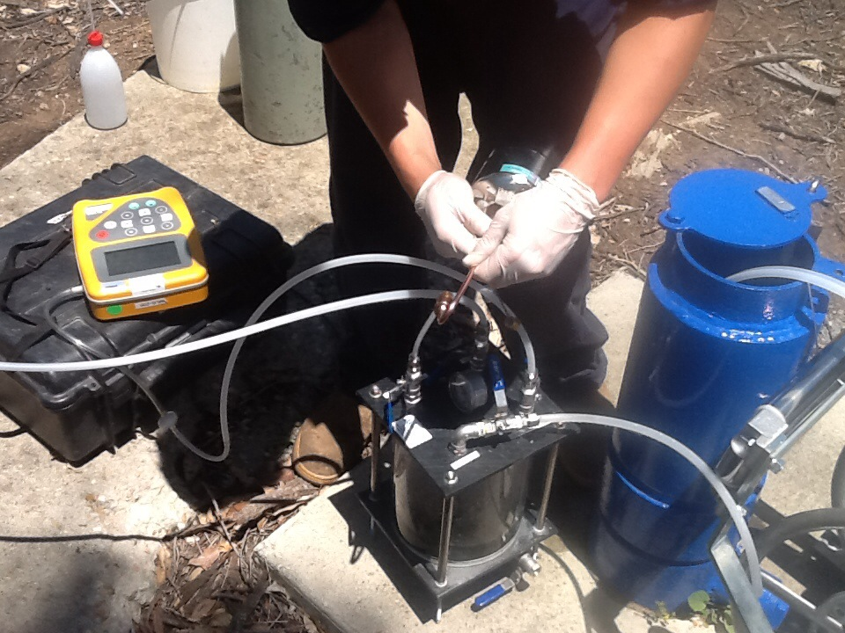
Figure 15 Example of gas collection and sampling procedure in the field
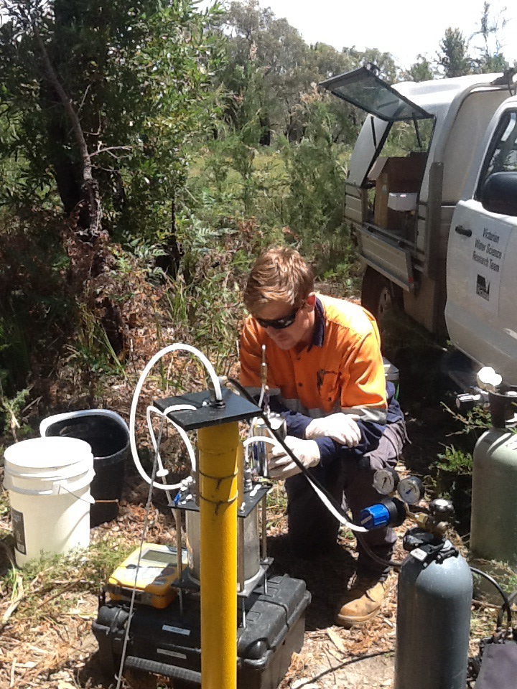
Figure 16 Example of gas collection and sampling procedure in the field

  - Reporting of gas concentrations
Unlike water samples, the mass of a particular analyte in a gas sample is dependent on the pressure and temperature of the sample. For this reason, the laboratory reports the following parameters in the methane analysis of gas samples collected in Summa Canisters:
- concentration of methane (in mg/m³)
- molar percentage of methane (as Mol %)
- pressure as received (in kPa)
- pressure – Laboratory Atmosphere (in kPa)
- temperature as received (as ºC).
The concentration of methane in the gas samples cannot be easily combined with the concentration of methane in water samples collected from the same bore. Therefore, the two results are reported separately in this study.

- Quality control and quality assurance
  - Quality control/quality assurance types
Water quality sampling from all bores included in this program was undertaken in accordance with HydroTerra standard operating procedures (Appendices A and B), EPA guidelines ‘A Guide to Groundwater Sampling’ (2000) and Australian Standard AS/NZS 5667.11 (1998). The following QA/QC samples were collected as part of the monitoring program:

Duplicate sample (also known as an intra-lab sample)
One duplicate sample was collected for every thirty samples collected. To collect a duplicate sample, water collected from the selected bore was separated into three bottle sets – one as the ‘primary’ sample, one as the ‘duplicate’ and one as the ‘triplicate’. The purpose of a ‘duplicate’ sample is to validate the consistency of the sampling technique and laboratory analysis procedures. To assess results, the relative percentage difference (RPD) between the duplicate and primary is calculated for each analyte where observed concentration is greater than five times the Limit of Reporting (LOR) and compared to acceptance criteria.

Triplicate sample (also known as an inter-lab sample)
One triplicate sample was collected for every thirty samples collected. The triplicate was collected at the same site as the duplicate sample. To collect a triplicate sample, water collected from the selected bore was separated into three bottle sets – one as the ‘primary’ sample, one as the ‘duplicate’ and one as the ‘triplicate’. The purpose of a ‘triplicate’ sample is to validate the results and analysis procedure of the primary lab. To assess results, the RPD between the duplicate and triplicate is calculated for each analyte where observed concentration is greater than five times the LOR and compared to acceptance criteria.

Field blank
One field blank was collected for every thirty samples collected. The purpose of the field blank is to validate the onsite sampling method. Sample bottles were filled with deionised water using the same method as filling bottles with groundwater. This included field filtration, where required. If all tested analytes for the field blank are returned with results below detection levels, then the onsite sampling technique is verified.

Transport blank (also known as trip blank)
The purpose of a transport blank is to detect any sample contamination that may occur during transportation, namely in the form of volatile organics. A transport blank consists of a vial filled with deionised water that is stored in the esky by the laboratory. The vial remains in the esky during the field program and is not removed until the esky and samples is returned to the laboratory. If no contamination has occurred during transport, then the transport blank will return results below detection limits for all analytes tested.

  - Acceptance criteria for quality control samples
The calculation for RPD for quality control samples follows the methodology outlined in AS 4482.1-2005 (sampling at contaminated sites). Acceptance criteria used in this assessment are outlined in Table 8.

Table 8 Acceptance criteria for QA/QC samples
QA/QC sample | Typical RPD for QA/QC sample where observed concentration is greater than five time LOR  (see Notes 1 and 2)
Duplicate | 30% - 40% of mean concentration of analyte.  See Note 3.
Triplicate | 30% - 50% of mean concentration of analyte determined by both laboratories.  See Note 3.
Notes:
- $Relative Percentage Difference RPD=\frac{Result No. 1-Result No. 2}{Mean result}×100$
- The significance of RPD of results should be evaluated on the basis of sampling technique, sample variability, absolute concentration relative to criteria and laboratory performance.
- This variation can be expected to be higher for organic analysis then for inorganics, and for low concentration of analytes.
  - QA/QC assessment
Duplicate samples were collected for three bores (WRK059112, WRK059120 and WRK059127). The calculated RPD values were within the guideline value of 30% to 50% and therefore, there is no concern regarding consistency of the sampling technique or laboratory analysis procedures.
Analysis of the two rinsate samples collected shows that the rinsate water does not contain any analytes which would impact on the results of the groundwater samples.
Analysis of the eight trip blank samples for hydrocarbons showed that no contamination occurred during transportation.

- Groundwater sampling –
summary of results
A total of 30 bores were sampled in the first round of Gippsland bore sampling. An error occurred in the sampling of one of these bores (90615) associated with bore location and hence the results obtained from this sample have been removed from analysis. The bores were sampled between 9th December 2014 and 17th January 2015. The second round of sampling was undertaken in March 2015 and the third round is scheduled to be undertaken in June 2015. This report will be up-dated with Round 2 and 3 results including any conclusions on temporal variations after all sampling is completed. The interpretation of Round 1 results focuses on spatial variations of analytes (both between aquifers and within aquifers).
The chemistry results as obtained from ALS Environmental are included in Appendix D.
  - Semi-volatile organic compounds
Seven dissolved Semi-volatile Organic Compound (SVOCs) were analysed in water samples, including; methane, ethane, propane, butane, propene, butane and ethene. Of these analytes multiple observations were recorded for dissolved methane and there was no detection of the other SVOCs in groundwater. The methane concentrations observed across the Gippsland region ranged from 0 mg/L to 33.4 mg/L. The median concentration is 2.4 mg/L.
In addition, methane concentrations were analysed in collected gas samples as per the procedure detailed in the Standing Operating Procedure (Appendix B).
Figure 17 shows the spatial distribution of the dissolved methane concentrations in analysed water samples detected across the Gippsland region.
Methane levels in each aquifer are summarised below.

Lower Tertiary Aquifer (Latrobe Group) (111)
Ten groundwater samples were collected from the Latrobe Group Aquifer and nine of the ten samples recorded dissolved methane. Six of the samples recorded concentrations less than 10 mg/L. The maximum concentration recorded was 33 mg/L.
The three high methane concentrations in groundwater associated with the Latrobe Group Aquifer occur to the southwest of the region, in close proximity to the township of Yarram and near the Foster Fault System.
Methane gas was detected in gas samples collected at the surface in five of the ten samples from the Lower Tertiary Aquifer. All samples with detected methane gas also had significant concentrations of dissolved methane in water samples.

Upper Mid-Tertiary Aquitard (Seaspray Gp including Lakes Entrance Formation) (108) and Upper Tertiary Aquitard (Jemmys Point Formation/Yallourn Fm/ Hazelwood Fm) (106)
A single groundwater sample was collected from the two aquitard units. There was no methane detected in the Upper Mid-Tertiary Aquitard and a low concentration (0.12 mg/L) was detected in the Upper Tertiary Aquitard.

Upper Mid-Tertiary Aquifer (Balook Formation/ Latrobe Valley Coal Measures) (107)
Three groundwater samples were collected from the Upper Mid-Tertiary Aquifer and the dissolved methane ranged from not detected in groundwater to 5.1 mg/L.

Upper Tertiary Aquifer (105)
Nine groundwater samples were collected from the Upper Mid-Tertiary Aquifer. Seven of the samples were collected from areas where the aquifer resides above the Upper Mid-Tertiary Aquitard (Lakes Entrance Formation) and two of the samples were collected where the Aquitard is absent.
Where the aquitard was present the average methane concentration was 1.8 mg/L and where it is absent the average was 4.7 mg/L.

Quaternary Aquifer (100) and Upper Tertiary/Quaternary Aquifer (Haunted Hills Formation) (102)
Five groundwater samples were collected from the shallow Quaternary Aquifer and Haunted Hills Formation Aquifer. Four samples did not detect any methane in groundwater and a single sample recorded 0.4 mg/L.
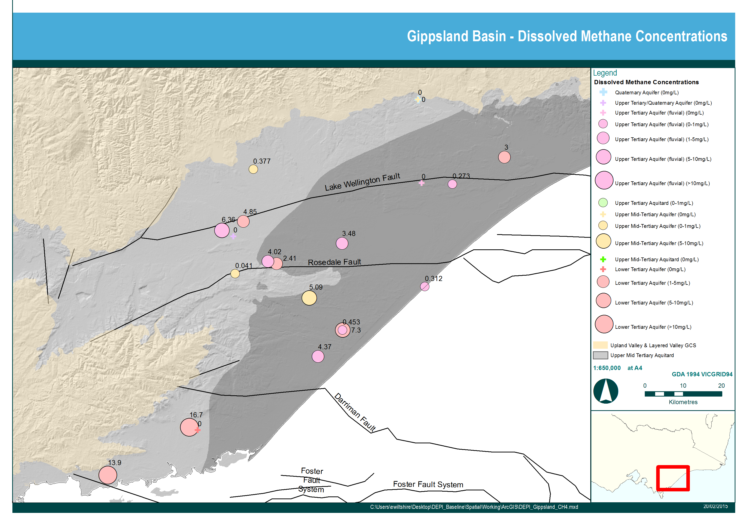
Figure 17 Distribution of dissolved methane concentration by aquifer
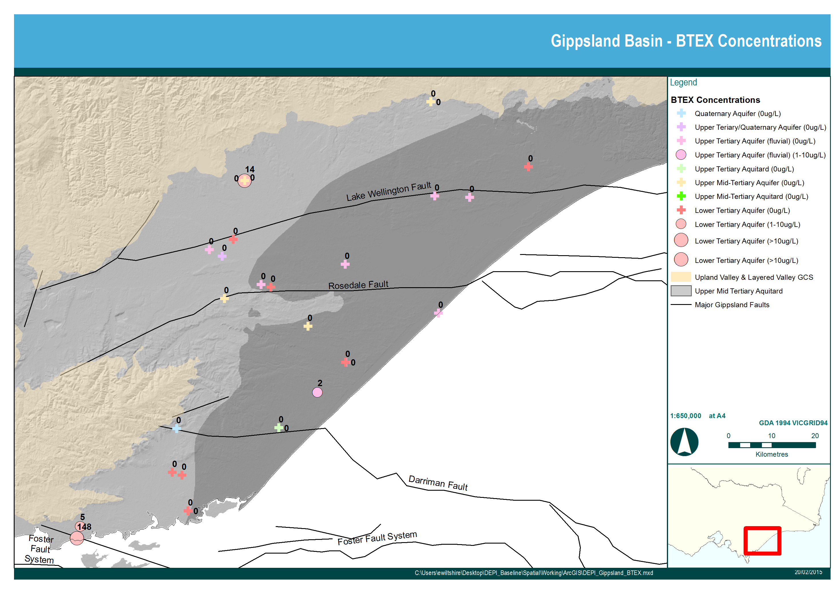
Figure 18 Distribution of BTEX results by aquifer
  - Total petroleum hydrocarbons
Total petroleum hydrocarbons (TPH) are defined as carbon chains in the range of C6 through C35. TPH in groundwater can be either naturally occurring or can have anthropogenic origins.
TPH was detected in 8 of the 30 bore sampled and 7 of these bores are screened in the coal bearing units of the Lower Tertiary Aquifer (Latrobe Group) and the Upper Mid-Tertiary Aquifer (Latrobe Valley Coal Measures and Balook Formation). The samples mostly contain hydrocarbons in the C10 to C28 fraction although this provides no evidence of source. Although no definitive conclusion can be drawn on the source of the hydrocarbons, the depth of the bores, the presence of coals and the likely lack of interaction with the surface, suggest a natural origin.
    - BTEX
All samples were analysed for the presence of Benzene, Tolulene, Ethylbenzene, and Xylene (collectively known as BTEX). BTEX compounds are naturally found in crude oil, coal and gas deposits. The spatial distribution of analysed BTEX compounds in the analysed samples is given in Figure 18.
Four groundwater samples in the Gippsland region indicate the presence of a BTEX compound. Three of these bores are screened in the Lower Tertiary Aquifer (out of 10 Lower Tertiary Aquifer bores sampled) and one in the Upper Tertiary Aquifer (Boisdale Formation) (out of 10 Upper Tertiary Aquifer bores sampled). DSDBI (2013) also analysed three of these bores for BTEX and also recorded the presence of BTEX in groundwater samples.
These bores are screened in the Latrobe Group Aquifer and the Boisdale Formation Aquifer. Concentrations of Ethylbenzene, Tolulene and Xylene are lower than guideline values for health; however concentrations of Benzene exceed health guidelines in two instances.
There are two potential sources of BTEX in groundwater: either contamination from an external source, or natural occurrence. One line of evidence to indicate that the BTEX is naturally occurring is that one sample was collected from an artesian bore, which reduces the likelihood of oil or petrol residue in the bore itself, generating the elevated reading. The readings suggest that BTEX may be naturally occurring in some areas of the Lower Tertiary Aquifer and possibly the Boisdale Formation.
  - Inorganic analytes and indicators
A number of inorganic analytes and indicators were analysed to help characterise the chemistry of each aquifer.
    - Major ion chemistry
The ratio of various cations and anions in any one aquifer is often reasonably constant and provides a chemical signature of that aquifer. Changes in these ratios over time can signal chemical mixing of aquifers. One method for characterising the geochemistry of aquifers is the use of Piper diagrams (Piper, 1953). A Piper diagram plot showing the ratios of the analysed cations and anions by aquifer is shown in Figure 19. Scholler diagrams have also been generated to analyse major ion chemistry for each aquifer (Figure 21).
These plots indicate that the aquifers show similar ranges for major ions with few outliers. The groundwater is of sodium chloride type. The aquitards show similar salinity to the aquifers’ water, but contain significantly more magnesium and sulphate than the aquifers. Some samples show elevated sulphate and one of these samples is also acidic and has a high redox potential (bore 47063 from the Lower Tertiary Aquifer). This may indicate acid sulphate production at this bore.
The Upper Tertiary Aquifer Fluvial and Lower Tertiary Aquifer had higher chloride to sulphate ratios due to low calcium and magnesium, not due to exchanges.
There are no vertical trends in major ion chemistry. The similarity of groundwater above and below the aquitards suggests lateral flow originates from a similar source and undergoes similar processes.

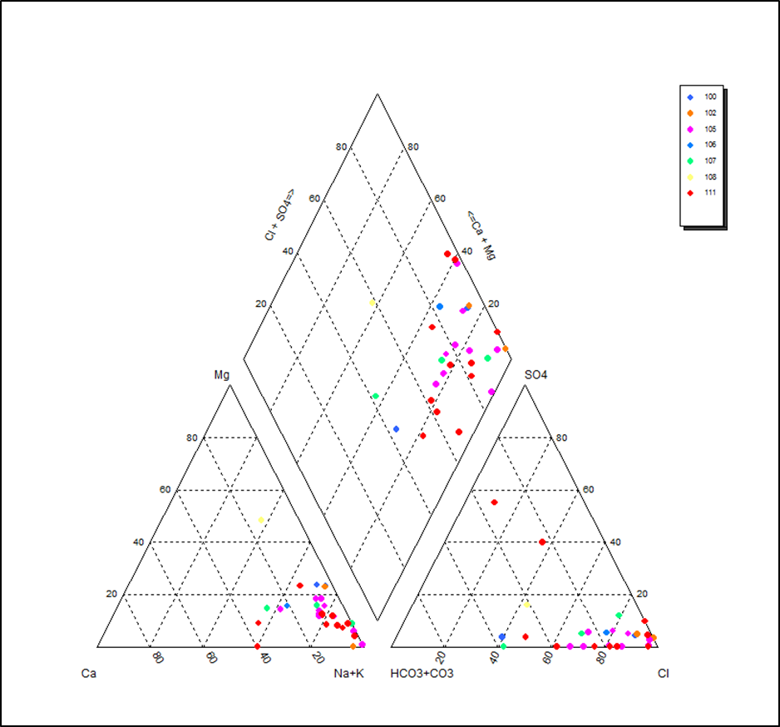
Figure 19 Piper diagram of major ion analyses by aquifer

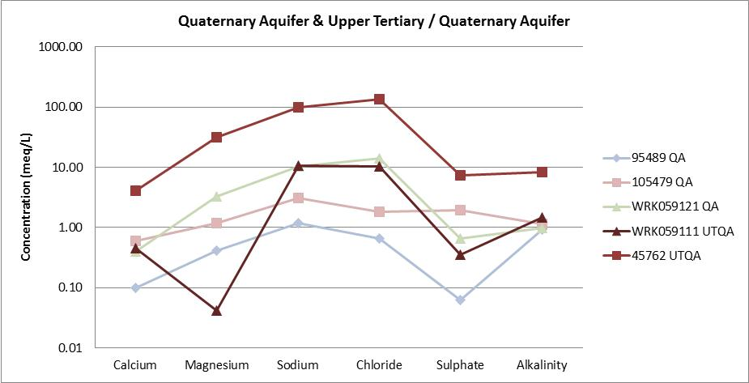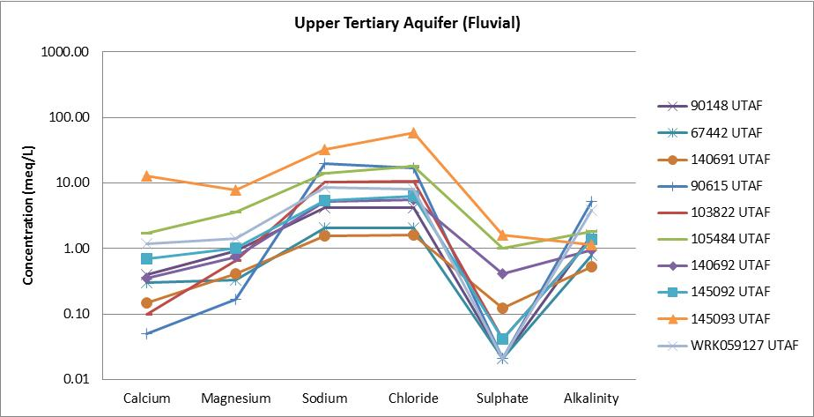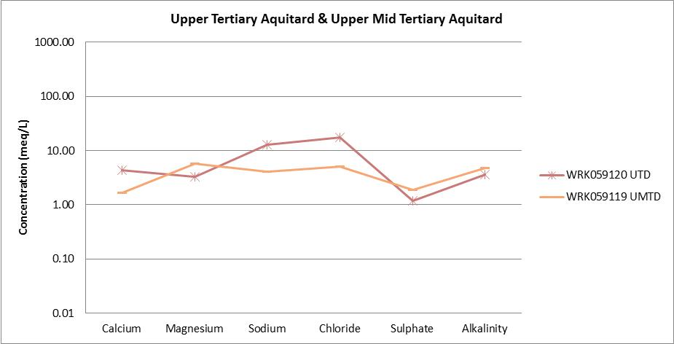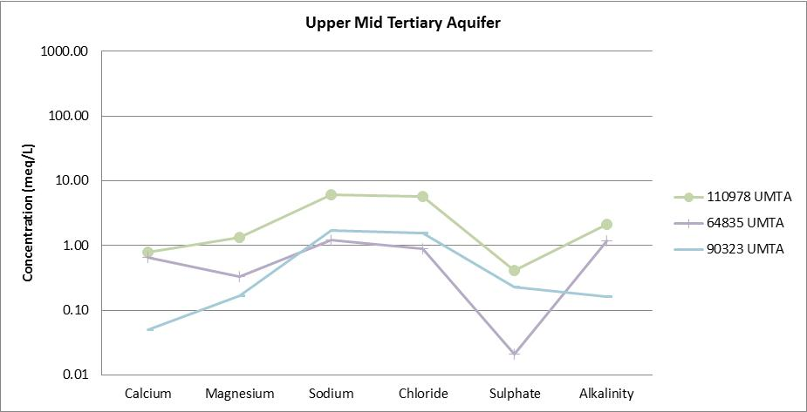
Figure 20A Schoeller diagrams showing major ion chemistry for each aquifer

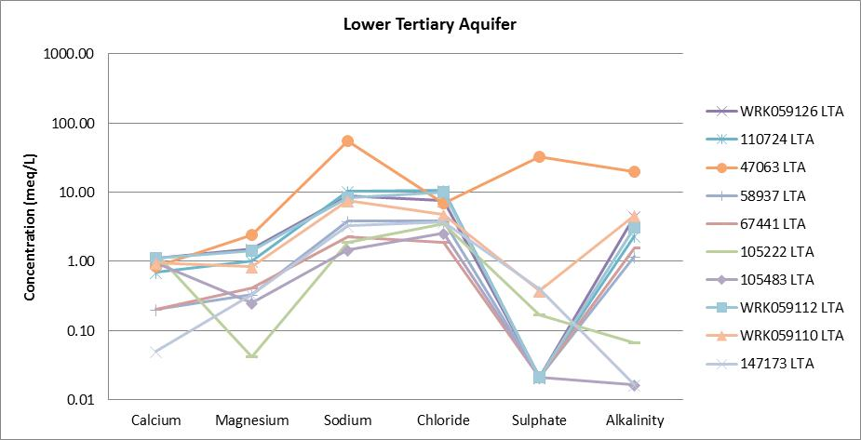
Figure 21B Schoeller diagrams showing major ion chemistry for each aquifer
    - Salinity
Groundwater salinity has been measured according to Total Dissolved Solids (TDS) concentration. The average groundwater salinity for all aquifers ranges from fresh to brackish (324 to 4,130 mg/L). The qualitative salinity classifications are according to the Water and Rivers Commission (1998). Groundwater salinity ranges per aquifer are summarised in Table 9.

Table 9 Summary of salinity results by aquifer (Total Dissolved Solids – TDS)
Aquifer | Number of bores sampled | Minimum Groundwater TDS (mg/L) | Maximum Groundwater TDS (mg/L) | Average Groundwater TDS (mg/L)
Quaternary Aquifer (100) | 3 | 151 | 923 | 500
Upper Tertiary Quaternary Aquifer (102) | 2 | 859 | 7,400 | 4,130
Upper Tertiary Aquifer (fluvial) (105) | 9 | 239 | 5,090 | 1,057
Upper Mid Tertiary Aquitard (106) | 1 | 1,250 | 1,250 | 1,250
Upper Mid Tertiary Aquifer (107) | 3 | 170 | 515 | 324
Upper Mid Tertiary Aquitard (108) | 1 | 773 | 773 | 773
Lower Tertiary Aquifer (111) | 10 | 252 | 3,620 | 821
    - Nitrogen
Groundwater samples were analysed for Kjeldahl Nitrogen, oxidised Nitrogen and total Nitrogen (the sum of the two). The results for total Nitrogen are summarised by aquifer in Table 10. The highest nitrogen content was found in samples taken from the Quaternary Aquifer (or watertable). This is an expected result given the likely leaching of nutrients through the unsaturated zone to the watertable from land which is often heavily fertilised (especially in the Macalister Irrigation District in the Sale/ Maffra area). Lower nitrogen levels were found in other aquifers although slightly higher values were found in the Lower Tertiary Aquifer which is likely to be an inherent characteristic of the aquifer rather than leaching from the surface. Natural Gas composition can include small quantities of nitrogen among other things.
Nahm (2002) indicated that nitrate provided significant variation in distinguishing aquifers in the Gippsland region. The results from this study are consistent with Nahm’s (2002) observations with significant variation in average nitrogen values between aquifers.

Table 10 Summary of Nitrogen results by aquifer (total Nitrogen)
Aquifer | Number of Samples Collected | Minimum Nitrogen (mg/L) | Maximum Nitrogen (mg/L) | Average Nitrogen (mg/L)
Quaternary Aquifer (100) | 3 | 0.2 | 8.4 | 2.9
Upper Tertiary Quaternary Aquifer (102) | 2 | 0.2 | 1.1 | 0.7
Upper Tertiary Aquifer (fluvial) (105) | 9 | 0.2 | 1.6 | 0.6
Upper Mid Tertiary Aquitard (106) | 1 | 0.0 | 0.0 | 0.0
Upper Mid Tertiary Aquifer (107) | 3 | 0.2 | 0.7 | 0.4
Upper Mid Tertiary Aquitard (108) | 1 | 0.7 | 0.7 | 0.7
Lower Tertiary Aquifer (111) | 10 | 0.0 | 3.3 | 1.2
    - Field indicators
Field parameters were collected in the field including: pH, redox, dissolved oxygen, temperature and odour. Averages for each aquifer are summarised in Table 11.
The median Dissolved Oxygen (DO) concentration for each aquifer ranges from 0.3 to 2.6 mg/L (Table 11), which is low relative to atmospheric oxygen (~10 mg/L). This means the atmospheric oxygen that was originally present in the infiltrating rainwater has been consumed in the soil and unsaturated zone by microbial activity and decomposition of organic matter (Rose and Long, 1998). The relatively high median dissolved oxygen value in the Lower Tertiary Aquifer combined with the relatively low median redox value possibly suggests limited microbial reduction of oxygen despite the apparent reducing conditions or movement of oxygen from overlying aquifers.
Average temperature for each aquifer is fairly consistent, ranging from 16.1 to 18°C (Table 11). No observation of increasing temperature with depth was observed.
Hydrogen sulphide odour was noted at three of the Lower Tertiary Aquifer bores (Table 11). Natural Gas composition can include hydrogen sulphide and so it is reasonable that the odour of this gas was detected where the major coal bearing aquifer was being sampled. Natural gas that contains significant amounts of hydrogen sulphide is often referred to as sour gas.
Groundwater pH ranges from weakly acidic (5.8) to weakly alkali (8.6) across the aquifer in the Gippsland region (Table 11).

Table 11 Summary of indicator parameters collected in the field
Aquifer | Average pH | Median Redox (mV) | Median DO (mg/L) | Average Temperature (º C) | Odour
Quaternary Aquifer (100) | 5.8 | 53 | 1.29 | 16.6 | Three occurrences of hydrogen sulphide (egg) odour in the 111 aquifer only.
Upper Tertiary Quaternary Aquifer (102) | 8.6 | 25.7 | 2.35 | 16.6
Upper Tertiary Aquifer (fluvial) (105) | 6.6 | -66.7 | 0.32 | 18.0
Upper Mid Tertiary Aquitard (106) | 6.2 | 12 | 0.29 | 16.5
Upper Mid Tertiary Aquifer (107) | 6.1 | -59.7 | 0.74 | 17.2
Upper Mid Tertiary Aquitard (108) | 7.5 | -158 | 0.67 | 16.1
Lower Tertiary Aquifer (111) | 7.4 | -73.5 | 2.58 | 17.5

- Groundwater sampling –
aquifer characterisation
This Chapter provides comments on the sampling results by aquifer relating back to the justification
for bore selection.
  - Quaternary Aquifer (100) and Upper Tertiary/Quaternary Aquifer (102)
The Quaternary Aquifer and the Upper Tertiary Quaternary Aquifer contain the watertable. Five watertable bores were sampled and comments on the results are provided in Table 12.
The salinity of the five sampled watertable bores is variable, ranging from 151 mg/L to 7,400 mg/L. The analysis indicates that the salinity is sodium chloride dominated. Four of the bores record salinity <1,000 mg/L TDS and only a single bore located in the Macalister Irrigation District has returned a significantly higher salinity value.
There is no detection in any of the measured organic compounds in four of the five watertable bores sampled, suggesting that the upwards migration of organic compounds from deeper coal bearing units does not reach the watertable. The exception is bore 95489 located north-west of Maffra where methane was detected but in concentrations less than the underlying Upper Tertiary Aquifer and Lower Tertiary Aquifer. This is likely to be a result of the absence of the regional Upper Mid-Tertiary Aquifer seal and/or the relatively shallow depth of the Lower Tertiary Aquifer at this site (less than 100 m from the surface). The methane results for the watertable are consistent with the conceptual model that the Upper Mid-Tertiary Aquitard inhibit upwards groundwater movement and areas of aquitard absence are likely to exhibit greater inter-aquifer connection.

Table 12 Summary of Round 1 results for sampled watertable bores
Bore | Aquifer Monitored | Justification for inclusion in the monitoring network | Comments
WRK059111 | Upper Tertiary/Quaternary Aquifer (102) | - Located near Ramsar listed Corner Inlet.  - Nested with WRK059110 | - No organics detected suggesting no upwards migration of compounds from underlying coal bearing units despite being on edge of aquitard extent  - Relatively high alkalinity
45762 | Upper Tertiary/Quaternary Aquifer (102) | - WG CMA bore targeting watertable aquifer in Denison GMU  - Located in the lake wellington fault area of interest | - No organics detected suggesting no upwards migration of compounds from underlying coal bearing units despite being west of aquitard extent and over Lake Wellington Fault  - Salinity is sodium chloride dominated
105479 | Quaternary Aquifer (100) | - Monitors the watertable aquifer in the Wy Yung GMU  - Nested with 110978 (Balook) | - No organics detected suggesting no upwards migration of compounds from underlying coal bearing units despite being west of aquitard extent and over Lake Wellington Fault
WRK059121 | Quaternary Aquifer (100) | - Located outside of subregional prospectivity  - Located along Darriman Fault  - Located outside of regional seal | - No organics detected suggesting no upwards migration of compounds from underlying coal bearing units despite being west of aquitard extent and over Darriman Fault
95489 | Quaternary Aquifer (100) | - Located in the MID  - Nested with WRK059126 and WRK059127.  - Also located where the regional seal is absent | - Methane detected although lower concentration than bores in deeper Lower Tertiary Aquifer and Upper Tertiary Aquifer at the same site suggesting upwards decay in methane levels  - Bore located in area where Lower Tertiary Aquifer is closest to the surface relative to the other bores.

  - Upper Tertiary Aquifer (fluvial) (105)
In the Gippsland region, the Upper Tertiary Aquifer (fluvial) consists of the Wurruk Sand member of the Boisdale Formation. A total of nine bores screened in the Upper Tertiary Aquifer were sampled and comments on the results are provided in Table 13.
Methane concentrations were detected in most samples and are either sourced from the aquifer itself, or the result of upwards migration from underlying aquifers. Given that the Wurruk Sand member of the Boisdale Formation is a fluvial unit and contains little carbonaceous material, the most likely source is the underlying coal bearing units of the Upper Mid-Tertiary Aquifer (where present) or the Lower Tertiary Aquifer. The higher average methane concentration for the two samples collected away from the Upper Mid-Tertiary Aquitard seal relative to eight samples collected above the aquitard suggests that the aquitard is restricting upwards movement although this is a tentative conclusion based on a small sample size.

Table 13 Summary of Round 1 results for sampled Upper Tertiary Aquifer bores (Boisdale Formation)
Bore | Justification for inclusion in the monitoring network | Comments
145092 | - Located in the area of prospectivity and high value rivers and wetlands | - Methane concentration detected but significantly lower concentration than underlying Lower Tertiary Aquifer suggesting some upwards leakage of methane through Lower Tertiary Aquitard seal  - Minor concentration of BTEX – anomalous relative to lack of detection in any other Upper Tertiary Aquifer bore
90615 | - Located near Gippsland Lakes Ramsar site.  - Monitors the target aquifer (Boisdale Formation) in the Sale WSPA.  - Located in Lake Wellington Depression area of interest | - Groundwater sample not included in the analysis due to an error in the sample location.  - Other analyses undertaken at the same time by RMIT at the correct location indicate a methane concentration of 0.11mg/L. The negligible methane concentration suggests little or no upwards leakage of methane through Lower Tertiary Aquitard seal which is particularly thick in this area.
105484 | - Located in the area of prospectivity and high value rivers and wetlands  - Monitors the target aquifer (Boisdale Formation) in the Giffard GMU.  - Located in the Seaspray depression area of interest.  - Nested with 105483 | - Methane concentration detected but significantly lower concentration than Lower Tertiary Aquifer bore 105483 at the same site suggesting some upwards leakage of methane through Lower Tertiary Aquitard seal  - No other organics detected
67442 | - Located in the area of prospectivity and high value rivers and wetlands  - Monitors the target aquifer (Boisdale Formation) in the Sale GMU  - Located along Rosedale Fault | - Methane concentration detected were slightly lower than nearby Lower Tertiary Aquifer bore 67441 at the same site suggesting some upwards leakage of methane through regional seal  - Suggests the location on western edge of seal is providing a vertical conduit for methane
90148 | - Located in the area of prospectivity and high value rivers and wetlands  - Monitors the target aquifer (Boisdale Formation) in the Sale GMU  - Located in the lake wellington depression area of interest and hydrocarbon seep | - Methane concentration of 3.48 mg/L suggests suggesting some upwards leakage of methane through Lower Tertiary Aquitard seal (or small amounts of methane sourced from the aquifer itself which is unlikely given the lack of organic material in the aquifer)  - No other organics detected
145093 | - Located in the area of prospectivity and high value rivers and wetlands, including Ramsar listed Lake Reeve  - Monitors the target aquifer (Boisdale Formation) in the Giffard GMU | - Methane concentration of 0.312 mg/L suggests suggesting possible upwards leakage of methane through Lower Tertiary Aquitard seal although smaller concentrations relative to other bores away from seal suggest seal is restricting vertical flow  - No other organics detected  - Anomalously high calcium result
WRK059127 | - Located in the MID and forms nested site with 95489 and WRK059126  - Also located where the regional seal is absent | - Methane concentration is lower than underlying Lower Tertiary Aquifer bore WRK059126 and higher than overlying Upper Mid-Tertiary Aquifer bore 95489 suggesting an upward migration of methane  - No other organics detected
103822 | - Located along the Lake Wellington Fault  - Provides information on Boisdale Fmn aquifer chemistry in area of absent regional seal | - Methane elevated relative to Boisdale bores overlying Lower Tertiary Aquitard seal suggesting absence of seal and/or presence of fault maybe promoting upwards migration of methane  - No other organics detected
140692 | - Located along the Lake Wellington Fault  - Provides information on Boisdale Fmn aquifer chemistry in area of regional seal | - Small methane concentration suggesting small amount of leakage from underlying coal bearing formations  - No other organics detected
140691 | - Monitors the target aquifer (Boisdale Formation) in the Sale GMU  - Located along the Lake Wellington Fault in the vicinity of bore 109044 which had elevated hydrocarbon readings but could not be sampled due to poor bore condition. | - No detected methane suggesting effectiveness of Lower Tertiary Aquitard for sealing underlying coal bearing deposits  - No other organics detected

  - Upper Tertiary Aquitard (106) and Upper Mid-Tertiary Aquitard (108)
One Upper Tertiary Aquitard bore and one Upper-Mid Tertiary Aquitard bore was sampled and comments on the results are provided in Table 14.

Table 14 Summary of Round 1 results for sampled Upper Tertiary Aquitard bore
Bore | Justification for inclusion in the monitoring network | Comments
WRK059120  (106)  and  WRK059119 (108) | - These two bores are nested  - Located in the area of prospectivity and high value rivers and wetlands  - Located in Seaspray Depression area of interest | - Methane concentration for 106 bore is low (0.122 mg/L)  - Methane not detected for 108 bore  - Possible methane source within the Upper Tertiary Aquitard (106) although concentrations suggest only a minor source  - No other organics detected

  - Upper Mid-Tertiary Aquifer (107)
The Upper Mid-Tertiary Aquifer contains the Balook Formation and the Latrobe Valley Coal Measures (Yarragon and Yallourn Formations). Three bores was sampled screening the Upper Mid-Tertiary Aquifer and comments on the results are provided in Table 15.

Table 15 Summary of Round 1 results for sampled Upper Mid-Tertiary Aquifer bores
Bore | Justification for inclusion in the monitoring network | Comments
64835 | - Located in the area of prospectivity and key rivers and wetlands  - Located in Seaspray Depression area of interest | - Methane concentration of 5.09 mg/L is likely to be sourced from either leakage from underlying Lower Tertiary Aquifer and/or from local coal seams within the Latrobe Valley Coal Measures and Balook Formation  - No other organics detected
90323 | - Located in the area of prospectivity and key rivers and wetlands  - Located along Rosedale Fault area of interest | - Methane and TPH concentrations are likely to be sourced from coal seams within the aquifer
110978 | - Monitors the Upper Mid-Tertiary Aquifer in the Wy Yung GMU  - Nested with 105479 (watertable aquifer bore) | - Methane was not detected in this bore or the overlying shallow bore with which it is nested.  - This is consistent with the conceptual model, given that the primary methane source (the Lower Tertiary Aquifer) is absent in this area.

  - Lower Tertiary Aquifer (111)
The Lower Tertiary Aquifer includes the Traralgon Formation coals and sands and the Yarram Formation.
A total of ten bores screened in the Lower Tertiary Aquifer were sampled. The Traralgon Formation coal seams within the Lower Tertiary Aquifer are potentially prospective for coal seam gas development. Therefore, it is particularly important to characterise the groundwater chemistry of this unit for later comparison if coal seam gas development were to occur. Comments on the results of each bore are
given in Table 16.
In general, the methane concentrations in the Lower Tertiary Aquifer are significantly higher than in sampled overlying aquifers. Also, BTEX was detected in 3 of the 10 bores and TPH in 6 of the 10 bores. Given the significant depth of the aquifer and the separation from any anthropogenic source, the most likely source of the detected hydrocarbons is likely to be the coal deposits within the aquifer.
The average salinity of the 10 samples was 821 mg/L suggesting that the aquifer contains low salinity water consistent with its use for irrigation especially in the Yarram area. The major ion concentrations suggest that the salinity is sodium chloride dominated.

Table 16 Commentary on Round 1 results for sampled Lower Tertiary Aquifer bores
Bore | Justification for inclusion in the monitoring network | Comments
105483 | - Monitors the target aquifer (Latrobe Group) in the Yarram GMU  - Located in the area of prospectivity and key rivers and wetlands  - Located in the Seaspray depression area of interest.  - Nested with 105484 | - Higher methane concentration than Boisdale bore 105484 at same site suggests Upper Mid-Tertiary Aquitard is an effective seal for upwards migration of methane  - Methane detected in collected gas sample.  - TPH detected
67441 | - Located in the area of prospectivity and key rivers and wetlands  - Monitors the target aquifer (Latrobe Group) in the Stratford GMU  - Located along Rosedale Fault | - Methane concentration of 4.41 mg/L is consistent with other LTA bores and suggests high coal content of unit may be the source  - TPH detected – likely to be natural source associated with coal deposits
WRK059110 | - Monitors the target aquifer (Latrobe Group) in the Yarram WSPA  - Nested with WRK059111 | - Methane concentration of 4.65 mg/L is consistent with other LTA bores and suggests high coal content of unit may be the source  - Comparison with <0.01 mg/L for nested watertable bore WRK05911 suggests Upper Mid-Tertiary Aquitard is an effective seal above coal deposits  - No other organics detected
147173 | - Monitors the target aquifer (Latrobe Group) in the Yarram GMU and located in close proximity to Yarram township | - No organics detected which is anomalous given the methane detected in many of the other LTA bores
105222 | - Monitors the target aquifer (Latrobe Group) in the Yarram GMU and located in close proximity to Yarram township | - High methane reading of 16.7 mg/L – on the high side of concentrations in other LTA bores  - Methane detected in collected gas sample.  - TPH detected – likely to be natural source associated with coal deposits
WRK059126 | - Located in the MID and forms nested site with 95489 and WRK059127  - Also located where the regional seal is absent | - Methane concentration of 8.52 mg/L is consistent with other LTA bores and suggests high coal content of unit may be the source  - TPH and BTEX detected – likely to be natural source associated with coal deposits  - Higher methane levels than shallower bores 95489 and WRK059126 suggest upward reduction in methane concentration associated with vertical migration  - Methane detected in collected gas sample.
58937 | - Located along the Lake Wellington Fault | - Methane concentration of 4.85 mg/L is consistent with other LTA bores and suggests high coal content of unit may be the source  - TPH detected – likely to be natural source associated with coal deposits
110724 | - Elevated hydrocarbons were measured in this bore and recommendation was made for a resample for hydrocarbons.  - Located along Forster Fault. | - High methane reading of 13.9 mg/L – on the high side of concentrations in other LTA bores  - Methane detected in collected gas sample.  - Minor TPH detected – likely to be natural source associated with coal deposits  - BTEX detected although low concentration
47063 | - Monitors the target aquifer (Latrobe Group) in the Stratford GMU | - Methane concentration of 3 mg/L is consistent with other LTA bores and suggests high coal content of unit may be the source  - TPH detected – likely to be natural source associated with coal deposits
WRK059112 | - Monitors the target aquifer (Latrobe Group) in the Yarram WSPA  - Located along Forster Fault. | - High methane reading of 33.7 mg/L – highest concentrations of the LTA bores  - Methane detected in collected gas sample.  - TPH detected – likely to be natural source associated with coal deposits  - BTEX detected – significantly higher than all other bores

- Conclusions
The main conclusions from the analysis of the groundwater sampling results from 30 bores in the Gippsland region are given below.

Major ions
The sampled groundwater are sodium chloride dominated. There are no vertical trends in major ion chemistry. The similarity of groundwater above and below the aquitards suggests lateral flow originates from a similar source and undergoes a similar process.

Methane
- Methane concentrations tend to be highest in the coal bearing units of the Lower Tertiary Aquifer (Latrobe Group) and the Upper Mid-Tertiary Aquifer (Latrobe Valley Coal Measures and Balook Formation). The methane concentrations in these units are likely to be sourced from the organic content of the coals.
- There is a decreasing methane concentration upwards above the coal bearing units (for example all watertable bores had undetected or negligible methane concentrations). All nested sites exhibit this trend. The methane concentrations in upper aquifers in areas where the Upper Mid-Tertiary Aquitard is absent is slightly higher than in areas where it is present suggesting the Upper Mid-Tertiary Aquitard partially restricts upwards flow of methane.
- There is no apparent increasing trend in methane concentrations near faults.
- The methane levels detected in the Gippsland region are largely consistent with other study results, whereby the median value is low, with occasional higher concentration occurrences.
Methane was only detected in analysed gas samples from bores screened in the Lower Tertiary Aquifer and only in bores with significant methane concentrations in water samples. The higher confined pressures in the Lower Tertiary Aquifer is likely to result in the gas coming out of solution during the sampling process.

Ethane, Ethene, Butane, Butene, Propane and Propene
There were no observations of Ethene, Butane, Butene, Propane and Propene in 29 of the 30 sampled bores and this suggests that these compounds are not a natural occurrence in any of the sampled aquifers and any future detection is likely to reflect an anthropogenic origin.

BTEX
- BTEX was detected in the Lower Tertiary Aquifer and the Upper Tertiary Aquifer. The lack of BTEX in the shallower aquifers suggests that BTEX compounds are unlikely to be a natural occurrence in these aquifers and any future detection is likely to reflect an anthropogenic origin.
- The source of the detected BTEX in some of the Lower Tertiary Aquifer bores is unknown and could be either anthropogenic or natural.

Total Petroleum Hydrocarbons (TPH)
- TPH was detected in 8 of the 30 bores sampled and 7 of these bores are screened in the coal bearing units of the Lower Tertiary Aquifer (Latrobe Group) and the Upper Mid-Tertiary Aquifer (Latrobe Valley Coal Measures and Balook Formation). The samples mostly contain hydrocarbons in the C10 to C28 fraction although this provides no evidence of source. Although no definitive conclusion can be drawn on the source of the hydrocarbons, the depth of the bores, the presence of coals and the likely lack of interaction with the surface suggest a natural origin.
- The TPH detected in Upper Tertiary Aquifer bore WRK059127 is an anomalous result. All of the other nine samplings of Upper Tertiary Aquifer returned a TPH result below detection. If the TPH result in Bore WRK059127 is confirmed in the second and third sampling rounds, then the detection may indicate upward movement of TPH from underlying coal bearing units in an area where the Upper Mid-Tertiary Aquitard seal is absent.
Aside from the anomalous result in WRK059127, the lack of TPH in the shallower units above the Lower Tertiary Aquifer and the Upper Mid-Tertiary Aquifer suggests that TPH compounds are unlikely to be a natural occurrence in these aquifers and any future detection is likely to reflect an anthropogenic origin.

Napthalene
- The lack of detection of naphthalene in any of the 30 sampled bores suggests that these compounds are not a natural occurrence in any of the sampled aquifers and any future detection is likely to reflect an anthropogenic origin.

Nitrogen
- The Quaternary Aquifer contains the highest nitrogen concentrations likely to be result of leaching from fertiliser rich surface soils to the watertable.
Slightly higher values were found in the Lower Tertiary Aquifer compared to other confined aquifers which is likely to be an inherent characteristic of the aquifer rather than leaching from the surface. Potentially the nitrogen is associated with the presence of natural gas in this coal bearing aquifer.
The Round 1 groundwater chemistry results presented in this report are generally consistent with the prevailing conceptual model of groundwater flow in the Gippsland region summarised in Chapter 2. The upwards decrease in methane concentrations is consistent with the general upwards groundwater flow across the region. Although not definitive, the upwards reduction in methane levels suggests the detected methane in the upper units (especially the Upper Tertiary Aquifer (Boisdale Formation)) is likely to be sourced from the underlying coal bearing units of the Lower Tertiary Aquifer and the Upper Mid-Tertiary Aquifer.
The results are consistent with the Upper Mid-Tertiary Aquitard (Lakes Entrance Formation) being a seal on top of the Lower Tertiary Aquifer although the methane results show that upwards seepage through the aquitard to overlying aquifers is possible and that the seal is imperfect. Similarly, the results suggest that areas of aquitard absence are likely to exhibit greater inter-aquifer connection.
There is no apparent increase in hydrocarbon concentrations in aquifers overlying coal bearing units near faults although there is not enough data to indicate whether faults provide conduits for fluid flow as suggested by the conceptual model.

References
Alberta Environment (2006) Standard for Baseline Water-Well Testing for Coalbed Methane/Natural Gas in Coal Operations April 2006 < http://environment.alberta.ca/documents/Standard_for_Baseline_Water-Well_Testing_for_CBM_Apr2006.pdf >
Chaytor, S. and Shaw, R., (2008), Synopsis of the report “Recommended Sampling, Analysis, and Reporting Protocols for Baseline Groundwater Sampling in Advance of Coalbed Gas Development in the Telkwa Coalfield, British Columbia;” in: Geoscience Reports,2008, BC Ministry of Energy, Mines and Petroleum Resources, pages 9-11.
Colorado Oil and Gas Conservation Commission (2014) State-wide groundwater baseline sampling and monitoring rules - the Alberta Environment standard for baseline water well testing (2006) or the protocols developed for British Columbia
Colorado Oil and Gas Conservation Commission, Rule set 609. State-wide groundwater baseline and monitoring as of September 30 2014 : < http://cogcc.state.co.us/ >
CSIRO (2011) A desktop study of the occurrence of Total Petroleum Hydrocarbon (TPH) and partially water-soluble organic compounds in Permian coals and associated coal seam groundwater.
CSIRO (2011b) Basin Resource Management for Carbon Storage. A literature review. Sunil Varma, Jane Hodgkinson, Laurent Langhi, Bozkurtt Ciftci, Brtett Harris and James Underschultz, Report no. EP116370.
DELWP (2015) Onshore natural gas water science studies – Otway region groundwater sampling and characterisation for hydrocarbons, Department of Environment, Land, Water and Planning. May 2015.
DSDBI (2013) Gippsland Basin regional aquifer data collection method assessment. Department of State Development, Business and Innovation. Draft in preparation.
Geoscience Australia (2009), “Groundwater Sampling and Analysis – A Field Guide.” Geoscience Australia Record 2009/27 GeoCat#68901
GHD (2012) Report on the development of Statewide 3D aquifer surfaces. May 2012. Report to the Department of Sustainability and Environment.
GHD (2014) State Groundwater Observation bore Network – review, redefinition and works prioritisation. Prepared for the Department of Environment and Primary Industries, July 2014.
Goldie Divko, LM (2015), A review of natural gas prospectivity: Gippsland region, Department of Economic Development, Jobs, Transport and Resources, Melbourne, Victoria (draft in preparation).
Goldie Divko, O’Brien, Tingage and Harrison (2009). Geological carbon storage in the Gippsland Basin, Australia: Containment Potential. VicGCS Report 1, Department of Primary Industries.
Goldie Divko, L.M., O'Brien, G.W., Harrison, M.L. and Hamilton, P.J. 2010, 'Evaluation of the regional top seal in the Gippsland Basin: Implications for Geological Carbon Capture and Storage and Hydrocarbon Prospectivity.' APPEA Journal 2010. 50th Anniversary Issue. pp463-486.
Leusch, F., Bartkow, M., (2011) A short primer on benzene, toluene, ethylbenzene and xylenes (BTEX) in the environment and in hydraulic fracturing fluids. PDF file on http://www.derm.qld.gov.au/environmental_management/coal-seam-gas/pdf/btex-report.pdf, accessed on the 18th of July 2011.
Malek R. and Mehin K. (1998) Oil and Gas Resources of Victoria Department of Natural Resources and Environment © Crown (State of Victoria) Copyright 1998 Petroleum Development.
Nahm (2002) The Gippsland Basin and its role in the genesis and accumulation of petroleum. A thesis submitted as a requirement for the Degree of Doctor of Philosophy in the School of Earth Sciences, the University of Melbourne.
NRMMC (2011) Australian Drinking Water Guidelines Paper 6 National Water Quality Management Strategy. National Health and Medical Research Council, National Resource Management Ministerial Council, Commonwealth of Australia, Canberra.
O’Brien, Tingate, Goldie Divko, Harrison, Boreham, Liu, Arian and Skladzien (2008) First order sealing and hydrocarbon migration processes, Gippsland Basin, Australia: implications for CO2 geosequestration. PESA Eastern Australasian Basins Symposium III Sydney, 14–17 September, 2008.
Orem, W.H., Tatu, C.A., Lerch, H.E., Rice, C.A., Bartos, T.T., Bates, A.L., Tewalt, S., Corum, M.D., (2007) “Organic compounds in produced waters from coalbed natural gas wells in the Powder River Basin, Wyoming, USA”. Applied Geochemistry, 22(10), 2240-2256.
Piper, A.M. 1953, A Graphic Procedure in the Geochemical Interpretation of Water Analysis. United States Geological Survey, Washington D.C. ISBN ASIN: B0007HRZ36.
QGC (2012) QCLNG Groundwater quality and hydrochemistry program. QGC Pty Ltd (2012)
Schaeffer J. (2008) Scaling point based aquifer data for developing regional groundwater models: Application to the Gippsland groundwater system. PhD Thesis. Department of Civil and Environmental Engineering, University of Melbourne, February 2008.
Schulz and Zabel (2006) Marine Geochemistry. Horst D. Schulz, Matthias Zabel.(2006). London, Springer.
SKM (2011) A review of the Victorian Aquifer Framework. Final 1, April 2011. Report prepared for the Victorian Department of Sustainability and Environment. Unpublished report.
Varma and Michael (2011) Impact of multi-purpose aquifer utilisation on a variable-density groundwater flow system in the Gippsland Basin, Australia.
WHO (2005) Petroleum Products in Drinking Water. Background document for development of WHO Guidelines for Drinking-water Quality. WHO/SDE/WSH/05.08/123, Geneva, World Health Organisation.
Woollands & Wong (Editors) (2001), Petroleum atlas of Victoria, Australia. Department of Natural Resources

Appendices

Appendix A. Standard operating procedure for groundwater sampling

Appendix B. Standard operating procedure for collection of dissolved gas and groundwater samples from coal seams

Appendix C. Standard operating procedure for the deployment and operation of double valve pumps

Appendix D. Laboratory results


© The State of Victoria Department of Environment, Land, Water & Planning 2015

This work is licensed under a Creative Commons Attribution 4.0 International licence. You are free to re-use the work under that licence, on the condition that you credit the State of Victoria as author. The licence does not apply to any images, photographs or branding, including the Victorian Coat of Arms, the Victorian Government logo and the Department of Environment, Land, Water and Planning (DELWP) logo. To view a copy of this licence, visit http://creativecommons.org/licenses/by/4.0/

ISBN 978-1-74146-622-5 (pdf)

Accessibility
If you would like to receive this publication in an alternative format, please telephone the DELWP Customer Service Centre on 136186, email customer.service@delwp.vic.gov.au or via the National Relay Service on 133 677 www.relayservice.com.au. This document is also available on the internet at www.onshoregas.vic.gov.au

Disclaimer
This publication may be of assistance to you but the State of Victoria and its employees do not guarantee that the publication is without flaw of any kind or is wholly appropriate for your particular purposes and therefore disclaims all liability for any error, loss or other consequence which may arise from you relying on any information in this publication.

