A review of gas prospectivity:
Gippsland region

June 2015

Acknowledgements
The author wishes to thank Tim Moore for his contribution to the text (Appendix 1) and for his permission to use figures 8.2, A1.1, A1.2 and A1.3 from Moore (2012). Peter Arditto is also thanked for his contribution to section 8.3.
Gordon Wakelin-King is thanked for his contribution to the text (section 1.2) and for his review of the text.
Dr Phil O’Brien of Geoscience Australia is thanked for his review and useful comments.
David Higgins, Graham Callaway, Cassady O’Neill and Michelle Guzel are thanked for their help with mapping and drafting figures.

Goldie Divko, L. M., 2015. A review of gas prospectivity: Gippsland region. Department of Economic Development, Jobs, Transport and Resources. Melbourne, Victoria.

Contents
List of figures 4
List of tables 4
Executive summary 5
Conventional gas 5
Tight gas 5
Shale gas 5
Coal seam gas 6
Hypothetical development scenarios 6
1 Introduction 7
1.1 Gas types 7
1.2 Gas resource estimation and reporting 9
1.3 Gas exploration in Gippsland 11
1.4 Study area 12
2 Regional geology 15
2.1 Tectonic setting 15
2.2 Stratigraphy 16
3 Previous exploration 20
3.1 Oil and gas 20
3.2 Coal 20
3.3 Coal seam gas 22
4 Current tenements 24
4.1 Petroleum exploration permits and retention leases 24
4.2 Exploration licences 24
5 Conventional gas 29
5.1 Intra-Latrobe Group 30
5.2 Strzelecki Group 33

6 Tight gas 34
6.1 Strzelecki Group 35
6.2 Wombat, Trifon and Gangell fields 35
7 Shale gas 37
7.1 Shale gas reservoir properties 38
7.2 Identification of source rocks in Gippsland 39
8 Coal seam gas 40
8.1 Formation of coal seam gas 40
8.2 Coal properties 41
8.3 Coal seam gas from black coal 43
8.4 Coal seam gas from brown coal 45
9 Geological uncertainty 51
9.1 Broad geological uncertainty 51
9.2 Delineation of formations of interest 52
9.3 Specific rock characteristics 52
10 Gas prospectivity 54
10.1 Conventional gas 54
10.2 Tight gas 54
10.3 Shale gas 55
10.4 Coal seam gas 55
11 Hypothetical gas development scenarios 57
11.1 Coal seam gas (brown coal) 57
11.2 Tight/shale gas 58
12 Conclusions 60
References 61
Glossary 68
Abbreviations and units 69

Appendix 1 70
Formation of gas in coal 70
How is gas generated? 70
How is gas stored? 73
How does gas move through the coal reservoir? 73
References 76
Appendix 2 78

List of figures
Figure 1.1 Gas types. 8
Figure 1.2 Petroleum Resource Management System Resources Classification Framework 10
Figure 1.3 Location map of South Gippsland and onshore Gippsland Basin. 12
Figure 1.4 South Gippsland region structural elements. 13
Figure 1.5 Onshore and offshore elements of the Gippsland Basin. 14
Figure 2.1 Gippsland Basin stratigraphy. 17
Figure 3.1 South Gippsland black coal sub-crop. 21
Figure 4.1 Gippsland Basin onshore Petroleum Exploration Permits and Retention Leases. 25
Figure 4.2 Current Exploration Licences with a Coal Seam Gas stated as a target. 26
Figure 5.1 Conventional gas schematic. 29
Figure 5.2 Distribution and thickness of the Golden Beach Subgroup in the onshore Gippsland Basin 31
Figure 5.3 Porosity and permeability plots from the Latrobe Group in the onshore Gippsland Basin. 32
Figure 6.1 Tight gas schematic. 34
Figure 7.1 Shale gas schematic. 37
Figure 8.1 Coal seam gas schematic. 41
Figure 8.2 Correlation of different rank parameters, all approximate. 42
Figure 8.3 Net thickness of the T0, T1 and T2 coal seams in the Traralgon Formation. 46
Figure 8.4 Cross-section showing wells across the Seaspray Depression 48
Figure 11.1 Gippsland Basin coal seam gas development scenarios. 58
Figure 11.2 Gippsland Basin tight/shale gas development scenarios. 59
Figure A1.1 Simplified pathway of secondary biogenic methane production in coal 71
Figure A1.2 Schematic showing biogenic and thermogenic gas generation 72
Figure A1.3 Coal bed permeability versus depth in a coal seam from the Permian age Bowen basin 75

List of tables
Table 3.1 Cancelled, surrendered and expired Exploration Licences. 23
Table 4.1 A list of companies that nominate coal seam gas as a target in their mineral exploration licence. 27
Table 4.2 EL 4416 gas estimates. 28
Table 7.1 A guide to organic richness in shales as given by TOC. 38
Table 7.2 Kerogen types.. 38
Table 8.1 Average values for Traralgon coal seams. 49
Table 8.2 Compilation of reported conductivity values (m/d). 50

Executive summary
Water science studies to assess the potential impacts of possible onshore gas developments on Victoria’s water resources are being undertaken by government. The Geological Survey of Victoria (GSV) has reviewed the prospectivity of all gas types in the Gippsland Basin to inform the preparation of an impact assessment on water resources. This review of gas prospectivity of the Gippsland region includes the onshore portion of the Gippsland Basin and South Gippsland. The review draws on the current knowledge of the geology and resource distribution discovered to date through exploration activity.
There are two sedimentary sequences that are prospective for gas in the onshore Gippsland Basin and one in South Gippsland. The Early Cretaceous Strzelecki Group across the Gippsland region is potentially a target for all gas types: conventional, tight, shale and coal seam gas. The overlying Latrobe Group in the onshore Gippsland Basin has potential for conventional gas and coal seam gas.

Conventional gas
No conventional gas accumulations have been found to date in the onshore Gippsland region. Explorers have searched for conventional gas onshore, targeting the top of the Latrobe Group, the unit that hosts much of the oil and gas offshore. Many conventional structural traps have been tested without success. Units deeper within the Latrobe Group (known as the intra-Latrobe Group) have been found to contain oil and gas offshore and it has been suggested that these units might be prospective in the onshore Gippsland Basin but little work has been done to specifically target these units onshore.
The Latrobe Group attains its greatest onshore thickness near the central Gippsland coast in the Seaspray Depression, and therefore could be considered the most likely area to find conventional gas. Better mapping of the intra-Latrobe Group units and associated rock properties could help to assess conventional gas prospectivity in the onshore Gippsland Basin.
Previous explorers have also searched for conventional gas in coarse sandstone units at the base of the Strzelecki Group. These sandstones belong to the Tyers River Subgroup. The distribution of this unit is not well known. It was intersected by the well Megascolides-1, drilled in 2004, but was not present in Megascolides-2 just over a kilometre away, illustrating the difficulty in targeting this conventional prospect.

Tight gas
The Strzelecki Group, found across Gippsland, is the primary target for tight gas. Wells penetrating the top of the unit are common but few penetrate a significant thickness, so data is sparse. Gas could be irregularly distributed throughout the formation or found trapped in discrete areas. The Wombat/Trifon/Gangell tight gas fields could be an example of the latter. The fields are estimated by the permit holder to host 1.7 Trillion cubic feet (Tcf) of gas. The gas is found in tight rocks within and beneath geological structures in the Seaspray Depression. Whether gas is distributed throughout the Strzelecki Group in quantities that may prove to be commercial is unknown.

Shale gas
Across Gippsland, the distribution of shales as potential shale gas reservoirs is unknown. Shaley units have been encountered in the few wells that have intersected the Strzelecki Group in South Gippsland, and in the onshore Gippsland Basin. It is therefore possible that shale gas reservoirs exist within the tight Strzelecki Group sequence. There are geological differences between the Strzelecki Group and the gas producing shale formations in the United States and elsewhere that suggests the Strzelecki Group is not highly prospective for shale gas but lack of data prevents any clear statement.

Coal seam gas
Both black and brown coal seams are found in the rocks of the Gippsland region. The black coal seams found in South Gippsland are part of the Strzelecki Group. The brown coals of the Gippsland Basin and Latrobe Valley are younger in age and are named, from oldest to youngest, the Traralgon, Morwell and Yallourn seams. Both have been the focus of past coal seam gas exploration in the region. There have
been no discoveries of coal seam gas to date and knowledge of the resource potential in Gippsland is extremely limited.
The prospectivity of the Strzelecki Group black coals appears poor on the basis of the current information. In the only test for coal seam gas in 2004, the black coal seams encountered in the Megascolides-1 well were discontinuous and thin and the gas readings were low. There is no data available for most of the area where black coals may be found, and evaluation of the prospectivity is therefore difficult.
The current tenement holder over the onshore Gippsland Basin has estimated that the brown coals may host
3.7 Tcf of gas. To date there have been no proper tests to establish whether there is gas trapped in the coal and whether the gas could be extracted if it is there. As there is a large volume of brown coal present, large prospective resources (i.e. undiscovered) of gas can be calculated on the basis of assumed gas content. If it was found that actual gas content or producibility was low, then the prospectivity would be significantly reduced.

Hypothetical development scenarios
As part of this review, hypothetical scenarios for the potential development of gas in the onshore Gippsland Basin and South Gippsland were devised. For there to be a chance of development, the prospective rock unit must be present, and so the presence or absence of the geological formation of interest was the first consideration in the development of scenarios. Secondary considerations included information from specialist studies indicating areas that have favourable rock characteristics within a prospective formation, and areas where there has been recent exploration.
Hypothetical development scenarios for tight gas were focussed on the Seaspray Depression where several tight gas fields and prospects have been identified. The scenarios included tight and shale gas, as shale-like units are also found in the Strzelecki Group. For coal seam gas from brown coal, various scenarios were envisaged based on the location of the coal resource, its depth and the current exploration licence over the area.
Scenarios for conventional gas were not defined because of the large degree of geological uncertainty associated with potential conventional gas formations and the lack of past success to provide guidance. A potential scenario for coal seam gas from black coal in South Gippsland was also excluded
for similar reasons.
There is a significant degree of uncertainty associated with both the prospectivity for gas in the Gippsland region and potential development scenarios. The uncertainty is primarily related to the geology. The current understanding and delineation of target geological formations across the Gippsland region is imperfect. There are also a number of very specific characteristics that a geological unit must exhibit to be considered truly prospective for gas. To varying degrees, for all gas types, these characteristics are poorly understood across the onshore Gippsland region.

Introduction
Water science studies have been undertaken by government to assess the potential impacts of possible onshore gas developments on Victoria’s water resources. The Department of Environment, Land, Water and Planning is leading the water studies with technical assistance from the Geological Survey of Victoria (GSV). GSV is investigating all types of onshore gas - tight, shale, coal seam and conventional gas, through a review of the prospectivity of each of these gas types. This prospectivity review was used to inform the preparation of an impact assessment on water resources.
This report describes past and current exploration efforts in the onshore Gippsland Basin and South Gippsland. The geology of the Gippsland region is summarised to provide a geological context for the subsequent discussion. The prospectivity of each gas type is reviewed on the basis of current available published and unpublished data. In particular, the review focuses on where future development of each gas type would be more prospective, based on current knowledge of the geology and resource distribution discovered to date through exploration activity.
This review is not a resource assessment. In Victoria, little data pertaining to unconventional gas potential is available. The data that has been gathered to assess onshore conventional gas has been used to inform this review. The evaluation of an unconventional resource requires knowledge of a greater number of geological and petroleum-related parameters across larger areas than for conventional gas resources. As such, the current data is limited in its application.

Gas types
Gas is found in conventional or unconventional reservoirs; gas in unconventional reservoirs can be described as tight, shale or coal seam gas (Figure 1.1).
The majority of oil and gas produced across the globe comes from conventional reservoirs. This is also the case in Victoria, where all gas production to date is from conventional reservoirs. The majority of gas discovered and produced to date in Victoria has been from the offshore portion of the Gippsland Basin, with smaller but significant volumes from the offshore Otway Basin. Relatively smaller gas fields were discovered and produced between 1986 and 2006 in the onshore Otway Basin.

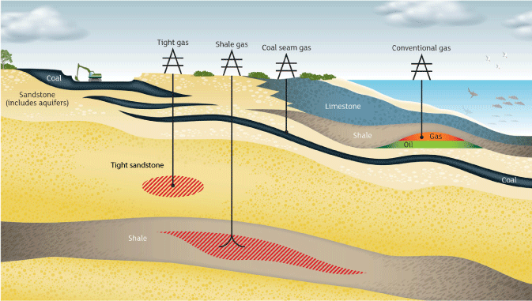
Figure 1.1 Gas types.
Conventional gas reservoirs are commonly porous and permeable rocks such as sandstones or limestones. Impermeable rocks, such as claystones, lie directly above the reservoir and are known as a seal or cap-rock. The gas is trapped in the reservoir and under the seal in geological structures. Geological structures are like an inverted dish, with the gas held underneath. A gas well drilled into the geological structure will intersect the porous gas reservoir and, when present, gas will flow into the well.
Tight, shale and coal seam gas are termed unconventional gas types. These differ from conventional gas in that the gas is trapped at or near the source, which may also act as the gas reservoir. In the case of tight gas, the gas is produced from relatively low permeability and low porosity sedimentary reservoirs. The lack of permeability of the rock prevents gas from migrating, so it is trapped in the tight rock formation. A similar principle applies to shale gas, where the gas is sourced from and trapped in, very fine-grained sedimentary rocks that have low porosity and permeability and are organic-rich. The gas is held on organic matter in the rock, in tiny pores between grains, and in any fractures present in the rock. In the case of coal seam gas (also known as coal bed methane), naturally occurring methane in the coal seams is held on the coal surfaces by water pressure and may also exist in the gaps and cracks in the coal seams.
Shale gas has been produced in the United States since 1820 (e.g. Martin et al., 2010) and coal seam gas production in Queensland has grown from the first small-scale commercial production 18 years ago at Moura (Slater & Baker, 2012). In the United States, it is only in the last few years that decades of experience and knowledge gained from the development of individual shale gas plays, and advancements in well completion technologies, have led to the growth of the industry. The rising price of the commodity has also contributed to the commercial viability of gas development projects that would not have been possible in the past.
The difference between conventional gas production and the unconventional gas types (tight, shale and coal seam gas) is that for most conventional wells, gas will flow from the reservoir into the well and to the surface infrastructure without assistance, whereas for the other gas types, additional technologies are required to release the gas. For instance, gas may not flow unless the rocks are fractured to create artificial permeability in the formation to release the trapped gas. For coal seam gas extraction, water must be drawn away from the coal seam by depressurising the coal to release the gas into the well.
Not all unconventional gas types require fracturing or are suitable for fracturing, and some conventional gas reservoirs are artificially fractured to maintain or enhance production. For instance, more than 700 conventional wells in the Cooper Basin have been fracture-stimulated to enhance hydrocarbon recovery in South Australia since 1969 (Goldstein et al., 2012).

Gas resource estimation and reporting
Australian companies, particularly those with reporting obligations under ASX listing rules, report their estimates of petroleum (oil or gas) assets according to a system developed by the Society of Petroleum Engineers (SPE), known as the Petroleum Resource Management System 2007 or PRMS. The following is summarised from the PRMS (SPE, 2007).
There are three categories of resource (Figure 1.2), determined by the progress from untested concept toward commercial production, and each category may be further defined by the degree of certainty by which it is known.
The lowest category is Prospective Resource: an estimate from geological data of economically recoverable volumes, as yet undiscovered. Because many variables are poorly understood the range between a high and low estimate of a prospective resource will be large, and crucially, the actual presence of recoverable petroleum at all is yet to be tested by drilling.
Once a discovery of recoverable petroleum is made, the resource, or part of it, may be described as a Contingent Resource: the volume that may be commercially recoverable once certain contingencies are satisfied. The contingencies may include commercial, legal, logistical or technical.
The term Reserve is applied only where commerciality can be shown, and is defined more rigorously than resources. Reserves are volumes anticipated to be commercially recoverable by a development project from a given date forward under defined conditions. There must be a high confidence in the commercial producibility of the reservoir, as supported by actual production or formation tests. Reserves must be discovered, recoverable, commercial, and remaining, based on the development project(s) applied. The specification of the development project is important: different methods of development (e.g. well spacings) may allow more or less of the petroleum in place to be commercially produced, thus each development plan has a different reserve even though the geology is the same.
The critical factors for elevation of a resource from prospective to contingent and from contingent to
Reserve are thus discovery and commerciality. A discovery is where one or several exploratory wells
have established, through testing, sampling, and/or logging, the existence of a significant quantity of potentially moveable hydrocarbons. Shows and indications are not discoveries, whereas a flow or recovery in volume may be.
Commerciality requires demonstrated evidence that commercial flow rates are attainable, that production and transport facilities to a known market are available, that legal, contractual and commercial arrangements and internal approvals are in place, that project economics meet investment criteria and that the controlling entity is proceeding into commercial production or has a clear intention to do so. In summary, an undrilled prospect may be quantified with a prospective resource, if successful and whilst under evaluation it may contain a contingent resource, and once all hurdles toward commercial production are cleared it may be considered a reserve.
As the exact volume of oil or gas that will ultimately be economically recoverable over the life of a project is unknowable a range of values can be reported. When a single value is reported it should be accompanied by an indication of where the value sits in the range. This range is expressed in terms such as ‘low’, ‘high’ or ‘most-likely estimate’, or as ‘proven’, ‘probable’ or ‘possible’, or in statistical terms ‘P10’, ‘P50’ and ‘P90’.
The statistical terms indicate that (for example) there is a 90% chance that the volume will exceed the P90 figure, whereas there is only a 10% chance that the volume will exceed the P10 figure. In reporting reserves as a single number for simplicity, most entities report a 2P or PP value (proven plus the probable), which is the most likely or median value.
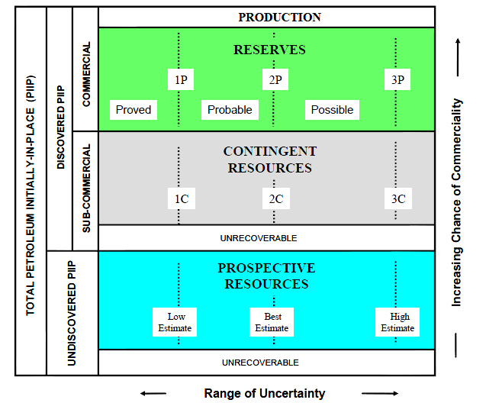
Figure 1.2 Petroleum Resource Management System Resources Classification Framework
(after SPE, 2007).
In all cases, the unrecoverable portion is not part of the resource or the reserve. Terms such as Petroleum Initially In Place (PIIP) are used to describe the volume in the ground.
Public reports of volumes discovered or anticipated may not state whether these are recoverable or in place, and categories or certainty values may have been used without due regard to the formal definitions. Care and understanding of the basis of the resource estimation method is essential.
Using the categories defined here, Victoria has no reserves of unconventional hydrocarbons.

Gas exploration in Gippsland
The Gippsland Basin, which has both onshore and offshore elements, is considered one of Australia's most prolific hydrocarbon provinces with the offshore area hosting several oil and gas fields. In the offshore Gippsland Basin to date, 26,089 PJ of liquid hydrocarbons (crude oil, condensate and naturally occurring LPG resources) and 9120 PJ of gas have been produced (Geoscience Australia & BREE, 2014). It is estimated that 1396 PJ of crude oil, 959 PJ of condensate, 609 PJ of LPG and 9253 PJ of conventional gas remains in the Gippsland Basin (Geoscience Australia & BREE, 2014).
In the onshore Gippsland Basin, there is a long history of petroleum exploration, with 197 wells drilled since 1886. The majority of these wells targeted petroleum in the same geological formations as those found to host oil and gas in the offshore area. Although numerous oil and gas shows (readings) were recorded, no conventional discoveries were made. The discovery and recovery of relatively small volumes of oil at Lakes Entrance around the 1920s and 1930s would be considered the most successful historical petroleum encounter to date in the onshore area.
Over about the last 15 years, in their exploration of the onshore Gippsland Basin, Lakes Oil NL have targeted gas and oil in the sedimentary sequence beneath the offshore hydrocarbon-bearing units. Lakes Oil has defined three gas accumulations known as the Wombat, Trifon and Gangell fields. The gas is accumulated in and below relatively tight (impermeable) reservoirs within structural closures. Lakes Oil hold a retention lease over the fields in a geologically defined area known as the Seaspray Depression. Another company, Icon Energy holds an exploration permit in an adjoining area that might host tight gas.
In 2001 companies began taking up exploration licences for coal seam gas (also called coal bed methane) across the onshore Gippsland Basin and the South Gippsland area. Large volumes of brown coal underlie the onshore Gippsland Basin in thick (i.e. > 20 m) relatively continuous seams that companies such as IER (Ignite Energy Resources) have targeted. Across South Gippsland, areas that are host to thinner (i.e. <1 m) and less continuous black coal seams are covered by a larger number of smaller exploration licence areas, with companies also targeting coal seam gas.

Study area
The study area defined for this review is based on the occurrence of potential gas-bearing units. The area includes both the South Gippsland region and the onshore portion of the Gippsland Basin (Figure 1.3) because of the geology, exploration history and current exploration interests across both areas. The distinction is made between the two areas because the geology, and hence the types of sedimentary rocks found there, are different. This in turn affects the gas type that might be found.
Given the geology, exploration history and current exploration interests across both the onshore Gippsland Basin and South Gippsland, the study area for this review covers these areas.
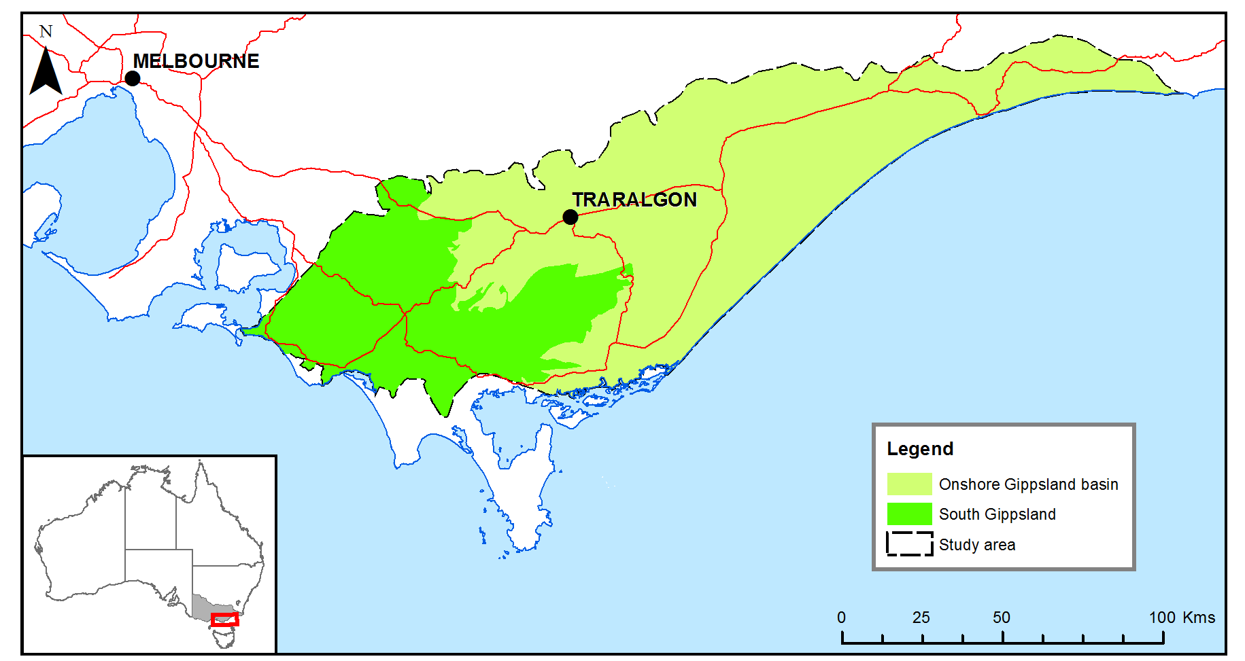
Figure 1.3 Location map of South Gippsland and onshore Gippsland Basin.
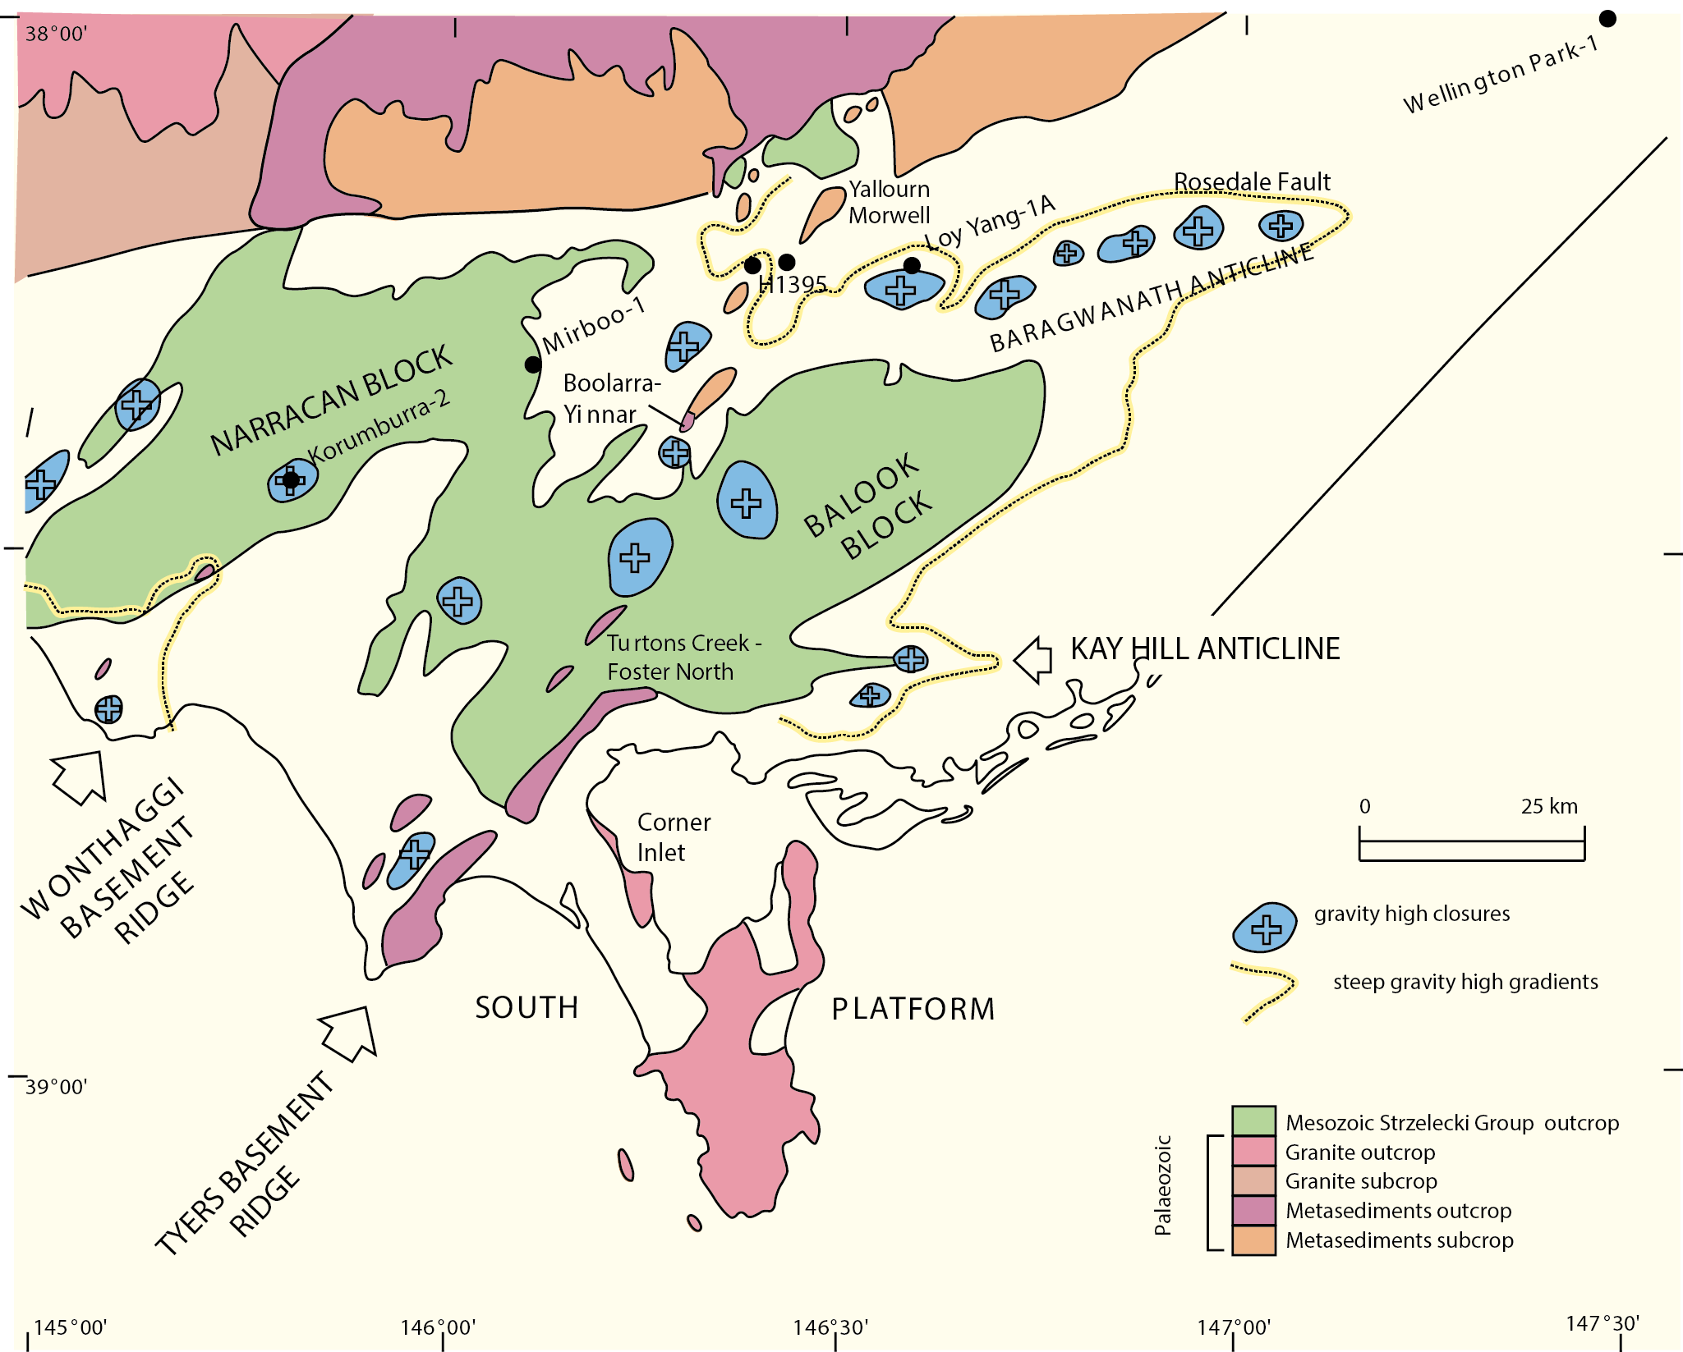
Megascolides-1 & 2
Figure 1.4 South Gippsland region structural elements. (After Holdgate, 2003).
In South Gippsland, the sandstones and mudstones of the Strzelecki Group underlie the entire region and are most prominent in outcrop as the topographic highs of the Strzelecki Ranges. To the northeast of the ranges, the sediments of the Latrobe Valley overlie the Strzelecki Group. Palaeozoic basement highs such as the Wonthaggi Basement Ridge and the Tyers Basement Ridge have a northeast to southwest strike orientation that is consistent with that of mapped Palaeozoic outcrop in the region (Figure 1.4). The basement highs, which are notable as shallow black coal deposits, are located on or adjacent to these structures. Jenkin (1971) provided the most comprehensive identification and naming of physiographic features and structural elements to date.
Most of the Gippsland Basin lies offshore under Bass Strait but there is also an onshore component. All the commercially produced gas from the Gippsland Basin has come from offshore. The location, size and shape of the oil (green) and gas (red) fields are shown in Figure 1.5. Both the onshore and offshore Gippsland Basin are divided into distinct areas based on the underlying structure of the geological formations. In most cases the areas are delineated by faults or fault systems.
The Seaspray Depression (Hocking, 1976) is of particular interest because prospective tight and coal seam gas resources have been identified within this area.

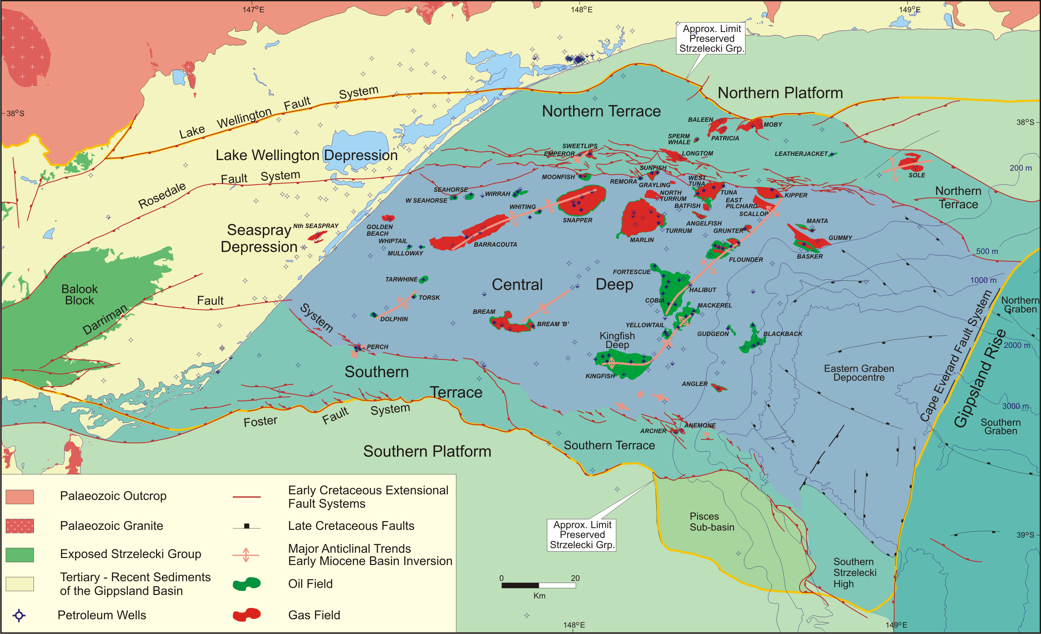
Figure 1.5 Onshore and offshore elements of the Gippsland Basin.

Regional geology

Tectonic setting
The evolution of the geology of the Gippsland region is recorded in three major depositional sequences ranging from Early Cretaceous to Recent in age. The overall tectonic control on the sedimentary systems of the basin is imprinted by a series of basin-wide angular unconformities. The Gippsland Basin is an east-west trending feature that formed as a consequence of the break-up of Gondwana in the Mesozoic (Rahmanian et al. 1990, Willcox et al., 1992, 2001; Norvick & Smith, 2001; Norvick et al., 2001).
As part of the Early Cretaceous rift system that developed during the initial separation of Australia and Antarctica, the early architecture of the Gippsland Basin featured a rift valley complex composed of multiple northeast – southwest trending half-grabens into which the thick sequence of volcanoclastic Strzelecki Group sediments was deposited (Rahmanian et al., 1990). The older Palaeozoic basement ridges were buried during these earliest structural events (Constantine, 1992).
With the separation of Australia from Antarctica at the end of the Early Cretaceous (around 95 million years ago), the development of the Otway Unconformity in Gippsland is associated with uplift around the margins of the old rift and the increased prominence of the major ridges separating the Otway, Gippsland and Bass basins (Rahmanian et al., 1990). These changes in tectonic regime resulted in a more confined area of deposition in the Gippsland Basin and a change in provenance from volcanoclastic deposition to the more quartoze-rich sediments of the overlying Latrobe Group.
A second phase of rifting in the Late Cretaceous, associated principally with Tasman Sea spreading produced a classic extensional basin geometry comprising a depocentre (the Central Deep) flanked by platforms and terraces to the north and south (Rahmanian et al., 1990). The Central Deep is bound by the Darriman fault system (Maung, 1989) to the south and the Rosedale fault system (e.g. Hocking, 1976) to the north. The Foster fault system (Milliken, 1968) separates the Southern Terrace from the Southern Platform, and the Lake Wellington fault system (e.g. Stainforth, 1984) separates the Northern Terrace from the Northern Platform. These offshore structural elements extend onshore; the Alberton, Seaspray and Lake Wellington (including the Latrobe Valley) depressions and the Lakes Entrance Platform are defined (i.e. Thomas and Baragwanath, 1949, Hocking and Taylor, 1964, Hocking, 1976). The Seaspray and Lake Wellington Depressions are separated by the Baragwanath Anticline, an uplifted structural block, with
faulted margins.
During the Late Cretaceous the second phase of rifting provided the accommodation space within which the earliest mainly terrestrial Latrobe Group sediments were deposited. Breakup along the eastern margin of Australia at around 80Ma in the Campanian left the Gippsland Basin as a failed rift. A peak in volcanism is recorded around this time – the Campanian volcanics. From the Latest Cretaceous and into the Eocene, the change from a fault controlled to marginal sag regime is recorded in the change in sedimentation. Marine influence increased and more marginal environments were common (Rahmanian et al., 1990). During the Eocene and up to the early Oligocene, the coal seams of the Traralgon Formation formed in swamps extending into the subsiding Latrobe Valley Depression, around the north of the Balook Block of the South Gippsland highlands (Gloe, 1984).
From the latest Eocene, compression created the prominent northeast to southwest-trending anticlines which form the main hydrocarbon traps offshore (e.g. Smith, 1988). Uplift associated with the compression created an erosional surface that is seen across the top of the Latrobe Group; although that unconformity is not basin-wide (Hoffman et al., 2012).
During the Oligocene, slow basin subsidence, warmer ocean temperatures and a change in ocean currents resulted in widespread carbonate deposition across Australia’s southern margin (Holdgate & Gallagher, 1997). During the Oligocene and into the late Miocene continuing subsidence in the Latrobe Valley Depression and protection from marine incursion provided by a narrow but continuous barrier sand complex resulted in the formation of the thick coal seams of the Morwell and Yallourn formations in coal swamps (Gloe, 1984). Tectonism has continued to overprint the basin as documented by localised uplift during the Neogene (Dickinson et al, 2001).

Stratigraphy
The mostly sedimentary rock units found both at the surface and in the subsurface in Gippsland have been described to various extents, dated using fossil evidence, and for the most part, given geological names. The description of geological units in this context is known as stratigraphy. Since a stratigraphic framework for the Gippsland Basin was established, there have been numerous changes to the nomenclature. The current framework is a product of those various changes, and many challenges remain to reconcile the onshore and offshore stratigraphy and some relationships between shallow onshore units. However, three broad stratigraphic successions across Gippsland (based on lithological variations) are generally recognised. These stratigraphic groups comprise (a) the Strzelecki Group, a thick sequence of non-marine, volcanoclastic-rich sediments; (b) the Latrobe Group, a sequence of marine and non-marine siliciclastics that host all the known hydrocarbon occurrences in the offshore Gippsland Basin; and (c) the Seaspray Group, a carbonate-dominated succession that is the regional seal to the top Latrobe Group oil and gas accumulations (Figure 2.1).

Strzelecki Group
The Strzelecki Group represents non-marine syn-rift sedimentation and unconformably overlies Palaeozoic igneous and folded sedimentary rocks. The Strzelecki Group has strong affinities with the Otway Group in the Otway Basin (Duddy & Green, 1992), and includes a basal unit of alluvial fan conglomerates and fluvial coarse quartzose sandstones of Neocomian age (the Tyers River Subgroup). The remainder of the Strzelecki Group is an undifferentiated sequence of interbedded lithic, volcanoclastic sandstones and mudstones, including several coal-rich horizons, all of which accumulated under a fluvial depositional regime (Holdgate & McNicol, 1992; Tosolini et al., 1999). The total thickness of the Strzelecki Group is ill-defined; it may be up to 3000 m in places (Mehin & Bock, 1998; Duddy, 2003) but may also reach 6000 m (Chiupka, 1996). Offshore, the group is regarded by the industry as ‘economic basement’, although considered to have potential for hydrocarbon generation and accumulation, in particular in the onshore part of the basin (Mehin & Bock, 1998), where the tight gas accumulations of the North Seaspray and Gangell fields are reservoired in the Strzelecki Group. The burial history and diagenetic alteration of the volcanoclastic detritus that comprises the majority of the Strzelecki Group sediments has resulted in generally low permeability characteristics.

Tyers River Subgroup
The Tyers River Subgroup has been identified as a potential hydrocarbon reservoir, sealed by the overlying tight Strzelecki volcanoclastic sequence (Chiupka, 1996). This is the basal unit of the Strzelecki Group, and comprises the Tyers Conglomerate, which is a quartz-rich fluvial conglomerate derived from the Palaeozoic basement present around the northern margin of the Gippsland (Tosolini et al., 1999), overlain by the quartzose Rintoul’s Creek Sandstone. These units were deposited around the basin margins and against the footwalls of the half grabens that developed during the initial rifting phase. The Rintoul’s Creek Sandstone is the lateral equivalent of the Pretty Hill Formation in the Otway Basin. Analysis of the unit suggests that it has limited lateral distribution, and thins rapidly towards the basin centre (Tosolini et al., 1999).
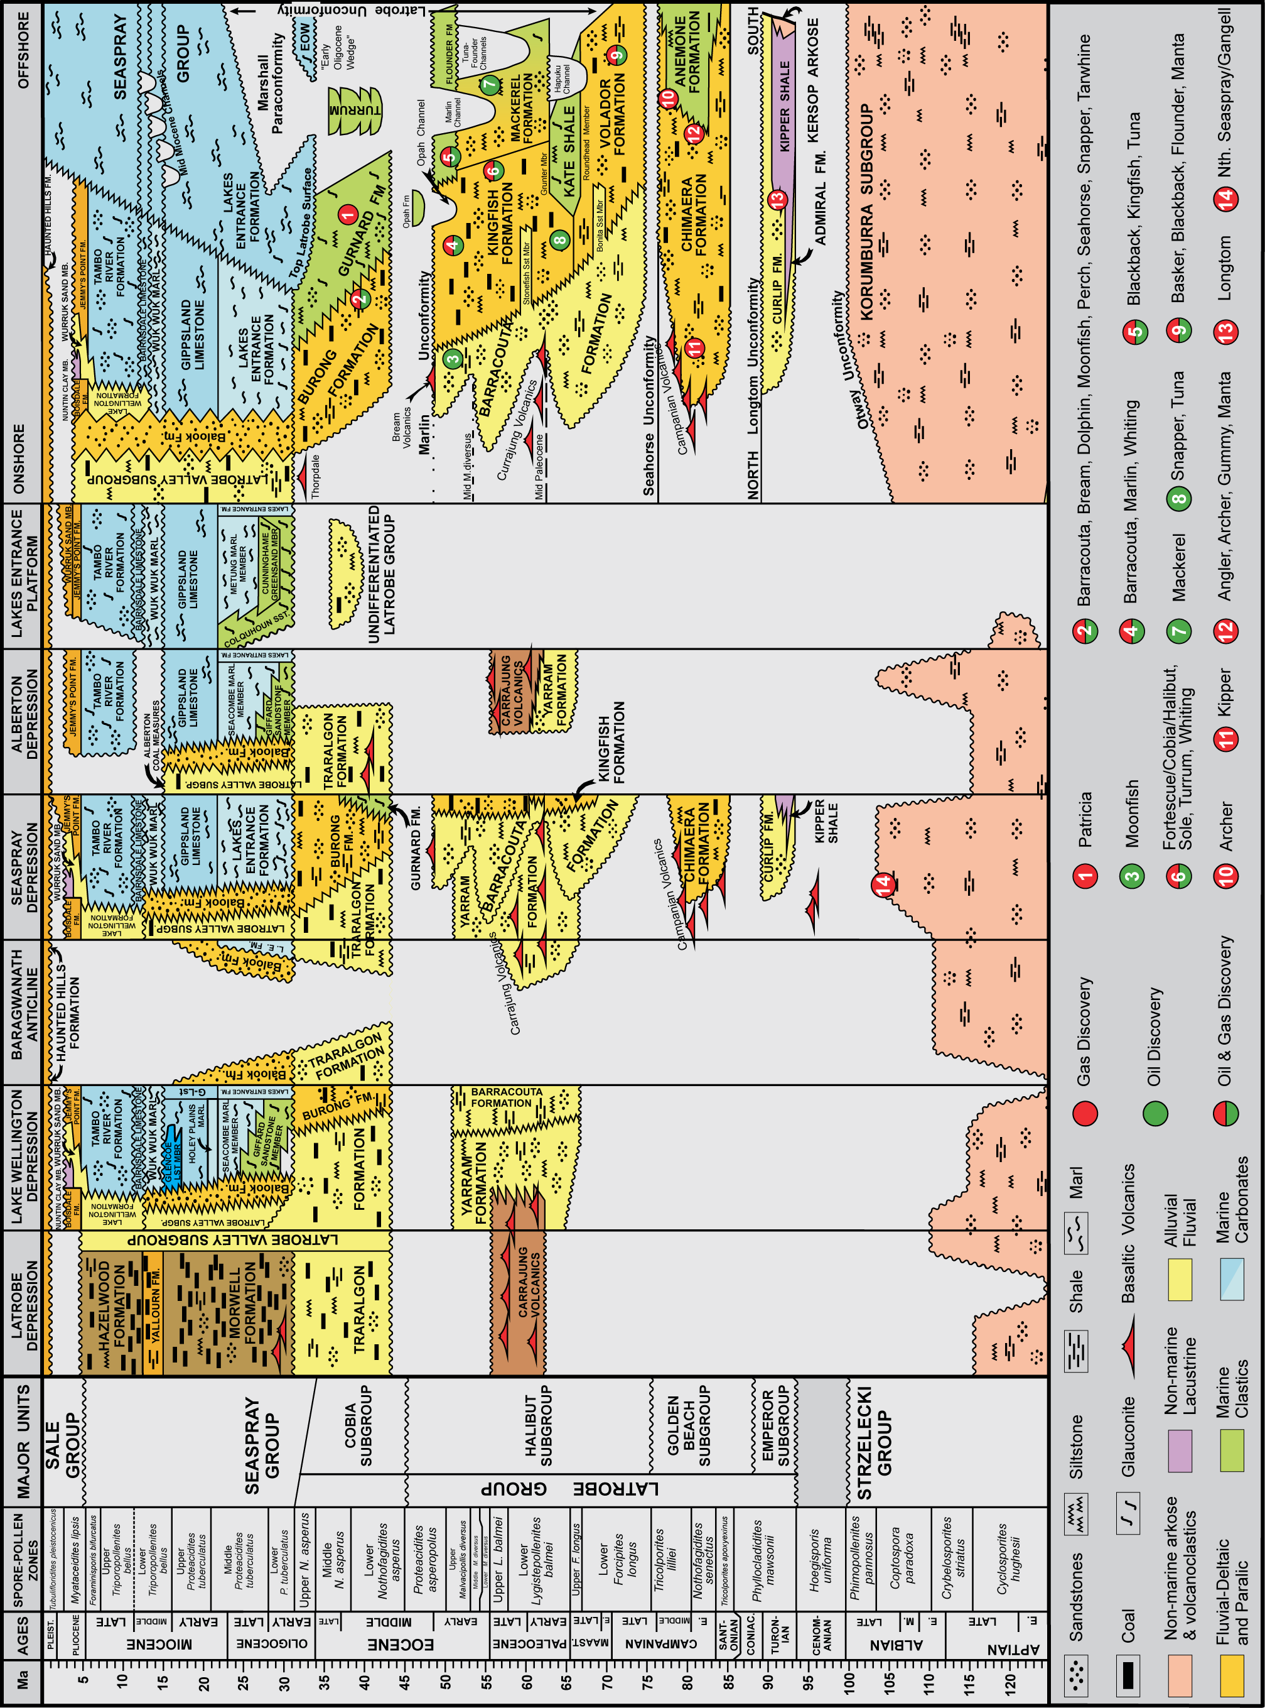
Figure 2.1 Gippsland Basin stratigraphy. Left to right in each column = west to east. (Compiled from Bernecker & Partridge, 2001; Chiupka, 1996; Gallagher & Holdgate, 1996; Holdgate & Gallagher, 2003; Partridge, 2006a; Partridge, 2006b & Tosolini et al., 1999).

Latrobe Group
The Latrobe Group hosts all currently known hydrocarbons in the offshore part of the basin. Four subgroups are discriminated and each consists of formations that are distinguished according to their main depositional facies assemblages (Figure 2.1).

Emperor Subgroup
The Emperor Subgroup is the oldest depositional unit of the Latrobe Group and is separated from the underlying Strzelecki Group by the Otway Unconformity. Large amounts of erosional material were delivered to the evolving rift-valley, in which one or several deep lakes emerged as the depocentre. The Emperor Subgroup (Bernecker & Partridge, 2001) has been intersected around the basin margins only in the vicinity of the bounding faults of the Northern and Southern terraces. Onshore, this subgroup is intersected in several wells close to the coast in the Seaspray Depression only.
The Emperor Subgroup comprises coarse-grained alluvial fan/plain as well as lacustrine facies associations, and comprises four formations, of which only the lacustrine Kipper Shale (Lowry & Longley, 1991) and the fluvial-deltaic Curlip Formation (Bernecker & Partridge, 2001) have been intersected in the onshore Gippsland Basin. The Kipper Shale is dominated by mudstones with intercalated fine-grained to medium-grained sandstones (Marshall & Partridge, 1986; Marshall, 1989; Lowry & Longley, 1991) and is a potential sealing facies. The Curlip Formation (Bernecker & Partridge, 2001) consists of sandstones and conglomerates that are interbedded with thin shales and minor coals. The formation overlies and interfingers with the Kipper Shale; the top marked by the basin-wide Longtom Unconformity that terminates Emperor Subgroup deposition.

Golden Beach Subgroup
The Golden Beach Subgroup has been recognised by Chiupka (1996) as a potential hydrocarbon reservoir. It is essentially confined to the Central Deep, including the onshore Seaspray Depression, where it is represented by the fluvial-deltaic Chimaera Formation (Bernecker & Partridge, 2001). The Chimaera Formation is a non-marine succession that comprises coarse-grained alluvial/fluvial sediments as well as fine-grained floodplain deposits including some coals (Bernecker & Partridge, 2001), and can exceed 300 m in thickness. The Chimaera Formation has been intersected in wells close to the coast and near the Rosedale Fault System in the Seaspray Depression, but is absent from the Lake Wellington Depression. The Golden Beach Subgroup also contains several volcanic horizons that are possibly intersected in the Darriman-1 well in the Seaspray Depression. These volcanics terminate the Golden Beach Subgroup and signal another depositional hiatus represented by the Seahorse Unconformity (Bernecker & Partridge, 2001).

Halibut Subgroup
The Halibut Subgroup hosts the bulk of the hydrocarbons in the Gippsland Basin and comprises five formations – the Volador, Mackerel, Kingfish and Barracouta formations and the Kate Shale - that are distinguished according to their dominant depositional facies regimes. These formations document the changes from non-marine to marine environments in a west-east or onshore-offshore direction, and are outlined by Bernecker et al. (2003). Two of these formations are intersected in the onshore basin, the Barracouta Formation (revised and formalised by Hocking, 1976) which is characterised by fluvial siltstones, sandstones and minor coals and was deposited on an upper coastal plain. The Kingfish Formation is intersected only in Golden Beach West-1, and in Golden Beach-1A in the 3 nautical mile zone immediately offshore, and is a typical lower coastal plain, coal-rich facies.

Cobia Subgroup
The middle Eocene to early Oligocene Cobia Subgroup (formerly the Cobia Group of Thompson, 1986) comprises the coal-bearing, lower coastal plain facies of the Burong Formation (Partridge, 1999), which is reasonably well-developed across the eastern part of the onshore Gippsland Basin and the shallow to open marine Gurnard Formation (James & Evans, 1971). The Gurnard Formation is a condensed section composed of fine-grained to medium-grained glauconitic siliciclastics and acts as a top seal for some of the giant hydrocarbon fields offshore (as shown by Daniel, 2005). Deposition of the Cobia Subgroup ceased during the early Oligocene, as a consequence of a marked decline in sediment supply. Large areas of the central basin were left with starved or condensed sections, which led to the development of what is traditionally known as the ‘Latrobe Unconformity’ (Partridge, 1999). On seismic sections, this surface is expressed by a prominent reflector marking the boundary between siliciclastic and calcareous rocks, which from biostratigraphic data, should be considered a composite of several, separate erosional events (Partridge, 1999).

Seaspray Group
The Seaspray Group consists of calcareous sediments that unconformably overlie the siliciclastics of the Latrobe Group and includes the basal Lakes Entrance Formation and overlying Gippsland Limestone. Onshore, the Cunninghame Greenstone Member, Giffard Sandstone Member, Colquhoun Sandstone Member, Seacombe Marl and the Metung Marl are identified as constituent units of the Lakes Entrance Formation (Hocking, 1976). The shift from siliciclastic to cool-water carbonate deposition in the Gippsland Basin occurred in the early Oligocene, as a consequence of a change in ocean circulation along the southern Australian margin (Holdgate & Gallagher, 1997). Since then, cool-water carbonate production resulted in progradation of the shelf edge. Onshore, in the Lake Wellington and Seaspray Depressions, a marine sequence of middle Miocene to Pliocene aged sediments rests unconformably on the Gippsland Limestone. This sequence is comprised of the Wuk Wuk Marl, Bairnsdale Limestone, Tambo River Formation and Jemmys Point Formation.
The Seaspray Group, in particular the Lakes Entrance Formation, is considered a basin-wide, high quality regional top seal. The Lakes Entrance Formation is the lowermost unit of the Seaspray Group and is composed predominantly of smectite-rich calcareous mudstones and claystones, with some variation in composition across the basin (Bernecker et al., 1997, Hocking, 1976, Holdgate & Gallagher, 1997). The Lakes Entrance Formation is considered to provide excellent top seal containment offshore and in parts of the onshore Gippsland Basin (O’Brien et al., 2008; Goldie Divko et al., 2010). Onshore, to the west of the current coastline, the Lakes Entrance Formation interfingers with the Balook Formation, a barrier sand system that laterally separates the marine Seaspray Group carbonates from the back-barrier swamp and coastal plain Latrobe Valley Coal Measures. The Balook Formation is generally limited in lateral extent but contains tongues that extend up to 30 km into the coal measures (Holdgate & Gallagher, 2003). It is significant as it marks the edge of the sealing facies of the marine Lakes Entrance Formation.

Latrobe Valley Subgroup
The Latrobe Valley Subgroup (formerly known as the Latrobe Valley Group of Hocking, 1972) has been restricted to the sequence in the Latrobe Valley Depression and demoted to subgroup status (Partridge et al., 2013). The main coal-bearing formations of the Latrobe Valley are identified in this sequence as are the Traralgon, Morwell and Yallourn, formations (Holdgate & Gallagher, 1997; Holdgate & Clarke, 2000). In the Lake Wellington, Seaspray and Alberton Depressions, and around the margins of the Baragwanath Anticline, the Traralgon Formation overlies tuffs and basalts of the Carrajung Volcanics. Underlying the volcanics, there is a sequence of fluvial/alluvial conglomerates, sandstones, thin coals and shales of the Yarram Formation, which is equivalent in age to the Halibut Subgroup offshore.

Sale Subgroup
The Sale Group (Hocking, 1972) included the continental coarse clastics deposited in the early Pliocene. This included the lower Boisdale Formation and the younger Haunted Hill Formation. The Sale Group has since been restricted by Partridge et al. (2013) to the Latrobe Valley Depression and demoted to Subgroup status, with the Haunted Hill Formation as the only formation recognised in the Latrobe Valley and Seaspray depressions.

Previous exploration

Oil and gas
Exploration for oil and gas in Gippsland began in 1886 when bores were sunk with the object being to strike oil (Ower, 1921). During the late 1800s both the government and private industry embarked on drilling programs to locate gold, minerals, coal and water. By the 1920s, boreholes drilled for the specific purpose of finding oil and gas in the Lakes Entrance area (Lake Bunga, Boola Boola and Colquhoun) had limited success. Mineral oil had been found in an area around Lakes Entrance in a glauconitic sandstone unit about 350 to 400 metres below the surface. Forty-five bores (both private and government) had intersected the oil-bearing unit by 1934 (Mines Department, 1935). Over a period of four years, production totalled around 80000 gallons of heavy oil of “asphaltic base” (Mines Department, 1935). As a result, the prospect of finding further oil in the region was considered promising and a submission to Parliament was prepared to liberalise conditions for granting oil leases and to encourage prospecting for oil in the state. By the 1950s, Woodside Lakes Entrance Oil Company held permits on the Victorian south-east coast, where they drilled a number of exploration wells with no commercial success (Wilkinson, 1988).
During the 1960s exploration was successful in Queensland, Central Australia, Western Australia, and in the Gippsland Basin in offshore Victoria. Production facilities and associated infrastructure were established. In 1964, following the signing of an agreement between BHP and Esso, East Gippsland Shelf-1 (Barracouta-1) became the first offshore well drilled in Australia. The well was a success, encountering gas. Confirmed by a second well, the Barracouta field was proven as a commercial discovery and marked the commencement of major gas development for Victoria. By 1967, after the discovery of further gas in the Marlin field, contracts to secure gas supply were signed and platforms, pipelines and an onshore terminal were planned (Wilkinson, 1988). Esso Australia (1988) further details exploration and production history in the offshore Gippsland Basin.
Whilst Esso/BHP went on to make further discoveries offshore, including the Kingfish and Fortescue-Halibut fields, interest in petroleum exploration in the onshore basin has continued until the present day with a total of 197 wells drilled for the purpose of finding oil or gas. A large portion of exploration in the onshore Gippsland Basin targeted structures at the top of the Latrobe Group (Chiupka, 1996). None were discoveries, although shows and/or high background gas readings have been documented.
To date, Lakes Oil is the only company to make a gas discovery onshore, announcing an estimated 1.7 Tcf of gas in the Wombat, Trifon and Gangell fields near Seaspray. Exploration carried out over the last decade by companies such Karoon Gas and Lakes Oil provide valuable insights into conventional and unconventional hydrocarbon plays in the Gippsland region via data and reports gathered from their respective activities. This review draws on this data along with other datasets. This information is drawn together to form the discussion presented in later sections of this report.

Coal
Black coal was first discovered around 1826, and brown coal discoveries followed in 1857. Although the black and brown coal resources of the Gippsland Region differ in their physical character, distribution and volume, both resources served the early needs of the southern Victorian community to power steam engines and small industries, and the vast brown coal deposits of the Latrobe Valley are still in use today for electricity production.

Early black coal exploration
Following the discovery of coal near Cape Patterson around 1826 (Vines, 2008), surveys of the area between San Remo, Korumburra and Nyora identified numerous coal-bearing localities (e.g. Stirling, 1892; 1895 a, b, c). Stirling (1895a) records in detail the coal occurrences and numerous mining leases across the Korumburra and Jumbunna coal-fields. The Outtrim coal-field and coal seams at Berry’s Creek, Boolarra, Cape Paterson, Kardella, Kilcunda and Mirboo (Figure 3.1) had all been identified by 1895 (Stirling, 1895a, b, c). The coal was utilised locally for domestic purposes, steam production and even annealing steel. In 1909, the State Coal Mine in Wonthaggi was opened to supply coal to the Victorian railways (Edwards et al., 1944).
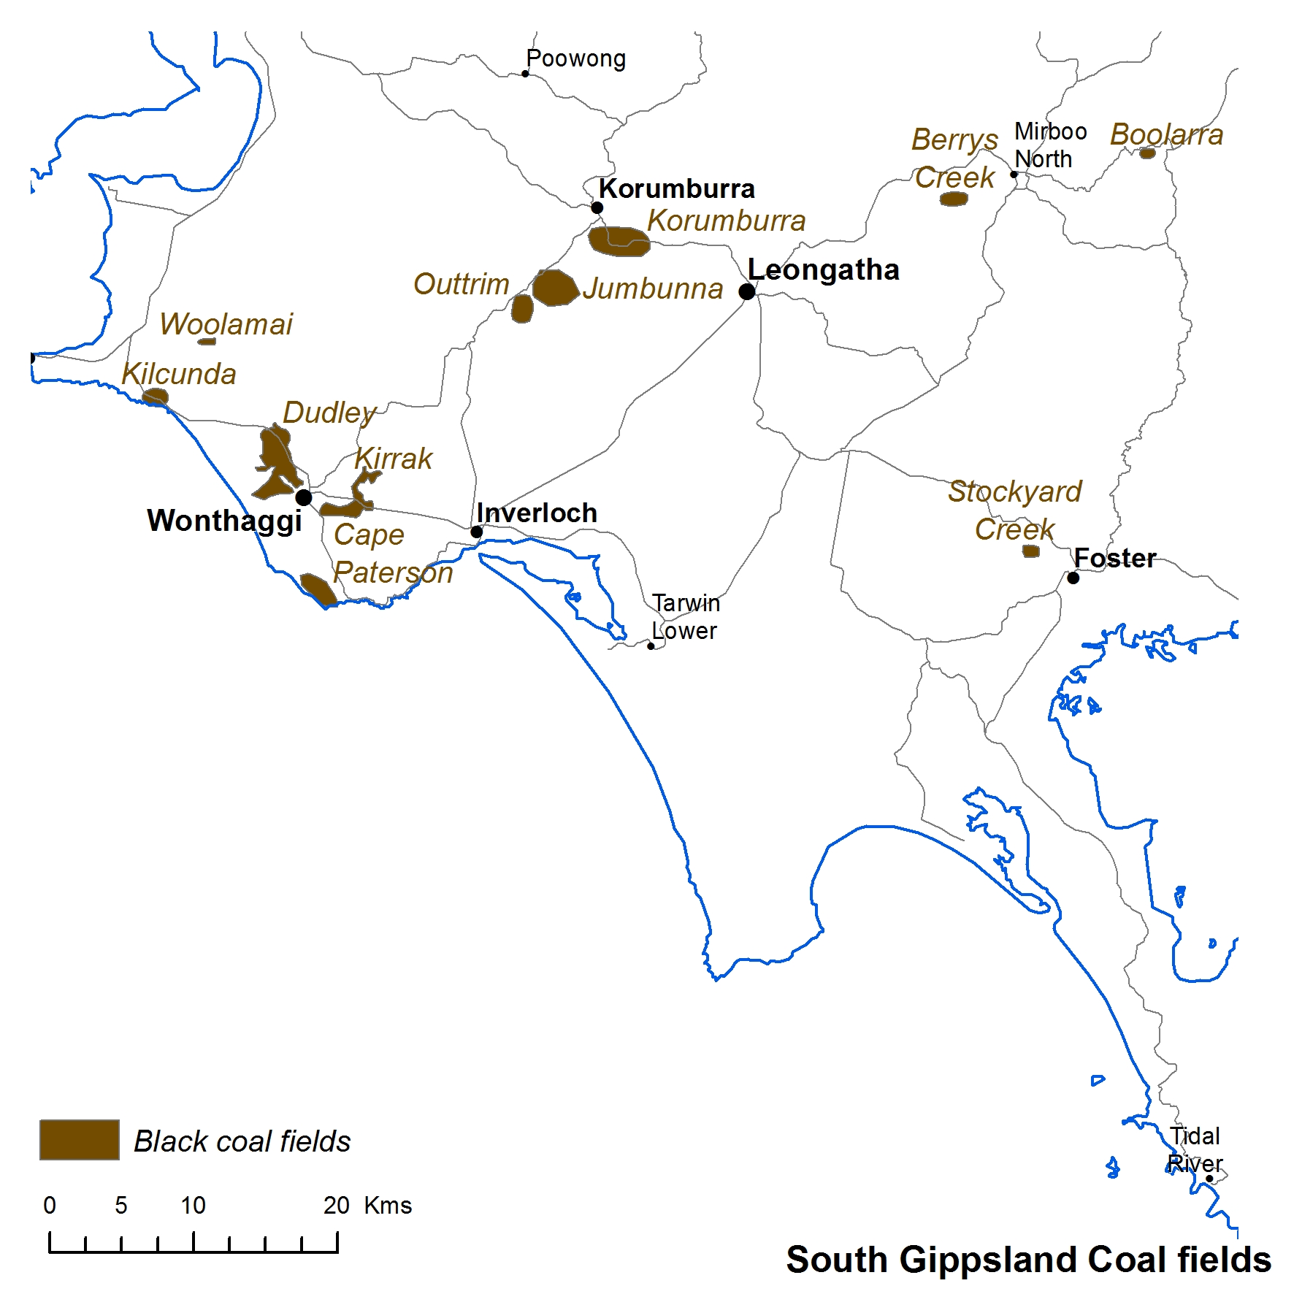
Figure 3.1 South Gippsland black coal sub-crop.
Mining for black coal was often hazardous, as was demonstrated by the devastating Wonthaggi State Mine disaster caused by an underground coal gas and coal dust explosion in 1937 that killed 13 miners (e.g. The Mercury, 1937). The role of coal gas in this disaster has been cited in recent years as evidence for the presence of coal seam gas in the Strzelecki Group coals but it is unclear how much methane the coal actually contains relative to economic thresholds. Official reports on the disaster indicate that open-flame lamps were routinely used, which suggests that gas influx was not a major concern. No contemporary measurements of gas content exist, although a 1936 report by the mine manager quoted in Harper (1987) stated “The mines are not gaseous, and naked light is used, but stone dusting is adopted.” Stone dusting is a form of coal-dust hazard reduction, indicating that coal dust was considered the greater fire and explosion hazard.
By the early 1960s many of the mines had closed. Seams had been mined out, some having reached depths (e.g. 300 metres) that were no longer considered economic. The State Coal Mine at Wonthaggi closed in 1968 and is now a tourist attraction.

Brown coal exploration
Gloe (1984) documented the stages in which discovery, exploration and development of the Victorian brown coals took place. Brown coal was first discovered in the Latrobe Valley in the 1850s to the northeast of Moe. Numerous other discoveries had been made in previous decades, but attempts at development were hampered by complex geological structure and variable coal quality (Gloe, 1984).
In the 1880s, activity initiated by a number of companies around Morwell led to the discovery of 30 and 50 metre thicknesses of brown coal. When six seams totalling 245 metres thickness were encountered during drilling in 1890, the Mines Department proclaimed that the deposits were probably the greatest in thickness yet discovered in the world. In the early 1900s a program of drilling established the presence of a large resource sufficient to establish the State Electricity Commission of Victoria in 1921. The SECV oversaw the development of the state’s brown coal resources, initially focusing on establishing a power station to manage electricity generation and supply (Vines, 2008).
In the 1950s long term planning to determine total coal resources and characteristics was undertaken. Because variability in coal quality had become a processing issue, drilling took place in areas previously drilled but this time to greater depths in order to test coal samples for key quality parameters (Gloe, 1984). Through the 1960s to 1980s, a combination of remote sensing using geophysical techniques and facies modelling followed by drilling helped to delineate additional fields outside the Latrobe Valley, such as the Alberton coalfield (Holdgate, 2003).
Today in the Latrobe Valley, brown coal production is dominated by three mines: Hazelwood, Loy Yang and Yallourn. In 2013-14 total production in Victoria was 57.8 Mt (DEDJTR, 2015).

Coal seam gas
The first Coal Seam Gas (Coal Bed Methane) exploration licenses were granted in Victoria in 2001. Exploration to date has not yielded a commercial coal seam gas discovery. Exploration in the Gippsland region has centred over coal-bearing regions in South Gippsland and the onshore Gippsland Basin. Cancelled, surrendered and expired exploration licences are listed in Table 3.1.

Table 3.1 Cancelled, surrendered and expired Exploration Licences.
Company | Exploration Licence | Target/activities
Flatoak | 4850 | Cretaceous black coals in the Wonthaggi-Korumburra-Inverloch region; thin seams <3m. No record of on-ground activities.
Greenpower Natural Gas | 4619, 4620, 4803, 4804, 4805, 4806, 4807, 4808, 4809, 5228 | Company annual reports indicate a focus on lignite resources for conventional mining and coal to liquids technology .
Karoon Gas | 4537 | Tested Strzelecki Group for CSG and conventional gas potential (latter under a PEP). Drilled two wells (Megascolides-1 and -2) in 2004 and 2007, respectively.
Leichhardt Resources | 5081 | Coals near Fish Creek targeted for CSG, coal mining and conversion to Syngas – desktop reviews and modelling carried out. No on-ground activities reported.
Monash Energy Coal | 4681, 4682 | No report available.
Mr Stanislaw Wassylko | 5229 | No report available.
Sawells – Greenpower Energy | 4858, 4860, 4861, 4862, 4859, 4902 | Sub-bituminous to high volatile bituminous black coal seams of the Wonthaggi Formation, Strzelecki Group.  Desktop studies and drill-hole location plans.
Seamair | 5180 | CSG in Strzelecki Group black coals near the Kongwak Monocline. Desktop studies only to plan drill holes. No on-ground activities.

Current tenements
Two types of tenements may be granted in Victoria to allow for gas exploration: Petroleum Exploration Permits and Exploration Licences. Petroleum Exploration Permits (PEPs) are granted to companies to explore for petroleum (including gas but excluding coal seam gas) under the Petroleum Act (1998). Prospective blocks are offered to companies via an acreage release process, which is run in tandem with the Commonwealth Acreage Release and other participating states and territories. Petroleum exploration may also be carried out under a retention lease, which enables the holder of an exploration permit to retain certain rights to a petroleum discovery that is not considered commercially viable at the time. Exploration Licences (ELs) for minerals, including coal and hydrocarbons contained in coal are granted to companies
via a direct application process by the State Regulator under the Mineral Resources (Sustainable Development) Act (1990).

Petroleum exploration permits and retention leases
Current Petroleum Exploration Permits in the Gippsland region are restricted to the onshore Gippsland Basin and the Latrobe Valley and do not extend to South Gippsland (Figure 4.1). There are two Petroleum Exploration Permits (PEPs) and two Petroleum Retention Leases (PRLs). PEP166, PRL2 and PRL3 are held by Lakes Oil (Petro Tech Pty Ltd), and PEP170 is held by Icon Energy. Both companies have stated their intention to target tight gas in the Strzelecki Group (e.g. Lakes Oil, 2014 and Icon Energy, 2014). In addition, Lakes Oil is interested in pursuing exploration and production of oil from the Lakes Entrance oilfield in PRL3 (Lakes Oil, 2012).

Exploration licences
The first Victorian exploration licence (EL) for coal seam gas (coal bed methane) was granted in
September 2001 under the Mineral Resources (Sustainable Development) Act (1990). Between August
2001 and May 2012, 35 separate exploration licenses were granted. Some companies have specifically targeted coal seam gas, whereas others have probably undertaken multi-commodity exploration that could include coal seam gas.
Sixteen exploration licences that include coal seam gas as a target resource are current today over parts of Bass Coast, Baw Baw, Cardinia, Latrobe, East Gippsland, South Gippsland and Wellington Local Council Areas (Figure 4.2). The nine companies that hold current exploration licences are listed in Table 4.1.

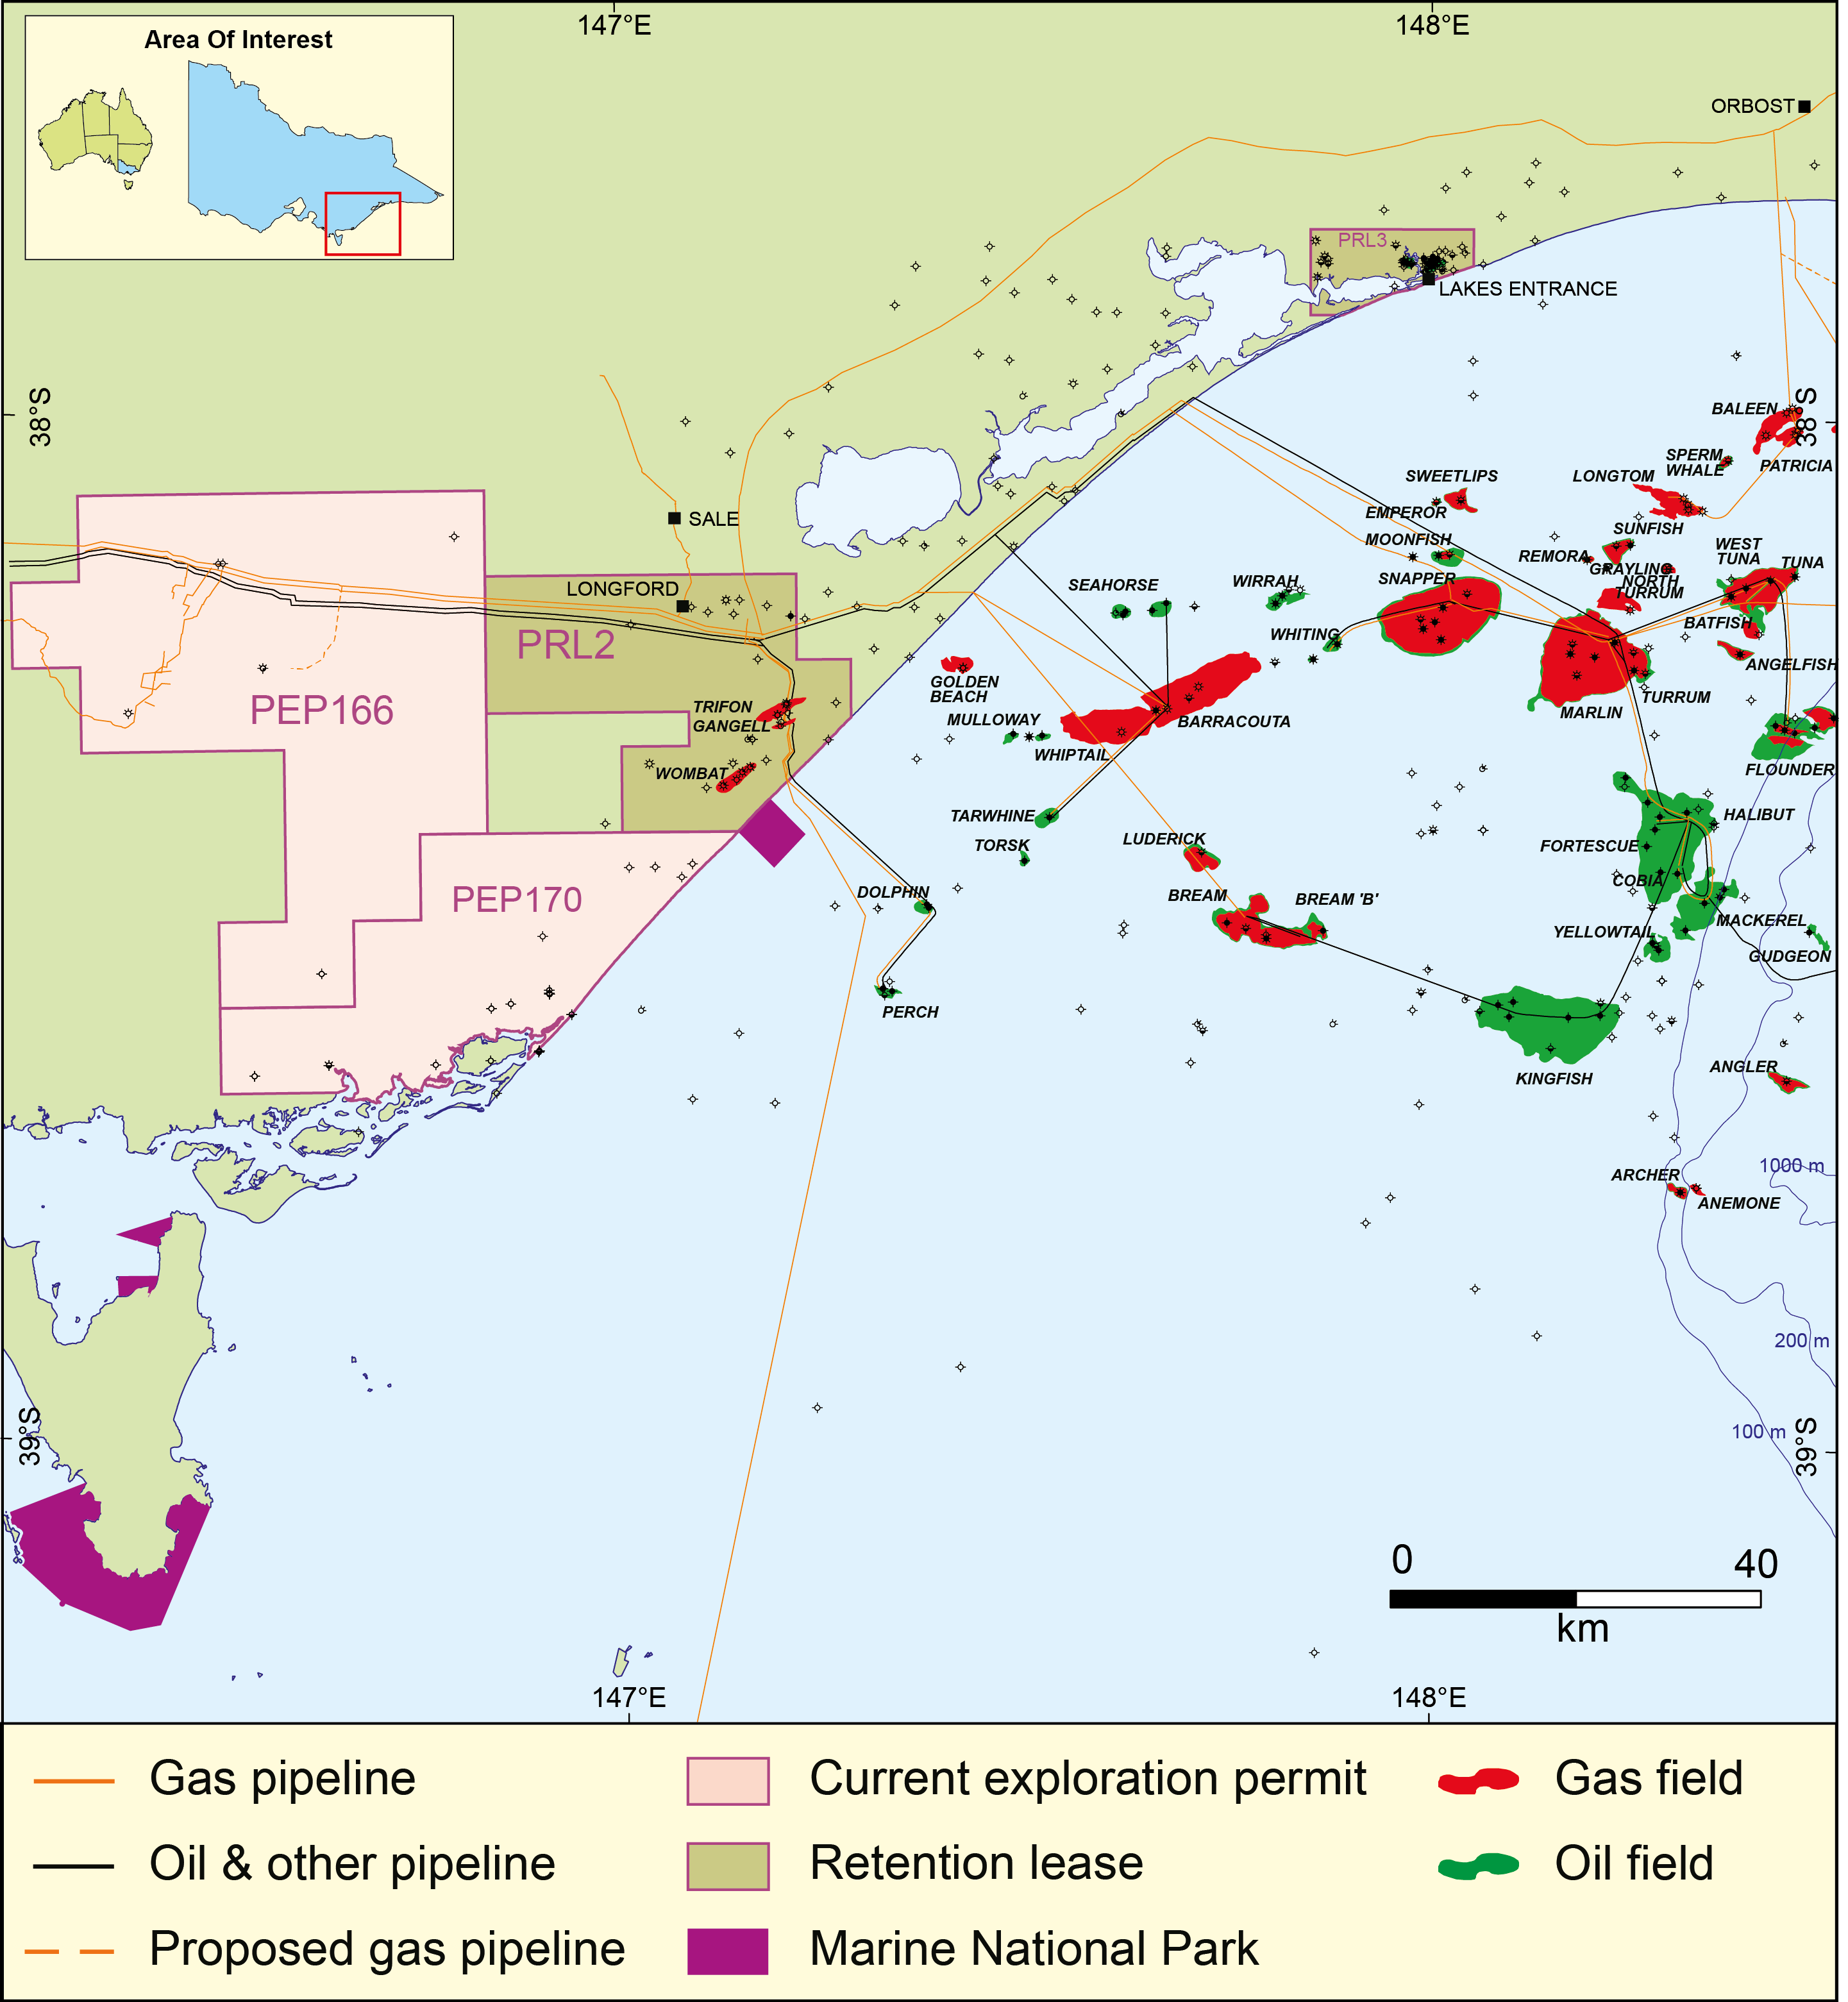
Figure 4.1 Gippsland Basin onshore Petroleum Exploration Permits and Retention Leases.

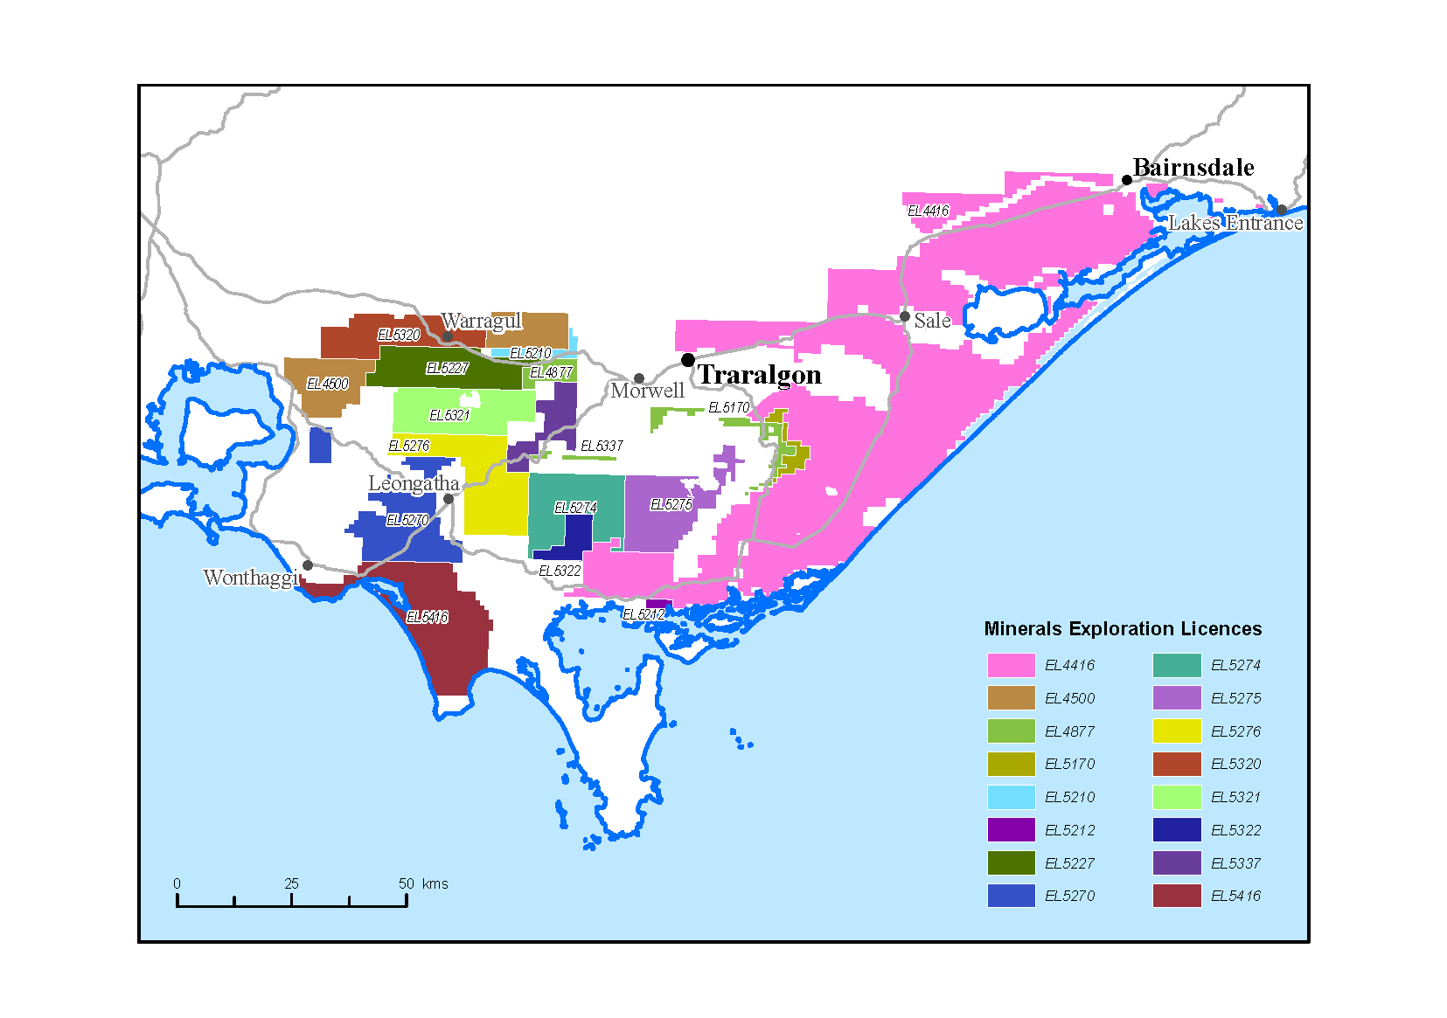
Figure 4.2 Current Exploration Licences with a Coal Seam Gas stated as a target.

Table 4.1 A list of companies that nominate coal seam gas as a target in their mineral exploration licence.
Tenement | District | Municipality | Primary Owner
EL4500 | Gippsland | Cardinia Shire | Greenpower Natural Gas
EL4416 | Gippsland | Wellington Shire | Ignite Energy Resources
EL4877 | Gippsland | Baw Baw Shire | Sawells
EL5210 | Gippsland | Baw Baw Shire | Resolve Geo
EL5212 | Gippsland | South Gippsland Shire | Resolve Geo
EL5227 | Gippsland | Baw Baw Shire | Greenpower Natural Gas
EL5270 | Gippsland | South Gippsland Shire | Clean Global Energy
EL5276 | Gippsland | South Gippsland Shire | ECI International
EL5320 | Gippsland | Baw Baw Shire | ECI International
EL5321 | Gippsland | Baw Baw Shire | ECI International
EL5337 | Gippsland | Baw Baw Shire | Mantle Mining Corporation
EL5170 | Gippsland | Wellington Shire | La Trobe Fuels
EL5274 | Gippsland | South Gippsland Shire | ECI International
EL5275 | Gippsland | Wellington Shire | ECI International
EL5322 | Gippsland | South Gippsland Shire | ECI International
EL5416 | Gippsland | South Gippsland Shire | Leichhardt Resources

Ignite Energy Resources (IER) holds the current exploration licence for the 3,800km² EL4416 – the largest of all the exploration licences in Gippsland. The company is targeting the deeper lignite seams, containing biogenic natural gas created by microbial activity within the lower-rank coal (Ignite Energy Resources, 2014). The potential resource size reported by Ignite Energy Resources (2014) is 3.7 Tcf contingent resource (2C); independently estimated by MHA Petroleum Consultants (Table 4.2).

Table 4.2 EL 4416 gas estimates.
Estimate | Low (1C) | Best (2C) | High (3C)
Contingent | 0.66 Tcf | 3.7 Tcf | 9.1 Tcf
Prospective | 0.23 Tcf | 1.3 Tcf | 3.5 Tcf
Source: MHA Petroleum Consultants
The previous tenement holder of EL4416, CBM Resources, commenced a drilling program in 2002, which included involvement in two conventional petroleum wells. Gastar Exploration noted that in York-1, coals between 567 and 640 metres showed indications of methane gas and permeability (Gastar Exploration Ltd., 2002). The York-1 formation evaluation log indicates gas readings higher than background values (7.9 units) however these readings (<1%) were not considered significant by the permit holder (Lakes Oil, 2002).
Gastar (Joint Venture Partner with CBM Resources Pty Ltd), announced the drilling of the first pilot well for coal bed methane in EL4416 in the Gippsland Basin in May 2005. The pilot well (Burong #2) was drilled to a depth of 692 metres, intersecting a coal seam of around 14 metres thick (Gastar Exploration Ltd., 2005). A second pilot well (Burong #3) close-by to Burong #2 was planned, along with well completions using techniques commonly used in the Powder River Basin in the United States, with open-hole completions to be stimulated with water enhancements to flush away coal fines. The same article reported the intention to put the wells on production to gauge water and gas rates. No further information regarding the planned wells, techniques used and water production is available.

Conventional gas
The following four sections of this review provide information about the four prospective gas types; the geological formations in which the gas might be found; and, if available, information about the characteristics of the formations that might provide evidence for prospectivity. A discussion about the prospectivity of each gas type is provided in Section 10 of this review. Each of sections 5 to 8 begins with an explanation relevant to the gas type presented.
Conventional gas is stored in porous and permeable sedimentary rocks such as sandstone or limestone in geological structures known as traps. Traps are discrete structures that can be mapped with the aid of seismic surveys from the ground surface (or sea surface if offshore). The gas migrated into the trap through porous rock units from the source from which it was generated. Impermeable rocks known as a seal or cap-rock directly above the structure trap the gas (Figure 5.1).
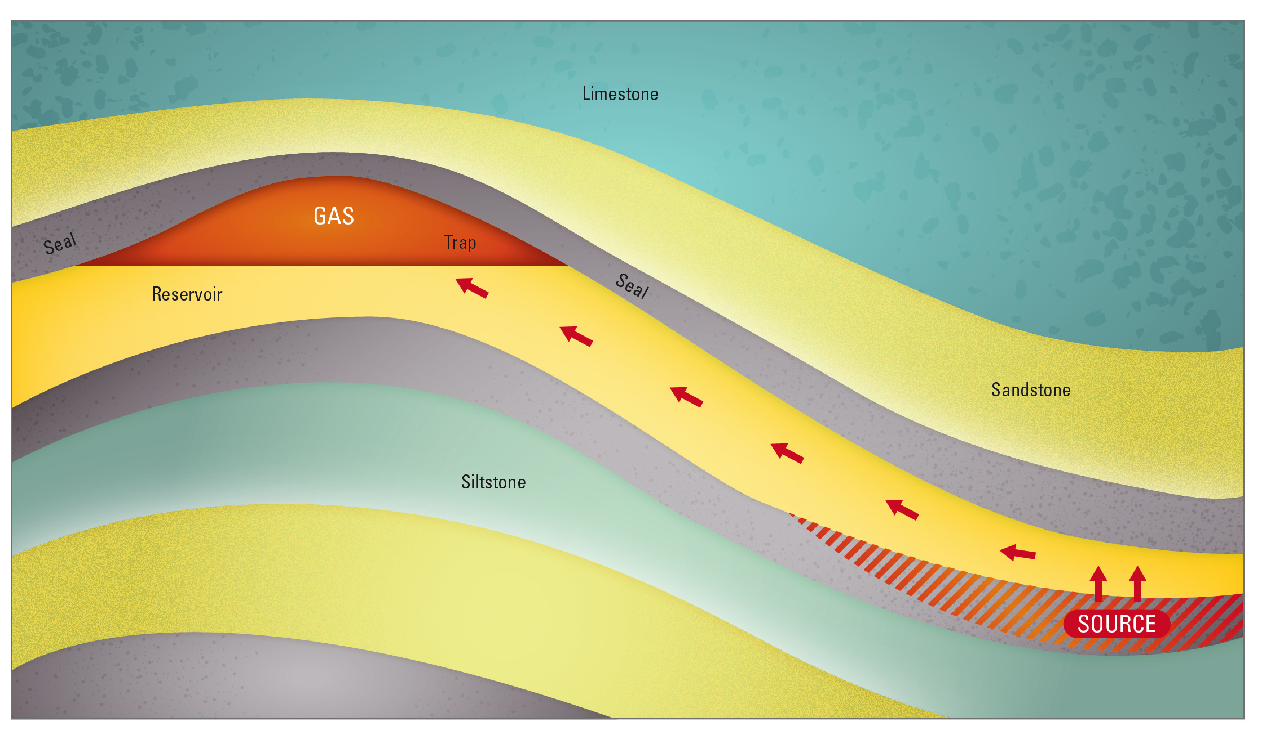
Figure 5.1 Conventional gas schematic.
Most of the 197 wells in the onshore Gippsland Basin to date have been drilled in the search for conventional hydrocarbons at the top of the Latrobe Group (the same strata in which oil and gas accumulations are found offshore). This drilling strategy has been unsuccessful despite large gas resources discovered in the Latrobe Group in offshore wells.
Gas is present in small quantities through the onshore Latrobe Group (as seen in mud logs and shows observed in wells), and has moved through the sedimentary sequence over geological time; as is evidenced in analysis such as Fluid Inclusion Stratigraphy (Miranda et al., 2012, 2013). Natural leakage and seepage of hydrocarbons in the Gippsland region was investigated as part of an evaluation of geological carbon storage potential of the area (Goldie Divko et al., 2009). Data from soil gas surveys (for example) reveal the distribution of natural hydrocarbons in the current day soil profile. This data indicates that hydrocarbons generated deeper in the rock sequence have migrated over millions of years through the Tertiary sequence (or part thereof) and potentially up fault planes. The migration of hydrocarbons beyond the top of the Latrobe Group onshore is more likely at the edge of the regional top seal – the Lakes Entrance Formation (Goldie Divko et al., 2010).
For a conventional resource, the generation, expulsion, migration and accumulation of hydrocarbons is crucial: these components together are known as a petroleum system. If one part of the system fails then
the likelihood of encountering a resource is reduced. In addition, events that occur after a resource is in place (has accumulated) may be favourable to its preservation or adversely affect the resource. In the onshore Gippsland Basin one such notable phenomenon is ‘water washing’ via the movement of fresh/meteoric waters through the reservoirs, which is thought to have degraded gas present in the
Latrobe Group (Kuttan et al., 1986).
Chiupka (1996) observed that past exploration failures at the top of the Latrobe Group in the onshore Gippsland region could be attributed to the erosional nature of the top Latrobe Group surface and the incursion of fresh water. As a result, Chiupka’s study outlined alternate hydrocarbon play fairways in the onshore Gippsland Basin, including and in addition to, that proposed earlier by Holdgate & McNicol (1992).
Chiupka’s (1996) alternative plays in the onshore Gippsland Basin and adjacent South Gippsland region include intra-Latrobe Group plays (i.e. the Halibut Subgroup), a Late Cretaceous play (incorporating the Chimaera and Curlip formations – at the time described as Golden Beach Formation), and the Early Cretaceous Tyers River Subgroup (Neocomian) play at the base of the volcanoclastic tight sandstones of the Strzelecki Group. The two former plays are essentially both intra-Latrobe Group plays (noting that a change in stratigraphic nomenclature has occurred since publication of the work). The two later plays - the basal Latrobe Group and the Strzelecki Group - were targeted during the 1950s and 1960s but success offshore at the top of the Latrobe Group prompted explorers to switch their attention to the same strata onshore (Holdgate & McNicol, 1992).

Intra-Latrobe Group
The Latrobe Group extends from the offshore to the onshore Gippsland Basin and is approximately bound by the Lake Wellington Fault System to the north and the Foster Fault System to the south. The westerly extent in the onshore Gippsland Basin is marked by the outcropping margin of the Strzelecki Group. The Latrobe Group attains its maximum onshore thickness along the coast and thins to the west. At Golden Beach West-1 (see Figure 5.2), the Latrobe Group is over 1500 metres thick; with the base of the sequence not reached. In the Lake Wellington Depression, the Latrobe Group thins to less than 300 metres.

Halibut Subgroup extent
The extent of the Halibut Subgroup is not mapped but most likely covers an area similar to that depicted in Figure 5.2. Chiupka (1996) mapped sandstone reservoirs and overlying sealing units within the Latrobe Group that correspond to the Halibut Subgroup. Oil-bearing sandstones from Seahorse-1 were correlated with sands in East Reeve-1 and Spoon Bay-1.
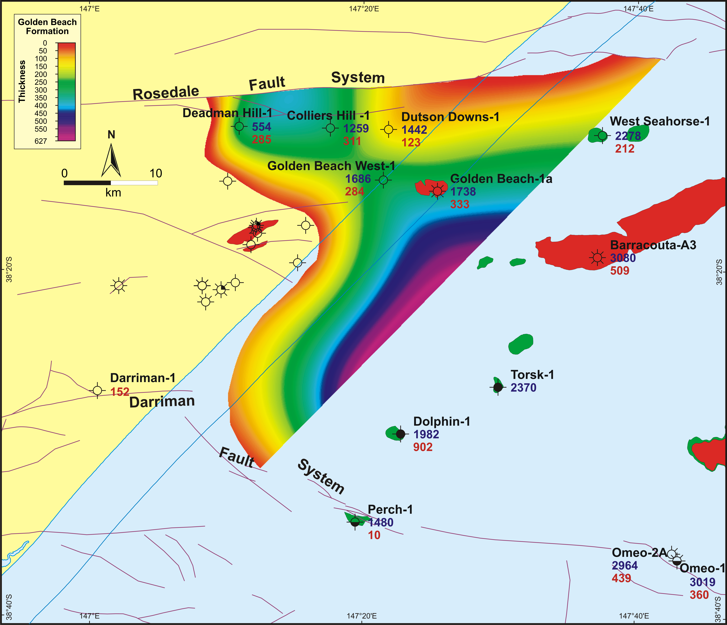
Figure 5.2 Distribution and thickness of the Golden Beach Subgroup in the onshore Gippsland Basin (from Goldie Divko et al., 2009). Around Darriman-1 there are volcanics of equivalent age to the Golden Beach Subgroup (Campanian). The blue number is the depth (mKB) of the subgroup top and the red number is the thickness; oil fields are shown in green and gas fields are red. Unnamed wells indicate where the Golden Beach Subgroup is absent onshore.

Golden Beach and Emperor subgroup extent
The lateral extent of the Late Cretaceous Golden Beach and Emperor subgroup units (i.e. the Chimaera and Curlip formations) has been mapped in the onshore portion of the basin (Bernecker and Partridge, 2001). The Golden Beach Subgroup is restricted to a small area to the immediate south of the Rosedale Fault, adjacent to the nearshore Golden Beach gas field (see Goldie Divko et al., 2009), whereas the Emperor Subgroup appears to have a wider distribution (see Bernecker and Partridge, 2001).

Reservoir quality
As depth increases, the porosity and permeability of the Latrobe Group decreases. Nonetheless, the porosity and permeability of the Latrobe Group is good, with porosities between 10 and 40% and permeabilities between 1 and 1000 mD. Measurements from core plug data often yield lower values than those from log-derived methods because the coarse and friable nature of the sands makes laboratory analysis more difficult.
Figure 5.3 Porosity and permeability plots from the Latrobe Group in the onshore Gippsland Basin. A: porosity versus depth for the Latrobe Group; B: permeability versus depth for the Latrobe Group; C: porosity versus permeability for the Latrobe Group. Data are a compilation of new analyses (indicated by ‘new’ in the legend) and existing petroleum well data held by GSV (from Goldie Divko et al., 2009).

Seal capacity
Chiupka (1996) carried out facies analyses on several wells intersecting the Late Cretaceous to Eocene intra-Latrobe sequence and identified both reservoir and sealing units within the sequence. Sealing capacity studies have demonstrated the potential of intra-Latrobe sealing units to effectively hold oil and gas accumulations (Daniel, 2005). Offshore oil and gas deposits held in place by intra-Latrobe seals also demonstrate good sealing capacity (Goldie Divko et al., 2010).

Source rocks
A study of kerogens from the Lygistepollenites balmei zone (Palaeocene) in the Gippsland Basin concluded that the host rocks were of predominantly terrestrial origin and that although there were a range of maturities present, the temperature was not high enough to cause significant hydrocarbon generation (Simpson, 1981). On that basis it was also concluded that the source of hydrocarbons in the system must have been from rocks deeper in the stratigraphic section.

Strzelecki Group
Strzelecki Group play potential was discussed by Holdgate & McNicol (1992). The unit was the target of previous drilling in South Gippsland (e.g. Tarwin Meadows-1). In the 1950s and 1960s wells drilled in the onshore Gippsland Basin around Woodside in the Alberton Depression (i.e. Woodside-1 and -2 and Woodside South-1) and farther to the north (e.g. Darriman-1, Seaspray-1, Duck Bay-1 and Wellington Park-1) had also targeted the Strzelecki Group. More recently, Karoon Gas drilled into the basal Strzelecki to assess the unit as a conventional target (Grosser, 2005).
Both the Tyers River Subgroup and Rintouls Creek Sandstone are thought to have been deposited around the basin margins and against the footwalls of the half grabens that developed during the initial rifting phase of the Gippsland Basin, thinning out towards the basin centre. A distribution of depositional facies and lateral extent was pieced together from sparse data and was presented BY Chiupka (1996).
The Karoon Gas Megascolides-1 well (see Figure 1.4) was drilled at the northern basin margin to the south of Warragul and encountered strong oil shows and recorded high mud gas readings in a 7 m interval of sandstone (equivalent in age to the Rintouls Creek Sandstone). Porosities ranged between 12 and 15%. A sample from 1889 mRT, had a porosity of 10.5% and 56 mD permeability. A second well, Megascolides-2 (see Figure 1.4), was drilled up-dip of Megascolides-1 to determine the lateral extent and vertical thickness of the oil-bearing sandstone, but the sandstone was completely absent and there were no hydrocarbon shows (Tolliday, 2007).
Lakes Oil has worked towards understanding the prospectivity of the lower units of the Tyers River Subgroup in wells Yallourn North-1 and Loy Yang-2, but the unpredictable distribution of these units and the thickness of the overlying Strzelecki Group have impeded this work.

Tight gas
Tight gas is sourced from relatively low permeability and low porosity sedimentary reservoirs (Figure 6.1). The lack of permeability does not allow the gas to migrate out of the rock. In this case the method to extract gas may involve fracturing the rocks to create artificial porosity and permeability.
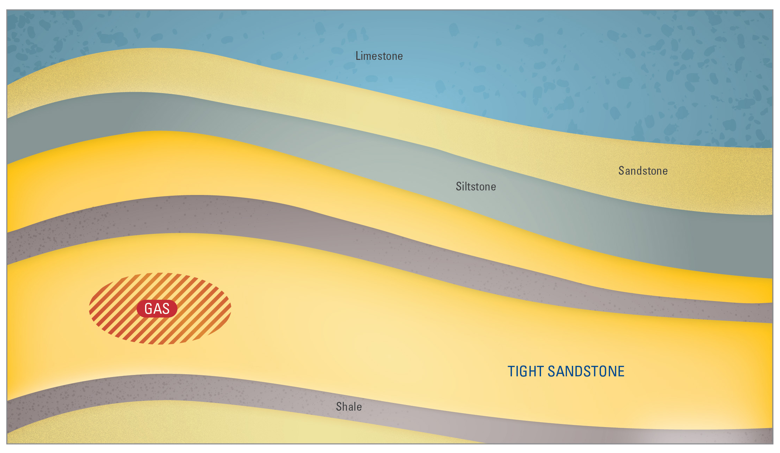
Figure 6.1 Tight gas schematic.
Low permeability tight gas reservoirs may be sandstones, carbonates, shales or coal seams. A tight gas reservoir is characterised by a matrix porosity of ≤ 10% and a permeability of ≤ 0.1 mD exclusive of fracture permeability (e.g. Haines, 2006). The American Association of Petroleum Geologists (AAPG) uses the term ‘tight gas sand’ to refer to low permeability sandstone reservoirs that produce primarily dry natural gas. Holditch (2006) defined tight gas reservoirs as “a reservoir that cannot be produced at economic flow rates nor recover economic volumes of natural gas unless the well is stimulated by a hydraulic fracture treatment, by a horizontal wellbore, or by use of multilateral wellbores”.
There are two forms of tight gas. One is known as basin-centred or pervasive gas and the other is discrete and defined by the limit of a trap – such is the case for conventional reservoirs. Basin-centred gas is continuous and widespread in its distribution. Wherever the tight formation is intersected there will be gas, although explorers look for “sweet spots” with better permeability. The issues associated with gas recovery are technical and relate to the tight nature of the reservoir. This is also true for discrete tight gas where accumulations occur in low-permeability, poor-quality reservoir rocks in localised geological features such as structural traps. Regardless of the definition or type, Australia currently has no tight gas reserves (Geoscience Australia & BREE, 2014).

Strzelecki Group
The Early Cretaceous (Albian-Aptian) volcanoclastic sandstones of the Strzelecki Group have been an exploration target for some decades (e.g. North Seaspray-1 in the 1960s) but since the late 1990s they have been the target of tight gas exploration. The average depth to the top of the Strzelecki Group sediments is approximately 1250 to 1500 metres below the surface. In general, the depth to the top surface increases towards the coastline and decreases inland, where the Strzelecki Group eventually outcrops across
South Gippsland.
Miranda et al (2011) calculated mean porosity and permeability values for the onshore Strzelecki Group. The calculated mean porosity was 14.3%. At depths greater than 1000 metres the value decreases to less than 10% and below 2400 metres the range is 2 to 8%. Data from the well Boundary Creek-1A tend to skew the calculations because the reservoir characteristics of the Strzelecki Group in this well are far better than is usual for this sequence (Duddy & Cook, 2002) and so are excluded in the data ranges presented here. For example, the median permeability including Boundary Creek-1A is 1.2 mD but by excluding that well the permeability is 0.034 mD.
Often, qualitative statements about permeability are noted. In wells such as Woodside South-1 porosities between 11 and 25% were recorded but the permeability was considered low. Watts (1965) commented that fresh water bearing sediments were encountered when drilling through the Latrobe Valley Coal Measures, whereas in the Mesozoic (Strzelecki Group), a drill stem test yielded salt water. This suggests that the permeability of the Strzelecki Group is so low as to not allow communication of fluids between the tight sandstones and overlying Latrobe Group. Mud log and FIS (Fluid Inclusion Stratigraphy) readings (Miranda et al., 2012, 2013) also exhibit a distinct change between the Strzelecki and Latrobe groups.
The first recorded shows of gas within the Strzelecki Group were recorded primarily from a 1.2 metre sandstone interval with low porosity and permeability at 1148.5 metres depth in the North Seaspray-1 well, drilled by Arco Limited/Woodside (Lakes Entrance) Oil Co. N.L. in 1962. An open-hole drill stem test (DST) and formation test produced wet gas at a rate of 50 to100 Mcfd (Ingram, 1963). Subsequent Strzelecki Group gas shows were encountered in North Seaspray-3 (drilled in 2000/2004), Trifon-1 (2000), Gangell-1 (2001), Trifon-2 and Wombat wells 1 to 3 (2004) and Wombat-4 (2009). Oil shows were also noted in the Wombat wells.

Wombat, Trifon and Gangell fields
Lakes Oil, which holds PRL2 (Petroleum Retention Lease 2), has announced 1.7 Tcf of gas (Campbell, 2009) in the tight sands of the Strzelecki Group in the Wombat, Trifon and Gangell fields.
The Wombat, Trifon and Gangell fields (see Figure 4.1) cover a combined area of 27 km². The Trifon and Gangell fields are hosted within a defined, 8 kilometre east-northeast trending structural high that is fault-bounded at top Strzelecki Group level (O'Brien & Campbell, 2005). Wombat wells 1 to 4 are located within an identified structural high at top Strzelecki Group level, based on 3D seismic data (Campbell, 2009).
The Strzelecki Group reservoir in the Wombat field is considered to be a dual-type reservoir where gas
is encountered both throughout the formation (with gas shows occurring well below the closure of top structures) and is also hosted in ‘sweet spots’ with improved porosity and permeability. As with conventional reservoir plays, variations in the original depositional environment appear to control the distribution and lateral continuity of the observed favourable sand intervals within the Strzelecki Group. These higher permeability units, together with the distribution of natural fractures, appear to be critically important in determining where favourable gas zones in the Wombat field occur (as was observed for Trifon-1
and Gangell-1).
These observations led Lakes Oil to use hydraulic fracture stimulation technology to investigate commercially viable flow rates from the Wombat gas field. A fracture stimulation program, conducted on a gas zone at 1,470 metres depth in Wombat-2, initially proved successful, but subsequent complications with the formation led to impeded gas flows that necessitated chemical treatments to restore pressure build-up and flow rates. Lakes Oil planned to use fracture stimulation for tight gas production in 27 gas zones identified between 1400 and 2500 m in Wombat-4 (Lakes Oil, 2012). As indicated by StimLOG modelling, Lakes Oil (2012) considered that fracture lengths of 200 ft (61 m) or 400 ft would increase the flow of the gas in the Strzelecki Group to economically viable rates. It is also considered that any completion involving hydraulic fracturing may be facilitated by natural fractures in the Strzelecki Group identified from sonic log signatures such as those seen in Gangell-1 (Short & Mulready, 2001).

Shale gas
Shale gas is sourced from very fine-grained sedimentary rocks that have low porosity and permeability and are organic-rich (Figure 7.1). The gas is held on organic matter in the rock, in pores between grains and any fractures present in the rock. As with tight gas, hydraulic fracturing of the formation to create artificial porosity and permeability may enhance production flow rates.
There are no estimates or reserves for shale gas in the Gippsland region. No petroleum exploration permit holder has indicated that they are searching for shale gas. Apart from analysis carried out on source rock samples from 10 wells in the onshore Gippsland Basin to understand potential source rocks as part of conventional petroleum systems (Mehin & Bock, 1998), no study has ever focused on shale gas potential
in Gippsland.
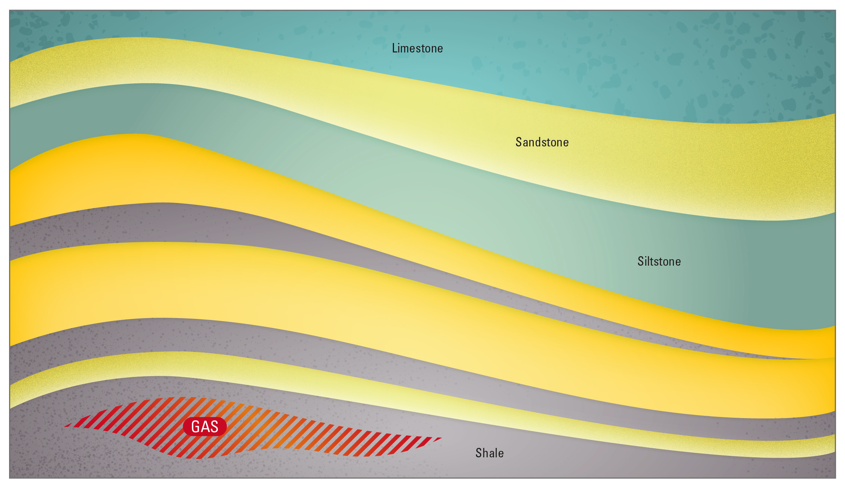
Figure 7.1 Shale gas schematic.
Shale gas is found in organic-rich fine-grained sedimentary rocks. Many shale gas and shale oil producing formations are not strictly shales, as the mineralogy of the reservoir is often dominated by quartz and calcite (e.g. Ottmann & Bohacs, 2014). A shale gas target formation is essentially the source rock component of a petroleum system. After first identifying that a target formation (shale/source rock) is present, it is important to establish the richness, quality and maturity of the unit/s.

Shale gas reservoir properties
The prospectivity of a shale gas play is reliant upon a number of geological considerations: the thickness of the formation and lateral extent, the depth to the formation, organic content (measured as TOC), kerogen type, thermal maturity, overpressure, and the brittleness of the formation as dictated by its mineralogy.

Organic richness
Hydrocarbons are mostly carbon (by molecular weight) and so the amount of carbon in a rock, to some extent, determines the ability of the rock to generate hydrocarbons. A measure of the organic richness of a rock is known as TOC (Total Organic Carbon). A guide to the richness of a source rock according to TOC is given in Table 7.1.

Table 7.1 A guide to organic richness in shales as given by TOC. (After Law, 1999).
Generation potential | Wt% TOC, Shales
Poor | 0.0 – 0.5
Fair | 0.5 – 1.0
Good | 1.0 – 2.0
Very good | 2.0 – 5.0
Excellent | >5.0

Kerogen type
Organic matter is transformed into kerogen over time, at greater burial depths and with increasing temperatures. The type of kerogen that forms depends on the original depositional environment of the organic matter. Sediments may be deposited in either the terrestrial or marine realm. Organic matter derived from terrestrial versus marine environments determines whether a source rock is more likely to generate oil or gas.
Kerogens are classified into four types (Table 7.2). The more hydrogen in the kerogen, the more likely it is to generate oil, and the higher the quality of the kerogen (Law, 1999). Type I kerogen is mainly oil prone but is uncommon; although the largest oil shale deposit in the world - the Green River Formation in the US has Type I kerogen. Type II kerogens can produce oil or gas depending on temperature. Type III kerogens are derived mostly from plant debris deposited in terrestrial settings and are gas prone. Most coals contain Type III kerogen. Type IV kerogen has little potential for generating oil or gas. A source rock may contain one or a mixture of kerogen types. Source rock characterisation studies rate the hydrogen content (and hence kerogen type) by a hydrogen index (HI) and oxygen index (OI) derived from careful measurement of material given off as a lab sample is heated through the generation phase (pyrolysis).

Table 7.2 Kerogen types. (After McCarthy et al., 2011 and Law, 1999).
Kerogen type | Predominant hydrocarbon potential | Amount of hydrogen | Source material | General environment of deposition
I | Oil | Abundant | Mainly algae | Lacustrine (lake)
II | Oil and gas | Moderate | Mainly plankton, some contribution from algae | Marine
III | Gas | Small | Mainly higher plants | Terrestrial
IV | Neither | None | Reworked, oxidised material | Various

Thermal maturity
Rock exposure to heat over time changes the chemistry of organic matter, and that change or ‘thermal maturity’ can be measured by vitrinite reflectance (expressed as Vr). Vitrinite is a one of several components of coal (known as macerals) found in buried organic matter. As the organic matter becomes thermally mature with burial and increasing temperature it devolves volatile components (i.e. oil; and at higher temperatures, gas) and the molecular structure of the remaining organic matter, including the vitrinite, becomes increasingly well-ordered and hence more reflective to light. Reflectance is measured on a polished surface of vitrinite in a sedimentary rock sample immersed in oil (ASTM, 2011). Other measures of maturity exist, and with care can be related back to vitrinite reflectance.
Source rocks within certain ranges of thermal maturity (expressed as vitrinite reflectance) are said to be immature, or within the oil or gas windows, or over-mature. The gas window is taken as a Vr of between 1.2% and 3%. The state of thermal maturation is as important as organic richness in determining the effectiveness of shale as a source rock and as a shale gas target. The depth range of the gas window and its lateral extent within a potential shale gas target are important constraints on prospectivity.

Identification of source rocks in Gippsland
There has been no effort to identify and map source rocks with shale gas potential in Gippsland. The stratigraphic and geographic extent of any potential shale gas play is unknown in the onshore Gippsland Basin and in the South Gippsland region. The data available is derived from source-rock studies in support of conventional exploration.
A number of wells that have intersected the Strzelecki Group have drilled through thick shales or shaly sequences (e.g. Megascolides-1 and Tarwin Meadows-1 drilled in South Gippsland). Re-examination of the logs and core and cuttings samples (where they have been acquired) might identify potential shale gas target units in the Strzelecki Group.
In their source rock analysis of onshore Gippsland samples, Mehin & Bock (1998) found that Strzelecki Group source rocks were organically richer than overlying Late Cretaceous samples; although it is unclear from the analysis, which types of lithologies were analysed. The Megascolides-1 terrestrial plus algal
source as described in Grosser (2005) is consistent with the findings of Mehin & Bock (1998). Maturity
within the Strzelecki Group was found to increase away from the North Seaspray area at the coast towards the inland locations Loy Yang and Rosedale. Potentially, thermal maturity data from the Wombat, Trifon
and Gangell wells (that were drilled after this analysis) could be integrated into the dataset to confirm the observed trends.
Mehin & Bock (1998) noted that previous onshore wells encountered potential Strzelecki source rocks with a range from 0.21 to 26.83 wt% TOC, with vitrinite reflectance in oil (Ro) values of 0.35-1.04% and HI values from 23 to 179 mg hydrocarbon (HC)/g TOC. These values are wide ranging and without knowing the individual lithologies and their place within a stratigraphic framework, it is difficult to draw any conclusions about shale gas potential.
Although the Late Cretaceous Emperor and Golden Beach subgroups have been identified in the Seaspray Depression (Bernecker & Partridge, 2001), the fluvio-deltaic facies of the Chimaera and Curlip formations would seem unlikely hosts for thick potential ‘shale gas’ sequences. However, fluviatile shales of Late Cretaceous age have been interpreted as a source of oil generation in the offshore Gippsland Basin (Burns et al., 1984). These shales are located much deeper, at 3900 m, than the same aged sequence onshore.

Coal seam gas
There are currently no known coal seam gas accumulations in the Gippsland region. With only a relatively small number of holes drilled for the purpose of coal seam gas, exploration and evaluation of the resource potential in Gippsland is at a very early phase. The only test to date in Gippsland for coal seam gas was undertaken by Karoon Gas in 2004 when they drilled Megascolides-1 to test separate coal seam gas and conventional gas plays.
Both black and brown coal seams are found in the rocks of the Gippsland region. Black coal seams are older and are part of the Early Cretaceous Strzelecki Group. The brown coals of the Gippsland Basin and Latrobe Valley are younger (Eocene to Miocene) and are named, from oldest to youngest, the Traralgon, Morwell and Yallourn seams.
The most extensive known black coal deposits in the Gippsland region are found across, and adjacent to,
a feature that is named the Wonthaggi Basement Ridge. The ridge, between Wonthaggi and Korumburra, hosts coal deposits that occur at or near the surface. Most of these coal deposits were discovered and extracted in the late 1800s and early 1900s. Drilling undertaken at this time, throughout the region’s
early industrial history, provides much of what is understood today about the distribution of black coal
in the region.
Brown Coal is synonymous with the onshore Gippsland Basin and in particular the Latrobe Valley, which generates more than 43 000 gigawatt hours of electricity (BREE, 2014; NEM, 2014) for the State of Victoria (accounting for more than 80% of the State’s electricity output) from vast shallow coal deposits of the Oligocene to Miocene Yallourn and Morwell Seams. The underlying Traralgon seams are, for the most part, too deep to mine at the surface but are considered to have potential for coal seam gas (Holdgate, 2003).

Formation of coal seam gas
Coal seam gas (CSG), also called coal bed methane, refers to naturally occurring methane in coal seams. The coal; mainly decomposed and essentially fossilized plant material, acts as the reservoir for the gas and the gas is itself generated within the coals. So the coal is both the source of the gas and the reservoir or storage unit for the gas (Figure 8.1).
Gas can be generated in one of two ways – either by biogenic processes, where microbes convert the coal into methane, or by thermogenic processes where heat drives chemical changes in the coal to produce methane. Biogenic and thermogenic processes are explained in more detail in Appendix 1.
Most gas in coals is stored by holding on to (or by being adsorbed on to) the coal surfaces and trapped by water pressure. When water pressure is reduced, gas will flow from the higher pressure area to the lower pressure area. This technique is used to allow the gas to flow towards a well where it is produced.
The permeability of the coal (how well the pores and gaps within the coal are connected) is of great importance because no amount of gas trapped in coal will be released unless there is a path for it to flow from between the organic particles of the coal. Permeability tends to decrease with depth in the subsurface because rocks deeper down are compressed under the weight of rocks above, but shrinkage of the coal with maturation can lead to small fractures (known as cleats) that can provide permeability. Further discussion on how gas is stored and moves in coal is presented in Appendix 1.

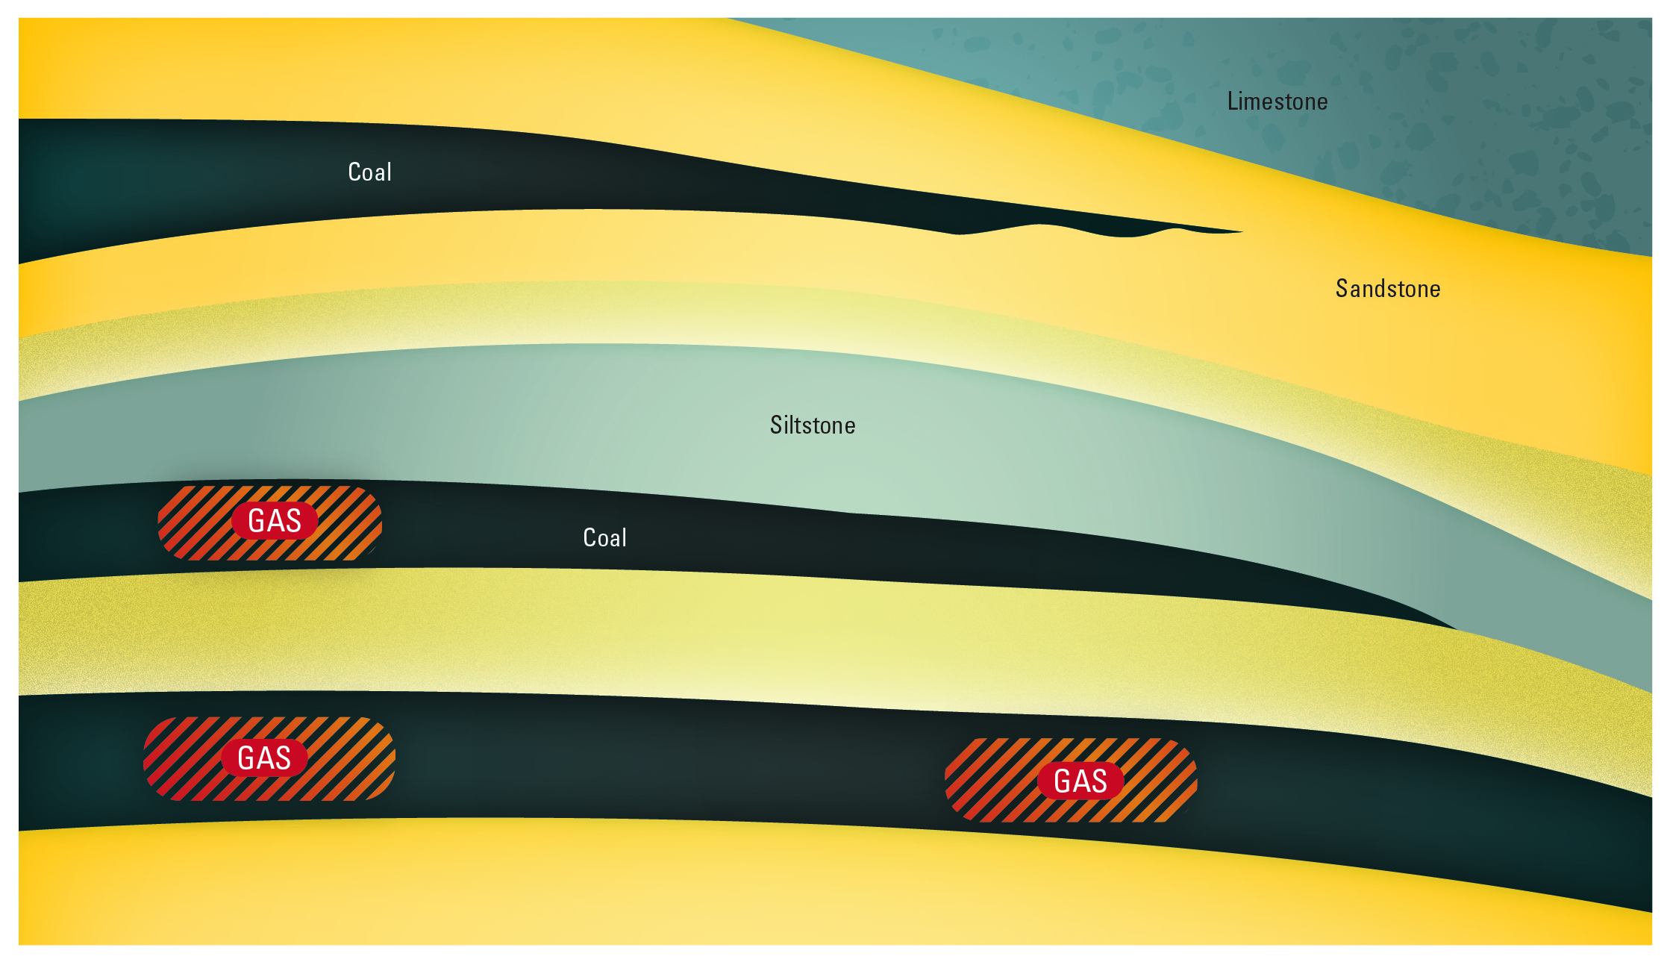
Figure 8.1 Coal seam gas schematic.

Coal properties
Coal is composed largely of organic matter, with some sedimentary particles like silt or clay (referred to as the ash content) and moisture (water trapped in the coal).These components and their constituents (e.g. carbon, hydrogen, oxygen and volatile matter) can all be measured via laboratory analysis. Coal composition can be quite variable, affecting the quality of the coal and, as a consequence, its potential use.
Coals form from the deposition and burial of plant remains. The geological time period and prevailing environmental conditions influence the type of plant materials that grow and are deposited, and in turn determine the internal composition of the coal. Coals are composed largely of a variety of microscopic constituents known as macerals, essentially like minerals in rocks. Different macerals give rise to different internal compositions within the coal, changing the ability to form gas and the potential to produce gas.
The depositional environment also influences the distribution of coals in a rock sequence; whether the coal is widely distributed or limited in its extent; whether the seams are thick or thin; whether there are many closely stacked seams vertically or few separated by a lot of inter-seam (inorganic) material; and whether or not the seams are connected.
To what extent coal formation has occurred is also important. This is reported as coal rank (Figure 8.2). Rank is a product of the chemical and physical changes that take place within the organic matter in the coal over time and with increasing temperature. As the coals are more deeply buried and exposed to higher pressures and temperatures, the rank increases. When the coal rank has increased to anthracite all gas has been generated and is no longer in the coal; the coal is then said to be “overcooked”. Lower ranked coals have high moisture content whereas the highest ranked coals have lost their moisture. The capacity of a coal to hold gas generally increases with rank but the relationship is actually more complex and dependent on a number of variables (Moore, 2012). Lower rank coals such as lignite are more likely to present as a biogenic coal seam gas play, whereas higher ranked coals will tend towards thermogenic gas.
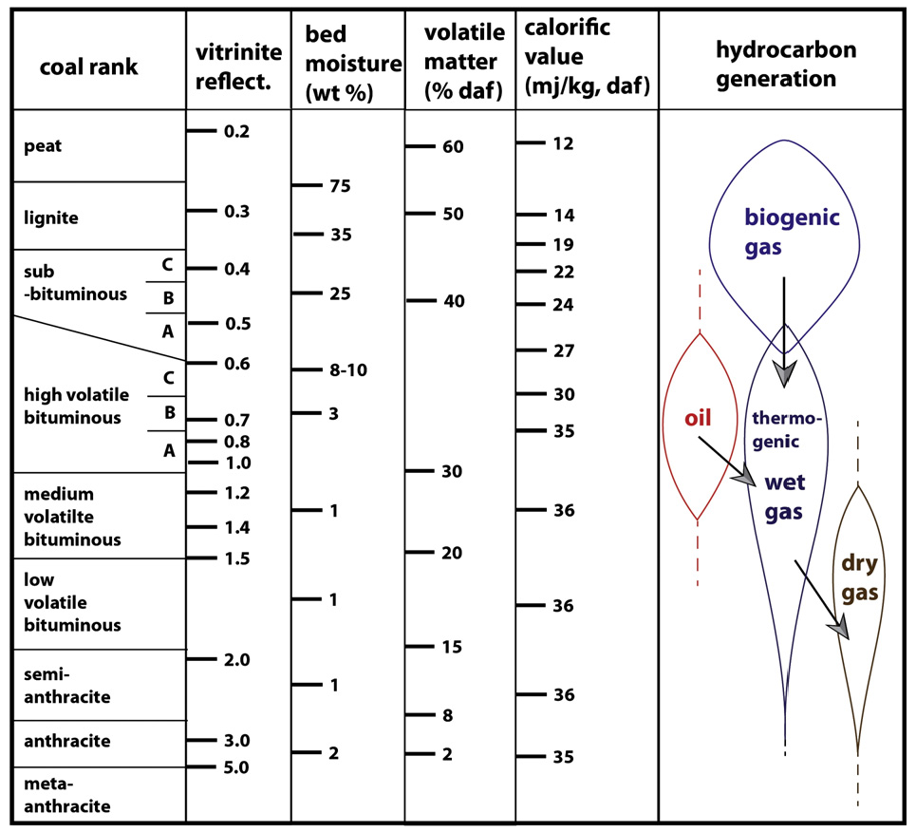
Figure 8.2 Correlation of different rank parameters, all approximate. (After Moore, 2012).
Coal rank can be defined in a number of ways. One of these is thermal maturity, a measure of which is vitrinite reflectance (expressed as Vr). Vitrinite is a type of maceral found in organic matter in coals. Reflectance is measured from a polished surface of vitrinite in a sedimentary rock immersed in oil (ASTM, 2011). Values which correspond to a coal rank suitable for coal seam gas range from about 0.2 to 2.0% (Figure 8.2).
The permeability and to a lesser degree, the porosity of a coal and the adjacent rocks, is a key variable in the recovery of coal seam gas. The porosity of a rock refers to the gaps or pore spaces between the grains where fluids or gas can reside. If those gaps or pore spaces are well connected, the rock is considered permeable. Permeability may also be created by fractures in a rock – that is microscale displacement within the rock sequence. In coals in particular, fractures known as cleats form in two sets perpendicular to each other and are known as face and butt cleats. They are important as they create both porosity and permeability in coal seam gas reservoirs.
Numerous different measurements of gas can be taken from a coal sample to assess suitability for coal seam gas production. The first of these is the gas type or quality (e.g. hydrocarbons such as methane versus inert gases such as CO₂ – the latter of no value for combustion purposes). Next is the measurement of coalbed gas content by the collection of freshly drilled coal samples and the measurement of gas emitted over weeks or months (gas desorption) as outlined in Seidle (2011). The gas content in cubic metres per tonne is compared with the coal sample’s ultimate gas holding capacity to determine the saturation. A saturated coal will begin to release gas immediately as the hydrostatic pressure of water is relieved, whereas an undersaturated coal will require greater removal of water pressure before gas production begins. The pressures at which gas production begins and ceases are important factors in the design of production equipment and in measuring the economic recovery factor.
In the absence of reliable desorption gas content measurements, the holding capacity, and other geological information may be used to estimate a possible gas content indirectly.

Coal seam gas from black coal
No coal seam gas accumulations have been discovered to date in the Early Cretaceous black coals of the Strzelecki Group in either South Gippsland or the onshore Gippsland Basin.
Most of the known coal deposits in South Gippsland are shallow – occurring at or near the surface. Data is sparse and comes from drilling activity around 100 years ago. Few modern deep wells have been drilled in the area. Tarwin Meadows-1 was drilled near Tarwin Lower in 1965, and more recently Megascolides-1 and -2 were drilled by Karoon Gas Ltd in 2004 and 2007. Megascolides-1 is of particular interest because it provides the only test of any coal in the Gippsland region for coal seam gas.
With so few deep exploration wells drilled and limited seismic data over South Gippsland, the understanding of the underlying basin structure and stratigraphy (and the coals within) is perhaps the most limiting factor in a review of potential coal seam gas from Strzelecki Group black coals.

Black coal seam distribution and thickness
The distribution and surface expression of black coal in South Gippsland is controlled by the north east striking Early Cretaceous basin forming faults (Holdgate, 2003). Most of the known black coal seams of South Gippsland are found at shallow depths (i.e. less than 400 metres) on or adjacent to subsurface Palaeozoic highs - the Wonthaggi and Tyers basement ridges. These include the coals of the Dudley and Kirrak basins at Wonthaggi, with smaller deposits at Kilcunda, Woolamai, Cape Paterson, Jumbunna, Outtrim, Kongwak and Korumburra (See Figure 3.1). Along the Tyers Basement Ridge are the small deposits located at Coalville, Mardan, Mirboo North, Yinnar South and Jeeralang Junction. Between the basement ridges are troughs, which make up a thick (i.e. greater than two kilometres) and more complete Strzelecki Group sedimentary sequence. The Wonthaggi coals represent the older part of the Strzelecki sequence and it is unknown whether or not the same coals are present in the troughs.
Although worked over through mining activity, the distribution of coals in the Kirrak and Dudley basins gives some indication of black coal distribution. The Kirrak and Dudley basins, occupy areas of 4.5 and 9.4 km² respectively. In the Kirrak Basin, two coal horizons were separated by up to 152 metres of sandstones and minor mudstone bands. The upper coal varied in its thickness but was up to 0.91 metres thick. Several thinner coals (10 cm to 15 cm thick) were also associated with this horizon. The lower horizon had only one coal seam with a maximum thickness in excess of 1.8 m (Edwards et al., 1944).
In the Dudley Basin, as many as eight separate coal seams were intersected by bores, with only two of the seams within a vertical thickness of about 305 metres considered of workable thickness at the time. The upper coal, in some places with a thickness of 3.4 metres, was worked over an area of 6.3 km². The lower coal was separated from the upper coal by 76 m to 91 m of sandstones and mudstone. It was thinner than the upper coal, with a maximum thickness of 1.2 metres, and extended over a smaller area (2.8 km²) and was mined out by 1942 (Edwards et al., 1944).

In contrast to the relatively laterally continuous coals of the Kirrak and Dudley basins, intense faulting
and intrusion by basaltic dykes truncated and compartmentalised other coalfields. Edwards et al. (1944) reported that more than 1,000 minor faults, with throws of from 0.6 to 7.6 metres were encountered in mine workings to 1944 within a total area of 13 km². The spacing of the faults was about 0.8 to 1.6 km apart, dividing the coal basins into roughly rectangular areas, each of which was compartmentalised and had to
be mined separately.
Coals were encountered in Tarwin Meadows-1 between 445 and 610 metres downhole; although it is difficult to ascertain individual seam thicknesses from the cuttings description (Laing, 1965).
Thin coals were observed by Grosser (2005) in Megascolides-1, mainly between 816 and 1160 metres downhole. From log analysis a total of 12.2 metres coal thickness was reported between 716 and 1098 metres. The seams ranged in thickness from 5 cm to 1.02 m with the most common thickness around 20 cm. A total of 43 individual seams were identified.

Physical characteristics
The Wonthaggi coals were described as alternating bands of bright and dull coal, of varying thickness (Edwards et al., 1944). Some bands and components (macerals) in the bright coals were described as having brilliant lustre and conchoidal fracture. Some of the coals intersected in the Tarwin Meadows-1 well were variously described as black and dull, some with sub-concoidal fracture, and others, bright with clean fractures and calcite vein material. In Megascolides-1, macerals from the inertinte group were commonly seen in coal samples (Grosser, 2005).
The air-dried moisture content of Strzelecki black coals is low: 5-10% moisture (Holdgate, 2003) and 2.9% (from Megascolides-1, Grosser, 2005). Volatile matter is recorded from 30 to 35% (Holgate, 2003) and 23.7% (Grosser, 2005).
The ash content of the Strzelecki black coals is variable. Traditionally low ash contents have been recorded (6-12%; Holdgate, 2003). However, Karoon Gas Ltd (Grosser, 2005) found their coal sample had an ash content of a much higher than expected 47.4%. Karoon’s predrill studies had shown that the documented ash content from mines and bores in the Narracan Trough were far lower. The high ash content and presence of many thin seams indicated potential coal seam splitting towards a major distributary channel with a higher sediment influx rather than the meandering fluvial depositional system interpreted at Wonthaggi (Medwell, 1954).

Black coal rank
The shallow Strzelecki black coals measured from outcrop have vitrinite reflectance values between 0.5
and 0.67% and are therefore considered high volatile bituminous coals in rank (Holdgate, 2003). Slightly higher vitrinite reflectance values ranging from 0.64% to 0.89% from a coal sample between 1039.25 and 1040.12 m in Megascolides-1 were consistent with a subbituminous to high volatile B bituminous coal rank (Grosser, 2005).

Coal seam gas measurements
A gas content derived from a Megascolides-1 coal sample taken between 1039.25 and 1040.12 m using an inverted, water filled measuring cylinder, resulted in a desorption gas content of 3.37 m³/tonne DAF (dried air free) over 2.45 days (Grosser, 2005). No calculation was made for gas lost in sample recovery or residual gas after desorption. The gas composition was essentially 100% methane with a small amount (0.01 Mol%) of carbon dioxide (Grosser, 2005).

Petrophysical analysis was also undertaken over the coal-bearing interval of 716.48 m to 1098.55 m (12.2 m black coal) using the PETROLOG CBM module to identify coal types and compute potential gas content (Grosser, 2005). These petrophysical calculations gave potential gas contents commonly at 289.8 SCF/ton
and up to 363.4 SCF/ton (8.1-10.1 cubic metre/tonne), which were substantially greater than from the one measured desorption sample. The discrepancy between the results of this analysis and the sample result would need to be confirmed by standard method sample desorption data from the Wonthaggi Coal Measures.
Mud log data from petroleum wells can give qualitative data on relative gas content (drill gas) and composition and are useful screening data for assessment of coal seam gas potential, but give no insight into coal permeability or potential coal seam gas productivity. In Tarwin Meadows-1, two minor gas shows and a strong gas show were recorded (Laing, 1965). The stronger show was associated with coarser sand, considered at the time as a potential conventional target, whereas one of the minor shows corresponded with a coal at the top of a coal-bearing sequence between 445 and 610 metres downhole. A thick shale-rich unit overlies the coals at this location.

Black coal permeability
The Strzelecki Group volcanoclastic sandstones are generally referred to as “tight”. That is, the sandstones exhibit very low porosity and permeability (as discussed in Section 6). The same observation has been made from deep wells drilled in the South Gippsland black coal bearing region. For example, Karoon Gas Ltd (Grosser, 2005) observed that the alteration upon burial of the Strzelecki Group volcanoclastic sandstones created very low porosity and permeability. No permeability measurements were taken during the drilling of Megascolides-1 to confirm these observations. The same is true of Tarwin Meadows-1.
Cleats were reported in coals around Wonthaggi (Edwards et al., 1944). The cleats were reported at intervals of less than 13 mm in the bright coal but were more widely spaced in the dull coal. The strike of the cleat ranged from 338° to 344°, an orientation which roughly parallels the present day compressional stress regime in the onshore basin (Nelson et al., 2006). This would allow cleat fractures to remain open, enhancing permeability and coal seam gas flow from the coal. In many parts of the Wonthaggi coalfield the cleat joints were lined with thin seams or films of calcite, reducing permeability.

Coal seam gas from brown coal
The Latrobe Valley and onshore Gippsland Basin is host to a very large and significant coal resource (430 billion tonnes, DEDJTR, 2015). Many of the Latrobe Valley coal fields are found at or near the ground surface but older seams are intersected at greater depths in the onshore Gippsland Basin, in particular, within a portion of that area known as the Seaspray Depression. This area, and the coal seams hosted within, has been a target for coal seam gas exploration in recent years. It is the size of the resource, the lateral extent and thickness of coal seams that is attractive to coal seam gas explorers. Estimates of around 335 billion tonnes of in situ brown coal below the areas currently mined (Holdgate et al., 2000) have provided sufficient motive to attract companies to explore for coal seam gas since 2001.
To a large degree, the distribution - extent and thickness of the Traralgon coal seams is known (Holdgate et al., 2000; Langhi et al., 2014), although there is some complexity in the stratigraphy that remains unresolved and is worthy of further investigation.
Routine laboratory analysis of brown coals intersected above 300 m in Gippsland provides useful coal quality data for mining purposes but this data has not been collected from coals below this depth. Therefore, useful coal quality data from the Traralgon coals is absent, along with additional data that could provide information about the coal as a coal seam gas reservoir.

Traralgon coal seam distribution and thickness
The Traralgon brown coal deposits are extensive, stretching from offshore of Sunday Island in the south to Lake Victoria in the north; essentially underlying the entire Gippsland Basin and the Latrobe Valley (Holdgate et al., 2000). A number of Traralgon coal seams are recognised and mapped across the onshore Gippsland Basin. The standard nomenclature divides the seams into T0, T1 and T2 seams with the former being uppermost in the sequence. Holdgate et al. (2000) further divided T0 from a-c, T1 from a-d and T2 from a-e. Although this subdivision is not widely used, is suggestive of the complexity hidden within the accepted simplistic scheme.
The Traralgon seams are intersected at depths between 30 and over 1000 metres below the ground surface in the onshore basin; some individual seams may aggregate to form a total thickness between 100 and 150 metres. Langhi et al. (2014), drawing on the work of Holdgate et al (2000) and a facies model created from geophysical log data, mapped the net thicknesses for all Traralgon coal seams (T0, T1 and T2) where the seams were greater than 3 m thick in the Seaspray Depression. The overall net thickness for all seams is greatest to the west and the north-east; decreasing to the east-south-east – offshore (Figure 8.3).
The depths at which the Traralgon seams are intersected increases towards the coast. For instance, in the parish of Wulla Wullock in the Seaspray Depression, bores intersect over 800 metres of Sale and Seaspray group sediments before reaching the uppermost Traralgon seam.
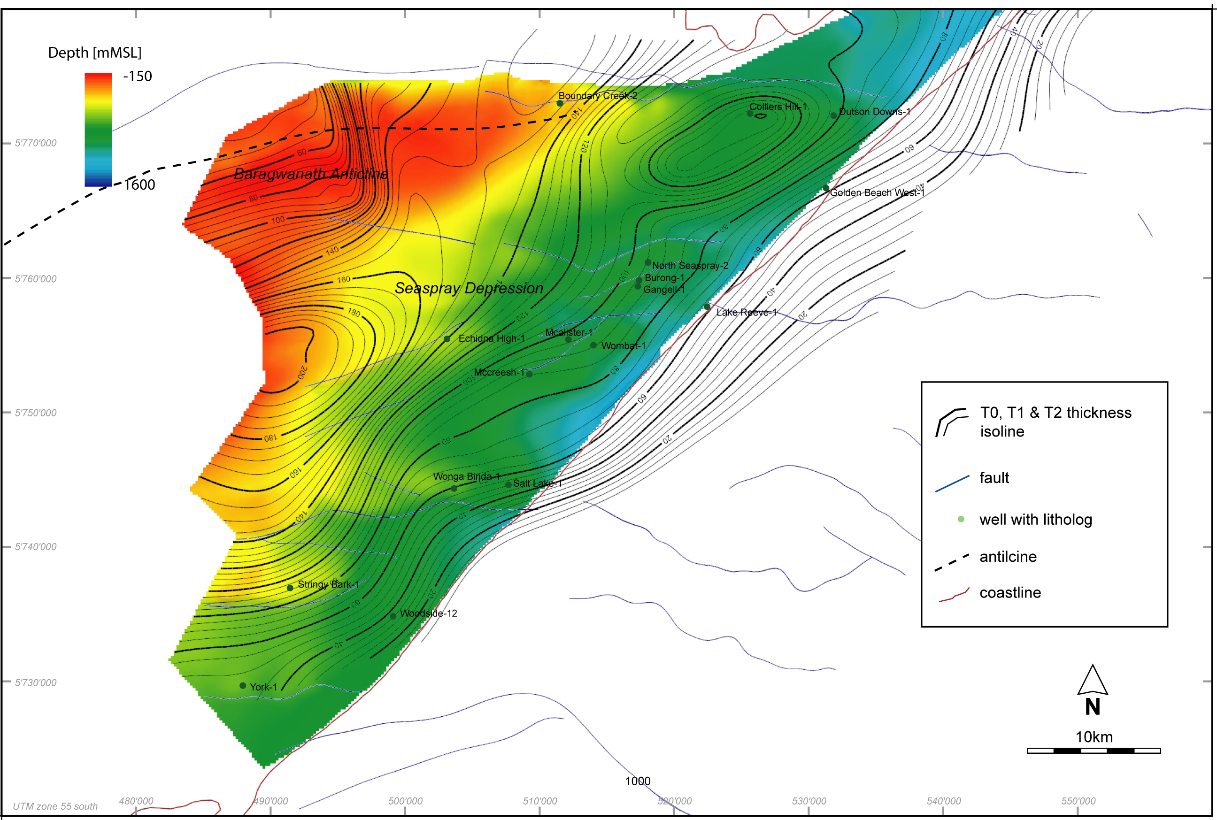
Figure 8.3 Net thickness of the T0, T1 and T2 coal seams in the Traralgon Formation. The thickness isolines (modified from Holdgate et al, 2000) overlie the top of the Traralgon coal sequence (i.e. top Latrobe Group merged with the base of the Dutson Sandstone member). Negative and positive values represent height above and below mean sea level, respectively (Langhi et al., 2014).
Using data from over 9000 bore intersections in the onshore Gippsland Basin and the Latrobe Valley, GHD (on behalf of the Department) built a model of all brown coal seams across the region. Outputs from that model are available as surfaces for viewing and downloading (GeoVic, 2015). The Traralgon coals (T0 and T1) are divided into upper, mid and lower seams and T2 divided into 2a and 2b seams. Roof and floor contours are available for all seams. Further validation of the model, including a quality check of the borehole input data, is required to further improve the outputs.
To enable coal seam gas production modelling, a static sedimentary facies model was constructed for the southern part of the Seaspray Depression (Ricard & Strand, 2014). Four sedimentary facies were defined from 11 gamma ray logs across the model domain: 1. Coal, 2. Channel (sand), 3. Crevasse splay (silt) and
4. Background (mud). As for other fluvio-deltaic depositional systems, coal seam and aquifer connectivity is high and where sealing units are present, they are discontinuous (Richard & Strand, 2014). The high percentage of sand in the system is particularly evident in a cross-section through the Seaspray Depression (Figure 8.4).

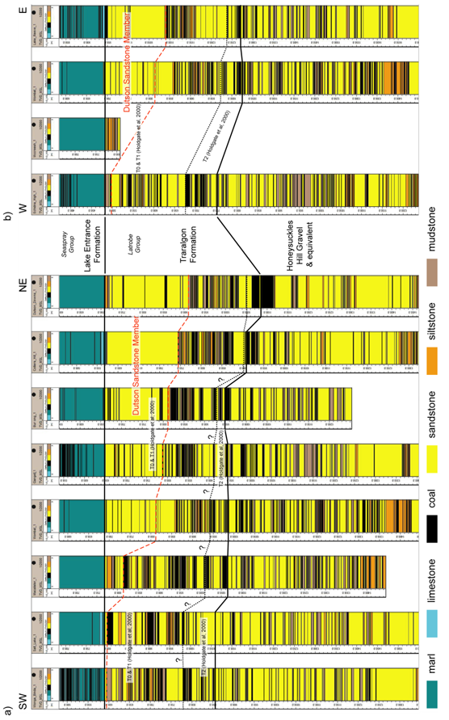
Figure 8.4 Cross-section showing wells across the Seaspray Depression (N.B. wells flattened at the top of the Latrobe Group) (Langhi et al., 2014).

Physical characteristics
The brown coals of the Latrobe Valley are divided into five lithotypes based on physical appearance when dry: colour, texture, degree of gelification, weathering pattern, and other supplementary physical properties. The lithotypes are: Pale, Light, Medium-light, Medium-dark and Dark (George & Mackay, 1991).
The moisture content of the Yallourn, Morwell and Traralgon coals ranges from 50 to 70% (Gloe, 1984). Values extracted from the Latrobe Valley coal model (Table 8.1) show that the Traralgon coals at shallow depths (<300 m) are at the lower end of the range. Gloe (1984) remarked that the few samples analysed from the Traralgon seams had a much lower moisture content, at about 30%.
Table 8.1 Average values for Traralgon coal seams.
Seam  (coal model) | Mass  (tonnes) | Moisture  % (DAF) | Volatiles  (%) | Fixed carbon  (%) | Ash content  (%)
TRU | 52846 | 52.66 | 47.50 | 64.22 | 9.75
TRM | 24724 | 52.50 | 46.92 | 64.01 | 16.55
TRL | 34036 | 51.05 | 46.70 | 64.15 | 8.82
T2A | 34832 | 52.38 | 47.19 | 64.95 | 4.18
T2B | 18867 | 51.40 | 46.64 | 64.82 | 5.58
Note: Data from the Traralgon seam database; polygon encircling Seaspray Depression; the deepest sample from 296 m had a moisture content of 46.5%.

Traralgon brown coal rank
There is an increase in vitrinite reflectance values in Merriman-1, North Seaspray-1, Burong-1 and Seaspray-1 where the coals are intersected deeper in the sedimentary sequence (i.e. values of 0.39 and the highest, 0.51, aligning coal rank with the sub-bituminous C to A range). At some of these depths (e.g. 1200 m), the permeability of the coals is expected to be too low for coal seam gas retention and production. Sander & Connell (2014) estimated a vitrinite reflectance between 0.35% and 0.38% for Latrobe Group coals at around 900 metres depth, which suggests that the coals are immature for thermogenic gas (see Figure 8.3).

Gas indications
Mud log and FIS data from the onshore Gippsland Basin indicate the presence of naturally occurring methane within the sedimentary sequence, in particular within the Latrobe Group. For the Traralgon coals within the Latrobe Group there are no gas content data (desorption, sorption or saturation).
In order to model potential field-scale coal seam gas production of the Traralgon coal seams, Sander & Connell (2014) estimated a range from 0.3 m³/t and 3 m³/t based on brown coal analogues from New Zealand, Sumatra and India. A value of 3 m³/t was used for their modelling because a gas content below this figure would not be considered commercially viable in Australia given the current cost base and current technologies (Sander & Connell, 2014).

Permeability in Traralgon brown coals
Coals in the Traralgon Formation act as aquitards as established by Schaeffer (2008), who used a conductivity of 1 x 10⁻⁶ m/day (0.001 mD) for the Traralgon coals. As a comparison, the sandy interbeds were represented by a conductivity of 5 x 10⁻³ m/day (6 mD). As these are average values, the actual range of values across heterogeneous coal sequences will be higher and lower. From a compilation of permeabilities it is clear a range of values exists but that values less than 1 mD (0.001 m/day) prevail (Table 8.2). Woskoboenko et al. (1991) quoted values of 0.01 mD to 100 mD for the Latrobe Valley coal seams with zones of higher permeability encountered across the Loy Yang dome.
Table 8.2 Compilation of reported conductivity values (m/d). (After Beverly et al., 2015).
 | Author
Seam | Schaeffer (2008) | SKM (1999, 2001) | PDA (2006) | USQ (2011) | Aquaterra (2008) | Harlow & LeCain (1993) | DPI (2009)
T1 | 1 x 10-6 to  5 x 10-3 |  | 0.015 to 0.1 | 0.0005 to 1.36 | 0.04 | 6 x 10-5 to 1.8 x 10-1 | 0.0025
T2 | 1 x 10-6 to  5 x 10-3 | 1.1 x 10-6 to 3.56 x 10-6 | 0.015 to 0.1 | 0.0005 to 1.36 | 0.04 | 6 x 10-5 to 1.8 x 10-1 | 0.0025

Geological uncertainty
There are many uncertainties that apply to the potential for natural gas resources across both South Gippsland and the onshore Gippsland Basin. A lack of fundamental geological data and knowledge restricts the understanding of the underlying structure and stratigraphy of South Gippsland, which in turn limits the ability to draw solid conclusions about the presence or absence of natural gas resources in the region. Some inferences can be made about resource potential from early coal exploration efforts and a very limited number of wells, with Megascolides-1 drilled by Karoon Gas in 2004 providing the greatest insights to date in the region.
In the onshore Gippsland Basin, a long history of petroleum and coal exploration has resulted in the acquisition of a significant amount of data but most of the acquisition was focused on the Latrobe Group and so is of limited value in the evaluation of the Strzelecki Group across the region. It is therefore often by chance that the same data may be relevant to the assessment of unconventional resources.
Some unconventional gas plays demand a more advanced knowledge of the geological framework, such as a depositional facies model. Where relevant basic data – seismic surveys, geophysical logs, and core and cuttings, along with laboratory analysis, have been acquired, opportunities exist to develop this knowledge but such work has yet to be directed at unconventional resources.
For some gas play types, physical parameters as yet unmeasured may be so significant that the presence or absence of a potential resource of any significance is entirely uncertain (for example, the lack of gas content and permeability data for the Traralgon coal seams).

Broad geological uncertainty
Drilling from 50 years ago provides an example of the uncertainty associated with the structural geology of the Gippsland region, specifically South Gippsland. Tarwin Meadows-1 was drilled in 1965, 7.5 kilometres from outcropping Palaeozoic basement. Alliance Oil Development Australia expected to drill through the entire Strzelecki Group sequence, but the well reached a total depth of 1203 metres in the Strzelecki Group without reaching the basement. At this depth the equipment used was at its physical limit, preventing
further drilling.
The underlying Palaeozoic structure and basement geometry is yet to be resolved. Structurally deformed Early Cretaceous sedimentary rocks (the Strzelecki Group) sit atop a structurally deformed Palaeozoic basement. To unravel the complexity of the underlying geology requires regional scale acquisition to advance the understanding of the structural framework. Field observations provide some understanding but as with most geological problems, it is subsurface data that is ultimately required. A number of seismic transects across South Gippsland might define the presence or absence of the Strzelecki Group and its thickness, and provide some information about the geometry of overlying units where present.
A gravity infill survey completed across South Gippsland (Matthews & McLean, 2015), when coupled with existing gravity data and sparse rock density data will provide a modelled surface that best approximates the underlying Palaeozoic basement terrain (Carstairs et al., in prep). This modelling will improve the understanding of the underlying structure of the South Gippsland subsurface.
With scarce seismic data acquired over South Gippsland to date (in a small area to the northwest) and much of that being directed at Latrobe Group features rather than the deeper Strzelecki Group, the uncertainty in the underlying geological structure across the whole Gippsland region is significant.

Delineation of formations of interest
Past geophysical surveys and drilling may help to identify a geological unit (its presence or absence) but the detailed stratigraphic knowledge of the sedimentary succession may be lacking. There may be some reasons for this: for example, the data is available and of sufficient quality but it has not been studied or the data is available but the quality is insufficient to support detailed analysis. Some examples pertinent to the current review of the Gippsland region are provided below.
There is no existing 3D geological framework model of the onshore Gippsland Basin. Some interpretation was carried out by 3DGEO in 2009 for the Geological Survey of Victoria, but the surfaces created and subsequently depth converted (McLean & Blackburn, 2013) are restricted to the offshore basin. Modifications to the stratigraphic nomenclature of the offshore basin (Bernecker & Partridge, 2001), to some extent apply to the onshore portion of the basin. Reconciliation of modern and historical naming and identification of the onshore Latrobe Group subunits is required. Until that mapping work is carried out, uncertainty in the Latrobe Group geology limits the understanding of conventional and coal seam gas plays in the onshore Gippsland Basin.
In South Gippsland, some data regarding black coals is available from early shallow coal mine drilling and a few more recent wells. For the Strzelecki Group black coals, while some coal distribution and quality data exists, gas content and saturation is estimated at best. Furthermore, data is restricted to a few well-explored geographic regions such as the area on and adjacent to the Wonthaggi Basement Ridge.
The uncertainty related to prospectivity in this instance is the lack of definition of the extent of seams and their thickness, coupled with the depth to coal seams and the connectivity of the seams.

Specific rock characteristics
Once regional structure and target formation distribution are known, specific data about source rock, reservoir and sealing unit characteristics is required. Above all, proper measurements of gas content and permeabilities in both brown and black coal units is required.
In the Gippsland region, little of the data previously acquired specifically targeted unconventional plays. While previous studies such as Holdgate & McNicol (1992), Chiupka (1996), Mehin & Bock (1998), Bernecker & Partridge (2001) and Goldie Divko et al. (2009) provide some insights into potential reservoir distribution and characteristics, some of these studies were undertaken long before unconventional gas was envisaged as prospective in the Gippsland region, and most were completed with traditional style conventional plays in mind, even if for the purpose of geological carbon storage.
Using existing data it is possible to better understand the characteristics of target formations through log analysis and laboratory analysis of core and cuttings samples. The latter is sometimes not applicable because useful analysis of dried, ageing coal samples are limited and sometimes the coarse-grained nature of samples (i.e. conventional porous and permeable reservoir samples) is such that regular analysis is not possible.
Miranda et al. (2011) outlined some specific examples to further characterise the reservoir characteristics of the Strzelecki Group tight gas play in Gippsland.
- Mineralogical assessment of various intervals within the Strzelecki Group, using techniques such as Ammtec’s Automated Mineralogical Analysis (AMA). This would provide information as to the specific mineralogy within the formation and how it may impact gas extraction and thus overall reservoir quality.
- Porosity and permeability assessment from cores and petrophysical (log) data of tight gas intervals within the Strzelecki Group. Detailed porosity and permeability data from cores provide information regarding the physical properties of selected tight gas intervals, and these cores can also be used to assess the geomechanical properties of the formation.
- Geochemical evaluation and hydrocarbon family typing of Strzelecki Group gas samples across the onshore and nearshore parts of the basin. This could provide information that would help to better understand regional gas migration pathways and the charge history of the hydrocarbon system.
- Reservoir simulation models of the Strzelecki Group to increase the understanding of the lateral and vertical distribution of potential tight gas sand targets in a regional context.
- Evaluation of both regional and local pressure or stress conditions and their effect on hydraulic fracture development. This would provide information that might assist in determining the distribution and orientation of fractures.
- Fracture simulation studies and geomechanical assessment of selected intervals within the Strzelecki Group (using, for example, Formation Micro Imager data – borehole images). Cores could be used to illustrate and assess both the physical properties and the behaviour of the formation under proposed fracture stimulation conditions.

Gas prospectivity
There is some prospect of finding conventional and/or unconventional gas in the onshore Gippsland Basin and in South Gippsland. Past drilling has shown that there is gas present but a commercial quantity of gas from the region has not been produced. An estimated 1.7 Tcf of tight gas in the Wombat, Trifon and Gangell fields (Campbell, 2009) and a potential 3.7 Tcf of coal seam gas in the Traralgon Formation within the confines of EL4416 (IER, 2014) represent the current state of exploration for, and definition of, gas resources in Gippsland. For this reason it would appear that tight gas and coal seam gas are the most prospective gas types in Gippsland. Significant geological uncertainty remains at this time (for example, the unknown gas content of the Traralgon coal seams).

Conventional gas
The most prospective area for conventional gas in the onshore Gippsland Basin is the Seaspray Depression where the thickest sequence of the Latrobe Group is encountered. With a greater thickness there is an increased probability of intersecting seal and reservoir pairs trapping hydrocarbons within the Maastrichtian to early Eocene Halibut Subgroup, below the traditional top Latrobe Group conventional play (i.e. Chiupka, 1996). Numerous offshore fields with oil and gas at the top of the Latrobe Group also have intra-Latrobe accumulations.
With the Late Cretaceous (Turonian to Campanian) Emperor and Golden Beach Subgroups identified in some wells close to the coast (Colliers Hill-1, Dutson Downs-1 and Merriman-1) there is some possibility that hydrocarbons may be intersected in these strata, also within the Seaspray Depression. Gas shows at this stratigraphic level in Dutson Downs-1 confirm that hydrocarbons have migrated into the Golden Beach Subgroup (Chiupka, 1996). Offshore, gas in the Kipper field is found in the Chimaera Formation of the Golden Beach Subgroup, while the Longtom field gas is reservoired in the Curlip Formation of the Emperor Subgroup.
In the South Gippsland region, the only prospective target for conventional gas is at the base of the Strzelecki Group where post-rift alluvial deposits have better porosity and permeability than the overlying volcanoclastic sandstones. The well Megascolides-1 encountered these sandstones with high gas readings and oil shows. However, the distribution of these sandstones is unknown, although postulated by Chiupka (1996). Megascolides-2 drilled only one kilometre away from Megascolides-1 failed to intersect the sandstones, demonstrating the enormous cost brought to bear on a project by geological uncertainty.

Tight gas
The two current permit holders in the onshore Gippsland Basin, Lakes Oil and Icon Energy, are seeking to target gas in the Strzelecki Group over the Seaspray Depression.
The reservoir characteristics of the Wombat field tight gas sands compare favourably in terms of porosity, permeability and environments of deposition, with those of sands within US tight gas basins. Although
some natural fractures are present within the Strzelecki Group (Short & Mulready, 2001), it would seem that fracture stimulation treatments would be required in order to establish and maintain commercial flow rates (Lakes Oil, 2012). Average production flow rates for gas per well are likely to be considerably lower than
for conventional gas wells and numerous wells would be required within each prospective field (Miranda
et al., 2011).
It is clear that recoverable gas (and oil) are present within the fields delineated by Lakes Oil in PRL2. Commerciality of that recovery has not been determined. It is also worth considering whether or not the tight hydrocarbon plays encountered in the Seaspray Depression fit the classification as described by Shanley et al. (2004) where the tight reservoirs are confined to structures rather than continuous tight basin-centred gas across wider areas.

Shale gas
In the United States, the most successful shale oil plays (which also have associated shale gas plays) have a number of similarities. These plays have concentrated Type II kerogen in marine strata, present-day total organic carbon (TOC) above 2%, a net thickness of TOC-rich rocks of more than 20 metres, thermal maturity in the oil window (for oil, with shale gas reservoirs being overmature oil source rocks), a brittle lithology that can sustain fractures, abnormally high fluid pressures, and a tectonic history conductive to oil retention.
From the limited information available, the shale gas prospectivity across the Gippsland region is almost impossible to determine. Although shale-rich units have been encountered in onshore drilling, there is limited source rock data that can be tied directly to geological units. In the absence of a geological framework model of the Strzelecki Group and the Late Cretaceous Golden Beach and Emperor subgroups onshore, it is difficult to make any meaningful comment about the lateral extent of potential shale gas units.
In comparison to large shale gas plays in the US, such as Eagle Ford and the Barnett Shale which have marine derived Type II kerogen, Gippsland source rocks are of terrestrial origin. TOC-rich rocks are present in both the Early and Late Cretaceous sequence in the onshore Gippsland Basin, but their associated lithologies would require further investigation.
Most shale gas plays are found in organically rich mudstones (Ottoman & Bohacs, 2014) where there is decreased clay content and quartz and calcite are increased, increasing the brittleness of the formation. The mineralogical composition of two samples from the Strzelecki Group in the Seaspray Depression (Darriman-1 at 1440 m and Carrs Creek-1 at 1633.8 m) were determined using Automated Mineral Analysis (Hamilton & Ly, 2009). Both samples had very little carbonate component and less than 30% quartz each. These samples were specifically tested for a geological carbon storage project, and were no doubt selected on the basis that they may contain a higher clay component. If these samples are representative of the formation then these may not be brittle enough to fracture stimulate to enhance gas production. However, if these samples represent units within the Strzelecki Group with a high clay content and reduced clay percentages are found elsewhere in the formation, then the formation may be brittle enough.

Coal seam gas
Black coal seams in South Gippsland and brown coal seams in the onshore Gippsland Basin may have coal seam gas potential. Brown coal seam distribution is generally known and the coal thicknesses in the onshore Gippsland Basin are substantial, but whether or not there is gas present is unknown. Black coal seams in South Gippsland have a known gas content (one value) but the distribution of deeper coals away from basement ridges where historic mining took place, is unknown. The black coal seams are thin, sparse, and through faulting and thickness changes, are irregularly distributed. Permeability is unknown.

Brown coal
Techno-economic modelling undertaken by CSIRO shows that at base case reservoir parameters (permeability of 10 mD and an assumed gas content of 3 m³/t) at a price of 7 AUD$ per GJ coal seam gas recovery would not be commercially viable. For production to be commercial the target coal seam reservoir would have to have a higher gas content (4 m³/t) or a permeability of at least 100 mD. Sander & Connell (2014) also found that a play could be economic if the reservoir permeability was lowered (1 mD) but the gas content was increased to 8 m³/t. Given that gas derived from biogenic production does not generally exceed 4 – 6 m³/t (Moore, 2012), the latter scenario is unlikely. At a lower gas content than 2.5 m³/t even a high permeability of 1000 mD would not result in a profitable coal reservoir.
The brown coals of the Gippsland Basin are often compared to the coals of the Powder River Basin in eastern Wyoming, USA. Typical in-situ coalbed gas content for the Powder River Basin is low (0.62 - 1.4 m³/t, Seidle, 2011) and the permeabilities are relatively high (35 - 500 mD) (Advanced Resources International, 2002); the latter of the two parameters accounting for the viability of the play.
In a heat flow modelling study, lower than predicted temperatures were measured in water bores in the onshore Gippsland Basin (Harrison et al., 2012). Cooler water from recharge into the basin may be flowing through the coals, reducing the temperature. The water may also introduce nutrients into the system that may have implications for coal seam gas potential (i.e. an increase in potential for biogenic methane).

Black coal
Karoon Gas Australia drilled Megascolides-1, located on the Northern Terrace of the Narracan Trough along the northwestern edge of the onshore Gippsland Basin, in 2004. Megascolides-1 was the first deep, modern exploration well to be drilled in the area as a combined coal seam gas and conventional hydrocarbon test of the Early Cretaceous Strzelecki Group.
Grosser (2005) drew some comparisons between the Strzelecki Group black coals intersected in Megascolides-1 and the coals of the San Juan Basin, which straddles New Mexico and Colorado in the United States. Traditionally gas in the basin has been produced from fractured sandstones, but since the 1970s-1980s, production from coal seam gas reservoirs (the Fruitland Formation) has increased from next to none to around 1 trillion cubic feet per year (Fassett, 2013). Gas contents in the San Juan Basin are 0.7-18.3 m³/t (Seidle, 2011). However, likening the Strzelecki Group black coals to those of the San Juan Basin may not be justified because the former is characterised by sub-optimal attributes: low gas content (i.e. 3.37 m³/t), a lower than optimum coal rank (lower than medium-volatile bituminous) and thin and discontinuous black coal distribution.

Hypothetical gas development scenarios
Hypothetical resource development scenarios for the Gippsland Basin are considered at a prospect/field scale, sub-regional scale and regional scale. Three scenarios each for coal seam gas and tight/shale gas are included. For prospect/field scale scenarios for coal seam gas and tight/shale gas, localities are based on information that is publicly available.
Scenarios for conventional gas have not been tested due to the lack of past success and the geological uncertainties associated with conventional gas exploration in the onshore Gippsland Basin. While the current tenement holders over the Seaspray Depression are searching for tight gas, there is no exploration for conventional gas in the region. Potential scenarios for all gas types are also difficult to delineate across South Gippsland due to the geological uncertainty associated with the area.
At a regional scale for coal seam gas the entire sub-crop extent of the Traralgon coal seams below a down-hole depth of 200 metres is considered (i.e. a maximum extent). For tight/shale gas, a region including the onshore Gippsland Basin and the Latrobe Valley where the Strzelecki Group sub-crops, comprises the regional scale scenario area.
For the gas development scenarios outlined here, the sub-regional scale scenario covers a physical area that lies, in lateral extent, between the prospect/field scale and the regional scale. The sub-regional scenario areas are more ‘considerate’ of prospectivity than are the regional scale scenarios.
Further information related to the following sub-sections is tabulated in Appendix 2.

Coal seam gas (brown coal)
Three scenarios for project development are presented in Figure 11.1.

Scenario 1 – Prospect/field scale
At a prospect/field scale scenario 1 covers the Burong pilot area identified by IER and Gastar (Gastar Exploration Ltd., 2005). The scenario area includes the extent of the top of the Traralgon seams within the Burong structure – an extent of 8.4 km².

Scenario 2 – Sub-regional scale
The second scenario covers an area that includes the roof of the Upper Traralgon coal seam (T1) sub-crop between 400 and 800 metres down-hole depth within EL4416 inside the Seaspray Depression – an area of some 438 km².

Scenario 3 – Regional scale
The third scenario covers an area of 2793 km² where the Traralgon coal seams sub-crop below 200 metres down-hole depth within the Seaspray Depression and the Latrobe Valley.
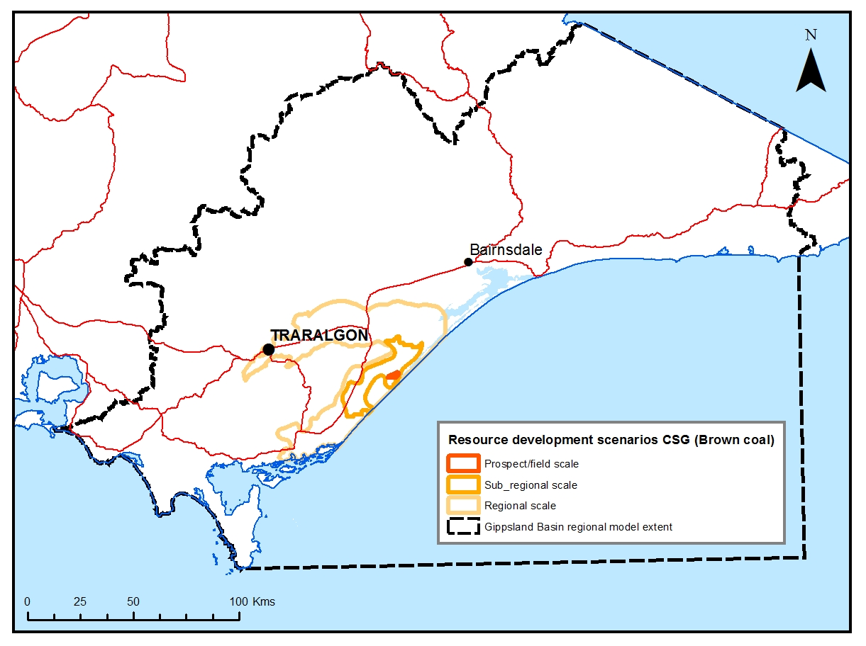
Figure 11.1 Gippsland Basin coal seam gas development scenarios.

Tight/shale gas
Three scenarios for tight/shale gas development are presented (Figure 11.2). In addition, a number of scenarios may be applied at a prospect/field scale (see below).

Scenario 1 – Prospect/field scale
The development of tight gas within the onshore Gippsland Basin is focused on gas shows observed within structural traps at top Strzelecki Group level (and potentially the Golden Beach Subgroup) in the Wombat, Trifon and Gangell fields (see Figure 4.1). A number of smaller scale prospects (Echidna, Steele and Carrs Creek) have also been identified (Lakes Oil, 2014), and these are included here. Scenarios for project scale development might combine any or all of the prospects/fields. One scenario might include the development of the fields only, while another might include all areas covered by both fields and prospects.

Scenario 2 – Sub-regional scale
The second scenario encompasses an area that includes the prospects/fields shown in Figure 11.2. Essentially, scenario 2 assumes that the entire area – the prospects, fields and all areas in between are prospective for tight/shale gas.

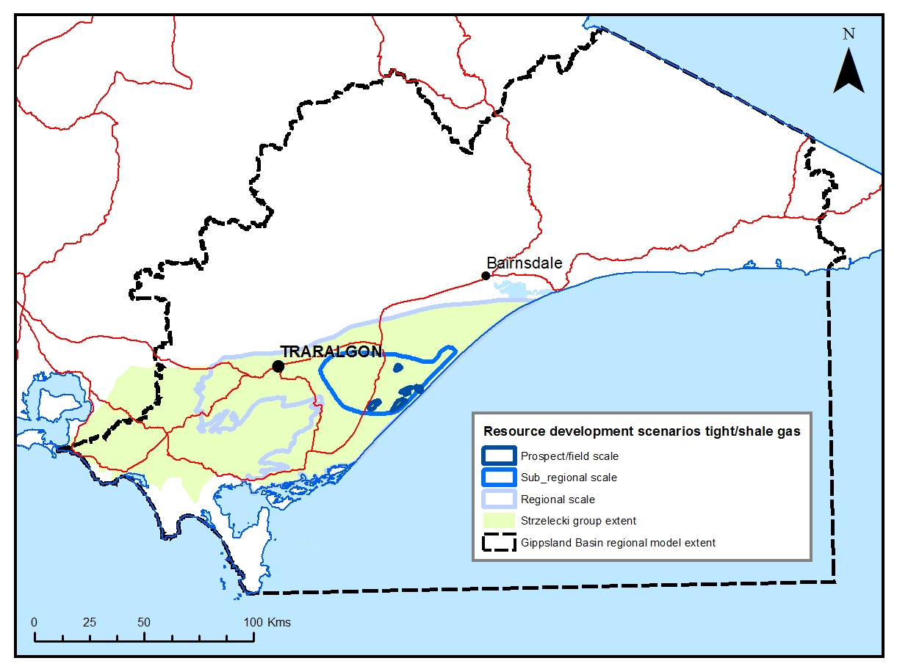
Figure 11.2 Gippsland Basin tight/shale gas development scenarios.

Scenario 3 – Regional scale
The third scenario covers an area of 5374 km² and includes all tight/shale sub-crop areas in the onshore Gippsland Basin and Latrobe Valley. The northern-most extent is delineated by the Lake Wellington Fault. The northwest extent is taken from Constantine (2001) and the southern boundary is defined by the edge of the ranges and the onshore Gippsland Basin proper.

Conclusions
Two sedimentary sequences in the onshore Gippsland Basin and one in South Gippsland are prospective for natural gas. The Early Cretaceous Strzelecki Group across the Gippsland region is a potential target for all natural gas types: conventional, tight, shale and coal seam gas. The overlying Latrobe Group in the onshore Gippsland Basin has potential for conventional gas and coal seam gas.
The largest barrier to better understanding the natural gas prospectivity of the Gippsland region is the geological uncertainty associated with all gas types. As outlined in section 10, in some cases a lack of basic geological data translates into uncertainty about the geological framework at a regional scale. Where data exists from previous exploration, it is often insufficient for characterising unconventional gas potential. Unknowns may include gross geological structure, the distribution and thickness of geological units, and the distribution of key lithologies and their properties within formations (such as mineralogy, maceral content, gas content, porosity, permeability, organic content, maturity and mechanical properties). However, available data has been drawn together in this review in order to provide direction for the water science studies on natural gas prospectivity.
Past explorers have searched for conventional targets in the relatively coarse-grained units at the base of the Strzelecki Group. In 2004 Karoon Gas found indications of oil and gas in this conventional play at the base of Megascolides-1 and a gas content of 3.37 m³/t from a Strzelecki Group black coal sample from the same well. The coal seams were thin and sparse and with lateral continuity unknown, there remains a large degree of geological uncertainty associated with coal seam gas potential from Strzelecki Group black coals.
The distribution of coarse units at the base of the Strzelecki Group has been proposed but so few wells have been drilled and there is little seismic data across the area that again, a significant degree of geological uncertainty remains. Also, within the Strzelecki Group, Lakes Oil has an estimated 1.7 Tcf of tight gas in the Wombat/Trifon/Gangell fields in the Seaspray Depression. No company has targeted ‘shale-rich’ units within the Strzelecki Group but for the purpose of the water science studies, tight and shale gas plays were “combined” to assess the potential impact of hypothetical gas production on water resources. Tight gas within the Strzelecki Group is the unconventional resource that is best supported by reported results.
Although gas shows and kicks in mud log readings at the top of the Latrobe Group (the traditional conventional play in the Gippsland Basin) have been encountered in previous drilling, fresh water flushing of the formation has been cited as the possible explanation for a lack of accumulations. Prior to the discovery of oil and gas in the offshore Gippsland Basin, drilling in the 1950s and 1960s targeted the older Late Cretaceous basal Latrobe Group units with no success. Both of these plays, together with intra-Latrobe Group units, have the potential for conventional gas but considering past exploration efforts that potential must surely be diminished.
Brown coaIs within the Traralgon Formation of the Latrobe Group are extensive and attain great thicknesses. Modelling carried out by Sander & Connell (2015) shows that for an estimated gas content of 3 m³/t and a permeability of 10 mD, gas production in the current market would not be viable.
In the offshore Gippsland Basin 9120 PJ of gas have been produced to date, and an estimated 9253 PJ of conventional gas remains in place. This remaining conventional gas sits at the top of the resource pyramid (e.g. McCabe, 1998) where small volumes of high-quality gas resources are relatively easy to develop and the extraction costs are lower. For the most part onshore gas resources, particularly the unconventional resources, sit at the base of the pyramid. These might be larger in volume but lower in quality, and they are more difficult to develop and more costly to extract.

References
ADVANCED RESOURCES INTERNATIONAL, 2002. Powder River Basin Coalbed Methane Development and Produced Water Management Study. Prepared for U.S. Department of Energy. 213p.
AMERICAN SOCIETY FOR TESTING AND MATERIALS (ASTM), 2011, Standard test method for microscopical determination of the reflectance of vitrinite dispersed in sedimentary rocks: West Conshohocken, PA, ASTM International, Annual book of ASTM standards: Petroleum products, lubricants, and fossil fuels; Gaseous fuels; coal and coke, Sec. 5, V. 5.06, D7708-11, pp. 823-830, doi: 10.1520/D7708-11, http://www.astm.org/Standards/D7708.htm Accessed 9th May 2012.
APPEA, 2015. Australian oil and gas glossary. http://www.appea.com.au/industry-in-depth/australia-oil-and-gas-glossary/ Accessed 21st May 2015.
AQUATERRA, 2008. Ashton Underground Mine Pikes Gully Seam Groundwater Modelling Report. Report submitted to ACOL in support of the Longwall/Miniwall 5-9 SMP Application.
BERNECKER, T. & PARTRIDGE, A.D., 2001. Emperor and Golden Beach Subgroups: The onset of Late Cretaceous sedimentation in the Gippsland Basin, SE Australia. In K.C. Hill & T. Bernecker (eds) Eastern Australasian Basins Symposium: A refocused energy perspective for the future, Petroleum Exploration Society of Australia, Special Publication, pp. 391-402.
BERNECKER, T., PARTRIDGE, A.D. & WEBB, J.A., 1997. Mid-Late Tertiary deep water temperate carbonate deposition, offshore Gippsland Basin, southeastern Australia. In N.P. James & J.D.A. Clarke (eds) Cool Water Carbonates, Society of Economic Palaeontologists and Mineralogists Special Publication 56, pp. 221-236.
BERNECKER, T., SMITH, M. A., HILL, K. A. & CONSTANTINE, A. E., 2003. Oil and gas – fuelling Victoria’s economy. In W.D Birch (ed.) Geology of Victoria, Geological Society of Australia Special Publication 23, pp. 469-487.
BEVERLY, C., HOCKING, M., CHENG, X., O’NEIL, C., SCHROERS, R. & BAKER, S. 2015. Gippsland groundwater model. Onshore natural gas water science studies. Victorian Government, Department of Environment, Land, Water and Planning. Technical report. 406p.
BREE, 2014. 2014 Australian energy statistics data. http://www.bree.gov.au/publications/australian-energy-statistics/2014-australian-energy-statistics-data. Accessed 14 August 2014.
BURNS, B. J., JAMES, A. T., & EMMETT, J. K., 1984. The use of gas isotopes in determining the source of some Gippsland Basin oils. The APEA Journal, 217-221.
Campbell, I., 2009, Tight gas: a lonely journey, Lakes Oil N.L., Melbourne. Unpublished presentation.
CARSTAIRS, J., MCLEAN, M. A. & RAWLING, T., in prep. Basement architecture of the onshore Gippsland Basin: insights from 3-D gravity inversion. Submitted to American Association of Petroleum Geologists international exhibition and conference, Melbourne, Australia.
CHIUPKA, J. W., 1996. Hydrocarbon play fairways of the onshore Gippsland Basin, Victoria. Victorian Initiative for Minerals and Petroleum Report 30. Department of Natural Resources and Environment. 50 p.
CONSTANTINE, A. E., 1992. Fluvial architecture and sedimentology of the Late Jurassic-Early Cretaceous Strzelecki and Otway groups. Geological Society of Australia Abstracts 32, 145p.
Constantine, A., 2001. Sedimentology, Stratigraphy and Palaeoenvironment of the Upper Jurassic-Lower Cretaceous Non-marine Strzelecki Group, Gippsland Basin, Southeastern Australia. PhD thesis, Monash University, Melbourne.
DANIEL, R. F., 2005. Carbon dioxide seal capacity study, Gippsland Basin, Victoria. CO2CRC Report No. RPT05-0035. 85p.
DEPARTMENT OF ECONOMIC DEVELOPMENT, JOBS, TRANSPORT AND RESOURCES, 2015. Lignite/Brown Coal. http://www.energyandresources.vic.gov.au/earth-resources/victorias-earth-resources/coal. Accessed 12th March 2015.
DEPARTMENT OF PRIMARY INDUSTRIES (DPI), 2009. Models of the Catchment Analysis Tool (CAT1D Version 32), August 2009, Technical Reference Manual. C. Beverly (ed.), Department of Primary Industries, 214p.
DICKINSON, J.A., WALLACE, M.W., HOLDGATE, G.R., DANIELS, J., GALLAGHER, S.J. & THOMAS, L., 2001. Neogene tectonics in SE Australia: implications for petroleum systems, The APEA Journal, 41, pp. 37-52.
DUDDY, I.R. 2003. Mesozoic, a time of change in tectonic regime. In W. D. Birch, (Ed.) Geology of Victoria, Geological Society of Australia Special Publication 23. Geological Society of Australia (Victoria Division). pp. 239-286.
DUDDY, I.R. & GREEN, P.F., 1992. Tectonic development of Gippsland Basin and environs: Identification of key episodes using Apatite Fission Track Analysis (AFTA). In C.M. Barton, K. Hill, C. Abele, J. Foster & N. Kempton (eds) Energy, Economics and Environment – Gippsland Basin Symposium, Australasian Institute of Mining and Metallurgy, Melbourne Branch, pp. 111-120.
DUDDY, I. R. & COOK, A. C., 2002. Boundary Creek-1 well, Gippsland Basin: a petrographic and maturity study of Strzelecki Group samples. Geotrack unpublished report 825.
EDWARDS, A.B., BAKER, G., & KNIGHT, K.L. 1944. The Geology of the Wonthaggi Coalfield, Victoria. Proceedings Australasian Institute Mining and Metallurgy, New Series 134, pp. 1-54.
ESSO AUSTRALIA, 1988. The Gippsland Basin. In APEA, Petroleum in Australia: The first century. pp. 174-190.
FASSETT, J. E., 2013. The San Juan Basin, a complex giant gas field, New Mexico and Colorado. American Association of Petroleum Geologists Search and Discovery Article #10254.
GALLAGHER, S. & HOLDGATE, G.R., 1996. Sequence stratigraphy and biostratigraphy of the onshore Gippsland Basin, S.E. Australia. Geological Society of Australia, Australian Sedimentologists Group Field Guide Series Number 11, 70p.
GASTAR Exploration LTD., 2002. Gastar Exploration, Ltd. Announces Plans for Initial Coalbed Methane Pilot Project in Victoria, Australia; Project to Test Potential for Multi-TCF CBM Development. http://www.thefreelibrary.com/Gastar+Exploration,+Ltd.+Announces+Plans+for+Initial+Coalbed+Methane...-a084064025. Accessed 5th August 2014.
GASTAR Exploration Ltd., 2005. Gastar Updates Recent Developments Effecting its Australian Coal Bed Methane Operationshttp://www.gastar.com/releasedetail.cfm?ReleaseID=226709. Accessed 24th September 2014.
GEORGE, A.M. & MACKAY, G.H., 1991. Chapter 2 – Petrology. In R.A. Durie (ed.) The Science of Victorian Brown Coal: Structure, Properties and Consequences for Utilisation, Butterworth-Heinemann, Oxford, UK.
GEOSCIENCE AUSTRALIA, 2015. Oil and gas resources of Australia – 2009. http:www.ga.gov.au/data-and-publications-search/publications/oil-gas-resources-australia/2009. Accessed 21st May 2015.
GEOSCIENCE AUSTRALIA & BREE, 2014. Australian Energy Resource Assessment. 2nd Ed. Geoscience Australia, Canberra.
GEOVIC, 2015. Explore Victoria Online. http://www.energyandresources.vic.gov.au/earth-resources/maps-reports-and-data/geovic. Accessed 15th June 2015.
GLOE, C. S., 1984. Chapter 4 - The geology, discovery, and assessment of the brown coal deposits of Victoria. In J. T. Woodcock (ed.) Victoria’s brown coal – a huge fortune in chancery. The Australasian Institute of Mining and Metallurgy, pp. 79-109.
GOLDIE DIVKO, L.M. CAMPI, M. J., TINGATE, P. R., O’BRIEN, G. W. & HARRISON, M. L., 2009. Geological Carbon Storage Potential of the Onshore Gippsland Basin, Victoria, Australia. Victorian Geological Carbon Storage initiative Report 2. Department of Primary Industries. 81p.
GOLDIE DIVKO, L.M., O’BRIEN, G. W., HARRISON, M. L. & HAMILTON, P. J., 2010. Evaluation of the regional top seal in the Gippsland Basin; implications for geological carbon storage and hydrocarbon prospectivity. The APPEA Journal, 50(1), pp. 463–486.

GOLDSTEIN, B., MENPES, S., HILL, A., WICKHAM, A., ALEXANDER, E., JAROSZ, M., PEPICELLI, D., MALAVAZOS, M., STARITSKI, K., TALIANGIS, P., CODA, J., HILL, D. & WEBB, M., 2012. Roadmap for unconventional gas projects in South Australia. Energy Resources Division, Department of Manufacturing, Innovation, Trade, Resources and Energy, Government of South Australia. 267p.
GROSSER, M., 2005. Megascolides-1 Well Completion Report, Volume 2, Interpretative Report. Karoon Gas Ltd. Unpublished Report. 39p + enclosures.
HAINES, L., 2006. Tight Gas, Oil and Gas Investor, Houston, Texas, Hart Energy Publishing, LP.
HAMILTON, P. J. & LY, C. V., 2009. Automated Mineralogical Analysis of 21 samples for Geoscience Victoria. Project A12357. Unpublished report. 18p. + appendices.
HARLOW, G. E. & LECAIN, G. D., 1993. Hydraulic characteristics of, and ground-water flow in, coal-bearing rocks of southwestern Virginia. U.S. Geological Survey water-supply paper 2388.
HARPER, P 1987. The Wonthaggi Coalfields, A Story of the Men and the Mines. EIA publishing. 152p.
HARRISON, B., TAYLOR, D., TINGATE, P. & SANDIFORD, M., 2012. Heat flow modelling and thermal history of the onshore Gippsland Basin: upside potential for unconventional gas and geothermal resources. In: T. Mares (ed.) Eastern Australasian Basins Symposium IV. Petroleum Exploration Society of Australia, Special Publication, CD-ROM.
HOCKING, J. B., 1972. Geologic Evolution and Hydrocarbon Habitat, Gippsland Basin. The APEA Journal, pp. 132-137.
HOCKING, J. B., 1976. Tertiary: Gippsland Basin. In J.G. Douglas & J.A. Ferguson (eds) Geology of Victoria, Geological Society of Australia Special Publication 5, pp. 248-273.
HOCKING, J. B. & TAYLOR, D. J., 1964. The Initial Marine Transgression in the Gippsland Basin, Victoria. The APEA Journal, pp. 125-132.
HOFFMAN, N., ARIAN, N. & CARMAN, G., 2012. Detailed seal studies for CO₂ storage in the Gippsland Basin. In T. Mares (ed.) Eastern Australasian Basins Symposium IV. Petroleum Exploration Society of Australia, Special Publication, CD-ROM.
Holdgate, G. R., 2003. Coal – world class energy reserves without limits. In W.D Birch (ed.) Geology of Victoria, Geological Society of Australia Special Publication 23, pp. 489-517.
HOLDGATE, G. R. & CLARKE, J. D. A., 2000. A review of Tertiary brown coal deposits in Australia – their depositional factors and eustatic correlations. AAPG Bulletin 84, pp. 1129-1151.
HOLDGATE, G. R. & GALLAGHER, S., 1997. Microfossil paleoenvironments and sequence stratigraphy of Tertiary cool-water carbonates, onshore Gippsland Basin, southeastern Australia. In N.P. James & J.D.A. Clarke (eds) Cool Water Carbonates, Society of Economic Palaeontologists and Mineralogists Special Publication 56, pp. 205-220.
HOLDGATE, G. R. & GALLAGHER, S.J., 2003. Tertiary – A period of transition to marine basin environments. In W.D Birch (ed.) Geology of Victoria, Geological Society of Australia Special Publication 23, pp. 289-335.
HOLDGATE, G. R. & McNICOL, M. D., 1992. New directions – Old ideas: Hydrocarbon prospects of the Strzelecki Group onshore Gippsland Basin. Gippsland Basin Symposium, pp. 121-131.
HOLDGATE, G. R., WALLACE, M. W., GALLAGHER, S. J. & TAYLOR, D., 2000. A review of the Traralgon Formation in the Gippsland Basin — a world class brown coal resource. International Journal of Coal Geology, 45, 55-84.
HOLDITCH, S. A., 2006: Tight gas sands. Journal of Petroleum Technology, 58(6), pp. 86-93.
Icon Energy, 2014. PEP170. http://www.iconenergy.com/irm/content/pep-170.aspx?RID=328. Accessed 10th November 2014.
Ignite Energy Resources (IER), 2014. Gippsland Gas. http://www.igniteer.com/gippsland-gas.html. Accessed 4th September 2014.
INGRAM, F. T., 1963. North Seaspray No. 1 Well Completion Report. Arco Limited/Woodside (Lakes Entrance) Oil Co. N. L. Unpublished report. 27p. + appendices.
JAMES, E.A. & EVANS, P.R., 1971. The stratigraphy of the offshore Gippsland Basin. The APEA Journal 11(1),
pp. 71-74.
JENKIN, J. J., 1971. Geological history of the West Gippsland region. Proceedings of the Royal Society of Victoria 84, pp. 19-28.
KUTTAN, K., KULLA, J.B. & NEWMAN, R.G., 1986. Freshwater influx in the Gippsland Basin: impact on formation evaluation, hydrocarbon volumes and hydrocarbon migration. The APPEA Journal, 26, pp. 242–249.
LAING, A. C. M., 1965. Well completion report, Alliance Tarwin Meadows No. 1. Unpublished report. 19p. + appendices.
LAKES OIL NL, 2002. York-1 Well Completion Report PEP158 Victoria. Unpublished report.
Lakes Oil, 2012. The way forward: Current projects. http://www.asx.com.au/asxpdf/20120920/pdf/428tzm12sxdp4b.pdf Accessed 10th November 2014.
Lakes Oil, 2014. Onshore Gippsland Basin Permits. http://www.lakesoil.com.au/index.php/permits/onshore-gippsland-basin-vic Accessed 24th October 2014.
LANGHI, L., RACHAKONDA, P.K., MICHAEL, K., STRAND, J. & GRESHAM, M., 2014. Hydrogeological data gap analysis for Victorian brown coal CSG scenario models - Hydrogeological and geological elements supporting the selection of data well locations for the assessment of coal seam gas prospectivity in the Seaspray Depression, Report EP146447, CSIRO, Australia.
LAW, C., A., 1999. Evaluating source rocks. In E. A. Beaumont & N. H. Foster (eds) Exploring for oil and gas traps. America Association of Petroleum Geologists, Oklahoma, US.
LOWRY, D.C. & LONGLEY, I.M., 1991. A new model for the mid-Cretaceous structural history of the northern Gippsland Basin. Australian Petroleum Exploration Association Journal 31, pp. 143-153.
MARSHALL, N.G., 1989. An unusual assemblage of algal cysts from the Late Cretaceous, Gippsland Basin, southeastern Australia. Palynology 13, pp. 21-56.
MARSHALL, N.G. & PARTRIDGE, A.P., 1986. Palynological analysis of Kipper-1, Gippsland Basin. Esso Australia Ltd. Unpublished Report 1986/18, 21p. 3 charts.
MARTIN, J. P., HILL, D. G., LOMBARDI, T. E. & NYAHAY, R., 2010. A primer on New York’s gas shales. http://offices.colgate.edu/bselleck/AppBasin/GasshaleMartin.pdf. Accessed 11th March 2015.
MATTHEWS, L. R. & MCLEAN, M. A., 2015. Gippsland Basin gravity survey. Department of Economic Development, Jobs, Transport and Resources. Melbourne, Victoria.
MAUNG, T. U., 1989. A Regional Seismic Synthesis of Offshore Gippsland Basin. Exploration Geophysics 20,
pp. 313-323.
MCCABE, P. J., 1998. Energy Resources – Cornucopia or Empty Barrel? AAPG Bulletin, 82(11), pp. 2110-2134.
MCCARTHY, K., NIEMANN, M., PALMOWSKI, D., PETERS, K. & STANKIEWICZ, A., 2011. Basic Petroleum Geochemistry for Source Rock Evaluation. Oilfield Review, 23(2), pp. 32-43.
MCLEAN, M. A. & BLACKBURN, G., 2013. A new regional velocity model for the Gippsland Basin. VicGCS Report 9, Department of Primary Industries.
MEDWELL, L. M., 1954. A review and revision of the flora of the Victorian Lower Jurassic. Proceedings of the Royal Society of Victoria. 65, pp. 63-111.
MEHIN, K. & BOCK, M.P., 1998. Cretaceous source rocks of the onshore Gippsland Basin, Victoria. VIMP Report 54, Department of Natural Resources and Environment, 98p.
MILLIKEN, J. W., 1968. Final Subsidy Report of the Offshore Gippsland Basin Marine Seismic Survey, EH-68. Esso Exploration and Production Australia, Inc. Unpublished Report.
Mines Department, 1935. Victoria: Gold and Minerals. Mines Department, Melbourne. H. J. Green Government Printer, Melbourne, 100 p.
Miranda, J., COLLINS, G., O’BRIEN, G. & CAMPI, M., 2011. Tight gas reservoirs in the Gippsland Basin: a preliminary assessment by Geoscience Victoria. Unpublished report.

MIRANDA J.A., HALL, D.L., PHIUKHAO, W., O'BRIEN, G.W., GOLDIE DIVKO, L.M., CAMPI, M.J. & TINGATE, P.R., 2012. Fluid inclusion volatile analysis in the Gippsland Basin: Implications for geological carbon storage. GeoScience Victoria VicGCS report 6. Department of Primary Industries.
MIRANDA J.A., HALL, D.L., O’BRIEN, G.W., PHIUKHAO, W.,GOLDIE DIVKO, L.M., CHAO, J.C., CAMPI, M.J. EID, R. & TINGATE, P.R., 2013. Fluid inclusion stratigraphy in the Gippsland Basin: implications for geological carbon storage. Department of Primary Industries.
MOORE, T.A., 2012. Coalbed methane: A review. International Journal of Coal Geology, 101, pp. 36 – 81.
National Electricity Market (NEM), 2014. NEM-Review – metered generation. Accessed 17 July, 2014.
NELSON, E., HILLIS, R., SANDIFORD, M., REYNOLDS, S., & MILDREN, S. 2006. Present-day state-of-stress of southeast Australia. APEA Journal 46 (1), pp. 283-306.
NORVICK, M. & SMITH, M.A., 2001. Mapping the plate tectonic reconstructions of southern and southeastern Australia and implications for petroleum systems. The APPEA Journal 41(1), pp. 15-35.
NORVICK, M.S., SMITH, M.A. & POWER, M.R., 2001. The plate tectonic evolution of eastern Australasia guided by the stratigraphy of the Gippsland Basin. In K.C. Hill & T. Bernecker (eds) Eastern Australasian Basins Symposium: A refocused energy perspective for the future, Petroleum Exploration Society of Australia, Special Publication, pp. 15-23.
O’BRIEN, G.W., TINGATE, P.R., GOLDIE DIVKO, L.M., HARRISON, M.L., BOREHAM, C.J., LIU, K., ARIAN, N. & SKLADZIEN, P., 2008. First order sealing and hydrocarbon migration processes, Gippsland Basin, Australia: Implications for CO₂ geosequestration. In J.E. Blevin, B.E Bradshaw & C. Uruski (eds) Eastern Australasian Basins Symposium III, Petroleum Exploration Society of Australia, Special Publication, pp. 1-28.
O'BRIEN, T., and CAMPBELL, I., 2005: Trifon-2 well completion report, basic geotechnical data, Lakes Oil N.L. / Petro Tech Pty. Ltd. Unpublished report. 32p.
OTTMANN, J. & BOHACS, K., 2014. Conventional Reservoirs Hold Keys to the ‘Un’s’. American Association of Petroleum Geologists, Explorer, February 2014.
OWER, L.H., 1921 Supposed natural wax at Toongabbie. Records of the Geological Survey of Victoria. 14(3), pp. 279-280.
PARTRIDGE, A.D., 1999. Late Cretaceous to Tertiary geological evolution of the Gippsland Basin, Victoria. PhD thesis, La Trobe University, Melbourne, 439 p.
PARTRIDGE, A.D., 2006a. Jurassic and Early Cretaceous palynology zonations for Australia. In E. Monteil (coord.), Australian Mesozoic and Cenozoic Zonations – updated to the 2004 Geological Timescale. Geoscience Australia Record 2006/23.
PARTRIDGE, A.D., 2006b. Late Cretaceous to Cenozoic spore-pollen and dinocyst zonations for Australia. In E. Monteil (coord.), Australian Mesozoic and Cenozoic Zonations – updated to the 2004 Geological Timescale. Geoscience Australia Record 2006/23.
PARTRIDGE, A. D., BERNECKER, T., KELMAN, A. P., KHIDER, K., LE POIDEVIN, S. & MANTLE, D. J., 2013. Gippsland Basin Biozonation and Stratigraphy, 2013 Chart 40. Geoscience Australia, Australian Government.
PDA, 2006. Ashton Coal Mine Longwall Panels 1-4 Subsidence Management Plan; Groundwater Assessment Report prepared by Peter Dundon and Associates Pty Ltd for Ashton Coal Operations Ltd.
RAHMANIAN, V.D., MOORE, P.S., MUDGE, W.J. & SPRING, D.E., 1990. Sequence stratigraphy and the habitat of hydrocarbons, Gippsland Basin, Australia. In J. Brooks (ed.) Classic Petroleum Provinces, Geological Society Special Publication 50, pp. 525-541.
RICARD, L. & STRAND, J., 2014. Potential impacts of CSG production on groundwater resources – Geomodelling and flow simulation (Draft), CSIRO, Australia.

SANDER, R. & CONNELL, L., 2014. Potential impacts of coal seam gas production on groundwater resources – field-scale production modelling and impact assessment. CSIRO Report Number EP149182. 61p.
SCHAEFFER, J., 2008. Scaling Point Based Aquifer Data for Developing Regional Groundwater Models: Application to the Gippsland Groundwater System. PhD Thesis, Department of Civil and Environmental Engineering, University of Melbourne, Melbourne, Australia.
SCHLUMBERGER, 2015. Oilfield Glossary. http:www.glossary.oilfield.slb.com/ Accessed 21st May 2015.
SEIDLE, J., 2011. Fundamentals of coalbed methane reservoir engineering. Pen Well Corporation, Oklahoma. 401p.
SHANLEY, K. W., CLUFF, R. M & ROBINSON, J. W., 2004. Factors controlling prolific gas production from low-permeability sandstone reservoirs: Implications for resource assessment, prospect development, and risk analysis. American Association of Petroleum Geologists Bulletin, 88, pp. 1083-1121.
SHORT, D.A. & MULREADY, J.N., 2001: Gangell-1, well completion report, PEP157-Victoria, Lakes Oil N.L., Unpublished Report, p. 203.
SIMPSON, M., 1981. Kerogens from the Lygistepollenities balmei zone with the Latrobe Valley Group of the Gippsland Basin. University of Melbourne, Unpublished report. 23 p.
SKM, 1999. Yarram subregional model. A report prepared by Sinclair Knight Merz for the Department of Natural Resources and Environment. Unpublished Report.
SKM, 2001. Gippsland subsidence modelling – Yarram. A report prepared by Sinclair Knight Merz for the Department of Natural Resources and Environment. Unpublished Report.
SLATER, S. & BAKER, G., 2012. CSG – 15 years of unprecedented development. In T. Mares (ed.) Eastern Australasian Basins Symposium IV. Petroleum Exploration Society of Australia, Special Publication, CD-ROM.
SOCIETY OF PETROLEUM ENGINEERS, 2007. Petroleum Resource Management System. http://www.spe.org/industry/docs/Petroleum_Resources_Management_System_2007.pdf. Accessed 21st April, 2015.
SMITH, G.C., 1988. Oil and gas. In J.G. Douglas & J.A. Ferguson (eds) Geology of Victoria, Geological Society of Australia, 2nd Edition, pp. 514-531.
STAINFORTH, J. G., 1984. Gippsland Hydrocarbons - a perspective from the basin edge. The APEA Journal,
pp. 91-100.
STIRLING, J., 1892. Reports on the Victoria Coal-fields (Part I). Department of Mines, Special reports. 16p + enclosures.
STIRLING, J., 1895a. Reports on the Victoria Coal-fields (No. 3). Department of Mines, Special reports. 20p + enclosures.
STIRLING, J., 1895b. Reports on the Victoria Coal-fields (No. 4). Department of Mines, Special reports. 4p.
STIRLING, J., 1895c. Reports on the Victoria Coal-fields (N0. 5). Department of Mines, Special reports.6p + enclosures.
THE MERCURY, 1937. Wonthaggi Mine Disaster – “Explosion caused by naked light” – Opinion of manager. The Mercury, Hobart, Tasmania, 31st March 1937.
THOMAS, D.E. & BARAGWANATH, W., 1949. Geology of the Brown Coals of Victoria, Part 1. Mining and Geological Journal, Department of Mines, Victoria 3(6), pp. 28-55.
THOMPSON, B.R., 1986. The Gippsland Basin - Development and stratigraphy. In R.C. Glenie (ed.) Second South-Eastern Australia Oil Exploration Symposium, Petroleum Exploration Society of Australia, pp. 57-64.
TOLLIDAY, R., 2007. Megascolides-2 PEP162/EL4537 Well Completion Report, Volume 1: Basic Data (Geology). Karoon Gas Ltd. Unpublished Report, 19 p + enclosures.
TOSOLINI, A-M. P., MCLOUGHLIN, S. & DRINNAN, A. N., 1999. Stratigraphic and fluvial sedimentary facies of the Neocomian lower Strzelecki Group, Gippsland, Victoria. Australian Journal of Earth Sciences, 46 (6), pp. 951-970.
UNIVERSITY OF SOUTHERN QUEENSLAND (USQ), 2011. Preliminary assessment of Cumulative Drawdown Impacts in the Surat Basin Associated with the Coal Seam Gas Industry, Investigation of parameters and features for a regional model of Surat Basin Coal Seam Gas developments, University of Southern Queensland.
VINES, J., 2008. Coal Mining Heritage Study in Victoria. The Heritage Council of Victoria. 288p.
WATTS, T. R., 1965. Woodside South No. 1 Well Completion Report. Woodside (Lakes Entrance) Oil Company N. L., Unpublished Report, 41p.
WILKINSON, R., 1988. A thirst for burning. David Ell Press, Sydney. 528p.
WILLCOX, J.B., COLWELL, J.B. & CONSTANTINE, A.E., 1992. New ideas on Gippsland Basin regional tectonics. In C.M. Barton, K. Hill, C. Abele, J. Foster & N. Kempton (eds), Energy, Economics and Environment - Gippsland Basin Symposium, Australasian Institute of Mining & Metallurgy, Melbourne.
WILLCOX, J.B., SAYERS, J., STAGG, H. M. J. & VAN DE BEUQUE, S., 2001. Geological framework of the Lord Howe Rise and adjacent ocean basins. In K.C. Hill & T. Bernecker (eds) Eastern Australasian Basins Symposium: A refocused energy perspective for the future, Petroleum Exploration Society of Australia, Special Publication, pp. 211-225.
WOSKOBOENKO, F., STACY, W. O. & RAISBECK, D., 1991. Chapter 4 – Physical structure and properties of brown coal. In R.A. Durie (ed.) The Science of Victorian Brown Coal: Structure, Properties and Consequences for Utilisation, Butterworth-Heinemann, Oxford, UK.

Glossary
Term | Explanation
Basin | A geological depression filled with sediments.
Exploration | The phase of operations in which a company searches for oil or gas by carrying out detailed geological and geophysical surveys followed up where appropriate by exploratory drilling in the most prospective locations
Fault | A break or planar surface in a brittle rock across which there is an observable displacement.
Gas show | An observation of hydrocarbons. An increase in gas readings from gas-detection equipment in a petroleum well.
Permeability | The degree to which gas or fluids can move through a rock.
Play | An area in which hydrocarbon accumulations or prospects of a given type occur  (e.g. shale gas play).
Porosity | The amount of pore space in between the grains in a rock that are available for air, water, other fluids or gas to be stored.
Production | The phase of bringing well fluids to the surface and separating then and storing, gauging and otherwise preparing the product for transportation.
Prospective resources | Petroleum that is potentially recoverable from undiscovered accumulations.
Prospectivity | An assessment, whether qualitative or quantitative, of the potential for prospective resources.
Reservoir | A rock or geological formation that may hold petroleum within the pore spaces in the rock.
Seal | An impermeable rock that forms a barrier or cap above reservoir rocks such that fluids cannot migrate beyond the reservoir.
Source rock | A rock rich in organic matter, which, if heated sufficiently, will generate oil or gas.
Trap | Any barrier to the upward movement of oil or gas, allowing either or both to accumulate.
Source: APPEA (2015); Geoscience Australia (2015); Schlumberger (2015).

Abbreviations and units
ASX Australian Securities Exchange
AMA Automated Mineral Analysis
CBM Coal Bed Methane
CSG Coal Seam Gas
DST Drill Stem Test
EL Exploration Licence
FIS Fluid Inclusion Stratigraphy
GSV Geological Survey of Victoria
LPG Liquefied Petroleum Gas
mD Millidarcies
Mt Million tonnes
Nm nanometres
PEP Petroleum Exploration Permit
PJ Petajoules
PRL Petroleum Retention Lease
PRMS Petroleum Resource Management System
SECV State Electricity Commission of Victoria
SCF/ton Standard Cubic Feet per Tonne
Tcf Trillion Cubic Feet
TOC Total Organic Content

Appendix 1

Formation of gas in coal
When natural gas (methane) is found within coal it is usually classified as an unconventional resource. The term unconventional refers to the fact that the gas is stored and extracted in a fundamentally different way than in the porous sandstone, limestone or highly fractured reservoirs that most oil and gas has been produced from to date. Other unconventional reservoirs include shale gas, shale oil, and tight sandstones, for example. A coal reservoir is unique in that it is composed almost entirely of organic material, whereas the other reservoirs are not. That the reservoir is composed of mostly organic material significantly affects how this reservoir type behaves in all of its properties. A major shift in thinking and engineering, from a conventional reservoir sense, is therefore needed, before any gas can be optimally extracted.
The starting point for understanding coal seam gas (CSG) reservoirs is to ask three basic questions: How is gas generated? How is gas stored? How does gas move through the coal reservoir?
The purpose of this appendix is to give concise answers to the above questions. The cited references will help readers investigate further if needed.

How is gas generated?
Coal seam gas may be produced through two very different pathways. One pathway is a biological process (and thus gas generated in this way is called ‘biogenic’ in origin), where microbes living within the coal actually convert coal molecules into methane. The second pathway is purely a chemical transformation driven by heat (and thus the gas is appropriately termed ‘thermogenic’) related to deeper burial that ‘devolatilizes’ the coal, with one of the volatiles released being methane. Just about all conventional gas plays are derived through thermogenic processes. Although coal seam gas production worldwide is predominately thermogenic gas, up to 10% is biogenic in origin (Strąpoć et al., 2011). For an idea of scale, total world production was at least 2 trillion cubic feet (Tcf) in 2009.

Biogenic coal seam gas
It has long been recognized that methane can be generated from microbes living within the coal (Rogoff et al., 1962) but it has only recently been discovered how that process works. To generate methane from coal requires the cooperation of two out of the three domains of life on earth: Bacteria and Archaea. There are literally hundreds of microbial taxa that are found in coal (Flores, 2013; Moore, 2012a; Strąpoć et al., 2011).
It is a consortium of bacteria that first takes the coal molecules – the actual, complexly-structured organic materials – and breaks them down (Figure A1.1). In relatively simplistic terms, there are two pathways that the bacteria use to consume the coal molecules; an anaerobic oxidation process and fermentation. These processes result in either production of acetate or carbon dioxide. Then the Archaea take over. It is thought that Archaea make the final conversion into methane through acetoclastic and CO₂-reduction methanogenesis (Strąpoć et al., 2008).

A character of biogenic coal seam gas plays is that they may vary significantly in their gas content, both vertically within a single seam as well as laterally (see Mares &Moore, 2008; Moore, 2012a; Warwick et al., 2008). Microbes are quite sensitive to their environment, thus even slight changes in temperature, pH, salinity and amount of available surface area within the reservoir will affect methane generation (Green et al., 2008). In addition there seems to be some evidence that the type of coal substrate is important; higher concentrations of waxy and resinous material may be more attractive to the microbes for conversion into methane (Mares, 2009; Moore, 2012a; Scott et al., 2007).
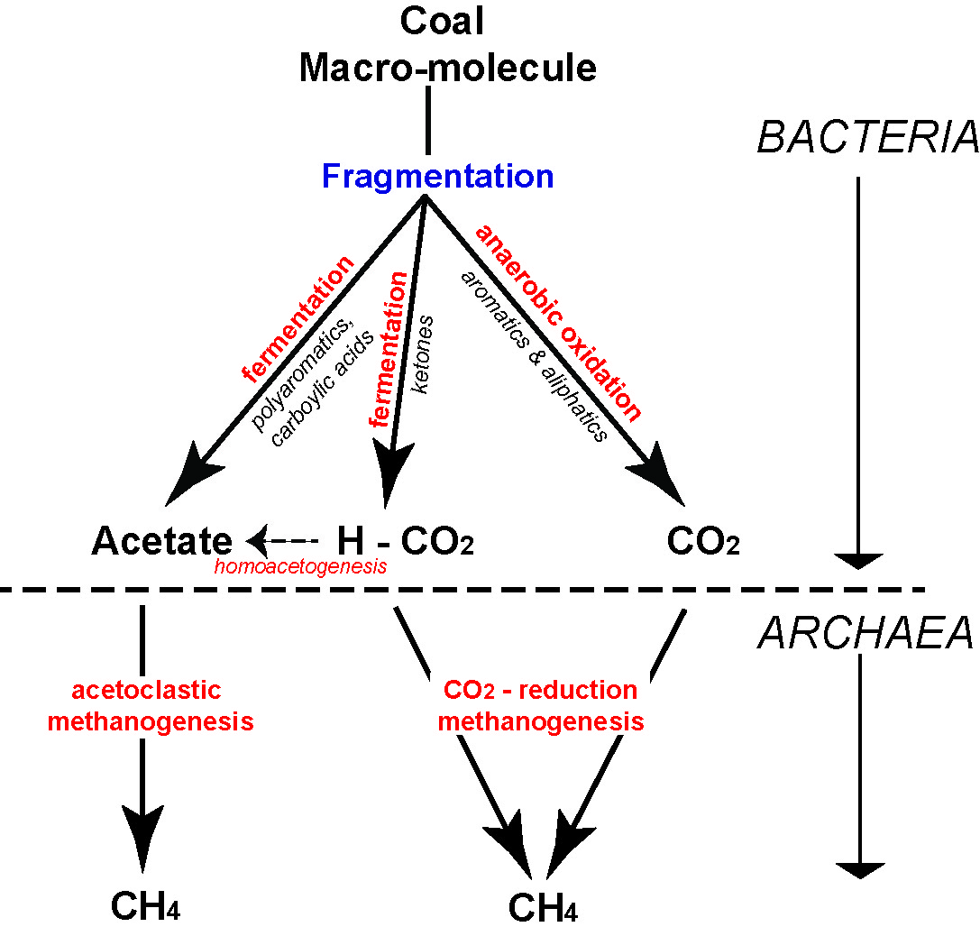
Figure A1.1 Simplified pathway of secondary biogenic methane production in coal (from Moore, 2012a).
The methanogenic microbes find it difficult to survive in temperatures above 55ºC (Scott & Fleet, 1994). Thus, biogenic gas generation tails off quickly above this temperature. However, it should be noted that if a coal is uplifted above this temperature threshold and re-inoculated with Bacteria and Archaea – most probably from groundwater recharge into the reservoir – then there may be renewed biogenic gas generation (Ayers Jr., 2002; Faiz et al., 2003; Flores et al., 2008; Smith & Pallasser, 1996).

Thermogenic coal seam gas
As coal is buried and heated its molecular structure rearranges itself. The most fundamental trend is that of increasing carbon content the deeper (and hotter) the coal bed is buried. In order for carbon to increase, the proportion of other elements, primarily oxygen, hydrogen, nitrogen and sulphur must decrease. These elements are thus more ‘volatile’ and this process is called de-volatilization. One of the most abundant molecules expelled is CH₄ – methane (Kopp et al., 2000).
The onset of thermogenic gas generation is approximately at the transition of subbituminous to bituminous coal (Figure A1.2) (Clayton, 1998). The exact timing of onset of thermogenic gas generation can vary. Some coals may start generation at slightly lower or slightly higher thermal maturities (i.e. rank) depending largely on the organic composition of the coal seam (Moore et al., 2014; Petersen, 2004, 2006; Whiticar, 1994). As long as there is a seal over the coal seam, gas will stay within the coal reservoir. Kinematic studies indicate that a sizeable volume of gas per unit of coal will be evolved, enough to completely ‘fill up’ any available space within the coal (Hunt, 1979; Zhang et al., 2008).
Cessation of thermogenic gas generation is thought to occur at temperatures greater than 555°C (Lewan & Kotarba, 2014). As with the onset of gas generation, there is no single temperature that de-volatilization will be complete, and will be dependent on reservoir composition and overall thermal history effects.
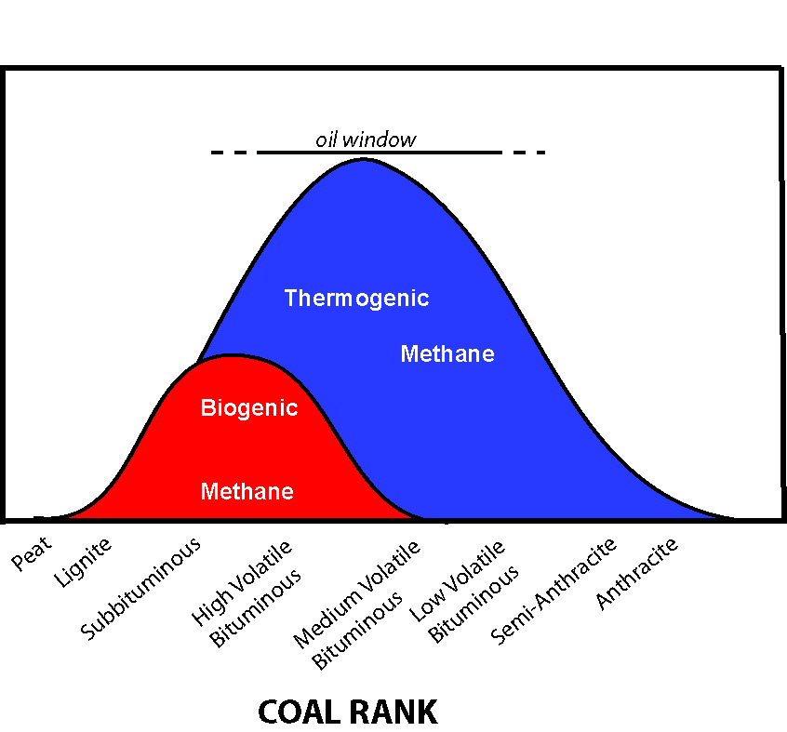
Figure A1.2 Schematic showing biogenic and thermogenic gas generation in relation to coal rank and the oil window. (Modified from Moore, 2012a).

How is gas stored?
In conventional reservoirs (typically sandstone and limestone), gas is stored within the pore space between the grains; that is, gas is ‘free’ and distinct from the surrounding rock material. Indeed, gas compressibility is an important consideration in conventional gas plays because with depth more gas can be compressed within the pore void. Coal holds its gas in a fundamentally different way.
Methane has a tendency to be sorbed (attached) onto the surface of organic materials. It is generally thought that methane can be absorbed or adsorbed. Absorption is where the methane is ‘dissolved’ within the molecular structure of the coal, whereas adsorption is when methane molecules have a physical attachment (through weak van der Waal forces) with the organic material (Ceglarsk-Stefańska & Brzóska, 1998; 2002; Rice, 1993). It is generally thought that most methane is attached through adsorption.
Thus it is the surface area of pores, not the pore volume, as in conventional reservoirs, which is ultimately the most important character in determining gas storage potential in coal. A practical consideration of this is that pore volume can remain the same but pore surface area can change drastically, with no pore volume increase, just by changing the size and abundance of the pores (Moore, 2012b). Pore surface area is also incredibly abundant in coals. In just one cubic centimetre, pores can have an internal surface area between 3 to 115 m² (Radlinski et al., 2004; Mares et al., 2009; Şenel et al., 2001).
Pores range in size from very small (angstroms) to relatively large (millimeters). In general, coal is thought to have a dual porosity system: large fractures and smaller pores (Clarkson & Bustin, 1999; Cui et al., 2004). Volumetrically, the fractures, though hugely influential in the reservoir’s permeability, are not where the methane is predominantly stored. Storage is mostly in pores less than 50 nm. Actually, the pore system is classified as those pores that are >50 nm (macropores), 2 – 50 nm (mesopores) and <2 nm (micropores) (Gan et al., 1972; Şenel et al., 2001). It is the micropores that are thought to hold most of the methane (Moore, 2012a).
Finally, although rank plays a large and important part in determining pore size (Gan et al., 1972), it is the organic composition of the coal that has the most direct influence. Studies by Bustin & Clarkson (1998) and Mares et al. (2009) indicate that different organic compositions will have different size distributions of pores; this ultimately also affects the storage capacity for methane as well.

How does gas move through the coal reservoir?
One of the many differences between conventional gas and coal seam reservoirs is that methane tends to stay put; firmly attached to the organics in a coal bed. Until, that is, there is a pressure drop, caused by de-watering, which allows the methane molecules to break the weak van der Waals forces and travel from higher to low-pressure areas. The de-watering process reduces hydrostatic pressure, at first near the drill hole but over time further and further out, progressively allowing the methane to flow.
Methane flow in coal seams is governed by two principles: Darcy’s Law and Fick’s Law. The latter deals with how the majority of methane in a coal bed starts its journey – diffusing out from the pores towards the fracture system where it more or less free flows towards the lower pressure area created by the well bore. From the moment the gas starts to flow freely, it is thought to behave in a way described by Darcy’s Law.
Fick’s Law describes how one set of molecules moves past another set of molecules (Philibert, 2005; Zarrouk, 2008), much like how air inside a balloon moves through the ‘solid’ rubber encasement of the balloon wall. The air inside the balloon is under relatively higher pressure compared to the air outside the balloon and so the high pressure air diffuses (albeit slowly) through the balloon wall to the lower pressure air outside. The rapidity of how fast those air molecules move is a function of the pressure gradient, the pore surface area and the distance the molecules need to travel.
Once, however, the methane molecules reach a coal cleat, or fracture system, the character of the flow becomes quite different to diffusion, and Darcy’s Law is best used to describe that movement (Seidle, 2011). Similar to diffusion, the pressure gradient is important. Viscosity of the fluid (or gas) must also be taken
into account. The resulting flow rate as derived through Darcy’s Law essentially describes permeability in
a rock medium.
It is permeability that usually determines if a coal seam gas play is commercial or not. Permeability in thermogenic coal seam gas is primarily determined by the number of cleats or fractures that a coal reservoir has and how open they are. Even very fine fractures are many times more permeable than the un-fractured coal: so they are effectively the ‘super highway’ of methane flow. In general, the higher the rank of the coal, the more frequent are the cleats/fractures, and thus the higher the permeability. But even within a single rank of coal there is a high degree of variability in cleat frequency depending on the coal type (Dawson & Esterle, 2010). Coals with higher concentrations of the organic particle type termed ‘vitrinite’, tend to have more cleats/fractures and thus higher permeability (Ayers Jr., 2002; Smyth & Buckley, 1993).
Biogenic coal seam gas is developed in coal that is too low in rank to develop cleat. In this case permeability is provided by original organic structure (i.e. leaf and woody tissue) that remains uncompressed enough in this low maturity material to provide original porosity and permeability for the passage of the gas.
It is not enough to just have cleats and fractures in the coal reservoir to allow gas to flow. They have to be open and remain open. Because coal is quiet compressible, it is highly effected by stress, both vertical as well as horizontal applied stresses (Bell, 2006; Sparks et al., 1995). No matter how permeable a coal reservoir might be at, say, 300 m; with depth, permeability tends to fall off dramatically (Esterle et al., 2006; McCants et al., 2001) (Figure A1.3). There are very few commercial coal seam gas plays that are deeper than 1000 m – the permeability is practically non-existent. Permeability is also not static, it can and does change as the reservoir is de-watered and de-gassed; the effects of which can be detrimental to, or sometimes a boost for, gas flow. Finally, cleats and fractures may be closed as a result of horizontal stresses or mineralisation, most likely caused by tectonic compression, regardless of depth.
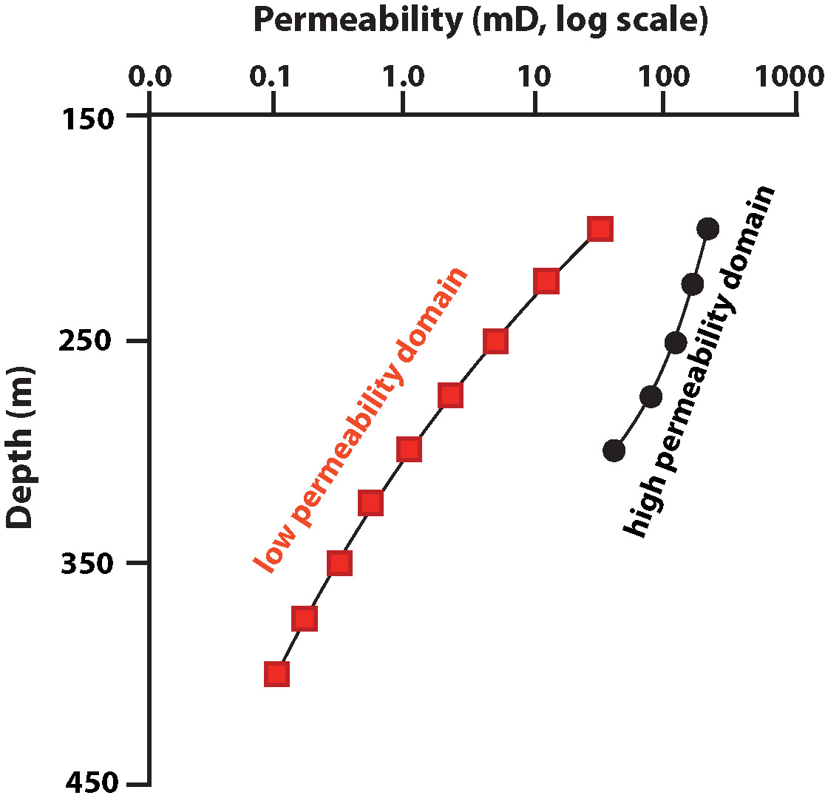
Figure A1.3 Coal bed permeability versus depth in a coal seam from the Permian age Bowen basin (Australia). Permeability has been spatially segregated into geological domains (i.e. geographic areas of similar geology and gas relationships) where ‘high’ and ‘low’ permeability have been identified. Note that the X axis is a log normal scale. See Esterle et al. (2006) for further explanation.

References
Ayers Jr., W.B., 2002. Coalbed gas systems, resources, and production and a review of contrasting cases from the San Juan and Powder River basins. AAPG Bulletin 86, 1853-1890.
Bell, J.S., 2006. In-situ stress and coal bed methane potential in Western Canada. Bulletin of Canadian Petroleum Geology 54, 197-220.
Bustin, R.M. & Clarkson, C.R., 1998. Geological controls on coalbed methane reservoir capacity and gas content. International Journal of Coal Geology 38, 3-26.
Ceglarsk-Stefańska, G. & Brzóska, K., 1998. The effect of coal metamorphism on methane desorption. Fuel 77, 645-648.
Ceglarsk-Stefańska, G. & Zarębska, K., 2002. The competitive sorption of CO2 and CH4 with regard to the release of methane from coal. Fuel Processing Technology 77-78, 423-429.
Clarkson, C.R. & Bustin, R.M., 1999. The effect of pore structure and gas presure upon the transport properties of coal: a laboratory modeling study. 2. Adsorption rate modeling. Fuel 78, 1345-1362.
Clayton, J.L., 1998. Geochemistry of coalbed gas - a review. International Journal of Coal Geology 35, 159-173.
Cui, X., Bustin, M. & Dipple, G., 2004. Differential transport of CO2 and CH4 in coalbed aquifers: Implications for coalbed gas distribution and composition. International Journal of Coal Geology 88, 1149-1161.
Dawson, G.K.W. & Esterle, J.S., 2010. Controls on coal cleat spacing. International Journal of Coal Geology 82, 213-218.
Esterle, J.S., Williams, R.J., Sliwa, R. & Malone, M., 2006. Variability in gas reservoir parameters that impact on emissions estimations for Australian black coals. Final Report ACARP Project C13071, Brisbane, 36 pp.
Faiz, M., Stalker, L., Sherwood, N., Saghafi, A., Wold, M., Barclay, S., Choudhury, J., Barker, W. & Wang, I., 2003. Bio-enhancement of coal bed methane resources in the southern Sydney Basin. APPEA 43, 595-610.
Flores, R.M., 2013. Coal and Coalbed Gas: Fueling the Future. Elsevier, Amsterdam.
Flores, R.M., Rice, C.A., Stricker, G.D., Warden, A. & Ellis, M.S., 2008. Methanogenic pathways of coal-bed gas in the Powder River Basin, United States: The geologic factor. International Journal of Coal Geology 76, 52-75.
Gan, H., Nandi, S.P. & Walker Jr., P.L., 1972. Nature of the porosity in American coals. Fuel 51, 272-277.
Green, M.S., Flanegan, K.C. & Gilcrease, P.C., 2008. Characterisation of a methanogenic consortium enriched from a coalbed methane well in the Powder River Basin, U.S.A. International Journal of Coal Geology 76, 34-45.
Hunt, J.M., 1979. Petroleum geochemistry and geology. Freeman & Co., San Francisco.
Kopp, O.C., Bennett III, M.E. & Clark, C.E., 2000. Volatiles lost during coalification. International Journal of Coal Geology 44, 69-84.
Lewan, M.D &, Kotarba, M.J., 2014. Thermal-maturity limit for primary thermogenic-gas generation from humic coals as determined by hydrous pyrolysis. AAPG Bulletin 98, 2581-2610.
Mares, T.E., 2009. An investigation of the relationship between coal and gas properties in the Huntly coalfield, New Zealand, Department of Geological Sciences. University of Canterbury, Christchurch, 394 pp.
Mares, T.E. & Moore, T.A., 2008. The influence of macroscopic texture on biogenically-derived coalbed methane, Huntly coalfield, New Zealand. International Journal of Coal Geology 76, 175-185.
Mares, T.E., Radlinski, A.P., Moore, T.A., Cookson, D., Thiyagarajan, P., Ilavsky, J. & Klepp, J., 2009. Assessing the potential for CO2 adsorption in a subbituminous coal, Huntly Coalfield, New Zealand, using small angle scattering techniques. International Journal of Coal Geology 77, 54-68.
McCants, C.Y., Spafford, S. & Stevens, S.H., 2001. Five-spot production pilot on tight spacing: rapid evaluation of a coalbed methane block in the Upper Silesian Coal Basin, Poland, The 2001 International Coalbed Methane Symposium. University of Alabama, Tuscaloosa, pp. 193-204.
Moore, T.A., 2012a. Coalbed methane: A review. International Journal of Coal Geology 101, 36-81.
Moore, T.A., 2012b. How many holes does it take to fill the Albert Hall? The importance of porosity in a coalbed methane reservoir, 36th Annual Convention & Exhibition, Indonesian Petroleum Association. Indonesian Petroleum Association, Paper IPA12-G-092, Jakarta, Indonesia, Not paginated.
Moore, T.A., Bowe, M. & Nas, C., 2014. High heat flow effects on a coalbed methane reservoir, East Kalimantan (Borneo), Indonesia. International Journal of Coal Geology 131, 7-31.
Petersen, H.I., 2004. Oil generation from coal source rocks: the influence of depositional conditions and stratigraphic age, Geological Survey of Denmark and Greenland Bulletin Nr 7, review of activities 2004, pp. 9-12, http://www.geus.dk/publications/bull/nr17/nr17_p09-12-uk.htm, accessed 14.05.16.
Petersen, H.I., 2006. The petroleum generation potential and effective oil window of humic coals related to coal composition and age. International Journal of Coal Geology 67, 221-248.
Philibert, J., 2005. One and a half century of diffusion: Fick, Einstein, before and beyond. Diffusion Fundamentals 2,
1-10.
Radlinski, A.P, Mastalerz, M., Hinde, A.L., Hainbuchner, M., Rauch, H., Baron, M., Lin, J.S., Fan, L., & Thiyagarajan, P., 2004. Application of SAX and SANS in evaluation of porosity, pore size and surface area of coal. International Journal of Coal Geology 59, 245-271.
Rice, D.D., 1993. Composition and origins of coalbed gas, in: Law, B.E., Rice, D.D. (Eds.), Hydrocarbons from coal. American Association of Petroleum Geologists, Studies in Geology 38, Tulsa, Oklahoma, pp. 159-184.
Rogoff, M.H., Wender, I., Anderson, R.B., 1962. Microbiology of coal. U.S. Bureau of Mines, p. 85.
Scott, A.C. & Fleet, A.J., 1994. Coal and coal-bearing strata as oil-prone source rocks: current problems and future directions, in: Scott, A.C., Fleet, A.J. (eds), Coal and coal-bearing strata as oil-prone source rocks? Geological Society Special Publication, London, U.K., pp. 201-205.
Scott, S., Anderson, B., Crosdale, P.J., Dingwall, J. & Leblang, G., 2007. Coal petrology and coal seam gas contents of the Walloon Subgroup - Surat Basin, Queensland, Australia. International Journal of Coal Geology 70, 209-222.
Seidle, J., 2011. Fundamentals of coalbed methane reservoir engineering. PennWell, Tulsa, Oklahoma.
Şenel, I.G., Gürüz, A.G. & Yücel, H., 2001. Characterization of pore structure of Turkish coals. Energy & Fuels 15,
331-338.
Smith, J.W. & Pallasser, R.J., 1996. Microbial origin of Australian coalbed methane. AAPG Bulletin 80, 891-897.
Smyth, M. & Buckley, M.J., 1993. Statistical analysis of the microlithotype sequences in the Bulli Seam, Australia, and relevance to permeability for coal gas. International Journal of Coal Geology 22, 167-187.
Sparks, D.P., McLendon, T.H., Saulsberry, J.L. & Lambert, S.W., 1995. The effects of stress on coalbed reservoir performance, Black Warrior Basin, U.S.A., Proceedings fo the Society of Petroleum Engineers Annual Technical Conference and Exhibition. SPE Paper 30743, Dallas, Texas, pp. 339-351.
Strąpoć, D., Mastalerz, M., Dawson, K., Macalady, J., Callaghan, A.V., Wawrik, B., Turich, C. & Ashby, M., 2011. Biogeochemistry of Microbial coal-bed methane. Annual Review of Earth and Planetary Sciences 39, 617-656.
Strąpoć, D., Picardal, F.W., Turich, C., Schaperdoth, I., Macalady, J.L., Lipp, J.S., Lin, Y.-S., Ertefai, T.F., Schubotz, F., Hinrichs, K.-U., Mastalerz, M. & Schimmelmann, A., 2008. Methane-producing microbial community in a coal bed of the Illinois Basin. Applied and Environmental Microbiology 74, 2424-2432.
Warwick, P.D., Breland Jr., F.C. & Hackley, P.C., 2008. Biogenic origin of coalbed gas in the northern Gulf of Mexico Coastal Plain, U.S.A. International Journal of Coal Geology 76, 119-137.
Whiticar, M.J., 1994. Correlation of natural gases with their sources, in: Magoon, L.B., Dow, W.G. (Eds.), The petroleum system - from source to trap. APG Memoir 22 pp.
Zarrouk, S.J., 2008. Reacting flows in porous media. VDM Verlag Dr Muller Aktiengesellshaft & Co. KG, Berlin.
Zhang, E., Hill, R.J., Katz, B.J. & Tang, Y., 2008. Modeling of gas generation from the Cameo coal zone in the Piceance Basin, Colorado. AAPG Bulletin 92, 1077-1106.

Appendix 2

Hypothetical gas development scenario data
Gas type | Development Type | Location/ Site | Target  Formation | Target formation depth (m) | Project area (km²)
Tight/Shale | (1) Prospect/field scale | Trifon/North Seaspray/Gangell fields | Strzelecki Group | 1,400 | 8.6
 |  | Wombat field | Strzelecki Group | 1400 - 1800 | 18.1
 |  | Echidna prospect | Strzelecki Group | 1000-1500 | 10.8
 |  | Steele/Boundary Creek prospect | Strzelecki Group | 750-950 | 4.8
 |  | Carrs Creek prospect | Strzelecki Group | 1,600 | 5.7
 | (2) Sub-regional | Seaspray Depression | Strzelecki Group | 1000-1800 | 1132
 | (3) Regional | Seaspray Depression + Latrobe Valley | Strzelecki Group | 1000-2700 | 5374
Coal Seam Gas (brown coal) | (1) Prospect/field scale | Burong prospect | Latrobe Group | 692 | 8.4
 | (2) Sub-regional | Seaspray Depression (restricted) | Latrobe Group | 400-800 | 438
 | (3) Regional | Seaspray Depression (full T seam extent) | Latrobe Group | 200-1200 | 2793

Authorised by the Victorian State Government,
Department of Economic Development, Jobs, Transport & Resources
1 Spring Street Melbourne Victoria 3000
Telephone (03) 9208 3333
June 2015
© Copyright State of Victoria
Except for any logos, emblems, trademarks, artwork and photography this document is made available under the terms of the
Creative Commons Attribution 3.0 Australia licence.

ISBN 978-1-74146-663-8 (pdf)

Accessibility
If you would like to receive this publication in an alternative format, please telephone DEDJTR Customer Service Centre 136 186, email customer.service@ecodev.vic.gov.au, via the National Relay Service on 133 677, www.relayservice.com.au
This document is also available on the internet at www.onshoregas.vic.gov.au
Disclaimer
This publication may be of assistance to you but the State of Victoria and its employees do not guarantee that the publication is without flaw of any kind or is wholly appropriate for your particular purposes and therefore disclaims all liability for any error, loss or other consequence which may arise from you relying on any information in this publication.

The contained energy within gas and oil is measured in joules or kilojoules. Large volumes in gas reservoirs are described in petajoules (PJ). Relating the contained energy to the physical volume in trillion cubic feet or billion cubic meters requires knowledge of the chemical makeup of the gases present, as different hydrocarbon species (e.g. methane, ethane, propane), contain different energies per unit volume, and some non-flammable gas such as nitrogen or carbon dioxide may be present in small amounts. ..

