Gippsland Region
Assessment of Potential Impacts
on Water Resources

June 2015

Acknowledgements
This report has been prepared by Jacobs (Australia) Pty Ltd for the Department of Environment, Land, Water and Planning in collaboration with the Geological Survey of Victoria (part of the Department of Economic Development, Jobs, Transport and Resources).
Independent review of this report was provided by:
Professor Rae Mackay, Director, Geotechnical and Hydrogeological Engineering Group, Federation University Australia
Professor Dayanthi Nugegoda, Ecotoxicology, School of Applied Science, RMIT University
Professor Craig Simmons, Director, National Centre for Groundwater Research and Training, Flinders University.

Contents
Figures 4
Tables 6
Glossary and abbreviations 8
1 Overview of impact assessment 10
1.1 Context 10
1.2 Study area 11
1.3 Onshore natural gas resources 12
1.4 Groundwater resources 12
1.5 Assessment approach 12
1.6 Results 16
2 Hydrogeological conceptual model 18
2.1 Introduction 18
2.2 Geology 18
2.3 Gas types and occurrence in the Gippsland region 29
2.4 Hydrogeology 32
2.5 Groundwater–surface water connectivity 49
2.6 Hydraulic connection between prospective onshore natural gas sources and groundwater 56
3 Aquifer depressurisation impact assessment 59
3.1 Introduction 59
3.2 Impact assessment approach 59
3.3 Impact assessment results 67
4 Chemical contamination of groundwater from hydraulic fracturing fluids: risk assessment 77
4.1 Overview of hydraulic fracturing 77
4.2 Key risks to water assets associated with hydraulic fracturing 79
4.3 Contaminant sources 79
4.4 Contaminant pathways 81
4.5 Contamination mechanisms 83
4.6 Summary of potential risks of hydraulic fracturing 88
4.7 Qualitative risk assessment 88

5 Induced seismicity risk assessment 90
5.1 Seismicity 90
5.2 Induced seismicity 92
5.3 Hydraulic fracturing 94
5.4 Gas development 95
5.5 Qualitative risk assessment 96
6 Land subsidence risk assessment 98
6.1 Summary of subsidence processes 98
6.2 Subsidence studies in Gippsland 99
6.3 Review of risk factors 99
6.4 Qualitative risk assessment 100
6.5 Summary 101
7 Management and mitigation of potential impacts and risks 102
7.1 Introduction 102
7.2 Possible mitigation measures 102
7.3 Potential impacts and risks requiring mitigation 103
7.4 Summary 107
8 Conclusions 108
8.1 Aquifer depressurisation 108
8.2 Chemical contamination of groundwater from hydraulic fracturing fluids 108
8.3 Induced seismicity 109
8.4 Land subsidence 109
8.5 Summary of potential impacts 109
8.6 Mitigation 110
8.7 Gaps and uncertainty 111
9 References 113
Appendix A: Literature review on risk assessment frameworks for onshore gas 120
Appendix B: Gippsland region assessment method 188
Appendix C: Data from numerical modelling 199
Appendix D: Maps of aquifer depressurisation assessment 204

Figures
Figure 1: Gippsland study area (showing surface water catchments) 11
Figure 2: Location of potential onshore natural gas development locations and surface water
resources in the Gippsland region used for impact assessment 13
Figure 3: Diagram showing the general relationship between surface features, aquifers and
potential gas-bearing geological formations in the Gippsland Region 14
Figure 4: Gippsland study area potential onshore natural gas resources and surface water resources 14
Figure 5: Structural features of the Gippsland Basin . 20
Figure 6: Gippsland Basin stratigraphy 21
Figure 7: Approximate thickness of the Strzelecki Group 22
Figure 8: Extent of main Latrobe Valley Group units 24
Figure 9: Extent and thickness of the M2C/Seaspray Sand unit 25
Figure 10: Approximate location of Balook Formation and the terrestrial deposits to the west
and north and marine deposits to the east and south 26
Figure 11. Cross-section, showing the complexity of the coal seams and beach barrier deposits
of the Latrobe Valley Group 27
Figure 12: Extent and elevation of the top of the Wurruk Sand member of the Boisdale Formation 30
Figure 13: Gippsland region tight and shale gas resource development scenarios 31
Figure 14: Gippsland region coal seam gas resource development scenarios 31
Figure 15: Victorian Aquifer Framework for Gippsland Basin hydrogeological units and aquifers 32
Figure 16: Salinity concentrations of upper aquifers in the Gippsland region 34
Figure 17: Groundwater elevation in the upper aquifers of the Gippsland region 34
Figure 18: Groundwater salinity in the Upper Tertiary Aquifer (Wurruk Sand unit of the
Boisdale Formation 37
Figure 19: Interpreted groundwater salinity in the combined Upper Mid-Tertiary Aquifer (Morwell
and Balook Formation) and the Lower Mid-Tertiary Aquifer (Seaspray Sand and M2C Aquifer) 37
Figure 20: Interpreted groundwater flow directions in the Upper Mid-Tertiary Aquifer 38
Figure 21: Extent and elevation of the Lower Tertiary Aquifer and the Lower Tertiary Basalts 41
Figure 22: Interpreted groundwater salinity in the lower aquifers, including the Lower Tertiary
Aquifer and the Lower Tertiary Basalts 42
Figure 23: Groundwater flow directions for the lower aquifers 42
Figure 24: Location of hydrographs for the Lower Tertiary Aquifer, showing a consistent decline in potentiometric surface across the Gippsland Basin 43
Figure 25: Interpreted Lower Tertiary Aquifer drawdown in metres between 2004 and pre-offshore
gas and oil extraction and mine dewatering 44
Figure 26: Approximate head of the Lower Tertiary Aquifer in 2008 45
Figure 27: Examples of hydrographs in the Balook and Latrobe Aquifers in the Yarram area 46
Figure 28: Location of Groundwater Management Units 48
Figure 29: Surface water features in the Gippsland study area as identified from the Victorian
Water Asset Database 50
Figure 30: Baseflow characterisation of studied Gippsland and Otway Basin rivers 51
Figure 31: Gippsland groundwater-dependent ecosystems 53
Figure 32: Location of wetlands fringing the Gippsland lakes 54
Figure 33: Location of wetlands fringing the Gippsland lakes 55
Figure 34: Overview of impact assessment 60
Figure 35: Potential impact on receptors due to aquifer depressurisation 63
Figure 36: Potential impacts to aquifers from possible tight and shale gas development. 64
Figure 37: Potential impacts to aquifers from possible tight and shale gas development 65
Figure 38. Potential impacts to aquifers from possible tight and shale gas development 66
Figure 39: Potential impacts on surface water users from possible tight and shale gas development 69
Figure 40: Potential impacts on surface water ecosystems from possible tight and shale
gas development 70
Figure 41: Potential impacts on aquifers from possible coal seam gas development 71
Figure 42: Potential impacts on aquifers from possible coal gas development 72
Figure 43: Potential impacts on aquifers from possible coal seam gas development 73
Figure 44: Potential impacts on surface water users from possible coal seam gas development 75
Figure 45: Potential impacts on surface water ecosystems from possible coal seam gas development 76
Figure 46: Schematic of a deep unconventional (shale) gas well in the Cooper Basin, Australia 78
Figure 47: Hydraulic fracturing fluid constituents 80
Figure 48: Location of formations where fracture height and hydraulic fracturing fluid volume were
collected. and Co-variance between fracture height and hydraulic fracturing fluid volume 83
Figure 49: Conceptual shape of zone of hydraulic fracture extent for a vertical well 84
Figure 50: Number and magnitude of earthquakes recorded from 2000 to 2012 worldwide and
in the USA 90
Figure 51: Earthquake magnitude and typical effect 91
Figure 52: Frequency and magnitude of earthquakes in Victoria from 1990 to 11 December 2014 91
Figure 53: Distribution and magnitude of earthquakes in Victoria from 1990 to 11 December 2014 92
Figure 54: Location and magnitude of seismic events caused by or likely to be related to energy development from various energy technologies worldwide 93
Figure 55: Potential impacts from coal seam gas developments: 100% and 50% development
scenarios 104
Figure 56: Potential impacts from tight and shale gas development: 100% and 50% development
scenarios 104

Tables
Table 1: Licensed entitlement and groundwater use in 2012–13 for Gippsland Groundwater
Management Units, excluding stock and domestic use. (Source: DEPI, 2014a.) 48
Table 2: Rules for defining the potential connection of water receptors to groundwater. 61
Table 3: Rules for defining the potential effect on water receptors of groundwater drawdown. 61
Table 4: Number of surface water users potentially impacted by tight and shale gas development
in Gippsland. 67
Table 5: Number of groundwater users potentially impacted by coal seam gas
development in Gippsland. 68
Table 6: Number of surface water users impacted by coal seam gas development in Gippsland. 74
Table 7: Likelihood assessment criteria for chemical contamination of groundwater from hydraulic
fracturing fluids. 88
Table 8: Consequence scale for chemical contamination of groundwater from hydraulic
fracturing fluids. 88
Table 9: Proposed likelihood assessment criteria for induced seismicity. 97
Table 10: Proposed consequence scale for induced seismicity. 97
Table 11: Proposed consequence scale for subsidence caused by drawdown in aquifers. 101
Table 12. Proposed likelihood assessment criteria for subsidence as a result of onshore gas
development. 101
Table 13: High inherent potential impact volumes under 100% development scenario. 105
Table 14: High inherent potential impact volumes under 50% development scenario. 105
Table 15: Moderate inherent impact volumes under 100% development scenario. 105
Table 16: Moderate inherent impact volumes under 50% development scenario. 106
Table 17: Indicative water volumes by source. 106
Table 18: Residual potential for impact due to aquifer depressurisation from onshore natural gas development in the Gippsland region. 107
Table 19: Residual potential risk due to hydraulic fracturing, induced seismicity and land
subsidence from onshore natural gas development in the Gippsland region. 107
Table 20: The potential impacts associated with aquifer depressurisation for each natural gas
scenario. 110
Table 21: The potential impacts associated with chemical contamination of groundwater from
hydraulic fracturing fluids, induced seismicity and land subsidence for each natural gas scenario. 110

Table 22: The potential impacts of aquifer depressurisation for each natural gas scenario following mitigation. 110
Table 23: The potential for chemical contamination of groundwater from hydraulic fracturing fluids,
induced seismicity and land subsidence for each natural gas scenario following mitigation measures. 111
Table AD1: Groundwater assessment methods. (Source: Anderson et al 2011.) 164
Table AE1: SEPP Beneficial Uses to be Protected and Groundwater Quality Indicators (mg/L of Total Dissolved Solids), (source: Victorian Government Gazette, 1997). 170
Table AF1: Setback distances from water resources and private dwellings in various US states.
(Source: NYSDEC, 2009.) 173

Glossary and abbreviations
Term |  | Meaning
AHD |  | Australian Height Datum
aquifer |  | rock or soil that readily transmits water
aquitard |  | rock or soil that transmits water very slowly
baseflow |  | contribution of surface water flow due attributed to groundwater
BoM |  | Bureau of Meteorology
CMA |  | Catchment Management Authority
confined aquifer |  | an aquifer in which an impermeable rock or soil layer or layers prevents water from seeping into the aquifer vertically
constant head boundary |  | time constant specified head which represents flows into or out of the model domain where groundwater connects or interacts with features (and the ocean) outside the model domain
co-produced water |  | the water extracted from coal seams to depressurise the coal seam thereby releasing gas
coal seam gas |  | coal seam gas
CSIRO |  | Commonwealth Scientific and Industrial Research Organisation
DEDJTR |  | Department of Economic Development, Jobs, Transport and Resources
DELWP |  | Department of Environment, Land, Water and Planning
DEM |  | digital elevation model defining surface elevations
DEPI |  | former Department of Environment and Primary Industries
drawdown |  | reduction in groundwater head elevation relative to a nominated baseline condition.
DSE |  | former Department of Sustainability and Environment
ET |  | water lost due to a combination of soil evaporation and vegetation transpiration
GA |  | Geoscience Australia
GDE |  | Groundwater Dependent Ecosystem
GL |  | Gigilitres
GMA |  | Groundwater Management Area
IESC |  | Independent Expert Scientific Committee
hydraulic head |  | energy contained in a water mass, produced by elevation, pressure or velocity
hydraulic conductivity (K) |  | the rate of flow of water through a cross section area under a unit gradient head
mAHD |  | elevation in metres with reference to the Australian Height Datum
m/day |  | metres per day
m³/day |  | cubic metres per day
MDBA |  | Murray Darling Basin Authority
MDBC |  | Murray–Darling Basin Commission
mg/L |  | milligrams per litre
M_{L} |  | Local magnitude, from the Richter magnitude scale that assigns a magnitude number to quantify the energy released by an earthquake
Term |  | Meaning
ML |  | Megalitres
MPa |  | mega Pascal
permeability |  | the property or capacity of a porous rock, sediment or soil for transmitting a fluid; it is the a measure of the relative ease of fluid to flow under unequal pressure
porosity | the percentage of the bulk volume of a rock or soil that is occupied by interstices, whether isolated or connected
potentiometric surface | an imaginary surface representing the total head of groundwater in a confined aquifer that is defined by the level to which the water rise in a bore
prospectivity | an assessment, whether qualitative or quantitative, of the potential for prospective resources
prospective resources | petroleum (including natural gas) which is potentially recoverable from undiscovered accumulations
recharge rate | water that flows below the root zone and enters the groundwater
SAFE | Victorian Secure Allocation Future Entitlement
specific yield (Sy) | the ratio of the volume of water that a given body of rock or soil will hold against the pull of gravity to the volume of the body itself. It is usually expressed as a percentage
specific storage (Ss) | the amount of water that a portion of an aquifer releases from storage, per unit mass or volume of aquifer, per unit change in hydraulic head, while remaining fully saturated
TCF | trillion cubic feet
TDS | total dissolved solids
transient | time-varying
transmissivity | the rates at which water is transmitted through a unit width of an aquifer under a unit hydraulic gradient
unconfined aquifer | an aquifer where the watertable is exposed to the atmosphere through openings in the overlying materials
VAF | Victorian Aquifer Framework
vertical hydraulic conductivity (Kz) | the rate of vertical flow of water through a cross section area under a unit gradient head
watertable | the surface where the groundwater level is balanced against atmospheric pressure; often, this is the shallowest water below the ground
WSPA | Water Supply Protection Area
yield | the volume of water discharged from a bore

1 Overview of impact assessment

1.1 Context
The purpose of the water science studies on onshore natural gas is to provide an initial screening analysis of the potential impacts of possible onshore gas exploration and development on water users and ecosystems.
There are four different types of possible onshore natural gas development in Victoria: conventional, shale, tight and coal seam gas. These types of natural gas developments may have different impacts on water resources.
At present there is no active onshore natural gas development in Victoria. The Geological Survey of Victoria has conducted research into potential areas where onshore natural gas resources may exist. However, the commercial feasibility of onshore gas development has not been determined. As a consequence, the studies documented here test the potential effects of hypothetical natural gas developments.
The studies assess the potential impacts due to; aquifer depressurisation (i.e. groundwater level decline), chemical contamination of groundwater from hydraulic fracturing fluids, induced seismicity and land subsidence.
Gas extraction depressurises the gas bearing formation and this may cause groundwater level decline, impacting water users and ecosystems. Groundwater level decline may also cause land subsidence.
Hydraulic fracturing can increase gas yield but may have the unintended consequence of contaminating water supply. Contamination could occur if as a result of fracturing there was a change in the connection between a gas source and the relevant groundwater resource. There is also a potential to induce seismicity (earth tremor).
The studies apply a causal pathway approach, describing where natural gas might be, where water resources are, and the physical connections between the gas and water resources. For aquifer depressurisation, modelling and analysis is utilised to assess the potential impacts on groundwater levels and by inference the potential impacts on water users and ecosystems, as relevant region-specific data was not available for a quantitative risk assessment approach but suitable for impact assessment. For chemical contamination of groundwater from hydraulic fracturing fluids, induced seismicity and land subsidence, a qualitative risk assessment approach is utilised to assess the potential risks to water users and ecosystems, as the necessary region-specific data for a quantitative risk assessment or impact assessment approach is not currently available.
The studies were conducted by the Department of Environment, Land, Water and Planning and the Geological Survey of Victoria (part of the Department of Economic Development, Jobs, Transport and Resources). An integral part of the water science studies has been the engagement of a scientific review panel, which has provided an independent peer review of this report, ensuring the rigour of the significant body of technical work that has been undertaken.
The studies have used the best available information, noting that there are known gaps in the geological and hydrogeological data sets. In light of this, the impact assessment has been completed conservatively; the results are likely to estimate higher impacts than may eventuate if development did occur.
There are issues that are beyond the scope of these water science studies. These include treatment and disposal of coproduced water, water use for fracturing and gas production, non-water resource issues such as amenity, air quality, fugitive gas emissions, on-site chemical management and bore integrity. Therefore the findings should be considered only with respect to the topics addressed.
The outputs of the studies take the form of two plain-language synthesis reports, one each for the Gippsland Region and Otway Region, and a series of stand-alone technical reports. This technical report presents the Gippsland region impact assessment work.

1.2 Study area
The report focuses on the potential impacts and risk to water users and ecosystems that might arise from onshore gas development in the Gippsland region (Figure 1). These potential impacts and risks are assessed for the lowland and plain areas within the Gippsland Basin where the upper part of the geological sequence comprises sedimentary formations. Areas where the basement formations outcrop in the north of the region are excluded from the study area. The study area is bounded at its northern edge by the bedrock outcrops in the highlands and to the south by the coast.
The vertical extent of the study area includes the entire aquifer sequence that comprises the Gippsland Basin (onshore only), which includes the Mesozoic and Palaeozoic bedrock and the overlying Tertiary sedimentary sequence. At the deepest part of the onshore sedimentary basin, around Seaspray, the top of the Mesozoic basement is 1400 metres deep (DELWP’s Aquifer Framework, as reported in Visualising Victoria’s Groundwater (2014)). The sedimentary sequence thins towards the north and east as the bedrock approaches the surface.
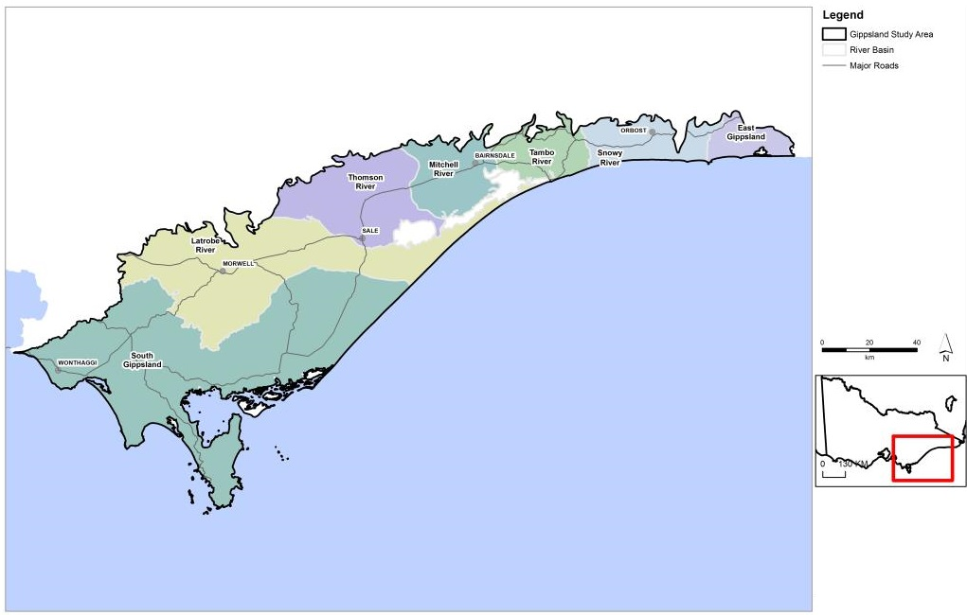
Figure 1: Gippsland study area, showing surface water catchments.

1.3 Onshore natural gas resources
The analysis includes possible tight and shale gas and coal seam gas developments in the Gippsland Basin. These are the range of natural gas types that could be developed in the onshore Gippsland Basin. There appears from the geological data available to be little prospect for viable conventional gas resources to occur onshore. Figure 2 shows the areas in the basin where gas might be found, based on the presence of a potentially prospective geological unit and previous petroleum exploration in the basin. Tight and shale gas are assessed as a single resource for the purpose of this analysis as both may be found in the one prospective formation. Coal seam gas potentially derived from brown coal is analysed separately.
Potential gas resources in the onshore Gippsland region are located at depth below the surface underneath and co-located with other rock units including aquifers. A diagrammatic view of the relationship between surface water features, aquifers and gas resources is shown in Figure 3.

1.3.1 Tight and shale gas
Potential tight and shale gas resources may be present within the geological formation known as the Strzelecki Group. The depth to the top of the Strzelecki Group varies across the region. The most likely depth at which gas may be retained in this formation is greater than 1500 m. Using this knowledge, an area of 1132 km² is potentially prospective (based on current petroleum retention licences). The full development of this area is adopted for impact assessment, even though smaller developments would be more likely at the time of any gas development.

1.3.2 Coal seam gas (brown coal)
Brown coals of the Traralgon Formation potentially host coal seam gas, although it is currently unknown whether gas is present in commercially recoverable volumes. The impact assessment is based on a scenario involving the development of an area of 438 km² of the Traralgon Formation where the coal seams of the formation are 400 to 800 m below the surface.

1.4 Groundwater resources
Groundwater resources are contained in layers of high water yield (aquifers) and may be relatively fresh or saline. The Gippsland Basin contains a variable sequence of aquifers that generally thicken eastwards through the Latrobe Valley and Seaspray Depressions and towards the coast. There is significant groundwater extraction for agriculture, commercial, mine and power station operation, town supply, and offshore oil and gas production (approximately 183 000 ML/annum of aggregated entitlement volume) in addition to stock and domestic bores.
Groundwater resources in the Gippsland Basin can be classified into three broad groups: the upper aquifers, the middle aquifers (which may be shallow to the west and north of the basin but deepen towards the east) and the lower aquifers (generally underneath the middle layer). These aquifer groups are generally separated by aquitards, which are low water-yielding formations.

1.5 Assessment approach
Prior to developing this impact assessment, a review of relevant Australian and international literature which looked at risk from gas development was completed. This is presented in Appendix A. This assessment includes impacts and risks associated with the potential future development of the following onshore natural gas resources in the Gippsland region:
• tight and shale gas (hereafter assessed as a single resource)
• coal seam gas (from brown coal).
The extent of the possible onshore natural gas resources used in the assessment was taken from Goldie Divko (2015) and is shown in Figure 4. Further details on the nature of the gas resources included in this impact assessment is provided in Chapter 2.

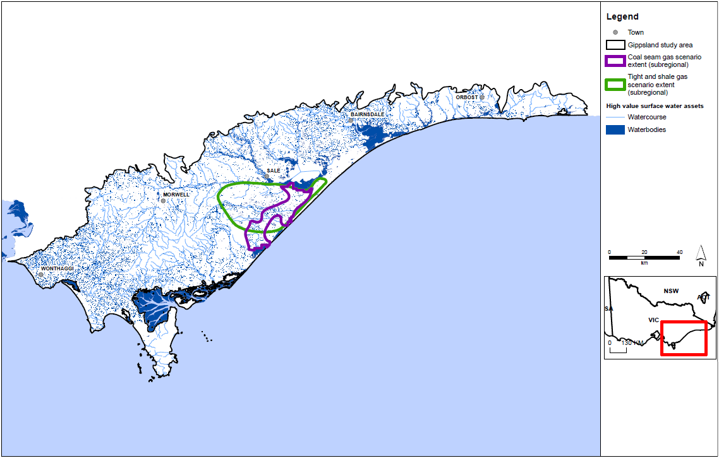
Figure 2: Location of potential onshore natural gas development locations and surface water resources in the Gippsland region used for impact assessment.
(Source: Goldie Divko 2015.)

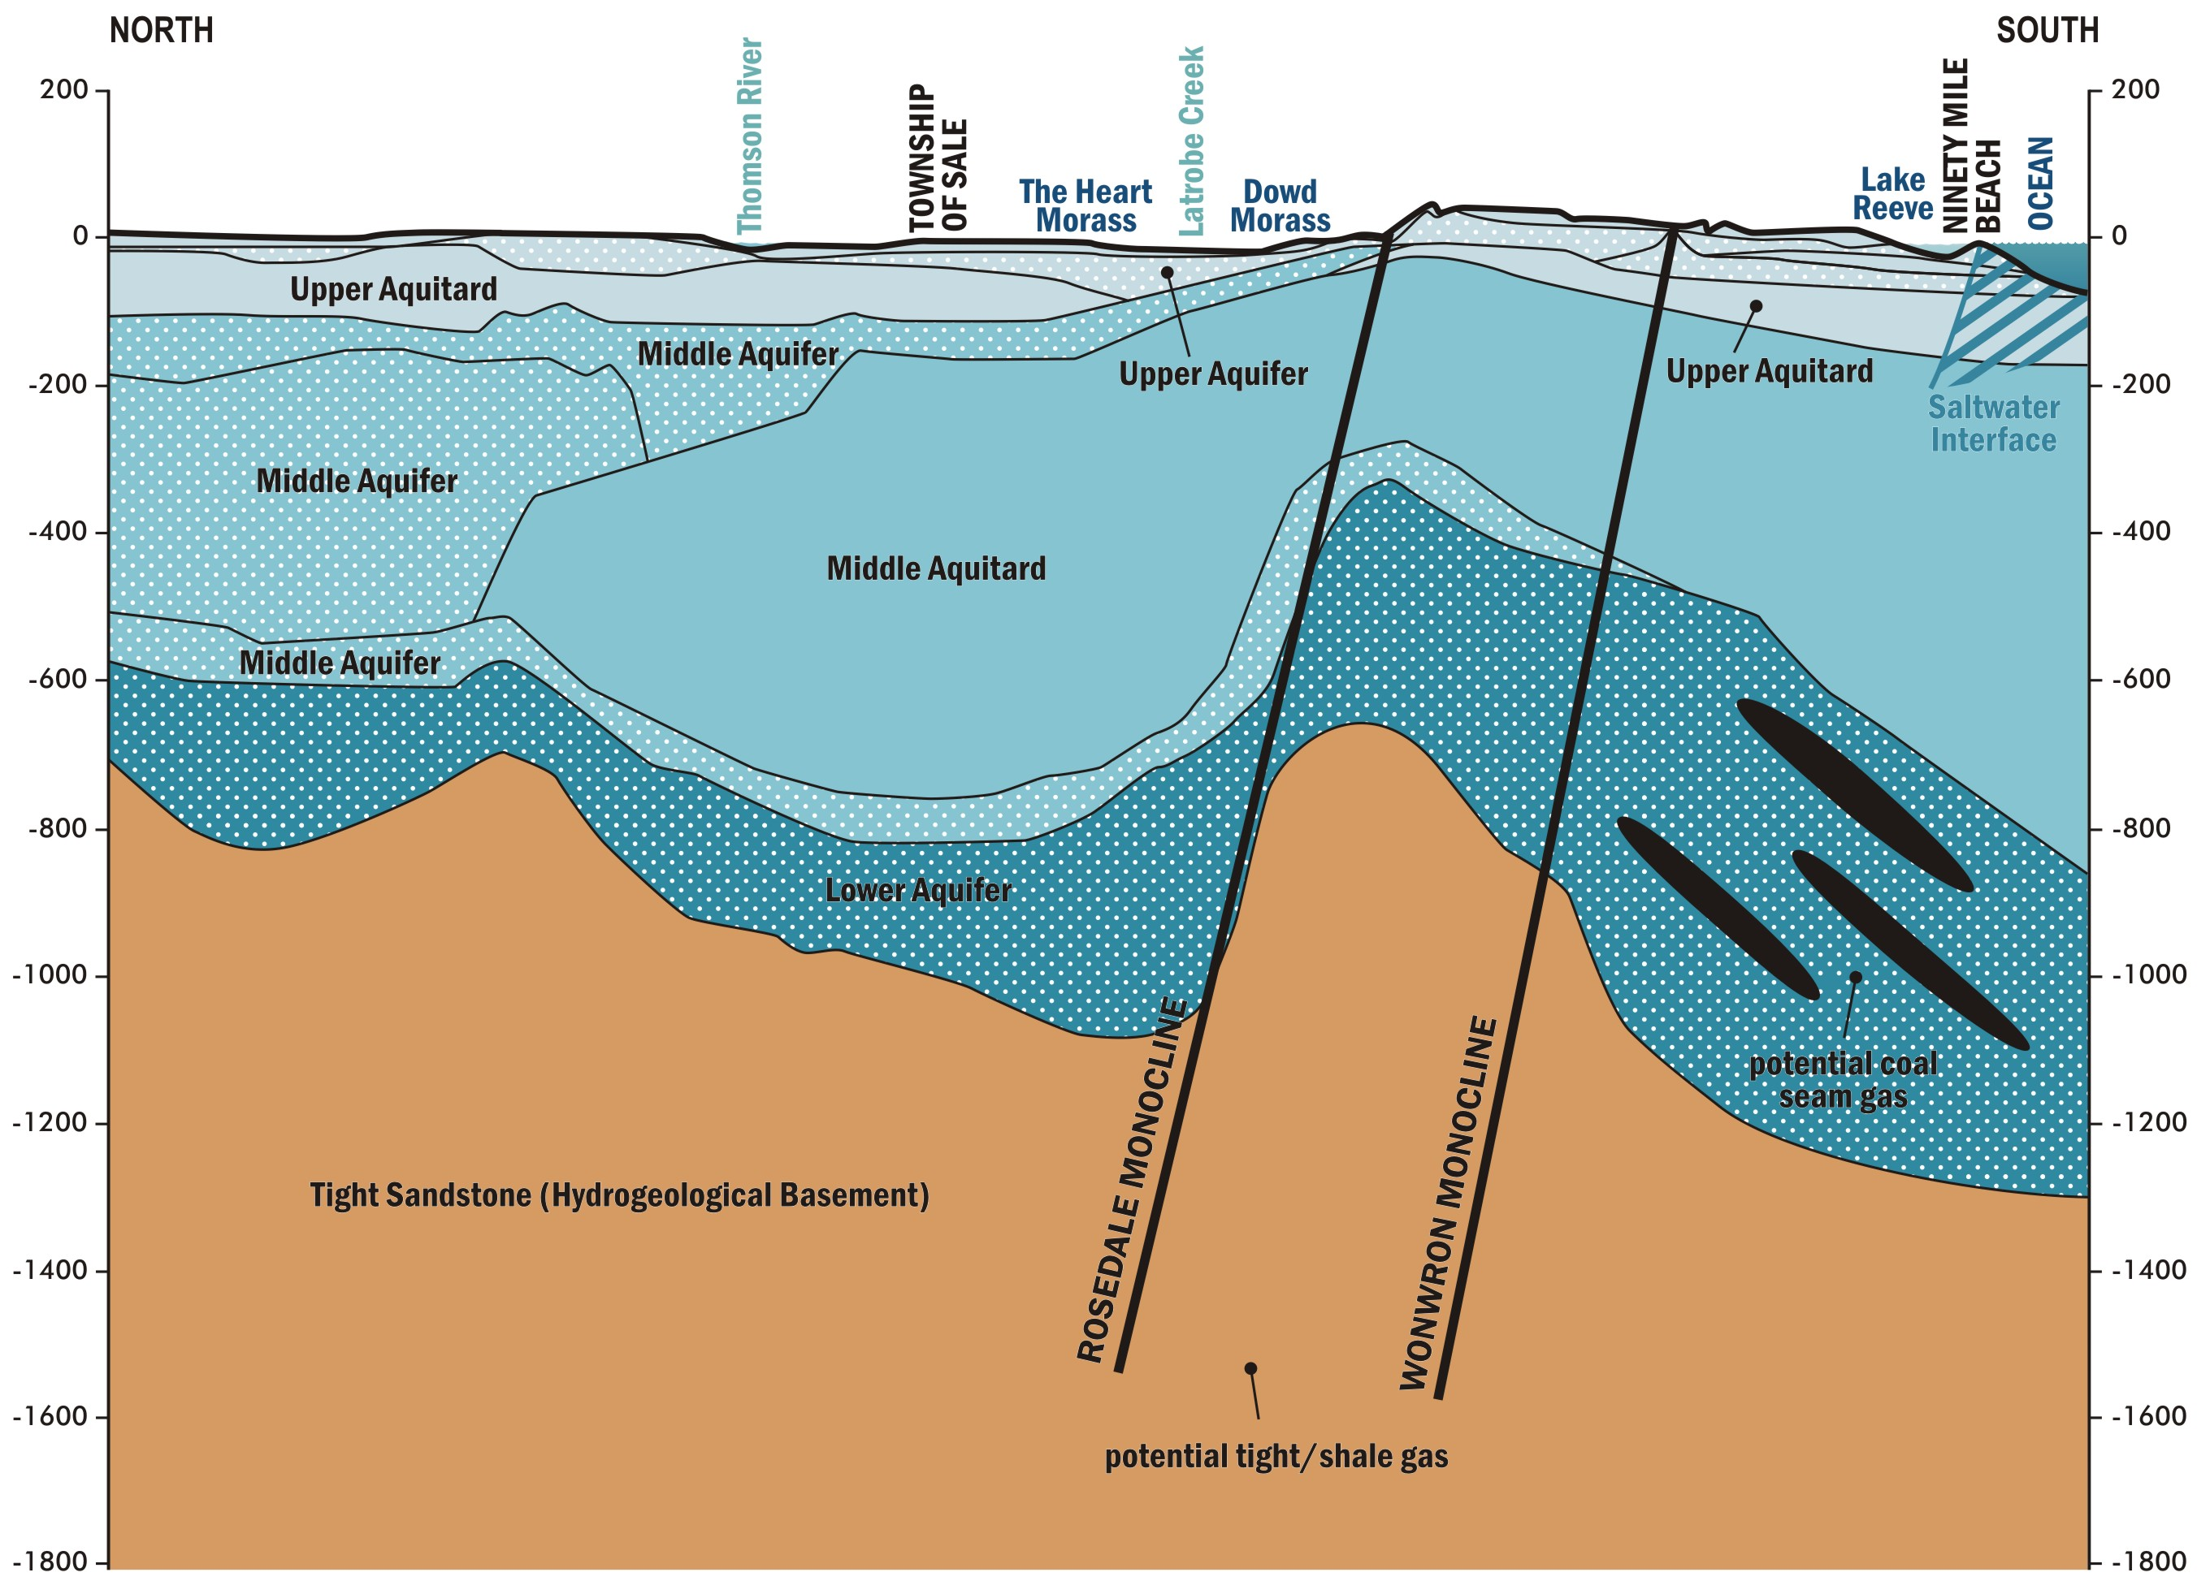
Figure 3: Diagram showing the general relationship between surface features, aquifers and potential gas-bearing geological formations in the Gippsland Region (mAHD).

Figure 4: Gippsland study area potential onshore natural gas resources and surface water resources. (Source: Goldie Divko 2015.)
The assessment framework is based on the hazard/pathway/receptor model to assess impacts on the receptors (water resources) from possible future onshore natural gas development. For an impact to occur all three components need to be present: a hazard, a receptor that could potentially be adversely impacted, and a pathway to link the two.
The four hazards assessed are:
1 aquifer depressurisation
2 chemical contamination of groundwater from hydraulic fracturing fluids
3 induced seismicity
4 land subsidence.
The approach assesses three types of high value water resource receptors:
• aquifers (which support groundwater users)
• rivers (which support surface water users and ecosystems)
• water bodies (wetlands and lakes which support surface water users and ecosystems).
The studies applied a causal pathway approach, describing where natural gas might be located, where water resources occur, and the physical connections between the gas and water resources. In the case of aquifer depressurisation, modelling and analysis was utilised to assess the potential impacts on groundwater levels and by inference the potential impacts on water users and ecosystems, as relevant region-specific data was not available for a quantitative risk assessment approach but suitable for impact assessment. For chemical contamination of groundwater from hydraulic fracturing fluids, induced seismicity and land subsidence, a qualitative risk assessment approach was used to assess the potential risks to water users and ecosystems, as the region-specific data needed for a quantitative risk assessment or impact assessment approach was not available.
The metrics used to determine the potential connection to groundwater and the potential drawdown expected from a gas development are outlined in subsequent chapters and detailed in Appendix B.
The potential for impacts was assessed according to the following criteria (for compete definitions refer to Chapters 3 to 6):
• low potential: impact is within normal variability or not anticipated (e.g. for groundwater users, a predicted decline in the watertable of less than 2 m and a predicted decline in deep groundwater levels of less than 10 m, or no change is anticipated)
• moderate potential: while the impact is outside normal variability, it does not significantly change the function of water users or ecosystems (e.g. for groundwater users, a predicted decline in the watertable of 2 m to 15 m or a predicted decline in deep groundwater levels of 10 m to 75 m)
• high potential: impact significantly changes the function of water users or ecosystems (e.g. for groundwater users, a predicted decline in the watertable of greater than 15 m or a predicted decline in deep groundwater levels of greater than 75 m).

1.5.1 Aquifer depressurisation
The pathway for aquifer depressurisation is the transmission of pressure reductions in the prospective gas formation through the adjacent seal or aquitard units, which may cause drawdown in the aquifers. For drawdown to have an impact it must occur in an aquifer that supports a receptor. This means that, for a surface water receptor to be adversely impacted, there must be a pathway between the gas source and the watertable that enables drawdown to occur in the watertable aquifer. To understand the hydrogeological pathways that have the potential to connect possible gas developments with overlying water resources, a hydrogeological conceptual model was produced. This is presented in Chapter 2.

The impact assessment for aquifer depressurisation is based on hypothesised gas development scenarios.
Impact assessment of aquifer depressurisation analyses the potential for impacts on groundwater users with an inferred impact on surface water users and ecosystems. This is based on an estimate of potential groundwater level changes from each hypothetical onshore natural gas development scenario.
The impact on water resources has been assessed for an operation of a hypothetical development running for 30 years. Impacts are assessed at the end of the operating period. This operating period corresponds to a typical life span of coal seam gas resources and infrastructure used in other jurisdictions. While 30 years is long enough for a scenario impact to be identified, maximum impacts may occur after 30 years.

1.5.2 Chemical contamination of groundwater from hydraulic fracturing fluids
In hydraulic fracturing the rock of the gas reservoir is put under pressure to generate small cracks in the rock allowing the gas to be extracted. The findings in the main report use the available literature to assess the in-situ hydrogeological factors that may contribute to fracture propagation beyond the intended zone of fracturing, an assessment of their distribution and potential for groundwater contamination.

1.5.3 Induced seismicity
Induced seismicity associated with unconventional gas extraction can be related to hydraulic fracturing, gas production and/or coproduced water re-injection. The potential impact of induced seismicity was assessed by a review of international literature for the key risk factors for induced seismicity and how they can be managed.

1.5.4 Land subsidence
The potential impacts of land subsidence as a result of gas extraction were assessed by a literature review. The literature review used a number of recent literature reviews undertaken for the Independent Expert Scientific Committee on Coal Seam Gas and Large Coal Mining Development that reports to the Federal Government, in addition to studies undertaken in Gippsland.

1.6 Results

1.6.1 Tight and shale gas
The potential for impacts on groundwater users from aquifer depressurisation for tight and shale gas development is inferred as low, because the predicted changes to groundwater levels would be within historical ranges for the region.
The potential for impacts on groundwater quality from aquifer depressurisation for tight and shale gas development is inferred as low, based on the predicted changes to groundwater pressure gradients being within historical ranges.
The potential for impacts on surface water users as a result of reduced stream flow or changes in surface water quality due to aquifer depressurisation is inferred as low, with the exception of localised areas of moderate to high potential impact in the central Latrobe Valley region. This is based on the predicted changes to groundwater levels. The areas of moderate to high potential impact could be reduced to low with implementation of one or more of the mitigation strategies, as described in Chapter 6.
The potential for impacts on ecosystems as a result of reduced stream flow due to aquifer depressurisation is inferred as low, with the exception of localised areas of moderate to high potential impact in the central Latrobe Valley region. This is based on the predicted changes to groundwater levels. However, there are possible technical and financial constraints to applying effective mitigation to this impact.
The potential for chemical contamination of groundwater from hydraulic fracturing fluids is low for tight and shale development, based on a review of national and international literature with consideration of the particular conditions of the Gippsland region and the fact that the use of BTEX in hydraulic fracturing fluids is banned under Victorian law.
The potential for induced seismicity is low for tight and shale gas development, based on a review of national and international literature with consideration of the particular conditions of the Gippsland region.
The potential for land subsidence is inferred as low for tight and shale development, based on the predicted changes to groundwater levels.

1.6.2 Coal seam gas
The potential for impacts on groundwater users from aquifer depressurisation for coal seam gas development is inferred as moderate to high, depending on the distance to the prospective development area, based on the predicted changes to groundwater levels. However, this could be reduced to low with implementation of one or more of the mitigation strategies as described in Chapter 6.
The potential for impacts on groundwater quality from aquifer depressurisation for coal seam gas development is inferred as moderate, based on the predicted changes to groundwater pressure gradients being significant within the context of historical ranges for the region. There are possible technical and financial constraints to applying effective mitigation to this impact.
The potential for impacts on surface water users as a result of reduced stream flow or changes in surface water quality due to aquifer depressurisation is inferred as moderate to high, depending on proximity to the proposed gas development. This is based on the predicted changes to groundwater levels. However, this could be reduced to low with implementation of one or more of the mitigation strategies as described in Chapter 6.
The potential for impacts on ecosystems as a result of reduced stream flow or changes in surface water quality due to aquifer depressurisation is inferred as moderate to high, depending on proximity to the proposed gas development. This is based on the predicted changes to groundwater levels. There are possible technical and financial limitations to applying effective mitigation to this impact.
Hydraulic fracturing is unlikely to be needed in any development of coal seam gas in Gippsland, and therefore would not have a potential impact in this region.
The potential for induced seismicity is low for coal seam gas development, based on a review of national and international literature with consideration of the particular conditions of the Gippsland region.
The potential for land subsidence is inferred as moderate for coal seam gas development, based on the predicted changes to groundwater levels. There are possible technical and financial constraints to applying effective mitigation to this impact.

2 Hydrogeological conceptual model

2.1 Introduction
This chapter provides an overview of the geology and the hydrogeology of the Gippsland Basin to present the hydrogeological conceptual model that informs the impact assessments presented in Chapters 3 to 6.
The hydrogeological model draws on literature in the areas of groundwater resource management, carbon sequestration and natural gas prospectivity.
The conceptual model:
• outlines the stratigraphy, onshore gas resources, key usable aquifers in the basin and significant groundwater dependent assets (receptors
• describes in general terms the potential hydrogeological pathways (pressure reduction transmission pathways) between the source and receptors
• defines low-permeability layers
• describes key hydrogeological parameters
• forms the basis of impact assessment from aquifer depressurisation
• informs risk assessments for hydraulic fracturing, induced seismicity and land subsidence.

2.2 Geology

2.2.1 Geological and structural setting
The Gippsland Basin is an approximate east–west trending sedimentary basin bounded by major fault systems on the southern and northern margins. Approximately two thirds of the basin is offshore. Formed during the final Gondwana break-up when the Indo-Australian and Antarctic plates rifted and the Tasman Sea opened, the basin consists of a thick sequence of Tertiary sediments overlying Mesozoic metasediments (Birch, 2003).
A number of structural features break the Gippsland Basin into several platforms and depressions, as shown in Figure 5. The most significant of these are discussed below.
The upthrown Balook Block forms the Strzelecki Ranges to the west and dips eastward, forming the Baragwanath Anticline. The Baragwanath Anticline is a significant structural features of the onshore part of the basin, running from the Gormandale region in the west to Golden Beach in the east and comprises a bedrock high with a thinner sequence of Tertiary sediments draped over the top. The thinning of the Tertiary sequence over the Baragwanath Anticline influences regional groundwater flow. The Rosedale Fault system occurs on the northern side of the Baragwanath Anticline, with sediments down-faulted on the north side of the fault.
The Darriman Fault System runs northeast from Foster to north of Yarram, then east to offshore regions of the Gippsland Basin. The Rosedale Fault System (to the north) and the Darriman Fault System (to the south) resulted in the downwards movement of the basement and the formation of the Seaspray Depression.
The Lake Wellington Fault System formed during the Late Cretaceous period and has an east–west trend. The fault separates the upfaulted Lakes Entrance Platform to the north from the Lake Wellington Depression to the south, as shown in Figure 5 (Goldie Divko et al., 2010).
The Moe Swamp Basin comprises Tertiary sediments and volcanics extending from west of Warragul east to the Haunted Hills Block (Walker and Mollica, 1990) A major fault near Yallourn has upfaulted the pre-Tertiary basement rocks to form the Moe Swamp Basin, which then filled with sediments and volcanics during the Tertiary. The Moe Basin is believed to be hydrogeologically isolated, so that groundwater within the basin does not directly interact with the rest of the Gippsland Basin (Jacobs, 2014a).

2.2.2 Stratigraphy
The stratigraphy of the Gippsland Basin can be divided into the following major units that overlie the Palaeozoic basement:
• Strzelecki Group
• Latrobe Group
• Latrobe Valley Group
• Seaspray Group
• Sale Group
• Quaternary formations.
The distribution of these units within the main structural features of the Gippsland Basin is shown in Figure 6.

The Strzelecki Group
The Mesozoic Strzelecki Group is a thick sequence of low-permeability, non-marine, volcanoclastic-rich sandstones and mudstones. The Strzelecki Group outcrops in the Strzelecki Ranges in the uplifted Balook Block (see Figure 5). The thickness of the Strzelecki Group is shown in Figure 7, which shows that the unit reaches a maximum thickness of more than 4000 m in the centre of the onshore basin and is thinnest in the outcropping Strzelecki Ranges, although a high level of uncertainty remains about the basin architecture through this region.
The elevation of the top of the Strzelecki Group is shown in Figure 7.

The Latrobe Group
The Latrobe Group comprises marine and non-marine siliciclastics that host all the known hydrocarbon occurrences in the offshore region of the Gippsland Basin (Goldie Divko et al., 2010). The group overlies the Strzelecki Group and occurs at a depth of around 1000 to 1500 m at Seaspray, with a thickness of 1000 m in onshore areas (SKM & GHD, 2010; VVG, 2014). The Latrobe Group includes three formations: the Yarram Formation, Carrajung Volcanics, and Traralgon Formation.
The Middle to Late Palaeocene Yarram Formation is found sporadically in the south-eastern section of the onshore Gippsland Basin in the Stradbroke, Alberton and Gelliondale areas (SKM and GHD, 2010). The unit comprises clayey, coarse-grained to pebbly sandstone with minor interbedded claystone and rare coal which infill former valleys in the pre-Tertiary basement. It is found sporadically overlying the Strzelecki Group and beneath the Carrajung Volcanics on the Balook Block of the Strzelecki Ranges (SKM and GHD, 2010).
The Carrajung Volcanics are present in central regions of the basin in the Latrobe Valley and overlie the Yarram Formation. The Carrajung Volcanics are widespread in the Seaspray and Alberton Depressions and in parts of the Latrobe Valley, and outcrop on the Balook Block, particularly around the edges adjacent to the bounding faults (SKM and GHD, 2010).
Traralgon Formation overlies the Carrajung Volcanics and is comprised of Early Eocene to Early Oligocene sands and interbedded brown coal seams extending between the Morwell Monocline and the coast (Geoscience Australia, 2012a). The formation can be found at a depth of approximately 370 to 600 m (Birch, 2003). The Traralgon Formation extends laterally to the Seaspray Depression and offshore. The Traralgon Formation coal resources are divided into three seams: Traralgon 0 (T0), Traralgon 1 (T1) and Traralgon 2 (T2). T2 is the oldest of the three seams and is underlain by up to 200 m of gravels at Holey Plains (often referred to as the Honeysuckle Hill Gravels) (Gloe, 1975). The T2 seam is present at Stradbroke with a thickness of over 100 m, while T1 reaches a thickness of over 100 m near Gormandale and Stradbroke, thinning off to the east near Holey Plains and Coolungoolun (Birch, 2003).

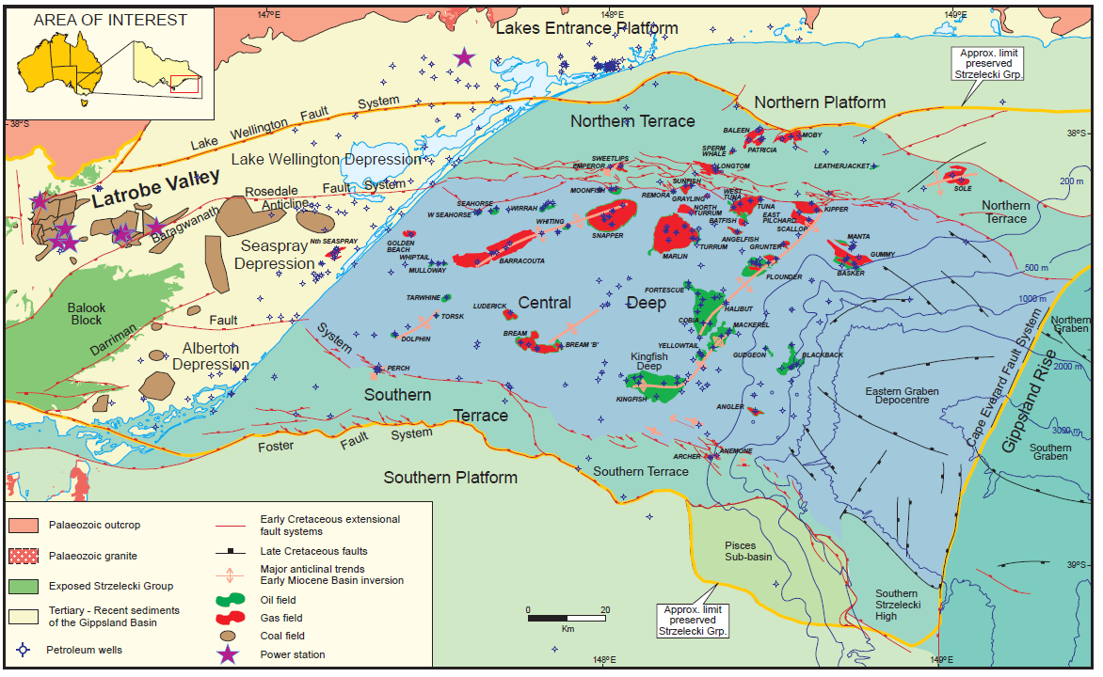
Figure 5: Structural features of the Gippsland Basin. (Source: Goldie Divko et al., 2010.)

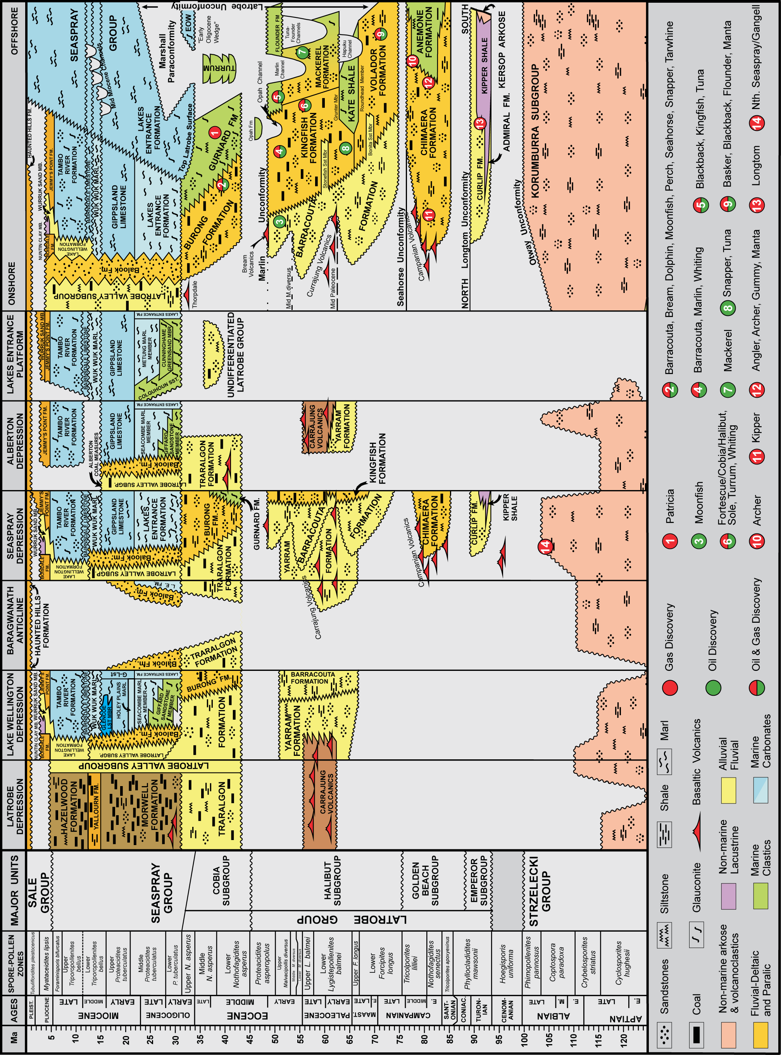
Figure 6: Gippsland Basin stratigraphy (Source: Goldie Divko et al, 2010.)

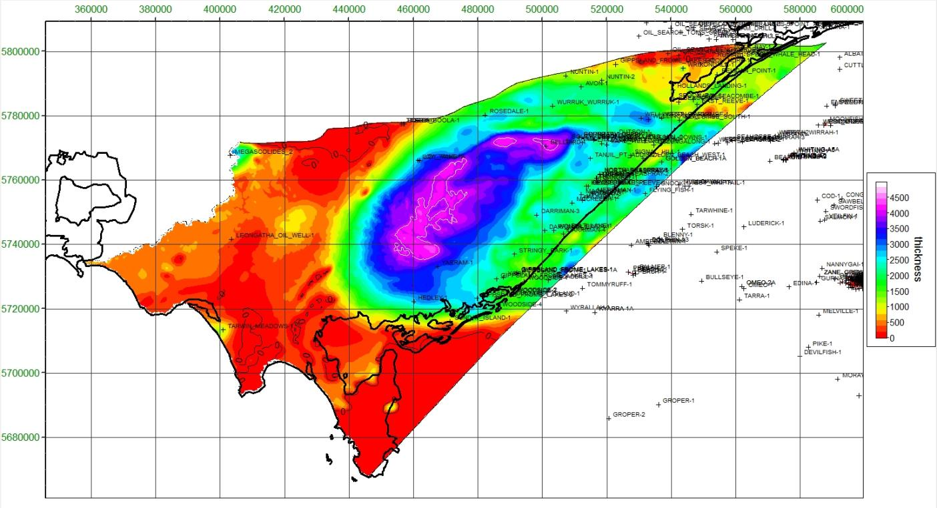
Figure 7: Approximate thickness of the Strzelecki Group. (Source: Goldie Divko, 2015.)

The Latrobe Valley Group
The Latrobe Valley Group includes a sequence of marine and non-marine claystones and siltstones and coal-bearing formations overlying the Traralgon Formation in the Latrobe Valley. The Latrobe Valley Group has in the past been referred to as a sub-group of the Latrobe Group, however more recently it has been recommended to be treated as a separate group (Birch, 2003; Vandenberg, 2012).
The Latrobe Valley Group comprises the following five formations (from oldest to youngest):
• Morwell Formation
• Alberton Coal Measures
• Yallourn Formation
• Hazelwood Formation
• Balook Formation.
The extent of the main formations comprising the Latrobe Valley Group is shown in Figure 8.
The Morwell Formation comprises Early Oligocene to Early Miocene large coal seams between 80 and 150 m thick, interfingered with sands and volcanics near the base. The various coal seams in the Morwell Formation have been named from youngest to oldest as M1A, M1B, M2A and M2B coal seams, with intervening sand layers referred to as M1A Aquifer, M1B Aquifer, M2A Aquifer, M2B Aquifer and M2C Aquifer after the coal seams they underlie (Schaeffer, 2008). The basal unit of the Morwell Formation is the Seaspray Sand or M2C unit which extends from the Latrobe Valley in the west to the Bairnsdale region in the east. The distribution and thickness of the Seaspray Sand and M2C unit is shown in Figure 9.
The Seaspray Sands and the M2C unit are depositionally synonymous and the names are sometimes used interchangeably; “Seaspray Sands” is commonly used in the Seaspray Depression, while “M2C” is the common term for this unit in the Lake Wellington and Latrobe Valley Depressions. The rest of the Morwell Formation extends from the Latrobe Valley to the Rosedale region. Reaching a maximum thickness of 200 m, the Morwell Formation is present between 20 and 40 m below natural surface in the outer reaches of the formation, extending to over 140 m deep near the Latrobe River between Morwell and Traralgon (Birch, 2003; Geoscience Australia, 2012b).
The Alberton Coal Measures are the lateral equivalent of the Morwell Formation in the Seaspray and Alberton Depressions and consist of coal seams interbedded with sand, clay and gravels (see Figure 8 for distribution).
The Yallourn Formation consists of late Early Miocene to early Middle Miocene coal seams between 80 to 150 m thick interbedded with non-marine claystones and mudstones combining to form a formation up to 200 m thick (Birch, 2003; Geoscience Australia, 2012c). The Yallourn Formation extends from the Maryvale and Yallourn area in the west to the Rosedale region in the east.
The Hazelwood Formation consists primarily of interbedded brown coal and clay and overlies the Yallourn Formation over the central Latrobe Valley (SKM and GHD, 2010). The unit has a similar distribution to the Yallourn Formation.
The Balook Formation consists of a lower unit dominated by fine-grained clay, about 100 m thick, and a thicker upper unit consisting of coarse-grained sand interlayered with thin clay layers (SKM and GHD, 2010). The Balook Formation is a beach barrier deposit occurring as a narrow band approximately 5 to 10 km wide between the terrestrial Latrobe Valley Coal Measures to the west and the marine deposits of the Seaspray Group to the east. It occurs in two distinct areas truncated by the Baragwanath Anticline (see Figure 10). The extent of the Balook Formation shown in Figure 8 is approximate; narrow bands of Balook Formation sands can extend laterally within both the Latrobe Valley Group and the Seaspray Group for tens of kilometres (Holdgate, 1996). The Balook Formation overlies the Latrobe Group.
A detailed analysis of the occurrence of the various coal seams and interlayered aquifers is given in Schaeffer (2008). An example of a cross-section from Schaeffer (2008) is reproduced in Figure 11.

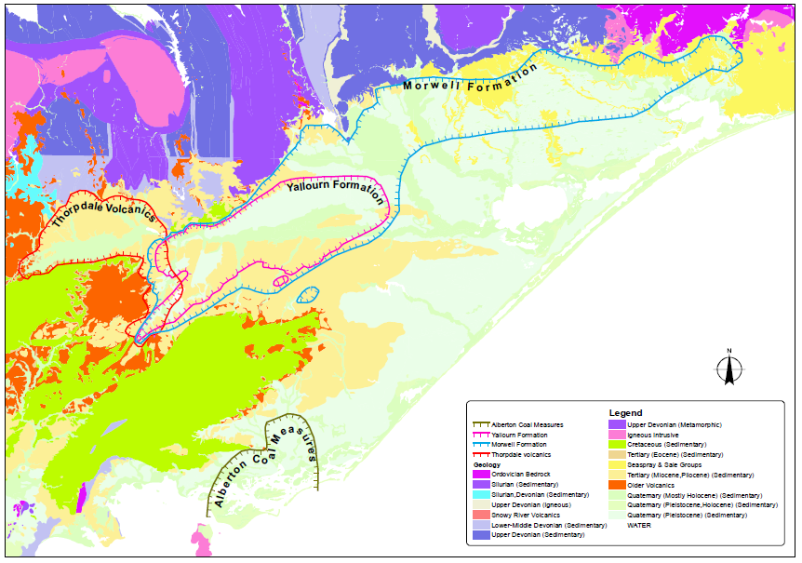
Figure 8: Extent of main Latrobe Valley Group units. (Source: SKM and GHD, 2009.)
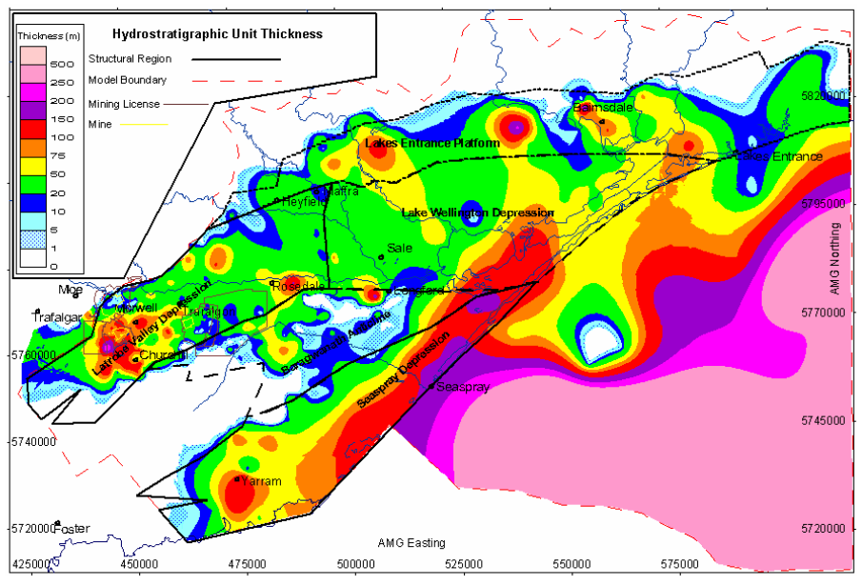
Figure 9: Extent and thickness of the M2C/Seaspray Sand unit. (Source: Schaeffer, 2008.)
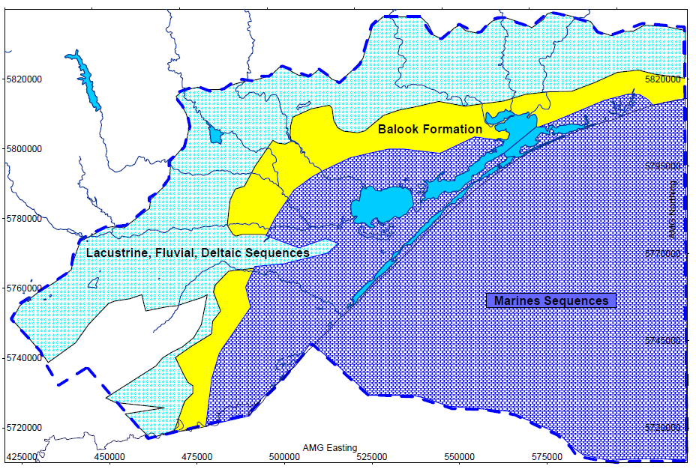
Figure 10: Approximate location of Balook Formation and the terrestrial deposits to the west and north and marine deposits to the east and
south. (Source: Schaeffer, 2008.)
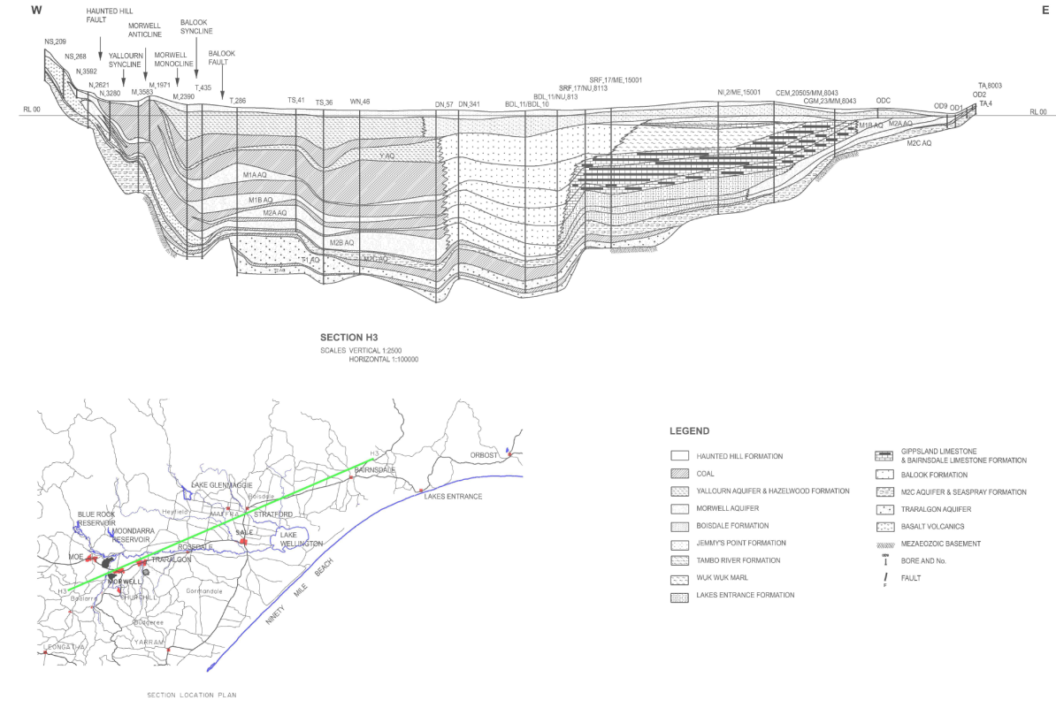
Figure 11: Cross-section, showing the complexity of the coal seams and beach barrier deposits of the Latrobe Valley Group. (Source: Schaeffer, 2008.)

Seaspray Group
The Seaspray Group consists of up to 900 m of calcareous sedimentary deposits overlying the Latrobe Group along the coast from the Lakes Entrance Platform to the Seaspray Depression, and contains six formations which are described briefly below.
The Lakes Entrance Formation extends over the Lake Wellington and Seaspray Depressions primarily comprising of mudstones and marl in the upper sections and sand and gravel deeper down. The maximum onshore thickness of the formation reaches approximately 225 m in the Lake Wellington Depression (SKM and GHD, 2010). The formation overlies the Latrobe Group in the Seaspray and Lake Wellington Depressions.
The Gippsland Limestone overlies the Lakes Entrance Formation and extends along the coast from Marlo to Yarram. The formation consists of a combination of marine carbonates, including limestone and marls, with thickness ranging from 500 to 1500 m at onshore and offshore locations respectively (SKM & GHD, 2010).
The Wuk Wuk Marl overlies the Gippsland Limestone, and has a maximum thickness of 25 m and comprises poorly bedded, brown and grey marl and extends along the coast from Lakes Entrance to Alberton, outcropping near Bairnsdale (Geoscience Australia, 2012e).
The Bairnsdale Limestone is a thin layer of limestone deposited along the coast from Lakes Entrance to the Seaspray Depression. The formation overlies the Wuk Wuk Marl.
The Tambo River Formation consists of shelly glauconitic marl, marly limestone and ferruginous fine sandstone and extends along the coast from Lakes Entrance to Alberton over the majority of the Seaspray Depression. The formation is approximately 100 m thick in the Lake Wellington Depression area, thinning to approximately 10 m at Bairnsdale (Birch, 2003; SKM and GHD, 2010).
The Lake Wellington Formation is the lateral equivalent of the Tambo River Formation in the Lake Wellington and Seaspray Depression. The unit consists of silty sands and sandy marl overlying the Balook Formation in the Rosedale region.

Sale Group
The Sale Group comprises a sequence of Late Miocene to Pliocene sediments deposited in marine and non-marine environments, reaching a maximum thickness of 200 m in the Sale region. The Sale Group overlies either the Seaspray Group or the Latrobe Valley Group and consists of three formations which are discussed briefly below.
The Upper Tertiary Boisdale Formation extends over a large section of onshore Gippsland Basin as well as along the coast near Seaspray. The Boisdale Formation is up to 100 m thick in areas near Sale and the Seaspray Depression, thinning to the east and west of Sale. The Boisdale Formation is divided into two members: the upper Nuntin Clay and the lower Wurruk Sands. The Nuntin Clay comprise of clays, gravels and fine to coarse grained sands, while the Wurruk Sand consists of medium to coarse-grained sands (SKM and GHD, 2010). The Wurruk Sand member of the Boisdale Formation is generally around 50 to 100 m thick in most areas but can be up to 200 m thick in the Sale area (SKM, 1998).
The extent of the Wurruk Sand member of the Boisdale Formation is shown in Figure 12. The extent of the Nuntin Clay is similar to the underlying Wurruk Sand. The Boisdale Formation extends in two main areas divided by the Baragwanath Anticline. South of the anticline, the Boisdale Formation extends from Yarram in the southwest to Loch Sport in the northeast. In the Dutson Downs area, the two occurrences of the Boisdale Formation are connected over the hinge of the Baragwanath Anticline. The Boisdale Formation grades laterally eastwards to the Jemmys Point Formation.
The Jemmys Point Formation comprises shelly and sandy marl and calcareous sandstone, overlain by shelly sand and minor gravels up to 110 m thick in the Golden Beach region (SKM and GHD, 2010). The Jemmys Point Formation is the lateral marine equivalent of the Boisdale Formation and outcrops in the Lakes Entrance area and is up to almost 110 m thick in the Golden Beach area of the Seaspray Depression (SKM and GHD, 2010).
The Haunted Hills Formation is a series of fluvial and lacustrine sediments comprising of clay, sandy clay, sand, gravel and clayey sand. It forms a geological unit predominantly 20 to 40 m thick (up to 80 m in some areas) spanning the majority of the low lying areas throughout the Gippsland Basin (SKM and GHD, 2010). The formation overlies the Boisdale and Jemmys Point Formations in the Lake Wellington and Seaspray Depressions. The unit outcrops as low hills in the Latrobe Valley and Rosedale area.

Quaternary formations
Quaternary sediments were deposited to form the most recent sequence of the Gippsland Basin in low lying regions of the basin along the coast and further inland from Bairnsdale to the Latrobe Valley. The Quaternary sediment formations can be divided into the following three groups:
• recent floodplain deposits — floodplain deposits near current rivers and streams, consisting of sands, gravels, silts and clays
• coastal lagoon deposits — these sediments interact with surface water features and consist of silt, clay, peat and minor sand (SKM and GHD, 2010)
• river terrace deposits — deposited up to 20 m above the outer reaches of river floodplains, and ranging from coarse gravels at the base grading upwards to gravel, sand, sandy clay and clayey silt (SKM and GHD, 2010).

2.3 Gas types and occurrence in the Gippsland region
The onshore part of the Gippsland Basin is prospective for tight and shale gas and coal seam gas. Conventional gas resources have not been defined onshore due to the high level of geological uncertainty.

2.3.1 Tight and shale gas prospectivity
Tight and shale gas is held in low-permeability and low-porosity rocks. The low permeability does not allow the gas to migrate out of the rock. The prospective formation for tight and shale gas in Gippsland is the Strzelecki Group, which underlies the Late Cretaceous – Tertiary Gippsland sedimentary basin. Goldie Divko (2015) provides an analysis of tight and shale gas prospectivity.
The extent of the hypothetical tight and shale gas development scenario used for the impact assessment is based on the sub-regional scale shown in Figure 13. This shows areas of higher potential for tight and shale gas prospectivity, where depth to top of potential gas-containing rocks ranges from 1400 to 2500 m.
2.3.2 Coal seam gas prospectivity
The prospective formation for coal seam gas in Gippsland is the brown coal seams of the Traralgon Formation. The brown coal seams of the Traralgon Formation in the onshore Gippsland Basin have the potential to contain entrapped gas. Unlike conventional oil and gas reserves, it is not necessary to have a seal above the coal seams as the gas in the coal beds is stable at the existing pressure. However, in theory, once the pressure is reduced through depressurisation and gas is released, the absence of an overlying seal may allow in gas escaping the seam, potentially reducing gas extraction rates, although this is yet to be proven.
The prospective formation for coal seam gas in Gippsland is the brown coal seams of the Traralgon Formation within the Lower Tertiary Aquifer (for an explanation of these terms see Section 2.4). The extent of the hypothetical coal seam gas development scenario used for the impact assessment is based on the sub-regional scale area shown in Figure 14. This shows where coal seam gas could occur, as defined by a depth to the top of Traralgon Formation of between 400 and 800 m. Goldie Divko (2015) provided an analysis of coal seam gas prospectivity.

Figure 12: Extent and elevation of the top of the Wurruk Sand member of the Boisdale Formation. (Source: SKM and GHD 2010.)

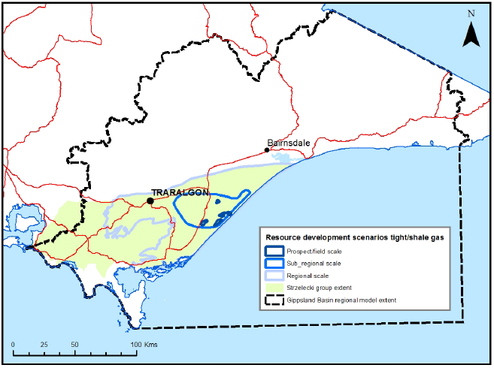
Figure 13: Gippsland region tight and shale gas resource development scenarios.
(Source: Goldie Divko, 2015.)
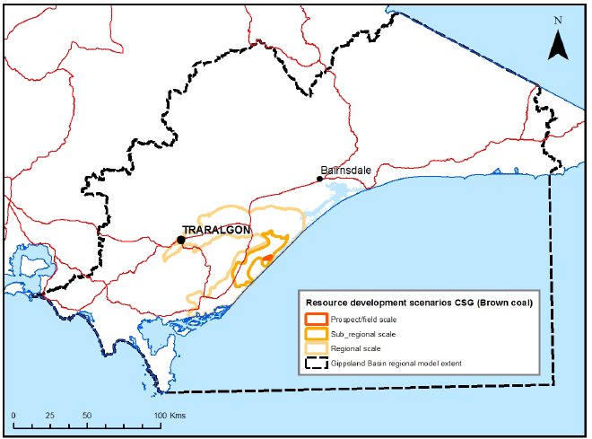
Figure 14: Gippsland region coal seam gas resource development scenarios. (Source: Goldie Divko, 2015.)
.

2.4 Hydrogeology
The Victorian Aquifer Framework groups the stratigraphic units described in Section 2.2 into hydrogeological units and aquifers, as shown in Figure 15. The framework classifies the full geological sequence and includes both aquifers and aquitards. The classification of aquifers and aquitards is regional and classifies the units that act as aquifers or aquitards at a regional scale, despite sometimes acting differently at local scales. Figure 15 also shows a broader classification into upper, middle and lower aquifers used in the Gippsland groundwater atlas produced by Southern Rural Water (SRW, 2012). The following sections describe the main features of the upper, middle and lower aquifers respectively.
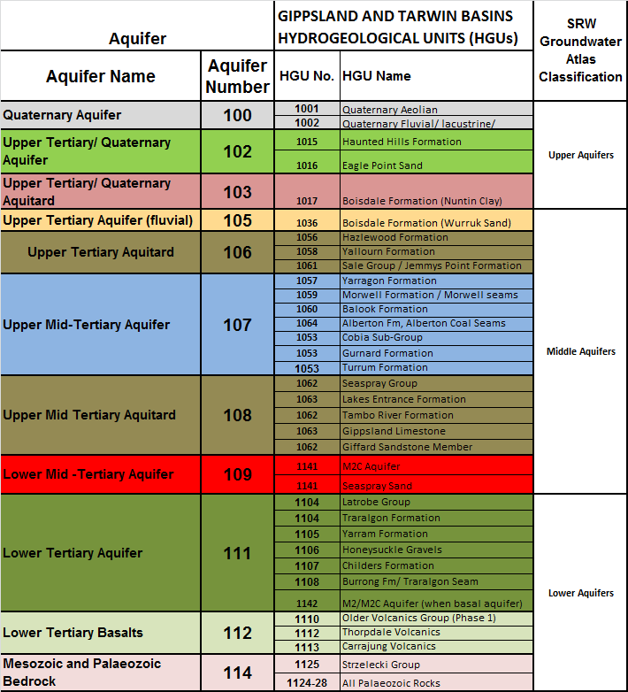
Figure 15: Victorian Aquifer Framework for Gippsland Basin hydrogeological units and aquifers.
(Source: GHD, 2013.)
    - Upper aquifers
The upper aquifers comprise the Quaternary Aquifer and the Upper Tertiary/Quaternary aquifer, together with the underlying Upper Tertiary/Quaternary Aquitard (Figure 15).
The Quaternary Aquifer consists of various surficial alluvial, flood plain and aeolian deposits. The Upper Tertiary/ Quaternary Aquifer consists of the Haunted Hills Formation and the Eagle Point Sand. These either underlie the Quaternary Aquifer surficial sediments or outcrop. Over much of the Gippsland Basin, both these aquifers are clay-dominated and low-yielding aquifers. However, in some areas well-developed sand and gravel layers can produce significant quantities of groundwater. They include:
- the Macalister Irrigation District in the Heyfield, Sale, Rosedale and Maffra regions where a gravel aquifer within the Quaternary Aquifer sediments of around 5 m to 10 m thickness is utilised for irrigation and stock and domestic supply and is covered by the Denison and Wa De Lock GMA
- the Mitchell River alluvial valley upstream of Bairnsdale where Quaternary Aquifer comprises alluvial sediments which provide a significant groundwater supply for many of the vegetable growers in the region and is covered by the Wy Yung GMA
- the Quaternary Aquifer alluvial plains of the Snowy River in the Orbost region covered by the Orbost GMA
- the Quaternary Aquifer coastal sand deposits in the Venus Bay region covered by the Tarwin GMA.
The Upper Tertiary/Quaternary Aquitard does not outcrop and consists of the Nuntin Clay (which is the confining layer in the Boisdale Formation) and Jemmys Point Formation. The Jemmys Point Formation is generally considered to be a low-yielding aquifer and in many places an aquitard (SKM and GHD, 2010). The Wurruk Sand in the Boisdale Formation is classified as the Upper Tertiary Aquifer (see Section 2.4.2).

Salinity
Figure 16 shows the watertable salinity across the upper aquifers in the Gippsland Basin. Salinity is generally less than 3500 mg/L total dissolved solids (TDS) with variations existing locally. Salinity ranges from less than 1000 mg/L TDS in the Wa De Lock and Nambrok–Denison regions to greater than 20 000 mg/L TDS in the eastern Clydebank region, where a near-surface watertable causes salts to concentrate (SRW, 2012).

Groundwater levels and flow patterns
The depth to watertable across the region is stable and generally lies between 5 and 10 m below the surface, although many areas are at depths of less than 2 m (WGCMA, 2005). Hydrographs show seasonal trends, with water levels highest in winter–spring and lowest in the summer period with variations as great as 5 m in the Macalister Irrigation District region.
The dominant recharge mechanism is rainfall recharge and irrigation during the October to March period. Hydrograph comparisons with rainfall show that the aquifer responds relatively rapidly to rainfall events (SKM, 2009a). Periodic flooding can cause episodic recharge in low lying areas around river systems. There is also evidence of river recharge to the shallow groundwater system in places (SRW, 2012). Discharge processes include evapotranspiration from the shallow watertable and discharge to rivers, wetlands, Lake Wellington and leakage to deeper aquifers, which is discussed further in the following section (SRW, 2012).
Groundwater flow directions generally mimic topography and flow towards the coast or local and regional discharge features. Figure 17 presents the elevation of the watertable, showing that groundwater flows in a south-easterly direction towards the coast.

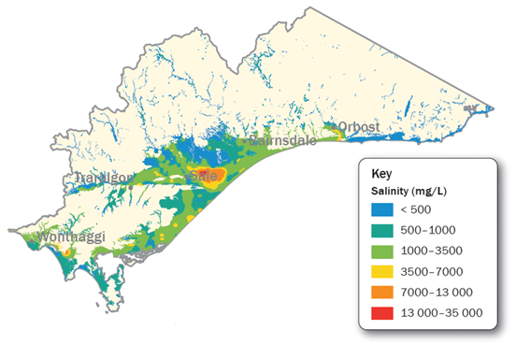
Figure 16: Salinity concentrations of upper aquifers in the Gippsland region. (Source: SRW, 2012.)

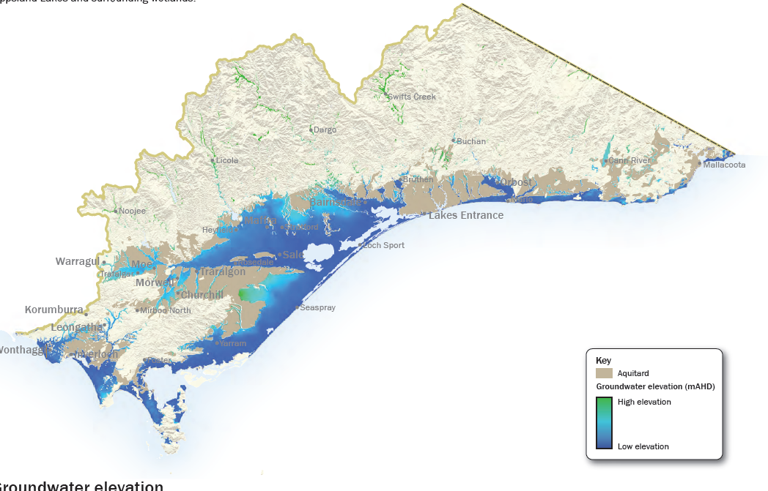
Figure 17: Groundwater elevation in the upper aquifers of the Gippsland region. (Source: SRW, 2012.)

Hydraulic connection to other aquifers
The units directly underlying the Upper Aquifers include the Upper Tertiary Aquifer (where the Boisdale Formation occurs), the Upper Tertiary Aquitard, and the Upper Mid-Tertiary Aquifer (where the Balook Formation occurs).
The hydraulic connection between the watertable in the Upper Aquifers and the underlying units has been studied in small areas of interest, with a focus on the higher-yielding aquifers in and around the Macalister Irrigation District and the Mitchell River alluvial valley.
Watertable overlying the Upper Tertiary Aquifer (Boisdale Formation)
Where the watertable of the Quaternary Aquifer overlies the Upper Tertiary Aquifer (Wurruk Sand of the Boisdale Formation) the Upper Tertiary/Quaternary Aquitard (Nuntin Clay) is thought to restrict groundwater flow between them (SKM, 2008a). Studies of the groundwater levels in and around the Macalister Irrigation District show that there is a general upwards fluid pressure gradient from the Upper Tertiary Aquifer (Wurruk Sand) to the overlying Quaternary Aquifer (SKM, 2008a). However, in areas of groundwater pumping from the Wurruk Sand, such as around the Sale town water supply bores and irrigation bores in the Clydebank area, a temporary downward gradient between the watertable and the Boisdale Formation has been observed (SKM, 2008a). Numerical groundwater modelling of the Boisdale Aquifer suggests that, despite the presence of the Nuntin Clay separating the watertable from the Wurruk Sand, there is still a significant net upward flow to the watertable (SKM, 2006a).
Watertable overlying the Upper Mid-Tertiary Aquifer (Balook Formation)
The Boisdale Formation thins westwards and in the area west of Sale is either thin or non-existent. This area marks the limit of Upper Tertiary alluvial deposition and represents a transition between the terrestrial deposits of the Latrobe Valley Group (coal measures) and the beach barrier deposits of the Balook Formation. This area is stratigraphically complex and vertical aquifer interaction has not been investigated to any great extent. However, Schaeffer (2008) postulates that the sandy units of the Balook Formation could provide a hydraulic pathway between the Latrobe Valley Coal Measures (Upper Mid-Tertiary Aquitard and Upper Mid-Tertiary Aquifer) and the overlying watertable.
Watertable in the Mitchell River floodplain
The Quaternary Aquifer is well developed in the Mitchell River floodplain, providing a source of good-quality irrigation water to vegetable growers in the area. In this region the Quaternary Aquifer overlies the Balook Formation of the Upper Mid-Tertiary Aquifer and the Jemmys Point Formation of the Upper Tertiary Aquitard. While little information is available, it is believed that the Quaternary Aquifer in the Mitchell River Valley plays an important role in recharging the underlying Upper Mid-Tertiary Aquifer and Lower Tertiary Aquifer (Latrobe Group) (SKM, 2007). SKM (2007) noted that in some areas there are significant thicknesses of clay separating the Quaternary sediments from the underlying Upper Mid-Tertiary Aquifer, suggesting that declining levels in these aquifers are unlikely to cause significant impacts on the water levels in the Quaternary aquifer or the Mitchell River. In other areas the deeper aquifers are known to sub-crop beneath the Quaternary alluvial aquifer and could therefore interact with the shallow aquifer and the river
(SKM, 2007).

2.4.2 Middle aquifers
The Middle Aquifers (Figure 15) consist of:
• the Upper Tertiary Aquifer – Wurruk Sand of the Boisdale Formation
• the Upper Tertiary Aquitard – Hazelwood, Yallourn and Jemmys Point Formation
• the Upper Mid-Tertiary Aquifer – Morwell and Balook Formations
• the Upper Mid-Tertiary Aquitard – Gippsland Limestone and the Lakes Entrance Formation
• the Lower Mid-Tertiary Aquifer – M2C aquifer and Seaspray Sand.
The Upper Tertiary Aquifer comprises the Wurruk Sand member of the Boisdale Formation; the extent is shown in Figure 12. The Upper Tertiary Aquifer is a high-yielding, low-salinity aquifer which is utilised for town water supply and irrigation in the Sale region, eastwards to Lake Wellington and in the coastal area around Seaspray and Giffard Plains.
The Upper Tertiary Aquitard comprises the Hazelwood, Yallourn and Jemmys Point Formations. The Hazelwood and Yallourn Formation occur in the Latrobe Valley area, with a combined thickness in the range of 100 to 200 m (VVG, 2014). Apart from the vicinity of the Yallourn East Field Mine, where fine sands occur, the Yallourn Formation is a poor aquifer (Schaeffer, 2008). However, it becomes sandier east of Loy Yang Mine, where it merges into the upper part of the Balook Formation (Schaeffer, 1988). Depositionally, the Jemmys Point Formation is the easterly marine lateral equivalent of the Boisdale Formation. Although it is younger than the Hazelwood and Yallourn Formations, it is included in the Upper Tertiary Aquitard because it acts predominantly as an aquitard.
The Morwell Formation and the Balook Formations combine to form the Upper Mid-Tertiary Aquifer. The Balook Formation is a thick but narrow sequence of predominantly sand layers interspersed with clay. It is used in the Yarram region where it comes close to the surface. The greater accessibility of overlying aquifers such as the Boisdale Formation is likely to be the reason for its lack of use in other areas.
The Morwell Formation contains a number of sand-dominated aquifers interspersed with brown coal seams, which generally act as aquitards. The intervening aquifers are named locally after their overlying coal seams as M1A Aquifer, M1B Aquifer, M2A Aquifer, M2B Aquifer and M2C Aquifer (Schaeffer, 2008). The most significant of these aquifers is the basal M2C Aquifer, which is an important regional aquifer. Consequently it has been given its own categorisation in the Victorian Aquifer Framework as the Lower Mid-Tertiary Aquifer.
The Upper Tertiary Aquitard consists of the marine Seaspray Group, including the basal Lakes Entrance Formation and the overlying Gippsland Limestone and Lake Wellington Formation. The spatial distribution of the marine units is shown in Figure 10. The unit increases in thickness in a south-easterly direction, reaching a thickness of more than 800 m on the coast in the Seaspray – Loch Sport area.

Salinity
The interpreted groundwater salinity of the Upper Tertiary Aquifer (Wurruk Sand member of the Boisdale Formation) is shown in Figure 18. The lower-salinity groundwater occurs in the region from Sale to Lake Wellington, where it is used extensively for irrigation and for the Sale town water supply. The aquifer is also used for irrigation in the Seaspray to Giffard area along the coast. The interpreted groundwater salinity in the Upper Mid-Tertiary Aquifer (Yarragon Formation, Morwell Formation and Balook Formation) and the Lower Mid-Tertiary Aquifer (M2C and Seaspray Sand) is shown in Figure 19. Groundwater quality in the Upper Mid-Tertiary Aquifer is generally of good quality and is utilised in the Yarram area as a source of irrigation water.

Groundwater levels and flow patterns
Analysis of trends in groundwater levels and groundwater flow patterns tends to be focused in areas and aquifers of concentrated monitoring and groundwater use. The discussion below focuses on studies in the Sale area for the Boisdale Formation Aquifer and the Latrobe Valley mines dewatering of the Morwell Formation.
Upper Tertiary Aquifer (Wurruk Sand member of the Boisdale Formation)
The Boisdale Formation is not exposed at the surface and is a confined aquifer system. The main recharge areas for the Boisdale Formation in the Sale WSPA is considered by HydroTechnology (1994) to be along the northern margin of the aquifer beneath the alluvial plain of the Thomson and Macalister rivers to the west of Maffra, and along the northern flank of the Baragwanath Anticline to the south of Sale (Figure 20). There is considered to be lesser amounts of recharge from the northern part of the aquifer between Stratford and Paynesville, and from the western part of the aquifer near Rosedale (SKM, 2000).

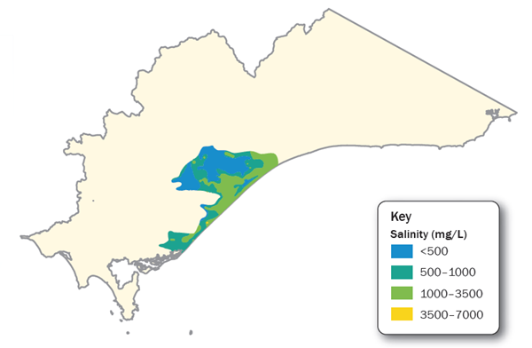
Figure 18: Groundwater salinity in the Upper Tertiary Aquifer (Wurruk Sand unit of the Boisdale Formation).
(Source: SRW, 2012.)
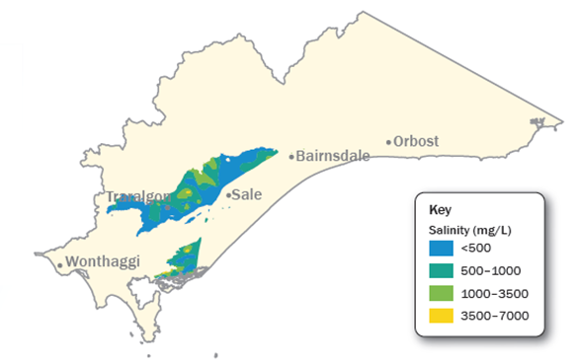
Figure 19: Interpreted groundwater salinity in the combined Upper Mid-Tertiary Aquifer (Morwell and Balook Formation) and the Lower Mid-Tertiary Aquifer (Seaspray Sand and M2C Aquifer). (Source: SRW, 2012.)

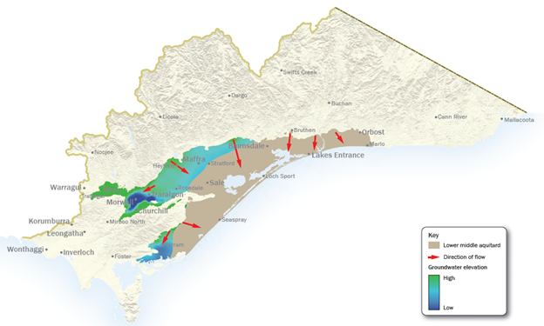
Figure 20: Interpreted groundwater flow directions in the Upper Mid-Tertiary Aquifer. (Source: SRW, 2012.)
In the Giffard–Seaspray region the recharge areas for the Boisdale Aquifer are thought to be along the southern flank of the Baragwanath Anticline, to the north of Woodside and Stradbroke (SKM, 2001) and possibly from the Yarram area to the west (SKM, 2001a). The groundwater level trends in the Giffard GMA have been generally flat (SKM, 2001).
An assessment of groundwater levels in the Sale GMA by SKM (2008a) show that the potentiometric surface of the Boisdale Aquifer has a downwards trend over the 5 years previous to the report, with the greatest declines in the area between Sale and Lake Wellington (average decline of 0.1 to 0.3 m/year). The declining trend in water levels is primarily attributed to the increase in local groundwater pumping from the Boisdale Aquifer.
Upper Mid-Tertiary Aquifer (Morwell Formation and Balook Formations)
The groundwater flow direction in the Upper Mid-Tertiary Aquifer is shown in Figure 19. The recharge areas for the aquifer are expected to be the northerly areas where the unit is closer to the surface, receiving downward recharge from overlying aquifers (SRW, 2012).
An analysis of groundwater level trends in the Balook Formation in the Yarram area by SKM (2009b) showed a consistent declining trend of between 0.4 to 0.7 m/year over a 5 year period. This was attributed mainly to the influence of the declining trends of the underlying Lower Tertiary Aquifer, with the recent increase in groundwater abstraction from the Balook Aquifer for irrigation use having little impact on the longer-term trend (SKM, 2009b).
Ongoing groundwater dewatering activities by the three Latrobe Valley mines has resulted in a regional-scale depression in the potentiometric surface of the Morwell Formation, centred on the mines. GHD (2006) noted declining groundwater level trends in the Morwell Formation Aquifer of between 0 to 1.3 m/year for the 2000 to 2005 period, with declining trends noted as far east as Rosedale.

Hydraulic connection to other aquifers
Upper Tertiary Aquifer (Wurruk Sand member of the Boisdale Formation)
In the Sale WSPA there is largely an upward groundwater pressure gradient between the Boisdale Formation and the overlying shallow aquifer systems, which suggests that there may be some upward leakage (SKM, 2008a). During periods of groundwater abstraction, water levels in the Boisdale Formation can fall below the levels in the upper aquifer system and potentially reverse the vertical flow direction (SKM, 2008a).
The Boisdale Aquifer in the Sale region is underlain in the west by the Latrobe Valley Group grading laterally eastwards into the Balook Formation Aquifer and the Seaspray Group. A small number of nested site hydrographs show that historically, there has been an upward gradient from the deeper Latrobe Valley Group/Balook Formation and the Latrobe Group to the Boisdale Formation (SKM, 2008a). However, hydrographs also show that this upwards gradient is decreasing with declining levels in the Lower Tertiary Aquifer (Latrobe Group) and the Balook Formation Aquifer (SKM, 2008a).
There has been limited investigation into the hydraulic connection between the Balook and the overlying Boisdale Aquifer. Schaeffer (2008) speculates that the lack of an obvious aquitard separating the Balook Formation from the overlying Boisdale Formation may suggest a conduit for upward groundwater movement. Similarly, there has been no serious investigation into the hydraulic connection between the Boisdale Aquifer and the Latrobe Valley Group and Gippsland Limestone Aquifers.
The Boisdale Aquifer occurs underneath the Gippsland Lakes, and there has been some concern expressed by Southern Rural Water and others about possible interaction between the aquifer and the lakes. Groundwater levels are generally above lake levels, indicating the potential for groundwater discharge to the lakes (SKM, 2009c). Greatest potential for interaction is around the northern shores of Lake Victoria and southern shores of Lake Wellington where the Boisdale Formation is closest to the base of the lake (SKM, 2009c). In other areas there are significant thicknesses of Nuntin Clay separating the lake from the aquifer, with little or no potential for interaction (SKM, 2009c).
In the coastal extent of the Boisdale Aquifer in the Seaspray–Giffard region there has been little investigation of the vertical movement between aquifers. The Boisdale is underlain by the Balook Formation in the western part of the Giffard GMA and SKM (2008b) speculates that there may be hydraulic connection between the Balook and the Boisdale in this region.
Upper Mid-Tertiary Aquifer
A lithological analysis by SKM (2009b) showed no significant aquitard separating the Balook Aquifer from the underlying Latrobe Group Aquifer in the Yarram region. The declining trends observed in the Balook Aquifer are likely to be a direct result of Latrobe Group aquifer pressure declines, although the response is dampened. Hydrograph analysis by SKM (2009b) showed that prior to the 1990s and early 2000s there was a general upward groundwater pressure gradient from the Latrobe aquifer to the Balook, but by 2009 declining groundwater levels in the Latrobe Group aquifer resulted in the potentiometric surfaces of the two aquifers being approximately the same.
The connection between the Balook/Latrobe Group aquifers and the overlying Boisdale Aquifer east of Yarram is not well known (SKM, 2008b). There is no evidence that the declining pressures in the Balook and Latrobe Group aquifers are having any impact on the overlying Boisdale Aquifer in this area.

2.4.3 Lower aquifers
The combined extent of the Lower Tertiary Aquifer and the Lower Tertiary Basalts is shown in Figure 21 and covers much of the Gippsland Basin.
The Lower Tertiary Aquifer includes the Yarram Formation, the Carrajung Volcanics and the overlying Traralgon Formation (SKM and GHD, 2010). The aquifer extends offshore from the Seaspray Depression. At the coast, along the centre of the Gippsland Basin, it is approximately 1000 m thick, but the offshore section is significantly thicker. Lower Tertiary Aquifer sediments thin dramatically across basin bounding structures such as the Baragwanath Anticline/Balook Block and to the north onto the Lakes Entrance Platform (SKM and GHD, 2010).
The Traralgon Formation is the most widespread unit of the Lower Tertiary Aquifer and includes extensive aquifers interbedded with several major brown coal seams which can be in excess of 100 m thick (Holdgate, 1996, 2000). The coal seams in the Traralgon Formation are important in the hydrogeology as they are regional aquitards, while thick sand and gravel sequences below, between and above them are regional aquifer systems from which groundwater is abstracted as part of offshore oil and gas extraction, onshore coal mining (Latrobe Valley) and irrigation (Yarram region) activities.
Outcropping Lower Tertiary Basalts on the eastern margins of the Strzelecki Ranges (Carrajung Volcanics and Older Volcanics) grade laterally below the surface into Lower Tertiary Aquifer sediments.
Salinity
The interpreted groundwater salinity in the lower aquifers is shown in Figure 22. The groundwater in the Lower Tertiary Aquifer, in particular, is generally of good quality, with salinities generally below 3500 mg/L.

Groundwater levels and flow patterns
The recharge areas for the Lower Aquifers are likely to be along the western and northern basin margins where the aquifer is elevated and closer to the surface and the overlying formations are thinnest, and along the axis of the Baragwanath Anticline (SRW, 2012). In the Yarram area, outcropping Lower Tertiary Basalts are likely to be the recharge area for the sub-cropping Lower Tertiary Aquifer (SKM, 2009b). The groundwater flow direction for the Lower Aquifers is shown in Figure 23.
Figure 24 provides a selection of groundwater hydrographs for the Lower Tertiary Aquifer, showing a consistent decline in groundwater potentiometric surface across the region of between 0.6 to 1.2 m/year since at least the mid 1970s. The relative contribution of offshore oil and gas extraction, irrigation development and mines dewatering to this regional decline has been debated for many years (e.g. CSIRO, 2004). It is clear that north of the Rosedale monocline the impact of mines dewatering is likely to be the dominant influence, while south and east of the monocline offshore gas and oil extraction combined with irrigation extraction in the Yarram area is likely to be dominant (CSIRO, 2004).
The earliest groundwater monitoring records from these bores mostly post-date the commencement of groundwater pumping for offshore gas and oil extraction and onshore mine dewatering. However, CSIRO (2004) reconstructed an interpretation of the pre-production potentiometric surface level for the Lower Tertiary Aquifer by extrapolating early groundwater level measurements. The total drawdown for the Lower Tertiary Aquifer to 2004 using this pre-production interpretation is shown in Figure 25. Despite the sustained decline in groundwater levels in the Lower Tertiary Aquifer, there is still a significant head over the top of the aquifer (Figure 26).

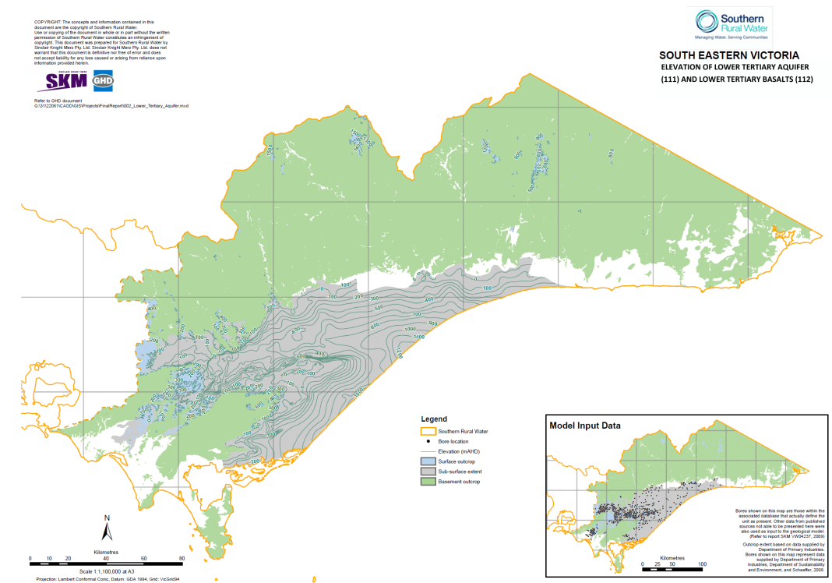
Figure 21: Extent and elevation of the Lower Tertiary Aquifer and the Lower Tertiary Basalts. (Source: SKM and GHD, 2010.)

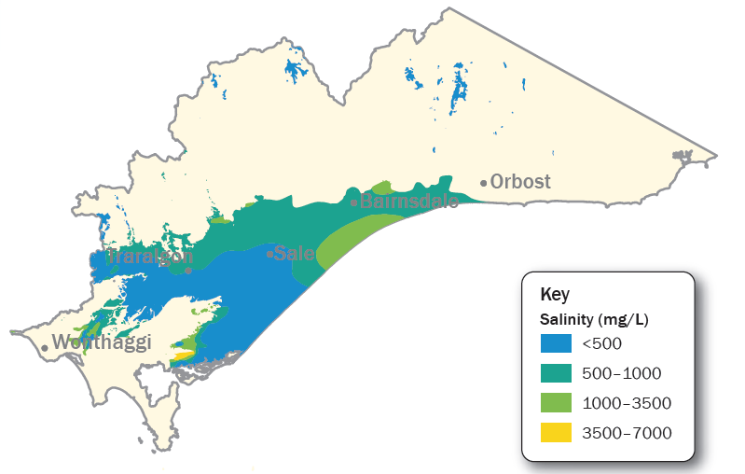
Figure 22: Interpreted groundwater salinity in the lower aquifers, including the Lower Tertiary Aquifer and the Lower Tertiary Basalts. (Source: SRW, 2012.)

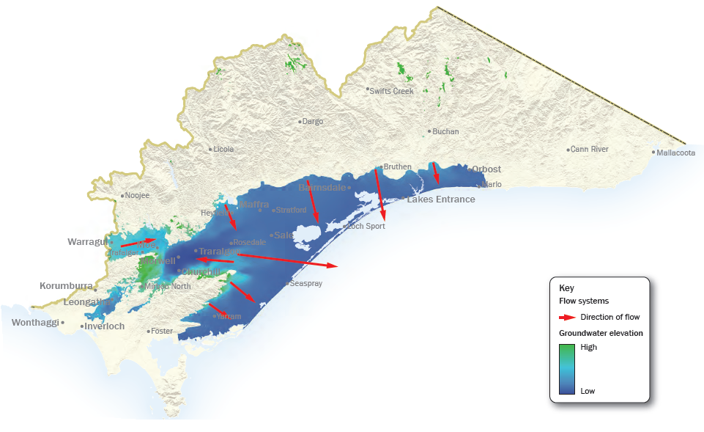
Figure 23: Groundwater flow directions for the lower aquifers. (Source: SRW, 2012.)

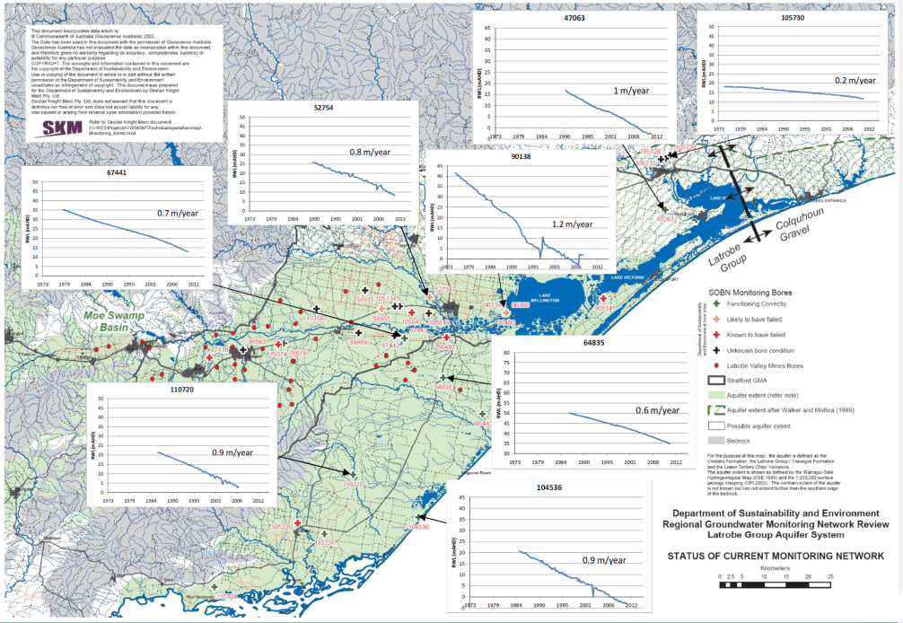
Figure 24: Location of hydrographs for the Lower Tertiary Aquifer, showing a consistent decline in potentiometric surface across the Gippsland Basin.
(Source: Evans, 2011.)
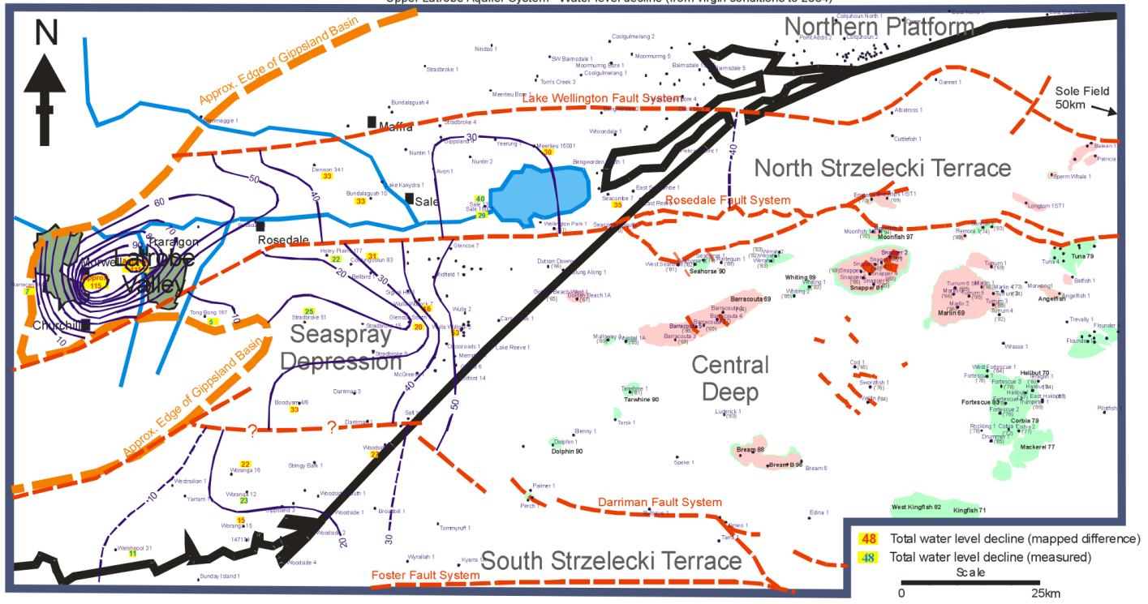
Figure 25: Interpreted Lower Tertiary Aquifer drawdown in metres between 2004 and pre-offshore gas and oil extraction and mine dewatering.
(Source: CSIRO, 2004.)
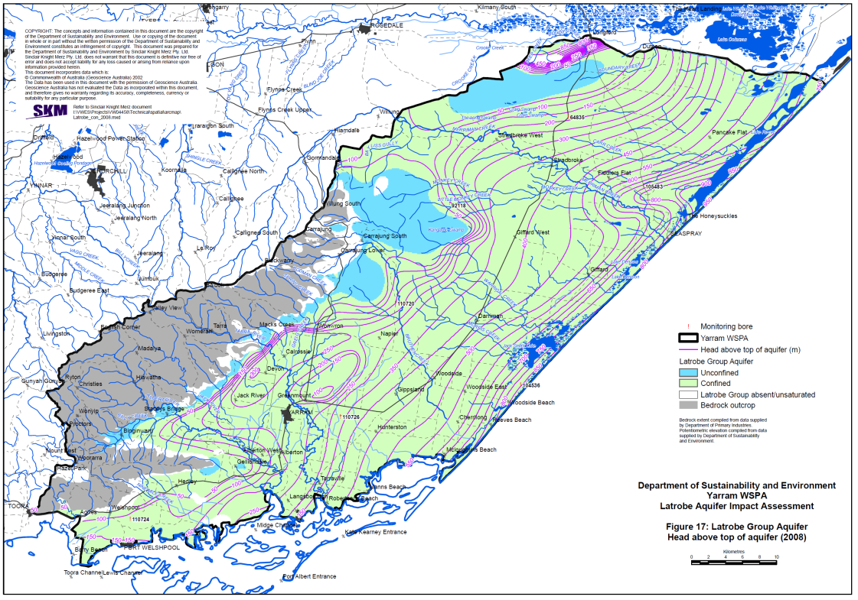
Figure 26: Approximate head of the Lower Tertiary Aquifer in 2008. (Source: SKM, 2009.)

Connection to other aquifers
There is likely to be a reasonable hydraulic connection between the Lower Tertiary Aquifer and the overlying Balook Formation in the Yarram area, as evidenced by hydrographs showing a dampened response in the Balook Formation to groundwater pressure declines in the Lower Tertiary Aquifer (see Figure 27 for examples of hydrographs).
The sealing properties of the Seaspray Group and the Lakes Entrance Formation in particular are discussed in Section 2.2. The presence of the Upper Mid-Tertiary Aquitard (Seaspray Group) as an effective aquitard is likely to restrict interaction between the Lower Tertiary Aquifer and overlying aquifers such as the Boisdale and Quaternary aquifers. However, the presence of the Mid-Tertiary Aquitard is restricted to the south-eastern part of the basin.
Goldie Divko et al. (2010) noted that the Lakes Entrance Formation thins around the Baragwanath Anticline and the capacity of the formation to act as a competent seal is therefore diminished. The detection of a hydrocarbon seep in the vicinity of the anticline, as demonstrated by radiometric data (O’Brien et al., 2008), suggests a loss of hydrocarbon containment across this area over geological time (Goldie Divko et al., 2010). This can also be translated to groundwater movement, suggesting that a vertical connection between the Lower Tertiary Aquifer and surficial Haunted Hills Formation in the region is possible. Groundwater use in the area is not particularly high; most of the better quality and higher-yielding surficial aquifers occur to the north (Quaternary Aquifer and Upper Tertiary Aquifer) and to the south (Upper Tertiary Aquifer).

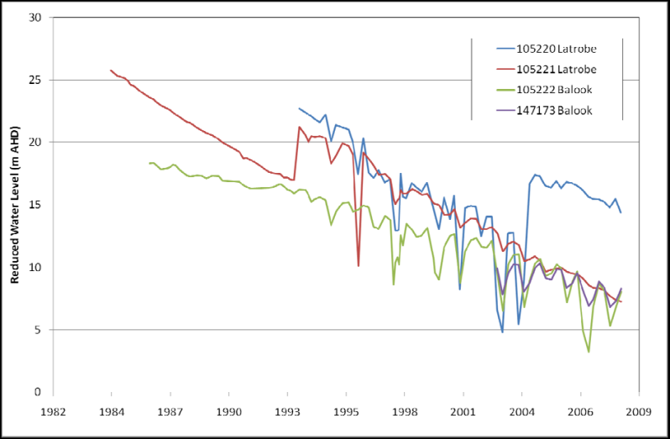
Figure 27: Examples of hydrographs in the Balook and Latrobe Aquifers in the Yarram area.
(Source: SKM, 2009b.)

2.4.4 Mesozoic and Palaeozoic rocks
The Mesozoic Strzelecki Group outcropping in the Strzelecki Ranges and the Palaeozoic rock outcropping in the highlands to the north also underlie the Tertiary sediments in the Gippsland Basin. Unlike the Tertiary sediments, in which groundwater flows through the pore spaces between the grains, groundwater within the Strzelecki Group and the Palaeozoic rocks flow mainly through natural fractures and fissures within the rock (i.e. they are fractured rock aquifers).
These fractured rock aquifers have low bore yields (<0.5 L/s) and/or reasonable to poor water quality (>1500 mg/L TDS). They often have weak regional flow connections or are disconnected, thus forming local flow systems and localised discharge zones such as springs.
The significant depths to basement in some areas underlying Tertiary sediments and the low-yielding nature of the units means that few bores have been drilled into the buried basement aquifers; however, the hydraulic behaviour of the buried portions of the unit is expected to be similar to the outcropping units.

2.4.5 Groundwater use
The key groundwater aquifers with good groundwater quality (less than 3500 mg/L salinity) are:

Upper Aquifers
• Quaternary Aquifer around the Macalister Irrigation District, which is used for irrigation and stock and domestic supply (covered by the Denison Water Supply Protection Area and the Wa De Lock Groundwater Management Area).
• Quaternary Aquifer less than 20 m deep in the Mitchell River floodplain upstream of Bairnsdale region, which is used for irrigation and stock and domestic supply (covered by the Wy Yung Groundwater Management Area).

Middle Aquifers
• Upper Tertiary Aquifer (Wurruk Sand of the Boisdale Formation) in the Sale–Seaspray–Giffard region, which is utilised for irrigation and town water supply (Sale) (covered by the Sale Water Supply Protection Area and the Giffard Groundwater Management Area).
• Balook Formation of the Upper Mid-Tertiary Aquifer occurring as a narrow band from the Yarram area in the south, west of Sale and extending north of the Gippsland Lakes to north of Bairnsdale. This aquifer is utilised in the Yarram area for irrigation and is covered by the Yarram Groundwater Management Area.

Lower Aquifers
• Lower Tertiary Aquifer, which is the basal unit underlying much of the Gippsland Basin. Although it is too deep in most parts of the basin for widespread use, it comes close to the surface in the Yarram area and is used as a source of irrigation supply (covered by the Stratford and Yarram Groundwater Management Areas).
• Lower Tertiary Aquifer (Thorpdale Volcanics and underlying Childers Formation) in the Moe region which is utilised for irrigation and stock and domestic purposes (covered by the Moe Groundwater Management Area).
A significant proportion of these aquifers are contained within Groundwater Management Units (GMUs) which have maximum limits for groundwater allocation. The location of the GMUs are shown in Figure 28. The licensed entitlement and groundwater use for 2012–13, excluding stock and domestic bores, is shown in Table 1.

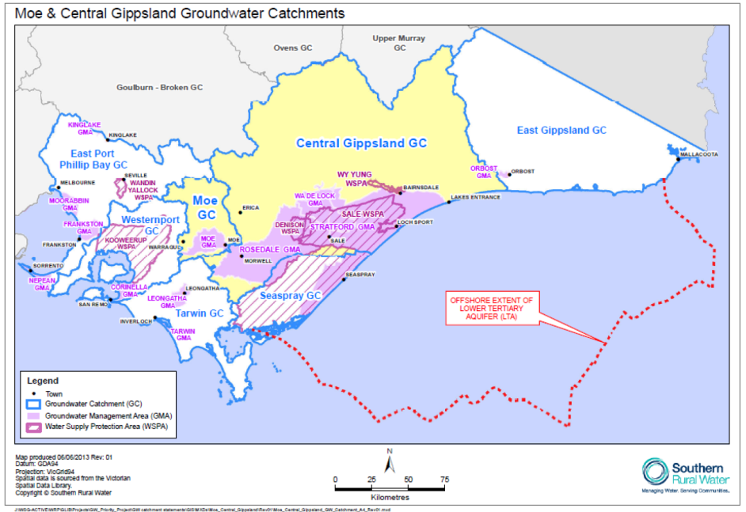
Figure 28: Location of Groundwater Management Units. (source: SRW, 2014.)

Table 1: Licensed entitlement and groundwater use in 2012–13 for Gippsland Groundwater Management Units, excluding stock and domestic use. (Source: DEPI, 2014a.)
Groundwater Management Unit | Aquifer group | Licensed entitlement (ML/yr) | Groundwater use in 2012–13 (ML/yr) | Total use (ML/yr)
Wa De Lock | Upper | 29287 | 8181 | 19815
Denison | Upper | 18501 | 10209 | 19815
Wy Yung | Upper | 7462 | 932 | 19815
Leongatha | Upper | 1841 | 180 | 19815
Tarwin | Upper | 38 | 13 | 19815
Orbost | Upper | 1217 | 300 | 19815
Sale | Middle | 21238 | 12739 | 33166
Giffard | Middle | 5689 | 1504 | 33166
Rosedale | Middle | 22372 | 18923 | 33166
Yarram | Middle and Lower | 25689 | 11668 | 30288
Stratford | Lower | 27645 | 17712 | 30288
Moe | Lower | 3967 | 908 | 30288
Offshore oil and gas | Middle and Lower | N/A | N/A | 100000 (approx.)
Total |  | 164946 |  | 183269 (approx.)

2.5 Groundwater–surface water connectivity
Water assets in the Gippsland Basin have been identified using the Victorian Water Asset Database, as shown in Figure 29, along with areas of less than 2 m depth to watertable. In this study, groundwater interaction with rivers and wetlands is inferred in areas where they intersect areas where there is less than 2 m depth to watertable.

2.5.1 Rivers
A study by GHD (2014) used river salinity / flow data combined with interstation flow comparisons where possible to characterise baseflow of rivers in the Gippsland region (Figure 30). The GHD (2014) study noted that along the Latrobe River a change occurs from a neutral or losing system in the area between Moe and Traralgon to a gaining stream downstream of Traralgon until it discharges to Lake Wellington east of Sale. GHD (2014) apportion the losing part of the Latrobe River to either a relatively high elevation of the river in the landscape due to faulting and/or depressurisation of the Tertiary Aquifer system (assumed to be from mine dewatering activities). If mine dewatering activities are a factor, then it demonstrates that pumping from the Lower Tertiary Aquifer and the Upper Mid-Tertiary Aquifer can have impacts on river flow. A number of case studies of groundwater–river interaction have been undertaken in the area, and are summarised below.

Tarra River
The Tarra River flows in a south-easterly direction from the Strzelecki Ranges through Yarram and to the coast. The river receives a component of its flow from groundwater discharge. The Tarra River flows across outcropping Lower Tertiary Basalts west of Yarram which are likely to be recharge areas for the Latrobe Group Aquifer (part of the Lower Tertiary Aquifer). It has been speculated that declines in pressure in the Latrobe Group Aquifer impact river flow in these recharge areas. For instance, SKM (2004) identified 46 km of rivers and streams (including the Jack, Albert and Tarra Rivers) which cross these Latrobe Group recharge areas. SKM (2005b) suggested that declining groundwater levels in the region are likely to have contributed to the calculated 75% reduction in baseflow in the Tarra River since the early 1950s. SKM (2006b) examined time-series of total natural flows in the Tarra River, which were estimated from a combination of stream gauge data and historic upstream demands. They concluded that although a downward trend was evident it was within the natural variability of the data.
The data sets examined in the SKM (2005b) and SKM (2006a) studies used different approaches (i.e. baseflow versus total flow and gauged flow versus estimated natural flow), however, both studies concluded that there was a downward trend in baseflow evident in the data. The key conclusion from both studies was that there was likely to have been a reduction in the baseflow component of stream flow in the Tarra River and catchments over the previous 50 years. The reduction in baseflow was likely to have been caused mainly by a reduction in rainfall over this period. Although there is no direct evidence, the circumstantial evidence suggests that the decline in baseflow may also be caused, to a smaller extent, by declines in groundwater levels resulting from local groundwater abstraction for irrigation and offshore gas and oil extraction (SKM, 2006b).

The Mitchell River
Groundwater levels compared to river levels show that the watertable contained within alluvial sediments in the Mitchell River floodplains upstream of Bairnsdale have a strong hydraulic connection to the river (SKM, 2007). During periods of flooding or high flow in the Mitchell River, the river is likely to be discharging to the watertable and vice versa during normal flow periods.
While the connection between the river and the watertable is strong, the connection between the watertable and deeper aquifers is not well known. In some areas significant thicknesses of clay separate the Quaternary sediments from the underlying Balook/ Latrobe Aquifers (SKM 2007), so that declining levels in these aquifers are unlikely to cause significant impacts on the water levels in the Quaternary aquifer or the Mitchell River. In other areas the deeper aquifers sub-crop beneath the Quaternary alluvial aquifer and could therefore interact with the shallow aquifer and the river (SKM, 2007).

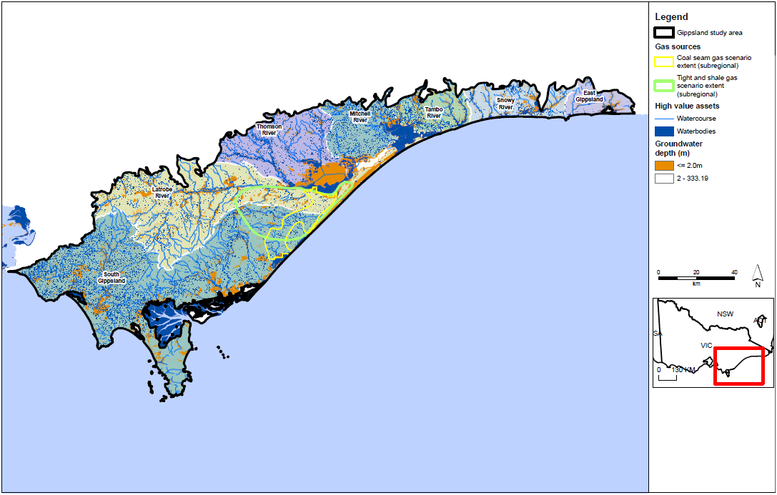
Figure 29: Surface water features in the Gippsland study area as identified from the Victorian Water Asset Database.
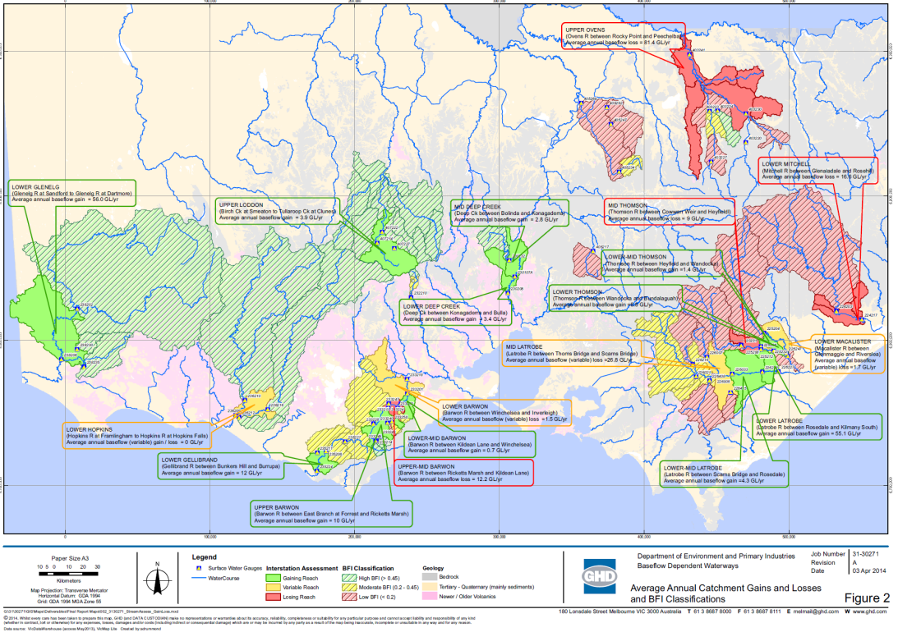
Figure 30: Baseflow characterisation of studied Gippsland and Otway Basin rivers. (Source: GHD, 2014.)

2.5.2 Groundwater-dependent ecosystems
The distribution of groundwater-dependent ecosystems across the Gippsland Basin is shown in Figure 31. Of particular significance is the series of wetlands on the margins of the Gippsland Lakes (see Figure 32). A series of studies on the wetlands adjacent to Lake Wellington are summarised below.

Lake Wellington wetlands
A number of wetlands flank Lake Wellington and tributary rivers, including:
• Clydebank Morass at the mouth of the Avon River
• Dowd Morass on the south side of the Latrobe River mouth
• The Heart Morass on the north side of the Latrobe River mouth
• Sale Common on the north side of the Latrobe River at the junction of the Thomson River
• Lake Coleman on the south side of Lake Wellington.
The locations of these and other Gippsland Lakes fringing wetlands are shown in Figure 33. A number of these wetlands are Ramsar-listed and have significant environmental and social values. All are within an area of shallow watertable and are expected to be receiving discharged groundwater. They were likely to have once been freshwater but are becoming brackish or saline because of an elevation of the watertable in the area caused by land clearing and irrigation, and because of the permanent connection of Lake Wellington to the sea via Lakes Entrance at the eastern end of the Gippsland Lakes system.
The relative contribution of groundwater differs among these wetlands. For instance, a study of Clydebank Morass by SKM (2003a) suggested that groundwater was a small contribution to the overall water balance, with most of the water coming from either the Avon River or Lake Wellington. However, much of the salt discharging to Clydebank Morass comes from overland flow across areas of saline land affected by an elevated watertable (SKM, 2003a). A similar process is also likely to be occurring at The Heart Morass and other wetlands in the vicinity, such as Lake Kakydra. The direct or indirect contribution of groundwater to Dowd Morass is minor and most of the salt and water fluxes come from the Latrobe River and Lake Wellington (SKM, 2003b).
Although the direct contribution of groundwater discharge to some of these wetlands may be relatively minor, the watertable plays an important role in providing a hydraulic barrier to leakage out of the wetlands. This highlights that there is a complex relationship between groundwater levels and the salt and water balance in these wetlands.
The Gippsland Lakes and associated wetlands mostly occur in an area where there is significant thickness of the Upper Mid-Tertiary Aquitard (Seaspray Group), ranging from approximately 700 m on the western shores of Lake Wellington to 240 m on the northern shores of Lake King (VVG, 2014). The Seaspray Group is an effective aquitard and is likely to at least partially separate the watertable hydraulically from the Lower Tertiary Aquifer and the Strzelecki Group, which are prospective for coal seam gas and tight and shale gas respectively.

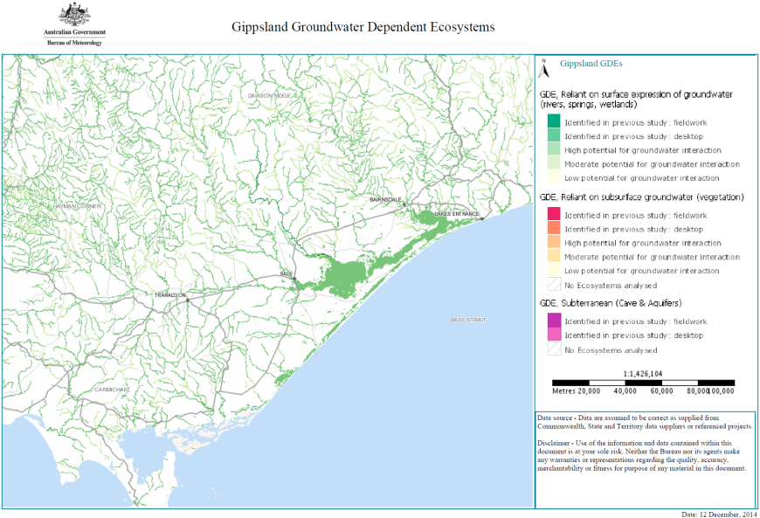
Figure 31: Gippsland groundwater-dependent ecosystems. (Source: Bureau of Meteorology, 2014.)
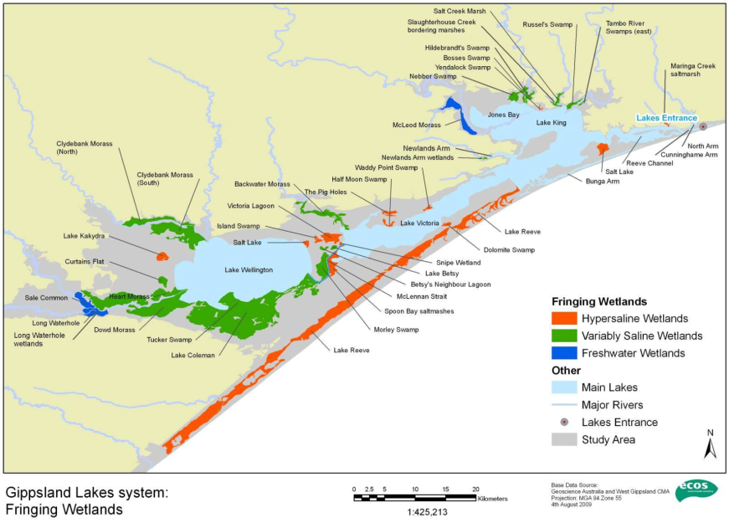
Figure 32: Location of wetlands fringing the Gippsland lakes. (Source: Tilleard et al., 2009.)
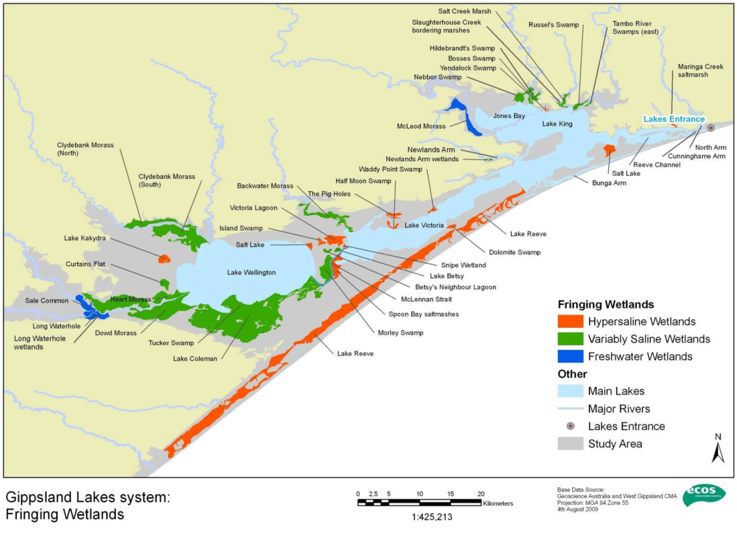
Figure 33: Location of wetlands fringing the Gippsland lakes. (Source: Tilleard et al., 2009.)

2.6 Hydraulic connection between prospective onshore natural gas sources and groundwater
In this study the pathway refers to the mechanism of pressure decline by which groundwater flows from the hazard to the receptor. An equivalent concept is connectivity, which refers to the ease with which groundwater can flow within or between geological formations (Gas Fields Commission, 2014). Groundwater flows in response to pressure or density gradients through the pores in the various formations. Groundwater may also flow along faults and fissures. Permeability is the term used to describe the ease with which water can flow horizontally and vertically through geological formations. In high-permeability formations groundwater flows relatively rapidly, whereas in low-permeability formations (commonly called aquitards) groundwater flows very slowly. The rate of flow varies from metres per year to millimetres per million years.
The potential hydrogeological connectivity between the natural gas sources and the surrounding aquifers is discussed below.

2.6.1 Tight and shale gas development
The Strzelecki Group is generally considered to be a low-yielding aquifer where it outcrops, as evidenced by the poor bore yields in the Strzelecki Ranges, which are sufficient only for stock and domestic purposes.
Tight and shale gas-bearing units within the Strzelecki Group occur in the upper part of the sequence in the Seaspray Depression and also in underlying units. Any impact from groundwater and gas extraction from the Strzelecki Group, would be detected first in the basal Lower Tertiary Aquifer, or in the Late Cretaceous sedimentary sequence if present and monitored. Further discussion of the behaviour of the Lower Tertiary Aquifer is provided in Section 2.6.2.
The following observations suggest that the propagation of formation depressurisation from the extraction of tight and shale gas from the Strzelecki Group is likely be slow and take significant periods of time to be observed:
• The hydraulic conductivity of the Strzelecki Group is likely to be low, with slow movement of drawdown propagation, although this effect may be countered by the expected low storativity which acts to increase diffusivity.
• The volumes of groundwater extracted are likely to be low because of the low hydraulic conductivity of the Strzelecki Group.

2.6.2 Coal seam gas
The prospective units for coal seam gas (Traralgon Formation coal seams) are contained within the Lower Tertiary Aquifer sediments. Groundwater levels in response to decades of pumping from the Lower Tertiary Aquifer in the Latrobe Valley for mine dewatering, offshore for gas and oil extraction and irrigation development provides an indication of how the system may react to additional pumping for coal seam gas development. The most prospective area for coal seam gas development is located geographically between the Latrobe Valley mines dewatering to the west, the offshore gas and oil extraction in Bass Strait to the east and the irrigation development in the Yarram area to the south. The discussion below brings together the conceptual understanding of the Gippsland region hydrogeology and the observations of hydrogeological response to historical pumping from the Lower Tertiary Aquifer.

Hydraulic connections within the Lower Tertiary Aquifer
The Traralgon Formation coal seams overlie the sands of the main aquifer sequence within the Lower Tertiary Aquifer. The lack of a defined aquitard between the Traralgon Formation coal seams and the underlying sands suggests a strong hydraulic connection between the two.
The Lower Tertiary Aquifer groundwater levels have been declining by between 0.6 m/year and 1.2 m/year since at least the mid-1970s across the Gippsland Basin, from Yarram in the southwest to Bairnsdale in the northeast (Figure 24). These regional declines in groundwater levels show that the Lower Tertiary Aquifer is a regionally extensive and connected aquifer across the Gippsland Basin with a reasonably consistent lateral response to groundwater extraction, albeit with some variability because of structural features such as the Rosedale monocline.
The rate of decline in groundwater levels in the Lower Tertiary Aquifer shows no sign of stabilising. Continued extraction for offshore oil and gas resources and mine dewatering is likely to result in a continuing decline. Historical declines in groundwater levels in the aquifer show that impacts can extend over large areas when extraction is sustained over a number of decades.

Hydraulic connections to overlying aquifers
The hydraulic connection between the Lower Tertiary Aquifer and overlying Upper Mid-Tertiary Aquifer (M2C/Seaspray Sand Aquifer) is interpreted from regional observations. In areas where there is significant thickness of Traralgon Formation coal seams, SKM and GHD (2010) suggested that the coal seams are likely to provide some impedance to flow between the underlying sands and the overlying M2C/Seaspray Sand Aquifer. SKM and GHD (2010) also suggested that, in the absence of coal seams, there could be reasonable hydraulic connection between them.
Recent work has focused on identifying seals above the Lower Tertiary Aquifer for the purpose of identifying suitable reservoirs for carbon capture and storage. This work has identified the marl and clay dominated Seaspray Group (Upper Mid-Tertiary Aquitard) as being an effective aquitard or seal above the Latrobe Group based on mercury injection capillary pressure (MICP) analysis of core samples (both onshore and offshore) reported in Goldie Divko et al. (2010). In particular, Goldie Divko et al. (2010) identified the Lakes Entrance Formation component of the Seaspray Group as a significant seal on the Traralgon Formation coals.
The above conclusions are also likely to apply to groundwater movement and highlight the importance of the Upper Mid-Tertiary Aquitard (especially the Lakes Entrance Formation) as a significant regional aquitard. Greater potential for hydrogeological connectivity exists in areas where the aquitard thins or is absent, in addition to the structural features mentioned previously that can act as conduits. Of particular significance is the presence of the Balook Formation (Upper Mid-Tertiary Aquifer) which occurs in two distinct narrow bands north and south of the Baragwanath Anticline. The Balook Formation responses to Lower Tertiary Aquifer groundwater level decline suggest that there is some vertical connection between the two aquifers (Section 2.2). Therefore, if the depressurisation impacts in the Lower Tertiary Aquifer were to reach areas connected to the overlying Balook Formation, there is potential for reducing the upward gradient between the two aquifers or even inducing a downward gradient. This has the most implications in the Yarram area where the Lower Tertiary Aquifer and Balook Formation Aquifers are utilised for groundwater supply.
The extent to which the reduced Balook Formation pressure declines could propagate to overlying aquifers such as the Boisdale Aquifer west of Sale and the Quaternary Alluvial Aquifer in the Macalister Irrigation District is uncertain and requires further investigation.
Goldie Divko et al. (2010) noted that in areas around the Baragwanath Anticline the Latrobe Group (Lower Tertiary Aquifer) are shallow (around 100 m to the top) with a thin capping of Lakes Entrance Formation. The detection of a hydrocarbon seep in the vicinity of the anticline as demonstrated by radiometric data (O’Brien et al., 2008) suggests a loss of hydrocarbon containment across this area (Goldie Divko et al., 2010). This can also be translated to groundwater movement, suggesting a vertical connection between the Lower Tertiary Aquifer and surficial Haunted Hills Formation in the region is possible.
The above discussion is focused on the lateral migration of depressurisation within the Lower Tertiary Aquifer and then the subsequent vertical migration of impacts in areas away from the Upper Mid-Tertiary Aquitard. However, even though the Upper Mid-Tertiary Aquitard has been shown to be a significant aquitard, there is potential of vertical connection through the aquitard. In the area of gas prospectivity, the thickness of Upper Mid-Tertiary Aquitard is between 50 and 600 m.

Summary of hydraulic connections
The above discussion highlights that the Lower Tertiary Aquifer is well connected laterally and that groundwater pumping for Latrobe Valley coal mining, offshore oil and gas extraction, and some irrigation and town water supplies, has resulted in the propagation of aquifer depressurisation over large distances if sustained over significant periods of time.
The vertical transmission of Lower Tertiary Aquifer depressurisation in the area of coal seam gas prospectivity is constrained by the presence of the Upper Mid-Tertiary Aquitard (particularly the Lakes Entrance Formation).

3 Aquifer depressurisation impact assessment

3.1 Introduction
Extraction of natural gas can affect water resources by changing the groundwater level in adjacent or overlying aquifers. This groundwater level change occurs as a result of movement of water from aquifers into the gas-bearing formations. This movement results from the pressure reduction generated by gas and water abstraction in the gas-bearing formation. This chapter of the report describes the approach to assessing potential impacts due to aquifer depressurisation from hypothetical gas developments.

3.2 Impact assessment approach

3.2.1 Literature review
In order to inform the impact assessment approach, a review of relevant Australian and international literature that looked at risk from gas development was completed. The focus of the literature review was guided by the requirements of this assessment, which included assessing the risks arising from the potential impact of possible onshore gas development on water resources across a broad region, and compatibility with limited data on the gas development and impacts. A large number of publications and other sources of information were identified and reviewed for relevance. The full list of sources is provided in Appendix A.
The literature review indicated that there is no single or standard risk assessment method which is tested and proven as fit-for-purpose for hypothetical onshore gas development. Alternative approaches have been adopted by different groups depending on the needs of the assessment and the information available. No one approach from the literature stood out as highly suited to analysing risks at a strategic level from hypothetical onshore gas developments.
The literature review also indicated that risk assessment methods generally require detailed site-specific geo-science data and extensive quantitative/numerical modelling to assess likelihood (e.g. probability of hazards occurring, historical instances of failure) and consequence (direct and indirect impacts). However, detailed region-specific data is not available in Victoria, largely due to there not having been a significant onshore gas industry in the state to generate such data.
It was concluded from the literature review that an impact assessment approach, rather than a risk assessment approach, that draws on specific Victorian groundwater impact policy, is appropriate and in keeping with the literature.
For assessing the impact of gas development through aquifer depressurisation the most relevant Victorian approach is the draft Ministerial guidelines for groundwater licensing and the protection of high value groundwater dependent ecosystems, as these guidelines:
• are designed to assist government in making decisions on proposed groundwater use (aquifer depressurisation), based on an assessment of the potential impacts on groundwater dependent ecosystems
• can accommodate a range of inputs to the assessment process, from purely qualitative and conceptual information, to quantitative data and numerical modelling inputs as available
• are pragmatic to apply
• have been developed based on a consultative process
• are currently in the process of being endorsed for use by the Victorian government.
This study has developed an impact assessment approach that is specific to the Victorian situation and draws on existing work for the assessment of groundwater-related impacts. It is unique to Victoria and not intended for the assessment of a specific gas development project.

3.2.2 Approach overview
The approach is designed to assess the potential impacts of hypothetical onshore natural gas developments on groundwater levels (depressurisation) and then, by inference, on groundwater users, groundwater quality, surface water quantity and quality, and groundwater dependent ecosystems.
The approach assesses three types of water resource receptors:
• aquifers (which support groundwater users)
• rivers (which support surface water users and ecosystems)
• water bodies (wetlands and lakes which support surface water users and ecosystems).
All three of the receptor types above are assessed as high and equal value. The assessment does not attempt to classify relative value of individual receptors (e.g. whether one aquifer or river / reach more important than another). The approach is outlined below; more detail is provided in Appendix B.
The impact assessment is characterised by assessing:
• the potential connection between receptors and groundwater, using depth to watertable as an indicator
• the potential effect of aquifer depressurisation on receptors, using predicted drawdown as an indicator.

Figure 34: Overview of impact assessment.

3.2.3 Potential connection between receptors and groundwater
In this impact assessment, the potential degree of hydraulic connection between receptors (rivers, lakes and wetlands) and groundwater is based on depth to groundwater, and is classified as follows:
• low potential for deep watertables
• moderate potential for moderate depth watertables
• high potential for shallow watertables.
In the case of aquifers the connection to groundwater is inherent and therefore the potential connection is always high. The rules for defining these three connection categories are outlined Table 2..

Table 2: Rules for defining the potential connection of water receptors to groundwater.
Water receptor | Low connection | Moderate connection | High connection
Rivers | Initial depth to watertable (before gas development) is greater than 6 m | Initial depth to watertable (before gas development) is between 2 and 6 m | Initial depth to watertable (before gas development) is less than 2 m
Water bodies (lakes, wetlands)
Aquifers | n.a. | n.a. | Inherent connection to groundwater

Areas that have been mapped as having shallow watertables (< 2 m) have a high potential for surface features to be connected to groundwater. Where deeper watertables are mapped (>6 m), surface water has a lower potential of being connected to the groundwater. The depth to watertable data used for this project is the mapping developed as part of DELWP’s SAFE database (GHD 2012) and is mapped on a grid across the areas of interest. This database provides a consistent approach to estimating connection through depth to watertable for this study. The depth to watertable map is derived from existing monitoring data and is more accurate in areas with a greater density of monitoring bores and in areas with limited monitoring bores, the elevation of the surface water body is applied when close to surface water features.

3.2.4 Potential effect of aquifer depressurisation

Table 3 presents the criteria which have been adopted to classify the effect of aquifer depressurisation on receptors, using predicted drawdown as an indicator. For surface water receptors, the delineation of a low potential effect of gas development (i.e. 0.1 m predicted drawdown) has been based on the minimum change in water level that could reasonably be discerned (DELWP unpublished data ). The upper limit of 2.0 m is based on a range of studies. It was identified during the development of the Groundwater Dependent Ecosystems Draft Ministerial Guidelines that watertable changes greater than 2.0 m can be expected to have a significant impact on ecosystems.

Table 3: Rules for defining the potential effect on water receptors of groundwater drawdown.
Water receptor | Low drawdown | Moderate drawdown | High drawdown
Rivers | Effect is small on stream flow of connected waterway to natural or current conditions  Minimum change in water level that could reasonably be expected to be measured in the field  Drawdown in watertable aquifer < 0.1 m after 30 years | Extraction impacts measurably on stream flow of connected waterway to natural or current conditions  Maximum annual variation in water level that could reasonably be expected  Drawdown in watertable aquifer between 0.1 m and 2 m after 30 years | - Extraction impacts significantly on stream flow of connected waterway to natural or current conditions  - Drawdown in watertable aquifer > 2 m after 30 years
            - Water bodies (lakes, wetlands)
Unconfined aquifers | Drawdown is small with respect to aquifer ability to supply  Drawdown < 2 m after 30 years | Extraction impacts measurably with respect to aquifer ability to supply, but can potentially be mitigated by deepening of boreholes/pumps  Drawdown between 2 m and 15 m after 30 years | Extraction is large with respect to aquifer ability to supply  Drawdown > 15 m after 30 years
Confined  aquifers | Drawdown is small with respect to aquifer ability to supply  Drawdown < 10 m after 30 years | Extraction impacts measurably with respect to aquifer ability to supply, but can potentially be mitigated by deepening of boreholes/pumps  Drawdown between 10 m and 75 m after 30 years | Extraction is large with respect to aquifer ability to supply  Drawdown > 75 m after 30 years

In the case of aquifers, the categories are based on extrapolation of the approach embedded in the draft Victorian water sharing guidance notes, in which a high potential for effect of gas development is determined when an aquifer ceases to be able to supply. Most aquifers in the study areas would need to have high drawdown before ceasing to supply (DELWP unpublished data).

3.2.5 Estimation of drawdown
Drawdown was modelled for the Gippsland region using a calibrated numerical groundwater model (DEDJTR, 2015). The detailed methodology is included in Appendix B. The predicted drawdown for aquifers and the watertable were estimated for potential onshore natural gas development scenarios over a development timeframe of 30 years beginning in 2013, and the difference in drawdown at the end of 30 years against a baseline based on recent use and climate, as detailed in the Appendix B, is used for assessment purposes.
The model has been developed to investigate the potential impacts of future gas developments and to understand the possible impacts of a potential natural gas industry on groundwater and surface waters within the Gippsland region. The model has been used to quantify groundwater flow and groundwater head levels within specified aquifers under historical conditions.
Seven hypothetical tight and shale gas and coal seam gas development scenarios were analysed under a dry future climate. Each scenario included an estimated likely water usage and well field design configurations. Simulation predictions were reported relative to a baseline state (no gas development) in which groundwater abstractions over the 30 years were fixed at the averaged historical values for the period 2003 to 2012; domestic and stock use was set to 1.5 ML/year for each relevant bore less than 30 years old; and all other outflow conditions were as applied in the 2001–2012 model calibration/verification period. An additional scenario that looked at the water level trends in observation bores after 100 years from the end of the 100% development scenario was also analysed (reported in Appendix B).
Key results of the modelling scenario include:
• the impacted area is increasing and has not reached an equilibrium condition at the end of the 30 year scenario period
• coal seam gas extraction impacts on the shallow watertable within 3 months following commencement of depressurisation
• tight and shale gas extraction impacts on the shallow watertable 23 months following commencement of depressurisation.
The scenario results are severe cases, particularly for impacts to surface water and ecosystems, due to the following assumptions:
• a prolonged dry future climate
• groundwater use averaged from the 2002–2012 extraction information, a period of relatively high groundwater use
• full development of the prospective gas field at commencement of gas extraction
• relatively high vertical hydraulic conductivities assigned to a some modelled layers when compared to other studies, though within reported limits
• no allowance for localised changes in aquifer hydraulic conductivity and storage coefficients due to depressurisation processes (i.e. no change in aquifer properties with the presence of gas).
Although the developed groundwater model cannot be used predictively to quantify the water balance or water levels at the regional scale under specific development scenarios, it is appropriate for comparison of changes to the water balance or water levels for different scenarios against a baseline condition.

The drawdown results are presented in Appendix D, and have been used directly in the assessment of the impact of aquifer depressurisation. The model computes a water level for each layer, however the “watertable” is not always in the top layer if this is relatively thin. In some areas the upper layers may be connected. Different layers of the model may have slightly different values and at any particular point the water levels of the unconfined layers are averaged to generate the mean value used in the assessment. For completeness, however, the relevant maximum reading at any point is also assessed and these results are provided in Appendix D.

3.2.6 Assessment of potential impact
The potential impact on a receptor from aquifer depressurisation is based on the potential for the receptor class to be connected to groundwater (represented by depth to watertable in metres), and the potential effect of aquifer depressurisation (represented by predicted drawdown in metres).
The impact matrix showing the combinations of potential connection and effect of aquifer depressurisation to evaluate overall potential impact is presented in Figure 35. If a receptor has a low potential connection to groundwater (deep watertable) and drawdown is predicted to be low, the potential impact on the receptor is assessed to be low. Conversely, the potential impact on a receptor with high connection (shallow watertable) and a high potential drawdown will be high.
The results are presented in summary figures in this report. The full set of maps of potential connection, effect and overall impact is provided in Appendix C.

Connection between receptor class and groundwater | High | HC / LD | HC / MD | HC / HD
Connection between receptor class and groundwater | Moderate | MC / LD | MC / MD | MC / HD
Connection between receptor class and groundwater | Low | LC / LD | LC / MD | LC / HD
 |  | Low | Moderate | High
 | Groundwater Drawdown
Key: HC = high connection, MC = moderate connection, LC = low connection
HD = high drawdown, MD = moderate drawdown, LD = low drawdown
Figure 35: Potential impact on receptors due to aquifer depressurisation.

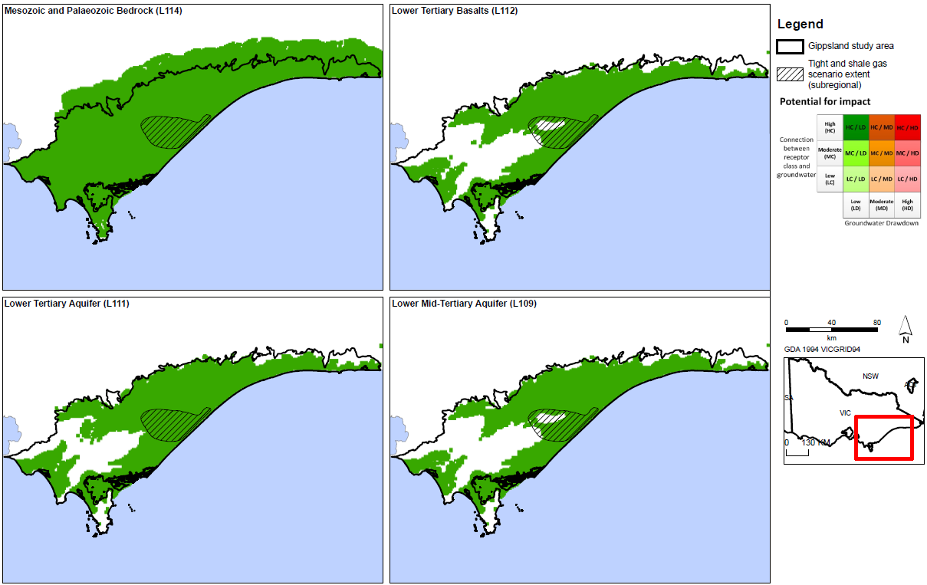
Figure 36: Potential impacts to aquifers (denoted by Victorian Aquifer Framework aquifer number) from possible tight and shale gas development.
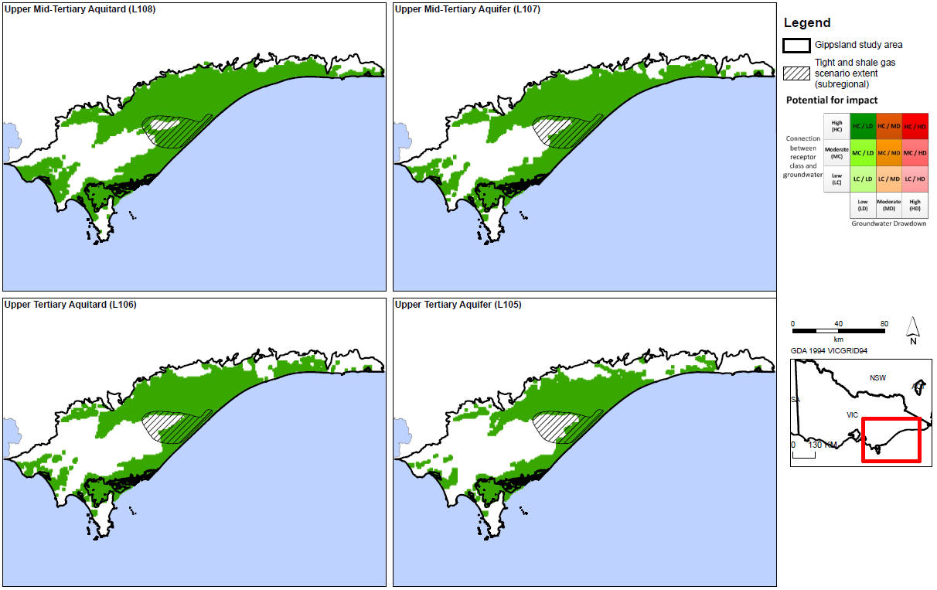
Figure 37: Potential impacts to aquifers (denoted by Victorian Aquifer Framework aquifer number) from possible tight and shale gas development.
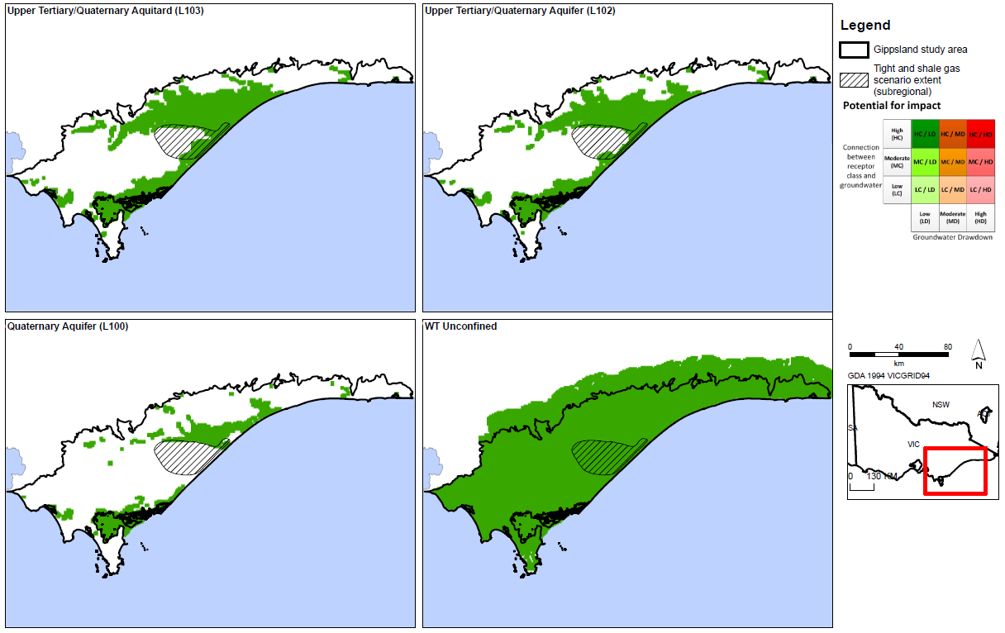
Figure 38: Potential impacts to aquifers (denoted by Victorian Aquifer Framework aquifer number) from possible tight and shale gas development.

3.3 Impact assessment results

3.3.1 Tight and shale gas
The results of the assessment of potential impact for the potential tight and shale gas development scenario are given inFigure 38a–c.

Potential impact on groundwater users
The potential impact on groundwater users is presented as impact classes for each aquifer; detailed result maps are given in Appendix D.
Overall the impact on all aquifers (confined and unconfined) from the development of tight and shale gas in the Gippsland region is inferred as low, with a typical impact classification of Category LC-LD. In the case of aquifers, the connection is always high as the depth to groundwater metric is always zero (i.e. aquifers are inherently connected to groundwater). This means that the drawdown metric for groundwater drawdown determines the overall impact rating. The category HC-LD (High Connect – Low Drawdown) is therefore the lowest impact possible for aquifers.
Small areas show higher drawdown and the maps in Appendix D show the drawdown that was used to calculate the impact result. Overall the impact on aquifers is small and the impact is classed as low.
Appendix D also gives the results of the impact assessment where the maximum modelled drawdown result in any layer is used, rather than the mean. For the tight and shale gas scenario using maximum modelled drawdown, the overall potential impact on groundwater users remains low.
The anticipated low hydraulic conductivity of the gas reservoir compared to the overlying aquifers suggests low water extraction volume and that there is unlikely to be greater than a modest drawdown, hence the impact is classed as low and the tight and shale gas scenario constitutes a low potential impact to the aquifers.

Potential impact on surface water users
The impact on surface water users is assessed by modelled drawdown in the watertable compared with the potential connection to the surface water (detailed maps are provided in Appendix D).
Areas of moderate to high potential impact are identified in the central Latrobe Valley region (Figure 36). In this area the response in the watertable from the tight and shale gas scenario is sufficient to identify a moderate to high potential impact on surface water resources as a result of this development scenario. Note that the maps show areas of moderate to high impact based on the depth to watertable and the predicted drawdown, but there may not be any surface water resources that could be affected.
The number of surface water licences that may be affected by these potential impacts are shown in Table 4. The actual use and dependency on these water licences was not assessed in this initial analysis.

Table 4: Number of surface water users potentially impacted by tight and shale gas
development in Gippsland.
Surface water users | MC/MD | HC/MD | LC/HD | MC/HD | HC/HD
Bulk entitlements and licences | 0 | 2 | 7 | 0 | 0

Potential impact on surface water ecosystems
The assessment indicates that there is a low potential for impact on surface water ecosystems across most of the region, based on predicted groundwater level changes as a result of possible tight and shale gas development.
Areas of moderate to high potential impact are identified in the central Latrobe Valley region (Figure 37), based on the predicted response in the watertable from possible tight and shale gas development. Note that the maps show areas of moderate to high potential impact based on the existing depth to watertable and the predicted drawdown. It is possible that in some areas surface water ecosystems may not be present and therefore none would be affected.

3.3.2 Coal seam gas scenario

Potential impact on groundwater users
The potential impact on groundwater users is presented as impact classes based for each aquifer. The method is described in Appendix B and detailed result maps are given in 0. The potential impact on the aquifers from potential coal seam gas developments ranges from low to high. The connection to an aquifer is always high, so the connection component of the assessment is consequently always high.
All aquifers have some areas of high potential impact within the proposed development area in response to this scenario (Figures 38a–c). Inside the identified gas development area, drawdown in response to gas development is predicted to be significant in the overlying confined aquifers, and as a result the potential impact on aquifers is high. This high impact relates to the specific scenario that is being presented (100% development of the entire coal seam gas resource). It is possible that coal seam gas could be developed with lower impacts than shown here, but some impact on aquifers is likely.
Based on drawdown results from the numerical model, the development of coal seam gas in the Gippsland region poses a moderate to high potential impact on aquifers in the immediate vicinity of the gas areas. There are large areas of aquifers that are classified as low potential impact outside the development area.
The number of groundwater entitlements that may be affected by these potential impacts is shown in Table 5. This shows that 202 groundwater users are located in areas of moderate to high potential impact, with bores intersecting several aquifers. The number of groundwater users impacted is typically lower in the shallower aquifers.

Table 5: Number of groundwater users potentially impacted by coal seam gas development in Gippsland.
Aquifer | MC/MD | HC/MD | LC/HD | MC/HD | HC/HD
Quaternary Aquifer (L100) |  |  |  | 1
Upper Tertiary/ Quaternary Aquifer (L102) |  |  |  | 3
Upper Tertiary/ Quaternary Aquitard (L103) |  |  |  | 13
Upper Tertiary Aquifer (fluvial) (L105) |  |  |  | 20
Upper Tertiary Aquitard (L106) |  |  |  | 87
Upper Mid Tertiary Aquitard (L108) |  |  |  | 47
Lower Mid Tertiary Aquifer (L109) |  |  |  | 2
Lower Tertiary Aquifer (L111) |  |  |  | 29 | 1

Potential impact on surface water users
The impact assessment shows that there are significant areas of moderate to high potential impact on surface water users immediately around the identified coal seam gas development area.
The impact map (Figure 39) identifies a large area of class LC-HD (Low Connection – High Drawdown), which although high on the drawdown scale is unlikely to be a connected system. The areas of high potential impacts to surface water resources from this coal seam gas development scenario extend beyond the limits of the development area.

Figure 39: Potential impacts on surface water users from possible tight and shale gas development.
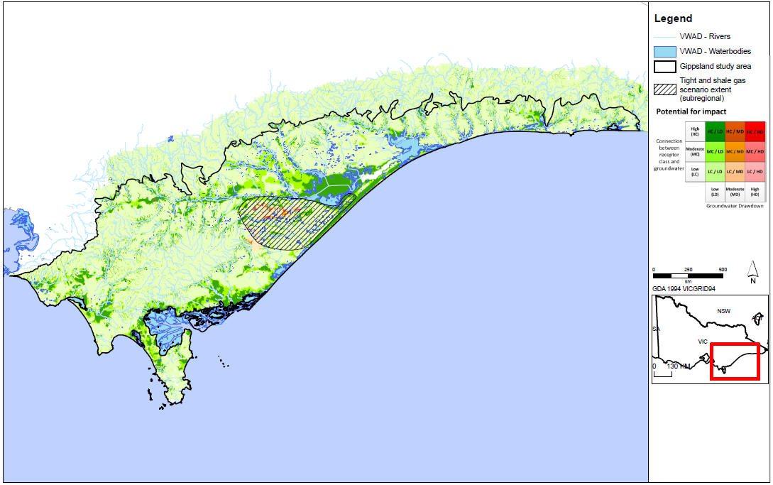
Figure 40: Potential impacts on surface water ecosystems from possible tight and shale gas development.
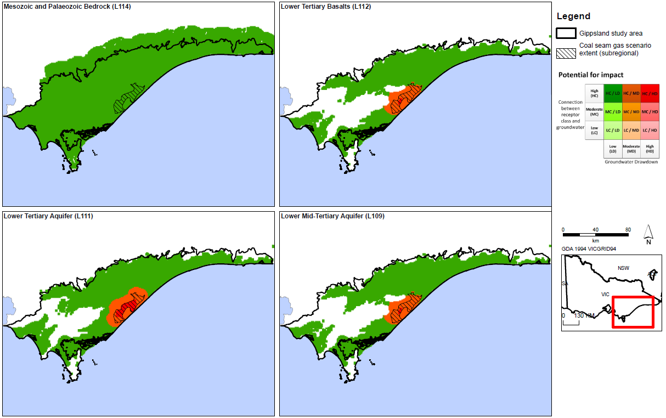
Figure 41: Potential impacts on aquifers (denoted by Victorian Aquifer Framework aquifer number) from possible coal seam gas development.
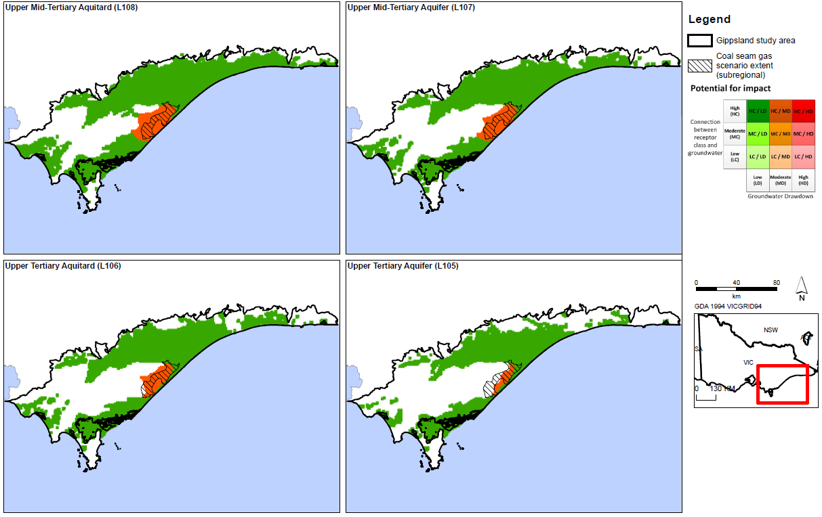
Figure 42: Potential impacts on aquifers (denoted by Victorian Aquifer Framework aquifer number) from possible coal gas development.
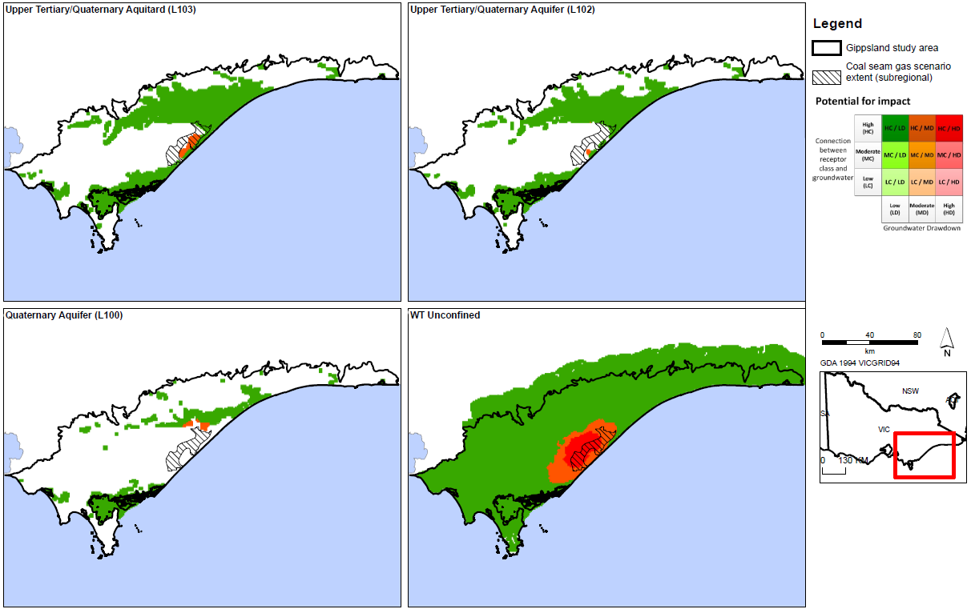
Figure 43: Potential impacts on aquifers (denoted by Victorian Aquifer Framework aquifer number) from possible coal seam gas development.
The number of surface water users that may be affected by these potential impacts is shown in Table 6. The total number of surface water users located in areas of moderate to high potential impact is 243.

Table 6: Number of surface water users potentially impacted by coal seam gas development in Gippsland.
Surface water users | MC/MD | HC/MD | LC/HD | MC/HD | HC/HD
Bulk entitlements and licences | 35 | 98 | 15 | 9 | 88

Potential impact on surface water ecosystems
The impacts to surface water ecosystems mirror the evaluated potential impacts to surface water users. The assessment shows that there are significant areas of moderate to high potential impact on surface water ecosystems immediately around the identified coal seam gas development area. The impact map (Figure 40) identifies a large area of class LC-HD (Low Connection – High Drawdown), which although high on the drawdown scale is unlikely to be a connected system.
The potential impact to surface water ecosystems from possible coal seam gas development is high, and the area of high potential impact extends beyond the limits of the development area.

3.3.3 Potential impacts on groundwater quality
Groundwater quality could conceivably be affected where gas development combined with regional groundwater use causes drawdown to significantly change regional gradients. If this were to occur where low-quality water was adjacent to good-quality water, the potential exists for migration of poor-quality water into areas of good-quality water. The impact of tight and shale gas development to groundwater gradients in the aquifer sequence is small and within the range of gradients that have already been experienced by aquifers. This is because in all cases the gas development areas underlie the aquifers and are separated from the aquifers by a significant geological seal, or an aquitard in the Upper Strzelecki. In the Gippsland region the potential for groundwater quality changes as a result of tight and shale gas development is low and thus the potential impact is assessed as low.
The impact of coal seam gas development on groundwater gradients in the aquifer sequence is potentially significant, as the coal seams are in close proximity to good quality regional aquifers. In the Gippsland region the potential impact of depressurisation on groundwater quality as a result of coal seam gas development is inferred to be moderate, but further work to confirm groundwater quality and predicted groundwater drawdowns is required to further characterise the potential impact.

3.3.4 Summary of results
The following summary observations can be made:
For coal seam gas development the potential impact of depressurisation on groundwater resources in the immediate vicinity of the gas development area is moderate to high for groundwater users and inferred as moderate for groundwater quality. Potential impacts to surface water users and ecosystems are high in areas close to the potential gas development and low elsewhere.
For tight and shale gas development the potential impact of depressurisation on groundwater resources is low for groundwater users. Potential impacts to surface water users and ecosystems are low, with the exception of areas of moderate to high potential impact identified in the central Latrobe Valley region.

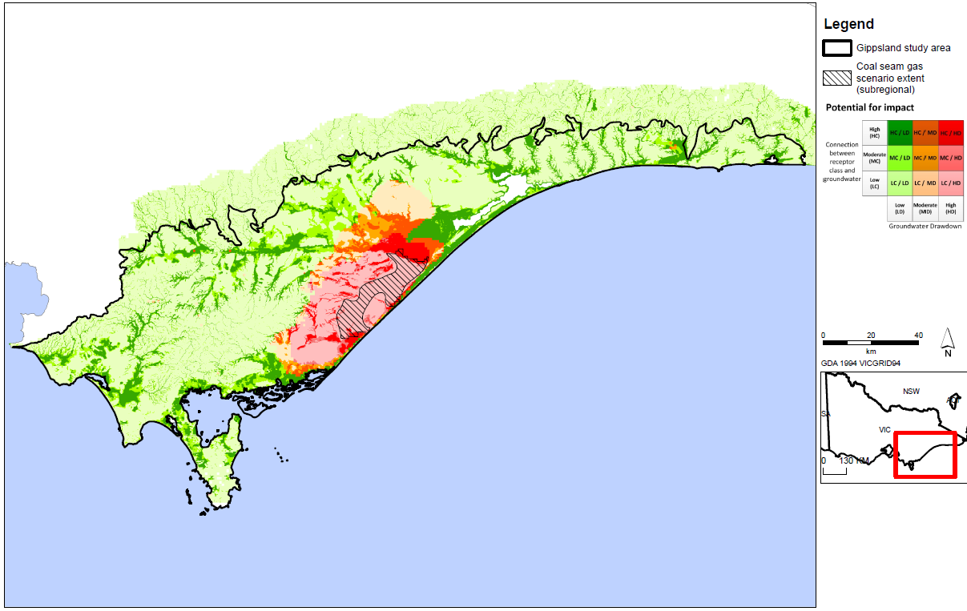
Figure 44: Potential impacts on surface water users from possible coal seam gas development.

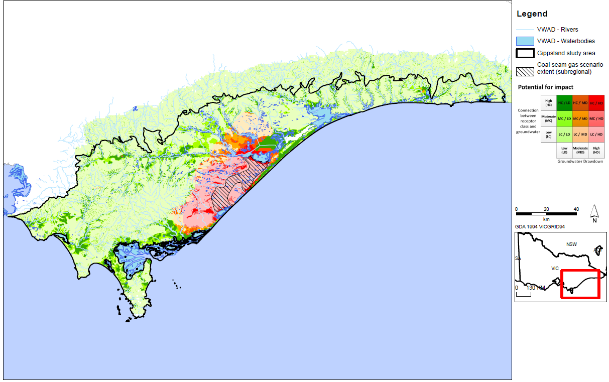
Figure 45: Potential impacts on surface water ecosystems from possible coal seam gas development.

4 Chemical contamination of groundwater from hydraulic fracturing fluids: risk assessment
Hydraulic fracturing is variously known as well stimulation, hydraulic fracturing, fraccing or fracking. The technical term ‘hydraulic fracturing’ is used in this report.
This section presents a qualitative risk assessment of potential chemical contamination of groundwater from hydraulic fracturing fluids, as the technical detail required to undertake more detailed analyses in Victoria is not available.
If tight and shale gas reserves are discovered onshore in the Gippsland region, hydraulic fracturing may be required for their development. While there is a significant volume of information available on the risks associated with hydraulic fracturing, the risks are difficult to quantity at a regional scale. Information required to fully assess the risks of hydraulic fracturing typically include detailed information of rock and reservoir properties, details about the proposed drilling and development techniques and specific analysis of the combination of these factors at individual wells or well sites. Given none of this detailed information is available for this study, a review of the key factors that influence the risks and how they relate to Victorian onshore gas has been undertaken. To this end, this document presents a discussion on the potential risks associated with hydraulic fracturing and builds upon scientific research and case studies in order to evaluate the associated risks to water resources. A key reference for this risk assessment discussion is Cook et al. (2013), who completed a study on shale gas in Australia. Cook et al. (2013) built on other key references such as King (2012) and RS/RSE (2012).

4.1 Overview of hydraulic fracturing
Hydraulic fracturing is a technique that has been employed in the petroleum industry globally for over 60 years and in Australia for over 40 years. The process involves ‘stimulating’ the hydrocarbon-bearing formations by the injection of fluid (and other materials) under high pressure to enhance the flow of hydrocarbons to the well head during later development. This stimulation creates or enhances permeability and existing fluid and gas pathways. Typically the process creates additional fractures in the reservoir rock and holds open for a period of time.
Hydraulic fracturing is required for most, though not all, types of onshore gas development. Hydraulic fracturing is not normally required for conventional gas because of the high porosities and permeabilities in which conventional gas is commonly found, together with the high formation pressures. Large amounts of conventional gas can often be extracted using a small number of wells. Shale gas and tight gas cannot usually be extracted using a single production well of the type used for conventional gas, because of the low permeabilities in the reservoir rocks. In the case of coal seam gas, some but not all gas fields have a high natural permeability due to the fractures in cleats, which means that hydraulic fracturing is required occasionally. In Australia since 2000, 8% of coal seam gas wells have been hydraulically fractured, and the industry estimates that between 10 and 40% of wells yet to be drilled for current coal seam gas developments across Australia (mainly Queensland) may need some method of flow enhancement, including hydraulic fracturing (SKM, 2012).
There have been significant technological advancements over the last decade resulting in the growth of the shale gas industry in the United States. Cook et al. (2013) highlighted that the implementation processes such as deep horizontal drilling, multiple-stage hydraulic fracturing, improved real-time sensing monitoring to guide both the horizontal drilling and hydraulic fracturing processes have improved the viability of natural gas developments in United States. These technological improvements in horizontal drilling techniques within
the petroleum industry is leading to coal seam gas developers utilising ‘surface to in-seam drilling’, or horizontal drilling, which can reduce the requirement for conventional hydraulic fracturing of coal seam
gas wells (SKM, 2012).
Figure 46 illustrates the effects of hydraulic fracturing in a vertical well and a horizontal well. Hydraulic fracturing is often performed sequentially at multiple depths and horizontally along beds. Additionally, fracturing may be conducted multiple times in the same well over its life in order to widen or lengthen the initial fractures to increase gas productivity.
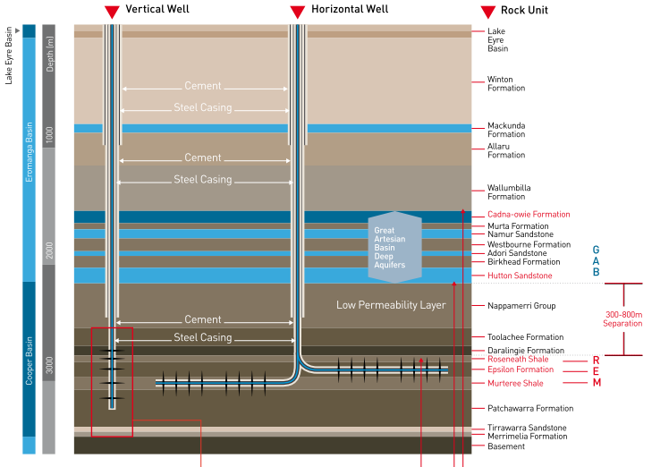
Figure 46: Schematic of a deep unconventional (shale) gas well in the Cooper Basin, Australia. (Source: Cook et al., 2013.)
Fluid volumes pumped down wells during the hydraulic fracturing of tight and shale gas formations are usually in the order of 10 to 20 million litres and reach maximum pressures of up to about 70 000 kPa over a period of a few hours (Myers et al., 2012, Kissinger et al., 2013, Lange et al., 2013). In coal seam gas developments, fracture fluid volumes are typically much smaller, usually ranging between 0.5 and 3 million litres (CSIRO, 2014).
After the prospective formation has been sufficiently fractured, pressures are reduced and the fluids are back-produced (removed) from the formation. The recently formed fractures are prevented from closing by the proppant (sand-sized particles included in the fluid mixture that is injected) allowing the gas to migrate through the more permeable formation and be extracted via the production well.
Cook et al. (2013) suggested that in a typical hydraulic fracture treatment between 3 and 12 additive chemicals may be used, depending on the characteristics of the water and the formation being fractured. The chemicals used in hydraulic fracturing are discussed in Section 4.3.

4.2 Key risks to water assets associated with hydraulic fracturing
The United States Environmental Protection Authority identified four mechanisms by which hydraulic fracturing can cause or increase the potential for groundwater contamination (USEPA 2011), including:
• failure of wells during the hydraulic fracturing process, which may create pathways by which contaminants can affect groundwater assets
• leakage of hydraulic fracturing fluids beyond the fracture zones from the prospective zone to adjacent formations
• mobilisation and migration of naturally occurring contaminants from the prospective zone to adjacent formations via fractures
• leakage of gas from prospective formations.
These broadly correlate with the findings of the Standing Council for Energy Resources, which indicated that the major risk during hydraulic fracturing was excessive fracture propagation, resulting in potential groundwater contamination via fracture fluid leakage and increased connectivity between naturally occurring contaminants and groundwater resources (SCER 2013).
Hydraulic fracturing operations also have the potential to cause groundwater and surface water contamination via a range of other mechanisms including co-produced water storage, contaminant spills, leakages and pipeline failures. King (2012) identified 20 key risks associated with hydraulic fracturing, which were summarised by Cook et al. (2013). The key risks relate to on-site spill and well integrity issues induced by hydraulic fracturing.
Well failure can occur due to incorrect construction, poor seal construction in the annulus, or deterioration due to pressure, stress or corrosion. If the cement or casing surrounding the well fails then contaminants may migrate through the resulting gaps, potentially contaminating surrounding aquifers (US EPA, 2012). The proper construction of the well and correct use of materials is therefore crucial to protect groundwater resources. In Queensland and NSW, coal seam gas wells are required to be constructed in accordance with the relevant code for practice for constructing and abandoning coal seam gas wells (DEEDI, 2011; DTIRIS, 2012). Other onshore gas wells are required to be constructed in accordance with the relevant state petroleum legislation.
For the purpose of this review it is assumed that appropriate standards and guidelines have been developed in order to minimise any risks associated with well installation. Therefore the review does not assess the risks to groundwater resources resulting from well integrity. While concerns continue to be raised regarding the integrity of wells and their potential to lead to groundwater contamination, such discussion is outside the scope of this generalised assessment of the risks to water resources.

4.3 Contaminant sources

4.3.1 Hydraulic fracturing fluid
Between 97% and 99% of hydraulic fracturing fluid consists of water and proppant, (IESC, 2014). Typically the proppant is sand. The other additives vary according to site specific requirements. A list and brief description of such additives have been listed in Table 7. There is a ban in Victoria on the use of mono-aromatic hydrocarbons such as benzene, toluene, ethylbenze and xylene (BTEX), so these chemicals cannot be used in hydraulic fracturing. In some cases hydraulic fracturing can be conducted using air instead of water, where carbon dioxide or nitrogen is used as a carrier fluid. Fracturing with carbon dioxide as the carrier fluid was first introduced in 1981 and has been used commercially in several unconventional gas applications in Canada and the United States (Gandossi, 2013). The technology can be preferable to water as carbon dioxide requires fewer chemical additives than water and offers enhanced gas recovery. The use of nitrogen as a hydraulic fracturing fluid is still a relatively new technology. The technique is commercially available and it has been applied for fracturing shale formations. Its usage appears to be limited.
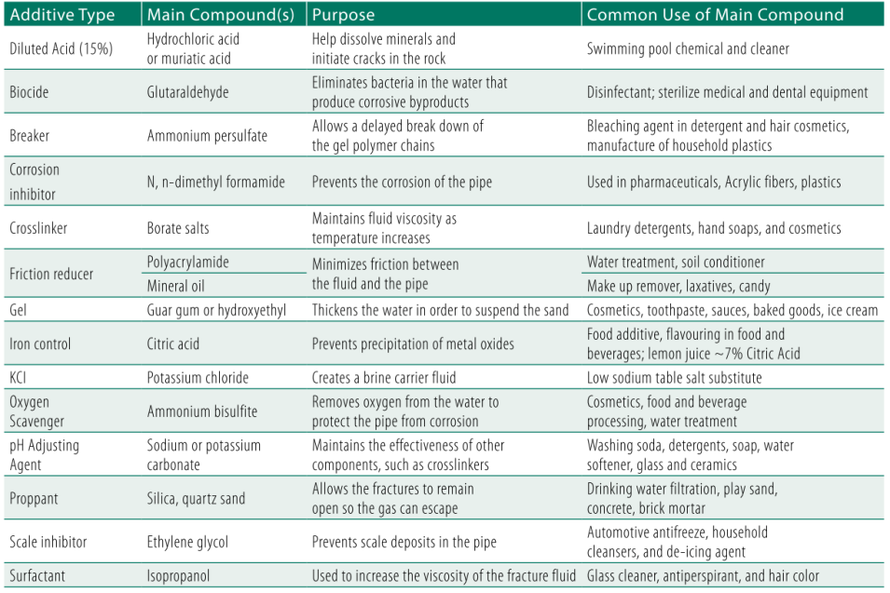
Figure 47: Hydraulic fracturing fluid constituents. (Source: Cook et al., 2013.)

4.3.2 Naturally occurring contaminants
Groundwater contains small quantities of naturally occurring substances such as heavy metals, radioactive elements and organic compounds (USEPA, 2011). Onshore natural gas also commonly contains various gases including methane, ethane, carbon dioxide, hydrogen sulphide, nitrogen and helium.
Hydraulic fracturing fluids can contain acids and carbonates which theoretically could have the potential to alter the acid-base (i.e. pH) conditions within the gas source formation. Additionally, the injected water could have the potential to alter the redox and temperature conditions within the prospective formation, further mobilising potentially hazardous substances. If naturally occurring contaminants are mobilised within the prospective formation, they can be recovered in the flow back water and be treated accordingly.
Limited research has been conducted on the mobility of naturally occurring substances associated with coals or other gas source formations in Australia. CSIRO (2011) found that water-soluble constituents of Permian coal may be produced by the breakdown of the chemical structures within the coal matrix. Such water-soluble compounds include phenols, aldehydes, ketones, and various compounds that contain carboxyl, hydroxyl and methoxyl groups. Other water-soluble compounds include nitrogen-bearing compounds (such as pyridines and amines), polycyclic aromatic hydrocarbons (PAHs), low-molecular-weight aliphatic hydrocarbons, and mono-aromatic hydrocarbons such as benzene, toluene, ethylbenze and xylene (BTEX).

In addition to the mobilisation of potentially hazardous metal, organic and gaseous compounds, the water quality within tight and shale gas formations is commonly low. Tight and shale gas sources have a low permeability and are typically located at greater depths than surface aquifers. These factors result in long groundwater residence times, greater water–rock interaction and mineral dissolution, resulting in groundwater with a high salinity.

4.4 Contaminant pathways
As outlined in the previous section, the primary contaminants associated with hydraulic fracturing include hydraulic fracturing fluids and gases. Assuming that well integrity is maintained and that contaminants in formations above the natural gas source do not migrate via the well, for the purposes of assessing the risk of release all of these contaminants are assumed to be sourced from the hydraulic fracturing fluids.
By their nature, tight and shale gas sources have a low permeability (otherwise they would not need to be fractured prior to gas extraction). The migration of contaminants from prospective tight and shale gas resource into adjacent aquifers therefore requires a pathway. Such pathways include the intersection of induced fractures with overlying or adjacent permeable formations, or intersection with a nearby natural fracture or fault system which may provide increased permeability (e.g. Kissinger et al., 2013; USEPA, 2004). In contrast to tight and shale gas, some coal seam gas formations may have a high permeability and hydraulic fracturing is not required.
There are two primary potential pathways for contaminants to migrate: newly created or widened fractures, or natural zones of high permeability driven by structural features such as faults. This section discusses these potential pathways in the context of the hydraulic fracturing process.

4.4.1 Fracture propagation
Over time hydraulic fracturing processes and technologies have become more sophisticated, but it is still energy intensive and expensive (Fisher and Warpinski, 2011). The industry has been motivated to better understand and control fracture growth, which has been documented technical and research articles.
For fractures to propagate they must be opened by internal pressure (Fisher and Warpinski, 2011). In order for this to occur, the internal pressure must be sufficient to counteract the least compressive stress, displace the walls of the fracture, propagate the fracture and counteract any pressure loss due to fluid leakage through the prospective formation (Flewelling et al., 2013). Fisher and Warpinski (2011) notes that in the Marcellus Shale, fractures generally propagate vertically in tight and shale gas formations at depths greater than about 600 m. This is because fracture growth occurs perpendicular to the direction of least stress (in the direction of maximum stress) and in this system, the vertical stress of the overburden typically becomes the largest single stress at depths greater than about 600 m.
During propagation, fracture width increases proportional to height. Thus, in order to maintain the fluid pressure required to propagate fractures, large volumes of fluid are required. Additionally, leakage of hydraulic fracturing fluids throughout the prospective formation can reduce fluid pressure and the extent of the fractures. As such, hydraulic fractures are limited in their extent and while heights have been recorded in excess of this in homogeneous shale formations, fractures of less than 100 m are most common (Fisher and Warpinski, 2011).
Predictive computer modelling and microseismic monitoring of fracture growth in the United States shales suggests a typical maximum vertical extent of 90 m (Cook et al., 2013). However, Fisher and Warpinski (2011) conducted a review of thousands of shale hydraulic fracturing treatments across North America and found that in rare occurrences when transmissive faults were intersected, additional height growth (about 100 m) can occur. This study showed that in such circumstances vertical fracture growth has been recorded up to 500 metres, however these large distances are likely to be the result of re-opening an old fault rather that a newly created fault propagating such distances. Such incidents were recorded in the Marcellus Shale which extends across New York, Pennsylvania, Ohio, Maryland, West Virginia and Virginia. Fracture growth in the Marcellus Shale generally showed a greater upward limit when compared to other shale units in the United States such as the Barnett Shale (Texas), the Woodford Shale (Oklahoma) and the Eagleford Shale (south Texas).
It should be noted that the dominant stress regime throughout North America is associated with extensional tectonics (processes associated with crustal stretching), while the dominant stress regime in Victoria is associated with compressional tectonics (processes driven by crustal compression). In this setting, it is expected that hydraulic fractures will propagate in a dominantly horizontal direction opposed to the vertical fracture direction that dominates at depths of greater than about 600 m in North America. As such, it is expected that the vertical extent of fractures resulting from stimulations in the Gippsland and Otway Basins is likely to be less than the 90 m extent cited in North American examples. Compression driven horizontal stresses are expected to be greater than those that exist in an extensional setting. This is supported by work in the Gippsland region (e.g. Nelson et al., 2006) which indicates that vertical stress will increase from 20 MPa to 66 MPa between 1 and 3 km depth below sea level, while the maximum horizontal stress will increase from about 40 MPa to 120 MPa over the same depths (a rate of about 40 MPa/km, roughly twice the rate of the vertical stress increase).
While hydraulic fracturing in prospective coal seam gas units (when required) can create new fractures, it most commonly opens and enlarges existing fractures within the coal seam (USEPA, 2004). In doing so, the connections of the natural fracture networks in and around the coal seams are increased and the overall permeability increased. It should also be noted that gases within coal beds are not structurally “trapped” by geologic strata in the same way that conventional and tight gas is and most of the coal seam gas is contained within the coal itself, adsorbed to the coal particles.
Fracture growth in coal seam gas formations is typically slow, with an average velocity of less than 10 m per minute initially, slowing to less than 1 metre per minute towards the end of the treatment (CSIRO, 2014). For a large coal seam gas development, proppant extent (and fracture widening) might extend to a distance of 200 to 300 metres from a vertical well (CSIRO, 2014).
Similar to shale gas, the depth and rock types surrounding coal seam gas have a fundamental influence on fracture dimensions and orientations. For coal seam gas in the United States, it is reported that at depths less than about 300 m the direction of least principal stress tends to be vertical and thus fractures tend to propagate horizontally (USEPA, 2004). USEPA (2004) reported that vertical fractures at this depth were usually related to pre-existing natural fractures in the coal seam. At depths greater than about 300 m, the direction of least principal stress generally becomes horizontal and thus vertical fractures tend to dominate. This means that for potential coal seam gas development in Victoria the least principal stress at the prospective depth should be determined to confirm the likely direction of propagation of fractures and optimise any hydraulic fracturing program.
Recent investigations indicate a clear and simple relationship between the volume of hydraulic fracturing fluids used during fracturing of shales and the height of the fractures developed (Flewelling et al., 2013). The study compared the estimated upper limit of fracture height as a function of fluid volume in over 12 000 fracture networks across Canada and America (approximately 57% of these data were collected in the Barnett, Eagle Ford, and Marcellus shale plays) that were mapped with microseismic sensors (Figure 48). The results indicate that the majority of fractures were less than 100 m, and the maximum vertical extent of possible fracture growth was about 600 m, with a limited number of fractures between 400 and 600 m (Figure 48).
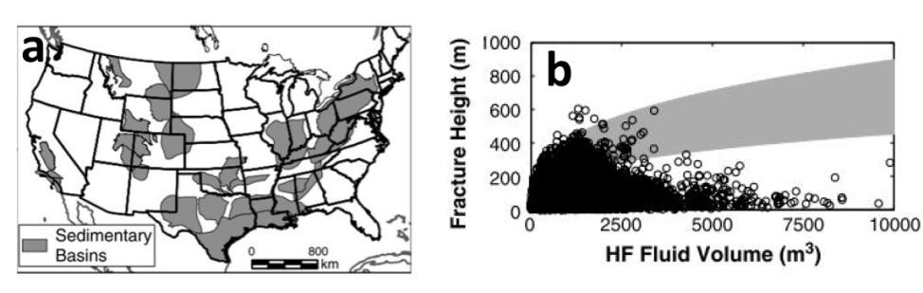
Figure 48: (a) Location of formations where fracture height and hydraulic fracturing fluid volume were collected. (b) Co-variance between fracture height and hydraulic fracturing fluid volume. (Source: Flewelling et al., 2013.)
While it is useful to have an idea of typical fracture extents, it is widely documented that hydraulic fracture growth is not always predictable and that all extractive industry activities, including onshore gas, carry some level of risk (IESC, 2014). Accordingly, pre-fracture assessments are commonly conducted as part of the hydraulic fracturing program design. Such assessments typically include a characterisation of the geology, permeability, stresses and fault distribution in the prospective and surrounding formations, and estimates of fluid loses during fracturing.

4.4.2 Natural faults and fractures
Faults have been suggested as mechanisms for enhancing fracture growth during hydraulic fracturing of prospective shale gas resources. This however ignores the principles underlying the formation of hydrocarbon reservoirs (Fisher and Warpinski, 2011). That is, if there has been an open pathway between the prospective formation and the near surface through an existing fault, then over geological time periods it is possible that hydrocarbons in the immediate vicinity could escape. If, on the other hand, the fault zone is not highly permeable and is closed, the conditions required to extend the fault may be almost identical to those required to induce fractures in competent rock.
These observations about the practicalities of oil and gas reservoirs strongly suggest that natural faults and fractures do not necessarily result in enhanced fracture growth during stimulation. In this context, it remains possible that the hydraulic fracturing may result in connection between induced fractures and fracture/fault zones with an elevated permeability (e.g. Kissinger et al., 2013; Lange et al., 2013). It is important to establish a sound geological and hydrogeological understanding of the prospective natural gas source and surrounding formations prior to hydraulic fracturing so as to avoid the potential for unwanted connection between high permeability areas.

4.5 Contamination mechanisms
The three main mechanisms by which hydraulic fracturing can lead to contamination are fluid migration, during hydraulic fracturing, passive fluid migration and gas migration.

4.5.1 Fluid migration during hydraulic fracturing
As discussed in Section 4.1, the maximum pressures reached during fracturing last for a few hours while total fracturing operations last around 12 hours (Lange et al., 2013). After fracture stimulation has ceased, the pressure built up in the formation drives the return of some fluids back to the surface via the well. Additionally, some further hydraulic fracturing fluids are returned to the surface during a flushing phase (back production), where guidelines recommended flushing out about 1.5 times the volume of the hydraulic fracturing fluid (IESC, 2014). Further recovery of hydraulic fracturing fluids will occur during the production of gas from the gas source.
The movement of fracturing fluids into a formation during the fracturing phase is known as fluid ‘leak-off’. This occurs during the fracturing phase as the pressure within the fractures is greater than the fluid pressure in the target formation.
Fluid leak-off rates have been estimated over the last 30 years and have become more efficient over time. The USEPA (2011) estimated variations in hydraulic fracturing fluid recovery in shale gas targets ranging from 25 to 75%. In contrast, estimates for the Marcellus Shale suggest a fracture fluid recovery rate of 10 to 30 % (Arthur et al., 2008). For coal seam gas, Penny et al. (1985) suggested a flow-back rate of about 30%, while Palmer et al. (1991) estimated a 61% fracturing fluid recovery rate over a 19 day period in the Black Warrior Basin. Golder Associates (2010) estimated a 40% fluid recovery rate for wells in the Surat Basin. These results are consistent with reports from the CSIRO (2014), who suggested typical recovery rates in the order of 30 to 60%. It is noted however that leak-off fluids may not be completely lost to the formation as these are partially recovered during gas production when fluid pressure regimes are reversed (IESC, 2014).
The risk of hydraulic fracture fluid entering groundwater resources has been previously assessed (IESC, 2014; US EPA, 2011), and three major factors that control contamination risks were outlined. These were:
• the distance between the natural gas source and overlying aquifers
• the geochemical and physical transport mechanisms operating between the natural gas source and overlying aquifers
• the hydraulic connectivity between the natural gas source and overlying aquifers.
Modelling of fracture fluid migration is simulated using organic compounds under the assumption that inorganic compounds are readily soluble and dissociate in groundwater (IESC, 2014). Models are typically initiated with a given volume and concentration of a chemical of potential concern to simulate those left after hydraulic fracturing. The models generally use dispersion and sorption processes to model transport but assume no degradation of chemicals over time.
Fate and transport modelling by Golder Associates (2010) was used to assess the migration of oxyalkylated alcohol and drilling mud from vertical coal seam gas wells. The modelling suggested that both compounds would migrate less than 5 m beyond the hydraulic fracturing radius of influence over a period of 1000 years. The hydraulic fracturing radius of influence is assumed to occur within 20 m of the perforated section of the well and is illustrated in Figure 49. This is an upper estimate as it assumes that natural groundwater conditions were resumed immediately after fracturing, whereas in reality hydraulic pressure gradients would be directed towards the well in the periods immediately after fracture stimulation.
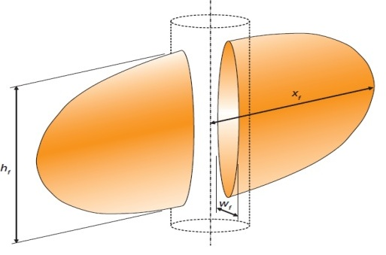
Figure 49: Conceptual shape of zone of hydraulic fracture extent for a vertical well. (Source: Golder Associates, 2010.)

To a similar end, Kissinger et al. (2013) modelled fluid migration from fractured shale gas reservoirs during over-pressure conditions in order to simulate conditions in onshore gas targets during hydraulic fracturing. Models were set up and run for a series of settings throughout the Musteland Basin and Lower Saxony Basin in Germany and included coal seam gas, tight gas and shale gas. Over pressures used in the simulations ranged from 5000 to 70 000 kPa and are a plausible range for hydraulic fracturing operations. Each model was run for 12 hours, representing 2 hours of high pressure fracturing and a 10 hour relaxation period. The results indicate that when the hydraulic fracture zones are directly overlain by low-permeability overburden, fluid migration from the fracture zone is negligible.
Kissinger et al. (2013) also assessed scenarios in which the low-permeability overburden contained a hypothetical naturally occurring fracture zone and a maximum fluid migration distance of 48 m was assumed. It was also noted that the assumed pressures over the duration of 2 hours were unlikely, and thus migration distances were an upper limit. Furthermore, large fluid losses during this period could be detected by the operator, and the connection to a fracture zone of high permeability is likely to reduce overall hydraulic fracturing due to pressure loss.
While the migration of fluids during hydraulic fracturing is thought of as a mechanism by which hydraulic fracturing fluids can migrate into natural formations and groundwater systems, naturally occurring contaminants may also be mobilised by this mechanism. For example, increased permeability within the target formations and high pressures generated during hydraulic fracturing may drive the movement of high-salinity groundwater from target formations into nearby aquifers. For the most part this would occur only if the fractures propagate out of the target formation.
Where hydraulic fracturing in coal seams are required, fractures are rarely induced during the injection of hydraulic fracturing fluids into coals seam gas formations. Instead the fluids are injected in order to widen and hold the existing fractures open. Therefore the extent of fluid migration during hydraulic fracturing in coal seams is reliant on the existing fracture network within and surrounding the coal seam, as well as the permeability of the units surrounding the coal seam.
The USEPA (2004) cited a study by Diamond and Oyler (1987) in which coal beds and surrounding formations were investigated after hydraulic fracturing had taken place. The study suggested that fluid movement during stimulations could exceed proppant distances and induced fracture distances, although significant uncertainties still exist. By adding fluorescent tracers to hydraulic fracture fluids during stimulations, the movement of fluids along and beyond fractures was traced. While tracers were used in eight stimulations and five of these were used together with proppant, in all but one of these scenarios the tracer migrated beyond the distance of the proppant. The most significant example of this was at Oak Grave Mine in Alabama, where the proppant was found about 30 m from the well while the tracer was found about 200 m from the well. In this circumstance it was found that the fracture width was essentially the width of the naturally occurring cleat, and without the tracer the cleat would not have been identified as a pathway for hydraulic fracture fluids.

4.5.2 Passive fluid migration
If induced hydraulic fractures become connected with existing zones of high permeability that are connected with aquifers (such as faults or fracture systems), contaminant-laden fluids have the potential to passively migrate into those aquifers. Unlike fluid migration during hydraulic fracturing, passive fluid migration after fracturing would rely on the natural hydraulic gradients within the formation and not the hydraulic gradients formed during fluid injections. In this context, fluid migration after fracturing is likely to occur over longer time scales than during fracturing, as natural hydraulic gradients are lower than those established during fracturing. Additionally, for a contaminant to migrate from the natural gas source into the overlying aquifers the prevailing vertical hydraulic gradient must be upward from the prospective formation, toward those aquifers.
This is consistent with modelling results of Kissinger et al. (2013), who found negligible vertical movement of a conservative tracer along a simulated high permeability fracture/fault zone linking a contaminant zone to an aquifer above with identical hydraulic heads. In contrast, when the same model was run with a hydraulic head in the contaminant zone 60 m greater than the aquifer above, the tracer migrated upward from the contaminant zone into the aquifer above over a period of 30 years. While the model indicates that groundwater contamination can occur when the simulated hydrogeological setting is optimised for contaminant migration, it should also be noted that tracer concentrations in the model decreased by a factor of 4000 over a fracture/fault zone of about 1000 m, indicating that significant dilution of contaminants is likely to occur in such settings.
In these simulations, contaminant transport via the low permeability formation (1 × 10^{–18} m²) surrounding the higher-permeability fracture/fault zone was not apparent, indicating that the passive movement of fluids through low-permeability seals is negligible.
The mobility of contaminants will rely on the physical hydrogeology of the area, the chemical nature of the hydraulic fracturing fluids used and the natural hydrogeochemistry of the groundwater system. Hydraulic fracturing fluids have the potential to mobilise naturally occurring substances from the prospective formation such as heavy metals (IESC, 2014). There are a range of chemical and biological processes which can reduce the mobility of naturally occurring substances. For example, a change in the redox potential of groundwater can decrease the mobility of naturally occurring substances, while microbes can reduce contaminant mobility by binding metals or organic substances (IESC, 2014).
The key issue with passive fluid migration is that the depressurisation associated with the gas extraction will create a gradient towards the well for the life of the gas field, typically 30 years and the key question becomes the recovery time before the natural gradient takes over. For deep confined reservoirs such as tight gas, this may take hundreds of years. Hence for a long period of time passive fluid migration into connected aquifers is not likely to occur.

4.5.3 Gas migration
In shale gas and tight gas reservoirs the natural barriers which seal the gas in the natural gas source formation also act as barriers to the vertical migration of gas from that formation. Additionally, during gas production high-pressure gradients toward the production well are established, and thus the migration of gases away from the well would be unlikely given that the well is in operation and maintains integrity (USEPA, 2011).
Recent modelling from Kissinger et al. (2013) has focussed on the migration of gas (methane) from a hydraulically fractured resource through low permeability overburden in order to simulate conditions in areas of the Lower Saxony Basin in Germany. The model simulations are based on one setting with an overburden of about 1200 m and another with an overburden of about 3500 m and variable vertical permeability’s ranging from 1 × 10^{–14} to 1 × 10^{–18} m² throughout the stratigraphy. The force driving the upward migration of gases in this setting is the buoyancy of the gas due to the density difference between gas and water phases, and capillary forces which differ from layer to layer and may cause the lateral spreading of gases (Kissinger et al., 2013). The simulations consider the migration of residual methane from a resource formation over a 100 year post-operation period.
The findings of the study indicate that the leakage of methane from a resource formation to surface aquifers is possible if a range of criteria are fulfilled. There must be a fully penetrating permeable fault/fracture zone that exists between the resource formation and aquifer. Additionally, large volumes of methane need to be mobilised from the gas reservoir and the gas reservoir needs to be relatively close to surface aquifers (i.e. methane did not migrate to the surface aquifer when separated from the resource by about 3500 m, but did when separated by about 1200 m). Kissinger et al (2013) suggests that fracturing operations should not be carried out in a reservoir with a fault zone that penetrates the full thickness of the overburden and that given this; it is highly unlikely that leakage of methane from a resource formation to surface would occur.

In undisturbed coal seams, gases migrate to areas of lower pressure or diffuse to areas of lower concentration via networks of natural minor fractures called cleats (IESC, 2014). Once within the cleat system the gas is adsorbed to the formation and held there under static conditions. However, once the pressure in the coal is lowered during depressurisation and development, the gas desorbs from the cleats and migrates to the area of lowest pressure. Horizontal or inclined wells and hydraulic fracturing (when required) can provide a high-permeability pathway via which gases can migrate. In contrast to shale gas, coal seam gas resources are often comparatively shallow and located in closer proximity to groundwater resources. Under these circumstances the hydraulic fracturing and depressurisation of coal seam gas may result in the mobilisation and migration of gases into adjacent groundwater resources when sufficient low permeability units are not present (USEPA, 2011; Eco Logical Australia, 2011).
The USEPA (2004) reported a number of incidents in which methane gas migration led to subsurface contamination. This includes incidents in the San Juan Basin (Colorado and New Mexico), the Powder River Basin (Wyoming and Montana), the Black Warrior Basin (Alabama) and the Central Appalachian Basin (Virginia and West Virginia). In The San Juan Basin the major mechanism driving the migration of methane to groundwater resources appeared to be improperly constructed and abandoned gas wells. However documented gas seeps and the occurrence of methane in water wells prior to any coal seam gas developments, also indicates that natural fractures probably serve as conduits in parts of the basin where coal formations are near or at the surface and in the interior of the basin, where the coal formations are deeper.
There have been many reports of methane being detected in water bores in Queensland, some of them natural and others resulting from coal seam gas developments. The Walloon Coal Measures in the Surat Basin act as an aquifer in areas where coal seam gas is also being developed. While gas in water bores was reported before the coal seam gas industry was established, the coal seam gas industry has drawn media attention as a result of the large-scale depressurisation, which appears to have caused fugitive gas emissions in water bores and inappropriately decommissioned or abandoned water bores and mining exploration bores (Day et al., 2014; Walker and Mallants, 2014). In the case of the Walloon Coal Measures the water bores are intersecting the same unit as the coal seams, and the gas has not migrated into an overlying aquifer; rather, it has been desorbed in response to the depressurisation. Risks associated with the construction and decommissioning or abandonment of wells are dealt with during project-specific risk assessments and are not assessed in this risk assessment. However, operational water bores with gas leakages are assessed.
As the chemical nature of the hydraulic fracturing fluid, groundwater system and geological formation at each natural gas source site will vary, it has been recommended that baseline characterisation of methane and other contaminants be conducted and overseen by relevant government agencies prior to hydraulic fracturing (RS/RAE, 2012). According to this recommendation, the baseline data should be collected from the same well that will be hydraulically fractured; however, water quality data from nearby wells screened in the same formation may also be suitable for baseline monitoring, provided they are up the hydraulic gradient from the fracturing site.
Cook et al. (2013) highlighted the importance of conducting baseline and key development studies, especially in relation to groundwater monitoring. They indicated that operators should carry out site-specific monitoring of methane and other groundwater contaminants before, during and after gas development operations. They pointed out that regulator-driven national baseline surveys of methane and other contaminants in groundwater are desirable to improve the understanding of background levels of methane in groundwater that is unrelated to gas development and remove ambiguity surrounding groundwater contamination.

4.6 Summary of potential risks of hydraulic fracturing
Hydraulic fracturing is commonly required during the development of tight gas and shale gas resource formations in order to increase permeability in the formation and the resulting well productivity. However, coal seam gas resource s often exhibit naturally high permeabilities and would be unlikely to require hydraulic fracturing prior to production. Horizontal drilling is also commonly used in the development of tight and shale gas. It is also being adopted by the coal seam gas industry in Australia, and this is often sufficient for gas development, and hydraulic fracturing is not required. In such circumstances the risks presented by hydraulic fracturing are eliminated.
The contamination risks presented by hydraulic fracturing derive from contaminants associated with hydraulic fracturing fluids used during stimulation (see Section 4.3.1) and contaminants that occur naturally in targets and proximal formations (e.g. poor-quality groundwater and methane). As hydraulic fracturing is conducted in settings where the target formation has a low permeability, the migration of contaminants from the target into an adjacent aquifer must be via a pathway of increased permeability that links the target to an aquifer. A review of relevant literature indicates that, for this to be achieved, an induced fracture must either extend beyond the limit of the low permeability target formation and into an adjacent low permeability formation, or intersect a structural feature (such as a fault/fracture zone) that provides a pathway of increased permeability. Additionally, a hydraulic gradient would be needed for groundwater to flow from the natural gas source towards the aquifer for the migration of liquid contaminants.

4.7 Qualitative risk assessment
Risks associated with hydraulic fracturing are assessed and managed through project-specific or site-specific studies. As the current study does not relate to a specific project, the assessment of potential risks associated with groundwater contamination from hydraulic fracturing fluids is based on the likelihood and consequence criteria shown in Table 7 and Table 8 respectively.

Table 7: Likelihood assessment criteria for chemical contamination of groundwater from hydraulic fracturing fluids.
Likelihood of fracture propagation | Pressure/time/volume of hydraulic fracturing
High | High pressure, Long time, High volume,
Low | Low pressure, Short time, Low volume

Table 8: Consequence scale for chemical contamination of groundwater from hydraulic fracturing fluids.
Hydraulic fracturing impact | Low consequence | Moderate consequence | High consequence
Increased connectivity with adjacent good quality aquifers | Fracture propagation is confined to a small fraction of formation thickness within the prospective formation. | Fracture propagation is confined to within the prospective formation. | Fracture propagation extends to adjacent formations.
Unacceptable contamination of adjacent good quality aquifers | Substantial recovery of fracture stimulation fluids (FSF), and or use of inert FSF. | Partial recovery of FSF, combined with fracture propagation within the prospective formation. | No or poor recovery of FSF, combined with fracture propagation into adjacent formations.

4.7.1 Tight and shale gas
The development of tight and shale gas in the Gippsland Basin may require hydraulic fracturing in some locations to increase formation permeability and hence gas production. Modelling of the development scenario proposed for potential tight and shale gas targeted a depth of 400 m across the entire Strzelecki Group for the purpose of this assessment. The vertical hydraulic conductivity of the Strzelecki Group in areas where tight or shale gas is possible is likely to be less than 10^{–5} m/d. This is because more permeable areas, associated with faulting, natural factures or weathering, are less likely to contain gas resources identified as potential tight or shale gas. The Strzelecki Group is directly overlain by an aquifer of value (the Latrobe Group aquifer). If gas was to be stored at depths less than 400 m the risk to the aquifer would be expected to increase.
Maximum vertical fracture propagation distances throughout North America are typically less than 100 m and are likely to be less than this throughout the Gippsland region (Cook et al., 2013, Nelson et al., 2006). Furthermore, under particular conditions vertical fracture extents great than 100 m have been recorded (e.g. Fisher and Warpinski 2011). While fractures of such distances cannot be completely disregarded, it is possible to mitigate the likelihood of generating such fractures by pre-treatment testing, fracture design, and the implementation of operational procedures such as careful monitoring (Fisher and Warpinski 2011). It has also been noted that in the event of a fracture intersecting zones of high permeability, operators would be able to identify fluid leakage and cease operation. There is little known on the fracture propagation potential and exact location of where gas is stored in the Strzelecki Group, thereby there have been a number of generalisations and assumptions made to determine risk. Furthermore, the likelihood of intersecting such zones can be reduced by fault and fracture mapping. Contamination via the generation of fully penetrating fractures or the intersection between stimulated and pre-existing fractures is unlikely.
The above information, and the fact that the addition of BTEX chemicals to hydraulic fracturing fluids is banned under Victorian law, suggests the overall risk of groundwater contamination resulting from hydraulic fracturing for tight and shale gas is low. However there is little known on the fracture propagation potential and exact location of where gas is stored in the Strzelecki Group, so that there have been a number of generalisations and assumptions made to determine risk. Key factors to be considered for a site-specific risk assessment are the thickness of the Strzelecki Group overlying the prospective formation, stress regimes in the prospect formation, and the proximity of hydraulic fracturing to existing faults.

4.7.2 Coal seam gas
With respect to coal seam gas in the Gippsland region, hydraulic fracturing is not expected to be required. The geomechanical properties of the coal seams are unlikely to be suitable for hydraulic fracturing to be effective. Horizontal drilling techniques could be implemented, which can negate the need for hydraulic fracturing in many cases in coal seam gas development. The current general professional opinion is that hydraulic fracturing would not be required in the coal seams in Gippsland, and therefore there would not be a potential impact in this region (Goldie Divko, pers. comm. 2015).

5 Induced seismicity risk assessment
This chapter outlines the risk assessment on induced seismicity informed by a literature review.

5.1 Seismicity
Seismic events or seismicity, refer to natural events which release energy in the Earth's crust due to tectonic processes such as faulting. This produces seismic wave energy which travels through the crust, producing earthquakes (Geosciences Australia, 2014). The motions of the Earth’s crust during such an event are recorded by seismometers and used to determine the size and location of seismic events. The amount of energy released during an episode is related to the crustal material, movement in the crust and the area over which the movement has occurred.
These features are commonly reported by using either the moment of magnitude (MW) scale (Hanks and Kanamori, 1979) or Richter (M_{L}) scale (Richter, 1935). The Richter scale was designed for measuring earthquakes ranging in magnitude from 3 to 7. Richter's original methodology is not always used as it does not give reliable results when applied to large earthquakes, and it was not designed to use data from earthquakes recorded at epicentral distances greater than about 600 km. The two scales are approximately equal for medium earthquakes (i.e. MW is approximately equal to M_{L} when MW is approximately 5) and in fact most methods for measuring earthquakes are based on Richter’s method.
The United States Geological Survey estimates that several million earthquakes occur in the world each year (USGS, 2014). However, it is likely that many go undetected because they are located in remote areas away from seismometers or are small in magnitude. The USGS’s National Earthquake Information Centre records approximately 50 earthquakes each day, or about 20 000 a year (Figure 50). Earthquakes of a magnitude of 3.4 or lower are typically not felt and are measurable only by seismographs, although exceptions to this may occur if a person is close to the epicentre (Middelmann, 2007). A summary of the likely consequences resulting from earthquakes of different magnitudes is summarised in Figure 51.

Figure 50: Number and magnitude of earthquakes recorded from 2000 to 2012 worldwide and in the USA. (Source: USGS, 2014.)
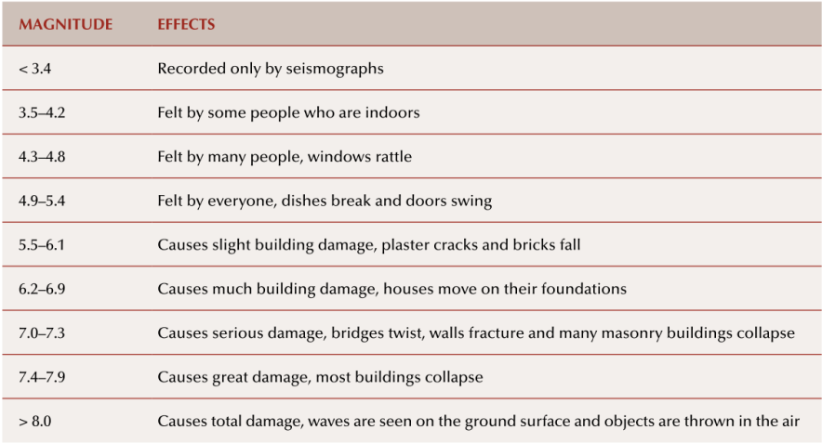
Figure 51: Earthquake magnitude and typical effect, (Source: Middelmann, 2007.)
Seismic events commonly occur in tectonically active areas such as plate margins where zones of crustal deformation are dominant. In these areas, strain energy accumulates over time until the contact strength between two surfaces is exceeded, resulting in a rupture (a fault) and a seismic event (Ellsworth, 2013). While far more common along plate margins, seismic events also occur within continental plates, as shear stress levels within plate interiors are commonly close to the strength limit of the crust and thus small perturbations that affect fault stability can trigger seismic events.
As Australia is located within a continental plate and away from plate margins, earthquakes occur less frequently than in marginal settings. In Australia a person is likely to experience an earthquake large enough to be felt once in every five to ten years (SRC, 2014). Despite this, regions within Australia remain seismically active, albeit at lower scales of magnitude. In Victoria 608 earthquakes have been recorded since 1990 (Geosciences Australia, 2014). Most seismic events in Victoria range in magnitude from 2.0 to 2.9 (Figure 52) and six earthquakes have recorded a magnitude of 4.0 or greater.
Within Victoria earthquakes occur throughout the southern portion of the Gippsland region (Figure 53) around the Strzelecki Ranges and the township of Moe. This is understood to be related to the reactivation of Palaeozoic faults due to northeast–southwest compressional stress (McCue et al., 2013).

Figure 52: Frequency and magnitude of earthquakes in Victoria from 1990 to 11 December 2014.
(Source: GA, 2014.)

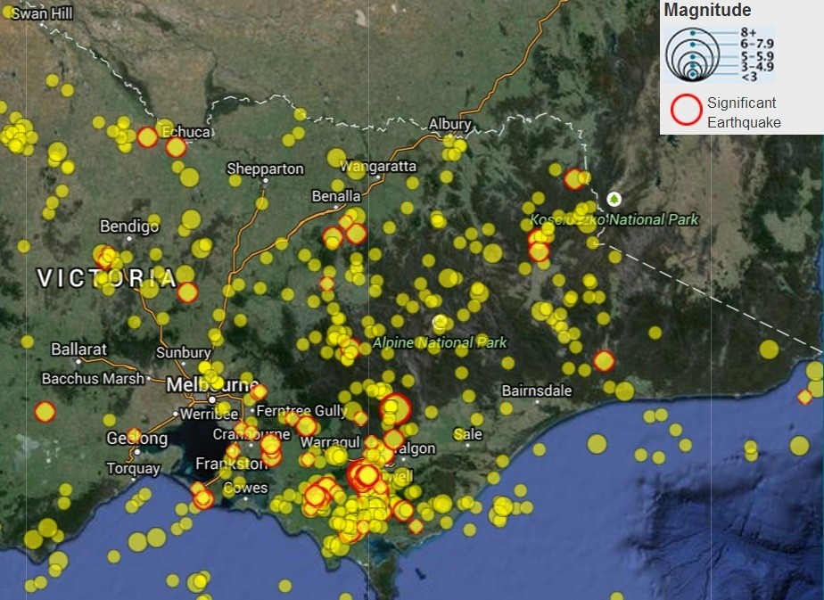
Figure 53: Distribution and magnitude of earthquakes in Victoria from 1990 to 2014. (Source: GA, 2014.)

5.2 Induced seismicity
Induced seismicity refers to seismic events that are triggered by human activity, including filling of large water reservoirs, mining, and activities involving pumping fluids or gases into the crust (which includes injection of water and gases). These activities produce changes in stress regimes and fluid or rock characteristics. The most common way to trigger an earthquake is to increase the groundwater pore pressure. Small local earthquakes can be triggered by pumping water into the crust, oil and gas extraction activities, and geothermal energy extraction (NAS, 2013).
It is important to highlight that while induced seismic events are triggered by human activity, they most commonly release pre-existing stresses that have built up between two surfaces (Ellsworth, 2013). Factors that control the probability of inducing a seismic event include the magnitude of the induced stress change, the spatial scale of the change, the natural stress regime of the material affected and the presence of pre-existing structural weaknesses in the subject material.
Induced seismicity associated with unconventional gas extraction is potentially related to three key activities:
• hydraulic fracturing
• gas production
• coproduced water re-injection.

Figure 54 summarises seismic events related to various forms of energy development, including:
• the extraction of oil and gas
• the secondary recovery of hydrocarbons from fluid injection
• the disposal of co-produced water via injection
• the construction of water reservoirs
• geothermal energy production
• hydraulic fracturing.
There has been a growing realisation that most of the injection-induced earthquakes associated with hydrocarbon development are associated with the re-injection of co-produced water into deep formations (Ellsworth, 2013). Nine earthquakes attributed to co-produced water re-injection have been felt in the United States of America (NAS, 2013). Seven of these had a magnitude of 4 or greater and the maximum magnitude was 4.8. The major mechanism driving these seismic events was an increase in pore pressure.
Management of coproduced water, including re-injection, is addressed by existing regulations and requirements for project-specific risk assessments (including the potential for induced seismicity). Therefore the re-injection of co-produced water as a cause of induced seismicity is not discussed further in this section. Instead the section focuses on other potential causes, notably hydraulic fracturing and gas production.
This distinction between hydraulic fracturing and re-injection of co-produced water is arbitrary, as hydraulic fracturing involves the injection of fluids to increase the pressure to create fractures. The key difference between the two activities relates to the period of time over which the higher pressures are maintained. For hydraulic fracturing the higher pressures are temporary (hours), compared to re-injection of co-produced water for disposal where the higher pressures are maintained over long time scales (i.e. indefinitely).

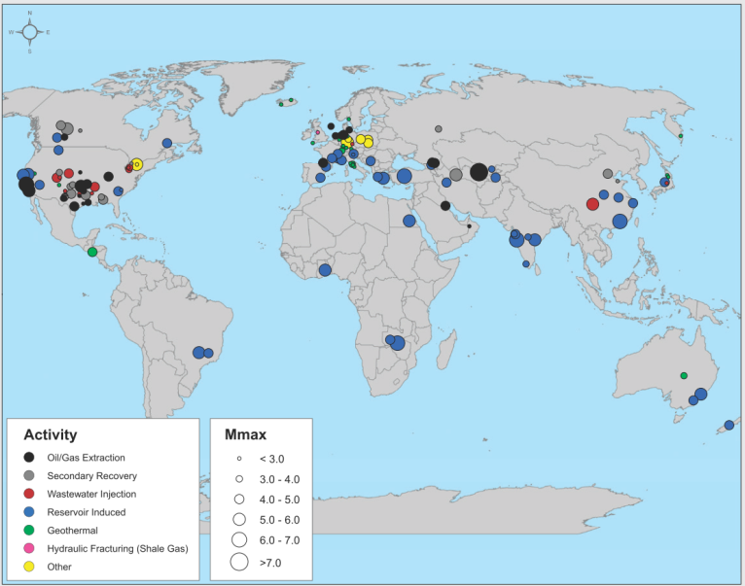
Figure 54: Location and magnitude of seismic events caused by or likely to be related to
energy development from various energy technologies worldwide. (Source: NAS, 2013.)

5.3 Hydraulic fracturing
In prospective onshore gas targets with low permeabilities (i.e. shale gas, tight gas and some coal seam gas targets), fluids may be injected into a target formation under pressure in order to create fractures and increase permeabilities. During this hydraulic fracturing, fracture growth is often mapped using micro-seismic monitoring. This process involves monitoring small movements resulting from fracture growth using arrays of sensitive receivers (geophones or accelerometers) deployed at various depths in nearby wells (Fisher and Warpinski, 2013). During fracture stimulations, hydraulic fracturing intentionally and continuously induces micro-seismic events. Most seismic events associated with hydraulic fracturing have a magnitude of less than 1 (Ellsworth, 2013).
Continuous monitoring of seismicity and the implication of a traffic light system was recommended by the Royal Society and the Royal Academy of Engineering (RS/RSE 2012), who indicated that for induced seismic events with an M_{L} between 0 and 1.7 operations may continue but monitoring after injections should be continued for at least two days, until the seismicity rates fall below one event per day. For events larger than M_{L} = 1.7 they recommended that injections should be temporarily stopped and flowback induced while monitoring continues. Green et al. (2013) proposed more stringent guidelines (as noted by Frogtech, 2013) as part of a study for the Department of Energy and Climate Change, recommending that operations be halted and remedial actions instituted if seismic events > 0.5 M_{L} are detected.
The Marcellus Shale in the United States extends throughout Pennsylvania, West Virginia, Ohio and
New York The area is characterised by low levels of seismic activity. The regional seismograph network
in this area systematically logs all earthquakes with a magnitude of greater than 2 and despite thousands
of fracture stimulations in Pennsylvania since the major development in the field since 2005, six earthquakes with a magnitude greater than 2 M_{L} have been recorded, with a maximum magnitude of 2.3 M_{L}
(Ellsworth, 2013).
Of around 35 000 hydraulically fractured shale gas wells which exist in the United States, one case of felt seismicity has been recorded in which hydraulic fracturing for shale gas development is suspected as the cause (NAS, 2013). This event was reported as a sequence of earthquakes in Oklahoma during nearby hydraulic fracturing operations, with a maximum magnitude of 2.9 M_{L}. Holland (2011) reported that despite a clear temporal correlation with hydraulic fracturing, the natural seismicity of the area and limitations in the data made it uncertain whether the source of the seismicity was related to hydraulic fracturing or natural processes. Subsequent work by Kim (2013) indicated that this seismicity was related to the injection of co-produced water and not hydraulic fracturing.
In British Columbia, Canada, a series of seismic events were recorded in the Horn River Basin associated with the development of shale gas targets in 2009 (BCOGC, 2012). This example is not displayed in Figure 54 as investigations into these seismic events were conducted contemporaneously with the NAS (2013) report. A total of 21 seismic events were recorded with a magnitude of 3.0 M_{L} or larger, however the largest (3.8) was reported as felt by workers. It was determined that the cause of the events was the injection of fluids during hydraulic fracture stimulation in close proximity to pre-existing faults (Ellsworth, 2013). It was also determined that the earthquakes were driven by the movement of previously unknown critically stressed faults that were oriented for failure. These were activated in response to increased fluid pressure communicated through conductive pathways that caused slip via a reduction in the effective normal stress.
In England one case of induced seismicity felt by workers has been confirmed to have been caused by hydraulic fracturing for shale gas development (Green et al., 2013). In April 2011, the Blackpool area experienced a seismic event of magnitude 2.3 M_{L} shortly after hydraulic fracturing in Cuadrilla’s Preese Hall well in the Bowland Shale (RS/RAE, 2012). An additional seismic event 1.5 M_{L} in magnitude occurred in May 2011 following further hydraulic fracturing of the same well. Both Green et al. (2013) and RS/RAE (2012) indicated that hydraulic fracturing was responsible for the induced seismic events as a result of reactivation of a pre-stressed fault.
The United States National Academy of Sciences has suggested that the low number of felt events relative to the large number of hydraulically fractured wells for shale gas is likely due to the short duration of injection of fluids and the limited fluid volumes used over a small spatial area (NAS, 2013).
In New Zealand hydraulic fracturing is a comparatively new technique, the first recorded hydraulic fracturing being undertaken in 1989. Almost all the fracturing undertaken to date has occurred near Taranaki. The New Zealand Parliamentary Commissioner for the Environment commissioned a study to evaluate the environmental impacts of hydraulic fracturing in New Zealand in 2012 (NZPCE, 2012). This study suggested that hydraulic fracturing in New Zealand creates earthquakes with magnitudes less than 2 M_{L} that cannot be felt at the surface. Earthquakes of this magnitude are within the natural variability experienced in the region. However, where injected hydraulic fracturing fluids migrate to an active fault, the fluid can cause movement within the stressed fault which allows the fault to slip. The study infers that it is not possible to trigger significant earthquakes if there is no local active fault and that the chance of inducing an earthquake is influenced by a range of variables, which include the volume of fluid injected, the size of the existing fault and how much stress it is under. The key conclusion of this study, based on records from the earthquake monitoring systems, was that there is no evidence to suggest that hydraulic fracturing around Taranaki has caused induced seismicity that could be felt at the surface.
In summary, with tens of thousands of hydraulic fracture stimulations globally, two events large enough to be felt by workers have been confirmed as related to hydraulic fracturing. As outlined above, this includes an event in British Columbia, Canada (maximum M_{L} = 3.8) and an event in Blackpool, England (maximum M_{L} = 2.3). Cook et al. (2013) summarised the findings of a number of reports with respect to the risk of induced seismicity presented by hydraulic fracturing and reported that:
• Seismicity induced by hydraulic fracturing would be no greater than 3 M_{L} and would be felt by few people, resulting in negligible, if any, surface impacts.
• Hydraulic fracturing itself rarely triggers earthquakes large enough to be a safety concern.
• Hydraulic fracturing a well as presently implemented for shale gas recovery does not pose a high risk for inducing felt seismic events.
Cook et al. (2013) concluded that despite the relatively low risk presented by hydraulic fracturing itself, real-time seismic monitoring can allow operators to respond to seismic indicators and mitigate the risk.

5.4 Gas development
Oil, gas and fluid extraction from a reservoir can cause declines in the pore pressure that can cause induced seismic events (NAS, 2013). Declining pore pressure associated with extraction causes contraction of the reservoir and induces stresses in the surrounding rock. This can increase horizontal stresses above and below the reservoir and increases the potential for reverse faulting. It has been estimated that the withdrawal of fluids from reservoirs can cause earthquakes up to magnitude 5.0 M_{L} (Grasso, 1992).
In a study into induced seismicity related to natural gas extraction, Van Eijs et al. (2006) found three major contributing factors in producing seismicity:
• pore pressure drop from pumping
• existing fault density overlying the gas field
• contrast in crustal stiffness between the reservoir rock and the surrounding rock.
The extraction of fluids and hydrocarbons may cause vertical stress reduction and isostatic uplift (the ascent of underlying rock as a result of the removal of overburden weight) of the lithosphere surrounding gas development (McGarr, 1991). This may induce slip on pre-existing faults at depth.

The National Academy of Sciences (NAS, 2013) reported that, on approximately 6000 producing oil and gas extraction fields across California, Illinois, Nebraska, Oklahoma and Texas, workers have felt seismic events at 20 locations. Of these, five events have had a magnitude of 4 or greater, and the most significant event had a magnitude of 6.5 M_{L}. The global distribution of seismic events related to oil and gas extraction are illustrated in Figure 54.
It has been well documented that the Lacq gas field in France provides a good example of induced seismicity resulting from fluid extraction (NAS, 2013). The gas reservoir is a limestone sequence approximately 500 m in thickness and the first earthquake felt at the site occurred after a decrease in pressure of approximately 300 bar (about 3060 mH₂O) from 1957 to 1969. Development over the ensuing about 15 years resulted in a further 200 bar pressure drop, accompanied by 800 seismic events with magnitudes up to 4.2 M_{L}. While this provides an example of seismicity related to reductions in pore pressure associated with fluid extraction, it should also be noted that the Lacq gas field is an example of a conventional gas production. The intrinsic differences between conventional and unconventional targets therefore should be accounted for before directly relating such results to unconventional targets.
Understanding seismicity induced by fluid and hydrocarbon withdrawal requires characterisation of stress changes associated with the large-scale reservoir expansion due to pore pressure reduction and uplift driven by mass removal. Because stress change can take place over large areas (approximate to the size of the oil/gas reservoir) there is potential for event magnitudes to be high. Additionally, unconventional gas is usually targeted over large areas and may induce seismicity over greater spatial scales. However in order to trigger an event, the stress field between two surfaces must be close to critical as stress changes in response to pore pressure reductions are typically small. For example at the Lacq gas field a pressure drop of 300 bar (about 3060 mH₂O) was required to increase the maximum shear stress by 1 bar (NAS, 2013).
Cook et al. (2013) also highlighted potential risks associated with pressure changes in gas reservoirs. A review of gas withdrawal and injection history at the Iona facility in southwest Victoria, including modelling of pressure changes, revealed maximum subsidence predictions of 2.5 and 9.0 mm at various stages of gas production from the reservoir. Subsidence was expected to be greatest directly above the reservoir but some displacement was expected up to 2.5 km from the centre of the reservoir. Fault stability during pressure changes was predicted by modelling plastic strain, and a value of 1% strain increase was used to indicate the point at which rock failure becomes elevated.

5.5 Qualitative risk assessment
The development of a qualitative risk assessment for induced seismicity involves the understanding of uncertainties associated with subsurface complexities. At the start of any subsurface project, the uncertainty is broad and is not expected to be fully resolved. The risks associated with induced seismicity include those associated with increased pressure driven by processes such as hydraulic fracturing and decreases in pressure resulting from gas or fluid extraction. These processes could possibly lead to fault reactivation and seismic events.
The likelihood of inducing a seismic event during gas development relies on a number of factors, including the natural level of seismicity in the area, current stress regimes in the target and surrounding formations, the prevalence and proximity of faults and weaknesses to the target, and the nature and operation of the development undertaken (e.g. pressure changes and intensity of development of wells). Using these later criteria, the likelihood of inducing a seismic event can be characterised as low, moderate or high (Table 9).

Table 9: Proposed likelihood assessment criteria for induced seismicity.
Induced seismicity likelihood | Pressure change | Intensity of development of wells
High | High change | High intensity
Moderate | Moderate change | Moderate intensity
Low | Small change | Low intensity

The consequence of induced seismicity is related to the magnitude or size of the seismic event that has been induced. Events less than 3 M_{L}.4 in magnitude are typically not felt by individuals and usually measurable only with seismometers. Events between and including 3.5 and 4.2 M_{L} in magnitude can be felt by individuals but cause little to no structural damage, while events 4.3 M_{L} or greater in magnitude are typically felt by individuals and have the potential to cause structural damage. These events have been categorised as of low, moderate and high consequence, respectively (Table 10).
The qualitative risk assessment framework as it relates to coal seam gas and tight and shale gas in the Gippsland region is discussed below.

Table 10: Proposed consequence scale for induced seismicity.
Induced seismicity impact | Low consequence | Moderate consequence | High consequence
Earthquake magnitude | M_{L} ≤ 3.4 | M_{L} between 3.5 and 4.2 | M_{L} ≥ 4.3

5.5.1 Tight and shale gas
Potential for induced seismicity associated with tight and shale gas development scenarios in the Gippsland Basin would be principally related to the hydraulic fracturing of gas-bearing formations. While a number of fault systems are present throughout the Gippsland Basin, providing potential for fault activation, the likelihood of hydraulic fracturing inducing seismic events large enough to be felt by an individual is highly remote; of the tens of thousands of hydraulic fracture stimulations that have occurred globally, two reports of induced seismicity felt by individuals have been confirmed. Furthermore, the maximum magnitude of these events was 2.3 and 3.8 M_{L}. The risk of tight and shale gas development causing induced seismicity is therefore low.

5.5.2 Coal seam gas
As discussed in Chapter 4, hydraulic fracturing is not expected to be required in the coal seams in Gippsland. Therefore the primary cause of potential induced seismicity in the case of coal seam gas would be related to fluid and gas removal. Gippsland is a moderately seismically active area driven largely by the reactivation of Palaeozoic faults from compressional stresses (McCue et al., 2013), whereby the presence of critically stressed faults throughout the region is possible. Additionally, removal of loads overlying the Palaeozoic fault system via fluid removal may drive increased reverse faulting, which is the major mechanism driving seismicity in the basin. Thus it is moderately likely that fluid and gas removal associated with coal seam gas will induce some level of seismicity.
Based on data from about the last 25 years, the magnitude of most seismic events in Victoria was between 2.0 and 2.9 M_{L} (about 70% of all events), and would generally not be felt by individuals. About 20% of seismic events in Victoria have a magnitude between 3.0 and 3.9 M_{L} (large enough to be felt by some individuals), and less than 1% recorded a magnitude between 4.0 and 4.9 M_{L} (large enough to be felt by most individuals and cause minor damage).
Groundwater pumping and coal mining in the Latrobe Valley and offshore oil and gas production is currently undertaken in the Gippsland region. These operations drive large-scale depressurisation within target formations similar to those associated with coal seam gas. As a result it is unlikely that coal seam gas development in the Gippsland region would cause seismic events large enough to be felt or cause minor damage, and the overall risk is therefore low.

6 Land subsidence risk assessment
Subsidence refers to the phenomenon of ground level lowering resulting from water (or fluid) removal from the subsurface. It is sometimes referred to as land subsidence. Subsidence is a geomechanical process that can potentially occur when water is withdrawn from an aquifer. One of the impacts that the development of onshore gas could have is to cause drawdown in aquifers in the Gippsland region. This chapter provides a brief review and overview of the process by which drawdown may lead to subsidence and a qualitative assessment of the potential risks that may arise from onshore gas extraction as a result.

6.1 Summary of subsidence processes
The pressure within an aquifer is caused by a combination of the weight of the sediments and the weight of water (fluid) and the atmosphere. This weight is borne in part by the aquifer sediments and in part by the water (fluid) in the aquifer. For the purposes of this discussion we will refer to the fluid in an aquifer as water. The weight of both the overlying sediment grains and the overlying water contribute to the aquifer pressure in proportion to the mix of water and sediment in the hydrogeological sequence.
Subsidence is potentially of concern in sedimentary aquifers (Poland, 1984). A sedimentary aquifer can be considered to be a collection of grains of gravel, sands, silt and clay of different sizes that are combined together. In the same way as sand at a beach is composed of small grains of sand that sit on each other, so are the grains in aquifers. Pressure from overlying sediments or rocks and the weight of water are carried by the grains in contact with each other. Increasing pressure will compress the sediments. The rate of compression with increasing pressure is small. It can be measured by taking samples of the sediment and testing in a laboratory.
As sediments are deposited they become progressively buried. The burial process compacts and consolidates the sediment. Over geological time the sediments may be moved or lifted by geological forces. Typically sediments as we find them today have been buried deeper in the earth at some stage in the past. In the Gippsland region most of the sedimentary aquifers and aquitards are currently shallower than their maximum historical burial and have also been subjected in turn to extensional and compressional faulting and deformation however there was considerable ambiguity on possible pre-consolidation stress (Underschultz et al., 2006).
Given that the pressure on an aquifer is carried by both the water and the sediment, when water is withdrawn from an aquifer, the amount of pressure that this carried by the sediment grains at any given depth increases. As a result of this increase in pressure, the sediment can be further compressed (or consolidated) and this compression can result in lowering of the land surface, or subsidence (Bouwer, 1978; Poland, 1984; Underschultz et al., 2006).
Different sediment types compress at different rates for a given additional pressure. Typically clays and fine grained sediments will compress the most and sands and courser grained sediments will compress the least. In any sedimentary sequence it has been observed that the majority of the observed consolidation comes from the fine grained sediments (Poland, 1984). Subsidence is dominated by compaction of the clay and fine grained sediments within a sedimentary sequence. Typically this means that for the aquifers and sediments in the Gippsland region, the aquitards will provide the majority of any potential settlement and thus are likely to be the source of the majority of any subsidence. Fractured rock aquifers are not expected to provide significant settlement.
Land subsidence in the Latrobe valley and in the Gippsland region has been the subject of on-going and long term assessment. Prompted initially by concerns about subsidence caused by dewatering and excavation at the open cut mines (Helm, 1984), further concerns were raised when it was realised that offshore oil and gas extraction may be contributing to onshore water level decline (SKM, 2001b; Hatton et al. 2004). A body of recent work has assessed the likelihood of subsidence in the Gippsland region
and specifically along the coast, and provides important information for this risk assessment. This is described below.

6.2 Subsidence studies in Gippsland
Land subsidence in the Latrobe Valley associated with open-pit coal mining and related groundwater extraction has been recognised for decades, and subsidence of over 2 metres has already been recorded (Hatton et al., 2004; Helm, 1984; Evans, 1983). In the mid 1990s the influence of offshore oil and gas production on declining levels in the Yarram area was recognised and a possible risk to coastal areas was identified should subsidence of any significant amount occur along the coast. A number of studies were undertaken as a result. The key findings from these studies were as follows (Hatton et al., 2004):
• Ongoing groundwater level decline in the Gippsland aquifers poses a potential risk of land subsidence.
• Rates of subsidence are likely to be initially low, especially as the sediments in the region that are most affected by drawdown appear to be over-consolidated, both on the basis of laboratory test results and by the observation of no detectable subsidence along the coast to date.
• Potential subsidence risk along the coast may be up to hundreds of millimetres.
Additional data were collected in the late 2000s and additional work was done by CSIRO to better define the subsidence risk, particularly along the coast. The conclusions from this work (Underschultz et al., 2006, Freij-Ayoub et al., 2007) were as follows:
• Within the accuracy of current measurement techniques, no subsidence has been measured along the coast.
• Realistic subsidence risk along the coast is up to approximately 1.5 m within 50 years.
• The rate of subsidence is likely to be low initially.
One of the issues identified with the above studies was that the expected subsidence rate is such that the measurement error is a significant factor in the assessment. As a result, further analysis was done to compare the different measurement techniques that could be used to provide a more precise measurement (DEPI, 2014b). This study concluded no subsidence along the coastal zone. The methods used are accurate to within 1–2 mm.

6.3 Review of risk factors
The key factors that influence the risk of subsidence are:
• water level drawdown in aquifers
• compressibility of the aquifer sediments, especially the aquitards (or clay bearing layers) and coal layers
• ratio of fine-grained (clay) sediments to medium to coarse-grained sediments (sands)
• length of time that the water level drawdown persists
• prior compaction (consolidation) history of the sediments.
For the Gippsland region, some of the risk factors are reasonably known and others can only be estimated or inferred. Each of the risk factors is discussed below.

Water level drawdown
The numerical model approach described earlier in this report has been used to estimate the potential drawdown in aquifers in the region as a result of onshore gas development. These drawdown estimates provide an indication of the likely influence of gas developments on regional groundwater systems. Drawdown is reasonably well known for the purposes of subsidence assessment and is not an
information gap.

Aquifer and aquitard compressibility
A limited number of key studies have provided actual sediment compressibility characteristics in the broader Gippsland region. The aquifers and aquitards are determined to be over-consolidated, and recompression ratio values are available from laboratory testing. Two key areas have been studied: near the mines, and along the coast. The extent to which these would be more applicable to the rest of the study area is not defined, but it can reasonably be assumed that these values are representative of the aquifers and, critically, the aquitards more widely.

Ratio of clay to sand
In the Gippsland region the stratigraphy is well defined for the Tertiary and overlying sediments. Stratigraphic profiles in the upper part of the sequence are well known. Deeper profiles are known from a limited number of bores, but they are generally well described and the ratios of clay to sand are well known, especially when compared with other parts of the state. The data on sediment size are adequate given the uncertainties in other parameters.

Timing of water level drawdown
The duration of drawdown and recovery is moderately well known. Estimates for onshore gas development are over 30 years and water level recovery in the aquifer sequence (as compared with the gas source rocks) is likely to be in the order of a decade or so. This variable is reasonably well known.

Consolidation history
The prior consolidation and compaction history of sediments is important when predicting subsidence, because their reaction to water withdrawal depends on whether the stress is greater or less than the maximum pressure that had been previously applied to them. Sediments with stresses that are less than the historical maximum are called over-consolidated. Sediments with stresses that are greater than previously applied are called normally consolidated sediments. The compressibility of over-consolidated sediments is about one tenth of the compressibility of normally consolidated sediments (Helm, 1984; Underschultz, 2006).
Laboratory testing and subsidence measurements provide reasonable evidence of the consolidation history that is relevant for assessing subsidence. These should be obtained as part of a site-specific investigation

6.4 Qualitative risk assessment
The consequence of subsidence depends on the receptor. Built structures have deformation limits; natural systems tend to be more resilient but will still have a limit. For this study the water resources being assessed are aquifers, streams and ecosystems that are dependent on groundwater. The consequence scale needs to be based on the nature of the water resource under consideration. For the purposes of this assessment the DELWP (2015) draft resource share guidance approach has been used as the basis of assessing consequence.
In this study consequence is not able to be determined directly from the drawdown data, as the key parameters to determine potential subsidence and the flow-on consequences require further study and calculations.
The likelihood of subsidence is determined by the nature of the aquifers and how they may respond to drawdown. In effect this means that a likelihood scale is going to be linked to the magnitude of subsidence that may occur. This is a combination of the consolidation parameters of the aquifers and aquitards and the expected drawdown. An approximate likelihood framework is proposed in Table 12.
For the Gippsland region, the drawdown estimates would provide a likelihood rating of low to moderate, depending on the scenario.

Table 11: Proposed consequence scale for subsidence caused by drawdown in aquifers.
Water resource (asset) group | Low consequence | Moderate consequence | High consequence
Groundwater users (aquifers) | Impact of subsidence is within annual variability in function and operating costs of current and future users. | Without modification, current pumping regime cannot meet water demand due to subsidence. | Aquifer, without modification of current pumping infrastructure such as deepening bores, cannot meet demand requirements as a result of subsidence.
Surface water users (rivers) | Subsidence results in either no change or a material change in river flow, with no measurable impairment of users’ ability to access entitlement. | Subsidence results in a material change in river flow, with measurable impairment of users’ ability to access entitlement. | Subsidence results in a material change in river flow, with significant impairment of users’ ability to access entitlement.
Surface water ecosystems | Subsidence results in no material change in ecosystem condition, with no measurable impairment of ecosystem function. | Subsidence results in material change in ecosystem condition, with measurable impairment of ecosystem function. | Subsidence results in material change in ecosystem condition, with significant impairment of ecosystem function.

Table 12. Proposed likelihood assessment criteria for subsidence as a result of onshore gas development.
Consolidation response / drawdown range | LOW  Less than 1 m drawdown over 30 years | MODERATE  Between 1 m and 10 m drawdown over 30 years | HIGH  Greater than 10 m drawdown over 30 years
HIGH  Normally consolidated sediments | Moderate likelihood | High likelihood | High likelihood
MODERATE  Over-consolidated sediments with >20% clay | Low likelihood | Moderate likelihood | Moderate likelihood
LOW  Over-consolidated sediments with little clay | Low likelihood | Low likelihood | Low likelihood

6.5 Summary
For the Gippsland region it is summarised that:
There is a low risk of subsidence from onshore tight and shale gas development.
There is a moderate risk of subsidence within 30 years from coal seam gas development.

7 Management and mitigation of potential impacts and risks

7.1 Introduction
This chapter considers options to mitigate inherent potential impacts and risks identified in this assessment. The purpose is to explore the potential to reduce the assessed inherent potential impacts and risks from medium or high to low. Mitigations for low potential impacts and risks have not been assessed for the purpose of this initial assessment because the potential impact or risk is deemed to be negligible or unlikely.
To understand the reduction in potential impacts and risks, an additional aquifer depressurisation scenario has been modelled, reducing the potential area of gas development to 50% of the original scenario for both the coal seam gas and tight and shale gas scenarios. This reduction in the developed area shows that it is possible to reduce the potential impacts and risks from gas developments. The results from these scenarios are discussed with respect to possible mitigation measures in this chapter, and they are referred to as the 50% scenario.
The options presented to mitigate the inherent potential impacts and risks associated with development of onshore natural gas resources are consistent with the Australian Standards Risk Management — Principles and Guidelines (AS/NZS 31000:2009) and the Environment Protection and Biodiversity Conservation Act 1999 Environmental Offsets Policy (DSEWPC 2012). The analysis of mitigation and residual risk is based on the assumption that mitigation controls and measures are fully implemented via an effective monitoring and enforcement regime to ensure compliance.
The following matters are considered with regard to assessing potential mitigation measures and inherent potential impacts and risks. The mitigation measures are based on either avoidance or transference of the impacts or risk. Standard practice would require a developer to bear the costs associated with any mitigating activities under the beneficiary pays principle.

7.2 Possible mitigation measures

Changing the activity
By reducing the scale, timing or location of potential natural gas development it may be possible to avoid or reduce the impacts to groundwater users, surface water users and ecosystems. This could include phasing gas developments during and after exploration, reducing the scale of developments, or introducing area-based limits on the natural gas development.

Managing the operation of groundwater users, surface water users and ecosystems
It may be possible to regulate operations of groundwater users and surface water users. For example, where there is an impact on part of the aquifer that reduces the yield from individual bores, it may be possible to increase the pumping duration to obtain the required volume of water.
In unregulated systems it would be difficult to manage flows which are dependent on baseflow in summer and hence may experience a measurable change in their water security.
In regulated systems it may be possible to meet ecological needs for instream ecosystems and surface water users by modifying flow regimes.

Altering infrastructure of groundwater users and surface water users
For groundwater users it may be possible to deepen bore casings to allow lowering of pumps to maintain access to groundwater. For surface water users it may be possible to construct or enlarge storage to maintain supply.

Offsets
For groundwater users, surface water users and ecosystems it may be possible to offset the loss of water supply with an alternative water resource. Alternative supplies include surface water supply, or groundwater supplied from a different location or from co-produced water from the gas development.
Compensatory offsets for ecosystems could comprise actions that do not directly offset the impacts on the protected ecosystem, but lead to associated benefits. This recognises that exactly the same biodiversity is not always available for an offset, so offsets can be targeted to equal or higher conservation priorities than the impacted ecosystem. Examples (from DSEWPC 2012) include:
• creating a new habitat
• improving an existing ecosystem
• contributing to an area recognised as important to increasing landscape connectivity, above and beyond what is required by the impacted ecosystem
• measures that benefit biodiversity but do not specifically involve protecting and managing an impacted ecological site
• funding for research for a particular ecology or educational program
• rehabilitation of impacted ecosystem sites where there are good prospects of the biodiversity being restored.

7.3 Potential impacts and risks requiring mitigation
The inherent potential impacts and risks identified in this assessment under a 100% development area scenario that are greater than low and hence would require mitigation measures are as follows:
• Aquifer depressurisation — The inherent potential impact on groundwater users from aquifer depressurisation from coal seam gas development is high, and on surface water users and ecosystems as moderate to high. The inherent potential impact on surface water users and ecosystems from aquifer depressurisation associated with tight and shale gas development is moderate to high.
• Land subsidence — The inherent potential impact is moderate for coal seam gas developments.
In this section mitigation options are explored for these inherent potential impacts and risks for each receptor: groundwater users, surface water users, ecosystems and for land subsidence.

7.3.1 Aquifer depressurisation

Changing the activity
The results of the assessment indicate that there is potential for reducing inherent potential impacts to groundwater users, surface water users and ecosystems. The inherent potential impacts from 50% of the development area are less than the 100% development scenario for coal seam gas (see Figure 55 below for comparison of potential impacts). It is also possible that the inherent potential impact on surface water users could be reduced. For gas development for coal seam gas, further modelling and assessment would be required to determine the threshold that changes the potential impacts from low to moderate.
Exploration activities would be less in volume and scale. Exploration may involve a single bore or a limited bore field to prospect for natural gas and would occur over a time frame of weeks to months with a relatively small volume extracted from groundwater. It is expected that exploration activities would have little potential impact on groundwater users, surface water users and ecosystems for this reason.
Key: red = high, orange = moderate, green = low. The hatching shows the area of development for each scenario.
Figure 55: Potential impacts from coal seam gas developments: 100% (left) and 50% (right) development scenarios.
For tight and shale gas development a comparison of the 50% and 100% development (Figure 56) shows significant change, such that there is little inherent potential impact at 50% combined development. Similarly, at 100% development there is little inherent potential impact found on the basis of the hypothesised development scenarios.
The assessment indicates that the inherent impacts can be reduced through modification of the scale and timing of natural gas development.

Key: red = high, orange = moderate, green = low. The hatching shows the area of development for each scenario.
Figure 56: Potential impacts from tight and shale gas development: 100% (left) and 50% (right) development scenarios.

Table 13: High inherent potential impact volumes under 100% development scenario.
Development | Water source | Domestic and stock (ML) | Irrigation  (ML) | Town water supply (ML)
Coal seam gas | Groundwater | 200 | 6800 | 0
 | Surface water diversion licences | 30 | 1700 | 0
Tight and shale gas | Groundwater | 0 | 0 | 0
 | Surface water diversion licences | 0 | 0 | 0

Table 14: High inherent potential impact volumes under 50% development scenario.
Development | Water source | Domestic and stock (ML) | Irrigation  (ML) | Town water supply (ML)
Coal seam gas | Groundwater | 100 | 4700 | 0
 | Surface water diversion licences | 30 | 1600 | 0
Tight and shale gas | Groundwater | 0 | 0 | 0
 | Surface water diversion licences | 0 | 0 | 0

Managing the operation of groundwater users, surface water users and ecosystems
During initial start-up of a potential gas development, the inherent impacts may be negligible but would be expected to increase through time, and there is potential to manage the operation of groundwater users’ surface water users and ecosystems during this time.
The reduced levels in a groundwater users bore may reduce yield but supply is available through longer pumping cycles. In high inherent impact areas full impact of development will make it unlikely this would be possible for existing users, but may still be an option in moderate inherent impact areas. It is possible to manage the regulated systems such as the lower reaches of the Latrobe River, but is not possible for unregulated streams such Merriman Creek in South Gippsland. Supplementary volume of water required for the Latrobe River would need to be purchased from the water market.
Altering impacts on infrastructure of groundwater users and surface water users
This most likely applies to the groundwater users in moderate inherent impact areas but is unlikely to apply to groundwater users in high inherent impact areas. The number of groundwater users and surface water users are shown in the tables below.

Table 15: Moderate inherent impact volumes under 100% development scenario.
Development | Water source | Domestic and Stock (ML) | Irrigation  (ML) | Town water supply (ML)
Coal seam gas | Groundwater | 40 | 3200 | 0
 | Surface water diversion licences | 100 | 1700 | 0
Tight and shale gas | Groundwater | 0 | 0 | 0
 | Surface water diversion licences | 0 | 10 | 0

Table 16: Moderate inherent impact volumes under 50% development scenario.
Development | Water source | Domestic and Stock (ML) | Irrigation  (ML) | Town water supply (ML)
Coal seam gas | Groundwater | 20 | 5100 | 0
 | Surface water diversion licences | 50 | 1300 | 0
Tight and shale gas | Groundwater | 0 | 0 | 0
 | Surface water diversion licences | 0 | 10 | 0

Offsets
It is expected that the volume of co-produced water (Table 17) from onshore natural gas development and water held under existing entitlements available through trade far exceeds the current groundwater and surface water entitlements that are impacted in moderate and high inherent impact areas. Providing alternative supply may require additional infrastructure including distribution pipe lines, water treatment and storage infrastructure and on-farm infrastructure. There would also be a consequential increase in the costs associated with this supply.

Table 17: Indicative water volumes by source.
Water source | Volume  GL/year
Co-produced tight shale gas | ~ 5.6
Co-produced coal seam gas | > 500
Total volume of groundwater entitlements (Gippsland Basin) | 0.07
Total volume of surface water entitlements (diversion licences in Gippsland Basin) | 0.08

With regard to alternative surface water supply, additional surface water entitlements would need to be bought from the market (from the Thompson or Macalister), and a water supply delivery system and on-farm distribution system would be required for distribution of the water. Again, there would be a consequential increase in the cost associated with the supply of this water.
The potential for obtaining groundwater supplies are low as alternative supplies are likely to be poorer in quality and would require treatment, as well as the water supply delivery system and on-farm distribution system.
Given the ecosystems identified are all protected ecosystems, analysis of the regulatory context is also required. Further analysis and assessment would be required on the technical point of view (e.g. the types of ecosystems and water dependency) and the regulatory context to determine whether ecosystem mitigations are feasible in the Gippsland region.
The site specific nature and scale of such analysis exceeds the time limitations of the water science studies and therefore the feasibility of technical or regulatory options will not be addressed in the impact mitigation chapter. Further modelling and assessment would be required to determine the scale that changes the inherent impact from low to moderate.

7.3.2 Subsidence
Further information is required to better assess the risks and potential to prevent significant subsidence due to a natural gas development, e.g. clay properties of the aquitards. Information can be obtained as part of a site-specific investigation. The major impact is on roads and pipelines and coastal drainage and inundation. For roads, pipelines and built environment, risks may be managed by design, maintenance and remediation.
With respect to coastal drainage, the Gippsland Lakes and any coastal inundation is problematic and difficult to imagine any measures can address these. For this reason the residual risk of land subsidence for the Gippsland basin remain as the inherent risk as moderate for coal seam gas.

7.4 Summary
There are a number of mitigation options that can be applied to the inherent potential impacts and risks to reduce the residual potential impact and risk profile from moderate and high to low.
The residual potential for impact profile (after mitigation is applied) for aquifer depressurisation due to onshore natural gas development in the Gippsland region is summarised in Table 18.

Table 18: Residual potential for impact due to aquifer depressurisation from onshore natural gas development in the Gippsland region.
Natural gas type | Gas development  (aquifer depressurisation)
Natural gas type | Groundwater users | Surface water users | Ecosystems
Tight and shale | L | L | H
Coal seam gas | L | L | H

The residual potential risk profile (after mitigation is applied) from chemical contamination of groundwater from hydraulic fracturing fluids, induced seismicity and land subsidence due to onshore natural gas development in the Gippsland region is summarised in Table 19.

Table 19: Residual potential risk due to hydraulic fracturing, induced seismicity
and land subsidence from onshore natural gas development in the Gippsland region.
Natural gas type | Chemical contamination of groundwater from hydraulic fracturing fluids |  |  | Induced seismicity | Land subsidence
Natural gas type | Groundwater users | Surface water users | Ecosystems | All users | All users
Tight and shale | L | L | L | L | L
Coal seam gas | N/A | N/A | N/A | L | M

8 Conclusions

8.1 Aquifer depressurisation
The assessment of the potential impacts of aquifer depressurisation used predicted drawdown results and depth to watertable to determine the potential impact. These results are based on full development of the potential gas resources (i.e. 100% extraction) at 30 years from the start of development. It may be possible to optimise the development case to reduce the potential impact.
Results show that the overall potential impact on all aquifers (confined and unconfined) from development of tight and shale gas in the Gippsland region is low. Potential impacts to surface water resources (including users) and ecosystems are low, with the exception of areas of moderate to high potential impact in the central Latrobe Valley region. Seven surface water licences are located in areas of elevated potential impact.
The potential impact on aquifers from coal seam gas development depends on the distance to the prospective development area. Inside the area of the identified gas development, predicted drawdown in response to gas development will be significant in the overlying confined aquifers, and as a result the potential impacts to aquifers are high. It is possible that an alternative coal seam gas development scenario could result in lower potential impact than shown here, but some potential impact on aquifers is likely.
Potential impacts to surface water resources (including users) and ecosystems are high in areas close to the potential gas development and low elsewhere. There are 243 surface water licences in areas of moderate to high potential impact.
It is concluded that development of coal seam gas in the Gippsland region poses a high potential impact on aquifers and surface water resources in the immediate vicinity of the gas areas. There are large areas of aquifers outside the development area that are classified as low potential impact.

8.2 Chemical contamination of groundwater from hydraulic fracturing fluids
The risks associated with chemical contamination of groundwater from hydraulic fracturing fluids were assessed based on available literature. The development of tight and shale gas in the Gippsland region may require hydraulic fracturing in order to increase formation permeability and hence gas production. The tight and shale gas development scenario used in this study indicates that the natural gas source is within the Strzelecki Group. The Strzelecki Group is directly overlain by an aquifer of value (the Latrobe Group aquifer), however the upper Strzelecki Group provides a suitable low-permeability formation between the potential gas-bearing units and the overlying aquifer. Given the typical fracture propagation distances of tens of metres, contamination or increased connectivity via the generation of fully penetrating fractures or the intersection between stimulated and pre-existing fractures is unlikely. As such, the aquifer would almost certainly remain unaffected by a potential increased hydraulic connectivity with the gas source formation. Likewise, contaminant migration between gas-bearing formations and adjacent aquifers is unlikely.
Based on the above, and the fact that the use of BTEX in hydraulic fracturing fluids is banned under Victorian law, the overall risk of groundwater contamination resulting from hydraulic fracturing in the Strzelecki Group for tight and shale gas is low. Key factors to be determined for a site-specific risk assessment are the thickness of the Strzelecki Group overlying the prospective formation, stress regimes and proximity to existing faults.
With regard to coal seam gas, hydraulic fracturing is not expected to be required in the coal seams in Gippsland, and therefore would not have a potential impact in this region.

8.3 Induced seismicity
Induced seismicity refers to seismic events that are triggered by human activity, including filling of large water reservoirs, mining, and activities involving pumping fluids such as water or gases such as carbon dioxide into the crust. These activities produce changes in stress regimes and fluid or rock characteristics. Risks associated with induced seismicity were informed by a literature review.
The likelihood of inducing a seismic event during gas development relies on a number of factors, including:
• the natural level of seismicity in the area
• current stress regimes in the prospective and surrounding formations
• the prevalence and proximity of faults and weaknesses to the prospective formations
• the nature of the development undertaken (i.e. total changes and rates of change in the stress regime).
The consequence of induced seismicity is related to the magnitude or size of the seismic event that has been induced.
Gippsland is a moderately seismically active area. Seismic activity there is driven largely by the reactivation of Palaeozoic faults from compressional stresses, which suggests that there may be critically stressed faults throughout the region. The potential for induced seismicity related to possible tight and shale gas development in the Gippsland region would be principally related to the hydraulic fracturing of gas source formations. Given that a number of fault systems are present throughout the Gippsland region, providing the potential for fault activation, the likelihood that tight and shale gas development would cause induced seismicity is moderate. The consequence is low based on the typical magnitudes of induced seismic events. The overall risk of tight and shale gas development causing induced seismicity that could be felt by humans (3.5 magnitude M_{L} and above) is therefore low.
Induced seismicity related to potential coal seam gas development is more likely to be caused by the predicted large-scale depressurisation inducing changes to stress regimes. Given the area is moderately seismically active, the likelihood that coal seam gas development causes induced seismicity is moderate. The consequence of these events is low, based on the typical magnitude of induced seismic events reported around the world. The overall risk of potential coal seam gas causing induced seismicity that could be felt (3.5 magnitude M_{L} and above) is therefore low.

8.4 Land subsidence
Subsidence refers to the phenomenon of ground level lowering resulting from water (or fluid) removal from the subsurface. Subsidence is a geomechanical process that can occur when water is withdrawn from an aquifer. One of the impacts that the development of onshore gas could have is to cause drawdown in aquifers in the Gippsland region.
Land subsidence in the Latrobe Valley associated with open-pit coal mining and the related groundwater pumping has been recognised for decades, and subsidence of over 2 m has already been recorded. Factors that contribute to subsidence include water level drawdown, aquifer and aquitard compressibility, ratio of clay to sand, the timing of water level drawdown and the consolidation history.
For the Gippsland region it is assessed that:
• there is a low risk of subsidence from onshore tight and shale gas development
there is a moderate risk of subsidence within 30 years from coal seam gas development.

8.5 Summary of potential impacts
Table 20 is a summary of the potential impacts for aquifer depressurisation from onshore natural gas development in Gippsland.

Table 20: The potential impacts associated with aquifer depressurisation for each natural gas scenario.
Natural gas type | Impacts on users
Natural gas type | Groundwater users | Surface water users | Ecosystems
Tight and Shale | Low | Low* | Low*
Coal Seam Gas (brown coal) | High | High | High
*Localised areas of moderate to high potential impact in the central Latrobe Valley region
Table 21 is a summary of the potential risks from chemical contamination of groundwater from hydraulic fracturing fluids, induced seismicity and land subsidence from onshore natural gas development in Gippsland.

Table 21: The potential impacts associated with chemical contamination of groundwater from hydraulic fracturing fluids, induced seismicity and land subsidence for each natural gas scenario.
Natural gas type | Chemical contamination of groundwater from hydraulic fracturing fluids |  |  | Induced seismicity | Land subsidence
Natural gas type | Groundwater users | Surface water users | Ecosystems
Tight and Shale | Low | Low | Low | Low | Low
Coal Seam Gas | N/A | N/A | N/A | Low | Moderate

8.6 Mitigation
There are a number of mitigation options that could be applied to the inherent potential impacts to reduce the residual potential impact profile from moderate and/or high to low. Table 22 summarises the profile of residual potential for impact (after mitigation is applied) for aquifer depressurisation resulting from onshore natural gas development in the Gippsland region.

Table 22: The potential impacts of aquifer depressurisation for each natural gas scenario following mitigation.
Natural gas type | Impacts on users
Natural gas type | Groundwater users | Surface water users | Ecosystems
Tight and shale | Low | Low | Low*
Coal seam gas (brown coal) | Low | Low | High  (unchanged)
*Localised areas of moderate to high in the central Latrobe Valley region

The residual potential risk profile (after mitigation is applied) from chemical contamination of groundwater from hydraulic fracturing fluids, induced seismicity and land subsidence due to onshore natural gas development in the Gippsland region is summarised in Table 23.

Table 23: The potential for chemical contamination of groundwater from hydraulic fracturing fluids, induced seismicity and land subsidence for each natural gas scenario following mitigation measures.
Natural gas type | Chemical contamination of groundwater from hydraulic fracturing fluids |  |  | Induced seismicity | Land subsidence
Natural gas type | Groundwater users | Surface water users | Ecosystems
Tight and shale | Low | Low | Low | Low | Low
Coal seam gas (brown coal) | N/A | N/A | N/A | Low | Moderate  (unchanged)

8.7 Gaps and uncertainty
This assessment has identified a number of areas of data uncertainty and data gaps. Additional information in the following areas would enable the assessment to be improved. The framework that has been developed is assessed to be valid despite the uncertainties in the data. With the provision of better data and evaluation the framework could be reapplied.
Throughout the report many areas of uncertainty have been discussed. The following areas are assessed to be the key gaps that are a high priority for further data gathering.
Permeability of seal rocks: In the Gippsland region the seal rocks for the gas reservoirs are also the key aquitards that separate the gas reservoirs from the main aquifers. Relatively little is known of the hydraulic properties of the seal rocks as they relate to water movement. Collection of data on the hydraulic performance of the seal rocks would help to refine the impact assessment. In this study a relatively high degree of connection has been adopted and it is possible that less connection exists over much of the area. This would lower the potential impact.
Delineation of potential gas sources: A licence holder has reported an estimated 2 trillion cubic feet of gas in the Wombat/Trifon/Gangell tight gas fields but commercial production has not taken place. Another licence holder has reported various estimates associated with the coal seam gas in exploration licence 4416, although a gas content has never been recovered from the Traralgon seam coals. For this study, an area of greater geographic extent has been assessed for both tight and shale and coal seam gas types. In this way this assessment envisages a greater scale of development than companies who are currently exploring in these areas would define. Clearly the extent of potential impact and risk is strongly influenced by the extent of the potential development. Better definition of the potential extent of the development, both laterally and vertically, will improve the assessment of potential impacts and risk to water resources.
Compaction and consolidation parameters: The risk of land subsidence is evaluated based on parameters for compaction. These parameters are known at few locations. Improved assessment of the risk of subsidence could be made if more data on the compaction of aquitards (and aquifers) was available.
Relationship between drawdown and river flows: For this assessment, the impact on surface water users has been assessed by inferring impact from the existing depth to watertable and predicted drawdown. Improved conceptualisations of the relationship between depth to watertable, predicted changes in groundwater levels and river flow could be developed. For example, if major river reaches were to have a drawdown sensitivity assigned to flow, then the drawdown estimates could be more readily assessed in terms of the impact on surface water availability. The current study infers that in all areas drawdown will lower surface water availability where the watertable is shallow. This may not be the case in all areas because of the nature of the surface water systems. Better conceptualisation of the link between groundwater and surface water flow would improve the assessment, allowing it to be accurate.
Connection of ecosystems to groundwater: The potential impacts to surface water ecosystems have been inferred from the groundwater depth and predicted groundwater drawdown. As is the case for surface water users, improved conceptualisations of the relationship between depth to watertable, predicted changes in groundwater levels and ecosystem integrity could be developed. The assessment could be improved if a better definition of the response to groundwater level change for different surface water ecosystems was available for Gippsland. This would enable a more accurate assessment to be made.
Overall, these data and knowledge gaps, although important, are not likely to alter the outcomes in
this report.

9 References
API, 2009. Hydraulic fracturing operations — well construction and integrity guidelines. API guidance document HF1, American Petroleum Institute, Washington USA.
ARTHUR, J. D., BOHM, B. & LAYNE, M., 2008. Hydraulic fracturing considerations for natural gas wells of the Marcellus Shale. Presented at the Ground Water Protection Council 2008 Annual Forum, Cincinnati, Ohio, 21–24 September 2008.
AQUATERRA, 2008. Ashton Underground Mine Pikes Gully Seam groundwater modelling report. Report submitted to ACOL in support of the Longwall/Miniwall 5-9 SMP Application. (unpublished)
ARMCANZ AND ANZECC, 2000. Australian and New Zealand guidelines for fresh and marine water quality. Australian and New Zealand Environment and Conservation Council, Agriculture and Resource Management Council of Australia and New Zealand.
BARTON, C.M., 1971. The Morwell "interseam" sands. Journal of the Geological Society of Australia 17(2), pp. 191–204.
BCOCG, 2012. Investigation of observed seismicity in the Horn River Basin. August 2012. BC Oil and Gas Commission.
DEDJTR, 2015. Onshore natural gas water science studies — Gippsland groundwater model. Department of Environment, Land, Water and Planning and the Department of Economic Development, Jobs, Transport and Resources, Melbourne. June 2015.
BIRCH W. D. (ed.), 2003. Geology of Victoria. Special Publication No. 12. Geological Society of Australia (Victoria Division).
BLAKE, W.J.R., 1972. An investigation of a groundwater supply for the township of Trafalgar, Parish of Moe. Report No. 1972/3, Geological Survey of Victoria.
BOUWER, H. 1978. Groundwater Hydrology. ISBN 0-07-006715-5.
BRUMLEY, J.C., BARTON, C.M., HOLDGATE, G.R. & REID, M.A., 1981. Regional groundwater investigation of the Latrobe Valley: 1976–1981. State Electricity Commission of Victoria and Victorian Department of Minerals and Energy, Victoria.
BUREAU OF METEOROLOGY, 2014. Groundwater dependent ecosystem atlas. http://www.bom.gov.au/water/groundwater/gde/ (accessed 12 December 2014).
COOK, P., BECK, V., BRERETON, D., CLARK, R., FISHER, B., KENTISH, S., TOOMEY, J. & WILLIAMS, J., 2013. Engineering energy: unconventional gas production. Report for the Australian Council of Learned Academies www.acola.org.au.
CSIRO (2004) Falling water levels in the Latrobe aquifer, Gippsland Basin. https://publications.csiro.au/rpr/pub?list=BRO&pid=procite:026b72a2-6e12-41c6-9222-f0501a7b5ddc
CSIRO, 2011. A desktop study of the occurrence of total petroleum hydrocarbon (TPH) and partially water-soluble organic compounds in Permian coals and associated coal seam groundwater. A report for AGL.
CSIRO, 2014. Hydraulic fracturing in coal seams. 4-00589. Commonwealth Scientific and Industrial Research Organisation.
DAHLHAUS, P.G. HEISLERS, D.S., BREWIN, D., LEONARD, J.L. DYSON, P.R., CHERRY, D.P., (2004) Port Phillip and Westernport groundwater flow systems. A report prepared for the Port Phillip and Westernport Catchment Management Authority, Frankston, Victoria.
DAY, S., DELL’AMICO, F. & JAVANMARD TOUSI, H., 2014. Field measurements of fugitive emissions from equipment and well casings in Australian coal seam gas production facilities. CSIRO, Australia.
DEPI, 2014a. Victoria Water Accounts 2012–2013 – A Statement of Victorian Water Resources.
DEPI, 2014b. Trial of satellite radar interferometry (InSAR) to monitor subsidence along the Gippsland Coast.
DEEDI, 2011. Code of practice for constructing and abandoning coal seam gas wells in Queensland. Ver5sion 1. Department of Employment, Economic Development and Innovation, Queensland.
DIAMOND, W. & OYLER, C. 1987. Effects of stimulation treatments on coal beds and surrounding strata evidence from underground observations. Report, RO 9083, Bureau of Mines Report of Investigations.
DTIRIS, 2012. Code of practice for coal seam gas — well integrity. Department of Trade and Investment, Regional Infrastructure and Services Resources and Energy, NSW. Available at: www.resources.nsw.gov.au
ECO LOGICAL AUSTRALIA, 2011. Proposed framework for assessing the cumulative risk of mining on natural resource assets in the Namoi Catchment. Project 11COFNRM-0006. Report prepared for Namoi CMA.
ELLSWORTH, W., 2013. Injection-induced earthquakes. Science 341, no. 6142. DOI: 10.1126/science.1225942.
EVANS, R., 2011. The amazing uniformity of the Gippsland Basin Latrobe Group Aquifer. Submission by Dr Richard Evans to the International Association of Hydrogeologists competition: Seven Wonders of the Hydrogeological World.
EVANS, R.S., 1983. Regional Groundwater Investigation of the Latrobe Valley. Stage 2 Mathematical Modelling Studies Volume 1. Report No DD187, SEC Fuel, Oct 1983
FISHER, K., WARPINSKI, N., 2011. Hydraulic fracture-height growth: real data. Report SPE 145949. Society of Petroleum Engineers.
FLEWELLING, S.A, TYMCHAK, M.P., WARPINSKI, N., 2013. Hydraulic fracture height limits and fault interactions in tight oil and gas formations. Geophysical Research Letters 40, pp. 3602–3606.
FRASER, C.J., 1980. Regional groundwater investigation of the Latrobe Valley — Initial mathematical modelling studies Volume 1. Fuel Department Report DD 149. State Electricity Commission of Victoria (unpubl.).
FREIJ-AYOUB, R., UNDERSCHULTZ, J., LI, F., TREFRY, C., HENNIG, A., OTTO, C. & MCINNES, K., 2007. Simulation of Coastal Subsidence and Storm Wave Inundation Risk in the Gippsland Basin” CSIRO Petroleum Report 07-003. Commonwealth Scientific and Industrial Research Organisation.
FROGTECH, 2013. Geological risks of shale gas in Australia. Project no. AAS801. Frogtech Pty Ltd.
Geosciences Australia, 2012a. Burong Formation, Australian Stratigraphic Units Database, http://dbforms.ga.gov.au/pls/www/geodx.strat_units.sch_full?wher=stratno=32302, accessed 14th November 2014.
GANDOSSI, L., (2013) An overview of hydraulic fracturing and other formation stimulation technologies for shale gas production. JRC technical report, Luxembourg Publications Office of the European Union, 2013. doi: 10.2790/99937
Geosciences Australia, 2012b. Morwell Formation, Australian Stratigraphic Units Database, http://dbforms.ga.gov.au/pls/www/geodx.strat_units.sch_full?wher=stratno=12392, accessed 14 November 2014.
Geosciences Australia, 2012c. Yallourn Formation, Australian Stratigraphic Units Database, http://dbforms.ga.gov.au/pls/www/geodx.strat_units.sch_full?wher=stratno=20769, Accessed 14 November 2014.
Geosciences Australia, 2012e. Wuk Wuk Marl, Australian Stratigraphic Units Database, http://dbforms.ga.gov.au/pls/www/geodx.strat_units.sch_full?wher=stratno=20658, accessed 14 November 2014.
Geosciences Australia, 2014. Geoscience Australia Earthquakes, http://www.ga.gov.au/earthquakes/, accessed December 2014.
GEO-ENG, 1993. Aquifer depressurisation report. Report No. 1204/1. Geo-Eng Pty Ltd.
GEO-ENG, 1996. The Latrobe Valley regional groundwater model and the Loy Yang Mine groundwater model — A review of work completed to October 1996. Draft Report 1205/12. Geo-Eng Pty Ltd (unpubl.)
GEO-ENG, 2001. Aquifer depressurisation strategic assessment. An unpublished report prepared by Geo-Eng Pty Ltd. Report No 1100/1204/21. Geo-Eng Pty Ltd.
GHD, 2006. Latrobe Valley regional groundwater and land level monitoring report. Five year review. Report prepared by GHD.
GHD, 2008a. East Gippsland CMA Groundwater Model, Interim steady-state model development report. Report prepared by GHD for Department of Sustainability and Environment, Victoria.
GHD, 2008b. Hydrogeological assessment to support licence application BCL 9030173. Report prepared by GHD for East Gippsland Water.
GHD, 2010. West Gippsland CMA Groundwater Model. Interim steady-state model development report. Report prepared by GHD for the Department of Sustainability and Environment, Victoria.
GHD, 2012. Development of State Wide 3D Aquifer surfaces. Report prepared by GHD for the Secure Allocation, Future Entitlements (SAFE) Project, Department of Sustainability and Environment, Victoria.
GHD, 2013. Report on the development of state-wide 3D aquifer surfaces. Report for the Department of Sustainability and Environment, Victoria (unpubl.).
GHD, 2014. Water Asset Identification Project, State Report. Prepared for the West Gippsland Catchment Management Authority, May 2014.
GLOE, C.S. (1975) Latrobe Valley coalfield. Economic Geology of Australia and Papua-New Guinea. Edited by D.M. Traves and D. King p 345-359.
GOLDER ASSOCIATES, 1990. Loy Yang regional groundwater model. Report No 89612362, prepared by Golder Associates Pty Ltd for State Electricity Commission of Victoria (unpubl.).
Golder Associates (2010) Coal Seam Hydraulic Fracturing Fluid Environmental Risk Assessment. Response to the Coordinator – General Requirements for Coal Seam Gas Operations in the Surat and Bowen Basins, Queensland http://www.santos.com/library/Roma_Shallow_Gas_East_EMP_AppD.pdf
GOLDIE DIVKO, L.M., 2015. A review of natural gas prospectivity in the Gippsland Region. Report prepared for the Department of Economic Development, Jobs, Transport and Resources, Victoria.
GOLDIE DIVKO, L.M., O'BRIEN, G.W., HARRISON, M.L. & HAMILTON, P.J., 2010. Evaluation of the regional top seal in the Gippsland Basin: Implications for geological carbon capture and storage and hydrocarbon prospectivity. APPEA Journal 2010 (50th anniversary issue), pp. 463-486.
GRASSO, J., 1992. Mechanics of seismic instabilities induced by the recovery of hydrocarbons. Pure and Applied Geophysics 139, pp. 507–534.
GREEN, C, Styles, P, Baptie, B. 2012 Preese Hall Shale Gas Fracturing, Review and Recommendations for Induced Seismic Mitigation, April 2012.
HANKS, T. & KANAMORI, H., 1979. A moment of magnitude scale. Journal of Geophysical Research: Solid Earth 87, pp. 2348–2350. DOI: 10.1029/JB084iB05p02348
HARLOW, G.E. & LECAIN, G.D., 1993. Hydraulic characteristics of, and ground-water flow in, coal-bearing rocks of south-western Virginia. Water-supply Paper 2388. U.S. Geological Survey.
HATTON, T., OTTO, C. & UNDERSCHULTZ, J., 2004. Falling Water Levels in the Latrobe Aquifer, Gippsland Basin: determination of cause and recommendations for future work. CSIRO Wealth from Oceans Flagship program, Land and Water Petroleum Resources, Commonwealth Scientific and Industrial Research Organisation.
HELM D.C., 1984. Latrobe Valley subsidence predictions. The modelling of time-dependent ground movement due to groundwater withdrawal. Report to Fuel Department and Design and Engineering Department of the State Electricity Commission Victoria (unpubl.).
HOLDGATE, G.R., 1996. The influences of sea level changes on coal seam deposition and equivalent facies, onshore Gippsland Basin. PhD Thesis, Department of Earth Sciences, Monash University, Clayton, Victoria.
HOLDGATE, G.R., WALLACE, M.W., GALLAGHER, S.J. & TAYLOR, D., 2000. A review of the Traralgon Formation in the Gippsland Basin — a world class brown coal resource. International Journal of Coal Geology 45, pp. 55-84.
HOLLAND, A., 2011. Examination of possibly induced seismicity from hydraulic fracturing in the Eola Field, Garvin Country, Oklahoma. Open file report OF1-2011. Oklahoma Geological Survey.
HYDROTECHNOLOGY, 1994. Boisdale aquifer groundwater resource — Regional hydrogeological assessment. Report for the Department of Conservation and Natural Resources, Victoria (unpubl.).
INDEPENDENT EXPERT SCIENTIFIC COMMITTEE ON COAL SEAM GAS AND LARGE COAL MINING DEVELOPMENT – IESC, 2014. Hydraulic fracturing ‘fraccing’ techniques, including reporting requirements and governance arrangements. June, 2014.
KIM, W., 2013. Induced seismicity associated with fluid injection into a deep well in Youngstown, Ohio. Journal of geophysical research: solid earth, 118, pp. 1–13. DOI:10.1002/jgrb.50247.
KING, G., 2012. Hydraulic Fracturing 101: What Every Representative, Environmentalist, Regulator, Reporter, Investor, University Researcher, Neighbour and Engineer Should Know About Estimating Frac Risk and Improving Frac Performance in Unconventional Gas and Oil Wells. Society of Petroleum Engineers.
KISSINGER, A., HELMIG, R., EBIGBO, A., CLASS, H., LANGE, T., SAUTER, M., HEITFELD, M., KLÜNKER, J. & WIEBKE, J., 2013. Hydraulic fracturing in unconventional gas reservoirs: risks in the geological system, Part 2. Environmental Earth Sciences 70, pp. 3855-3873.
LANGE, T., SAUTER, M., HEITFELD, M., SCHETELIG, K., JAHNKE, W., KISSINGER, A., HELMIG, R., EBIGBO, A. & CLASS, H., 2013. Hydraulic fracturing in unconventional gas reservoirs: risks in the geological system, part 1. Environmental Earth Sciences, 70, pp. 3839-3853.
McCUE, K., MUSSON, R. & GIBSON, G., 2013. A comparison of the seismicity of the UK and south eastern Australia. Australian Earthquake Engineering Society, http://www.aees.org.au/wp-content/uploads/2013/11/37-McCue-Kevin.pdf, accessed 15 May 2015.
McGARR, A., 1991. On a possible connection between three major earthquakes in California and oil production. Bulletin of the Seismological Society of America 81(3), pp. 948–970.
MIDDELMANN, M. (ed.), 2007. Natural hazards in Australia. Identifying risk analysis requirements. Geoscience Australia.
MOLLICA, F.J., 1991. Results of pumping test carried out on Bore 3468-15060, Sale. Technical Note TN/5. Rural Water Commission, Victoria.
NAHM, G.Y., 1972. Report on the pumping test of Bore No. 12, Parish of Harrow. Report No. 1972/6 Geological Survey of Victoria (unpubl.).
NAHM, G.Y., 1973a. Report on Bore No. 5, Parish of Wy Yung. Report No. 1973/71. Geological Survey of Victoria (unpubl.).
NAHM, G.Y., 1973b. Report on Bore Nos. 7, 8 and 9, Parish of Wy Yung. Report No. 1973/72. Geological Survey of Victoria (unpubl.).
NAHM, G.Y., 1974. Geology and groundwater resources of the Thorpdale area including aquifer test of Bore No. 46, Parish of Moe. Report No. 1974–36. Geological Survey of Victoria (unpubl.).
NAHM, G.Y., 1977. Groundwater resources in Gippsland. Report No. 1977/1, Geological Survey of Victoria.
NAHM, G.Y., 2002. The hydrogeology of the Gippsland Basin and its role in the genesis and accumulation of petroleum. PhD Thesis, The University of Melbourne.
NAHM, G.Y. & REID, M.A., 1979a. Report on the aquifer tests of the D.M.E. and S.E.C. joint project (1), Bore No. 197, Parish of Willung. Report No. 1979/29. Geological Survey of Victoria (unpubl.).
NAHM, G.Y. & REID, M.A., 1979b. Report on the aquifer tests of the D.M.E. and S.E.C. joint project (3), Bore No. 96, Parish of Coolungoolun. Report No. 1979/58. Geological Survey of Victoria (unpubl.).
NAHM, G.Y. & REID, M.A., 1979c. Report on the aquifer tests of the D.M.E. and S.E.C. joint project (5), Bore No. 307, Parish of Rosedale. Report No. 1979/61. Geological Survey of Victoria (unpubl.).
NAHM, G.Y. & REID, M.A., 1979d. The second aquifer tests on Bore Nos. 17 and 19, Parish of Sale. Report No. 1979/70.1979/64. Geological Survey of Victoria (unpubl.).
NAHM, G.Y. & REID, M.A., 1979e. Report on the aquifer tests of the D.M.E. and S.E.C. joint project (6), Bore No. 286, Parish of Traralgon, Report No. 1979/70. Geological Survey of Victoria (unpubl.).
NAS, 2013. Induced Seismicity Potential in Energy Technologies. National Academies Press, Washington, DC.
NELSON, E., HILLIS, R. & MILDREN, S., 2006. Stress partitioning and wellbore failure in the West Tuna Area, Gippsland Basin. Exploration Geophysics 37, pp. 215–221.
NZPCE, 2012. Evaluating the environmental impacts of fracking in New Zealand: An interim report. New Zealand Parliamentary Commissioner for the Environment, Wellington.
O'BRIEN, G.W., TINGATE, P.R., GOLDIE DIVKO, L.M., HARRISON, M.L., BOREHAM, C.J., LIU, K., ARIAN, N. & SLKLADZIEN, P., 2008. First order sealing and hydrocarbon migration processes, Gippsland Basin, Australia: implications for CO2 geosequestration. In: Blevin, J.E., Bradshaw, B.E. & Uruski, C. (eds) Eastern Australasian Basins Symposium III: Energy Security for the 21st century. PESA Special Publication, 1–28.
PALMER, I.D., KING, N.S., and SPARKS, D.P. (1991) The character of coal fracture treatments in Oak Grove field. Black Warrior Basin, SPE Paper No. 22914, Proceedings, 1991 Society of Petroleum Engineers Annual Technical Conference and Exhibition, pp.277-286.
PDA, 2006. Ashton Coal Mine Longwall Panels 1–4 Subsidence Management Plan; groundwater assessment. Report prepared by Peter Dundon and Associates Pty Ltd for Ashton Coal Operations Ltd.
PENNY, G.S., CONWAY, M.W. & WELLINGTON, L., 1985. Control and modelling of fluid leak-off during hydraulic fracturing. Journal of Petroleum Technology 37(6), pp. 1071–1081.
PRATT M., 1985. Groundwater investigation — Shires of Bass and Phillip Island. Report No. 1985/48. Geological Survey Victoria (unpubl.).
REID, M.A., 1985a. Completion Report on Sale 21, Sale town supply bore. Report No. 1985/57. Geological Survey Victoria (unpubl.).
REID, M.A., 1985b. Narracan 3737 Latrobe Valley Groundwater Investigation. Report No. 1985/66. Geological Survey Victoria (unpubl.).
RICHTER, C., 1935. An instrumental earthquake magnitude scale. Bulletin of the Seismological Society of America 25 pp. 1–32.
ROYAL SOCIETY AND THE ROYAL ACADEMY OF ENGINEERING – RS/RAE, 2012. Shale gas extraction in the UK: a review of hydraulic fracturing. London.
SCHAEFFER, J., 2008. Scaling Point Based Aquifer Data for Developing Regional Groundwater Models: Application to the Gippsland Groundwater System. PhD thesis. The University of Melbourne.
SEISMOLOGY RESEARCH CENTRE – SRC, 2014. Earthquakes in Australia. http://www.src.com.au/, accessed 18 May 2015.
SHUGG, A. & HARRIS, I.F., 1975. Evaluation of pumping test data of an unconfined fractured rock aquifer, Monbulk 3, Parish of Monbulk. Report No. 1975/47. Geological Survey Victoria (unpubl.).
SKM, 1998. Hydrogeological Review — Reassessment of Sale GMA. Report by Sinclair Knight Merz for Southern Rural Water Authority.
SKM, 1999. Yarram subregional model. Report by Sinclair Knight Merz for the Department of Natural Resources and Environment, Victoria (unpubl).
SKM, 2001a. Giffard Groundwater Management Area Review of monitoring requirements, Draft A, January 2001. SKM Project No. WC01484. Report by Sinclair Knight Merz for Southern Rural Water (unpubl.).
SKM, 2001b. Gippsland subsidence modelling — Yarram, A report prepared by Sinclair Knight Merz for Department of Natural Resources and Environment (unpubl.).
SKM, 2003a. Clydebank Morass salt and water balance study. Final 3. March 2003. SKM Project No. WC02169. Report by Sinclair Knight Merz for Department of Sustainability and Environment, Victoria.
SKM, 2003b. Dowd Morass salt and water balance study and the impact of management options. Final 2. Aug 2003. Project No. WC02169. Report by Sinclair Knight Merz for Department of Sustainability and Environment, Victoria.
SKM, 2004. Paper No. 4: Groundwater and stream interaction in the Yarram WSPA. Briefing paper to the Yarram WSPA Committee, 2004.
SKM, 2005b. Assessment of potential groundwater decline induced changes in Tarra River baseflow. Report by Sinclair Knight Merz for West Gippsland Catchment Management Authority (unpubl.).
SKM, 2006a. Sale Water Supply Protection Area Groundwater Model Construction and calibration. Draft A, 19th July 2006. Unpubl. Report to Southern Rural Water. SKM Project No. VW03438
SKM, 2006b. Tarra River Environmental FLOWS Assessment. Report by Sinclair Knight Merz for the West Gippsland Catchment Management Authority.
SKM, 2007. Groundwater Resource Assessment of Deeper Aquifers in the Lindenow region, East Gippsland, Final 2, 9th November 2007. SKM Project No. VW4107. Report by Sinclair Knight Merz for Southern Rural Water.
SKM, 2008a. Sale Groundwater Management Area — Groundwater resource appraisal. Final 1. 5th Aug 2008. SKM Project No. VW03438. Report by Sinclair Knight Merz for Southern Rural Water (unpubl.).
SKM, 2008b. Groundwater monitoring review of Latrobe Aquifer in the Yarram and Stratford GMAs and Boisdale Aquifer in the Giffard GMA Final 3, 16th June 2008. Report by Sinclair Knight Merz
SKM, 2009. Investigation into declining levels in the Latrobe Group and Balook Formation Aquifers in the Yarram WSPA. Final 12th June 2009. SKM Project No.VW04458. Report by Sinclair Knight Merz for Department of Sustainability and Environment, Victoria.
SKM, 2009a. Groundwater Monitoring Network Review – Denison WSPA. Final 14th Oct 2009. SKM Project No. VW04583. Report by Sinclair Knight Merz for Department of Sustainability and Environment.
SKM, 2009b. Investigation into declining levels in the Latrobe Group and Balook Formation Aquifers in the Yarram WSPA. Final 12th June 2009. SKM Project No. VW04458. Report by Sinclair Knight Merz for Department of Sustainability and Environment, Victoria (unpubl.).
SKM, 2009c. Understanding the Environmental Water Requirements of the Gippsland Lakes – Task 2 (v). Groundwater interaction with the Gippsland Lakes. Final 3, 24th Feb 2009. SKM Project No. VW04017. Report by Sinclair Knight Merz for WGCMA.
SKM, 2012. A leading practice framework for coal seam gas development in Australia. Advisory Report by Sinclair Knight Merz for the Commonwealth Department of Resources, Energy and Tourism.
SKM and GHD (2009) Hydrogeological mapping of southern Victoria. Unpublished report for Southern Rural Water.
SKM AND GHD, 2010. Hydrogeological mapping of Southern Victoria, Final 2, 20th April 2010. SKM Project No. VW04237. Report by Sinclair Knight Merz for Southern Rural Water (unpubl.).
SRW, 2012. Gippsland groundwater atlas. Southern Rural Water, http://www.srw.com.au/Page/Page.asp?Page_Id=689&h=-1, accessed 15 May 2015.
SCER, 2013. The National Harmonised Regulatory Framework for Natural Gas from Coal Seams. Standing Council for Energy Resources, http://scer.govspace.gov.au/files/2013/06/National-Harmonised-Regulatory-Framework-for-Natural-Gas-from-Coal-Seams.pdf, accessed 15 May 2015.
SZABO, L.G., 1979. Pumping test on Bore 2, Mount Franklin Mineral Water Spring. Scanex Minerals Pty Ltd, Melbourne.
Thatcher, R.C., 1976. Loy Yang Project aquifer characteristic from pump tests conducted during 1975. DD111, Fuel Department, Development and Planning Division, State Electricity Commission of Victoria (unpubl.).
THOMPSON, B.R., 1968. Longford Gippsland, Glenco South 80001 Esso BHP Water Bore No 2.
TILLEARD, J.W., O’CONNOR, N. & BOON, P.I., 2009. Understanding the environmental water requirements of the Gippsland Lakes system: Scoping Study, report by Moroka Pty Ltd, Ecos Environmental Consulting and Dodo Environmental for the East and West Gippsland Catchment Management Authorities.
UNDERSCHULTZ, J., BAILEY, W., FREIJ-AYOUB, R. & OTTO, C., 2006. Wealth from oceans. Falling water levels in the Latrobe aquifer, Gippsland Basin. Offshore aquifer update, onshore fault seal analysis, and preliminary numerical simulation of coastal subsidence risk. National Research Flagships Report, Commonwealth Scientific and Industrial Research Organisation.
POLAND, J.F. (ed.), 1984. Guidebook to studies of land subsidence due to ground-water withdrawal. Prepared for the International Hydrological Programme, Working Group 8.4. UNESCO.
USEPA, 2004. Evaluation of Impacts to Underground Sources of Drinking Water by Hydraulic Fracturing of Coalbed Methane Reservoirs. Report number EPA 816-R-04-003. United States Environmental Protection Agency.
USEPA, 2011. Plan to study the potential impacts of hydraulic fracturing on drinking water resources. Report number EPA/600/R-11/1 United States Environmental Protection Agency, available at www.epa.gov/research.
USEPA, 2004. Evaluation of Impacts to Underground Sources of Drinking Water by Hydraulic Fracturing of Coalbed Methane Reservoirs. Report number EPA 816-R-04-003.United States Environmental Protection Agency.
USGS, 2014. Earthquake Facts and Statistics, National Earthquake Information Centre. United States Geological Survey. Available at http://earthquake.usgs.gov/earthquakes/eqarchives/year/eqstats.php. Last accessed 12/12/2014
USQ, 2011. Preliminary assessment of cumulative drawdown impacts in the Surat Basin associated with the coal seam gas industry. Investigation of parameters and features for a regional model of Surat Basin coal seam gas developments. University of Southern Queensland.
VAN EIJS, R.M.H.E., MULDERS, F.M.M., NEPVEU, M., KENTER, C.J. & SCHEFFERS, B.C., 2006. Correlation between hydrocarbon reservoir properties and induced seismicity in the Netherlands. Engineering Geology 84: 99–111.
VANDENBERG, F., 2012. Confusing use of rock unit names in the Gippsland Basin. The Australian Geologist 163, pp. 16–17.
VVG, 2014. Visualising Victoria's groundwater. http://maps.ubspatial.com.au/vvg.php#.
WALKER, G. & MALLANTS, D., 2014. Methodologies for investigating gas in water bores and links to coal seam gas development. Commonwealth Scientific and Industrial Research Organisation.
WALKER, G. & MOLICA, F., 1990. Review of the Groundwater resources in the South East Region. A report for the Department of Water Resources Victoria. South East Region Water Management Strategy. Water Resources Management Report Series. No. 54. Department of Water Resources, Victoria.
WGCMA (2005) West Gippsland Salinity Management Plan. West Gippsland Catchment Management Authority. http://vro.depi.vic.gov.au/dpi/vro/wgregn.nsf/pages/wg_lwm_wg_sal_mgt

Appendix A:
Literature review on risk assessment frameworks for onshore gas

Contents
A1 Introduction 122
A1.1 Background 122
A1.2 Purpose of the literature review 122
A1.3 Literature review research objectives 123
A1.4 Scope of risk assessment framework 124
A1.5 Approach to the literature review 124
A1.6 Structure 125
A1.7 Summary of references 125
A2 Key findings 126
A2.1 Risk and uncertainty 126
A2.2 Hazards 127
A2.3 Sensitive receptors 128
A2.4 Pathways 131
A2.5 Thresholds 134
A2.6 Standard controls 135
A2.7 Consequence 138
A2.8 Likelihood 141
A2.9 Risk rating 143
A2.10 Presentation of risk assessment findings 145
A3 Implications for the design of QQRA 150
A3.1 Common elements 150
A3.2 Key differences 151
A3.3 Key conclusions 151

Appendix AA Matters out of scope for the literature review 153
Appendix AB Sources consulted 154
Appendix AC Features of unconventional onshore gas resources 162
Appendix AD Modelling pathways 164
Appendix AE Methodologies used to assess groundwater vulnerability 170
Appendix AF Controls 173
Appendix AG Consequence 176

A1 Introduction

A1.1 Background
Onshore natural gas resources can be broadly classified as conventional and unconventional. Conventional gas refers to gas trapped in multiple, relatively small, porous zone in various rock formations, like sandstone (CAPP, 2012). Conventional gas exists as free gas which has migrated away from its source rock and is trapped in a reserve by an impermeable layer. Conventional gas is significantly easier and more cost effective to extract and has been used in Australia since the mid-1960s (APH, 2008).
In comparison, unconventional gas remains in-situ in the formation in which it was produced and is held there by hydrostatic pressure. To release the gas, water is pumped from the aquifer to lower the pressure and release the gas (desorb). As water pressure is reduced, gas flow increases and water flow rates decrease over a period of a few months depending on the hydrogeological conditions. In some cases the permeability of the formation is too low to allow the gas to flow, and hydraulic fracturing may be used to increase the permeability. Unconventional gas is typically more difficult and costly to extract and larger volumes of groundwater is also produced (co-produced water) and needs to be managed. Technological advances in horizontal drilling and hydraulic fracturing have made unconventional gas supplies more commercially viable.
There are three main types of unconventional gas:
• Coal seam gas (coal seam gas), also known as coalbed methane (CBM), is natural gas found in coal seams. Coal seam gas is typically the shallowest unconventional gas found between 300 m to 1,000 m depth.
• Tight gas is found in sandstone, sands and carbonate that have a very low permeability and are generally deeper than coal seam gas reserves at depths ranging between 1200 m and 3000 m. The gas is extracted from the formation which has a low permeability and is required to be hydraulically fractured to increase the permeability to release the gas.
• Shale gas is found deeper again (2500 to 4000 m) in the fine grained sedimentary rock called shale (APPEA, 2013). Hydraulic fracturing is also required to increase the permeability to release the gas.
Figure A1 shows a conceptual diagram which illustrates the differences between gas sources. Conventional gas sources are shown in red, and unconventional gas sources exist in the shale and coal seams.
Unconventional gas resources in Australia are at an early stage of maturity (Geoscience Australia and BREE, 2012). Coal seam gas has been commercially produced in Australia since 1996 (Ross, 2013). Some tight gas has been commercially produced but the first shale gas is now starting to be produced in South Australia.

A1.2 Purpose of the literature review
The literature review is to provide a theoretical and practical basis for the design, development and application of the Qualitative and Quantitative Risk Assessment (QQRA) Framework. The focus of the literature review has been guided by the scope of the QQRA which is designed to assess the risk of onshore gas development, including conventional, coal seam gas, tight and shale, to water resources in the Gippsland and Otway Basins. Potential risks excluded from the scope of the QQRA is outlined in
Appendix AA.
Conventional gas is held in place by an overlying very low permeability layer which significantly reduces the potential interaction with groundwater resources. In contrast, unconventional gas and coal seam gas. Coal seam gas in particular, may pose a greater risk to water resources as in some cases, significant volumes of groundwater (or coproduced water) are also extracted. Coal seam gas is the shallowest unconventional gas type and therefore may be the closest to the groundwater resources. Consequently in terms of risk assessment frameworks, much of the literature is focussed on unconventional gas development, and coal seam gas in particular. In addition to this, Australia has been focussed on managing impacts associated with coal seam gas development in the last 5 to 10 years, with limited information available in Australia on tight and shale gas development. More information on tight and shale gas is found internationally in particular northern America. As a result, this literature primarily draws on the experience of risk assessment frameworks relating to coal seam gas, however the results are applicable to all onshore gas sources.
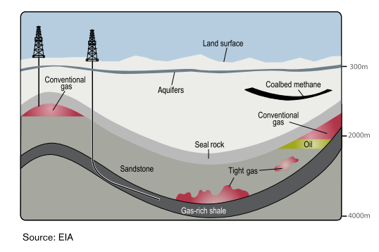
Figure A1: Conceptual diagram illustrating the differences between gas sources. (Source: CAPP, 2012.)

A1.3 Literature review research objectives
The literature review set out to answer the following questions:
- Is there an off-shelf, proven and widely accepted complete risk assessment methodology that can be adopted largely as is or with minor customisations to meet the purpose of QQRA?
- What are the key features and components of a risk assessment methodology used to identify and assess the potential risks to water resources within an ‘area/zone’ based on hypothetical onshore natural development scenarios?
- Are the features and components of a risk assessment methodology used to assess an application from a Proponent for approval to undertake development applicable/transferable to assessing potential risks of hypothetical development at a broader scale?
- What specific considerations and criteria have been used to identify, assess and rate potential risks for a hypothetical versus proposed development play?
- Are there any specific consequence and likelihood considerations or criteria unique to a specific type of gas (shale, tight, coal seam or conventional)?
The literature review has not examined nor reported on the potential or actual impacts of onshore natural gas development on water resources. The QQRA will not assess cumulative impacts; it will assess the impact of an individual development in different locations within an area of interest. The QQRA could eventually be amended to include cumulative impacts.

A1.4 Scope of risk assessment framework
The literature review separates findings regarding what risk assessment techniques and approaches have been used to inform Government policy decisions as distinct from an assessment of an onshore natural gas licence (work program) or work plan application. Overall the literature review found regulators in many jurisdictions are seeking to enhance their understanding of risks and define conditions or areas where onshore gas developments may or may not be assessed d.
The literature review considered frameworks and guidance available for each stage of a risk assessment process including:
• Sensitive receptors – the review considers how vulnerable regional water-related assets in the area of the development might be identified and what tools may be used.
• Hazards – the review focuses on how risk frameworks have framed and approached the issue of assessing potential impacts from unconventional gas development on sensitive receptors.
• Pathways – the review considers how complex cause-effect relationships has been conceptualised and what if any differences are evident in approaches to assessments for different onshore gas types (tight, shale, coal seam gas).
• Thresholds – the review is concerned to evaluate what criteria have been developed to provide guidance on assessing/rating the buffering capacity and resilience of groundwater resources and water-dependent assets.
• Standard Controls – the review focuses on what measures are commonly used to avoid or minimise risk.
• Consequence – the review summarises how risk assessments have approached estimating the level of impact on a water resource.
• Likelihood – the review examines how probability of impact has been assessed.
• Risk Rating – what approaches are used to assess ‘retained risk’ after standard controls have been applied and what criteria exist to determine the implication the retained risk.

A1.5 Approach to the literature review
The methodology used to complete the Literature Review involved identifying literature on the basis of:
• Resource focus: to the extent possible, preference was given to risk assessment techniques specifically addressing onshore natural gas developments (coal seam gas, tight, shale and conventional). Offshore oil and gas and offshore extractive and mining activities which impact on groundwater were also assessed for completeness.
• Jurisdictions: the literature review assessed risk assessment techniques developed in a number of jurisdictions, including England, Germany, United States, Canada and Australia.
• Provenance/authorship: the literature review assessed (in order of standing):
– peer-reviewed literature published in academic journals
– government policies or guidelines for conducting risk assessments (either mandated by law or recommended)
– literature including reports and papers produced by scientific agencies, Government agencies or peak industry bodies and
– publicly available risk assessment techniques used by private-sector proponents.

A1.6 Structure
The structure of the literature review is as follows:
Chapter 1 – Introduction – background, purpose, key research questions, methodology and references
Chapter 2 – Key Findings – organised by risk assessment phases of identify hazards, identify sensitive receptors, identify and assess pathway between hazard and sensitive receptors, set a threshold for acceptable impact on sensitive receptor(s), apply standard controls to ensure impact is within acceptable limits, assess the potential consequence and likelihood of risk occurring with standard controls in place and rate the retained risk. For each phase of the risk assessment, literature relevant to “policy specific” and “project specific” risk assessments has been analysed.
Section 3 – Key Implications for QQRA design, development and application – answers each of the key research questions by drawing on the key findings and outlines the key QQRA design and development implications
Appendices:
AA – Matters out of scope from the risk assessment & literature review
AB – List of references & sources consulted for the literature review
AC – Features of onshore gas resources
AD – Modelling pathways
AE – Methodologies used to assess groundwater vulnerability
AF – Controls
AG – Consequence.

A1.7 Summary of references
The full list of 115 sources consulted is provided in Appendix AA. Of these sources, 19 were deemed to provide direct and relevant material to the key literature review research questions.

A2 Key findings
Key findings have been discussed in terms of risks assessments to inform either government policy or a project scale risk assessment. The key findings for each of the following phases of risk assessment are discussed in the following sections:
• risk and uncertainty
• hazards
• sensitive receptors
• pathways
• thresholds
• standard controls
• consequence
• likelihood
• risk rating.

A2.1 Risk and uncertainty
A consistent finding arising from the literature review is that understanding of hydrogeological pathways is still evolving and groundwater models need to be refined as more monitoring data becomes available. Most of the literature reviewed, such as Moran and Vink (2010), emphasises that ongoing monitoring of water levels and other characteristics should be compared with modelled predictions to progressively refine models and present the best available representation of risk. The Independent Expert Scientific Committee (2014) proposes several quantitative approaches to assess uncertainty in risk determination for coal seam gas development, including:
• Bayesian methods for calculating model structural uncertainties.
• Stochastic modelling; which may be used to addresses likely inaccuracies in relation to uncertainties around estimated water flow rates and solute transport. It generates multiple hydrogeological scenarios which are run concurrently in a Monte Carlo framework. Statistical analysis is conducted on each result (Cook, 2003).
• Random domain decomposition. For example, Guadagnini et al (2003) focused on analysing two dimensional flow in a system where hydraulic properties and spatial distribution are known statistically but are otherwise uncertain.
• The transition probability approach which considers relative frequency of transitions from one state to another in a system consisting of multiple states (Elfeki et al, 1997:67).
• Decision theory to assist with risk management.
The simplifying assumptions underlying groundwater models are highlighted by the IESC (2014) and should be considered in both project and strategic level risk assessments. It provides a valuable summary of use of MODFLOW and FEFLOW groundwater models for project risk assessments in the United States and Australia. It shows there are limitations in how sources and pathways are conceptualised, even if most projects do seek to consider how uncertainty is assessed in each risk assessment. The report provides an evaluation of strengths and drawbacks of different types of modelling techniques (analytical, regional groundwater impact assessment, axisymmetric and reservoir assessments) in capturing potential impacts and groundwater processes. Full details are provided in Appendix D.
The temporal component to risk analysis is a key uncertainty factor. Potential changes to groundwater quality/quantity may take years to decades to develop depending on a variety of factors, including the proximity of an aquifer to a coal seam reservoir. Impacts may also persist for prolonged periods after potentially hazardous operations have ceased.
It is commonly agreed that the limitations and assumptions underpinning risk assessments should be subject to sensitivity analysis. For example, the Queensland Department Natural Resources & Mines Healthy Headwaters coal seam gas study (Worley Parsons, 2013) recommended that a sensitivity analysis be undertaken on the ranking and weighting criteria adopted by the panel of experts. In relation to coal seam gas water production, uncertainty could also be presented visually by means of an attribute layer to show the limits of current understanding around pathways, for instance in terms of interactions between Condamine Alluvium and the Walloon Coal Measures in the Surat and southern Bowen Basins, Queensland.

A2.2 Hazards
A hazard is a source of potential harm or a situation with a potential to cause loss (negative consequence). Hazard identification is first stage of any risk assessment process and should be used to inform preliminary investigations of potential impacts from onshore natural gas.

Risk assessment to inform government policy
The literature review did not identify any particular techniques for hazard identification at a policy level different to those techniques used to identify hazards for project risk assessments, which are outlined in section 0 below.

Risk assessment to inform project scale developments
In their paper prepared as part of the independent review of coal seam gas activities in NSW, Anderson et al (2013) group hazards on the basis of their contamination potential or contribution to depleting water resource aquifers and surface waters. Contamination issues are further disaggregated into operational hazards (e.g. extraction) and those associated with changes in hydrogeological environments. Potential consequences of depletion are impacts on Groundwater Dependent Ecosystems (GDEs) from movement of groundwater towards the depressurised coal seam gas formation. Seepage may also occur from surface water assets to depleted watertable aquifers.
Specific coal seam gas activities that may present hazards are provided in the methodology for conducting Bioregional Assessments by Barrett et al (2013) including depressurisation and dewatering of coal seams; potential regulated and unregulated discharge of stored worked water on mine sites; and fate of coal seam gas permeate and brine derived from treatments of associated water. The size and extent of a zone of depressurisation is influenced by a variety of factors including the size of the seam, its storage capacity, the pumping rate, initial pressure, recharge rates, geology and the flow of water through the seam.
Most sources consulted list potential hazards based on the activity source (specific actions taken in the course of onshore gas development). Wilson et al (2014) identify discharges to surface water, evaporation ponds, groundwater dewatering and extraction, hydraulic fracturing, in-situ gasification, managed aquifer recharge, overburden management, surface water diversion and capture and well drilling as potential hazards.

Identifying the potential direct and indirect effects on characteristics of groundwater resources is alternative approach used by IESC (2013) which provides a greater level of detail on the range of possible hazard scenarios; for example:
• Direct impacts are changes to physical/chemical characteristics of groundwater/surface water as a result of dewatering processes, and include loss of pressure in an aquifer, changes in groundwater chemistry from change in hydraulic relationship and changes in aquifer hydraulic properties such as porosity due to pressure reduction
• Indirect impacts to receptors occur through a pathway of cause and effect, such as the direct impact loss of pressure head in an aquifer has on dewatering on a gaining or losing stream; drying of agricultural wells or natural springs and the salinisation of freshwater aquifers from depressurisation of coal seams.
Arrow Energy (Coffey Environments, 2012) used the same framework of direct/indirect impacts as IESC to assess the potential impacts of the depressurisation of Walloon Coal Measures. However they conceptualise it somewhat differently. Impacts of depressurisation of aquifers to Walloon Coal Measures through the removal of gas and water is classified as a direct impacts whereas indirect impacts are potential consequences on aquifers above and below the measures. Groundwater drawdown resulting in a reduction in the supply to existing or future users and groundwater dependent ecosystems reliant on the Walloon Coal Measures is thus a direct impact. In contrast, groundwater flux and drawdown in adjacent aquifers causing water quality and supply impacts to existing and future users and groundwater dependent ecosystems, changes in inter-aquifer flows or subsidence are indirect impacts.
Hazards from other unconventional gas resources may vary as certain key characteristics (depth, permeability, groundwater take and need for hydraulic fracturing) are different for shale, tight and coal seam gas. A summary of these is provided in Appendix C. For instance, local hydrogeological characteristics between and within shale reserves will influence the volumes of water withdrawals required.
A conceptual approach to hazard identification is provided by NOPSEMA (2012) which gives an overview of the benefits and drawbacks of different hazard identification techniques; including HAZOP, historical records, Failure Modes, Effects and Criticality Analysis (FMECA) and Failure Modes and Effects Analysis (FMEA) as well as Fault Tree and Event Tree Analysis in the context of assessing risks from offshore oil and gas exploration and development.
These hazard identification techniques are applied to determine what could result in equipment or procedure failure (e.g. well drilling, well casing etc.) and therefore resulting in uncontrolled releases of dangerous additives.

A2.3 Sensitive receptors
Sensitive receptors are entities (members of the public, environmental values, water resources, third party infrastructure etc.) that could potentially be exposed to adverse impacts resulting from a hazard. This Literature Review is solely focused on water resources (aquifers, rivers, springs, wetlands and lakes).

Risk assessments to inform government policy
The Literature Review found no clear differences between the types of water resource assets included in a risk assessment used to inform policy decisions and a risk assessment used to assess and determine a licence/work plan application. Techniques to identify sensitive receptors are relevant to both types of assessment.

Risk assessment to inform project-scale developments
The literature review found two ways by which water resources are commonly identified: the sensitivity of the resource to potential impacts and the value of the water asset.
Most jurisdictions approach classification of water assets by considering both sensitivity and value. For instance NSW’s Aquifer Interference Policy has numeric quality and quantity criteria which must be achieved to be a highly-productive resources. This binary categorisation is further disaggregated according to source characteristics (alluvial, fractured rock etc.) which provides a measure of sensitivity. Victoria’s State Environmental Protection Policy (SEPP) for both Groundwater and Surface Waters similarly establishes minimum water quality thresholds for different Beneficial Uses, thereby incorporating a measure of value and sensitivity. The New York Department of Environment SGEIS evidences that it considers aquifer vulnerability on a combination of value and sensitivity-based criteria, although less detail is provided around specific values.
However, risk assessments for specific projects will usually go a step further and consider secondary impacts arising as a consequence of changes in quantity/quality of water (first-order impacts) e.g. to ecosystems, local communities and cultural values, existing or potential land uses and their economic implications including agriculture, tourism and recreation. The extent of investigation is likely to be at least partly determined by any relevant impact assessment pathway or applicable environmental regulations.
At a policy and project level, identification of sensitive receptors in relation to potential risks associated with onshore gas developments should consider the physical characteristics that determine sensitivity and value of the resource in terms of both the cultural and the ecological services they provide.
Queensland Department of Resources and Mines Healthy Headwaters study (2012) states that aquifers can be both receptors and pathways for potential impacts. The Guidelines for Groundwater Protection in Australia (1995) list potential attributes and techniques to underpin a classification of aquifer vulnerability as a receptor. Aquifer value is measured qualitatively based on its:
• designated beneficial use
• water quality (usually in terms of Total Dissolved Solids)
• social value
• economic value
• ecosystem values
• vulnerability to contamination
• current and planned land tenure and use
• availability of alternative sources
• current extent of contamination
• potential for successful clean-up
• hydraulic relationship with other resources (surface and groundwater).
NYSDEC consider the inherent susceptibility of the aquifers on the basis of:
• groundwater productivity
• aquifer vulnerability
• natural water quality
• whether the aquifer is confined or unconfined
• whether the aquifer is contained in bedrock or unconsolidated material.
This draws on pre-existing NYSDEC (1990) criteria that distinguished ‘principal aquifers’ from primary water supply aquifers’ based on aquifer area, thickness of saturated deposits and maximum obtainable well yields (actual or estimated).
The New South Wales Aquifer Interference Policy (2012) appears to place greater emphasis on value to distinguish between “highly productive” and “less productive” groundwater resources. This is on the basis of specific water quality and quantity standards — highly productive resources have less than 1500 mg/L total dissolved solids (TDS) content and yield water at a rate in excess of 5 L/s. Water quality, pressure and watertable criteria for highly productive groundwater resources are then tailored to different aquifer types (e.g. alluvial, porous, and fractured).
Guidance issued by NSW Office of Water (2014) for prospective mining and petroleum extraction activities, may also be relevant to identifying receptors to groundwater impacts from onshore natural gas developments. They outline that ‘proponents must identify sensitive receptors, which can include groundwater users, groundwater dependent ecosystems (GDEs), culturally significant sites (CSS), connected groundwater and surface water sources’. These can be defined as the ecological, economic or cultural characteristics of the bioregion. They can be assigned a defined value, and used (either directly or indirectly) to assess impact on water quantity or quality.
The Bureau of Meteorology’s Atlas of Groundwater Dependent Ecosystems identifies potential subsurface and surface expression of groundwater, and can help inform identification of sensitive receptors. The available information can be used as a starting point to study cause and affect pathways.
The New South Wales Office of Water (2012a) also classifies groundwater dependent ecosystems according to whether they are considered:
• sub-surface dependent (karst and caves, subsurface phreatic aquifer ecosystems, baseflow streams) or
• surface-dependent (groundwater dependent wetlands; baseflow streams; estuarine and near shore marine ecosystems and phreatophytes or groundwater dependent terrestrial ecosystems).
The NSW Office of Water collaborated with the NSW Division of Resources and Energy to develop the NSW Gas Plan. The Gas Plan was released in November 2014 and is framework to identify, study and protect groundwater in NSW, which will initially focus on basins that present the greatest potential for development to large-scale coal mining and onshore gas industry (NSW Government, 2014).
Spatial and temporal information is required about a receptor to determine potential impacts from natural onshore gas developments (DOE, 2013). Santos commissioned several studies in the Surat and Bowen basins in Queensland illustrating how impacts can vary both spatially and temporally (Golder Associates, 2009; Arrow Energy, 2012). Their findings predicted impacts on groundwater drawdown could extend for decades, even hundreds of years after operations cease. Arrow Energy (2012) considers the magnitude of potential impacts in terms of severity, duration and geographical extent, highlighting that impacts vary on the basis of distance from zone of depressurisation and the individual groundwater system.
In assessing groundwater dependent ecosystems, the Queensland Department of Resources and Mines Healthy Headwaters study (2012) determined flow-path lengths was a key factor in explaining why recharge springs have greater resilience to potential coal seam gas water extraction impacts than discharge springs.
The IRGC (2013) advises that baseline assessments or preliminary studies are required to identify receptors, and determine what an acceptable level of impact is. It considers that preliminary studies should focus on:
• groundwater quality and quantity
• existing pollution levels and sources
• flow and contaminant transport and biogeochemical interactions.
Combined these will determine the vulnerability of groundwater to contamination from onshore gas development activities.
The US state of Connecticut has a four-tier groundwater classification system. The system uses water usage arrangements rather than discharge criteria to determine the value and sensitivity of an aquifer resource. The system details the designated usage, relevant discharges that may be permitted and water quality criteria that must be achieved. These are set out in Table AE3.

A2.4 Pathways
A risk assessment should identify causal pathways through which a harmful event could lead to an adverse outcome (impact) for a receptor.
The IESC (2013) bioregional assessment methodology highlights the role of pathways in linking cause and effect, by distinguishing between activities that give rise to direct effects as opposed to indirect and cumulative impacts.

Risk assessment to inform government policy
No significant differences were identified between types of data required for pathway characterisation at a project and policy level. Data requirements for informing identification of pathways for policy and project risk assessments may be partially met by the Bioregional Assessments which are currently underway in Queensland, New South Wales and Victoria.
Internationally, the province of Alberta (Canada) targets its regulatory framework to assess the specific risks of a proposed development. The Energy Resources Conservation Board conducts an initial strategic risk assessment of a proposed development on the basis of the known or estimated oil or gas accumulation and geographic, geologic and temporal properties that exist at the development site (e.g. source rock, migration pathways, timing, trapping mechanism and hydrocarbon type). The strategic risk assessment is used to profile the proposed development as being potentially low, medium or high risk and therefore what assessment standard should be met by the proponent in preparing their licence application (ERCB, nd).
In Germany, on the basis of modelling of fluid flow dynamics and pathways in key basins, Ewen et al (2012) recommend that a statutory land-use framework be established, informing areas where fracking will and will not be permitted. A panel of experts used a strategic environmental risk assessment to recommend the following areas where fracking or deep-injection disposal would not be permitted. For example:
• Zone I and II drinking water protection areas
• thermal spring conservation areas
• areas exhibiting pressurised artesian/confined deep groundwater as well as continuous transparent pathways (marked by porous faults or having a history of disturbance)
• areas characterised by critical underground tectonic stress/upheavals.
The methodology used to undertake the strategic environmental risk assessment has not been made publicly available.
The New York State Department of Environmental Conservation (NYSDEC, 2011) use the source-pathway-receptor model in their assessment of potential impacts to drinking water from higher risk/high-volume hydraulic fracturing in the large and sensitive Marcellus Shale. The NYSDEC Draft Supplemental Generic Environmental Impact Statement or SGEIS (2009) reports that hydraulic fracturing does not present a ‘reasonably foreseeable’ risk of significant adverse impacts to potential freshwater aquifers from migration of fracturing fluids out of the target fracture formation, where the following conditions exist:
• maximum depth to the bottom of a potential aquifer ≤ 305 m
• minimum depth of the target fracture zone ≥ 610 m
• average hydraulic conductivity of intervening strata ≤ 1 x 10^{–5} cm/sec
• average porosity of intervening strata ≥ 10%.
The United States Environment Protection Authority identifies that man-made sub-surface disturbances (drinking water wells, exploratory wells, production wells, abandoned wells (plugged and unplugged), injection wells, and underground mines) may also act as conduits for contaminants. For shale gas the distance to drinking water reserves and the geochemical and transport processes occurring in intermediary strata are key determinants of level of risk of fluid leak off to those assets.
The Namoi Catchment study (Eco Logical Australia, 2012) considers that all types of resource extraction (coal seam gas, open cut and long-wall mining) are likely to have some level of impact on groundwater drawdown. The study established qualitative criteria for each asset such as depth to groundwater, connectivity, status, major recharge area, groundwater dependent ecosystem potential. The criteria were used to assign a score on a scale of 0–3. These were then combined and averaged to give final sensitivity values, from very high (> 1.5), high, moderate, low and very low (< 0.50).
The study found sensitive areas tend to be characterised by shallow watertable, areas that were isolated from surface flow (thereby increasing the importance of groundwater) and groundwater recharge areas.
The Queensland Department of Environment & Heritage Protection (nd) suggest the likelihood of impacts (i.e. pathways) arising on groundwater assets will be influenced by:
• the level of development
• the drawdown in the source aquifer of individual springs
• the degree of aquifer connectivity
• the potentiometric surface at individual springs.
Queensland Department of Natural Resources and Mines (2013) state aquifers are pathways for impacts. The study in the Surat and Bowen Basins in Queensland examined how hydrogeological properties (e.g. storativity, and transmissivity) influences the aquifer’s intrinsic vulnerability. Worley Parsons (2013) identify that flow of water in a groundwater system (aquifers and aquitards) is determined by two processes: hydraulic conductivity and hydraulic diffusivity. Hydraulic diffusivity determines the rate the pressure effects travels through the overlying aquifers, and laterally along the aquifer/coal seam.
Frogtech (2009) identify two groups of specific pathway assessment factors:
• Inter-aquifer connectivity — faults, fractures, and over- and under-lying gas shales (sources). Moran and Vink (2010) emphasise these must be accounted for in the models, or at least signalled as areas of concern.
• Risk assessments should consider the hydrogeological conditions of permeability, porosity and groundwater quality and flow direction. DOE (2013) also identify that aquifer pressure and pressure relationships between aquifers; watertable and potentiometric surface levels; groundwater-surface interactions may warrant consideration.

Risk assessment to inform project scale developments
The Australian Office of Water (2014) outlines two types of monitoring to be undertaken by proponents in relation to understanding potential pathways and water-related risks from other onshore extractive industries (petroleum and mining). They are:
Aquifer testing to understand hydraulic features and interaction with other aquifers and surface assets. This can minimise the need to ‘calibrate’ models and improves reliability of results and may include: pumping drawdown and recovery tests, slug tests, packer tests and laboratory core testing. Testing over longer periods through pump tests can help to elicit pathways to overlying surface water and alluvial systems, in parallel with a study of surface water chemistry.
Hydrogeochemical analysis (e.g. environmental isotopes) can be sampled to improve understanding of aquifer recharge and discharge processes, aquifer interconnectivity, groundwater-surface water interaction and groundwater dependent ecosystems, as well as specific consideration given to groundwater dependent ecosystem monitoring
Proponents are directed to estimate the likely water take from an aquifer or connected water surface over the duration of the project. The following guidance is also taken from the Office of Water and provides an indication of what conceptual models should consider:
• the location, timing, volume and method of take and use of water (and the prospective future take and use of water) by the proponent and other users of water sharing the resource
• the potential to base the conceptualisation on existing geological models presumably developed for the resource investigation phase
• detailed cross sections or three-dimensional block diagrams showing stratigraphy, major aquifers, aquitards, flow paths and groundwater levels
• groundwater level contour maps
• time-series groundwater level and stream gauge data
• groundwater and surface water quality data
• aquifer characteristics including porosity, hydraulic conductivity, storativity and transmissivity
• groundwater age, residence time, recharge and discharge processes
• topographic and geomorphic information including stream locations and bed elevations.
Approaches to assess source -pathways - receptor vary considerably according to Daly and Warren (1998). Daly and Warren note there is considerable variability in models in terms of the number of vulnerability categories that are identified and the scale of spatial representation that is used (from less than 1:10 000 to in excess of 1:500 000).
Studies may seek to model pathways for a range of hazards or concentrate on individual potential impacts, such as contamination. Myers (2012) conceptualise potential natural pathways and necessary conditions for water contamination from shale gas developments and proposes several potential transport scenarios based on hydrogeological conditions in the Marcellus shale. He tests potential impacts (transport times under different conditions and the time taken for the system to revert to steady-state) by varying scenarios according to whether there are individual or multiple gas developments, and whether or not there is in-situ fractures and potential connectivity. He notes limited data availability constrains the application of certain modelling tools, concluding that mapping of subsurface faults and establishing deep and shallow monitoring wells are two key requirements prior to significant resource development occurring (further details about the study are provided in 0).
The benefits and limitations of a number of commonly used groundwater solute transport models to understand potential pathways is provided Worley Parsons for the Queensland Department of Natural Resources & Mines (2013) in the context of coal seam gas in the Surat and Southern Bowen Basins. A fuller assessment of the components they consider and approaches used to classify risk to water resources are outlined in 0. Two drawbacks that are identified about groundwater solute transport models are:
• They all focus on risk of contamination to water sources where an impact is occurring at the surface and may travel horizontally or vertically through the system, whereas in coal seam gas production hazards can arise at considerable depths below the surface, and spread outwards from the source with the potential to eventually manifest themselves as impacts to groundwater resources.
Most are static (or point-in time) and typically do not fully factor in groundwater process or geological/hydrological pathways.
The alternative hybrid technique put forward in the study (the ‘Groundwater model and multi criteria analysis methodology) was established by consensus between a technical reference group of experts. It combines overlay methods used in multi-criteria analysis (similar to the methodologies above) with process-based (quantitative) information drawn directly from groundwater modelling conducted by Queensland Water Commission. Source, pathway and receptor attributes are selected for the specific basin study area in terms of risks to groundwater systems, and then overlaid by different vulnerability and consequence measures. These are ranked according to asset properties and weighed to inform the relative importance to overall calculation.

A2.5 Thresholds
To understand the significance of a predicted or observed impact, thresholds are required to be defined. For this section specific quantifiable criteria and the rationale for their use were sought wherever possible. The measures used to set level of unacceptable impact tend to be changes in water quantity/quality or deviation from an accepted norm (taking into account natural factors such as seasonal variability). There does not appear to be a difference in the thresholds used for project and policy risk assessments.
A common recommendation across government reports and within the academic literature is that more rigorous catchment-level risk assessment frameworks are required to inform future onshore gas development, and that key to this is the sharing of information between proponents and regulators.
In Queensland’s Department of Environment and Heritage Protection, the Department administers quantitative thresholds for protection of water assets under the Water Act 2000. Specific quantitative thresholds are set for coal seam gas project-related water declines in bores and reduced aquifer levels feeding natural springs. They are:
• If the projected decline from a bore exceeds the minimum threshold of a 5m reduction in water level for consolidated aquifers (e.g. sandstone) or a 2m reduction in water level for unconsolidated aquifers (i.e. shallow alluvial aquifers), then further investigation is required. If coal seam gas activities are determined to be responsible, then the Proponent is responsible for ‘making good’ the impact.
For springs, a spring impact management strategy is required to determine potentially affected springs, investigate risks and develop a management strategy to address these if the water level in the aquifer is expected to decline by more than the spring trigger threshold of 0.2 metres in the source aquifer (unless otherwise defined) at the location of the spring (EHP, n.d.).
The New South Wales Aquifer Interference Policy (2012) establishes quantitative thresholds for watertable and groundwater pressure, drawdown and groundwater and surface water quality changes in relation to highly productive and less productive groundwater sources. The thresholds have due regard to the geology of the water source (e.g. alluvial, coastal sands, porous rock, fractured rock). Refer to Appendix AF for tables listing these.
The Australian Council of Learned Academies Shale Gas report (2012) suggests thresholds for cumulative impacts at a catchment scale could be the use of groundwater extraction for shale gas as a proportion of total groundwater extraction and the proportion of shale gas water that contributes to surface water flow to nationally important wetlands.
The National Water Quality Management Strategy has published Guidelines for Drinking Water and Fresh and Marine Water Quality in Australia. These guidelines may be used for both project and policy risk assessments. The guidelines define several beneficial use or environmental values categories: aquatic ecosystems, drinking water; cultural and spiritual values; primary industries (including agriculture and general water uses, stock drinking water, aquaculture); recreation and aesthetics and industrial water. All of these, except industry and cultural/spiritual values have water quality guidelines based on numerical concentration limit or a narrative statement recommended to ensure the designated use is protected.
In Victoria groundwater protection legislation defines groundwater categories according to beneficial use and water quality criteria (SEPP, 1997). The concentration of Total Dissolved Solids (an indicator of salinity measured in mg/L) is used. Further information on beneficial uses and values is provided in Appendix F.
Exceedance of environmental values set out in the Water Quality Guidelines (ARMCANZ and ANZECC 2000) indicate potential for impact can be categorised as ‘slightly to moderately disturbed’; ‘highly disturbed ecosystems’ and ‘high conservation/ecological value ecosystems’. Water Quality Guidelines (ARMCANZ and ANZECC 2000) also recommend biological indicators should be used to complement the use of chemical indicators.
Guidance is available to help determine:
• acceptable level of change against relative condition categories of the ecosystem
applicability of different biotic taxa as indicators of aquatic ecosystem health (e.g. physical and chemical stress such as nutrients, dissolved oxygen, salinity, temperature, pH, optical properties and environmental flows).
Default trigger values are provided if locally-derived thresholds cannot be determined. The Commonwealth Department of Environment (2013) states that where no local/regional quality objectives exist, thresholds should be set in accordance with guidelines under National Water Quality Management Strategy and in consultation with the local water authority.
The Guidelines provide information on good-practice for conducting toxicology studies. Guidance is provided about factors affecting individual element toxicity and the level of confidence that can be derived depending on data used.
Setting triggers for further assessment is one of the recommendations in relation to risk from chemical constituents of fracking fluids by Ewen et al (2012). Under the proposed system, a substance can be identified as hazardous by one of three forms of assessment:
Classification by the European Union’s Regulation on Classification, Labelling and Packaging of Substances and Mixtures
Failure to meet Germany’s drinking water regulation requirements (limit of 0.1 µg/l of organic biocides)
Determine the hazard quotient which represents the ratio of potential exposure to the substance and the level at which no negative consequences are anticipated. If the hazard quotient value is greater than 1, adverse health effects are possible.

A2.6 Standard controls
Risk controls are the part of risk management that involves the provision of policies, standards and procedures that describe measures, techniques and practices to eliminate, avoid or minimise adverse risks. A standard control is a standard accepted onshore natural gas industry practice for addressing a potential impact on a sensitive receptor. Industry recognised and endorsed procedures, guidelines and methodologies may exist for a standard control.
The literature review found no distinct difference between the types of standard controls applied in a risk assessment to inform government policy and a risk assessment used to assess licence/work plan application.
There are many different types of standard controls that are adopted. The literature reviewed shows many jurisdictions are seeking to regulate aspects of onshore natural gas development activities through existing permitting regimes, and setting triggers under which proponents must conduct further monitoring and management (CRS, 2014).
For the purpose of this discussion standard controls have been broadly categorised as operational controls, land use planning controls, and monitoring controls and are discussed below.

Operational controls
Several sources consulted provide an overview of the legislative measures to minimise risk associated with onshore natural gas developments in the United States, Europe and Australia. For example Anderson et al (2013) classify the options available to minimise or offset impacts from onshore natural gas into strategic land use planning, codes of practice, managed aquifer recharge, ‘make-good’ arrangements, security bonds, improved technologies and research methods, groundwater remediation.
Well integrity, wastewater management and regulating chemical compounds used in hydraulic fracturing are the onshore natural gas hazards commonly targeted by mandatory regulation or best practice guidance for proposed projects that could impact on water resources across the UK, US and Australia.
In the United Kingdom, the Environment Agency (2011) requires any activity that proposes discharges to groundwater to produce management options such as enhancing the engineering measures or tightening operational and aftercare controls. The UK Onshore Operators Group (UKOOG) has produced Shale Gas Well Guidelines which sets out what proponents must comply with under various regulations and permitting systems. This includes legislation relating to well construction and design (to be informed by assessment of geological conditions), well control equipment, availability of competent personnel and the proponent making provision for independent well examinations.
In the United States, Worldwatch (2010) finds many state regulators often require compliance against standards set by the American Petroleum Institute (API, 2009) or other organizations which develop and update standards on recommended practice for oil and gas exploration and production activities. These include the API’s Hydraulic Fracturing Operations — Well Construction and Integrity Guidelines (HF1), Water Management Associated with Hydraulic Fracturing (HF2), and Practices for Mitigating Surface Impacts Associated with Hydraulic Fracturing (HF3).
The Commonwealth Government’s National Harmonised Framework for Coal Seam Gas (2012) has produced a list of 18 leading practices which can help to reduce risks associated with well integrity, hydraulic fracturing, chemical use and water management in coal seam gas operations. Further detail on these is provided in Appendix F.
The Queensland Department of Environment & Heritage Protection requires applicants to develop management criteria to ensure quantity and quality of co-produced water at critical control points: injection to aquifers, storage of produced water, transmission through pipelines, treatment of coal seam gas water and water quality acceptance criteria, beneficial use and management of produced waste. Queensland also has a Code of Practice for Constructing and Abandoning Coal Seam Gas Wells (DEEDI, 2011).
New South Wales Trade & Investment (2012) references good industry practice and relevant standards and specifications to be complied with, in respect of human and technological-based controls. Well integrity is the focus of one of two New South Wales Division of Resources and Energy Codes of Practice for coal seam gas, along with guidance to proponents on hydraulic fracturing. Coal seam gas titleholders are required to comply with both NSW Codes to assure coal seam gas activities are compliant with the Petroleum (Onshore) Act 1991.
AEA provide suggested or existing technology-based controls in United States jurisdictions relating to permanent well abandonment (minimum depth of cement for plugging), storage of waste-water and extent of production casing. The rationale used to determine these specific values is not provided.

DNV (2013) provides guidance to proponents around preventative risk management practices for shale gas development and operations. For instance, in order to avoid possible groundwater contamination from induced fractures, the operator should estimate:
• the minimum required vertical separation between the deepest groundwater formation boundary and the shallowest edge of induced fracture
• the minimum required distance between the wellbore above the prospective shale gas formation and the nearest edge of an induced fracture
• the minimum required distance between the outermost edge of an induced fracture and any nearby wellbore
• the minimum required distance between any identified pre-existing faults or fractures to the nearest edge of an induced fracture.
Risk management is often conceived as a hierarchy, with emphasis on minimising opportunity for hazards to arise (e.g. through timing or spacing of certain activities), providing mitigation appropriate to the hazard profile, and offsetting any remaining impacts. A common tool to minimise manageable risks is through operation-based regulations or referring proponents to best-practice codes or guidelines. These are to be regularly reviewed on the basis of the “As Low as Reasonably Practical” principle. Offshore oil and gas regulations are consistent with this regulatory approach.

Land use planning controls
The National Conference of State Legislatures (2012) provides a broad overview of state-based legislative measures to minimise risk of impact to water quality across the United State. These include setbacks or location restrictions to create buffers between drilling and public drinking water resources. Specific distances and criteria are not specified.
The New York Department of Environment and Conservation has banned unconventional gas development in the New York City and Syracuse watersheds (with suitable buffer areas), public water supplies, primary aquifers and certain state lands. Further controls (e.g. restrictions and setbacks) are recommended to restrict development in areas close to public water supplies, principal aquifers and other sensitive assets. Details are provided in Table AE1.
New South Wales similarly defined coal seam gas exclusion zones as part of their Strategic Regional Land Use Policy late last year focused on existing residential areas, which were updated earlier this year in relation to future growth areas and key industry clusters. In New South Wales coal seam gas development proposals on strategic agricultural land need to be assessed by a gateway panel before they are lodged. Gateway assessments are conducted by an independent panel of scientific experts and provide an additional level of scrutiny of a proposal’s land and water impacts, including consideration of potential effects of the proposal on aquifers against the Aquifer Interference Policy.
Examples of specific buffer zone distances from private wells, surface watercourse, and drinking water supplies that are proposed or recommended by authorities and natural resource management agencies in the United States are summarised by a report prepared for the for the European Commission by AEA (2012). Also collated by the AEA is the minimum depth or minimum separation between strata required for hydraulic fracturing to take place. These measures are recommended or mandated across different States, however the rationale used to determine these specific values was not provided.

Monitoring controls
The Queensland Water and Other Legislation Amendment Bill 2011 makes a range of changes to the Water Act 2000. In addition to an obligation on coal seam gas companies to enter into formal arrangement with landholders to ‘make good’ any impairment on landholder’s bores prior to these impacts actually occurring, it also mandates the “production of underground water impact” reports at no more than three yearly intervals. This is firmly based on adaptive management, as proponents are required to review monitoring results, produce predicted water level impacts using progressively updated groundwater flow models, write up a spring impact management strategy, and provide an updated water monitoring strategy.
Well integrity inspections are another feature of the United Kingdom regulatory framework designed to minimise risks and ensure construction is in accordance with standards (HSE, nd).

A2.7 Consequence
The potential consequence (adverse impact) of the risk identified occurring with standard controls in place should be assessed. Consequence (adverse) can typically range from critical through to negligible. The criteria used to determine potential impact can often be subjective and contentious.

Risk assessment to inform government policy
The Commonwealth of Australian Government’s National Partnership Agreement defines qualitatively what significant direct and indirect impacts on water assets and water-dependent would be. Some of these – ecological impacts, coastal and inland processes, heavy metal accumulation and water availability – are outside the scope of the risk assessment framework. The pertinent impacts are provided below and the full list is available in 0:
• result in substantial change in the quantity, quality or flow regimes of surface water or groundwater
• substantially alter groundwater pressure and/or watertable levels
The literature review did not identify any unique consequence -rating criteria applied to determine consequences used to specifically inform a government policy decision. The IESC (2014) provides consequence tables which vary in complexity depending on whether consequence (and likelihoods) can be defined in quantitative or qualitative terms.

Risk assessment to inform project scale development
The significance of the impact on a receptor depends on the sensitivity to the impact as well as the value of the receptor.
The Department of Environment (2013) provides general guidance to proponents on what level of impact may be deemed significant in terms of the hydrological characteristics of water resources. These are:
• changes in water quantity.
• modified integrity of hydrological or hydrogeological connections (including substantial structural damage e.g. large scale subsidence)
• altered area or extent of a water resource at a sufficient scale/intensity to significantly reduce current or future use for third party users.
In New South Wales, most waterways are protected on the basis of being ‘slightly to moderately disturbed ecosystems’ and thus a significant impact is likely if the expected change in water quality exceeds this level, as contained in relevant local or regional water quality objectives. These objectives are typically the 80% to 95% ecosystem protection values listed in the Australian Water Quality Guidelines (ARMCANZ and ANZECC 2000). Waterways which flow through relatively undisturbed national parks, World Heritage Areas or Ramsar-listed Wetlands(Matters of National Environmental Significance) benefit from more stringent thresholds and are deemed of ‘high conservation value’.
The Aquifer Interference Policy sets out the minimum levels (level 1) of groundwater protection a proposed development must achieve for specific groundwater sources. The level of protection will differ depending on whether the asset is a ‘highly productive’ or ‘less productive’ groundwater sources. Indicative minimum impact considerations for alluvial water sources are provided below and full details are available in 0:
• variation from watertable levels within 40m of high priority groundwater dependent ecosystems or high priority culturally significant sites
• pressure head declines of not more than 40% of post-water sharing plan levels
• changes in groundwater quality should not reduce beneficial use beyond 40m of the activity
• not contribute to more than 1% increase in salinity in highly-connected surface water at closest point to the activity.
DMITRE (2013) provide guidance on criteria used to assess level of environmental impact from under Petroleum and Geothermal Energy Act 2000. The framework is based around the concepts of manageability and predictability of a given impact:
• The predictability criterion is a function of size, scope, duration, likelihood/frequency and stakeholder concerns associated with potential impacts.
• The manageability criterion is based on the assumption of the event occurring, and is a consideration of the extent to which consequences can be avoided or minimised in terms of size, scope and duration. It too considers likelihood/frequency of the event occurring and stakeholder concerns, but additionally requires consideration and estimation of the potential for cumulative impacts.
The level of confidence in each of these criteria, as rated on a scale of 1 to 5, are the two decisive determinants in the environmental significance matrix (see Figure A2 below).
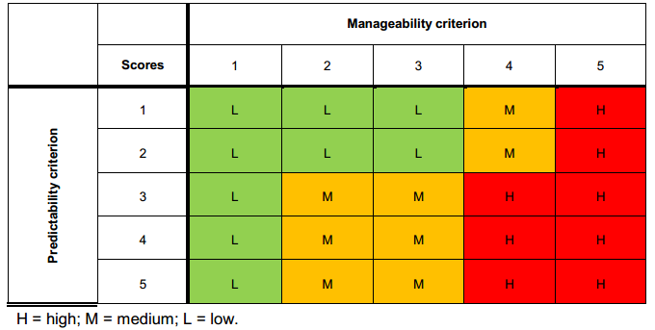
Figure A2: Matrix to determine level of environmental significance (DMITRE, 2013).
The circumstances outlined below determine the significance scores that should be applied:
• 1 – where potential adverse consequences can be completely avoided, there are no adverse consequences or low likelihood of an event (which would lead to adverse effects) occurring.
• 2 – where potentially adverse consequences cannot be entirely avoided, or likelihood of being realised is not low but these can be managed to occur only in the near term.
• 3, 4 – if impacts are expected to occur over a longer period, but they can be confined to a relatively small area in relation to surrounding environment, then a significance score of 3 can be given. If this is not the case a level of 4 should be applied. A score of 4 should also be given if impacts considered to be level 1 or 2 can have cumulative impacts with other existing activities.
• 5 – where consequences are potentially catastrophic with respect to scale or irreversibility or major concerns are raised by other stakeholders.
The Queensland Water Commission (2012) underground water impact report for the Surat and Bowen basins, assessed and ranked risks to springs on a level of 1 to 5. The level is determined on the basis of likelihood of reduced water flows, and on the resulting impact to spring values should this eventuate. For each spring vent, a risk level between 1 (lower) and 5 (higher) were assigned on the basis of the likelihood of there being reductions in the flow of water and likely consequences on spring values if a reduction in flow was to arise.
The Queensland Water Commission study (2012) used two criteria to assess consequence of impacts to springs. The two criteria were:
• conservation value – the updated conservation ranking for each spring informed by the spring survey
• proximity of the spring to the recharge area of the spring’s source aquifer, as an indicator of the ecosystem’s resilience to changes in terms of availability of water to the spring.
Cultural heritage values were not assessed in the study. The study did also not explicitly consider all factors that could influence groundwater drawdown propagation such as faults and wellbore pathways, and focussed entirely on springs and did not consider the potential sensitivity of the aquifers and groundwater users.

Techniques to determine consequence
NSW DPI Office of Water (2012b) Risk assessment guidelines for groundwater dependent ecosystems provides a process to identify, evaluate and assess the consequence of impacts to groundwater dependent ecosystems which explicitly recognises the inherent interconnectedness of groundwater and surface water assets – the process is summarised in Appendix G.
Multiple attributes are used to inform the consequence of impacts to four key aquifer assets. These are water quantity, water quality, aquifer integrity and biological integrity assets. High, medium and low impacts to water quantity and quality are determined in accordance with:
- Water quantity:
Reduction or fluctuation in groundwater levels or piezometric pressure beyond seasonal variation, leading to loss of or alteration to habitat type. If permanent, high impact; if temporary, medium impact. No change to aquifer water levels or pressure is a low impact.
Reversal of base flow conditions – if permanent, high impact; if temporary reversal exceeding seasonal variation, medium impact. No change in direction of flow is a low impact.
- Water quality:
Change in chemical conditions (e.g. in pH, DO, nutrients, temperature and/ or turbidity), if permanent, high impact. If temporary, medium impact. If negligible (<5%) it is a low impact
Permanent change in location or gradient of salt/freshwater interface
Reduction in water quality for identified trigger parameters– if beyond designated Beneficial Use category it is high impact; if within designated BU category medium impact. Negligible change for identified triggers is low impact (<5%)
- Aquifer integrity: If permanent destruction of aquifer matrix through major fracturing of bedrock, stream bed leading to dewatering of groundwater dependent ecosystems, then a high impact is determined. Moderate impacts are temporary adjustment to aquifer matrix, with minor fracturing leading to partial dewatering of groundwater dependent ecosystems. Low impacts must register no change in geologic structure from the activity.
- Biological integrity:
1 > 10% reduction in number of native species within groundwater dependent communities is a high impact. 5–10% is a moderate impact and no reduction is a low impact
2 >10% change to species composition is high impact, 5–10% is moderate impact, and no change is a low impact.
3 Risk of increasing the presence of exotic species is high if large populations of one or more species are recorded, moderate if species in small numbers are noted and low risk if no exotic species exist
4 Risk of removing or altering groundwater dependent ecosystem subtype habitat is high if there is >20% loss or change to habitat area, moderate if there is 10–20% change and low if there is no removal or alteration of habitat.
If proponents provide ‘unknown’ against more than half of these considerations, then the risk is high until evidence can be shown to prove otherwise.
Current measures to manage impacts to Groundwater Dependent Ecosystems largely fall under Water Management Act 2000, which provides for monitoring of impacts against change in groundwater extraction relative to extraction limit, change in climate-adjusted water levels, change in ecological condition of the aquifers and dependent ecosystems and change in water quality.
The Water Quality Guidelines (ARMCANZ and ANZECC 2000) provide guidance on performance indicators and trigger values for impacts to aquatic ecosystems in terms of physical/chemical stress. For some water quality indicators, the Water Quality Guidelines (ARMCANZ and ANZECC 2000) indicate there is a need to establish reference condition against which to measure impacts, which may be derived from on-site historic data or spatial data from reference/proximate sites.
The UK Royal Society of Engineering (2012) recommends that all shale gas operations be subject to an Environmental Risk Assessment, which provides better opportunity to prioritise and manage risks more proportionately than Environmental Impact Assessments, which do not consider event likelihood. ERAs should assess risks across the entire lifecycle of shale gas extraction to include waste disposal and well abandonment. However, no further specific information however was given about the form of risk assessment that should be undertaken.

A2.8 Likelihood
The next step in a standard risk assessment process is to evaluate qualitatively or quantitatively the probability of a hazardous event occurring. The likelihood of the consequence is typically based on the frequency of the sensitive receptor being exposed to the risk.

Risk assessment to inform government policy
The literature review did not identify any different techniques or criteria used to assess likelihood in the context of a risk assessment to inform government policy than those that are commonly used for project risk assessments.

Risk assessment to inform project-scale developments
Gormley et al (2011) suggest conceptualising likelihood in terms of three factors which should be addressed in risk assessments at a project level: the probability of an initiating event occurring, the probability of exposure to the hazard and probability of receptors being affected by the hazard (resilience/vulnerability). These may be assessed together or separately.
The Queensland Water Commission (2012) use three equally weighed criteria to assess likelihood. They involve use of predicted water pressure impacts in aquifers made using the regional groundwater flow model, the proximity of a spring to development areas, and the stratigraphic separation of a spring’s source aquifer from the prospective resource formations.
One technique for conceptualising likelihood and significance of impact is in relation to the worst case scenario. In terms of probability bounds analysis, a qualitative description of a worst case scenario for coal seam gas groundwater pumping is provided by Anderson et al (2013), and would involve:
• loss of the same volume of beneficial groundwater from an overlying aquifer as a result of enhanced flow along any geological pathways and/or leakage through pores and transmissive fractures or faults
• leakage along/through coal seam gas well casing if perfect seal was not achieved, the well casing materials shrink or well construction materials break/become permeable with time
• changes in groundwater chemistry and beneficial use due to mixing from different aquifers and aquitards
• deterioration of groundwater quality in beneficial aquifer to the point at which quality no longer meets requirements of groundwater users/beneficial use category as set out by authorities
• depletion of groundwater in the beneficial aquifer to a level/pressure preventing other users/uses from accessing groundwater entitlement for its intended purposes.
Historical trends and data may be used to assess event likelihood. For instance, Gross et al (2013) reviewed data on groundwater spills from storage and production facilities at active wells, finding relatively low likelihood of spills occurring. Whilst the crude oil compounds (benzene, toluene, ethylbenzene and xylene) exceeded national drinking water standards in 18-90% of recorded instances, subsequent measures were successful in remediating impacts in 87% of cases.
Riha and Rahm (2010) distinguish between gas drilling impacts that are deterministic, events that are certain to occur and a direct function of extent and pace of development and probabilistic, which may occur but whose occurrence and consequence is spatially and temporally unclear. Deterministic events can be foreseen, planned for and regulated, whereas probabilistic events must be inferred from historical data.
There are several approaches to estimating likelihood that generate semi-quantitative estimates of frequency of potential impacts being realised. In relation to project-level risk assessments for the offshore oil and gas industry, ABS (2000) propose the use of event tree analysis (modelling possible outcomes of an event against the end state), which may be particularly useful where multiple controls are in place to minimise risk. Fault-tree analysis is also suggested as a means of modelling complex interactions to determine how relationships between technological failure, external events and human error can interact. Finally, human reliability analysis can be used to identify areas of potential human error, and re-evaluate high risks according to impact that an individual could have in completing the scenario.
In the absence of historical records and given complexity of interactions between human, hydrological and geological components, the approach used by Rozell and Reaven (2012) may be the most useful. They apply probability bounds analysis (best and worst case scenarios) to investigate likelihood of possible water pollution in the Marcellus Shale by assessing contamination risk and epistemic uncertainty associated with five pathways: transportation spills, well casing leaks, leaks through fractured rock, drilling site surface discharge, and wastewater disposal.

A2.9 Risk rating
Risk estimation is the final step in a risk assessment, and is determined from the likelihood and consequences of an adverse outcome (with due regard to uncertainty) should the impact be realised. Retained risk assesses the residual impact after standard controls have been implemented.

Risk assessment to inform government policy

Risk rating: considerations
For the purpose of producing bioregional assessments, IESC (2014) states risk matrices and consequence tables, which may be quantitative, semi-quantitative or qualitative depending on the degree of confidence regarding likelihood and potential impacts, should consider residual impacts on the basis of likelihood of event occurrence, impact uncertainties and information from risk registers.
Risk registers are one component of the proposed centralised Risk Management and Prediction Tool for extractive industries recommended by the NSW Chief Scientist and Engineer (2014). It would also feature a database of event histories, and previous trigger action response plans, which in addition to improving review of proposed developments for government, would help to improve the ability to predict risk likelihoods and consequences of potential impacts in risk assessments.

Criteria and techniques
The literature review identified a couple of techniques to assist with a strategic planning risk assessment risk rating approach.
The Namoi Cumulative Risk Assessment Tool (NCRAT, Ecological Australia 2012) is a spatial tool which was developed for Namoi CMA to assess cumulative risk from mining and coal seam gas on ten natural resource assets at the strategic landscape scale. It focuses on relative risk from different development scenarios (e.g. risk level between site A and B) as opposed to absolute risk at the project level, which would need to be informed by more specific site-relevant data.
Sensitivity classes (very low, low, moderate, high and very high) were developed using thresholds identified by Namoi Catchment Action Plan. These set out immediate impacts and input layers required and developed rules for assigning scores. For instance, three forms of spatial data underlie representation of groundwater quality: coal resource potential (which indicates development feasibility), distribution of alluvial aquifers (risk will be greater where alluvial aquifers are above coal beds) and density of agricultural bores (to proxy for water demand by agriculture).
Sensitivity to groundwater drawdown was determined on the basis of 4 components: coal and gas potential, distribution of major groundwater aquifers in the catchment (and associated data regarding status – recovering, stable or declining - and groundwater connectivity -connected, transition, disconnected); groundwater depth data and groundwater dependent ecosystem potential.
Risk rating matrices were then developed for each type of impact – an example of which is provided in Section 2.10. The cumulative risk framework produced provides an indication of the relative risk of a scenario to the underlying asset, although it is noted that risk tables are not final and may be modified as improved data comes to hand.
Another approach to assessing vulnerability of water assets to hydrological change is provided by Wilson et al (2014) who apply the pressure-stressor-response model in the South Australian context. Rather than seek to identify impacts to individual assets, they develop classes based on their hydrology and potential for hydrological change. The component attributes used by Wilson et al are water source (which can be combination of surface and groundwater) and water regime (prevailing mode of flow in terms of magnitude, duration, frequency, seasonality).
Table A1: Qualitative impact categories for impacts to water resource asset classes. (Source: Wilson et al, 2014.) shows they developed qualitative impact categories on a scale of ‘negligible’, ‘low’, ‘moderate’ and ‘high’ for hydrological integrity, asset resilience and time to recovery of system criteria. These were rated for each combination of asset class, activity and effect. Unknown and not applicable impact ratings were also identified.

Table A1: Qualitative impact categories for impacts to water resource asset classes. (Source: Wilson et al, 2014.)
Qualitative impact categories | Changes to hydrological integrity | Resilience | Time to recovery
High | Change in ‘state’ (i.e. different asset class) | No return or transition back to previous hydrology or asset class | Permanent or non-permanent change
Moderate | Change to hydrology | No return or transition back to previous hydrology | Permanent change
Low | Change to hydrology | Return to expected/previous hydrology | Rapid
Negligible | No change to hydrology | Return to expected/previous hydrology | Not relevant
N/A | Not relevant | Not relevant | Not relevant
Unknown | Unknown | Unknown | Unknown

These impact ratings describe the potential change in hydrological characteristics of an asset caused by an activity and were assigned through a collaborative expert elicitation process combining knowledge from surface water hydrology, ecology of water dependent ecosystems and hydrogeology.
Considered alone, it does not represent a true risk assessment framework as it does not assess likelihood of coal seam gas and coal mining activities, values attached to water assets, acceptability or tolerability of vulnerabilities. However, it provides a starting point for considering potential scenarios of hydrological impacts based on a general asset type and coal seam gas or large coal mine activity, without factoring in local circumstances affecting vulnerability, such as asset-specific features or risk control measures that may already be in existence.

Risk assessment to inform project-scale developments

Risk rating criteria
The number of criteria comprising a risk assessment rating varies from study to study but impacts are usually represented using a 3 by 3 or 5 by 5 risk rating matrix.
Moran and Vink (2010) assign processes of water recharge, discharge and redistribution from coal seam gas activities a rating of ‘no significant changes', 'minor changes' 'intermediate' and 'significant changes/local risk' based on impacts to surface and groundwater assets. Flows between components of the system were categorised into ‘significant’, ‘intermediate’ and ‘minor’ changes.
The Alberta Ministry of Environment and Sustainable Resource Development, in Canada has developed a 3 stage, three tier risk rating tool which helps Proponents determine the level of analysis/investigation required for a licence application for oilfield injection activities (ERSD, 2006) . The three tiers, with increasingly stringent requirements for investigation are qualitatively described as:
Step 1 involves determining whether the project will likely have a minor, moderate or major consequence based on numeric and qualitative criteria for safe, secure drinking water supply (water supply effects up to x km, negligible, local or community supply constraints); healthy aquatic ecosystems (measurability of effect, in -stream flow needs, existence of cumulative effects) and reliable water supplies for a sustainable economy (degree of development pressure, competition for supply).
Step 2 involves rating of likelihood against probability criteria which are: ‘remote’ (practically impossible, occurrence of 1 in 100 years or less) ‘unlikely’ (conceivable but very unusual, occurrence is 1-10 in 100 years) or ‘likely’ (would happen often, more than 10 occurrences in 100 years).
Step 3 provides the risk matrix for self-assessment of retained risk and guidance on information that must be provided and measured Proponents complete a water allocation licence application for one of three tiers, based on project scale. Each tier specifies management aims and what data must be collected and the measures taken to conserve and prevent excessive water use.
Water-short areas are determined on the basis of low natural runoff potential (‘exceptionally dry’ being less than 5mm of runoff, and ‘potentially water short’ 5-10mm of runoff), and existing human use and administrative restrictions (3 categories are identified: water-short, which are closed to most new applications).
The report for ACOLA (2013) creates risk tables for each potential impact to ecological systems from shale gas development, assuming best practice measures are used to minimise spills, leaks and incidents and mitigate indirect impacts. In relation to surface water abstraction or drawdown of sub-surface water, it concludes there is a moderate risk of impacts to aquatic ecology based on the combined likelihood of impact occurring and consequences should this impact arise. Uncertainties are qualitatively captured on a scale of ‘high’, ‘medium’, ‘low’ based on ‘reliability’ of event likelihood and impact consequence. A description to support the rating is provided where needed. Refer to 0 for the risk tables.

A2.10 Presentation of risk assessment findings

Risk assessment to inform government policy
Multiple sensitivity layers were developed for the Namoi Catchment Management Authority by Eco Logical Australia (2012) to inform a cumulative risk assessment of different mining scenarios on ten types of natural resource assets found in the catchment. Table shows the relative risks posed by coal seam gas, open-cut mining and long wall mining to groundwater drawdown and quality at different locations in the Namoi catchment.
Owing to the study’s scope which assessed risks to both terrestrial and aquatic ecosystems, the risk assessment is focused on the potential footprint of mining (area requiring clearing) relative to catchment area.

Table A2: Risk matrix showing sensitivity of water assets at different scales of coal seam gas, Long-Wall Mining and Open-Cut Mining Development. (Source: Eco Logical Australia, 2012.)

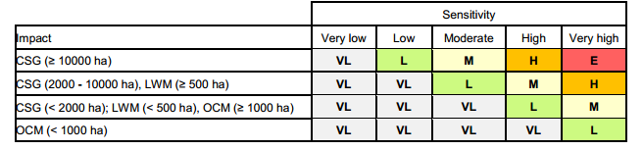
As shown in Figure A3 the relative risk water assets from different development scenarios is assessed to be greatest from large-scale coal seam gas development owing to the proximity to groundwater resources and the volume of co-produced water generated. Similar conclusions were drawn for sensitivity of groundwater quality to coal seam gas development, as shown in the top right diagram of Figure A3, due to the fact that coal seam gas has a relatively greater concentration of wells and holding ponds than open-cut or long-wall mining. This finding is relevant to considering relative risks from onshore unconventional gas to conventional gas development, which typically will involve gas extraction from a single rather than multiple wells.

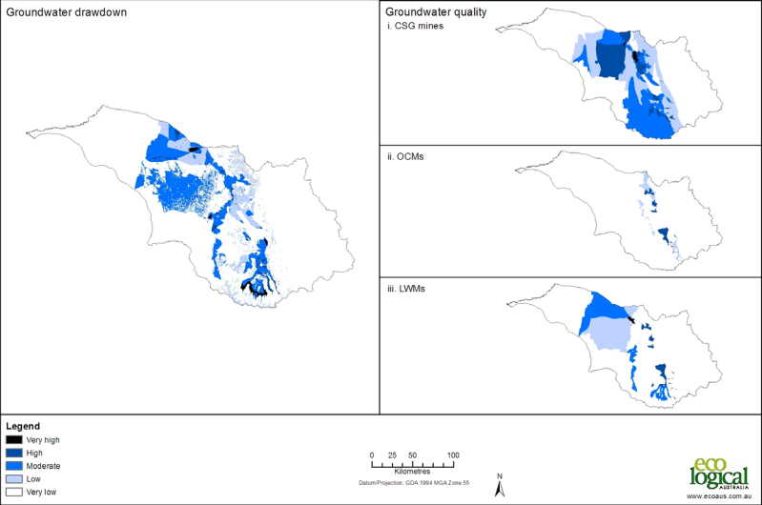
Figure A3: Sensitivity to Groundwater Drawdown under Coal Seam Gas, Open Cut Mining and Long Wall Mining Development. (Source: Eco Logical Australia, 2012.)

In Western Maryland, the Marcellus Shale Safe Drilling Initiative was designed to inform policymakers and regulators to determine whether and under what circumstances gas production can proceed without presenting unacceptable health and safety and environmental risks.
A qualitative risk assessment for unconventional gas well development was conducted by technical teams who reviewed available literature and identified potential risks across well lifecycle from site identification to abandonment/reclamation. Risks were assigned to categories, two relevant to this literature review being “potential impacts to surface and ground waters” and “water withdrawal”.
The risk assessment was based on two development scenarios: 25% extraction and 75% extraction levels of available natural gas resource. Table A3 below shows the assumptions underlying these scenarios.

Table A3: Development scenario assumptions. (Source: Maryland Department of Environment, 2014.)
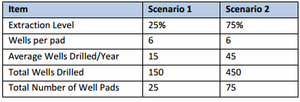
Risk impacts included direct and indirect impacts to human, community, ecological and recreation receivers. The likelihood (low, medium or high) and consequence (minor, moderate or serious) evaluated and combined to inform an assessment of a low, moderate or high risk rating for each risk (see Table).

Table A4: Risk ranking matrix. (Source: Maryland Department of Environment, 2014.)
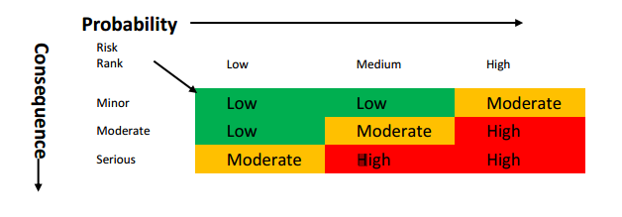
The risk assessment assigns a rating to each risk category by phase of well development (e.g. water withdrawal for drilling, water withdrawal for hydraulic fracturing), based on assumptions around the scale of development and ability of current regulatory framework to manage development.
However, it is not geographically-focused i.e. does not seek to evaluate risks under different hydrogeological conditions or to specific groundwater assets.
In Alberta, the Ministry of Environment and Sustainable Resource Development (ERSD) uses a qualitative
3 by 3 risk matrix (Table A5) as the basis for its guidelines around information which must be provided to support a Licence Application for oilfield injection. It instructs proponents to plot qualitative impacts (on a scale of minor, moderate and major) and probability ratings (remote, unlikely, likely) to determine the Tier level and corresponding technical, economic and net environmental effects which proponents must be characterised for the project.

Table A5: Risk-based tier selection: determining the appropriate Tier Level. (Source: ERSD, 2006.)
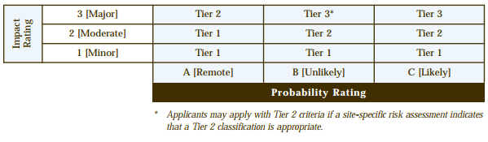
Table A6 and Table A6 provide high-level guidance to determine probability and impact and inform the selection of the appropriate tier level.

Table A6: Risk-based tier selection: scale of impact against ‘Water for Life’ goals. (Source ERSD, 2006.)
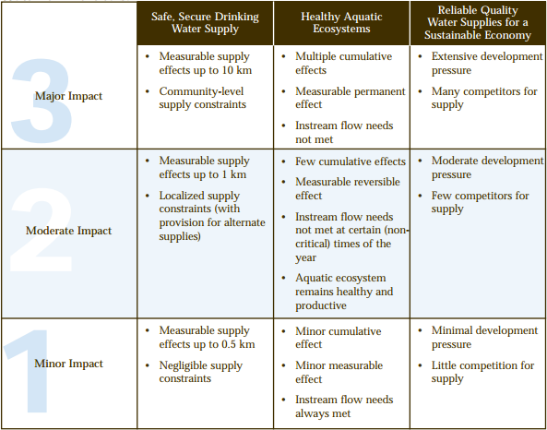

Table A7: Risk-based tier selection: determining probability of impacts. (Source: ERSD, 2006.)
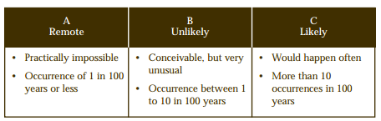

A3 Implications for the design of QQRA
There is no fit-for-purpose risk assessment methodology that is suited to analysing risks at a policy-making/strategic land use level to water resources from unconventional onshore gas developments.
Many jurisdictions use their existing regulation frameworks to manage risks from onshore gas development including water supply requirements, discharges to environment and well integrity.
Land use planning around onshore gas appears to be based on a precautionary approach to risk, given there is still considerable uncertainty around precise pathways for cause and effect. As pathways are highly site specific it is difficult to generalise likelihood of impacts across larger areas. Consequently, several regulators at both state and national level have delineated exclusion zones around pre-existing determinations of sensitive assets. For instance, New South Wales share the New York State Department of Environmental Conservation’s concern regarding protecting drinking water from principal and primary aquifers. However there are a number of studies and research programs to improve understanding and frameworks to manage impacts associated with onshore gas development e.g. Bioregional Assessments, Cumulative Management Areas (Queensland).
Components of project risk assessments are often transferable to assessing risk at a strategic level. This is particularly the case when considering the scale of unconventional gas developments in comparison to traditional conventional gas. Conventional gas typically involves relatively few wells, whereas unconventional gas, in particular coal seam gas involves many wells, sometimes 1,000s of wells over large areas. This blurs the distinction between project and regional scale assessments. In light of this, through the National Harmonised Framework the Federal Government requires that proponents assess cumulative impacts from other gas developments and/or different existing/potential land uses.
Common elements and differences between the two scales of risk assessments are discussed below.

A3.1 Common elements
Common to all risk assessment methodologies at either a project or hypothetical level is the characterisation of the existing hydrogeological conceptual model and establishing a baseline from which to assess potential impacts and identifying sensitive receptors (water resources and water-dependent assets). There is scope to integrate data from asset registers/natural resource management authorities (IESC, 2013).
Whilst numerical modelling is typically carried out for project level risk assessments, lack of sufficient data at a regional level to support strategic planning risk assessments means conceptual models and qualitative or semi-quantitative criteria are often adopted until better information becomes available. The exception to this is Queensland, where the Office of Groundwater Impact Assessment has commissioned numerical modelling of the cumulative management areas to understand predicted impacts across the region to inform government policy.
Another common element is the principle of hazard identification (i.e. the source-pathway-receptor). However hazard identification at a strategic planning scale will invariably have to make assumptions around onshore gas development in order to infer potential impacts (e.g. location, extent). This introduces an added dimension of uncertainty which needs to be factored into risk ratings or made clear in the limitations and assumptions section of a report.
In terms of understanding potential hydrogeological pathways, at both the project scale and the regional scale they are often described conceptually as there is rarely sufficient information to identify to describe them more in more detail and specifically.
Thresholds for significant impact are similar between project-based and strategic land-use planning risk assessments, and will depend on whether individual or cumulative impacts are being factored into consequence ratings.
The criteria used to identify water resources and water-dependent assets – typically value and sensitivity - are relevant to risk assessments for both actual and hypothetical developments. Arguably there has been greater focus on assessing sensitivity than value. At a strategic planning level, the scale and number of receptors involved means it may be necessary to group receptors into ‘asset classes’ according to common characteristics and pathways through which they could experience adverse impacts.

A3.2 Key differences
There are a couple of differences between project scale and strategic planning scale such as the project scale risk assessment will be required to consider potential impacts on a broader range of assets (terrestrial ecosystems, local communities etc.) as required under existing regulatory frameworks.
Also assessment of likelihood differs between hypothetical onshore gas development and actual proposed activity-based risk assessments. Likelihood at strategic planning level relates to the understanding of direct and indirect impacts between source and receptor. Likelihood for particular development would consider this, but also take into account project-specific considerations (control standards used, confidence around numerical modelling, expected development lifespan, current state of development)
In terms of risk identification considerations, hazards will vary according to the type of gas; the key risk for coal seam gas development relates more to depressurisation although hydraulic fracturing can be an issue in some cases. For developments targeting tight and shale gas the risks will primarily relate to potential impacts from hydraulic fracturing.
Strategic level risk assessments will have to give due regard to key differences in typical characteristics of different gas types (notably depth and permeability of overlying layers) and this will determine pathways by which potential impacts on water assets are realised. However, this is just one side of the equation and the characteristics of sensitive assets (confined/unconfined aquifers, perennial/ephemeral streams) will also have to be taken into consideration to determine likelihood of potential impacts being realised.
Thresholds could be alike between tight, shale and coal seam gas if they are outcome-focused, i.e. linked to changes in the quantity/quality of the water asset assessed, rather than the level or type of activity.
Risk rating is based on likelihood and consequence. As described above, pathways will determine likelihood of impacts at a strategic land use planning level so criteria used may differ between gas resources. However consequence is linked to potential for significant adverse effect on the receptor and criteria used is based on the threshold level of impact, which is common to the different types of gas that are targeted.

A3.3 Key conclusions
Individual jurisdictions are managing risks associated with onshore gas development differently as indicated by the following examples.
ERCB in Alberta (Canada) has developed generic risk profiles (geographic, geologic, temporal properties such as source rock, migration pathways, timing, trapping mechanisms and hydrocarbon type) and standard resource plays to inform if proposed development is likely to be a low, medium or high risk.
Queensland have used a regional numerical model to predict impacts within the defined Cumulative Impact Area. Even though threshold criteria have been defined, these are being challenged as further technical work is undertaken.
NSW has recently released the NSW Gas Plan which outlines the key actions already implemented such as the Strategic Regional Land Use Policy, the Aquifer Interference Policy and codes of practice for well integrity and hydraulic fracturing. The majority of other actions outlined in the plan are directed and reducing the number of exploration licences and ensuring the community benefits from gas development.
South Australia released a Roadmap for Unconventional Gas Projects in South Australia in late 2012. Five working groups were established in 2013, one is focused on pooling together water use forecasts for basin wide modelling in Cooper-Eromanga basin as an initial step towards life-cycle catchment planning (DMITRE, 2014). Groundwater assessment projects have also been conducted in Arckaringa and Pedirka basins (Wohling et al, 2013), owing to significant potential for large-scale mining or coal-seam gas development, the findings will be to inform further resource characterisation and testing.
Western Australia, the EPA is assessing hydraulic fracturing for shale and tight gas projects on a case-by-case basis as for petroleum and mining to date. Government agencies will in parallel periodically review and refine the regulatory framework, for instance the Department of Mines and Petroleum is revising regulations for well design and operation and the Department of Water is reviewing current water legislation (DMP, 2014).
In terms of approaches to risk assessments, the key conclusions from the literature review are outlined below:
• The literature review found many jurisdictions are seeking to enhance understanding of risks and define under what conditions or in what areas onshore gas developments may be considered.
• 5 × 5 consequence and likelihood criteria and risk rating scales require detailed data and/or extensive quantitative/numerical modelling and project specific risk assessments which treat consequence (direct, indirect, financial and non-financial etc) and likelihood (probability, historical instances of failure) differently (DMITRE, 2013)
• Two most common ways by which water resources are commonly identified are the vulnerability/sensitivity of the resource (physical characteristics) to potential impacts and the value of the water asset.
Risk assessments used to answer/inform strategic planning and policy questions typically involve cumulative impacts and the most similar approach to this project is the Namoi CMA (Eco Logical Australia 2012). Key components of the approach in the Namoi catchment are:
• spatial tool to assess cumulative risk from mining and coal seam gas on ten natural resource assets at strategic landscape scale.
• focuses on relative risk between site A and B, not absolute risk
• five classes of sensitivity (VL, L, M, H, VH)
• sensitivity was determined by:
– coal and gas potential
– distributions of major groundwater aquifers in catchment and connectivity
– groundwater level data
– groundwater dependent ecosystems potential
– qualitative risk matrices developed for each aquifer.
The proposed approach for the QQRA has not been implemented at a regional scale anywhere in the world where all the components of the risk assessment framework (consequence, likelihood and hence risk) can be assessed qualitatively and semi-quantitatively using existing information and eventually quantitatively as more accurate information becomes available.

Appendix AA Matters out of scope for the literature review
The literature review has been guided by the scope of the QQRA, as such the following hazards, receptors and impacts identified in Figure AA1 below have not been the primary focus for analysis.

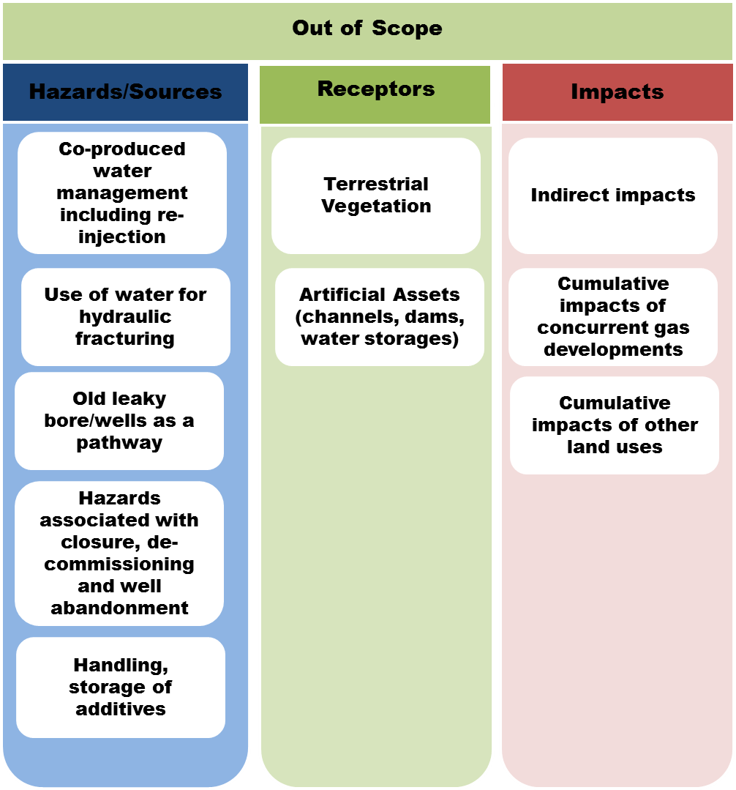
Figure AA1: Hazards, receptors and impacts outside the scope of the proposed Qualitative and
Quantitative Risk Assessment (QQRA) Framework.

Appendix AB Sources consulted
A. GUADAGNINI, L. GUADAGNINI, D. M. TARTAKOVSKY AND C. L. WINTER, "Random domain decomposition for flow in heterogeneous stratified aquifers", Stoch. Environ. Res. Risk Assess., vol. 17, no. 6, pp. 394-407, 2003
A.M.M. ELFEKI, G.J.M. UFFINK, F.B.J. BARENDS (1997) Groundwater Contaminant Transport: Impact of heterogenous characterization: a new view on dispersion
ACCENTURE (2013) Water and Shale Gas Development: Leveraging the US experience in new shale developments, http://www.accenture.com/SiteCollectionDocuments/PDF/Accenture-Water-And-Shale-Gas-Development.pdf
ADBDULLAHI, U.S. (2009) Evaluation of Models for Assessing Groundwater Vulnerability to Pollution in Nigeria, Bayero Journal of Pure and Applied Sciences, 2(2): 138 - 142
AEA (2014) Shale gas risk assessment for Maryland, http://chesapeakeclimate.org/wp/wp-content/uploads/2014/02/Shale-gas-risk-assessment-for-Maryland_Feb2014.pdf Report for Chesapeake Climate Action Network and Citizen Shale
AEA TECHNOLOGY (2012) Support to the identification of potential risks for the environment and human health arising from hydrocarbons operations involving hydraulic fracturing in Europe. Report prepared for the for the European Commission http://ec.europa.eu/environment/integration/energy/pdf/fracking%20study.pdf
ALBERTA MINISTRY OF ENVIRONMENT AND SUSTAINABLE RESOURCE DEVELOPMENT - ERSD (2006) Water Conservation And Allocation Guideline for Oilfield Injection
http://esrd.alberta.ca/water/education-guidelines/documents/Oilfield_Injection_Guideline_2006.pdf
AMERICAN BUREAU OF SHIPPING (2000) Guidance Notes on Risk Assessment Applications for the Marine and Offshore Oil and Gas Industries
https://www.eagle.org/eagleExternalPortalWEB/ShowProperty/BEA%20Repository/Rules&Guides/Current/97_RiskAssessApplMarine&OffshoreO&G/Pub97_RiskAssesment
ANDERSON ET AL (2013): Background Paper on Groundwater Resources in Relation to Coal Seam Gas Production, WRL Technical Report 2013/09 http://www.chiefscientist.nsw.gov.au/__data/assets/pdf_file/0007/38158/WRL-2013-09-Final-November-2013.pdf
ANDRZEJ J. WITKOWSKI, ANDRZEJ KOWALCZYK, JAROSLAV VRBA (2007) Groundwater Vulnerability Assessment and Mapping CRC Press http://books.google.com.au/books?id=LTqEEL6ROcgC&dq=risk+assessment+aquifer&source=gbs_navlinks_s
APH (2008) Australia’s natural gas issues and trends. M. Roarty. Parliamentary Library Research Paper no.25. ISSN 1834 9854. http://www.aph.gov.au/binaries/library/pubs/rp/2007-08/08rp25.pdf
ARROW ENERGY (2012) EIS groundwater Impact Assessment: Surat Gas project http://www.arrowenergy.com.au/__data/assets/pdf_file/0005/2966/126908_SGP_EIS_Groundwater_Factshet.pdf
ARROW ENERGY (2012) Supplementary Report to the Surat Gas Project EIS http://www.arrowenergy.com.au/__data/assets/pdf_file/0016/8611/7040_12_Ch08_Rev1.pdf
AUSTRALIAN PETROLEUM PRODUCTION & EXPLORATION ASSOCIATION (peak industry body) Western Australian Onshore Gas: Code of Practice for Hydraulic Fracturing http://www.newstandard.com.au/wp-content/uploads/2011/11/APPEA_Code_of_Practice.pdf
BARRETT, D.J., COUCH, C.A., METCALFE, D.J., LYTTON, L., ADHIKARY D.P., AND SCHMIDT R.K., 2013 (2013) Methodology for bioregional assessments of the impacts of coal seam gas and coal mining development on water resources. A report prepared for the Independent Expert Scientific Committee on Coal Seam Gas and Large Coal Mining Development through the Department of the Environment.
NSW
BASELINE FOR COMPARISON OF ALL FUTURE POTENTIAL RISKS (http://www.resourcesandenergy.nsw.gov.au/landholders-and-community/coal-seam-gas/water-data-project
BRITISH COLUMBIA OIL & GAS COMMISSION (2014) Well Permit Application Manual http://www.bcogc.ca/node/5854/download?documentID=874&type=.pdf
BUREAU OF METEOROLOGY, Groundwater Dependent Ecosystem Atlas http://www.bom.gov.au/water/groundwater/gde/
CAMPIN, D. (2013) Environmental Regulation of Hydraulic Fracturing in Queensland, Society of Petroleum Engineers Annual Technical Conference and Exhibition https://www.spe-qld.org/useruploads/files/spe_166146_for_6_march_2014.pdf
CAPP (2012) Upstream Dialogue – The Facts on Natural Gas. Canadian Association of Petroleum Producers (CAPP). Available at: http://www.capp.ca/UpstreamDialogue/NaturalGas/Pages/default.aspx (Accessed October 2013)
COMMONWEALTH OF AUSTRALIA (2013) Significant Impact Guidelines: Coal Seam Gas and Large Coal Mining Developments – Impacts on Water Resources http://www.environment.gov.au/system/files/resources/d078caf3-3923-4416-a743-0988ac3f1ee1/files/sig-water-resources.pdf
COMMONWEALTH OF AUSTRALIA (2014) Coal seam gas extraction: modelling groundwater impacts, prepared by Coffey Geotechnics for the Department of the Environment, Commonwealth of Australia’ http://www.environment.gov.au/system/files/resources/ee38b672-6faa-452e-979f-d97b7d425333/files/coal seam gas-modelling-groundwater-impacts.pdf
CONNECTICUT ENVIRONMENTAL CONDITIONS ONLINE (2010) CT ECO Complete User Guide: Water Quality Classifications. http://cteco.uconn.edu/guides/resource/CT_ECO_Resource_Guide_Water_Quality_Classifications.pdf
COOK, P J et al. (2013) “Engineering energy: unconventional gas production.” Report for the Australian Council of Learned Academies (ACOLA)
COOK, P.G. (2003) A guide to regional groundwater flow in Fractured Aquifers, CSIRO http://lwa.gov.au/files/products/river-landscapes/px020312/px020312.pdf
COOK, P.J. (2013) Life Cycle of Coal Seam Gas Projects: Technologies and Potential Impacts Report for the New South Wales Office of the Chief Scientist and Engineer http://www.chiefscientist.nsw.gov.au/__data/assets/pdf_file/0010/31321/Life-Cycle-of-Coal-Seam-Gas-Report_FINAL_PJC.pdf
COUNCIL OF AUSTRALIAN GOVERNMENTS (n.d.) National Partnership Agreement on Coal Seam Gas and Large Coal Mining Development https://www.ehp.qld.gov.au/management/impact-assessment/pdf/partnership-agreement.pdf
DALY, D. AND WARREN, W.P. (1998) Mapping groundwater vulnerability: the Irish perspective. Geological Society, London, Special Publications, 130:179-190
DALY, D. AND WARREN, W.P. (1998) Mapping groundwater vulnerability: the Irish perspective Geological Society, London, Special Publications, 130:179-190,
DECC (2014) “Fracking UK Shale: water” https://www.gov.uk/government/uploads/system/uploads/attachment_data/file/277211/Water.pdf
DEPARTMENT OF ENVIRONMENT & HERITAGE PROTECTION (n.d.) Guideline Water Act Underground Water Impact Report https://www.ehp.qld.gov.au/management/non-mining/groundwater.html
DEPARTMENT OF ENVIRONMENT (2013) Significant impact guidelines 1.3: Coal Seam Gas and Large Coal Mining Developments – impacts on water resources. Commonwealth of Australia
http://www.environment.gov.au/system/files/resources/d078caf3-3923-4416-a743-0988ac3f1ee1/files/sig-water-resources.pdf
DEPARTMENT OF MINES AND PETROLEUM (2014) ‘Natural Gas from Shale and Tight Rocks: An overview of Western Australia’s regulatory framework’. Government of Australia
http://www.dmp.wa.gov.au/15139.aspx
DEPARTMENT OF PRIMARY INDUSTRIES AND ENERGY (1995) National Water Quality Management Strategy: guidelines for Groundwater Protection in Australia http://www.environment.gov.au/system/files/resources/4d08becb-c90a-4637-bcbc-5772451f7c5e/files/nwmqs-groundwater-guidelines.pdf
DEPARTMENT OF SUSTAINABILITY AND ENVIRONMENT () Policy Paper: Improving Management of Victoria’s Groundwater Resources http://www.depi.vic.gov.au/__data/assets/pdf_file/0005/188942/Improving-management-of-Victorias-groundwater-resources.pdf
DEPI article: Groundwater monitoring of the State Observation Bore Network http://www.depi.vic.gov.au/water/governing-water-resources/environmental-contributions/groundwater-monitoring-of-the-state-observation-bore-network
DET NORSKE VERITAS (2013) Recommended Practice: Risk Management of Shale Gas Developments and Operations file:///C:/Users/AHerford/Downloads/rp-u301_2013-01.pdf
DIVISION OF WATER TECHNICAL & OPERATIONAL GUIDANCE (1990) Primary & Principal Aquifer Determinations http://www.dec.ny.gov/docs/water_pdf/togs213.pdf
DMITRE (2013) Criteria for classifying the level of environmental impact of regulated activities: requirement under Part 12 of the Petroleum and Geothermal Energy Act 2000 https://sarigbasis.pir.sa.gov.au/WebtopEw/ws/samref/sarig1/image/DDD/PGRG004.pdf
DMITRE (2014) South Australian Developments: Excellence in Oil and Gas 2014. http://www.pir.sa.gov.au/__data/assets/pdf_file/0019/218350/Excellence_in_O_and_G_Alexander_Mar2014.pdf
DNRM (2014) Report on the coal seam gas engagement and compliance plan 2013 http://www.dnrm.qld.gov.au/__data/assets/pdf_file/0007/171646/report-coal seam gas-engagement-compliance-plan.pdf
ECO LOGICAL AUSTRALIA 2012. Assessing the cumulative risk of mining scenarios on bioregional assets in the Namoi Catchment: Development and trial of an interactive GIS tool. Prepared for Namoi Catchment Management Authority http://specialplaces.namoi.xceed.com.au/client/multimedia/stage_3_report_final_v2_1__dec12.pdf
EHP (n.d.) coal seam gas water management: Measurable criteria https://www.ehp.qld.gov.au/management/non-mining/documents/coal seam gas-water-measurable-criteria.pdf
EHP (n.d.) Guideline Water Act 2000: Underground Water Impact Reports and Final Reports https://www.ehp.qld.gov.au/management/non-mining/documents/uwir-guideline.pdf
ENERGY RESOURCES CONSERVATION BOARD (2011) “Unconventional Gas Regulatory Framework – Jurisdictional Review” http://www.aer.ca/documents/reports/r2011-A.pdf
ENERGY RESOURCES CONSERVATION BOARD (n.d.) “Regulating Unconventional Oil & Gas in Alberta: A Discussion paper”, http://www.aer.ca/documents/projects/URF/URF_DiscussionPaper_20121217.pdf
ENERGY RESOURCES DIVISION DEPARTMENT FOR MANUFACTURING, INNOVATION, TRADE, RESOURCES AND ENERGY (2012) First draft: Roadmap for Unconventional Gas Projects in South Australia http://www.petroleum.pir.sa.gov.au/__data/assets/pdf_file/0006/170889/Combined_doc_19_April.pdf
ENVIRONMENT AGENCY (2011) H1 Environmental Risk Assessment framework: Annex J – Groundwater https://www.gov.uk/government/uploads/system/uploads/attachment_data/file/298242/geho0410bsip-e-e.pdf
ENVIRONMENT AGENCY (2013) “An Environmental Risk Assessment for shale gas exploratory operations in England” https://www.gov.uk/government/uploads/system/uploads/attachment_data/file/296949/LIT_8474_fbb1d4.pdf
EPA OFFICE OF RESEARCH & DEVELOPMENT (2012) Study of the Potential Impacts of Hydraulic Fracturing on Drinking Water Resources: Progress Report http://www2.epa.gov/sites/production/files/documents/hf-report20121214.pdf
EVANS & PECK (2009) Bickham Coal WRA & draft WMP Appendix 3: Surface Water and Groundwater Risk Assessment
EWEN, C., BORCHARDT, D., RICHTER, S., & HAMMERBACHER, R., (2012) Hydrofracking Risk Assessment Executive Summary: Study concerning the safety and environmental compatibility of hydrofracking for natural gas production from unconventional reservoirs http://dialog-erdgasundfrac.de/sites/dialog-erdgasundfrac.de/files/Ex_HydrofrackingRiskAssessment_120611.pdf
FISHER, J.B. (n.d.) Environmental Issues and Challenges In Coal Bed Methane Production
GEOSCIENCE AUSTRALIA AND BREE, 2012, Australian Gas Resource Assessment 2012, Canberra http://www.ga.gov.au/webtemp/image_cache/GA21116.pdf
GOLDER ASSOCIATES (2009) Santos GLNG Project – Arcadia, Fairview, Roma coal seam gas Fields: Groundwater and Associated Water Management Impact Assessment http://www.santosglng.com/media/pdf1597/AttachmentD2_Groundwater.pdf
GOLDER ASSOCIATES (2010) Coal Seam Hydraulic Fracturing Fluid Environmental Risk Assessment. Response to the Coordinator – General Requirements for Coal Seam Gas Operations in the Surat and Bowen Basins, Queensland http://www.santos.com/library/Roma_Shallow_Gas_East_EMP_AppD.pdf
GOLDER ASSOCIATES (2014) (Presentation on) Impacts of Mining on GDEs and Groundwater Quality, Groundwater in Mining, Adelaide 2 May 2014
HEALTH & SAFETY EXECUTIVE ( HSE Information sheet: Guidance on Risk Assessment for Offshore Installations http://www.hse.gov.uk/offshore/sheet32006.pdf
HEALTH & SAFETY EXECUTIVE (n.d.) HSE Shale Gas Regulation, available online: http://www.hse.gov.uk/shale-gas/assets/docs/shale-gas.pdf
http://www.nopsema.gov.au/assets/Guidance-notes/N-04300-GN0165-Risk-Assessment.pdf
HUNTER, T. AND TAYLOR, M. (n.d.) Regulatory Best Practice for coal seam gas in Qld: A Briefing Paper http://www.law.uq.edu.au/documents/cimel/Regulatory-Best-Practice-for-Coal-Seam-Gas-in-Queensland-Briefing-Paper.pdf
IESC (2013) Information Guidelines for Independent Expert Scientific Committee advice on coal seam gas and large coal mining development proposals http://www.iesc.environment.gov.au/publications/information-guidelines-independent-expert-scientific-committee-advice-coal-seam-gas
IESC (2014b) Coal seam gas extraction: modelling groundwater impacts
Impact of Shale Gas Development on Regional Water Quality, Science, 17 May 2013
INTERNATIONAL ENERGY AGENCY (2012) Golden Rules for Golden Age of Gas: World Energy Outlook Special Report on Unconventional Gas http://www.worldenergyoutlook.org/media/weowebsite/2012/goldenrules/weo2012_goldenrulesreport.pdf
JACKSON et al. (2013) Issue Paper: Groundwater Protection and Unconventional Gas Extraction: The Critical Need for Field-Based Hydrogeological Research, Groundwater, 51 (4): 488-510 http://onlinelibrary.wiley.com/doi/10.1111/gwat.12074/abstract?deniedAccessCustomisedMessage=&userIsAuthenticated=false
LANDIS, W.G. (2004) Regional Scale Ecological Risk Assessment: Using the Relative Risk Model, CRC Press http://books.google.com.au/books?id=-gdO-NF1bb0C&pg=PA13&lpg=PA13&dq=risk+assessment+receptors&source=bl&ots=aUpZ8IWfVs&sig=UmB8O19JbhOWKiYJMQqYIVyIpzs&hl=en&sa=X&ei=u3JIVMSbNsS5mwXAgoLwAw&ved=0CE0Q6AEwCA#v=onepage&q=risk%20assessment%20receptors&f=false
MAATHUIS, H. AND SIMPSON, M. (2006) Groundwater Resources in the Yorkton Aquifer Management Plan Area: Final Report, Saskatchewan Research Council, SRC Publication No. 10419-1E06, June 2006.
MARYLAND DEPARTMENT OF ENVIRONMENT (2014) Assessment of risks from unconventional gas well development in the Marcellus Shale of Western Maryland. Appendix G Water Withdrawal and H: Wells & Formations http://www.mde.state.md.us/programs/Land/mining/marcellus/Pages/Risk_Assessment.aspx
MONTANA BUREAU OF MINES & GEOLOGY (2002) Potential Ground-Water Drawdown and Recovery from Coalbed Methane Development in the Powder River Basin, Montana. Project Completion Report to the U. S. Bureau of Land Management
http://www.blm.gov/pgdata/etc/medialib/blm/mt/field_offices/miles_city/og_eis/techdocs.Par.2601
MORAN, C. AND VINK, S. (2010) Assessment of impacts of the proposed coal seam gas operations on surface and groundwater systems in the Murray-Darling Basin, commissioned by Department of Sustainability, Environment, Water, Population and Communities http://www.environment.gov.au/epbc/notices/assessments/pubs/coal-seam-gas-operations-impacts.pdf
MYERS, T (2012) Potential Contaminant pathways from Hydraulically Fractured Shale to Aquifers, Groundwater, 50 (6): 872-882 http://onlinelibrary.wiley.com/doi/10.1111/j.1745-6584.2012.00933.x/full
NATIONAL CONFERENCE OF STATE LEGISLATURES (2012) Natural Gas Development and Hydraulic Fracturing: A policymaker’s guide http://www.ncsl.org/documents/energy/frackingguide_060512.pdf
NATURAL ENGLAND (2011) “Green Leaves III” Guidelines for Environmental Risk Assessment & Management, https://www.gov.uk/government/uploads/system/uploads/attachment_data/file/69450/pb13670-green-leaves-iii-1111071.pdf
NATURAL RESOURCES CANADA (2013) “Responsible Shale Development – Enhancing the Knowledge Base on Shale oil and Gas in Canada”. Annex B: Shale Resources Compendium https://www.nrcan.gc.ca/sites/www.nrcan.gc.ca/files/www/pdf/publications/emmc/Shale_Resources_e.pdf
NEW YORK STATE DEPARTMENT OF ENVIRONMENTAL CONSERVATION (2009). Draft Supplemental Generic Environmental Impact Statement (SGEIS) on the Oil, Gas, and Solution Mining Regulatory Program. Albany, New York, USA: Chapter 6 Potential Environmental Impacts. NYSDEC. http://www.dec.ny.gov/energy/58440.html
NEW YORK STATE DEPARTMENT OF ENVIRONMENTAL CONSERVATION (2011). Revised Draft Supplemental Generic Environmental Impact Statement (RDSGEIS) on the Oil, Gas and Solution Mining Regulatory Program. Albany, New York, USA: Well Permit Issuance for Horizontal Drilling and High-Volume Hydraulic Fracturing to Develop the Marcellus Shale and Other Low-Permeability Gas Reservoirs. http://www.dec.ny.gov/data/dmn/rdsgeisfull0911.pdf
NOBLE AND HARRIMAN (2008) Regional Strategic Environmental Assessment (R-SEA): Methodological Guidance and Good Practice. Environmental Assessment Task Group, Alberta Environment, Canadian Council of Ministers of Environment http://environment.gov.ab.ca/info/library/8181.pdf
NOPSEMA (2012) Hazard Identification Guidance Note, Revision 5 http://www.nopsema.gov.au/assets/Guidance-notes/N-04300-GN0107-Hazard-Identification.pdf
NOPSEMA (2012) Risk Assessment Guidance Note, Revision 4
NSW CHIEF SCIENTIST & ENGINEER (2014) Placement of monitoring equipment for water resources in NSW http://www.chiefscientist.nsw.gov.au/__data/assets/pdf_file/0007/47086/140630-FINAL-Monitoring-Report.pdf
NSW CHIEF SCIENTIST & ENGINEER (2014) On measuring the cumulative impacts of activities which impact ground and surface water in the Sydney Water Catchment
NSW DEPARTMENT OF TRADE AND INVESTMENT, REGIONAL INFRASTRUCTURE AND SERVICES, RESOURCES & ENERGY (2012) Code of Practice for coal seam gas: Well Integrity https://www.nsw.gov.au/sites/default/files/coal seam gas-wellintegrity_sd_v01.pdf
NSW DPI OFFICE OF WATER (2013) Water and Coal Seam Gas: Fact Sheet 3 Regulation & Monitoring file:///C:/Users/AHerford/Downloads/groundwater_coal_seam_gas_regulation_monitor.pdf
NSW EPA (2012) “Guidelines for the Assessment and Management of Sites Impacted by Hazardous Ground Gases” http://www.epa.nsw.gov.au/resources/clm/120932GroundGas.pdf
NSW EPA Risk assessment tool for licensing (http://www.epa.nsw.gov.au/poeoraapp/default.aspx).
NSW GOVERNMENT (2014) NSW Gas Plan – Protecting what’s valuable, securing our future. http://www.resourcesandenergy.nsw.gov.au/__data/assets/pdf_file/0005/534830/NSW-Gas-Plan.pdf
NSW GOVERNMENT CHIEF SCIENTIST & ENGINEER (2014) Final Report of the Independent Review of Coal Seam Gas Activities in NSW http://www.chiefscientist.nsw.gov.au/__data/assets/pdf_file/0005/56912/140930-coal seam gas-Final-Report.pdf
NSW GOVERNMENT CHIEF SCIENTIST & ENGINEER (2014) Independent Review of Coal Seam Gas Activities in NSW: Study of regulatory compliance systems and processes for coal seam gas http://www.chiefscientist.nsw.gov.au/__data/assets/pdf_file/0006/56913/140930-Final-Compliance-Report.pdf
NSW OFFICE OF WATER (2012) NSW Aquifer Interference Policy http://www.resourcesandenergy.nsw.gov.au/__data/assets/pdf_file/0017/516113/nsw_aquifer_interference_policy.pdf
NSW OFFICE OF WATER (2012b) Risk assessment guidelines for groundwater dependent ecosystems: Volume 1 – The conceptual framework file:///C:/Users/AHerford/Downloads/gde_risk_assessment_guidelines_volume_1_final_accessible%20(4).pdf
NSW OFFICE OF WATER (2014) Groundwater Monitoring and Modelling Plans – Information for prospective mining and petroleum exploration activities
NSW RESOURCES & ENERGY: Water Monitoring Framework http://www.resourcesandenergy.nsw.gov.au/landholders-and-community/coal-seam-gas/water-data-project and http://www.resourcesandenergy.nsw.gov.au/__data/assets/pdf_file/0007/526633/Water-Monitoring-Framework-factsheet.pdf
NYSDEC (1990) Memorandum to Regional Water Engineers, Bureau Directors, Section Chiefs to clarify the meaning of the terms ‘Primary Water Supply Aquifer’ and ‘Principal Aquifer’ as they are set forth in the Upstate New York Groundwater Management Program, and to establish guidance for determining whether an aquifer is assessed as a Primary Water Supply Aquifer or Principal Aquifer http://www.dec.ny.gov/docs/water_pdf/togs213.pdf
PAGE, D. et al., 2009. Operational residual risk assessment for the Salisbury stormwater ASTR project. CSIRO: Water for a Healthy Country National Research Flagship
Petroleum and Geothermal Energy Resources (Resource Management and Administration) Regulations 2014 a s summarised inhttp://www.jws.com.au/images/news/migrated/TMB%20-20WA%20onshore%20regulations.pdf http://www.dmp.wa.gov.au/documents/Draft_Resource_Regulations.pdf
PRECHT, P. AND DEMPSTER, D. (2012) “Final Report: Jurisdictional Review of Hydraulic Fracturing Regulation” Report for Nova Scotia Hydraulic Fracturing Review Committee Nova Scotia Department of Energy and Nova Scotia Environment http://www.novascotia.ca/nse/pollutionprevention/docs/Consultation.Hydraulic.Fracturing-Jurisdictional.Review.pdf
QLD DEEDI, 2011. Code of Practice for Constructing and Abandoning Coal Seam Gas Wells in Queensland. QLD Department of Employment, Economic Development and Innovation.
QUEENSLAND WATER COMMISSION (2012) Draft Underground Water Impact Report, Surat Cumulative Management Area, Consultation Draft, May 2012
RAHM, B.G. & RIHA, S.J. (2010) Framework for Assessing Water Resource Impacts from Shale Gas Drilling http://nywea.org/clearwaters/10-4-winter/8.pdf
RAHM, B.G. & RIHA, S.J. (2012) Toward strategic management of shale gas development: Regional, collective impacts on water resources, Environmental Science and Policy, 17 12-23 http://ac.els-cdn.com/S1462901111001948/1-s2.0-S1462901111001948-main.pdf?_tid=d9d3021e-526d-11e4-ace9-00000aab0f6b&acdnat=1413159428_bef54731abc60324c87ba0cbfbe55d3a
Risks and Risk Governance in Unconventional Shale Gas Development http://pubs.acs.org/doi/pdf/10.1021/es502111u
ROSS, C. (2013) Research paper - Unconventional Gas: coal seam gas, shale gas and tight gas: An introduction and overview to the development of unconventional gas in Victoria. http://www.academia.edu/6887415/Unconventional_Gas_coal_seam_gas_shale_gas_and_tight_gas
ROZELL, D.J. AND REAVEN, S.J. (2011) Water Pollution Risk Associated with natural Gas Extraction from the Marcellus Shale, Risk Analysis, 32 (8): 13 http://onlinelibrary.wiley.com/doi/10.1111/j.1539-6924.2011.01757.x/abstract;jsessionid=9B3C4A3F241551EA7B984D5BC6EF4FE9.f03t01?deniedAccessCustomisedMessage=&userIsAuthenticated=false
SABA T, ORZECHOWSKI M (2011) Lack of data to support a relationship between methane contamination of drinking water wells and hydraulic fracturing. Proc Natl Acad Sci USA
SAIERS AND BARTH (2012) Potential Contaminant Pathways from Hydraulically Fractured Shale Aquifers, Groundwater, 50 (6) http://onlinelibrary.wiley.com/doi/10.1111/j.1745-6584.2012.00990.x/abstract?deniedAccessCustomisedMessage=&userIsAuthenticated=false
SKM (2012) Impacts of groundwater extraction on streamflow in selected catchments throughout Australia http://archive.nwc.gov.au/__data/assets/pdf_file/0020/22907/Impacts-of-groundwater-extraction-on-streamflow-in-selected-catchments-throughout-Australia.pdf
STAMMERS, J. (2012) Coal Seam Gas: Issues for Consideration in the Illawara Region, NSW, Australia http://ro.uow.edu.au/cgi/viewcontent.cgi?article=1038&context=thsci
Attempt at risk analysis matrix (pg. 122)
STANDING COUNCIL ON ENERGY AND RESOURCES (2013) “The National Harmonised Regulatory Framework for Natural Gas from Coal Seams” The Committee for Economic Development of Australia - CEDA (2012) “Australia’s Unconventional Energy Options” https://ceda.com.au/media/263565/cedaunconventionalenergyfinal.pdf
STEMPVOORT, D.V, EWERT, L, WASSENAAR, L. (1993) Aquifer Vulnerability Index: A GIS-Compatible Method for Groundwater Vulnerability Mapping, Canadian Water Resources Journal, 18 (1) http://www.tandfonline.com/doi/pdf/10.4296/cwrj1801025
STUART, M.E. (2012) “Potential groundwater impact from exploitation of shale gas in the UK”. British Geological Survey
SWAYNE, N. (2012) Regulating coal seam gas in Queensland: lessons in an adaptive environmental management approach? Environmental and Planning Law Journal, 29(2), pp. 163-185. http://eprints.qut.edu.au/49293/2/49293.pdf
SYDNEY CATCHMENT AUTHORITY Principles for Managing Mining and Coal Seam Gas Impacts http://www.sca.nsw.gov.au/__data/assets/pdf_file/0017/40850/SCA-Mining-Principles.PDF
THE CHARTERED INSTITUTION OF WATER AND ENVIRONMENTAL MANAGEMENT (2014) “An independent review of shale gas exploration and exploitation in the UK with a particular focus on the implications for the water environment http://www.ciwem.org/media/1023226/Shale%20Gas%20and%20Water%20WEB.pdf
THE ROYAL SOCIETY & THE ROYAL ACADEMY OF ENGINEERING (2012) “Shale Gas Extraction in the UK: a Review of Hydraulic Fracturing”
UNITED KINGDOM ONSHORE OPERATORS GROUP (2013) UK Onshore Shale Gas Well Guidelines: Exploration and appraisal phase, Issue 1 February 2013
https://www.gov.uk/government/uploads/system/uploads/attachment_data/file/185935/UKOOGShaleGasWellGuidelines.pdf
UNIVERSITY OF WOLLONGONG (2012) Bioregional Assessment Project: Sydney Metropolitan, Southern Rivers and Hawkesbury-Nepean Catchments: Data Collation Phase to study the Impact of Mining Activity and Coal Seam Gas on Environmental Assets http://ro.uow.edu.au/cgi/viewcontent.cgi?article=1376&context=smhpapers
URS (2013) for BHP Billiton. Red Hill Mining Lease EIS: Appendix J Groundwater Impact Assessment http://www.planning.nsw.gov.au/planningsystem/pdf/southerncoalfieldinquiry_sca_monitoring.pdf
USEPA (2011). Draft Plan to Study the Potential Impacts of Hydraulic Fracturing on Drinking Water Resources. Washington DC: Office of Research and Development, United States Environmental Protection Agency http://yosemite.epa.gov/sab/sabproduct.nsf/0/D3483AB445AE61418525775900603E79/$File/Draft+Plan+to+Study+the+Potential+Impacts+of+Hydraulic+Fracturing+on+Drinking+Water+Resources-February+2011.pdf
VARMA, S, 2009, Southern Perth basin groundwater-resource assessment: Application of the SWAMS and ESCP models, Department of Water, Government of Western Australia, Hydrogeological record series, Report no. HG26. http://www.water.wa.gov.au/PublicationStore/first/83807.pdf
VICTORIAN GOVERNMENT GAZETTE (1997) State Environment Protection Policy: Groundwaters of Victoria http://www.epa.vic.gov.au/~/media/Publications/S160.pdf
WARNER et al. (2012) Geochemical evidence for possible natural migration of Marcellus Formation brine to shallow aquifers in Pennsylvania, PNAS, 109 (30) http://www.pnas.org/conteandersonnt/109/30/11961.full.pdf+html
WILSON H E C, IMGRABEN S, AURICHT C M (2014) Assessment of Vulnerability of Water Assets to Hydrological Change caused by Coal Seam Gas and Large Coal Mining Development in South Australia. DEWNR Technical Report 2014/02 https://www.waterconnect.sa.gov.au/Content/Publications/DEWNR/DEWNR-TR-2014-02.pdf
WOHLING, D., KEPPEL, M., FULTON, S., COSTAR, A., SAMPSON, L. AND BERENS, V. (2013), Australian Government Initiative on Coal Seam Gas and Large Coal Mining – Arckaringa Basin and Pedirka Basin Groundwater Assessment Projects, DEWNR Technical Report 2013/11https://www.waterconnect.sa.gov.au/Content/Publications/DEWNR/Arckaringa_Pedirka_Stage1_Report.pdf
WORLEY PARSONS (2013) Groundwater risks associated with coal seam gas development in the Surat and southern Bowen basins: Final report, prepared for Department of Natural Resources & Mines http://www.dnrm.qld.gov.au/__data/assets/pdf_file/0020/106148/act-5-groundwater-risks-report.pdf
WORLEY PARSONS (n.d.) Healthy HeadWaters Coal Seam Gas Water Feasibility Study: Spatial analysis of coal seam gas water chemistry http://www.dnrm.qld.gov.au/__data/assets/pdf_file/0011/106022/activity-1-2-poster.pdf

Appendix AC Features of unconventional onshore gas resources
The distinction drawn between conventional and unconventional gas is linked to the cost, difficulty and techniques required to extract the resource. Table AC1.
Table AC1: Characteristics of Unconventional Gas Resources.
 | Coal seam gas | Shale gas | Tight gas
Source and reservoir rocks | Low rank Coal both the source and the reservoir | Low permeability fine grained sedimentary rocks constitute both the source and the reservoir | Various source rocks have generated gas that has migrated into low permeability sandstone and limestone reservoirs
Depth | Shallower  300-1000 m | Deeper  1000–2000+ m  2000–4000 m | In excess of 1000 m
Permeability | Lower flow rate (permeability) than conventional gas, higher density of wells required to develop a resource | Harder than coal, very low permeability | Very low permeability
Hydraulic fracturing | Whether or not fracking is required is dependent on the nature and depth of the coals. Not needed for shallow brown coal | Most often required to increase the permeability. High pressure required ( due to depth of rock, strength of shale)
Extraction technology | Vertical or directional wells; if required,generally low numbers of fracks per well  Dewatering of coals an essential feature of most coal seam gas developments.  Gas is adsorbed onto the coal | High volume/pressure hydraulic fracturing required and directional or horizontal wells are usually necessary  Wells may need to be fracked multiple times.  Shales have diverse reservoir properties, and a wide array of drilling, completion, and development practices may be applied to exploit them  In the US almost all shale gas is extracted from horizontal wells and vertical induced fractures. In Australia the stress field is often compressive, and fracking in vertical wells may be necessary. | Large scale hydraulic fracturing treatments. required and horizontal wells may be necessary.  Hydraulic fracture stimulation (single or multi-stage) is necessary to produce from tight gas reservoirs via vertical, slanted and horizontal wells.
Water usage | If hydraulic fracturing is necessary, some water would be required for the fracturing process. | Large volumes of water are required for hydraulic fracturing  Estimates of water requirements vary depending on rock formation, the number of stages that are fractured, whether vertical or horizontal wells are drilled and also between operators. Additionally, much of the water is or can be recycled water.  Indicative figures from Nicot and Scanlon (2012) of water use for shale-gas production in 3 major plays in Texas, the major shale gas producer in the US:  – Eagle Ford Shale: 4.3 m gallons (1040 wells)  – Barnett Shale: 2.8 m gallons (15 000 wells in mid 2011)  – Haynesville Shale: 5.7 m gallons (390 wells)  Note: Figures are based on well completion data.
Co-produced Water | Water must be pumped from seams to reduce reservoir pressure and allow gas to flow.  Dewatering may produce significant volumes, although highly variable according to stage of gas extraction. | Low volumes of produced water, insignificant in many cases, than coal seam gas
Adapted from Cook (2003), Barrett et al. (2013)

Appendix AD Modelling pathways

Methods of assessing groundwater attributes

Table AD1: Groundwater assessment methods. (Source: Anderson et al 2011.)
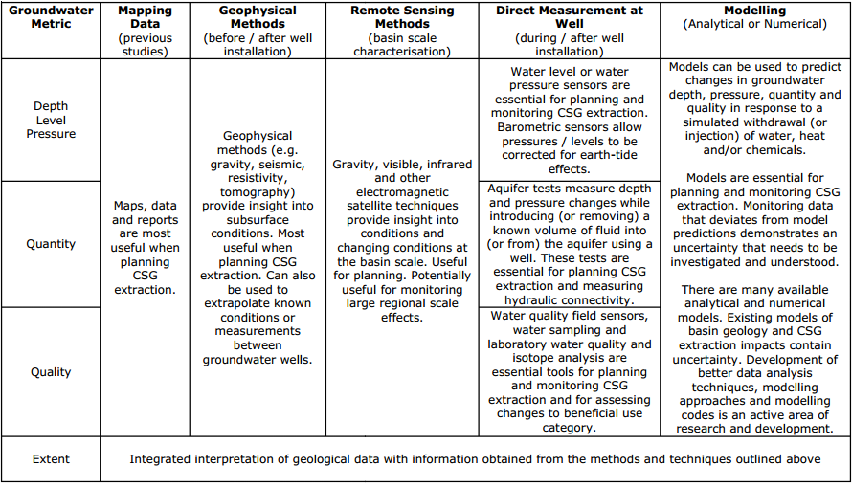

Groundwater vulnerability assessment models
The following methodologies have been developed in the European and US contexts of minimising contamination risks to sensitive groundwater systems and in some cases as a basis for defining spatial controls (zoning) for land use development.
GOD (measuring Groundwater occurrence (including recharge), Overlying lithology rating, and Depth to water rating (Foster, 1987) was one of the earliest indexing methods developed in the UK context. Key components are: ground A result of less than 0.3 is low, 0.3-0.5 moderate, 0.5 high and >0.7 extreme.
DRASTIC is a methodology developed by the US EPA and has been more widely used. It comprises 7 parameters: Depth to groundwater, net recharge, aquifer media, soil media, topography, influence of the vadose zone media, and hydraulic conductivity of the aquifer (Aller et al., 1987). Van Stempvoort et al note there is some overlap between certain criteria. Weights are assigned to each parameter on a scale of 1 to 5 – with depth to water the greatest significance (5) and topography the least (1).
The AVI (Aquifer Vulnerability Index) implicitly considers parameters used by DRASTIC (with the exception of topography and aquifer media). It seeks to estimate hydraulic resistance of aquitards to vertical flow using water well records, according to two parameters: thickness of sedimentary layers (gravel, sand, fractured till clay or shale at 0-5m; 5-10m and >10m from surface, massive till, mixed sand-silt-clay, massive clay or shale) above the shallowest aquifer and b) judge the hydraulic conductivity of each layer.
Regions are then contoured according to relative level of hydraulic resistance (isovulnerability) on a scale of 1 to 5 (extremely low, low, moderate, high and extremely high) which can be understood in terms of what the minimum thickness a particular layer must be to have a” less than extremely high vulnerability to impacts”.
Van Stempvoort et al suggest these can be used to help and thus delineate groundwater protection zones or be used for screening potential land uses. However they also recognise certain limitations: exclusion of aquifer media from assessment criteria is significant, as it influences the rate at which groundwater contamination can spread. Detailed information would be required on boundaries, flow paths and would need to be gathered from studies in-situ or data on major aquifer systems, Other parameters that are omitted are porosity and water content of the porous media, and reactivity of the layers. Each aquifer is assigned the same value, and the model does not seek to measure determinants of aquifer quality.
EPIK – Epikarst, Protective cover, Infiltration conditions and Karstic network development (Doerfliger and Zwahlen, 1998; Doerflinger et al., 1999) have been used to assess groundwater vulnerability in karst areas. For example it has been applied by the Swiss Agency for the Environment, Forests and Landscape as a standard tool for groundwater Protection zone delineation in these areas. It considers development of epikarst, effectiveness of the protective cover, conditions of infiltration and development of the karst network. Again, relative weights are assigned to each component and an equation is used to give an overall value of protection (Abdullahi, 2009).

Pathways and conditions for contamination from high volume hydraulic fracturing (shale gas) – Myers (2012)
In relation to high volume hydraulic fracturing of shale gas in the Marcellus Shale, Myers (2012) seeks to identify potential natural pathways and necessary conditions for contaminants to adversely impact water resources. Travel times of contaminants through bedrock are also estimated based on hydraulic parameters.
Several potential transport scenarios are developed based on pre-development baseline conditions and which are refined once fracturing has commenced:
1 natural upward advective flow from head drop of 30m from shale to ground surface
2 same conditions as (1) with vertical fracture connecting the surface, simulating flow into alluvial aquifers near stream channels
3 study effect of more extensive fracturing on a regional shale – considering effects on changes in flows and time to reach steady-state equilibrium
4 same conditions as (3) but with vertical fault as in (2)
5 simulate actual injection of 13-15 million litres of fluid over a 5 day period, into fractured shale from a horizontal well with and without a fault and potentiometric surface and flux changes.
Potential pathways include advective transport through sedimentary rock, fractures and faults, and abandoned wells or open boreholes. The latter pathway is not considered in his study. Myers (2012) considers actual changes in gradient and potential for buoyancy (created by difference in mass/density of water due to high TDS content) forcing water upwards as factors affecting fluid flow and concludes the potential for contaminants to enter into contact with overlying formations can occur as a result of:
• fracking out of formation
• the creation of links between fractures in the shale to overlying bedrock, or
• displacing ﬂuids from the shale into the overburden.
In reality the risk of the latter is assessed to be very low, as there is virtually no naturally permeability to allow fluids to move into the overburden except as a result of a poorly completed well, a risk which is outside the scope of the Risk Assessment (see Appendix A – Matters out of Scope for the Literature Review).

The applicability of different methodologies to conceptualise pathways such as MODFLOW-2000 and dual porosity modelling are reviewed by Myers in light of data availability and knowledge of hydrogeological conditions. Assumptions underpinning modelling in relation to geological characteristics and resource depth are set out.
Myers concludes fracking can alter the shale and overburden hydrogeology, releasing fluids and contaminants from the shale which can also result from injected ﬂuid forcing other ﬂuids out of the shale. High pressure is generated from injection of fluid, which dissipates over distance and time, key estimates of these are provided below:
• •Pressure drops back to pre-injection level within 300 days, suggesting that impacts of fracking extend beyond time at which fracking ceases.
• Potential surface contamination from advective transport could take up to tens of thousands of years however fracking could reduce this to tens or hundreds of years, and shorter lags could be experienced from preferential flow through conductive faults or fracture zones.
• Vertical ﬂow be affected over large areas depending on the density of wells that are developed in region.
A caveat with the analysis is that there is no data to verify either the pre- or post-fracking properties of the shale and hence a number of recommendations are made to improve detection of contaminant transport including mapping of subsurface faults, establishing setbacks between fracking operations and faults, establishing deep and shallow monitoring wells prior to significant resource development occurring.

Modelling regional impacts

Table AD2: Modelling Approaches, Simplifications and Uncertainty Analysis at a Project Level. (Source: Commonwealth of Australia, 2014.)
Coal seam gas Project  /Author | Modelling tool used | Modelling approach  Processes involved | Simplifications/  Assumptions | Uncertainty Analysis
Arrow Energy Surat Gas Project, Australia (Arrow Energy Pty Ltd, 2012) | MODFLOW | Regional groundwater model (120,000 km2 model domain)  Well field represented by individual abstraction wells  Cumulative impacts assessed (including other coal seam gas developments) | Dual-phase and unsaturated flow, geomechanical effects, and dual porosity nature of coal all assumed insignificant  Assessed to be limited groundwater–surface water interaction – simple (non-coupled) approach to groundwater–surface water interaction adopted  Coal horizontal anisotropy not modelled  Coal seams not modelled independently of coal measures  Hydraulic connectivity of geologic structural features ignored  (Hydraulic fracturing not proposed to be undertaken by Arrow, thus its potential impact was not required to be assessed) | Deterministic uncertainty analysis only: Sensitivity analysis for specific aquifer parameters and multiple aquifers. Effect of sensitivity-adopted parameter values on calibration performance discussed  Indicated significance of hydraulic parameters and range of drawdown magnitudes
Australia Pacific LNG  Project, Australia (Australia Pacific LNG, 2010; Geoscience Australia and Habermehl, 2010) | FEFLOW | Regional groundwater  Model (172,740 km2 model domain)  Finite element method  (FEFLOW) allows improved definition of complex geology  Dual-phase flow implicitly accounted for by reducing coal seam permeability  Cumulative impacts assessed (including other coal seam gas developments) | Geomechanical effects, and dual porosity nature of coal all assumed insignificant  Simple (non-coupled) approach to groundwater–surface water interaction adopted  Coal horizontal anisotropy not modelled  Coal seams not modelled independently of coal improved definition of complex geology  Dual-phase flow implicitly accounted for by reducing coal seam permeability  Cumulative impacts assessed (including other coal seam gas developments) | Deterministic uncertainty analysis only: Sensitivity analysis (two extreme cases only) for aquifer, recharge and stream conductance parameters.  Effect of sensitivity-adopted parameter values on calibration performance discussed  Indicated significance of hydraulic parameters and range of drawdown magnitudes
Santos Gladstone LNG Project, Australia (Santos, 2009) | Analytical model (Roma field),  MODFLOW  (Comet Ridge field) | Regional groundwater model  Model domain limited to project area  Time-varying constant head boundary condition used to represent well field (rather than pumping/flow rates) for MODFLOW model;  constant pumping rate used to represent well field in analytical model | Model not calibrated  Dual-phase flow, coal dual porosity and anisotropy, and Geomechanical effects not included  Coal seams not modelled independently of coal measures  Vertical movement of groundwater not well constrained  Aquifer confinement and interconnection simplified  Effects of geological faults assumed insignificant  Analytical modelling did not account for size of well field  Apparently no accounting of groundwater–surface water interaction | Limited deterministic uncertainty analysis:  Sensitivity analysis (four cases) for specific aquifer parameters and recharge for the MODFLOW model, and for storativity for the analytical model  Coal seam gas well fields were modelled separately and cumulative impacts associated with other developments assessed on a qualitative basis
Surat Basin (QGC, 2009) | MODFLOW | Regional groundwater model – coal seam gas region divided into three subdomains (hydraulic compartmentalisation assumed)  Time-varying constant head boundary condition used to represent well field (rather than pumping/flow rates) | Dual-phase flow, coal dual porosity and anisotropy, and geomechanical effects not included  Coal seams not modelled independently of coal measures  No consideration of rainfall recharge  Simplified geology, homogeneous isotropic conditions  Cumulative impacts not assessed  Apparently no accounting of groundwater–surface water interaction | None
Queensland Water Resources (CWC, 2012) | MODFLOW | Regional groundwater model (300,000 km2 model domain) | Modelling of historical coal seam gas operation, included simulation of multiple coal seam gas operations, was used to develop and assess cumulative impacts and aggregate groundwater extraction associated with coal seam gas extraction | Uncertainty analysis was carried out using multiple simulations incorporating changes to the model. The results of this analysis were used to assess uncertainty in the predicted impacts
Namoi Catchment (Schlumberger Water Services, 2012) |  | Regional groundwater model (30,000 km2 model domain)  coal seam gas well fields modelled  using a specified extraction rate over each well field modelled  Cumulative impacts assessed (existing and proposed developments) | Separate model of surface water system  Multi-layered model to address future coal seam gas and coal mine development. Modelling of existing, planned and possible development  Cumulative effects assessed through multiple model analyses by comparing the results for a range of alternate development scenarios with a base case of limited development  Groundwater impacts on surface water obtained using nominated head boundaries to represent permanent  Water courses | Sensitivity analyses carried out to assess uncertainty associated with rock permeability and recharge values adopted
Powder River Basin, Montana, US (Myers, 2009) | MODFLOW | Regional groundwater model  (1240 km2 model domain)  Subregional constant head boundary condition used to represent coal seam gas well field | Dual-phase flow, coal dual porosity and anisotropy not included.  Geomechanical effects assumed to have no impact  Coal seams not modelled independently of coal measures  Cumulative impacts not assessed Implicit (uncoupled) groundwater–surface water interaction | None

Table AD3: Evaluation of modelling approaches. (Source: IESC, 2014.)
Modelling approach/ purpose | Advantages | Disadvantages | Appropriate application
Analytical | Efficient and simplified analysis of all potential impacts to groundwater resources  Useful when data is limited and/or geological and hydraulic conditions are relatively simple | Unable to capture complex geologic geometries (e.g. non-uniformly layered geology) or hydraulic conditions (e.g. coal anisotropy)  May oversimplify hydraulic processes | Screening or preliminary assessment (particularly where data is severely limited)  Can be a valuable tool for modelling flow in the vicinity of individual wells
Axisymmetric | Useful for modelling relatively symmetric conditions (e.g. in vicinity of coal seam gas wells where geological conditions are axisymmetric) | Not suitable for regional scale assessment  Available tools do not consider gas desorption and migration, dual phase flow or coal dual porosity, which may pose inaccuracies in predicting impacts  Not capable of assessing cumulative impacts | Assessment of impacts in the near-well (or near-field) under axisymmetric conditions  Can be a valuable tool for modelling flow in the vicinity of individual wells
Reservoir assessment | Designed (and therefore best suited) to predict produced water volumes and depressurisation and in the near-field.  Can model near-field produced water re-injection.  Tools do not consider groundwater–surface water interaction  Most tools account for geomechanical processes, gas desorption and migration, dual phase flow and coal dual porosity, as well as complex geological conditions | Reservoir assessment | Assessment of impacts to groundwater (not surface water) in the near-field (but not water quality)  Used for design of coal seam gas well networks
Regional Groundwater Impact Assessment | Tools practicable for regional scale impact assessment  Capable of representing complex geology, assessing cumulative impacts and changes to groundwater quality | Generally ignores geomechanical processes, gas desorption and migration, dual phase flow and coal dual porosity; this may create inaccuracies | Regional-scale assessment of impacts, water quality, re-injection and cumulative impacts

Appendix AE Methodologies used to assess groundwater vulnerability

Victoria – State Environment Protection Policy
The State Environment Protection Policy (Groundwaters of Victoria) 1997 establishes water quality objectives and indicators based on Total Dissolved Content concentrations for various Beneficial Uses of groundwater as outlined in tables AE1 and AE2 below.

Table AE1: SEPP Beneficial Uses to be Protected and Groundwater Quality Indicators (mg/L of Total Dissolved Solids), (source: Victorian Government Gazette, 1997).
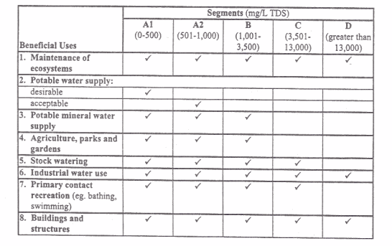

Table AE2: Groundwater quality indicators and objectives by beneficial use. (Source: Victorian Government Gazette, 1997.)
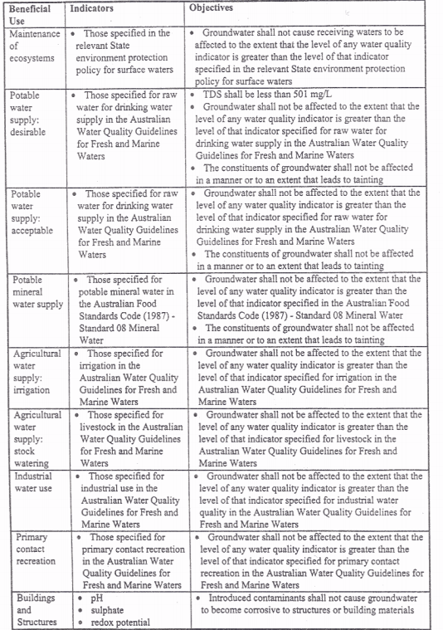

Connecticut’s groundwater classification system
Connecticut’s Water Quality Standards comprise three components:
- Standards, which assign water quality goals, allowable discharges
- Classification and Criteria, which set out water quality classes, designated uses and criteria that must be achieved (chemical or physical levels, or bacterial concentrations)
- Classification maps, illustrating what classification is assigned to specific surface or groundwater assets based on their designated use.
The water quality classification system is comprised of several classes for different types of water resources, including 5 classes for inland surface waters, and 4 classes for ground water (GAA, GA, GB, and GC) – see Table AEAE3.

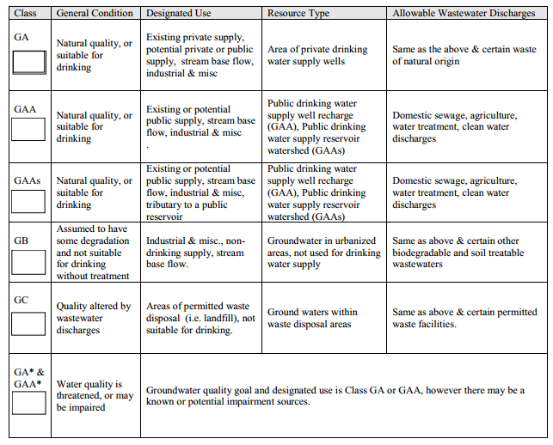
Table AE3: Connecticut’s Groundwater Quality Classes. (Source: Connecticut Environmental Conditions Online, 2010.)

Appendix AF Controls

Setback distances from sensitive receptors in the US

Table AF1: Setback distances from water resources and private dwellings in various US states. (Source: NYSDEC, 2009.)
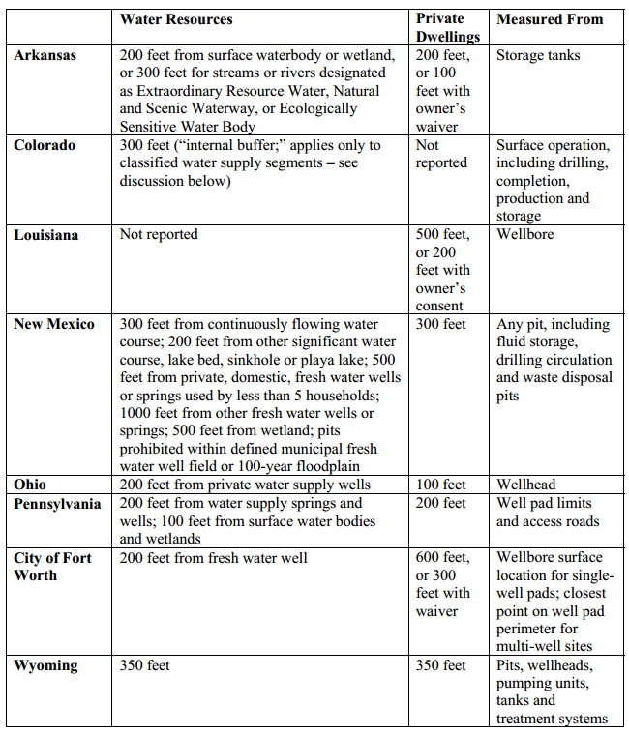

Technical assistance provided to the New York State Department of Environmental Conservation (NYSDEC, 2009) by ICF included a review of setback distances from water resources and private dwellings across several US states – see Table AF1.
The following section transcribes the NYSDEC (2009) proposed setback distances in relation to well drilling and high-volume hydraulic fracturing.
“An application for a permit to drill less than 305 metres from a municipal water supply well be considered "always significant" and requires a site-specific supplemental EIS to assess groundwater hydrology, potential impacts and propose mitigation measures.
Site disturbance for multi-well pads and high-volume hydraulic fracturing be prohibited within 610m of any public (municipal or otherwise) water supply well, reservoirs, natural lake or man-made storage system.
For at least two years the surface disturbance associated with high-volume hydraulic fracturing, including well pad and associated road construction and operation, be prohibited within the boundaries of primary aquifers and outside but within 120 metres of their boundaries.
A site-specific SEQRA review (Environmental Impact Assessment) be required for high-volume hydraulic fracturing projects at any proposed well pad within 120 metres of the boundary of a Principal Aquifer.
It will not issue well permits for high-volume hydraulic fracturing within 120 metres of a private water well or domestic-supply spring, unless waived by the landowner.
The preliminary revised draft SGEIS document (2011) confirmed that irrespective of the intended formation and number/direction of wells to be drilled, site-specific environmental assessments and SEQRA determinations of significance would be required for the following types of HVHF applications:
1 Any proposed high-volume hydraulic fracturing where the top of the target fracture zone is shallower than 610 metres along a part of the proposed length of the wellbore
2 Any proposed high-volume hydraulic fracturing where the top of the target fracture zone at any point along the entire proposed length of the wellbore is less than 305 metres below the base of a known fresh water supply
3 Any proposed well pad within the boundaries of a principal aquifer, or outside but within 150 metres of the boundaries of a principal aquifer
4 Any proposed well pad within 45 metres of a perennial or intermittent stream that is not a tributary to a public drinking water supply, storm drain, lake or pond
5 A proposed surface water withdrawal that is found not to be consistent with the Department’s preferred passby flow methodology
6 Any proposed well location within 305 metres of New York City Department of Environmental Protection’s subsurface water supply infrastructure.”

Principles for mitigating coal seam gas impacts
The National Harmonised Regulatory Framework sets out 18 principles for managing potential coal seam gas impacts across the lifecycle of a typical development. Most of these practices would address risks to more than one of the four areas of concern: well integrity, water management, hydraulic fracturing and chemical use. See Table AF2 below for further details.

Table AF2: Leading practices to mitigate potential impacts from coal seam gas.
(Source: SCER, 2013.)
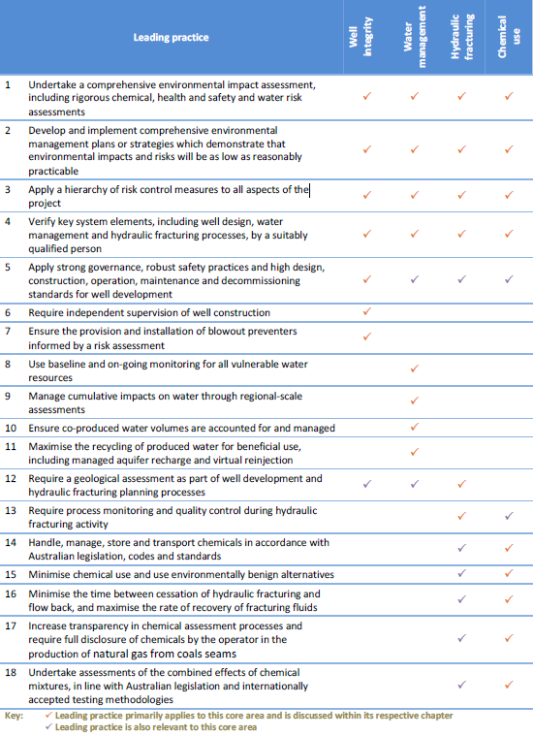

Appendix AG Consequence

Principles to define significant impact – National Partnership Agreement
According to the National Partnership Agreement, a significant impact on water resources is caused by an action (or the effect of several actions) – that would directly or indirectly:
• result in substantial change in the quantity, quality or flow regimes of surface water or groundwater
• substantially alter groundwater pressure and/or watertable levels
• alter the ecological character of a wetland that is state or nationally significant or Ramsar-listed
• divert or impound rivers or creeks or substantially alter drainage patterns
• reduce biological diversity or change species composition or ecosystem processes
• alter coastal processes and inland processes, including sediment movement or accretion, or water circulation patterns
• result in persistent organic chemicals, heavy metals or other potentially harmful chemicals accumulating in the environment such that biodiversity, ecological integrity, human health or other community and economic use may be adversely affected, or
• substantially increase demand for – or reduce the availability of water for – human consumption or ecosystem services.

Figure AG1: Ecological Valuation and Risk Assessment process. (Source: NSW Office of Water, 2012.)

NSW aquifer interference policy: Minimal impact considerations for aquifer interference activities
The following tables sourced from the NSW Aquifer Interference Policy provide quantitative thresholds against key water characteristics (level, pressure, quality) for highly productive and less productive groundwater resources (refer to ‘Receptors’ section in body of the Literature Review for a definition of these) in different groundwater systems.
Note that individual criteria have been established for the Great Artesian Basin groundwater sources on the basis of its particular hydrogeology and management profile.

Table AG1: Minimal impact considerations for watertable, pressure and quality thresholds by category of highly productive groundwater sources (alluvial, coastal sands, porous rock, fractured rock and Great Artesian Basin). (Source: NSW Office of Water, 2012.)
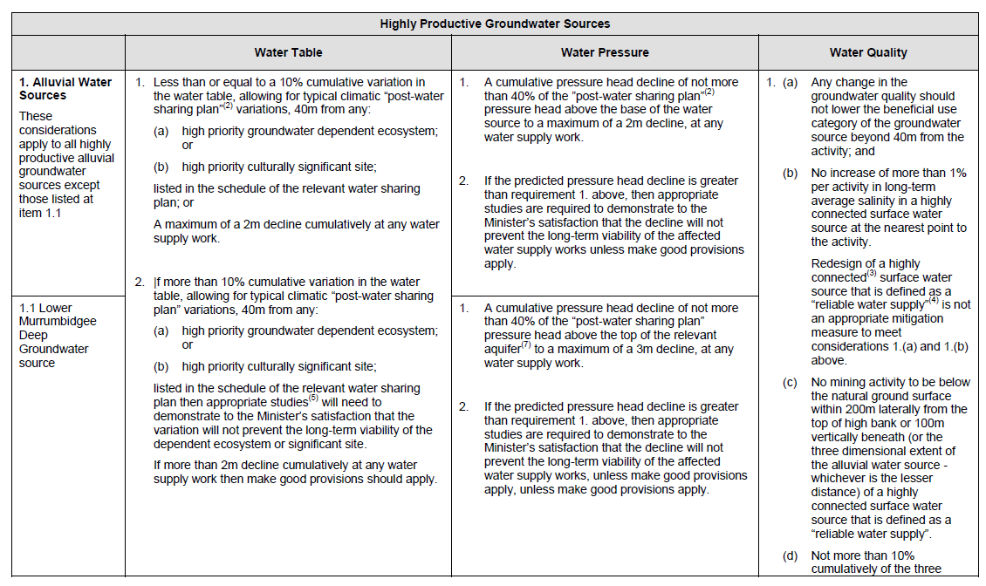
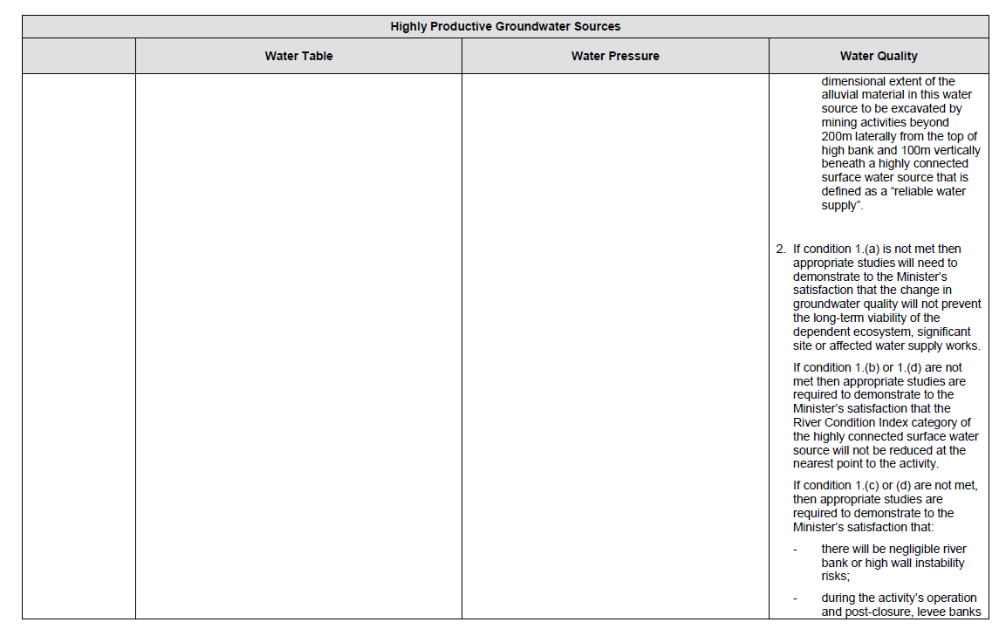
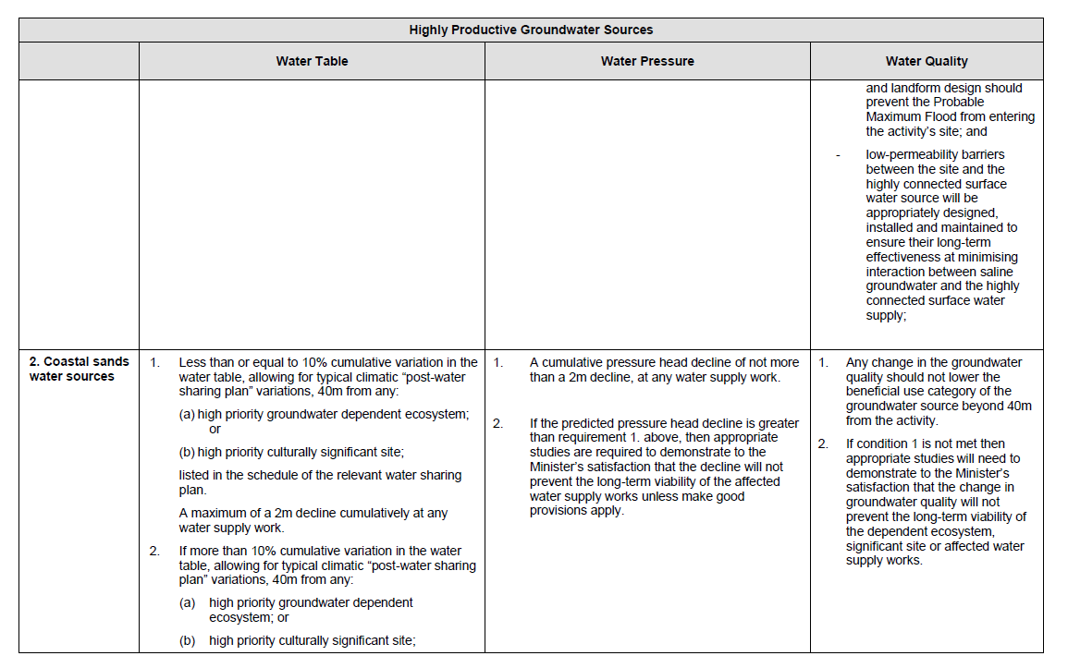
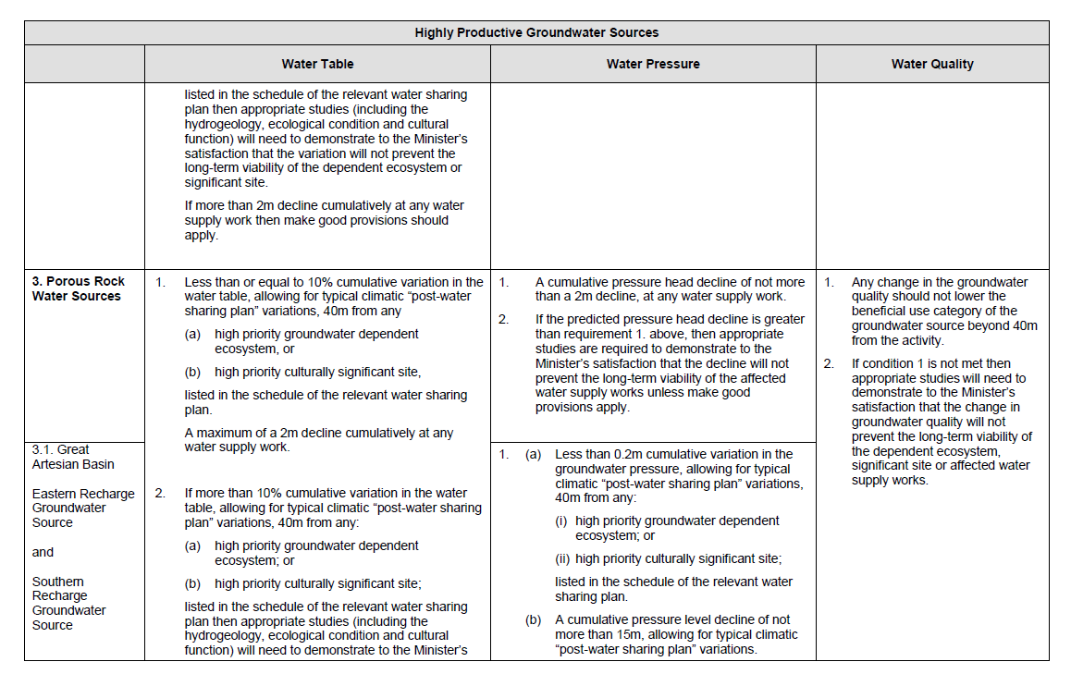
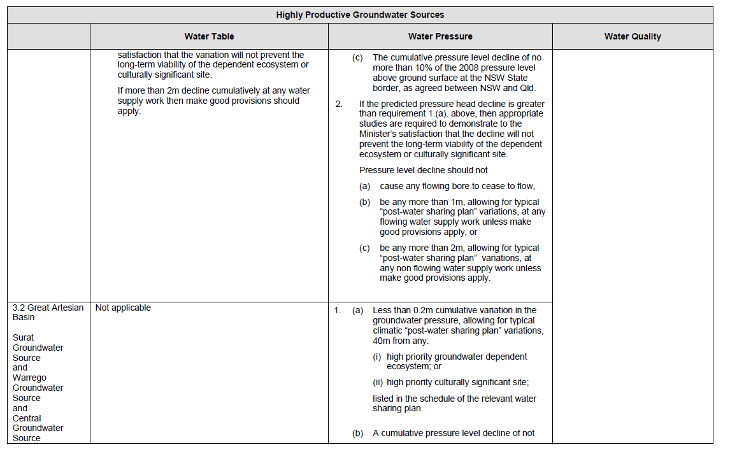
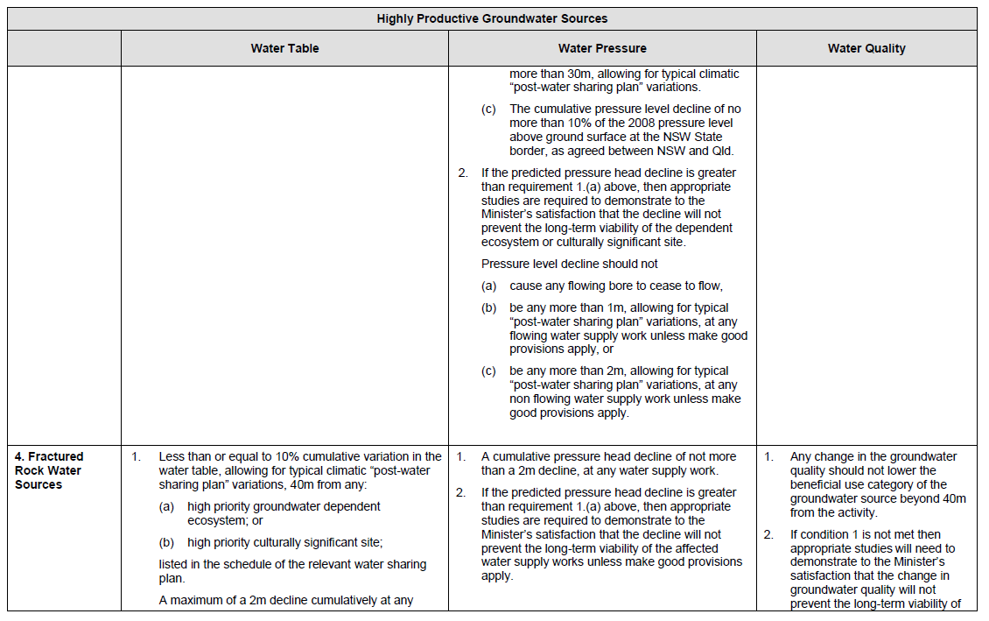
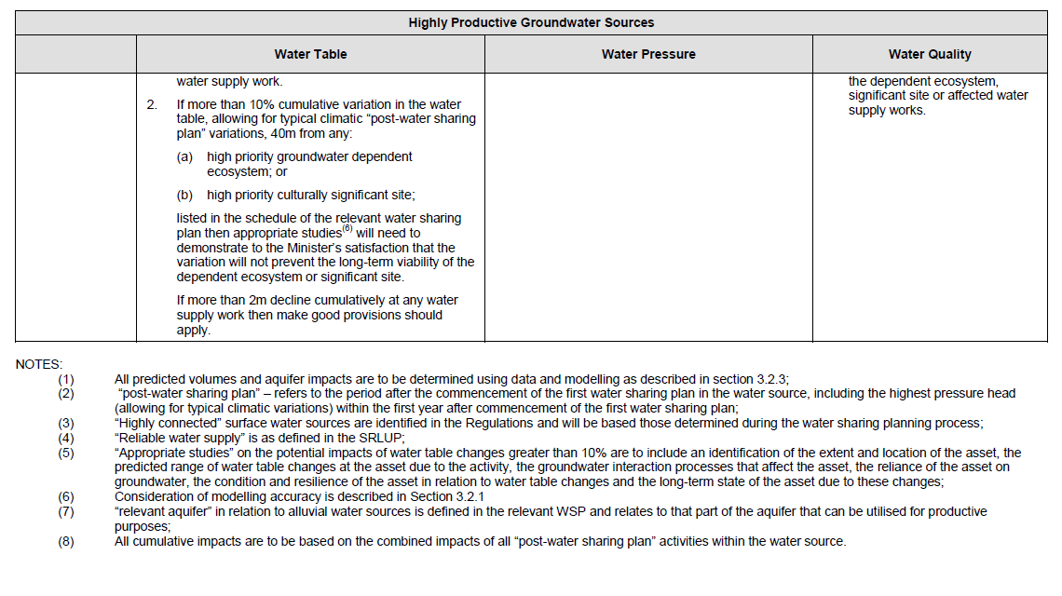

Table AG2: Minimal impact considerations for watertable, pressure and quality thresholds by category of less productive groundwater sources (alluvial, porous rock, fractured rock). (Source: NSW Office of Water, 2012.)
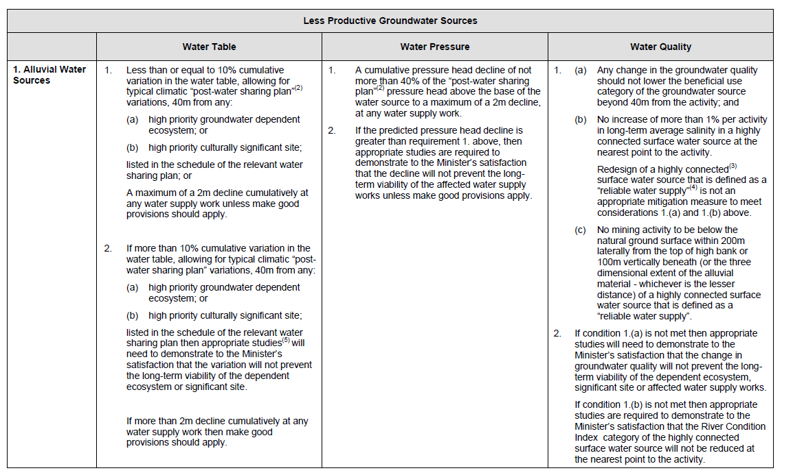
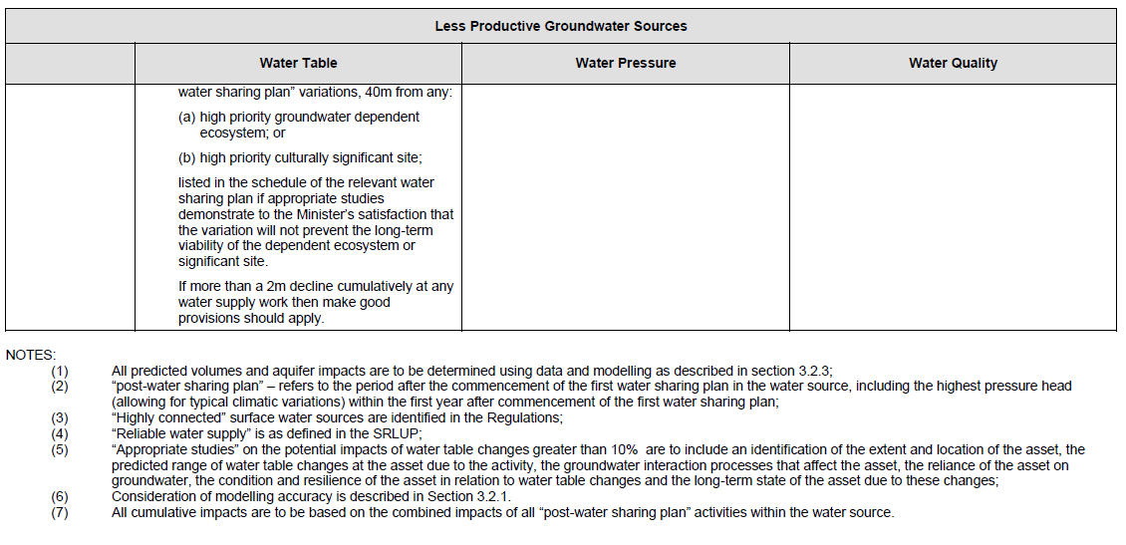

DMITRE (2013) Manageability and predictability criteria as determinants of environmental significance.
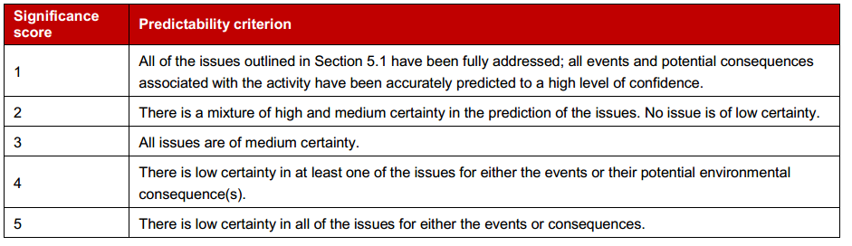
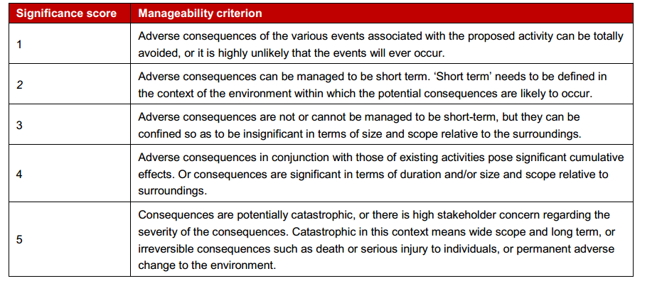
Figure AG3: Guidance to determine manageability score (source: DMITRE, 2013)

Tools to inform impact analysis IESC (2014)
IESC (2014) outlines that impact analysis should draw on conceptual models, analysis of thresholds, carrying capacity and ecotoxicology, numerical modelling of direct impacts, and numerical and conceptual modelling of pathways to assess indirect and cumulative effects.
• Direct impacts should be assessed using satellites and ground movements from Geodetic GPS systems, such as InSAR.
• Indirect impacts should be considered through impact pathways, via model functions which quantitatively link influence of direct impact on indirect impacts of each receptor. Confidence in determined impact level can be assessed through an impact analysis model.

Table AG4: Qualitative risk matrix example (source: ACOLA, 2013).
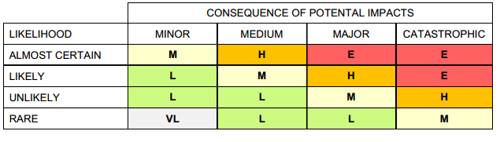

Appendix B:
Gippsland region assessment method

Contents
B1 Introduction 189
B1.1 Onshore natural gas resources 189
B2 Hazard/pathway/receptor model 190
B2.1 Hazard 190
B2.2 Pathway 190
B2.3 Receptors 191
B3 Aquifer depressurisation 192
B3.1 Introduction 192
B3.2 Definition of impact 192
B3.3 Hydraulic connection between groundwater and receptors 193
B3.4 Definition of drawdown 195
B4 Chemical contamination of groundwater from hydraulic fracturing fluids 197
B5 Induced seismicity 198
B6 Land subsidence 198
References 198

B1 Introduction
This report describes the method used for the impact assessment of possible future onshore natural gas developments in the Gippsland region. The assessment framework was informed by a literature review on approaches to impact and risk assessments for onshore gas development, which is presented in Appendix A of the main report.
A key assumption for the assessment is that existing regulations and guidelines (based on leading practices) are applied which ensure that operational impacts are manageable. The assessment therefore conveys the residual impacts of a gas development activity that is established and operated in accordance with current regulations. The assessment of potential impacts on water resources will be based on normal operations. This project is not considering potential impacts associated with failures of process or controls, such as poor well integrity.

B1.1 Onshore natural gas resources
The impact assessment has assessed hypothetical development of the following potential onshore natural gas resources in the Gippsland region:
• tight and shale gas (i.e. assessed as a single resource)
• coal seam gas (from brown coal deposits).
Figure B1 shows the areal extent of the hypothetical gas development scenarios adopted for this assessment (from Goldie Divko, 2015). Further information on potential gas resources is included in the conceptual model description in Chapter 4 of the main report.
Hypothetical development of onshore conventional gas, and coal seam gas from black coal, is not included in this impact assessment, as there is significant geological uncertainty associated with the prospectivity and location of such gas types in the Gippsland Region.

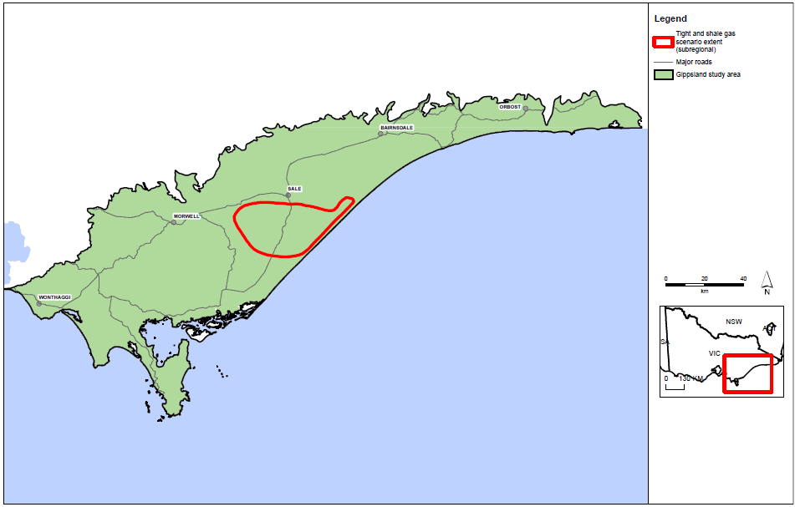
Figure B1: Extent of potential tight and shale gas in Gippsland. (Source: Goldie Divko, 2015.)

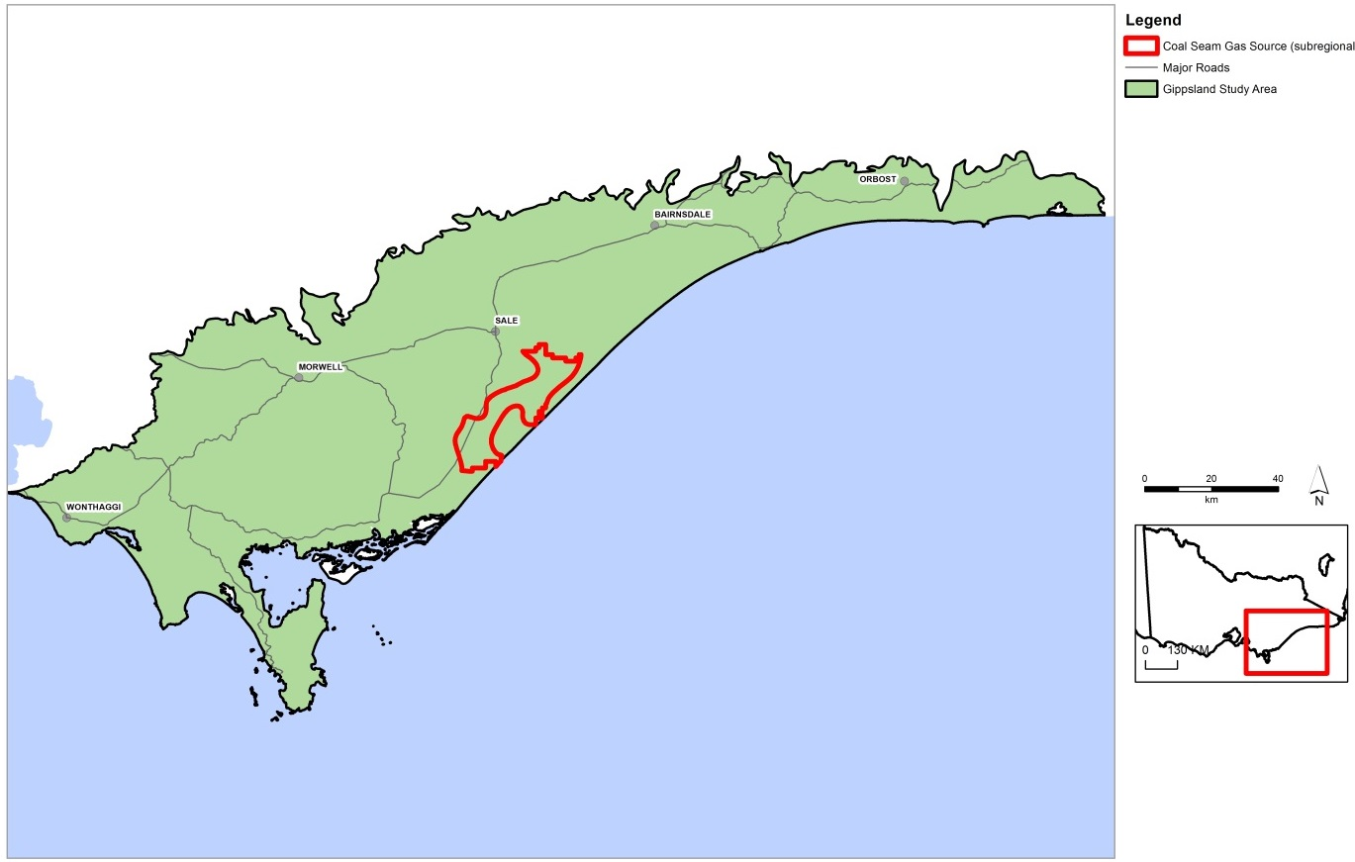
Figure B2: Extent of potential coal seam gas in Gippsland. (Source: Goldie Divko, 2015.)

B2 Hazard/pathway/receptor model
The impact assessment framework is based on the hazard/pathway/receptor model to assess the potential impacts on receptors (water resources) resulting from possible future onshore gas development. For a potential impact to exist, all three components need to be present: a hazard, a receptor that could potentially be adversely affected, and a pathway to link the two.

B2.1 Hazard
Four key hazards for water resources have been assessed in the Gippsland region:
1 aquifer depressurisation
2 chemical contamination of groundwater from hydraulic fracturing fluids
3 induced seismicity
4 land subsidence.
Depressurisation of aquifers associated with onshore gas development is the key hazard assessed in this impact assessment. For the development scenarios, numerical modelling was undertaken to assess aquifer depressurisation and resulting drawdown, which then feeds into the impact assessment. The modelling method is described in Section 2.3.
While changes in aquifer pressure are also associated with hydraulic fracturing, induced seismicity and land subsidence, these hazards have multiple causes (i.e. well failure and re-injection of coproduced water) that are more appropriately assessed within the project-specific approvals process. Due to the broad context of this study, the assessment of causes of potential impacts associated with these hazards have been based on a review of international literature review rather than a modelling approach.

B2.2 Pathway
The hazards associated with gas extraction arise largely because of the possibility that altered fluid pore pressure in a gas source formation which may be transmitted to overlying (or underlying) aquifers or aquitards. The impact pathway is determined by the potential for pressure reductions in the gas source formation to propagate through the adjacent hydrogeological units and cause drawdown in overlying or underlying aquifer(s). For drawdown to adversely impact receptors, it must occur in the aquifer that supports the receptor. This means that a surface water receptor can be impacted only if there is a pathway that allows drawdown to propagate from the gas source to the watertable aquifer.
A hydrogeological conceptual model was produced in order to understand the hydrogeological pathways that have the potential to connect possible gas developments with overlying water resources. The hydrogeological conceptual model outlines:
• stratigraphy and gas source formations for onshore gas extraction, key usable aquifers in the basin and significant groundwater dependent assets (receptors)
• potential hydrogeological pathways between the source and the receptors
• potential low permeability layers between the source and the receptors
• aquifer parameters (e.g. K_{h}, S and K_{v}).
The hydrogeological conceptual model informs the impact assessment approaches and is presented in Chapter 2 of the main report.

B2.3 Receptors
This assessment considers the potential impacts of onshore gas development in three types of water resources, or receptors:
• aquifers (which support groundwater users)
• rivers (which support surface water users and ecosystems)
• water bodies (wetlands and lakes which support surface water users and ecosystems).
The water resources included in the impact assessment are identified by the following attributes:
• surface water assets (rivers and water bodies) as listed in the Victorian Water Assets Database (VWAD)
• aquifers as defined in the Victorian Aquifer Framework (VAF) and incorporated into the DEPI SAFE scheme with a mapped salinity less than 3500 mg/L.
The surface water resources assessed in this assessment are shown in Figure B3. These assets have been generated using the Victorian Water Assets Database, which is a geospatial database of water asset features that has attributes disaggregated from the Water Asset Identification Project database(GHD, 2014). The surface water resources shown in Figure B3 includes all rivers and creeks but exclude those classified as irrigation channels, drains, structures or farm dams.
In this study the potential impacts on springs are not specifically assessed. Instead it is assumed that wherever an impact on a surface water asset and the watertable is high, impacts to springs are also high.
Terrestrial vegetation has also been excluded, because dependence on groundwater is highly variable and site-specific. Further work is required to accurately identify and characterise terrestrial vegetation ecosystems to incorporate them into the assessment framework.

Figure B3: Gippsland study area potential onshore gas development locations and surface water resources.

B3 Aquifer depressurisation

B3.1 Introduction
Aquifer depressurisation can affect water resources by changing the groundwater level in adjacent aquifers. This water level change occurs if water drains from aquifers into gas source formations when pressure is reduced in the source formation by gas and water extraction. The change in water level is normally expressed as drawdown, or a change in the pressure level in an aquifer. For example in the watertable, the drawdown would be expressed as the drop in the level of the watertable, in metres.
To assess the potential impact of aquifer depressurisation on water resources it is necessary to assess:
• the potential hydraulic connection between groundwater and receptors
• the potential drawdown that may result from gas development.

B3.2 Definition of impact
The potential impact on a receptor class from aquifer depressurisation is based on the potential for the receptor class to be connected to groundwater (represented by depth to watertable in metres), and the potential effect of aquifer depressurisation (represented by predicted drawdown in metres).
The impact matrix showing the combinations of potential connection and effect of aquifer depressurisation to evaluate overall potential impact is presented in Figure B4. If a receptor class has a low potential connection to groundwater (deep watertable) and drawdown is predicted to be low, the potential impact on the receptor class is considered to be low. Conversely, the potential impact on a receptor class with high connection (shallow watertable) and a high potential drawdown will be high.
Further information on the criteria adopted for defining connection and drawdown is presented in the following sections.
The potential impacts to receptor classes have been assessed for hypothetical gas field development scenarios over a timeframe of 30 years, as this is an indicative project life cycle of possible future natural gas developments. Different potential effects may result if a longer time frame was to be used.
The results are presented in summary figures in this report. The full set of potential connection, effect and overall impact is available as a separate volume.

Connection between receptor class and groundwater | High | HC / LD | HC / MD | HC / HD
Connection between receptor class and groundwater | Moderate | MC / LD | MC / MD | MC / HD
Connection between receptor class and groundwater | Low | LC / LD | LC / MD | LC / HD
 |  | Low | Moderate | High
 | Groundwater drawdown
Key: HC = high connection, MC = moderate connection, LC = low connection
HD = high drawdown, MD = moderate drawdown, LD = low drawdown
Figure B4: Potential impact on receptors due to aquifer depressurisation.

The potential impacts on water resources have been assessed for full gas field development over a timeframe of 30 years, as this is an indicative project life cycle of possible future natural gas developments. Different impacts may result if a longer time frame was to be used.
The impact assessment process for aquifer depressurisation requires the initial or current depth to watertable (to indicate potential connection) and both mean and maximum predicted drawdown (to indicate potential effect) for a gas development scenario.
For surface water receptors, combining the rankings for connection and drawdown at 100 m² resolution across the region delivers the inherent impact ranking for surface water resources in that local 100 m² area. For aquifers only drawdown is used to indicate impact, as all aquifers are inherently connected to groundwater.

B3.3 Hydraulic connection between groundwater and receptors
In this assessment the potential hydraulic connection between groundwater and receptors is represented by depth to groundwater. The use of this metric is consistent with other groundwater dependent ecosystems studies, including the groundwater dependent ecosystems Atlas (Bureau of Meteorology, 2012) and the groundwater dependent ecosystems Toolbox study (NWC, 2011).
In the case of surface water receptors (rivers, lakes and wetlands), the potential connection to groundwater is classified as:
• low for deep watertables
• moderate for moderate depth watertable
• high for shallow watertables.
In the case of aquifers, connection to groundwater is inherent and therefore the potential connection is always high.
The rules for defining these three categories are outlined in Table B1. These rules were defined based on whether the surface water resource was expected to be gaining, variable gaining and losing, or losing or disconnected (DELWP pers. comm. 2015).
For shallow watertables (< 2 m below the surface) there is a high potential connection with surface water; that is, surface water bodies may gain water from groundwater. Where the watertable is more than 6 m below the surface, surface water has a lower potential connection to groundwater.

Table B1: Rules for defining the potential connection of water receptors to groundwater.
Water receptor | Low connection | Moderate connection | High connection
Rivers | Initial depth to watertable (before gas development) is greater than 6 m | Initial depth to watertable (before gas development) is between 2 and 6 m | Initial depth to watertable (before gas development) is less than 2 m
Water bodies (lakes, wetlands)
Aquifers | n.a. | n.a. | Inherent connection to groundwater

The depth to watertable data used for this project is the mapping developed as part of DELWP’s SAFE database. The data has a resolution of 100 m² grid cells and was classified into the hydraulic connection categories of low (> 6 m), moderate (between 2 and 6 m) and high (< 2 m).
Compilation of the watertable geometry (elevation and depth) required a number of data types. Principal among these were well-distributed bore readings of watertable depth and a model of the terrain surface. For the methodology adopted for this project, broad mapping of the surface aquifers across the project area was also required.
Surface aquifer mapping was sourced from the Victorian component of the National Groundwater Information System. Bore readings were obtained from a number of existing Sinclair Knight Merz (SKM) projects specific to regions within the state and the Victorian Stratigraphic Database, compiled for the Victorian component of the National Groundwater Information System (SKM and GHD 2010). To ensure only bores suitable for modelling the watertable were adopted, data from the database was limited to those bores less than or equal to 50 m deep.
Compilation of the watertable geometry utilised two main methodologies. The first involved a terrain
analysis technique based on the premise that the watertable is a smoothed and subdued reflection of topography. Within the basement areas of the watertable aquifer the result of this analysis was adopted as the watertable model. The second method involved using the available bore data and the output from the first method as input to the surface modelling utility ANUDEM (Ref. ANU001) to generate the watertable model for each CMA.
Figure B5 shows the data classified according to the connection categories. As discussed above, in the case of aquifers, connection to groundwater is inherent and therefore the potential connection is always high.
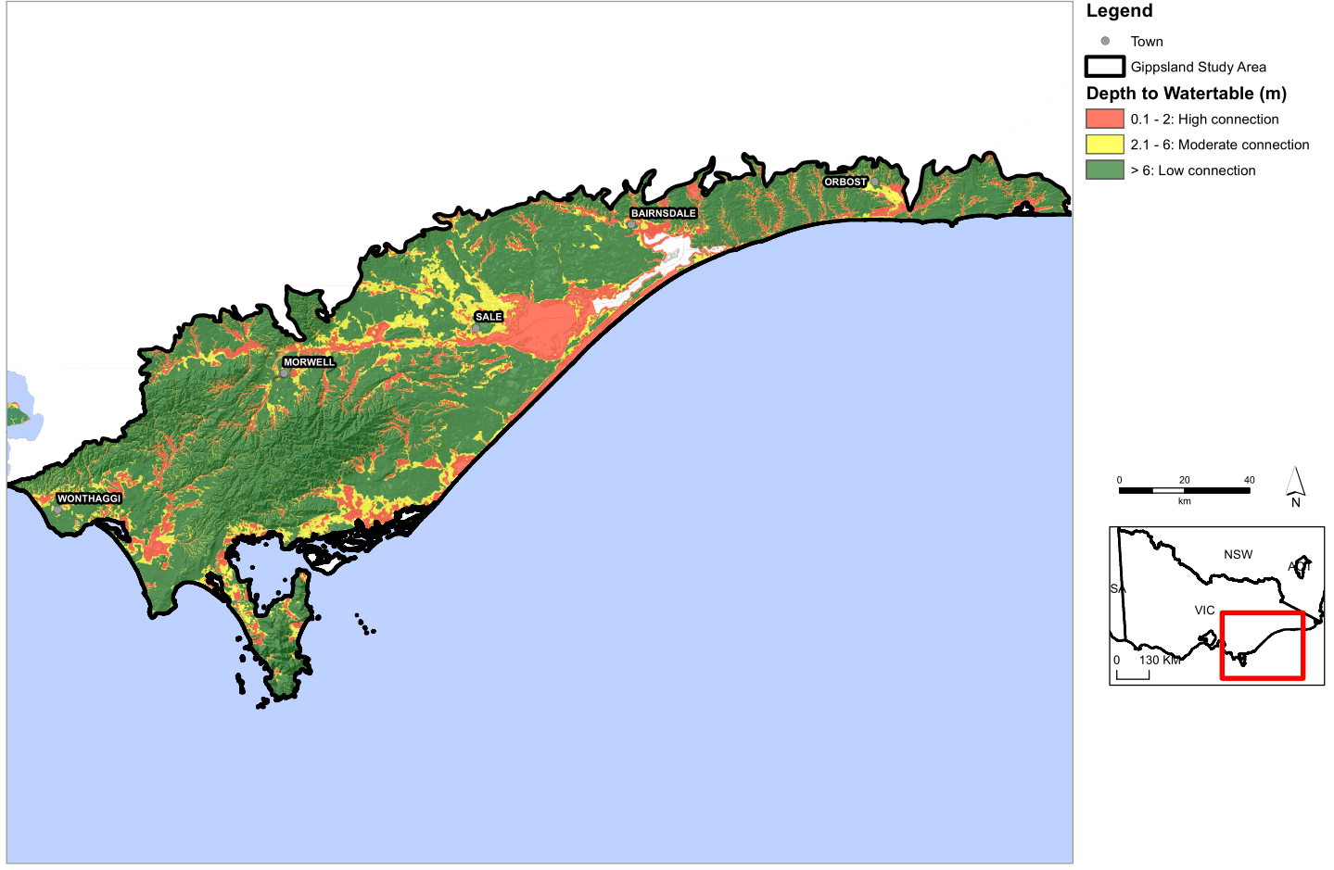
FigureB5: Depth to watertable in the Gippsland study area (initial conditions for this project), derived from DELWP’s SAFE project data (source: SKM and GHD 2010)

B3.4 Definition of drawdown
For this assessment the potential effects on water resources of aquifer depressurisation is based on the predicted drawdown.
Rules were defined which classified the effect on water resources of drawdown from each hazard as Low, Moderate or High. These rules are outlined in Table. For surface water receptors, the delineation of the ‘Low’ category (i.e. 0.1 m) was based on the minimum change in water level that could reasonably be expected to be measured in the field (DELWP pers. comm. 2015). The potential for a material adverse effect on a surface water receptor due to a drawdown of less than 0.1 m is considered to be low.
The upper limit of 2.0 m is based on previous studies which measured a maximum annual variation in water level of 2.0 m in south-western Victoria (Dresel et al., 2012). In the case of aquifers, the definitions of categories were based on advice from DELWP (pers. comm. 2015).

Table B2: Rules for defining the potential effect on water receptors of groundwater drawdown.
Water receptor | Low drawdown | Moderate drawdown | High drawdown
Rivers | Drawdown in watertable aquifer < 0.1 m after 30 years | Drawdown in watertable aquifer between 0.1 m and 2 m after 30 years | Drawdown in watertable aquifer > 2 m after 30 years
Water bodies (lakes, wetlands) | Drawdown in watertable aquifer < 0.1 m after 30 years |  | Drawdown in watertable aquifer > 2 m after 30 years
Unconfined aquifer | Drawdown < 2 m after 30 years | Drawdown between 2 m and 15 m after 30 years | Drawdown > 15 m after 30 years
Confined aquifer | Drawdown < 10 m after 30 years | Drawdown between 10 m and 75 m after 30 years | Drawdown > 75 m after 30 years

Drawdown was modelled for the Gippsland region using a numerical model by Beverly et al., (2015, in prep). The next section describes the modelling method used to predict drawdown.

Numerical modelling approach for predicting drawdown
A numerical model was developed for the Gippsland region to assess potential groundwater drawdown due to possible onshore gas development. With reference to Table, this was done by:
- Modelling and calibrating a “baseline” scenario of existing groundwater use in a dry climate
- Modelling hypothetical onshore gas development scenarios in combination with the baseline scenario
- Comparison of the hypothetical onshore gas development scenarios against the baseline scenario to assess potential groundwater drawdown due to possible onshore gas development.
The model predicts the amount of drawdown in aquifers and the watertable that could be caused by depressurising the gas source formations. Drawdown results from the model were provided using a 29 layer model with a 100 m by 100 m scale for hypothetical development of tight and shale gas and coal seam gas in Gippsland.
Groundwater use has remained fairly steady over the 10 years from 2002 to 2012 (Beverly et al., 2014). A dry climate (based on 2006 data for rainfall and temperature) was used over the 30 year modelling period. As groundwater use is not expected to increase significantly in the future and the purpose of the modelling is to assess the potential impacts on onshore gas developments, the baseline groundwater use was based on:
- licensed entitlement: the average use over the period 2002 to 2012
- domestic and stock: 1.5 ML/year for each bore that is less than 30 years old.
Six potential development scenarios were modelled for the Gippsland region, as shown in Table that included the existing offshore oil and gas and the Latrobe Valley mine operations. For the impact assessment the 50% and full development scenarios (TableB3) have been used to assess potential impacts. The predictions were run for a 30 year period from 1 January 2013, which assumes that the baseline and potential gas developments were fully established from 1 January 2013.

Table B3: Development scenarios tested in the Gippsland numerical model. For the impact assessment, scenarios 2 and 4 have been used.
Scenario | Climate | Latrobe Valley coal mines | Other groundwater licence entitlement | Offshore oil and gas | Onshore natural gas project
1 (baseline) | Dry | Average usage over 10 years | Average usage over 10 years | Average usage over 10 years | None
2 (coal seam gas) | As above | As above | As above | As above | Coal seam gas, 100% of available gas extracted
3 (coal seam gas 50%) | As above | As above | As above | As above | Coal seam gas, 50% of available gas extracted
4 (tight and shale) | As above | As above | As above | As above | tight and shale, 100% of available gas extracted
5 (tight and shale, 50%) | As above | As above | As above | As above | tight and shale, 50% of available gas extracted
6 (coal seam gas & tight and shale, 50%) | Dry | As above | As above | As above | Coal seam gas & tight and shale, 50% of available gas extracted

The aquifer and aquitard structure and parameters are defined in the numerical model (Beverly et al. 2014, in prep). A summary of the model layers is provided in Appendix C of the main report.
Although in some cases there are multiple aquifers and aquitards within a single Victorian Aquifer Framework layer, the drawdown is presented as the mean drawdown for each Victorian Aquifer Framework aquifer layer. The mean drawdown is considered the best approach for assessing potential impact, however to demonstrate the variation in drawdown predictions, the maximum drawdown is also included in Appendix D that accompanies this report.
The drawdown results from the numerical modelling are presented in Appendix D of the main report, and have been used directly in the assessment of potential impacts associated with aquifer depressurisation at the regional scale.
The impact assessment utilised drawdown results from Scenario 2 (100% coal seam gas development) and Scenario 4 (100% tight and shale gas development) compared to the baseline (Scenario 1) drawdown results and are presented in Chapter 3. The results from the other scenarios at reduced development also used to assess implications to inform mitigation of potential risks in Chapter 7 of the report.

Numerical modelling of long term impacts
In order to assess the long term impact of a development scenario, the model run was extended to determine water level trends 100 years after the end of the 100% coal seam gas development scenario and the results are provided in the model report.
Results based on 766 groundwater calibration bore hydrograph trends estimate that 74% of calibration bores return to baseline or improved trends following cessation of coal seam gas abstractions after 100 years.

B4 Chemical contamination of groundwater from hydraulic fracturing fluids
The approach to assessing potential impacts associated with chemical contamination of groundwater from hydraulic fracturing fluids assumes that hydraulic fracturing is conducted according to the appropriate regulatory guidelines and that appropriate controls are in place during a fracture episode.
The potential impacts from hydraulic fracturing on reservoirs and aquifers is an area of intense study and the subject of many published reports. Importantly, the actual impact of fracturing depends on a number of elements that are very specific to a well, in particular the specific site and most especially the well construction methods and hydraulic fracturing operations. Given the site specific nature of the potential risks associated with hydraulic fracturing, the qualitative risk assessment is based on international literature.
The impact assessment describes the features and elements of hydraulic fracturing that lead to the creation of a pathway or the enhancement of a pathway between the gas source and the water resources. In cases where hydraulic fracturing has caused adverse impacts, the primary cause has been attributed to surface infrastructure failure, poor well integrity or insufficient monitoring during the hydraulic fracturing operations to alert operators to an issue. The purpose of the literature review is to determine if there are any cases where fractures have propagated beyond the target formation, and whether any conclusions have been drawn on maximum fracture propagation distances, minimum thicknesses of overlying aquitard or distance to nearest high value groundwater resource. The key impact assessed is that hydraulic connection between the gas source and the adjacent aquifer is significantly increased as a result of hydraulic fracturing.
The findings in the main report use literature to assess the in-situ hydrogeological factors that may contribute to fracture propagation beyond the target zone and an assessment of their distribution across each region.

B5 Induced seismicity
Induced seismicity has been detected at a number of locations around the world and is typically associated with re-injection of co-produced water. Given the range of causes of induced seismicity, the potential impact of induced seismicity has been assessed through a review of international literature. Recent publications have documented the international literature and reviewed key risk factors for induced seismicity and how they can be managed. These are described in the specific context of the Gippsland region so that the elements that influence induced seismicity can be put into context.
The findings in the main report use the literature to assess the potential for induced seismicity across
each region.

B6 Land subsidence
The potential impacts of land subsidence as a result of gas extraction are assessed through a literature review. The literature review uses a number of recent literature reviews undertaken for the Independent Expert Scientific Committee on Coal Seam Gas and Large Coal Mining Development that reports to the Federal Government in addition to studies undertaken in Gippsland.
The findings in the main report assesses the potential for land subsidence as a result of aquifer depressurisation in the Gippsland region.

References
DEDJTR, 2015. Onshore natural gas water science studies — Gippsland groundwater model. Department of Environment, Land, Water and Planning and the Department of Economic Development, Jobs, Transport and Resources, Melbourne. June 2015.
BUREAU OF METEOROLOGY, 2012. Atlas of groundwater dependent ecosystems. http://www.bom.gov.au/water/groundwater/gde/ Accessed 12th Dec 2014
COOK, P., BECK, V., BRERETON, D., CLARK, R., FISHER, B., KENTISH, S., TOOMEY, J. AND WILLIAMS, J., 2013. Engineering energy: unconventional gas production. Report for the Australian Council of Learned Academies (www.acola.org.au).
DRESEL P. E., ZYDOR H., HEKMEIJER P., ADELANA M., 2012. Catchment scale impacts of land use in south-western Victoria. Department of Primary Industries, Victoria.
GHD, 2013. Report on the development of state-wide 3D aquifer surfaces. Report for the Department of Sustainability and Environment, Victoria (unpubl.).
GHD, 2014. Water Asset Identification Project, State Report. Report prepared for the West Gippsland Catchment Management Authority.
GOLDIE DIVKO, L.M., O'BRIEN, G.W., HARRISON, M.L AND HAMILTON, P.J., 2010. Evaluation of the regional top seal in the Gippsland Basin: Implications for Geological Carbon Capture and Storage and Hydrocarbon Prospectivity. APPEA Journal (50th anniversary issue): 463-486.
IESC, 2014. Hydraulic fracturing ‘fraccing’ techniques, including reporting requirements and governance arrangements. Independent Expert Scientific Committee on Coal Seam Gas and Large Coal Mining Development.
NWC, 2011. Australian Groundwater Dependent Ecosystems toolbox. Waterlines Reports Nos 69 and 70.
SKM and GHD 2010. Hydrogeological mapping of Southern Victoria, Final 2, 20 April 2010. SKM project no. VW04237. Report to Southern Rural Water.

Appendix C:
Data from numerical modelling
This appendix presents data and information that has been provided by the Gippsland Basin Numerical groundwater model. The model has been developed by DELWP and information from the model was provided to Jacobs (DEPI, 2015 in prep).

Table C1: Description of numerical model layer structure.
Layer | VAF no. | Coal name | Comment | VAF HGU | Layers¹ | Aquifer type² | Ss^{3,4} | Sy^{3,4} | Kxy (m/d) ^{3,4} | Reference
1 |  |  | Marine water thickness | N/A | N/A | N/A | (1.0E-5) | (1.0) | (100)
2 | 101 |  | Quaternary | Various Aeolian deposits  (1001), various fluvial,  lacustrine, alluvial and  colluvial sediments (1002) | 1 | UC | (1.0E-5) | 0.04–0.25  (0.07) | 0.1–100  (2.01) | Schaeffer (2008); GHD (2008a, 2010); Dahlhaus et al. (2004); Mollica (1991)
3 | 102 |  | Haunted Hill Formation | Haunted Hill Formation  (1015), Eagle Point Sand (1016) | 1 | UC | (1.0E-5) | 0.05–0.2  (0.1) | 0.2–50  (2.01) | Schaeffer (2008); GHD (2008a, 2010); Dahlhaus et al. (2004)
4 | 103 |  | Nuntin clay | Boisdale Fm (Nuntin Clay)  (1017), Jemmys Point  Fm (1061), Sale Grp (1061) | 1 | C/UC | 1.0E-7 to 1.0E-5  (1.0E-6) | 0.005–0.1  (0.04) | 0–0.5  (0.23) | Schaeffer (2008); Walker & Mollica (1990); GHD (2008a, 2010)
5 | 105 |  | Boisdale Formation | Boisdale Fm (Wurruk  Sand) (1036), Unnamed Tertiary Sands, Gravels and Clays (1082) | 1 | C/UC | 1.0E-5 to i1.0E-3  (1.0E-4) | 0.1–0.2  (0.1) | 1–30  (12.38) | Schaeffer (2008); Nahm (1977); Nahm & Reid (1979a); SKM (1999); Walker & Mollica (1990); GHD (2008a, 2010)
6 | 106 |  | Jemmy’s Point Formation and upper Hazelwood Formation | Jemmy’s Point Formation (1061) and upper Hazelwood Formation | 1 | C/UC | 1.0E-5 to 5.0E-4  (2.0E-5) | 0.1–0.2  (0.1) | 0.2–13  (0.23) | Schaeffer (2008); Nahm (1977); Nahm & Reid (1979a); GHD (2010)
7 | 106 | Yallourn Coal Seam | Y, Y1a, Y1b, Y2, Y1; y_all | Yallourn Formation (1058) | 2 | C/UC (Aquitard) | 1.0E-5 to 5.0E-4  (2.0E-5) | 0.001–0.05  (0.02) | <0.0001–1  (0.00005) | Schaeffer (2008); Brumley et al. (1981); PDA (2006); Aquaterra (2008); Harlow & LeCain (1993); USQ (2011).
8 | 106 | Yallourn Aquifer & interseam | Hazelwood Formation; y_all floor & M1a_all top | Hazelwood Formation (1056), Yallourn Formation (1058) | 3 | C/UC | 1.0E-05 to 1.0E-04  (1.0E-5) | 0.05–0.1  (0.1) | 0.2–8  (2.44) | Schaeffer (2008); GHD (2008a, 2010); SKM (1999); Blake (1972)
9 | 107, 108 | Lower M2 interseam, | Balook Formation Tambo River, Wuk Wuk Marl, Gippsland Limestone, | Balook Fm (1060), LVG: Yarragon Fm, Alberton Fm (1064), Cobia Subgroup, Gurnard Fm, Turrum Fm, Tambo River Fm, Gippsland Limestone (1063), Giffard Sandstone  Member, Middle Lakes Entrance Fm (1062) | 9 | C/UC | 1.0E-06 to 1.0E-04  (5.0E-6) | 0.04–0.06  (0.05) | 2–57  (3.53) | Schaeffer (2008); GHD (2008a, 2010); Reid (1985); Golder Associates (1990); SKM (1999); Brumley et al. (1981); Thatcher (1976)
10 |  | M1A coal | Yarragon Formation, M10, M1a, M1b2, ML, M12; M1a_all | Yarragon Formation (1057), Upper Gippsland Limestone | 4 | C/UC (Aquitard) | 1.0E-6 to 5.0E-4  (1.0E-5) | 0.001–0.05  (0.02) | <0.0001–1  (0.00005?) | Schaeffer (2008); SKM (1999); Brumley et al. (1981); PDA (2006); Aquaterra (2008); Harlow & LeCain (1993); USQ (2011).
11 |  | Morwell 1A interseam/ aquifer | M1a_all_floor & M1b_top | Morwell Formation (1059), Middle Gippsland Limestone | 5 | C/UC | 1.0E-05 to 1.0E-04  (5.0E-6) | 0.05–0.1  (0.1) | 0.2–8  (2.44) | Schaeffer (2008); GHD (2008a, 2010); SKM (1999); Nahm (1972)
12 |  | Morwell 1B coal | M1b, M1b1, M1b2, ML, M12 | Morwell Formation / Morwell seams (1059), Lower Gippsland Limestone | 6 | C/UC (Aquitard) | 1.0E-6 to 5.0E-4  (5.0E-6) | 0.001–0.05  (0.02) | <0.0001–1  (0.00005) | Schaeffer (2008); Brumley et al. (1981); PDA (2006); Aquaterra (2008); Harlow & LeCain (1993); USQ (2011).
13 |  | Morwell 1B interseam | Floor M1b_all & M2_all top | Morwell Formation / Morwell seams (1059), Upper Lakes  Entrance Formation | 7 | C/UC | 9.35E-09 to 1.0E-04  (4.0E-6) | 0.06–0.1  (0.1) | 0.01–48  (0.97) | Schaeffer (2008); GHD (2008a, 2010); Nahm (1977); Fraser (1980); Barton (1971); Golder Associates (1990); SKM (1999); Golder Brawner (1970)
14 |  | Morwell 2 | M2, M2A, M2B coal; M2_all | Morwell Formation / Morwell seams (1059), Middle Lakes  Entrance Formation | 8 | C/UC (Aquitard) | 1.0E-5 to 5.0E-4  (1.0E-5) | 0.001–0.05  (0.02) | <0.0001–1  (0.42) | Schaeffer (2008); Brumley et al. (1981); PDA (2006); Aquaterra (2008); Harlow & LeCain (1993); USQ (2011); GHD (2008a, 2010)
15 | 108 |  | Lake Entrance Formation | Lakes Entrance Fm (1062) | 10? | C/UC (Aquitard) | 1.0E-5 to 5.0E-4  (1.0E-5) | 0.001–0.05  (0.02) | <0.0001–2  (0.5) | Schaeffer (2008); GHD (2008a, 2010)
16 | 109 |  | M2c aquifer/Seaspray sands | LVG: M2C aquifer, Seaspray Sand (1062), Lower Lakes Entrance Fm (1062), Seaspray Sands | 11, 12, 13 | C/UC | 1.0E-06 to 1.0E-03  (3.0E-5) | 0.03–0.1  (0.1) | 0.15–76.06  (1.63) | Schaeffer (2008); GHD (2008a, 2010); Nahm (1973a, 1973b, 1977); Brumley et al. (1981); Thatcher (1976); Geo-Eng (1993; 1996; 2001); Reid (1985); Barton (1971); Golder Associates (1990); SKM (1999); Fraser (1980);
17 | 112 |  | Thorpdale volcanics | ThorpdaleVolcanics (1112) | 9, 11? | C/UC | 5.0E-06 to 3.0E-04  (1.0E-5) | 0.015–0.1  (0.1) | 0.03–1.11  (0.51) | Schaeffer (2008); GHD (2008a, 2010); Thatcher (1976); Reid (1985a; 1985b); Golder Associates (1990); SKM (1999); Nahm & Reid (1979a, 1979b); GHD (2010); Pratt (1985)
18 | 111 |  | Upper Latrobe Group | Childers Fm (1107), M2 / M2C aquifer (when basal  aquifer), Honeysuckle Gravels (1106), Yarram Fm (1105) | 13? | C/UC | 1.0E-06 to 1.00E-03  (1.0E-4) | 0.03–0.1  (0.1) | 0.22–32.35  (1.63) | Schaeffer (2008); GHD (2008a, 2010); Brumley et al. (1981); Thatcher (1976); Geo-Eng (1993; 1996; 2001); Reid (1985a; 1985b); Golder Associates (1990); SKM (1999); Fraser (1980); Nahm (1974); Nahm & Reid (1979a, 1979b); GHD (2010); Pratt (1985)
19 | 111 | T1 coal | TP, T1, TRU, TRM, TRL | Traralgon Fm/Burong Fm (1108), Carrajung Volcanics | 14 | C/UC (Aquitard) | 1.0E-6 to 5.0E-4  (1.0E-5) | 0.001–0.05  (0.02) | <0.0001–0.1  0.0025 | Schaeffer (2008); Brumley et al. (1981); PDA (2006); Aquaterra (2008); Harlow & LeCain (1993).
20 | 111 | T1 interseam | Floor T1_all & Top T2_all | Traralgon Fm/Burong Fm (1108) | 15 | C/UC | 1.5E-06 to 1.0E-04  (1.0E-4) | 0.015–0.1  (0.1) | 2–48.26  (2.02) | Schaeffer (2008); GHD (2010); Nahm (1977); Nahm & Reid (1979b, 1979c, 1979d; 1979e); Brumley et al. (1981); Geo-Eng (1993; 2001); Golder Associates (1990); SKM (1999); GHD (2008)
21 | 111 | T2 coal |  | Traralgon Fm/Burong Fm (1108) | 16 | C/UC (Aquitard) | 1.0E-6 to 5.0E-4  (1.0E-5) | 0.001–0.05  (0.02) | <0.0001–0.1  0.0025  (0.0025) | Schaeffer (2008); GHD (2008a, 2010); Brumley et al. (1981); PDA (2006); Aquaterra (2008); Harlow & LeCain (1993).
22 | 111 | T2 interseam | Lower Latrobe Group; T2_all floor & | Lower Latrobe Group; T2_all floor & Traralgon Fm/Burong Fm (1108) | 17 | C/UC | 1.0E-06 to 1.5E-05  (7.0E-6) | 0.015–0.1  (0.1) | 0.11–24.65  (2.02) | Schaeffer (2008); GHD (2008a, 2008b, 2010); Brumley et al. (1981); Thompson (1968); SKM (1999).
23 | 114 |  | Strzelecki top | Strzelecki top | 18 | C/UC | >1.0E-8 to 6.0E-4  (1.0E-6) | >0.01–0.1  (0.02) | >0.0001–1  (0.002) | GHD (2008a, 2010); Dahlhaus et al. (2004); Shugg & Harris (1975); Szabo (1979)
24 | 114 |  | Strzelecki 500m; >0-500m | Strzelecki 500 m; >0500 m | 18 | C/UC | >1.0E-8 to 6.0E-4  (1.0E-6) | >0.01–0.02  (0.02) | >0.0001–1  (0.002) | GHD (2008a, 2010); Dahlhaus et al. (2004)
25 | 114 |  | Strzelecki 1km; >500 & <=1000 | Strzelecki 1 km; >500–1000 | 18 | C/UC | >1.0E-8 to 6.0E-4  (1.0E-6) | >0.01–0.02  (0.02) | >0.0001–1  (0.0004) | GHD (2008a, 2010); Dahlhaus et al. (2004)
26 | 114 |  | Strzelecki 1p5 km; >1000–15000 m | Strzelecki 1p5 km; >1000–15000 m | 18 | C/UC | >1.0E-8 to 6.0E-4  (1.0E-6) | >0.01–0.02  (0.02) | >0.0001–1  (0.0004) | GHD (2010); Dahlhaus et al. (2004)
27 | 114 |  | Strzelecki 2 km | Strzelecki 2 km | 18 | C/UC | >1.0E-8 to 6.0E-4  (1.0E-6) 10-5 | >0.01–0.1  (0.02) | >0.0001–1  (0.0004) | GHD (2008a, 2010); Dahlhaus et al. (2004)
28 | 114 |  | Strzelecki 3 km | Strzelecki 3 km | 18 | C/UC | >1.0E-8 to 6.0E-4  (1.0E-6) | >0.01–0.02  (0.01) | >0.0001–1  (0.0004) | GHD (2008a, 2010); Dahlhaus et al. (2004)
29 |  |  | Strzelecki 4 km; >4000 m | Strzelecki 4 km; >4000 m | 18 | C/UC | >1.0E-8 to 6.0E-4  (1.0E-6) | >0.01–0.02  (0.01) | >0.0001–1  (0.0004) | GHD (2008a, 2010); Dahlhaus et al. (2004)
30 |  |  | Palaeozoic basement 200 m thick |  | 18 |  | >1.0E-8 to 6.0E-4  (1.0E-6) | >0.01–0.02  (0.02) | >0.0001–0.003  (0.0004) | GHD (2008a, 2010)
1 Schaeffer (2008)
2 UC = unconfined, C/UC = confined/unconfined
3 The ranges of aquifer parameter values were obtained from the publications listed in the table
4 The aquifer parameter values in bracket are the initial values for the groundwater model in the study. They are primarily sourced from the previously calibrated groundwater models (GHD 2008a, 2010).

Appendix D:
Maps of aquifer depressurisation assessment

Contents
Figure D1: Gippsland study area. 206
Figure D2: Depth to watertable in the Gippsland study area. 207
Figure D3: Gippsland coal seam gas scenario extent. 208
Figure D4: Tight and shale gas scenario extent. 209
Figure D5: Location of internationally significant wetlands in the Gippsland region. 210
Figure D6: Gippsland surface water assets. 211
Figure D7a: Tight and shale gas drawdown for aquifers in Gippsland region. 212
Figure D7b: Tight and shale gas drawdown for aquifers in Gippsland region. 213
Figure D7c: Tight and shale gas drawdown for aquifers in Gippsland region. 214
Figure D7d: Tight and shale gas watertable drawdown in Gippsland region. 215
Figure D8a: Potential impact of tight and shale gas development on aquifers in Gippsland region. 216
Figure D8b: Potential impact of tight and shale gas development on aquifers in Gippsland region. 217
Figure D8c: Potential impact of tight and shale gas development on aquifers in Gippsland region. 218
Figure D9: Potential impact of tight and shale gas development on surface water users in
Gippsland region. 219
Figure D10a: Tight and shale gas drawdown for aquifers in Gippsland region. 220
Figure D1b: Tight and shale gas drawdown for aquifers in Gippsland region. 221
Figure D10c: Tight and shale gas drawdown for aquifers in Gippsland region. 222
Figure D11: Tight and shale gas watertable drawdown for Gippsland region. 223
Figure D12a: Potential impact of tight and shale gas on aquifers in Gippsland region. 224
Figure D12b: Potential impact of tight and shale gas on aquifers in Gippsland region. 225
Figure D12c: Potential impact of tight and shale gas on aquifers in Gippsland region. 226
Figure D13: Tight and shale gas impact assessment for surface water users in Gippsland region. 227
Figure D14: Potential impact of tight and shale gas on surface water ecosystems in Gippsland region. 228
Figure D15: Potential impact of tight and shale gas on surface water ecosystems in Gippsland region. 229
Figure D16a: Coal seam gas drawdown for aquifers in Gippsland region. 230
Figure D16b: Coal seam gas drawdown for aquifers in Gippsland region. 231
Figure D16c: Coal seam gas drawdown for aquifers in Gippsland region. 232
Figure D16d: Coal seam gas watertable drawdown for Gippsland region. 233
Figure D17a: Potential impact of coal seam gas on aquifers in Gippsland region. 234
Figure D17b: Potential impact of coal seam gas on aquifers in Gippsland region. 235
Figure D17c: Potential impact of coal seam gas on aquifers in Gippsland region. 236
Figure D18a: Potential impact of coal seam gas on surface water users in Gippsland region. 237
Figure D18b: Potential impact of coal seam gas on surface water ecosystems in Gippsland region. 238
Figure D19a: Coal seam gas drawdown for aquifers in Gippsland region. 239
Figure D19b: Coal seam gas maximum drawdown for aquifers in Gippsland region. 240
Figure D19c: Coal seam gas drawdown for aquifers in Gippsland region. 241
Figure D19d: Coal seam gas drawdown for aquifers in Gippsland region. 242
Figure D20a: Potential impact of coal seam gas for aquifers in Gippsland region. 243
Figure D20b: Potential impact of coal seam gas for aquifers in Gippsland region. 244
Figure D20c: Potential impact of coal seam gas for aquifers in Gippsland region. 245
Figure D21: Potential impact of coal seam gas for surface water users in Gippsland region. 246
Figure D22: Potential impact of coal seam gas in Gippsland region. 247
Figure D23: Potential impact of coal seam gas on surface water ecosystems in Gippsland region. 248
Figure D24: Potential impact of coal seam gas on surface water ecosystems in Gippsland region. 249

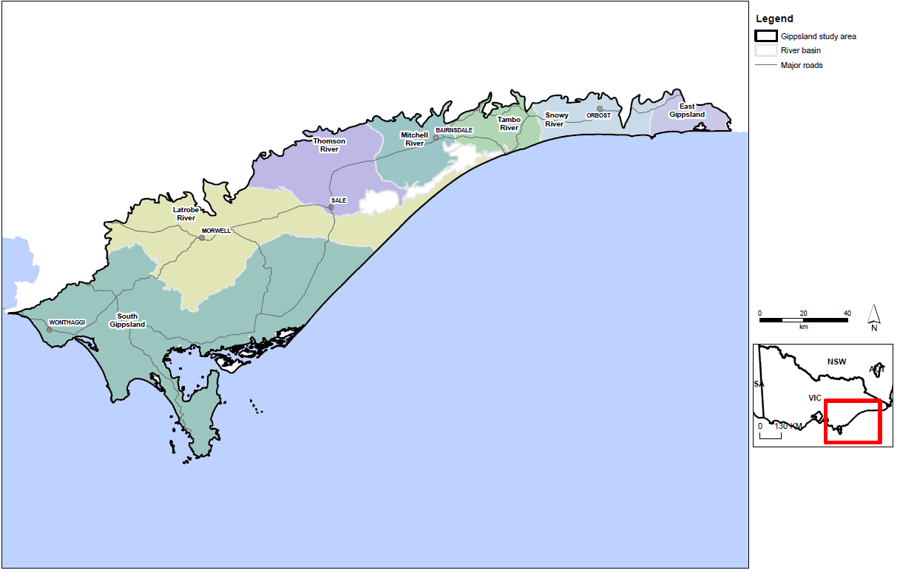
Figure D1: Gippsland study area.
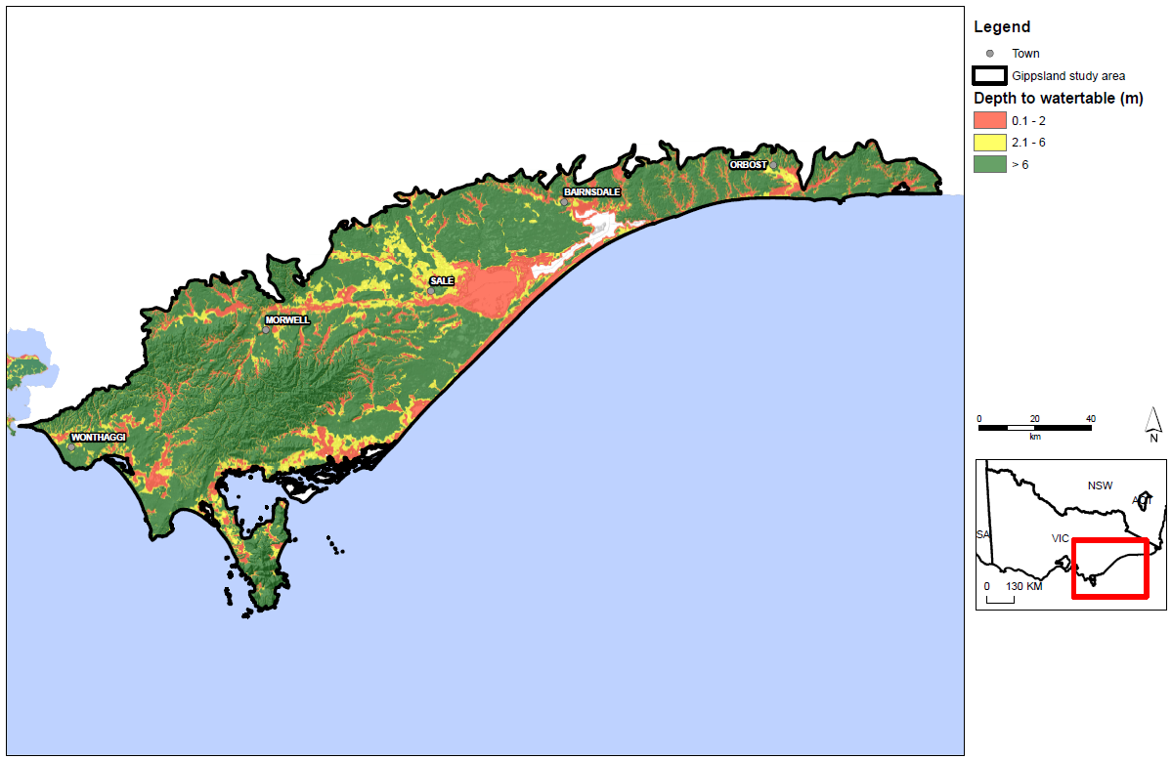
Figure D2: Depth to watertable in the Gippsland study area.
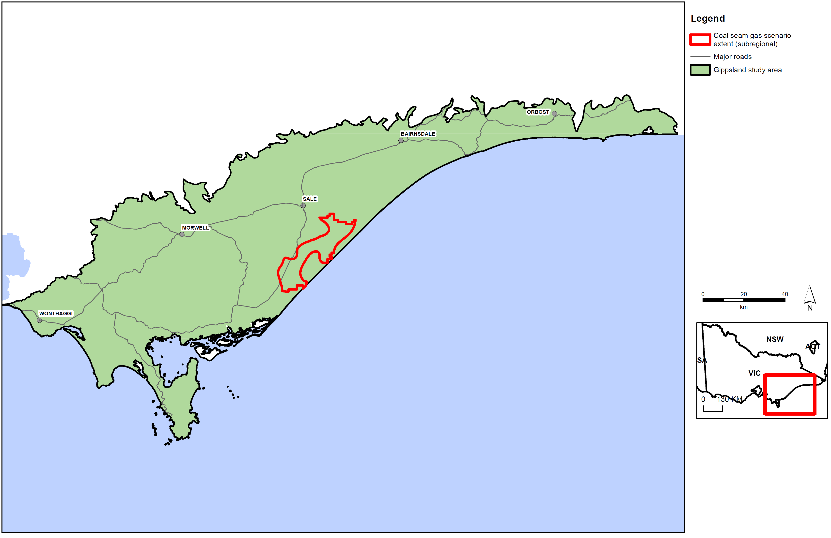
Figure D3: Gippsland coal seam gas scenario extent.
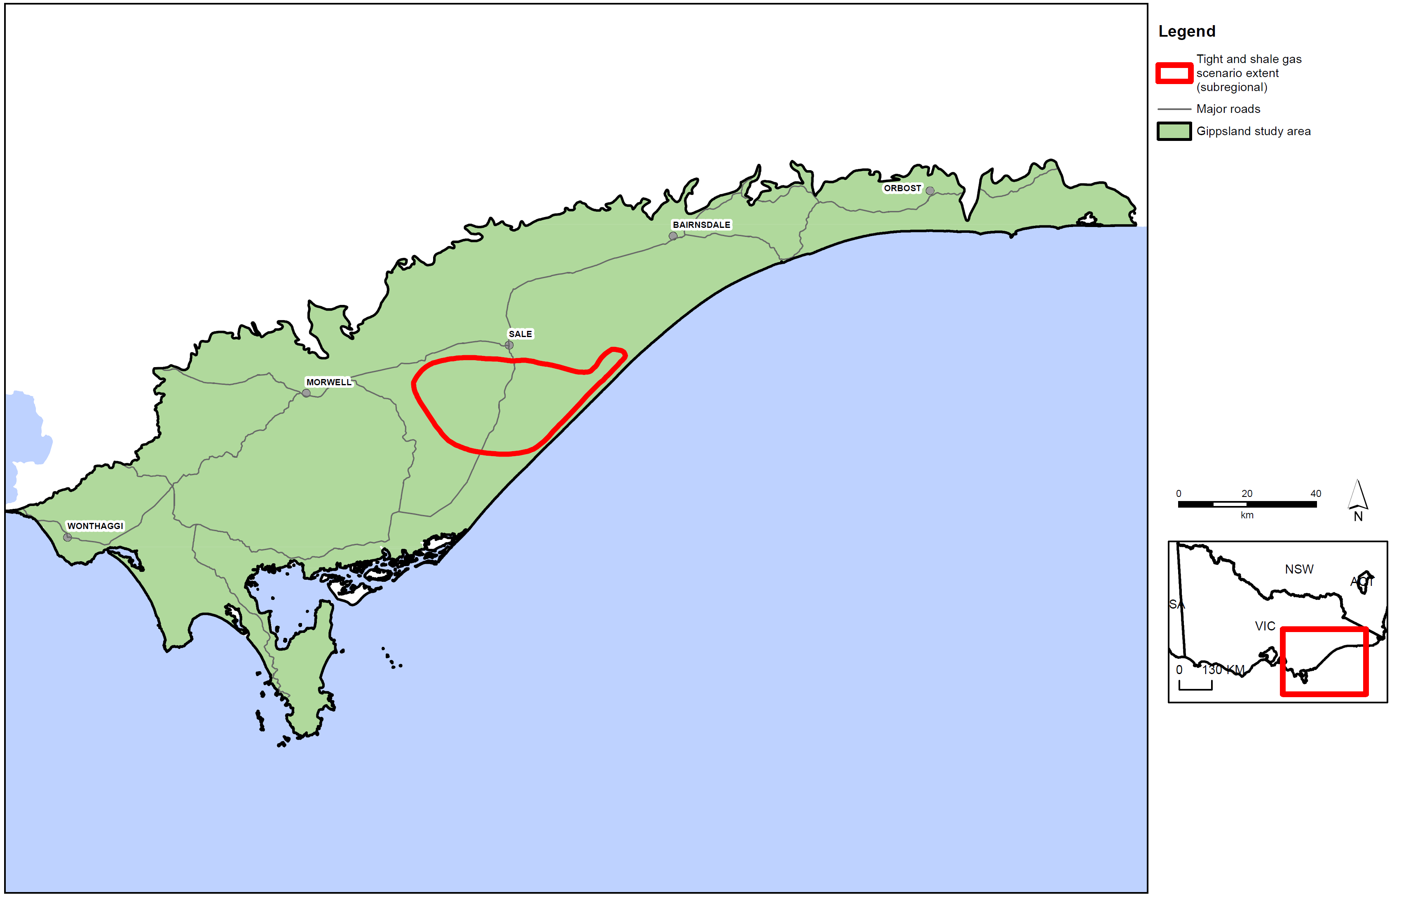
Figure D4: Tight and shale gas scenario extent.

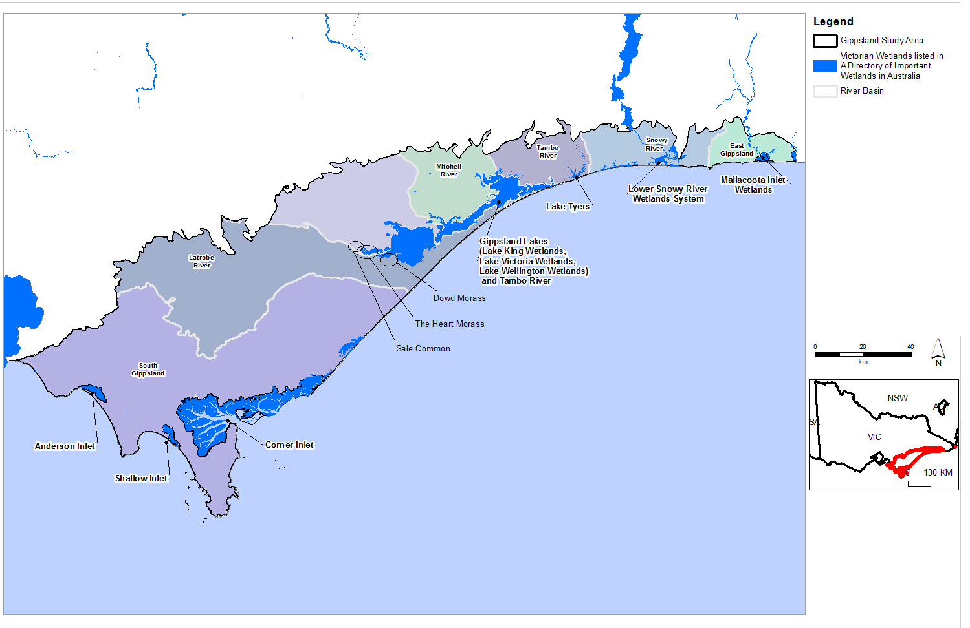
Figure D5: Location of internationally significant wetlands in the Gippsland region.
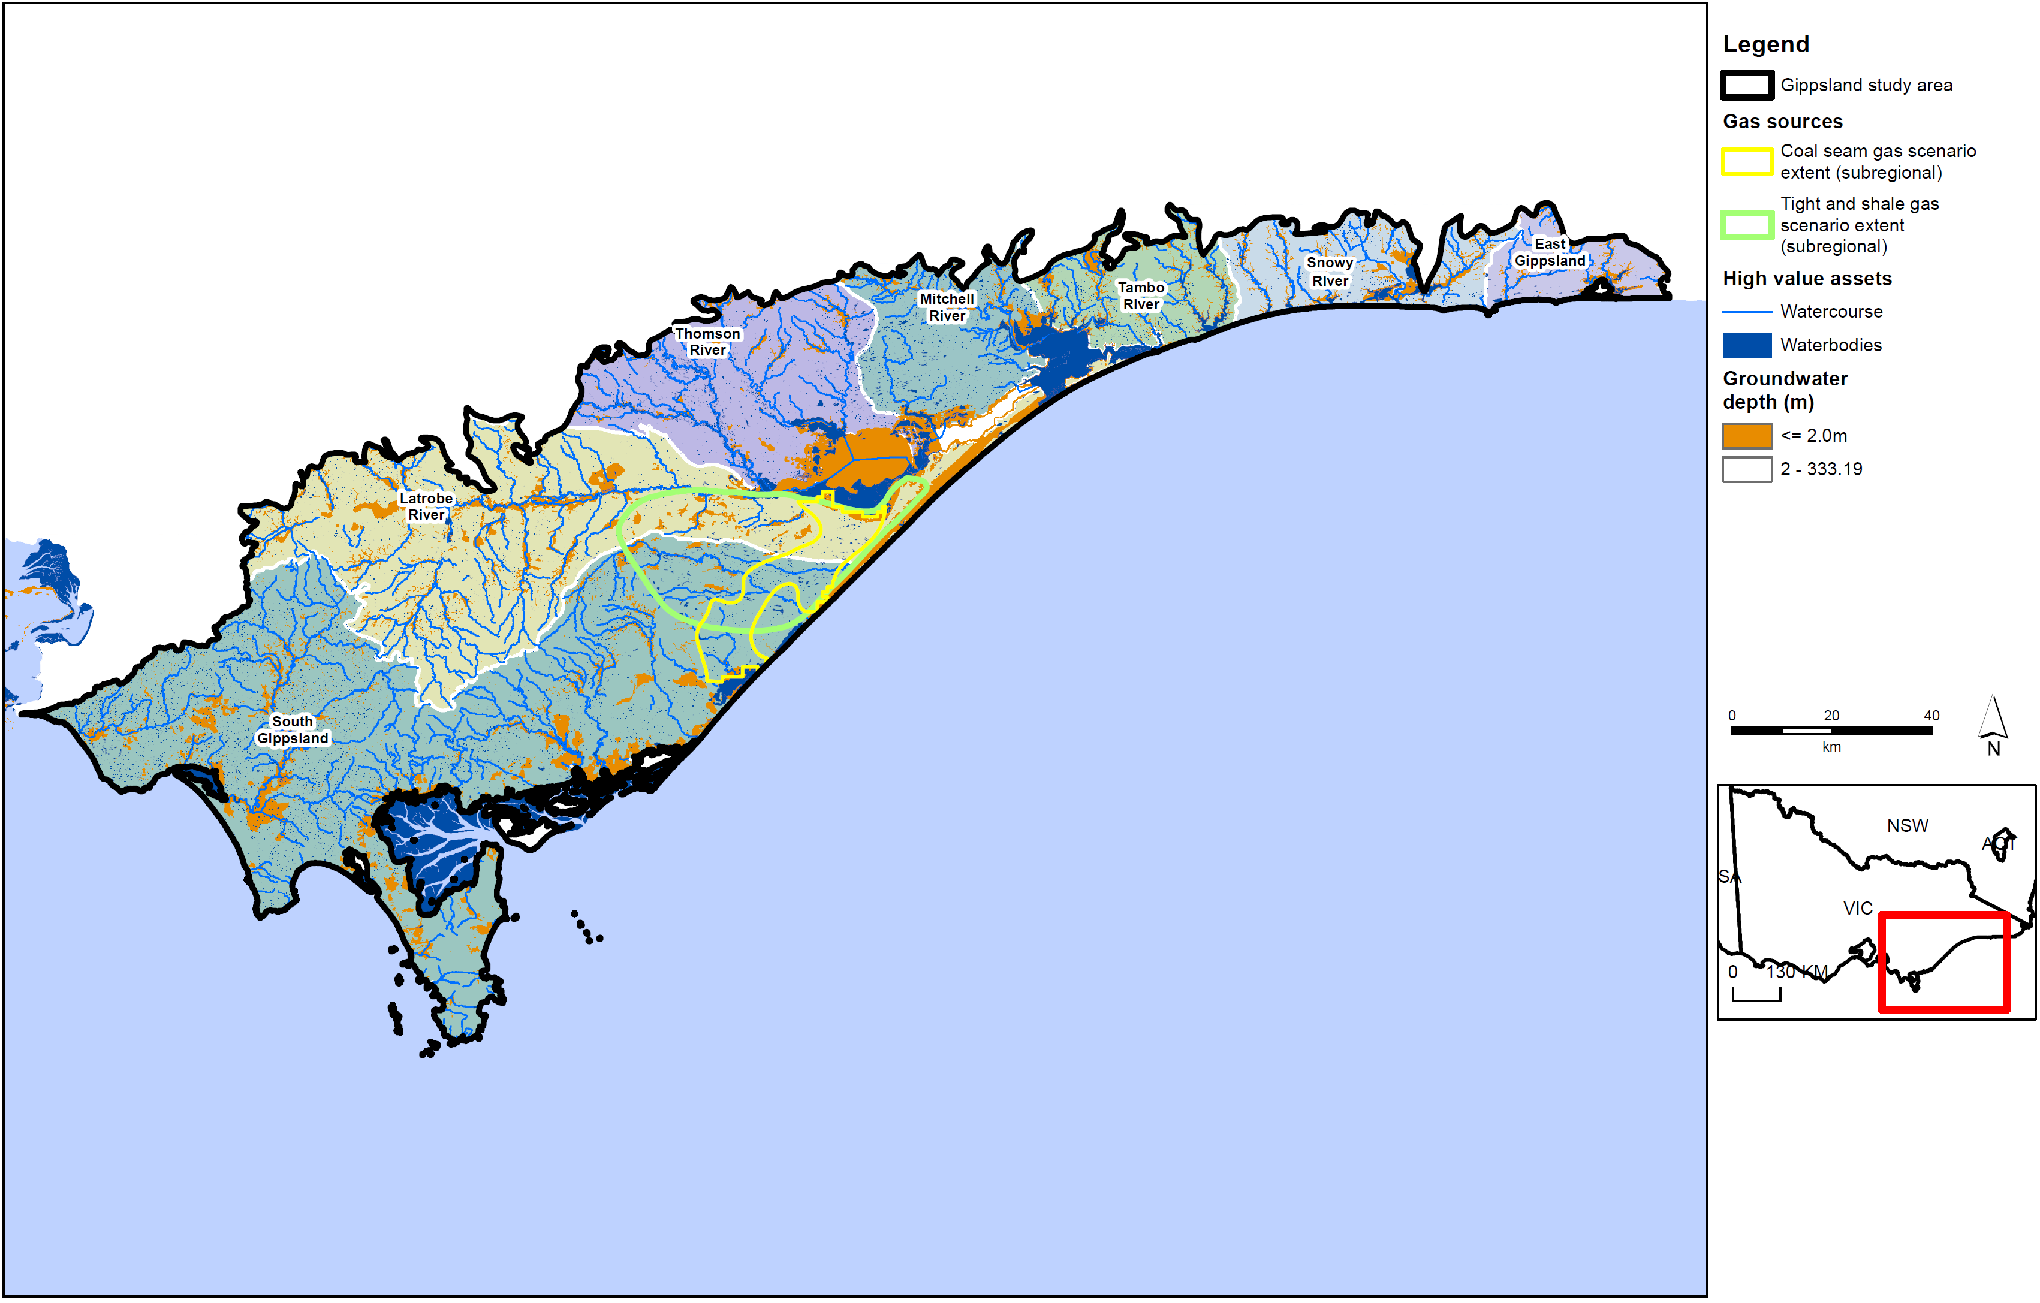
Figure D6: Gippsland surface water assets.
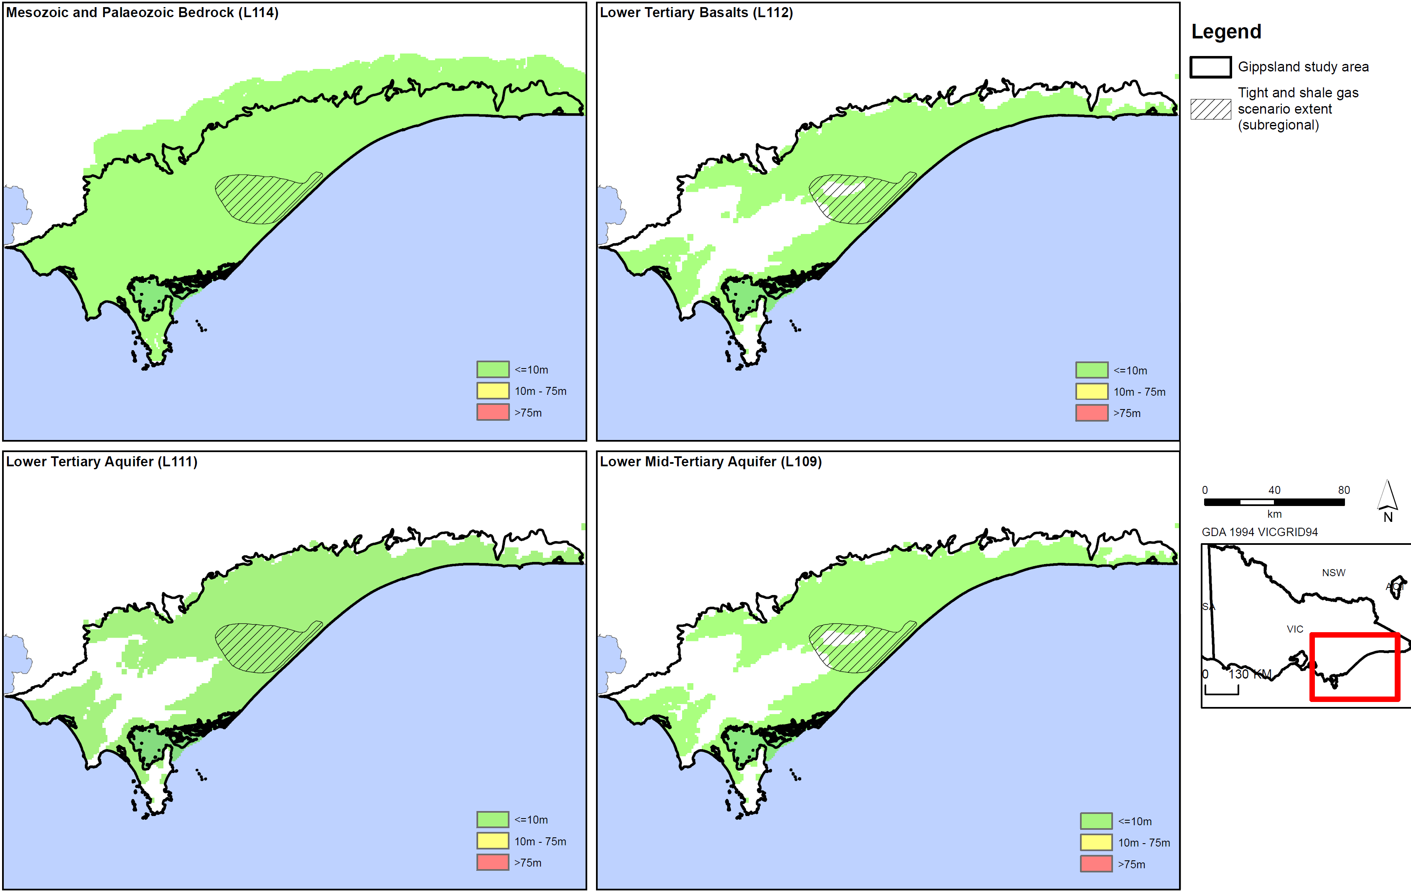
Figure D7a: Tight and shale gas drawdown for aquifers in Gippsland region.
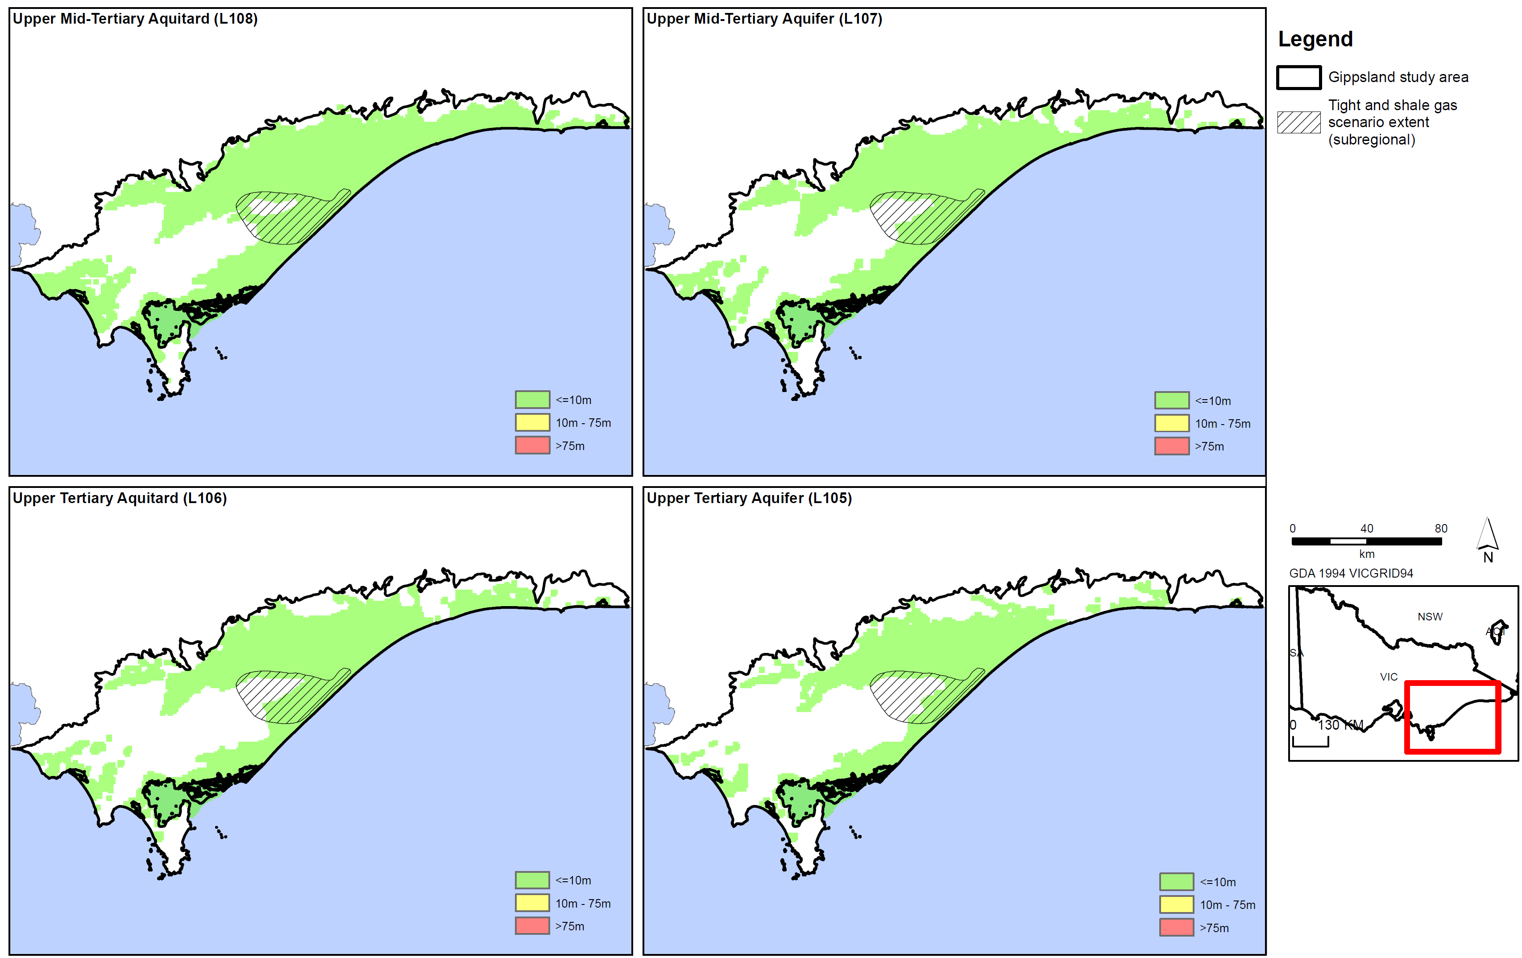
Figure D7b: Tight and shale gas drawdown for aquifers in Gippsland region.
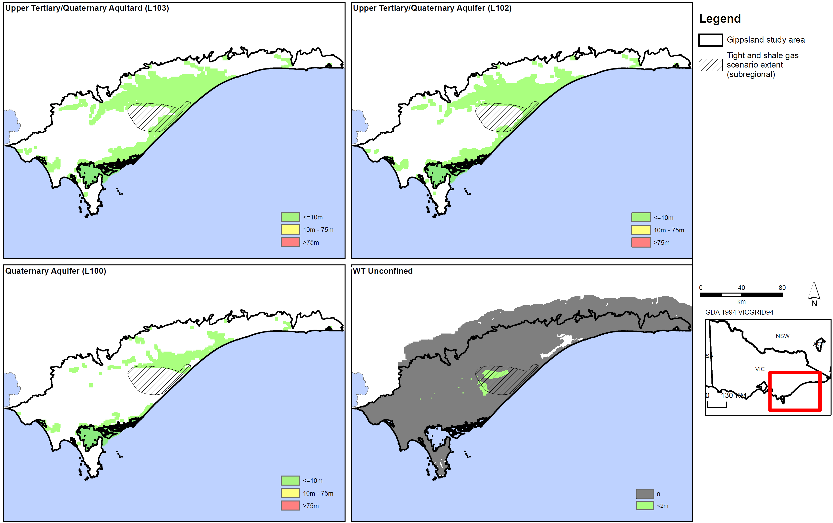
Figure D7c: Tight and shale gas drawdown for aquifers in Gippsland region.
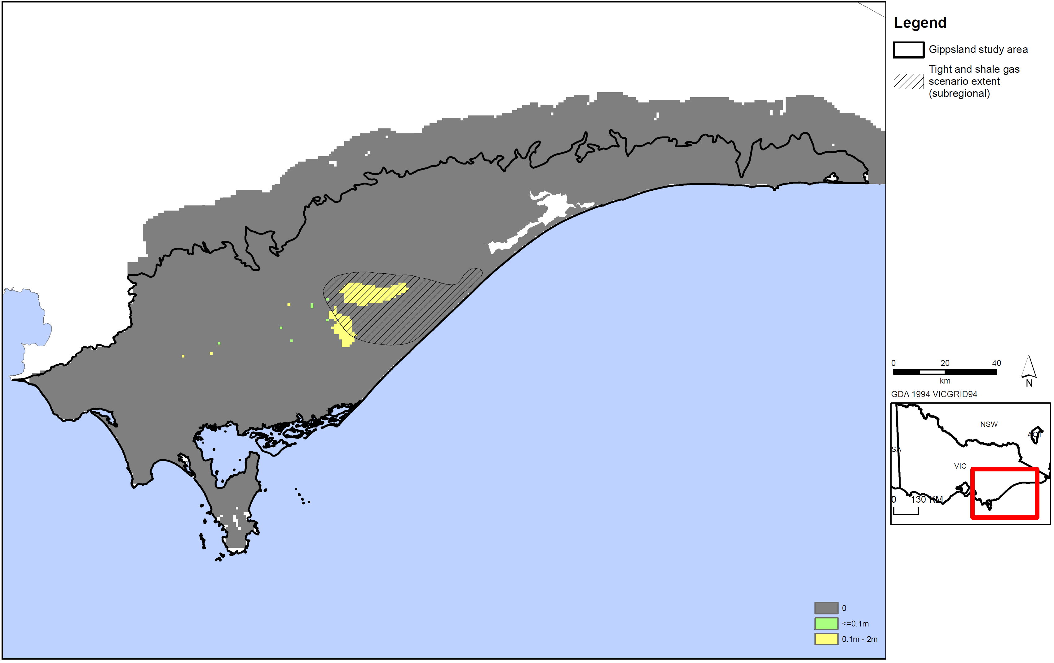
Figure D7d: Tight and shale gas watertable drawdown in Gippsland region.
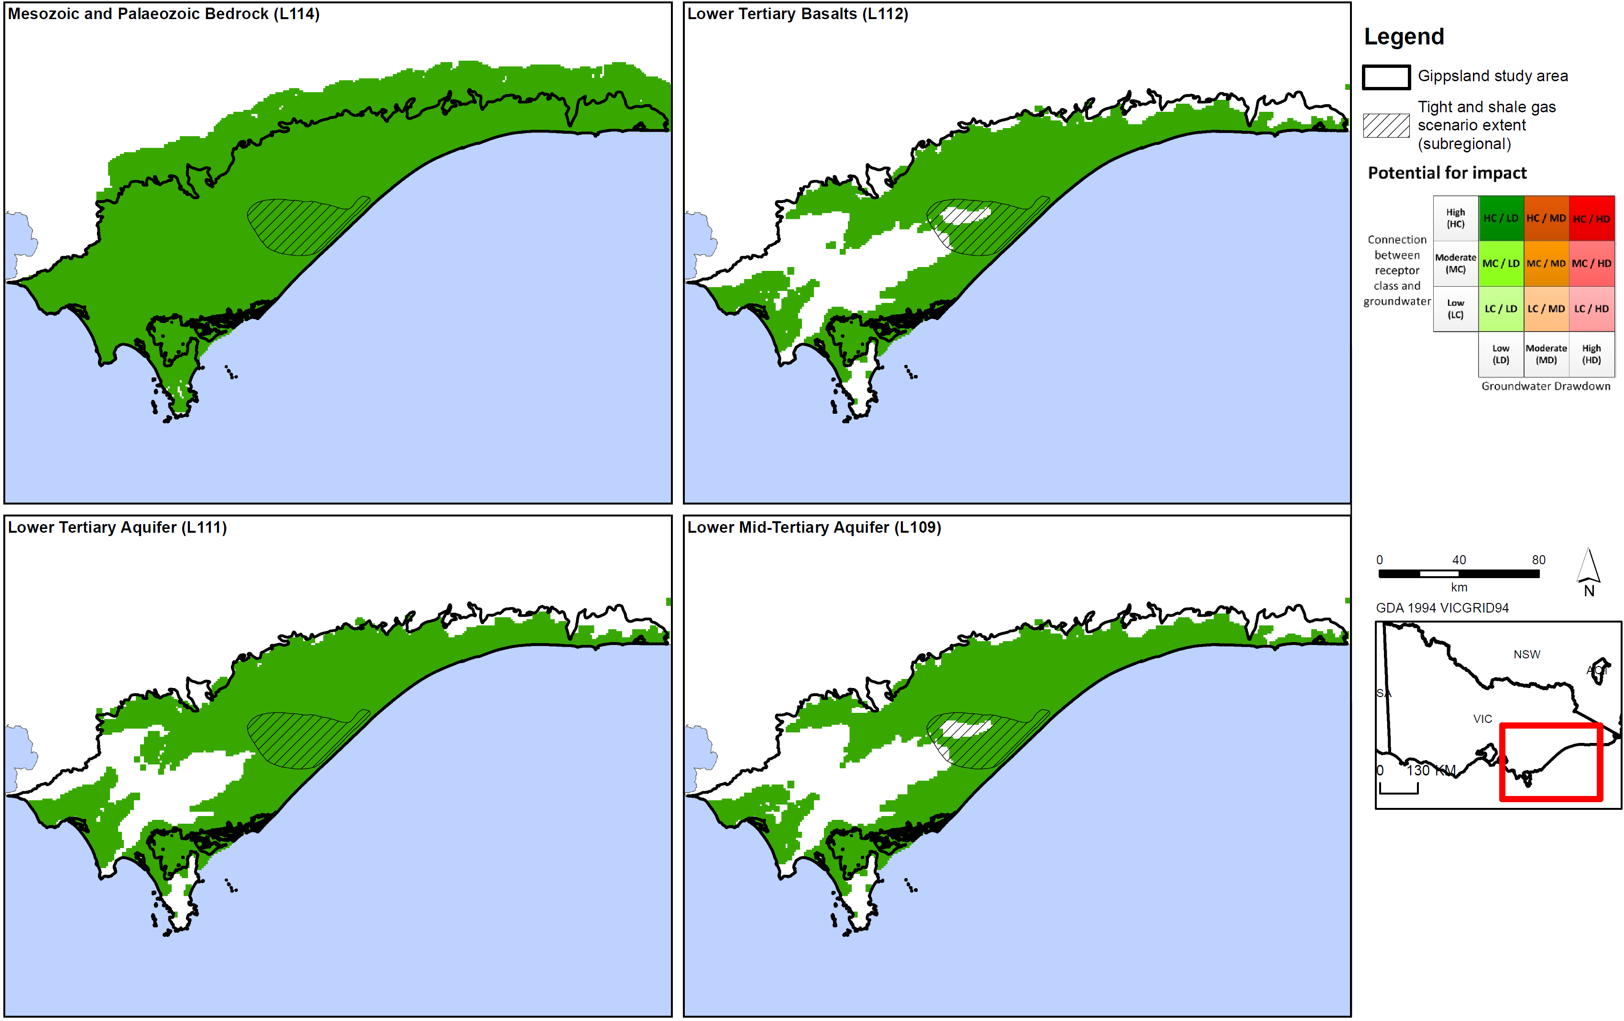
Figure D8a: Potential impact of tight and shale gas development on aquifers in Gippsland region.
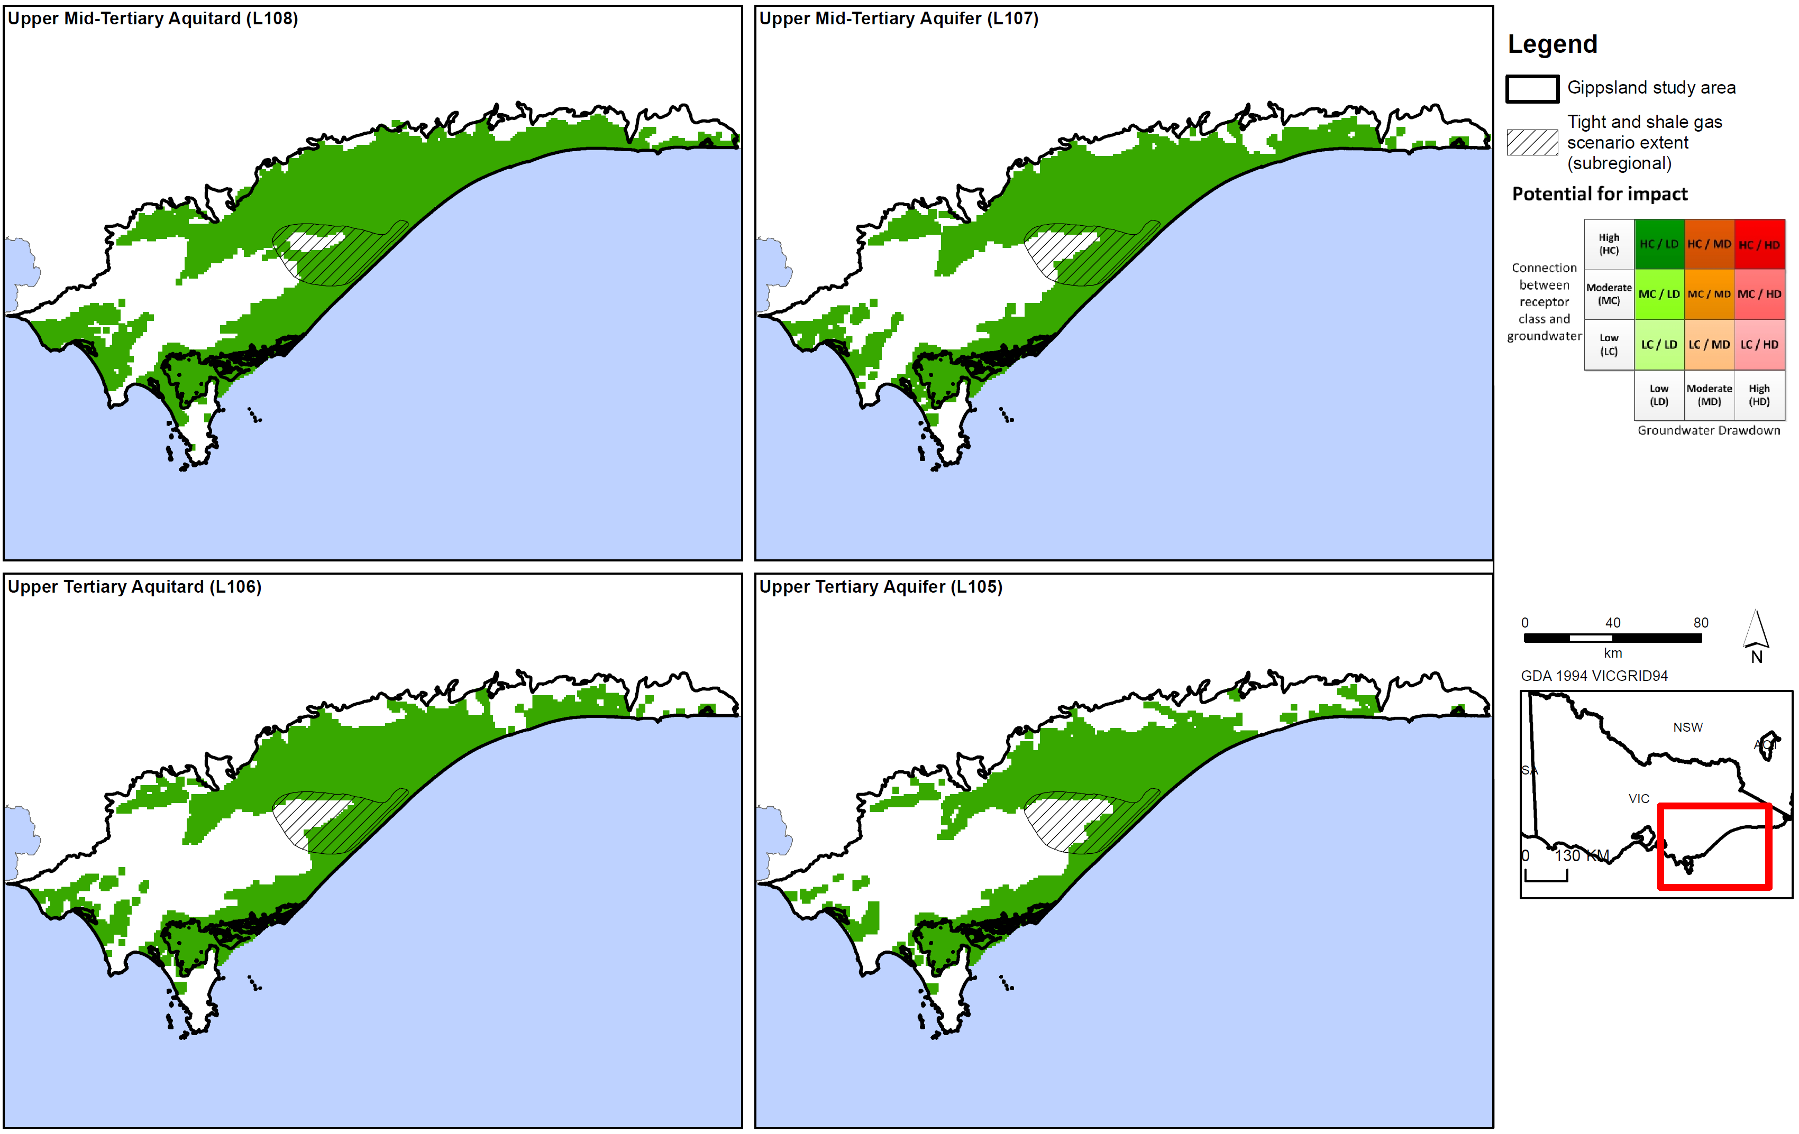
Figure D8b: Potential impact of tight and shale gas development on aquifers in Gippsland region.
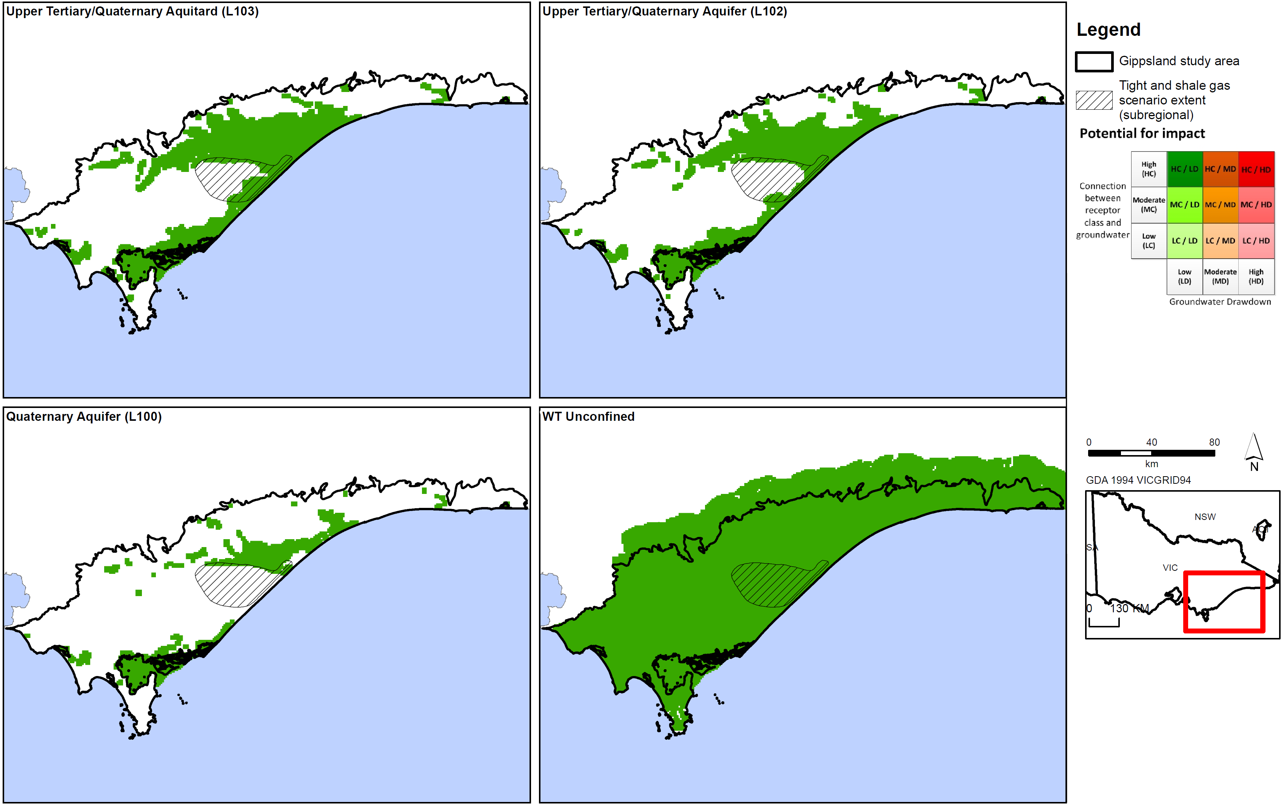
Figure D8c: Potential impact of tight and shale gas development on aquifers in Gippsland region.
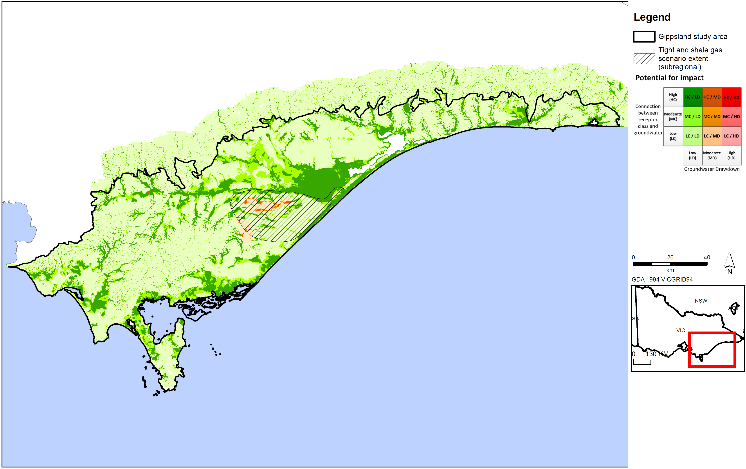
Figure D9: Potential impact of tight and shale gas development on surface water users in Gippsland region.
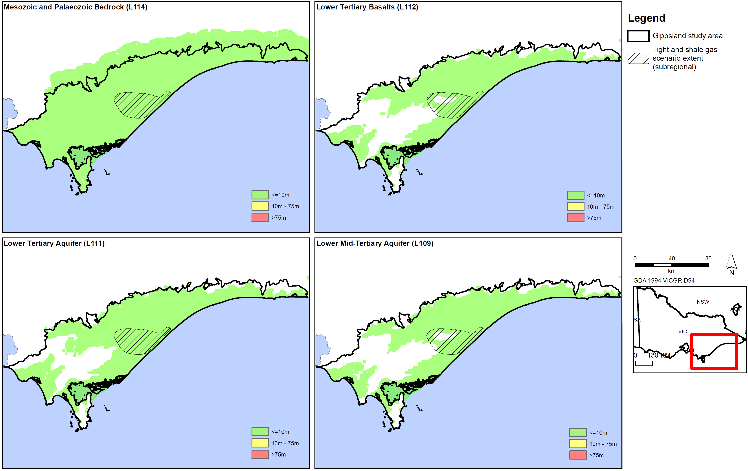
Figure D10a: Tight and shale gas drawdown for aquifers in Gippsland region.
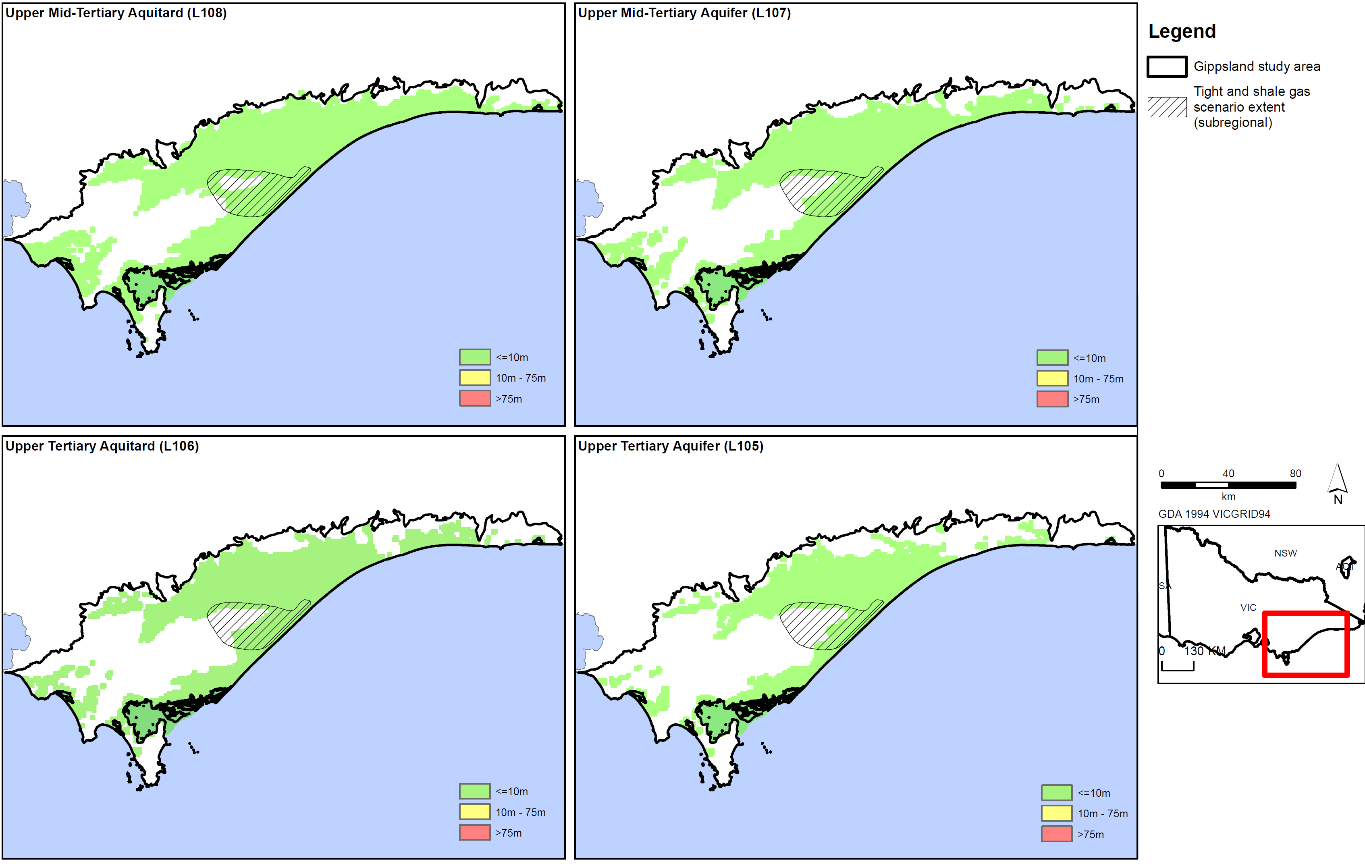
Figure D1b: Tight and shale gas drawdown for aquifers in Gippsland region.
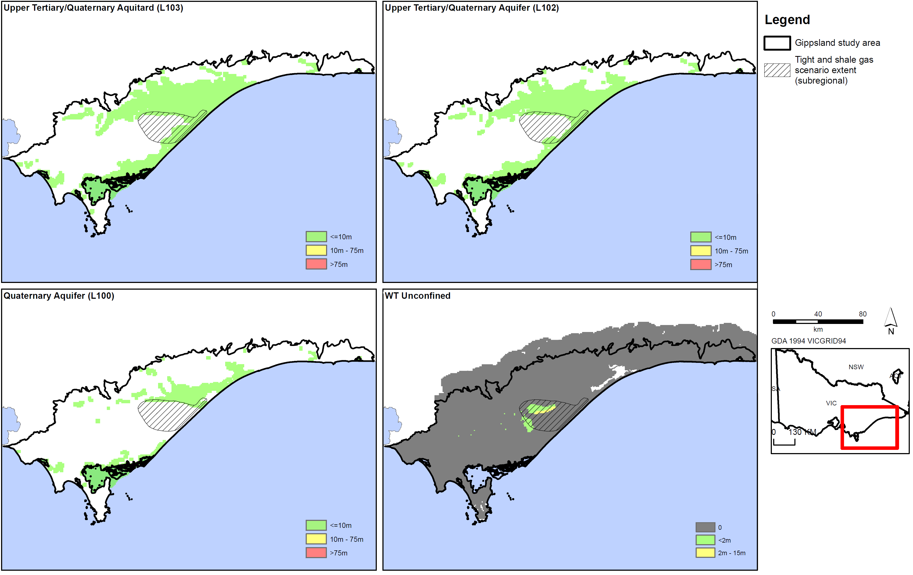
Figure D10c: Tight and shale gas drawdown for aquifers in Gippsland region.
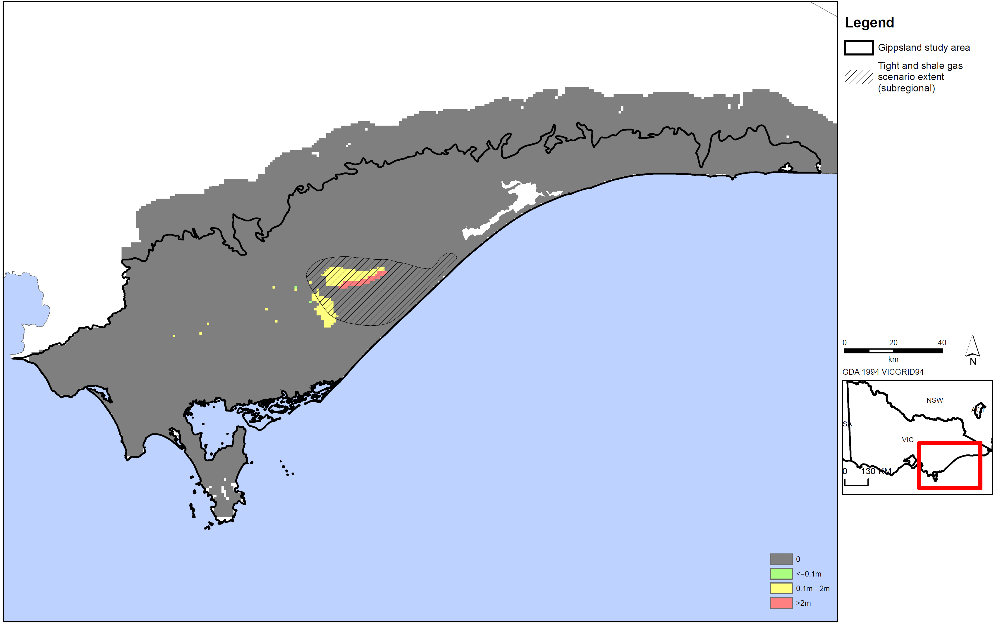
Figure D11: Tight and shale gas watertable drawdown for Gippsland region.
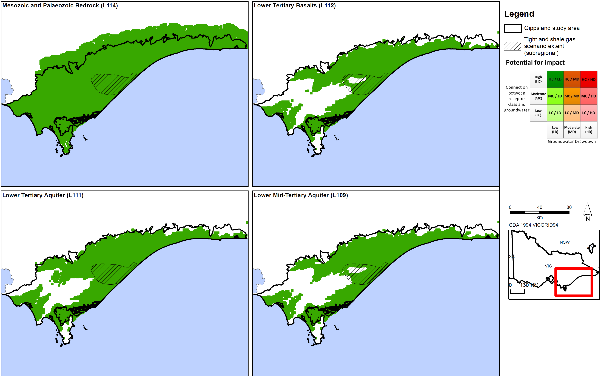
Figure D12a: Potential impact of tight and shale gas on aquifers in Gippsland region.
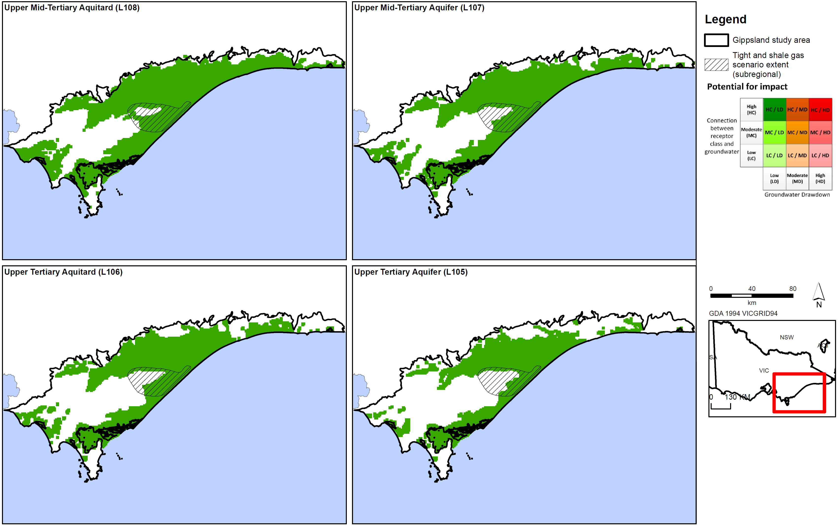
Figure D12b: Potential impact of tight and shale gas on aquifers in Gippsland region.
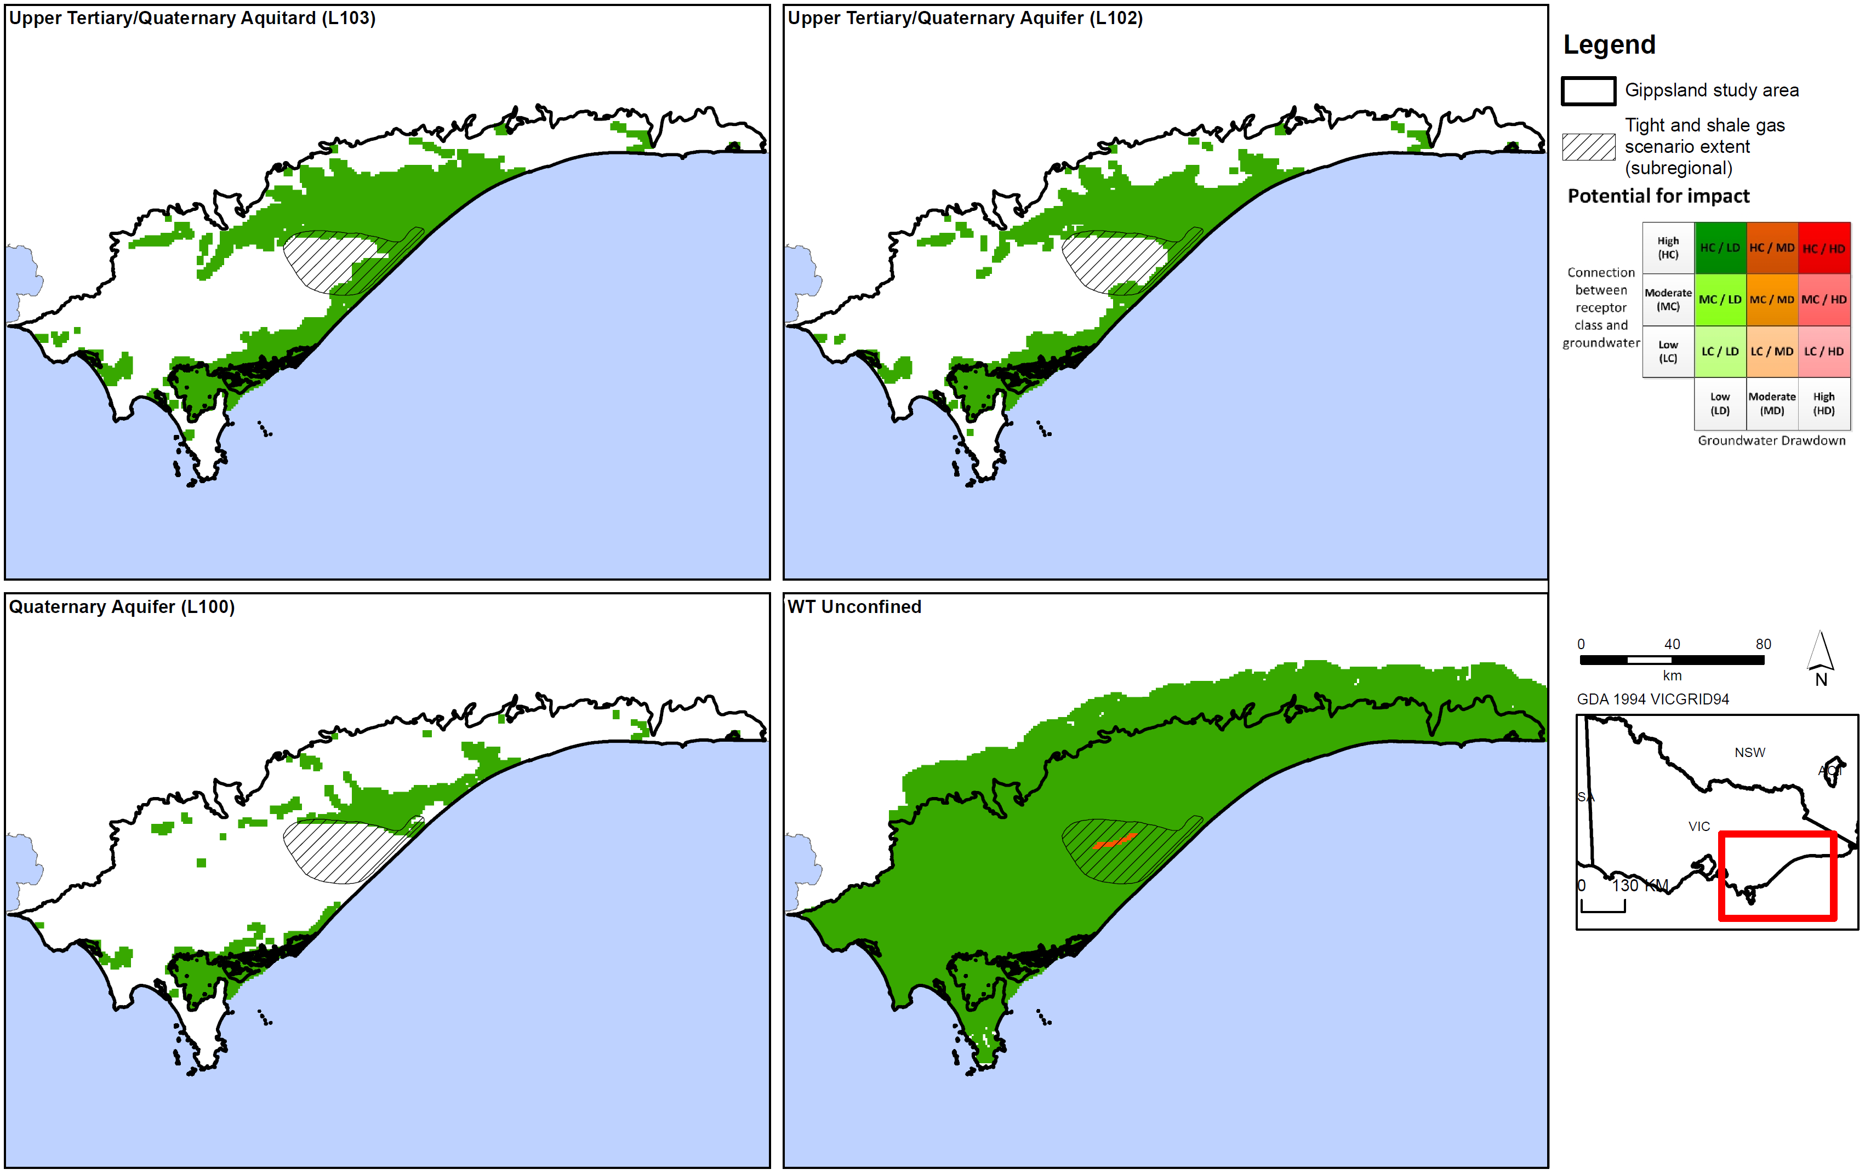
Figure D12c: Potential impact of tight and shale gas on aquifers in Gippsland region.
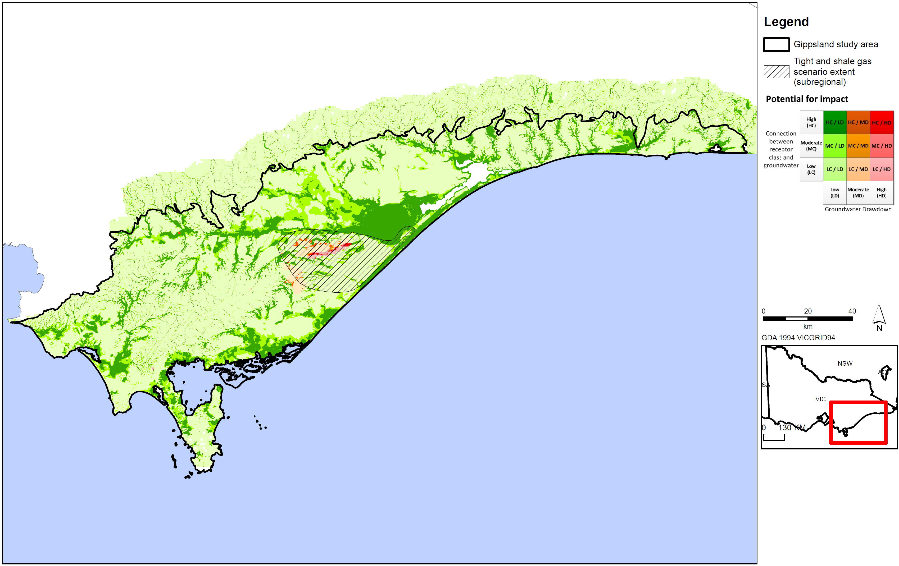
Figure D13: Tight and shale gas impact assessment for surface water users in Gippsland region.
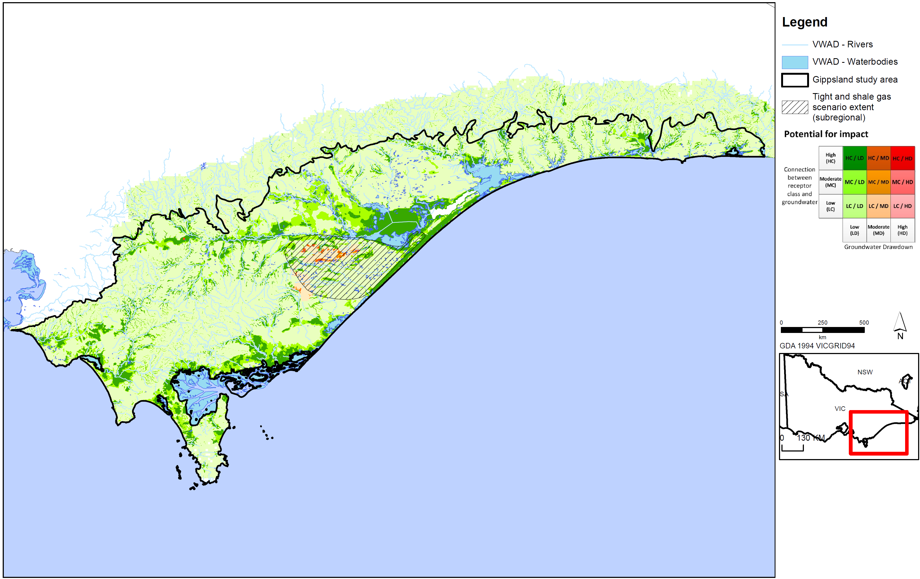
Figure D14: Potential impact of tight and shale gas on surface water ecosystems in Gippsland region.
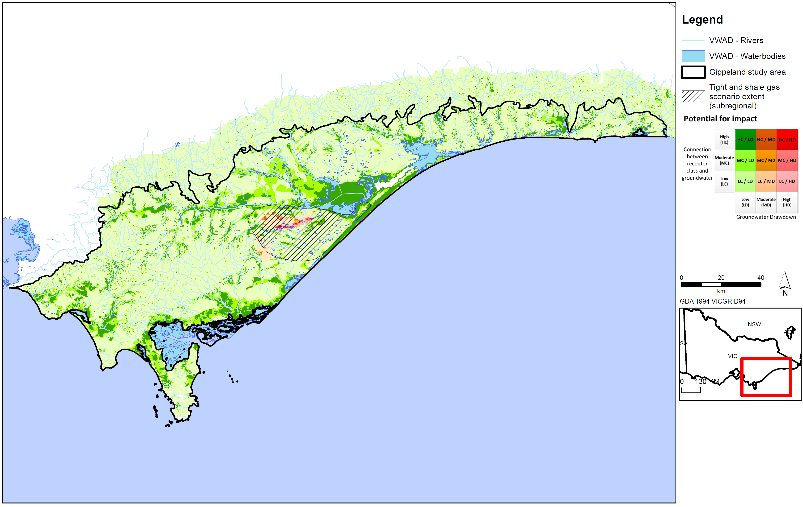
Figure D15: Potential impact of tight and shale gas on surface water ecosystems in Gippsland region.
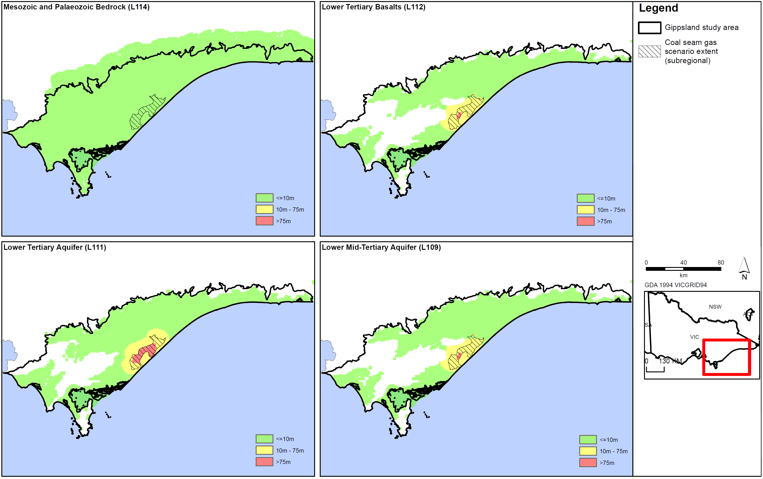
Figure D16a: Coal seam gas drawdown for aquifers in Gippsland region.
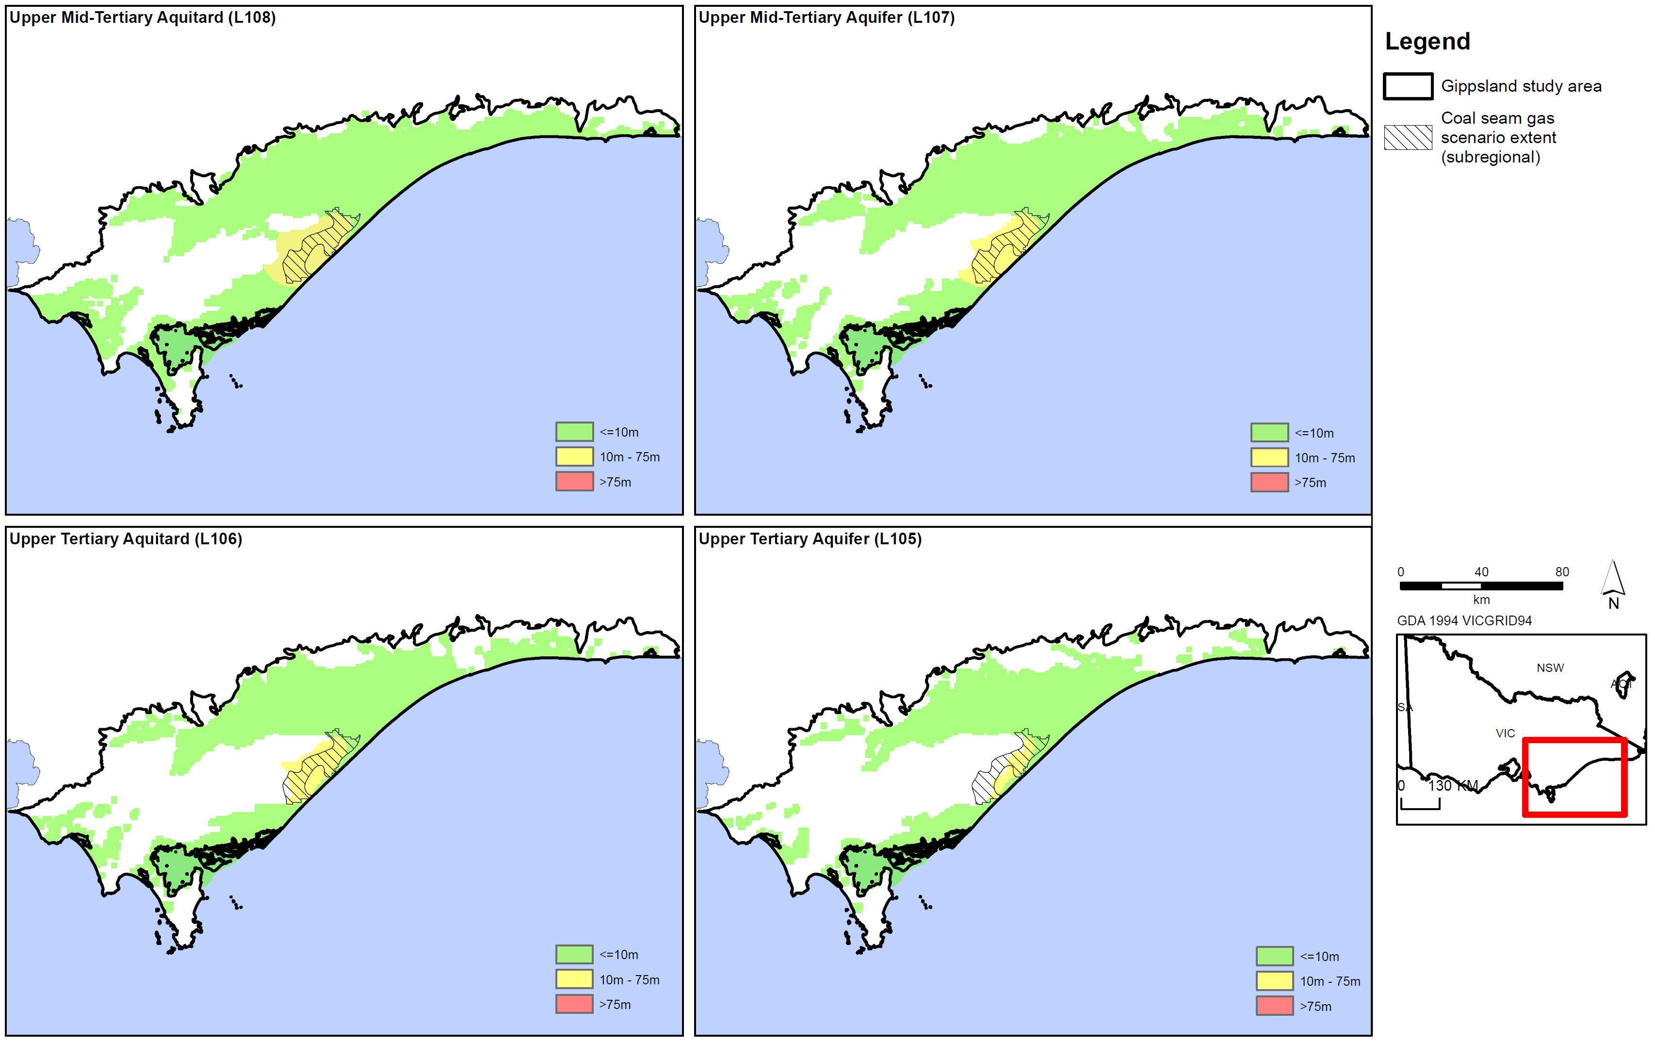
Figure D16b: Coal seam gas drawdown for aquifers in Gippsland region.
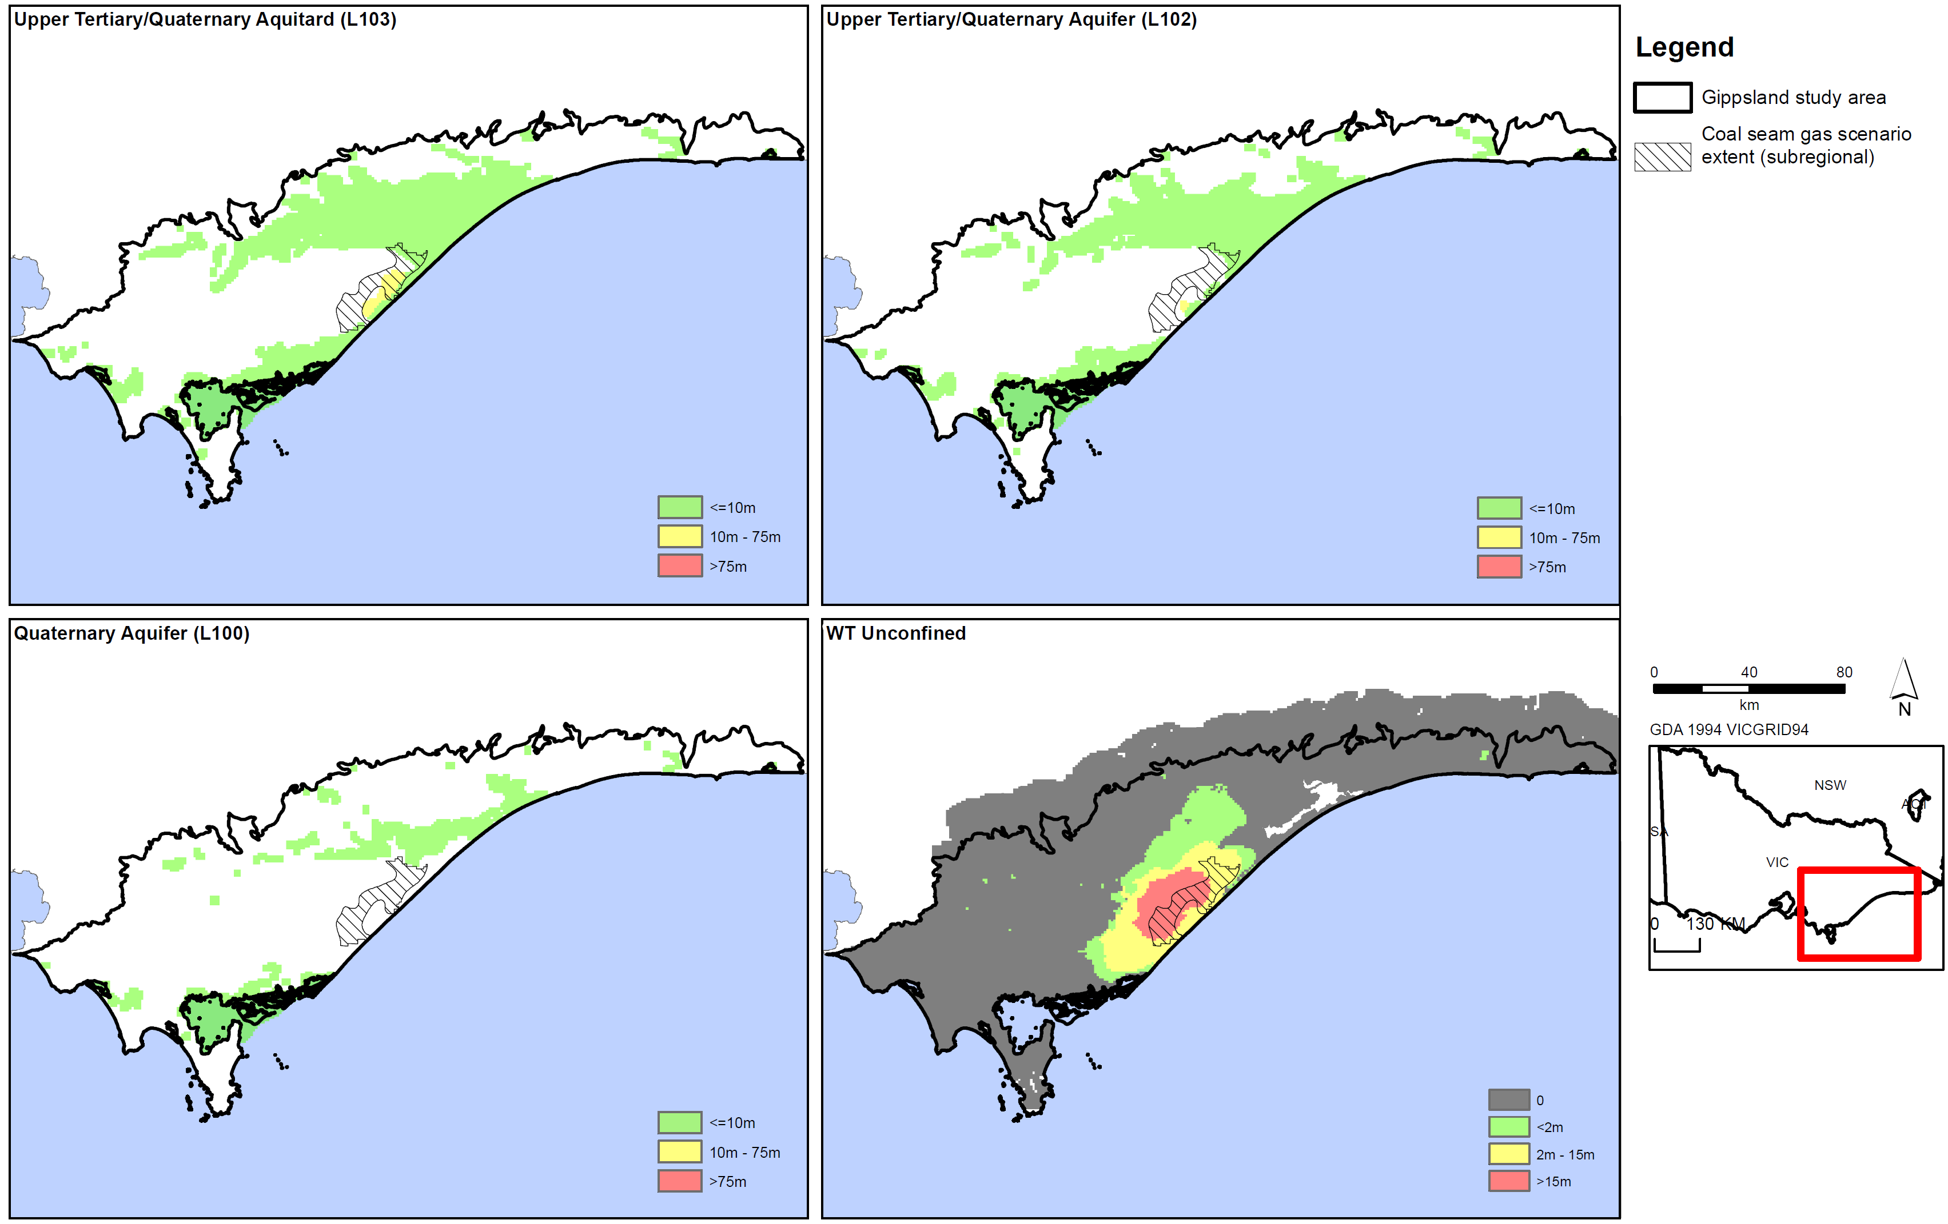
Figure D16c: Coal seam gas drawdown for aquifers in Gippsland region.
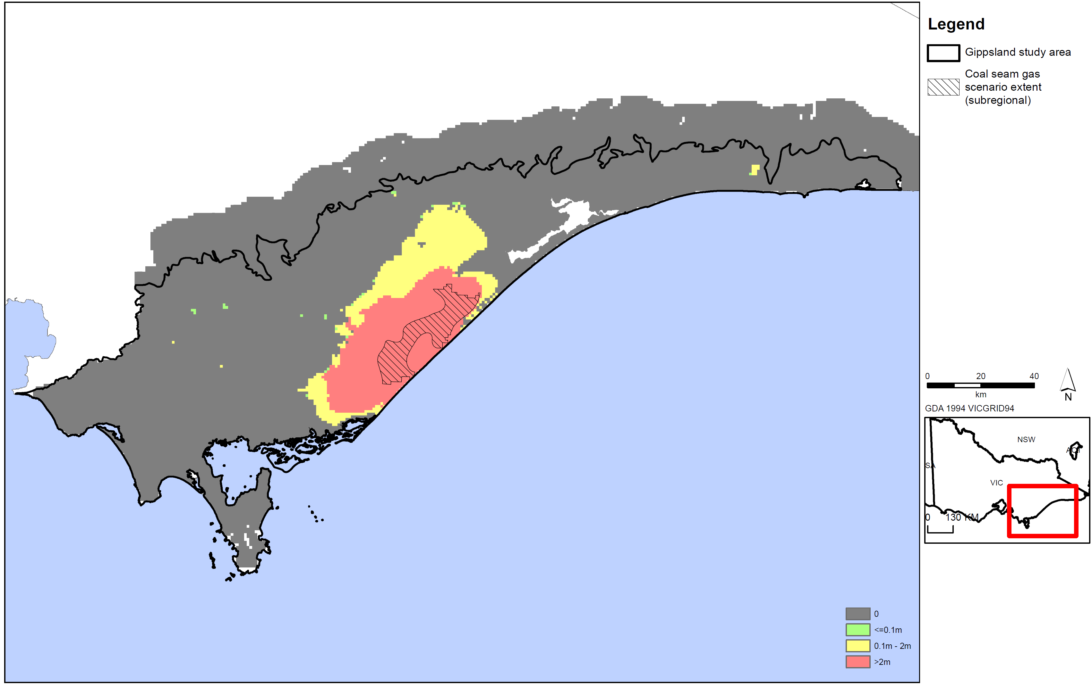
Figure D16d: Coal seam gas watertable drawdown for Gippsland region.
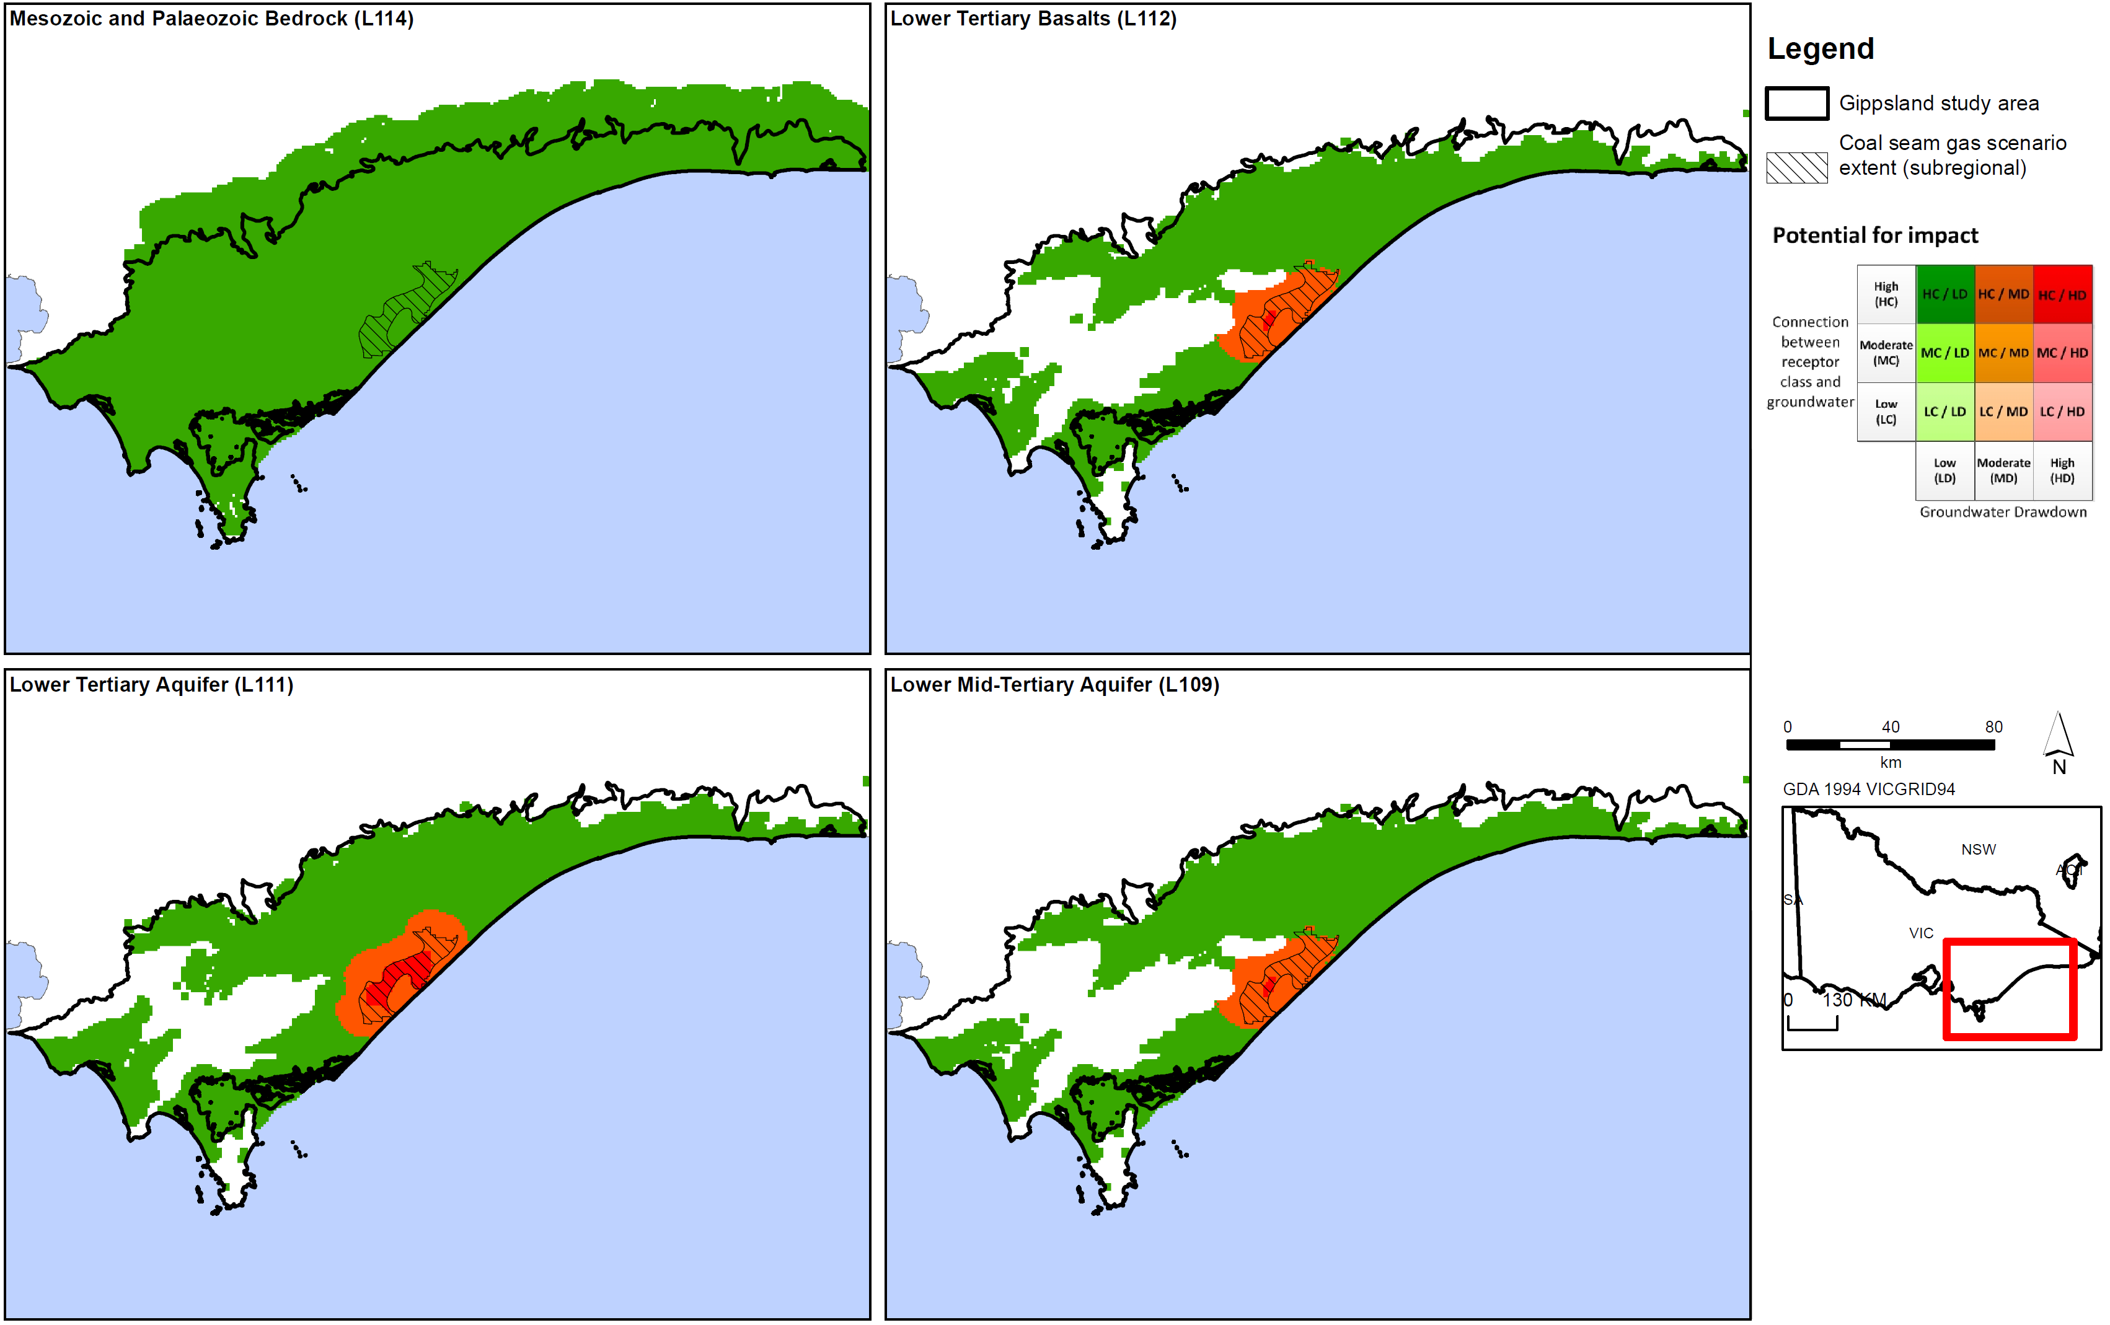
Figure D17a: Potential impact of coal seam gas on aquifers in Gippsland region.
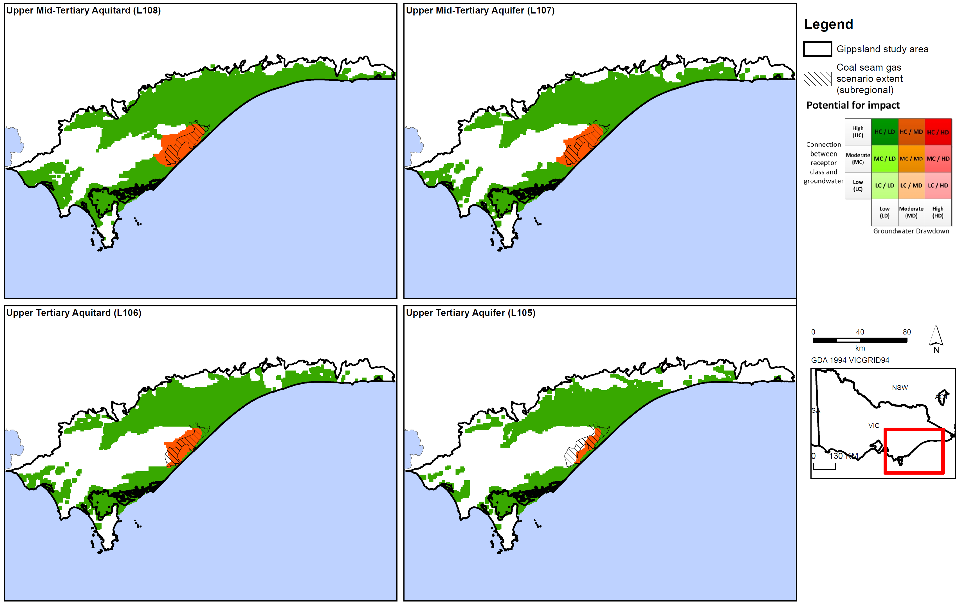
Figure D17b: Potential impact of coal seam gas on aquifers in Gippsland region.
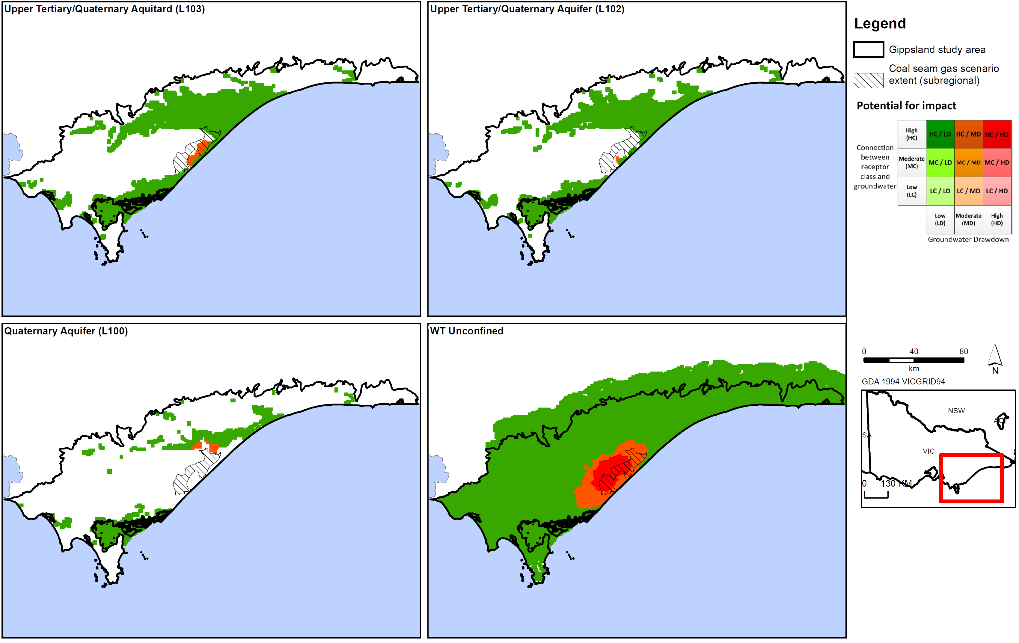
Figure D17c: Potential impact of coal seam gas on aquifers in Gippsland region.
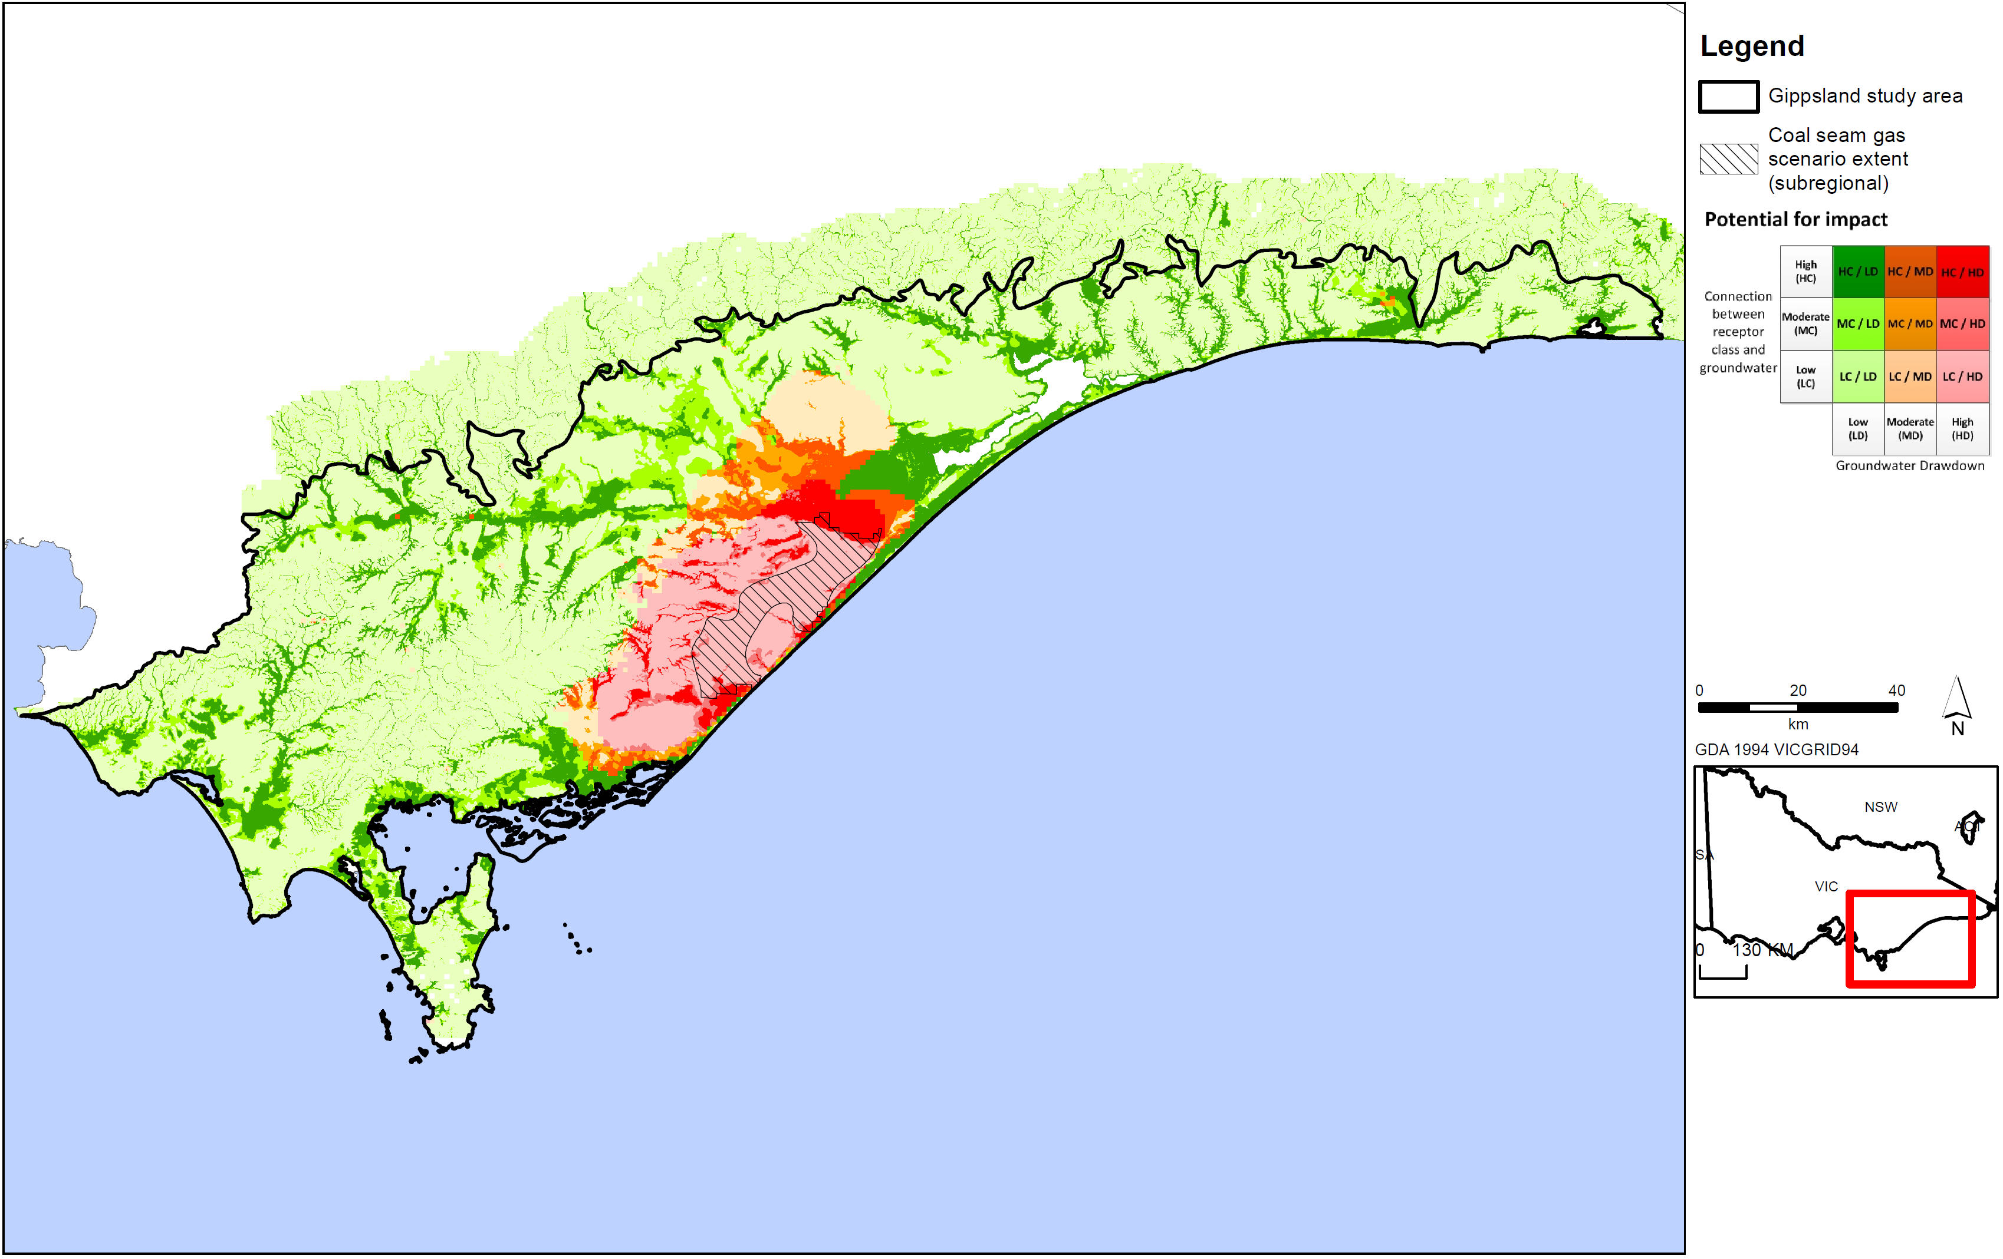
Figure D18a: Potential impact of coal seam gas on surface water users in Gippsland region.
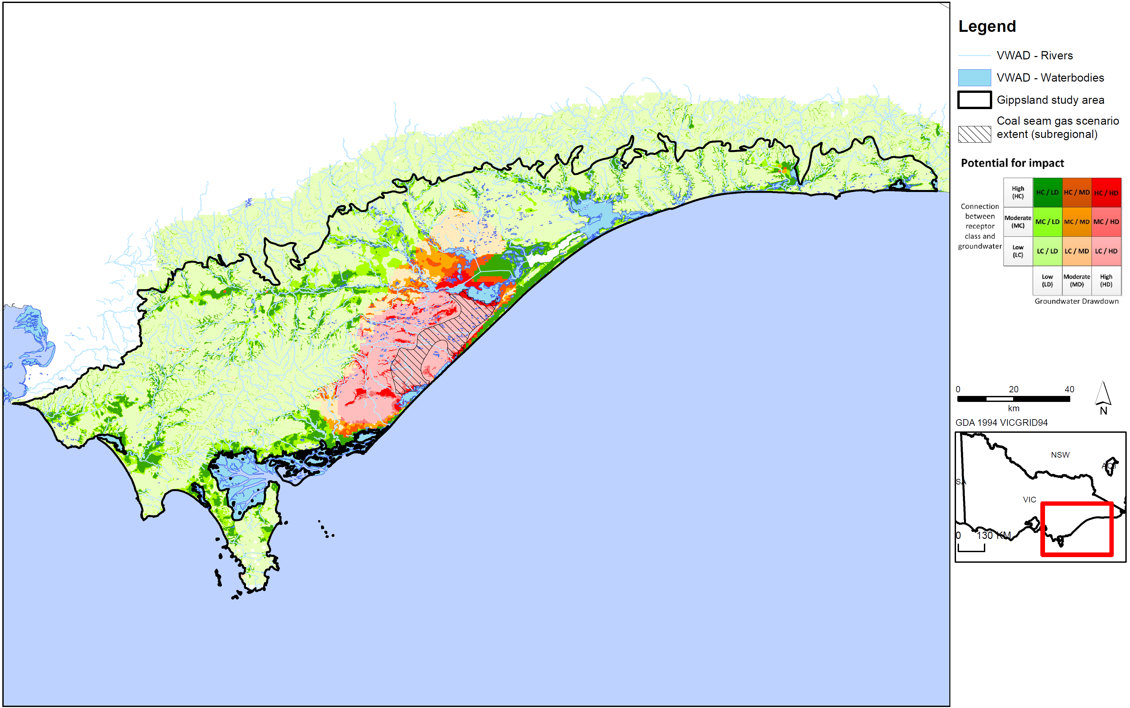
Figure D18b: Potential impact of coal seam gas on surface water ecosystems in Gippsland region.
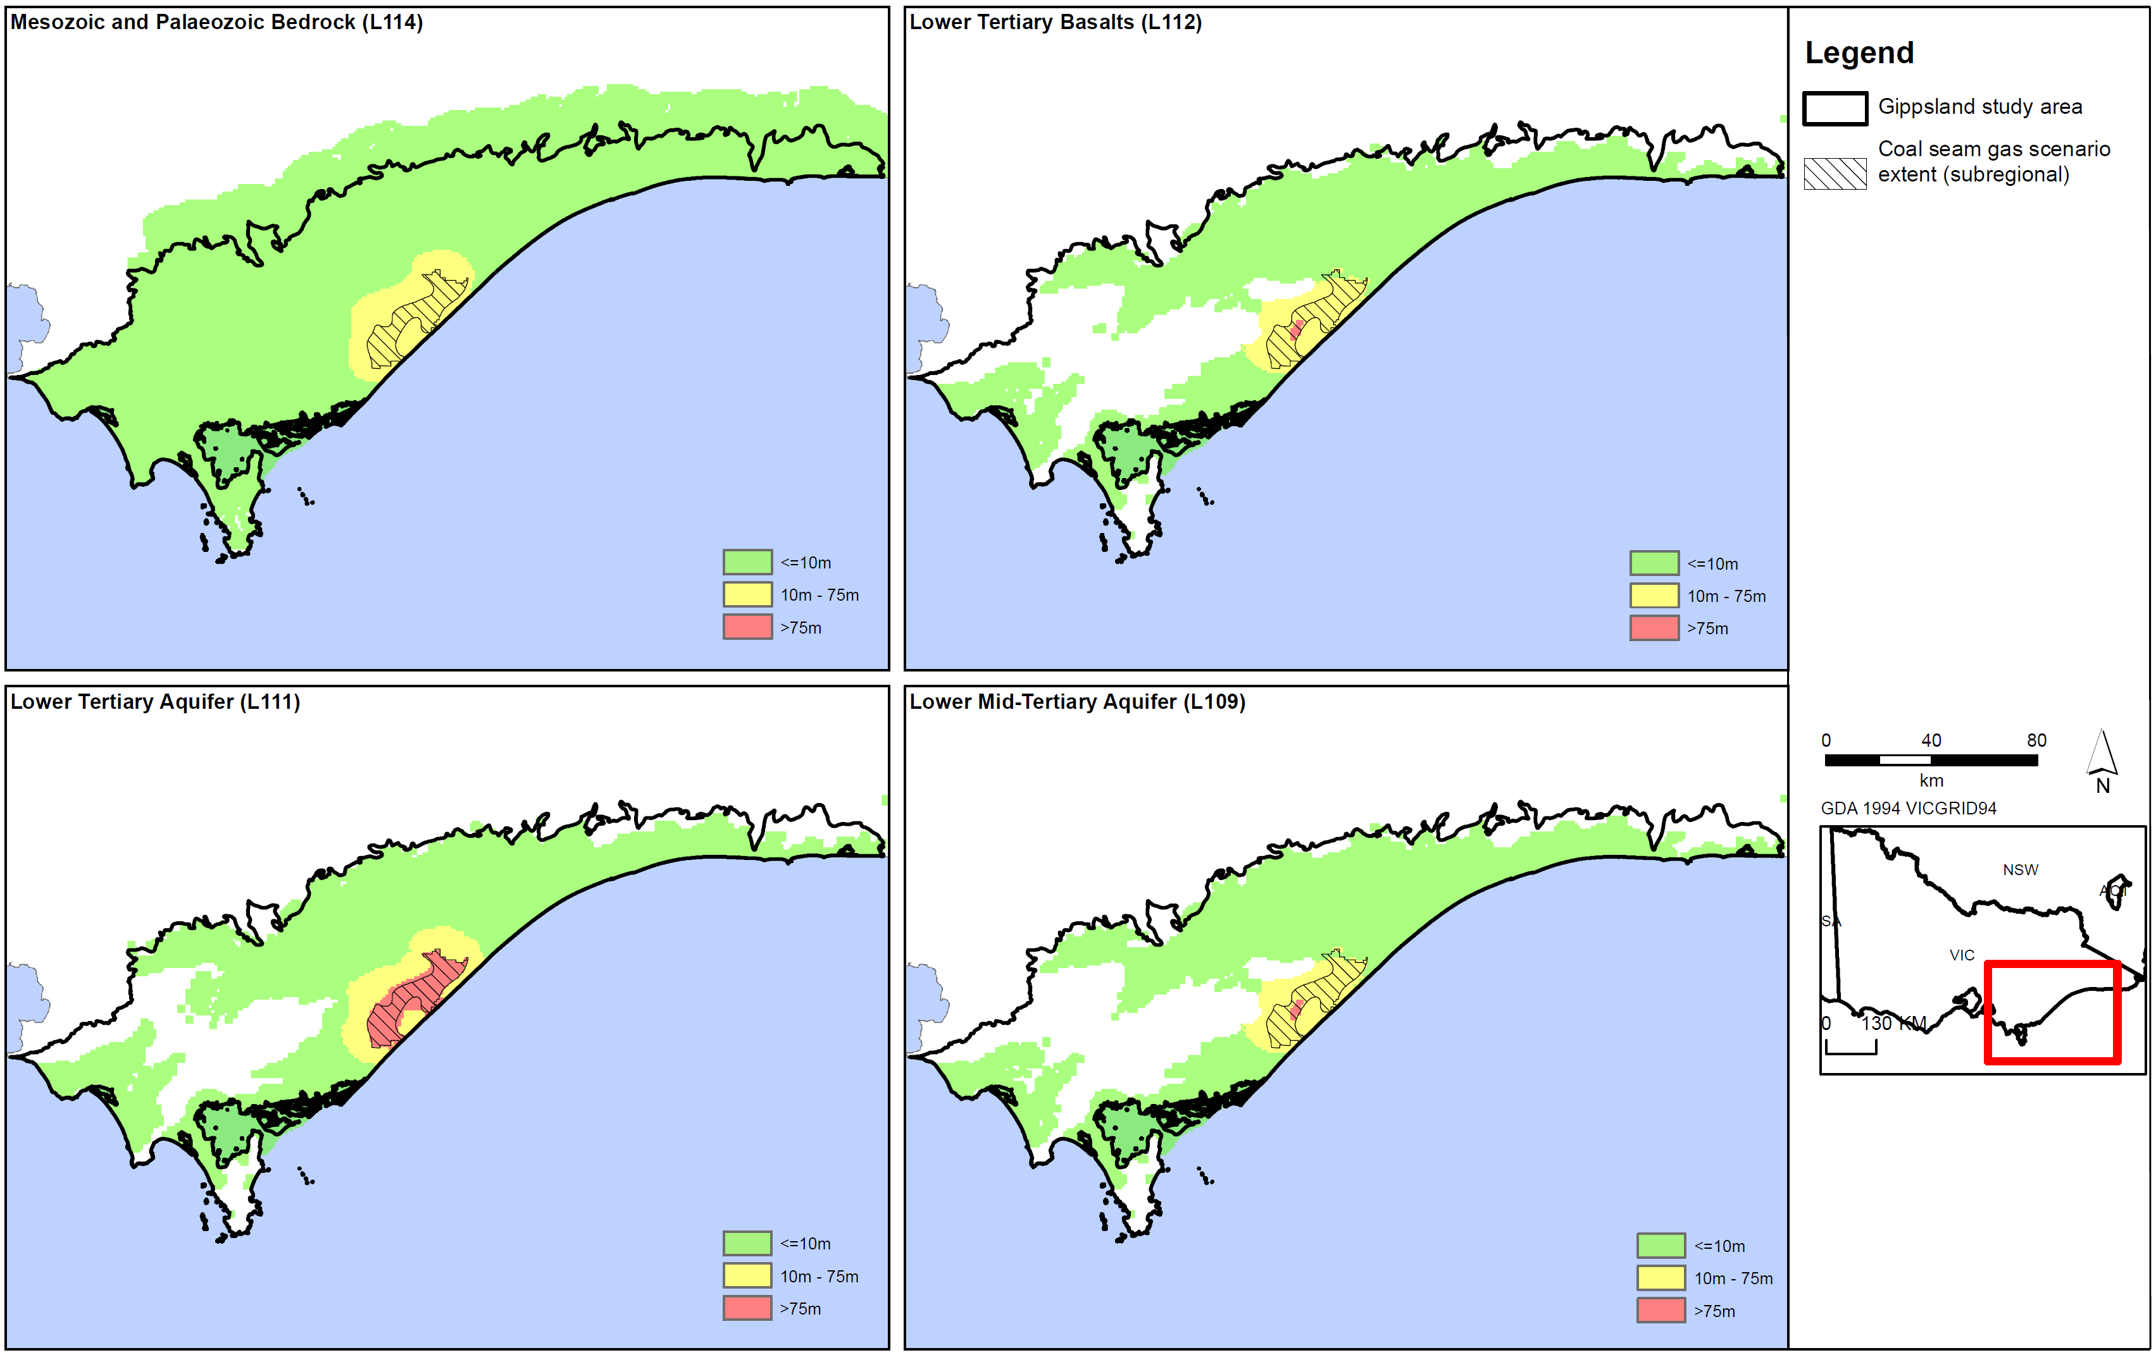
Figure D19a: Coal seam gas drawdown for aquifers in Gippsland region.
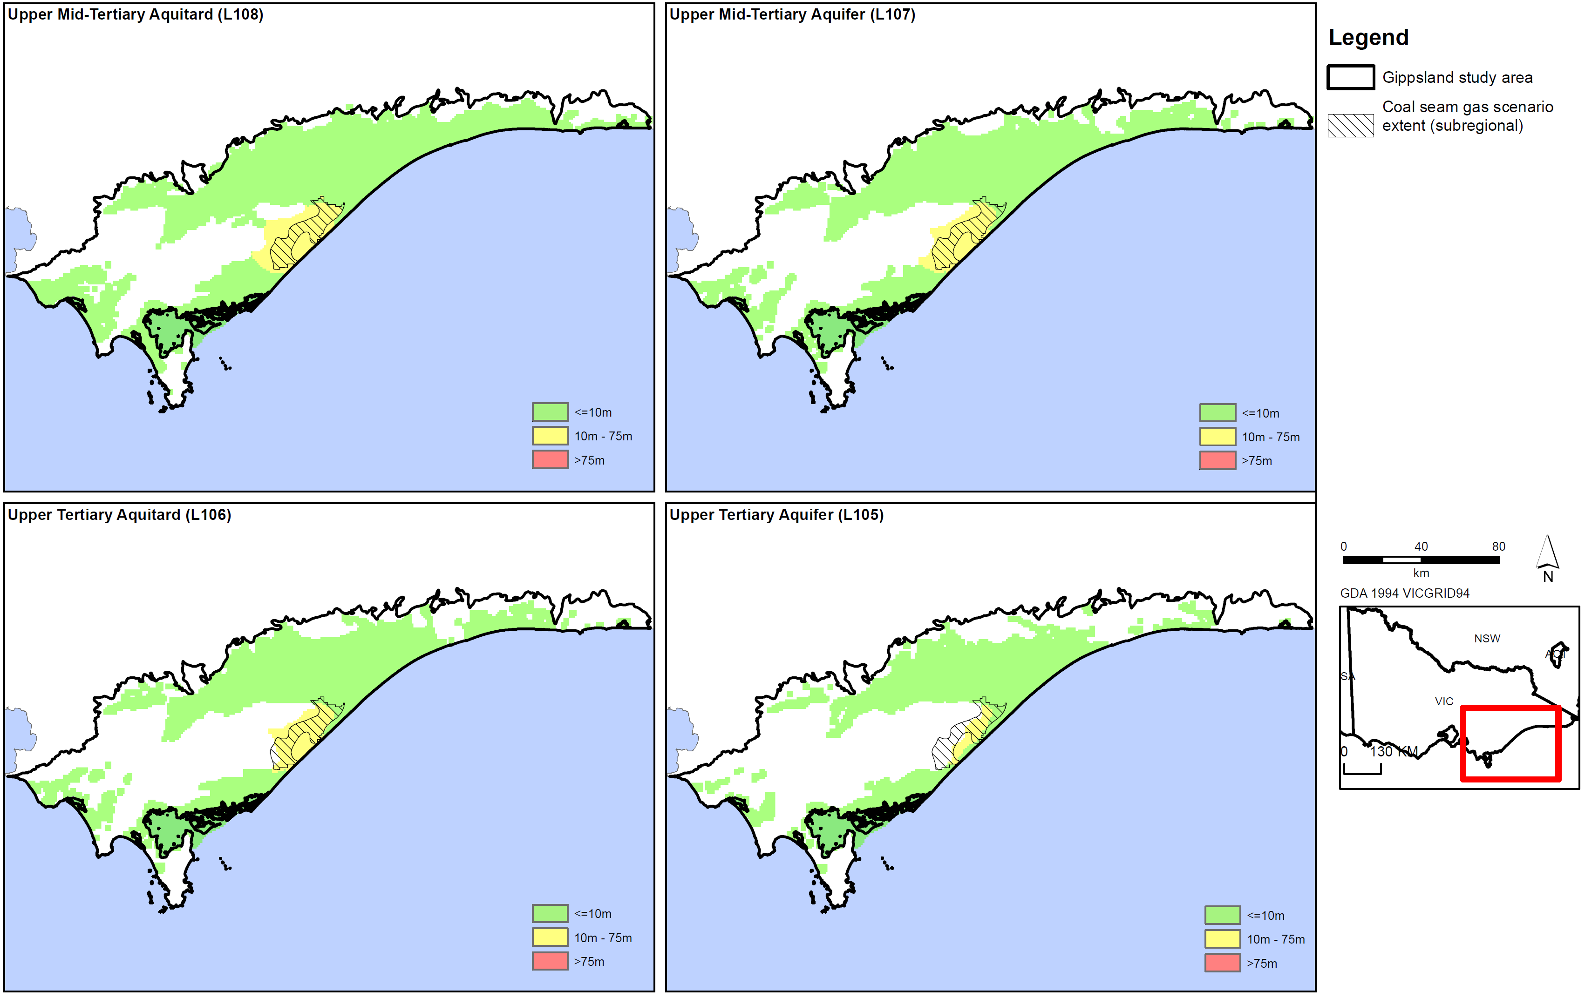
Figure D19b: Coal seam gas maximum drawdown for aquifers in Gippsland region.
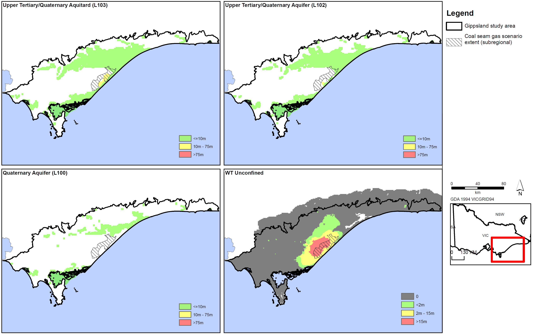
Figure D19c: Coal seam gas drawdown for aquifers in Gippsland region.
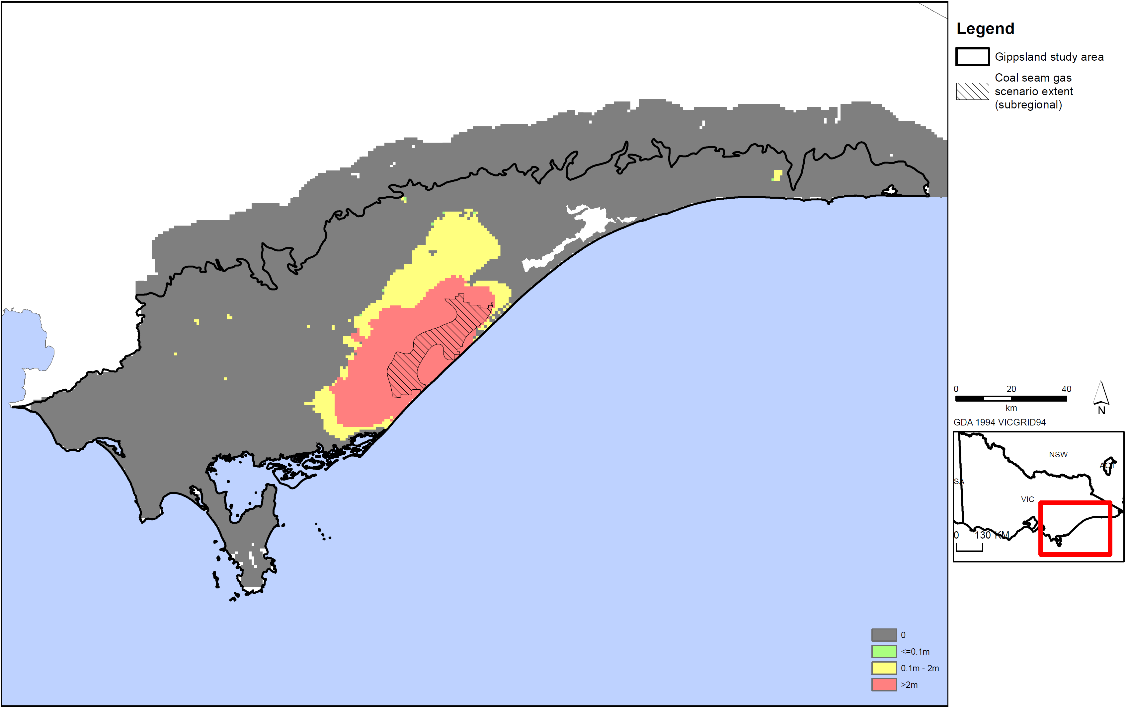
Figure D19d: Coal seam gas drawdown for aquifers in Gippsland region.
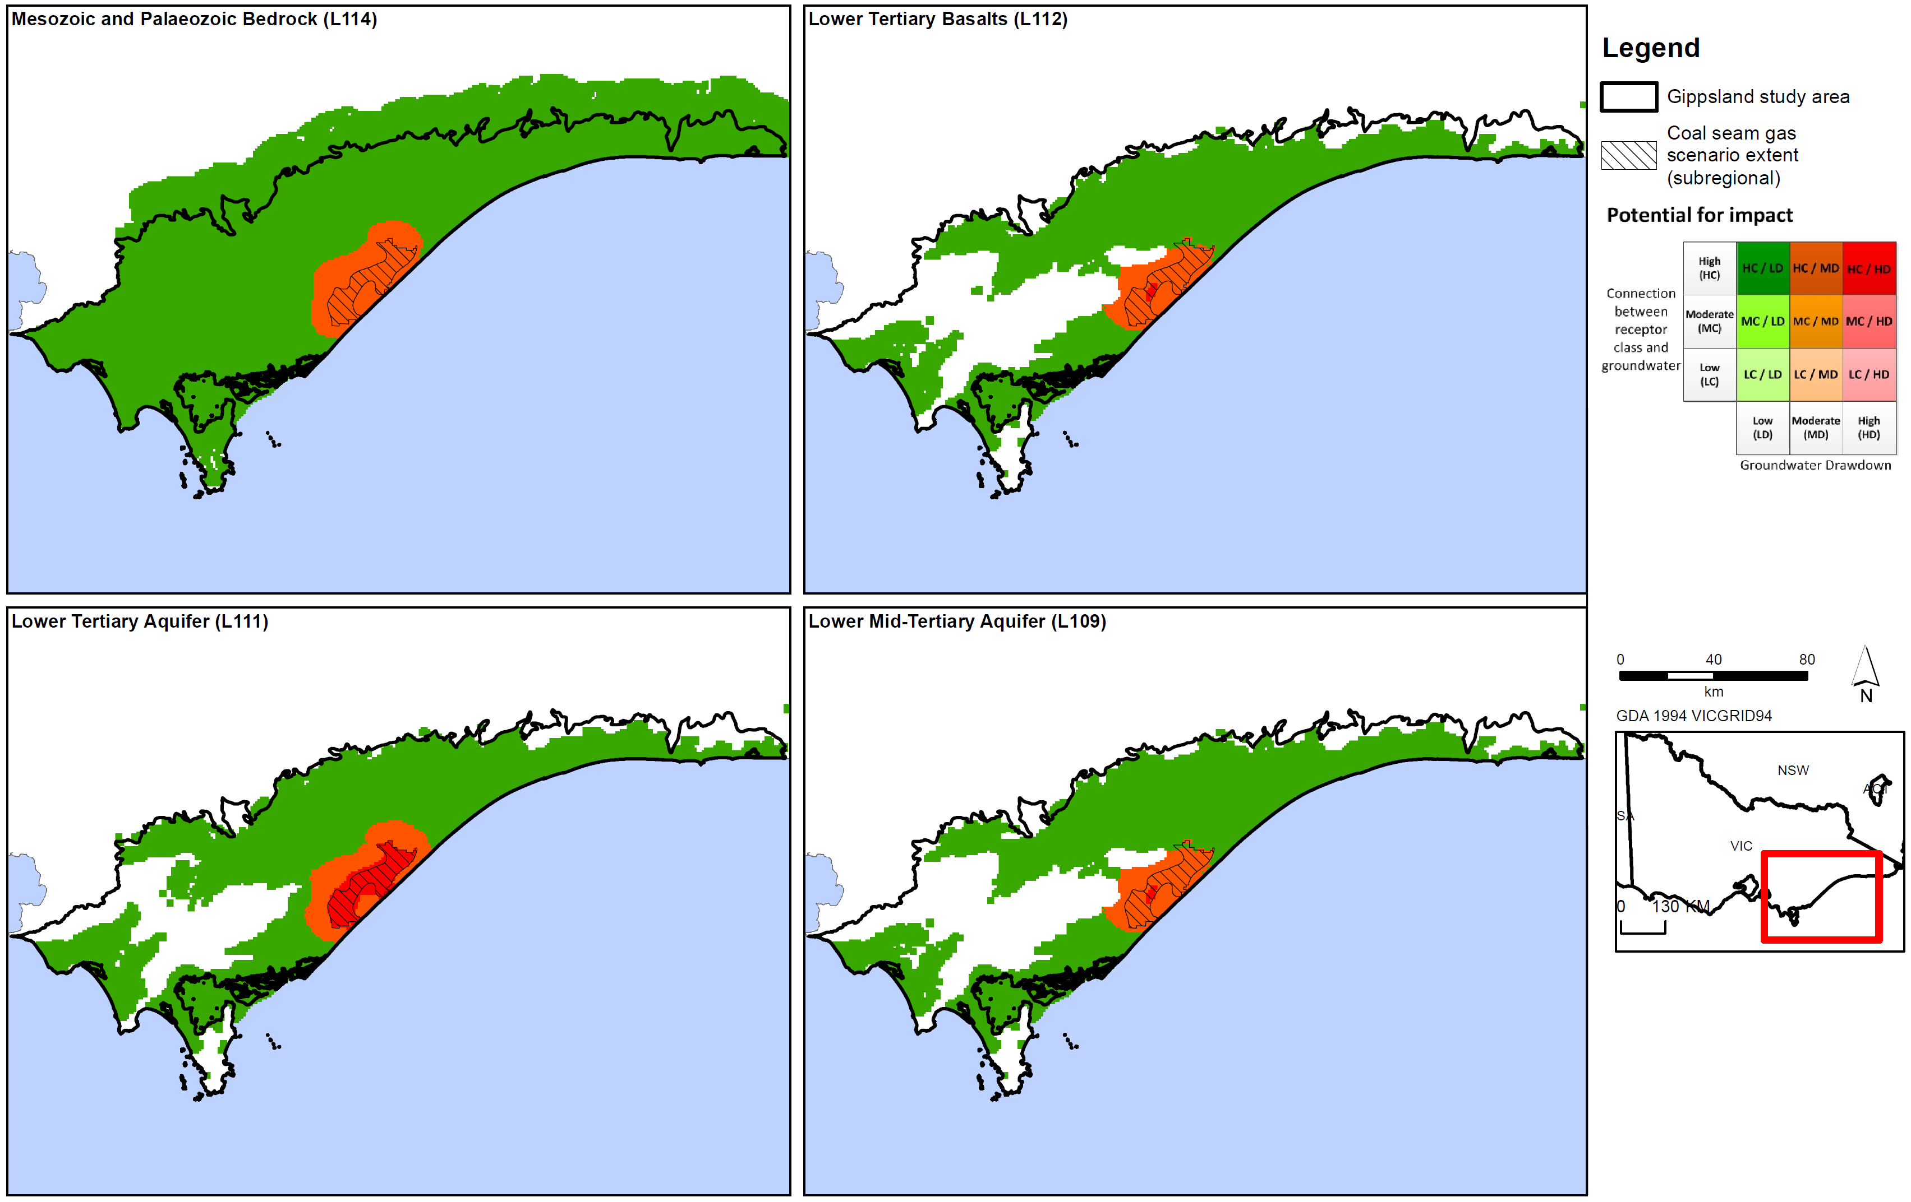
Figure D20a: Potential impact of coal seam gas for aquifers in Gippsland region.
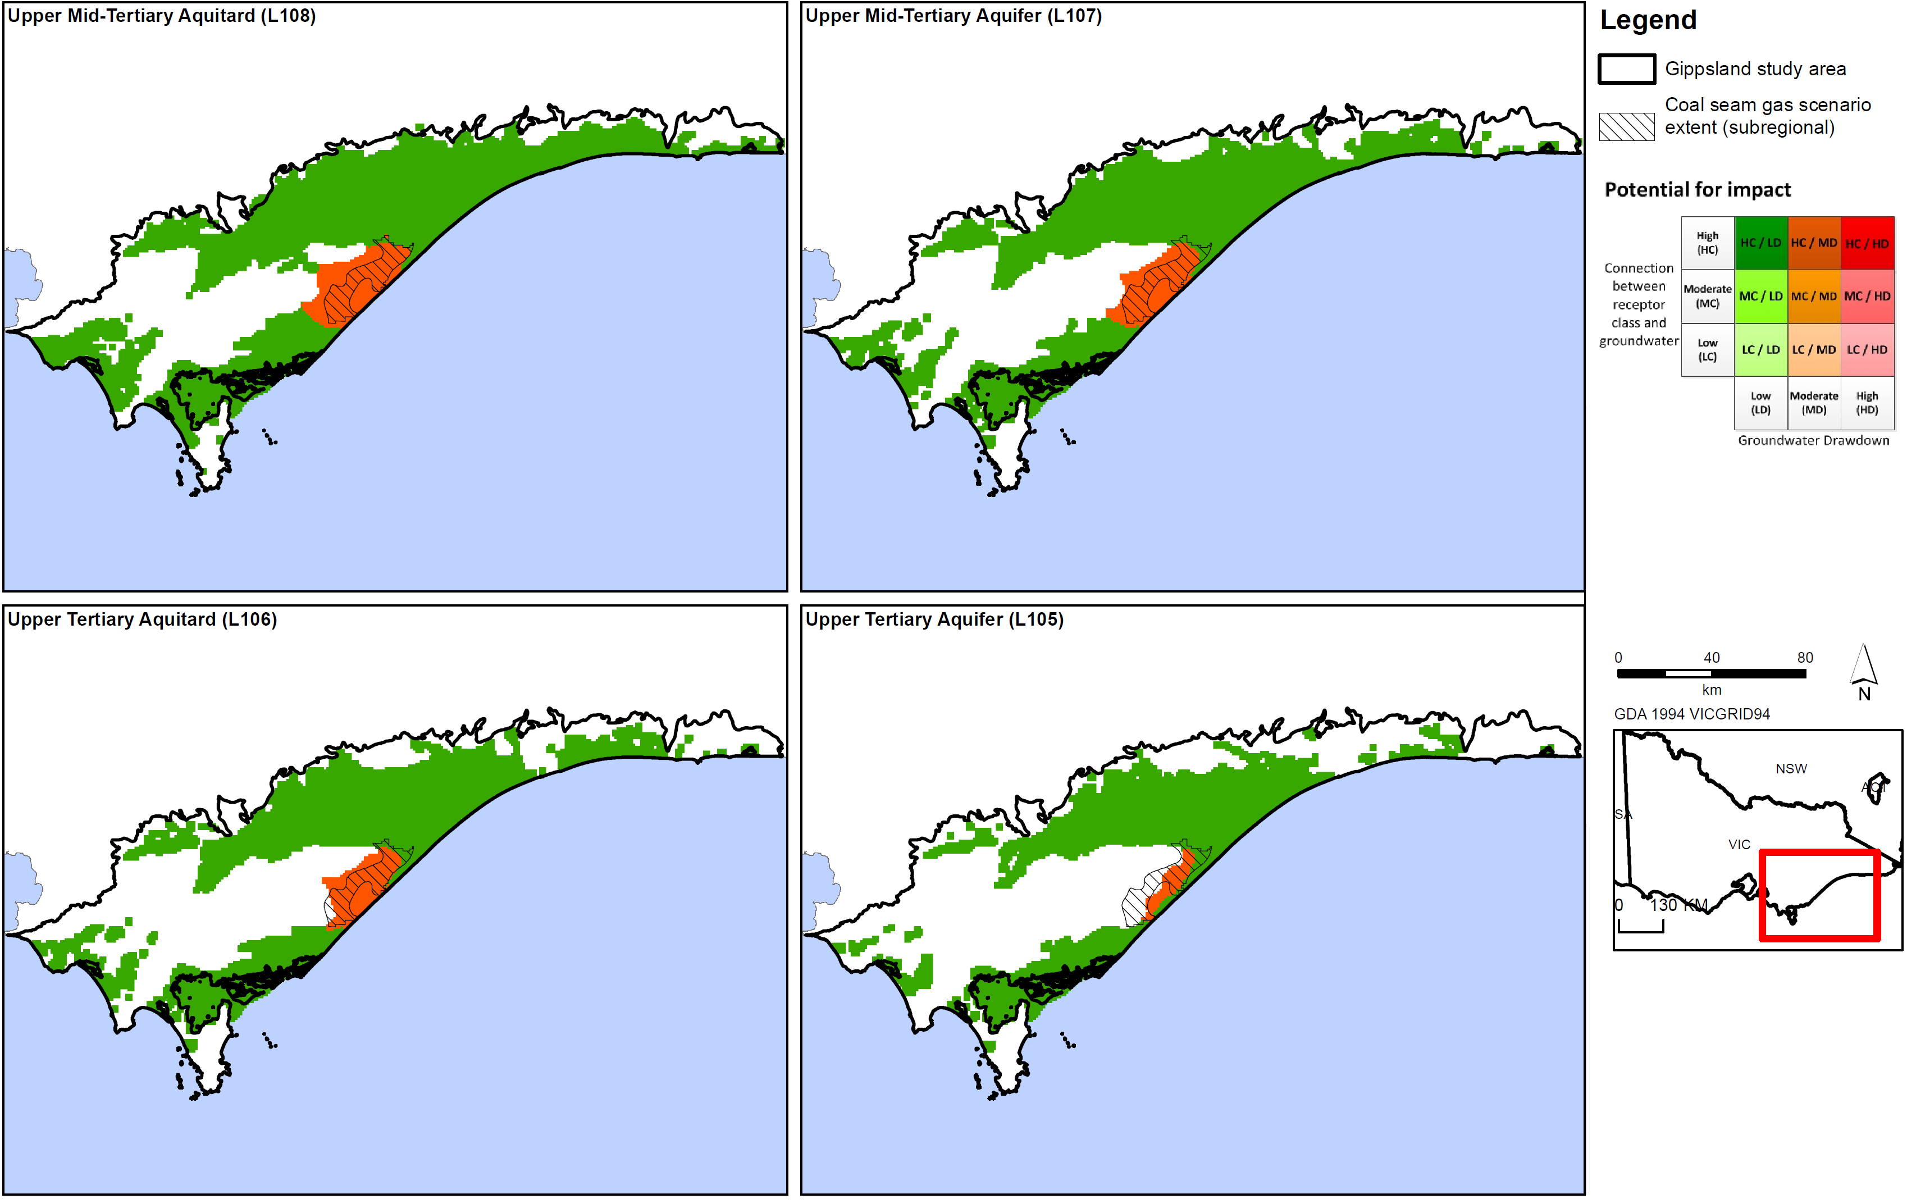
Figure D20b: Potential impact of coal seam gas for aquifers in Gippsland region.
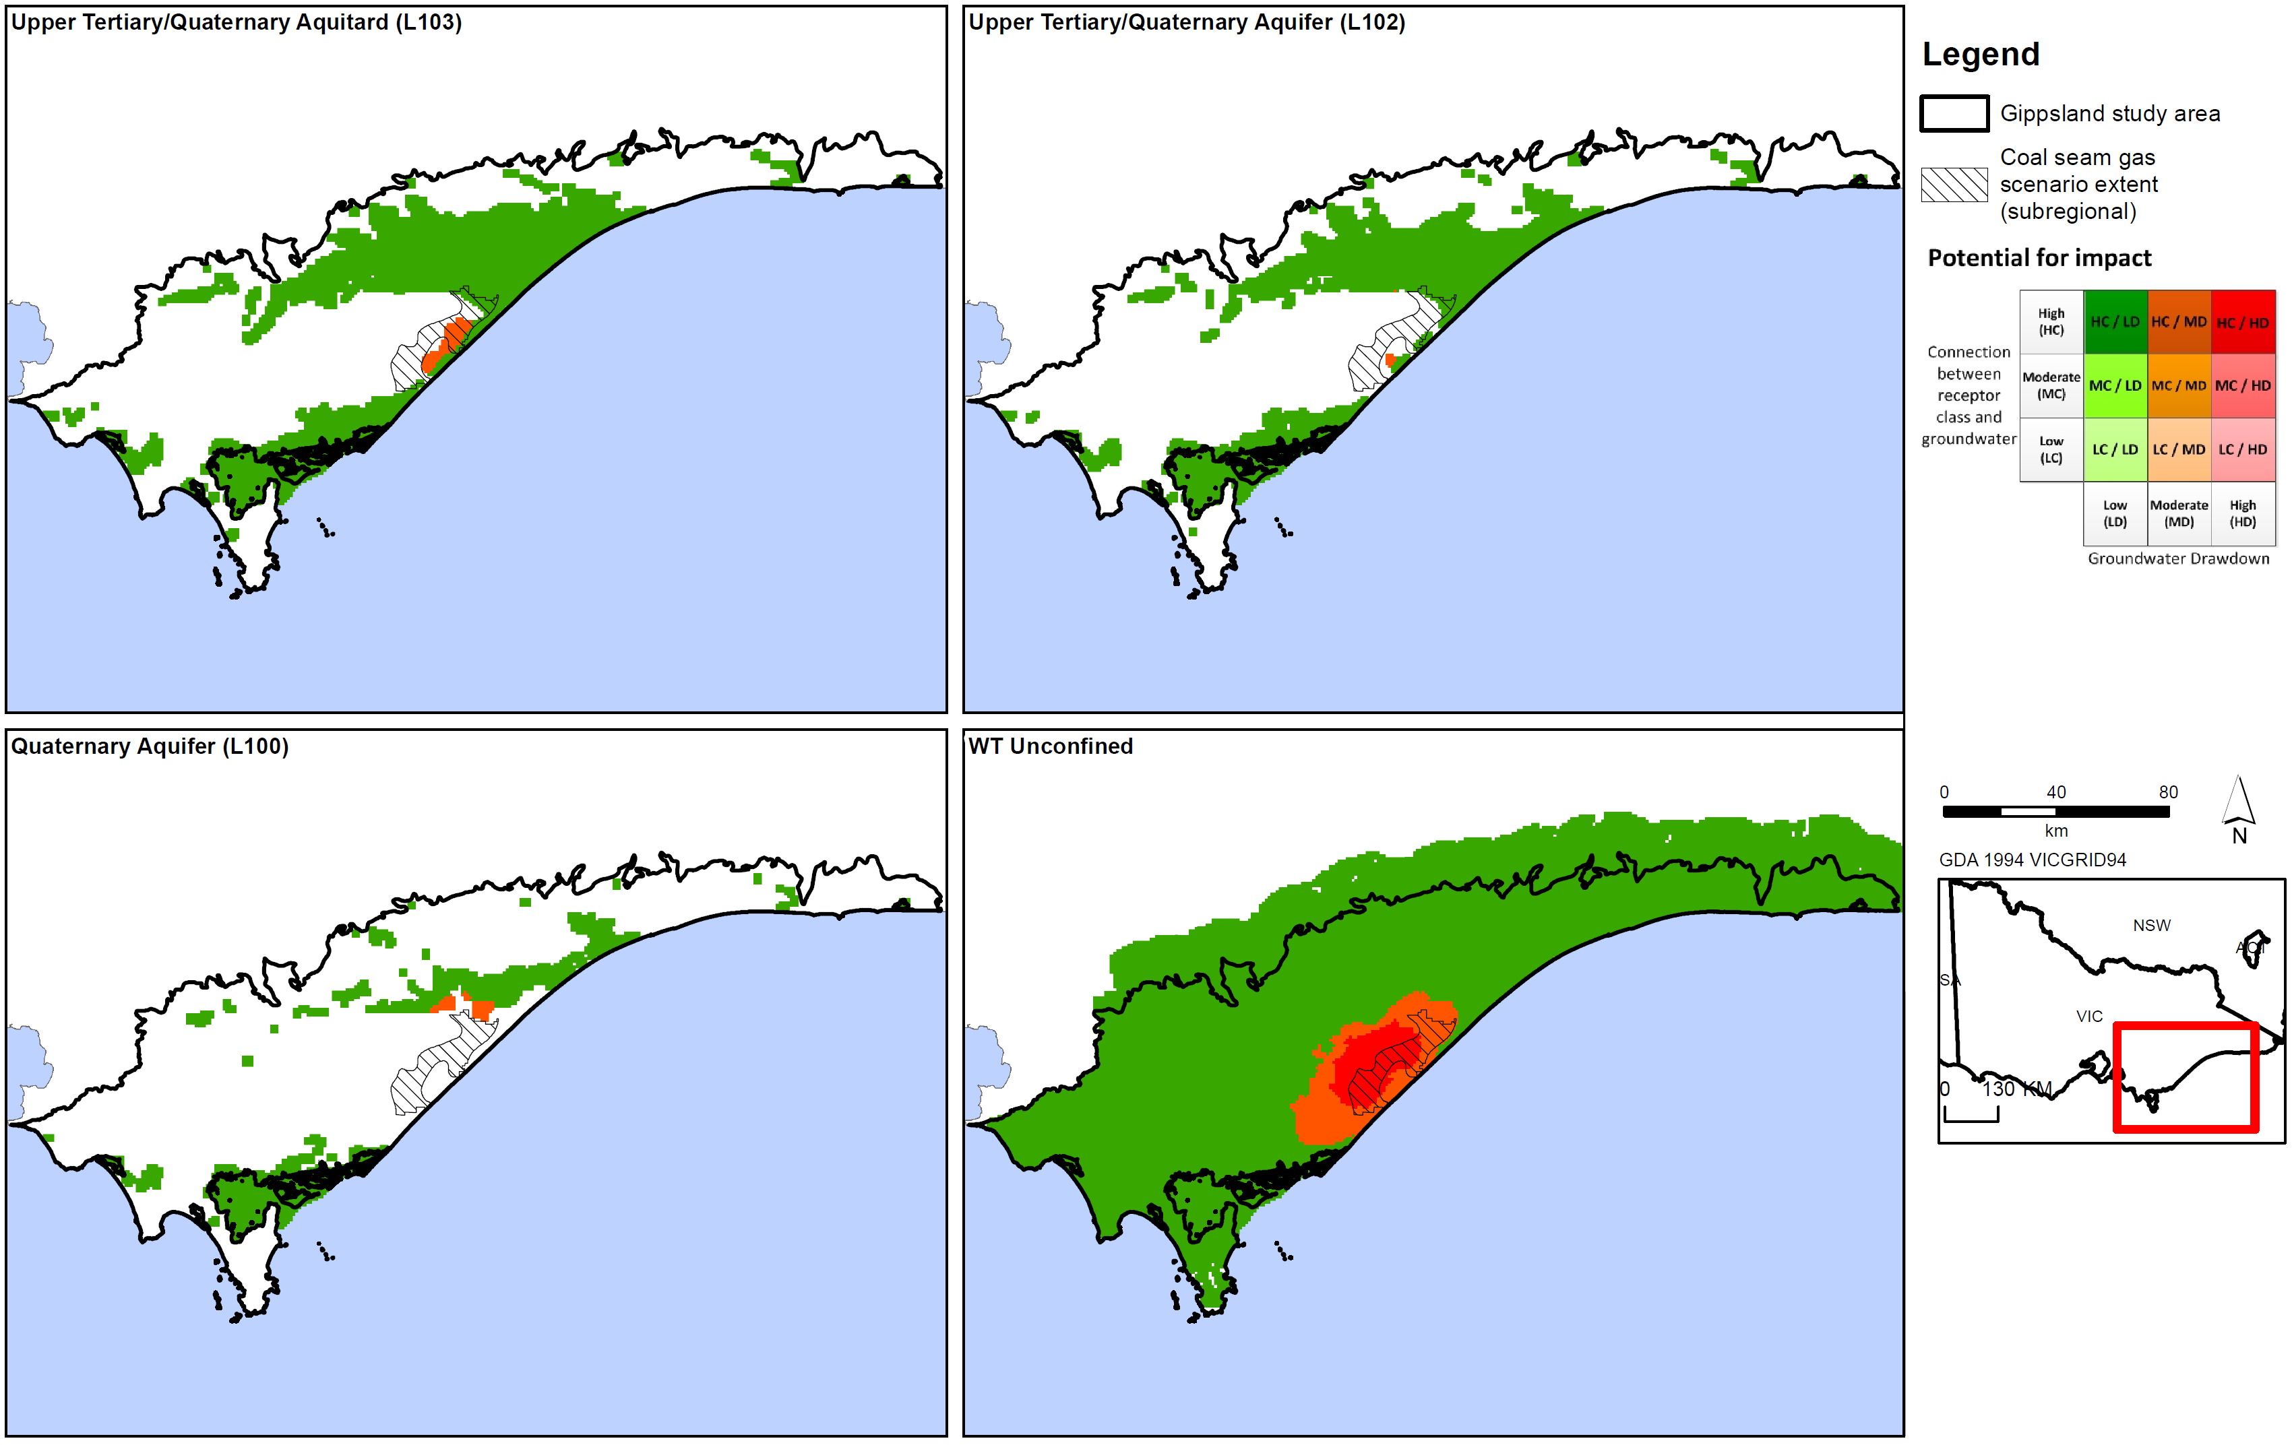
Figure D20c: Potential impact of coal seam gas for aquifers in Gippsland region.
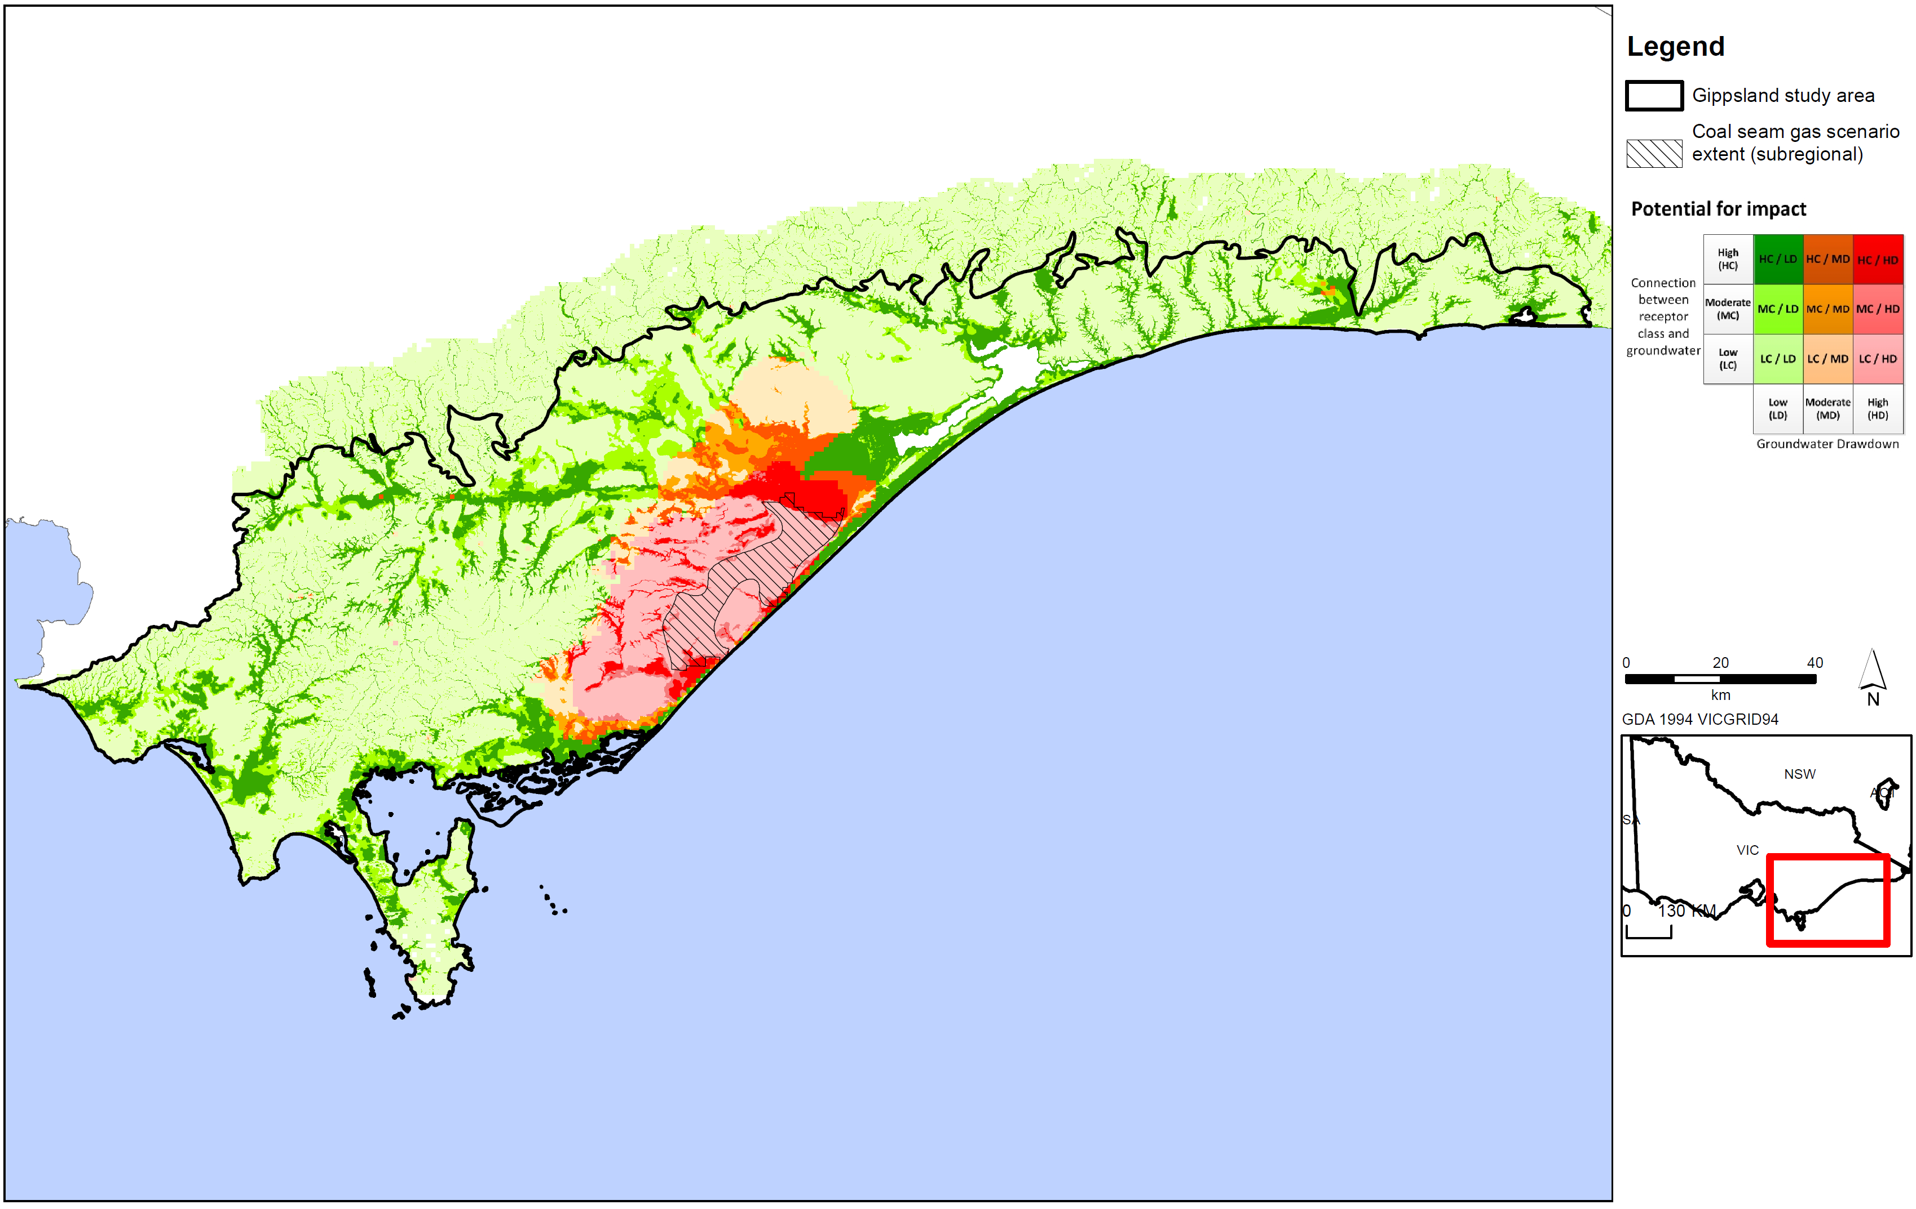
Figure D21: Potential impact of coal seam gas for surface water users in Gippsland region.
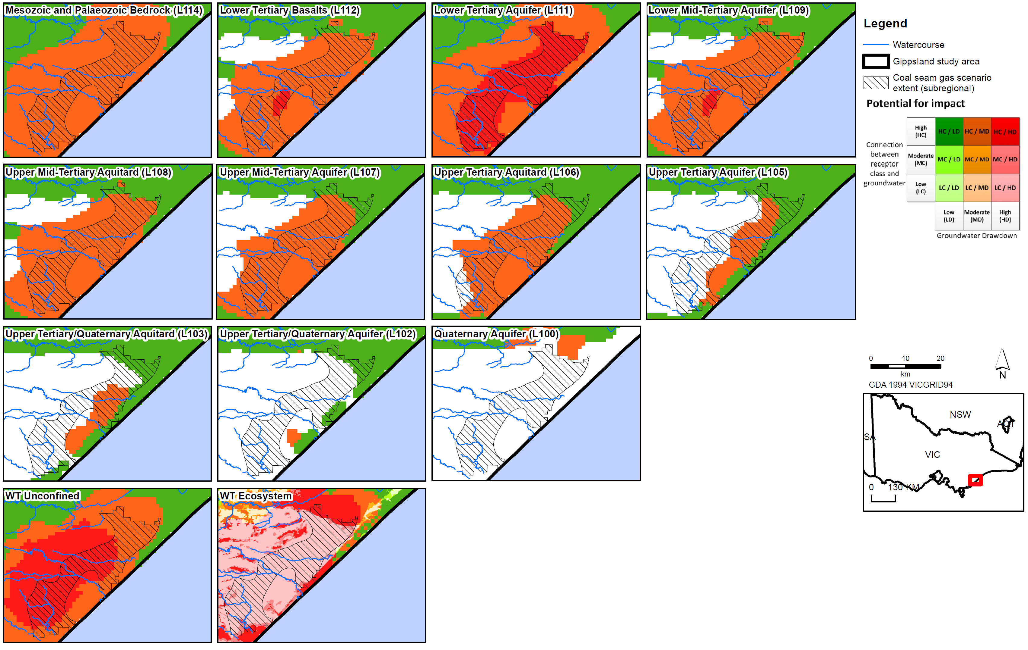
Figure D22: Potential impact of coal seam gas in Gippsland region.
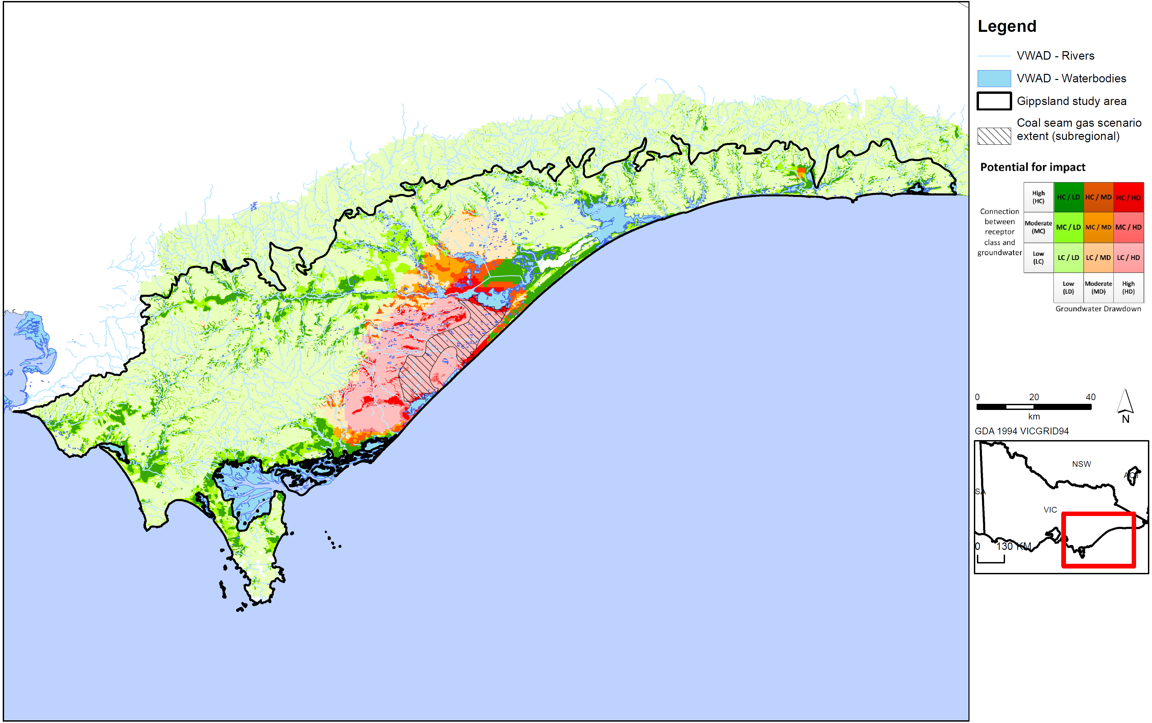
Figure D23: Potential impact of coal seam gas on surface water ecosystems in Gippsland region.
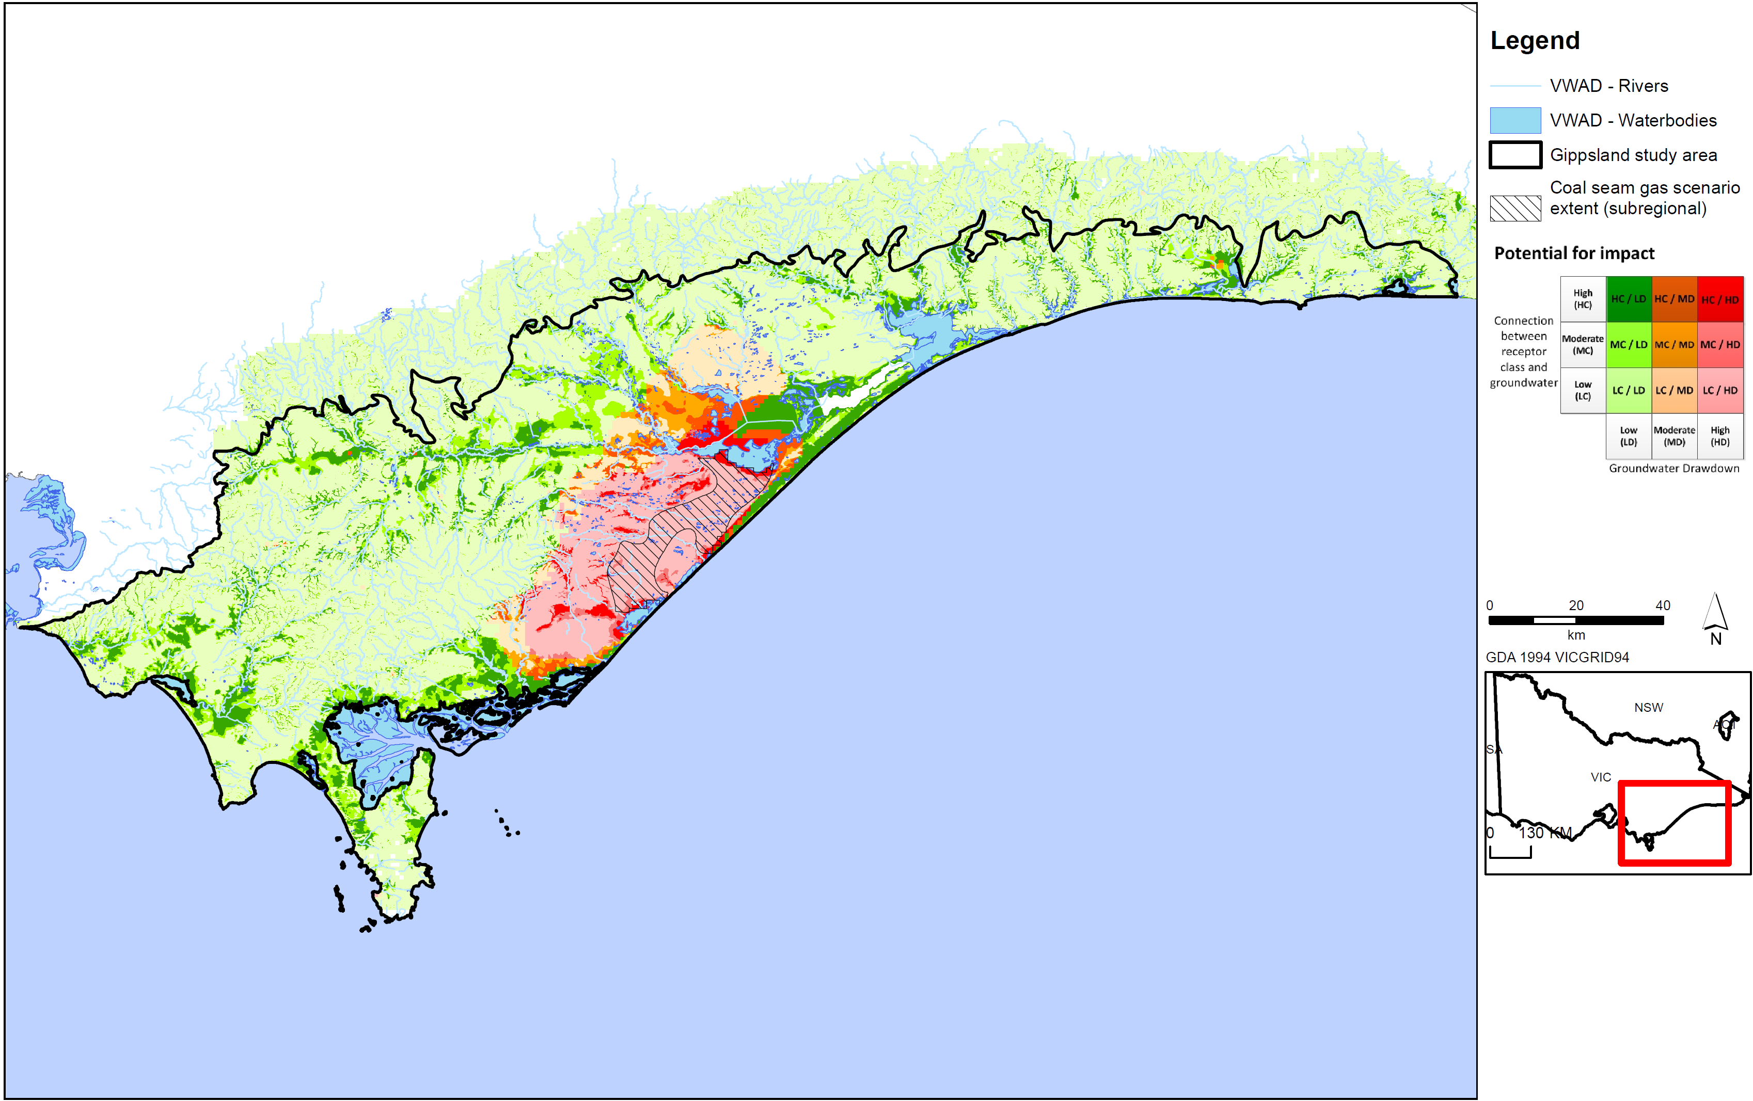
Figure D24: Potential impact of coal seam gas on surface water ecosystems in Gippsland region.


© The State of Victoria Department of Environment, Land, Water & Planning 2015

This work is licensed under a Creative Commons Attribution 4.0 International licence. You are free to re-use the work under that licence, on the condition that you credit the State of Victoria as author. The licence does not apply to any images, photographs or branding, including the Victorian Coat of Arms, the Victorian Government logo and the Department of Environment, Land, Water and Planning (DELWP) logo. To view a copy of this licence, visit http://creativecommons.org/licenses/by/4.0/

ISBN 978-1-74146-619-5 (pdf)

Accessibility
If you would like to receive this publication in an alternative format, please telephone the DELWP Customer Service Centre on 136186, email customer.service@delwp.vic.gov.au or via the National Relay Service on 133 677 www.relayservice.com.au. This document is also available on the internet at www.onshoregas.vic.gov.au

Disclaimer
This publication may be of assistance to you but the State of Victoria and its employees do not guarantee that the publication is without flaw of any kind or is wholly appropriate for your particular purposes and therefore disclaims all liability for any error, loss or other consequence which may arise from you relying on any information in this publication.

Methodology for Bioregional Assessments produced for the Independent Scientific Committee on coal seam gas and Large Coal Mining Development
High productivity aquifers must be at least 5 to 10 square miles of contiguous area, with a thickness of saturated deposits should average at least 20 feet through most of the area, and at some locations be at least 50 feet thick and sustained yields to individual wells should be 50 gallons per minute or more from sizeable areas
http://www.indiana.edu/~spea/faculty/pdf/IRGC-Report-2013.pdf
http://www.dec.ny.gov/data/dmn/ogprdsgeisfull.pdf
Ecological Australia (2012) Shale Gas Development in Australia: Potential Impacts and Risks to Ecological Systems. Final report prepared for the Australian Council of Learned Academies (ACOLA). January 2013.
Study conducted in the context of Germany, with EU and national legislation governing chemical use.
http://fas.org/sgp/crs/misc/R43148.pdf
https://www.ehp.qld.gov.au/management/non-mining/documents/coal seam gas-water-measurable-criteria.pdf
https://www.nsw.gov.au/sites/default/files/coal seam gas-wellintegrity_sd_v01.pdf
http://www.ncsl.org/documents/energy/frackingguide_060512.pdf
Significant Impact Guidelines
Healthy HeadWaters coal seam gas Water Feasibility Study, Activity 5 Groundwater Risks Associated With Coal Seam Gas Development in the Surat and Southern Bowen Basinshttp://www.dnrm.qld.gov.au/__data/assets/pdf_file/0020/106148/act-5-groundwater-risks-report.pdf
Guidelines for Environmental Risk Assessment and Management, Green Leaves III
Water Pollution Risk Associated with Natural Gas Extraction from the Marcellus Shale
Pressure being the coal seam gas activity, stressor the potential hydrological change caused by the pressure and response the change in environmental, social or economic values.
ERSD anticipate that around 80% of ER projects are small-scale and may be categorised as Tier 1, except in water-short and potentially-water-short areas of Alberta. These projects account for approximately 20 per cent of water use. Large-scale projects (Tier 2 or Tier 3) are expected to use around 80 per cent of non-saline water use for oilfield injection.
new draft regulations governing exploration and production of petroleum and geothermal energy resources in onshore WA. Onshore regulation is also evolving in the Eastern States with Queensland and South Australia taking proactive steps towards unconventional gas development. However, regimes in New South Wales and Victoria are seen to have a more restrictive effect on the development of these projects due to delays in approving activities and a shifting moratorium on the coal seam gas industry in those states
Barrett et al (2013)
ACOLA (2013)
http://www.parliament.vic.gov.au/publications/research-papers/8927-unconventional-gas-coal-seam-gas-shale-gas-and-tight-gas
Energy Resources Division Department for Manufacturing, Innovation, Trade, Resources and Energy (2012) First draft: Roadmap for Unconventional Gas Projects in South Australia http://www.petroleum.pir.sa.gov.au/__data/assets/pdf_file/0006/170889/Combined_doc_19_April.pdf
Cook, P.J. (2003) Life Cycle of Coal Seam Gas Projects: Technologies and Potential Impacts Report for the New South Wales Office of the Chief Scientist and Engineer http://www.chiefscientist.nsw.gov.au/__data/assets/pdf_file/0010/31321/Life-Cycle-of-Coal-Seam-Gas-Report_FINAL_PJC.pdf
http://www.petroleum.pir.sa.gov.au/__data/assets/pdf_file/0006/170889/Combined_doc_19_April.pdf
Energy Resources Division Department for Manufacturing, Innovation, Trade, Resources and Energy (2012) First draft: Roadmap for Unconventional Gas Projects in South Australia
Stempvoort et al (1993) Aquifer Vulnerability Index: A GIS-Compatible Method for Groundwater Vulnerability Mapping, Canadian Water Resources Journal, 18 (1)
Original distances specified in NYSDEC (2009) are in feet, not metres.
excluding engineered impoundments constructed for fresh water storage associated with fracturing operations
http://www.dec.ny.gov/data/dmn/ogprdsgeisfull.pdf

