Gippsland region synthesis report

Overview of the assessment of potential
impacts on water resources

June 2015

Acknowledgements
This report was prepared by Jacobs (Australia) Pty Ltd for the Department of Environment, Land, Water and Planning in collaboration with the Geological Survey of Victoria (part of the Department of Economic Development, Jobs, Transport and Resources).
Independent review was provided by:
Professor Rae Mackay, Director, Geotechnical and Hydrogeological Engineering Group, Federation University Australia
Professor Dayanthi Nugegoda, Ecotoxicology, School of Applied Science, RMIT University
Professor Craig Simmons, Director, National Centre for Groundwater Research and Training, Flinders University.

Contents
Summary 3
1 Introduction 7
1.1 What are the water science studies? 7
1.2 How did we go about it? 8
1.3 About this report 9
2 Onshore natural gas 10
2.1 Onshore natural gas types in the Gippsland region 10
2.2 History of gas exploration and development 12
2.3 Industry practices for production of natural gas 12
3 Water resources of the Gippsland region 14
3.1 Groundwater 14
3.2 Surface water 16
3.3 Ecosystems 17
3.4 Groundwater and surface water connection 18
3.5 Groundwater sampling and characterisation for hydrocarbons 20
4 Where are gas and water likely to be connected? 21
5 What are the potential impacts from possible natural gas development? 22
5.1 Assessment approach 22
5.2 Potential impacts from aquifer depressurisation 23
5.3 Potential for chemical contamination of groundwater from hydraulic fracturing fluids 27
5.4 Potential for increased earthquakes 28
5.5 Potential for land subsidence 28
5.6 Summary of the potential impacts prior to mitigation 29
6 What could be done to reduce the potential impacts? 30
6.1 The basis for mitigating potential impacts 30
6.2 Mitigation study results 31
Water science studies outputs for Gippsland region 33
Glossary of terms and abbreviations 34

Summary
This report is a synthesis of the Gippsland region component of the onshore natural gas water science studies. These studies provide the Victorian Government and community with technical information about potential water-related issues and impacts that may arise as a consequence of the development of an onshore natural gas industry in Victoria.
The Gippsland and Otway regions were the focus of these studies. This is because these two regions are thought to be the most prospective areas in Victoria for onshore natural gas development. At present there is no active onshore natural gas development in Victoria. Tight gas, shale gas and coal seam gas are the three main types of prospective onshore natural gas in Gippsland. As far as is known at present, there is no significant onshore conventional gas potential in the Gippsland region.
The purpose of the water science studies on onshore natural gas is to provide an initial screening analysis of the potential impacts of possible onshore gas exploration and development on water users and ecosystems. The studies assess the potential impacts of aquifer depressurisation (i.e. groundwater level decline), chemical contamination of groundwater from hydraulic fracturing fluids, induced seismicity, and land subsidence.
Gas extraction depressurises the gas-bearing formation and may cause a decline in groundwater level, which could impact water users and ecosystems. Groundwater level decline may also cause land subsidence.
Hydraulic fracturing can increase gas yield, but may unintentionally contaminate water supplies with hydraulic fracturing fluids and induce seismicity (earthquakes).
The studies apply a causal pathway approach, describing where natural gas might be, where water resources are, the physical connection between the gas and water resources, and utilising modelling and analysis to infer impacts on water users and ecosystems.
The studies were conducted by the Department of Environment, Land, Water and Planning and the Geological Survey of Victoria (part of the Department of Economic Development, Jobs, Transport and Resources). An essential part of the water science studies was the engagement of a scientific review panel, which provided an independent peer review of the studies, ensuring the rigour of the significant body of technical work that was undertaken.
The studies have used the best available information, although noting that there are known gaps in the geological and hydrogeological data sets. Because of these gaps the impact assessment is conservative; that is, the results are likely to estimate higher impacts than may eventuate if development did occur. It is important to note that there are issues that are beyond the scope of these water science studies. These include treatment and disposal of co-produced water, water use for fracturing and gas production, and non-water resource issues such as amenity, air quality, fugitive gas emissions, on-site chemical management and bore integrity. Therefore, the findings that follow should be considered only with respect to the topics addressed.

Findings for the Gippsland region
Overall, the potential for impacts on water users and ecosystems from possible onshore natural gas developments in Gippsland was found to be low for tight and shale gas (with some exceptions) and moderate to high for coal seam gas.
The specific findings are summarised below and in Tables 1 to 4.

Tight and shale gas
- The potential for impacts on groundwater users from aquifer depressurisation for tight and shale gas development is low, as inferred from a predicted decline in the watertable of less than 2 m and a predicted decline in deep groundwater levels of less than 10 m.
- The potential for impacts on groundwater quality from aquifer depressurisation for tight and shale gas development is inferred as low, based on the predicted changes to groundwater pressure gradients being within historical ranges.
- The potential for impacts on surface water users as a result of reduced stream flow or changes in surface water quality due to aquifer depressurisation is generally low, with the exception of localised areas of moderate (as inferred from a predicted decline in watertable of greater than 0.1 and less or equal to 2.0 m) to high potential impact (as inferred from a greater than 2.0 m predicted decline in watertable) in the central Latrobe Valley region. This is inferred, based on the predicted changes to groundwater levels. However, the areas of moderate to high potential impact could be reduced to low with implementation of one or more of the mitigation strategies outlined in this report.
- The potential for impacts on ecosystems as a result of reduced stream flow caused by aquifer depressurisation is generally low, with the exception of localised areas of moderate to high potential impact in the central Latrobe Valley region. This assessment is inferred from the predicted changes to groundwater levels. Applying effective mitigation in these localised areas may have technical and financial limitations if the potential impact is moderate to high.
- The potential for chemical contamination of groundwater from hydraulic fracturing fluids is low for tight and shale gas development, based on a review of national and international literature, the particular geological conditions of the Gippsland region, and the fact that the addition of BTEX chemicals to hydraulic fracturing fluids is banned under Victorian law.
- The potential for induced seismicity is low for tight and shale gas development, based on a review of national and international literature with consideration of the particular geological conditions of the Gippsland region.
- The potential for land subsidence is low for tight and shale development, based on the predicted changes to groundwater levels.

Coal seam gas
- The potential for impacts on groundwater users from aquifer depressurisation as a result of coal seam gas development is moderate to high (e.g. greater than 15 m decline in the watertable), based on the distance to the prospective development area and the predicted changes to groundwater levels. The impact could be reduced to low by implementing one or more of the mitigation strategies outlined in this report.
- The potential for impacts on groundwater quality from aquifer depressurisation for coal seam gas development is inferred as moderate, based on predicted depressurisation which is moderate to high. There are possible technical and financial implications to applying effective mitigation to reduce this impact.
- The potential for impacts on surface water users as a result of reduced stream flow or changes in surface water quality caused by aquifer depressurisation is moderate to high, depending on proximity to a proposed natural gas development. This is inferred from the predicted changes to groundwater levels. However, this can be reduced to low by implementing one or more of the mitigation strategies outlined in this report.
- The potential for impacts on ecosystems as a result of reduced stream flow or changes in surface water quality caused by aquifer depressurisation is moderate to high, depending on proximity to the proposed natural gas development. This is inferred from the predicted changes to groundwater levels. There are possible technical and financial constraints on applying effective mitigation to reduce this impact.
- Hydraulic fracturing is not expected to be required for the development of coal seam gas, and therefore would not have any potential impact in this region.
- The potential for induced seismicity is low for coal seam gas development, based on a review of national and international literature with consideration of the particular geological conditions of the Gippsland region.
- The potential for land subsidence is moderate for coal seam gas development, based on the predicted changes to groundwater levels. There are possible technical and financial limitations to applying effective mitigation to reduce this impact from moderate to low.

Table 1: The potential for impacts associated with aquifer depressurisation for each natural gas scenario without any mitigation measures applied.
Natural gas type | Impacts on users
Natural gas type | Groundwater users | Surface water users | Ecosystems
Tight and shale | Low | Low* | Low*
Coal seam gas (brown coal) | High | High | High
*Localised areas of moderate to high potential impact in the central Latrobe Valley region

Table 2: The potential for impacts associated with hydraulic fracturing, induced seismicity and land subsidence for each natural gas scenario, without mitigation measures applied.
Natural gas type | Chemical contamination of groundwater from hydraulic fracturing fluids |  |  | Induced seismicity | Land subsidence
Natural gas type | Groundwater users | Surface water users | Ecosystems
Tight and shale | Low | Low | Low | Low | Low
Coal seam gas | N/A | N/A | N/A | Low | Moderate

Table 3: The potential for impacts of aquifer depressurisation for each natural gas scenario following mitigation measures.
Natural gas type | Impacts on users
Natural gas type | Groundwater users | Surface water users | Ecosystems
Tight and shale | Low | Low | Low*
Coal seam gas (brown coal) | Low | Low | High  (unchanged)
*Localised areas of moderate to high impact in the central Latrobe Valley region

Table 4: The potential for chemical contamination of groundwater from hydraulic fracturing fluids, induced seismicity and land subsidence for each natural gas scenario following mitigation measures.
Natural gas type | Chemical contamination of groundwater from hydraulic fracturing fluids |  |  | Induced seismicity | Land subsidence
Natural gas type | Groundwater users | Surface water users | Ecosystems
Tight and shale | Low | Low | Low | Low | Low
Coal seam gas (brown coal) | N/A | N/A | N/A | Low | Moderate  (unchanged)

- Introduction
  - What are the water science studies?
The water science studies provide an initial screening analysis of a set of potential water-related issues and impacts that may arise as a consequence of the development of an onshore natural gas industry.
The studies describe where natural gas might be, where water resources are, and assess what physical connections there may be between these gas and water resources. Where these resources are thought to be physically connected, the potential quantity and quality impacts on groundwater were investigated, and by inference the potential impacts on groundwater users, surface water users and ecosystems. The potential effectiveness of possible mitigation strategies have also been assessed.
There are four different types of possible onshore natural gas development in Victoria: conventional, shale, tight and coal seam gas. These types of gas developments may have different impacts on water resources and so each is assessed in these studies.
The two study regions are the Gippsland region and the Otway region (Figure 1) as these are thought to be the most prospective areas in Victoria for onshore natural gas development. While the Geological Survey of Victoria has conducted some research into potential areas where onshore natural gas resources may exist, the commercial feasibility of onshore gas development has not been determined.
Figure 1: Otway (left) and Gippsland (right) study regions.
The four topics investigated with regard to the potential impacts of developing an onshore natural gas industry are:
- aquifer depressurisation
- chemical contamination of groundwater from hydraulic fracturing fluids
- induced seismicity
- land subsidence.
The studies was undertaken by the Department of Environment, Land, Water and Planning with the assistance of the Geological Survey of Victoria (part of the Department of Economic Development, Jobs, Transport and Resources), as a joint program, between June 2014 and June 2015.
The outputs of the studies take the form of two synthesis reports (one each for the Gippsland region and Otway regions) and a series of technical reports. This report is the synthesis report for the Gippsland region.
  - How did we go about it?
These studies have used the best available data, noting that this is limited by gaps in the geological and hydrogeological data. New information was generated to augment the existing body of knowledge on onshore natural gas and how it relates to water resources in the Gippsland and Otway regions. As a result, the following were developed as part of the water science studies:
- hypothetical gas development scenarios
- a database identifying water resources and their attributes for the state of Victoria
- groundwater modelling
- a baseline groundwater monitoring program
- a regional assessment of potential impacts on water resources for the Gippsland and Otway regions.
The outputs of the studies provide government and communities with a substantial body of new, region-specific technical information for considering the potential development of an onshore gas industry in these two regions.
A scientific review panel has provided an independent peer review of this report, as well as the Gippsland region assessment of potential impacts and the Gippsland groundwater model, ensuring the rigour of the work. A list of the detailed technical reports prepared as part of the Gippsland region water science studies is provided on page 33.
The detailed technical reports present the specific methods used to conduct the detailed assessments, including the use of an 'impact assessment' approach for the analysis of aquifer depressurisation and a 'risk assessment' approach for the analysis of hydraulic fracturing, induced seismicity and land subsidence. The term 'impact assessment' is used in this synthesis report to describe the approach for a wider audience.
As there is no onshore natural gas development in Victoria at present, these studies have assessed the potential impacts of hypothetical natural gas development projects on water users and ecosystems in the Gippsland and Otway regions.
Within the bounds of the issues assessed, a conservative approach has been taken towards assessing the potential impacts associated with onshore natural gas development. This conservative approach is appropriate given the limited data available and the need to test hypothetical scenarios for analysis. Therefore, the findings in this report are likely to estimate higher impacts than may eventuate if development did occur.
A range of mitigation strategies were assessed. For water users these included reducing the scale, timing or location of the development of the hypothetical resource, scheduling the operations of water supply systems, augmenting water supply systems, and offsetting the loss of water supply with alternative water resources. An assessment of the potential effectiveness of such mitigation strategies was completed to determine whether these additional controls and offsets might alleviate some of the potential impacts predicted under the full development case.
  - About this report
Chapter 2 of this report explains the different types of potentially prospective onshore natural gas in the Gippsland region, provides a synopsis of gas exploration and development in the region, and outlines industry production practices for the different types of natural gas.
Chapter 3 provides an overview of the groundwater and surface water resources of the Gippsland region and the significant water-dependent ecosystems. It also explains how groundwater and surface water resources can be connected. Finally, this chapter presents the results of the monitoring of groundwater quality that was undertaken to inform these studies.
Chapter 4 discusses where gas resources and groundwater resources are likely to be connected in the Gippsland region. This information is used to inform the assessment of the potential impacts from possible onshore natural gas development.
Chapter 5 summarises the potential impacts on water users and ecosystems from possible tight, shale and coal seam gas development prior to possible mitigation. The potential impacts associated with aquifer depressurisation, chemical contamination of groundwater from hydraulic fracturing fluids, induced seismicity and land subsidence are discussed in turn.
Chapter 6 discusses the potential to reduce impacts through mitigation, and presents the resultant potential impacts.
The technical reports prepared for the Gippsland region as part of the water science studies are listed on page 33.

- Onshore natural gas
Natural gas is a naturally occurring hydrocarbon consisting primarily of methane, but can also contain small amounts of ethane, propane, butane and pentanes. Sulfur compounds, nitrogen, carbon dioxide, water and other substances may also be present. Natural gas forms over millions of years, as heat and pressure transform decaying plant and animal matter buried in rock layers.
  - Onshore natural gas types in the Gippsland region
Tight gas, shale gas and coal seam gas are the three main types of prospective onshore natural gas in Gippsland. There is no significant onshore conventional gas potential in the Gippsland region based on current information.
Tight gas refers to natural gas trapped in low permeability rock formations such as sandstone and carbonate. Tight gas might be located at depths of 1000 to 3000 m below the ground surface in some areas of the Gippsland region. | 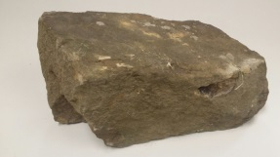 | 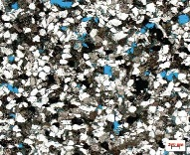
Shale gas might also be located at depths between 1000 and 3000 m in some areas of the Gippsland region, within a fine-grained sedimentary rock called shale. | 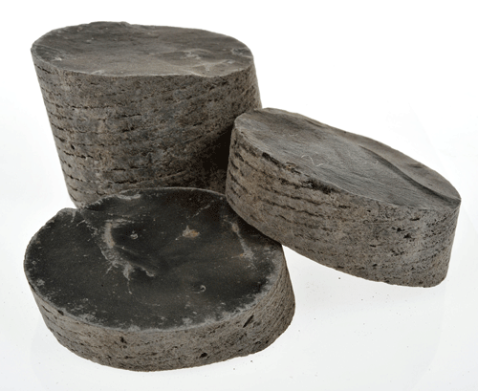 | 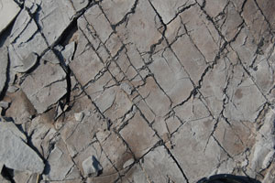
Coal seam gas, also known as coalbed methane, is natural gas found in coal seams. Coal seam gas is generally a shallower natural gas resource than tight and shale gas. In the Gippsland region, coal seam gas might be located in brown coal seams at depths between 400 and 800 m. Coal seam gas is held in coal seams by water pressure. | 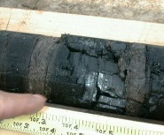 | 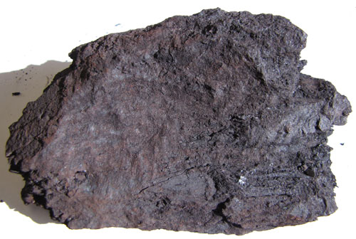
Tight and shale gas are assessed as a single resource in the Gippsland region, as they are expected to be located within the same geological formation (tight sandstones and shales of the Strzelecki Group). The approximate location of potentially prospective tight, shale and coal seam gas is shown in Figure 2. The cross-section in Figure 3 shows a representation of the typical geological formations bearing potential natural gas resources and the relative depth of the different potential natural gas sources.

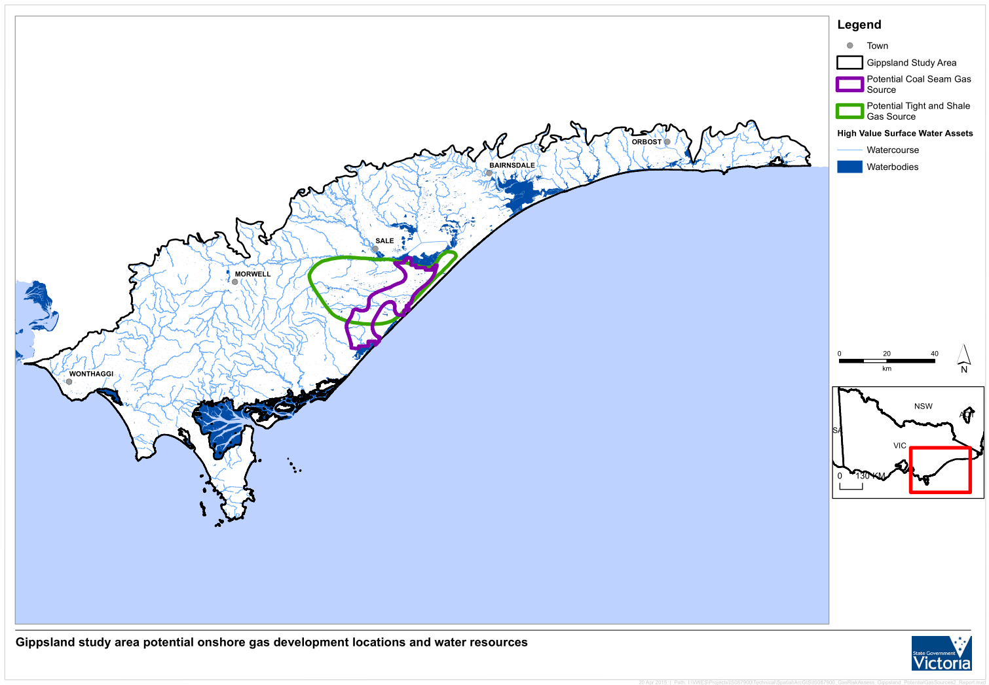
Figure 2: Extent of hypothetical onshore natural gas development scenarios for the assessment of potential impacts on water resources in the Gippsland region.

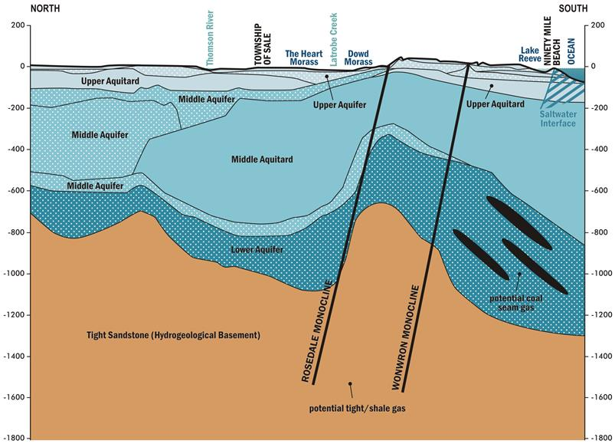
Figure 3: Typical geological formations bearing prospective onshore natural gas in the Gippsland region (depth shown in metres).
  - History of gas exploration and development
Exploration for petroleum in the Gippsland region began with the drilling of the first well in 1886 at Toongabbie. The subsequent discovery of natural gas in the offshore Gippsland region under Bass Strait led to the development of the conventional offshore oil and gas fields in the Gippsland region, with production starting in the late 1960s.
Across the Gippsland region, nearly 200 wells have been drilled for exploration purposes. No oil or gas has been commercially produced from the onshore Gippsland region to date, with the exception of the recovery of heavy oil in the 1930s near Lakes Entrance.
  - Industry practices for production of natural gas
Unlike conventional gas, tight, shale, and coal seam gas may be continuous over wide geographic areas rather than concentrated in discrete areas. This observation is based on experience elsewhere. This means that increased drilling activity may be necessary for both exploration and development phases for these natural gas types. The development of tight and shale gas (and sometimes coal seam gas) uses technologies such as horizontal drilling and hydraulic fracturing techniques to extract the gas. Tight and shale gas project developers may drill multiple wells from a single well pad, which enables a greater spacing between the well pads at the surface: often around 1 km. Well spacing for coal seam gas production is generally around 400 m, which means more wells are required over the same area.
The development of tight and shale gas production has advanced in the USA due to the application of hydraulic fracturing and horizontal drilling technologies (Figure 4). Hydraulic fracturing, also called fracture stimulation or fracking, is a process that generates small fractures to increase the permeability of the rock formation and allows greater gas extraction. Tight gas rocks within the Gippsland region may require hydraulic fracturing in order to increase their permeability, enabling the gas to be released. The applicability of hydraulic fracturing to extract tight and shale gas in Victoria is not proven. Horizontal drilling (also known as directional or in-seam drilling) is used to access all types of natural gas. There is a lot that must be understood about the geology from on-ground surveys and vertical drilling before determining whether horizontal drilling would be effective to extract gas. This technique has been successfully used in the USA. The applicability of horizontal drilling methods to potential natural gas formations in Victoria is not proven.
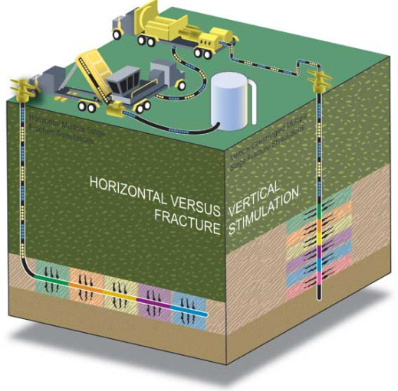
Figure 4: Hydraulic fracturing or stimulation process in vertical and horizontal wells. (Source: Standing Council for Energy Resources, 2013, The National Harmonised Regulatory Framework for Natural Gas from Coal Seams)

- Water resources of the
Gippsland region
  - Groundwater
Groundwater is water that is stored under the ground within aquifers and aquitards. An aquifer is a layer of rock that is porous enough to hold groundwater and permeable enough to allow the groundwater to flow. An aquitard is a layer of rock that may hold groundwater, but is less permeable than an aquifer and therefore restricts groundwater flow. Groundwater can vary in quality from fresh to saline.
The Gippsland region contains a variable sequence of aquifers and aquitards. The sequence of aquifers and aquitards generally thickens toward the coast. Groundwater and surface water are extracted in the Gippsland region for agriculture, town water supplies, mine dewatering and offshore oil and gas extraction.
The main sources of groundwater resources in the Gippsland region are found in three main aquifer groups:
- Upper aquifers are generally less than 100 m deep and comprise the alluvial sediments of the Haunted Hills Formation and the Eagle Point Sands.
- Middle aquifers are generally deeper than 100 m and can be up to several hundred metres deep. Important regional aquifers include the Boisdale Formation, Balook Formation and Morwell Formation. These are sand-dominated aquifers interspersed with brown coal seams.
- Lower aquifers can be over several hundreds of metres deep, (although lower aquifers can also be close to the surface at the edge of the Gippsland Basin). The aquifers include the Yarram Formation, the Carrajung Volcanics and the overlying Traralgon Formation of the Latrobe Group. The coal seams in the Traralgon Formation represent regional aquitards, while thick sand and gravel sequences above and below the coal seams represent regional aquifer systems. The onshore part of the Gippsland region is thickest at the coast near Seaspray, where the lower aquifer sequence is around 1000 m thick. The entire Gippsland region extends offshore, where it becomes significantly thicker (to around 4000 m thick).
Groundwater is also found in the basement rocks. This comprises the Strzelecki Group (as found in the Strzelecki Ranges) and Palaeozoic rocks (as found in the Central Highlands). Groundwater yields are generally low in these rocks except where bores intersect natural fractures and fissures in the shallow weathered zone (less than 100 m depth).
Figure 5 shows the density (in ML/km²) of groundwater entitlement to pump from all aquifers and the town water supply bores across the Gippsland region. The distribution of bores highlights that groundwater use is scattered throughout the region. High water-use areas are located around Yarram in the south west, north of Sale, and north west of Bairnsdale for agriculture, and the Latrobe Valley for mining purposes. The location of stock and domestic bores is shown in Figure 6. Groundwater entitlement refers to licensed groundwater use; the total annual entitlements from the upper, middle and lower aquifers are shown in Figure 7. In addition to the entitlements shown in Figure 6 and Figure 7, offshore oil and gas production extracts a water-equivalent volume of approximately 100 000 ML per year.
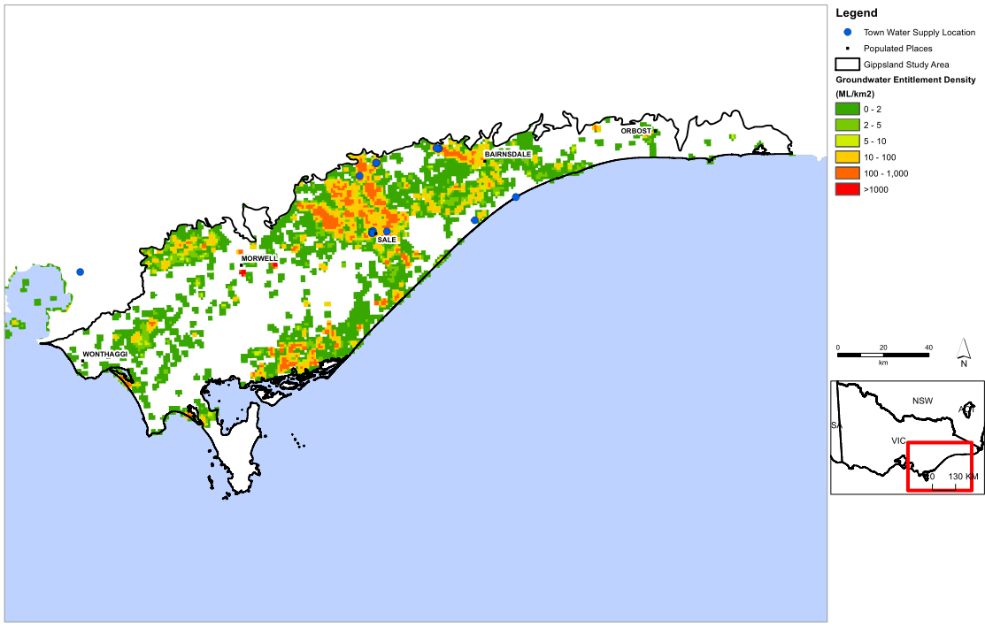
Approximate area of offshore oil and gas production
Figure 5: Density of groundwater entitlements (ML/km²) (and town water supply bores)
in the Gippsland region.

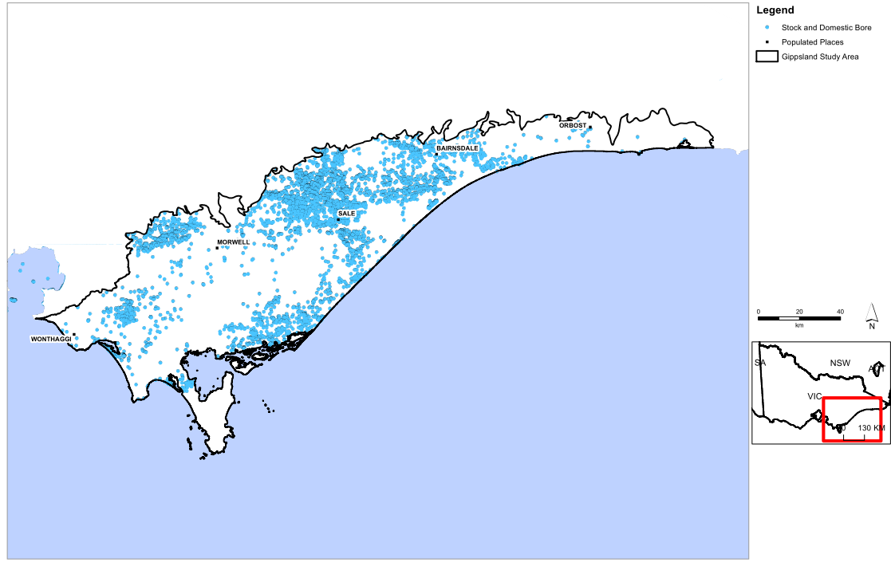
Figure 6: Location of stock and domestic bores in the Gippsland region.
LOWER AQUIFER
Approximately 30,000 ML/year in groundwater entitlements in lower aquifers.
UPPER AQUIFERS
Approximately 20,000 ML/year in groundwater entitlements in upper aquifers.
No entitlements
(no aquifers).

MIDDLE AQUIFERS
Approximately 32,000 ML/year in groundwater entitlements in middle aquifers.
Figure 7: Groundwater entitlements in the Gippsland region (note: oil, gas and groundwater of a water-equivalent volume of approximately 100 000 ML per year for offshore oil and gas).
  - Surface water
The major surface water features of the Gippsland region fall within the seven river basins shown in Figure 8. With the exception of streams draining the East Gippsland and South Gippsland basins that flow directly into the sea, the remaining rivers all flow into the Gippsland Lakes. Of these, the Latrobe, Thomson and Macalister Rivers are all regulated by major onstream storages. The total volumes of entitlements (licences to take and use surface water) for 2012–2013 are also summarised in Figure 8.

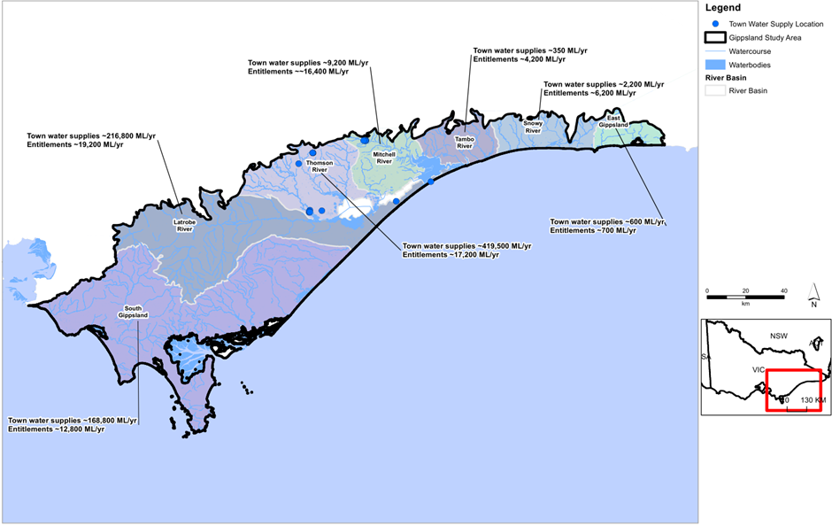
Figure 8: Major surface water features and entitlements in the Gippsland region.
The majority of surface water entitlements are in the Thomson, Latrobe and South Gippsland river basins. These three basins account for 95% of town water supplies and entitlements in the Gippsland region for the 2012–2013 period.
  - Ecosystems
Numerous water-dependent ecosystems including lakes and wetlands are located in the Gippsland region. The Gippsland Lakes are the largest estuarine lagoon system in Australia and are Ramsar-listed and recognised as internationally important. Other nationally important wetlands in the Gippsland region are recognised in the Directory of Important Wetlands in Australia (Figure 9); for example:
- The Heart Morass, estimated to be the largest private wetland restoration project in Australia.
- Dowd Morass.
- Sale Common, the only remaining naturally freshwater wetland on public land in the Gippsland Lakes.
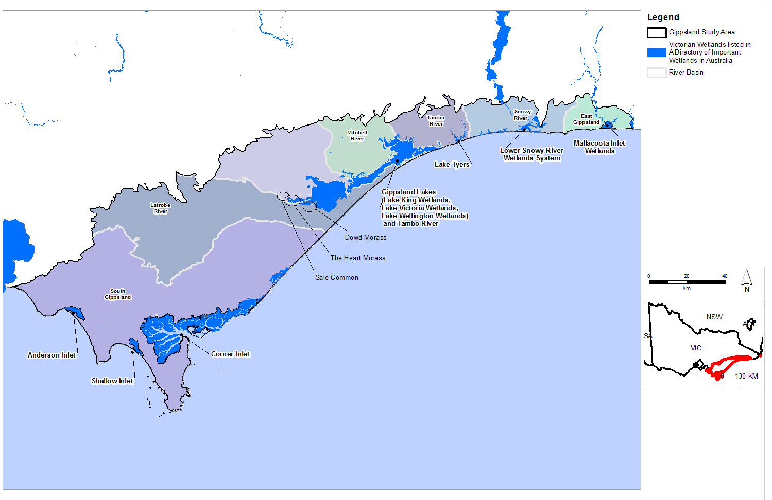
Figure 9: Wetlands listed in the Directory of Important Wetlands in Australia.
  - Groundwater and surface water connection
Groundwater and surface water are connected resources in places. Groundwater contributes to river flow when the watertable is higher than the river level. The volume of groundwater that contributes to the river flow is called baseflow. When the groundwater level is below the river level, a river may lose water to the groundwater; this is known as groundwater recharge. If there is a low-permeability layer between the base of the river and the underlying groundwater, the river and groundwater resources are likely to be poorly connected or disconnected.
Water bodies, such as lakes and wetlands, have a similar connection to groundwater, depending on the depth to watertable adjacent to and beneath the water body and the permeability of the ground beneath the water body.
Depth to watertable provides an indication of where groundwater and surface water systems may be connected. The depth to watertable across the Gippsland region is shown in Figure 10. Areas with a depth to watertable of less than 2.0 m were assessed as having a high potential for connection between surface water bodies and groundwater. Areas with a depth to watertable of between 2.0 and 6.0 m were assessed as having a moderate potential for connection, while areas with a depth to watertable of greater than 6.0 m were assessed as having a low potential for connection.
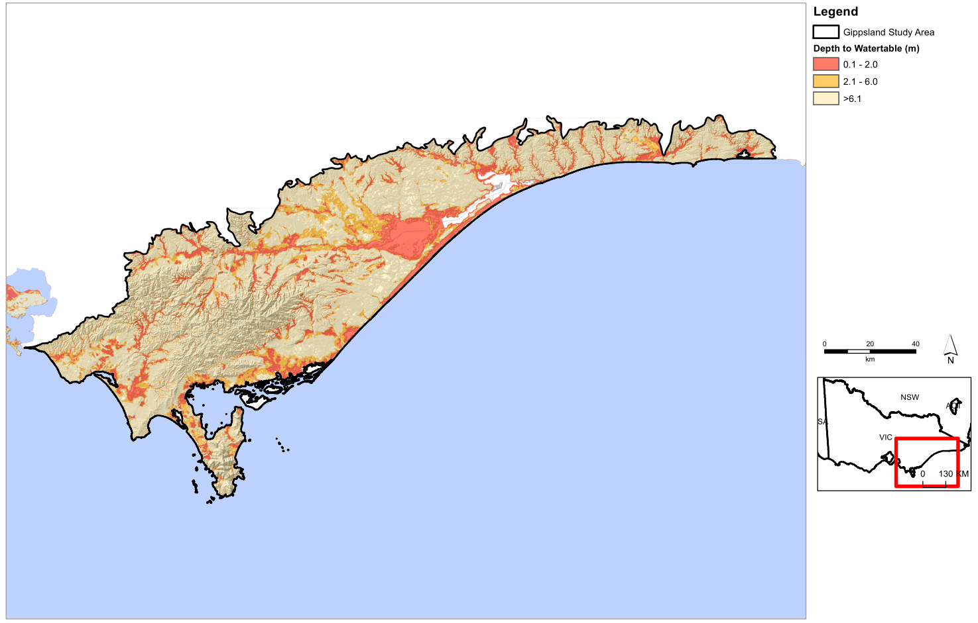
Figure 10: Depth to watertable across the Gippsland region.

  - Groundwater sampling and characterisation for hydrocarbons
The water science studies included groundwater sampling and characterisation for hydrocarbons (see list of water science studies reports on page 33). In 2014, 29 bores were sampled across the Gippsland region in the upper, middle and lower aquifers. The groundwater was sampled for a range of parameters, primarily hydrocarbons. The results of the sampling indicate the following:
- Methane is widespread in groundwater throughout the region, at concentrations up to 35 parts per million, which tended to be the highest in coal-bearing units of the lower aquifers and middle aquifers. Methane in these units is likely to be sourced from the organic contents of the coals. The methane concentrations decrease upwards, above the coal bearing units. All the watertable bores had undetected or negligible methane concentrations. Methane occurs naturally in the atmosphere and is commonly found at trace levels as a dissolved component of groundwater. It can also be released by anthropogenic activities including agriculture, landfill and hydrocarbon development. There is no authoritative guidance for methane concentrations in groundwater.
- Ethane, ethene, butane, butene, propane and propene: these compounds were not detected in the 29 bores sampled, suggesting that they are not naturally occurring in the sampled aquifers.
- Benzene, toluene, ethylbenzene, and xylene (BTEX) was detected in 4 bores: 3 in the coal-bearing units of the lower aquifer (with a BTEX concentration up to 148 parts per billion) and 1 in the upper aquifer (with a BTEX concentration up to 2 parts per billion). The BTEX detected may be naturally occurring but could also be the result of human activities. The detected BTEX did not exceed relevant guideline thresholds.
- Total petroleum hydrocarbons (TPH) was detected in 9 of the 29 bores sampled, at concentrations up to 3 parts per million, and 8 of those bores are in coal-bearing units of the lower aquifer. Although no definitive conclusion can be drawn on the source of the hydrocarbons, the depth of the bores, the presence of coals and the likely lack of interaction with the surface suggest a natural origin. The detected TPH could exceed relevant guideline thresholds, depending on the intended use of the water.
- Naphthalene was not detected, which suggests that this compound is not naturally occurring in any of the sampled groundwater.

- Where are gas and water likely
to be connected?
Groundwater resources in the Gippsland region occur in the upper, middle and lower aquifers at depths less than 1000 m below ground surface.
Tight and shale gas resources in the Gippsland region are located beneath the aquifer layers (i.e. greater than 1000 m). The geological formations known as the Strzelecki Group offer the most likely conditions for containing tight and shale gas. The gas may be found in either tight rocks or shale and is likely to be most prospective around Seaspray on the central Gippsland coast. The gas resource is usually separated from the lower aquifer by low-permeability material that holds the gas in place and limits any potential connectivity with overlying water resources. The degree of separation varies from one location to another. Where the prospective natural gas resource is located near the top of the Strzelecki Group, there is less separation from the lower aquifer and the potential connectivity with overlying water resources would need to be assessed on a location-by-location basis.
Coal seam gas is associated with the brown coals in the Traralgon Formation that occurs within the sequence of geological formations that make up the lower aquifers. The brown coal seams are thick and occur at depths suitable for coal seam gas. Since the Traralgon coal seams are located in the lower aquifer sequence they could be hydraulically connected to the lower aquifers. There is also the potential for the lower aquifers to be connected to the middle aquifers in some areas of the Gippsland region. Groundwater modelling supports the idea that there is connectivity between coal seam gas and groundwater resources in the Gippsland region. While interconnections between the natural gas sources and aquifers are expected, the complex vertical and horizontal distribution of the aquifers and aquitards means that the degree of connection will vary significantly across the region.

- What are the potential impacts from possible natural gas development?
  - Assessment approach
A screening-level approach was used to assess the potential impacts of natural gas development on water users and ecosystems. The key elements of the approach are summarised in Table 5 and Table 6. For further details about the impact assessment criteria, refer to the report titled Gippsland region assessment of the potential impacts on water resources (full reference given on page 33).

Table 5: Approach to assessing potential impacts.
Potential impacts | Groundwater users | Surface water users | Ecosystems
Aquifer depressurisation | Groundwater modelling to estimate  potential declines in groundwater levels | Inferred from modelled declines in  groundwater levels
Chemical contamination from hydraulic fracturing fluids | Review of national and international literature with consideration  of the particular geological conditions of the Gippsland region
Induced seismicity
Land subsidence

Table 6: Impact criteria.
Level of impact | Criteria | Example
Low | Impact is within normal variability | For groundwater users, a predicted decline in the watertable of less than 2 m and a predicted decline in deep groundwater levels of less than 10 m or no change is anticipated
Moderate | While the impact is outside normal variability, the impact does not significantly change the function of water users or ecosystems | For groundwater users, a predicted decline in the watertable of 2 m to 15 m or a predicted decline in deep groundwater levels of 10 m to 75 m
High | Impact significantly changes the function of water users or ecosystems | For groundwater users, a predicted decline in the watertable of greater than 15 m or a predicted decline in deep groundwater levels of greater than 75 m

  - Potential impacts from aquifer depressurisation
    - The basis for potential impacts
This section provides an overview of the potential impacts that may arise from aquifer depressurisation, based on international experience.
The possible impact on water users and ecosystems from aquifer depressurisation caused by natural gas development depends on the gas development type (tight, shale and coal seam gas) and the nature of connections between groundwater, surface water, ecosystems and the natural gas.
Tight gas and shale gas are stored in low-permeability rock formations, which also have low water yields. Technologies such as hydraulic fracturing and horizontal drilling are sometimes required to increase permeability and to release the gas from a sufficiently large volume of the rock. Gas is removed from the formation by lowering the groundwater pressures, which is achieved by pumping the groundwater from the drilled wells. The gas is recovered with the pumped groundwater.
Coal seam gas is held in the coal seam by water pressure. As for tight gas, the water pressure must be reduced to release and extract the gas, which can be achieved by pumping groundwater from the coal seam. In coal seam gas extraction, hydraulic fracturing is often not required to release the gas.
Removing groundwater to extract natural gas means that groundwater may flow from adjacent aquifers towards the area of gas extraction, leading to lowering of pressures (depressurisation) of these aquifers. After long periods of pumping the depressurisation may extend to shallow aquifers and to a wider region than just the area of natural gas development. Eventually, depressurisation may affect surface water bodies. Given the close proximity of the coal seam gas resources to major regional aquifers, coal seam gas has the most potential to impact on water users and ecosystems.
All forms of natural gas development have the potential to impact groundwater users, surface water users and ecosystems as a result of aquifer depressurisation, leading to loss of access to groundwater, reductions in surface water flows or changes in groundwater quality. Generally, changes in groundwater quality may arise when groundwater levels and flow regimes change to the extent that poorer quality groundwater is drawn into good quality aquifers. Reduced groundwater levels and changes in groundwater quality may have the potential to impact surface water users or ecosystems where the resources are connected.
    - Gippsland region study results
Based on the water science studies, the potential impacts from aquifer depressurisation for possible tight gas, shale or coal seam gas developments in the Gippsland study region are as follows:

Tight and shale gas
- The potential for impacts on groundwater users from aquifer depressurisation for tight and shale gas development is low across the Gippsland region (see Figure 11) because the predicted changes to groundwater levels are within historical ranges for the region.
- The potential for impacts on groundwater quality from aquifer depressurisation in tight and shale gas development is inferred as low, because the predicted changes to groundwater pressure gradients are within historical ranges for the region.
- The potential for impacts on surface water users and ecosystems as a result of reduced stream flow or changes in surface water quality due to aquifer depressurisation is generally low, with the exception of localised areas of moderate to high potential impact in the central Latrobe Valley region. This is inferred from the predicted changes to groundwater levels.

Coal seam gas
- The potential for impacts on groundwater users from aquifer depressurisation for coal seam gas development is moderate to high, depending on proximity to the prospective development area (Figure 12), based on the predicted changes to groundwater levels. There are 202 groundwater users that could experience a potential moderate to high impact from coal seam gas development.
- The potential for impacts on groundwater quality from aquifer depressurisation for coal seam gas development is inferred as moderate, because the predicted depressurisation is moderate to high.
- The potential for impacts on surface water users and ecosystems as a result of reduced stream flow or changes in surface water quality due to aquifer depressurisation is moderate to high, depending on proximity to the prospective development area. This is inferred from the predicted changes to groundwater levels. There are 245 surface water users that could experience a potential moderate to high impact from coal seam gas development.

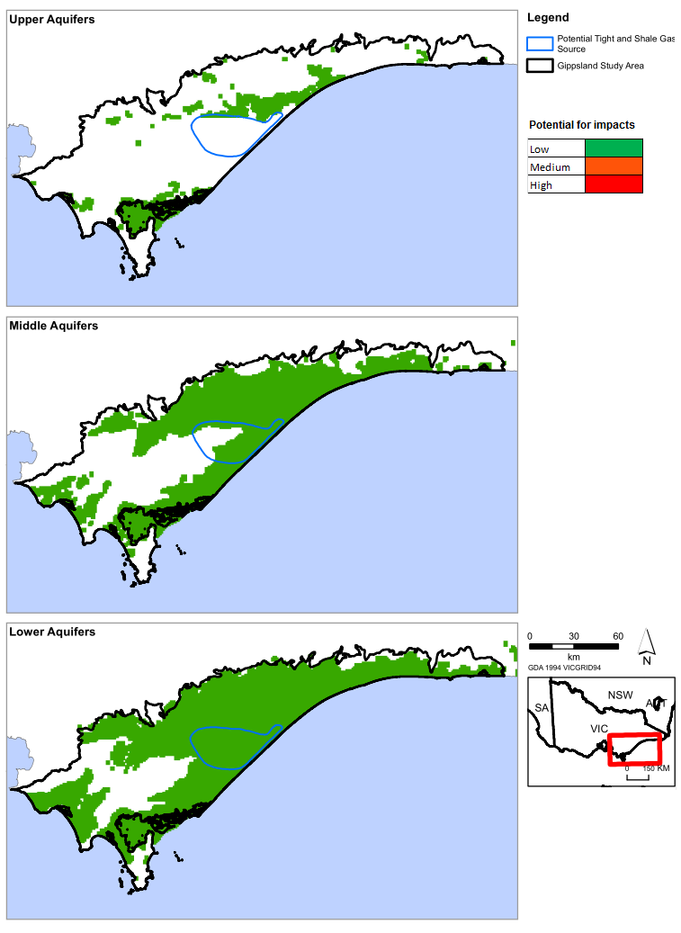
Figure 11: Potential impacts for groundwater users from possible tight and shale gas development.
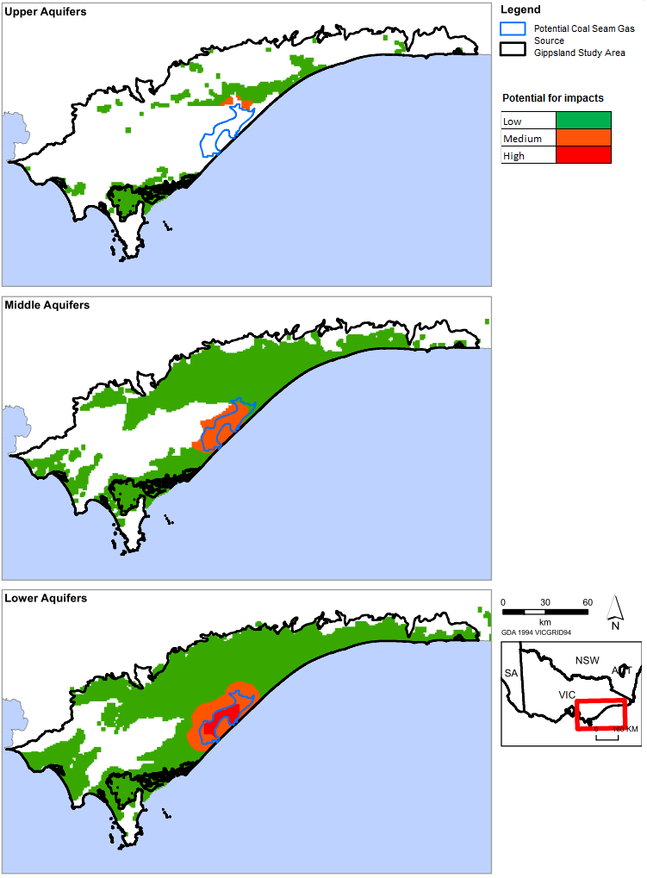
Figure 12: Potential impacts for groundwater users from possible coal seam gas development.

  - Potential for chemical contamination of groundwater from hydraulic fracturing fluids
    - The basis for potential impacts
Chemicals are used in many aspects of the petroleum and natural gas industry, including drilling operations, hydraulic fracturing, water management and treatment and general operations such as fuel for transport. Drilling fluids are typically water-based and include clays and other additives to control density and viscosity, which reduces fluid loss and prevent potential gas release. Hydraulic fracturing fluids are composed primarily of water (typically 90%), sand or a manufactured equivalent (typically 9%) and chemical additives (typically 1%). The chemical additives used in hydraulic fracturing fluid vary, depending on the application, the nature of the rock formation, the developer and, in some cases, legislation and regulations applicable to the state or territory. Many of the chemicals are commonly used in other industries, including chemicals used in swimming pool additives, disinfectants and detergents. There is a ban in Victoria on the use of BTEX, so these chemicals cannot be used in hydraulic fracturing.
Based on experience from existing tight and shale gas development around the world, the development of tight and shale gas in the Gippsland region could require hydraulic fracturing in order to increase rock permeability and hence gas production. The literature suggests that typical fracture propagation distances are in the order of tens of metres.
Potential impacts to groundwater users, surface water users and ecosystems as a result of hydraulic fracturing operations relate primarily to chemical contamination of groundwater from hydraulic fracturing fluids. This can occur if the fracture propagation extends further than intended and creates a direct connection to an aquifer.
The potential impacts to water users and ecosystems from hydraulic fracturing were assessed by reviewing international literature on typical fracture propagation distances within the context of their geological setting and applying that to the Gippsland geological setting. This review assessed the potential for connections to be created between hydraulic fracturing fluids and water resources.
    - Gippsland region study results
With respect to tight and shale gas, the Strzelecki Group is directly overlain by aquifers. Based on the vertical permeability values that have been published for the top of the Strzelecki Group sequence and adjacent units, the intervening rocks between the target natural gas formation and the overlying aquifer are of suitably low permeability. The maximum vertical fracture propagation distances throughout North America are typically less than 100 m but are likely to be significantly less in Gippsland because of the local geology. The potential for chemical contamination of groundwater via the generation of fully penetrating fractures or the intersection between stimulated and pre-existing natural fractures was assessed as unlikely. The aquifer would therefore almost certainly remain unaffected by hydraulic fracturing of the gas-bearing rock.
Based on the above, and the fact that the addition of BTEX chemicals to hydraulic fracturing fluids is banned under Victorian law, the overall potential for chemical contamination of groundwater from hydraulic fracturing fluids in the Strzelecki Group for tight and shale gas was assessed to be low.
With respect to coal seam gas, hydraulic fracturing is not expected to be required in the coal seams in Gippsland, and therefore there is no potential for associated chemical contamination of groundwater.

  - Potential for increased earthquakes
    - The basis for potential impacts
Small earthquakes can be triggered by human activity; this is known as induced seismicity. Induced seismicity associated with natural gas development may be related to three key activities:
- hydraulic fracturing
- large-scale depressurisation as a result of natural gas development
- re-injection of produced water.
    - Gippsland region study results
The Gippsland region is a moderately seismically active area. Natural seismicity is driven largely by compressional stresses in the Earth’s crust. An assessment of the potential for induced seismicity caused by hydraulic fracturing and depressurisation from tight, shale and coal seam gas developments in the Gippsland region was completed. Overall, the potential for these activities to induce seismicity (i.e. an earthquake) in Gippsland with a magnitude greater than 3.5 (M_{L}), which is the smallest earthquake that can be felt by an individual, was assessed to be low.
Experience from overseas indicates that most induced earthquakes caused by natural gas development are associated with re-injection of produced water into deep rock formations. The potential for re-injection of water to induce seismicity in Gippsland is site-specific and would need to be assessed on a case-by-case basis.
  - Potential for land subsidence
    - The basis for potential impacts
Land subsidence can be brought about by declining groundwater levels. When dewatering reduces the pressure in fine-grained sediments (e.g. clays or brown coal) the sediments can be compressed, causing a lowering of the land surface. Prior consolidation and compaction history of sediments is important when predicting subsidence.
    - Gippsland region study results
Land subsidence in the Latrobe Valley associated with open pit coal mining and related groundwater pumping has been recognised for decades, and subsidence of over two metres has been recorded near Hazelwood and Loy Yang coal mines. The coastal fringe has also been identified as an area that is particularly sensitive to land subsidence. This has prompted a number of studies and monitoring of land subsidence in this area.
For the Gippsland region the water science studies indicate that there is:
- a low potential for subsidence from onshore tight and shale gas development based on the small water level drawdown in aquifers predicted to result
- a moderate potential for subsidence from coal seam gas development based on the predicted water level drawdown in lower aquifers in the immediate vicinity of the natural gas development.

  - Summary of the potential impacts prior to mitigation
A summary of the potential for impacts, without any mitigation measures applied, is presented in Table 7 and Table 8 below.

Table 7: The potential for impacts associated with aquifer depressurisation for
each natural gas scenario.
Natural gas type | Impacts on users
Natural gas type | Groundwater users | Surface water users | Ecosystems
Tight and shale | Low | Low* | Low*
Coal seam gas (brown coal) | High | High | High
*Localised areas of moderate to high potential impact in the central Latrobe Valley region

Table 8: The potential for impacts associated with hydraulic fracturing, induced seismicity and land subsidence for each natural gas scenario.
Natural gas type | Chemical contamination of groundwater from  hydraulic fracturing fluids |  |  | Induced seismicity | Land subsidence
Natural gas type | Groundwater  users | Surface water users | Ecosystems
Tight and shale | Low | Low | Low | Low | Low
Coal seam gas | N/A | N/A | N/A | Low | Moderate

- What could be done to reduce the potential impacts?
Because of the limited data available, the impact assessment presented here is conservative, and it is likely to estimate higher impacts than may eventuate if development did occur.
The potential impacts from tight and shale gas development are moderate to high for surface water users and ecosystems in localised areas.
The potential impacts from coal seam gas development are moderate to high for groundwater users, surface water users and ecosystems, moderate for groundwater quality, and moderate for land subsidence.
Possible mitigation actions were assessed to reduce the potential for impacts from medium and high to low. There are no mitigation requirements for low impacts because the threshold value is so low that the potential impact is deemed to be negligible or unlikely.
  - The basis for mitigating potential impacts
Potential impacts to groundwater users could be reduced by the following mitigation approaches:
- reducing the scale, timing or location of potential natural gas development
- scheduling the operations of groundwater bores
- deepening groundwater bore casings
- offsetting the loss of water supply with alternative water resources.
Potential impacts to surface water users could be reduced by the following mitigation approaches:
- reducing the scale, timing or location of natural gas development, although this has limited applicability to tight and shale gas development
- scheduling operations for regulated rivers
- increasing or constructing on-farm storage capacity
- supply with alternative water resources.
Potential impacts to ecosystems could be reduced by the following mitigation approaches:
- reducing the scale, timing or location of natural gas development
- scheduling operations for regulated rivers
- supplying alterative water resources
- offset approaches, including compensatory offsets.
Offset approaches lead to associated benefits. This recognises that biodiversity cannot be offset like for like, so offsets can be targeted to equal or higher conservation priorities than the impacted ecosystem. Examples include: creating new habitats; improving an existing ecosystem; contributing to an area recognised as important to increasing landscape connectivity, above and beyond what is required by the impacted ecosystem; measures that benefit biodiversity but do not specifically involve protecting and managing an impacted ecological site; funding for ecological research or educational programs; and rehabilitation of impacted ecosystem sites where there are good prospects of the biodiversity being restored.
  - Mitigation study results
The assessment of the above mitigation approaches indicates:
- The potential for impacts on groundwater users and surface water users may be reduced to low by implementing a combination of the above mitigation approaches. There would be a consequential increase in the costs associated with any new or improved infrastructure.
- There are possible technical and financial limitations on the above mitigation approaches for ecosystems, including offsets. The potential for impacts to ecosystems in the Gippsland region therefore remains moderate to high for coal seam gas.
- The potential for land subsidence impacts could be reduced by phasing the natural gas development in smaller projects (to reduce the spatial and temporal extent of aquifer depressurisation), and improving the design, maintenance and remediation of affected assets (roads and pipelines, coastal drainage, etc.). With respect to coastal drainage, mitigating the effect of subsidence on the Gippsland Lakes and on any coastal inundation is problematic. Given the potentially widespread nature of subsidence that may result from broad scale drawdown, it is difficult to conceive any practical measures that could address potential impacts. Therefore the potential for land subsidence in the Gippsland region remains moderate for coal seam gas.
The residual potential for impacts from onshore natural gas development in the Gippsland region with the above mitigation actions is summarised in Table 9 and Table 10. The tables present unmitigated impacts for ecosystems and land subsidence, as there are possible technical and financial limitations on effective mitigation to these impacts as discussed above.

Table 9: The potential for impacts of aquifer depressurisation for each natural gas scenario
following mitigation (compare with Table 7).
Natural gas type | Impacts on users
Natural gas type | Groundwater users | Surface water users | Ecosystems
Tight and shale | Low | Low | Low*
Coal seam gas (brown coal) | Low | Low | High  (unchanged)
*Localised areas of moderate to high impact in the central Latrobe Valley region

Table 10: The potential for chemical contamination of groundwater from hydraulic fracturing fluids, induced seismicity and land subsidence for each natural gas scenario following mitigation measures (compare with Table 8).
Natural gas type | Chemical contamination of groundwater from hydraulic fracturing fluids |  |  | Induced seismicity | Land subsidence
Natural gas type | Groundwater users | Surface water users | Ecosystems
Tight and shale | Low | Low | Low | Low | Low
Coal seam gas (brown coal) | N/A | N/A | N/A | Low | Moderate  (unchanged)

Water science studies outputs for Gippsland region

Gippsland region synthesis report (this report) Department of Environment, Land, Water and Planning and the Geological Survey of Victoria, 2015. Onshore natural gas water science studies — Gippsland region synthesis report. Department of Environment, Land, Water and Planning and the Department of Economic Development, Jobs, Transport and Resources, Melbourne. June 2015.

Onshore natural gas prospectivity: Gippsland region
GOLDIE DIVKO, L.M., 2015. A review of natural gas prospectivity: Gippsland region. Department of Economic Development, Jobs, Transport and Resources. June 2015.

Gippsland Basin gravity survey
MATHEWS, L.R. & MCLEAN, M.A., 2015. Gippsland Basin gravity survey. Geological Survey of Victoria Technical Record 2015/1. Geological Survey of Victoria, Melbourne.

Victorian Water Asset Database
Department of Environment, Land, Water and Planning, 2014. Victorian Water Asset Database, (electronic resource: not online)

Groundwater sampling and characterisation for hydrocarbons for the Gippsland region Department of Environment, Land, Water and Planning, 2015. Onshore natural gas water science studies — Gippsland region groundwater sampling and characterisation for hydrocarbons. Department of Environment, Land, Water and Planning, Melbourne. June 2015.

Gippsland groundwater model Department of Economic Development, Jobs, Transport and Resources, 2015. Onshore natural gas water science studies — Gippsland groundwater model. Department of Environment, Land, Water and Planning and the Department of Economic Development, Jobs, Transport and Resources, Melbourne. June 2015.

Gippsland region assessment of potential impacts
Department of Environment, Land, Water and Planning and the Geological Survey of Victoria, 2015. Onshore natural gas water science studies — Gippsland region assessment of potential impacts on water resources. Department of Environment, Land, Water and Planning and the Department of Economic Development, Jobs, Transport and Resources, Melbourne. June 2015.

Glossary of terms and abbreviations
Term | Meaning
aquifer | rock or soil that readily transmits water
aquitard | rock or soil that transmits water very slowly
baseflow | contribution of surface water flow attributed to groundwater
BTEX | benzene, toluene, ethylbenzene and xylene
confined aquifer | an aquifer in which an impermeable rock or soil layer or layers prevents water from seeping into the aquifer vertically
drawdown | reduction in groundwater head elevation relative to a nominated baseline condition.
entitlements | the volume of water authorised to be taken and used by an irrigator or water authority, including bulk entitlements, environmental entitlements, water rights, sales water, and surface water and groundwater licences
ML | megalitre; one million litres
M_{L} | Local magnitude, from the Richter magnitude scale that assigns a magnitude number to quantify the energy released by an earthquake
Ramsar (Convention) | An international treaty that aims to conserve wetlands which have been listed for their international significance and ensure that they are managed wisely, signed in Ramsar, Iran, in 1971
regulated river | a river containing structures such as dams or major diversion weirs which control the flow of water in the river for licensed diverters or users in an irrigation district
unconfined aquifer | an aquifer where the watertable is exposed to the atmosphere through openings in the overlying materials
watertable | the surface where the groundwater level is balanced against atmospheric pressure; often this is the shallowest water below the ground


© The State of Victoria Department of Environment, Land, Water & Planning 2015

This work is licensed under a Creative Commons Attribution 4.0 International licence. You are free to re-use the work under that licence, on the condition that you credit the State of Victoria as author. The licence does not apply to any images, photographs or branding, including the Victorian Coat of Arms, the Victorian Government logo and the Department of Environment, Land, Water and Planning (DELWP) logo. To view a copy of this licence, visit http://creativecommons.org/licenses/by/4.0/

ISBN 978-1-74146-617-1 (pdf)

Accessibility
If you would like to receive this publication in an alternative format, please telephone the DELWP Customer Service Centre on 136186, email customer.service@delwp.vic.gov.au or via the National Relay Service on 133 677 www.relayservice.com.au. This document is also available on the internet at www.onshoregas.vic.gov.au

Disclaimer
This publication may be of assistance to you but the State of Victoria and its employees do not guarantee that the publication is without flaw of any kind or is wholly appropriate for your particular purposes and therefore disclaims all liability for any error, loss or other consequence which may arise from you relying on any information in this publication.

A regulated river is one where downstream flows are regulated by a major storage or dam to supply irrigation water.

