Victorian Gas Program

Progress Report: Report No. 2
February 2019

Contents
Executive summary 3
1. Overview 5
2. Onshore conventional gas studies 6
2.1 Conventional gas 6
2.2 Geoscience studies 7
2.2.1 Otway Basin rock characterisation progress 9
2.2.2 Modelling and mapping progress 19
2.3 Environmental studies 24
2.3.1 Inventory of potential environmental hazards 24
2.3.2 Onshore environmental risks and mitigation controls 24
2.3.3 Regional baseline studies 26
2.3.4 Point scale well integrity impact assessment 30
2.3.5 Regional groundwater impact assessment 30
2.4 Onshore conventional gas governance 31
2.4.1 Stakeholder Advisory Panel for Onshore Conventional Gas 31
2.4.2 Victorian Gas Program Scientific Reference Group 32
3. Offshore gas geoscience studies 33
3.1 Acreage release 33
3.2 Airborne gravity survey 34
4. Underground gas storage investigations 35
4.1 Representative Technical Studies 35
4.1.1 Site screening 35
4.1.2 Fluid dynamics and reservoir geomechanics 36
4.2 Detailed Technical Studies 36
4.3 Assessment of infrastructure costs of additional underground gas storage 36
4.4 Economic Assessment 36
4.5 Collaboration with Lochard Energy – Iona-7 Development Well 37
5. Supporting program components 38
5.1 Community engagement 38
5.1.1 Progress to date 38
5.2 Resource planning 40
5.3 Regulatory reform 40
6. References 41
7. Glossary 45
Appendix 1 – Reservoir, seal and source rocks 46
Appendix 2 – Regional geology of the Otway Basin 49
Appendix 3 – Stakeholder Advisory Panel for Onshore Conventional Gas Communiques 57

Executive summary
This report builds on the first Victorian Gas Program Progress Report published in January 2018, which outlined the three-year work schedule of scientific studies to investigate evidence of Victoria’s potential for future gas supply and to inform future Victorian Government decisions on the risks, benefits and impacts associated with onshore conventional gas. This report presents a summary of the studies undertaken thus far, the data collected from environmental investigations and information from investigations into onshore and offshore gas potential. A visual snapshot of the work delivered is included in the opening pages of this report.
While the report is technical in nature because it provides detailed information from scientific research, its purpose is also to be accessible to the Victorian community. As the Program progresses, further scientific data will be analysed, with future progress reports continuing to share evidence-based results in a transparent and accountable way.

Onshore conventional gas studies – obtaining better data
A suite of geoscientific, technical and environmental studies are underway that will provide an evidence-based estimate of prospective gas resources at a regional level and look closely at the risks, benefits and impacts associated with onshore conventional gas. This will inform future decisions of Government while the onshore conventional gas moratorium is in place until 30 June 2020. The studies focus on Victoria's two most prospective regions for gas: the Otway Basin (currently considered to have the highest potential for new discoveries) and the Gippsland Basin.
To date, rock characterisation studies in the Otway Basin include sampling of over 2,400 rock specimens, yielding over 3,500 measurements and associated analyses. These new measurements will be interpreted to assess the key components of the petroleum system, namely: reservoir, seal and source rocks.
Air quality and groundwater data acquisition has commenced in the onshore portions of both the Otway and Gippsland Basins to establish a baseline against which any future changes can be measured. To date, approximately 8,500 kilometres of roadsides have been surveyed for carbon dioxide and methane levels, and 69 groundwater samples have been collected from deep-water bores across the Otway Basin. All results are within expected ranges.
The construction of 3D geological framework models for both the Otway and Gippsland Basins, using existing and new geological data, is underway. Two initial 3D models for the Otway Basin have already been delivered. These models will provide the geological framework for scientists to understand where gas may be and the location of groundwater. All 3D geological framework models will be completed in 2019.

Offshore gas studies – supporting offshore gas exploration with geoscience
Natural gas has been extracted in waters off Victoria's coast for decades and is a vital part of the state's energy supply network. Future supply is dependent on new gas discoveries. To encourage commercial exploration for potential new natural gas resources, the Victorian Government released for tender five new offshore acreage areas in the Otway Basin in May 2018. The areas are in state-controlled waters (three nautical miles off the coast). Applications for the five exploration areas will be assessed after the tender closes on 15 February 2019.
To support explorers who are assessing the released offshore acreage areas, an airborne gravity survey commenced in August 2018. This survey covered about 16,000 square kilometres of the Otway Basin. Two planes measuring small variations in gravity offshore and onshore provided new evidence regarding rock structures below the sea and land so new interpretations can be produced. The resultant data will both improve the understanding of Otway Basin geology as well as provide a precompetitive dataset in support of offshore gas exploration.

Underground gas storage – investigating opportunities to help secure more reliable gas supply
The Victorian Gas Program is assessing the potential for further underground gas storage sites. Increased underground gas storage may help to secure more reliable gas supplies and mitigate short-term price peaks, particularly during any interruptions in the gas supply system. The assessment focuses on 13 depleted gas fields around Port Campbell. Our collaborative partner, CSIRO, has completed initial technical studies to rank these underground storage areas for their engineering and geomechanical capacity.

Program governance – testing our methodology and results
Since its inception in August 2017, the Stakeholder Advisory Panel for Onshore Conventional Gas has met five times. Chaired by Victoria’s Lead Scientist, Dr Amanda Caples, the Panel includes representatives from farming, environment and industry groups, local government and the community. The Panel is independently advising the Minister for Resources on the risks, benefits and impacts of future onshore conventional gas exploration and production.
Victoria’s Lead Scientist is also Chair of the Victorian Gas Program Scientific Reference Group (formerly the Scientific Reference Group for Onshore Conventional Gas). The reference group now has an expanded remit – providing peer review of all components of the Program.

Community engagement, resource planning and potential regulatory reform – building knowledge
Underpinning all of these scientific endeavours is a comprehensive community engagement program. The Geological Survey of Victoria has established a team of geoscientists and community engagement staff at the Warrnambool Deakin University campus. The team is focused on briefing local government, industry, farmers, local school students, environmental and community groups on the geoscience of the Otway Basin and the objectives of the Victorian Gas Program. Over 570 engagements have taken place and more will occur as the research activities continues.
Resource planning and potential regulatory reforms will commence once the broader findings of the Victorian Gas Program are known.
The next progress report will build on the work to date and analyse the evidence gathered from the Program’s scientific research to help inform government decisions.

1. Overview
The Victorian Gas Program, which runs from 2017 to 2020 has four major components:
- Onshore conventional gas – Geoscience and environmental studies are being conducted on the risks, benefits and impacts of onshore conventional gas, while the moratorium is in place until 30 June 2020. These studies are being overseen by Victoria’s Lead Scientist and a Stakeholder Advisory Panel, made up of farmers, industry, local government and the community. The findings are being peer reviewed by an expert Scientific Reference Group. The geoscience investigations into onshore conventional gas are designed to provide an evidence-based resource estimate.
- Offshore gas – Work is underway to support commercial exploration for further discoveries of gas off Victoria’s coast to help increase gas supply.
- Underground gas storage – Opportunities for further underground gas storage in the onshore Otway Basin are being investigated to help secure more reliable gas supplies and to mitigate short-term price peaks, particularly during any interruptions in the gas supply system.
- Community engagement, resource planning and potential regulatory reform – The Victorian Gas Program includes a range of other activities to support the investigations into onshore conventional gas, offshore gas and underground gas storage. These include an extensive engagement program for farmers, industry, local government and regional communities over the life of the Victorian Gas Program. Resource planning and potential regulatory improvements will also be undertaken once the broader findings of the Victorian Gas Program are known.
This progress report outlines the scope of the Victorian Gas Program, provides an overview of the techniques being employed by the Geological Survey of Victoria to conduct the scientific studies and describes the status of the project’s activities. Subsequent reports will provide data analysis and results.
All study results will be made available at http://earthresources.vic.gov.au/gasprogram.

2. Onshore conventional gas studies
The onshore conventional gas studies are delivering extensive scientific, technical and environmental input on the risks, benefits and impacts of onshore conventional gas. Work has been focused on the area between Port Campbell and Warrnambool, which the Geological Survey of Victoria considers the most prospective for conventional gas in the Otway Basin. Studies also include work in the Gippsland Basin.
The studies incorporate the following components:
- Rock characterisation studies will achieve enhanced understanding of rock property layers (e.g. porosity, permeability, organic content) within the study areas. This involves analysing geoscience data and rock samples (drill cores). Subsequent mapping will form the basis of the prospectivity assessment and resource estimates.
- Three-dimensional (3D) geological models use previously collected geological data, rock characterisation analysis and well data. The models are being built to define the stratigraphic (rock layers) and structural framework (that is, geological faults), which form the basis for petroleum systems modelling. Such models will provide insights into possible gas resources and also the nature and location of groundwater.
- Gas prospectivity and resource estimates will be developed using the above geological analyses and models, for both the Otway and onshore Gippsland basins.
- Targeted stratigraphic drilling may be carried out in the onshore Otway Basin to fill knowledge gaps and to increase certainty of the prospectivity and resource estimates.
- Environmental studies will identify the key environmental factors relevant to each stage of the life cycle for onshore conventional gas (that is, exploration, development, production, decommission and rehabilitation stages). Environmental vectors and receptors for each stage have been identified before and after a conventional gas well head. This information will help identify the best environmental indicators and dataset requirements to monitor gas activities. Environmental measurements are being collected to establish baseline conditions, which will provide a benchmark for considering potential risks and impacts of future conventional gas activities.

2.1 Conventional gas
Conventional gas reservoirs are commonly found in porous and permeable rocks such as sandstones or limestones (Figure 2.1). Impermeable rocks such as claystones or shales found directly above gas reservoirs are known as a seal or cap-rock. The gas is trapped in the reservoir under the seal, commonly in geological structures. Geological structures can be like an inverted dish (refer to Figure 2.1), with the gas trapped beneath. A well drilled into a geological structure will intersect the porous gas reservoir. If gas is present, it will flow into the well.
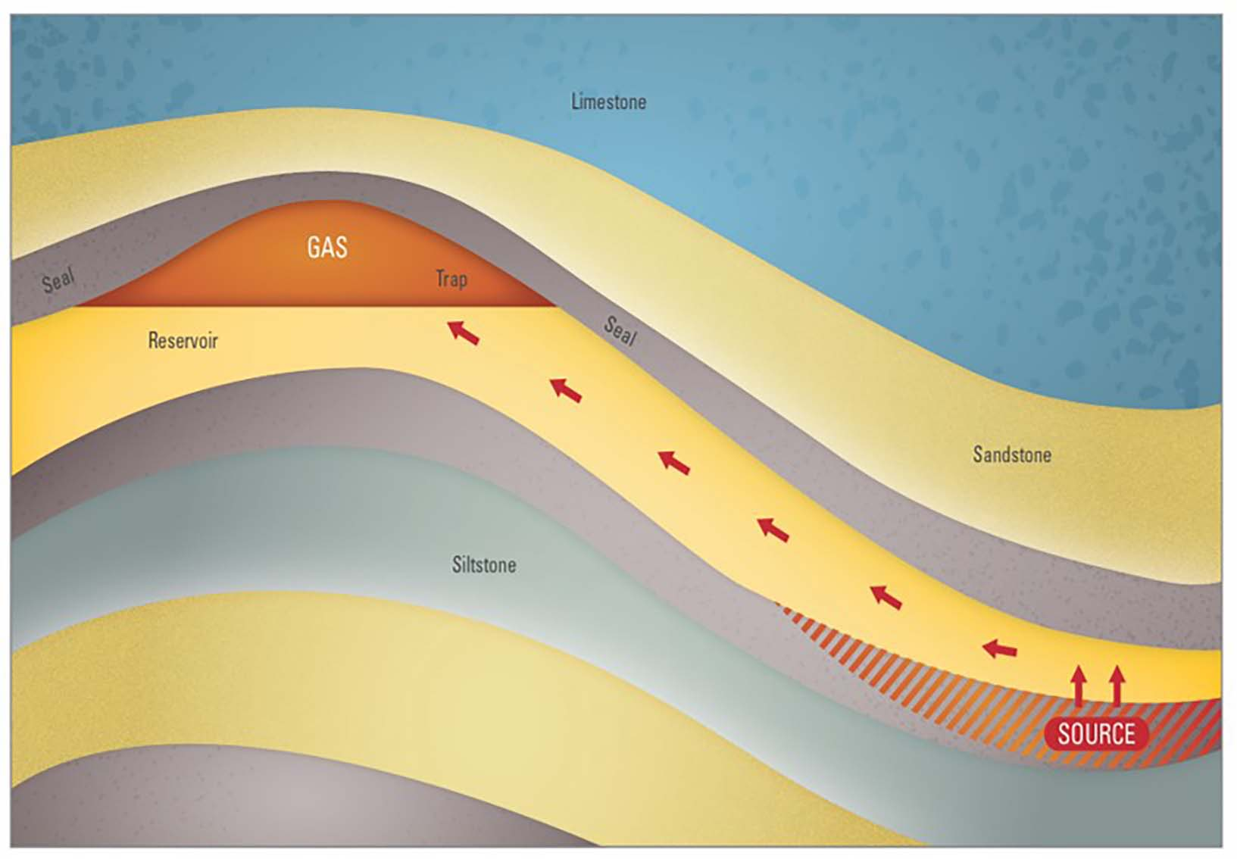
Figure 2.1: Conventional gas schematic
Gas is generated from a source rock that has a relatively high content of organic matter. Generation is dependent on a number of variables, such as temperature and burial depth. The gas then migrates from the source via porous and permeable rocks or other conduits such as faults. The gas accumulates, or is trapped, in a reservoir. Overlying sealing rocks prevent the gas from migrating further. The gas is commonly trapped under geological structures, but other geological traps are possible (for example, stratigraphic traps).
Reservoirs, seals and source rocks are the focus of the rock characterisation studies (refer to Section 2.2.1), which are underway as part of the onshore conventional gas studies. The rock characterisation studies are being carried out to better understand the properties of the rock layers (e.g. porosity, permeability, organic content) within the study areas. This will involve analysing geoscience data and rock samples (drill cores). The resultant mapping will form the basis of reviewing possible migration routes as well as the gas prospectivity assessment and resource estimates. Further information about reservoir, seal and source rocks is presented in Appendix 1. Progress on these studies is discussed in the following sections.

2.2 Geoscience studies
The geoscience studies in the Otway Basin are well underway, and the Gippsland Basin studies have commenced. Otway Basin rock characterisation and 3D framework modelling are continuing with preliminary results delivered for all of these activities.
The selection and analysis of Otway Basin legacy rock samples from the Geological Survey of Victoria’s drill core library in Werribee have been completed for reservoir, seal and source rocks. Progress to date on the analysis of those data sets is presented in this report (refer to Section 2.2.1). The building of the preliminary Otway Basin 3D geological models is complete with reviews and refinements to follow.
In addition, the Geological Survey of Victoria is commissioning new analysis on the age of rock samples from fossils throughout the rock sequence. This is known as biostratigraphy, and it will help our geoscientists to interpret, with greater certainty, the time (in millions of years) when rock units were deposited in the Otway Basin. Furthermore, the mineral content in rock samples will be analysed to understand relationships between the characteristics of different sedimentary rock types and the minerals that comprise them. This is especially important in seals where the grain size is too small to see without a microscope.
Most of the Otway Basin work discussed in the following sections focuses on the Otway and Sherbrook groups (that is, the reservoir, seal and source components of petroleum systems in the Otway Basin). However, other studies such as 3D modelling and biostratigraphy are concerned with mapping and/or studying all the rock units in the basin (refer to Figure 2.2). A summary geological history of the Otway Basin, including descriptions of geological units which are the focus of the studies to date, is included in Appendix 2 as additional information.
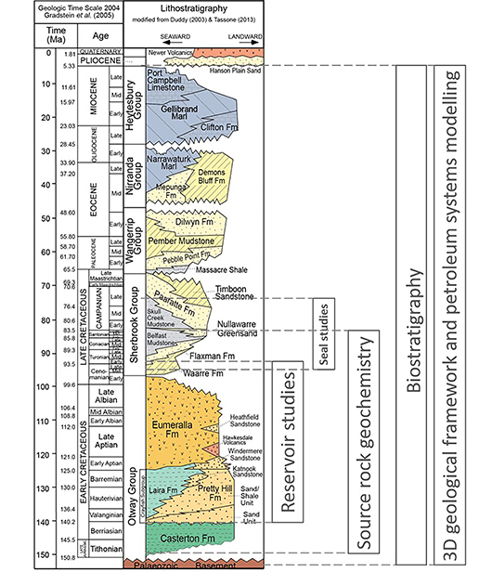
Figure 2.2: Geology and rock unit focus for the Otway Basin studies

2.2.1 Otway Basin rock characterisation progress
Selected rock samples from the Geological Survey of Victoria’s core library in Werribee are being analysed in a laboratory. To date, 363 porosity and permeability, 79 seal capacity and 979 source rock geochemistry measurements have been acquired through new laboratory analysis. Further samples have been selected for a biostratigraphy study (820) and mineral analysis (180).
Petrophysical studies have also begun. These studies integrate the new single point reference measurements from rock samples with specialist continuous well-length measurements from wireline logs routinely acquired during the drilling of a petroleum well. Well data from wireline logs provides the link between physical samples and other remote sensing data, like the seismic data that the 3D geological framework model is constructed from.

2.2.1.1 Reservoir studies
Reservoirs are an important component of a working petroleum system. The thickness and extent of a specific reservoir rock can be mapped using outcrops, seismic data and well logs. While porosity can be determined from well logs, a thorough assessment of reservoir quality, including permeability and petrology (origin, structure, and composition of rocks), requires the analysis of rock samples from drill cores. Reservoir characterisation studies have therefore focused on the analysis of rock samples from the drill core collection held by the Geological Survey of Victoria.
Previous investigations of the Otway Basin have identified three regionally extensive reservoir rock units:
- The Waarre Formation is a proven gas-bearing sandstone reservoir in the Victorian portion of the Otway Basin and was the primary objective of many of the exploration wells drilled in the vicinity of Port Campbell and adjacent offshore areas. The Waarre Formation is the principal reservoir of the Austral-2 Petroleum System (O’Brien et al., 2009). The reservoirs of the Waarre Formation host the gas that is being produced offshore from the Casino, Halladale and Speculant gas fields. These reservoirs are also used for gas storage at the Iona underground gas storage facility.
- The Eumeralla Formation is an interbedded succession of sandstones, siltstones and shales that underlies the Waarre Formation and has been a secondary exploration objective for petroleum companies. While Eumeralla Formation sandstones have frequently been found to be gas-bearing, the unit has not produced sustainable flows of gas.
- The Pretty Hill Formation is a sequence of sandstones with interbedded siltstones, claystones and shales and is the main reservoir of the Austral-1 Petroleum System. The Pretty Hill Formation (Sawpit Sandstone) was the reservoir in several gas discoveries in the South Australian part of the Penola Trough (including the recent gas discovery at Haselgrove-3). This unit extends into south-west Victoria.
The Victorian Gas Program sampling and analysis activities are focused on the Waarre, Eumeralla and Pretty Hill formations. Much of this work has already been completed.
The Program’s geoscientists selected samples from 38 wells across the Otway Basin (Figure 2.3) to complement existing measurements of porosity and permeability and extend the understanding of reservoir characteristics into areas that lack legacy data. As most of the petroleum industry’s drill core has already been analysed, the sampling program uses drill core from groundwater bores to allow data analysis outside of previously explored areas. Sampling of the Eumeralla Formation has been exclusively from groundwater bores, while samples from the Pretty Hill Formation have been mostly from stratigraphic drilling conducted by the Geological Survey of Victoria between 1990 and 1992.
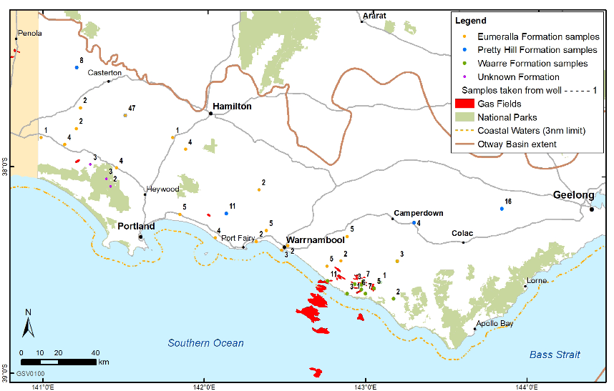
Figure 2.3: Distribution of wells with new porosity and permeability data, including number of samples per well
Routine core analysis has been completed by a specialist laboratory. A total of 234 core samples were submitted for plug preparation to determine the porosity, permeability and grain density.
Sample preparation required the trimming of the irregularly shaped pieces of drill core into a cylindrical plug with a diameter of one inch (25 millimetres). The plugs were then cleaned with solvents before being dried in a conventional oven. Cleaning the plugs removed residual hydrocarbons or other organic contamination, and any salts that might have precipitated in the pore spaces. The latter was considered particularly important given that some of the sampled drill cores have been in storage for over 40 years.
The dried core plugs were photographed before their porosity and permeability were measured. Figure 2.4 shows cores from the Waarre Formation that demonstrate the difference between the sedimentary units in this formation.
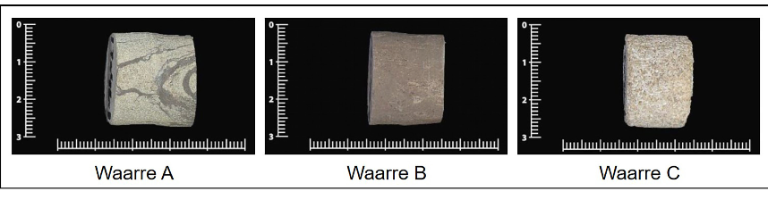
Figure 2.4: Samples from the Waarre Formation, units A, B and C (scale in cm)
Pore volume (porosity) and permeability of the core plugs were determined using an integrated porosimeter and pressure decay permeameter at ambient pressure conditions (800 pounds per square inch by gauge). The porosimeter uses the principle of gas expansion described by Boyle’s Law (Boyle, 1662) to determine the pore volume by injecting helium into the core plug, whilst the operation of the permeameter is based on Darcy’s Law (Darcy, 1856).
Where suitable plugs could not be cut, a probe permeameter was used, which injects a fixed volume of nitrogen gas at known pressure into the core, then measures the rate at which the pressure declines to determine the permeability. Probe permeameter measurements were also taken on most of the conventional core plugs, allowing a comparison to be made between the different techniques for determining permeability. This has resulted in a mixed sample set as summarised in Table 2.1. Porosity and permeability could not be measured on six of the 234 samples (four from the Waarre Formation and two from the Eumeralla Formation).
Table 2.1: Porosity and permeability analysis: number of samples submitted, and measurements acquired
Formation | Samples Submitted | Conventional Core Analysis | Probe Permeameter
Waarre | 97 | 59 | 75
Eumeralla | 58 | 46 | 40
Pretty Hill | 79 | 71 | 72
Total | 234 | 176 | 187
Conventionally measured porosity and permeability data acquired from the new analyses are broadly comparable with equivalent legacy/regional data for the Waarre and Pretty Hill formations (Figures 2.5 and 2.7). Results for the Eumeralla Formation show significantly higher porosity in many samples (Figure 2.6). Legacy/regional data is displayed in grey on these charts.
Results from the Waarre Formation samples generally show slightly lower permeability than might be expected for a given porosity when compared to the legacy data, but still plot within the cloud of regional data points (Figure 2.5). Conversely, the Port Campbell well results have higher permeability than initially predicted, even though these are from some of the deepest sampled depths (that is, 2,500 metres in Port Campbell-2). This could be due to either preservation of porosity or the development of secondary porosity.
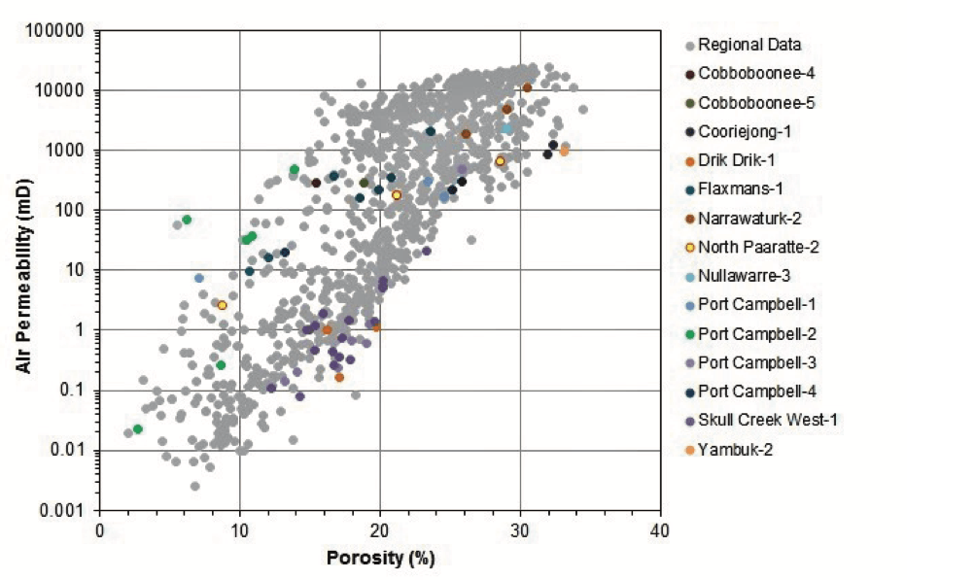
Figure 2.5: Porosity-permeability cross-plot for samples from the Waarre Formation
Limited legacy data is available for the Eumeralla Formation. However, many of the porosity results from the new analysis are up to 10 percentage points higher than the older measurements, although permeability values are comparable (Figure 2.6). Closer inspection of the data reveals that porosity values greater than 30 per cent are mostly from shallow depths (typically less than 400 metres) with none deeper than 1,150 metres. This suggests that porosity may have been either preserved by shallow burial or enhanced by deep weathering processes. The deeper samples from below 1,425 metres (Malanganee-4, Mumbannar-6, Niranda-3 and Nullawarre-3) plot within the main cluster of the legacy data.
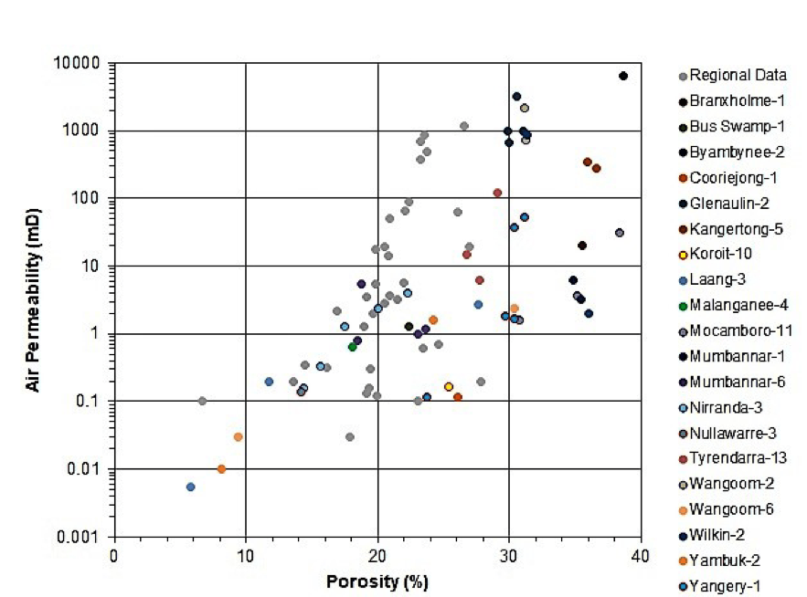
Figure 2.6: Porosity-permeability cross-plot for samples from the Eumeralla Formation
Comparison of the new and pre-existing data for the Pretty Hill Formation shows a consistency between the two sets of measurements (Figure 2.7). The legacy data include analytical results from three of the four wells that were sampled for this study (Mocamboro-11, Pretty Hill-1 and Warracbarunah-2), increasing the size of the data set but not the geographical coverage.
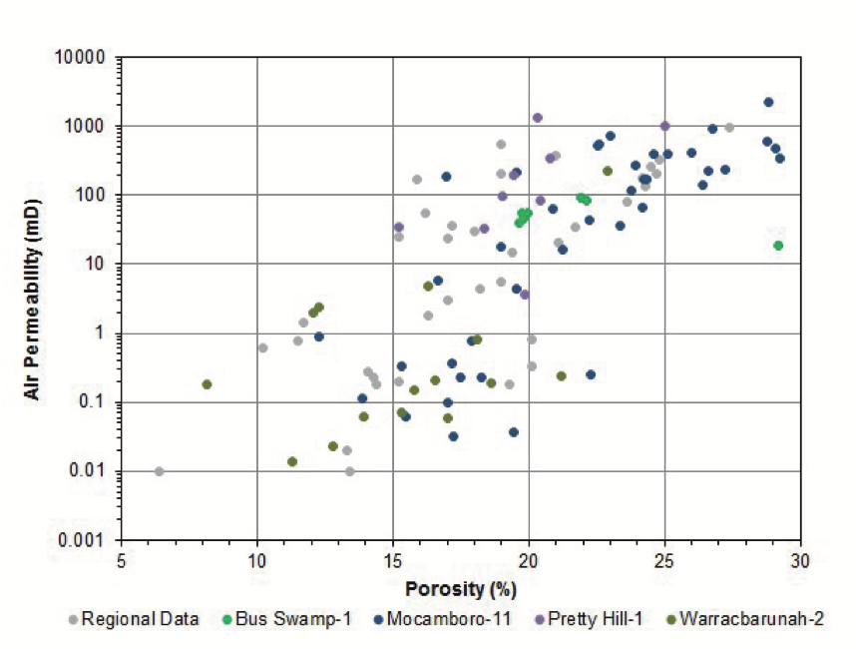
Figure 2.7: Porosity-permeability cross-plot for samples from the Pretty Hill Formation
Routine core analysis at ambient conditions is complete, as is research to determine porosity and permeability under simulated overburden pressure conditions. The objective of the latter is to understand the fluid flow behaviour of the different reservoir units at their expected depth of burial. Overburden measurements also provide an indication of rock compressibility during hydrocarbon production.
The new porosity and permeability data will be integrated with lithological data (including sedimentary core logs and petrology), palaeontological data and wireline log data. This will develop an understanding of the distribution, thickness and quality of the principal reservoir units across the Otway Basin. Maps summarising the distribution of sedimentary environments at the time of deposition of the reservoir units will also be prepared for use in the investigation of prospective areas for gas exploration.

2.2.1.2 Seal rock studies
Sealing rocks are an essential component of petroleum systems and act to create a barrier that impedes the upward movement of hydrocarbons. The Victorian Gas Program is investigating seal potential through mapping, sampling and analysis, combining three fundamental components: seal capacity, seal geometry, and seal integrity.
Seal capacity is tested using a special core analysis known as a mercury injection capillary pressure (MICP) test. Pressure thresholds from MICP analysis are used to calculate the column height of oil or gas that the seal could potentially hold. This is a direct measurement of the size of the gas/oil column that the formation is capable of preserving.
Regional sealing lithologies in the Otway Basin were studied by Daniel and Kaldi (2014) as part of the CO2CRC pilot plant carbon dioxide sequestration containment studies. The Pember Mudstone, Paaratte Formation, Skull Creek Mudstone, Belfast Mudstone and associated intraformational seals were assessed as part of the CO2CRC study. The Belfast Mudstone had the highest range of sealing capacities relative to all other formations tested.
MICP analysis has now been carried out on 79 core and cuttings samples from potential sealing formations, including the Pretty Hill Formation, Eumeralla Formation, Waarre Formation (Unit B), the Flaxman Formation, the Belfast Mudstone and Skull Creek Mudstone, along with the Nullawarre Greensand, Paaratte Formation and Pember Mudstone (Figure 2.8).
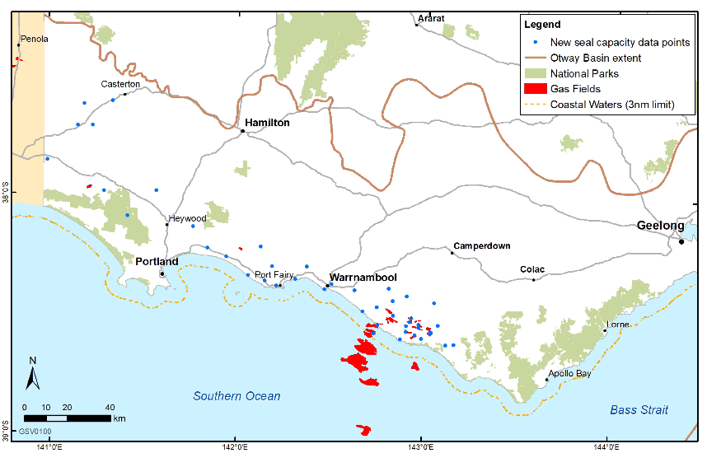
Figure 2.8: Distribution of wells and bores with new seal capacity data
Preliminary results (Figure 2.9) indicate that most formations sampled have some good seal capacity. Most samples from the Belfast Mudstone have high sealing capacity. Decreased capacity measurements from the Belfast Mudstone are attributed to samples from cuttings rather than core. Samples analysed from the Nullawarre Greensand have an overall low sealing capacity, which was anticipated given the sandy nature of the formation. Samples from the Nullawarre Greensand were included in the study as the formation is found between the underlying Belfast Mudstone and overlying Skull Creek Mudstone. Although it is clear that sealing capacity increases with depth, additional mineral analysis will be included in the study to help determine other potential controls on sealing capacity.
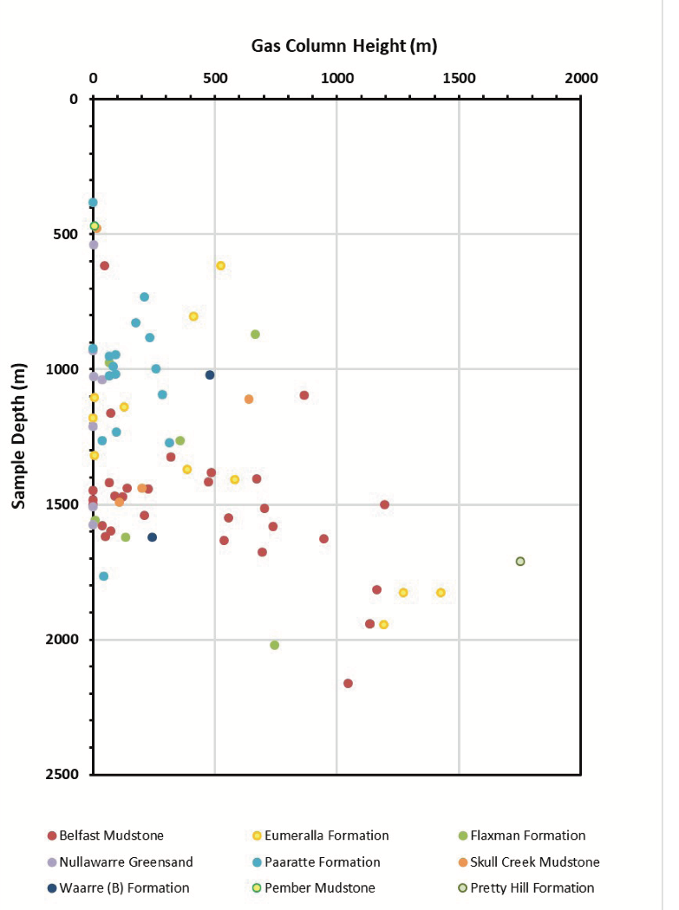
Figure 2.9: Seal capacity results for 79 legacy core and cuttings samples

2.2.1.3 Source rock geochemistry
Hydrocarbons are generated from source rocks: geological units capable of generating movable quantities of hydrocarbons from organic-rich facies (refer to Section 2.1). An evaluation of organic geochemical parameters is currently underway to evaluate the Otway Basin source rocks, including organic richness, kerogen type and thermal maturity. Organic carbon enrichment in the stratigraphy of the Otway Basin is the primary driver for the formation of petroleum. The investigation will increase the knowledge of the distribution of organic carbon throughout the basin.
Samples were taken from historical Otway Basin drill core and cuttings held at the Geological Survey of Victoria’s core library. The samples were analysed for total organic carbon (TOC) content, pyrolysis, maceral content and reflectance (VR), and kerogen kinetic parameters. Fifty-five petroleum wells and bores were included in the study, with 979 individual samples taken for analysis (Figure 2.10). The wells and sampled intervals were selected to provide new data for areas that have a paucity of geochemical analysis in relation to petroleum generation.
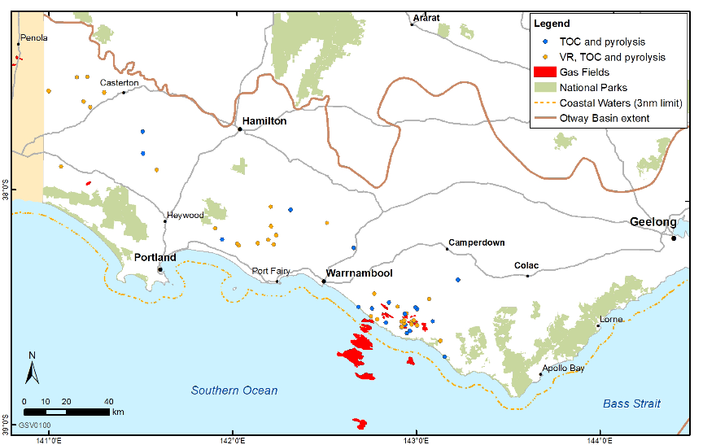
Figure 2.10: Distribution of wells and bores with new source rock geochemistry data
Early results indicate that geochemical variation exists within the source rocks contributing to the petroleum systems of the Otway Basin. Thermal maturity investigations are under way, with vitrinite reflectance investigations providing additional thermal history information to previously data-poor regions. Increased thermal maturity data through the Eumeralla Formation helps provide the necessary conditions for hydrocarbon generation in the basin (Austral-2 petroleum system; Figure 2.11). These results are preliminary, and continuing work is underway to determine the kinetic heating parameters necessary for resolving the thermal conditions needed for hydrocarbon generation from the identified source rocks. Vitrinite is a key organic material that petroleum is generated from and its reflectance properties change upon heating, with albedo (reflectance index) increasing with temperature. Reflectance values relative to depth are useful to incorporate into the petroleum systems modelling studies as thermal indicators of uplift after initial burial of the rock sequence.
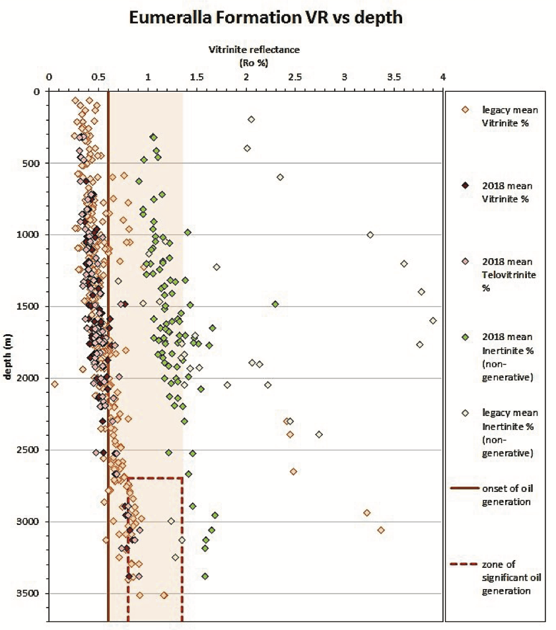
Figure 2.11: Eumeralla Formation maceral reflectance values from legacy and 2018 sampling analysis
Photomicrographs of the samples (Figure 2.12) provide visual references of reflectance for estimating thermal maturity throughout the sampled regions.
The vitrinite family of macerals maturation trend relative to depth indicates hydrocarbon generation occurs at approximately 2,100 metres depth, with significant generation (>0.8 percentage of vitrinite reflectance) occurring at approximately 2,700 metres depth of burial.
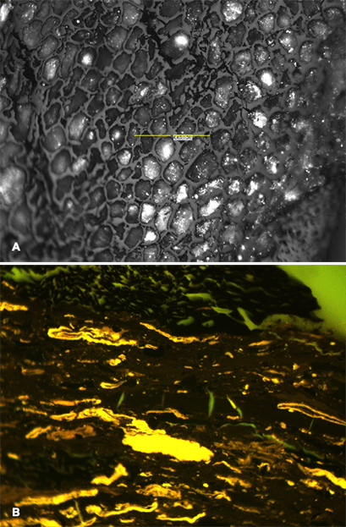
Figure 2.12: Petrographic micrographs of samples from the well Hotspur-1
Showing: (A) vitrinite plant cellular structures (reflected light); (B) fluorescence of organic matter (luminescence under blue light) in the Eumeralla Formation, both at 50X magnification.
The sample set for the source rock characterisation has included, amongst other potential source rock units, the Belfast Mudstone. Previously, there was limited organic geochemistry data for the Belfast Mudstone. However initial results have yielded information that helps classify the source rock quality of the onshore Belfast Mudstone (Figure 2.13). Generally, the remaining potential to generate hydrocarbons (S2 values, that is milligrams of hydrocarbon per gram of rock) diminishes with increasing thermal maturity (shown by increasing Tmax values, the temperature at the highest yield of hydrocarbons) as hydrocarbons are generated and expelled. The S2 value is determined by pyrolysis and indicates the remaining generative potential in the rock is none (< 2), poor (2 to 3), fair (3 to 5), good (5 to 10), or very good (> 10). The Belfast Mudstone is dominated by samples that lack any potential to generate hydrocarbons. Further analysis to determine the kinetic parameters of hydrocarbon generation from each formation is in progress using samples from additional wells, with results expected in early 2019.
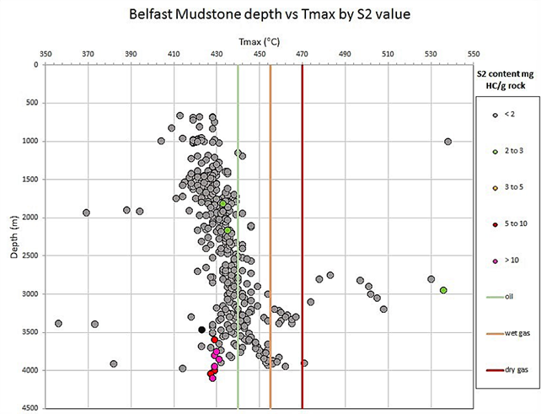
Figure 2.13: Belfast Mudstone hydrocarbon generative potential in the Otway Basin
Tmax indicates the temperature of the highest yield of hydrocarbons, and S2 is the potential volume yield of hydrocarbons in milligrams per gram of rock.

2.2.1.4 Biostratigraphy
The biostratigraphy component includes a review of the onshore Otway Basin stratigraphy to incorporate new biostratigraphic data from approximately 1,000 rock samples taken from existing conventional cores and drill-cuttings from the Geological Survey of Victoria’s Werribee core library, with 820 samples taken to date. The focus will be to correlate and assign refined geological ages to strata based on their fossil assemblages. The Geological Survey of Victoria compiled a data package of pre-existing paleontological (biostratigraphic) reports and charts from the onshore Otway Basin to guide the choice of samples.
Final samples were taken in January 2019. Processing and analysis of the new micropalaeonological and palynological samples is underway and the review is on schedule, with the final report to be submitted by June 2019. The legacy and new data will be used to improve lithostratigraphic and chronostratigraphic correlations across the onshore Otway Basin.

2.2.1.5 Petrophysics
The petrophysics component of the study provides a link between the Otway Basin rock characterisation studies and the petroleum systems modelling.
Data from the rock characterisation studies and wireline petrophysical logging tools are being used to interpret rock types in the subsurface. A wireline log provides a continuous measurement of rock formation properties with specialised down-hole instruments. These measurements include electrical properties (that is, resistivity), sonic properties, natural emissions of radiation, and bulk density. The log responses change due to varying lithology or fluid zones.
Wireline log analysis is one of the most fundamental methods to characterise reservoirs. Using wireline log data, petrophysical properties such as the volume of shale, hydrocarbon saturations (such as gas), porosity and permeability can be calculated.
There are many techniques to calculate petrophysical properties from wireline logs. As part of this study, a five-step workflow was applied. An example of this workflow is outlined in Figure 2.14.
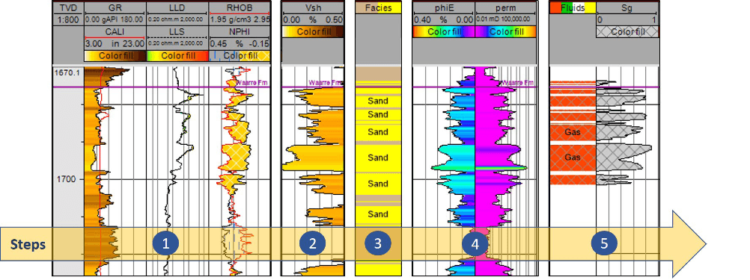
Figure 2.14: The five-step workflow used to calculate petrophysical properties from wireline logs
(1) log display and initial data interpretation, (2) shale volume estimation using the gamma ray log, (3) porosity and permeability estimation using log and core data from the Otway Basin rock characterisation studies, (4) lithology interpretation and (5) fluid zone interpretation and calculation of gas saturation.
The workflow has been applied to all the wells within the Port Campbell Embayment that have recorded petrophysical data. The next stage in the study is to apply the workflow to the remaining wells in the Otway Basin external to the Port Campbell Embayment.
The output from the petrophysical study will provide a direct input into the petroleum systems modelling and resource estimation as part of the Onshore Conventional Gas studies. It will also provide an input into the Underground Gas Storage technical studies (refer to Section 4.2).

2.2.2 Modelling and mapping progress

2.2.2.1 Otway 3D geological framework model
The Geological Survey of Victoria commissioned the construction of 3D geological framework models of the Otway Basin. This component of the study comprises two elements – a regional 3D model of the Victorian Otway Basin and a detailed 3D model of the Port Campbell Embayment and Shipwreck Trough. Both elements will support subsequent petroleum systems and hydrogeological modelling.
Interpretation of seismic horizon and well data was completed in June 2018. Seismic interpretation was undertaken using two-dimensional (2D) and 3D seismic data acquired by industry over the past 50 years that is publicly available through Geological Survey of Victoria archives (http://earthresources.efirst.com.au). Nine regional horizons were mapped across approximately 15,000 kilometres of 2D seismic lines and 4,000 square kilometres of 3D seismic data and more than 150 wells and boreholes across the Otway Basin were included in the interpretation project. These horizons were selected based on the geological properties of potential reservoirs and key structural surfaces, to identify the timing of different stages of basin formation.

Element 1 – Regional three-dimensional geological model of the Victorian Otway Basin
Element 1 will provide an extension of the existing regional-scale onshore Otway Basin model from the Water Science Studies (State Government Victoria, 2015) at a comparable resolution. The model will incorporate nearshore/offshore and onshore geological interpretation of the entire Victorian Otway Basin sedimentary sequence. The Otway Basin sedimentary sequence includes the top of the Palaeozoic basement to the bathymetric surface/present-day land surface and all mappable sedimentary units that outcrop or sub-crop in the Otway Basin. The study excludes the Torquay Sub-basin as defined onshore by the edge of the Otway Ranges, Barrabool Hills, and Paraparap High (refer to Figure A2.1 in Appendix 2). The extent of the combined 2D and 3D seismic interpretation is represented by the extent of the coloured horizons in Figure 2.15.
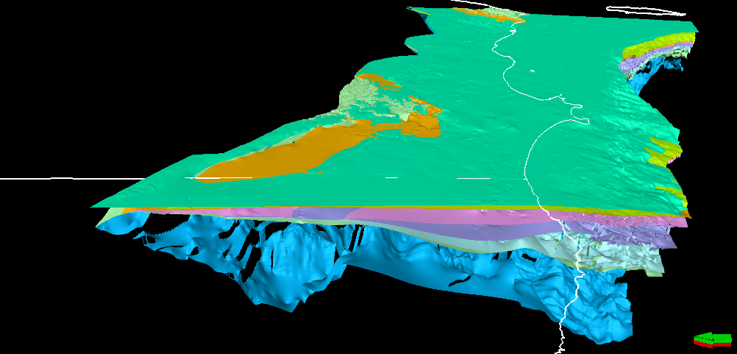
Figure 2.15: The nine key horizons across the Otway Basin selected for regional interpretation
A 3D model of the evolution of the Otway Basin is being built to combine the newly modelled surfaces, new interpretations and legacy data. This model will be a primary input into the petroleum systems model currently being constructed.
The primary interpretation phase of Element 1 is complete and maps of the individual geological horizons are being created. The Geological Survey of Victoria is reviewing the products as they are delivered.

Element 2 – High resolution 3D geological model of the Port Campbell Embayment and Shipwreck Trough
A high-resolution 3D geological model of the Port Campbell Embayment and adjacent Shipwreck Trough is being constructed (Figure 2.16). The components for this study are similar to those in Element 1. However, the availability of 3D seismic data and a higher concentration of drilled wells in the region allows the evaluation of this area at higher resolution. The framework from Element 2 will be useful for the detailed prospectivity and resource estimates as well as the Underground Gas Storage technical studies (refer to Section 4).
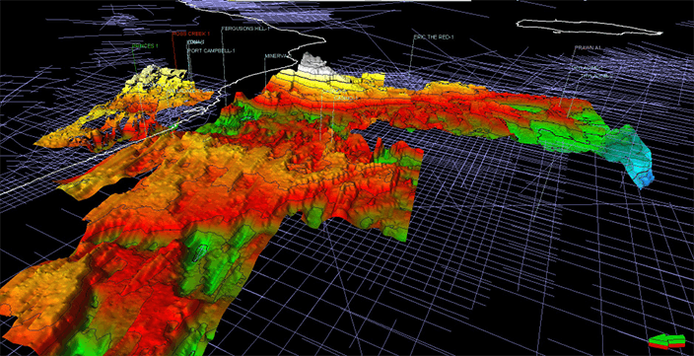
Figure 2.16: Structure map – Top Waarre Formation in the Port Campbell Embayment and Shipwreck Trough

2.2.2.2 Otway Basin petroleum systems modelling
The petroleum systems modelling combines available new and existing data and interpretation to estimate hydrocarbon resources in the Otway Basin. New data includes seismic and structural interpretations from the 3D framework modelling and the rock characterisation studies, including geochemistry, seal capacity and biostratigraphy. Existing data includes well, temperature and pressure data, along with historical geological assessments to characterise present-day conditions of the basin. This data will be used to determine the depositional history of the basin and hydrocarbon generation, and movement and preservation throughout geological time.
To construct the petroleum systems model of the Otway Basin, the Program’s geoscientists began by collating, reviewing and performing quality control assessments on the input data. Well correlation panels comprising 274 wells were created in Petrel® modelling software (Figure 2.17). Lithologies and petrophysical properties were interpreted from wireline log data for each well and calibrated using data from core analysis.
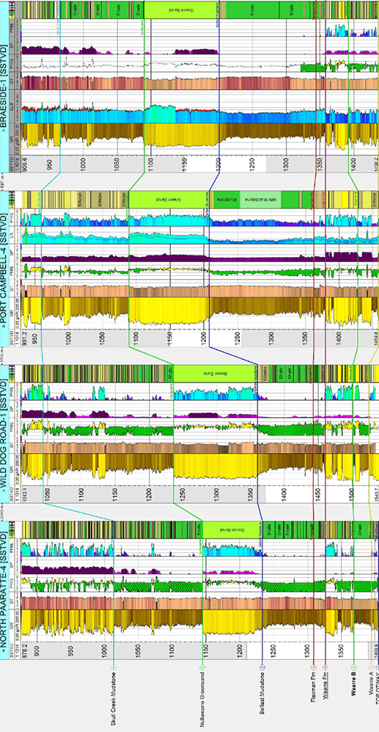
Figure 2.17: Correlation panel of well petrophysical data in the Otway Basin
Showing interpreted lithology and petrophysical log data.
Next steps include combining the well correlation panels with biostratigraphy and the structural models to predict periods of rifting (periods of increased sediment deposition), hiatus (periods of non-deposition) and uplift (periods of erosion).
Once the 3D geological framework is finalised, a 3D basin-wide model will be generated from lithological facies and petrophysical properties (Figure 2.18).
Further work will include:
- modelling of depositional history
- predicting boundary conditions during times of rifting and uplift
- creating source rock richness maps and kerogen kinetics composition (refer to Appendix 1)
- building basin-wide 3D paleo-heatflow models for predicting the timing of hydrocarbon generation and expulsion.
A geomechanical and paleo-pressure model will be constructed to predict seal capacity, fault seal conductivity, and hydrocarbon migration pathways. These models will ultimately be used together to calculate a gas resource estimation.
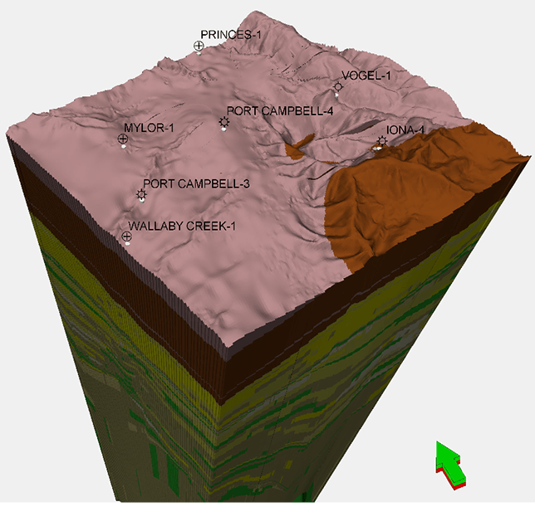
Figure 2.18: 3D static model of the Port Campbell Embayment (built in Petrel®)

2.2.2.3 Otway Basin stratigraphic drilling
The Geological Survey of Victoria is assessing the need to drill a targeted stratigraphic well in the onshore Otway Basin. Through stratigraphic drilling, the presence or absence of key rock units would be assessed, providing confidence in the Geological Survey of Victoria’s geological model in an underexplored area of the basin.
The Geological Survey of Victoria has reviewed existing Otway Basin geology and petroleum data to investigate the optimal location for placement of a stratigraphic well that will maximise our ability to decrease uncertainty relating to gas prospectivity and resource estimates.
An approach has been developed to narrow potential locations from the entire onshore Otway Basin (hundreds of square kilometres scale) to areas of interest (square kilometre scale). This has involved creating a GIS data model to compile all available geological and petroleum data to inform selection of areas of interest.
The requirement to drill will be determined under the oversight of Victoria’s Lead Scientist and comply with all the requirements of the Petroleum Act 1998 and Petroleum Regulations 2011. BTEX chemicals (that is, benzene, toluene, ethylbenzene and xylene) and hydraulic fracturing cannot be used in any circumstance under Victorian law. Furthermore, the Geological Survey of Victoria will not enter private land without a landholder’s prior agreement.

2.2.2.4 Gippsland 3D geological framework model
The petroleum prospectivity of the onshore and offshore Gippsland Basin within Victoria’s jurisdiction is being investigated as part of the Victorian Gas Program and an assessment of the potential for further conventional gas discoveries is being prepared. The project commenced in September 2018 and will take about a year to complete. It will include the construction of a 3D geological model that defines the structure and stratigraphy of the subsurface geology of the onshore Gippsland Basin. The extent of the study area is shown in Figure 2.19.
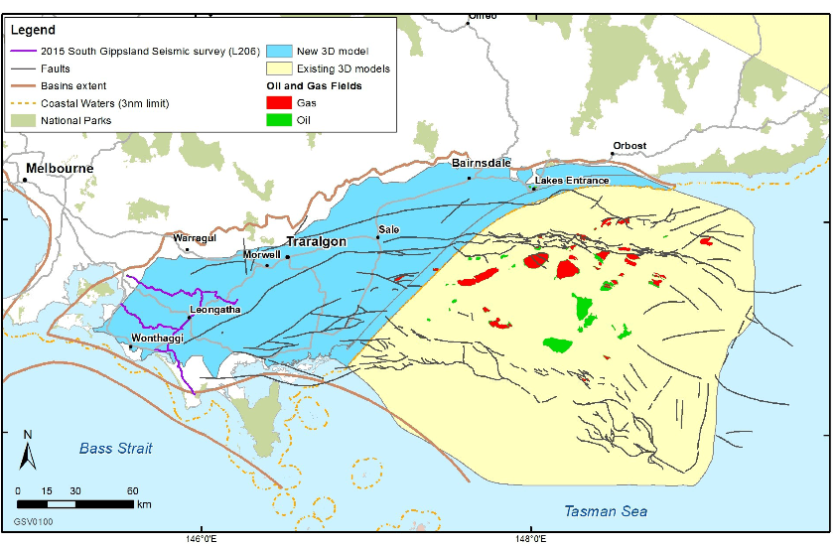
Figure 2.19: Gippsland Basin study area
Existing 3D model coverage is shown in yellow (offshore). The current extent of onshore research area is shown in blue. The 2015 South Gippsland Seismic Survey lines (acquired near Leongatha and Wonthaggi) are shown in purple.
The new model will complement and extend interpretations of the offshore Gippsland Basin, notably the work completed under the Geological Survey of Victoria’s Victorian Geological Carbon Storage initiative in 2010-11 (http://earthresources.efirst.com.au). New interpretations will address the full stratigraphic section from the top of the Palaeozoic basement to the present-day land surface, with emphasis on delineating intra-Latrobe Group units in the Seaspray Depression.
The Geological Survey of Victoria has commissioned the interpretation. An independent reviewer will provide feedback on the methodology and interpretations to the Geological Survey of Victoria, the Scientific Reference Group and other stakeholders.
The project will integrate existing well and 2D seismic data, including the South Gippsland regional seismic lines acquired by Geological Survey of Victoria in 2015 (Figure 2.19). If required, rock characterisation studies will be carried out to evaluate source rocks, reservoir rocks and seal rocks using legacy samples stored at the Geological Survey of Victoria’s core library. Deliverables will include a suite of maps illustrating the regional structure of the onshore Gippsland Basin and the thickness and geometry of key geological units. The maps will be used by the Program's geoscientists to construct the 3D geological framework model.
While having similar goals and workflows as the Otway 3D geological framework models (refer to Section 2.2.1), the onshore Gippsland Basin study has a smaller scope in terms of geographical size and the amount of data available for the evaluation due to current perceptions of the remaining potential for future gas discoveries.

2.3 Environmental studies
The environmental studies projects will provide an understanding of the current environmental conditions and potential impacts if onshore gas development was to proceed. The Geological Survey of Victoria is undertaking baseline environmental studies (groundwater and air quality) to determine if there could be an impact on the environment if a conventional gas industry was developed in the Otway and Gippsland Basins. The new environmental data collected will be a valuable environmental reference point for Victoria into the future.
Key environmental baseline indicators are being identified to ensure potential impacts can be quantified. Previously, the Victorian Water Science Studies (State Government Victoria 2015) undertook a regional scale assessment of conventional development in the Otway Basin and found the potential impacts to ecosystems and water users were low. This study will further refine the potential impacts in the Otway Basin and determine the potential impacts for the Gippsland Basin.

2.3.1 Inventory of potential environmental hazards
The Geological Survey of Victoria has compiled an inventory of the potential environmental hazard risks associated with onshore conventional gas exploration, specifically for onshore geophysical exploration and onshore conventional gas drilling. The likelihood of a potential hazard being realised has been assessed and ranked as part of the inventory. Risk mitigations have also been developed. The inventory will be used to help guide industry and regulators if onshore conventional gas exploration was to occur in the future.

2.3.2 Onshore environmental risks and mitigation controls
In Victoria, onshore petroleum activities are primarily governed by the regulatory framework established through the Petroleum Act 1998 and Petroleum Regulations 2011. The regulatory framework has evolved with the onshore petroleum industry in Victoria and sets out how industry is required to protect the environment when carrying out petroleum activities. The regulatory framework was in place prior to the moratorium on onshore conventional gas and to date has provided for robust environmental protection and risk management.

2.3.2.1 Overview of the regulatory framework
Prior to carrying out any petroleum operation (defined as any activity relating to petroleum exploration or petroleum production), an authority holder is required to submit an Operation Plan to the Minister under the Petroleum Act 1998. The Petroleum Regulations 2011 require an Operation Plan to include an Environment Management Plan that outlines how the authority holder will manage environmental risks. The plan must be reviewed and accepted by the Minister before an authority holder can carry out any petroleum operations. Additionally, the authority holder must observe the plan, and ensure that operations are carried out in accord to it, with penalties in place for non-compliance.
The Environment Management Plan must describe:
- the environment, inclusive of any values and sensitivities
- relevant cultural, historic, ecological, biological, landscape, and economic aspects of the environment that may be affected by the petroleum operation.
The description of the environment forms the basis of identifying and evaluating the environmental effects and risks of the petroleum operation that are directly and indirectly caused by the normal activities of the petroleum operation. Furthermore, an assessment of the risks of potential effects on the environment resulting from reasonably proximate and possible activities relating to the petroleum operation, or incidents or events that are not normal activities, incidents, or events arising from the operation.
An Environment Management Plan must define standards and objectives that the authority holder will be bound to in assessing whether they have protected the environment from their petroleum operation. Measurement methods that determine whether the objectives and standards have been met must also be included.

An important element of the Environment Management Plan is the implementation strategy. The implementation strategy sets out how the authority holder will:
- ensure environmental performance objectives and standards are met
- identify the systems, practices, and procedures that:
  - eliminate or minimise potential adverse environmental effects and risks from the petroleum operation so far as is practical
  - meet environmental performance objectives and standards.
- establish a clear chain of command (outlining roles and responsibilities) in relation to the implementation, management, and review of the plan
- include measures to ensure each employee or contractor meets their responsibilities in relation to the environment and ensure they have the appropriate skills and training to fulfil them
- provide for monitoring, audit, and review of environmental performance and the implementation strategy
- maintain quantitative records of emissions and discharges in to the air, land, or subsurface that can be monitored and audited against environmental performance standards
- include arrangements to record, monitor, and report information about the petroleum operation that will allow the Minister to determine if the plan is complied with
- provide appropriate consultation for the life of the operation about the authority holder’s environmental performance with relevant State and Commonwealth agencies, and other relevant interested parties and organisations
- provide an up to date emergency response manual with detailed arrangements for dealing with any threat to the environment near the petroleum operation and ensuring that a threat does not harm the environment.
While the Minister provides the final approval for an Environmental Management Plan, the Minister relies on Earth Resources Regulation to make assessments on behalf of the Minister. The regulatory framework also requires authority holders to consult the relevant agencies, interested people and organisations and provide a report on the outcome of this consultation as part of the Environment Management Plan. Earth Resources Regulation ensures compliance with the plan by conducting physical site inspections, examining the records required by the Petroleum Act 1998, and the Operation Plan.
Finally, an Environment Management Plan must include a statement of the corporate environmental policy of the authority holder, a report on any consultations between the holder of the authority and relevant agencies, interested people and organisations while developing the plan, and a list of all Victorian or Commonwealth environmental legislation that may be applicable to the petroleum operation.
Environmental risks arising from petroleum activities are also governed through a comprehensive legislative framework that goes beyond the Petroleum Act 1998 and Petroleum Regulations 2011. In addition to this framework, authority holders must comply with several other acts and regulatory mechanisms including the Aboriginal Heritage Act 2006, Catchment and Land Protection Act 1994, Environment Protection Act 1970, Environment Protection and Biodiversity Conservation Act 1999, Flora and Fauna Guarantee Act 1988, Planning and Environment Act 1987, Water Act 1989, and the Wildlife Act 1975.
Dependant on the level of risk, a Planning Permit or an Environmental Effects Statement is required prior to a petroleum operation proceeding. A Planning Permit must be obtained unless an Environmental Effects Statement has been prepared. An Environmental Effects Statement is normally required when the potential risks of an operation are significant. The Minister administering the Environment Effects Act 1978 determines whether an authority holder must prepare an Environmental Effects Statement. If indigenous artefacts or areas of cultural significance are located in the operation area or likely to be located in the operation area, a Cultural Heritage Management plan is also required that outlines how items or areas of cultural significance will be managed and protected.

2.3.3 Regional baseline studies

2.3.3.1 Groundwater sampling
Water sampling of Victorian Government groundwater observation bores is being conducted across south-west Victoria and Gippsland (Figures 2.20 and 2.21). As of December 2018, 69 of 100 proposed groundwater samples had been collected. Of the proposed sampled bores, approximately 80 are in south-west Victoria and approximately 20 are in Gippsland. This sampling will provide a comprehensive baseline of current groundwater conditions (focusing on deep aquifers) and will improve the understanding of groundwater processes.
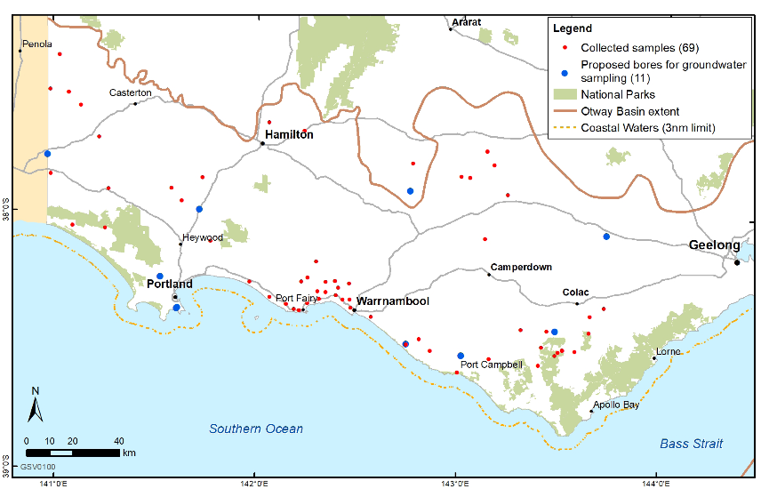
Figure 2.20: Location of proposed and sampled baseline groundwater monitoring bores in south-west Victoria
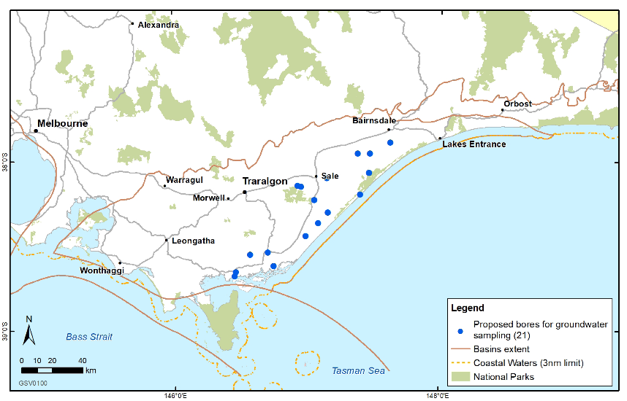
Figure 2.21: Location of proposed and sampled baseline groundwater monitoring bores in Gippsland
Many groundwater samples have been collected from bores more than 500 metres deep, and some more than one kilometre deep, where the gas source rock is nearby. In many instances, this is the first time a comprehensive groundwater sample has been collected from these bores. There have been no unexpected results from the groundwater sampling to date.
A variety of chemical parameters are being analysed including stable isotopic tracers and dissolved methane. The dissolved methane concentrations in the groundwater collected from the various aquifers to date has varied (Figure 2.22). However, these results show that the dissolved methane concentrations in south-west Victoria are low, and below the Australian Drinking Water Guidelines' threshold of 10 milligrams per litre (mg/L) (NHMRC, NRMMC 2017).
The above colour coded results are according to different aquifers (Victorian Aquifer Framework, GHD 2012). Results suggest methane concentration tends to increase in the groundwater with depth.
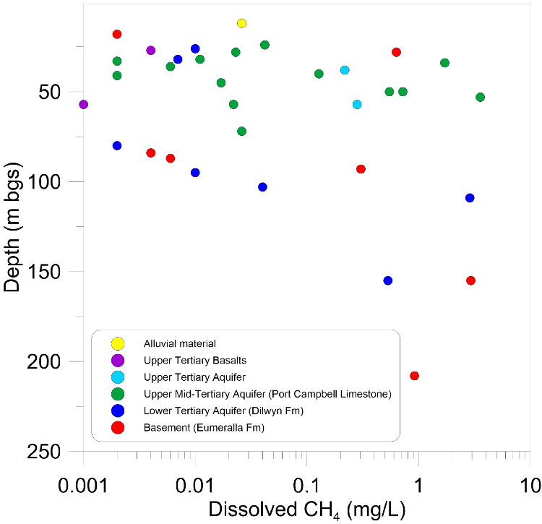
Figure 2.22: Depth (metres below ground surface) versus dissolved methane concentration (mg/L) of groundwater samples
The above colour coded results are according to different aquifers (Victorian Aquifer Framework, GHD 2012). Results suggest methane concentration tends to increase in the groundwater with depth.

2.3.3.2 Air quality measurements
Two regional air quality measurements occurred in April 2018 and November 2018. The surveys were conducted using atmospheric monitoring equipment commonly used for regional baseline studies and the assessment of fugitive gas source emissions.
The regional surveys were conducted in both south-west Victoria and Gippsland, roughly six months apart, to capture any seasonal variation in the concentration of methane and carbon dioxide. Smaller, targeted surveys were also conducted in both regions with additional specialist equipment to monitor atmospheric ethane. At the conclusion of the air quality activity, around 8,500 kilometres were surveyed across all six surveys in both south-west Victoria and Gippsland. Figures 2.23 and 2.24 show the path of the first regional survey routes through the study areas. The second regional surveys replicated these locations as closely as possible.
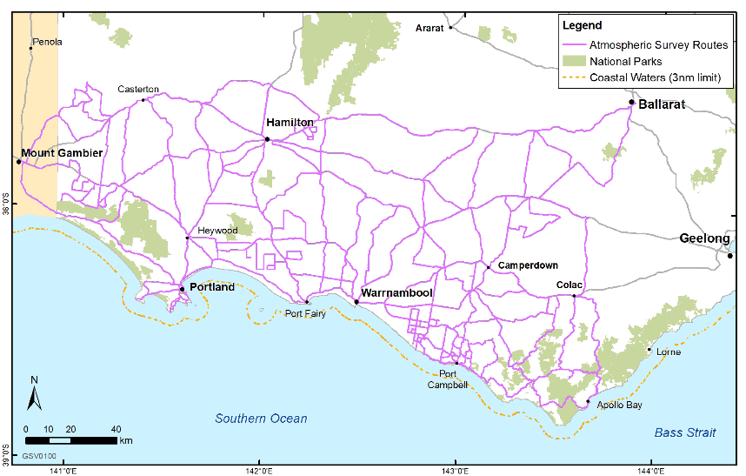
Figure 2.23: The completed route covered by the regional atmospheric survey in south-west Victoria
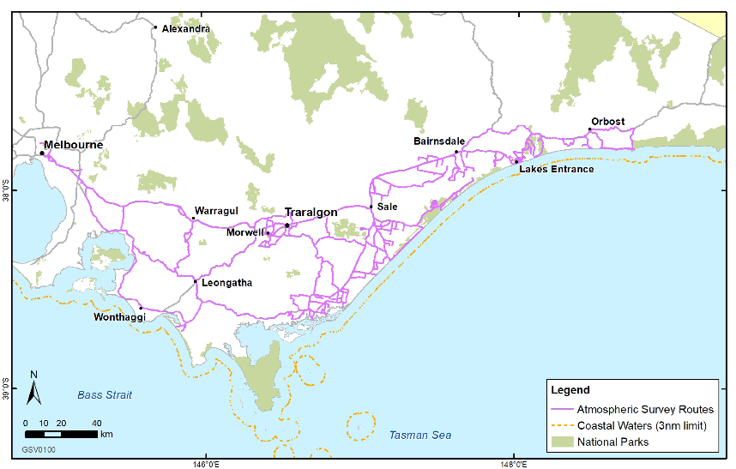
Figure 2.24: The completed route covered by the regional atmospheric survey in Gippsland
Data collected during the surveys provide an atmospheric baseline concentration for methane and carbon dioxide and identifies sources of both gases in the region. Throughout the surveys, climatic factors, such as wind speed, direction and rainfall were also monitored as they impact the interpretation of results. The seasonal surveys identified very similar baseline concentrations for both regions, suggesting limited seasonal influence on either greenhouse gas. Currently, concentration and isotopic data from the surveys is being processed and interpreted to better understand the occurrence of both gases in the region.
Small point sources of methane throughout the survey area were identified as being associated primarily with surrounding livestock industries, vehicle emissions and fires (bush, grass and domestic wood). Similarly, low concentrations of methane were identified near gas infrastructure between Warrnambool and Port Campbell (Figure 2.25). No elevated methane concentrations were identified around historic petroleum drilling sites.
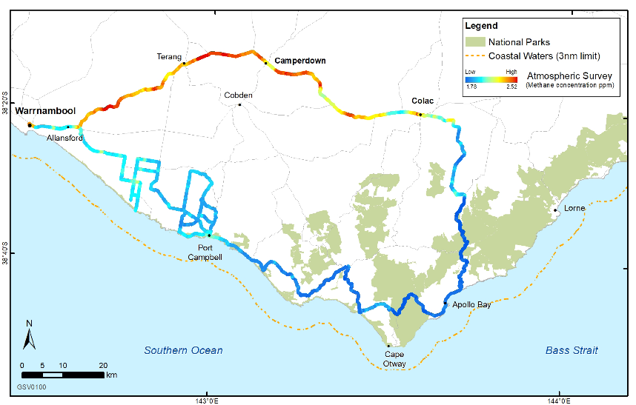
Figure 2.25: Example of data collected as part of the atmospheric survey
The colours show relative methane concentrations ranging from blue (low) to red (high). The highest value is 2.52 parts per million (ppm). Concentrations are well below the Victorian Environmental Protection Agency (EPA) guidelines of 10,000 ppm.
The targeted surveys used additional equipment to monitor ethane. These surveys were conducted in areas where elevated methane, most likely associated with gas infrastructure, was encountered during the regional surveys. These additional measurements assisted to identify the source of fugitive gas emissions. This is because methane produced via biological processes (biogenic – such as that emitted by cattle) does not occur with ethane, whereas methane produced at depth (thermogenic – such as that targeted and emitted by gas infrastructure) does. Thereby, ethane and methane gases together are correlated where thermogenic methane emissions. This correlation is seen as an enhancement ratio, which enables a clear differentiation between sources of methane (Figure 2.26).
Overall, the atmospheric survey found that instances of elevated methane above background were infrequent and well below the EPA atmospheric emission concentration limit of 10,000 parts per million (ppm) (EPA 2002; EPA 2018). Baseline concentrations of both methane and carbon dioxide in south-west Victoria and Gippsland resemble baseline concentrations for the southern hemisphere monitored at Cape Grim (CSIRO 2018).
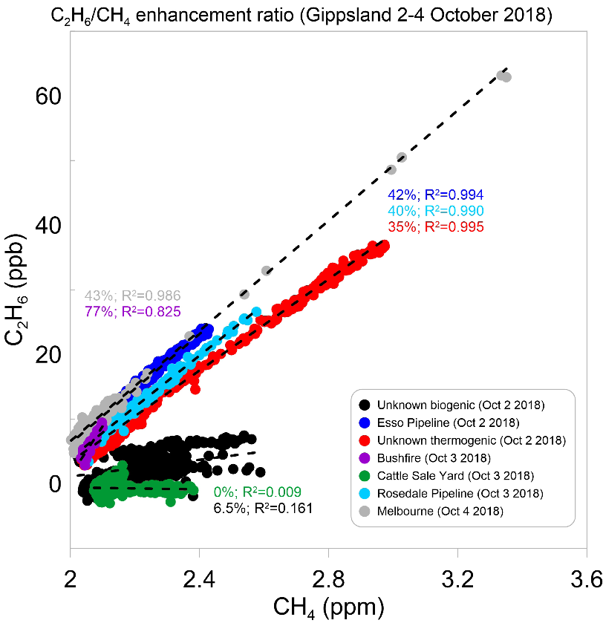
Figure 2.26: Methane/Ethane enhancement ratio for atmospheric methane sources in the Gippsland Basin
Highest value of methane concentration is only max 4.55 ppm. Concentration limit as per the EPA is 10,000 ppm.

2.3.4 Point scale well integrity impact assessment
Site scale modelling of the potential impact a poorly sealed well may have on groundwater will be undertaken. Modelling will quantify the likely volumetric and local impact that a compromised bore seal may have. This assessment will enable better understanding of the magnitude of potential risks associated with conventional gas drilling and extraction, which will then be used to inform the regional groundwater impact assessment and regulations.

2.3.5 Regional groundwater impact assessment
The studies will simulate regional groundwater flow processes of south-west Victoria (and offshore) and the Gippsland Basin to consider the potential impact a conventional gas industry may have on the near and onshore areas of Victoria. Understanding the groundwater processes in the regions combined with point scale assessments are important for assessing any future potential impacts a conventional gas industry may, or may not, have.
The simulation of groundwater processes will use geological data sets that have been developed as part of the detailed stratigraphic assessments for the geoscience studies. Components of the groundwater flow modelling are:
- groundwater pumping
- groundwater-surface water interaction
- groundwater recharge
- groundwater evaporation
- existing conventional gas water usage.

Groundwater impact assessment model development is underway for south-west Victoria. The 3D stratigraphic model developed as part of the geoscience studies is being incorporated with the existing onshore surfaces from the Victorian Aquifer Framework (GHD 2012).Groundwater impact assessment modelling is underway in south-west Victoria and involves the development of a regional scale groundwater model. A new first pass 3D stratigraphic model will be incorporated with existing onshore surfaces of Victorian Aquifer Framework (GHD 2012).
All relevant environmental data sets for the groundwater model are being compiled and further refinements are in progress. The Southwest Region Groundwater Model comprises 14 hydrogeological units. A schematic conceptual model is illustrated in Figure 2.27.
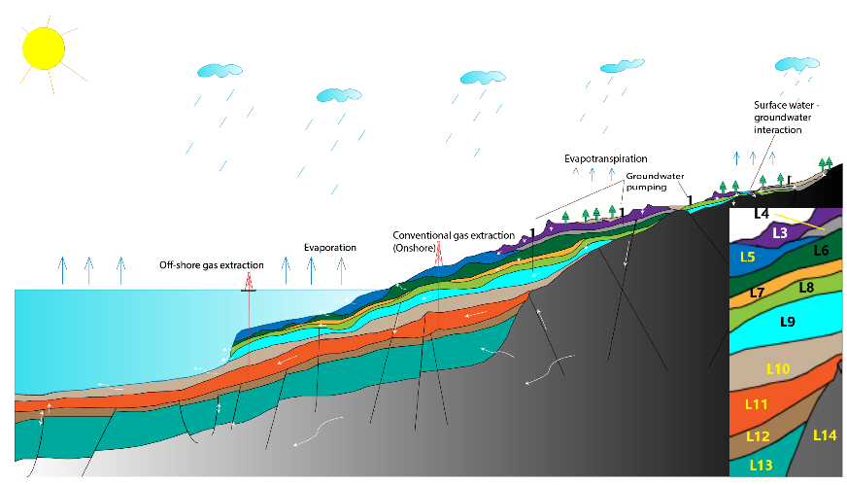
Figure 2.27: Schematic conceptual diagram of Southwest Region Groundwater Model

2.4 Onshore conventional gas governance

2.4.1 Stakeholder Advisory Panel for Onshore Conventional Gas
Victoria’s Lead Scientist, Dr Amanda Caples, chairs the Stakeholder Advisory Panel for Onshore Conventional Gas, which meets on a quarterly basis. The panel includes stakeholder representation from key sectors and groups, including farmers, industry, local government, environment and the community. The panel has been providing the Minister for Resources with advice on the risks, benefits and impacts related to onshore conventional gas during the moratorium, with particular attention being paid to social, economic and environmental factors.
To date, the panel has formally met on five occasions: 17 August 2017, 10 November 2017, 8 March 2018, 7 June 2018, and 6 September 2018.
Communiques for these meetings are included as Appendix 3.
While the sixth panel meeting was to be held on 9 November 2018, it was postponed to February 2019 due to the Government being in caretaker mode prior to the State Election.
Communiques for meetings are available on the Lead Scientist’s web page: http://djpr.vic.gov.au/victorias-lead-scientist

2.4.2 Victorian Gas Program Scientific Reference Group
Victoria’s Lead Scientist also chairs the Victorian Gas Program Scientific Reference Group (formerly the Scientific Reference Group for Onshore Conventional Gas). While the Scientific Reference Group’s original remit was to provide independent peer review advice to the Lead Scientist on the study scope and outputs related to the risks, benefits and impacts of onshore conventional gas, their remit has since expanded to include all components of the Victorian Gas Program.
In March 2018, two new members were added to the group’s existing composition:
- Professor Peter Gell, surface waters expert from Federation University Australia
- Associate Professor Andrew Barton, water resources expert from Federation University Australia.
In July 2018, the group met to review the geoscience and environmental studies.
Members with specific expertise will review Victorian Gas Program activities related to their field of study on an ad hoc basis to ensure that scientific and technical outputs are robust.
The Scientific Reference Group meets formally when required.

3. Offshore gas geoscience studies
The offshore gas geoscience studies will improve understanding of gas prospectivity at a sub-basin scale through geophysical surveys (for example, airborne gravity surveying) and through the onshore gas geoscience studies, such as the 3D geological framework modelling. Between August 2018 and January 2019, an airborne gravity survey was conducted over 16,000 square kilometres of the Otway Basin, including state onshore and offshore areas and Commonwealth waters.
The seismic horizon and well data interpretation completed in June 2018 (refer to Section 2.2) has identified areas off the Victorian coast in the Otway Basin that are likely to be prospective for offshore gas. This work underpins the 2018 offshore acreage release and will continue to support commercial exploration for gas discoveries off the Victorian coast once acreage is awarded. The Program continues to identify other prospective offshore areas that may be released in the future.

3.1 Acreage release
In May 2018, the Victorian Government invited applications from the oil and gas industry to explore five areas in Otway Basin State waters, extending out to three nautical miles from the coast. The release areas are located between Port Campbell and the South Australian border (Figure 3.1) and have a combined surface area of 1,318 square kilometres.
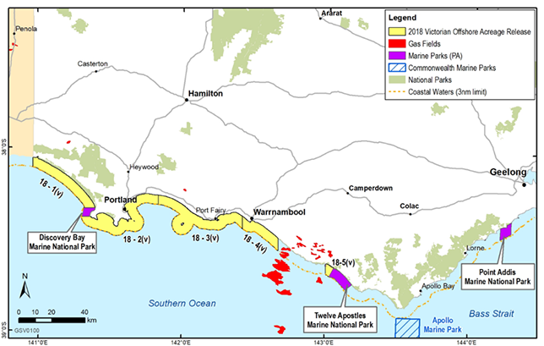
Figure 3.1: Location of offshore petroleum exploration acreage release areas in Victorian State waters
The release areas are underexplored and have not been drilled previously. Several of the areas adjoin existing producing oil and gas fields.
The acreage release is at the very start of the process to develop potential new gas fields. There are many more regulatory and consultative steps to take place should gas be discovered. As the first step, applicants will have to submit a work program proposal for assessment, a summary of financial and technical capability and records of past performance in Australia and overseas exploration and development operations.
Marine National Parks are excluded from the release areas and from any future petroleum exploration or development proposals. Marine seismic survey work is not allowed during whale migrations.
Unlike the moratorium on onshore conventional gas, and the permanent ban on onshore unconventional gas, there is no moratorium or ban on offshore exploration or production of natural gas.
Applications for the five acreage release blocks close in February 2019. Tenders received will be assessed in accordance with regulatory requirements.

3.2 Airborne gravity survey
The Geological Survey of Victoria commissioned an airborne gravity and gradiometry survey that was conducted in south-west Victoria (Figure 3.2). The survey began in August 2018 and was completed in January 2019. Data from the survey will be used to complement Victorian Gas Program studies and will be released as an open file dataset.
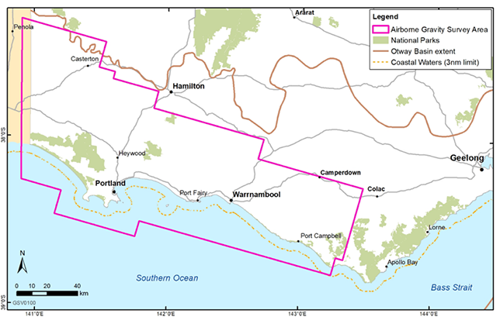
Figure 3.2: Airborne gravity survey area over the Otway Basin
Airborne gravity and gradiometry data was collected using a specially equipped aircraft that flew above the sea and land. The aircraft flew in a grid pattern. An instrument on board the aircraft recorded changes in gravity acceleration, which can then be interpreted as density variation in the rocks. Density contrasts between adjoining geological units are important for this method to be effective.
The survey used a FALCON® airborne system, which can acquire airborne gravity and gradiometry data at the same time. The acquisition of both will be useful as conventional gravity is good for imaging deeper geological structures, while gradiometry is more effective at imaging shallow structures. Qualitative interpretations of the data will infill and complement seismic datasets in the Otway Basin, particularly over the three-nautical mile zone around the Otway coast where very little geological data has been acquired previously.
The objectives of the survey are to resolve the shape of:
- deeper structures, which have an impact on petroleum generation (that is, 500 metres to eight kilometres below ground)
- shallow structures, which have the potential to trap hydrocarbons (that is, 1.5 to 2.5 kilometres below ground).

4. Underground gas storage investigations
The underground gas storage investigations focus on the onshore Otway Basin and examine the potential for further underground natural gas storage sites. This will help secure more reliable gas supplies and mitigate short term price increases, particularly during interruptions in the gas supply system.
In addition to the three gas fields that collectively form the Iona underground gas storage operation, another 13 depleted or unproduced gas fields have been identified in the Port Campbell area of the Otway Basin that could have suitable geology for conversion to gas storage reservoirs.
As the identified sites either contain or have contained gas in the past, a geological structure is in place that is able to effectively and reliably contain gas over time. All of the sites have Waarre Formation (Unit C sandstone reservoir – as at Iona) and are sealed by the overlying Belfast Mudstone.
The investigations comprise four components:
- Representative Technical Studies
- Detailed Technical Studies
- Assessment of the infrastructure costs of additional gas storage
- Economic assessment.

4.1 Representative Technical Studies
The Geological Survey of Victoria entered into a Research Agreement with CSIRO to complete the Representative Technical Studies for Underground Gas Storage. As part of these studies, CSIRO conducted a site screening as well as fluid dynamics and reservoir geomechanics. The Representative Technical Studies have been completed and the technical reports associated with the results are due to be released later in 2019.

4.1.1 Site screening
The aim of the CSIRO investigation was to geologically characterise and rank prospective underground gas storage sites for detailed reservoir evaluation. The scope of the study was restricted to known, primarily depleted, gas fields in the Port Campbell area of the Otway Basin. The three fields of the Iona project were included to validate the ranking approach that was used (Figure 4.1).
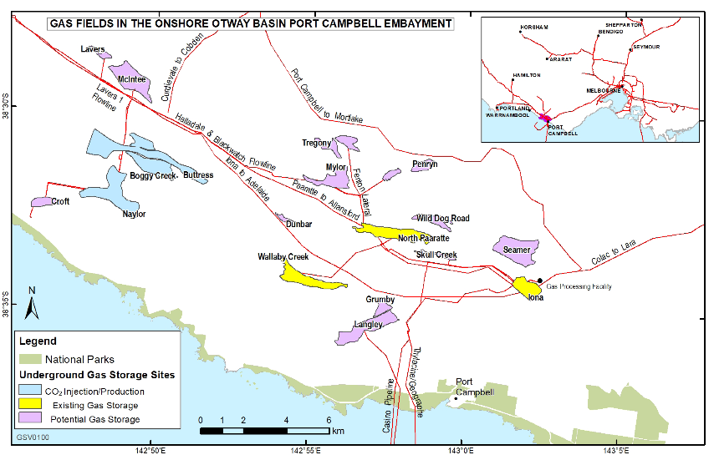
Figure 4.1: Gas fields in the onshore Otway Basin Port Campbell Embayment
Blue fields are carbon dioxide (CO₂) production fields and CO₂ production and storage pilot sites, yellow are existing Underground Gas Storage sites and lilac are potential Underground Gas Storage sites. After Buschkuehle et al. (2018).
The study collated publicly available geological and geophysical data to create a database of the geological structure of each field, a table of key geological and engineering parameters and a summary reservoir description. Key parameters included reservoir thickness and quality (that is, porosity and permeability), areal extent of the accumulation and an estimate of the volume of original gas in place.
A quantitative interpretation of wireline logs was undertaken to determine porosity and water/hydrocarbon saturation, and then integrated with regional routine core analysis data from the Waarre Formation and calculated porosity values, to derive estimated permeability and provide an improved interpretation from that previously published.
A weighted ranking methodology was then used to assess the suitability of each structure as a potential gas storage reservoir. Methodology and results from the site screening will be published later in 2019.

4.1.2 Fluid dynamics and reservoir geomechanics
CSIRO completed preliminary fluid flow and geomechanical simulations to investigate:
- the impact of repeated cycles of gas injection and production on the capacity and efficiency of the storage reservoir
- the effects of reservoir compaction and the potential for long-term changes in the local stress regime of the reservoir.
CSIRO conducted fluid dynamics simulation on two numerical models representative of typical Waarre Formation gas-bearing structures in the Port Campbell area of the Otway Basin. The numerical models comprise a mesh of cells that are assigned varying values of key physical parameters such as porosity, permeability and proportion of gas in the pore space (the gas saturation, or S_{g}). Results from the study will be published later in 2019.

4.2 Detailed Technical Studies
The Geological Survey of Victoria has commissioned Detailed Technical Studies for underground gas storage with the results for the most prospective fields to be completed in the first half of 2019.
The studies are evaluating opportunities for underground natural gas storage in the Otway Basin, which requires detailed geoscientific assessment of candidate sites. These sites have been short-listed based on the ranking methodology developed in the Representative Technical Studies with improved estimation of storage capacity and additional petrophysical analysis. Six sites were short-listed for further evaluation. Results of the ranking will be published later in 2019.
The technical evaluation will involve building a fine-scale geocellular static model that numerically represents the structure and properties of the selected reservoir, associated aquifer and overlying cap rock. Reservoir performance will be modelled by dynamic fluid flow simulation of multiple cycles of gas injection and withdrawal, with modelling of geomechanics of the seal, reservoir and overburden also to be carried out. Geomechanical modelling will address fault seal integrity through multiple injection and withdrawal cycles and estimation of ground heave or subsidence (although the screening studies have shown that these issues are both unlikely in normal operating conditions).

4.3 Assessment of infrastructure costs of additional underground gas storage
The results of the Representative Technical Studies and the Detailed Technical Studies will feed into the assessment of infrastructure costs of further underground gas storage. This assessment will estimate development costs, operational complexity, and proximity to processing and supply infrastructure.

4.4 Economic Assessment
The results of the Representative Technical Studies, the Detailed Technical Studies and the assessment of infrastructure costs will feed into an economic case for the development of new underground gas storage facilities in Victoria.

4.5 Collaboration with Lochard Energy – Iona-7 Development Well
As part of the continuing development of the Iona Underground Gas Storage Project, Lochard Energy (the project operator) proposed to drill a new gas injection/production well, IonaFigure 4.2: Location of Iona-7 (Image courtesy of Lochard Energy) 4.2). Discussions between the Geological Survey of Victoria and Lochard Energy identified several areas for collaboration that could add valuable geological data to the Victorian Gas Program.
Drilling of the well commenced in early June 2018 and concluded on 1 July 2018. Lochard Energy provided the Geological Survey of Victoria with cuttings of representative samples of rock that covered the entire well. This work between the Geological Survey of Victoria and Lochard Energy, is a demonstration of successful industry-government collaboration.
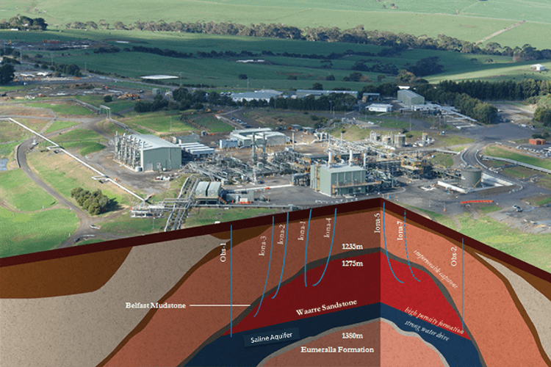
Figure 4.2: Location of Iona-7 (Image courtesy of Lochard Energy)

5. Supporting program components

5.1 Community engagement
An extensive stakeholder and community engagement program has been under way since the Victorian Gas Program commenced in 2017. The program informs community and industry leaders and the public about scientific findings and other developments. It has focused on the Gippsland Basin and the Otway Basin, which are known prospective gas regions in Victoria.
The broad objectives of the stakeholder and community engagement program are to:
- inform and educate stakeholders, local communities and the public about the Victorian Gas Program and its scientific findings
- build the capacity of stakeholders and communities to offer informed input
- build trust and nurture relationships
- enable the community to have a voice and inform decisions throughout the Victorian Gas Program.
The stakeholder and community engagement program supports the other components of the Victorian Gas Program, including the onshore conventional gas studies, the offshore gas studies and the underground gas storage investigations.

5.1.1 Progress to date
The stakeholder and community engagement program has now reached out to over 570 individual stakeholders across south-west Victoria, Melbourne and Gippsland through more than 470 events (including briefings, meetings, forums, emails and telephone calls).
Stakeholders are informed of the deliberations of the Stakeholder Advisory Panel on Onshore Conventional Gas via the communiques from each panel meeting (refer to Appendix 3).
The Geological Survey of Victoria has now presented its 3D geological models to councillors, chief executive officers and senior staff in six local government authorities in the Otway Basin (Corangamite, Warrnambool, Southern Grampians, Glenelg, Moyne and Surf Coast). Mayors and chief executive officers of five Gippsland local government authorities (Latrobe, Wellington, South Gippsland, Eastern Gippsland and Baw Baw) have also been briefed on the Victorian Gas Program.
Councillors wanted to understand how they could explain the difference between conventional and unconventional gas (banned) to their communities. They suggested that the Victorian Gas Program should progressively communicate the scientific findings to engage and inform the community in a positive way about the region’s gas potential.
Other topics raised by local government representatives included government policy on the onshore conventional gas moratorium, the need to protect groundwater for farmers and communities, the potential economic benefits of future onshore conventional gas developments, and exploration licences for onshore conventional gas. Figure 5.1 depicts the key issues raised through local government engagements regarding the Program.
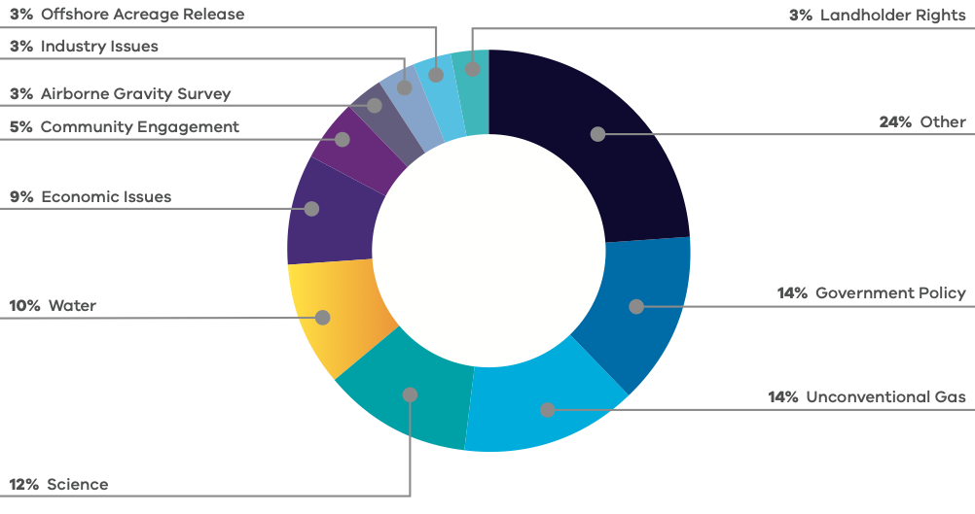
Figure 5.1: Key issues raised through local government engagements about the Victorian Gas Program
Other stakeholder networks across south-west Victoria and Gippsland that have been briefed on the Victorian Gas Program include:
- farmer organisations
- catchment management authorities
- environmental groups
- economic development associations
- other community groups
- water authorities.
These stakeholders also emphasised the importance of explaining the science and the difference between conventional gas and banned unconventional gas to communities. They raised the topic of government policy, particularly in relation to the permanence of the ban on unconventional gas. Environmental issues were raised more often than in local government engagements, particularly in relation to climate change and the need to transition to renewable energy resources
Figure 5.2 depicts the key issues raised regarding the Program though the Otway and Gippsland stakeholder engagements.
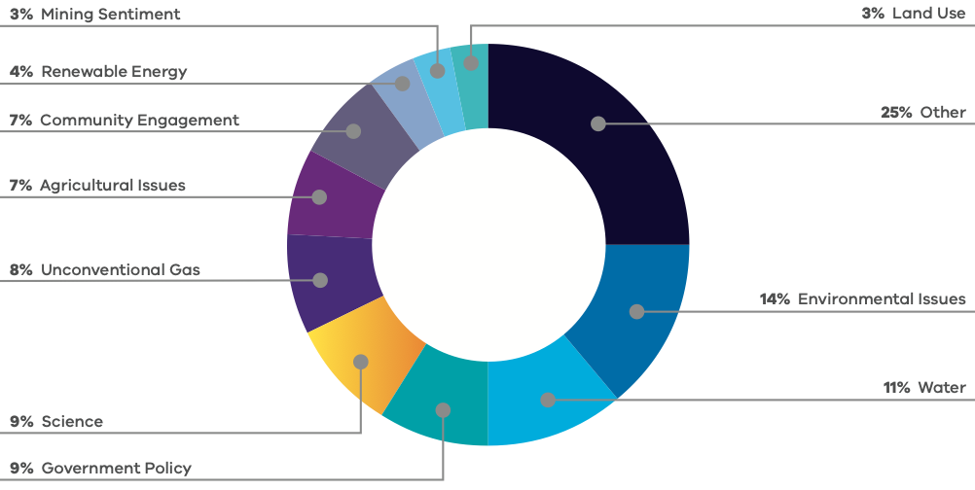
Figure 5.2: Key issues raised through Otway and Gippsland stakeholder engagements
Victorian Gas Program staff also attended large agricultural events, including the Sungold Farm Field Days in Warrnambool in February 2018 and Sheepvention in Hamilton in August 2018. Both events were attended by thousands of people. These events were ideal opportunities to show the Geological Survey of Victoria’s 3D geological models and to explain the purpose of the Victorian Gas Program to farmers and local community members. Staff have also presented on the regional geological profile of the Otway Basin to over 720 regional primary and secondary school students, and participated in Deakin University’s Warrnambool Open Day.
The opening of the Geological Survey of Victoria’s south west regional office in September 2018 was well attended by local stakeholders, providing a valuable opportunity to strengthen relationships with local government, schools and environmental and community groups.
The petroleum industry has also been kept informed about the Victorian Gas Program. The former Minister for Resources, Mr Tim Pallas, delivered a speech on the Victorian Gas Program at the Australian Domestic Gas Outlook Conference in March 2018. The release of new offshore acreage areas in the Otway Basin was also promoted at the Australian Petroleum Production and Exploration Association conference in May 2018.
Recent media activities include Victoria’s Lead Scientist being interviewed about the Victorian Gas Program in the industry magazine The Australian Pipeliner in June 2018. Articles on the underground gas storage, offshore acreage release and airborne gravity survey of the Otway Basin have also been featured in The Age, The Herald Sun and several regional newspapers, including The Standard (Warrnambool), The Portland Observer and The Hamilton Spectator. The opening of the Geological Survey of Victoria’s new south west regional office at Deakin University Warrnambool was also featured in The Standard.
There was extensive engagement in the lead up to the Otway Basin airborne gravity survey to ensure community awareness. Key stakeholders briefed included:
- municipal emergency response networks in south-west councils
- Victoria Police
- Country Fire Authority
- State Emergency Service
- Parks Victoria
- Agriculture Victoria
- farming organisations.
Future engagement will focus more on:
- informing local communities and groups about scientific findings
- understanding attitudes towards the potential development of onshore conventional gas in the Otway Basin.

5.2 Resource planning
Resource planning will commence once the geoscience studies indicate which areas could be prospective for onshore conventional gas. The planning will consider other natural resources, cultural and environmental impacts as well as existing land use.

5.3 Regulatory reform
Potential regulatory reforms will be informed by the geoscience and environmental studies and the community engagement program. Potential policy, administrative and legislative reforms will be developed for Government once the broader findings of the Victorian Gas Program are known.

6. References
AMERICAN SOCIETY FOR TESTING AND MATERIALS (ASTM), 2011, Standard test method for microscopical determination of the reflectance of vitrinite dispersed in sedimentary rocks: West Conshohocken, PA, ASTM International, Annual book of ASTM standards: Petroleum products, lubricants, and fossil fuels; Gaseous fuels; coal and coke, Sec. 5, V. 5.06, D7708-11, pp. 823-830, doi: 10.1520/D7708-11, http://www.astm.org/Standards/D7708.htm Accessed July 2018.
APPEA, 2018. Australian oil and gas glossary. http://www.appea.com.au/oil-gas-explained Accessed July 2018.
BOCK, P.E. & GLENIE, R.C., 1965. Late Cretaceous and Tertiary depositional cycles in southwestern Victoria. Proceedings of the Royal Society of Victoria, 79, pp. 153-163.
BOREHAM, C.J., HOPE, J.M., JACKSON, P., DAVENPORT, R., EARL, K.L., EDWARDS, D.S., LOGAN, G.A. & KRASSAY, A.A., 2004. Gas–oil–source correlations in the Otway Basin, southern Australia In P. J. Boult, D. R. Johns & S. C. Lang (eds) Eastern Australasian Basins Symposium II: Petroleum Exploration Society of Australia Special Publication, pp. 603-627.
BOYD, G.A. & GALLAGHER, S.J., 2001. The sedimentology and palaeoenvironments of the Late Cretaceous Sherbrook Group in the Otway Basin. In K.C. Hill & T. Bernecker (eds) Eastern Australasian Basins Symposium – A Refocussed Energy Perspective for the Future, Petroleum Exploration Society of Australia, Special Publication, pp. 475-483.
BOYLE, R., 1662. New Experiments Physico-Mechanical, Touching the Air: Whereunto is Added A Defence of the Authors Explication of the Experiments, Against the Obiections of Franciscus Linus, and, Thomas Hobbes. Oxford: H. Hall for T. Robinson.
BRADSHAW, M.T., 1993, Australian Petroleum Systems. Petroleum Exploration Society of Australia Journal, 21, pp. 43-53.
BROWN, G.A., 1965. New Geological Concepts in the Casterton Area, Otway Basin, Victoria. APEA Journal, 5, pp. 27-35.
BROWN, B.J., MÜLLER, R.D., GAINA, C., STRUCKMEYER, H.I.M., STAGG, H.M.J. & SYMONDS, P.A., 2003. Formation and evolution of Australian passive margins: implications for locating the boundary between continental and oceanic crust. Geological Society of Australia Special Publication 22 and Geological Society of America Special Paper 372, pp. 223-243.
BUCKINGHAM, I.D., 1992. Well Completion Report Killara-1 PEP 101 Otway Basin Victoria, Volume 1: text. Anglo Australian Oil Company N.L. Unpublished Report, p. 62.
BUFFIN, A.J. 1989. Waarre Sandstone Development within the Port Campbell Embayment. The APEA Journal, pp. 299-311.
BUSCHKUEHLE, M., RICARD, L.P., L.AFORCE, T., 2018. Review of Potential Underground Gas Storage Sites in the Otway Basin Victoria, Australia. Unpublished Report. CSIRO, Clayton, Victoria.
CSIRO, 2018. Latest Cape Grim greenhouse gas data. https://www.csiro.au/en/Research/OandA/Areas/Assessing-our-climate/Latest-greenhouse-gas-data, Accessed May 2018.
CUPPER, M. L., WHITE, S. & NEILSON, J. L., 2003. Quaternary: ice ages – environments of change. In W.D. Birch (ed) Geology of Victoria, Geological Society of Australia, Special Publication 23, pp. 337-359.
CURRELL, M., BANFIELD, D., CARWRIGHT, I. & CENDON, D.I., 2017. Geochemical indicators of the origins and evolution of methane in groundwater: Gippsland Basin, Australia. Environmental Science and Pollution Research 24(15), pp. 13168-13183.
DANIEL, R.F. & KALDI, J.G., 2014. Evaluating CO₂ Column Height Retention of Cap Rocks. In P.J. Cook, (ed.) Geologically Storing Carbon: Learning from the Otway Project Experience. CSIRO Publishing, Melbourne. p. 400.
DARCY, H., 1856. Les fontaines publiques de la ville de Djion. Victor Dalmont, Paris.
DICKINSON, J.A., WALLACE, M.W., HOLDGATE, G.R., DANIELS, J., GALLAGHER, S.J. & THOMAS, L., 2001. Neogene tectonics in SE Australia: implications for petroleum systems, The APEA Journal, 41, pp. 37-52.
DUDDY, I.R., 2003. Mesozoic, a time of change in tectonic regime. In W.D. Birch (ed) Geology of Victoria, Geological Society of Australia, Special Publication 23, pp. 239-286.
EDWARDS, D.S., STRUCKMEYER, H.I.M., BRADSHAW, M.T. & SKINNER, J.E., 1999. Geochemical Characteristics of Australia’s Southern Margin Petroleum Systems. Australian Petroleum Production and Exploration Association Journal, 39(1), pp. 297-321.
ENVIRONMENT PROTECTION AUTHORITY VICTORIA, 2002. Protocol for Environmental Management – Minimum Control Requirements for Stationary Sources. https://www.epa.vic.gov.au/~/media/Publications/829.pdf Accessed 10 July 2018.
ENVIRONMENT PROTECTION AUTHORITY VICTORIA, 2018. Landfill gas fugitive emissions monitoring guideline. https://www.epa.vic.gov.au/our-work/publications/publication/2018/february/1684 Accessed July 2018.
FRIELING J., HUURDEMAN E.P., REM C.C.M., DONDERS T.H., PROSS J., BOHATY S.M., HOLDGATE G.R., GALLAGHER S.J., MCGOWRAN B., & BIJL P.K., 2018: Identification of the Paleocene–Eocene boundary in coastal strata in the Otway Basin, Victoria, Australia, Journal of Micropalaeontology, 37, pp. 317-339.
GEOSCIENCE AUSTRALIA, 2009. Oil and gas resources of Australia – 2009. http://www.ga.gov.au/data-and-publications-search/publications/oil-gas-resources-australia/2009/glossary Accessed July 2018.
GHD., (2012). Victorian Aquifer Framework – updates for seamless mapping of aquifer surfaces. Consultancy report prepared by GHD for the Victorian Department of Sustainability and Environment, May 2012.
GLOE C.S. & HOLDGATE, G., 1991. Chapter 1 – Geology and Resources. In R.A. Durie (ed.) The Science of Victorian Brown Coal: Structure, Properties and Consequences for Utilisation, Butterworth-Heinemann, Oxford, UK.
GRADSTEIN, F.M., OGG, J.G. & SMITH, A.G., 2005. A Geologic Time Scale 2004. University Press, Cambridge.
GUZEL, M., 2015. Review of Formation Tops of the onshore Otway Basin, Victoria, Australia. Unpublished report.
HOLFORD, S.P., TUITT, A.K., HILLIS, R.R., GREEN, P.F., STOKER, M.S., DUDDY, I.R., SANDIFORD, M. & TASSONE, D.R., 2014. Cenozoic deformation in the Otway Basin, southern Australian margin: implications for the origin and nature of post-breakup compression at rifted margins. Basin Research 26, pp. 10-37.
HOLDGATE, G.R. & GALLAGHER, S.J., 2003. Tertiary, a period of transition to marine basin environments. In W.D. Birch (ed.) Geology of Victoria, Geological Society of Australia, Special Publication 23, pp. 289-335.
HUNT, J.M. (ed), 1995. Petroleum Geochemistry and Geology (2nd edition), W.H. Freeman, New York. p. 742.
JACKSON, R.B., VENGOSH, A., DARRAH, T.H., WARNER, N.R., DOWN, A., POREDA, R.J., OSBORN, S.G., ZHAO, K. & KARR, J.D., 2013. Increased stray gas abundance in a subset of drinking water wells near Marcellus shale gas extraction. PNAS, 110(28), pp. 11250-11255.
KALDI, J.G. & ATKINSON, C.D., 1997. Evaluating seal potential: example from the Talang Akar formation, offshore Northwest Java, Indonesia, In R. C. Surdam (ed.), Seals, Traps and the Petroleum System, AAPG Memoir 67, pp. 85-101.
KEATING, K., 1993. The lithostratigraphy, palynology and sequence stratigraphy of the Pebble Point Formation. Unpublished BSc (Hons) thesis. La Trobe University, Bundoora, Victoria.
KOPSEN, E. & SCHOLEFIELD, T., 1990. Prospectivity of the Otway Supergroup in the central and western Otway Basin. The APEA Journal, 30, pp. 263-278.
KRASSAY, A.A., CATHRO, D.L. & RYAN, D.J., 2004. A regional tectonostratigraphic framework for the Otway Basin. In P.J. Boult, D.R. Johns & S.C. Lang (eds) Eastern Australasian Basins Symposium II, Petroleum Exploration Society of Australia, Special Publication, pp. 97-116.
KREUZER, R.L., DARRAH, T.H., GROVE, B.S., MOORE, M.T., WARNER, N.R., EYMOLD, W.K., WHYTE, C.J., MITRA, G., JACKSON, R.B., VENGOSH, A. & POREDA, R.J., 2018. Structural and Hydrogeological Controls on Hydrocarbon and Brine Migration into Drinking Water Aquifers in Southern New York. Groundwater, 56(2), pp. 1-20.
LAFORCE, T., LU, M., CONNELL, L., LUDOVIC R., BUSCHKUEHLE, M., DANCE, T., 2018. Otway Basin Reservoir Technical Studies on Gas Storage and Recovery Dynamic fluid modelling. Unpublished Report. CSIRO, Melbourne.
LAW, C., A., 1999. Evaluating source rocks. In E. A. Beaumont & N. H. Foster (eds) Exploring for oil and gas traps. America Association of Petroleum Geologists, Oklahoma, US.
LOVIBOND, R., SUTTILL, R.J., SKINNER, J.E. & ABURAS, A.N., 1995. The Hydrocarbon Potential of the Penola Trough, Otway Basin. APEA Journal 35, pp. 358-371.
MCCARTHY, K., NIEMANN, M., PALMOWSKI, D., PETERS, K. & STANKIEWICZ, A., 2011. Basic Petroleum Geochemistry for Source Rock Evaluation. Oilfield Review, 23(2), pp. 32-43.
MITCHELL, M.M., DUDDY, I.R. & O’SULLIVAN, P.B., 1997. Reappraisal of the age and origin of the Casterton Formation, western Otway Basin, Victoria. Australian Journal of Earth Sciences 44, pp. 819-830.
MORGAN, R., 1997. Early Cretaceous/Latest Jurassic palynology review of the Victorian Otway Basin. Morgan Palaeo Associates Report 1997/14.
MORGAN, R., ALLEY, N.F., ROWETT, A.I. & WHITE, M.R., 2002. Biostratigraphy. In: P.J. Boult & J.E. Hibburt (eds) Petroleum Geology of South Australia. Volume 1: Otway Basin, Second edition, South Australia, Department of Primary Industries and Resources, Petroleum Geology of South Australia Series Volume 1, Chapter 7.
MORTON, J.G.G., 1990. Revisions to stratigraphic nomenclature of the Otway Basin, South Australia. Quarterly Notes of the Geological Survey of South Australia 116(19).
MORTON, J.G.G., HILL, A.J., PARKER, G. & TABASSI, A. 1994. Towards a unified stratigraphy of the Otway Basin. In: National Geoscience Mapping Accord Symposium April 1994, Melbourne, Australian Geological Survey Organisation Record 1994/14, pp. 7-12.
NHMRC, NRMMC (2017) Australian Drinking Water Guidelines 6. National water quality management strategy. https://www.nhmrc.gov.au/guidelines/publications/eh52 Accessed June 2018.
NORVICK, M.S. & SMITH, M.A., 2001. Mapping the plate tectonic reconstruction of southern and southeastern Australia and implications for petroleum systems. The APPEA Journal 41, pp. 15-35.
O’BRIEN, G.W., BOREHAM, C.J., THOMAS, H. & TINGATE, P.R. 2009. Understanding the critical success factors determining prospectivity–Otway Basin, Victoria. The APPEA Journal 49, pp. 129-169.
PARKER, G. J., 1995. Early Cretaceous stratigraphy along the northern margin of the Otway Basin, Victoria. Victorian Initiative for Minerals and Petroleum Report 23. Department of Agriculture, Energy and Minerals.
PARTRIDGE, A.D., 2001. Revised Stratigraphy for the Sherbrook Group. In K.C. Hill & T. Bernecker (eds) Eastern Australasian Basins Symposium – A Refocussed Energy Perspective for the Future, Petroleum Exploration Society of Australia, Special Publication, pp. 455-464.
PARTRIDGE, A.D., 2006a. Jurassic – Early Cretaceous spore-pollen and dinocyst zonations for Australia. In: E. Monteil (coord) Australian Mesozoic and Cenozoic Palynology Zonations – updated to the 2004 Geologic Time Scale, Geoscience Australia Record 2006/23.
PARTRIDGE, A.D., 2006b. Late Cretaceous – Cenozoic palynology zonations Gippsland Basin. In: E. Monteil (coord) Australian Mesozoic and Cenozoic Palynology Zonations – updated to the 2004 Geologic Time Scale, Geoscience Australia Record 2006/23.
PRICE, P.L., 1998. Palynostratigraphic Review of PEP 119, Otway Basin, Victoria for SANTOS Ltd. APG Consultants Report 640/06, SANTOS File 1997/46.
SCHLUMBERGER, 2018. Oilfield Glossary. http://www.glossary.oilfield.slb.com Accessed 12 July 2018.
STACEY, A., MITCHELL, C., STRUCKMEYER, H. & TOTTERDELL, J., 2013. Geology and hydrocarbon prospectivity of the deepwater Otway and Sorell basins, offshore southeastern Australia. Geoscience Australia Record 2013/02, p. 55.
STATE GOVERNMENT VICTORIA, 2015. Otway region synthesis report – Overview of the assessment of potential impacts on water resources. Onshore natural gas water science studies. https://www.parliament.vic.gov.au/images/stories/committees/EPC/Submission_658_-_Attachment_C_-_Water_Science_Study_-_Otway_Region.pdf Accessed July 2018.
SUMMONS, R. E., BRADSHAW, M., CROWLEY, J., EDWARDS, D. E., GEORGE, S. C. & ZUMBERGE, J. E., 1998. Vagrant oils: geochemical signposts to unrecognised petroleum systems. In P. G. Purcell & R. R. Purcell (eds) The Sedimentary Basins of Western Australia 2, Petroleum Exploration Society of Australia Symposium, Perth, pp. 447-472.
TABASSI, A. & DAVEY, L.K., 1986. Recovery of oil from the basal Pebble Point Formation at Lindon No. 1 – summary, results and implication. In R.C. Glenie (ed) Second Southeastern Australia Oil Exploration Symposium, Technical Papers Presented at PESA Symposium, 14-15 November 1985, Melbourne, Petroleum Exploration Society of Australia, Victorian and Tasmanian Branch, pp. 241-253.
TASSONE, D., 2013. Otway Basin Unconventional Assessment. (Australian School of Petroleum, University of Adelaide, unpublished report).
TICKELL S. J., EDWARDS J. & ABELE C. 1992. Port Campbell Embayment 1:100 000 map geological report. Report of the Geological Survey of Victoria 95p.
U.S. DEPARTMENT OF THE INTERIOR OFFICE OF SURFACE MINING, 2001. Technical measures for the investigation and mitigation of fugitive methane hazards in areas of coal mining. Pittsburgh, PA, USA.
WAKELIN-KING, G. & MENPES, S., 2007. Appendix 2. Summary of Coal Data from Petroleum Wells. In T.J. Evans, B.W. Cuffley & R. Blake. Exploration Licences EL 4604, EL 4952, Coal Seam Gas Project, onshore Otway Basin, south west Victoria, Final Annual Technical and Relinquishment Report. Purus Energy Ltd. Unpublished report.
WOOLLANDS, M. A. & WONG, D., 2001. Petroleum Atlas of Victoria, Australia. Department of Natural Resources and Environment. p. 208.

7. Glossary
Term | Explanation
Basin | A geological depression filled with sediments.
Exploration | The phase of operations in which a company searches for oil or gas by carrying out detailed geological and geophysical surveys, followed up where appropriate by exploratory drilling in the most prospective locations.
Fault | A break or planar surface in a brittle rock across which there is an observable displacement.
Permeability | The degree to which gas or fluids can move through a rock.
Play | An area in which hydrocarbon accumulations or prospects of a given type occur.
Porosity | The amount of pore space in between the grains in a rock that are available for air, water, other fluids or gas to be stored.
Production | The phase of bringing well fluids to the surface and separating them, and storing, gauging and otherwise preparing the product for transportation.
Prospective resources | Petroleum that is potentially recoverable from undiscovered accumulations.
Prospectivity | An assessment, whether qualitative or quantitative, of the potential for prospective resources.
Reservoir | A rock or geological formation that may hold petroleum within the pore spaces in the rock.
Seal | An impermeable rock that forms a barrier or cap above reservoir rocks such that fluids cannot migrate beyond the reservoir.
Source rock | A rock rich in organic matter, which, if heated sufficiently, and placed under sufficient pressure, will generate oil or gas.
Trap | Any barrier to the upward movement of oil or gas, allowing either or both to accumulate.
Source: APPEA (2018); Geoscience Australia (2009); Schlumberger (2015).

Appendix 1 – Reservoir, seal and source rocks

Reservoirs
Two of the most important characteristics of a reservoir rock are its porosity and permeability. The volume of hydrocarbons accumulated in a reservoir is related to the available pore space (Figure A1.1 Porosity). The ability of the hydrocarbons to flow from the reservoir, and the rate of flow, is related to the permeability (Figure A1.2 Permeability).
In relation to the Otway Basin rock characterisation studies, the purpose is to identify and characterise reservoir units in the sub-surface of the basin. Porosity and permeability studies are focused on the Waarre and Pretty Hill formations, which are proven reservoir units in the Otway Basin. The Geological Survey of Victoria is also investigating reservoir potential within the Eumeralla Formation, in particular, the Heathfield and Windermere Sandstone members or equivalents as described in Appendix 2 – Regional Geology).
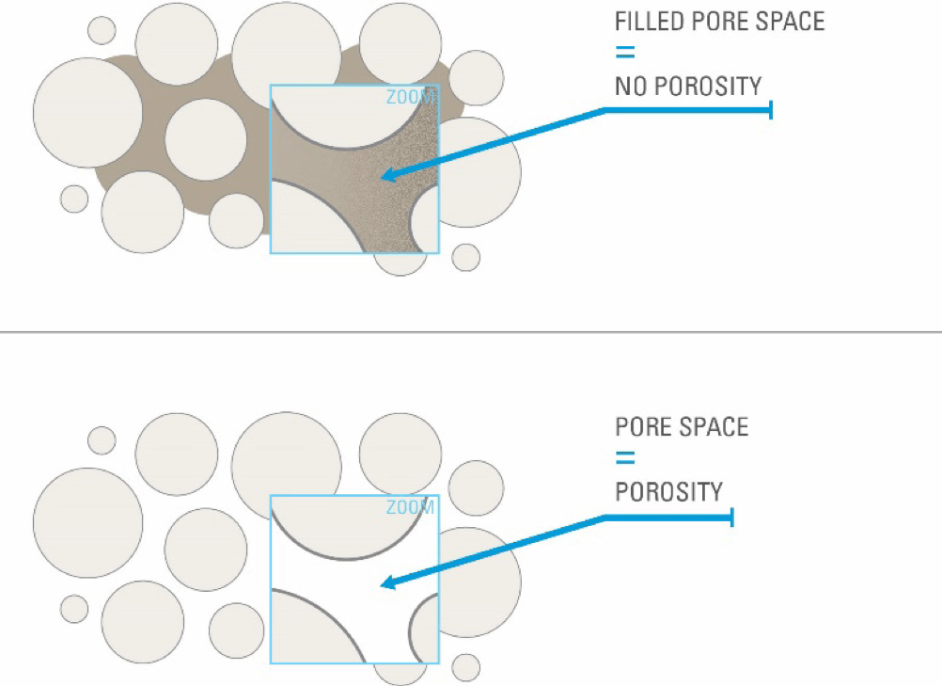
Figure A1.1: Porosity
The spaces between the grains in sedimentary rocks are called pores.
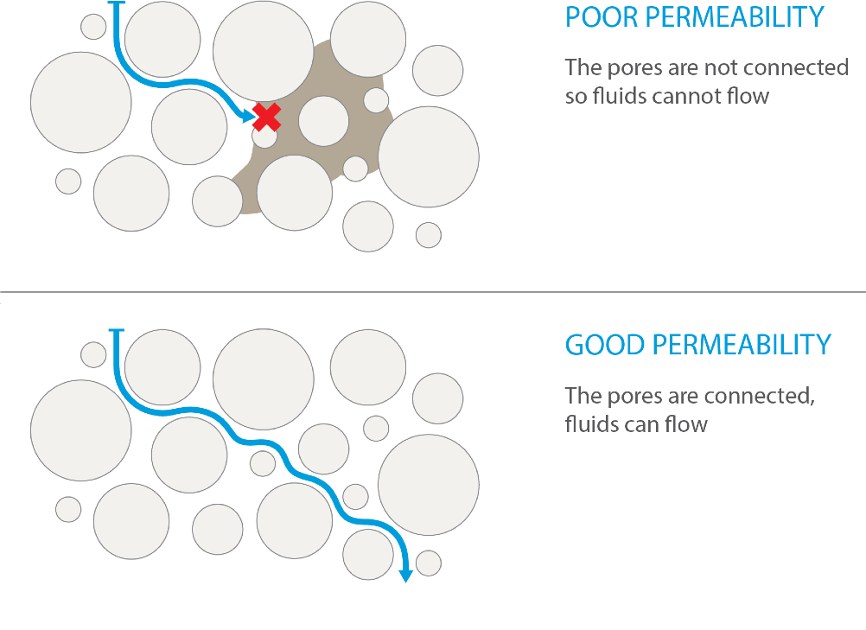
Figure A1.2: Permeability
if the pores in the reservoir are connected, the rock has good permeability.

Seal rocks
Seal rocks are an essential component of the petroleum system. Migrating/migrated hydrocarbons must be contained within a trap that is ‘sealed’ by an overlying relatively impermeable unit. Traps may be stratigraphic or structural (fault controlled) or both, and so in some instances, sealing across faults is significant.
Seal potential mapping combines (1) seal capacity with (2) seal geometry and (3) seal integrity (Kaldi & Atkinson, 1997). A map of seal potential will be produced as part of this study from integration of these three components:
- capacity – the calculated amount of hydrocarbon column height a lithology can support;
- geometry – the structural position, thickness and aerial extent of the lithology; and
- integrity – rock mechanical properties such as ductility, compressibility and brittleness.
The purpose of the Otway Basin seal rock characterisation studies is to identify potential sealing rock lithologies and to test seal capacity – how capable a sealing rock unit is of containing hydrocarbons, using a special core analysis known as Mercury Injection Capillary Pressure (MICP) technique.
Pressure thresholds from MICP analysis are used to calculate the column height of oil or gas that the seal could potentially hold. Sealing formations are only effective to the capacity (pressure) that they can retain or withhold. Pressure over this threshold will result in migration of hydrocarbons, including gas, through overlying formations. This is a direct measurement of the size of the gas/oil column that the formation is capable of preserving. This dataset will be used in conjunction with seismic mapping and other well data (from three-dimensional geological modelling) to delineate the seal (seal geometry) and the competence of sealing lithologies in the Otway Basin.

Source rocks
A source rock is a rock rich in organic matter, which if heated sufficiently can generate oil or gas. To evaluate potential source rocks in the Otway Basin, the Geological Survey of Victoria is assessing legacy data and acquiring new measurements of 1. organic richness; 2. kerogen type; and 3. thermal maturity.

a. Organic richness
Hydrocarbons are mostly carbon (by molecular weight) and so the amount of carbon in a rock, to some extent, determines the ability of the rock to generate hydrocarbons. A measure of the organic richness of a rock is known as TOC (Total Organic Carbon). A guide to the richness of a source rock according to TOC is given in Table A1.1.
Table A1.1: A guide to organic richness in shales as given by TOC (after Law, 1999)
Generation potential | Wt% TOC, Shales
Poor | 0.0 – 0.5
Fair | 0.5 – 1.0
Good | 1.0 – 2.0
Very good | 2.0 – 5.0
Excellent | >5.0

b. Kerogen type
Organic matter is transformed into kerogen over time, at greater burial depths and with increasing temperatures. The type of kerogen that forms is dependent on the original source material, which is related to the depositional environment of the organic matter. Sediments may be deposited in either the terrestrial or marine realm. Organic matter derived from terrestrial versus marine environments determines whether a source rock is more prone to generating oil or gas.
Kerogens are classified into four types (Table A1.2). The more hydrogen in the kerogen, the more likely it is to generate oil, and the higher the quality of the kerogen (Law, 1999). Type I kerogen is mainly oil prone but is uncommon. Type II kerogens can produce oil or gas depending on temperature. Type III kerogens are mostly derived from plant debris deposited in terrestrial settings and are gas prone. Most coals contain Type III kerogen. Type IV kerogen, from varied sources and generally recycled, has little potential for generating oil or gas and is largely inert. A source rock may contain one or a mixture of kerogen types. Source rock characterisation studies rate the hydrogen content (and hence kerogen type) by a hydrogen index (HI) and oxygen index (OI) derived from careful measurement of material given off as a lab sample is heated through the generation phase (pyrolysis).
Table A1.2: Kerogen types (after McCarthy et al., 2011; Law, 1999)
Kerogen type | Predominant hydrocarbon potential | Amount of hydrogen | Source material | General environment of deposition
I | Oil prone | Abundant | Mainly algae | Lacustrine (lake) setting
II | Oil and gas prone | Moderate | Mainly plankton, some contribution from algae | Marine setting
III | Gas prone | Small | Mainly higher plants | Terrestrial setting
IV | Neither | None | Reworked, oxidised material | Varied settings

c. Thermal Maturity
As rock exposure to heat over time changes the chemistry of organic matter, that change, or thermal maturity, can be measured by vitrinite reflectance (expressed as Vr). Vitrinite is a one of several components of coal (known as macerals) found in buried organic matter. As the organic matter becomes thermally mature with burial and increasing temperature, it devolves volatile components (that is, oil and at higher temperatures, gas) and the molecular structure of the remaining organic matter, including the vitrinite, becomes increasingly well-ordered and hence more reflective to light. Reflectance is measured in oil of a polished surface of vitrinite in a sedimentary rock (ASTM, 2011). Other measures of maturity exist and with care, can be related back to vitrinite reflectance. Vitrinite reflectance extends over a longer maturity range than any other thermal maturity indicators, and the vitrinite maceral is relatively abundant in prospective Victorian basins such as the Otway Basin, and is therefore directly relevant to the rock characterisation studies.
The relative ability of a source rock to generate petroleum is defined by its kerogen quantity (TOC) and quality (high or low in hydrogen, determined by pyrolysis). Whether or not the source rock has generated petroleum is determined by its state of thermal maturity, that is, immature, mature, or post-mature with respect to oil (Hunt 1995).

Appendix 2 – Regional geology of the Otway Basin

Tectonic setting
The Otway Basin is a north-west to south-east trending basin that extends for 500 kilometres along the onshore and offshore parts of south-eastern Australia (Figure A2.1). It is a passive margin, rift basin (Brown et al., 2003) that formed during the break-up of southern and eastern Gondwana.
Rifting in the Late Jurassic-Early Cretaceous resulted in the development of grabens and half-grabens of limited lateral extent (Krassay et al., 2004) and varying orientations (NW-SE in the onshore Otway Basin, E-W in the western and central Otway Basin, SW-NE in the eastern Otway Basin and Torquay Sub-basin, and N-S in the Shipwreck Trough; Stacey et al., 2013). Up to eight kilometres of Otway Group continental and fluvio-lacustrine sediments were deposited in the Early Cretaceous depocentres.
Compressional inversion and uplift in the early Late Cretaceous separated the Torquay Sub-basin from the eastern Otway Basin and shifted the locus of extension offshore (Krassay et al., 2004). A thick sequence of Sherbrook Group fluvial, deltaic and shallow marine sediments was deposited in the Late Cretaceous depocentres, including the Shipwreck Trough.
Rifting in the Otway Basin “culminated at the end of the Cretaceous and is marked by a regional intra-Maastrichtian unconformity” (Holford et al, 2014). Krassay et al (2004) interpreted this to represent the separation of Australia and Antarctica, although the first evidence of oceanic-crust in the Otway Basin does not appear until the middle Eocene (Norvick & Smith, 2001).
The intra-Maastrichtian unconformity was followed by basin margin subsidence and the deposition of the transgressive siliciclastic Wangerrip Group, which reaches a maximum thickness of more than 1200 metres in the Portland Trough (Holdgate & Gallagher, 2003). Local inversion in the middle Eocene resulted in the intra-Lutetian unconformity, which separates the Wangerrip Group from the overlying prograding marine clastics and carbonates of the Nirranda Group (Holdgate & Gallagher, 2003; Krassay et al., 2004). The Nirranda Group has a maximum thickness of about 200 metres in the Portland Trough and the Port Campbell Embayment (Holdgate & Gallagher, 2003). The marine marls and limestones of the Heytesbury Group are separated by two regional unconformities from the underlying Nirranda Group and the overlying thin Pliocene to Pleistocene shallow marine sediments and basalts of the Bridgewater Bay Group.

Stratigraphy
The mostly sedimentary rock units found both at the surface and in the subsurface across the Otway region have been described to various extents. Based on lithological variations in the Otway Basin, six main sequences are described: the Otway Group, Sherbrook Group, Wangerrip Group, Nirranda Group, Heytesbury Group and Bridgewater Bay Group (Figure A2.2).
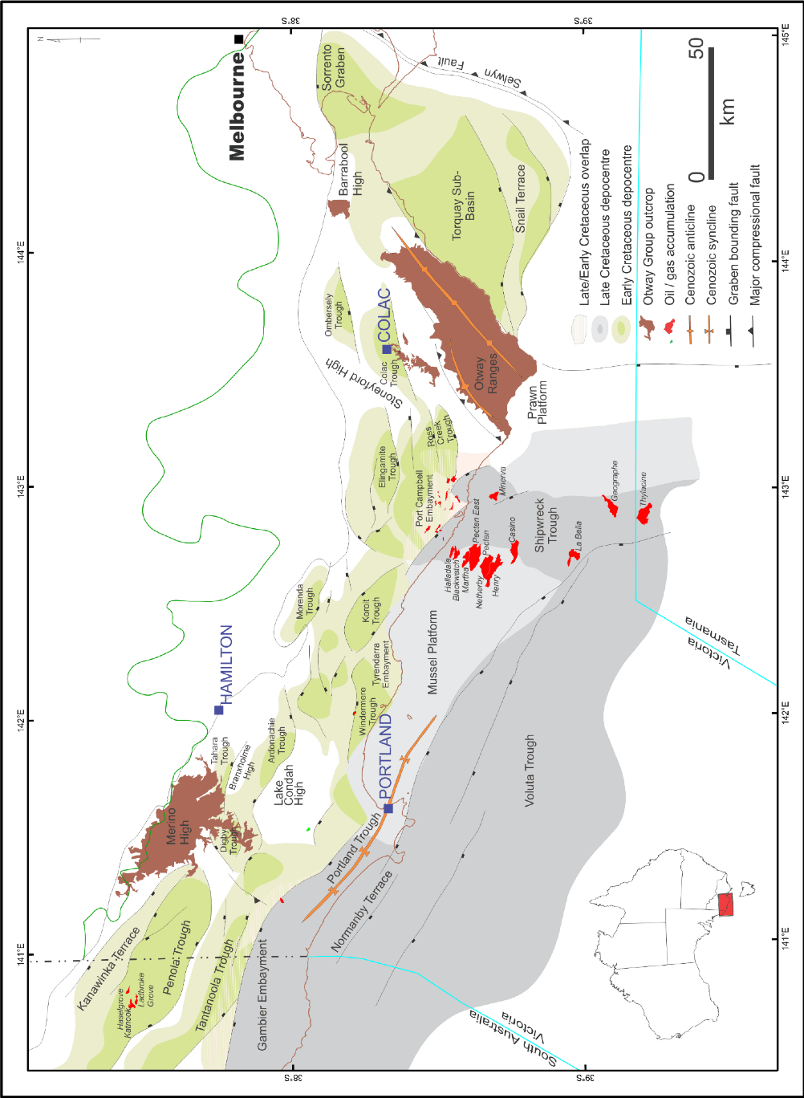
Figure A2.1: Depocentres of the Otway Basin showing the distribution of gas fields
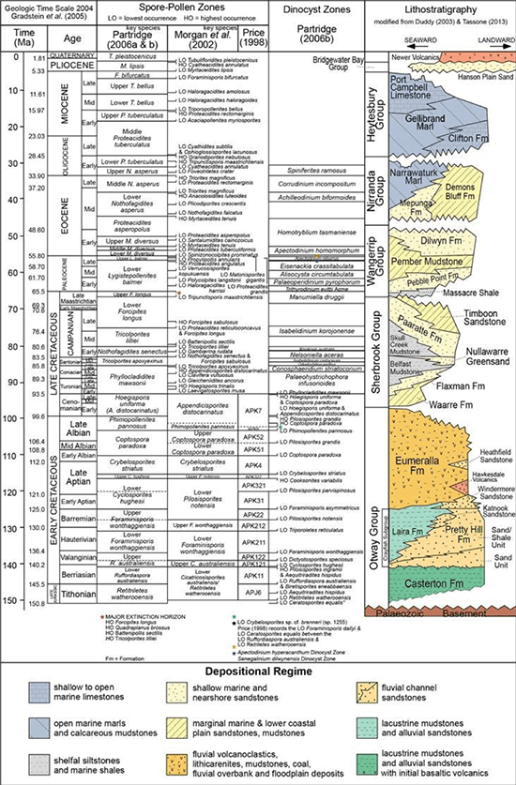
Figure A2.2: Stratigraphy of the Victorian Otway Basin

Casterton Formation
The Casterton Formation was deposited during the latest Jurassic to Early Cretaceous in half-grabens related to rifting between Australia and Antarctica (Mitchell et al., 1997). The Casterton Formation type section is found between 2220 mKB and 2450 mKB in Casterton-1 (Morton et al., 1994). It “consists of interbedded carbonaceous shale, with minor feldspathic sandstone and siltstone and basaltic volcanics” (Morton et al., 1994).

Otway Group
There are some notable discrepancies between the accepted stratigraphic nomenclature for the Otway Group as adopted for the South Australian portion of Otway Basin versus that for Victoria. For instance, the status of the Group is raised to Supergroup in South Australia. Units such as the Katnook Sandstone and the Laira Formation are identified within the Crayfish Group in South Australia, whereas these have not been identified in Victoria (Parker, 1995).

Pretty Hill Formation
The Pretty Hill Formation is the only lithostratigraphic unit from the Crayfish Subgroup that is identified in Victoria. The Pretty Hill Formation consists of sandstone, with varying proportions of interbedded siltstone, claystone and shale, which were deposited in fluvio-lacustrine and alluvial environments, although at the top of Moyne Falls-1 rare saline algae indicate brackish conditions (Morgan, 1997).
In the Penola Trough, the Pretty Hill Formation is subdivided into four informal members: The Pretty Hill sandstone, Sawpit sandstone, Sawpit shale and McEachern sandstone (Lovibond et al., 1995) but the application of this division is questioned (Guzel, 2015).

Laira Formation
The Laira Formation consists of light grey to green siltstone and claystone interbedded with fine grained sandstone deposited in fluvial floodplain to shallow lacustrine environments and was first defined by Morton (1990) from the type section encountered in Katnook-2 in South Australia. It is most well developed in the Penola Trough and gives way to the Pretty Hill Formation in the eastern part of the basin. Parker (1995) identified the Laira Formation from several wells in the Victorian section of the Penola Trough, but pointed out that the stratigraphic units described in Early Cretaceous half grabens are often restricted to these depocentres.

Eumeralla Formation
The Eumeralla Formation is composed of medium to coarse grained fluvial channel sandstones interbedded with mudstone, fine sandstone and shale, including palaeosoils and coal seams that were deposited in levees and floodplains (Duddy, 2003). The sandstones and mudstones are quartz-poor, volcanogenic sediments derived largely from the products of contemporaneous explosive dacitic volcanism (Duddy, 2003).
Outcrops of the Eumeralla Formation occur in the Otway Ranges, Barrabool High and Merino High. In the Victorian Otway Basin, the Windermere and Heathfield sandstones and the Killara Coal Measures are recognised as distinct units within the Eumeralla Formation.

Windermere Sandstone
The Windermere Sandstone is composed of interbedded sandstones and shales and is 105 metres thick at its type section in Windermere-2. The Windermere Sandstone is considered to occur at the base of the Eumeralla Formation and was deposited in the base of troughs; usually upon an unconformable base, due to a “significant change in depositional and structural style” (Morton et al., 1994).
The gas discovered in Katnook-1 in South Australia was reservoired in the Windermere Sandstone, although the reservoir was reported to be of poor quality (Kopsen & Scholefield, 1990). In Victoria, oil in the Windermere Sandstone is considered to be sourced from a coaly lithology in the Crayfish Subgroup – an Austral-1 source (See section 3.3; Boreham et al., 2004).

Heathfield Sandstone
The Heathfield Sandstone is a distinct quartzose sandstone and is recognised in a number of wells in the Penola Trough (Duddy, 2003). It is represented by poorly consolidated quartz sand between 1254.3 and 1263.1 m in the well Heathfield-1 (Brown, 1965). Whilst the Heathfield Sandstone probably reflects limited accumulations derived from local basement sources its widespread distribution in the Albian suggests a common origin, perhaps related to a period of uplift and erosion of the northern margin to the Penola Trough that rejuvenated the supply of quartzose detritus and possibly during “a lull in local contemporaneous volcanism” (Duddy, 2003).
Distinct sandstones of the same age have also been identified on the Merino High, on the central northern margin of the Otway Basin, in the Ross Creek Trough, in the Windermere Trough, and in Fergusons Hill-1, between the Ross Creek Trough and the Otway Ranges, and in North Eumeralla-1, Eumeralla-1 and Killara-1, north of the Windermere Trough (Guzel, 2015).

Killara Coal Measures
The black coals of the Early Cretaceous Eumeralla Formation have been intersected by wells and boreholes many decades. Following the drilling of Killara-1, Buckingham (1992) first applied the informal name – the ‘Killara Coals’ to describe the coal seams found at the base of the Eumeralla Formation. The Killara Coal Measures are therefore not a formal lithostratigraphic unit and, whilst coal beds may occur in the “Basal Eumeralla Formation”, they also occur elsewhere in the Eumeralla Formation (Guzel, 2015). Coals of the same age (as found in Killara-1) from the base of the Eumeralla Formation are found in Lindon-1 on the Lake Condah High, Stoneyford-1 on the Stoneyford High, and possibly in Hawkesdale-1 on the central northern margin of the Otway Basin (Wakelin-King & Menpes, 2007). The coals of the Eumeralla Formation are not laterally extensive and consequently are difficult to correlate.

Sherbrook Group
The siliciclastic Sherbrook Group was derived largely from eroded Palaeozoic basement and the Eumeralla Formation (Duddy, 2003). The nature of the contact between the Sherbrook and Otway groups is variable – from conformable or mildly disconformable in the Late Cretaceous depocentres to massively unconformable where the Sherbrook Group wedges out onto mid-Cretaceous inversion structures (Duddy, 2003). As a consequence, the Sherbrook Group is absent from the northern margin of the Otway Basin, except in Heathfield-1 in the Penola Trough, where it is only 140.6 metres thick (Guzel, 2015).

Waarre Formation
The Waarre Formation (previously the Waarre Sandstone of Bock & Glenie, 1965) is the basal unit of the Sherbrook Group. The unit is characterised by clean quartzose sandstones, conglomerates and minor siltstones and shales of non-marine origin. The type section is identified in the petroleum well Port Campbell-2 (Morton et al., 1994). Commonly in the Port Campbell Embayment wells, the Waarre Formation is divided into units A, B and C on the basis of lithological variations (Buffin, 1989).

Flaxman Formation
The Flaxman Formation is typically an interbedded sand/shale unit. It is composed of dark grey silty mudstone and fine grained grey brown sandstones, with distinctive ‘floating quartz’ from coarse sand to pebbles, common microplankton, and irregular glauconite, which becomes more common along with rare arenaceous and calcareous foraminifera towards the top (Duddy, 2003). It is considered that the Flaxman Formation was deposited in a lower delta plain environment (Boyd & Gallagher, 2001).

Belfast Mudstone
The Belfast Mudstone, in the middle of the Sherbrook Group, is a “remarkably uniform pyritic marine shale” (Duddy, 2003). In Victoria, the Belfast Mudstone represents a middle to outer shelf, open-marine, prodeltaic environment (Boyd & Gallagher, 2001) and forms a major regional seal for prospective hydrocarbon accumulations in sandstone reservoirs in the Waarre and Flaxman Formations (Duddy, 2003). It is conformable with, and partly a facies variant of, the underlying Flaxman Formation and the overlying Paaratte Formation, and includes a “significant contribution of detritus from reworking of the volcanogenic sediments of the Eumeralla Formation” (Duddy, 2003).

Nullawarre Greensand
The Nullawarre Greensand, also originally described as part of the Paaratte Formation, is a distinctive green, glauconitic, fine to coarse grained sandstone. It has been intersected in wells and bores in and around the Port Campbell Embayment, Tyrendarra Embayment and Mussel Platform (Woollands & Wong, 2001).

Skull Creek Mudstone
The Skull Creek Mudstone exists in the onshore and nearshore areas of the Port Campbell Embayment as a thin unit, thickening substantially in the offshore towards the outer shelf. Initially described as a member of the Paaratte Formation, it was proposed as a formation by Partridge (2001) who assigned it to Early Campanian zones in the onshore, ranging to Late Campanian offshore.

Paaratte Formation
The Paaratte Formation consists of quartzose, fine to coarse grained, laminated, sometimes ioturbated, cross-bedded, greenish sandstones interbedded with mudstone and occasional coals (Duddy, 2003) that were mainly deposited in a marine lower to upper deltaic environment (Boyd & Gallagher, 2001).

Timboon Sandstone
The Timboon Sandstone, at the top of the Sherbrook Group, is characterised by fine to very coarse sandstones with siltstone/mudstone interbeds with occasional leaf fossils and represents the onset of fluvial terrestrial interdistributary deposition in the Otway Basin (Boyd & Gallagher, 2001). The culmination of rifting in the Otway Basin is marked by a regional intra-Maastrichtian unconformity (Holford et al., 2014) at the top of the Sherbrook Group.

Wangerrip Group
The transgressive siliciclastic Wangerrip Group consists of the Cretaceous/Tertiary Boundary Shale (the Massacre Shale), Pebble Point Formation, Pember Mudstone and Dilwyn Formation. Local inversion in the middle Eocene resulted in an intra-Lutetian unconformity that separates the Wangerrip Group from the overlying Nirranda Group (Holdgate & Gallagher, 2003; Krassay et al., 2004); whilst an intra-Maastrichtian unconformity, associated with the culmination of rifting in the Otway Basin (Holford et al., 2014), separates it from the underlying Sherbrook Group.

Massacre Shale
The Massacre Shale occurs as a thin shale unit straddling the Cretaceous-Tertiary boundary and was deposited in a widespread transgressive event. The formation has a distinctive geophysical log signature and pinches out in the offshore section of the basin (Partridge, 2001).

Pebble Point Formation
The Pebble Point Formation consists of ferruginous (mainly quartz) sandstone, grit and conglomerate with less common fossiliferous beds (Holdgate & Gallagher, 2003). In the Gambier Embayment oolitic and pelletal sandstone and claystones display a complex mineralogy ranging from chlorite to glauconite with secondary replacement by siderite and phosphate (Holdgate & Gallagher, 2003). Macro and micro fossil content indicate a dominantly transgressive shallow marine environment and an early to middle Paleocene age (Holdgate & Gallagher, 2003).

Pember Mudstone
The Pember Mudstone consists of tan to grey siltstones, mudstones and shales, usually pyritic, carbonaceous and micaceous, and locally glauconitic. Carbonate-cemented sandstones are more common in the upper part of the formation, as are rare arenaceous foraminifera (Holdgate & Gallagher, 2003). The Pember Mudstone represents a delta-front and prodelta environment. Although it usually conformably overlies the Pebble Point Formation (Holdgate & Gallagher, 2003), in places there is evidence of a disconformable relationship (Tabassi & Davey, 1986; Keating, 1993) and in Greenslopes-1, north of the Windermere Trough, it is absent.

Dilwyn Formation
The Dilwyn Formation is transitional with the underlying Pember Mudstone and is characterised by sandstones predominating over shales and by transgressive-regressive repetitions of sandstone-siltstone claystone (Holdgate & Gallagher, 2003). The sandstones were deposited as distributary channels, and barriers and offshore bars associated with a delta-front environment, whilst the shales may include marine arenaceous and calcareous foraminifera (Holdgate & Gallagher, 2003). Brown coals are found in the Dilwyn Formation; such as those at Benwerrin that are considered Palaeocene in age (Gloe & Holdgate, 1991).

Nirranda Group
The marine Nirranda Group consists of the carbonate dominated Narrawaturk Marl, the mixed carbonate and clastic Mepunga Formation (Holdgate & Gallagher, 2003) and, north-east of the Port Campbell Embayment, the clastic Demons Bluff Formation (Tickell et al., 1992). An intra-Lutetian unconformity, due to local inversion in the middle Eocene, separates the Nirranda Group from the underlying Wangerrip Group (Holdgate & Gallagher, 2003; Krassay et al., 2004), and an early-late Oligocene regional unconformity occurs between the Nirranda Group and the overlying Heytesbury Group.

Mepunga Formation
The Mepunga Formation consists of coarse and often pebbly, ferruginous, occasionally glauconitic sandstones, with sandstones and sandy limestones that are often dolomitic, glauconitic and ferruginous offshore and in the Portland Trough (Holdgate & Gallagher, 2003). The foraminiferal faunas indicate deposition in paralic high-energy shoreline environments in the north, to outer shelf marine environments in the south; whilst the preservation of restricted calcareous faunas and miliolinids indicates inner to mid-shelf marine environments in the eastern part of the basin (Holdgate & Gallagher, 2003).

Narrawaturk Marl
The Narrawaturk Marl consists of marly, sandy, ferruginous, glauconitic, occasionally dolomitic mudstone, occasionally cherty and dolomitic marl; some coarse ferruginous sandstone; sandy limestone and sandy marl; and, in the west, a dolomitic marly limestone (Holdgate & Gallagher, 2003). Based on planktonic foraminifera most of the Narrawaturk Marl is early Oligocene in age (Holdgate & Gallagher, 2003).

Heytesbury Group
The marine Heytesbury Group consists of the carbonate-dominated Port Campbell Limestone, the Gellibrand Marl, and the basal part-clastic, part-carbonate Clifton Formation (Holdgate & Gallagher, 2003). The base of the Heytesbury Group is marked by a disconformity (Holdgate & Gallagher, 2003), whilst at the top there is an unconformity, which formed due to tectonic uplift and regression at the end of the Miocene (Holdgate & Gallagher, 2003).

Clifton Formation
The Clifton Formation consists of sandy limestone, which may be dolomitic or contain thin horizons of phosphate and limonite nodules, limestone and, north-east of the Port Campbell Embayment, ferruginous sandy marl (Holdgate & Gallagher, 2003). The clastics in the sandy facies, deposited around the margin of the basin, were supplied by rivers to the north and east. The depositional environment transitions from paralic coastal environments in the north and east to high-energy outer shelf environments, where clastic poor limestones are deposited, in the south and west (Holdgate & Gallagher, 2003).

Gellibrand Marl
The Gellibrand Marl has abundant planktonic foraminifera that indicate a middle Miocene to late Oligocene age (Holdgate & Gallagher, 2003). The marl was deposited in a low-energy inner shelf environment north of Port Campbell where there was clastic input, whilst an outer shelf environment was predominant around the Portland area (Holdgate & Gallagher, 2003). In the Gambier Embayment, more limestone-rich facies were deposited in shallower seas.

Port Campbell Limestone
The Port Campbell Limestone was deposited in outer shelf water depths during peak transgressions and at mid to inner shelf depths during regressions. The upper part of the Port Campbell Limestone records continuous sea level fall towards the end of the Miocene. Based on planktonic foraminifera it is late to early middle Miocene in age (Holdgate & Gallagher, 2003).

Bridgewater Bay Group
Following widespread tectonic uplift in the Pliocene (e.g. Dickinson et al., 2001), a sequence of relatively thin localised units was deposited during the Pliocene to Pleistocene. Some discrepancies exist in the nomenclature but named units include: The Whalers Bluff Formation, Werrikoo Limestone, Nelson Bay Formation, Dorodong Sands, Grange Burn Formation, Hanson Plain Sand, Moorabool Viaduct Formation and the Newer Volcanics (Holdgate & Gallagher, 2003; Cupper et al., 2003).

Petroleum systems
The hydrocarbons of the Otway Basin belong to the Austral petroleum supersystem, which includes all southern Australian sedimentary basins (as defined by Bradshaw, 1993 and Summons et al., 1998, based on the age of the source rocks and their common tectonic history). As such, the hydrocarbons of the Otway Basin are assigned to the Austral supersystem.
The Austral petroleum supersystem is further divided into three sub-systems (Edwards et al., 1999); Austral-1, -2 and -3. The three-fold subdivision recognises the difference in geochemical characteristics of liquid hydrocarbons encountered in petroleum exploration wells. The main difference between the liquid hydrocarbons is related to the different stratigraphic age and depositional environment of the source rocks that form part of each subsystem.
Most Otway Basin hydrocarbon discoveries belong to the Austral-1 and -2 petroleum systems (Edwards et al., 1999). The Waarre Formation reservoirs, together with the source rocks of the Eumeralla Formation and overlying Belfast Mudstone seal units comprise the key elements of the Austral-2 petroleum system.

Appendix 3 – Stakeholder Advisory Panel for Onshore Conventional Gas Communiques

Communique 1 – August 2017
“On 17 August 2017, I chaired the inaugural meeting of the Stakeholder Advisory Panel for onshore conventional gas studies, which is part of the State Government’s Victorian Gas Program (http://earthresources.vic.gov.au/earth-resources/victorian-gas-program).
The Panel has been established by the [former] Minister for Resources, the Hon. Wade Noonan, to oversee the onshore conventional gas geoscientific and environmental studies over the next three years.
The role of the Panel is to provide the Minister for Resources with advice on the risks, benefits and impacts related to onshore conventional gas, with particular attention paid to social, economic and environmental factors.
The Panel will meet regularly over the next three years and includes a broad range of views, including farmers, industry, local government and the community. Panel members are able to provide feedback from the community and other stakeholders as the studies are undertaken.
The Panel members appointed are:
- Mr Stephen Bell, Chief Executive Officer, Qenos
- Mr Ben Davis, Secretary Australian Workers’ Union Victorian Branch
- Mr Gerald Leach, Chair of the Victorian Farmers’ Federation Land Management Committee
- Ms Alison Marchant, Secretary of Frack Free Moriac
- Ms Linda French, Community Development Manager, Lattice Energy (formerly Origin Energy)
- Mr Tennant Reed, Principal National Adviser, Public Policy, Australian Industry Group
- Cr Joanne Beard, Mayor of Corangamite Shire and representative of the Great South Coast Group
- Mr Mark Wakeham, Chief Executive Officer, Environment Victoria
Minister Noonan welcomed the panel at its inaugural meeting. For the benefit of the panel, the Minister reiterated the course the Victorian Government had taken to legislate to permanently ban hydraulic fracturing (fracking) and coal seam gas, while extending the moratorium on onshore conventional gas to 30 June 2020. He said the moratorium would allow time for a scientific program to assess the potential onshore conventional gas resources of the State. The program will include environmental baseline studies and the community will be actively engaged over the life of the studies. The results of the study and the panel’s work would help guide future decisions about the prospects for onshore conventional gas exploration and development beyond the middle of 2020.
During the meeting, representatives from Geological Survey of Victoria (GSV), the Government’s geoscience unit, gave a briefing on the schedule of onshore conventional gas geoscientific and environmental studies that will be conducted.
The focus of the studies will be on the Otway Basin in south west Victoria, particularly between Warrnambool and Port Campbell. The GSV has identified this area as having the greatest potential for onshore conventional gas. Some studies will be done in the Gippsland Basin, although based on existing data, the GSV considers this basin to be less likely to hold onshore conventional gas resources than the Otway Basin.
The geoscience studies will involve rock characterisation studies and analysis of current geoscience data. The results will assist in the development of three-dimensional models for the Otway and Gippsland geological basins. The environmental studies in the field will provide baseline data on groundwater chemistry and atmospheric conditions across the Otway and Gippsland basins.
GSV representatives emphasised the importance of community engagement to support the geoscientific and environmental studies. This included insights of engagement activity undertaken to date with local regional councils, community groups, peak industry bodies, water catchment management authorities, gas exploration companies and academics.
An important part of the community engagement program is to progressively provide the results of the studies to the public. Factual information from the studies will be provided to farmers, industry, local government and regional communities. A local team of geology specialists and a dedicated community engagement officer based in Warrnambool will ensure the community remains involved and informed about the studies. In practical terms, this means that there are people on the ground who can answer questions for local residents and landholders.
As Victoria’s Lead Scientist and panel chair, I am looking forward to working with the Panel over the next three years. I am sure the advice we will provide the Minister will assist the Government to make the best decisions possible about onshore conventional gas for all Victorians.
For more information visit the Victorian Gas Program on the Earth Resources website at http://earthresources.vic.gov.au/earth-resources/victorian-gas-program.

Communique 2 – November 2017
The second meeting of the Stakeholder Advisory Panel for onshore conventional gas studies was held in south-west Victoria on 9 and 10 November 2017 at Port Campbell and Camperdown and surrounding areas. This region of Victoria in the Otway geological basin is a focus of the Victorian Gas Program.
The meeting commenced on 9 November 2017 with a visit to the Otway Gas Plant and the Halladale and Speculant Well site, near Port Campbell.
The tour of Origin Energy’s facility provided the Panel with a first-hand view of a gas processing plant. Origin Energy representatives explained how the facility’s design and operational procedures ensure stringent health, safety and environment regulations are met.
The Panel then moved to Nirranda to see the Victorian Gas Program groundwater science team in action, sampling and recording trace chemistry at a groundwater monitoring bore as part of the environmental baseline studies of the Program.
On 10 November 2017, the second day of the Stakeholder Advisory Panel’s meeting was held in Camperdown.
The discussions covered progress reports on the geoscientific studies, environmental studies and community and stakeholder engagement to date.
The Panel received a briefing on the $1.62 million 3D geological models of the Otway Basin (onshore and offshore) that will be built and how they form the foundation for providing a gas resource estimate. The Panel heard that rock characterisation studies (including chemostratigraphy, porosity and permeability analysis) – key inputs into the 3D geological models – have also commenced.
The onshore environmental science project intends to sample over 100 deep groundwater bores and undertake an atmospheric methane survey to establish regional baseline conditions during 2017 and 2018. To date, 14 water bores have been sampled.
Later in 2018, the environmental program will also investigate existing exploration wells to determine more local baseline conditions.
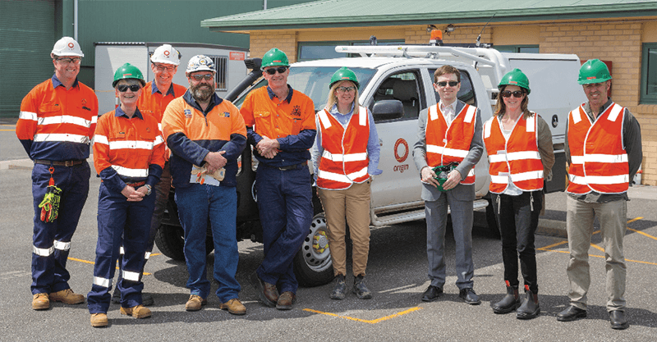
The Stakeholder Advisory Panel at the Otway Gas Processing Plant.
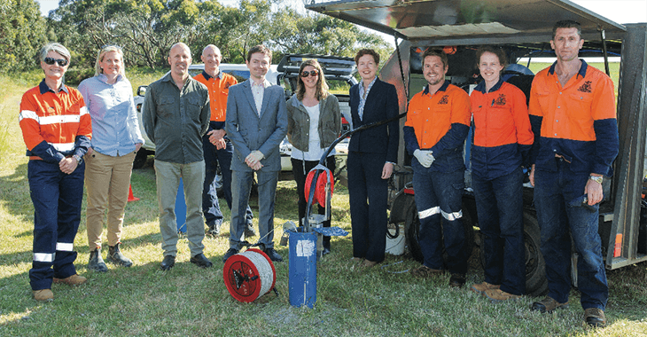
The Stakeholder Advisory Panel learning about the groundwater monitoring program.
The overview of the engagement program highlighted that over 80 individual engagements have occurred to date, covering local governments, gas explorers, gas us ers, regulators and environmental and community groups. Most engagements have been one-on-one discussions and small group meetings. As the Geological Survey of Victoria Warrnambool team reaches full complement more sophisticated engagements and presentations will commence.
Five media articles about the Victorian Gas Program had been featured in newspapers in south-west and regional Victoria since the program was announced. Additionally, while the Stakeholder Advisory Panel was in Camperdown, I gave an interview to ABC south west regional radio about the Panel’s work.
The Panel’s review of the projects to date is providing valuable insights and suggestions to ensure that the scientific studies are meeting the concerns and interests of the various stakeholders connected to the onshore conventional gas studies.
The next Stakeholder Advisory Panel meeting is scheduled for March 2018.

Communique 3 – March 2018
The third meeting of the Stakeholder Advisory Panel for the Victorian Gas Program’s Onshore Conventional Gas Studies was held in Melbourne on Thursday, 8 March 2018.
The meeting commenced with a presentation from the Geological Survey of Victoria on the current 3D geological models of the Otway and Gippsland basins. These models capture the sub-surface structure of each basin and will ultimately provide a picture of the presence of onshore conventional gas resources.
A significant objective of the Victorian Gas Program is to refine the current models through seismic data analysis together with rock characterisation studies to produce a much more detailed understanding of each basin’s geological structure. The Geological Survey of Victoria is currently presenting these 3D geological models to councils in south west Victoria to explain the scientific approach being taken by the Victorian Gas Program.
At the meeting, Panel members discussed the national gas market, the contribution of Victoria’s offshore gas resources, and the possible impact of any onshore conventional gas resources identified through the Victorian Gas Program on gas supply and pricing. I acknowledged that the scientific work being undertaken is at a very early stage and highlighted that it will provide the State with the best picture of Victoria’s potential for onshore conventional gas resources. This information will assist government to make future evidence-based decisions about any development of onshore conventional gas resources.
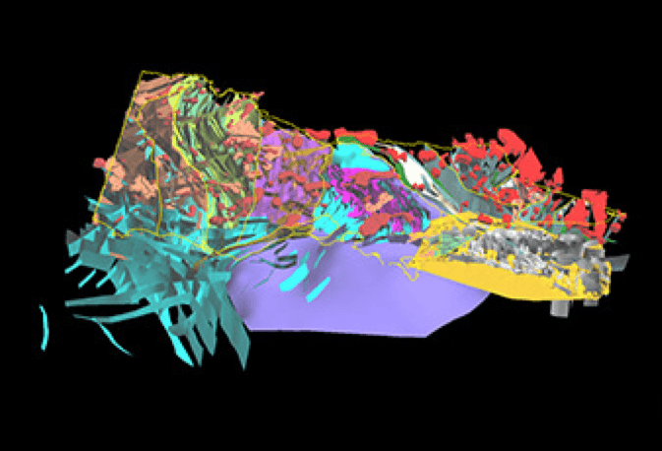
Geological model of rock outcrops across Victoria
The use of gas as an energy source in the context of the state’s carbon emission targets and commitments on climate change was also discussed. A consolidated picture of how government is improving energy efficiency in businesses and households to reduce demand, including initiatives to increase supply of renewable energy, is being prepared to inform the Panel.
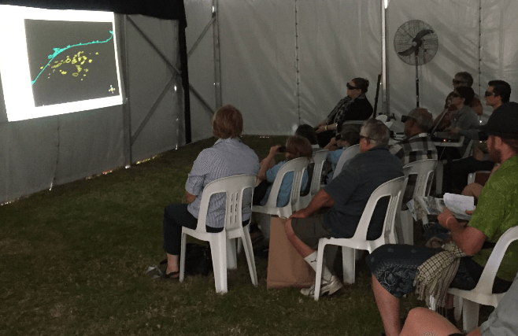
Public attending one of the Geological Survey of Victoria’s 3D model presentations at Sungold Field Days
A major task of the Panel is to eventually provide government with advice on the risks, benefits and impacts of onshore conventional gas. At the meeting, the Panel began to consider the scope of work needed to be undertaken for this study. An initial environmental risk assessment framework was tabled for Panel members to consider. The study’s scope will receive independent expert advice from the Scientific Reference Group throughout the Program.
The Director of Geological Survey of Victoria updated the Panel on the progress of the Victorian Gas Program. Key highlights included:
- Following months of data review and planning, the geoscience team is in the process of selecting rock samples for analysis of source, seal and reservoir rocks (necessary components of a petroleum resource system). Approximately 1400 samples have been selected for analysis, and a further 1700 samples will be analysed to establish mineral and fossil content.
- The environmental studies team has now sampled 25 groundwater bores for chemistry content and 42 bores for stygofauna (a miniature creature that may indicate the health of groundwater) in south west Victoria. Groundwater bore testing will begin in Gippsland in late April, and air quality surveying in the Otway Basin is expected to begin in April. This data will help to establish the existing environmental baseline conditions, which would provide a benchmark for considering the potential risks and impacts of conventional gas activities.
- To support commercial exploration for further discoveries of gas off Victoria’s coast an airborne gravity survey of the Otway Basin will be undertaken. The survey will measure minute differences in gravitational force from different rock strata both onshore and offshore. The data collected will provide a data set of varying rock densities across the basin.
- The community engagement program continues to connect with strategic stakeholders in south west Victoria and Gippsland. A major community engagement initiative was held at Sungold Field Days, one of the largest agricultural shows in south west Victoria, in February 2018. A marquee cinema showing 3D projections of Victoria’s geology was set up to show the geology of the Otway Basin and introduce the VGP to farmers, students and community groups.
The next Stakeholder Advisory Panel meeting will be held in June 2018.

Communique 4 – June 2018
The fourth meeting of the Stakeholder Advisory Panel for the Victorian Gas Program’s (VGP) Onshore Conventional Gas Studies was held in Melbourne on Thursday, 7 June 2018.
The Minister for Resources, Tim Pallas, opened the meeting and reinforced the Panel’s key role in understanding and discussing the VGP’s scientific findings and the risks, benefits and impacts of any onshore conventional gas development. He highlighted the importance of informed debate and the need for government to understand both the needs of industry and the diversity of views across the community.
The Minister responded to a range of questions from the Panel on regulatory issues such as landowner rights and community benefits, including how best to secure domestic supply from local resources. He also addressed contextual issues such as government’s commitment to CO₂ emission reduction targets, how we manage the transition from coal to renewable energy technologies and the need for greater transparency in energy distribution and retail markets.
The Minister was followed by Ms Kylie White, Deputy Secretary, Energy, Environment and Climate Change in the Department of Environment, Land, Water and Planning (DELWP). Ms White reiterated the Victorian Government’s commitment to an affordable, reliable and renewable energy future – with legislated targets and support for transition to zero (net) emissions by 2050. Ms White confirmed that Victoria is on track to achieving the Victorian Renewable Energy Target of 25% by 2020 with renewables producing over 16 per cent of Victoria’s electricity in 2017, up from around 11 per cent in 2014. She provided an overview of current initiatives such as the Energy Efficiency and Productivity Strategy, the Renewable Energy Action Plan, the Victorian Renewable Energy Target Program Reverse Auction and the Victorian Energy Upgrades program.
Ms White responded to questions from Panel Members who sought to understand how government is working with industry to reduce gas demand; clarification of the definition of zero emissions; and government plans to respond to the capacity of different sectors to transition from fossil fuels faster than others.
The Director of the Geological Survey of Victoria (GSV) advised the Panel that the VGP’s scientific work is on schedule. The new 3D geological framework model for the Otway Basin is only a few months away. The geoscience team will next focus its efforts on filling critical knowledge gaps through a ‘stratigraphic’ drilling program to provide new rock samples for analysis.
He also advised that the baseline air quality surveying (measuring methane and carbon dioxide concentrations) of the Otway Basin, has commenced and will continue until July 2018.
The panel was also updated on several upcoming VGP announcements, including:
- a collaborative project between GSV and the Iona Gas Plant, near Port Campbell, to share analytical drill core data that could assist in understanding the potential for storing gas in depleted onshore gas fields in the area, and
- details of the supplier, timing and flight area of an airborne gravity survey of south west Victoria to better understand the regional, large-scale geology of the Otway Basin, both onshore and offshore.
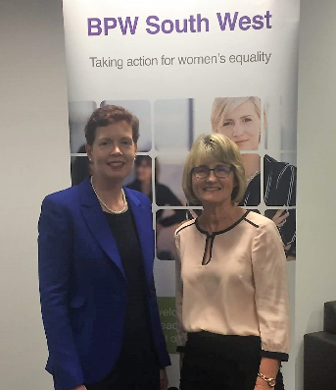
I was delighted to talk about the Victorian Gas Program in April to over 70 members from the Business and Professional Women South West Association at Deakin University Warrnambool campus.
The geoscience overview was followed by a community engagement update. The reach of the program to date now includes 290 stakeholders across south west Victoria, Melbourne and Gippsland.
GSV has presented its 3D geological models to Councillors across the Otway Basin and briefed Mayor and Chief Executive Officers across Gippsland on the VGP. Other regional networks such as farmer organisations, catchment management authorities, environmental groups, economic development associations and community groups have also been engaged.
The next Stakeholder Advisory Panel meeting will be held in September 2018.

Communique 5 – September 2018
The fifth meeting of the Stakeholder Advisory Panel (SAP) for the Victorian Gas Program's (VGP) Onshore Conventional Gas was held in Camperdown on Thursday, 6 September 2018.
The Panel received their first briefing on the VGP's regulatory reform project, which will develop policy, administrative and legislative reform proposals for Government once the broader scientific findings regarding the potential for onshore conventional gas are known.
The presentation covered the Government's current policy on gas, including the moratorium on onshore conventional gas in place until mid-2020. It detailed the legislative and regulatory controls currently in place through the Victorian Petroleum Act 1998 and Petroleum Regulations 2011 and where there might be opportunities to harmonise regulatory frameworks.
The onshore conventional gas regulatory reform program will include assessing best practice arrangements around gas exploration and production from other jurisdictions (including other Australian states and territories, New Zealand, North America, Canada and Europe) and recommendations from relevant reviews and inquiries. There is also potential for a social baseline assessment to be undertaken as part of building an evidence base of community attitudes to future gas exploration.
Panel members identified that landholders often had little knowledge about their rights and regulatory processes when dealing with gas explorers and developers, suggesting the need for better information products to support landholders. Members also discussed the lengthy time scale of resources projects and how communities would often be concerned about environmental impact and land rehabilitation. It was also suggested the regulatory reform program should look at the Victorian Pipelines Act 2005 to evaluate if the Act's provisions for dealing with landholders were superior to the Petroleum Act 1998.
Panel members recommended that as the Gippsland and Otway Basins were the focus of the VGP, workshops on how gas exploration and production were regulated should be prioritised for communities in those regions.
The Panel was updated on VGP activities including:
- the airborne gravity survey currently underway in South-West Victoria, including the engagement and community awareness campaign
- the completion of the rock sampling data collection phase, and the commencement of the analysis of source, seal and reservoir rock measurements
- progress on building the petroleum systems model, combining all available new and existing data and interpretations to estimate hydrocarbon resources (gas) in the Otway Basin
- 50% completion of groundwater bore sampling for chemistry in South-West Victoria, providing data that will assist to build a gas field groundwater impact assessment scenario model
- progress on the regional air quality survey program of the Gippsland and Otway Basins
- engagement of over 500 individual stakeholders across South-West Victoria, Melbourne and Gippsland through more than 420 events (i.e. briefings, meetings, forums, emails and telephone calls)
- progress on the geoscientific assessment of underground gas storage potential of depleted reservoirs around Port Campbell.
Following the meeting, a number of SAP members attended the official opening of the Geological Survey of Victoria's South West Regional Office at Deakin University Warrnambool. The office is undertaking a range of VGP scientific studies and engaging with the community.
The next Stakeholder Advisory Panel meeting will be held in November 2018.
(Please note: The November 2018 Stakeholder Advisory Panel meeting was postponed due to the Government being in caretaker mode prior to the State Election.)

