Victorian Gas Program
Progress Report No. 4
March 2020
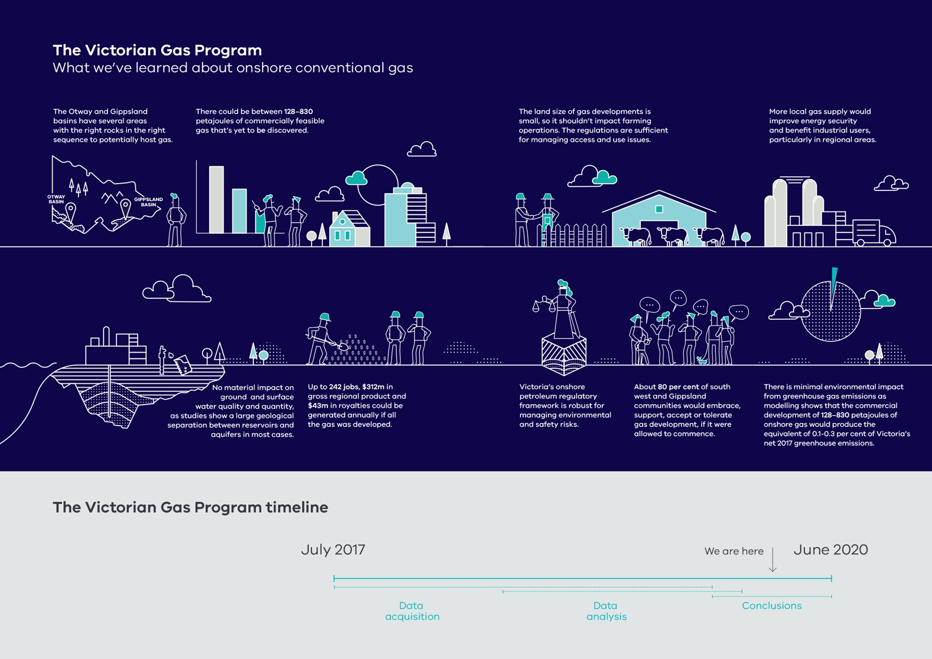
Authorised by the Director, Geological Survey of Victoria
Department of Jobs, Precincts and Regions
1 Spring Street Melbourne Victoria 3000
Telephone (03) 9651 9999
© Copyright State of Victoria, 2020.
Department of Jobs, Precincts and Regions 2020
Except for any logos, emblems, trademarks, artwork and photography this work is made available under the terms of the Creative Commons Attribution 3.0 Australia licence. To view a copy of this licence, visit creativecommons.org/licenses/by/3.0/au. It is a condition of this Creative Commons Attribution 3.0 Licence that you must give credit to the original author who is the State of Victoria.
This document is also available in an accessible format at djpr.vic.gov.au

Bibliographic reference
GEOLOGICAL SURVEY OF VICTORIA., 2019. Victorian Gas Program Progress Report No 4. Department of Jobs, Precincts and Regions, 60 pp.
ISSN 2208-9160 – Online (pdf/word) ISBN 978-1-76090-302-2 (pdf/online/MS word)
Geological Survey of Victoria Catalogue Record 161683
Key Words gas, Otway Basin, porosity, permeability, reservoir, Gippsland Basin,
air quality, groundwater

About the Victorian Gas Program
The Victorian Gas Program (the program) is a comprehensive science-led program, incorporating geoscientific and environmental research to assess the risks, benefits and impacts of potential onshore conventional gas exploration and production.
The program is also investigating the potential for further discoveries of onshore conventional and offshore gas in the Otway and Gippsland geological basins and assessing the feasibility of additional onshore underground gas storage in depleted reservoirs around the Port Campbell area.
The program includes an extensive, proactive and phased community and stakeholder engagement program, through which the results of the scientific studies are being communicated.

About the Geological Survey of Victoria
The Geological Survey of Victoria (GSV) is the Victorian Government’s geoscience agency and sits within the Department of Jobs, Precincts and Regions.
The Geological Survey of Victoria provides evidence-based knowledge and information to Government, industry, academia and the community, on Victoria’s earth resources, using the latest geoscience technologies and methods.
For more details visit earthresources.vic.gov.au/gsv.

Disclaimer
This publication may be of assistance to you, but the State of Victoria and its employees do not guarantee that the publication is without flaw of any kind or is wholly appropriate for your particular purposes and therefore disclaims all liability for any error, loss or other consequence which may arise from you relying on any information in this publication. The Victorian Government, authors and presenters do not accept any liability to any person for the information (or the use of the information) which is provided or referred to in the report.

Acknowledgements
The Geological Survey of Victoria would like to acknowledge the following groups for their contributions to this report:
- Victoria’s Lead Scientist, Dr Amanda Caples for her oversight and feedback regarding the onshore conventional gas studies.
- The Victorian Gas Program – Program Control Board for their governance oversight of the Victorian Gas Program.
- The Stakeholder Advisory Panel for Onshore Conventional Gas for their oversight and feedback on the assessment of the risks, benefits and impacts of onshore conventional gas. Membership of this panel includes:
  - Jo Beard, Great South Coast Group
  - Stephen Bell, Qenos
  - Linda French, Beach Energy
  - Ben Davis, Australian Workers Union
  - Jonathan La Nauze, Environment Victoria
  - Gerald Leach, Victorian Farmers Federation
  - Alison Marchant, Community / Frack Free Moriac
  - Tennant Reed, Australian Industry Group.
- The Victorian Gas Program Scientific Reference Group for their expert peer review and advice of this report and the assessment of the risks, benefits and impacts of onshore conventional gas. Membership of this group includes:
  - Dr Steve Mackie, Subsurface geoscientist
  - Dr Marita Bradshaw, Petroleum geologist
  - Prof Dayanthi Nugegoda, Ecotoxicologist
  - Professor Peter Gell, Palaeoecologist
  - Prof Damian Barrett, Environmental scientist
  - Dr Andrew Barton, Water resources engineer
Ernst & Young for preparing economic and greenhouse gas modelling and consolidating and assessing the risks, benefits and impacts of onshore conventional gas exploration and development.

Table of contents
Acknowledgements 4
Executive summary 9
1 Overview 13
1.1 Technical reports published to date 13
2 Onshore conventional gas studies 15
2.1 Geoscience studies – Otway Basin 15
2.2 Geoscience studies – Gippsland Basin 24
2.3 Environmental studies 30
2.4 Onshore conventional gas governance 41
3 Supporting program components 43
3.1 Community engagement 43
3.2 Resource and land use planning 50
4 Tying it all together: Risks, benefits and impacts assessment for onshore conventional gas 55
4.1 Methodology 55
4.2 Risks, benefits and impacts assessment for the Otway Basin 65
4.3 Risks, benefits and impacts assessment for the Gippsland Basin 78
4.4 Summary of findings 88
References 90
Glossary 92
Appendix 1: Stakeholder Advisory Panel for Onshore Conventional Gas communiques 93

List of figures
Figure 2.1 Otway Basin stratigraphy 16
Figure 2.2 Schematic representation of key layers produced for the geological framework. The topmost layer is the ground surface and sea floor. 19
Figure 2.3 Composite 2D seismic line in western Victoria showing interpreted horizons. 20
Figure 2.4 Surfaces from the 3D geological framework model were used to populate the petroleum systems model. 21
Figure 2.5 Full Eumeralla Formation gas expulsion from 0-10 million years in the Port Campbell Embayment/Shipwreck Trough – a good fit with discovered fields and dry holes of O’Brien et al. (2009). 22
Figure 2.6 Petroleum Resources Management System – Resource Classification Matrix. 23
Figure 2.7 Stratigraphy of the Gippsland Basin. 25
Figure 2.8 Structure map of the Strzelecki Group, onshore to offshore merged grid in two-way time. 27
Figure 2.9 Intra-Strzelecki Group gas expulsion in the Gippsland Basin. 29
Figure 2.10 A plot showing the chemical composition of the groundwater in the Otway Basin. 31
Figure 2.11 Distribution of methane (mg/L) for all groundwater samples collected in the Otway Basin. 32
Figure 2.12 A plot of the isotopic ratio of carbon in CH₄ (δ¹³C-CH₄) vs the isotopic ratio of hydrogen in CH₄ (δD-CH₄) in the Otway Basin, which enables a visualisation of the source of groundwater methane. 33
Figure 2.13 A plot showing the chemical composition of the groundwater in the Gippsland Basin (termed a ‘Piper plot’). 34
Figure 2.14 Distribution of methane (mg/L) for all groundwater samples collected in the Gippsland Basin. 35
Figure 2.15 A plot of the isotopic ratio of carbon in CH₄ (δ¹³C-CH₄) vs the isotopic ratio of hydrogen in CH₄ (δD-CH₄) in the Gippsland Basin, which enables a visualisation of the source of groundwater methane. 36
Figure 2.16 Area considered for environmental impact assessment associated with prospective gas development. 38
Figure 2.17 Area considered for environmental impact assessment associated with prospective gas development. 40
Figure 3.1 Attitudes towards onshore conventional gas development in the Otway Basin: total South-West region 2019. 44
Figure 3.2 Perceptions of community adapting to onshore gas development: South-West region, 2019. 45
Figure 3.3 Figure 3.3 Perceptions about onshore conventional gas development: summary underlying drivers, South-West region, 2019. 47
Figure 3.4 Attitudes towards onshore conventional gas development in the Gippsland Basin – total Gippsland Basin, 2019. 48
Figure 3.5 Perceptions of community adapting to onshore gas development – Gippsland region, 2019. 49
Figure 3.6 Perceptions about onshore conventional gas development: summary underlying drivers, Gippsland region, 2019. 50
Figure 3.7 Otway Basin – Final resource and land use planning model 52
Figure 3.8 Gippsland Basin – Preliminary resource and land use planning model. 53
Figure 4.1 Otway Basin high hypothetical exploration and development scenario – gas yet to be found in the Port Campbell Embayment (Eastern Region), the Penola Trough (Western Region) and in the Central Region. 59
Figure 4.2 Gippsland Central Onshore Region – geographic area for low, medium and high hypothetical exploration and development scenarios. 61

List of tables
Table 2.1 Regional horizons interpreted in the Otway Basin as part of the Victorian Gas Program. 18
Table 2.2 Subregional horizons interpreted in the Otway Basin as part of the Victorian Gas Program. 18
Table 2.3 Stratigraphic horizon nomenclature from the previous offshore interpretation and that adopted for this Victorian Gas Program study. 26
Table 2.4 Estimated impact on ground and surface water under each Gippsland Basin hypothetical scenario 41
Table 4.1 Otway Basin summary of hypothetical gas exploration and development scenarios. 55
Table 4.2 Gippsland Basin summary of hypothetical gas exploration and development scenarios. 60
Table 4.3 Benefit and impact assessment scoring model. 63
Table 4.4 Risk matrix. 64
Table 4.5 Risk ranking. 64
Table 4.6 Receptors for risks, benefits and impacts assessment. 65
Table 4.7 Otway Basin hypothetical scenarios: Risk, benefit and impact assessment summary – Economic receptors. 66
Table 4.8 Otway Basin hypothetical scenarios: Risk, benefit and impact assessment summary – Social receptors. 71
Table 4.9 Otway Basin hypothetical scenarios: Risk, benefit and impact assessment summary – Environmental receptors. 76
Table 4.10 Gippsland Basin hypothetical scenarios: Risk, benefit and impact assessment summary – Economic receptors. 78
Table 4.11 Gippsland Basin hypothetical scenarios: Risk, benefit and impact assessment summary – 82
Table 4.12 Gippsland Basin hypothetical scenarios: Risk, benefit and impact assessment summary – Environmental receptors. 86

Executive summary
This report builds on the first three Victorian Gas Program Progress Reports published in January 2018, February 2019 and December 2019. The Progress Reports provide updates on the three-year scientific studies being undertaken by the Geological Survey of Victoria to:
- investigate evidence of Victoria’s potential for future onshore conventional gas supply and storage
- assess the risks, benefits and impacts associated with onshore conventional gas.
The Victorian Gas Program is not studying onshore unconventional gas (fracking), which the government permanently banned in 2017.
This report presents a summary of the onshore conventional gas studies undertaken to date, including data from geoscience, environmental and social research studies. As the Victorian Gas Program progresses, new data is continually being analysed and publicly released via a series of progress and technical reports.

Onshore conventional gas studies – what has been done?
The Victorian Gas Program’s geoscientific, technical, environmental and social studies, including an evidence-based estimate of prospective gas resources at a regional level, have been used to assess the risks, benefits and impacts of onshore conventional gas exploration and development. This work will inform government decisions regarding the moratorium on onshore conventional gas exploration and development, which is in place until 30 June 2020.

Geoscience studies
Both the Otway and Gippsland basin three dimensional (3D) geological framework models are complete. These models provide the framework to understand where rock units that could host conventional gas may be present, as well as the location and movement of groundwater. Geological surfaces and other outputs from the 3D geological models have been used to complete petroleum systems modelling for both basins.
Petroleum systems models simulate gas generation and migration through time and display the composition and volumes of any trapped gas resources. The completed models have identified where potential new accumulations of gas could be discovered at a regional scale. Each model was validated by its ability to predict known hydrocarbon accumulations. Both basin models generated enough gas to account for gas discovered to date.
Prospectivity assessments have been undertaken and have identified areas prospective for gas in the Otway and Gippsland basins. These have formed the basis for the hypothetical onshore conventional gas exploration and development scenarios used in the risks, benefits and impacts assessment (see Figure 4.1 and Figure 4.2).
A range of prospective gas resource estimates has now been calculated for both the Otway and Gippsland basins.

Environmental studies
The Victorian Gas Program has sampled groundwater from 103 Victorian Government observation bores across the Otway and Gippsland basins and analysed 144 analytes. This comprehensive dataset builds on existing data and provides a baseline measure of groundwater conditions, including dissolved methane, mainly in deep aquifers, across the regions. These regional datasets may support regulation of the sector by equipping government with a baseline it can use to monitor and report on any industry impacts.
Regional groundwater impact assessments have also been undertaken. The assessments simulated regional groundwater movement processes in both the onshore and offshore components of the Gippsland and Otway basins to determine the potential impact of onshore conventional gas development. Hypothetical groundwater impact assessment scenarios were developed for the onshore and offshore components of the Gippsland and Otway basins where prospective conventional gas areas have been interpreted to determine if there would be any impact on the environment and groundwater supply aquifers. These impact assessments simulated the regional groundwater movement processes in both basins to determine the potential impact that onshore conventional gas development may have. The scenarios are used to determine if there would be any impact from onshore conventional gas exploration and development on groundwater supply aquifers.

Resource and land use planning
Each model was built from over 140 data sets and displays features spatially, allowing identification of existing and potential future land uses and landscape sensitivities. The models specify:
- areas where resource exploration or development could align with existing or future land uses
- areas where features of sensitivity or significance may exist that would need to be considered and addressed prior to any exploration or development proceeding
- areas where resource exploration or development may not be appropriate.
These datasets would support government in understanding potential interactions with other land uses during any potential future acreage releases and impact assessments.

Social research and community engagement
The Geological Survey of Victoria commissioned CSIRO to establish a social baseline in the Otway and Gippsland basins. Quantitative research focused on community wellbeing and regional attitudes to onshore conventional gas development. A telephone survey of 810 people was undertaken between August and November 2019. The results provide a statistically robust understanding of regional communities’ current attitudes and concerns about any future onshore conventional gas exploration and development.
The Victorian Gas Program’s team of geoscientists and community engagement staff have also continued to brief local government, industry, farmers, local school students, and environmental and community groups on the program and geoscience studies. To date, over 800 engagements have taken place, with future engagements planned to share the final scientific findings as the program concludes.
The Victorian Gas Program’s geoscience team has also shared its knowledge and passion for geology by presenting to over 1400 South-West Victorian primary and high school students, many of whom viewed the state’s 3D geological model.

Program governance – independently testing our methodology
and results
The methodology and results from the program’s studies continue to be tested via the guidance and advice of the Victorian Gas Program’s independent Stakeholder Advisory Panel for Onshore Conventional Gas and the Scientific Reference Group, both chaired by Victoria’s Lead Scientist.

Assessment of the risks, benefits and impacts
The Geological Survey of Victoria commissioned an assessment of the risks, benefits and impacts of onshore conventional gas to tie together the Victorian Gas Program’s scientific, technical, environmental and social studies. This assessment also incorporated economic and greenhouse gas modelling. Potential risks, benefits and impacts of seven hypothetical onshore conventional gas exploration and development scenarios in the Otway and Gippsland basins were considered on 17 economic, social and environmental receptors. The hypothetical scenarios included low, medium and high cases in both basins, and an extra minimum case in the Otway Basin. The results will be used to inform government decisions about the future of the onshore conventional gas moratorium.
The Stakeholder Advisory Panel provided oversight of and feedback on the assessment, and found it to be factual, objective and accurate in the Victorian context.
The Scientific Reference Group also provided peer review input and advice and found that the assessment had been undertaken with strong technical rigour and is suitable for informing government decision making.

Key findings:
Based on the likely risks, benefits and impacts of the seven hypothetical gas development scenarios, the assessment found that:
- Victoria is prospective for onshore conventional gas, with the range estimated to be 128–830 petajoules (minimum to high scenarios of potentially discoverable and extractable gas).
- Development of onshore conventional gas would create jobs and benefit regional communities and economies. Up to 242 jobs, $312 million in gross regional product and $43 million in royalties (at the high scenario) could be generated each year across Victoria during production. Development could potentially start from 2023–24 if industry makes a gas discovery, considers it commercially feasible to develop and secures the necessary regulatory approvals.
- Prospectivity assessments have identified the west, central and eastern areas of the onshore section of the Otway Basin as prospective for conventional gas (refer to Figure 4.1). Prospectivity assessments have also identified the central onshore area of the Gippsland Basin as prospective for conventional gas (see Figure 4.2).
- No development scenarios identified any material impact on ground and surface water quality or quantity. This finding is based on the groundwater impact modelling studies, which generally found a large geological separation between conventional gas reservoirs and aquifers.
- In regard to land access and rehabilitation, the legislation is clear that gas developers must enter into a land access agreement prior to commencing exploration and must restore land that was developed to its original state (or be compensated appropriately). Regulatory improvements regarding landholder and community consultation would further address risks and impacts.
- The scale of land required for conventional gas exploration and development is relatively small and discrete. There is no evidence to suggest that there is significantly reduced land available to other users. All hypothetical scenarios, with the exception of the high scenario, were found to have neutral impacts, with a slightly negative impact for the high scenario.
- Overall, the minimum, low and medium scenarios would have no material impact on existing farm industries, food and biosecurity; with the high scenario having a slightly negative impact. Biosecurity was assessed as a key risk to farming industries, noting that this risk is assessed as moderate for all scenarios because projects would not proceed unless the impacts are assessed by the regulator (via an Environment Management Plan) to be as low as reasonably practicable.
- Victoria’s onshore Petroleum Regulatory Framework is robust for managing environmental and safety risks. The regulatory framework could be improved in its provisions for community engagement and industry transparency.
- About 80 per cent of the South-West and Gippsland communities would embrace, support or tolerate onshore conventional gas development. Community support would be enhanced by providing genuine engagement opportunities and more information about industry activity and how the community’s interests are being managed.
- The additional 128–830 petajoules of gas that could be produced in the state would contribute to gas supply but would not meet Victoria’s forecasted shortfalls. The additional gas would improve energy security by increasing the diversity of gas supply. It would also benefit industrial users, particularly in regional areas, by providing new options for local gas supplies.
- The expected amount of new gas would not be a large enough volume to impact gas prices or gas demand in the state.
- Greenhouse gas emissions from the hypothetical scenarios would be between 122,000 to 329,000 tonnes CO₂-e annually. This represents 0.1 to 0.3 per cent of Victoria’s net 2017 greenhouse gas emissions and would need to be accounted for under Victoria’s Climate Change Act 2017.

Next report
The next Progress Report will build on the work completed to date and provide the final results for the onshore conventional gas and offshore gas studies, as well as the investigations into underground gas storage.

Overview
This Progress Report focuses on the outputs of the onshore conventional gas studies under the Victorian Gas Program. It outlines the scope of the Victorian Gas Program, an overview of the techniques being used by the Geological Survey of Victoria to conduct the scientific studies, and the status of activities. Subsequent reports will provide further data analyses and results.
The onshore conventional gas studies comprise geoscience, technical, environmental and social studies on the risks, benefits and impacts of onshore conventional gas exploration and production, while the moratorium is in place until 30 June 2020. These investigations will provide an evidence-based prospective gas resource estimate. The studies are overseen by Victoria’s Lead Scientist and an independent Stakeholder Advisory Panel, comprising farmers, industry, local government and the community. The findings are peer-reviewed by an expert Scientific Reference Group.
An extensive engagement program for farmers, industry, local government and regional communities has been undertaken in parallel to support the onshore conventional gas scientific investigations. Resource and land use planning and potential regulatory improvement projects are also under way. These projects have been informed by the findings of the Victorian Gas Program.

Technical reports published to date
A number of technical reports have been published to date to share the evidence-based results of the studies undertaken as part of the program. These reports include:
- Technical Report 1 – New porosity and permeability measurements from legacy core, Onshore Otway Basin, Victoria
- Technical Report 2 – New seal capacity measurements from legacy core and cuttings, Onshore Otway Basin, Victoria
- Technical Report 3 – Mineralogical and textural characterisation of sedimentary rock samples, Onshore Otway Basin, Victoria
- Technical Report 4 – New vitrinite reflectance measurements from legacy core and cuttings, Onshore Otway Basin, Victoria
- Technical Report 5 – New source rock geochemistry measurements from legacy core and cuttings, Onshore Otway Basin, Victoria
- Technical Report 6 – Full Spectrum FALCON® airborne gravity and aeromagnetic survey, Otway Basin, Victoria
- Technical Report 7 – New palynology results from legacy core and cuttings, Otway Basin, Victoria
- Technical Report 8 – New micropalaeontological results from legacy core, Otway Basin, Victoria
- Technical Report 9 – A preliminary ranking of potential Underground Gas Storage sites, Onshore Otway Basin, Victoria
- Technical Report 10 – New kerogen kinetics data from legacy rock cuttings, Onshore Otway Basin, Victoria
- Technical Report 11 – A review of the preliminary Underground Gas Storage site ranking, Onshore Otway Basin, Victoria
- Technical Report 12 – An elemental chemostratigraphic study, Onshore Otway Basin, Victoria
- Technical Report 13 – Regional baseline stygofauna survey, Onshore Otway Basin, Victoria
- Technical Report 14 – Regional baseline stygofauna survey, Onshore Gippsland Basin, Victoria.
Further reports will be published as the program draws to a close. All study results and reports will be made available at earthresources.vic.gov.au/gasprogram.

Onshore conventional gas studies

Geoscience studies – Otway Basin
The geoscience studies in the Otway Basin are progressing with the rock characterisation studies complete and all technical reports related to this part of the program published (see Section 1.1).
The Otway Basin three-dimensional (3D) geological framework model is undergoing final review prior to publication. Geological surfaces from the framework model have been used to complete petroleum systems modelling and to inform the mapping for the prospectivity assessment.
A map of prospective areas in the Otway Basin is being finalised and now includes inputs from petroleum systems modelling, in addition to maps of source, seal and reservoir units compiled using legacy data and new information acquired during the Victorian Gas Program. The prospectivity assessment has been used as an input to the estimate of Victoria’s undiscovered conventional gas potential.
The following sections are a summary of the technical work undertaken since Progress Report 3 (Geological Survey of Victoria, 2019). Final technical reports for each study are being generated and will be released when completed.
The Otway Basin work discussed in the following sections mainly focuses on the Otway and Sherbrook groups, the main geological units where hydrocarbons have already been found. However, other studies such as 3D modelling and biostratigraphy are focused on evaluating all the rock units in the basin (see Figure 2.1). A summary of the geological history of the Otway Basin, including descriptions of the geological units that are the focus of the studies to date, is included as Appendix 2 of Progress Report 2 (DJPR, 2019).
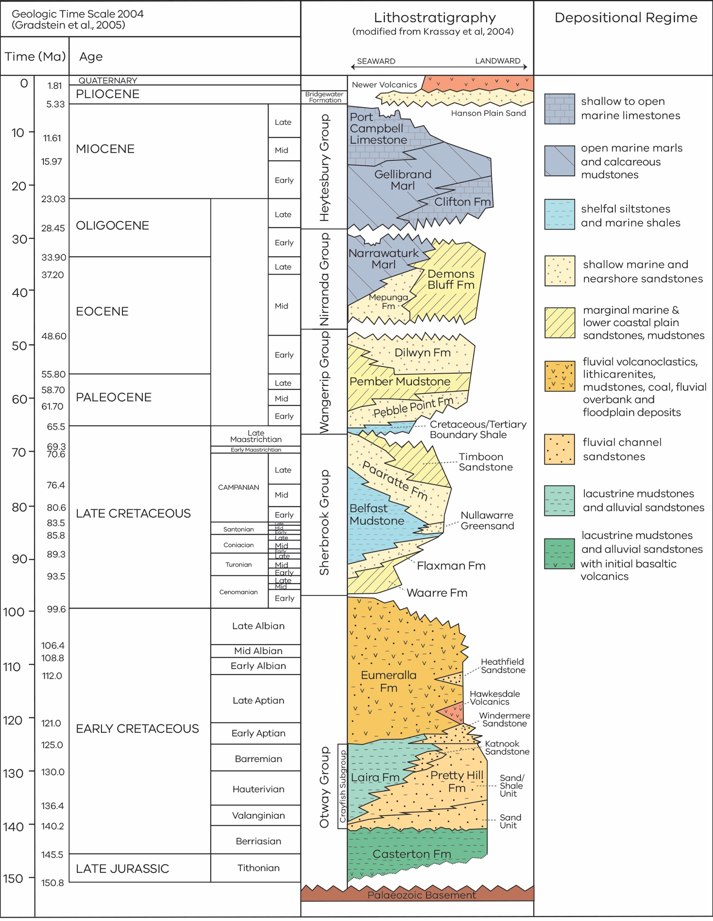
Figure 2.1 Otway Basin stratigraphy

Geoscience modelling
The interpretation of the surfaces of the rock layers that make up the 3D geological framework model for the Otway Basin has been reviewed by Victorian Gas Program geoscientists and independent reviewers. Products and a report are undergoing final checks and refinements prior to publication.
The Otway Basin petroleum systems model has been built using all available new and existing data and interpretations to inform the prospectivity assessment.

Regional 3D geological framework model
The Geological Survey of Victoria commissioned the construction of an Otway Basin regional 3D geological framework model. The geological framework model was constructed by Frogtech in 2017 and 2018, and incorporated results from an earlier study by the Geological Survey of Victoria. The new framework model included a regional 3D model of the Victorian Otway Basin and a more detailed 3D model of the Port Campbell Embayment and Shipwreck Trough.
A preliminary interpretation of seismic and well data was completed in June 2018. Review and refinement of the velocity model and interpretations were completed in 2019.
The seismic interpretation was undertaken using two-dimensional (2D) and 3D seismic data acquired by industry over the past 50 years. The seismic data is publicly available in the Geological Survey of Victoria’s archives (earthresources.efirst.com.au). Nine regional horizons were mapped across approximately 15,000 kilometres (km) of 2D seismic lines and 4000 km² of 3D seismic data. More than 150 wells and boreholes across the Otway Basin were included in the interpretation. The model includes all mappable sedimentary units in the basin between the top of the Palaeozoic basement and the present-day bathymetric or land surface.
The results have been progressively incorporated into petroleum systems modelling and prospectivity assessment mapping. Reports are in the review and final edit stage.
The datasets produced as part of this study are:
- a comprehensive seismic survey dataset containing most of the seismic surveys acquired by industry and government in the Otway Basin since the 1970s
- a set of surfaces and interpretations of nine regional horizons extending across most of the region (Table 2.1) and a set of sub-regional horizons, where the extent of the layer is limited (Table 2.2).
Table 2.1 Regional horizons interpreted in the Otway Basin as part of the Victorian Gas Program.
Regional horizons | Extent
Seafloor and ground surface | Regional
Top Heytesbury Group | Regional
Top Nirranda Group | Regional
Top Wangerrip Group | Regional
Top Sherbrook Group | Regional
Top Shipwreck Group | Regional offshore, Port Campbell Embayment onshore
Top Eumeralla Formation | Regional
Top Crayfish Subgroup | Regional onshore
Basement | Regional

Table 2.2 Subregional horizons interpreted in the Otway Basin as part of the Victorian Gas Program.
Sub-regional horizons | Extent
Top Gellibrand Marl | Sub-regional onshore
Top Mepunga Formation | Port Campbell Embayment/Shipwreck Trough only
Top Pember Mudstone | Regional onshore
Top Pebble Point Formation | Sub-regional onshore/offshore
Top Thylacine Sandstone Member/O. porifera | Port Campbell Embayment/Shipwreck Trough only
Top Waarre Formation | Regional offshore, Port Campbell Embayment/Shipwreck Trough
Heathfield Sandstone | Limited extent onshore
Top Basal Eumeralla high amplitudes | Limited extent onshore
Top Pretty Hill Formation | Limited extent onshore
Top Casterton Formation | Sub-regional onshore

The regional 3D geological framework consists of layers representing the major regional sequences of rocks in the Otway Basin (Figure 2.2). As a standalone output, these layers provide information about the distribution, shape and geological history of the Otway Basin. The framework extends over all of the Victorian Early Cretaceous rocks in the Otway Basin. An extension of the model into the prospective Penola Trough in South Australia has allowed correlation between a proven active petroleum system in the west and potential systems on the eastern side of the Penola Trough in Victoria (Figure 2.3).
Incorporated in this study are interpretations of the landscape and environment (palaeogeography) at the time of deposition of the rock layers. This and other work undertaken by the Geological Survey of Victoria populates the space between the surfaces with information about the rocks’ properties. This helps to determine the potential for the rocks to host gas resources.
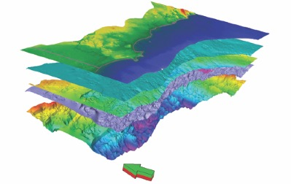
Figure 2.2 Schematic representation of key layers produced for the geological framework. The topmost layer is the ground surface and sea floor.
Figure 2.3 Composite 2D seismic line in western Victoria showing interpreted horizons.

Petroleum systems modelling
Petroleum systems modelling can be used to understand whether petroleum (e.g., gas) is present and how much might exist in prospective rocks. Geological, geophysical and engineering data is used to create 3D models of the subsurface that incorporate the history of a sedimentary basin, including the processes and components necessary to form petroleum. Components include a source rock, reservoir, trapping mechanism, seal, and the appropriate relative timing of formation of these (Schlumberger, 2020).
The petroleum systems modelling for the Otway Basin has combined new and existing data and interpretations, including seismic and structural interpretations from the 3D framework modelling and rock characterisation studies, including geochemistry, seal capacity and biostratigraphy. Existing data was also incorporated including well, temperature and pressure data publicly available from company well completion reports, along with historical geological assessments. This allowed characterisation of present-day conditions in the basin and helped to determine the depositional history of the basin and hydrocarbon generation, and movement and preservation throughout geological time.
Using the data and interpretations from the Victorian Gas Program, a 3D model of the petroleum systems present in the Otway Basin has been built. The petroleum systems model is based on subsurface maps defining the tops of the formations that form the sediments in the basin (Figure 2.4). Based on these maps and the geological history, the model simulates how the basin was formed and filled through geological time, including episodes of rifting and uplift.
Figure 2.4 Surfaces from the 3D geological framework model were used to populate the petroleum systems model.
The major source rocks for the petroleum discovered in the Otway Basin to date are the Eumeralla Formation and the Crayfish Subgroup (notably the Casterton and Pretty Hill formations). The organic matter in the Eumeralla Formation consists mostly of coals and is the source of the gas found onshore in the Port Campbell Embayment and the offshore accumulations in the Shipwreck Trough. The source rocks in the Casterton and Pretty Hill formations also consist mostly of coals as well as some organic matter that was deposited in a lake environment. This is the source for the gas found in the Penola Trough.
When building a petroleum systems model, these source rocks must be defined in terms of the amount and type of organic matter that is present and the thickness of the layers that contain them. This was completed using statistical analysis across the basin of total organic content values, which is a measure of the amount of organic matter present in the rock sample, and hydrogen index values, an indicator of the type of organic matter. Based on measurements from more than 2000 samples from the Eumeralla Formation and over 1400 for the Crayfish Subgroup it was possible to define the source rocks for the model.
When source rocks are heated to sufficiently high temperatures, they can generate petroleum that can migrate out of the source rock and into potential reservoirs. The timing and extent of this heating is important as it determines whether enough petroleum is generated to migrate and fill reservoirs and whether traps are formed at the time of migration. The heating of rocks is largely controlled by burial, uplift and the heat generated by the earth’s mantle. To be able to model this heat flow through geological time, a series of one-dimensional (1D) models were built. A 1D-model combines data measured when drilling a well, such as temperature, pressure and lithology with data measured from rocks brought to the surface at that well’s location. This data includes vitrinite reflectance, which is a measurement of the extent of heating the organic matter has experienced. With this data, a 1D-model can be calibrated – this means that when the model calculates the present-day temperature and the vitrinite reflectance, it must match the actual measured values. This results in greater confidence that the 1D-model accurately reconstructs the geological history at that well location in the basin. This approach was used to build and calibrate 53 1D-models across the Otway Basin, which were then used to calibrate the 3D-model, covering the whole study area. A history of heat flow throughout the whole Otway Basin was then simulated.
The key reservoir formations in the Otway Basin consist of the Waarre Formation in the eastern part of the basin and the sandstone layers that are present in the Crayfish subgroup in the Penola Trough in the west. The petroleum systems model includes maps that define the depth and extent of these formations. These were used to model the flow of hydrocarbons along these surfaces, which migrate into suitable structures to form accumulations.
The capacity of potential reservoirs to contain commercial volumes of petroleum is controlled by the porosity and permeability of the overlying formations. For the Waarre Formation reservoirs, the seals are the Flaxman Formation and the Belfast Mudstone. For the Crayfish Subgroup, these are intra formational shale layers. The sealing capacity of these rock units was confirmed by Victorian Gas Program studies (Goldie Divko & Karolia, 2019).
With all elements of the petroleum system defined in the 3D model (i.e. source, reservoir and seal), as well as heat flow, burial and uplift, a simulation of the deposition of sediments and the generation, migration and accumulation of petroleum in the Otway Basin was performed. The veracity of the model was demonstrated by its prediction of known accumulations. Given the uncertainties that accompany each piece of data that is incorporated into the model, several simulations were performed, each representing a different scenario where the impact of these uncertainties are tested.
The main results from the modelling suggest that the Eumeralla Formation has generated large volumes of gas since the Mid-Cretaceous (i.e., some 80 million years ago), as well as small amounts of liquids. Since the formation is very thick, especially offshore, the deeper sections generated gas much earlier than the shallower sections. Maps were produced from the model showing the different volumes generated and expelled at different levels of the Eumeralla Formation. This study found that, at present day, sections of the Eumeralla Formation are still generating gas (Figure 2.5).
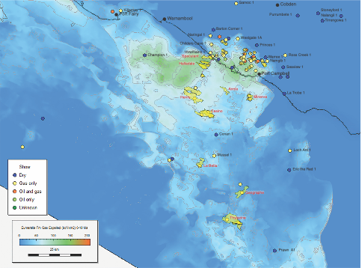
Figure 2.5 Full Eumeralla Formation gas expulsion from 0-10 million years in the Port Campbell Embayment/Shipwreck Trough – a good fit with discovered fields and dry holes of O’Brien et al. (2009).
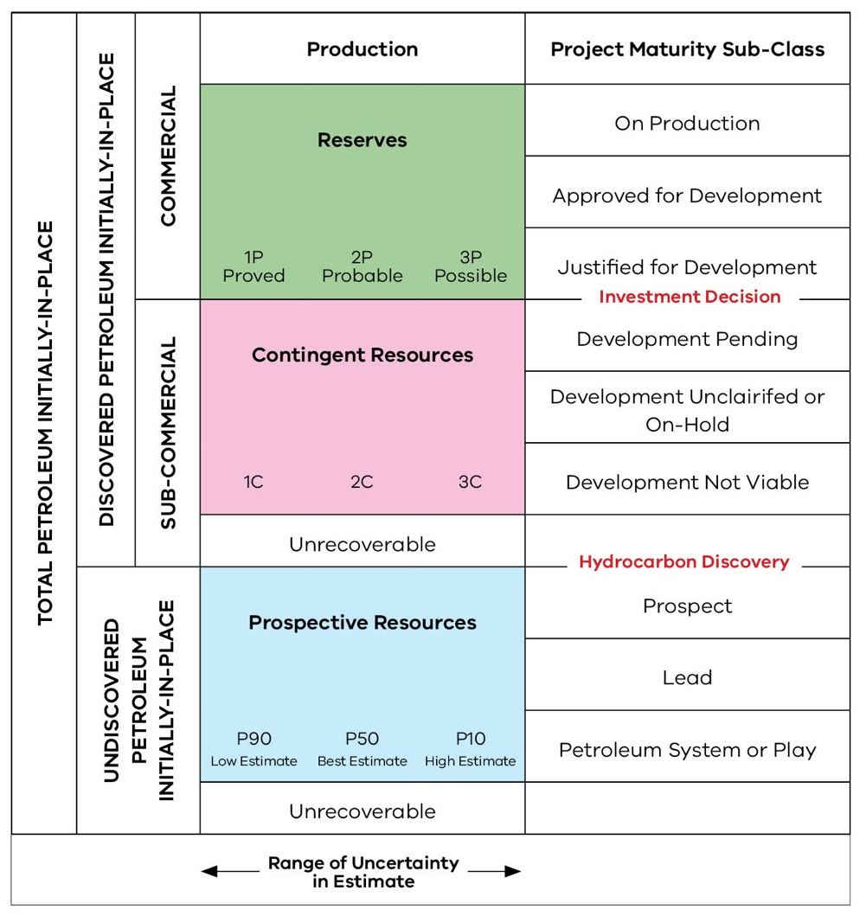
Figure 2.6 Petroleum Resources Management System – Resource Classification Matrix.
Source: modified from Society of Petroleum Engineers, 2018.
The assessment that has been carried out as part of the Victorian Gas Program studies is a prospective resource estimate. A resource estimate is a prediction of how much gas might be found and developed as a result of industry exploration programs in the future – i.e., ‘how much gas is there left to find’.
In 2000, the United States Geological Survey (USGS, 2000) developed a methodology for assessing resource potential as part of their world petroleum assessment of 159 of the world’s largest petroleum systems. This methodology was applied by Geoscience Victoria (now the Geological Survey of Victoria) to the Otway Basin (O’Brien & Thomas, 2007) to estimate undiscovered hydrocarbon resource potential (or Yet-to-find – YTF). Since most exploration and production activities had taken place in the offshore areas within these basins, the previous Geological Survey of Victoria studies focused on the offshore input data. O’Brien & Thomas (2007) used the USGS method, suggesting that the Victorian Otway Basin contained significantly more undiscovered gas (1.8 – 3.6 Tcf) than had been found at that time.
The approach adopted by the Victorian Gas Program follows the resource estimation method used by the USGS:
- Yet-to-find = (number of features) x (size (volume of recoverable gas) of features)
Each of these inputs was informed by the prospectivity mapping and the results of past exploration to produce the resource estimate. A resource estimate addresses the uncertainty in the amount of gas that might be found by estimating a range (i.e. it is not a single number) in billion cubic feet (Bcf).
For the onshore Otway Basin, the low (P90) prospective resource estimate is 294 Bcf (317 PJ) and the high (P10) estimate is 660 Bcf (715 PJ). These values represent the prospective resource range that was used as the basis for the hypothetical exploration and development scenarios in the risks, benefits and impacts assessment for the Otway Basin (see Table 4.1 for summary of hypothetical scenarios for the Otway Basin).

Geoscience studies – Gippsland Basin
The geoscience studies in the Gippsland Basin are progressing with the 3D geological framework model undergoing final review prior to publication. Geological surfaces and paleogeographic mapping from the framework model have been used to complete petroleum systems modelling and to inform the mapping that is being undertaken for the prospectivity assessment.
All data and mapping inputs have now been compiled for the Gippsland prospectivity assessment with preliminary mapping requiring refinement. The prospectivity assessment has been used as an input to the estimate of Victoria’s undiscovered conventional gas potential.
The 3D geological framework modelling for the Gippsland Basin includes all the rock units that are present in the basin (see Figure 2.7), whereas the petroleum systems modelling and prospectivity assessment focuses on the Latrobe and Strzelecki groups.
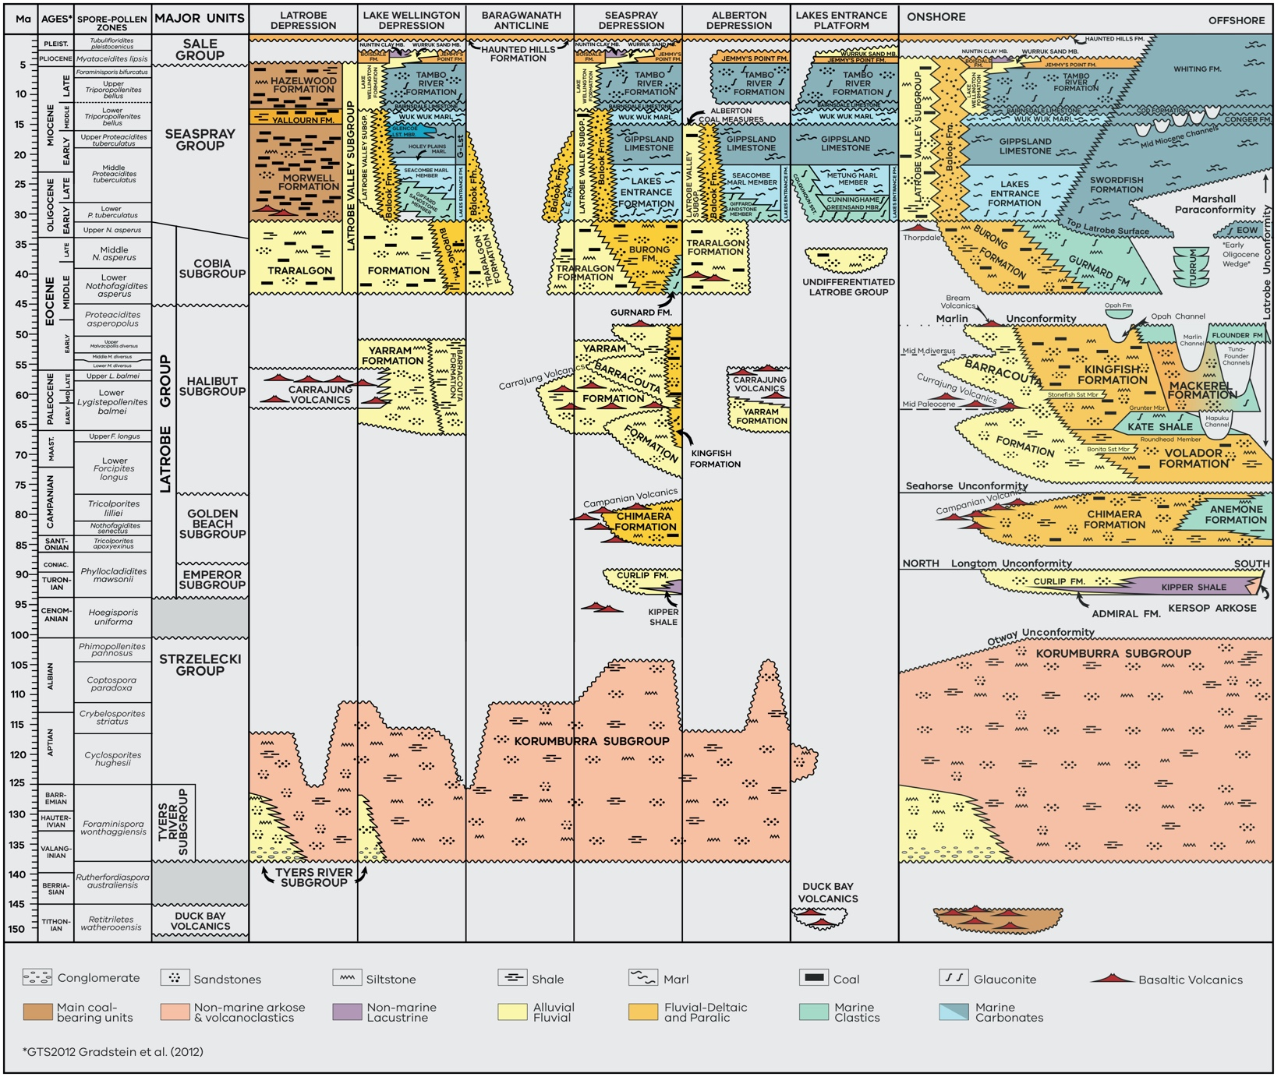
Figure 2.7 Stratigraphy of the Gippsland Basin.
Source: Compiled from Bernecker & Partridge, 2001; Chiupka, 1996; Gallagher & Holdgate, 1996; Holdgate & Gallagher, 1997; Partridge, 2006a; Partridge, 2006b & Tosolini et al., 1999.
The following sections are a summary of the technical work undertaken since Progress Report 3 (Geological Survey of Victoria, 2019). Final technical reports for each study are being generated and will be released when completed.

Geoscience modelling
The interpretation of the surfaces of the rock layers that make up the 3D geological framework model for the Gippsland Basin has been reviewed by Victorian Gas Program geoscientists and independent reviewers, with products and a report undergoing final checks and refinements prior to publication.
The Gippsland Basin petroleum systems model has been built using all available new and existing data and interpretations to inform the prospectivity assessment.

Regional 3D geological framework model
PetroAus Pty Ltd was engaged by the Geological Survey of Victoria to construct a regional 3D geological framework model of the onshore Gippsland Basin, using all available seismic and well data acquired from previous petroleum exploration and data from groundwater and coal boreholes. Additional legacy data from gravity surveying and geological studies were incorporated in the construction of the 3D model. A total of 2916 km of onshore 2D seismic data acquired between 1961 and 2015 was available for interpretation. In addition, 9622 km of offshore 2D seismic was available. This seismic data, together with 745 wells and boreholes, was loaded into specialist software, which was used to carry out the seismic interpretation and structural mapping.
Non-seismic datasets such as wells and boreholes were used for sub-surface mapping in regions where the seismic data coverage was sparse or non-existent. The seismic interpretation included the nearshore Gippsland Basin and a portion of the offshore basin to allow for a merge of this new interpretation with an existing offshore model.
The number of horizons for which merged onshore-offshore maps could be produced and the area covered was limited by the mapping available from the previous offshore interpretation (Table 2.3). Although this limited the number of merged surfaces to six, the resulting maps illustrate the present-day time structure (Figure 2.8) through the stratigraphic sequence for the entire eastern portion of the Gippsland Basin (e.g. Figure 2.7).
Table 2.3 Stratigraphic horizon nomenclature from the previous offshore interpretation and that adopted for this Victorian Gas Program study.
Victorian Gas Program study  - key mapping horizons |  | Colour used to denote seismic horizon | Offshore Gippsland Basin (McLean & Blackburn, 2013) | Victorian Gas Program study - merged onshore-offshore mapping | Victorian Gas Program study  - 3D Model
South Gippsland (West) | Onshore and nearshore Gippsland Basin (East)
 |  |  |  |  | Surface elevation
Latrobe Valley Coal Measures | Jemmys Point Formation | Violet | Base late Miocene | Late Miocene Horizon | Late Miocene Horizon
 | Gippsland Limestone | Brown | Mid-Miocene Unconformity | Mid Miocene Horizon | Mid Miocene Horizon
 | Lakes Entrance Formation | Royal blue | Lakes Entrance Formation | Early Miocene Horizon | Early Miocene Horizon
Latrobe Group | Latrobe Group/Cobia Subgroup | Orange | Latrobe Group | Top Latrobe Group | Top Latrobe Group
 | Halibut Subgroup | Bright pink |  |  | Top Halibut Subgroup
 |  |  | KT unconformity
 | Golden Beach Subgroup | Yellow |  |  | Top Golden Beach Subgroup
 | Emperor Subgroup | Light blue |  |  | Top Emperor Subgroup
Strzelecki Group | Strzelecki Group | Green | Strzelecki Group | Top Strzelecki Group | Top Strzelecki Group
Basement | Basement | Red | Basement | Top Basement | Top Basement

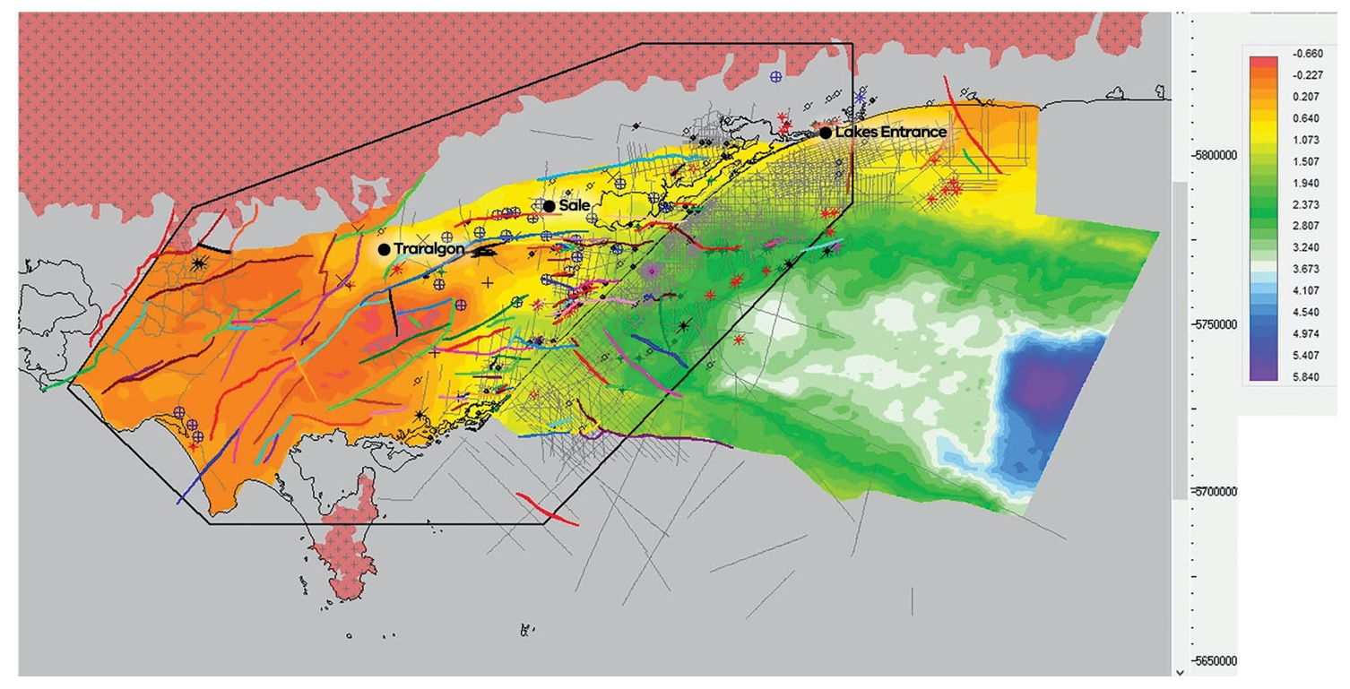
Figure 2.8 Structure map of the Strzelecki Group, onshore to offshore merged grid in two-way time.

Petroleum systems modelling
A petroleum systems model for the Gippsland Basin was built to provide input on source rock type and distribution, burial history, maturity, expelled volume, migration pathways and fetch areas for the onshore Gippsland Basin. This model will inform the Gippsland Basin prospectivity assessment.
To determine source rock type and quality, a geochemistry database was created from existing open file organic geochemistry data. This included RockEval data for source rocks from cuttings, side wall cores and conventional cores, hydrocarbon properties data, gas composition data, isotope data for liquids and gases, saturate/aromatic data for hydrocarbons, source rock extracts and reservoir extracts. Vitrinite reflectance data was also included to provide source rock maturity information.
Well data was examined and collated to provide a database for 1D well and map-based modelling. This included temperature data, pressure data and lithology data. Formation tops were provided by the Geological Survey of Victoria and PetroAus and, where necessary, taken from well completion reports.
Merged depth grids for the onshore and offshore Gippsland Basin were available from the regional 3D framework model. A large portion of the offshore basin was included so that all expelled volumes of gas with the potential to migrate to the onshore area were included in this study. Paleogeography maps from the framework model were used to help constrain source rock distribution and seal distribution and capability.
A geochemistry interpretation was undertaken to determine source rock quality. Oil and source rock correlation was used to establish potential source facies within sequences and potential migration pathways. Palaeogeography was also included to provide geologic constraints to source rock type and distribution.
Twenty-three 1D well models were built in the area of interest, along with one pseudo-well. Thorough investigation of the tectonic evolution of the basin and the implications for heat-flow was completed to create an accurate lithosphere model for the project. Well models were built using provided stratigraphy, the lithology from logs, and from descriptions of cores and cuttings. The models were calibrated to available temperature, vitrinite reflectance, RockEval and pressure data and a location specific source rock, assigned based on the source rock potential in the well.
The map-based model was built using the depth grids provided. The 1D models were imported to provide calibration points for temperature gridding. Erosion and hiatuses were determined from seismic, temperature and pressure trends included. The source rock models interpreted from geochemistry were built and kinetics were assigned. Seal maps were built using field column heights, paleogeography, lithology from wells and seal capacity testing (where available). Source rock maturity, the volume of expelled hydrocarbons and other properties (such as the ratio of gas to liquids and oil density) were then calculated.
Multiple cases of up-dip migration of gas from the deep source areas in the centre of the basin to the margins were modelled using variable parameters such as, seal capacity, expelled gas volumes, migration losses, carrier bed thickness, porosity and fault seal. Probability of migration and accumulation was determined and mapped, along with fetch areas.
Six source rock surfaces were interpreted: Kingfish Formation, Volador Formation, Kipper Shale, Strzelecki Group (upper) and the Strzelecki Group. Maturity and expulsion mapping of these suggests maturity for generation and expulsion has been attained by all mapped source rock sequences.
Timing of expulsion for the intra Strzelecki Group source rock is modelled to have taken place from approximately 100 million years ago, with gas generation and expulsion continuing to present day (Figure 2.9). The timing of generation and expulsion from the shallower formations is dependent on varying depth of burial but is modelled to begun approximately 50 million years ago and is continuing to the present day
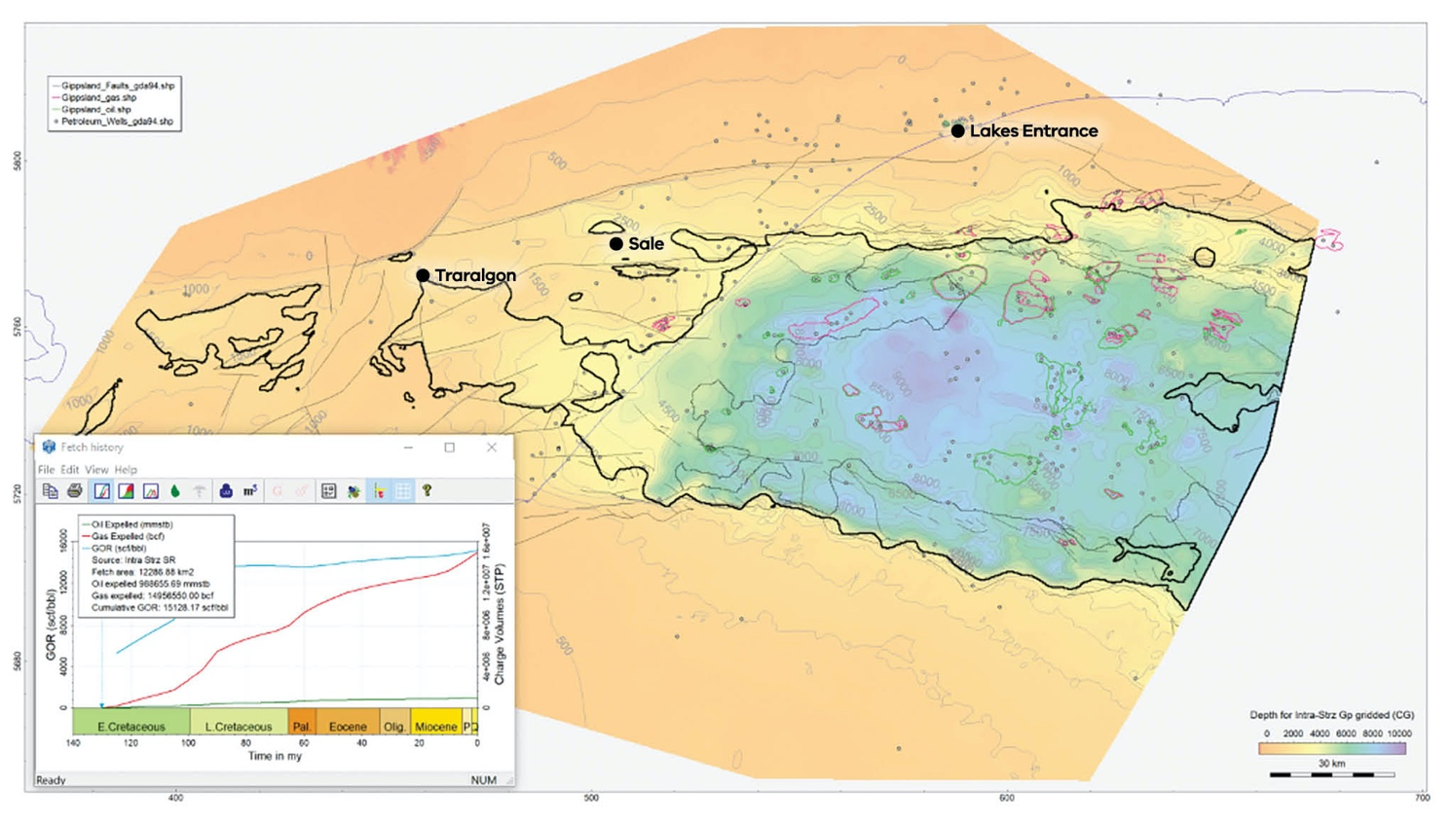
Figure 2.9 Intra-Strzelecki Group gas expulsion in the Gippsland Basin.
Migration mapping suggests that there are suitable pathways for gas to move from the offshore to the onshore areas and allows for good calibration with existing fields. This suggests that offshore generated hydrocarbons are an important input to the onshore prospectivity. Additionally, Strzelecki sourced hydrocarbons, particularly gas, have migrated to mapped structures onshore. These show good calibration with soil gas anomalies, indicating multiple potential leads for further investigation.

Onshore conventional gas prospectivity assessment and resource estimate for the Gippsland Basin
A prospectivity assessment and gas resource estimation were prepared for the Gippsland Basin. This process has involved compilation of data to produce a series of maps that categorise conventional gas prospectivity across the basin. The main objective of the prospectivity assessment was to produce a map that shows how resource prospectivity changes across the region to the margin of that area (i.e., to the point where there is no prospectivity). To begin the prospectivity assessment, Geological Survey of Victoria geoscientists have compiled source, seal, reservoir and trap data in a specialist GIS package. This task is being completed for seven potential plays across the Gippsland Basin.

Gippsland Basin prospectivity assessment
The Gippsland Basin prospectivity assessment has been conducted using the same methodology for the Otway Basin (see Section 2.1.2.1 for further information on the methodology).
Play mapping has focused on prospective reservoir-seal pairs in the Early Cretaceous to Oligocene aged Strzelecki and Latrobe groups (see Figure 2.7), with work being prioritised on those plays which have already been proved by the successful discovery of gas during previous drilling. The results from prior drilling were analysed as part of the workflow and used to create common probability maps for each play, which were then rendered as ‘traffic light’ maps. New GIS shape files were then created to show areas where prospectivity is proven (green), uncertain (yellow) or unlikely (red).
The prospectivity mapping has formed the basis for the hypothetical scenario mapping used in the risks, benefits and impacts assessment (see Figure 4.2 in Section 4.1.1).

Gippsland Basin resource estimation
The resource estimate for the Gippsland Basin is a prospective resource estimate as defined by the Petroleum Resources Management System (see Section 2.1.2.2). There are currently no reserves attributable to the onshore Gippsland Basin.
For the onshore Gippsland Basin, the low (P90) prospective resource estimate is 35 Bcf (38 PJ) and the high (P10) estimate is 105 Bcf (115 PJ). These values represent the prospective resource range that was used as the basis for the low to high scenarios in the risks, benefits and impacts assessment for the Gippsland Basin (see Table 4.2 for summary of hypothetical scenarios for the Gippsland Basin).

Environmental studies
The environmental studies project has improved our understanding of the current environmental conditions and potential impacts should onshore conventional gas development occur. Environmental studies have established a baseline reference of groundwater chemistry, atmospheric methane and stygofauna populations to improve their understanding of groundwater and methane throughout the Otway and Gippsland regions.
The data that has been collected is a valuable environmental reference point for Victoria. In parallel, the Geological Survey of Victoria assessed the potential impact that gas exploration and development may have on water resources by undertaking regional scale groundwater impact modelling.

Regional groundwater baseline assessments
Regional baseline assessments of groundwater chemistry, environmental isotopes, dissolved methane, and hydrocarbon occurrence have been completed in the Otway and Gippsland geological basins. In total, 103 groundwater samples (117 including duplicates) have been collected from Victorian Government State Observation Bore Network bores and town water supply wells across both basins and 144 analytes were analysed. These baseline assessments are the most comprehensive hydrochemical datasets collected in both geological basins by the Victorian Government to date. These datasets will improve understanding of groundwater conditions and processes. These regional datasets may also support regulation of the sector equipping government with a baseline that it can use to monitor and report on any industry impacts.

Otway groundwater baseline assessment
In the Otway Basin a total of 81 groundwater samples (88 including duplicates) have been collected from bores with depths ranging between 8 to 1500 metres (m). This is the first time detailed hydrochemical analyses have been collected from most of these bores. Generally, groundwater quality in the basin is good and there were no unexpected results for any of the Otway Basin groundwater samples.
Major ion chemistry analysis has shown that the groundwater quality in most samples collected is of good quality for irrigation and stock use, and variable quality for drinking water use. The groundwater in the Otway Basin generally falls into two groups; Na-Cl dominated (Group 1) and Na-Cl-HCO₃ dominated
(Group 2) (Figure 2.10). Evapotranspiration, carbonate-water rock interactions and distance along flow paths are the main variables impacting on the groundwater chemistry of the Otway Basin.
Figure 2.10 A plot showing the chemical composition of the groundwater in the Otway Basin.
Stable water isotopes have shown that surface water infiltration from rainfall is the main mechanism of replenishing the aquifers in the basin. The groundwater in the Otway Basin shows a trend of increasing age with depth, with radiocarbon age dating determining that the groundwater has an age range beginning from 30,000 years ago to the present day.
Methane occurs naturally in groundwater and is regarded as non-toxic (Bell et al., 2017; Rice et al., 2018). There is no authoritative health guidance for methane concentration in groundwater (ANZECC, 2000; Jacobs, 2015), or drinking water (NHRMC, 2011). There is an action level defined for methane concentration in domestic water bores (10 to 28 milligrams per litre – mg/L), which is not a groundwater contamination threshold, but rather an explosion safety mitigation level for the exsolving of methane into air in the enclosed spaces in domestic bores (Eltschlager et al., 2001).
Methane occurs in very low concentrations in Otway Basin groundwater with concentration measurements between <0.002 mg/L and 13 mg/L (Figure 2.11). Additional data, such as the isotopic composition of the methane and its relationship with ethane suggest that the methane is primarily biogenic in origin – i.e., it has been produced naturally by microbes eating organic matter in groundwater.
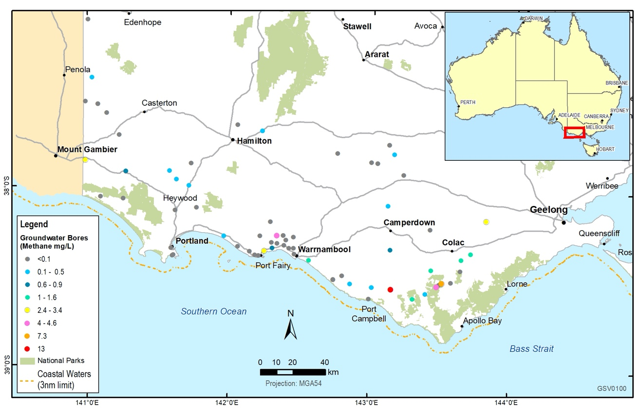
Figure 2.11 Distribution of methane (mg/L) for all groundwater samples collected in the Otway Basin.
The absence of thermogenic methane (i.e. natural gas) in the deep groundwater samples indicates that the geology provides a good seal for the basin (Figure 2.12). Very low concentrations of longer chain hydrocarbons and other petroleum by-products were detected in very few samples and are most likely the result of contamination during either bore construction or sampling.
Figure 2.12 A plot of the isotopic ratio of carbon in CH₄ (δ¹³C-CH₄) vs the isotopic ratio of hydrogen in CH₄ (δD-CH₄) in the Otway Basin, which enables a visualisation of the source of groundwater methane.
Source: Whiticar (1999).

Gippsland groundwater baseline assessment
In the Gippsland Basin, a total of 22 groundwater samples (29 including duplicates) have been collected from bores with a depth range of 15 m to 1100 m. Generally, groundwater quality in the basin is good and no unexpected results were obtained for any of the groundwater samples.
Major ion chemistry has shown that the groundwater comprises of primarily Na-Cl-type water (Figure 2.13).
It is of suitable quality for irrigation and stock use, and variable quality for drinking water use.
Figure 2.13 A plot showing the chemical composition of the groundwater in the Gippsland Basin (termed a ‘Piper plot’).
Evapotranspiration and groundwater mixing are the main controls on the groundwater chemistry of the Gippsland Basin. Stable water isotopes have revealed that surface infiltration from rainfall is the main mechanism of replenishing the aquifers in the basin. Groundwater age in the Gippsland Basin did not display any trend with depth, with radiocarbon age dating determining the groundwater is between 200 and approximately 25,000 years old.
Methane occurs in groundwater throughout much of the Gippsland Basin and generally increases with depth, with concentrations ranging from 0.0027 mg/L to 67 mg/L (Figure 2.14).
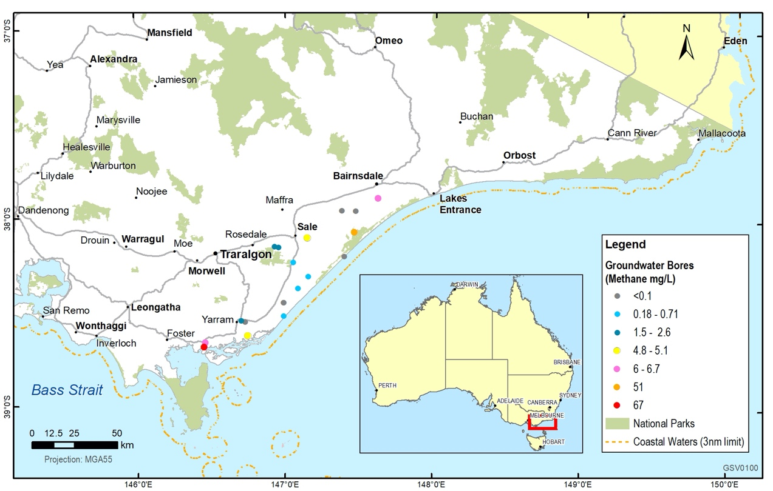
Figure 2.14 Distribution of methane (mg/L) for all groundwater samples collected in the Gippsland Basin.
Data suggests that most of the methane in the basin is biogenic. In some groundwater samples near the Gippsland coast, methane analysis suggests that there may be a thermogenic component in the methane (Figure 2.15). Consistent groundwater sampling would determine if there is any impact on the occurrence of groundwater methane with changing formation pressure (either from gas or groundwater extraction). Longer chain hydrocarbons and other petroleum by-products were detected in very low concentrations in many of the samples. Some of these occurrences can be attributed to contamination during either bore construction or sampling. However, there are two samples that suggest natural occurrence of these compounds in the groundwater.
Figure 2.15 A plot of the isotopic ratio of carbon in CH₄ (δ¹³C-CH₄) vs the isotopic ratio of hydrogen in CH₄ (δD-CH₄) in the Gippsland Basin, which enables a visualisation of the source of groundwater methane.
Source: Whiticar (1999).

Site scale impacts of legacy petroleum wells
Environmental impact investigations were conducted to assess the current and potential impacts of historical oil and gas drilling operations on groundwater and atmospheric conditions now and into the future. This investigation is the first of its kind undertaken in Victoria. The potential groundwater impact was considered in the Port Campbell Embayment (Otway Basin) and the Seaspray Depression (Gippsland Basin). Results found there is no evidence that the environment has altered as a result of these drilling activities over the past 100 years.
Atmospheric methane analysis was undertaken using Picarro atmospheric measurement equipment, the same equipment that was used to survey the regional methane concentration across the Otway and Gippsland basins in 2018 (refer to Section 2.3.1.2 in Progress Report 3 – Geological Survey of Victorian (2019) for further details on the Victorian Gas Program’s Air Quality Survey). In locations where historic drilling sites occur near roadsides, the atmospheric methane (and carbon dioxide) were assessed for any anomalies in methane levels compared to local and regional averages. It should be noted that not all historic drilling sites were investigated in the basins; only those located near the roadside were investigated.
There were very few groundwater monitoring bores located within 2 km of any historic drilling sites. Of the analysed bores, there is no evidence that drilling operations and abandonment practices, dating back to the 1920’s, have impacted groundwater chemistry of the nearby aquifers. However, the small number of groundwater observation bores near these sites limits the confidence in the conclusions that can be made.
Hypothetical assessment of the potential groundwater impact from an open void was undertaken to assist in identifying which factors should be considered in a risk assessment and the magnitude of the maximum impact. Factors that were assessed included:
- the maximum distance groundwater pressure change could occur
- the maximum volume of inter-aquifer transfer
- the change in groundwater salinity.

Onshore Otway Basin
Results in the Port Campbell area revealed that vertical groundwater flow within the Otway Basin moves towards the Dilwyn aquifer from the Port Campbell Limestone aquifer and the gas source rock. Any groundwater flow through an open void is dominated by groundwater from the Port Campbell Limestone aquifer. The scenario modelling found that the upward groundwater movement from the gas source rock (Waarre Formation) would account for two per cent of the total open void flux volume. Groundwater quality impacts were found to be concentrated within the Dilwyn aquifer and local in nature. The modelled impact of an open void on groundwater quality in the Dilwyn aquifer could be an increase in salinity of 0.05 mg/L per year over a 2.8 km impact radius until the void is closed. This compares with current salinity levels of 320 to 630 mg/L.

Onshore Gippsland Basin
Seaspray Depression was analysed, and the results revealed that groundwater pressure differences cause groundwater to flow towards the Latrobe aquifer from the Boisdale aquifer and the gas source rock. Scenario modelling of an open void found that groundwater from the Boisdale aquifer dominated the open void flow volume into the Latrobe Group Aquifer, whereas groundwater movement from the gas source rock accounts for only one per cent of the open void flux volume. Groundwater quantity impacts were found to be concentrated within the upper Boisdale aquifer and are local in nature. The maximum modelled impact of an open void in this aquifer could be a decline in head pressure of about 4 m and an impact area radius of 2 km. Likewise, groundwater quality impacts would be limited to the Latrobe aquifer and local in nature. The groundwater quality impact of the Latrobe aquifer could be an increase in salinity of 1.5 mg/L per year over a 1 km impact radius until the void is closed. This compares with a current salinity levels of 110 to 630 mg/L.

Regional groundwater impact assessments
Regional groundwater impact assessments have simulated the regional groundwater movement processes in both the on and offshore Gippsland and Otway basins. The investigations have modelled the potential magnitude of impact of onshore conventional gas development. As part of these investigations, existing groundwater processes and demands were considered, including:
- groundwater-surface water interaction
- groundwater recharge and evaporation
- groundwater pumping for irrigation, town, domestic and stock supplies
- groundwater depressurisation as a result of existing conventional gas industries.
The groundwater impact assessment models for both regions have been built using a stratigraphic framework which incorporates the 3D stratigraphic model developed as part of the geoscience studies (see Section 2.1.1.1) and the existing onshore hydrostratigraphic surfaces from the Victorian Aquifer Framework. The groundwater modelling used historic groundwater level measurements as a reference whereby the model was adjusted until the groundwater model closely matched historic groundwater level data. Hypothetical groundwater impact assessment scenarios were developed for the onshore and offshore components of the Gippsland and Otway basins (see Section 4.1.1) where prospective conventional gas areas have been interpreted to determine if there would be any impact on the environment and groundwater supply aquifers. These impact assessments simulated the regional groundwater movement processes in both basins to determine the potential impact that onshore conventional gas development may have.
Impact receptors considered were:
- volume removed from the nearest water resource aquifer (megalitres – ML)
- groundwater level drawdown greater than 5 m from the nearest water resource aquifer (hectares)
- volume impact on surface water receptors (ML/year)
- area of water table drawdown > 0.1 m (hectares)
- time to initial impact (years)
- time to maximum impact from initial impact (years)
- time to recover (years).

Otway groundwater impact assessment
Hypothetical development scenario areas were evaluated according to prospective gas development areas in the Otway Basin (Figure 2.16). Differing densities of gas development wells were considered, depending on the scenario (high – 125 wells; medium – 81 wells; low – 52 wells; and minimum case – 39 wells – see Table 4.1), with each distributed evenly across the scenario areas. These gas source locations are approximately 1 to 2 km below any groundwater supply aquifer. The scenarios assumed that each gas well started producing gas at the same time, rather than in a staged manner. Therefore, the estimated impact is at the maximum level possible.
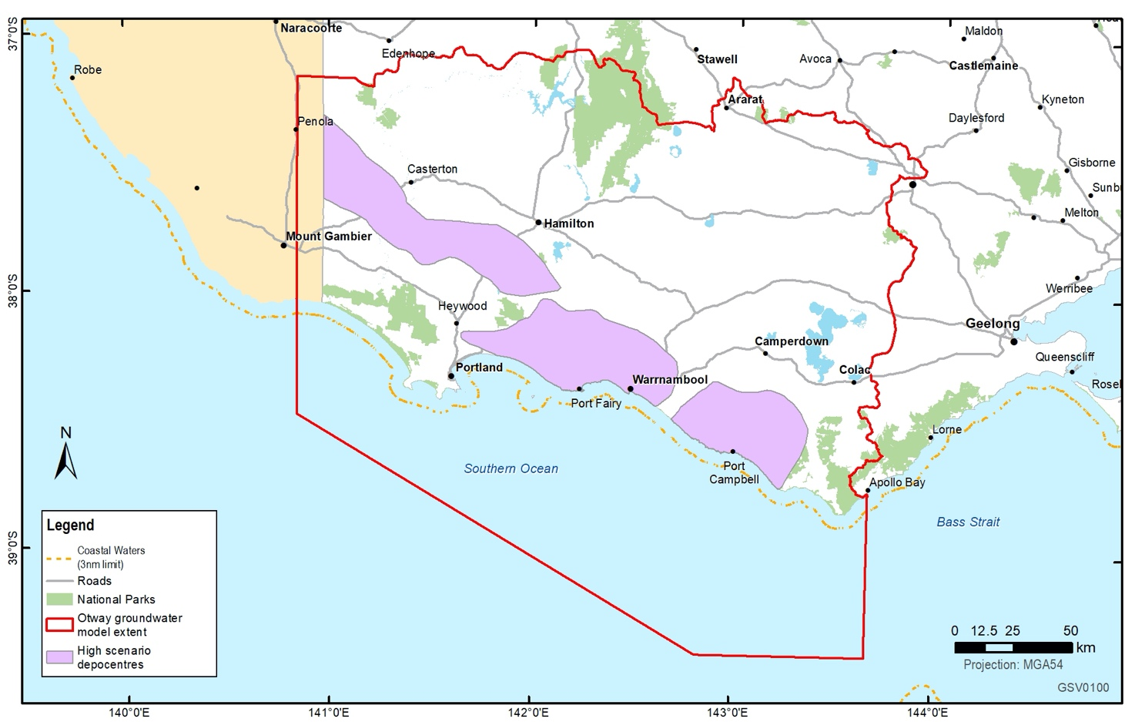
Figure 2.16 Area considered for environmental impact assessment associated with prospective gas development.
Model scenario results found that there was a very small impact on the overlying groundwater supply aquifer (Dilwyn Formation) and no impact to the environment. The impact scenarios, where all gas production wells became operational at the same time impacts were considered on groundwater resource. The results of these scenarios are presented in Table 2.4.
Metric | Impact based on scenario
Metric | Minimum case | Low | Medium | High
Volume removed from the nearest water resource aquifer (ML) | 81 | 294 | 433 | 660
Groundwater level drawdown greater than 5 m from the nearest water resource aquifer (hectares) | 0 | 0 | 0 | 0
Volume impact on surface water receptors (ML/year) | 0 | 0 | 0 | 0
Area of water table drawdown > 0.1 m (hectares) | 0 | 0 | 0 | 0
Time to initial impact (years) | 0 | 0 | 6 | 4
Time to maximum impact from initial (years) | 0 | 0 | 9 | 13
Time to recover (years) | 0 | 0 | 15 | 29

Source: (Hocking et al, 2020a)
No impact on the watertable, aquifer water quality or surface water flow was identified for all scenarios (Hocking et al, 2020a). Impacts were used to inform and assess the environmental receptors in the Otway Basin risks, benefits and impacts assessment (see Section 4.2 for assessment results).

Gippsland groundwater impact assessment
Hypothetical development scenario areas were evaluated according to prospective gas development areas in the Gippsland Basin (Figure 2.17) and analysed for potential impacts on the groundwater supply aquifer and the environment. In this case, seven individual gas development wells were considered in specific locations in the prospect area. In these locations, the prospective gas sources vary between 200 m to 2 km below groundwater resource aquifers. Three scenarios were considered:
- high – production to occur for seven and a half years
- medium – production to occur for five years
- low – production to occur for two and a half years.
Each scenario assumed all seven wells operated at the same time, rather than in a staged manner. Therefore, the estimated impact is at the maximum level possible.
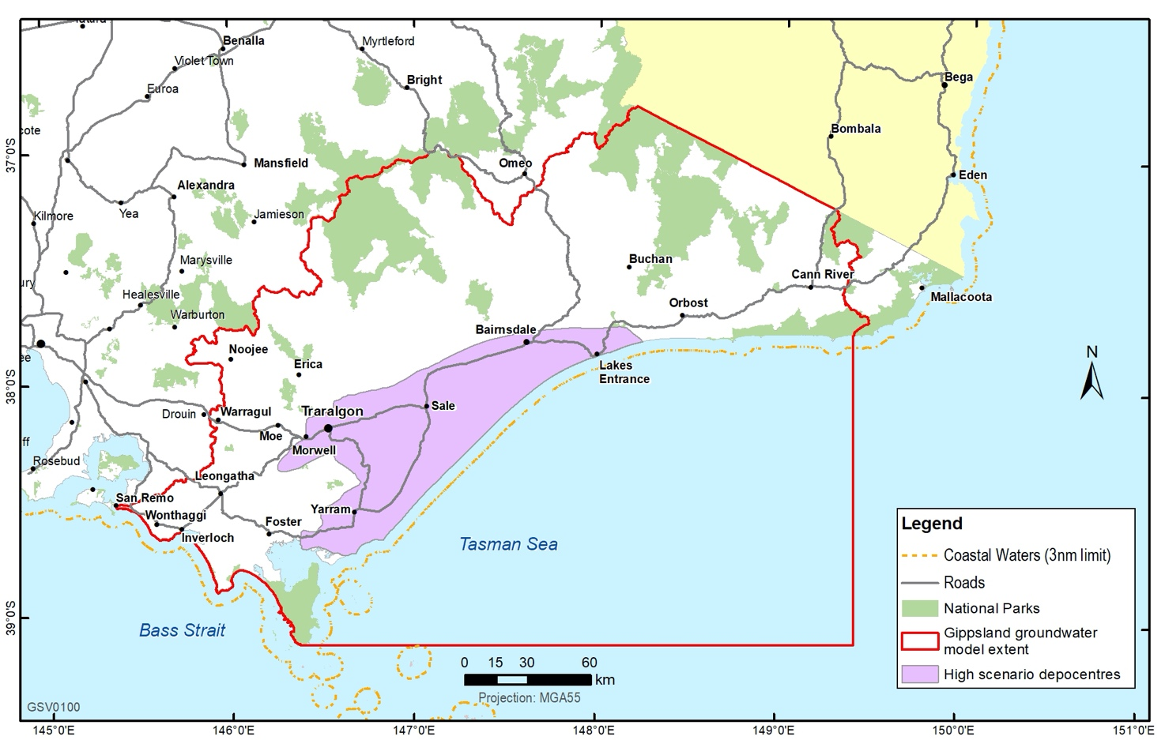
Figure 2.17 Area considered for environmental impact assessment associated with prospective gas development.
Model scenario results suggest there would be some groundwater level and volume impact on the overlying Latrobe Group Aquifer if any development scenarios were to occur. The ‘high’ development scenario predicted that around 800 ML per year for seven years would be removed from the overlying aquifer storage with approximately seven hectares of aquifer pressure lowered by more than 5 m. The total groundwater level recovery time for the ‘high’ scenario is predicted to be approximately 20 years. In contrast, the ‘low’ scenario predicted that approximately 450 ML per year for four years would be removed from the Latrobe Group Aquifer, also with seven hectares of aquifer water level drawdown greater than 5 m (Table 2.5).
Table 2.4 Estimated impact on ground and surface water under each Gippsland Basin hypothetical scenario
Metric | Impact based on scenario
Metric | Low | Medium | High
Total approx. volume removed from the nearest water resource aquifer (ML) | 450 | 600 | 800
Groundwater level drawdown greater than 5 m from the nearest water resource aquifer (hectares) | 7 | 7 | 7
Volume impact on surface water receptors (ML/year) | 0 | 0 | 0
Area of watertable drawdown > 0.1 m (hectares) | 0 | 0 | 0
Time to initial impact (years) | 2.5 | 3 | 3
Time to maximum impact from initial (years) | 2.5 | 3.5 | 3.5
Time to recover (years) | 9 | 14 | 18

Source: (Hocking et al, 2020a)
There was no impact identified on the watertable, aquifer water quality or surface water flow for all scenarios (Hocking et al, 2020).
These impacts were used to inform and assess the environmental receptors in the Gippsland Basin risks, benefits and impacts assessment (see Section 4.3).

Onshore conventional gas governance

Stakeholder Advisory Panel for Onshore Conventional Gas
Victoria’s Lead Scientist, Dr Amanda Caples, chairs the Stakeholder Advisory Panel for Onshore Conventional Gas. This panel meets quarterly and includes representatives from key sectors and groups, including farmers, industry, local government, environment and the community. The panel has provided the Minister for Resources with advice on the risks, benefits and impacts related to onshore conventional gas exploration and development during the moratorium, with particular attention paid to social, economic and environmental factors.
To date, the panel has formally met on ten occasions: 17 August 2017, 10 November 2017, 8 March 2018, 7 June 2018, 6 September 2018, 14 February 2019, 9 May 2019, 8 August 2019, 21 November 2019 and 13 February 2020.
The Stakeholder Advisory Panel provided oversight and feedback on the assessment of the risks, benefits and impacts (see Section 4 for assessment results). The Stakeholder Advisory Panel analysed the information provided in the assessment and concluded it is factual and objective in making an accurate representation in the Victorian context.
Communiques for these meetings are included as Appendix 1. The communiques are also available on the Lead Scientist’s web page: djpr.vic.gov.au/victorias-lead-scientist.

Victorian Gas Program Scientific Reference Group
Victoria’s Lead Scientist also chairs the Victorian Gas Program Scientific Reference Group. This group provides independent peer review advice to the Lead Scientist on the study scope and outputs of the program.
Members with relevant expertise review Victorian Gas Program activities related to their field of study on an ‘as required’ basis to ensure that scientific and technical outputs are robust. Most recently, the Scientific Reference Group provided peer review input and advice on the final outputs of the risks, benefits and impacts assessment to ensure its robustness (see Section 4 for assessment results). The Scientific Reference Group advised that the assessment had been undertaken with strong technical rigour and is suitable for informing government in its decision making.
The Scientific Reference Group meets formally when required.

Supporting program components

Community engagement
The stakeholder and community engagement program is delivered alongside the scientific components of the Victorian Gas Program to keep community and industry leaders and the public informed. Engagement is focused on the communities closest to the Otway and Gippsland basins and aims to:
- inform and educate stakeholders, local communities and the public about the Victorian Gas Program and its scientific findings
- build the capacity of stakeholders and communities to offer informed input
- build trust and strengthen relationships
- enable the community to have a voice throughout the Victorian Gas Program.
Over the last two years, the program has engaged with more than 810 people across south west Victoria, Melbourne and Gippsland, via more than 665 events (including briefings, meetings, forums, emails and telephone calls). Stakeholders are diverse and include:
- farmers
- environmental groups
- local and state governments
- community members
- traditional owners
- business and industry
- water authorities.
Activities are catalogued in the Victorian Gas Program stakeholder engagement database and matters raised are recorded. This database is updated regularly and people on the database are communicated to frequently as the program progresses.
The Geological Survey of Victoria also commissioned the Commonwealth Scientific and Industrial Research Organisation (CSIRO) to establish a social baseline in the Otway and Gippsland basins to provide evidence to support the social factors assessed in the risks, benefits and impacts assessment (see Section 4).

Social baseline assessment
Quantitative research was undertaken between June and December 2019 to provide a statistically robust understanding of community wellbeing and regional attitudes to onshore conventional gas development in the Otway and Gippsland basins.

Methodology
CSIRO conducted a telephone survey between September and October 2019 of a randomly selected and representative sample of 801 residents – 501 in the Otway Basin and 300 in the Gippsland Basin.
The survey comprised more than 160 questions designed to measure residents’ perceptions of community wellbeing, as well as local attitudes towards onshore conventional gas. The survey also measured residents’ views about a range of factors that are important to communities in relation to onshore conventional gas development.
The survey work is now complete. Results indicate that there are a range of views about onshore conventional gas and that these views also vary across the basins. About 80 per cent of residents across both regions would tolerate or support further gas development, while 20 per cent would reject it. Results also indicate that local communities would be more supportive of a conventional gas industry when:
- they are engaged early and openly by industry
- governance is effective and transparent
- regulation is strong
- they have confidence that their communities would be treated fairly.
The findings of the assessment are summarised in the next sections.

Social baseline data for South-West Victoria

Attitudes and perceptions regarding onshore conventional gas development
Across South-West Victoria, 79 per cent of people indicated they would tolerate, be ok with, approve, or embrace onshore conventional gas development in the region (Figure 3.1).
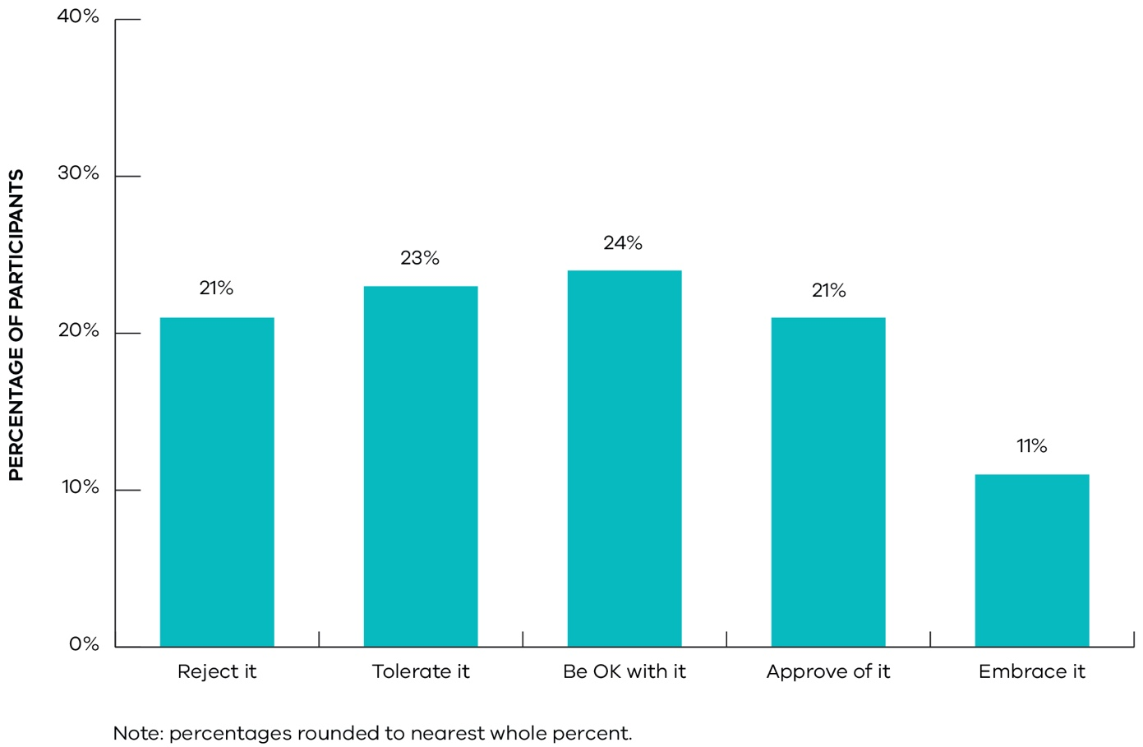
Figure 3.1 Attitudes towards onshore conventional gas development in the Otway Basin: total South-West region 2019.
Subregional differences in attitudes towards onshore conventional gas development were apparent. There were also differences between farm owners and non-farm owners, with farm owners holding more negative views than people who did not own a farm.

Adapting to onshore conventional gas development
Fifty-nine per cent of residents in South-West Victoria thought their community would adapt or change into something better in response to onshore conventional gas development (Figure 3.2).
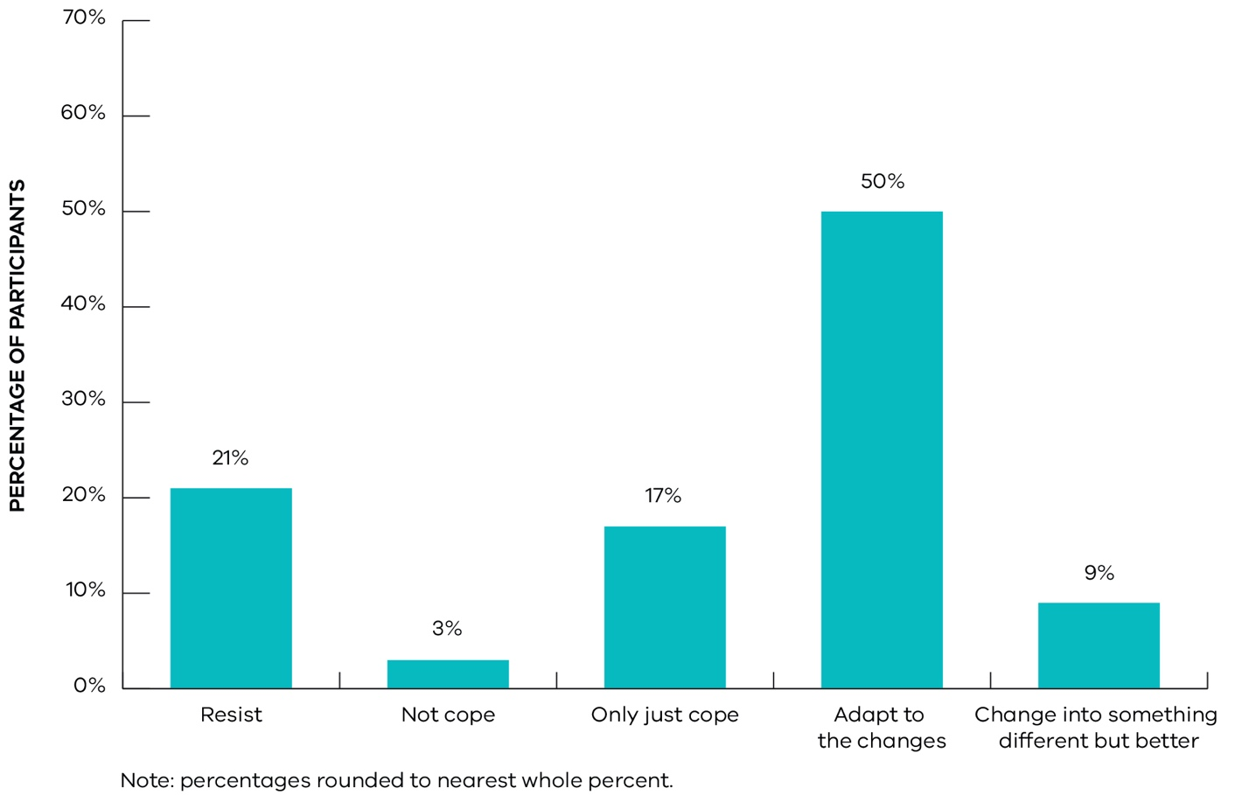
Figure 3.2 Perceptions of community adapting to onshore gas development: South-West region, 2019.

Perceptions of underlying drivers of social acceptance
The survey also examined issues that were important to communities and that underpin people’s overall attitudes towards onshore conventional gas development. Questions measured perceptions of risk, information needs, views about the government’s handling of onshore conventional gas development and the role of gas in the energy mix.
In South-West Victoria, a number of underlying drivers influence people’s perceptions (Figure 3.3):
- Concerns about overall impacts overall were moderate (M = 3.17), with similar levels of concern between immediate issues (e.g., impacts on water and the community) and more future oriented concerns (e.g., the integrity of gas wells over time).
- People perceived the severity of risks to be moderate (M = 3.28) and only had modest confidence that risks could be managed (M = 3.13).
- Potential benefits from onshore gas development were perceived favourably (M = 3.38). Residents viewed local benefits and wider regional and societal benefits similarly.
- Distributional fairness scores were also moderately good (M = 3.57), indicating that people, on average, thought it fair under the condition that landowners were compensated fairly and that the benefits outweighed the impacts.
- Perceptions of trust in gas companies were limited on average across the SW region (M = 2.61). Views regarding how a gas company would treat locals (relationship quality and procedural fairness) were unfavourable, indicating low expectations that the community would be treated fairly or that gas companies would be genuine in their interactions.
- Perceptions of governance and confidence in government to hold companies to account through regulation were marginal (M = 2.92). Similarly, expectations that government would engage with communities about gas were borderline with limited trust in government and the ability of communities, gas companies, local councils and state government to collaboratively work together to solve issues.
- Knowledge levels about onshore conventional gas development and an understanding of the differences between conventional and unconventional gas was limited (M = 2.85) with people indicating a need for more information (M = 3.57).
- People had a favourable view of the government’s processes for dealing with onshore conventional gas development in terms of the moratorium and undertaking the science first (M = 3.31). People also indicated they had a positive view on average about the broader role of gas in the future energy mix (M = 3.37).
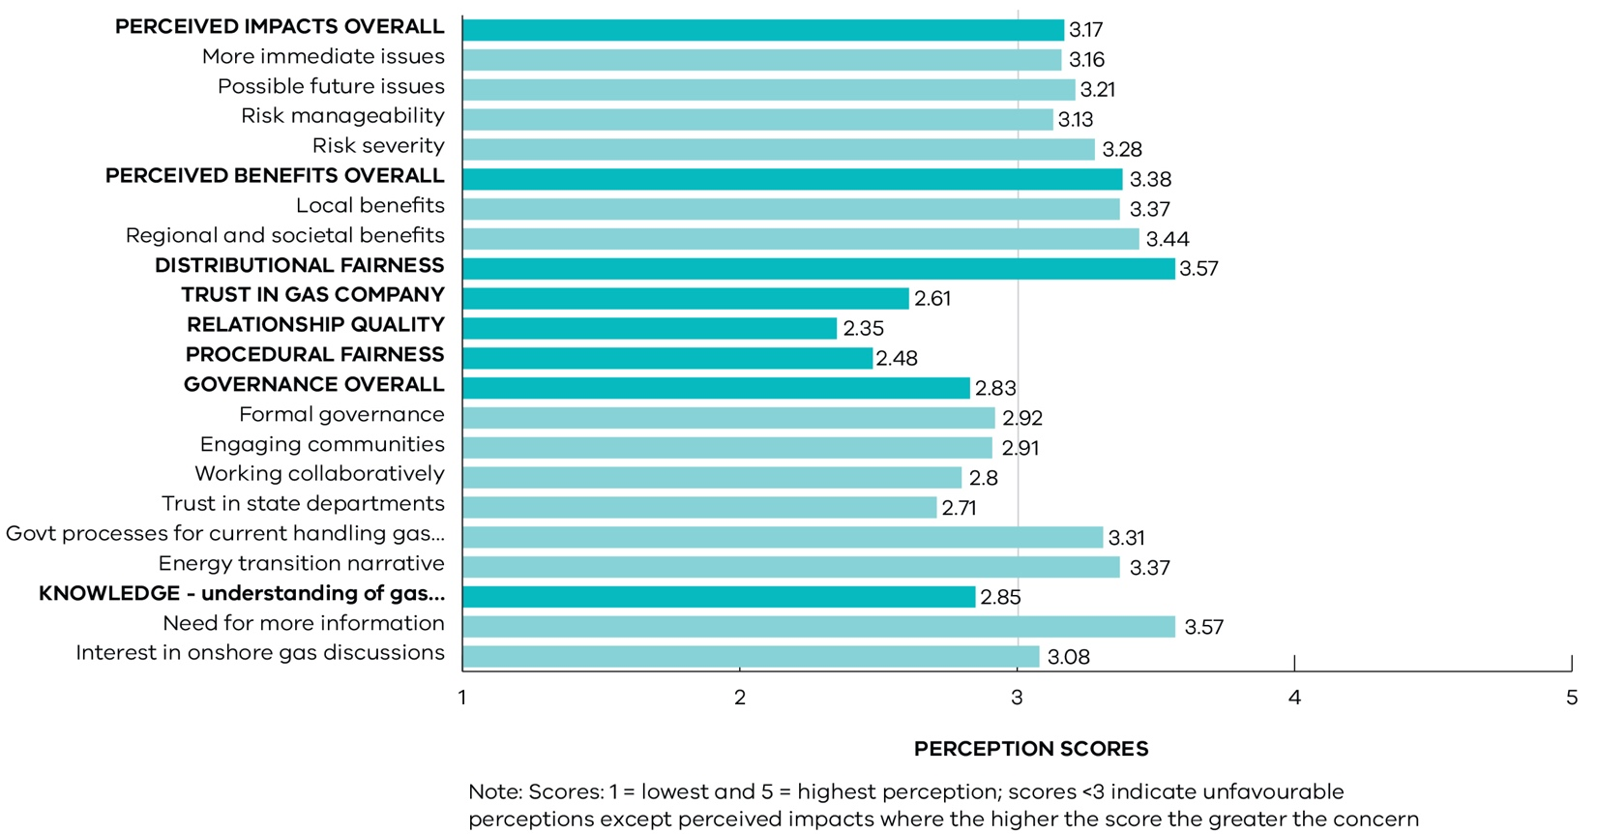
Figure 3.3 Figure 3.3 Perceptions about onshore conventional gas development: summary underlying drivers, South-West region, 2019.

Social baseline data for Gippsland

Attitudes and perceptions regarding conventional gas development
Across the Gippsland region, 84 per cent of people indicated they would tolerate, be ok with, approve, or embrace onshore conventional gas development in the region (Figure 3.4).
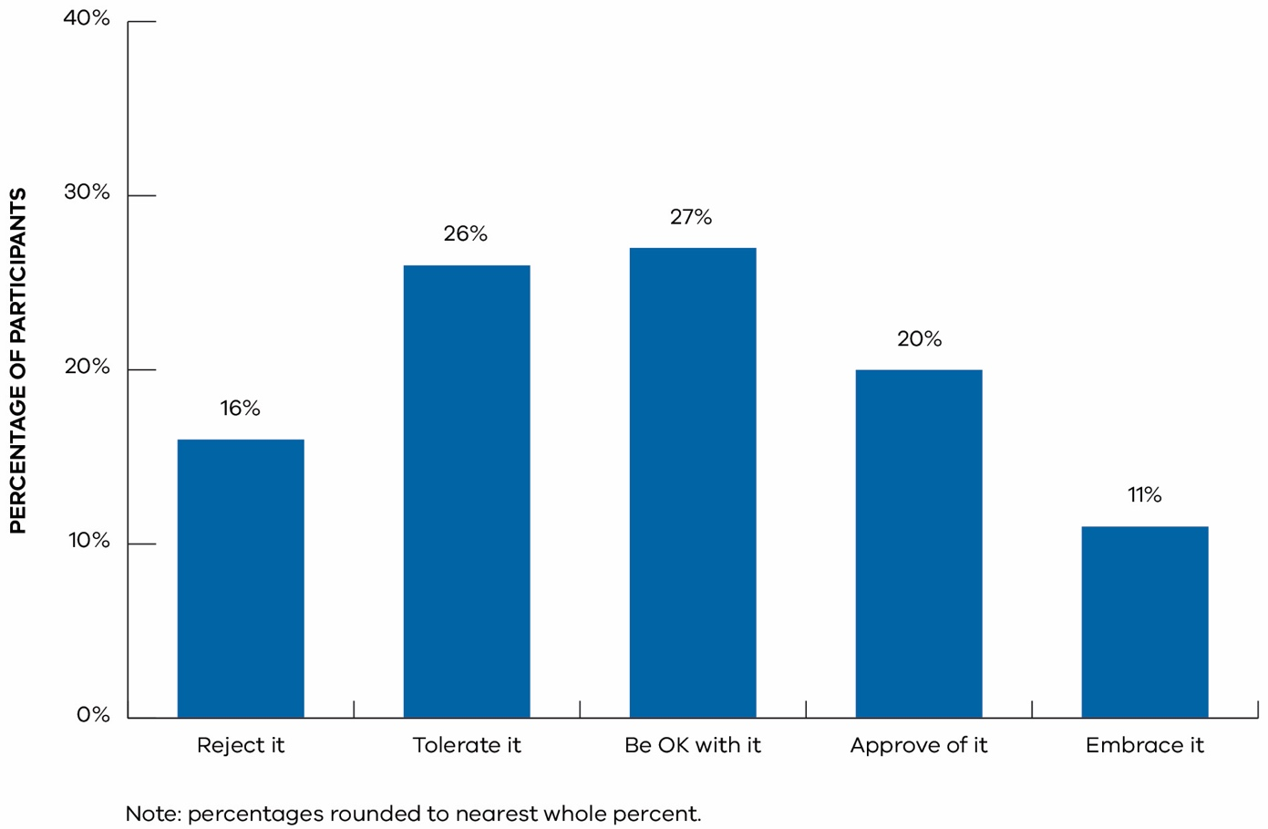
Figure 3.4 Attitudes towards onshore conventional gas development in the Gippsland Basin – total Gippsland Basin, 2019.
Attitudes towards onshore conventional gas development were similar across the Gippsland Basin. There were also differences in attitudes between farm owners and non-farm owners, with the percentage of farm owners who reject gas development (33 per cent) almost three times that of non-farm owners (12 per cent).

Adapting to onshore conventional gas development
Sixty-five per cent of residents in the Gippsland region thought their community would adapt or change into something better in response to onshore conventional gas development (Figure 3.5).
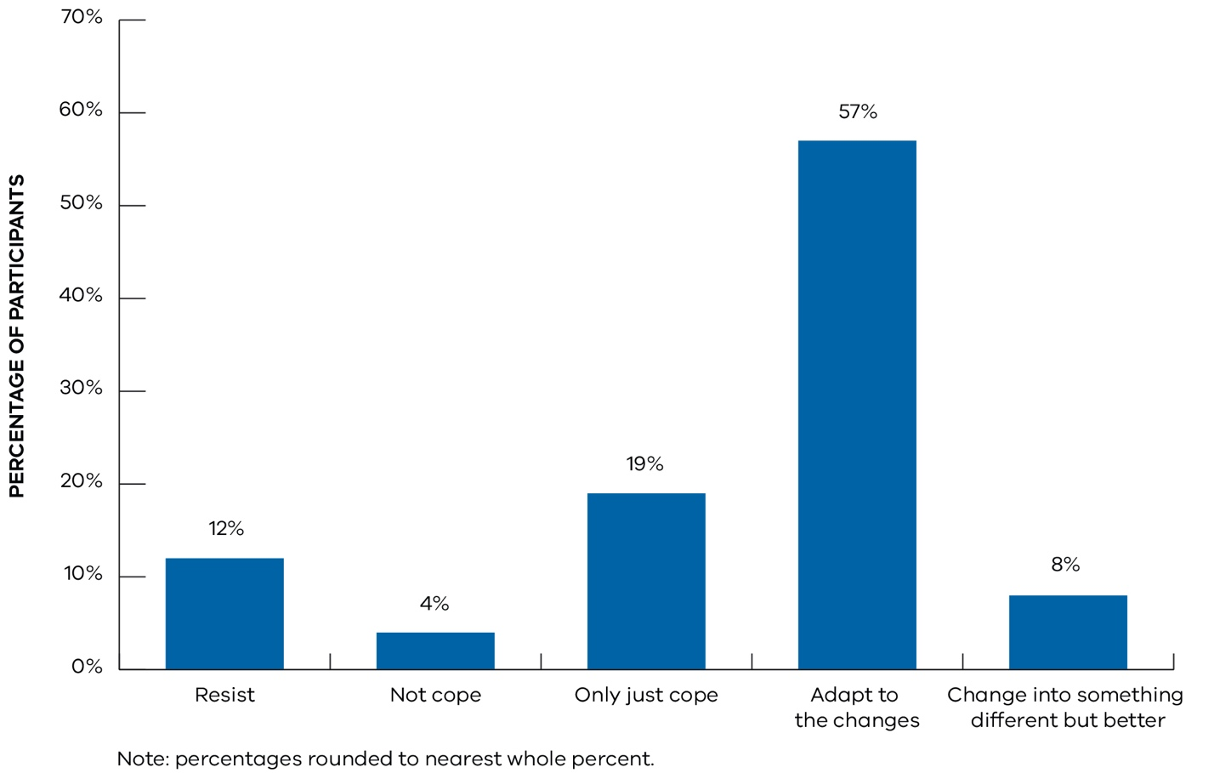
Figure 3.5 Perceptions of community adapting to onshore gas development – Gippsland region, 2019.

Perceptions of underlying drivers of social acceptance
The survey examined issues that were important to communities and that underpin people’s overall attitudes towards onshore conventional gas development. Questions measured perceptions of risk, need for information, views about the government’s handling of onshore conventional gas development and the role of gas in the energy mix.
In Gippsland, a number of underlying drivers influence people’s perceptions (Figure 3.6):
- Concerns about overall impacts were moderate (M = 3.26) with similar levels of concern between immediate issues (e.g., impacts on water and the community) and future oriented concerns (e.g., the integrity of gas wells over time).
- People perceived the severity of risks to be moderate (M = 3.41) and only had modest confidence that risks could be managed (M = 3.16).
- Potential benefits from onshore conventional gas development were perceived favourably (M = 3.45). Residents viewed local benefits and wider regional and societal benefits similarly.
- Distributional fairness scores were also moderately good (M = 3.58), indicating that people, on average, thought it fair under the condition that landowners were compensated fairly and that the benefits outweighed the impacts.
- Perceptions of trust in gas companies were limited (M = 2.56). Views regarding how a gas company would treat locals (relationship quality and procedural fairness) were unfavourable, indicating low expectations that the community would be treated fairly or that gas companies would be genuine in their interactions.
- Perceptions of governance and confidence in government to hold companies to account through formal governance like legislation and regulation was marginal (M = 2.94). Similarly, expectations that government would engage with communities about gas was borderline and confidence in their ability to work together with communities and gas companies to solve issues was limited, with trust in state government departments and agencies overseeing onshore conventional gas development being relatively low.
- On the other hand, people had a modestly positive view of the government’s processes for dealing with onshore conventional gas development in terms of the moratorium and undertaking the science first (M = 3.13). People also indicated they had a positive view on average about the broader role of gas in the future energy mix (M = 3.25).
- Knowledge levels about onshore conventional gas development and an understanding of the differences between conventional and unconventional gas was limited (M = 2.62) with people indicating a need for more information (M = 3.59).
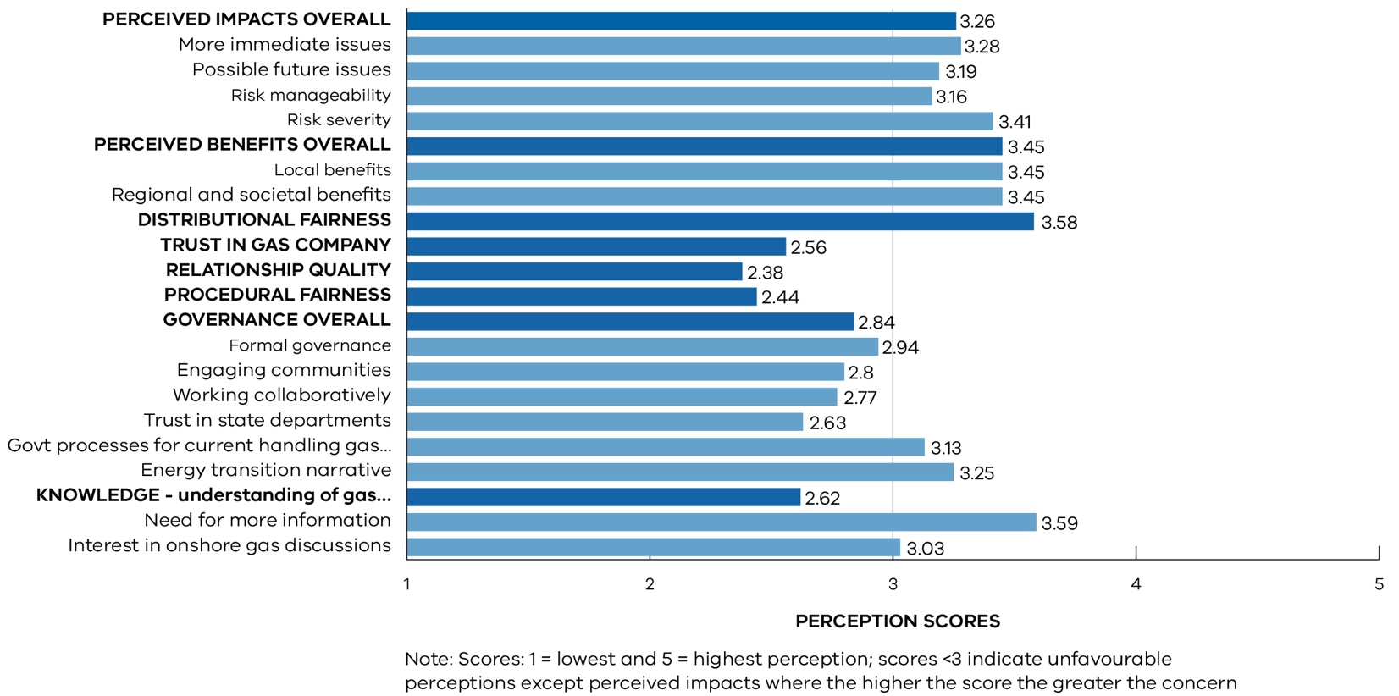
Figure 3.6 Perceptions about onshore conventional gas development: summary underlying drivers, Gippsland region, 2019.

Resource and land use planning
A strategic land assessment of the South-West region has been undertaken as part of the Victorian Gas Program’s scientific research into the risks, benefits and impacts of onshore conventional gas. This will ensure that any future onshore conventional gas development has information appropriate to the local context.
The Resource and Land Use Planning Project used a multi-criteria analysis methodology to consider existing land uses and landscape features across the Otway and Gippsland basins, with a clear understanding of community views in order to adopt the best land use options. As a primary deliverable, resource and land use planning models were developed for the Otway and Gippsland basins.
The models provide a high-level regional assessment of the land within the Otway and Gippsland basins in relation to suitability for the potential for coexistence with any onshore conventional gas development. The model takes into account the suite of potential impacts that conventional gas development may have on the natural and socio-economic environment and integrates them into high-level spatial analysis of land use suitability.
Over 140 spatial data layers have been collated to map the Otway and Gippsland basins’ unique natural, cultural, environmental, and social land uses to build a land use inventory. Seven land use themes were assessed including environmental value, climate change vulnerability, topography, heritage value, social value, infrastructure, and regional significance. These were used to better understand the sensitivities and significant values across the Otway Basin.
Most datasets used in the analysis were sourced authoritative data, which is data obtained from state and federal government agencies and cover the whole of Victoria. Overlaying this information is a scoring framework to identify potential locations where the land may be constrained and, therefore, impact the potential for development of onshore conventional gas.
If land is scored as being constrained, this means that:
- there are features of sensitivity or significance that would need to be considered and addressed prior to any development proceeding or
- resource development may not be appropriate in the context of local land values and/or features.
Combining this data, a model was produced that provides visualisation of areas of significance and sensitivity and captures existing and future land uses and landscape sensitivities in the basins to be considered prior to development.
The outputs are regional constraint maps which demonstrate constraints and opportunities for the potential for multi and sequential land use.
The models identified areas where features of sensitivity or significance exist that would need to be considered and addressed prior to any exploration or development proceeding.
This is a useful assessment that could be undertaken in conjunction with the licencing and approvals process to ensure that any issues are addressed and acknowledged as part of any early approval stages to mitigate land use conflicts and promote multi and sequential use. These datasets would also support government in understanding potential interactions with other land uses during any potential future acreage releases and impact assessments.
These models have informed the social and environmental factors assessed as part of the risks, benefits, and impacts assessment (see Section 4).

Otway Basin resource and land use planning model

Otway Basin preliminary model
A resource and land use planning model has been developed for the Otway Basin. Once the preliminary model was developed, the model and methodology were tested with key staff from local government planning teams, the Stakeholder Advisory Panel and local officers of state government agencies, to ensure all relevant data and was captured.

Consultation and workshops in South-West Victoria
The engagement program was delivered during October and November 2019, targeting key government agencies and stakeholders, subject matter experts and South-West region residents. It was designed to test methodology assumptions and capture local issues, values and insights.
Three stakeholder workshops and seven community workshops were held across South-West Victoria (Port Campbell, Warrnambool, Port Fairy, Penshurst, Portland, Camperdown and Casterton), inviting residents and other participants to share local knowledge and ensure the final model reflects local values. The workshops were supported by a newspaper advertising campaign and a range of communication materials were also prepared including a fact sheet and online frequently asked questions. A total of 150 people attended the workshops.
Common themes from the workshops include food security and protection of agricultural land, environmental risks, particularly to water supplies, gas markets and domestic gas reservation policies and how searching for new fossil fuels fits in a climate change context.
The findings from the engagement informed an updated framework and model. Stakeholder feedback resulted in a number of additional datasets being added to the preliminary model, such as additional sites of economic and social value not captured in existing data. This included a new tourism development, and residential growth area boundaries. The scoring framework was also further refined in relation to agricultural land and to extend buffer distances around roosting sites for Bent Wing Bats across the South-West coast.

Final Otway Basin model
The model (Figure 3.7) indicates that there are no areas without any constraints in the Otway Basin. Therefore, all areas require appropriate planning and management if development were to take place.
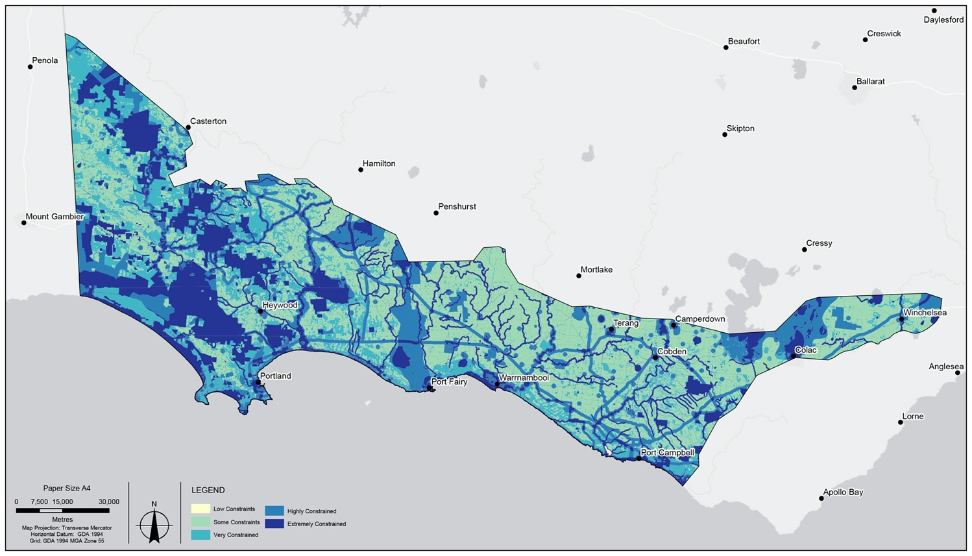
Figure 3.7 Otway Basin – Final resource and land use planning model
In addition to the areas currently prohibited and restricted through existing legislation, further highly constrained areas have been identified through this process.
Areas and/or features identified in the model as highly constrained include:
- areas already prohibited and restricted through existing legislation
- areas within and surrounding townships and residential zones
- areas along rivers and near water bodies and coastal areas
- vegetation, habitat or species of environmental importance
- cultural heritage or landscape values of significance
- areas with exposure to natural or environmental hazards such as fire, flood or other
- other current or potential land use conflicts and constraints identified through the resource and land use planning model as having environmental, cultural, economic, and/or social significance.
The model is dynamic in nature and can be built on and reanalysed as required. Any potential future onshore conventional gas exploration and development can be informed by the information appropriate to the local context.

Gippsland resource and land use planning model

Gippsland Basin
The Gippsland Basin in eastern Victoria is home to areas of distinctive rural and coastal landscapes, productive agricultural land, and environments with significant biodiversity value. To date, the Gippsland resource and land use planning model has been developed by collecting authoritative datasets to map the region’s unique natural, built and heritage features.

Preliminary Gippsland model
The preliminary Gippsland model (Figure 3.8) and indicates that there are no areas without any constraints in the Gippsland Basin. Therefore, all areas require appropriate planning and management if development was to occur.
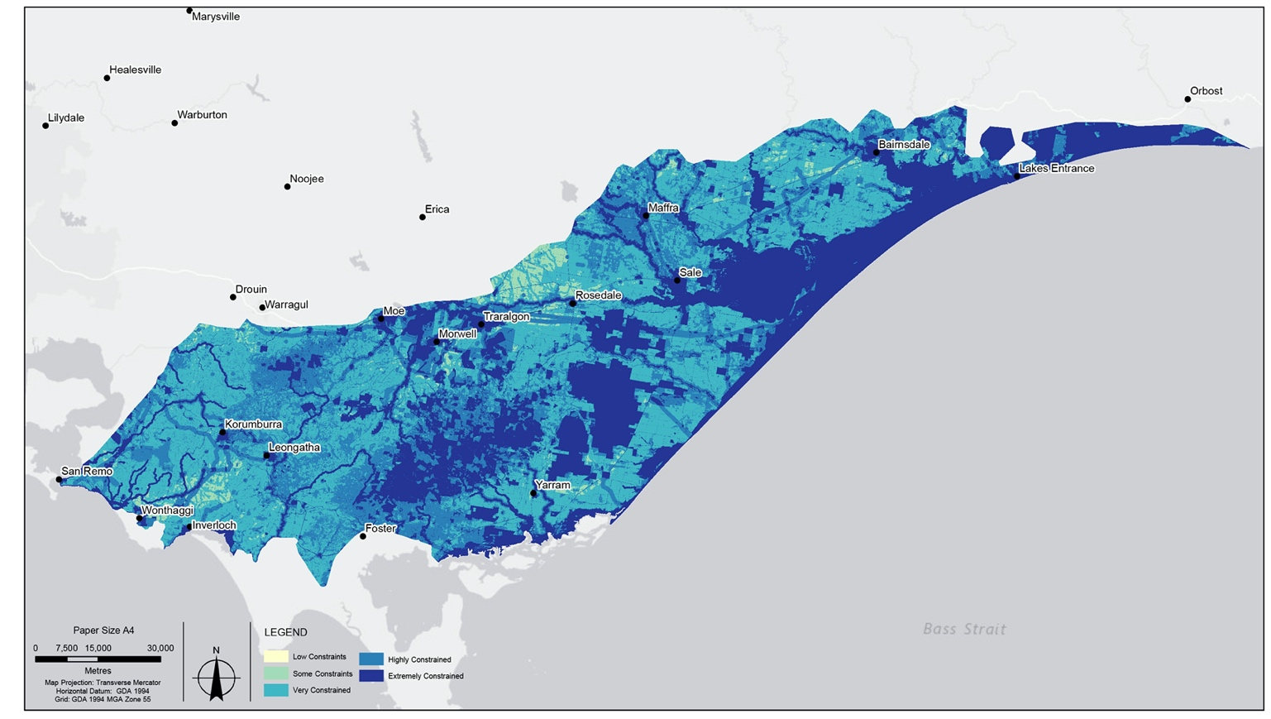
Figure 3.8 Gippsland Basin – Preliminary resource and land use planning model.

Consultation and workshops
The preliminary model for the Gippsland Basin is being tested with key staff from local government and other government authorities within Gippsland.
A Gippsland stakeholder workshop was held in Traralgon in March 2020. Community workshops are scheduled to take place in April 2020 to seek feedback and input into the preliminary model and associated framework.
On completion of the community workshops, the preliminary model will be updated and a Gippsland Basin findings report will be published.

Tying it all together: Risks, benefits and impacts assessment for onshore conventional gas

Methodology
Ernst & Young was commissioned to provide an assessment and report on the risks, benefits and impacts of development scenarios for potential new onshore conventional gas exploration and development in Victoria.
The scope of the report covers the following petroleum activities:
- exploration – includes seismic surveys, geotechnical surveys and exploration/appraisal drilling
- development – includes wellhead installation, pipeline construction and gas plant expansion/construction
- operations – includes production from the well via a pipeline to a gas plant, and trucking of condensate to refineries (which may also be required)
- rehabilitation (or transitional rehabilitation) – includes returning some of the land to its former use (e.g. reducing a drilling lease to an operating well lease)
- complete rehabilitation – includes removing infrastructure and returning the land to its former use or other agreed use (as required under the Petroleum Act 1998).
The assessment represents the culmination and synthesis of the Victorian Gas Program’s reviews and studies, which have been supplemented by Ernst & Young’s economic and greenhouse gas analysis and publicly available information. Throughout each stage of the assessment, engagement and feedback was sought from Victoria’s Lead Scientist, the Victorian Gas Program’s independent Stakeholder Advisory Panel for Onshore Conventional Gas and the Scientific Reference Group.

Hypothetical scenarios
Hypothetical scenarios were constructed to assess the potential impact of gas exploration and development in Western Victoria (the Otway Basin), and in South-Eastern Victoria (the Gippsland Basin).
For each basin, low, medium and high levels of hypothetical gas exploration and development were considered, with the inclusion of a minimum case for the Otway Basin. The hypothetical scenarios are based on prospectivity assessments conducted by the Victorian Gas Program (see Sections 2.1.2.1 and 2.2.2.1 for further information on the Otway and Gippsland prospectivity assessments). The Otway Basin has an additional ‘minimum case’ scenario that reflects the quantity of gas that was discovered and produced in the Port Campbell area in the past. A ‘minimum case’ scenario has not been prepared for the Gippsland Basin because there has never been any commercial onshore gas production and the level of knowledge of resources is much less.
For the Otway Basin hypothetical scenarios (minimum, low, medium, high), the number of exploration wells drilled, resultant discoveries and resource size increases through each of the scenarios (Table 4.1).
Table 4.1 Otway Basin summary of hypothetical gas exploration and development scenarios.
# | Scenario | Description
1 | Otway Basin (minimum case) | - Total estimated discovered resources of 81 Bcf (90 PJ)  - Discoveries in the following reservoir rock units: upper Waarre Formation, Pretty Hill Formation and the Sawpit Sandstone  - Exploration and development in the Eastern Region (Port Campbell Embayment) and Western Region (Penola Trough)  - Eighteen (18) exploration wells resulting in six discoveries; 14 development wells are required, inclusive of the six discovery wells  - Gas discovered in the Port Campbell Embayment is processed using existing facilities and gas discovered in the Penola Trough requires one new processing plant (either full-scale or modular).
2 | Otway Basin (Low) | - Total estimated discovered resources of 294 Bcf (317 PJ)  - Discoveries in all seven reservoir rock units: Flaxman Formation, lower and upper Waarre Formation, Heathfield Sandstone, Windermere Sandstone, Pretty Hill Formation and Sawpit Sandstone  - Exploration and development in the Eastern Region (Port Campbell Embayment), Western Region (Penola Trough) and Central Region  - Fifty-four (54) exploration wells resulting in 18 discoveries; 52 development wells are required, inclusive of the 18 discovery wells  - Gas discovered in the Port Campbell Embayment is processed using existing facilities and/or a new modular plant; a new modular plant is required for the Central Region; gas discovered in the Penola Trough requires one new full-scale processing plant.
3 | Otway Basin (Medium) | - Total estimated discovered resources of 434 Bcf (470 PJ)  - Discoveries in all seven reservoir rock units: Flaxman Formation, lower and upper Waarre Formation, Heathfield Sandstone, Windermere Sandstone, Pretty Hill Formation and Sawpit Sandstone  - Exploration and development in the Eastern Region (Port Campbell Embayment), Western Region (Penola Trough) and Central Region  - Eighty-one (81) exploration wells resulting in 27 discoveries; 81 development wells are required, inclusive of the 27 discovery wells  - Gas discovered in the Port Campbell Embayment is processed using existing facilities and/or a new modular plant; a new modular plant is required for the Central Region; gas discovered in the Penola Trough requires one new full-scale processing plant.
4 | Otway Basin (High) | - Total estimated discovered resources of 660 Bcf (715 PJ)  - Discoveries in all seven reservoir rock units: Flaxman Formation, lower and upper Waarre Formation, Heathfield Sandstone, Windermere Sandstone, Pretty Hill Formation and Sawpit Sandstone  - Exploration and development across the Victorian Otway Basin from the Eastern Region (Port Campbell Embayment) to the Western Region (Penola Trough) including the Central Region  - One hundred and thirty-eight (138) exploration wells resulting in 46 discoveries; 125 development wells are required, inclusive of the 46 discovery wells  - Gas discovered in the Port Campbell Embayment is processed using existing facilities and/or a new modular plant; a new modular plant is required for the Central Region; gas discovered in the Penola Trough requires one new full-scale processing plant, with potential for an additional modular plant.

As an example, in the Otway Basin high hypothetical scenario, there is a greater level of exploration and development in the Port Campbell Embayment (Eastern Region), Penola Trough and the area to the southeast (Western Region), and Central Region (e.g. the Tyrendarra Embayment, Windermere and Warrong troughs – see Figure 4.1).
# | Scenario | Description
1 | Otway Basin (minimum case) | - Total estimated discovered resources of 81 Bcf (90 PJ)  - Discoveries in the following reservoir rock units: upper Waarre Formation, Pretty Hill Formation and the Sawpit Sandstone  - Exploration and development in the Eastern Region (Port Campbell Embayment) and Western Region (Penola Trough)  - Eighteen (18) exploration wells resulting in six discoveries; 14 development wells are required, inclusive of the six discovery wells  - Gas discovered in the Port Campbell Embayment is processed using existing facilities and gas discovered in the Penola Trough requires one new processing plant (either full-scale or modular).
2 | Otway Basin (Low) | - Total estimated discovered resources of 294 Bcf (317 PJ)  - Discoveries in all seven reservoir rock units: Flaxman Formation, lower and upper Waarre Formation, Heathfield Sandstone, Windermere Sandstone, Pretty Hill Formation and Sawpit Sandstone  - Exploration and development in the Eastern Region (Port Campbell Embayment), Western Region (Penola Trough) and Central Region  - Fifty-four (54) exploration wells resulting in 18 discoveries; 52 development wells are required, inclusive of the 18 discovery wells  - Gas discovered in the Port Campbell Embayment is processed using existing facilities and/or a new modular plant; a new modular plant is required for the Central Region; gas discovered in the Penola Trough requires one new full-scale processing plant.
3 | Otway Basin (Medium) | - Total estimated discovered resources of 434 Bcf (470 PJ)  - Discoveries in all seven reservoir rock units: Flaxman Formation, lower and upper Waarre Formation, Heathfield Sandstone, Windermere Sandstone, Pretty Hill Formation and Sawpit Sandstone  - Exploration and development in the Eastern Region (Port Campbell Embayment), Western Region (Penola Trough) and Central Region  - Eighty-one (81) exploration wells resulting in 27 discoveries; 81 development wells are required, inclusive of the 27 discovery wells  - Gas discovered in the Port Campbell Embayment is processed using existing facilities and/or a new modular plant; a new modular plant is required for the Central Region; gas discovered in the Penola Trough requires one new full-scale processing plant.
4 | Otway Basin (High) | - Total estimated discovered resources of 660 Bcf (715 PJ)  - Discoveries in all seven reservoir rock units: Flaxman Formation, lower and upper Waarre Formation, Heathfield Sandstone, Windermere Sandstone, Pretty Hill Formation and Sawpit Sandstone  - Exploration and development across the Victorian Otway Basin from the Eastern Region (Port Campbell Embayment) to the Western Region (Penola Trough) including the Central Region  - One hundred and thirty-eight (138) exploration wells resulting in 46 discoveries; 125 development wells are required, inclusive of the 46 discovery wells  - Gas discovered in the Port Campbell Embayment is processed using existing facilities and/or a new modular plant; a new modular plant is required for the Central Region; gas discovered in the Penola Trough requires one new full-scale processing plant, with potential for an additional modular plant.

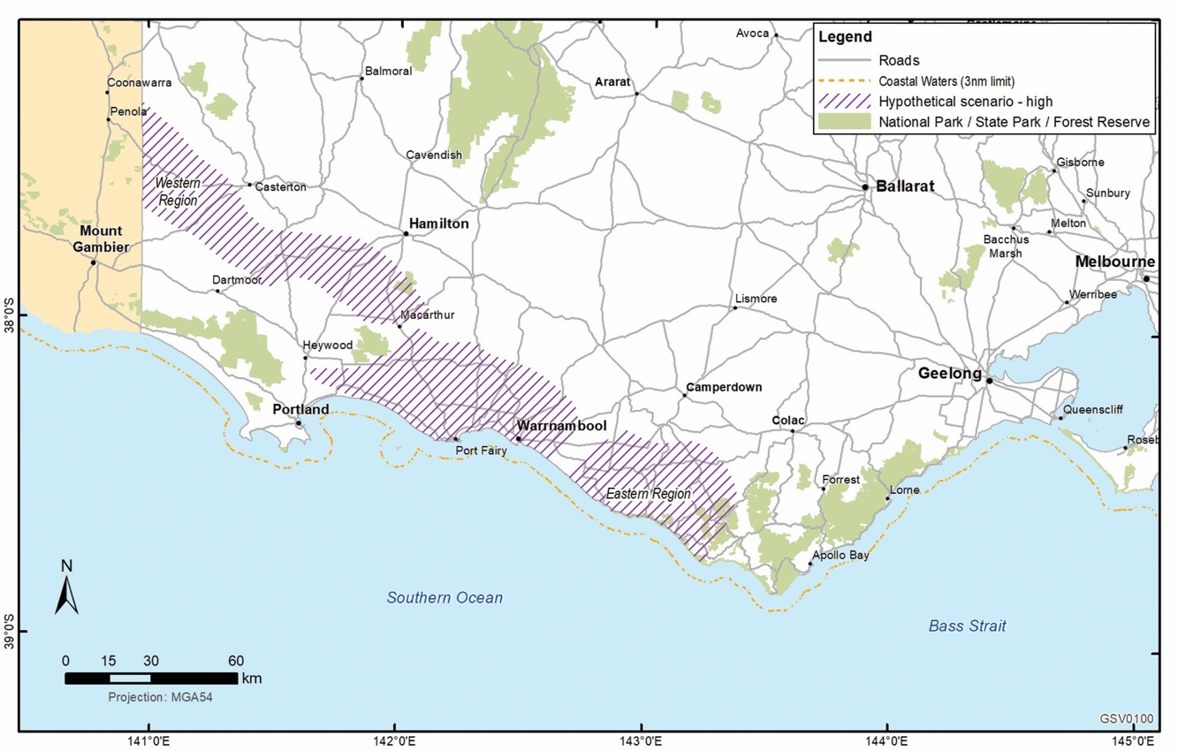
Figure 4.1 Otway Basin high hypothetical exploration and development scenario – gas yet to be found in the Port Campbell Embayment (Eastern Region), the Penola Trough (Western Region) and in the Central Region.
For the Gippsland Basin, hypothetical scenarios (low, medium and high) the number of exploration wells drilled, resultant discoveries and resource size increases through each of the scenarios (Table 4.2).

Table 4.2 Gippsland Basin summary of hypothetical gas exploration and development scenarios.
# | Scenario | Description
1 | Gippsland Basin (Low) | - Total estimated discovered resources of 35 Bcf (38 PJ)  - Discoveries in all seven reservoir rock units: the Seaspray Group, Cobia, Halibut Golden Beach and Emperor subgroups (of the Latrobe Group), the Strzelecki Group, including the Tyers Subgroup  - Exploration and development in the Central onshore region  - Seventy (70) exploration wells resulting in seven discoveries  - Nine development wells are required, inclusive of the seven discovery wells  - Gas discovered in the Central onshore region is processed using existing facilities and/or a new modular plant.
2 | Gippsland Basin (Medium) | - Total estimated discovered resources of 70 Bcf (77 PJ)  - Discoveries in all seven reservoir rock units: the Seaspray Group, Cobia, Halibut Golden Beach and Emperor subgroups (of the Latrobe Group), the Strzelecki Group, including the Tyers Subgroup  - Exploration and development in the Central onshore region  - Seventy (70) exploration wells resulting in seven discoveries  - Eighteen (18) development wells are required, inclusive of the seven discovery wells  - Gas discovered in the Central onshore region is processed using existing facilities and/or a new modular plant.
3 | Gippsland Basin (High) | - Total estimated discovered resources of 105 Bcf (115 PJ)  - Discoveries in all seven reservoir rock units: the Seaspray Group, Cobia, Halibut Golden Beach and Emperor subgroups (of the Latrobe Group), the Strzelecki Group, including the Tyers Subgroup  - Exploration and development in the Central onshore region  - Seventy (70) exploration wells resulting in seven discoveries  - Twenty-seven (27) development wells are required, inclusive of the seven discovery wells  - Gas discovered in the Central onshore region is processed using existing facilities and/or a new modular plant.

All discovered resources for all reservoir rock units are located within the Central onshore region (Figure 4.2).
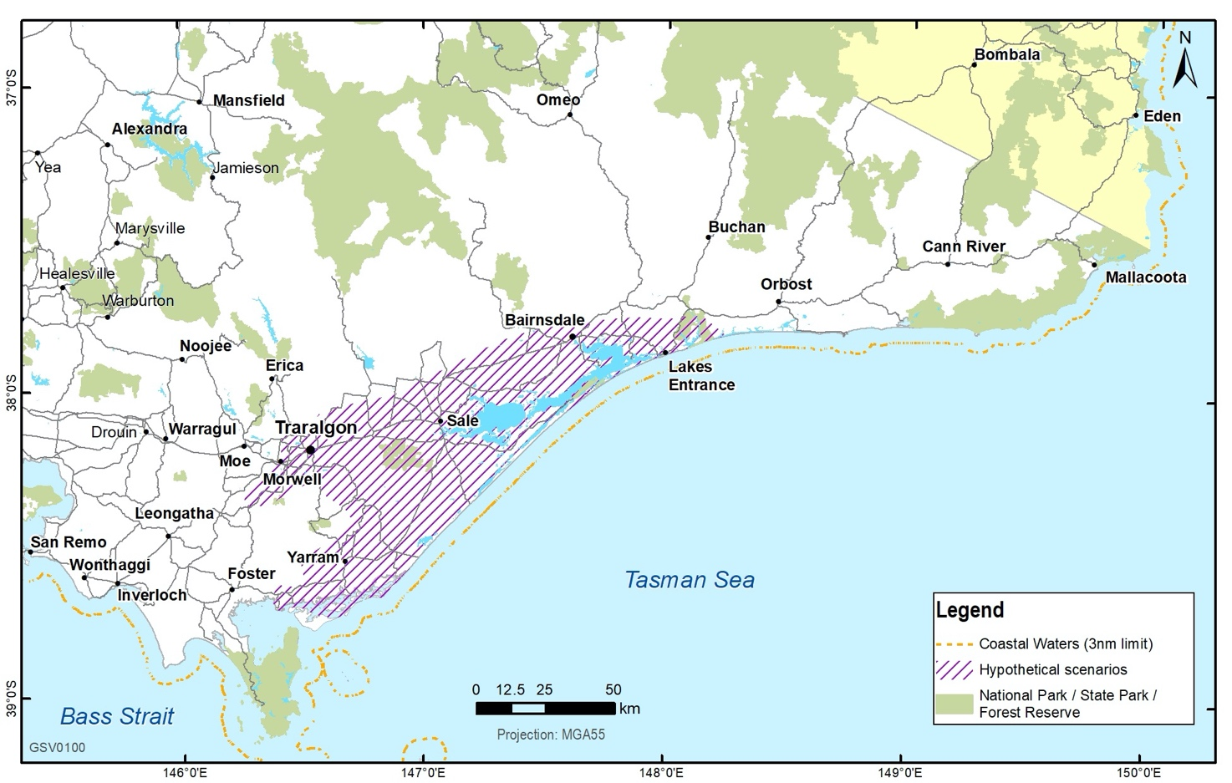
Figure 4.2 Gippsland Central Onshore Region – geographic area for low, medium and high hypothetical exploration and development scenarios.
These hypothetical exploration and development volumes form the foundation of the economic and greenhouse gas emissions modelling, and guide the assessment of the risks, benefits and impacts of onshore conventional gas exploration and development in Victoria.

Approach
The key steps in developing this assessment were:
- Completing a literature review - a review of the Victorian Gas Program studies (geoscience and environmental studies, community and stakeholder engagement, and resource and land use planning), and publicly available literature was completed.
- Developing scenarios and risks, benefits and impacts assessment framework – seven hypothetical conventional gas exploration and development scenarios were developed by the Geological Survey of Victoria (four in the Otway Basin and three in the Gippsland Basin). In addition, the risks, benefits and impacts assessment framework, including the economic, social and environmental receptors were clearly defined.
- Conducting economic and emissions modelling – economic impact analysis was conducted (via Computable General Equilibrium modelling) to measure the net impact of changes on an economy from the hypothetical scenarios. Similarly, emission modelling was conducted to measure the absolute greenhouse gas emissions and greenhouse gas emissions intensity from the hypothetical scenarios.
- Completing the risks, benefits and impacts assessment - the risks, benefits and impacts were identified for each economic, social and environmental receptor from the hypothetical scenarios by applying the risks, benefits and impacts assessment framework and drawing upon the Victorian Gas Program scientific study outputs, the literature review, and economic and environmental modelling.
- Reporting – a report was designed and drafted to provide an assessment of the risks, benefits and impacts of potential new onshore conventional gas exploration and development in Victoria.

Assessment framework
A multi-faceted assessment framework was used to evaluate the risks, benefits and impacts of seven hypothetical gas exploration and development scenarios (four in the Otway Basin and three in the Gippsland Basin).
Social, environmental and economic receptors were identified in consultation with the Stakeholder Advisory Panel, the Scientific Reference Group, and other government agencies such as the Department of Environment, Land, Water and Planning and the Department of Premier and Cabinet. A workshop was conducted on 19 November 2019 with the Geological Survey of Victoria, Victoria’s Lead Scientist and the Stakeholder Advisory Panel to confirm the 17 social, environmental and economic receptors for use in the assessment (see Table 4.6).
For each hypothetical scenario and its time horizon (short, medium or long term), the assessment considered the potential risks, benefits, and impacts associated with each of the social, environmental and economic receptors.
The assessment framework consists of:
- Benefits and impacts assessment analyses the positive or negative effect that a hypothetical gas exploration and development scenario could have on the receptor, assuming the industry complies with the current legislative framework. The overall assessment of the impact is calculated by the net effect of the hypothetical gas exploration and development scenario on the receptor.
- Risks assessment considers the likelihood and consequence that the receptor will be exposed to harm because of a hypothetical gas exploration and development scenario, assuming the industry complies with the current legislative framework (based on the ISO31000:2009 Risk Management – Principles and Guidelines).
A scoring model (Table 4.3) was employed to rank the benefit and impact assessment for each hypothetical scenario on a receptor, and a risk matrix was applied to assess the risk to a receptor. Combining the benefit and impact scoring provides a net-effect summary assessment for each receptor and each scenario.
Table 4.3 Benefit and impact assessment scoring model.
Scoring | Description | Further guidance
 | Hypothetical scenario has an extremely positive impact on the receptor | Extent of benefit: benefit to environment reaches a large geographical area, social benefit impacts large community (e.g. numerous towns)  Duration of benefit: long term
 | Hypothetical scenario has a positive impact on the receptor | Extent of benefit: environmental benefits are moderately localised, social impacts are felt by small communities (e.g. individual town, large section of community)  Duration of benefit: medium term
 | Hypothetical scenario has a slightly positive impact on the receptor | Extent of benefit: environmental benefits are localised, social benefits impact several individuals (e.g. multiple landholders)  Duration of benefit: short to medium term
— | Hypothetical scenario has no material impact on the receptor | Extent of impact: impact is negligible, environmental impact is highly localised, social impacts are felt at an individual level  Duration of impact: short term, temporary
× | Hypothetical scenario has a slightly negative impact on the receptor | Extent of impact: environmental impact is localised, social impacts are felt by several individuals (e.g. multiple landholders)  Duration of impact: short term to medium term
×× | Hypothetical scenario has a negative impact on the receptor | Extent of impact: environmental impacts are moderately localised, social impact are felt by small communities (e.g. individual town, large section of community)  Duration of impact: medium term
××× | Hypothetical scenario has an extremely negative impact on the receptor | Extent of impact: impact on environment reach a large geographical area, social impact felt by large communities (e.g. numerous towns)  Duration of impact: long term

The risk assessment considered the consequence, cause of the risk, likelihood, control measures and residual impact of the risk on the receptors.
The risk matrix shown in Table 4.4 is based on multiplying the consequence and likelihood of a risk. Table 4.5 defines the rankings based on the scores in the risk matrix.
Table 4.4 Risk matrix.
 |  | - Likelihood
 |  | - 5. Very likely | - 4. Likely | - 3. Possible | - 2. Unlikely | - 1. Highly unlikely
Consequence | - 5.Severe | - 25 | - 20 | - 15 | - 10 | - 5
Consequence | - 4. Serious | - 20 | - 16 | - 12 | - 8 | - 4
Consequence | - 3. Moderate | - 15 | - 12 | - 9 | - 6 | - 3
Consequence | - 2. Minor | - 10 | - 8 | - 6 | - 4 | - 2
Consequence | - 1. Negligible | - 5 | - 4 | - 3 | - 2 | - 1

Table 4.5 Risk ranking.
Risk ranking | Score
Severe | 20-25
High | 10-19
Moderate | 5-9
Low | 1-4

Victorian Gas Program studies and quantitative and qualitative public information were used, along with economic and greenhouse gas emissions modelling to inform this assessment and assess how each hypothetical scenario might potentially impact the 17 receptors (see Table 4.6).
Table 4.6 Receptors for risks, benefits and impacts assessment.
Focus area | Receptors
Economic receptors | - Employment  - Gross State Product  - Gross regional product and gross regional income  - Domestic gas supply  - Gas prices  - Government revenue
Social receptors | - Community, health, safety and security  - Community wellbeing and social cohesion  - Land access and use issues  - The Aboriginal community and people  - Schools, education and vocational capacity  - Aboriginal and other Victorian cultural heritage  - Existing farm industries, food and biosecurity  - Labour and working conditions
Environmental receptors | - Greenhouse gas emissions  - Groundwater and surface water quality and quantity  - Affected native flora and fauna

Risks, benefits and impacts assessment for the Otway Basin

Economic impacts
The economic assessment found that all the Otway Basin hypothetical exploration and development scenarios are expected to result in employment growth in the Otway region, increased economic value to the Otway region (and Victoria), and increased government revenue (e.g. royalties and company taxation). Otway Basin exploration and development scenarios are expected to slightly improve gas supply available to Victorian gas users. However, no material impact is expected on Victorian gas prices regardless of the timeframe or level of development (Table 4.7).
The economic impact was assessed using a computable general equilibrium model, which measured the net change to the economy in response to the hypothetical exploration and development scenarios. The economic modelling was informed by gas production and price forecasts published by the Australian Energy Market Operator (AEMO, 2019), historical average development rates and Australian benchmark cost estimates of similar gas developments and asset types.
Table 4.7 Otway Basin hypothetical scenarios: Risk, benefit and impact assessment summary – Economic receptors.
Receptor and score | Findings
Economic receptors
Receptor  ER1 Employment  Score | The assessment found all scenarios are projected to result in employment growth primarily in the Otway region. This ranged from average annual additional 57 full-time equivalents under the minimum scenario (or total of 569 full-time equivalents – 387 direct and 182 indirect) over the lifetime of production to an average annual additional 204 full-time equivalents under the high scenario (or total of 5506 full-time equivalents – 3816 direct and 1689 indirect) over the lifetime of production.  The analysis suggests that there will be some redistribution of labour as a result of the project, with employment being drawn from the rest of Victoria in order to satisfy demand. The ratings for each scenario have been assessed based on their relative overall impact on employment across Victoria with high scenario expected to have the largest impact on employment across the state, however, still minor in comparison to total state employment.  No further mitigations or risks were identified for this receptor.
   | Benefit /impact | Risk
  Minimum case | — | N/A
  Low scenario |  | N/A
  Medium scenario |  | N/A
  High scenario |  | N/A
Receptor  ER 2 Gross state product  Score | The assessment found all scenarios are projected to result in a positive impact to Victoria’s gross state product, ranging from an average annual additional $76.50 million under the minimum scenario (a total of $764.97 million over the lifetime of production) to an average annual additional $282.10 million under the high scenario (a total of $7,616.63 million over the lifetime of production).  The ratings for each scenario have been assessed based on their relative overall impact on gross state product for Victoria. As a share of total gross state product, the minimum case equates to 0.02 per cent and the high scenario 0.04 per cent.  No further mitigations or risks were identified for this receptor
   | Benefit /impact | Risk
  Minimum case |  | N/A
  Low scenario |  | N/A
  Medium scenario |  | N/A
  High scenario |  | N/A
Receptor  ER3 Gross regional product and gross regional income  Score | The assessment found all scenarios are projected to result in a positive impact to the Otway region’s gross regional product, ranging from an average annual additional $65.55 million under the minimum scenario (a total of $655.53 million over the lifetime of production) to an average annual additional $248.54 million under the high scenario (a total of $6,710.66 million over the lifetime of production). Similar to the estimated gross regional product impact, the gross regional income figures increase from the minimum to high scenarios due to the underlying gas production and investment inputs. The additional annual average gross regional income ranges from $81.06 million to $336.01 million respectively.  The ratings for each scenario have been assessed based on their relative overall impact on gross regional product and the gross regional income for the Otway region.  No further mitigations or risks were identified for this receptor.
   | Benefit /impact | Risk
  Minimum case |  | N/A
  Low scenario |  | N/A
  Medium scenario |  | N/A
  High scenario |  | N/A
Receptor  ER4 Domestic gas supply  Score | The qualitative assessment considered the extent to which the Otway Basin exploration and development scenarios could affect gas supply.  Gas production from offshore Victoria has typically been more than sufficient to meet direct use demand. In 2018, gas processed in Victoria was 348 PJ and consumption was 220 PJ, resulting in a 128 PJ surplus of gas. However, due to falling production forecasts from the offshore Gippsland and Otway basins, annual supply adequacy is expected to tighten over the next five-years reducing the surplus to 23 PJ in 2023. Current forecasts by AEMO suggest that shortfalls are expected from 2024 onwards.  Unless currently uncommitted gas supply projects proceed, Victoria is expected to become a net-importer of gas (e.g. more reliant on gas sources from outside the state in particular from Queensland).  The assessment identified that all four hypothetical scenarios could begin producing in the 2023-24 financial year if discoveries were made that were considered commercially viable and the necessary regulatory approvals were gained. The level of production under the high and medium scenarios would be much higher than in the low and minimum case.  The assessment found that the low, medium and high scenarios could:  - reduce the tightening gas supply situation in Victoria, with the potential to add up to an estimated 20 PJ of gas supply in 2024 and 33 PJ in 2025 (~9.0 per cent and ~14.8 per cent of forecast Victorian consumption in 2023 respectively)  - improve energy security by increasing the diversity of Victoria’s supply (which is largely sourced from Longford gas facility)  - increase gas available for industrial users (who are expected to see the greatest benefit as they would likely have opportunities to purchase gas directly from producers, rather than through retail contracts which often include higher transportation costs and a retailer margin)  - improve the availability of gas supply for gas-powered generation on peak system demand days (as without additional gas supply capacity, restrictions and curtailment of gas-powered generation may be necessary in 2023 (and beyond) on a 1-in-20 year peak system demand day)  - improve the amount of gas available for uses such as a transition fuel.  Overall, the assessment found that the level of benefit obtained is limited by the scale and timing of development, which over the lifetime of production is relatively small as a proportion of Victoria’s total gas supply and consumption (and energy supply and consumption).  Therefore, only the low, medium and high scenarios are expected to have a slightly positive impact on Victoria’s energy supply.  The minimum case is not expected to have a material impact on Victoria’s supply. This is because annual gas production is a small proportion of total forecast Victorian supply (e.g. 5.8 per cent of Victoria’s forecast consumption, and 5.3 per cent of Victoria’s forecast production in 2025) and is only expected to produce gas for a limited period (e.g. eight years ending in 2032). However, it is still sufficient to support local industry.  The introduction of a domestic prioritisation mechanism (e.g. right of first offer) was identified as a further mitigation. Such a mechanism could require gas produced from Otway Basin scenarios to be offered to Victorian gas users first.  This type of mechanism would be expected to improve the terms of negotiation for local gas users.  No risks were identified to this receptor.
   | Benefit /impact | Risk
  Minimum case | — | N/A
  Low scenario |  | N/A
  Medium scenario |  | N/A
  High scenario |  | N/A
Receptor  ER5 Gas prices  Score | The qualitative assessment considered the extent to which the hypothetical Otway Basin exploration and development scenarios could improve gas and electricity price outcomes for Victorians.  In the case of gas prices, the assessment found that the level of gas development under the scenarios is unlikely to materially change the level or diversity of suppliers in Victoria to the extent that it increases competition for gas users. As a result, it was unlikely to reduce the price of gas for Victorians and prices will continue to be set largely by the liquefied natural gas netback price.  While the development scenarios are unlikely to influence overall prices, they may help reduce costs for some Victorian industrial users, particularly those located closest to the development. Victorian industrial users may be able to purchase gas directly from producers reducing transportation costs that would be incurred from buying gas from the east-coast gas market.  A similar conclusion was reached with respect to wholesale electricity prices. The assessment found that the hypothetical gas development scenarios were unlikely to reduce wholesale gas prices because the level of gas development is not expected to change gas supply or prices.  Therefore, based on the analysis, all four Otway Basin hypothetical exploration and development scenarios are expected to have no material impact on the gas price receptor regardless of the timeframe or level of development  No further mitigation measures or risks were identified for this receptor.
   | Benefit /impact | Risk
  Minimum case | — | N/A
  Low scenario | — | N/A
  Medium scenario | — | N/A
  High scenario | — | N/A
Receptor  ER6 Government revenue  Score | The qualitative assessment considered the extent to which the Otway Basin exploration and development scenarios could affect government revenue.  The petroleum regulatory framework requires gas producers to pay royalties to government for the use of state-owned resources.  The Otway Basin hypothetical scenarios would increase royalties obtained from onshore conventional gas production by the Victorian Government. The level of benefit from royalties is directly linked to the level and timing of production. For example, the minimum case is expected to provide ~$9.4 million in annual average royalties over the lifetime of production, which is only eight years (2024 to 2031). By contrast, the high development scenario is expected to provide the greatest level of benefit with annual average royalties expected to reach ~$31.1 million per year over the lifetime of production which is spread over 26 years (from 2024 to 2049).  The assessment also identified that the exploration and development scenarios are expected to provide a slightly positive benefit on government revenue through company taxation from Victorian onshore gas producers. It was acknowledged that the applicability of various tax forms and the amount of company taxation payable is dependent on many factors and, therefore, difficult to quantify.  Based on this analysis, the impact of each scenario on government revenue is linked to the level and timing of production. Both these factors materially influence revenue from royalties and company taxation.  No further mitigation measures or risks were identified for this receptor.
   | Benefit /impact | Risk
  Minimum case |  | N/A
  Low scenario |  | N/A
  Medium scenario |  | N/A
  High scenario |  | N/A

Social impacts
The assessment found that the Otway Basin exploration and development scenarios are expected to deliver benefits (e.g. increases in employment, wage and salary income), impacts (e.g. noise, dust generation) and risks (e.g. cultural heritage) across the suite of social receptors. Identified risks are largely expected to be mitigated through various measures (e.g. risks to cultural heritage managed through various measures as required under the Aboriginal Heritage Act 2006 and Heritage Act 1995) (Table 4.8).
Table 4.8 Otway Basin hypothetical scenarios: Risk, benefit and impact assessment summary – Social receptors.
Receptor and score | Finding
Social receptors
Receptor  SR1 Community health, safety and security  Score | The qualitative assessment considered the extent to which the Otway Basin exploration and development scenarios could affect community health, and safety and security within the region.  While there are potential negative impacts and risks within the region due to fire and spill risks, visible flaring, noise and vibrations, and dust generation, these will be mitigated through requirements under the current regulatory framework to be as low as reasonably possible. In the case of noise and dust generation from operations/exploration, the impact is expected to be comparable with other land use activities such as farming. The impacts and residual risks are not considered to differ between scenarios, as the mitigating actions will manage the impact or risk to be as low as reasonably practicable and to an acceptable level, regardless of the footprint of the petroleum activities. Mitigating actions will also reduce the likelihood of the risk occurring.  Therefore, the scenarios are expected to have a slightly negative impact on the community’s health, safety and security and are assessed as having a low risk, based on the average ratings for each impact and risk.  Proposed mitigation measures to improve the regulatory framework will also reduce the severity of the impacts and the likelihood of the identified risks occurring.
   | Benefit /impact | Risk
  Minimum case | x | L
  Low scenario | x | L
  Medium scenario | x | L
  High scenario | x | L
Receptor  SR2 Community wellbeing and social cohesion  Score | The qualitative assessment considered the extent to which the Otway Basin exploration and development scenarios could affect community wellbeing and social cohesion within the region.  Community attitudes to the proximity of development and exploration are important to consider. However, the impact of this measure on each of the exploration and development scenarios is neutral based on the results of surveys conducted with residents of the Otway local government areas. The extent of contribution could vary between the Otway Basin hypothetical exploration and development scenarios as the number of locations where gas is developed changes. As the number of locations increase where gas is developed, contributions to community projects could increase. However, this would be dependent on a number of factors, including the locations of operation, size of the operations and commercial return obtained by producers. Community engagement, although non-prescript, is required under legislation, providing benefits but there is room for improvement. Further mitigation is suggested through stronger community engagement required in legislation. On the other hand, access and affordability of housing, essential services and the impact on local roads and traffic are expected to have neutral impacts on the community.  Therefore, based on the high-level analysis and average scoring, all scenarios are expected to have a neutral impact.  No risks were identified for this receptor.
   | Benefit /impact | Risk
  Minimum case | — | N/A
  Low scenario | — | N/A
  Medium scenario | — | N/A
  High scenario | — | N/A
Receptor  SR3 Land access and use issues  Score | The qualitative assessment considered the extent to which the Otway Basin exploration and development scenarios could affect land access and use.  Landholder consultation (that informs landowner consent and compensation and lease agreements) is dictated by the nature and scale of the petroleum activity. However, the legislation is clear that gas developers must enter into a land agreement prior to commencing exploration which is expected to have a neutral impact for landowners.  With respect to the adequacy of community consultation, it was found that the process would be assumed to be consistent for each of the projects, and therefore the impact would increase in line with the exploration and development levels across the scenarios. The size of land impacted by gas exploration and development activities are expected to increase directly within an increase in production as there is a correlation with the number of wells and infrastructure built under each scenario. However, the absolute size of land required for conventional gas exploration and production is relatively small. With underground pipelines, there is no evidence to suggest that there is significantly reduced land available to other users.  It is anticipated that increases in land value will be negligible and devaluation of land will be mitigated through compensation to directly impacted landowners, resulting in a negligible residual impact.  Based on the ratings in the analysis, the minimum case, low and medium scenarios are expected to have neutral impacts. The hypothetical high scenario is expected to have a slightly negative impact.  The risk of inadequate rehabilitation is expected to be low across all scenarios as the regulatory framework requires operators to restore land that was developed and that landowners will be appropriately compensated for any land that can no longer be returned to its original state.  Further mitigation measures of increased landowner engagement requirements and stronger involvement of land holders in decision making particularly around rehabilitation would further address risks and impacts.
   | Benefit /impact | Risk
  Minimum case | — | L
  Low scenario | — | L
  Medium scenario | — | L
  High scenario | x | L
Receptor  SR4 The Aboriginal community and people  Score | The qualitative assessment considered the extent to which the Otway Basin exploration and development scenarios could affect the Aboriginal community and its people within the region. While there is potential for drilling and development to encroach on land under Native Title or impact on Aboriginal people, existing mitigation measures limit these potential impacts and risks.  Engagement activities undertaken by operators and the implementation of Reconciliation Action Plans are likely to result in slightly positive outcomes for the Aboriginal community and its people within the region, especially as transparency of gas development is increased with the Aboriginal community and practical actions to drive reconciliation are provided, both internally and within the community. The creation of ongoing employment within the Otway region also provides opportunities for Aboriginal community members and businesses. These are expected to increase in line with production across the Otway gas exploration and development scenarios.  Overall, this results in all hypothetical scenarios having slightly positive impacts on the Aboriginal community and its people based on the average rating across all benefits and impacts.  There is a low risk that gas exploration and development activities could impact land that is under Native Title. Potential serious consequences are mitigated through several measures, including the Native Title Act 1993, and the implementation of an Indigenous Land Use Agreement. Further, the Petroleum Act requires that a compensation agreement be made where Native Title exists. Compensation is payable for any loss or damage that has or will be sustained in relation to the land as a direct, natural and reasonable consequence of the approval of, or carrying out of petroleum operation on land.
   | Benefit /impact | Risk
  Minimum case |  | L
  Low scenario |  | L
  Medium scenario |  | L
  High scenario |  | L
Receptor  SR5 Schools, education and vocational capacity  Score | The qualitative assessment considered the extent to which the Otway Basin exploration and development scenarios could affect schools, education and vocational capacity.  With respect to projected increase in apprenticeships and population growth, the assessment found that increases in the extent of gas production results in increases in employment, wage, salary, and median household income. This is consistent with the perceived local perceptions of benefits from onshore conventional gas development in the Otway region. As production increases, so too does the demand for labour in the region. As such, an increase in employment and associated benefits is correlated with an increase in gas production.  Similarly, contributions to school funding from industry are expected to result in increasing levels of benefit, which is dependent on several factors, including the number of locations where gas is developed and the scale of gas development and exploration.  Therefore, the minimum scenario is expected to have a slightly positive impact, the low and medium scenarios are expected to have a positive impact and the high scenario is expected to have an extremely positive impact on the schools, education and vocational capacity (based on the average rating for each impact).  No further mitigation measures or risks were identified for this receptor.
   | Benefit /impact | Risk
  Minimum case |  | N/A
  Low scenario |  | N/A
  Medium scenario |  | N/A
  High scenario |  | N/A
Receptor  SR6 Protection of cultural heritage  Score | The qualitative assessment considered the extent to which the Otway Basin exploration and development scenarios could affect non-Aboriginal and Aboriginal cultural heritage sites.  Areas of non-Aboriginal and Aboriginal cultural heritage within the region are unlikely to be impacted by the Otway Basin hypothetical exploration and development scenarios. This is because the risks to cultural and indigenous heritage sites are mitigated through the regulatory framework (including the Heritage Act 1995 and the Aboriginal Heritage Act 2006) once it is recognised that the land is of cultural, religious/spiritual and/or Aboriginal significance through cultural heritage surveying. However, if development occurred on sites of significance, this could result in irreparable damage to the place of significance, resulting in the hypothetical scenarios having a moderate risk on the protection of cultural heritage receptor.  No benefits or impacts were identified for this receptor.
   | Benefit /impact | Risk
  Minimum case | N/A | M
  Low scenario | N/A | M
  Medium scenario | N/A | M
  High scenario | N/A | M
Receptor  SR7 Existing farm industries, food and biosecurity  Score | The qualitative assessment considered the extent to which the Otway Basin exploration and development scenarios could affect existing farm industries, food and biosecurity. It identified the Otway scenarios could slightly negatively impact on coexisting with existing agriculture industries, livestock near petroleum activities, gross size of farming land used for exploration and development, and the management of potential and actual incursion of pests and diseases. The consequences of these impacts increase with the level of production, as the number of well sites required increases, thereby potentially affecting more land used currently for farming. However, the land size required for petroleum activities is relatively small in comparison to the area required for farming, and the regulatory framework mitigates the impacts through arrangements to compensate for temporary losses of farming income for having production wells on their property. Industry practice is often to go above the minimum compensation requirement for providing a source of off-farm income.  Overall, the minimum case, low and medium scenarios were assessed as having no material impact, and the high scenario was assessed as having a slightly negative impact.  The potential and actual incursion of pests and diseases was assessed as a key risk to farming industries. These risks are managed on a project by project basis, with each project required to have an adequate Environment Management Plan in place, identifying measures that comply with all relevant regulations and legislation. Proposed reforms to the Petroleum Regulatory Framework would further mitigate this risk. Therefore, the risk has been assessed as moderate for all scenarios, as projects would not proceed unless the impacts are assessed by the regulator to be as low as reasonably practicable.  Improvements in community and landholder engagement requirements, particularly around rehabilitation would benefit the operator’s ability to coexist with existing agricultural industries. Stronger consideration of farming as a land-use in government decision making when granting acreage and permits would also be of benefit.
   | Benefit /impact | Risk
  Minimum case | — | M
  Low scenario | — | M
  Medium scenario | — | M
  High scenario | x | M
Receptor  SR8 Labour and working conditions  Score | The qualitative assessment considered the extent to which the Otway Basin exploration and development scenarios could affect labour and working conditions. The assessment found that Enterprise Bargaining Agreements are common within the oil and gas industry. The existence of, and conditions within an Enterprise Bargaining Agreement result in positive outcomes for labour and working conditions. These are independent of the level of gas exploration and development, so benefits are not expected to vary between scenarios. Diversity policies are also common in the industry, resulting in positive impacts on worker representation for all exploration and development scenarios.  The assessment also found that the extent of organisational policies and procedures is up to the discretion of the employer. However, at a minimum, the employer has a legal responsibility to provide a safe and healthy workplace. Increases in gas production have little impact on the working conditions of employees, as organisations are required to have policies and procedures governing working conditions regardless of the size of a development. The frameworks and policies would provide benefits to employees irrespective of the size of production. However, these are expected to be comparable to other employers in the region.  Therefore, the minimum case, low, medium and high scenarios are expected to have a slightly positive impact on labour and working conditions.  No further mitigation measures or risks were identified for this receptor.
   | Benefit /impact | Risk
  Minimum case |  | N/A
  Low scenario |  | N/A
  Medium scenario |  | N/A
  High scenario |  | N/A

Environmental impacts
The assessment found that the Otway Basin exploration and development scenarios are expected to result in a slight increase in absolute greenhouse gas emissions as a proportion of Victoria’s net 2017 greenhouse gas emissions. The scenarios also have a low risk of negatively impacting on ground and surface water quality and quantity and native flora and fauna (Table 4.9).
Table 4.9 Otway Basin hypothetical scenarios: Risk, benefit and impact assessment summary – Environmental receptors.
Receptor and score | Findings
Environmental receptors
Receptor  ENR1 Greenhouse gas emissions  Score | The assessment identified the Otway Basin exploration and development scenarios would result in an increase in absolute annualised GHG emissions as a proportion of Victoria’s net 2017 greenhouse gas emissions ranging from 0.1 per cent (~101,891 t CO2e) under the minimum case to 0.2 per cent (~249,067 t CO2e) under the high scenario. Therefore, all scenarios are expected to deliver a minor negative impact on absolute greenhouse gas emissions.  While the Otway Basin exploration and development scenarios are not expected to significantly change or alter the State’s composition of its greenhouse gas emissions, the assessment found that greenhouse gas emissions from the Otway Basin hypothetical scenarios are expected to represent an increased proportion of Victoria’s net greenhouse gas emissions portfolio into the future as Victoria introduces emission reduction initiatives in line with the net-zero 2050 target.  However, the Otway Basin hypothetical exploration and development scenarios are not expected to significantly alter the trajectory to achieving Victoria’s 2050 net-zero target, as the additional supply is not expected to change market dynamic or impact the consumption of gas.  The findings from the assessment have indicated that all Otway Basin hypothetical exploration and development scenarios are expected to have a minor increase on greenhouse gas emissions.  The Geological Survey of Victoria has measured a baseline of atmospheric measurements in the Otway region so any future changes in air quality resulting from future petroleum exploration and development could be identified appropriately.  No risks were identified for this receptor.
   | Benefit /impact | Risk
  Minimum case | x | N/A
  Low scenario | x | N/A
  Medium scenario | x | N/A
  High scenario | x | N/A
Receptor  ENR2 Groundwater and surface water quality and quantity  Score | The quantitative assessment considered the extent to which the Otway Basin hypothetical exploration and development scenarios could affect ground and surface water within the region. The only measure shown to have an impact on ground and surface water is the volume of water removed from the nearest aquifer resource. The groundwater impact modelling showed that impacts on groundwater quantity and quality would be negligible due to the large geological separation between conventional gas reservoirs and aquifers.  Under the current regulatory framework, the removal of water resources must be at an acceptable level to receive development approval.  All scenarios are expected to have no material impact on ground and surface water based on the average rating.  The risk of groundwater and surface water contamination was rated as low, mitigated by the fact that the Environmental Management Plan must address the risk of potential contamination.  A further mitigation measure was identified for this receptor to improve the regulatory requirements regarding groundwater monitoring and reporting. This regulatory activity could be supported by the Victorian Gas Program's regional baseline data of groundwater chemistry, dissolved methane, and hydrocarbon occurrence, so that any future changes in groundwater condition can be identified.
   | Benefit /impact | Risk
  Minimum case | — | L
  Low scenario | — | L
  Medium scenario | — | L
  High scenario | — | L
Receptor  ENR3 Affected native flora and fauna  Score | The qualitative assessment considered the extent to which the Otway Basin exploration and development scenarios could affect native flora and fauna within the region. Key risks have been identified that could affect native flora and fauna. Greater numbers of wells will have a greater impact however the impact of each well will vary depending on its location. The small size of well leases during drilling (typically 1 hectare, with a much smaller footprint for operating wells), in addition to the use of existing infrastructure (e.g. aligning pipelines alongside existing pipeline easements) further reduces the overall impact, particularly for the minimum and low development scenarios. It is also important to note once the gas has been extracted from the well, the area will be rehabilitated, reducing the long-term impact on flora to nil. As such, impacts are only expected to occur in the short to medium term.  As environmental risks are managed on a project-by-project basis, each project will need to have an approved Environmental Management Plan and will need to comply with a number of local, state and federal regulations and legislation. Therefore, the risk has been assessed as low for all scenarios, as projects would not proceed unless the impacts are determined by Earth Resources Regulation to be as low as reasonably practicable and meeting the requirements of other environmental legislation.  No benefits or impacts were identified for this receptor.  As an additional mitigation measure, the Victorian Gas Program’s resource and land use planning model can be used to inform regulatory decision making (see Figure 3.7 for the summary of areas identified as constrained in the Otway Basin).  No benefits or impacts were identified for this receptor.
   | Benefit /impact | Risk
  Minimum case | N/A | L
  Low scenario | N/A | L
  Medium scenario | N/A | L
  High scenario | N/A | L

Risks, benefits and impacts assessment for the Gippsland Basin

Economic impacts
The assessment found that all the Gippsland Basin exploration and development scenarios are expected to result in employment growth in the Gippsland region, increased economic value to the Gippsland region (and Victoria), and increased government revenue (e.g. royalties and company taxation). Gippsland Basin exploration and development scenarios are expected to have no material impact on Victorian gas supply or gas prices regardless of the timeframe or level of development (Table 4.10).
Table 4.10 Gippsland Basin hypothetical scenarios: Risk, benefit and impact assessment summary – Economic receptors.
Receptor and score | Findings
Economic receptors
Receptor  ER1 Employment  Score | The assessment found all scenarios are projected to result in employment growth primarily in the Gippsland region. This ranged from average annual additional 21 full-time equivalents under the low scenario (or total of 355 full-time equivalents - 145 direct and 210 indirect over the lifetime of production) to an average annual additional 68 full-time equivalents under the high scenario (or total of 890 full-time equivalents – 520 direct and 370 indirect over the lifetime of production).  The analysis suggests that there will be some redistribution of labour as a result of the project, with employment being drawn from the rest of Victoria in order to satisfy demand. The ratings for each scenario have been assessed based on their relative overall impact on employment across Victoria with the high scenario expected to have the largest impact on employment across the state. This is, however, still assessed as a marginal impact as a proportion of total employment.  No further mitigation measures or risks were identified for this receptor.
   | Benefit /impact | Risk
  Low scenario | — | N/A
  Medium scenario | — | N/A
  High scenario | — | N/A
Receptor  ER2 Gross state product  Score | The assessment found all scenarios are projected to result in a positive impact to Victoria’s gross state product, ranging from an average annual additional $18.26 million under the low scenario (a total of $310.4 million over the lifetime of production) to an average annual additional $76.39 million under the high scenario (a total of $993 million over the lifetime of production).  The ratings for each scenario have been assessed based on their relative overall impact on gross state product for Victoria. As a share of total gross state product, the low scenario equates to 0.00 per cent and the high scenario 0.01 per cent.  No further mitigations or risks were identified for this receptor.
   | Benefit /impact | Risk
  Low scenario | — | N/A
  Medium scenario |  | N/A
  High scenario |  | N/A
Receptor  ER3 Gross regional product and gross regional income  Score | The assessment found all scenarios are projected to result in a positive impact to the Gippsland region’s gross regional product, ranging from an average annual additional $14.76 million under the low scenario (a total of $250.9 million over the lifetime of production) to an average annual additional $63.37 million under the high scenario (a total of $823.9 million over the lifetime of production). Similar to the estimated gross regional product impact, the gross regional income figures increase from the low to high scenarios due to the underlying gas production and investment inputs. The additional annual average gross regional income ranges from $16.01 million to $1,085.78 million respectively. The ratings for each scenario have been assessed as having a neutral or slightly positive benefit based on their relative overall impact on gross regional product and gross regional incomefor the Gippsland region.  No further mitigations or risks were identified for this receptor.
   | Benefit /impact | Risk
  Low scenario | — | N/A
  Medium scenario |  | N/A
  High scenario |  | N/A
Receptor  ER4 Domestic gas supply  Score | The qualitative assessment considered the extent to which the Gippsland Basin exploration and development scenarios could affect gas supply.  Gas production from offshore Victoria has typically been more than sufficient to meet direct use demand. In 2018, gas processed in Victoria was 348 PJ and consumption was 220 PJ, resulting in a 128 PJ surplus of gas. However, due to falling production forecasts from the offshore Gippsland and Otway basins, annual supply adequacy is expected to tighten over the next five-years reducing the surplus to 23 PJ in 2023. Current forecasts by AEMO suggest that shortfalls are expected from 2024 onwards.  Unless currently uncommitted gas supply projects proceed, Victoria is expected to become a net-importer of gas (e.g. more reliant on gas sources from outside the state, in particular from Queensland).  The assessment identified that all three hypothetical exploration and development scenarios are expected to begin producing in the 2023-24 financial year if discoveries were made that were considered commercially viable and the necessary regulatory approvals were gained. The level of production under the high and medium scenarios would be higher than in the low scenario.  The Gippsland hypothetical scenarios could add up to an estimated 12 PJ of gas supply in 2024 and 13 PJ in 2025 (~5.4 per cent and ~5.8 per cent of forecast Victorian consumption in 2023 respectively). However, this amount of gas produced is not expected to have a material impact on Victoria’s gas supply. This is due to the annual gas production being a small proportion of total forecast Victorian supply (e.g. a maximum of less than 6 per cent of Victoria’s forecast consumption, less than 6 per cent of Victoria’s production supply and only active for a limited period – 10 years of production.  As such, the estimated amount of gas that could be produced under all scenarios would be insufficient to materially:  - reduce the tightening gas supply situation in Victoria  - improve energy security by increasing the diversity of Victoria’s gas supply (which is largely sourced from Longford gas facility via the offshore gas fields)  - improve the availability of gas supply for gas-powered generation on peak system demand days (as without additional gas supply capacity, restrictions and curtailment of gas-powered generation may be necessary in 2023 (and beyond) on a 1-in-20 year peak system demand day)  - improve the amount of gas available for uses such as a transition fuel.  However, the assessment found that the amount of gas could:  - increase gas available for industrial users (who are expected to see the greatest benefit as they would likely have opportunities to purchase gas directly from producers, rather than through retail contracts which often include higher transportation costs and a retailer margin).  Overall, the assessment found that the level of benefit obtained is limited by the scale and timing of development, which over the lifetime of production is relatively small as a proportion of Victoria’s total gas supply and consumption (and energy supply and consumption).  The introduction of a domestic prioritisation mechanism (e.g. right of first offer) was identified as a further mitigation. Such a mechanism could require gas produced from Gippsland Basin scenarios to be offered to Victorian gas users first.  This type of mechanism would be expected to improve the terms of negotiation for local gas users.  No further risks were identified for this receptor.
   | Benefit /impact | Risk
  Low scenario | — | N/A
  Medium scenario | — | N/A
  High scenario | — | N/A
Receptor  ER5 Gas prices  Score | The qualitative assessment considered the extent to which the hypothetical Gippsland Basin exploration and development scenarios could improve gas and electricity price outcomes for Victorians.  In the case of gas prices, the assessment found that the level of gas development under the scenarios is unlikely to materially change the level or diversity of suppliers in Victoria to the extent that it increases competition for gas users. As a result, it was unlikely to reduce the price of gas for Victorians and prices will continue to be set largely by the liquefied natural gas netback price.  While the development scenarios are unlikely to influence overall prices, the assessment found they may help reduce costs for some Victorian industrial users, particularly those located closest to the development. Victorian industrial users may be able to purchase gas directly from producers reducing transportation costs that would be incurred from buying gas from the east-coast gas market.  A similar conclusion was reached with respect to wholesale electricity prices. The assessment found that the hypothetical gas development scenarios were unlikely to reduce wholesale gas prices because the level of gas development is not expected to change gas supply or prices.  Therefore, based on the analysis, all three Gippsland Basin hypothetical exploration and development scenarios are expected to have no material impact on the gas price regardless of the timeframe or level of development.  No further mitigation measures or risks were identified for this receptor.
   | Benefit /impact | Risk
  Low scenario | — | N/A
  Medium scenario | — | N/A
  High scenario | — | N/A
Receptor  ER6 Government revenue  Score | The qualitative assessment considered the extent to which the Gippsland Basin exploration and development scenarios could affect government revenue.  The petroleum regulatory framework requires gas producers to pay royalties to government for the use of state-owned resources.  The Gippsland scenarios would increase royalties obtained from onshore conventional gas production by the Victorian Government. The level of benefit from royalties is directly linked to the level and timing of production. For example, the low scenario is expected to provide ~$6.1 million in annual average royalties over the lifetime of production which is only six years (2024 to 2029). By contrast, the high development scenario is expected to provide the greatest level of benefit with annual average royalties are expected to reach ~$11.9 million per year over the lifetime of production, spread over 10 years (from 2024 to 2033).  The assessment also identified that the exploration and development scenarios are expected to provide a slightly positive benefit on government revenue through company taxation from Victorian onshore gas producers. It was acknowledged that the applicability of various tax forms and the amount of company taxation payable is dependent on many factors and, therefore, difficult to quantify.  Based on this analysis, the impact of each scenario on government revenue is linked to the level and timing of production. Both of these factors materially influence revenue from royalties and company taxation. However overall benefits are expected to still be only slightly positive due to low production levels in all development scenarios.  No further mitigation measures or risks were identified for this receptor.
   | Benefit /impact | Risk
  Low scenario | — | N/A
  Medium scenario |  | N/A
  High scenario |  | N/A

Social impacts
The assessment found that the Gippsland Basin exploration and development scenarios are expected to deliver benefits (e.g. increases in employment, wage and salary income), impacts (e.g. noise, dust generation) and risks (e.g. cultural heritage) across the suite of social receptors. Identified risks are largely expected to be mitigated through the existing regulatory framework (e.g. risks to cultural heritage managed through various measures as required under the Aboriginal Heritage Act 2006 and the Heritage Act 1995) (Table 4.11).
Table 4.11 Gippsland Basin hypothetical scenarios: Risk, benefit and impact assessment summary –
Receptor and score | Findings
Social receptors
Receptor  SR1 Community health, safety and security  Score | The qualitative assessment considered the extent to which the Gippsland Basin exploration and development scenarios could affect health and safety within the region. While there are potential negative impacts and risks within the region due to fire and spill risks, visible flaring, noise and vibrations, and dust generation, these will be mitigated through requirements under the current regulatory framework to be as low as reasonably practicable. In the case of noise and dust generation from operations/exploration, the impact is expected to be comparable with other land use activities such as farming. The impacts and residual risks are not considered to differ between scenarios, as the mitigating actions will manage the impact or risk to be as low as reasonably practicable and to an acceptable level, regardless of the size of exploration or development. Mitigating actions will also reduce the likelihood of the risk occurring.  Therefore, the scenarios are expected to have a neutral impact on the community’s health and safety and are assessed as having a low risk, based on the average ratings for each impact.  Proposed mitigation measures to improve the regulatory framework will also reduce the severity of the impacts and the likelihood of the identified risks occurring.
   | Benefit /impact | Risk
  Low scenario | — | L
  Medium scenario | — | L
  High scenario | — | L
Receptor  SR2 Community wellbeing and social cohesion  Score | The qualitative assessment considered the extent to which the Gippsland exploration and development scenarios could affect community wellbeing and social cohesion within the region.  Community attitudes to the proximity of development and exploration are important to consider. However, the impact of this measure on each of the exploration and development scenarios is neutral based on the results of surveys conducted with residents of Gippsland local government areas. The extent of contribution is unlikely to vary between the Gippsland Basin hypothetical exploration and development scenarios as the locations where gas is developed is consistent. Community engagement, although non-prescript, is required under legislation, providing benefits but there is room for improvement. Further mitigation is suggested through stronger community engagement requirements in the legislation. On the other hand, access and affordability of housing and essential services and the impact on local roads are expected to have negative and neutral impacts respectively.  Therefore, based on the high-level analysis and average scoring, all scenarios are expected to have a neutral impact.  No risks were identified for this receptor.
   | Benefit /impact | Risk
  Low scenario | — | N/A
  Medium scenario | — | N/A
  High scenario | — | N/A
Receptor  SR3 Land access and use issues  Score | The qualitative assessment considered the extent to which the Gippsland Basin exploration and development scenarios could affect land access and use. Landholder consultation (that informs landowner consent, compensation agreements and lease agreements) is dictated by the nature and scale of the petroleum activity. However, the legislation is clear that gas developers must enter into a land agreement prior to commencing exploration. This is expected to have a neutral impact for landowners.  With respect to the adequacy of community consultation, it was found that the process would be assumed to be consistent for each of the projects, and therefore the impact would increase in line with the exploration and development levels across the scenarios. The size of land impacted by gas exploration and development activities are expected to increase directly within an increase in production as there is a correlation with the number of wells and infrastructure built under each scenario. However, the absolute size of land required for conventional gas exploration and production is relatively small. With underground pipelines, there is no evidence to suggest that there is significantly reduced land available for other users.  It is anticipated that increases in land value will be negligible and devaluation of land being mitigated to directly impacted landowners, resulting in a negligible residual impact.  Based on the ratings in the analysis the low, medium and high scenarios are expected to have neutral impacts.  The risk of inadequate rehabilitation is expected to be low across all scenarios as the regulatory framework requires operators to restore land that was developed. Landowners are expected to be appropriately compensated for any land that can no longer be returned to its original state.  Further mitigation measures of increased landowner engagement requirements and stronger involvement of landholders in decision making particularly regarding rehabilitation, would further address risks and impacts.
   | Benefit /impact | Risk
  Low scenario | — | L
  Medium scenario | — | L
  High scenario | — | L
Receptor  SR4 The Aboriginal community and people  Score | The qualitative assessment considered the extent to which the Gippsland exploration and development scenarios could affect the Aboriginal community and its people within the region. While there is potential for drilling and development to encroach on land under Native Title, or impact on Aboriginal people, existing mitigation measures are strong, limiting these potential impacts and risks.  Engagement activities undertaken by operators and the implementation of Reconciliation Action Plans are likely to result in slightly positive outcomes for the Aboriginal community and its people within the region especially as transparency of gas development is increased with the Aboriginal community and practical actions to drive reconciliation are provided, both internally and within the community. The creation of ongoing employment within the Gippsland region also provides employment opportunities for Aboriginal community members and businesses. These are expected to increase in line with production across the Gippsland gas exploration and development scenarios.  Overall, this results in all hypothetical scenarios having slightly positive impacts on the Aboriginal community and its people, based on the average rating across all benefits and impacts.  There is a low risk that gas exploration and development activities could impact land that is under Native Title. Potential serious consequences are mitigated through several measures, including the Native Title Act 1993, and the implementation of an Indigenous Land Use Agreement. Further, the Petroleum Act requires that a compensation agreement be made where Native Title exists. Compensation is payable for any loss or damage that has or will be sustained in relation to the land as a direct, natural and reasonable consequence of the approval of, or carrying out of petroleum operation on land.
   | Benefit /impact | Risk
  Low scenario |  | L
  Medium scenario |  | L
  High scenario |  | L
Receptor  SR5 Schools, education and vocational capacity  Score | The qualitative assessment considered the extent to which the Gippsland Basin exploration and development scenarios could affect schools, education and vocational capacity.  With respect to a projected increase in apprenticeships and population growth, the assessment found that increases in the extent of gas production would result in increases in employment, wage, salary, and median household income. This is consistent with the perceived local perceptions of benefits from onshore conventional gas development in the Gippsland region. As production increases, so too does the demand for labour in the region. As such, an increase in benefits is correlated with an increase in gas production.  Similarly, contributions from industry to school funding are expected to result in increasing levels of benefits, dependent on several factors. This includes the number of locations where gas is developed, and the size of gas development and exploration. However, as this contribution is not required by the regulatory framework, the impact from this measure has been assessed as neutral  Therefore, the low, medium and high scenarios are expected to have a slight positive impact on the schools, education and vocational capacity, based on the average rating for each impact.  No further mitigations or risks were identified for this receptor.
   | Benefit /impact | Risk
  Low scenario |  | N/A
  Medium scenario |  | N/A
  High scenario |  | N/A
Receptor  SR6 Protection of cultural heritage  Score | The qualitative assessment considered the extent to which the Gippsland hypothetical exploration and development scenarios could affect non-Aboriginal and Aboriginal cultural heritage sites.  Areas of non-Aboriginal and Aboriginal cultural heritage within the region are unlikely to be impacted by the Gippsland hypothetical exploration and development scenarios. This is because the risks to cultural and indigenous heritage sites are mitigated through the regulatory framework (including the Heritage Act 1995 and the Aboriginal Heritage Act 2006) once it is recognised that the land is of cultural, religious and/or Aboriginal significance through cultural heritage surveying. However, if development occurred on sites of cultural heritage, it could result in irreparable damage to the place of significance. Therefore, the scenarios are expected to have a moderate risk on the protection of the cultural heritage receptor.  No benefits or additional impacts were identified for this receptor.
   | Benefit /impact | Risk
  Low scenario | N/A | M
  Medium scenario | N/A | M
  High scenario | N/A | M
Receptor  SR7 Existing farm industries, food and biosecurity  Score | The qualitative assessment considered the extent to which the Gippsland exploration and development scenarios could affect existing farm industries, food and biosecurity. It identified that the Gippsland scenarios could slightly negatively impact on coexisting with existing agriculture industries, livestock near petroleum activities, and the gross size of farming land used for exploration and development. The consequences of these impacts increase with the level of production, as the number of well sites required increases, thereby potentially affecting more land used currently for farming. However, the land size required for petroleum activities is relatively small in comparison to the area required for farming, and the regulatory framework mitigates these impacts through compensation arrangements to compensate for temporary losses of farming income for having production wells on their property. Further proposed regulatory reforms would require enhanced community consultation and consideration which would benefit the operator’s ability to coexist with existing agricultural industries. Industry practice is often to go above the minimum compensation requirement, providing a source of off-farm income.  Overall, the low, medium and high scenarios were assessed as having no material impact.  The potential and actual incursion of pests and diseases was assessed as a key risk to farming industries. These risks are managed on a project by project basis, with each project required to have an adequate Environmental Management Plan in place, identifying measures that comply with all relevant regulations and legislation. Proposed reforms to the Petroleum Regulatory Framework would further mitigate the risk. Therefore, the risk has been assessed as moderate for all scenarios, as projects would not proceed unless the impacts are assessed by regulators to be as low as reasonably practicable.  Improvements in community and landholder engagement requirements, particularly around rehabilitation, would benefit the operator’s ability to coexist with existing agricultural activities. Stronger consideration of farming as a land-use in government decision making when granting acreage and permits would also be of benefit.
   | Benefit /impact | Risk
  Low scenario | — | M
  Medium scenario | — | M
  High scenario | — | M
Receptor  SR8 Labour and working conditions  Score | The qualitative assessment considered the extent to which the Gippsland Basin exploration and development scenarios could affect labour and working conditions. The assessment found that Enterprise Bargaining Agreements are common within the oil and gas industry. The existence of, and conditions within an Enterprise Bargaining Agreements result in positive outcomes for labour and working conditions. These are independent of the level of gas exploration and development. Therefore, benefits are not expected to vary between scenarios. Diversity policies are also common in the industry, resulting in positive impacts on worker representation for all exploration and development scenarios.  The assessment also found that the extent of organisational policies and procedures is up to the discretion of the employer. However, at a minimum, the employer has a legal responsibility to provide a safe and healthy workplace. Increases in gas production have little impact on the working conditions of employees, as organisations are required to have policies and procedures governing working conditions regardless of the size of development. These are expected to be comparable to other employers in the region.  Therefore, the low, medium and high scenarios are expected to have a slightly positive impact on the labour and working conditions overall.  No further mitigation measures or risks were identified for this receptor.
   | Benefit /impact | Risk
  Low scenario |  | N/A
  Medium scenario |  | N/A
  High scenario |  | N/A

Environmental impacts
The assessment found that all scenarios in the Gippsland Basin exploration and development scenarios are expected to result in a slight increase in absolute greenhouse gas emissions as a proportion of Victoria’s net 2017 greenhouse gas emissions. However, this is not expected to materially impact the receptor. The scenarios also have a low risk of negatively impacting ground and surface water quality and quantity or native flora and fauna (Table 4.12).
Table 4.12 Gippsland Basin hypothetical scenarios: Risk, benefit and impact assessment summary – Environmental receptors.
Receptor and score | Findings
Environmental receptors
Receptor  ENR1 Greenhouse gas emissions  Score | The assessment identified the Gippsland Basin exploration and development scenarios would result in an increase in absolute annualised greenhouse gas emissions as a proportion of Victoria’s net 2017 greenhouse gas emissions between 0.02 per cent (~20,245 t CO2e) under the low scenario and 0.07 per cent (~80,120 t CO2e) under the high scenario.  While the Gippsland Basin exploration and development scenarios are not expected to significantly change or alter the state’s composition of its greenhouse gas emissions, the assessment found that greenhouse gas emissions from the Gippsland Basin scenarios are expected to represent an increased proportion of Victoria’s net greenhouse gas emissions portfolio into the future as Victoria introduces emission reduction initiatives in line with the net-zero 2050 target.  However, the Gippsland Basin exploration and development scenarios are not expected to significantly alter the trajectory to achieving Victoria’s 2050 net-zero target, as the additional supply is not expected to change market dynamics or impact the consumption of gas.  Findings from the assessment have indicated that none of the Gippsland Basin hypothetical exploration and development scenarios are expected to have a material impact on greenhouse gas emissions (as they only represent 0.02-0.07 per cent of Victoria’s net 2017 greenhouse gas emissions).  The Geological Survey of Victoria has measured a baseline of atmospheric levels in the Gippsland region. Therefore, any future changes in air quality resulting from petroleum exploration and development could be identified appropriately.  No further risks were identified for this receptor.
   | Benefit /impact | Risk
  Low scenario | — | N/A
  Medium scenario | — | N/A
  High scenario | — | N/A
Receptor  ENR2 Groundwater and surface water quality and quantity  Score | The quantitative assessment considered the extent to which the Gippsland Basin hypothetical exploration and development scenarios could affect ground and surface water within the region. The measures shown to have an impact on ground and surface water are the volume of water removed from the nearest aquifer resource and the groundwater level draw down. The groundwater impact modelling showed that impacts on groundwater quantity and quality would be negligible due to the large geological separation between conventional gas reservoirs and aquifers.  Under the current Petroleum Regulatory Framework, the removal of water resources must be at an acceptable level to receive development approval.  All scenarios are expected to have no material impact on ground and surface water based on the average rating.  The risk of groundwater and surface water contamination was rated as low, given that a project specific Environmental Management Plan must address the risk of potential contamination.  A further mitigation was identified for this receptor to improve the regulatory requirements around groundwater monitoring and reporting. This regulatory activity could be supported by the Victorian Gas Program's regional baseline data of groundwater chemistry, environmental isotopes, dissolved methane and hydrocarbon occurrence – any future changes in groundwater condition could then be identified.
   | Benefit /impact | Risk
  Low scenario | — | L
  Medium scenario | — | L
  High scenario | — | L
Receptor  ENR3 Affected native flora and fauna  Score | The qualitative assessment considered the extent to which the Gippsland Basin exploration and development scenarios could affect native flora and fauna within the region. Key risks have been identified that could affect native flora and fauna. Given the low number of wells in all scenarios the impact is expected to be minimal for all scenarios. The small size of well leases during drilling (typically 1 hectare, with a much smaller footprint for operating wells), in addition to the use of existing infrastructure (e.g. aligning pipelines alongside existing pipeline easements) and the addition of a single modular plant in the high development scenario further reduces the overall impact. It is also important to note that, once developed, the wells will only be there for a certain timeframe. Once the gas has been extracted from the well and the area would be rehabilitated, reducing the long-term impact on flora to nil. As such impacts are only expected to occur in the short to medium-term.  As environmental risks are managed on a project-by-project basis, each project will need to have an approved Environmental Management Plan and will need to comply with all relevant regulations and legislation. Therefore, the risk has been assessed as low for all scenarios, as projects would not proceed unless the impacts are as low as reasonably practicable and meet the requirements of environmental legislation.  As an additional mitigation measure, the Victorian Gas Program’s resource and land use planning model can be used to inform regulatory decision making (see Figure 3.8 for the summary of areas identified as constrained in the Gippsland Basin).  No benefits or impacts were identified for this receptor.
   | Benefit /impact | Risk
  Low scenario | N/A | L
  Medium scenario | N/A | L
  High scenario | N/A | L

Summary of findings
Based on the likely risks, benefits and impacts of the seven hypothetical gas development scenarios, the assessment found that:
Victoria is prospective for onshore conventional gas, with the range estimated to be 128–830 petajoules (minimum to high scenarios of potentially discoverable and extractable gas).
Development of onshore conventional gas would create jobs and benefit regional communities and economies. Up to 242 jobs, $312 million in gross regional product and $43 million in royalties (at the high scenario) could be generated each year across Victoria during production. Development could potentially start from 2023–24 if industry makes a gas discovery, considers it commercially feasible to develop and secures the necessary regulatory approvals.
Prospectivity assessments have identified the west, central and eastern areas of the onshore section of the Otway Basin as prospective for conventional gas (refer to Figure 4.1). Prospectivity assessments have also identified the central onshore area of the Gippsland Basin as prospective for conventional gas (see Figure 4.2).
No development scenarios identified any material impact on ground and surface water quality or quantity. This finding is based on the groundwater impact modelling studies, which generally found a large geological separation between conventional gas reservoirs and aquifers.
In regard to land access and rehabilitation, the legislation is clear that gas developers must enter into a land access agreement prior to commencing exploration and must restore land that was developed to its original state (or be compensated appropriately). Regulatory improvements regarding landholder and community consultation would further address risks and impacts.
The scale of land required for conventional gas exploration and development is relatively small and discrete. There is no evidence to suggest that there is significantly reduced land available to other users. All hypothetical scenarios, with the exception of the high scenario, were found to have neutral impacts, with a slightly negative impact for the high scenario.
Overall, the minimum, low and medium scenarios would have no material impact on existing farm industries, food and biosecurity; with the high scenario having a slightly negative impact. Biosecurity was assessed as a key risk to farming industries, noting that this risk is assessed as moderate for all scenarios because projects would not proceed unless the impacts are assessed by the regulator (via an Environment Management Plan) to be as low as reasonably practicable.
Victoria’s onshore Petroleum Regulatory Framework is robust for managing environmental and safety risks. The regulatory framework could be improved in its provisions for community engagement and industry transparency.
About 80 per cent of the South-West and Gippsland communities would embrace, support or tolerate onshore conventional gas development. Community support would be enhanced by providing genuine engagement opportunities and more information about industry activity and how the community’s interests are being managed.
The additional 128–830 petajoules of gas that could be produced in the state would contribute to gas supply but would not meet Victoria’s forecasted shortfalls. The additional gas would improve energy security by increasing the diversity of gas supply. It would also benefit industrial users, particularly in regional areas, by providing new options for local gas supplies.
The expected amount of new gas would not be a large enough volume to impact gas prices or gas demand in the state.
Greenhouse gas emissions from the hypothetical scenarios would be between 122,000 to 329,000 tonnes CO₂-e annually. This represents 0.1 to 0.3 per cent of Victoria’s net 2017 greenhouse gas emissions and would need to be accounted for under Victoria’s Climate Change Act 2017.

References
AEMO (2019). Victorian Gas Planning Report. AEMO (2019). Gas Statement of Opportunities. and Core Energy (2019) Wholesale gas price outlook databook.
ALLEN, P.A. & ALLEN, J.R., 2013. Basin analysis: Principles and application to petroleum play assessment. John Wiley & Sons.
ANZECC, 2000. Australian and New Zealand Guidelines for Fresh and Marine Water Quality. National Water Quality Management Strategy Paper No. 4.
APPEA, 2020. Australian oil and gas glossary. www.appea.com.au/industry-in-depth/australian-oil-and-gas-glossary/ Accessed 10th February 2020.
BELL, R.A., DARLING, W.G., WARD, R.S., BASAVA-REDDI, L., HALWA, L., MANAMSA, K. & Ó DOCHARTAIGH, B.E., 2017. A baseline survey of dissolved methane in aquifers of Great Britain. Science of the Total Environment 601-602, 1803-1813.
BERNECKER, T. & PARTRIDGE, A.D., 2001. Emperor and Golden Beach Subgroups: The onset of Late Cretaceous sedimentation in the Gippsland Basin, SE Australia. In K.C. Hill & T. Bernecker (eds) Eastern Australasian Basins Symposium: A refocused energy perspective for the future, Petroleum Exploration Society of Australia, Special Publication, pp. 391-402.
CHIUPKA, J. W., 1996. Hydrocarbon play fairways of the onshore Gippsland Basin, Victoria. Victorian Initiative for Minerals and Petroleum Report 30. Department of Natural Resources and Environment. 50 p.
DJPR, 2019. Victorian Gas Program Progress Report No. 2. Department of Jobs, Precincts and Regions, State of Victoria. 72p.
ELTSCHLAGER, K.K., HAWKINS, J.W., EHLER, W.C. & BALDASSARE, F., 2001. Technical measures for the investigation and mitigation of fugitive methane hazards in areas of coal mining. U.S. Department of the Interior Office of Surface Mining.
GALLAGHER, S. & HOLDGATE, G.R., 1996. Sequence stratigraphy and biostratigraphy of the onshore Gippsland Basin, S.E. Australia. Geological Society of Australia, Australian Sedimentologists Group Field Guide Series Number 11, 70p.
GEOLOGICAL SURVEY OF VICTORIA, 2019. Victorian Gas Program Progress Report No. 3. Department of Jobs, Precincts and Regions, State of Victoria. 60pp.
GEOSCIENCE AUSTRALIA, 2020. Australian Energy Resources Assessment, Appendices -glossary. https://aera.ga.gov.au/#!/glossary Accessed 10th February 2020.
GOLDIE DIVKO, L.M. & KAROLIA, M., 2019. New seal capacity measurements from legacy core and cuttings, Onshore Otway Basin, Victoria. Victorian Gas Program Technical Report 2. Geological Survey of Victoria. Department of Jobs, Precincts and Regions. Melbourne, Victoria. 17p.
HOCKING, M. & BEVERLY, C. AND BOLD, T. (2020) Gippsland Groundwater Model (GGM v1.1), Gippsland Basin, Victoria. Victorian Gas Program Technical Report. Geological Survey of Victoria. Department of Jobs, Precincts and Regions. Melbourne, Victoria. 266p. (in prep).
HOCKING, M., TORKZABAN, S., GAAL, A., BOLD, T., IVERACH, C. AND BEVERLY, C. (2020a) Otway groundwater impact assessment – conventional gas development scenarios. Victorian Gas Program Report Technical Report. Geological Survey of Victoria. Department of Jobs, Precincts and Regions. Melbourne, Victoria. (in prep).
HOLDGATE, G. R. & GALLAGHER, S., 1997. Microfossil paleoenvironments and sequence stratigraphy of Tertiary coolwater carbonates, onshore Gippsland Basin, southeastern Australia. In N.P. James & J.D.A. Clarke (eds) Cool Water Carbonates, Society of Economic Palaeontologists and Mineralogists Special Publication 56, pp. 205-220.
JACOBS, 2015. Gippsland region synthesis report – Overview of the assessment of potential impacts on water resources. Onshore natural gas water science studies. Report prepared by Jacobs for DELWP and GSV. 36p.
MCLEAN, M. A. & BLACKBURN, G., 2013. A new regional velocity model for the Gippsland Basin. VicGCS Report 9, Department of Primary Industries.
NHMRC, 2011. Australian Drinking Water Guidelines Paper 6 National Water Quality Management Strategy. National Health and Medical Research Council, National Resource Management Ministerial Council, Commonwealth of Australia, Canberra.
O’BRIEN, G., BOREHAM, C., THOMAS, H. & TINGATE, P., 2009. Understanding the critical success factors determining prospectivity—Otway Basin, Victoria. The APPEA Journal, 49(1), pp.129-170.
O’BRIEN, G.W. & THOMAS, J.H., 2007. A technical assessment of the yet-to-find hydrocarbon resource inventory, offshore and onshore Otway Basin, Victoria, Australia. Victorian Initiative for Minerals and Petroleum Report 90, Department of Primary Industries.
PARTRIDGE, A.D., 2006a. Jurassic and Early Cretaceous palynology zonations for Australia. In E. Monteil (coord.), Australian Mesozoic and Cenozoic Zonations – updated to the 2004 Geological Timescale. Geoscience Australia Record 2006/23.
PARTRIDGE, A.D., 2006b. Late Cretaceous to Cenozoic spore-pollen and dinocyst zonations for Australia. In E. Monteil (coord.), Australian Mesozoic and Cenozoic Zonations – updated to the 2004 Geological Timescale. Geoscience Australia Record 2006/23.
RICE, A.K., LACKEY, G., PROCTOR, J. & SINGHA, K., 2018. Groundwater quality hazards of methane leakage from hydrocarbon wells: A review of observational and numerical studies and four testable hypotheses. WIREs Water. 5(4), 1-18.
SCHLUMBERGER, 2020. Oilfield Glossary. https://www.glossary.oilfield.slb.com/ Accessed 10th February 2020.
SOCIETY OF PETROLEUM ENGINEERS. 2018. Petroleum Resources Management System. [online] Available at: https://www.spe.org/en/industry/petroleum-resources-management-system-2018/ [Accessed 5 March 2020].
SPE INTERNATIONAL, 2020. Petrowiki. petrowiki.org/PetroWiki Accessed 10th February 2020.
TOSOLINI, A-M. P., MCLOUGHLIN, S. & DRINNAN, A. N., 1999. Stratigraphic and fluvial sedimentary facies of the Neocomian lower Strzelecki Group, Gippsland, Victoria. Australian Journal of Earth Sciences, 46 (6), pp. 951-970.
USGS, 2000. US Geological Survey World Petroleum Assessment 2000 – Description and Results.
WHITICAR, M., 1999. Carbon and hydrogen isotope systematics of bacterial formation and oxidation of methane. Chemical Geology 161 pp. 291–314.

Glossary
Term | Explanation
Basin | A geological depression filled with sediments.
Exploration | The phase of operations in which a company searches for oil or gas by carrying out detailed geological and geophysical surveys, followed up where appropriate by exploratory drilling in the most prospective locations.
Fault | A break or planar surface in a brittle rock across which there is an observable displacement.
Hydrocarbons | Organic compounds consisting entirely of hydrogen and carbon. Hydrocarbons are the principal components of oil and natural gas.
Permeability | The degree to which gas or fluids can move through a rock.
Petroleum | Liquid, gaseous and solid hydrocarbons; includes oil, natural gas, gas condensate, ethane, propane, butane and pentane.
Play | An area in which hydrocarbon accumulations or prospects of a given type occur.
Porosity | The amount of pore space in between the grains in a rock that are available for air, water, other fluids or gas to be stored.
Production | The phase of bringing well fluids to the surface and separating them, and storing, gauging and otherwise preparing the product for transportation.
Prospective resources | Petroleum that is potentially recoverable from undiscovered accumulations.
Prospectivity | An assessment, whether qualitative or quantitative, of the potential for prospective resources.
Reservoir | A rock or geological formation that may hold petroleum within the pore spaces in the rock.
Seal | An impermeable rock that forms a barrier or cap above reservoir rocks such that fluids cannot migrate beyond the reservoir.
Source rock | A rock rich in organic matter, which, if heated sufficiently and placed under sufficient pressure, will generate oil or gas.
Trap | Any barrier to the upward movement of oil or gas, allowing either or both to accumulate.

Source: APPEA (2020); Geoscience Australia (2020); Schlumberger (2020); SPE international (2020).

Appendix 1: Stakeholder Advisory Panel for Onshore Conventional Gas communiques

Communique 1 – August 2017
On 17 August 2017, I chaired the inaugural meeting of the Stakeholder Advisory Panel for onshore conventional gas studies, which is part of the State Government’s Victorian Gas Program (http://earthresources.vic.gov.au/earth-resources/victorian-gas-program).
The Panel has been established by the [former] Minister for Resources, the Hon. Wade Noonan, to oversee the onshore conventional gas geoscientific and environmental studies over the next three years.
The role of the Panel is to provide the Minister for Resources with advice on the risks, benefits and impacts related to onshore conventional gas, with particular attention paid to social, economic and environmental factors.
The Panel will meet regularly over the next three years and includes a broad range of views, including farmers, industry, local government and the community. Panel members are able to provide feedback from the community and other stakeholders as the studies are undertaken.
The Panel members appointed are:
- Mr Stephen Bell, Chief Executive Officer, Qenos
- Mr Ben Davis, Secretary Australian Workers’ Union Victorian Branch
- Mr Gerald Leach, Chair of the Victorian Farmers’ Federation Land Management Committee
- Ms Alison Marchant, Secretary of Frack Free Moriac
- Ms Linda French, Community Development Manager, Lattice Energy (formerly Origin Energy)
- Mr Tennant Reed, Principal National Adviser, Public Policy, Australian Industry Group
- Cr Joanne Beard, Mayor of Corangamite Shire and representative of the Great South Coast Group
- Mr Mark Wakeham, Chief Executive Officer, Environment Victoria
Minister Noonan welcomed the panel at its inaugural meeting. For the benefit of the panel, the Minister reiterated the course the Victorian Government had taken to legislate to permanently ban hydraulic fracturing (fracking) and coal seam gas, while extending the moratorium on onshore conventional gas to 30 June 2020. He said the moratorium would allow time for a scientific program to assess the potential onshore conventional gas resources of the State. The program will include environmental baseline studies and the community will be actively engaged over the life of the studies. The results of the study and the panel’s work would help guide future decisions about the prospects for onshore conventional gas exploration and development beyond the middle of 2020.
During the meeting, representatives from Geological Survey of Victoria (GSV), the Government’s geoscience unit, gave a briefing on the schedule of onshore conventional gas geoscientific and environmental studies that will be conducted.
The focus of the studies will be on the Otway Basin in South-West Victoria, particularly between Warrnambool and Port Campbell. The GSV has identified this area as having the greatest potential for onshore conventional gas. Some studies will be done in the Gippsland Basin, although based on existing data, the GSV considers this basin to be less likely to hold onshore conventional gas resources than the Otway Basin.
The geoscience studies will involve rock characterisation studies and analysis of current geoscience data. The results will assist in the development of 3D models for the Otway and Gippsland geological basins. The environmental studies in the field will provide baseline data on groundwater chemistry and atmospheric conditions across the Otway and Gippsland basins.
GSV representatives emphasised the importance of community engagement to support the geoscientific and environmental studies. This included insights of engagement activity undertaken to date with local regional councils, community groups, peak industry bodies, water catchment management authorities, gas exploration companies and academics.
An important part of the community engagement program is to progressively provide the results of the studies to the public. Factual information from the studies will be provided to farmers, industry, local government and regional communities. A local team of geology specialists and a dedicated community engagement officer based in Warrnambool will ensure the community remains involved and informed about the studies. In practical terms, this means that there are people on the ground who can answer questions for local residents and landholders.
As Victoria’s Lead Scientist and panel chair, I am looking forward to working with the Panel over the next three years. I am sure the advice we will provide the Minister will assist the Government to make the best decisions possible about onshore conventional gas for all Victorians.
For more information visit the Victorian Gas Program on the Earth Resources website at http://earthresources.vic.gov.au/earth-resources/victorian-gas-program.

Communique 2 – November 2017
The second meeting of the Stakeholder Advisory Panel for onshore conventional gas studies was held in south-west Victoria on 9 and 10 November 2017 at Port Campbell and Camperdown and surrounding areas. This region of Victoria in the Otway geological basin is a focus of the Victorian Gas Program.
The meeting commenced on 9 November 2017 with a visit to the Otway Gas Plant and the Halladale and Speculant Well site, near Port Campbell.
The tour of Origin Energy’s facility provided the Panel with a first-hand view of a gas processing plant. Origin Energy representatives explained how the facility’s design and operational procedures ensure stringent health, safety and environment regulations are met.
The Panel then moved to Nirranda to see the Victorian Gas Program groundwater science team in action, sampling and recording trace chemistry at a groundwater monitoring bore as part of the environmental baseline studies of the Program.
On 10 November 2017, the second day of the Stakeholder Advisory Panel’s meeting was held in Camperdown.
The discussions covered progress reports on the geoscientific studies, environmental studies and community and stakeholder engagement to date.
The Panel received a briefing on the $1.62 million 3D geological models of the Otway Basin (onshore and offshore) that will be built and how they form the foundation for providing a gas resource estimate. The Panel heard that rock characterisation studies (including chemostratigraphy, porosity and permeability analysis) – key inputs into the 3D geological models – have also commenced.
The onshore environmental science project intends to sample over 100 deep groundwater bores and undertake an atmospheric methane survey to establish regional baseline conditions during 2017 and 2018. To date, 14 water bores have been sampled.
Later in 2018, the environmental program will also investigate existing exploration wells to determine more local baseline conditions.
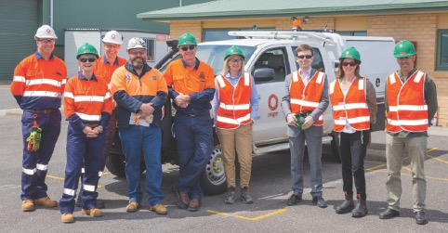
Figure A1.1 The Stakeholder Advisory Panel at the Otway Gas Processing Plant.
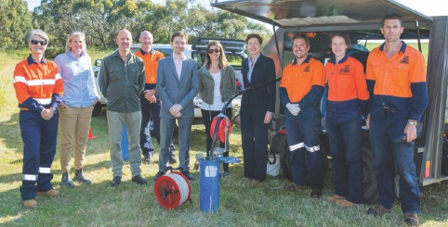
Figure A1. 2 The Stakeholder Advisory Panel learning about the groundwater monitoring program.
The overview of the engagement program highlighted that over 80 individual engagements have occurred to date, covering local governments, gas explorers, gas users, regulators and environmental and community groups. Most engagements have been one-on-one discussions and small group meetings. As the Geological Survey of Victoria Warrnambool team reaches full complement more sophisticated engagements and presentations will commence.
Five media articles about the Victorian Gas Program had been featured in newspapers in south-west and regional Victoria since the program was announced. Additionally, while the Stakeholder Advisory Panel was in Camperdown, I gave an interview to ABC South-West regional radio about the Panel’s work.
The Panel’s review of the projects to date is providing valuable insights and suggestions to ensure that the scientific studies are meeting the concerns and interests of the various stakeholders connected to the onshore conventional gas studies.
The next Stakeholder Advisory Panel meeting is scheduled for March 2018.

Communique 3 – March 2018
The third meeting of the Stakeholder Advisory Panel for the Victorian Gas Program’s Onshore Conventional Gas Studies was held in Melbourne on Thursday, 8 March 2018.
The meeting commenced with a presentation from the Geological Survey of Victoria on the current 3D geological models of the Otway and Gippsland basins. These models capture the sub-surface structure of each basin and will ultimately provide a picture of the presence of onshore conventional gas resources.
A significant objective of the Victorian Gas Program is to refine the current models through seismic data analysis together with rock characterisation studies to produce a much more detailed understanding of each basin’s geological structure. The Geological Survey of Victoria is currently presenting these 3D geological models to councils in South-West Victoria to explain the scientific approach being taken by the Victorian Gas Program.
At the meeting, Panel members discussed the national gas market, the contribution of Victoria’s offshore gas resources, and the possible impact of any onshore conventional gas resources identified through the Victorian Gas Program on gas supply and pricing. I acknowledged that the scientific work being undertaken is at a very early stage and highlighted that it will provide the State with the best picture of Victoria’s potential for onshore conventional gas resources. This information will assist government to make future evidence-based decisions about any development of onshore conventional gas resources.
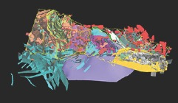
Figure A1.3 Geological model of rock outcrops across Victoria
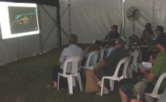
Figure A1.4 Public attending one of the Geological Survey of Victoria’s 3D model presentations at Sungold Field Days
The use of gas as an energy source in the context of the state’s carbon emission targets and commitments on climate change was also discussed. A consolidated picture of how government is improving energy efficiency in businesses and households to reduce demand, including initiatives to increase supply of renewable energy, is being prepared to inform the Panel.
A major task of the Panel is to eventually provide government with advice on the risks, benefits and impacts of onshore conventional gas. At the meeting, the Panel began to consider the scope of work needed to be undertaken for this study. An initial environmental risk assessment framework was tabled for Panel members to consider. The study’s scope will receive independent expert advice from the Scientific Reference Group throughout the Program.
The Director of Geological Survey of Victoria updated the Panel on the progress of the Victorian Gas Program. Key highlights included:
- Following months of data review and planning, the geoscience team is in the process of selecting rock samples for analysis of source, seal and reservoir rocks (necessary components of a petroleum resource system). Approximately 1400 samples have been selected for analysis, and a further 1700 samples will be analysed to establish mineral and fossil content.
- The environmental studies team has now sampled 25 groundwater bores for chemistry content and 42 bores for stygofauna (a miniature creature that may indicate the health of groundwater) in South-West Victoria. Groundwater bore testing will begin in Gippsland in late April, and air quality surveying in the Otway Basin is expected to begin in April. This data will help to establish the existing environmental baseline conditions, which would provide a benchmark for considering the potential risks and impacts of conventional gas activities.
- To support commercial exploration for further discoveries of gas off Victoria’s coast an airborne gravity survey of the Otway Basin will be undertaken. The survey will measure minute differences in gravitational force from different rock strata both onshore and offshore. The data collected will provide a data set of varying rock densities across the basin.
- The community engagement program continues to connect with strategic stakeholders in South-West Victoria and Gippsland. A major community engagement initiative was held at Sungold Field Days, one of the largest agricultural shows in South-West Victoria, in February 2018. A marquee cinema showing 3D projections of Victoria’s geology was set up to show the geology of the Otway Basin and introduce the VGP to farmers, students and community groups.
The next Stakeholder Advisory Panel meeting will be held in June 2018.

Communique 4 – June 2018
The fourth meeting of the Stakeholder Advisory Panel for the Victorian Gas Program’s (VGP) Onshore Conventional Gas Studies was held in Melbourne on Thursday, 7 June 2018.
The Minister for Resources, Tim Pallas, opened the meeting and reinforced the Panel’s key role in understanding and discussing the VGP’s scientific findings and the risks, benefits and impacts of any onshore conventional gas development. He highlighted the importance of informed debate and the need for government to understand both the needs of industry and the diversity of views across the community.
The Minister responded to a range of questions from the Panel on regulatory issues such as landowner rights and community benefits, including how best to secure domestic supply from local resources. He also addressed contextual issues such as government’s commitment to CO₂ emission reduction targets, how we manage the transition from coal to renewable energy technologies and the need for greater transparency in energy distribution and retail markets.
The Minister was followed by Ms Kylie White, Deputy Secretary, Energy, Environment and Climate Change in the Department of Environment, Land, Water and Planning (DELWP). Ms White reiterated the Victorian Government’s commitment to an affordable, reliable and renewable energy future – with legislated targets and support for transition to zero (net) emissions by 2050. Ms White confirmed that Victoria is on track to achieving the Victorian Renewable Energy Target of 25% by 2020 with renewables producing over 16 per cent of Victoria’s electricity in 2017, up from around 11 per cent in 2014. She provided an overview of current initiatives such as the Energy Efficiency and Productivity Strategy, the Renewable Energy Action Plan, the Victorian Renewable Energy Target Program Reverse Auction and the Victorian Energy Upgrades program.
Ms White responded to questions from Panel Members who sought to understand how government is working
with industry to reduce gas demand; clarification of the definition of zero emissions; and government plans
to respond to the capacity of different sectors to transition from fossil fuels faster than others.
The Director of the Geological Survey of Victoria (GSV) advised the Panel that the VGP’s scientific work
is on schedule. The new 3D geological framework model for the Otway Basin is only a few months away.
The geoscience team will next focus its efforts on filling critical knowledge gaps through a ‘stratigraphic’ drilling program to provide new rock samples for analysis.
He also advised that the baseline air quality surveying (measuring methane and carbon dioxide concentrations) of the Otway Basin, has commenced and will continue until July 2018.
The panel was also updated on several upcoming VGP announcements, including:
- a collaborative project between GSV and the Iona Gas Plant, near Port Campbell, to share analytical
drill core data that could assist in understanding the potential for storing gas in depleted onshore gas fields in the area, and
- details of the supplier, timing and flight area of an airborne gravity survey of south west Victoria to better understand the regional, large-scale geology of the Otway Basin, both onshore and offshore.
The geoscience overview was followed by a community engagement update. The reach of the program
to date now includes 290 stakeholders across south west Victoria, Melbourne and Gippsland.
GSV has presented its 3D geological models to Councillors across the Otway Basin and briefed Mayor and Chief Executive Officers across Gippsland on the VGP. Other regional networks such as farmer organisations, catchment management authorities, environmental groups, economic development associations and community groups have also been engaged.
The next Stakeholder Advisory Panel meeting will be held in September 2018.
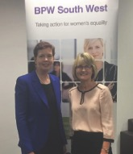
Figure A1.5 I was delighted to talk about the Victorian Gas Program in April to over 70 members from the Business and Professional Women South West Association at Deakin University Warrnambool campus.

Communique 5 – September 2018
The fifth meeting of the Stakeholder Advisory Panel (SAP) for the Victorian Gas Program's (VGP) Onshore Conventional Gas was held in Camperdown on Thursday, 6 September 2018.
The Panel received their first briefing on the VGP's regulatory reform project, which will develop policy, administrative and legislative reform proposals for Government once the broader scientific findings regarding the potential for onshore conventional gas are known.
The presentation covered the Government's current policy on gas, including the moratorium on onshore conventional gas in place until mid-2020. It detailed the legislative and regulatory controls currently
in place through the Victorian Petroleum Act 1998 and Petroleum Regulations 2011 and where there might
be opportunities to harmonise regulatory frameworks.
The onshore conventional gas regulatory reform program will include assessing best practice arrangements around gas exploration and production from other jurisdictions (including other Australian states and territories, New Zealand, North America, Canada and Europe) and recommendations from relevant reviews and inquiries. There is also potential for a social baseline assessment to be undertaken as part of building
an evidence base of community attitudes to future gas exploration.
Panel members identified that landholders often had little knowledge about their rights and regulatory processes when dealing with gas explorers and developers, suggesting the need for better information products to support landholders. Members also discussed the lengthy time scale of resources projects
and how communities would often be concerned about environmental impact and land rehabilitation.
It was also suggested the regulatory reform program should look at the Victorian Pipelines Act 2005
to evaluate if the Act's provisions for dealing with landholders were superior to the Petroleum Act 1998.
Panel members recommended that as the Gippsland and Otway Basins were the focus of the VGP, workshops on how gas exploration and production were regulated should be prioritised for communities
in those regions.
The Panel was updated on VGP activities including:
- the airborne gravity survey currently underway in South-West Victoria, including the engagement
and community awareness campaign
- the completion of the rock sampling data collection phase, and the commencement of the analysis
of source, seal and reservoir rock measurements
- progress on building the petroleum systems model, combining all available new and existing data
and interpretations to estimate hydrocarbon resources (gas) in the Otway Basin
- 50% completion of groundwater bore sampling for chemistry in South-West Victoria, providing data
that will assist to build a gas field groundwater impact assessment scenario model
- progress on the regional air quality survey program of the Gippsland and Otway Basins
- engagement of over 500 individual stakeholders across South-West Victoria, Melbourne and Gippsland through more than 420 events (i.e. briefings, meetings, forums, emails and telephone calls)
- progress on the geoscientific assessment of underground gas storage potential of depleted reservoirs around Port Campbell.
Following the meeting, a number of SAP members attended the official opening of the Geological Survey
of Victoria's South West Regional Office at Deakin University Warrnambool. The office is undertaking a range of VGP scientific studies and engaging with the community.
The next Stakeholder Advisory Panel meeting will be held in November 2018.
(Please note: The November 2018 Stakeholder Advisory Panel meeting was postponed due to the Government being in caretaker mode prior to the State Election.)

Communique 6 – February 2019
The sixth meeting of the Stakeholder Advisory Panel for the Victorian Gas Program (VGP) Onshore Conventional Gas Studies was held in Melbourne on Thursday, 14 February 2019.
Minister for Resources, Jaclyn Symes, spoke at the beginning of the meeting via teleconference. The Minister's remarks included her appreciation for the work of panel members in bringing diverse perspectives and advice on the issue of onshore conventional gas.
As scientists at the Geological Survey of Victoria gather and model the available data on the Otway Basin, critical gaps in information have emerged. The VGP provides scope for stratigraphic drilling to fill such data gaps and better understand rock layer changes across the basin. The Panel received their first briefing on how the VGP would prepare to undertake this work. Panel members asked questions about the need for undertaking the drilling activity and the benefit it would provide in terms of data and information. Questions were also raised about risks and how they would be mitigated, including engagement with the local community. A decision on whether to proceed with stratigraphic drilling will be taken later this year.
Late in 2019, the onshore areas of the Otway Basin with potential for conventional gas resources will be known. These areas will then be the focus of Resource Land Use Planning studies to understand the unique environmental, social and economic land use features of each area. The Panel was briefed on the methodology and process planned to undertake these assessments.
Amanda Caples and Corangamite mayors Victorian Gas Program hydrogeologists spent time at Sungold Field Days agriculture event in February, talking to farmers and others about groundwater in South-West Victoria.
- Completion of the airborne gravity survey across 16,000 km2 of South-West Victoria, identifying extremely small variations in the earth's gravitational field. The interpreted data will be publicly available later in the year.
- Continuing geoscientific analysis and interpretation of new and existing rock measurements. The results will be incorporated into the petroleum systems modelling, along with existing data and interpretations, to help provide an estimate of hydrocarbon (gas) resources in the Otway Basin.
- Progress of sampling groundwater bores in south-west Victoria. A groundwater sampling campaign will commence in Gippsland in March 2019. The collected data will provide a comprehensive baseline of current groundwater conditions and will improve the understanding of groundwater processes.
- Completion of the second atmospheric baseline survey for Gippsland and South-West Victoria. The results were similar to the first survey round with slight increases of methane concentrations in urban areas, cattle yards and proximity to native vegetation burn off. Raised methane concentration readings were also repeated around the Port Campbell gas storage facility. All concentrations were well below EPA guidelines.
- Commencement of a desktop review of socio-economic and environmental receptors. These receptors will provide the baseline data to underpin a risk, benefit and impact assessment of a hypothetical onshore conventional gas development, once the detailed findings of the geoscientific and environmental studies are known.
- Engagement with over 580 individual stakeholders across south-west Victoria, Melbourne and Gippsland through more than 480 events (i.e. briefings, meetings, forums, emails and telephone calls).
- Commencement of detailed geoscientific assessment of the depleted gas reservoirs in the Port Campbell area. This work will continue to rank and differentiate the depleted reservoirs regarding their potential storage capabilities.
The next Stakeholder Advisory Panel meeting will be held in May 2019.
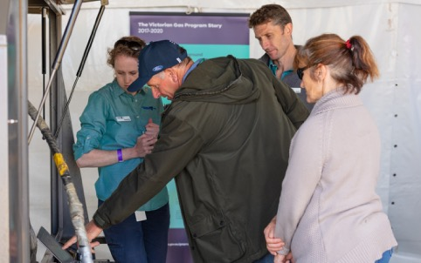

Communique 7 – May 2019
The seventh meeting of the Stakeholder Advisory Panel for the Victorian Gas Program's (VGP) Onshore Conventional Gas Studies was held in Camperdown on Thursday, 9 May 2019.
Victoria's Lead Scientist and Chair of the Stakeholder Advisory Panel, Dr Amanda Caples, opened the meeting and welcomed newly appointed panel member Jonathan La Nauze, Chief Executive Officer Environment Victoria. Dr Caples also provided details of her activities since the last Panel meeting including attendance at the Australian Domestic Gas Outlook conference and a meeting with Friends of the Earth and Environment Victoria representatives to be briefed on key Victorian Gas Program activities.
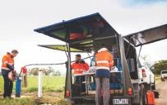
Groundwater sampling
Key presentations to the Panel included:
- An update on the progress of the Resource Land Use Planning studies, which will assist in understanding the unique environmental, social and economic features of each prospective resource area (a zone with the geology to potentially host conventional gas) identified by the VGP's studies. The Panel will be involved in a workshop to determine the criteria and value weightings for the land use framework at its next meeting.
- A briefing on the commencement of a case study regarding the risks, beneﬁts and impacts of the Otway Basin gas production and processing facility in Port Campbell. This work will inform the next phase of work, which is a risk, beneﬁt and impact assessment of hypothetical onshore conventional gas developments, based on the outcomes of the VGP's studies.
- An update on potential policy and regulatory reform development, including the preliminary identification of practices to improve a social licence to operate, along with an assessment of the adequacy of the current regulations to manage these areas. Initial findings indicate that the regulations are quite robust but with potential areas for improvement, including; community and landholder engagement as well as transparency of industry activities.
- An update on the stratigraphic drilling project to fill in key geological data gaps in the northern part of the onshore Otway Basin. If the project proceeds, an extensive community engagement program would be undertaken. Members discussed the proposed communications and engagement activities and raised queries about how climate change factors would be acknowledged.
Panel members were also updated on other VGP activities including:
- The start of the release of technical reports on new data acquired from the geoscientific studies of the Otway Basin.
- The completion of the data acquisition phase of the airborne gravity survey of the Otway Basin. The data will improve interpretation and visualisation of the deep rocks and structures of the Otway Basin.
- Deep groundwater bore sampling in the Otway Basin is now finished, and sampling in the Gippsland Basin is nearing completion.
- Scientific studies investigating the potential to expand Victoria's underground gas storage capacity are progressing well. Several depleted gas fields around Port Campbell are being assessed in terms of their geophysics, geology and commerciality for repurposing to provide underground gas storage.
- The potential timing for the announcement of preliminary resource areas for the Otway geological basin. Panel members discussed and made recommendations about a communications and engagement approach to support the announcement.
To date, over 620 individual stakeholders have been engaged across south-west Victoria, Melbourne and Gippsland through more than 550 events (i.e. briefings, meetings, forums, emails and telephone calls).

Communique 8 – August 2019
The eighth meeting of the Stakeholder Advisory Panel for the Victorian Gas Program’s (VGP) Onshore Conventional Gas Studies was held in Melbourne on Thursday, 8 August 2019.
The meeting began with an update on the geological modelling of areas in the south west that may have the rock characteristics, sequence and structure to potentially host onshore conventional gas.
The Panel’s questions about the modelling included clarification about the methodology used to determine an area’s prospectivity and its resource estimate. There was also discussion about the types of exploration activities that would be required to confirm if a prospective area had a commercial quantity of conventional gas.
Panel members also participated in a Resource and Land Use Planning workshop to examine and prioritise the key themes for a new land use model of the Otway Basin. The model seeks to identify areas of sensitivity and significance that may need to be considered if the moratorium on exploration of onshore conventional gas was allowed to sunset in 2020.
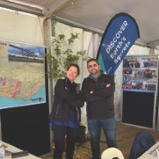
Some of the Geological Survey of Victoria team sharing the science at Sheepvention 2019 in Hamilton.
Members provided advice and input on the model’s themes, priorities and data sources. An overview of the proposed community and stakeholder consultation workshops across the Otway Basin to explain the model and seek public feedback was also discussed.
Panel members were updated on VGP activities, including:
- Progress of the rock characterisation studies, including sampling of close to 7,000 south-west Victorian rock specimens resulting in over 300,000 new measurements. This new data is being fed into the modelling of the prospective resource areas in the Otway Basin. The data will be a key input to estimating Victoria’s undiscovered gas potential.
- The near completion of 3D geological models for the Otway Basin. A similar 3D framework model is also being built for the Gippsland Basin.
- The release of the largest airborne gravity dataset ever collected in Victoria. Modelling using the new data will improve current understanding of deep structures in the Otway Basin, especially in areas where there is currently
very little data.
- Completion of the second atmospheric baseline concentration survey (carbon dioxide and methane) for both Gippsland and south west Victoria.
The results are similar to the first round, which showed levels were within normal Environmental Protection Authority ranges.
- Finalisation of the groundwater sampling program for both the Otway and Gippsland basins, with 113 deep groundwater samples collected.
- Completion of the investigations into opportunities for further underground gas storage. The reports will be made publicly available in late 2019/early 2020.
- Engagement with over 660 individual stakeholders across south-west Victoria, Melbourne and Gippsland through more than 550 events (i.e. briefings, meetings, forums, emails and telephone calls).
- Presentations to over 1,200 primary and secondary students in south west Victoria to increase their understanding of geoscience and their regional geology.
- The commencement of a social research survey across the Otway and Gippsland basins that will examine communities’ perceptions of onshore conventional gas exploration and development.
- The upcoming release of Progress Report 3 and other VGP technical reports.
The Panel also received a presentation on the Victorian Hydrogen Investment Program by a representative from the Department of Environment, Land, Water and Planning. The State Government backed program will support hydrogen research, trials and demonstrations, creating a new base of industry knowledge and skills to assist in diversifying Victoria’s energy future. More information can be found at the Energy website.
The next Stakeholder Advisory Panel meeting will be held in November 2019.

Communique 9 – November 2019
The ninth meeting of the Stakeholder Advisory Panel for the Victorian Gas Program’s (VGP) Onshore Conventional Gas Studies was held in Camperdown on Thursday, 21 November 2019.
The meeting began with an update on the results of the geoscientific studies, including analysis of the data from the rock characterisation studies and the airborne gravity survey. The new chemostratigraphy data has provided greater understanding of the Otway Basin’s prospectivity for onshore conventional gas than was initially anticipated. As a result, it has been decided not to proceed with stratigraphic drilling in the Penola Trough, west of Casterton, as the project is unlikely to provide significant new geological insights at a regional level.
The new 3D geological models for both the Otway and Gippsland basins are also on track to help complete the prospectivity assessments and resource estimates. The data from these models will also be coupled with groundwater impact modelling for both basins.
Panel members received an update on the Resource and Land Use Planning project for the Otway Basin. Seven community workshops were held across the region in October and November 2019. Local residents viewed and provided comment on the model. Developed from over 140 authoritative data sets, the model seeks to identify areas of sensitivity and significance that may need to be considered if the moratorium on exploration or development of onshore conventional gas ends in 2020. A similar model will be built for the Gippsland Basin and displayed at local community workshops in early 2020.
The Panel was also briefed on the commencement of the VGP’s assessment of the risks, benefits and impacts of future potential onshore conventional gas developments. A consulting group will work closely with the Stakeholder Advisory Panel to deliver the assessment. Their work will feature hypothetical gas development scenarios based on the VGP’s geoscience and environmental studies, resource and land use planning models and social baseline research. Panel members provided feedback on the methodology and issues and inputs to be incorporated into the assessment.
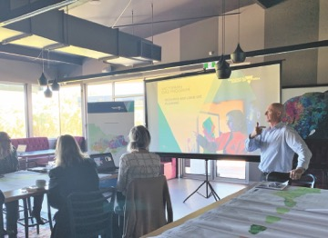
Public workshops were held across the south west in late 2019 to seek feedback on a new resource and land use planning model.

Other program updates included:
- Preliminary findings of the geoscience studies, indicating that some areas of the onshore Otway Basin have the potential to host conventional gas.
- Preliminary findings of the environmental studies’ modelling and regional groundwater impact scenarios in the Otway Basin, indicating negligible impacts on groundwater as any potential gas resource would be over a kilometre below aquifers.
- Engagement with over 740 individual stakeholders across south-west Victoria, Melbourne and Gippsland through more than 640 events (i.e. briefings, meetings, forums, emails and telephone calls).
- Presentations to over 1,390 primary and secondary students in south west Victoria to increase local understanding of geoscience and regional geology.
- Completion of a social research survey of communities across the Otway and Gippsland basins that examines communities’ perceptions of onshore conventional gas exploration and development. The final report is expected to be ready in early 2020.
- Findings from the VGP’s policy and regulatory review, including analysis indicating that the onshore petroleum regulatory framework is robust for managing environmental and safety risks.
- The upcoming release of Progress Report 3, which provides a summary about where the various studies are at, and other VGP technical reports.
The next Stakeholder Advisory Panel meeting is planned for February 2020.

M = mean

