
Extractive Resources

Supply and Demand Study 2022-30
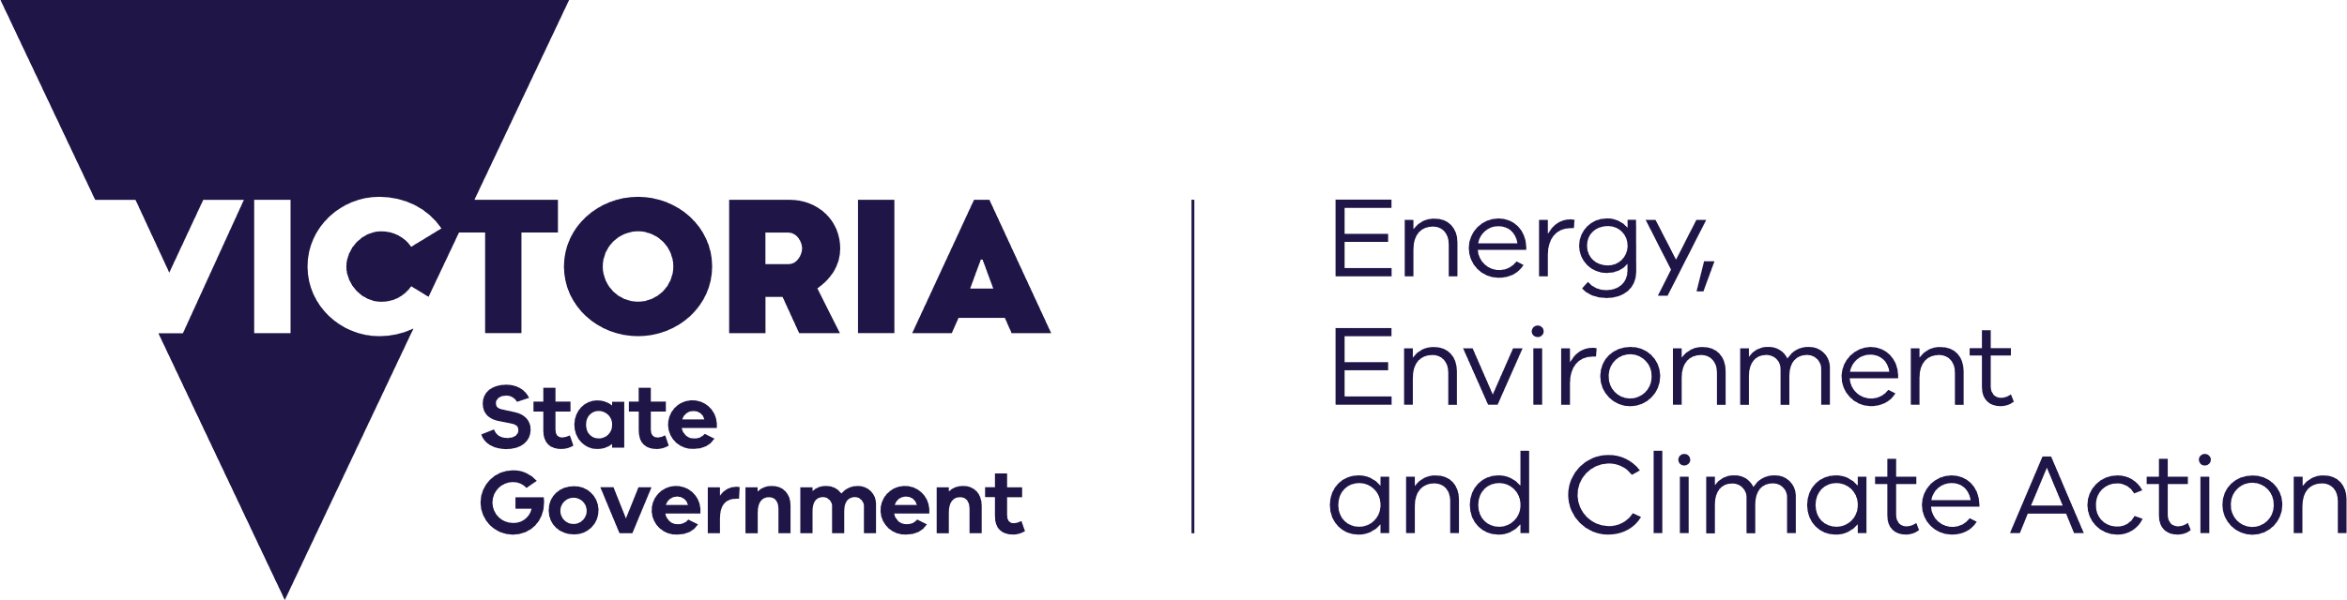
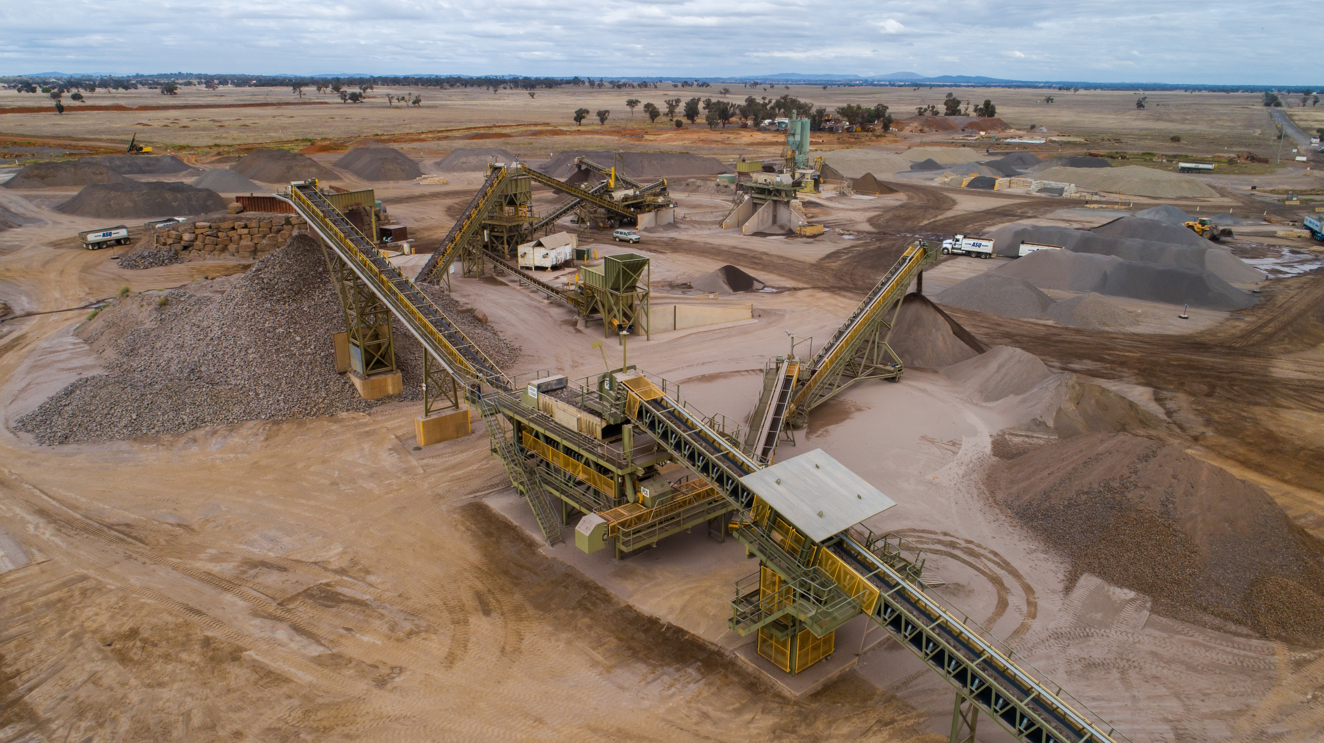





deeca.vic.gov.au

Acknowledgements
The Department acknowledges the contributions to the development of the Report made by Extractives Strategy Taskforce and extractive industry operators involved in the project.


We acknowledge and respect Victorian Traditional Owners as the original custodians of Victoria’s land and waters, their unique ability to care for Country and deep spiritual connection to it.
We honour Elders past and present whose knowledge and wisdom
has ensured the continuation of culture and traditional practices.
DEECA is committed to genuinely partnering with Victorian Traditional Owners and Victoria’s Aboriginal community to progress their aspirations.
© The State of Victoria Department of Energy, Environment and Climate Action, August 2023.
Creative Commons
This work is licensed under a Creative Commons Attribution 4.0 International licence, visit the Creative Commons website (http://creativecommons.org/licenses/by/4.0/).
You are free to re-use the work under that licence, on the condition that you credit the State of Victoria as author. The licence does not apply to any images, photographs or branding, including the Victorian Coat of Arms, and the Victorian Government and Department logos.
ISBN 978-1-76136-326-9 (pdf/online/MS word)

Contents
Summary 3
1. Introduction 6
1.1 Problem statement and project scope 6
1.2 Extractive materials 7
What are extractive materials and what are they used for? 7
Hard rock 7
Sand and gravel 7
Clay 8
Clay shale 8
Limestone 8
Recycled materials 8
Factors influencing the supply of raw materials 8
1.3 Market analysis 9
Previous Supply Demand Study 9
Recent Demand Changes 9
Recent production changes 10
Drivers of Victorian demand 11
Current production figures, by rock category 11
Coronavirus (COVID-19) pandemic impacts 12
1.4 Resources vs reserves 12
Resources and reserves 12
1.5 Victorian Government initiatives to ensure reliable and affordable supply 13
Resource and land use planning theme from the Extractive Resources Strategy 14
Efficient regulation theme from the Extractive Resources Strategy 14
Transport and local infrastructure planning theme from the Extractive Resources Strategy 14
2. Demand analysis 15
2.1 Methodology and assumptions 15
2.2 Actual demand vs the 2016 Supply Demand Study 16
2.3 Statewide demand forecast 16
2.4. Demand by local government area 17
2.5. Demand by sector 19
2.6. Demand for limestone 21
2.7 Conclusions relating to demand analysis 21
3. Supply analysis 22
3.1 Methodology and assumptions 22
Supply data gathered from industry surveys 22
Supply data gathered from work authority annual reports 22
Supply data methodology 23
Supply modelling uncertainty and assumptions 23
3.2 Supply forecasts 23
Location of supply 25
3.3 Distance and transport costs 28
3.4 Conclusions relating to supply analysis 28
4. Integration analysis 29
4.1 Methodology and assumptions 29
4.2 Integration analysis findings 31
4.3 Impact of supply and demand on costs 34
4.4 Conclusions relating to integration analysis 35
5. Simulation modelling tool 36
5.1 Methodology and assumptions 36
5.2 SMT scenarios 37
Model simulations 37
How to use the scenarios 38
Chosen scenarios 38
5.3 Findings from the SMT scenarios 38
Model results 38
5.4. Conclusions relating to the SMT scenarios 43
6. Opportunities for future analysis 44
6.1 Revised supply demand forecasts 44
6.2 Development of a replenishment Index 44
6.3 Consideration of recycled materials in supply demand analysis 44
Asphalt 45
Crushed concrete 45
Recycled crushed glass in concrete 45
Recycled crushed glass 45
6.4 Integration analysis and simulation modelling tool advances 45
6.5. Sydney case study 45
7 Study conclusions 46
8. Appendices 47
8.1 Supply-side engagement – Survey questions 47
9. Glossary 50

Summary
Victoria’s extractive resources industry is a vital part of the State’s economy, representing around $1 billion annually at the quarry gate. Extractive resources, such as sand, gravel, hard rock and clay are the key ingredients for a range of products such as concrete, asphalt, and road base which are essential to the construction industry. The construction industry is valued at $21.6 billion and employs around 240,000 people in 89,000 businesses.
Demand for extractive resources is being driven to unprecedented levels by population growth and projects in Victoria’s ‘Big Build’. Victoria’s Big Build is delivering $90 billion of transport projects, including 165 major road and rail projects, and increasing construction of residential, commercial and renewable energy infrastructure by the private sector.
Victoria has benefited from a competitive extractive resource industry, which operated close to market, providing ample accessible and affordable materials for Government projects and consumers. When old quarries closed for transition to other land uses, new quarries opened in areas that were on the fringe between urban Melbourne and rural Victoria (known as peri-urban areas). The supply of extractive resources for infrastructure was consistently replenished at a stable cost.
However, the extractive resources replenishment rate is deteriorating. Competing land uses and changing community attitudes are leading to regulatory uncertainty and longer timeframes for new quarry and quarry variation approvals. As fewer new quarries are developed, there is increasing production in existing approved reserves. This becomes necessary as the alternative is transporting more extractive resources from further afield, incurring increased transport costs and additional emissions. In addition, specifications for high-quality sand and quarry materials are tightening for higher durability projects, thereby further limiting supply. Maintaining such supply of high-quality products close to Melbourne’s building projects is not sustainable in the long-term without additional quarries coming online.
This Extractive Resources Supply and Demand Study 2022-30 (the Study) conducted during 2021-22 investigates whether Victoria has the supply of extractive resources to meet demand between 2021-22 and 2029-30. The Study makes statewide and regional level supply and demand forecasts across the key extractive resource commodities and uses scenario analysis to predict the transport distance impacts under the current market trajectory.
The Study has estimated Victoria’s extractive reserves for 2022-2030 by interviewing 20 companies that collectively account for 145 work authorities. The survey data from the interviews covers approximately 70 per cent of Victoria’s production, with the balance of production supplemented with resource estimates derived from industry annual reports. The survey shows that current Victorian work authorities hold at least 1.13 billion tonnes of reserves that are approved for development. Additionally, a further 811 million tonnes of resources could be available but regulatory approvals would be required to develop these. Development of these resources may also be limited by commercial factors such as resource quality and market specifications.
Statewide demand for extractive materials is expected to increase from 63.7 million tonnes in 2020-21 to 79.5 million tonnes by 2030, higher than the historical trend growth. The demand forecasts indicate that Greater Melbourne will account for around 80 per cent of total extractive resource demand from 2021-22 to 2029-30. In particular, outer urban growth areas, including Greater Geelong, Wyndham, Hume, Whittlesea and Casey, are expected to be major consumers of extractive materials due to increased construction driven by population growth.
The forecast cumulative demand of 640 million tonnes from 2021 to 2030 represents around 56 per cent of current reserves over that period. While at an aggregated statewide level there would appear to be enough extractive resources to meet forecast demand up to 2030, there are specific product and location demands that do not always correspond to the quality and location of available reserves.
The regional analysis undertaken showed that under current predictions, extractive resources will increasingly need to be sourced from more distant quarries. This generates added costs and other issues, including increased truck movements and emissions.
With moderate assumptions, it is expected that between 2021 and 2030, the average distance to transport hard rock, and sand and gravel, to Melbourne could increase from 32 km to 151 km and 62 km to 183 km, respectively. This presents about a 120 km increase for both commodities.
This is concerning because transport costs are approximately 25-30 per cent of the total extraction cost for quarries close to project sites, with trucking costs estimated to be about 20 cents per tonne per kilometre. With heavy construction materials for residential and non-residential builds equating to about 40 per cent of building material costs, these cost increases are likely to affect housing, roads, social infrastructure and The Big Build and Big Housing Build projects. More trucks driving longer distances increase the state’s carbon footprint and the wear and tear on roads.
The regional supply analysis within the Study showed that, unlike hard rock, which is more widespread around Melbourne, sand is more localised in certain areas of the State. Most of the sand supply is in the Lang Lang to Grantville sand belt, which spans the local government areas (LGAs) of Cardinia, Bass Coast and South Gippsland to the east of Greater Melbourne. West of Greater Melbourne, sand reserves are more limited and concentrated in Barwon and in the Central Highlands, while the Goulburn Valley/Seymour region is well positioned to supply Melbourne’s north.
This means Victoria potentially has a higher risk exposure to sand supply shortfalls if a major quarry in a sand-producing region were to withdraw from the market without replenishment. This is pertinent as current sand reserves are increasingly depleting and key sand-producing are facing major competing land-use challenges.
A prototype simulation modelling tool was developed to provide insights into the possible transport distance and transport cost impacts if sand supply from a particular region were reduced today as a result of regional resource exhaustion without any new replacement quarries being developed. The modelling showed that reducing sand supply in key supply areas to the east or west of Melbourne would impact the entire state with most LGAs needing to source their sand from more distant suppliers (sometimes from interstate) and the price of sand would increase significantly. For example, a reduction in annual production of about 1 million tonnes of sand from the eastern regions of Victoria could lead to an increase in transport costs of about 40 per cent relative to baseline.
The Study presents the most robust Victorian extractive resource supply and demand assessment to date. While the dataset continues to have limitations, it is a major refinement to previous estimates published in the 2016 ‘Extractive Resources in Victoria: Demand and Supply Study 2015-2050’.
This Study is a ‘point-in-time’ short- to medium-term forecast of main groups of extractive resources at a broad geographic scale. The Study should be revised in the future with up-to-date input from industry to improve accuracy and maintain currency. The Study would benefit from better incorporation of recycled concrete and glass data and an extractive resource replenishment index to better forecast extractive resource supply.
The Study concludes that the forecast supply/demand outlook for extractive materials in Victoria will tighten. While market forces may stimulate new quarry developments as material prices rise, barriers to entry for new quarries are increasing and may be reducing competition.
Without a response, it is likely that Victoria will face significant transport distance and material cost increases up to 2030. Determining the response is complex. The state must balance competing land use policies and priorities particularly in peri-urban areas. It must also consider regulatory reform, to better enable the approval of new quarries and quarry expansions, and to maintain carbon emission reduction targets.
The Victorian Government is implementing the Extractive Resources Strategy and the Joint Ministerial Statement Extractive Resources to provide greater certainty for industry to invest and supply affordable construction materials to support long-term growth.

For the medium- to long-term, this includes legislative reform to inter alia streamline quarry approvals processes, and rolling out Strategic Extractive Resource Areas to secure resources into the long-term in areas proximate to future demand locations. The new Resources Victoria Approvals Coordination function will also play a role in boosting short- to medium-term supply by helping to accelerate decisions on quarry site expansions and other proposals to extend operations across the state.

Introduction

1.1 Problem statement and project scope
The Department of Energy, Environment and Climate Action (DEECA) manages Victoria’s extractive resources. The Department conducts strategic planning with the Department of Transport and Planning to assist the efficient long-term supply of extractive materials for the construction across Victoria.
Extractive resources are geological materials sourced from the Earth’s surface, such as sand, gravel, hard rock, clay and clay shale, and limestone. These resources are the basis for producing concrete, cement, road base, glass, bricks and asphalt used in infrastructure such as roads, railways, bridges and commercial and residential buildings.
The Victorian extractive industry supports the state’s $23 billion building and construction industry. The extractive industry is estimated to be worth about $1 billion annually at the ‘quarry gate’, with more than 500 active quarries across Victoria annually producing over 60 million tonnes of aggregated stone, clay, limestone, sand, gravel, and hard rock.
Demand for extractive resources in Victoria has significantly increased in recent decades due to a growing population, the expansion of the state’s residential and commercial construction activities, and the development of new roads, rail lines, hospitals, schools, wind turbines and other public infrastructure.
To help ensure housing, infrastructure and commercial construction projects can be delivered cost competitively across Victoria, the state’s supply of extractive resources needs to meet the changing demand levels over the short- and medium-term.
Government and industry decision makers who influence the supply of extractive resources require accurate, current and forward-looking supply and demand information to support efficient resource and land use planning, regulatory decision-making, and public and private investment. Accordingly, the Victorian Government’s Helping Victoria Grow: Extractive Resources Strategy commits to updating the state’s extractive resource supply and demand forecasts every five years and its data supports text throughout this report.
Preliminary findings from previous departmental and industry analysis show that existing supplies of extractive resources will not adequately cover emerging Victorian demand. There is also anecdotal evidence that new extractive resources will be less than those provided by ones closing which may add to supply shortfalls. The result may be significantly increased transport distances and prices for extractive resources.
This Extractive Resources Supply and Demand Study 2022-30 (the Study) aims to examine the supply and demand forecasts for hard rock, sand and gravel, and for clay and clay shale (clay) in the short- to medium-term. These raw materials are essential for the construction of Victoria’s major infrastructure.
The Study considers the following questions that relate to whether the supply of extractive resources can meet demand:
- Is there enough quality extractive material available to meet the forecasted demand in the short-, and medium-term?
- Are there indications that supplies will not be able to be met? If so, what rock types are at risk of under-supply?
- Is this under-supply risk localised or statewide?
- Is the delivery of the Government’s pipeline of major infrastructure projects at risk because of insufficient extractive resources?
To help answer these questions, the Study conducts separate forecasts for supply and demand and combines these through an integration analysis. This analysis and the simulation modelling tool provide potential future scenarios for Victoria and help predict whether the state can meet the expected demand until 2030.
This short timeframe (to 2030) Study builds on previous analysis to enable a more accurate assessment and planning for the short-term impacts. A future report will consider the longer-term supply and demand impacts.
The Study provides an evidence base for Government to tailor interventions in the short- to medium-term so they have the greatest impact. It will assist the Government in implementing the Helping Victoria Grow: Extractive Resources Strategy by further identifying critical and strategically important regions where supply shortfalls are likely to be most pronounced. The Study does not assess or recommend specific interventions.
The Study also supports industry in its investment decision-making by highlighting areas where strong demand is likely to emerge for extractive resources.

1.2 Extractive materials

What are extractive materials and what are they used for?
Extractive materials include rock, gravel, sand and clay that are used for producing construction materials such as concrete, asphalt, road base, fill, bricks, tiles and glass. The construction of a standard detached dwelling that is connected to street and utilities requires a range of extractive materials (Figure 1).
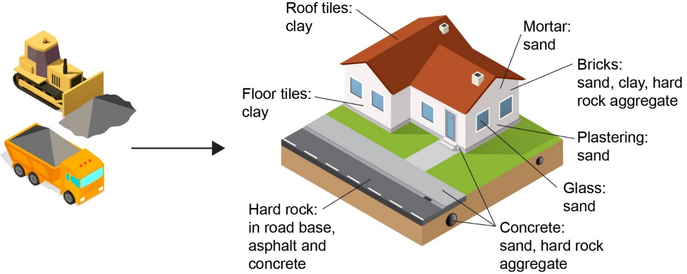

Figure 1 Extractive material usage in housing and infrastructure

Hard rock
Hard rock is a generic term, with many different grades with higher and lower specifications. There is greater demand for higher specification hard rock and there may be less of this in an extractive resources deposit. Specifying the amounts of each rock grade in a deposit is important because different specifications are useful for different infrastructure projects.
Hard rock produces aggregates for making concrete and asphalt. Crushed, it serves as road base. In this report, hard rock includes basalt, dolerite, gneiss, granite, hornfels, quartzite, rhyodacite, schist, sedimentary, slate and trachyte.

Sand and gravel
High specification sand and gravel is most sought after by concrete and asphalt producers. Bricks and plastering also require sand, but this can be of different specifications. Pure sand is most sought after. However, sand may be mixed with gravel, often requiring expensive processing and creating much waste. Industry needs to know the specification ratios within a reserve to help with project planning.

Clay
In Victoria clay is typically used to make bricks. But the production of bricks has been declining as other, lighter products such as clay pavers replace them. Depending on their material and quality, some clay materials excavated during civil projects can be used as low-grade fill or sub-grade replacement. However, project engineering dictates whether these recycled products can be used.

Clay shale
Weathered shale and siltstone deposits are used as the basis of all brick, and to a certain extent tile and pipe manufacture, in the Melbourne area.

Limestone
Limestone is mostly used in agriculture to improve soil fertility and reduce acidity. Occasionally it is used in gold processing. While limestone represents only a small percentage of the Victorian extractive industry (about 1 million tonnes per year) demand is increasing rapidly. Limestone quarries are usually in coastal areas with important cultural and heritage values.

Recycled materials
Recycled construction and demolition waste are increasingly being used as a substitute for raw sand and hard rock materials. About 6.5 million tonnes were estimated to be used for this purpose in 2019-20 compared to 54.8 million tonnes of hard rock and sand.
Recycled materials include:
- reclaimed asphalt pavement
- crushed concrete
- recycled crushed glass in concrete
- recycled crushed glass.
Using recycled extractive resources has many benefits including:
- reducing landfill
- preserving raw resources
- reducing greenhouse gas emissions
- cost reductions due to shorter transport distances.
Currently, recycled materials represent only a small portion of all construction materials produced. There are still barriers to overcome before recycled materials are more widely adopted in construction projects, such as supply costs, the need to meet technical specifications, and the supply cost of recycled materials.

Factors influencing the supply of raw materials
The supply of extractive resources in Victoria is primarily carried out by private businesses in a market-driven economy. Supply is fully demand-driven with minimal stockpiling and export. Victoria’s annual production of extractive resources is a representation of annual consumption within Victoria.
Extraction at a quarry is approved by establishing a work authority. Work authorities are areas of land where permissions have been granted to extract raw materials under section 77I of the Minerals Resources (Sustainable Development Act) 1990. Work authorities are required under State legislation unless exemptions apply.
A number of factors determine where quarry development occurs. A quarry needs to have a sufficient quantity of high-quality raw material, and it requires good access to transport routes and proximity to demand (the projects). If a quarry does not meet these requirements, it is difficult to justify the capital investment needed to develop and maintain a new site and its processing facilities.
A proposed quarry must also obtain regulatory approvals and maintain compliance. Earth Resources Regulation must endorse a work plan, and approvals must be sought from local councils, water authorities, and the Department of Energy, Environment and Climate Action. Quarry operators must ensure they are not affecting cultural heritage, protected vegetation or biodiversity offset zones.
Due to high transport costs, quarries are more viable when located near demand centres, which tend to be in areas that are on the fringe between urban Melbourne and rural Victoria (known as peri-urban areas). These areas also often contain a range of competing land uses and quarry developments are increasingly facing challenges from local communities, land developers and organised opposition groups. These are likely to become an increasingly dominant determinant of where quarries can be located.
The price of raw materials is driven by the cost base and the markup. The cost base reflects the cost of producing and transporting the raw materials. The price mark-up depends on competition, including the distance of other quarries from demand centres.

1.3 Market analysis

Previous Supply Demand Study
In 2016, the Victorian Government commissioned the Extractive Resources Demand and Supply Study 2015-2050 (the 2016 Study) that was undertaken by PricewaterhouseCoopers (PwC). The 2016 Study used demand modelling that linked the amount of construction expenditure from each sector and each rock type to population and employment growth.
The 2016 study used emails, letters, face-to-face interviews and web-based surveys to gather resource estimates and production data from industry. There was in-house geospatial economic modelling to analyse extractive demand and supply. The study concluded that due to rising demand and urban sprawl into potential extractive zones, the Victorian extractive resources industry may not have enough material to meet future demand.
The 2016 study estimated that there were 11 billion tonnes of extractive resources in current and planned future work authorities from 2015 to 2050. This was significantly higher than the supply estimates made using the methodology of the current 2022-2030 Study and while it was a 35-year period, it was considered by extractive resource industry representatives to be a significant overestimate.
The 2016 study estimated transporting resources an additional 25 km would incur $2 billion of additional costs, increasing construction costs. To mitigate increasing construction costs, the report identified a list of strategic locations and critical resources that should be secured to ensure future supply.
The local government areas (LGAs) identified as key to providing future resources included South Gippsland, Greater Geelong, Mitchell, Knox and Cardinia. The Study indicated that hornfels and clay and clay shale would be in short supply across the state.
The current Study aims to build on this work by providing more robust data (generated with industry surveys) and more detailed analysis and finer granularity about where and how many quarries are needed to meet Victorian demand. This will support the Government in its implementation of planning protection through Strategic Extractive Resource Areas.

Recent Demand Changes
Melbourne is fortunate to have had ready access to high-quality hard rock supplies. This has enabled the city to expand with quality construction, while keeping supply transportation costs down.
Most of the businesses in the extractive industry are small- to medium-sized, with many family-owned, private companies. However, a few national companies account for an overwhelming portion of the market share.
Hard rock is the dominant group within the extractive resources market, with basalt being the most common type. Sand and gravel follow, with clay next, and limestone holding the smallest percentage of the market. Refer to Table 1.
Residential building construction represents the strongest demand for extractive resources, followed by non-residential building, transport, and energy and utilities (Figure 2).
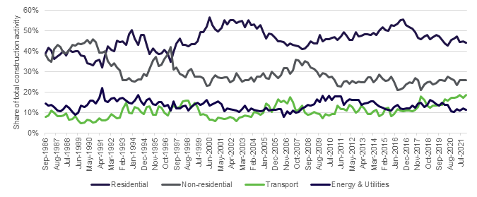
Figure 2 Historical share of construction activity by sector
Since the 2016 Study, demand for extractive resources has been tracking above the forecasted ‘High Scenario’. New demand modelling shows that demand for extractive resources is likely to grow faster due to the Government’s continued investment in major infrastructure projects.

Recent production changes
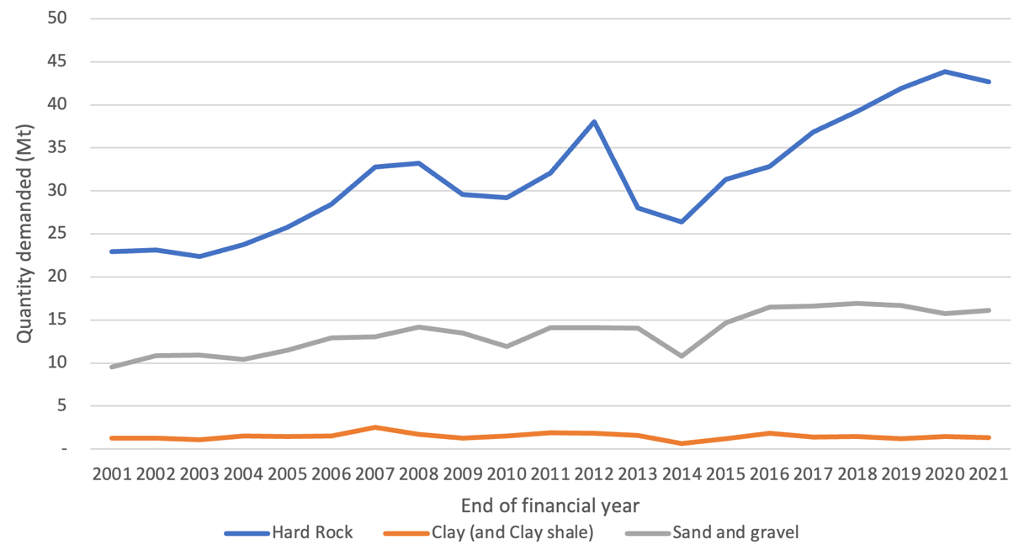
Figure 3 Historical extractive resources production by rock type
Extraction of hard rock, and sand and gravel has grown substantially over the past five years, with production continuing at high levels. In contrast, clay production has remained flat over the past five years, indicating stable demand for clay and clay products (Figure 3).
In 2020-21, Victoria produced approximately 63.7 million tonnes of extractive resources, including 42.7 million tonnes of hard rock, and 16.1 million tonnes of sand and gravel.
The extractive resources demand increase is partly because during the last five years the Victorian Government has significantly increased infrastructure investment, from an average of $4.6 billion a year between 2005-06 and 2015-16, to an average of $12.2 billion a year between 2016-17 to 2020-21. Additionally, there has been extensive residential construction, particularly in urban growth areas. The transport sector’s demand for extractive resources as a proportion of total demand has increased from 11 per cent in 2015 to 18 per cent in 2021 and is forecast to be 19 per cent in 2030.

Drivers of Victorian demand
Demand for total extractive resources is expected to continue to grow on average by approximately 2.5 per cent per year from now until 2030. Demand for hard rock is expected to grow by an average of 2.7 per cent per year, whereas demand for sand and gravel is expected to grow at a much faster rate, of 3.9 per cent per year.
An additional 16 million tonnes of supply will be demanded in 2030 above that supplied to the market in 2022. This additional supply would equate to an additional 32 quarries in 2030, each producing 500,000 tonnes per annum, located similarly close to demand. Alternatively, existing quarries would need to increase production substantially.
Ongoing and timely replenishment of extracted resources from new or expanded hard rock and sand quarries in suitable locations will avoid potential supply imbalances and higher material costs.
This continued growth in the demand for extractive resources is due to Victoria’s Big Build and Big Housing Build projects and high levels of residential construction associated with population growth and its need for housing.
Major Victorian infrastructure projects placing significant demand on the extractive industry include:
- Metro Tunnel: to run for nine kilometres beneath Melbourne’s central business district and beyond, including five new underground stations to accommodate new high-capacity trains
- North-East Link to create an essential freeway connection between Melbourne’s north and east
- Level Crossing Removal Program to remove Melbourne’s 85 most dangerous railway level crossings by 2025
- West Gate Tunnel Project to provide quicker and safer journeys to the western suburbs, Geelong and Ballarat, and to take thousands of trucks off residential streets
- Regional Rail Revival Program to improve infrastructure and services on regional rail lines
- School buildings program, including 100 new schools to be opened across the state by 2026.

Current production figures, by rock category
Table 1 presents data on the latest production figures for the Study’s focus rock types.
Table 1 Production, by rock category for FY 2021-22. (Mt, million tonnes)
Rock type | Production (Mt) | % of total Production | Value of sales (million)
Hard rock | 44.55 | 63.72 | $813.76
Sand and gravel | 16.48 | 23.57 | $247.36
Clay (and clay shale) | 2.74 | 3.92 | $4.35
Limestone | 2.02 | 2.89 | $35.86
*Other | 4.12 | 5.89 | $55.58
Total | 69.91 | 100 | 1156.90
Source: ERR Annual Statistical Report 2022
*Other – includes Scoria, Sedimentary, Soil and Tuff materials
*Note: This data has not been adjusted to accommodate amendments to annual returns by tenement holders and annual returns received after the publication of the report.

Coronavirus (COVID-19) pandemic impacts
COVID-19 has had little impact on the construction industry, with some of the highest extractive demand occurring during the past few years. Government stimulus, through programs such as the Commonwealth Government’s HomeBuilder grants, has further strengthened demand for extractive resources.
Projects involving extractive resources tend to have a lead time of about two years, so there was already work committed in 2020 when the pandemic began. The most noticeable impact on the industry during the pandemic was an increase in domestic landscaping and an associated increase in demand for materials such as concrete.
For many decades, the extractive industry has experienced three- to five-year demand cycles, with an underlying upward trend due to population increase. However, the past decade has seen industry growth, with conditions now particularly strong.

1.4 Resources vs reserves

Resources and reserves
Resources in the context of the Study refer to extractive materials that are contained within work authorities but do not have the required approvals for their extraction. Some resources may never be extracted due to various economic and environmental factors.
Within the extractive industry there are over 500 quarry operators. These operators must have work authorities. Within the perimeter of the work authority, the operator may apply for regulatory approvals to carry out extraction. However, only resources within an approved work plan boundary, that exists within the work authority envelope, can be legally extracted.
However, not all of the resource in a given work authority will be extracted due to:
- Regulatory approvals restrictions: planning permits or other approvals to extract the resource may not be secured over all or part of the work authority.
- Environmental factors: some of the resource may be covered by protected native vegetation or subject to waterways or water tables, or may be under sites of high aboriginal heritage significance.
- Economic factors: some of the resource may be too deep to extract economically
- Specification factors: some of the material may be of insufficient quality to meet the standards required for end uses.
- Geotechnical constraints on quarry’s geometry.
Figure 4 shows a representation of a quarry’s resources bounded by the work authority boundary, and the reserves within the work authority that are permitted to be extracted.
The resource estimate represents the absolute upper limit of what could be potentially extracted from a work authority. However, in many cases, the upper limit is unlikely to be realised. While, resource estimates are useful to support the forecast future extractive resource supply, caution needs to be exercised due to this upward bias.
Reserves are the extractive resources within a work authority that are approved for production and are likely to be developed. This estimate represents the most likely scenario. However, there will still be economic reasons for the reserve not being fully developed (e.g. it may not be the correct specification). The Study assumes that all reserves can be sold, even though some may not be sufficient quality to make it to market.

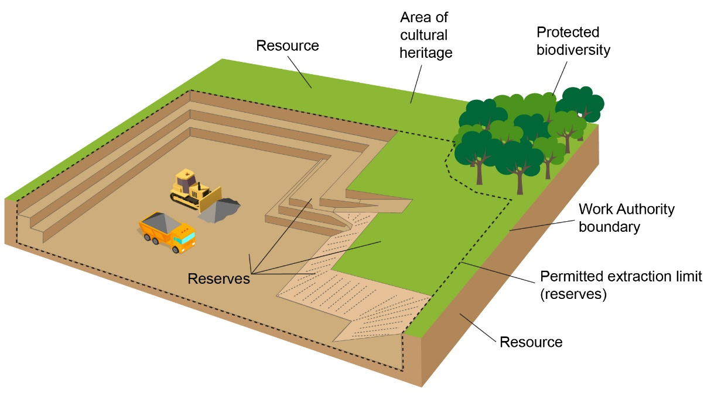
Figure 4 Representation of quarry resource vs reserves. Source: Adapted from Prosser (2018)

1.5 Victorian Government initiatives to ensure reliable and affordable supply
In 2017, Plan Melbourne 2017-2050 was released as a 35-year blueprint to ensure Melbourne grows more sustainable, productive and liveable as its population approaches 8 million. The plan establishes that extractive resource industries and future extractive resource assets need to be protected.
In 2018, the Victorian Government released the Helping Victoria Grow: Extractive Resources Strategy which aims to secure extractive resources for current and future generations to affordably build homes and infrastructure. This strategy sets out a comprehensive and integrated work program and includes initiatives with Victorian Government agencies, industry, local councils and other stakeholders.
In 2018, the Resources and Planning Ministers issued a Joint Ministerial Statement setting out priority areas to deliver a better approach for land use planning and regulation.
On 15 December 2021, the Minister for Resources released the Strategic Extractive Resources Roadmap that details priority actions for establishing Strategic Extractive Resource Areas (SERAs) up to the end of 2023. This roadmap includes priority actions for refreshing Extractive Industry Interest Areas (EIIAs) and improving the supply of geoscience information.
The Extractive Resources Strategy recognised that planning and efficient regulation are needed to ensure that Victoria has an ongoing supply of extractive resources. It consists of six themes:
- resource and land use planning, including economic studies.
- transport and local infrastructure planning
- efficient regulation
- confident communities
- environmental sustainability
- innovative sector.
Strategic actions are underway in the Department across each of these themes to improve Government policy settings to ensure that important extractive industry projects can be established more quickly close to areas of high demand, ensuring construction materials remain affordable.

Resource and land use planning theme from the Extractive Resources Strategy
A key aspect of the Extractive Resources Strategy is the implementation of SERAs to help ensure that access to valuable resources is retained in Local Government Areas (LGAs). SERAs are based on the availability of in-demand rock types, proximity to future growth areas and other local considerations. In 2021, two pilot SERA projects were successfully incorporated into the planning schemes of the Wyndham and South Gippsland LGAs. Three more SERAs are planned for implementation in 2023, informed by the findings of updated supply and demand analyses.
A broader strategic tool in securing extractive resources is to expand on the Extractive Industry Interest Areas (EIIAs). These currently exist in the Victorian Planning Provisions, identifying land that meet criteria on prospectivity, access and land use compatibility. The planning scheme requires decision makers to consider the need for the extractive resources in the EIIA as a check before approving any incompatible uses that would sterilise it.
The Strategic Extractive Resources Roadmap was devised to implement the Extractive Resources Strategy land use components. It also gave the opportunity for engagement with Government agencies, councils, industry and the community. The roadmap is supported by economic modelling, geoscience and supply and demand statistics data.
Statewide policy helps to ensure that local councils’ decisions will contribute to the interests of the state. Implementing extractive resource policies means that where LGAs contain particularly valuable extractive resources, these lands cannot be developed for other purposes, such as housing, that would sterilise those resources.

Efficient regulation theme from the Extractive Resources Strategy
With growing pressure for more short- to medium-term extractive resource supplies, the Government has introduced the Priority Project List and the Resources Victoria Approvals Coordination initiatives to expedite work plan variation approvals. These initiatives aim to make untapped resources within work authorities available for the future market and increase the availability of shovel-ready reserves (those with investment certainty) to meet immediate market needs.
The Better Approvals for Regulators (Earth Resources) program addresses quarry proponents’ access to the approval system. The program reviewed the approvals process for statutory authorisations by the Earth Resources Regulator and has led to improvements to the application assessment process by the Earth Resources Regulator and better information for quarry proponents on how to produce successful applications. A new code of practice for common risk management techniques for quarries is now being developed and should further streamline approvals.

Transport and local infrastructure planning theme from the Extractive Resources Strategy
Transport costs contribute significantly to the overall cost of extractive resources and the affordability of construction projects. Reducing transport distances reduces the final cost of materials and reduces emissions and impacts on communities.
The Extractive Resources Strategy highlights the importance of efficient freight routes, particularly at the first and final kilometres of transporting extractive resources. Further studies are planned to inform transport infrastructure road and rail projects that improve the movement of extractive materials.

2. Demand analysis

2.1 Methodology and assumptions
For this report, the Department engaged Frontier Economics to review the previous demand forecast undertaken by PwC. The review listed the following opportunities for improvement:
- Develop in-house modelling capability and develop econometric time series models for forecasting
- Model demand for extractive resources directly, as opposed to modelling demand for construction expenditure.
The demand forecasts have been designed to assist in determining whether supply is likely to be sufficient to meet demand over the short- (2021-22 to 2026-27) and medium-term (2026-27 to 2029-30).
The demand forecasts, which capture statewide demand, are presented by LGA. This information is used later in this report (in the integration analysis) to determine whether supply areas are close to regions of high demand, including growth areas and major projects.
The demand forecasts rely on the use of historical production data for each of the two rock types (hard rock, and sand and gravel) both separately and collectively (as a total) to develop short- and medium-term models. The models assume that the level of production today represents demand and then it applies various demand drivers and makes assumptions about how much of an impact this will have on future demand.
The demand for clay was not modelled. Instead, its growth rate, expected to be relatively constant, is extrapolated over 2022-30.
The short-term models are linear econometric models, driven by macroeconomic indicators. The medium-term models are trend models, where total extractive resources and hard rock production grow at their historical rate and sand and gravel production growth is determined by its historical relationship to population.
Table 2 below outlines the drivers of demand in the short- and medium-term models.
Table 2. Drivers of demand in the short- and medium-term models
Variable | Short-term drivers  (2021-22 to 2026-27) | Medium-term drivers  (2026-27 to 2029-30)
Total extractive resources demand | Roads, highways and subdivision construction  Gross state product | Historical and forecast data growth rates
Hard rock demand | Roads, highways and subdivision construction  Gross state product | Historical and forecast data growth rates
Sand and gravel demand | Roads, highways and subdivision construction  Pipeline of residential construction  Gross state product | Population
Clay demand | Historical growth rate

The analysis makes the following assumptions with regard to forecast production which it uses as a surrogate for estimated demand.
- Total extractive resources production is expected to increase by 25 per cent, from 63.7 million tonnes in 2020-21 to 79.5 million tonnes in 2029-30.
- Hard rock production is expected to increase by 27 per cent, from 42.7 million tonnes in 2020-21 to 54.2 million tonnes in 2029-30.
- Sand and gravel production is expected to increase by 41 per cent, from 16.1 million tonnes in 2020-21 to 22.7 million tonnes in 2029-30.
- Clay production is expected to remain flat, increasing marginally by 1 per cent from 1.3 million tonnes in 2020-21 to 1.31 million tonnes in 2029-30.
The analysis forecasts demand for raw materials and does not consider demand for recycled materials.
Based on the Study, the short-term models (for total hard rock, and sand and gravel production) forecast production to be higher than the historical trend growth from 2021-22 to 2026-27.
It is noted that the forecast demand models utilise 2020-21 production data as a starting point. Since their development, more current 2021-2022 production data has been released by Earth Resources Regulation in its 2021-22 statistical report. There may be some discrepancy between the more current actual data and the forecasting in this report as a result.

2.2 Actual demand vs the 2016 Supply Demand Study
Since the previous 2016 Demand and Supply Study, actual demand for extractive resources has been tracking above the ‘high scenario’ forecast in that study. Updated demand forecasts are expected to illustrate further increases in the demand for extractive resource production due to the Government’s continued investment in major infrastructure projects (Figure 5).

Figure 5 Financial year forecasts published in the PwC report (D&S 2016-2050)

2.3 Statewide demand forecast
The statewide demand forecast 2022-30 is outlined in Figure 6. Demand for extractive resources is expected to continue increasing overall with the highest demand being for hard rock, followed by sand and gravel, and then clay. The demand for hard rock, and sand and gravel are increasing steadily, but the demand for clay is relatively constant and is expected to remain flat.
The forecast shows that aggregated statewide demand for extractive materials is expected to increase from 63.7 million tonnes in 2020-21 to 79.5 million tonnes by 2030.

Figure 6 Statewide demand forecasts (2022-30)

2.4. Demand by local government area
Modelled demand forecasts for 2022-30 at an LGA level for hard rock, sand/gravel, and clay have been outlined in Figures 7, 8 and 9 respectively. The models show that demand in the Melbourne metropolitan region makes the largest contribution to statewide demand (driven by residential and non-residential construction). LGAs on the outskirts of Greater Melbourne, such as Greater Geelong, Casey, Whittlesea, Hume and Wyndham, are likely to increase their demand more quickly than LGAs further away from Melbourne due to construction driven by population growth. Production of extractive resources to support electricity generation (mainly wind farms) is expected to be a significant driver of increasing demand in regional Victoria.
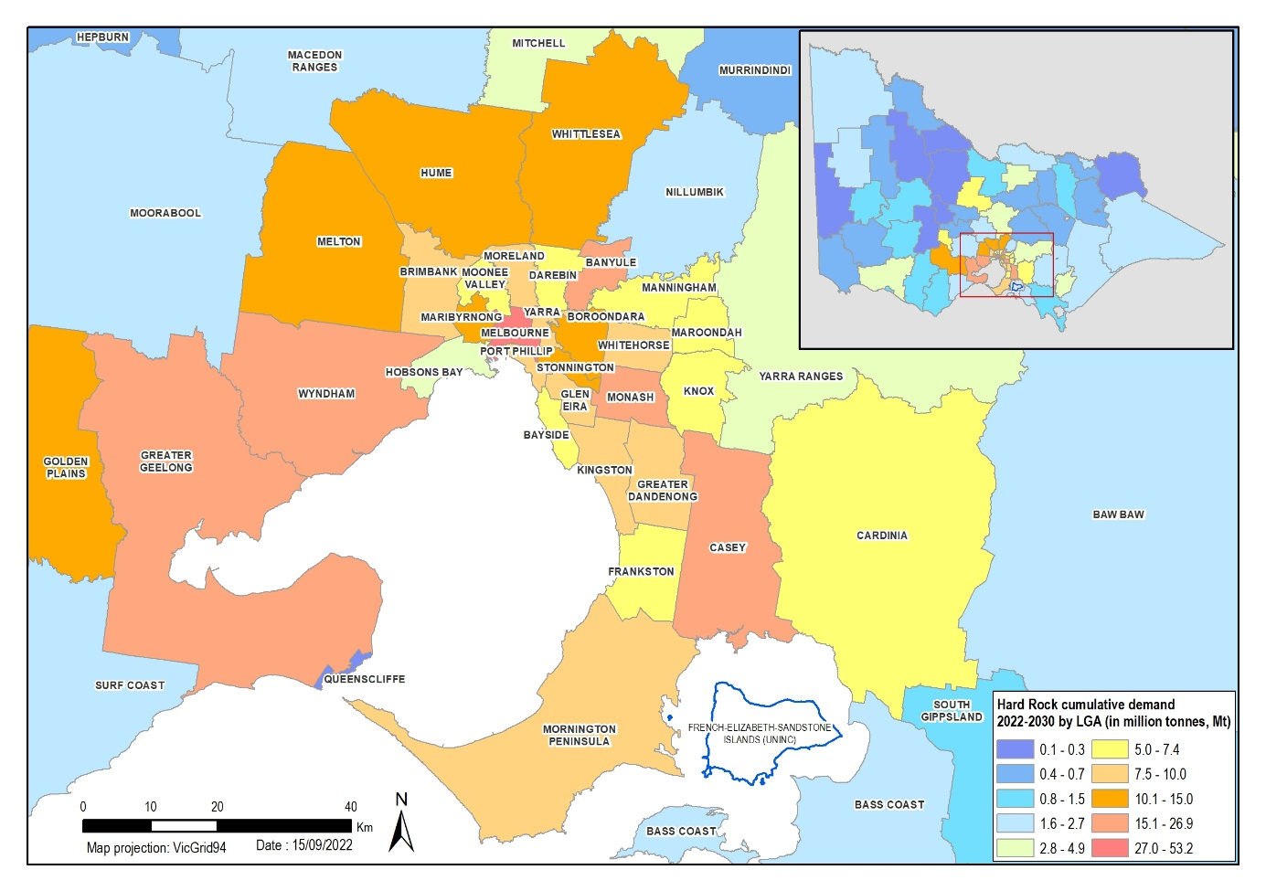
Figure 7 Hard rock demand forecasts (2022-30)
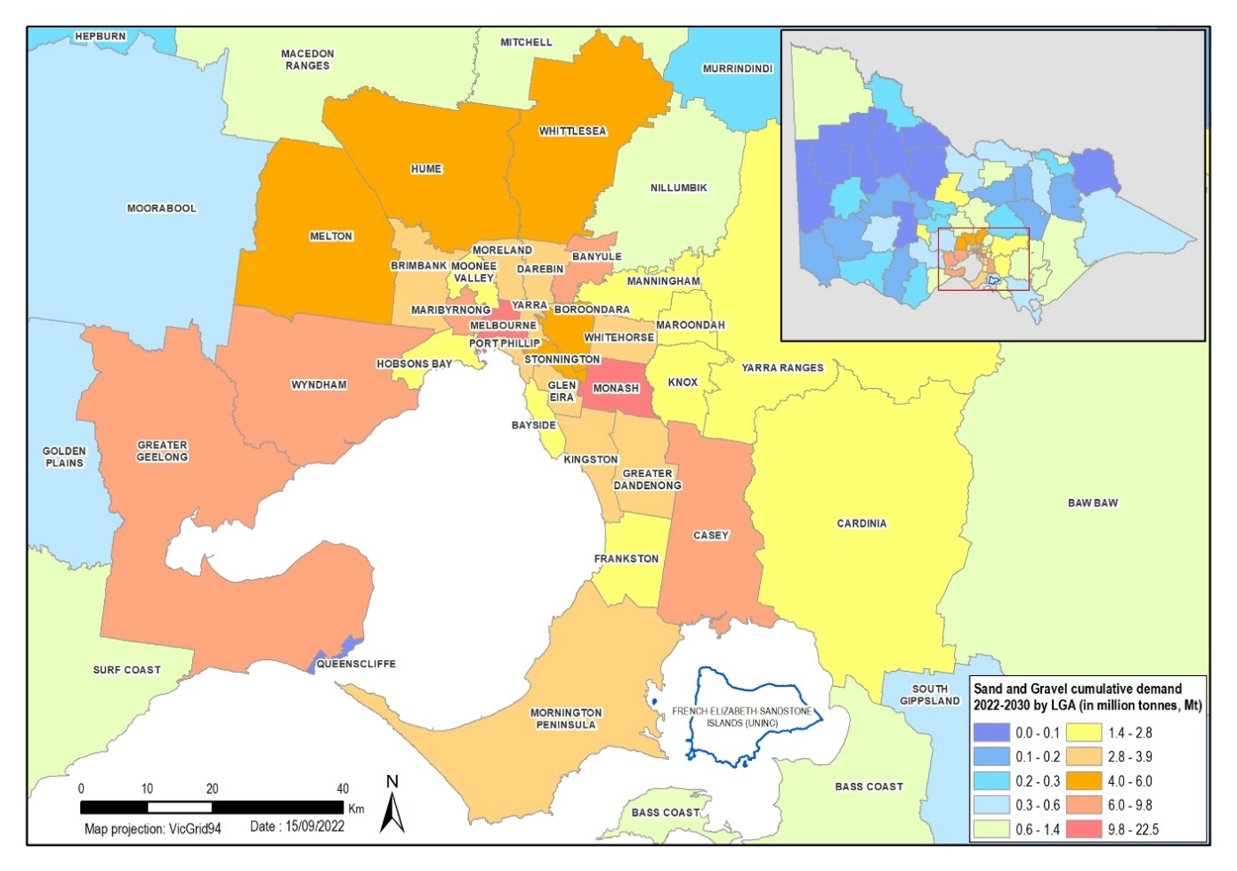
Figure 8 Sand and gravel demand forecasts (2022-30)
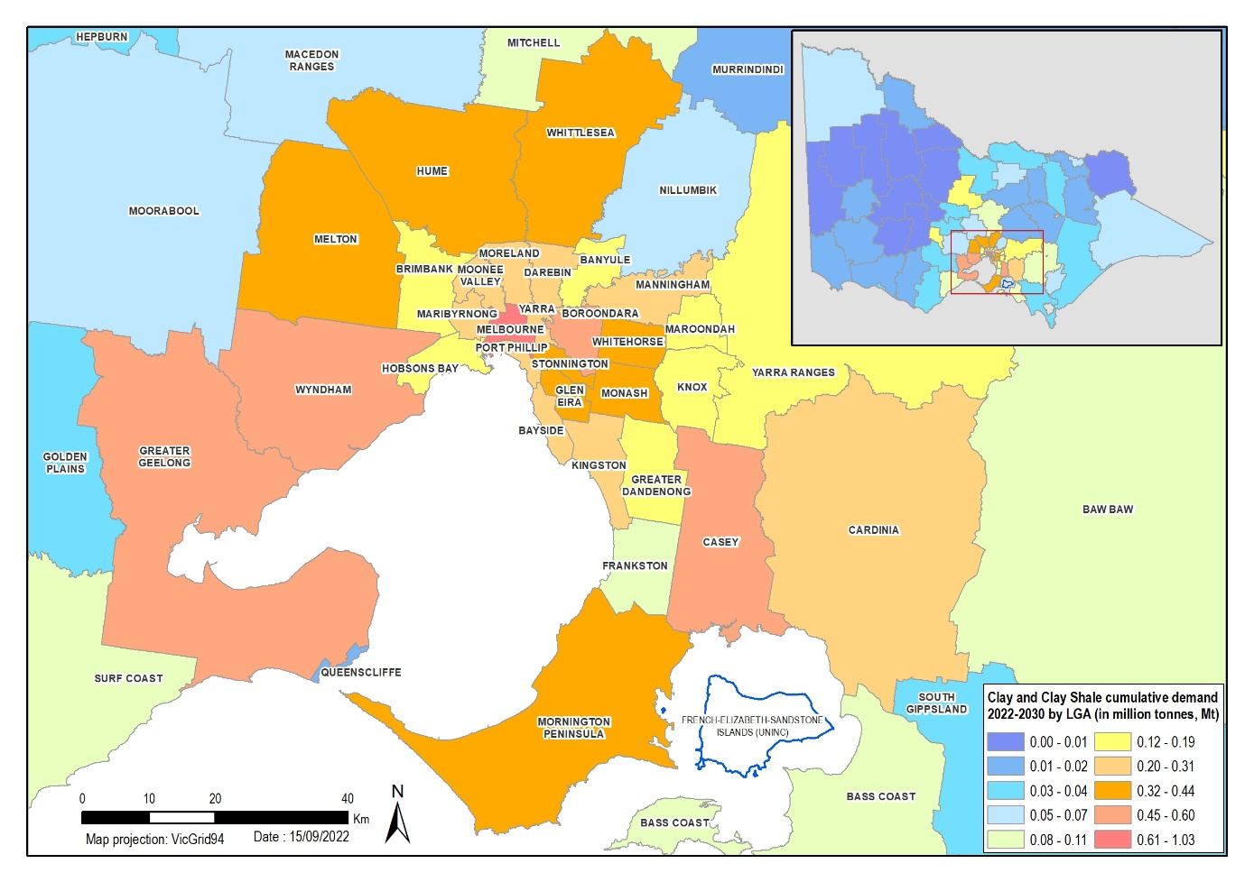
Figure 9 Clay demand forecasts (2022-30)

2.5. Demand by sector
The residential sector contributes the most to the overall demand for Victorian extractive resources, followed by the non-residential sector. The contribution of different sectors to the total demand for extractive resources has varied considerably over time. This is particularly true for the non-residential, transport, and the energy and utilities sectors, for which the largest share over the period was roughly double the smallest. However, in recent years, transport’s demand for extractive resources has been increasing, and transport has overtaken the demand for energy and utilities (Table 3 and 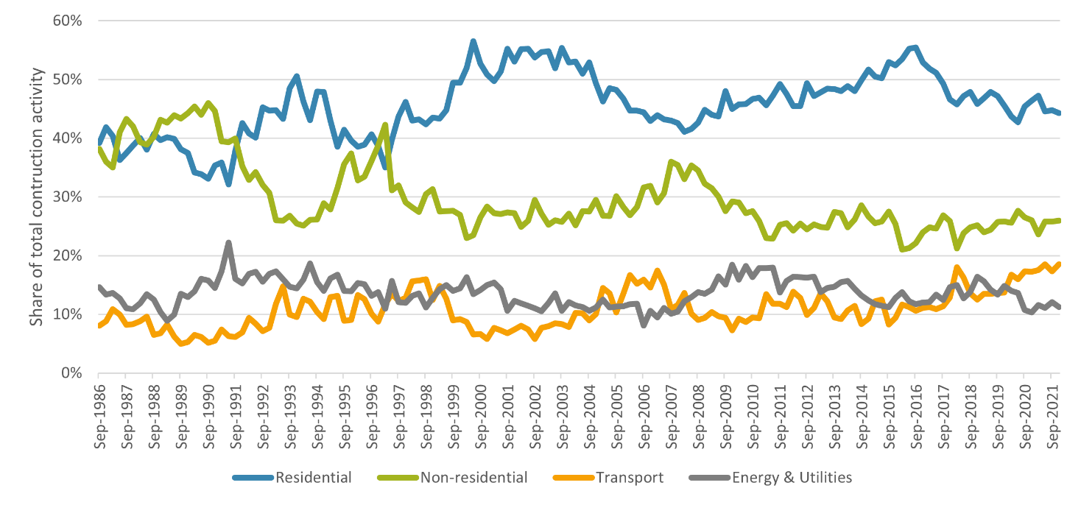
Figure 10).
Table 3 Demand for supplies to support construction activity by sector
 | Residential | Non-residential | Transport | Energy and utilities
2015 | 51% | 27% | 11% | 12%
2021 | 46% | 26% | 18% | 11%
2030 | 46% | 24% | 19% | 11%

Figure 10 Historical share of construction activity by sector
The residential sector demands all extractive types analysed in the Study. For the other sectors, it is assumed that there may be little or no demand for some of the extractive types. All sectors have high demand for hard rock, and sand and gravel, as these are used in construction (Table 4).
Table 4 Rock type requirements by sector

2.6. Demand for limestone
Limestone demand forecasting was not undertaken. Limestone represents only a small percentage of the Victorian extractive industry (about 1.2 million tonnes per year). Limestone is an intermediate input for cement clinker, an input for concrete. However, Victorian cement production has ceased, or has been greatly reduced in recent years, in part, to meet net zero emissions targets.
While limestone production for cement represents only a small and declining percentage of the Victorian extractive industry, demand for cement and concrete is expected to increase rapidly over 2022-30.
LGAs with a high demand for limestone have changed significantly. Historically, the demand for limestone was widespread, coming from the construction industry where limestone was used to produce clinker for cement production.
The two main drivers of the demand for limestone in Victoria are agriculture and gold mining. In agriculture, limestone is applied to soil to balance pH. Agricultural demand is seasonal, with farmers mostly spreading limestone during summer. Gold mining uses limestone for processing gold.
Hence, the greatest demand for limestone comes from rural LGAs with extensive agriculture and LGAs with gold mines.

2.7 Conclusions relating to demand analysis
Metropolitan Melbourne continues to have the highest demand for extractive resources. This is due to residential construction and construction in sectors linked to population growth, such as commercial buildings. Melbourne is forecast to demand 80 per cent of the state’s total hard rock between 2022-30, with the greatest demand from the western suburbs. Demand for sand and gravel is likely to be greatest in the south-east and north-east, and the demand for clay is forecast to be greatest in the west.
Casey, Monash and Wyndham LGAs consistently demand more extractive resources than many other LGAs in outer Melbourne, reflecting a high level of residential construction and the planned infrastructure projects, such as the Suburban Rail Loop.
In regional Victoria, planned and prospective wind farm construction in south-west Victoria is expected to concentrate extractive resources demand.

3. Supply analysis
The purpose of supply-side forecasting is to model the amount of extractive resources expected to be available to market, and whether that amount meets forecast demand in every year over the forecast horizon (2022-30).

3.1 Methodology and assumptions
The supply forecasts in the Study are based on data from the 2020–21 financial year. The primary data was collected as part of industry surveys in that year. This data represents a reserve estimate and has a high reliability in that it is approved for development and is considered technically and economically feasible to extract. For work authorities that were not covered by the industry surveys, data obtained from work authority holder annual reports was utilised to make up the gap. This data is less reliable and cannot be differentiated as to whether it represents resource data or reserve data.
The supply data has been broken down into four categories of extractive resources: hard rock, sand and gravel, clay and other.

Supply data gathered from industry surveys
With regards to the industry survey data, the Department undertook in person interviews with 20 industry operators that represented 145 work authorities. The companies interviewed represented approximately 70 per cent of the state’s 2020-21 production.
The following data was collected for each work authority by way of tailored questions asked by Departmental staff.
- Summary of current operations
- the top three rock types they extracted, in order of weight
- a resource estimate of the site in metric tonnes, including percentages by rock type
- the current reserve that is permitted to be extracted (in metric tonnes) and the associated percentages of this by rock type
- the maximum production rate of the quarry site (metric tonnes per annum)
- estimation of additional resources and production due to planned expansion (before 2030)
- plans for the work authority in the future (e.g. apply for variation, close).
- estimation of location, size and timing of production of any new quarries/expansions.
The Appendix includes further information on the questions asked.
The survey data that is used in the initial supply forecasts is reserves data. Forecasting (as described in the forecasting section below) then factors in known new work plan approvals and variations that aim to develop some of the surveyed resource estimate data over time.
This survey data is being treated as Commercial in Confidence and the work authority level data is visible only to the Department to support its analysis. To ensure that confidentiality requirements are met the data reported has been aggregated to a suitable level so that no specific work authority can be identified. For this reason, the regional analysis has been aggregated in Regional Development Victoria partnership zones rather than LGAs. If the regional data were presented by LGA, in some instances where there were limited suppliers to the area, it would have been possible to identify specific suppliers.

Supply data gathered from work authority annual reports
The industry surveys did not account for all work authorities in Victoria. For work authorities that were not able to be interviewed, resource estimations were derived from the mandatory 2020-21 financial year report (the annual report).
Under the Mineral Resources (Sustainable Development) (Extractive Industries) Regulations 2019, each extractive industry work authority must annually report (under Regulation 19(3)(h) the most recent extractive resource estimate for the extractive industry work authority. This provision was introduced recently in 2020.
This regulatory annual reporting requirement does not provide specificity as to what the resource estimate needs to include. It is likely that the data collected under this requirement is an overall estimate of the resource within the work authority and is not the reserve estimate (i.e. it would include resources that are not approved for development under an approved work plan). While it is not possible to be definitive, to ensure conservative assumptions, the annual report data is considered to be a resource rather than a reserve estimate. As such, it is likely to be an overestimate of the amount of material that each work authority can bring to market.
In addition, this reported data is not verified or audited.
While the annual report data is less reliable, it has still been included in the Study as it was the only way to establish a complete supply dataset. This is pertinent. Appropriate caveats are made throughout the report.

Supply data methodology
The supply forecast models commence with quantity of reserves held in work authorities in operation. For work authorities included in the industry interviews, these values will reflect what was reported. For work authorities not involved in the interviews, these values will be the resource estimate, as reported in the work authority annual returns for 2020-21.
The supply forecast has been constructed for three rock types and reported at the LGA level over the forecast horizon (2022-30). The supply forecast involves determining the stock of extractive materials in each year, where the stock of supply equals the current total reserves for a given rock type, plus any additional supply expected to come online via known work plan variations or approvals before 2030.
In forecasting new supplies that may come online prior to 2030, three separate supply replenishment forecasts have been used:
- Low supply replenishment scenario: This scenario is conservative; new supplies are derived from low-risk work plan approvals and variations only
- Medium supply replenishment scenario: Moderate assumptions in that the additional supply is derived from low- and medium-risk work plan and work plan variations.
- High supply replenishment scenario: Optimistic in that additional supply assumes all proposed work plan and work plan applications are approved.
The level of risk to a work plan or work plan variation application was determined via multicriteria analysis that included whether planning permits were required, whether blasting was required, quarry location, size, and any known environmental, cultural or community sensitivities.
Whether an application has a low, medium or high chance of approval depends on whether the application is for a new or existing site. New work authority sites usually require planning permits from the relevant local council, which can introduce barriers. However, an extension application for an existing quarry that has previously been submitted to the Earth Resources Regulation and is already statutory endorsed is more likely to proceed through the next stages of the process.

Supply modelling uncertainty and assumptions
The model includes a degree of uncertainty that should be acknowledged. In the case of the supply data, the most pertinent sources of uncertainty include:
- The regulatory approvals process and estimating the length of time that may be involved.
- Commercial decision making in that the work plan (and length/scope of extraction) may be changed over time by the work authority holder.

3.2 Supply forecasts
Table 5 describes the current extractive reserves and resources available as estimated by survey data and data from industry’s annual reporting requirements. The data shows current Victorian work authorities hold 1,131 million tonnes in reserves and an additional 811 million tonnes of extractive resources. Hard rock has the most reserves available, followed by sand and gravel, clay and other products.
As expected, the addition of the annual report data suggests that there is a significantly greater supply available. It is also clear that this is an overestimation because the survey data (reserve data) comprises about 70 per cent of annual extractive resources production, and the increment of 811 million tonnes represents about a 60 per cent increase in the supply estimate overall (whereas it should rationally represent about 30 per cent).
While this is a limitation of the dataset, it is the best means available to estimate a complete supply dataset that covers all work authorities in Victoria. Consequently, it has been kept in the analysis.
Table 5 Current extractive reserves and resources by rock group or rock type
Rock Type | Reserve (Mt) | Resource (Mt)
Data source | Survey data | Annual report data
Hard rock | 955 | 434
Sand and gravel | 149 | 131
Clay (and clay shale) | 19 | 9
Other | 8 | 237
Total | 1,131 | 811

Table 6 shows that regional areas contain more reserves than metropolitan areas. There are only 587 million tonnes of extractive resources left in metropolitan areas, but 1,356 million tonnes across the regional areas.
Table 6 Current reserves by rock type and region (Mt)
Rock type in millions of tonnes (Mt) | Hard rock | Sand | Clay | Other | Total
Regional | 879 | 225 | 12 | 239 | 1356
Metro | 510 | 55 | 16 | 6 | 587
Total | 1389 | 281 | 28 | 244 | 1942

Table 7 shows that most of the proposed supply of rock and sand comes from work authority variation permit applications are for hard rock. This suggests there are quarries now that could supply more rock if allowed to extract from a larger area. Due to dwindling sand and gravel supplies, this rock type requires the greatest number of new work authorities or work plan variations. There are no permits for creating new clay work authorities and only a few work plan variations to extend the reach of already existing ones.
Table 7 Proposed new supply 2022-30 from new work authorities/work plan variations by rock group or rock type
Rock type | Work plan variations (Mt) |  | New work authorities (Mt) | Share of additional tonnages (%)
Hard rock | 563 |  | 41 | 71
Sand and gravel | 173 |  | 86 | 28
Clay (and clay shale) | 11 |  | 0 | 1
Other | 0 |  | 0 | 0
Total | 747 |  | 127 | 100
Getting a work plan variation approved requires significant planning and regulatory requirements to be met. To get an entirely new work authority approved requires further regulatory steps. It is therefore risky to assume that all possible work plan variations and new work authority proposals will proceed. The state cannot rely on the extractive material that is forecast from all of these variations and proposals as not all may come to fruition.
Table 8 shows how many more additional tonnages of extractive materials may be available under three risk scenarios, based on the data in Table 7. To establish these risk scenarios, industry survey information about work plan variations and new work authorities was correlated with a high-level assessment of planning complexity levels (e.g. land use zones, overlays) at the supply locations.
The high-risk scenario (high supply replenishment scenario) assumes that all the work plan variations and new work authority permits are expected to be approved and the supply to enter the market by 2030. However, this is an unlikely outcome due to delays and restrictions associated with regulatory approvals (including planning permits) community resistance and other factors.
The medium risk scenario (medium supply replenishment scenario) assumes that both low and medium risk applications for approvals will be granted and that the supply from these will enter the market.
The low-risk scenario (low supply replenishment scenario) is the most conservative. It assumes that only applications for new work authorities and variations to existing work authorities that have limited restrictions (and are therefore very likely to be approved) will enter the market.
Table 8 Additional tonnages available for new work authorities or variations to current work authorities, by risk category
Risk category | Work plan variations (Mt) | New work authorities (Mt)
High | 747 | 127
Medium | 253 | 15
Low | 163 | 0

Location of supply
The following figures show sources of extractive materials likely to supply the market. The maps have been further aggregated to Victoria’s nine regional partnerships to ensure that no single work authority can be identified.
Most of the hard rock supply is in north and west Greater Melbourne, and in regional Victoria (Figure 11).
Most of the sand and gravel supply is located the Lang Lang to Grantville sand belt, which spans the LGAs of Cardinia, Bass Coast and South Gippsland to the east of Greater Melbourne. West of Greater Melbourne, there are some reserves in Barwon and in the Central Highlands (Figure 12).
The majority of clay is located just north of the Melbourne CBD. West of Melbourne are some smaller reserves in the Golden Plains region (Figure 13).
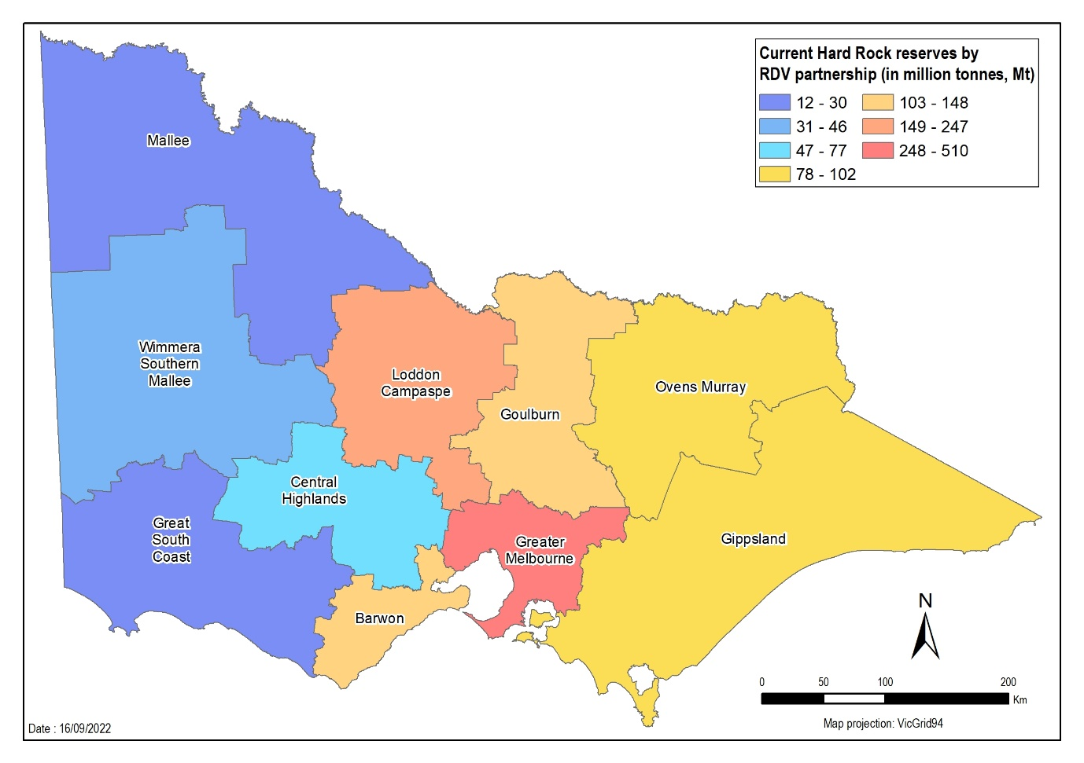
Figure 11 Current hard rock reserves categorised by Regional Development Victoria partnership zones (Mt)
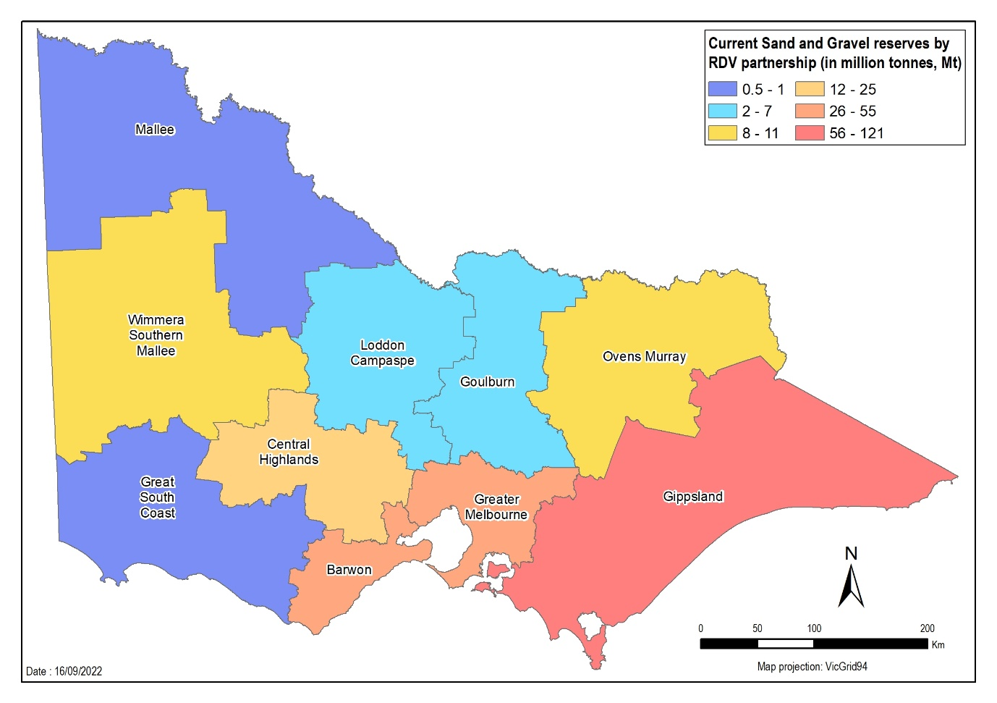
Figure 12 Current sand and gravel reserves categorised by Regional Development Victoria partnership zones (Mt)
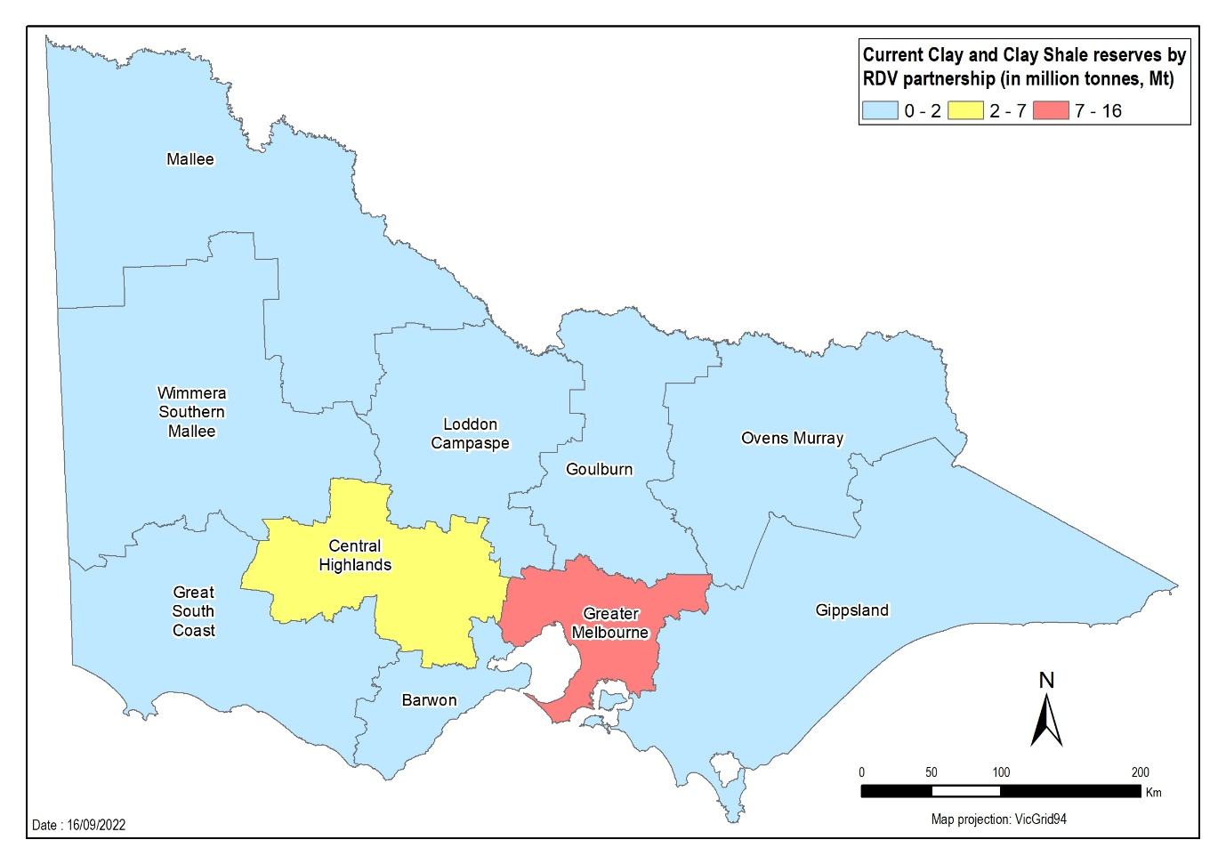
Figure 13 Current clay and clay shale reserves categorised by Regional Development Victoria partnership zones (Mt)

3.3 Distance and transport costs
The extractive industry incurs costs at many levels. There is the initial (high) cost of establishing a quarry. This takes time and involves assessments to ensure that the geology and other relevant environmental factors can justify the investment. Then there are extensive site facility set-up costs including processing plants, mobile equipment, amenities, offices, weighbridges, workshops and access roads.
Next is the cost of extracting and transporting the product. Raw extractive resources need to be processed and then transported to a project site. In Australia, most transport is by road, some by rail and a little by ship. The closer the quarry is to the project site, the lower the product cost.
Historically, Melbourne has been fortunate with lower extractive resource costs due to quarries being close to construction regions. The Study has found the average distance for transporting hard rock to metropolitan Melbourne is 20-25 km; for sand it is 50 km.
Transport costs are approximately 25-30 per cent of the total extraction cost for quarries close to project sites.
Once extractive resources exceed these transport distances, the cost of rock starts to increase significantly. As a rule of thumb, the Study assumes that transport costs are flat and about 20 cents per tonne per kilometre.
Trucking is more expensive than rail or shipping. However, trucks are often the only vehicles that can access quarry sites.
To minimise costs, a project may obtain material from several quarries. For example, in a road project, a quarry close to the start of the road may initially be cheapest. As the road progresses, another quarry may be closer and hence cheaper. Understanding the supply and demand across Victoria helps with project planning.
Other costs associated with the extractive industry are:
- damage to roads during transport
- fuel used in trucks
- Occupational Health and Safety, and compliance
- depreciation
- labour
- repairs and maintenance
- fuel and energy
- royalties
- environmental impact, including emissions.

3.4 Conclusions relating to supply analysis
Different areas of Victoria supply different extractive resources. Supply is mostly concentrated reasonably close to Greater Melbourne, the location of greatest demand. Quarry location is important, as the closer it is to a project site, the lower the cost of extractive resources.
The Department has undertaken surveys and analysed data to determine the current and likely future status of the Victorian extractive industry. Forecasts are based on three categories of likelihood of sites proceeding: low, medium, high. The results help determine aspects of the Victorian extractive industry most under threat and the response options.
Hard rock represents the extractive material in highest demand, followed by sand.

4. Integration analysis

4.1 Methodology and assumptions
This section integrates supply and demand forecasts for extractive materials at a regional scale and relates them to impacts on transport distances to market. To the best of the Department’s knowledge, this is the first analysis of this nature that has been undertaken by Government.
This analysis, termed ‘integration analysis’ or ‘integration model’ has been designed and undertaken by Departmental analysts using Microsoft Excel. The approach has produced the forecast supply and demand data presented in the Study, subject to a number of assumptions. It is a prototype analysis and has not been tested or peer reviewed outside Government so the results should be treated as indicative only and not be used to make investment decisions. The model represents a useful tool for Government use in the future to support policy analysis and decision making.
The model assumes that minimising transport costs will determine the most likely suppliers of material to demand centres, which ordinarily will preclude more distant suppliers. While this logic holds true, some market behaviours involving joint ventures and alliances, aggressive quotations, and supply assurances can result in a departure from this premise.
The integration analysis aims to identify regions of high demand and relate these to regions of concentrated supply, and establish the potential transport distance impacts that emerge from this comparison. The key steps involved in the integration model have been outlined in Figure 14. The integration model provides a more complete picture of the extractive industry’s position and the scenarios that may arise in the future.

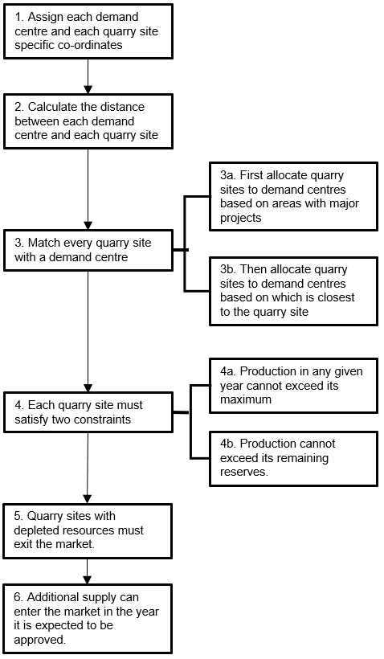
Figure 14 The steps involved in integration modelling of extractive resources
The integration model is underpinned by a series of key assumptions.
Supply and demand forecasts have been matched based on rock types (e.g. sand and gravel) rather than product types (e.g. concrete sand). All rock types are assumed to be of the same quality which is not the case in practice.
Two or more work authorities have been allowed to supply demand centres. The model primarily requires that demand be supplied from Victorian work authorities, however, demand centres are allowed to source material from interstate if no Victorian suppliers are available to fulfil their demand. If extractive materials are needed to be imported from interstate, the model assumes this material has travelled a distance of 500 km.
Similar to the supply forecasts, the model allows for work authorities to be depleted and to exit the market in a given year. Further supplies are allowed to re-enter the market if they have a pending plan to vary the work authority extraction parameters expected to be approved before 2030. This follows the same low-, medium- and high-risk scenarios developed in the supply forecasts within section 3 that reflect the likelihood of additional supply entering the market.
Within the integration model, the low-risk scenario has been termed a high-replenishment scenario and the high-risk scenario has been termed the low-replenishment scenario.
Each work authority has also been assumed to produce raw material at the same cost, with transport costs being the only difference in price for the projects.
The findings of the integration models have not been presented at the LGA level to protect data confidentiality requirements of work authorities.
While the Government retains all the raw data and modelling, this report focuses on findings of the medium supply replenishment scenario. The Study does not, however, assess the likelihood of the assumptions underpinning this scenario eventuating.

4.2 Integration analysis findings
The modelled weighted average transport distances under varying supply replenishment scenarios, for each of hard rock and for sand and gravel are shown in Table 9 and Table 10 respectively.
These results show that transport distances generally would rise by 2030.
As expected, under a low supply replenishment scenario, where there is little chance of new work authorities, plans or plan variations being approved, transport distances increase the most. Conversely, under the high supply replenishment scenario, when there is a higher expected rate of replenishment, average transport distances increase the least.
Under the assumptions made within the medium supply replenishment scenario, average transport distances of hard rock to Greater Melbourne would increase by about 120 km for hard rock and for sand and gravel.
Table 9 Weighted average transport distances for hard rock under varying supply scenarios
Hard rock | Low replenishment scenario |  | Medium replenishment scenario |  | High replenishment scenario
Average transport distance (km) | Greater Melbourne | Regional Victoria | Greater Melbourne | Regional Victoria | Greater Melbourne | Regional Victoria
2022 | 32 | 20 | 32 | 20 | 32 | 20
2030 | 165 | 32 | 151 | 32 | 71 | 32

Table 10 Weighted average transport distances for sand and gravel
Sand and gravel | Low replenishment scenario |  | Medium replenishment scenario |  | High replenishment scenario
Average transport distance (km) | Greater Melbourne | Regional Victoria | Greater Melbourne | Regional Victoria | Greater Melbourne | Regional Victoria
2022 | 62 | 20 | 62 | 20 | 62 | 20
2030 | 209 | 63 | 183 | 63 | 138 | 63

To demonstrate the regional capability of the model, the average transport distances for hard rock under the medium supply replenishment scenario, in 2022 and then again in 2030 are illustrated via maps in Figures 15 and 16 respectively. The average transport distances for sand and gravel under the medium supply replenishment scenario, in 2022 and then again in 2030 are illustrated via maps in Figures 17 and 18 respectively. These figures show average transport distances for materials to construction projects in Victoria’s LGAs, under the medium-risk supply scenario.
Figures 15-18 are useful for visualising the differential impacts on transport distances for different regions and they demonstrate the potential of this model for undertaking such analysis. For example, the LGAs within Greater Melbourne compete for hard rock, sand and gravel. Areas north of Melbourne are at a disadvantage in obtaining sand and gravel as most of the state’s supply is close to Port Phillip Bay. Areas such as Mildura and Swan Hill in the state’s north are likely to access extractive materials from interstate.
While the results are indicative, when assumptions are made that many work authorities with significant resources or large production capacities are leaving the market as their reserves become depleted, increased transport distances for LGAs are observed, particularly those in Greater Melbourne.

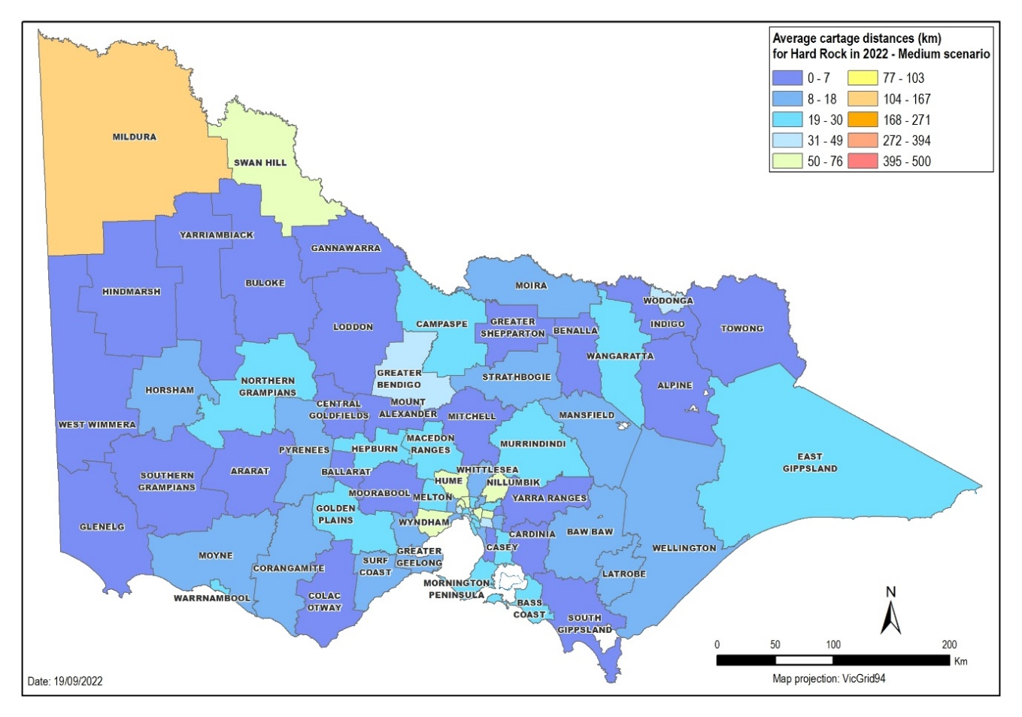
Figure 15 Average transport distances for hard rock in 2022 under the medium supply replenishment scenario
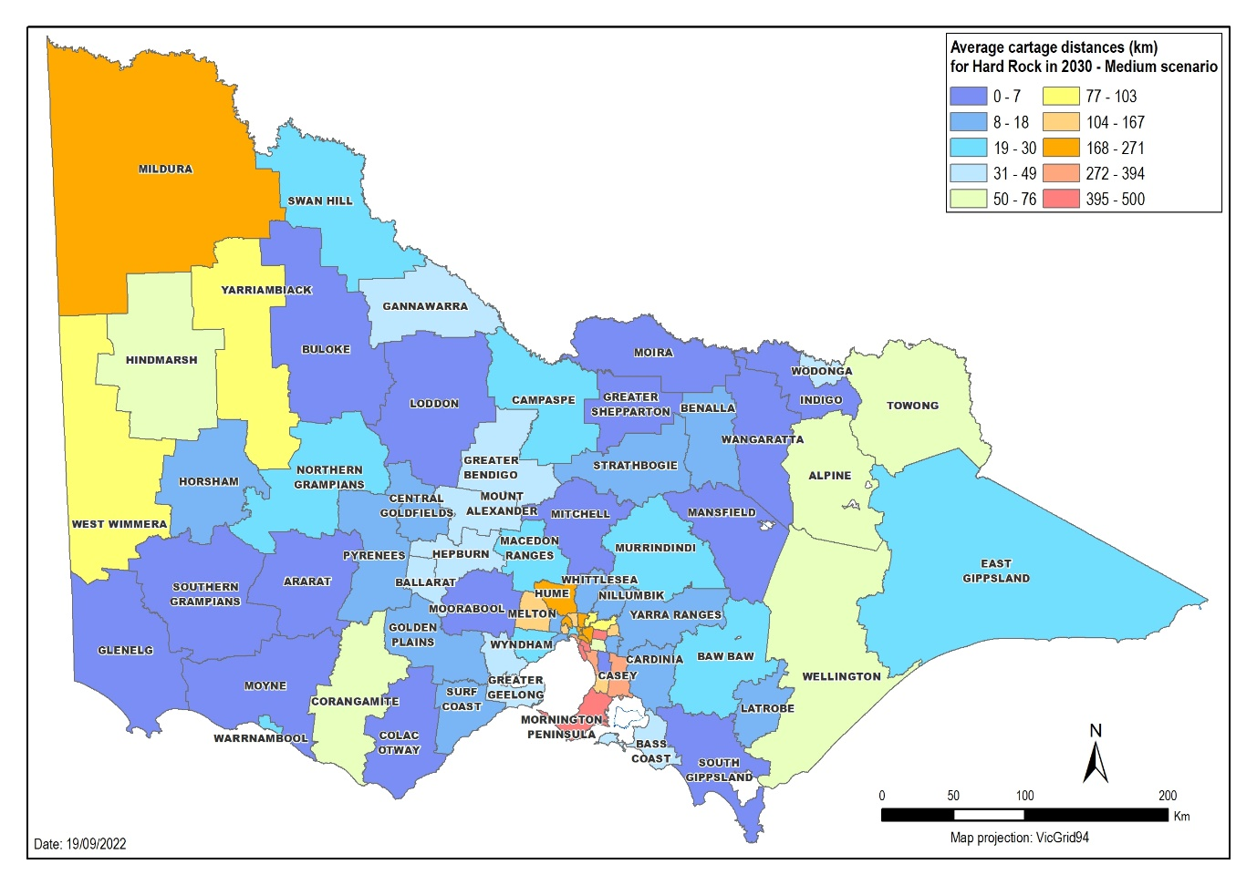
Figure 16 Average transport distances for hard rock in 2030 under the medium supply replenishment scenario
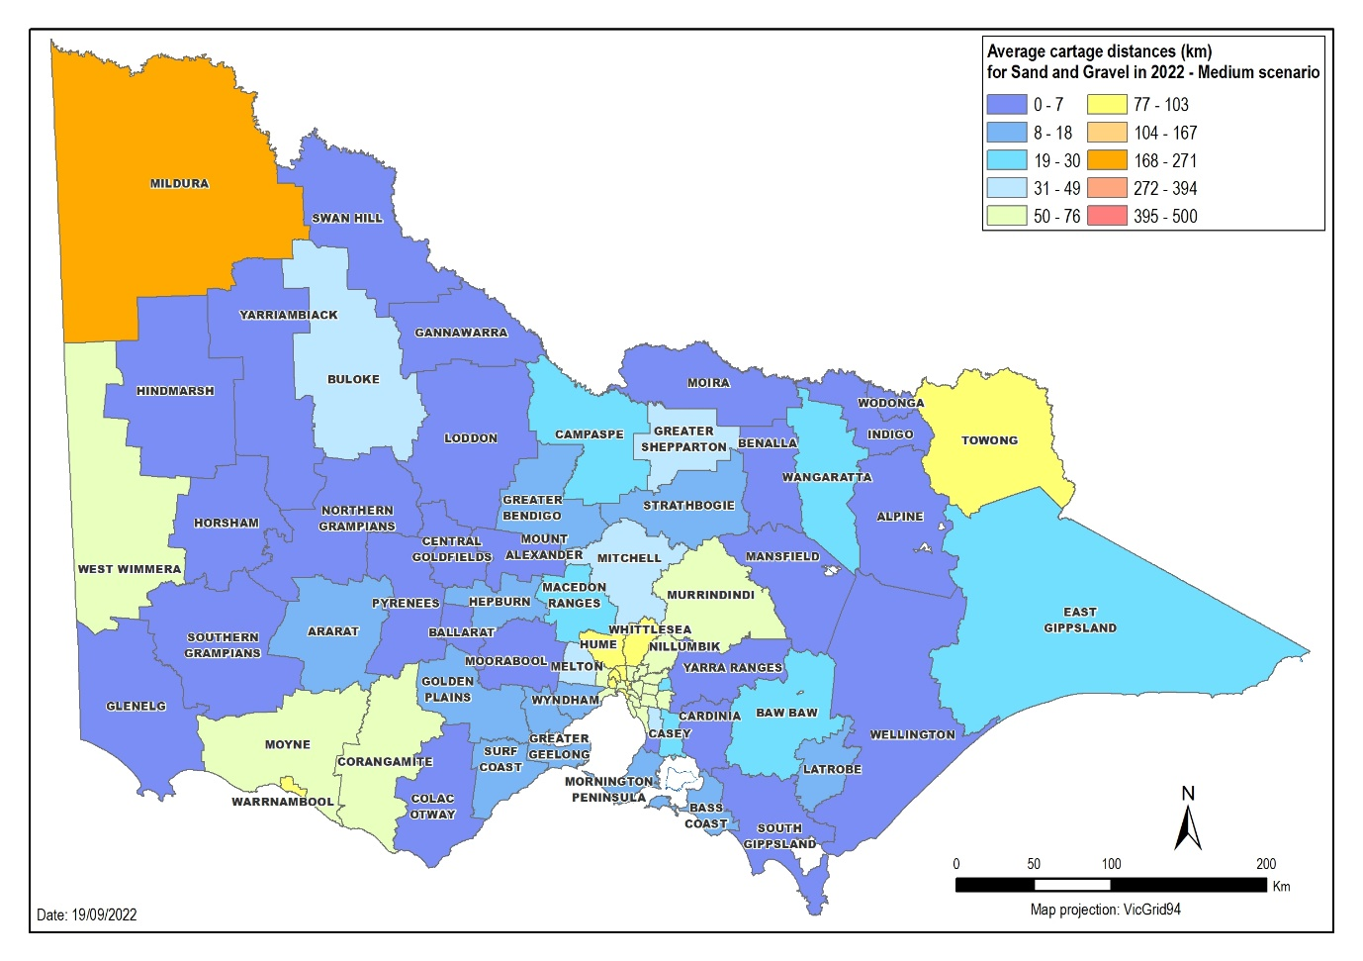
Figure 17 Average transport distances for sand and gravel in 2022 under the medium supply replenishment scenario
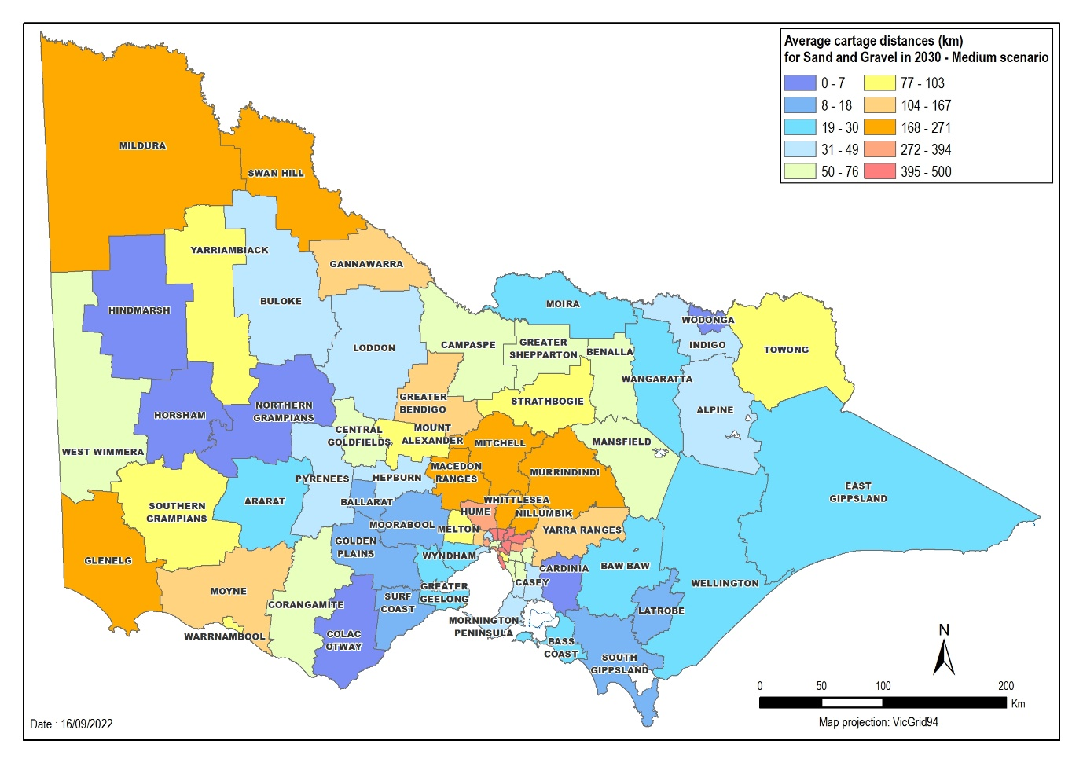
Figure 18 Average transport distances for sand and gravel in 2030 under the medium supply replenishment scenario

4.3 Impact of supply and demand on costs
The proportion of extractive materials in construction projects heavily depends on the structure and design of the building and the type of extractive material needed. The estimates in Table 11 show the percentage of a project’s cost associated with extractive resources.
Table 11 Share of extractive-based construction materials as a percentage share of total building material costs
Project type | Percentage range (% estimate)
Residential | 22 - 53
Non-residential | 39 - 48
Transport – Road | 35 - 48
Transport – Rail | 1 - 6
Energy & Utilities – Solar Farm | 1
Energy & Utilities – Wind Farm | 3 - 4

These estimates can help approximate what projects will cost in the near future. Extractive cost increases will lead to increased project costs by 2030. Under the medium supply scenario, transport costs are expected to increase by 70 per cent and 51 per cent for hard rock and sand and gravel, respectively, between 2021-22 to 2029-30. With these increases, a metropolitan Melbourne elevated rail project estimated at $1.4 billion of building materials and $87 million of extractive materials in 2021-22, would have extractive resources costing $112 million in 2029-30.
The estimates can also help to predict how the costs of building a house may increase by 2030. If a typical house uses $6,300 of extractive resources in 2021-22 and the same price impacts for the elevated rail project are applied, the cost of extractive resources will rise to $7,496. Note, this statement considers only costs of extractive resources, and doesn’t account for other price rises.
Although wind farms are expected to demand high volumes of extractive materials (320,000 tonnes for a 100 turbine facility), this cost is small compared to the other building costs, such as the tower, turbine and turbine blades.

4.4 Conclusions relating to integration analysis
The integration model is a promising tool for Government to use to understand the impacts of various supply demand forecasts on regional transport distances of extractive resources materials. The model needs further review and testing of its underlying assumptions to ensure that the findings are robust.
The model demonstrates that a medium replenishment scenario would lead to a major increase in average transport distances for supply to Melbourne and the regions. In the short-term, additional supply would be needed beyond the assumptions in the medium replenishment scenario to ensure that extractive materials are delivered to Greater Melbourne at an affordable price.
Actual kilometre distances must be treated as indicative and further work is required to confirm the results. But the outputs still show there is a case for Government to intervene in the market to support further expansions of extractive resources in close-to-demand-areas beyond what is expected in the status quo. The results indicate that work plan approvals and new work authorities that can service Greater Melbourne should be prioritised for approval. This is particularly important for work plan variations associated with an existing work authority that has a high production capacity with depleting reserves.
A limitation of this analysis is that it does not consider site-specific issues (such as cultural heritage, native vegetation or groundwater issues) associated with applications for work plan variations and new work authorities. A further limitation is that the data inputs represent only known and planned quarry developments at the point that industry surveys were undertaken. It does not factor in any quarry developments from new market entrants, or plans not disclosed by the existing industry, that may occur between now and 2030.

5. Simulation modelling tool

5.1 Methodology and assumptions
To further support the integration model, the Department commissioned Digital Twin Analytics to develop a prototype simulation modelling tool (SMT). The SMT assesses the potential impacts of reducing supply of an extractive commodity in a certain supply area on the extractive resources supply chain in Victoria.
The SMT is a ‘digital twin’, constructed using agent-based simulation techniques. Agent-based simulations replicate the actions and interactions of autonomous agents, such as organisations or groups, to understand a system’s behaviour and what governs its outcomes. In essence, the SMT creates a digital twin of the real world that can be endlessly manipulated.
The model incorporates inputs that:
- define model scope (e.g. work authorities and projects)
- define scenario parameters (e.g. work authority products and capacities)
Analyses utilising the SMT require supply and demand forecasts which the model utilises to “act-out” the contracting and supply of extractive resources throughout the state.
Supply (production) is estimated from work authorities: their location the type and quantity of product they supply (e.g. sand) as well as secondary materials produced. The industry survey and annual report supply data generated within the Study form the basis of this input.
Demand for materials (end products) is estimated from projects: residential housing, commercial housing, transport-related (road, bridge, rail) and other industrial projects. Variables include project timing, size, material requirements, and the material demand profile
The projects drive the model by creating demand for raw materials. Based on the type and size of the project, the model estimates the type of materials required from work authorities, and when.
The model geolocates work authorities, processing plants and construction projects within Victoria. The model establishes hypothetical supply contracts between the consumers of construction materials and their suppliers by selecting the closest one (by road travel distance) that can provide the type and quantity of building materials the consumer requires. If one supplier cannot supply all the project’s needs, the model may seek materials from other suppliers.
The model assumes that the closest supplier is the cheapest, although this may not be true. The model also makes assumptions about what defines a project – its size, and the type and quality of material it requires. An overview of the current SMT is provided in Figure 19.
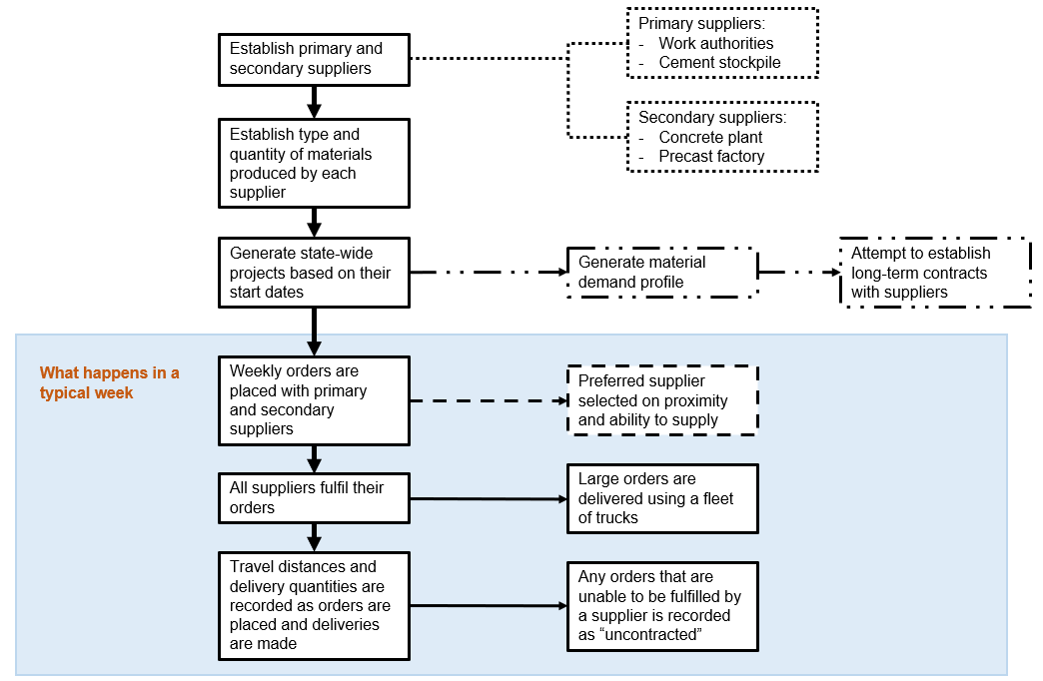
Figure 19 Simulation Modelling Tool steps
The SMT is the result of a number of prototyping iterations to develop a tool to enable the evaluation of the extractive resources supply chain in Victoria. It is currently in prototype 2 stage with a number of refinements and enhancements identified for development in subsequent prototyping stages.
The SMT model will help the Government understand potential scenarios and consider the following questions:
- Are there adequate sand resources available to meet demand?
- How will demand for sand affect the availability of supply?

5.2 SMT scenarios

Model simulations
In this instance, the model has been used to understand what happens when sand supply in key supply areas to the east and west of Melbourne is withdrawn from the market and the impact on material availability for the building and construction industry. This is based on real-world possibilities in Victoria today.
There were three simulations: a base case and two restricted sand supply scenarios. The analysis was based on the 2020-21 financial year.
- Base case. This scenario is used to compare model results with the performance of sand supply in 2020-21. It ensures that the model is calibrated to produce results comparable with actual industry performance.
- East. In this scenario, there is reduced capacity to supply sand to the east of Melbourne. The East scenario took the base case scenario configuration and reduced the quantity of sand able to be supplied to the east of Melbourne (i.e. from the Lang Lang to Grantville sand belt).
- West. This scenario involves reduced capacity to supply sand to the west of Melbourne. The West scenario took the base case scenario and reduced the quantity of sand able to be supplied to the west of Melbourne (i.e. from Bacchus Marsh).

How to use the scenarios
The SMT can test a variety of scenarios. The scenarios do not represent forecasts of the sand supply chain performance. Instead, they represent a retrospective analysis of what may have resulted in 2020-21 had the indicated sand supplies been unavailable. The SMT is still a prototype, so it would be unwise to attempt to forecast future supply chain performance until the model has been further verified and validated. The scenarios should instead be used to help support decision-making on extractive resource management.

Chosen scenarios
The scenarios involved work authorities of significance to the Victorian sand market. The Shire of Moorabool, incorporating Bacchus Marsh, accounted for 7.4 per cent of annual sand production in 2020–21. The Lang Lang to Grantville sand belt spans three LGAs (Cardinia, South Gippsland, Bass Coast) and accounted for 38.4 per cent of 2020–21 sand production.

5.3 Findings from the SMT scenarios

Model results
The SMT models statewide demand for sand, based on demand for sand and sand-based products (i.e. concrete) generated by construction projects. Modelled construction projects (including residential, non-residential, transport, and energy-related) generate demand for sand.
In 2020-21, sand demand was greatest closer to Greater Melbourne and moderate in the north of the state (Figure 20). Total sand demand was modelled including for processed materials such as asphalt and concrete. Data comes from industry reporting and interviews with selected operators.
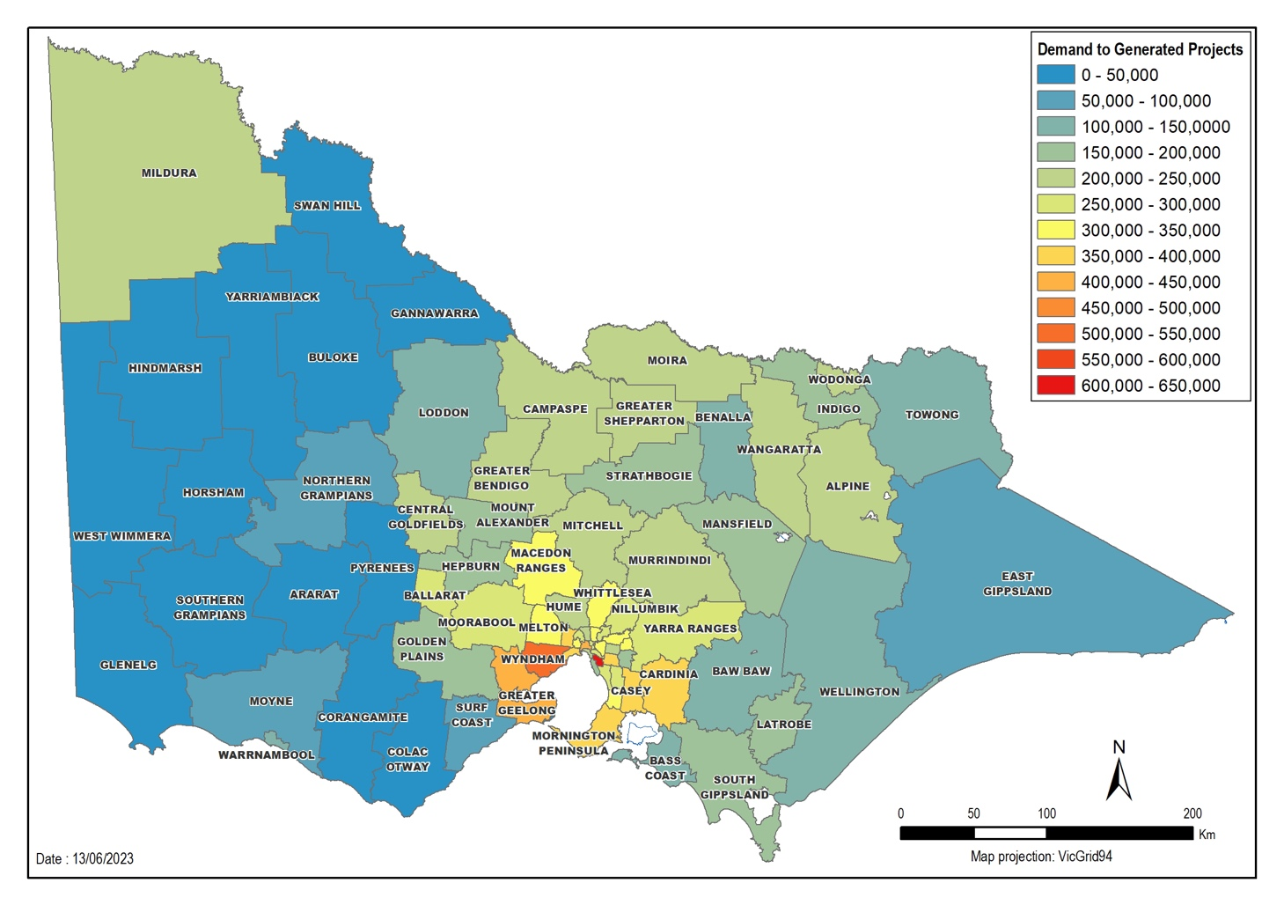
Figure 20 Heatmap of demand for sand by LGA (in tonnes per annum) for 2020-21
In the base case scenario, sand production is concentrated within two distinct regions, to the west and east of Melbourne (Figure 21). The western supply region includes the LGAs of Golden Plains, Greater Geelong and Moorabool Shire. To the east of Melbourne, there is supply from the Lang Lang to Grantville sand belt.

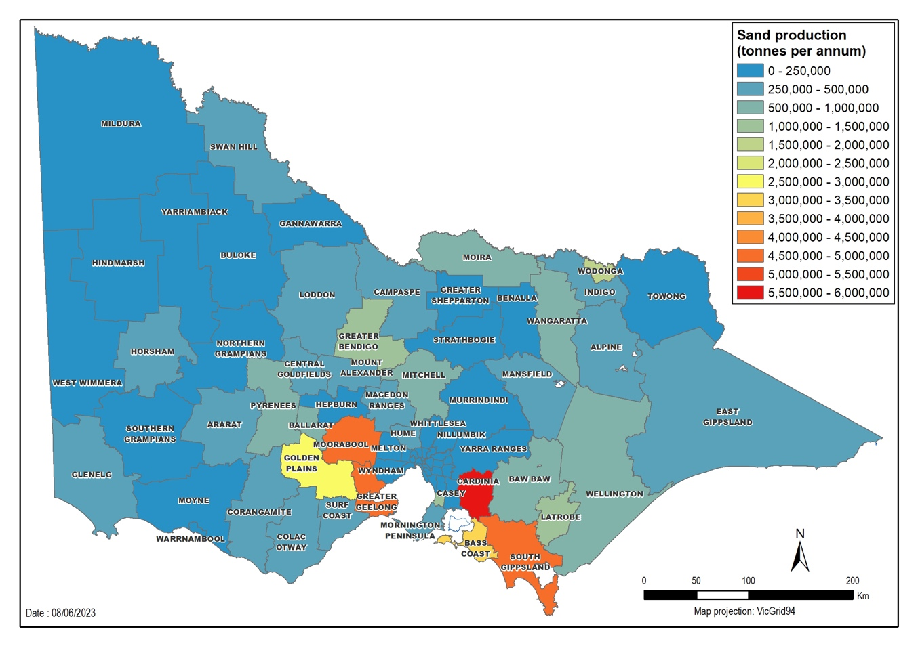
Figure 21 Heatmap of sand production by LGA (tonnes per annum)
In the East scenario, eastern regions of Victoria significantly reduce their sand production (Figure 22 East). The scenario shows that if there was less sand available in the east, other areas may be required to increase their production to meet demand.
The areas required to satisfy sand demand are not necessarily western region LGAs, as they are already at maximum production capacity. Instead, the areas that offer sand may be significantly further away from Greater Melbourne.
In the West scenario, the western sand regions significantly reduce their contributions (Figure 22 West). The eastern regions continue to provide some sand, but again there is a need for supplies to come from areas much further away from Melbourne, where most of the sand is required.
To account for the reduced production, the model included several proxy interstate work authorities, allowing projects to source material interstate if Victorian work authorities cannot fulfil their orders.
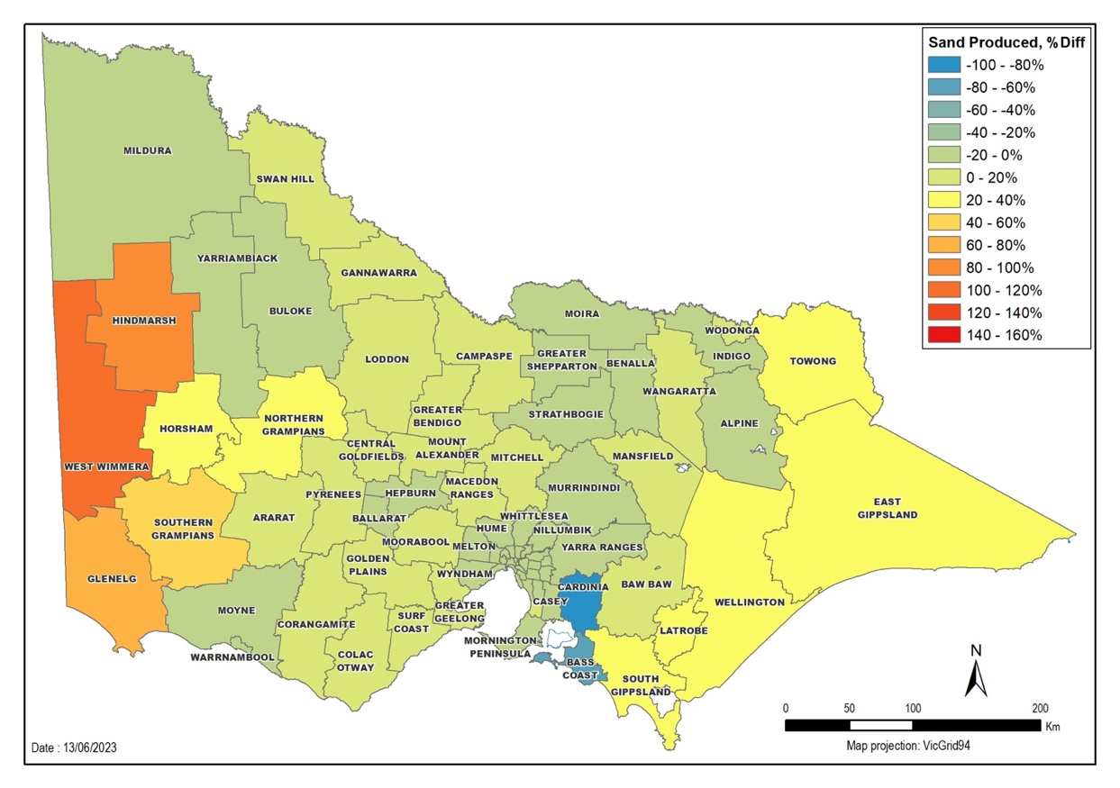
Figure 22 (a) Difference in annual production between scenarios and base case (East scenario)

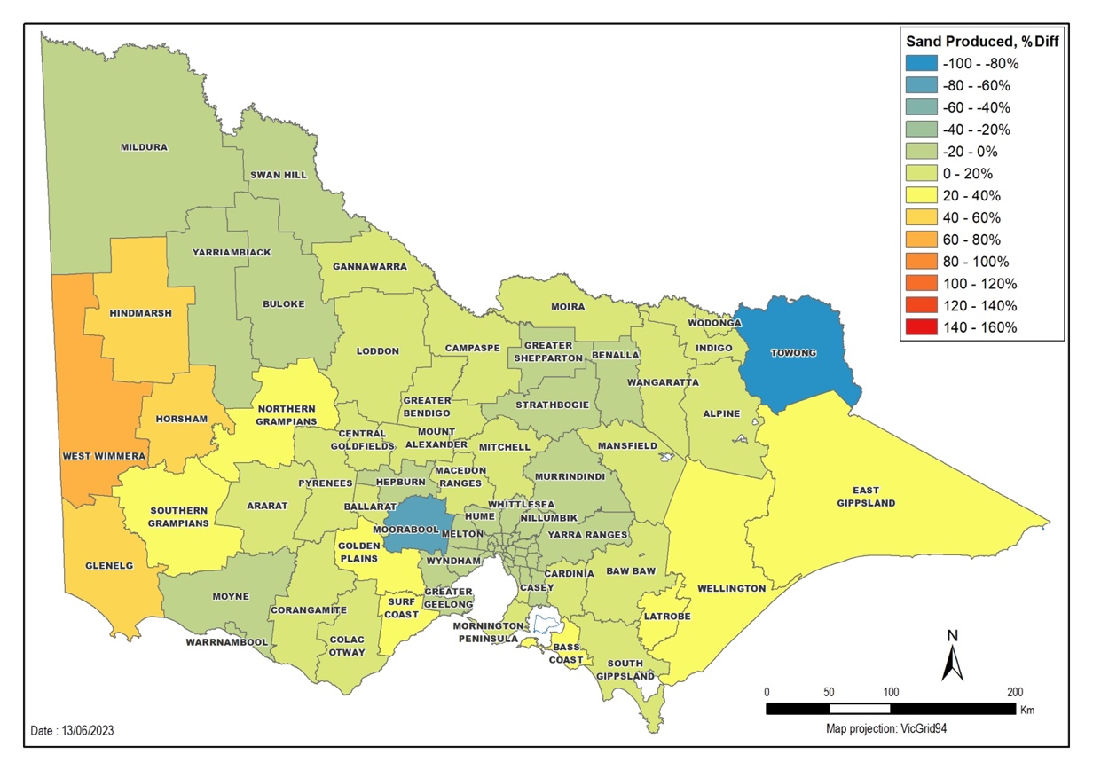
Figure 22 (b) Difference in annual production between scenarios and base case (West scenario)
Regardless of whether sand production is reduced in the east or the west, the entire state is affected, with most LGAs needing to source their sand from more distant suppliers (Figure 23). Most projects around Melbourne would experience increases in sand costs, with some parts of the city heavily impacted. Projects in the eastern regions are most adversely affected in both scenarios.

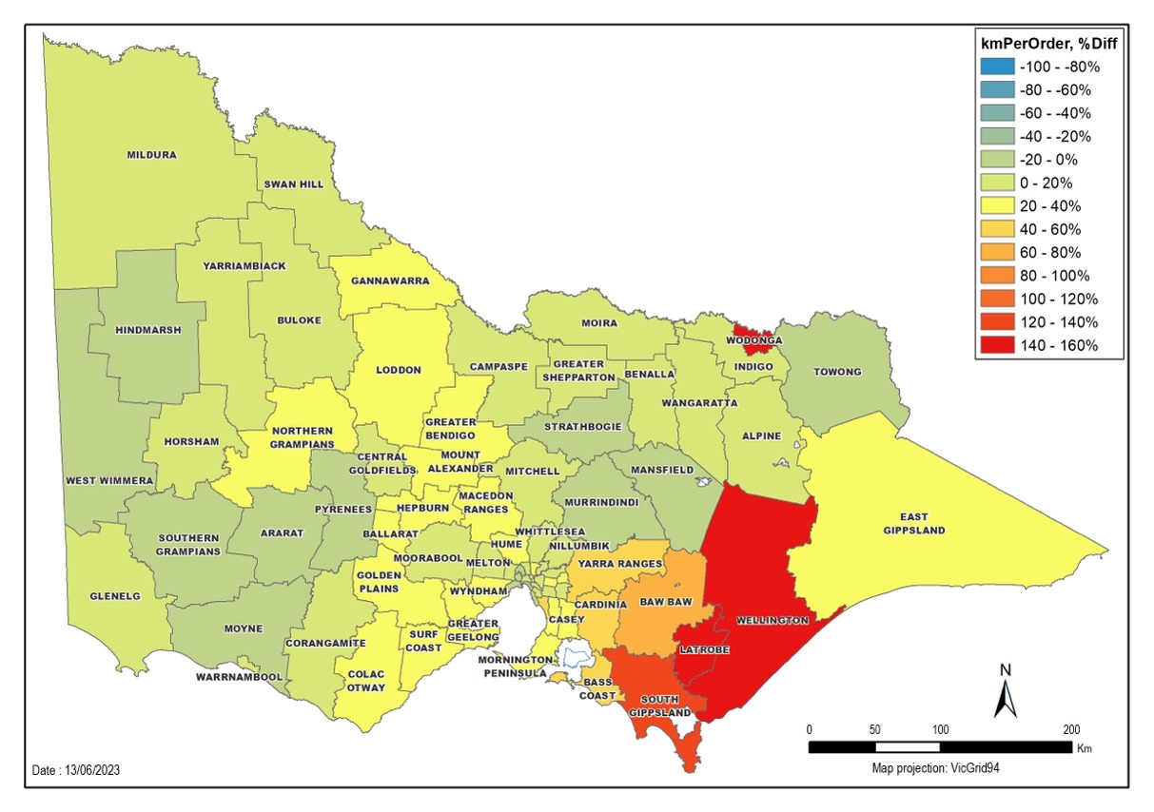
Figure 23 (a) Percentage difference in km per order, East disabled scenario
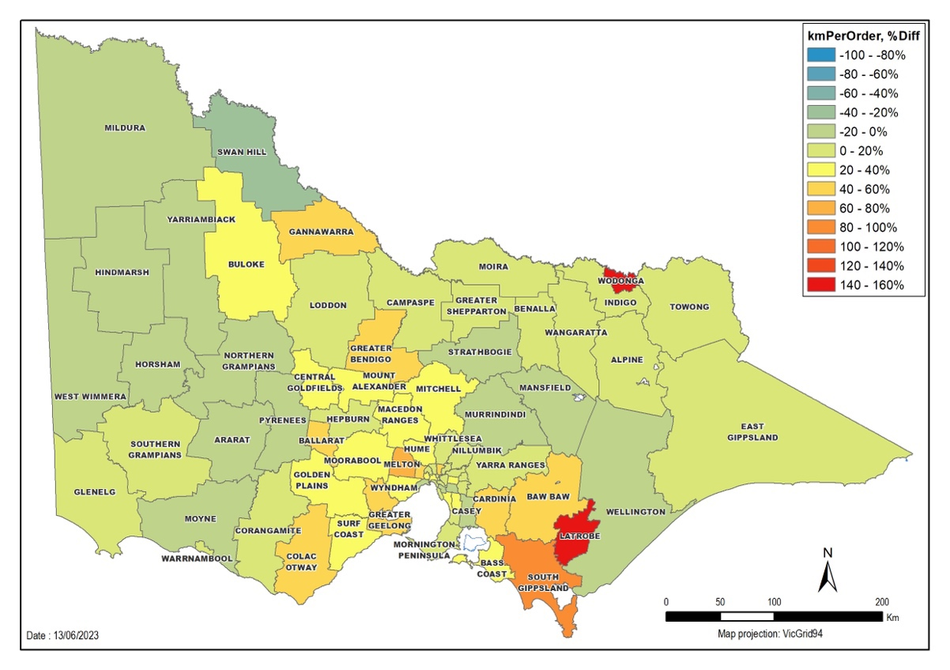
Figure 23 (b) Percentage difference in km per order, West disabled scenario

In the East and West sand supply reduction scenarios, transportation distances increase (Table 12).
The approximate transport costs in each scenario can be estimated, assuming a flat rate of $0.20 per km per tonne of sand (Table 12). The eastern region significantly reducing their sand supply is slightly more expensive.
Table 12 Results of modelling for Victorian sand supply scenarios
 | Base | East | West
Victorian production (Mt) | 14.5 | 13.6 | 13.9
Km travelled per sand order delivered | 90 | 127 | 121
Km travelled per sand tonne delivered | 2.26 | 3.17 | 3.03
Total distance travelled (‘000 km) | 32,000 | 44,000 | 42,000
Transport costs ($ million) | 12.6 | 18.2 | 17.2
Increase in transport costs relative to baseline | - | 44% | 37%

5.4. Conclusions relating to the SMT scenarios
The SMT investigated how Victorian construction projects would be affected if sand supply (and therefore sand-based materials such as concrete) had to be sourced from different locations. A reduction in sand supply in either the main western or eastern sand belts caused flow-on effects to projects across the state. The model suggests that in these cases sand would need to be sourced from further away from Greater Melbourne, possibly even interstate, to meet demand. The cost of extractive resources would increase.
Modelling to show possible future scenarios is critical to ensure that planning considers, and adequately prepares for, various options. The analysis will help determine future extractive resource locations and support faster approvals processes to maintain future supplies.
The SMT serves as independent, robust and accessible evidence to support efficient, effective and equitable, government decision making. The tool will assist in identifying current and potential future bottlenecks.

6. Opportunities for future analysis

6.1 Revised supply demand forecasts
Compiling the Study was a significant and resource-intensive effort on behalf of both Government and the work authority holders involved in industry surveys.
The data in the Study was compiled in 2021-22. While the Study includes the most robust extractive resources supply and demand dataset to date, the data should be revised periodically to maintain currency. Broader industry surveys would increase the total coverage of the industry as a proportion of the supply data, improving accuracy. The Study would benefit from a closer examination of supply by LGAs although data confidentiality issues would need to be overcome. Further in-depth analysis of the regions where extractive resources are most depleted could also be conducted to identify which regions should be prioritised for extractive resources development within planning frameworks and a multiple land-use context.
While the Study has a short-term focus of eight years, the previous PwC 2016 report considered a 35-year time horizon. A further longer-term study would have merit. However, determining quantifiable supply and demand estimates over the 8-year timeframe of the Study was challenging. As observed during the Study, both the supply and demand outlooks for extractive materials are dynamic and can alter over just a few years, due to influences such as Government infrastructure spending, floods and the economic impacts of the COVID pandemic. A study such as the current one is likely to support Government decision making for about five years.
As also observed, the development of the analysis relies heavily on work authority and other stakeholder engagement and can generate significant fatigue. This should be considered in the design of any study revisions. There may be opportunities for acquiring accurate reserves data with less effort and with improvements to internal data sharing, which was a significant impost in the Study.
It may be optimal to conduct revised quantity-based supply and demand assessments (including product level analysis) over a 10-year forecast period and at regular intervals of about five years. This would balance data reliability with effort and stakeholder fatigue. The period between assessments could be used to improve model design and reporting methodology. Longer-term studies with horizons of more than ten years would likely be better suited as qualitative assessments and to be more strategic, focused on addressing emerging and longer-term supply challenges.

6.2 Development of a replenishment Index
Future supply demand analysis would benefit from a supply replenishment index and industry groups have made repeated requests for such an index to be developed.
A replenishment index measures the rate at which rock types are consumed and replaced. An index of 1 would indicate that extractive materials are being used at the rate they can be sourced. An index lower than 1 indicates extractive resources are being used faster than they can be developed. Separate indices could be calculated across the state and for strategic regional areas.
The Study lacked a replenishment index. Instead, it attempted to estimate replenishment as a forecast by understanding from industry surveys any plans to bring new supply online via applications for new work authorities, work plans or work plan variations and then making assumptions about approval likelihood. A robust replenishment index would require increased sophistication in industry data reporting and Government analysis and reporting.

6.3 Consideration of recycled materials in supply demand analysis
In 2020, the Victorian Government released Recycling Victoria: A new economy, a plan that lists actions to promote a more circular economy. The Recycled First Policy was introduced as part of this circular economy strategy. This policy requires companies that bid for major transport infrastructure projects to prioritise recycled and reused Victorian materials while maintaining compliance and quality standards.
Given that the Study has identified that supply is likely to have difficulties meeting future demand, recycled materials are likely to play an increasingly significant role. There would be benefit in incorporating supply and demand for recycled materials in any future revisions to the Study.
For example, the following should be considered:

Asphalt
New asphalt can contain up to 40 per cent of reclaimed asphalt pavement. The Peninsula Link, for example, incorporates 22 per cent reclaimed asphalt pavement.

Crushed concrete
Crushed concrete (100 per cent purity) may be used as road subbase. Several of Melbourne’s major roads, including Eastlink, have used up to 200,000 tonnes of crushed concrete.

Recycled crushed glass in concrete
Wyndham City Council is trialling recycled crushed glass as an aggregate in footpaths. Up to 30 per cent fine glass aggregate may be used as a replacement aggregate in concrete mixes.

Recycled crushed glass
Recycled crushed glass can directly replace raw sand in products such as asphalt, road base, pipe bedding and granular filter material. Parts of the Koroit Creek Road level crossing removal project incorporate recycled crushed glass as bedding material.

6.4 Integration analysis and simulation modelling tool advances
The Study made use of an integration model developed within the Department and a simulation modelling tool that was developed by Digital Twin Analytics utilising data provided by the Department. The Department should review and refine both of these models and undertake assumption testing to increase the robustness of predictions. This could be a continual improvement process in between further supply demand study revisions.

6.5. Sydney case study
Sydney sits on a sandstone base with isolated patches of bluestone. During the city’s development, Prospect Hill and Penrith in the west were a ready source of extractive resources for construction, respectively, hard rock, and sand and gravel. These resources have been consumed, so there are no high-quality sources of extractive resource aggregate within approximately 100 km of the city.
Marulan, about 180 km south-west of Sydney, represents a new extractive area with high quality deposits. As a large greenfield area, the location is ideal. The extractive zone has sufficient environmental land buffers that do not infringe on residential regions and no heritage or environmental restrictions. Rail reduces transport costs.
Unlike Sydney, Melbourne still benefits from quarries being located close to market. However, as the work authorities close to Melbourne are depleted, and if replenishment is not successful (a trend indicated in the Study), Victoria may need new strategies. The main issue for Victoria is that, unlike New South Wales, there are no large, open resource areas within 200 km. Victoria may need to consider multiple smaller work authorities dispersed amid towns and farms. The Victorian industry will need to prepare for this by protecting what little greenfield areas there are for the explicit use of extractive resources.

7 Study conclusions
The Study provides the most up-to-date supply and demand forecasts and models of the Victorian extractive industry. The modelling indicates that Greater Melbourne consumes most of Victoria’s extractive resources. Demand is concentrated in and around the metropolitan area, but is spreading with the infrastructure needs of an increasing population.
Victoria continues to have supplies of hard rock, sand and gravel, clay and limestone. However, supplies may need to come from further afield if current work authorities cannot meet demand and have their resources depleted. Sourcing extractive resources further away from the demand centres will add significant transport costs to extractive resources products.

8. Appendices

8.1 Supply-side engagement – Survey questions
Preliminary questions:
Unique codes for quarry site?
Name of Respondent?
Role of Respondent?
Current quarry operations
1. What is the name and locality of your quarry site?
2. What local government area is the quarry site located in?
2(b) If other, which LGA?
3. What are the top three rock types extracted from the quarry site? List in order of prominence. [1st prominent]
3. What are the top three rock types extracted from the quarry site? List in order of prominence. [2nd prominent]
3. What are the top three rock types extracted from the quarry site? List in order of prominence. [3rd prominent]
Resource estimate
1(a). What is the current total resource estimate at your quarry site (within the work authority/authorities), in metric tonnes?
1(b). Level of measurement for (1a) above?
2. What percentage (%) of the resource estimate does the top three rock types make up? Refer to Section B, Q3. [Rock type 1]
2. What percentage (%) of the resource estimate does the top three rock types make up? Refer to Section B, Q3. [Rock type 2]
2. What percentage (%) of the resource estimate does the top three rock types make up? Refer to Section B, Q3. [Rock type 3]
3(a). What is the current reserve (e.g. technically feasible to extract and located within approved extraction limit) at your quarry site? Metric tonnes.
3(b). Level of measurement for (1a) above?
4. What percentage (%) of the reserve does the top three rock types make up? Refer to Section B, Q3. [Rock type 1]
4. What percentage (%) of the reserve does the top three rock types make up? Refer to Section B, Q3. [Rock type 2]
4. What percentage (%) of the reserve does the top three rock types make up? Refer to Section B, Q3. [Rock type 3]
5. What is the maximum production rate of your site (in metric tonnes per annum) that is possible under current operational limitations?
6. What are the main constraints to increasing your site's rate of production or throughput? Select one of the following
6(b) If other, please describe
Current quarry expansions - work plans and work authorities
1. Has a work plan variation, new work plan, or amendment/new work authority for the quarry site been submitted, or is planning to be submitted before 2030, in order to increase production at the quarry?
1. If not already submitted, what is the estimated timing of submitting the work plan variation or work authority?
2. What is the estimated tonnage of additional resource that will be encompassed by the change of work plan or work authority?
3. Level of measurement for (1c) above?
4. What is the estimated additional tonnage of production per annum that will be enabled by the change of work plan or work authority? Metric tonnes.
5. What is the estimated timing for when the additional resources or production will come into effect?
6. Does the change of work plan or work authority involve a continuation of any of the top three rock types at the current site? Refer to Section B, Q3. [Rock type 1]
6. Does the change of work plan or work authority involve a continuation of any of the top three rock types at the current site? Refer to Section B, Q3. [Rock type 2]
6. Does the change of work plan or work authority involve a continuation of any of the top three rock types at the current site? Refer to Section B, Q3. [Rock type 3]
Work authorities
1. If not already submitted, what is the estimated timing for submitting the work authority application?
2. What is the estimated tonnage of additional resource that will be encompassed by the new work authority?
3. Level of measurement for (2c) above?
4. What is the estimated additional tonnage of production per annum that will be enabled by the new work authority? Metric tonnes.
5. What is the estimated timing for when the additional resources or production will come into effect?
6. Is the new work authority a continuation of any of the top three rock types at the current site? Refer to Section B, Q3. [Rock type 1]
6. Is the new work authority a continuation of any of the top three rock types at the current site? Refer to Section B, Q3. [Rock type 2]
6. Is the new work authority a continuation of any of the top three rock types at the current site? Refer to Section B, Q3. [Rock type 3]
How many new quarries (work authorities) does the operator currently have proposed (lodged) that are expected to be operational before 2030?
Future quarry sites (for each Additional Future Quarry)
1. Has a work authority number been issued by Earth Resource Regulator for the proposed quarry site? What is the work authority number?
2. If not yet lodged, when is the application likely to be lodged with the Earth Resource Regulator?
3. In which local government area is the proposed quarry site located in?
4. What is the estimated tonnage of resource within the boundaries of the proposed quarry site? Metric tonnes.
5. What are the top three rock types extracted from the quarry site? List in order of prominence. [1st prominent]
5. What are the top three rock types extracted from the quarry site? List in order of prominence. [2nd prominent]
5. What are the top three rock types extracted from the quarry site? List in order of prominence. [3rd prominent]
6. What percentage (%) of the estimated resource does the top three rock types make up? Refer to Section E, Q4. [Rock type 1]
6. What percentage (%) of the estimated resource does the top three rock types make up? Refer to Section E, Q4. [Rock type 2]
6. What percentage (%) of the estimated resource does the top three rock types make up? Refer to Section E, Q4. [Rock type 3]
7. What is the estimated tonnage of resource that will be extracted per annum? Metric tonnes.
8. In what year is production expected to begin?
9. Does the operator have another proposed quarry?

9. Glossary
Term | Definition
Biodiversity offsets | Are a system where if one area of land is developed another must be conserved in its place to ensure enough parts of the state are kept untouched for ecological purposes.
Demand | The amount of raw materials needed by Victoria.
Earth Resources Regulation | Victoria's Regulator of exploration, mining, quarrying, petroleum, recreational prospecting and other earth resource activities.
Victorian extractive industry | The business involving the removal (or extraction) of various rock types from land for sale or commercial use, or for use in construction, building, road, or manufacturing works. For further information on rock types and industry involvement see here.
Extractive industry interest areas | Areas identified as possibly containing sufficient quality and quantity of extractive resources to run a viable work authority. For more info see here.32
Extractive resources | The various rock types that are quarried. This report focuses on hard rocks such as basalt, granite and hornfels, sand and gravel, limestone, clay and clay shale. For more info see here.32
Greater Melbourne | The 31 LGAs located within metropolitan Melbourne. Approximately 4.9 million people live in Greater Melbourne.
High supply scenario | A scenario in which all applications for work plan variations and new work authorities across Victoria proceed, so the state is expected to have more raw material available.
Integration analysis | Spatial analysis using demand and supply forecasts to identify any potential future shortfalls and supply constraints.
Low supply scenario | A scenario in which applications for work plan variations and new work authorities only assessed as low-risk across Victoria proceed, so the state is expected to have less raw material available.
Medium supply scenario | A scenario in which applications for work plan variations and new work authorities assessed as low- and medium-risk across Victoria proceed, so the state is expected to have some raw material available.
Operator | An extractive industry professional or company who has been granted permission via a work authority to extract raw materials from a quarry.
Priority Project List | Is a list that highlights Victorian quarry projects that will be given priority planning consideration.
Quarry gate (price) | The price of extracting raw materials without factoring in transport.
Quarry site | A site where raw materials such as hard rock or sand are extracted. A quarry site can consist of more than one work authority.
Raw extractive material | Extractive materials in their original form, without any processing. For example basalt or sand as it comes from the ground.
Recycled extractive materials | Construction products that are repurposed and can be reused as a substitute to raw materials. For example, reclaimed asphalt pavement, crushed concrete, recycled glass, recycled crushed glass.
Regional Development Victoria partnership | Is a partnership between local communities within nine regions of Victoria and the state government to ensure that local needs are met.
Reserves | Total quantity of material within permitted extraction limits of a specific work authority. For the Study, it is assumed that all reserves can be sold at market.
Resource | Total quantity of raw extractive material within work authority boundaries. Not all of a resource will make it to market due to extraction limitations such as depth limits, vegetation protection, or cultural heritage management plan.
Simulation modelling tool | Model that simulates the Victorian extractive industry supply chain by simulating interactions between work authorities, processing plants and construction projects.
Sterile land | Land that is unable to be used as a quarry because it has been selected for another incompatible use.
Specifications | Referring to the characteristics and quality of a certain construction material.
Strategic extractive resource area | Area likely to contain extractive resources of sufficient quantity and quality to support commercial quarry operations. These resources are close to appropriate transport routes and located in areas where a potential quarry will have limited impact on the environment and surrounding land uses. For more info see here.32
Strategic resource | Region with a high quantity material suitable for producing construction materials that is located relatively close to current and future demand.
Supply | The amount of raw materials across Victorian quarry sites.
Supply shortfall | Occurs when the amount of raw materials that Victoria has does not meet the amount that the state requires.
The Department of Energy, Environment and Climate Action (DEECA) | This state government department manages Victoria’s energy, environment, water, agriculture, forestry, resources, climate action, and emergency management functions. Extractive resources are part of our environment and are hence are managed by this department.
The Department of Environment, Land, Water and Planning (DELWP) | This state government department manages Victoria’s climate change, energy, environment, water, forests, planning and emergency sectors. Now Department of Energy, Environment and Climate Action.
Transport costs | The costs associated with transporting raw material from the quarry gate to processing plants and to projects.
Transport Network Development Plan | Guide to the short-, medium- and long-term priorities needed to modernise the public transport network.
Victoria’s Big Build | The overarching program delivering $165 million in major road and rail projects across the state to improve the transport sector.
Victoria’s Big Housing Build | A state government initiative to invest $5.3 billion into building 12,000 new homes throughout metro and regional Victoria over the next four years. To learn more see here.
Work authority | Legally designated areas for undertaking quarrying activities. Work authorities are required under State legislation unless exemptions apply.
Work plan (new) | An application to ERR to develop a new work authority at a new or existing quarry site.
Work plan variation | An application submitted to ERR by a work authority to conduct extraction works outside of the originally agreed perimeters of their quarry.

Average of 2020-22 (Earth Resources Regulation Annual Statistical Reports)
www.business.vic.gov.au/business-information/construction-industry-regulation#overview
Based on annual report data of non-surveyed operations.
Earth Resources Regulation Annual Statistical Report FY 2020-21, (Source ERR), based on annual returns submitted by 5/11/21 at time of integration analysis. Subsequently revised by ERR up to 66.78 million tonnes.
Annual growth 2001-2021 was 2.06% (Source ERR).
If a quarry is close to a project site the transport baseline cost is 25-30 per cent of the total extraction cost, with trucking costs at 20 cents/tonne/kilometre. See Table 12.
Earth Resource Regulation State Statistical Reports 2017-21.
Extractive Resources Strategy, 2018 (https://earthresources.vic.gov.au/projects/extractive-resources-strategy)
Pulse Check, DJPR, 2022
https://www.sustainability.vic.gov.au/research-data-and-insights/waste-data/annual-waste-data-reports
Earth Resources Regulation 2019-20 Annual Statistical Report.
Earth Resources Regulation Annual Statistical Report FY 2020-21, (Source ERR), based on annual returns submitted by 5/11/21.
DJPR internal modelling 2021 (independently reviewed)
Victorian 2022-23 Budget, Chapter 4 – State Capital Program
Victorian 2022-23 Budget, Chapter 4 – State Capital Program
As of 11 February 2022, Victoria had the highest number of applications for HomeBuilder grants: https://treasury.gov.au/coronavirus/homebuilder
Proser, C.C, 2016, “Geoconservation, Quarrying and Mining: Opportunities and Challenges Illustrated Through Working in Partnership with the Mineral Extraction Industry in England”, Geoheritage (2018) 10:259-270.
https://earthresources.vic.gov.au/__data/assets/pdf_file/0014/821300/RRV-Strategic-Extractive-Resources-Roadmap.pdf
Extractive Resources Strategy
Read more about the project priority list: https://earthresources.vic.gov.au/projects/extractive-industry-priority-project-list
https://earthresources.vic.gov.au/legislation-and-regulations/regulation-review-and-reform/better-approvals#:~:text=Better%20Approvals%20for%20Regulators%20(BAR)%20is%20a%20state%2Dwide,expected%20of%20a%20modern%20regulator.
Extractive Resources in Victoria: Demand and Supply Study 2015-2050 Final Report, May 2016
Earth Resources Regulation Annual Statistical Report FY 2020-21, (Source ERR), based on annual returns submitted by 5/11/21.
https://www.rdv.vic.gov.au/regional-partnerships/partnerships
DJPR Industry survey, 2022
Results were capped to 160 per cent to properly render colour ranges
Results were capped to 160 per cent to properly render colour ranges
Results were capped to 160 per cent to properly render colour ranges
Results were capped to 160 per cent to properly render colour ranges
Read more about recycling and Victoria’s plan for a circular economy: https://www.vic.gov.au/victorias-plan-circular-economy
Greater Sydney market - quarry product supply review by Conmats consulting, John Malempre, March 2022
https://www.planning.vic.gov.au/__data/assets/pdf_file/0031/595273/PPN89-Extractive-Industry-and-Resources-September-2022.pdf
https://liveinmelbourne.vic.gov.au/discover/melbourne-victoria/metropolitan-melbourne

