

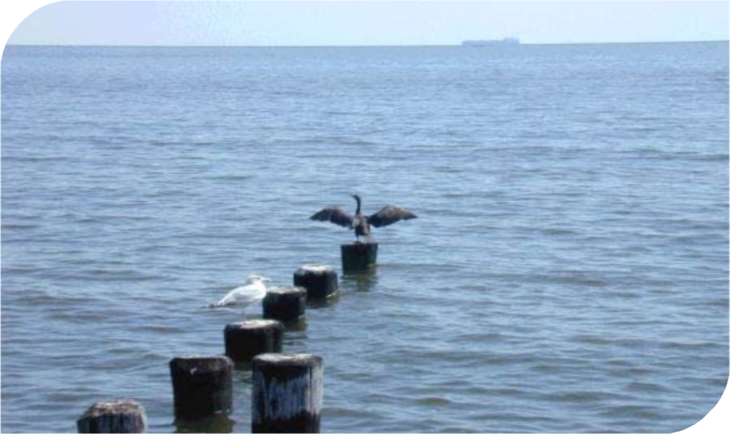


2011
Summary Environment Plan



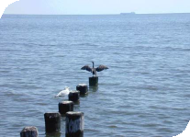
Contents

Contents
- INTRODUCTION 3
- LOCATION OF THE PIPELINE 4
- PIPELINE ENVIRONMENT 6
3.1 Physical Environment 6
  - Biological Environment 7
  - Cultural Environment 7
  - Socio-economic Environment 7
- ENVIRONMENT HAZARDS, MANAGEMENT APPROACH AND CONTROLS 9
- CONSULTATION 12


Introduction

IN T R O D UC T IO N

This is a summary of the Environment Plan for the Bass Strait section of the Tasmanian Gas Pipeline. The plan was prepared by Tas Gas Networks Pty Ltd and approved by the Department of Primary Industries (Victoria) on 6 April 2011.
The summary plan includes the following:
Section 2 – Coordinates of the activity;
Section 3 – Description of the receiving environment; Section 4 – Details of major environmental hazards and
controls and a summary of the management approach;
Section 5 – Details of consultation taken and plans for ongoing consultation.



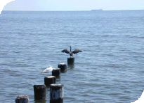

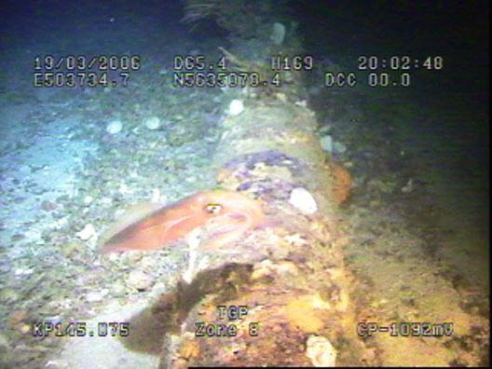



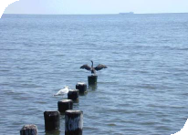
The Location

LO C AT I O N O F T H E P I P EL I N E

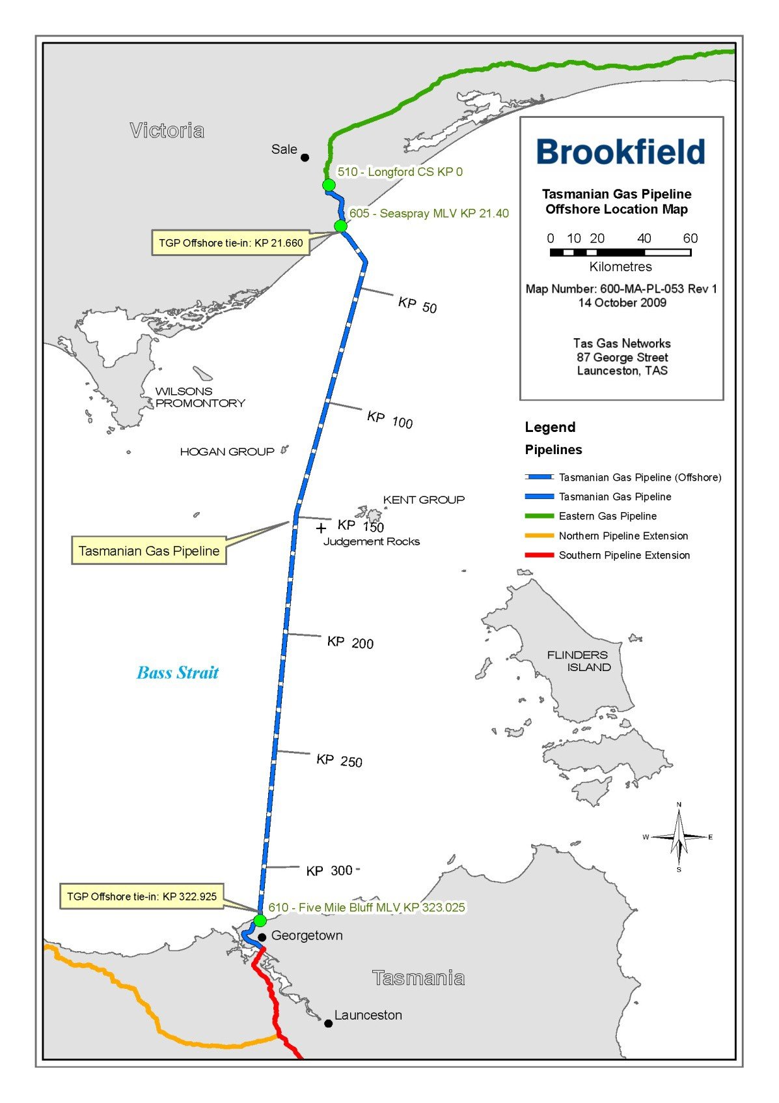

The Location

The Tasmanian Gas Pipeline (‘TGP’) runs from Longford in Victoria to north-east Tasmania. This Environment Plan focuses on the Bass Strait sub-sea section from the low water mark
at Ninety Mile Beach, about one kilometre east of Seaspray, Victoria, to the low water mark at Five Mile Bluff on the coast of Tasmania near Georgetown, including a portion of the drilled
shoreline crossings at the Victorian and Tasmanian landfalls. The following table shows the coordinates of the pipeline route across Bass Strait.

 | KP | WGS 84 (Zone 55) |  | AMG 66 (Zone 55) |  | Geographic WGS 84
Feature |  | Eastings (m) | Northings (m) | Eastings (m) | Northings (m) | Latitude | Longitude
Vic. End
HDD Entry | 21.647 | 517,842.2 | 5,753,741.4 | 517,730.0 | 5,753,558.0 | -38.125157 | 147.121525
HDD Exit | 22.735 | 518,167.2 | 5,752,703.4 | 518,055.0 | 5,752,520.0 | -38.222522 | 147.122873
IP 1A |  | 518,645.3 | 5,751,176.5 | 518,533.1 | 5,750,993.1 | -39.231473 | 147.124858
IP 1B |  | 520,368.0 | 5,749,364.1 | 520,255.8 | 5,749,180.7 | -38.241339 | 147.135978
IP 1 |  | 526,271.2 | 5,738,832.4 | 526,159.0 | 5,738,649.0 | -38.295452 | 147.180459
IP 2 |  | 502,979.2 | 5,631,602.4 | 502,867.0 | 5,631,419.0 | -39.275455 | 147.020468
IP 3 |  | 491,100.2 | 5,462,000.4 | 490,988.0 | 5,461,817.0 | -40.593526 | 146.533908
IP 3A |  | 491,244.7 | 5,460,138.7 | 491,132.5 | 5,459,955.3 | -41.003564 | 146.534517
HDD Exit | 322.344 | 491,082.2 | 5,458,505.2 | 490,970.0 | 5,458,321.8 | -41.012861 | 146.533813
HDD Entry | 323.303 | 490,997.1 | 5,457,650.4 | 490,884.9 | 5,457,467.0 | -41.015633 | 146.533444
Tas. End

The Environment

PI PE L I N E E NV I R O NM E NT 3.1 Ph ys ic a l En viron men t



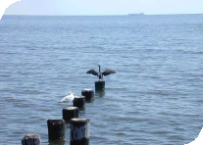
Bass Strait was formed approximately 12-15,000 years ago by the inundation of a land bridge that had once connected Tasmania and Victoria. It is a comparatively shallow sea (depths of up to 80m) with the western and eastern entrances defined by the continental shelf that extends between King Island and Cape Otway in the west and between Flinders Island and Wilsons Promontory in the east. Beyond the continental shelf the seabed declines sharply to depths of over 3,000 m.
The seabed along the direct route between Seaspray and Five Mile Bluff is reasonably featureless. In the vicinity of the pipeline corridor the seabed consists primarily of fine and medium grained quartzose sands with a mean grain size of 0.12 - 0.25mm.
Coarse sands and gravels are present to a lesser extent in the proximity of the Victorian shore crossing (Hydro Tasmania 2001). Seabed current manipulations have formed some sand waves.
Circulation or mixing of water in Bass Strait is mainly dependent on tidal currents, but wind-driven currents, coastal trapped waves, barometric pressure-induced currents, density-driven flows and ocean-scale circulation patterns also contribute. The current speeds ultimately depend on the proximity to the eastern entrance of Bass Strait with lower current speeds expected to the west.
Current speeds between 0.30 -
0.79 m/s occur during 5 year return period storms while current speeds of 0.41 - 1.03 m/s occur
during 100 year return period storms.
The average annual rainfall is
757.2 mm (recorded at Flinders Island) with the highest rainfall and most rainy days occurring from May through to August. Winds are typically strongest during spring and weakest during the winter: 50-60% of winds are under 10 knots with 30-37% of winds occurring between 10 and 20 knots. Strongest winds (greater than 20 knots) mainly originate from the west. Average temperatures range from 17.5 deg. C in summer to 10.7 deg. C in winter.
Protection of the region from westerly and south-westerly swells is provided by Wilsons Promontory, Tasmania and King Island. However, during five and 100 year storm events, wave heights may range from 4.5 - 5.5 m and 6.8 - 7.5 m respectively. Although the pipeline was originally laid on the surface of the seabed, strong current and wave activity may result in shifting sands and periodical burial of pipeline sections.
The pipeline route passes within the vicinity of a number of small islands or island groups. These include (in order from north to south):
- The Hogan Island Group, which straddles the border between Victoria and Tasmania and is located about 10 km to the west of the pipeline corridor and about 45km east of Wilsons Promontory, Victoria;
- Curtis Island Group lying about 25km west of the pipeline corridor and made up of Curtis Island, Cone Island, Sugarloaf Rock and Devils Tower;
- The Kent Group: an archipelago of five islands and offshore rocks situated approximately half way between Wilsons Promontory and the northern end of Flinders Island. The main group of islands (incorporating Deal, Dover and Erith Islands) lies about 23km east of the pipeline. Judgement Rocks, a small granite island with an area of 0.39 ha lies to the south-west of the main islands of the Kent Group and about 10km east of the pipeline corridor;
- The Bass Pyramid Group, made up of Craggy Island, Wright Rock and Bass Pyramid and lying between Flinders Island and the Kent Group. Bass Pyramid is a small, steep-sided granite island with an area of <1 ha and lies about 20km east of the pipeline corridor;
- Tenth Island, part of the Waterhouse Island Group off the northern coast of Tasmania, lies approximately 9km east of the pipeline corridor.
All islands, apart from Boundary Islet within the Hogan Island Group, are under the jurisdiction of Tasmania and lie at least 8km from the pipeline corridor.

The Environment

Biologic a l
E n vi ro n men t

Bass Strait is an area of relative high faunal diversity and supports a number of species of high conservation and commercial value. This is partly due to its unique biogeographical location at the convergence of three marine biogeographical regions: the Peronian (New South Wales), Maugean (Tasmania) and Flindersian (southern Australia).

There are many different temperate ocean habitat types represented in Bass Strait from open beaches and rocky reefs (both exposed and sheltered) to offshore islands, soft bottom habitats (sand, mud and seagrass) and open sea. The main marine ecosystems present within and immediately surrounding the pipeline primarily comprise:
- Plankton;
- Macroalgae;
- Benthic infauna and epifauna;
- Pelagic and demersal species;
- Pinnipeds;
- Cetaceans; and
- Birds.

Cultural E n vi ro n men t

The potential for impact of the pipeline on submerged terrestrial
sites dating from the period prior to the creation of Bass Strait (prehistoric) is considered low, partly due to the effect of physical factors on surface deposits as sea levels rose, but also due to the subsequent sedimentation and burial of submerged terrestrial sites that would have occurred following inundation. No submerged terrestrial sites were identified during construction of the pipeline

The coastal zone of both Victoria and Tasmania potentially contain numerous heritage sites, predominantly of recent formation (last 1 000 years). However, archaeological surveys conducted prior to construction of the pipeline found little evidence within the pipeline corridor of sites of either Aboriginal or non- Aboriginal origin (Hydro Tasmania 2001). All potential sites within the foreshore landform of the alignment were nonetheless avoided via use of directional drilling under the coastal zone.

Data on shipwrecks in the region indicates a significant number are present throughout Bass Strait.
However, exact resting places for most of these wrecks are unknown and none appear to be in the vicinity of the pipeline route.

So ci o - eco n o mi c E n vi ro n men t
A wide range of human activities occur in the waters of Bass Strait including commercial oil and gas fields, shipping, commercial and recreational fishing and other recreational activities:
- The Gippsland Basin has been producing significant oil and gas resources since the 1960s and includes a number of operating fields. Petroleum permits have been issued for exploration and production within the central Bass Strait region with the closest operating field located at least 3km to the east of the pipeline;
- Bass Strait is one of Australia’s busiest shipping areas with passengers and freight being transported between the mainland and Tasmania as well as New Zealand. The highest volumes of traffic travel in an east-west direction with connections to Melbourne and Geelong. Substantial volumes of traffic also occur between Melbourne/Geelong and Tasmania moving in a north- south direction.



The Environment



Status – Issued Policy - 143P001T
Version 4 – July 2009
ENVIRONMENT POLICY

Tas Gas Networks is committed to excellence in environmental management through its environmental commitments to its shareholders, customers and the community.

This will be achieved by:

- Recognising that environmental management is a corporate priority and integrating this into all business processes from the purchase of goods to the provision of network assets and services;

- Conducting all activities in a manner consistent with the principles of sustainable management and caring for the environment;

- Developing an environmentally aware culture by demonstrating management commitment, implementing management systems, and providing the time and resources to educate and train employees and contractors;

- Implementing management strategies to meet current and anticipated performance standards; and

- Consulting the local community on its concerns, aspirations and values and ensuring that local heritage will be respected and historic places and artifacts will be preserved.

We will measure our success by achieving our goal of zero reportable environmental incidents. We will also see to maintain robust management systems and processes to ensure continuous improvement in Environmental Management.

Richie Sheather General Manager Tas Gas Networks

6 July 2009

4 E N V I R O N M E NT H A Z A R D S , M A NA G E M E NT A P PR O A C H A ND C O NT R O L S

The Environment Plan has been prepared for the offshore operational phase of the TGP and identifies aspects of the TGP operations that have the potential to have an adverse effect on the physical, biological, social and cultural aspects of the environment.

It is recognised that emergencies on the offshore TGP may lead to serious, long term environmental damage and environmental emergencies and may include (but are not limited to):
- Fire/explosion on board the offshore support vessel;
- Gas leaks from the pipeline;
- Oil/chemical spills from support vessels;
- Natural events (heavy weather); and
- Third party damage.
Since construction, a 500m marine safety zone has been established around the pipeline to assist in protecting the pipeline from inadvertent damage.
Enforcement of this safety zone is the responsibility of the Australian Maritime Safety Authority (AMSA). AMSA is also responsible for ensuring that the pipeline is marked on maritime charts and notifies owners and operators of the precise location of the pipeline through its routine Notices to Mariners program.

In addition, the following controls have been adopted by the operator of the pipeline: Tas Gas Networks, to manage threats to the environment:
- periodic subsea surveys using remotely-operated vehicles (ROV), and Side Scan Sonar (SSS) to detect existing or
potential damage and for the determination of maintenance and operational requirements;
- an intelligent pipeline pigging activity whereby an electronically-equipped device (pig) is inserted into the pipeline to detect metal loss in the pipeline wall;
- major event driven surveys following severe weather conditions in the Bass Strait or suspected pipeline impact, incorporating a risk assessment and possible pipeline inspection or survey;
- an Oil Spill Contingency Plan;
- risk assessments to ensure all environmental risks associated with identified hazards relating to pipelines are assessed and the appropriate management and control measures are implemented to keep the risks at a level as low as reasonably practicable (‘ALARP’);
- liaison with Bass Strait fishing enterprises.
Tas Gas Networks takes a proactive management approach to protecting the environment and aims to:
- carry out intelligent pigging of the pipeline every 10 years;
- perform ROV surveys every 2 years with targeted high risk areas when needed;
- review maximum allowable operating pressure (MAOP) every 5 years;
- conduct a formal safety assessment and a risk assessment review every 5 years in accordance with the requirements of AS2885.3;
- conduct an annual risk assessment to determine any change to survey frequencies.
The following table contains a summary of the key environmental risk associated with the operation of the pipeline and control measures implemented to reduce the risk to as low as reasonably practical.

Potential Impact | Mitigation Measures
Hazard to commercial fishing and shipping (obstacle) (collision and oil spill potential).  Hazard to recreational users of Marine National Parks. | Comply with all regulatory requirements regarding notification of vessel movements.  Maintain appropriate communication with local fishing industry and other affected groups.  Navigation lights on vessel and continuous radio and radar watch.  Ship collision avoidance procedures.
Introduction or spread of marine pests through ballast water. | Compliance with national quarantine requirements (AQIS) for managing ballast water.
Disturbance to marine fauna by underwater noise generated by echo sounder and side scan sonar equipment, eg physiological impacts on sensitive fauna such as cetaceans. | Inspections on 2 year cycle (FY 20011, 2013 and FY2015). Acoustic equipment to be kept below 140dB when whales observed within 3 km; alternatively, procedures in accordance with EPBC Guidelines to be observed.
Disturbance to seabed and benthic communities from anchor impacts. | Anchoring only to be undertaken during emergencies.  Avoid use of anchors within marine protected areas. If anchors must be used, sufficient steps to avoid dragging should be undertaken.  Responsible use of navigation charts and baseline biological data to avoid disturbance to reefs and habitat within marine protected areas.
Large spill to ocean causing:  - Disturbance to marine fauna including mammals, birds and other organisms;  - Oiling of coastlines (including National Parks and State Reserves). | Refueling to be undertaken in port only.
Storage and disposal of environmentally hazardous wastes and general waste causing:  - Visual pollution of marine environment;  - Degradation of seabed habitat;  - Potential mortality of marine fauna through ingestion or entanglement. | All personnel are trained in waste management requirements. Regulations/requirements within the International Convention for Prevention of Pollution from Ships (MARPOL) and by state  Pollution of Waters by Oil and Noxious Substances Act 1986  (PWONS) will be followed.  No waste to be disposed overboard except for comminuted sewage and food wastes in offshore waters where permitted (disposed of at sea beyond 12 NM of the nearest land).  Wastes segregated, containerized and appropriately labelled All environmentally hazardous and general waste is collected and returned to shore for disposal using a licensed contractor.  Documented waste management procedures and disposal records where required.  Standard handling and safety procedures.


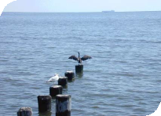
Environmental Hazards, Management Approach and Controls

Potential Impact | Mitigation Measures
Potential impacts to marine mammals by engine and equipment. | Noise sources continuous and similar to commercial vessels in the area.  Acoustic equipment to be kept below 140dB when whales observed within 3 km; alternatively, procedures in accordance with EPBC Guidelines to be observed.  Adherence to National Guidelines for Whale & Dolphin Watching.  Activity outside peak migration periods for cetaceans.
Spill incidents – loss of hydrocarbons/fuel to ocean causing:  - Potential impacts to marine fauna and water quality;  - Oiling of marine animals;  - Oiling of coastlines (including National Parks and State Reserves);  - Contamination of sediments. | Training of staff.  Regulations/requirements within the International Convention for Prevention of Pollution from Ships (MARPOL) and implemented by state Pollution of Waters by Oil and Noxious Substances Act 1986 will be followed.  Avoid refuelling at sea and if unavoidable, refuelling is to take place during daylight hours. Hoses to be fitted with dry break- couplings and refuelling operations to be monitored at all times.  Provision of oil spill response equipment and materials Contractor to adhere to Oil Spill Contingency Plan as detailed in the offshore support vessel emergency procedures.  Oil spills to be reported immediately to the Rescue Coordination Centre Australia in Canberra.

Consultation

5 CO N S U L TA TI O N
Tas Gas Networks has an active consultative approach in its role as Operator of the Tasmanian Gas Pipeline. Stakeholders include:
- Department of Primary Industries, (Victoria);
- National Offshore Petroleum Safety Authority;
- Energy Safe Victoria;
- Department of Infrastructure, Energy and Resources (Tasmania).
In more recent times, as part of the Integrity Management Review of the pipeline completed this year, the following organisations were involved in Tas Gas Networks active consultative approach:

- the South-East Tasmania Fishing Association (SETFIA) regarding the creation of an awareness programme in respect to the location of the pipeline route in order to prevent damage to the pipeline from fishing activities;
- the Commonwealth Department of Sustainability, Environment, Water, Population and Communities in order to ascertain whether pipeline operational activities are restricted in the Beagle Commonwealth Marine Reserve (proclaimed in 2007 after the pipeline had been in operation for a number of years);

- a number of offshore expert consultants including:
  - J P Kenny – Pipeline and subsea engineering;
  - Cardno Lawson Treloar – Oceanographic monitoring;
  - Monarc Environmental;
  - Professor Andrew Palmer and Dr Roger King – Subsea pipeline engineering.
Tas Gas Networks currently uses a variety of consultants to assist in integrity management of the subsea pipeline and protection of the surrounding environment including those above. It is Tas Gas Networks’ intention to continue doing so on an as needs basis into the future.



Contact Details
The Operator’s nominated liaison person for the Tasmanian Gas Pipeline is: Mr Andrew Bambridge
Transmission Manager Tas Gas Networks Pty Ltd 87 George Street
Launceston, Tasmania 7250

Telephone: 03 6336 9362
Email: Andrew.Bambridge@tasgas.com



