
Environment Plan Summary
OEUP-V9000-PLN-ENV-007

Enterprise 3D Seismic Survey (Otway Basin)
Environment Plan Summary

Review Record

Rev | Date | Reason for Issue | Prepared | Checked | Approved
A | 30/08/13 | Issued for review | JB | BM | BM

Once printed, this is an uncontrolled document unless issued and stamped Controlled Copy or issued under a transmittal.

Security: Commercial in Confidence – Origin Internal Use and for submission to Vic Dept of Transport and NOPSEMA only

Table of Contents
Environment Plan Summary 1
Table of Contents 2
- Introduction 3
- Seismic Survey Location 4
- Seismic Acquisition Methodology 6
- Summary of Existing Environment 7
  - Physical Environment 7
  - Biological Environment 7
    - Mammal Species 8
    - Turtles 8
    - Birds 8
    - Fish Species 8
    - Marine Invertebrates 9
  - Socio-economic Environment 9
    - Heritage 9
    - Oil and Gas Infrastructure 9
    - Shipping 9
    - Commercial Fisheries 9
    - Tourism 9
- Environmental Hazards and Controls 10
  - Acoustic disturbance 10
  - Physical Presence of the Vessel 11
  - Exotic species Introduction 11
  - Routine Vessel Discharges 11
  - Marine Oil Spills 12
  - Equipment Loss in the Marine Environment 12
- Management Approach 15
- Consultation 16
- Contact details 17

Introduction
Origin Energy Resources Limited (Origin) is proposing to undertake the Enterprise 3- Dimensional (3D) seismic acquisition survey (the Enterprise seismic survey) in Victorian waters and adjacent Commonwealth waters in the Otway Basin. The survey area is within exploration permit area VIC/P42 (V), and would be adjacent to the coastal area between the towns of Peterborough and Port Campbell. As the permit operator, Origin has an obligation to investigate the petroleum potential of the exploration permit area. Seismic surveying will be conducted to determine the presence and economic viability of potential hydrocarbons in the Otway Basin exploration permit area VIC/P42 (V).
Origin has prepared an environmental plan for the Enterprise seismic survey acquisition activity proposed to be undertaken in the exploration permit area VIC/P42(V) in accordance with all relevant State and Commonwealth legislation and addresses the following key elements;
 compliance with all applicable legislation;
Origins understanding of how the proposed operations will interact with the environment;
Measures to ensure the environmental and other marine user impacts and risks shall be continuously reduced to as low as reasonably practicable (ALARP);
that appropriate performance objectives, standards and measurement criteria are in place to measure environmental performance; and
the systematic implementation of controls that have been established to minimise environmental impacts and associated risk with the activity.
In the event the seismic program alters to increase an existing environmental effect or risk, new activities are planned, or if a new significant environmental effect or risk is identified, this plan will be revised and resubmitted to the regulators for approval in accordance with the OPGGS (E) Regulations and the Offshore Petroleum and Greenhouse Gas Storage Regulations 2011 (Victoria).

Seismic Survey Location
The survey will be undertaken principally in Victorian coastal waters, with some activities also undertaken in adjacent Commonwealth waters within the Otway Basin on the western side of Bass Strait offshore from Peterborough and Port Campbell.
The survey acquisition will take place between 1km and 1.4km to the south of the coastal water boundary (Figure 2.2–note the boundary of the State waters is shown in red).Due to the turning requirements of the survey vessel and the need to deploy equipment further offshore, some of these activities will take also place within the Commonwealth marine area adjacent to the survey area. The survey will be conducted in water depths from 20 m to 65 m. Area boundary coordinates are provided in Table 2-1 and shown in Figure 2.1.
Table 2-1 Boundary Coordinates for the Proposed Seismic Survey Area

 | Latitude |  |  | Longitude
Location point | Degrees | Minutes | Seconds | Degrees | Minutes | Seconds
A | -38º | 35' | 22.25" | 142º | 49' | 41.31"
B | -38º | 36' | 12.75" | 142º | 48' | 53.91"
C | -38º | 36 | 34.00” | 142º | 49 | 31.29”
D | -38º | 37' | 05.58" | 142º | 49' | 18.60"
E | -38º | 37' | 36.22" | 142º | 51' | 19.38"
F | -38º | 39' | 50.68" | 142º | 50' | 28.01"
G | -38º | 41' | 23.08" | 142º | 55' | 04.69"
H | -38º | 41' | 12.62" | 143º | 00' | 05.41"
I | -38º | 38' | 41.43" | 143º | 00' | 04.38"
J | -38º | 37' | 28.79" | 142º | 59' | 08.79"

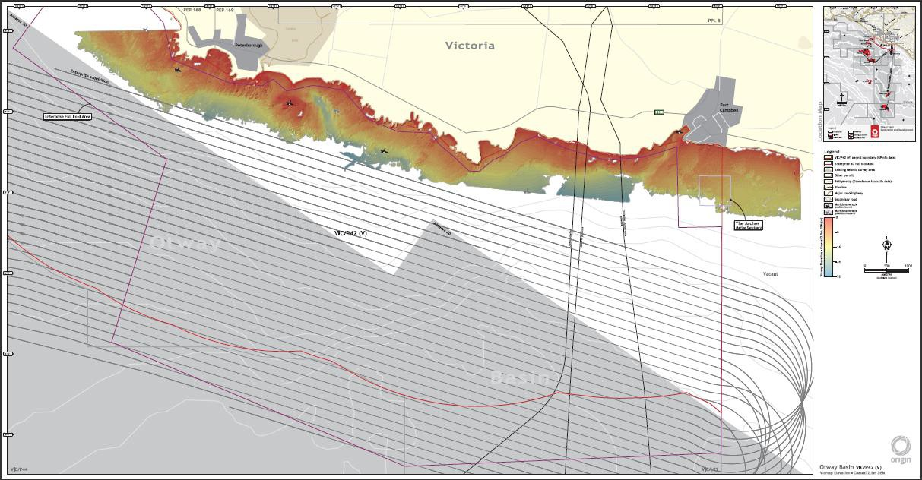
Figure 2.1 Schematic representation of proposed Enterprise seismic survey lines

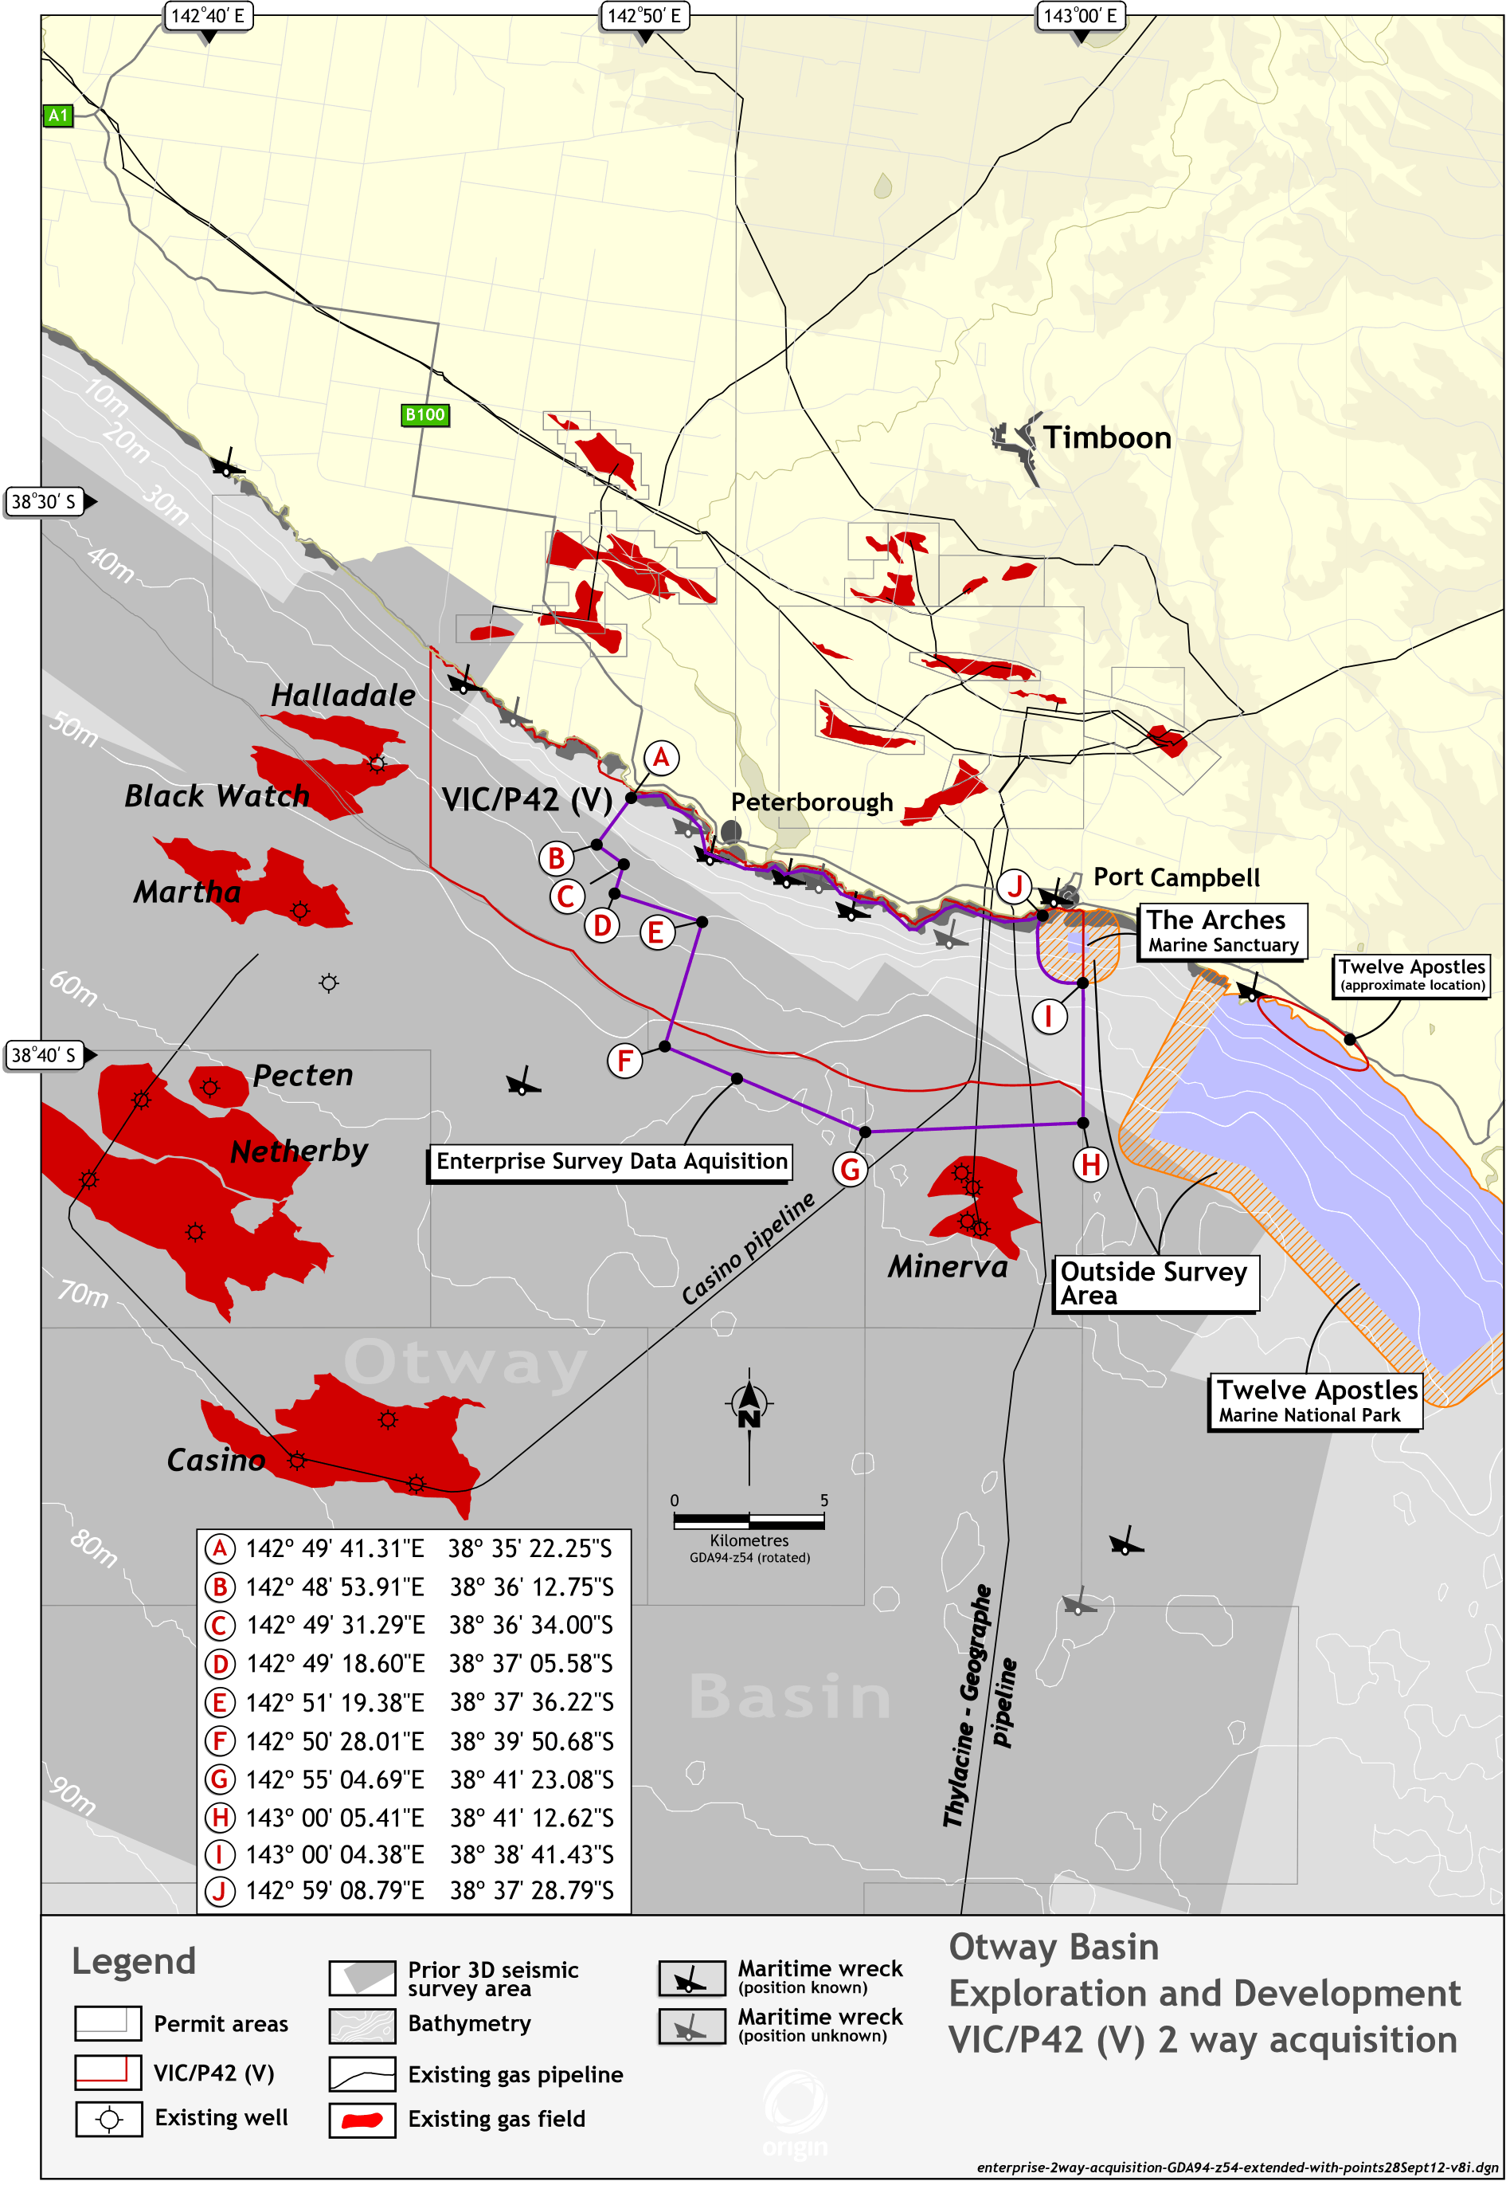

Figure 2.2 Proposed Enterprise seismic survey area

Seismic Acquisition Methodology
The Enterprise seismic survey is planned to be acquired between 1st November and 30th December 2013 or 2014. The survey will be conducted using a purpose-built seismic survey vessel with emergency tow and survey support duties provided by a dedicated vessel.
In addition to the seismic survey vessel and support vessel, there will be two guard vessels on alternating attendance schedules to provide continuous survey reconnaissance and assist with operational safety between the seismic operations and any marine leisure, commercial and/or fisheries traffic in the area.
The data acquisition will be conducted using a purpose-built seismic survey vessel, towing acoustic source arrays and 4,500 m to 5,100 m long hydrophone streamers along pre- planned parallel survey transects. The seismic survey vessel will traverse the survey area parallel to the coast along defined transects with the vessel and the towed spread avoiding entering the marine park areas through robust survey planning with the preferred contractor. Each survey transect will be approximately 13 km to 16 km in length. The parallel linear transects are evenly spaced at approximately 200 – 300 m apart (depending on the capacity of the vessel selected to undertake the work), with the survey vessel traversing each transect at approximately 4 -5 knots (9 km/hr).
The streamer separation distance will be 100 m with a streamer depth of between 7-8 m. The streamers will have depth controllers and emergency recovery units not more than 300m apart, positioning and lateral steering units not more than 600m apart, and will be either foam construction or gel filled. The streamers will be ballasted to account for changes in buoyancy due to fresh water entering the coastal water areas from local aquifers. The individual acoustic source volume will not exceed 2,500 cubic inches and an operating pressure of 2,000 psi. The acoustic source arrays will be approximately 50 m apart and towed approximately 150 m astern of the vessel at a depth of approximately 5–7 m, producing sound energy at frequencies up to 250 Hz. The armoured tow leader, communication and air delivery umbilical cable for each source will have sufficient additional buoys and or buoyancy to prevent the tow leader cable catenaries from being at the risk of touching the seabed in the shallower inshore area during acquisition and turning areas.
The acoustic source will trigger every 18.75 m or approximately 8 to10 seconds in ideal current and weather conditions, alternating between the two acoustic source arrays, producing impulses that are reflected from the boundaries of the geological layers in the subsurface. The reflection data will be detected by hydrophones inside the streamers. The data is then processed to provide an image of the sub-surface.
Vessel operations will occur 24 hours a day. The survey vessel Master will provide the Australian maritime authorities with a “Notice to Mariners” outlining the area of operations and a request that all other vessels provide clearance around the survey vessel and equipment.
In the event of weather or sea conditions interfering with seismic operations, the vessel would assess the conditions and either move offshore to a safe distance or, If likely to be for an extended unworkable weather period of more than 5 days, would return to shelter at Portland.

Summary of Existing Environment

Physical Environment
As part of the interim marine and coastal regionalisation for Australia, the IMCRA Technical Group (1998) has classified the area where the survey area is located as part of the meso-scale region defined as ‘Otway’.
The climate in the Otway is described as cool temperate with cool wet winters and warm dry summers. The coast line is typically high energy with cool water temperatures typified by localised, regular, nutrient rich coastalup wellings in the west of the region.
The seabed in this area is sloping and consists primarily of rocky reefs and boulders, with some areas of soft sediment, including accumulations of sand in gutters and crevices. The survey area covers the depth ranges from approximately 20m at the most northern (inshore) boundary, down to approximately 70 m at the most southern boundary. In Commonwealth waters the survey acquisition would be undertaken entirely in water depths in excess of 50 m.
The adjacent shorelines in Victorian State waters consist principally of vertical cliffs, with a narrow intertidal zone of rocky and soft sediments, including vertical seastacks. The bathymetry in the area of the proposed survey is shown in Figure 2.1 and 2.2.
Intertidal rocky shores are the predominant habitat from Port Fairy to Apollo Bay. The Littoral or Intertidal Zone exists between the high tide and low tide levels and is typically dominated by grazing snails, mussels and barnacles. Below the low tide level is the Sub littoral Zone and this is often algae-dominated bychitons, other molluscs and numerous crustaceans.
Victoria’s shallow rocky reefs occur either as extensions of intertidal rocky shores or as isolated offshore reefs and are scattered from the low-water mark to a depth of 20-30 metres. Generally, the shallow reef is dominated by species of kelp and one other brown seaweed. Other species which may occur include turf algae, green algae, ascidians, bryozoans, echinoderms and sponges.
Deep rocky reefs are found in water depths of greater than 20-30 m. At this depth the algae found on shallower reefs are replaced by invertebrates such as sponges, bryozoans, corals, sea whips and ascidians.

Biological Environment
The permit lies within the south east marine region. The following fauna can be found in the region:
The fish fauna of the region consists of about 600 species, of which 85% are believed to be endemic;
Marine mammals including whales and seals;
Marine invertebrates include diverse groups such as sponges, crabs, sea stars, anemones, octopus, squid and molluscs;
More than 20 species of migratory birds spend time in the region; and little penguin.
The Twelve Apostles Marine National Park lies to the east of the permit area, covers 7,500ha and extends along 17km of the Victorian coastline and The Arches marine sanctuary lies approximately 2 km south of Port Campbell (see Figure 2.2).
The two nearest Commonwealth marine reserves, the Apollo and Zeehan are approximately 50km and 120 km respectively from the nearest permit boundary.

Mammal Species
Marine mammals are a feature of the region’s fauna and may occur in the vicinity of the proposed survey. Twelve species of cetacean and two seal species are listed as having the species /or species habitat potentially occurring in the area of the proposed seismic acquisition area.
The survey has been timed to coincide with the least probability of encountering all whale species.

Turtles
Two threatened reptile species were identified as either the species or habitat likely to present in the proposed survey area. The threatened reptiles include the Loggerhead turtle (Caretta caretta), listed as endangered and the Leatherback turtle (Dermochelyscoriacea), listed as endangered.
The loggerhead turtle is globally distributed in subtropical waters and is rarely seen in Victorian waters. The leatherback turtle is an occasional visitor to Bass Strait and no major leatherback nesting areas have been identified in Australia.

Birds
A total of 28 threatened bird species were identified as potentially occurring in the survey area and include:
15 albatross species.
4 petrel species.
1 sea-eagle.
8 bird species (bitterns and terns), which are primarily terrestrial species but which may utilise estuarine and intertidal habitats.
The identified albatross and petrel species may potentially overfly and forage within the proposed survey area and a colony of approximately 12,000 short-tailed shearwaters nest on Mutton Bird Island from September til April and the birds may be feeding or resting on the water in the area of the survey operations.
Other than threatened or migratory species, only four (4) species would be expected to utilise the marine or coastal areas, and include the Great skua (Catharactaskua), Black- faced cormorant (Phalacrocorax fuscescens), Hooded plover (eastern) (Thinornisrubricollis rubricollis) and the Little penguin (Eudyptula minor).
The little penguin is known to breed on beaches and feed in the area of the proposed survey. The closest colony to the seismic survey area is the region between the Twelve Apostles to the east of the proposed survey area and London Arch just offshore of the coast between Port Campbell and Peterborough.

Fish Species
Fish species include both recreational (tuna, marlin, and Australian salmon) and commercial species (orange roughly, flathead, flake, and trevalla) (NOO, 2002). Crustaceans and shellfish are also present in the area, including the commercially important species, southern rock lobster and abalone.
Four species of shark, the great white shark, Grey Nurse Shark, Mako shark and porbeagle are listed as occurring in the region.
An additional 29 species of fish (including pipefish and seahorse species and the Southern Bluefin Tuna) are listed as potentially occurring in the area as marine or protected species.

Marine Invertebrates
There are 10 protected species of marine invertebrate, including 7 echinoderms, 1 chiton and 2 opisthobranch species, which may potentially be present in the survey area.

Socio-economic Environment

Heritage
The nearest National Heritage Place is located onshore in Victoria, being the Great Ocean Road and Scenic Environments at a distance of approximately 1,200 metres from the closest point of the project area.
There are three historic shipwrecks within the permit area, being; The Falls of Halladale (1908);
Schomberg (1855); and Newfield (1892).
All of the wrecks are described as lying in shallow water and being well flattened, and none are within the area where active seismic acquisition will take place.
The proposed Enterprise 3D survey is remote from any World Heritage Property.

Oil and Gas Infrastructure
There are a number of production fields located in the Otway Basin and includes the Otway gas project, Casino gas project and the Minerva gas project.
Oil and gas undersea pipelines from these three projects pass under the eastern edge of the survey area. These are clearly marked on navigational maps and there are no plans for any equipment from the survey to touch the sea floor. The pipelines are located under established shipping channels and the survey will not pose any further risk.

Shipping
Bass Strait is one of Australia’s busiest shipping routes. Commercial vessels use the route when transiting between ports on the east, south and west coasts of Australia.
Origin will provide the Australian Maritime Safety Authority (AMSA) with information allowing issue of a “Notice to Mariners” outlining the area of operations and a request that all other vessels provide clearance around the survey vessel and equipment.

Commercial Fisheries
The key Commonwealth and state managed commercial fisheries operating in or near the Enterprise survey area are the southern rock lobster, Victorian eel fishery and the Victorian abalone fishery. Two shark fishermen have indicated that they periodically fish the waters 3 to 5Nm from shore in the survey area.
Other fisheries distant to the Survey area include Trawl fisheries for scale fish and shark, demersal long line fishing, and squid fisheries. Due to the distance to these fisheries the survey is not expected to impact these fisheries.

Tourism
The key areas of tourism in the area include land-based sightseeing from the Great Ocean Road and lookouts along the road, helicopter sightseeing, private and chartered vessels touring into the Twelve Apostles Marine Park, diving and fishing.

Environmental Hazards and Controls
Origin has identified, qualitatively risk assessed and reviewed the environmental hazards associated with the Enterprise 3D Seismic Campaign.
The methodology utilised is consistent with the Australian Standard for Risk Management: AS/NZS ISO 31000:2000, Origin risk management policies, procedures and tool kits and NOPSEMA’s guidance notes regarding environment plans. Two workshops were held between February and November 2012 with environmental, safety and seismic survey experts, taking into account information received during stakeholder consultation and from fisheries and cetacean expert advisors. The reviews considered the specific environmental aspects, causes and potential impacts on environmental values. The risk assessment has also been based on:
previous seismic projects by Origin in the region and lessons learned; the activities proposed for Enterprise 3D seismic project;
consideration of the seismic acquisition technology to be used;
knowledge of the receiving environment, with particular emphasis on sensitive environmental aspects of the project area;
ongoing consultation and liaisons with stakeholders to mitigate risks;
alternatives relating to the types of vessel, timing of the survey, seismic methodology and source volume were all taken into consideration.
Key environmental Hazards identified in the Hazard workshops are described below, along with a discussion of the controls implemented to reduce the associated risk to the environment. Potential environmental impacts and controls are summarised in Table 5-1.

Acoustic disturbance
The main potential impact related to the proposed activity is acoustic disturbance caused by the seismic source. The location of the survey is subject to very high ambient noise levels as a result of wind, waves and surf action. Noise loggers placed in the Warrnambool coastal region and nearby offshore sites over a 7 month period identified that the highest proportion of time at high noise levels and more periods of high noise occurred at the coastal sites. Modelling undertaken indicated that the peak acoustic pressures produced for all seismic sources are smaller than those produced by the mean annual wave height and corresponding wave period near the shore line.
Controls will be implemented to minimise the risk of acoustic disturbance to marine species and humans to an acceptable level that is considered as low as reasonably possible and the survey has been timed to minimise the likelihood of encounters with all whale species. Origin will conduct the survey using the smallest suitable acoustic source, able to image the target depth area of interest and will be conducted using a method to minimise the overall time required for the survey. Gradual increase in the seismic source volume for no less than 30 min will allow any mobile marine fauna to move away while the source volume is low. Qualified marine mammal observers will be on duty during daylight hours.
Due to the proximity of the survey to the shore Origin consult with all known diving clubs, representative organisations and dive shops in Victoria to provide information on the potential hazards of underwater noise on divers and information on the location and timing of the survey. Additionally, signage will be posted at identified potential access points and support vessels will accompany the seismic survey vessel at all times and will provide liaison with any recreational vessels in the area.

Physical Presence of the Vessel
The proposed Enterprise survey will utilise a Seismic vessel, a support vessel and a guard vessel. Even with observers there is still a risk to marine mammals. The timing of the survey to November/December, a period when there is the least likelihood of whale species being present in the vicinity of the survey. Further controls include the use of towed marine streamers rather than seabed nodes or cables, to reduce the time required for acquisition as far as possible and the use of a slow, consistent tow pattern in the area will allow marine fauna to move away from the vessel.
The design of the towed equipment, with solid or foam filled streamers and the design of the tail buoys, minimizes any risk of entanglement.
Consultation will continue with peak stakeholder organisations for fisheries and shipping, and local vessel charter operators, including ongoing consultation and communication to inform them of the exact survey dates once these are established with the marine seismic contractor and signage will be erected at boat ramps in the area to notify people launching recreational vessels of the survey activities and requesting them to maintain a safe distance.
During the survey, if other vessels are sighted, standard maritime protocols and precautions will be in place to provide adequate distance to avoid vessel collisions. A continuous watch will be maintained (visual, radar, AIS and radio) and radio contact will be made with other vessels approaching the area. The support vessel and guard vessels will also be used to liaise with any other vessels in the area and ensure that a safe distance is maintained.
The presence of the seismic vessel may temporarily disrupt commercial and recreational fishing activities in the immediate area as a result of the need to ensure navigational safety for both the seismic vessel, towed equipment and other vessels in the area. The temporary exclusion of fixed bottom to surface floats and fishing gear (e.g. lobster pots) in the seismic area would also be required to avoid the risk of entanglement and damage to fishing and or towed marine seismic equipment.
The vessel will be present in the survey working area over a period of approximately 5 to 14 days depending on weather conditions for acquiring seismic data, and the area will be immediately available for access by fishing operators at the conclusion of the survey.

Exotic species Introduction
The Enterprise survey vessels will have no requirement to discharge water ballast or sediment into the marine environment during the normal course of the survey operations. The vessels used in the operation are kept as free as possible of marine growth through the use of antifouling paints and the vessel hulls are cleaned during out-of-water surveys.

Routine Vessel Discharges
All garbage, other than food wastes, will be retained on board the vessels and the only risk of plastics entering the ocean is as a result of accidental loss overboard. Management practices such as designated garbage storage and secure storage areas will be in place throughout the survey to minimise the risk of any accidental discharge of waste as far as possible. All vessels will be required to hold a waste management plan.
Sewage discharges at sea will only be made in strict accordance with MARPOL and Australian maritime pollution regulations with respect to distance from land and treatment provisions.
Where there are operational discharges from vessels engaged in the project, these will be in accordance with MARPOL 73/78 (Annex 1 – Oil, Annex IV – Sewage, Annex V – Garbage and Annex VI – Air) including the standards and certification of all on board pollution control equipment and maintenance of records relating to waste management and disposal.

Marine Oil Spills
Marine oil spills may occur during refuelling or as a result of damage to vessel bunker tanks from collision or grounding. A lesser potential source of marine oil spills is leaks of hydraulic or lubricating oils on board the vessel. Any refuelling operations required will occur only at a port facility where there are permanent facilities to adequately manage the refuelling and transfer process with minimal environmental risk. Refuelling operations will be in full accordance with the vessel and refuelling contractor’s bunkering procedures to minimise any risk of a spill. There will be no ship-to-ship fuel transfers during the survey.
The risk of collision is controlled through the generally slow operating speed of the vessel, the continuous presence of the support and guard vessels, Notices to Mariners in the area, avoidance of operations in poor weather or sea conditions, avoiding operations in shallow water, and the additional level of watch keeping associated with the seismic operations.
All vessels will have a current Shipboard Oil Pollution Emergency Plan (SOPEP) or equivalent and will be carrying spill containment kits, which will aid in immediate containment and clean-up of any releases on the deck during machinery maintenance (e.g. diesel or lubricating oils) or refuelling in port.
A Project specific Oil Spill Contingency Plan (OSCP) has been developed in consultation with State and Commonwealth combat agencies.

Equipment Loss in the Marine Environment
Control measures to avoid and minimise the risk of lost equipment will include the use of navigational controls, solid foam based streamers that will not sink if released, industry standard and certified towing equipment and maintenance procedures to ensure all equipment in maintained to a high standard High visibility equipment and flotation devices on all equipment and the availability of a work boat and support vessels will assist in equipment recovery if required.

Table 5-1 Summary of potential impacts and control measures for the Enterprise 3D seismic survey

Impact Category | Potential Impacts | Control and mitigation measures
Acoustic impacts | Potential for physical or behavioural disturbance to marine mammals (particularly whales) as a result of acoustic disturbance.  Potential for temporary displacement of fish, impacting on commercial fisheries in the immediate area.  Potential impact to humans as the area is near shore and a recreational area for divers and fisherman | Survey will be timed to minimise the likelihood of encounters with whales. Use of the lowest possible source volume suitable for acquisition of the survey.  Survey method is selected to reduce the actual time the vessel needs to be in the area to complete the survey.  Contact is being maintained with any dive charters and signage will be posted at boat ramps and access points. A support vessel will be on hand at all times to facilitate communication with other marine users who enter the seismic area.  Gradual increase of the source volume over a period of not less than 30 minutes allows for any mobile marine fauna to move away from the sound source while it is at low volume.  Observation, low-power and shutdown zones as prescribed by DSEWPaC for whale.
Vessel Presence | Potential for vessel strike to marine fauna  Potential for entanglement of marine fauna in survey equipment  Interference/ interaction with fisheries or other marine users. | Survey will be timed to minimise the likelihood of encounters with whales. Equipment design to reduce the risk of entanglement.  Tail buoys on the streamers will be fitted with turtle guards to minimise the risk of entanglement of marine fauna.  Vessel speeds during the survey will be slow, minimising the risk of vessel strike.  Dedicated work boat and support vessel will be available at all times for immediate deployment to free any entangled fauna and or recover lost equipment.  Direct consultation with fishing operators in the region.  A support vessel will be on hand at all times to facilitate communication with other marine users who enter the seismic area.  Trained MMOs will be on duty during all daylight survey acquisition operations.
Exotic species introduction | Pest / pathogen establishment in the survey area Potential loss of income to fisheries.  Potential impact to native marine flora and fauna | Vessel hull cleaning, antifouling and inspection history.  No ballast water will be released into the survey area. The vessel will at all times comply with Australian Quarantine regulations.  Support and Guard vessels local to the area
Routine Vessel | Marine pollution from floating debris | Waste management plan on all vessels.



Discharges | Contamination of the marine environment | All discharges in accordance with MARPOL73/78 and domestic regulations. IMO approved pollution control equipment.
Marine Oil Spills | Pollution impacts on marine fauna and impacts to shoreline  Impacts on other marine users and commercial fisheries | No ship-to-ship fuel transfers. Bunkering only at licensed shore facilities.  SOPEP and OSCP up to date and exercised. Signed off by AMSA, State combat agencies and AMOSC.  Use of light fuel if at all possible.  Operations will be suspended in unfavourable weather and sea conditions. Navigational safety measures, liaison with other marine users.
Equipment Loss | Potential for entanglement with marine fauna or other marine users. | Support vessels and work boat on hand to recover equipment.  Lights and radar reflectors on tail buoys to minimise likelihood of vessel interactions.  Industry standard certified, planned maintenance routines and approved procedures and protocols to minimise risk of loss.  Equipment design facilitates recovery if lost.

Management Approach
The survey will be managed in accordance with:
the Origin Enterprise 3D Seismic Survey Environment Plan accepted by NOPSEMA under the Offshore Petroleum and Greenhouse Gas Storage (Environment) Regulations 2009;
the particular manner prescribed in EPBC Referral still under consideration by DSEWPaC;
all relevant environmental and safety legislation; and
Origin’s Health Safety and Environment Management System.
The accepted Environment Plan defines and details objectives, standards and criteria with response to all potential environmental impacts from the survey activity. These are supported by systems, practices and procedures to direct, review and manage the survey activities and to continually reduce the potential for environmental harm to as low as reasonably practicable in all cases. The accepted Environment Plan also identifies roles and responsibilities, training and competency requirements and measures for implementation of controls, managing non-compliance, emergency response and monitoring, auditing and reporting throughout the Project.
The Environment Plan shall be implemented by Origin working together with the selected seismic operator, with day-to-day implementation occurring on the seismic vessel under the leadership of the Party Chief and the Origin Offshore Representative. The Origin Project Manager will have oversight of the performance of the project against the Environment Plan and will initiate reviews and audits as required. In the event of a vessel incident, the Origin Emergency Response Team will work together with HSE, technical advisors and government combat agencies as required to respond.

Consultation
Consultation on this project began in May 2012 as part of the development of this Environment Plan. Origin maintains relations with stakeholder groups in the Otway region and has consulted on the Enterprise project with potentially interested groups. These include;
Commonwealth, state and local government representing primary industry, environment and maritime users;
Fisheries Peak Bodies, representative groups and individual operators from Apollo Bay, Port Campbell, Port Fairy, Warrnambool and Portland. Fisheries represented included rock lobster, Trawl, eel, and squid fisheries; and
Community, tourism representatives, environmental representative groups and non- government organisations.
The Victorian population has an active interest in reports of oil and gas exploration undertaken within the state and the offshore environment. Consultation has identified that the key marine users in the area who may be impacted by the proposed survey are commercial fishermen.
Ongoing consultation with marine stakeholders includes:
Issue of an updated fact sheet giving the specifics of the dates, vessel and methods once all regulatory approvals have been issued;
Disseminating information about the survey through local community groups and media;
Disseminating information about the survey through Seafood Industry Victoria, for inclusion in their monthly newsletters;
Maintaining a 24/7 contact number for anyone with questions or concerns about the project;
Issue of notices to mariners;
Communication of rock lobster research results to commercial fishing representative agencies and government stakeholders.

Contact details

John Oxley Centre – North Tower 339 Coronation Drive
Milton 4064
Telephone Number: 07 3037 7219
Email: Robert.meagher@originenergy.com.au Contact Person: Robert Meagher

