GeoVic 3.0
Help Documentation

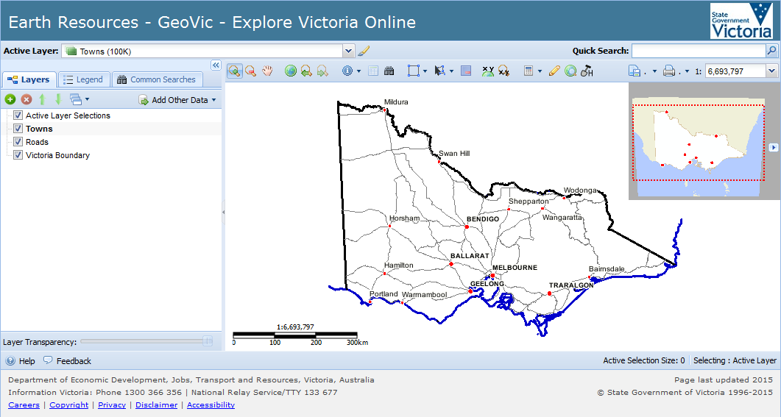

Version | Comment | Author | Date
3.0 | Main Version | Richard Bramfit | 10/12/2010
3.0.1 | Translated to word | Robert Lane | 13/12/2010
3.02 | Re-arranged and reworded | Robert Lane | 22/12/2010
3.03 | Updated uncompleted sections | Richard Bramfit | 04/01/2011
3.04 | Updated Add a WMS Layer | Richard Bramfit | 20/01/2011
3.05 | Added how to find All Crown Land within a Mineral Tenement | Richard Bramfit | 07/02/2011
3.10 | Corrected to incorporate all minor changes.  Added Historic Mining Activity and Google Maps  Image Alternate text | Robert Lane | 20/11/2015

Table Of Contents
Table Of Contents 2
Introduction 4
Quick Start 5
What’s New 8
GeoVic 3 Default Screen Layout 9
1. Active Layer, Select Set Symbology and Quick Search 10
Active Layer Display and Drop Down List 10
Selected Feature Symbology 11
2. Main Tools and Buttons 17
Zoom In 17
Zoom Out 18
Pan 19
Initial Extent 19
Previous Extent 19
Next Extent 19
Identify 20
Tabular View 21
Advanced Search 27
Select Features 30
Common Selection Functions 32
Coordinate Display 36
Zoom to Map Coordinate 37
Measurement Tools 37
Markup / Redline Tools 40
Google Maps 51
Historic Mining Activity Report 53
File Menu 54
Print Menu 63
3. Scale Display and Control 65
4. Tab menus 65
Layers Tab 65
Legend Tab 65
Common Searches Tab 66
5. Layers – Control Buttons 67
Add Layers 67
Remove Layers 67
Move Layer Up 68
Move Layer Down 68
Themes 69
Add Other Data 71
6. Layers – Table of Contents & Context Menu 81
Layers – Table of Contents 81
Layers Context Menu 81
7. Layers – Layer Transparency Control 84
8. Locality Map 84
9. Help, Feedback and Login (if not logged in) 84
Help 85
Feedback 85
Login Session 86
10. Main Map Display and Main Map Context Menu 86
Main Map Display 86
Map Context Menu 86
11. Scale Bar and Scale Bar Context Menu 88
Scale Bar 88
Scale Bar Context Menu 88
12. Historic Mining Activity 89
Definitions 89
Examples 90
Example 75 Vine Street Bendigo – Certificate 92
Example 75 Vine Street Bendigo – Detailed Report 93
13. Frequently Asked Questions 98
Q) How can I get the Tabular View Button to work? 98
Q) How can I get the Advanced Search Button to work? 98
Q) How can I copy and paste the geographic coordinates of a location? 98
Q) What are the Key Layers? 98
Q) What can be searched within the Quick Search? 98
Q) Where can I get detailed Mineral Tenement information from? 99
Q) What does ‘Could not find mapEngine geovic.arcims’ mean? 103
14. How To's 105
How To Create Maps For Workplans using GeoVic 3 - General Location Plan 105
How To Create Maps For Workplans using GeoVic 3 - Regional Plan 106
How To Find all Crown Land Parcels in a Mineral Tenement 108
Click the Common Searches tab. There are six searches available. Select the second search 2. Crown in Mineral Tenement Search. 109
15. Layers (Key & Quick Search) 111
Key Layers defined for Identify and Select 111
Layers enabled for the Quick Search 111
16. Known Issues 113
17. Contacts 114

Introduction
The Earth Resources web mapping application, GeoVic 3 allows users to search our geospatial databases and display the results as maps or tables.
Datasets that can be viewed and interrogated include mineral, petroleum and extractive industries tenements, land-use and airborne geophysical survey boundaries, gravity, magnetic and radiometric images, borehole & well data, surface geochemistry results, mines and mineral occurrences, and geological maps and interpretations at various scales.
This application will eventually provide our clients with on-line access to all Earth Resources services and databases to help them carry out their business.
The map service is based on the licenced use of Weave technology as developed by Cohga for the Department of Economic Development, Jobs, Transport and Resources.
Special Notes
1. This application reports locations using VICGRID94 co-ordinates based on the GDA94 datum
2. GeoVic 3 is optimised for use with Firefox. Most features should however work with any recent standards compliant browser. GeoVic 3 will not work for Internet Explorer 6
3. As GeoVic 3 is an internet application, please ensure that your browser will allow popups from this site.

Quick Start

Quick Start - How to Add a Layer
GeoVic 3 starts with 3 layers in the Layers, Table of Contents.
To add extra layers, click on the Add Layers button.
This gives you access to a folder structure very similar to what was in the previous GeoVic. Simply enable the layers you want to add to the Layers, Table of Contents and hit the Apply button.
Another way to add layers is to use the Add Theme button, which will add predefined groups of layers.

Quick Start - Accessing Detailed Text Information
There are three basic methods.
• 1. Quick Search Method
Enter text in the Quick Search box and choose a feature.
Display the Tabular View of the results.
• 2. Select Feature Method
Make the layer 'Active' (see below.)
Select one or more map features.
Display the Tabular View of the results.
• 3. Identify Method
Make the layer 'Active' (see below.)
Identify a map feature (results are displayed in a tabular view).
Making a layer 'Active' is required to view text information.

Quick Start - Making a Layer Active
For most searches, a dataset will need to be active for you to search it. The only case where this is not true, is when you use the Quick Search. When using Quick Search, a successful search will change the Active Layer to the relevant data source. Quick Search accesses key business layers outlined in the Layers, Key and Quick Search.
To make a layer active, it needs to be added to the Layers, Table of Contents first. Then either:
right click on the layer name in the Layers, Table of Contents. Click on the Set Active option and then choose the sub-component (most layers only have one, but some have more)
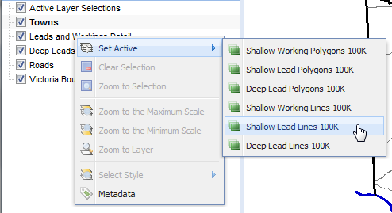
or select it from the Active Layer: drop down list.
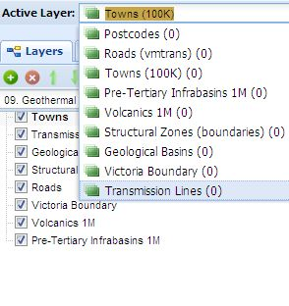

Quick start - Identify
Once a layer is active the Identify tool can be used to access information. When a map feature is clicked, an Excel like tabular view will be presented. It is useful to note that some layers have more than one tabular view available.

Quick start - Selecting Features
Apart from the Quick Search: option, there are three main ways of selecting map features. A feature is selected when it is displayed on the Main Map Display with a yellow outline. Note that a feature can be selected and displayed, even when the layer is otherwise not visible. (key difference to the old GeoVic).
1. Activate a layer and select the Common Search tab.
Most layers have at least one search available where a user can perform text based searches.
2. Activate a layer and click the Select Features tool.
After activating the tool, wherever on the Main Map Display the mouse is clicked, it will select the features of the Active Layer.
3. Click on the Advanced Search button.
This is a more advanced tool than the Common Searches tab. (Replaces the old GeoVic's adhoc query builder).

Quick Start - Tabular View
Once map features from the Active Layer are selected, click on the Tabular View button.
This will present a tabular view of the features from the Active Layer. Like the Identify tool, it is useful to note that some layers have more than one tabular view available.

Quick Start - Clearing Selections
Selections are set to New by default, which means that each time you do a selection on a particular layer it replaces the old selection.
To clear selections you can either click the Clear the Selection From the Active Layer button in the main toolbar, click the Common Selection Tools button and use the Clear All Selections from All Layers button, or use either of the two Clear Selection buttons found in the Layers Context menu
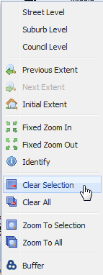

What’s New
• Quick Search implemented to find features quickly. (including property addresses)
• Common Searches implemented to streamline searches.
• More information available from our databases directly (eg Tenements, Boreholes and Mines and Mineral Occurrences)
• Corporate Reports linked to features (eg Tenements, Boreholes and Mines and Mineral Occurrences) – (BIRT reports)
• Layer transparency and layer reordering capability.
• Linkages for maps directly to the online store.
• Access to many more or improved images (especially if you login)
• Ability to work on a tablet.
• Google Maps linkages.
• Geological Layer specific functions
o For layers in Geology, Interpretations, State Wide Data, Geology 250K Seamless
o GSV Web Feature Service (WFS) and Web Map Services (WMS) implemented.
o Searching of our Web Map Service Catalog and being able to add WMS’s to the map.
o Web Map Service Style selector.
• Customisable selection symbology for individual layers.
• Re-arranged layers and folder structure to make it easier to find data.
• Changed the way new layers are added to aid transparency and reduce clutter.
• Changed the way the system works - incorporating active layers.
• Changed the look and feel to meet new web standards for Department of Economic Development, Jobs, Transport and Resources.

GeoVic 3 Default Screen Layout
1. Active Layer, Select Set Symbology and Quick Search
2. Main Tools and Buttons

3. Scale Display and Control

4. Tab Menus
5. Layers – Control Buttons
6. Layers – Table of Contents & Context Menu (right mouse button click)
7. Layers – Layer Transparency Control
11. Help, Feedback and Login (if not logged in)
8. Locality Map

9. Main Map Display and Main Map Context Menu (right mouse button click)

10. Scale Bar and Scale Bar Context Menu (right mouse button click)

12. Active Layer & Selection Size Message Box

13. Window Controls (Hide and Open)

1. Active Layer, Select Set Symbology and Quick Search

Active Layer Display and Drop Down List

The layer name that displays in the Active Layer display is the current Active Layer. In most cases the Active Layer will also be listed in the Layers - Table of Contents area, but there are some exceptions. For example, the layer Postcodes will not appear in the Layers - Table of Contents area, even when it has been selected as the Active Layer.
For any spatial selections (default method), Identify (default method), Common or Adhoc searches, an Active Layer must be selected. It does not matter if the Active Layer is visible or not. Nor does it matter if the Active Layer is 'greyed out' - which means that the layer cannot be shown due to being outside the viewable scale range.
Clicking the drop down listing shows:
• a) All layers listed in the Layers - Table of Contents area, together with
• b) Layers that have features currently selected, including in brackets, the number of features selected for each layer.
The exception to all the above is when you have added images to the Layers - Table of Contents area. Images cannot be made active, as there are is no attribute data associated with them. Hence they will never appear in the Active Layer drop down list.
Another way to make a layer active, is to right click the layer in the Layers - Table of Contents area, click Set Active and select the layer.
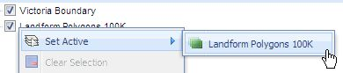

Selected Feature Symbology

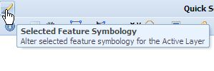
The Selected Feature Symbology function can be used to change the appearance of selected features from the Active Layer. There are two modes of operation, Standard and Thematic.

Selected Feature Symbology - Standard Mode
By default, GeoVic 3 draws selected features in two ways. For selected polygon and line features, GeoVic 3 renders these in yellow. For selected points, they are rendered as black points with yellow outlines. However alternate colours can be chosen, and this can be achieved by clicking on the Select Feature Symbology button.
For selected features there are 2 broad types of symbology changes that can be done.
Standard will allow the entire set of selected features to be changed to the same symbology.
Thematic will allow the symbology to be set against particular attribute values.
To use the Selected Feature Symbology function, you need to select features from the Active Layer first. If the selected features are points, then pressing the Selected Feature Symbology button will cause the Edit Symbology GUI to appear as shown below:
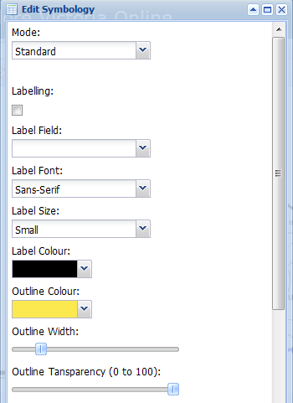
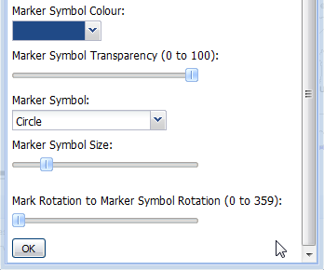
For selected points for Standard symbology, labelling can be enabled by enabling the label checkbox and selecting an attribute to label on. The font type, size and colour can also be changed. For the outline of the marker point, the default outline colour can be changed by selecting a new colour from the Outline Colour drop down combo box. The width of the outline can also be changed by using the Outline Width slider control. Likewise the opacity of the outline can be changed by adjusting the Outline Transparency slider control.
The fill colour can be changed by selecting a different Marker Symbol Colour and adjusting the transparency using the Marker Symbol Transparency slider control. The default circle shape can be changed by selecting a different shape from the Marker Symbol combo box. The rotation and size can also be adjusted by the Marker Symbol Size and Mark Rotation slider controls.
If the selected features are lines, the selected feature symbology labelling can be changed as per points. The selected line symbology can also be changed with the Line Colour, Line Width and Line Transparency.
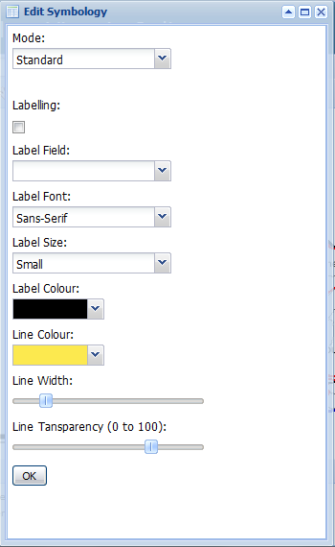
For polygon features, the labels can be enabled and the outline and fill colours can be modified.
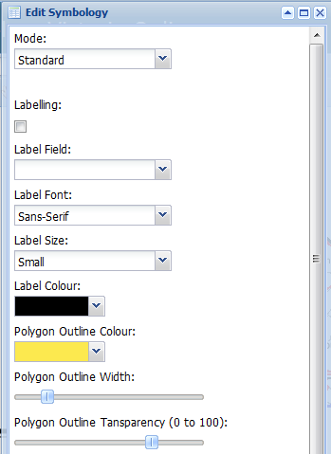
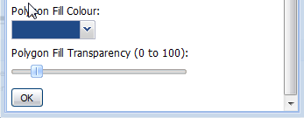

Selected Feature Symbology - Thematic Mode
In the standard mode, all selected features will be given the same colour/width/transparency that you nominated. However, you can update the colours of the selected symbology based upon the attribute values found in the selected features. To do this, change the Mode from Standard to Thematic.
To use the Thematic Mode, you need to select a field from the Field drop down list. Once a field is selected, press the Get Theme button. The Get Theme operation assigns colours to each of the distinct values found in the selected features for the field chosen.
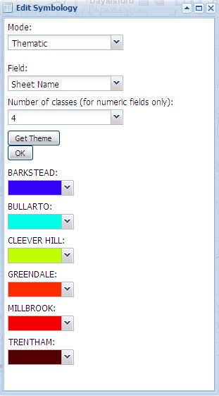
In most cases, the field you select will be a string, date or character field. However, if you select a numeric field, then instead of displaying distinct numeric values, the Select Features Symbology function will assign symbol colours based on numeric ranges. (the default number of ranges being four)
In the example below, Contours is the Active Layer. A number of Contours have been selected, and in this case the Contour elevation values range from 250 to 750 metres. As the field elevation is a numeric field, the Select Features Symbology function will create 4 colour symbols.
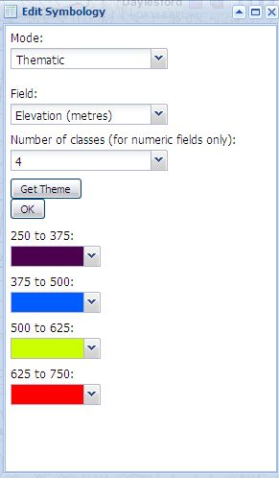
Changing the number of classes will update the range intervals. Shown below is the same Contour example, but this time with eight classes being created instead of four.
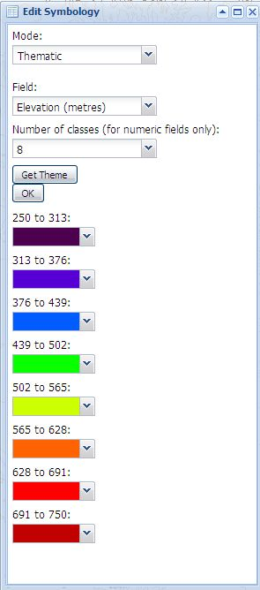
Note: currently both the Legend and the Print Menu legend will not display the colours and attributes of the edited selected symbology. (the selected feature symbology does appear in the Print Menu map)
Quick Search
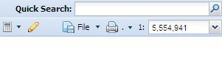
To quickly find a specific map feature, use the Quick Search function. For example, to zoom to Bendigo, just type Bendigo in the Quick Search data entry box. As you type this name, map features that have been linked to what is typed will automatically appear in a paged listing. When the whole word is entered, the page listing will display those map features that have the word 'Bendigo' associated with them. Map features that best match the typed name appear first in the page listing.

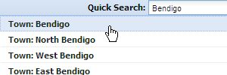
The Quick Search function also accepts wild card characters. Use an asterisk (*) to replace zero or more characters in a search word. Use a question mark (?) to replace exactly one character in a search word
While you type into the Quick Search data entry box, GeoVic 3 first tries to find an exact match. If an exact match is found, them that record is displayed to you. If no exact match is found, then possible matches are displayed for you to choose from.
Because GeoVic 3 has access to more than 800 layers, only a small selection of layers have been made available for the Quick Search utility.
The layers that Quick Search uses are shown in the Layers (Key and Quick Search) section. (see the Table of Contents)

2. Main Tools and Buttons

Zoom In

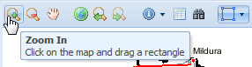
The Zoom In tool allows you to interactively zoom to a specific location. This is done by first clicking and making the Zoom In tool active.
The Zoom In function can then be used in either of two ways.
1. Use the mouse and click anywhere on the map. This will decrease your map scale by half.
Or
2. Click and hold the mouse down on the Main Map Display. You will see a box being created which represents the desired zoom location. When you have defined the area of interest, release the mouse button and the Main Map Display will zoom to the area defined. See below.

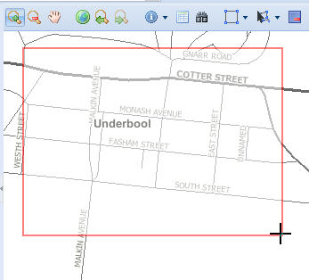

You cannot zoom in beyond 1:250 scale.

Zoom Out

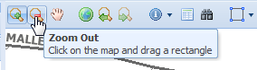
The Zoom Out tool allows you to interactively zoom out from a specific location. This is done by first clicking and making the Zoom Out tool active.
The Zoom Out function can be then performed in either of two ways.
1. Use the mouse and click anywhere on the Main Map Display. This will increase your map scale by two.
Or
2. Click and hold the mouse down on the map. You will see a box being created which represents the desired Zoom location. When you have defined the area of interest, release the mouse button and the map will zoom out to the area defined. See below.
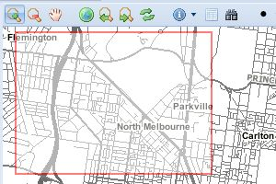

Pan

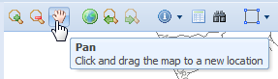
The Pan tool allows you to drag the Main Map Display around to the desired location. This is done by first clicking and making the Pan tool active, then clicking and holding the mouse down on the Main Map Display and dragging it to the location desired. Releasing the mouse will refresh the Main Map Display to the new location.

Initial Extent

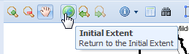
Clicking the Initial Extent button changes the current Main Map Display extent to GeoVic 3 opening map extent. The initial extent spatial range cannot be changed (by the user).

Previous Extent

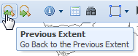
The Previous Extent button moves you back to your previous locations. Every time you Pan, Zoom or change the Main Map Display location, GeoVic 3 keeps track of the extents, allowing you to move back to your previous locations. Note that if this button is disabled, it means that you have not yet changed the current extent.

Next Extent

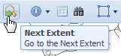
If you have used the Previous Extent button you will notice that the Next Extent button becomes enabled. This enables you to move to the location you were at before you pressed the Previous Extent button.

Identify

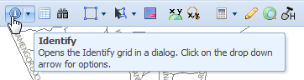
The Identify tool is used to open the Identify grid in a popup window. This is done by first clicking and making the Identify tool active. Once the tool is active, either click on the Main Map Display, or hold the mouse down on the Main Map Display and drag a circle to define the selection area. When you have defined the area of interest, (AOI) release the mouse button and the popup window will open. The value of attributes of the identified features are listed in the grid.
The Identify grid can also be minimised, so that you can view the Main Map Display without losing the Identify results.
There are three modes of operation for Identify. The default mode is to show just the attributes of the Active Layer. The Active Layer does not need to be visible (though it makes more sense to make it visible). Nor does it matter if the Active Layer is 'greyed out' - which means that the layer cannot be shown on the Main Map Display due to being outside the viewable scale range. But again, it makes more sense to use the Identify on features you can see on the map, rather than just blindly using this tool.
The other modes of the Identify tool can be selected by clicking on the small arrow next to the Identify icon.
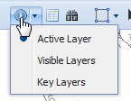
In the above graphic, the Active Layer mode is the default action. (this has a dot next to it). Selecting the Visible Layers option will force the Identify action to use the Visible Layers mode. This mode setting will remain, until you decide to change it to Key Layers or change it back to the Active Layer.
The second mode, works on Visible Layers. Visible layers are those that are checked in the Layers – Table of Contents. When in this mode, Identify will give attributes of the visible features found in the AOI. The popup window itself will be split, with the layer names found on the left plane, with attribute information on the right. Next to each layer name will be the number of records found for that layer.
Note: Two layers Towns and Roads, even when visible in the Layers – Table of Contents, will not be displayed in the Identify (Visible Layers) results.
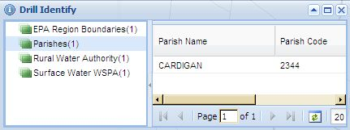
Note that when using the Visible Layers mode, only those layers found within the “Area of Interest” (AOI) will appear in the Identify popup window. Unlike the default mode, the Visible Layers mode is scale dependant. For example if you have Property Address as one of the visible layers, then the Identify - Visible Layers option will list property addresses only when you have zoomed to the viewable scale.
Be aware that if you define a large AOI you may end up returning too many records, resulting with the message below
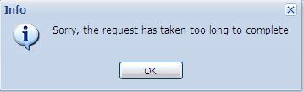
The third Identify mode works on Key Layers. The Key Layers are listed in the Layers (Key and Quick Search) section.
This mode works similar to the Visible Layers mode - just in this case the layers selected have been pre-defined by GeoVic 3
Note: These layers do not need to be in your Layers – Table of Contents when using this mode.
In the Identify popup window itself, field names (columns) can be sorted, hidden and filtered. (See the Tabular View section for further details)

Tabular View

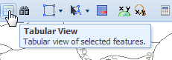
The Tabular View is used to display text information for selected features from the Active Layer. This tool is only activated when the current Active Layer has features selected. There are many extra functions embedded in the Tabular View popup window which are explained below

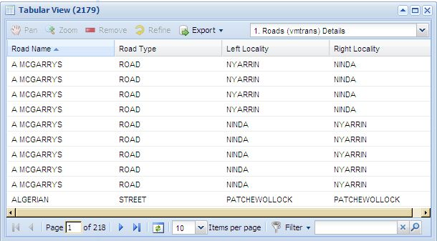
The Tabular View window's title has the number of feature selected (in the above example we have 2179). Below the title are a number of tools.

Tabular View - Highlight Features
If one or more records in the Tabular View are selected by the mouse, the record/s will highlight in blue. Also, on the Main Map Display the features belonging to those records will be each highlighted by a green marker symbol. The marker symbols will appear provided that the map features are visible in the Main Map Display. You will also notice that the Pan, Zoom, Remove and Refine buttons become enabled.

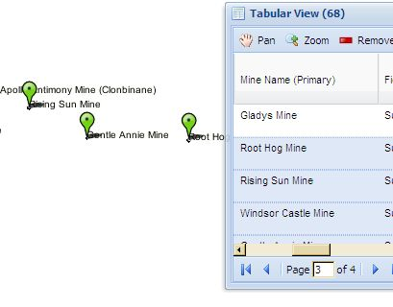

Tabular View – Pan

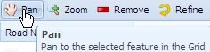
Click this button, and the Main Map Display will Pan to the highlighted record. The Pan does not change the scale of the map - so if you are viewing at a small scale (eg 1:1,000,000) you probably will not see the Main Map Display move to a new location. The Tabular View - Pan will only work if just one record from the Tabular View is highlighted.

Tabular View - Zoom

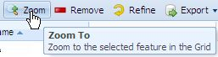
Click this button, and the Main Map Display will zoom to the highlighted records in the Tabular View.

Tabular View - Remove

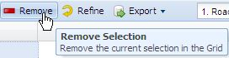
This removes any records highlighted within the Tabular View.

Tabular View - Refine

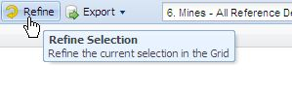\
This reduces the current selection in the Tabular View to just the highlighted records.

Tabular View - Export

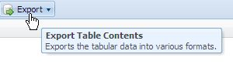
The contents in the Tabular View can be exported to various formats. All records in the Tabular View are exported. The Export function does not make any adjustments in regards to hidden columns (see below), highlighted records, or column sorting (see below).

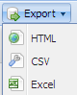
The formats are
• HTML
• Comma Separated Values
• Microsoft Excel

Tabular View - Alternate Views
A view in the GeoVic 3 Tabular View is similar to a worksheet in Excel . Most GeoVic 3 layers have one view in the Tabular View. However, there are several that have multiple attribute views. For example, the layer Mines and Mineral Occurrences has eight views. If an Active Layer has multiple views, a view drop down list is automatically added to the Tabular View popup window.
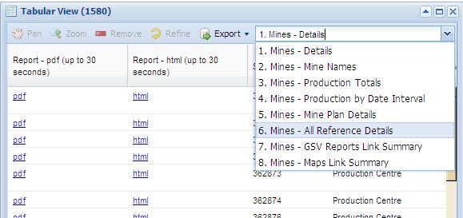
Simply select any of the Alternate views, and the Tabular View will update itself with the results of the selected view.
Where there are layers that have multiple views available, the Export function will export only those records that appear in the current view. So if for example, you did want to export all the data for Mines and Mineral Occurrences, you would need to select each one of the eight views, and perform an Export for each.

Tabular View - Column Sorting
Records in the Tabular View can be sorted. Click on the column title, and a menu will appear, giving you the options to sort the column, either by descending or by ascending. Note that the Export function does not capture any sorting you may have applied.
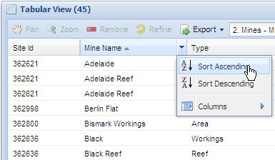

Tabular View - Column Hiding
You can hide one or more columns from the Tabular View. Simply select any column heading, click the Columns menu item, and a list of all the columns current for the Tabular View are shown.
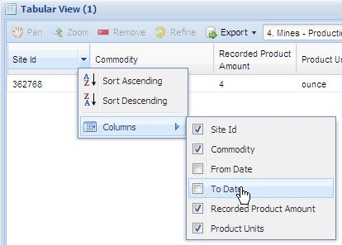
Uncheck the column names you wish to hide from the Tabular View. Note that the Export function ignores any changes you make to column visibility.

Tabular View - Navigation

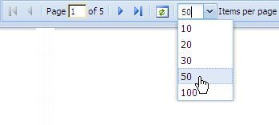
By default, the Tabular View will display 20 records at a time. If there are more records, then the attribute data is displayed in pages, with 20 records per page. Use the Arrow keys at the bottom of the Tabular View popup window to navigate to the other pages.
You can change the number of items per page. Use the pull down list to alter the default setting.

Tabular View - Filter

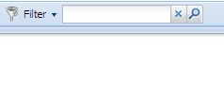
The Filter function is a text filter, that operates on the current selected attributes from a nominated field item. It is used to reduce the number of records shown in the Tabular View. For example, in the Tabular View below there are many tenements selected. To show only those that have a Tenement Number of EL4433, you first click the small arrow next to the word Filter. This action causes a drop down list to appear, listing all the field names available for filtering. For this example, clicking the field called Tenement No from this list will make Tenement Number the Active Filter field.

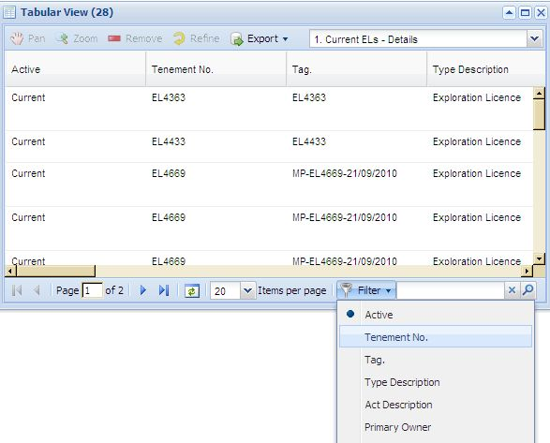
Once the field is selected, type in the Filter data entry box EL4433 and click the button next to the Filter data entry box. The Tabular View then reduces the records displayed to only show those where Tenement Number is EL4433

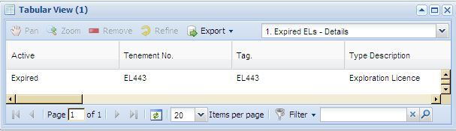
To view your previous original selection, press the button next to the Filter data entry box.
Note: Currently the filter only works for text fields. The filter appears not to work on columns that contain numeric or date attributes.

Advanced Search

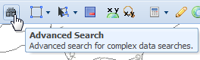
The Advanced Search lets you select features in a layer by constructing a query on the layer's attribute data. The concept behind the Advanced Search is similar to Common Searches, with the Advanced Search having the capacity to create queries on more item/field names, and to create more complex queries.
For example, if you want to find all Current Mineral Exploration Licenses with a Title Status of Surrendered, you cannot do this with the Common Search, as it does not have this field name available. The query can be performed using the Advanced Search as follows:
Firstly, make the layer Current Mineral Exploration Licenses active. Then click the Advanced Search button. The Advanced Search query builder popup window will then appear. To make the query, you need to perform the following steps:
Most layers have just one Search Type. In the case of Current Mineral Exploration Licenses, the Search Type is Current ELS - Details. So, just leave this first drop down list item as is (there is only one).
For the Having drop down list, select the item/field name. In this case, it is Title Status. Once this item is selected, you will see that the query builder window is slightly modified, with the words Title Status appearing as the heading of the fourth drop down list.
Next, select the operator. In this case, we use the default operator, which is already set to be equal to. So, you can leave this item as is.
The last drop down list has automatically generated all the available distinct values found for Title Status. So, select Surrendered, as shown below.
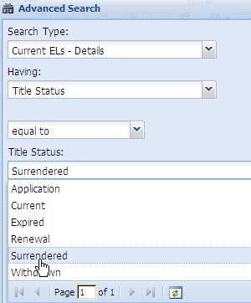
Click the Add to Definitions button to add the query to the Filter Definition window. For this example, the definition will appear as "STATUSSDSC = 'Surrendered' " (Note: Many of the label/item names appearing in GeoVic 3 are aliases to less friendlier column names in the layer's data table. In this case, the label Title Status has been used to represent an actual column named STATUSDSC.)
Click the New button found at the bottom of the query builder window. The features will then be selected on the Main Map Display. You can then view the attributes of the selected features by clicking the Tabular View button.

Advanced Search - Performing More Complex Queries
The above example was for a very simple query. But the Advanced Search query builder is designed to create more complex searches. The query builder has "smarts" in it, so that it can create the correct expression for you. For instance, in the previous example, quotes were added to the value Surrendered, because the item Title Status is of field type string. For date field names, a calendar icon will appear alongside the fourth drop down menu . Clicking this will display a calendar, allowing you to select a date. (see below)
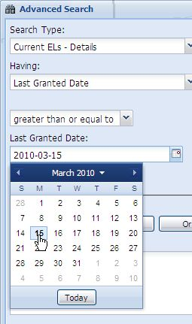
The buttons
are further logical operands you can use to create more complex queries. Use the Verify button to check that your syntax is correct.
The roles of the select buttons located at the bottom of the Advanced Search window are:
• New Creates a new selection of features, clearing the current selected features.
• Add Adds new features to any features that are currently selected.
• Remove Removes features from the features currently selected.
• Refine Selects only from the features that are currently selected.
Note: In some cases, no drop down list of values are listed/generated in the fourth item. This usually occurs for items that are of type decimal or floating point. For example, there are a number of layers that have a field item named HECTARES. If you select HECTARES as the field item, then no drop down list of values will appear for Hectares. In such cases you simply just type in a number.
In general, if the field has discrete values then a drop down list will be generated (but not if it has continuous values – eg many decimals)

Advanced Search - Search Types
Most layers have just one Search Type, with just a small number of layers having two. For example, the layer Current Mineral Exploration Licenses has two Search Types available - the Default Mines Search, and a second named 2. Mines - Mine Names Search.
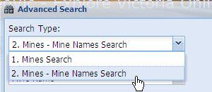

Select Features

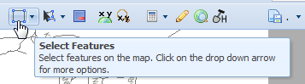
Map features can be selected graphically by using this tool. How this tool operates is defined by three operating definitions: Entity, Shape and Action.
The default action of this tool is to select a new feature from the current Active Layer using a rectangle with the mouse.
The definitions are described below:

Select Features - Entity
By default, the Select Features tool operates by selecting only features from the current Active Layer. However this default action can be changed. Click the small drop down arrow next to the Select Features tool to see the available options. Hover the mouse over the Entity menu item to see the three Entity options.
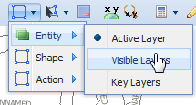
An alternate operation is to use the Select Features tool to select features from all Visible Layers. Visible Layers are those that are checked in the Layers - Table of Contents. When in this mode, the Select Features tool will select visible features on the map.
To see what has been selected for each individual layer when the Entity - Visible Layers option is being used, click the Active Layer drop down. This will show the number of features selected from each Visible Layer. To see attribute details of each individual layer, make active that specific Visible Layer, and open the Tabular View window.
The third entity option available for the Select Features tool is to select features from the Key Layers. The Key Layers are listed in the Layers (Key and Quick Search) section (see the table of Contents)
Note: These layers do not need to be in your Layers – Table of Contents when using the third entity option.
GeoVic 3 displays the current status of the Select Features tool in the bottom right corner in the Active Layer & Selection Size message box. (Eg if Key Layers is the Entity, then you will see the words Selecting: Active Layer as shown below)
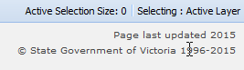

Select Features - Shape

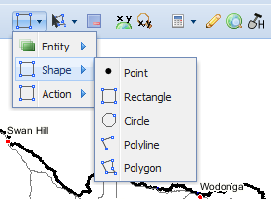
Features can be selected using various Shape methods by using the mouse. What shape is currently in use can be seen by the Shape icon that is currently on display for the Select Features tool. As the Shape - Rectangle is the default Shape when GeoVic 3 starts, then a Rectangle icon is displayed for the Select Features tool
The Shapes are:
Move your mouse to a location on the Main Map Display and click. Features found at that location are then selected and highlighted on the Main Map Display.
Use your mouse to drag a rectangle on the Main Map Display. Features that intersect with the rectangle become selected and are highlighted on the Main Map Display.
Use your mouse to drag a circle on the Main Map Display. Features that intersect with the circle become selected and are highlighted on the Main Map Display. When this option is used a Confirm Radius data entry box will appear where the radius of the Circle can be overridden.
Use your mouse to digitise a line on the Main Map Display. Features that intersect with the line become selected and are highlighted on the Main Map Display.
Use your mouse to digitise a polygon on the Main Map Display. Features that intersect with the polygon become selected and are highlighted on the Main Map Display.

Select Features - Action

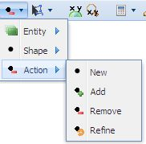
By default, a new set of features are selected each time the Select Features tool is used. However, this default action can be changed.
The Actions are:
Selects new features, discarding any previous selection.
Adds new features to any features that are currently selected.
Removes features from the features currently selected
Selects only from the features that are currently selected
Usually you would keep the default action to New. If you do change the Action, then you should notice that the Select Features tool's icon will change according to the action you have selected. A green plus sign is added to the shape icon if the Add Action is used, an orange minus sign if the Remove Action is used, and an orange arrow if the Refine Action is used.

Common Selection Functions

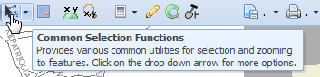
This option provides various utilities for selected features. These utilities can be found by clicking the drop down arrow next to the Common Selection Functions icon

Common Selection Functions - Clear All Selections

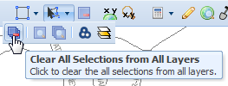
The Clear All Selections button when clicked clears the selected features from all layers.

Common Selection Functions - Zoom Selection

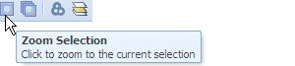
The Zoom Selection button when clicked will zoom to the current selected features in the Active Layer.

Common Selection Functions - Zoom All Selection

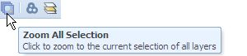
The Zoom All Selection button when clicked will zoom to the extent of all selected features .

Common Selection Functions - Buffer

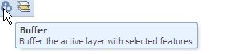
The buffer function is used to select features by using an intersect/buffer operation. For example, if you want to find all the boreholes that lie within 2 kilometres of a town, this is what you would do.
1. First select the town from the Towns (100K) layer (e.g. Quick Search Walhalla).
2. Next make Boreholes – All active (hint: add Wells and Boreholes – All first).
3. Now click the Buffer button. The Buffer popup window will open.
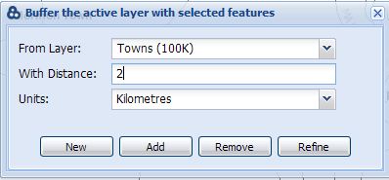
The From Layer drop down list will contain the layer names of those layers that have map features currently selected within the GeoVic 3 session. As the layer Towns (100K) is the only layer that has features selected, then this is the only layer available.
4. Select units Kilometres, and type in 2. Click on the New button. GeoVic 3 will then:
• Buffer the Towns (100K) by 2 kilometres.
• Zoom to the spatial extent of the selected bores within the buffer.
• Draw a red outline of the buffer extent on the map.
• Select and Highlight any Boreholes - All that lie within the buffer with the yellow selection colour.

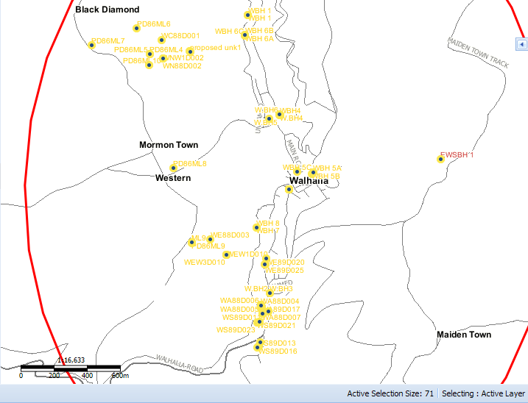
The Buffer function can also be used to perform selections within the same layer. For example, if you want to select all exploration licences that lie within 10 km of a selected exploration license you would simply:
1. First select the exploration license you want from the Current Mineral Exploration License layer.
2. Click on the Buffer button.
3. Make Current Mineral Exploration License the From Layer. Make the distance 10 km. Then click the New button. Shown below is an example.
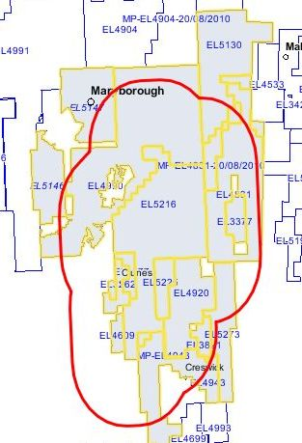

Common Selection Functions - Intersect

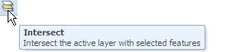
The Intersect tool is used for performing a selection in one layer by using features selected from another. You would use this tool if for example you want to find all boreholes that lie within a parish. (in fact this example is similar to the first example used in the Buffer tool, except this time there is no buffer). So to perform this query you would:
1. First select the parish you want from the Parishes layer. (eg Quick Search Belfast)
2. Next make Boreholes – All active (hint: add Wells and Boreholes – All first)..
3. Now click on the Intersect button. The Intersect popup window will open.
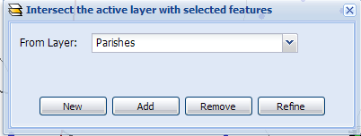
4. The From Layer pull down lists those layers that have features currently selected. Select Parishes, and click the New button. GeoVic 3 should then select those boreholes that fall within the parish, as shown in an example below
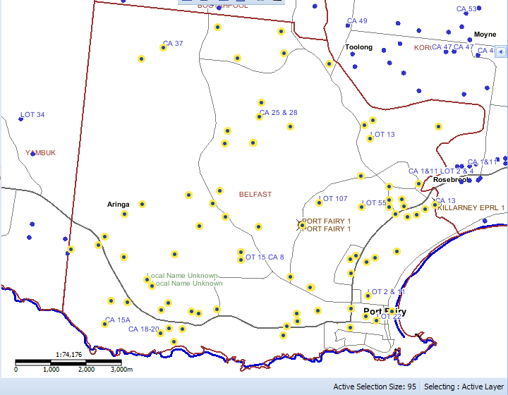

Clear the Selection from the Active Layer

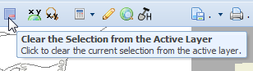
The Clear the Selection from the Active Layer button when clicked clears the selected features from the Active Layer.

Coordinate Display

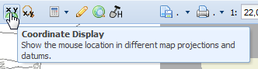
This tool simply shows the position of the mouse cursor when it is over the Main Map Display using three mapping coordinate systems.

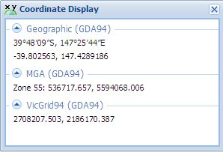

Zoom to Map Coordinate

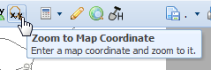
Click the button and the Zoom to Map Coordinate popup window will appear.

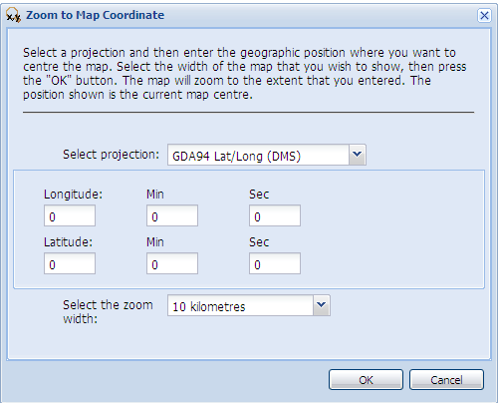
Select a projection from the Select projection pull down list. The Zoom to Map Coordinate window will then update according to the projection chosen. Next enter the location co-ordinates where you want to centre the Main Map Display. Finally pick a zoom width from the Select the zoom width pull down options. Press the OK button. The Main Map Display should then zoom to the location you entered.

Measurement Tools

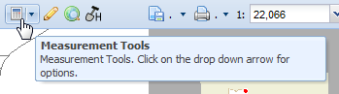
A set of tools that show the length and area results for lines or polygons you draw on the Main Map Display, as well as for selected features in the active layer.

Measurement Tools - Measure Polyline

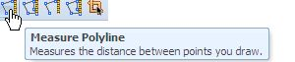
Show the segment length, bearing and total length of a line you draw on the Main Map Display.
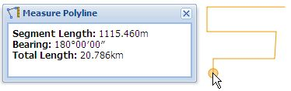

Measurement Tools - Measure Polygon

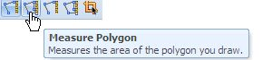
Show the segment length, bearing and total area of any polygon you draw on the Main Map Display.
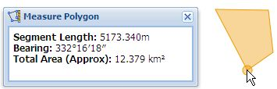

Measurement Tools - Measure the Distance Between Multiple Points (Advanced)

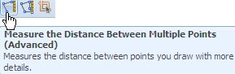
Shows the segment length, bearing and total length of a line you draw on the Main Map Display, with extra detail. Double click the mouse, to end the line you are drawing.
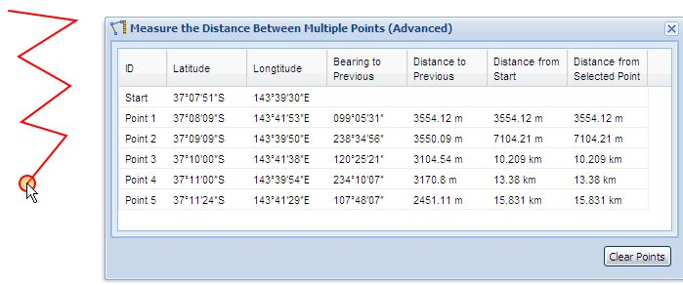

Measurement Tools - Total Area and Length (Advanced)

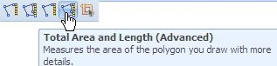
Shows the segment length, bearing and total area of a polygon you draw on the Main Map Display, with extra detail. Double click the mouse, to end the drawing.
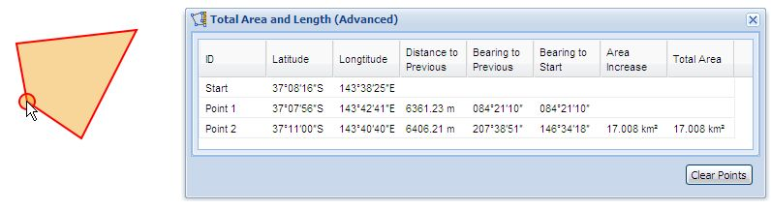
Note: You can change what is shown in the tabular results by hiding columns if required.

Measurement Tools - Total Area and Length of Selected Features
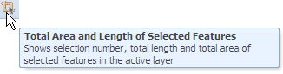
This button only becomes activated when you have selected features in the current Active Layer. It shows the total length and total area of selected polygons or polylines in the Active Layer.
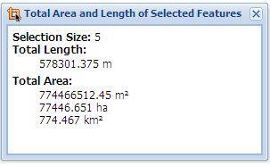

Markup / Redline Tools

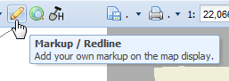
This tool provides a basic set of graphic elements/symbols that can be used to draw on the Main Map Display. Clicking this button loads the Redline Toolbar

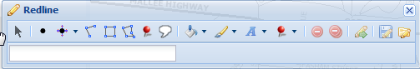
There are seven basic graphic elements that can be drawn on the Main Map Display. These are explained below.

Markup / Redline Tools - Point
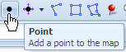
To add a point to the Main Map Display, first click the Point button found on the Redline toolbar, then place the mouse onto the Main Map Display at the place where you want to add the point. Click the mouse, and a point will be added to the Main Map Display. Further points can be added by clicking the mouse on the Main Map Display.
By default, redline points are solid yellow with a black outline. To change the default appearance of a point you first need to use the Modify button. Press the Modify button, then select the point you want to modify. A point is selected when the mouse cursor appears like this:
The solid yellow infill colour can be changed by selecting the Fill button. Click the small arrow found next to this button and a selection of colours will appear. You can also select the degree of transparency by adjusting the slider control.
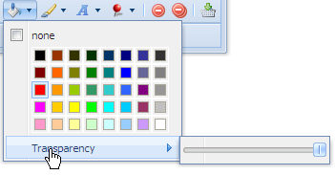
Please note that once you have selected a fill colour, all redline marker elements that you draw afterwards will by filled with that selected colour. The exception to this behaviour is the Marker element – which only has three colours available - red, green and blue.
The black outline of a point can by altered by using the Line button. Click the small arrow next to the symbol and like the Fill button, a selection of colours will appear.
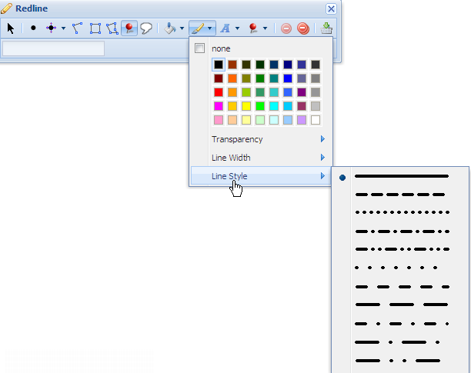
Besides changing the line colour, you can also change the line width, and the line style. If you do change the default line colour/transparency/width/style, then further mark up elements you add to the map (except for Markers and Callouts ) will be drawn using your new line behaviour.
Text can be added to a point. After adding a point to the Main Map Display, select the point using the Modify button. When the mouse cursor appears like this:, type the text string in the textbox found in the Redline toolbox. What you type in the textbox will be added to the selected point.
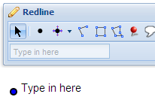
If required, you can alter the text appearance by clicking the small arrow next to the Text button.
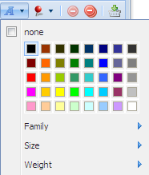
When you change the colour, font, size or weight, the selected text will be modified with that change. Please note that changing the colour, size, weight or family of text only alters the selected text. Any text added to other mark up symbols will appear in the default text style.
The Modify button can be used to move a point. Select a point by first clicking the Modify button, and then the point. When the mouse cursor appears like this: , click the mouse again, and then move the mouse. The point will then follow the mouse. Click the mouse again and the point will be moved to the new position. Text associated with the selected point will also be moved.

Markup / Redline Tools - Point with Coordinate
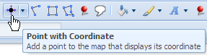
This marker symbol is similar to the point symbol, but appends the coordinate position to the point as shown below:
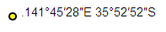
The default appearance of the point with coordinate marker is a solid yellow fill point with a black outline, with the coordinates displayed in latitude and longitude. To add a point with coordinate, first click the Point with Coordinate button, then place the mouse onto the Main Map Display position where you want to add the point. Click the mouse, and a point will be added to the Main Map Display. Further points can be added by clicking the mouse on the Main Map Display.
Point with coordinates can also be displayed by referencing the Map Grid of Australia (MGA). By clicking the small arrow next to the Point with Coordinate button, a pull down list of coordinate options appear. In the example below a point coordinate using the map grid of Australia for zone 54 has been added.

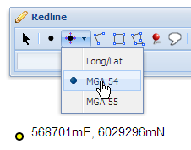
If you do not know what zone your current map display is in, click the Coordinate Display button found in GeoVic’s main toolbar. In the Coordinate Display window, under the heading “Map Grid of Australia (GDA94), the Zone for your current map display will be shown.
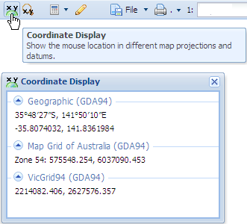
Like the point symbol, the default appearance of the point with coordinate symbol can be changed. Use the Modify button and select the symbol with the mouse. When the mouse cursor appears like this: , you can then modify the point with coordinate symbol by clicking the Fill , Line or Text buttons.
Caution: You can also move the point with coordinate symbol, but the coordinate text associated with the selected point will not be updated with the point’s new location. It would be best if you delete the point, and add a new point to the new location.

Markup / Redline Tools - Polyline
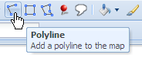
Use the Polyline button to add lines to the Main Map Display. By default polylines are solid in style and black. To change the polyline colour, style or thickness, click first the Modify button. Then with the mouse click the polyline A selected polyline will appear with orange dots along the polyline vertices. An example of a selected polyline is shown below.

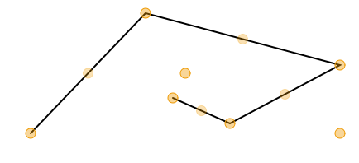
Also note in the above polyline that there is a orange dot in the centre of the polyline, and another at the bottom right corner
Once a polyline is selected you can change the polyline’s appearance by clicking the arrow next to the Line tool.
Text can also be added to a selected polyline. The position of the text will be in the centre of the polyline
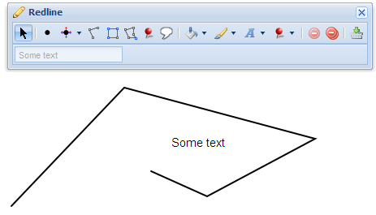
The shape of a selected polyline can also be adjusted. Position the mouse over one of the orange dots that appear overlapping a polyline vertex, until the mouse cursor changes to . When this occurs, a vertex of the polyline has been selected. Click the mouse, and drag the selected vertex to a new position.
To change the position of a polyline, grab with the mouse the orange dot that appears in the centre of the polyline. To change the size of a polyline, grab with the mouse the orange dot that appears in the right bottom corner of the polyline.

Markup / Redline Tools - Rectangle
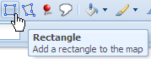
Rectangles can be added to the Main Map Display by first clicking the Rectangle button. Then click the mouse on the Main Map Display and drag the mouse. As you drag the mouse, a red rectangle will be generated, outlining the current shape.
Clicking the mouse again, will cause a rectangle symbol to appear on the Main Map Display.
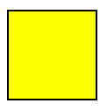
The default appearance of a rectangle symbol will be solid yellow fill, with a black outline. Use the Modify button , together with the Fill and Line buttons to change the rectangle’s appearance. Text can also be added to the rectangle, and is placed in the center of the rectangle. The Modify button can be used to change the rectangle’s size and position.

Markup / Redline Tools - Polygon
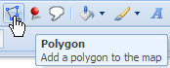
The polygon symbol is very similar in operation to the rectangle symbol. To add a polygon element to the Main Map Display, first click the Polygon tool button. Then with the mouse on the Main Map Display, click in three different locations. An yellow shape will then appear on the map.
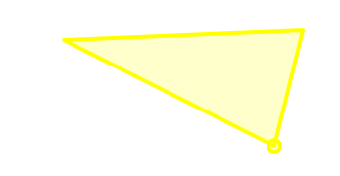
Continue clicking till the desired shape is obtained, then double click to stop the operation. The outlined shape will then appear (if the default colours and lines types are not changed) as a solid yellow filled polygon with a black outline.
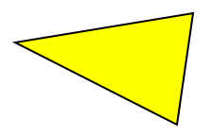
As with the rectangle symbol, use the Modify button to add text, change position, change shape or alter the appearance of the polygon.

Markup / Redline Tools - Marker
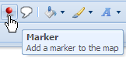
The Marker button can be use to add marker elements to the Main Map Display. To add a marker to the Main Map Display, click the Marker button, and then click to a location on the Main Map Display. Further markers can be added by simply clicking the mouse to other locations on the Main Map Display
Only three colours are available to the marker symbol. The default colour is green. On the Redline toolbar, there is a pull down option available, where you can change the default colour to red or blue.
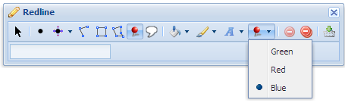
Text can be added to a marker, by first selecting the marker with the Modify button . Move the mouse over the marker until mouse cursor changes to . Then in the text box in the Redline toolbar, add the text string you want to add to the marker. Use the Text button to change the appearance of the text.
The Modify button can also be used to change the position of a marker symbol. (operates the same way as for point symbols – as explained above)

Markup / Redline Tools - Callout
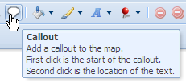
To add a callout, first click the Callout button. Then in the Main Map Display click the start position of the callout. Then click to the location where the text will be displayed. A popup window will then appear, as shown below.
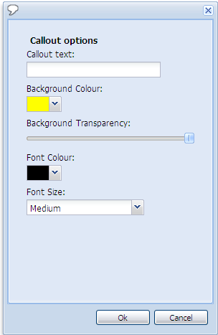
Enter the text in the text box under the heading Callout text: By default the callout marker background colour is solid yellow, with black text.
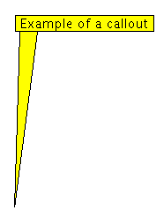
You can change the colour and transparency of the current callout by selecting a different background colour and altering the transparency factor. Font size and colour can also be changed. Note: If you add another callout, the default background colour and font colour/size is not changed. When you click the Ok button, the callout symbol will appear on the map.
Unlike the other redline marker elements, the callout symbol once created cannot be modified. The Fill , Line or Text buttons do not operate on the callout symbol. With the Modify button you can select the callout and move it. If you were to add text into the Redline textbox on a selected callout symbol, that text will appear at the anchor point of the callout – which may/may not be what you require. If you want to change the text in a callout, it is best to delete and create a new callout with the correct text.
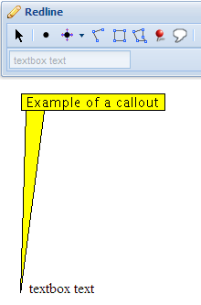

Markup / Redline Tools - Delete
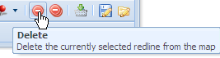
To delete a callout symbol, you first need to select the element using the Modify button. When a symbol is selected, the Delete button will become activated. Pressing this button will then delete the selected symbol from the Main Map Display.

Markup / Redline Tools - Delete All
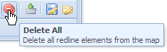
By pressing the Delete All button, all redline symbology is removed from the Main Map Display.

Markup / Redline Tools - Export features as shapefile
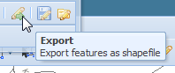
Redline elements on the Main Map Display can be exported – but the results are not what you might be expected. In the example below, the following redline symbology is exported as shapefiles using the Export button.
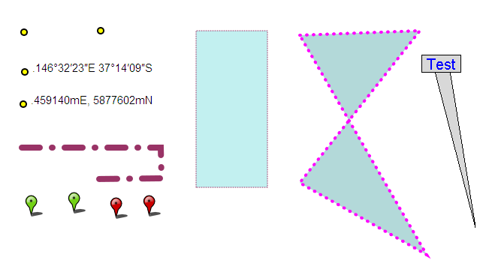
When the Export button is pressed, a popup display shown below will appear, asking for projection type. Currently, the shapefile projection parameters are not being exported correctly (this is a known bug), so leave the projection type as the default value – Geographic GDA 94.
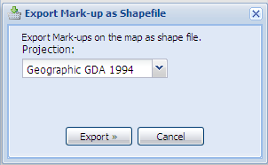
Hit the Export button. A zip file will be created, containing from one to three shape files. The shape files are simply named “Point”, “LineString” or “Polygon”.
Shown below is the result of exporting the above redline symbology (using a GIS application named Arcmap). The redline point, point with coordinates and markers are simply captured as points. The redline polyline symbol is captured as a polyline shapefile, while the redline polygon and rectangle elements are captured as polygons. The redline callout symbol is only captured as a point – the point being the start (anchor) position of the callout.
Note that no text, colour, line style, line thickness or fill colour is captured. No attributes exist in the shapefile’s attribute tables
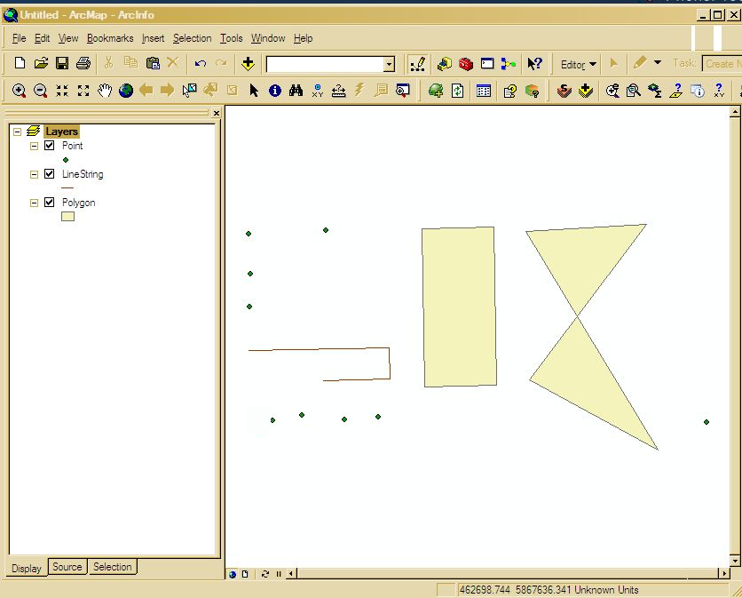
Markup / Redline Tools - Save and Load Functions
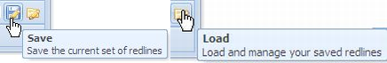
NOTE: These functions are only available for Registered users. (i.e., you need to login)

You can save redline elements in a web browser session. Simply click the Save button to capture the current redline elements. A popup window will appear, asking you to enter a name to the selected set of elements. Add a name into the textbox and hit OK. The elements will be saved under the name you typed in. ( and are saved under your registered identity on the GeoVic server)

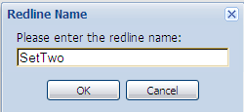

The Load button is used to retrieve any redline sets captured in previous GeoVic Sessions. Hitting this button will launch a window listing the selected redline element sets you have saved in past GeoVic sessions. In the popup example shown below, three sets have been saved from previous session.

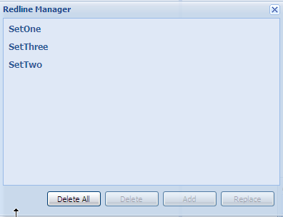

To load a previous session, select the named set you want to load, and hit the Add button. The redline symbology will be displayed on your Main Map Display – but you may need to zoom to the correct area and scale to view the saved redline elements correctly.

Use the Delete button to delete any saved redline sets that are no longer required.

Note: The Replace button currently has bugs in it – please do not use.

Google Maps
The Google Maps button is used to open up a google maps session in roughly the same area as is currently shown in the map area of GeoVic.
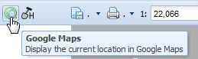
When the button is clicked a window as follows appears.
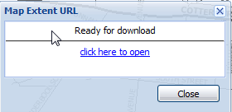
If you then click on click here to open it will open a google maps session.
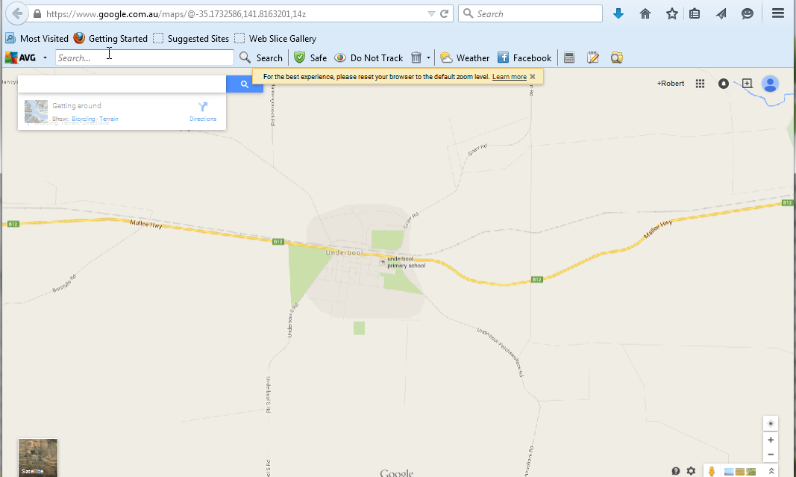
When GeoVic looks as follows
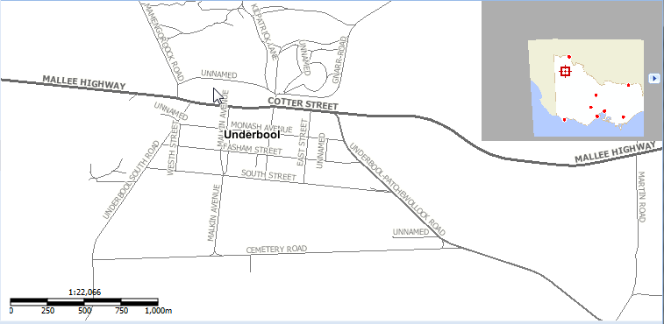

Historic Mining Activity Report
The Historic Mining Activity Report button is used to perform an analysis for the likelihood of Historic Mining Activity on a property address or a crown parcel. Please note, the likelihood of this activity does not always mean there is remaining evidence of the activity (including mine openings)
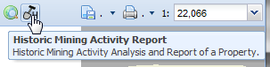
In the registered site.

Either
Click on the Tool
And follow the prompts for property or parcel selection
Or if the selection options are not really what you want
Search For the Property Address or Crown Parcel

Quick search for property address.
Or after adding the property address or the parcel boundary layer and activate the
layer
Use one of the following selection mechanisms
Common search
Adhoc search
Select features to perform a spatial search
Once one or more property address or crown parcel is selected
Click on the Tool
And follow the prompts

Examples
Refer to SECTION 12 - Examples

Definitions
Refer to SECTION 12 - Definitions

Disclaimer
Mining activity information is provided from plans and records that may be incomplete and may not be entirely free from errors. It is provided for information only
and should not be relied upon as definitive of the status of any area of land. It is provided on the basis that all persons accessing it undertake responsibility for assessing
the relevance and accuracy of its content.
The State of Victoria and its officers, agents or employees do not guarantee that the work is without flaw of any kind or is wholly appropriate for your particular purposes
and therefore disclaims all liability for any error, loss or other consequence which may arise from you relying on any information in this work.

File Menu
The tools found within the File Menu button deal with exporting sessions and bookmarks.
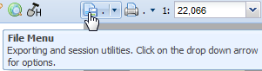

File Menu - Save and Email Session

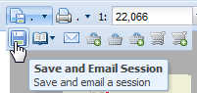
This function captures your current GeoVic 3 session. Each time you change the appearance on GeoVic 3, the GeoVic 3 server records all the map details in what is called a session key. The Save and Email Session function simply records your current session key, and sends this as an email notice to the email address you nominate.
The Save and Email Session popup window requires you to enter two email addresses. The first email address is to the person you are sending it to (and you can send it to your address), and the second is your email address.

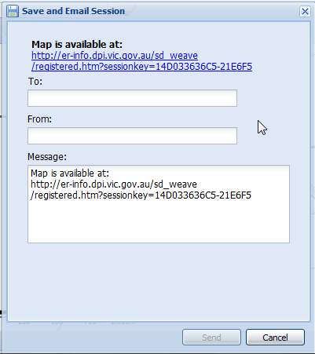
Email the session key by clicking the Send button. The receiver will get an email with the subject "GeoVic Session", with a message similar to:
Map is available at: https://gsv.vic.gov.au/sd_weave/registered.htm?sessionkey=14D033636C5-21E6F5
Contained in the message is a unique hyperlink to the session that you have saved. The session details are kept on the GeoVic 3 server. Sessions are only kept for 90 days. (saves disk space and ensures sessions are not likely to be corrupted due to system changes)
Note: No error notification is given if you type an incorrect email address in the To: textbox.

File Menu - Bookmarks of Zoom Extents

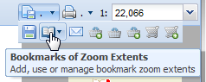
This function can be used to save a Main Map Display’s extent (defined spatial locations). You need to supply a name for each Main Map Display extent you wish to save. Bookmarks will persist between web browser sessions of GeoVic 3 - as long as you do not clear your web browser's history. Bookmarks however are not saved by the Save and Email Session function.

File Menu - Email Map
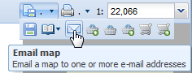
The Email Map function can be used to email the Main Map Display image as a PNG or PDF file to any email address.
The Email Map popup window requires you to enter two email addresses. The first email address is to the person you are sending it to (and you can send it to your address), and the second is your email address.
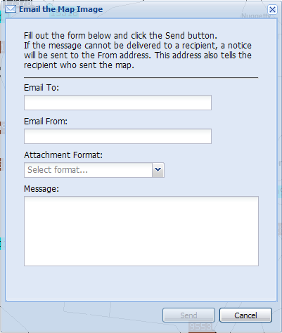

File Menu - Export Victorian Tenements within the Current Window

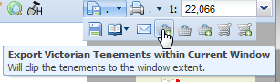
NOTE: This function is only available for Registered users. (ie: you need to login)
This function only exports Victorian Tenement layers that Earth Resources is custodian of. (note: Does not include Petroleum Tenements outside Victorian coastal waters).
Formats available for export are MS Excel, ESRI Shapefile, GML, KML and AutoCad DXF formats.
Pressing the Export Victorian Tenements within the Current Window button opens the following window:
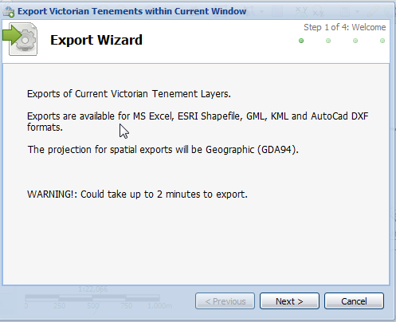
Then pressing Next
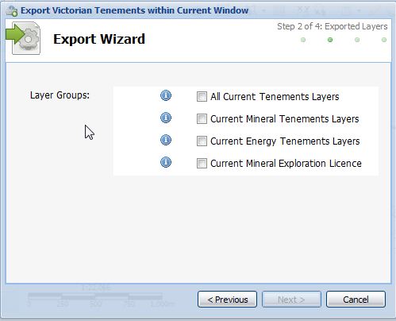
And select the group or groups to export
Use the information button to find out what layers exist in each group.
It does not matter what layers are loaded or currently displayed in Layers - Table of Contents. What is important, is the Group layer you select, and the spatial extent/coverage of your Main Map Display window. When activated, the Export Victorian Tenements within the Current Window function will examine each layer listed in the selected group. If features from a layer are found in the current Main Map Display's spatial extent, then that layer will be exported. Hence if you select a layer Group that contains ten layers, you could end up with a minimum of no exports (because no features from any of the ten layers were found in the current Main Map Display window), or up to ten exports (as all ten layers did have features present in the current Main Map Display window).
The spatial projection output for the shapefile format is geographic coordinates with datum GDA94. The spatial projection output for KML format is geographic coordinates with datum WGS84.
Metadata for the layers is also added to the export.

File Menu - Export Selected

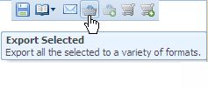
NOTE: This function is only available for Registered users. (i.e., you need to login)
This function only exports selected map features in layers that Earth Resources is custodian of. (Map layers from Tenements, Minerals, Energy, Wells and Boreholes, Geology and Geophysics). To use this function, you must have features selected in at least one layer (preferably one of the Earth Resources layers)
Formats available for export are MS Excel, ESRI Shapefile, GML, KML and AutoCad DXF formats.
The Export Selected function works upon Earth Resources layer groups. These groupings are similar to the layer folders in the Add Layers function. Pressing the Export Selected button opens the following window:
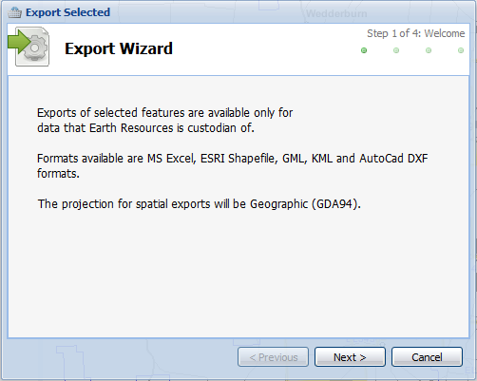
Then pressing Next.
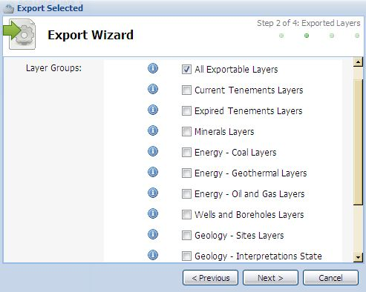
Use the information button to find out what layers exist in each group.
By default, all the current selected features that belong to Earth Resources layers will be exported, regardless of what Earth Resources layer group each layer belongs to. But you can nominate to just export features belonging to layers in a certain layer group. For example, you may have features selected from minerals, tenements and geology layers, but you just want to export the features belonging to current tenements. In that case, just un-tick the All Exportable Layers and tick the Current Tenements Layers group.
Be aware that if you have many features selected from many layers, then you may get a "time out" message, because your request to export all the features is taking the GeoVic 3 server too long to generate.
The spatial projection output for the shapefile format is geographic coordinates with datum GDA94. The spatial projection output for KML format is geographic coordinates with datum WGS84.
Metadata for the layers is also added to the export. This tool does not export images.

File Menu - Export Features in Current Window

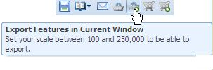
NOTE: This function is only available for Registered users. (.ie., you need to login)
This function only exports map features for layers that Earth Resources is custodian of. (Tenements, Minerals, Energy, Wells and Boreholes, Geology and Geophysics). To use this function, you need to have your map scale sitting between 1:100 and 1:250,000
Formats available for export are MS Excel, ESRI Shapefile, GML, KML and AutoCad DXF formats.
The Export Features in Current Window function works upon Earth Resources layer groups. These groupings are similar to the layer folders in the Add Layers function. Pressing the Export Features in Current Window button opens the following window:
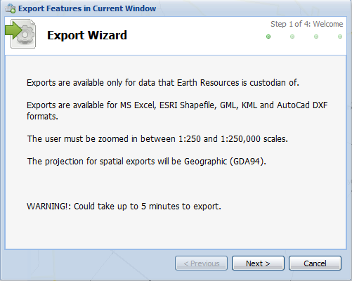
Then pressing Next.
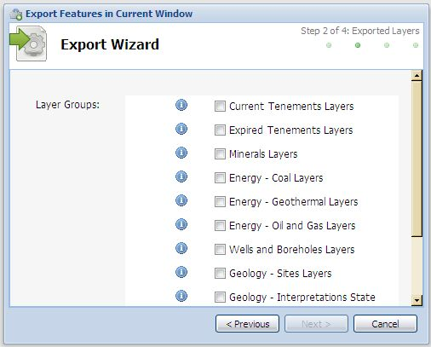
Use the information button to find out what layers exist in each group.
It does not matter what layers are loaded or currently displayed in Layers - Table of Contents. What is important, is the Group layer you select, and the spatial extent/coverage of your Main Map Display window. When activated, the Export Features in Current Window function will examine each layer listed in the selected group. If features from a layer are found in the current Main Map Display's spatial extent, then that layer will be exported. Hence if you select a layer Group that contains ten layers, you could end up with a minimum of no exports (because no features from any of the ten layers were found in the current Main Map Display window), or up to ten exports (as all ten layers did have features present in the current Main Map Display window).
Be aware that if many features are found amongst all the layers in the group, then you may get a "time out" message, because your request to export all the features is taking the GeoVic 3 server too long to generate.
The spatial projection output for the shapefile format is geographic coordinates with datum GDA94. The spatial projection output for KML format is geographic coordinates with datum WGS84.
Metadata for the layers is also added to the export.

File Menu - Export Data Via DataVic (uses the Spatial Datamart)

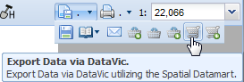
NOTE: This function is only available for Registered users. (i.e., you need to login)
This function is under construction.
It basically allows you to search for earth resources layers and export them
You will eventually be presented with a product that you can order.

Eventually, you will be presented with a set of mandatory options for delivery. You then need to set the top 4 options and then click on the Apply to All button to apply the choices. Then the Submit button should be pressed.

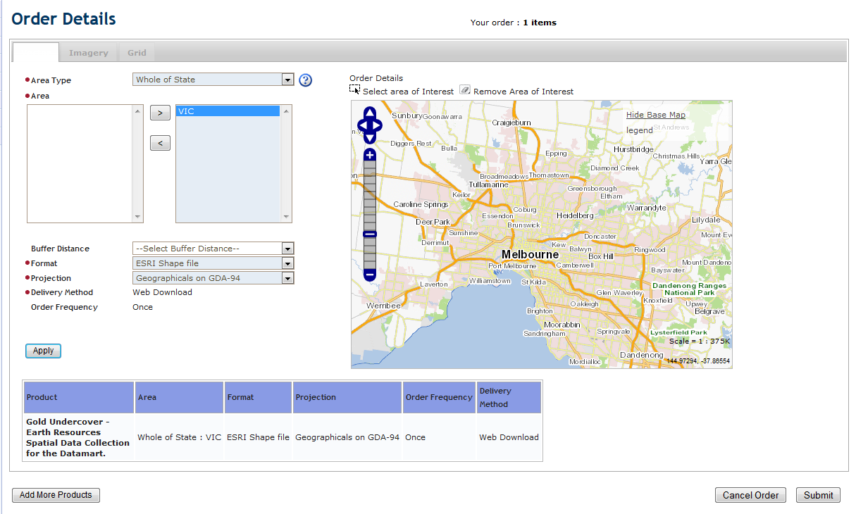
Then click the Submit button again
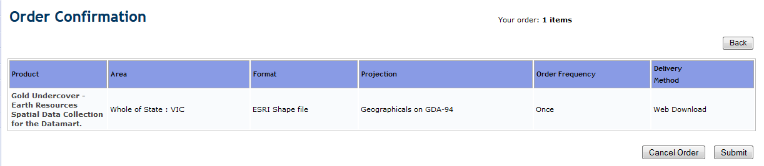
You will then be sent confirmation of your order.
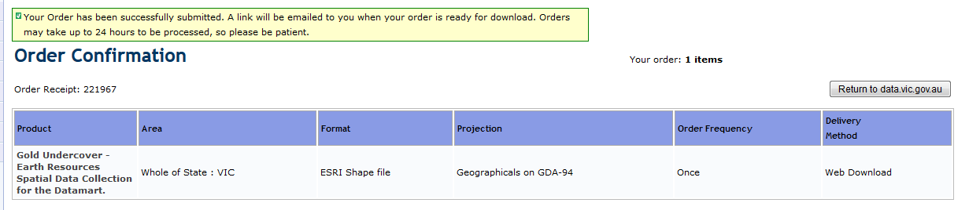
The request is submitted to a queue. When the request is completed, you will be sent a notification email and a link to click on to download the result. Shown below is an example.
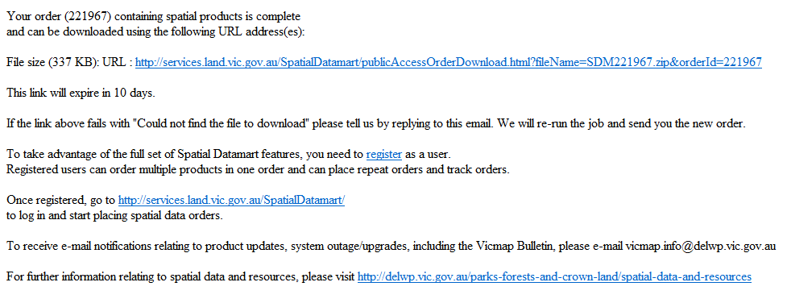

File Menu - Export Geophysical Archive Data

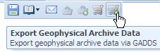
NOTE: This function is only available for Registered users. (i.e., you need to login)
This function allows you to order and obtain Geophysical data within the current Main Map Display window from GeoScience Australia’s Geophysical Archive Data Delivery System (GADDS).
Clicking on the button opens up the following popup window:
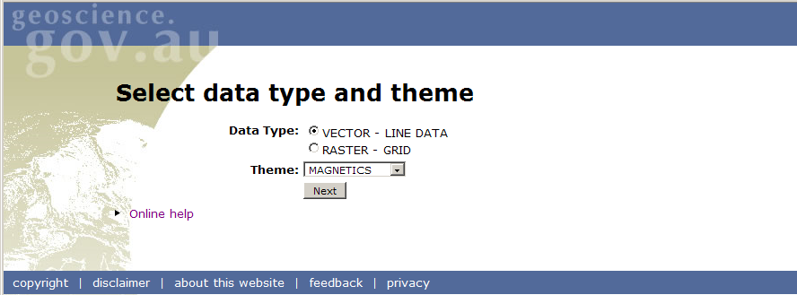
For information on how to use this application, click on the Online Help link.

Print Menu

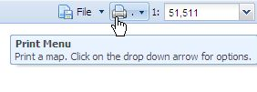

Use this menu option to create an A4 or an A3 size portrait or landscape map of the current GeoVic 3 Main Map Display. Everything that appears in the Main Map Display of GeoVic 3 should appear on the printed map (this can be different when the printed map display scale differs to the screen map display scale when layer display scales are involved). The map created from this tool is in PDF format.
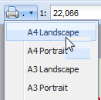
Currently, most of the elements that make the printed map, e.g. the scale bar, north arrow, locality map, disclaimer, map position, legend position, header position, etc are fixed. But there are some elements you can change. These are the map title, the projection (Geographic, MGA or VicGrid94), the scale, and the style of map grids. These properties can be chosen from the Print Parameters popup window (as shown below), that appears after you click the Print Menu arrow button and then the item “A4 Landscape”.
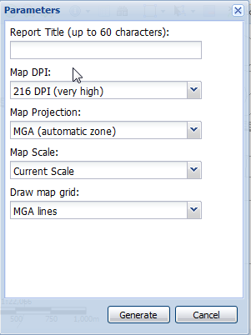
Once you have chosen the Print Parameters, press the Generate button to create the PDF document. The map should then appear as a new page/tab in your internet browser.
Be aware that the printed A4 map is based on a ratio of 7 units width by 5 units in height. So if you are using a very wide screen, the printed map may look different to that on your wide screen. Adjust the size of Main Map Display to the above ratio to get a better idea of what the printed map will appear like.
Known Issues:
- Any Edit Symbology colours/values will not appear in the printed legend.
- User added data, such as shapefiles, KMLS, GMLs and CSV files will appear on the printed map, but not in the printed legend.
- If the number of Legend symbols is large, then only the top most legend symbols that can fit in the A4 or A3 printed legend will be displayed, with the remaining legend elements not shown.

3. Scale Display and Control
The Scale Display and Control serves two purposes. The first is to show the current map scale. The second is to change the scale. You can either type in a new scale, or select one of the pre defined scales in the drop down list. This second function on the Scale tool can sometimes be a faster alternative than the Zoom In button.

4. Tab menus

Layers Tab

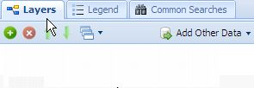
The Layers tab shows the Layers - Table of Contents. It lists the layers that are currently available. The current Active Layer will appear in bold text. When GeoVic 3 starts, the layer named Towns is the default Active Layer.
To the left of the name of each layer is a checkbox. The role of the check box is to control visibility. By default, as each layer is added to the Layers - Table of Contents, the visibility for that layer is turned on.
Layers can be added to the Layers - Table of Contents by either using the Add Layers or Add Theme buttons. If a layer is added, and appears in light grey text, then that layer cannot be viewed at the current map scale.
The maximum allowed layers in the Layers - Table of Contents is twenty. If you try to add more than this, you will get a message box asking you to remove some layers
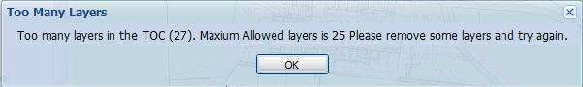
For more detail on this – please refer to the Layers – Table of Contents & Context Menu section.

Legend Tab

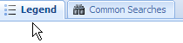
This tab displays the Main Map Display symbology for the layers in the Layers - Table of Contents. The order of the symbology follows the layer order in the Layers - Table of Contents. If a layer is made not visible, then that layer's symbology is not shown. Also, if a layer has a drawing scale restriction, and that layer is currently outside the scale range, then that layer's symbology is not shown.

Common Searches Tab

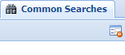
The Common Searches tab is used to select features from the Active Layer. The searches available for each layer are those you will find useful to quickly find features. For more detailed searches, use the Advanced Search function. If you have ideas for additions to our pre-configured Common Searches, please feel free to submit them via the Feedback function.
For most layers, there will be at least one Common Search available. For example, if Towns (100K) is the Active Layer, then there is just Common Search available, which contains a pull down list for Place Name. Click the pull down arrow for Place Name, and select, for example, Walhalla. Click the New button at the bottom of the Common Search panel, and the Main Map Display will zoom to Walhalla.
With some layers there are several Common Searches available. For example, the layer Current Mineral Exploration Licences has six.
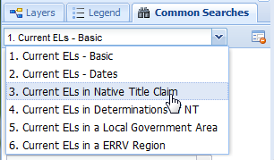
The last four alternate Common Searches for Current ELs have been designed to do spatial selections with other layers. For example selecting Common Search number 3 (Current ELs in Native Title Claim) is designed to find Exploration Licences overlapping Native Title Claims. Spatial Selection type searches are denoted by the word “in”. With Borehole layers there are eleven Common Searches. With Boreholes you can perform searches by location coordinates, by Parish, by Lithology, by 100k map etc.
If you are performing several searches using the same Common Search, use the Reset button to clear the form before making a new query.
The roles of the select buttons located at the bottom of the Common Searches panel are:
• New: Creates a new selection of features, clearing the current selected features.
• Add: Adds new features to any features that are currently selected.
• Remove: Removes features from the features currently selected.
• Refine: Selects only from the features that are currently selected.

5. Layers – Control Buttons

Add Layers

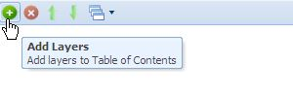
To add layers and images to the Layers - Table of Contents, click the Add Layers button. This action launches the Add Layers popup window, which lists all the available pre-configured images and layers in a directory tree.
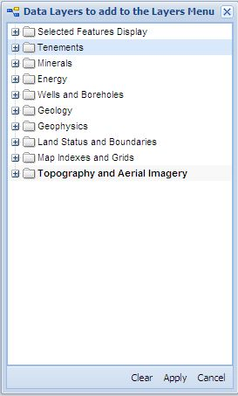
From this popup window you can add and remove one or multiple layers/images at a time. By default all layers/images that are added to the layers area have their visible check box ticked.

Remove Layers

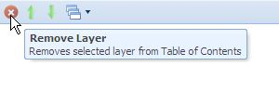
This button is used to remove layers from the Layers - Table of Contents. To remove a layer, highlight the layer in the Layers - Table of Contents with the mouse, and then hit the Remove Layers button. The layer will then be removed from the Layers - Table of Contents.
Layers can also be removed by un-checking them in the Add layers popup window.

Move Layer Up

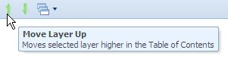
Layers are drawn onto the Main Map Display according to the draw order of the Layers - Table of Contents. The layer that is listed last on the Layers - Table of Contents list is drawn first, followed by the layers listed above it.
When layers are added to the Layers - Table of Contents, GeoVic 3 determines where best to position the layer in the Layers - Table of Contents list. Images are placed at the bottom, with polygon layers positioned above the images, polyline layers above the polygons, and points above the polyline layers.
You can change this draw order in the current Layers - Table of Contents by highlighting a layer in the Layers - Table of Contents, and selecting either the Move Layer Up button or Move Layer Down button to change the position of the layer on the layer list.
A faster method to use is simply grab the layer with the mouse and use a drag and drop action to place the layer at the desired position within the Layers - Table of Contents.

Move Layer Down

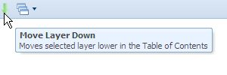
Layers are drawn onto the map face according to the draw order of the Layers - Table of Contents . The layer that is listed last on the Layers - Table of Contents list is drawn first, followed by the layers listed above it.
When layers are added to the Layers - Table of Contents, GeoVic 3 determines where best to position the layer in the Layers - Table of Contents list. Images are placed at the bottom, with polygon layers positioned above the images, polyline layers above the polygons, and points above the polyline layers.
You can change this draw order in the current Layers - Table of Contents by highlighting a layer in the Layers - Table of Contents, and selecting either the Move Layer Up button or Move Layer Down button to change the position of the layer on the layer list.
A faster method to use is simply grab the layer with the mouse and use a drag and drop action to place the layer at the desired position within the Layers - Table of Contents.

Themes

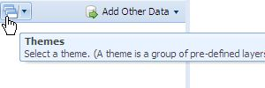
GeoVic 3 has a number of map Themes, that can be loaded to the Layers - Table of Contents quickly by using the Themes button. Click the Theme button box to see the available Themes.
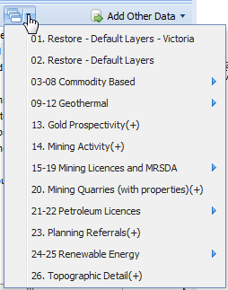
Shows the 03 to 08 Commodity Based expanded menu.
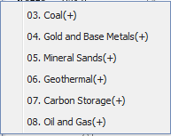
Shows the 09 to 12 Geothermal expanded menu.
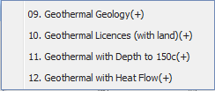
Shows the 15 to 19 Mining Licences and MRSDA expanded menu
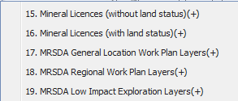
Shows the 21 to 22 Petroleum Licences expanded menu
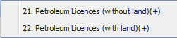
Shows the 24 to 25 Renewable Energy expanded menu
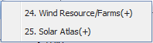
The Themes button can also be used to remove all layers from the Layers - Table of Contents, leaving just the Default layers (Towns, Roads and Victoria Boundary). Theme 02 restores just the Default Layers without changing the map extent, while Theme 01, does the same but changes the map to the initial (Victoria state wide) extent.

Add Other Data

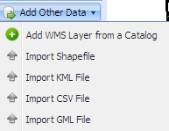

GeoVic 3 has the capability of importing spatial data as new layers. You can import the following:

- Web Map Service layers (WMS)
- Shapefile,
- KML (files created from Google Earth)
- Comma Separated Value files (CSV)
- Geography Markup Language files (GML)

Images cannot be imported into GeoVic 3.

Any imported spatial data will only be displayed if it lies within the Victorian boundary.
For CSV, GML and shapefiles you need to know in advance what projection the data you want to add is in. (The exception to this is with KML files, as KML files only have one projection). The acceptable projections (all based on datum GDA94) are Geographic, MGA Zone 54, MGA Zone 55 and VicGrid94. If your shapefile, GML or CSV file is not in one of these projections, then the Add Other Data function will fail. For CSV files, you also need to know in advance the names of the columns that hold the X (longitude) and Y (latitude) coordinates.
Any shapefile or KML file that is created by the Export Features in Current Window tool or the Export Selected tool (both tools only available for Registered users) can be used for importing back into GeoVic 3.
Please note that GeoVic 3 does not import the attribute data associated with the imported file. Hence no Common Search, Tabular Views, Identify or Advanced Search functionality can be made on any imported data. You cannot make any imported layer an Active Layer. Or you can do is view it, or zoom to it.
Imported data from the Add Other Data options can only be displayed in one colour

Add Other Data – Add WMS Layer From a Catalog

Pressing the Add WMS Layer From A Catalog button will launch a new window as shown below.
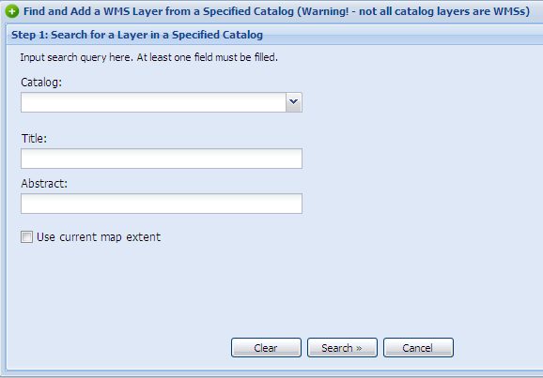
Two WMS catalogs are available, the first from the Victorian Department of Primary Industries, the second from AuScope .
To use the first catalog, select Victoria DPI Earth Resources Catalog from the Catalog pull down list.
In the text box labelled Title, you need to add a search word. Some examples are geological, lithology, contact, age, vic, gsv, or 250K. Enter a word and hit the Search button.
If nothing is found you will receive this message:
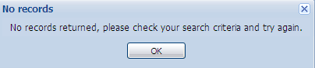
Otherwise, you will get a new window, that lists the available datasets, similar in appearance to the one shown below.
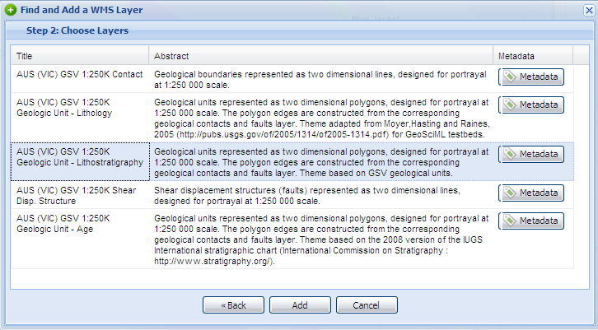
Select from the list with your mouse a dataset you wish to load (clicking it will highlight it in blue). Then click the Add button. Wait a few seconds and you should see a message saying:
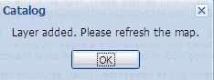
Hit the OK button. The layer will be added to the Layers - Table of Contents list. (Refreshing the map is usually not required).
If the dataset you pick happens to be already loaded, then you will get this message:
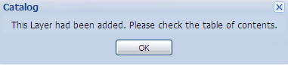
Some WMS layers come with drawing “Styles”. A WMS layer has drawing Styles if the Select Style function becomes activated in the Layers - Table of Contents context menu. Shown below is an example of an added WMS layer that has Style capability enabled.
Another catalog available is the Auscope Portal Catalog. Entering search words in the Title textbox such as seismic, south, mining or age will reveal results.

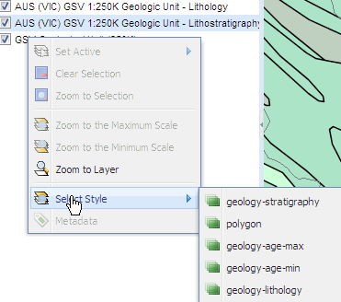
Note the following known bugs:
The GeoVic 3 application cannot tell if a WMS layer is capable of being displayed in the VicGrid94 projection. Hence even though a layer might load into the Layers - Table of Contents, nothing may be seen in the Main Map Display. Another cause of WMS layers not displaying is the simple fact that the WMS layer selected has no features available in the Main Map Display geographic extent.
The Abstract search word does work, but tends to yield fewer results than the Title search
The Use current map extent check box is not working.
The Catalog named “Other” is still undergoing development.

Add Other Data – Import Shapefile

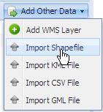

To add your own shapefile to GeoVic 3, select the Import Shapefile option from the Add Other Data function. A new window titled Import Shapefile as a New Layer will then appear, as shown below.
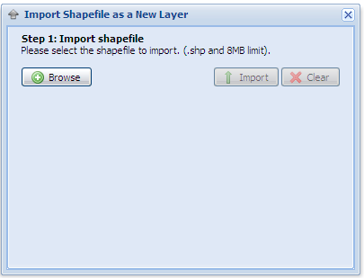
Click the button. A file upload dialog GUI will display. To select your shapefile, you need to navigate to it, and then select it by clicking the shapefile component that has the file extension shp.
Once your shapefile is selected, the shapefile name is added to the Import Shapefile as a New Layer window.
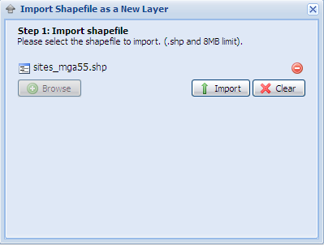
You then need to click the button. If your shapefile is greater than 8 MB, then the shapefile will not be loaded, and GeoVic 3 will inform you that your shapefile is too large. If not, then the Import Shapefile as a New Layer window then updates to that shown below.
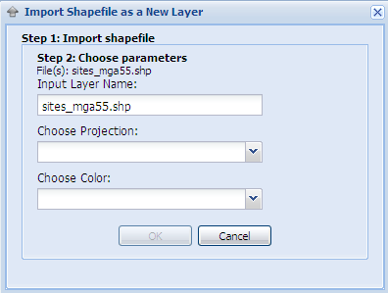
You then need to choose the projection of your shapefile from the Choose Projection combo box, and then a colour from the Choose Colour combo box. The OK button will then be enabled. Click the OK button to complete the last step. Your shapefile will then be added to the Layers, Table of Contents. You may need to click the Initial Extent button to see where the shapefile is in the Main Map Display.

Add Other Data – Import KML File
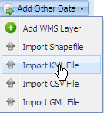
To add a KML to GeoVic 3, select the Import KML File option from the Add Other Data function. A new window titled Import KML as a New Layer will then appear, as shown below.
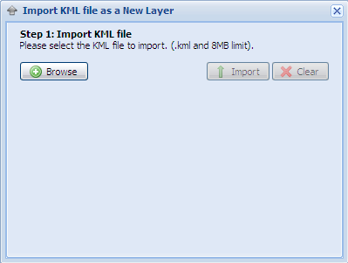
Click the button. A file upload dialog GUI will display. Select the KML file you want to load. Once the KML file is selected, the KML name is added to the Import KML as a New Layer window.
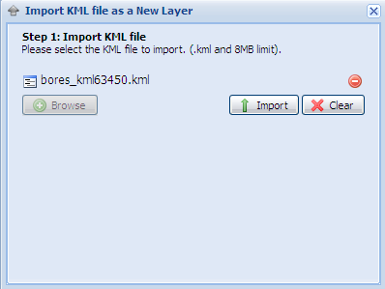
You then need to click the button. If the KML file is greater than 8 MB, then your KML file will not be loaded, and GeoVic 3 will inform you that your KML file is too large. If not, then the Import KML as a New Layer window then updates to that shown below.
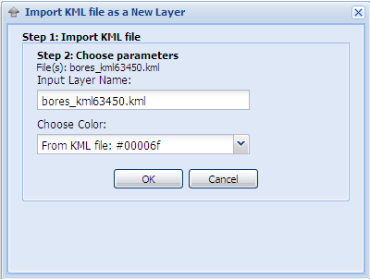
It is optional if you change the Input Layer Name. A KML file comes with a set colour, but you can change the colour to those found in the Choose Colour combo box. Press the OK button to add your KML file to the Layers, Table of Contents. You may need to click the Initial Extent button to see where your KML file is in the Main Map Display.

Add Other Data – Import CSV File

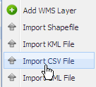
To add a CSV to GeoVic 3, select the Import CSV File option from the Add Other Data function. A new window titled Import CSV as a New Layer will then appear, as shown below.
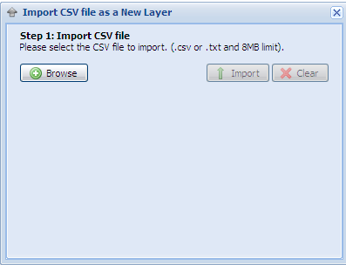
Click the button. A file upload dialog GUI will display. Select the CSV file you want to load. The CSV file can have the file extension txt or csv. Once the CSV file is selected, the CSV name is added to the Import CSV as a New Layer window.
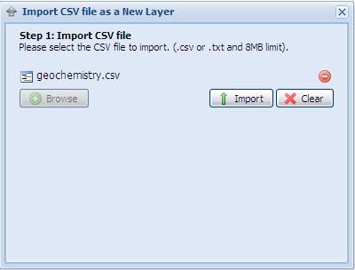
You then need to click the button. If the CSV file is greater than 8 MB, then your CSV file will not be loaded, and GeoVic 3 will inform you that your CSV file is too large. If not, then the Import CSV as a New Layer window then updates to that shown below.
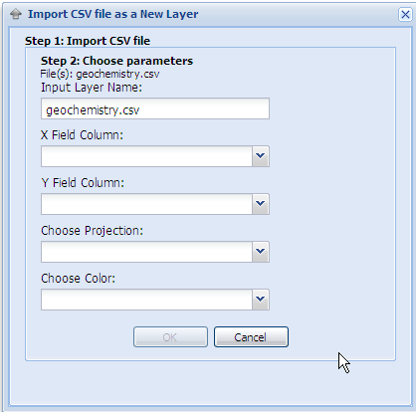
It is optional if you change the Input Layer Name. The pull down items in the combo boxes X Field Column and Y Field Column are the field item names found in your CSV file. For the X Field Column, you need to select the correct field item from your CSV file that represents the Longitude, Easting or X component of your data. Likewise for the Y Field Column, you need to select the correct field item that represents the Latitude, Northing or Y component.
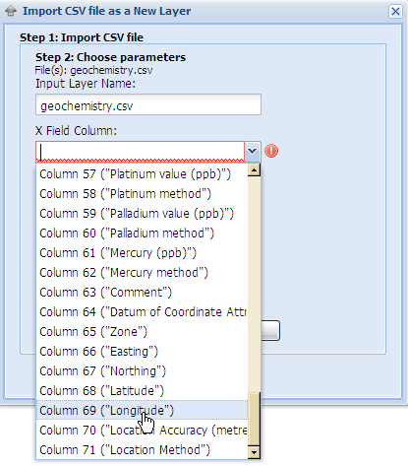
Next you need to select the projection from the Choose Projection combo box, and then select a colour from the Choose Colour combo box. Once all this is done, the OK button is enabled. Click the OK button to complete the last step. Your CSV file will then be added to the Layers, Table of Contents. You may need to click the Initial Extent button to see where the CSV is in the Main Map Display.

Add Other Data – Import GML File
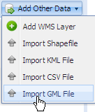
The Import GML File function is very similar to the Import Shapefile function, as explained above. The only difference between loading a shapefile and loading a GML file is that the GML file has the file extension gml instead of shp.
6. Layers – Table of Contents & Context Menu

Layers – Table of Contents
The Layers - Table of Contents can be hidden by clicking the small arrow found in the middle of the border bisecting the Layers - Table of Contents and the Main Map Display. The same small arrow can then be used to redisplay the Layers - Table of Contents. An alternate method to hide the Layers - Table of Contents is by clicking the double arrow button found just above the Common Searches tab.

Layers Context Menu

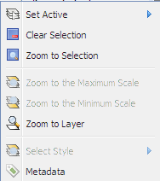
Right click a layer in the Layers - Table of Contents, and a context menu will appear. The items in this menu are briefly explained below:

Layers Context Menu - Set Active
To make a layer active, right click the layer in the Layers - Table of Contents, click Set Active and select the layer.
Some layers are made from a set of component datasets. For example the layer Leads and Working Details is actually comprised of six datasets. In such cases you make one of these datasets the Active Layer.
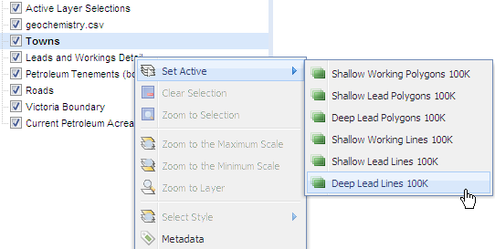
Images cannot be made active, because they do not have attribute data associated with them. Likewise, some map layers, AGD66 Lat/Long Graticule for example, cannot be made active for the same reason.

Layers Context Menu - Clear Selection
Clears the selection in the Active Layer. Becomes enabled if there are features currently selected in the Active Layer. This method is also available in the Main Map Context menu, as well as in the Common Selection Functions.

Layers Context Menu - Zoom to Selection
Zooms to the selections in the Active Layer. Becomes enabled if there are features currently selected in the Active Layer. This method is also available in the Main Map Context menu, as well as in the Common Selection Functions.

Layers Context Menu - Zoom to the Maximum Scale
Because many of the GeoVic 3 map layers contain thousands of features, there is little value in GeoVic 3 attempting to draw all of these at small scales. Hence many Geology map layers, some Coal layers, and others have draw scale restrictions applied to them. For example, the layer Miscellaneous Lines 250K has a Maximum Scale restriction of 1:300,000. Such restrictions are applied so that the layer is not drawn at small scales. In other words, when the whole of Victoria is being viewed (around 1:5,000,000) the Miscellaneous Lines 250K layer will not be drawn. It is only at larger scales, that is when you zoom in, that the layer will draw.
You can see if a layer has a scale restriction by hovering your mouse over the layer name in the Layers - Table of Contents. A tooltip will appear if the layer has a restriction applied. Also, the layer will appear grayed out if you are currently outside the draw scale range. (Note the scale restriction only determines if a layer can be drawn - it does not restrict selection and queries).
The Zoom to the Maximum Scale menu option becomes enabled if a layer has a Maximum Scale restriction. Clicking Zoom to Maximum Scale will change the scale of the Main Map Display to the Maximum Scale of that layer. You may still be unable to see any of the features because you may have zoomed to an area where the features do not exist. For example, if you started at GeoVic's 3 initial extent, and then clicked Zoom to the Maximum Scale for Miscellaneous Lines 250K, you would end up around the Healesville and Marysville area. But there are no Miscellaneous Lines 250K features in this area. However, if you then Pan to Echuca (use the box in the Locality Map is the quickest way to do this) you will see the Miscellaneous Lines 250K features drawn.

Layers Context Menu - Zoom to the Minimum Scale
Only a few image layers have a drawing Minimum Scale restrictions. These restrictions are in place because some layers are not intended to be viewed at large scale. Currently, selecting this action, will render the layer NOT visible. For example, the layer Depth to 150C Image 1M, has a minimum scale restriction of 1:100,000. Click on this action, and the map will scale to 1:100,000, but the layer will not be visible. Make the scale slightly larger (eg 1:100,001) and the layer will now appear.

Layers Context Menu - Zoom to Layer
Many layers do not cover the whole extent of Victoria. Use this function to zoom to the layer selected. In some cases the layer may still not be visible, because although you may have zoomed to the extent of the layer, you may still be outside the Maximum Scale restriction.

Layers Context Menu - Select Style
A small number of geology layers in GeoVic 3 are able to be viewed on the Main Map Display in different states based upon a style criteria. For example, Geological Unit 250K has 5 styles. Changing the Style will change the appearance of Geological Unit 250K on the Main Map Display.

Layers Context Menu - Metadata
Provides a hyperlink to the layer's metadata.
Eg: for Current Mineral Exploration Licences
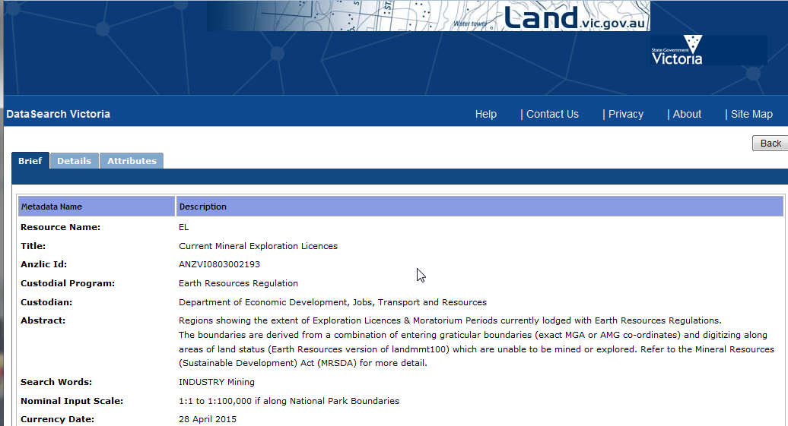

7. Layers – Layer Transparency Control
The transparency of each layer can be adjusted by the Layer Transparency slider control found at the bottom of the Layers – Table of Contents

8. Locality Map
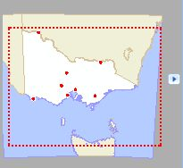
The purpose of the Locality Map is to indicate the location and extent of the Main Map Display in relation to the state of Victoria. The red outline box shows the current the Main Map Display extent. This outline can also be moved, and can be used as a Pan alternative.
The Locality Map can be hidden by clicking the arrow icon found on the right of the Locality Map.

9. Help, Feedback and Login (if not logged in)

Help
Clicking on this option opens up a popup window as follows.
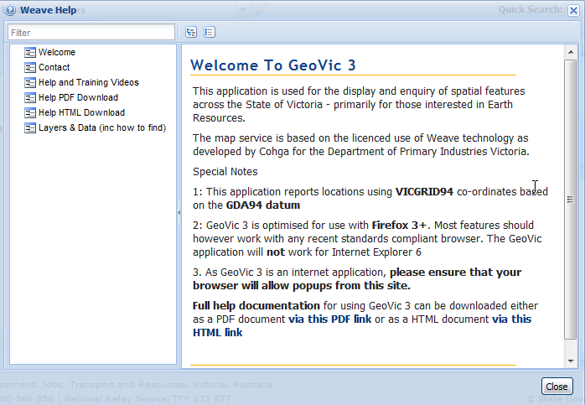

Feedback
Clicking on this option opens up the following popup window.
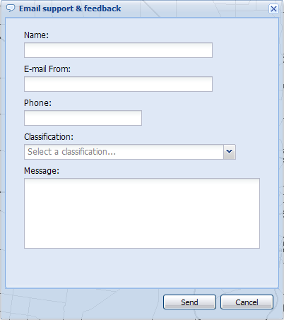
This window can be used by you to send us feedback in regards to GeoVic 3.

Login Session

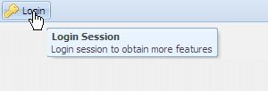
Registered users can use the Login button to access more layers, images, digital elevation models (DEMS) and functionality. Extra functionality is added to the File Menu function.
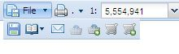
For example you can request for more spatial information from the Export Data Via DataVic function or from the Export Geophysical Archive Data function.

10. Main Map Display and Main Map Context Menu

Main Map Display
The area of the screen where the map display takes place. Any layer that has been added to the Layers – Table of Contents will display in this area.

Map Context Menu

Right clicking the mouse in the Main Map Display menu raises the Map Context Menu.

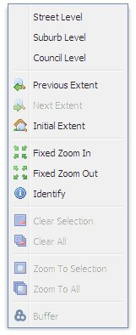
The items are:
• Street Level: This changes the Main Map Display scale to 1:2,500
• Suburb Level: This changes the Main Map Display scale to 1:25,000
• Council Level: This changes the Main Map Display scale to 1:130,000
• Previous Extent: Does the same as the Previous Extent button
• Next Extent: Does the same as the Next Extent button
• Initial Extent: Does the same as the Initial Extent button
• Fixed Zoom In: Zooms in by changing the scale by a factor of 0.5. (Eg from 1:100,00 to 1:50,000
• Fixed Zoom Out: Zooms out by changing the scale by a factor of 1.5 (Eg from 1:100,00 to 1:150,000)
• Identity: This identity menu item performs independently from the Identity tool in GeoVic 3. This identity only works on the Active Layer, and does not perform on Visible or Key Layers. Hence you can have both Identify windows open together . Click the Identity menu item, then click to a location on the Main Map Display.
• Clear Selection: Clear the selected features from the Active Layer.
• Clear All: Clear the selected features from all layers.
• Zoom to Selection: Zooms to all the features selected in the Active Layer.
• Zoom to All: Zooms to all the features selected in all the layers. Becomes enabled if there are features selected from other layers, and features are selected in the the Active Layer.
• Buffer: Does the same as the Buffer tool in the Common Selection tools.

11. Scale Bar and Scale Bar Context Menu

Scale Bar
The area of the Main Map Display where the scale bar is displayed.

Scale Bar Context Menu
There is also a context menu for the scale bar, which changes the units of measurement on display
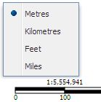

12. Historic Mining Activity

Definitions

4 Classifications
- Our records indicate that there may have been mining activity on this site and that there may be evidence of that activity remaining on this site. This evidence may include mine openings.
- Our records do not indicate the existence of any mining activity on this site, but the site may be over or close to known mining activity. Note that there may be unrecorded mine openings connecting with such activity.
- Our records do not indicate the existence of any mining activity on or under this site, but the site is within an area of past prospecting or mining activity. Note that there may be unrecorded mine workings present.
- Our records do not indicate the presence of any mining activity on this site, and the site appears to be outside any known mined area.

Classification Determination Methodology
It is based on overlap and/or intersections with datasets as follows.
Layer (and entity) | Analysis type | Result classification
Mines and Mineral Occurrences (minsite) &  Historical Mining Activity (shaft) | Intersection with selection | 1
 | Within 100m buffer around selection | 2
 | Within 1000m buffer of selection | 3
Current Mining Licences and Leases(min) &  Current Extractive Industry Tenements (ewa) | Intersects with selection | 2
 | Within 500m buffer of selection | 3
Expired Mining Licences and Leases (minhst),  Expired Extractive Industry Tenements (ewahst),  Expired Mineral Leases 1860s – 1966 (milhst),  Expired Gold Mining Leases 1860s – 1958 (gmlhst),  Expired Tailings Licences (tlhst) | Intersects with selection | 2
 | Within 500m buffer of selection | 3
Deep leads (dla & dll) | Within 100m buffer of selection | 3

The default result classification result is 4.
Detailed Reports are only available for a result classification of 1 or 2.

Examples

75 Vine Street Bendigo
Using the quick search, type the address and select it
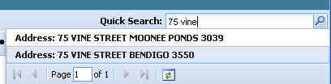
Once the property is selected and displayed in GeoVic, use the new function from the tools menu 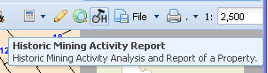
A popup of results will appear.
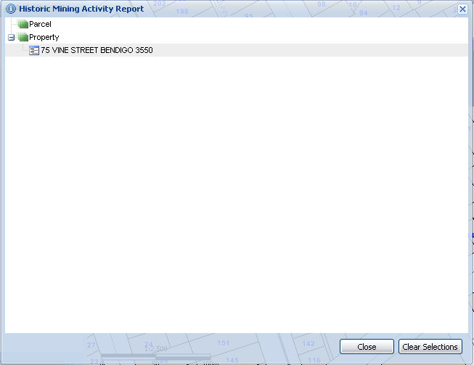
Click on the address and a result’s popup will appear
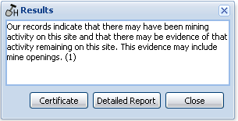
A detailed report will be available if the result is 1 or 2 (as opposed to 3 or 4)
If “Certificate” is pressed a certificate will be produced
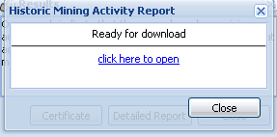
In pdf format (refer to Appendix 3)

If “Detailed Report” is chosen
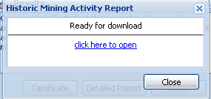
And a pdf report is generated (refer to appendix 4)
Example 75 Vine Street Bendigo – Certificate
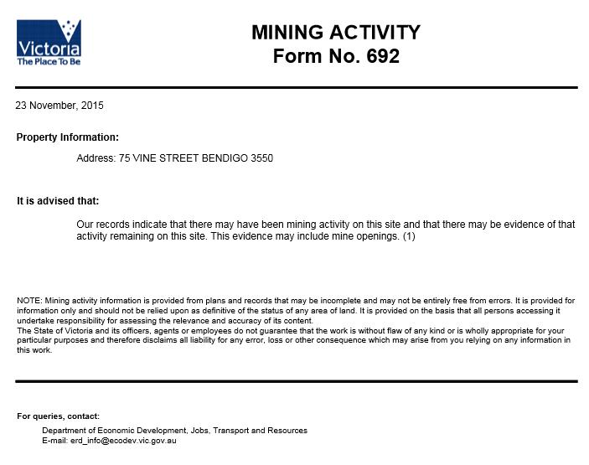

Example 75 Vine Street Bendigo – Detailed Report

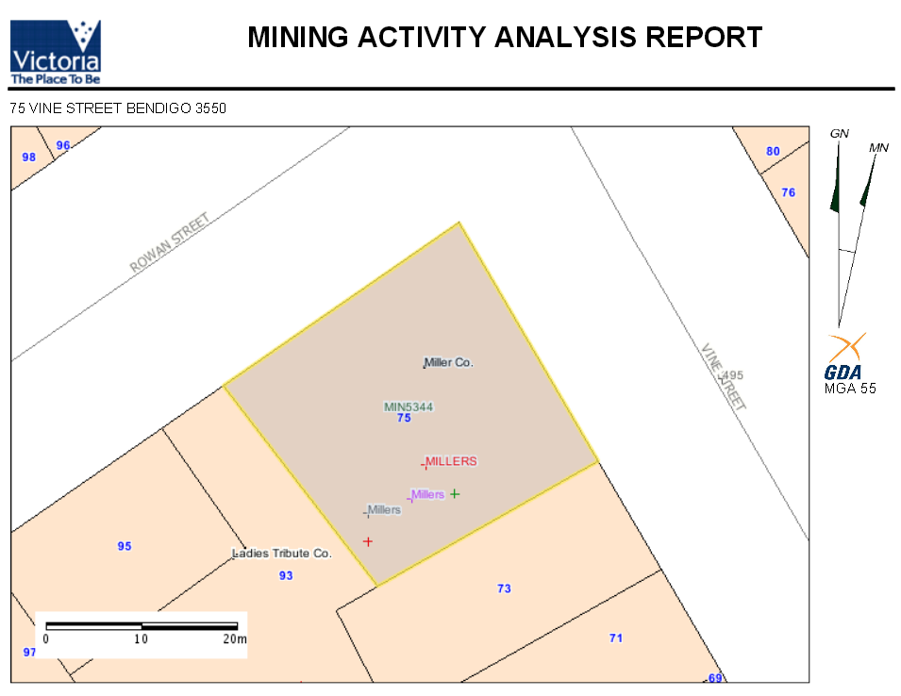
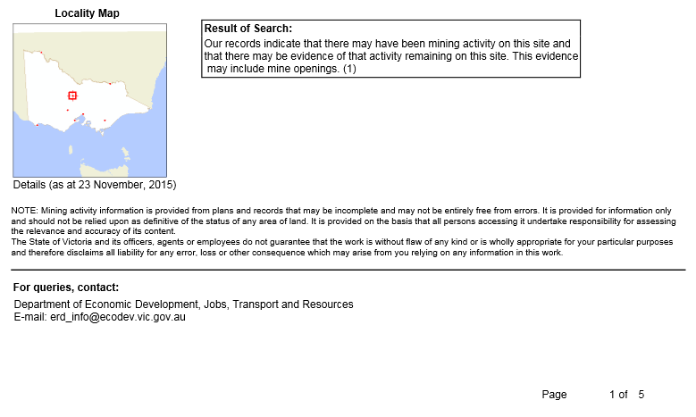

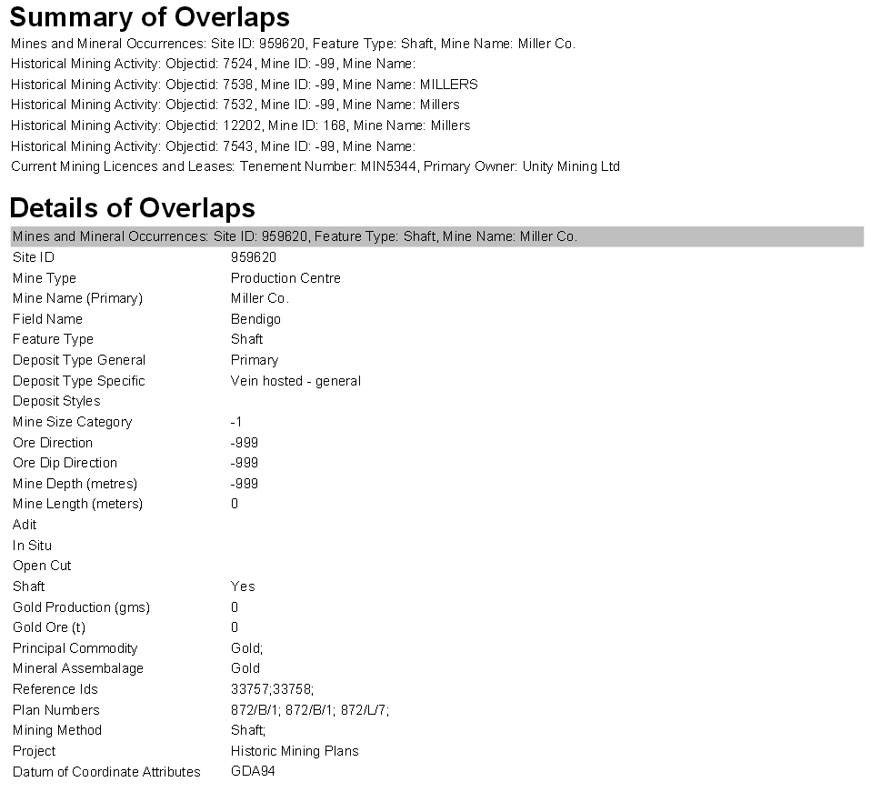
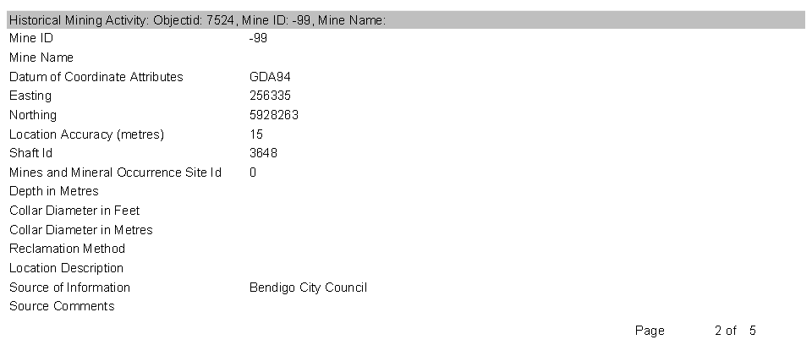

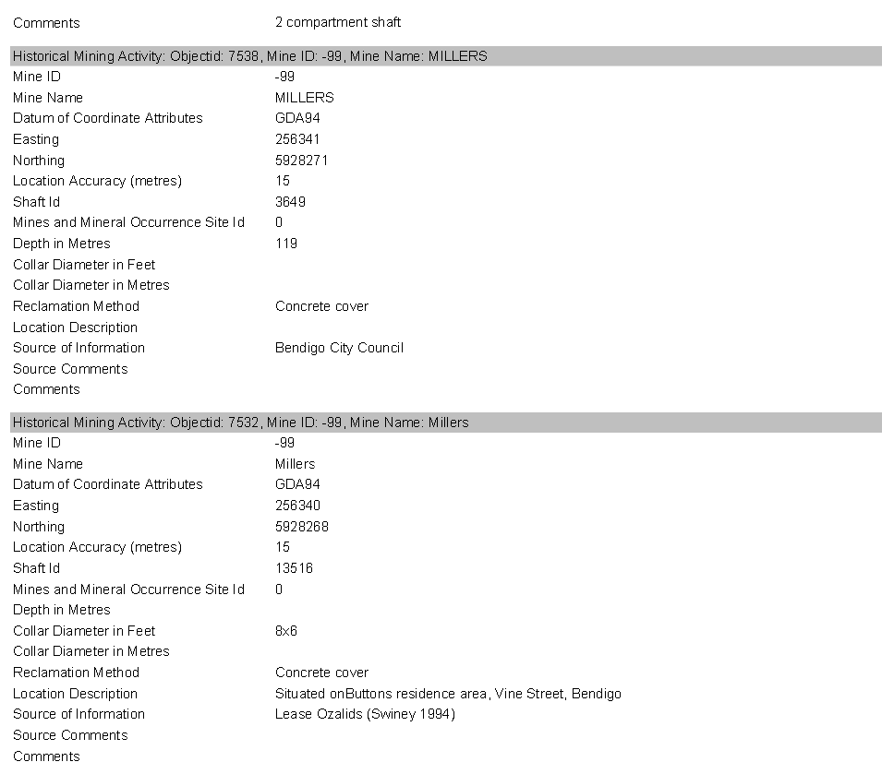
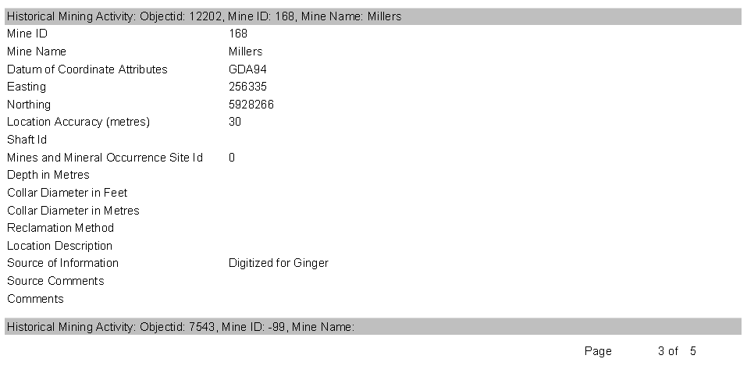
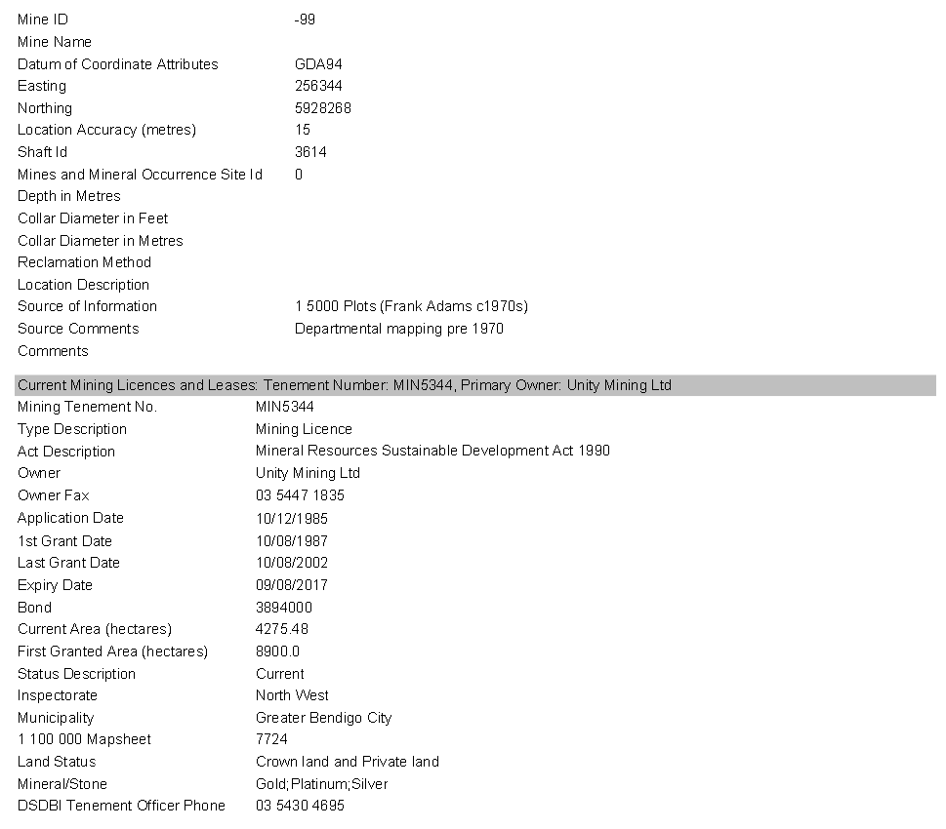

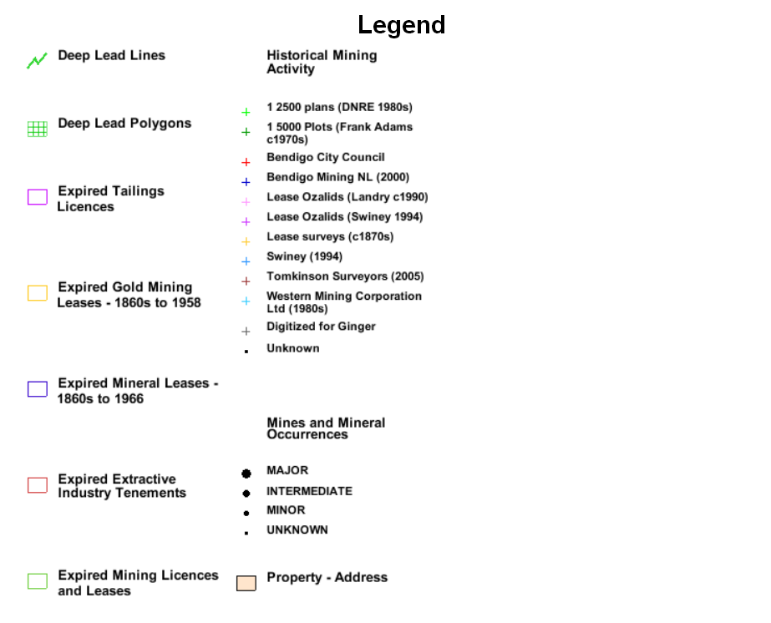
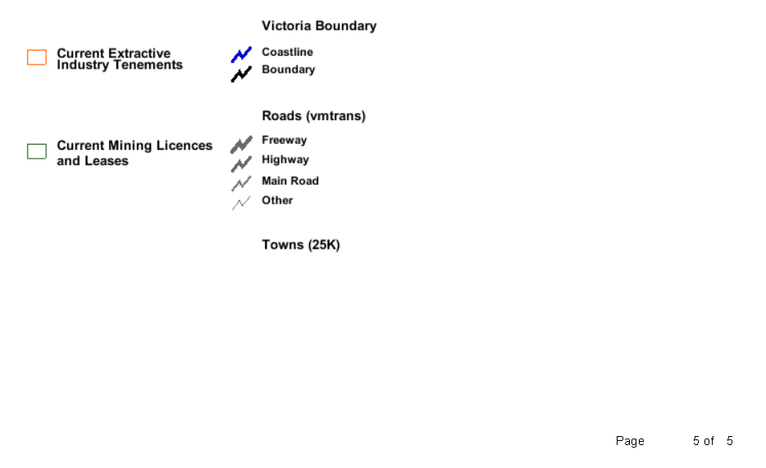

13. Frequently Asked Questions

Q) How can I get the Tabular View Button to work?
The Tabular View button only becomes active if features from the Active Layer are selected.

Q) How can I get the Advanced Search Button to work?
The Advanced Search button only becomes active if an Active Layer is set, and that layer has attribute data associated with it.

Q) How can I copy and paste the geographic coordinates of a location?
Although the Coordinate Display tool shows the current coordinates of your mouse position on the Main Map Display, you cannot capture the coordinates with a cut and paste operation because as soon as you move the mouse, the coordinates will change with the mouse position.
To get round this, you can use the Markup/Redline tool menu instead. Use the Point with Coordinate tool and with your mouse, click the location required on the Main Map Display. Then select the point element with the Modify tool. When you do this, you will see that the coordinates of the location are captured in the Markup/Redline text input box as shown below.
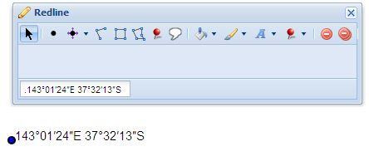.
With you mouse you can then copy these coordinates (Ctrl C) into your clipboard memory. Use the Delete function to delete the redline symbol from your Main Map Display.

Q) What are the Key Layers?
Both the Identify and Select Feature actions can be set to act upon Key Layers.
Refer to the Layers (Key & Quick Search) section

Q) What can be searched within the Quick Search?
Because GeoVic 3 has access to more than 300 layers, only a small selection of layers have been made available for the Quick Search utility.
Please refer to the Layers (Key & Quick Search) section

Q) Where can I get detailed Mineral Tenement information from?
All of the Mineral Tenement layers have detailed information available via Identify or Tabular View. Shown in the screen capture below is an example of information obtainable from GeoVic 3 session for Mineral Tenements.
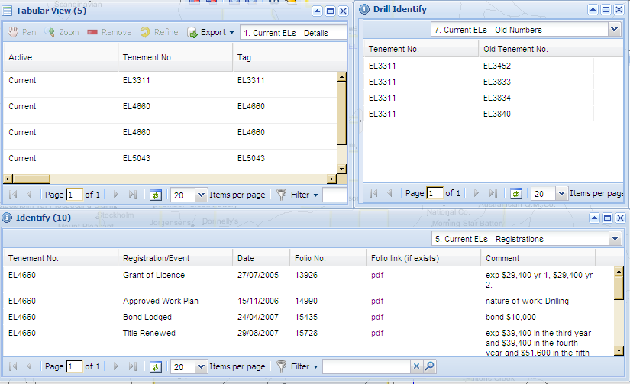
- From grids
Information of tenement data is displayed in a series of grids available from the Identify and Tabular View functions. This information can be downloaded from the Tabular View window by using the Export function, and can be captured in HTML, CSV or Excel format.
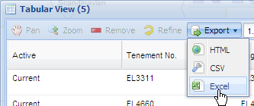
- From detailed reports
Formatted reports (html or PDF) are also available as hyperlinks within the Identify and Tabular View grids. To find them look at the 2. – Reports view in the Tabular View or Identify results, \ 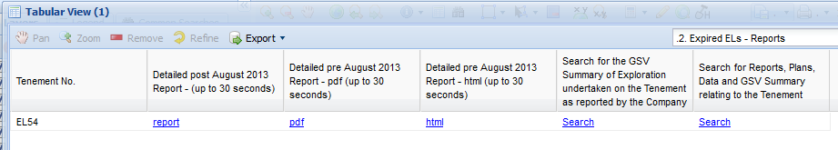.
- From summary information regardimg company submitted reports.
This information is an openfile summary report (PDF) compiled from information submitted by the tenement operator.
To find the summary PDF files, look at the 2. – Details view in the related Tabular View or Identify window click on the 2nd last element in the grid shown above. Click the hyperlink named on any record. This will search for the summary and display it if we have it.
These summary reports will not exist for every Tenement.
- From detailed company submitted reportsregarding exploration
This information is an openfile information compiled from information submitted by the tenement operator.
To find the summary PDF files, look at the 2. – Details view in the related Tabular View or Identify window click on the last element in the grid shown above. Click the hyperlink named on any record. This will search for the company reports and display them if we have any.
These “reports” will not exist for every Tenement.
In some cases – as tenements have been renamed, finding the associated files can be problematic. We have included an “old” and “ new” “number” grid where appropriate, to help users track down the tenement numbers with files.

Q) Where can I get detailed Mine information from?
The “Mines and Mineral Occurrence” layer (and some deposit style layers) has detailed information available via Identify or Tabular View. An example of what is available is shown below.
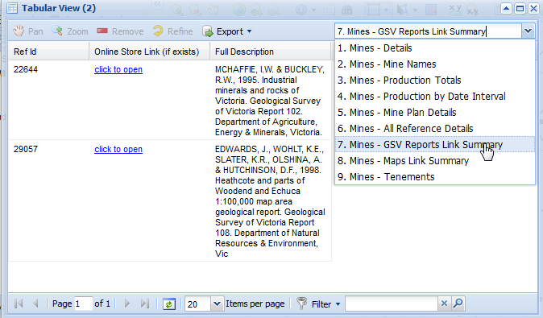
- From grids
Information of mine data is displayed in a series of grids available from the Identify and Tabular View functions. This information can be downloaded from the Tabular View window by using the Export function, and can be captured in HTML, CSV or Excel format.

Useful views in the Tabular Views and Identify windows are:
Mines – Mine Names – includes alternative mine names
Mines – Production by date interval
Mines – Mine Plan Details – includes links to the mine plans – if we have them…
Mines – All Reference Details
Mines – GSV Reports Link Summary – includes these specific references and a link to the online store.
Mines – Maps Link Summary – if the site is linked to a map show the reference and possible online store link.
- From detailed reports.
Formatted reports (html or PDF) are also available as hyperlinks within the Identify and Tabular View grids. To find them look at the 1. Mines – Details view in the Tabular View or Identify results.

Q: Where can I get more information on the Aerial Imagery?
The Aerial Imagery shown on GeoVic 3 is sourced from the Coordinated Imagery Program. For further information visit the Land Channel web site www.land.vic.gov.au/cip

Q) Where can I get detailed Petroleum Tenement – Vic information from?

The “Petroleum Tenements - Vic” layer has detailed information available via Identify or Tabular View. An example of what is available is shown below
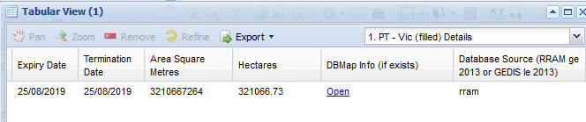

- From grids
Information of tenement data is displayed in a series of grids available from the Identify and Tabular View functions. This information can be downloaded from the Tabular View window by using the Export function, and can be captured in HTML, CSV or Excel format.
Useful views in the Tabular Views and Identify windows are:
Petroleum Tenements – Work Programs
Petroleum Tenements – All Events
- From detailed reports.
Formatted reports (html or PDF) are also available as hyperlinks within the Identify and Tabular View grids. To find them look at the 1. Petroleum Tenements – Reports view in the Tabular View or Identify results and scroll towards the end of the grid. Hyperlinks to the reports are highlighted in magenta.
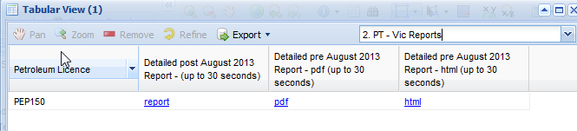
- From detailed DBMap Info
This information is a huge series of linked formatted reports (html) and includes information from our DBMap database.
For the information, look at the 1. Petroleum Tenements – Details view in Identify or Tabular View grid and scroll to the end of the grid. Click the hyperlink named found under the Column title DBMap Info (if exists).
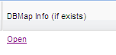
These links will not exist for every Tenement.

Q) Why does the Identify say 'No Data Available'?
Some map layers contain no attribute data. For example Geological Basins only shows the outlines on the map face, but there is no other data associated with it. Hence if you click an Identify on this layer, no results will appear.

Q) Why does the Map Display show the message 'Not all selections were drawn'
This message usually appears within the Main Map Display if you have some map features selected, but not all of them are located in your current Main Map Display window. The purpose of this message is to inform you of this scenario.
This message can also appear if you have made a huge selection of map features (say over 10,000), and GeoVic 3 cannot render all the selected features in time.

Q) Why does the Common Searches tab say 'No Searches Available'?
Some map layers contain no attribute data. For example Geological Basins only shows the outlines on the map face, but there is no other data associated with it. Hence as there is no attribute data for such layers, no common search methods will exist.

Q) What does ‘Could not find mapEngine geovic.arcims’ mean?
Most of the layers used by GeoVic 3 comes from an ArcIMS service managed by the Department of Environment, Land, Water and Planning. Sometimes this server will go down for maintenance or for short outages. Hence GeoVic3 will be unable to load images. For the short outages of a few minutes, the system will restart the connection to this service when it becomes available. Sometimes this problem will persist because the ArcIMS service does not come back up. If this problem persists, please contact us to attempt to restore the service.

Q) What does ‘Could not find mapEngine landvic.wms’ mean?
Most of the aerial and satellite photography that is used by GeoVic 3 comes from an Image Web Server managed by the Department of Environment, Land, Water and Planning. Sometimes this server will go down for maintenance. Hence GeoVic3 will be unable to load images. You will be able to tell if the server is down, by looking at the Data Layers to add to the Layer Menu contents, and view the contents found in the folder named Topography and Aerial Imagery, as shown below.
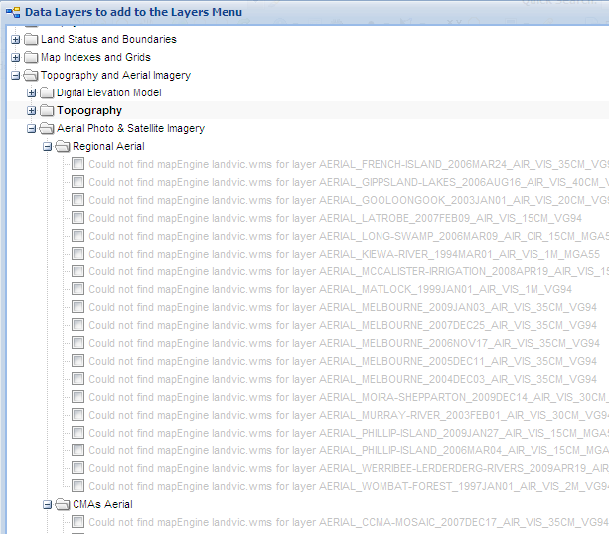

How To's
How To’s are step by step instructions on some of the common uses for GeoVic 3.
How To Create Maps For Workplans using GeoVic 3 - General Location Plan
The following steps outline a way of generating a "general location plan" as outlined in the Extractive Industry Work Plan Guideline
The Steps are
- Start GeoVic 3
- In the Quick Search: text input box, type in the Tenement Number
- Select the tenement. GeoVic 3 should zoom to the selected tenement
- Remove the tenement layer from the Layers – Table of Contents
- Go to the Scale combo box, and select either 50,000 or 100,000 scale
- Add the theme MRSDA General Location Work Plan Layers to the Layers, Table of Contents.
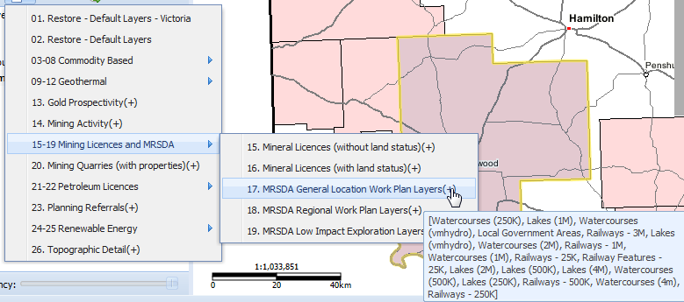
- Using the Markup/redline tool, outline the proposed Quarry location with a polygon, and add a label to it
- Print the map using the GeoVic 3 Print button. Use the following options:
  - For the Report Title type the words "General Location Plan"
  - For the Map Scale - choose either 1:50,000 or 1:100,000
GeoVic’s 3 Print function automatically contains a North Arrow, Legend, Scale and Drawing Date - as required by the Industry Work Plan Guideline
Shown below is a hypothetical example using GeoVic 3 for a General Location Plan at 1:50,000.
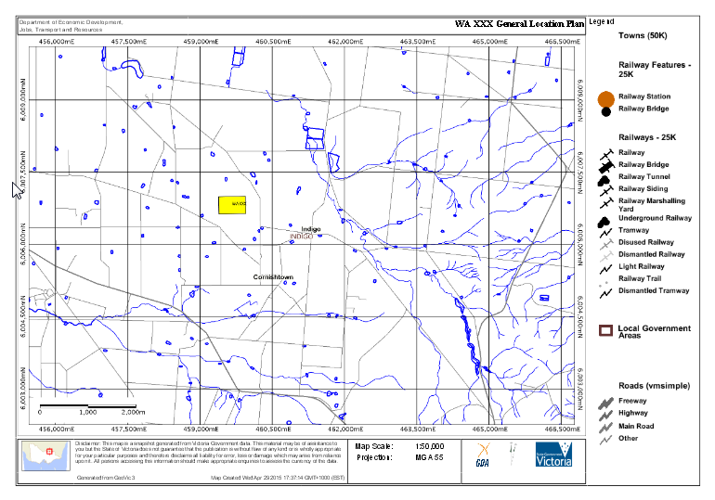

How To Create Maps For Workplans using GeoVic 3 - Regional Plan
The following steps outline a way of generating a "regional plan" as outlined in the Extractive Industry Work Plan Guideline
The Steps are
- Start GeoVic 3
- In the Quick Search combo box type in the Tenement Number
- Select the tenement. GeoVic 3 should zoom to the selected tenement
- Remove the tenement layer from the the Layers – Table of Contents
- Go to the Scale combo box, and select 25,000 scale
- Add the theme MRSDA Regional Work Plan Layers to the Layers, Table of Contents.
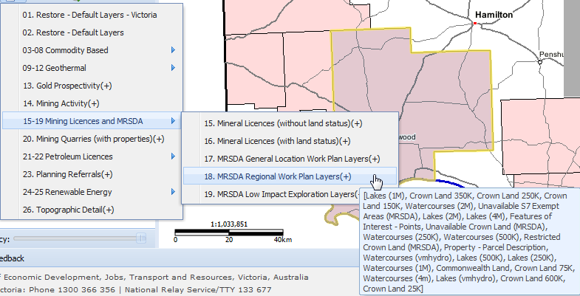
- Using the Markup/redline tool, outline the proposed Quarry location with a polygon, and add a label to it
- NOTE: The plan should also include proposed access roads and occupied houses within 2km from the site.
GeoVic 3 does not have map layers showing occupied houses, nor proposed access roads. For proposed access roads, you can use the Redline tool and manually sketch in any proposed roads.
Note: When we are able to add occupied house data to GeoVic 3, we will do so.
(“residential building” data is being added to the “Features of Interest – Points” dataset, but at present it is insufficient for our requirements. In the meantime aerial photography may aid in the determination)
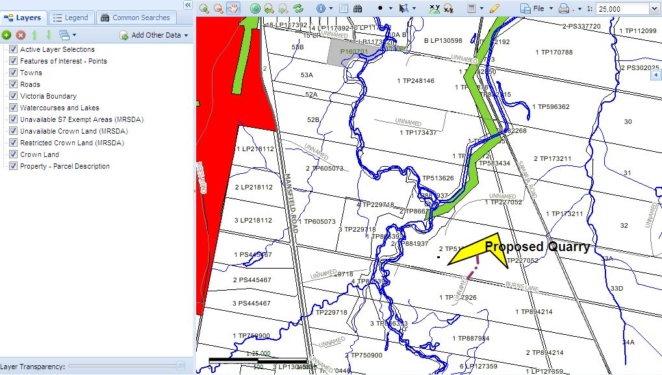

Using the Redline point symbol for each occupied house could be one way of highlighting occupied homes.
- Print the map using GeoVic’s 3 Print function. Use the following options:
  - For the Report Title type the words "Regional Plan"
  - For the Map Scale - choose 1:25,000
GeoVic 's 3 Print function automatically contains a North Arrow, Legend, Scale and Drawing Date - as required by the Industry Work Plan Guideline
Shown below is a hypothetical example using GeoVic 3, of a printed Regional Plan, (occupied houses shown as blue points, proposed road as violet dash line) at 1:25,000
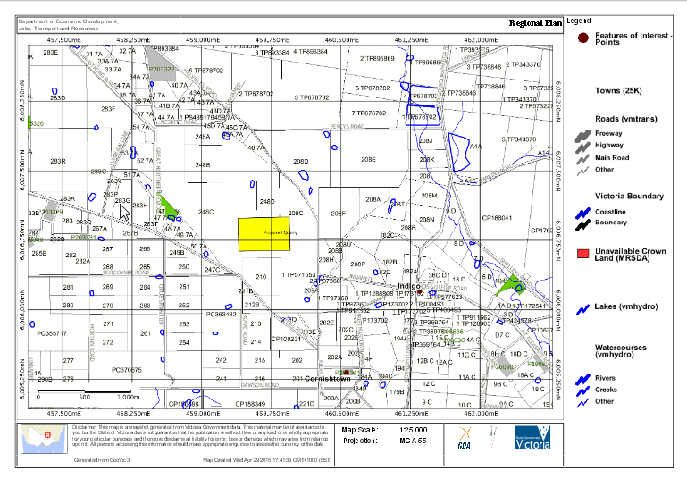

How To Find all Crown Land Parcels in a Mineral Tenement
First find the layer named Crown Land, which is found under the Land Status and Boundaries folder in the Data Layers to add to the Layers Menu. Tick this layer in the Check box, and click the Apply button, to add this layer to the Layers, Table of Contents.

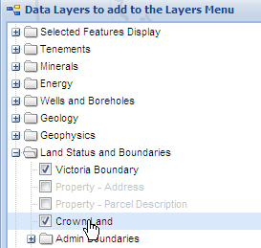

The Crown Land layer is made up of 6 data sets. Make the Active Layer Crown Land 25K.

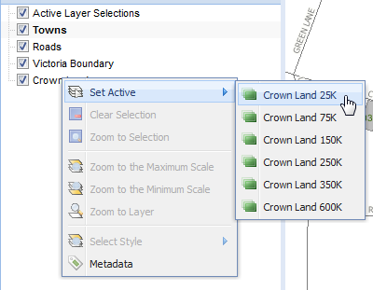

Click the Common Searches tab. There are six searches available. Select the second search 2. Crown in Mineral Tenement Search.
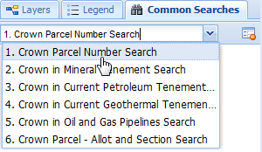
This second style of Common Search is designed to find all Crown Land Parcels that lie within a Mineral Tenement. It has one pull down item, which lists all the current and expired Mineral Tenement numbers. Select the Tenement number you want to query, and click the button.
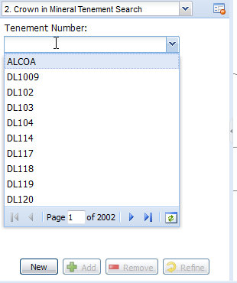
All Crown land parcels that overlap the Mineral Tenement will be selected, and the Main Map Display will zoom to these parcels. Opening the Tabular View will list the Crown parcels found. From the Tabular View you can export the results to Excel, as comma delimited text file, or as a HTML file using the Export function. Shown below is an example of Crown land found for Tenement Number EL5119.

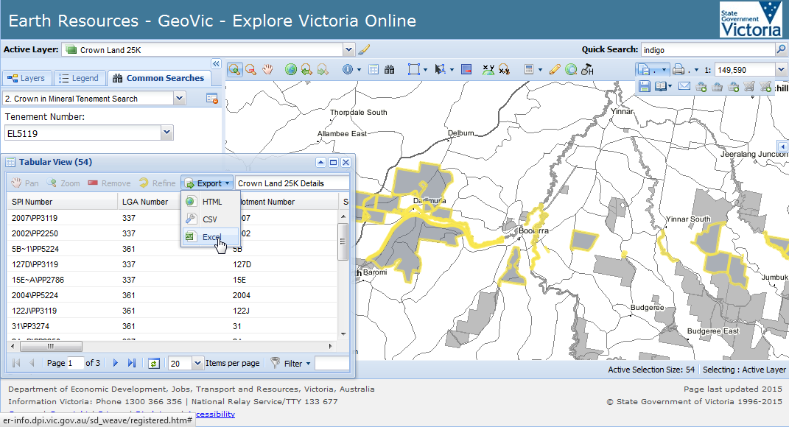

If you have more than one Tenement to query, and you wish to retain the current results, select the next Tenement number from the Common Search list, but this time press the button, instead of the button.

Layers (Key & Quick Search)

Key Layers defined for Identify and Select

• Boreholes - All
• Current Extractive Industry Tenements
• Current Geothermal Tenements (boundaries)
• Current Mineral Exploration Licences
• Current Mining Licences and Leases
• Current Mineral Moratoriums
• Current Prospecting Licences
• Current Retention Licences
• Energy Access Authorities – Vic (boundaries)
• Mines and Mineral Occurrences
• Oil and Gas Pipelines - Vic
• Petroleum Tenements – Vic (boundaries)
• Wells - Petroleum

Layers enabled for the Quick Search
Shown below are the layers that have Quick Search enabled. Some of these layers also have a key word attached to them. For example, the layer Boreholes -All has the search option of using the keyword 'bore'. Hence typing bores 1101 will find records faster then typing 1101.
Layer | Key word | Searchable Items
All GSV Maps |  | Brief Map Title, Reference Id, Full Map Title, Publication Date, Full Reference
Boreholes - All | bores | Site Id, Company Name, Usage, Status, Purpose, Sub-purpose, Local Name, Parish Name, Parish Hole Number
Current Extractive Industry Tenements |  | Tenement No, Primary Owner, Mineral/Stone
Current Geothermal Tenements (boundaries) |  | Geothermal Tenement, Holder
Expired Gold Mining Leases - 1860s to 1958 |  | Tenement No, Primary Owner, Mineral/Stone
Current Mineral Exploration Licences |  | Tenement No, Primary Owner, Mineral/Stone
Current Mineral Moratoriums |  | Tenement No, Primary Owner, Mineral/Stone
Current Mining Licences and Leases |  | Tenement No, Primary Owner, Mineral/Stone
Current Prospecting Licences |  | Tenement No, Primary Owner, Mineral/Stone
Current Retention Licences |  | Tenement No, Primary Owner, Mineral/Stone
Energy Access Authorities – Vic (boundaries) |  | Petroleum Licence, Holder
Expired Extractive Industry Tenements |  | Tenement No, Primary Owner, Mineral/Stone
Expired Mineral Exploration Licences |  | Tenement No, Primary Owner, Mineral/Stone
Expired Mineral Leases - 1860s to 1966 |  | Tenement No, Primary Owner, Mineral/Stone
Expired Mining Licences and Leases |  | Tenement No, Primary Owner, Mineral/Stone
Expired Tailings Licences |  | Tenement No, Primary Owner, Mineral/Stone
Local Government Areas | lga | Official Lga Name
Mines and Mineral Occurrences |  | Site Id, Mine Name, Type
Oil and Gas Pipelines - Vic |  | Petroleum Licence, Holder
Parishes | Parish | Parish Name
Petroleum Tenements – Vic (boundaries) |  | Petroleum Licence, Holder
Property Address |  | Street Number, Name and Suburb
Standard Map Tiles 25K | 25k | Sheet Name, Sheet Number
Standard Map Tiles 250K | 250k | Sheet Name, Sheet Number
Towns (100K) |  | Place Name

Known Issues
• Large searches (over 10000) will sometimes timeout.
• Markup (Redline) is complex to use and has bugs.
• Web Feature Services need enhancement (especially the searches)
• Legend Refinement (i.e. shows all geological units in the legend (WMS and ArcIMS) (won’t be resolved soon)
• Maximum layers in the “Layer” area is set to 25, due to speed of display issues.

- Contacts
GeoVic 3 General Support
Earth Resources
Business Centre
1 Spring Street
Melbourne
Ph: 136 186
Email: gsv_info@ecodev.vic.gov.au
Business Hours: 8.30am - 4.30pm (Mon - Fri)
Contacts
For specific contacts within the Earth Resources, please view the Contacts Page
Data Supply for datasets that Earth Resources are not the custodian of.
For Aerial Photography and Topographic data (ie. Roads, Rivers, Contours etc.) contact (03) 8636 2333 or www.land.vic.gov.au

