MINERALS EXPLORATION AND GROUNDWATER

WHAT IS GROUNDWATER?
Groundwater is water held beneath the earth’s surface in pores and crevices of rocks and soil.
Over time, water from rain and rivers moves downward through the ground, ﬁlling the spaces between grains of soil or rock. Like surface water, groundwater can be still (trapped between layers of impermeable rock) or ﬂowing.
Layers of soil and rock that are saturated with water are called aquifers and lie beneath most parts of Victoria. The top of the aquifer is known as the water table.
The groundwater within aquifers varies in quality from fresh drinking water to saltier than seawater.
In some areas, landholders tap into ground water using windmills or pumps to extract the water for domestic use, stock, and irrigation. Approximately 60 cities and towns across Victoria, including Geelong and Ballarat, rely on groundwater as either a supplementary or primary water supply.
Deep groundwater reserves are more resilient to changes in rainfall than dams, lakes, and rivers. However, reﬁlling deep aquifers can take many, many years.
For more information on groundwater go to:
www.water.vic.gov.au/groundwater/victorias-groundwater-resources
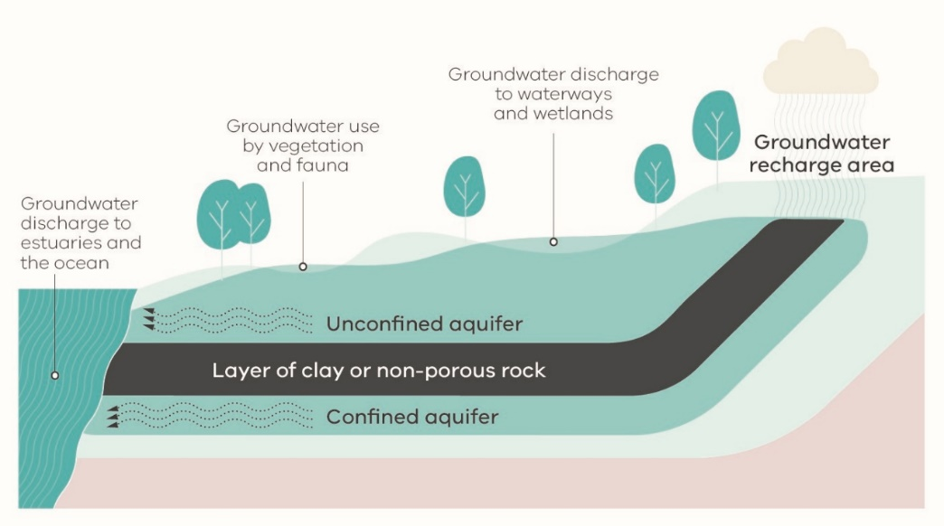

Can minerals exploration drilling impact groundwater?
Yes, drilling has the potential to intersect groundwater but there are strict regulations that govern how drilling is undertaken and how drill holes are decommissioned to ensure no adverse impacts on groundwater.

Using experts
Many exploration companies in Victoria use licensed water drillers to drill exploration holes, to take rock samples or to monitor groundwater.
Exploration drillers often also operate as water bore companies.
Prior to drilling, explorers should seek the advice of regional water authorities and their hydrologists about information on local groundwater systems and expected groundwater conditions at speciﬁc drill sites.

Did you know?
You can ﬁnd out about the groundwater quality, yield, and depths of nearby bores at Visualising Victoria’s Groundwater (VVG) – a map tool that provides details on existing groundwater bores across Victoria.
You can also get an idea of aquifer depths, quality, and yield from Groundwater Resource Reports – a map tool managed by the Victorian Government.

Safeguarded through regulation
Whenever there is an intention to drill to take groundwater (for purposes other than for stock and domestic use), a licence is required under the Water Act 1989.
This law applies to minerals exploration companies, just as it does for farmers and other landholders.
This includes where a minerals explorer drills to take water samples rather than geological samples.
Causing groundwater to be polluted is an offence under the Environment Protection Act 1970.
Under the Mineral Resources (Sustainable Development) Act 1990, the exploration company, as the licence holder, is held responsible for exploration works.
Exploration companies must obtain a Work Plan approval from the Department of Jobs, Precincts and Regions (DJPR) when their activities are likely to exceed threshold limits which deﬁne low impact exploration.

To obtain a Work Plan, the explorer must describe its exploration activities in detail, identify each of the environmental and other risks posed by the activity and outline the strategies that will be employed to mitigate those risks. This includes any potential risks to groundwater.
Work Plans submitted are assessed by DJPR and, if water is a potential concern, they are also referred to the Department of Environment, Land, Water and Planning (DELWP) and rural water authorities.
The Minister for Resources may impose conditions on a licence to protect groundwater.

Exploration licence conditions
Under a minerals exploration licence, the licensee must ensure all reasonable measures are taken to minimise the impacts of drilling.
Operations must also be conducted in a manner that protects the environment and human health.
The licensee must:
- prevent contamination of aquifers
- not drill within 200 metres of a named waterway or within 100 metres of an irrigation channel
- ensure a temporary cap is ﬁtted when a drill hole is to be left open
- keep accurate records of decommissioning procedures for future reference, and to demonstrate that the drill holes have been satisfactorily plugged and rehabilitated.
The Code of Practice for Mineral Exploration sets out the recommended practices for drill operation and bore construction, managing aquifers, operating sumps and decommissioning drill holes.

Decommissioning practices
Unlike water bores, minerals exploration drill holes have a relatively short life.
Once sampling and testing activities have been completed, drill holes are to be decommissioned in accordance with Victoria’s Guidelines for environmental management in exploration and mining. Decommissioning is normally done immediately following drilling and testing, while the drilling rig is positioned over the drill hole.
The principal objective of sealing completed drill holes is to restore, as far as possible, the original groundwater (hydrogeological) conditions.
Completed drill holes need to be sealed properly to:
- prevent pollution of groundwater by stopping poor quality water and other foreign substances down the drill hole
- prevent intermingling of waters from different aquifers via the drill hole
- conserve aquifer yield by preventing uncontrolled ﬂow of groundwater
- eliminate any physical hazard (to native animals, livestock, humans, and machinery) which may result from an open hole in the ground.
Methods used by exploration companies to decommission and seal drill holes are tailored to match the needs of the site’s speciﬁc characteristics. Factors considered include:
- Site geology – rock types and strata, and degree of consolidation
- Site hydrogeology – number and type of conﬁned and unconﬁned aquifers, conﬁning bed characteristics (e.g. grain size, composition, thickness)
- Groundwater occurrence –groundwater pressure levels, water chemistry and quality
- Site topography – likelihood of surface waters ﬂooding into drill holes.
The requirements for decommissioning and sealing drill holes will also depend on the type of aquifer system intersected. Explorers are required to refer to an Earth Resources publication Guidelines for Abandonment of Mineral Drillholes for advice on the sub-surface abandonment of drill holes.

Are landholders entitled to receive the water information collected by exploration companies?
Exploration companies are not required to provide data collected about groundwater or surface water to landholders. However, landholders may negotiate access to this data at any time. This might occur, for example, when negotiating the conditions associated with granting consent for the exploration company to access private land or negotiating a compensation agreement.

Are landholders able to use the drill hole as a water bore?
No. Landholders wanting to access groundwater need to apply to the rural water authority for a bore construction licence before commencing drilling for water.

Drillhole restoration
- All drill holes must be capped below the ground surface, after completing the drilling program.
- Where groundwater ﬂows at the surface, the aquifer must be sealed to permanently stop the ﬂow.
- Where bores are no longer required for exploration work, they should be decommissioned immediately to restore the aquifer isolation that existed before the bore was drilled.
- The contents and liners of a decommissioned sump should be disposed of at a site approved for the disposal of such waste.
- Where groundwater ﬂows at the surface from an unconﬁned aquifer, the aquifer must be sealed or capped to stop the ﬂow.
- Where conﬁned or multiple aquifers are intersected, the drill hole must be sealed to prevent ﬂow of water between aquifers and subsequent groundwater contamination.
- Accurate records must be kept of any decommissioning procedure to provide future reference and to demonstrate to the Earth Resources regulator that the drill holes have been satisfactorily decommissioned.

Decommissioning and restoration practices
Decommissioned drillholes must be permanently sealed to restore as far as possible the original hydrogeological conditions.
All bores and test holes that are to be decommissioned must be permanently sealed to prevent:
- the entry of any surface ﬂuids and contaminants
- the intermixing of ﬂuids and pressures between aquifers
- injury and harm to people and animals.
Complete and accurate records shall be kept of the entire decommissioning procedure.
Regardless of the decommissioning method used, a concrete or grout surface seal to a minimum depth of 5 metres shall be installed in all decommissioned bores or holes.
Where a soil topping is required, the surface seal should be installed to 1m below the surface, and the soil topping should be compacted and mounded to prevent ponding of surface water above the decommissioned bore.
For multi-port monitoring bores aquifer isolation must be maintained at all times during operation.
DELWP recommends exploration companies use industry best practices for the decommission and rehabilitation of exploration drill holes irrespective of whether these were done for water or core rock sampling.
Industry best practices can be found in the online publication Minimum construction requirements for water bores in Australia
Two examples of drillhole decommissioning and rehabilitation
Decommissioning a single aquifer non-ﬂowing bore
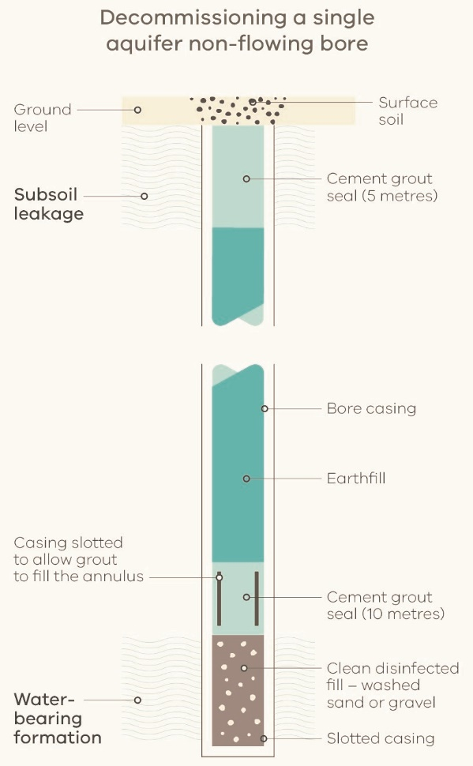

Decommissioning a ﬂowing bore using cement grout bridges
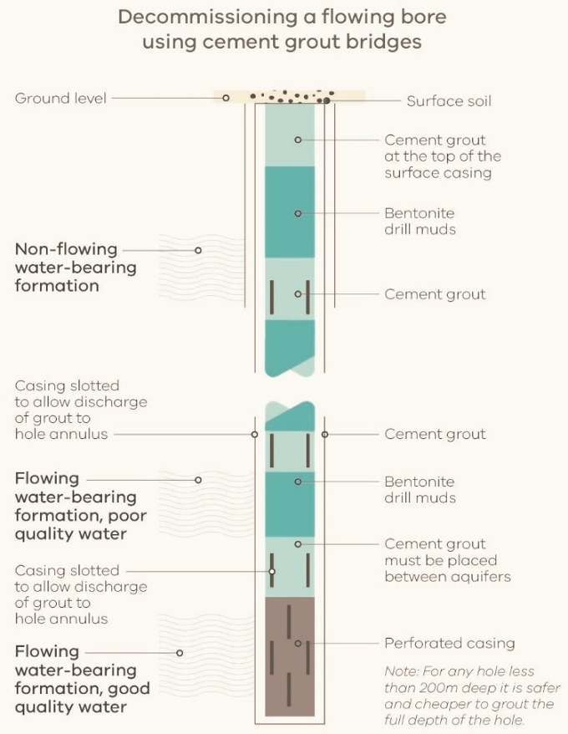
Authorised by the State Government of Victoria, Melbourne.
© Copyright State Government of Victoria 2020
This publication is copyright. No part may be reproduced by any process except in accordance with provisions of the Copyright Act 1968.

