Reportable Incidents
A Guide to Reporting under the Petroleum Act 1998 and Petroleum Regulations 2021

Authorisation
Approved by: Chief Inspector on 17 May 2022
Review date: by May 24
Contact: Mark D Duthie (DJPR)
Content Manager reference: DOC/22/37014 Guidance note – Reportable Incidents under Petroleum Act – Compliance - 20220517

Introduction and objectives
This guidance note provides authority holders with clear guidance about their obligations, under regulation 45(1) of the Petroleum Regulations 2021 (the regulations), to report any reportable incident in an appropriate, timely manner.
The overall objectives are to:
- encourage good quality reporting by providing clear guidance on what reportable incidents are, how and when they should be reported and what the potential consequences are for not reporting these types of incidents
- assure land holders, other community members and government that authority holders will be held accountable to fulfil their obligations to protect people, land, infrastructure, petroleum reservoirs and the environment throughout the life cycle of their resource projects
- provide guidance about how failure to comply with reporting obligations will be addressed in line with legislative and good regulatory practice.
Reportable incidents, as specified in the regulations, are defined in detail in section 2.

Procedure or guideline statement
Detailed, accurate and timely reporting of reportable incidents:
- enables key risks to be promptly identified and effectively addressed
- provides accurate, current data that supports forward planning related to managing and responding to risk
- gives the community assurance that the controls in place to manage risk are appropriate and effective.
Regulation 45(1) of the Petroleum Regulations 2021 defines a reportable incident as:
‘…an incident arising directly out of a petroleum operation that is reasonably likely to cause significant harm or damage to individuals, the environment, the integrity of the petroleum operation or the immediate area (whether above or below ground).’
If unclear about whether an event is a reportable incident, contact Earth Resources Regulation for advice. Reporting is always recommended if in doubt.

Roles and responsibilities
In accordance with Regulation 45 of the regulations, all petroleum reportable incidents must be reported to Earth Resources Regulation, which can be done via the dedicated incident mobile number below. This number is monitored 24/7.
0419 597 010
The authority holder must give notice of a reportable incident within two hours of when the reportable incident occurs or if the authority holder is not initially aware of the reportable incident, from when the authority holder becomes aware that it occurred.
The notice must be given orally and:
- include the material facts and circumstances of the reportable incident that the holder of the authority knows or is able, by reasonable search or enquiry, to find out
- describe any action taken by the holder of the authority to avoid or mitigate any impacts to individuals, public safety, public amenity or the environment of the reportable incident and
- describe any immediate corrective action taken, or proposed to be taken, by the holder of the authority to stop, control or remedy the reportable incident.
Within three days after the holder of an authority has given notice to Earth Resources Regulation of a reportable incident, the authority holder must submit a written report that includes:
- all details required to be included in the report outlined above.
Within 30 days after the holder of an authority has given notice of a reportable incident, the authority-holder must provide a written report that includes:
- the date, time and place of the reportable incident and
- a description of the reportable incident and
- any known or suspected causes of the reportable incident and
- a root cause analysis of the reportable incident and
- a description of the steps taken by the holder to minimise the impacts of the reportable incident and
- a description of the steps taken or proposed to be taken by the holder to prevent a recurrence of the reportable incident.
Regardless of whether reports of the event have been made to other regulatory agencies (e.g. EPA or WorkSafe Victoria), a report must be made to Earth Resources Regulation in accordance with the Petroleum Act 1998 (the Act) and the regulations.
Reports should be emailed to ERRChiefInspector@ecodev.vic.gov.au

Principles
Reportable incidents must be reported as this is a requirement under regulation 45(2), 45(3), 45(4) and 45(5) of the Petroleum Regulations 2021.
Benefits from reporting reportable incidents include:
- providing information to Earth Resources Regulation as to the nature and cause of an incident, the risk posed and the response underway or proposed. This in turn enables Earth Resources Regulation to provide informed comment to Emergency Services or other areas of government if required
- the information received is used to analyse trends within the industry, identify emerging issues and direct activity with co-regulators such as WorkSafe Victoria, Environment Protection Authority (EPA), Country Fire Authority (CFA), Fire Rescue Victoria and local government authorities
- reporting assists with investigation and root cause analysis to guide continuous improvement and helps promote a culture of safety and compliance
- reporting in accordance with regulatory obligations ensures transparency in operations, enhances community confidence in the industry and in the individual authority holder.
Earth Resources Regulation also encourages the reporting of incidents related to the public, environment, or integrity of the petroleum operation with minor or no consequence that occur within the worksite, as this is often a useful way to anticipate and prevent more serious incidents from occurring.

Reportable incident – process diagram
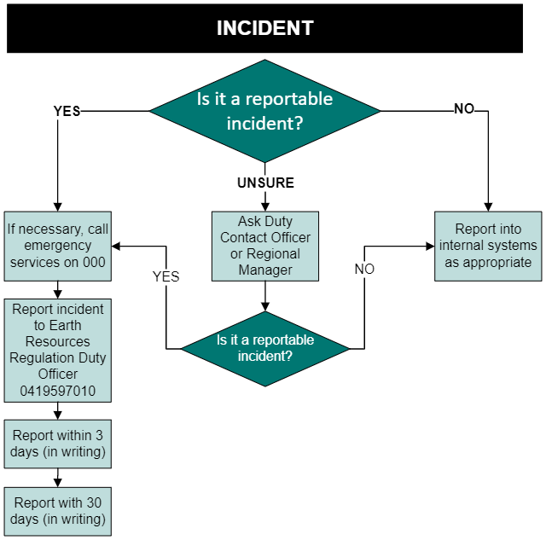

Related information
In relation to petroleum, it is an offence under regulation 45(2), 45(3), 45(4) and 45(5) of the regulations to fail to give notice of an incident at the prescribed time and in the prescribed manner, and can result in enforcement action, including prosecution of the offence.
Failure to report can be categorised as a failure to:
- report reportable incidents at all or
- report in the prescribed manner or
- provide a written report as requested.
Section 213(3) of the Petroleum Act 1998 makes it an offence to fail to comply with any lawful requirement of an inspector or making a statement knowing it to be false or misleading. Such an offence may result in enforcement action being taken.

Earth Resources Regulation 24-hour contact
Earth Resources Regulation maintains a 24-hour response and notification capability.
The first point of contact for any out of hours response is the Earth Resources Regulation Duty Officer (DO). The DO is responsible for the initial management of incidents and informing the Chief Inspector of incidents of significance. The DO can be contacted at any time by calling 0419 597 010.
Where it is unclear as to whether an incident is reportable, the DO should be contacted for advice.

Notification contacts
- Earth Resources Regulation Duty Officer: 0419 597 010 (24 hours)
- Email for written notification: ERRChiefInspector@ecodev.vic.gov.au

