Latrobe Valley Regional

REHABILITATION STRATEGY

ABORIGINAL ACKNOWLEDGEMENT
The Victorian Government proudly acknowledges Victoria’s Aboriginal community and their rich culture and pays respect to their Elders past and present and emerging. We acknowledge Aboriginal people as Australia’s first peoples and as the Traditional Owners and custodians of the land and water on which we rely. We recognise and value the ongoing contribution of Aboriginal people and communities to Victorian life and how this enriches all Victorians. We embrace the spirit of reconciliation, working towards the equality of outcomes and ensuring an equal voice.
The Victorian Government recognises the Gunaikurnai people who are the Traditional Owners of a large area of Gippsland affected by the Latrobe Valley Regional Rehabilitation Strategy – the area spanning from Warragul in the west to the Snowy River in the east, and from the Great Dividing Range in the north to the coast in the south.

FOREWORD
The Latrobe Valley has been the powerhouse of Victoria’s economy for decades.
Coal mining in the Latrobe Valley began almost a century ago to support the then Yallourn Power Station, which at the time was the first brown coal-fired power station outside of Germany.
The Latrobe Valley’s brown coal resource has been used to produce reliable, affordable electricity for years, with the region’s mining and power generation sector employing thousands of people both directly and indirectly.
However, the closure of the Hazelwood Mine and Power Station in 2017 and the projected closure of Yallourn and Loy Yang in 2032 and 2048 respectively, highlights the fundamental shift underway in the region’s economy as more renewable energy sources come online and the demand for electricity produced from brown coal reduces. As this occurs and the mining cycle comes to an end, the focus will turn to mine rehabilitation and finding positive and practical solutions for an area where some of the largest, open cut coal mines in the country are located, in close proximity to communities.
The Hazelwood Mine Fire in 2014 and subsequent inquiries highlighted that mine rehabilitation was an area needing a greater focus from all parties. The Hazelwood Mine Fire Inquiry found that there were a number of knowledge gaps associated with mine rehabilitation including the use of water to fill mine voids, the preferred option of each of the Latrobe Valley mine operators.
The Victorian Government committed to developing a regional rehabilitation strategy to help address these knowledge gaps. The Latrobe Valley Regional Rehabilitation Strategy is the culmination of four years of work that has delivered a major program of technical studies. The strategy has been prepared by the Department of Jobs, Precincts and Regions in collaboration with the Department of Environment, Land, Water and Planning and has had input from many as it has evolved.
The technical studies have considered the stability and fire risks associated with the mines once they cease operating and how these might be managed, as well as water availability and water quality considerations to deliver the various rehabilitation options.
This Strategy has been developed taking into account the findings of these studies and I am pleased to be delivering on our legislative commitment to undertake this important piece of work for the Latrobe Valley community, mine operators and other stakeholders.
This Strategy will guide mine rehabilitation planning for years to come. Importantly however, it does not prescribe the final landform for each of the mines, rather allows for the consideration of rehabilitation options that can be demonstrated to deliver a safe, stable and sustainable outcome. This allows for adaptability in our approach to rehabilitation planning and decision-making regarding mine rehabilitation, which in turn provides for consideration of environmental conditions and community and stakeholder views at the time. This is critical when you consider that based on current timelines, the region’s next brown coal mine is not due to close until 2032 and then 2048.
This Strategy is not the end of the road; there is more work to be done. This document outlines a series of further actions to be undertaken to ensure that planning for mine rehabilitation is informed by a robust evidence base and supported by clear and transparent decision-making processes. The Strategy is a living document; it will be updated at least once every three years to ensure it is informed by the most current information and knowledge.
I would like to take this opportunity to thank those that have participated in and contributed to this project over the last several years. In particular, I would like to thank the Latrobe Valley Mine Rehabilitation Commissioner, Emeritus Professor Rae Mackay and the Latrobe Valley Mine Rehabilitation Advisory Committee. Your input and insights have been greatly valued along the journey.
I look forward to seeing the implementation of this Strategy in the years ahead. This, coupled with the Victorian Government’s new Morwell-based Mine Land Rehabilitation Authority, will deliver positive mine rehabilitation outcomes for the Latrobe Valley.
Hon Jaclyn Symes MP
Minister for Resources

Volume 1

INTRODUCTION

PURPOSE
The Latrobe Valley Regional Rehabilitation Strategy (LVRRS) delivers on the legislated requirement, pursuant to section 84AZM of the Mineral Resources (Sustainable Development) Act 1990 (MRSD Act), for the Minister for Resources by 30 June 2020 to prepare a document that sets out the strategy in relation to:
- the safety, stability and sustainability of coal mine land and any adjacent land;
- the planning for the Latrobe Valley region in relation to the rehabilitation of coal mine land and any adjacent land, and the relationship between each mine void;
- the development of a plan for the monitoring and evaluation of coal mine land after rehabilitation of that land is complete.
The LVRRS supports integrated planning and decision‑making for the rehabilitation of the Latrobe Valley coal mines – Hazelwood, Yallourn and Loy Yang – within a regional context through providing guidance to the community, mine licensees, public sector bodies and other stakeholders on matters that need to be considered in planning for, and undertaking, rehabilitation of the three coal mines.
This strategy:
- works within the legal and regulatory framework of the MRSD Act and accompanying regulations that applies to all major mining operations in Victoria.
- as such, does not set out a rehabilitation plan for each mine, as this will be subject to further technical investigations and form part of each mine licensees’ Declared Mine Rehabilitation Plan to be submitted to the Department of Jobs, Precincts
and Regions (DJPR).
The table below maps the legislated requirements under Section 84AZM of the MRSD Act against the contents of this document:
Table 1: Legislated requirements of the LVRRS under Section 84AZM of the MRSD Act

MRSD Act, Section 84AZM  The LVRRS must set out the strategy in relation to: | Guide to relevant sections  of this document
The safety, stability and sustainability of coal mine land and any adjacent land | Principles to guide rehabilitation planning for each Latrobe Valley coal mine in a regional context  Process for integrated rehabilitation planning  Implementation actions
The planning for the Latrobe Valley region in relation to the rehabilitation of coal mine land and any adjacent land, and the relationship between each mine void
The development of a plan for the monitoring and evaluation of coal mine land after rehabilitation of that land is complete | Development of a plan for monitoring and evaluation of coal mine land after rehabilitation is complete

CONTEXT
This strategy has been developed on the basis that:
- All three Latrobe Valley coal mines are on privately owned land, and the rights and obligations of landholders apply.
- The MRSD Act places responsibility for rehabilitation of individual mine sites on mine licensees, including planning, rehabilitation works and associated costs.
- Government’s role is to provide policy and guidance, and to facilitate or support investment by industry where there is a clear community benefit. Its role should not constrain the ability of industry to find new and innovative solutions to mine rehabilitation.
- There are social, cultural, environmental and economic factors that may change the feasibility of rehabilitation options available at future points in time, including significant uncertainties associated with climate change and water availability.
- Rehabilitation is likely to take decades after the cessation of mining at each site, and the community should have the opportunity to be involved over this time.

VISION AND OUTCOMES
The vision of this strategy is that the Latrobe Valley coal mines and adjacent land are transformed to safe, stable and sustainable landforms which support the next land use.
This vision will be delivered by achieving six outcomes for the rehabilitation of coal mine land, and the monitoring and evaluation of that land after rehabilitation is complete:
- People, land, environment and infrastructure are protected.
- Land is returned to a safe, stable and sustainable landform.
- Aboriginal values are protected.
- Community are engaged, and their aspirations inform the transformation.
- Long term benefits and future opportunities to the community are optimised.
- An integrated approach to rehabilitation and regional resource management is adopted.
To support the realisation of this vision and outcomes, the LVRRS sets out principles to guide planning for the rehabilitation of Latrobe Valley coal mines and adjacent land within a regional context (Figure 1).
Figure 1: LVRRS vision, outcomes and implementation principles

Vision
The Latrobe Valley coal mines and adjacent land are transformed to safe, stable and sustainable landforms which support the next land use.

Regional mine rehabilitation outcomes
People, land, environment and infrastructure are protected
Land is returned to a safe, stable and sustainable landform
Aboriginal values are protected
Community are engaged, and their aspirations inform the transformation
Long term benefits and future opportunities to the community are optimised
An integrated approach to rehabilitation and regional resource management is adopted

Implementation principles
Fire risk of rehabilitated land should be no greater than that of the surrounding environment
Traditional Owner involvement in rehabilitation planning should be developed in consultation with Gunaikurnai Land and Waters Aboriginal Corporation
Requirements for ongoing management to sustain a safe and stable landform should be minimised as far as practicable
Community should be consulted on rehabilitation proposals, the potential impacts, and have the opportunity to express their views
Mine rehabilitation should plan for a drying climate. Rehabilitation activities and final landforms should be climate resilient
Mine rehabilitation and regional land use planning should be integrated and the rehabilitated sites should be suitable for their intended uses
Any water used for mine rehabilitation should not negatively impact on Traditional Owners’ values, environmental values of the Latrobe River system or the rights of other existing water users
Ground instability and ground movement risks and impacts during rehabilitation and in the long-term should be minimised as far as practicable

BACKGROUND
The Hazelwood Mine Fire Inquiry (HMFI) considered the future rehabilitation of the Latrobe Valley’s three coal mines – Hazelwood, Yallourn and Loy Yang. The HMFI was in response to the major fire in the Hazelwood mine over February-March 2014, caused by embers spotting into the Hazelwood mine from bushfires burning in close proximity to the mine. The fire burned for 45 days, sending smoke and ash over Morwell and surrounding areas.
The HMFI considered six general rehabilitation approaches that could be implemented to achieve safe and stable landforms. In considering these approaches, the HMFI recognised the potential for beneficial final land use is a key criterion in assessing rehabilitation options, but concluded that the safety, stability and sustainability of the landform was of
paramount importance.
The HMFI commissioned a consultant report into the six rehabilitation options. The report concluded that four of the options were ‘not viable’ at the time due to the judgment that technical or financial aspects of the rehabilitation works associated with these options rendered them impracticable, that ongoing active management activities at the sites and associated risks and costs would be undesirable, and that next land uses should not be limited (e.g. to waste disposal). The remaining two options involved the creation of a waterbody to full or partly fill the mine voids. A report written jointly by a group of six mine rehabilitation experts convened by the HMFI Board, including the consultant’s principal hydrogeologist and three experts retained by mine licensees, agreed that these were the only two options that could be considered viable at the time, for similar reasons as those presented in the options report. However, two of the experts noted that it was possible that these waterbody options may be considered less attractive or viable in the future once additional research on likely future water availability was undertaken.
The HMFI Board stated that it was persuaded by the expert evidence, at the time, that a waterbody-based option was considered the most viable rehabilitation approach at each void, based on the ongoing significant fire and stability risks to be managed following cessation of mining, and the technical and financial aspects of the rehabilitation works. However, the Board also accepted that there were many unresolved issues about how a waterbody option could be achieved.
- ‘Prolonged years of drought combined with water restrictions, extreme weather events and a greater awareness of climate change have dramatically influenced society’s views and expectations on current and future water usage. The original concept of all three coal mines being flooded with water to create artificial lakes may not be viable in light of changing environmental and regulatory constraints. This plan needs to be revisited, as recommended by the Sustainable Water Strategy.
- At this point in time, the mine licensees are not using their full water allocations under their [entitlements], despite this being proposed under the rehabilitation plans for the Yallourn and Loy Yang mines. This means that the impacts on the water system of the full use of those allocations (assuming they are available) are unknown, and could be significant for the region. Further, if water is available under the current allocations but at a cost, or only over a certain period of time, this may impact the viability of this option as compared with others.
- Without certainty around this issue, it is difficult for the Board to determine, other than to confirm that without reliable sources of water, the pit lake option will be unviable and unsustainable. The uncertainty in this area is a limitation of the option, particularly due to the volumes of water, the timeframes, and the potential for external factors to influence availability of water.’
The Board concluded that:
‘…it is not at all clear that sufficient water will be available to any of the mines for the purpose of rehabilitation, in terms of both using existing water allocations and the quantity of water available in the water system at the time the mines are scheduled to be filled.’
Consequently, one of the key findings of the HFMI was that there were significant gaps in knowledge and uncertainties surrounding the closure and rehabilitation of the Latrobe Valley’s mines, both at the site scale and regional scale.

HAZELWOOD MINE FIRE INQUIRY GOVERNMENT
IMPLEMENTATION PLAN
To fill the regional knowledge gaps identified by the HMFI, the Victorian Government committed to investigating the feasibility of the water-based rehabilitation options identified by the HMFI for the Latrobe Valley mines, and to prepare the LVRRS to guide regional and influence site scale rehabilitation planning, taking into account the interconnections between the voids.
Regional studies were undertaken by Government to investigate:
- Geotechnical considerations
- Water considerations, and
- Land use considerations for regional planning around the three coal mine voids.
Alongside these studies, the mine licensees committed to an integrated research program to address site scale knowledge gaps, such as the stability of submerged mine walls (known as batters), viable batter angles, levels of backfill needed to mitigate stability and fire risks, wave erosion, and the requirements for ongoing maintenance and monitoring after rehabilitation is complete. As part of the Government’s Implementation Plan, the Earth Resources Regulator and the Latrobe Valley Mine Rehabilitation Commissioner (the Commissioner) oversaw the Batter Stability Project to research and advise on the design of safe and stable mine batters in the long term. The Commissioner has also undertaken legislated reviews and provided recommendations on rehabilitation research plans prepared by the three mine licensees.
The Government further undertook a Preliminary Land Use Vision to consider a range of land use opportunities for the future of the Latrobe Valley once the mines have been rehabilitated. This Preliminary Land Use Vision was informed by a series of stakeholder and community workshops throughout 2018–2019.
The Minister for Resources also approved the release of an overview of the LVRRS for public consultation in November 2019.

LATROBE VALLEY REGIONAL GEOTECHNICAL STUDY
The Latrobe Valley Regional Geotechnical Study investigated the regional stability and fire risks associated with the coal mine voids, and whether those risks could be mitigated if water were used to fill or partly fill the voids. Safe operating conditions at the Latrobe Valley coal mines are currently maintained through active controls such as large-scale groundwater pumping and drainage, surface water management and extensive monitoring. Nonetheless, unexpected and undesirable land movements have occurred throughout the operating life of the mines, ranging from small, continuous movement of mine batters to major batter failures extending beyond the mine crest. An example of a recent major batter failure was in 2007, when a batter failure at Yallourn mine led to the Latrobe River diverting into the mine for six days. Exposed coal has also caught fire a number of times, causing impacts to communities and the mines, most recently during the 2014 Hazelwood mine fire.
The past failures and ground movements over the life of the Latrobe Valley mines demonstrate that active controls and regulation practices cannot guarantee the prevention of major ground movements or coal fires.
Passive controls provide more sustainable methods for minimising these risks. In the context of mine rehabilitation, this is achieved through landform design. Passive design elements include the use of rock and water to stabilise mine floors and batters, and covering coal (e.g. with soil or water) to prevent coal ignition by external sources. Passive controls would minimise post-closure stability and fire risks to adjacent communities, infrastructure and waterways, and would significantly reduce the maintenance requirements of the rehabilitated landform and associated ongoing costs.
As the mines close it will be highly desirable to transition to passive controls, to the extent practicable, to manage stability and fire risk, to ensure that post-closure risks to the community and environment are minimised and that maintenance of the rehabilitated landform is environmentally and economically sustainable.
The Latrobe Valley Regional Geotechnical Study found that a waterbody-based rehabilitation approach could achieve safe and stable landforms for the Latrobe Valley coal mines through largely passive controls, noting that active controls may still be needed to produce, fill, maintain and monitor levels and quality of water and/or other resources in the void into perpetuity to maintain safety and stability. However, longer fill times arising from limited water availability would present stability challenges that would need to be actively managed over the duration of any filling of the mine.

LATROBE VALLEY REGIONAL WATER STUDY
The Latrobe Valley Regional Water Study investigated whether, and to what extent, the proposed filling, or partial filling, of the mine voids with water taken from the Latrobe River system and Latrobe Valley aquifers would result in adverse ecological, social, cultural and economic impacts to the region.
The Regional Water Study found that up to 3,000 gigalitres (GL) of water could be needed to completely fill all mine voids to their crests. If the mine voids were only partially filled with water to prevent floor heave, the volume of water collectively required by the three mines would be approximately 1,600 GL (Table 2). As mine rehabilitation will be undertaken progressively as individual mines close, this means that the volumes of water, if required, would not all be required at once. It is likely that if a water-based mine rehabilitation approach were taken, it would take many decades to fill or partially fill the voids with water.
The study further found that the ongoing volume of water needed to maintain water levels in the mine voids to offset evaporation, should a water-based mine rehabilitation approach be taken for all three mines, is estimated to be around 15 GL per year, but could be higher depending on the future climate. In comparison, water supplied to towns (excluding industry) across Central Gippsland totalled approximately 13 GL per year in 2017–18.
Uncertainty in future water availability poses a significant risk to water-based rehabilitation approaches, as water may not be available in the volumes required and at the times needed. The Regional Water Study found that there is significant uncertainty about whether water required for water-based rehabilitation approaches would be available from the Latrobe River system under a median or dry climate change scenario (Figure 2). The Latrobe Valley has predominantly experienced drying conditions since 1997, which is consistent with what has been experienced across Victoria over the same time period, and that surface water availability in the Latrobe River system has decreased from a longer-term average of about
800 GL a year to about 600 GL a year.
Climate change projections for the region indicate a wide range of possible futures. Comparisons of observations and projections in Victoria for both rainfall and climate suggest that temperature has been tracking toward the upper limit of projections while winter rainfall has been tracking toward the drier end of projections. The Regional Water Study found there are uncertainties associated with future water availability due to climate change and climate variability, and that mean annual water availability in the Latrobe River under a ‘dry climate’ scenario is projected to further decline to approximately 467 GL a year by 2050, and 334 GL by 2080. Under such a scenario, water from the Latrobe River system would not be available for mine rehabilitation because it would have unacceptable impacts on other existing entitlement holders and minimum environmental flows.
Table 2: Volume of water required to create water bodies in the mine voids (indicative)

Mine | Scheduled  Closure Date | weight balance (GL) | Full pit lake (GL)
Hazelwood | Closed | 530 | 638
Yallourn | 2032 | 0 | 725
Loy Yang | 2048 | 1,111 | 1,418

To protect the security of existing entitlements for other water users and prevent further environmental impacts, the maximum annual supply of water for mine rehabilitation would need to be no more than the power stations’ current annual net usage, and may need to be limited to a volume smaller than this, should the Minister for Water decide to permit the take and use of water for the purpose of mine rehabilitation from the Latrobe River system. Any filling of the mine voids with water from the Latrobe River system would need to be subject to conditions, such as restricting or halting filling when it is dry, to prevent unacceptable impacts on other water users and the environment and allow for declines in water availability to be shared between all water users.
Figure 2: Water availability in the Latrobe River system: Latrobe River inflows compared with minimum environmental water requirements and consumptive uses, including power generation
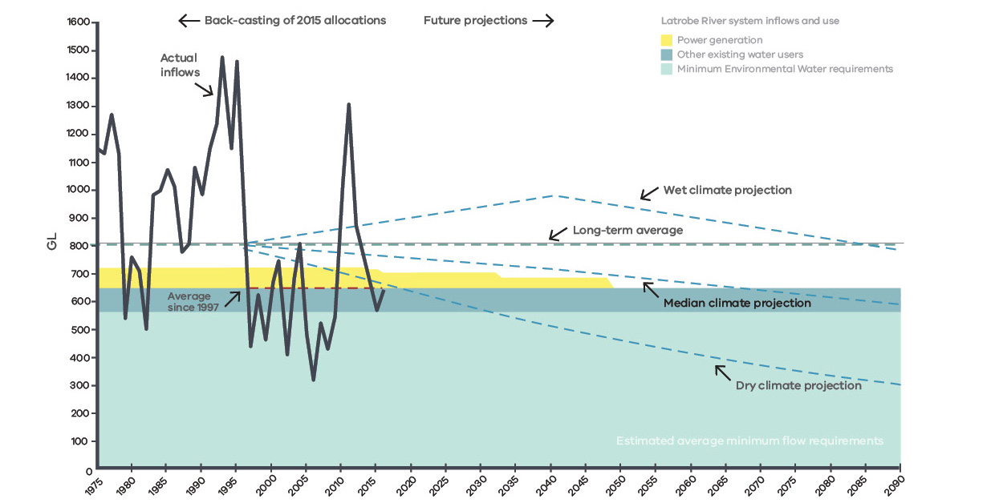
Modelling undertaken for the Regional Water Study shows that it would take a minimum of 15 to 30 years
to fill each mine void with locally sourced water, but this estimate assumes that there are no dry conditions that interrupt supply and does not account for evaporative losses. When evaporative losses are considered, these timeframes could extend out by another five years. Given the uncertainty in the future climate, it is difficult to predict what impact dry conditions could have on fill times.
However, under a dry climate scenario it is unlikely that water will be available for mine rehabilitation in most years, particularly in the latter half of the century. It may be possible to continue filling the mine voids at a slower rate during dry conditions by using groundwater, but rehabilitation could take many decades. For example, if filling Loy Yang were restricted to using groundwater only it would take approximately 75 years to achieve weight balance.
In light of these findings, the Regional Water Study included a semi-quantitative assessment of the feasibility of using alternative sources, such as desalinated water, recycled water and/or stormwater, for the purposes of mine rehabilitation. The assessment concluded that there are currently no new or alternative water sources that would be more economically feasible for mine rehabilitation than water sourced from the Latrobe River system and Latrobe Valley aquifers. This conclusion was drawn primarily from the basis that the new or alternative water sources surveyed were deemed to be comparatively more expensive. The study did note, however, that alternative water sources may become more feasible or attractive in the future if a water-based rehabilitation approach is adopted and low water availability in the Latrobe River system is likely to significantly limit rehabilitation progress. The study stated that a more thorough quantitative assessment of specific options may be warranted in the future and that such an investigation could include environmental, cultural, social and economic benefits and costs.

LATROBE VALLEY REGIONAL LAND USE STUDY
In order to consider a range of land use opportunities for the future of the Latrobe Valley once the mines have been rehabilitated, a Preliminary Land Use Vision for the Latrobe Valley mines and surrounding region was prepared. The Preliminary Land Use Vision was informed by a series of stakeholder and community workshops throughout 2018-2019. The draft Preliminary Land Use Vision was placed on public exhibition and a report was prepared on the wide and divergent range of views expressed by stakeholders and the community. These views have been considered and have helped inform the LVRRS’ identified outcomes.
The Preliminary Land Use Vision considered existing land use provisions and policy and the economic and social opportunities that could be created by the closure and rehabilitation of the mines. The Gippsland Regional Growth Plan and Latrobe City Council’s Live Work Latrobe reports informed the analysis in the Preliminary Land Use Vision. Themes for future land use were applied along with consideration of the studies into regional water issues and the geotechnical findings.
The Preliminary Land Use Vision found that many land use options could be included in the post-rehabilitation landscape, that many different land use options were acceptable to the community, and that the transition of uses over time could be linked with the stages of mine rehabilitation. The end state of the mine void, as an empty void, a partial pit waterbody or a full pit waterbody, will create different land use constraints and opportunities. Other matters regarding separation of sensitive uses and consideration of fire and stability risks will need closer examination at a mine specific level.

PUBLIC CONSULTATION ON THE LVRRS AND STAKEHOLDER RESPONSE
DJPR released the Overview of the LVRRS for public consultation in November 2019. A summary of this consultation is included with this strategy.
A key theme that emerged from stakeholder and community consultation was a desire for a range of rehabilitation options to be further considered, including non water-based options as well as options that do not involve the use of water from the Latrobe River system. Keeping the range of possible options open was considered valuable by some stakeholders, particularly those seeking to protect water resources and cultural and environmental values. A range of stakeholders also expressed doubts that use of water for mine rehabilitation would be the best use of the region’s valuable water resources, especially when this water could otherwise be used for:
- agricultural expansion and the jobs and food security for Victoria that it would provide
- improving the health of a major river system and Ramsar-listed Lakes system, and/or
- providing water-based opportunities for Traditional Owners.
These sentiments were expressed by Gunaikurnai Land and Waters Aboriginal Corporation (GLaWAC), the Latrobe City Council, West Gippsland Catchment Management Authority, Victorian Environmental Water Holder, Victorian Farmers Federation, irrigators within the region and Environment Victoria, among others.
Mine and power station operators have been consistently clear that—from their perspective—water is the only practicable option for mine rehabilitation, as they foresee significant costs and risks associated with other options. Some of the Latrobe Valley mine licensees have flagged risks to continuing mine and power station operations due to uncertain access to water for mine rehabilitation and associated cost uncertainties. They seek access to water in a fair and equitable way to fill the voids to levels that achieve a safe and stable post-mining landform. The operators have also communicated their understanding that any water accessed or permitted for rehabilitation would need to be adaptive to protect other existing water users and minimum environmental flows, but hold the view that new water users should not take priority over mine rehabilitation. The mine licensees emphasised the need to partner with government to create value through amenity works above the minimum requirements to provide safe, stable and sustainable rehabilitated landforms. Two of the operators have requested an opportunity to further explore the feasibility of new or alternative water sources in collaboration
with government.
A range of community organisations and community members are open to water-based rehabilitation options, providing the use of water does not adversely impact other users in the system. Many stakeholders expressed a desire to see the rehabilitated voids and surrounding land offer amenity to the region and Victoria more broadly. Other community members acknowledged that, while water may provide the best option to achieve safe and stable landforms, they had significant concerns about the sustainability of such an approach given the large volumes of water required to create and maintain water bodies in the voids.

PRINCIPLES TO GUIDE REHABILITATION PLANNING FOR EACH LATROBE VALLEY COAL MINE IN A REGIONAL CONTEXT
Planning for rehabilitation of the coal mines in the Latrobe Valley should have regard to the principles of sustainable development as set out in the MRSD Act, which relate to community wellbeing, regional and economic development, intergenerational equity, environmental protection and community involvement.
The LVRRS sets out principles to guide the planning associated with both mine rehabilitation, and the monitoring and evaluation of that mine land after rehabilitation is complete, in the Latrobe Valley.
These principles have been designed to capture and address the first two of the LVRRS’ three legislative requirements, being to set out a strategy in relation to:
- the safety, stability and sustainability of coal mine land and any adjacent land; and
- the planning for the Latrobe Valley region in relation to the rehabilitation of coal mine land and any adjacent land, and the relationship between each mine void.
Regional and site-scale planning for mine rehabilitation in the Latrobe Valley should have regard to the principles of sustainable development and the principles set out in the LVRRS.

1. THE FIRE RISK OF THE REHABILITATED LAND SHOULD BE NO GREATER THAN THAT OF THE SURROUNDING ENVIRONMENT
Exposed coal in the Latrobe Valley coal mines has caught fire a number of times, causing impacts to communities and the mines, most recently during the 2014 Hazelwood mine fire.
Coal fire risk is best managed by covering exposed coal. If water is chosen by a mine operator as the preferred rehabilitation method for mine void ground stability control, it would also assist in covering large areas of exposed coal and,
if water levels are maintained, fire risk would be eliminated for the covered coal.
Coal coverage can also be achieved by providing a suitable soil-vegetation cover system able to withstand erosion.
Where there is a risk that the covered coal may become exposed, for example through erosion or declining water levels in the void, a long-term cover maintenance plan would be required. This may need to be augmented by fire suppression infrastructure where the cover material performance is limited or subject to deterioration.
Exposed coal should be covered to the extent necessary and practicable. Coal fire risk controls for the rehabilitated mine, whether achieved with water, soil-vegetation cover and/or fire suppression infrastructure, should be designed to achieve no fire risk greater than that of the surrounding environment, taking account of their efficacy, longevity and maintenance requirements.

2. GROUND INSTABILITY AND GROUND MOVEMENT RISKS AND IMPACTS DURING REHABILITATION AND IN THE LONG-TERM, AND REQUIREMENTS FOR ONGOING MANAGEMENT TO SUSTAIN A SAFE AND STABLE LANDFORM, SHOULD BE MINIMISED AS FAR AS PRACTICABLE
The Latrobe Valley Regional Geotechnical Study Synopsis Report sets out the key ground movement risks of significance
to mine rehabilitation planning in the Latrobe Valley, possible controls for these risks, and areas that require further consideration.
The safety and stability of the existing coal mine voids is currently maintained through a range of active controls such as groundwater pumping and drainage, surface water management and extensive monitoring, and limiting the types of adjacent land uses (including preventing public access). Nonetheless, unexpected and undesirable land movements have occurred ranging from small, continuous movement of mine batters to major batter failures extending beyond the mine crest. An example of a recent major batter failure was in 2007, when a batter failure at Yallourn mine led to the Latrobe River diverting into the mine for six days.
Based on these historical mine instability events, it is clear that active controls and regulation practices cannot guarantee that major ground movements or coal fires will not occur in the future.
Passive controls can significantly reduce the need for ongoing action in managing safety and stability risk. In the context of mine rehabilitation, this is achieved through landform design. Passive design elements may include the use of sediments and water to stabilise mine floors and batters.
The Regional Geotechnical Study Synopsis Report noted that, as the mines close, it will be desirable to transition to passive controls to manage stability to minimise post-closure risks to the community and environment.
Whether a particular post-mining landform can be considered safe and stable depends on the proposed post-mining land use and acceptance of residual ground movement risk associated with that landform. For example, what is considered safe and stable for an industrial post-mining land-use may be different to that for a housing development or broad-acre agricultural land-use.
The post-mining landforms should present the lowest reasonably achievable risk to public health and safety, both within and beyond the mine boundaries, at the time of relinquishment and into the future. Future ground movements of the post-mining landforms should be minimised as far as reasonably practicable and those movements that occur should be understood, predictable and controllable, having regard to the proposed post-mining land use(s).
Rehabilitation plans should provide for a transition to passive controls to eliminate or minimise stability and fire risks to the extent practicable. Any residual risks to the community, infrastructure or the environment should be minimised using controls that can be sustainably maintained, having regard to the availability and financial and energy costs of controls including water or other materials needed to maintain the mine void in an acceptably safe, stable and sustainable condition in perpetuity.

3. MINE REHABILITATION SHOULD PLAN FOR A DRYING CLIMATE. REHABILITATION ACTIVITIES AND FINAL LANDFORMS SHOULD BE CLIMATE RESILIENT
The Latrobe Valley Regional Water Study found that surface water availability in the Latrobe River system has decreased in the past 20 years, and that there are uncertainties associated with future water availability due to climate change and climate variability.
Rehabilitation approaches that predominantly use water from the Latrobe River system pose a significant risk to successful mine rehabilitation, as water may not be available in the volumes required and at the times needed.
Under current conditions, or a drier climate, the volume of water available for water-based mine rehabilitation approaches may be limited and any approach to mine rehabilitation that utilises water from the Latrobe River system may need to be restricted or halted during dry conditions to prevent unacceptable impacts on existing users and the environment. Extended fill times arising from limited water availability are likely to present safety and stability challenges and fire risks that would need to be managed. Fire risks would also be greater in a drier climate, and lower soil moisture could potentially impact the integrity of soil-vegetation coal cover systems.
It is therefore essential that, due to the long time frames involved with mine rehabilitation, the impacts of climate change are considered when addressing questions posed by the HMFI about the reliability of sources of water for mine rehabilitation.
Rehabilitation should plan for a drying climate and rehabilitation approaches that manage safety and stability risks with no water or less water, or water from alternative water sources such as recycled or desalinated water, forming part of the solution.
Where a water-based approach to mine rehabilitation is proposed, there is a risk that sufficient water will not be available. Alternative/contingency rehabilitation options should be identified to ensure a safe, stable and sustainable rehabilitated landform can be achieved to safeguard the welfare of future generations.
Rehabilitation should achieve safe, stable and sustainable landforms under the range of future climate and water availability scenarios recommended in the guidelines issued by the Department of Environment, Land, Water and Planning (DELWP) for water resource planning activities.

4. ANY WATER USED FOR MINE REHABILITATION SHOULD NOT NEGATIVELY IMPACT ON TRADITIONAL OWNERS’ VALUES, ENVIRONMENTAL VALUES
IN THE LATROBE RIVER SYSTEM, OR THE RIGHTS OF OTHER EXISTING WATER USERS
The surface water of the Latrobe River system and the groundwater from the Latrobe Valley aquifers support a variety of uses in the Latrobe River catchment and a diverse mix of social, cultural, economic and environmental values are derived from these uses. Water from the Latrobe River system is currently used to supply drinking water to homes and businesses in Gippsland, for growing and processing food and fibre products in the area, and for electricity generation and other industrial purposes. Environmental water protects the system’s biodiversity which is of great cultural importance to Traditional Owners and supports recreation and tourism in the region. Furthermore, Victoria has international, national and state-based obligations to protect and restore the Gippsland Lakes, which are a Ramsar-listed wetland of international importance.
Without careful planning that takes into consideration regional risks, mine rehabilitation in the Latrobe Valley could potentially impact upon a wide range of values in the Latrobe Valley and beyond.
If the drying conditions predominantly experienced in Gippsland continue into the future, supplying local surface water for mine rehabilitation could impact on:
- Traditional Owner values — GLaWAC has identified many sites of cultural significance along waterways that could be impacted by changing water quantity and quality. They have also emphasised the importance of connected Country and the role the Latrobe River plays in the health of the Lower Latrobe wetlands and the Gippsland Lakes.
- Existing water users — The Latrobe River system is an important source of water for towns, industry (including electricity generation), agriculture, recreation and the economic activities tied to these uses of water.
- Environmental values — the Latrobe River system supports significant ecological values, including wetlands of international importance in the Gippsland Lakes Ramsar Site. The Latrobe River system provides habitat to many nationally listed threatened species and ecological communities such as the
Eastern Curlew and the Green and Golden Bell Frog.
Through Water for Victoria (2016), the Government is committed to recognising Aboriginal values and objectives for water and to supporting Aboriginal peoples’ access to water for economic development.
Mine rehabilitation should not adversely impact on the environmental values of the Latrobe River system.
The principles of sustainable development, as set out in the MRSD Act, state that biological diversity should be protected, and ecological integrity maintained.
If there are threats of serious or irreversible environmental damage, lack of full scientific certainty should not be used
as a reason for postponing measures to prevent environmental degradation and decision-making should be guided by:
- a careful evaluation to avoid serious or irreversible damage to the environment wherever practicable; and
- an assessment of the risk-weighted consequences of various options.
Protection of environmental values in the Latrobe River system depends on the volume of water available for the environment, the timing of when there is water, the quality of the water (e.g. salinity, dissolved oxygen etc) and the physical form of the waterway (i.e. to allow the migration of fish up and down waterways). Mine rehabilitation plans that change the volume, timing or quality of water in the Latrobe River or the physical form of the waterway should be carefully evaluated. Protection of environmental values should be assessed using metrics that reflect these factors, such as the environmental flow recommendations for the Latrobe River and the water quality indicators and objectives in the environment reference standards under the Environment Protection Amendment Act 2018.
To protect the security of existing entitlements for other water users and prevent further environmental impacts, the maximum annual supply of water for mine rehabilitation would need to be no more than the power stations’ current annual net usage, and may need to be limited to a volume smaller than this, should the Minister for Water decide to permit the take and use of water for the purpose of mine rehabilitation from the Latrobe River system. This is because the power generators use less water than their entitlement volume and return large volumes of water to the river system (return flows).
Since 2005-06, the Latrobe Valley power stations have used, on average, around 78 GL per year of surface water from the Latrobe River system for power generation, and the mine operations have extracted around 28 GL per year of groundwater to maintain the stability of the coal mine voids during mining activities. Around 23 GL of water per year has also been returned to the Latrobe River system, which has been used by irrigators and provided benefits to the environment. As a result, the net surface water usage for power generation has been around 55 GL per year.
If the drying conditions currently being experienced in Gippsland continue into the future, by 2048, when Loy Yang is scheduled to close, inflows in the Latrobe River system may be approximately half of their historic average. Under such a scenario, the available water for existing entitlement holders and water users, including farmers, households and the environment, would decline and need to be shared. If, under these conditions, water from the Latrobe River system was also made available for mine rehabilitation, these declines to existing entitlement holders and water users would be further exacerbated.
If water from the Latrobe River system and Latrobe Valley aquifers is needed for mine rehabilitation, the entitlements and needs of existing users, including communities, farmers and the environment, would need to be protected.
An application for a water entitlement under the Water Act 1989 must be considered with regard to a range of matters, including (but not limited to):
- any adverse effect that the allocation or use of water under the entitlement is likely to have on existing authorised uses of water (including reliability of supply), the waterway or aquifer, and the maintenance of the environmental water reserve in accordance with its objective;
- the need to protect the environment, including the riverine and riparian environment;
- the needs of other potential applicants;
- any water to which the applicant is already entitled; and
- the existing and projected availability of water in the area.
Safeguards, such as conditions on access to water and/or other resources for mine rehabilitation, should be put in place to protect the environment, Traditional Owner values and the rights of existing water users. Approaches to mine rehabilitation should not be permitted to adversely impact on these rights, or result in unreasonable interferences in making progress towards their improvement.

5. TRADITIONAL OWNERS SHOULD BE INVOLVED IN REHABILITATION PLANNING, ASSESSMENT AND DECISION-MAKING
The Victorian Government acknowledges its obligations and responsibilities within its Recognition and Settlement Agreement with GLaWAC, as agreed to under the Traditional Owner Settlement Act 2010.
It is recognised that the rehabilitation of the Latrobe Valley mines and surrounding land parcels should involve GLaWAC and consider its Whole of Country Plan. Mine licensees should continue to expand their engagement with GLaWAC and Traditional Owners in the Latrobe Valley as rehabilitation activities are progressed.
As part of the mine site rehabilitation, opportunities for healing and renewal to the biodiversity of the natural environment should be considered. This may include locations that have been significantly modified by mining and farming activities and form part of the mine licensees’ land holdings.
Steps to restore and/or reinstate natural systems in the vicinity of waterways and identified sites of cultural significance should be acknowledged and where possible included in site and precinct plans.
Consistent with the Victorian Government’s commitments in Water for Victoria (2016), any water access arrangements for mine rehabilitation should ensure that there are opportunities for consultation with GLaWAC as part of this process.
GLaWAC should be consulted and be involved in the healing and future protection of Country and appropriate cultural activities in association with the mine sites and the region.

6. THE COMMUNITY SHOULD BE CONSULTED ON REHABILITATION PROPOSALS, THE POTENTIAL IMPACTS, AND HAVE THE OPPORTUNITY TO EXPRESS THEIR VIEWS
Individual mine licensees have obligations to engage the community and other stakeholders regarding mine rehabilitation. It is expected that the development of their rehabilitation plans should be informed and supported by engagement with the local community and other key stakeholders. Figure 3 outlines the process for informing rehabilitation plans in relation to rehabilitation of the Latrobe Valley coal mines.
Community consultation by mine licensees should focus on:
- building collective understanding of the challenges, opportunities and technical constraints associated with each rehabilitation option considered;
- finding common ground, identifying aspirations, and acceptable and unacceptable impacts associated with each rehabilitation option; and
- helping the mine licensee’s/licensees’ understanding of community views and sentiment regarding various rehabilitation options and use this feedback to inform their rehabilitation planning.
Planning for and delivery of consultation activities should be undertaken in line with relevant regulations and legislation including the MRSD Act, Water Act 1989 and planning-related Acts. Where consultation is required, the licensees should document how they have provided information to community and stakeholders regarding rehabilitation options for their sites and how community and stakeholder views have been considered and informed the licensee’s selection of their preferred option.

7. MINE REHABILITATION AND REGIONAL LAND USE PLANNING SHOULD BE INTEGRATED, AND THE REHABILITATED SITES SHOULD BE SUITABLE FOR THEIR INTENDED USES
Mine rehabilitation planning should be integrated with regional land use planning. The objectives of planning in Victoria under Section 4 of the Planning and Environment Act 1987 include ‘to provide for the fair, orderly, economic and sustainable use, and development of land’, as well as ‘to balance the present and future interests of all Victorians’. In addition, the objectives of the planning framework established by this Act include:
‘to enable land use and development planning and policy to be easily integrated with environmental, social, economic, conservation and resource management policies at State, regional and municipal levels.’
Integrating mine rehabilitation and regional land use planning consistent with these objectives should allow for the economic and sustainable use of rehabilitated land in a way that is fair and orderly, and gives weight to the interests of Victorians in the future as well as in the short-term.

Latrobe Planning Scheme
Rehabilitation planning should be aligned with strategic directions and related provisions in the Latrobe Planning Scheme. Planning policy should be consistent with policy guidance for the preparation of declared mine rehabilitation plans, which are required for all declared mines (currently the three Latrobe Valley coal mines), and
vice versa.
The Latrobe Planning Scheme should be amended to incorporate strategic actions relating to:
- Structure planning for the post-mining use and development of rehabilitated mines and immediately adjoining land within mine licence areas as rehabilitation progresses and is completed
- Ensure appropriate coordination with rehabilitation planning under the MRSD Act
- Ensure appropriate coordination with planning and related decision-making under the Catchment and Land Protection Act 1994 to integrate land use planning and catchment management, and
- Require assessment of proposed new land uses and development in relation to both:
- likely environmental, economic and social effects
- applicable policy for after-use of rehabilitated coal mine land.
Relevant government agencies should consult with the Latrobe City Council and stakeholders on the best approach to implement these actions.
Proposed rehabilitated and post-mining land use should be consistent with the objectives of planning in Victoria, and with State, Regional and Local Planning Policy and Planning Scheme Provisions.

REHABILITATION TO ENABLE THE BEST PRACTICABLE USE OF LAND
The purpose of mine rehabilitation is to achieve a safe, stable and sustainable landform that will support the next land use. Planning for rehabilitation should therefore be linked to planning for the use of land both during and after the transition to a rehabilitated state.
Proposals for the rehabilitation of mined land should identify both practicable and intended land uses for the rehabilitated landform, having regard to:
- relevant objectives and strategies in the Latrobe Planning Scheme
- innovative practice in the after-use of rehabilitated open-pit coal mines
- existing land uses in the Latrobe Valley region
- nearby land uses on similar terrain
- impacts of transitional stages or sequencing of rehabilitation on nearby land uses
- current and emerging technologies for land uses in the Latrobe Valley region
- the need for buffers from sensitive land uses, environmentally sensitive areas or hazardous areas
- the likely requirement for ongoing water, energy and land management inputs
- strategic assessment of land development and subdivision under the existing zones and overlays applicable to the
mine sites
- opportunities for environmental enhancement
- opportunities to support Aboriginal values for Country and its healing
- opportunities for siting of infrastructure of state or regional significance
- consultation with adjoining landholders, the community, Traditional Owners, Latrobe City Council and relevant authorities, and
- climate resilience, the principles of sustainable development and the objectives for planning in Victoria.
Rehabilitation of both the mine void and adjacent land should reach a stable state to support the intended land use for the long term. The planned final rehabilitated landform profile, soil characteristics and environmental conditions should:
- be resilient to processes that could deteriorate the landform’s ability to support the intended use, with the need for long-term maintenance and management minimised, and
- not result in any unacceptable offsite impacts to the environment, built infrastructure or social, economic and cultural values.
Applying these objectives to mine rehabilitation highlights how the interests of Victorians in the future as well as in the short-term will be approached; and provides for integrating planning for rehabilitation with planning for land use and development, as well as with objectives for economic development, social well-being and environmental sustainability – including for water use and climate resilience.
Proposed rehabilitated and post-mining land use should consider environmental sensitivity of the land use(s) and transitional use(s) being part of the strategic planning for these sites. Land stability, soil conditions and water conditions of the rehabilitated mines and adjacent land should be suitable for their proposed land use(s).
The proposed rehabilitation option should enable the best practicable use of land, in terms of realising opportunities for sustainable development, environmental enhancement and community amenity.

DEVELOPMENT OF A PLAN FOR MONITORING AND EVALUATION
OF COAL MINE LAND AFTER REHABILITATION IS COMPLETE
The Mine Land Rehabilitation Authority (MLRA) will be responsible for (but not limited to) the following functions in relation to monitoring and evaluation of coal mine land:
- monitoring and evaluation of the risks posed by geotechnical, hydrogeological, water quality or hydrological factors for declared mine land in relation to public safety, the environment and relevant infrastructure, and
- ensuring the monitoring and maintenance for registered mine land is carried out.

The plan for monitoring and evaluation of coal mine land after rehabilitation of that land is complete will take into consideration:
- community and stakeholder views in relation to the rehabilitation of Latrobe Valley coal mines
- changing hazards arising from evolving climate conditions
- surface and sub-surface (coal) fire hazards, as well as site access for fire suppression
- ground movement and stability hazards
- land management requirements in terms of soil, vegetation, weed and pest control
- rates of water loss from any pit lakes and the availability of water for topping-up

The plan will be developed in consultation with a range of stakeholders, including:
- mine licensees
- Traditional Owners
- community members and organisations
- Latrobe City Council
- relevant government agencies, including DELWP and the Environment Protection Authority

PROCESS FOR INTEGRATED REHABILITATION PLANNING
This section sets out a proposed process for integrated rehabilitation planning for each Latrobe Valley coal mine in a regional context, with reference to the relationships between mine voids (see Figure 3).
This process:
- supplements the existing statutory process under the MRSD Act,
- is supported by the function of the MLRA under the MRSD Act to:
- monitor and evaluate the implementation of the regional rehabilitation strategy
- monitor and evaluate implementation and effectiveness of rehabilitation planning activities
- coordinate rehabilitation planning activities
- engage with community and stakeholders in relation to the rehabilitation of declared mine land
- carry out strategic audits and investigations in relation to the rehabilitation of declared mine land
- monitor and evaluate the risks posed by geotechnical, hydrogeological, water quality or hydrological factors for declared mine land in relation to public safety, the environment and relevant infrastructure.
- is consistent with the conclusions of the HMFI, which acknowledged that the options it had identified as less viable may require further investigation if, after further studies, uncertainties remain about future water availability from the Latrobe River system and groundwater.
DJPR’s Resources Group will:
- develop new Declared Mine regulations to specify further information, methods or processes to support the Mineral Resources (Sustainable Development) Amendment Act 2019; and
- assist the Integrated Mines Research Group (IMRG) in identification of investigations to bridge rehabilitation knowledge gaps, with oversight from the MLRA.
DELWP’s Water and Catchments Group will provide guidance to assist the mine licensees assess future water availability from the Latrobe River system. This will include:
- guidance on appropriate use of climate change scenarios based on the Guidelines for Assessing the Impact of Climate Change on Water Supplies in Victoria, and
- high-level guidance on potential pathways for accessing water from the Latrobe River system for the purposes of Latrobe Valley mine rehabilitation including indicative conditions that may be placed on any water entitlements that protect the rights of existing users, like farmers, towns and businesses, the environment and values of Traditional Owners.
This guidance will support the mine licensees to prepare a Declared Mine Rehabilitation Plan that demonstrates that, based on best available information, mine rehabilitation can achieve safe, stable and sustainable landforms under the range of future climate and water availability scenarios.
Mine licensees will be encouraged to collaborate with Government and stakeholders to further assess the feasibility of alternative water resources for mine rehabilitation, such as recycled or desalinated water.
Mine licensees are also encouraged to work with community, stakeholders and relevant government agencies to identify alternative/contingency rehabilitation options to manage land stability and fire risks if sufficient water is not available, where water-based rehabilitation is proposed.
The information provided through these processes will help to inform mine licensees’ preparation of their Declared Mine Rehabilitation Plans for assessment by DJPR. As part of the assessment process, DJPR will undertake the following in accordance with the MRSD Act:
- seek advice from a range of other relevant government agencies in accordance with the MRSD Act,
- consult with the MLRA which must consider this Strategy, particularly the principles set
out herein, and
- consider the principles of sustainable development as set out in Section 2A of the MRSD Act.
If water from the Latrobe River system and/or Latrobe Valley aquifers is required for mine rehabilitation, mine licensees can apply for water entitlements for mine rehabilitation purposes (if needed) five years prior to the mine licensee(s) ceasing mining operations at the site.

Figure 3: – Process for integrated mine rehabilitation planning
in the Latrobe Valley from 2020 to 2025 (indicative timing)
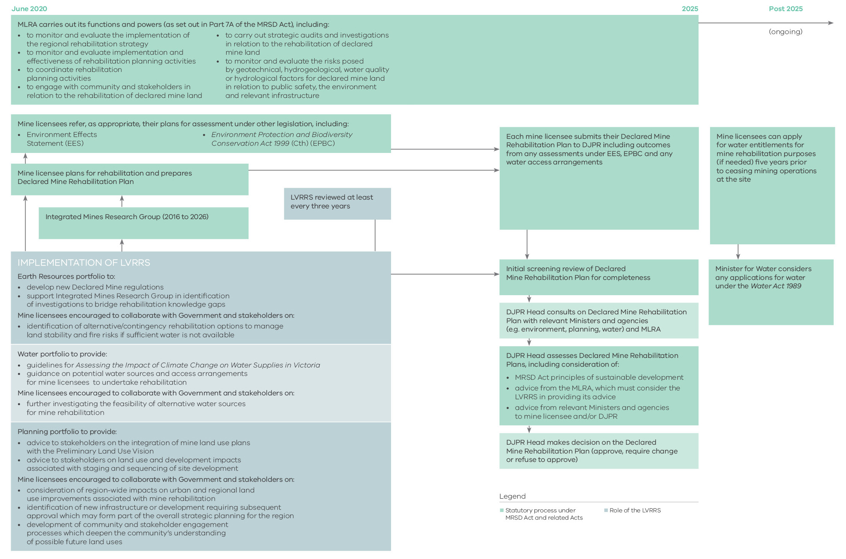

IMPLEMENTATION ACTIONS
This section sets out the Government’s plan for implementing this strategy.
Implementation Action  (lead agency) | Detail on Action Required | Completion  date
Provide guidance on the use  of climate change scenarios  for water resource planning  for mine rehabilitation  (DELWP) | DELWP to provide guidance on climate change  scenarios to be used by mine licensees when planning for projected water resource availability.  Updated guidance for the Latrobe Valley context will be provided upon the release of the next iteration of the ‘Guidelines for Assessing the Impact of Climate Change on Water Supplies in Victoria’. This analysis is to inform licensees’ preparation of their Declared Mine Rehabilitation Plan. | Q4 2020
Develop new Declared  Mine regulations  (DJPR) | DJPR to develop new Declared Mine regulations to achieve oversight, stakeholder engagement, knowledge management and regulation of the  Latrobe Valley coal mine land. | Q1 2021
Guidance on potential  water sources and access  arrangements for mine licensees to undertake rehabilitation  (DELWP) | DELWP to provide high-level guidance on how water from the Latrobe River system may be allocated and accessed for the purposes of Latrobe Valley mine rehabilitation including indicative conditions that may be placed on any water entitlements that protect the rights of existing users, like farmers, towns and businesses, the environment and values of Traditional Owners. This advice is to inform  licensees’ preparation of their Declared Mine Rehabilitation Plan. | Q2 2021
Further assess the feasibility  of alternative water sources  that could be used for mine  rehabilitation  (DELWP with DJPR support) | Mine operators encouraged to collaborate with Government and stakeholders to further assess  the feasibility of alternative water sources (such as recycled or desalinated water) for mine rehabilitation. This analysis should inform licensees’ preparation of their Declared Mine Rehabilitation Plan. | Q2 2021
Identify alternative/contingency rehabilitation options to manage land stability and fire risks if  sufficient water is not available  (DJPR) | Mine operators encouraged to collaborate with Government and stakeholders to identify alternate/contingency rehabilitation options to manage land stability and fire risks in case sufficient water  is not available. | Q2 2021
Support Integrated Mines  Research Group  (DJPR) | DJPR to support the Integrated Mines Research Group in identification of investigations to bridge rehabilitation knowledge gaps, with oversight  from the Mine Land Rehabilitation Authority | Q4 2026

MONITORING AND EVALUATION OF THIS STRATEGY
The Mine Land Rehabilitation Authority (MLRA) is responsible for the monitoring and evaluation of the LVRRS. The MLRA is to be established on 30 June 2020 and will replace the Latrobe Valley Mine Rehabilitation Commissioner.
The key objectives of the MLRA are:
- to provide assurance to the Victorian community that public sector bodies and the Latrobe Valley licensees are implementing the regional rehabilitation strategy;
- to promote the participation of the community and stakeholders from the Latrobe Valley in the implementation of the regional rehabilitation strategy.
- The MLRA will be responsible for (but not limited to) the following functions in relation to the LVRRS:
- developing and maintaining a framework for the monitoring and evaluation of rehabilitation planning activities
- monitoring and evaluating the implementation of the LVRRS in accordance with that monitoring framework
- carrying out strategic audits of public sector bodies and declared mine licensees in relation to the implementation
of rehabilitation planning activities and the LVRRS
- providing advice and recommendations to the Minister in relation to both the LVRRS and the rehabilitation plans of licensees
- providing information and education to the Victorian community about the LVRRS
- monitoring and evaluating the risks posed by geotechnical, hydrogeological, water quality or hydrological factors for declared mine land in relation to public safety, the environment and relevant infrastructure, and
- monitoring and reporting, in accordance with the monitoring framework, on
- the implementation by public sector bodies and Latrobe Valley licensees of the regional rehabilitation strategy, and
- the effectiveness of the regional rehabilitation strategy.

The MLRA is to address the following matters as part of its required annual report to the Minister for Resources:
- The progress, outcomes and issues in incorporating the LVRRS principles in the mine rehabilitation planning of the Latrobe Valley coal mines, and
- The progress, outcomes and issues in completing the LVRRS implementation actions identified in this strategy.
The Minister may also direct that a more detailed report focused on these matters be provided.
The Minister for Resources must review the LVRRS at least once every three years after it is published, pursuant to section 84AZO of the MRSD Act. The first review of the LVRRS is to be completed no later than 30 June 2023.
The Minister may amend the regional rehabilitation strategy at any time, after consulting with the MLRA.

GLOSSARY OF TERMS
Alternative water sources: Water from sources other than the Latrobe River system or Latrobe Valley aquifers, such as recycled water, desalinated water or treated stormwater.
Batter: The inclined section of an open-pit mine wall.
Aquifer: An underground layer of water-bearing permeable rock, rock fractures or unconsolidated materials (gravel, sand, or silt) from which groundwater can be extracted.
Declared Mine: Under the MRSD Act, the Minister for Resources can declare mines if they present significant geotechnical or hydrogeological risks of harm to public safety, the environment or public infrastructure. Declared mines are required to have additional mine stability plans to manage the ongoing risks they present. At present, the only declared mines in Victoria are the three Latrobe Valley coal mines: Hazelwood, Loy Yang and Yallourn.
DELWP: The Department of Environment, Land, Water and Planning (DELWP) is the Victorian Government department responsible for the water and planning portfolios.
Desalinated water: Water derived from a desalination process, in which salt and mineral components are removed from saline water.
DJPR: The Department of Jobs, Precincts and Regions (DJPR) is the Victorian Government department responsible for the resources portfolio.
Engagement: Interactions between people, often between a company and its stakeholders. Can involve but not restricted to consultation, communication, education and public participation.
Environmental flows: The quantity, timing, and quality of water flows required to sustain freshwater and estuarine ecosystems and the human livelihoods and well-being that depend on these ecosystems.
GLaWAC: The Gunaikurnai Land and Waters Aboriginal Corporation (GLaWAC) is the prescribed
body corporate on behalf of the Gunaikurnai people for the purposes of the Native Title Act 1993 (Cth) and is a Registered Aboriginal Party for the purposes of the Aboriginal Heritage Act 2006 (Vic).
Groundwater: Water found underground in the cracks and spaces in soil, sand and rock. It is stored in and moves slowly through geologic formations of soil, sand and rocks called aquifers.
IMRG: The Integrated Mine Research Group (IMRG) was established by the Latrobe Valley coal mine operators in response to the HMFI Recommendation 18, for mine operators to develop an integrated research plan that identifies common research areas and priorities for the next ten years, to be reviewed every three years.
Latrobe River system: Comprises the Latrobe River and its estuary, its tributaries (e.g. Loch River, Tooronga River, Tanjil River, Tyers River, Morwell River, Moe River, Traralgon Creek, etc.), the Ramsar-listed wetlands and other fringing environments of the lower Latrobe River, and Lake Wellington and the broader Gippsland Lakes system.
Latrobe Valley: The Latrobe Valley is an inland geographical district and urban area of the Gippsland region in the eastern part of Victoria, Australia.
Latrobe Valley Mine Rehabilitation Commissioner: The Commissioner, also known as the LVMRC, provides assurance that the government and the operators of the Latrobe Valley coal mines are advancing planning for mine closure and the LVRRS. Based locally in the Latrobe Valley, the Commissioner provides independent advice and recommendations to the LVRRS and the Minister for Resources on the development of the LVRRS.
Local community: Refers to communities that will be impacted directly and indirectly by the Latrobe Valley coal mines and will be most affected by rehabilitation and completion of rehabilitation following cessation of operations.
MLRA: The Mine Land Rehabilitation Authority (MLRA) is the statutory authority responsible for monitoring and evaluating implementation of the LVRRS. The MLRA is to be established on 30 June 2020 and replaces the Latrobe Valley Mine Rehabilitation Commissioner.
MRSD Act: The Mineral Resources (Sustainable Development) Act 1990 (MRSD Act) is the legislative framework for mining in Victoria.
Post-Closure Management: The requirement to maintain monitoring and management of a mine site after the bulk of the mine infrastructure has been demolished and removed and the site has been fully rehabilitated.
Ramsar Convention: The Ramsar Convention on Wetlands of International Importance is an international treaty for the conservation and sustainable use of wetlands. It is also known as the Convention on Wetlands. It is named after the city of Ramsar in Iran, where the Convention was signed in 1971.
Recycled water: Water sourced through wastewater (i.e. water that has been used before) that is cleaned to a high standard so it can be repurposed for diverse uses.
Rehabilitation: The process of repairing the damage done by mining activity. For example, coal mine rehabilitation typically involves flattening the steep sides of the mine, covering exposed coal with soil and clay and revegetating the area with trees and grasses.
Safe, stable and sustainable: Principles defined in section 4 of the MRSD Regulations as:
- is not likely to cause injury or illness; and
- structurally, geotechnically and hydro-geologically sound; and
- non-polluting; and
- aligns with the principles of sustainable development.
Stakeholder: A person or group that is affected by, or can influence, mine rehabilitation.
Surface water: Water that collects on the surface of the ground.
Sustainable development principles: Principles set out in Section 2A of the MRSD Act:
- community wellbeing and welfare should be enhanced by following a path of economic development that safeguards the welfare of future generations
- there should be equity within and between generations
- biological diversity should be protected and ecological integrity maintained
- there should be recognition of the need to develop a strong, growing, diversified and internationally competitive economy that can enhance the capacity for environment protection
- measures to be adopted should be cost effective and flexible, not disproportionate to the issues being addressed, including improved valuation, pricing and incentive mechanisms
- both long and short term economic, environmental, social and equity considerations should be effectively integrated into decision-making
- if there are threats of serious or irreversible environmental damage, lack of full scientific certainty should not be used as a reason for postponing measures to prevent environmental degradation and decision-making should
be guided by —
- a careful evaluation to avoid serious or irreversible damage to the environment wherever practicable; and
- an assessment of the risk-weighted consequences of various options
- development should make a positive contribution to regional development and respect the aspirations of the community and of Indigenous peoples;
- decisions and actions should provide for community involvement in issues that affect them.
Stormwater: Water from flowing over ground surfaces and in natural streams and drains as a direct result of rainfall over a catchment. Stormwater consists of rainfall runoff and any material, soluble or insoluble, that gets swept up in its flow.

Volume 2

Regional Geotechnical Study Synopsis Report

CONTEXT AND SCOPE
The Latrobe Valley Regional Rehabilitation Strategy (LVRRS) is part of the Victorian Government’s response to the findings of the Hazelwood Mine Fire Inquiry (HMFI), which found significant uncertainties and knowledge gaps surrounding the rehabilitation and closure of the Latrobe Valley’s three brown coal mines.
The HMFI’s Board of Inquiry found that, with the current knowledge available, some form of water body was the most viable rehabilitation option for the coal mine voids, but that many unanswered questions remain concerning the feasibility of the potential mine pit lakes. The Strategy addresses some of these knowledge gaps, informed by several technical studies.
The Strategy considers the mines individually and collectively in the context of potential impacts (positive and negative) on the environment, Aboriginal and non-Aboriginal cultural heritage values, infrastructure and land uses in the Latrobe Valley, with a particular focus on water and land stability. The primary objective of rehabilitation is to achieve a safe, stable and sustainable landform for the closed mines. The strategy does not negate the obligation on the mine operators to develop individual mine rehabilitation and closure plans; rather, it provides guidelines that inform the preparation of these plans by the mine operators.
As part of the LVRRS, the Victorian Government commissioned a Regional Geotechnical Study. Specialists investigated the stability and fire risks associated with the coal mine voids, whether these risks could be mitigated by supplying water to fill the voids to a level that achieves stability (to reduce the need for ongoing active controls), and whether filling the mines with water could result in adverse ground movement impacts within and around them.

KEY FINDINGS

1. ACTIVE AND PASSIVE CONTROL OF RISKS
Active controls such as groundwater pumping and drainage, surface water management and extensive monitoring are required to maintain safe operating conditions at the Latrobe Valley coal mines. Nonetheless, unexpected and undesirable land movements have occurred ranging from small, continuous movement of mine walls (known as batters) to major batter failures extending beyond the mine crest. Exposed coal has caught fire a number of times, causing impacts to communities and the mines, most recently during the 2014 Hazelwood Mine Fire.
It is clear that active controls and regulation practices can’t guarantee there won’t be major ground movements or coal fires,
as evidenced by these past failures and movements over the life of the Latrobe Valley mines.
Passive controls avoid the need for ongoing action in managing risk. In the context of mine rehabilitation, this is achieved through landform design. Passive design elements include the use of sediments and water to stabilise mine floors and batters, and covering coal (e.g. with soil) to prevent coal ignition by external sources.
As the mines close it will be necessary to transition to passive controls to manage stability and fire risk, to ensure that post-closure risks to the community and environment are minimised and that maintenance of the rehabilitated landform is environmentally and economically sustainable.

2. STABLE FLOORS AND BATTERS
The study found that:
- The pit lake rehabilitation option can achieve a safe, stable and sustainable landform through
a largely passive control by:
- providing a counterweight to upward pressures from aquifers below each mine, thereby preventing instability caused by ‘floor heave’ and eliminating the current need to pump large quantities of groundwater (around 30 GL/year in total, across all three mines) from the aquifers to maintain stability.
- increasing lateral pressure to stabilise batters, thereby reducing the current need to actively control batter movement through groundwater drainage and surface water management.
- Extended fill times arising from limited water availability, or not filling to a level that provides the required counterweight for lateral pressures, present stability challenges that would need to be actively managed.
- Minimisation of seepage inflow through the management of surface waters and coal cover materials, in addition to coal groundwater pressure control through drainage boreholes, may be required to maintain low ground movement risks. Controls will be required during the filling period, and potentially on an ongoing basis for any coal batters extending above the final water level.
- Areas outside of the pit requiring ongoing management and/or planning controls would be reduced compared to current requirements if water levels are at or above the minimum required to achieve counterweight
to future vertical and horizontal groundwater pressures.
- Ground movements will occur in response to filling a mine with water, due to a ‘lake loading’ effect. These are not expected to have adverse impacts but will need to be monitored to ensure that if any impacts arise to existing and future infrastructure, they are addressed as part of the mine rehabilitation process.
The study did not examine stability due to future water level changes in the rehabilitated mines arising from either regional water resources management or climate-controlled changes in water supply. Since ground movements could occur under dynamic water level changes, this is an area that requires further consideration as part of rehabilitation planning and implementation.
The study did consider the possibility of increased seismic activity induced by filling a mine void with water but did not establish the likelihood of either increased seismic frequency or magnitude. A qualitative assessment suggests that a possible increase in frequency could occur but that an increase in seismic magnitude is not likely. Further work is required to improve this assessment given the particular nature of the hydrogeological setting of the Latrobe Valley and the changes in deep geological stresses that have occurred due to mining to date.
The study did not specifically consider in-pit design issues related to mine rehabilitation.

3. GROUND SUBSIDENCE AND REBOUND
The study found that:
- Groundwater extraction for mine stability has led to gradual land subsidence across the region.
- If groundwater extraction for mine stability control can be stopped following mine rehabilitation, land surface rebound is expected. The magnitude of the rebound is expected to be less than the subsidence that has occurred and it is anticipated that this rebound would occur gradually over many decades and relatively evenly across the region. This is an area that requires further consideration as part of rehabilitation planning.

4. MANAGING FIRE RISK
The study found that:
- Coal fire risk is best managed by covering exposed coal.
- If water is provided for ground stability control it would cover large areas of exposed coal. As such, active controls on fire risks would be significantly reduced for the final rehabilitated landform if the water levels required to passively control ground movement are achieved.
- Coal coverage above the water line can be achieved by providing a suitable soil-vegetation cover system that is resistant to erosion. Where vegetated soil or other materials are used to cover coal, a long-term cover maintenance plan is recommended.
- Extended fill times arising from limited water availability present greater stability challenges and fire risks (due to the extended period of exposed coal) that would need to be managed compared to a shorter fill time.
- If final water levels vary, a zone of exposed coal may occur between the water level and the soil-vegetation cover at or above the maximum water level. Assessment will be needed of the fire risks arising from the exposed coal and a suitable fire risk management plan developed.
- Rehabilitation of the mines should include an objective that the final landform presents no greater fire risk to the community than the surrounding environment.
- The study did not examine the following areas, which require further consideration as part of rehabilitation planning:
- The feasibility of different options for covering coal above the water line.
- The risk of spontaneous combustion of the coal under future vegetated soil covers.

5. AREAS FOR CONSIDERATION IN REHABILITATION PLANNING
The study highlights that water, if available in sufficient quantity, can provide an effective resource to support the long-term rehabilitation of the mine voids that reduces the need for ongoing active management of ground movement and fire risk.
The study also shows that there are issues that remain unresolved at the present time that will require consideration. Areas that require further consideration as part of rehabilitation planning by the mine operators include:
- Batter specific stability analysis, design, management measures and monitoring.
- Designs for surface water drainage and groundwater pressure management during the fill period and, if required,
for ongoing stability of elevated land areas adjacent to the mine.
- Ground movement risk management due to possible future water level changes in the rehabilitated mines arising from water supply shortages.
- Justification for the use of water in mine rehabilitation considering available and practical alternatives to the creation of a pit water body for managing ground movement and fire risks.
- Justification for the selection of the final water level to achieve stability and the assessment of risks of varying water levels to support water resources planning.
- Options assessment for covering coal at and above the water line.
- Risk assessment of spontaneous combustion and the potential for coal fires beneath coal cover materials.
- Risk management requirements to prevent combustion of coal exposed by cover erosion and/or lake water level variations. Cover erosion risks will need to be assessed, and maintenance requirements established for areas of high erosion risk.
- Assessment of seismic risk due to filling mine voids with water.
- Assessment of potential ground movements arising from ‘lake loading’ and land surface rebound.
- Assessment of monitoring and management requirements for eventual rebound of the land surface.

ACHIEVING A SAFE AND STABLE LANDFORM FOR THE LONG-TERM

1. GROUND MOVEMENT OVERVIEW
Ground movements have been a feature of mining in the Latrobe Valley since the first mine was opened. These movements can be attributed to the nature of the rocks that make up the geological structure of the Latrobe Valley, the significant volumes of coal and sediments extracted through mining, and the nature of the surface and subsurface water bodies and the hydraulic pressures that they exert on the rocks. Ground movement occurs when stresses are redistributed within
the ground as a result of mining.
Observations over many years have provided a good understanding of the type and extent of ground movement impacts related to mining. This knowledge is the basis for mine stability management practices which include analysis of movement mechanisms, mine design, water control methods and review of outcomes against expected conditions. This same knowledge also provides the basis for the assessment of potential outcomes from mine rehabilitation.
The mining induced ground movements of significance to rehabilitation are identified to be:
- Block sliding
- Sinkhole formation
- Floor heave
- Subsidence
Each of these movement types can occur separately or together depending on the conditions prevailing in the mine. While
block sliding typically results in rapid movements after onset, sinkhole formation, floor heave and subsidence are all longer time processes that occur over weeks to decades.
Seismic events are also considered by the mine operators as possible initiators of ground movement.
These movements and their controls and significance for rehabilitation are examined in the remainder of this section.

2. BLOCK SLIDING

Operating mines
The principal risk to batter stability within the Latrobe Valley’s coal mine voids is elevated groundwater pressures behind the coal face, which can act as a destabilising force – ‘pushing’ large coal blocks toward the void. This is known as ‘block sliding’, as the coal blocks tend to slide along geological layers of lower shear strength (Figure 1).
In order to reduce groundwater pressures within the coal and thus minimise the risk of block sliding, the Latrobe Valley coal mine operators maintain a network of horizontal drains (installed by boring horizontally into the coal from within the mine) and surface water diversions. The horizontal drains and surface water diversions are supported by extensive monitoring networks at each mine to ensure that groundwater pressures and coal movements are within expected bounds. The monitoring networks are maintained by the mine operators, who also undertake the collection and analysis of the monitoring data. These various controls on batter stability, within the mine voids, involve significant labour, specialist knowledge and financial costs on an ongoing basis.
Despite significant operational controls on batter stability, there have been a number of large-scale batter movements over the history of mining in the Latrobe Valley, including:
- 2007 – block sliding resulting in batter failure which allowed the Latrobe River to divert into Yallourn mine (Figure 2)
- 2011 – closure of the Princes Freeway south of Morwell for seven months, due to pavement cracking as a result of block sliding of northern batters at Hazelwood mine.
It is evident that the best engineering and regulation practices cannot account for all environmental conditions (e.g. extreme weather and localised ground conditions) and are highly dependent on available finances, labour, and specialist technical knowledge. It will be necessary to transition to more passive and sustainable controls on ground movement as mines close and resulting voids are transitioned to a different landform.

Mine rehabilitation
The Regional Geotechnical Study found that filling the mines with water can stabilise batters by increasing lateral pressure on the face of the batters. Put another way, groundwater pressure behind the coal faces is less critical if there is sufficient counter pressure from water within the mine voids (i.e. the hydraulic gradient across the coal face is minimised). This approach would significantly reduce the current need to actively control batter movement through groundwater drainage and surface water management.
Extended fill periods or not filling to a level that provides the required counterweight for lateral pressures presents stability challenges, both during the fill period and for the final landform design. This may necessitate significant changes to the mine batters (e.g. major earth moving to create buttresses) and long-term active management of ground and water movements.
Ongoing maintenance and drainage would be needed in elevated areas of coal batters above water level, if water is used as the rehabilitation solution, as build-up of groundwater pressure in such batters may increase the probability of adverse ground movement. If mine voids were partly filled with water, a greater batter height would remain above lake level, requiring more extensive ongoing batter drainage and maintenance.
Management of surface waters and coal cover materials to minimise the risk of seepage inflows, in addition to control
of coal groundwater pressures through drainage boreholes, may be required to maintain low ground movement risks.
Controls will be required during the filling period, and potentially on an ongoing basis, for any batters above the final designed water level.
Areas outside of the pit requiring ongoing management of surface water and/or planning zone controls would be reduced compared to current requirements if water levels are at or above the minimum required to achieve counterweight to future vertical and horizontal groundwater pressures.
The study did not examine future water level changes in the rehabilitated mines arising from either planned or climate- induced changes in water supply. Since ground movements could occur under dynamic water level changes, this is an area that requires further consideration as part of rehabilitation planning and implementation.
Areas that require further consideration as part of rehabilitation planning by the mine operators include:
- batter-specific stability analysis, design and monitoring.
- designs for surface water drainage and groundwater pressure management during the fill period and, if required, for ongoing stability of elevated land areas relative to the final designed water level adjacent to the mine.
- management of ground movement risks due to possible future water level changes in the rehabilitated mines arising from water supply shortages.
- justification for the use of water in mine rehabilitation based on available and practical alternatives to the creation of a pit water body for managing batter stability.
Figure 1: Simplified cross-section showing ‘block sliding’ mechanism
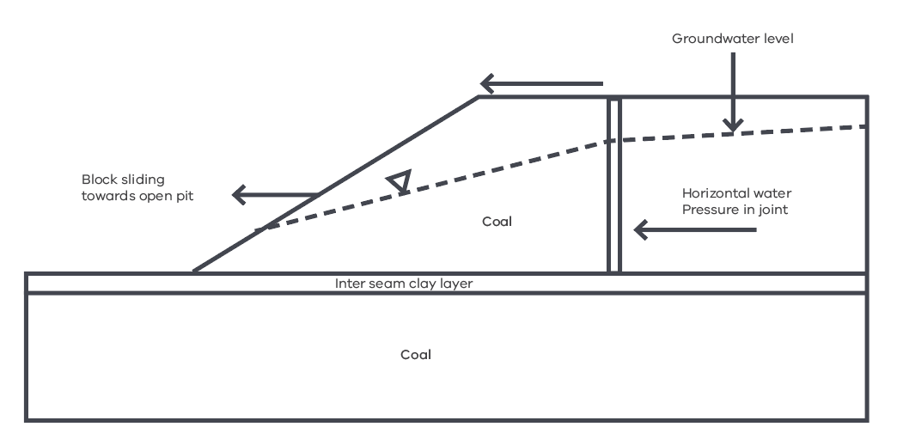

Figure 2: A major batter failure led to the Latrobe River diverting into the Yallourn mine for six days in 2007
(Source: Hazelwood Mine Fire Inquiry 2015/16 Report Volume IV - Mine Rehabilitation)
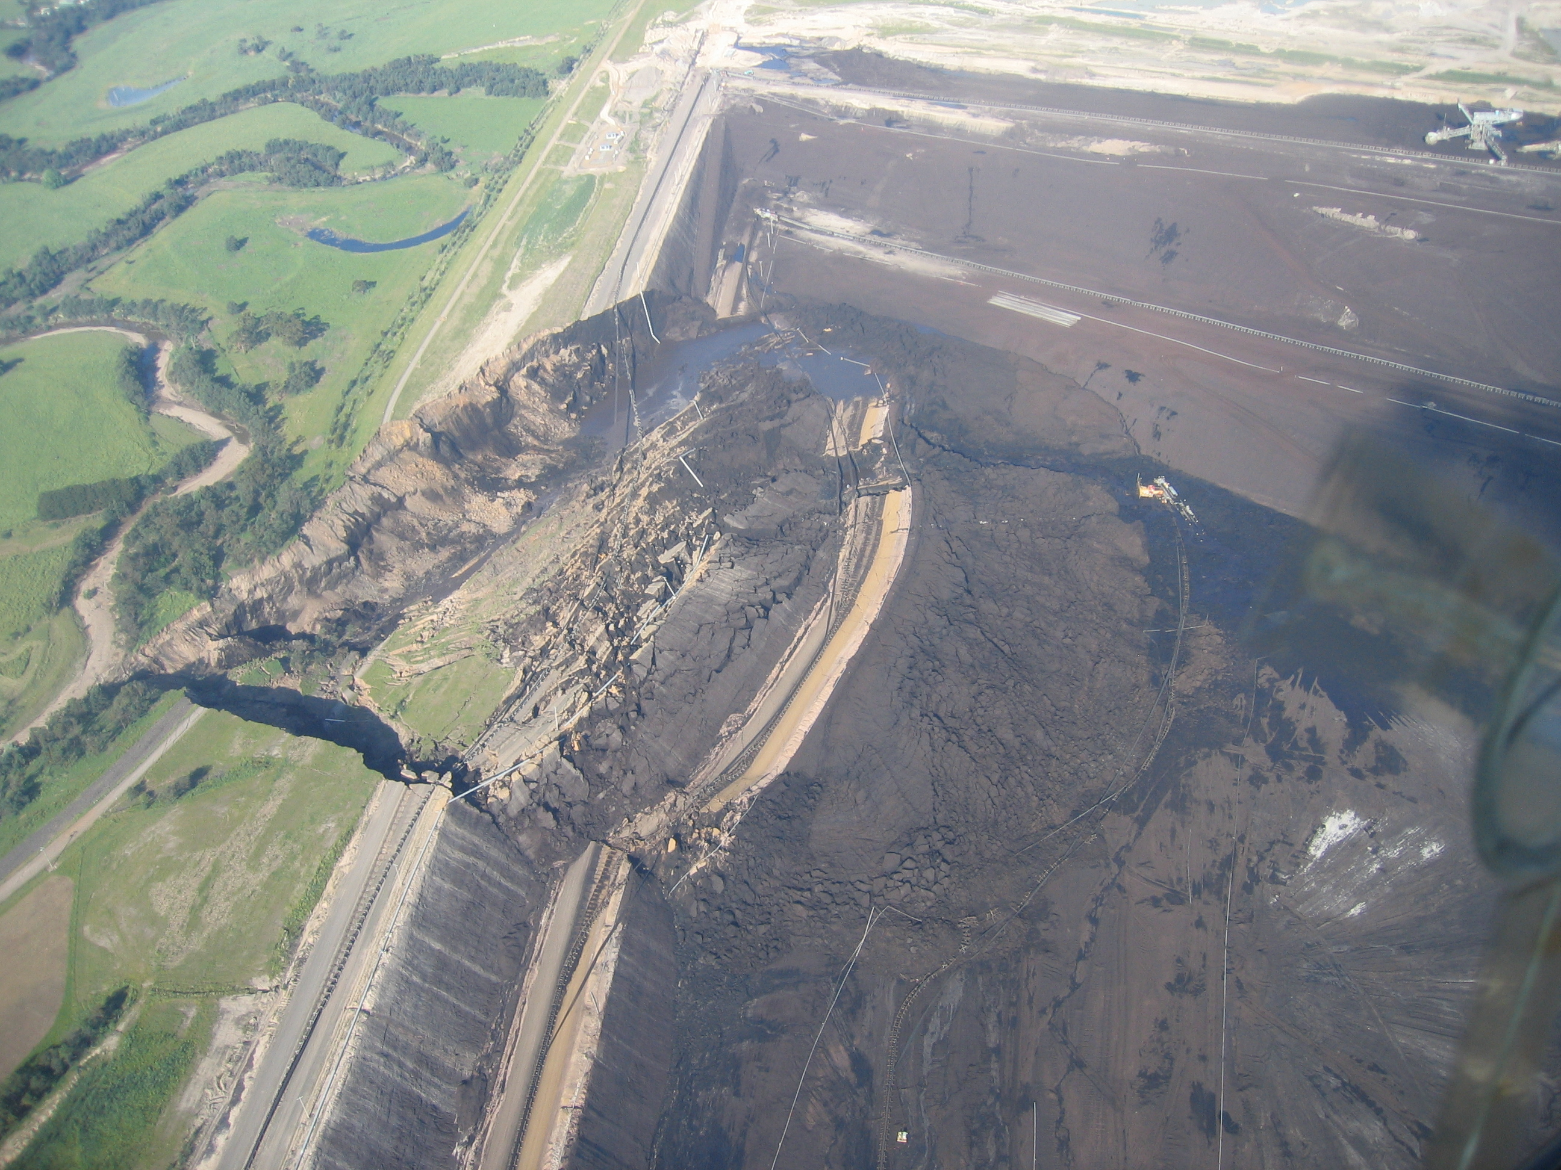

3. SINKHOLE FORMATION

Operating mines
Sinkholes (Figure 3) have the potential to form as a result
of ‘piping erosion’ mechanisms when either:
- surface water flows are concentrated into open tension cracks or joints in the coal, initiating a sub-surface erosion process. Such an erosion process may develop into a void large enough to create a collapse in the overlying ground surface; or
- surface water flows are concentrated into the ground close to the crest of a mine batter, and flow down through the coal to exit through the face of the batter. Internal erosion can then occur within coal tension cracks and joints, which can lead to piping tunnels and the collapse of the overlying ground surface, forming sinkholes.
The potential for sinkholes to form is highly dependent on local geological and hydrological conditions, in both mining and non-mining environments. Areas where significant movement has already occurred and/or block sliding, which may have opened tension cracks or joints in the coal, will present a greater potential for sinkhole formation.
Piping erosion and sinkholes have been observed in the Latrobe Valley where the presence of jointed coal at shallow depth below an erodible overburden layer allows water ingress to the coal seam. Sinkholes developed across the Morwell Main Drain in 2011 after the ground cracked in response to ground movement, and water entered the cracks or open joints after a heavy rainfall event. Sinkholes have also been identified and repaired along forest drains adjacent to Latrobe Road, beyond the Yallourn mine lease boundary, with minor ongoing sinkholes evident in November 2018.

Mine rehabilitation
Filling the mines with water, if water is available in the volumes required, can significantly reduce the potential for sinkholes and piping erosion by:
- stabilising batters and therefore minimising the potential for ongoing opening of tension cracks or joints in coal; and
- minimising groundwater gradients around the voids and therefore the potential for concentrated flows of water through the ground.
Sinkhole formation is likely to be an ongoing feature of the areas adjacent to the mines and monitoring and maintenance of sinkholes, as they occur, will be an ongoing feature of mine land management going forward.
Figure 3: Schematic representation of sinkhole formation
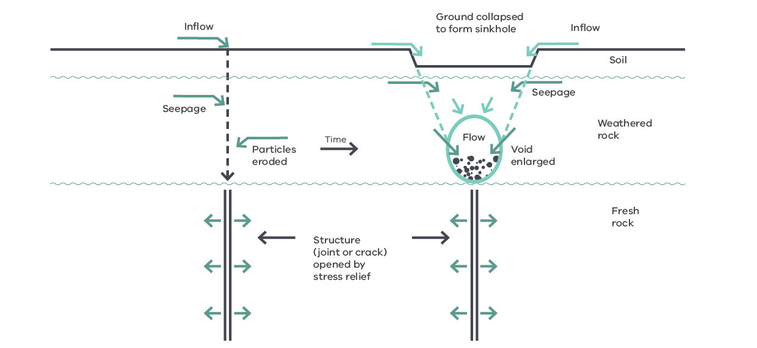

4. FLOOR HEAVE

Operating mines
Floor stability in the Latrobe Valley coal mines is maintained by pumping significant quantities (around 30 GL/year across all three mines) of groundwater from the confined aquifers below each mine (this process is also termed ‘aquifer depressurisation’). This reduces the groundwater pressure in the confined aquifers, to less than the downward weight of the remaining coal and sediments overlying the aquifer below the mine floor; a process referred to as maintaining weight balance (Figure 4). ‘Floor heave’ can occur if the upward pressure from confined aquifers exceeds the weight of coal and sediments above the aquifer at any point across the mine floor.
Heave is a problem for mining as it affects the stability of the mine machinery. It also can effectively reduce the lateral resisting forces acting at the toe of mine batters and promote batter movements and possible block sliding.

Mine rehabilitation
The Regional Geotechnical Study found that filling the mines with water could be used to counterweight upward pressures from aquifers below each mine, thereby preventing instability caused by ‘floor heave’ and eliminating the current need to pump groundwater from the aquifers to maintain stability once mines are rehabilitated.
When all groundwater pumping for aquifer depressurisation stops at all three mines the groundwater pressures will return over time to much higher pressures beneath the mines. It is not expected that the groundwater pressures will return to the levels that they were prior to mining commencing as other groundwater users will continue to operate.
Maintaining weight balance for mine rehabilitation is based on the idea that the in-pit water body level should be established to provide a positive counterweight to the maximum future groundwater pressures that can arise below the mine in the different aquifers.
While the water level in the pit is being raised during the rehabilitation phase, groundwater pressures will need to be maintained below the effective weight of water and rock above the aquifer top. For this reason, it is expected that groundwater pumping will occur throughout the whole period of rehabilitation at each mine.
Figure 4: Simplified cross-section showing ‘floor heave’ mechanism (Source: Hazelwood Mine Fire Inquiry Report 2015/16 Volume IV – Mine Rehabilitation)
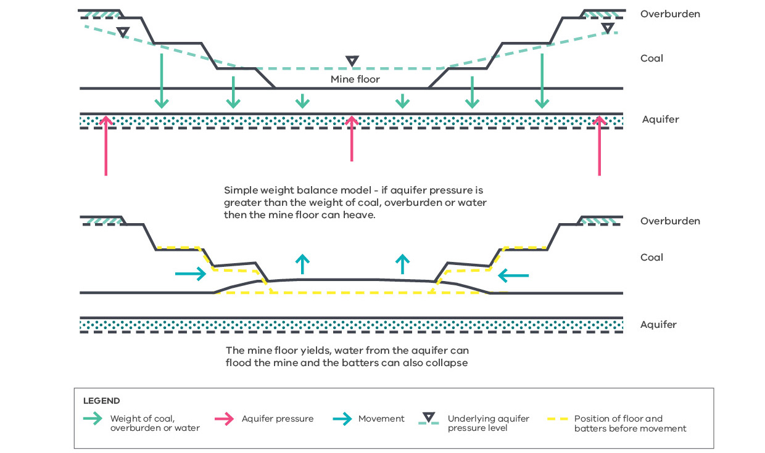

5. SUBSIDENCE AND REBOUND

Operating mines
Floor stability in the Latrobe Valley coal mines is maintained by depressurising the aquifers below each mine, as previously noted in Section 4. As the aquifers being depressurised underly the Latrobe Valley region, the effects of depressurisation extend across the region resulting in land level subsidence, centred around the mines and reducing radially (Figure 5). Changes in land level have been observed and well documented on a regional scale in the Latrobe Valley since the 1950s. The Latrobe Valley Regional Groundwater Management Committee oversees monitoring and reporting of regional subsidence, and projection of potential future subsidence. The results from this program indicate that:
- subsidence of up to 2.6 metres (total, from the 1950s to date) has been observed near the mines and while most subsidence (an estimated 80%) is interpreted as having already occurred, it is continuing due to ongoing groundwater depressurisation. Recent observations in the Morwell township indicate ongoing subsidence rates at approximately 10 millimetres per year.
- subsidence in the Latrobe Valley from the 1950s to date has been generally gradual (both spatially and temporally), with no known significant impacts to the built or natural environment.

Mine rehabilitation
Subsidence will continue as long as the current rates of groundwater pumping are required to maintain stability of the mines. Groundwater pumping for mine stability could be eliminated following rehabilitation, if the mines are filled with water (Section 4), thereby halting regional subsidence.
When all groundwater pumping for aquifer depressurisation stops at the three mines, groundwater pressures will return over time to much higher pressures beneath the mines, although it is not expected that the groundwater pressures will return to the levels that they were prior to mining commencing (Section 4).
The study found that:
- following rehabilitation regional land level subsidence will reverse (rebound) to some extent in response to aquifer repressurisation.
- as with subsidence, rebound is expected to occur gradually and relatively evenly across the region over many decades.
- preliminary estimates of the extent of rebound range from 25% to 50% of the observed subsidence. Rebound is not anticipated to have any significant impacts on the region’s built or natural environment, given the timescales involved and relatively even distribution of ground response. This will need to be confirmed through further studies as part of detailed rehabilitation planning, and any associated monitoring and management requirements identified.
Figure 5: Subsidence to 2015 (contour values in millimetres)
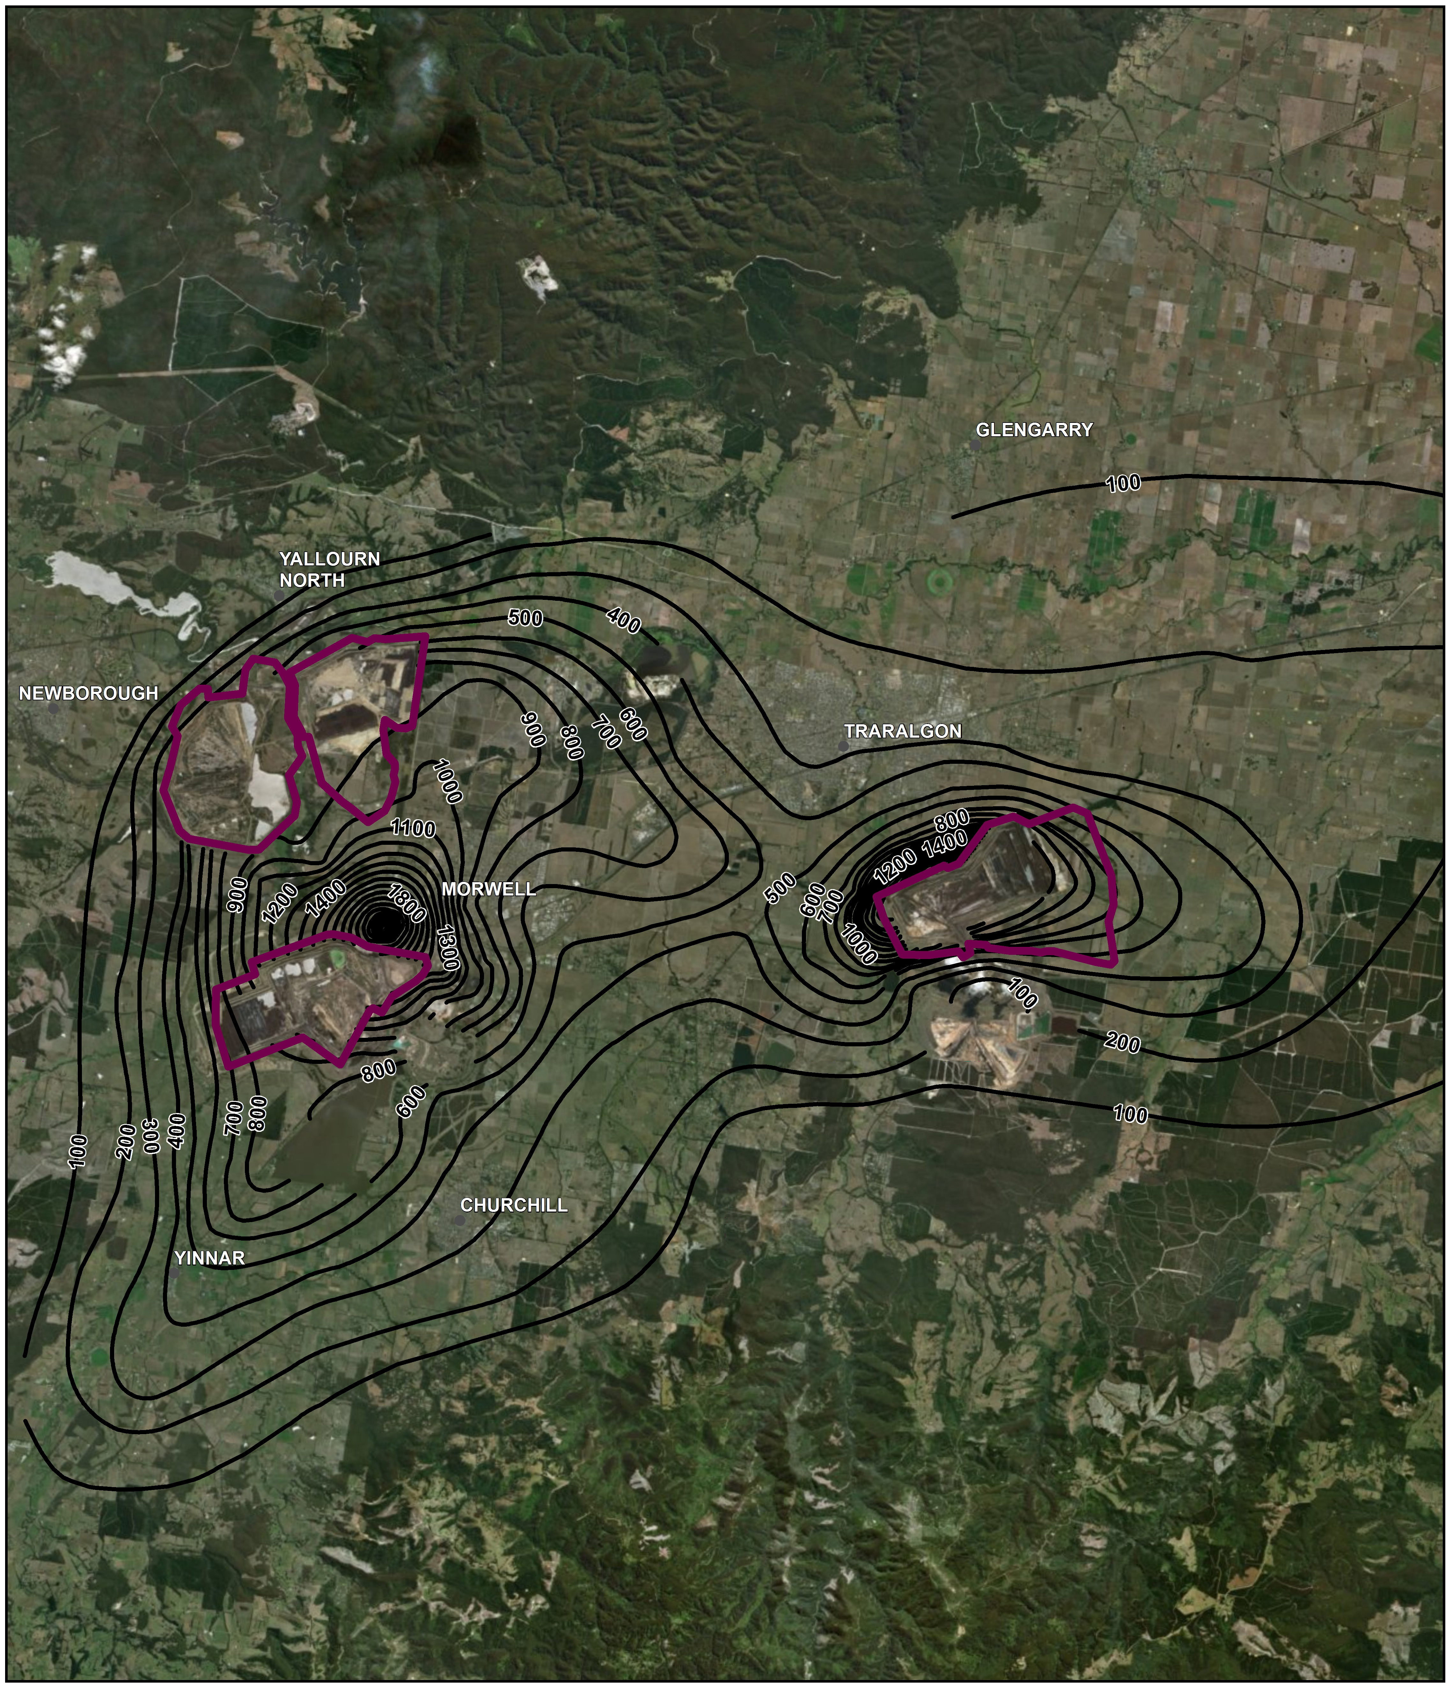

OTHER CONSIDERATIONS

1. MANAGING FIRE RISK

Operating mines
The Hazelwood Mine Fire Inquiry Report 2015/16 Volume IV notes that ‘at present, each mine operator manages fire risk through a combination of mine design, training, on-hand expertise, equipment, vegetation management and monitoring. Since the introduction of mining licence condition 1A in January 2015, each mine operator has prepared a Risk Assessment and Management Plan, which includes a focus on fire risks and controls’. The Board of Inquiry also noted that ‘as the 2014 Hazelwood mine fire demonstrated, uncovered coal represents a serious fire risk’.
The Hazelwood Mine Fire (Figure 6) is the latest in a number of major fires at Latrobe Valley coal mines over the course of their history.
Observations over many years have provided a good understanding of the type and extent of fire risks related to mining. This knowledge is the basis for mine fire management practices which include design and placement of fire suppression systems and emergency response. This, together with lessons learnt from past fire events, provides the basis for assessment of potential fire outcomes from mine rehabilitation.
As the mines reach the end of their life and are progressively rehabilitated there are some challenges to maintaining controls on fire occurrence which need to be managed, including:
- establishing suitable soil-vegetation cover on the steep coal batters left by mining, particularly if the cover is to be resistant to erosion and movement in the long-term.
- maintaining fire infrastructure in areas that are undergoing progressive rehabilitation.
- that some of the fire retardants used in modern firefighting are unsuitable in the context of operating and rehabilitated Latrobe Valley coal mines, due to the risk of contaminating off-site groundwater and surface water.

Mine rehabilitation
The study found that:
- coal fire risk is best managed by covering exposed coal.
- if water is provided for ground stability control it would also assist in fire management by covering large areas of exposed coal.
- active controls on fire risks could be significantly reduced for the final rehabilitated landform, compared to management of the existing mines, if the water levels required to passively control ground movement are achieved.
- coal coverage above the water line could be achieved by providing a suitable soil-vegetation cover system that is resistant to erosion. As no soil cover system will be completely resistant to erosion a long-term cover maintenance plan is likely to be required.
- extended fill times arising from limited water availability present greater stability challenges and fire risks (due to the extended period of exposed coal) that would need to be managed compared to a shorter fill time.
- if final water levels vary, a zone of exposed coal may occur between the water level and the soil-vegetation cover. Assessment will be needed of the fire risks arising from the exposed coal and a suitable fire risk management plan developed.
- climate projections for the region include potentially longer periods of dry weather and more extreme weather events, which could present additional challenges to managing fire risks across the region in the long-term. This must be considered in the planning and design of controls for fire risk for the rehabilitated mines.
- rehabilitation of the mines should include an objective that the final landform presents no greater fire risk to the community than the surrounding environment.
The study did not examine:
- the feasibility of different options for covering coal above the water line; this is an area that requires further consideration as part of rehabilitation planning.
- the risk of spontaneous combustion of the coal under future vegetated soil covers; this is also an area that requires further consideration as part of rehabilitation planning.

2. LAKE LOADING
‘Lake loading’ refers to the weight and lateral pressure of water added to the post-mining pit floor and batters – producing vertical and horizontal movement in response.
The study utilised industry-standard analysis methods to provide a preliminary indication of the potential extent of such movements, using parameters representative of the region while not being specific to any one mine site.
The preliminary analysis indicates that:
- during lake filling, there is potential for horizontal movements due to the weight of water acting on the mine batters. The magnitude of the movement will depend on the material properties, groundwater pressures and batter geometry and may not be exhibited by all batters.
- the maximum potential horizontal and vertical movement away from the mine due to lake loading of the batters is anticipated to be close to the mine crest, reducing with distance away from the mine.
- based on the simplified model used, the maximum vertical and horizontal movements are calculated to be less than 20 centimetres within 300 metres of the pit crest, reducing to small movements (and within tolerable thresholds for infrastructure) at one kilometre from the crest. Different model assumptions would have produced different results, but these figures give an indicative scale of the response.
- the response time of these effects closely follows the establishment of a particular lake level, such that lake- induced movement can be considered a short-term effect.
- ground movements, due to ‘lake loading’ are not expected to be a problem and are expected to be limited to the areas already subject to mining-induced ground movements. Lake loading movements will need to be monitored to ensure that any adverse impacts that might arise to existing and future infrastructure are addressed as part of the mine rehabilitation process.
While the preliminary analysis provides an indication of the potential extent of ground movements due to lake loading, actual ground movement responses will vary depending on site-specific conditions such as batter geometry, geology, groundwater conditions and coal jointing.
Mine specific responses will need to be modelled as part of the detailed rehabilitation planning for each mine, the results factored into design, and the actual response monitored during rehabilitation and post-closure, to ensure that any potential for adverse impacts to existing and future infrastructure is addressed as part of the mine rehabilitation process.

3. SEISMICITY

Operating mines
The Australian Standard 1170.4-2007 Structural design actions Part 4: Earthquake actions in Australia, sets out procedures for determining earthquake actions and associated design requirements for structures. More recently, Geoscience Australia produced a National Seismic Hazard Map of Australia. These references are used by the Latrobe Valley coal mine operators to inform the design of batters.

Mine rehabilitation
The design of final batters and slopes, as part of the rehabilitation of the Latrobe Valley coal mines, will need to comply with relevant Australian Standards and guidelines on earthquake actions.
The study considered the possibility of risks arising from seismicity induced by filling a mine with water and ceasing groundwater pumping but did not establish the likelihood of either increased seismic frequency or magnitude. A qualitative assessment suggests that a possible increase in frequency could occur but that an increase in seismic magnitude is not likely. Further work is required to improve this assessment given the particular nature of the hydrogeological setting of the Latrobe Valley and the changes in deep geological stresses that have occurred due to mining to date.
Figure 6: Burning batters during the Hazelwood mine fire
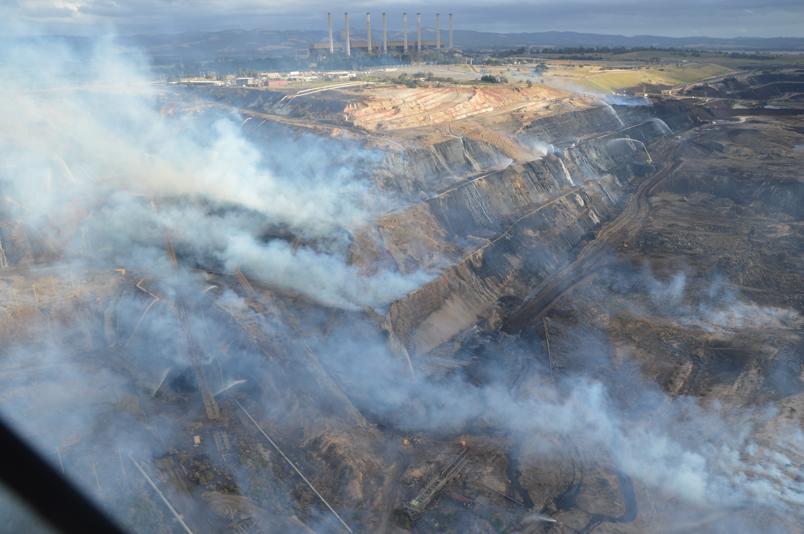

Regional Water Study Synopsis Report

CONTEXT AND SCOPE
The Latrobe Valley Regional Rehabilitation Strategy (LVRRS) is part of the Victorian Government’s response to the findings of the Hazelwood Mine Fire Inquiry (HMFI), which found significant uncertainties and knowledge gaps surrounding the rehabilitation and closure of the Latrobe Valley’s three brown coal mines.
The HMFI’s Board of Inquiry found that, with the current knowledge available, some form of water body was the most viable rehabilitation option for the coal mine voids, but that many unanswered questions remain concerning the feasibility of the potential mine pit lakes. The Strategy addresses some of these knowledge gaps through technical studies undertaken as part of the Latrobe Valley Regional Rehabilitation Strategy.
The Strategy considers the mines individually and collectively in the context of potential impacts (positive and negative) on
the environment, Aboriginal and non-Aboriginal cultural heritage values, infrastructure and land uses in the Latrobe Valley, with a particular focus on water and land stability. The primary objective of rehabilitation is to achieve a safe, stable and sustainable landform for the closed mines.
The Regional Water Study assessed:
- Potential water availability and use of regional water resources for mine rehabilitation
- Potential alternative water sources to those currently available to the three mines
- Potential water quality impacts in water bodies, groundwater and off-site surface waters
- Potential impacts on aquatic ecosystems and downstream users
- Scope of likely requirements for long-term regional groundwater monitoring.
This synopsis summarises the key findings of the Regional Water Study, covering the following areas:
- Environmental effects
- Climate change projections
- Water supply options
- Integrated water resource modelling
- Pit lake water quality modelling
- Environmental flow recommendations
- Water availability
- Water use scenarios
- Groundwater flux modelling
- Regional groundwater projections
- Water-related effects
- Pit lake modelling
- Water availability for mine rehabilitation

KEY FINDINGS

1. WATER AVAILABILITY
The Latrobe Valley has experienced dry conditions since 1997, and the LVRRS will need to be able to account for uncertainty around future climate and water availability by planning for a continuation of this drying trend and a drier future.
If the dry conditions currently being experienced in Gippsland continue into the future, there is a risk of impacts if surface water is supplied for mine rehabilitation without conditions that protect other water users and the environment.
- Average inflows since 1997 into the Latrobe River system have declined sharply from pre-1997 levels – from 800 GL/y to 600 GL/y.
- Climate change projections for the region indicate a wide range of possible futures, from very dry (500 GL/y average at 2040) to wet (1,000 GL/y at 2040). The median prediction is a marginal decline to 700 GL/y average
by 2040, and 650 GL/y by 2065.
- Water resource modelling indicates that the recent dry period since 1997 could imply different trajectories for
future climate:
- The decline could be ‘on-trend’, following a drying climate projection (i.e. not a drought but the ‘new normal’)
- The decline could be a drought (temporary), with the possibility of reversion to the long-term average (closer to 800 GL/y) subject to a future possible decline associated with climate change.
- Since 1997, there have been shortfalls in river flows in 15 of 21 years, by up to 67% compared to an average year, after extraction for consumptive uses.
- In three consecutive years (2011–2013) since 1997, inflows significantly exceeded minimum flow needs and
consumptive use, indicating that climate and streamflow still has the capacity to deliver good water years, although potentially at a reduced frequency compared to pre-1997 conditions.
- Under long-term average conditions with a median climate change projection, average water availability is likely to be sufficient to allow the mines to fill at a rate limited to current levels of consumptive use for power generation without significantly impacting river function or water security until about 2035, after which water availability may become more limited.
- Under current conditions or a dry climate, average water availability is significantly lower, with a relatively large proportion of years in which surface water supply for mine rehabilitation could not be sustained, although there could also be years of relatively high water availability in which water for rehabilitation could be accommodated.
- Although filling the mine voids with water would pose a significant demand on the Latrobe system, supply of water for this purpose could be feasible if it is accepted that the filling rate is limited to the power stations’ current annual net usage and that filling is restricted or halted under dry conditions to prevent unacceptable impacts on water security, other water users and values including river function and the Lower Latrobe wetlands and Gippsland Lakes.
- New water demands or future growth in the Latrobe Valley could reduce the amount of water available for mine rehabilitation if water availability is limited in the future and new sources of water are not found.
It would take 15 to 30 years to fill each mine pit with water using existing water sources
- Hazelwood has a void volume of 640 GL, and using a combination of groundwater (pumped for stability) and
surface water, would take 15 to 20 years to fill without interruption.
- Yallourn has a predicted final void volume of 725 GL at closure (2032), and using the same amount of surface water currently used for power generation plus a supply of surface water equivalent to that supplied to Hazelwood after supply to Hazelwood ceases, would take 20 to 25 years to fill without interruption.
- Loy Yang has a predicted final void volume of 1,420 GL at closure (2048), and at current levels of groundwater and surface water usage, would take 25 to 30 years to fill without interruption.
- These timeframes could be extended significantly if filling from surface water sources is delayed due to dry conditions,
or shortened if smaller fill volumes are needed or additional water sources become available for use.
Top-up for evaporative losses would be needed to maintain pit lakes
- An external supply of water would be needed to make up for evaporative loss from potential pit lakes in order to maintain the required lake level.
- Under current climate conditions, about 4–6 GL per year per mine void would be needed to maintain water levels, totalling about 15 GL/y for all three mines. This is likely to increase under a drying climate.
- For comparison, over 2017/18, Gippsland Water supplied about 13 GL of water to its residential and non-residential customers (excluding major industry).
Keeping Hazelwood and Loy Yang dry would require ongoing groundwater pumping
- Keeping these two mine voids empty would require significant ongoing groundwater pumping to maintain the safety and stability of the mine voids. This would likely result in ongoing regional and local ground subsidence.
- Ongoing groundwater pumping is unlikely to be needed at the Yallourn mine, even if it were not to be filled with water, but this could change depending on the final mine void and the rehabilitation approach adopted at the other mines (which could increase groundwater levels in the area of the Yallourn mine).

2. ALTERNATIVE WATER SOURCES
Currently there are no alternative water sources that are considered more feasible than existing water sources for mine rehabilitation, although this may change in the future
- No alternative water sources of suitable quality, volume or comparative cost are currently considered feasible at the present time to assist in mine rehabilitation compared to existing water sources, although this may change in the future.
- Large volumes of water, of more than 5–10 GL/y, would be needed to materially hasten the filling process, although smaller volumes may become more important if mine void filling occurs slowly.
- Source water would need to be of acceptable quality, including low nutrients and dissolved contaminants.
- Treated recycled water from the Eastern Treatment Plant, for example, while potentially offering high volumes (100 GL/y), was found to have unacceptably high nutrient levels, which would result in high treatment costs in addition to the capital and operating costs of a pipeline to the Latrobe Valley.
- Some alternative water sources, such as recycled treated wastewater, may become more feasible or attractive if low water availability in the Latrobe system limits rehabilitation progress significantly.

3. WATER QUALITY
Water quality risks are not significant and are manageable
- No significant sources of potential pollutants were identified in the Hazelwood and Loy Yang mine voids, and no significant water quality risks were identified based on known mine materials at these sites.
- Yallourn has a significant quantity of stockpiled acid sulphate soils in the western mine void, which will act as
an ongoing source of acidity unless covered or inundated. The impact of these materials on water quality during filling is expected to be manageable, and once treated, is not expected to have any long-term impact.
- Although no significant water quality risks were identified at a high level, the potential for water quality risks needs to be studied in detail at the end of mining operations based on reliable and representative data.
- Mine water bodies that are not regularly flushed may experience a gradual decline in water quality over time (many decades) due to evaporative concentration of salinity and other accumulated contaminants, but the impacton water quality is not expected to be significant.
- The main factor influencing water quality in the mine voids is the quality of the water used to fill the voids.
- Acceptable water quality objectives are considered to be achievable without ongoing in-pit treatment if the water used to fill the mine voids is of suitable quality.
- Any releases from the pit lakes would need to meet applicable water quality standards, and the final landforms should be configured to allow releases to be ceased or controlled.
- Due to the very low rates of groundwater interaction with the pit lakes and the broadly benign water quality, no significant risk of groundwater quality impacts was identified.

4. ECOLOGICAL IMPLICATIONS
Failure to deliver minimum flow requirements in the Latrobe River would likely result in unacceptable impacts
- Some Ramsar wetlands at the lower end of the Latrobe River system have undergone significant salinisation in recent years due to insufficient freshwater flushing, caused by a combination of dry conditions, lack of freshwater flows, rising sea level and saline inundation events.
- Updated flow recommendations for the Latrobe River and lower estuary and wetlands quantify the minimum flows needed to maintain sufficiently fresh conditions in the lower reaches of the river, to counter salinisation of the highly valued Ramsar wetlands and other fringing environments of the lower Latrobe River and Lake Wellington.
- Under a drying climate, the physical and ecological function of the river will inevitably change due to a natural decline in inflows, even before any consumptive use.
- The impact of consumptive use, including for rehabilitation, is therefore expected to increase over time under a drying climate.
- Sustained shortfalls in minimum flow requirements are likely to result in ongoing salinisation of previously freshwater wetlands and ecological areas, noting that shortfalls in flows from the Thomson and Macalister Rivers also contribute to such impacts in the lower Latrobe estuary and Lake Wellington.

5. GROUNDWATER MONITORING
Existing groundwater monitoring activities appear to be adequate considering the known risks
- Additional groundwater quality monitoring near the mine pits is expected to be required only if a water quality issue in a pit lake is identified. No such issues are predicted.
- Groundwater drawdown and recovery rates can be adequately monitored using the existing monitoring network if the monitoring bores are maintained in adequate condition and data is made available.
- Potential impacts on other consumptive users of groundwater would need to be assessed if any increase in groundwater pumping rates beyond those required for maintaining stability or extension of pumping duration is proposed.

TECHNICAL SUMMARY

1. ENVIRONMENTAL EFFECTS SCOPING STUDY
The purpose of this aspect of the study was to:
- understand whether sufficient information is available to assess the potential effects of mine rehabilitation
on water-dependent environmental values.
- identify key information gaps that could be realistically filled through the Strategy.
- provide the information needed to plan the remainder of the technical studies.
The potential physical, hydrologic and water quality changes that may occur as a result of mine rehabilitation were assessed, and the processes that may be influenced by these changes (in Gippsland waterways) and water-related ecological assets that are vulnerable to these changes were identified.

Key outcomes
- The lower Latrobe estuary and wetlands have experienced significant salinisation impacts in recent years. Understanding the drivers of this process is essential to assess the potential for these impacts to be exacerbated by mine rehabilitation.
- Up-to-date knowledge of environmental flow requirements for the length of the Latrobe River from Lake Narracan to Lake Wellington is essential to assess potential flow-related impacts of mine rehabilitation.
- It is important to investigate the water quality implications of potential cumulative deposition issues arising from toxicants that may be introduced into the mine void.
- It is necessary to further understand the geomorphic processes in the area, specifically changes to erosion processes, sediment supply and geomorphic characteristics of the system.

2. CLIMATE CHANGE PROJECTIONS
The purpose of this aspect of the study was to:
- understand potential changes to water availability as a result of climate change and long-term climate variability using the framework and guidelines of the Victorian Climate Initiative.
Any assessment of the viability of water bodies (pit lakes) over the medium to long-term, during the rehabilitation (filling) period and into the future, needs to take account of potential changes to water availability as a result of climate change and long-term climate variability (such as periods of prolonged drought). Climate projections were derived for use in modelling rehabilitation scenarios, water sources and fill rates.

Key outcomes
- The climate factors recommended by the Victorian Climate Initiative Guidelines (using the empirical downscaling method) at 2040 and 2065 for the climate scenario accepted as being representative of current trends were found to be adequate for projections up to about 2090.
- Rainfall, streamflow, evaporation and temperature factors were provided for the 10% (dry), median and 90% (wet) projections from the set of 42 global climate models considered in the Victorian Climate Initiative in order to inform the range of possible futures.
- Gridded scaling factors were recommended for rainfall, temperature and evaporation while catchment-aggregated change factors were recommended for streamflow. Annual scaling was considered to introduce less uncertainty than seasonal scaling factors, subject to sensitivity analyses.
- It was recommended that the full available climate dataset from 1957 be used to model future scenarios (with climate scaling factors applied), with pre-1975 data scaled to post-1975 conditions to correct for the 1975 step change.
- It was concluded that modelling beyond 2090 is highly uncertain and could be considered only in a very qualitative sense.
- The uncertainty associated with climate change is one of many that impact the Strategy, including changes
in consumptive water demand, bushfire risk, and land use-driven changes to streamflow.

3. WATER SUPPLY OPTIONS FEASIBILITY ASSESSMENT
The purpose of this aspect of the study was to investigate potential water sources, in addition to existing water sources that are being used for power generation, that could be considered for use in mine rehabilitation.
A comprehensive list of ideas for possible alternative water sources was developed through a stakeholder workshop.
These ideas were then subjected to a rapid desktop assessment based on potential water volumes, costs, water quality, logistics, infrastructure requirements, timing, availability, regulatory and licensing requirements, and stakeholder planning and integration aspects. Ideas with potential feasibility for mine rehabilitation would then be assessed in more detail in follow-up studies.
The potential sources of water included various sources in the Latrobe system, stormwater, recycled water, wastewater, desalinated water and water from the Victorian water grid.

Key outcomes
- No new or alternative water sources were found to be feasible for mine rehabilitation at this point in time.
- Existing groundwater extraction and supply from the Latrobe River, its tributaries and storages are therefore considered the most feasible source of water, subject to appropriate access arrangements, infrastructure and management constraints.
- New or alternative water sources were found to be comparatively more expensive, too difficult to access, and/or of too small a volume to materially contribute to rehabilitation at this point in time, although this may change in the future with changes in water availability and/or investment in alternative water sources.
- specific water sources of note include:
- recycled water from the Eastern Treatment Plant could potentially provide large volumes (100 GL/y) of reliable flow and is broadly of acceptable quality, but would require significant investment in a pipeline. However, the water’s elevated nutrient levels could potentially present an unacceptable risk for a pit lake. Investment into treatment was considered to be required to reduce this water quality risk to acceptable levels.
- water sourced via a connection to the Victorian water grid would compete with urban uses, which are already under significant pressure, and expected to be much more costly than local water sources.
- desalinised seawater was considered to be prohibitively expensive, and raw seawater to present significant risks to freshwater groundwater systems and water-dependent ecosystems.
- other local recycled water and stormwater streams are considered to be of too small a volume to meaningfully impact regional rehabilitation decisions at the present time, but may become more attractive if water availability becomes more constrained in future.
- although the rapid assessment did not reveal any feasible alternative water supply options, a more thorough assessment of specific options could be warranted in future. Such an investigation could include environmental, economic and broader social impacts.

4. INTEGRATED WATER RESOURCE MODELLING SCOPING STUDY
The purpose of this aspect of the study was to:
- understand the requirements and technical constraints for modelling the pit lakes’ interaction with surface water and groundwater.
- develop a framework and approach for completing the modelling studies.
Workshops were held to deliberate on possible approaches and available knowledge. The results of the study were used to develop an implementation or project execution plan as an extension of this task.

Key outcomes
- A proprietary groundwater model maintained by GHD should be used to model groundwater behaviour near and in the pit lakes.
- A regional groundwater model maintained by the Geological Survey of Victoria should be used to model groundwater behaviour on a regional basis.
- The REALM (REsource ALlocation Model) modelling tool should be used to model surface water in the Latrobe River system.
- The near-pit surface and groundwater models can be run separately because surface water extraction is not considered to have a material impact on groundwater, based on a lack of strong interaction between the shallow aquifer system and the deeper regional aquifers.
- The impact on streamflow from groundwater dewatering of deep regional aquifers can be considered by a surface water model. It is expected that losses from streams to groundwater will not change significantly and may not occur for decades or indeed centuries.
- A pit lake model is needed to integrate water from surface water, evaporation and groundwater. The pit lake and surface water models need to synchronise volume and rate data from surface water sources to the pit lakes, and the pit lake model and groundwater model fluxes will need to be reconciled.
- The GoldSim software package should be used to model pit lake filling and water quality evolution.
- The filling of pit lakes should consider solute transport, and the pit lake model can then examine changes in concentration over time. The movement of chemicals in groundwater can be assessed using particle tracking.

5. PIT LAKE WATER QUALITY MODELLING SCOPING STUDY
The purpose of this aspect of the study was to:
- assess geochemical and water-related risks associated with rehabilitation of the three Latrobe Valley mines.
- develop an approach to modelling the three systems based on risk prioritisation.
As part of the study, a technical panel of geochemists toured each of the mines to identify mine domains (e.g. overburden dumps, drains, ash dumps), materials of interest and potential water quality risks based on observation and available knowledge.

Key outcomes
- No significant or unmanageable risks were identified based on an order of magnitude assessment, although each site has specific risks that should be accounted for:
- Hazelwood is considered to have no significant identified potential for pollution or water quality impacts related to the mineralogy and materials in the mine pit.
- Yallourn is considered to have no significant contemporary potential for pollution or water quality impacts in the Maryvale and East Fields. However, the site is known to have a stockpile of acid-forming materials (acid sulphate soils) in the legacy Township Field pit. These materials will release acidity, which will need to be treated while the void is dry and during any filling process. There are predicted to be no ongoing acid inputs if inundated.
- Loy Yang has notable horizons of marcasite – a potentially acid-forming sulphide mineral. However, these horizons are only up to 15 cm thick and are exposed very rarely in the mine pit batters. They are therefore predicted to have no discernible impact on the water quality of a pit lake. Under a partial pit lake scenario, slow release of acid is possible (due to exposure of acid-forming materials to air) but expected to be of minor significance, and could be minimised through appropriate cover design.
- All three mines have external overburden and ash dumps that have the potential to release acid and other pollutants, and these are currently, and should continue to be in the future, managed separately from the mine pits. The Hazelwood mine void also contains an internal ash dump that will be required to be encapsulated in a way that prevents or minimises potential contribution of pollutants to a waterbody.
- The water quality of any waterbody at all three mines will be mainly influenced by the chemistry of the water used to fill the mine voids.
- Water body hydrodynamics (limnology) in the mine pit would be difficult to predict due to the unusual thermal profile of the voids (warm at base) and the yet-to-be-determined quality of water used to fill the void. A risk management approach (minimising nutrient and salinity inputs) is considered appropriate to meet water quality objectives that would potentially support beneficial use or discharge to receiving waters.

6. ENVIRONMENTAL FLOW RECOMMENDATIONS
The purpose of this aspect of the study was to understand the minimum flow requirements for the Latrobe system as a key input to the assessment of water availability for mine rehabilitation.
The Latrobe River, its tributaries, estuary and wetlands are subject to a highly regulated flow regime as a result of water resource development and water use in the catchment. The study was conducted for the system from Lake Narracan to Lake Wellington, including the main tributaries (Morwell River, Traralgon Creek, Tyers River and Tanjil River), the Lower Latrobe Wetlands, the Latrobe Estuary and the Thomson Estuary.
The study was conducted using a standard FLOWS method in combination with the Estuary Flows Method (EFAM), which are appropriate for estuarine and wetland areas. The assessment sought to understand the minimum functional flow requirements in reference to water-dependent ecological values using the best available ecologic, hydrologic, hydraulic and geomorphic information.
It built on the previous Latrobe River environmental flow recommendations study completed in 2007 and 2013, which was limited to the freshwater sections of the Latrobe system upstream of the Thomson River confluence.
The Latrobe system was divided into 11 reaches, with flow recommendations derived for eight using the latest methods and an expert process to meet objectives set in reference to the present geomorphology and values of the Latrobe system (which reflect the current flow regime after consumptive extraction).
The flow recommendations were set according to the seasonal timing and minimum duration, magnitude (daily flow volume) and frequency of flow events needed to meet the established objectives. The flow events represent different elements of a natural flow regime, as depicted in Figure 1.

Key outcomes
- Flow recommendations are largely consistent with previous studies, and the new recommendations for additional reaches are consistent with upstream flows.
- The target reach for achieving minimum flows (based on highest water demand) is the reach of river upstream of Rosedale. The total amount of water required to deliver all the flow recommendations for this reach under an average climate scenario is about 560 GL/y.
- If flow recommendations are met for the Latrobe and Thomson Rivers, this flow target is expected to achieve sufficiently regular freshwater flushing of the lower Latrobe estuary. Freshwater flushing has been deficient in recent years, resulting in significant salinisation impacts in the estuary and dependent wetlands. Opportunities to improve environmental flow regimes will be explored further through the LVRRS.
Figure 1: Notional hydrograph of the terms used to describe the flow regime, and thus flow recommendations,
for the environmental flow recommendations study for the Latrobe River, estuary and Lower Latrobe Wetlands
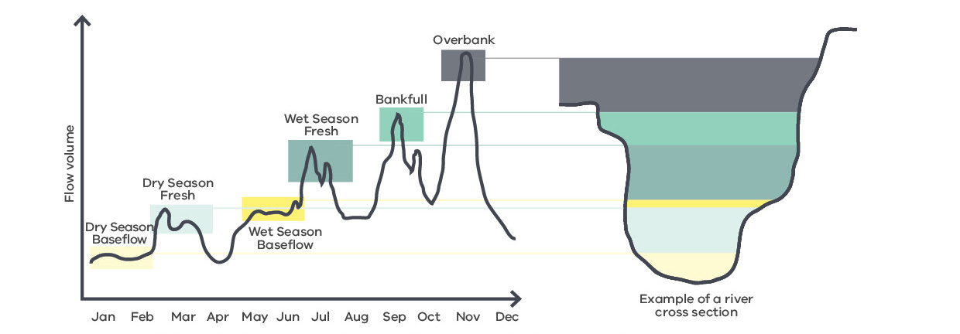

7. WATER AVAILABILITY
The purpose of this aspect of the study was to:
- quantify historical water availability in the Latrobe River system.
- model water availability over the timeframe of mine rehabilitation considering possible climate change futures and long-term climate variability.
This study used the reconstructed unimpacted historic inflows into the Latrobe River (upstream of Rosedale) derived using the Latrobe REsource ALlocation Model (REALM) for 1957 to 2017, with pre-1975 streamflow data scaled to match post-1975 climate conditions. This dataset represents streamflow in the absence of all consumptive water use and farm dams.
To model the potential change in water availability into the future, climate change factors were applied to the long-term inflow average under the wet, median and dry climate scenarios, interpolating the factors between 1995 and 2040, and between 2040 and 2065, and extrapolating the 2040–2065 trend beyond 2065. The sensitivity of the results on the 1995 start date (mid-point of the 1975–2014 Victorian Climate Change Initiative analytical period) for applying incremental climate change (and plausible alternatives) is considered in the findings.

Key outcomes
- The historic water availability in the Latrobe system appears to have undergone a step change since 1997 corresponding to a reduction in long-term average flow of about 800 GL/y to an average of about 600 GL/y over the past 20 years (illustrated by the dashed green line in Figure 2).
- The ‘dry climate’ projection based on the post-1997 period, which includes the Millennium Drought, is possibly consistent with the observed step change in the Latrobe system since 1997 (average 600 GL/y).
- This step change (post-1997) and ‘dry climate’ projection could have two possible interpretations – continued drought period and/or drying trend, which makes modelling future scenarios difficult and uncertain. By using a long-term dataset, the drought represents an anomaly and thus modelling intrinsically shows a return to long-term average conditions.
- To overcome this, an analytical approach based on climate statistics was adopted, and the two interpretations considered separately as equally possible climate pathways.
- The results therefore indicate that the possibility of a dry climate needs to be planned for while remaining flexible to the relative opportunities of a possible return to long-term average or wet conditions.
- Under a dry climate, flows in the Latrobe system could decline significantly by 2060 to about 400 GL/y on average. Such a decline would drive an incremental change in character for the Latrobe River system, and would require re-assessment of the minimum environmental flow requirements for the system.

Figure 2: Total water availability in the Latrobe system (upstream of the Latrobe-Thomson confluence) using historical inflows and climate projections
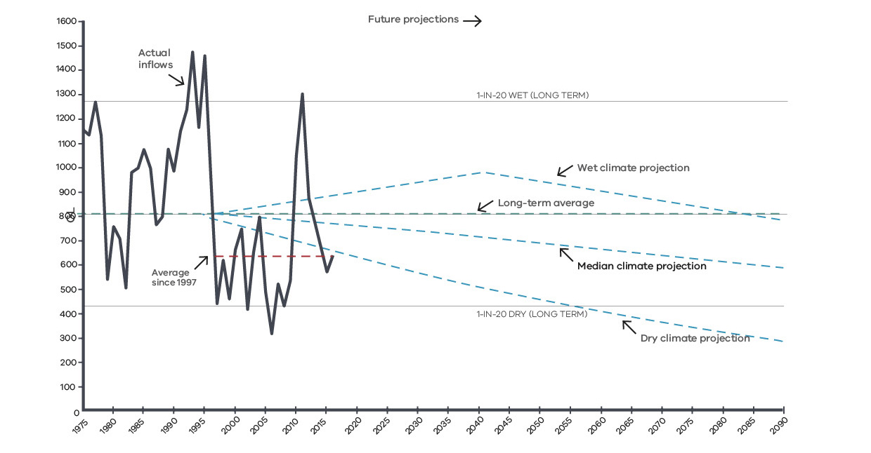

8. WATER USE SCENARIOS
The purpose of this aspect of the study was to:
- model filling of the mine voids with water to full and partial levels and fill rates using potentially locally available water sources in order to determine filling timeframes and interactions among the three filling pits and operating power stations.
The key assumptions adopted for the modelling analysis, which would be revisited as part of the analysis supporting any future mine rehabilitation planning, are as follows:
- In order to prevent instability, groundwater pumping continues until stability is achieved and then is slowly ramped down based on mine configuration and known risks. This effectively decouples this analysis of pit filling from groundwater behaviour in the confined aquifers (underlying Hazelwood and Loy Yang) and allows groundwater modelling to be conducted using a simplified groundwater pumping scenario.
- Only existing physical water access arrangements for the three mines and power stations are considered as potential local water sources.
- A supply of surface water, such as that supplied in the past by Gippsland Water for power generation, could be made available to all mine operators in a sequential manner over time.
- Water extraction from the Latrobe River under arrangements similar to the existing arrangements for power generation would be limited to the current level of consumption (i.e. not the full nominal volume of the entitlement or licence). This acknowledges that the effects of current usage are well understood and serves as a benchmark for potential future provision of water for mine rehabilitation.
- Under a full pit lake scenario, top-up to account for evaporative losses would in the first instance be sourced via existing pipelines from the Latrobe River and not local catchments.

Key outcomes
- Water use scenario modelling shows that under the above assumptions, there is no material change to current patterns of water use over the course of rehabilitation, and no undesirable effects due to early closure (i.e. stacking of impacts).
- Evaporation from the pit lakes should be estimated in the first instance using Morton’s shallow lake evaporation, which is available as gridded data in the Latrobe Valley. Evaporation under current conditions is predicted to be of the order of 4–6 GL/y per water body.
- The timeframe for filling of the mine pits under these assumptions is in the range of 15–20, 20–25 and 25–30 years for the Hazelwood, Yallourn and Loy Yang mines, assuming that all mines continue operating to planned closure and there is no interruption of surface water supply (noting that interruption of water supply over these timeframes is likely and would result in extension of these timeframes for filling).

9 GROUNDWATER FLUX MODELLING
The purpose of this aspect of the study was to:
- predict the likely movement of groundwater into and out of the mine voids and possible pit lakes in the context of rehabilitation, in order to understand the potential contribution of groundwater to the water balance during and post filling, and the potential for local groundwater contamination or other groundwater impacts.

Key outcomes
- Due to the need to maintain low aquifer pressures (by groundwater pumping) during filling the mine void with water, groundwater seepage is not a material contributor to the filling volume (although pumped groundwater is assumed to be transferred to the mine void during pit filling as a significant proportion of the final lake volume).
- Groundwater fluxes (inward and outward) under a full pit lake scenario are considered to be very small (<0.5 ML/d), in comparison to pit lake volume, and change in direction over time and location in the mine void (both in terms of elevation and pit perimeter) in response to recovery of groundwater pressures.
- The contribution of groundwater seepage to pit lake filling, either losing or gaining, is less than 0.5% of annual fill rates.
- At Hazelwood, due to the low flux rates, it is considered there will be little interaction between the pit lake and groundwater.
- At Hazelwood, net groundwater fluxes into the pit, after recovery of groundwater pressures do not appear sufficient to support a stable pit lake level, meaning that additional water would be required to maintain a stable partial pit lake level (~1 ML/d of inflows versus net evaporative loss of ~11 ML/d).
- The accuracy of modelling is subject to ongoing review; however, given the very small interaction with groundwater, significant error in flux predictions does not materially change the outcomes.
- Similar findings hold for the Yallourn and Loy Yang mines, but would need to be re-evaluated once mining ceases.

10. REGIONAL GROUNDWATER PROJECTIONS
The purpose of this aspect of the study was to predict the recovery and future trajectory of groundwater levels and pressures in the context of mine rehabilitation, climate change and other factors such as offshore oil and gas extraction (which uses significant volumes of groundwater from regional aquifers).
The study provides an understanding of whether regional aquifers are likely to eventually recover to pre-mining levels and identify the need for, and location of, groundwater monitoring.

Key outcomes
- Groundwater pressures in the deep confined aquifers currently pumped by the mines to maintain stability are considered unlikely to fully recover to pre-mining levels on a regional basis due to insufficient recharge under most future climate scenarios.
- The predicted degree of permanent decline depends on the climate scenario used.
- These results potentially have implications for future groundwater management and sustainable yields in the region.
- Whether rehabilitation results in a partial or full pit lake is considered to have no material effect on the recovery of deep groundwater pressures, other than potentially delaying recovery if groundwater pumping continues for an extended period.
- No need for additional groundwater monitoring beyond the existing monitoring network was identified.

11. WATER-RELATED EFFECTS
The purpose of this aspect of the study was to:
- identify the aquatic ecosystem values that could potentially be impacted by mine rehabilitation.
- describe the current condition and existing trajectories of these values.
- determine the potential effects of mine rehabilitation on these ecosystems.
- recommend ways to improve the condition of these ecosystems.
The study considered the system as five mega-habitats, including shallow lakes (Lake Wellington), freshwater wetlands (Sale Common), variably saline wetlands (Heart and Dowd Morasses), Latrobe estuary, Latrobe River and the tributaries. Rehabilitation water use scenarios were used to assess the impacts on the flow regime and thus the potential effects on aquatic ecosystems.

Key outcomes
- The condition of many aquatic ecosystems in the Latrobe system are considered to be in decline. This is especially significant for the end-of-system Ramsar sites, recognised as wetlands of international significance.
- Power generators discharge slightly turbid and saline waters into Morwell River and Traralgon Creek as a result of their operations. The cessation of coal-fired power generation will mean that these tributaries may experience better water quality but a higher frequency of cease-to-flow periods.
- Further reduced freshwater inflows and rising sea levels could increase salinity in Lake Wellington, the Latrobe estuary and fringing wetlands, reducing freshwater habitat.
- Water use for mine rehabilitation, if limited to the current volumes of water use associated with power generation, is considered to have no additional significant effect on the seasonal or total annual flow in the Latrobe system.
- However, under an increasingly drying climate (as indicated by modelling), the total footprint of water take for mine rehabilitation would increase.
- While there is insufficient evidence to draw definite conclusions, the study proposed that continued extraction of water at current levels (without conditions) under a drying climate scenario would likely exacerbate the existing negative impacts on the high value aquatic ecosystems of the Latrobe.

Figure 3: Water availability in the Latrobe River system – Latrobe River inflows compared with minimum river flow recommendations and consumptive uses, including power generation and possible future pit lake filling. This assumes no change in future demand for non-mining consumptive use.

12. PIT LAKE MODELLING
The purpose of this aspect of the study was to develop a fit-for-purpose model that could be used to simulate filling of the mine voids, including water balance and water quality evolution, using the information, parameters and assumptions captured and derived during the Regional Water Study that can be updated in the future.
The model was implemented in GoldSim using a daily timestep, with many options for configuration and testing of rehabilitation parameters such as water sources and fill rates, catchment interception, climate projections and input water
quality parameters.

Key outcomes
- The modelling shows that the water quality of the pit lakes is dominated by the quality of water sources used to fill the mine void, and not potential local pollution sources.
- The scenario of a pit lake with ongoing external water input (of suitable quality) and outflow is more likely to achieve and maintain higher water quality.
- Mine water bodies that are not regularly flushed are likely to undergo gradual decline in water quality over time (e.g. 100 years) due to accumulation and evaporative concentration of salinity and potentially other contaminants in supplied water.
- No significant water quality risks were identified at this stage, although this would need to be reassessed at the end of mining operations and consider also the water quality of the proposed water supply.

13. WATER AVAILABILITY FOR MINE REHABILITATION
This aspect of the study integrated the technical studies to:
- understand the implications for mine rehabilitation and the types of decisions that would need to be made to develop the Strategy.

Key outcomes
- Water availability in the Latrobe River system is uncertain given the wide range of possible climate projections, as depicted above in Figure 3.
- In dry periods, water availability can fall significantly short of minimum environmental flow requirements and consumptive usage.
- In wet periods, there are sufficient local water resources to meet all demands including potentially mine rehabilitation.
- The frequency of dry and wet periods is uncertain, and more frequent dry periods could result in limitation to water
availability and delays to mine rehabilitation if based on a partial or full pit lake.

Summary of LVRRS Consultation

BACKGROUND
In response to the Hazelwood Mine Fire Inquiry (HMFI) findings, the Government released a detailed implementation plan that included a commitment to develop a regional rehabilitation strategy for the Latrobe Valley’s three brown coal mines.

IMPORTANCE OF ENGAGEMENT TO THE PROJECT
The Latrobe Valley Regional Rehabilitation Strategy (LVRRS) has been developed in consultation with mine owners, key stakeholders and the community.
The LVRRS Project Team recognised early on that engagement with key stakeholders would be critical in developing the LVRRS. Open and transparent engagement with the mine licensees, water industry, Latrobe City Council, Traditional Owners and the Latrobe Valley community at large would be important to ensure that the diverse views of these stakeholders and their aspirations for mine rehabilitation and the wider region and environment were understood and could be reflected in the final Strategy.
With that in mind, the Latrobe Valley Regional Rehabilitation Strategy Community and Stakeholder Engagement Strategy (engagement strategy) was developed in the first stage of the Project. The purpose of the engagement strategy was to identify the key stakeholders for the Project, the outcomes sought from engagement activities throughout the
LVRRS Project’s four stages, and the engagement tools and methods that would be implemented during each.
The engagement strategy took a local first approach, recognising that the people of the Latrobe Valley are the people with the most to gain or lose from the rehabilitation of the Latrobe Valley’s brown coal mines.
Benefits of the engagement approach have been wider community awareness, with many of the questions asked having been answered throughout the technical studies, presentations and panel discussions. Most importantly the diverse range of stakeholder views have been heard and considered, informing the LVRRS.

KEY OUTCOMES AND TOOLS FOR EACH STAGE OF THE PROJECT
A summary of the engagement outcomes sought during each of the LVRRS Project’s four stages is provided in Table 1. This also includes a summary of the key engagement activities delivered.
Table 1: Summary of the LVRRS Project’s engagement aims, objectives and activities delivered
 | Stage One  Project initiation | Stage Two  Existing  conditions review | Stage Three  Modelling  and Analysis | Stage Four  Integrate findings
Aims | - Start to engage stakeholders in project planning. | - Understand the current environment and build the community’s understanding of the issues. | - Take people on the journey of what is technically possible. Taking that into account, create a shared vision for the future use of the area. | - Release a draft of the strategy for consultation that reflects community and stakeholder views.
Objectives | - Project scope planning for the technical investigations.  - Forming relationships.  - Establishing the Latrobe Valley Mine Rehabilitation Advisory Committee (LVMRAC). | - Inform people about the project including the challenges, constraints and opportunities.  - Understand what is important to the community.  - Introduce the Latrobe Valley Mine Rehabilitation Commissioner.  - Build people’s technical  understanding.  - Undertake a land use directions and vision exercise with community and stakeholders to identify a preliminary vision for the Regional Rehabilitation Strategy project area. | - Keep people informed about the project including progress and emerging issues.  - Build knowledge about the technical process and outcomes.  - Start an informed dialogue around future use. | - Ensure the strategy contains no surprises and reflects the outcomes of the engagement process.
Delivered | - Stakeholder  briefings and meetings.  - Scoping  workshops.  - Establishment  of the LVMRAC. | - Factsheets.  - Latrobe Valley Advisory Committee meetings commence.  - Open house information sessions.  - Market research.  - Focus groups.  - Workshops, meetings and briefings.  - Introduction of the Latrobe Valley Mine Rehabilitation Commissioner. | - Formation of social history committee.  - Preliminary Land Use Vision (PLUV) public co-design consultation.  - PLUV information stalls.  - Specialist workshops with technical stakeholders.  - Factsheets. | - Release of water and geotechnical synopsis reports.  - Factsheets.  - Community event.  - Focus groups.  - Public consultation on PLUV and LVRRS Overview.  - LVRRS Overview Consultation report.  - PLUV Consultation report.  - Stakeholder briefings.  - Release of the LVRRS.

A number of engagement methods have been used to achieve the objectives of the engagement strategy. These include scoping workshops, briefings and meetings with specific stakeholders, workshops, community events and ‘pop ups’, focus groups and surveys. These have been supported by a range of communications products such as factsheets, community newsletters, reports and presentations, social media and website updates.
The stakeholder environment for mine rehabilitation in the Latrobe Valley is large and complex. It is the people of the Latrobe Valley who have the most to gain or lose from the rehabilitation of the Latrobe Valley coal mines. The effect of rehabilitation also reaches those regionally and more broadly, encompassing all Victorians. With this in mind, the following stakeholders have been key to the development of the LVRRS.

ROLES OF THE LVMRC AND LVMRAC IN ENGAGEMENT
The Latrobe Valley Mine Rehabilitation Commissioner (LVMRC) played an important independent and legislated role in promoting the LVRRS and rehabilitation of the coal mines in the Latrobe Valley. The role of the LVMRC was to promote participation of local community and stakeholders within the Latrobe Valley in mine rehabilitation. These include the community, public sector bodies and licensees. The LVMRC was involved in education sessions and meetings to promote communication and resolution of issues between the various stakeholders.
The Latrobe Valley Mine Rehabilitation Advisory Committee (LVMRAC) played an equally important role in engagement for the LVRRS. The role of the LVMRAC was to provide expert and strategic advice on the development of the LVRRS. The members included diverse representation from the water sector, Latrobe Valley coal mine licensees, local and state government bodies, community members, Latrobe City Council, representations of Traditional Owners, and union representatives. This ensured that the view of multiple stakeholders was heard around the table and considered in the development of the LVRRS.
Figure 1: Key stakeholders in the preparation of the LVRRS
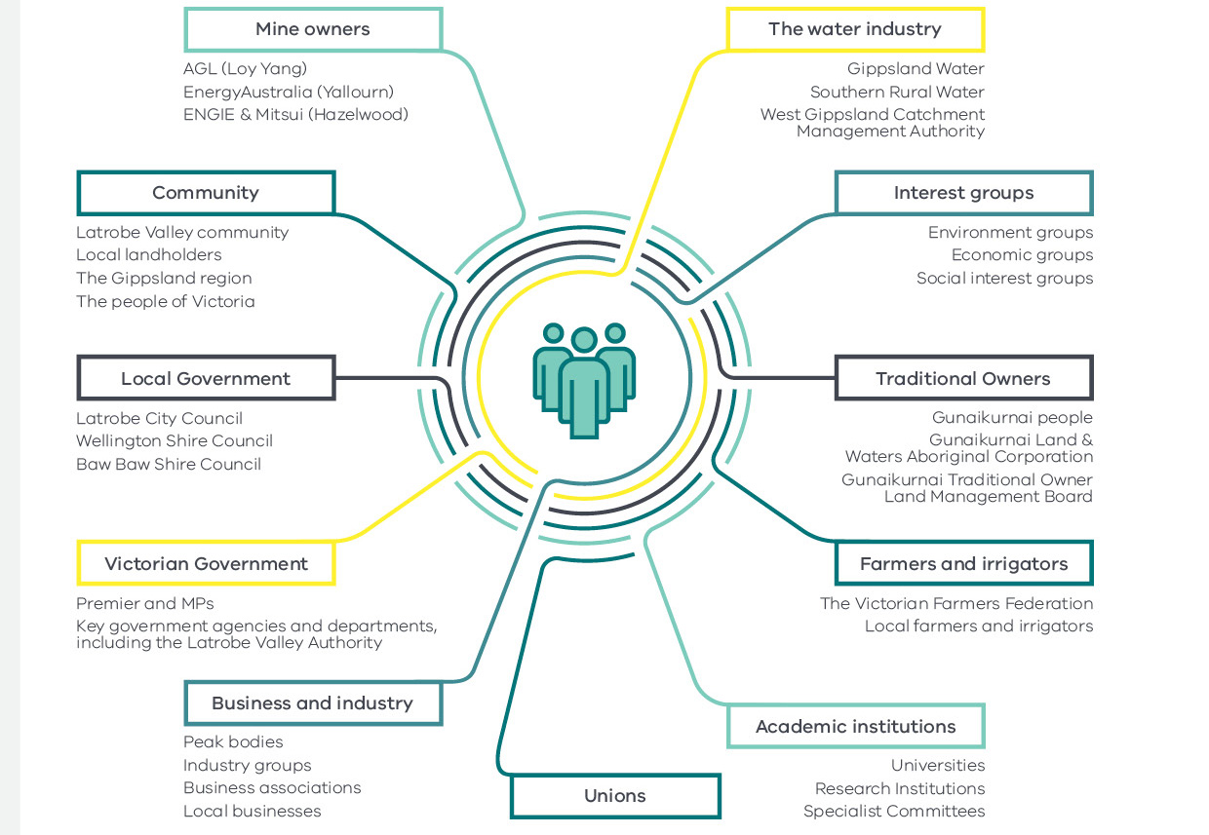

WHAT WE’VE DONE
A range of stakeholders were engaged throughout the project to gauge their knowledge of mine rehabilitation, their aspirations for rehabilitation of the three brown coal mines in the Latrobe Valley as well as for the wider Latrobe region with regards to water and the environment, and their desired level of involvement through the process of rehabilitation planning and implementation.
Individual stakeholders have also been briefed to keep them up to date on progress and allow them opportunities to provide input at key points of the LVRRS.
This has included targeted engagement on specific aspects of the LVRRS such as the development of a position to inform water access for mine rehabilitation and what this means for irrigation and the environment. Stakeholders were provided with an opportunity to hear how their feedback was considered in the final LVRRS. Consultation reports on the Preliminary Land Use Vision and the LVRRS Overview have been published on Engage Victoria.
Alongside these opportunities, the LVMRC and LVMRAC were regularly consulted and provided valuable expertise and feedback. They have also provided important avenues for engaging more widely on the LVRRS through their own networks.

Opportunities for consultation with community and other key stakeholders on the LVRRS to date includes:
Figure 2: Summary of engagement activities during the preparation of the LVRRS
- More than 1500 people participated in market research for the LVRRS to gain a comprehensive understanding of community attitudes towards brown coal mine rehabilitation in the Latrobe Valley
- More than 20 meetings of the LVMRAC
- 10 open days, community sessions and events with more than 150 attendees
- More than 50 meetings and briefings with 395 attendees
- 11 workshops with more than 140 attendees
- More than 100 submissions received through public consultation processes
- 12 focus groups with more than 100 attendees

WHAT WE’VE HEARD

KEY FEEDBACK THROUGHOUT THE PROCESS
A number of opportunities have existed for consultation over the life of the project. Key feedback from the following opportunities are summarised below.

Market research
In 2017, 1583 people were surveyed across target groups representative of ‘Victoria’, ‘Latrobe City’, ‘Farmers’, ‘Business operators’ and ‘Tourist operators’ (Figure 3), with representatives drawn from local government areas across the Latrobe Valley such as Latrobe City, Baw Baw and Wellington Shires, except for those in the ‘Victoria’ group.
Figure 3. Market research target groups representative of Victoria

The survey contained 41 questions with a mix of Likert scale and open-ended questions. The aim of the market research was to understand people’s knowledge and attitudes toward mine rehabilitation, specifically for the three brown coal mines in the Latrobe Valley.
The most common thoughts that came to mind about mine rehabilitation included potential jobs and economic improvement impacts through mine rehabilitation, the return of the mine sites to nature, cynicism about whether mine rehabilitation would be done well, and concerns about the expense of mine rehabilitation and who would be responsible for this.
There were differing understandings of ‘safe’ in terms of mine rehabilitation that were apparent between the ‘Victoria’ group and other groups, with other groups more likely to define it in terms of safety of people in the local area and region. Conversely, the terms ‘stable’ and ‘sustainable’ were more similarly defined across groups.
The majority of people saw the mine licensees as responsible for financing and implementing rehabilitation. Many people also saw a role for government in mine rehabilitation, with a greater proportion believing that this role included financial assistance as well as implementation (approximately 70 per cent, compared with approximately 60 per cent for undertaking rehabilitation).
A clear concern for the safety of both humans and the environment was evident for all groups when considering the design of any rehabilitation options. Local groups also expressed a specific concern for mine workers.
Local groups valued the area for the lifestyle opportunities available, as well as the location and employment opportunities. There was also a desire for those who lived locally for future access to the coal resource not to be sterilised through mine rehabilitation. This was in recognition of the value that coal brought to the community in terms of economic and employment benefits.

PRELIMINARY LAND USE VISION
Exhibition of the Preliminary Land Use Vision (PLUV) occurred between October and November 2019. The PLUV was developed to inform the transformation of the Latrobe Valley over time through the closure and rehabilitation of the three major open-cut coal mines and associated power stations. The PLUV provides a set of guiding directions for future land use and development, based on achieving positive social, economic and environmental outcomes.
A total of 79 people responded to the online survey through Engage Victoria during the exhibition. The survey was made up of multiple choice, open and demographic questions. A further 15 longer submissions were also received through the exhibition process.
The survey focused on the four key themes presented in the vision:
- Theme 1: Tourism, Liveability, Recreation.
- Theme 2: Industry, Business, Commerce.
- Theme 3: Agriculture, Energy, Water.
- Theme 4: Services, Education, Training.
In relation to theme one, just under two thirds of respondents supported the PLUV, with the most common responses for improvement being more parks and green spaces, and recreation and tourism hubs (Figure 4).
Figure 4. Response to the question: Do you support this Vision? Theme 1: Tourism, Liveability, Recreation

There was some mention of specific recreation ideas such as the use of the Hazelwood Pondage and
a trans-Latrobe bike trail as part of a trans-Gippsland trail.
‘Reopen the Hazelwood Pondage as a water based recreational and educational site...this site is within walking distance of the townships of Yinnar and Churchill and within bicycling distance of many places...part of its amenity value as such is that its free to all – like the riverside (Brisbane) and rock pools (Aussie beaches) which are places for everyone.’
‘Reforestation with a variety of native and appropriate trees for the area must be a priority to create a habitat for wildlife as well as adding positive benefit to both the community and climate issues.’
In relation to theme two, more than two-thirds of respondents supported the PLUV (Figure 5).
Figure 5. Response to the question: Do you support this Vision? Theme 2: Industry, Business, Commerce

The most common response for other opportunities for business and industry was about renewable energy, recycling and other sustainable industries.
‘Ensuring that business parks built in the area focus on both blue-collar jobs, and white-collar jobs, for a strong and diverse economy. In addition to focusing on engineering, the area is surrounded by agricultural industries, so we should not ignore the potential for advancing food sciences, advanced food manufacturing, and even the health sciences.’
‘I’d like to see smart thinking we need to shift to Hemp industries Fibre and biodegradable plastic, save Plantations for wood production, not paper! Farming practices that produce sugars for alcohol fired power stations... renewable provides a more stable economy for the agriculture sector.’
The PLUV for theme three was supported by two-thirds of respondents (Figure 6).
Figure 6. Responses to the question: Do you support this Vision? Theme 3: Agriculture, Energy, Water

The most common responses for improvement included reforestation, parks and increased environmental protection; transformation of mine sites into sites for renewable energy generation; and sustainable, environmentally friendly industries.
‘Farmers can host solar farms and solar gardens and wind turbines to produce electricity for the grid and it would be very important to keep this area as a base for energy production…Some farms with the right topography could even host pumped hydro dams on theirs and maybe a neighbour’s property.’
‘Water is going to be the most valuable commodity in our drying climate and whatever we do we need to use it wisely and not support those industries which would take more than a fair allotment to keep them going.’
Two-thirds of respondents supported the vision for theme four (Figure 7).
Figure 7. Responses to the question: Do you support this Vision? Theme 4: Service, Education, Training

The most common responses for opportunities for improvement were investment in schools, TAFEs, universities and students; new renewable energy industries; and better public transport.
‘Make it a centre of excellence setting up a demonstration centre for all renewable energy technologies.’
‘The Latrobe Valley is ideally situated to be a centre of Government services for the Gippsland region and as well as building on the Latrobe Regional Hospital and Federation University.’
‘Improve public transport to and from metropolitan areas.’
A common thread across the themes can be seen in the desire for renewable energy. This was also a strong theme in the open responses, with almost two-thirds of respondents who provided additional comments through the online survey wanting the current power stations to be closed with renewable energy available now. There was also a call for government to act, rather than just talk or create strategies. In addition, five respondents called for an Environmental Effects Statement process to be undertaken for mine rehabilitation.
‘It is good that the Government is thinking ahead as to the best way forward for our area and I am certain that the area has a positive future with the start-up of clean industries.’
‘I am concerned that air pollution from power stations affects the quality of valley residents’ lives significantly, and I believe that a transition for the valley would improve both the health and the economic circumstances of the residents.’
A number of respondents to the PLUV also commented on water security and environmental concerns, particularly if water
was used for mine rehabilitation at the expense of other users (industry, urban, environment) in a drying climate.

LVRRS OVERVIEW
A survey seeking feedback on the LVRRS Overview was published through Engage Victoria between 20 November 2019 and 17 January 2020. The survey was made up of multiple choice, open and demographic questions. A total of 31 submissions were received through Engage Victoria. Of these, 21 responded directly to the questions, with nine longer submissions or submissions that provided general feedback but did not necessarily respond directly to the questions on Engage Victoria (Figure 8).
Figure 8. Submissions received in response to the LVRRS Overview

There were a range of views about the preferred rehabilitation option and final landform from stakeholders. One key theme that emerged is the desire for a range of rehabilitation options to be explored further, including those that do not involve water, with one respondent describing government’s role in this as:
‘…[to] encourage and facilitate the development [of] a range of potential options rather than being, as is currently apparent, locked into a single option that is dependent on a number of as yet untested assumptions.’
This view has been expressed particularly by stakeholders who believe the future availability of water in a drying climate is doubtful, especially when the available water could be used for other beneficial uses. Regardless of the final landform, the desire for the rehabilitated voids to offer amenity to the region and Victoria more widely was expressed by a number of stakeholders, for example:
‘…the rehabilitated sites need to leave the Latrobe Valley with a positive legacy from coal mining and should create a positive amenity for the community that contributes to the future social and economic integrity of the region.’
Contrasting this, mine licensees note that it is important that expectations around the delivery of amenity value are managed. The mine licensees stress their legislative obligations for mine rehabilitation to achieve the requirements of safe, stable and sustainable, which they believe are best achieved through the use of water. However, they believe that the provision of additional amenity beyond this would require leadership from and partnership with government:
‘Government should play an important role in managing the expectations of the community around future land use and not create community expectations beyond safe, stable and sustainable without being prepared to fund the additional costs of meeting community expectations.’
Given the potential impact of water access for mine rehabilitation in a drying climate, there was feedback to ‘consider long-term climate projections in setting parameters for rehabilitation, including water availability’. Similar requests to assess the cost of providing water for mine rehabilitation on the environment were also made, with specific reference to the internationally significant Ramsar-listed wetlands and lakes. Requests for an Environmental Effects Statement for mine rehabilitation plans were also made by a number of respondents, including Latrobe City Council.
The role of government in mine rehabilitation was often seen by respondents as either protecting or preserving what they identified as important, both from the point of view of the environment, including water resources, and access to the coal resource. Examples of feedback from respondents interested in preserving the coal resource mentioned the importance that ‘there will still be access to the coal resource if in the future other uses are found for brown coal’. Similarly, Latrobe City Council noted that ‘mine rehabilitation should be undertaken in a manner that does not preclude future opportunities to utilise what is a globally significant resource’.
In addition, respondents viewed the government as having a role in assessing risks and alternative rehabilitation options, as well as providing guidance to and working in partnership with mine licensees. ENGIE commented on the support that should be provided to mine licensees by government, stating:
‘Government’s role in mine rehabilitation should not be limited to setting legislation, regulation, policy and guidance [as the principles suggest], but also to providing coordinated, multi-agency support to mine licensees, in the knowledge that historical decisions made by government had a direct bearing on the current challenges confronting them.’
Traditional Owners noted the collaborative role that government should play. They acknowledged the work of government in establishing the Mine Land Rehabilitation Authority, noting government’s ongoing role in healing of Country through rehabilitation. The need for government to understand connected Country, particularly through the region’s wetlands, rivers and lakes, was highlighted. Collaborative relationships between mine licensees, government and Traditional Owners was identified as important to help achieve this.
Clear feedback from a number of stakeholders is the need for transparency in the decision-making process. Various respondents were also keen to be involved in the process, ensuring that their views were considered in any decisions. There was a desire for active engagement, but also a realisation that all expectations may not be met, with one respondent noting ‘compromise will be necessary to enable progress’.
Respondents wanted regular engagement throughout the mine rehabilitation process, not just at the end. A number of respondents were also keen to access technical information, both in an easy to understand format and the full technical reports. It was suggested that engagement through multiple media would help stakeholders, especially given the varied media through which stakeholders both heard about opportunities to engage and were willing to engage. Examples ranged from attendance at community events to citizen science programs.
Clarity on the decision-making process and the evidence required for options analysis to present a preferred rehabilitation option was also important. Some of the mine licensees were concerned by the burden of proof required to assess multiple options beyond pit lakes, with some arguing that they have already undertaken the required studies in previous years to assess their need for water for rehabilitation. They also believed that, as the initial purchase of the mine and infrastructure was based on rehabilitation plans using water, a shift away from this concept would lead to a shift in the risk profile for which government would need to account:
‘It would be very difficult for mine licensees to achieve a safe, stable, and passive final landform without the planned access to water, exposing operators to risks that bear no resemblance to those foreshadowed in the acquisition of the asset. It’s unclear how Government would work to ameliorate this shift in risk profile.’
A common understanding of key terms for mine rehabilitation was also an important component of clarity. One respondent noted that government should:
‘be more prescriptive about what will and will not constitute a sustainable outcome. This will benefit all stakeholders, including the [mine] operators, as this will remove ambiguity and investment of developing options that have no chance of meeting sustainability criteria.’

Conversely, other respondents, while noting the desire for clarity, also acknowledged the need to balance this with flexibility, especially in the face of a drying climate. The process for assessments to support the preparation and delivery of rehabilitation plans was therefore seen as critical to this balance and continues to be led by DJPR and DELWP.

FOCUS GROUPS ON THE LVRRS OVERVIEW
During the consultation on the LVRRS Overview, six focus groups were held to gain a better understanding of broader community views, particularly of those who had not expressed an interest in mine rehabilitation to date. A total of 51 participants attended these focus groups across the sessions.
Overall, there appeared to be a low level of knowledge of the mines, the LVRRS and mine rehabilitation within the wider Latrobe Valley community, with some confusion as to the number of coal mines in the Latrobe Valley and whether the coal seam in the Hazelwood mine was actually still burning after the 2014 Hazelwood Mine Fire. Issues that were of concern for participants included health impacts, safety and potential fire risks.
Initial thoughts around closure included the economic and social impact with a loss of jobs and general economic decline of the region. There was agreement that something would also need to be done with the remaining ‘holes’ to ensure that they didn’t become eyesores for the region. Ideally, some form of tourist attraction would be preferred, however, articulation of what this might be was difficult. Use of the sites for alternative energy production was also explored. Regardless of the rehabilitation option chosen, there was strong sentiment that the option should provide jobs for the local community.
Although participants believed that both the mine licensees and government had a role in rehabilitation, there was some lack of clarity on what the role of each was. After discussion, however, government was often viewed in terms of providing guidance and also playing a key role in compliance. The role of mine licensees was seen as important in ensuring the plan that they implemented for rehabilitation was agreed with the local community.
The concepts of ‘safe, stable and sustainable’ elicited thoughts about air quality and dust suppression, eliminating fire risks, eliminating emissions and stable land (no landslips or erosion).
There were concerns about the amount of water required and how the quality of the water would be maintained if it were just stored in the voids. This was particularly in the context of climate change and the possibility of water in the voids impacting the quality of water in the surrounding areas respectively. Ultimately, however, there was broad acceptance of using water to rehabilitate the mines with a number of caveats including turning the voids into an asset for the community and an opportunity for local jobs.
Given the timelines for rehabilitation, there was mention that the younger generations should be engaged in the decision-making process.
Given that many of the participants hadn’t heard of the LVRRS, it was important to understand how they could be connected into the discussion in future, particularly through the rehabilitation planning and implementation phases. Social media was seen as a key medium through which to engage for many in the region, with some stating that they didn’t read newspapers or watch television. There were those, however, who said they do not use social media. The use of local people and networks was also identified as a way to help get the message across and connect with the local community.

WATER ACCESS FOR MINE REHABILITATION
The Department of Environment, Land, Water and Planning (DELWP) met with key stakeholders to gather feedback on the draft position on water access for mine rehabilitation between November 2019 and January 2020. The engagement was based around principles and policies to apply to decisions around access to water for mine rehabilitation. An initial round of consultation was also undertaken from mid-late 2019
to inform the draft position.
Traditional Owners conveyed that they are keen to be a part of decisions made about mine rehabilitation, particularly given the alignment of mine rehabilitation with the goal of healing Country outlined in the Gunaikurnai Land and Waters Aboriginal Corporation’s Whole-of-Country Plan. A cost / benefit analysis was proposed, to include not only economic and environmental aspects, but also cultural and social aspects. This was also supported by other environmental water managers and local government authorities. Water is essential to self-determination and the protection and managing of water, particularly regarding the region’s wetlands, rivers and lakes, is an intergenerational and custodial responsibility.
The West Gippsland Catchment Management Authority and the Victorian Environmental Water Holder, together with conservation-based community groups, underscored the importance of water for the environment, holding that this should be a priority given the already stressed Latrobe River system and our international obligations to protecting the Gippsland Lakes Ramsar Site. They emphasised that mine rehabilitation must plan for a drying climate, and be able to adapt to the climate conditions experienced during rehabilitation. Concerns about impacts on environmental flows and flow regimes was also raised.
Irrigators were concerned about the impact mine rehabilitation might have on their own water security and the ability of the food and fibre sector in the region to expand, particularly in the context of a drying climate. Considering the region’s importance to Victoria’s agricultural production, there is concern that filling the voids with water from the Latrobe River system would put the region at risk. An understanding of the value of water was requested to take into account the valuable uses for water other than for mine rehabilitation.
Environmental groups identified the importance of water for the environment, proposing that this should be a priority given the already stressed Latrobe River system and our international obligations to protecting the Gippsland Lakes Ramsar Site.
A component of this was for mine rehabilitation planning to recognise the situation of a drying climate, with flexibility to respond to this built into plans. Concerns about impacts on environmental flows and flow regimes was also mentioned.
There was a desire for more clarity around terms such as ‘essential’ and ‘safe and stable’ particularly in the context of water. Clarity on the process for assessment of rehabilitation options was also requested, again in relation to evidence required to demonstrate that water is essential for mine rehabilitation. Transparency of the decision-making process was also a key theme.
Mine licensees believe that water is the only real solution for a safe and stable void, and have stated that they require access to a reliable water source to enable this, particularly during critical times in the fill regime. Clarity is needed around the evidence to demonstrate the essential need for water to help them put forward their case in the decision-making process.
In order to assess the competing demands on water, a better understanding of the opportunity costs was proposed. A number of stakeholders highlighted that if water is used for mine rehabilitation, an opportunity cost for a new industry or potential expansion of an existing industry or environmental flow would exist. There was an argument that, should water from the Latrobe River system be repurposed from being for power generation to being for mine rehabilitation, the cost should be indexed and equitable.
Given the existing stress on the Latrobe River system, a number of stakeholders expressed the desire for other non-water rehabilitation options to be explored. Similar to this, a consideration of alternative water sources (recycled and desalination) for mine rehabilitation was also mentioned. It was identified that this may also help to free up water in the Latrobe River system for other uses.

COMMON THEMES TO EMERGE
A number of key themes have emerged across the project’s consultation.
Clarity around terms and definitions, to ensure all stakeholders understand what is being discussed. Clarity is also about ensuring the processes, including evidence required, and responsibilities are clear for all stakeholders.
Consideration of multiple options. Stakeholders have requested that consideration of multiple options include a risk analysis, particularly in relation to fire and stability risks, or a cost / benefit analysis, including economic, environmental and cultural elements. To be included in these analyses is also a desire to ensure any option doesn’t limit future potential access to coal.
Consideration of a drying climate. Many stakeholders were aware of the drying climate and wanted to see this as a critical factor in decision-making. The fact that multiple users are competing for a resource that is also desirable for mine rehabilitation, such as water, was clear throughout consultation, particularly when each of these users may view the value of the resource differently.
Engagement and collaboration. All stakeholders were keen to remain engaged through the process of decision-making and implementation of mine rehabilitation. Of particular note was collaborating and working in partnership with the community, mine licensees and Traditional Owners, each of whom has their own unique engagement needs.
Amenity both from the point of view of a final rehabilitated landform and associated uses, such as reforestation or water bodies for recreational use, to the potential for renewable energy alternatives. The range of options proposed spanned those that would bring value and to the region and Victoria more broadly.

WHAT WE’VE DONE TO ADDRESS FEEDBACK
The LVRRS is structured around eight implementation principles. These take into account key themes raised through the various opportunities for consultation and feedback from stakeholders. An example of this can be seen in the principle regarding fire risk and concerns from the community, in particular about fire risk and safety. The accompanying statement for this principle also acknowledges the possibility for various rehabilitation options including those that do not rely on water.
Another example of stakeholder views incorporated into the LVRRS is an acknowledgement of a drying climate and the need to ensure that rehabilitation plans are climate resilient as far as practicable and do not impact water security. As an example of this, mine licensees will be required to demonstrate how their mine rehabilitation plan can be adapted under mild, median and dry climates. Further evidence of balancing this with the concerns of fire risk can be seen in the statement relating to this implementation principle.
Consistent feedback about ensuring that water for the environment and existing water users aren’t impacted is reflected in another of the implementation principles. This has been coupled with the important consideration of Traditional Owner values, particularly how they align to water.
A risk-based approach to analysis and assessment of options is also evident in a number of principles, such as the principle around ground instability and ground movement risks. This incorporates feedback from stakeholders on the need for any decision-making process to take a risk-based approach.
Defining terms in various communications products has been an important part of communicating with the broad range of stakeholders, all of whom have varying levels of understanding. An underlying theme across all engagement has continued to be the need to ensure terms and concepts are understood. In order to meet the needs of various stakeholders we will set out technical information in plain English and clear diagrams, with the aim of testing these explanations with stakeholders before they are published.
The importance of being able to engage with stakeholders where they are, at their relevant level of understanding and to the extent that they wish is also being taken into account. The commitment for government to develop an approach to community engagement in the planning and assessment pathway is evidence of this. Working with Traditional Owners to develop a pathway for involvement in the process is also an important government commitment.

Contact us
This report is available at earthresources.vic.gov.au/projects/lvrrs and water.vic.gov.au/planning/LVRRS
Please visit earthresources.vic.gov.au/projects/lvrrs to learn more about the Latrobe Valley Regional Rehabilitation Strategy or you can contact the project team at lvrrs@ecodev.vic.gov.au or on (03) 5184 2000

For the purpose of the Strategy ‘adjacent land’ is land that is close to coal mine land and which has the potential to be impacted by the coal mining, rehabilitation, or post-closure activities.
Hazelwood Mine Fire Inquiry 2016, Hazelwood Mine Fire Inquiry Report 2015/16 Volume IV - Mine Rehabilitation, Victorian Government Printer, Melbourne, pp. 74-82, parliament.vic.gov.au/file_uploads/11172_HAZ_MFIReport-2015_16-Volume4_FA_LR_15B0_pQfGZRfC.pdf.
The four options were considered unviable at the time due to the following conclusions: i. Full backfill, due to the lack of available fill material onsite or locally, and the significant costs associated with bringing in new material. ii. Partial backfill above the water table, due to the lack of available fill material onsite or locally, and the significant costs associated with bringing in new material. This landform would also require active management and extensive drainage to remain dry in perpetuity. iii. Lined void, due to the likely impact on environmental amenity, potential high costs associated with creating the lining, and limitations for end land use, as it would only support landfill or waste disposal. iv. Rehabilitated void, due to the need for ongoing landform stability works, such as dewatering into perpetuity. See: HMFI (2016), p. 81.
The HMFI Board was established as a Board of Inquiry pursuant to Section 88C of the Constitution Act 1975 and comprised the Honourable Bernard Teague AO (Chair), Professor Emeritus John Catford, and Ms Sonia Petering. The Board was independent to the Victorian Government.
Hazelwood Mine Fire Inquiry 2016, Hazelwood Mine Fire Inquiry Report 2015/16 Volume IV - Mine Rehabilitation, Victorian Government Printer, Melbourne, p. 82, parliament.vic.gov.au/file_uploads/11172_HAZ_MFIReport-2015_16-Volume4_FA_LR_15B0_pQfGZRfC.pdf.
Hazelwood Mine Fire Inquiry 2016, Hazelwood Mine Fire Inquiry Report 2015/16 Volume IV - Mine Rehabilitation, Victorian Government Printer, Melbourne, p. 109, parliament.vic.gov.au/file_uploads/11172_HAZ_MFIReport-2015_16-Volume4_FA_LR_15B0_pQfGZRfC.pdf.
Department of Premier and Cabinet 2016, Hazelwood Mine Fire Inquiry Victorian Government Implementation Plan June 2016, Victorian Government Printer, Melbourne, p. 75, vic.gov.au/hazelwood-mine-fire-inquiry-victorian-government-response-and-actions.
The Draft Preliminary Land Use Vision can be viewed on the Department of Environment, Land, Water and Planning website at: planning.vic.gov.au/policy-and-strategy/latrobe-valley-strategy
Department of Environment, Land, Water and Planning 2019, Latrobe Valley Regional Rehabilitation Strategy Regional Water Study Synopsis Report, Department of Environment, Land, Water and Planning, East Melbourne, water.vic.gov.au/__data/assets/pdf_file/0022/436441/13018-DJPR_Latrobe-Valley-Regional-Rehabilitation-Strategy-Water-Study-Synopsis_V2.pdf.
The three mines currently have licences under the Water Act 1989 to extract groundwater from the Morwell Formation Aquifer, Traralgon Formation Aquifer and the Haunted Hills Gravel Aquifer to maintain safety and stability of the mine voids during mining operations.
The Latrobe system supplies the townships of Yarragon, Trafalgar, Willow Grove, Moe, Yallourn North, Morwell, Yinnar, Boolarra, Churchill, Hazelwood North, Traralgon, Traralgon South, Tyers, Glengarry, Rosedale, Toongabbie, Cowwarr, Darnum (north side of freeway and Fonterra milk factory) and Thorpdale (carting). In 2016 the Latrobe system serviced 36,926 residential customers, 3,323 non-residential customers.
Department of Environment, Land, Water and Planning 2020, Long-term Water Resource Assessment for Southern Victoria, Department of Environment, Land, Water and Planning, East Melbourne, water.vic.gov.au/__data/assets/pdf_file/0025/457126/DELW0146_LTWRA_OverviewReport.pdf.
Department of Environment, Land, Water and Planning 2019, Victoria’s Climate Science Report 2019, Department of Environment, Land, Water and Planning, East Melbourne, climatechange.vic.gov.au/__data/assets/pdf_file/0029/442964/Victorias-Climate-Science-Report-2019.pdf.
Power generation refers to net water use for power generation by Hazelwood, Yallourn and Loy Yang; which are assumed to cease commercial operations after 2017, 2032 and 2048 respectively. Other existing water users include industrial, urban, farm dams and irrigation users. The figure assumes no change in future demand for these other existing users. Minimum environmental flow requirements in the figure represent the current best estimate of the average amount of water required to deliver the flow recommendations for the reach of the Latrobe River upstream of Rosedale under a scenario of long-term average water availability.
Department of Environment, Land, Water and Planning 2019, Latrobe Valley Regional Rehabilitation Strategy Regional Water Study Synopsis Report, Department of Environment, Land, Water and Planning, East Melbourne, water.vic.gov.au/__data/assets/pdf_file/0022/436441/13018-DJPR_Latrobe-Valley-Regional-Rehabilitation-Strategy-Water-Study-Synopsis_V2.pdf.
Based on the assumption that groundwater use would be at the rate of historic use at Loy Yang since 2006.
Mineral Resources (Sustainable Development) Act 1990 s2A(2):
Mineral Resources (Sustainable Development) Act 1990 s84AZM(a)
Mineral Resources (Sustainable Development) Act 1990 s84AZM(b)
The Gippsland Lakes include Sale Common, parts of Dowd and Heart Morass and a short section of the lower Latrobe Estuary.
East Gippsland Catchment Management Authority 2015, Gippsland Lakes Ramsar Site Management Plan, East Gippsland Catchment Authority, Bairnsdale, Victoria, egcma.com.au/wp-content/uploads/2019/06/Gippsland-Lakes-Ramsar-Site-Management-Plan-Full.pdf.
Further information on the objectives and functions of the Mine Land Rehabilitation Authority is provided under Monitoring and Evaluation of this Strategy.
Hazelwood Mine Fire Inquiry 2016, Hazelwood Mine Fire Inquiry Report 2015/16 Volume IV - Mine Rehabilitation, Victorian Government Printer, Melbourne, p. 114, parliament.vic.gov.au/file_uploads/11172_HAZ_MFIReport-2015_16-Volume4_FA_LR_15B0_pQfGZRfC.pdf.
The Mineral Resources (Sustainable Development) Amendment Act 2019 introduces new obligations for declared mines to bolster their existing rehabilitation responsibilities, clarify the closure processes and create new post-closure obligations. These obligations are directly applicable to the three Latrobe Valley coal mines as they are all ‘declared’ mines.
The IMRG was established by the Latrobe Valley coal mine operators in response to the HMFI Recommendation 18, to develop an integrated research plan that identifies common research areas and priorities for the next ten years, to be reviewed every three years. The IMRG provides an existing avenue for Government to participate in an integrated mines research group.
Hazelwood Mine Fire Inquiry 2016, Hazelwood Mine Fire Inquiry Report 2015/16 Volume IV - Mine Rehabilitation, Victorian Government Printer, Melbourne, p. 114, parliament.vic.gov.au/file_uploads/11172_HAZ_MFIReport-2015_16-Volume4_FA_LR_15B0_pQfGZRfC.pdf.
As no soil cover system will be completely resistant to erosion a long-term cover maintenance plan is likely to be required.
Hazelwood Mine Fire Inquiry 2016, Hazelwood Mine Fire Inquiry Report 2015/16 Volume IV - Mine Rehabilitation, Victorian Government Printer, Melbourne, p. 87, parliament.vic.gov.au/file_uploads/11172_HAZ_MFIReport-2015_16-Volume4_FA_LR_15B0_pQfGZRfC.pdf.
Hazelwood Mine Fire Inquiry 2016, Hazelwood Mine Fire Inquiry Report 2015/16 Volume IV - Mine Rehabilitation, Victorian Government Printer, Melbourne, p. 86, parliament.vic.gov.au/file_uploads/11172_HAZ_MFIReport-2015_16-Volume4_FA_LR_15B0_pQfGZRfC.pdf.
Hazelwood Mine Fire Inquiry 2016, Hazelwood Mine Fire Inquiry Report 2015/16 Volume IV - Mine Rehabilitation, Victorian Government Printer, Melbourne, p. 114, parliament.vic.gov.au/file_uploads/11172_HAZ_MFIReport-2015_16-Volume4_FA_LR_15B0_pQfGZRfC.pdf.
Gippsland Water 2018, Gippsland Water 2017/18 Annual Report, Gippsland Water, Traralgon, Victoria, gippswater.com.au/application/files/6315/3742/4099/Gippsland_Water_2017-18_Annual_Report.pdf.
Department of Environment, Land, Water and Planning 2016, Guidelines for Assessing the Impact of Climate Change on Water Supplies in Victoria, Department of Environment, Land, Water and Planning, East Melbourne, water.vic.gov.au/__data/assets/pdf_file/0014/52331/Guidelines-for-Assessing-the-Impact-of-Climate-Change-on-Water-Availability-in-Victoria.pdf.
Department of Environment and Primary Industries. 2013. FLOWS – a method for determining environmental water requirements in Victoria. Victorian Government. Melbourne, Australia. (online) water.vic.gov.au/__data/assets/pdf_file/0025/474505/DEPI-FLOWS-method-Edition-2_WEB.pdf
Department of Sustainability and Environment 2012, Estuary Environmental Flows Assessment Methodology for Victoria, Department of Sustainability and Environment, East Melbourne, dro.deakin.edu.au/eserv/DU:30056781/pope-estuaryenvironmental-2012.pdf.
EarthTech 2007, Assessment of Environmental Flow Requirements for the Latrobe River Amended Final Recommendations Report, EarthTech, Melbourne, Victoria, .vewh.vic.gov.au/__data/assets/pdf_file/0003/371883/Latrobe-River-Environmental-Flow-Assessment-Final-Recommendations-FINAL-compressed.pdf.
Water Tech 2013, Latrobe River Estuary Environmental Flows Investigation, Water Tech, Melbourne, Victoria.
GHD 2018, Latrobe Water Resource Model Daily Input - Stage 2 Input Derivation and Validation. A report written for the Department of Environment, Land, Water and Planning. GHD, Melbourne, Victoria.
Department of Environment, Land, Water and Planning 2016, Guidelines for Assessing the Impact of Climate Change on Water Supplies in Victoria, Department of Environment, Land, Water and Planning, East Melbourne, water.vic.gov.au/__data/assets/pdf_file/0014/52331/Guidelines-for-Assessing-the-Impact-of-Climate-Change-on-Water-Availability-in-Victoria.pdf.
Department of Jobs, Precincts and Regions 2020, Latrobe Valley Regional Rehabilitation Strategy Overview Consultation Report, Department of Jobs, Precincts and Regions, Melbourne, Victoria, s3.ap-southeast-2.amazonaws.com/hdp.au.prod.app.vic-engage.files/1815/8933/9241/LVRRS_Overview_Consultation_Report.pdf
Latrobe Valley community member 2020, Submission 3, s3.ap-southeast-2.amazonaws.com/hdp.au.prod.app.vic-engage.files/1615/7654/8202/LVRRS_Overview_-_Submission_3.pdf.
Environment Victoria 2020, Environment Victoria response to LVRRS Overview, s3.ap-southeast-2.amazonaws.com/hdp.au.prod.app.vic-engage.files/9215/7949/5713/Environment_Victoria_response_to_LVRRS_Overview.pdf.
Loy Yang B Power Station 2020, Latrobe Valley Regional Rehabilitation Overview (letter), s3.ap-southeast-2.amazonaws.com/hdp.au.prod.app.vic-engage.files/3815/7949/4354/Loy_Yang_B_Power_Station_response_to_LVRRS_Overview.pdf.
Latrobe Valley community member 2020, Submission 12, s3.ap-southeast-2.amazonaws.com/hdp.au.prod.app.vic-engage.files/1915/7957/5447/Submission_12.pdf.
Latrobe Valley community member 2020, Submission 6, s3.ap-southeast-2.amazonaws.com/hdp.au.prod.app.vic-engage.files/8015/7947/4594/Submission_6.pdf.
Latrobe City Council 2020, Latrobe City Council Submission to Latrobe Valley Regional Rehabilitation Strategy - Overview, Latrobe City Council, Morwell, Victoria, s3.ap-southeast-2.amazonaws.com/hdp.au.prod.app.vic-engage.files/6815/7923/4900/Latrobe_City_Council_response_ to_LVRRS_Overview.pdf.
ENGIE 2020, Latrobe Valley Regional Rehabilitation Overview (letter), s3.ap-southeast-2.amazonaws.com/hdp.au.prod.app.vic-engage.files/8915/7966/4227/ENGIE_response_to_LVRRS_Overview.pdf.
Latrobe Valley community member 2020, Submission 6, s3.ap-southeast-2.amazonaws.com/hdp.au.prod.app.vic-engage.files/8015/7947/4594/Submission_6.pdf.
EnergyAustralia 2019, Regarding the Latrobe Valley Regional Rehabilitation Strategy Overview (letter), s3.ap-southeast-2.amazonaws.com/hdp.au.prod.app.vic-engage.files/2515/7742/2918/EnergyAustralia_response_to_LVRRS_Overview.pdf.
Latrobe Valley community member 2020, Submission 12, s3.ap-southeast-2.amazonaws.com/hdp.au.prod.app.vic-engage.files/1915/7957/5447/Submission_12.pdf.

