General Duty
Quick reference tool for operators
This guide gives examples of how the general duty may apply in practice. It is designed to help operators understand the types of controls that may be needed as site risks become more complex.

General duty overview
As of 1 July 2027, operators undertaking exploration, mining and quarrying in Victoria have a duty under section 12C of the Mineral Resources and Extractive Industries Act 1990 (the Act) to, as far as reasonably practicable, eliminate or minimise risks of harm to:
- members of the public
- the environment
- infrastructure
- land
- property.
This is known as the ‘general duty’. The duty applies to current and former operators if they have not yet met their rehabilitation obligations.

Meeting the general duty
You need to manage the risks from your operations. To comply with the general duty, you need to demonstrate how you:
- identify hazards
- assess the risks posed by those hazards
- put controls in place to remove or reduce risks
regularly check that the controls are working.
You must assess what is reasonably practicable when managing risk. This means thinking about:
- how likely the risk is
- how serious the harm could be
- what you know or should know about the risk and ways to control it (state of knowledge)
- what controls are available and suitable
the cost of those controls.
Figure 1: The four-step risk management cycle
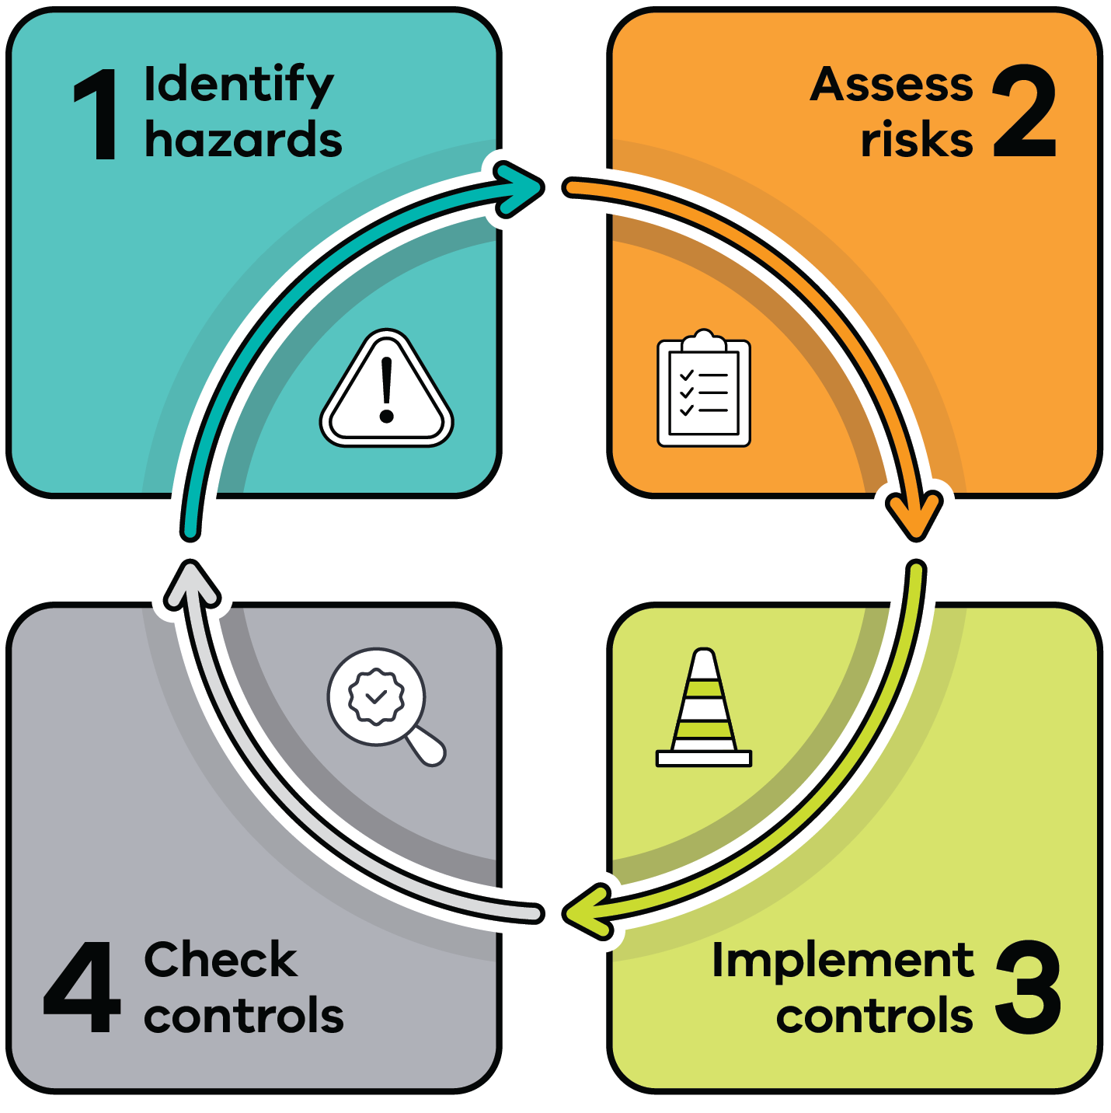

Rules that apply at your operation
The general duty applies to all operations. It is supported by regulations and Codes of Compliance (quarrying, exploration and mining).
These set the minimum requirements for managing risks at your operation for certain activities. What you must follow depends on your risk level.
- Lower risk level operations must follow the relevant Code of Compliance (Code) and any licence/work authority conditions.
- Moderate or higher risk level operations must follow the standards set in the regulations (Standards), any licence/work authority conditions and their approved rehabilitation plan.
All sites, regardless of risk level, must meet the general duty. This includes identifying and managing all risks from all activities at your operation, not just those in the Code or Standards.
Figure 2: The minimum requirements for managing risks at your operation
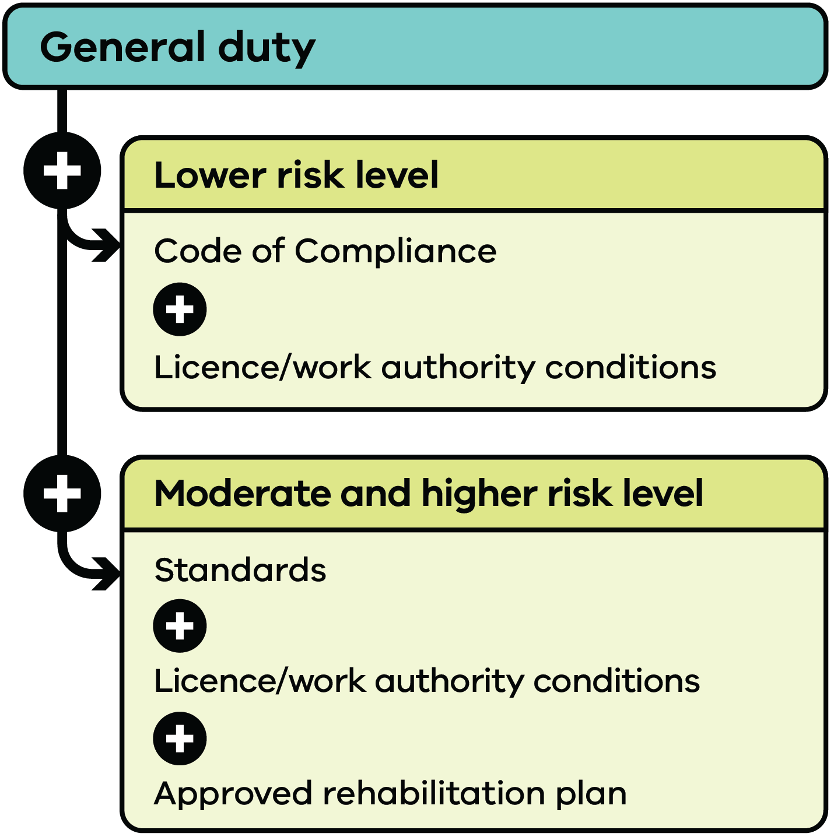

What this means in practice
The Code of Compliance and Standards set minimum requirements for certain activities. However, meeting those requirements may not be enough if your site has higher, more complex or changing risks. You may need stronger controls to meet the general duty.
You also need to consider how risks change and accumulate over time. You must review your risk management controls regularly and update them when needed. This may include using a trigger action response plan (TARP) when there is an immediate risk.
Your risk controls should also support progressive rehabilitation. This means managing risks in a way that helps you achieve rehabilitation outcomes as your site changes over time.

What to expect during inspections and audits
You must be able to show how you manage risks at your site. This includes how you:
- identify and assess the risks
- put controls in place
- check that those controls are working
review and improve your approach over time.
You need to keep clear records, such as:
- risk assessments
- management plans
- procedures
- training records.

Examples of risk management in practice
Table 1 shows what different risk management controls may look like for specific activities/risks you might have at your site. The different levels of controls are:
- Required practice – what you must do (minimum requirements)
- Stronger practice – what better risk management looks like (how you could improve your practices)
- Leading practice – what best practice looks like
Not meeting your duty – what happens when risks are not managed
Your controls should reflect the complexity of your site and the risks you need to manage.
Use these examples to assess your own site and improve controls where needed. For example, if your operation has ongoing, complex or connected risks, you may need ‘stronger’ or ‘leading’ controls to meet the general duty.
Table 1: Examples of the general duty in practice for different activities/risks
Activities/  risks | Example of risk management control:  Required practice | Example of risk management control:  Stronger practice | Example of risk management control:  Leading practice | Not meeting your duty
General risk management and monitoring | - Have a documented risk management and monitoring program/plan in line with the Code or Standards and any licence/work authority conditions | - Set additional review triggers in the risk management and monitoring program/plan (for example, when compliance limits are exceeded) | - Build continuous monitoring, triggers and feedback into everyday operations  - Use risk management to guide business strategy and planning | - Risks are missed and not monitored  - Issues are not acted on early and escalate
Qualifications | - Hire suitably qualified and trained employees and contractors  - Keep records of training and inductions (i.e. training register)  - Ensure managers have the right qualification in line with the Code or Standards | - Refresh training and inductions regularly (e.g. annually or as circumstances change)  - Match qualifications to your operation (e.g. mine) | - Build workforce capability into business planning | - Employees, contractors (including designers) and managers do not have the skills to do the work safely  - Work is done incorrectly, without proper supervision or results in an incident
Geotechnical/ landform stability | - Design landform stability (i.e. benches and stockpiles) in line with the Code; or  - Develop a geotechnical risk management and monitoring plan in line with the Standards | - Review whole site stability regularly (e.g. every 2 years) to confirm that design assumptions are valid as per exposure and rock mass behaviour conditions | - Engage an independent expert (e.g. an engineering geologist) to periodically (e.g. every 5 years) peer review the geotechnical management and monitoring plan | - Signs of potential slope failure (e.g. subsidence, excessive cracking) are missed  - Final landform is not safe, stable or sustainable
Fire management | - Maintain fire preparedness in line with the Code; or  - Develop a fire risk management and monitoring plan in line with the Standards | - Keep fire authorities' contacts list up to date (within response plan) | - Develop mature working relationships with CFA/FRV  - Run fire response drills | - Fire risks are not identified and controlled  - Increased likelihood of fire event
Air and dust emissions | - Minimise or eliminate air emissions (e.g. particulate matter and nuisance dust) in line with the Code or Standards | - Use continuous air quality monitoring and link it to a weather station (telemetry)  - Set up alerts for onsite employees | - Share live air quality data so community and other stakeholders can see it in real time | - Dust and air emissions adversely affect sensitive receptors (e.g. community health)
Blasting | - Undertake blasting in line with the Code or Standards  - A qualified person prepares a blast impact assessment/plan | - Regularly monitor blast impacts at sensitive receptors | - Develop detailed blast modelling  - Continuously monitor blast impacts at sensitive receptors | - Dust, ground vibration and air blasts affect nearby sensitive receptors
Imported materials | - Manage imported materials correctly in line with the Code; or  - Develop and implement an imported material management and monitoring plan in line with the Standards | - Review your imported material management and monitoring plan regularly (e.g. annually) | - Actively contribute to research and development for alternative options to material importation (e.g. onsite treatment and reuse). | - Contaminated material brought onsite  - Damage to local ecosystem, biodiversity and/or culture  - Imported materials not suitable for proposed rehabilitated final landform
Tailings/quarry fines | - Minimise production of tailings/quarry fines  - Design, construct and manage storage facilities in line with the Code or Standards | - Eliminate surface impounded deposition (e.g. dry stacking as part of rehabilitation)  - Design, construct and manage storage facilities in line with industry best practice (e.g. ANCOLD) | - Consider water reduction methods (e.g. mechanical dewatering)  - Improve safe storage (e.g. dry stacking or underground backfill)  - Research, develop and test new management options | - Storage facility failures (e.g. excessive ground movement, water ponding at toe of embankment)  - Poor monitoring  - Groundwater contamination
Waste rock dumps | - Design, construct, manage and rehabilitate waste rock dumps in line with the minimum requirements under the general duty (all sites) or Standards (moderate and higher risk only) | - Design is applied in a structured and multi-disciplinary approach throughout the full cycle  - A qualified person regularly (e.g. every 5 years) reviews performance against the design | - Use risk-based and data-driven design, construction and management across the full life cycle of the site to ensure closure ready landform outcomes | - Waste rock dumps are not safe, stable or sustainable (e.g. risk of failure, contamination risks)
Noise pollution | - Eliminate or minimise the impacts from noise pollution from activities in line with the Code or Standards | - Implement a regular noise management and monitoring program onsite | - Keep a record of high noise (i.e. decibel) events  - Install systems that warn when noise levels are too high | - Noise adversely affects sensitive receptors and community
Surface water contamination | - Design and implement erosion, drainage and water run-off controls in line with the Code or Standards | - Maintain and regularly review surface water management and monitoring plan  - Add additional review triggers for heavy rain events | - Trial better sediment treatment technologies as needed | - Failure to act quickly after sediment control failure  - Ongoing impacts on surface water (e.g. contamination, turbidity)
Groundwater contamination | - Manage groundwater and reduce impacts in line with the Code or Standards | - Maintain and regularly review groundwater management and monitoring plan  - Include clear trigger levels and response actions | - Regularly review monitoring data and trends (e.g. meteorological) to ensure long-term and cumulative impacts are managed | - Impacts on groundwater quality (e.g. contamination or overextraction) are not identified and managed
Hazardous substances and dangerous goods | - Store and handle hazardous materials safely in line with the Code or the minimum requirements of the general duty (all sites) | - Use bunded, self-draining concrete pads for maintenance and refuelling  - Connect collection drains to interceptor traps and check and empty them often  - Keep a detailed and up-to-date register of hazardous substances and dangerous goods onsite | - Build advanced containment facilities  - Look for safer alternatives to reduce the need for hazardous substances and dangerous goods (e.g. electric vehicles) | - Not responding quickly and appropriately after a spill (e.g. chemical)  - Ongoing spills or storage failures that could contaminate soil or groundwater
Systems, policies and procedures | - Develop systems, policies and processes in line with the Code or the minimum requirements of the general duty (all sites) | - Regularly review (e.g. annually) systems, policies and processes  - Reinforce the importance of ‘general duty’ compliance | - Continuously review and improve systems, policies and procedures, and adjust if necessary  - Build ‘general duty’ compliance into organisational culture, strategy and planning | - Employees do not understand their responsibilities under the general duty  - Increasing and/or frequent incidents reported to management  - Community and stakeholder complaints increase and/or are not addressed
Disclaimer: Table 1 shows examples only. It does not explain how to comply with the Act and regulations. Resources Victoria provides separate guidance on how to meet the general duty under the Act. This guidance may cover some of the risks and controls outlined in this tool. Guidance from the regulator is only one source of information. You are still responsible for understanding the risks and controls that apply to your work and keeping your knowledge up to date (state of knowledge).

Publication information

Acknowledgement of Victorian Traditional Owners
We acknowledge and respect Victorian Traditional Owners as the original custodians of Victoria’s land and waters, their unique ability to care for Country and deep spiritual connection to it.
We honour Elders past and present whose knowledge and wisdom has ensured the continuation of culture and traditional practices.
DEECA is committed to genuinely partnering with Victorian Traditional Owners and Victoria’s Aboriginal community to progress their aspirations.

Copyright
© The State of Victoria Department of Energy, Environment and Climate Action, June 2026.

Creative Commons
This work is licensed under a Creative Commons Attribution 4.0 International licence, visit the Creative Commons website.
You are free to re-use the work under that licence, on the condition that you credit the State of Victoria as author. The licence does not apply to any images, photographs or branding, including the Victorian Coat of Arms, and the Victorian Government and Department logos.
ISBN 978-1-76176-922-1 (print)
ISBN 978-1-76176-923-8 (pdf/online/MS word)

Disclaimer
This publication may be of assistance to you but the State of Victoria and its employees do not guarantee that the publication is without flaw of any kind or is wholly appropriate for your particular purposes and therefore disclaims all liability for any error, loss or other consequence which may arise from you relying on any information in this publication.

Accessibility
To receive this document in an alternative format, phone the Customer Service Centre on 136 186, email customer.service@deeca.vic.gov.au, or contact National Relay Service on 133 677 or visit the National Relay Service website. This document is available on the DEECA website.
End of document.

The regulations mean Mineral Resources (Sustainable Development) (Mineral Industries) Regulations 2019 or Mineral Resources (Sustainable Development) (Extractive Industries) Regulations 2019, whichever is relevant.

