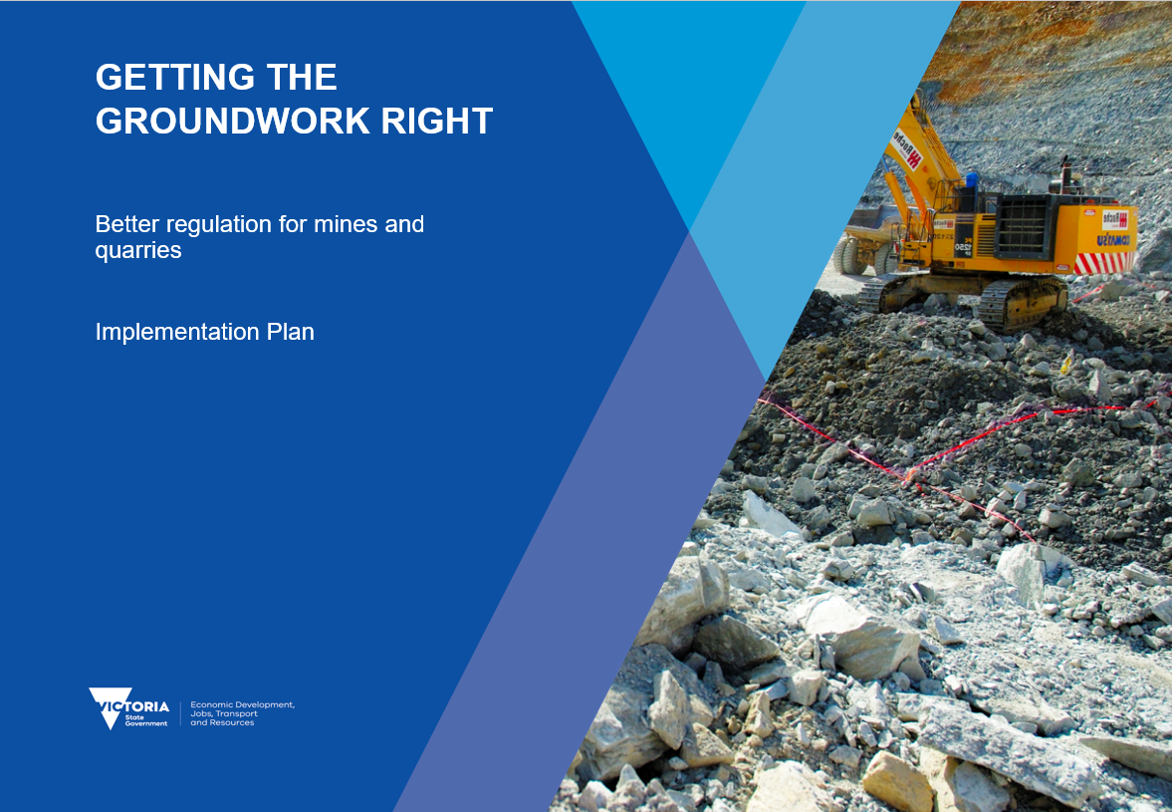

**Getting the Groundwork Right: Better regulation of mines and quarries**

**Implementing the Commissioner’s Report**



**Implementation Plan GAANT**





**Getting the Groundwork Right: The background**

Victoria’s earth resources sector plays a significant role in the state’s economy. Mining makes an important contribution to activity in some regions in Victoria. The extractives industry generates the raw construction materials that enable the state’s development: transport infrastructure, schools, hospitals and housing.

Regulation of the sector is principally the responsibility of the Earth Resources Regulation branch of the Department of Economic Development, Jobs, Transport and Resources. However, many departments and agencies have an interest in the safe and responsible operation of mining and extractives sites. Earth Resources Regulation works with other regulators to manage regulatory approvals for the sector.

The Continuous Improvement Project was tasked with finding ways to improve regulation of mines and quarries. The Commissioner for Better Regulation led the project through until the end of October 2017. The Commissioner’s *Getting the Groundwork Right* Report included opportunities to improve practice and process, which are now being applied. This implementation plan sets out the actions to give effect to the Commissioner’s recommendations.

The Department of Economic Development, Jobs, Transport and Resources has established a taskforce and project governance arrangements with co-regulators and industry to support the delivery of the initiatives set out in this implementation plan. The taskforceis working with Earth Resources Regulationto identify opportunities for operational, regulatory and legislative improvements to enable Earth Resources Regulation to operate as a ‘best practice’ regulator – using a modern regulatory framework, the best available information technologies and highly skilled staff.

**About this implementation plan**

This implementation plan outlines how the Victorian Government is delivering a modern, proportionate and robust regulatory system in the earth resources sector. It maps out three phases of work over the coming months and years that will give effect to the recommendations of the Commissioner for Better Regulation.



**Implementing the recommendations in the Report**

The recommendations have been collated into the three workstreams:

1. **Outcomes-based approach:** focused on operational enhancements to transform Earth Resources Regulation to a modern outcomes-based regulator. Outputs will include guidance on the submission and assessment of variations, the development of standard risk management plan templates and controls, and differentiated pathways for licence, work authorities, new work plans and work plan variation applications. This stream of work will be the key focus for the first half of 2018 and will lay the groundwork for coming phases.
2. **Capability uplift**: focused on the enhancement of Earth Resources Regulation’s capability and capacity over coming years. It takes time and dedication to build the individual and organisational ability to perform functions effectively, strengthening the capabilities and systems to perform core functions sustainably, and to continuously improve and develop these. In order to meet the expectations of industry and co-regulators Earth Resources Regulation must have sufficient resources with specialist knowledge. Systems and processes must support the work of Earth Resources Regulation’s staff. This means developing a new suite of standard operating procedures, efficiency enhancements, ensuring our IT systems and website are fit for purpose, ensuring staff receive appropriate training and development, and improving stakeholder engagement capability.
3. **Regulatory system**: The immediate focus on improvements to the regulatory system will target the relationship between planning and earth resources regulation. Improved guidance on the distinction between the roles and responsibilities of the Minister for Planning and the Minster for Resources is necessary for industry, local government and communities. The completion of this work and the outputs from workstreams 1 and 2 will form the basis of further work to consider broader enhancement to the regulatory system and associated governance arrangements.

**Additional actions to facilitate further improvements**

In addition to the recommendations in the Report, three actions have been identified to facilitate further improvements to regulation of the resources sector:

* *Improved data collection and performance reporting*: Earth Resources Regulation acknowledges that there is further work to be done in the collection, analysis and publication of data to improve transparency about Earth Resources Regulation’s own performance, the impact of the reforms in this implementation plan, and the overall health of the minerals and extractives sectors for meaningful public performance reporting. Data and performance measurement will be further developed in 2018 as part of program evaluation and performance reporting to underpin the program and facilitate transition into Earth Resources Regulation as a business as usual function. Earth Resources Regulation’s intention is to improve data collection and performance reporting from the bottom up to meet current and future reporting needs; a fundamental redesign of the IT systems is required in order to collect robust data and enable performance reporting within the Approvals space.



* *Enhancing industry liaison and issues resolution:* Earth Resources Regulation has existing processes to address formal complaints about its performance, however, a gap has been identified for dealing with enquiries from industry or co-regulators that may not equate to a formal complaint or may not be associated with an existing application for a licence, work plan or variation. A principal stakeholder liaison function will be piloted for six months and will form part of the Capability Uplift work stream. The function will reside within the Resources Division of the Department of Economic Development, Jobs, Transport and Resources but independent to Earth Resources Regulation.
* *Applications handling review*: Early deliverables in the implementation work program will enable further application handling improvements. In the spirit of continuous improvement, the application process will be regularly reviewed to reflect the outcomes and implementation of CIP outcomes.

**Three-phased delivery plan**

Delivery of this plan over three phases enables the leveraging of early improvements to provide an iterative, structured and disciplined approach to deliver the continuous improvement program. Outputs from phases one and two will inform the direction and focus in subsequent phases. Specifically, outputs and learnings from phases one and two will be critical inputs into the legislation and governance work to be undertaken in phase three.

The three workstreams are spread across three phases:

* **Phase one** is focused on improving practices and processes, enabling the right decisions at the right time. This phase will be rolled out during the first half of 2018, with major deliverables impacting all three workstreams of the program.
* **Phase two** is about boosting confidence in and respect for the regulatory system. This means investing in regulatory capability, including greater industry and community engagement, as well as improving coordination between regulators. This phase will be rolled out from 1 July 2018 to 30 June 2019.
* **Phase three** will focus on the legislative framework, including Earth Resources Regulation’s structure and governance, to ensure the regulatory regime is fit-for-purpose and relevant in the long term. Phase three will initially focus on enhancements to planning policy relevant to earth resources. This phase will be rolled out from 1 July 2019 to 30 June 2020.

This implementation plan is a product of co-design with relevant parties. Successful regulatory improvement requires effective partnerships across government, as well as the support of and ongoing engagement with industry. This program is not just about Earth Resources Regulation, it is about improving the overall regulatory system.

Performance monitoring and regular reporting on delivery are critical elements of this implementation plan. Aligned with this, the Department of Economic Development, Jobs, Transport and Resources will refine and re-issue this implementation plan on a rolling basis to reflect the findings of the performance monitoring, and in the spirit of continuous improvement may adjust the implementation plan based on the learnings from the development of the products in the earlier phases. This is not a ‘set and forget’ exercise, it is an ongoing commitment to better regulation.



**What does ‘better regulation’ mean?**

The community has high expectations about how the earth resources sector operates. The earth resources sector needs a regulatory framework that provides certainty and minimises unnecessary red tape and regulatory delays. The government has responsibility for regulating industry to ensure the highest safety standards, protect the environment, preserve cultural heritage, enhance community amenity while enabling industry to contribute to growth in productivity and employment in Victoria. These outcomes are paramount, and there is scope to improve the way we achieve them.

Better regulation means a robust and effective regulatory system — one that meets community expectations and support the government’s objectives, minimising the adverse consequences of permitted regulated actions and costs to households and businesses whilst improving the operating environment for industry through regulatory certainty and efficiency.



**A framework for better regulation**

In modernising the regulatory regime, Earth Resources Regulation is moving to an ‘outcomes-based approach’. This means clearly specifying the regulatory outcomes that operators are expected to deliver, while allowing operators to decide how best to achieve those outcomes. The emphasis here is on setting precise, measurable and well-understood outcome standards. The regulator monitors the outcome: only if an operator’s chosen approach is deficient will the regulator intervene. This places the principal onus on operators and allows the regulator to focus its efforts on managing underperformance.

Moving to outcomes-based regulation is a journey, with steps along the way to build confidence and capability. There is merit in expanding the regulatory ‘toolkit’ to include management systems that ensure consistent treatment of specific risks, and performance standards that specify outcomes on a case-by-case basis. There is still a place for prescriptive measures and regulatory action, where there is a clear preferred method to manage the most significant or unacceptable risks. There are a range of supporting activities that will enable Earth Resources Regulation to adopt outcomes-based approaches over time. This includes better guidance, improved systems, and proactive engagement with industry to build understanding and facilitate compliance.

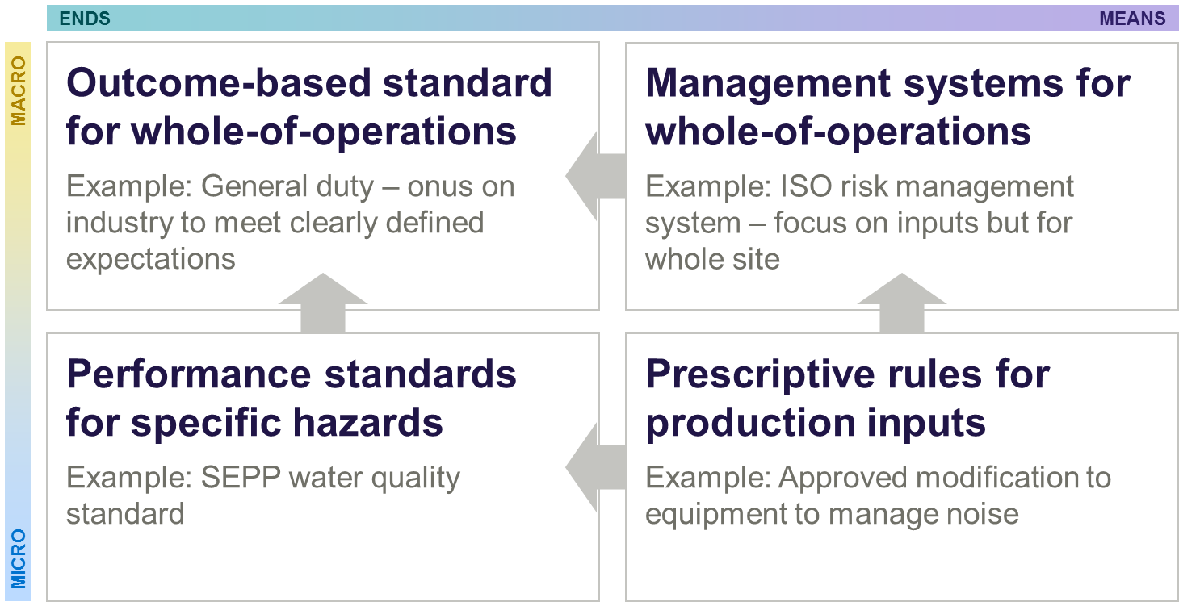



**Modern: Delivering the intent of past reforms**

As the Commissioner for Better Regulation made clear in the Report, past reforms to the regulatory framework were well-intentioned, but inconsistent implementation has impeded realisation of the full benefits. In particular, the introduction of a new approach to the assessment and approval of work plans in December 2015 caused considerable confusion and uncertainty within industry. A key focus of the Report was charting a course forward.

The changes that took effect on 8 December 2015 required that all new work plans lodged for approval with Earth Resources Regulation include a risk management plan. This is just one element of a work plan, and one that plays a considerable role in supporting delivery of regulatory outcomes. The risk management plan must:

* discuss the risk profile of the site and the proposed works, including the control measures to eliminate or minimise the identified risks associated with quarrying (or mining or exploration) hazards;
* outline the controls an operator proposes to apply to manage those risks, including specification of the acceptance criteria for each control measure, and monitoring and performance reporting against each control measure.

Earth Resources Regulation is developing standard risk management plans to provide default approaches for managing a range of common risks for the extractive and mining industries, which operators can *voluntarily* choose to apply to satisfy their regulatory requirements. This is fully consistent with the intention of the December 2015 changes and will not require additional change to existing legislation or regulations.

Where proposed new or changed work may result in new or changed quarrying (or mining or exploration) hazards that give rise to additional risks, or where the standard controls would be insufficient to manage particular risks given the operating context, the operator will be required to supplement the relevant standard risk management plan with customised controls targeted to the specific higher-risks. This will enable Earth Resources Regulation to better focus its regulatory effort on assessing those non-standard activities. Operators will also be free to develop alternative controls to those set out in the standard risk management plan, if they consider they have a better way to deliver the required regulatory outcomes. As with management of higher-risk issues, operators will be required to supplement their standard risk management plan with an explanation of how they will achieve and demonstrate compliance with regulatory standards.

Standard risk management plans establish a clear minimum benchmark for compliance. The standard controls will act as a compliance benchmark indicator for operators — providing standard risk management options for the mitigation of specific standard risks. This will offer a simple way for low-risk operators to comply with their risk management plan obligations in their new work plan, based on clear risk management standards. This will be backed up by enhanced monitoring, reporting and auditing protocols to verify compliance.



The standard risk management plans are being developed now, and will involve extensive consultation across government and with industry. Earth Resources Regulation expects to introduce the standard risk management plans in July 2018.

**New work plan approvals**

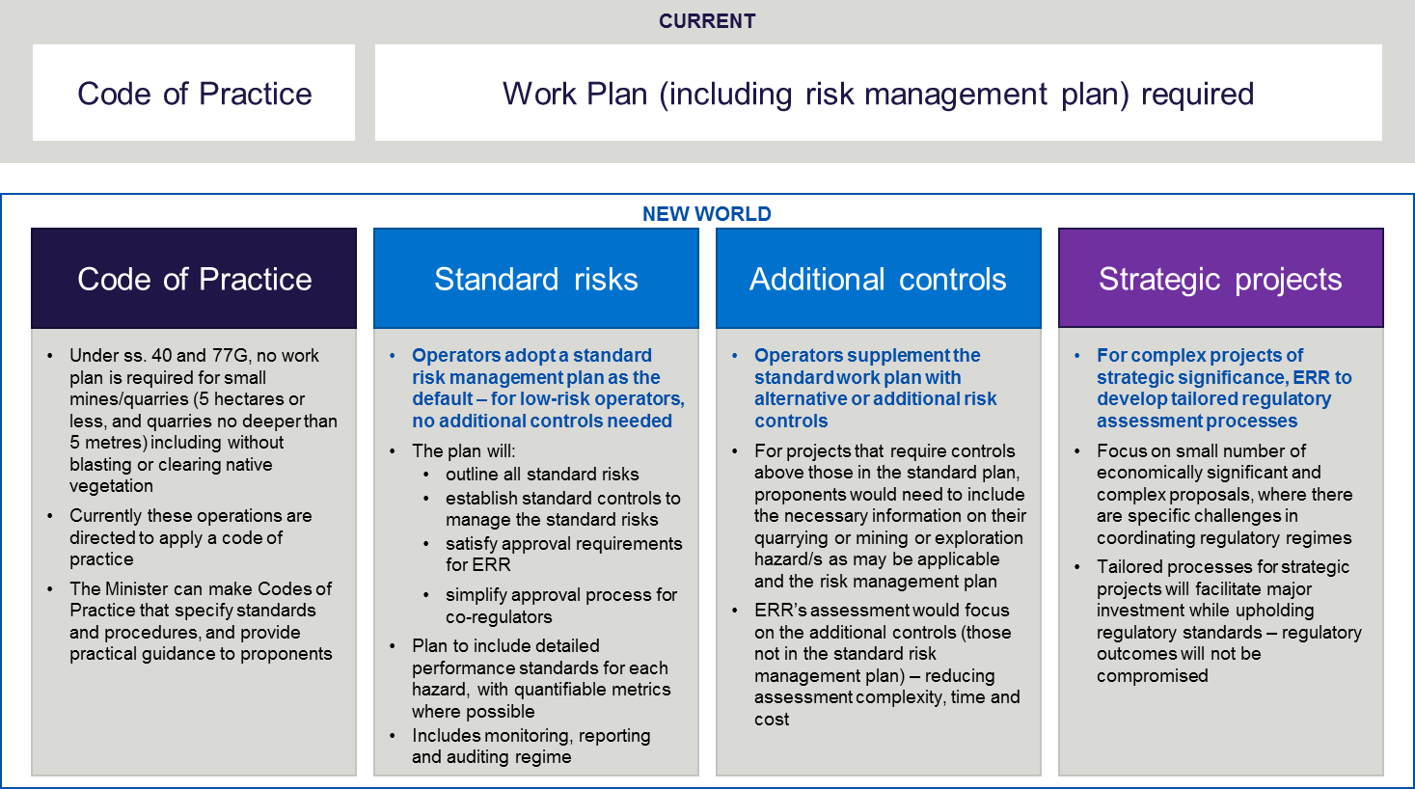



**Proportionate: Focusing on what matters most**

The standard risk management plan approach is the first step in enabling a more proportionate regulatory approach.

Work plans lodged prior to 8 December 2015 remain valid, enforceable regulatory instruments. Operators can continue to operate under these older work plans — though they can voluntarily elect to submit a work plan in the new format introduced in 2015.

Earth Resources Regulation is developing a new process for the submission and assessment of new work plans. Earth Resources Regulation will move away from a standardised approach to a new approach that will differentiate between projects with all, or mostly, standard risks and strategic projects.

The Codes of Practice will also be reviewed to ascertain if there are further opportunities to broaden the reach of the codes to capture more low risk operations.

These pathways will be clarified with specific information on risk analysis and management. Following consultation across government and pilots with industry and co-regulators, the streamlined approach will take effect from July 2019.

Aligned with these procedural improvements, the interactions between Earth Resources Regulation’s approvals processes and the planning system are being clarified. A Planning Practice Note — expected to be issued in late 2018 — will improve guidance for local councils making decisions with respect to planning approvals for mines and quarries. In addition, the Minister for Resources and the Minister for Planning are working together on further opportunities to provide greater certainty for industry and the community through the release of a joint Ministerial statement for release in the middle of 2018.



**Robust: Building confidence in the regulatory system**

A best practice regulator focuses on how to enable compliance. It works collaboratively with businesses, consumers and the wider community to identify ways to minimise regulatory burden and champion innovation.

At the same time, a best practice regulator remains squarely focused on the community’s needs and government’s expectations. It acts in a decisive, timely manner to minimise risks to public safety, the environment, land, property and infrastructure.

Confidence in the regulatory system requires a practical understanding of how industry operates and the commercial interests of businesses to self-manage risks, as well as a firm grasp on the reasons for regulation and the powers available to the regulator to address poor performance. Ensuring the regulator has sufficient capability to make well-informed judgments is paramount.

Earth Resources Regulation acknowledges there is much work required to boost industry respect and community trust in the regulatory system. In 2018, Earth Resources Regulation is refreshing its engagement processes and guidance to industry. Earth Resources Regulation’s stakeholder reference group will be renewed and focused on better sharing information and explaining policy changes. Improvements to processing systems will give operators ‘real-time updates’ on how their applications are tracking. And new issues resolution pathways will allow problems to be appropriately escalated through Earth Resources Regulation and the Department, and demonstrate to industry and the community that the regulator is listening and responding.



 



**Ensuring success** 



**How can you be involved?**

The Department of Economic Development, Jobs, Transport and Resources will be liaising with industry and the co-regulators over the next two years through both formal governance arrangements and on a case by case basis to support individual projects.

The Commissioner for Better Regulation will be reporting on the progress of the project six monthly. These reports, along with regular project updates, will be made available on the Earth Resources Regulation website.

If you would like to provide input into the project please email us on resources.vic@ecodev.vic.gov.au