GOLDEN BEACH-2 OFFSHORE DRILLING ENVIRONMENT PLAN SUMMARY
Vic/RL1(V)

Revision 0

GB Energy (Vic) Pty Ltd
ABN 60 615 552 693
Rev | Date | Description | Author | Checked | Approved | Document
A | 12/05/2023 | Draft for internal review | AC | GP | SM | GB-GB2-AP-  PLA-003
0 | 17/05/2023 | Issued to ERR | AC | GP | SM
Table of Contents
Acronyms iii
1. Introduction 1
1.1 Background 1
1.2 Project Summary 1
1.3 Proponent 1
1.4 Titleholder and Liaison Person Details 1
1.5 Scope 1
2 Activity Description 4
2.1 Activity Location 4
2.2 Timing 7
2.3 Objective of the Activity 7
2.4 Project Management 7
2.5 Field Characteristics 7
2.6 Reservoir and Gas Specifications 7
2.7 Drilling Operation 9
2.8 Drilling Program 11
2.9 Cement Program 15
2.10 Formation Evaluation 15
2.11 Wellhead 15
2.12 Well Abandonment 16
2.13 Well Control 17
2.14 Drilling Summary 18
3 Stakeholder Consultation 20
3.1 Stakeholder Identification 20
3.2 Engagement approach and methodology 22
3.3 Record of stakeholder engagement 24
3.4 Summary of stakeholder consultation 24
3.5 Ongoing Consultation 26
4 Description of the Existing Environment 29
4.1 Regional Context 33
4.2 Coastal Environment 36
4.3 Conservation Values and Sensitivities 37
4.4 Biological Environment 58
4.5 Cultural Heritage Values 77
4.6 Socio-economic Environment 78
5 Impact and Risk Assessment Methodology 84
5.1 Risk Assessment Approach 84
5.2 Risk Management Process 84
5.3 Risk Monitoring and Review 93
6 Environmental Impact and Risk Assessment 95
7 Implementation Strategy 116
7.1 Environmental Management Systems 116
7.2 Training and Awareness 117
7.3 Environmental Emergencies and Preparedness 117
7.4 Recording and Reporting 118
7.5 Management of Change 119
7.6 Monitoring 119

Acronyms
Acronym | Definition
2D | Two-dimensional
3D | Three-dimensional
AIS | Automatic Identification System
ALARP | As Low As Reasonably Practicable
AMSA | Australian Maritime Safety Authority
AMP | Australian Marine Park
APPEA | Australian Petroleum Production and Exploration Association
AS/NZS | Australian Standard/New Zealand Standard
ATBA | Area to be Avoided
BHA | Bottom Hole Assembly
BIA | Biologically Important Area
BoM | Bureau of Meteorology
BOP | Blowout Preventer
BWMC | Ballast Water Management Certificate
BWMP | Ballast Water Management Plan
BWR | Ballast Water Report
BWRS | Ballast Water Record System
CAMBA | Agreement between the Government of Australia and the Government of the People’s Republic of China for the Protection of Migratory Birds and their Environment
CEFAS | Centres for Environment, Fisheries and Aquaculture Science
CER | Commission for Energy Regulation (UK)
CFSR | Climate Forecast System Reanalysis
CHARM | Chemical Hazard and Risk Management
CH4 | Methane
CO2 | Carbon Dioxide
CO2-e | Carbon Dioxide Equivalent
CSIRO | Commonwealth Scientific and Industrial Research Organisation
Cth | Commonwealth
CTS | Commonwealth Trawl Sector
DAFF | Department of Agriculture, Fisheries and Forestry (Cth)
DAWE | Department of Agriculture, Water and the Environment (Cth) (former)
DAWR | Department of Agriculture and Water Resources (Cth)
DCCEEW | Department of Climate Change, Energy, the Environment and Water (Cth)
DDR | Daily Drilling Report
DEDJTR | Victorian Department of Economic Development, Jobs, Transport and Resources (Vic) (former)
DEECA | Department of Energy, Environment and Climate Action (Vic)
DELWP | Department of Environment, Land, Water and Planning (Vic)
DNP | Director of National Parks
DoD | Department of Defence (Cth)
DoE | Department of the Environment (Cth) (former)
DoEE | Department of Environment and Energy (Cth) (former)
DOR | Daily Operation Report
DoT | Department of Transport (Vic)
DP | Dynamic Positioning
DSEWPC | Department of Sustainability, Environment, Water, Population and Communities (Cth) (former)
EAC | East Australian Current
EARPL | Esso Australia Resources Pty Ltd
EES | Environmental Effects Statement
EIA | Environmental Impact Assessment
EIAPP | Engine International Air Pollution Prevention
EMBA | Environment that May Be Affected
EMV | Emergency Management Victoria
EMGPS | Electrolytic Marine Growth Protection system
EP | Environment Plan
EPA | Environment Protection Authority (Vic)
EPBC Act | Environment Protection and Biodiversity Conservation Act 1999 (Cth)
EPO | Environmental Performance Outcome
EPS | Environmental Performance Standard
ERA | Environmental Risk Assessment
ERP | Emergency Response Plan
ERR | Earth Resources Regulation (division of DEECA)
ESD | Ecologically Sustainable Development
FFG Act | Flora and Fauna Guarantee Act 1988 (Vic)
FFS | Fish Friendly Structure
FTU | Formazin Turbidity Units
GB-2 | Golden Beach-2 well
GHG | Greenhouse Gas
G&G | Geophysical and Geotechnical
GLaWAC | Gunaikurnai Land & Waters Aboriginal Corporation
GMP | Garbage Management Plan
HMCS | Harmonised Mandatory Control Scheme
HQ | Hazard Quotient
HSE | Health, Safety and Environment
HSEMS | Health, Safety and Environmental Management System
HVAC | Heating Venting and Air Conditioning
IAFS | International Anti-fouling System
IAPP | International Air Pollution Prevention
IBA | Important Bird Area
IEE | International Energy Efficiency
IMO | International Maritime Organisation
IMS | Invasive Marine Species
IMT | Incident Management Team
IOGP | International Association of Oil & Gas Producers
IOPP | International Oil Pollution Prevention
IPIECA | International Petroleum Industry Environmental Conservation Association
ISPP | International Sewage Pollution Prevention
ITOPF | International Tanker Owners Pollution Federation
IUCN | International Union for the Conservation of Nature
JAMBA | Agreement between the Government of Australia and the Government of Japan for the Protection of Migratory Birds and Birds in Danger of Extinction and their Environment
JSA | Job Safety Analysis
KEF | Key Ecological Feature
LOT | Leak Off Test
LoWC | Loss of Well Containment
LWD | Logging While Drilling
MARPOL | International Convention for the Prevention of Pollution from Ships 1973, as modified by the Protocol of 1978
MARS | Maritime Arrivals Reporting System
MDO | Marine Diesel Oil
MMscfd | Million standard cubic feet per day
MNES | Matter/s of National Environmental Significance
MNP | Marine National Park
MODU | Mobile Offshore Drilling Unit
MoC | Management of Change
MSL | Mean Sea Level
MSV | Maritime Safety Victoria
MWD | Measurement While Drilling
NIW | Nationally Important Wetland
NNTT | National Native Title Tribunal
NOAA | National Oceanic and Atmospheric Administration
NOPSEMA | National Offshore Petroleum Safety and Environmental Management Authority
NOPTA | National Offshore Petroleum Titles Authority
NOx | Nitrous Oxides
NPWS | National Parks and Wildlife Service (NSW)
NRT | National Response Team
NSR | Non-search and Rescue
NSW | New South Wales
N₂O | Nitrous Oxide
OCNS | Offshore Chemical Notification Scheme
ODS | Ozone-Depleting Substance
OIW | Oil-in-Water
OPEP | Oil Pollution Emergency Plan
OPGGS Act | Offshore Petroleum and Greenhouse Gas Storage Act (Vic)
ORCA | Oil Spill Response Company of Australia
OSTM | Oil Spill Trajectory Modelling
OSPAR | Oslo-Paris Conventions
OWR | Oiled Wildlife Response
OWS | Oily Water Separator
P&A | Plug and Abandon/Plugged and Abandoned
PLONOR | Poses Little or No Risk
PMS | Planned Maintenance System
PMST | Protected Matters Search Tool
PPE | Personal Protective Equipment
PSI | Pounds per square inch
PSZ | Petroleum Safety Zone
RAMSAR | Convention on Wetlands of International Importance especially as Waterfowl Habitat
RO | Reverse Osmosis
ROV | Remotely Operated (underwater) Vehicle
RQ | Risk Quotient
RWP | Relief Well Plan
SCERP | Source Control Emergency Response Plan
SDS | Safety Data Sheet
SEEMP | Ship Energy Efficiency Management Plan
SEP | Stakeholder Engagement Plan
SESS | Southern and Eastern Scalefish and Shark
SETFIA | South-East Trawl Fishing Industry Association
SHS | Scalefish Hook Sector
SME | Subject Matter Expert
SMPEP | Shipboard Marine Pollution Emergency Plan
SMS | Short Message Service
SPE | Society of Petroleum Engineers
SPL | Sound Pressure Level
SPRAT | Species Profile and Threats Database
SRT | State Response Team
STCW | International Convention on Standards of Training, Certification and Watchkeeping for Seafarers
STP | Sewage Treatment Plant
TEC | Threatened Ecological Community
TSS | Total Suspended Solids
TSV | Transport Safety Victoria
TVDSS | True Vertical Depth Subsea
VBA | Victorian Biodiversity Atlas
VFA | Victorian Fisheries Authority
Vic | Victoria
VOC | Volatile Organic Carbon
VRFish | Victorian Recreational Fishing
WBM | Water-based Mud
WOMP | Well Operations Management Plan

Introduction

Background
This Summary Environment Plan (EP) is prepared in accordance with Regulation 13E(3)(4) of the Offshore Petroleum and Greenhouse Gas Storage (OPGGS) Regulations 2021 (Vic). The EP was accepted by the Earth Resources Regulation (ERR) branch of the Department of Energy, Environment and Climate Action (DEECA) on the 3rd of May 2023.

Project Summary
GB Energy (Vic) Pty Ltd (hereafter referred to as GB Energy) is proposing to appraise and develop the natural gas held in the Golden Beach gas field located within Victorian waters
20 m deep approximately four kilometres off Ninety Mile Beach, in the Gippsland Basin (Figure 1.1). The project is referred to as the Golden Beach Energy Storage Project (hereafter referred to as ‘the Project’).
GB Energy plans to appraise the Golden Beach gas field by drilling Golden Beach-2 (GB-2) using a jack-up Mobile Offshore Drilling Unit (MODU) commencing in June or July 2023. This well will form part of the broader project. GB-2 will appraise the eastern block via full hole coring, logging while drilling (LWD) and wireline logging. The total duration of the appraisal drilling program is estimated to be 22 days.
The activity will be conducted entirely within Victorian State waters in accordance with the OPGGS Act and Regulations.

Proponent
GB Energy is an independent Australian energy company formed in 2017 that is focused on the development of domestic gas production and energy infrastructure. GB Energy’s objective is to provide a new source of local gas supply and flexible gas storage in one of Australia’s oldest and most prolific gas-producing regions, the Gippsland Basin. This gas will serve domestic markets.
The infrastructure created by GB Energy will provide efficiency and flexibility to the energy market. This has the potential to reduce market disruptions and will support low-emission and renewable energy agendas in the future.

Titleholder and Liaison Person Details
In accordance with Regulation 18 of the OPGGS Regulations, titleholder and nominated liaison contact details are provided below:
Steven Marshall
Chief Operating Officer
Level 1, 110 Church St, Hawthorn, Victoria 3122
Phone: 1800 423 637
Email: sm@gbenergy.com.au

Scope
The activity will be conducted in accordance with all applicable legislation and regulations, and specifically to meet the requirements of the OPGGS Act and Regulations. For this activity, the petroleum activity (as defined in Regulation 6 of the OPGGS Regulations) is defined as:
To drill, complete and appraise one well to test the targeted reservoir sands for gas production and future gas storage purposes, from the time the MODU first enters the Project area (see Section 2.1), until the time that it jacks-down and departs the Project area.
This document provides a summary of the full EP accepted by DEECA in accordance with Regulation 13E(3)(4) of the OPPGS Regulations.

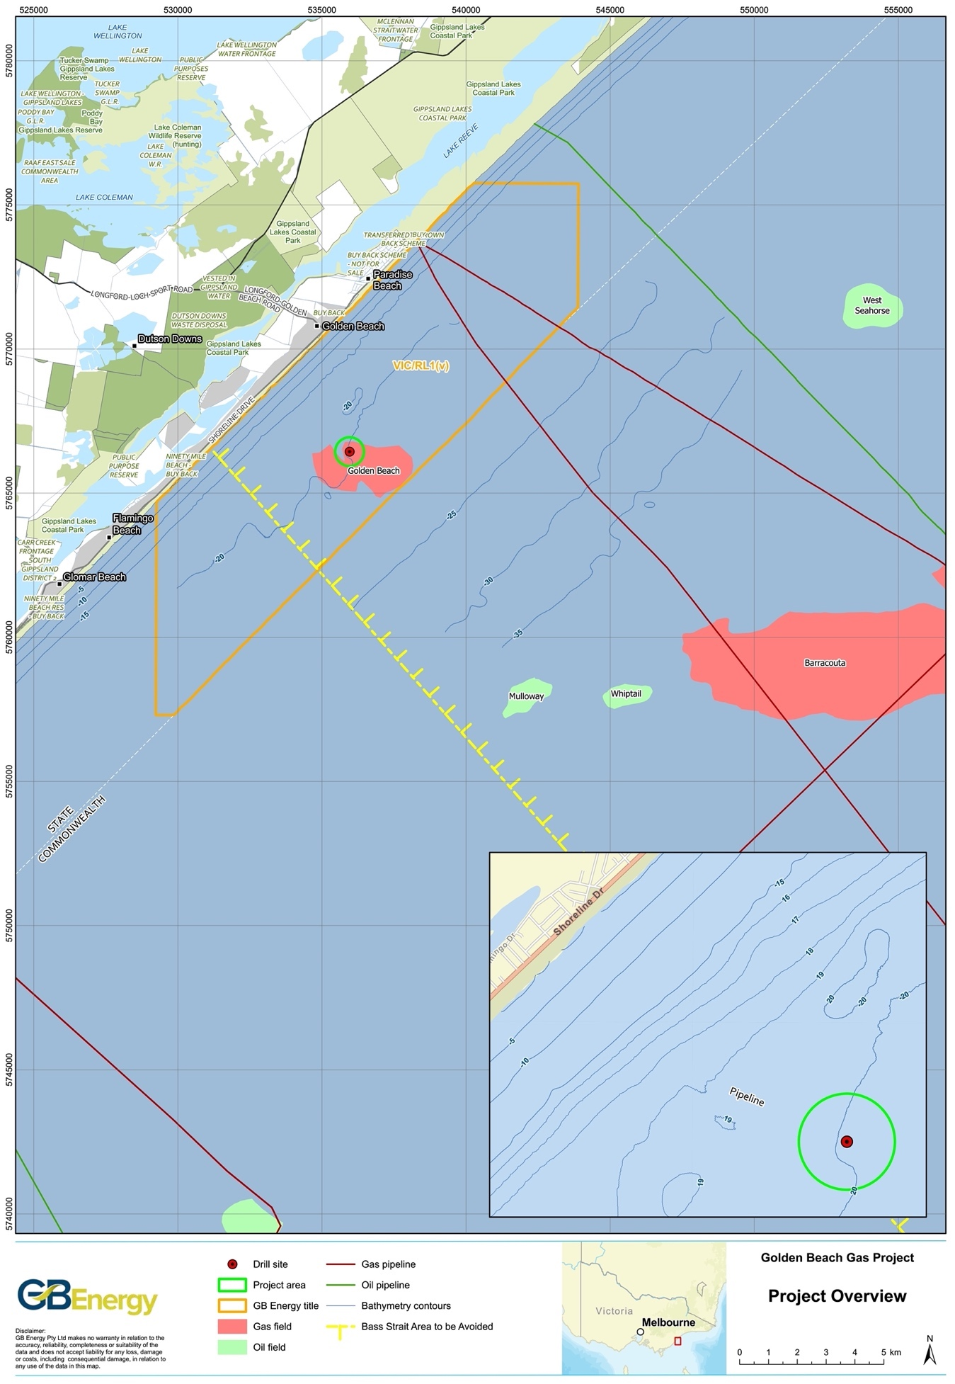
Figure 1.1 The Project area location

Activity Description

Activity Location
The Vic/RL1(V) permit is located entirely in Victorian state waters (see Figure 1.1). The drilling campaign will take place in the Golden Beach Energy Storage Project area (herein referred to simply as the ‘Project area’).
The Project area includes the drill site and a 500 m buffer around the drill site (Figure 2.1), as this reflects the extent of the temporary Petroleum Safety Zone (PSZ) that will be established during drilling and is the area in which the MODU will have operational control over the support vessels. The coordinates of the drill site are outlined in Table 2.1. Water depth at the drill site is 20 m, referenced to mean sea level (MSL).
Table 2.1. GB-2 location
Geographic coordinates | Grid coordinates
Latitude: 38° 14' 57.616" S  Longitude: 147° 24' 39.507" E | Northing: 5,766,440 m N  Easting: 535,960 m E
GDA 94, MGA Zone 55S
At its closest point, the drill site is located 4.2 km southwest (and the Project area located
3.7 km southwest) of the centre of the township of Golden Beach, midway along the Ninety Mile Beach between Loch Sport and Seaspray in south Gippsland. The drill site is located
3.5 km from the nearest shoreline.
Distances from the drill site and Project area to nearby features are provided in Table 2.2.
Table 2.2 Distances from the drill site to key regional features
Feature | Distance and direction to the nearest point  of the feature
 | From drill site | From Project area
Towns
Golden Beach (town centre) | 4 km northeast | 3.5 km northeast
Paradise Beach | 5.7 km northeast | 5.2 km northeast
Honeysuckles | 18.8 km southwest | 18.3 km southwest
Seaspray | 23 km southwest | 22.5 km southwest
Loch Sport | 26 km northeast | 25.5 km northeast
Lakes Entrance | 64 km northeast | 63.5 km northeast
Petroleum infrastructure
Golden Beach-1/-1A  (Plugged & Abandoned, P&A) | 1.3 km southeast | 800 m southeast
Golden Beach West-1 (onshore) (P&A) | 4.5 km west-north-west | 4.0 km west-north-west
Bream to shore pipeline: Vic/PL32 & Vic/PL32(V) (gas) | 6.7 km northeast | 6.2 km northeast
Barracouta to shore pipeline: Vic/PL1 & Vic/PL1(V) (gas) | 7.8 km northeast | 7.3 km northeast
Tarwhine subsea well (oil) | 18 km south | 17.5 south
Seahorse subsea wells (nearest) (oil) | 19 km east | 18.5 km east
Tasmanian gas pipeline | 22 km west | 21.5 km west
Non-petroleum infrastructure
Regional Outfall Sewer (ROS)  (Delray Beach) | 1.5 km northwest | 1 km northwest
Basslink electricity interconnector cable | 32 km southwest | 31.5 km southwest
Australian Marine Parks (AMPs)
Beagle | 96 km southwest | 95.5 km southwest
Victorian marine parks
Ninety Mile Beach Marine National Park (MNP) | 24.5 km southwest | 24.5 km southwest
Natural features
Lakes Entrance (channel) | 62 km northeast | 61.5 km northeast
Hogan Island group | 110 km southwest | 109.5 km southwest

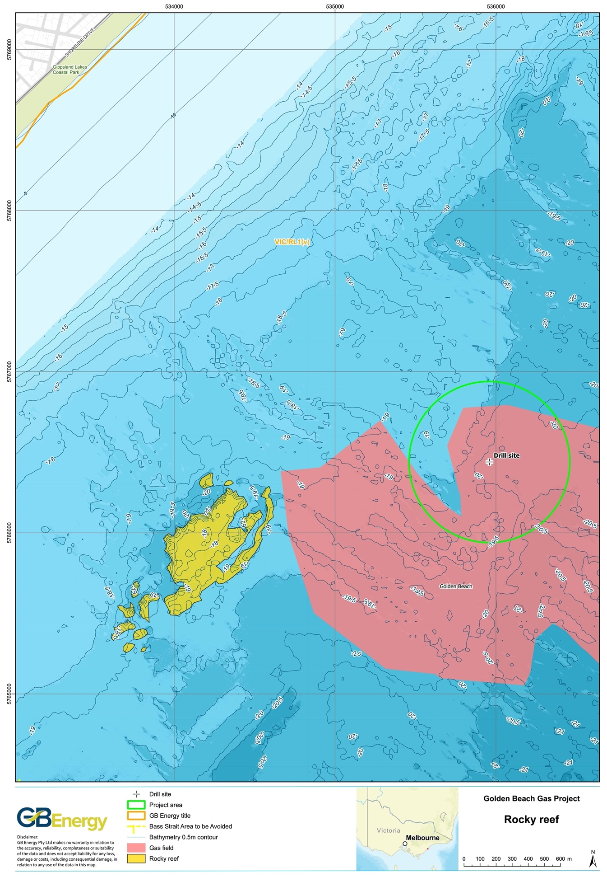
Figure 2.1 The Project area

Timing
The activity is expected to take 22 days and is scheduled to commence in June or July 2023, contingent on the mobilisation of the MODU from its previous and the receipt of regulatory approvals.

Objective of the Activity
The objective of the Golden Beach-2 activity is to appraise the Golden Beach gas field to provide subsurface data to inform the future development of the Golden Beach gas field.
The future development will occur in two phases, with the first phase being the production of a portion (30 - 40 petajoules, PJ) of the gas within the reservoir. The second stage will be the conversion of the field into a gas storage facility providing an initial 250 terajoules (TJ)/day of withdrawal capacity with a potential lifespan of 40 years.

Project Management
AGR Australia Pty Ltd (AGR) is the Drilling Management Contractor (DMC) appointed to this project by GB Energy. AGR is responsible for providing project management and well delivery services for the activity.
In Australia, AGR has drilled over 40 offshore wells in all the major basins in water depths ranging from 40 m to 1,100 m. In early 2020, AGR drilled the Gular-1 well for the CarbonNet Project in the same field.

Field Characteristics
The Golden Beach structure is a large, closed anticline (“dome”), measuring approximately
10 km by 7 km, oriented east-west and containing Gippsland Basin strata of the Seaspray and Latrobe Groups.
Two petroleum exploration wells (Golden Beach-1A and Golden Beach West-1) have already been drilled in the Golden Beach gas field, so the stratigraphy of the field is well known. The Golden Beach gas occurs in the Cobia Subgroup, which is a coarse-grained quartzose sandstone at the top of the Latrobe Group. The sandstone was deposited in a marine shoreface environment and overlies the fluvial coal and sandstone sequence more common in the Latrobe Group.
The reservoir is sealed by the Lakes Entrance Formation, a marine calcareous claystone that seals all top-Latrobe fields in the Gippsland Basin. The structure that traps the gas is not filled to the spill-point. The sandstone below the gas water contact is water-saturated and is believed to be connected laterally with the regional aquifer system of the Gippsland Basin.
At depth below the field, the T2 member of the Traralgon coal sequence and associated smaller seams form an apparent aquitard (seal) between proposed CO2 injection operations of CarbonNet and the Golden Beach hydrocarbon gas reservoir.
The top of the reservoir is expected to be encountered at approximately 616 m true vertical depth subsea (TVDSS). The thickness of the gas zone is known from the offset well Golden Beach-1A. This well drilled through the gas-water contact at approximately 652.5 m TVDSS, thus the gas bearing sandstone section is 32.5 m thick.

Reservoir and Gas Specifications
The Golden Beach-1A well tested a number of Latrobe Group targets and was terminated near the base of the prospective section. The only significant hydrocarbons intersected was the reservoir at the top of the Latrobe Group. The gas was flow tested to surface and flowed at 4.2 million standard cubic feet per day (MMscfd) from a short interval through relatively low-diameter test tools. Interpretation of the results for the well design and length of the production interval indicated the unconstrained flow capacity of the test at 22.8 MMscfd.
Samples retained from the flow were analysed and found to be predominantly methane, with some nitrogen, and small traces of other hydrocarbon gasses.

Aquifers and Salinity
The pressure as measured in the Golden Beach field was measured in 1967 at 987 pounds per square inch (psi) (some uncertainty exists in this value due to hardware limitations). GB Energy estimates that current pressure in the reservoir is now approximately 900 psi, with
+/- 25 psi uncertainty. Residual water salinity is unknown in the reservoir but is expected to be low (fresh) in the aquifer below the gas zone.
Unlike oil production where prolonged periods of co-production are required to drain the recoverable reserves, this Project requires no production of water. A small amount of water (in the order of 150 litres of water per gigajoule [GJ] of gas production) is expected to condense from the gas stream and be captured in the compressor station for treatment and disposal. This water is not expected to be saline.

Hydrocarbon Quality
The gas composition outlined in Table 2.3 was assayed based on bottom samples captured during the test of the gas zone in the Golden Beach-1A well. It is likely that this is a biogenic gas, similar to that seen in the Sole and Baleen fields on the northern margin of the Gippsland Basin. The gas composition is unlikely to have changed, although modern sampling and measurement will improve the level of certainty and detail.
Table 2.3. Compositional analysis of the Golden Beach-1A well
Element | GSV Lab  Mole % (as measured) | Mole % (corrected for atmospheric contamination) | G&F lab Mole % (as measured) avg of two | Mole % (corrected for atmospheric contamination)
Hydrogen | Trace | Trace | 0.001 | 0.001
Helium | Nil | Nil | 0.01 | 0.01
Methane | 93.3 | 94.3 | 93.4 | 94.3
Ethane | Nil | Nil | 0.07 | 0.08
Propane and higher | Nil | Nil | 0.01 | <0.1
Oxygen | 0.2 | Nil | 0.2 | 0
Nitrogen | 6.3 | 5.5 | 6.3 | 5.5
Carbon dioxide | 0.01 | 0.01 | <0.1 | <0.1
TOTAL | 99.81 | 99.81 | 100.09 | 99.41

Predicted Hydrocarbon Volume
Based on the results of the CarbonNet 2018 Pelican 3DMSS and those of the 1967 Golden Beach-1A well, GB Energy has modelled the gas in place and the portion recoverable in the Project. The gas is classified as a Contingent Resource under the Petroleum Resources Management System (PRMS) endorsed by the Society of Petroleum Engineers (SPE). The ‘P’ value indicates the range of uncertainty in the assessment and is analogous to a minimum (P90), most likely (P50) and maximum (P10) case. The predicted volumes are similar to previously published estimates of the gas in place and are presented in Table 2.4.
Table 2.4. Golden Beach gas field contingent resources
 | P90 | P50 | P10
Gas initially in place (bcf) | 70.1 | 86.2 | 106.1
Contingent resource (bcf) | 1C | 2C | 3C
Total recoverable (bcf) | 49.1 | 66.8 | 88.7

Gas, or other hydrocarbon, is unlikely to be encountered in zones other than the target reservoir. This prediction is based on the absence of other significant hydrocarbon zones in the 1967 well and that there are no direct hydrocarbon indicators in the seismic data outside of the target zone, nor are there any other trapping structures interpreted.

Drilling Operation
This section provides details on the drilling activity relating to the MODU, support vessels, helicopter and supply base for the Project.

The MODU
The well will be drilled using the Valaris 107 jack-up MODU (Photo 2.1). Jack-up MODUs are typically used for drilling in water depths of less than 150 m.
The following points describe the process of MODU positioning on location (as illustrated in Figure 2.2):
- The MODU will be towed into position by support vessels.
- Once in the desired location and with the MODU stationary, the legs are lowered to be in complete contact with the seabed, the rig hull is raised +/-3 m above the sea surface (‘air gap’) and rig stabilisation activities are conducted (pre-loading).
- When pre-loading activities are completed the MODU raises itself approximately 15 m above the sea surface. At this point, the drilling derrick is cantilevered over the edge of the MODU in readiness for drilling.
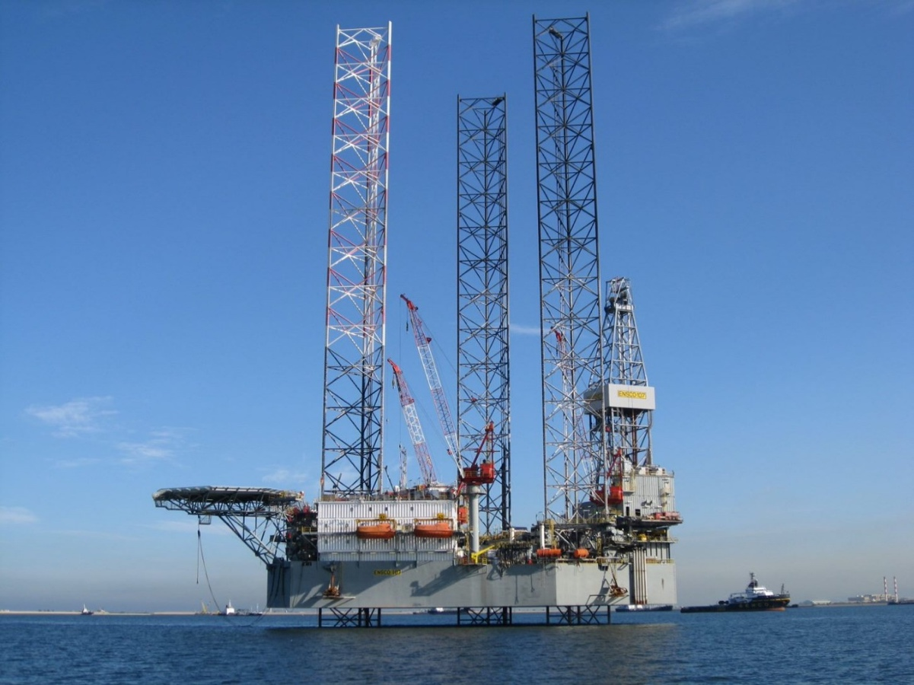
Photo 2.1. The Valaris-107 jack-up MODU
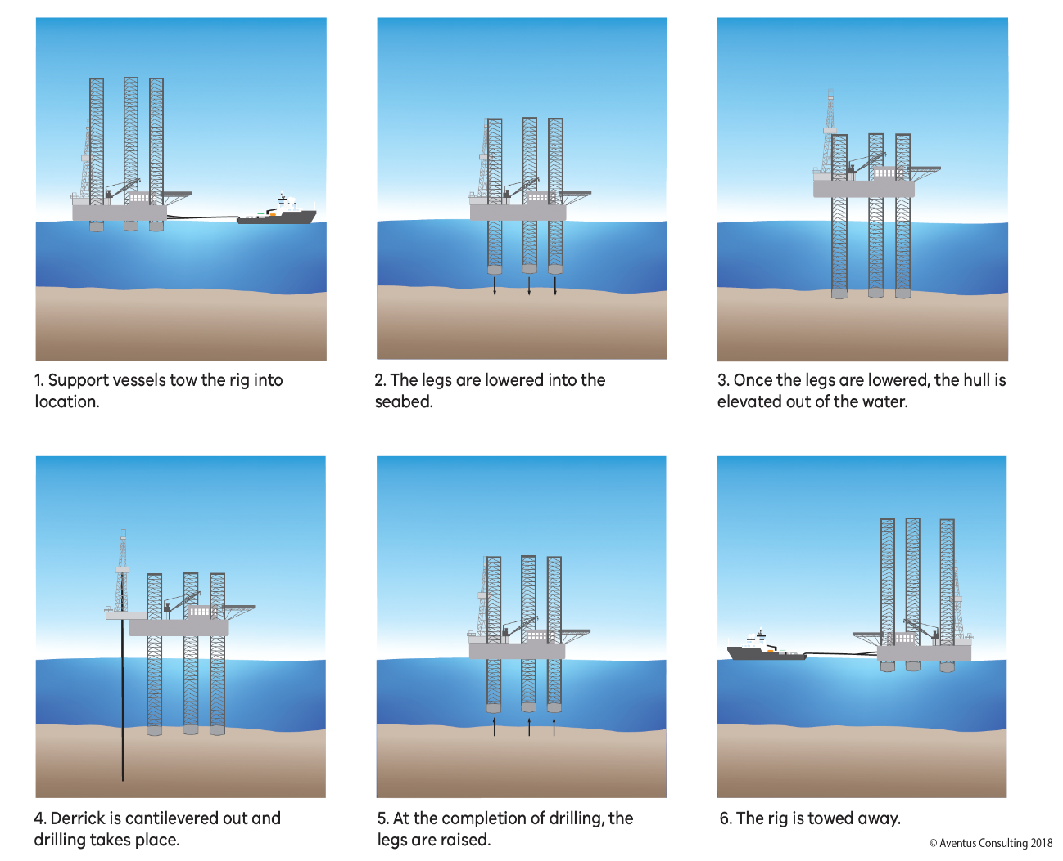
Figure 2.2. Simplified outline of the MODU positioning process

Support Vessels
The MODU will be supported by two support vessels for the duration of drilling, the Go Sirius and Go Spica (operated by Go Offshore). Support vessels will be used to supply fresh water, food, fuel, bulk drilling fluid materials and equipment to the MODU. They will also remove waste from the MODU, monitor the PSZ (intercepting errant vessels as required) and assist in emergency response situations.
There will be one support vessel on standby close to the MODU at all times during the Project to provide a continuous emergency response capability. The vessels hold station using dynamic positioning (DP) and no support vessel anchoring will occur in the Project area in order to reduce the risk of anchor contact (and potential damage) to nearby rocky reefs.
Initial mobilisation of crew to the support vessels will be via port call. Refuelling of the support vessels will take place within port.

Helicopters
Helicopter operations to the MODU are planned as required but usually will be one return flight each day from Tooradin Airport.
Air Ambulance Victoria may be utilised in emergency situations for the transportation of workers to suitable emergency medical facility onshore.

Supply Base
Marine operations will be based out of the Port of Melbourne (400 km northwest of the Project area by sea).
Drilling equipment, tubulars, fluids, bulks and cement will be stored at, or transit through, this supply base and subsequently be delivered to the MODU by the support vessels. All cement will be mixed onboard the MODU.

Drilling Program
The GB-2 appraisal well will be drilled as a vertical well using a water-based mud (WBM) system. Following the drilling and evaluation of the well, it shall be fully Plugged and Abandoned (P&A).
The well is planned to be drilled and evaluated as per the following steps:
- The 36” (914 mm) conductor hole will be drilled vertical with a rotary assembly.
- The 30” (762 mm) conductor will be run with a 20” (508 mm) shoe. The conductor is planned to be cemented to seabed.
- A 17½” (444 mm) surface hole will be drilled vertically with a rotary bottom hole assembly.
- The 13⅜” (340 mm) surface casing will be run and cemented in place, with a minimum Top of Cement 150 m above the 13⅜” shoe depth.
- A surface well head will be installed and the MODU’s BOP rigged-up and pressure tested.
- The 13⅜” shoetrack will be drilled out with a 12¼” (311 mm) bit and a formation integrity test (FIT) or leak-off test conducted.
- A vertical 12¼” hole will be drilled using a rotary assembly.
- A 30 m conventional core will be cut in one coring run.
- The 12¼” hole will be further drilled vertically to total depth (TD) at 709 m TVDSS with the previous rotary assembly.
- The well will be logged via multiple wireline runs.
- The well will then be P&A.
The well schematic is illustrated in Figure 2.3.
No Vertical Seismic Profiling (VSP) or well testing (flaring) will take place.
The well will be P&A after drilling and evaluation. No completion or production equipment will be installed and no equipment will remain on the seabed at the completion of drilling.

Drilling Fluids
Drilling fluids (or muds) will be used during the drilling program to provide a range of functions, including:
- Control of formation pressures (i.e., providing a hydrostatic head by managing mud density to control formation pressures and maintain well stability);
- Transport of drill cuttings out of the hole to the seabed or back to MODU for discharge;
- Act as a conduit to send real time geological and survey data from the drill bit to surface;
- Maintenance of drill bit and assembly (i.e., lubrication, cooling and support); and
- Sealing of permeable formations to prevent formation invasion.
The drill cuttings will be circulated to the rig and separated from the mud by the shale shakers and other separation equipment as required. The recovered mud will be returned to the mud tanks for re-circulation and the cuttings discharged overboard.
The calculated volumes of drill cuttings to be generated and drilling and completion fluid discharged from GB-2 are outlined in Table 2.5. The data includes mud discharged at the end of the well.
Table 2.5. Approximate drilling cuttings and mud discharge volumes for GB-2
Bore diameter (inches) | Well interval | Cuttings | Mud |  | Discharge duration (days)
 |  | Volume discharged (m³) | Type | Volume discharged (m³)
36” | Conductor hole | 28 | WBM | 750 | 0.5
17½” | Surface hole | 68 | WBM | 475 | 1.0
12¼” | Reservoir hole | 16 | WBM | 320 | 1.0
 | Total | 112 |  | 1,545 | 2.5 days

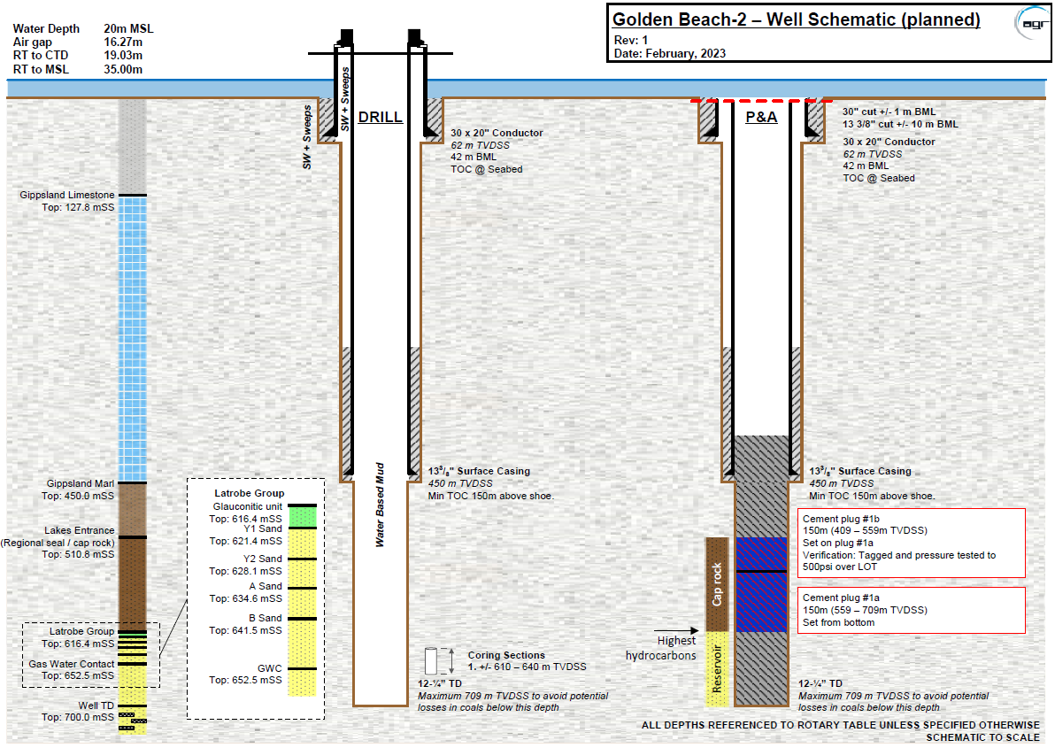
Figure 2.3. GB-2 schematic

Drill Fluid Additives
Seawater or drill water is the primary constituent of drilling fluids. Inert drilling fluid additives are added to the seawater or drill water to form a WBM.
In the absence of Australian standards regarding the suitability of drilling mud chemical additives, the OCNS is generally used as a basis for selecting environmentally acceptable chemicals in the Australian offshore petroleum industry.
The OCNS uses the Harmonised Mandatory Control Scheme (HMCS) developed through the Oslo-Paris (OSPAR) Convention 1992. This ranks chemical products according to Hazard Quotient (HQ), calculated using the Chemical Hazard and Risk Management (CHARM) model. The CHARM model requires the biodegradation, bioaccumulation and toxicity data of the product to be provided.
Under the OSPAR Convention, organic-based compounds used in production, completion and workovers, drilling and cementing are subject to the CHARM model. The CHARM model calculates the ratio of the ‘Predicted Effect Concentration’ against the ‘No Effect Concentration’ expressed as a HQ, which is then used to rank the product. The HQ is converted to a colour banding to denote its environmental hazard.
Gold has the lowest hazard, followed by silver, white, blue, orange and purple (having the highest hazard).
Products not applicable to the CHARM model (i.e., inorganic substances, synthetic-based muds (SBM), hydraulic fluids or chemicals used only in pipelines) are assigned an OCNS grouping A – E, with ‘A’ having the greatest potential environmental hazard and ‘E’ having the least. Products that only contain substances termed PLONORs (Pose Little or No Risk to the environment) are given the OCNS ‘E’ grouping (Figure 2.4). Data used for the assessment includes toxicity, biodegradation and bioaccumulation.
GB Energy will only use chemicals that are highly ranked under the OCNS rating system (i.e., ‘Gold’ or ‘Silver’ [CHARM] and ‘E’ or ‘D’ [non-CHARM], or equivalent) in the drilling fluid design. Where a chemical has not been ranked under OCNS, the drilling fluids contractor will conduct a ‘pseudo rating’ using toxicity and environmental data for the individual substances of a product. The rating is conducted following the hazard assessment process outlined by CEFAS for the OCNS scheme.
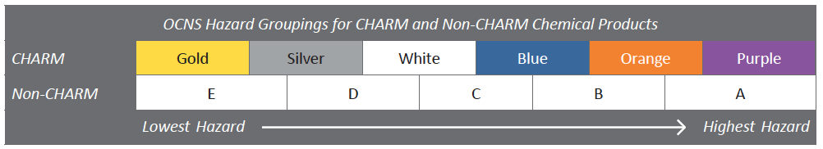
Figure 2.4. Illustration of hazard ranking bands for chemical products classified under the OCNS.
At the end of the drilling program, any drilling fluid remaining in the mud tanks will be discharged overboard (mud and brine), with quantities likely to be minimal due to the shallow nature of the well. Any dry, unopened sacks of chemicals left over at the end of drilling will be returned to shore.

Cement Program
Cement will provide one of the main barriers for isolation of the wellbore from reservoir conditions as well as provided structural support for the conductor. The final cement plan will be confirmed once a cement service provider has been selected. The notional cement program is outlined below:
- 30” x 20” conductor – the conductor will be cemented to the seabed.
- 13⅜" surface casing - the surface casing is planned to be cemented to a minimum of 150 m above the shoe setting depth.
- 12¼” open hole – an open hole cement plug(s) will be set with a minimum cement length of 60 m adjacent to the Lakes Entrance Regional seal. The abandonment plug cement will be extended approximately 50 m into the 13-3/8” casing. The abandonment plug will be weight (10,000 pounds) and pressure tested (500 psi above leak off test).

Cement Disposal
Cement is mixed as required to ensure minimal wastage. Flushing of lines and equipment is conducted at the end of each cementing operation with seawater.
There will be some excess cement discharged at the seabed during the cementing of the conductor and surface casing strings. Typically, once quality cement returns are observed at the seabed, cement mixing will cease and displacement will commence, with a minimal quantity of cement being deposited around the wellhead during the displacement.
It is estimated that in the order of 40 m³ of cement slurry will be discharged for the well.
At the end of the drilling program, the MODU will move to another operator, so leftover cement will be transferred to the next operator.

Formation Evaluation
Evaluation of the well will be carried out via LWD/MWD, coring and wireline logging. Pressure measurement and fluid recoveries will be carried out in the reservoir section by a Modular Dynamic Tester (MDT) wireline tool.
The Formation Evaluation Program shall provide baseline geological and reservoir parameters for the reservoir such that preliminary models based on the 1967 well can be extended and updated. These models will then form the basis of the final design and delivery of the production and storage infrastructure development. Further testing of the reservoir during production will be carried out at a later date, and this data will inform the subsequent transition to gas storage.
The well will not be flow tested (i.e., there will not be any flaring).

Wellhead
A 13-5/8” surface wellhead system will be installed as part of the well integrity envelope prior to drilling the reservoir section. The API-6A compliant wellhead will be rated to 10,000 psi and will include interfaces for connecting the drilling BOP and transferring load to the conductor.
The wellhead system connects directly to the surface casing via a premium, gas-tight connection. No additional casing or hangers will be installed through the wellhead as part of the GB-2 operations.

Well Abandonment
The well will be P&A, as per the schematic in Figure 2.5. The final abandonment plan will be confirmed once the well has been drilled and logged to ensure that the barriers are located at the necessary depths. Post-cement verification, the surface BOP and wellhead will be removed and all casing removed to below the mudline.
The planned abandonment ensures all penetrated hydrocarbon zones are isolated from the seabed by at least 60 m of cement, providing a combination barrier and restoration of the cap rock. The abandonment plug cement will be extended approximately 50 m into the 13-3/8” casing. The abandonment plug will be weight (10,000 pounds) and pressure tested (500 psi above LOT).
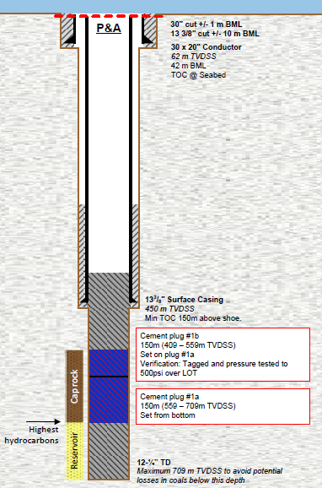
Figure 2.5. GB-2 well abandonment design

Well Control
A blowout is an uncontrolled flow of formation fluids from the well after the primary control is lost and either the secondary well control has not been activated or has failed.
Blow outs are prevented during drilling operations by monitoring the formation pressure and controlling the density (or weight) of the drilling fluids. When a rise in formation pressure is observed, the density of the drilling fluid is increased to maintain an overbalance of pressure against the formation and to keep the wellbore stable. The drilling fluid density is considered the primary well control barrier. In the event that the primary well control system fails, the secondary well control is activated, and the BOP is closed to prevent the uncontrolled flow from the well.
A BOP is a mechanical device designed to seal off a well at surface when required. The system is made up of a number of different types of closing mechanisms consisting of:
- Rams (opposing pistons that move horizontally across the top of the well, creating a seal around the drill string, casing or completion tubing);
- Blind shear rams that are capable of shearing drill pipe and sealing the wellbore; and
- Annular preventers (which deploy an elastomer donut-like device) can also be used to close off the well around various sizes of pipe.

Blowout Preventer
A BOP rated to a minimum of 10,000 psi working pressure will be installed and pressure tested prior to drilling the reservoir section. The BOP consists of a series of hydraulically-operated valves and sealing mechanisms that are open to allow the mud to circulate during drilling, but can be quickly closed if excessive pressure (a ‘kick’) enters the well. The following outlines the steps that would initially be taken in response to a well kick:
- If a kick occurs and secondary controls are required, an annular preventer or pipe ram is closed to prevent any further influx from the reservoir into the well if there is pipe in the hole (otherwise blind/shear rams are closed if there is no pipe in the hole).
- Lastly, the blind shear rams, which, if necessary, can shear the drill pipe and seal the well completely.
During drilling, the BOP will be function tested and pressure tested in accordance with the NOPSEMA-accepted Safety Case Revision.

Response to a Loss of Well Control

The nature of the loss of well control leading to a hydrocarbon release will determine the type of source control activities required and the duration of the response. Source control activities can include:
- Well capping and containment;
- Relief well drilling; and
- ROV Intervention.
In the event of a blowout during drilling, reservoir modelling indicates that a maximum rate of 147 MMscf/day would be released through the open hole for a period of time. It is assumed that there will be a pressure drop over time, though this has not been calculated.
GB Energy will have a contract in place with a well control service provider that allows it to access personnel and equipment to rapidly respond to a well control response.

Relief Well
A relief well is a longer-term response option to stop uncontrolled flow from a well (i.e., ‘kill’ a well) and to permanently abandon the well. A relief well is drilled to intersect the well that is flowing out of control to provide a conduit to pump high density fluid into the well, and thus stop well flow. GB Energy will begin to execute its Source Control Emergency Response Plan (SCERP) which comprises a Relief Well Plan (RWP), immediately after a blowout incident and in parallel with other response activities.
It is important to note that the design of the well has taken into account the data for the offset wells, which reduces the risk of a blowout from occurring.

Drilling Summary
The key drilling activity parameters are summarised in Table 2.7.
Table 2.7. Key drilling parameters
Element | Details
Location and timing
Permit assessment area | Vic/RL1(V)
Project area | 500 m buffer zone around the drilling location
Water depth | 20 m
Nearest landfall | Ninety Mile Beach – 3.5 km northwest
Start date (earliest) | June 2023
Duration of activity | 22 days
MODU and support services
MODU | Jack-up, Valaris-107
Support vessels | Go Offshore (Go Sirius and Go Spica)
Marine base | Port of Melbourne
Drilling details
Well depth | 709 mMDSS
Drill cuttings volume (est) | 112 m³
Drilling fluid | WBM
Muds discharge volume (est) | 1,545 m³
Cement discharge volume (est) | 40 m³
Flaring | No
VSP | Not required

Stakeholder Consultation
The overarching objective of the Project’s stakeholder consultation program is to enable the delivery of the Project consistent with regulatory requirements and good practice engagement and secure government approvals of the various phases of the Project.
GB Energy is committed to meeting these objectives by:
- Identifying stakeholders whose functions, interests or activities may be affected the activity;
- Confirming the relevant persons in accordance with the regulations and engaging those stakeholders at the earliest opportunity;
- Ensuring relevant persons are informed about the activity and the potential environmental and social impacts and risks;
- Proactively providing informative, accurate and timely information, and ensuring stakeholders have an adequate opportunity to consider the information and provide feedback;
- Ensuring affected stakeholders are informed about the consultation process and that their feedback, questions and concerns are considered in this EP; and
- Providing a mechanism for assessing the merit of any stakeholder objections, complaints or claims of adverse impacts received throughout the consultation period and providing feedback to that stakeholder in a timely fashion.

Stakeholder Identification
The totality of the defined activities, the nature and scale of the activity, the physical EMBA, the relevant values and sensitivities of the EMBA, the identification and assessment of risks and impacts, were comprehensively assessed to identify categories of authorities, entities, persons, and organisations (‘relevant persons’ as per reg 13F (1)) whose functions, interests or activities may be affected by the activities to be carried out under the EP.
The environmental values and sensitivities that occur within the EMBA were assessed to determine which categories of relevant persons may potentially be affected by the activities to be carried out. These assessments were then used to identify categories of relevant persons who may potentially be affected by the activities to be carried out (Table 3.1).
Each category was then researched to identify authorities, entities, persons and organisations whose functions, interests and activities may be affected by the activity.
Table 3.1. Relevant persons identified for the activity
Category A – Authority or entity of the State
Commonwealth government agencies
AMSA - Nautical and Regulation Section | Department of Defence (DoD) – Defence Support Group & Royal Australia Air force (RAAF) Base East Sale
AFMA
Australian Hydrographic Office (AHO) | NOPSEMA
Department of Climate Change, Energy, the Environment and Water (DCCEEW) | Department of Agriculture, Fisheries and Forestry (DAFF)
Victorian government agencies
DEECA (formerly the Department of Environment, Land, Water and Planning (DELWP)) | Victorian Fisheries Authority (VFA)
 | West Gippsland Catchment Management Authority (CMA)
Department of Transport (DoT) - Marine Safety – Pollution Resilience and Emergency Coordination
 | East Gippsland CMA
EPA | DEECA - ERR
Maritime Safety Victoria (MSV) | Department of Treasury and Finance
Parks Victoria | Invest Victoria
Elected Victorian government officials
Minister Danny O’Brien
Local Government
Wellington Shire Council | East Gippsland Shire Council
Category B – Person or Organisation with Functions, Interests or Activities that may be Affected
First Nations People
GLaWAC
Petroleum and greenhouse gas titleholders
CarbonNet Project | Esso Australia Resources Pty Ltd (EARPL)
Petro Tech Pty Limited | Carnarvon Hibiscus Pty Ltd
3D Oil
Fisheries associations – commercial
Commonwealth Fisheries Association (CFA) (Comfish) | Seafood Industry Victoria (SIV)
 | South-East Trawl Fishing Industry Association (SETFIA)
Eastern Zone Abalone Industry Association (EZAIA)
 | Victorian Abalone Council
Lakes Entrance Fisherman’s Cooperative (LEFCOL) | Victorian Scallop Fishermen’s Association (VSFA)
Commercial fishing licence holders
Mitchelson Fisheries
Local groups and residents
Golden Paradise Beach Ratepayers & Residents Association | Local residents (predominantly the towns of Golden Beach and Paradise Beach, but also further field such as Sale and Traralgon), via the Golden Beach Community Centre
Landowners (onshore pipeline alignment)
Fishing Associations – recreational
Victorian Recreational Fishing (VRFish)
Boating/sailing associations
Yachting Victoria
Other offshore projects/assets
Star of the South offshore wind farm (proposal) | Flotation Energy
Corio Generation
Emergency preparedness and response agencies
Gippsland Coastguard
Category C – Any other Person or Organisation
Win TV | Latrobe Valley Express newspaper
Gippsland Times & Maffra Spectator newspaper | Australian Financial Review newspaper

Engagement approach and methodology

Engagement approach
The OPGGS Regulations requires titleholders to give each relevant person sufficient information to allow them to make an informed assessment of potential effects on their functions, interests or activities from the activities in the EP. Provision of information is responsive and adaptive to the individual needs and circumstances of the relevant person seeking the information. Key approaches to providing sufficient information are set out in Table 3.2.
Table 3.2. Information provided for Relevant Persons categories
Category | Description | Information type
13F(1)(a) | Relevant authorities or entities of the State | Information sheet emailed to relevant persons.  EES available on GB Energy website (until January 2023).  Provision of further information where requested or required.  Participation in TRG during the development of the EES.  Meeting or phone call where requested or required.  Commencement and cessation notices for relevant agencies.
13F(1)(b) | Persons or organisations whose functions, interests or activities may be affected by the activity | Information sheet emailed to relevant persons.  EES available on GB Energy website (until January 2023).  Draft EP available on the GB Energy website. Particularly for fisheries, this allows fishers to review maps and determine whether their activities may be affected.  Meetings with SETFIA.  Phone calls (when there is no response to initial emails).  Provision of further information where requested or required.  Public notice advertisements.  Feature stories (print, radio, television, social media).  Community information sessions in Golden Beach.
13F(1)(c) | Any other person or organisation | Updates to project timings.  Commencement and cessation notices.  Public notice advertisements.  Feature stories (print, radio, television, social media).  Community information sessions in Golden Beach.

Consultation methodology
The methods of consultation that GB Energy has adopted are outlined below in Table 3.3. GB Energy believes these consultation methods are comprehensive and adequate as it has not received any feedback from relevant persons that these consultation methods are inadequate or that additional methods are required.
Table 3.3. Methods of engaging with relevant persons
Engagement tool | Description
Digital communication
GB Energy website | Website is updated as new information becomes available.  The EES documentation was available from October 2020 until January 2023.  The GB-2 drilling EP was available from 9 March 2023.
Frequently asked questions (FAQs) | Available on the GB Energy website to address anticipated questions or those that have been asked by relevant persons.
Project email | An email address (info@gbenergy.com.au) is available for project enquiries and is publicised via the website, information sheets and print advertisements.
Email updates | For those that have opted in to email communications, emails are issued at regular intervals to provide project updates.
LinkedIn | Project updates are included on the GB Energy LinkedIn (professional networking site). This has 783 followers at end of February 2023.
Print communication
Information sheets | Information sheets and other written communications have been and will continue to be developed to provide project updates to relevant persons listed in the project’s consultation database. These are distributed electronically via email and/or included on the GB Energy website. Copies may also be printed and issued with accompanying letters or for distribution at in-person events. Fact sheets will be distributed by mailbox drop and through the Golden Paradise Beach Ratepayers Association.
Letters | Letters are used to provide formal correspondence and used to formally respond to stakeholders in respect of specific issues, concerns or requests.
Media and advertising | Radio (Gippsland FM) and local print (for example, The Gippsland Times (circulation of 13,500), Latrobe Valley Express (circulation of 35,700) and the local Letts Beach News) are used to inform people about the Project and provide feedback opportunities.
Public displays/notices | Public notices are placed in local newspapers to promote activities in line with engagement best practice and regulatory obligations.
Direct engagement
1800 phone number | A dedicated toll free 1800 phone number (1800 423 637) is established for the project. All contacts are logged into the project’s consultation software, and the response is assigned to the relevant member in the project team.
Face-to-face meetings | Meeting stakeholders face-to-face as required.
Virtual meetings | GB Energy hosted virtual meetings when Covid-19 restrictions were in place.
Information sessions | Community information sessions have been and will continue to be conducted to provide an opportunity for relevant persons and the broader local communities to meet the project team and ask questions or express concerns.  The information sessions were widely publicised through the local ratepayers’ association, community organisations such as the local bowls and golf clubs, local media, letterbox drops and direct email to registered parties.  To date, the community meetings have attracted from 10 to 45 attendees at each meeting, with the Project hiring local venues and utilising the services of the local Men’s Shed to provide distribution of meeting notifications and catering on the day. Every effort is made to give stakeholders at least four weeks’ notice of a meeting.

Record of stakeholder engagement
GB Energy uses Consultation ManagerTM software as its stakeholder records management system. This holds copies of all correspondence issued and received in the development of the Project, including issues raised and their resolution.

Summary of stakeholder consultation
A summary of consultation undertaken in the course of preparing this EP is provided in Table 3.4. This summary indicates that GB Energy has provided sufficient time (about six months) to relevant persons to engage on the GB-2 activities. To date, no relevant persons have raised concerns that their functions, activities or interests may be negatively impacted by the GB-2 campaign.
Table 3.4. Summary of consultation undertaken in the course of preparing the EP
Date | Description
2020 / 2021
Multiple | Ongoing consultation through the EES process
2022
20 March | Statement form Commonwealth Government on funding for the drilling of the appraisal well
26 May | Initial notification to ERR on intent to drill the appraisal well and that the previously submitted Drilling EP will be retracted and replaced with an appraisal drilling EP
21 July | Meeting with CarbonNet (overlapping greenhouse gas titleholder) informing them of plan to drill GB-2 appraisal well
13 September | GB-2 Drilling EP submitted to ERR for assessment
30 September | Information flyer #1 distributed by campaign email
4 October | Annual Titleholder meeting with ERR – Provide update on VIC/RL1 workplan and  GB-2 drilling
28 October | Assessment feedback from ERR on the GB-2 EP
23 December | GB Energy website update
2023
5 January | Information flyer #2 distributed by campaign email
31 January | ERR provided additional comments on the GB-2 EP, centred entirely on consultation with relevant persons in light of the Case and the Appeal
3 February | Article in the Australian Financial Review about the Golden Beach Gas Project
3 February | Meeting with Golden Beach Residents and Rate Payers Association to discuss the GB-2 well and future consultation requirements
20 February | Article in the Gippsland Times
7 March | Advertisements in The Gippsland Times & Latrobe Valley Express on consultation sessions
9 March | Information session at Golden Beach community hall
9 March | TV interview with WinTV and GB Energy Chief Operating Officer, detailing the GB-2 drilling and upcoming consultation sessions
10 March | Draft EP (Rev 2 that was assessed by ERR) made available on GB Energy website
10 March | Information flyer #3 released
23 March | Information session at Golden Beach community hall
6 April | Information session at Golden Beach community hall

A complete copy of original communications to and from all stakeholders was provided in the full EP submission to DEECA.

Ongoing Consultation
GB Energy continues to consult with relevant persons regarding the GB-2 drilling campaign and the project more broadly. For GB-2, this will be achieved via a number of methods, as outlined in Table 3.5. The planned events and notifications are subject to change, based upon the operational timings for the MODU arrival and commencement of operations. Additional events and/or the timing and content of events may be modified based upon the feedback received from relevant persons.
Any new relevant persons identified through the ongoing consultation process will be contacted and provided information about the activity relevant to their functions, interests or activities. Ongoing Consultation with Relevant Persons.
Table 3.5. Summary of plan for ongoing consultation with relevant persons
Timing/  milestone | Relevant person | Consultation method/content
Ongoing
As required | All relevant persons | - Communication of information and addressing queries and concerns via email, phone or meeting.  - Project updates including acceptance of EP and start and completion of drilling.
Pre-drilling
23 March and 6 April 2023. | Local community | Fortnightly early evening drop-in sessions at the Golden Beach community hall ahead of drilling to provide the local community with whatever information they are seeking.  Frequency and timing to be adjusted as required (i.e., more or less frequent or earlier or later in the day depending on feedback at the first few sessions).
22nd March | All | Online webinar – registration details published in the March newsletter, GB Energy website and local social media groups.
8th April 2023 | Local community | Information stand at the End of Summer Surf Festival market day in Golden Beach.
When MODU leaves prior drilling location in northern Australia (notionally 2-3 weeks prior to drilling) | Relevant persons identified as marine users and relevant government departments and agencies | Notifications of activity commencement, including:  - Location of activity, coordinates and map;  - MODU mobilisation pathway;  - Timing of activity (expected start and finish date and duration);  - MODU and support vessel details, including call signs and contact details;  - PSZ information; and  - GB Energy contact details.
 | GB Energy LinkedIn members | Posting of a LinkedIn notification that MODU is on its way to the GB-2 location, marking a significant milestone for the project.
2 to 4 weeks prior to activity commencing | AHO & MSV | MODU contractor to issue notification of activity for publication of NTM, including:  - Geographical coordinates of the well location;  - Duration of MODU presence on location;  - PSZ information;  - MODU and support vessel details including names, Maritime Mobile Service Identity (MMSI)), satellite communications details (including INMARSAT-C and satellite telephone), contact details and call signs; and  - GB Energy contact details.  GB Energy will provide updates on project timing and any changes to the intended operations.
10 days prior to activity commencing | DEECA – ERR  NOPSEMA | Email notification of start of activity.
7 days prior to MODU arrival | Local community and visitors | Signage will be posted at the Golden Beach lookout and camp grounds along the foreshore providing details of the drilling program given that the MODU will be highly visible from the beach and foreshore.
 | Local community | Advertising of MODU arrival in The Gippsland Times and Latrobe Valley Express newspapers.
48 – 24 hrs prior to activity commencing | AMSA - JRCC | Per AHO & MSV information.
While drilling
During activity | All relevant persons | - Communication of information and addressing queries and concerns via email, phone or meeting.  - Emergency notifications via email, as and if required (e.g., diesel spill).
 | GB Energy LinkedIn members | LinkedIn post to provide update on drilling.
 | General public | Progress updates released weekly via the GB Energy website.
 | Commercial fishers active in the area | SMS via SETFIA advising of MODU location, PSZ and activity timing.
Drilling completion
Within 24 hours of activity completion | AMSA – JRCC | Email notification providing information on drilling completion in order to cease AusCoast warnings.
Within 2 days of activity completion | All relevant persons | Email notification providing information on drilling completion and MODU demobilisation pathway.
 | AHO & MSV | Email notification providing information on drilling completion in order to cease NTM.
Within 10 days of activity completion | DEECA - ERR | Email notification of cessation of activity in order to close out the EP.
 | Local community | Remove information signage at the Golden Beach lookout and camp grounds.
 | General public | Notification of cessation of activity via the GB Energy website.

Description of the Existing Environment
The ‘environment that may be affected’ (EMBA) by the activity is summarised in this section, together with its values and sensitivities. Each hazard associated with the Project (e.g., seabed disturbance and atmospheric emissions) has its own unique spatial distribution and thus EMBA. The description of the existing marine environment in this chapter has been defined by the most significant hazard and its associated EMBA, which is that relating to a marine diesel oil (MDO) spill.
A hydrocarbon spill scenario has been modelled, which in turn defines the extent of the EMBA for the Project (Figure 4.1). It is important to note that the MDO spill EMBA does not represent the extent of an individual spill trajectory. The EMBA is defined as:
The combination of 100 randomly selected spill simulations delineating the extent of moderate level hydrocarbon exposure to the sea surface (10 g/m²), moderate contact to shorelines (>100 g/m² or) and the extent of high exposure to hydrocarbons entrained in the water column (100 ppb) as a result of the loss of 155 m³ of MDO over 6 hours under annualised metocean conditions from a support vessel within the Project area.
Where appropriate, descriptions of the regional environment are provided for context. The ‘environment’ is defined as:
- Ecosystems and their constituent parts, including people and communities;
- Natural and physical resources;
- The qualities and characteristics of locations, places and areas;
- The heritage value of places; and
- The social, economic and cultural features of the matters listed previously.
The key external sources of information utilised in developing this section include:
- EPBC Act Protected Matters Search Tool (PMST) database, undertaken in 2020 (DAWE, 2020a) and revised in August 2022 (DCCEW, 2022).
- Victorian Biodiversity Atlas (VBA), undertaken in 2020 (DELWP, 2020b) and revised in August 2022.
- The Atlas of Living Australia (ALA).
- Shorebirds 2020 database.
- eBird database.
- National Conservation Values Atlas undertaken in 2020 and revised in August 2022 (DAWE, 2020b).
- Species Profile and Threats Database (SPRAT).
- FFG Act Threatened Species List (DELWP, 2019).
- DELWP Threatened Species Advisory List (DSE, 2013a).
- New South Wales (NSW) BioNet Atlas.
- South-east Marine Region Profile (DoE, 2015a).
- South-east Bioregional Plan (CoA, 2015).
- Marine Natural Areas Values Study Vol 2: Marine Protected Areas of the Flinders and Twofold Shelf Bioregions (Barton et al., 2012).
- Eastern Victorian Ocean Scallop Fishery 2017-18 Abundance Survey (Fishwell Consulting/VFA, 2018a).
- Eastern Victorian Ocean Scallop Fishery 2022 Pre-season Abundance Survey (Koopman et al., 2022).
- Victorian Oil Spill Response Atlas (OSRA) (DEDJTR, 2017) (obtained by request from the DEECA).
- CarbonNet Project reports (parts of this project took place in the Golden Beach Gas Project area):
- Pelican 3DMSS Offshore Habitat Assessments Executive Summary (CarbonNet, 2020).
- Gular-1 Offshore Appraisal Well EP Summary (CarbonNet, 2019).
- G&G Investigations EP Summary (CarbonNet, 2018).
- Pelican 3DMSS EP Summary (CarbonNet, 2018).
- Geophysical survey of the Project area conducted by Fugro Australia Marine Pty Ltd (Fugro) for GB Energy in early 2020.
- Commonwealth Scientific and Industrial Research Organisation (CSIRO) Gippsland Marine Environmental Monitoring data (raw data not publicly available) (CSIRO, 2018).
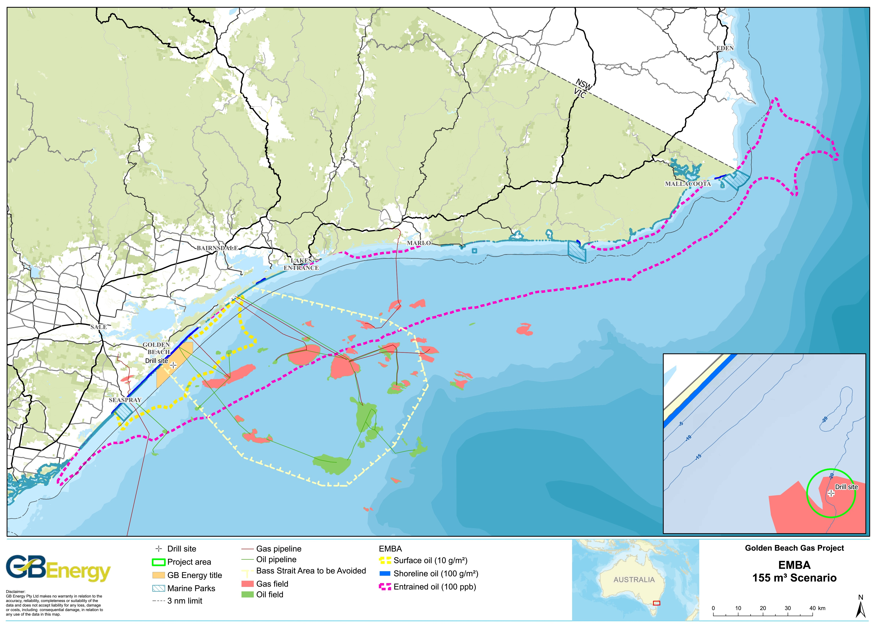
Figure 4.1. The spill EMBA
Table 4.1 summarises the likely presence or absence of receptors and sensitivities within the Project area and EMBA based on the key information sources previously listed.
Table 4.1. Presence and absence of receptors in the project area and spill EMBA
Receptor | Project area | EMBA
Physical
Low profile rocky reef | No | Patchy
Sponge garden | Possible | Yes
Conservation Values
AMPs | No | No
World Heritage-listed properties | No | No
National Heritage-listed properties | No | No
Threatened Ecological Communities (TECs) | No | Yes
Key Ecological Features (KEFs) | No | Yes
Nationally Important Wetlands (NIWs) | No | Yes
Victorian marine protected areas | No | Yes
Onshore protected areas | No | Yes
Biological Environment
Plankton | Yes | Yes
Benthic species: | Yes | Yes
- commercial scallops | Likely to have isolated individuals | No beds that are commercially viable
- rock lobsters | No | Yes
Seagrass beds | Isolated & sparse | Yes
Fish: | Yes | Yes
- Biologically Important Area (BIA) for great white shark | Yes | Yes
Cetaceans: | Yes | Yes
- BIA for pygmy blue whale | Yes | Yes
- BIA for southern right whale | Yes | Yes
- BIA for humpback whale | No | Yes
Pinnipeds | Foraging only, no haul-out or breeding sites | Yes
Reptiles | Vagrants only | Vagrants only
Seabirds | Yes | Yes
Shorebirds | Yes | Yes
Marine pests | Possible | Possible
Cultural Heritage Values
Shipwrecks | No | Yes
Indigenous heritage | No | Yes
Socio-economic Environment
Native Title | No | No
Tourism | Possible game fishing | Yes
Petroleum infrastructure | No | Yes
Commercial fishing | Shark gillnet/hook (Cth)  Ocean access (Vic)  Ocean purse seine (Vic) | Shark gillnet/hook (Cth)  Trawl (Cth)  Rock lobster (Vic)  Ocean access (Vic)  Ocean purse seine (Vic)  Inshore trawl (Vic)
Recreational fishing | Possible game fishing | Yes
Commercial shipping | Yes | Yes
Green shading denotes presence, red shading denotes absence.

Regional Context
The Project area is located within the Southeast Shelf Transition provincial bioregion within the South-east marine region (DoE, 2015a). The coastline adjacent to the bioregions (as classified at the Commonwealth and state scales) is exposed, with long sandy beaches broken by rocky headlands and numerous coastal lagoons.

Climate
The region’s climate is moist cool temperate (Barton et al., 2012), with cool wet winters and cool summers. It is influenced by rain bearing cold fronts that move from south-west to north-east across the region, producing strong winds from the west, north-west and south-west.
Bass Strait is located on the northern edge of the westerly wind belt known as the Roaring Forties. Occasionally, intense meso-scale low-pressure systems occur in the region, bringing very strong winds, heavy rain and high seas. These events are unpredictable in occurrence, intensity and behaviour, but are most common between September and February (McInnes and Hubbert 2003).

Physical Environment
Fugro undertook a geophysical survey of the Project area in March 2020 for GB Energy (for the purposes of the geophysical survey, the project area encompassed the proposed pipeline route and drill site). The survey provided an investigation and hazard assessment of the Project area, including characterisation of the seabed.
The gradient of the Project area is very flat, ranging from 0 m at the beach to 19.5 m at its deepest point at the well centre location over a distance of 3.2 km from the coast.
The key observations from the survey were:
- There are elongated seabed depressions oriented northwest-southeast in the Project area;
- The proposed pipeline route passes through seabed depressions;
- The seabed at the proposed well locations is flat; and
- The seabed depression depths measured less than one metre from the surrounding seabed.
Intermittent and very narrow areas of low-profile reefs (about 0.5 m to 1.5 m in height above the surrounding seabed), running parallel to the coast, are scattered through the nearshore sandy sediments along the Ninety Mile Beach. These reefs comprise calcarenite and occur immediately behind the surf zone, in water depths ranging from 7 to 25 m (Barton et al., 2012), and are likely to be often covered by mobile sand. Absence of these reefs from the Project area was confirmed with the geophysical survey undertaken in 2020.
The seabed samples collected indicate that the seabed of the Project area is predominantly two types of carbonate sand:
- Class 1: Low, uniform, reflectivity response interpreted as flat lying sediments including fine to medium grained carbonate sands with silts.
- Class 2: Moderate to high reflectivity response interpreted as fine to coarse carbonate sands, gravels and shells.
A marine habitat assessment (using a non-intrusive towed camera) was commissioned by CarbonNet and conducted in early April 2017 to provide information for the CarbonNet Pelican 3DMSS. The primary aim of the assessment, among others, was to determine broad seabed substrate types of the survey area, which included the GB Energy Project area. Of the 71 sites sampled in the MSS acquisition area, eleven sites occur within 2.5 km of the Project area (sites 23, 24, 31, 32, 33, 34, 41, 42, 43, 64 and 65), with none of these occurring within the GB Energy Project area (CarbonNet, 2020).

Oceanography
The Project area is located in shallow water depths ranging from 10 to 20 m in the Gippsland Basin. The bathymetry contours generally run parallel to the coast, though this pattern is less pronounced in waters deeper than 18 m.
Water Currents
Currents within Bass Strait are primarily driven by tides, winds and density-driven flows (RPS, 2020a). The region is oceanographically complex, with sub-tropical influences from the north and sub-polar influences from the south (DoE, 2015a). There is a slow easterly flow of waters in Bass Strait and a large anti-clockwise circulation (DoE, 2015a).
Surface currents flow in the northeast to southwest axis parallel with the coastline. The average monthly surface current speed was 0.30 metres per second (m/s), with the maximum surface current speeds ranging between 0.8 and 1.0 m/s.
Sea Temperature
The shallowness of Bass Strait means that its waters more rapidly warm in summer and cool in winter than waters of other nearby regions (DoE, 2015a).
Waters of eastern Bass Strait are generally well mixed, but surface warming sometimes causes weak stratification in calm summer conditions.
Sea surface temperature in the region varies annually from a minimum of 14°C (August/September) to a maximum of 18°C (March). The average annual sea surface temperature is 16°C.
Tides and Waves
Tidal currents run parallel to the coast and follow a semi-diurnal pattern (Barton et al., 2012), with some diurnal inequalities (Jones and Padman, 1983). Speeds of 0.5 m/s are not uncommon with maximum tidal flows of 3 m/s occurring in some areas (Fandry, 1983). Barton et al (2012) report that strong tidal currents (2 to 2.5 knots, or 1-1.3 m/s) are characteristic of the area. Tidal variation is 0.9 m for spring tides and 0.6 m for neap tides (Barton et al., 2012).
Bass Strait is a high-energy environment exposed to frequent storms and significant wave heights (Jones, 1980), though Barton et al (2012) report wave energy in the Twofold Shelf Bioregion as relatively low. Storms may occur several times a month resulting in wave heights of 3 to 4 m or more.
Ambient Ocean Sound
Physical and biological processes contribute to natural background sound. Physical processes include that of wind, waves, rain and earthquakes, whilst biological noise sources include vocalisations of marine mammals and other marine species.
Ambient underwater sound characterisation of the Pelican 3DMSS acquisition area (which took place over the Project area) was undertaken in February 2018 (CarbonNet, 2018). The study involved four deployment locations, with site1 being the closest to the Project area (3.6 km to the east in a water depth of 19 m). The three other sound loggers were located in water depths of 26, 27 and 39 m, with the next closest site (site 2) located 5.5 km southeast of the Project area.
The ambient underwater soundscape of the Golden Beach region was contributed to strongly by weather events (wind and wave noise correlated with tidal state), with low levels of shipping and biological sound. Both Stations 3 and 4 (in water depths of 27 m and 39 m, respectively) show the presence of snapping shrimp, with elevated power spectral density levels above 1.5 kHz due to their contributions at night. Biological sources are primarily evident in recordings from Station 3 in the 1-10 kHz and 10-32 kHz bands as elevated night time levels, which are likely linked to increased biological activity at the nearshore reef, as they are not evident at Station 4.
Increased noise levels in the 10-100 Hz band (primarily at Station 3) occur on a 6-hourly cycle, aligning with the tidal cycle. The highest levels occur as the tide rises from low to high at night early in the week, with similar noise levels for all tidal cycles at the end of the week as the moon approached the last-quarter on the 8th of February 2018.The tidal cycles are more noticeable at Station 3 as it is in shallower water than Station 4, and also because it is closer to the coast, and the sound levels are more influenced by wave action on the beach.
The daily sound exposure level (SEL) ambient underwater sound values varied between a minimum of 162.5 dB re 1 μPa2.s and maximum of 163.7 dB 1 μPa2.s at Station 3, and a minimum of 158.3 dB 1 μPa2.s and a maximum of 163.6 dB 1 μPa2.s at Station 4 (CarbonNet, 2018).

Coastal Environment
The physical coastal environment described in this section is defined by the potential extent of dispersion of moderate threshold entrained hydrocarbons predicted under the MDO spill scenario, which stretches from McLaughlin’s Beach in Victoria to Green Cape in NSW.
The environmental features of the coast immediately adjacent to the Project area are dominated by sandy sediment with sparse reef (low-profile carbonate reef, see Section 4.1). The Wellington Shire coast is dominated by Ninety Mile Beach, which is entirely sandy beach and provides important hooded plover (Thinornis rubricollis) nesting habitat. East of Cape Conran, in the East Gippsland Shire coast section, rocky headlands intertidal shore platforms become interspersed among sections of sandy beach, though sandy beach remains the dominant coastal feature.
The presence or absence of environmental sensitivities along the coastline of the EMBA (divided into local government area sectors) is presented in Table 4.2.
Table 4.2. Coastal sensitivities within the EMBA
Environmental receptor | Wellington Coast | East Gippsland Coast
Shoreline types
Sandy beach | Yes | Yes
Mixed sand beach/shore platform | No | Yes
Intertidal shore platform | No | Yes
Nearshore substrates
Intertidal sand flat | Yes | Yes
Subtidal sand flat | Yes | Yes
Subtidal low-profile patch reef | Yes | Yes
Rocky reef | Yes | Yes
Species presence
Australian fur-seal haul-out sites | No | Yes
Australian fur-seal breeding colony | No | Yes
New Zealand fur-seal colony | No | Yes
Little penguin colony | No | Yes
Estuarine fish habitat | Yes | Yes
Hooded plover habitat | Yes | Yes
Tern nesting sites | Yes | Yes
Shorebird roosting sites | Yes | Yes

Conservation Values and Sensitivities
The conservation values and sensitivities within the EMBA are described in this section.

Australian Marine Parks
No AMPs are intersected by the EMBA.

World Heritage-Listed Properties
World Heritage Listed-properties are examples of sites that represent the best examples of the world’s cultural and heritage values, of which Australia has 19 properties (DCCEEW, 2022b). No properties on the World Heritage List occur within the EMBA.

National Heritage-Listed Properties
The National Heritage List is Australia’s list of natural, historic and Indigenous places of outstanding significance to the nation (DCCEEW, 2022c). There are no National Heritage-listed places in Bass Strait.

Wetlands of International Importance
Ramsar wetlands are those that are representative, rare or unique wetlands, or are important for conserving biological diversity, and are included on the List of Wetlands of International Importance developed under the Ramsar Convention. There are two Ramsar wetlands in the EMBA. The ‘Gippsland Lakes’ and ‘Corner Inlet’ Ramsar sites (Figure 4.2) are intersected by the EMBA and are described here.
Gippsland Lakes
The Gippsland Lakes Ramsar site is a system of lakes and wetlands extending eastward from Sale to Lake Tyers, in some areas extending to the high-water mark of the ocean, and cover an area of 58,824 ha (Parks Victoria, 2003). These lakes and wetlands occur landwards of the coastal dunes adjacent to the EMBA, and at its nearest point, the site’s boundary that runs to the high-water mark is located 5.5 km north of the EMBA.
There is a high concentration of archaeological sites in the Gippsland Lakes area including artefact scatters, shell middens, scarred trees, occupation sites, burials and axe-grinding grooves (Parks Victoria, 2003).
Parts of the Lakes system are heavily used for commercial and recreational fisheries and for other water-based recreation, while the immediate hinterland has been developed for agricultural uses and limited residential and tourism purposes (Parks Victoria, 2003).
Corner Inlet
The Corner Inlet Ramsar Site is located approximately 250 km south-east of Melbourne and includes Corner Inlet and Nooramunga Marine and Coastal Parks, and the Corner Inlet MNP. It covers 67,192 ha and represents the most southerly marine embayment and intertidal system of mainland Australia (Parks Victoria, 2005a).
The major features of Corner Inlet that form its ecological character are its large geographical area, the wetland types present (particularly the extensive subtidal seagrass beds), diversity of aquatic and semi-aquatic habitats and abundant flora and fauna, including significant proportions of the total global population of a number of waterbird species (BMT WBM, 2011).

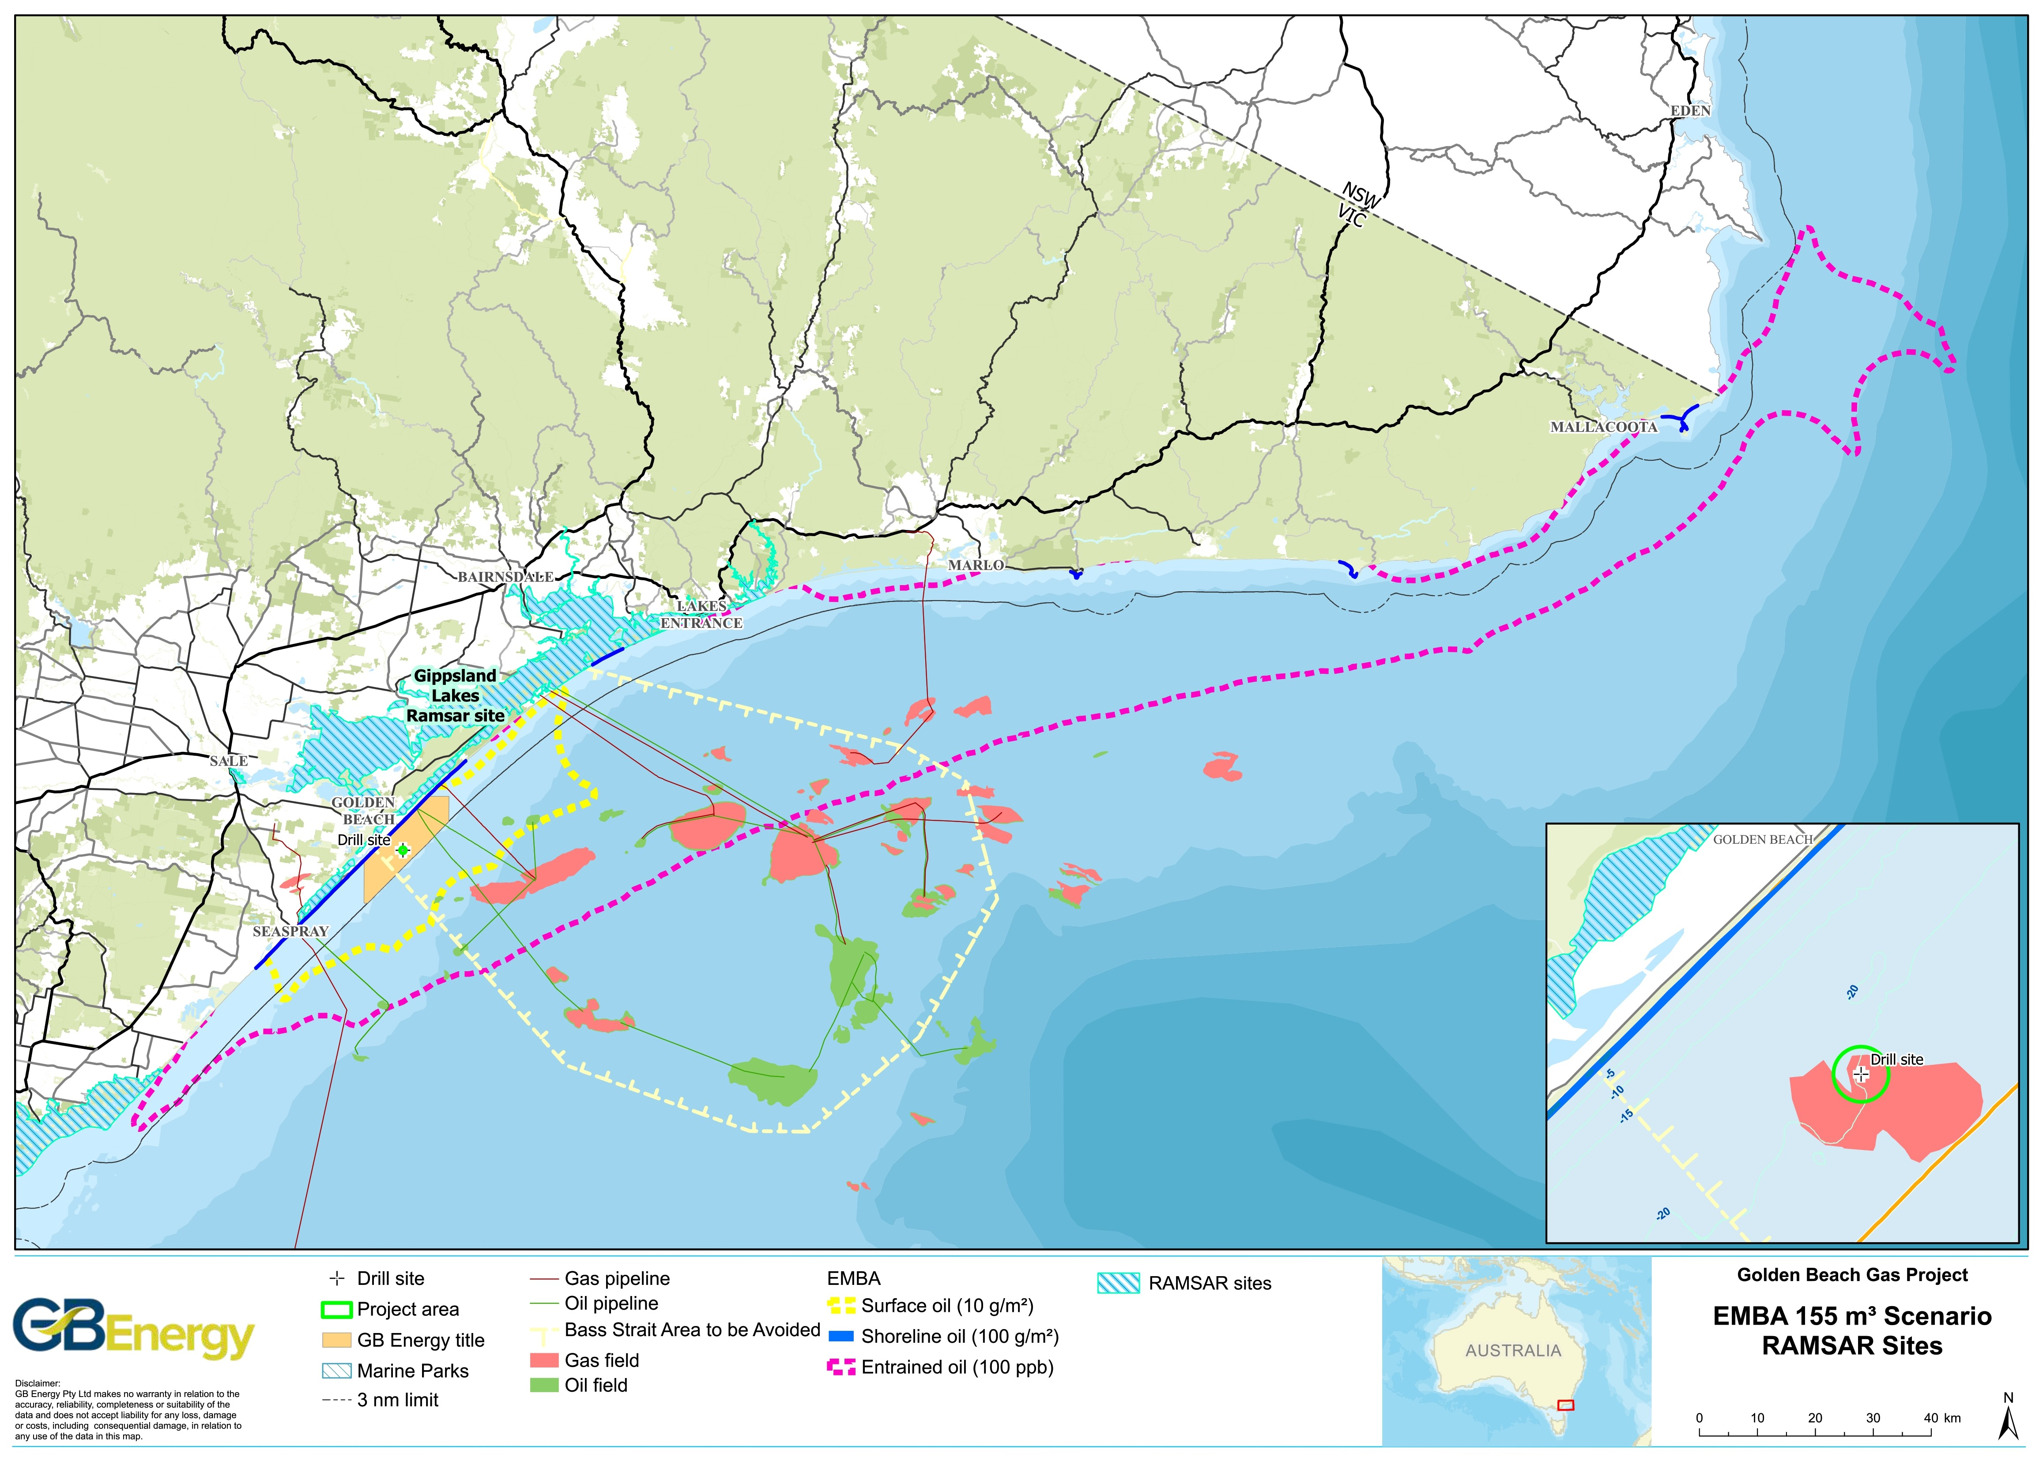
Figure 4.2. Ramsar wetlands intersected by the Project area and spill EMBA

Threatened Ecological Communities (TECs)
TECs provide wildlife corridors and/or habitat refuges for many plant and animal species, and listing a TEC provides a form of landscape or systems-level conservation (including threatened species). The ‘Giant kelp marine forests of south east Australia’ and ‘Subtropical and temperate coastal saltmarsh’ TECs are described here as they are present in the EMBA. Mapping presented in Figure 4.3 illustrates where TECs potentially occur due to the presence of suitable substrate and not necessarily where they are known to occur. TECs may occur outside the areas indicated.
Giant Kelp Marine Forests of South East Australia
The Giant Kelp Marine Forests of South East Australia TEC is mapped as potentially occurring within small coastal parts of the EMBA including a small area near Point Hicks (170 km northeast of the Project area) and areas east of Mallacoota (225 km northeast of the Project area). The majority of the TEC is mapped as potentially occurring along the Tasmanian coast and the west coast of the Furneaux Group, which is outside the EMBA.
Subtropical and Temperate Coastal Saltmarsh
According to the Conservation Advice for Subtropical and Temperate Coastal Saltmarsh, this TEC occurs in a relatively narrow strip along the Australian coast, within the boundary along 23°37’ latitude along the east coast and south from Shark Bay on the west coast of Western Australia (TSSC, 2013). The community is found in coastal areas which have an intermittent or regular tidal influence.

Commonwealth Heritage-listed Places
Commonwealth Heritage-listed places are natural, indigenous and historic heritage places owned or controlled by the Commonwealth (DCCEEW, 2022d). No properties on the Commonwealth Heritage List occur within the Project area or EMBA.

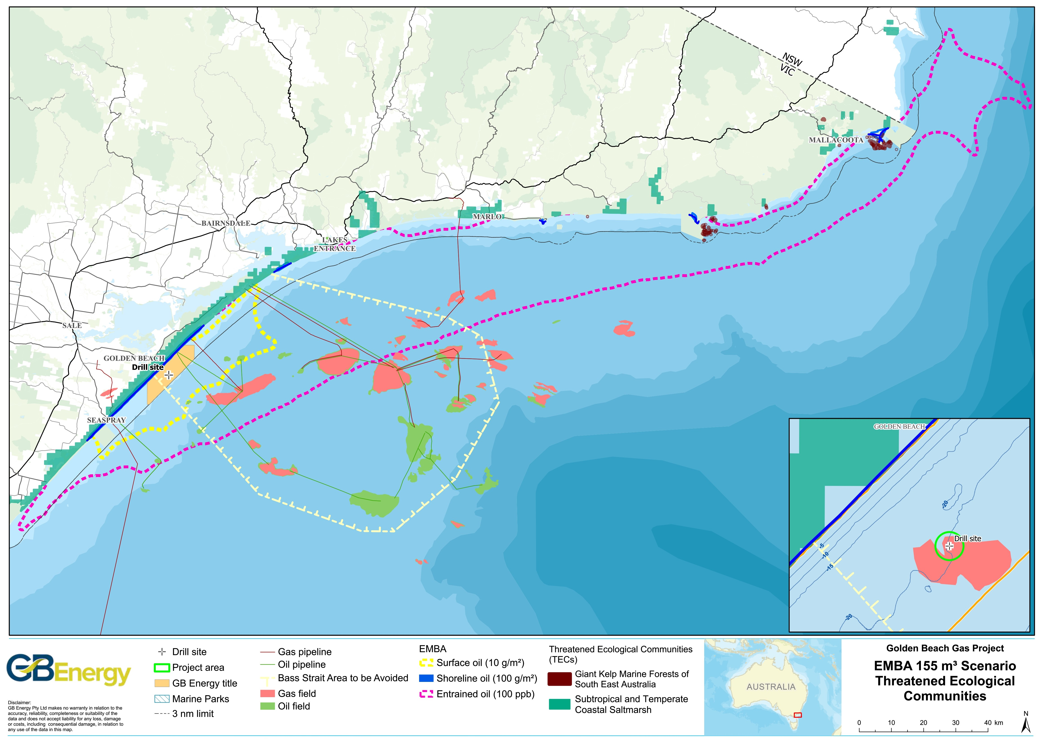
Figure 4.3. TECs intersected by the Project area and spill EMBA

Key Ecological Features
KEFs are elements of the Commonwealth marine environment that, based on current scientific understanding, are considered to be of regional importance for either the region's biodiversity or ecosystem function and integrity.
The Project area does not overlap any KEFs. The spill EMBA intersects one KEF (Figure 4.4), this being the Upwelling East of Eden (53 km east of the Project area).
Upwelling East of Eden
Dynamic eddies of the EAC cause episodic productivity events when they interact with the continental shelf and headlands. The episodic mixing and nutrient enrichment events drive phytoplankton blooms that are the basis of productive food chains including zooplankton, copepods, krill and small pelagic fish (DoE, 2015a). Therefore, the key value of the KEF is its high productivity and aggregations of marine life.
The upwelling maintains regionally high primary productivity that supports fisheries and biodiversity, including top order predators, marine mammals and seabirds. This area is one of two feeding areas for blue whales and humpback whales, known to arrive when significant krill aggregations form. The area is also important for seals, other cetaceans, sharks and seabirds (DoE, 2015a).

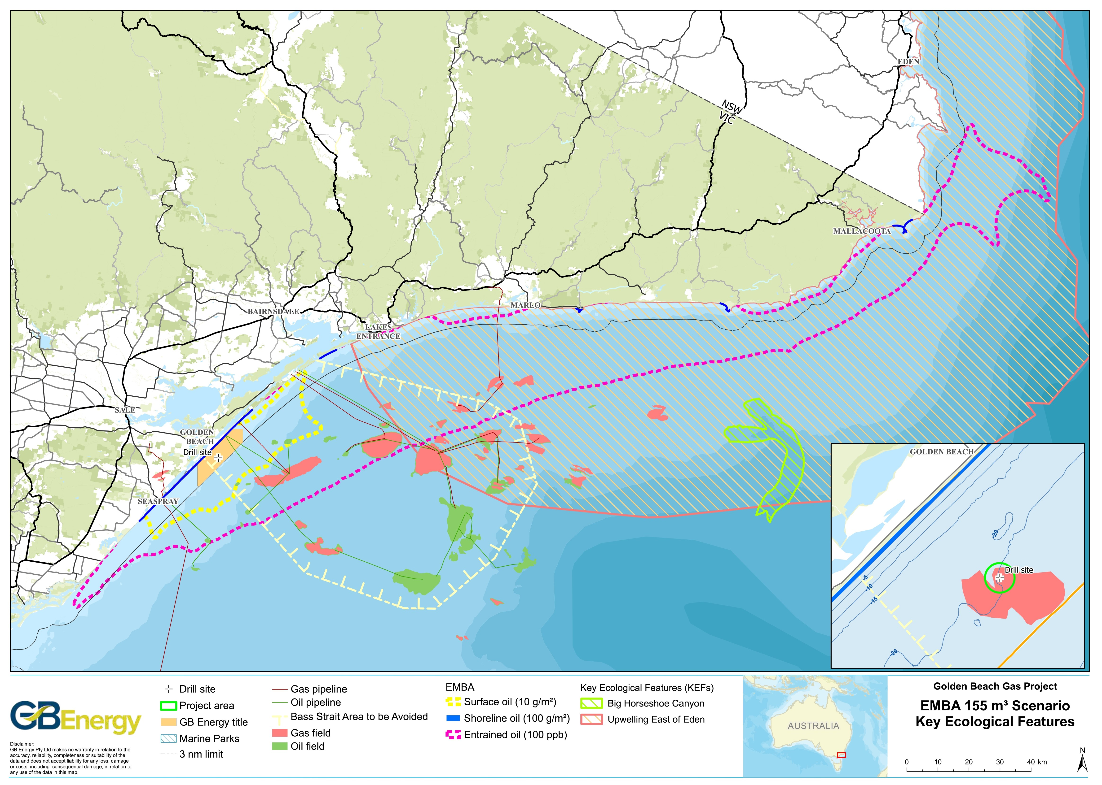
Figure 4.4. KEFs intersected by the Project area and spill EMBA

Nationally Important Wetlands
NIWs are considered significant for a variety of reasons, including their importance for maintaining ecological and hydrological roles in wetland systems, providing important habitat for animals at a vulnerable or particular stage in their life cycle, supporting 1% or more of the national population of any native plant or animal taxa or for its outstanding historical or cultural significance (DCCEWW, 2022e).
No NIWs occur within the Project area.
Twelve (12) NIW were identified that are intersected by the EMBA (Figure 4.5). Ten (10) of these NIW would only be intersected by the spill EMBA if they are open to the sea at the time of a spill. These NIWs are described below based on DCCEWW (2022e) moving west to east along the EMBA.
- Corner Inlet (VIC066) – Corner Inlet is listed as a Ramsar site and supports 22 waterbirds species listed under the JAMBA and 17 waterbird species under the CAMBA agreements.
- Jack Smith Lake State Game Reserve (VIC069) – Jack Smith Lake was once likely a bay that has now been isolated from the sea by the development of a sandy barrier. The wetland features thickets of swamp paperbark (Melaleuca ericifolia), which are subject to regular wetting and drying cycles. There is an artificial ocean outlet that controls water levels within the site. Over 100 bird species including 45 waterbird species have been recorded on the reserve including the threatened orange-bellied parrot (Neophema chrysogaster).
- Lake King Wetlands (VIC071) – The Lake King Wetlands form part of the Gippsland Lakes Ramsar Site and consists of two large coastal lagoons and associated channels with surrounding salt marshes and brackish to fresh marshes. The wetlands are high value for ecological, recreational, scientific, cultural and landscape features and supports 46 waterbird species including ten species listed under the JAMBA and CAMBA agreements.
- Lake Bunga (VIC085) – Lake Bunga is part of the Gippsland Lakes Ramsar Site. The lake is fed by the Bunga Creek and is rarely open to the sea. The wetland has supported 21 waterbird species including the little tern (Sterna albifrons), hooded plover (Thinornis rubricollis) and white-bellied sea-eagle (Haliaeetus leucogaster).
- Lake Tyers (VIC086) – Lake Tyers is a branched inlet formed by the marine submergence of incised valleys and is fed by several creeks including Stony and Boggy Creeks. The wetland has a well-developed tidal delta with marshy islets and is occasionally open to the sea. The wetland supports 54 waterbird species and is of ecological, scientific and cultural importance due to its forested shores, unspoilt character and Aboriginal archaeological sites.
- Ewing’s Marsh (Morass) (VIC132) – This wetland was formerly an open lagoon supplied with seawater and freshwater floods though is now virtually enclosed within a barrier. Ewing’s Marsh has thick shrub, sedge, rush and grass-dominated vegetation merging into heathland and forest on its inland side, and into dune shrubland on the seaward border. Approximately 440 plant taxa have been recorded at the site.
- Snowy River (VIC150) – The Snowy River wetland reach is 175 km long and an average corridor size of 400 m. Closer to the sea, the lower reach is characterised by low relief plains. The lower reach areas are high value for their ecological, recreational, scientific, educational and scenic values. The wetlands are an excellent example of a floodplain system consisting of a diverse range of habitats and contain extensive areas of swamp paperbark (Melaleuca ericifolia), reed beds, salt marsh and mudflats which have been cleared or badly degraded elsewhere throughout the Snowy River floodplain.
- Sydenham Inlet Wetlands (VIC134) – The Sydenham Inlet Wetlands include a variety of wetland types affected by fresh to saline water and provides a large area of estuarine habitat and supports a high diversity of flora and fauna. Approximately 260 plant taxa have been recorded at the site as well as 10 bird species listed under the JAMBA and CAMBA agreements.
- Tamboon Inlet Wetlands (VIC135) – This wetland is located in east Gippsland and hosts a variety of wetland types that are affected by fresh and saline water, which supports a diversity of flora and fauna in estuarine habitat. 96 plant taxa (including 38 introduced) have been recorded in the Tamboon Inlet area. The inlet is fringed by multiple vegetation classes including riparian scrub complex and coastal saltmarsh. The south of the inlet is separated from Bass Strait behind a dune and barrier system that forms part of Ninety Mile Beach. The inlet may flow to Bass Strait during times of high flow, though generally remains closed.
- Thurra River (VIC155) – The reach corridor of Thurra River has an area of 2,920 ha and flows through State forest and Croajingolong National Park. There are 29 threatened flora species and 37 threatened fauna species within the wetland. Ninety Mile Beach and the associated dunes create a barrier to Bass Strait, which may be open during times of high flow, though generally remains closed.
- Benedore River (VIC154) – This wetland occurs in east Gippsland in the Croajingolong National Park. The Benedore River has no introduced fish species and a natural assemblage of native species, which indicates pristine conditions. There are 16 threatened flora species recorded in the wetland. There are 25 threatened fauna species including the little tern (Sterna albifrons). The Benedore River is contained behind Ninety Mile Beach dunes, which may be open during times of high flow.
- Mallacoota Inlet Wetlands (VIC133) – This wetland was formed by the submergence of two river valleys and partial closure of the marine embayment by a sandy barrier and accumulation of dunes. Eighty-nine (89) waterbird species have been recorded at Mallacoota Inlet. The wetland is fringed by lowland forest and coastal saltmarsh.

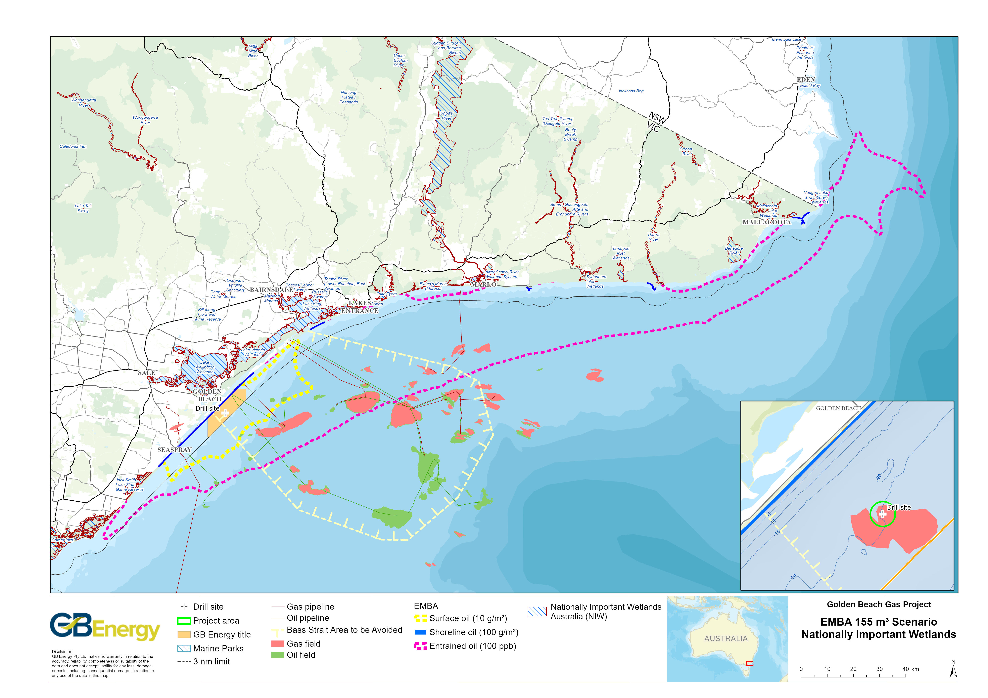
Figure 4.5. NIWs intersected by the Project area and spill EMBA

Victorian Protected Areas
Victoria has 24 MNP s and sanctuaries that are protected and managed under the National Parks Act 1975 (Vic) by Parks Victoria.
There are no marine protected areas in the Project area. There are six marine protected areas and six onshore protected area (i.e., reserves that extend to the low water mark) intersected by the EMBA. These are shown in Figure 4.6 and described in Table 4.3, moving west to east along the EMBA.

New South Wales Protected Areas
New South Wales has a large network of onshore and offshore protected areas that are established, protected and managed under the National Parks and Wildlife Act 1974 by the National Parks and Wildlife Service (NPWS).
There are two onshore reserves and no marine reserves intersected by the EMBA as shown in Figure 4.6 and described in Table 4.4, moving south to north.

Table 4.3. Victorian marine and coastal protected areas in the spill EMBA
Name | Location | Description
Marine protected areas
Wilsons Promontory Marine Park | 105 km southwest of the Project area | Wilsons Promontory Marine Park, together with the Marine Reserve and MNP, make significant contributions to Victoria’s marine protected areas. The marine park includes biological communities with distinct biogeographic patterns, including shallow subtidal reeds, deep subtidal reefs, intertidal rocky shores, sandy beaches, seagrass, subtidal soft substrates and expansive areas of open water (Parks Victoria, 2006a).  The marine park provides important habitat for several threatened shorebird species and islands within the park act as important breeding sites for Australian fur seals (Parks Victoria, 2006a).
Nooramunga Marine and Coastal Reserve | 68 km southwest of the Project area | Nooramunga Marine and Coastal Park covers an area of 30,170 ha in Corner Inlet. The park is also protected as a Ramsar wetland (see Section 5.4.4). The park consists of shallow marine waters, intertidal mudflats and a series of over forty sand islands. The Park, along with the Corner Inlet Marine and Coastal Park to its west, contain the largest stands of white mangrove and saltmarsh areas in Victoria. The saltmarshes are dominated by beaded glasswort (Sarcocornia quinqueflora) and shrubby glasswort (Tecticornia arbuscula). Seagrass meadows also occur throughout the park. Seaward of the mangroves are extensive areas of intertidal mud and sand flats. An immense range of marine plants and invertebrates can be found here that provide food for the thousands of migratory wading birds that arrive each year from their northern hemisphere breeding grounds. The seagrass meadows provide habitat to over 300 marine invertebrates, including a range of large crabs, seastars, sea snails, iridescent squid and many fish including pipefish, stingarees, flathead, whiting and flounder. Finfish such as snapper, King George whiting, flathead, garfish and salmon are caught by recreational fishers. Thirty-two (32) migratory wader species have been recorded in the park, including the largest concentrations of bar tailed godwit (Limosa lapponica) and great knot (Calidris tenuirostris) in south-eastern Australia. In summer the ocean beaches and sand provide nesting habitat for pied oystercatchers (Haematopus longirostris), crested terns (Thalasseus bergii), Caspian terns (Hydroprogne caspia), fairy terns (Sternula nereis) and hooded plovers (Thinornis rubricollis).
Ninety Mile Beach MNP | 23 km southwest of the Project area | The Ninety Mile Beach MNP covers an area of 2,750 ha and extends along approximately 5 km of coastline and offshore for 5 km from the high-water mark (Parks Victoria, 2006b). The park protects an internationally significant sandy environment, recognised for its exceptionally high diversity of marine invertebrates.  The park’s key natural values are listed as:  - Very high diversity of marine invertebrates, including the large endemic southern Australian seastar (Coscinasterias muricata) and the soft coral Pseudogorgia godeffroyi;  - Scattered low calcarenite reefs providing habitat for a distinctive marine invertebrate fauna, especially sponges, with sparse flora communities of small red algae; and  - Important habitat for threatened shorebird species, including species listed under international migratory bird agreements.  The low sub-tidal calcarenite reefs scattered throughout the park support a unique invertebrate biota, including colourful sponge gardens. The long sandy beach (the area between the high water and low water marks are included in the park) provide extensive habitat for shorebirds, including international migratory waders and the threatened hooded plover (Parks Victoria, 2006b).  The Ninety Mile Beach MNP supports four distinct marine ecological communities; these being intertidal sandy beach, subtidal sandy sediment, subtidal reef and open waters.  More than 800 different species were found within 10 m² of Ninety Mile Beach subtidal sand (compared to 300-400 per 10 m² in comparable habitats), making it one of the most biologically diverse marine environments in the world (Parks Victoria, 2006b).  Intertidal sand communities along the Ninety Mile Beach are species-poor, which is typical of coarse-grained, steep-faced, high-energy beaches.  The sub-tidal reefs support a community dominated by invertebrates, particularly sponges and sea squirts. Seaweeds are largely absent, possibly because of frequent scouring by shifting sand. The reefs themselves are likely to be periodically covered and uncovered by sand (Parks Victoria, 2006b).  The waters of the park have aggregations of juvenile white shark (Carcharodon carcharias), snapper (Pagrus auratus), Australian salmon (Arripis spp.), long-finned pike (Dinolestes lewini) and short-finned pike (Sphyaena novaehollandiae). The southern right whale, Australian fur seals and New Zealand fur-seals are known to frequent the park.  The Ninety Mile Beach is a potentially important area for the endangered hooded plover (listed as vulnerable in Victoria). However, their numbers between McLoughlins Point and Seaspray on biannual counts between 2000 and 2006 declined markedly from 40 to three, with none observed during the 2004 and 2006 survey. The loss of roosting and nesting areas due to beach erosion may be a major factor. The area is also used by other threatened shorebirds, including crested terns, Caspian terns, pied oystercatchers and sanderlings (Parks Victoria, 2006b).
Beware Reef Marine Sanctuary | 128 km northeast of the Project area | The Beware Reef Marine Sanctuary covers 220 ha and lies 5 km offshore southeast of Cape Conran, in water depths ranging from 0 to 40 m. The park’s key natural values are listed as:  - A diversity of habitats, including subtidal and intertidal reefs, exposed reefs and subtidal soft sediment.  - A haul-out area for Australian fur seals and New Zealand fur seals.  - A diversity of invertebrates and fish species.  - A reef environment, including shipwrecks, rich in marine biota.  - Threatened fauna, including several bird species and marine mammals.  - Outstanding landscapes, seascapes and spectacular underwater scenery.  - Excellent opportunities for scientific investigation and learning.  - Opportunities to build knowledge of marine protected areas and their management and to further understand marine ecological function and changes over time.  It is composed of a permanently exposed granite reef that emerges from the sandy floor approximately 28 m deep. The reef is 70 m long above water and continues for 1 km below the water to the southeast. The reef is characterised by numerous bisecting subtidal gutters. There are also three shipwrecks within the park. Beware Reef Marine Sanctuary supports five known marine ecological communities, these being subtidal soft sediment, subtidal reef, intertidal reef, exposed reef and pelagic communities. Subtidal soft sediment communities are the most widespread within the sanctuary, likely to support (though unconfirmed through surveys) various polychaete, isopod, amphipod, cumacean and cephalopod species. Species such as spotted stingaree (Urolophus gigas), gurnard, flathead, common gurnard perch (Neosebastes scorpaenoides), banded stingaree (Urolophus cruciatus) and school whiting (Sillago flindersi) may have a seasonal presence in and around the sanctuary. Thick stands of bull kelp (Nereocystis spp.) dominate lower intertidal reef communities of the sanctuary, with the cunjevoi sea squirt (Pyura stolonifera) being the dominant invertebrate on the intertidal reef. A variety of brown algae occupy waters less than 10 m deep, along with red coralline turf algae and bull kelp on the edges of the reef. In deeper waters (13–20 m), long striped Ecklonia dominates the flora. There are mixed stands of the canopy-forming brown algae crayweed (Phyllospora comosa) and common kelp. Australian fur seals and New Zealand fur seals use the reef platform as a haul-out site for most of the year. Little penguins rest on the platform throughout the year, and it is a common roosting and feeding area for seabirds. Marine mammals such as southern right whales, humpback whales, killer whales), bottlenose dolphins and common dolphins are transient visitors to the sanctuary.
Point Hicks MNP | 165 km northeast of the Project area | The Point Hicks MNP covers 3,810 ha and extends along 9.6 km of coastline and offshore from the high-water mark to the 3 nm state waters limits to water depths of 88 m. The reefs directly below Point Hicks, Whaleback Rock and Satisfaction Reef are the best-known geological features of the park. Point Hicks itself is a granite headland with a wide rocky and bouldery shore formed up to 10,000 years ago.  The park’s key natural values are listed as:  - A diversity of habitats, including subtidal and intertidal reefs, subtidal soft sediment and sandy beaches;  - A very high diversity of fauna, including intertidal and subtidal invertebrates;  - Co-occurrence of eastern temperate, southern cosmopolitan and temperate species, as a result of the mixing of warm eastern and cool southern waters;  - A range of rocky habitats;  - Mammals such as dolphins, whales and fur-seals;  - Transient reptiles from northern waters, including turtles and sea snakes;  - Threatened fauna, including whales and several bird species;  - Outstanding landscapes, seascapes and underwater scenery;  - Outstanding active coastal landforms, such as granite reefs and mobile sand dunes;  - Excellent opportunities for scientific investigation and learning; and  - Outstanding opportunities to build knowledge of marine protected areas and their management and to further understand marine ecological function and changes over time.  A prominent biological component of the subtidal reef areas is kelp and other seaweeds. Large species of brown algae, such as common kelp and crayweed, are present along the open coast in dense stands. Giant species of seaweeds such as string kelp (Macrocystis pyrifera) and bull kelp also occur (Parks Victoria, 2006c). The front reefs and Whaleback Reef, which have high relief gutters of up to 15 m have high sessile invertebrate diversity and abundance on the vertical walls.  An important characteristic of Point Hicks MNP is its canopy-forming algae (a mixture of crayweed and common kelp Ecklonia radiata) and small understorey algae. The reef beneath the canopy varies from encrusting and erect sponges to small fleshy red algae. The invertebrate community includes moderate abundances of blacklip abalone (Haliotis rubra) and the red bait crab (Plagusia chabrus).
Cape Howe MNP | 233 km northeast of the Project area | The Cape Howe MNP covers 4,060 ha and extends along 4.8 km of coastline and offshore from the high-water mark to the 3 nm state waters limit to water depths of 105 m (Parks Victoria, 2006d). The waters of the park contain both high-profile granite and low-profile sandstone reefs.  The park’s key natural values are listed as:  - Diversity of habitats including subtidal and intertidal reefs, subtidal soft sediment and sandy beaches;  - Co-occurrence of eastern temperate, southern cosmopolitan and temperate species, as a result of the mixing of warm eastern and cool southern waters;  - Marine mammals such as whales, dolphins, Australian fur seals and New Zealand fur seals;  - Transient reptiles such as green turtles from northern waters;  - Threatened fauna including whales and birds;  - Foraging area for a significant breeding colony of little penguins from neighbouring Gabo Island;  - Outstanding active coastal landforms within and adjoining the park, such as granite and sandstone reefs;  - Outstanding landscapes, seascapes and spectacular underwater scenery;  - Victoria’s most easterly MNP abutting one of only three wilderness zones on the Victorian coast;  - Excellent opportunities for scientific investigation and learning;  - Outstanding opportunities to build knowledge of marine protected areas and their management, and to further understand marine ecological function and changes over time.  Subtidal soft sediment communities are the most widespread communities in the park, with the diversity of invertebrates expected to be high. Common fish are herring cale (Odax cyanomelas), leatherjacket (Meuschenia freycineti), striped mado (Atypichthys strigatus), banded morwong (Cheilodactylus spectabilis) and damselfishes (Parma microlepis and Chromis hypsilepis). Its deep (30 to 50 m) sandstone reefs are heavily covered with a diverse array of sponges, ascidians and gorgonians. Transient mammals such as southern right whales, humpback whales, killer whales, Australian fur-seals, New Zealand fur-seals, bottlenose dolphins and common dolphins are transient visitors to the park.
Coastal protected areas
McLoughlins Beach – Seaspray Coastal Reserve | 30 km southwest of the Project area | This park encompasses the foreshore between McLoughlins Beach and Seaspray, including a narrow portion of the sea. There is no management plan for this coastal reserve and a paucity of information about the reserve’s values. The sandy foreshore provides habitat for hooded plover nesting, and is popular with recreational fishers (with salmon, flathead, snapper and tailor being the main catch species).
Gippsland Lakes Coastal Park | 600 m northwest of the Project area (at its closest point) | The Gippsland Lakes Coastal Park is a narrow coastal reserve, covering 17,584 ha along the Ninety Mile Beach (including the beach itself) from Seaspray to Lakes Entrance. The park supports valuable remnant vegetation including Coast Banksia Woodland, Heath Tea-Tree Heathland and Hairy Spinifex Grassland. The Park takes in extensive coastal dune systems, woodlands and heathlands, as well as water bodies such as Lake Reeve and Bunga Arm. These water bodies (listed as Ramsar wetlands) are protected from ocean processes via the dune barrier system that ranges in height between 5 and 8 m. The coastal vegetation strip is identified as containing Littoral Rainforest and Coastal Vine Thickets of Eastern Australia).  The park’s key natural values are listed as (use of the term ‘parks’ in this section references the adjacent Lakes National Park):  - Supports valuable remnants of vegetation communities that have been disturbed throughout much of their range, including Coast Banksia Woodland, Heath Tea-tree Heathland and Hairy Spinifex Grassland;  - Lake Reeve is of international significance and is a site of special scientific interest. This long, shallow lagoon is fringed by salt marsh with a number of plant species ‘relatively uncommon in Victoria east of Seaspray’;  - Six threatened flora and over 20 threatened fauna species listed under the EPBC Act or FFG Act have been recorded within the Park;  - Lake Reeve provides important breeding habitat for a number of waterfowl species and is one of Victoria’s five most important areas for waders;  - The wetlands are important nursery areas for many fish species; and  - The Parks contain sites of National, State and regional geological and geomorphological significance mainly associated with the evolution of the barrier system that formed the Gippsland Lakes.  More than 190 species of birds have been recorded on Sperm Whale Head. Although there have been few dedicated fauna surveys, 26 species of native mammals, 17 of reptiles and 11 of amphibians have been recorded in the parks. Gippsland Lakes Coastal Park is considered the most important site in Victoria for the endangered New Holland mouse (Pseudomys novaehollandiae).
Ewing Morass Wildlife Reserve | 82 km northeast of the Project area | Location and area The Ewing Morass Wildlife Reserve adjoins the Lake Tyers State Park and extends from Pettman Road to Corringle Creek, extending from the high water mark north into heavily forested hinterland, half way between the coastline and the Princes Highway. This reserve is primarily reserved for the purposes of duck hunting, with the species normally present including the Pacific black duck (Anas superciliosa), grey teal (Anas gracilis), mountain duck (Tadorna tadornoides) and chestnut teal (Anas castanea). The shoreline of this park consists of wide sandy beaches, part of the Ninety Mile Beach.
Marlo Coastal Reserve | 104 km northeast of the Project area | There is no publicly available formal written information regarding the Marlo Coastal Reserve. Information from the Draft Marlo Foreshore Management Plan (DSE, 2013b) indicates that the reserve covers the Marlo River and adjacent banks, extending seawards only so far as the sand dunes.
Cape Conran Coastal Park | 125 km northeast of the Project area | Cape Conran Coastal Park covers an area of 11,700 ha and is bounded by Marlo Coastal Reserve to the west, Croajingolong National Park to the east (eastern shore of Sydenham Inlet), State forest and private property to the north, and the Tasman Sea, at low water mark, to the south. The park forms part of the Gippsland Lakes Ramsar site (see Section 5.4.4).  The park’s key natural values are listed as:  - Rich and diverse vegetation, including damp and lowland forest, woodlands, various types of heathland, swamp, coastal and riparian communities;  - The Dock Inlet catchment, a pristine example of a coastal stream system with Cape Conran Coastal Park and associated wetlands terminating in a freshwater coastal lagoon;  - The undisturbed Yeerung River supporting predominantly native fish is one of only two entirely lowland rivers in the region draining directly to the sea;  - Almost 50 species of threatened fauna including six endangered nationally, and 14 bird species listed under international migratory bird agreements;  - At least 40 species of threatened flora, including the Bonnet Orchid (Cryptostylis erecta) and Leafless Tongue-orchid (Cryptostylis hunteriana) which are both vulnerable nationally;  - Extensive heathland areas in excellent condition harbouring populations of threatened fauna, including the Eastern ground parrot (Pezoporus wallicus) and Smoky mouse (Pseudomys fumeus);  - Sydenham Inlet, part of the Bemm Heritage River corridor, supporting expansive seagrass meadows that provide important habitat for fish and waterbirds;  - High scenic values associated with the diverse geological formations of the park’s headlands, its coastal estuaries and heathy plains; and  - Excellent examples of coastal dynamics such as sand movement, wave action and river outflows.  The seagrass beds within Sydenham Inlet sustain a diverse range of native fish and are critical to the maintenance of regional fish populations.
Croajingolong National Park | 151 km northeast of the Project area | Croajingolong National Park covers an area of 88,355 ha and extends along 100 km of the coast, from Sydenham Inlet in the west to the NSW border in the east, with the mean low water mark of the coast forming the park’s southern boundary (Parks Victoria, 1996). Two major physiographic units are represented in the park, these being coastal tablelands and coast dune complexes (some vegetated and some mobile).  The ocean beaches of the park attract migratory seabirds and waders, including little terns (Sternula albifrons), crested terns, fairy terns and the hooded plover, while the wetlands provide habitat for a rich assemblage of waterfowl and native fish such as spotted galaxias (Galaxias truttaceus), gudgeon, bass and the Australian grayling.  The park’s key natural values are listed as:  - A wide variety of highly significant coastal landforms including tidal inlets, estuaries and lagoons, dune-blocked lake and swamp systems, freshwater interdune lakes, extensive sand dunes and sand sheets, and prominent rocky cliffs;  - Many sites recognised for their geological and geomorphological significance;  - Habitats supporting over 1,000 recorded native plant species, 87 of which are listed as threatened in Victoria and have their primary stronghold in the Park;  - Ninety species of orchids, including all five of Australia’s lithophytic and epiphytic orchids;  - Significant and well-developed sites of Warm Temperate Rainforest in the lower reaches of a number of rivers;  - Coastal Heathland, a community considered to be extremely species rich, and covering up to 10% of the park;  - Habitats supporting 43 species of threatened native fauna, including the little tern, ground parrot, eastern bristle-bird (Dasyornis brachypterus), eastern broad-nosed bat (Scotorepens orion), and Australian fur-seal;  - The Skerries, one of only four Australian fur-seal colonies in Victoria and an important breeding site for little penguins and other seabirds;  - Records of one third of Victoria’s, and one quarter of Australia’s, bird species;  - Some of the richest amphibian habitats in Victoria;  - Highly significant coastal streams and catchments that are relatively undisturbed, with an absence of introduced fish species and good populations of native fish species; and  - Localities with among the highest wilderness quality in the State, outside the Mallee, and two of the three coastal wilderness areas in Victoria.

Table 4.4. New South Wales marine and coastal protected areas in the spill EMBA
Name | Location | Description
Coastal protected areas
Nadgee Nature Reserve | 240 km northeast of the Project area | The park’s key natural values are listed by NPWS (2003) as:  - The only coastal wilderness area in NSW;  - A variety of coastal landforms, including dissected low tablelands, coastal plain, estuaries and lagoons, cliffs and sea caves;  - Coastline has national significance for its diversity of geology and geomorphological features;  - Contains several NSW-listed threatened plant species listed;  - Contains 48 species of native mammal, 216 bird species, 28 reptile species and 16 amphibians;  - Intertidal rock platforms have a rich, well-developed littoral fauna and Nadgee Point/Black Head has the most diverse biota of any headland in NSW south of Narooma; and  - Contains some extensive Aboriginal shell middens in sand dunes.

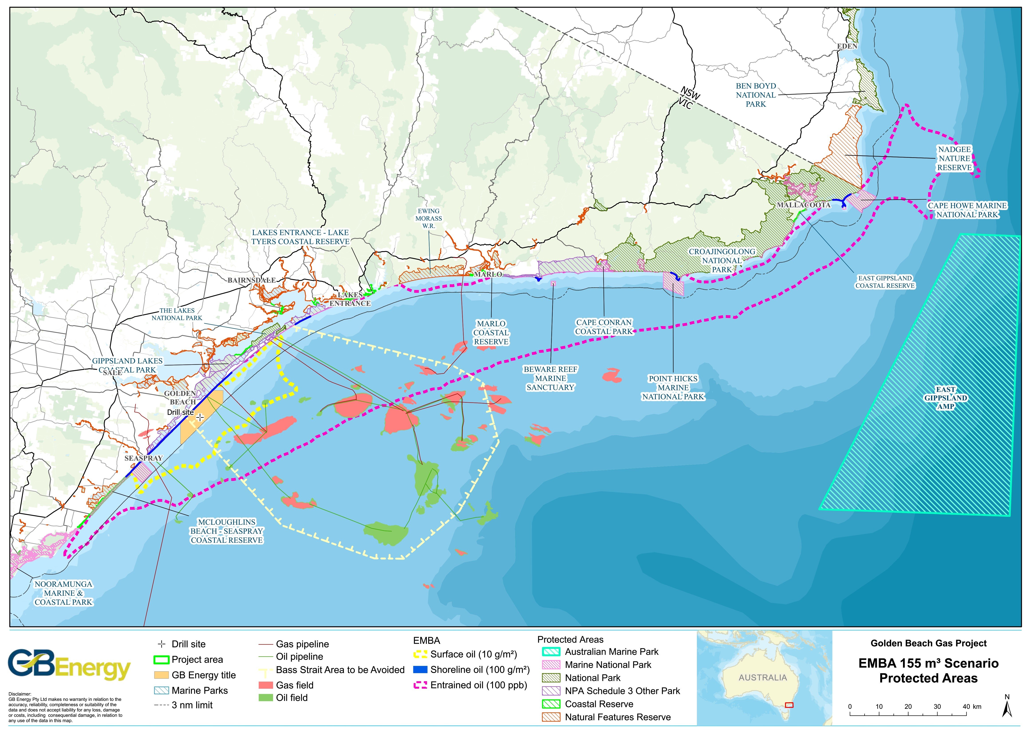
Figure 4.6. Protected areas intersected by the Project area and spill EMBA

Biological Environment
BIAs are identified for those species that may occur within the Project area and EMBA. BIAs are spatially defined areas, defined by the DAWE based on expert scientific knowledge, where aggregations of individuals of a species are known, or likely, to display biologically important behaviour such as breeding, foraging, resting or migration (DAWE, 2020b). The BIAs do not represent a species’ full distribution range.

Benthic Assemblages
The seascape of the region is composed of a series of massive sediment flats, interspersed with small patches of reef, bedrock and consolidated sediment (Wilson and Poore, 1987). OSRA mapping for the Ninety Mile Beach indicates that there is an abundance of sandy sediments with few areas of emergent reefs in the region (see Figure 4.7).
In the Project area, the ALA records the occurrence of dozens of benthic species, including bristle worms (11), crabs (10), sea snails (14), shrimps and amphipods (20), brittle stars (7) and sea cucumbers (2). The VBA does not contain any records of benthic species in the Project area.
CSIRO has conducted biological surveying and investigation at the sites in and around the Project area. Investigations at these sites includes towed camera and ROV footage, fish baiting and sampling of epibenthic fauna.
The general assemblage of epibenthic fauna at sites in the Project area is consistent with the literature describing the region, with gastropods, polychaetes, echinoderms, cnidarians, crustaceans, bivalves and an assortment of sponges being collected and identified (CSIRO, 2018). Where hard substrate is identified at investigation sites, such as at site 14 (1.8 km northeast of the Project area), species richness is higher than the soft substrate samples.
A marine habitat assessment was undertaken by CarbonNet for their Pelican 3D MSS and conducted in early April 2017 to characterise the seabed. This habitat assessment included 11 sites located less than 2.5 km away from the Project area. Nine of the 11 sites consisted of sandy sediments and gravels/shells with contouring that is typical of mobile seabed affected by swell waves and strong tidal currents. Rocky reef was present at two sites located 800 m to 1 km to the southwest of the Project area. No beds of giant kelp, seagrass or sponges were observed at any of the 11 sites within 2.5 km of the Project area.
Surveys of benthic fauna conducted by CSIRO in 2017 at sites within and adjacent to the Project area did not identify the presence of commercial scallops.
The southern rock lobster (Jasus edwardsii) is found on coastal reefs from the south-west coast of WA to the south coast of NSW, including Tasmania and the New Zealand coastline. Southern rock lobsters are found to depths of 150 m (DPI, 2009). In the Gippsland region, southern rock lobster habitat occurs as patchy, discontinuous low-profile reef running parallel to the coast. Such habitat is known to occur between 800 m and 1 km southwest of the Project area.
In Victoria, the abundance of rock lobster decreases from west to east reflecting a decrease in the availability of suitable rocky reef habitat (DPI, 2009). Rocky reef is present as scattered patches to the southwest and northeast of the Project area in waters less than 20 m depth.
During the CarbonNet pre-seismic survey habitat assessment in January 2018, 10 sites of known reef habitat were selected for rock lobster trapping with 81 rock lobster recorded (CarbonNet, 2020). The locations of these sites remain confidential.

Flora
Literature searches, combined with oil spill response atlas (OSRA) mapping, indicate that marine flora, such as seagrasses and macroalgae, are generally not abundant in the extensive areas of subtidal sand flats in the nearshore waters of the EMBA, however there are sites in the EMBA where these do occur, such as at Mallacoota Inlet. This is likely due to the high-energy nature of the Gippsland coastline, the mobile nature of sands and the lack of available hard substrate, which prevents many species being able to anchor themselves.
A search of the VBA database for the EMBA reports 53 species of marine flora including red, green and brown algae species.

Plankton
Plankton is a key component in oceanic food chains and comprises two elements; phytoplankton and zooplankton, as described herein.
Phytoplankton biomass is greatest at the extremities of Bass Strait (particularly in the northeast) where water is shallow and nutrient levels are high.
Zooplankton is the faunal component of plankton, comprising small crustaceans (such as krill) and fish larvae that feed on zooplankton.
An assessment of zooplankton was undertaken to determine pre- and post-MSS abundance of zooplankton at sites within CarbonNet’s Pelican MSS area (8 km southeast of the Project area) and at reference sites during January and February 2018. Pre-MSS plankton samples collected were dominated by copepods, cladocerans and salps while post-MSS plankton samples were dominated by the dinoflagellate Noctiluca scintillans. Other groups present included siphonophores, fish larvae, fish eggs, polychaetes, ghost shrimps and cnidarians. There was variance between and within assessments, with samples exhibiting levels of diversity and abundance typical of healthy temperate coastal waters. Neither lobster nor scallop larvae were present in any of the samples assessed (CarbonNet, 2018).

Fish
It is estimated that there are over 500 species of fish found in the waters of Bass Strait, including a number of species of importance to commercial and recreational fisheries (LCC, 1993).
There are 41 fish species listed under the EPBC Act with potential to occur in the spill EMBA. This includes 13 species listed as threatened, four species listed as migratory and a further 26 listed marine species all of which are Sygnathiformes (seahorses, pipefishes and their relatives) (Table 4.5).

Table 4.5. EPBC Act-listed fish that may occur in the Project area and EMBA
Scientific name |  | Common name |  | EPBC Act status |  |  |  |  |  | BIA within the EMBA? |  | Recovery Plan in place?
 |  |  |  | Listed threatened species | Listed migratory species |  |  | Listed marine species
Freshwater
Galaxiella pusilla | Dwarf galaxias |  | V |  | - |  | - |  | - |  | RP
Prototroctes maraena | Australian grayling |  | V |  | - |  | - |  | - |  | RP, CA
Oceanic
Carcharodon carcharias |  | Great white shark |  | V |  | Yes |  | - |  | B, D, F |  | RP
Carcharias taurus |  | Grey nurse shark (eastern population) |  | CE |  | - |  | - |  | F, M |  | RP
Centrophorus harrissoni |  | Harrisson's dogfish |  | CD |  | - |  | - |  | - |  | LA
Centrophorus zeehaani |  | Southern dogfish |  | CD |  | - |  | - |  | - |  | LA
Epinephelus daemelii |  | Black rockcod |  | V |  | - |  | - |  | - |  | CA
Galeorhinus galeus |  | School shark |  | CD |  | - |  | - |  | - |  | LA
Hoplostethus atlanticus |  | Orange roughy |  | CD |  | - |  | - |  | - |  | -
Isurus oxyrinchus |  | Shortfin mako |  | - |  | Yes |  | - |  | - |  | -
Lamna nasus |  | Porbeagle |  | - |  | Yes |  | - |  | - |  | -
Rexea solandri (eastern Australian population) |  | Eastern gemfish |  | CD |  | - |  | - |  | - |  | LA
Rhincodon typus |  | Whale shark |  | V |  | Yes |  | - |  | - |  | CA, LA
Seriolella brama |  | Blue warehou |  | CD |  | - |  | - |  | - |  | LA
Thunnus maccoyii |  | Southern bluefin tuna |  | CD |  | - |  | - |  | - |  | LA
Pipefish, seahorses and seadragons
Heraldia nocturna | Upside-down pipefish |  | - |  | - |  | Yes |  | - |  | -
Hippo-campus abdominalis | Big-belly seahorse |  | - |  | - |  | Yes |  | - |  | -
Hippo-campus breviceps | Short-head seahorse |  | - |  | - |  | Yes |  | - |  | -
Hippo-campus minotaur | Bullneck seahorse |  | - |  | - |  | Yes |  | - |  | -
Histio-gamphelus briggsii | Crested pipefish |  | - |  | - |  | Yes |  | - |  | -
Histiogamphelus cristatus | Rhino pipefish |  | - |  | - |  | Yes |  | - |  | -
Hypselo-gnathus rostratus | Knifesnout pipefish |  | - |  | - |  | Yes |  | - |  | -
Kaupus costatus | Deepbody pipefish |  | - |  | - |  | Yes |  | - |  | -
Kimblaeus bassensis | Trawl pipefish |  | - |  | - |  | Yes |  | - |  | -
Leptoichthys fistularius | Brushtail pipefish |  | - |  | - |  | Yes |  | - |  | -
Lissocampus runa | Javelin pipefish |  | - |  | - |  | Yes |  | - |  | -
Maroubra perserrata | Sawtooth pipefish |  | - |  | - |  | Yes |  | - |  | -
Mitotichthys semistriatus | Half-banded pipefish |  | - |  | - |  | Yes |  | - |  | -
Mitotichthys tuckeri | Tucker's Pipefish |  | - |  | - |  | Yes |  | - |  | -
Notiocampus ruber | Red pipefish |  | - |  | - |  | Yes |  | - |  | -
Phyllopteryx taeniolatus | Common seadragon |  | - |  | - |  | Yes |  | - |  | -
Solegnathus robustus | Robust pipehorse |  | - |  | - |  | Yes |  | - |  | -
Solegnathus spino-sissimus | Spiny pipehorse |  | - |  | - |  | Yes |  | - |  | -
Stigmatopora argus | Spotted pipefish |  | - |  | - |  | Yes |  | - |  | -
Stigmatopora nigra | Widebody pipefish |  | - |  | - |  | Yes |  | - |  | -
Stipecampus cristatus | Ringback pipefish |  | - |  | - |  | Yes |  | - |  | -
Syngna-thoides biaculeatus | Double-end pipehorse |  | - |  | - |  | Yes |  | - |  | -
Urocampus carinirostris | Hairy pipefish |  | - |  | - |  | Yes |  | - |  | -
Vanacampus margaritifer | Mother-of-pearl pipefish |  | - |  | - |  | Yes |  | - |  | -
Vanacampus phillipi | Port Phillip pipefish |  | - |  | - |  | Yes |  | - |  | -
Vanacampus poecilo-laemus | Longsnout pipefish |  | - |  | - |  | Yes |  | - |  | -

Definitions
EPBC Act | Description
Listed threatened species | A native species listed in Section 178 of the EPBC Act as either extinct, extinct in the wild, critically endangered, endangered, and vulnerable or conservation dependent.
Listed migratory species | A native species that from time to time is included in the appendices to the Bonn Convention and the annexes of JAMBA, CAMBA and ROKAMBA, as listed in Section 209 of the EPBC Act.
Listed marine species | As listed in Section 248 of the EPBC Act.

Key
EPBC status (@ August 2022) | V | Vulnerable
 | E | Endangered
 | CE | Critically endangered
BIA | A | Aggregation
 | D | Distribution (i.e., presence only)
 | F | Foraging
 | M | Migration
 | R | Roosting
Recovery plans  (under the EPBC Act 1999) | CA | Conservation Advice
 | CMP | Conservation Management Plan
 | RP | Recovery Plan
 | LA | Listing Advice
(under the FFG Act 1988) | AS | Action Statement

Great white shark (EPBC Act: Vulnerable, FFG Act: Threatened)
The great white shark (Carcharodon carcharias) is widely distributed and located throughout temperate and sub-tropical waters, with their known range in Australian waters including all coastal areas except the Northern Territory (DSEWPC, 2013).
Studies of great white sharks indicate that they are usually solitary animals, largely transient and only temporarily resident (e.g., days to weeks) in areas it inhabits (DSE, 2003; DSEWPC, 2013). However, individuals are known to return to feeding grounds on a seasonal basis (Klimley & Anderson, 1996). The species moves seasonally along the south and east Australian coasts, moving northerly along the coast during autumn and winter and returning to southern Australian waters by early summer.
Observations of adult sharks are more frequent around fur seal and sea lion colonies, including Wilsons Promontory (approximately 107 km southwest of the Project area) and the Skerries (approximately 196 km northeast of the Project area) (DSE, 2003).
Juveniles are known to congregate in certain key areas including the Ninety Mile Beach area (including Corner Inlet and Lakes Entrance), where a BIA for breeding is overlapped by the Project area.
Corner Inlet may be an important nursery area for the eastern population of great white sharks, mostly from mid-summer through to autumn (DSEWPC, 2013). A BIA (distribution only) for the great white shark covers the entire southeast marine region, with the nearest feeding BIA being around Kangaroo Island in SA (875 km to the west-northwest).
Given their transitory nature and the proximity of known congregation areas, great white sharks may occur within the Project area and EMBA, particularly during early summer.
Grey nurse shark (east coast population) (EPBC Act: Critically Endangered, FFG Act: Critically Endangered)
The grey nurse shark (Carcharius taurus) (eastern population) is a large robust species that has become critically endangered due to commercial fishing, spearfishing and protective beach meshing (TSSC, 2001). It was historically widespread in sub-tropical and warm temperate seas and previously recorded from all Australian states except Tasmania and have all but disappeared from Victorian waters (TSSC, 2001).
The species currently has a broad inshore distribution throughout sub-tropical to cool temperate waters on the continental shelf, with separate east coast and west coast populations (DoE, 2014b). The east coast population extends from central Queensland to southern NSW, occasionally as far south as the NSW/Victoria border (DoE, 2014b), which coincides with the BIA for their distribution and breeding (October to November).
Preferred habitat for grey nurse sharks is inshore rocky reefs or islands, generally aggregating near the seabed in water depths of 10-40 m in deep sandy or gravel filled gutters, or in rocky caves (DoE, 2014b). There are no known aggregation sites located off the Victorian coast (DoE, 2014b).
Given the current distribution of the grey nurse shark, it is unlikely to occur within the spill EMBA in significant numbers.
Sygnathids (EPBC Act: Listed marine species, FFG Act: Not listed)
Thirty-three (33) of the 42 marine ray-finned fish species identified in the EPBC Act PMST (79%) are sygnathiformes, which includes seahorses, seadragon, pipehorse and pipefish. The majority of these fish species are associated with seagrass meadows, macroalgal seabed habitats, rocky reefs and sponge gardens located in shallow, inshore waters (e.g., protected coastal bays, harbours and jetties) less than 50 m deep (Museums Victoria, 2020). It is likely that sygnathid species occur at the rocky reef to the southwest of the Project area and at rocky reef sites throughout the EMBA.
The PMST species profile and threats profiles indicate that the sygnathiforme species listed for the EMBA are widely distributed throughout southern, south-eastern and south-WA waters. The diverse range of ecological niches afforded by rocky reef sites throughout eastern Bass Strait would be expected to provide suitable habitat for these listed species. Whereas the absence of reef and seagrass habitat observed within the Project area would suggest the diversity and abundance of these species would be far less in the Project area.

Cetaceans
The PMST indicates that 24 whale species and eight dolphin species may reside within or migrate through the Project area and EMBA. These species are presented in Table 4.6 and a description focused on threatened species follows.
All species recorded in the VBA database and NSW BioNet Atlas are also recorded in the PMST results. The ALA has no cetacean records for the Project area, but 21 species for the EMBA.
DELWP notes that all cetacean sightings from their annual aerial surveys are included in the VBA up to the end of 2018. For their 2019 surveys, there are no cetacean sightings from within the Project area and seven records (only of southern right whales) in the EMBA (east Gippsland and southern NSW).
Table 4.6. EPBC Act-listed cetaceans that may occur in the Project area and EMBA
Scientific name | Common name | EPBC Act status |  |  | FFG Act status | BIA within the EMBA? | Recovery Plan in place?
 |  | Listed threatened species | Listed migratory species | Listed marine species
Whales
Balaenoptera acutorostrata | Minke whale | - | - | Yes | - | - | -
Balaenoptera bonaerensis | Antarctic minke whale | - | Yes | Yes | - | - | -
Balaenoptera borealis | Sei whale | V | Yes | Yes | - | - | CA
Balaenoptera edeni | Bryde’s whale | - | Yes | Yes | - | - | -
Balaenoptera musculus | Blue whale (pygmy) | E | Yes | Yes | L | D, F | CMP
Balaenoptera physalus | Fin whale | V | Yes | Yes | - | - | CA
Erardius arnuxii | Arnoux’s beaked whale | - | - | Yes | - | - | -
Caperea marginata | Pygmy right whale | - | Yes | Yes | - | - | -
Eubalaena australis | Southern right whale | E | Yes | Yes | L | M, Known core range | CMP
Globicephala macrorhynchus | Short-finned pilot whale | - | - | Yes | - | - | -
Globicephala melas | Long-finned pilot whale | - | - | Yes | - | - | -
Hyperoodon planifrons | Southern bottlenose whale | - | - | Yes | - | - | -
Kogia breviceps | Pygmy sperm whale | - | - | Yes | - | - | -
Kogia simus | Dwarf sperm whale | - | - | Yes | - | - | -
Megaptera novaeangliae | Humpback whale | - | Yes | Yes | - | F | LA
Mesoplodon bowdoini | Andrew’s beaked whale | - | - | Yes | - | - | -
Mesoplodon densirostris | Blainville’s beaked whale | - | - | Yes | - | - | -
Mesoplodon grayi | Gray’s beaked whale | - | - | Yes | - | - | -
Mesoplodon hectori | Hector’s beaked whale | - | - | Yes | - | - | -
Mesoplodon layardii | Strap-toothed beaked whale | - | - | Yes | - | - | -
Mesoplodon mirus | True’s beaked whale | - | - | Yes | - | - | -
Physeter macrocephalus | Sperm whale | - | Yes | Yes | - | - | -
Tasmacetus shepherdi | Shepherd’s beaked whale | - | - | Yes | - | - | -
Ziphius cavirostris | Cuvier’s beaked whale | - | - | Yes | - | - | -
Dolphins
Delphinus delphis | Common dolphin | - | - | Yes | - | - | -
Grampus griseus | Risso’s dolphin | - | - | Yes | - | - | -
Lagenorhynchus obscurus | Dusky dolphin | - | Yes | Yes | - | - | -
Lissodelphis peronii | Southern right whale dolphin | - | - | Yes | - | - | -
Orcinus orca | Killer whale | - | Yes | Yes | - | - | -
Pseudorca crassidens | False killer whale | - | - | Yes | - | - | -
Tursiops aduncus | Indian Ocean bottlenose dolphin | - | - | Yes | - | B | -
Tursiops truncatus | Bottlenose dolphin | - | - | Yes | - | - | -
Pygmy blue whale (EPBC Act: Endangered, listed migratory, FFG Act: Threatened)
Blue whales (Balaenoptera musculus) are the largest living animals on earth, growing to a length of over 30 m, weighing up to 180 tonnes and living up to 90 years (DoE, 2015b). The Tasman-Pacific pygmy blue whale (B. musculus. brevicauda) is the sub-species that migrates through Bass Strait, found in waters north of 55°S (DoE, 2015b). Blue whales are a highly mobile species that feed on krill (euphausids, Nyctiphane australis).
A BIA for ‘possible foraging area’ for the pygmy blue whale covers most of eastern Bass Strait, including the Project area, with known foraging areas with high annual use (abundant food source) occurring off the southwest Victorian coast (Figure 4.7).
The time and location of the appearance of blue whales in the South-east Marine Region generally coincides with the upwelling of cold water in summer and autumn along the southeast SA and southwest Victoria coast (the Bonney Upwelling) and the associated aggregations of krill that they feed on (DoE, 2015b; Gill and Morrice, 2003). This is a key feeding area for the species. Pygmy blue whales predominately occupy the western area of the Bonney Upwelling from November to December, and then move southeast during January to April, though the within-season distribution trends in Bass Strait are unknown (DoE, 2015b).
Given the intersection of the foraging BIA with the Project area, it is possible that pygmy blue whales migrate through the Project area, though this possibility is low, and sightings would be most likely to occur during autumn.
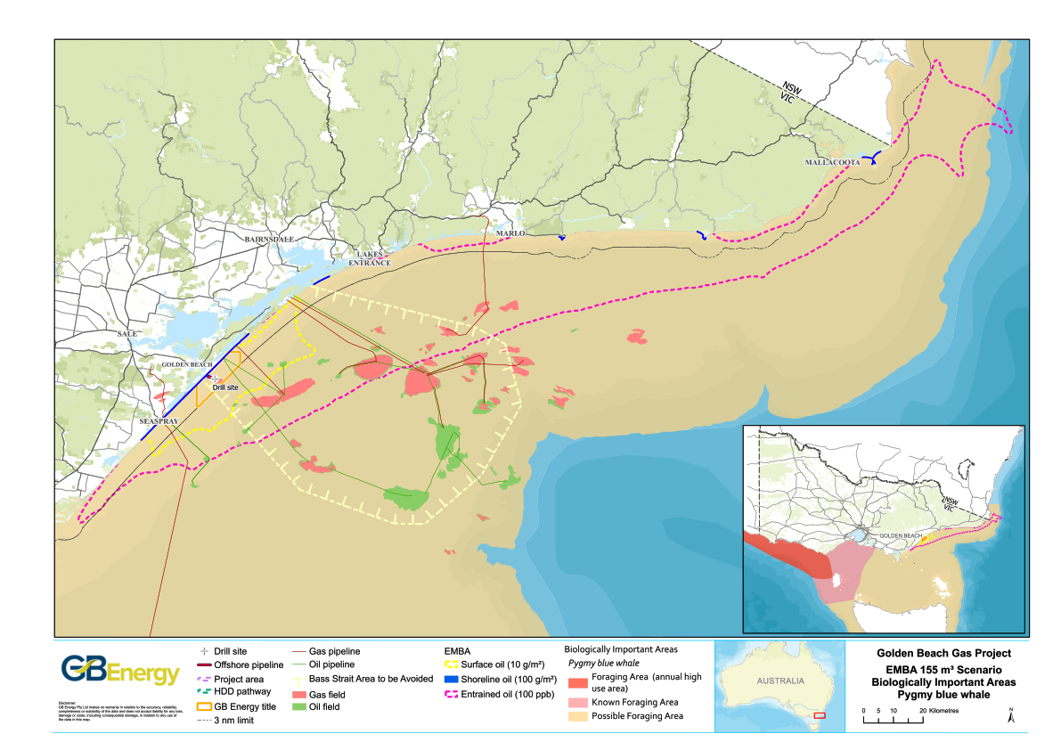
Figure 4.7. Pygmy blue whale BIA intersected by the Project area and spill EMBA
Southern right whale (EPBC Act: Endangered, listed migratory, FFG Act: Threatened)
Southern right whales (Eubalaena australis) are medium to large black (or less commonly grey-brown) baleen whales (DSEWPC, 2012c). They reach a maximum length of approximately 17.5 m and a weight of around 80 tonnes, with mature females slightly larger than males (DSEWPC, 2012c). The Australian population is estimated at 3,500 individuals (Charlton et al., 2014).
The southern right whale is present off the Australian coast between May and October (sometimes as early as April and as late as November) (DSEWPC, 2012c). This species generally migrates to the warmer waters of Southern Australia during winter and inhabits sub-Antarctic waters in the summer, where their main feeding grounds are generally between 40°S and 55°S (DoEE, 2005).
The closest known calving/nursery grounds to the Project area occurs at Logan’s Beach off the coast of Warrnambool in southwest Victoria (approximately 426 km west of the Project area) and intermittently at Portland (507 km west of the Project area) (DSEWPC, 2012c).
The National Conservation Values Atlas recognises a BIA for migration/resting on migration for the southern right whale through all Victorian state waters, including those around the Project area (Figure 4.8), as they are known to generally occur within 2 km of shorelines (DSEWPC, 2012c).However, a defined near-shore coastal migration corridor is considered unlikely given the absence of any predictable directional movement for the species (DSEWPC, 2012c).
Southern right whales are likely to be present in the EMBA during their seasonal migration season of May to October. DELWP’s 2019 aerial cetacean surveys did not record any southern right whales within the Project area, while there were seven records of this species in the eastern parts of the EMBA during July and August (off the coastlines of Marlo and Mallacoota in Victoria and Eden and Tathra in southern NSW).

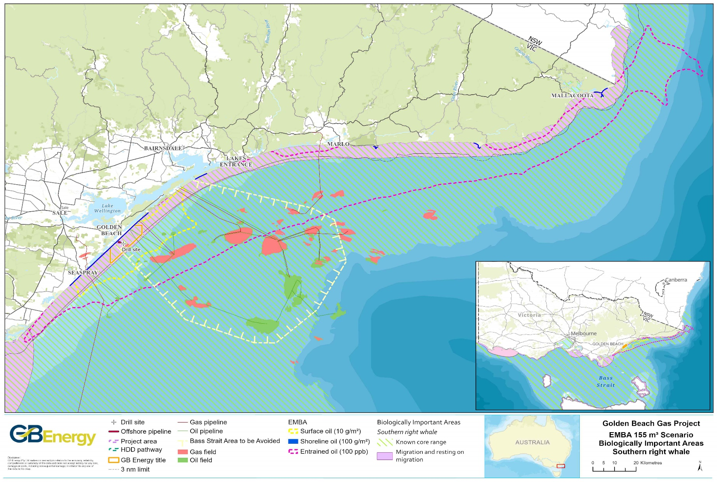
Figure 4.8. Southern right whale BIA intersected by the the Project area and spill EMBA
Humpback whale (EPBC Act: listed migratory, FFG Act: Critically endangered (southern))
The humpback whale (Megaptera novaeangliae) is a moderately large (15-18 m long) baleen whale that has a worldwide distribution but geographic segregation. In the 19th and 20th centuries, humpback whales were hunted extensively throughout the world’s oceans and as a result it is estimated that 95% of the population was eliminated. In Australia, commercial whaling of humpback whales ceased in 1963 and until this time, it is estimated that humpback whales were reduced to between 3.5 and 5% of pre-whaling abundance (TSSC, 2015b).
Bass Strait represents part of the core range of the E1 Group, but feeding, resting or calving is not known to occur in Bass Strait (TSSC, 2015b), though migration through Bass Strait may occur. The nearest area that humpback whales are known to congregate (foraging BIA) is at the southern-most part of NSW (near the eastern border of Victoria), approximately 240 km northeast of the Project area and within the EMBA.
Humpback whales undertake annual migrations between their summer feeding grounds in Antarctic waters to their breeding and calving grounds in sub-tropical and tropical inshore waters, migrating up the Australian east coast (TSSC, 2015b). The northern migration off the southeast coast starts in April and May, with the southern migration occurring from November to December. This migration tends to occur close to the coast, along the continental shelf boundary in waters about 200 m deep (TSSC, 2015b).
As the Project area and the EMBA represent a core range for humpback whales, they may be encountered, particularly during April, May, November and December, though the likelihood is considered low for the Project area due to their preference for migrating along the edge of the continental shelf in waters much deeper than those of the Project area.
Dolphins (EPBC Act: Listed marine species)
None of the eight dolphin species listed in the PMST results are listed as threatened under the EPBC Act or FFG Act. Many dolphins are cosmopolitan species that are generally restricted to continental shelf environments.
Listed in the VBA database is the Burrunan dolphin (Tursiops australis), a species of bottlenose dolphin only recognised as a separate species in 2011, is present in the Gippsland Lakes. This species is listed as threatened under the FFG Act. Only two resident populations of Burrunan dolphin are known to occur, comprising about 50 individuals in the Gippsland Lakes and 100 individuals in Port Phillip Bay (Charlton-Robb et al., 2011). It is unclear whether migration occurs between these sites, though researchers from the Marine Mammal Foundation released information in mid-2017 indicating that there are genetic similarities between the dolphins in the Gippsland Lakes and around Tasmania’s Freycinet Peninsula (ABC, 2017). The Marine Mammal Foundation believes a transient group of male dolphins swim between Gippsland and eastern Tasmania to breed with two different populations of female dolphins. The taxonomic validity of this new species has been questioned by the Committee for Taxonomy for the International Society for Marine Mammology (DRI, 2016). Burrunan dolphins, if present in the Project area or EMBA, are likely to just migrate through (rather than use these areas as permanent habitat).

Pinnipeds
There are two pinniped species recorded under the PMST as potentially occurring within the Project area and EMBA (Table 4.7) (DAWE, 2020a). These species are not listed as threatened under the FFG Act. There are no breeding or haul-out sites within the Project area or EMBA for both species, though the area may provide year-round foraging habitat. There is no BIA for these species in the EMBA.
Table 4.7. EPBC Act-listed pinnipeds that may occur in the Project area and EMBA
Scientific name | Common name | EPBC Act status |  |  | FFG Act status | BIA within the EMBA? | Recovery Plan in place?
 |  | Listed threatened species | Listed migratory species | Listed marine species
Arctocephalus forsteri | New Zealand  fur-seal | - | - | Yes | L | - | -
Arctocephalus pusillus | Australian fur-seal | - | - | Yes | - | B | -

Reptiles
Four species of marine turtle are listed under the EPBC Act as potentially occurring in the EMBA, these being the loggerhead turtle (Caretta caretta), green turtle (Chelonia mydas), leatherback turtle (Dermochelys coriacea) and hawksbill turtle (Eretmochelys imbricate). No BIAs for turtles occur within Bass Strait, with turtles in Victorian waters considered to be rare vagrants outside their usual range. No turtles are listed as threatened under the FFG Act 1988 (Vic), except for the leatherback turtle.

Avifauna
Given the focus on the marine impacts of the project, the focus of this section is true seabirds (i.e., birds of the order Procellariiformes) and true shorebirds (i.e., birds of the order Charadriiformes). Seabirds are those whose normal habitat and food source is derived from the sea, whether that be coastal or offshore, while shorebirds spend more of their time (nesting, feeding and breeding) on the shoreline and don't swim.
Ninety-three (93) bird species (seabirds and shorebirds) are listed under the EPBC Act as potentially occurring in the Project area and EMBA (Table 4.8). The majority of these are listed as migratory and marine species.
Field surveys undertaken for the Golden Beach Gas Project EES (Practical Ecology, 2020) along the shoreline adjacent to the Project area identified the presence of the following shorebird and seabird species:
- Hooded plover (Thinornis cucullatus);
- Pacific golden plover (Pluvialis fulva);
- Pacific gull (Larus pacificus);
- Shy albatross (Thalassarche cauta);
- Pied cormorant (Phalacrocorx varius); and
- White-bellied sea eagle (Haliaeetus leucogaster).

Table 4.8. EPBC Act-listed bird species that may occur in the Project area and EMBA
Scientific Name | Common Name | EPBC Act status |  |  | FFG Act status | BIA within the EMBA | Recovery Plan in place?
 |  | Listed threatened species | Listed migratory species | Listed marine species
True seabirds (34 species)
Albatross
Diomedea antipodensis | Antipodean albatross | V | Yes | Yes | - | F | Generic RP in place for all albatross in Australia, + AS for all albatross
Diomedea gibsoni | Gibson’s albatross | V | - | Yes | - | -
Diomedea epomophora | Southern royal albatross | V | Yes | Yes | L | -
Diomedea exulans | Wandering albatross | V | Yes | Yes | L | F
Diomedea sanfordi | Northern royal albatross | E | Yes | Yes | - | -
Phoebetria fusca | Sooty albatross | V | Yes | Yes | L | -
Thalassarche bulleri | Buller’s albatross | V | Yes | Yes | L | F
Thalassarche bulleri platei | Northern Buller’s albatross | V | - | - | - | -
Thalassarche carteri | Indian yellow-nosed albatross | V | Yes | Yes | L | F
Thalassarche cauta | Shy albatross | E | Yes | Yes | L | F
Thalassarche chrysostoma | Grey-headed albatross | E | Yes | Yes | L | -
Thalassarche eremita | Chatham albatross | E | Yes | Yes | - | -
Thalassarche  impavida | Campbell albatross | V | Yes | Yes | - | F
Thalassarche melanophris | Black-browed albatross | V | Yes | Yes | - | F
Thalassarche salvini | Salvin’s albatross | V | Yes | Yes | - | -
Thalassarche steadi | White-capped albatross | V | Yes | Yes | - | -
Thalassarche sp. nov. | Pacific albatross | V | Yes | Yes | - | -
Petrels
Fregetta grallaria | White-bellied storm-petrel | V | - | - | - | - | -
Halobaena caerulea | Blue petrel | V | - | Yes | - | - | CA
Macronectes giganteus | Southern giant petrel | E | Yes | Yes | L | - | Generic RP and AS for giant petrels
Macronectes halli | Northern giant petrel | V | Yes | Yes | L | -
Pelecanoides urinatrix | Common diving petrel | - | - | Yes | - | F | -
Pelagodroma marina | White-faced storm-petrel | - | - | Yes | L | B, F | -
Pterodroma leucoptera | Gould’s petrel | E | - | - | - | - | RP
Other seabirds
Apus pacificus | Fork-tailed swift | - | Yes | Yes | - | - | -
Ardenna carneipes | Flesh-footed shearwater | - | Yes | Yes | - | - | -
Ardenna grisea | Sooty Shearwater | - | Yes | Yes | - | F | -
Ardenna pacifica | Wedge-tailed shearwater | - | Yes | Yes | - | F | -
Ardenna tenuirostris | Short-tailed shearwater | - | Yes | Yes | - | F | -
Catharacta skua | Great skua | - | - | Yes | - | - | -
Haliaeetus leucogaster | White-bellied sea-eagle | - | - | Yes | L | - | -
Pachyptila turtur | Fairy prion | - | - | Yes | - | - | -
Pachyptila turtur subantarctica | Fairy prion (southern) | V | - | - | - | - | CA
Pandion haliaetus | Osprey | - | Yes | Yes | - | - | -
True shorebirds (59 species)
Actitis hypoleucos | Common sandpiper | - | Yes | Yes | L | - | -
Anthochaera phrygia | Regent honeyeater | CE | - | - | L | - | CA, RP
Arenaria interpres | Ruddy turnstone | - | Yes | Yes | L | - | -
Botaurus poiciloptilus | Australasian bittern | E | - | - | L | - | CA, LA
Bubulcus ibis | Cattle egret | - | - | Yes | - | - | -
Calidris alba | Sanderling | - | Yes | Yes | - | - | -
Calidris acuminata | Sharp-tailed sandpiper | - | Yes | Yes | - | - | -
Calidris canutus | Red knot | E | Yes | Yes | L | - | CA
Calidris ferruginea | Curlew sandpiper | CE | Yes | Yes | L | - | CA
Calidris tenuirostris | Great knot | CE | Yes | Yes | L | - | CA
Calidris melanotos | Pectoral sandpiper | - | Yes | Yes | - | - | -
Calidris ruficolis | Red-necked stint | - | Yes | Yes | - | - | -
Callocephalon fimbriatum | Gang-gang cockatoo | E | - | - | - | - | CA
Calyptorhyn-chus lathami lathami | South-eastern glossy black-cockatoo | V | - | - | - | - | CA
Charadrius bicinctus | Double-banded plover | - | - | Yes | - | - | -
Charadrius leschenaultii | Greater sand plover | V | Yes | Yes | L | - | CA
Charadrius mongolus | Lesser sand plover | E | Yes | Yes | L | - | CA
Charadrius veredus | Oriental plover | - | Yes | Yes | - | - | -
Charadrius ruficapillus | Red-capped plover | - | - | Yes | - | - | -
Dasyornis brachypterus | Eastern bristlebird | E | - | - | L | - | RP
Eudyptula minor | Little penguin | - | - | Yes | - | B, F | -
Falco hypoleucos | Grey falcon | V | - | - | L | - | CA
Gallinago hardwickii | Latham’s snipe | - | Yes | Yes | - | - | -
Gallinago megala | Swinhoe’s snipe | - | Yes | Yes | - | - | -
Gallinago stenura | Pin-tailed snipe | - | Yes | Yes | - | - | -
Grantiella picta | Painted honeyeater | V | - | - | L | - | -
Himantopus himantopus | Black-winged stilt | - | - | Yes | - | - | -
Hirundapus caudacutus | White-throated needletail | V | Yes | Yes | L | - | -
Lathamus discolour | Swift parrot | CE | - | Yes | L | - | RP, LA
Limosa lapponica | Bar-tailed godwit | - | Yes | Yes | L | - | -
Limosa lapponica bauera | Nunivak bar-tailed godwit | V | - | - | - | - | CA
Limosa limosa | Black-tailed godwit | - | Yes | Yes | L | - | -
Monarcha melanopsis | Black-faced monarch | - | Yes | Yes | - | - | -
Motacilla flava | Yellow wagtail | - | Yes | Yes | - | - | -
Myiagra cyanoleuca | Satin flycatcher | - | Yes | Yes | - | - | -
Neophema chrysogaster | Orange-bellied parrot | CE | - | Yes | L | - | RP, LA
Neophema chrysostoma | Blue-winged parrot | - | - | Yes | - | - | -
Numenius Madagascar-iensis | Eastern curlew | CE | Yes | Yes | L | - | CA
Numenius minutus | Little curlew | - | Yes | Yes | - | - | -
Numenius phaeopus | Whimbrel | - | Yes | Yes | L | - | -
Philomachus pugnax | Ruff | - | Yes | Yes | - | - | -
Pycnoptilus floccosus | Pilotbird | V | - | - | - | - | CA
Pluvialis fulva | Pacific golden plover | - | Yes | Yes | L | - | -
Pluvialis squatarola | Grey plover | - | Yes | Yes | L | - | -
Recurvirostra novaehollandiae | Red-necked avocet | - | - | Yes | - | - | -
Rhipidura rufifrons | Rufous Fantail | - | Yes | Yes | - | - | -
Rostratula australis | Australian painted snipe | E | - | Yes | L | - | CA, LA
Sterna albifrons | Little tern | - | Yes | Yes | L | - | LA
Sternula nereis | Fairy tern | - | - | Yes | L | - | -
Sterna fuscata | Sooty tern | - | - | Yes | - | - | -
Symposiachrus trivirgatus | Spectacled monarch | - | Yes | Yes | - | - | -
Sterna (Sternula) nereis nereis | Australian fairy tern | V | - | - | L | - | CA
Thinornis cucullatus | Hooded plover | - | - | Yes | L | - | -
Thinornis cucullatus cucullatus | Hooded plover (eastern) | V | - | Yes | - | - | CA
Tringa brevipes | Grey-tailed tattler | - | Yes | Yes | L | - | -
Tringa glareola | Wood sandpiper | - | Yes | Yes | L | - | -
Tringa nebularia | Common greenshank | - | Yes | Yes | L | - | -
Tringa stagnatilis | Marsh sandpiper | - | Yes | Yes | L | - | -
Xenus cinereus | Terek sandpiper | - | Yes | Yes | L | - | -
Note: birds that are terrestrial and/or coastal that do not occur within shoreline habitats are not described within this section.
Exclusively Seabirds
Albatross (EPBC Act: Endangered & vulnerable, listed migratory, FFG Act: many listed as threatened)
Albatrosses (and giant-petrels) are among the most dispersive and oceanic of all birds, spending more than 95% of their time foraging at sea in search of prey and usually only returning to land (remote islands) to breed (EA, 2001). Only five species of albatross and the southern and northern giant petrel are known to breed within Australia. Breeding within Australian territory occurs on the isolated islands of Antarctica (Giganteus Island, Hawker Island and Frazier islands) and the Southern Ocean (Heard Island, McDonald Island, Macquarie Island, Bishop and Clerk Islands), as well as islands off the south coast of Tasmania and Albatross Island off the north-west coast of Tasmania in Bass Strait (DSEWPC, 2011a).
All Australian waters can be considered foraging habitat for albatross and petrels, with the most important habitat considered to be south of 25°S (DSEWPC, 2011a), which includes the Project area. Given these species’ ability to cover vast ocean distances while foraging, it is possible they may overfly and forage in the vicinity of the Project area.
The albatross species listed in have a widespread distribution throughout the southern hemisphere.
No breeding colonies or nesting areas for the listed albatross species are located near the Project area or EMBA (DSEWPC, 2011a).
Petrels (EPBC Act: Vulnerable and endangered, some listed migratory)
The seven petrel species listed as potentially occurring within the EMBA are widely distributed throughout the southern hemisphere. No breeding colonies or nesting areas for the listed petrel species are located in or near the Project area or EMBA.
Other seabirds
Other seabirds listed in the PMST may occur within the Project area and EMBA as their ecological niches dictate.
Shorebirds and Coastal Species
The plovers, terns, sandpipers, snipes, godwits and other shorebird species feed on a range of molluscs, worms, crustaceans and insects along the shoreline or the wetlands behind the coastal dunes, some breeding overseas before returning to Australia, while others breed in Australia and nest along the sandy beaches of Ninety Mile Beach.
Important Bird Areas
BirdLife Australia and Birdlife International, in association with Rio Tinto, identified 314 Important Bird Areas (IBAs) in Australia between 2005 and 2009. The IBA program was developed to identify the most important areas on Earth for birds, to promote their significance for conservation and assist in their prioritisation of conservation efforts and resources (Dutson et al., 2009). IBAs are sites (distinct areas or places from surrounding areas) and are not protected by legislation. The nearest IBA to the EMBA is the Gippsland Lakes.

Marine Pests
Marine pests known to occur in South Gippsland, according to Parks Victoria (2015) and Butler et al (2012) include:
- Pacific oyster (Crassostrea gigas);
- Northern pacific seastar (Asterias amurensis);
- New Zealand screw shell (Maoricolpus roseus); and
- European shore crab (Carcinus maenas).
The Marine Pests Interactive Map (DAFF, 2020) indicates that the Port of Melbourne is known to harbour the following species:
- Northern pacific seastar;
- European shore crab;
- European fan worm (Sabella spallanzannii);
- Japanese kelp (Undaria pinnatifida);
- Asian shore crab (Hemigrapsus sanguineus); and
- Asian date mussel (Musculista senhousia).
These species have the potential to be picked up in the ballast water and transferred to the Project area. Two of these species (Pacific oyster and European green crab) are also known to occur in the Gippsland Lakes (Hirst & Bott, 2016).

Cultural Heritage Values

Aboriginal Heritage
The coastline adjacent to the Project area is occupied by the Gunaikurnai language group. The Gippsland coastline is of significant Aboriginal cultural heritage significance. There are numerous areas containing Aboriginal shell middens (i.e., the remains of shellfish eaten by Aboriginal people) along the sand dunes of the Gippsland coast. Coastal shell middens are found as layers of shell exposed in the side of dunes, banks or cliff tops or as scatters of shell exposed on eroded surfaces. These areas may also contain charcoal and hearth stones from fires, and items such as bone and stone artefacts, and are often located within sheltered positions in the dunes, coastal scrub and woodlands. Other archaeological sites present along the Gippsland coast include scar trees and assorted artefact scatters (Basslink, 2001).

Maritime Archaeological Heritage
Shipwrecks (together with their associated relics) over 75 years old are protected within Commonwealth waters under the Historic Shipwrecks Act 1976 (Cth) and in Victorian waters under the Victorian Heritage Act 1995 (Vic).
Shipwrecks
There are no shipwrecks mapped as occurring in the Project area (DAWE, 2020j).
There are 70 shipwrecks within the EMBA, with the closest stranded on the shoreline. These are:
- Trinculo (VHR S680) – an iron-hulled, three-masted sailing ship, wrecked in 1879 and driven ashore at Ninety Mile Beach east of Seaspray. The wreck is visible on the beach. This wreck is the nearest to the Project area (24 km to the west).
- Julius (VHR S376) – a schooner wrecked in 1892 between Refuge Cove and Lakes Entrance, 26 km northeast of the Project area.
- Norfolk (VHR S493) – a screw steamer that caught fire off the Ninety Mile Beach in December 1914 and was beached in an attempt to save the vessel. However, the vessel was completely burnt out. The wreck is variously reported to be onshore and lie in 28 m water depth, about 30 km northeast of the Project area.
Shipwreck Protection Zones
Of the 650 shipwrecks in Victoria, nine have been placed within protected zones (a no-entry zone of 500-m radius [78.5 ha] around a particularly significant and/or fragile shipwreck) (DCCEEW, 2022f). The SS Glenelg is located 60 km southeast of the Project area, and within the EMBA.

Socio-economic Environment
This section describes the social and economic environment of the Project area and the EMBA.

Coastal Settlements
The coastline adjacent to the Project area is sparsely populated, with the adjoining townships of Golden Beach and Paradise Beach being the closest. These towns are located within the Wellington Shire Council.
The populations for Golden Beach and Paradise Beach are 356 and 172, respectively. In Golden Beach, 60.1% of the 461 private dwellings are unoccupied, while 67.2% of the 286 private dwellings in Paradise Beach are unoccupied (ABS, 2021).
Camping among the sand dunes is also available along this section of coastline. Golden Beach has a small group of retail shops, a community hall, church, caravan park, football oval, bowling green and 9-hole golf course.

Native Title
Victoria
The National Native Title Tribunal (NNTT) database identifies that there is Native Title Determination registered over much of the coastline adjacent to the Project area, this being for the Gunai/Kurnai People (VCD2010/001).
There are no other Native Title Claims over the Project area or adjacent coastline (NNTT, 2020). There are no Indigenous Land Use Agreements (ILUA) registered by the NNTT along the coastline adjacent to the Project area (NNTT, 2020).
New South Wales
In 2017, the South Coast People lodged a native title claim in the Federal Court of Australia that was registered on 31 January 2018. The South Coast people’s claim covers
16,808 km², extending south from Sydney to Eden, along the south coast of NSW and west towards Braidwood and extends 3 nm seaward (NNTT, 2020).

Commercial Fishing
Several Commonwealth and Victorian commercial fisheries are licensed to operate in and around the Project area and the EMBA.
Commonwealth-managed Fisheries
Commonwealth fisheries are managed by the AFMA under the Fisheries Management Act 1991 (Cth). Their jurisdiction covers the area of ocean from 3 nm from the coast out to the 200 nm limit (the extent of the Australian Fishing Zone [AFZ]). Commonwealth commercial fisheries with jurisdictions to fish the EMBA are the:
- Bass Strait Central Zone Scallop Fishery;
- Eastern Tune and Billfish Fishery;
- Eastern Skipjack Tuna Fishery;
- Southern Bluefin Tuna Fishery;
- Small Pelagic Fishery (eastern sub-area);
- Southern Squid Jig Fishery; and
- Southern and Eastern Scalefish and Shark (SESS), incorporating;
- Gillnet and Shark Hook sector.
- South East Trawl sector.
- Scalefish Hook sector (SHS).
Only the Southern Squid Jig Fishery, Eastern Tuna and Billfish Fishery and the SESS are likely to fish within the EMBA.
Victorian-managed Fisheries
Victorian-managed commercial fisheries with access licences that authorise harvest in the waters of the Project area and the EMBA include the following (noting that not all actually operate in the area):
- Ocean Scallop;
- Rock Lobster (Eastern zone);
- Ocean Access (general, all species);
- Ocean Purse Seine (noted by VFA as being the most active fishery in the region);
- Trawl (inshore);
- Abalone (central zone) (does not operate in the Project area);
- Wrasse (does not operate in the Project area); and
- Banded Morwong (by permit) (does not operate in the Project area).
Through its consultation process, GB Energy identified Mitchelson Fisheries (Mitchelson) as the key operator in the waters of, and adjacent to, the Project area. Mitchelson primarily catches sardines and other pelagic species such as salmon, mackerel, sandy sprat, anchovy and white bait.
Mitchelson has advised GB Energy that there is very limited rock lobster fishing in the waters around the Project area and that they are the only fishery holding a license in the Victorian waters around the Project area.

Recreational Fishing
Recreational fishing along the Gippsland coast typically targets snapper, King George whiting, flathead, bream, sharks, tuna, calamari, and Australian salmon.
Recreational fishing and boating are largely confined to the Gippsland Lakes and nearshore coastal waters, though surf fishing does occur along the beaches adjacent to Golden Beach. As Bass Strait is relatively shallow, the water currents through the Bass Strait can create unpredictable seas, reducing the numbers of recreational boats from venturing long distances into the Bass Strait from shore. VRFish has stated that small boats are likely to fish around the nearshore reef area, while larger game fishing boats are likely to fish further out to sea and use nearby ports and boat ramps for launching. There are no boat ramps adjacent to the Project area.
The Golden Beach Surf Fishing Competition takes place over the weekend nearest Australia Day and during the Easter long weekend (midnight Good Friday to midnight Easter Sunday) each year between Seaspray and Loch Sport. The period of time between Christmas and Australia Day weekend are generally the busiest for recreational fishing.

Tourism
Marine-based tourism and recreation in the Bass Strait is primarily associated with recreational fishing and boating (see previous section).
The Gippsland Lakes (comprising Lake Victoria, Lake King, and Lake Wellington, together with other smaller lakes, marshes and lagoons) are the primary tourist attraction in the region. The communities adjacent to this network of lakes are popular tourist towns for their boating and fishing activities, along with bushwalking, bird watching and other nature-focused activities.

Offshore Energy Exploration and Production
Petroleum
In 2018, Victoria accounted for 11% of Australia’s crude oil production, 11% of Australia’s condensate production, 49% of Australia’s liquified petroleum gas (LPG) production and 10% of Australia’s conventional gas production (APPEA, 2019).
The Project area and EMBA intersects the Gippsland oil and gas production province, which contains numerous offshore platforms, subsea wells and pipelines.
The Project area is located in proximity to several gas pipelines, these being:
- TasGas pipeline (Tasmanian Gas Pipeline Pty Ltd) – located 21 km southwest of the Project area;
- Seaspray to Dolphin to Perch pipeline (EARPL) – located 19 km southwest;
- Bream A to shore pipeline (EARPL) – 5 km northeast; and
- Barracouta to shore pipeline (EARPL) – 6.9 km northeast.

Electricity
The EMBA intersects the Basslink Interconnector, which is a
400 kV DC electricity interconnector that allows the trade of electricity between Tasmania (hydropower) and the National Electricity Market of the mainland. Basslink runs from Loy Yang in Gippsland, Victoria, across Bass Strait to Bell Bay in Northern Tasmania.
Renewable Energy
The EMBA intersects Australia’s first offshore area declared available for renewable energy projects (Figure 4.9). The Project area is located about 10 km from the declaration area. Several offshore wind farm projects are proposed within the declaration area.

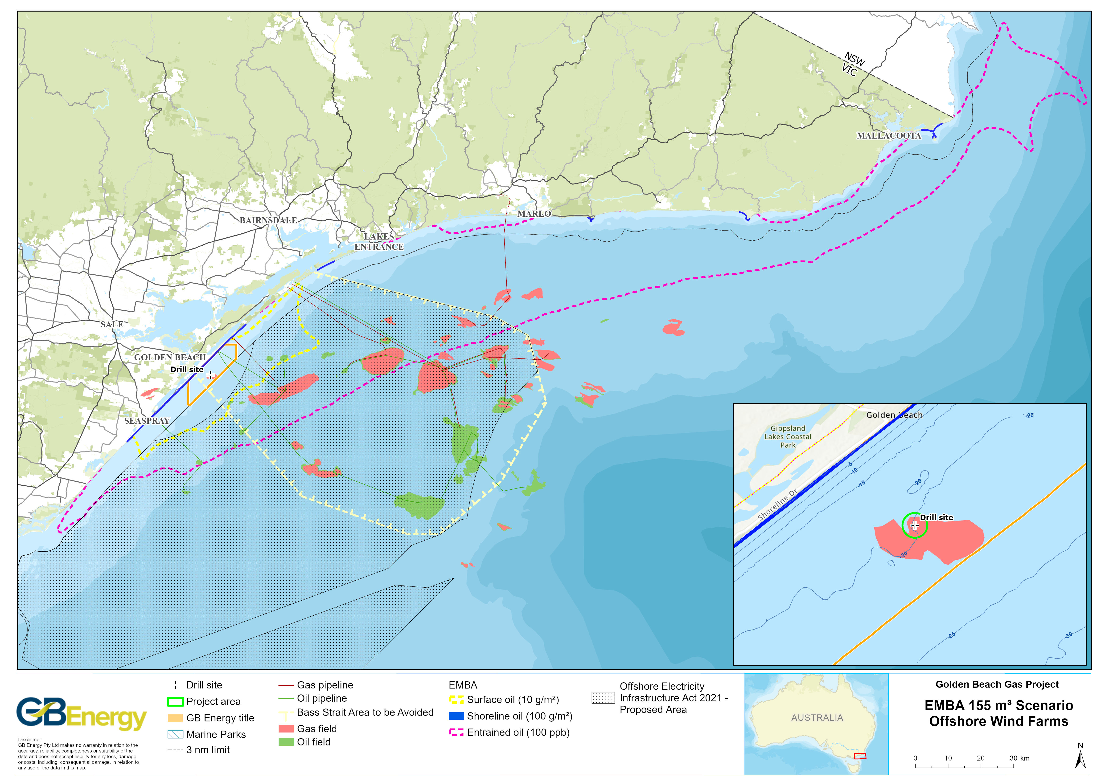
Figure 4.9. Offshore renewable energy declaration area intersected by the Project area and spill EMBA

Commercial Shipping
The South-east Marine Region (which includes Bass Strait) is one of the busiest shipping regions in Australia (DoE, 2015a). Lakes Entrance is an important fishing port for the region (DoE, 2015a).
The Project area is located entirely within the area to be avoided (ATBA) (see Figure 4.9). This area is a routing measure that ships in excess of 200 gross tonnes should avoid due to the high concentration of offshore petroleum infrastructure that can provide a navigational hazard. Operators of vessels greater than 200 gross tonnes must apply to NOPSEMA to enter and be present within the ATBA (NOPSEMA, 2016).

Defence Activities
The Project area is located beneath Defence Restricted Airspace R359C. There are no defence training areas within the EMBA (DoE, 2015a).

Impact and Risk Assessment Methodology
While ‘impacts’ and ‘risks’ are acknowledged as having different meanings, the term ‘risk’ is used throughout this chapter when describing the overall methodology of assessing impacts and risks given that AS/NZS 31000:2009 uses the term ‘risk’ (but is intended to also describe the approach to assessing impacts).

Risk Assessment Approach
GB Energy uses a risk management methodology that is compliant with the Australian New Zealand Risk Management Standard ISO31000:2018 (Risk management-Principles and guidelines).
The risk management framework is illustrated in Figure 5.1.

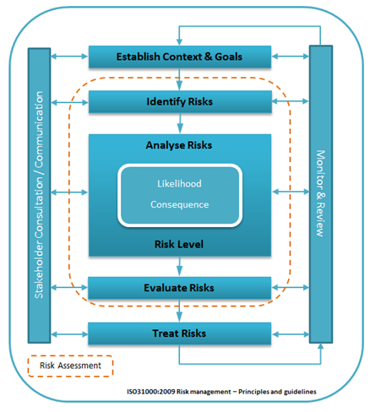
Figure 5.1. Risk management framework

Risk Management Process
GB Energy’s environmental risk management methodology follows the ISO 31000 Risk Management Principles, which consists of the following steps:
- Identifying the environmental aspects of the activity (including stakeholders that may be affected by the activity);
- Analysing the environmental impacts and risks of the activity;
- Evaluating those impacts and risks;
- Identifying the treatments that can be incorporated into the activity to ensure the impacts and risks are managed to be as low as reasonably practicable (ALARP) and acceptable; and
- Ensuring the environmental management system (EMS) is robust enough to achieve the objectives in place to manage the impacts and risks of the activity.

Stakeholder Identification
Stakeholder engagement and cooperation is an essential part of GB Energy’s corporate sustainability strategy. Stakeholder consultation is an important part of GB Energy’s environmental risk management process because it assists in determining the significance of impacts its activities may have.

Risk Identification
GB Energy originally held an environmental risk assessment workshop in late November 2020 to identify whether there were any changes to impacts and risks compared to those presented in the EES. This workshop identified that the impacts and risks of the offshore campaign remained the same, with some of the controls refined slightly.
A follow up environmental risk assessment workshop, specific to the GB-2 well, was held in late August 2022. This did not identify new issues compared to the original risk workshop. The outcomes of the workshops were recorded in a risk register, which has been used to support the impact and risk assessment in the EP.

Risk Analysis
The OPGGS Regulations 15(4) requires that the EP detail and evaluate the environmental impacts and risks for an activity, including control measures used to reduce the impacts and risks of the activity to ALARP and an acceptable level.
Environmental impact and risk are defined as:
- Impact: any change to the environment, whether adverse or beneficial, that wholly or partially results from an activity.
- Risk: the likelihood of a specific undesired event occurring within a specific period or in specified circumstances and with specified consequences.

Determining risk consequence
GB Energy defines consequence as:
The nature of the outcome of an event.
The consequence definitions are provided in Table 5.1.

Table 5.1. Consequence definitions
 | Safety  (impact to GB Energy or contracting personnel) | Environment  (impact to the physical and ecological environment and cultural heritage) | Financial  (loss of revenue, business interruption, commodity trading, asset loss) | Reputation and social  (services and community interruption) | Regulation  (OHS, environment, industrial relations, trade practices, industry acts)
5. Catastrophic | Multiple fatalities or serious irreversible disability (>30%) to multiple persons | - Effects at the landscape level (hundreds or thousands of square kilometres or hectares).  - A very large group of plants or animals affected. Entire habitat type or species population. Several populations of one or more threatened species or habitats experiences mortalities.  - Permanent impact (e.g., >50 years) and irreversible. Rehabilitation is unlikely to be successful. Habitat or species is highly unlikely to recolonise.  - An extensive hydrocarbon spill (e.g., over 100,000 litres) that requires clean up over weeks or months.  - Permanent loss of item/place of international or national cultural heritage significance. | EBIT  - Impact, loss or deterioration from expectation greater than $30m.  CASH FLOW  - Severe cash flow crisis.  - Difficult to source funds.  - Probable credit rating downgrade. | - Community outrage, conflict between neighbours/towns over months to years.  - Irreparable damage of highly valued items or structures of great cultural significance  - State-wide or national interest/outrage beyond the area of operations.  - Business or residency is no longer viable. Permanent exclusion from operations or nuisance that cannot be mitigated. | - Very significant fines and prosecutions.  - Prolonged multiple litigations and fines.
4. Major | Single fatality or major permanent injury/ illness or moderate irreversible disability (<30%) to one or more persons. | - Extensive area of effect (hundreds of square kilometres or hectares).  - Large group of plants or animals affected. Nearly an entire habitat type or species population affected. One or more populations of a threatened species or habitat experiences injuries or mortalities.  - Long-term duration of impact (e.g., 20-50 years), wholly or partially reversible damage. Active rehabilitation required over many years. Habitat or species is unlikely to recolonise.  - A very large hydrocarbon spill (e.g., up to 100,000 litres) that requires clean up over weeks.  - Damage to item/place of international or national cultural heritage significance that is very difficult to repair or may result in permanent scarring. Permanent impact. | EBIT  - Impact, loss or deterioration from expectation >$3m  but <$30m.  CASH FLOW  - Loss of flexibility and/or increase in cost to source funds. | - Very large community affected (e.g., multiple suburbs/towns or city, entire fishery).  - High increased cost of living or business operations (e.g., hundreds of thousands of dollars), high-level/long-term nuisance. Business or residency unlikely to remain viable. Long-term (e.g., months) exclusion from operations.  - Community outrage, conflict between neighbours/towns. | - Major breach of regulation and significant prosecution including class actions.
3. Serious | Serious reversible / temporary injury / illness (e.g., lost time >3 days or hospitalisation or Alternate/Restricted Duties >1 month). | - Localised to extensive effect (tens of square kilometres or hectares).  - Large group of plants or animals affected. Partial habitat or population loss. A small population of a threatened species is affected.  - Long-term duration of impacts (e.g., 10-20 years), reversible damage. Active rehabilitation required over years. Habitat or species is likely to recolonise.  - A large hydrocarbon spill (e.g., up to 10,000 litres) that takes several days to clean up.  - Serious (e.g., extensive) but repairable damage to item/place of international or national cultural heritage significance. Repair/restoration may take months or years. | EBIT  - Impact, loss or deterioration from expectation >$300k but <$3m.  CASH FLOW  - Material impact to cash flow. | - Large community affected (e.g., town/s of several thousand people, dozens of fisheries licencees).  - Moderate increased cost of living or business operations (e.g., tens of thousands of dollars), high-level nuisance. Business or residency may not remain viable. Long-term (e.g., weeks to one month) exclusion from operations.  - Noticeable community unrest/tension. | - Serious breach of law/regulation with investigation or report to authority and possible prosecution.  - Performance Infringement Notice.
2. Moderate | Reversible temporary injury/illness (e.g., lost time or hospitalisation or Alternate/Restricted Duties <1 month). | - Moderately localised extent of effect (<10 square kilometres or hectares).  - Minor impact on a small to medium sized group of plants or animals. A small number of individuals of a threatened species is affected.  - Medium-term duration of impact (e.g., 5-10 years), reversible damage. Active rehabilitation may be required over weeks to months. Habitat or species is highly likely to recolonise.  - A medium-sized hydrocarbon spill (e.g., up to 1,000 litres) that requires clean up over several days.  - Repairable damage to item/place of state or national cultural heritage significance. Repair/restoration may take weeks or months. | EBIT  - Impact or loss >$30k but <$300k.  CASH FLOW  - Impact to project or business unit cash flow. | - Small number of people or small community affected (e.g., town of several hundred people, <20 fisheries licencees).  - Minor increased cost of living or business operations (e.g., thousands of dollars), medium-level nuisance. Short-term (up to several days) exclusion from normal operations.  - Some community unrest/tension, some locally-based complaints. | - Breach of law/regulation or non-compliance.  - Minor legal issues.  - Litigation possible.
1. Minor | Injury/illness not requiring Medical Treatment (no lost time, no Alternate/ Restricted Duties).  - First Aid  - Report Only. | - Localised effect (<1 square kilometre or hectare).  - Little or no effect on small number of plants or animals or habitat. No threatened species are affected.  - Short to medium-term duration of impact (e.g., several months to 5 years), reversible damage. No active rehabilitation likely. Habitat or species will recolonise.  - A small hydrocarbon spill (e.g., less than 100 litres) that requires no active clean up.  - No visible damage to item/place of local, state, national or international cultural heritage significance. | EBIT  - Impact or loss >$3k but <$30k.  CASH FLOW  - No significant impact. | - Up to several individuals affected (e.g., multiple landholders, <5 fishing licencees).  - Minor increased cost of living or business operations (e.g., hundreds of dollars), low-level nuisance, minimal or no exclusion from normal operations.  - No community unrest or negative media. | - Local investigation.  - Minor breach of regulation.  - On the spot fine or technical non-compliance.  - Prosecution unlikely.

Determining risk likelihood
GB Energy defines likelihood as:
The chance of occurrence (sometimes per unit in time).
The definitions of likelihood are provided in Table 5.2.
Table 5.2. Consequence definitions
Frequency |  | Description | Probability
E | Almost certain | Impact is occurring now.  Could occur within days to weeks. | 99% chance of occurring within the next year.
D | Likely | Balance of probability will occur.  Could occur within weeks to months | >50% chance of occurring within the next year.
C | Possible | May occur shortly but a distinct probability it won't.  Could occur within months to years. | >10% chance of occurring within the next year.
B | Unlikely | May occur but is not anticipated.  Could occur in years to decades. | >1% chance of occurring within the next year.
A | Remote | Occurrence requires exceptional circumstances.  Exceptionally unlikely event in the long-term future. | <1% chance of occurring within the next year.

Risk Evaluation
The risk is evaluated by ‘multiplying’ likelihood and consequence, as per Table 5.3. The recommended form of action, escalation and monitoring for each risk level is provided in Table 5.4.
Chapter 6 presents the ‘inherent’ rating (pre-treatment) and ‘residual’ risk rating (with controls adopted) for each risk (unplanned events).

Table 5.3. Qualitative risk analysis matrix
 |  | Consequence
 |  | 1 | 2 | 3 | 4 | 5
Frequency |  | Minor | Moderate | Serious | Major | Catastrophic
E | Almost certain | Medium | High | High | Extreme | Extreme
D | Likely | Low | Medium | High | High | Extreme
C | Possible | Low | Medium | Medium | High | High
B | Unlikely | Low | Low | Medium | Medium | High
A | Remote | Low | Low | Low | Low | Medium

Table 5.4. Risk treatment action
Risk ranking | Treatment action
EXTREME  The risk is intolerable | - Modify the threat, the frequency or consequence so that the risk is reduced to 'high' or lower.  - For an operational activity, the risk shall be reduced as soon as possible, typically within a timescale of not more than a few weeks.  - For commercial risks, review the risks and where practicable reduce by additional mitigation measures such as hedging, insurance, etc.
HIGH  The risk is tolerable if ALARP | - Repeat threat identification and risk evaluation processes to verify and, where possible, quantify the risk estimation; determine the accuracy and uncertainty of the estimation.  - Where the risk ranking is confirmed to be 'high', if practicable, modify the threat, the frequency or consequence to reduce the risk ranking to ‘medium’ or 'low'.  - Where the risk ranking cannot be reduced to 'medium' or 'low', to demonstrate ALARP it is necessary to review if it is reasonably practicable to remove threats, reduce frequencies and/or reduce the severity of consequences, and if it is reasonably practicable, these risk treatment actions shall be applied. If it is not reasonably practicable, no further action is required and ALARP is demonstrated.  - For an operational activity, the reduction to 'medium’ or 'low' or demonstration of ALARP shall be completed as soon as possible; typically within a timescale of not more than a few months.
MEDIUM  The risk is tolerable | - Determine the management plan for the threat to prevent occurrence and to monitor changes that could affect the classification.  - Management responsibility must be specified – monitor to determine if risk changes and needs to be reassessed.
LOW  The risk is tolerable | - Review at the next review interval.  - Manage by routine procedures – reassess at next review.

Risk Treatment
Each of the impacts and risks identified and evaluated in Chapter 6 have associated control measures. The following sections describe how ALARP and acceptability are defined and assessed.

Demonstration of ALARP
The ALARP principle is defined as:
the demonstration that the cost of further risk reduction measures is grossly disproportionate to the benefit gained.
The ALARP principle arises from the fact that infinite time, effort and money could be spent attempting to reduce a risk or impact to zero. This principle is also illustrated in Figure 5.2.

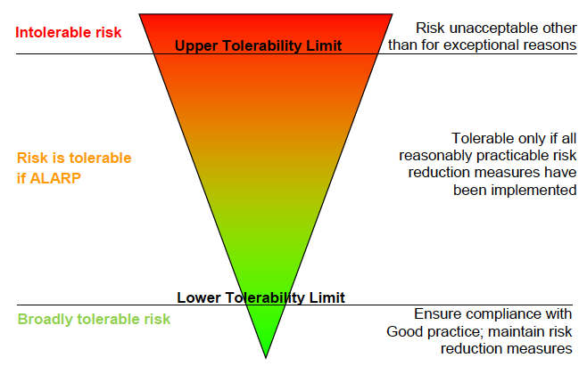
Source: CER (2015).
Figure 5.2. The ALARP principle
There is no universally accepted guidance to applying the ALARP principle to environmental assessments. For this EP, the guidance provided in NOPSEMA’s Environment Plan decision making guideline has been applied and augmented where deemed necessary (as outlined in GB Energy’s Risk Management Procedure).
The level of ALARP assessment is dependent upon the:
  - Residual impact and risk level (high versus low); and
  - The degree of uncertainty associated with the assessed impact or risk.
A risk is considered to be reduced to ALARP when the following criteria are met:
- There are no additional reasonably practicable measures available to further reduce the risk, or
- There are no reasonably practicable alternatives to the activity, or
- The ‘cost’ of implementing further measures is grossly disproportionate to the reduction in risk.
These factors are used to demonstrate ALARP in Chapter 6.

Demonstration of Acceptability
In addition to determining whether environmental risks are ALARP, GB Energy undertakes an assessment of all environmental hazards to determine whether they will be of an acceptable level. GB Energy considers a range of factors when evaluating the acceptability of environmental impacts associated with its activities, as outlined in Table 5.5.
Table 5.5. Acceptability test
Test | Question
Internal context
Policy compliance | Is the proposed management of the risk or impact aligned with the GB Energy’s HSE Policy?
Management System Compliance | Is the proposed management of the risk or impact aligned with the GB Energy’s HSE Management System or supporting procedures?
Stakeholder engagement
Social acceptability | Have stakeholders raised any concerns about activity impacts or risks, and if so, are measures in place to manage those concerns?
Legislation, industry standards and best practice
Laws and standards | Is the risk or impact being managed in accordance with existing Australian or international laws or standards such as MARPOL, Flag State Marine Orders, API standards, etc?
Industry practice | Is the impact or risk being managed in line with industry practice, such as OSPAR OCNS, Industry Codes of Environmental Practice, etc?
Environmental context | Is the impact or risk being managed pursuant to the nature of the receiving environment (e.g., sensitive or unique environmental features generally require more management measures to protect them than environments widely represented in a region)?
Environmentally Sustainable Development (ESD) Principles | Does the proposed risk or impact comply with the accepted industry principles of conduct that ESD principles be integrated into company decision-making?
ALARP | Are there any further reasonable and practicable controls that can be implemented to further reduce the risk or impact?

Risk Monitoring and Review
To support the risk management system, it is necessary to have a process of monitoring and review. Ongoing review is required to ensure that risks and treatment plans remain relevant. Factors impacting upon risk assessments and control practices can be identified through regular monitoring.
Priority should be given to monitoring risks that are rated as ‘high’ or above (as defined in Table 5.4). Factors that should be considered as part of the monitoring and review process are:
- Has there been a change to the context established that impacts on this risk?
- Are there any events that could lead to a change in likelihood or consequence or the level of risk?
- Are treatments being followed through and meeting timelines, key performance indicators and requirements?
- What events have impacted on the progress of treatment?
- Is the treatment impacting on the level of risk as identified?
- Is it the right treatment?
The monitoring and review process is undertaken to support the reporting process and is an opportunity to identify emerging risks that have arisen, that need to be analysed and addressed, if required.
Monitoring and review aspects are described in the Implementation Strategy (Chapter 7).

Environmental Impact and Risk Assessment
This section presents the EIA and ERA for the environmental impacts and risks identified for the project using the methodology described in Chapter 5.
A summary of the impact and risk ratings for each impact and risk identified and assessed in this chapter is presented in Table 6.1.
Table 6.1. Drilling environmental impact and risk rating summaries
Hazard |  | Inherent | Residual
Impacts (planned events) |  | Consequence rating
1 | Seabed disturbance | Minor | Minor
2 | Generation of underwater sound | Minor | Minor
3 | Discharge of drill cuttings and muds – (high exposure) | Moderate | Moderate
 | – (low exposure) | Minor | Minor
4 | Discharge of cement | Minor | Minor
5 | Atmospheric emissions | Minor | Minor
6 | Light emissions (biological and social) | Minor | Minor
7 | Discharge of sewage and grey water | Minor | Minor
8 | Discharge of cooling and brine water | Minor | Minor
9 | Discharge of bilge water and deck drainage | Minor | Minor
Risks (unplanned events) |  | Risk rating
10 | Accidental overboard release of waste | Medium | Low
11 | Introduction of IMS – environmental | Medium | Medium
 | – commercial fisheries | Medium | Medium
12 | Displacement of or interference with third-party vessels  – displacement | Low | Low
 | – interference | Low | Low
13 | Vessel strike with megafauna – individuals | Low | Low
 | – population | Low | Low
14 | Accidental bulk discharge of chemicals or hydrocarbons | Medium | Low
15 | Diesel spill | Low | Low
16 | Dry gas release from loss of well containment (LoWC) | Low | Low
Hydrocarbon spill response activities |  | Risk rating
17 | Relief well drilling | Low | Low
 | Surveillance and tracking | Low | Low
 | Protection and deflection – nearshore habitat | Low | Low
 | – shoreline habitat | Low | Low
 | – fauna disturbance | Low | Low
 | Shoreline assessment and clean-up – shoreline habitat | Medium | Low
 | OWR – fauna injury | Low | Low
 | – fauna death | Low | Low

Table 6.2 presents a summary of the environmental hazards associated with the Project, the impacts and risks of these hazards, the impact and risk ratings and the environmental performance standards (EPS) required to manage the identified impacts and risks. An EPS is defined as a statement of the performance required of a control measure. In Table 6.2, the words denoted in bold font are the control measure.

Table 6.2. Environmental impact and risk assessment for the Project
Hazard | Potential impacts & risks | Avoidance, management and mitigation measures (environmental performance standards) | Residual impact or risk
Impacts (planned events) |  |  | Residual consequence rating
Seabed disturbance | Removal of and disturbance to seabed sediments.  Turbidity of the water column at the seabed. | - The results of the geophysical investigation have been used to inform the MODU location and confirm the drilling location is free from seabed obstacles.  - Support vessel Masters use bathymetric mapping and Global Positioning System (GPS) to avoid mapped seabed obstacles and monitor vessel clearances to ensure there is clearance at all times between the vessel and the seabed.  - An ROV will be deployed and video used to confirm the MODU positioning and drilling locations are free from seabed obstacles.  - MODU anchors and chains, if used, are deployed in accordance with the MODU contractor’s procedures.  - MODU anchors and chains, if used, are deployed such that the rocky reef site located southwest of the drill site is avoided, in line with the bathymetric mapping.  - Soft pinning will not be undertaken.  - Large bulky items are securely fastened to or stored on the MODU deck and support vessel decks to prevent loss to sea.  - A crane handling and transfer procedure is in place and implemented by crane operators (and others, such as dogmen) to prevent dropped objects.  - The crane operators are trained to be competent in the handling and transfer procedure to prevent dropped objects.  - Visual inspection of lifting gear is undertaken every quarter by a qualified competent person (e.g., maritime officer) and lifting gear is tested regularly in line with the MODU Planned Maintenance System (PMS).  - MODU-specific jack-up procedures are used to ensure compliance with stability criteria and reduce the risk of foundation shift or failure.  - An ROV is deployed to search for non-buoyant dropped objects so that they can be marked with geographic coordinates (and for later retrieval, where possible).  - Dropped objects left behind at the end of drilling (that cannot be retrieved) will be reported to DEECA (ERR). | Minor
Generation of underwater sound | Physiological or pathological impacts to local populations of marine fauna and avifauna. | - In accordance with the drilling program, no VSP will be undertaken.  - Support vessel crews will implement EPBC Regulations 2000 (Part 8, Division 8.1), embodied in The Australian National Guidelines for Whale and Dolphin Watching (DoEE, 2017), which means maintaining watch for cetaceans such that:  - Caution zone (300 m either side of observed whales and 150 m either side of observed dolphins) – vessels must operate at speeds <6 knots within this zone.  - No approach zone (100 m either side of observed whales and 50 m either side of observed dolphins) – vessels must operate at speeds <6 knots within this zone and should not enter this zone and should not wait in front of the direction of travel or an animal or pod/group.  - Do not encourage bow riding.  - If animals are bow riding, do not change course or speed suddenly.  - If there is a need to stop, reduce speed gradually.  - Selected vessel crews have completed an environmental induction covering the above-listed requirements.  - Support vessel engines and thrusters are maintained in accordance with the respective PMS to ensure they are operating efficiently | Minor
Discharge of drill cuttings and muds | Increased water column turbidity, smothering of benthic habitat and potential toxicity impacts to fauna. | - Only WBM will be used for the drilling program (not SBM).  - The mud contractor uses only ‘Poses Little or No Risk’ (PLONOR), ‘D’/’E’ (non-CHARM) or ‘Gold’/’Silver’ (CHARM) OCNS-rated base fluids and additives in the drilling fluid system.  - Where for technical reasons an additive is required that has not been registered with CEFAS (and therefore does not have a rating), the mud contractor will apply the CHARM, or in the case of non-CHARMable products, the OCNS process to calculate the CHARM rating or OCNS grouping.  - Only additives with a HQ of <30 (silver/gold ranking) or an OCNS grouping of D/E will be used.  - In accordance with the Fluid Program, the shaker screens are used during drilling the 8.5” well section to maximise fluid separation from cuttings prior to overboard disposal. Screens not in use will be on standby.  - Operation of the separation treatment system is monitored on a full‐time basis by the Derrickman/Shaker‐Hand to ensure optimal system performance.  - Drilling fluid testing is performed by the Mud Engineer working under the supervision of the Drilling Supervisor at least twice per day.  - At the end of the drilling program, mud will be discharged over a minimum duration of 6 hours. | Minor (low exposure)  Moderate (high exposure)
Discharge of cement | Localised and temporary turbidity of the water column, smothering and alteration of benthic habitat and potential toxicity impacts to benthic fauna. | - The cement contractor ensures that only PLONOR, ‘D’/’E’ (non-CHARM) or ‘Gold’/’Silver’ (CHARM) OCNS-rated cement additives are used.  - Where for technical reasons an additive is required that has not been registered with CEFAS (and therefore does not have a rating), GB Energy will apply the CHARM, or in the case of non-CHARMable products, the OCNS process to calculate the CHARM rating or OCNS grouping.  - Only additives with a HQ of <30 (silver/gold ranking) or an OCNS grouping of D/E will be used.  - Once good cement returns are noted for cementing the conductor at the seabed by the ROV Technician (with the aid of fluorescein dye and/or pH probe), the mixing and pumping of cement will cease, and displacement of the string with drilling fluid will begin.  - Manage the cement program such that nearly all cement is used in the cement jobs prior to discharge overboard. At the completion of drilling, if dry cement remains, then the following decision process will determine how to deal with the remaining cement:  - Minimise the inventory of cement on board. If that is not possible, then;  - Transfer cement to the next operator. If that is not possible, then;  - Any leftover slurry is mixed with seawater and discharged overboard over a minimum of 4 hours. | Minor
Atmospheric emissions | Decrease in air quality due to gaseous emissions and particulates from MDO combustion and contribution to the incremental build-up of GHG in the atmosphere (influencing climate change). | - All solid combustible waste is returned to shore for appropriate disposal (rather than incinerated).  - Only low-sulphur (<0.5% m/m) MDO will be used in order to minimise SOx emissions.  - All combustion equipment is maintained in accordance with the PMS (or equivalent).  - Vessels with gross tonnage >400 tonnes possess equipment, systems, fittings, arrangements and materials that comply with the applicable requirements of MARPOL Annex VI.  - Vessels >400 gross tonnes and involved in an international voyage implement their SEEMP to monitor and reduce air emissions.  - Vessels >400 gross tonnes must ensure that firefighting and refrigeration systems are managed in accordance with the PMS to minimise ODS.  - The HVAC system is maintained in accordance with the PMS (or equivalent).  - Fuel use will be measured, recorded and reported for abnormal consumption, and in the event of abnormal fuel use, corrective action will be taken to minimise air pollution. | Minor
Light emissions | Light glow may act as an attractant to light-sensitive species (e.g., seabirds, fish, migratory and non-migratory birds, sea turtles and zooplankton), in turn affecting predator-prey and population dynamics (due to attraction to or disorientation from light). | - Light glow is minimised by managing external vessel lighting in accordance with:  - AMSA Marine Orders Part 30 (Prevention of Collisions).  - AMSA Marine Orders Part 59 (Offshore Support Vessel Operations).  - Lighting is directed to working areas (rather than overboard) to minimise light spill to the ocean.  - Lighting directed overboard can be manually over-ridden (with a local switch were possible) such that it is only switched on as required (e.g., man overboard).  - GB Energy Offshore Representative will report grounded or injured birds on the MODU to the GB Energy Environmental Specialist.  - All crew are informed of their reporting responsibilities for grounded or injured birds during the environmental induction.  - Incidents of grounded or injured birds on the MODU will be handled in accordance with the grounded or injured bird procedure below:  - At least one experienced seabird subject matter expert (SME) handler will be on call to provide advice and support to the GB Energy Offshore Representative and HSE Advisor on board the MODU.  - If required, the seabird SME handler will travel to the MODU and provide advice and training to the GB Energy Offshore Representative (and other personnel on board the MODU, as necessary) regarding handling of grounded birds.  - At least two containers will be available on board the MODU to house grounded birds and transport them to shore as required.  - If additional containers are required, they will be mobilised to the MODU on advice from the SME.  - Recovered birds held in containers should be located in a dark, cool  (25-27°C) and quiet environment.  - The seabird handler is responsible for welfare of recovered birds while in containers and is the decision maker regarding treatment or release of grounded birds.  - If a bird requires treatment, it will be transported onshore for professional treatment.  - Release of birds will occur at least two hours before sunset to prevent re-attraction to light on the MODU. | Minor
Discharge of sewage and grey water | Reduction in surface water quality around the discharge point. | - Sewage and grey water are treated in a MARPOL-compliant STP prior to overboard discharge.  - The STP is maintained in accordance with the PMS.  - In the event of a STP malfunction, untreated sewage will be managed accordingly:  - MODU – stored in holding tanks until issue is rectified, or transferred to support vessels for discharge >12 nm from shore.  - Support vessels - discharged when the vessel is >12 nm from shore. | Minor
Discharge of cooling and brine water | Increased sea surface temperature and salinity around the discharge point.  Potential toxicity impacts to marine fauna from residual biocide and scale inhibitors. | - Engines and associated equipment that require cooling by water will be maintained in accordance with the PMS so that they are operating within accepted parameters.  - Only ONCS ‘Gold’/’Silver’ (CHARM) or ‘D’/’E’ (non-CHARM)-rated chemicals are used in the cooling and brine water systems.  - The EMGPS is maintained in accordance with the PMS to ensure it is operating efficiently (without the use of chemicals). | Minor
Discharge of bilge water and deck drainage | Reduction of surface water quality around the discharge point.  Acute toxicity to marine fauna through ingestion of, or contact with, heavily contaminated water (in the event of malfunction of the OWS or an uncontrolled spill on an un-bunded deck). | - Hydrocarbon and chemical storage areas (process areas) are bunded and drain to the bilge tank (or equivalent).  - Portable bunds and/or drip trays are used to collect spills or leaks from equipment that is not contained within a permanently bunded area (non-process areas).  - All bilge water passes through a MARPOL-compliant OWS set to limit OIW to <15 ppm prior to overboard discharge.  - The OWS is maintained in accordance with the vessel PMS.  - The OWS is calibrated in accordance with the PMS to ensure the 15 ppm OIW limit is met.  - The residual oil from the OWS is pumped to tanks and disposed of onshore (no whole residual bilge oil is discharged overboard).  - In the event of OWS malfunction, all oily water is retained onboard for transfer to shore or discharged in waters >12 nm from the shore.  - Through regular training, the MODU and vessel crews are competent in spill response and have appropriate response resources in order to prevent or minimise hydrocarbon or chemical spills discharging overboard.  - Fully stocked SMPEP response kits and scupper plugs or equivalent drainage control measures are readily available to the crew and used in the event of a spill to deck to prevent or minimise discharge overboard.  - Deck cleaning detergents are biodegradable.  - Housekeeping of the decks is maintained to a high standard to ensure open drains do not carry residual hydrocarbons and chemicals to sea.  - The vessel-specific SMPEP is implemented in the event of a large spill of hydrocarbons or chemicals overboard. | Minor
Risks (unplanned events) |  |  | Residual risk assessment
 |  |  | C | L | RR
Accidental disposal of hazardous and non-hazardous materials and waste | Marine pollution (litter and a temporary and localised reduction in water quality), injury and entanglement of individual animals (such as seabirds and seals) and smothering or pollution of benthic habitats. | - A MARPOL Annex V-compliant GMP is in place for the MODU (and for support vessels >100 gross tonnes or certified to carry 15 persons or more) that sets out the procedures for minimising, collecting, storing, processing and discharging garbage.  - Waste is stored, handled and disposed of in accordance with the GMP. This will include measures such as:  - No discharge of general operational or maintenance wastes or plastics or plastic products of any kind.  - Waste containers are covered with secure lids to prevent solid wastes from blowing overboard.  - All solid wastes are stored in designated areas before being sent ashore for recycling, disposal or treatment.  - Any liquid waste storage on deck must have at least one barrier to minimise the risk of spills to deck entering the ocean. This can include containment lips on deck (primary bunding) and/or secondary containment measures (bunding, containment pallet, transport packs, absorbent pad barriers) in place.  - Correct segregation of solid and hazardous wastes.  - MODU and vessel crews are inducted into waste management procedures at the start of the drilling program to ensure they understand how to implement the GMP.  - Crane transfers are undertaken in accordance with the MODU-specific lifting procedures.  - The MODU cranes and lifting equipment are maintained fit for use at all times in accordance with the PMS to minimise the risk of dropped objects.  - Solid waste that is accidentally discharged overboard is recovered if reasonably practicable.  - No putrescible waste is discharged in the Project area (or state waters in general). All putrescible waste is transferred to shore for suitable disposal. | Moderate | Unlikely | Low
Establishment of invasive marine species | Reduction in native marine species diversity and abundance, displacement of native marine species, socio-economic impacts on commercial fisheries and changes to conservation values of protected areas. | - The MODU and support vessels are managed in accordance with the National Biofouling Management Guidance for the Petroleum Production and Exploration Industry (AQIS, 2009). This means:  - Conducting in-water inspection by divers or inspection in drydock if deemed necessary.  - Biofouling risk will be assessed, with cleaning of hull and internal seawater systems undertaken if deemed necessary.  - Anti-fouling coating status taken into account, with antifouling renewal undertaken if deemed necessary.  - The MODU and any support vessels >400 gross tonnes carry a current IAFS Certificate that is complaint with and Marine Order Part 98 (Anti-fouling Systems).  - For the MODU and support vessels (and HLV or tow vessels, if it/they enter the Project area), an IMS evaluation takes place prior to the MODU mobilising to site based on the following:  - Inspecting the IAFS certificates to ensure they are current.  - Reviewing recent MODU/vessel inspection/audit reports to ensure that the risk of IMS introduction is low.  - Determining recent ports of call to determine the IMS risk of those ports.  - Determining the need for in-water cleaning and/or re-application of anti-fouling paint if neither has been done recently in line with anti-fouling and in-water cleaning guidelines and undertake such cleaning or re-application of anti-fouling coating as determined to be necessary.  - Implementing the guidance provided in the Australian Biofouling Management Requirements (DAWE, Version 1, 2022).  - Submersible equipment will be cleaned (e.g., biofouling is removed) prior to initial use for the project.  - A vessel contractor pre-qualification is undertaken to ensure biofouling and ballast water controls meet Project requirements.  - Support vessels will fulfil the requirements of the Australian Ballast Water Management Requirements (DAWR, 2020, v8). This includes requirements to:  - Carry a valid Ballast Water Management Plan (BWMP).  - Submit a Ballast Water Report (BWR) through the Maritime Arrivals Reporting System (MARS).  - If intending to discharge internationally-sourced ballast water, submit BWR through MARS at least 12 hours prior to arrival.  - If intending to discharge Australian-sourced ballast water, seek a low-risk exemption through MARS.  - Hold a Ballast Water Management Certificate (BWMC).  - Ensure all ballast water exchange operations are recorded in a Ballast Water Record System (BWRS).  - Non-compliant discharges of domestic ballast water are to be reported to EPA and DCCEEW immediately. | Serious | Unlikely | Med
Displacement or interference with third-party vessels and activities. | Presence of vessel/s (and towed equipment), damage to or loss of fishing equipment and loss of commercial fish catches. | - GB Energy has undertaken thorough pre-activity consultation with fishing stakeholders to ensure that commercial fishers are aware of the drilling and support vessel operations, timing and PSZ.  - The AHO/MSV will be notified of the activity no less than four weeks prior to the activity commencing to enable the promulgation of Notice to Mariners and AusCoast navigational warnings.  - The MODU and support vessels use anti-collision monitoring equipment (24-hour radar watch, Global Maritime Distress Safety System [GMDSS] and AIS).  - The temporary PSZ is gazetted in the Victorian Government Gazette, effective from the MODU’s arrival on location (to include the MODU as a temporary fixture and the XMTs as permanent fixtures).  - Visual and radar watch is maintained on the bridge of the support vessels at all times.  - The Vessel Masters and deck officers have valid SCTW certificates in accordance with AMSA Marine Order 70 (seafarer certification) (or equivalent) to operate radio equipment to warn of potential third-party spatial conflicts (e.g. International Convention on Standards of Training, Certification and Watch-keeping for Sea-farers [STCW95], GDMSS proficiency).  - Constant communications between the MODU and support vessels are maintained to ensure the vessels are patrolling the PSZ at all times.  - The Vessel Masters issue warnings (e.g., radio warning, flares, lights/horns) to third-party vessels approaching the PSZ in order to prevent a collision with the MODU.  - One of the support vessels will remain close to the MODU at all times and will intercept approaching vessels that have not heeded radio advice about the presence of the MODU.  - GB Energy will use South East Trawl Fishing Industry Association’s (SETFIA) short message service (SMS) service to notify fishers of the drilling activity, timing and PSZ at least 2 weeks prior to drilling.  - GB Energy will apply to NOPSEMA for a Bass Strait ATBA authorisation for the MODU and support vessels to operate within the ATBA.  - The Vessel Master will sound the general alarm, manoeuvre the vessel to minimise the effects of the collision and implement all other measures as outlined in the vessel or structure collision procedure (or equivalent).  - Vessel collisions will be reported to MSV and AMSA if that collision has or is likely to affect the safety, operation or seaworthiness of the vessel or involves serious injury to personnel. | Minor | Poss | Low
Vessel strike with megafauna | Injury or death of cetaceans, pinnipeds and turtles. | - Support vessel crews will implement The Australian National Guidelines for Whale and Dolphin Watching (DoEE, 2017b) for sea-faring activities, which means:  - Caution zone (300 m either side of observed whales and 150 m either side of observed dolphins) – vessels must operate at speeds <6 knots within this zone.  - No approach zone (100 m either side of observed whales and 50 m either side of observed dolphins) – vessels must operate at speeds <6 knots within this zone and should not enter this zone and should not wait in front of the direction of travel or an animal or pod/group.  - Do not encourage bow riding.  - If animals are bow riding, do not change course or speed suddenly.  - If there is a need to stop, reduce speed gradually.  - Support vessel crews have completed an environmental induction covering the above-listed requirements.  - Vessel crews, but most notably the vessel Masters and Mates, will keep watch for whales and dolphins at all times so that the guidelines can be implemented.  - Injury to megafauna serious enough to require intervention/rescue is reported to the Whale and Dolphin Emergency Hotline on 1300 136 017 as soon as possible. No attempts to assist/rescue megafauna should be made by vessel crew.  - Vessel strike causing injury to or death of a cetacean is reported to the DCCEEW via the online National Ship Strike Database within 72 hours of the incident. | Minor (individ-uals)  Minor  (popul-ation) | Unlikely  Remote | Low  Low
Accidental discharge of drilling fluids, chemicals or hydrocarbons | Pollution of the water column.  Toxicity to marine fauna | - GB Energy’s pre-acceptance inspection of the MODU confirms that storage tanks, equipment, bunding and machinery spaces are free of defects.  - All hydrocarbons and chemicals are stored within secure receptacles within bunded areas or dedicated chemical lockers that drain to bilge tanks.  - Helicopter aviation fuel is stored in an appropriate, secure, and self-bunded receptacle.  - MODU refuelling procedure will be used (including use of dry break couplings, competent personnel, etc) during helicopter refuelling operations (if required).  - Where hydrocarbons and chemicals are stored within open draining decks, receptacles are stored on/in temporary bunds.  - The MODU OIM ensures that crew undertake spill response training every three months in accordance with the SMPEP and training matrix.  - In accordance with the SMPEP, oil spill response kits are available in relevant locations around the MODU, are fully stocked and are used in the event of hydrocarbon or chemical spills to deck.  - Planned maintenance is undertaken to the PMS schedule.  - The mud dump valve/s are locked, with the keys remaining secure in a key locker. A PTW will be required to unlock the dump valve/s, which involves an assessment by the OIM regarding the need for a specific operation.  - The MODU OIM will report a bulk spill to the DSV and lead the onboard response in line with the SMPEP.  - GB Energy will report to the DoT (EMB) and DEECA within 2 hours of becoming aware of the spill. | Moderate | Unlikely | Very Low
Diesel spill | Pollution of sea surface, water column and shoreline.  Injury or death of marine fauna, avifauna and macroalgae through ingestion or contact.  Contamination of fish stocks and potential closure of fisheries. | - GB Energy supplies the support vessels with detailed bathymetry data from the Project area (obtained during the geophysical survey) for inclusion in their navigation systems so that combined with their draft, groundings can be avoided.  - The MODU Bunkering Procedure will be implemented in order to prevent an MDO spill. This will include (but is not limited to):  - A JSA and PTW is signed off for each bunkering event, taking into account spill response considerations.  - Ensuring that the dry-break refuelling hose couplings assembly is in order to minimise the risk of a spill and hose floats are installed on the refuelling hose so that a hose leak is quickly and easily visible.  - Ensuring that communications (visual and/or audio) between the MODU and the vessel will be tested by the MODU Chief Mate and Vessel Master prior to bunkering commencing.  - Ensuring that fuel transfer hoses are replaced in accordance with the PMS or when they are visibly degraded  - The bunkering operation is supervised at all times.  - Ensuring that bunkering only commences during daylight hours and in calm sea conditions.  - Ensuring that tank level indicators and level alarms are provided in the control room for the bunkering tanks.  - No support vessel refuelling will be undertaken at sea (this will be done in port).  - The MODU and vessels have approved SMPEPs (or equivalent appropriate to class) that is implemented in the event of a large MDO spill.  - In accordance with the SMPEP, oil spill response kits are available in relevant locations, are fully stocked and are used in the event of hydrocarbon or chemical spills to deck.  - Within 4 weeks prior to the MODU and support vessels mobilising to site, a desktop oil spill response exercise will be conducted to test interfaces between the SMPEPs, OPEP, VicPlan and NatPlan.  - GB Energy will report the spill to regulatory authorities within 2 hours of becoming aware of the spill.  - The Vessel Master will authorise actions in accordance with the relevant SMPEP (or equivalent according to class) and the activity-specific OPEP to limit the release of MDO.  - The MODU and vessels have approved SMPEPs (or equivalent appropriate to class) that is implemented in the event of a large MDO spill.  - MODU and support vessel crews are trained in spill response techniques in accordance with their SMPEP. | Moderate  (Benthic fauna; Plankton; Cetaceans; Pinnipeds; Seabirds; Shorebirds; Sandy beaches)  Minor  (Macroalgae; Pelagic fish; Marine reptiles; Commercial fisheries) | Remote  Remote | Low
Dry gas release from loss of well containment | Release of flammable gas.  Explosion.  Pollution of the atmosphere, water surface and water column.  Toxicity impacts to exposed fauna. | - An independent BOP survey ensures the BOP is fit for purpose to verify it is functional and reliable.  - The following plans are implemented in order to minimise the possibility of a well blowout:  - Rig acceptance program completed by independent third-party.  - WOMP (NOPSEMA-accepted).  - Safety Case and SCR (NOPSEMA-accepted).  - Drilling Program.  - Well control bridging document between the MODU contractor and GB Energy.  - Drilling fluid program.  - Cement program.  - BOP testing procedure.  - AGR Well Standards.  - The BOP is installed after the surface casing and is not removed until drilling is complete in order to prevent a well blowout.  - The BOP is pressure tested prior to deployment, upon initial latch-up with the wellhead and every 21 days in accordance with API Standard 53. The BOP is function tested every 7 days.  - The well casing is pressure tested after installation prior to drilling ahead.  - The driller continuously monitors mud flow parameters (pressure, pump rate, return liquid volumes, alarms, etc) to ensure that the primary well control barrier (the mud system) is operating as designed.  - Cement testing (for strength, etc) will take place in accordance with the Cement Program prior to downhole use to ensure it will cure properly and isolate the well from formations.  - The GBE Drilling Supervisor or OIM will run at least one (frequency determined by the ERP well control exercise (e.g., BOP drill) per well during the drilling campaign in accordance with the Drilling Program.  - The OIM, Driller, Assistant Driller and GB Energy Drilling Supervisor are trained and qualified to IWCF/IADC WellCap well control standards so that well control emergencies are efficiently and properly manage.  - The DSV monitors and ensures that two barriers are maintained at all times after installation of the BOP.  - The SCERP will be implemented to contain the well flow.  - The relief well is drilled in accordance with the SCERP.  - A desktop emergency response exercise is undertaken within 4 weeks prior to drilling commencing.  - GB Energy will report the incident to NOPSEMA and DEECA (ERR) within 2 hours of the LoWC. | Minor | Remote | Low
Oil Spill Response Activities
Relief well drilling | Impacts and risks previously outlined | - GB Energy has in place a SCERP that describes the scope of activities, MODU specifications and schedule and relief well schematic.  - Relevant stakeholders (such as nearby titleholders and government maritime agencies) will be consulted on the exact location of the relief well prior to drilling to ensure their current or planned operations are not compromised.  - Contract is in place between with a well control specialist to ensure mobilisation of well control specialist personnel upon request.  - An OPEP readiness review exercise is undertaken within 4 weeks prior to drilling to verify that relief well resources are available for mobilisation.  - The relief well drilling is undertaken in accordance with the RWP. | Minor | Unlikely | Low
Surveillance and tracking | Disturbance to marine and coastal fauna and habitats. | - Access to operational response capabilities is maintained through ORCA and access to the Maritime Emergencies Non-search and Rescue (NSR) Plan.  - GB Energy participates in regular desktop drills to test response capabilities.  - GB Energy ensures that ORCA undertakes regular inspection and testing of its oil spill response equipment (for booming, this is related to booms, anchors and associated equipment).  - Within 4 weeks prior to the MODU and support vessels mobilising to site, a desktop oil spill response exercise will be conducted to test interfaces between the SMPEPs, OPEP, NatPlan and VicPlan.  - Visual observations from the vessels are initiated immediately following a spill.  - An Incident Action Plan (IAP) is prepared by the IMT Planning Officer within the first 24 hours after the spill starts, which is used to guide response activities.  - Visual observations from aircraft are initiated within 12 hours of request (subject to daylight hours).  - Vectoring undertaken by an onsite spill assessor within 3 hours of spill report.  - Real-time OSTM results are provided by RPS to GB Energy within 4 hours of notification of the spill.  - Surveillance aircraft will ensure buffer distances of 500 m (helicopters) and 300 m (fixed wing) are maintained around cetaceans in accordance with EPBC Regulations 2000 (Part 8). | Minor | Unlikely | Low
Protection and deflection - booming | Disturbance to marine and coastal fauna and habitats, and to coastal Aboriginal cultural heritage. | - As per ‘surveillance and tracking’.  - Within 6 hrs of spill event notification, SCAT have mobilised to areas of predicted impact (daylight permitting) in consultation with East Gippsland Shire Council. SCAT information and the status of estuaries is provided to IMT for inclusion in operational NEBA.  - An operational NEBA is prepared by the IMT to determine the net benefits of the booming strategy for the estuarine areas predicted to be contacted by MDO within 4 hours of receiving OSTM.  - Personnel and equipment resources are deployed to site to undertake the protection and deflection activities within timeframes outlined in the IAP.  - Booming operations continue until such time as no further sheen is visible on the sea surface, at the direction of the IMT Leader.  - Environmental briefings are conducted prior to work commencing in order to identify risks and suitable controls.  - Access to estuarine areas is via established tracks. Access outside of existing tracks and pathways is determined in consultation with local DELWP representatives.  - Vessels do not anchor in and booms are not anchored to areas of OSRA-mapped or visible kelp forest, reef, sponge gardens or seagrass meadows.  - Adequate monitoring personnel are in place at booming locations to maintain and attend to the operability of booms, including the release of fauna caught in booms (where safe to do so).  - Vessel Masters maintain the following buffer distances around cetaceans (in accordance with the Australian Guidelines for Whale and Dolphin Watching for sea-faring activities):  - ‘Caution zone’ (300 m either side of whales and 150 m either side of dolphins) – vessels must operate at no wake speed in this zone.  - ‘No approach zone’ (100 m either side of whales and 50 m either side of dolphins) – vessels should not enter this zone and should not wait in front of the direction  - Waste storage tanks and hoses are located within a contained, impervious area.  - Spill kits are available at oil recovery area and it is under supervision and secured from public access.  - Collected waste is disposed in accordance with Victorian EPA waste disposal requirements. | Minor | Unlikely | Low
Shoreline assessment and cleanup | Disturbance to coastal fauna and habitats, Aboriginal cultural heritage, temporary exclusion of the public from amenity beaches, secondary contamination. | - As per ‘surveillance and tracking.’  - SCAT teams mobilised to site within 6-24 hours of the notification of the spill (daylight hours permitting).  - SCAT information is provided to the IMT Leader for inclusion into the NEBA. An operational NEBA is undertaken to determine net benefits.  - If an operational NEBA identifies that shoreline clean-up is required, the IAP includes this information to guide the response, with personnel and equipment deployed to relevant locations.  - Shoreline clean-up resources are deployed to site within timeframes identified in the IAP.  - Environmental briefings are conducted prior to clean-up commencing in order to identify risks and suitable controls.  - Access to shoreline is via established tracks (with track edges fenced with bunting if required). Access outside of existing tracks and pathways is determined in consultation with local DELWP representatives.  - Mobile equipment to be driven as close to the water’s edge as possible to prevent impacts to shoreline birds.  - Clean-up will keep to the inter-tidal zone as far as possible.  - In consultation with local DELWP representatives, known occurrences of Aboriginal cultural heritage are flagged for avoidance.  - Waste storage is located within a contained, impervious area.  - Area is under supervision and secured from the public.  - Oiled waste is transported in accordance with EPA waste disposal requirements.  - All access points (personnel and equipment) will be controlled via designated access points through decontamination facilities. | Minor | Poss | Low
Oiled wildlife response | Distress, injury or death of fauna through inappropriate handling and treatment.  Hazing of target fauna may result in disruption to feeding, resting, breeding activities of non-target species. | - As per ‘surveillance and tracking’.  - DELWP personnel are mobilised to site within 12 hours of the notification from the SCAT team that fauna are at risk.  - OWR kits are mobilised to site within 12 hours of the notification from the SCAT team that fauna are at risk.  - An operational NEBA is undertaken to determine net benefits of undertaking OWR.  - If an operational NEBA identifies that OWR is required, the IAP includes measures to guide the response, with personnel and equipment deployed to relevant locations.  - Access to shoreline is via established tracks (with track edges fenced with bunting if required). Access outside of existing tracks and pathways is determined in consultation with local DELWP representatives.  - Mobile equipment to be driven as close to the water’s edge as possible to prevent impacts to shoreline birds.  - Wildlife is only handled and treated by DELWP-trained or Phillip Island Nature Park wildlife clinic oiled wildlife responders.  - Environmental briefings are conducted prior to clean-up commencing in order to identify risks and suitable controls. | Minor | Unlikely | Low

Implementation Strategy
GB Energy retains full and ultimate responsibility as the titleholder of the activity and is responsible for ensuring that the mitigation measures outlined throughout Chapter 6 are implemented.
GB Energy has overall responsibility for the management of the activity to ensure that:
- Design and execution of the activity is in accordance with industry accepted practice and legislated standards;
- All regulatory approvals are obtained prior to activity commencement;
- Contractors have been pre-qualified by GB Energy as having appropriate resources and equipment to undertake the investigations and have appropriate systems in place to ensure that these activities are undertaken in accordance with all legislative requirements;
- The environmental impacts and risks of the activity are minimised and reduced to ALARP and environmental performance is monitored; and
- The day-to-day direction of work and the monitoring and auditing of work by contractors is undertaken in accordance with the accepted EP (this document).
The MODU contractor will have the day-to-day control and management of the MODU through the OIM and the support vessels through the respective vessel Masters. The OIM and vessel Masters have over-riding authority and responsibility to make decisions with respect to environmental protection and pollution prevention and to request assistance as may be necessary.

Environmental Management Systems

GB Energy
GB Energy has in place a HSEMS that is aligned with ISO 14001:2016 (Environmental Management Systems – requirements with guidance for use).
The HSEMS contains 14 elements for identifying, managing and reducing the company’s impact on health, safety and the environment, based on the principle of continual improvement and the ‘plan, do, check, act’ cycle in line with ISO14001.

AGR
AGR’s management system is accredited with ISO 9001:2015 and ISO 14001:2016 and governs all of the group business as documented in the AGR Management System Manual.
AGR uses a standardised management system process to ensure that project activities are planned and managed efficiently and with due consideration to good oilfield practice, local and international standards as they relate to well design, operations planning, construction and then subsequent suspension or abandonment operations. This process is known as the Well Delivery Process (WDP). The AGR WDP is a central component of the AGR Management System and is being used for this activity.

MODU and Vessel Contractors
The MODU and support vessel contractors are required to have systems in place that meet the requirements of the GB Energy HSE Policy and are broadly aligned with the HSEMS Elements.

Training and Awareness

Recruitment and Training
During its contractor selection process, GB Energy will conduct an HSE pre-qualification using the Contractor HSE Evaluation process to ensure that the chosen MODU and support vessel contractors have procedures in place to ensure the correct selection, placement, training and ongoing assessment of employees..

Environmental Induction
An activity-specific HSE induction for all personnel working on the activity will be undertaken prior its commencement. All personnel will be required to sign an attendance sheet to confirm their participation in and understanding of the induction.

Oil Spill Response Training
Quarterly training of MODU and support vessel crews in SMPEP procedures is a MARPOL requirement for vessels over 400 GRT.
During its contractor audit process, GB Energy will assess the MODU and support vessel contractors’ implementation of their SMPEPs (or equivalent, relevant to class).
An office-based desktop spill response exercise of the activity-specific OPEP will be conducted by GB Energy, involving key contractors such as key AGR, MODU and support vessel personnel, prior to the activity commencing.

Toolbox Talks and HSE Meetings
Environmental matters will be included in daily toolbox talks as required by the specific task being risk assessed (e.g., waste management), in daily operations meetings and weekly HSE meetings.

Communications
The MODU contractor, support vessel Masters and Drilling Supervisor (DSV) are jointly responsible for keeping their personnel informed about HSE issues, acting as a focal point for personnel to raise issues and concerns.

Environmental Emergencies and Preparedness
In the event of an emergency of any type, the MODU Offshore Installation Manager (OIM) and the support vessel Masters will assume overall onsite command and act as the Emergency Response Coordinator (ERC). All persons aboard the MODU and support vessels will be required to act under the ERC’s directions. The DSV will maintain communications with the HSE Manager who will become the overall IMT Leader and will also coordinate with GB Energy’s OSRT in the event of an emergency involving an oil spill. Oil spill emergency response support will be provided by ORCA.

Adverse Weather Protocols
It is the duty of the MODU OIM and support vessel Masters to act as the focal point for all actions and communications with regards to any emergency, including response to adverse weather or sea state, to safeguard their facility or vessel, all personnel onboard and environment.

MODU and Support Vessel Emergencies and Oil Spills
Activity-specific emergency response procedures will be included in the MODU and support vessel contractors’ ERPs. The ERPs will contain instructions for MODU and support vessel emergency, medical emergency, search and rescue, reportable incidents, incident notification and emergency contact information.
SMPEPs and ERPs include MODU- and vessel-specific procedures for the following:
- Fire and explosion;
- Incidents – collision, grounding, hull damage, man overboard, equipment failure;
- Helicopter crash;
- Waste management;
- Hazardous materials and handling; and
- Hydrocarbon and chemical spills.
The MODU OIM and support vessel Masters will ensure that their crews are fully aware of the vessel-specific requirements and that exercises for vessel-related incidents are conducted.

Emergency Response Training
The readiness and competency of GB Energy (and its oil spill response contractor ORCA), AGR, the MODU contractor and support vessel contractors to respond to incidents and emergencies will be tested by conducting a desktop emergency response exercise prior to the MODU arriving on location.
A scenario will be chosen that combines an emergency with risk to human life (such as fire) and risk to the environment (large hydrocarbon spill). This way several plans (i.e., the ERP and OPEP) can be tested simultaneously.
Any learnings, findings or recommendations identified as part of the testing exercise will be addressed and incorporated into the relevant ERPs and procedures to ensure they remain effective.

MODU-specific training
The MODU OIM is responsible for ensuring that personnel fulfilling emergency response roles are competent in crisis and emergency procedures related to the protection of HSE and integrity. The level of training and associated competency demonstration is dependent on individual roles in a crisis or emergency situation.
The MODU OIM is also responsible for ensuring relevant personnel undertake oil spill preparedness and response training in line with the MODU’s personnel training and qualifications matrix. This includes identification and development of approved competency and noncompetency-based courses, and ensuring training is undertaken to schedule and records are maintained.

Recording and Reporting
All environmental near-misses and incidents, including non-compliances with the EP EPO and EPS, must be communicated immediately to the DSV who will then report to the AGR HSEQ Manager and the GB Energy COO. This expectation will be reinforced at inductions, daily toolbox meetings and weekly HSE meetings.
All environmental near-misses and incidents will be recorded in GB Energy’s Incident and Corrective Actions Register in accordance with the HSE Incident, Investigation, Management and Reporting Procedure within 8 hours of being notified of the incident.
The MODU OIM and/or support vessel Masters will lead an investigation into the cause, effects and learnings of the incident as per the contractor’s investigation procedures. Where circumstances warrant it, this investigation will be conducted jointly with the GB Energy COO and AGR HSEQ Manager. Following an investigation, AGR, the MODU and/or vessel contractor and GB Energy will develop remedial actions and communicate these to the team (and wider organisations, as appropriate) to prevent recurrence. These actions will be tracked to completion.
Regulation 6 of the OPGGS Regulations defines the following incident types:
- Recordable incident – a breach of an EPO or EPS in the EP that applies to the activity that is not a reportable incident.
- Reportable incident – an incident relating to the activity, whether or not described in the EP in force for the activity, that has caused, or has the potential to cause, moderate to catastrophic environmental consequences and a breach of or non-compliance with the Act or the EPO in this EP.
In accordance with the regulations, GB Energy will report any reportable incidents to ERR within 2 hours of becoming aware of the incident, and recordable incidents will be reported to ERR no later than 15 days after the end of the calendar month.

Management of Change
AGR’s Management of Change (MoC) process will take precedence over GB Energy’s MoC procedure during the drilling of GB-2, consistent with the requirements of the MODU Safety Case Revision .

GB Energy
GB Energy's MoC procedure will be used to determine whether any changes to the design of the activity (or other factors) trigger revisions to the EP that require re-submission to ERR.

AGR
AGR will utilise the ‘Management of Risk and Control of Change’ for all changes and deviations for well-related activities after the approval of the GB-2 Well Basis of Design (BoD) document, until the well is handed over to GB Energy. This includes planning and operations including drilling, well interventions or workovers, or any other work designed and executed by AGR.

Monitoring

Field Environmental Monitoring
GB Energy will maintain a quantitative record of emissions and discharges, and other environmental matters generated on location during the activity.
The MODU contractor is responsible for collecting this data and reporting it to the GB Energy COO. This is facilitated by completing a daily environmental monitoring register that will be provided by GB Energy to the contractor. These results will be reported in the end-of-activity EP performance report submitted to ERR.

Auditing, Assurance and Inspections
Environmental performance of the activity will be reviewed in a number of ways. These reviews are undertaken to ensure that:
- EPS are being implemented;
- Potential non-compliances and opportunities for improvement are identified; and
- All environmental monitoring requirements have been met before completing the activity.
The following arrangements will be established to ensure environmental performance is in line with this EP.
- Pre-activity HSE Due Diligence Inspection;
- Onboard EP compliance audit; and
- Regular inspections by the onboard HSE Advisor.

