Reportable Events
A Guide to Reporting under the Mineral Resources (Sustainable Development) Act 1990

Authorisation
Approved by: Chief Inspector on 17 May 2022
Review date: by May 24
Contact: Mark D Duthie (DJPR)
Content Manager reference: DOC/22/37950 Guidance note – Reportable Events under MRSDA – Compliance - 20220518

Introduction and objectives
This guidance note provides authority holders with clear guidance about their obligations in relation to exploration, mining or quarries under the Mineral Resources (Sustainable Development) Act 1990 (the Act) and to notify of reportable events in an appropriate, timely manner.
The overall objectives are to:
- encourage good quality reporting by providing clear guidance on what reportable events are, how and when they should be reported and what the potential consequences are for not reporting these types of events
- assure land holders, other community members and government that authority holders will be held accountable to fulfil their obligations to protect people, land, infrastructure and the environment throughout the life cycle of their resource projects
- provide guidance about how failure to comply with reporting obligations will be addressed in line with legislative and good regulatory practice.
Reportable events, as specified in the Act and associated regulations, are defined in detail in section 2.

Procedure or guideline statement
Detailed, accurate and timely reporting of reportable events:
- enables key risks to be promptly identified and effectively addressed
- provides accurate, current data that supports forward planning related to managing and responding to risk
- gives the community assurance that the controls in place to manage risk are appropriate and effective.
A ‘reportable event’ under the Act refers to an undesirable event arising from exploration, mining or extractive industries activities or work done under a minerals licence or an extractive industries work authority.

Reportable events in relation to mining
Regulation 51(2) of the Mineral Resources (Sustainable Development) (Mineral Industries) Regulations 2019 prescribes the following events arising out of exploration or mining under a licence as reportable events:
- an explosion or outbreak of fire
- slope failure, unexpected slope movement, progressive slope collapse or failure of slope stability control measures
- an injury to a member of the public caused by the carrying out of mining or associated operations
- an uncontrolled outburst of gas
- an unexpected or abnormal inrush of groundwater, other water or other fluid
- blasting that results in an ejection of flyrock outside the work plan area of the approved work plan for the licence
- an escape, spillage or leakage of a harmful or potentially harmful:
(i) substance or
(ii) slurry or
(iii) tailings
- a breach of a licence condition, or non-compliance with the approved work plan for the licence or the work plan conditions, that results or is likely to result in a risk to:
(i) the environment or
(ii) any member of the public or
(iii) property, land, or infrastructure in the vicinity of the work under the licence
- an abnormal event
- an event that results or may result, in significant impacts on public safety, the environment or infrastructure.

Reportable events in relation to quarrying
Regulation 20(2) of the Mineral Resources (Sustainable Development) (Extractive Industries) Regulations 2019 defines a reportable event as meaning:
- an explosion or outbreak of fire
- slope failure, unexpected slope movement, progressive slope collapse or failure of slope stability control measures
- an injury to a member of the public caused by the carrying out of the extractive industry or associated operations
- an uncontrolled outburst of gas
- an unexpected or abnormal inrush of groundwater, other water or other fluid
- blasting that results in an ejection of flyrock outside the work plan area of the approved work plan for the extractive industry work authority
- an escape, spillage or leakage of a harmful or potentially harmful:
(i) substance or
(ii) slurry or
(iii) tailings
- a breach of a condition of the extractive industries work authority, or non-compliance with the approved work plan for the extractive industries work authority or the work plan conditions, that results or is likely to result in a risk to:
(i) the environment or
(ii) any member of the public or
(iii) property, land, or infrastructure in the vicinity of the work under the extractive industry work authority
- an abnormal event
- an event that results, or may result, in significant impacts on public safety, the environment or infrastructure.
If it is unclear whether an event is a reportable event, Earth Resources Regulation can be contacted for advice. If in doubt, it is always recommended to report.

Roles and responsibilities
In accordance with Mineral Resources (Sustainable Development) (Mineral Industries) Regulation 51(1) (under S41AC of the Act) and Mineral Resources (Sustainable Development) (Extractives Industries) Regulation 20(1) (under S77KA of the Act), all events must be reported to the Chief Inspector as soon as practicable after the reportable event occurs. This can be done via the dedicated duty officer mobile number below. The number is monitored 24/7.
0419 597 010
The report must be made either orally or in writing and must include the following information:
- the date, time and place of the event
- a description of the event
- the steps taken to minimise the impact of the event.
If requested, a written report of the reportable event must be given and must include the following:
- the date, time and place of the event
- the details of the event, including the impact, or likely impact of the event on public safety, the environment or infrastructure
- any known or suspected causes of the event
- details of the actions taken to minimise the impact of the event
- details of action taken or proposed to be taken to prevent a recurrence of the event.
The written report must be given as soon as practicable after the request is made.
Regardless of whether reports of the event have been made to other regulatory agencies (e.g. EPA or WorkSafe Victoria), a report must be made to Earth Resources Regulation in accordance with the Act and the regulations.
Emailed reports can be sent to ERRChiefInspector@ecodev.vic.gov.au

Principles
Reportable events must be reported as this is a requirement under regulation 51(1), 51(3), and 51(4) of the Mineral Resources (Sustainable Development) (Mineral Industries) Regulations 2019, and under regulation 20(1), 20(3) and 20(4) of the Mineral Resources (Sustainable Development) (Extractives Industries) Regulations 2019.
Benefits from reporting reportable events include:
- providing information to Earth Resources Regulation as to the nature and cause of an event, the risk posed and the response underway or proposed response; this in turn enables Earth Resources Regulation to provide informed comment to Emergency Services or other areas of government if required
- the information received is used to analyse trends within the industry, identify emerging issues and direct activity with co-regulators such as WorkSafe Victoria, Environment Protection Authority (EPA), Country Fire Authority (CFA), Fire Rescue Victoria and local government authorities
- reporting assists with investigation and root cause analysis to guide continuous improvement and helps promote a culture of safety and compliance
- reporting in accordance with regulatory obligations ensures transparency in operations, enhances community confidence in the industry and in the individual authority holder.
Earth Resources Regulation also encourages the reporting of events related to public safety, environment, land and infrastructure with minor or no consequence that occur within the worksite, as this is often a useful way to anticipate and prevent more serious incidents from occurring.

Reportable event – process diagram
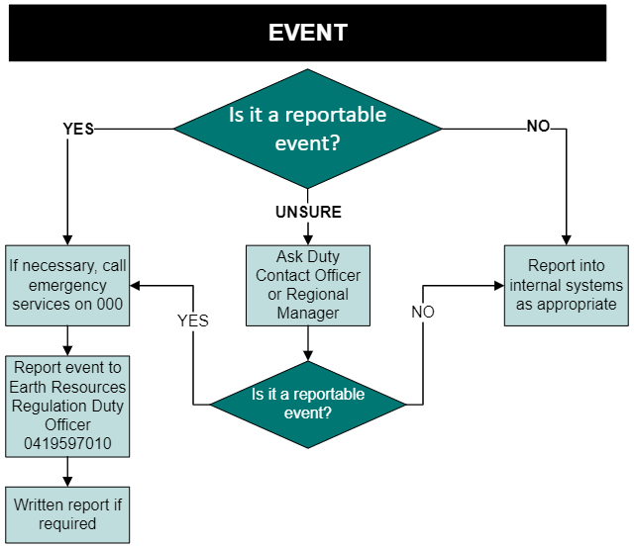

Related information
In relation to exploration and mining, it is an offence under Regulation 51(3) of the Mineral Resources (Sustainable Development) (Mineral Industries) Regulations to fail to give notice of an event.
In relation to the extractive industries, it is an offence under Regulation 20(3) of the Mineral Resources (Sustainable Development) (Extractive Industries) Regulations to fail to give notice of an event.
Failure to report a reportable event in the prescribed time or in the prescribed manner can result in enforcement action including infringements and/or prosecution of the offence.
Failure to report can be categorised as a failure to:
- report reportable events at all or
- report in the prescribed manner or
- provide a written report as requested.
Section 95R of the Act makes it an offence to fail to comply with any lawful requirement of an inspector or making a statement knowing it to be false or misleading. Such an offence may result in enforcement action being taken.

Earth Resources Regulation 24-hour contact
Earth Resources Regulation maintains a 24-hour response and notification capability.
The first point of contact for any out of hours response is the Earth Resources Regulation Duty Officer (DO). The DO is responsible for the initial management of incidents and informing the Chief Inspector of incidents of significance. The DO can be contacted at any time by calling 0419 597 010.
Where it is unclear as to whether an incident is reportable, the DO should be contacted for advice.

Notification contacts
- Earth Resources Regulation Duty Officer: 0419 597 010 (24 hours)
- Email for written notification: ERRChiefInspector@ecodev.vic.gov.au

