Earth Resources Sector Indicators
  - 2020‑2021
Victoria State Government
Jobs, Precincts and Regions

Mineral exploration
Victoria’s mineral exploration expenditure recorded a new high in 2020–21, reaching $183.8 million, a 35% increase from $135.8 million in 2019–20.1
The number of metres drilled exceeded last year’s number by 20.3% – from 388,362 metres in 2019–20 up to 467,585 metres in 2020–21.²
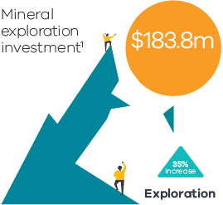
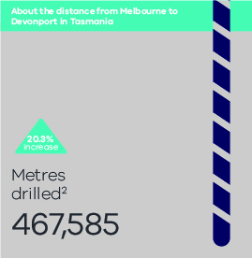
Gold continues to drive mineral exploration investment in Victoria with an 83% increase in 2020–21 compared to the year before.³
Number of new miner’s rights in 2020–21 was 13,835 – an increase of 63% from 2019–20.⁵
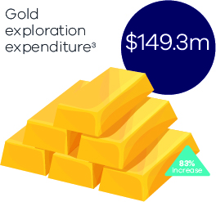
Private new capital expenditure in the Victorian resources sector in 2020–21 was $618 million.⁴
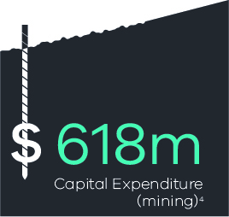

Minerals licences
In 2020–21, there were 526 total current mineral licences across four tenement types (exploration, mining, prospecting and retention licences), 18% higher than the previous year.⁶
In 2020–21, 101 new licence applications were granted, a 114% increase from 47 in 2019–20.⁷
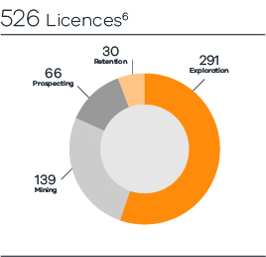
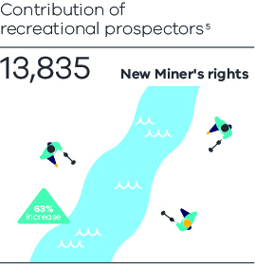
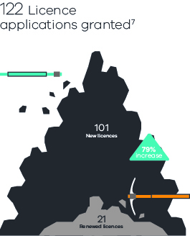

Employment
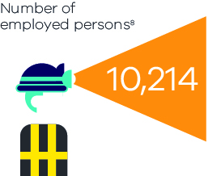

Extractives
In 2020–21, the Victorian extractives industry continued to perform at record‑high levels, with total production equivalent to over 63 million tonnes and total sales of $1 billion (ex‑quarry).
Hard rock production declined slightly by 1.8% from 2019–20, whereas sand and gravel production increased by 2.5% from 2019–20.
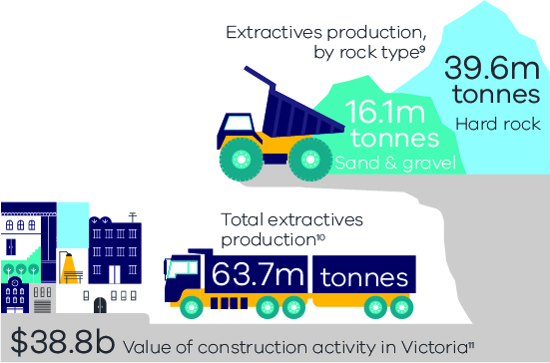

Gas
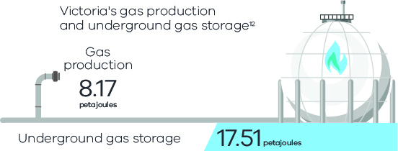
Endnotes
1 ABS, Mineral and Petroleum Exploration, series ID: A2266875F.
2 Earth Resources Regulation, unpublished data.
3 Earth Resources Regulation Statistical Report 2020–21, page 10.
4 ABS, Private new capital expenditure and expected expenditure Australia, table 12 data series: A3517642T.
5 Earth Resources Regulation, unpublished data. A miner’s right is different from a prospecting licence. Recreational prospectors are required to hold a miner’s right in Victoria which allows them to remove and keep minerals discovered on Crown land or private land where the activity is permitted.
6 Earth Resources Regulation Statistic Report 2020–21, page 15.
7 Earth Resources Regulation Statistic Report 2020–21, page 15.
8 National Institute of Economic and Industry Research (NIEIR), unpublished data. Covering industries which are categorised by the ABS as included under the Mining division: Coal mining, Metal ore mining, Non metallic mineral mining and quarrying, Oil and gas extraction, Exploration and other mining support services.
9 Earth Resources Regulation Statistical Report 2020‑21.
10 Earth Resources Regulation Statistical Report 2020–21.
11 ABS Construction Work Done, table 04 series ID: A83778675W.
12 Earth Resources Regulation, Annual Statistical Report 2020–21. Quantity of gas produced in Victorian state waters only i.e. within Victoria’s three nautical mile zone.
For more information earthresources.vic.gov.au
Authorised by the Victorian Government, Melbourne
Victoria State Government
Jobs, Precincts and Regions

