Code of practice

For the construction, operation and decommissioning of petroleum wells in Victoria
AUGUST 2023
Contact Us
Comments, questions or recommendations for amendments to this Code should be sent to petroleum.feedback@ecodev.vic.gov.au
Acknowledgements
In order to facilitate consistency with other state and territory requirements where possible, development of this Code has been informed by similar documents published in Queensland, Northern Territory and New South Wales. Earth Resources Regulation would like to thank the staff in these states and territories for their input, contribution and support in finalising this Code.
© State of Victoria (Department of Energy, Environment and Climate Action) 2023.
This work, Code of Practice for the construction, operation and decommissioning of petroleum wells in Victoria, is licensed under a Creative Commons Attribution 4.0 licence. You are free to reuse the work under that licence, on the condition that you credit the State of Victoria (Department of Energy, Environment and Climate Action) as author, indicate if changes were made and comply with the other licence terms. The licence does not apply to any branding, including the Victorian Government logo and the Department of Energy, Environment and Climate Action logo.
Copyright queries may be directed to IPpolicy@dtf.vic.gov.au.
Disclaimer
This publication may be of assistance to you but the State of Victoria and its employees do not guarantee that the publication is without flaw of any kind or is wholly appropriate for your particular purposes and therefore disclaims all liability for any error, loss or other consequence which may arise from you relying on any information in this publication. While every effort has been made to ensure the currency, accuracy or completeness of the content, we endeavour to keep the content relevant and up to date and reserve the right to make changes as required. The Victorian Government, authors and presenters do not accept any liability to any person for the information (or the use of the information) which is provided or referred to in the report.
Definitions 4
1 About this Code 13
1.1 Introduction 13
1.2 Purpose 13
1.3 Scope 14
1.4 Revision 15
2 Framework for application of this Code 16
2.1 Legislative framework for petroleum wells in Victoria 16
2.2 Interaction between the Code and the Petroleum Act and other relevant legislation 16
2.3 Relationship between this Code and the Operation Plan 17
2.4 Alternative means of compliance 17
2.5 Relevant guidance documents 17
3 Petroleum well lifecycle 18
3.1 Overview of the petroleum well lifecycle 18
4 Petroleum well requirements 19
4.1 Well design and barriers 20
4.1.1 Principles 20
4.1.2 Means of compliance 21
4.1.3 Good industry practice 22
4.2 Casing and tubing 23
4.2.1 Principles 23
4.2.2 Means of compliance 24
4.2.3 Good industry practice 25
4.3 High pressure, high temperature wells 26
4.3.1 Principles 26
4.3.2 Means of compliance 27
4.3.3 Good industry practice 27
4.4 Working with Hydrogen Sulphide 28
4.4.1 Principles 28
4.4.2 Means of compliance 29
4.4.3 Good industry practice 30
4.5 Cementing 30
4.5.1 Principles 31
4.5.2 Means of compliance 31
4.5.3 Good industry practice 35
4.6 Aquifer protection 36
4.6.1 Principles 36
4.6.2 Means of compliance 37
4.6.3 Good industry practice 37
4.7 Wellheads 37
4.7.1 Principles 38
4.7.2 Means of compliance 38
4.7.3 Good industry practice 39
4.8 Well control 39
4.8.1 Principles 39
4.8.2 Means of compliance 39
4.8.3 Good industry practice 41
4.9 Drilling and completion fluids 42
4.9.1 Principles 42
4.9.2 Means of compliance 42
4.9.3 Good industry practice 43
4.10 Evaluation, logging, testing and coring 44
4.10.1 Principles 44
4.10.2 Means of compliance 45
4.10.3 Good industry practice 46
4.11 Well integrity management 46
4.11.1 Principles 46
4.11.2 Means of compliance 48
4.11.3 Good industry practice 49
4.12 Workover and intervention 50
4.12.1 Principles 50
4.12.2 Means of compliance 50
4.12.3 Good industry practice 50
4.13 Well suspension and maintenance 50
4.13.1 Principles 51
4.13.2 Means of compliance 51
4.13.3 Good industry practice 52
4.14 Well decommissioning 52
4.14.1 Principles 53
4.14.2 Means of compliance 54
4.14.3 Good industry practice 70
4.15 Leak management 71
4.15.1 Principles 71
4.15.2 Means of compliance 71
4.15.3 Good industry practice 73
Appendices 74
Appendix 1 – Additional guidance 74
Appendix 2 79

Definitions
Note: The definitions below are for the purpose of understanding this document. These definitions are further to the definitions under the Petroleum Act 1998 and Petroleum Regulations 2021 and are provided for the purpose of additional guidance. If any discrepancy between these definitions is found, then the definitions in the Petroleum Act 1998 and Petroleum Regulations 2021 prevail.
Term | Description
Abnormal pressure | Formation or zones where the pore pressure is above the normal, regional hydrostatic pressure.
ALARP | As low as reasonably practicable (used in evaluating risk).
Annulus/Annular space | The space between two concentric objects, such as between the wellbore and casing or between casing and tubing, where fluid can flow.  A‑annulus – annulus between the tubing and production casing.  B‑annulus – annulus between the production casing and the previous (larger diameter) casing.
API | American Petroleum Institute
Aquifer | A water bearing geological formation(s) as defined by the Victorian Aquifer Framework, Hydrogeological Units from Aquifer number 100 to 112. Refer to Appendix 2.
Authority | Means an exploration permit, a retention lease, production licence, special access authorisation or special drilling authorisation (section 4 of the Petroleum Act).
Barrier | Any means of preventing an uncontrolled release or flow of wellbore fluids to surface.
BHST | Bottom Hole Static Temperature
Blowout | Uncontrolled flow of formation fluids (water, oil, gas, or mixture of these) from a well.
BOP | Blowout Preventer
Bore or water bore | Includes a water observation bore, water supply bore or injection bore.
Casing | A pipe placed in a well to prevent the wall of the hole from caving in and to prevent movement of fluids from one formation to another.
Casing shoe | The bottom of the casing string, including the cement around it, or the equipment run at the bottom of the casing string.
Cement | Powder consisting of alumina, silica, lime and other substances that hardens when mixed with water. Extensively used to bond casing to the walls of the wellbore. Different specifications of cement are used for different purposes. Can be a collective term for cement and non‑cementitious materials that are used to replace cement.
Cement plug | Portion of cement placed at some point in the wellbore.
Cementing | The application of a liquid slurry of cement and water to various points inside and outside the casing.
Centraliser | A device to keep the casing or liner in the centre of the wellbore to help ensure efficient placement of a cement sheath around the casing string.
Christmas tree | Control valves, pressure gauges and chokes assembled at the top of a well to control the flow after the well has been drilled and completed.
Circulation | The process of pumping a fluid down the well and back up to the surface in a drilling or workover operation.
CO₂ | Carbon Dioxide
Code | Code of Practice for the construction, operation and decommissioning of petroleum wells in Victoria.
Completion | A generic term used to describe the assembly of downhole tubulars and equipment required to enable safe and efficient production from an oil or gas well. The point at which the completion process begins may depend on the type and design of well.
Contractors | Third parties contracted by the petroleum authority holder to provide well engineering equipment including drilling rigs, materials, equipment and services.
Coring | Process of cutting cylindrical sample of the formations.
Corrosion | Any of a variety of complex chemical or electrochemical processes (except rust) by which metal is destroyed through reaction with its environment.
Crossflow | Fluid from zones with different pressure characteristics are in communication.
Decommissioning (well) | Permanently closing off wells in a way that ensures that strata, particularly freshwater aquifers, are adequately isolated and the safe removal of equipment and facilities related to the well.
Department | Victorian Government department responsible for administering the Petroleum Act and Petroleum Regulations (Department of Energy, Environment and Climate Action or successor).
Design factor | A margin applied to a load or structural strength to account for uncertainty as to the load, the structural properties, or both.
DHSV | Down Hole Safety Valve
Drilling fluid/mud | Circulating fluid that can lift cuttings from the wellbore to the surface  and cool down the drill bit.
Earth Resources Regulation (ERR) | The Petroleum regulator in the Department of Energy, Environment and Climate Action, responsible for administering the Petroleum Act and the Petroleum Regulations.
EC | Electrical conductivity
Evaluation | Includes mud logging, wireline logging and formation evaluation while drilling, coring and well testing.
Exploration well | A well constructed for the purpose of exploring for petroleum. In this Code, the definition of exploration wells also applies to appraisal wells.
FIT | Formation Integrity Test
Formation pressure | Force exerted by fluids in a geological formation.
Gas | Any naturally occurring hydrocarbon in a gaseous phase.
Gas injection well | A well into which gas is injected for the purpose of maintaining or supplementing pressure in the reservoir and/or for gas storage.
Good cement | Cement that has been verified to position, quantity and quality.
Good industry practice | These are recommended practices, methods and techniques to assist authority holders in meeting the means of compliance. These are not in themselves means of compliance or principles.
H2S | Hydrogen Sulphide
High vis pill | High Viscosity Pill
Horizontal well | Deviation of a borehole from vertical so that the borehole penetrates a productive formation at 90-degrees inclination from vertical.
HPHT wells | High pressure, high temperature (HPHT) wells, typically in industry accepted as ≥150°C (300°F) undisturbed bottom hole static temperature, ≥69MPa (10,000psi) expected surface pressure needing deployment of pressure control equipment with a rated working pressure in excess of 69MPa (10,000psi).
HT | High temperature (HT) wells, typically ≥150°C (300°F) bottom hole static temperature.
Injection well | Well through which gas is stored or fluids are injected into an underground stratum which may increase reservoir pressure.
Intermediate casing | The string of casing set in a well after the surface casing.
ISO | International Standards Organisation
Kg | Kilograms
Kick | An unplanned entry of water, gas, oil or other formation fluid into the wellbore during drilling.
Kick tolerance | Maximum volume of formation fluid influx that can be safely shut in and circulated out of the well without breaking down the formation.
Leak‑off test | Progressive wellbore formation pressure test until leak‑off to provide well integrity information.
Liner | A casing string that does not extend to the top of the wellbore, but instead is anchored or suspended from inside the bottom of the previous casing string.
LOT | Leak Off Test
LWD | Logging while drilling, or formation evaluation while drilling.
m | Metre(s).
Managed pressure drilling | An adaptive drilling process used to precisely control the annular pressure profile throughout the wellbore while drilling.
Means of compliance | These are the expectations of Earth Resources Regulation (ERR) for meeting/complying with the requirements of the Petroleum Act and Petroleum Regulations. By adhering to these expectations, the well or bore would meet the principles.
Minister | Minister for Energy and Resources
Minor leak | See section on leak classification in this Code.
NACE | National Association of Corrosion Engineers
NAF | Non‑Aqueous Drilling Fluid
NORSOK | Norwegian Petroleum Industry Standards
OCTG | Oil Country Tubing Goods
Offset well information | Near well information available from previous drilling in the immediate vicinity of the proposed well.
OGI | Optical Gas Imaging
Open hole | The uncased portion of a well.
Packer | Piece of downhole equipment that consists of a sealing device which is used to block the flow of fluids through the annular space between the pipe and the wall of the wellbore or the annular space between two pipes.
Perforating | The method of opening a well through the casing to the formation bearing the fluid to be produced.
Permanent barrier | A verified barrier that will maintain a permanent seal. A permanent barrier must extend across the full cross section of the well and include all annuli.
Petroleum | - any naturally occurring hydrocarbon (whether in a gaseous, liquid or solid state); or  - any naturally occurring mixture of hydrocarbons (whether in a gaseous, liquid or solid state); or  - any naturally occurring mixture of one or more hydrocarbons (whether in a gaseous, liquid or solid state) and one or more of the following: hydrogen sulphide, nitrogen, helium or carbon dioxide (section 6 of the Petroleum Act).
Petroleum Act | Petroleum Act 1998 (Vic)
Petroleum exploration | Petroleum exploration is the carrying out of one or more of the following activities for the purpose of finding petroleum or reservoirs:  - conducting geological, geophysical and geochemical surveys;  - making wells;  - taking samples for the purpose of chemical or other analysis;  - extracting petroleum from land for the purpose of determining whether it will be viable to extract it commercially (section 7 of the Petroleum Act).
Petroleum operation | Any activity relating to petroleum exploration or to petroleum production (section 4 of the Petroleum Act).
Petroleum production | Petroleum production is:  - the extraction of petroleum from land for the purpose of producing it commercially;  - the injection and storage of petroleum in reservoirs for the purpose of later recovering it;  - the recovering of petroleum from reservoirs into which the petroleum was previously injected;  - any activity incidental to any activity listed in paragraph (a), (b) or (c), including the processing of petroleum and transportation of petroleum within the area in which the petroleum is being produced (section 8 of the Petroleum Act).
Petroleum Regulations | Petroleum Regulations 2021 (Vic)
Petroleum well | A hole in the sub‑soil made by drilling, boring or any other means in connection with a petroleum operation, but does not include a seismic shot hole.
pH | Index of acidity or alkalinity of the fluid.
Plug | Any object or device that blocks a hole or passageway.
PPFG | Pore Pressure and Fracture Gradient
Pressure control equipment | Includes the BOP stack, BOP control system, full open safety valves, circulating hose (and circulating head), drill‑string safety valves (inside BOPs), mud and cement pumps, the choke and kill lines and manifold, mud gas separator and all associated pipework and valves.
Primary cementing | The process of placing a cement sheath around a casing or liner string.
Principles | These are the fundamental requirements that must be adhered to during the lifecycle of the well or bore.
Production casing | A casing string that is set across the reservoir interval and within which the primary completion components are installed.
Production zone | Hydrocarbon producing zone of the formation.
psi | Pounds per square inch.
Reservoir | An underground natural reservoir that is suitable for the storage of petroleum (section 4 of the Petroleum Act).
SDS | Safety Data Sheets
SG | Specific gravity
Shut‑in well | Non-active well which has not yet been suspended or a temporarily inactive well.
Sulphide stress cracking | A form of hydrogen embrittlement which is a cathodic cracking mechanism, affecting susceptible alloys of steels.
Surface | A natural ground surface or the top of the BOP flange when installed.
Surface casing | A drilled and cemented pipe used to provide blowout protection, to seal off water/hydrocarbon sands, and prevent loss of circulation. Also used to seal off water sands, weak formations and/or lost circulation zones. In some cases, surface and intermediate casing requirements are provided by the same string.
Suspended well | A shut-in well which has an additional requirement as defined in the WIMS as it has been offline for a significant period of time.
Territorial sea baseline | Refers to the line from which the seaward limits of Australia’s Maritime Zones are measured. It generally corresponds with the low water line along the coast and will be a straight line across deeply indented localities.  Geoscience Australia  Maritime Boundary Definitions
TOC | Top of Cement
TS | Technical Specifications
Underbalanced | Wellbore condition in which the pore pressure exceeds the wellbore hydrostatic pressure.
Underbalanced/managed pressure drilling | A drilling activity employing equipment and controls where the pressure exerted in the wellbore is intentionally maintained less than (underbalanced) or close to (managed pressure) the pore pressure in any part of the exposed formations.
US NSPS | United States New Source Performance Standards, Environmental Protection Agency
USEPA | United States Environmental Protection Agency
Water bearing formation | A geological formation bearing water as defined by the Victorian Aquifer Framework, Hydrogeological Units from Aquifer number 113 and deeper. Refer to Appendix 2.
Water observation bore | Water bore used to monitor groundwater pressure or used to access groundwater for taking water samples. This has the same meaning as water monitoring bore under the Water Act 1989.
Water supply bore | Includes a bore constructed for taking groundwater and a bore for injecting water or brine (injection bore).
Well activity | Means well operation, including construction, operation, well intervention, workover, suspension and decommissioning.
Well barrier | Envelope of one or several well barrier elements preventing fluids from flowing unintentionally from the formation into the wellbore, into another formation or to the external environment.
Well integrity | Well integrity, in relation to a well, means that the entire length of the well, for the life of the well:  - is under control, in accordance with an operation plan accepted under section 161 of the Act; and  - is able to contain reservoir fluid; and  - is not the subject of any unforeseen risks (regulation 5 of the Petroleum Regulations).
Well intervention | An operation carried out by re‑entering an existing well.
Well or well‑hole | A hole in the sub‑soil made by drilling, boring or any other means in connection with a petroleum operation but does not include a seismic shot hole. This includes production, exploration, appraisal wells and gas injection wells.
Wellhead | The system of spools, valves and associated adapters that provide pressure control.
WIMS | Well Integrity Management System
WOC | Wait on Cement
WOMP | Well Operation Management Plan
Workover | Well procedure to perform one or more of a variety of remedial/maintenance operations on a well to maintain well integrity or attempt production increase. Examples of workover operations are pump repairs, well deepening, plugging back, pulling and resetting liners, squeeze cementing and re‑perforating.

- About this Code
  - Introduction
This Code of Practice (Code) is made in accordance with section 250 of the Petroleum Act 1998 (Petroleum Act) and supports the implementation of the Petroleum Regulations 2021 (Petroleum Regulations). This Code intends to inform industry on minimising and managing risks associated with onshore petroleum wells during all stages of the petroleum well lifecycle (construction, operation, suspension and decommissioning). The Code is to be read in conjunction with the Petroleum Act and the Petroleum Regulations.
This Code aims to provide practical guidance to authority holders in designing and carrying out petroleum operations. It contains standards, rules and specifications relevant to petroleum operations to assist this purpose.
A person is not liable to any civil or criminal proceeding only because the person has failed to observe any provision of an approved code of practice. If a person allegedly contravenes a provision of the Petroleum Act, this Code is admissible as evidence in that proceeding. The Code can be used to establish the alleged contravention, if a provision of the Code is relevant to the alleged contravention matter and the person failed to observe that provision (section 251 of the Petroleum Act).
Earth Resources Regulation (ERR) within the Department of Energy, Environment and Climate Action (DEECA) is the regulator for onshore petroleum operations in Victoria. ERR reports to the Minister for Energy and Resources on the management of onshore petroleum resources activities in Victoria.
  - Purpose
The purpose of this Code is to provide practical guidance to authority holders under the Petroleum Act and Petroleum Regulations on onshore petroleum well operations during all stages of the petroleum well lifecycle so that:
- The impacts on members of the public and the environment and land and property as a result of petroleum operations will be minimised as far as is practicable (section 3(2)(b) of the Petroleum Act); and
- Land affected by petroleum activities is rehabilitated (section 3(2)(c) of the Petroleum Act).
Note: This Code focuses on the well decommissioning aspect of land rehabilitation. For information on the surface earth works and revegetation aspects of land rehabilitation, see the EMP (Environment Management Plan) guidance.
This Code focuses on well integrity, containment of petroleum and the protection of groundwater resources, both short and long-term.
The Code uses the following terms to describe the regulator’s expectations of authority holders with regard to well management:
- Principles: these are the fundamental requirements that must be adhered to during the lifecycle of the well or bore.
- Means of compliance: these are the expectations of Earth Resources Regulation for meeting/complying with the requirements of the Petroleum Act and Petroleum Regulations. By adhering to these expectations, the well or bore would meet the principles.
Good industry practice: these are recommended practices, methods and techniques to assist authority holders in meeting the means of compliance. These are not in themselves means of compliance or principles.
  - Scope
The inclusions and exclusions associated with this Code are listed in Table 1.
Table 1: Inclusions and exclusions
Inclusions | Exclusions
- Site selection  - Well design and construction  - Well operation  - Well suspension and maintenance  - Well decommissioning  - Responsibilities for managing well activities  - Reporting and notification obligations  - Leak incident management  - Water/waste management in well operations  - Subsurface environmental management | - Wells regulated under other legislation (e.g. water wells, water monitoring bores)  - Financial considerations (e.g. compensation, bonds, fees, charges and taxes)  - Requirements under occupational health  and safety and environmental legislation  - Manufacturer or certification requirements of drilling rigs or associated equipment  - Surface environmental management and rehabilitation beyond the wellhead  - Reservoir management  - Pipelines, gathering lines and processing plants

  - Revision
At the time of making of the Code, it is intended to review the Code within 12 months of commencement and from then on every two years, or as needed for reasons such as changes in legislation, regulations and industry standards. The Code may be updated/varied from time to time and the current published version will be maintained on the department website.
- Framework for application of this Code
  - Legislative framework for petroleum wells in Victoria
Onshore petroleum well activities are regulated under the Petroleum Act and the Petroleum Regulations.
Any wells drilled from an onshore location to an offshore target are regulated under both the Petroleum Act and the Offshore Petroleum and Greenhouse Gas Storage Act 2010. The Petroleum Act applies to all activities landward from the territorial sea baseline whereas the Offshore Petroleum and Greenhouse Gas Storage Act 2010 applies to petroleum activities seaward from the territorial sea baseline. The National Offshore Petroleum Safety and Environmental Management Authority (NOPSEMA) should be contacted regarding well management requirements under the Offshore Petroleum and Greenhouse Gas Storage Act 2010.
Before carrying out any well activity covered by this Code, the holder of the authority must prepare an operation plan (section 161(1) of the Petroleum Act). If the petroleum operation includes the making of a new well, carrying out activities on an existing well or decommissioning a well, the operation plan must include a Well Operation Management Plan (WOMP) (regulation 22 and 36 of the Petroleum Regulations). The WOMP must describe each of the proposed stages of well activity (regulation 36(1)(c). If the WOMP needs to be changed at any point, this would need to be managed via proposing a variation to the operation plan, as set out in section 163 of the Act. Plans should be reviewed and maintained as necessary to ensure that they remain current.
  - Interaction between the Code and the Petroleum Act and other relevant legislation
This Code provides practical guidance on how to comply with the obligations set out in the Petroleum Act and the Petroleum Regulations that relate to well operations. If there is an inconsistency between the obligations under the Petroleum Act or Petroleum Regulations and this Code, the obligations under the Petroleum Act and Petroleum Regulations prevail.
Any obligations placed on authority holders under other legislation take precedence over the Code. These may include, but are not limited to:
- Pipelines Act 2005
- Occupational Health and Safety Act 2004
- Dangerous Goods Act 1985
- Environment Protection Act 1970
- Climate Change Act 2017
- Gas Safety Act 1997
Crown Land (Reserves) Act 1978.
If there is any inconsistency between the requirements of the Code and these statutes, the requirements of these statutes prevail.
  - Relationship between this Code and the Operation Plan
The guidance in this Code will assist the authority holder in preparing their operation plan.
  - Alternative means of compliance
An authority holder may seek approval for an operation plan that includes alternative means of compliance with the Petroleum Act and Petroleum Regulations (i.e. different to the contents of this Code) where this will achieve a better outcome than the relevant measures in this Code.
  - Relevant guidance documents
Relevant industry standards, recommended practices, technical reports and industry experience apply across the full petroleum well lifecycle. Relevant guidance has been included within this Code. A non-exhaustive list of some other relevant guidance documents is provided in Appendix section at the end of this Code.
- Petroleum well lifecycle
  - Overview of the petroleum well lifecycle
The Code refers to key stages of a petroleum well activity because each stage has inherent risks and specific requirements and standards to be applied to manage these risks.
Construction | ‘Well construction’ refers to the construction process required or recommended elements to be constructed (including repair/rework) and verification tasks to be performed to achieve the intended design. It addresses any variations from the design which require a revalidation against the identified hazards and risks.
Operation | ‘Well operation’ refers to the requirements or recommendations and methods for managing well integrity during the operation of the well (e.g. production, injection, intervention, workover).
Suspension | ‘Well suspension’ refers to requirements and recommendations for managing well integrity during suspension of well activities.
Decommissioning | ‘Well decommissioning’ refers to the requirements or recommendations for permanently decommissioning a well.

- Petroleum well requirements
The petroleum well requirements set out in this Code are outlined in the sections of this chapter below. All requirements support the following regulations in the Petroleum Regulations.
- Regulation 22 ‘Content of operation plan’
- Regulation 23 ‘Notice of operation plan’
- Regulation 26 ‘Notice regarding variation to operation plan’
- Regulation 28 ‘Consent to conduct production tests or well tests’
- Regulation 29 ‘Consent to suspend or decommission a well’
- Regulation 36 ‘Well operation management plan’
- Regulation 39(2) ‘Annual Report’
- Regulation 46 ‘Requirement for daily drilling report’
- Regulation 47 ‘Requirement for initial well completion report and data’
- Regulation 48 ‘Requirement for final well completion report and data’
Regulation 49 ‘Well decommissioning report’.
Where a section of this Code supports a specific regulation, this is indicated in the sub‑sections below. The Code applies throughout the well lifecycle including decommissioning.
Section | Regulations supported
4.1 Well design and barriers | 22, 23, 26, 28, 29, 36, 47, 48, 49
4.2 Casing and tubing | 22, 23, 26, 36, 47, 48, 49
4.3 High pressure and high temperature | 22, 23, 26, 36, 47, 48
4.4 Working with hydrogen sulphide | 22, 23, 26, 36
4.5 Cementing | 22, 23, 26, 36, 47, 48 49
4.6 Aquifer protection | 22, 23, 26, 36, 49
4.7 Wellheads | 22, 23, 26, 36
4.8 Well control | 22, 23, 26, 36, 47, 48
4.9 Drilling and completion fluids | 22, 23, 26, 36, 46, 47, 48
4.10 Formation evaluation | 22, 23, 26, 28, 36, 47, 48, 49
4.11 Well integrity management | 22, 23, 26, 28, 29, 36, 47, 48, 49
4.12 Workover and intervention | 22, 23, 26, 36, 49
4.13 Well suspension and maintenance | 22, 23, 26, 29, 36, 47, 48
4.14 Well decommissioning | 22, 23, 26, 29, 36, 47, 48, 49
4.15 Leak detection and management | 22, 23, 26, 36, 39(2)

  - Well design and barriers
Well design refers to the features that are considered when planning and constructing a well. The well design defines the desired final status of the well. Well barriers refer to the components of a well designed to prevent fluids or gases from flowing unintentionally from one geological formation into another formation or to escape at surface.
    - Principles
Wells are designed and constructed (including when converting exploration wells to production, injection or storage wells) to enable the safe and environmentally sound production of petroleum by ensuring that:
- well objectives are met;
- any unintentional influx, crossflow contamination between hydrocarbon bearing zones and aquifers and outflow to external environment is prevented;
- fluids are contained within the well and associated pipework and equipment without leakage;
- barrier envelopes are designed such that the failure of the primary barrier will not lead
to an uncontrolled release of formation fluids (e.g. blowout);
- zonal isolation between differently pressured permeable formations (e.g. aquifers and hydrocarbon bearing zones) is achieved; and
- the introduction of substances that may cause environmental risks are minimised as far as is reasonably practicable.
Systems and processes are put in place to contain and control wellbore fluids, provide structural support and retain well integrity throughout all reasonably anticipated construction, testing, production, injection, intervention, workover, suspension and decommissioning load conditions.
The completion is designed to operate within the maximum expected pressures and load conditions until final well decommissioning.
    - Means of compliance
- A basis of design for well lifecycle is conducted. Basis of design consists of, but is not limited to, well design and well barriers during the well lifecycle.
- Casing setting depths take into account aquifer, water bearing formations and production zone locations and the requirements for well control.
- Pressure control equipment is installed based on risk assessment (e.g. BOP equipment to API Standard 53).
- Use fit-for-purpose casing weight and grade with appropriate casing running procedures. This includes consideration for casing corrosion risk and connection suitability.
- Use appropriate well design and construction materials.
- Perform modelling to specify the quantity and design of centralisers needed to achieve a good stand‑off for cement job and use them.
- Use engineered cement slurries with both appropriate and effective cement placement techniques.
- Ensure that all fluids produced from the well travel directly from the production zones to the surface without cross contamination.
- Ensure that all wells are constructed, maintained and decommissioned in a manner where it can be demonstrated that there are two independently verified well barriers between a hydrocarbon bearing or abnormally pressured formation and the surface.
- Ensure that aquifers and water bearing formations are isolated and protected.
- A barrier can only be considered verified when there is physical evidence that the barrier has been placed in its desired location and will perform its required function.
- Whenever drilling fluids are used as a primary barrier, sufficient reserves of drilling fluids and supplies of drilling fluid weighting materials are available at well site for immediate use so that the well can be maintained full of drilling fluid.
- Barrier placement and verification procedures are developed to identify satisfactory establishment of barriers at each relevant stage of well operations during well construction.
- Exemption from two independently verified barriers may be permissible in the following scenarios:
- when it has been demonstrated that there is no natural lift mechanism for hydrocarbons or water to flow to the surface;
- during top hole or surface hole drilling where shallow fluid risk has been assessed as being negligible;
- during diverter drilling;
- during planned underbalanced and managed pressure drilling where surface equipment design limits are not exceeded;
- during decommissioning, when two overlying formations need to be isolated from one another and two barriers are not feasible, then a continuous cement plug of at least 50m (or as the geology permits) is placed above and below the interface;
- in other circumstances during well lifecycle activities when a risk assessment has been completed as per authority holder’s risk management processes.
- All well designs and construction procedures include contingency planning to mitigate the effects of failures in the event of unplanned process upsets or events during construction.
- Storage/injection wells design considerations include pressure, thermal stresses, corrosion resistant materials (tubular and cement) and injection rates. Maintenance is carried out to avoid loss of well integrity.
- For storage/injection wells, undertake risk management in accordance with API RP 1171 and ISO/TS 16530‑1.
    - Good industry practice
- Review offset well information to assist in the design process for new wells.
- Include nearby deep‑water bores in the record keeping and dataset as part of the offset review.
- Consider offset data that details any evidence of tubular corrosion. If corrosion has been observed, authority holders will need to conduct a risk assessment and take action to ensure well integrity.
- In determining the placement of casing strings, use the offset well review formation horizons or zones from which water bores produce.
- Well design is completed by suitably qualified or experienced personnel. Review and assurance of well design is completed by other suitably qualified or experienced person(s) independent from the design originator and their immediate line management, and independent from the team that has responsibility for construction of the well.
- Use sustainable construction practices and operating procedures (e.g. to conserve water and reduce waste).
- Select casing hardware, including liner hangers, float equipment, centralisers, cement baskets, wiper plugs (top and bottom), stage tools and external casing packers, that will ensure zonal isolation is part of the well design.
- Review information on geological strata and formations and fluids within them, that the well may intersect and any hazards which they may contain.
- Schematic drawings of well barrier arrangements are prepared for the well or group of related wells.
- The test pressures for verifying well barriers are applied in the direction of flow towards the external environment. If this is not possible or introduces additional risk, the test pressure can be applied against the direction of flow towards the external environment, provided the well barrier is designed to seal in both flow directions.
  - Casing and tubing
Casing is steel pipe that is run into the wellbore and is usually cemented in place.
The purpose of the casing is:
- to prevent the hole from caving in;
- to prevent contamination of aquifers;
- to prevent water migration to producing formation;
- to control pressures during drilling.
Tubing is also a steel pipe, used to transport produced fluids to the surface.
    - Principles
Casing and tubing are designed to withstand the various compressive, tensile and bending forces that are exerted while running‑in the hole, as well as the collapse and burst pressures that it may experience during different phases of well life (e.g. cementing, pressure testing, stimulation and production cycles). Casing strings are designed to facilitate installation of pressure control equipment.
The casing program is configured to accommodate all identified subsurface hazards and to minimise risk as far is reasonably practicable, either from crossflow between formations or the uncontrolled release of well bore fluids to surface, so that the aquifers are isolated and protected throughout the life of the well.
Casing setting depths are selected to provide an adequate safety margin between the formation fracture pressure and anticipated pressures during well control and casing cementation operations.
Note: Hydraulic fracturing is banned in Victoria.
    - Means of compliance
- All casing in pressure containing applications, casing connections, wellheads and valves used in wells are designed to withstand the loads, pressures and temperatures that may act on them throughout the entire well lifecycle, including decommissioning. This includes casing running and cementing, any treatment pressures, production pressures, potential well control situations, any potential corrosive conditions (H₂S, CO₂, etc) and other factors pertinent to local experience and operational conditions.
- Casing and tubing stress analysis is carried out on all foreseeable load scenarios that may be imposed on the well. Casing design considers both uniaxial and triaxial analysis.
- In all wells, the conductor pipe does not need to meet the casing requirements as mentioned in (a) and (b) above.
- Methods of preventing external corrosion that impacts on well integrity are considered and implemented where appropriate.
- Surface plugs and barriers are installed to prevent surface pollutants from entering the well and to prevent wellbore fluids from escaping to the surface environment or into aquifers.
- Appropriate design safety factors are applied to design of the casing strings and casing connections.
- The design safety factors used are appropriate for the anticipated well life, service conditions and local experience.
- All casing and tubing are manufactured to the latest edition of API 5CT/ISO 11960. The rated capacity of the pipe body and connections are obtained from the latest edition of API 5CT/ISO 11960 or the manufacturer’s technical specifications. Any material other than steel used for casing and tubing is to have appropriate manufacturing specifications and verifiable properties.
- To verify casing integrity during the well construction process, casing is to be pressure tested prior to drilling out for the next hole section (in the case of surface or intermediate casing) and prior to completion operations commencing (in the case of production casing). Ensure that the test pressure is greater than the maximum anticipated surface pressure (considering the fluid gradient of the potential formation fluid influx from the next hole section) but does not exceed the burst pressure rating of the casing with the design factor applied.
- Minimum casing setting depth is sufficient to meet the isolation requirements of groundwater aquifers and provide an acceptable kick tolerance for the next hole‑section to be drilled. The kick tolerance criteria selected will be dependent upon knowledge of the local PPFG profiles and of the likely kick conditions in the well.
- All production casing strings are to contain gas tight connections.
- The yield stress of the Oil Country Tubing Goods (OCTG) are de‑rated for temperature.
- Welded connections are not permitted on any type of well. Seamless and electric‑welded pipe is permitted provided it is manufactured in compliance with API 5CT/ISO 11960.
- Casing life is designed to take account of expected well life and to minimise post-decommissioning impact.
    - Good industry practice
- Casing and tubing designs are carried out with the aid of industry recognised software, to confirm that temperature effects and forces such as flowback‑induced compression forces are accounted for.
- For casing run in wells, pipe body and connections have verifiable properties (i.e. in terms of burst, collapse and tensile strengths).
Note: Casing manufactured to API specifications must meet strict requirements for compression, tension, collapse and burst resistance, as well as quality and consistency.
- When making up a casing connection, it is important that the recommended torque be applied. Too much torque may over‑stress the connection and may result in failure of the connection. Too little torque may result in leaks at the connection. For production casing, a record of torque turn plot should be maintained.
- The correct use of casing dope, appropriate temperature application and its impact on torque make‑up is incorporated into casing running procedures.
- Consider using gas tight connections where appropriate.
- Consider the potential impact of high casing pressure on cement bond quality when determining pressures for any casing tests carried out before cement has properly set.
- Drilling contractors and well site supervisors review and ensure compliance of the work program to run, install and test all casing strings during well construction.
- Long-term monitoring and recording of casing condition is undertaken.
- Pressure tests for verification of casing integrity, to:
- be greater than the maximum anticipated surface pressure;
- be equal to the maximum annulus pressure used for pressure testing of completion strings/tools for the particular string;
- not exceed the casing design factor for the pressure test load;
- not exceed the rated capacity of weakest component of casing string; and
- not exceed the rated burst capacity of the casing with design factor applied.
- Casing connection qualification testings are ISO 13679 and API RP 5C5 based on intended service.
- Compression rating of connections are applied to casing and tubing design as per the manufacturer’s recommended values.
- Where appropriate, suitable allowance is made for lifecycle casing wear, erosion and corrosion. Casing wear is monitored closely in high angle wells during well construction, as well as throughout well life. Casing wear modelling performed for highly deviated wells.
- Consideration of metal‑to‑metal seal thread connections in production casing and tubing strings for wells designed for gas lift and for gas wells that cross either hydrocarbon‑bearing zones or abnormally pressured water zones.
- Conductor casing string is installed to protect the well and equipment against surface formation instability and to enable circulation of drilling fluid from the well prior to the surface casing being installed.
  - High pressure, high temperature wells
This section provides specific additional requirements for wells that operate at above standard working temperatures and pressures. High temperature is defined as an undisturbed Bottom Hole Static Temperature (BHST) greater than 150°C (300°F). High pressure is defined as either the maximum pore pressure of any porous formation that exceeds a hydrostatic gradient of 18kPa/m (0.8psi/ft) or needing deployment of pressure control equipment with a rated working pressure greater than 69MPa (10,000psi).
    - Principles
For High Pressure, High Temperature (HPHT) wells, limits relating to maximum anticipated surface pressures, circulating temperatures and well pressure control equipment capabilities and readiness must be understood, with well design and construction taking account of these and other factors.
The key principles for HPHT petroleum well design involve:
- accurate determination of pressure, temperature and reservoir fluid characteristics;
- modelling to predict temperatures and pressures during well construction and well activity stages;
- identification of fit-for-purpose rig requirements including drill string, downhole tools and well pressure control equipment;
- establishment of specific procedures for drilling, tripping and well control to address HPHT zones in well; and
- contingency planning for well control.
A well may be only high temperature, only high pressure or both high pressure and high temperature.
    - Means of compliance
- For HPHT wells, a PPFG plot is developed and included in all WOMPs.
- A risk assessment is carried out on HPHT wells to understand level of PPFG monitoring and connection fingerprinting required while drilling.
- Wells are designed and operated to prevent the possibility of a temperature rise causing fluids to be trapped, generating a pressure in excess of the equipment rating.
- Industry-recognised software is used for casing design in HPHT wells. This is to confirm that temperature effects and resultant compression forces in particular are adequately assessed in the casing and tubing design.
- Rig selection and capability for HPHT operations satisfy the well construction requirements.
- Advanced well control response and equipment are considered as part of the well design for tertiary well control response.
- Specific training for HPHT well control response is undertaken by personnel in charge of well activities – for Tool‑pushers, Drillers and Assistant Drillers, as a minimum – onsite.
- Contingencies are in place to mitigate failures or unplanned events during construction.
    - Good industry practice
- In areas where PPFG cannot be determined accurately from offset well data, pore pressure prediction studies based on seismic data and/or other specialist techniques may be used.
- In high temperature wells, the wellbore temperature can vary significantly between a static (geothermal) condition and the dynamic, or circulating, condition of the mud system. Temperatures measured while drilling and logging are taken into account to help optimise mud properties, cementing fluid properties and design.
- When drilling with a weighted fluid, the density of the fluid in/out of the well is checked at an appropriate frequency to confirm the correct weight is being maintained to control the well. In HPHT wells, the fluid is in general weighed at a higher frequency than other wells.
- Modelling of the equivalent static density and equivalent circulating densities are conducted where accurate control of mud weight is required (e.g. small overbalance scenarios).
- Consideration is given to pore pressure prediction while drilling.
- Bottom hole assembly components are rated for the anticipated temperature and pressure in the appropriate hole section(s):
- Consideration is given to use of both a drilling float valve and a drop‑in dart sub in the drill string. Consideration is given to two drop‑in dart subs in tapered drill strings.
- Drilling float valves may be ported following a risk assessment.
- Consideration is given to using a drilling stand to facilitate installation of a kill assembly for high pressure pumping that may be needed during a well killing operation when drilling in abnormally pressured hydrocarbon bearing zones with potential to flow.
- Consideration is given to the working temperature rating for well pressure control equipment, to meet the maximum anticipated continuous exposure temperature for rubber/elastomer components and high pressure hoses. Critical spares include components exposed to high temperatures while drilling.
  - Working with Hydrogen Sulphide
This section provides specific operational requirements for wells that encounter Hydrogen Sulfide (H₂S) gas. Hydrogen Sulphide gas is a hazardous substance.
    - Principles
Suitable operational practices are in place to manage the risks associated with Hydrogen Sulfide (H₂S), a hazardous substance and a dangerous goods sometimes found in fluids encountered in oil and gas production.
H₂S management practices – triggered when H₂S exceeds 10ppm (by volume) in air – include:
- characterisation of the probability and concentration levels of H₂S that may be encountered; and
- the safe handling of any H₂S encountered during well operations.
    - Means of compliance
- On exploration or appraisal wells, or where there is evidence of H₂S in the region, a review of reservoir and offset well data is carried out for a well, or campaign of wells in the same reservoir, to determine the probability and concentration levels of H₂S.
- Emergency response planning considers landholders and surrounding community as well as addressing WorkSafe Victoria requirements.
- Drilling contractor and any service companies involved in well site operations are advised of predicted H₂S levels and temperatures.
- Appropriate H₂S training/competence of drilling contractor and key service personnel.
- Fit-for-purpose H₂S detection equipment is used on site.
- A flare system is provided to safely collect and burn H₂S gas during well control or well test operations. Flare lines are located as far away from the well as reasonably practicable.
- For operations where H₂S is predicted, continuous H₂S monitoring equipment capable of continuously measuring and displaying the concentration of H₂S in ambient air is installed.
- The monitoring and response arrangements meet WorkSafe Victoria requirements.
- For H₂S operations where the partial pressure of H₂S gas exceeds 350Pa (0.05psi), or 70kPa (10psia) in sour crude systems, equipment and materials are selected based on resistance to sulphide stress cracking and corrosion. For recommendations on selection of equipment and materials for sour conditions, refer to National Association of Corrosion Engineers (NACE) Standard MR0175/ISO 15156.
- Elastomers, packing and other non‑ferrous parts exposed to H₂S are resistant at the maximum anticipated temperature of exposure.
- A drilling fluid program includes the use of an H₂S scavenger to remove any H₂S from the drilling fluid, if required.
- When coring operations are conducted in possible H₂S bearing zones, breathing apparatus is worn and handheld sensors are used to test for H₂S for the final 10 stands and this is continued while retrieving the inner core barrels, opening the core barrels and examining the cores. Prior to transportation, cores are sealed and marked to indicate the presence of H₂S.
- If H₂S in the gas phase is predicted during well test operations, H₂S concentration is monitored at first hydrocarbons to surface and at regular intervals throughout the test.
- If H₂S levels exceed original design assumptions or cannot be controlled with the resources available on the rig, the well is shut-in. The well remains shut‑in until the level of H₂S readiness is increased such that operations can continue safely.
    - Good industry practice
- The selection of equipment and materials for use under sour conditions are done in accordance with NACE Standard MR0175/ISO 15156.
- Consult API RP 49: Recommended Practices for Safe Drilling of Wells Containing H₂S.
- H₂S sensors that activate and provide audible and visual alarms when sensing 5ppm of H₂S in the atmosphere are installed and confirmed to be functioning.
- All fixed and portable detectors are function‑tested weekly, or in accordance with manufacturer’s specifications.
- Detection for H₂S in drilling muds utilises methods such as the Garrett Gas Train method and the Hach test, of which the Garrett Gas Train method provides greater accuracy and a quantitative result. Tests provide useful information to help decide scavenger treatment levels. Removal of H₂S or its resulting sulphide anion from drilling mud requires its precipitation as an insoluble salt. The addition of Zinc Carbonate (ZnCO₃) to drilling mud will form insoluble Zinc Sulphide.
- Prior to penetrating known or predicted H₂S zones, all rig H₂S detectors are confirmed to be functioning correctly and tested. Drilling fluids are confirmed to be within specification – especially with respect to pH for water‑based muds and Particulate Organic Matter alkalinity greater than two for non‑aqueous muds. Testing frequency for H₂S is determined and actioned.
- Flaring and well testing takes place only when the wind strength and direction is conducive to carrying all released gas from the gas flare, oil burner, or otherwise, away from sensitive receptors.
- Sampling for H₂S is conducted where safe and practical and data used for optimisation of future well designs and surface facilities.
  - Cementing
Cementing during well construction and decommissioning refers to placement of cement sheath in the annulus between the casing and the formation.
The purpose of the cementing is:
- to support the casing;
- protect the casing from formation fluids;
- protection of aquifers from drilling fluids and other contaminants;
- isolate different formations;
- prevent formation fluids from migrating to the surface.
    - Principles
Petroleum wells are cemented to:
- prevent migration paths and isolate the target zone from other formations;
- protect groundwater from contamination;
- maintain the pressure and quality of aquifers;
- obtain and maintain well integrity;
- protect the casing from corrosion (noting that corrosion rates of steel with an adequate cement coating are sufficiently low that cement encapsulation of steel is accepted as a permanent barrier);
- provide axial support for the casing string to permit further drilling and to provide an anchor for BOP equipment;
- reduce possibilities of casing buckling and/or collapse, particularly in situations where abnormal formation stresses occur; and
- provide a seal to the casing shoe, or equivalent, to control pressure.
Note: For cementing during decommissioning, see section 4.14 Well Decommissioning.
    - Means of compliance
- To prevent communication between zones of differing pressure and water quality:
- All surface casing is cemented from shoe to surface.
- Cement jobs are to be designed such that all aquifers, high pressure zones and hydrocarbon zones are adequately isolated.
- Where cement is not brought to surface during well decommissioning, isolation of all water bearing formations is achieved through a cement barrier inside casing – across impermeable formations and above and below each water bearing formation.
- Testing pressures take into account the collapse pressure of the inner casing string and the fracture gradient at the outer casing shoe.
- Cement constituents and properties are suitable for the intended conditions and are used in compliance with the relevant SDS requirements.
- Wait on Cement (WOC) setting time prior to:
- Slacking off or removing BOPs – is based on cement achieving a minimum of 0.7Mpa (100psi) compressive strength at the temperature of any potential flow zone in the annulus just cemented. Alternatively, a mechanical barrier that is compliant with API 65 – Part 2 may be used and tested to verify a pressure seal prior to removing BOPs.
- Pressure testing of casing (unless conducting a green cement pressure test on bump) or drilling out the shoe track for a subsequent hole section – achieves a minimum compressive strength of 3.5MPa (500psi) based on laboratory testing time for the cement at casing shoe.
- Appropriate cement laboratory testing procedures are carried out (as per ISO 10426‑2 or API RP 10B‑2: Recommended Practice for Testing Well Cements) on representative samples of the mix water, cement and additives to confirm the resulting cement slurry meets the cement criteria (refer Table 2).
- The testing includes slurry density, rheology, thickening time, free water, fluid loss (if required), fluid compatibility (cement, source/mix water, drilling mud, spacers used), mechanical properties and compressive strength development with time.
Table 2: Primary cementing criteria
Property | Cement criteria
Density | - Designed to maintain well control, prevent gas channelling and achieve the required compressive strength yet avoid losses during cement placement.
Planned Top of Cement (TOC) | - TOC to comply with barrier requirements set out in this Code.  - On high temperature wells, TOC is designed to mitigate against  wellhead growth due to temperature during flow back and production.  - Surface casing TOC is designed to surface.  - In aquifers zones intermediate or production casing TOC is designed to surface.  - TOC for intermediate and production casing is placed at least 300m (985 ft) measured depth above the top‑most permeable hydrocarbon formation or water bearing formations or aquifer.  - The design TOC, if not to surface, for any intermediate or production casing string is determined such that it has been demonstrated that the length of the cement column will not conflict with the primary cementing principles.

- Free water content of the cement is specified as less than 2% using the free water test outlined in API RP 10B‑2. Based on this requirement being met, calcium chloride or other chloride-based accelerants can be used.
- All zones (hydrocarbon, aquifers and water bearing formations) are isolated with cement of a minimum ultimate compressive strength of 3.5MPa (500psi).
- During all cement jobs where the casing to be cemented is installed to the surface, cement returns to surface are continuously monitored and recorded to confirm the effectiveness of cement placement.
- Pressures during the cement job – and in particular immediately prior to plug bump – are recorded as a potential indicator of cement column height and of any problems downhole.
- Casing centralisation simulation is undertaken to achieve a minimum of 70% stand‑off across the total intended cementing overlap/section. Where 70% casing stand-off is not achievable, cement modelling is to be performed to demonstrate that cementation objectives can be met at the lower centraliser stand‑off.
- Centralisation calculations for a vertical well are to include a deviation of three-degrees (3°) from vertical at casing depth, unless otherwise proven. Where the actual deviation exceeds three-degrees (3°), the actual deviation data is used. Refer to API 10D‑2.
- Review centraliser selection and application in the API Technical Report 10TR4: Selection of Centralisers for Primary Cementing Operations.
- An appropriate wiper plug assembly is used for production casing to enable plug bump and pressure test of the casing before cement cures.
- A verification procedure for primary cement jobs is in place.
- If surface casing is set shallower than 60m true vertical depth, the next casing string (intermediate or production casing) is cemented to surface.
- Document and respond to any cementing issues, including but not limited to:
- unable to verify that primary cementing objectives have been achieved by utilising at least three of the verification methods described in Table 3;
- unable to verify that primary cementing objectives have been achieved once final
pressure tests and/or wireline evaluation has been completed; or
- unsuccessful in the initial attempt to remediate a primary cement job.
- To prevent communication between zones of differing pressure and water quality:
- Where cement is not returned to surface, wireline logging or pressure testing is performed and the results recorded to verify isolation of the casing/casing annulus, after the cement has reached a compressive strength of 3.5MPa (500psi) at surface conditions. In certain cases, alternate means of verifying zonal isolation can be considered provided that the authority holder has applied best practice in all aspects of cementing operations.
Table 3: Verification and evaluation methods for primary cement jobs
Completion type | Verification criteria | Contingency
Requirements which cover annular side – casing and liner cementation | - Slurry mixed and placed in accordance with contractor approved cementation procedures and the cement job pressure charts show pressure rise during cement displacement in line with expectations.  - Shoe track volume not over‑displaced when displacing cement slurry.  - Downhole losses not greater than the excess pumped within the cement procedure, and calculated TOC using final circulating pressure (FCP) and measured fluid returns achieves the objective(s) identified within the cementation program.  - No significant losses or slumping post‑placement of cement.  - Casing successfully pressure tested.  - An appropriate cement integrity test such as a FIT (understanding the difference between a FIT and a LOT and using the appropriate test suitable for the specific circumstance).  - Appropriate cement evaluation log. | - Where verification is inconclusive, the extension of good quality cement above the shoe, above hydrocarbon bearing zones or above aquifers is verified by appropriate cement evaluation tools and interpreted by a competent person.  - Remedial cement job/top up cementing as required.
Additional liner cementation requirements | - Pressure test of liner top packer is performed and recorded to verify that zonal isolation has occurred after total cement has reached a comprehensive strength of 3.5MPa (500psi). Testing pressures is no less than 3.5MPa (500psi) over the previous casing LOT at the shoe. | - If a failed pressure test occurs on bump, set liner top packer, circulate out excess cement and WOC prior to conducting pressure test again.  - If the pressure test fails again, may opt to run a liner tie back packer on top of the liner top and retest.

    - Good industry practice
- Proper wellbore preparation, hole cleaning and conditioning prior to the cement job. Once casing has been run to landing depth, circulate a minimum of one‑hole volume of drilling mud immediately prior to commencing cementing procedures.
- Movement of the casing (rotation and reciprocation) are considered to improve drilling mud removal and promote cement placement.
- Cement job design includes proper cement spacer design and volume to ensure the appropriate contact time during pumping. Where a viscosified non‑Newtonian spacer is used, the rheology should be formulated to optimise drilling fluid removal ahead of the cement slurry.
- Calliper logs in production hole sections, where available, used to confirm cement volume requirements and stand-off calculations. Requirements for levels of excess cement are based on local experience and conditions.
- Water and cement slurry samples are taken (periodically during each cement job) as an aid to monitoring cement job quality and as a visual cue for speed of cement set up. Cement samples are maintained on site for the duration of well construction with results recorded.
- LOTs or FITs are used on drill out of surface casing shoes as a potential guide to shoe integrity (i.e. good cement around the casing shoe) as well as assisting with well design to address well control risk.
- All cementing operations are carried out with appropriate mixing, blending and pumping of the cement job at the well site. These activities are properly supervised and recorded. This includes recording of any cementing problems encountered.
- Ensure that the cement is adequately set by allowing the determined cement setting time and then perform confirmation testing on the cement integrity.
- Wiper plugs are recommended for surface and intermediate casings to prevent contamination of cement and to enable plug bump and pressure test of casing prior to cement curing.
- Verification and evaluation recommendations for primary cement jobs are outlined in Table 3.
- Cement slurry design considerations are included in Table 4.
Table 4: Primary cementing slurry design considerations
Slurry property | Consideration
Fluid loss | Controlled to maintain cement slurry properties during placement (e.g. avoid dehydration and premature thickening, less efficient mud displacement and possible losses to permeable formations).
Free water | Free water in cement slurries is limited to avoid weak set cement and formation of gas migration channels.
Comprehensive strength | Both the thickening time and increase in compressive strength are measured using consistometer and UCA (Ultrasonic Compressive Strength Analysis) tests on the cement (at representative bottom hole conditions).

Specific well type requirements
- For high temperature wells, best practice is to confirm geothermal temperature has been calibrated from circulating temperatures measured while drilling the well. If necessary, the wellbore is cooled with adequate circulation prior to commencing cementing operations to minimise chance of thickening time varying from the predictions based on the tested cement formulation.
- For high temperature wells, high temperature blend (with silica) slurries are considered for all cement slurries, particularly where cementing to surface to mitigate wellhead growth. Hot wells may have high flowing wellhead temperatures that can lead to strength retrogression of cement near surface.
  - Aquifer protection
Aquifer protection within this section refers to the various protections that are put in place around a petroleum well in relation to managing any risks to the groundwater environment.
Note: Broader groundwater risk and impact assessment and monitoring is a requirement of the environment management plan that must be included in the operation plan (see regulations 22 and 33 of the Petroleum Regulations). This is beyond the scope of this Code.
    - Principles
Protection of aquifers is an integral consideration in well design and includes:
- well‑defined stratigraphic definition to the base of the deepest recognised aquifer in the local area prior to drilling;
- aquifers are considered during the well design process;
- aquifers in the area are isolated from the surface and each other and any hydrocarbon bearing zones using barriers in line with section 4. 1 Well design and barriers;
- drilling fluids are designed to minimise environmental harm as far as is practicable, in line with section 4.9 Drilling and completion fluids.
    - Means of compliance
- The design of aquifer isolation and water bearing formation is included in the WOMP.
- Ensure casing setting depth is selected to protect aquifer and water bearing formation systems.
- Ensure cementing design and verification is carried out in line with this Code.
- Cementing and Top of Cement (TOC) are consistent with section 4.11 Well integrity management and 4.1 Well design and barriers set out in this Code.
- Monitoring of barriers and casing condition are addressed in the WIMS.
- For wells in the vicinity of groundwater resources, primary cementing is used to maintain isolation between groundwater and hydrocarbon‑bearing zones and well operations unless it can be proven that they were in hydraulic communication prior to the well being drilled. Section 4.14 Well decommissioning of this Code details further relevant isolation requirements.
- If primary cementing fails to achieve the isolation objectives stated in the points above, remedial cementing is undertaken.
- In aquifer and water bearing formation zones, set the casing 10m into the top of the aquitard/impermeable zone (assuming that the aquitard is greater than 10m thickness).
    - Good industry practice
- Refer to API Standard 65‑2, Isolating Potential Flow Zones during well construction.
- Groundwater monitoring is considered, recognising that installing groundwater bores brings its own risks of communication with aquifers that would need to be managed.
- Aquifers of environmental or economic value discovered during drilling are recorded.
  - Wellheads
A wellhead system is a surface component which is used to:
- regulate pressures during well operations;
- act as a suspension point for casing, tubing, Christmas tree and other production equipment;
- connect the well to the BOP;
- provide access to the well in a controlled manner;
- provides a means of hanging production tubing and installing the Christmas tree and other production equipment.
    - Principles
The wellhead is a part of the defined safe operating envelope for the duration of well life. Wellheads:
- maintain well integrity at surface;
- support casing and completion tubing strings by providing a suspension point;
- support the BOP during drilling and work with the Christmas tree to contain fluids during production; and
- provide the arrangement for sealing, testing, monitoring, injecting into and bleeding off between annuli.
Wellheads are threaded or welded onto the first string of casing, which is cemented in place during drilling operations, to form an integral part of the well.
    - Means of compliance
- Monitor wellheads for leaks or emissions in line with section 4.15 Leak management of this Code.
- Wellhead equipment and running tools are specified in accordance with API Specification 6A/ISO 10423 and NACE MR0175/ISO 15156.
- Wellhead and production tree pressure ratings exceed all reasonably expected loads for the entire life of the well. Wellhead Product Specification Level (PSL) is matched to the fluid properties, pressure and temperature of flowing conditions.
- Side outlet valves are rated to at least the same pressure as the wellhead unit to which they are attached. Moreover, all components on the hanger, Christmas tree and valves are rated to the well pressure envelope.
- Wellheads for high temperature wells include design for lockdown of hangers, rated for the well conditions.
- Casing to wellhead pressure tests (‘P’ seal area or equivalent) does not exceed 80% of the collapse rating of the casing.
- Wellheads have adequate valve outlets accessible and operational to allow for monitoring of annuli.
    - Good industry practice
- Wellheads are designed to take into account maximum axial loading. If an emergency slip and seal assembly is run this may affect maximum axial loading.
- Ensure that during initial wellhead installation and subsequent well intervention, wellhead seal tests and workovers are conducted to test the mechanical integrity of the wellhead sealing components (including valve gates and seals) and to confirm that they are capable of holding against well pressure.
  - Well control
Well control refers to the measures that are applied to prevent uncontrolled release of wellbore effluents to the external environment or uncontrolled underground flow during well operations.
    - Principles
Well control reduces hazards during construction, testing or intervention of a petroleum well. The primary purpose of well control is to provide barriers to prevent uncontrolled release of formation fluids. Well control for an overbalanced approach is defined as:
- Primary well control: the maintenance of a hydrostatic pressure of fluid in the wellbore, sufficient to balance the fluid pressure (pore pressure) in the formations drilled. In practice, a defined excess hydrostatic pressure is maintained to provide a safe level of “overbalance” to formation pressure.
- Secondary well control: used when the primary well control fails. In the event of a loss of hydrostatic pressure or formation pressure exceeding hydrostatic pressure, there is potential for an influx of formation fluids to the well. If the well begins to flow, pressure control equipment (e.g. BOPs, diverter) will be in place to contain an influx of formation fluid and allow it to be handled (e.g. safely circulated out of the well).
The requirements for well control systems will vary when underbalanced or managed pressure drilling techniques are employed. However, in all operations the guiding principle is to maintain at least two verified well barriers when formation fluid release is possible.
    - Means of compliance
- A plan for managing excess subsurface pressure, such as via a relief well, is in place for the well construction phase.
- Well control in safety management systems is addressed. A well control document is available at well sites, detailing requirements for equipment level, kick detection and well control techniques.
- During design phase, kick tolerance volume, methodology, criteria and permissible maximum values are established.
- Hole section-specific kick tolerance criteria are prepared and adhered to.
- Methods are established for early identification of fluid influx (well kick).
- Kick tolerance is designed for both swab and underbalanced kicks.
- Kick tolerance is constantly revaluated as the well is drilled.
- During well construction, install well pressure control equipment (e.g. BOP stack and wellhead) for all operations after the installation of the surface casing. Well pressure control equipment can be terminated once the well is plugged and decommissioned or cased and suspended after all hydrocarbon zones and aquifers are isolated and barriers established and verified.
- Use pressure control equipment compliant with API Specifications 16A, 16C and 16D.
- The level of pressure control equipment required on any operation and the configuration employed is suitable for the well, risk assessed and documented accordingly.
- Function and pressure test pressure control equipment in line with API Standard 53, including drill-through equipment, choke and kill line systems and pressure storage systems (e.g. accumulators).
- Best industry practice is used to ensure that the surface gas handling system for drilling operation is fit-for-purpose and used within operating limitations. To control an influx, wellbore fluids are directed through the choke and kill manifold to circulate hazardous fluids (gas solubility) within a safe gas handling system.
- The operating limits of the safe gas handling system take into account the design and operating capacities of the mud‑gas separator, the arrangement of the vent line, liquid seal and emergency relief/bypass line. A well-specific analysis is necessary to confirm the system capacity is compatible with the parameters of the reservoir gas and properties of the drilling fluids.
- If undertaking underbalanced activities, a well control risk assessment is conducted and control measures to counter the absence of primary well control are documented.
- All personnel involved in well control procedures and implementation have appropriate industry recognised training certification to undertake their work, including relevant competency standards.
- For H₂S applications, all well pressure control equipment meets the requirements of NACE MR0175/ISO 15156 Specifications for H₂S operations.
- The surface gas handling system for drilling operations is fit-for-purpose and used within the operating limitations, so that the potential risks of fire and explosion from free gas are identified and managed, and volumes of gas vented or flared are recorded.
- Working temperature rating for well pressure control equipment meets the maximum anticipated continuous exposure temperature for rubber/elastomer components.
- Well control equipment is function tested and pressure tested in accordance with API Standard 53 at least every three weeks.
- All well pressure control equipment, including connections, valves, fittings, piping etc. (excluding annular BOPs) is rated to exceed maximum anticipated shut‑in surface pressure.
- Regular and realistic drills pertaining to ongoing or upcoming operations are conducted to train involved personnel in detection, prevention and recovery of a lost barrier.
- Methods are established that prevent blowouts in drill pipe in case unexpected subsurface pressures are encountered.
- A gas detection system is used on the well site to identify hydrocarbon bearing formations and potential gas influx.
    - Good industry practice
- Additional guidance for selection and use of well pressure control equipment is documented in API Standard 53: Blowout Prevention Equipment Systems for Drilling Wells.
- Safety critical spares for BOP and other pressure control equipment are readily accessible. Ensure proper storage of rubber/elastomer consumables to prevent degradation by heat or light.
- Methods for early identification of fluid influx may include monitoring of mud pit level, flowline flow rate and trip volume sheets derived from trip tank measurements.
- Well control equipment is pressure tested during drilling:
- fortnightly; and
- at the following times:
- after installation of any new wellhead component and BOP assembly and prior to drilling;
- when any equipment change is made and after repairs;
- prior to drilling into a suspected high pressure zone;
- prior to production test; and
- as specified in the WOMP.
  - Drilling and completion fluids
Drilling fluids are specially designed fluid mixtures that are used to aid the drilling of wells.
The main functions of drilling fluids are to:
- carry cuttings out the hole;
- cool and clean the drill bit;
- reduce friction;
- maintain the stability of the bore;
- maintain downhole hydrostatic pressure;
- be non‑damaging to the formation.
Completion fluids are used in completion operations such as perforating casing, cementing casing, etc. These fluids are designed specifically to improve well productivity, reduce formation damage and clean out the wellbore. Completion fluids are generally highly saturated brines with very high density.
    - Principles
Drilling and completion fluids:
- maintain well integrity and meet well barrier requirements;
- optimise hole conditions for the retrieval of quality geological and reservoir data;
- minimise reservoir damage as far as is practicable;
- improve drilling performance; and
- minimise impacts on members of the public and environment as far as is practicable.
    - Means of compliance
- Fluids are selected and managed to ensure all products used in all stages of well life (construction, operation, suspension and decommissioning) are used in accordance with manufacturer’s recommendations and relevant SDS.
- The name, type and quantity of each chemical used on each well throughout the well construction, operation and decommissioning process is recorded.
- When drilling through aquifers, and until aquifers are cased off and isolated by verified barriers, then:
- only air, water or water‑based drilling fluids are used; and
- chemicals or other substances that may contaminate the aquifer are not added to the drilling fluid.
- Where a Non‑Aqueous Drilling Fluid (NAF) is planned, an assessment is carried out to confirm the rig is suitable for the fluid use. This includes:
- suitable clean up equipment;
- suitable seals and valves and loading/unloading hoses;
- adequate bunding and drip trays to minimise any likely discharges into the environment as far as is practicable;
- ensure compliance with environmental requirements including storage and disposal; and
- closed circulation system for NAFs.
- Where H₂S is predicted, or deemed likely, then:
- the pH of the fluid is monitored on a regular basis (a decrease in pH may indicate H₂S contamination), high pH can be used to hold the sulphides in the mud; and
- Zinc Carbonate (ZnCO₃), Zinc Oxide or Ironite sponge is available to treat a fluid system containing up to 500ppm H₂S.
- Testing of the active drilling fluid is carried out in accordance with API RP 13B at least twice per day.
- Borehole stability analysis is conducted for all deviated wells over 40‑degree (40°) inclination and for all wells in areas known to be susceptible to wellbore instability issue or tectonic activity.
    - Good industry practice
- Drilling fluids are a carefully monitored and controlled mixture designed to:
- achieve best drilling results and ensure efficient removal of formation cuttings;
- control formation pressures;
- minimise formation damage as far as is practicable; and
- record Equivalent Circulating Density (ECD) and Equivalent Mud Weight (EMW).
- Ensure that the drilling fluid selected is appropriate for the well design to manage any locally experienced drilling problems and the geological conditions likely to be encountered.
- Use biodegradable substances in the drilling fluid where practicable.
- The source of water used for all well operations (e.g. drilling, workover) is recorded for future well monitoring purposes.
- Products chosen, stored and used at concentrations that minimise impacts on members of the public, land and the environment as far as practicable.
- Use established, effective drilling practices to achieve a stable, uniform and, as far as practicable, in‑gauge hole.
- Biocide, oxygen scavenger and/or corrosion inhibitor are considered for all water‑based systems.
- Drilling fluid is captured and recycled for reuse as much as practicable.
- Lost circulation material strategies are documented, based on field experience or offset well data, and sufficient stocks are kept on site for contingency purposes.
- When drilling with a closed mud system, fluid weight and viscosity in and out of the hole is checked regularly and recorded by the Drilling Contractor/Well Servicing Contractor. This frequency is increased during narrow pore pressure/fracture pressure window drilling.
- To maintain accurate volume accounting, fluid transfers are not made to or from the active system while drilling through critical pore pressure ramps, unknown pore pressure zones, narrow pore pressure/fracture pressure window drilling, during cementing operations or negative flow‑back/pressure testing.
- Specify and maintain on location the minimum stock of contingency barite (or other weighting agents) for exploration and production wells.
Specific well types
- For high temperature wells, density variation simulation and rheology testing at field/well conditions (e.g. FANN70 testing or equivalent) are considered to test wellbore temperature effect on the mud density profile.
  - Evaluation, logging, testing and coring
In petroleum exploration and development, evaluation, logging, testing and coring are used to characterise the subsurface environment including the reservoir, aquifer, formation fluids and to determine the ability of the wellbore to produce petroleum.
    - Principles
Evaluation, logging, testing and coring seeks to:
- characterise reservoir properties, including the following:
- petrophysical properties;
- formation fluid properties;
- geomechanical properties; and
- evaluate reservoir productivity.
Cutting samples, core samples, fluid samples and other samples from the petroleum well drilling process must be collected, stored and/or distributed according to legislative and regulatory requirements.
    - Means of compliance
- Gathering of:
- an accurate downhole survey using appropriate techniques;
- samples of formation cuttings, cores and fluid samples; and
- relevant equipment that can recover or conduct survey of logging equipment lost downhole.
- Requirements for all well tests (for wells that will not flow to surface, only relevant points apply):
- Well test program, including preparation of a well and tool schematic.
- All well test equipment is in appropriate hazardous classification areas on well test site.
- Flare pit design and flaring management ensures that no fires are started outside the pit and that radiant heat is managed to ensure the safety of personnel and members of the public, and to protect land and property.
- Clear and accurate definitions of temperature and pressure ratings are provided for all surface equipment. Any pressure de‑rating due to elevated temperatures is addressed in the emergency shutdown and monitoring systems.
- The line to the testing choke manifold is rated and pressure tested to the maximum expected surface pressure as calculated from reservoir pressure less the hydrostatic of a gas column to surface plus any kill or surface treatment pressure.
- Pressure monitoring capability is available at the wellhead. During the well test, actual flowing conditions are recorded and compared to predicted values.
- The well test surface equipment is designed, prepared and operated in accordance with API 6A, NACE MR‑01‑075, ANSI B31.3 (Spools and Crossovers).
- Emergency response procedures are in place.
- Extended production testing program, if undertaken, includes:
- proposed timing and duration;
- the equipment proposed to be used for the test including accurate flow measurement devices(s);
- the well schematic; and
- the proposed method of disposal of petroleum, produced water, flowback fluid or gas produced.
- The storage, management and transport of any dangerous goods used (e.g. explosives) is in accordance with the requirements of the Dangerous Goods Act 1985.
- Service companies providing radioactive or explosive materials are appropriately licensed and have procedures for the safe transport, handling and use of:
- radioactive sources in formation evaluation tools (i.e. wireline logging tools and logging while drilling tools);
- radioactive tracers;
- density measurement equipment;
- radioactive markers in well completions and well test strings; and/or
- explosives to be used in drilling, well completions and well testing operations.
- During coring operations, the testing for gas using handheld sensors at the rig floor is conducted while retrieving the inner core barrels as well as when opening the core barrel and examining the cores.
    - Good industry practice
- Where appropriate (e.g. when hole conditions and pressure regimes dictate), authority holders should ensure secondary well pressure control equipment is in place during logging operations. This may include such equipment as wireline lubricators or pack‑offs.
- Casing and tubing stress analysis considers the well test load cases to confirm operating envelope for the well, if applicable.
- Hole conditions are assessed prior to running emitting sources into a petroleum well.
  - Well integrity management
Well integrity is defined in regulation 5 of the Petroleum Regulations 2021 to mean that the entire length of the well, for the life of the well:
- is under control, in accordance with an operation plan accepted pursuant to section 161 of the Petroleum Act; and
- is able to contain formation fluid; and
- is not the subject of any unforeseen risks.
Well integrity management refers to managing and maintaining well barrier and well integrity by the authority holder over the well lifecycle.
    - Principles
Well integrity ensures containment and prevents the escape of fluids to subsurface formations or to the surface. To maintain the well in a suitable condition for its useful life, regular monitoring and maintenance is necessary. A Well Integrity Management System (WIMS) and documents related to subsurface assets ensure that a well will meet its operational and well integrity objectives through its lifecycle, as shown in Figure 1.
Wells are designed to be operated such that:
- well integrity is maintained at all times and barriers meet Section 4.1 Well design and barriers of the Code;
- integrity of well barriers is validated through a well integrity testing program;
- well barrier status is known and technical integrity risks are managed;
- the safe operating envelope for the well is not exceeded; and
- all material and equipment installed in a well must maintain well integrity for the lifespan of its use.
A suitable well design, construction and integrity assurance process is in place including maintaining necessary well documentation and undertaking regular audits to ensure the highest level of well integrity is maintained throughout the lifecycle of all wells.
The relevant well integrity standards, such as ISO 16530–1:2017 Well integrity – Part 1: Life cycle governance and Norwegian Petroleum Industry Standards (NORSOK) D‑010, are consulted when compiling a WIMS, which is part of the WOMP.
The typical scope of a WIMS is shown in Figure 1.
Note: The figure uses the term 'abandonment' which is equivalent to the term 'decommissioning' used in this Code.
Figure 1: Well integrity lifecycle phases and common elements of well integrity management
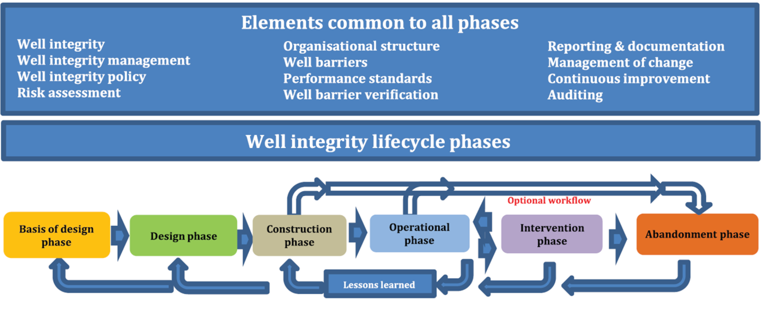
Source: ISO 16530‑1:2017 Well integrity – Part 1: Lifecycle governance.
Image features two blue boxes with a diagram of the well integrity lifecycle phases underneath. The first blue box features the heading Elements common to all phases with a list of elements underneath. The elements listed are Well integrity, well integrity management, well integrity policy, risk assessment, organisational structure, well barriers, performance standards, well barrier verification, reporting and documentation, management of change, continuous improvement, and auditing.
The second blue box underneath this features the heading Well integrity lifecycle phases. Underneath this is a diagram showing the phases, with the first phase being basis of design phase. This then points to design phase, construction phase, operational phase, intervention phase, with the final phase being the abandonment phase. There are arrows pointing back and forth between the operational phase and the intervention phase indicating there could be some back and forth in these phases. There are additional arrows showing an optional workflow once the construction phase has been reached, pointing towards the operational phase, and bypassing the intervention phase to finish on the abandonment phase. The diagram features arrows pointing backwards underneath it from the abandonment phase back through to the basis of design phase with the caption lessons learned underneath.
    - Means of compliance
- The WIMS covers:
- a regular wellhead maintenance program;
- inspections for identification and management of leaks, as per Section 4.15 Leak management of this Code;
- routine operational site visits;
- monitoring and management of annuli pressures;
- barrier maintenance and verification;
- assessment during the well lifecycle, of the wellhead, tubing and casing, for any wear due to erosion or corrosion and its impact on well integrity;
- risk assessment and response levels for impaired barriers; and
- well integrity records to be maintained.
- A well integrity and validation program is established for all wells and includes:
- Routine Subsurface Integrity Testing (SIT);
- well integrity and well barrier validation requirements in line with section 4.1 of this Code;
- a minimum testing frequency for wells in the operational phase of their lifecycle that is in line with the well integrity risks as per the accepted WOMP; and
- triggers for well integrity testing based on:
- well integrity monitoring; and
- substantive changes to well barriers or well operating envelope.
- Recording the existing risk level of wells, operational status and completion status of all wells and any other observations related to well integrity.
- Undertaking a risk assessment if a well integrity issue is identified (e.g. primary barrier has significantly degraded or failed) and any identifying abatement measures.
- Specify the best practice standard to be followed for managing well integrity over the well lifecycle (e.g. Oil and Gas UK, NORSOK D‑010).
    - Good industry practice
- All surface equipment associated with the well barrier envelope has a preventative maintenance program in place.
- If the annulus is being abnormally charged with gas, an analysis of the gas content may assist in determining the source and nature of a potential leak.
- Conduct annular casing pressure management in accordance with API Recommended Practice 90‑2 Annular Casing Pressure Management for Onshore Wells.
- Well barriers are tested and monitored in line with their function and associated acceptance criteria, as necessary. Parameters that could affect well integrity negatively are monitored.
- Consideration given to temperature, pressure, well noise logs and completion profile for gas storage wells as a means to assess well integrity.
- Well integrity testing using multiple methods and not relying on a single diagnostic.
- Annulus pressure monitoring to provide integrity assurance of the subsurface well barrier elements and their interface with the wellhead. The principle considerations for management of integrity of well annuli are that:
- adequate access to the annulus is provided for during preliminary well planning and design;
- testing during installation of casing, tubing, downhole permanent barrier and wellhead components to confirm the integrity of all barriers that bind each annulus;
- annulus pressure is monitored and maintained within defined maximum allowable limits; and
- annulus investigations and remedial measures are carried out to identify and remediate annulus integrity problems.
  - Workover and intervention
The terms well workover and intervention refer to the process of performing major maintenance or remedial treatments on a well. These can be done either as remedial work to restore barriers, enhance production or reconfigure the well completion.
    - Principles
Any re‑completion or well modification is designed so that the well is operated within the maximum expected pressure and load conditions until final decommissioning. Workovers and interventions are designed and implemented to meet relevant industry standards.
    - Means of compliance
- Ensure well barriers are in place during intervention of the well and, if necessary, risk assess any deviations.
- Fit-for-purpose well design and construction materials.
- Well barrier schematics are developed and included in the workover/intervention program. Barrier verification requirements clearly outlined in the well workover/intervention program.
- The potential for accumulation of naturally occurring radioactive materials in well equipment is assessed and appropriate measures put in place to minimise risks as far as is practicable.
    - Good industry practice
- During well intervention when equipment is removed from a well or is depressurised for maintenance, a breakdown or visual inspection takes place of all equipment to confirm condition after being in service.
- Evidence of corrosion for recovered equipment is used to determine well mechanical integrity and help predict possible issues for intervention in similar wells.
- All new barriers or new operating envelopes are verified and recorded prior to well handover to production or decommissioning.
  - Well suspension and maintenance
For various reasons, an authority holder may decide to suspend a well. Following well suspension, an authority holder may bring the well into production or may decommission the well. Unlike well shut‑in, well suspension has additional requirements as defined by the authority holder in the Well Integrity Management Systems (WIMS).
Note: The Minister’s consent is required to suspend a well and a well may only be suspended in accordance with that consent (see regulation 29 of the Petroleum Regulations).
    - Principles
Review management systems for wells that are suspended for significant periods of time. This includes wells that are unlikely to return to production, wells that have not returned to production for a significant period or wells that have never commenced production since they were suspended.
Undertake care and maintenance work at suspended wells to ensure well integrity and site safety is maintained.
The primary considerations for suspension of a well are to ensure that:
- all fluids from the well are contained and water cannot enter the well from surface;
- monitoring requirements can be met and production can readily be resumed; and
- all safety requirements are met.
The following matters are considered when suspending a well:
- construction characteristics and integrity history of the well including integrity of cement columns;
- geological formations encountered and potential loss zones;
- hydrogeological conditions (i.e. aquifers);
- environmental risks;
- industry standards; and
- perforated zones.
    - Means of compliance
- Two verified well barriers used for well suspension.
- During re‑entry, workovers and other maintenance work, or during temporary suspension of open hole sections due to weather or other operational reasons, one verified barrier may be used, provided it has been risk assessed and is for the minimum time required.
- Suspension of wells are addressed in the WIMS.
- Appropriate suspension fluids are used. Biocide, oxygen scavenger and/or corrosion inhibitor are used in the wellbore in‑between or above isolation plugs.
- The potential accumulation of naturally occurring radioactive materials in well equipment is assessed and appropriate measures taken to reduce risks to the health and safety of people and the environment.
- The wellhead is protected from collision and reckless acts by third parties with the following minimum requirements:
- the wellheads are fenced off, with the signage reflecting well name, authority holder contacts and emergency contact details;
- the valve handles are either removed or chained and padlocked; and
- all wellheads are safely accessible for inspection and monitoring.
- Ensure that there are no wellhead leaks.
- Wellheads are serviced and the sealing elements pressure tested at time of suspension in accordance with the original equipment manufacturer’s guidelines.
- Use Down Hole Safety Valves (DHSV) where appropriate.
    - Good industry practice
- Wells, apart from monitoring wells, which have been shut‑in for 2 years are suspended with temporary packers and/or bridge plugs at the appropriate depths.
  - Well decommissioning
Well decommissioning refers to the permanent closure of a well at the end of its useful life. It involves the permanent sealing of wells and the removal of any well infrastructure where practicable.
It involves:
- sealing of wells to prevent mixing of liquids and gases between petroleum bearing formations and aquifers, including isolation of aquifers from each other; and
- preventing the escape of liquids and gases to the surface.
When a well is decommissioned, associated infrastructure is removed in line with the decommissioning proposal within the operation plan.
These requirements relate specifically to the well decommissioning petroleum lifecycle stage.
Note: The Minister’s consent is required to decommission a well, and a well may only be suspended in accordance with that consent (regulation 29 of the Petroleum Regulations).
    - Principles
Petroleum well decommissioning ensures environmentally sound and safe isolation of the well, protection of groundwater resources, isolation of the productive formations from other formations and the removal of surface equipment.
Well decommissioning is conducted such that well barriers contain and control wellbore fluids, provide structural support and otherwise retain well integrity throughout the well decommissioning load conditions.
Barriers used for decommissioning a well or section of a well are permanent well barriers. For a plug to be considered as a permanent barrier the plug should form a rock‑to‑rock barrier.
The only permanent well barriers are open hole cement plugs or cement plugs in casing with good quality cement on the outside. Other materials may be considered by the authority holder, but these will need to be verified before they can be considered permanent barriers.
The well decommissioning objectives are to ensure:
- isolation of aquifers from each other and from permeable hydrocarbon zones;
- isolation of permeable hydrocarbon zones from each other unless commingling is permitted;
- permeable formations containing fluids at different pressure gradients and/or significantly different salinities are isolated from each other to prevent crossflow;
- that there is no pressure or flow of hydrocarbons or fluids at surface both internally (in the well) and externally (behind all casing strings);
- recovery/removal of surface equipment and infrastructure minimising any interference with activities of the landholder on their land (e.g. farming activities);
- the site is left in a safe, stable and sustainable condition and free of contaminants.
The following matters are considered prior to well decommissioning:
- the construction characteristics and integrity history of the well including but not limited to:
- sustained pressure/flow on casing annulus;
- confirmation of cement tops where cement returns were not achieved;
- integrity of cement columns;
- casing integrity;
- “fish stuck in hole”; and
- perforated zones.
- geological formations encountered;
- potential loss zones;
- hydrogeological conditions (i.e. aquifers);
- environmental risks;
- regulatory requirements, authority conditions and industry standards; and
- wells are left in a safe, stable and sustainable condition upon completion of decommissioning.
Note: Also see the cementing section 4.5 of this Code.
    - Means of compliance
- The basis of design for decommissioning, where applicable, includes:
- Lithology of the reservoir clearly showing any oil and gas shows during drilling.
- Cap rock and the reason for its selection.
- Any LOT and FIT performed during well construction.
- Casing cementing records, along with logs run.
- Pore Pressure and Fracture Gradient.
- History of annulus pressure readings of the well.
- Fluids used while drilling and fluid currently in the wellbore and how it will be disposed.
- Metallurgy of the casing and casing shoe and how it will affect the decommissioning process.
- Any well that is to be decommissioned is filled and sealed in such a manner to prevent leakage of petroleum and/or formation fluid.
- Cement is used as the primary sealing material. Cementing is carried out as per requirements set out in Cementing section 4.5 of this Code.
- Water‑based fluids mixed with, as appropriate, biocide, oxygen scavenger and/or corrosion inhibitor, are left in the wellbore in‑between cement plugs, if the plugs are not in immediate contact with each other.
- All aquifers and groundwater formations are isolated from each other as per section 4.6. Aquifers are also isolated from any permeable hydrocarbon bearing zones by a minimum of two barriers (as defined in section 4.1, unless 4.1.2 (n) applies).
- Prior to commencing decommissioning, confirm the absence of pressure/flow externally behind all casing strings. This requires a surface casing vent flow test to determine if hydrocarbons, liquid, or any combination of substances is escaping from the casing vent assemblies. Any pressure build‑up is addressed.
- Prior to conducting the surface decommissioning, confirm the absence of pressure/flow internally (within the well) and externally (behind all casing strings). Wells with no history of external flow/pressure may be cut and capped immediately. All other wells are monitored for a minimum of 6 months prior to conducting surface decommissioning.
- Sucker rods, pumps and tubing (unless used as a sacrificial stinger) and any other debris in the well is removed ensuring that safety is not compromised by such removal.
- A 50m weighted high‑vis pill is spotted below each cement plug that is not set directly above a physical barrier (hole bottom is included as a physical barrier) and where there is any potential for losses below the cement plug (i.e. any open section).
- Cement plugs do not exceed 300m in length, unless installed with coil tubing or sacrificial stinger.
- A surface cement plug being a minimum 10m in length is placed at the top of the inner most casing. The surface plug acts as a barrier to prevent any long‑term ingress into the wellbore and is not deemed to be a pressure containing barrier. Well barriers are established below the surface cement plug. If the top of the surface cement plug is less than 10m below the surface, the casing can be topped up with cement.
- In cases where the impermeable formation is at least 50m long, there is a continuous cement barrier of at least 50m in length adjacent to the impermeable formation (cap rock) overlying the uppermost hydrocarbon zone.
- Cement plug requirements and verification methods of this Code also consider the following:
- Cement the inner casing strings to surface. This would not apply, for example, where cement cannot be brought to surface due to weak formation or other reasons which can be covered in the WOMP (see regulation 36(2) of Petroleum Regulations).
- A mechanical barrier (e.g. bridge plug) may be used in appropriate situations as a support to set a cement plug on top of it. If a mechanical barrier is used, it is set as close as is practicable above perforations. When a mechanical barrier is used, it or the cement plug directly above it is verified by tagging it with a minimum 2270kg (5000lb) set down weight and pressure tested to 3.5MPa (500psi) above the estimated (or previously recorded) leak off pressure (within the limits of the casing and wellhead pressure ratings). As long as the gas gradient from the surface is not fracturing the formation below, a shallower mechanical plug can be considered.
Note: The use of slick‑line or wireline is not an accepted method of verifying the tops of plugs.
- If using a sacrificial stinger to set open hole plugs, provided no losses observed during cement placement then no tag is necessary. This assumes the open hole plug is not set off bottom.
- For a final surface cement plug extending from ground level, the TOC is visible and at surface. A shallow set plug is not considered a permanent barrier given the very low formation pressures at ground level. Well barriers are established and verified with the plugs below the surface cement plug.
- If unable to achieve the required 2270kg (5000lb) set down weight (e.g. plug is too shallow, or coil tubing is used) the minimum force with which plug is verified is maximum string weight.
- Plugs that do not pass pressure testing are remediated until the requirements below are achieved:
- If sufficient depth is available to meet requirements an additional cement plug may be installed and re‑tested.
- For failed mechanical barriers an additional mechanical barrier may be installed and re‑tested.
- If insufficient depth is available, the plug(s) is then drilled out and circulated. The plug(s) is then re‑run and pressure tested.
- Plugs that are confirmed as too low or too high after tagging are remediated until requirements are achieved as noted below:
- A plug is too low if it has a top less than 15m vertical above the zone it was intended to cover. Such a plug is built up to required depth and its location confirmed.
- High plugs are drilled out if the theoretical plug base is less than 15m vertical below the base of the zone it was intended to cover. The plug is re‑cemented and its location confirmed.
- BOPs and/or the wellhead are not to be removed until the cement plug across the surface casing shoe or plug across the uppermost open section, including perforations, has been physically tagged for correct location, then pressure tested.
- Wellhead is removed and the casing string(s) is cut at a minimum of 2m below surface.
- The well is capped below the surface with a marker plate made of appropriate material that is fastened and installed in a manner as to prevent any potential for pressure to build up within the casings while restricting access to the casing strings at the top (vented/ported plate).
The marker plate is installed as per the following requirements (Figure 12):
- the unique identifying name of the well;
- the total depth in metres of the well; and
- the date the well was decommissioned.
- Marker plate is to be laid approximately 20cm above the top of the casing.
- An appropriate plaque, that states the following information, is placed on surface on a fence post, building or any other permanent structure nearest to the well:
- The unique identifying name of the well.
- The total depth in meters of the well.
- The date the well was decommissioned.
- The distance and direction to the well from the plaque (if the plaque is not located directly over the well). A post cemented in place on or near the well location is the preferred option but may not be practical for the landowner.
Note: Surface rehabilitation is not addressed in this Code. Refer to the Environmental Management Plan.

Figure 2: Schematic of a permanent barrier showing the barrier envelope (red dashed line to restore caprock, its barrier elements and recommended practices)
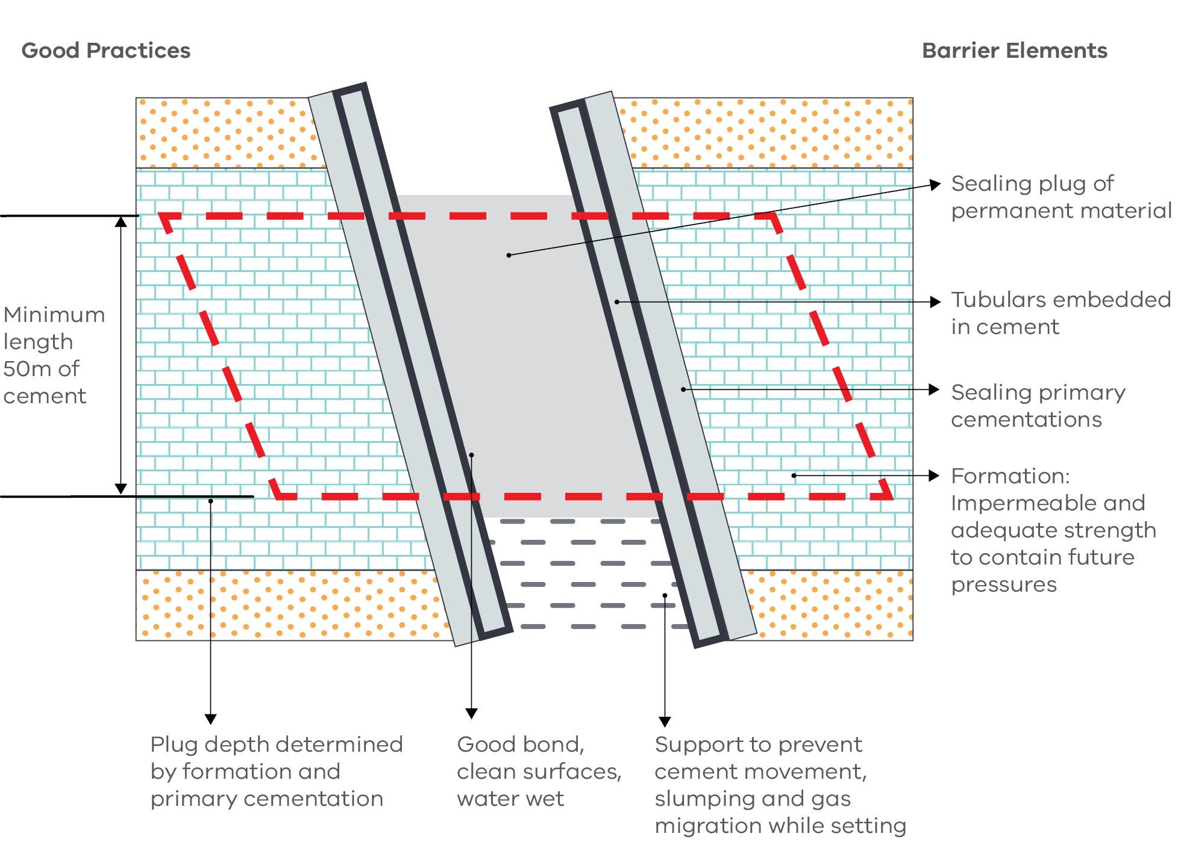
Source: Guidelines for Abandonment of Wells, Issue 5, Oil and Gas UK.
The diagram shows casing inside a hole section with cement inside the casing and the casing formation annulus. There is a heading on the left stating Good Practices and a heading on the right stating Barrier Elements.
Two vertical grey rectangles are on a slight angle in the middle of the diagram, with two more rectangles of the same size on the outside. An arrow points from the inner rectangles labelled Tubulars embedded in cement, and an arrow points from the outer rectangles labelled Sealing primary cementations. In the centre of the tubulars is a grey area with two arrows pointing, the first labelled Sealing plug of permanent material, the second labelled Good bond, clean surfaces, water wet. Underneath the sealing plug are grey dotted lines, with an arrow labelled Support to prevent cement movement, slumping and gas migration while setting. To the outside of the tubulars is an area depicted by blue bricks, with an arrow pointing stating Formation: impermeable and adequate strength to contain future pressures.
A red dashed rectangle features in the middle of the diagram and indicates the barrier envelope. The height of the barrier envelope has arrows pointing between it stating Minimum length 50m of cement. Underneath the barrier envelope is an arrow pointing downwards stating Plug depth determined by formation of primary cementation.
Figure 3: General requirements for well decommissioning
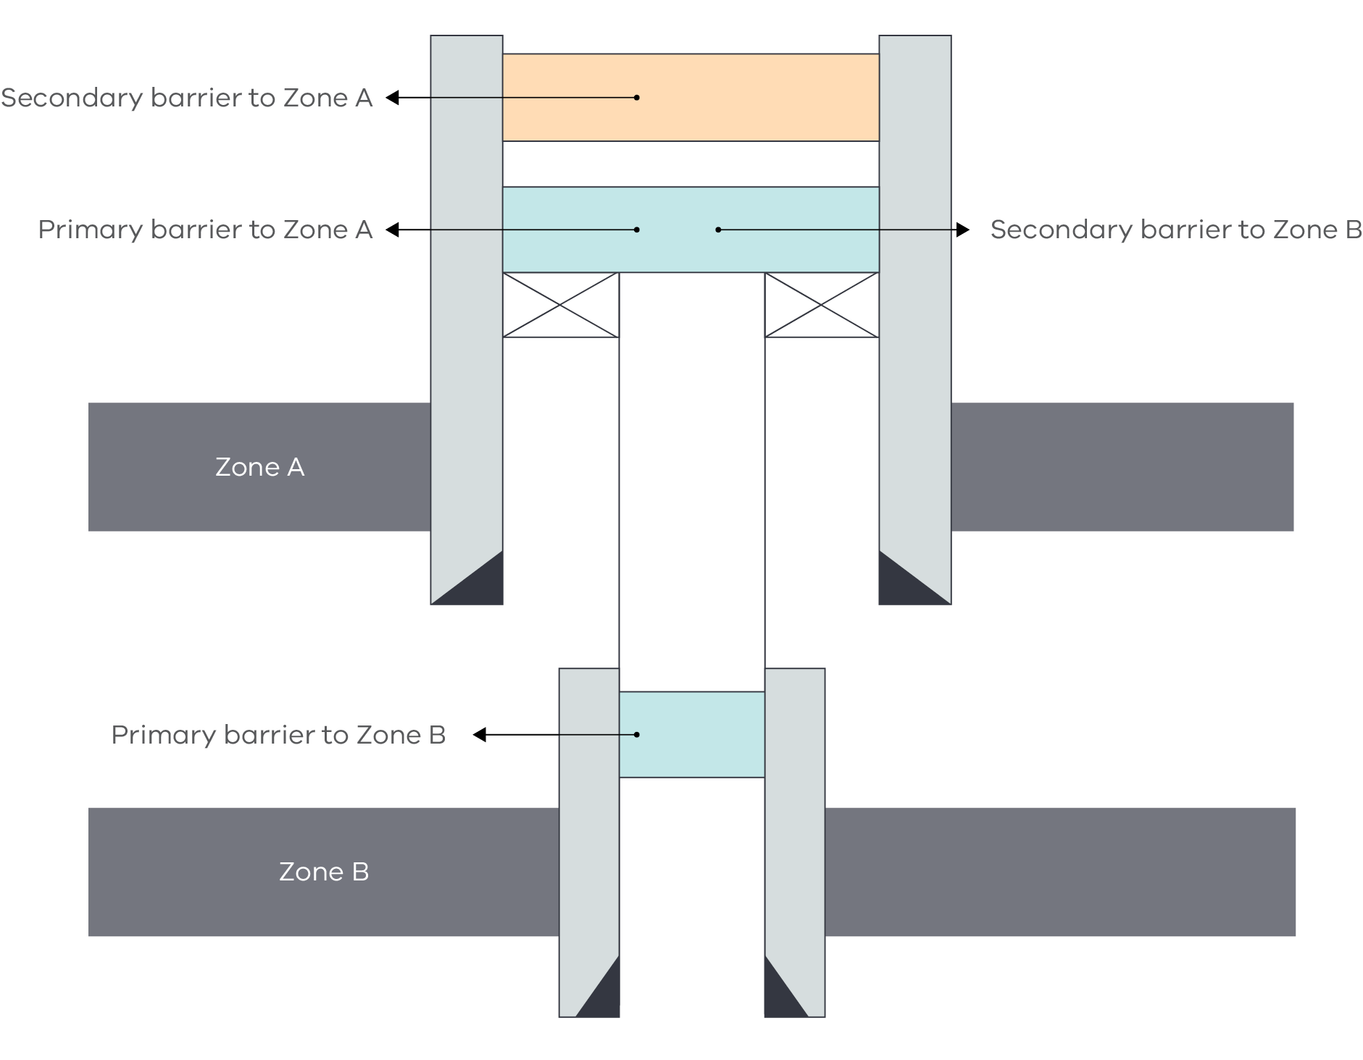
Source: Guidelines for Abandonment of Wells, Issue 5, Oil and Gas UK.
The diagram shows the cross-section of a well liner hanger which passes through two geological Zones. These are identified by the labels Zone A and Zone B.
Zone A is at the top of the diagram. The cement casing is depicted by two vertical rectangles either side. Black triangles in the bottom corner of each rectangle represent the casing shoes. An orange horizontal rectangle near the top between the two vertical rectangles represents a cement plug. An arrow points left to a label titled Secondary barrier to Zone A. A blue horizontal rectangle further down from the orange one represents another cement plug. Arrows point to labels titled Primary barrier to Zone A (left) and Secondary barrier to Zone B (right).
Two small rectangles with diagonal lines criss-crossing from corner to corner are directly beneath the blue rectangle representing mechanical or bridge plugs. From these, two fine vertical lines run side-by-side depicting the well liner hanger. These connect to another smaller blue horizonal rectangle between two vertical rectangles with black triangles in their bottom corners. These represent the cement casing and casing shoes for Zone B. An arrow points from the blue horizontal rectangle, representing a cement plug, to a label titled Primary barrier to Zone B.
Figure 4: Example of the position of permanent barrier as determined by the actual geological setting (i.e. relative to the zones with flow potential or caprock)
In this illustration the main reservoir and sandstones A and B are considered hydrocarbon bearing and/or over pressured, hence require two barriers opposite a competent caprock.
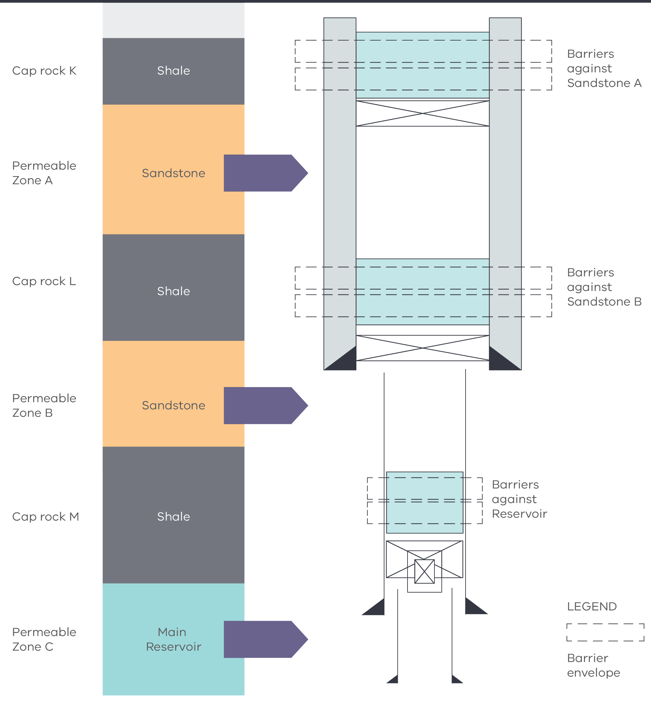
Source: Guidelines for Abandonment of Wells, Issue 5, Oil and Gas UK.
Note 1: In this example two barriers are shown per zone with flow potential. This will be the case if barriers cannot be shared (i.e. caprock L is not capable of containing the maximum anticipated pressure from the main reservoir or caprock K is not capable to contain the pressure of sandstone B).
Note 2: In this example the barriers are placed on a packer or bridge plug as a firm support to prevent slumping of the cement slurry down the well or gas migrating upwards as the cement is thickening.
The diagram shows the position of permanent barriers in relation to their geological setting. The geological setting shown on the left of the diagram and the well cross-section on the right are designed to be read top down.
The geological setting on the left starts with cap rock K, shale, then underneath permeable Zone A, sandstone. The well cross section on the right displays two vertical rectangles either side representing cement casing. A blue horizontal rectangle near the top between the two vertical rectangles represents a cement plug. Two dashed rectangles indicate barriers against sandstone A. Underneath this in permeable sandstone A the vertical cement casings continue; a cross is at the top in between the casings representing a mechanical bridge or plug.
Moving down the diagram the geological setting on the left shows cap rock L, shale, then underneath permeable Zone B, sandstone. The same as above is shown here with the vertical cement casings finishing at the top of permeable Zone B, sandstone. Black triangles in the bottom corner of each rectangle represent the casing shoes. Dashed rectangles feature around a blue rectangle cement plug indicating barriers against sandstone B.
Further down the diagram the geological setting on the left shows cap rock M, shale, and permeable Zone C, main reservoir. In the middle of permeable Zone B, sandstone, two fine vertical lines run side-by-side depicting the well liner hanger finishing at the top of permeable Zone C, main reservoir. Black triangles in the bottom corner of each line represent the casing shoes. A blue horizontal rectangle is in the middle of cap rock M, shale, between the two fine vertical lines representing a cement plug. Two dashed rectangles indicate barriers against reservoir. Underneath this a cross is in between the well liner hanger representing a mechanical bridge or plug, with another cross over the top of it representing a secondary mechanical bridge or plug. In permeable Zone C, main reservoir two fine vertical lines run side-by-side depicting the well liner hanger. Black triangles in the bottom corner of each line represent the casing shoes.
Figure 5: Comparison of length for dual and combination barriers
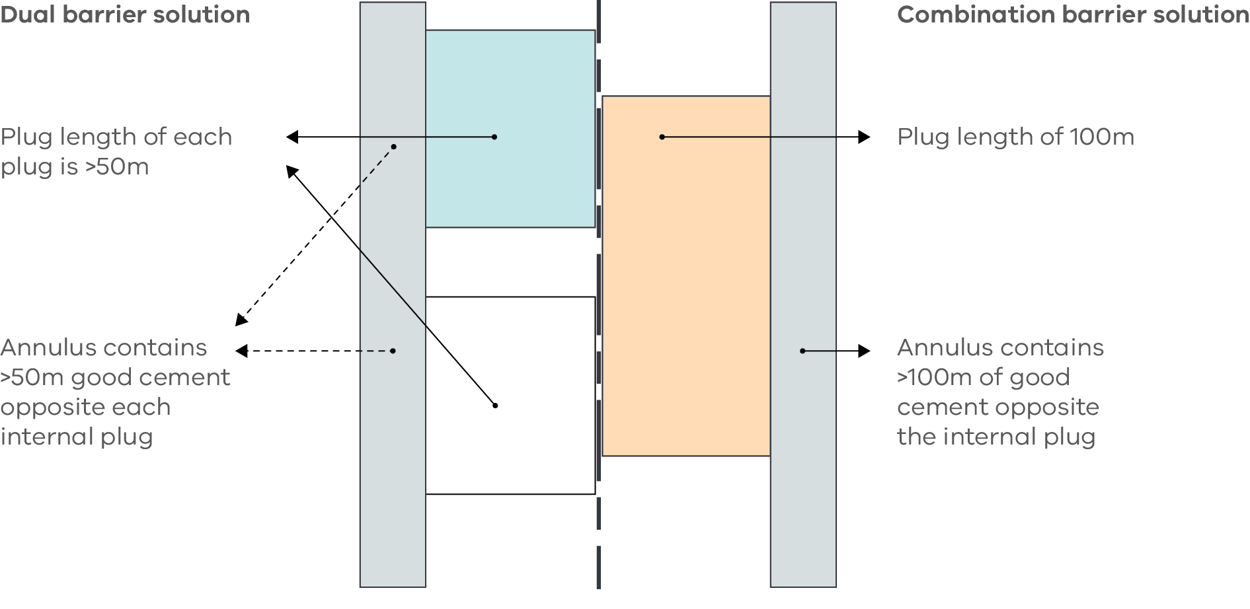
Source: Guidelines for Abandonment of Wells, Issue 5, Oil and Gas UK.
The diagram presents two barrier solutions separated by a bold dashed vertical line in the centre.
The left side is labelled Dual barrier solution. The annulus is represented by a long narrow vertical rectangle on the left. The primary cement plug is represented by a small blue box near the top. The secondary cement plug is represented by small white box toward the bottom of the diagram. Arrows point from both boxes to a label stating Plug length of each plug is >50m. Dashed arrows beside each plug point from the annulus to a label stating Annulus contains >50m good cement opposite each internal plug.
The right side is labelled Combination barrier solution. The annulus is represented by a long narrow vertical rectangle on the right. An arrow points from this to a label stating Annulus contains >100m of good cement opposite the internal plug, The cement plug is represented by a large orange box near the top. An arrow points from this to a label stating Plug length of 100m.
Figure 6: Example of permanent barrier for an open hole if potential internal pressure does not exceed the casing shoe fracture pressure
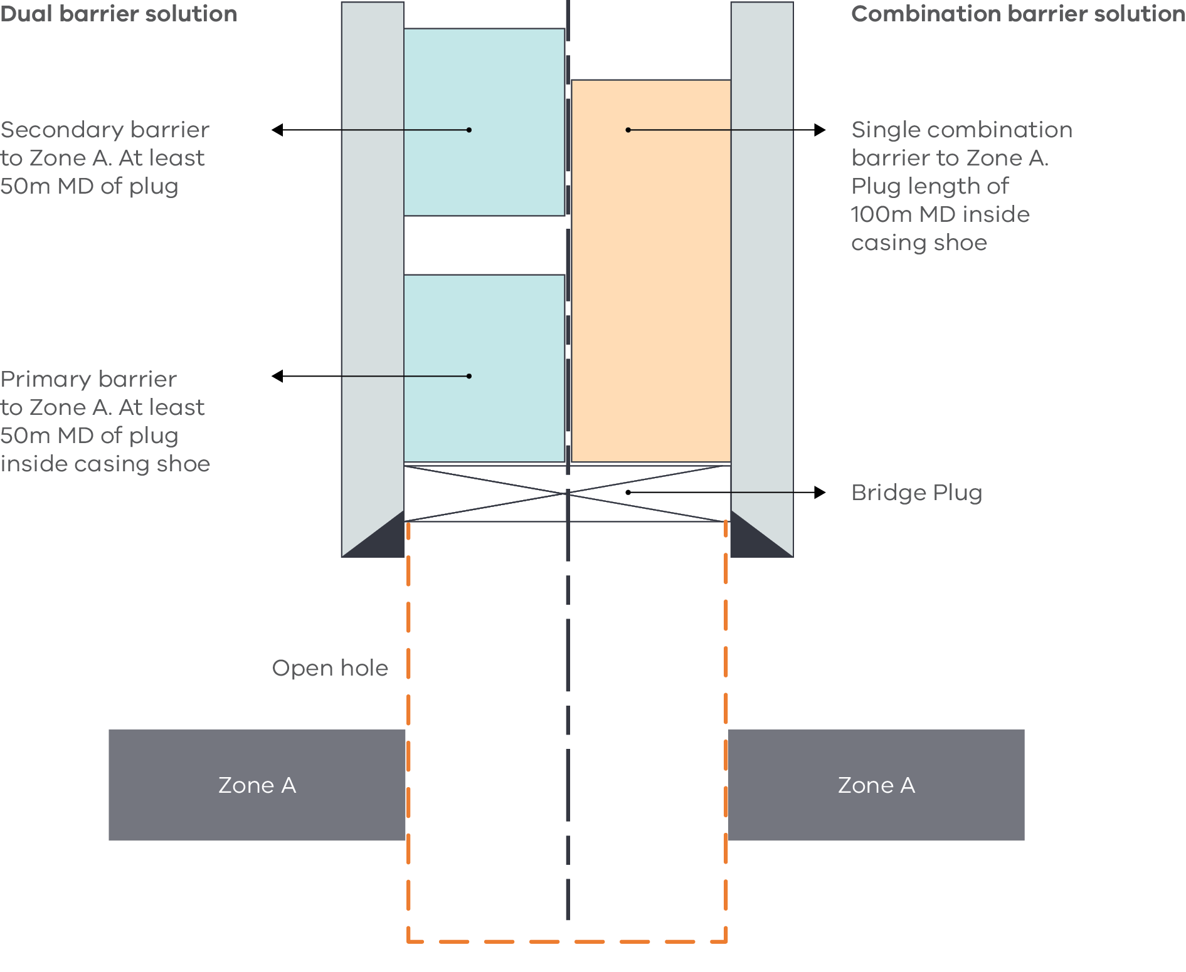
Source: Guidelines for Abandonment of Wells, Issue 5, Oil and Gas UK.
The diagram presents two barrier solutions separated by a bold dashed vertical line in the centre.
The left side is labelled Dual barrier solution. The cement casing is depicted by a vertical grey rectangle on the left. A black triangle in the bottom corner represents the casing shoe. The secondary cement plug is represented by a small blue box near the top, and the primary cement plug is represented by small blue box underneath. An arrow points from the top plug stating Secondary barrier to Zone A. At least 50m MD of plug. An arrow points from the bottom plug stating Primary barrier to Zone B. At least 50m MD of plug inside casing shoe.
The right side is labelled Combination barrier solution. The cement casing is depicted by a vertical grey rectangle on the outside, with a black triangle at the bottom corner representing a casing shoe. The cement plug is represented by a large orange box near the top. An arrow points from this stating Single combination barrier to Zone A. Plug length of 100m MD inside of casing shoe.
Underneath, in between the two cement casings and spanning the left and right solutions, a cross runs diagonally from corner to corner directly beneath the cement plugs. This represents a mechanical or bridge plug. Underneath the bridge plug is a red dashed box representing an open hole, which leads to geological Zone A, finishing shortly after Zone A.
Figure 7: Example of open hole permanent barriers if zone A requires isolating from zone B, but the potential internal pressure from zone A does not exceed the casing shoe fracture pressure
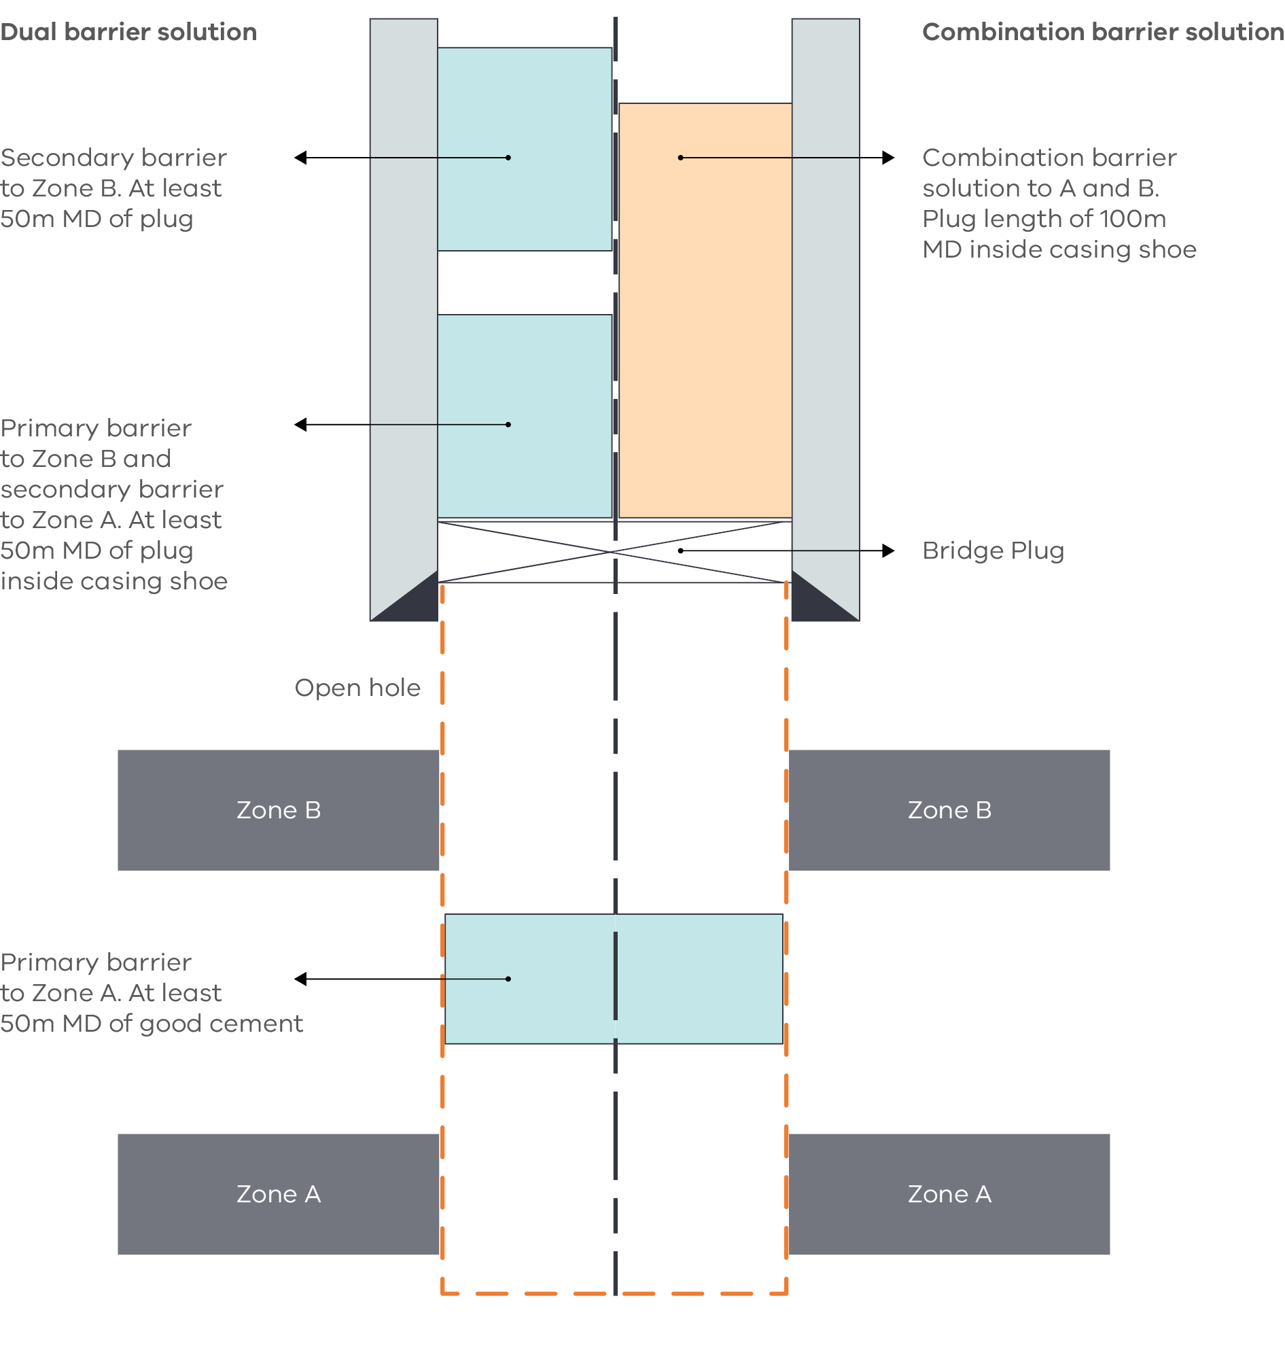
Source: Guidelines for Abandonment of Wells, Issue 5, Oil and Gas UK.
The diagram presents two barrier solutions separated by a bold dashed vertical line in the centre.
The left side is labelled Dual barrier solution. The cement casing is depicted by a vertical grey rectangle on the outside, with a black triangle at the bottom corner representing a casing shoe. The secondary cement plug is represented by a small blue box near the top, and the primary cement plug is represented by small blue box underneath. An arrow points from the top plug stating Secondary barrier to Zone B. At least 50m MD of plug. An arrow points from the bottom plug stating Primary barrier to Zone B and secondary barrier to Zone A. At least 50m MD of plug inside casing shoe.
The right side is labelled Combination barrier solution. The cement casing is depicted by a vertical grey rectangle on the outside, with a black triangle at the bottom corner representing a casing shoe. The cement plug is represented by a large orange box near the top. An arrow points from this stating single combination barrier to Zone A and B, plug length of 100m MD inside of casing shoe.
Underneath, in between the two cement casings and spanning the left and right solutions, a cross runs diagonally from corner to corner directly beneath the cement plugs. This represents a mechanical or bridge plug. Underneath the bridge plug is a red dashed box representing an open hole, which runs down to Zone B and Zone A. A blue box in between Zone B and Zone A represents a cement plug. An arrow points from the cement plug stating primary barrier to Zone A, at least 50m MD of good cement.
Figure 8: Example of open hole permanent barriers if potential internal pressure exceeds the casing shoe fracture pressure (two permanent barriers are required)
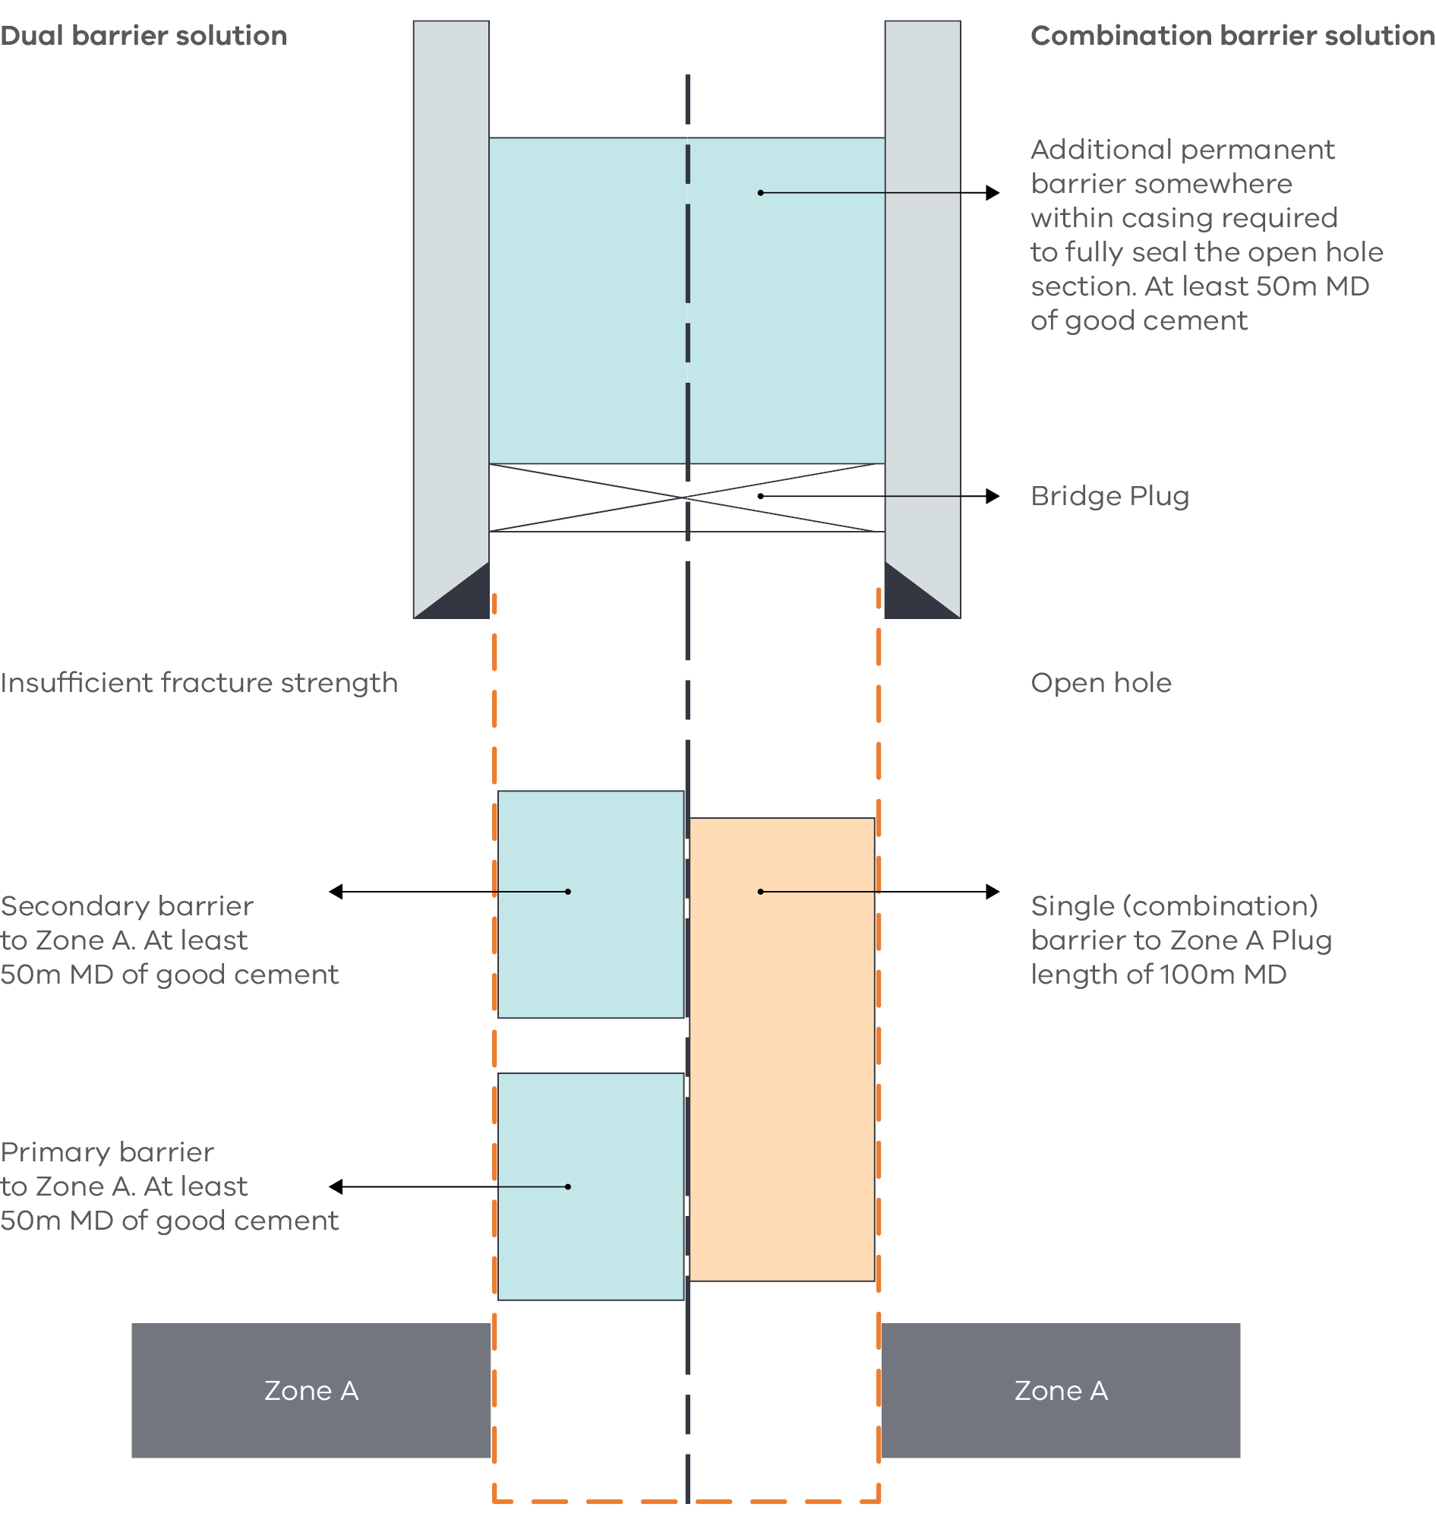
Source: Guidelines for Abandonment of Wells, Issue 5, Oil and Gas UK.
The diagram presents two barrier solutions separated by a bold dashed vertical line in the centre.
The left side is labelled Dual barrier solution, and the right side is labelled Combination barrier solution. The cement casing is depicted by vertical grey rectangles on the outside, with black triangles at the bottom corners representing casing shoes. There is a cement plug spanning both solutions, which is represented by a small blue box near the top. A diagonal cross from corner to corner directly beneath the cement plug represents a mechanical or bridge plug. An arrow points from the cement plug stating Additional permanent barrier somewhere within casing required to fully seal the open hole section. At least 50m MD of good cement.
Underneath the bridge plug is a red dashed box representing an open hole. This leads to options for cement plugs, then geological Zone A. A label beside the open hole reads Insufficient fracture structure.
The cement plugs underneath the open hole on the left side, the dual barrier solution, feature a secondary cement plug represented by a small blue box, and a primary cement plug represented by small blue box underneath. An arrow points from the top plug stating Secondary barrier to Zone A. At least 50m MD of good cement. An arrow points from the bottom plug stating Primary barrier to Zone A. At least 50m MD of good cement.
The cement plug underneath the open hole on the right side, the combination barrier solution, is represented by a large orange box. An arrow points from here to a label stating Single combination barrier to Zone A Plug length of 100m MD.
Figure 9: A side‑tracked well with decommissioned open hole section
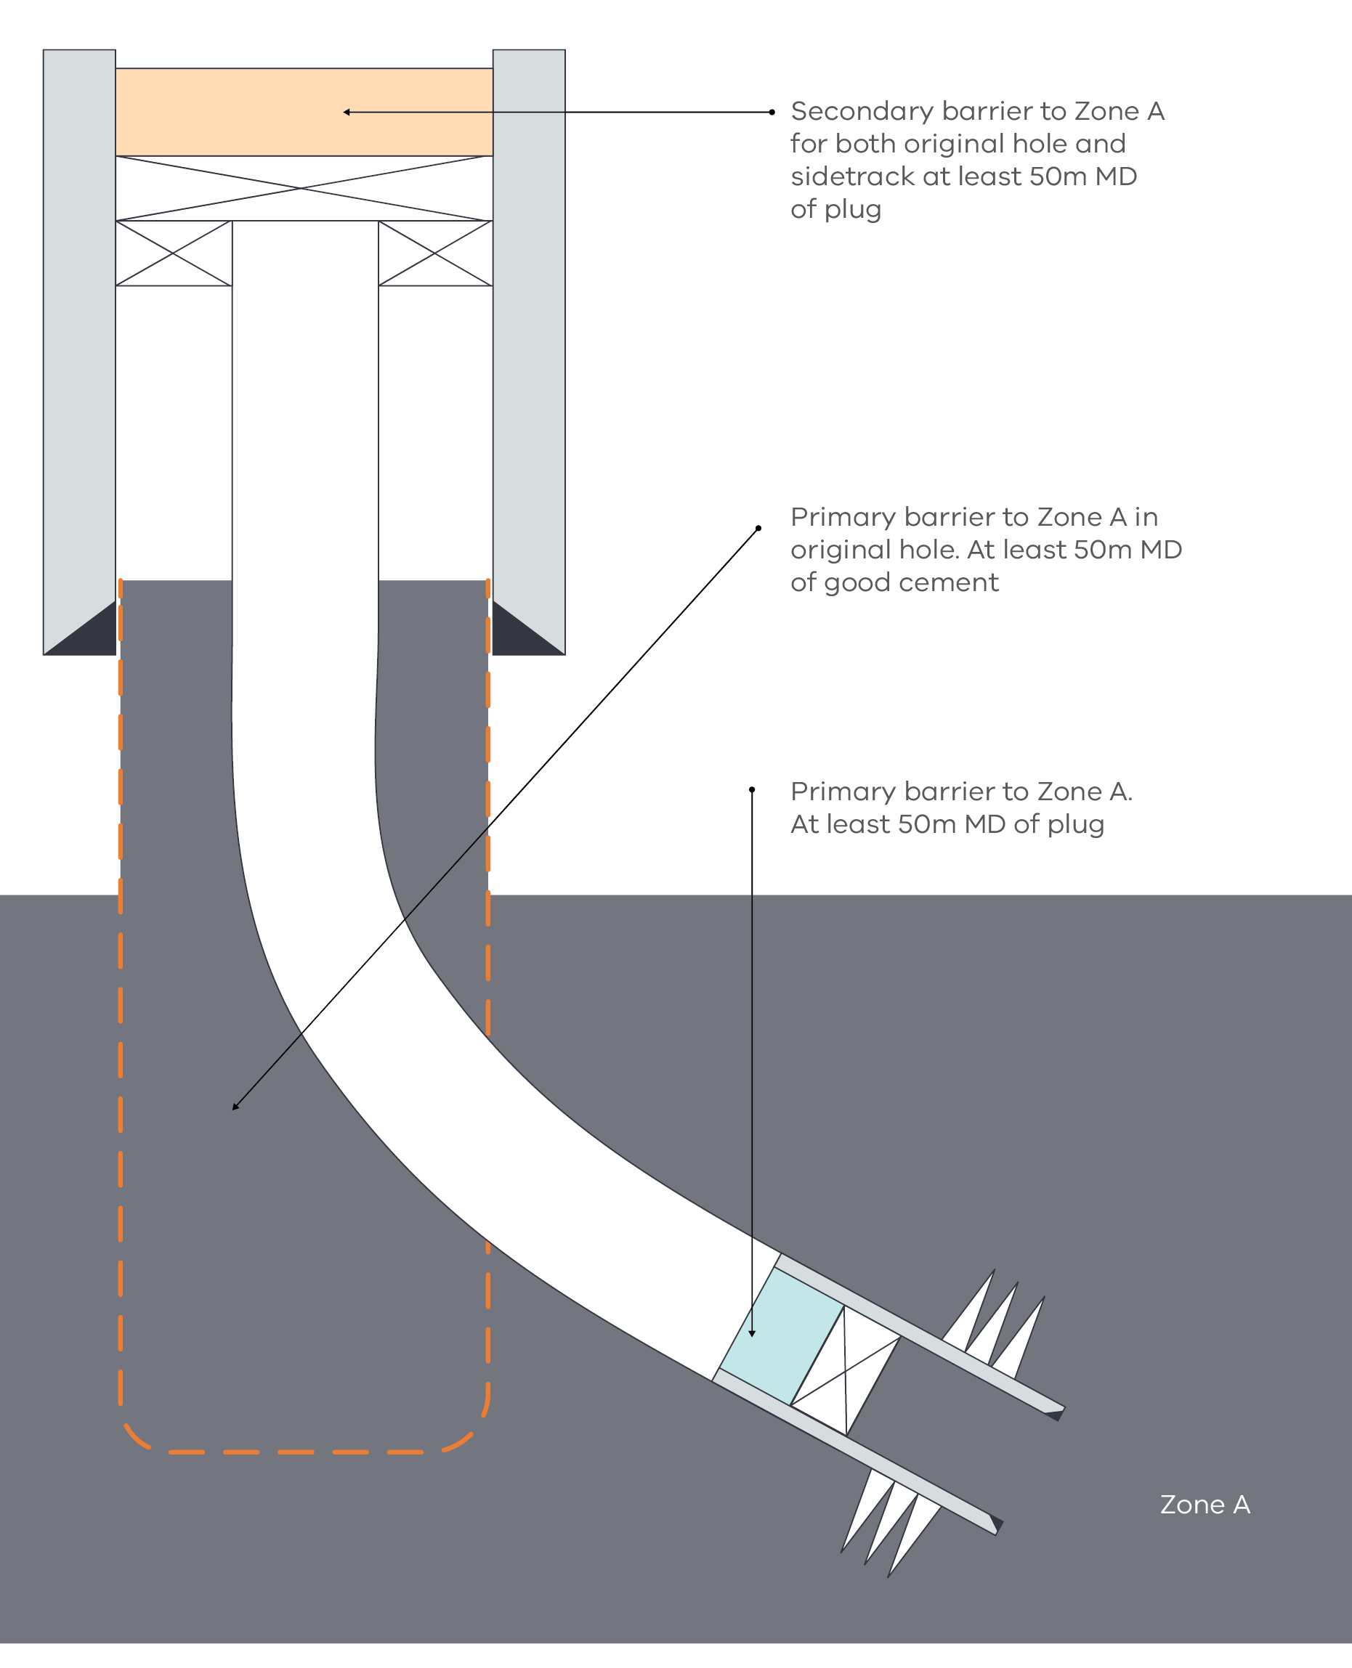
Source: Guidelines for Abandonment of Wells, Issue 5, Oil and Gas UK.
The diagram presents a cross-section of a sidetracked well with a decommissioned open hole section.
The cement casing is depicted by two vertical rectangles either side. Black triangles in the bottom corner of each rectangle represent the casing shoes. An orange horizontal rectangle near the top between the two vertical rectangles represents a cement plug. An arrow points left stating Secondary barrier to Zone A for both original hole and sidetrack at least 50m MD of plug.
Underneath the cement plug is a diagonal; cross from corner to corner representing a mechanical or bridge plug. Underneath the bridge plug are two small rectangles with diagonal lines criss-crossing from corner to corner representing two more mechanical or bridge plugs. From these, two fine vertical lines run side-by-side depicting the well liner hanger and curve down to the right, into geological Zone A. A red dashed box representing an open hole surrounds the well liner and leads directly down with no curve to geological Zone A. An arrow points from the Zone stating Primary barrier to Zone A in original hole., at least 50m MD of good cement.
At the end of the curved well liner hanger is cement casing depicted by two vertical rectangles on either side. Black triangles in the bottom corner of each rectangle represent the casing shoes. A blue box between the cement casings represents a cement plug. An arrow points from the plug stating primary barrier to Zone A. At least 50m MD of plug. Underneath the cement plug is a diagonal cross from corner to corner representing a mechanical or bridge plug.
Figure 10: Example decommissioning schematic of the lower section of a high angle well
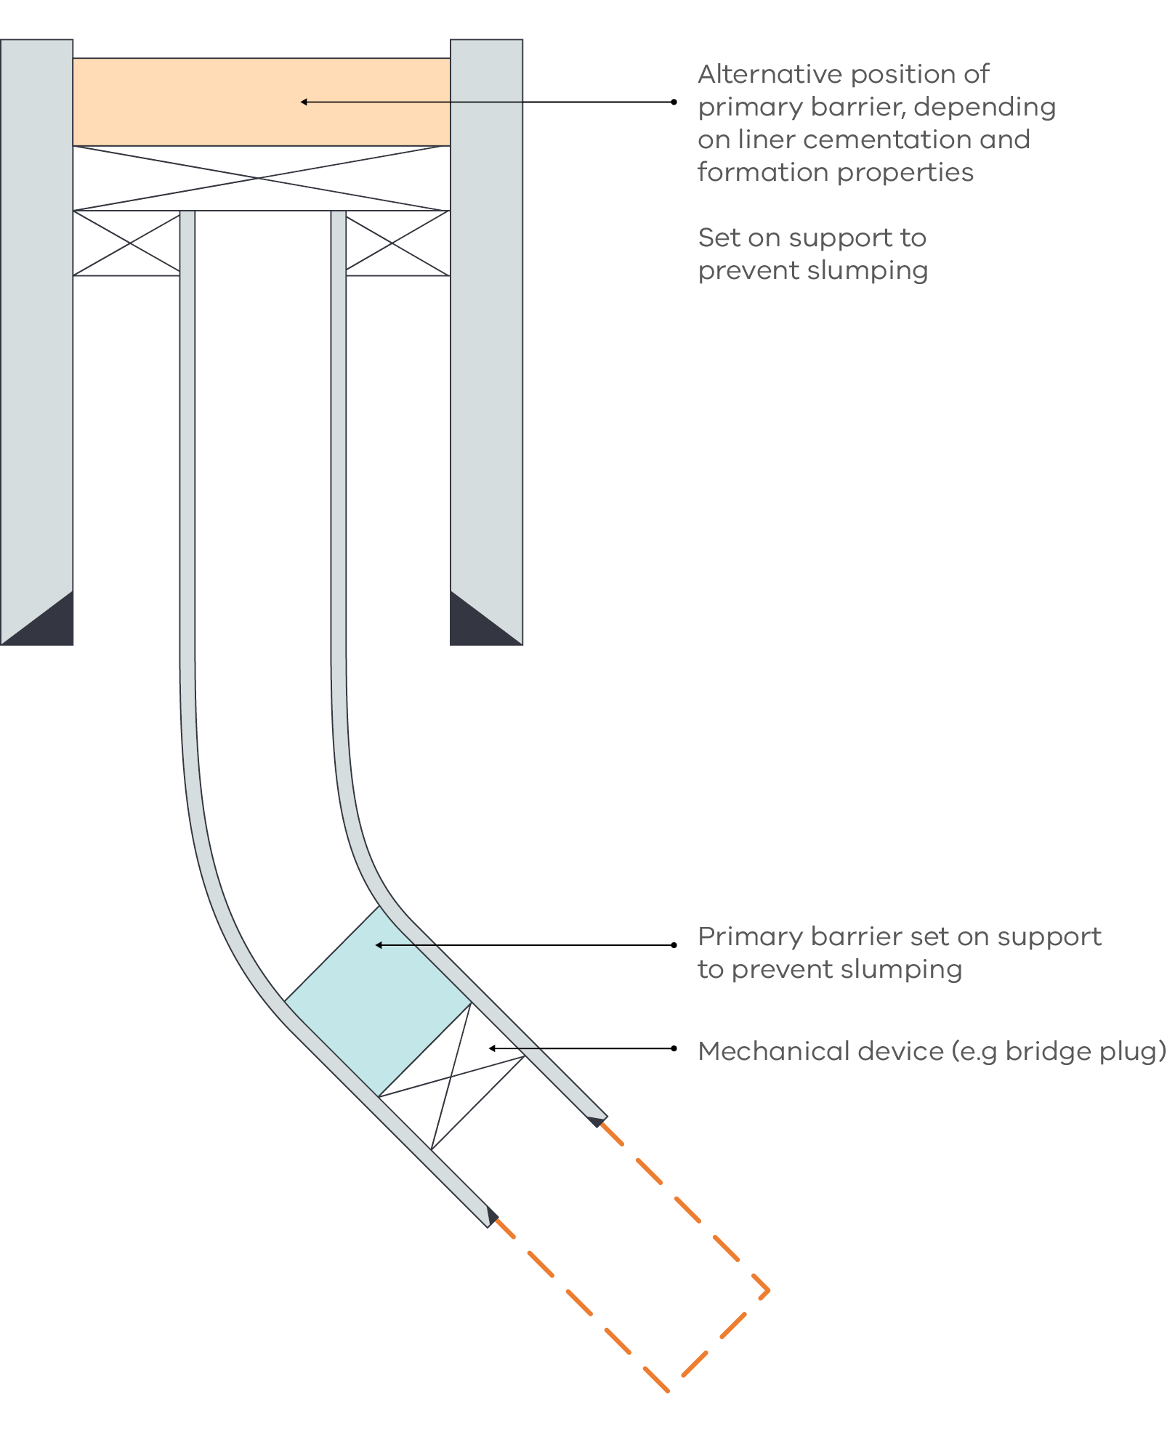
Source: Guidelines for Abandonment of Wells, Issue 5, Oil and Gas UK.
The diagram presents a well cross-section of a high angle well with a decommissioned open hole section.
The cement casing is depicted by two vertical rectangles either side. Black triangles in the bottom corner of each rectangle represent the casing shoes. An orange horizontal rectangle near the top between the two vertical rectangles represents a cement plug. An arrow points left stating Alternative position of primary barrier, depending on liner cementation and formation properties. Set on support to prevent slumping.
Underneath the cement plug is a diagonal cross from corner to corner representing a mechanical or bridge plug. Underneath the bridge plug are two small rectangles with diagonal lines criss-crossing from corner to corner representing two more mechanical or bridge plugs. From these, two fine vertical rectangles run side-by-side depicting the well liner hanger with cemented casing and curve down to the right. Black triangles in the bottom corner of each rectangle represent the casing shoes. At the end of the well liner hanger is a red dashed box representing an open hole.
At the end of the curved well liner hanger, just before it ends is a blue box between the cement casings, which represents a cement plug. An arrow points from the plug stating Primary barrier set on support to prevent slumping. Underneath the cement plug is a diagonal cross from corner to corner representing a mechanical or bridge plug.
Figure 11: Liner lap cementation
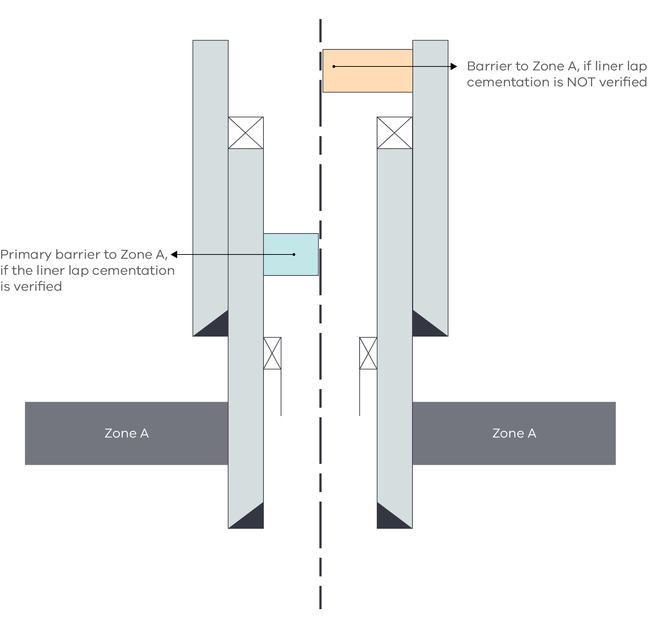
Source: Guidelines for Abandonment of Wells, Issue 5, Oil and Gas UK.
The diagram presents a cross-section of a well separated by a bold dashed vertical line in the centre.
The cement casing is depicted by two vertical rectangles either side finishing before Zone A. Black triangles in the bottom corner of each rectangle represent the casing shoes. In the centre of this is another cement casing depicted by two vertical rectangles either side finishing after Zone A. Black triangles in the bottom corner of each rectangle represent the casing shoes. The inner cement casing has two small rectangles with diagonal lines criss-crossing from corner to corner on top of them representing mechanical or bridge plugs. Two more mechanical bridges or plugs can be seen to the inside of the cement casings halfway down the diagram, just before Zone A.
To the left of the dashed line to the inside of cement casings, halfway down is a small blue box representing a cement plug. An arrow points left stating Primary barrier of Zone A, if liner lap cementation is verified.
To the right of the dashed line at the top of the outer cement casings is an orange horizontal rectangle representing a cement plug. An arrow points right stating barrier of Zone A, if liner lap cementation is NOT verified.
Figure 12: Example of a decommissioned well
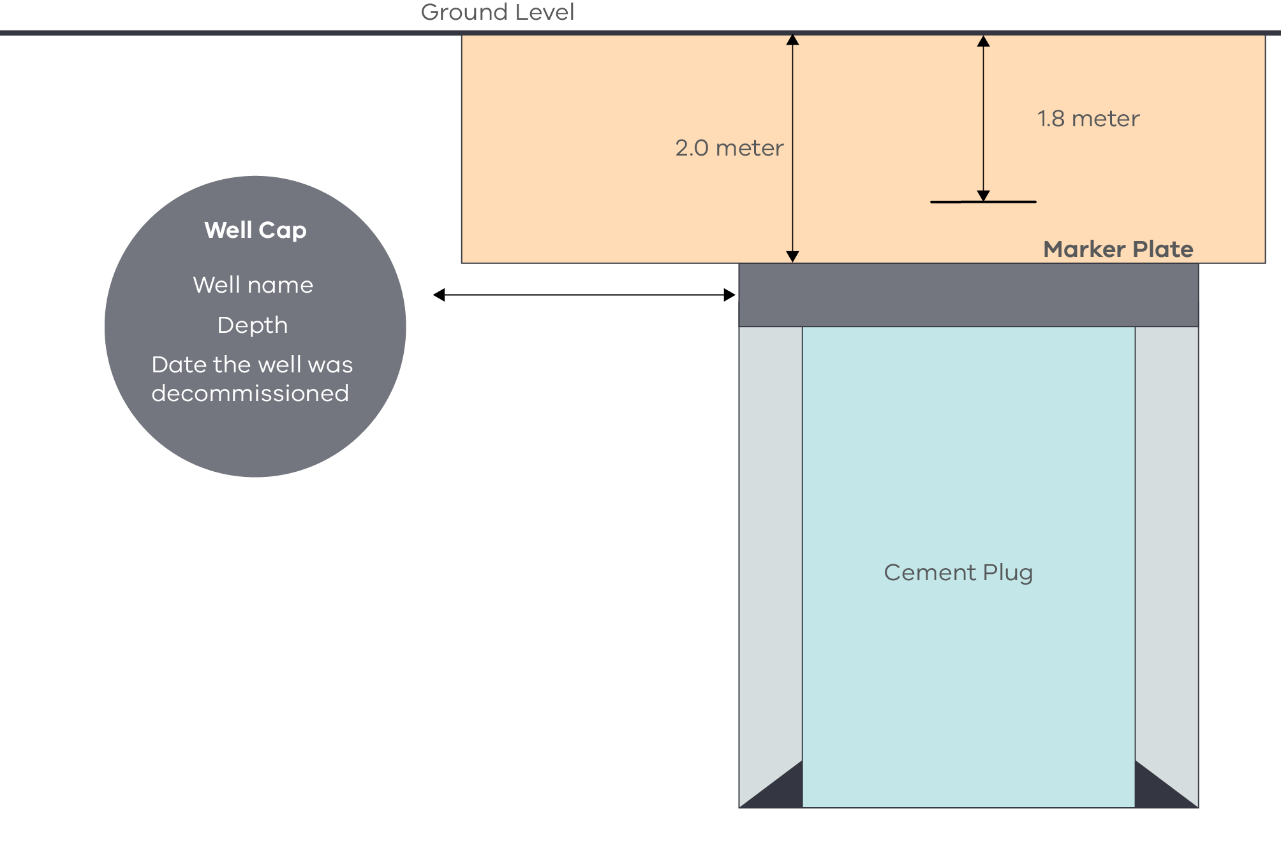
Source: Guidelines for Abandonment of Wells, Issue 5, Oil and Gas UK.
There is a bold horizontal line at the top of the diagram with a label above it that says Ground level. An orange horizontal rectangle is positioned directly underneath representing a well casing, which has been filled with cement. The casing has a two-directional arrow pointing from the top to the bottom of it labelled 2.0 meter, with another two directional arrow to the right of it that finishes slightly shorter than the first labelled 1.8 meter. At the bottom of the second arrow is a small horizontal line labelled Marker Plate.
Below the orange cement plug is a well casing which has been filled with cement. This is represented by a large, vertical rectangle. Inside this large rectangle a smaller dark grey rectangle lines the top of the cross section and is labelled Well cap, well name, depth, date the well was decommissioned. Underneath this are three vertical rectangles, two light-grey thin rectangles on the outside representing cement casings, and a blue vertical rectangle in the middle that is labelled Cement plug.
    - Good industry practice
- Calculate cement volumes where possible using an integrated open hole volume calculated from a calliper on a wireline log (this applies mostly to exploration wells which are to be decommissioned).
- If no calliper data is available, 30–40% above theoretical volume calculated from nominal casing diameter and gauge hole size is used, along with local hydrogeological knowledge and offset well data.
- Plugs are normally minimum 50m in length (primary barrier). Instead of using two primary barriers of 50m, a combination plug of 100m can be utilised after performing risk assessment. If the hole is badly washed‑out, it may be better to set two short plugs over the washed‑out section than to try to cover this interval with one plug.
- After placement of a cement plug the rate to pull the work string is controlled to avoid intermixing of the plug and other fluids in the hole.
- When placing a plug, excess cement is used and circulated off the top of the plug.
- Work string wiper dart/balls are used to separate cement and fluids during placement. If wiper darts are used a catcher sub is included in the work‑string.
- Displacement rates during cement plug placement is kept as high as practicable without exceeding the open hole fracture gradient. This aids in the displacement of the wellbore fluids by the spacer and cement flowing up the annulus. Spacer volumes are adjusted to provide adequate contact time based on the estimated displacement rate.
- The WOC time for tagging is based on the pre‑job lab testing of the slurry at BHST, preferably on an Ultrasonic Cement Analyser. Typically, the time to 3.5MPa (500psi) compressive strength is adequate for tagging cement. If the cement plug does not take weight, it is recommended to increase WOC in 4-hour increments up to a maximum of 12 hours additional WOC time.
- Balanced cement plug volumes pumped incorporates allowances for open hole and cased hole contamination.
- Section milling of casing during decommissioning is considered where inadequate annular side cement is found.
- Consider installing cement plugs along the entire open hole section.
- In order to pull dry pipe after placing a balanced cement plug, the plug is well under‑displaced to enable it to fall into a hydrostatically balanced position.
  - Leak management
This section addresses upstream assessment, detection, leak management plan, frequency, equipment, procedures and remediation of hydrocarbon leaks at wells pads and wellheads.
Note: This Code does not apply to gathering lines, pipelines or gas processing plants.
    - Principles
The purpose of leak management is to:
- eliminate or reduce emissions as far as is reasonably practicable;
- have effective systems and processes in place to detect any emissions;
- leak detection monitoring methods are fit-for-purpose and monitoring is conducted by a suitably qualified or experienced person.
Note: As a majority of onshore petroleum wells in Victoria are gas wells, this section will focus on fugitive gas emissions. An equivalent process would apply to any unplanned releases of other gases, oil or condensates.
    - Means of compliance
- Operational well sites are regularly inspected to identify any hydrocarbon emissions from petroleum activities at the site.
- Risk assessment is carried out to identify the risk posed by the leak and an appropriate leak response protocol is put in place.
- Monitoring and maintenance practices are put in place, with a rationale for these, including for the frequency of monitoring.
- Equipment, design standards and maintenance practices are selected with a view to minimising emissions as far as is practicable.
- All persons completing emission detection activities are properly trained and with competency confirmed.
- Leak inspections of individual wells are undertaken at a frequency determined through risk assessment and with consideration of previous audit/inspection findings. For external monitoring and leak testing, test components are in line with OEM recommendations.
- Wellheads or Christmas trees are tested within 48 hours of major maintenance (e.g. valve change‑out, actuator changeout, seal replacement, etc).
- Gas detection instruments are calibrated and maintained in accordance with the manufacturer’s requirements and the method (e.g. USEPA method 21).
- Where OGI instruments are used for leak detection, an annual inspection using US EPA Method 21 is also to be performed on the facility.
- If OGI is used for leak detection, the instrument is capable of imaging a gas that is half methane, half propane at a concentration of 10,000ppm (by volume) at a flow rate of ≤60g/hr from a quarter inch (6.4 mm) diameter orifice.
- If other superior leak detection methods are available, these may also be proposed.
- If a leak is found and it is safe to do so:
- clearly identify and record the source of the leak;
- if using USEPA Method 21, record the concentration of methane at the surface of the component for a sustained period of approximately twice the response time of the instrument in accordance with USEPA Method 21; and
- for OGI methods, record the video image of the leak.
- If a liquid petroleum leak is found and it is safe to do so:
- record the estimated volume of liquid leaking or leaked over time; and
- clearly identify and record the source of the leak.
- If a leak is found and is too large or not safe to measure, it will be assumed that the leak is a significant leak.
Leak Classification
Minor Leaks
- A minor leak is a leak that:
- originates from an above ground source;
- is an unplanned release;
- yields a methane concentration of 500ppm (by volume) to 5000ppm (by volume) when measured at the surface of the component according to USEPA Method 21; and
- any emission visible with an Optical Gas Imaging (OGI) instrument.
Significant Leaks
- A significant leak is a leak originating from the wellhead and meets one of the following criteria:
- a leak due to an unplanned release from the wellhead that gives a sustained Lower Explosive Limit reading greater than 10% (5000ppm by volume), when measured at the surface of the component according to USEPA Method 21. This is also to be treated as a well integrity failure;
- a liquid petroleum (condensate/oil) loss of containment that exceeds 80 litres of hydrocarbons.
- In the event that a significant leak is detected, the safety management system requirements for risk assessment and emergency response are followed.
- Remediation work is conducted in line with the following:
- Only start work after a suitable risk assessment has been undertaken and relevant safety procedures are followed, including consideration of all the required Personal Protective Equipment and emergency response materials.
- For leaks identified on well equipment – higher order controls, such as containment by repair, are implemented wherever possible.
- For leaks identified on well casings or adjacent to the well casing (where a workover rig is necessary to effect repair), repairs are completed as soon as reasonably practicable.
    - Good industry practice
- The authority holder’s practices are consistent with the emissions management plan described in US NSPS 2016 and relevant parts of the following sections: §60.5397a, §60.5410a, §60.5415a and §60.5420a.
- The inspection frequency is consistent with the monitoring requirements in US NSPS 2016 and relevant parts of the following sections: §60.5397a, §60.5410a and §60.5415a.
- The minimum requirements for gas detection instruments, operation and calibration procedures are consistent with the requirements in US NSPS 2016 and relevant parts of section §60.5397a.

Appendices

Appendix 1 – Additional guidance
- ANSI Process Piping B31.3 2008.
- ANSI/API Specification 15HR, High Pressure Fiberglass Line Pipe.
- ANSI/API Specification 15LR, Low Pressure Fibreglass Line Pipe and Fittings.
- API RP 10B‑2, 2nd Edition, April 2013. Complete Document. Recommended Practice for Testing Well Cements.
- API Recommended Practice 10B‑4, Recommended Practice on Preparation and Testing of Foamed Cement Slurries at Atmospheric Pressure.
- API Recommended Practice 10B‑5, Recommended Practice on Determination of Shrinkage
and Expansion of Well Cement Formulations at Atmospheric Pressure.
- API Recommended Practice 10B‑6, Recommended Practice on Determining the Static Gel Strength of Cement Formulations.
- API Recommended Practice 10D‑2, Recommended Practice for Centralizer Placement and Stop‑collar Testing.
- API Recommended Practice 10F, Cementing Float Equipment Testing.
- API Recommended Practice 13B‑1, Recommended Practice for Field Testing Water‑based Drilling Fluids.
- API Recommended Practice 13B‑2s, Recommended Practice Standard Procedure for Field Testing Water‑Based Drilling Fluids.
- API Recommended Practice 13D, Recommended Practice on the Rheology and Hydraulics of Oil Well Drilling Fluids.
- API Recommended Practice 49, Recommended Practices for Safe Drilling of Wells Containing H₂S.
- API Recommended Practice 53, Blowout Prevention Equipment Systems for Drilling Operations.
- API Recommended Practice 54, Occupational Safety for Oil and Gas Well Drilling and Servicing Operations.
- API Recommended Practice 59, Recommended Practice for Well Control Operations API Specification 16C, Choke and Kill Systems.
- API Recommended Practice 5A3, Recommended Practice on Thread Compounds for Casing, Tubing, Line Pipe and Drill Stem Elements.
- API Recommended Practice 5A5, Field Inspection of New Casing, Tubing and Plain‑end Drill Pipe.
- API Recommended Practice 5B1, Gauging and Inspection of Casing, Tubing and Line Pipe Threads.
- API Recommended Practice 5C1, Recommended Practice for Care and Use of Casing and Tubing.
- API Recommended Practice 5C5, Procedures for Testing Casing and Tubing Connections.
- API Recommended Practice 5C6, Welding Connections to Pipe.
- API Recommended Practice 92U, Underbalanced drilling operations.
- API RP 90‑2, Annular Casing Pressure Management for Onshore Wells.
- API SPEC 6A: 2018 Specification for Wellhead and Tree Equipment.
- API Specification 10A, Cements and Materials for Well Cementing.
- API Specification 10D, (R2015) Specification for Bow‑Spring Casing Centralizers.
- API Specification 12J, Specification for Oil and Gas Separators.
- API Specification 13A, Drilling Fluids Materials.
- API Specification 16A, ISO 13533, Specification for Drill-Through Equipment.
- API Specification 16C, Specification for Choke and Kill Systems.
- API Specification 16D, Control Systems for Drilling Well Control Equipment and Control Systems for Diverter Equipment.
- API Specification 16RCD, Drill-Through Equipment (Rotating Control Devices).
- API Specification 16ST, Coil Tubing Well Control Equipment Systems.
- API Specification 5B, Specification for Threading, Gauging and Thread Inspection of Casing, Tubing and Line Pipe Threads.
- API Specification 5CT, Casing and Tubing.
- API Specification 8A/8C, Grinding of wells (to suit casing elevators).
- API Standard 53, Blowout Prevention Equipment Systems for Drilling Operations.
- API Standard 65‑2, Isolating Potential Flow Zones During Well Construction.
- API Technical Report 10TR1, Cement Sheath Evaluation.
- API Technical Report 10TR2, Shrinkage and Expansion in Oil Well Cements.
- API Technical Report 10TR3, Temperatures for API Cement Operating Thickening Time Tests.
- API Technical Report 10TR4, Technical Report on Selection of Centralizers for Primary Cementing Operations.
- API Technical Report 10TR5, Technical Report on Methods for Testing of Solid and Rigid Centralizers.
- API Technical Report 5C3, Technical Report on Equations and Calculations for Casing, Tubing and Line Pipe used as Casing or Tubing; and Performance Properties Tables for Casing and Tubing.
- AS 2634-1983, Chemical Plant Equipment – Made from Glass‑Fibre Reinforced Plastics (GRP) Based on Thermosetting Resins.
- AS/NZS 1477:2017 PVC Pipes and Fittings for Pressure Applications.
- ASTM D2240-15e1, Standard Test Method for Rubber Property – Durometer Hardness 1.
- ASTM D2310 (2012), Standard Classification for Machine‑Made “Fibreglass” (Glass‑Fibre‑Reinforced Thermosetting‑Resin) Pipe.
- ASTM D2517‑18, Standard Specification for Reinforced Epoxy Resin Gas Pressure Pipe and Fittings.
- ASTM D2996-17, Standard Specification for Filament‑Wound “Fiberglass” (Glass‑Fiber‑Reinforced Thermosetting‑Resin) Pipe.
- ASTM D412, Standard test Methods for Vulcanized Rubber and Thermoplastic Elastomers – Tension 1.
- ASTM D471-16a, Standard Test Method for Rubber Property – Effect of Liquids.
- Australian Radiation Protection and Nuclear Safety Agency (ARPANSA) – Disposal of Naturally Occurring Radioactive Material (NORM).
- ISO 10407, Drill Stem Design and Operating Limits.
- ISO 10414‑1, Recommended Practice for Field Testing Water-Based Drilling Fluids.
- ISO 10414‑2D, Recommended Practice for Field testing of drilling fluids – Part 2: Oil‑based fluid.
- ISO 10426‑1, Specification for Cements and Materials for Well Cementing.
- ISO 10426‑5, Recommended Practice on Determination of Shrinkage and Expansion of Well Cement Formulations at Atmospheric Pressure.
- ISO 10426‑6, Methods of determining the static gel strength of cement formulations.
- ISO 10427‑1, Specification for Bow‑Spring Casing Centralizers.
- ISO 10427‑2, Recommended Practice for Centralizer Placement and Stop Collar Testing.
- ISO 10427‑3, Recommended Practice for Performance Testing of Cementing Float Equipment.
- ISO 10432, Specification for Wellhead and Christmas Tree Equipment.
- ISO 11960, Specification for Casing and Tubing.
- ISO 13354, Drilling and production equipment – Shallow gas diverter equipment.
- ISO 13500, Specification for Drilling Fluid Materials.
- ISO 13503‑1, Petroleum and natural gas industries – Completion fluids and materials – Part 1: Measurement of viscous properties of completion fluids.
- ISO 13503‑3, Petroleum and natural gas industries – Completion fluids and materials – Part 3: Testing of heavy brines.
- ISO 13678, Recommended Practice on Thread Compounds for Casing, Tubing, Line Pipe and Drill Stem Elements.
- ISO 13679, Recommended Practice on Procedures for Testing Casing and Tubing Connections.
- ISO 15463, Field Inspection of New Casing, Tubing and Plain‑end Drill Pipe.
- ISO 16530‑1:2017, Well integrity – Part 1: LIfecycle governance
- ISO 17855‑1:2014, Polyethylene (PE) moulding and extrusion materials – Part 1: Designation system and basis for specifications.
- ISO 31000:2018, Risk management – Principles and guidelines.
- ISO10426‑2, Recommended Practice for Testing Well Cements.
- Managing risks of hazardous chemicals in the workplace, 2018.
- Minimum construction requirements for water bores in Australia 4th ed.
- NACE Standard MR 0175/ISO 15156 Materials for use in H₂S–containing environments in oil and gas production.
- National Exposure Standards for Atmospheric Contaminants in The Occupational Environment, National Occupational Health and Safety Commission (NOHSC) document [NOHSC:1003(1995)].
- NOHSC: 1008 2004, National Standard Approved Criteria for Classifying Hazardous Substances.
- NOHSC: 1013 1995, National Standard for Limiting Exposure to Ionising Radiation.
- NOHSC: 3017 1994, Guidance Note for the Assessment of Health Risks Arising from Hazardous Substances in the Workplace.
- NOHSC: 3022 1995, Recommendations for Limiting Exposure to Ionising Radiation.
- NOHSC: 7039 1995, Guidelines for Health Surveillance.
- NORSOK Standard D‑010, Well integrity in drilling and well operations.
- Oil and Gas UK OP071, 2015, Guidelines for the suspension and abandonment of wells.
- Schlumberger Oilfield Glossary.
Science Direct, 2015, Casing and Liners for Drilling and Completion (Second Edition).
Department of Jobs, Precincts and Regions, Preparing Operation Plans – Guideline for Authority Holders under the Petroleum Act 1998, (Consultation Draft) 2021. Department of Energy, Environment and Climate Action to publish final version in 2023.

Appendix 2
VAF hydrogeological groundwater units (HGUs) by aquifer (mapping layer) across major sedimentary basins
Aquifer Name | Aquifer Code | Aquifer Number | HGUs Otway Basin | HGUs Central Coast Basins | HGUs Gippsland Basin | HGUs Murray Basin – North West | HGUs Murray Basin – North East
Quaternary Aquifer | QA | 100 | Various aeolian deposits (1001), various fluvial, lacustrine, alluvial and colluvial sediments (1002) | Various aeolian deposits (1001), various fluvial, lacustrine, alluvial and colluvial sediments (1001), Quaternary sandy limestone, calcarenite and shell deposits (1003) | Various aeolian deposits (1001), various fluvial, lacustrine, alluvial and colluvial sediments (1002) | Various aeolian deposits (1001), various fluvial, lacustrine, alluvial and colluvial sediments (1002), Monoman Formation/Channel Sand (1140) | Various aeolian deposits (1001), various fluvial, lacustrine, alluvial and colluvial sediments (1002)
Upper Tertiary/ Quaternary Basalt Aquifer | UTB | 101 | Quaternary stony rises, tuffs, undiff Quaternary basalt (inc Newer Volcanics) (1005) | Quaternary stony rises, tuffs, undiff Quaternary basalt (inc Newer Volcanics) (1005) | ABSENT | ABSENT | Undiff Quaternary basalt (inc Newer Volcanics) (1005), unnamed Quaternary trachyte (1004)
Upper Tertiary/ Quaternary Aquifer | UTQA | 102 | ABSENT | ABSENT | Haunted Hill Formation (1015), Eagle Point Sand (1016) | Shepparton Fm (1008‑1010) | Shepparton Fm (1008‑1010)
Upper Tertiary/ Quaternary Aquitard | UTQD | 103 | ABSENT | ABSENT | Boisdale Fm (Nuntin Clay) (1017), Jemmys  Point Fm (1061), Sale Grp (1061) | Blanchetown Clay (1014) | ABSENT
Upper Tertiary Aquifer (marine) | UTAM | 104 | Whalers Bluff Formation (1049), Moorabool Viaduct Fm (1034), Hanson Plain Sand (1030), Dorodong Sand (1031), Grange Burn Formation -1032 | Moorabool Viaduct Formation (1034) | ABSENT | Loxton Parilla Sand (1019), Moorna Fm (1020)  Chowilla Fm (1022) | Parilla Sand (1019)
Upper Tertiary Aquifer (fluvial) | UTAF | 105 | Unnamed duricrust (1028), undifferentiated Upper Tertiary Aquifer (fluvial) (1023) | Brighton Group (1033), Baxter Sandstone -1035 | Boisdale Fm (Wurruk Sand) (1036) | Calivil Fm (1023) | Calivil Fm (1024), undifferentiated Upper Tertiary Aquifer (fluvial) (1023)
Upper Tertiary Aquitard | UTD | 106 | ABSENT | ABSENT | Hazelwood Formation (1056), Yallourn Formation (1058) | Bookpurnong Fm (1038), Lower Loxton Clays (1039), Geera Clay (younger) (1134), Winnambool Formation (younger) (1135), Renmark Group (younger) (1136) | ABSENT
Upper Mid‑Tertiary Aquifer | UMTA | 107 | Port Campbell Limestone (1050), Portland Limestone (1048), Gambier Limestone (1041), Bochara Limestone (1048), Heywood Marl (1048), Heytesbury Group (1048) |  | Balook Fm (1060), LVG: Yarragon Fm (1057), LVG: Morwell M1‑2 aquifers (1059), Alberton Fm (1064), Cobia Subgroup (1053), Gurnard | Murray Group Limestone (1052), Nelson Fm (1052), Glenelg Group (1052), Duddo | ABSENT
Upper Mid‑Tertiary Aquifer | UMTA | 107 |  | Batesford Limestone (1051), Sherwood Formation (1055), Yallock Formation (1129) | Fm (1053), Turrum Fm (1053) | Murray Group Limestone (1052), Nelson Fm (1052), Glenelg Group (1052), Duddo | ABSENT
Upper Mid‑Tertiary Aquifer | UMTA | 107 |  |  |  | Limestone (1046), Morgan Limestone (1043), Winnambool Formation (interleaving) (1137) | ABSENT
Upper Mid‑Tertiary Aquitard | UMTD | 108 |  | Torquay Group (1072), Fyansford Fm (1054), | Seaspray Group (1062), Lakes Entrance Fm (1063), Tambo River Fm (1062), Gippsland Limestone (1063), Giffard Sandstone Member (1062) | Winnambool Fm (1067), Geera Clay (1066), undifferentiated UMTA (interleaving – older) (1139) | ABSENT
Upper Mid‑Tertiary Aquitard | UMTD | 108 | Gellibrand Marl (1068) | Newport Silt (1069), Maddingley Coal (1132) |  |  | ABSENT
Lower Mid‑Tertiary Aquifer | LMTA | 109 | Clifton Fm (1074) | Maude Fm (1070) | LVG: M2C aquifer (1141), Seaspray Sand ‑1141 | ABSENT | ABSENT
(Lower) Tertiary Basalts | LTB | 112 | Phase 2 (‘Gellibrand’) Basalts (1081) | ABSENT | ABSENT | ABSENT | ABSENT
Lower Mid‑Tertiary Aquitard | LMTD | 110 | Wangoom Sand (1079), Narrawaturk Marl | Demons Bluff Group (1085), Anglesea Fm -1085 |  |  | ABSENT
Lower Mid‑Tertiary Aquitard | LMTD | 110 | (1080), Upper Mepunga Fm (1084), Sturgess |  | Flounder Fm (1086) | Ettrick Fm (1076), Boga Silt (1077) | ABSENT
Lower Mid‑Tertiary Aquitard | LMTD | 110 | Point Member (1083), Nirranda Group (1078) |  |  |  | ABSENT
(Lower) Tertiary Basalts | LTB | 112 | Phase 2 Basalts (1081) | Phase 2 Basalts (1081), Mornington Volcanics -1111 | Thorpdale Volcanics (1112) | ABSENT | ABSENT
Lower Tertiary Aquifer | LTA | 111 | Lower Mepunga Fm (1100), Dilwyn Fm (1093), Yaugher Volcanics (1093), Pember Mudstone (1095), Pebble Point Fm (1097), Timboon
Lower Tertiary Aquifer | LTA | 111 | Sand (1101), Rivernook Member (1093), Burrungule Member (1094), Moomowroong Sand Member (1098), Wiridjil Gravel Member (1099), Brucknell Member (1100), Wangerrip Group (1091)
Lower Tertiary Aquifer | LTA | 111 | Dartmoor Fm (1091) |  | Childers Fm (1107), M2/M2C aquifer (when basal aquifer) (1142), Latrobe Group (1104)
Lower Tertiary Aquifer | LTA | 111 | Knight Group (1091) | Eastern View Fm (1096), Werribee Fm (1102), Yaloak Fm (1103),  Childers Fm (1107) | Traralgon Fm (1104), Burong Fm (1108), Honeysuckle Gravels (1106), Yarram Fm (1105) | Upper, Middle and Lower Renmark Group (inc Warina Sand, Olney Fm) (1087‑09), White Hills Gravels (1071) | Upper, Middle and Lower  Renmark Group
Lower Tertiary Aquifer | LTA | 111 |  |  |  |  | (1087‑09), White Hills Gravels (1071)
Lower Tertiary Basalts | LTB | 112 | Older Volcanic Group (Phase 1) (1110) | Mornington Volcanics (1111), Older Volcanic Group (Phase 1) (1110) | Carrajung Volcanics (1113), Older Volcanic Group (Phase 1) (1110) | ABSENT | Older Volcanic Group (Phase 1) (1110)
Cretaceous and Permian Sediments | CPS | 113 | Paaratte Fm (1119), Belfast Mudstone (1120), Flaxman Fm (1121), Nullawarre Greensand (1122), Waarre Fm (1123) | NOT MAPPED | NOT MAPPED | Monash Formation (1115), Millewa Group ‑1116 | Urana Formation (1117)
Mesozoic and Palaeozoic Bedrock | BSE | 114 | Eumeralla Fm (1125), Casterton Fm (1125), Crayfish subgroup (1125), all Palaeozoic | Permian Glacial Sediments, all Palaeozoic Basement Rocks (1124‑28) | Strzelecki Group (1125), all Palaeozoic Basement Rocks (1124‑28) |  | Permian Glacial Sediments, Strzelecki Group (1125), all Palaeozoic Basement Rocks (1124‑28)
Mesozoic and Palaeozoic Bedrock | BSE | 114 | Basement Rocks (1124‑28) | Permian Glacial Sediments, all Palaeozoic Basement Rocks (1124‑28) | Strzelecki Group (1125), all Palaeozoic Basement Rocks (1124‑28) | all Palaeozoic Basement Rocks (1124‑28) | Permian Glacial Sediments, Strzelecki Group (1125), all Palaeozoic Basement Rocks (1124‑28)

Pressure containing applications ‘include all applications where the integrity of casing required to maintain well control’.
Guidance on groundwater monitoring is given in 5.12 of ‘Preparing operation plans – Guideline for authority holders under the Petroleum Act 1998’, Department of Jobs, Precincts and Regions, (Consultation Draft) 2021. Department of Energy, Environment and Climate Action to publish final version in 2023.

