Benambra Waxlip Spur Surface Water Sampling Results

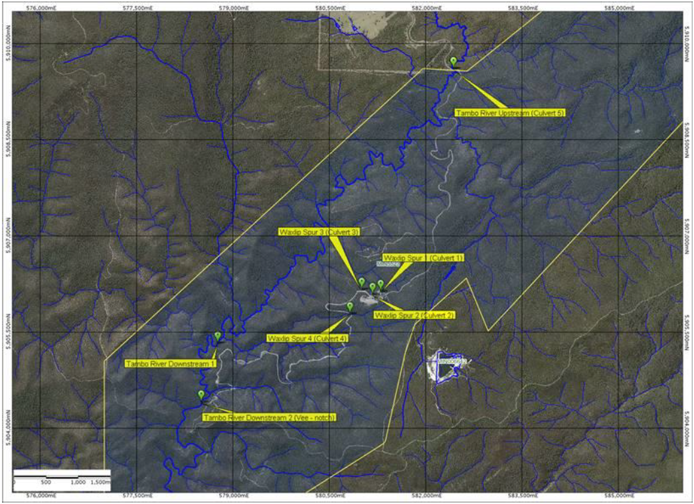
Map of sampling area
Tailings Storage Facility

Benambra Waxlip Spur Surface Water Sampling Results to September 2025 – pH

The below image is indicative of sampling locations. Not to scale.

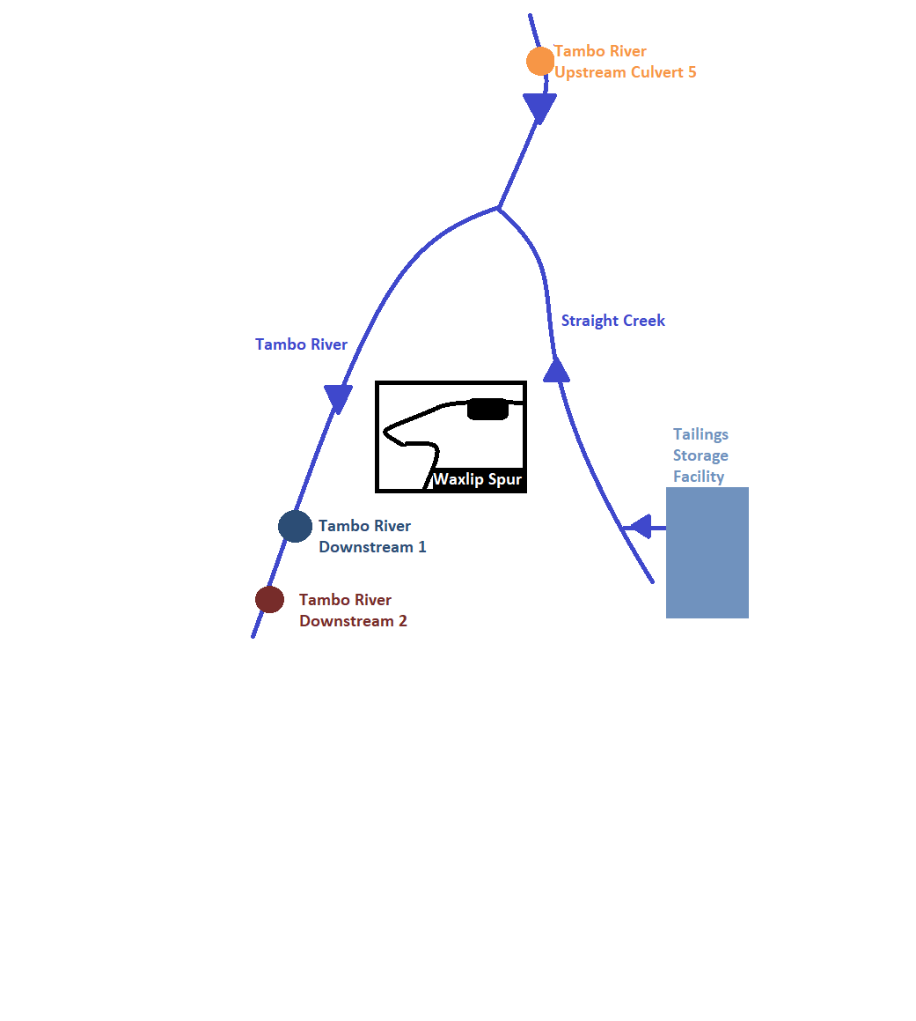
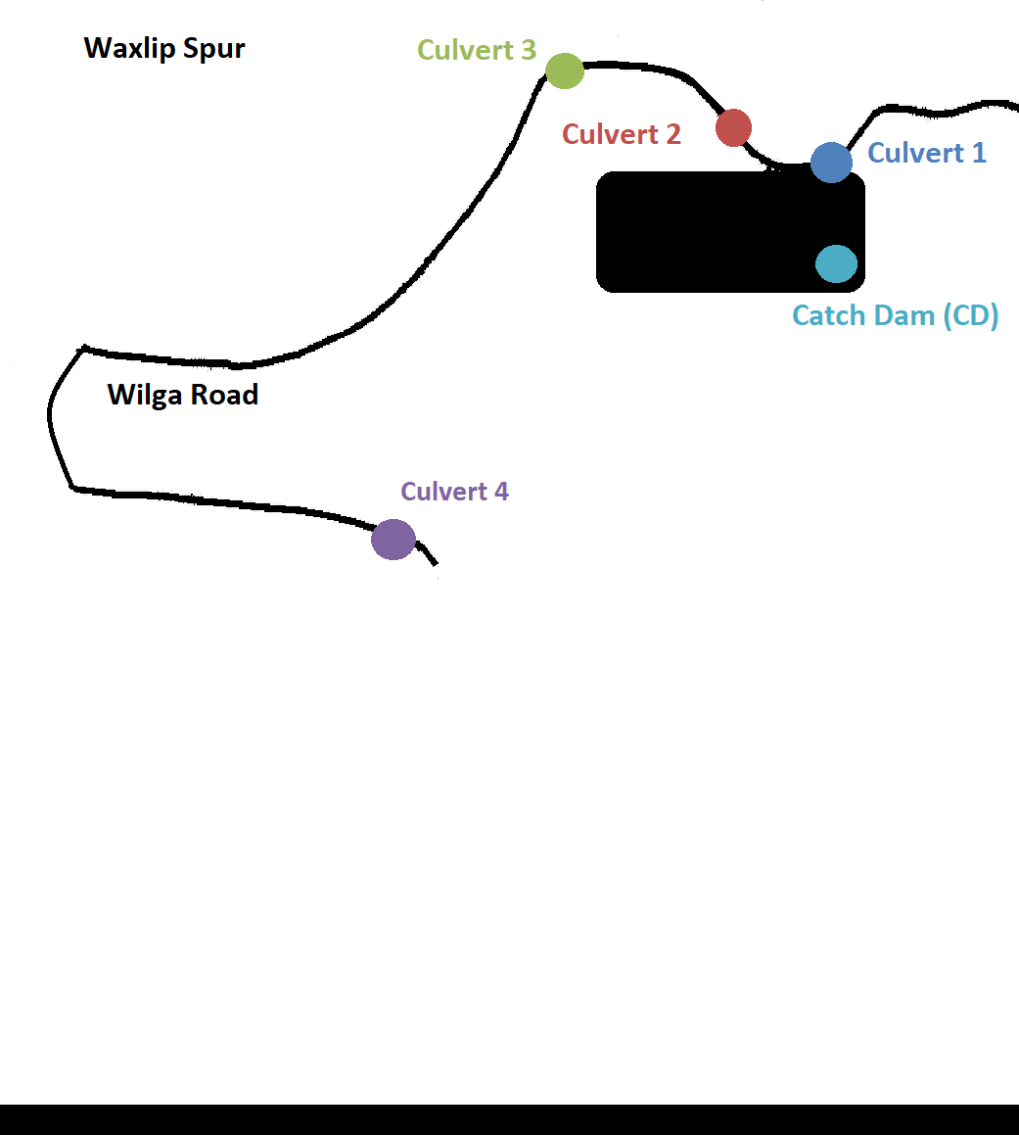
The data plotted in the above graph can vary with rainfall and water levels. There is no regular discharge to the creek, except in flood conditions. Environmental Quality Objectives (i.e. levels acceptable for this receiving environment) have not yet been developed.

Benambra Waxlip Spur Surface Water Sampling Results to September 2025 - Copper

The below image is indicative of sampling locations. Not to scale.
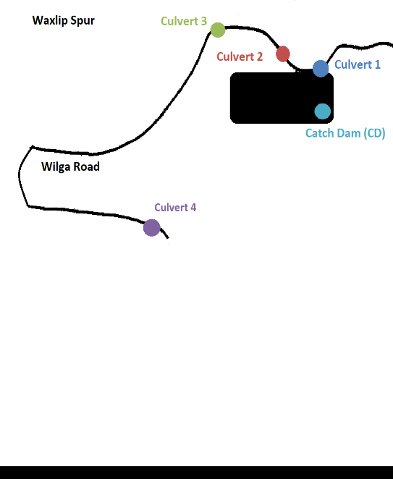

The data plotted in the above graph can vary with rainfall and water levels. There is no regular discharge to the creek, except in flood conditions. Environmental Quality Objectives (i.e. levels acceptable for this receiving environment) have not yet been developed. Copper values <0.001mg/L are shown as 0.001mg/L to display the overall trend.

Benambra Waxlip Spur Surface Water Sampling Results to September 2025 – Zinc

The below image is indicative of sampling locations. Not to scale.

The data plotted in the above graph can vary with rainfall and water levels. There is no regular discharge to the creek, except in flood conditions. Environmental Quality Objectives (i.e. levels acceptable for this receiving environment) have not yet been developed. Zinc values <0.005 mg/L are shown as 0.005 mg/L to display the overall trend.

