Trailing Liabilities for Victoria’s Declared Mines
Consultation Paper

Contents
Overview 3
Background – Existing rehabilitation requirements in Victoria 4
Mining lifecycle and rehabilitation liability 4
Rehabilitation Obligations 4
Requirement for licensees to show capacity to finance rehabilitation 5
Rehabilitation plans 5
Rehabilitation bonds 5
Additional rehabilitation requirements for declared mines 5
Cost recovery and other enforcement 6
Why introduce trailing liability provisions for rehabilitation? 7
Case Study – Northern Endeavour Floating Production Storage Facility (Commonwealth) 7
Trailing Liabilities can help fill a regulatory gap 7
What types of mining licences should trailing liabilities apply to? 9
Case Study – Rehabilitation liability for the Latrobe Valley coal mines 9
Future declared mines 10
Other types of resources 10
Question 10
How should trailing liabilities provisions operate? 11
The Commonwealth Offshore Petroleum Trailing Liabilities Framework 11
How can this regime be adapted for Victoria? 12
Proposed scope of trailing liability provisions 12
Enforcement 13
Changes in ownership 13
Questions – Proposed Trailing Liabilities Framework 13
Next Steps 15

Overview
On 5 May 2022 the Victorian Government made a public commitment to introduce legislation to amend the Mineral Resources (Sustainable Development) Act 1990 (MRSDA) to include a trailing liability scheme for rehabilitation of declared mines, which are currently the three Latrobe Valley coal mines.
The Government made this commitment to bolster Victoria’s regulatory framework for coal mine rehabilitation.
Under Victorian legislation, mine rehabilitation and post-closure arrangements must be led and funded by mine licensees. The new provisions will:
- reduce the likelihood that rehabilitation costs are passed onto Victorians; and
- provide the Government with a new tool to require those who derived greatest financial benefit from mining projects to be responsible for remediating the rehabilitation risks and liabilities caused by the project.
Similar provisions were passed by the Commonwealth Government last year for decommissioning offshore infrastructure, following an extensive review.
The trailing liability provisions are intended as a last resort tool to help protect Victorian taxpayers from a worst-case scenario where a licensee fails to or is unable to meet its rehabilitation obligation. While this is not expected to occur, the Government wants to be prepared just in case. Once in place, the Government will be able to issue remedial actions requiring former licensees and/or related persons (dating back to 5 May 2022) to take on rehabilitation obligations if circumstance arise where the current title holder is no longer present or able to complete rehabilitation.
This consultation paper provides the context for why Government intends to introduce the trailing liability provisions, an overview as to how the provisions could work, the possible risks, issues and costs associated with the implementation of trailing liabilities and seeks your views about how the trailing liabilities regime should be designed.
It is imperative that the design is right so that the regime is effective and does not have unforeseen impacts on stakeholders.
Legislative measures are proposed to be backdated to be effective from 5 May 2022.
The intent is to introduce legislation into Parliament in 2023 and backdate it to be effective from 5 May 2022, the date the Government announced its intent to introduce trailing liabilities. This process is similar to how the Commonwealth Government introduced trailing liability provisions for the offshore the Offshore Petroleum sector under the Offshore Petroleum and Green Gas Storage Act 2006 (Commonwealth Offshore Act).
Following passage of the legislation, further consultation will be undertaken around the design of any new Regulations necessary to give detail on the circumstances when trailing liabilities would be used and how the provisions will be implemented. Consultation will also take place on any Guidelines developed in relation to trailing liabilities provisions.
The trailing liability provisions will not change the existing rehabilitation obligations of the declared mine licensees. The rehabilitation obligations are not new. Declared mine licensees are aware of these and have made it explicit that they are committed to meeting their obligations.

Background – Existing rehabilitation requirements in Victoria
When the State issues mining licences, it expects mine licensees to fulfil their rehabilitation obligation in a timely manner and pay the costs of rehabilitation by fully rehabilitating the mining site.
If mine licensees are unable or unwilling to rehabilitate, the State must step in to rehabilitate the site and pay for the remaining rehabilitation at the expense of taxpayers, or risk major catastrophes eventuating.

Mining lifecycle and rehabilitation liability
All mining businesses must manage rehabilitation liability, which varies over the life of an operation, and also manage their assets to ensure they can meet their rehabilitation obligations (Figure 1).
Figure 1 Rehabilitation liability over the life of a mining operation
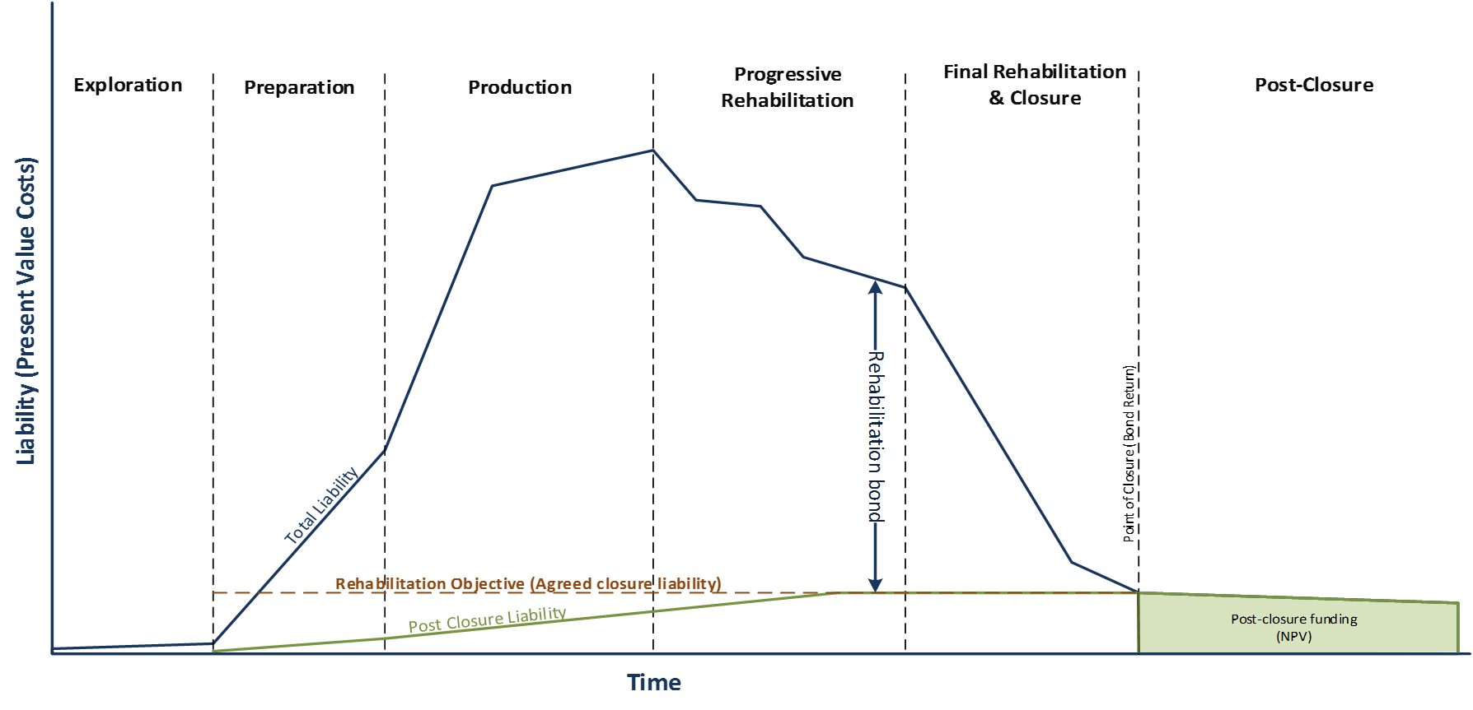
To manage these growing financial risks as the business matures, large mining companies may move to divest or restructure their mature assets to focus on areas of new production potential and reduce the financial risk posed by their rehabilitation liability. They may seek to involve new entrants to the industry, for example smaller companies or joint ventures who bring a fresh perspective and a have different risk profile.

Rehabilitation Obligations
In Victoria, the Mineral Resources (Sustainable Development) Act 1990 (MRSDA) sets the obligation for mine licensees to rehabilitate land once mining is complete and manages the risk to the State that licensees may default on rehabilitation through:
- A requirement for licensees to have the capacity to finance rehabilitation;
- Rehabilitation plans;
- Rehabilitation bonds;
- Declared mine rehabilitation obligations; and
- Debt recovery and other enforcement.
The obligation to rehabilitate under the MRSDA and associated enforcement powers continuing to apply to the mine licensee after the mining licence expires.
All these measures aim to:
- encourage progressive rehabilitation and improved rehabilitation planning by mine operators; and
- provide the State of Victoria financial assurance against the risk of rehabilitation default and the costs of rehabilitation.

Requirement for licensees to show capacity to finance rehabilitation
As part of the mining licence application applicants must satisfy the Minister for Resources that they are ‘fit and proper’ to hold the licence, including that they are likely to be able to finance the proposed work and rehabilitation of the land (refer Section 15(6)(d). The Financial Capability Policy issued by Earth Resources Regulation outlines the process by which an applicant’s financial capability will be assessed and the factors the Minister or the Minister's delegate will take into account when making decisions about financial capability). The financial capability requirement continues to apply during the life of the licence and the Minister can cancel the licence if the licensee no longer meets the requirement (refer Section 38(1)(b)(vi)). The Minister for Resources can also block corporate changes by not approving a transfer of a licence if they are not satisfied that the transferee is able to finance the proposed work and rehabilitation (refer Section 33(3)).

Rehabilitation plans
All mine licensees must have an approved rehabilitation plan for how they will meet their rehabilitation obligations and the State has information collection and inspection powers to ensure the rehabilitation plan is being implemented. The State also has enforcement powers to require the licensee to implement the rehabilitation plan.
The rehabilitation plan also provides a basis for the State to assess rehabilitation liability and sets the rehabilitation plan criteria to be fulfilled by the State if it has to step in.

Rehabilitation bonds
A mine licensee must provide financial security for the cost of meeting its rehabilitation obligation in the form of a rehabilitation bond (refer Section 80. The financial security for a rehabilitation bond is normally in the form of a bank guarantee). The State can draw from the rehabilitation bond to cover any rehabilitation costs incurred by the Minister for Resources if the mine licensee defaults (refer Section 83). While mining and rehabilitation are underway, the State can require mine licensees to do rehabilitation liability assessments to determine the adequacy of the rehabilitation bond, based on the rehabilitation plan (refer Section 79A). The Minister for Resources can also ask for a further rehabilitation bond if the existing bond is insufficient (refer Section 80(4)).
There is a specific Latrobe Valley coal mine bond policy that requires the declared mine bonds to be reviewed at least every 5 years (refer Rehabilitation Bond Policy for the Latrobe Valley Coal Mines). The Government is reviewing bond policy and intends to update bonds in 2023.

Additional rehabilitation requirements for declared mines
As declared mines (by the Minister for Resources under s7C of the Act.) the three Latrobe Valley coal mines are subject to additional risk prevention requirements and pay a mine stability levy to fund research and technical advice.
The rehabilitation of declared mine land is regulated by both the general provisions relating to rehabilitation of all mines under the MRSDA (as described in the previous section) and by the special declared mine rehabilitation framework inserted into the MRSDA by the Mineral Resources (Sustainable Development) Amendment Act 2019 (the Amendment Act) introduced in response to the Hazelwood Mine Fire Inquiry recommendations.
The scheme for the rehabilitation and post-closure management of declared mine land introduced by the Amendment Act includes:
- The need for Declared Mine Land Rehabilitation Plans (DMRPs) that recognise the sites will require ongoing monitoring and management to remain safe, stable and sustainable after rehabilitation is completed;
- Establishing a register of declared mine land that includes the land, any conditions or prescribed matters applying to the land, and a post-closure plan;
- A Mine Land Rehabilitation Authority (the Authority) created with functions and responsibilities for the rehabilitation of declared mine land through guidance provided by the Latrobe Valley Regional Rehabilitation Strategy (LVRRS) where appropriate;
- The Declared Mine Fund to meet the ongoing costs associated with the post-closure management of declared mine land if the land is transferred to the Authority.
The declared mine land framework is enabling, so much of the detail will be set out in supporting regulations. Recent amendments to the Mineral Resources (Sustainable Development) (Mineral Industries) Regulations 2019 support the powers and processes for declared mines in the MRSDA. These regulations will enable better management of the rehabilitation of Victoria’s declared mine sites, bringing clarity for operators, government and the community and prescribing the development and implementation of long-term plans that are critical to transforming those sites into safe, stable and sustainable landscapes, helping ensure the best outcomes for the Gippsland region.

Cost recovery and other enforcement
If the mine licensee fails to rehabilitate mine land, the Minister for Resources can use the enforcement powers in Part 12 of the MRSDA to compel compliance. If the licensee defaults and does not carry out the rehabilitation after being asked to rehabilitate, the Minister for Resources can rehabilitate (refer Section 83(1)) the site either directly or via contractual arrangements with outside providers. The Minister can use the bond to fund the rehabilitation and can seek costs of rehabilitation which exceed the amount of the bond from the licensee or former licensee as a debt in Court (refer Section 83(4)).

Why introduce trailing liability provisions for rehabilitation?
The regulatory framework works on the assumptions that mine licensees have sufficient financial capacity to rehabilitate and assumes that the risk of mine licensee defaulting on rehabilitation is managed by the mine licensee providing a sufficient bond to enable the Government to complete any outstanding rehabilitation.
The Government uses compliance and enforcement tools to ensure that a mining licensee’s rehabilitation plan is completed.
While the MRSDA contains provisions for ensuring that an operator leads and funds rehabilitation, it does not include provisions for ensuring that the Victorian public is protected from declared mine rehabilitation liabilities if mine licensees default and cannot complete rehabilitation commitments and the bond does not cover the rehabilitation costs.
Mine licensees may not be able to complete rehabilitation if they:
- experience financial difficulties and cannot update their bond per the requirements of the Departmental 5-yearly review or continue rehabilitation work;
- become insolvent or go into liquidation, noting that when mine licensees go into liquidation the Minister for Resources only has access to rehabilitation bonds;
- restructure their organisation, leaving a new company/ entity as mine licensee that is less able to complete rehabilitation than the parent company to which the title was initially awarded.
The case study below gives a real example of circumstances where the Commonwealth government had to step in and rehabilitate where trailing liabilities provisions would have provided an additional enforcement tool.

Case Study – Northern Endeavour Floating Production Storage Facility (Commonwealth)
In 2015 Northern Oil and Gas Australia (NOGA) acquired the Laminaria-Corallina oil fields and the Northern Endeavour Floating Production Storage and Offtake facility in offshore waters regulated by the Commonwealth Government.
NOGA’s 2015 acquisition was made on the assumption that further petroleum production was possible despite the previous title holder having announced its intention to cease production from Northern Endeavour in the second half of 2016. NOGA had significant issues in complying satisfactorily with its regulatory safety obligations which lead to actions by NOPSEMA requiring production of gas to cease. NOGA had insufficient financial resources to continue operating and went into voluntary administration in September 2019.
The Commonwealth Government is now managing the decommissioning of the facilities and the associated oilfields (refer to review into the circumstances leading to the administration and liquidation of Northern Oil and Gas Australia (NOGA), Steve Walker, August 2020).
In that case, to ensure that taxpayers were not left to pay for the decommissioning and remediation, the Commonwealth Government passed legislation to apply a temporary levy on other petroleum producers.
Following the NOGA failure, the Australian Government introduced a trailing liabilities framework (the Commonwealth Framework) for the offshore petroleum sector in Commonwealth waters, which enabled it to call back a former titleholder and/or related persons to complete rehabilitation or address issues with rehabilitation.

Trailing Liabilities can help fill a regulatory gap
On 5 May 2022 the Minister for Resources, the Hon Jaala Pulford, announced her intention to introduce trailing liability provisions to enable government to call back a former titleholder and/or related persons to complete rehabilitation or address issues with rehabilitation, in line with similar provisions passed by the Commonwealth Government for decommissioning offshore infrastructure.
In her announcement the Minister for Resources proposed the application of trailing liabilities provisions to the three declared mines to help meet the State’s overall rehabilitation objectives that:
- where a mine licensee cannot complete rehabilitation, then those parties that benefited from the operation are accountable for meeting the rehabilitation obligations;
- the Victorian Government and Victorian community are protected from rehabilitation liability if a title holder defaults on its rehabilitation obligation and a rehabilitation bond fails to adequately cover the cost;
- trailing liabilities could also serve as a strong incentive for title holder companies to make organisational and commercial decisions from the outset of mining and rehabilitation that support successful completion of rehabilitation.
The following sections of this consultation paper seek your views on:
- The application of trailing liabilities provisions to declared mines.
- How should trailing liabilities provisions operate?

What types of mining licences should trailing liabilities apply to?
It is proposed that trailing liabilities should be applied to declared mines under the MRSDA. The declared mines present more extensive rehabilitation requirements due to their very large and highly complex nature. These mines pose higher risks to the surrounding landscape, community, infrastructure, and environment than quarries or smaller mines.

Case Study – Rehabilitation liability for the Latrobe Valley coal mines
The Latrobe Valley coal mines and their associated power stations have provided energy to Victoria for nearly a century. The three mines are in different stages of the rehabilitation lifecycle (Figure 2).
Figure 2 – Latrobe Valley coal mines stage in the rehabilitation lifecycle
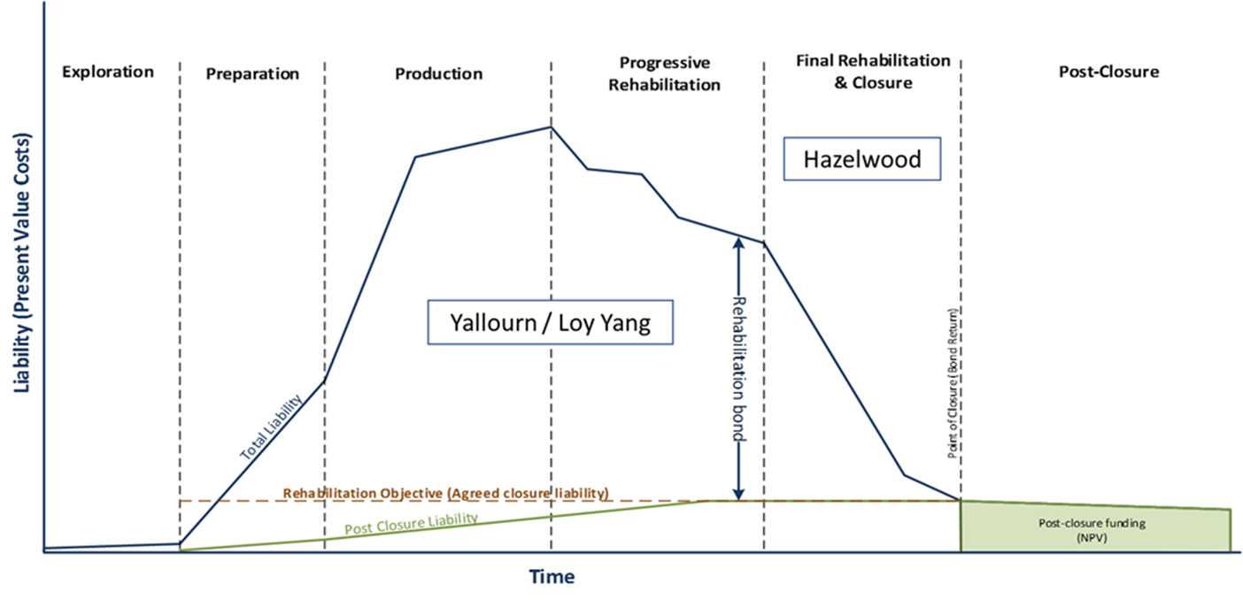
The Hazelwood coal mine closed in 2017 and since then the power station has been decommissioned and its owner ENGIE has been working towards closure and relinquishment of the mine site. The other two mines are approaching the end of their productive lives:
- Yallourn is scheduled to cease mining and power generation in 2028; and
- The Loy Yang A power station, which is supplied by the Loy Yang mine, is scheduled to finish mining operations in 2035.
The Latrobe Valley coal mines are large and complex. The size of these voids and proximity to nearby townships, infrastructure and waterways means adverse events carry significant consequences for their safety and stability and impacts on how they can be rehabilitated.
The Latrobe Valley coal mines are markedly different from other mines in the State for several reasons:
- relative to the volumes of coal, the Latrobe Valley mines excavate only minor amounts of excess material including sand, clay, and silt as the coal deposits are highly concentrated. As a result, these mines have created large voids over their operating lives; and
- the mines need to be constantly maintained to prevent harms to human life, the environment or infrastructure, as the coal mine walls and floor are inherently unstable and fire prone. Ground instability could harm workers in the mine or damage nearby infrastructure and communities, and fire is a constant risk. Smoke from the fire at Hazelwood in 2014 caused long-term harm to both workers and people in the surrounding community.
The Latrobe Valley coal mine licensees who are continuing to mine and generate power also face risks associated with the energy transition in addition to the financial pressures of operating assets nearing the end of their economic life. In its 2020 report Pathways to 2050 (FY20 TCFD Report) AGL acknowledges these transition risks:
Transitional risks include risks in end-of-life asset planning and the rehabilitation of assets. The risk of misalignment of these plans with future scenarios leading to possible stranded assets and revenue loss, and continued policy uncertainty. A further growing transitional risk facing AGL is access to capital from both equity and debt investors.
The proposal to introduce trailing liabilities for the declared mines is precautionary. It recognises the possibility that the complex financial issues facing the companies that operate the Latrobe Valley coal mines and power generators could lead to business decisions that change the financial positions or ownership structures in a manner that impacts on the entities that hold the mining licences for the declared mines.

Future declared mines
In addition to the three declared mines, the Minister for Resources can declare additional mines if they present significant risks to public safety, the environment or infrastructure due to geotechnical, hydrogeological, water quality or hydrological factors within the mine. This power could be used for mines that present complex and ongoing risks. Mines which present these types of risks are likely to require complex rehabilitation and ongoing monitoring and maintenance, which in turn can create financial pressures towards the end of the mining life cycle. The proposal for trailing liabilities to apply to all declared mines recognises these risks.

Other types of resources
The Government is committed to the proposal to legislate to apply trailing liabilities to declared mine from 5 May 2022. In response to this consultation the government may consider extending trailing liabilities in the future to other resources sectors by:
- mirroring the Commonwealth Offshore Act provisions in the Victorian offshore area regulated by the Offshore Petroleum and Greenhouse Gas Storage Act 2010; and
- making further amendments to the MRSDA and other resources legislation.

Question
Do you agree that trailing liabilities provisions should only be applied to declared mines? What are your reasons for that view?

How should trailing liabilities provisions operate?
The Victorian Government intent is to mirror the Commonwealth legislation that has been through a robust consultation process and to make adaptations that are necessary and relevant to the MRSDA and declared mine rehabilitation. Basing the Victorian approach on the Commonwealth framework will enable us to draw on the experience of the Commonwealth in implementing the regime and will help to create certainty of approach across asset classes. Submissions to this consultation paper will assist the Government in its final design of the trailing liabilities legislation.
An overview of the Commonwealth framework is available at Trailing liability for decommissioning of offshore petroleum property: guidelines on the Department of Industry, Science and Resources website. A detailed overview, including relevant discussion papers, of the Australian Governments review process that led to the implementation of trailing liability provisions in the Commonwealth Offshore Act can be found at Offshore oil and gas on the Department of Industry, Science and Resources website.

The Commonwealth Offshore Petroleum Trailing Liabilities Framework
The Commonwealth Framework was introduced to ensure that the costs and liabilities associated with decommissioning will be borne by the petroleum industry and do not become the responsibility of government or the Australian community.
Under the Commonwealth Framework, former titleholders or related parties (as at 1 January 2021 or after) can be called back in a range of circumstances to undertake any required decommissioning or address any residual related issues. The Commonwealth Framework provides enabling provisions in the Commonwealth Offshore Act and, without limiting the powers in the Act, relies on guidelines to provide further detail as to the scope of the trailing liability provisions and how these provisions may be applied.
The parties that could be issued remedial directions include:
- titleholders
- related bodies corporate
- related persons who
  - acted jointly with the titleholder
  - derived a significant financial benefit from the title
  - had the ability to influence activities under the title.
The situations under which these parties could be issued remedial directions include where:
- a current titleholder has failed to decommission in accordance with regulatory requirements
- issues arise in relation to previously decommissioned property.
Recognising that each case is different, the Commonwealth Framework provides flexibility to decide which person is the most appropriate, in the individual circumstances, to be issued a remedial direction. The Commonwealth Framework also provides a strong focus on ensuring procedural fairness.
The Commonwealth Framework also includes change of control provisions enabling regulatory oversight of changes in ownership of the title holder which would not require a licence transfer e.g. where a majority of shares in the titleholder are bought by a new company. This aims to ensure that a titleholder will remain suitable (including technically and financially capable) to hold the title as a result of a transaction in which an offshore project is proposed to be bought and sold, but is not currently captured by a transfer of the related title or titles. The provisions require title holders to seek approval for changes in ownership above a set threshold.

How can this regime be adapted for Victoria?
The aim of the proposed reforms is to reduce the risk of existing declared mine licensees disposing of mature to late-life assets to entities that may not be financially or technically capable of undertaking rehabilitation and fulfilling their obligations by:
- Ensuring the risks and liabilities of rehabilitation remain the responsibility of those who have derived the greatest financial benefits from the project; and
- Bringing about a change in behaviour and increase due diligence by a company when determining who it sells its titles and assets to.
The legislation will apply the new provisions to former mine licensees and related parties from the date of the then Minister’s announcement in May 2022. Under the proposed framework, new broad powers would be inserted into the MRSDA to apply in a range of circumstances, providing the Victorian Minister for Resources (with administrative support from Earth Resources Regulation) with the ability to call back any former mine licensee and/or related body corporate or persons (from the date of 5 May 2022 onwards) by issuing a remedial notice or order requiring them to take on rehabilitation obligations. This includes the ability to call back companies who have been given consent to surrender the title by the Minister, or sold their interests via a transfer, dealing or other form of commercial transaction. The decision about whether to issue a remedial notice and to whom would sit with the Minister, consistent with the regulations and guidelines.

Proposed scope of trailing liability provisions
It is intended the trailing liabilities provisions be applied to incumbent and future licensees and/or persons that existed on or after 5 May 2022 (the date of the initial public announcement), rather than apply retrospectively to all current and former licensees. The provision would be enduring in that a former licensee and/or related person could be issued with a remedial rehabilitation direction at any point after their involvement in the title has ceased.
The provisions would be used by the Minister for Resources as a last resort option available to government to prevent rehabilitation liability from falling to the State, and if all other safeguards have failed.
Consistent with the Commonwealth framework, the concept of a ‘related person’ for the purposes of trailing liability would be introduced. This would enable the government to require a range of entities to undertake or pay for remedial activities, including decommissioning in the event the current mine licensee does not meet its rehabilitation obligations.
To achieve this, it is intended that the MRSDA be amended for declared mines only, to expand the existing remedial notices and orders and enforcement orders (currently outlined in Division 4 pf the MRSDA) to related persons in addition to the mine licensee (in line with s586(2A) of the Offshore Petroleum and Greenhouse Gas Storage Act 2006):
- a related body corporate of the registered holder of the permit, lease or licence;
- any former registered holder of the permit, lease or licence; or
- a person who was a related body corporate of any former registered holder of the permit, lease or licence at the time the permit, lease or licence was in force.
It is intended that the amendments also include the ability for the Minister for Resources to determine any further related persons (who had an interest on 5 May 2022 or after) if the Minister believes that the person has had a significant enough interest for it to be reasonable for them to contribute to rehabilitation. Following the Commonwealth framework, the legislation would create a broad provision enabling trailing liabilities to be applied to ‘related persons’ with the details of who might be a related person to be captured by guidance which would be consulted on after the passage of the legislation. It is appropriate to use a broad definition in legislation because the specific ownership and management arrangements of mining operations can vary and are difficult to specifically prescribe. The Commonwealth has issued guidance defining a ‘related person’ as one who (in line with s586(2B) of the Offshore Petroleum and Greenhouse Gas Storage Act 2006):
- is capable of significantly benefiting financially, or has significantly benefited financially, from the operations authorised by the licence;
- is, or has been at any time, in a position to influence the way in which, or the extent to which, a person is complying, or has complied, with the person’s obligations under this Act; and
- is acting or has acted jointly with the title holder, or a former holder, of the licence in relation to the operations authorised by the licence.
Decisions on the detailed scope of a ‘related person’ in Victoria, such as the extent to which it could be applied to off takers who are using the outputs of the declared mine, will be a matter for consultation during the final design of the trailing liability provisions, including an exposure draft of the Bill, regulations and guidelines.

Enforcement
It is intended that the nature of the remedial notice or order to rehabilitated that will be issued to a related person would be kept in line with remedial notices and orders that could be issued to a current title holder for the purposes of fulfilling the obligations under a rehabilitation plan. Similarly, the penalty provisions for non-compliance the remedial notice or direction will be kept in line with those that already exist for existing titleholders.
Further detail would be included in regulations and guidelines after the amendments to the MRSDA are made. Any regulations and guidelines would also be subject to separate formal consultation processes. It is intended that regulations and guidelines could provide supporting binding and non-binding detail. Regulations could specify technical details such as:
- who a remedial direction could be issued to;
- how the principles of procedural fairness will be applied;
- how remedial directions will be complied with (the recipient of the direction will not have tenure or a title); and
- how non-compliance with remedial directions will be managed.
Guidelines could address the factors to be considered in determining which related person is issued a direction. The Commonwealth Framework guidelines focus on the following considerations:
- experience with the property;
- recency of interest in the title;
- capacity to conduct the relevant remedial action; and
- other matters considered relevant by the decision maker.

Changes in ownership
The MRSDA contains some powers for the regulator to consider whether a mine licensee remains financially capable of meeting its rehabilitation obligations as outlined in section 2. The MRSDA does not contain specific provisions requiring mine licensees to seek approval of changes in ownership above a set threshold. The 5 May 2022 announcement did not address including provisions on changes in ownership in amendments to the MRSDA to introduced trailing liabilities. However, we are now seeking feedback on whether change of ownership should be considered in the legislation as it would support the effective operation of the trailing liabilities framework.

Questions – Proposed Trailing Liabilities Framework
- What are your views on the Commonwealth Government’s trailing liabilities regime?
- Do you believe the Commonwealth Government trailing liabilities regime, developed for the offshore petroleum sector, could be adapted to Victoria’s declared mines? What are your reasons for that view?
- Do you think the proposed trailing liability regime will be effective in ensuring Victorians are not exposed to rehabilitation liability risk?
- What are your views on the proposed Victorian trailing liability regime?
- Do you have any suggested improvements to the proposed Victorian regime?
- If the trailing liabilities provisions were used, do you believe the related persons should have access to any existing rehabilitation bond to undertake the necessary works, as they would be doing the rehabilitation instead of the Government?
- If the trailing liabilities provisions were used and rehabilitation obligations were completed successfully by the related persons, do you think their expenses should be reimbursed (in full or in part) from any rehabilitation bond held by Government against the operation?
- Should the MRSDA be amended to declared mine licensees to seek approval of changes in ownership above a set threshold?
- Do you have any further comment on any other aspects of the proposed trailing liability scheme?

Next Steps
The Government intends to consult further on the development of the trailing liabilities provision with an exposure draft to be introduced in 2023 after which legislation would be brought before the Victorian Parliament. The proposed legislation would be subject to parliamentary oversight and approval.
The legislation would commence once the amendments are passed by the Victorian Parliament and supporting regulations and guidance material have been developed. The trailing liabilities provisions will apply from 5 May 2022 when the intent to introduce such provisions was announced by the then Minister.
Backdating the operation of legislation is not uncommon and it is critical that certainty and procedural fairness is maximised by being explicit about intent as early as possible. The announcement was made early so that the current operators of declared mines would know what is ahead and could begin factoring this commitment into their commercial decision making.
As the trailing liability provisions will be of direct relevance to the three Latrobe Valley Coal mines, government will ensure close communications with these operators to ensure they have an opportunity to contribute to consultations and clearly understand what the proposed changes mean.

