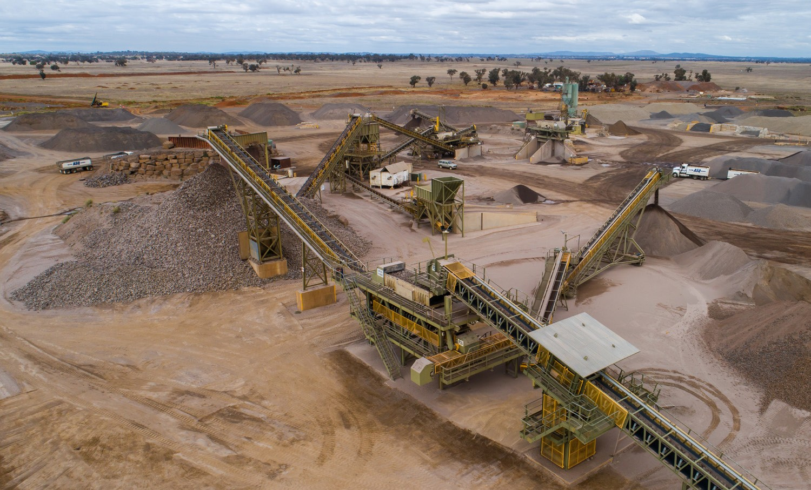This checklist is for proponents to fill out prior to submitting a work plan or work plan variation application to ensure the application is complete and of high-quality. If the items on this checklist are properly addressed, the extent of change requests will be reduced.

Applicant
pre-submission checklist
WORK PLAN AND WORK PLAN VARIATION
For further detail on the information required refer to the relevant guidance provided on the Earth Resources Website.
Some sites may have certain environmental or landform conditions where it is unclear on what type of detail or issues should be addressed, in this instance we recommend contacting your Assessments Officer to discuss.
Please provide the completed checklist when making submission of the work plan or work plan variation for endorsement by forwarding to Workplan.Approvals@ecodev.vic.gov.au.

Work Plan Requirements Checklist
General Items
Submission Date | DD/MM/YYYY
Work Authority/Licence Number | WAXXXXXX / MINXXXXXX
Name of Applicant(s) | Name of primary tenement holder (individual or company)
Initial site meeting date (note: if the initial site meeting was held more than one year ago, your proposal has changed significantly, or multiple co-regulator contacts have changed consider the benefits of convening a follow up meeting). | DD/MM/YYYY (indicate type of meeting (e.g. online, on site, etc.)  If an initial site meeting was not held, please detail the reason
Co-regulator follow-up meetings | DD/MM/YYYY - include reason  DD/MM/YYYY - include reason
Geotechnical meeting with Earth Resources Regulation | DD/MM/YYYY - include reason
Authority / Agency / Council Advice
Detail the directions and requirements determined by the relevant co-regulators in relation to the proposal. Including the following:
- Were all the relevant co-regulators engaged on the proposal?
- Have all the requirements been undertaken / incorporated and in-principle approval received?

Work Plan Requirements Checklist
Work Plan / Variation Items
Description of Work | ☐ Operations  ☐ Geology  ☐ Sensitive Receptors  ☐ Location map  ☐ Site drawings and Sections
Risk Management | ☐ Identification of Hazards and Risks  ☐ Risk Management Plan
Rehabilitation Plan | ☐ End Land Use  ☐ Landform - Safe, Stable and Sustainable  ☐ Closure Objectives  ☐ Closure Criteria  ☐ Rehabilitation Significant Event / Milestones  ☐ Rehabilitated Land Risks (risks that may require monitoring,  maintenance, treatment or other ongoing land management  activities after rehabilitation is complete.
Community Engagement Plan | ☐ Community Affected  ☐ Community Consultation / Sharing and Receiving  Information  ☐ Complaint Management
Supporting Documents
Applicable Assessments / Studies | ☐ Blasting Impact  ☐ Geotechnical  ☐ Groundwater  ☐ Surface Water  ☐ Noise  ☐ Flora and Fauna  ☐ Cultural Heritage  ☐ Other (list below)
Applicable Management Plans | ☐ Blasting  ☐ Ground Control  ☐ Ground Water  ☐ Surface Water  ☐ Noise  ☐ Native Vegetation Clearing / Offset  ☐ Cultural Heritage Management Plan  ☐ Other (list below
2

