Victorian Gas Program
PROGRESS REPORT
Report 1 | January 2018
Overview 3
Gas use 3
Victorian Gas Program 3
Gas Reserves and Resources 4
Onshore gas reserves and resources 5
Offshore gas reserves and resources 6
Next steps 6
1. Victorian Gas Program 7
1.1 Introduction and objectives 7
1.2 Scope 7
1.3 Study area 8
1.4 Regional geology 8
2. Onshore conventional gas studies 12
2.1 Geoscience studies 13
2.1.1 Rock characterisation progress 13
2.1.1.1 Basin audit 14
2.1.1.2 Reservoir porosity and permeability 15
2.1.1.3 Seal studies 15
2.1.1.4 Source rock geochemistry 16
2.1.1.5 Chemostratigraphy 17
2.1.2 Otway three-dimensional geological framework model progress 17
2.1.3 Next steps 19
2.1.3.1 Three-dimensional Gippsland model 19
2.1.3.2 Stratigraphic drilling 19
2.2 Environmental studies 20
2.2.1 Inventory of potential environmental hazards 20
2.2.2 Regional baseline studies 21
2.2.2.1 Groundwater sampling 21
2.2.2.2 Air quality assessment 22
2.2.3 Regional groundwater impact assessment 22
2.2.4 Landscape inventory 23
2.2.5 Next steps for the Environmental Studies 23
2.3 Onshore conventional gas governance 23
2.3.1 Stakeholder Advisory Panel for Onshore Conventional Gas 23
2.3.2 Scientific Reference Group for Onshore Conventional Gas 24
3. Offshore gas geoscience studies 24
3.1 Progress to date 25
3.2 Next steps 25
3.2.1 Airborne Gravity Survey 25
3.2.2 Acreage release 26
4. Underground gas storage investigations 26
4.1 Progress to date 27
4.1.1 Geoscience assessment of underground gas storage potential 27
4.1.2 Economic and regulatory assessment of underground gas storage 28
4.2 Next steps 28
5. Supporting program components 28
5.1 Community engagement 29
5.1.1 Progress to date 29
5.1.2 Next steps 30
5.2 Resource planning 30
5.2.1 Next steps 30
5.3 Regulatory reform 31
5.3.1 Progress to date 31
5.3.2 Next Steps 31
6. Existing and potential gas resources 31
6.1 Past activity and discoveries 31
6.2 Potential gas resources and reserves 33
6.3 Potential gas production 35
7. Onshore underground gas storage – known capacity, recharge and drawdown rates 36
7.1 Iona underground gas storage 36
7.2 Dandenong liquefied natural gas storage 37
8. Previous studies 38
8.1 A technical assessment of the yet-to-find hydrocarbon resources inventory, offshore and onshore Otway Basin, Victoria, Australia (2007) 38
8.2 Onshore Water Science Studies (2015) 38
8.3 Unconventional gas resource estimates (2017) 38
8.4 Commonwealth Government – Offshore South East Australia Future Gas Supply Study (2017) 38
9. References 39
Appendix 1. Gas facts 40
A1.1 Summary 40
A1.2 Gas consumption 41
A1.2.1 About natural gas 41
A1.2.2 Types and locations of onshore gas 42
A1.2.2.1 Where is onshore gas found? 42
Conventional gas 43
Tight gas 43
Shale gas 44
Coal seam gas 44
Units of gas 46
A1.3 Petroleum Resources Management System 46
Appendix 2. Fact sheets for each bore sampled to date 49
Appendex 3. Stakeholder Advisory Panel for Onshore Conventional Gas Communiques 60
Communique 1 60
Communique 2 61
Appendix 4. Local and regional media clippings regarding the Victorian Gas Program 63

Reviewed by Dr Amanda Caples, Victorian Government’s Lead Scientist
Authorised for publication by the Acting Deputy Secretary Resources
Department of Economic Development, Jobs, Transport and Resources
1 Spring Street Melbourne Victoria 3000
Telephone (03) 9452 8903
© Copyright State of Victoria, 2018.Department of Economic Development, Jobs, Transport and Resources 2018
Except for any logos, emblems, trademarks, artwork and photography this work is made available under the terms of the Creative Commons Attribution 3.0 Australia licence. To view a copy of this licence, visit www.creativecommons.org/licenses/by/3.0/au. It is a condition of this Creative Commons Attribution 3.0 Licence that you must give credit to the original author who is the State of Victoria.
This document is also available in an accessible format at www.economicdevelopment.vic.gov.au
Bibliographic reference:
ISSN 2208-9160 – Online (pdf / word
GSV Catalogue Record # 154701 Keywords: Victoria, gas, petroleum, Otway Basin, Gippsland Basin
Acknowledgements:
The Stakeholder Advisory Panel for onshore conventional gas studies for their initial advice on the risks, benefits and impacts related to onshore conventional gas at this stage of the program. The Scientific Reference Group for Onshore Conventional Gas for their initial independent peer review advice at this stage of the program.
Disclaimer:
This publication may be of assistance to you but the State of Victoria and its employees do not guarantee that the publication is without flaw of any kind or is wholly appropriate for your particular purposes and therefore disclaims all liability for any error, loss or other consequence which may arise from you relying on any information in this publication. The Victorian Government, authors and presenters do not accept any liability to any person for the information (or the use of the information) which is provided or referred to in the report.
For more information about Earth Resources Programs and Policy visit the website at www.earthresources.vic.gov.au

Overview

Gas use
Natural gas is commonly used by households for cooking and heating or as an energy supply for industrial purposes. Gas is also used as a raw material (feedstock) for manufacturing products such as fertilisers, paper, plastic bottles and pipes, and chemicals. In most cases, there is no substitute for feedstock gas.
Victorian households and businesses typically consume about half the volume of natural gas produced off the Victorian coast in Bass Strait and processed onshore at the Longford, Lang Lang, Otway and Minerva gas facilities in Victoria. The Australian Energy Market Operator (2017) reported that approximately 205 petajoules of gas was consumed in Victoria and 190 petajoules was piped interstate in 2016. The demand and price of gas in eastern Australia has increased since the commencement of LNG exports from Queensland in early 2015.

Victorian Gas Program
The Victorian Gas Program, which runs from 2017 to 2020, is delivering geoscience and environmental research and related activities, including community engagement, resource planning and regulatory improvements for onshore conventional gas, offshore gas and underground gas storage. It is investigating Victoria’s gas prospectivity and the issues associated with gas exploration and development to inform future decisions by the Victorian Government.
The Victorian Gas Program has four major components:
Onshore conventional gas – Geoscience and environmental studies are being conducted on the risks, benefits and impacts of onshore conventional gas, while the moratorium is in place until 30 June 2020. These studies are being overseen by Victoria’s Lead Scientist and a Stakeholder Advisory Panel, made up of farmers, industry, local government and the community. The findings will be peer reviewed by an expert Scientific Reference Group. The geoscience investigations into onshore conventional gas are designed to provide an evidence-based resource estimate.
Progress to date includes completing an initial ‘basin audit’ to identify the key datasets, including data and knowledge gaps, to inform the detailed design of the work program. An initial inventory has been prepared to identify potential environmental hazards associated with conventional gas activities. Additionally, work is underway on a range of key projects, including rock characterisation and chemostratigraphy studies; source, reservoir and seal analyses; development of three-dimensional geological models of the Otway geological basin; and collection of baseline groundwater and air quality samples.
Offshore gas – Work is underway to supporting commercial exploration for further discoveries of gas off Victoria’s coast to help increase gas supply.
New geoscience information is being acquired to identify prospective areas in the offshore part of the Otway geological basin. In early 2018, airborne gravity data will be collected over an 18,000 kilometre square area covering State and Commonwealth waters using a specially-equipped aircraft. The resultant data will be analysed, alongside other existing data, by geoscientists to identify prospective areas for gas off the Victorian coast.
Acreage within State waters in the Otway geological basin will be released for gas exploration in May 2018 (coinciding with the release of acreage in adjacent Commonwealth waters).
Underground gas storage – Opportunities for further underground gas storage in the onshore Otway geological basin are being investigated to help secure more reliable gas supplies and to mitigate short term price peaks, particularly during any interruptions in the gas supply system.
The Australian Competition and Consumer Commission’s (ACCC) Gas Inquiry 2017–2020 Interim Report (December 2017) recently reaffirmed the potential role that gas storage can play in the East Coast Gas Market in managing supply outages and maintaining system security.
This component of the work program will include an assessment of the geological and economic potential of the underground rock formations. The technical reservoir study component of the investigations includes generating reservoir simulation models and developing high-level reservoir management plans. At this preliminary stage, up to ten reservoirs sites have been identified for further assessment of their potential for gas storage.
The Geological Survey of Victoria is also advancing its discussions with existing tenement holders and relevant research organisations, with the aim to identify and establish areas for collaborative work. A research agreement has been established with the CSIRO to undertake technical studies for underground gas storage.
Community engagement, resource planning and potential regulatory reform – The Victorian Gas Program includes a range of other activities to support the investigations into onshore conventional gas, offshore gas and underground gas storage, including an extensive engagement program for farmers, industry, local government and regional communities over the life of the program. There is also provision to undertake resource planning and potential regulatory improvements, in response to the various investigation findings.
To date, more than 95 engagements have been undertaken since the Victorian Gas Program was announced in May 2017, including with industry and community groups.
The Victorian Government allocated $42.5 million in the 2017-18 State Budget to deliver the Victorian Gas Program.
The studies are being undertaken by scientists from the Geological Survey of Victoria and focus on the Otway geological basin in south-west Victoria and the Gippsland geological basin in south east Victoria.

Gas Reserves and Resources
The Petroleum Resources Management System provides a consistent, internationally recognised framework for assessing and classifying total quantities of petroleum (including gas) in known and yet-to-be discovered accumulations. Petroleum Resources Management System recognises four categories of ‘recoverable’ petroleum:
- Production is the cumulative quantity of petroleum that has been recovered from a known accumulation at a given date;
- Reserves are quantities of petroleum which are anticipated to be commercially recoverable from a given date forward. To qualify as reserves the petroleum must be discovered. Reserves are further categorised by the level of certainty associated with the estimate as either proved (1P), proved and probable (2P), or proved plus probable plus possible (3P);
- Contingent Resources are potentially recoverable quantities of petroleum from known accumulations that are not yet ready for commercial development. Contingent Resources are also categorised on the level of confidence in the estimate into 1C (highest confidence), 2C (mid case), and 3C (lowest confidence);
- Prospective Resources are estimates of the amount of petroleum that can be recovered from undiscovered accumulations. Prospective Resources may relate to specific, identified potential hydrocarbon traps (‘prospects’) or a geological basin.
Further information on the Petroleum Resources Management System is presented in Appendix 1. Information is also available on the Petroleum Resources Management System website.
Estimates of the size of gas resources, particularly prospective resources, are generally reported as raw gas volumes (either cubic feet or cubic metres), whereas a unit of energy is used, typically petajoules, in describing gas produced for energy markets. Conversion from a volume to an energy equivalent requires knowledge of the heating (calorific) value of the gas and whether the raw gas volume is reduced by the presence of non-hydrocarbon gases (such as CO2). In this report, volumetric units are used when describing gas resources with energy units being used in discussion of gas markets.

Onshore gas reserves and resources
There are no onshore gas reserves (1P, 2P or 3P) in Victoria as defined by the Petroleum Resources Management System.
There are differing estimates of how much conventional gas might be present in the onshore areas of Victoria’s Otway and Gippsland geological basins. The different estimates reflect uncertainties inherent in the underlying data, use of different estimation methods and differing definitions of the geographical area under assessment, and whether or not unconventional gas is included. This is further complicated by the use of different units of measurement (i.e. billion cubic feet, trillion cubic feet and petajoules). The effect of this is that the different estimates are not comparable.
For example, O’Brien & Thomas (2007) estimated that the Victorian Otway Basin could contain between 1.8 and 3.6 trillion cubic feet of undiscovered conventional gas, but their calculation included both onshore and offshore areas in State and Commonwealth waters – so does not clearly define the potential for further onshore discoveries of conventional gas.
Similarly, Geoscience Australia (2017) estimated Victoria’s onshore unconventional gas potential (shale gas and tight gas) at 26.8 trillion cubic feet (P50 estimate of potentially recoverable gas), with 19.2 trillion cubic feet in the Gippsland Basin and 7.6 trillion cubic feet in the Otway Basin (Table 3). Any potential commercial recovery of unconventional gas is technically unproven in Victoria’s geological basins, and would likely require hydraulic fracturing (‘fracking’) or dewatering aquifers depending on the geological formations. Hydraulic fracturing and coal seam gas extraction have been banned under Victorian legislation since 16 March 2017.
At this stage, the Geological Survey of Victoria has a ‘working estimate’ for conventional gas resources of around 110 petajoules for the area around Port Campbell, based on the O’Brien & Thomas (2007) study.
The Geological Survey of Victoria considers this area to be most prospective for new conventional gas discoveries. The Gippsland Basin is considered to be less prospective for commercial-scale discoveries of onshore conventional gas, pending further geoscience investigations.
It appears that the potential for onshore conventional gas is relatively small compared to past production and known offshore gas reserves in Bass Strait.
It is important to note that the current estimates for onshore conventional gas resources are based on desktop assessments. Whilst gas might be present it may not be able to be extracted in a way that is safe, technically possible or commercially viable.
A key deliverable of the Victorian Gas Program is to produce a rigorous and auditable assessment and estimate of the prospective onshore conventional gas resources under Victoria’s jurisdiction.

Offshore gas reserves and resources
In November 2017, Geoscience Australia released its Offshore South East Australia Future Gas Supply Study, which focused on the three geological basins offshore from Victoria – Gippsland Basin, Otway Basin, and Bass Basin – and the Sorell Basin off the west coast of Tasmania.
The study estimated that there are 3.8 trillion standard cubic feet of proved and probable (2P) gas reserves, including 3.2 trillion standard cubic feet of 2P gas reserves in the Gippsland Basin and 554 billion standard cubic feet of 2P gas reserves in the Otway and Bass Basins.
The study also concluded that there are 3.7 trillion standard cubic feet of contingent resources (2C) that remain to be produced from offshore south east Australia, of which 80 per cent is located within the Gippsland Basin. Additionally, the study identified 4.3 trillion standard cubic feet of prospective, undiscovered gas volumes that are yet to be drilled.
Drilling from an onshore location to access offshore gas is permissible in Victoria, with gas production currently underway near Peterborough in the Otway Basin.
The Geological Survey of Victoria will identify potential new sources of onshore conventional gas and offshore gas off the Victorian coast and produce better defined gas resource estimates, by acquiring and interpreting new scientific data alongside the existing data.
In the interim, a summary of the current range of gas resource estimates from various sources is presented in Section 6 of this report.

Next steps
The delivery of the Victorian Gas Program will be responsive to the findings arising from the various scientific investigations for each major program component, feedback from community engagement and future policy and regulatory review work.
The Council of Australian Governments (COAG) Energy Council recently agreed to Victoria’s proposal to amend the national Gas Supply Strategy and associated Implementation Plan to provide a more holistic approach by recognising all types of gas including:
- offshore gas – a major source of gas supply for domestic households and industry along Australia’s east coast,
- onshore conventional gas, and
- underground gas storage.
The Victorian Government has also invited the Commonwealth Government to contribute additional joint funding to expand the program.
The Geological Survey of Victoria is liaising with other research organisations and existing tenement holders to identify potential partnership arrangements, with the aim to maximise the benefit the State’s investment in the Victorian Gas Program.
Further progress reports will be published to explain the work being undertaken, and the science and techniques employed to identify future gas resources. Subsequent reports will deal with the interpretation of data and its meaning as it is gathered during the Victorian Gas Program.
Regular communiques will also be published by Victoria’s Lead Scientist following meetings with the Stakeholder Advisory Panel for Onshore Conventional Gas.
All study results will be made publicly available at http://earthresources.vic.gov.au/earth-resources/victorian-gas-program

1. Victorian Gas Program

1.1 Introduction and objectives
The Resources Legislation Amendment (Fracking Ban) Act 2017 came into effect on 16 March 2017. This legislation amended the Petroleum Act 1998 to permanently ban the exploration and development of all onshore unconventional gas (including hydraulic fracturing or ‘fracking’ and coal seam gas extraction) in Victoria (Department of Premier and Cabinet, 2016) to protect agriculture, the environment and regional communities.
As part of the Resources Legislation Amendment (Fracking Ban) Act 2017, the Victorian Government also legislated to extend the moratorium on the exploration and development of onshore conventional gas until 30 June 2020. While the moratorium is in place, Victoria’s Lead Scientist is overseeing extensive scientific and technical studies on the risks, benefits and impacts of onshore conventional gas as part of the Victorian Gas Program. More information on gas sources can be found in Appendix 1.
The Victorian Gas Program, which is currently underway until 2020, will deliver a comprehensive program of geoscience and environmental research and related activities, including community engagement, resource planning and regulatory improvements for onshore conventional gas, offshore gas and underground gas storage. It will assess Victoria’s gas prospectivity and issues associated with gas exploration and development to inform future decisions made by the Victorian Government.
The Victorian Government has allocated $42.5 million over three years in the State Budget 2017/18 with which to deliver the program. The objectives of the program are:
Delivering extensive scientific, technical and environmental studies on the risks, benefits and impacts of onshore conventional gas while the moratorium is in place until 30 June 2020. As there are no proved and probable onshore gas reserves in Victoria, the geoscience investigations into onshore conventional gas are designed to provide an evidence-based resource estimate.
Supporting commercial exploration for further discoveries of gas off Victoria’s coast to help increase gas supply. This work will acquire new geoscientific information to identify prospective areas in the offshore part of the Otway geological basin.
Investigating the opportunities for further underground gas storage in the onshore Otway geological basin to boost the security of gas supplies and to mitigate short-term price peaks, particularly during any interruptions in the gas supply system.
Supporting the work programs for onshore conventional gas and offshore gas, including resource planning, regulatory improvements and a comprehensive engagement program for farmers, industry, local government and regional communities.
The studies will be undertaken by scientists and other professionals from the Geological Survey of Victoria and will focus on the Otway Basin in south-west Victoria and the Gippsland Basin in south east Victoria.
All study results will be made publicly available.

1.2 Scope
The scope of the Victorian Gas Program is designed to address the program objectives listed in Section 1.1.
- The following activities are in scope:
- Supporting commercial exploration for further discoveries of gas off Victoria’s coast to help increase gas supply
- Investigating the opportunities for further underground gas storage in the onshore Otway geological basin to help secure more reliable gas supplies and to mitigate short term price peaks, particularly during any interruptions in the gas supply system.
- Identify risks, benefits and impacts of onshore conventional gas to inform future government decisions
- Geoscientific studies on onshore conventional gas to determine resource estimates
- Environmental studies related to onshore conventional gas exploration and production
- Community and stakeholder engagement
- Land resource planning for onshore conventional gas, subject to the study results
- Policy, legislative and regulatory reform as relevant.

1.3 Study area
The onshore Otway Basin geoscience program will cover the entire onshore geological basin from the northern tip of the Otway Ranges, across south-west Victoria to the South Australian border (refer to Figure 1). The program is focusing on the Port Campbell Embayment, where conventional gas has been discovered and produced in the past, and where new gas accumulations are most likely to be found. The studies will initially focus on the area considered by the Geological Survey of Victoria to be most prospective for conventional gas in the Otway geological basin, between Port Campbell and Warrnambool. The onshore Gippsland geological basin is considered to be less prospective for conventional gas.
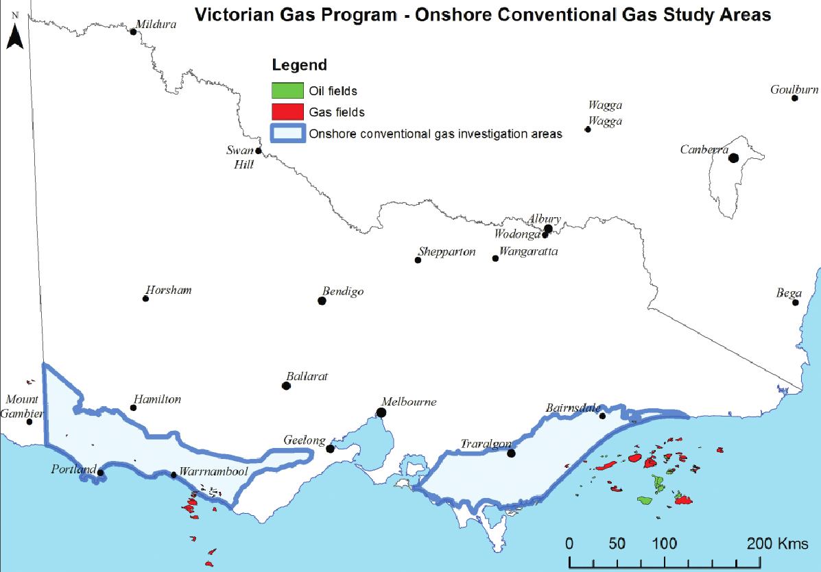
Figure 1: Study area for geoscience and environmental studies

1.4 Regional geology
The Otway Basin is a northwest-southeast trending basin that extends for 500 km along the onshore and offshore parts of South Eastern Australia (Figure 2). The geology across the land surface in south west Victoria is represented by sedimentary rocks (such as the Port Campbell Limestone) and igneous rocks (such as the Newer Volcanics). In the chart (Figure 3), these units are marked at the top of the column on the right as they represent some of the youngest rocks in the Otway Basin. Below the land surface, underground, lies a sequence of much older rocks, which are the main focus of the geoscience studies.
Based on lithological variations in the Otway Basin, six main sequences (Figure 3) are described:
- the Otway Group
- Sherbrook Group
- Wangerrip Group
- Nirranda Group
- Heytesbury Group
- Bridgewater Bay Group.
The main focus of the geoscience studies will be the Otway and Sherbrook Groups. The Waarre Formation and overlying Flaxman Formation and Belfast Mudstone are the primary reservoir and seal units for the conventional gas discovered to date in the Port Campbell Embayment. The underlying Eumeralla Formation is host to the source rocks, from where the gas migrated. A secondary conventional reservoir unit is the older Pretty Hill Formation, with the underlying Casterton Formation hosting the source rocks and the Eumeralla Formation providing the seal.
A more detailed explanation of types and locations of onshore gas can be found in Appendix 1.

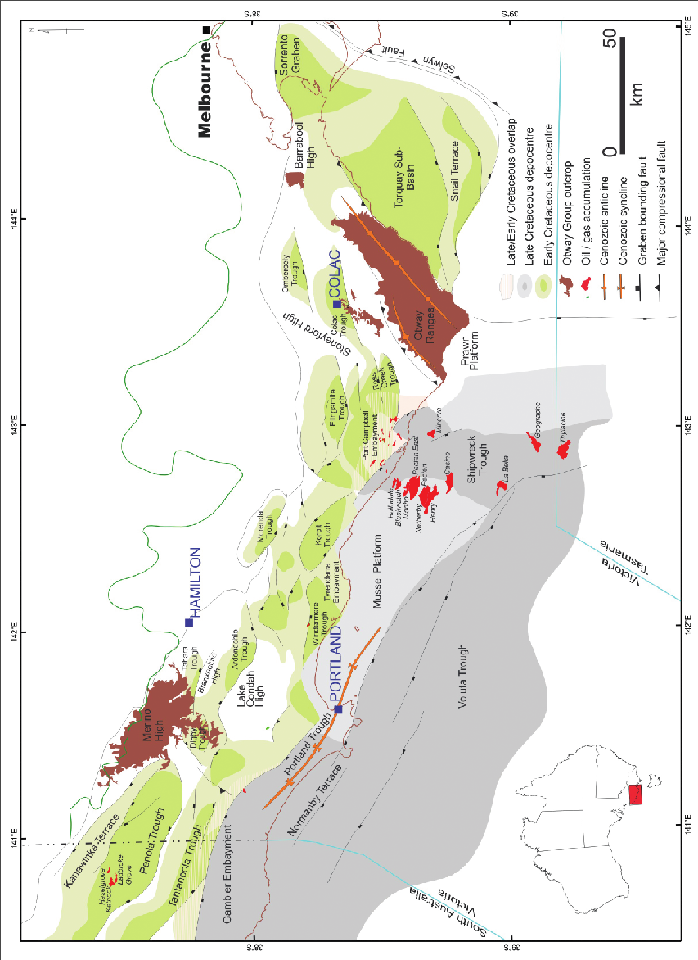
Figure 2: Otway Basin depocentres (site of maximum deposition) with gas accumulations denoted in red

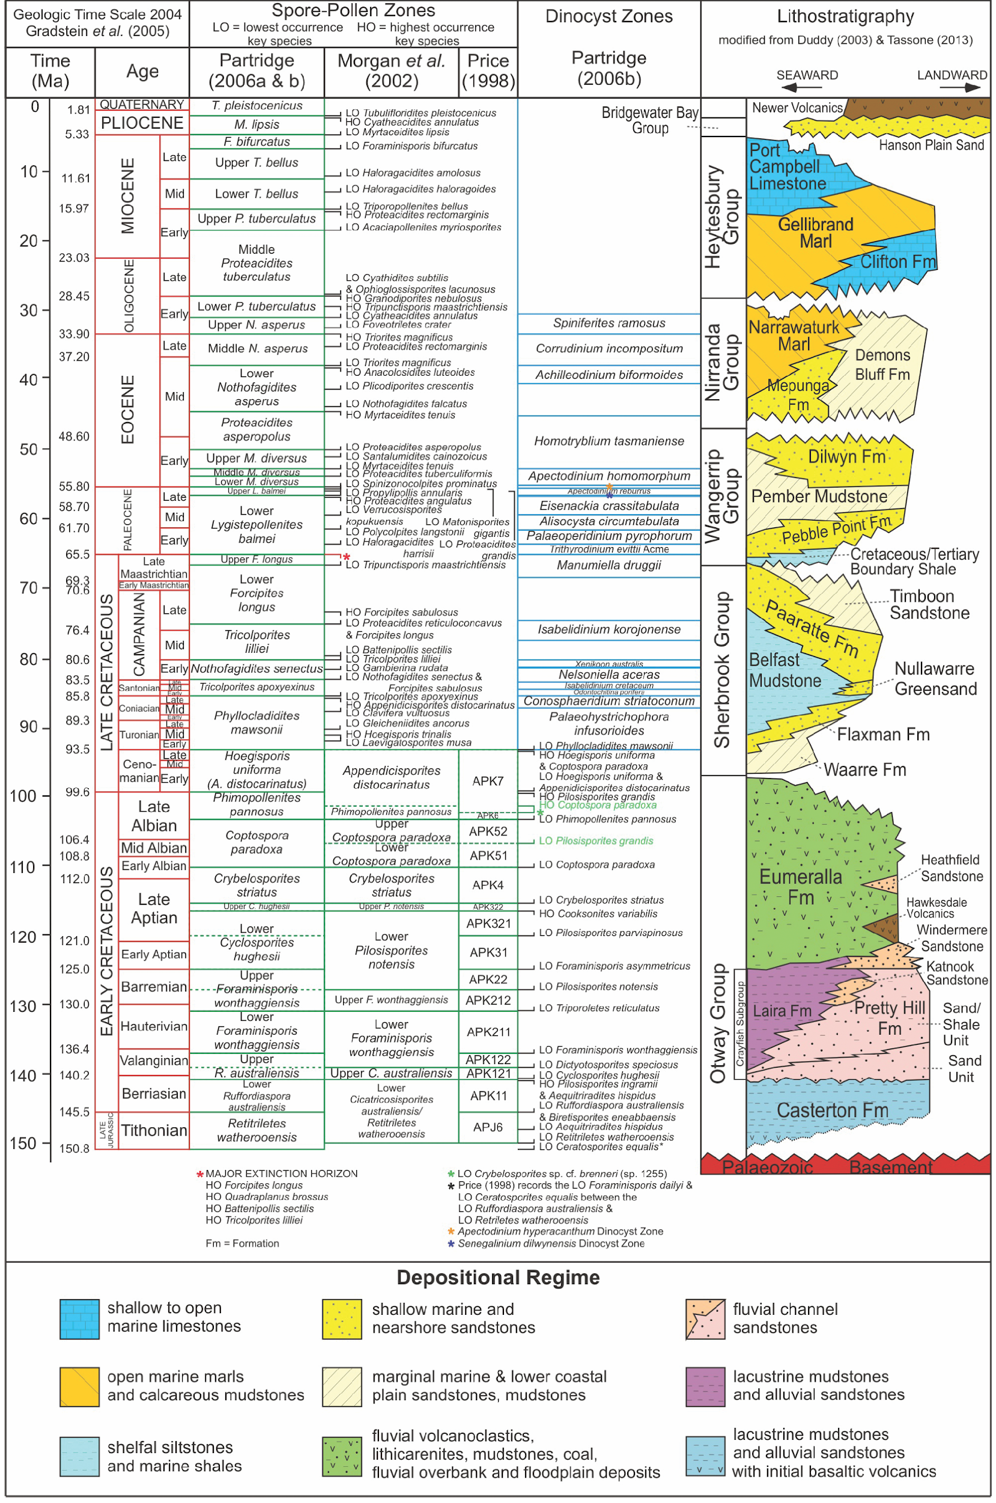
Figure 3: Otway Basin stratigraphy (after Guzel, 2015)

2. Onshore conventional gas studies
This program will deliver extensive scientific, technical and environmental input on the risks, benefits and impacts of onshore conventional gas. Initial work will focus on the area considered by the Geological Survey of Victoria to be as most prospective for conventional gas in the Otway Basin, between Port Campbell and Warrnambool.
Victoria’s’ Lead Scientist is overseeing this program in consultation with the Stakeholder Advisory Panel (refer to Section 2.3.1 for further information) made up of farmers, industry, local government and community members, with input from independent peer reviewers.
Specifically, the program incorporates the following components:
- Rock characterisation studies to achieve enhanced understanding of rock property layers (e.g. porosity, permeability, organic content) within the study areas. This will involve analysing geoscience data and rock samples (drill cores). Subsequent mapping will form the basis of the prospectivity assessment and resource estimates.
- Three-dimensional geological models, using previously collected geological data, rock characterisation analysis and well data. These will be built to define the stratigraphic (rock layers) and structural framework (e.g. geological faults). Such models will provide insights into possible gas stores and also the nature and location of groundwater. This knowledge will assist in answering questions about the risks, impacts and benefits of onshore conventional gas.
- Gas prospectivity and resource estimates, to be developed using the above geoscience components, for both the Otway and onshore Gippsland basins.
- Targeted stratigraphic drilling may be carried out in the onshore Otway Basin to fill gaps in the geological knowledge of the area and to increase certainty of the gas prospectivity and resource estimates.
- Environmental studies to identify the key environmental factors relevant to each stage of the life cycle for onshore conventional gas (i.e. exploration, development, production, decommissioning and rehabilitation stages). This work will also identify the environmental vectors and receptors for these gas activities before and after a conventional gas well head, including any key knowledge or data gaps. This information will be used to identify the most relevant types of environmental indicators and data set requirements to monitor the gas activities.
Environmental measurements will be collected to establish the existing baseline conditions, which would provide the benchmark for considering the potential risks and impacts of conventional gas activities.
For example, the environmental studies will involve scientists gathering new data on groundwater chemistry and collating existing data to inform both the studies and stakeholders about past and potential future changes related to the landscape and subsurface in relation to conventional gas activity. State groundwater monitoring bores will be sampled and regional groundwater models will be built and used to inform regional impact assessments.
Figure 4 depicts the onshore conventional gas geoscience and environmental studies timing and milestones.
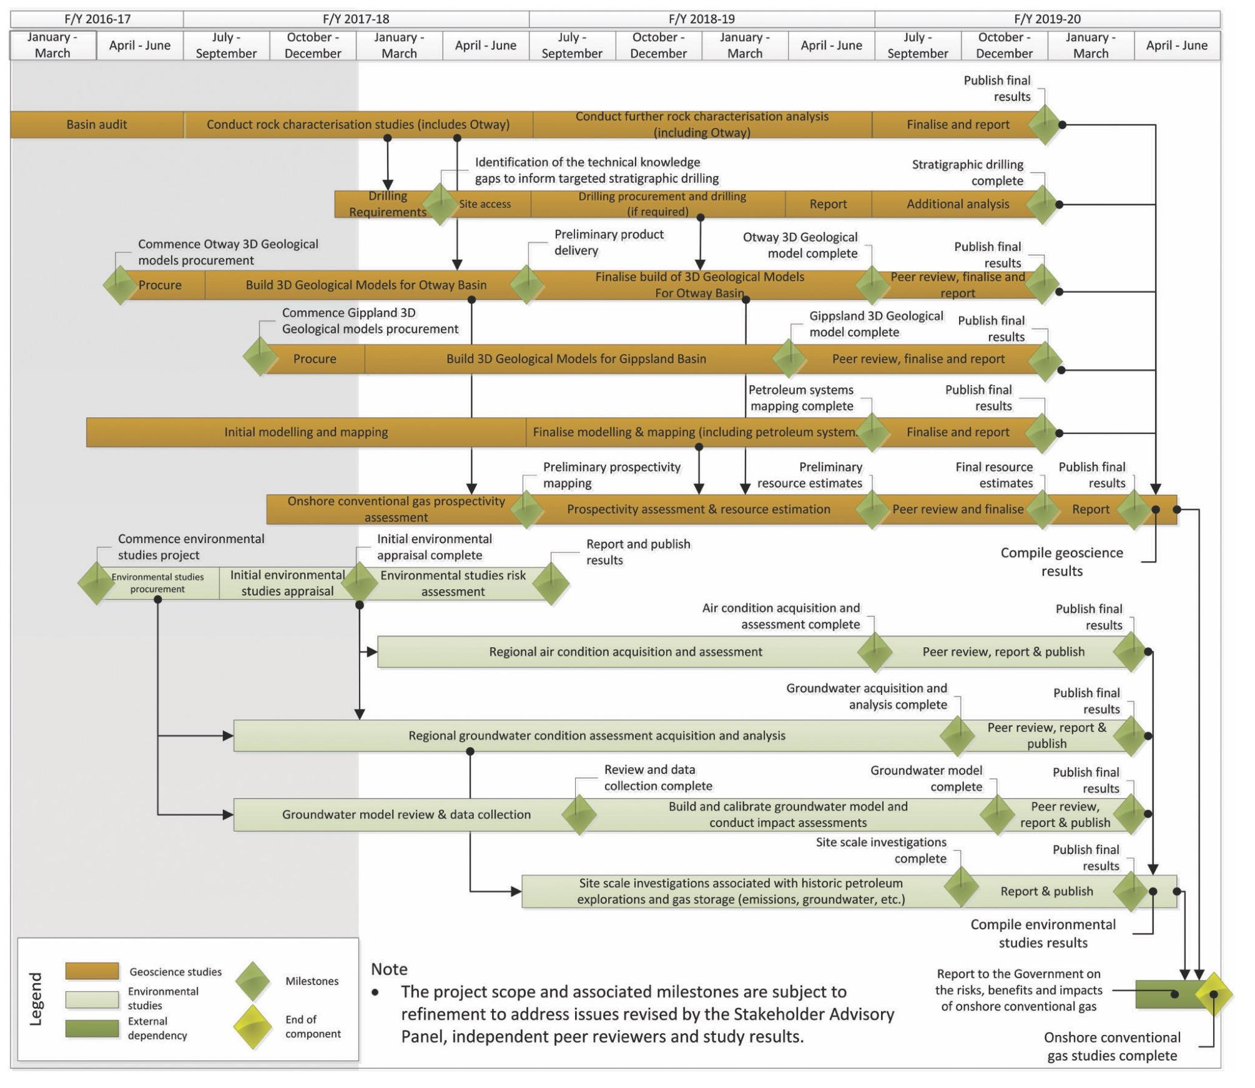
Figure 4: Onshore conventional gas geoscience and environmental studies – timing and milestones
Geoscience and environmental studies have begun in the Otway Basin. Geoscientific work has commenced, including rock characterisation and three-dimensional geological model building, whilst groundwater sample collection has begun in the eastern Otway Basin to the northwest of the Otway Ranges.

2.1 Geoscience studies
The geoscience studies have commenced with a ‘basin audit’ and literature review to collate existing data and knowledge. This work will continue for the duration of the program in order to be responsive to new information. Both have guided the selection of samples for key components of the rock characterisation studies. Building of three-dimensional geological models in the Otway Basin has also commenced.

2.1.1 Rock characterisation progress
The program’s rock characterisation studies involve the laboratory analysis of selected rock samples from the Geological Survey of Victoria’s core library. The rock samples were acquired from previous drilling activity across Victoria over numerous decades, and delivered to the core library for warehousing. The type of rock samples that are being selected for analysis for the Victorian Gas Program include examples of source, reservoir and seal rocks from the subsurface in the Otway Basin.
Source, reservoir and seal rocks are important components of a conventional petroleum system. These rocks exhibit physical properties that can be measured in a laboratory.
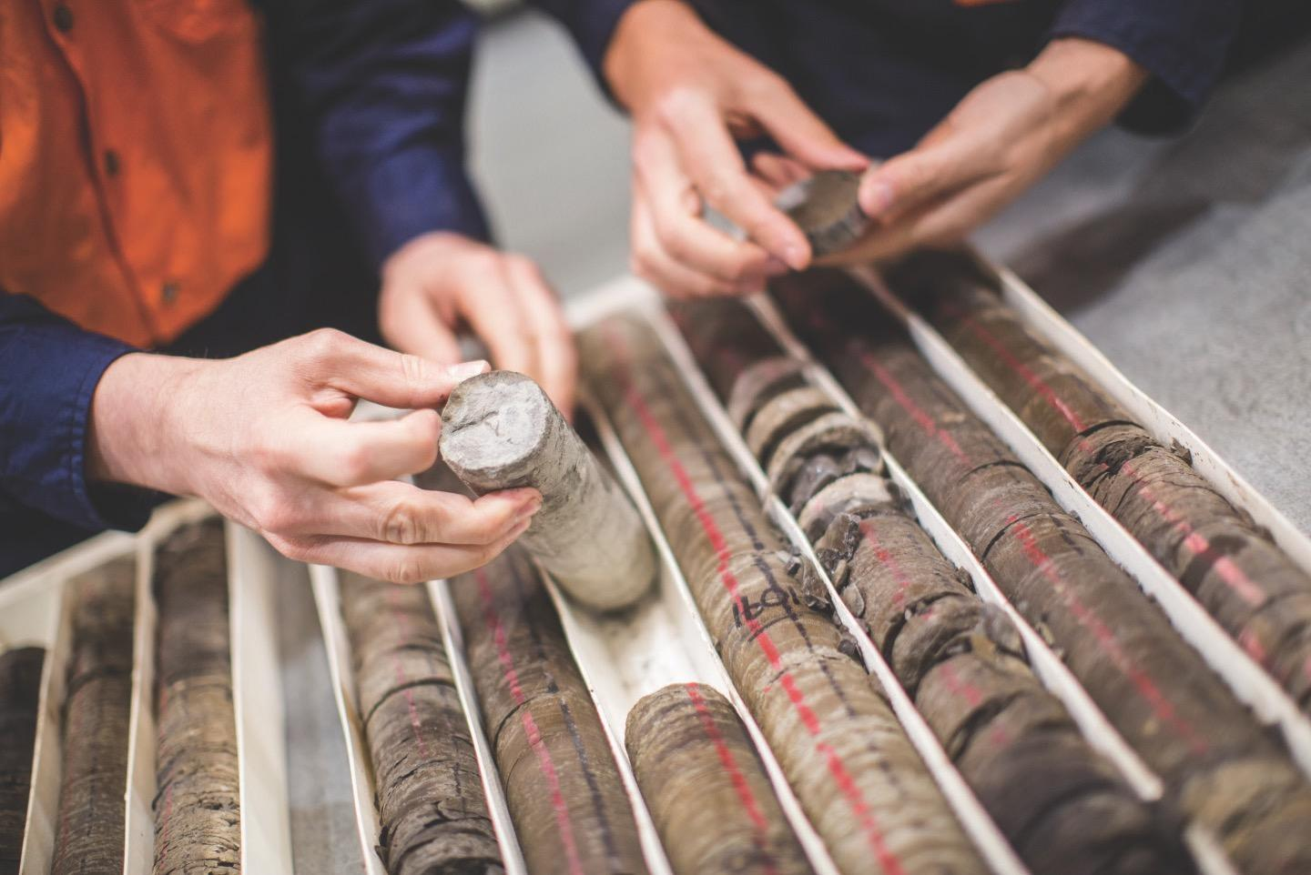
Figure 5: Core from the Geological Survey of Victoria’s core library (2017)
Examples of rock properties to be measured include the porosity and permeability of reservoir rock units and the organic content of source rocks.
Additional rock property data will enable the Geological Survey of Victoria to map the distribution of source, reservoir and seal rocks with greater accuracy.
The Geological Survey of Victoria has begun rock characterisation studies in the Otway Basin. Scientists have reviewed rock property and other geological data that the Geological Survey of Victoria has collected from decades of drilling for water and petroleum in the State. Through such analyses, also known as a basin audit, the Geological Survey of Victoria has established the geographic and down-hole (subsurface) distribution of known values from previous acquisition and studies. The auditing process will continue for the duration of the program as scientists advance their investigations. Hence, the basin audit will provide a base data set, with most relevant data points captured. An associated review of scientific literature will continue throughout the project.
Undertaking the basin audit has already established the wells and boreholes which have available rock samples (core and cuttings) stored at the Werribee Core library. The process of sampling suitable rock specimens has also begun.
There are limitations in using warehoused core and cuttings samples. Some limitations previously encountered by the Geological Survey of Victoria include but are not restricted to degradation of the sample whilst in storage, integrity of the sample with regards to consolidation, cavings from shallower, up-hole units, and contamination from drilling mud. However, it is common practice to use existing rock samples for regional geoscientific investigations of this nature.
Laboratory analysis of the rock samples will range from standard (routine) tests such as porosity, permeability, density and total organic content (for which numerous laboratories offer services), to specialist tests and interpretations such as Chemostratigraphy which uses Inductively Coupled Plasma Optical mission and Mass Spectrometry to chemically delineate lithofacies and organofacies within source, seal and reservoir rock units.

2.1.1.1 Basin audit
A review of existing well data from the Otway Basin was carried out between November 2016 and March 2017. Data was viewed from wells and boreholes to understand the types and distribution of current data sets to inform the Geoscience project components.
The geological point data consisted of well completion reports, the Geological Survey of Victoria’s internal boreholes database (for lithology logs, geophysical logs, core and cuttings), company data (e.g. Exploration Licence reports), the Geological Survey of Victoria consolidated datasets (i.e. Victorian Initiative for Minerals and Petroleum and Victorian Geological Carbon Storage program compilations), CO2CRC data, reports and data from the water science studies and other studies such as previous three-dimensional framework modelling.
The Geological Survey of Victoria has so far compiled data sets detailing boreholes, wells, geographic coordinates, core and cuttings availability, and formation tops. The compilation is being used by the Geological Survey of Victoria geoscientists as a reference to understand both the limitations of the data for use in proposed work programs and also to identify opportunities to extend current data sets. Furthermore, it enables geoscientists to assess areas of poor data quality that cannot support further investigation unless new data is acquired (e.g. through drilling).

2.1.1.2 Reservoir porosity and permeability
The Geological Survey of Victoria will deliver new data and information to support the assessment of potential reservoirs within key geological formations. The primary consideration in reservoir characterisation is porosity and permeability
The volume of hydrocarbons accumulated in a reservoir is related to the available pore space. The ability for the hydrocarbons to flow from the reservoir, and the rate of flow is related to the permeability.
Reservoir porosity and permeability studies will focus on the Waarre and Pretty Hill formations. The Geological Survey of Victoria will also investigate potential within the Eumeralla Formation, in particular the Heathfield and Windermere Sandstone members or equivalents.
Data compiled during the basin audit has revealed there are only 39 existing porosity data points and 37 permeability data points in the primary reservoir in the Otway Basin. An initial assessment of suitable core and cuttings specimens has identified up to 300 samples for future analysis.
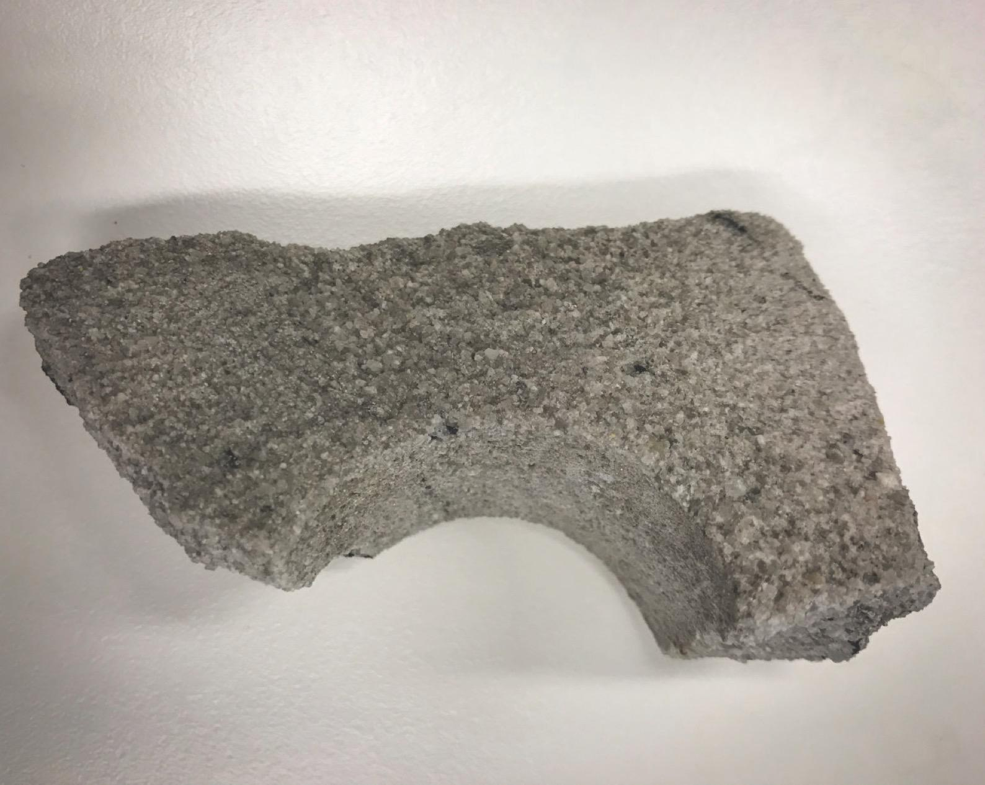
Figure 6: Reservoir rock – clean, coarse-grained sandstone (Waarree C Formation, sample from Iona-4)

2.1.1.3 Seal studies
Seal rocks are an essential component of petroleum systems and act to create a barrier that impedes the upward movement of hydrocarbons. Geological traps are ‘sealed’ by an overlying relatively impermeable unit.
The Victorian Gas Program will investigate seal potential through mapping, combining three fundamental components: (1) seal capacity, (2) seal geometry, and (3) seal integrity (Kaldi & Atkinson, 1997). Work on seal capacity and geometry has commenced.
Seal studies utilise special core analysis in laboratories known as Mercury Injection Capillary Pressure to test the extent to which a sealing rock unit can contain hydrocarbons (seal capacity). Pressure thresholds from Mercury Injection Capillary Pressure analysis are used to calculate the potential column height of oil or gas that the seal could hold. This data can be used in conjunction with seismic mapping and other well data to delineate the seal (seal geometry).
Regional sealing lithologies in the Otway Basin have been studied by Daniel & Kaldi (2014) as part of the CO2CRC pilot plant carbon dioxide sequestration containment studies. The Pember Mudstone, Paaratte Formation, Skull Creek Mudstone, Belfast Mudstone and associated intra-formational seals were assessed as part of this study, with 26 data points available from CRC wells -1 and -2. Less than 10 additional data points were discovered during the data audit.
The Geological Survey of Victoria has identified up to 100 samples from the Waarre Formation (Unit B), the Flaxman Formation, and the Belfast Mudstone that will be analysed as part of the Victorian Gas Program. Additional geological formations may be included in the study, following this preliminary investigation.
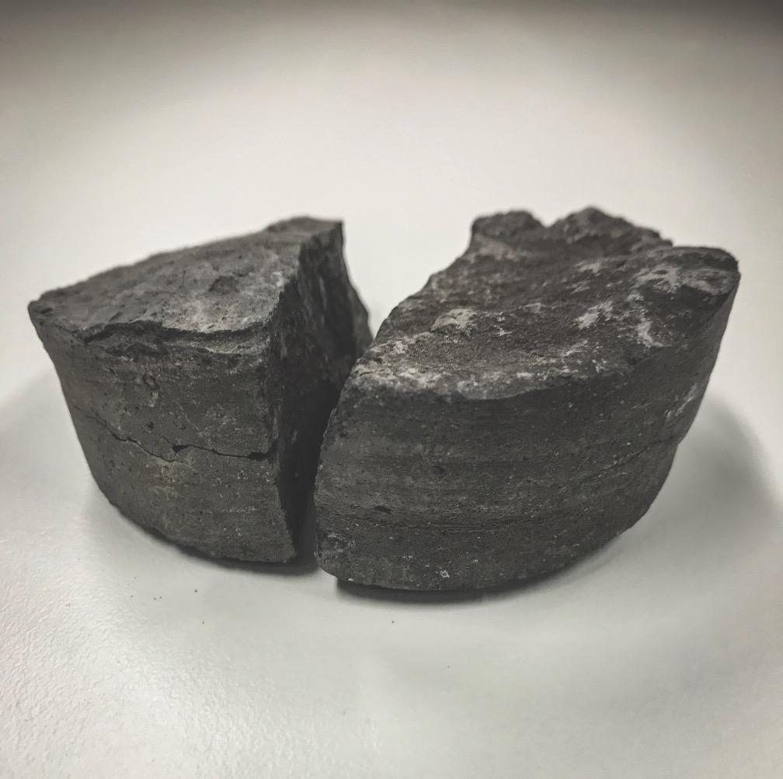
Figure 7: Seal rock – mudstone (Belfast mudstone, sample from Port Campbell-2)

2.1.1.4 Source rock geochemistry
Petroleum is generated from source rocks, that is, rocks capable of generating movable quantities of hydrocarbons. An evaluation of organic geochemical parameters is used to evaluate source rocks, including organic richness, kerogen type and thermal maturity.
A measure of the organic richness of a source rock is known as Total Organic Carbon given petroleum is mostly carbon (by molecular weight), the amount of carbon within a rock, to some extent, determines its ability to generate petroleum. Samples with satisfactory organic richness can then be investigated further using hydrous pyrolysis (e.g. Rock-eval). Pyrolysis analyses simulate oil generation and expulsion from source rocks.
Over time, dependent on the depth and temperature of burial, organic matter contained in sediments is transformed into kerogen. The type of kerogen that forms is reliant upon the original depositional
environment of the organic matter. Kerogen in rocks has four principal sources: marine, lacustrine, terrestrial and recycled. Most of the world’s oil has originated from marine and lacustrine kerogen, whereas most coal is from terrestrial plants. Recycled kerogen is largely inert. The relative ability of a source rock to generate petroleum is defined by its kerogen quantity (Total Organic Carbon) and hydrogen quality (reported as high or low as determined by pyrolysis). An assessment of thermal maturity will determine whether a source rock has generated petroleum.
When rocks are exposed to heat over time, the chemistry of organic matter in the rock changes. That change or thermal maturity can be measured by vitrinite reflectance (expressed as Vr). Vitrinite is a one of several components of coal found in buried organic matter. As the organic matter becomes thermally mature, it devolves volatile components. The remaining organic matter becomes more reflective to light and that reflectance is measured. Other measures of maturity exist and, with care, can be related back to vitrinite reflectance. However, vitrinite reflectance extends over a longer maturity range than any other thermal maturity indicator, and the maceral is relatively abundant in prospective Victorian basins.
To date, the Geological Survey of Victoria has compiled a list of current TOC, Rock-eval and Vr data, along with potentially useful core and cuttings held at the Werribee Core Library, including petroleum wells and water bores. Gaps in the data will be filled by a program of sampling and analysis of further TOC, Rock-eval and Vr. Additional specialist studies are planned.
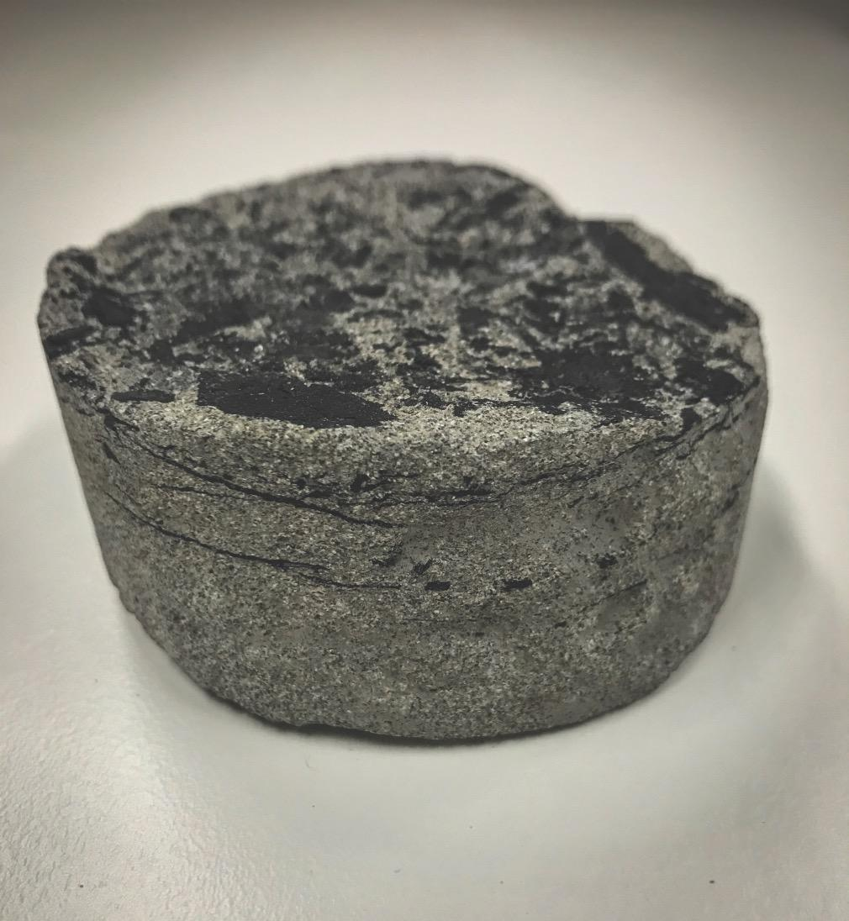
Figure 8: Source rock due to presence of organic material (Eumeralla Formation, sample from Flaxmans-1)

2.1.1.5 Chemostratigraphy
Beyond the standard analysis of reservoir, seal and source rocks, the Geological Survey of Victoria will also implement a suite of specialist analyses. This has been demonstrated by the commissioning and completion of a pilot chemostratigraphic study which involved two wells in the Otway Basin: Ross Creek-1 and Fergusons Hill -1.
The aim of the chemostratigraphic analysis was to identify and correlate chemical facies (chemofacies) between the two wells to improve the understanding of the lithostratigraphy in the Otway Basin sedimentary succession. The analysis identified six unique sequences, and the subdivision of twenty-two packages. Further classification identified twenty-nine unique chemofacies that correlated between the wells.
The data collected throughout the chemostratigraphic study will also be used to gain further insight into the origin of sediments within these packages, and to identify potential petroleum-generating source rocks in the Eumeralla Formation. The pilot study raises the possibility of using chemostratigraphy as a tool to help geoscientists identify where and how reservoir rocks change across the Otway Basin, and how rock properties change with burial and time. This in turn may aid in the identification of regions where the rocks will develop unfavourable properties for petroleum movement and preservation in the Otway Basin.

2.1.2 Otway three-dimensional geological framework model progress
The Geological Survey of Victoria commissioned the construction of a three-dimensional geological model of the Otway Basin in June 2017. The model will define the stratigraphic and structural framework across the onshore and offshore Victorian Otway Basin. It will provide the basis for addressing the risks, impacts and benefits of onshore conventional gas and offshore gas. A preliminary interpretation is due in June 2018, to facilitate subsequent work programs.
The model will build on past work completed as part of the Geological Survey of Victoria’s 3D Victoria initiative and Water Science Studies. In 2015, the Department of Environment, Land, Water and Planning and the Geological Survey of Victoria completed the Water Science Studies (2015) to help provide a better understanding of the potential impacts of onshore gas development on Victoria’s water resources.
The model involves the interpretation of most of the currently available two-dimensional seismic data across the Otway Basin. Petroleum wells and water bores will also be included in the model. Electromagnetic and potential field survey information (primarily magnetic and gravity data) will also be used to aid in the creation of the geological model. The data used for this interpretation has been acquired mainly over the past 50 years of exploration in the Otway Basin, however some well data dates to the 1940s.
A specialist service provider is delivering two major elements:
Element 1 – Regional three-dimensional geological model of the Victorian Otway Basin
Element 1 will provide an extension of the existing regional-scale, onshore Otway Basin model (including the nearshore/offshore areas), at a comparable resolution. The regional three-dimensional geological model will consist of a geological interpretation of the entire Victorian Otway Basin sedimentary sequence nearshore/offshore, incorporating the current onshore model. The entire sedimentary sequence includes the top of the Palaeozoic basement to the bathymetric surface/present-day land surface; any sedimentary unit that either outcrops or sub-crops (or both), that can be mapped within the Otway Basin. The study excludes the Torquay Sub-basin as defined onshore by the edge of the Otway Ranges, Barrabool Hills, and Paraparap High.
Element 2 – High resolution three-dimensional geological model of the Port Campbell Embayment and Shipwreck Trough
A high resolution three-dimensional geological model of the Port Campbell Embayment and adjacent Shipwreck Trough will be built. This will include a geological interpretation of the entire sedimentary sequence inclusive of the top of the Palaeozoic basement to the bathymetric surface/present-day land surface (any sedimentary unit that either outcrops or sub-crops (or both), that can be mapped within the Otway Basin) that is consistent with the regional three-dimensional geological model interpretation. The resolution of the model will be suitable for prospectivity assessments and resource estimates.
Both models will include:
- a stratigraphic analysis in both two-way-time and depth converted forms
- a seismic facies analysis
- a structural interpretation in two-way-time and depth converted forms
- maps of regional stratigraphic surfaces, horizons, sequences and facies, including extent of units, structure contours and extent of the basin
- isochron and isopach maps of units and their extent
- velocity maps, and derived velocity model(s) with interval velocities of key units and estimates of uncertainty.
These geological models will be the primary input for a further series of studies that the Geological Survey of Victoria will undertake internally prior to 30 June 2020 to inform government of risks, benefits and impacts posed by onshore gas. These surfaces, combined with information from wells, boreholes and other surveys, will be used to model the depositional environment of sediments containing the pre-cursors to oil and gas. Delivery of the three-dimensional geological model will enable completion of subsequent workflows prior to June 2020, and as such, all final deliverables are due by the end of June 2019, with preliminary deliverables due by June 2018. New point data from the Geological Survey of Victoria will be incorporated into the models as results become available throughout the project to inform other in-house studies.
Further analysis and computer modelling will determine the volumes, types (oil and/or gas) locations and times when those precursor rocks were exposed to conditions that were conducive to generate and expel hydrocarbons.
The analysis of the volume and timing of generation and expulsion of hydrocarbons from the source rocks in the Otway basin will then be combined with the three-dimensional model to evaluate the migration (the movement of the hydrocarbons through permeable rocks) and the trapping of hydrocarbons in structures that have been mapped as part of the Otway Basin three-dimensional geological model building and study. This then enables the Geological Survey of Victoria to evaluate potential resources in the Otway Basin.
This workflow (Interpretation -> Analysis -> Modelling) is considered industry best practice for the exploration of oil and gas. What is extraordinary about this project is its scale. Oil and gas companies generally do not produce models that do not relate directly to their acreage and thus whole of basin studies are rarely undertaken.
The study commenced with a review of existing work and an evaluation of the available data in August 2017.
A previous study, as part of the Water Science Studies, was chosen as a base for the threedimensional geological model. However significant data quality and interpretative issues with that project, due to its short timeframe and limited scope, make it unsuitable for a simple merge with this new project.
As part of the data preparation phase for the current Otway three-dimensional geological model, data loading and quality control of 898 well locations, review of 201 well reports, and the loading of downhole logs for 100 selected wells across the Otway Basin was undertaken. The large amount of available data involved the creation of a geographic information system (GIS) database to enable management of the well data. This was conducted in parallel with the well data loading. Simultaneously, seismic data was loaded, reviewed and repaired or discarded depending on its quality.
Well and seismic data was integrated using the time depth relationships in 111 wells. Biostratigraphic, velocity data, formation tops, deviation surveys were been added to the project well and seismic database.
The data preparation and loading for the model was completed in early October 2017. The Geological Survey of Victoria subsequently received a copy of the Kingdom seismic and well databases, and a GIS project at a review meeting on 11 October 2017. This data will be integrated into the studies and will allow ongoing dialogue with Frogtech Pty Ltd regarding their interpretation methods and decisions as part of the peer review process. Further updates to this dataset will continue to be provided throughout the project at critical stages.
Two primary geoscience interpreters are working on the interpretation of all shallow horizons (Figure 9). The primary focus involves interpretation of several Cenozoic horizons for use in hydrological modelling. They will also be required for the thermal and burial history modelling inputs allowing the calculation of timing and location of the expulsion of hydrocarbons. Two-dimensional well and seismic cross sections have already been created as the first step in the interpretation process.
The shallow horizons are also the least deformed. Given the highly deformed nature of the Otway Basin, a top-down approach allows less deformed, younger layers to be stripped back enabling a better understanding of the deeper reservoir horizons.
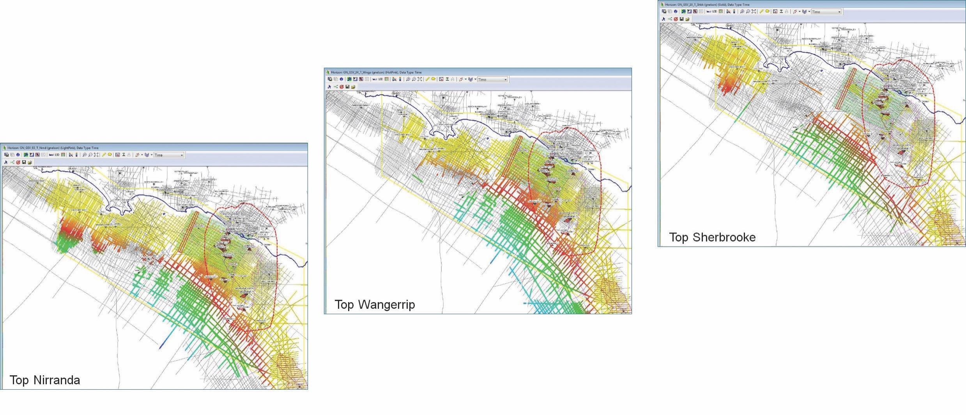
Figure 9: Current offshore progress of shallow horizons
Work on the Cenozoic horizons has progressed so that in some areas (primarily the Shipwreck Trough) preliminary work has begun on the interpretation of the Sherbrook Group in the latest Cretaceous; approximately 65 million years old.
Velocity modelling, using well and seismic processing data to convert seismic data from time to depth, has also commenced. Seismic data is acquired in time (the time it takes sound waves to travel to and from a source to horizons beneath the surface). Depth surfaces are required, for three-dimensional petroleum systems modelling and hydrogeological modelling. The data used for the velocity model is being evaluated and will be corrected where required.

2.1.3 Next steps

2.1.3.1 Three-dimensional Gippsland model
The Geological Survey of Victoria will be seeking a suitable supplier to build a three-dimensional model of the Gippsland Basin, extending previous three-dimensional modelling of the Gippsland Basin undertaken by the Victorian Government.

2.1.3.2 Stratigraphic drilling
The Geological Survey of Victoria will begin assessing the design of a targeted stratigraphic (rock) drilling in the onshore Otway geological basin to fill gaps in the geological knowledge of the area and to increase certainty of the gas prospectivity and resource estimates.
Any proposal to drill will be based on areas where the Geological Survey of Victoria has identified significant gaps in the geoscience data, which is needed to better understand the prospectivity for onshore conventional gas and the potential impacts of extracting it. The stratigraphic drilling will be used to obtain fresh rock samples that can be analysed to characterise key properties such as porosity and permeability, to inform assessments of how gas and water moves through different rock layers.
The maximum drill depth is limited by the thickness of the Otway Basin sediments, which are up to four kilometres thick near Port Campbell. The requirement to drill will be determined once the initial geoscience and environmental studies are completed under the oversight of the Lead Scientist. BTEX chemicals or hydraulic fracturing will not be used in any of the drilling work. The Geological Survey of Victoria would not enter private land without a landholder's prior agreement.

2.2 Environmental studies
Environmental studies are underway to identify the key environmental factors relevant to each life cycle stage for onshore conventional gas (i.e. exploration, development, production, decommissioning and rehabilitation stages). This information will be used to identify the most relevant types of environmental indicators and data set requirements to monitor gas activities. Note that a previous assessment (Water Science Studies, 2015) found that the potential impacts on water users and ecosystems from possible onshore conventional gas developments in the Otway region are low.
Environmental measurements will be collected to establish existing baseline conditions, in order to benchmark potential risks and impacts of conventional gas activities.

2.2.1 Inventory of potential environmental hazards
An initial inventory of potential environmental hazards associated with conventional petroleum activities has been compiled to inform the environmental studies. The initial inventory of hazards is listed in Table 1.
Table 1: Initial inventory of potential environmental hazards associated with conventional petroleum activities
Potential hazard | Typical causes
Physical
Soil disturbance | Clearing, compaction for rig, vehicle travel, soil ripping for rehabilitation
Soil and/or groundwater contamination | Poor well planning and execution (e.g., casing failure), hydrocarbon and chemical spills, well blowout, loss of containment
Surface water contamination | Hydrocarbon and chemical spills, loss of containment, poor stormwater management
Depressurisation of water aquifer | Extraction of gas
Atmospheric pollution | Drill rig, machinery, equipment and vehicle emissions, flaring, venting, fugitive emissions
Dust generation | Preparation of well lease, vehicle travel on unsealed surfaces, wind erosion of well lease, soil ripping for rehabilitation
Fire | Ignition of vegetation during clearing or during flaring, well blowout and explosion, equipment and plant malfunction, bushfire/grass fire reaching site, refuelling
Handling, use, transport and disposal of materials and waste | Poor storage of hazardous materials, poor housekeeping, inadequate waste management procedures
Ecological
Disturbance to fauna, loss of vegetation and fauna habitat | Vegetation clearing for well lease and/or access road, fire, noise and light disturbance
Introduction/spread of weeds, pests and pathogens | Vegetation clearing for lease pad and/or access roads, fire, introduction of foreign material on machinery, introduction of contaminated hard stand material
Heritage
Disturbance to Aboriginal and non-Aboriginal cultural heritage | Vegetation clearing for lease pad and/or access roads
Socio-economic
Light pollution | Physical presence of drill rig (lighting on derrick, flaring), vehicles and machinery
Noise pollution | Physical presence of drill rig, vehicles and machinery (engine sound, compressors, reversing beepers), drilling, flaring, presence of wellhead
Disturbance to roads and traffic | Movement of drill rig, vehicles and machinery along roads (formed/unformed) and farm tracks
Reduced land use potential | Well lease and access road construction, physical occupation of land, poor rehabilitation
This inventory will be further developed following consultation with interested stakeholders to ensure that all key areas are covered.

2.2.2 Regional baseline studies

2.2.2.1 Groundwater sampling
Regional groundwater condition assessment will sample more than 100 State Government-owned groundwater monitoring bores across mainly south-west Victoria and some in Gippsland. The objective of groundwater sampling is to determine the current, and thereby expected, groundwater chemistry of deep groundwater systems. This information will then be used to understand groundwater processes and pathways, and also provide a reference point in time of the groundwater conditions in the region should any environmental change occur, such as gas exploration/development.
Groundwater sampling in south-west Victoria began in July 2017. It involved taking water samples from deep bores (up to 1500 metres). Included in the groundwater sampling has been the analysis of an array of chemical elements and measurement of dissolved methane. As of November 2017, 10 of the 100 proposed groundwater bores had been sampled. To date, most groundwater sampling has focused south of Colac and is trending west (see Figure 10). Fact sheets outlining the findings from each sampled bore have been produced (refer to Appendix 2).
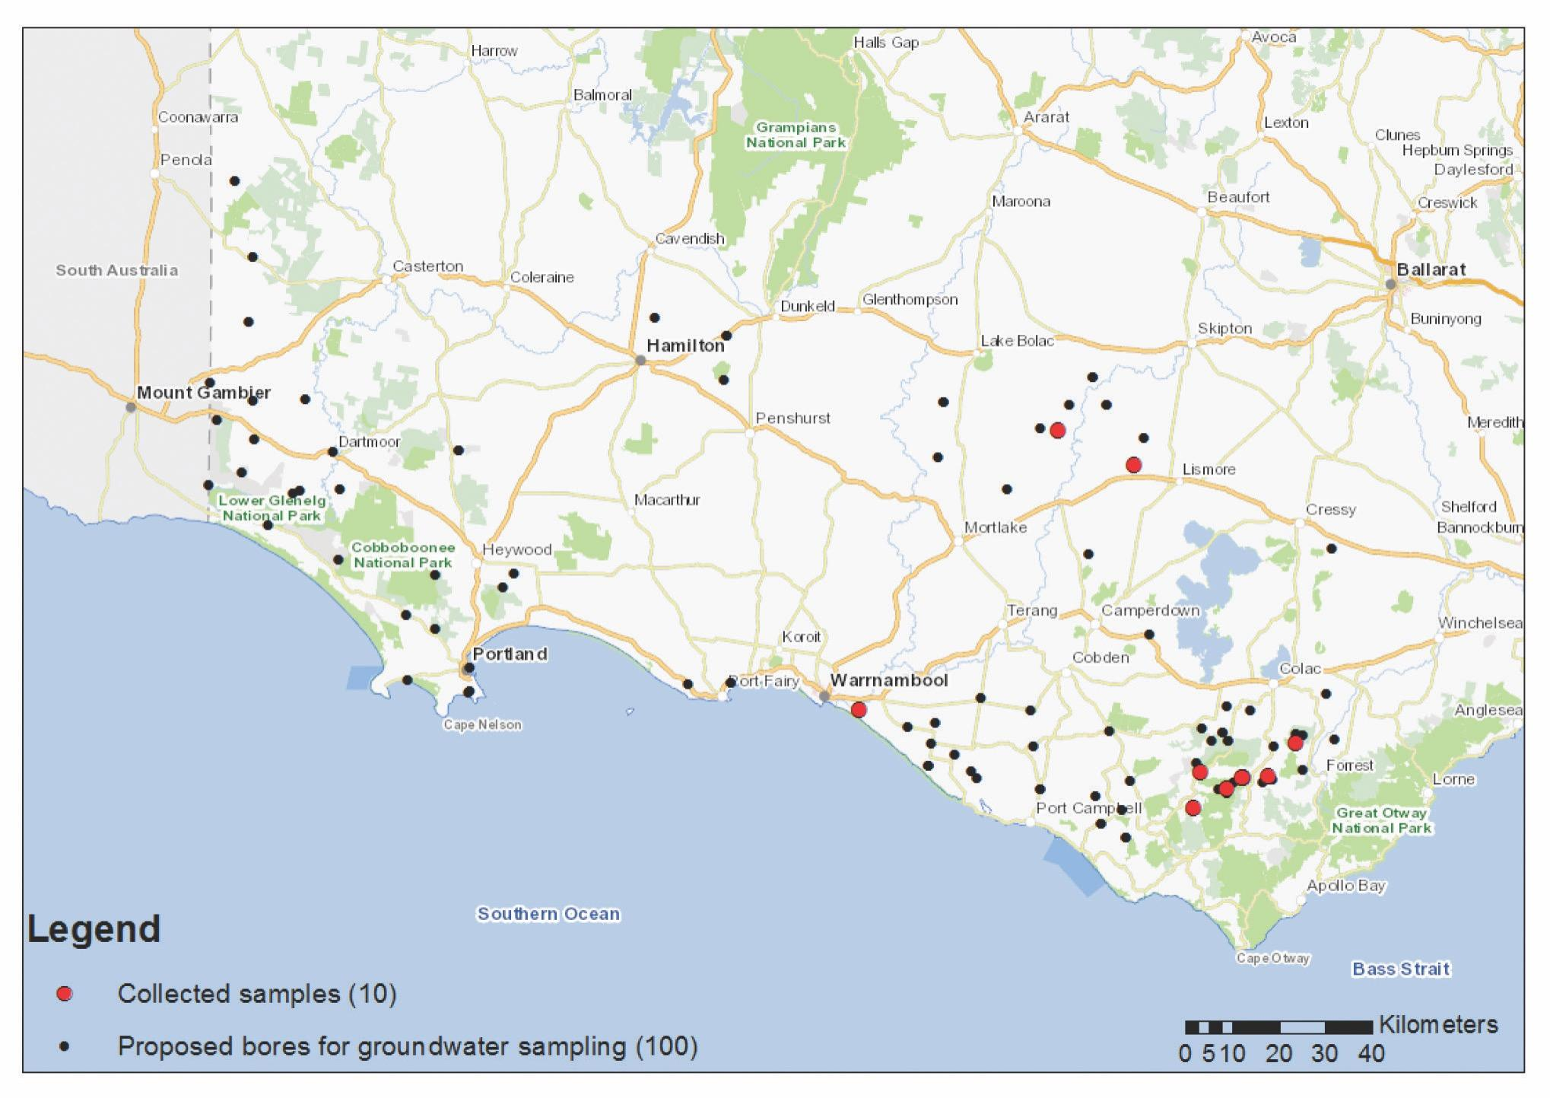
Figure 10: Location of proposed and sampled baseline groundwater monitoring bores (currently 10 of 100 sampled)
The groundwater sampling activities have received recent local media attention, as on 20 October 2017, the Warrnambool Standard featured an article about the groundwater sampling team and their work around the south-west of Victoria.
Preliminary results from the groundwater sampling have found no irregular concentrations or gas content.

2.2.2.2 Air quality assessment
The regional air quality assessment will be undertaken using air gas surveys which are commonly carried out to assess the location of current, and changes in, fugitive gas emissions. The air gas surveys will provide context to the extent that current gas emissions are present and will determine any change in gas emissions following gas exploration and/or development. The environmental significance of natural and fugitive gas emissions in south-west Victoria is unknown, and is not explicitly accounted for in Australia’s greenhouse gas accounts (Day et al., 2014).
This activity will identify typical seasonal environmental gas concentrations across south-west Victoria, Gippsland and locations where unexpected results occur.
Progress has already been made on the survey design and methodology of the mobile air quality survey. Additionally, a literature review of pre-existing information in the region is being developed alongside consultation with CSIRO for the use of specialist equipment.

2.2.3 Regional groundwater impact assessment
Regional groundwater flow processes of south-west Victoria (and offshore) will be simulated to consider:
1. the impact a conventional gas industry has on the near and onshore areas of south-west Victoria
2. the potential impact a conventional gas industry may have on the near and on-shore areas of south-west Victoria.
Understanding the groundwater processes in the region is important for assessing any future impacts a conventional gas industry may, or may not, have.
The simulation of groundwater processes will utilise the spatial hydro stratigraphic data sets which will be developed as part of the detailed stratigraphic assessments by the geoscience studies. All components of the water balance will be considered as part of the groundwater flow modelling. These components are:
- groundwater pumping
- base flow
- recharge
- evaporation
- existing conventional gas impacts.
The method proposed for this project is the same developed as part of those applied to the Gippsland area as part of the Victorian Water Science Studies (2015) (refer to Section 8.2) in 2015. Specifically, industry standard groundwater modelling software (MODFLOW) will be applied to the spatial stratigraphic datasets which will be developed as part of the geoscience studies (refer to Section 2.1). Following model calibration differing land use and conventional gas development scenarios will be considered with the guidance of potential conventional gas field locations and sizes.
The conventional gas development groundwater impact assessment of south-west Victoria has begun and involves the development of a regional scale groundwater model which has local refinement. To date, a first pass three-dimensional stratigraphic model has been developed and built into the modelling framework.

2.2.4 Landscape inventory
The Geological Survey of Victoria requested Agriculture Victoria Research to compile an inventory of landscape datasets over a defined study area including Port Campbell and surrounding areas. This inventory will support the forthcoming Resource Planning activities. This was a preliminary exercise to determine the suitability of individual datasets to highlight potential landscape sensitivity for inclusion in future onshore gas impact studies.
Spatial information showing landscape features has been prepared to inform future environmental assessments and planning in areas that are potentially prospective for onshore conventional gas in south west Victoria. This dataset may also support communication to a broad range of stakeholders.

2.2.5 Next steps for the Environmental Studies
The next steps for the environmental studies are to continue groundwater and air quality sampling throughout 2018. Furthermore, an environmental risk assessment on the potential hazards identified in Table 1: Initial inventory of potential environmental hazards associated with conventional petroleum activitieswill be conducted and reported on to inform the overall environmental studies.
Site-scale investigations of legacy wells will begin on completion of the regional scale groundwater sampling program.

2.3 Onshore conventional gas governance

2.3.1 Stakeholder Advisory Panel for Onshore Conventional Gas
Victoria’s Lead Scientist, Dr Amanda Caples, chairs the Stakeholder Advisory Panel for Onshore Conventional Gas. The panel represents a broad range of views from various sectors and groups, including farmers, industry, local government and the community. Their role is to provide the Minister for Resources with advice on the risks, benefits and impacts related to onshore conventional gas, with particular attention to be paid to social, economic and environmental factors, during the moratorium.
The appointed panel members are:
- Mr Stephen Bell, Chief Executive Officer, Qenos
- Mr Ben Davis, Secretary Australian Workers Union Victorian Branch
- Mr Gerald Leach, Chair of the Victorian Farmers Federation Land Management Committee
- Ms Alison Marchant, Secretary of Frack Free Moriac
- Ms Linda French, Community Development Manager, Lattice Energy (formerly Origin Energy)
- Mr Tennant Reed, Principal National Adviser, Public Policy, Australian Industry Group
- Cr Joanne Beard, Mayor of Corangamite Shire and representative of the Great South Coast Group
- Mr Mark Wakeham, Chief Executive Officer, Environment Victoria.
The panel will continue to meet regularly over the next three years. Panel members are able to provide feedback from the community and other stakeholders as the studies are undertaken.
Communiqués for the 17 August and 10 November 2017 meetings and are included as Appendix 3. Communiques from future meetings will continue to be made publicly available on the Lead Scientist’s web page.

2.3.2 Scientific Reference Group for Onshore Conventional Gas
Victoria’s Lead Scientist chairs the meetings of the Scientific Reference Group for Onshore Conventional Gas. The purpose of the Reference Group is for the experts to provide independent peer review advice relevant to their area of expertise to the Lead Scientist on study scope and outputs related to the risks, benefits and impacts of onshore conventional gas.
The current group members are:
- Professor Dayanthi Nugegoda, ecotoxicology and environment ecosystems expert from the Royal Melbourne Institute of Technology
- Dr Marita Bradshaw, petroleum geoscience and prospectivity expert, formerly from Geoscience Australia
- Dr Steve Mackie, petroleum exploration and development expert from Geosim Consulting
- Professor Damian Barrett, socio-economic expert, CSIRO.
The group will assess the technical rigour and suitability of the science used in the program, including reviewing program reports and outputs.
As the program progresses, the group’s membership may be expanded to include other individuals with subject matter expertise in relevant fields of study, as necessary.

3. Offshore gas geoscience studies
The offshore gas geoscience program will support the commercial exploration for further gas discoveries off the Victorian coast. This work will acquire new geoscientific information to identify areas off the Victorian coast, specifically in the Otway Basin, that are likely to be prospective for offshore gas.
The offshore gas geoscience program will improve the understanding of gas prospectivity at a sub-basin scale through geophysical surveys (e.g. airborne gravity surveying).
An airborne gravity survey will be conducted over 18,000 square kilometres of the Otway geological basin, including State onshore and offshore areas and Commonwealth waters.
Victoria will also release acreage in State waters in early 2018 to enable further commercial exploration and development of offshore gas resources.
Figure 11 depicts the main components and indicative milestones for the offshore gas geoscience program.
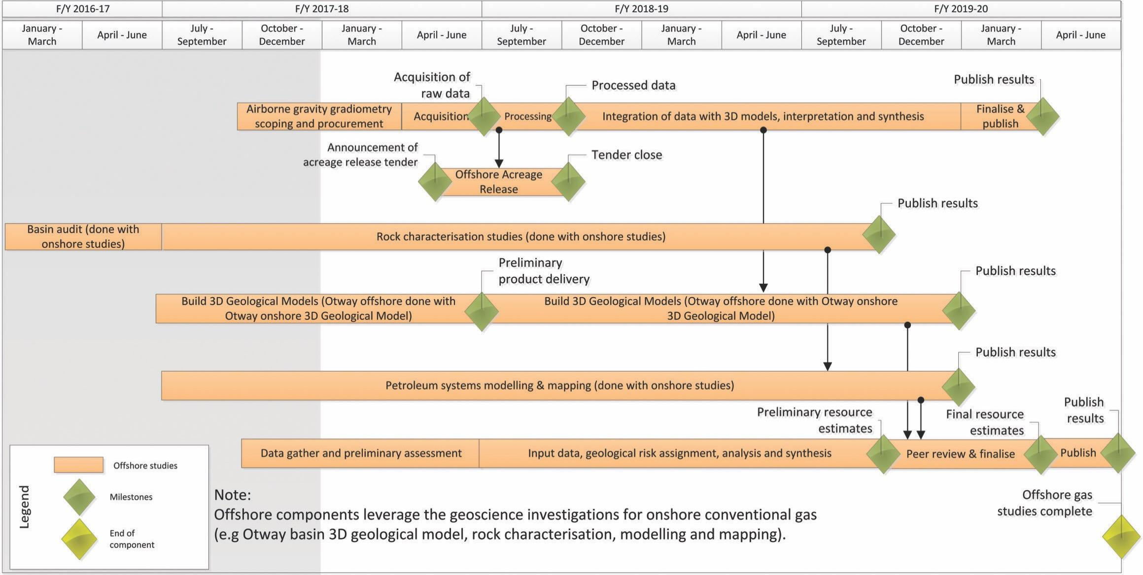
Figure 11: Offshore gas geoscience program – timing and milestones

3.1 Progress to date
The work currently being undertaken as part of the onshore gas geoscience studies, particularly the three-dimensional geological model of the Otway Basin, will underpin the offshore gas studies.
An expression of interest for the provision of processed airborne geophysical data (airborne gravity and/or gravity gradiometry) over the Otway Basin was released to market on 20 December 2017.

3.2 Next steps

3.2.1 Airborne Gravity Survey
An airborne gravity survey will be conducted over 18,000 square kilometres of the Otway geological basin, including State onshore and offshore areas and Commonwealth waters during 2018. Airborne gravity data will be collected using a specially-equipped aircraft that will fly above the sea surface, allowing the aircraft to collect the highest quality data.
The data will be used by geologists to detect rock structures deep underground, using a gravity meter to detect changes in gravity and rock density.
This aerial work will provide new geoscientific data to identify prospective areas for offshore gas off the Victorian coast (see Figure 12).
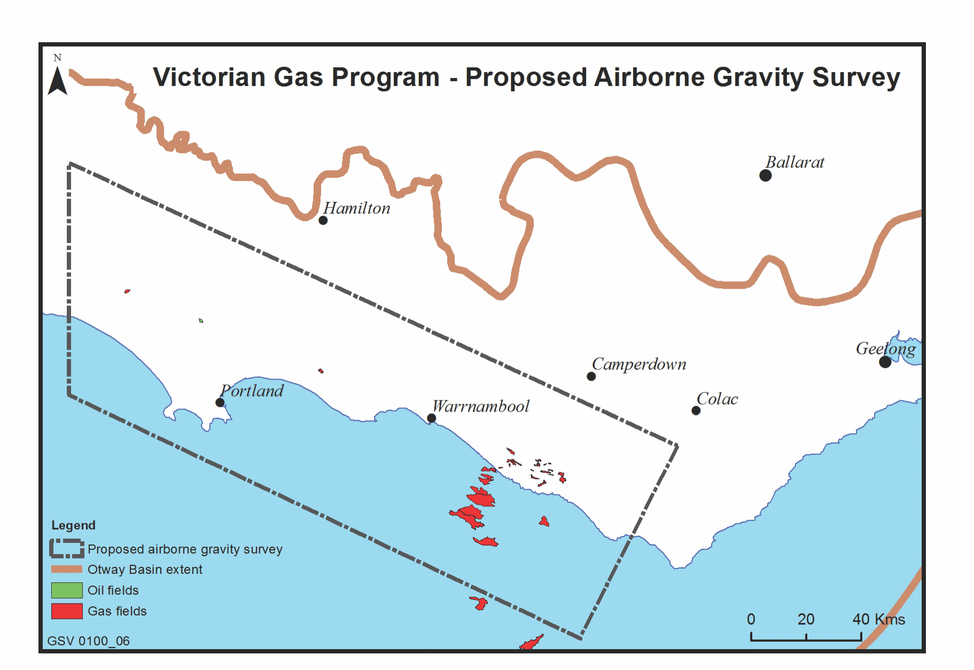
Figure 12: Proposed area for airborne gravity survey

3.2.2 Acreage release
In May 2018, a release of new petroleum acreage will occur off the Victorian coast, specifically in the Otway Basin, promoting more commercial gas exploration and development.

4. Underground gas storage investigations
This program will focus on the onshore Otway Basin and investigate the potential for further underground gas storage sites to help secure more reliable gas supplies and to mitigate short term price increases, particularly during any interruptions in the gas supply system.
The program incorporates analysis and modelling of geoscientific information to assess the potential of known subsurface geological structures for underground gas storage, including rock characterisation studies (e.g. porosity, permeability). The program will also assess the economic potential of these geological formations.
Figure 13 depicts the underground gas storage investigations timing and milestones.
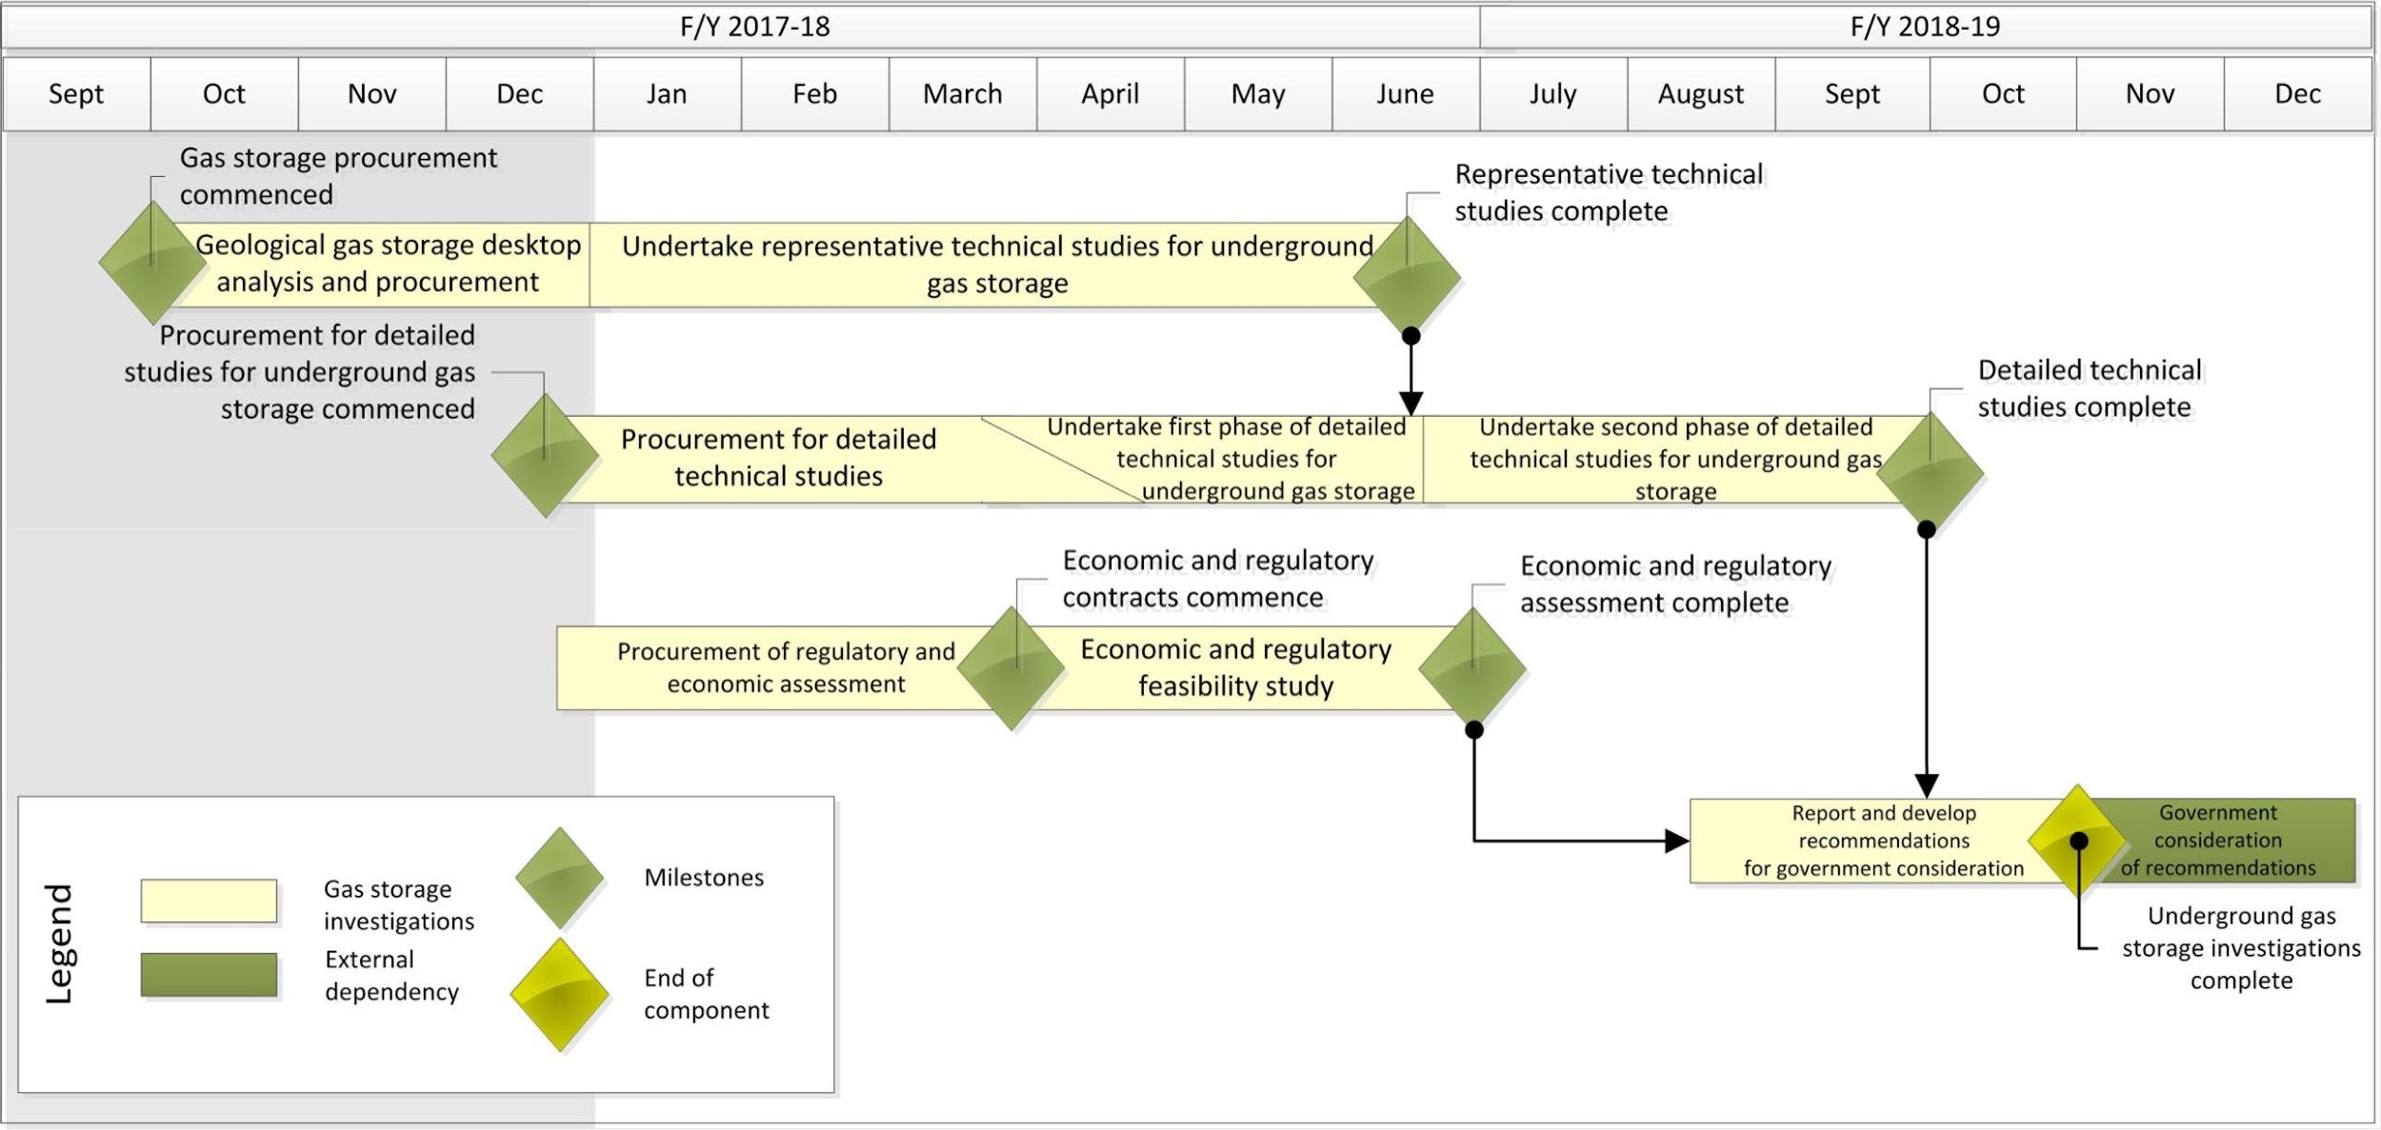
Figure 13: Underground gas storage investigations – timing and milestones
Currently known, yet depleted, non-producing gas reservoirs are being considered for gas storage suitability. There are currently 13 Petroleum Production Licences with a number of fields identified as having potential for gas storage. These sites will be subject to further investigation by applying key selection criteria to focus geoscientific considerations for economic assessment.
The Australian Competition and Consumer Commission’s (ACCC) Gas Inquiry 2017–2020 Interim Report (December 2017) identified the role that gas storage can play in the East Coast Gas Market in managing supply outages and maintaining system security.
The report outlined the important role that Victoria’s Iona storage facility played in 2016 in meeting Victorian/SA and NSW demand during a prolonged outage at a Queensland supply source.
The report also identified the following new storage opportunities in Victoria
- The underground gas storage component of the Victorian Gas Program in the Otway Basin
- Iona gas storage expansion
- New Gippsland Basin Golden Beach Storage.

4.1 Progress to date

4.1.1 Geoscience assessment of underground gas storage potential
The technical reservoir study component of the underground gas storage investigations includes generation of reservoir simulation models and developing high-level reservoir management plans. These activities will be progressed using collaborative opportunities with industry and other relevant organisations.
The Geological Survey of Victoria aims to identify potential additional gas storage sites of depleted, and known but not produced, reservoirs under a current Petroleum Production Licence. Thirteen fields have been identified as having potential for gas storage. Additionally, opportunities to enhance the current storage capability at Iona, North Paaratte and Wallaby Creek storage reservoirs were identified. Sites that will not be considered further for gas storage are:
- one storage site currently being utilised for carbon dioxide production by BOC
- two source and storage sites already being utilised by the CO2CRC Research Facility.
Data required to develop a more detailed understanding of the potential for storage is held by the Geological Survey of Victoria (e.g. annual reporting, drilling reports). This will be complemented by core materials assessment and also by production and monitoring data provided by the current Petroleum Production Licence holders. Relevant Geological Survey of Victoria-managed data has been identified, sorted and partitioned ready for utilisation through a Cloud-based application for the next stage of the underground gas storage project.
Planning and consultation is underway for securing potential collaborative partnerships with industry and other relevant organisations to develop and deliver the underground gas storage investigations.

4.1.2 Economic and regulatory assessment of underground gas storage
Scoping for an economic and regulatory assessment component to the underground gas storage investigations is underway. This will assess the economic viability of developing prospective gas storage reservoirs. It will include establishing an understanding of the costs of development, operation and working capital costs of stored gas and applicable reforms.

4.2 Next steps
An integrated review of the geology, geophysics and reservoir engineering studies will be undertaken to define the fields suitable for storage appropriate to the next stage of developing their storage characteristics. This stage will result in fit for purpose geological and corresponding simulation models which will be peer reviewed and calibrated by history matching the production and monitoring data available from the incumbent licencees. Engagement with the Petroleum Production Licence holders will be progressed to ensure a collaborative approach to these investigations and utilisation of available data.
These simulation models will be used to model upside and downside cases across a range of development options and surface facility parameters. Reservoir management plans will be developed to ensure that reservoir injection and withdrawal rate boundaries are understood to preserve the integrity of the reservoir over time and multiple cycles. This will provide the basis for completing reservoir injection and withdrawal forecasts so that economic viability can be studied.
Economic feasibility of the potential gas storage sites will include assessment of financial, operational and location factors. This will provide an understanding of the costs to develop and operate, the technical complexity of operating and the proximity to processing and supply hubs. The basis for this analysis will be the outputs of the reservoir modelling and management plans and known infrastructure.
The regulatory framework for underground gas storage in Victoria will be assessed to consider reforms that would enable effective utilisation of gas storage assets in the state. This will consider the rights of holders of current permits and licences.
Findings from the investigations will be consolidated into a report for release at the end of June 2018 and submitted for government consideration.

5. Supporting program components
There are three supporting program components.
- Community engagement
- Resource planning
- Regulatory improvements
Figure 14 depicts the supporting program components timing and milestones.
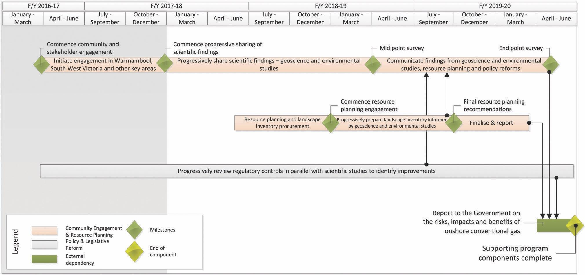
Figure 14: Supporting program components – timing and milestones

5.1 Community engagement
An extensive, proactive and phased community and stakeholder engagement program is being developed and implemented progressively with the aim to inform and involve people as the studies progress. Landholders, local residents and communities will have access to the scientific findings and be provided with opportunities to ask questions and obtain answers during this time. A community engagement officer is now based in the Warrnambool area to engage with community groups and members.
Community information sessions and open days in the areas most prospective for gas will be held on the geoscience and environmental studies and on other topics of interest, such as gas production methods and regulatory controls.
Frequent briefings and information will continue to be provided to councils, community leaders and community groups, with the aim to keep them up-to-date on the progress of the studies. Information will also be published on the Government’s ‘Earth Resources’ website: www.earthresources.vic.gov.au

5.1.1 Progress to date
To date, more than 95 engagement activities have been undertaken, including industry and community briefings since the program was announced in the State Budget in May 2017. Briefings, presentations and discussions have occurred with (but not limited to):
- local governments in south west Victoria and Gippsland
- unions
- gas explorers and developers
- regional State Government agencies
- science and policy groups
- media
- industry groups
- farmers and farming organisations
- industry gas users
- universities, and
- community, environmental and advocacy groups
- water authorities in south west Victoria.
The main focus of the community engagement program to date has been is the Otway geological basin, the most prospective area for onshore conventional gas. A team of up to 15 geoscience and environmental specialists and project staff is being established as part of a new Geological Survey of Victoria office in Warrnambool. Additional engagement activities are also planned for stakeholder groups in Gippsland.
Engagement is currently occurring with stakeholder groups in the various regions to inform them about the Victorian Gas Program, answer their questions and find out how they would like to be informed and consulted throughout the studies.
Information about the Victorian Gas Program is being delivered to community and industry via a number of forums. Petroleum explorers and development companies have been invited to share relevant geological data with the Geological Survey of Victoria to ensure that the most accurate geological models of the Otway and Gippsland geological basins are produced.
Media has helped increase community awareness of the Victorian Gas Program particularly in south-west Victoria. To date, a number of articles have been published in local and regional newspapers regarding the Victorian Gas Program. These media clippings are included in Appendix 4.
Additionally, a radio interview was also held with Victoria’s Lead Scientist on ABC Radio Ballarat on relay to south-west Victoria on 10 November 2017.
The feedback from engagements has been generally positive and constructive. Key insights include the following:
- regional community support for the State Government’s banning of hydraulic fracturing (fracking) and coal seam gas
- communities feel that the studies into onshore conventional gas provide an opportunity to do things right – including early engagement with clear information about the regional geology and the scientific program and its findings to local residents
- widespread support for Victorian Gas Program’s approach
- some regional community members do not support the development of gas or other fossil fuels
- farmers’ concerns have focused on land access issues, sharing benefits of resource development, groundwater (contamination and use/depletion) sustainability, earth tremors, competitive energy pricing, local impacts (quarries, roads, trucks)
- industry participants have stated the need for more gas supply, greater price competition and potential protection measures to support and secure domestic supply
- some Shires within the Otway geological basin support conventional onshore gas exploration and development.

5.1.2 Next steps
The Lead Scientist and the Geological Survey of Victoria will continue to work closely with communities and interested stakeholders as the Victorian Gas program is progressively implemented over the next three years.
Landholders, local community members and the wider Victorian community will have access to scientific findings as the studies progress, and will be provided with opportunities to ask questions.

5.2 Resource planning
A detailed landscape inventory will be prepared to identify key natural resource, cultural, environmental and existing land use values in the areas prospective for gas, including gaining a clear understanding of community views.
Resource planning activities conducted in parallel with the geoscientific and environmental studies will ensure that any future gas exploration and development only takes place where it is appropriate to the local context.

5.2.1 Next steps
Resource planning work will commence once the geoscience studies indicate which areas are potentially prospective for onshore conventional gas.

5.3 Regulatory reform
A comprehensive policy and regulatory review is being undertaken in parallel with the geoscience studies, community engagement and resource planning activities. A key focus will be to identify national and international best practice in gas regulation, to inform government decisions in the future.

5.3.1 Progress to date
On 25 August 2017, Victoria initiated action to secure the Council of Australian Governments (COAG) Energy Council’s agreement to broaden the National Gas Supply Strategy to include onshore conventional gas resources, offshore gas and underground gas storage.
Desktop research and analysis of reports that may have implications for onshore conventional gas is complete. This includes consideration of reports on other types of gas, which have been analysed to determine whether their recommendations may also be applicable for onshore conventional gas. Such reports include the Victorian Auditor General’s Office report on Unconventional Gas: Managing Risks and Impacts (2015), the Parliamentary Inquiry into Onshore Unconventional Gas in Victoria (2015) and the National Harmonised Regulatory Framework for Natural Gas from Coal Seams. The findings will inform the scope of the overall regulatory review.
Hydraulic fracturing and coal seam gas exploration and development are banned under Victorian legislation. Only recommendations that apply to understanding the benefits, risks and impacts associated with onshore conventional gas are included in the analysis. Aspects of the regulatory regime that may be considered for policy, administrative and legislative reform as part of the Victorian Gas Program include:
- risk based strategies and approvals processes
- baseline geological, environmental, and social data to inform evidence-based policy and underpin risk management of potential gas exploration and development activities
- land access, compensation, dispute resolution, community consultation requirements and royalty arrangements
- information disclosure requirements for regulated activities
- models for risk-based impact assessment processes
- third party oversight and auditing requirements for key elements of environmental performance
- increasing transparency of resources permits and licences over land
- improving consistency across resources legislation.

5.3.2 Next Steps
Future work will consolidate the desktop research on policy, administrative and legislative approaches in other jurisdictions for onshore conventional gas and offshore gas. The team will continue to work with its counterparts under the COAG Energy Council to implement the collaborative actions of the National Gas Supply Strategy to the extent that these apply to permitted activities in Victoria.

6. Existing and potential gas resources

6.1 Past activity and discoveries
Oil and gas have been produced from the Gippsland and Otway basins since the 1960s and 1980s respectively. The Gippsland Basin, comprising both onshore and offshore elements, is considered one of Australia’s most productive hydrocarbon provinces with offshore areas hosting several significant oil and gas fields. Gas discoveries in the onshore and offshore Otway Basin, concentrated around the Port Campbell area, established the region as an active gas producing province. As of July 2015, 9995 petajoules of gas had been produced from the offshore Gippsland Basin and 1264 petajoules from the Otway and Bass basins combined (‘Australia’s gas resources part production and remaining resources’, Geoscience Australia, 2015).
In the onshore Gippsland Basin, there is a long history of petroleum (oil and gas) exploration with 197 wells drilled since 1886. The majority of these wells targeted petroleum in the same geological formations as those found to host oil and gas in the offshore area. Although numerous oil and gas shows (readings) were recorded, no conventional discoveries were made. The discovery and recovery of relatively small volumes of oil at Lakes Entrance around the 1920s and 1930s would be considered the most successful historical petroleum encounter to date in the onshore area. In the three nautical mile zone, within Victoria’s jurisdiction offshore of the Gippsland coast (Figure 15), the Golden Beach gas field was discovered in 1967.
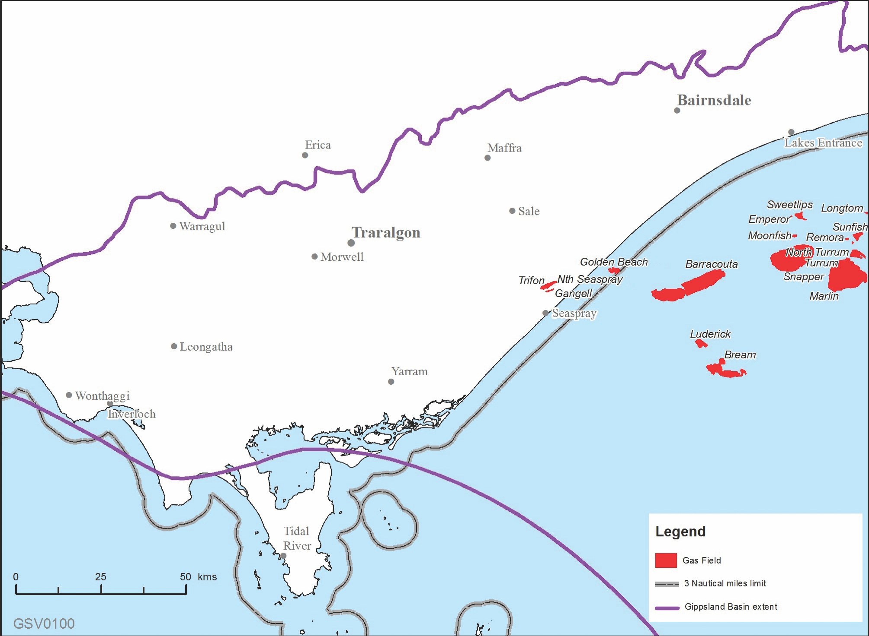
Figure 15: Gas fields in the Gippsland Basin
Throughout the onshore Otway Basin, a lengthy history of petroleum (oil and gas) exploration has also been recorded with 155 wells drilled since the early 1920s. Gas was first discovered in the onshore Victorian Otway Basin in 1959 (refer to Figure 16), in the Port Campbell Embayment, but it was not until 1978 that a commercial gas discovery in the same area revived interest in the commodity. Between 1979 and 2003, a further 20 small conventional gas fields were discovered. From the early 1990s into the 2000s, gas discoveries both onshore and offshore around the Port Campbell Embayment established the region as an active gas producing province. For 20 years between 1986 and 2006, two facilities, North Paaratte and Heytesbury, processed gas from the onshore fields. In the onshore Otway Basin, gas remains in place in the Grumby and Langley fields due to the high carbon dioxide content – 53 per cent and 66 per cent respectively (Woollands & Wong, 2001), whilst methane remains in place in the Lavers Field.
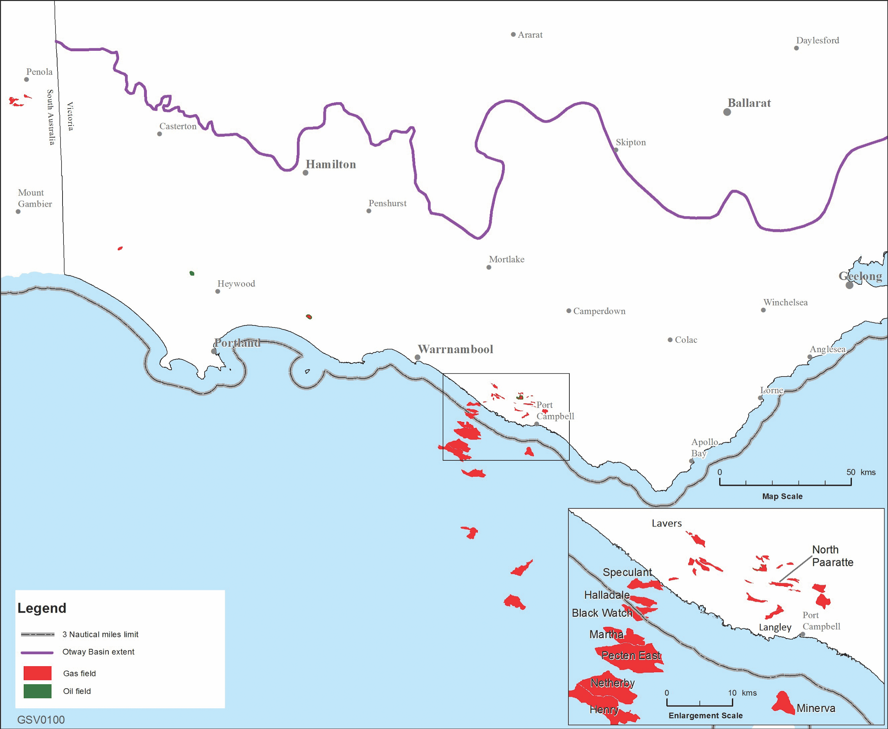
Figure 16: Gas fields in the Otway Basin

6.2 Potential gas resources and reserves
In November 2017, Geoscience Australia released its Offshore South East Australia Future Gas Supply Study, which focused on the three geological basins offshore from Victoria – Gippsland Basin, Otway Basin and Bass Basin – and the Sorell Basin off the west coast of Tasmania.
The study estimated that there are 3.8 trillion standard cubic feet (approximately 4169 PJ) of known 2P gas reserves, including 3.2 trillion standard cubic feet (approximately 3511 PJ) of 2P gas reserves in the Gippsland Basin and 554 billion standard cubic feet (approximately 608 PJ) of 2P gas reserves in the Otway and Bass Basins.
The study also concluded that there are 3.7 trillion standard cubic feet (approximately 4060 PJ) of 2C resources that remain to be produced from offshore south east Australia, of which 80 per cent is located within the Gippsland Basin. Additionally, the study identified 4.3 trillion standard cubic feet (approximately 4718 PJ) of prospective, undiscovered volumes that are yet to be drilled.
Inside the three nautical mile zone, offshore of the Otway coast from Port Campbell, the Halladale field was discovered in 2005, and the nearby Speculant gas field in late 2014. Gas is now being produced from the Halladale and Speculant fields. The gas reservoired in these fields is considered to be gas reserves, as the gas is being commercially recovered via a defined development project.
Gas production off the coast of Victoria during 2016 was 402 petajoules (Australian Energy Regulator, pg. 69, Table 2.1, 2017). In 2016, approximately 205 petajoules of gas was consumed in Victoria and 190 petajoules was piped interstate (Australian Energy Market Operator, 2017).
In onshore Victoria, there are no proved and probable reserves. Current onshore activities comprise gas storage and minor carbon dioxide production in the Otway Basin. The depleted Iona, North Paaratte and Wallaby Creek gas fields, to the north and northeast of Port Campbell, operate as a gas storage facility, taking gas piped from offshore production and storing it prior to release to consumers. Victoria’s only onshore gas well is located at Boggy Creek and produces a small amount of carbon dioxide gas.
There are differing estimates of how much conventional gas might be present in the onshore areas of Victoria’s Otway and Gippsland geological basins. The different estimates reflect uncertainties inherent in the underlying data, use of different estimation methods and differing definitions of the geographical area under assessment, and whether or not unconventional gas is included. This is further complicated by the use of different units of measurement (i.e. billion cubic feet, trillion cubic feet and petajoules). The effect of this is that the different estimates are not comparable.
For example, O’Brien & Thomas (2007) estimated that the Victorian Otway Basin could contain between 1.8 and 3.6 trillion cubic feet of undiscovered conventional gas, but their calculation included both onshore and offshore areas in State and Commonwealth waters – so does not clearly define the potential for further onshore discoveries of conventional gas.
Energy Quest's EnergyQuarterly (Sept 2017) quantified the following potential gas resources and reserves in Victoria and surrounding offshore areas (Table 2), which includes an estimate of prospective resources sourced from the Australian Energy Market Operator’s (2017) Gas Statement of Opportunities 2017.
Table 2: Potential gas resources and reserves in Victoria and surrounding offshore areas, in petajoules (Energy Quest, EnergyQuarterly, September 2017)
Location | Basin | 2P | 2C | Prospective resources
Victorian onshore | There are no proved and probable reserves | 11 petajoules
Commonwealth waters | Bass Basin | 85 petajoules | 215 petajoules | 0 petajoules
 | Gippsland Basin | 2483 petajoules | 2051 petajoules | 6124 petajoules
 | Otway Basin | 313 petajoules | 139 petajoules | 1107 petajoules
Victorian State Waters | Otway Basin (Halladale/Black Watch/Speculant) | 37 petajoules | 34 petajoules | 0 petajoules
Total | 2918 petajoules | 2439 petajoules | 7242 petajoules

Geoscience Australia (2017) estimated Victoria’s onshore tight and shale gas potential at 26.8 trillion cubic feet (potentially recoverable unconventional gas resources) with 19.2 trillion cubic feet in the onshore Gippsland Basin and 7.6 trillion cubic feet in the Otway Basin (refer to Table 3).
Table 3: Otway and Gippsland basins – potentially recoverable unconventional gas resources
Gas type | Otway Basin | Gippsland Basin | Total
Tight gas | 5.8 trillion cubic feet | 13.6 trillion cubic feet | 19.4 trillion cubic feet
Shale gas | 1.7 trillion cubic feet | 5.6 trillion cubic feet | 7.3 trillion cubic feet
Total | 7.6 trillion cubic feet | 19.2 trillion cubic feet | 26.8 trillion cubic feet

It is important to note that recovery of this gas would require hydraulic fracturing and that potential recovery is technically unproven in Victoria (i.e. the rocks themselves may not allow for recovery of the gas, irrespective of what laws are in place).
At this stage, the Geological Survey of Victoria has a ‘working estimate’ for conventional gas resources of around 110 petajoules for the area around Port Campbell, based on the O’Brien & Thomas (2007) study. The Geological Survey of Victoria considers this area to be most prospective for new conventional gas discoveries. The Gippsland Basin is considered to be less prospective for commercial-scale discoveries of onshore conventional gas, pending further geoscience investigations.
It appears that the potential for onshore conventional gas is relatively small compared to past production and known offshore gas reserves in Bass Strait.
It is important to note that the current estimates for onshore conventional gas resources are based on desktop assessments. Whilst gas might be present it may not be able to be extracted in a way that is safe, technically possible or commercially viable.
A key deliverable of the Victorian Gas Program is to produce a rigorous and auditable assessment and estimate of the prospective onshore conventional gas resources under Victoria’s jurisdiction.

6.3 Potential gas production
Total annual raw gas production for south east Australia during the 2016 calendar year was equivalent to 474 billion standard cubic feet, with production over any given 12-month period since 2012 ranging between 415 and 474 billion standard cubic feet. In a simplistic scenario, which assumes demand at current levels and no further efforts to progress contingent resources into production (reserves), sufficient gas reserves are available (2P) for the next eight to nine years. If this simplistic scenario is further extended to incorporate the estimated 2C contingent resources available, it indicates sufficient gas volumes are available for 15 to 20 years (Department of Industry, Innovation and Science, 2017).

7. Onshore underground gas storage – known capacity, recharge and drawdown rates
Gas storage opportunities in the Otway basin will utilise existing depleted reservoirs to store gas during periods of low gas demand for supply in peak demand periods. These gas storage reservoirs feature an impermeable cap rock above a permeable structure, often sandstone, where gas has accumulated over millions of years from naturally decomposing materials. Following the production of the original natural gas, some of these reservoirs, with good porosity and permeable storage structures, are suited to gas storage. A driving mechanism, often a water drive, maintains reservoir pressure. This pressure determines compression required to inject gas into storage and to deliver the stored gas to processing facilities and/or transmission pipelines.
Gas withdrawn from storage requires processing in order to ensure that liquid levels meet the specification for sales gas and is odorised for safe transportation and use.

7.1 Iona underground gas storage
The Iona underground gas storage facility is located near the south west Victorian township of Port Campbell and stores gas in the depleted Iona, North Paaratte and Wallaby Creek reservoirs which consist of highly permeable, porous sandstone ideally suited to storage of natural gas. Figure 17 represents the Iona reservoir, showing the five Iona production wells (Iona 1 to 5) the planned addition of Iona 7. It includes the features mentioned above including the Iona Gas Plant, utilised for injecting gas into storage and for processing withdrawn gas prior to delivery to customers.
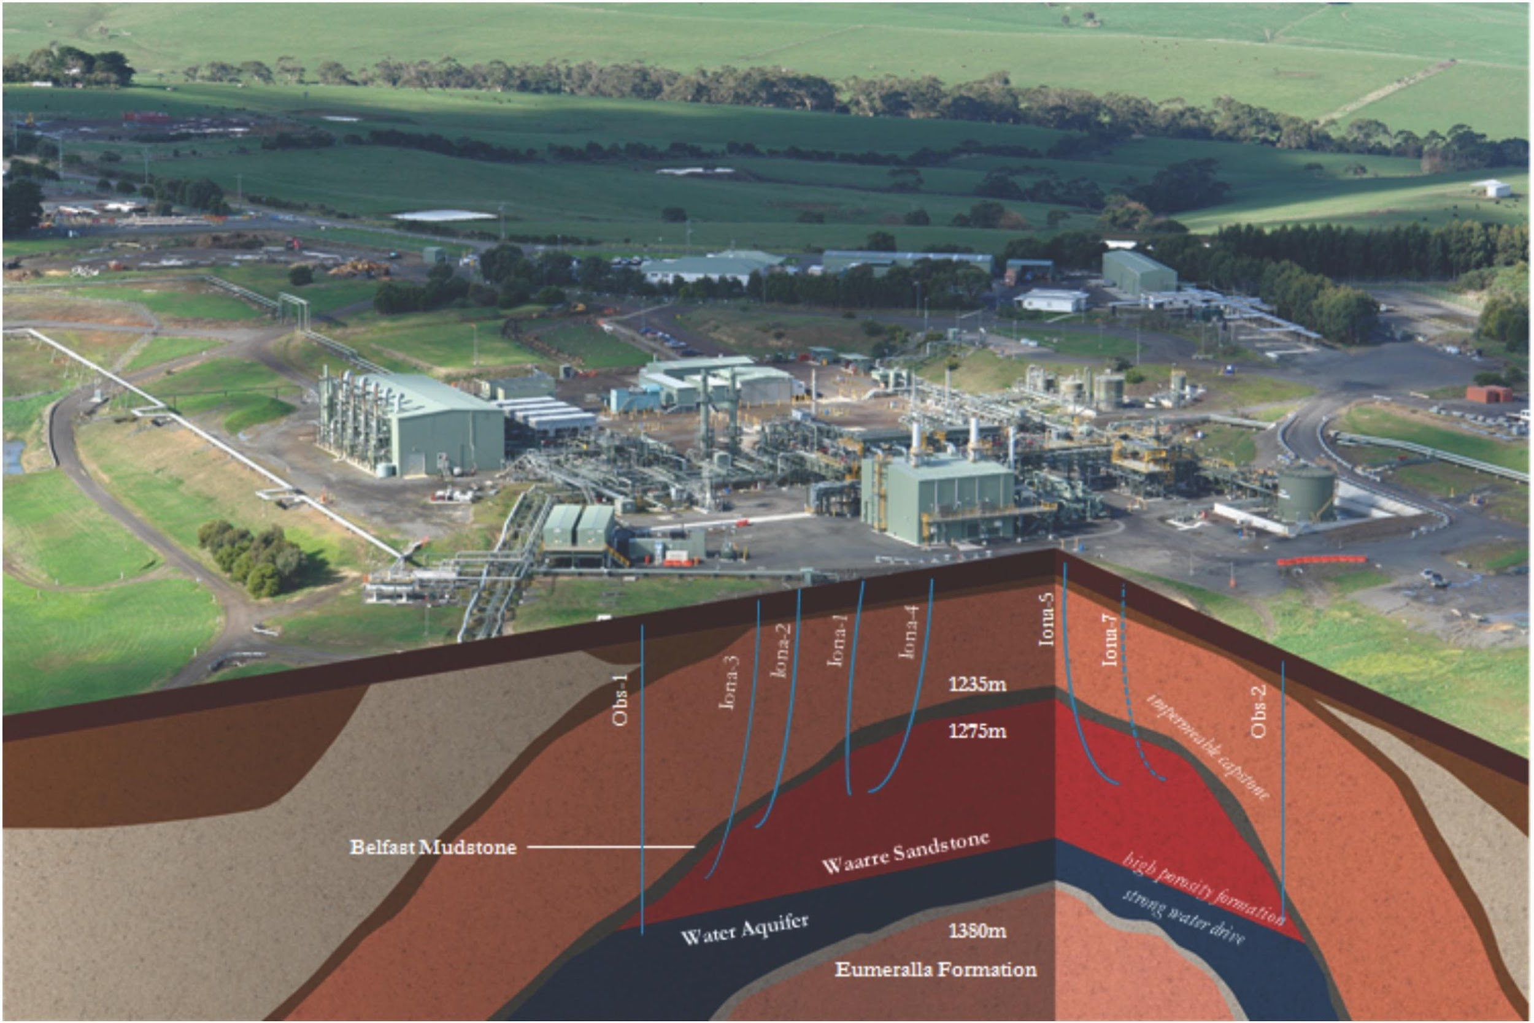
Figure 17: Representation of the Iona Gas Storage facility (Lochard Energy, 2017)
The current total Iona underground gas storage reservoir capacity is 26 petajoules (includes Iona, North Paaratte and Wallaby Creek). Injection capacity into the storage reservoirs is 153 terajoules per day with a withdrawal capacity from storage of 390 terajoules per day.
The Iona underground gas storage facility operator has advised the Australian Energy Market Operator of plans to expand its future reservoir withdrawal and injection capacity. These expansion works include:
- committed reservoir withdrawal capacity to increase from 390 terajoules per day to 440 terajoules per day and reservoir injection capacity to increase from 153 terajoules per day to 173 terajoules per day during 2017
- further reservoir withdrawal capacity increases from 440 terajoules per day to 570 terajoules per day, and reservoir injection capacity increases from 173 terajoules per day to 230 terajoules per day, are proposed by the end of 2019 (see Table 4).
Table 4: Iona gas storage capacity
Year | Max. reservoir withdrawal capacity (terajoules/day) | Max. Iona underground gas storage facility net injections in Declared Transmission System (terajoules/day) | Max. Iona reservoir injection capacity (terajoules/day) | Max. Iona underground gas storage Facility net withdrawals from Declared Transmission System (terajoules/day)
2017 | 390 | 435 | 153 | 300
2018 | 440 | 440 | 173 | 400
2019 | 440 | 440 | 173 | 400
2020 | 570 | 570 | 230 | 400
2021 | 570 | 570 | 230 | 400
This is consistent with a submission by Lochard Energy to the Australia Energy Regulator in March 2017 with a minor difference in ultimate injection to storage capacity (230 vs 250 terajoules per day).
Iona underground gas storage expansion is the easiest and most economic option to increase the gas swing capacity to market. Lochard Energy intends to increase Iona underground gas storage withdrawal capacity from 390 terajoules per day to 570 terajoules per day and storage injection from 153 terajoules per day to 250 terajoules per day through the workovers of two existing reservoir wells and the addition of one or two new wells. Current plant capacity will be utilised to bring the expanded reservoir deliverability to market.
(Source: Lochard Energy submission to AER March 2017)

7.2 Dandenong liquefied natural gas storage
The Dandenong liquefied natural gas facility has a storage capacity of 680.8 terajoules with approximately 580 terajoules of this capacity available to market participants.
Vaporisation capacity of up to 5.5 terajoules per hour is available for peak saving purposes. This capacity equates to the vaporisation of 87 terajoules per day. This facility is able to vaporise approximately 10 terajoules per hour at its maximum (non-firm rate) capacity.
The maximum liquefaction rate, injection to storage, is up to 82 terajoules per month, averaging approximately 2.7 terajoules per day (Australian Energy Market Operator, 2017)

8. Previous studies

8.1 A technical assessment of the yet-to-find hydrocarbon resources inventory, offshore and onshore Otway Basin, Victoria, Australia (2007)
In 2007, the Geological Survey of Victoria assessed the Victorian part of the Otway Basin for its likely undiscovered hydrocarbon potential (O’Brien & Thomas, 2007). The study was based on data predominantly from 2001. The assessment found that the basin has undiscovered gas resources most likely between 1.849 and 3.696 trillion cubic feet.

8.2 Onshore Water Science Studies (2015)
In 2015, the Department of Environment, Land, Water and Planning in collaboration with the Geological Survey of Victoria (part of the Department of Economic Development, Jobs, Transport and Resources) conducted water science studies on onshore natural gas is to provide an initial screening analysis of the potential impacts of possible onshore unconventional gas exploration and development on water users and ecosystems. The studies assess the potential impacts of aquifer depressurisation (i.e. groundwater level decline), chemical contamination of groundwater from hydraulic fracturing fluids, induced seismicity, and land subsidence. The Gippsland and Otway regions were the focus of these studies (Department of Economic Development, Jobs, Transport and Resources, 2015).

8.3 Unconventional gas resource estimates (2017)
In 2017, Geoscience Australia assessed the potential for unconventional gas and liquids in the Otway and Gippsland basins. The interim reports were based on desk top studies using limited publicly available data. The reports noted that significant improvements could be made to the reliability of these assessments if more data were available. Results from this study are summarised in Section 6.2.

8.4 Commonwealth Government – Offshore South East Australia Future Gas Supply Study (2017)
The Commonwealth Government’s Department of Industry, Innovation and Science released the Offshore South East Australia Future Gas Study on 24 November 2017 (Department of Industry, Innovation and Science, 2017). Results from this study are summarised in Section 6.2.
According to the Study (2017), the short term prospects for gas are that:
- there are two gas projects currently under development in offshore Victoria and Tasmania —Cooper Energy’s Sole Project (Gippsland Basin) and Lattice Energy’s Black Watch development (Otway Basin). Both of these are relatively small by historical standards
- the major known gas fields of south east Australia, have been developed and are significantly depleted. Future production sources will continue to shift from the high volume, shallow depth, high-quality gas fields to low volume, deeper, low-quality gas fields, and most will effectively backfill existing capacity rather than create net new gas volumes for the market.
- there are two other potential projects which could be taken to the market in the short to medium term, but both have limitations around infrastructure and commerciality.
- the Greater Dory prospect on the outer eastern edge of the Gippsland Basin represents a potential exploration prospect which may defer the inevitable transition into smaller, deeper gas deposits, but it would still take between seven and 10 years to bring to market if successful.

9. References
Australian Competition and Consumer Commission (2017) Gas inquiry 2017–2020 Interim report. Available at: https://www.accc.gov.au/publications/serial-publications/gas-inquiry-2017-2020/gas-inquiry-december-2017-interim-report [Accessed 28 Dec. 2017]
Australian Energy Market Operator. (2016). National Electricity & Gas Forecasting. [online] Available at: http://forecasting.aemo.com.au/Gas/AnnualConsumption/Total [Accessed 28 Nov. 2017].
Australian Energy Market Operator (2015). ‘2017 GSOO Contracts Reserves Costs Assumptions’. Gas Statement of Opportunities. March 2017. [online] Available at: https://www.aemo.com.au/-/media/Files/Gas/National_Planning_and_Forecasting/GSOO/2017/2017-Gas-Statement-of-Opportunities-input-data-files.zip [Accessed 25 Nov. 2017]
Australian Energy Market Operator (2017). Gas Statement of Opportunities. March 2017. [online] Available at: https://www.aemo.com.au/-/media/Files/Gas/National_Planning_and_Forecasting/GSOO/2017/2017-Gas-Statement-of-Opportunities.pdf [Accessed 27 Nov. 2017].
Australian Energy Market Operator (2017). Victorian Gas Planning Report. March 2017. [online] Available at: https://www.aemo.com.au/-/media/Files/Gas/National_Planning_and_Forecasting/VGPR/2017/2017-VICTORIAN-GAS-PLANNING-REPORT.pdf [Accessed 27 Nov. 2017].
Australian Energy Regulator (2017). State of the Energy Market. May 2017. [online] Melbourne, p.69. Available at: https://www.aer.gov.au/system/files/AER%20State%20of%20the%20energy%20market%202017%20-%20A4.pdf [Accessed 27 Nov. 2017].
COAG Energy Council Gas Supply Strategy (2017) [online] Available at: http://www.coagenergycouncil.gov.au/sites/prod.energycouncil/files/publications/documents/COAG%20EC%20Gas%20Supply%20Strategy%20-%20revised%20August%202017.pdf [Accessed 28 Nov. 2017].
Day, S., Dell’Amico, M., Fry, R. & H Javanmard Tousi, (2014) Field measurements of fugitive emissions from equipment and well casings in Australian coal seam gas production facilities, CSIRO, Australia.
Daniel, R.F. & Kaldi, J.G.(2014). Evaluating CO2 Column Height Retention of Cap Rocks. In P.J. Cook, (ed) Editor Peter Cook, In Geologically Storing Carbon: Learning from the Otway Project Experience. CSIRO Publishing, Melbourne.
Department of Economic Development, Jobs, Transport and Resources (2015) Water science studies. [online] Available at: http://earthresources.vic.gov.au/earth-resources/victorian-gas-program/onshore-conventional-gas/water-science-studies [Accessed 11 Dec 2017]
Department of Industry, Innovation and Science (2016), Australian energy update 2016, p. 15. Canberra, September. [online]. Available at: https://www.industry.gov.au/Office-of-the-Chief-Economist/Publications/Documents/aes/2016-australian-energy-statistics.pdf [Accessed 11 Dec 2017].
Department of Industry, Innovation and Science (2017). Offshore South East Australia Future Gas Supply Study November 2017 [online] Available at: https://industry.gov.au/resource/UpstreamPetroleum/OffshorePetroleumDevelopment/Pages/SEGasSupplyStudy.aspx [Accessed 10 Nov 2017].
EnergyQuest (2017). EnergyQuarterly. September 2017 Report.
EnergyQuest (2017). EnergyQuarterly. March 2017 Report.
Farr, M. (2017). ‘Crucial negotiations over energy security involve bewildering jargon’. News.com.au. [online] Available at: http://www.news.com.au/finance/economy/australian-economy/crucial-negotiations-over-energy-security-involve-bewildering-jargon-and-amounts/news-story/2eec769cace53eed1b42b27b4ff2c52a [Accessed 19 Nov. 2017].
Geological Survey of Victoria (2017) Types and locations of onshore gas. [online] Available at: http://earthresources.vic.gov.au/earth-resources/victorian-gas-program/onshore-conventional-gas/types-and-locations-of-onshore-gas
Geoscience Australia (2017). Australia’s gas resources past production and remaining resources (petajoules). [image] Available at: http://www.ga.gov.au/aera/gas [Accessed 3 Nov. 2017].
Geoscience Australia (2017). Interim Otway Basin unconventional resource assessment. Geoscience Australia, Canberra.[online] Available at: https://d28rz98at9flks.cloudfront.net/104440/Rec_104440.pdf [Accessed 3 Nov. 2017]
Geoscience Australia. (2017). Interim Gippsland Basin unconventional resource assessment. Geoscience Australia, Canberra. [online] Available at: https://d28rz98at9flks.cloudfront.net/104422/Rec_104422_v3.pdf [Accessed 3 Nov. 2017]
Guzel, M., 2015. Review of Formation Tops of the onshore Otway Basin, Victoria, Australia. Unpublished report.
Kaldi, J.G. & Atkinson, C.D. (1997) Evaluating Seal Potential: Example from the Talang Akar Formation, Offshore Northwest Java, Indonesia. In R.C. Surdam (ed) Seals, Traps and the Petroleum System, AAPG Memoir 67, 85-101.
Lochard Energy. (2017). Iona’s reservoirs and facility. [online] Available at: https://lochardenergy.com.au/iona-gas-plant/reservoirs/ [Accessed: 29 Nov 2017]
Minister for Resources. (2017). Fracking Banned In Victoria, Giving Certainty To Farmers. (online) Available at: https://www.premier.vic.gov.au/fracking-banned-in-victoria-giving-certainty-to-farmers/ [Accessed 10 Nov. 2017].
O’Brien, G.W. & Thomas, J.H. (2007). A technical assessment of the yet-to-find hydrocarbon resource inventory, offshore and onshore Otway Basin, Victoria, Australia. Victorian Initiative for Minerals and Petroleum Report 90, Department of Primary Industries.
Origin Energy (2017). 2017 Annual Reserves Report: For the year ended 30 June 2017. [online] Available at: https://www.originenergy.com.au/content/dam/origin/about/docs/170815-2017-reserves-report.pdf [Accessed 11 Dec 2017].
Parliament of Victoria (2015). Inquiry into onshore unconventional gas in Victoria. [online] Available at: https://www.parliament.vic.gov.au/images/stories/committees/SCEP/GAS/Report/EPC_58-03_Text_WEB.pdf [Accessed 28 Nov. 2017].
Society of Petroleum Engineers (2007). Petroleum Resources Management System. [online] Available at: http://www.spe.org/industry/docs/Petroleum_Resources_Management_System_2007.pdf [Accessed Nov 28 2017]
Victorian Auditor General’s Office (2015). Unconventional Gas: Managing Risks and Impacts. [online] Available at: https://www.audit.vic.gov.au/sites/default/files/20150819-Unconventional-gas.pdf [Accessed 28 Nov. 2017].
Woolands, M.A. & Wong, D. (2001). Petroleum Atlas of Victoria, Australia. Department of Natural Resources and Environment. p.208.

Appendix 1. Gas facts

A1.1 Summary
- Natural gas consists mainly of methane, a compound with one carbon atom and four hydrogen atoms, but may also contain carbon-rich molecules such as ethane, propane, butane and pentane. Other substances and gases such as sulphur compounds, nitrogen, carbon dioxide and water can also be present and naturally occurring.
- Gas is found in geological units within sedimentary basins. Three sedimentary basins offshore of Victoria contain proven or potential gas resources. These are the Gippsland, Otway and Bass basins (Figure A.1).
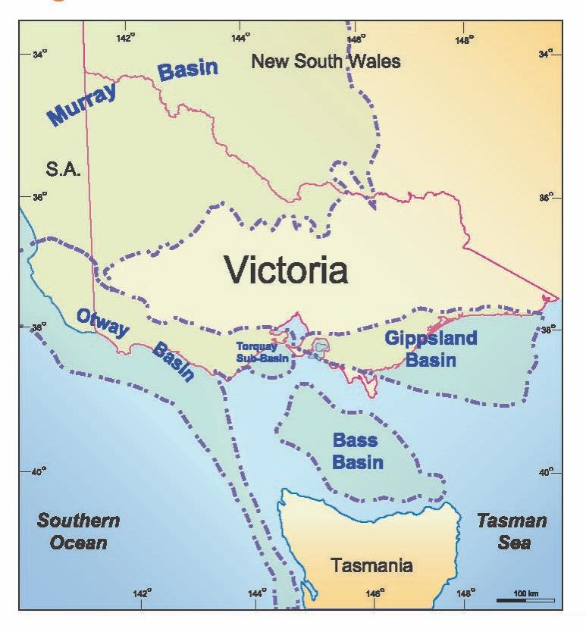
- In onshore Victoria, there are no proved and probable reserves.
- The majority of oil and gas produced across the globe (historically and at present) comes from conventional reservoirs. This remains the case in offshore and onshore Victoria, where all natural gas production has been from conventional reservoirs.
- The majority of offshore, conventional gas discoveries off the Victorian coast have been in Commonwealth waters within the Gippsland Basin. Discoveries and production have also originated from the Otway Basin.
- Extraction from the offshore Gippsland Basin commenced in 1965, when a BHP/Esso joint venture first began production from the Barracouta gas field.
- Smaller yet significant discoveries in offshore Victorian state waters such as the relatively recent discovery of the Halladale and Speculant fields have also been made in the Otway Basin.
- In June 1979, the Commonwealth and the states reached an agreement on the governance of the seabed adjacent to Australia. The Offshore Constitutional Settlement established that the states have jurisdiction over the seabed to within three nautical miles of the low water mark (5.6km). Beyond the three nautical mile limit, the Commonwealth has exclusive jurisdiction.
- The Offshore Petroleum and Greenhouse Gas Storage Act 2010 (Vic) governs the Victorian offshore waters, and associated seabed within the three nautical mile limit.
- The Offshore Petroleum and Greenhouse Gas Storage Act 2006 (Cth) governs the Commonwealth waters (three nautical miles to 200 nautical miles from shore) and the associated seabed.
- The portion of Commonwealth waters adjacent to Victoria are administered by a joint authority comprising the Commonwealth and Victorian ministers.

A1.2 Gas consumption

A1.2.1 About natural gas
Natural gas is available in most Victorian cities and large towns, its use is varied and widespread. Gas is commonly used for cooking, heating or as an energy supply for manufacturing. Gas is used as a raw material (feedstock) for creating products such as fertilisers, paper, plastics and chemicals. In most cases, there is no substitute for feedstock gas.
Increasingly, gas-fired turbines will be used to supplement baseload electricity generation in place of coal-fired plants. In 2015-16, there were 1.9 million Victorian residential and small business gas customers (p. 11, Essential Services Commission, 2016). In addition, based on data from the National Gas Forecasting Report (2016) by the Australian Energy Market Operator, out of a total of 208.7 petajoules consumed in Victoria in 2016, 59 per cent of usage was by the residential and commercial sectors (Figure A.2).
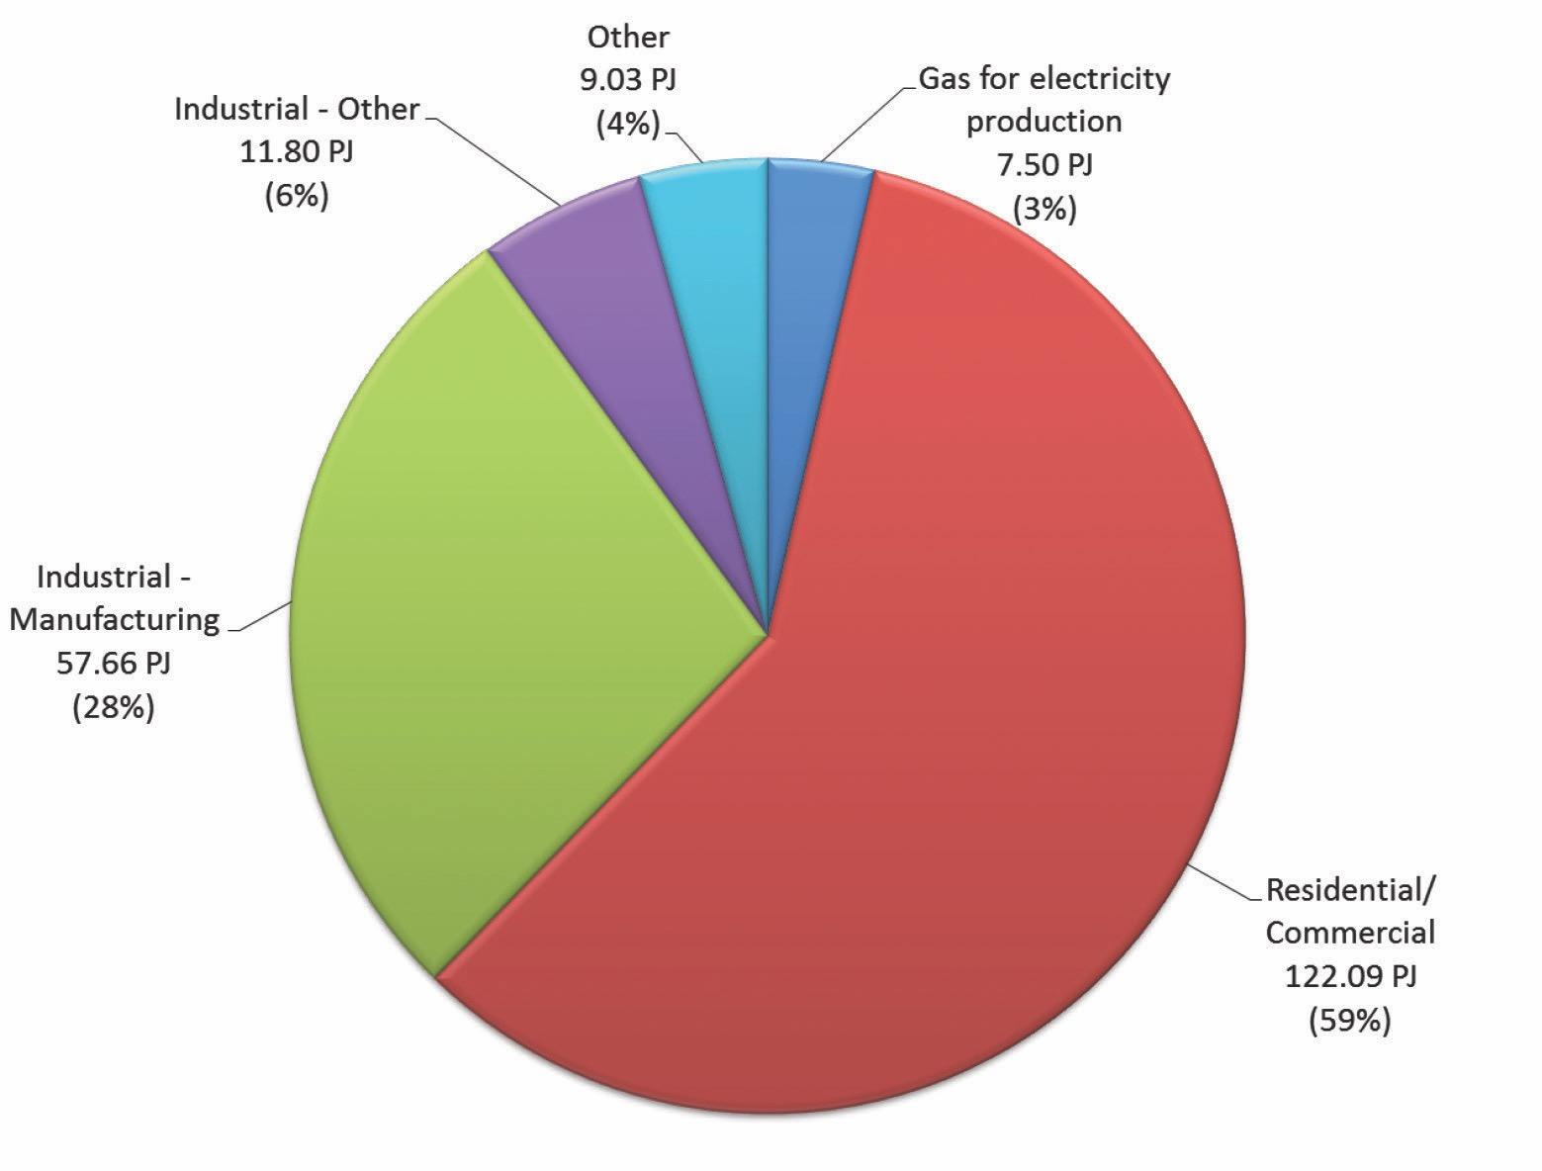
Figure A.2: Victorian natural gas usage by sector, in petajoules, of total natural gas usage, based on data from the National Gas Forecasting Report (Australian Energy Market Operator, 2016)
Historically, Victoria’s gas supply has been sourced from local offshore wells both near the coast and in Bass Strait since the 1960s.
Victorians typically consume about 200 petajoules of gas per annum, which is roughly half the production of natural gas generated from local gas plants. The surplus is sent interstate via a network of gas pipelines considered the backbone of the south east gas market. It subsequently enables excess supply to be traded across state borders.

A1.2.2 Types and locations of onshore gas
Onshore gas is found deep under the land surface in sedimentary rocks. The majority of gas supplied to Victorian consumers to date has been produced from offshore hydrocarbon fields under the seabed.
Onshore gas can be found in different sedimentary rocks known as tight sandstones (tight gas), shales (shale gas), coal seams (coal seam gas) or porous sandstones (conventional gas).
The main difference between tight gas, shale gas, coal seam gas and conventional gas is the type of rock that the gas is found in and the way in which the gas is stored. The methods used to produce gas from these different sources also varies (Geological Survey of Victoria, 2017).

A1.2.2.1 Where is onshore gas found?
Onshore gas is found around Australia including in New South Wales, Queensland, South Australia and the Northern Territory.
In Victoria, gas may be found in three broad areas. These are known as sedimentary basins and are named after the areas they cover: the Gippsland Basin, the Otway Basin and the Murray Basin. The basin boundaries are defined on the basis of their geology – they contain layers of sedimentary rocks (e.g. sandstones and shales) that have been deposited, buried, compacted; and in most cases folded and faulted by movement within the Earth’s crust over many millions of years.
Victoria’s Gippsland and Otway sedimentary basins have an onshore and an offshore component. Exploration for oil and gas has occurred for around 100 years in the onshore Gippsland and Otway basins. However, the majority of oil and gas discoveries and production to date have been from the offshore Gippsland and Otway basins. Relatively small amounts of gas have been produced in the onshore Otway Basin. Three of these traps is now used to store gas underground at Port Campbell – the Iona Gas Plant.
There is currently no onshore natural gas (methane) production in Victoria. The State does not have any defined resources of conventional gas in onshore areas that could be drawn on a commercial, basis.
Boggy Creek Pty Ltd operates the carbon dioxide production facility in the onshore Otway geological basin, which produces carbon dioxide for industrial use and soft drinks.
The Geological Survey of Victoria considers the Gippsland geological basin to be less prospective than the Otway geological basin for onshore conventional gas (Geological Survey of Victoria, 2017).

Conventional gas
Conventional gas reservoirs are commonly porous and permeable rocks such as sandstones or limestones (Figure A.3). Impermeable rocks such as claystones or shales found directly above gas reservoirs are known as a seal or cap-rock. The gas is trapped in the reservoir under the seal, commonly in geological structures. Geological structures are like an inverted dish, with the gas held underneath. A well drilled into a geological structure will intersect the porous gas reservoir. If gas is present, it will flow into the well.
Gas is generated from a source rock that has a relatively high content of organic matter. Generation is dependent on a number of variables, such as temperature and burial depth. The gas then migrates from the source via porous and permeable rocks or other conduits such as faults. The gas accumulates, or is trapped, in a reservoir. Overlying sealing rocks prevent the gas from migrating further. The gas is commonly trapped under geological structures but other geological traps are possible (e.g. stratigraphic traps) (Geological Survey of Victoria, 2017).
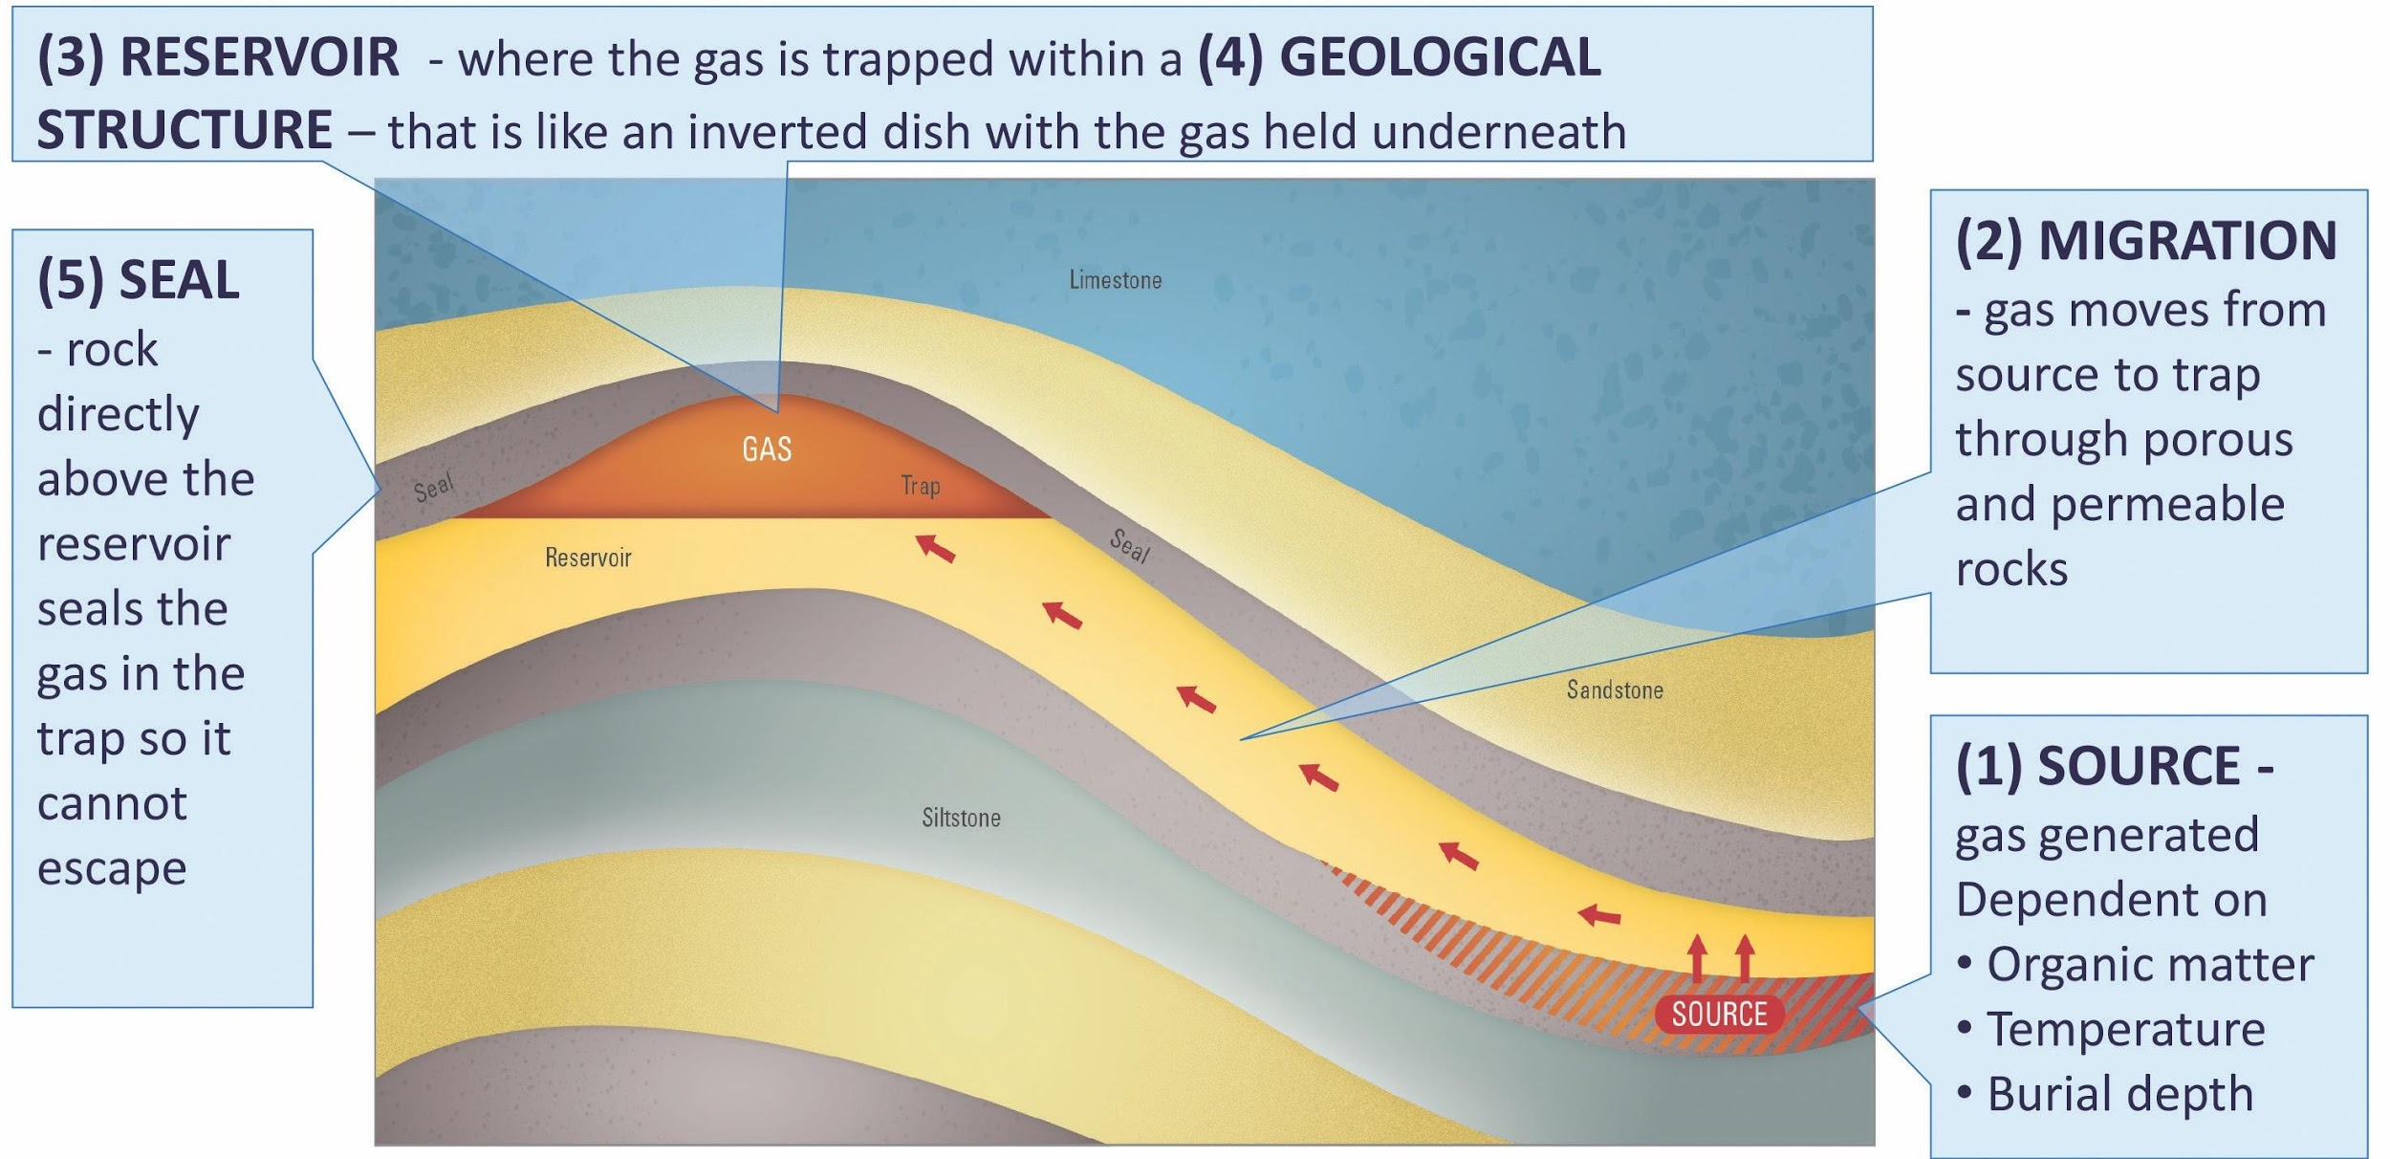
Figure A.3: Components of a conventional petroleum system

Tight gas
Tight gas is sourced from relatively low permeability and low porosity sedimentary reservoirs (Figure A.4). The lack of permeability does not allow the gas to migrate out of the rock. In this case the method to extract gas may involve fracturing the rocks to create artificial porosity and permeability (Geological Survey of Victoria, 2017).

Shale gas
Shale gas is sourced from very fine-grained sedimentary rocks that have low porosity and permeability and are organic-rich (Figure A.4). The gas is held in organic matter in the rock, in tiny pores between grains and any fractures present in the rock. As for tight gas, fracturing the rocks to create artificial porosity and permeability will release the gas (Geological Survey of Victoria, 2017).

Coal seam gas
Coal seam gas, also called coal bed methane, refers to naturally occurring methane in coal seams (Figure A.4). The gas is held on coal surfaces and trapped by water pressure in the gaps and cracks in the coal seams. In order to allow the gas to flow, water is drawn away from the seams to release the gas into a gas well (Geological Survey of Victoria, 2017).
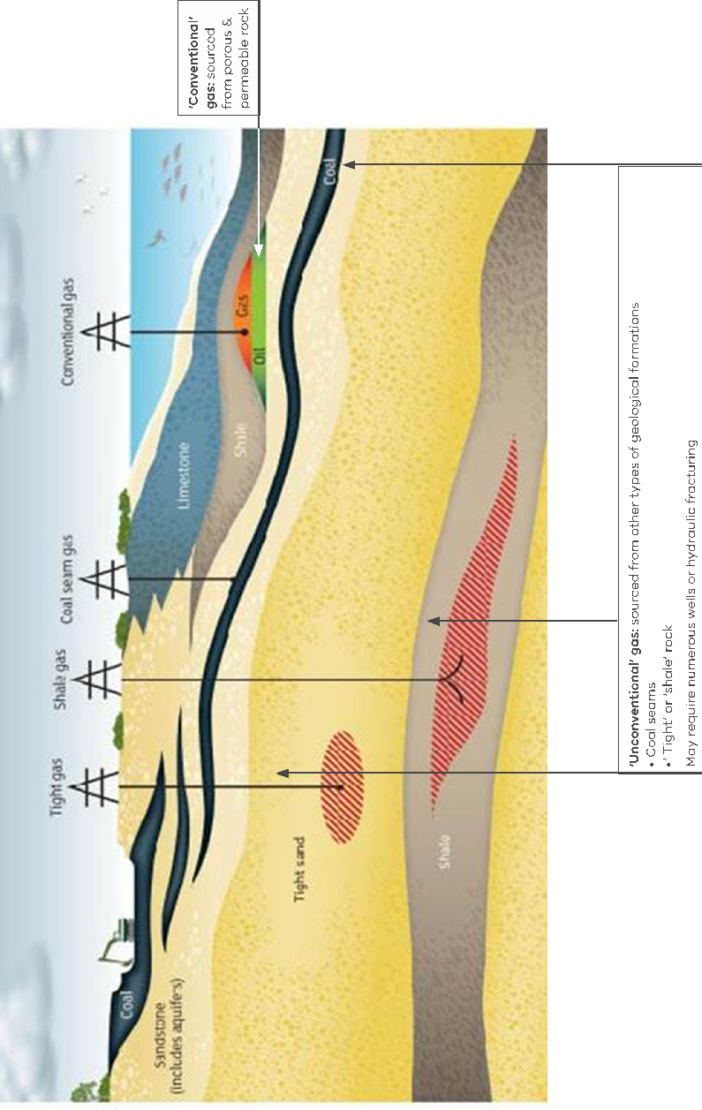
Figure A.4: Types of natural gas

Units of gas
Gas is generally measured in standard cubic feet or petajoules. Table A.1 includes the definitions of terminology relating to units of gas.
Table A.1: Definitions of terminology relating to units of gas
Terminology | Definition
Joule | the metric measurement unit for energy.
Petajoules (PJ) | Equals 1,000,000,000,000,000 joules. Sales gas is reported by its energy content (PJ) after processing.
Billion standard cubic feet (Bscf) | Raw gas is represented as a pre-processed volume (i.e. Bscf) because it includes non-petroleum components (e.g. CO2)
Trillion standard cubic feet (Tscf) | Raw gas is represented as a pre-processed volume (i.e. Tscf) because it includes non-petroleum components (e.g. CO2)
“Just one petajoule is enough gas to fuel demand from a fair-sized regional centre such as… Warrnambool for a year. Or keep the lights on at a major industrial site such as a chemical plant” (Farr, 2017).

A1.3 Petroleum Resources Management System
The Petroleum Resource Management System Resources Classification Framework assesses and describes resources according to three levels of recovery (Society of Petroleum Engineers, 2007):
Prospective Resource: an estimate from geological data of unrecoverable volumes, as yet undiscovered
Contingent Resource: on discovery of recoverable petroleum the resource, or part of it, is described according to certainty ranging from 1C (most certain) to 3C (less certain)
Reserves: is only applied when a volume of petroleum is expected to be commercially recoverable. Details of defined dates and conditions of extraction are described by a development project. Reserves are classified as 1P (proved), 2P (proved and probable) or 3P (proved, probable and possible).
In short, ‘resources’ do not equal ‘reserves’.
Figure A.5 depicts the stages in the Petroleum Resources Management System and the regulatory regime, typical activities and indicatives costs at each stage of gas development.
Further information on the PRMS can be found at the PRMS website: http://www.spe.org/industry/docs/Petroleum_Resources_Management_System_2007.pdf
Typical commercial onshore exploration, development and production costs are in the order of $100 million. Comparatively, offshore commercial exploration, development and production costs are in the order of $600 million. For both onshore and offshore, it can take anywhere from six to 26 years before getting to the gas production stage.
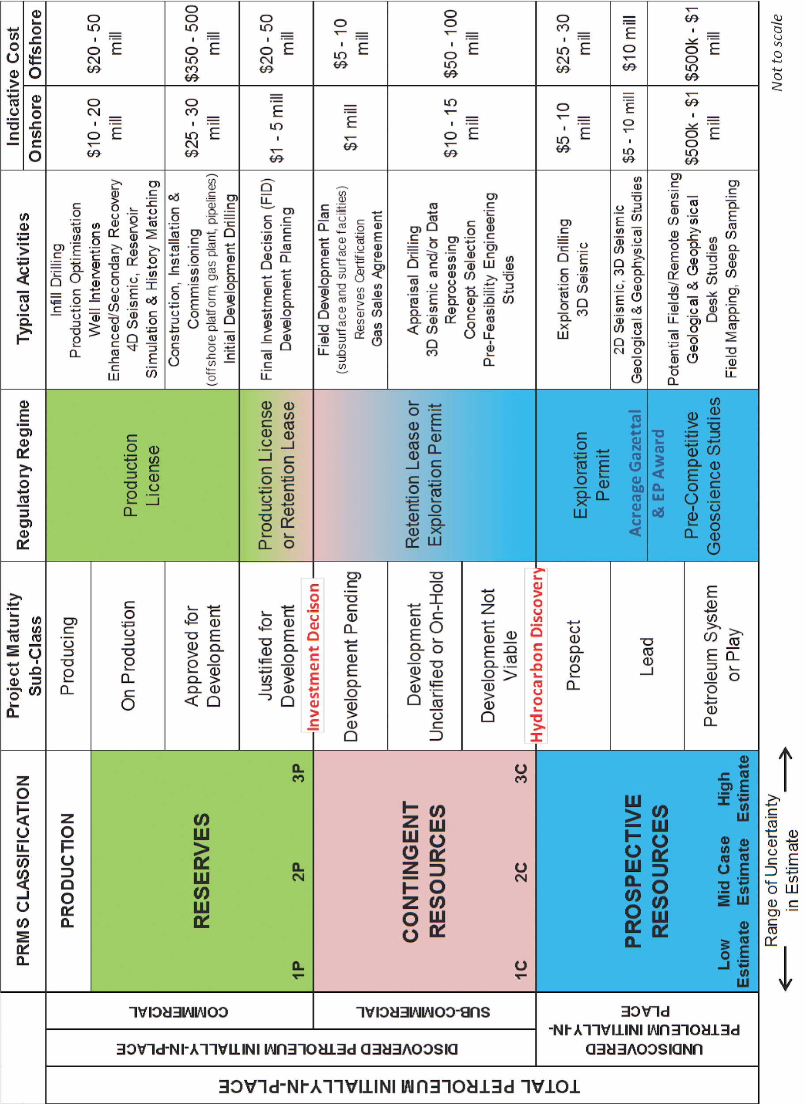
Figure A.5: Petroleum Resources Management System – Resource Classification Matrix, including regulatory regime, typical activities and indicative cost at each stage of development (modified from Society of Petroleum Engineers, 2007)
Figure A.6 demonstrates the timeline that it took for the Speculant gas field to begin producing gas.
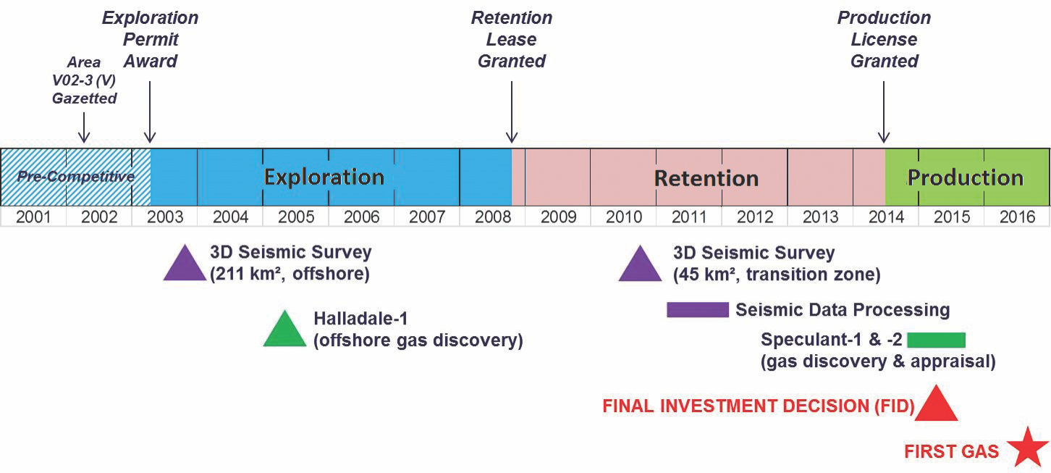
Figure A.6: Example timeline for exploration to production – Speculant gas field in offshore Otway Basin

Appendix 2. Fact sheets for each bore sampled to date
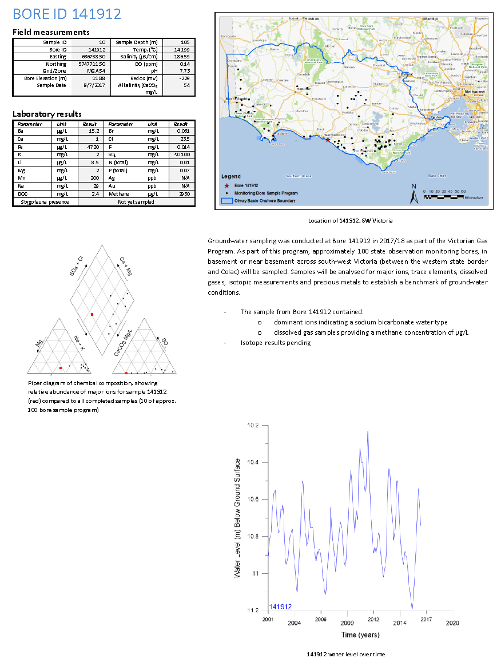

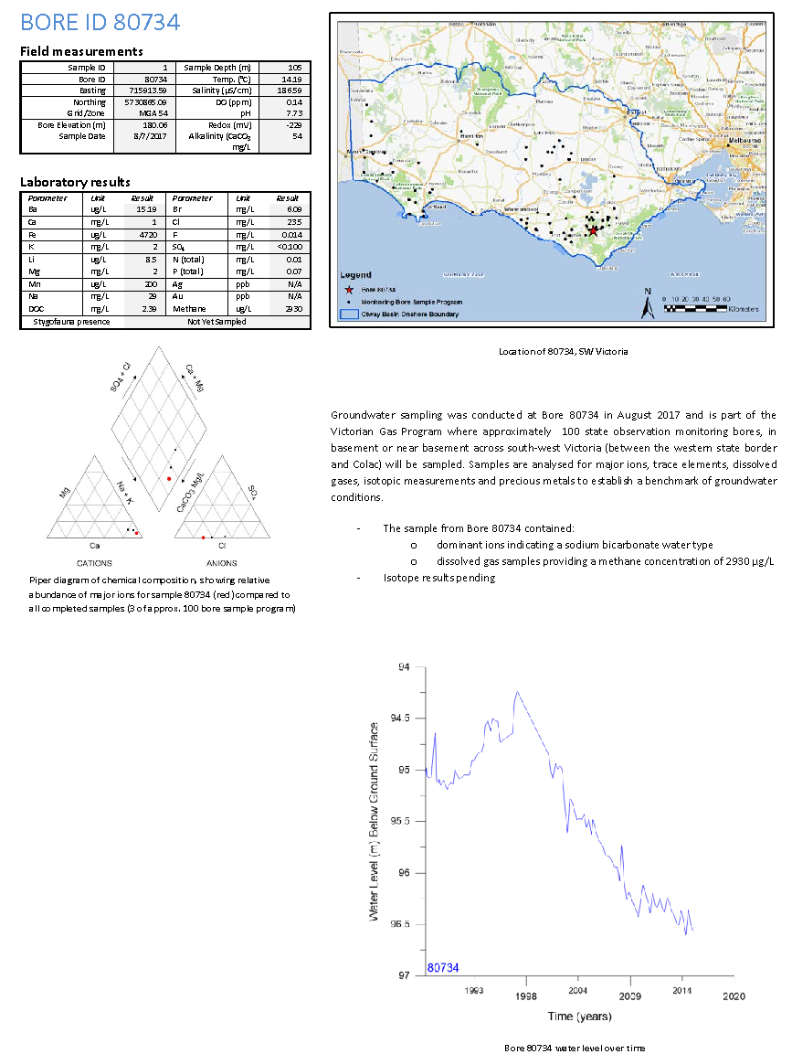

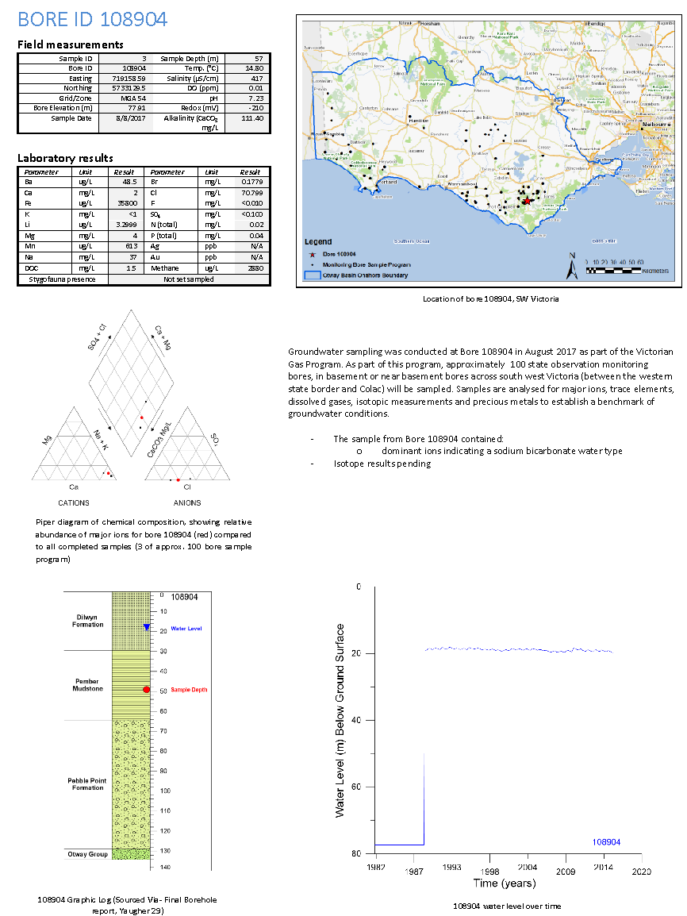

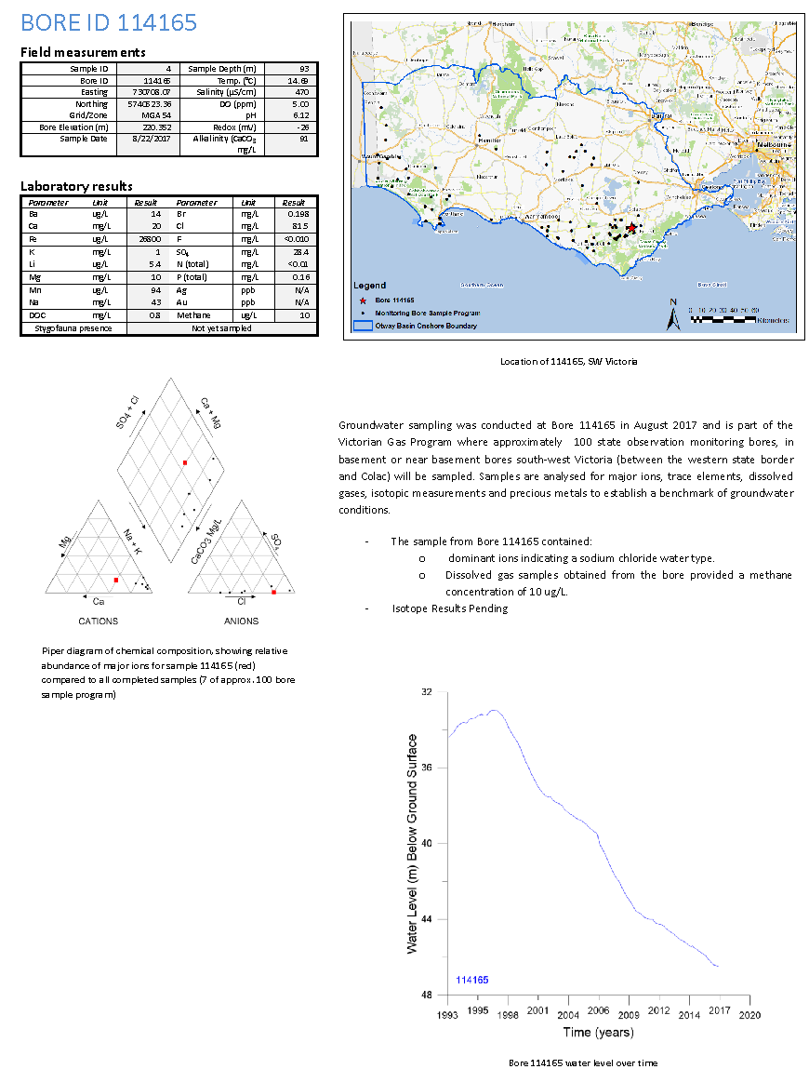

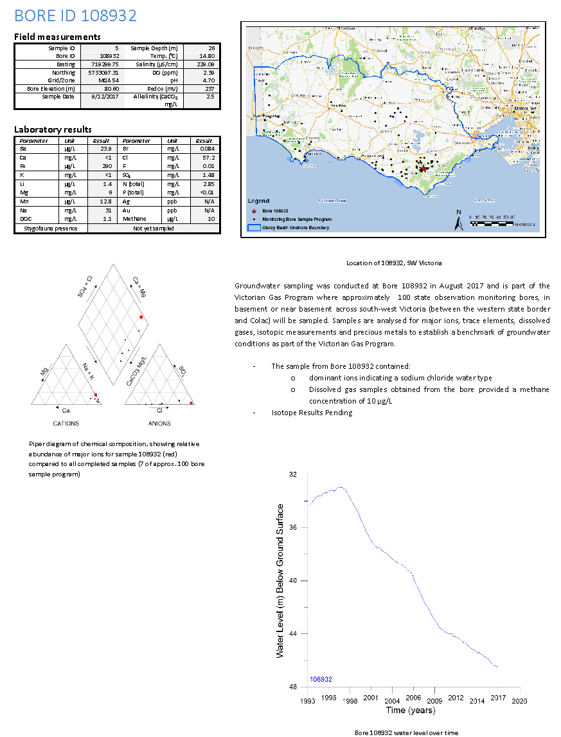

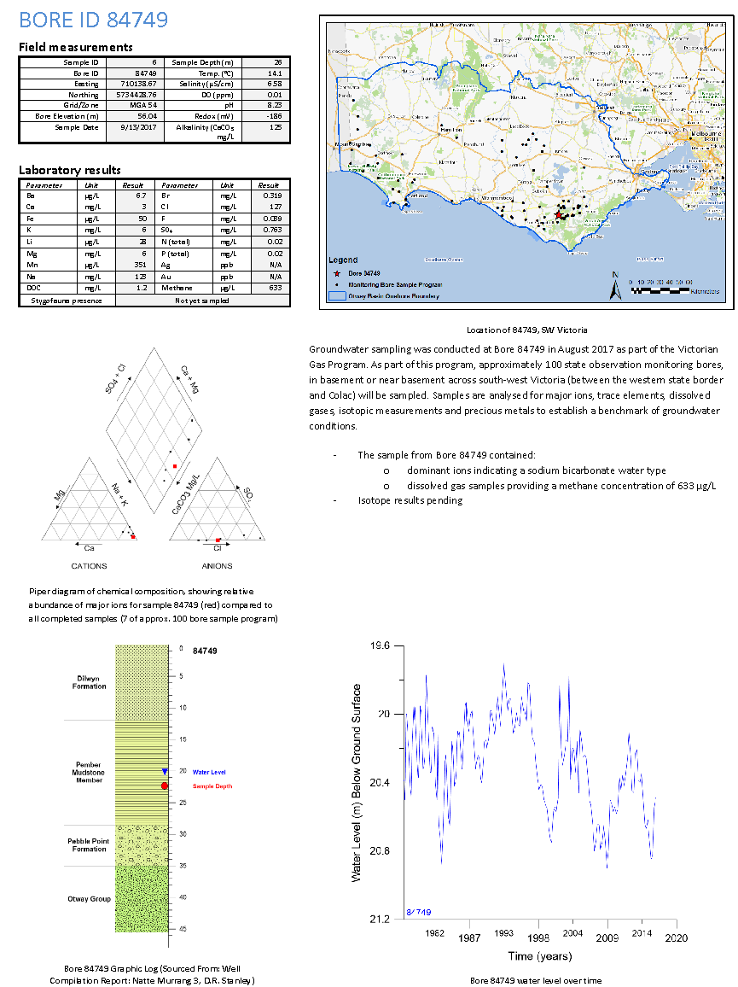

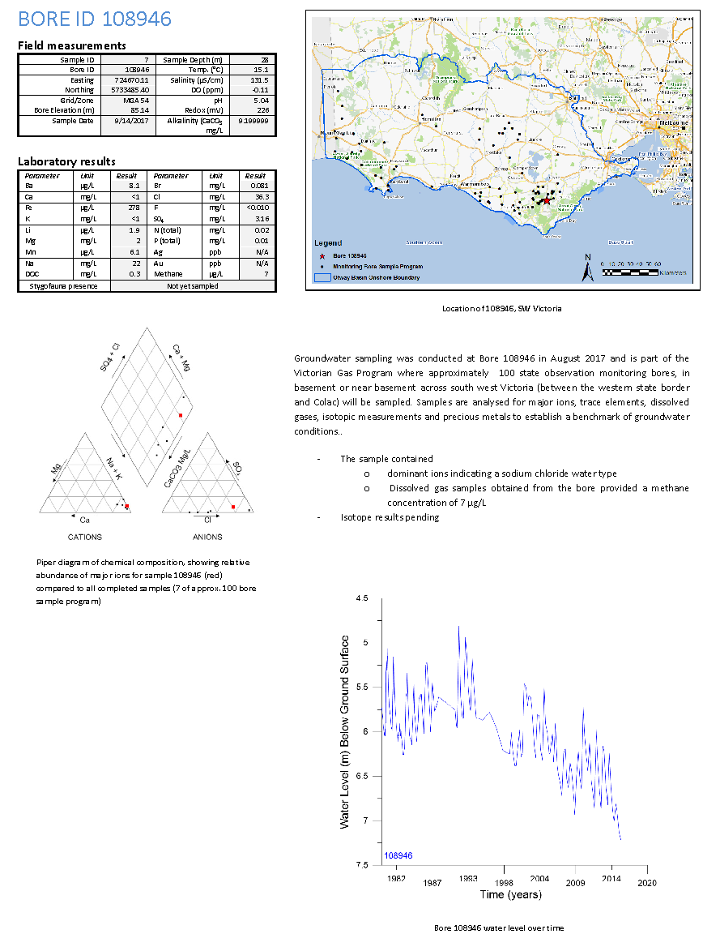

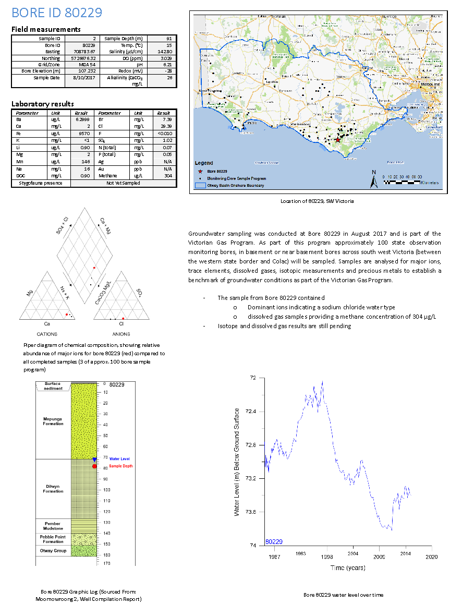
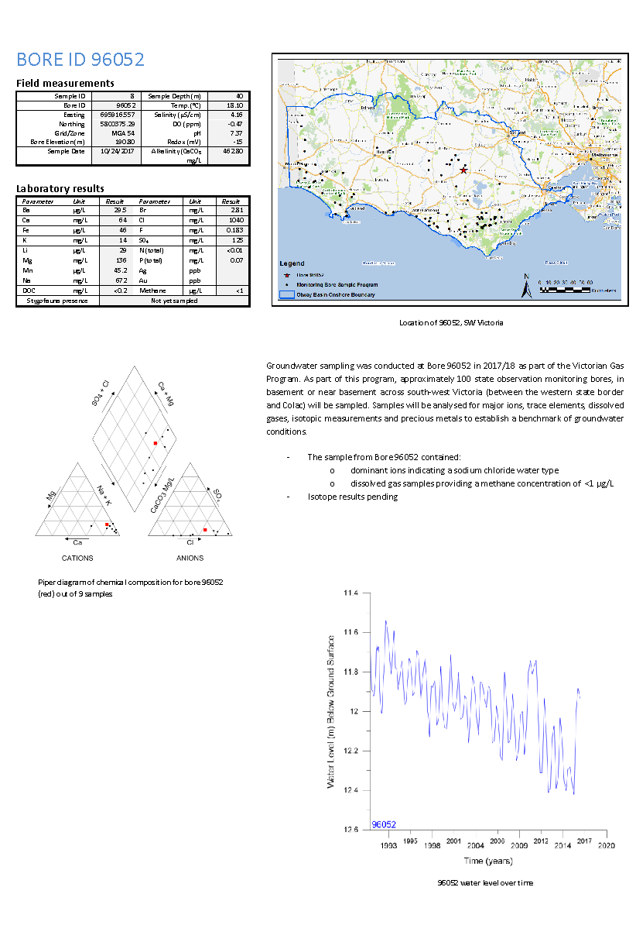
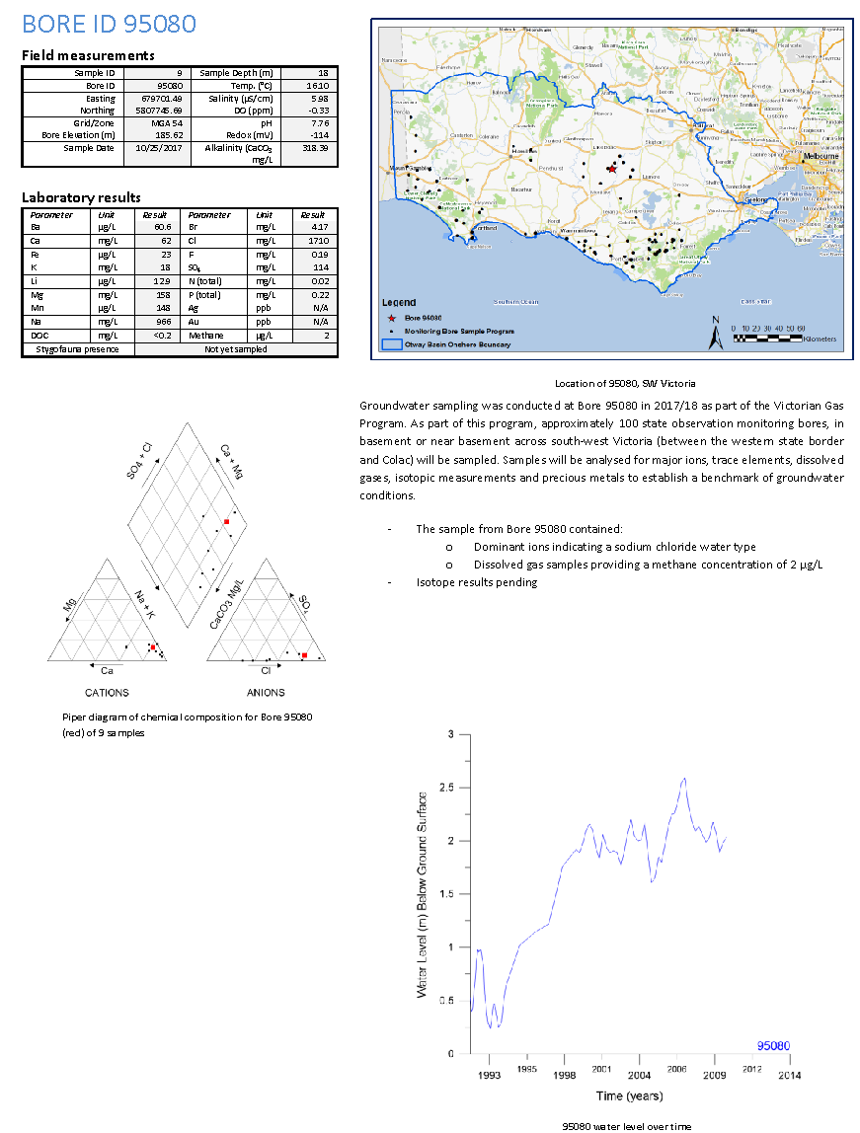

Appendex 3. Stakeholder Advisory Panel for Onshore Conventional Gas Communiques

Communique 1
Dr Amanda Caples, Victoria’s Lead Scientist
“On 17 August 2017, I chaired the inaugural meeting of the Stakeholder Advisory Panel for onshore conventional gas studies, which is part of the State Government’s Victorian Gas Program http://earthresources.vic.gov.au/earth-resources/victorian-gas-program
The Panel has been established by the [former] Minister for Resources, the Hon. Wade Noonan, to oversee the onshore conventional gas geoscientific and environmental studies over the next three years.
The role of the Panel is to provide the Minister for Resources with advice on the risks, benefits and impacts related to onshore conventional gas, with particular attention paid to social, economic and environmental factors.
The Panel will meet regularly over the next three years and includes a broad range of views, including farmers, industry, local government and the community. Panel members are able to provide feedback from the community and other stakeholders as the studies are undertaken.
The Panel members appointed are:
- Mr Stephen Bell, Chief Executive Officer, Qenos
- Mr Ben Davis, Secretary Australian Workers’ Union Victorian Branch
- Mr Gerald Leach, Chair of the Victorian Farmers’ Federation Land Management Committee
- Ms Alison Marchant, Secretary of Frack Free Moriac
- Ms Linda French, Community Development Manager, Lattice Energy (formerly Origin Energy)
- Mr Tennant Reed, Principal National Adviser, Public Policy, Australian Industry Group
- Cr Joanne Beard, Mayor of Corangamite Shire and representative of the Great South Coast Group
- Mr Mark Wakeham, Chief Executive Officer, Environment Victoria
Minister Noonan welcomed the panel at its inaugural meeting. For the benefit of the panel, the Minister reiterated the course the Victorian Government had taken to legislate to permanently ban hydraulic fracturing (fracking) and coal seam gas, while extending the moratorium on onshore conventional gas to 30 June 2020. He said the moratorium would allow time for a scientific program to assess the potential onshore conventional gas resources of the State. The program will include environmental baseline studies and the community will be actively engaged over the life of the studies. The results of the study and the panel’s work would help guide future decisions about the prospects for onshore conventional gas exploration and development beyond the middle of 2020.
During the meeting, representatives from Geological Survey of Victoria (GSV), the Government’s geoscience unit, gave a briefing on the schedule of onshore conventional gas geoscientific and environmental studies that will be conducted.
The focus of the studies will be on the Otway Basin in south west Victoria, particularly between Warrnambool and Port Campbell. The GSV has identified this area as having the greatest potential for onshore conventional gas. Some studies will be done in the Gippsland Basin, although based on existing data, the GSV considers this basin to be less likely to hold onshore conventional gas resources than the Otway Basin.
The geoscience studies will involve rock characterisation studies and analysis of current geoscience data. The results will assist in the development of three-dimensional models for the Otway and Gippsland geological basins. The environmental studies in the field will provide baseline data on groundwater chemistry and atmospheric conditions across the Otway and Gippsland basins.
GSV representatives emphasised the importance of community engagement to support the geoscientific and environmental studies. This included insights of engagement activity undertaken to date with local regional councils, community groups, peak industry bodies, water catchment management authorities, gas exploration companies and academics.
An important part of the community engagement program is to progressively provide the results of the studies to the public. Factual information from the studies will be provided to farmers, industry, local government and regional communities. A local team of geology specialists and a dedicated community engagement officer based in Warrnambool will ensure the community remains involved and informed about the studies. In practical terms, this means that there are people on the ground who can answer questions for local residents and landholders.
As Victoria’s Lead Scientist and panel chair, I am looking forward to working with the Panel over the next three years. I am sure the advice we will provide the Minister will assist the Government to make the best decisions possible about onshore conventional gas for all Victorians.
For more information visit the Victorian Gas Program on the Earth Resources website http://earthresources.vic.gov.au/earth-resources/victorian-gas-program
(Sourced from: https://economicdevelopment.vic.gov.au/about-us/overview/organisation-structure/victorias-lead-scientist/stakeholder-advisory-panel-onshore-conventional-gas-studies)

Communique 2
Dr Amanda Caples, Victoria’s Lead Scientist
The Stakeholder Advisory Panel at the Otway Gas Processing Plant.
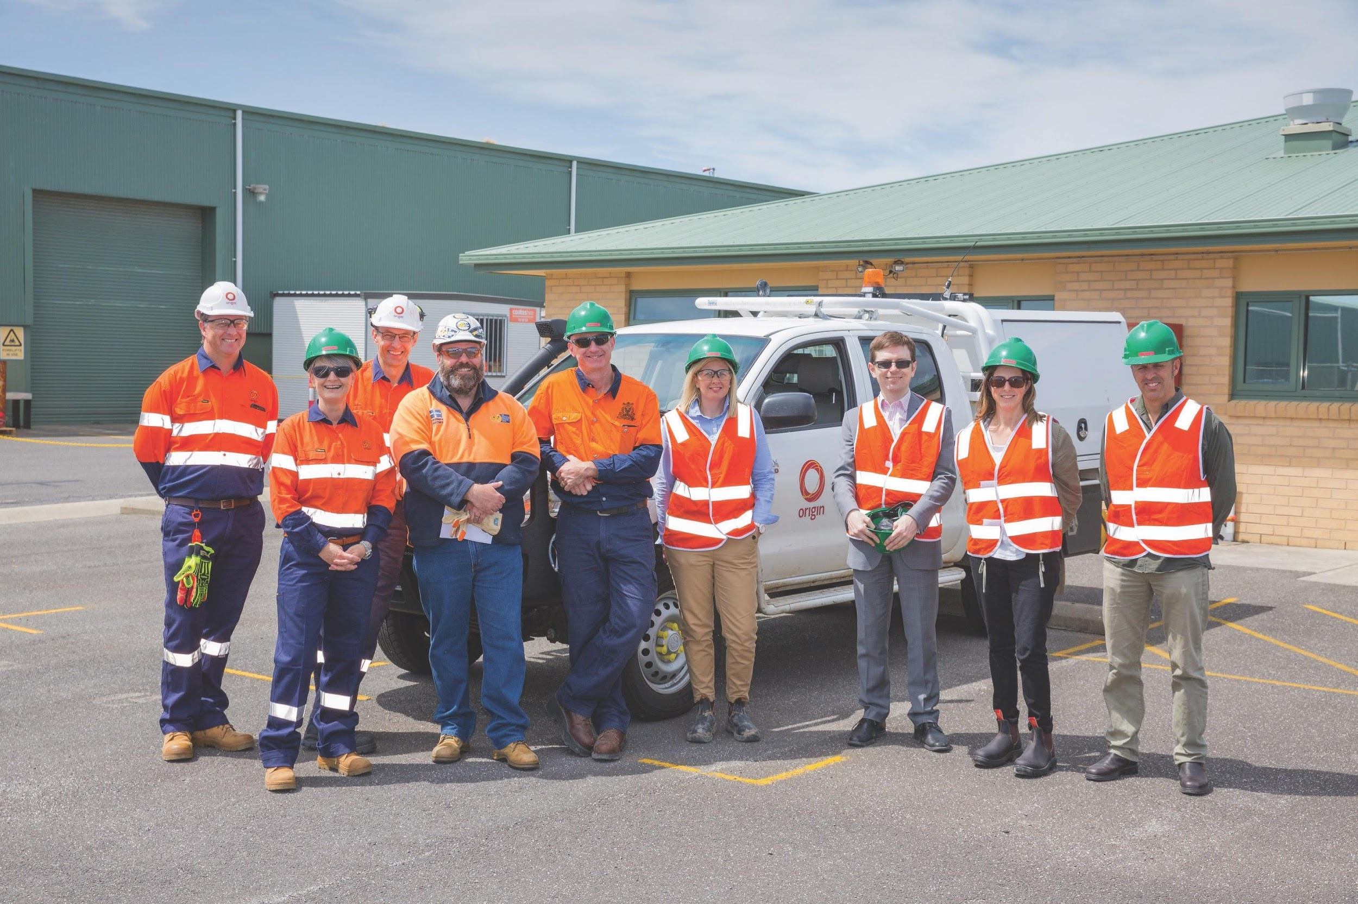
The second meeting of the Stakeholder Advisory Panel for onshore conventional gas studies was held in south-west Victoria on 9 and 10 November 2017 at Port Campbell and Camperdown and surrounding areas. This region of Victoria in the Otway geological basin is a focus of the Victorian Gas Program.
The meeting commenced on 9 November 2017 with a visit to the Otway Gas Plant and the Halladale and Speculant Well site, near Port Campbell.
The tour of Origin Energy’s facility provided the Panel with a first-hand view of a gas processing plant. Origin Energy representatives explained how the facility’s design and operational procedures ensure stringent health, safety and environment regulations are met.
The Panel then moved to Nirranda to see the Victorian Gas Program groundwater science team in action, sampling and recording trace chemistry at a groundwater monitoring bore as part of the environmental baseline studies of the Program.
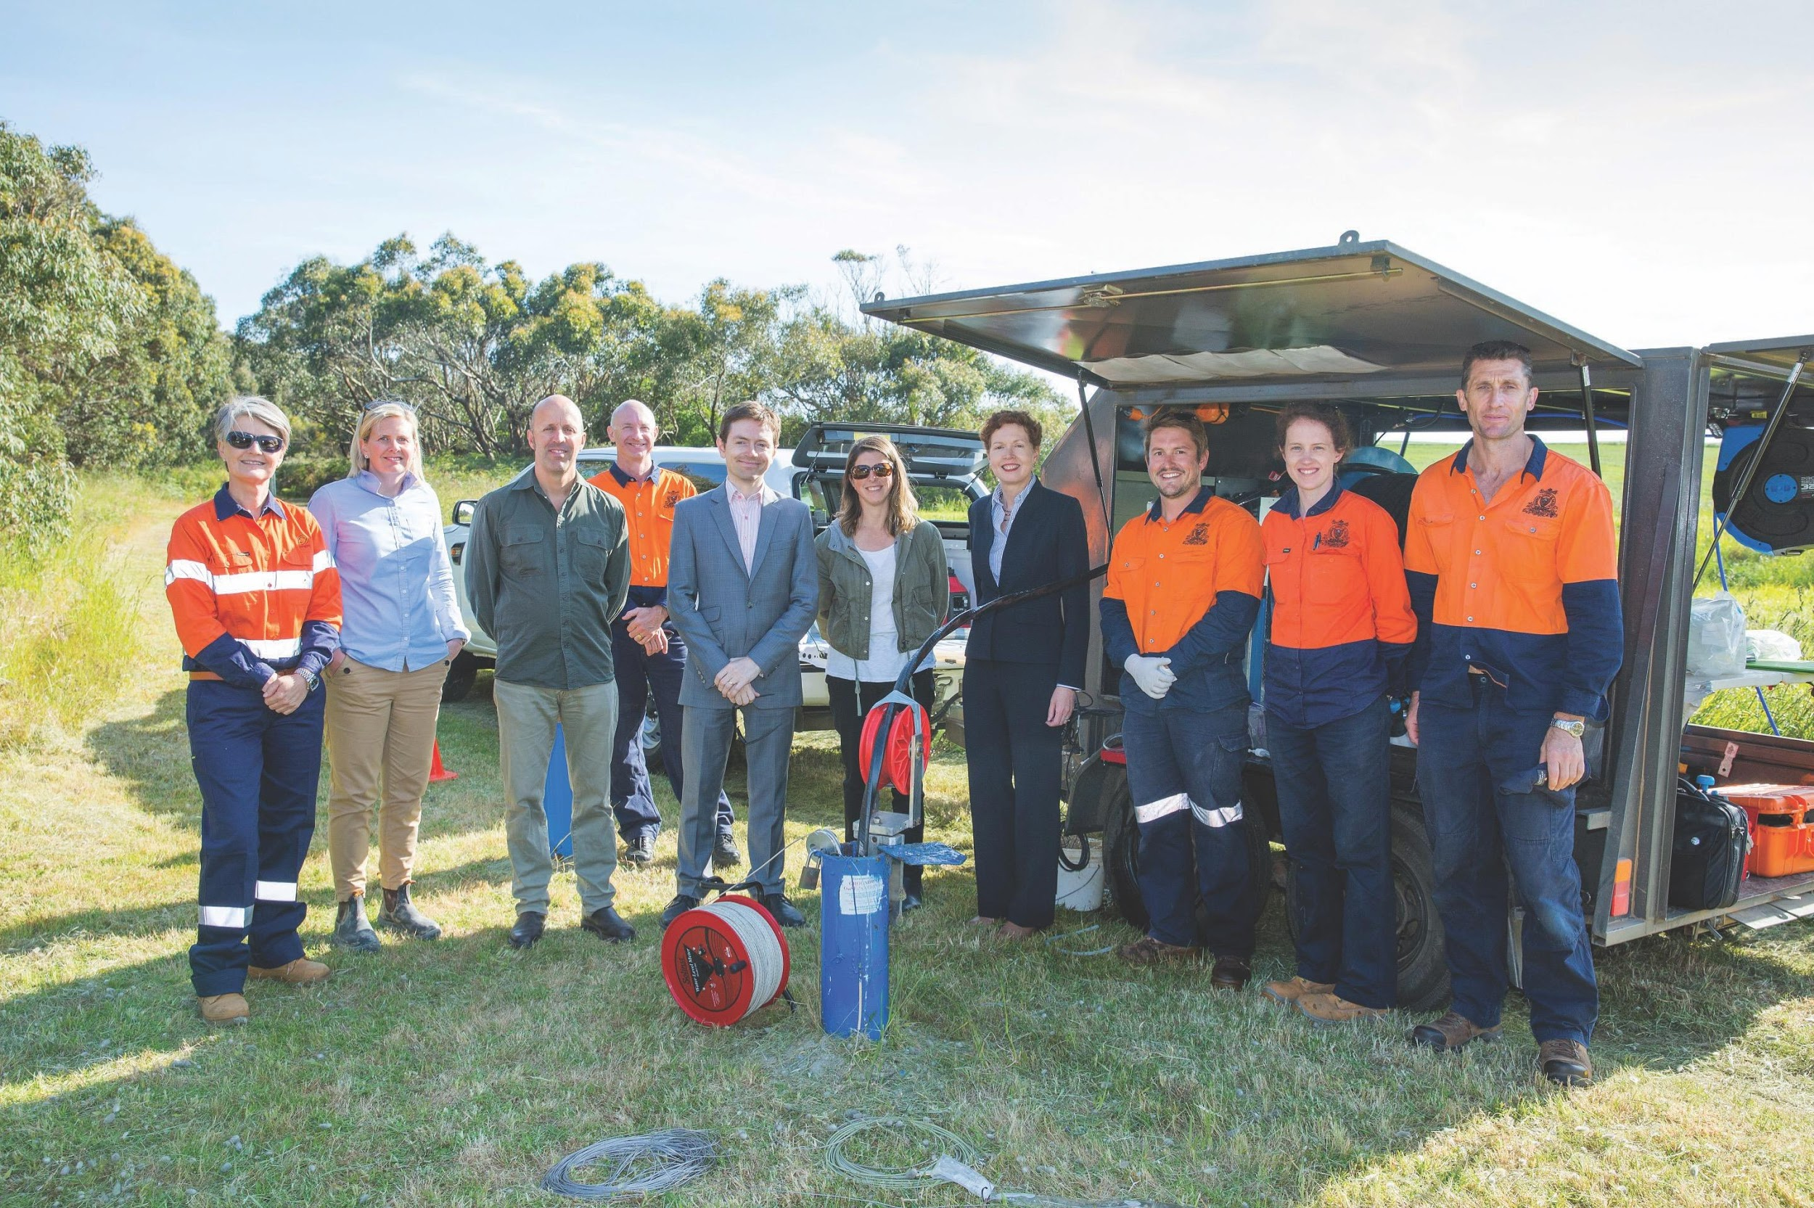
The Stakeholder Advisory Panel learning about the groundwater monitoring program.
On 10 November 2017, the second day of the Stakeholder Advisory Panel’s meeting was held in Camperdown.
The discussions covered progress reports on the geoscientific studies, environmental studies and community and stakeholder engagement to date.
The Panel received a briefing on the $1.62 million 3D geological models of the Otway Basin (onshore and offshore) that will be built and how they form the foundation for providing a gas resource estimate. The Panel heard that rock characterisation studies (including chemostratigraphy, porosity and permeability analysis) – key inputs into the 3D geological models – have also commenced.
The onshore environmental science project intends to sample over 100 deep groundwater bores and undertake an atmospheric methane survey to establish regional baseline conditions during 2017 and 2018. To date, 14 water bores have been sampled.
Later in 2018, the environmental program will also investigate existing exploration wells to determine more local baseline conditions.
The overview of the engagement program highlighted that over 80 individual engagements have occurred to date, covering local governments, gas explorers, gas users, regulators and environmental and community groups. Most engagements have been one-on-one discussions and small group meetings. As the Geological Survey of Victoria Warrnambool team reaches full complement more sophisticated engagements and presentations will commence.
Five media articles about the Victorian Gas Program had been featured in newspapers in south-west and regional Victoria since the program was announced. Additionally, while the Stakeholder Advisory Panel was in Camperdown, I gave an interview to ABC south west regional radio about the Panel’s work.
The Panel’s review of the projects to date is providing valuable insights and suggestions to ensure that the scientific studies are meeting the concerns and interests of the various stakeholders connected to the onshore conventional gas studies.
The next Stakeholder Advisory Panel meeting is scheduled for March 2018.

Appendix 4. Local and regional media clippings regarding the Victorian Gas Program
Sourced from the Warrnambool Standard (2017)
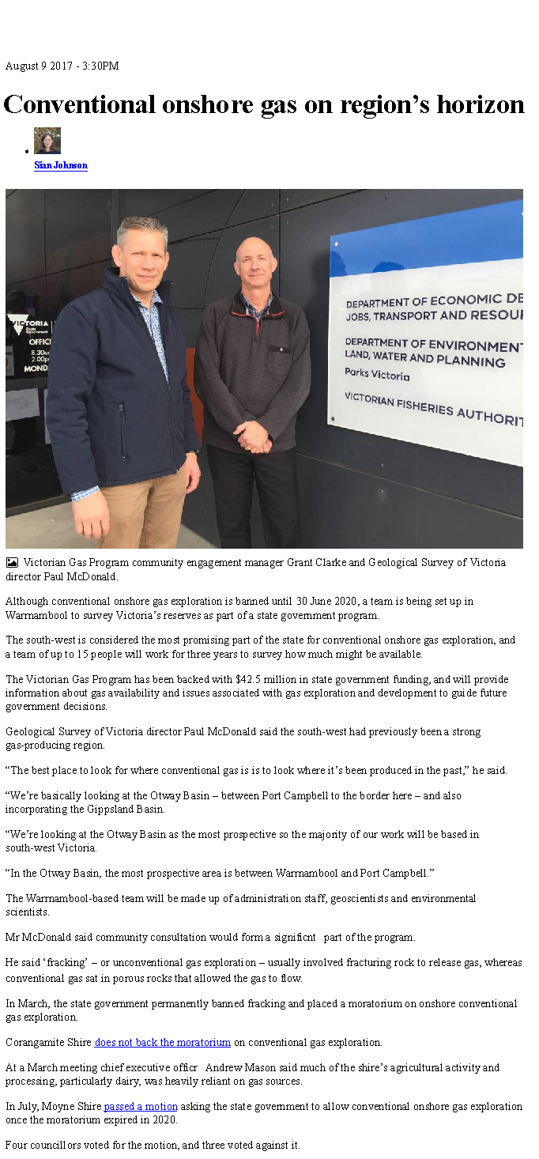
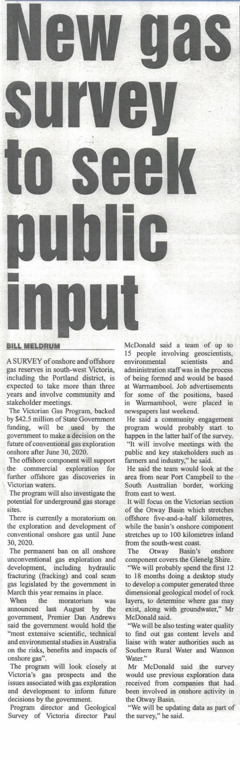
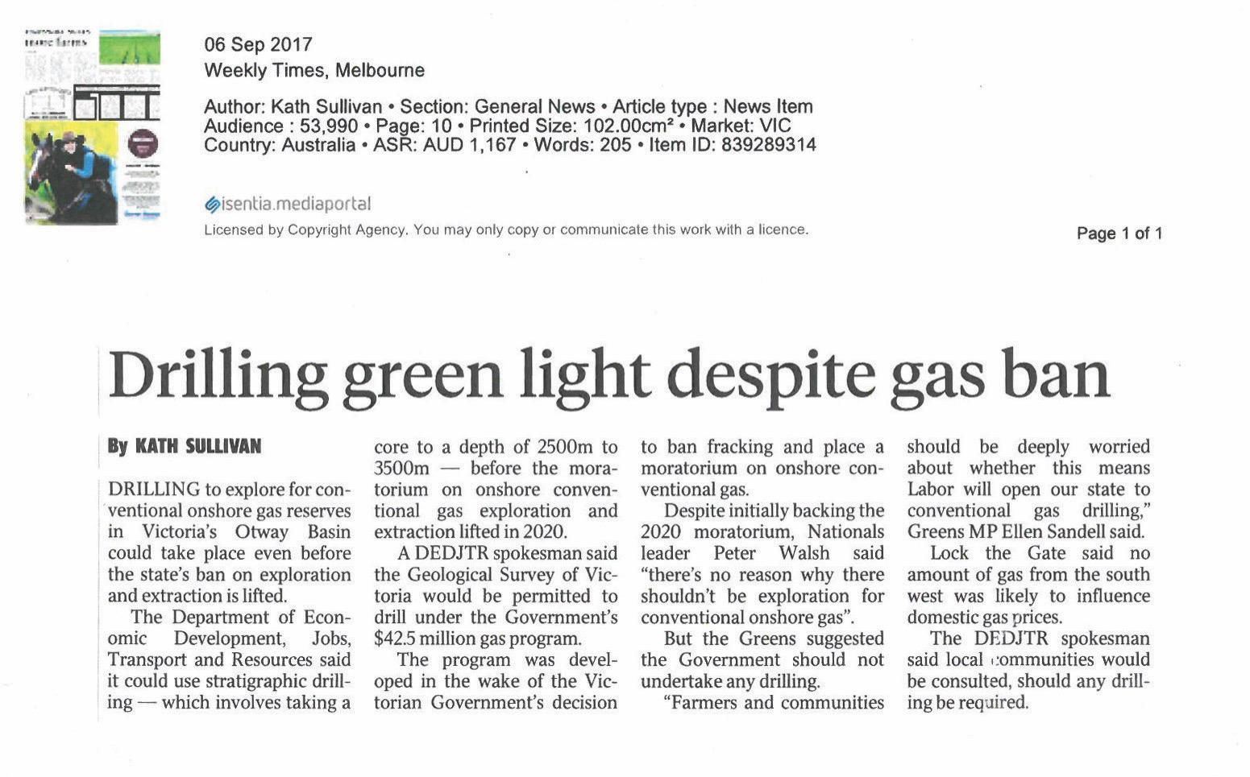
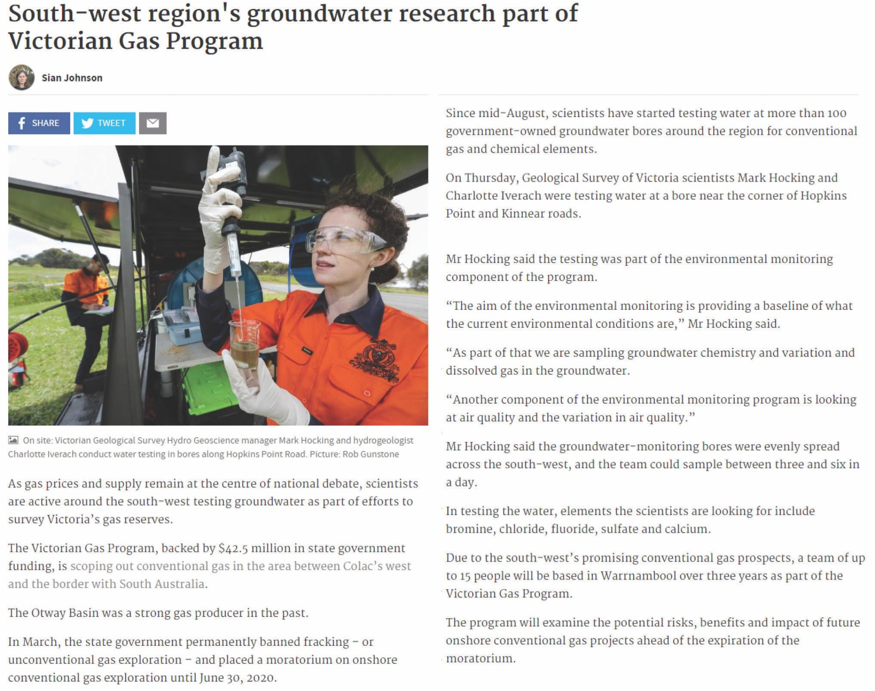
Sourced from the Warrnambool Standard: http://www.standard.net.au/story/4999941/regions-groundwater-research-part-of-victorian-gas-program-video/

A widely used conversion factor in Australia is 1.0 Petajoule is equivalent to 0.91 Billion cubic feet
The conversion from volumes of gas, such as trillion cubic feet of gas, to energy (PJ) is provided as an estimate only. The commercial development process for converting the gas to energy may result in lower energy yields depending on the composition of the gas. For example, the gas may include carbon dioxide that will not be converted to energy.
Prospective resources estimates have been sourced from the Australian Energy Market Operator Gas Statement of Opportunities 2017 (info as at 31 December 2015)
Origin Energy, 2017
EnergyQuest provided a 2C estimate for the total Otway Basin of 173 PJ (this estimate of Commonwealth waters reserves is based on the Origin Halladale 2C estimate of 34 petajoules).
Estimated as 5 per cent median assessed volume
“For all assessments, publicly available data relevant to Otway Basin shale and tight resource plays was limited, necessitating the use of local analogues and geologically reasonable assumptions. Significant improvements could be made to the reliability of this assessment if more data were available. Of particular note is the use of well data to define the prospective rock volumes. This has likely produced a very conservative estimate of the gas- and liquids-in-place as only the geology penetrated by existing drilling has been able to be evaluated. Further work using a basin-wide 3D model would enable the assessment of the full geological volume and potentially alter the resource assessment result significantly” (pg. iii, Geoscience Australia, 2017).
“For all assessments completed, publically available data specifically relevant to Gippsland Basin shale and tight resource plays was limited, necessitating the use of analogues and geologically reasonable assumptions. Significant improvements could be made to the reliability of this assessment if more data was available” (pg. iii, Geoscience Australia, 2017).
Net injection capacity into the Declared Transmission System is reservoir withdrawal capacity plus production capacity.
Net withdrawal capacity is total quantity of gas that can be withdrawn from the Declared Transmission System for reservoir injection plus injections into interconnected pipelines (the total quantity is limited by the compression capacity at the Iona underground gas storage facility).

