Benambra Tailings Storage Facility (TSF) Surface Water Sampling Results

Map of sampling area
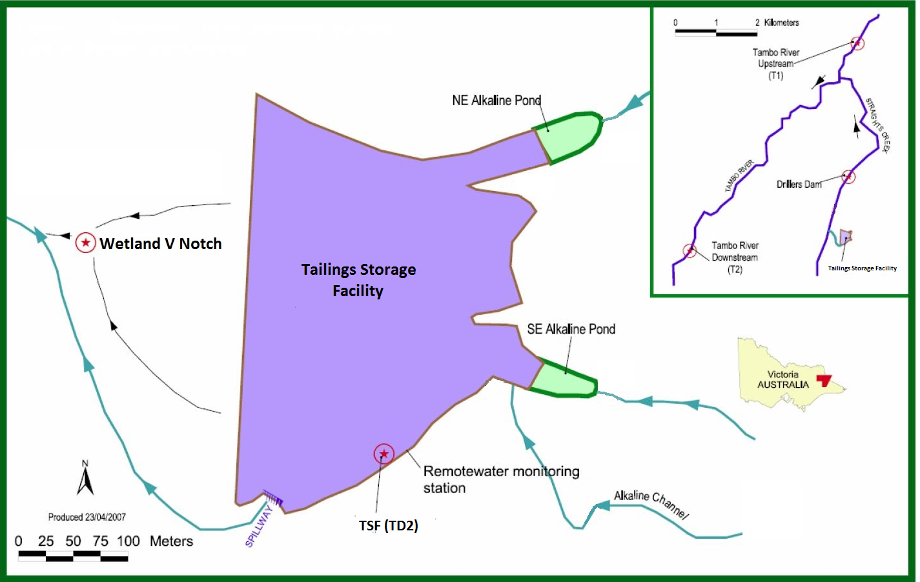

Benambra Tailings Storage Facility (TSF) Surface Water

Sampling Results from January 2019 to September 2025 – pH
The below image is indicative of sampling locations. Not to scale.

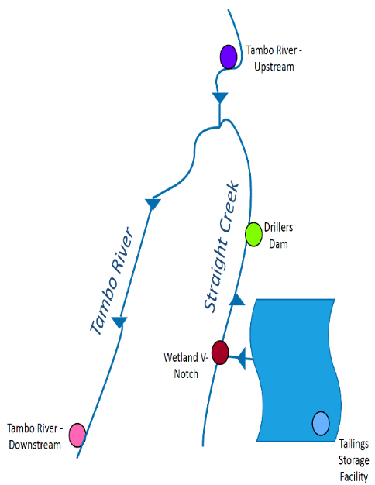
The data plotted in the above graph can vary with rainfall and water levels. The TSF sampling is taken from the dam. There is no regular discharge into Straight Creek, except in flood conditions. Environmental Quality Objectives (i.e. levels acceptable for this receiving environment) have not yet been developed.

Benambra Tailings Storage Facility (TSF) Surface Water Sampling Results from January 2014 to April 2024* - Copper

The below image is indicative of sampling locations. Not to scale.

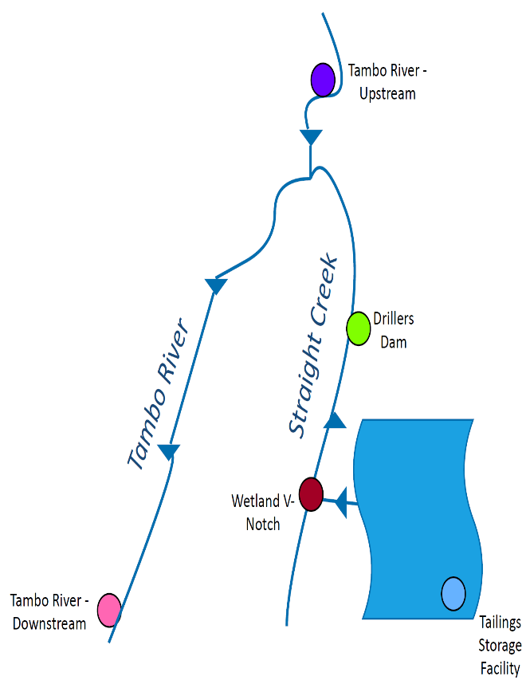

The data plotted in the above graph can vary with rainfall and water levels. The TSF sampling is taken from the dam. There is no regular discharge Into Straight Creek, except in flood conditions. Environmental Quality Objectives (i.e. levels acceptable for this receiving environment) have not yet been developed. Copper values <0.001mg/L are shown as 0.001mg/L to display the overall trend.
*Monthly monitoring was undertaken by the Stockman Project and the data provided to DEECA up until April 2024.

Benambra Tailings Storage Facility (TSF) Surface Water Sampling Results from January 2014 to April 2024* – Zinc

The below image is indicative of sampling locations. Not to Scale.

The data plotted in the above graph can vary with rainfall and water levels. The TSF sampling is taken from the dam. There is no regular discharge into Straight Creek, except in flood conditions. Environmental Quality Objectives (i.e. levels acceptable for this receiving environment) have not yet been developed. Zinc values <0.005mg/L are shown as 0.005mg/L to display the overall trend.
*Monthly monitoring was undertaken by the Stockman Project and the data provided to DEECA up until April 2024.

