

A study into potential alternative and contingency rehabilitation options for Latrobe Valley coal mines
  - Latrobe Valley Regional Rehabilitation Strategy – Implementation Action 5

resources.vic.gov.au



Acknowledgements
This study was undertaken by Resources Victoria, supported with technical advice and review from Pells Sullivan Meynink, EnergyAustralia Yallourn and AGL Loy Yang.

Disclaimer
The information contained in this document is provided for information purposes only and does not give rise to any legal obligations or duties, valid or enforceable in any way against the State of Victoria, its Ministers, Victorian Government departments, employees, officials, agents, consultants and contractors (the State).
The content of this document is subject to change and does not represent current or future policy of the State or endorse the feasibility of any of the options contained in this document. To the extent that the information in this publication is informed by consultation with Latrobe Valley coal mine licensees or stakeholders, the information does not necessarily represent coal mine licensees’ or stakeholders’ views. Final Declared Mine Rehabilitation Plans may include analysis or findings that differ to this report, as information and mine plans develop over time.
This publication may be of assistance to you but the State of Victoria and its employees do not guarantee that the publication is without flaw of any kind or is wholly appropriate for your particular purposes and therefore disclaims all liability for any error, loss or other consequence which may arise from you relying on any information in this publication.
© The State of Victoria Department of Energy, Environment and Climate Action May 2025.
Creative Commons
This work is licensed under a Creative Commons Attribution 4.0 International licence, visit the Creative Commons website (http://creativecommons.org/licenses/by/4.0/).
You are free to re-use the work under that licence, on the condition that you credit the State of Victoria as author. The licence does not apply to any images, photographs or branding, including the Victorian Coat of Arms, and the Victorian Government and Department logos.
ISBN 978-1-76176-282-6 (pdf/ MS word)
Disclaimer
Accessibility
To receive this document in an alternative format, phone the Customer Service Centre on 136 186, email customer.service@delwp.vic.gov.au, or contact National Relay Service on 133 677. Available at Resources Victoria website (https://resources.vic.gov.au/).

We acknowledge and respect Victorian Traditional Owners as the original custodians of Victoria’s land and waters, their unique ability to care for Country and deep spiritual connection to it.
We honour Elders past and present whose knowledge and wisdom has ensured the continuation of culture and traditional practices.
Resources Victoria is committed to genuinely partnering with Victorian Traditional Owners and Victoria’s Aboriginal community to progress their aspirations.
The Victorian Government recognises the Gunaikurnai people who are the Traditional Owners of a large area of Gippsland affected by the Latrobe Valley Regional Rehabilitation Strategy – the area spanning from Warragul in the west to the Snowy River in the east, and from the Great Dividing Range in the north to the coast in the south.

Important note about this document
The Department of Energy, Environment and Climate Action (DEECA) undertook this study to provide stakeholders and community with a shared information base on potential alternative and contingency rehabilitation options for Latrobe Valley coal mines. The information contained in this report is hypothetical and conceptual.
Preparing and implementing site-specific mine rehabilitation plans is the responsibility of mine licensees; this needs to be underpinned by robust assessment and well-informed decision-making. In preparation of Declared Mine Rehabilitation Plans (DMRPs), mine licensees may consider a range of options to achieve safe, stable and sustainable post-mining landforms, including the use of water and/or earth moving to achieve long-term stability and mitigate fire risks. Each DMRP must consider climate change, including the potential impacts on future water availability, and be resilient to a potentially drier future climate.
The content of this document is subject to change and does not represent current or future policy of the State or endorse the feasibility of any of the options contained in this document. Similarly, to the extent that the information in this publication is informed by consultation with Latrobe Valley coal mine licensees or stakeholders, the information does not necessarily represent coal mine licensees’ or stakeholders’ views.
Final Declared Mine Rehabilitation Plans may include analysis or findings that differ to this report, including because information and mine plans will continue to develop over time. The Mineral Resources (Sustainable Development) Act 1990 places responsibility for rehabilitation of individual mine sites on mine licensees, including planning, rehabilitation works and associated costs.

Page intentionally left blank

Contents
Summary 1
1 Introduction 3
1.1 Purpose 3
1.2 Stability modelling methods 4
1.3 Validation of analysis approach 21
2 Potential changes in stability over time 23
2.1 Factors influencing stability 23
2.2 Stages of filling 23
3 Estimated earthworks 27
3.1 Summarised results 27
3.2 Retaining a dry void 28
3.3 Partial and full fill – Yallourn 30
3.4 Partial and full fill - Loy Yang 34
4 Supporting calculations 37
4.1 Background 37
4.2 Basic mine parameters 38
4.3 Earthworks logistics 43
References 49
Appendix 1 Summarised assessment method 51

Page intentionally left blank

Summary
The Department of Energy, Environment and Climate Action (DEECA) undertook this study to provide stakeholders and community with a shared information base on potential alternative and contingency rehabilitation options for Latrobe Valley coal mines. The study confirmed the considerable requirements for construction and ongoing active engineering controls to maintain stability under these options.
The analysis identified the potential need for hundreds of millions of tonnes of suitable fill material to be sourced from outside the mine licence areas to stabilise the mines and to cover the coal for fire protection. The current annual production from quarries across Victoria is approximately 70 million tonnes. This provides critical resources to the Victorian Government’s building programs, including the ‘Big Build’.’ The requirement for mine rehabilitation would be in addition to this, needing construction of many new quarries to provide tens of millions of tonnes of material each year over several decades.
If constructed, dry voids would require a high level of active management, including ongoing deep groundwater extraction to manage upward floor heave, shallow groundwater drainage to control mine wall stability and maintenance to address erosion and slumping/cracking of the clay/soil cover over coal for fire management. A dry void is considered the most susceptible to variabilities in ground conditions and to changes over time that could result in uncontrolled ground movements (i.e. collapses or ‘failures’)
Partially or fully filling mine voids with water provides the greatest likelihood of maintaining long-term stability. Fill material would still be required, but it is likely that this could be sourced internally from the mines or through additional quarries within the mine licence areas. A partial fill solution for any of the mines would require significant operational management, including ongoing groundwater drainage and cover maintenance. Both partial and full fills would require maintenance of water levels through regular top ups, along with water quality and cover maintenance at and above the water level once the target water level was reached.
The risk of an external ignition source starting a fire or coal spontaneously combusting would be eliminated beneath the water level in partial or full fill options. A dry void and the areas above the water level in partially or fully-filled voids would rely on a cover of clay or soil over areas of coal to reduce the risk of an ignition source starting a fire. That would reduce access to oxygen to feed a fire once it commenced and would reduce oxygen supply to coal that could spontaneously combust.
This report sets out the study context, method and results. The method is also summarised in Appendix 1.

Page intentionally left blank

Introduction

Purpose
Over the coming decades the three Latrobe Valley coal mine sites will continue the transition from active mining and power generation to closure and mine rehabilitation. This report supports the Amendment to the Latrobe Valley Regional Rehabilitation Strategy released by the Victorian Government in October 2023 by providing the State, stakeholders and community with a shared information base on potential alternative and contingency rehabilitation options for Latrobe Valley coal mines.
A range of stakeholders including mine licensees were consulted during the implementation of the LVRRS on potential alternative and contingency rehabilitation options for the Latrobe Valley coal mines and to identify some of the key considerations required if a mine licensee were to further pursue such options. The information contained in this report is hypothetical and conceptual only.
Preparing and implementing Declared Mine Rehabilitation Plans (DMRPs) is the responsibility of mine licensees. This needs to be underpinned by robust assessment and well-informed decision-making. Each DMRP must consider site- and domain-specific conditions, climate change impacts to surface water availability and be resilient to a future potentially drier climate. The hypothetical options in this report do not represent a policy position of the Victorian Government.
The Latrobe Valley Regional Rehabilitation Strategy (LVRRS) sets out implementation actions to help better understand the potential use of water and alternatives to water for rehabilitation of the Latrobe Valley coal mines.
LVRRS Implementation Action 5 (IA5) is to “’Identify alternative/contingency rehabilitation options to manage land stability and fire risks if sufficient water is not available”. Completion of this implementation action involved modelling the stability for a range of hypothetical options for the Yallourn and Loy Yang mines. This report provides technical detail on the approach to modelling in completion of this action and the results. The results are also summarised in the October 2023 Amendment to the LVRRS.

Scope
This study considers the potential ‘baseline’ stability at end of mining operations (before final rehabilitation works), and where the mine void is not considered suitably stable for closure, what rehabilitation works and controls are required to stabilise the voids, under the following three options:
- without the use of surface water, groundwater or alternative water sources (alternative option), and
- where water is initially available, and filling of a mine void commences but cannot be completed as planned due to reduced water availability (contingency option).
- designed partial fill of the mine void.
The intent of this study is to provide a reasonable basis for understanding some of the key considerations associated with different rehabilitation options, particularly in relation to achieving safe and stable post-mining landforms. As such, the scope of this study is limited to numerical modelling of slope stability for suitably representative sections of geotechnical domains for Yallourn and Loy Yang mines and associated estimates of earth works required to achieve safe and stable conditions.
This study does not include:
- Any specific consideration of Hazelwood Mine, as at the time of writing ENGIE was preparing an Environment Effects Statement and Declared Mine Rehabilitation Plan which will consider similar issues to those in this report at a site-specific level of detail.
- Optimisation of stability using a risk-based approach of the consequences of failure.
- Modelling of the long-term integrity of the Morwell River Diversion within the Yallourn mine as a water diversion structure.
- Assessment of circular and kinematic batter failure mechanisms.
- Three-dimensional batter stability modelling, given the technical complexity of this method.
- Assessment of subsidence due to aquifer depressurisation (groundwater pumping).

Ground conditions
Capturing the ground conditions as accurately as possible is key to ensuring accurate assessments of stability ​( (Read & Stacey, 2009))​. The Latrobe Valley coal mines contain some of the world’s thickest brown coal seams. The coal itself exhibits a very low density and contains subvertical joints. Numerous interseams are present, especially at Loy Yang, comprising weak, clayey, subhorizontally bedded soils.

Failure modes
At the Latrobe Valley coal mines, a type of failure known as block sliding is of importance, given its feasibility and severity of possible consequences. Block sliding is often driven by the ingress of water into fractures behind the slope face in conjunction with clayey interseams that can act like a slippery surface. Increased pressure onto a fracture surface from water may “push” a block of coal forward and initiate slip along the interseam. The block sliding mechanism is illustrated in Figure 1.1

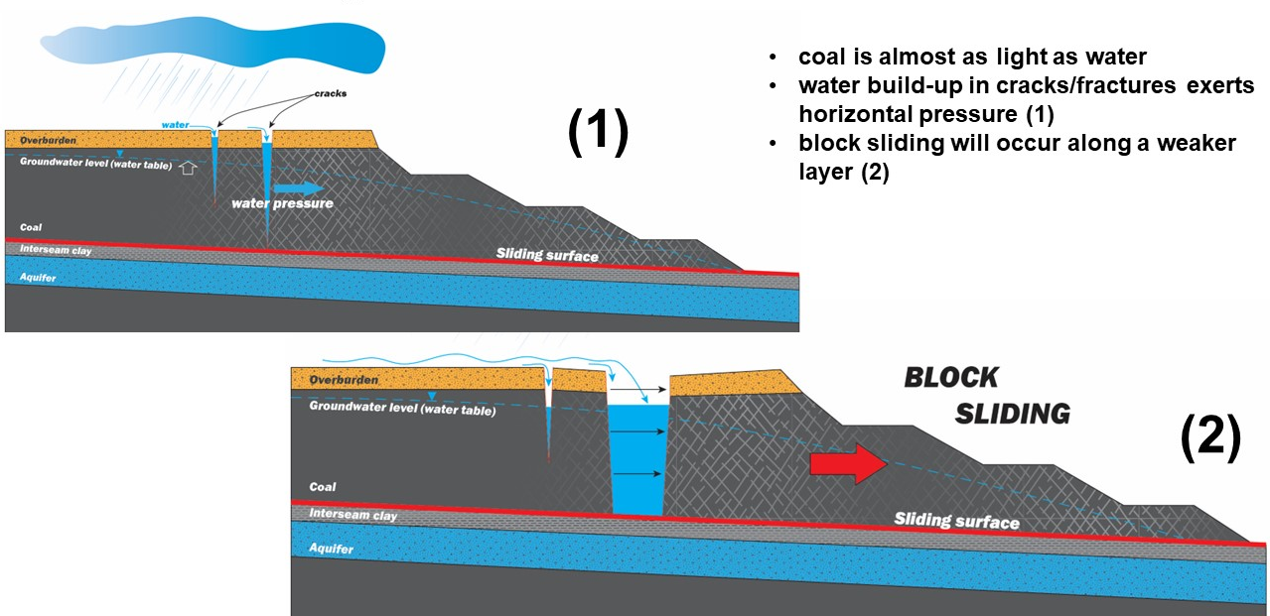
Figure 1.1 Schematic diagram of a block sliding failure mechanism in coal (courtesy MLRA)

Stability modelling methods
Modelling was undertaken for representative cross-sections of slopes to determine the extent of physical controls, including reprofiling batter geometry, buttressing and ground surcharging, in addition to surface water and groundwater management, needed to maintain stability. Stability was assessed on the basis of achieving hypothetical design acceptance criteria. A summary of the overall approach is provided in Appendix 1, with further detail set out below.

Hypothetical acceptance criteria
There are typical design acceptance criteria for operating open-cut mines from Read & Stacey (2009). Stability is often assessed by calculation of a slope’s Factor of Safety (FoS), and where possible (depending on the data available), Probability of Failure (PoF). These are replicated in Table 1.1
Table 1.1 Typical FoS and PoF acceptance values (Read & Stacey, 2009)
Slope scale | Consequences of failure | Typical design acceptance values
 |  | FoS (minimum) (static) | FoS (minimum) (dynamic) | PoF (max) P[FoS ≤ 1]
Bench | Low-high | 1.1 | N/A | 25-50%
Inter-ramp | Low | 1.15-1.2 | 1.0 | 25%
 | Medium | 1.2 | 1.0 | 20%
 | High | 1.2-1.3 | 1.1 | 10%
Overall | Low | 1.2-1.3 | 1.0 | 15-20%
 | Medium | 1.3 | 1.05 | 5-10%
 | High | 1.3-1.5 | 1.1 | ≤5%
Such criteria are not currently published for the case of rehabilitated mine slopes, necessitating that acceptance criteria be derived from an empirical assessment of similar cases and reasonable judgement. Therefore, hypothetical criteria were derived following a review of FoS design criteria by the mine operators, those conventionally applied criteria used in the mining industry (Table 1.1), and those noted as indicative of accepted extractive industry practice.
Table 1.2 lists the hypothetical acceptance criteria used for stability modelling assessment adopted for the Yallourn mine as part of the IA5 investigation. Considering the consequence of failure of a rehabilitated slope and a permanent lifespan requirement post-closure, a FoS equal to or greater than 1.5 design criteria was adopted for the limited access (dry) rehabilitation state. For a value-added rehabilitation state and a post-water fill rehabilitation state, a FoS equal to or greater than 2.0 was adopted considering the intended increased land use objectives sought between a limited access and value-added rehabilitation state. Having public access to the mine void and/or mine void waterbody itself intuitively suggests that the risk of harm to persons, infrastructure or equipment may be higher, thus necessitating that stricter acceptance criteria are adopted.
A minimum FoS of 1.5 was assumed to be acceptable during filling, understanding that the landform is not in a final rehabilitated state as fill progresses. It provided for a level of stability that if there was an interruption to water supply, it would be adequate to maintain stability given that the site was still in the active rehabilitation phase, and thus still in operational control by the mine licensees where access could be managed. If at any point, filling is permanently stopped (i.e. the landform reaches a partial fill level), remedial works would need to be undertaken to raise the FoS to the acceptable post-filling stability criteria (i.e. greater than or equal to 2.0).
Table 1.2 Summary of hypothetical acceptance criteria used in stability modelling.
Option | Rehabilitation option/state | Minimum FoS
Dry mine void (alternative) | Limited access | 1.5⁵
 | Value-added | 2.0
Water-filled mine void (contingency) | During filling | 1.5
 | Post-filling (partial or full) | 2.0

Model inputs

Slope geometry
2D cross sections for geotechnical domains of the mine to represent baseline cases were generated from The State’s Coal Resource Model using MineScape software. For each geotechnical domain, and dependent on length, up to 3-4 cross-sections were taken such that individual variations within domains were captured. The cross-section locations were generally taken in the middle and towards each end of the respective domains. There were a total of 59 sections generated for Yallourn (Figure 1.2), and 28 sections for Loy Yang (Figure 1.3). All sections were subject to basic stability analyses; only certain sections were selected for additional analysis through supplementary scenarios given the conceptual level of this study. The sections selected for additional analysis were chosen due to their position as critical slopes for mine stability.
The surface boundary of the respective batter cross sections created was defined utilising the end of mining operation pit shell profile, as provided by the mine operator. The respective 2D cross sections created extended a distance of 500 m back from the batter crest and 500 m into the mine from the toe of the batter to set the overall cross section length.
During the period this report was prepared EnergyAustralia (EA) and AGL announced earlier target closure dates for Yallourn Power Station and Mine and Loy Yang A Power Station, respectively. Section 0 of this report sets out the associated implications and adjustments to the analysis underpinning this report.

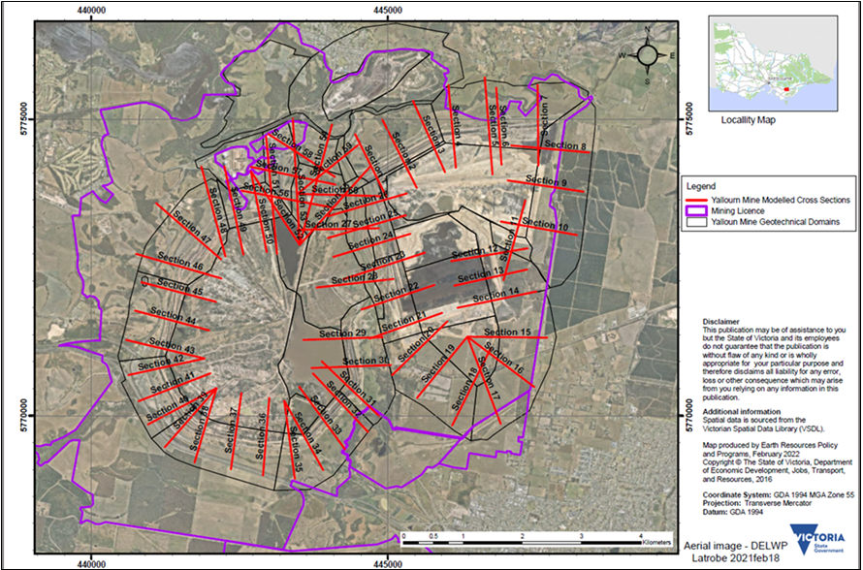
Figure 1.2 Yallourn Mine - modelled cross section locations

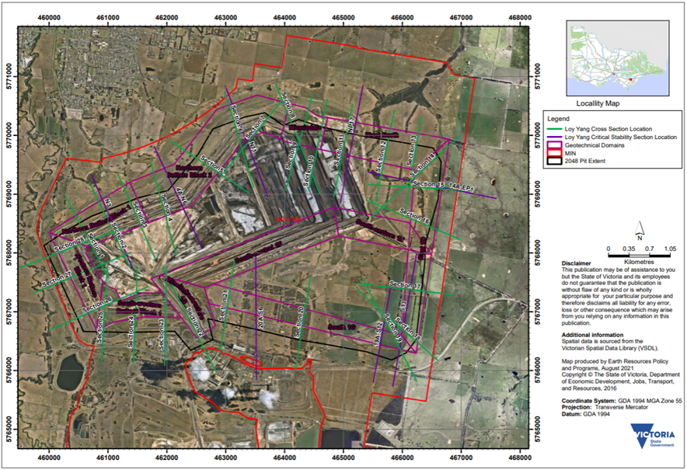
Figure 1.3 Loy Yang Mine - modelled cross section locations

Material parameters
Material strength parameters adopted for slope stability modelling were sourced from the mine operators and are a compilation of results from annual drilling and material testing programmes.
Yallourn
Mine strength parameters appropriate for undertaking a deterministic slope stability assessment were adopted from Yallourn reports in consultation with EnergyAustralia Yallourn (EA). These are listed in Table 1.3. These parameters were appropriate at the time the study was completed and based on EA’s knowledge at the time. Since this study, EA has advised that:
- It has undertaken further extensive and detailed data reviews and collected additional data.
- This process has focussed on a more conservative approach to data assessment and parameter derivation and therefore there is a likelihood that the material parameters adopted for the final Yallourn Mine rehabilitated landform design may differ.
- If updated parameters where to be adopted, the implication would likely be that similar or increase material volumes would be required to meet the stability criteria set for the LVRRS IA5 study.

Table 1.3 Yallourn material parameters used in slope stability modelling.
Batter | Material Type | Condition |  | Unit Weight (kN/m³) | Cohesion  (kPa) | Friction Angle (º)
YTF Western Batters | In-situ overburden | - |  | 19.6 | 20 | 24
 |  | Highly plastic |  |  | 5 | 20
 | Coal | - |  | 11 | 100 | 40
 | Interseam | Overburden fact stability |  | 19.6 | 43 | 18
 |  | Hillside stability |  |  | 34 | 17
 |  | Residual, upper 20 m |  |  | 0 | 13
 |  | Back-calculated, inferred upper 20 m |  |  | 0 | 11
 | Surcharge embankment | - |  | 18.3 | 0 | 24
 | Coal joint | - |  | - | 0 | 35
YTF Hernes Oak Batters | In-situ overburden | Highly plastic |  | 19.6 | 5 | 20
 | Coal | Perpendicular to bedding |  | 11.2 | 100 | 40
 |  | Parallel to bedding |  |  | 160 | 40
 | Interseam | Within 100 m of mine |  | 19.6 | 0 | 13
 |  | Between fault and 100 m from crest |  |  | 23 | 17
 |  | West of fault |  |  | 34 | 17
 | Overburden dump | - |  | 16 | 1 | 20
 | Tight tension crack | - |  | - | 0 | 40
 | Rough shear joint or open tension joint | - |  | - | 0 | 33
 | Smooth shear joint or bedding place joint | - |  | - | 0 | 29
YTF Northern Batters | Overburden (sandy clay, clay) | - |  | 19.5 | 20 | 24
 | Coal | - |  | 11.2 | 150 | 40
 | Interseam (clay and silty sand) | Residual |  | 19 | 0 | 16
 | Midfield dump material (sand and clay) | - |  | 17 | 0** | 30*
*Residual strength parameter
**Overburden dump strength parameters on back-analysis of the final dumped operating face
YTF Southern and Southwest Batters | Overburden (sand clay, clay) | - |  | 19.6 | 20 | 24
 | Coal | - |  | 11.2 | 150 | 40
 | Interseam (clay and silty sand) | - |  | 19.6 | 0 | 16
Fire Services & Flocculation Pond Batters | Overburden (sand clay, clay) | - |  | 19.6 | 20 | 24
 | Coal | - |  | 11 | 150 | 40
 | Interseam (clay and silty sand) | - |  | 19.6 | 0 | 16
YTF Overburden Dump | Mixed material (most likely) | - |  | 17 | 1 | 20
 | Good material (upper limit) | - |  | 17 | 3 | 30
 | Weak material (lower limit) | - |  | 15 | 1 | 10
RCB Batter | Ash (at toe) | - |  | 18 | 0 / 0 | 30 / 30
 | Weak dump fill | - |  | 18 | 0 / 20 | 20 / 0
 | Stiff dump fill | - |  | 19 | 0 / 40 | 27 / 0
 | Natural overburden* | - |  | 20 | 20 / 50 | 25 / 0
 | Coal | - |  | 11.2 | 100 / 220 | 35 / 0
 | Interseam | - |  | 18 | 0 / 0 | 13 / 13
NB: “/” indicates drained (static) / undrained (seismic load)
*Variable material types, consists of interbedded layers of sandy clays, clayey sands, sands and sandy gravel
YEF Northern Batters | In-situ overburden | - |  | 19.5 | 20 | 24
 | Coal | - |  | 11.2 | 150 | 40
 | Interseam | Upper | Peak | 19 | 40 | 23
 |  |  | Residual |  | 0 | 16
 |  | Lower |  |  | 40 | 23
 | Coal / Day interface | Peak |  | - | 40 | 23
 |  | Residual |  | - | 0 | 16
 | Coal joint | - |  | - | 0 | 35
YEF & YEFX Latrobe River Batters | In-situ overburden |  |  | 19.5 | 20 | 24
 | Coal |  |  | 11.2 | 150 | 40
 | Coal debris |  |  | 10.7 / 10.0 | 0 | 32
 | Interseam | Peak | 0-200 MPa | 19 | 0 | 35 / 33*
 |  |  | 200-800 MPa |  | 52 / 42* | 23
 |  |  | 800-2000 MPa |  | 75 / 67* | 21
 |  | Residual | 0-200 MPa |  | 0 | 16 / 14*
 |  |  | 200-800 MPa |  | 11 | 13 / 11*
 |  |  | 800-2000 MPa |  | 30 | 12 / 10*
NB: Interseam strength variable with effective stress
*Lower bound parameters
YEFX Latrobe Road Batters | In-situ overburden | - |  | 19.5 | 20 | 24
 | Coal | - |  | 11.2 | 150 | 40
 | Interseam | Peak |  | 19 | 40 | 23
 |  | Residual |  |  | 0 | 16
 | Coal / clay interface | Peak |  | - | 40 | 23
 |  | Residual |  | - | 0 | 16
YEF Overburden Dump | Overburden Dump | - |  | 17 | 3 | 30
Morwell River Diversion (MRD) - Western Section YEF / Coal Dyke (conveyor embankment) | In-situ overburden | - |  | 19 | 20 | 28
 | Coal | - |  | 11 | 150 | 30
 | Interseam | - |  | 19 | 20 | 25
 |  | Clay layers |  | 19 | 3 / 0* | 16 / 12*
 | Toe berm | - |  | 19 | 0 | 28
*Extreme strength parameters, also referred to as lower bound parameters
MRD - YMF Western Batters  (Adjacent to MRD) | In-situ overburden | - |  | 19 | 20 | 28
 | Coal | - |  | 11 | 150 | 30
 | Interseam | General |  | 19 | 25 | 25
 |  | Weak clay layers |  | 19 | 3 | 16
 |  | Lower bound |  | 19 | 0* | 12*
 | Overburden dump | - |  | 19 | 2 | 25
 | Engineering fill | - |  | 19 | 5 | 28
 | Coal joint | - |  | - | 0 | 35
*Extreme strength parameters, also referred to as lower bound parameters
YMF Maryvale Field ALL Batters | Overburden (sand clay, clay) | - |  | 19.5 | 20 | 24
 | Coal | - |  | 11.2 | 150 | 40
 | Interseam (clay and silty sand) | - |  | 19 | 0* / 3** | 16
*Adopted strength parameters by GHD
**Adopted strength parameter by Golder Associates and used for sensitivity analysis to examine the effects of cohesion by GHD
YNOC Batters | Coal | - |  | 11.2 | 150 | 40
 | Ligneous clay / inferior coal | - |  | 16.2 | 0 | 25
 | Dry ash (from twin ash ponds) | - |  | 13 | 15 | 27
 | Wet ash (in situ) | - |  | 13 | 20 | 30
 | Weak ash (bottom of basins) | - |  | 14.2 | 5 | 10
 | Alluvium | - |  | 19.1 | 0 | 30
 | Haunted Hill Formation | - |  | 19.1 | 20 | 24
 | Morwell Formation | - |  | 19.1 | 50 | 27.5
 | Tertiary sediments | - |  | 16.2 | 30 | 28
 | Mesozoic sediments (weathered clay) | Peak |  | 19.1 | 0 | 18
 |  | Residual |  |  | 0 | 13.9
 | Overburden dump, stabilised fill | - |  | 17.1 | 0 | 30
 | Select fill | - |  | 18.6 | 20 | 30
 | Refuse dump | - |  | 14.7 | 0 | 25
 | Previous landslip* | - |  | 16.2 | 20 | 18
*Seven landslips have occurred between 1950 and 1972 in the area surrounding YNOC
YNOC Twin Ash Ponds | Foundation ash | - |  | 12.75 | 0 (up to 20 kPa) | 30
 | Suspended ash | - |  | 12.75 | 0 | 0
 | Embankment fill | - |  | 20 | 2* | 27
 | Extra dumped ash | - |  | 12.75 | 0 | 30
 | Ash wedge | - |  | 12.75 | 0 | 30
*Apparent cohesion, bi-linear envelope used
Mine Floor - Maryvale Field | Coal (Yallourn Morwell Formation) | - |  | 11 | Not required | Not required
 | Interseam (Yallourn Formation) | - |  | 17.5* | Not required | Not required
 | M1A Interseam (Morwell Formation) | - |  | 17.5 | Not required | Not required
*Further work is required to better define density

Loy Yang
Loy Yang’s database was sourced from various AGL reports and includes a statistical analysis of testing data, allowing the definition of parameter distributions and statistical values. Lower quartile (25th percentile) residual strengths were generally used such that the values are representative of the greater material mass. These are listed in Table 1.4.
Table 1.4 Loy Yang material parameters used in slope stability modelling (from Loy Yang Mine 2019 Whole of Life Concept Geotechnical Assessment (GHD, 2021) and Interseam Sampling and Testing – Block 2 Interseam Strength Characterisation (GHD, 2020)).
Domain | Material type | Distribution | Cohesion, c (kPa) |  |  |  |  |  |  | Friction Angle, Φ (º)
 |  |  | Mean | SD | Max | Min | Rel. Max | Rel. Min | Peak CoV | Mean | SD | Max | Min | Rel. Max | Rel. Min | Peak CoV
NB1 | Yallourn | Uniform | 82.5 | 46.2 | 170.0 | 10.0 | 87.5 | 72.5 | 27% | 14.15 | 0.6 | 13.0 | 11.0 | 1.8 | 1.8 | 12%
 | M1A | Lognormal | 53.6 | 24.7 | 165.0 | 0.0 | 111.4 | 53.6 | 46% | 22.45 | 1.8 | 26.0 | 14.0 | 3.6 | 8.5 | 8%
 | M1B | Lognormal | 55.1 | 34.7 | 215.0 | 0.0 | 159.9 | 55.1 | 63% | 26.7 | 6.1 | 40.0 | 23.0 | 13.3 | 3.7 | 23%
 | M2A | Normal | 58.2 | 23.9 | 142.0 | 0.0 | 83.8 | 58.2 | 41% | 25.5 | 1.5 | 30.0 | 11.0 | 4.5 | 14.5 | 6%
 | M2B | Uniform | 36.3 | 33.2 | 115.0 | 0.0 | 78.8 | 36.3 | 119% | 27.0 | 0.0 | 27.0 | 27.0 | 0.0 | 0.0 | 0%
NB2 | Yallourn | Lognormal | 46.8 | 20.1 | 131.0 | 0.0 | 84.3 | 46.8 | 43% | 17.9 | 5.9 | 29.0 | 6.2 | 11.1 | 11.7 | 33%
 | M1A | Lognormal | 53.6 | 24.7 | 165.0 | 0.0 | 111.4 | 53.6 | 46% | 22.45 | 1.8 | 26.0 | 14.0 | 3.6 | 8.5 | 8%
 | M1B | Normal | 63.9 | 44.1 | 225.0 | 0.0 | 161.1 | 63.9 | 69% | 24.95 | 7.0 | 31.0 | 15.5 | 6.1 | 9.5 | 28%
 | M2A | Normal | 76.4 | 26.7 | 150.0 | 0.0 | 73.6 | 76.4 | 35% | 23.45 | 2.3 | 30.0 | 8.5 | 6.6 | 15.0 | 10%
 | M2B | Lognormal | 79.2 | 32.5 | 170.0 | 20.0 | 90.8 | 59.2 | 41% | 24.15 | 7.0 | 32.0 | 15.5 | 7.9 | 8.7 | 29%
Operating batters | M1A | Normal | 57.1 | 21.7 | 122.0 | 0.0 | 64.9 | 57.1 | 38% | 22.05 | 4.4 | 31.0 | 8.5 | 9.0 | 13.6 | 20%
 | M1B | Normal | 62.5 | 30.0 | 180.0 | 0.0 | 117.6 | 62.5 | 48% | 25.25 | 3.5 | 36.0 | 10.5 | 10.8 | 14.8 | 14%
 | M2A | Normal | 112.5 | 33.8 | 240.0 | 0.0 | 127.5 | 112.5 | 30% | 22.4 | 4.0 | 38.0 | 9.8 | 15.6 | 12.6 | 18%
 | M2B | Normal | 102.6 | 39.0 | 301.0 | 0.0 | 198.5 | 102.6 | 38% | 23.0 | 6.7 | 44.0 | 12.5 | 21.0 | 10.5 | 29%
SB2 | M1B | Lognormal | 40.4 | 20.6 | 115.0 | 0.0 | 74.6 | 40.4 | 51% | 28.5 | 3.1 | 37.0 | 17.6 | 8.5 | 10.9 | 11%
 | M2A | Lognormal | 64.8 | 40.2 | 202.0 | 0.0 | 137.2 | 64.8 | 62% | 26.85 | 5.6 | 42.0 | 10.9 | 15.2 | 16.0 | 21%
 | M2B | Normal | 74.1 | 26.7 | 200.0 | 16.0 | 126.0 | 58.1 | 36% | 23.3 | 3.5 | 34.5 | 5.0 | 11.2 | 18.3 | 15%
SB1 | M2A | Lognormal | 41.1 | 23.8 | 125.0 | 0.0 | 84.0 | 41.1 | 58% | 30.9 | 1.9 | 35.0 | 13.9 | 4.1 | 17.0 | 6%
 | M2B | Lognormal | 93.0 | 27.9 | 200.0 | 0.0 | 107.0 | 93.0 | 30% | 24.2 | 2.9 | 33.3 | 6.1 | 9.2 | 18.1 | 12%
WB1 | M2A | Uniform | 28.8 | 21.7 | 75.0 | 0.0 | 46.3 | 28.8 | 61% | 26.25 | 4.0 | 33.0 | 19.0 | 6.8 | 7.3 | 31%
 | M2B | Lognormal | 80.1 | 60.9 | 400.0 | 0.0 | 319.9 | 80.1 | 76% | 26.2 | 5.5 | 38.0 | 17.0 | 11.8 | 9.2 | 21%
All | Overburden | Uniform | 50.0 | 8.7 | 65.0 | 35.0 | 15.0 | 15.0 | N/A | 26.0 | 4.0 | 33.0 | 19.0 | 7.0 | 7.0 | N/A
 | Coal | Uniform | 150.0 | 5.8 | 160.0 | 140.0 | 10.0 | 10.0 | N/A | 35.0 | 2.0 | 40.0 | 33.0 | 5.0 | 2.0 | N/A

Clay Cover
To evaluate whether the mine rehabilitation options include a clay cover as part of the rehabilitated mine batter material composition for stability modelling, a sensitivity assessment of what impact 1 m of coal cover (clay) has on FoS was undertaken for six batters representing different Yallourn batter domains. A change in FoS in the order of 0.1 to 0.2 was deemed significant.
Capping material may erode away over time. However, considering maintaining coal cover integrity is important for long term coal fire prevention and excess surface water infiltration purposes, it was assumed any significant coal erosion would be managed.
The outcome of the sensitivity assessment indicated that the FoS often increased by more than 0.1, translating to an approximate 5% FoS improvement. An independent review for this assessment, undertaken by Pells Sullivan Meynink, noted that:
‘the improvement in stability via coal cover is driven by the unit weight of the cover material (clay) relative to the unit weight of coal, as well as the location of the cover relative to the failure pivot point, which acts as a stabilising force. It should also be noted that if a clay layer is placed against the batters with no water depressurisation holes installed, it may act in reality as a deterrent to pore pressure depressurisation within the batter, on that basis additional measures need to be in place to install new depressurisation holes within the cover material.’
Based on the sensitivity outcomes and assumption regarding maintaining the integrity of any constructed coal cover, it was deemed appropriate to include coal cover as part of the rehabilitated batter stability assessments.

Hydrogeology
For both mines, regional groundwater levels (reported in metres relative to the Australian Height Datum (AHD)) were adopted. Approaching the slope face, the groundwater table was drawn back over the length of the slope and assumed to drain at the toe. This allowed the approximation of a straight-line gradient behind the slope, set at various degree intervals, depending on the distance that drawdown begins behind the slope face (Figure 1.4)
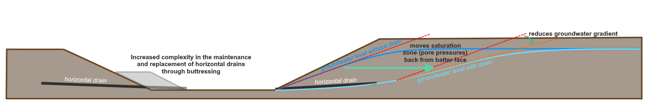
Figure 1.4 Groundwater gradients

Gradient
Yallourn
Groundwater gradients were modelled at the following intervals from the slope toe to the top of the unconfined water table surface (phreatic surface):
- 6°,
- 9°, and
- 12°.
These scenarios were modelled with and without a coal joint filled with water at distances behind the slope crest of:
- 100 m,
- 200 m, and
- 300 m.
Interseam pore pressures were assumed as fully decayed.
Generally, groundwater gradients were designed to be controlled at 9°, as this is preferred in terms operational performance, construction and maintenance. Reliance on maintaining a 6° groundwater gradient could carry significant risk with performance integrity. Investigation of a 12° gradient was sought for understanding the sensitivity of groundwater on slope stability.
Given the indefinite lifespan of the slopes, the ability to maintain slope groundwater gradients at 9° long-term has been questioned due to the significant resources required to maintain the groundwater control infrastructure (asset integrity and design performance) in a post-rehabilitation setting. The evaluation subsequently identified FoS reduces up to 35% if groundwater gradient control is allowed to increase from 9° to 12°. Should a long-term groundwater gradient control of 12° be adopted the rehabilitation earthworks required to achieve the nominated FoS targets set for a limited access or value-added rehabilitation option was estimated to be in the order of 200+% greater than that if adopting a 9° groundwater gradient control.
In consideration that the void was to remain stable in perpetuity, a groundwater gradient of 12° was selected as the design criteria to accommodate the greatest possible range of post-rehabilitation outcomes.
Loy Yang
Groundwater gradients at 15° from the slope toe to the top of the unconfined water table surface (phreatic surface), with and without a coal joint filled with water, at a model-calculated and unrestricted distance behind the crest, were modelled. Interseam pore pressure were assumed as fully decayed. The difference in gradients between Yallourn and Loy Yang, namely that Loy Yang has a much steeper gradient, is a feature of Loy Yang’s greater overall pit depth – Yallourn is relatively shallow at less than 90 m depth, whereas Loy Yang is currently over 200 m deep. The gradient at Loy Yang also has an observed sensitivity to short-term high rainfall events, due to the presence of multiple interseams. With coal cover significantly retarding coal seam and interseam free drainage through the batter face, perched groundwater will form, resulting in elevated gradients in the coal seam and interseam layers.
For 8 select sections within the value-added rehabilitation option only, the gradient was modelled at 6° (south domains) or 7° (north, east and west domains) as these are representative of controlled gradients that would exist in a dry void operating mine.

Water body level
The relative levels (RL) of the water body for partial and full fills at each mine are listed in Table 1.5.
Table 1.5 Water body levels at each mine
Mine | RL at partial fill (m) | RL at full fill (m)
Yallourn | 20 | 37
Loy Yang | 25 | 46

For Yallourn, a partial fill (RL of 20 m) results water covering overburden material in the “Township Field” domain, which has been identified as being susceptible to oxidisation and generation of acid sulphate soils, with the potential to affect sensitive receptors on and off site. For Loy Yang, RL46 was modelled as the point at which water would naturally outflow from the filled void. For stability purposes, filling to RL45 or RL46 are considered approximately equivalent – that is modelling of stability at RL46 can be considered to be representative of filling to RL45.

Assessment methods
Two-dimensional (2D) limit equilibrium (LE) analysis was used to assess slope stability, as is often employed in industry because it is relatively fast and easy to define. Rocscience©’s 2D limit equilibrium modelling software, Slide2, was used for slope stability modelling. A schematic illustration of LE analysis is shown in Figure 1.5 and an example Slide2 model of Yallourn Mine is shown in Figure 1.6.
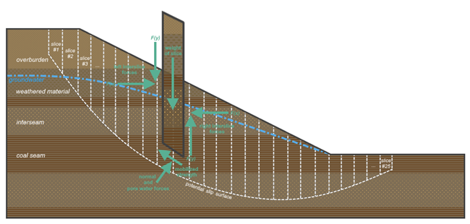
Figure 1.5 Methods of slices in limit equilibrium slope stability analyses

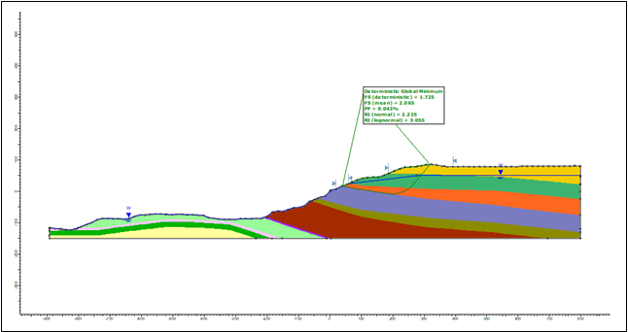
Figure 1.6 Sample Slide2 Model of Yallourn Mine
The following settings were applied in Slide2 for simulating block sliding failure and conducting slope stability analyses:
- The following slice methods were run for each assessment:
  - Bishop Simplified and Janbu Corrected – as primary methods, for conservatism, and
  - GLE (General Limit Equilibrium) / Morgenstern-Price - for comparative purposes, to illustrate a more “realistic” failure mechanism.
- A non-circular slip surface was analysed.
  - For both mines, block search was used with projection angles of the active block ranging 75°-85° and projection angles of the passive block ranging 25°-35° (see Figure 1.7)
  - For Loy Yang only, Cuckoo search was also used, allowing the model to self-determine the slip surface. This was later decided as the primary search method given that it yielded a similar or lower FoS relative to respective block search.
- The slip surface extents were set just beyond 300 m from the slope crest and about 75 m forward of the slope toe.
- The slip surface depth was modelled at 1 m, 5 m and at 10 m below the coal and interseam interface.
- The slope limits were placed just outside of the extent of the slip surface created.
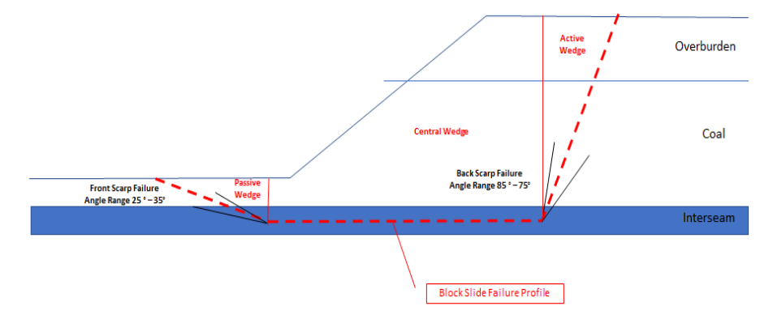
Figure 1.7 Block slide mechanism modelled in Slide2

Design process
The process for determining the potential rehabilitation works to achieve the hypothetical acceptance criteria followed a step-wise, trial-and-error process, as illustrated in the flowchart (Figure 1.8). The following considerations were paramount when modifying the slopes:
- When trialling slope modification works the aim is to achieve the target FoS with the least works and/or reliance on groundwater controls, plus:
  - Achieving a slope grade of 1V:3H or lower, that facilitates maintenance works (e.g. coal cover), for recreation or alternative land use purposes and/or access, is a primary design criterion.
  - All exposed coal on the final slope surface must be covered with a 1 m thick coal cover. Any batter reshaping (cut and fill) that results in exposed coal faces requires the coal to be re-covered.

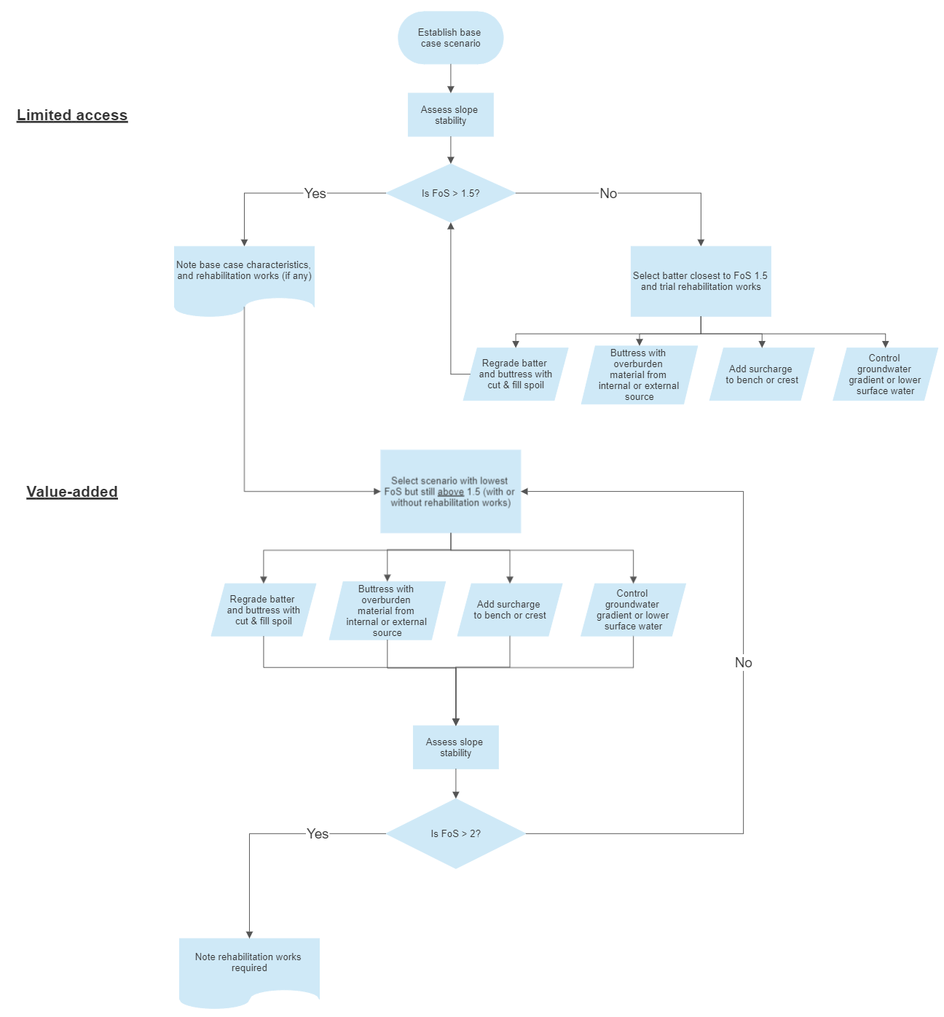
Figure 1.8 Design process for determining required rehabilitation works to achieve hypothetical design criteria.

Validation of analysis approach
The following technical reviews were undertaken:
- Independent technical review of the modelling by Pells Sullivan Meynink– build/result/design recommendations, and
- Presentation of modelling approach and results to EnergyAustralia and AGL for comment.
Engagement with Pells Sullivan Meynink, EnergyAustralia and AGL was undertaken progressively to review model build approach, address data and information constraints and provide guidance on the appropriateness of the adopted batter stability assessment approach.

Page intentionally left blank

Potential changes in stability over time

Factors influencing stability
Slope stability often requires ongoing monitoring, maintenance and in some cases, additional engineering, in order to retain stability over time. This is due to the time-decaying effect of certain geological processes that contribute to instability, such as erosion, evaporation, seasonal and/or climatic groundwater and surface water fluctuations, and external changes to topography or surficial loading. At Loy Yang particularly, the presence of multiple interseams makes the slope more susceptible to erosion by water in these areas. The influence of groundwater is the largest contributing factor to instability. As a result, though the same end criteria are to be met for all rehabilitation options, not all options are “equal”, in that some situations require more control to retain stability than others.
This is the case for a partial fill, compared to a full fill, as discussed below. The overall arguments for a full fill being less sensitive to environmental changes, and more robust in perpetuity, relative to a partial fill are:
- Prior to filling, rehabilitation works that intend to help stabilize the slopes during filling can be difficult to achieve.
- During filling, stability often decreases around the level of a partial fill, before stabilizing at the level of a full fill.
- After filling, despite being designed to the same stability criteria, a partial fill is inherently more sensitive to change than a full fill.

Stages of filling
At the Latrobe Valley mines, the difference in water level between a partial and full fill is generally in the range of 17-20 m. At the completion of rehabilitation (pit water level achieved), the assumption is that the mine stability performance will match that of the design criteria. This is contingent upon the assumption that the design itself accurately captures the ground conditions and the subsequent risks. As we are dealing with complex earth systems, this necessitates that the appropriate mean conditions have been incorporated into any modelling that has determined the rehabilitation design.
At cessation of mining, the mine void will be filled with a combination of earthworks (for slope stability and rehabilitation purposes) and, if decided, a nominated volume of water. This is illustrated in Figure 2.1. It is certain that some level of rehabilitation works will be required, if at the very least a thin layer of clay to cover exposed coal, but also structures to retain an acceptable criterion of slope stability during filling, considering this may take decades to achieve.
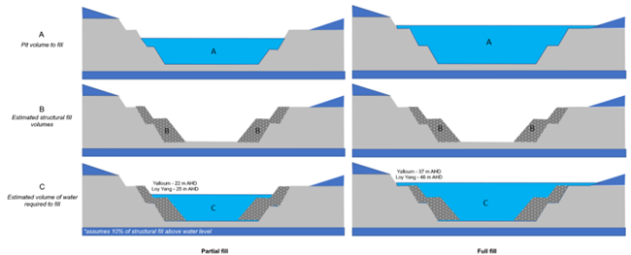
Figure 2.1 Stages of filling
The ability for a slope to maintain long-term (perpetual) stability is paramount, because any new rehabilitation works to bring the slope back to a stable state (as defined by accepted criteria), in the event of failure or deterioration, will be increasingly difficult once batters are largely submerged by water. Even reparation of exposed batters may be difficult due to access issues, and while small-scale failures may not prove critical for stability, they are critical to fire suppression since coal may become exposed.

Pre-filling
Where a partial fill or a full fill is designed for an FoS of 2.0 and a PoF of 0.5%, they are, from a stability perspective, equivalent at the point of completion. However, how stability is achieved may differ. For example, a partial fill design is likely to require additional management controls such as horizontal drains within the mine and surface water management around the mine along with monitoring and maintenance. Pre-filling rehabilitation works that are intended to limit the degree of decrease in FoS during filling are limited, due to specific batter geometries, geological unit orientations, and sensitive receptors beyond batter crests.

During filling
Filling the mine void with water can be thought of as having a “buttressing” effect on slope stability, in that the weight of the water against the slope counteracts the force that pushes it to fail. Following this logic, one would expect the slope to become increasingly stable as filling progresses. Moreover, it follows that for a fully filled void, all batters would benefit from this buttressing effect; for a partial fill, only those under water would experience this effect, and those above water would still be susceptible to failure to the same degree as they were in a “dry” option.
However, assuming all else is equal (i.e. rehabilitation works and fill rates), the relationship between stability and fill level has been demonstrated as non-linear. In other words, there are periods during filling where there is a higher risk of instability than that at lower water levels. Ultimately, however, the FoS at the end of filling is always higher than the FoS at the start.
An analysis of FoS versus relative level (RL) shows that certain batters are susceptible to falling below the required design criteria during various stages of the filling process. This is illustrated in Figure 2.2.
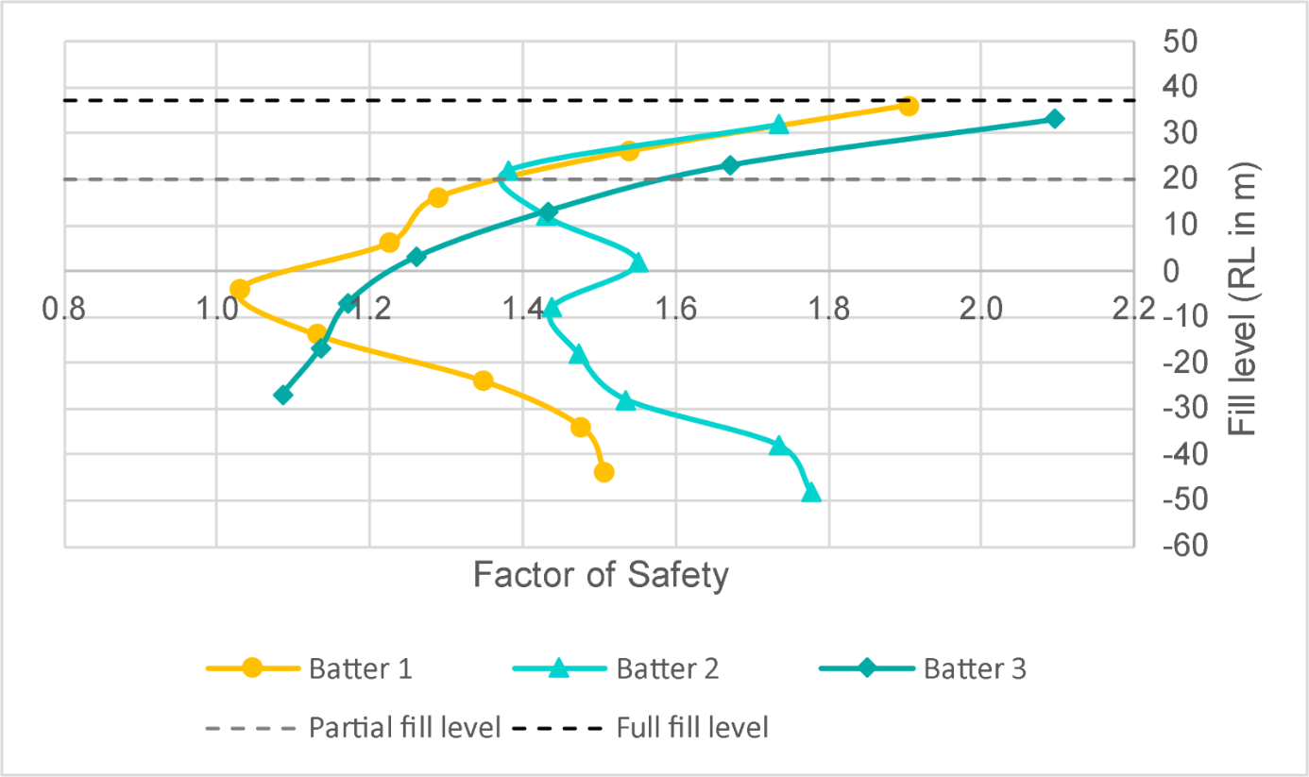
Figure 2.2 FoS vs fill level for three different batters. NB: This graph is indicative only and does not intend to display actual values.

For example, Batter 1 begins at the minimum acceptable stability criterion, and then decreases during filling before ultimately increasing again. Batter 2 begins above the minimum acceptable stability criterion, then decreases slightly and fluctuates around this threshold before ultimately surpassing it. Batter 3 begins below the minimum acceptable stability criterion, but displays a consistently positive increase the onset of filling to the end.
In general, a full fill results in a stabilizing effect that achieves an FoS>2.0 and a partial fill, where the majority of batters are still exposed above water level, results in a destabilizing effect that reduces the FoS. However, this is not true for all batters, and even so it may be possible to design rehabilitation works and employ management practices such that the FoS does not fall below the design criteria at any point during filling.

Post-filling
At the point of completion of rehabilitation (or the point of model output when predicting outcomes), the stability criteria for a partial and a full fill are the same. That is, both must achieve a FoS of 2.0 and a PoF of 0.5%. If conditions can be maintained as at the end of rehabilitation construction, then it can be assumed that the calculated design criteria will be retained into the future. In reality, it is likely that conditions will change over time, even in minor ways, that can change the probability of failure.
The degree of change will depend on the complexity of the ground conditions, the physical environment around the mines, the climate, the effectiveness of management controls required and the capacity of the model to accommodate all these variables. In the modelling alone, it is more likely that the model will underestimate the actual risks for a partial water body compared to a full water body. An example is in the ability of a model to assess the high spatial and time variable groundwater conditions.
Irrespective of the model, whether for partial or full fill, change will occur. However, there is a greater potential for change for a partial fill than a full fill, and that the consequence of the change will have a greater likelihood of increasing the PoF, to the point where a major failure may occur. This is illustrated in Figure 2.3.
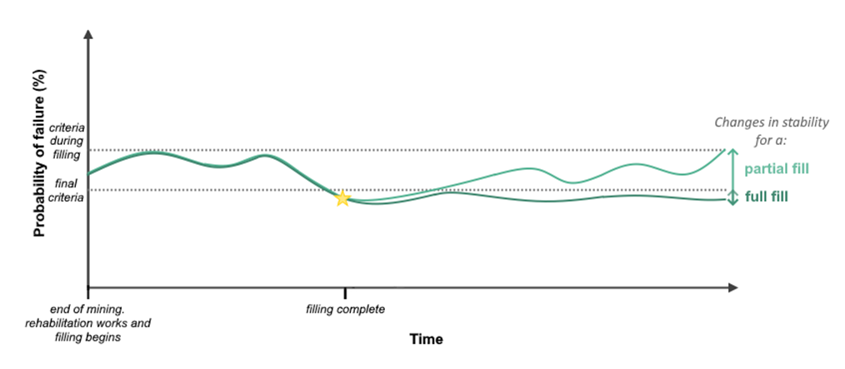
Figure 2.3 Stability changes over time for each fill option (indicative only, does not display actual values)

Mechanisms of change
As with any landmass, incremental movements are likely to still occur, despite any engineering works or management practices. These movements in themselves are unlikely to cause a major failure, but can result in lateral and vertical movements in the 10s to 100s of mm in scale. As stresses continue to release, these small-scale movements may result in the opening of or expansion of vertical joints or “cracks” in the coal seam. This can cause “sinkholes” to form in the overlying sediments. The cracks themselves may cause localised impacts, but it is their capacity to allow water to enter the coal that represents the greatest potential impact on stability. Creep through changing stress and fluctuating groundwater levels can 'ratchet' open the cracks.
Where management interventions are fully effective, then any change in groundwater level may be manageable. However, if efficiency diminishes, groundwater pressures can change, increasing the forces that can drive a major failure. This starts to move away from the assumptions in the rehabilitation design modelling, potentially increasing the PoF. Given the perpetual lifespan of the rehabilitated slopes, it is unreasonable to assume there will not be at least one instance of decreased effectiveness at some point.
Likewise changing conditions can affect the assumptions in the model. Even with horizontal drains working 100% efficiently, but more so if they are not, significant rainfall events and flooding can cause rapid increases in groundwater levels, increasing the driving force for major failures. Changes in land use around the mine can also increase infiltration rates or create ponding of water at the surface, increasing the rate of fill of any vertical cracks and prolonging the time they remain “elevated”. These changes can create significant variations from the design conditions, increasing the PoF. It is unreasonable to design for events that are extremely unlikely to occur, nevertheless this does not preclude those events from occurring.
In a full option, all of these same mechanisms can occur, but to a lesser scale. As horizontal drains are unlikely to be required to manage groundwater levels, it is one less thing that can fail. The extent of creep will be less, as groundwater pressure fluctuations will be smaller. Rapid rainfall and ponding may increase infiltration to the water table, but the change in gradient will be less and localised change in pressures will be smaller. As a result, a full fill is a more “robust” option. There is greater capacity for variation to occur for a partial fill, therefore a higher likelihood that conditions will change over time that can create conditions for major failure than for a full fill.
Page intentionally left blank

Estimated earthworks

Summarised results
Based on the analysis method adopted for this project, Table 3.1 summaries estimated earthworks required to construct all necessary civil structures (buttressing, surcharging, etc.) to meet the hypothetical design criteria.
Table 3.1 Summary of estimated earthworks requirements for construction of civil structures.
Mine | Option | Mine closure year | Structural earthworks  (rounded to nearest 10 Mm³) | Growth medium  (rounded to nearest 0.5 Mm³) | Type of option
Yallourn | Full fill  RL37 m AHD | 2028 | 40 | 1.5 | Comparison
 | Partial fill  RL20 m AHD |  | 50 | 3.0 | Contingency
 | Dry void |  | 190 | 7.5 | Alternate
Loy Yang | Full fill  RL46 m AHD | 2048 | 30 | 1.0 | Comparison
 | Partial fill  RL25 m AHD |  | 40 | 2 | Contingency
 | Dry Void |  | 250 | 6 | Alternate
 | Full fill  RL46 m AHD | 2035 | 30 | 1 | Comparison
 | Partial fill  RL25 m AHD |  | 40 | 1 | Contingency
 | Dry void |  | 200 | 4.5 | Alternate

Retaining a dry void

Hypothetical Design criteria and numerical modelling
The hypothetical design criteria are summarised in Table 3.2.
Table 3.2 Hypothetical design criteria for Yallourn and Loy Yang.
Criteria |  | Mine |  | Comment
 |  | Yallourn | Loy Yang
Stability | Minimum “Factor of Safety” (FoS) at completion | 2.0 | 2.0 | Guidelines for quarries​ (DJPR, 2020) and Read & Stacey (2009)
 | Overall batter gradient | 1V:3H | 1V:3H | Minimum requirement for the use of light mechanized equipment to maintain (eg. slashers, mowers).
Fire protection - minimum cover material over coal (m) |  | 1 | 1 | This is the minimum at any point. Thickness will vary but will be no less than 1m at its thinnest point.
Growth medium to support vegetation - minimum to support shallow rooted grasses and shrubs (m) |  | 0.3 | 0.3 | Minimum to establish shallow rooted grasses and scrubs.
Maximum groundwater gradients behind the batter – on completion, dry void. |  | 12° on all batters | 15° on all batters | Maximum groundwater gradient in long term allowing for fluctuations due to dry/wet events and allowing for time to repair / replace major failures in the groundwater management system.
The hypothetical design criteria were applied to two-dimensional cross-sections using geotechnical modelling software. The location of sections was chosen to represent each distinct geotechnical zone in the mine area. Geotechnical zones are developed by the mine operator and are based on similarities in geology, geometry and groundwater levels. The generation of representative 2D cross-sections from the 3D model is illustrated in Figure 3.1Figure 3.1 Generation of 2D cross-sections from a 3D geological model. The model for each section was built from:
- 3-D geological model of the LV coal measures
- Groundwater gradients based on regional groundwater monitoring reports
- Geotechnical parameters from published datasets
- Assumes that upward groundwater pressures continue to be managed by groundwater pumping (at whatever rate is necessary to maintain pressure management).

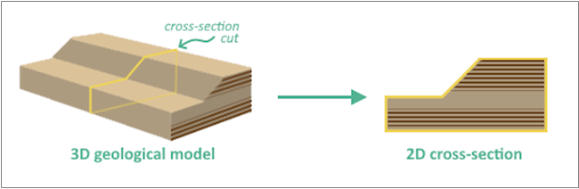
Figure 3.1 Generation of 2D cross-sections from a 3D geological model
Each section (see Figure 1.2 & Figure 1.3 for section locations) was modelled using 2D geotechnical stability modelling software – Rocscience Slide 2.0. All sections were derived from the Regional Coal Model (2003) with updated pit shells estimating final pit geometry based on updated closure dates, current extraction rates and current pit geometries. Representative of material properties for the geological units and the design criteria were determined from publicly available geotechnical reports from Yallourn and Loy Yang, as outlined in section 1.2.2.2 Where the FoS for the dry void of the section without any modification was >=2.0, no further modelling was required.

Extrapolation to volumes
As the model section is in two dimensions, the “area” of buttressing was converted to a volume per metre length by assigning a 1 metre thickness to the section. This provided a volume of structural fill for each section at 1m increments.
For each batter / geotechnical zone, the volume of structural material was calculated based on a length weighted average approach (Figure 3.2). For sensitivity a volume using the minimum section volume and maximum section volume for a batter / geotechnical zone was calculated for comparison.
Calculations for the Yallourn Mine – dry void solution only demonstrated that if the minimum or maximum section thickness was applied to the whole batter length instead of the length weighted average, the volume required for structural fill vary in the order of +-40%.
- 1 to 4 sections were assessed for the dry void options per geotechnical zone / batter
- For partial fill analysis, one section per geotechnical zone / batter was assessed using the section with the lowest FoS from the dry void assessment
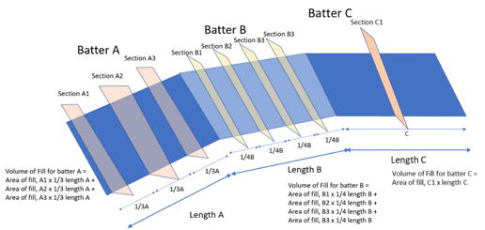
Figure 3.2 Approach to estimating structural earthworks volumes from available geotechnical sections.
The total structural fill requirement for the mine was calculated by summing the volumes for each individual batter / geotechnical zone (Table 3.3)
Table 3.3 Dry void structural earthworks requirements for Yallourn and Loy Yang.
Mine | Closure year | Minimum earthworks (Mm³) | Length weighted average Earthworks (Mm³) | Maximum earthworks (Mm³)
Yallourn | 2028 | 120 | 190 | 270
Loy Yang | 2048 | 170 | 250 | 350
Loy Yang | 2035 (Target) | 130 | 200 | 290
Notes: Numbers rounded to nearest 10 Mm3. During the period this report was prepared EnergyAustralia (EA) and AGL announced earlier target closure dates for Yallourn Power Station and Mine and Loy Yang A Power Station, respectively. Section 0 of this report sets out the associated implications and adjustments to the analysis underpinning this report.

Capping and growth medium
This assessment assumes that for the purpose of fire prevention, all capping is a uniform 1 m thickness. In addition to the 1 m capping, it is also assumed a 0.3 m growth medium will be applied to the capping to facilitate the growth of vegetation to mitigate erosion. The volumes of material required for capping and the growth medium are not included in the structural earthworks volume. However, these volumes are included in the material balance volumes as it is a required product for final rehabilitation.

Partial and full fill – Yallourn
The analysis approach for Yallourn to assess the stability and any associated earthworks to achieve the hypothetical stability criteria utilized representative sections extrapolated to other sections where earthworks may be required (Table 3.4).
Modelled sections
In undertaking the modelling, there are some key things to note. The sections are representative of the geotechnical zones used by the mine licensees. A representative number of sections was assessed with the exception of:
- Latrobe River Batters – East Field: A section was proposed through an area of a previous failure where the Latrobe River system broke into the mine after a large-scale block failure. Given the level of disturbance in this area, it was not possible for this project to apply appropriate geotechnical properties to this section – it was not modelled.
- Sections along the west side of the Morwell River Diversion (MRD). Five sections along the west side of the MRD including sections where the MRD joins the northern and southern batters were assessed for the dry option. In developing these sections, the location of fill material within the Township Field beneath the MRD was determined from limited available data and an analysis of historical air photos. The reliability of this method of interpretation, along with the limited understanding of the properties of the fill material means the confidence in these sections is lower than for other sections where the underlying geology is clear. When it came to modelling partial and full fill, these 5 sections were not modelled due to this low level of confidence.

Table 3.4 Summary of process for assessing partial fill stability requirements
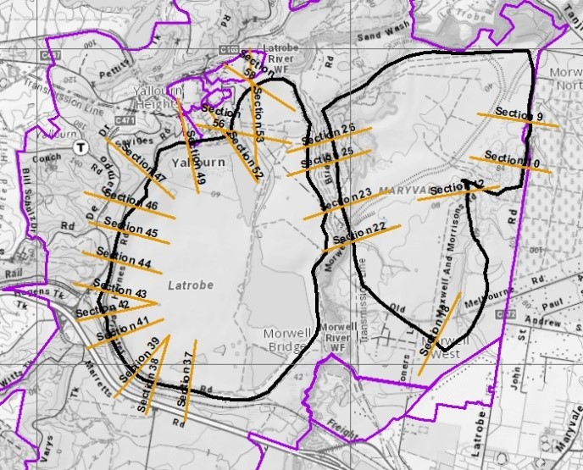Sections identified as requiring structural works for filling | - For Yallourn, change in FoS during filling was assessed for the majority of sections for a 12deg groundwater gradient  - Discussion of water fill options with mine operators highlighted that 12deg during filling was unlikely, as operators would continue to manage groundwater gradients  - A more realistic groundwater gradient was considered to be in the order of 6 deg.  - An initial analysis of the majority of sections to assess stability when dry at a 6deg was undertaken.  - The minimum FoS on filling was assessed as part of the analysis  - The Average dip in FoS between the toe FoS and the Minimum FoS was assessed – the median “dip” in FoS was 18%  - The modelled sections were evaluated – where the minimum FoS (-18%) was <1.5, the section was identified as requiring further stability work. In total 23 sections were assessed as requiring further analysis.
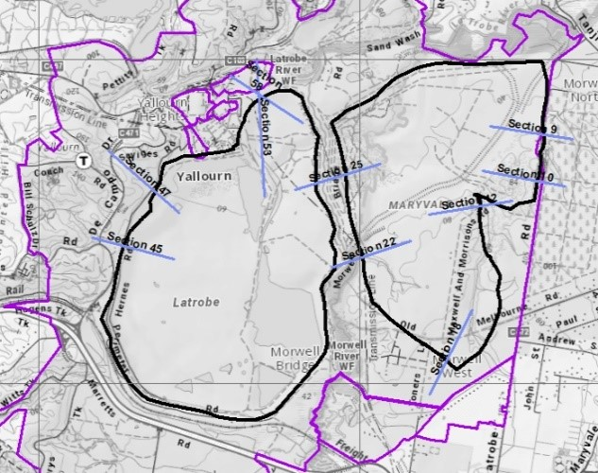Representative sections modelled | - Of the 23 sections identified as likely to require further stability analysis to meet the on-fill and at target level FoS criteria, 10 were selected for modelling based on a spread of location and on being “worse case”  - Additional earthworks were assessed to meet the target stability of >=2 at Full Level and at Partial Full level (two separate analysis), then to ensure that FoS >1.5 during filling.  - For modelled sections – apply model outcomes.  - For all other sections identified as requiring or potentially requiring earthworks to support – see Table 3.5 for method  - Multiply section values (m3/m) by their representative batter length - using ratio for other like batters (Table 3.6). If no batter modelled, section with the highest ratios of those modelled was used.  - The estimated earthworks for each option was the sum of the individual representative sections.

Table 3.5 Interpolation of earthworks volumes from modelled to unmodelled sections - method
Section type | Earthworks volume, dry void, 12 deg gradient | Volume of earthworks to achieve FoS 2 at target level and FoS>1.5 on filling – Partial Fill level | Volume of earthworks to achieve FoS 2 at target level and FoS>1.5 on filling – Full fill level
Modelled section | A | B | C
Unmodelled section, same batter as modelled section | D | (B/A)xD | (C/A)xD
Unmodelled section, - no modelled section on batter | E | (B/A^{max})xE | (C/A^{max})xE
Where B/A^{max} and C/A^{max} is the ratios from the section with the highest ratios of those modelled.
Of the 10 modelled sections, 6 required earthworks to achieve the target FoS criteria for both partial and full fill, 2 required it for partial fill only and two, on more detailed modelling did not require any addition earthworks.

Table 3.6 Interpolation of earthworks volumes from modelled to unmodelled sections - ratios
Modelled sections | RL20m, 6⁰ earthworks / Dry Void 12⁰ FoS2 works | RL37m, 6⁰ earthworks / Dry Void 12⁰ FoS2 works | RL 20m 6⁰ earthworks (modelled) | RL 37m 6⁰ earthworks (modelled) | Dry Void 12 Deg FoS 2 (modelled)
MRD Conveyor Embankment | 0.88 | 0.20 | 12850 | 2883 | 14647
YTF Hernes Oak Batter ¹ | 0.78 | 0.80 | 11681 | 11987 | 14901
YTF Western Batter | 0.73 | 0.70 | 12447 | 11879 | 17043
YTF Latrobe South Batter | 0.76 | 0.50 | 6130 | 4027 | 8072
RCB Batter | 0.66 | 0.45 | 1100 | 750 | 1665
Maryvale Southwest Batter | 0.26 | 0.10 | 4667 | 1825 | 17713
Maximum² | 0.88 | 0.80
1: Section with the overall highest ratios across both partial and full fill
2: Highest ratios for partial and full fill – all modelled sections
Of the sections modelled Figure 3.3 is a summary of the distributions of FoS on filling.

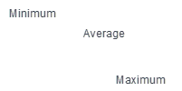
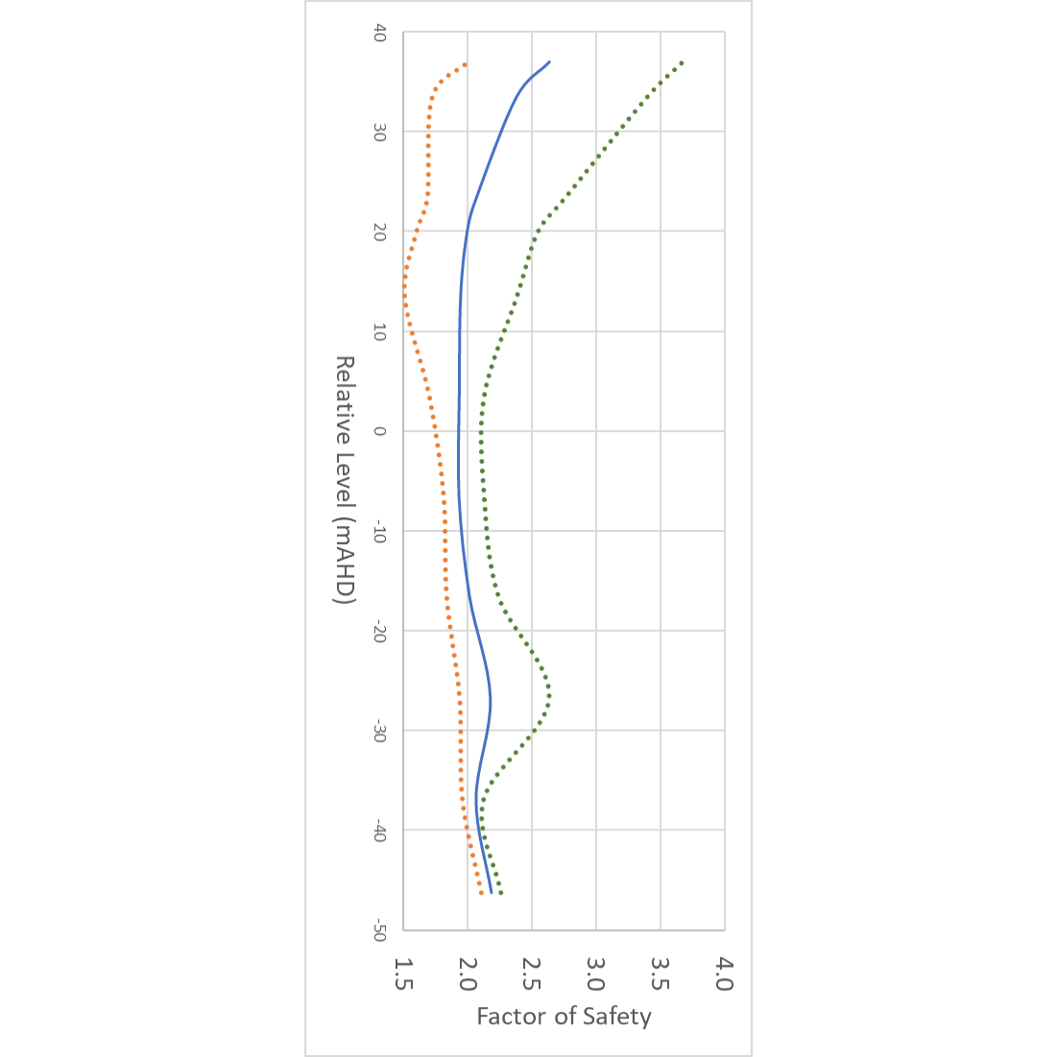
Figure 3.3 Variability in Factor of Safety with filling depth from modelled sections

Sensitivity analysis – ratios
As the approach relied on 10 modelled sections extrapolated to the other sections, several different approaches to how the extrapolation ratios was applied were tested (Table 3.7)
Table 3.7 Sensitivity analysis to determine estimated earthworks requirements for partial and full fill - Yallourn
Ratio Approach | Description | Earthworks (MCM) for Partial Fill | Earthworks (MCM) for Full Fill
Initial approach | Use modelled data for modelled sections  Where another section on the same batter, use the derived ratio for that batter.  For all other batters, use section with the overall highest ratios across both partial and full fill | 51 | 41
Sensitivity 1 – max ratio | Use modelled data for modelled sections  Where another section on the same batter, use the derived ratio for that batter.  For all other batters, use section highest ratios for all modelled sections for partial and full fill | 57 | 42
Sensitivity 2 – similar batters | Use modelled data for modelled sections  Where another section on the same batter, use the derived ratio for that batter.  For unmodelled sections on adjacent batters where they have similar characteristic – eg, adjacent batters on a north facing section of the mine  For all other batters, use section with the overall highest ratios across both partial and full fill | 52 | 36
Rounded Average |  | 53 | 39
Rounded to the nearest 10MCM |  | 50 | 40

Partial and full fill - Loy Yang
The same method applied to Yallourn was applied for Loy Yang (Figure 3.4, Table 3.8 and Table 3.9), with some variation resulting from the specifics of the Loy Yang mine.
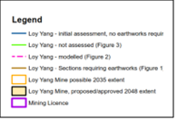
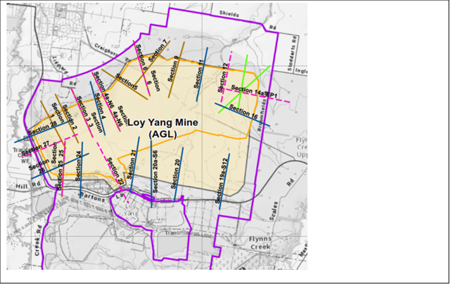
Figure 3.4 Section analysis – summary

Table 3.8 Ratios used to determine earthworks volumes for filling
Sections | RL 25m | RL 46m |  | RL 25 6 Deg works | RL 36m 6 Deg works
 | 6 Deg | 6 Deg |  | divided by | divided by
 | Works m2/m | Works m2/m |  | Dry Void 15 Deg FoS 2 | Dry Void 15 Deg FoS 2 | Dry Void 12 Deg FoS 2
 | FoS 2.0 | FoS 2.0 |  | Works | Works | Works (m³/m)
Northern Batters Block 1 - Section 3 | 6,448 | 6,448 | A | 0.31 | 0.31 | 20508
Northern Batters Block 2 - Section 4a-N6 | 7,087 | - | B | 0.32 | - | 22494
Northern Batters Block 2 - Section 6 | 25,140 | 22,838 | C | 0.42 | 0.38 | 59791
South Western Batters Block 1 - Section 25 | 68 | 68 | D | 0.14 | 0.14 | 499
 |  |  | Maximum (C) | 0.42 | 0.38

Table 3.9 Estimated earthworks volumes – partial and full fill
Ratio Approach | Description | Earthworks (MCM) for Partial Fill | Earthworks (MCM) for Full Fill
Initial Approach | - Use modelled data for modelled sections  - Where another section on the same batter, use the derived ratio for that batter.  - For all other batters, use section with the overall highest ratios across both partial and full fill | 47 | 39
Sensitivity 2 – similar batters | - Use modelled data for modelled sections  - Where another section on the same batter, use the derived ratio for that batter.  - For unmodelled sections on adjacent batters where they have similar characteristic – eg, adjacent batters on a north facing section of the mine  - For all other batters, use section with the overall highest ratios across both partial and full fill | 31 | 25
Rounded Average |  | 39 | 32
Rounded to the nearest 10MCM |  | 40 | 30

Page intentionally left blank

Supporting calculations

Background

Available data
The State’s 3D digital geological model of the Latrobe Valley was originally developed in 2003 (Jansen, Say, & Maher, 2003) ​ for use in Surpac and MineScape. Since then, the model has been updated to include data from 9,086 boreholes over a total area of 4,916 km2, covering all onshore Gippsland Basin brown coal fields. Roofs and floors have been created for the 16 thickest brown coal seams and splits off main parent seams. The stratigraphic (geology) model is based on a 200 m grid. The block (coal quality) model is based on a 160 m x 160 m x 12 m block size. Seventeen coal quality parameters are incorporated into the block model, including moisture and ash percentages, as well as minerals and inorganics.
For the three Latrobe Valley coal mines, pit shells have been generated and/or provided as follows:
- Hazelwood Mine – 2017 LiDAR data acquired in a jointly funded project between Engie and the Department (Earth Resources Regulation).
- Yallourn Mine - LiDAR data comprised of 2017/2018 data covering the Township Field, East Field and Maryvale fields and 2021 LiDAR data covering the western and northern extents (including the Yallourn North Open Cut Extension mine). A 2032 pit shell supplied by EnergyAustralia in 2018 to reflect the mine design and closure date in their currently approved Workplan (2018).
- Loy Yang Mine – 2019 LiDAR from Regional Roads Victoria. 2048 pit shell provided as ArcGIS polygon and polyline data by AGL in 2019 to reflect the mine design and closure date in their currently approved Workplan (2015).

Assumptions
To undertake these calculations, various assumptions were made where data was not able to be verified, publicly available or able to be sourced from the mine operators, or where it was subject to change over time. All assumptions were based on best available knowledge and reasonable judgement at the time, but may not be representative of current states as coal mining, production and rehabilitation planning has progressed since the time of calculation. Nevertheless, the supporting work remains valid in terms of providing a basis for estimating values and the relative scale of effort required to achieve the rehabilitation design options being considered. These assumptions are outlined below.
The closure dates for the 3 coal mines are based on:
- Hazelwood Mine – March 2017 (actual mine closure date and year LiDAR data was acquired by the Department).
- Yallourn Mine – 2028. In March 2021, EnergyAustralia announced that Yallourn Mine will close 4 years earlier than planned (2032).
- Loy Yang Mine – 2032-2035 and 2048. 2032 is an earlier possible closure date based on an Australian Energy Market Operator (AEMO) forecast that all coal plants could be shut across Victoria by 2032. 2048 is the currently approved closure date.
The key relative levels (RLs – in surveying, this refers to equating elevations of survey points with reference to a common assumed datum) are based on the figures in the corresponding approved work plans for the 3 mines.
Table 4.1 summarises the key assumptions used in this report.

Table 4.1 Key assumptions about the Latrobe Valley coal mines
Mine | Closure date | RL at full fill (m) | RL at partial fill (m) | Maximum pit depth (m) | Deepest coal seam mined
Hazelwood | 2017 | 45 | 35 | 140 | Morwell 1B
Yallourn | 2028 | 37 | 20 | 125 | Yallourn
Loy Yang | 2032-2035/2048 | 46 | 25 | 215 | Morwell 2A
Note: Further information on the implication of earlier closure dates on pit geometries is provided in Section 4.2 of this report.

Limitations
The model that the calculations in this report are based on is The State’s 3D digital geological model of the Latrobe Valley coal resource. This is a regional scale model designed to model the coal resource over a very large area with disparate data (borehole) distribution. This is not a mine-scale model. Specific limitations with regards to the 3D geological model are ​(Jansen, Say, & Maher, 2003)​:
- Some intraseam occurs within seams, particularly away from the mines. These were not modelled separately, but were taken account of during resource calculations.
- Only the sixteen thickest coal seams and splits were modelled. Smaller seams and splits were either incorporated with these sixteen or not modelled.
- Very little account was taken of outcrop geology, gravity, magnetics, radiometrics or seismic datasets in constraining the surfaces. Consequently, some seams extend further than they should. Examples include the M2a and M1seams at the northwest and southwest edges of the model and the M2 seam at the west edge of the model.
- Roughly 80% of surfaces generated using a 200 m grid are within ±4 m of bore intersections. A reduction in grid size may result in better-constrained surfaces.
- No account was taken of changes to coal quality caused by drill method.
- Minescape is unable to display orthophotos, satellite and geophysical images.
- Minescape was unable to export useable grid files, only dxf format contours. Consequently, GIS contour surfaces have poorly defined boundaries and 0 m isopachs. Tab delimited text grid files were generated in Minex from dxf format contour files.
- Fire holes were not modelled separately and are included in the Haunted Hill Formation.
- Thorpdale and Carrajung volcanics were not modelled.
- Minescape bores do not stop at total depth drilled, but appear to intersect basement.
- Faults in Strzelecki Group basement appear to be reflected in the overlying Traralgon, Morwell and Yallourn formations as monoclines and fault splays sets. The throws on these faults are small given the scale of the model and are not shown.

Basic mine parameters
The calculations described below are necessary to gain a general understanding of the rehabilitated mine void geometry and material composition, and provide the basis for several other supporting works.

New pit geometries considering early closure dates
Three-dimensional mine pit shells were created to reflect future mine geometry given possible early closure dates for Yallourn mine (at 2028) and Loy Yang mine (at 2032). These new pit shells were then used to calculate updated values for volume and surface area calculations.

Method
MineScape (v. 2021) was used to create 3D pit shells based on surface maps from work plans reflecting the 2028 and 2032 (potential end of life) mine void extents for Yallourn and Loy Yang, respectively.
The mine extents at 2032 for Yallourn were provided by EA, based on their 2018 Work Plan. The extents at 2028 were interpolated based on average mining rates, with a final rehabilitated slope of 1:3 on the batters.
Loy Yang’s mine extents at 2048 were provided by AGL as 2D polygons/polylines in ArcGIS, based on their 2015 Work Plan Variation (WPV). A 3D pit shell was generated from 2019 LiDAR data using a Digital Terrain Model (DTM). The extents at 2032 were interpolated based on average mining rates, with a final rehabilitated slope of 1:3 on the batters.

Output
Projected mine extents at potential end of mining operations for Yallourn and Loy Yang are presented in Figure 4.1 and Figure 4.2, respectively.

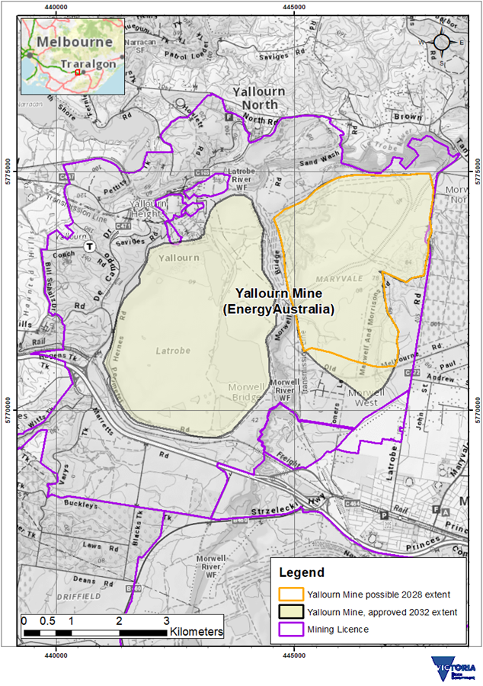
Figure 4.1 Projected mine extent at end of mining operations – Yallourn
Based on a revised analysis of filling options to RL 20 m AHD and RL 37 m AHD, where the groundwater gradient behind the batters is managed at 6° or less, earthworks to increase batter stability are generally not required. In the area of proposed mining to 2032 at Yallourn, none of the batters require additional structural earthworks if the mine void is filled with water. This suggests that the volume of earthworks does not change when bringing the mine closure date forward from 2032 to 2028.
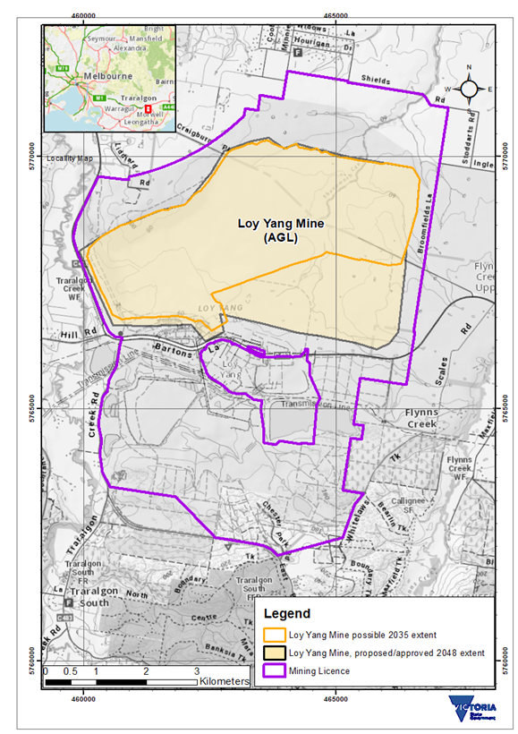
Figure 4.2 Projected mine extent at nominal end of mining operations - Loy Yang

Lengths of domains
The lengths of the geotechnical domains for each of the 3 coal mines were calculated. This is primarily to support calculations of potential earthworks volumes required for structural fill.

Method
ArcGIS (version 10.5.1) was used to create polygons from an operator-provided map of geotechnical domains. These polygons were then overlaid onto the most recent aerial photo available. The length was measured along the toe (base) of the mine.

Output
The results of the domain lengths calculations are provided in Table 4.2 to Table 4.4.
Table 4.2 Domain lengths for Yallourn mine
Field | Domain | Toe length (m)
Maryvale | Eastern | 1,447
 | Overflow Embankment | 1,328
 | Southeast | 1,596
 | Southwest | 1,302
 | Western | 1,455
East field (YEF) | Latrobe River | 1,686
 | Latrobe Road | 1,796
 | Northern | 1,176
East field extension (YEFX) | Southern | 663
Township field (YTF) | Fire Service Ponds | 1,257
 | Floc Pond | 1,287
 | Hernes Oak | 1,255
 | Latrobe South | 731
 | Midfield Dump | 1,656
 | Northern | 1,049
 | RCB | 773
 | Southern | 1,637
 | Southwest | 1,016
 | Western | 1,183

Table 4.3 Domain lengths for Loy Yang mine
Domain | Toe length (m)
Northern Batters Block 1 | 1,128
Northern Batters Block 2 | 2,901
Minniedale | 724
Pivot North | 1,666
East 1D | 2,819
South 1G | 3,316
Mine infrastructure 1G | 1,276
South-western Batters Block 1 | 1,139
Western Batters Block 1 | 714

Table 4.4 Domain lengths for Hazelwood mine
Field | Domain | Code | Toe length (m)
East field | Eastern (EFEB) | EFEB | 1,609
 | Northern (EFNB) | EFNB | 2,020
Southwest field | Northern (SWFNB) | SWFNB | 1,832
North field | Western (NFWB) | NFWB | NA
 | Northern (NFNB) | NFNB | 2,245
 | Southern (WFSB) | WFSB | 2,142
 | Western (WFWB) | WFWB | 1,535
Southeast field | Western (SEFWB) | SEFWB | 1,065
 | Southern (SEFSB) | SEFSB | 1,367

Earthworks logistics
The location, volume, type and availability of earth materials within and around the mine licence is critical to assess if the mine void is to be left dry and capped or filled. It is certain that some degree of capping on exposed coal is necessary as a means of fire suppression. Depending on the land use requirements, additional earth material may be required to allow growth of vegetation or provide suitable foundation materials for building of infrastructure. Clays are an important source of structural fill, which may be required to construct buttresses or surcharge on slopes as civil retaining structures for increased stability measures.
Establishing where these materials might be sourced from is a key consideration in understanding the potential practicalities associated with rehabilitation options. If sufficient material is unavailable from within or near the mine licence, there may be considerable impacts and costs incurred from sourcing, transport, and temporary storage of suitable material.

Thickness of overburden lithologies
The thicknesses of the different lithologies within the overburden within the 3 mining licences were calculated. For this investigation the “clay” lithologies were prioritised because they had the most potential as structural fill. These are shown in Table 4.5.

Table 4.5 Clay lithologies considered for this calculation
Code | Name/description
CLY | Clay
CLY0 | Soft clay
CLY1 | Hard clay
CLY2 | Sandy clay
CLY3 | Silty clay
CLY5 | Gravelly clay
CLY6 | Ligneous clay
CLY8 | Clay and silt
CLY9 | Clay and gravel or sand

Method
Lithology information was exported from the Latrobe Valley Coal Bore Database from within each of the mining licences (using the list of bores used to constrain The State’s Latrobe Valley Coal Model. This data was then filtered in Microsoft Excel to only retain the data above the first inferior coal/coal intersection, and then filtered to accumulate the clay intervals for CLY, CLY2 and CLY3. No stripping ratio or cut-off depth was applied, however the base of the borrow material was set to 2 m above the coal interface so as not to expose the coal. The depth to the first and last instance of clay found in borehole logs was used to calculate a clay thickness(Figure 4.3).
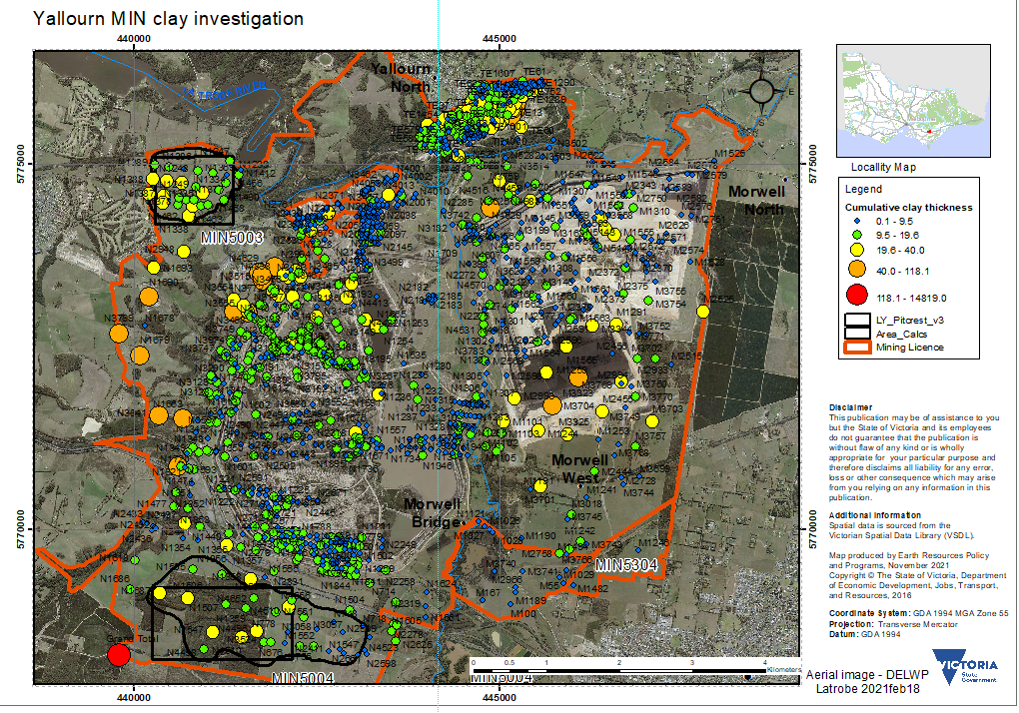
Figure 4.3 Cumulative clay thickness within overburden from borehole data

Output
Four hypothetical borrow areas have been identified. The hypothetical Loy Yang borrow area, however, is situated under the current external overburden dump and therefore is unavailable for use unless the overburden is removed. The hypothetical Hazelwood borrow area is not explicitly considered given the focus of the investigations on the mines still in operation (Yallourn and Loy Yang). The remaining hypothetical borrow areas, Blacks Track and Newborough, are situated within the Yallourn mine licence area. The results are tabulated in Table 4.6Table 4.6 Hypothetical borrow areas investigated within mine licence boundaries and shown in Figure 4.4.
Table 4.6 Hypothetical borrow areas investigated within mine licence boundaries
Resource area* | Area (km²) | Average cumulative thickness (m) | Volume (million m³) | Average depth to base of clay (m) | Maximum depth (m) | Average depth to top of clay (m) | Average interburden (m)
Blacks Tk 1 | 1.9 | 15 | 29 | 19 | 42 | 1.7 | 1.6
Blacks Tk 2 | 2.6 | 12 | 31 | 15 | 42 | 1.4 | 1.5
Newborough 1 | 9.8 | 18 | 17 | 23 | 55 | 1.1 | 3.4
Newborough 2 | 9.8 | 18 | 18 | 23 | 55 | 1.1 | 3.4
Hazelwood 1 | 1.0 | 8 | 9 | 11 | 25 | 1.2 | 1.6
Hazelwood 2 | 1.0 | 8 | 8 | 11 | 25 | 1.2 | 1.6
Loy Yang 1 | 3.7 | 16 | 59 | 29 | 68 | 3.8 | 9.2
Loy Yang 2 | 4.4 | 15 | 65 | 26 | 68 | 3.4 | 8.1
*Where the area is denoted “1”, this indicated the area delineated by a square box on the map. A “2” denotes the irregular-shaped area.
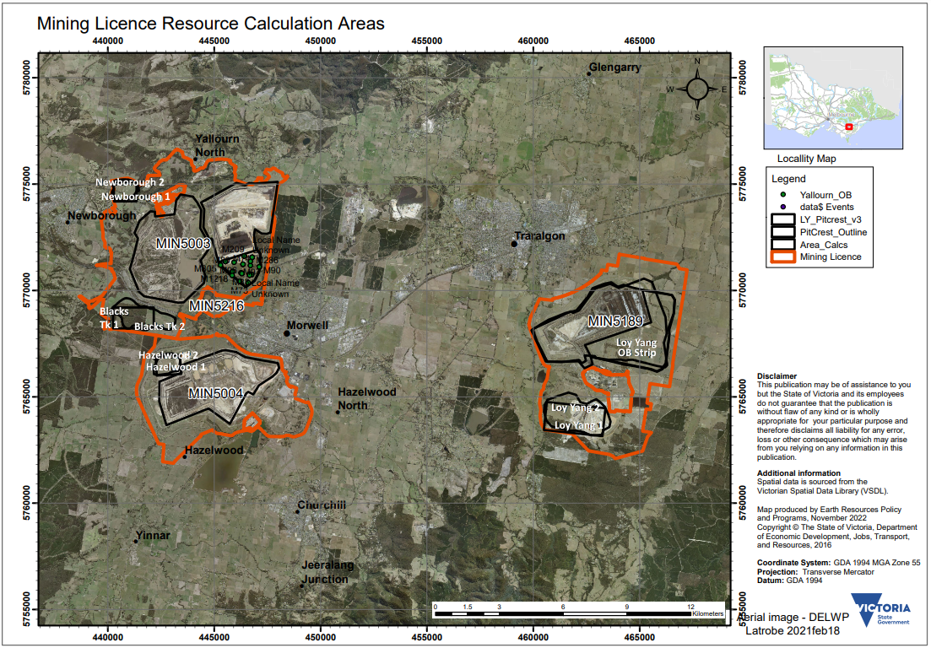
Figure 4.4 Hypothetical borrow areas in mine licence areas

Volume of overburden to be excavated over life of mine
This investigation was undertaken to estimate the volume of material within the overburden that will be mined between 2021 and the end of the proposed mine life for Yallourn (2032/2028) and Loy Yang (2048).

Method 1 - Borehole investigation
ArcGIS was used to calculate the area of the remaining overburden strip in ArcGIS. Boreholes within that area were used to calculate the overage thickness of the overburden. Multiplying the average thickness by the area gives the overall volume of the strip until the end of mining (2032). To calculate to 2028 (for Yallourn), the total area was divided by the number of years remaining to get the annual average volume of overburden mined. This was then multiplied by 7 to get the volume until 2028 (Yallourn).

Method 2 - Strip ratio
The annual coal production (averaged over the last 5 years) was multiplied by the strip ratio and the number or years (a strip ratio of 6:1 means that there are 6 tonnes of coal for every 1m3 of overburden) to determine the volumes.
Note: The difference between these methods is that Method 1 is driven by the spatial data, whereas Method 2 is driven by mine production data and assumptions about the strip ratio. Both methods have their limitations. Method 1 assumes a mine extent to the end of mine and Method 2 assumes a constant annual production and strip ratio (which is why several strip ratio scenarios are reported.

Output
The results are tabulated in Table 4.7. Results from Method 1 are highlighted in orange, results from Method 2 are highlighted in green
Table 4.7 Volume of overburden to be mined over the remaining life of mine (from 2021)
Mine | Closure year | Area at end of mine life (km²) | Volume of overburden from boreholes to end of mine life (million m³) | Annual coal production (5-year average) (Mt) | Volume of overburden (million m³)
 |  |  |  |  | Based on strip ratio 5:1† | Based on strip ratio 4:1† | Based on strip ratio 3:1†
Yallourn | 2032 (11 years*) | 2.0 | 46 | 16 | 30 | 35 | 44
 | 2028 (7 years*) | 1.2 | 30 | 16 | 22 | 26 | 32
Loy Yang | 2048 (27 years*) | 7.6 | 94 | 27 | 124 | 148 | 185
 | 2035 (14 years*) | 2.9 | 37 | 27 | 64 | 77 | 95
*From the completion of this analysis in 2021.
†Assumes density of coal at 1.12 t/m³.

Page intentionally left blank

References
AGL. (2022). AGL. Retrieved from AGL Loy Yang Power Station: https://www.agl.com.au/about-agl/how-we-source-energy/loy-yang-power-station?zcf97o=vlx3ap
DJPR. (2020). Geotechnical guideline for terminal and rehabilitated slopes: Extractive industry projects. Melbourne: State Government of Victoria.
Jansen, B., Say, P., & Maher, S. (2003). Digital Geological Model of the Latrobe Valley Coal Resource. Geological Survey of Victoria (Unpublished).
Read, J., & Stacey, P. (2009). Guidelines for Open Pit Slope Design. Collingwood: CSIRO.

Page intentionally left blank

Appendix 1 Summarised assessment method

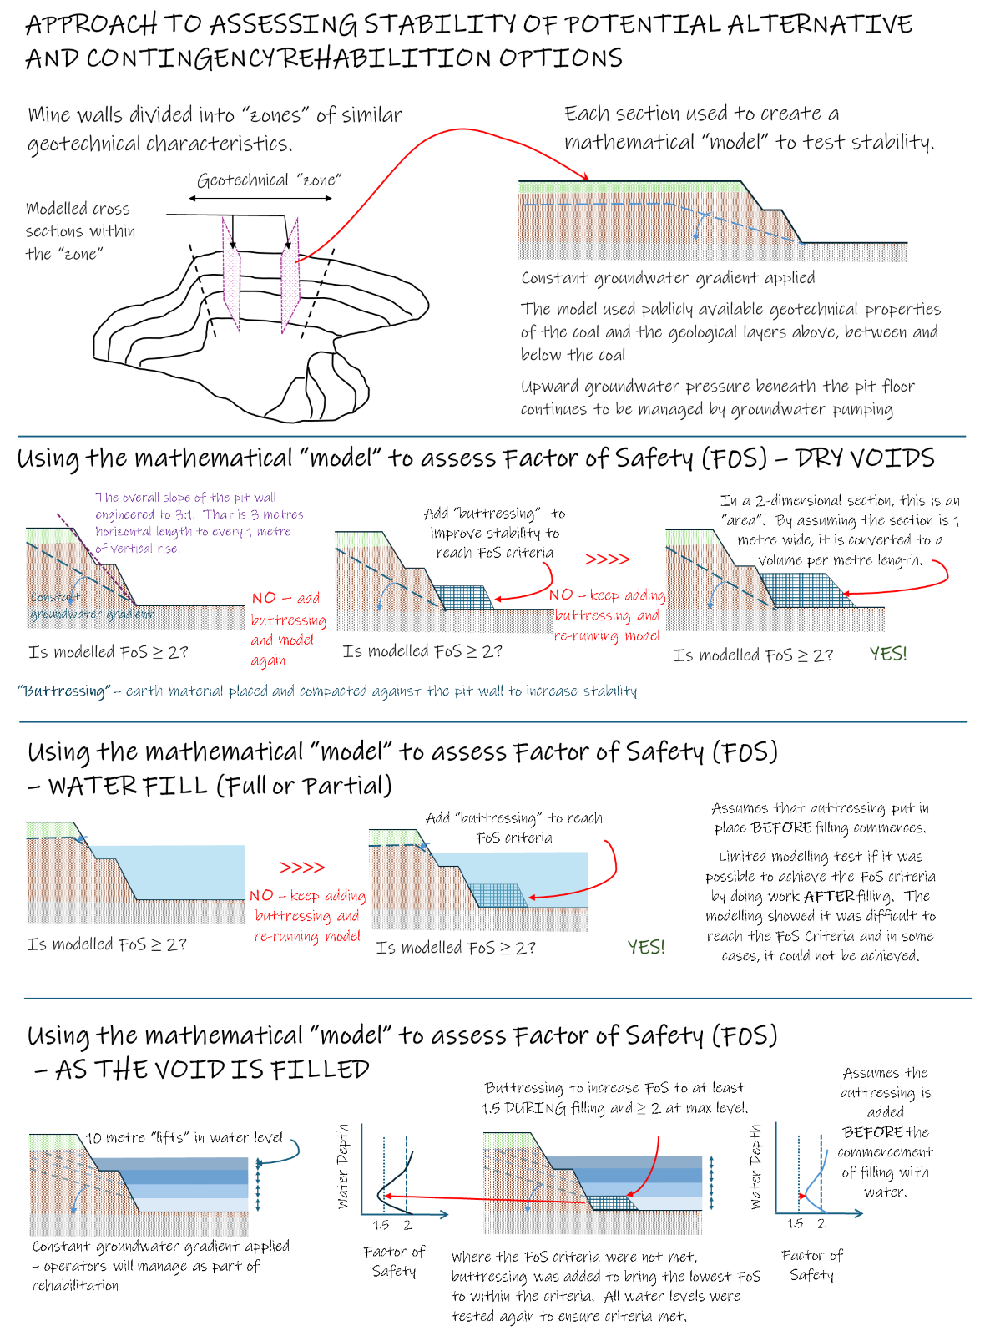
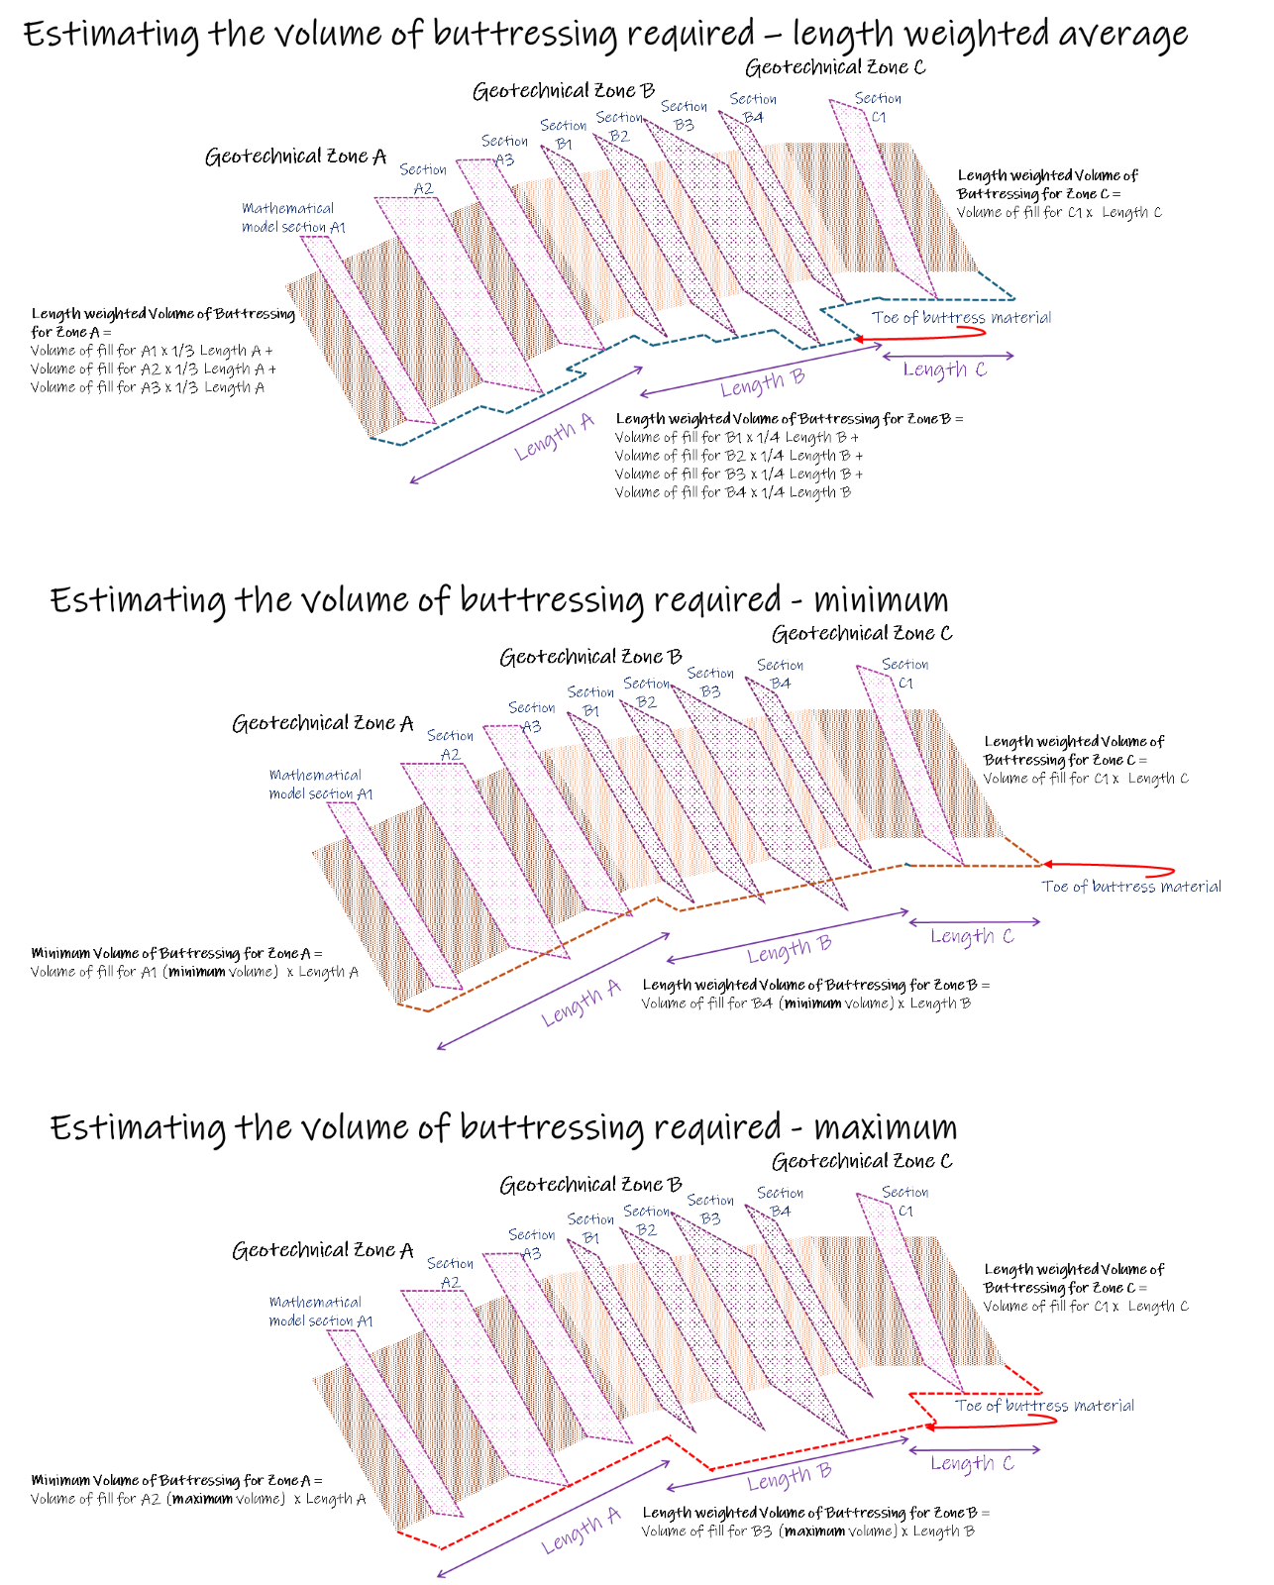







resources.vic.gov.au

Alternative rehabilitation options (or ‘dry voids’) are defined as those that do not rely on filling the mine voids with water (partially or fully). Contingency rehabilitation options are defined as those designed to address the scenario where water is initially available, and filling of a mine void commences, but cannot be completed as planned due to reduced water availability.
https://resources.vic.gov.au/projects/lvrrs
Rehabilitation without the use of surface water, groundwater or alternative water sources.
Where water is initially available, and filling of a mine void commences but cannot be completed as planned due to a change in water availability.
Developments since the drafting of this report suggest that the FoS may need to be higher than this for final rehabilitated slopes.
https://earthresources.efirst.com.au/categories.asp?cID=36
Jansen, B., Say, P. & Maher, S., 2003. Digital geological model of the Latrobe Valley coal resource. Geological Survey of Victoria Unpublished Report 2003/2. Earth Resources publications
Jansen, B., Say, P. & Maher, S., 2003. Digital geological model of the Latrobe Valley coal resource. Geological Survey of Victoria Unpublished Report 2003/2. Earth Resources publications
Since the time this work was undertaken, AGL announced it will target the end of 2035 financial year to close Loy Yang A power station (AGL, 2022). Analysis undertaken based on a 2032 closure date is considered a reasonable approximation for a 2035 closure date for the purpose of this study and report.
https://earthresources.efirst.com.au/categories.asp?cID=36
https://earthresources.efirst.com.au/categories.asp?cID=36

