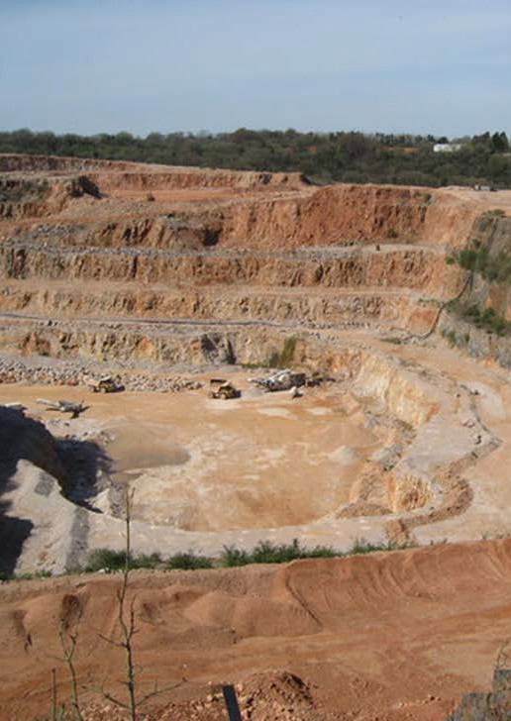

Geotechnical engagement sessions
INFORMATION FOR PROPONENTS

Contents
- Purpose 3
- What are geotechnical risks? 3
- When is participation recommended? 3
- What is the process for setting up a geotechnical engagement session? 3
- What is expected of participants? 4
- How will Earth Resources Regulation monitor the benefit of sessions to industry? 4
- For further information 4
Appendices 5

Purpose

The following information has been prepared to help extractive industry applicants participate in geotechnical engagement sessions with Earth Resources Regulation, during the work plan application or variation phase.

Geotechnical engagement sessions aim to reduce change requests by providing greater clarity upfront and address industry feedback that they often feel ‘stuck in an endless loop’.
Participation is entirely voluntary, and sessions are not designed to add time or complexity to the work plan process - they are an opportunity for applicants to obtain upfront guidance from Earth Resources Regulation around investigations and risk management for complex sites.

What are geotechnical risks?
Geotechnical risks at an extractive industry site are defined as those risks associated with ground movements in or around a quarry. Ground movements may vary from minor to significant (such as subsidence or natural rebound) or catastrophic (such as slope failure). For further guidance on geotechnical risks and the process of
preparing geotechnical information for a work plan, see the Geotechnical guideline for terminal and rehabilitated slopes: extractive industry projects.

When is participation recommended?
Whether a geotechnical engagement session is required or not is at the discretion of the industry applicant. Applicants may find engagement beneficial for complex quarry sites, including aspects such as:
- Floodplain quarries
- Dredging quarry conditions
- Slimes dams
- Blasting sites
- Complexity due to non-homogenous material conditions in slopes
- Complexity due to groundwater/perched water tables affecting slopes
Industry applicants should first look at the relevant guideline(s) to establish if the required advice is there. In all cases, the reasoning for requesting an engagement
session is to be clearly documented in the pre-engagement checklist for review by Earth Resources Regulation prior to
a session being formally scheduled.
Note: Earth Resources Regulation also recommends uptake of these sessions in instances where an independent geotechnical engineer (“competent person”) has not yet been engaged, and industry would benefit from talking through the investigation and assessment requirements to decide how to move forward.

What is the process for setting up a geotechnical engagement session?
We recommend booking the first consult early on. Booking the sessions early in the process may be beneficial for determining required geotechnical investigations, including, for example, considerations around appropriate long term stability controls. It is recommended that applicants advise whether they would find geotechnical engagement sessions beneficial at the initial site meeting to enable forward prioritisation by Earth Resources Regulation.
Note: The site meeting is where the proponent and their geotechnical advisors, Earth Resources Regulation and relevant co-regulators and local authorities will meet
to discuss the site-specific conditions, potential risks and issues, together with the planning, work plan and other legislative requirements. Certain aspects of site geotechnical characteristics may be discussed at this meeting; however, the majority of analysis will occur
outside of this session as more information is collected and understood, and the geotechnical assessment report is prepared.
The key steps for engaging with Earth Resources Regulation are as follows:
- To book a geotechnical engagement session, the proponent should first contact Earth Resources Regulation Technical Services: TechnicalServices.err@ecodev.vic.gov.au, including a brief description of the scope and list of required attendees.
- You will receive return correspondence from the responsible officer and be required to complete the engagement checklist as the basis for identifying more details to include in the meeting agenda.
- Upon completion and receipt of the checklist, the responsible officer will liaise with the industry applicant to discuss a suitable day, time and required attendees.
- Once the day and time are confirmed, the industry applicant can progress with agenda preparation, aligned to the checklist and agenda template, and issue to attendees. Earth Resources Regulation requests that the agenda be received at least 1-week prior to the formal meeting date.
- Following the meeting(s), the proponent is to write up the agreed outcomes of the geotechnical engagement using the minutes template and share with Earth Resources Regulation for all parties’ record keeping.
The outcome of each consultation will be saved in RRAM and referred to during evaluation of the geotechnical assessment report.

If and when a subsequent meeting is required, the proponent again notifies Technical Services, and the above process is repeated.

What is expected of participants?
Earth Resources Regulation requests that the following ‘rules of engagement’ be observed by industry applicants:
- Unless absolutely necessary, we request that all engagement sessions be held via the MS Teams platform to facilitate spread of attendees across Victoria (unless already meeting face-to-face on the same day, for example, at the initial site meeting);
- Please include your qualified geotechnical engineer in the engagement (where appointed), to maximise the depth of discussion and for provision of technical support. Earth Resources Regulation can provide technical support in so far as it relates to stepping through the investigation/risk management strategy,
aligned to standards and guidelines, or sound boarding work to date in terms of best-practice alignment.
However, we will not be contributing to detailed technical specifications under each element or issue area as that is the role of the consultant and we need to maintain independent objectivity as the regulator;
- Earth Resources Regulation will not provide detailed technical advice, but rather assess whether the proponent is following relevant technical guidelines and industry best practices. Therefore, engaging with us under this process does not provide a guarantee that the application will be successful upon formal assessment. These sessions are designed to assist with development of the geotechnical report, the rehabilitation plan and any related risk assessments to be completed. However, as an application typically consists of other documents, such as other technical studies and information, geotechnical assessment
of the application (following the geotechnical engagement process) will consider the application as a whole. As such, direction provided by us during the engagement process does not constitute approval of the geotechnical aspects under the application;
- We will also not be reviewing or signing off geotechnical assessment reports pre-submission of the work plan package. Depending on the extent of work completed prior to formally engaging with us, it may be useful to bring along a copy of the point-in-time geotechnical report for reference and as a discussion tool;
- Proponents complete the engagement checklist ahead of both the initial engagement session and any subsequent sessions required. This ensures a focused, issues-based agenda;
- We request proponents be responsible for completion of both the agenda and minutes and send a copy to the attendees for record keeping. Technical Services will
be reviewing the minutes – acceptance of these can be taken as assurance that the wording accurately reflects discussions and outcomes. As such, the minutes will
be a critical way forward on progressing geotechnical
work during the engagement process;
- We will review previous engagement checklists, agendas and minutes to avoid relitigating previous issues, and to ensure Technical Services’ involvement remains strictly in a strategic/technical advisory capacity as described; and
- Earth Resources Regulation recommends up to three sessions, however, encourages proponent discretion in booking as many or as little sessions as required. In
each instance, the pre-engagement checklist needs to be re-completed and an outline of what has changed since the previous engagement needs to be provided.

How will Earth Resources Regulation monitor the benefit of sessions to industry?
To help us better understand your experience of the geotechnical engagement process and identify
opportunities for improvement, we will adopt a rolling survey as part of an ongoing post-implementation review. We would greatly appreciate your feedback via the short survey, which should take less than 10 minutes to complete. The survey link will be provided to you upon completion of your engagement with Technical Services.

For further information
- Geotechnical guideline for terminal and rehabilitated slopes: extractive industry projects
- Preparation of work plans and work plan variations – guideline for extractive industry projects
- Guidance Note on Reportable Events for Mineral and Extractive Operations

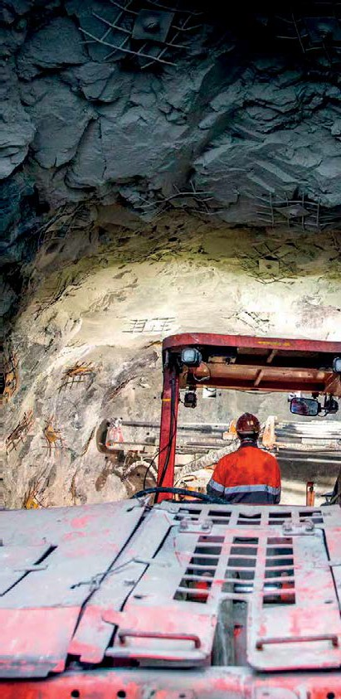

Appendices

Appendix A: Geotechnical engagement checklist

This checklist is part of the overall geotechnical engagement pack. It will assist in simplifying the work plan geotechnical assessment process, with reduction in back- and-forth resulting in likely cost and time savings.

Please complete this checklist according to the risks and issues you wish to discuss during your geotechnical engagement session. Providing this information in advance of the meeting will enable Earth Resources Regulation to provide targeted and tailored advice in areas most relevant to your application.
Once complete, please return to the contact identified in the relevant email from Earth Resources Regulation.
Issue type (tick if applicable) | Description of specific issue and ERR guidance sought
☐ Lack of geotechnical or geological data to inform
geotechnical assessment (geological/geotechnical
investigations to consider)
☐ Applicable Design Acceptance Criteria to use for
terminal and rehabilitated slopes
☐ Understanding of hydrogeological conditions (e.g.
visible signs of seepage or discharge, pore pressure
behind high walls, surface water management
systems, long-term groundwater level)
☐ Surcharge loading
☐ Slimes dams and/or other water structures
☐ Impact on Existing infrastructure (i.e. property or
services adjacent to both the crest and toe of the
slope, both external and located on site)
☐ Proximity of dams, dumps and voids
☐ Waste dump stability
☐ Proximity of sensitive receptors
☐ Slope stability management controls
☐ Dispersive soils and clays
☐ Surface water and long-term erosion controls
☐ Geotechnical Risk Assessment
☐ Rehabilitation considerations
☐ Requirement for Ground Control Management Plan

Please use the space below to describe any other risks or issues you wish to discuss with Technical Services:
Description of specific issue and scope of ERR guidance sought (add space as required) [In addition to the above, I would like to discuss X… ]

[I am seeking the following clarification or guidance from ERR… ]
Completed by: [Your name, Company & site details] Date: [XX/XX/XXXX]

Appendix B: Agenda Template: Work plan geotechnical engagement sessions
This agenda template will assist in simplifying the work plan geotechnical assessment process, with reduction in back- and-forth resulting in likely cost and time savings.
The template is to be used as a standard agenda for the geotechnical engagement sessions. Fields are populated with examples to aid completion by the proponent.
Please complete the agenda and issue to attendees, following submission of the pre-engagement checklist to Earth Resources Regulation and confirmation of its completeness. The checklist is critical to give an indication of the risks and issues requiring discussion, including scope of Earth Resources Regulation advice required.

Subject | Geotechnical engagement session
Date and Time | 12:00pm, 6 April 2022
Location | Online (MS Teams)
Meeting Number | 1
Authority Number | WAXXXX
Company and Site | Extractives Pty Ltd, Nar Nar Goon (site X)
Minute-taker | John Johnson, Extractives Pty Ltd

Attendee (Name, Organisation) | Apologies (Name, Organisation

# | Item detail | Owner
1 | Acknowledgement of Country | ERR Technical Services
2 | Current status of the geotechnical assessment process | Proponent/Independent Geotechnical Engineer
3 | Specific risks or issues [description below to be populated based on pre-engagement checklist completed by proponent] E.g.:  - E.g. slime dams and/or other waste structure;  - Waste dump stability  - Geotechnical risk assessment | Proponent/Independent Geotechnical Engineer
4 | Detailed discussion on risks & issues:  - Alignment to guidelines and best practice  - Action required | Independent Geotechnical Engineer/ERR Technical Services
5 | Next steps/submission timelines/meeting administration  - Summary of meeting outcomes | Proponent/Independent Geotechnical Engineer

Appendix C: Minutes template - Work plan geotechnical engagement sessions
This minute template will assist in simplifying the work plan geotechnical assessment process, with reduction in back-and- forth resulting in likely cost and time savings.
The template is to be used as a standard meeting record for the geotechnical engagement sessions between industry applicants and Earth Resources Regulation. Fields are populated with examples to aid completion by the proponent and/ or their independent geotechnical engineer.
Please complete this meeting record and issue to all invitees. This record will be used by Earth Resources Regulation to ensure items are not revisited in future engagement sessions – a reminder that these meetings are for the purpose of technical advisory/strategic direction, not composition of individual specifications or other report elements.

Subject | Geotechnical engagement session
Date and Time | 12:00pm, 6 April 2022
Location | Online (MS Teams)
Meeting Number | 1
Authority Number | WAXXXX
Company and Site | Extractives Pty Ltd, Nar Nar Goon (site X)
Minute-taker | John Johnson, Extractives Pty Ltd

Attendee (Name, Organisation) | Apologies (Name, Organisation
Responsible minute taker to populate this list based on actual attendance at the meeting. Add or delete rows based on attendance. | Responsible minute taker to pre-populate this list based on actual attendance at the meeting

Summary of Key Discussion Points
Insert in this row high level of summary of why the engagement session was called. What was the key risk/ issue and objective sought?
Example: this meeting was scheduled to discuss 1) proposal for expansion areas, 2) terminal slope angle and 3) ground instability for the site WA123, to enable progression of the geotechnical assessment report as part of the work plan variation.
Issue #1: [Describe high level category of risk or issue]
Provide particulars of the issues noted by ERR and the strategy for resolving the risk or issue going forward in the work plan application
Example Issue #1: Expansion areas
Extractives Pty Ltd. (‘Extractives’) described its intent to complete a cell expansion (cell 6) to the west of the current extraction area, within the buffer area. ERR noted that this is contradictory to the approved planning permit conditions (Condition 6a of the amended planning permit, dated 2005). Condition 6a noted that no extraction works shall occur on the land within 100 metres to the east of Browns Road and any other areas shown as a buffer to the excavation area on the endorsed plans. As such, ERR noted that a landscape buffer needs to be planted and maintained to the satisfaction of the Responsible Authority.

Summary of Key Discussion Points
Issue #2: [Describe high level category of risk or issue]
Provide particulars of the issues noted by ERR and the strategy for resolving the risk or issue going forward in the work plan application
Example Issue #2: Batter slope angle and size - terminal slopes:
Extractives sought to test whether the terminal slope angle designed for met the relevant guidelines and conditions. From the discussion, ERR recognised that there was a discrepancy between the terminal slope configuration for the eastern slopes of cell 5 and that specified in the planning permit (condition 6a) amended August 2005. Planning Permit condition 6a states that the batter slopes on the quarry adjacent to the South East Water channel be kept to 1V:2H or flatter. The terminal batters, as per the drawings put forward by the geotechnical engineer, shows the terminal batters at 3V:1H for the southern and northern barriers of Cell 5.
Issue #3: [Describe high level category of risk or issue]
Provide particulars of the issues noted by ERR and the strategy for resolving the risk or issue going forward in the work plan application
Example Issue #3: ground instability:
Extractives sought to test whether its performance measures for ensuring compliance to design of all rehabilitated quarry faces, embankments and dumps are sufficient. ERR noted the following:
- Need to provide further details on how a stable batter will be established in the long term with water present in the pit.
- ERR also sought to understand how much movement is acceptable in the long term and the frequency of ‘routine inspection’.
- Extractives needs to consider how the geotechnical testing of the site materials will be applied to confirm performance measures against design compliance. Similarly the proponent needs to consider how geological and structural mapping and stability assessments will be applied to demonstrate performance measures against design compliance.
- With regards to site inspection before and after significant rainfall events, the definition of ‘significant’ rainfall needs to be better defined. For example, a 1 in 10-year rainfall event, 1 in 100-year rainfall event etc.? ERR suggested
consulting available information from the Bureau of Meteorology as a starting point to defining ‘significance’: Design Rainfalls: Water Information: Bureau of Meteorology (bom.gov.au). The proponent needs to be able to demonstrate in the report that the frequency of inspections is adequate to manage erosion and sedimentation issues.
Add or remove rows to this table depending on the number of risks and issues discussed under the agenda

Summary of Meeting Outcomes
Issue | Action | Post-meeting update (as applicable)
1 | Summarise actions aligned to risks or issues discussed above as per the agenda  Example Action: Review proposal for expansion area (cell 6) and ensure that the conditions of planning permit and buffer zone requirements are observed. | Describe progress made against agreed action undertaken by industry to resolve  Example Update: Actioned XX/XX, reflected in updated report.
2 | Example Action: Review proposal for expansion area (cell 6) and ensure that the conditions of planning permit and buffer zone requirements are observed. | Example Update: Actioned XX/XX, reflected in updated report.
3 | Example Action: Update description of control measures and performance measures for ground stability to ensure fundamental principles noted by ERR are included. | Example Update: Actioned XX/XX, reflected in updated report.
Add or remove rows as appropriate tailored to the number of risks/issues and associated actions discussed

