  - Victorian Critical
Minerals Roadmap
  - Resources for Net Zero
Table of Contents
Ministerial Foreword 1
Critical minerals – A generational opportunity for Victoria 3
Australia’s critical minerals and strategic materials 7
Supporting our national critical minerals needs 9
Critical minerals mining: a low impact activity 14
Our vision: a world-leading critical minerals industry 20
Theme 1: Mapping the opportunities 23
Theme 2: A modernised regulatory regime 30
Theme 3: Critical minerals production and processing in Victoria 37
Theme 4: Sharing the benefits of Victoria’s minerals 40
Conclusion 49
Publication information 50

Ministerial Foreword
Victoria is home to world-class deposits of critical minerals, vital for our transition to a net-zero future. We have some of the largest global reserves of ilmenite, rutile, and zircon, placing us in a prime position to meet the surging demand for critical minerals needed to deliver renewable energy targets in Australia and internationally. This demand is expected to grow sixfold by 2040.
Our mining sector already plays a key role in regional economies, supporting over 7,400 jobs and delivering more economic value per worker than any other industry. The development of a Victorian critical minerals industry will bring further economic and social advantages to Victoria over the decades to come, creating in particular economic development opportunities and long-term, highly-skilled jobs within regional communities.
For this industry to be a success, the interests of regional communities and Traditional Owners must be understood and respected, and they need to see real benefits.
We established Resources Victoria as the driver of the Victorian Government’s reforms to unlock sustainable minerals development. The Victorian Critical Minerals Roadmap creates the foundations for a coordinated and integrated approach to foster this new industry – tailored to Victoria.
At its core, it’s about ensuring industry has confidence to develop new projects in a timely fashion, while empowering regional communities and Traditional Owners in the process.
Victoria has challenges that other states do not have – our small land mass means that mining operations are likely to be close to local communities and landholders. We will aim to drive early engagement and certainty for communities and industry, by integrating land-use, environmental and community values into our long-term planning for the sector. And, we'll establish community benefit arrangements for local communities and Traditional Owners. This will help boost investment certainty, streamline project approvals and deliver positive outcomes.
But our compact size is also an advantage. With easy access to infrastructure, skilled workers, and services, we can create a seamless mine-to-manufacturing supply chain that captures the full value of our resources.
By investing in critical minerals, we’re not just building an industry—we’re shaping a prosperous, sustainable future for all Victorians, with lasting social and economic benefits for our regional communities and Traditional Owners.
The Hon. Lily D’Ambrosio MP
Minister for Climate Action
Minister for Energy and Resources
Minister for the State Electricity Commission

Critical minerals – A generational opportunity for Victoria
Critical minerals are a collection of metal and non-metal resources considered essential for renewable energy infrastructure, modern computing, emerging technologies and sustainable economic development. They are described as critical due to their vulnerability to future supply risks because of geological scarcity or geopolitical factors.
The production of critical minerals is an essential step in the transition to a net-zero economy. In the coming decades, there will be unprecedented global demand for these materials, as nations that signed the Paris Agreement of 2015 work together to attempt to limit global warming to 1.5°C above pre-industrial levels. To achieve this target, production of critical minerals needs to be increased to make, among other things, wind turbines, electric vehicles and advanced electronics including semi-conductors.
The International Energy Agency estimates that achieving global net-zero targets will require mining six times more minerals by 2040 than what was produced in 2020. This equates to around US$1.7 trillion in global mining investment and over 3 billion tonnes of metals.
Victoria is already a leader in taking action to respond to climate change. But we also have an opportunity to play a further role as a reliable and ethical source of minerals that enable renewable energy generation. This is thanks to Victoria’s long history of mining, exceptional environmental, social and governance (ESG) standards and robust regulatory environment.
Victoria’s critical mineral resources include globally significant quantities of titanium, zirconium, and associated rare-earth elements in mineral sand deposits in the northwest of the state. Central Victoria has Australia’s largest antimony deposits and Australia’s only operating antimony mine.

A net-zero state
Victoria was one of the first jurisdictions in the world to put a net-zero emissions target in law. The commitment is now to achieve net-zero emissions by 2045.
Victoria beat its first target - to reduce emissions 15–20% below 2005 levels by 2020 – with a cut of almost 30%.
Building on this success, new targets provide a clear path to net-zero emissions:
28–33% by 2025
45–50% by 2030
75–80% by 2035
Harnessing these resources responsibly will create jobs and economic activity for Victoria’s regions, provide royalties to the people of Victoria, supply ethically sourced materials into the market and strengthen Victorian and Australian supply chains.

Opportunities for the Mallee and Wimmera Southern Mallee Regions
Victoria's nine Regional Economic Development Strategies (REDS) identify opportunities for economic growth for each of Victoria’s Regional Partnership regions, based on an evidence base highlighting each areas unique strengths and comparative advantages. With the northwest of Victoria rich in critical mineral resources, the Mallee REDS and the Wimmera Southern Mallee REDS highlight opportunities for these regions to capitalise on the emerging critical minerals sector. This includes supply chain opportunities to bring diversification and resilience benefits to the local community.
The development of mineral sands projects will create high value jobs, attract skilled workers and stimulate economic development including in secondary industries such as transportation and logistics. This presents significant opportunities for local economies participating in the mineral sands value chain. Preliminary economic modelling estimates that the mineral sands industry in northwest Victoria could support around 2,000 additional jobs if the most advanced mineral sands projects move to production. This could increase to up to 7,000 additional jobs if more of the mineral sand resources are produced.
We also recognise that increased economic activity could have other impacts, including an increased demand for local housing, roads, schools, childcare, health and other services.
It also creates opportunities for young people to work in rewarding, high-tech jobs that contribute directly to Victorian and global net-zero outcomes.
We will work in partnership with local communities, and across government agencies, as the industry develops, to anticipate and monitor impacts, design appropriate place-based responses, and ensure local economies are engaged in value chain opportunities, and communities see genuine, long-term benefits as a result of industry growth.
Working in partnership with Traditional Owners and regional communities to ensure they receive meaningful and sustainable benefits from industry growth is a key part of how we will deliver on Theme 4: Sharing the Benefits of Victoria’s Minerals.
The Victorian Critical Minerals Roadmap outlines a vision for a strategically and economically important critical minerals industry that is valued by the community. This will be achieved through a comprehensive geoscience-to-mine-to-manufacture approach that emphasises meaningful community consultation, partnerships with Traditional Owners and sustainable mining practices.
We need this generational opportunity to work for everyone. Central to this is giving clarity and certainty to proponents, communities and Traditional Owners about our processes, and their role in them. We have the opportunity to embed early engagement and consultation to ensure more transparent and predictable regulatory pathways. Government also needs to be responsive to the needs of the community and the industry – whether it be skills, infrastructure or other community benefits.
To achieve this vision, the Roadmap signals actions that the government will undertake over the next 12 months, across 4 themes. Each theme also flags further possible future initiatives. Potential implementation of these initiatives will be considered in due course, with the Roadmap intended to be a live document that will be reviewed at regular intervals and which will evolve with changing circumstances.
By addressing these challenges collectively, Victoria can lead in responsible minerals development to deliver value now and for future generations.
Figure 1: Mining's contribution to the State’s economy
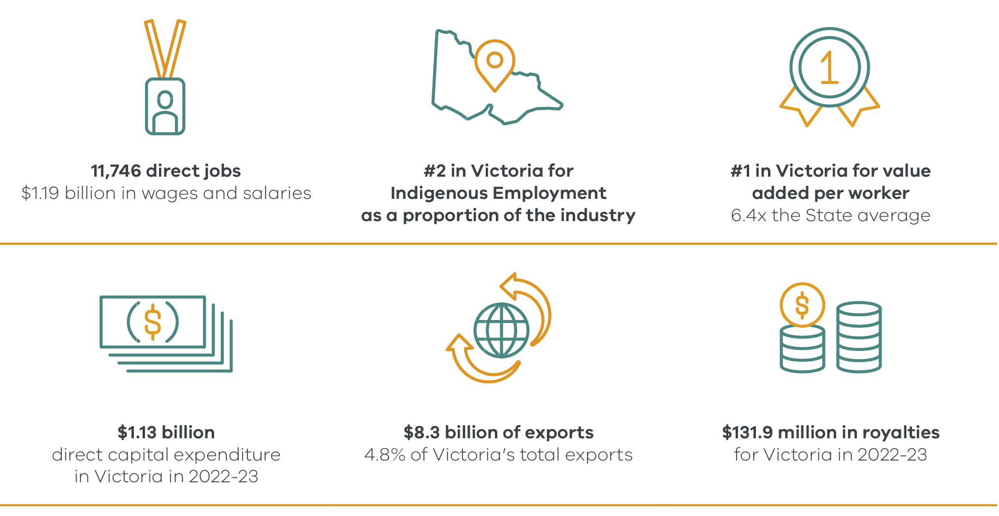
Note: REMPLAN - Economic Modelling and Planning System, Release 2 of 2023 modelled data (published April 2024) based on Australian Bureau of Statistics (ABS) 2001-2021 Censuses, Victoria (State), 19 Sector view, Copyright 1999—2024 REMPLAN.

Australia’s critical minerals and strategic materials
There is no single list of critical minerals. Countries prioritise different minerals at different times depending on supply and demand, technological innovation and the shifting needs of society.
Figure 2: Australia’s Critical Minerals
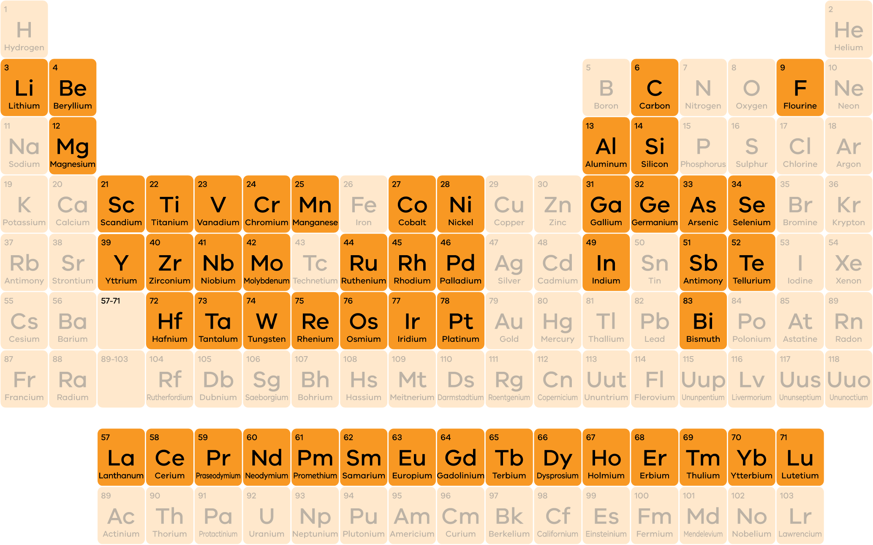
Australia’s Strategic Materials
- Aluminium
- Copper
- Phosphorus
- Tin
- Zinc

In addition to critical minerals, the Australian Government maintains a second list of minerals referred to as strategic materials, which are also important for advanced manufacturing as part of the transition to net-zero emissions. While in demand from international strategic partners, the supply chains for strategic materials are not currently vulnerable enough to be considered critical minerals.
Unless otherwise explicitly stated, references to critical minerals in the Victorian Critical Minerals Roadmap include materials listed under either the Australian Government’s critical minerals or strategic materials lists.
The Australian Government’s critical minerals list supports the transition to net-zero, advanced manufacturing, defence technologies and capabilities and broader strategic applications. It is updated regularly in response to global strategic, technological, economic and policy changes.

Supporting our national critical minerals needs
Victoria's geology hosts multiple critical mineral resources of international significance. This includes a range of demonstrated resources of important critical minerals and strategic materials. Demonstrated resources are a concentration or occurrence of material in such form, quality and quantity that there are reasonable prospects for eventual economic extraction.

Victorian critical minerals: key facts
- Victoria has 39% of Australia's zircon and approximately 27% of world reserves, with an estimated 33 million tonnes (Mt) of economic reserves.
- Victoria has 51% of Australia's rutile and 22% of its ilmenite – key titanium bearing minerals – estimated at over 19 Mt and 63 Mt, or approximately 32% and 7% of world reserves respectively.
- Victoria has Australia’s only operating antimony mine, with resources of over 33,000 tonnes of antimony.
The awareness of these known resources has also spurred on significant new exploration for critical minerals in Victoria.
The Murray Basin is an area that covers large parts of northwest Victoria as well as parts of New South Wales and South Australia. This area contains extensive mineral sand deposits, which are old sands that contain concentrations of critical minerals such as zirconium, titanium, and rare-earth elements. These minerals are essential for many applications including solar panels, engine turbines, electric vehicles, and hydrogen electrolysers. The value of these known deposits was estimated by the Commonwealth Scientific and Industrial Research Organisation (CSIRO) in 2014 at approximately $200 billion, with almost 85 percent located in Victoria.
Victoria also contains substantial deposits of antimony. An alloying element, antimony is used to harden lead in storage batteries and in various applications in the semiconductor industry. Several of central Victoria’s gold-bearing quartz deposits also contain stibnite, the only significant ore mineral of antimony. A demonstrated antimony resource is located at Costerfield.
The state also has demonstrated resources of strategic materials, most notably copper and zinc in the west and northeast of the state. Tin has also been produced in Victoria in the past. Additionally, strategic material resources may contain critical minerals such as indium and tungsten. If identified and characterised, these could present further value-add opportunities during processing
Many of Victoria’s demonstrated resources are located near trainlines with port access.

Victoria’s Demonstrated Critical Mineral and Strategic Material Resources
Figure 3: The location of critical mineral and strategic material resources
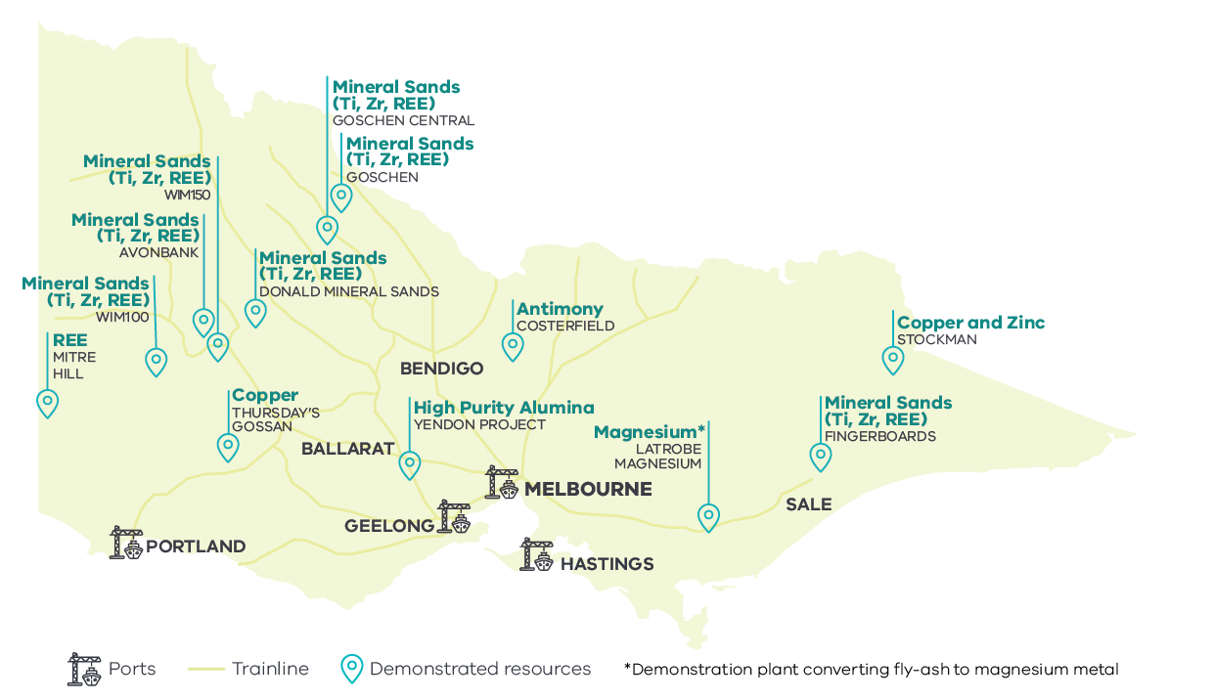
In addition to existing demonstrated resources, exploration is underway in Victoria for a range of other critical minerals, which may also lead to future discoveries of significance.
More information about Victoria’s demonstrated resources of critical minerals is provided below.

Antimony (Sb)
Antimony is mined in central Victoria alongside gold. Antimony is historically and economically the second most important metallic commodity in Victoria after gold, with the close association of the two in Victoria an attractive exploration and development proposition.

Copper (Cu)
Copper has been discovered in west and northeast Victoria with further exploration potential identified and ongoing development studies underway.

High Purity Alumina (HPA)
One high purity alumina resource has been defined in central Victoria with other potential unrealised opportunities already identified in similar geology in central and western Victoria.

Magnesium (Mg)
In the Latrobe Valley, magnesium metal will be extracted using fly-ash produced by brown coal power plants. As well as magnesium metal, this low emission process will produce other valuable by-products such as Supplementary Cementitious Material (SCM), silica and iron oxide.

Rare-Earth Elements (REE)
REEs, in particular neodymium, praseodymium, dysprosium and terbium, are contained within minerals such as monazite and xenotime in Victoria’s mineral sand deposits.

Titanium (Ti)
Titanium minerals – including ilmenite, leucoxene and rutile – are common in Victoria’s mineral sand deposits. Titanium has previously been produced from mineral sands in Victoria.

Zinc (Zn)
Zinc resources have been defined in northeast Victoria. In addition to further discoveries of zinc in the region, there may be potential for other associated critical minerals such as indium within the current resource.

Zirconium (Zr)
Zirconium is present in the form of the mineral zircon, which is common in Victoria’s mineral sand deposits. Zirconium has previously been produced from mineral sands in Victoria.

Critical minerals mining: a low impact activity
Victoria’s critical minerals mining is, and will continue to be, low impact, ensuring potential environmental risks and impacts on landholders and local communities are minimised.
The metals life cycle operates through a sequence of stages. The mining industry operates through exploration, discovery, development, production and rehabilitation, while processing of minerals to metals and the manufacturing and recycling of components form part of the ‘downstream’ metals process.
Mining for critical minerals in Victoria has traditionally been through small footprint underground mines and low impact mineral sands mining.

Antimony
Victoria’s antimony and gold mines are underground operations, with a small aboveground footprint. This is an efficient way to extract minerals and minimise associated waste rock. Modern underground mining and mineral processing is becoming highly sophisticated with the application of new technology, from the identification of the resource to the electrification of mining equipment and rehabilitation. An emerging opportunity is the reprocessing of mine waste to extract more from less and further reduce an operation’s environmental footprint.

Mineral Sands
One of the advantages of mineral sands development is its relatively low environmental impact and its demonstrated rehabilitation successes.
Prior to mining, the depth and extent of the soil profile that overlies the mineral sand deposit is delineated. The various topsoil, subsoil and clay layers are then carefully removed and safely stockpiled separately so that they can be returned in the same order during rehabilitation post-mining.
Mineral sands deposits can be excavated using either wet or dry extraction techniques, each of which is chosen based on the specific characteristics of the deposit and the surrounding environment.
Wet extraction involves dredging the mineral sands from under the surface of a pond created for extraction purposes. In this method, a floating dredge is used to excavate the sand. The dredge extracts the sand and pumps it as a slurry to a floating concentrator. The concentrator uses gravity separation techniques to begin the process of separating the valuable heavier minerals from the lighter sand particles.
Dry extraction uses conventional earth moving equipment to excavate the mineral sands deposit. This method is typically used for deposits located above the water table or in arid regions where creating a pond is not feasible. The excavated material is transported to a processing plant where it is mixed with water to form a slurry, allowing for the separation of the high-value heavy minerals.
After the mineral-bearing sand has been extracted, the overburden material is replaced, sometimes within as little as 12 months, and the land is rehabilitated to the pre-mining landscape in a condition suitable for prior non-mining uses.
Rehabilitation and post-closure management are the final stages of the life cycle of a mining operation. Government regulates operations throughout this process to ensure environmental and social expectations are met.

WIM Resource Avonbank Test Pit Rehabilitation
In 2019 WIM Resource, a mineral sands developer, established a test site at its Avonbank Project near Horsham to evaluate the feasibility of mining, processing and rehabilitation. The study investigated the impacts of mining and rehabilitation on soils and crop growth, health and yield. The goal of the demonstration trial was to achieve a final landform following rehabilitation commensurate with the surrounding areas and pre-mining landscape. The demonstration trial involved:
- Excavation of a test pit and removal of over 11,000 tonnes of ore
- Construction of a demonstration scale Wet Concentration Plant (WCP) at site
- Processing of ore through the WCP over six months to produce a high-quality Heavy Mineral Concentrate (HMC)
Rehabilitation of the test pit back to a cropping land use and ongoing monitoring
Following final rehabilitation, the site showed no material evidence of ground movement or erosion, and the estimated crop yield monitored through each growing season was similar or higher in the rehabilitated site than in the unmined areas in 2021 and 2022.
WIM Resource's rehabilitated Avonbank test pit with barley crop (2021), demonstrating rehabilitation post-mineral sand mining
Figure 4: WIM Resource's rehabilitated Avonbank test pit with barley crop (2021), demonstrating rehabilitation post-mineral sand mining

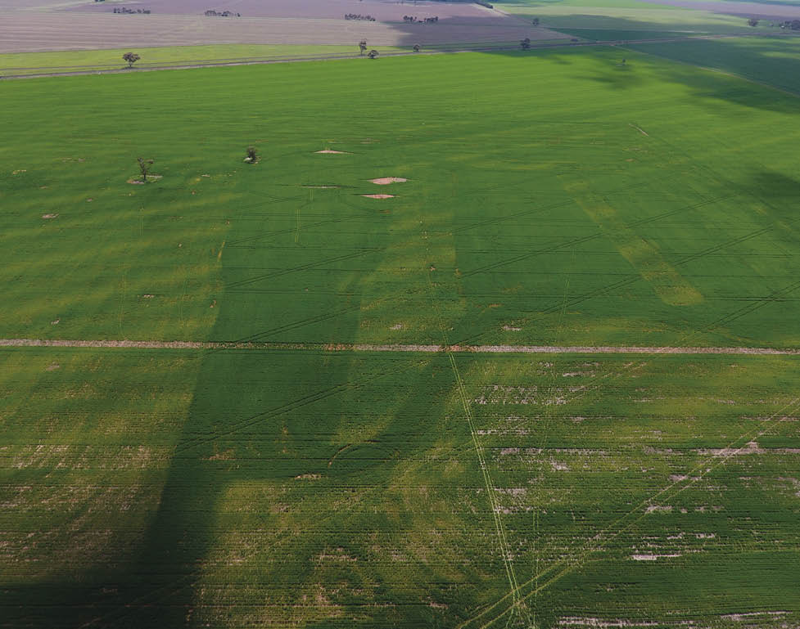

Mining life cycle
The following diagram depicts the life cycle of a mine, from pre-competitive geoscience through to the end of mining and subsequent land use.

Government
Government provides regulatory oversight to ensure industry is meeting community, environment and legislative requirements.

Industry
Industry has a responsibility to be monitoring social and environmental considerations.
Figure 5: The life cycle of a mine
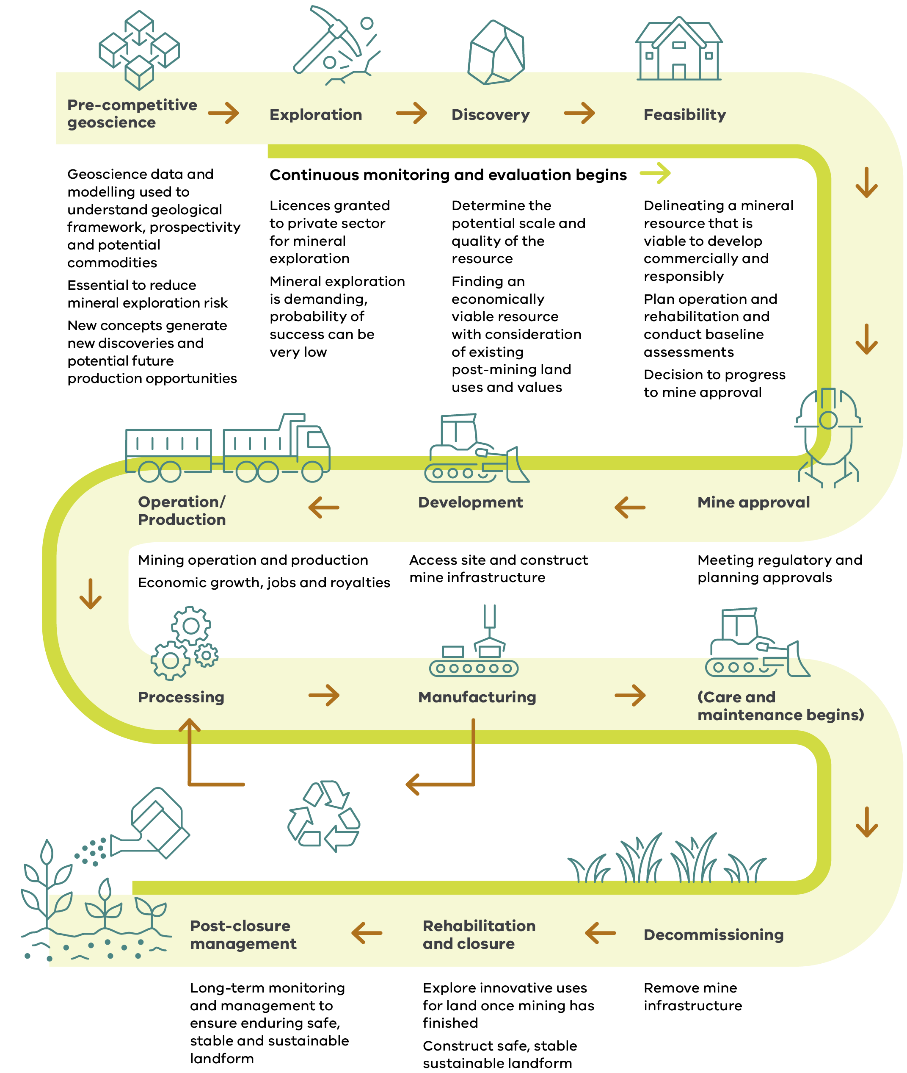

Our vision: a world-leading critical minerals industry
Victoria has the potential to be a major player in ethically-produced critical minerals with our globally significant mineral deposits.
Victoria-specific opportunities include access to Melbourne as a major hub for mining companies and the Mining Equipment, Technology and Services (METS) sector, proximity to infrastructure and a skilled workforce, opportunities for advanced manufacturing and research, and Victoria’s strong environmental and social credentials.
The 2024-25 Federal Budget is investing $22.7 billion over the next decade to maximise the economic and industrial benefits of the transition to net-zero, with critical minerals processing identified as a priority industry for a Future Made in Australia. Federal initiatives, including the Critical Minerals Production Tax Incentive, Critical Minerals National Productivity Initiative and Resourcing Australia’s Prosperity, will support Victoria to strategically identify and develop its place in the Australian critical minerals sector.
Building on Victoria’s strengths and the priorities and opportunities set by the Australian Government, the Victorian Government wants to see a local, world-leading critical minerals industry that is attractive for investment, is environmentally responsible, provides opportunities to regional communities, and forms meaningful partnerships with Traditional Owners.

Our Vision
A world-leading ethical critical minerals sector in Victoria that:
- has timely approvals for development
- delivers significant economic benefits for regional communities
- is environmentally responsible
- creates opportunities for future downstream industries
forms strong and lasting partnerships with local communities and Traditional Owners
The Victorian Critical Minerals Roadmap will help us achieve this vision through actions grouped around four themes.
As this Roadmap and its implementation is intended to be reviewed and updated on a regular basis, the actions focussed on here are short-term, with possible, longer-term actions also noted for consideration at a future point in time.

Theme 1: Mapping the opportunities
Building on a strong foundation of geoscience projects, economic and infrastructure assessment and policy analysis, the Victorian Government will identify and establish new Critical Minerals Priority Development Zones.
To do this, the government will provide clear and comprehensive pre-competitive information by modernising our geoscience data and new-generation geological mapping.
The priority zones will ensure early consideration of land use and associated community values, to help facilitate smoother project approvals and reduce investment risks, making Victoria an attractive destination for responsible and respected investors and operators.

Theme 2: A modernised regulatory regime
Victoria will establish a Victorian Critical Minerals Coordination Office to reduce approvals timelines. The government will also review guidance materials and operational practices to provide greater clarity and streamline processes. This will support the government’s continued implementation of a modernised duty-based regime for exploration and mining approvals.

Theme 3: Critical minerals production and processing in Victoria
Manufacturing is a major component of the state’s economy and a driver of growth and innovation. Victoria also boasts the nation’s largest manufacturing workforce, and world-class research and innovation capabilities and hosts a range of globally integrated supply chains.
Victoria will investigate downstream production opportunities in critical mineral processing and manufacturing. Preliminary studies highlight potential economic and national supply security benefits from downstream processing facilities in our state. Investigating prospects for ‘urban mining’ will seek to further grow our sustainable mineral processing opportunities. Where possible, Victoria will also seek to partner with the Australian Government and other Australian states and territories to enable more value-added development and expand markets.

Theme 4: Sharing the benefits of Victoria’s minerals
Victoria will investigate benefit sharing models for local communities and Traditional Owners, balancing the interests of community, landholders, Traditional Owners, government and industry to optimise social, environmental and economic outcomes. Creating pathways for skills development will also be considered.

Theme 1: Mapping the opportunities
Victoria is a densely populated state with a relatively small land size when compared to other jurisdictions in Australia. As such, competing land uses, proximity to urban centres and environmental considerations can impact community confidence in mining operations. This in turn can increase the complexity of required consultation and create uncertainty for industry if operations are not supported by local communities.
We need to build the confidence of industry and local communities in the process of identifying both areas for future development and protection.
To do this, the government will undertake strategic land use assessments to identify Critical Mineral Priority Development Zones for mineral sands, antimony and other critical minerals.
Strategic land use assessments will be based on modern, fit-for-purpose geoscience to identify areas of mineral prospectivity, in conjunction with assessments of land, water, agriculture and infrastructure uses, and associated sensitivities and existing protections. Through this analysis, the government will identify the areas that have the highest likelihood of developing successful critical minerals operations. This will be supported by exempting environmentally important areas from mineral exploration or development under existing legislation but with a clear and transparent policy.
Early engagement with Traditional Owners and the First People’s Assembly of Victoria will also ensure that cultural heritage mapping and data collation is properly considered through all stages of scoping and future exploration, in line with considering Land Water Justice as part of the Treaty Negotiation Framework (this is further outlined under Theme 2).
The identification of these Critical Mineral Priority Development Zones will be the basis for Resources Victoria, which leads the government’s work in developing and regulating our state’s earth resources, to drive development of this new industry in partnership with Traditional Owners, local communities and proponents.
As these zones are established, we will continue to look at ways to strengthen their role and provide greater certainty for proponents and local communities based on experiences using the areas, developments in technology and data, and evolving international best practice.
Beyond a select number of known mineral resources in Victoria, the potential of Victoria’s geology to host the current array of critical minerals is not well understood. Resources Victoria will harness existing geoscience expertise and data, build capacity, and leverage national and international collaborative applied research partnerships to update the geological mapping of Victoria, and develop a better understanding of favourable geology. This will be the basis for establishing Critical Mineral Priority Development Zones.
Victoria’s critical minerals investment opportunities will also continue to be promoted to domestic and international investors, leveraging Victoria’s successes in minerals exploration, mining and processing for gold and antimony.
Collaboration with relevant Victorian government partners, such as Invest Victoria, will support this promotion to attract Australian and international investment to our state.

What we are doing now:

Taking a whole of Victorian Government approach
The Victorian Government has formed a Whole of Government Critical Minerals Taskforce, led by Resources Victoria, to coordinate and guide the Government’s actions in the Critical Minerals Priority Zones. These actions include approvals facilitation, community consultation and other activities where Government has a role to drive faster development of new critical minerals projects.

Applied geoscience
The Victorian Government is expanding its applied geoscience data and knowledge to characterise some of Victoria’s known critical mineral opportunities. The age, distribution and geological environment where these minerals formed are all vital in understanding where else in Victoria critical minerals may occur and how these compare with occurrences in Australia and elsewhere around the world.

Strategic land use assessment pilot
The Victorian Government is undertaking a strategic land use assessment pilot in northwest Victoria to define mineral sands Priority Critical Minerals Development Zones.
The assessment is being driven by geoscience and incorporates social, cultural, agricultural and environmental considerations as well as interactions with existing land and water uses, this will be done in close collaboration with VicGrid.
Consultation will occur with local communities and Traditional Owners as we refine and create the Priority Critical Mineral Development Zones.
A multi-criteria analysis (MCA), a proven scientific and mathematic method used to consider different criteria in a decision-making process, is used to properly weight these competing needs and uses. This information is then combined with advanced Geographic Information Systems (GIS) technology to create a spatial MCA.
The approach taken for this spatial MCA makes use of geographically characterised geological, social, economic, engineering, planning and environmental criteria to assess areas of opportunity and constraint for future development mineral sands.
While the pilot does not yet include cultural heritage or Traditional Owner or Native Title rights that may exist under the Traditional Owner Settlement Act 2010 (Vic) and Native Title Act 1993 (Commonwealth), this information will be incorporated in future models following meaningful discussions with Traditional Owners regarding the most appropriate means of representation.
Example of Strategic Land Use Assessment over northwest Victoria mineral sands region.
This example is based on trial datasets and should not be interpreted as a definitive analysis.
Figure 7: Example of Strategic Land Use Assessment over northwest Victoria mineral sands region. This example is based on trial datasets and should not be interpreted as a definitive analysis.

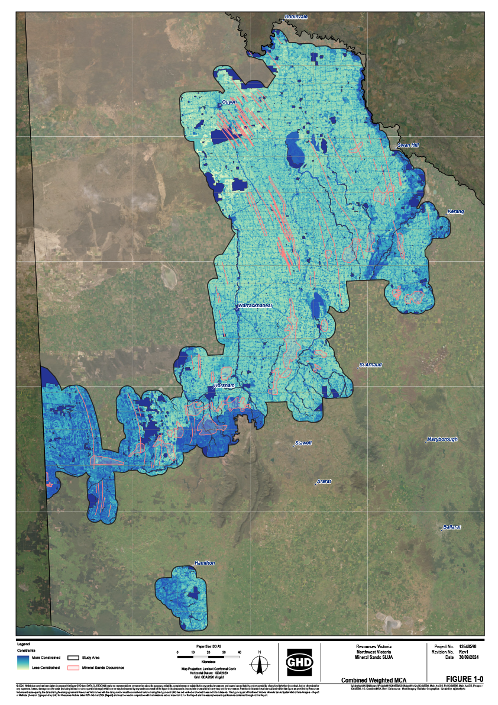

What we will do within the next 12 months

Further applied geoscience and land use assessment
We will work with Geoscience Australia and CSIRO to:
- Capture geological baseline data, including rare earth elements naturally present in northwest Victoria
- Undertake focused mine waste assessments for critical minerals and landscape rehabilitation in central Victoria
- Acquire new information on Victoria’s geochronology (measuring the age of rocks and minerals) and geochemistry (determining the chemistry of rocks and minerals)
- Commence a next generation statewide gravity map for Victoria
- Facilitate Victoria's first statewide airborne electromagnetic map for geology and groundwater

Antimony priority areas
Based on its first pilot to identify a Priority Critical Minerals Development Zone for mineral sands, the Victorian Government will also commence a strategic land use assessment to identify priority areas for antimony development. Resources Victoria will provide investment support tailored to antimony projects within these zones to drive the state's action in accelerating the antimony supply chain.
Antimony occurs in some gold deposits of central Victoria and is currently being extracted from the Costerfield gold-antimony mineral deposit near Heathcote, the only mine in Australia currently producing antimony. Mineral deposits containing antimony and gold are currently known to occur in rocks of the Bendigo and Melbourne geological zones, although the geology that controls their location and distribution within these zones and potentially beyond, including areas concealed by younger cover rocks, is yet to be determined.
A deeper understanding of the geology, in conjunction with consideration of social, environmental, cultural and land use considerations, will form the basis for definition of an antimony Priority Development Zone in central Victoria.

Development of a minerals exploration and development exclusion policy
Under the Mineral Resources (Sustainable Development) Act 1990 (MRSD Act), section 7 provides the Minister a broad power to exempt land from minerals exploration and development for a range of reasons. This is an important tool for government to send a signal to industry and communities about the areas that are not suitable for these activities.
We will develop a clear and transparent policy about the criteria we will use to apply section 7 exemptions in the future.

Possible future initiatives

Increased geoscience data and knowledge
The Victorian Government will consider further opportunities to grow and share our geoscience data and knowledge through:
- The commencement of Victoria’s GeoSCI (Strategic, Continuous Improvement) geological mapping initiative to deliver a public-facing sustainable dynamic geology map of Victoria that is the foundation for any Strategic Land Use Assessment for earth resources
- An inventory of Victoria’s critical minerals
- Critical mineral commodity focus studies
A new geoscience data interface to help unlock over $1.5 billion of existing industry mineral exploration data

Strengthening the role of Critical Minerals Priority Development Zones
Building on the results of initial work, we aim to undertake policy analysis to strengthen the role of the Critical Minerals Priority Development Zones.
This may include targeted community engagement, priority assistance for landholder agreements, grants for communities and industry, and project approval coordination assistance for proponents within these regions.

Theme 2: A modernised regulatory regime
Victoria has strict controls over minerals exploration and mining to protect our environment and other land uses such as cultural practices, agriculture and recreation and tourism. The Victorian Government recognises that the regulation of minerals exploration and mining must be fit for purpose for today’s conditions and encourage responsible investment in our minerals sector.
We need the system to work for everyone – central to this is giving clarity and certainty to industry, communities and Traditional Owners about our processes, and their role in them. Building on the strategic land use assessment and development of Critical Mineral Priority Zones in Theme 1, we want to drive early, authentic and on-going community engagement in the planning and development of minerals projects and to provide outcomes as soon as possible to exploration and mining proponents within reasonable timeframes.
This will include early and ongoing engagement with the First Peoples’ Assembly of Victoria, Department of Premier and Cabinet and Registered Aboriginal Parties to ensure Aboriginal cultural heritage considerations are embedded at the appropriate early stages of strategic project planning. This early engagement will assist with clear regulatory pathways, transparent and predictable regulation and Traditional Owner self-determination in line with the legislative obligation of the entire Victorian Government enshrined within the Advancing the Treaty Process with Aboriginal Victorians Act 2018 (Vic).
The Victorian Government is committed to identifying ways to drive responsible development of the State’s critical minerals resources that ensure that communities can remain confident that operations are safe and minimise environmental impacts.
This commitment will build on current work by the government such as introducing reforms to approvals under the MRSD Act, the establishment of Resources Victoria Approvals Coordination (RVAC) and work to uplift the efficiency of minerals approvals.

What we are doing now

Extending Resources Victoria Approvals Coordination
Resources Victoria Approvals Coordination (RVAC) was established in 2023 as part of Resources Victoria to reduce the uncertainty associated with complex earth resources development approvals in Victoria.
RVAC case manages development opportunities from the pre-application phase through to approval, working through barriers in the application process as they arise. This includes support for work plan approvals, licence renewals, and guidance in developing applications.
RVAC prioritises its support for critical minerals and gold projects with a demonstrated history of regulatory compliance including environmental protection measures, strong social licence, and respect for Traditional Owners.
RVAC has been extended until 2027 to enable continued case management of approvals and reduce uncertainty for the earth resources industry.

Streamlining approval processes
The Victorian Government passed the Mineral Resources (Sustainable Development) Amendment Act 2023 (the Amendment Act) last year. These reforms will replace a complex and outdated work approvals framework with a contemporary and transparent regulatory system based on a statutory duty for managing risk and clear codification of standards. By removing the need for work plans, the Amendment Act removes unnecessary red tape that slows down approvals processes and increases the cost of doing business in Victoria.
The legislative reforms are enabling in nature and are set to commence by 1 July 2027. This provides the necessary time to work closely with industry, local and state government, environmental, community and landholder representatives, and with Traditional Owners, to design the regulatory and supporting detail.
There is no reduction in regulatory standards with the new framework; project monitoring and site inspections will continue with clearer standards and less administrative burden.
The new legislation and regulations strike the right balance between supporting the resources industry to deliver the critical minerals Victoria needs, while protecting the environment and local communities.
Additional reforms to relevant processes will be considered during this process to further streamline approvals, making Victoria a more attractive destination for critical minerals investment.

Improvements to approvals processes
Resources Victoria has been working to clear previous minerals approvals backlogs and further streamline approvals processes.
In FY2023–24, Resources Victoria cleared 95% of its minerals licensing application backlog.
In 2023–24, 67.9% of licence applications and work plan decisions were approved within statutory timeframes against a target of 95%. Performance was 93% within timeframes when adjusted for end of year industry shutdown period and licensing backlog decisions.
In FY2024–25, Resources Victoria is continuing to improve regulatory practices to reduce timeframes for work plan assessments and licensing. These operational improvements aim to address resourcing and capability gaps, application quality, disproportionate effort being spent on low-risk applications, referral advice delays and planning delays.
Resources Victoria is rolling out a triage and assessment framework in late 2024 to provide timelier throughput for low-risk licence applications, reduce processing times by having applicants complete a compliance declaration upfront, consistently prioritise the highest value activities, and allocate assessment effort according to risk and complexity. Other actions being progressed include supporting the Development Facilitation Pathway to address planning delays and completing a new pre-submission quality check prior to work plan application lodgement.

Rehabilitation and Rehabilitation Bonds
Resources Victoria is implementing a comprehensive regulatory practice strategy to progressively improve the quality of rehabilitation plans and set contemporary rehabilitation bonds.
Transitional measures are available to industry, which may be applied to assist in the reduction of a site’s rehabilitation liability.
Resources Victoria is working with current mineral sands licence holders to improve the consistency of rehabilitation outcomes on proposed projects. Effective regulation of rehabilitation outcomes underpins community confidence in the sector. Applying more robust acceptance criteria for future projects will provide clarity for operators and ensure a positive legacy is achieved post mining.

What we will do within the next 12 months

Establish the Critical Minerals Coordination Office (CMC)
The Victorian Government will establish the CMC in Resources Victoria to facilitate and coordinate all critical minerals approvals in order to minimise approval times and uncertainty.
CMC will build on the successes of Resources Victoria Approvals Coordination (RVAC), but with a dedicated focus on critical minerals and support for critical mineral projects within priority development zones.
The CMC will work with other facilitation agencies within the Victorian Government to ensure a coordinated approach.

Enhanced guidance for operators and communities
In addition to the reforms already underway, the government will implement targeted improvements to guidance for industry. These efforts will include:
- Support to Comply: this 12-month initiative will increase the efficiency of government regulatory services by improving the pre-application support available to proponents. This will involve improving access to and updating guidance material to increase earth resources business’ understanding of requirements and obligations under the legislative and regulatory framework, and help ensure all applications, when submitted, include all the necessary information required to enable an informed, timely decision.
- Review and update of guidance materials: the government has commenced a review to ensure that public information for proponents, landholders, and communities is up to date, clear and accessible. This review may identify further work that is needed for more detailed guidance, codes and strengthened policy settings.

More efficient regulatory processes
Building on the work already underway to improve regulatory processes, Resources Victoria will:
- Introduce streamlined processing for exploration applications: Applicants may be eligible for streamlined processing upon completion of a compliance declaration.
- Consider the prioritisation of exploration licence approvals for certain mineral types.
- Continue the compliance-based waiver of exploration licence land surrender requirements over the next 12 months: Resources Victoria will continue its recent practice of not requiring a decrease of land under an exploration licence as is normally required under section 38A of the MRSD Act, if explorers comply with their licence requirements.

Possible Future Initiatives

Land use co-existence policy for earth resources, renewable energy industries and agriculture
Victoria is currently undergoing an energy transition to net-zero that will require significant investment in energy infrastructure in regional and rural areas, including construction of transmission lines, wind and solar farms and battery storage. Many planned renewable energy projects intersect with critical minerals exploration projects across the state, however there is currently no guidance regarding how the earth resources and renewable energy industries should interact.
In addition, there are intersections between the critical minerals and agriculture sectors relating to potential competition for land, water and employment.
To support the co-existence and collaboration between stakeholders in the earth resources, renewable energy and agriculture industries, government will consider developing a co-existence policy for these industries.
Creation of guidance will provide clarity and investment certainty for these industries, reduce land-owner access-fatigue, increase community confidence, and enable possibilities for co-design and collaborative opportunities.

Optimising environmental impact processes
In Victoria, if an infrastructure or other project is considered to have potentially significant environmental risks, the proponents will be required to undertake an Environment Effects Statement (EES) as part of their required land use planning approval. To ensure that critical minerals projects are considered appropriately, the Victorian Government’s Economic Growth Statement is committing to reform the EES process to accelerate and support approvals.
We’ll give industry certainty by targeting an assessment review of no longer than 18 months, driven by sharper assessment scopes, providing extra support to proponents – making it faster, cheaper, and more predictable. RVAC will continue to work directly with minerals proponents to provide an additional level of facilitation throughout the approvals process.

Theme 3: Critical minerals production and processing in Victoria
The extraction of critical minerals in Victoria provides us with opportunities beyond the shipping of these resources to other jurisdictions for further processing and refinement.
The Victorian Government will investigate these opportunities to build on Victoria’s existing strengths in mining and associated industries, manufacturing and education. Preliminary studies have highlighted the economic and employment benefits of developing downstream processing facilities for Victoria’s critical minerals deposits. Such facilities would also support Australia’s sovereign capability needs whilst providing regional development opportunities.
In addition to economic and security benefits, establishing a downstream manufacturing industry would provide environmental benefits when compared to existing practices, given the proximity to the minerals source and our strong environmental standards.
Development of downstream industries also provides an opportunity for recycling as part of Victoria’s move towards a circular economy. This could include opportunities for “urban mining”, which involves extracting valuable materials from waste that would otherwise go to landfill, such as valuable metals and other minerals from e-waste like solar panels and batteries.
Figure 8: Steps in the critical minerals supply chain
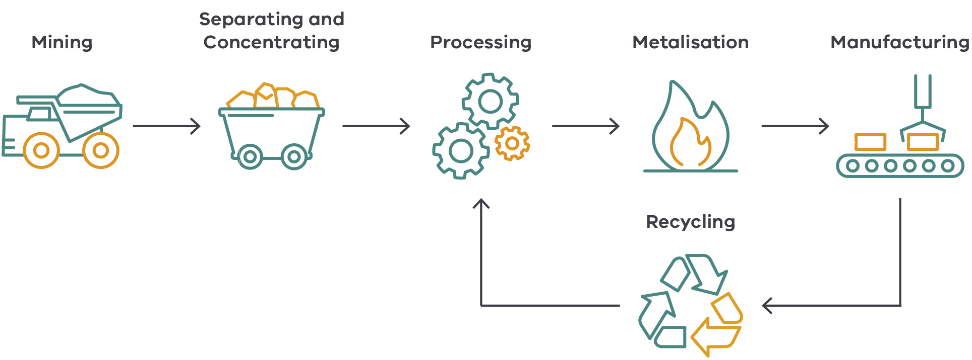
In considering these opportunities, it will be important for Victoria to continue to collaborate with the Australian Government and other Australian states and territories to identify opportunities for Victoria in supply chains, including international agreements.

What we are doing now

Critical mineral supply chain assessment
The Victorian Government is currently investigating critical mineral supply chains to determine where the state can maximise economic opportunities and its contribution to building national critical mineral security.
This will continue to be in collaboration with the Australian Government and other Australian states and territories.

What we will do within the next 12 months

Critical minerals advisory group
The Victorian Government will convene an advisory group comprising industry, academics, and other relevant stakeholders to advise on the establishment of a critical minerals downstream industry in regional Victoria.
A comprehensive review by this group will investigate the optimal point for Victoria to be embedded in a national critical minerals supply chain.

Possible Future Initiatives

Downstream opportunities feasibility study
Locations in regional Victoria offer opportunities for developing downstream processing hubs, supported by large-scale renewable energy projects.
Based on results of initial assessments and advice from the advisory group, the Victorian Government will consider undertaking a feasibility study of downstream critical minerals manufacturing opportunities.
This will consider views of relevant industry partners, potential energy demands and opportunities to be integrated in Renewable Industrial Precincts, opportunities for cross-border processing, infrastructure requirements and investment models across the different parts of the supply chain.

Theme 4: Sharing the benefits of Victoria’s minerals
The Victorian Government is committed to finding ways to share the benefits derived from our critical minerals sector equitably with local communities and Traditional Owners of Country.
We will seek to work in partnership with Traditional Owners, regional communities, and local councils to design two benefit sharing models; one for local communities and one for Traditional Owners. These models will focus on delivering genuine and sustainable outcomes. We will also engage with industry to ensure the models consider global best practice in industry community investment and reflect the mining sector’s commitment to social responsibility.
These broad models will provide a foundation for the development of place-based or tailored benefit sharing models that take into account the economic characteristics, values, and community aspirations of a particular region. The development of local benefits sharing models for Traditional Owners will reflect Victoria’s commitment to First People’s self-determination.
Benefits from minerals and mining activities include a growth in regional economic activity and the creation of skilled and well-paid jobs. To fully realise these benefits for local communities, and to provide greater certainty for industry, these jobs will need to be filled by skilled, local workers. To support this, the government will work in partnership with industry peak bodies, the education and skills sector and the community to build a skilled workforce in critical minerals regions and provide long term, quality career opportunities for regional workers.
Our commitment to deliver genuine benefit sharing between critical minerals operations, regional communities and Traditional Owners, combined with existing high environmental standards, provides Victoria the opportunity to become a leading supplier of ethically-sourced critical minerals.

Sharing benefits with local communities and Traditional Owners
Understanding the interests of industry, community, landowners and Traditional Owners in Victoria will inform two tailored and equitable benefit sharing models for local communities and Traditional Owners respectively. These models will then form the basis for more tailored or place-based approaches for particular regions.

These benefit sharing models will be underpinned by the following principles:
- The benefits of Victoria’s mineral wealth should be equitably shared.
- Benefit sharing must support and foster economic prosperity, environmental responsibility and social licence.
- Benefits include tangible and non-tangible opportunities that are enduring and strategic for the region.
- Partnerships and ongoing meaningful collaboration are critical to identify benefits and to allow Traditional Owner partnerships for the entire project life cycle, from exploration to rehabilitation of mining land.
- Schemes must not be one-size-fits-all. There must be recognition of the specific needs of the local environment, communities, and Traditional Owners and Country.
Benefit sharing should be formalised with clear parameters. These parameters will include clear definitions of meaningful engagement and permissioning, with a forward-looking strategy towards ensuring self-determination for Traditional Owners.
If the process to develop benefits sharing models for Victoria is undertaken in this manner, we can establish long-standing and meaningful relationships that do not only benefit local communities and Traditional Owners, but also landowners, industry and government.
Resources Victoria will work with Traditional Owners to investigate options for a dedicated Traditional Owner benefit sharing model, identifying key concerns and opportunities for both financial and non-financial benefits that can flow from mining operations on Country to Traditional Owners.
Figure 9: Meaningful sharing of benefits is important for everyone
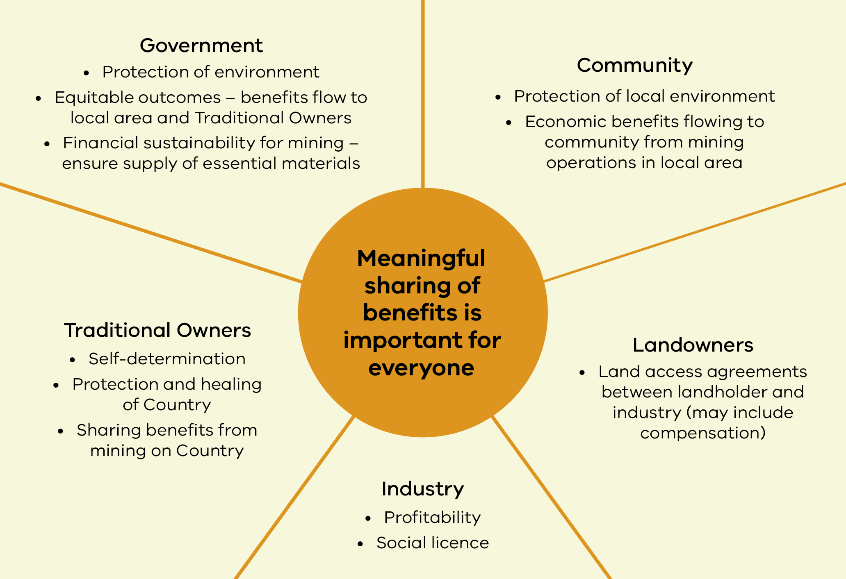

First Nations and mining in Victoria
The mining industry currently employs a higher percentage of First Nations people than any other industry in Victoria (at 1.29% of the workforce, compared to 0.75% across all other industries).
Resources Victoria is working to support Traditional Owners in realising land, water, and cultural rights in connection to Country and to foster Traditional Owner self-determination.
This work will align with the Department of Energy, Environment and Climate Action’s 2020–2025 Aboriginal Self Determination Reform Strategy “Pupangarli Marnmarnepu Owning Our Future” to support the ongoing protection of Country and the integration of Aboriginal cultural authority in informing decisions that affect the management and control of land, water and other natural resources.
The Victorian Government is legislatively committed to Treaty with First Peoples, as reflected within the Advancing the Treaty Process with Aboriginal Victorians Act 2018 (Vic) and the Treaty Authority and other Treaty Elements Act 2022 (Vic). Throughout Victoria’s history, First Peoples have been excluded from social and economic opportunities from activities undertaken on Country. Work to develop a model for sharing Victoria’s critical minerals wealth with Traditional Owners will align with, and build on, Treaty negotiations by applying the same principles centred on promoting self-determination and building strong relationships based on respect. The Victorian Government will work with the First Peoples’ Assembly, the democratically elected First Peoples’ Representative Body that is legislatively obligated to negotiate Statewide Treaty on behalf of Traditional Owners and Aboriginal Victorians. This work will also align with agreements, negotiations and rights enshrined under the Traditional Owner Settlement Act 2010 (Victoria) and the Native Title Act 1993 (Commonwealth).
The Traditional Owner benefits sharing model will be grounded in a recognition and understanding of the tangible and intangible heritage of Country and the need to return value to Country.
Benefit sharing opportunities with Traditional Owners may include but are not limited to:
- employment,
- training and capacity building,
- supply of goods and services to mining projects,
- social and community infrastructure,
- the gifting, leasing or renting of land, and
cultural heritage and environmental protection to support and strengthen that available under legislation.
The Yoorrook Justice Commission will deliver the final report on its investigation into land, sky and waters, health, housing and education, and economic prosperity in 2025. Policies will be reviewed and amended as necessary to ensure consistency with any relevant future findings and recommendations of the Commission.

Case Study: Fosterville Gold Mine
Agnico Eagle Mines Ltd (Agnico) operates the Fosterville gold mine, Victoria’s largest gold producer. Fosterville Gold Mine is based in Central Victoria, on the traditional Djandak (Country) of the Dja Dja Wurrung people and DJAARA, the Dja Dja Warrung Clans Aboriginal Corporation.
DJAARA and Agnico signed their Bakaru Wayaparrangu agreement in 2024. Meaning “in the middle we meet” (pronounced “Buck-a-ru Waya-pa-rrung-u”) in the Dja Dja Wurrung language, Bakaru Wayaparrangu is an historic agreement between the two parties.
The first benefit sharing agreement of its kind in Victoria, it aims to build a long-term relationship and to support the self-determination aspirations of the Dja Dja Wurrung people.
According to DJAARA, “Bakaru Wayaparrangu will ensure that Dja Dja Wurrung People are compensated for some of the impact and receive some of the benefit from mining activity that is currently occurring on Djandak. DJAARA will receive a share of the wealth generated by the mine. This income will be used for the benefit of DJAARA Members”.
DJAARA will also have access to environmental information about Fosterville Gold Mine operations and the opportunity to monitor and challenge environmental management.

What we will do within the next 12 months

A benefits sharing model for community and Traditional Owners
The Victorian Government will develop and deliver a community benefits sharing model. This will include consultation on the proposed model to map and understand the various interests of communities, landholders and industry to ensure a balanced and equitable approach.
The Victorian Government will invite Traditional Owners to partner in co-designing a benefit sharing model to promote self-determination, with timing for this action also determined as part of this partnership. This work will take place in the context of future Statewide and Traditional Owner Treaty negotiations and will therefore include ongoing engagement with the First Peoples’ Assembly.
This work will be guided by key principles as mentioned on page 42.

Possible future initiatives

Further work on benefits sharing
The government will work on implementing the community benefit sharing model to promote and build social licence for critical mineral.
Work will also continue to strengthen the partnership with Traditional Owners and First Nations people and organisations in co-designing and implementing a Traditional Owner benefit sharing model.

Local skills benefit local communities
A critical minerals industry in Victoria will require a highly skilled workforce of both tertiary-educated and trades staff such as engineers, accountants, heavy machine operators and mechanics.
This provides a generational opportunity to establish highly-paid positions in regional Victoria, with jobs generated across the mining life cycle from new mineral discoveries and future production, through to innovative uses for land following rehabilitation.
Victoria is a small and densely populated state. Although this can create challenges with competing and sensitive land uses, it also means mining opportunities are closer to a potential workforce. Local jobs for the workforce needed to drive our critical minerals industry into the future provide significant benefits for local communities. Local jobs provide greater employment certainty and opportunities for local residents, encourage population growth in regional centres away from Melbourne and incentivise local upskilling and qualifications. But local jobs, and jobs close to population centres, amenities and families also benefit the mining industry by reducing the expense of logistics of a fly-in, fly-out workforce, as well as increasing the value of mining operations held by locals.
However, skills shortages are an existing challenge already facing the mining sector and will only increase with skills demands for renewable energy and other emerging sectors.
A pipeline of skills over the coming decades is required. This is particularly challenging given the lag effect between skills development and employment.
To start on this journey, the Victorian Government will look to partner with industry for a coordinated approach across industry, education providers and research organisations to identify geographical and skill areas of most need and to consider longer‑term solutions.
This approach will utilise Victoria’s strength of proximity of mining activities to Melbourne and regional population centres, our world leading education and research institutions and our Mining Equipment, Technology and Services (METS) providers.

What we are doing now

Building the skills base in related industries
The Victorian Government is already investing in building skills to support the net-zero and clean economy transition, including the commitment to support 6,000 apprentices and trainees in the renewable energy sector by 2035, and the development of the Victorian Energy Jobs Plan.

What we will do within the next 12 months

Victorian Critical Minerals Skills Development Partnerships
Building on the Victorian Government’s broader skills agenda, the government will partner with industry peak bodies to identify areas of most need and to consider longer-term solutions. This could include an audit of skills needed and potential training options for Victoria’s main critical minerals regions.

Building a workforce starts at school
Workforce development for careers in critical minerals exploration and mining, support services and downstream industries, will benefit from strong education and training pathways.
In Victoria every child is supported to complete year 12, sufficiently equipped for a successful transition into the world of work, or further education.
Industry can have a positive influence on career choices when it chooses to engage early in the careers journey - this is significantly improved when it supports young people to remain in school until they have completed year 12.
Work-based-learning and other important schools-based activities that promote informed career choices, can commence as early as year 7. Work-based learning is equally relevant to career planning for occupations that require a higher education pathway as it is for vocational/trade outcomes.

Conclusion
The Victorian Critical Minerals Roadmap is the first step in Victoria’s contribution to the global supply of ethically sourced, high-quality minerals essential for the energy transition and advanced technologies.
This journey will also build a foundation for long-term economic resilience, sustainability, and prosperity for our regions.
The Victorian Government is committed to working closely with industry, communities, and Traditional Owners to ensure the responsible and sustainable development of these resources according to global environmental, social and governance expectations.
This Roadmap outlines the steps needed to attract investment and support industry growth, while ensuring that Victoria’s critical minerals are developed in a way that aligns with our state’s environmental, social and governance values.
The government will continue to engage with stakeholders during implementation of the Roadmap and to consider new opportunities and challenges as they arise.
By focusing on sustainable practices and community engagement, Victoria can lead in the responsible development of critical minerals, delivering long-lasting benefits for all Victorians.
resources.vic.gov.au

Publication information

Acknowledgements
The Victorian Government acknowledges Aboriginal Traditional Owners of Country throughout Victoria and pays respect to their cultures and Elders past and present.

Copyright
© The State of Victoria Department of Energy, Environment and Climate Action, March 2024.

Creative Commons
This work is licensed under a Creative Commons Attribution 4.0 International licence, visit the Creative Commons website (http://creativecommons.org/licenses/by/4.0/).
You are free to re-use the work under that licence, on the condition that you credit the State of Victoria as author. The licence does not apply to any images, photographs or branding, including the Victorian Coat of Arms, and the Victorian Government and Department logos.
ISBN 978-1-76136-595-9 (pdf/online/MS word)

Disclaimer
This publication may be of assistance to you but the State of Victoria and its employees do not guarantee that the publication is without flaw of any kind or is wholly appropriate for your particular purposes and therefore disclaims all liability for any error, loss or other consequence which may arise from you relying on any information in this publication.

Accessibility
To receive this document in an alternative format, phone the Customer Service Centre on 136 186, email customer.service@delwp.vic.gov.au, or contact National Relay Service on 133 677. Available at DEECA website (www.deeca.vic.gov.au).
End of document.

